*The Coronation*

Asherati City bustles with anticipation and frenzy over the coronation.

Chieftainess Asherati, taking the name of her late father and his city to ensure a smooth transition of power, lifts her scepter high in the air as bird-men up above throw confetti and petals all around the congregation of spectators and citizens.

Cheers, squawks, coos, tweets and shouts decorate the southwestern corner of the plateau as even more spectators approach from the cliffside dwellings that overlook the valley and river that brought the heroes here.

The heroes congregate among a circle of more jovial youngsters, most of them girls, and make Jason forget all about Persephone’s voluptuous form. Their lithe frames are coupled with a fragrance of cleanliness and youth that the archer only vaguely recalls.

The scout’s eyes linger at one of two of the girls with pent up desires, but finally turns away, they being too young.

The coronation itself is a brief ritual, lasting all but 4 minutes, though it’s succeeded by a 2-hour soiree as the sun’s slight dip in the sky begins to signal early afternoon.

“I propose we go get some arrows and other gear before we head out,” Jason poses.

Some of the heroes are low on provisions, and though they’ve eaten and drunk their fill just now, if they go to Saltmarsh, they’ll need to bring at least a day’s rations, which some of them lack.

~\*~

Marchant is the name of the raptoran vendor—a man with graying feathers and hair—in charge of all things non-martial. “If’n you want weapons, armor, quivers and the like, go see me missus across the way,” he instructs the heroes as they peruse his incense, foodstuffs, and wineskins. He has nothing to sell worth over 9000 GPs.

In the tent across the way, Jadartha is happy to provide any and all assistance with any needed gear, though like her husband’s tent, hers has no wares worth over 9000 GPs.

Jason acquires only the arrows and supplies he needs for the trip.

Jason, Faith, Lludd, and Know stand between the two tents now, having equipped themselves as needed.

“So what is in Saltmarsh,” Lludd asks.

Know answers, “It’s a settlement much larger than this one, and much more diverse... and there’s a chance that it’s a waypoint between this plane and the Astral.” The last part is speculation based on the information he knows, and may not be correct.

~\*~

The coronation is over. The new Chieftainess and her diplomatic entourage present the heroes with medals of honor, and offer what gold and trinkets they have to spare. “You are and will forever be our allies. If we should see one another on the battlefield again, we will fight as fiercely as we all did against the Thunder Tyrant,” the Chieftainess proclaims.

“It was an honor to fight with your people. They are all brave and loyal. I wish you many years of peace and that we may not have to fight any more wars. But if it comes to such, then I will stand with your peoples.”

Jason kneels before the Chieftainess and bows his head before leaving.

And with that, the quartet of heroes—a scout, a paladin, a druid, and a trapsmith—were escorted southward and down the plateau by a dozen or so younger valets. Upon touching down by the riverside where their boat had crashed, the heroes surveyed both of the maps in Know’s possession.

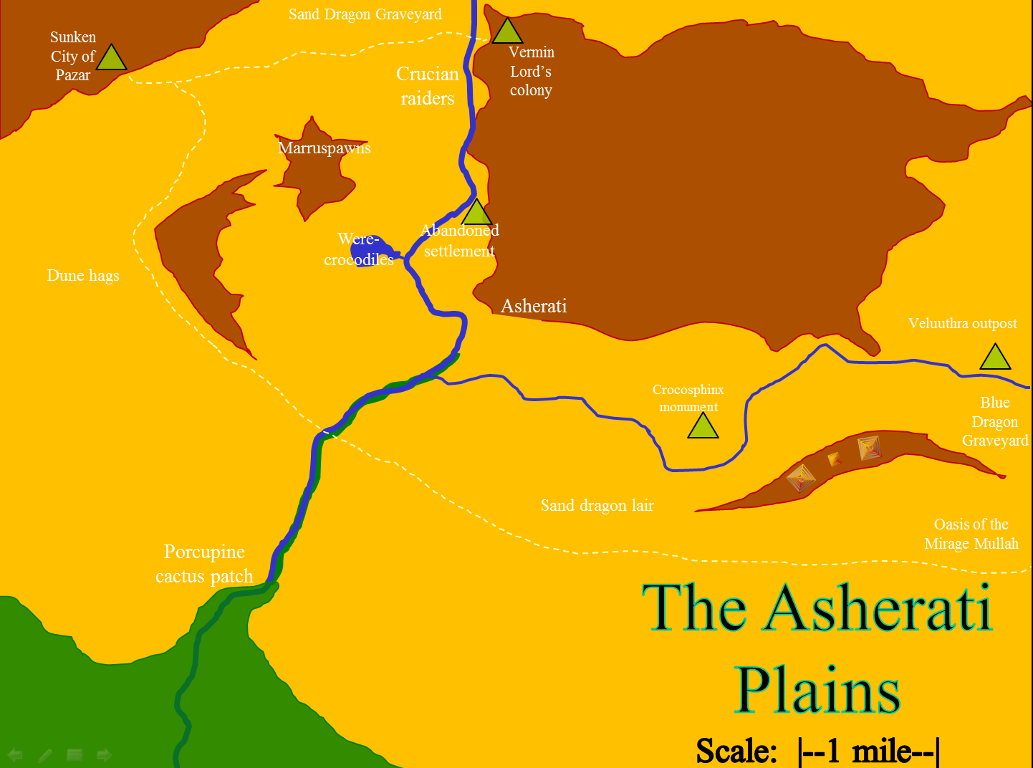

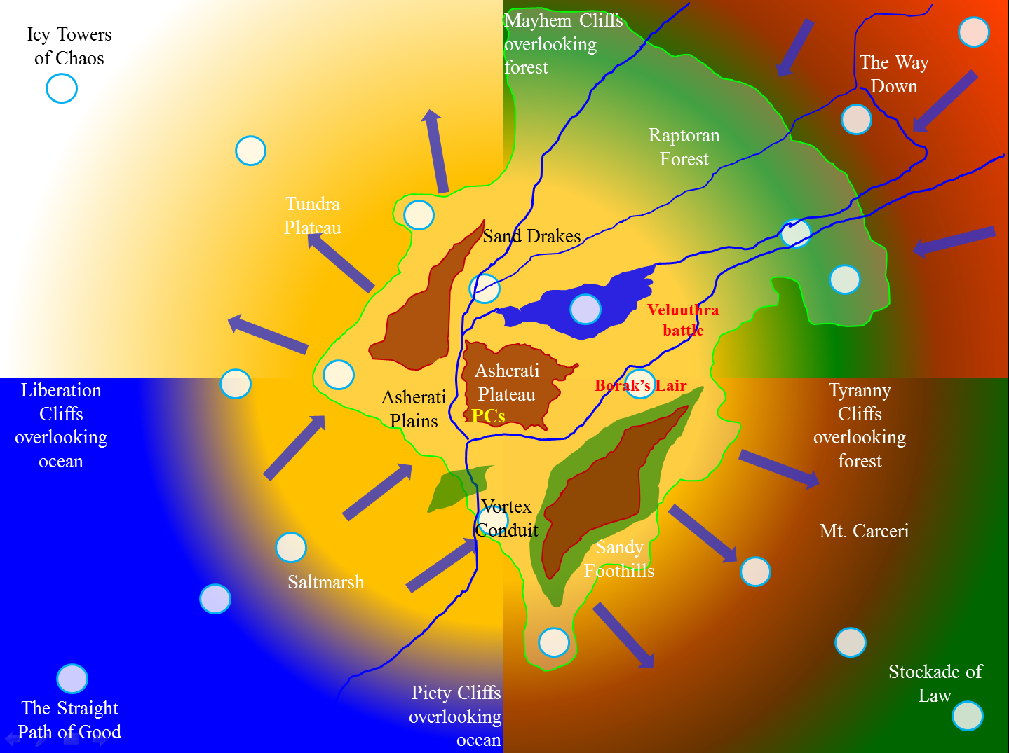

“Know,” Faith reiterates her point with a question. “Is there anything that indicates a way to get back into the Gauntlet?”

“From what Frayed mentioned,” the changeling paraphrases. “Each of the white circles represents a conduit or portal. Beyond this, I don’t know any details.”

Jason’s sharp eyes and mouth point out, “We were there, in Borak’s lair, and I didn’t see any portal.”

“We didn’t go into the upper levels, where the al-Iborak were allegedly hanged,” Faith reminds Jason.

“And it’s also possible that we walked right by it, but didn’t notice it. There’s a spell called *analyze portal* that I think someone should learn how to cast,” the changeling trapsmith believes.

“Anyway, why would you ever want to go back to that hellish place?” asks Jason.

“We could use a cleric... or an archivist,” Lludd admits. “I can serve as healer for now, but a druid does well to have cleric and archivist companions.”

“Well?” one among the splintered band of heroes asks, “Shall we be off to Saltmarsh or somewhere else?”

“The Saltmarsh for now. Let us see what adventures await us there,” Jason said.

And with this, the band of heroes walks off peacefully towards the setting sun.