PLANESCAPE NEXUS

A D&D 3.5 campaign

“Out by a shanty where the dust hangs high
Far from a river where things grow green
The flowers weep and they lean away
From the bloodstained soil beneath my feet.”

~ Terence Trent D’Arby

Chapter 1: Escape from the Gauntlet

T
he Outer Planes—also known as the Divine Realms, Spiritual Destinations, and Godly Domains—are the home of the deities and demigods, the devils and demons, the archons and inevitables, and even some efreeti and djinn who have left the tawdry comforts of the Inner Planes to whet their taste for more exotic adventures. Our story begins near the airtight, ironclad borders of Carceri, the plane of incarceration, rigidity, and rectification, though legend states that it is in the benign plane of Bytopia that our heroes will forge their immediate futures.

Dextir Dubya—gatecrasher extraordinaire—has led a band of translplanar renegades through the Astral shores of the Outer Planes in hopes of liberating the captives of a pocket plane known as the Gauntlet. The gnome’s planar vessel, the Venture Galley, commandeered only by one as well versed in the measures of spacetime as Dextir, was confiscated by some still unknown entity, and the heroes have nearly reached the vessel. The able navigator feels as much urgency to escape this place as do the others, but he also is aware of the amount of treasure that is stored somewhere on this level.

The party—Faith, Jason, Kali, Dextir, and a few others—have scoured three levels of the Gauntlet’s inner sanctum, dubbed the Old Quarter, and have fended off quite a few conjured foes in the process of trying to find an exit. In the process of scouring the Gauntlet, the heroes have realized that this pocket plane is rife with portals to Carceri, with which it is also coterminous. This means very little to some of the heroes, other than that a trip to Carceri is usually one-way, and it is one of the least hospitable of the Outer Planes, suited to the captivity of wretched souls after leading lives of moral repugnancy on the Material Plane.

Faith—the group’s paladin—had convinced the rest of the heroes that it would be a noble deed to free the remaining captives from the captivity of the now abandoned Gauntlet, a gladiatorial arena of death and resurrection formerly run by extraplanar sadists who reveled in the ongoing carnage. A band of heroes—now scattered to the far ends of the planes—had been responsible for the collapse of the Gauntlet, among them Faith and Jason, and these two now lead the rest of the adventuring party along the exit route that leads to Dextir’s vessel.

Dextir opens up his haversack and takes an inventory of the remaining cure potions.

Item | Mass | Notes
Crate of Potions | 2.0 | Potion of cure moderate wounds (21)
Among other bits of treasure, which they duly confiscated and adopted as their own, was a crate of potions of cure moderate wounds, some of which have been drunk. As such, everyone is up to full health, even though they’ve all faced some scrapes in the last hour.

They clear a flight of stairs, huffing as they reach the top, and enter another row of gauntlets, chock-full of blades, flames, and probably pressure plates that trigger more conjurings. Whoever runs this place is truly sadistic.

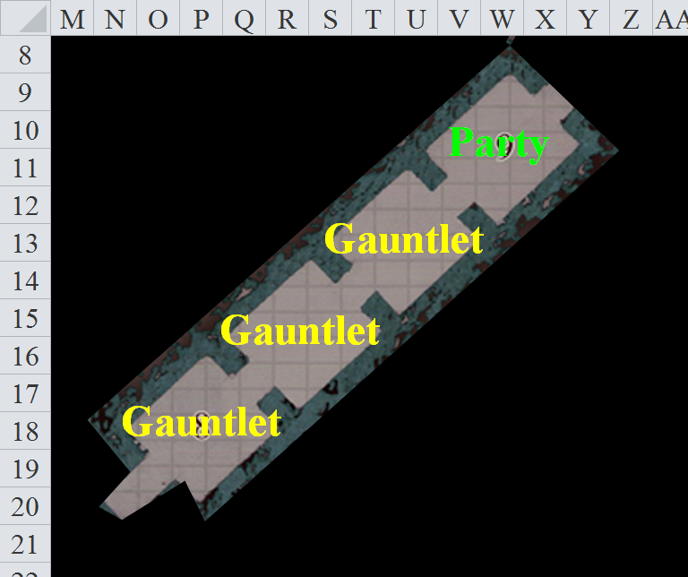

“I grow tired of these shenanigans,” Kali absently spins her sword around in a show of skill as she peers into the next room. The sword comes to a stop, blade pointing downward at a slight angle; little sparks can be seen erupting here and there along the blade’s length. Her left hand comes up to rub her upper arm. The pain lessens now, but she is still sore after the healing of the wound she received on the level below.

Jason stands behind the others, not because he likes his point of view of the Cormyrean woman, but for one using a bow, it usually keeps him out of hand-to-hand combat. He redirects his thoughts from the girl. She has specifically warned him what she would use her blades for if he made any more request for specific services. He has become bold as of late, probably due to the loss of the one he loved several weeks back as she had chosen another direction.

Doctor Caleb Jones “Doc” is a slender human man in his late 20’s. His brown hair always seems messy, and his brown eyes always seem fixated on something looking for something beyond your sight. He is dressed for outdoor travel with simple, sturdy clothing and solid boots. He is a wizard priest of Shaundakul the Rider of the Winds. “I am traveling to wherever my feet take me, looking for portals and mapping them all out.”

“You, gnome, what’s your name?” Kali thought for a moment. “Sam… or something? Don’t you people have some kind of trap sense? See what kind of trap is ahead.”

Sam looks up at Kali, a scowl crossed her brow, “That would be those of the thieving persuasion.... Gnomes follow more noble practices....” she pauses, going over what she has prepared.... “Nope... no spells either.... you could always use a long pole to test the ground out in front but I don’t think you have one of those either. And if you think I am going to summon something so that you can have it die to find a trap you have another thing coming...”

Opening her cloak, she pulls a small flask out of one of the pockets and took a sip of the warm, sweet tea.

“If you ask nicely, I might allow you to use a floating disc.... or levitate, that way you don’t touch the ground at all but I am trying to save the spells until I really need them.”

Caleb has already cast spells upon himself, specifically, extended greater mage armor [expires in hours], longstrider [expires in hours], and see invisibility [expires in 110 minutes]. His eyes glow iridescent with nearly perfect vision, his feet nimbly carrying his magically armored form, the magenta hue barely bothering him as he looks into the next room, wishing they hadn’t lost that rogue with whom they’d been rolling. Looking for invisible things, the male spellcaster detected traces of magic having been used here recently, but no active auras alerted his attention.

Caleb runs his fingers through his hair. “I don’t really have any skills at finding or removing traps.” Timing the speed of the pendulum therein, he looks for any changes and to see if it can be easily dodged. It seems an easy enough challenge.

Faith detects evil in the room, or rather, detects the lack thereof. “I could fly up to the pendulum and see if I can slow it down or possibly...” she looks around for something she could jam into the ceiling to stop the swinging blade...”disable it,” she finishes.

Kali looks from one to the other, completely ignoring the scout. He is useless in her eyes. “What I would do for a good rogue! Luck did not play us favorites this day, my friends.” She is still getting to know the group, and how it can work together and become a finely tuned machine. She doesn’t consider herself the leader, leaving that position to the paladin.

Jason watches everything, his ears attentive for any sounds. These newcomers are a welcome addition, he thinks. The Cormyrean is high-strung. He smiles. Oh, this one is a good romp. The woman looked in his direction, and he quickly wipes the simile from his face.

Kali considers pushing the scout through; at least then he will serve a good purpose. The Cormyrean sighs, “How is that calculation on the pendulum timing coming? Are we going to need to run the whole thing at one time or stop between each?”

This Doctor Jones seems but maybe a little addled. So far his mind has been in the right place and the group has come this far. Then there is the gnome: a gnome with wings and horns, no less. He makes a note to ask about those when they got out of this mess. She seems to be a fun person to hang around.

Speaking of messes, the group will not be here if it were not for the beloved paladin and her all-righteous free-the-gladiator-slaves quest. Course, he thought, “I didn’t have to come along.” I could have been by myself in the middle of the desert with a bunch of bird people—raptorans or whatever—and quite a few females willing to have a good time. He yawned as he let the other make the decision.

Oh, and one cannot forget Dextir, the dwarf, maybe a gnome who can hurtle himself through portals. Why is he so often chased by demons? “Hmm,” the others look at him, accepting something. The scout realized he must have spoken out loud.

Dextir has also been calculating the pace of the pendulum, noting as much regularity in its swing as Caleb does. “Shall we then?” the rock gnome produces a handkerchief, blows his nose, tosses it into the adjacent chamber, and watches uneventfully as it hits the ground, not far from the line along which the pendulum slashes. “I’ll go first, I suppose.”

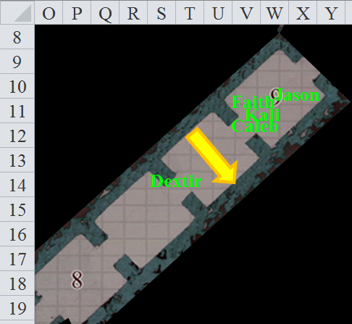

The halberd-like blade comes swinging down behind the wide-brimmed-hatted rock gnome as she turns back with a self-approving look, then turns forward to see what is in store for them in the next chamber. Here, he sees nothing special, however. His wrist sports a planar compass, which he uses to gauge the direction and distance to various planar polarities, in this case, the Astral Plane. “We’re almost there,” he reports. “Perhaps another 300’ or less.”

Kali follows in Dextir’s footsteps, dodging the pendulum and taking the spot next to the gnome.

Jason waits until most of the party makes it through the next room before he crosses after them.

Faith casts fly on herself and moves to T14 above Dextir.

Caleb moves to U15 and peeks into the next room, looking for magic and portals, but seeing neither.

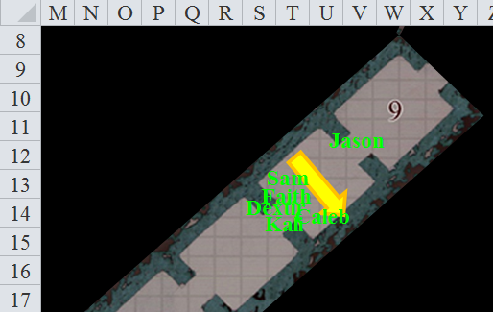

The pendulum blade swings just behind Sam. She feels the near slice of her ankles as the giant axe-like sheet of metal swooshes inches away from her heels and coattails.

It is at this moment that Jason realizes that his Bracelet of the Planar Champion is missing. Voicing this, he alerts Faith to the fact that hers has also gone missing.

Given the hesitation of the others, Dextir grows impatient, and says, “Alright, come on!” And as he takes a step forth, the gatecrasher inadvertently stepps on a pressure plate that no one had the keen eye to spot, and triggers a sword-like blade to slash at Kali, who stands the threshold between the two rooms.

Save | Rank | Ability & Mod. | Misc. Mods. | Total | Roll | Check
Kali: Reflex | 6 | Dex (+3) | 1 | 10 | 15 | 25
Success.
Dmg: ½ x (5 + 8) = 6 [91/97].

Jason stands about 15’ behind the others, hoping his teammate is alright, but seeing quite a bit of blood spurting all over the dimly lit chamber.

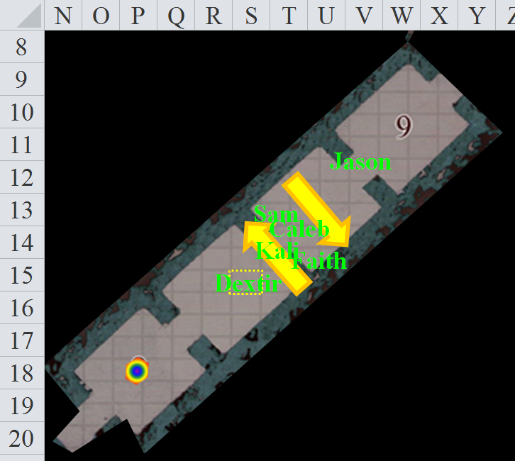

“Kali, I’m so sorry!” Dexir apologizes as he tries to step back onto the previous tile, which seems more stable.
Then, a peculiar, rainbow-patterned sphere appears in the last room into which they can see, beyond which is another threshold and a wall to block all view further southwest.

“I bet you are” replied Kali sarcastically as she limped over the square to the north of Dextir and cautiously continued on to stand just at the corner of the next door without being in the doorway.

Dextir and a few others among the party move forward a bit, seeing that the rainbow-patterned sphere is an illusory figment. It becomes nearly invisible as they approach, but it is evident from the sounds of clanking metal that something is moving up ahead. It’s uncertain as to whether it’s coming from the northwest or the southeast corridor that comprise the T-shaped area just ahead of them.

[Deathblade Wall Scythe: CR 8; mechanical; touch trigger; manual reset; Atk +16 melee (2d4+8 plus poison, scythe); poison (deathblade, DC 20 Fortitude save resists, 1d6 Con/2d6 Con); Search DC 24; Disable Device DC 19.]

Behind them, the gauntlet’s deathblades continue to swish back and forth as the heroes carefully avoid them and the now evident pressure plate.

Round 1

As the others clear the room before him Jason moves forward making sure to watch the timing on the swing pendulum so that he can pass unscathed. (S14)

Caleb moves to R16 and detects magic ahead of himself and see if he knows anything of what is going on.

Faith moves to Q15 drawing her sword and casting protection from evil. She flies to Q17, two feet off the ground after casting protection from evil.

The sound of mechanical movement and metal grinding against metal comes closer, and now Dextir and a few of the others can now see an animated object comprised entirely of bronze—or perhaps an armored person clad as such—coming into view.
Roll 1d20 = 13. See below.

The construct faces them, takes a few steps forward, then lets out a piercing shriek.
Dmg to Dextir: 7 sonic + stun.
Character | Save vs. | Ranks | Mods | Roll | Save
Dextir | Fortitude | 2 | 0 | 13 | 15
Success. Dextir is not stunned.
Dmg to Kali: 2 sonic + stun.
Kali: Save | Rank | Ability & Mod. | Misc. Mods. | Total | Roll | Check
Fortitude | 6 | Con (+1) | 1 | 8 | 20 | 28
Success. Kali is not stunned.

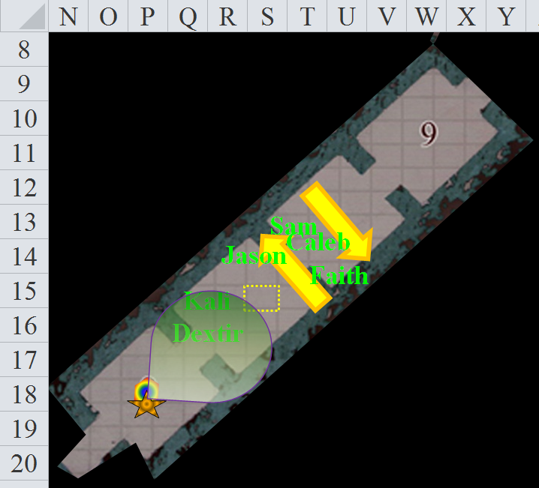

Round 2

Jason—with bow already in hand—sends two arrows at the construct.
Ranged Weapon | Dmg. | D+ | TH+ | Critical | Rng. | Wt. | Atk | Roll | Check
Aquaticbane Longbow +2 | 1d8 | +2 | 2 | x3 | 200’ | 3.0 | +14 | 5 | 19
2nd Shot | 1d8 | +2 | 2 |  |  |  | +9 | 6 | 15
Miss, miss.

Kali rushes forward, passing by Dextir and keeping to the left wall before attacking the enemy.
Melee Weapon | Dmg | D+ | TH+ | Critical | Type | Wt. | Atk | Roll | Check
Scimitar +2 | 1d6 | 2 | 2 | 18-20, x2 | Slashing | 4.0 | +14 | 14 | 28
Crystal of Electrical Assault, Greater | - | 1d6 | - | - | - | 0.0
Hit. Dmg: 5 + 5 electric = 10.

Faith flies to P17 and attacks the construct.
Melee Weapon | Dmg | D+ | TH+ | Critical | Type | Wt. | Atk | Roll | Check
Sacred Greatsword +1 | 2d6+2+5 | +6 + 1 | 1 | 17-20/x2 | Slashing | 16.0 | +15 | 9 | 24
Hit. Dmg: 5 + 2 + 5 + 6 + 1 = 19.

The contraption clucks like a cuckoo, then falls, and shatters into hundreds of pieces and fragments.

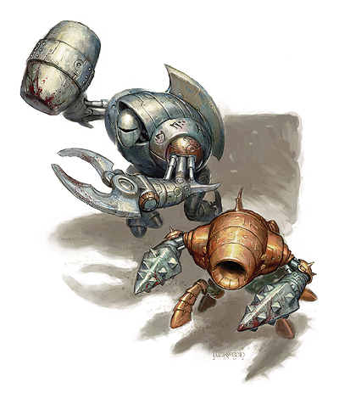

Dextir ironically declares, “Let’s call that one a pulverizer if we have to refer to it in the future.”

And with that, a second construct, appears from the same direction. “And let’s call this one a hammerer!”

This contraption is made almost entirely of steel, and sports a pincer claw and a hammer.

Dextir then produces his light crossbow and delivers a single shot at the hammerer, hitting it.
Ranged Weapon | Dmg. | D+ | TH+ | Critical | Rng. | Wt. | Atk | Roll | Check
Light Crossbow +2 | 1d6 | 2 | 2 | 19-20, x2 | 80’ | 2.0 | +10 | 14 | 24
Hit. Dmg: 3 + 2 = 5.

Caleb has walked southwestward until he could see the first construct, and now sees that it has been replaced by one with a hammering mechanism, and casts magic missile at it.
Dmg: 18 + 5 = 23 magic.

Sizzling with the bursts of five magic missiles, the remaining automaton calculates the relative odds of various outcomes.
1d20 = 2.

It takes so long to do so that it momentarily commits no actions.

Round 3

Jason moves so he is positioned in front of the pressure plate (R16) and fires a single arrow if he can see.
Ranged Weapon | Dmg. | D+ | TH+ | Critical | Rng. | Wt. | Atk | Roll | Check | Notes
Composite Longbow +2, Skirmish | 1d8 | +2 +3d6 | 2 | x3 | 200’ | 3.0 | +16 | 8 | 24 | +1 within 30’
Crystal of Acid Assault, Greater | - | 1d6 |  |  |  |  |  |  |  | -1 to AC 1 round
Hit. Dmg: 6 + 2 + 11 + 4 acid = 23 + (-1) to AC.

Kali takes a 5’ step forward in order to attack the creature that has stalled, but Jason has just finished it off.

A few plates fall off of the hammerer, and roll around the room uneventfully as the sounds and echoes of the battle recede and a soft hum can now be heard coming from the corridors ahead.

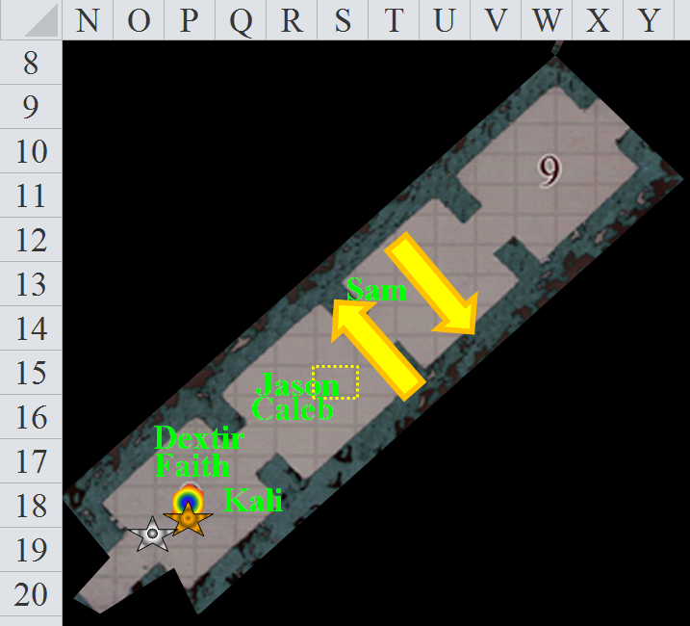

Round 4

Dextir walks towards the southwestern corridor, careful to not touch the destroyed constructs, and looks back at his teammates, wondering what else lies before them.

The Turmish woman follows behind Dextir, sliding her left-hand scimitar into its place. She keeps an alert eye out for any problems.

Jason pauses as he reaches the destroyed machine and takes note of what is left. He checks the arrows he fired to see if any part or whole was usable. He intends to start repair any arrow that he can, but these have banged against metallic foes, and are themselves irreparable.

Dextir and Kali secure the southeastern and northwestern corridors, respectively.

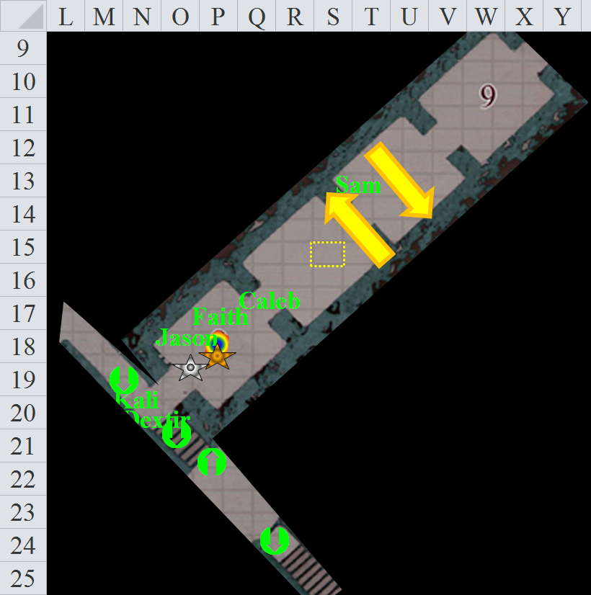

To the southeast is a staircase leading downward, while to the northwest is a sloped corridor, also leading downward. Beyond the southeastwardly staircase is another flight of stairs going further down, hopefully towards the flowing tributaries that lead to the River Oceanus.

Dextir and Kali wait for the others to catch up, wishing they could cast trapfinding spells. Dextir is accustomed to leading the others, given his slightly-better-than-average ability to spot and hear things, but his ability as a rogue is fairly specialized, and not exceptionally suited for trapfinding, at least not compared to a rogue of his stature. No, this man has specialized in multiplanar escape artistry: the gatecrasher extraordinaire. And though he cannot spot or construct traps very well, he could at least smith a fine lock in lieu of a trap, and he’s been known to disable a few warding mechanisms when conditions are favorable.

To complement his ability to escape virtually any dangerous situation is his broad, if not vast, knowledge of the Planes and the realms within them. At this moment, this well-read geographer and expert dungeoneer trusts his senses far better than those of his current crew.

Round 5

Dextir begins to descend the staircase, followed by Kali a few feet behind.

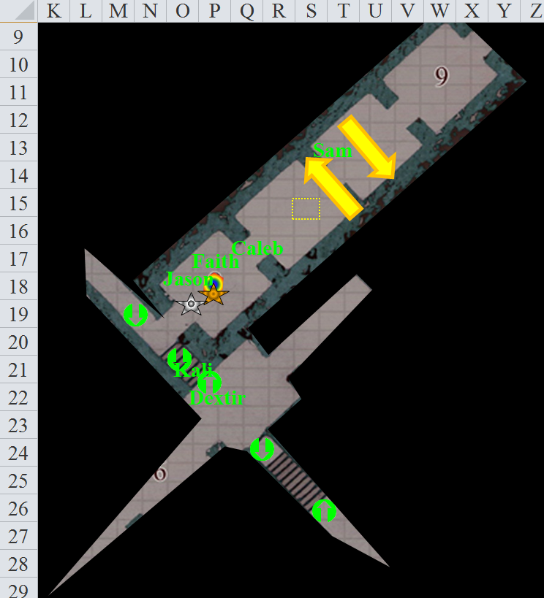

Coming from the southeast, the sounds of chains dragging momentarily alerts Jason, who vaguely remembers having battled a chain devil not long ago. But this place lacks the sulfurous scent of any devil. Instead, it smells of limestone and oil, with perhaps a scent of coal.

The might have inadvertently stepped on another trigger, as Dextir and Kali now both hear sandstone grinding against sandstone, the telltale grind-hiss of the movement regular as clockwork, as if guided by a counterweight.

Faith follows along with the others, keeping an eye out and recalling her protection from evil spell.

Caleb examines the constructs and sees if he can tell their primary use: war or building or something else. These are most likely security golems that the keeper(s) of this place use(s) in addition to the swinging blades and other gauntlet features.

Sam follows Caleb and starts to take parts from the pair... slipping any loose pieces into her bag.

Kali takes out her main hand weapon, this being a scimitar +2.

Round 6

The sound of chains dragging grows louder. Dextir and the others take up defensive positions.

In the nearly total darkness now, the humans in the band cannot see.

Dextir’s low-light vision is quite useful here, and he describes—whispering—for the party the narrow corridors that continue to comprise this level of the lair that they are now fleeing.

It is then that a chain golem comes into view to Dextir, as the others think to light a torch or cast a light-producing spell.

Dextir identifies it aloud so that the others who cannot see it can at least act accordingly.

Sam and Faith suspect—and Caleb is almost sure—that where there is a chain golem, there is a kyton: a chain devil.

But upon further pondering on what he already knows, Caleb is reminded of an instance in which a necromancer—not a diabolist or devil—had at her disposal such a golem. Dextir also surmises that the chain golem may well be under the control of something altogether different from a devil, particularly on this chaotic demiplane.

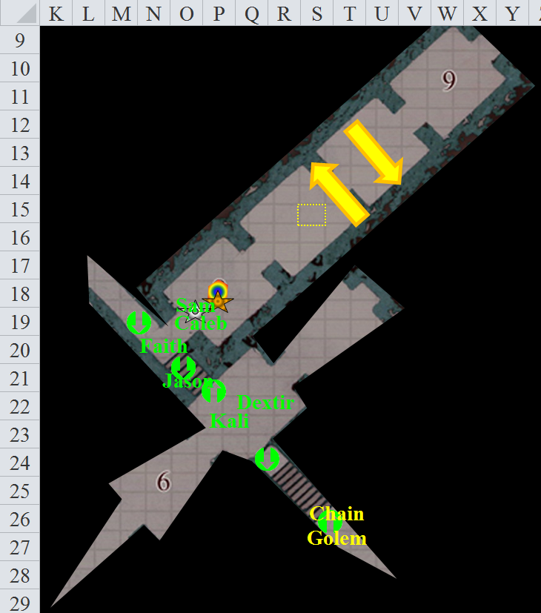

Kali slips an everburning torch out of her pack and lights it behind her back before tossing it into the middle of the room.

Caleb moves into the room and tosses a lesser orb of acid at the golem.

The chain golem appears completely unaffected by the magical orb of acid.

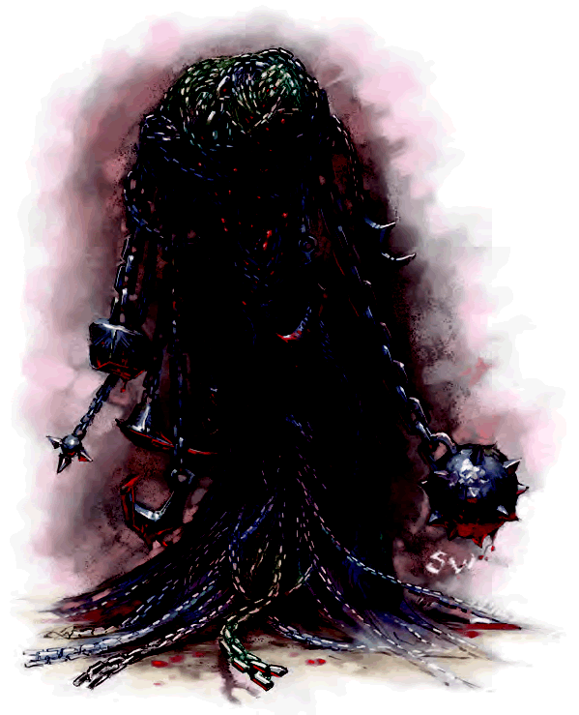

Faith has no clear path to charge the chain golem, so she flies above the heads of the others and charge-attacks it.
Melee Weapon | Dmg | D+ | TH+ | Critical | Type | Wt. | Atk | Roll | Check
Sacred Greatsword +1 | 2d6+2+5 | +6 + 1 | 1 + 2 | 17-20/x2 | Slashing | 16.0 | +17 | 8 | 25
Hit. Dmg: 9 + 2 + 5 + 6 + 1 + 2 = 25.

The chain golem tries to parry Faith’s attack, but fails to do so. It then attacks Faith.
Character | Attack Type | Damage | BAB | Mod+ | W+ | Other+ | d20 | Total
Chain Golem | Chain Rake 1 | 1d8+4+wounding | 5 | 4 | 0 | 0 | 18 | 27
Chain Golem | Chain Rake 2 | 1d8+4+wounding | 5 | 4 | 0 | 0 | 5 | 14
Hit, miss. Dmg: 1 + 4 = 5 + wounding (-1 to Con). Partial damage negated [91/95].

Jason stays on the stairs with his bow ready to fire at the creature as soon as he can find a mark.
Ranged Weapon | Dmg. | D+ | TH+ | Critical | Rng. | Wt. | Atk | Roll | Check | Notes
Aquaticbane Longbow +2 | 1d8 | +2 | 2 | x3 | 200’ | 3.0 | +14 | 20 | 34 | +1 within 30’
2nd Shot | 1d8 | +2 | 2 |  |  |  | +9 | 6 | 15 | +1 within 30’
3rd Shot, Rapid Firing | 1d8 | +2 | 2 |  |  |  | +14 | 19 | 33 | +1 within 30’
Crystal of Acid Assault, Greater | - | 1d6 |  |  |  |  |  |  |  | -1 to AC 1 round
Threat, miss, hit. 1d20 = 6 + 14 = 20, not a critical hit. Dmg: (6 + 2 + 3 acid) + (7 + 2 + 4 acid) = 8 + 9 + 7 acid = 24 + (-4) to AC on next round, rendered moot by its destruction.

The chain golem turns to an inanimate pile of chains on the ground as the sound of shifting sandstone betray the presence of a lesser stone golem incoming from the southwestern passage.

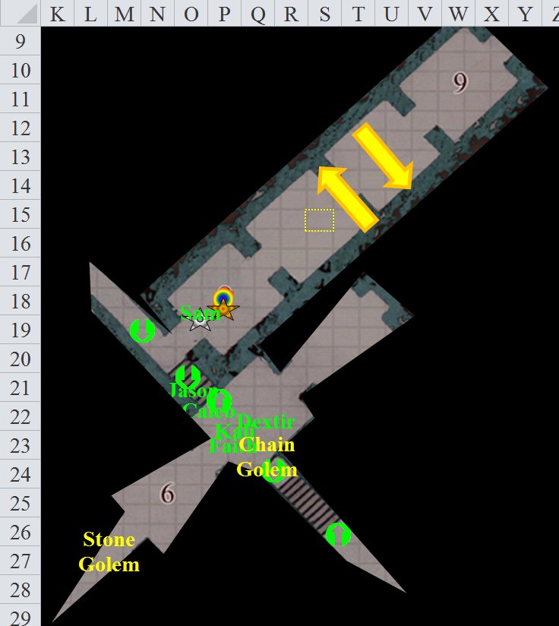

Round 7

The stone golem prepares its limbs for melee combat, seemingly targeting Kali.

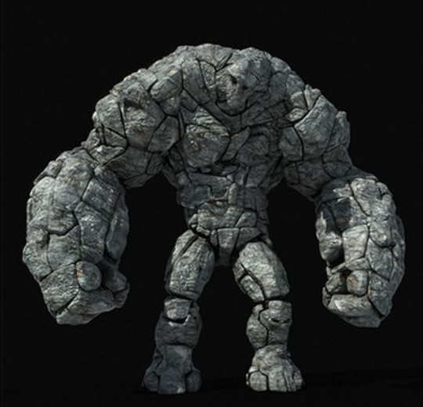

This is the smallest stone golem any of the heroes has ever seen. Weighing about 1500 pounds and reaching a height of 6’ 5”, it charge-attacks Kali as Faith flies above them.
Character | Attack Type | Damage | BAB | Mod+ | W+ | Other+ | d20 | Total
Lesser Stone Golem | Slam 1 | 1d8+4 | 6 | 4 | 0 | +2 charge | 19 | 31
Hit. Dmg: 5 + 4 + 2 = 11 [78/97].

The ceiling here is 10’ above the floor, so Faith is still at risk of being reached by the stone golem’s wide reach.

Caleb, Faith and Kali are now in the golem’s slowing sphere.
Save vs.  slow | Rank | Ability & Mod. | Misc. Mods. | Total | Roll | Check | Notes
Caleb: Reflex | 3 | Dex (+3) | 2 | 8 | 3 | 11
Faith: Reflex | 2 | Dex (+1) | 5 | 8 | 17 | 25
Kali: Reflex | 6 | Dex (+3) | 1 | 10 | 1 | 11 | +2 versus Enchantments
Fail, success, fail. Caleb and Kali are slowed until Round 14.

Spotting the slowing energy around the stone golem, Jason makes a 5’ adjustment, then looses his arrows at the stone monster.
Ranged Weapon | Dmg. | D+ | TH+ | Critical | Rng. | Wt. | Atk | Roll | Check | Notes
Aquaticbane Longbow +2 | 1d8 | +2 | 2 | x3 | 200’ | 3.0 | +14 | 16 | 30 | +1 within 30’
2nd Shot | 1d8 | +2 | 2 |  |  |  | +9 | 11 | 20 | +1 within 30’
3rd Shot, Rapid Firing | 1d8 | +2 | 2 |  |  |  | +14 | 16 | 30 | +1 within 30’
Crystal of Acid Assault, Greater | - | 1d6 |  |  |  |  |  |  |  | -1 to AC 1 round
Hit, miss, hit. Dmg: (7 + 2 + 1 + 3 acid) + (2 + 2 + 1 + 6 acid) = 15 + 9 acid = 24. Partial damage negated.

Two carefully placed shots dig into the crevices of the stone golem’s joints, while a third shot simply bounces off of the construct’s left breast-stone.

Feeling kind of out of sorts, Kali [slowed] has barely the alacrity to attack the stone creature once, and does nothing else at the moment.
Melee Weapon | Dmg | D+ | TH+ | Critical | Type | Wt. | Atk | Roll | Check
Scimitar +2 | 1d6 | 2 | 2 | 18-20, x2 | Slashing | 4.0 | +14 | 4 | 18
Miss.

Faith full-attacks the chain golem, power-attacking for +2.
Melee Weapon | Dmg | D+ | TH+ | Critical | Type | Wt. | Atk | Roll | Check
Sacred Greatsword +1 | 2d6+2+5 | +6 + 1 | 1 – 2 | 17-20/x2 | Slashing | 16.0 | +13 | 16 | 29
2nd Attack | 2d6+2+5 | +6 + 1 | 1 – 2 | 17-20/x2 | Slashing |  | +8 | 7 | 15
Hit, miss. Dmg: 9 + 2 + 5 + 6 + 1 + 4 = 27. Partial damage negated.

Caleb [slowed] casts haste [expires on Round 17] on the party, negating the slow effects on himself and Kali, and aiding the others by speeding up their muscular movements without affecting their metabolic speed. He also tries to remember anything he knows about chain and stone golem to share with the party.

Dextir [hastened] takes a 5’ step back and reloads his crossbow, then fires a bolt at the golem’s face.
Ranged Weapon | Dmg. | D+ | TH+ | Critical | Rng. | Wt. | Atk | Roll | Check
Light Crossbow +2 | 1d6 | 2 | 2 | 19-20, x2 | 80’ | 2.0 | +10 | 18 | 28
Hit. Dmg: 2. All damage negated.

Dextir then has time to reload again.

Sam [hastened] hesitates.

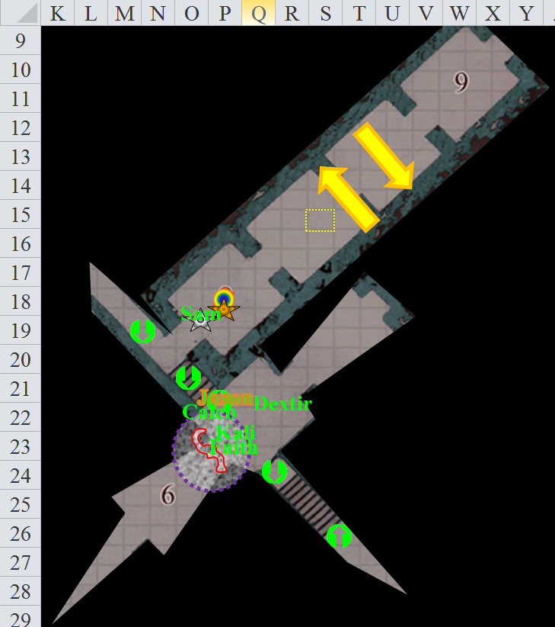

Round 8

The lesser stone golem then gurgles something that sounds like, “Trespassers, die!” as it attacks Kali.
Character | Attack Type | Damage | BAB | Mod+ | W+ | Other+ | d20 | Total
Lesser Stone Golem | Slam 1 | 1d8+4 | 6 | 4 | 0 | 0 | 9 | 19
Lesser Stone Golem | Slam 2 | 1d8+4 | 6 | 4 | 0 | 0 | 3 | 13
Miss, miss.

Jason [hastened] rapid-fires again.
Ranged Weapon | Dmg. | D+ | TH+ | Critical | Rng. | Wt. | Atk | Roll | Check | Notes
Aquaticbane Longbow +2 | 1d8 | +2 | 2 | x3 | 200’ | 3.0 | +14 | 8 | 24 | +1 within 30’
2nd Shot | 1d8 | +2 | 2 |  |  |  | +9 | 12 | 21 | +1 within 30’
3rd Shot, Rapid Firing | 1d8 | +2 | 2 |  |  |  | +14 | 16 | 30 | +1 within 30’
4th Shot, haste | 1d8 | +2 | 2 |  |  |  | +14 | 2 | 16 | +1 within 30’
Crystal of Acid Assault, Greater | - | 1d6 |  |  |  |  |  |  |  | -1 to AC 1 round
Hit, miss, hit, miss. Dmg: (7 + 2 + 1 + 5 acid) + (6 + 2 + 1 + 3 acid) = 19 + 8 acid = 27.

The stone automaton is nearly destroyed, but can still use its makeshift fists as flails, or even catapults, if its fists should fall off altogether. It rears back just as Faith [hastened] repeats her full-power-attack +2.
Melee Weapon | Dmg | D+ | TH+ | Critical | Type | Wt. | Atk | Roll | Check
Sacred Greatsword +1 | 2d6+2+5 | +6 + 1 | 1 – 2 | 17-20/x2 | Slashing | 16.0 | +13 | 17 | 30
2nd Attack | 2d6+2+5 | +6 + 1 | 1 – 2 | 17-20/x2 | Slashing |  | +8 | 13 | 21
3rd Attack, haste | 2d6+2+5 | +6 + 1 | 1 – 2 | 17-20/x2 | Slashing |  | +13 | 10 | 23
Threat, miss, hit. 1d20 = 15 + 13 = 28, critical hit. Dmg: [2 x (7 + 2 + 5 + 6 + 1 + 4)] + (6 + 2 + 5 + 6 + 1 + 4) = 50 + 24 = 74.

The stone golem perishes, becoming a pile of rubble that twitches and crumbles at first, then settles.

Kali checks her wound, wrapping a piece of cloth around it. She then retrieves her torch. “Should we examine any of these other rooms? Mayhaps there lies some treasure in one.”

Sam [hastened] is preoccupied with salvaging automaton parts.

As the others secure the situation, Dextir [hastened] takes a peek inside the northeastern passage, which appears at first to be a dead end, but as the gatecrasher enters the room and draws his inquisitive attention to the statue of a halfling artificer with a brass monocle and a golden beard-cuff dangling from his chin. The male figure is unknown to the heroes, but it would stand to reason that this figure is or once was the master of this dungeon complex.

Using his loaded crossbow, he tugs at the statue and sees what he’d expected to see: the budging of the statue counterclockwise, which opens up a secret passage. He says as much as soon as he realizes it.

Round 9

Jason checks on his arrows, hoping to find a shaft that had not been broken or a head that was not ruined. “I am all for getting out of this place,” he says as he puts down the faulty shaft in his hand and picks up another one that is still usable.

“Where should we go then?” Dextir whispers, thinking he hears more movement coming from the other side of the newly revealed passage.

Faith, floating to the southeast of Kali, hears very faint sounds of motion from both her southeast and southwest.

Caleb asks, “Would it not be fascinating to get to the bottom of this complex?”

Faith says, “We need to see if there is anyone to free from here.”

The question now is: what is causing movement? Captives waiting to be freed, or perhaps more golems?

Dextir spotted inside the dark tunnel a statue, describing it aloud to the others as that “of a helmeted humanoid wearing the guise of a cleric of Boccob.”

Caleb goes back to check on Sam, but Sam is gone, nowhere to be seen or heard.

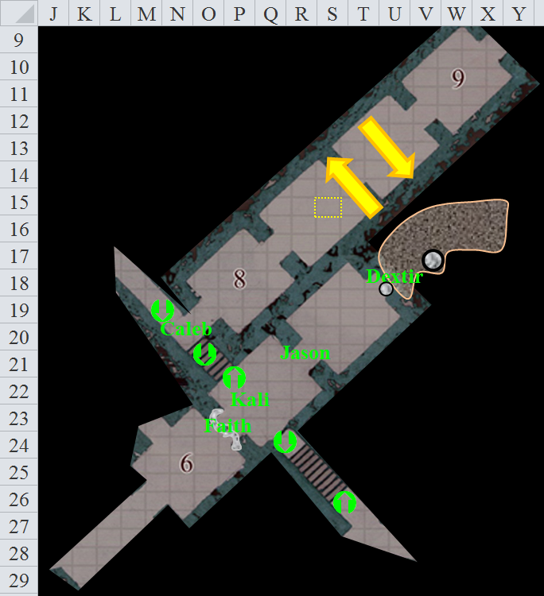

Round 10

Character | Group | Initiative | Roll | Modified Roll | Move
Force Golem | 2 | 7 | 19 | 26 | 30’
Jason | 1 | 7 | 15 | 22 | 50’
Sam | 1 | 6 | 15 | 21 | 30’
Caleb | 1 | 3 | 14 | 17 | 30’
Dextir | 1 | 3 | Fudged | Fudged | 30’
Kali | 1 | 7 | 5 | 12 | 30’
Faith | 1 | 1 | 5 | 6 | 20’

Still aided by the haste spell, they keep their ears peeled as Dextir starts to ask, “So whe-” before he stops, turns, and points and shoots at the force golem that comes at him from the other side of the secret passage, but not before he has to contend with a pulse of force coming his way.
Character | Attack Type | Damage | BAB | Mod+ | W+ | Other+ | d20 | Total
Force Golem | Ranged Touch | Pulse | 3 | 2 | 0 | 0 | 8 | 13
Miss.

An alarm sounds momentarily, then ceases as the force golem attacks and approaches further and utters, “Boccob’s Black Sheep, have you any fools? Yessir, yessir, three chests full! They come for the gold, silver and gems, but they ne’er will see the light of day again.” Its voice sounds mad, and Dextir notes that this particular golem has reinforced itself with all manner of metallic treasure. Evading the force that would have knocked him prone, the rock gnome fires.
Ranged Weapon | Dmg. | D+ | TH+ | Critical | Rng. | Wt. | Atk | Roll | Check
Light Crossbow +2 | 1d6 | 2 | 2 | 19-20, x2 | 80’ | 2.0 | +10 | 17 | 27
Hit. Dmg: 2 + 2 = 4. Partial damage negated.

Jason moves toward Dextir as he alerts the others (T18) and skirmishes off an arrow when he sees the culprit.
Ranged Weapon | Dmg. | D+ | TH+ | Critical | Rng. | Wt. | Atk | Roll | Check | Notes
Composite Longbow +2, Skirmish | 1d8 | +2 +3d6 | 2 | x3 | 200’ | 3.0 | +16 | 19 | 35 | +1 within 30’
Crystal of Acid Assault, Greater | - | 1d6 |  |  |  |  |  |  |  | -1 to AC 1 round
Hit. Dmg: 5 + 2 + 17 + 5 acid = 29 + (-1) to AC. Partial damage negated.

The arrow splits upon impact with the force golem, acid splashing all over its torso.

Caleb moves within range of the golem and casts spiritual weapon, directing a replica of Shaundakul’s greatsword—the Sword of Shadows—against the golem.
Melee Weapon | Dmg | D+ | TH+ | Critical | Type | Wt. | Atk | Roll | Check
Spiritual Greatsword | 2d6 | 3 | 0 | 19-20, x2 | Slashing | 0.0 | 10 | 6 | 16
Miss.

The greatsword clanks against some of the treasure adorning the force golem, but does the golem no damage.

Kali hurries into the room, moving 30’ with her weapon in hand and the torch in the other.

At the other end of the formation, Faith hears the sounds of multiple moving entities coming from the southeast. She says to Kali, “Help them with the golem. I will see what comes the other way.” Faith ignores the sound coming from the southeast and instead flies southwest, looking down the side passage but seeing nothing.

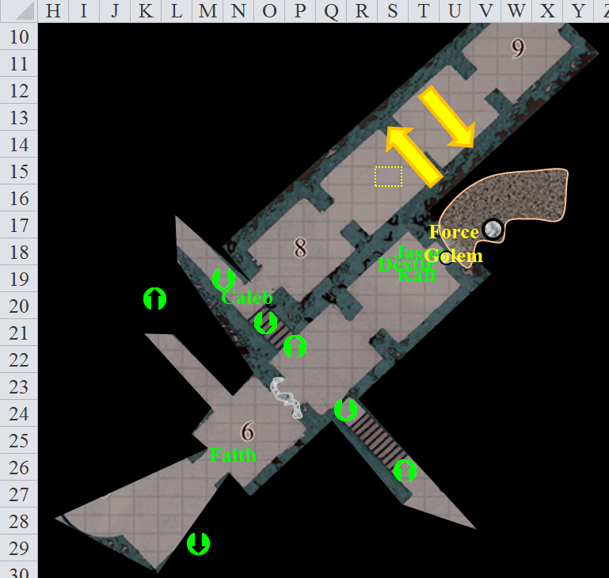

Round 11

The force golem reaches Dextir and attacks him.
Character | Attack Type | Damage | BAB | Mod+ | W+ | Other+ | d20 | Total
Force Golem | Slam 1 | 1d8+4 | 3 | 3 | 0 | 0 | 15 | 21
Hit. Dmg: 2.

Jason [hastened] fires multiple arrows at the golem.
Ranged Weapon | Dmg. | D+ | TH+ | Critical | Rng. | Wt. | Atk | Roll | Check | Notes
Aquaticbane Longbow +2 | 1d8 | +2 | 2 | x3 | 200’ | 3.0 | +14 | 10 | 24 | +1 within 30’
2nd Shot | 1d8 | +2 | 2 |  |  |  | +9 | 4 | 13 | +1 within 30’
3rd Shot, Rapid Firing | 1d8 | +2 | 2 |  |  |  | +14 | 14 | 28 | +1 within 30’
4th Shot, haste | 1d8 | +2 | 2 |  |  |  | +14 | 13 | 27 | +1 within 30’
Crystal of Acid Assault, Greater | - | 1d6 |  |  |  |  |  |  |  | -1 to AC 1 round
Hit, miss, hit, hit. Dmg: (4 + 2 + 1 acid) + (7 + 2 + 4 acid) + (2 + 2 + 5 acid) = 17 + 10 acid = 27 + (-1) to AC. Partial damage negated.

Caleb notes that the golem is nearly destroyed. He _____.

Dextir takes a 5’ step back, reloads his crossbow, and fires again.
Ranged Weapon | Dmg. | D+ | TH+ | Critical | Rng. | Wt. | Atk | Roll | Check
Light Crossbow +2 | 1d6 | 2 | 2 | 19-20, x2 | 80’ | 2.0 | +10 | 5 | 15
Miss.

Then the hastened gnome reloads again.

Kali drops the torch and attacks with the weapon in her right hand.
Melee Weapon | Dmg | D+ | TH+ | Critical | Type | Wt. | Atk | Roll | Check
Scimitar +2 | 1d6 | 2 | 2 | 18-20, x2 | Slashing | 4.0 | +14 | 11 | 25
2nd Attack | 1d6 | 2 | 2 | 18-20, x2 | Slashing | - | +14 | 7 | 21
Crystal of Electrical Assault, Greater | - | 1d6 | - | - | - | 0.0
Hit, hit. Dmg: (3 + 2 + 1 electric) + (2 + 2 + 6 electric) = 9 + 7 electric = 16. Partial damage negated.

The force golem disappears, and the treasure drops to the ground.

Faith _____.

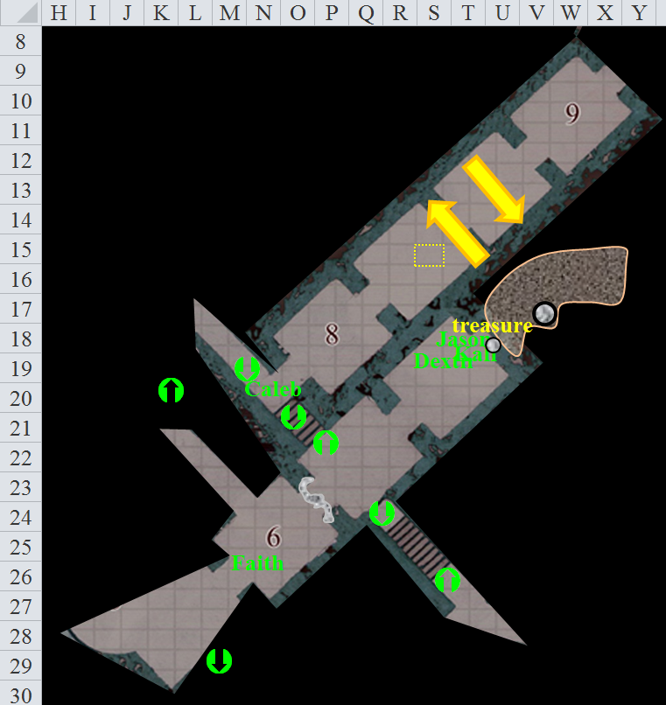

Round 12

Character | Group | Initiative | Roll | Modified Roll | Move
Kali | 1 | 7 | 9 | 16 | 30’
Jason | 1 | 7 | 6 | 13 | 50’
Golems | 2 | -1 | 14 | 13 | 20’
Caleb | 1 | 3 | 7 | 10 | 30’
Sam | 1 | 6 | 2 | 8 | 30’
Faith | 1 | 1 | 6 | 7 | 20’
Dextir | 1 | 3 | 3 | 6 | 20’

“Well, at least that didn’t take long,” Kali says as she reaches down to pick up the treasure and place it in a bag to be looked at later. She then remembers to retrieve her torch but does not have a chance to do so yet.

Jason returns to the hall to see if he may help Faith.

Faith has raised her sword as the sound of metal clanking against stone alerts her to the incoming iron golem that now makes itself evident as it reaches the top of a flight of stairs to Faith’s southwest. Jason doubts his arrows will do much to this particular automaton.

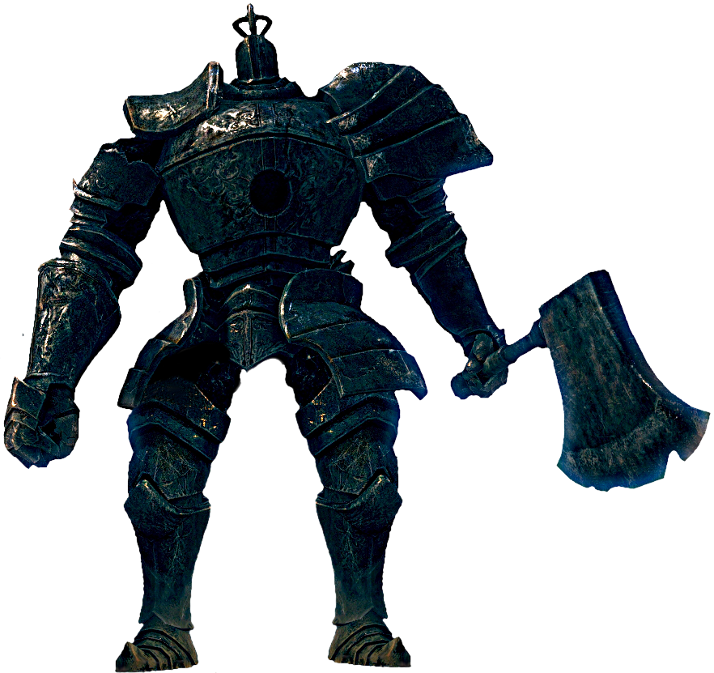

However, it is the flesh golem now approaching Jason from the southeast that troubles the archer more.

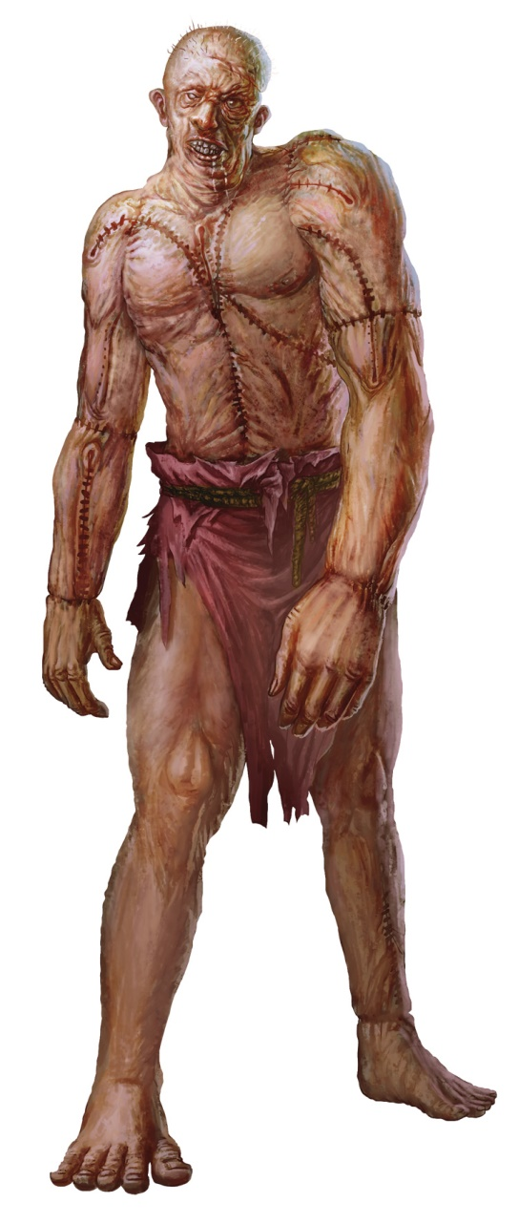

Caleb stands at the intersection, looking around in all 4 directions and seeing the iron golem and the flesh golem ready to defend this place.

Faith [hastened] retreats from the iron golem, flies back northeast, then to the southeast, and clashes with the flesh golem, having time to full-attack.
Melee Weapon | Dmg | D+ | TH+ | Critical | Type | Wt. | Atk | Roll | Check
Sacred Greatsword +1 | 2d6+2+5 | +6 + 1 | 1 | 17-20/x2 | Slashing | 16.0 | +15 | 17 | 32
2nd Attack, haste | 2d6+2+5 | +6 + 1 | 1 | 17-20/x2 | Slashing |  | +15 | 17 | 32
Hit, hit. Dmg: (7 + 2 + 5 + 6 + 1) + (8 + 2 + 5 + 6 + 1) = 43. Partial damage negated.

With his crossbow reloaded, Dextir [hastened] gets into a more defensible position, then fires at the iron golem, reloading afterwards.
Ranged Weapon | Dmg. | D+ | TH+ | Critical | Rng. | Wt. | Atk | Roll | Check
Light Crossbow +2 | 1d6 | 2 | 2 | 19-20, x2 | 80’ | 2.0 | +10 | 11 | 21
Miss.

Coming around the bend in the corridor ahead, the iron golem continues its approach as it prepares the weapon most suitable for the job, a spiked appendage that now begins to dangle by a chain—a built-in flail. It targets Jason and picks up speed.

The flesh golem swings a meaty fist at Faith.
Character | Attack Type | Damage | BAB | Mod+ | W+ | Other+ | d20 | Total
Flesh Golem | Slam 1 | 2d8+5 | 6 | 4 | 0 | 0 | 9 | 19
Flesh Golem | Slam 2 | 2d8+5 | 6 | 4 | 0 | 0 | 5 | 15
Miss, miss.

Both swings bounce off the heroine’s armor.

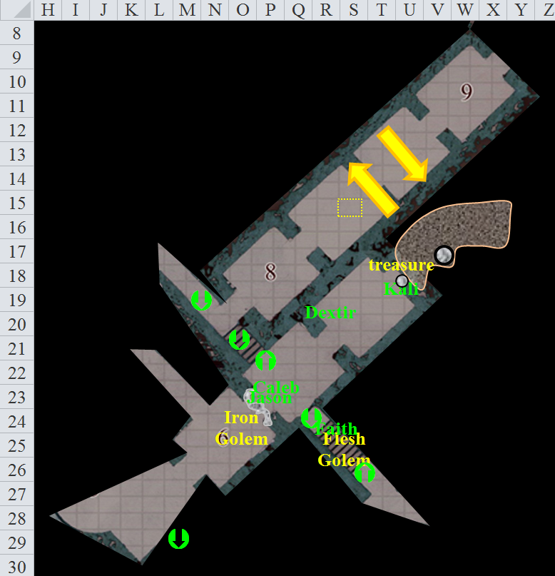

Round 13

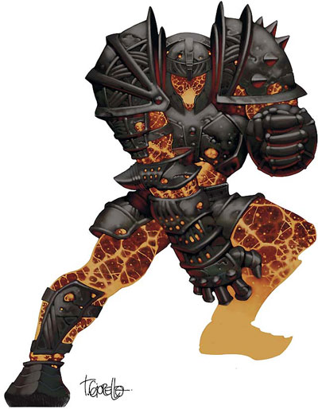

Dextir hears another golem approaching, then spots its molten form as it rushes towards Kali. He fires at it as he warns her with enough time for her to take a step to the side.
Ranged Weapon | Dmg. | D+ | TH+ | Critical | Rng. | Wt. | Atk | Roll | Check
Light Crossbow +2 | 1d6 | 2 | 2 | 19-20, x2 | 80’ | 2.0 | +10 | 11 | 21
Light Crossbow +2 (haste) | 1d6 | 2 | 2 | 19-20, x2 | 80’ | 2.0 | +10 | 13 | 23
Hit, hit. Dmg: 5 + 2 = 7.

The dwarf-sized construct seems to speak, but it’s in Ignan, so no one can understand. It takes what is referred to as a molten step, scalding Kali [no save].
Dmg: 3 fire. [75/97]

The flesh golem full-attacks Faith.
Character | Attack Type | Damage | BAB | Mod+ | W+ | Other+ | d20 | Total
Flesh Golem | Slam 1 | 2d8+5 | 6 | 4 | 0 | 0 | 19 | 29
Flesh Golem | Slam 2 | 2d8+5 | 6 | 4 | 0 | 0 | 16 | 26
Hit, hit. Dmg: (8 + 5) + (11 + 5) = 13 + 16 = 29. Partial damage negated. [63/95]

Lacking the breath weapon that its mightier counterparts use to lay waste intruders, the lesser iron golem full-attacks Jason.
Character | Attack Type | Damage | BAB | Mod+ | W+ | Other+ | d20 | Total
Lesser Iron Golem | Slam 1 | 1d8+4 | 12 | 11 | 0 | 0 | 12 | 35
Lesser Iron Golem | Slam 2 | 1d8+4 | 12 | 11 | 0 | 0 | 7 | 30
Hit, hit. Dmg: (3 + 4) + (2 + 4) = 7 + 6 = 13. [53/66]

Kali looks up at the sounds and moves just in time as a magmacore golem moves after her.
Dmg: 6 fire. [69/97]

Jason [hastened] uses the advantage of the haste spell and moves back to the bottom steps of the stairs they had just come down.

Caleb commands his spiritual weapon to attack the magmacore golem on Kali.
Melee Weapon | Dmg | D+ | TH+ | Critical | Type | Wt. | Atk | Roll | Check
Spiritual Greatsword | 2d6 | 3 | 0 | 19-20, x2 | Slashing | 0.0 | 10 | 15 | 25
Hit. Dmg: 4 + 3 = 7.

Faith [hastened] full attacks the flesh golem, power-attacking for 2.
Melee Weapon | Dmg | D+ | TH+ | Critical | Type | Wt. | Atk | Roll | Check
Sacred Greatsword +1 | 2d6+2+5 | +6 + 1 | 1 | 17-20/x2 | Slashing | 16.0 | +15 | 4 | 19
2nd Attack | 2d6+2+5 | +6 + 1 | 1 | 17-20/x2 | Slashing |  | +10 | 20 | 30
3rd Attack, haste | 2d6+2+5 | +6 + 1 | 1 | 17-20/x2 | Slashing |  | +15 | 19 | 34
Hit, threat, hit. 1d20 = 5 + 10 = 15, not a critical hit. Dmg: (7 + 2 + 5 + 6 + 1 + 4) + (2 + 2 + 5 + 6 + 1 + 4) + (6 + 2 + 5 + 6 + 1 + 4) = 25 + 20 + 24 = 69. Partial damage negated.

The pious templar slashes the flesh golem into two, then three, then four separate components, none of which appear to do much on their own. They twitch about on the ground as the paladin looks on the lesser iron golem.

Grabbing her torch, Kali moves to the door to view the situation. She attacks the magmacore golem with both her weapons, then sidesteps to its right.
Melee Weapon | Dmg | D+ | TH+ | Critical | Type | Wt. | Atk | Roll | Check
Scimitar +2 | 1d6 | 2 | 2 | 18-20, x2 | Slashing | 4.0 | +14 | 13 | 27
2nd Attack | 1d6 | 2 | 2 | 18-20, x2 | Slashing | - | +14 | 10 | 24
Crystal of Electrical Assault, Greater | - | 1d6 | - | - | - | 0.0
Hit, hit. Dmg: (3 + 2 + 6 acid) + (5 + 2 + 3 acid) = 12 + 9 acid = 21. Partial damage negated.

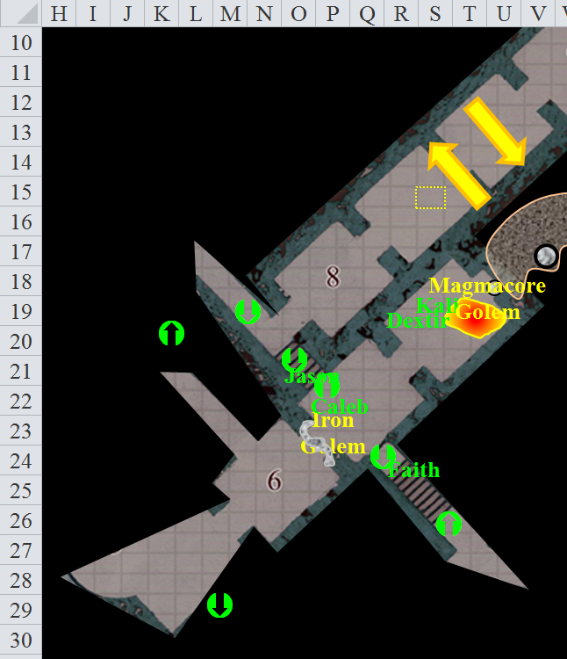

Round 14

Dextir targets the magmacore golem with his crossbow.
Ranged Weapon | Dmg. | D+ | TH+ | Critical | Rng. | Wt. | Atk | Roll | Check
Light Crossbow +2 | 1d6 | 2 | 2 | 19-20, x2 | 80’ | 2.0 | +10 | 1 | 11
Miss.

He then reloads and shoots again.
Ranged Weapon | Dmg. | D+ | TH+ | Critical | Rng. | Wt. | Atk | Roll | Check
Light Crossbow +2 | 1d6 | 2 | 2 | 19-20, x2 | 80’ | 2.0 | +10 | 14 | 24
Hit. Dmg: 6 + 2 = 8. Partial damage negated.

Kali attacks the magmacore golem as she drops her torch yet again and begins to take out her second sword.
Melee Weapon | Dmg | D+ | TH+ | Critical | Type | Wt. | Atk | Roll | Check
Scimitar +2 | 1d6 | 2 | 2 | 18-20, x2 | Slashing | 4.0 | +14 | 20 | 34
Crystal of Electrical Assault, Greater | - | 1d6 | - | - | - | 0.0
Scimitar +1 | 1d6 | 1 | 1 | 18-20, x2 | Slashing | 4.0 | +13 | 19 | 32
Crystal of Cold Assault, Greater | - | 1d6 | - | - | - | 0.0
Scimitar +2 [haste] | 1d6 | 2 | 2 | 18-20, x2 | Slashing | 4.0 | +14 | 16 | 30
Crystal of Electrical Assault, Greater | - | 1d6 | - | - | - | 0.0
Threat, threat, hit. 1d20 = 17, 13, both critical hits. Dmg: [2 x (6 + 2 + 2 acid)] + [2 x (4 + 2 + 5 cold)] + (1 + 2 + 6 cold) = 16 + 12 + 3 + 4 acid + 16 cold = 31 + 4 acid + 16 cold = 51. Partial damage negated.

The magmacore golem is destroyed, and drops at Kali’s feet, scalding her Celestial chainmail.

Jason [hastened] withdraws to Q21 before dropping his bow and taking up his axe, making ready to attack the beast if he steps into the zone, then throws the axe at the flesh golem.
Ranged Weapon | Dmg. | D+ | TH+ | Critical | Rng. | Wt. | Atk | Roll | Check | Notes
Hand Axe of Frost | 1d6 | +1d6 | 1 | x3 | 30’ | 6.0 | +14 | 17 | 31 | +1 within 30’
Hit. Dmg: 5 + 6 + 1= 12. Partial damage negated.

The lesser iron golem full-attacks Caleb.
Character | Attack Type | Damage | BAB | Mod+ | W+ | Other+ | d20 | Total
Lesser Iron Golem | Slam 1 | 1d8+4 | 12 | 11 | 0 | 0 | 2 | 25
Lesser Iron Golem | Slam 2 | 1d8+4 | 12 | 11 | 0 | 0 | 9 | 32
Hit, hit. Dmg: (2 + 4) + (8 + 4) = 6 + 12 = 18. [51/97]

Faith full-attacks the flesh golem, power-attacking for +2.
Melee Weapon | Dmg | D+ | TH+ | Critical | Type | Wt. | Atk | Roll | Check
Sacred Greatsword +1 | 2d6+2+5 | +6 + 1 | 1 – 2 | 17-20/x2 | Slashing | 16.0 | +13 | 12 | 25
2nd Attack | 2d6+2+5 | +6 + 1 | 1 – 2 | 17-20/x2 | Slashing |  | +8 | 15 | 23
3rd Attack, haste | 2d6+2+5 | +6 + 1 | 1 – 2 | 17-20/x2 | Slashing |  | +12 | 14 | 27
Hit, miss, hit. Dmg: (8 + 2 + 5 + 6 + 1 + 4) + (10 + 2 + 5 + 6 + 1 + 4) = 54. Partial damage negated.

Caleb casts benign transposition with Kali, changing places with her, and smiling and nodding at Dextir.

Round 15

Dextir knows he can’t do much against an iron golem, but he tries anyway. He reloads his crossbow, then shoots a bolt, then reloads again.
Ranged Weapon | Dmg. | D+ | TH+ | Critical | Rng. | Wt. | Atk | Roll | Check
Light Crossbow +2 | 1d6 | 2 | 2 | 19-20, x2 | 80’ | 2.0 | +10 | 20 | 30
Threat. 1d20 = 15 + 10 = 25, critical hit. Dmg: 2 x (3 + 2) = 10. Partial damage negated.

Kali twists to attack the iron golem with both of her sabers.
Melee Weapon | Dmg | D+ | TH+ | Critical | Type | Wt. | Atk | Roll | Check
Scimitar +2 | 1d6 | 2 | 2 | 18-20, x2 | Slashing | 4.0 | +14 | 18 | 32
Crystal of Electrical Assault, Greater | - | 1d6 | - | - | - | 0.0
Scimitar +1 | 1d6 | 1 | 1 | 18-20, x2 | Slashing | 4.0 | +13 | 9 | 22
Crystal of Cold Assault, Greater | - | 1d6 | - | - | - | 0.0
Hit, miss. Dmg: (2 + 2 + 5 electric) + (4 + 1 + 3 cold) = 17. All kinetic damage negated.

The lesser iron golem, indeed, weakened by Dextir’s bolt that is still lodged in its eye socket, flails violently at Kali.
Character | Attack Type | Damage | BAB | Mod+ | W+ | Other+ | d20 | Total
Lesser Iron Golem | Slam 1 | 1d8+4 | 12 | 11 | 0 | 0 | 2 | 25
Lesser Iron Golem | Slam 2 | 1d8+4 | 12 | 11 | 0 | 0 | 17 | 40
Miss, hit. Dmg: 8 + 4 = 12. [39/97]

“Will need some healing soon,” Kali said, hardly realizing it.

Caleb attacks the iron golem with his spiritual weapon, moving back into the main room.
Melee Weapon | Dmg | D+ | TH+ | Critical | Type | Wt. | Atk | Roll | Check
Spiritual Greatsword | 2d6 | 3 | 0 | 19-20, x2 | Slashing | 0.0 | 10 | 14 | 24
Miss.

Faith attacks the iron golem.
Melee Weapon | Dmg | D+ | TH+ | Critical | Type | Wt. | Atk | Roll | Check
Sacred Greatsword +1 | 2d6+2+5 | +6 + 1 | 1 | 17-20/x2 | Slashing | 16.0 | +15 | 10 | 25
2nd Attack | 2d6+2+5 | +6 + 1 | 1 | 17-20/x2 | Slashing |  | +10 | 8 | 18
3rd Attack, haste | 2d6+2+5 | +6 + 1 | 1 | 17-20/x2 | Slashing |  | +15 | 15 | 30
Hit, miss, hit. Dmg: (6 + 2 + 5 + 6 + 1) + (11 + 2 + 5 + 6 + 1) = 45. Partial damage negated.

Jason wishes he still had his axe. It’s currently lodged in a wedge in the iron golem’s shoulder. Instead, the archer listens for other signs of peril as the iron golem falls, clanks a bit, then rests silently without an inkling of animation.

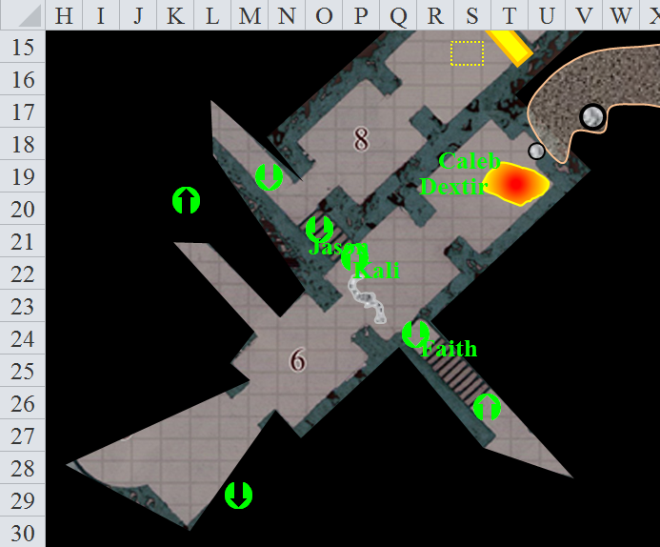

Round 16

Caleb gives up endure elements and cast cure on Kali.
Kali heals 7 + 11 = 18 hps. [50/97]

Faith uses Sacred Healing on the whole party.
All wounded friendlies gain 12 hps over the course of 4 rounds.

Those who were affected by the slow spell no longer feel its weight, but the haste spell that countered is also about to expire. With their last few moments of increased alacrity, the party regroups to reassess its position.

Jason retrieves his ax.

Round 17

Faith listens for more movement, but hears none, as the heroes heal.

Caleb gives up magic circle and cast cure serious wounds on Kali. He recalls benign transposition, magic missile , and lesser orb of acid.

Jason prepares his bow as he stands watch.

“Thanks for the healing,” says Kali.

Round 18

Sounds get closer.

Round 19

Sounds get even closer, and now Faith sees a clay golem coming their way.

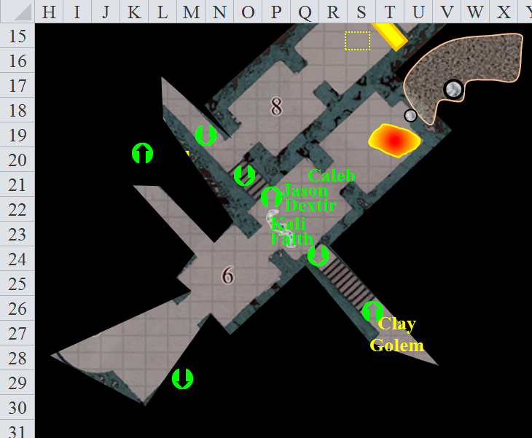

Faith casts rhino’s rush, and charges the clay golem, leaping down the staircase and power-attacking for +2.
Melee Weapon | Dmg | D+ | TH+ | Critical | Type | Wt. | Atk | Roll | Check
Sacred Greatsword +1 | 2d6+2+5 | +6 + 1 | 1 + 2 – 2 | 17-20/x2 | Slashing | 16.0 | +15 | 18 | 33
Threat. 1d20 = 20, critical hit. Dmg: 2 x 2 x (5 + 2 + 5 + 6 + 1 + 4) = 4 x 23 = 92. Partial damage negated.
Jason, where does the +5 damage bonus come from?

Despite the massive hunk of clay that Faith chops off of the golem, what remains of it is still somewhat intact.

1d100 = 62, nothing happens.

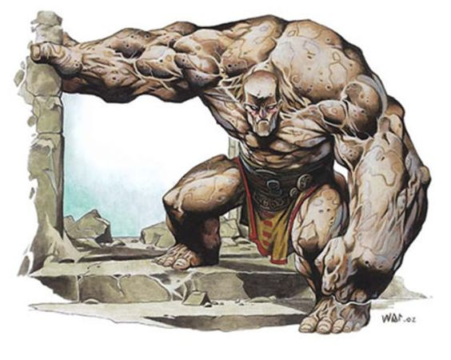

The clay golem full-attacks Faith.
Character | Attack Type | Damage | BAB | Mod+ | W+ | Other+ | d20 | Total
Clay Golem | Slam 1 | 2d10+7+cursed wound | 8 | 6 | 0 | 0 | 15 | 29
Clay Golem | Slam 2 | 2d10+7+cursed wound | 8 | 6 | 0 | 0 | 2 | 14
Hit, miss. Dmg: 15 + 7 = 22 + cursed wound. This damage will be very difficult to heal. Partial damage negated.

Caleb moves into a line of sight with the clay golem and casts magic missile on it.

Each of the magical bolts bounces right off the clay golem. His knowledge of spellcrafting told Caleb that this construct was immune to most forms of magic.

Dextir hides behind Caleb and tries to sneak attack the clay golem as Faith engages it in melee.
Dextir | Rank | Ability & Mod. | Misc. Mods. | Total | Roll | Check
Hide | 11 | Dex (+3) | 0 | 14 | 15 | 29
See below.
Character | Skill | Ranks | Mods | Roll | Save
Clay Golem | Spot | 0 | 0 | 14 | 14
Hide is successful.
Ranged Weapon | Dmg. | D+ | TH+ | Critical | Rng. | Wt. | Atk | Roll | Check
Light Crossbow +2 | 1d6 | 2 | 2 | 19-20, x2 | 80’ | 2.0 | +10 | 11 | 21
Hit. Dmg: 5 + 2 + 9 = 16. Partial damage negated.

Kali moves to the north of the doorway (S23) and prepares to attack with both swords when the creature enters the room.

Jason moves so he can see down the hall and fires an arrow at the clay golem.
Ranged Weapon | Dmg. | D+ | TH+ | Critical | Rng. | Wt. | Atk | Roll | Check | Notes
Aquaticbane Longbow +2 | 1d8 | +2 | 2 | x3 | 200’ | 3.0 | +14 | 6 | 20 | +1 within 30’
Crystal of Acid Assault, Greater | - | 1d6 |  |  |  |  |  |  |  | -1 to AC 1 round
Miss.

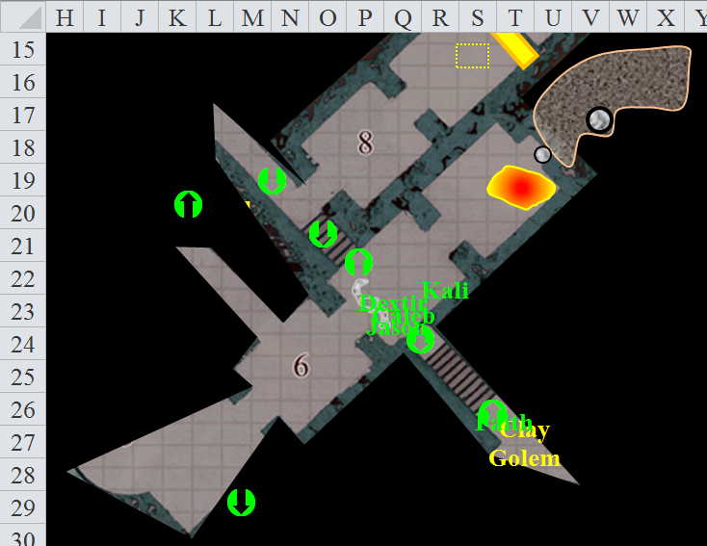

Round 20

Jason tries his luck again.
Ranged Weapon | Dmg. | D+ | TH+ | Critical | Rng. | Wt. | Atk | Roll | Check | Notes
Aquaticbane Longbow +2 | 1d8 | +2 | 2 | x3 | 200’ | 3.0 | +14 | 18 | 32 | +1 within 30’
2nd Shot | 1d8 | +2 | 2 |  |  |  | +9 | 1 | 10 | +1 within 30’
3rd Shot, Rapid Firing | 1d8 | +2 | 2 |  |  |  | +14 | 12 | 26 | +1 within 30’
Crystal of Acid Assault, Greater | - | 1d6 |  |  |  |  |  |  |  | -1 to AC 1 round
Hit, miss, hit. Dmg: (8 + 2 + 1 + 4 acid) + (4 + 2 + 1 + 5 acid) = 16 + 9 acid = 25. Partial damage negated.

The clay golem takes two of the three arrows in its sandy eye sockets, and begins to dissolve, turning into an inanimate ooze on the ground as Faith backs away and emits another emanation of Sacred Healing.
All wounded friendlies gain 12 hps over the course of 4 rounds.

Round 21

Jason rapid fires at the clay monster.

Kali waits at the wall next to the entrance to the hallway. The look on her face is more ‘OH GOD’ as the other moved down the wall to attack leaving no room for others to attack. This limiting the full might of the company.

“What in the 9 hells are you doing, Caleb? I could have ended up back to the beast and killed.” Kali asks and says in a very angry voice. “You want survive long with those shenanigans?” The woman leans against the nearest wall as the adrenalin sweeps out and she begins to feel the pain and fatigue from her badly wound body.

As if apologizing after all the healing is done, Caleb casts lesser vigor on Kali.
Kali gains 1 hit point per round over the course of 11 rounds.

Dextir pulls out some potions from his haversack, “Alright, who’s in? Faith?”

With all the creatures dead Faith says, “Let’s finish checking this place out and heads down the stairs.”

Jason moves to collect his axe and any arrows that might be salvageable, hoping to stay out of Kali’s ire before she blames the whole thing on him.

Dextir notes the tension between the two heroes, his eyes shifting and his lips pursing before the gnome begins to follow Faith.

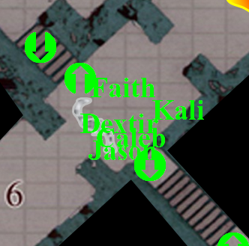

Round 22

“Did we finish looking into that room on the east? I want to make sure nothing is left behind us,” Kali says, looking at Dextir. She begins wiping her blades with a cloth from her pack.

“I just wish we were out of this place,” Jason says to no one in-particular, more relaxed now.

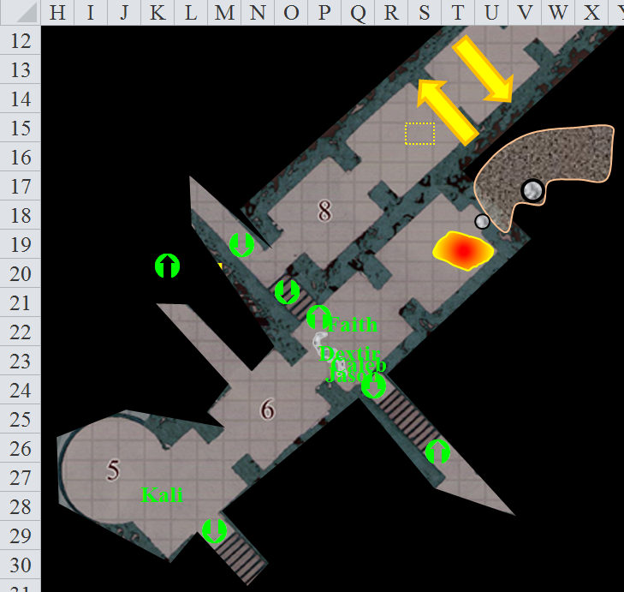

Round 23

Kali reaches a cylindrical tower-like chamber that forms part of the main corridor. To her southeast is another flight of stairs that leads downward into pitch-black. The cylindrical room to the northeast has three slits in the wall that serve as windows, letting in a nice, cool draft.

Meanwhile, Faith reaches a Y-shaped connector among these tunnels, and feels a flash pass through her, blinking, as do the others. Suddenly, they’re affected as if by a clairvoyance spell, having a full visual of this entire level of the gauntlet they’ve just raided and are now escaping.

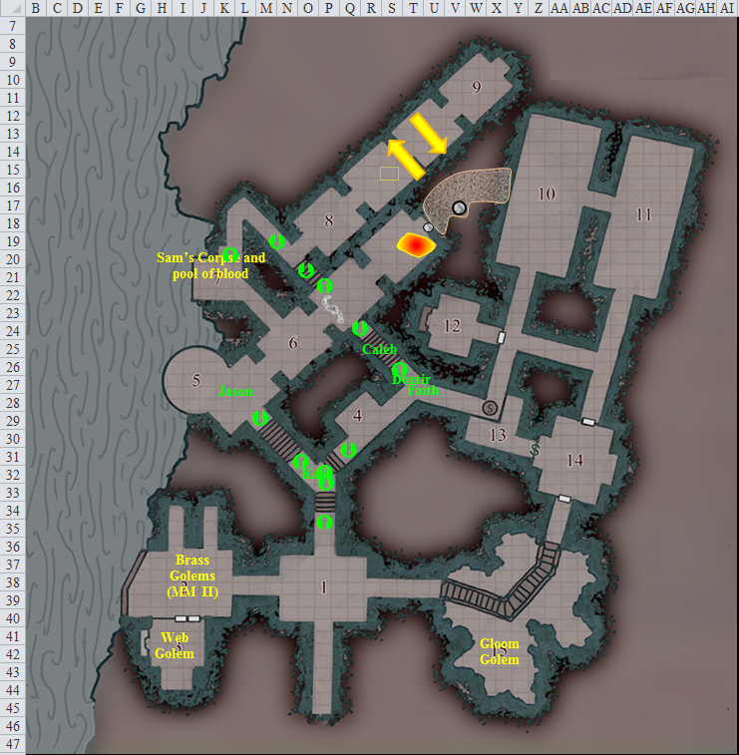

They can see two brass golems in one of the chambers, a web golem closeted up just south of them, and a gloom golem guarding the chasm below the bridge at the southeastern end of the complex.

They also clearly see the fairly well organized treasure in the two northeastern chambers, one whose walls are lined with a library, and the other whose walls are adorned with weapon racks and armor stands. Faith stands in the very center of the level, and she can now clearly see the secret passage in front of her, to the east-southeast.

More importantly perhaps, is what appears to be a mirror with a console of gems underneath it. Dextir identifies it as a control panel, most likely for the golems and for this gauntlet.

And then, each of them can also clearly see the corpse of Sam—their former ally—bleeding at the northwestern point that meets the River Oceanus.

Caleb follows along with Dextir.

Round 24

Dextir moves over to the control panel, studying its gem-like interface console.

Faith flies back at full speed to check on Sam. She makes it all the way down the hall, but has to stop in order to turn about 140 degrees, then beholds the dead body of the winged gnome.

Caleb looks around and says, “Maybe we need to stick together.” He is glancing toward the rooms with the library in it.

Along the rows of books are adventures to be read, recipes to be cooked, maps to be traveled, and all manner of instructional manuals related to golem crafting and maintenance.

Caleb heads over to the treasure rooms, enters the easternmost one, and detects magic over the library books looking for anything magical. Finding six magical books stacked against one another, he looks over the titles.

- Maximizing Upper Body Mass
- The Quick and the Nimble
- Tough Guy’s Journal of Being Tough
- How Not to Be Wrong: The Power of Mathematical Thinking
- The Better Part of Valor
- How to Win Friends and Influence NPCs

There are a few other books along other library shelves further down the room that also glow with magical auras, but Caleb now seems interested in the maps on the table.

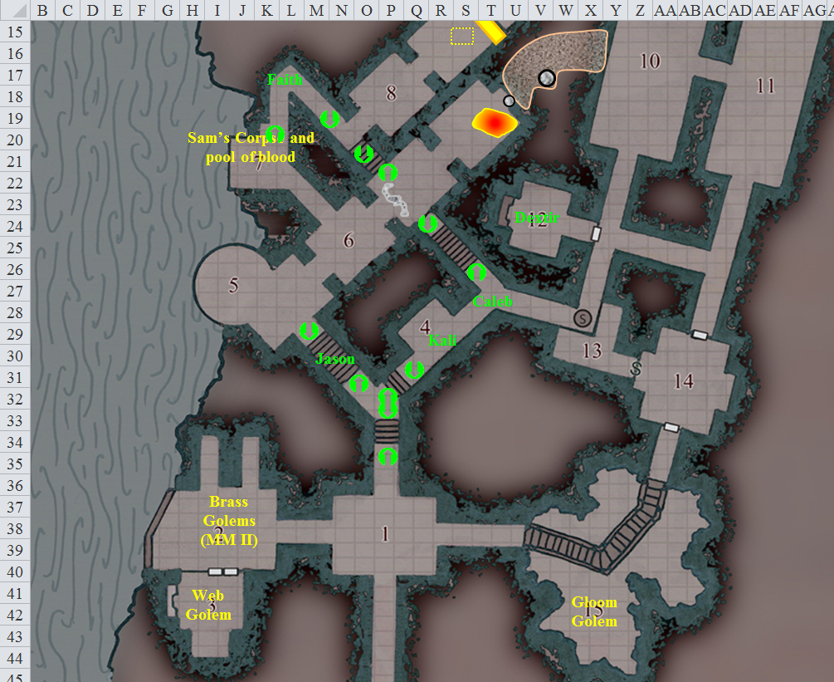

Round 25

The control panel is relatively straightforward, and is written in Gnomish, so it’s a breeze for Dextir. There’s an onscreen view of each brass golem, as well as one of the web golem, and one of the gloom golem. Apparently, the other screens had disappeared upon the other golems’ destruction, he surmised.

Caleb takes some time gathering maps up and storing them in his haversack.

Faith flies up to Sam and lays on hand for a point trying to save her, though the damage was too severe, and the body does not respond.

Round 26

Turning to the gauntlet control panel, which now comes onscreen, Dextir can tell that there are several hydraulic drawing mechanisms that draw the tower to his west upward and downward. Upward returns them to the previous level, where they destroyed nearly every goblin they encountered, throwing the rest down flights of stairs and leaving them incapacitated. Downward is the hatch that allows large golems to be brought into this area. This freight elevator of sorts descends into an outcropping of rock that extends the tower’s base facilitating incoming and outgoing traffic. This was their exit.

Caleb thinks about the magical books he just saw, and keeps taking maps and cartographic notations with him.

Faith picks up Sam’s dead body.

Round 27

Faith and flies back to Dextir, who is now busy at the control panel.

Dextir now accesses a deeper level of security, now not only able to monitor the golems mentally via clairvoyance, but also able to shut them down via this control panel. He promptly does so, and watches the brass golems compacting themselves into can-like structures; the gloom golem dissipating into dark, coagulated air; and the web golem simply freezing in place.

Caleb has amassed quite a collection of maps.

Round 28

Dextir is able to glean the identity of the only user of this device, a halfling artificer posing with a brass monocle and a golden beard-cuff dangling from his chin. The male artificer’s name is Grandmaster Smooch, and below his image is a gravestone with the warhammer symbol of Flandal Steelskin, the gnomish patron deity of craftsmanship.

The information on the screen suggests a true neutral: a self-interested fellow who kept to himself and was driven mad by the combination of solitude and his obsession for artificial automatons. Occasional journal entries, delivery expenses, love letters to one flesh golem or another; it is all quite tragic, the trail he left behind in these logs and archives.

Caleb grabs a few more maps.

Faith reaches Dextir, presenting Sam’s body in her arms.

“What a pity…” the gnome says.

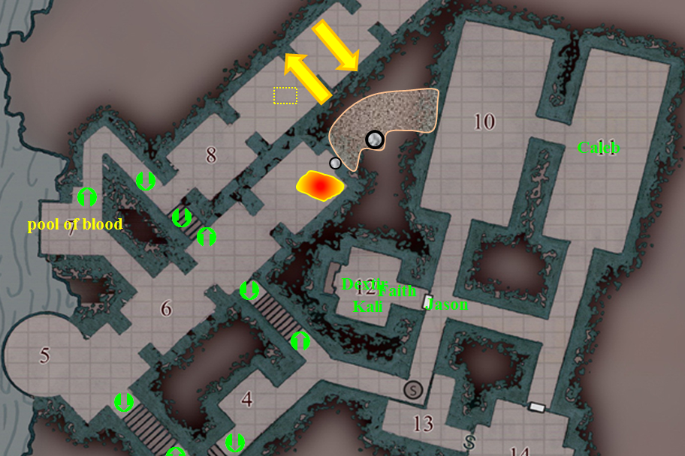

Round 29

Caleb grabs the six books and chucks them in his haversack, hearing the footsteps and voices of his comrades nearby, and having a visual bearing on them via an unexplained clairvoyance spell.

Jason sees, both with his eyes and with his mind, the western treasure room, filled with all types of weapons and armor, as well as chests probably filled with jewels and other fanciful riches.

Dextir takes a break from manipulating the Gauntlet’s control panel, now displaying a few historical tidbits about the gladiators who’ve come and gone through here, and fidgets with one of his own, bejeweled mini-scepter hanging at his side. He explains, “Getting the ship to meet us here,” he points to the western tower on the miniaturized map of this level, and says, “That’s our exit point. I’ve disabled the remaining golems, as you can probably see, so I propose we, uh, salvage a bit of the late artificer’s gear and be off.”

Round 30

Faith heads towards the treasure room, floating just below the ceiling.

Dextir enters the westernmost treasure room, and spots a variety of wands and transdimensional items that catch his fancy.

As he does so, he thinks he might be able to cannibalize some of the components of the control panel in order to have access to one of those two brass golems with a handheld controller comprised of his scepter, one of these gadgets on the shelf whose name he can’t recall, and some of the active gems on the console.

He continues to think about it as he browses through the treasure room’s selection of cloaks and other wares.

Round 31

Dextir removes his +1 cloak of resistance and swaps it for a +2 upgrade. Instead of donning it, however, he also takes a nice mithral chain shirt +2 off the shelf and begins to unbuckle his own +1 equivalent.

Faith finds a +3 full plate suit. She takes it down off the mount, and ensures that it fits her dimensions.

Round 32

Dextir removes his mithral chain shirt +1 [done on Round 42].

Faith removes her full plate +1 [done in 3 + 1 = 4 minutes (Round 72)].

Caleb comes around to where she is and instantly notices the magical aura around the plate that Faith is considering donning. “Nice!”

Round 43

Dextir dons his new mithral chain shirt +2 [done on Round 53].

As he comes closer, Caleb is unable to identify the aura he detects around Faith’s would-be +3 full plate armor. “What is that?” he asks rhetorically.

Faith—who is busy taking off her own plate suit with no intention of ever donning it again, and who is able to detect evil, even on items—answers anyway, “It’s a plate suit, but it’s even more enchanted than this one.”

“Yes, but what is that glow all about the gauntlets and boots?” asks the divine and arcane spellcaster.

The pious templar—unable to see what he’s talking about—looks down at it, but does not stop undressing before the handful of fertile men.

[This armor has a quality that must first be identified before it can be unlocked.]

Round 54

Dextir puts on his new cloak of resistance +2.



At that moment, the party becomes aware of a figure—most likely a gnome or halfling—moving about through this labyrinthine level. The figure has just entered the corridor with the pendulum blades.

The little halfling does his best to avoid the pendulum blades.
Gordo: Skill | Rank | Ability & Mod. | Misc. Mods. | Total | Roll | Check
Reflex | 7 | Dex (+3) | 0 | 10 | 10 | 20
Reflex | 7 | Dex (+3) | 0 | 10 | 12 | 22
Success, success.

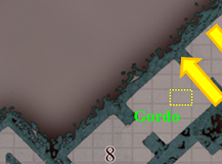

Gordo then spots the pressure plate that Dextir and the others had missed and triggered. Careful to step around it, he now notes the two destroyed automatons to his southwest.

Round 55

Walking around the clunks of metal and wires, the halfling begins to hear the dim echoes of voices up ahead. He closes his mouth, breathes through his nose, and blinks a few times as he stands perfectly still, then takes a few steps towards the T-intersection, having deemed it untrapped.

It’s evident now that the sound is coming from the southeast, far beyond the two flights of stairs that lead down.

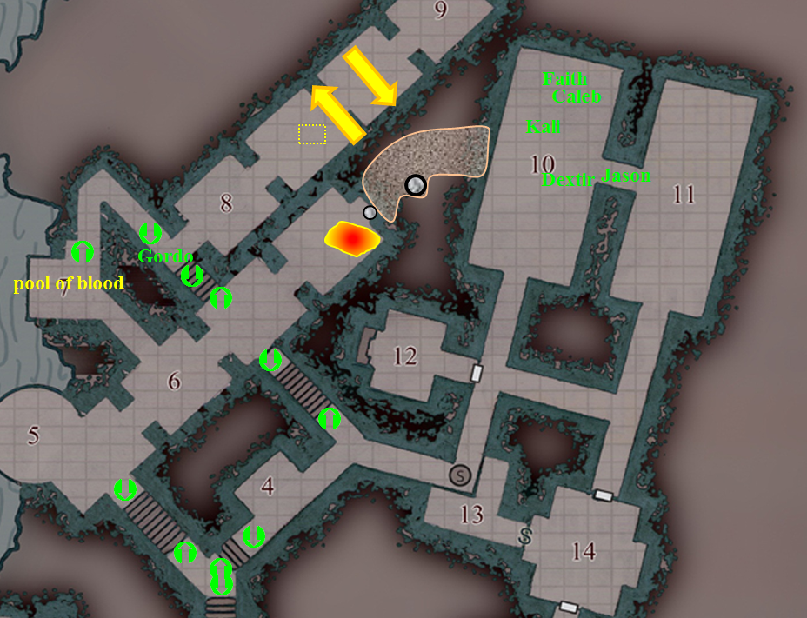

Round 56

Following his sense of hearing, Gordo creeps southeastwardly and discerns that his next turn will be a left turn.

Caleb has filled his haversack full with maps and books that tell of travels to strange places. He uses his knowledge and experience to help him pick the best ones.

Round 57

Gordo approaches that left turn, but notices some peculiarities in the bend. He studies the contour of the wall, finds the secret passage, and determines there are no traps in sight.

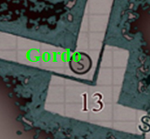

Round 58

[Usually, Int- and Wis- based checks aren’t revealed for the sake of game enjoyment. Here it’s appropriate because of the clairvoyance spell affecting the other PCs.]

Gordo: Skill | Rank | Ability & Mod. | Misc. Mods. | Total | Roll | Check
Hide | 5 | Dex (-1) | 6 | 10 | 9 | 19
Listen | 7 | Wis (+0) | 2 | 9 | 16 | 25
Move Silently | 5 | Dex (-1) | 4 | 8 | 14 | 22
Spot | 7 | Wis (+0) | 0 | 7 | 16 | 23
See below.

The halfling rogue wis then startled as he sees that a handful of folks twice his size—a woman among them scantily clad and improving by the second in that regard—are already staring at him when he comes into view. They are neither whispering nor speaking loudly, but muttering to each other something that sounds like, “… do you think? Should we…?”

“Friend or foe, lad?” a male, gnomish voice then comes his way.

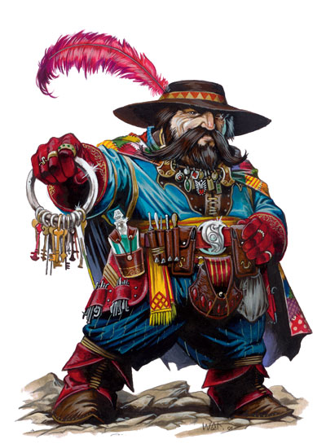

Faith—a seasoned combatant—is hardly expecting a fight, and continued to undo the clasps and knots holding her plate mail together. Still, she detects for evil on the newcomer.

“Friend. Definitely friend, good gnome, sir!” Gordo says, approaching the group with a smile on his face and outstretched hand, and looking for the gnome that matches the voice.

Round 59

“What brings you to this place?” Faith asks the halfling.

“I’m not exactly sure how I got here, but it’s really exciting, isn’t it? Quite the place. I was in some old ruins, trying to get my mitts on this immense snow opal, and there was this altar...anyway, I was transported to this plane. But it’s kind of the place to be, right? This beats what I was doing before this by half, at least!”

Kali ignores the halfling and looks though the library for anything on strength training or better fighting stance, while the scout looks for items dealing with archery and dexterity. She does not think to ask Caleb, who actually has a tome on those very subjects, having razed and raked the shelves and stowed dozens of books in his extradimensional bag.

Round 60

“Hello! I am Kali, and it will be good to have a halfling with us. You people are always happy and cheerful.” She looks back over her shoulder. “Not like some others I know.” She goes down on one knee to greet him and shake his hand.

Round 61

“You mean short people,” Dextir asks. “That’s a misnomer. You twicelings just don’t know how to take us seriously sometimes... because we are cuter... and cuddlier.” He smiles at Kali, raising an eyebrow hidden under the cone of his hat.

“Well some of you are cute,” Kali winks at the halfling.

Round 62

The halfling shakes Kali’s hand. “I feel I will be of use, especially in a topsy-turvy locale like this. My sneaky skills might be just what you need indeed,” Gordo says jovially. He seems to be happy to be in this place.

Round 73

After Gordo is good and done telling his origin story, taking place in a far-off realm called Faerûn, Jason says, “I’ve been here a while. I was brought here against my will and forced to play their rules until we broke free.”

Faith tosses the last of the plate mail on the ground, leaving it strewn about as a clear sign to posterity that someone was here, and begins to unhinge the straps of the +3 armor. “I’ll need some help putting this on properly,” the paladin announces. Dextir and Caleb practically bump into each other volunteering. [Done on Round 113]

Round 113

Faith removes the crystals from her old armor and places them on the new armor.

The introductory conversation has ended, and everyone is fully reequipped down to their loincloths and quivers.

Dextir shifts his gear as he lifts up on his feet momentarily. “Well, if we’re ready then, my ship should be waiting for us by now. I’d normally ask you to lead the way,” one rogue says to another. “But at the moment, the rest of us can clairvoyantly see this entire level.

Round 114

They head southwestward, with Dextir in the lead.

Gordo sidles up to Dextir, “I can take the point if you like, chief. I’m good at sussing out traps and such.”

“Like I said, son,” Dextir studies the halfling. “We’re all clairvoyant right now.”

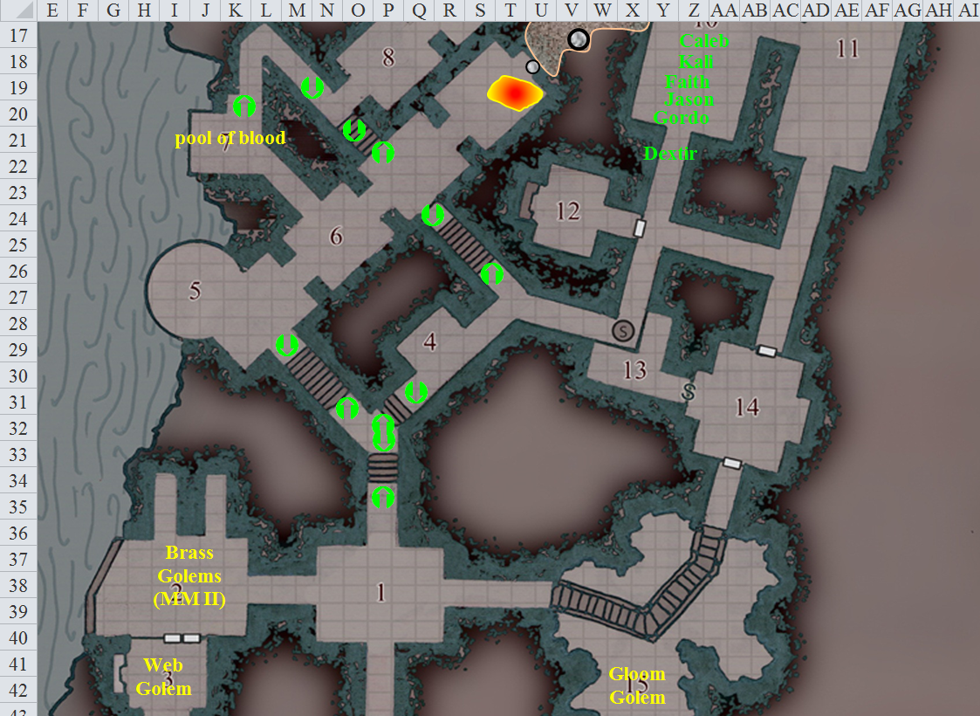

Caleb finishes up his gathering with a string of pearls, “This will let me identify any unknown magic items we have,” and a couple of spell books following along at the rear of the party.

Faith is all geared up and ready to go following near where Dextir is, “So, Gordo, my name is Faith; I am a Templar of Torm. We are happy to take you with us out of here, but I am not sure where in the planes we will end up. Dextir here, she indicates the gnome, calls himself a gatecrasher. I am just not sure whether he knows where those gates will lead.”

“Then we shall crash those gates together, new friend Dextir. And pleased to meet you, Faith. Your deity is mighty, His Loyal Fury is known far and wide,” Gordo says with a revering smile.

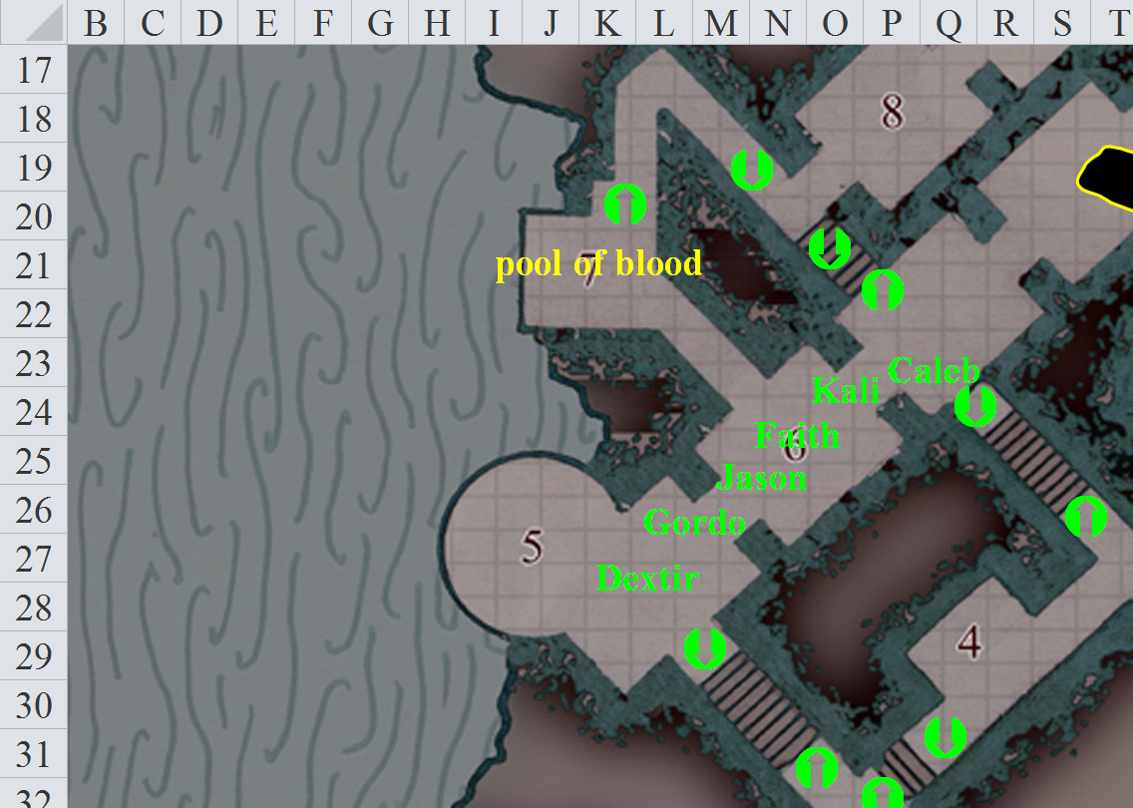

Round 118

Casually making their way to the pressure plate, Dextir waits until they are all gathered, and then asks, “So what do you think?”

“We just step onto it and it goes down?”

“No, look,” Gordo points out the lever hidden into the stonework.

They step onto the cylindrical platform, and the halfling pulls down the lever.

And down they go for about 30’, then stop to see the gnome’s transplanar vessel waiting for them.

Dextir has by now produced his remote controller, and directs the archer’s platform to rest atop the wedge between the tower and the vessel. Jason remembers how useful the platform is, having made his way here with Dextir aboard this unique vessel.

