Chapter 11: Larlum the Redhanded

A

nd with that, the *teleport* spell was cast, and they were once again above the battlefield, with nary a foe in sight. Caleb had placed them about 30’ above the high ground, just south of the slot canyon. The bluffs beyond were as striking as they had been before, but one thing stood out now that they had reached such a southern vantage point.

At this exact altitude, they were in a position to barely see over the hills to the south a bit of shoreline about 2 miles south-southeast of them, and serendipitously, a ship was moored a few hundred feet out. Furthermore, Jason and Kali spotted the tracks in the snow left not only by the villains that somewhat bested them, but more noticeably by their mounts. These tracks began about 200’ east of them, and headed southwest until they joined with the trail, which was now muddy, and nearly depleted of snow.

The trail went on for about half a mile until the flatness of the bluffs gave way to hillier ground, and they would have to approach or gain altitude to see any further, which would compromise their position if someone were watching from afar.

“Jason, if you’re willing, I’ll cast *invisibility* on you and you can fly higher to get a better vantage point. Someone could well still be *detecting invisibility*, but sheer range should help protect you from danger,” Magpie offered. “Regardless, let’s continue toward Larlum’s lair, keeping an eye out for the boat or dangers. We need to make good use of our flight to cover ground while it still lasts.”

“I will pass on this; flying does not suit me. The ground is my abode,” said Jason, already flying, but passing on the *invisibility*.

Magpie didn’t argue with the scout. If he didn’t want to scout, she wouldn’t argue. “Alright, let’s proceed with all haste to the ship. If we destroy it and its guards first, that gives us more time to deal with our enemies, and we might be able to draw out some more guardians in a more piecemeal fashion.”

“If we come across the riders as we go, we should attack them as well. Kill their mounts and slow them reuniting with the others.” Frayed replied, rubbing his little hands together.

“You’ve changed after your ordeal, Frayed,” Caleb commented.

“Torture does that,” came the warmage’s simple reply.

Round 100

They were about 10000’ away (2 miles or so) from the ship, and they had about 2 minutes left on the *mass fly* spell. Flying at 240’ every six seconds, they would cover a maximum of 9600’ before their flight would expire. Being 2640’ away from the hilltop beyond which they would see much more once they cleared it, they began by skirting the path and the flat terrain at an average altitude of 15’.

“I will move ahead and scout if you give me a moment and about 40’ before you follow. Stop when I stop,” said Jason. He then moved ahead at full speed keeping himself from skylining over the ridge to his front. He would adjust his altitude to do this until he was about 50’ from the top then he would float up just enough to peek over.

Round 101

As Magpie suggested, the scout and the rest of the party made a beeline for the ship, getting the most distance out of the fast moving flight as they can, and changing altitude only in accordance with the topography.

Rounds 102 – 110

Within a minute’s flight, they were almost at the hilltop—240’ away from it to be exact—and would be overlooking the summit in 6 seconds. Still a good 7000’ or more from their destination, they continued to scan the sky and the hills for enemies. The tracks made in the mud and snow by the horses were evident, and followed the trail that presumably led right to Larlum’s bone grotto.

Round 111

They reached the summit, and saw once more the shore and the ship over a mile away. It was still too far to tell if anyone was near the shore.

“Ok,” said Jason, “We still going to the ship?” He paused waiting for an answer and when received he would make a bee line at top speed in that direction.

Round 112

“Yes. We go to the ship and set a fire so big Larlum will see it from wherever he’s hiding!” Frayed punched his fist.

“We do know where he’s hiding,” Magpie pointed out.

“Shut up, Magpie. To the ship!” Frayed called triumphantly.

Rounds 113 – 117

They headed straight for the ship, now that it was in everyone’s sights.

Round 118

They were now less than 6000’ away from the shore, and could still not identify anyone.

Rounds 119 – 127

The six heroes continued speeding towards the ship, knowing that unless *dispelled*, their ability to fly would get them to their destination before expiring.

“Stay the course, heroes,” Faith commended everyone for the efforts that she knew they would make. “We shall right a thousand wrongs this day.”

Those with better sight could barely spot a flying figure, but whether or not it was that ogre mage they’d encountered would remain to be determined. They pressed on as other figures began to be visible on the ground, making their way down a path towards the ship.

They were still too far from any potential enemy to do much harm, and would no doubt soon be spotted themselves, so they clustered a bit more in their flight paths in order to better confer.

“We’re at least 3500’ away from those people,” Jason pointed to the handful of people walking towards the ship. “You spellslingers should be within long casting range of them in a minute, and right in their faces in a few seconds more, if you like.”

“I suggest we move lower to the ground to make us harder to see. This we needed to do now. I don’t wish to be dispelled out of the air,” said Kali.

Round 128

They did as Kali suggested, skirting the rolling hills at an altitude of 15’.

|  |  |  |  |  |  |  |
| --- | --- | --- | --- | --- | --- | --- |
| **Save vs.**  Scraping | **Rank** | **Ability & Mod.** | **Misc. Mods.** | **Total** | **Roll** | **Check** |
| **Caleb, Reflex** | **4** | **Dex (+3)** | 2 | 9 | 4 | 13 |
| **Faith, Reflex** | **2** | **Dex (+1)** | 5 | 8 | 1 | 9 |
| **Frayed, Reflex** | **3** | **Dex (+2)** | 3 | 8 | 9 | 17 |
| **Kali, Reflex** | **7** | **Dex (+4)** | 1 | 12 | 15 | 27 |
| **Jason, Reflex** | **8** | **Dex (+5)** | 1 | 14 | 12 | 26 |
| **Magpie, Reflex** | **5** | **Dex (+1)** | 2 | 8 | 14 | 22 |

*Success for all but Faith. Dmg: 1. Dmg negated.*

“Yes” replied Jason as he began his recent. “If we can let’s take them by surprise and if one you casters has something like *fireball* we should defer are attacks until you have rained fire down on them.”

“You alright?” someone asked Faith.

She smiled.

Rounds 129 – 130

“Eh, dispel has a max range of like 300 feet. We’ve a whiles before we need to worry about that, and even if they dispel us, we just float to the ground. Whereas, my fireballs go like 800 feet. We can drop a bit lower if folks want, but I’ve been itching to blast people to the 7 Hells all day and that’s what I’m going to do,” Frayed replied to Kali and Jason’s concerns.

Rounds 131 – 132

“We should space out a bit, just so they have a harder time fireballing us back. If we keep thirty feet between the mass fliers, that’s me, Caleb, Kali, and Faith, they can only catch at most 2 of us in an area affect. Jason and Frayed have their own flies, so can space out more. I’d say 50’,” Magpie tossed in her two coppers. “How do we know there aren’t slaves or prisoners in that column?”

Darkfather Aquíferoz cast *divine presence [expired on Round 1232].*

*Aquíferoz gained +5 Profane bonus to Intimidate checks vs. those not faithful to Velsharoon, plus additional alignment-based bonuses, if applicable*.

Round 133

“Larlum doesn’t strike me as the sort to keep slaves or prisoners. He creates undead, which are far more controllable. I believe we’re safe to engage.” Caleb wasn’t bloodthirsty like Frayed was, but he was feeling pragmatic about this.

Darkfather Aquíferoz cast *Hell’s power [expired on Round 1233]*.

*Aquiferoz gained +2 to AC, plus DR 1/+1*.

Round 134

They were now less than 2000’ away, maybe a quarter of a mile or so, and could identify several types of foes by their movement.

A dozen or so zombies—about half of them gnome-sized and the others elf- and human-sized—were lugging stuff and towing a pair of *Tenser’s floating disks* towards the ship.

The ogre-mage was flying above the ship, and had probably spotted them by now.

There was now a cavalry of a half-dozen coalescing near the shore, and these were most likely the same posse that Larlum had dispatched earlier. They had galloped and cantered all the way over, and their horses were surely exhausted.

Larlum was nowhere in sight.

It was a 30’ boat, and would need quite a crew, so it could also be assumed that at least one potential foe resided within the hull at the moment.

“It’s highly unlikely that the cavalry have any flight capability,” Caleb deduced.

Darkfather Aquíferoz cast *detect magic [expired on Round 246]*.

Round 135

“We’re about 1600’ away,” the archer announced, now within 8 range increments of his intended targets.

Darkfather Aquíferoz cast *entropic shield [expired on Round 244]*.

*Aquíferoz gained 20% concealment chance to be missed by ranged weapons and ranged touch attacks/spells*.

Milfuegos Mopworken cast *Hell’s power [expired on Round 1235]*.

*Milfuegos gained +2 to AC, plus DR 1/+1*.

Who the Bone Whisperer cast *false life [expired on Round 6735]*.

*Who tBW gained 3 + 10 = 13 temporary hps.*

Round 136

A horn was blown by someone near the ship. The zombies stayed their course, lugging crates and other things to the ship. “We’ve been acquired,” Jason reported the obvious.

The party was pretty sure that the cavalry that had met them about 10 minutes ago at the bluffs was now mostly depleted of spells, at least the spells that mattered most. Fuchsia’s testimony had withstood every test, and chances were that that warmage who had fried them with *fireballs* was spent. That left the elites that Fuchsia had mentioned, who probably *did* have their signature spells intact and ready to unleash upon the heroes.





“They’ll have at least two senior clerics of Velsharoon,” Jason remembered. “Faith, you want to take those?”

Faith made a mental recollection of the main foes that were likely to accompany the zombies and the cavalry, and with so many spellcasters, she didn’t know whom she would attack first, leaving the aristocrat to Jason or someone else. “Who brings an aristocrat to a party like this?” she asked rhetorically.

Darkfather Aquíferoz cast *nightshield [expired on Round 245]*.

*Aquíferoz gained +3 to all Saves, plus immunity to magic missiles*.

Milfuegos Mopworken cast *detect magic [expired on Round 246]*.

Who the Bone Whisperer cast *fire in the blood [expired on Round 246]*.

Caleb and Magpie flew about 20’ from each other, because any further would end the *mass fly*. Jason knew this, and tried to stay no further ahead from the others than 15’. They were 70’ away from Frayed to minimize the risk of Area Affect spells.

Frayed, with his own *fly* spell, had moved himself some 70’ away *[DM assumption based on ambiguity: he is 70’ south-southwest of Magpie]* from his nearest ally. While still out of his long range, he slowed down in order to cast *shield [expired on Round 246]* and *cat’s grace [cast on Round 137; expired on Round 247]* upon himself. All of his *‘heart of’* spells were still active from the morning.

*Frayed gained +4 to AC, +4 to Dex, and other Dex-based bonuses.*

When Frayed began casting his *shield*, Magpie gave Caleb a premeditated hand gesture and cast *greater mirror image [expired on Round 246]*.

*Magpie manifested 1 + 4 = 5 mirror images of herself.*

Caleb nodded and cast *mass resist energy (fire*) *[expired on Round 1236]*, slowing down considerably.

*All PCs gained Resistance to Fire (30).*

The archer, paladin, and dancer also slowed down in order to maintain everyone’s flight capability. They would all have to cover a bit more distance if they wanted to be within *fireball* casting range. Fortunately, they had been blessed by Caleb’s *mass resist energy* spell, and they would have to make the best of it, now that the paladin, dancer, and scout were leading the way to the fleeing villains.

Rounds 137 and 138

Darkfather Aquíferoz cast *negative energy aura [expired on Round 148]*.

*Aquíferoz emanated 10’ radius field causing 2 points of negative energy damage (healing undead)*.

Milfuegos Mopworken cast *shield of faith* upon himself *[expired on Round 247]*.

*Milfuegos gained +3 to AC*.

Who the Bone Whisperer cast *detect magic [expired on Round 247]*.

A sixth rendition of Magpie was added to her existing *mirror images*.

“Get those spells ready,” Jason said. “We’ll soon enter the long-range spell zone.”

They couldn’t quite see the whites of their enemies’ eyes just yet, but anyone with a *fireball* spell would soon be able to pull such a prank on the other side.

The calls to battle could now be heard. The ogre mage seemed to be calling the shots, flying from his position above the ship to a rock just south of the sandy shore, where there appeared to be a robed human standing.

*The scale of this map is deliberately small because you’re still over 1000’ northwest of A1.*

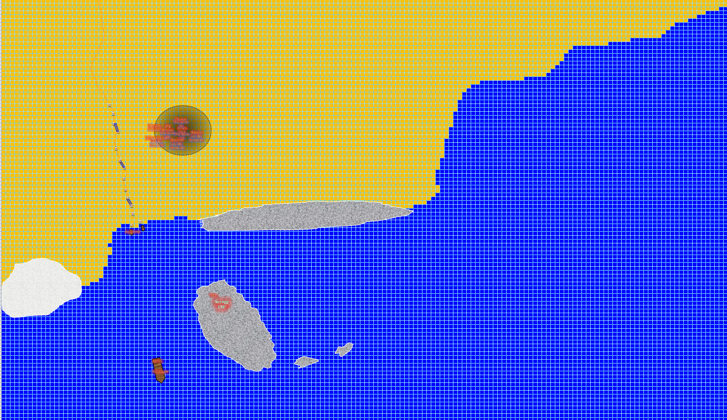

*The north-south trail has about 10 zombies making their way south. The cavalry is clustered to the zombies’ east (the black circle represents the dragon shaman’s aura). The ship, as expected, is 200’ south of the shore. Two dinghies are moored on the shore, tethered to stakes in the sand. The PCs are flying 240’ southeast per turn at an altitude of 15’ until you post otherwise. Square A1 is approximately 250’ away from the cluster of mounted combatants, so you can expect your PC to enter the map by Round 141.*

“Watch your distances from each group of fliers,” said Jason as he moved so that no group was less than 60’ from him. He readied his bow about 12 seconds before he intended to fire.

[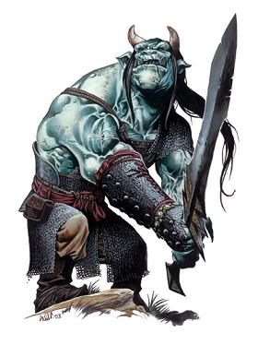](http://www.google.com/url?sa=i&rct=j&q=&esrc=s&source=images&cd=&cad=rja&uact=8&ved=2ahUKEwiuhZn_yoXaAhVE3WMKHUeZDVsQjRx6BAgAEAU&url=http://forgottenrealms.wikia.com/wiki/File:Ogre_Mage.JPG&psig=AOvVaw375Tkwmx2KFum2kM4P0vzY&ust=1522002412810241)

The ogre mage was ready for these punks, and would make his master proud today. Scrogg the Pleasurepain—a transgendered ogre mage—was a grandmother of three, and now imagined having the funds to return to see her grandkids and spoil them rotten. But first, they would have to kill these intruders, take their equipment, and hawk it all in a city big enough to have a market for high-end goods like the ones they were about to loot! He drank a potion of *bull’s strength [expired on Round 177]*.

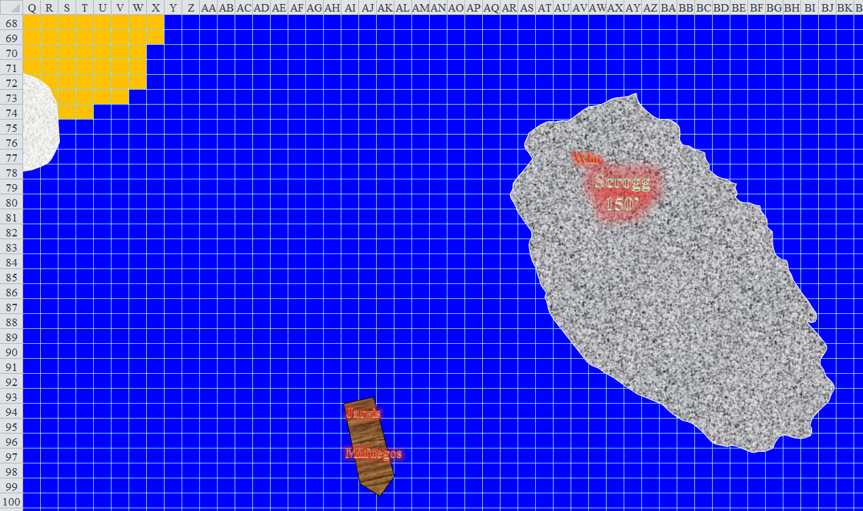

The ogre mage cast *detect magic [expired on Round 197]* again, studying the incoming class of morons, and contemplating sucking the eyeballs out of the archer’s skull. Still able to *see invisibility*, the diviner sought to find any and all weaknesses in the intrepid heroes, and relay them to the rest of the home team.

[](https://www.google.com/url?sa=i&rct=j&q=&esrc=s&source=images&cd=&cad=rja&uact=8&ved=2ahUKEwi_j-XU04XaAhVS9GMKHQwCBoAQjRx6BAgAEAU&url=https://www.pinterest.co.uk/palanolho/character-male-gnomehalfling/&psig=AOvVaw1R0mQsdECVaNswJbUt5wqC&ust=1522004741849447)

Who the Bone Whisperer cast *vampiric touch [expired on Round 738]*.

[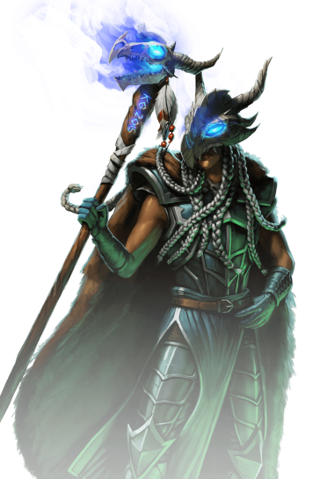](https://www.google.com/url?sa=i&rct=j&q=&esrc=s&source=images&cd=&cad=rja&uact=8&ved=2ahUKEwik8ZGdu4XaAhWBKGMKHeoGA3kQjRx6BAgAEAU&url=https://wardragons.com/game-info/portrait/33&psig=AOvVaw0vsCE1h9bvQW2S24MWOd5S&ust=1521998186900706)

Rockin’ an Aura of Senses to aid the cavalry’s perception, Cruel-Déjà Huhlgarix proposed a few premeditated contingencies—calling them Putsch 22a, 16th offend/defend, and 3rd-Retreat Guard—and spurred her heavy warhorse to make its way slowly west as each member of his squadron put about 25’ between themselves and the black dragon shaman. The leader of the horsemen then drank a potion of *bear’s endurance [expired on Round 187]*.

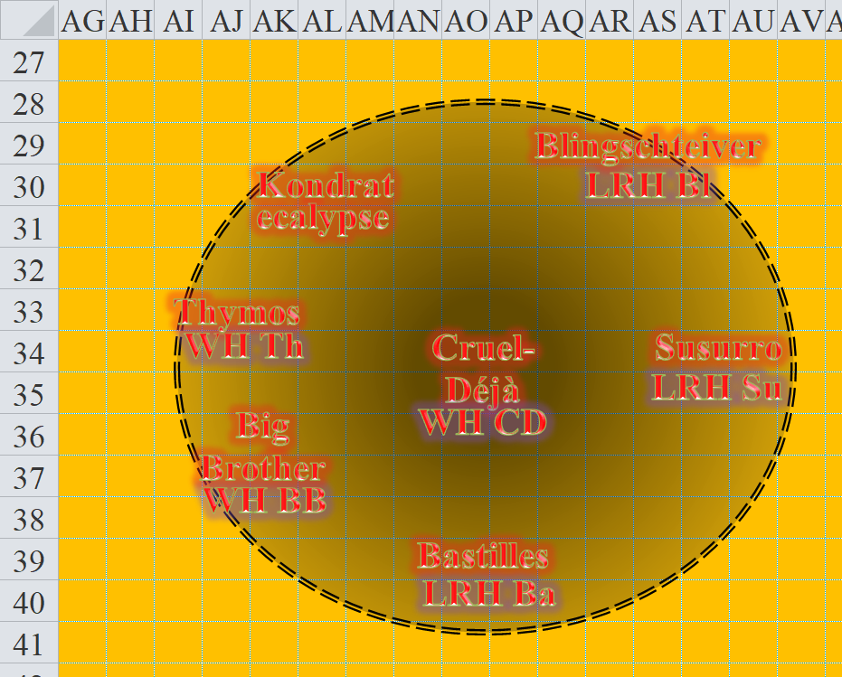

The ecalypse—an eight-legged horse comprised primarily of shadowstuff and guts—neighed and roared simultaneously as its rider smirked in anticipation of butchering some of these marshmallow-eating do-gooders.

[](http://www.google.com/url?sa=i&rct=j&q=&esrc=s&source=images&cd=&cad=rja&uact=8&ved=2ahUKEwi-1NfM0YXaAhUI3WMKHWzBBBMQjRx6BAgAEAU&url=http://www.kinggames.dk/shop/diabolist-1522p.html&psig=AOvVaw2fQA5SMyk7cIpZohTNDIMH&ust=1522004188535934)

Kondrat of Netheril—an elven shade favored of Velsharoon—held a quarterstaff in one hand and the reins of her ecalypse in the other. With her *nightshield* spell expired minutes ago, she cast the spell again upon herself *[expired on Round 197]*, and the same went for her *ghost touch armor [expired on Round 198]*.

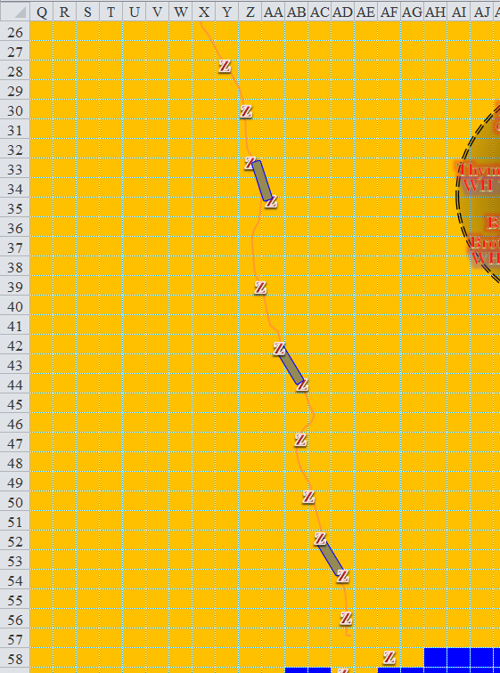

The zombies carrying provisions to the dinghies continued southward, ignoring the heroes flying 15’ above the sandy, gradually sloping, plain after they’d cleared the last rolling hill.

[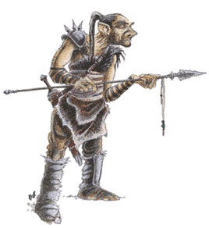](https://www.google.com/url?sa=i&rct=j&q=&esrc=s&source=images&cd=&cad=rja&uact=8&ved=2ahUKEwjf7vWv0IXaAhVRImMKHQ2dCQsQjRx6BAgAEAU&url=https://your-dungeon-is-problematic.tumblr.com/post/132363649841/half-ogres-add&psig=AOvVaw0uspUSAwoRkZ12mhp9eFNF&ust=1522003861512397)

Blingschteiver would soon cast *fire shield* upon himself, but needed to time the casting a bit better, so he waited to do so. For now, he would prepare his signature *fireball* spell, trying to get as many foes in it as possible.

[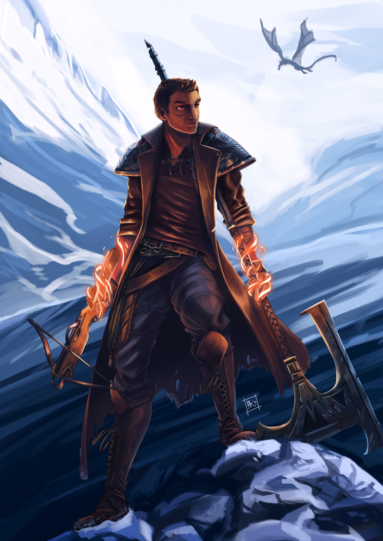](https://i.redd.it/gdj20dw9xy4y.png)

Thymos the Redhanded drank a potion of *bull’s strength [both expired on Round 188]*, as did Big Brother Bothammers.

*Thymos the Redhanded and Big Brother Bothammers both gained +4 to Strength.*

[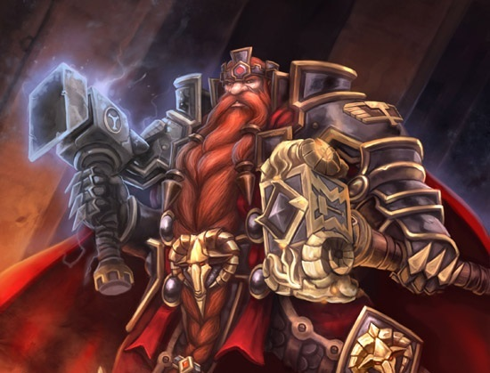](https://www.google.com/url?sa=i&rct=j&q=&esrc=s&source=images&cd=&cad=rja&uact=8&ved=2ahUKEwj2go-C0YXaAhVQ62MKHYYSAowQjRx6BAgAEAU&url=https://www.pinterest.com/pin/378935756122012363/&psig=AOvVaw27cv8TlB_pxdkxUsQ0OY3f&ust=1522004035151196)

Bastilles Croixième had the heroes between 2 and 3 range increments of his bow, which had *accuracy* cast upon it. After positioning his light riding horse about 15’ from his previous position, the scout took a potshot at Jason, just to see how it felt.

|  |  |  |  |  |  |  |  |  |  |
| --- | --- | --- | --- | --- | --- | --- | --- | --- | --- |
| **Character** | **Attack Type** | **Damage** | **BAB** | **Mod+** | **W+** | **Other+** | **d20** | **Total** | **Targeting** |
| Bastilles Croixième | Composite Longbow +2 | 1d6 | 6 | 3 | 2 | -2 height -4 range | 9 | 14 | +3d6 skirmish |

*Miss.*

[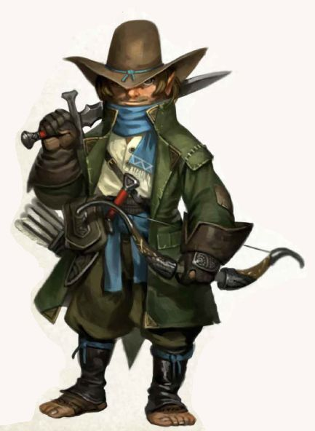](https://www.google.com/url?sa=i&rct=j&q=&esrc=s&source=images&cd=&cad=rja&uact=8&ved=2ahUKEwj8h9-S0YXaAhUMy2MKHXTqCbQQjRx6BAgAEAU&url=https://www.pinterest.com/javidante/fantasy-gnomes/&psig=AOvVaw14luKxJlVmqzjwr-L5ZBZY&ust=1522004065190916)

Jason warned, “Arrows incomiiing!”

Darkfather Aquíferoz cast *weapon of the deity [expired on Round 149]*.

*Aquíferoz augmented his quarterstaff with the Shock feature, and a +1 to hit and damage*.

Aboard the westernmost dinghy, Milfuegos Mopworken cast *bear’s heart [expired on Round 149]* on himself, Jarvis, and anyone inside the hull of the ship.

*Milfuegos, Jarvis, and possibly other living allies below gained +4 to Strength, plus 29 temporary hps*.

Frayed, Caleb, and Magpie flew more slowly for the moment, not yet in range. With a seventh rendition of Magpie added to her existing *mirror images*, Magpie looked around and liked what she saw.

Round 139

The heroes had slowed down to cast spells, giving the villains a few extra seconds to drink some of their potions and otherwise buff up a bit more.

An eighth and final rendition of Magpie was added to her existing *mirror images*.

Thymos the Redhanded drank a potion of *bear’s endurance*, burping.

*Thymos gained +4 to Con and consequent bonus hps.*

Scrogg the Pleasurepain flew upwards and towards the beach a bit, achieving his previous altitude of 150’. The ogre then also drank a buff potion.

[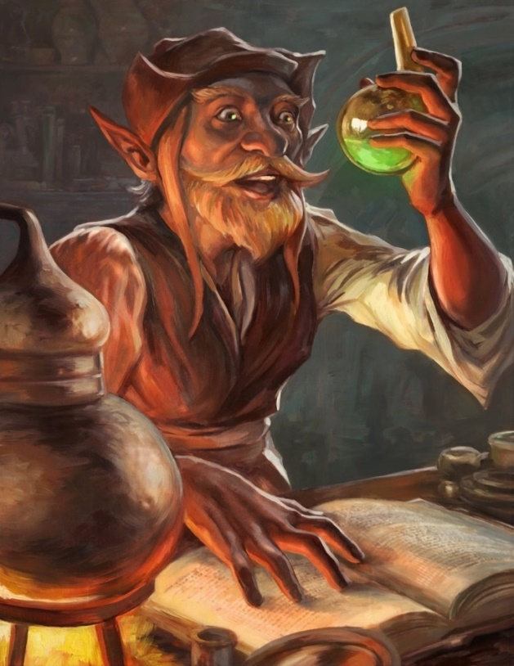](https://www.google.com/url?sa=i&rct=j&q=&esrc=s&source=images&cd=&cad=rja&uact=8&ved=2ahUKEwixvpry0YXaAhUUI2MKHY6_DMEQjRx6BAgAEAU&url=https://egilthompson.deviantart.com/art/Alchemist-Halfling-620056508&psig=AOvVaw0TgUZvM9Uaw_Y0kfi4rm0Z&ust=1522004250082041)

Superintendent Milfuegos Mopworken—the mastermind behind the plot to overthrow the Gondian clergy in Bytopia—was aboard the ship, and began to command a few undead sailors to lower the sails of the ship, which they did. He had also dispatched his planar ally—a barbed devil—to dive into the waters and head to shore in order to better deal with the heroes that the devil had agreed to slay in exchange of payment. The diabolist was pleased to now see a few barbs emerging near the breaking waves to his north-northwest.

One strong ghoul pulled up the anchor as three weaker zombies turned the wheel that drew up the anchor’s chain.

The diabolist then cast *summon monster I [expired on Round 149]*, conjuring a fiendish raven that flew directly towards the heroes.

Larlum the Redhanded was nowhere in sight.

[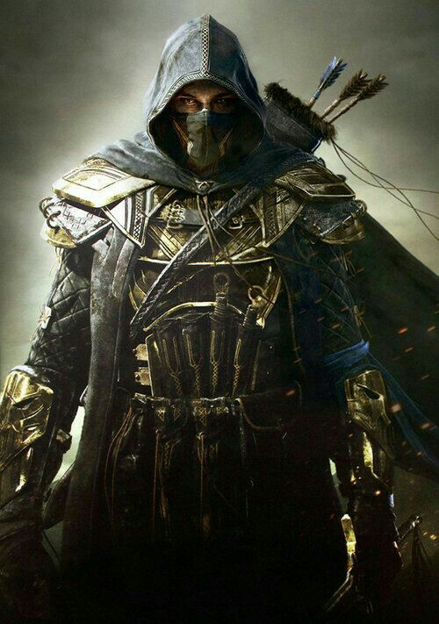](https://www.google.com/url?sa=i&rct=j&q=&esrc=s&source=images&cd=&cad=rja&uact=8&ved=2ahUKEwiay4-j0YXaAhULy2MKHQwaAj0QjRx6BAgAEAU&url=https://www.pinterest.com/pin/218776494377372546/&psig=AOvVaw3dwu0-UtCSMTmyfp6wefNO&ust=1522004104213780)

Susurro Windswept drank a potion of *cat’s grace [expired on Round 179]*, and surveyed the horizon to ensure that no surprise attacks would come from any other direction.

Cruel-Déjà Huhlgarix drank a potion of *eagle’s splendor [expired on Round 189]*.

Kondrat of Netheril drank a potion of *eagle’s splendor [expired on Round 179]*.

Big Brother Bothammers drank a potion of *cat’s grace [expired on Round 179]*.

[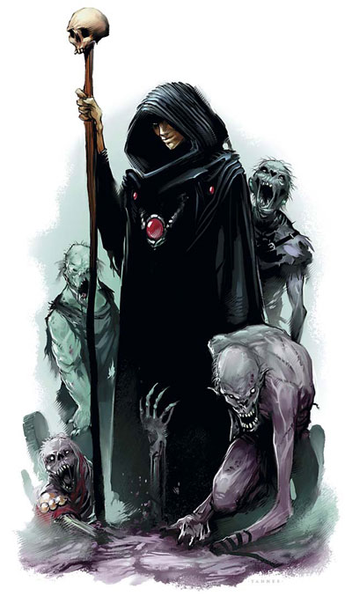](http://www.google.com/url?sa=i&rct=j&q=&esrc=s&source=images&cd=&cad=rja&uact=8&ved=2ahUKEwjQqOG90YXaAhUU5mMKHa13AIAQjRx6BAgAEAU&url=http://forgottenrealms.wikia.com/wiki/Necromancy&psig=AOvVaw1H23FtUjRRoni72JF-Vbmd&ust=1522004157310560)

Darkfather Aquíferoz thought of the numerous maladies he could inflict upon the heroes when they got a little closer, so he waited patiently for now, casting a *message* spell for a certain someone in the cavalry.

Who the Bone Whisperer cast *insect plague [expired on Round 249]*.

The insect plague—comprised of three coterminous swarms of locusts—flew in the direction of the heroes, targeting the cluster of five.

Bastilles Croixième had the heroes within 2 range increments, and the scout now took a couple of shots at his flying counterpart.

|  |  |  |  |  |  |  |  |  |
| --- | --- | --- | --- | --- | --- | --- | --- | --- |
| **Character** | **Attack Type** | **Damage** | **BAB** | **Mod+** | **W+** | **Other+** | **d20** | **Total** |
| Bastilles Croixième | Scimitar +2 | 1d4+2 | 6 | 1 | 2 | -2 height -2 range | 13 | 22 |
| Bastilles Croixième | 2nd Attack | 1d4+2 | 1 | 1 | 2 | -2 height -2 range | *1* | 5 |

*Miss, miss.*

Blingschteiver screamed some bloody murder at the top of his lungs, taunting Jason and the others to step on up and get their craniums cracked.

[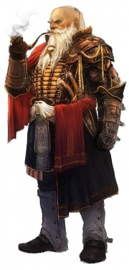](https://www.google.com/url?sa=i&rct=j&q=&esrc=s&source=images&cd=&cad=rja&uact=8&ved=2ahUKEwie47Gg04XaAhVQyWMKHXMrB7MQjRx6BAgAEAU&url=https://www.dandwiki.com/wiki/Noble_(3.5e_Template)&psig=AOvVaw0xw27NwiGmHReC8kOP5nC-&ust=1522004630306133)

Jarvis Rutherfyord III was a man with many gadgets, and now touched his Greater Crystal of Aquatic Action just to make sure it was there. It didn’t need activation, as did his healing belt and other doodads, but he rubbed it anyway for good measure. Smoking Perception Spice in a Pipe of Wisdom +3, it was the aristocrat who had first spotted the heroes almost a minute ago, and alerted the rest with a single call that the heroes had been too far to hear. He cast *sanctuary* from a scroll, and folded his arms as the battle unfolded.

Frayed flew at top speed again, almost getting into long spellcasting range.

Magpie continued flying towards the cavalry, regaining top speed, but not quite catching up to Frayed. Kali and Caleb flew in the middle of the cluster of heroes.

The dragon shaman’s Aura of Senses turned to one of Toughness, recognized by Jason, who had traveled extensively with Persephone, a brass dragon shamaness.

