Round 140

Jason and the cavalry were no more than 600’ from one another by now, and could see the white foam of the shallow waves breaking just a few feet from the sandy shore. It was a good day to die, but a better one to vanquish evil under the morning sun and amidst the evaporating snow that barely covered the treetops down here along the coast. Independent of the *mass fly* spell cast on most of his band, Jason picked up speed again.

Magpie guessed that she was now within long range of the cavalry, and she was right, but realized that she was *not* within range of Who, the Bone Whisperer, when she cast *silence* upon the robed gnome perched atop the rock a few hundred feet south of the shore.

Caleb cast *fireball* on the same targets that Frayed was setting his sights onto.

|  |  |  |  |  |
| --- | --- | --- | --- | --- |
| **Character** | **Save vs.**  *fireball* | **Ranks** | **Roll** | **Save** |
| Cruel-Déjà Huhlgarix | Reflex | 5 | 2 | 7 |
| Kondrat of Netheril | Reflex | 5 | 11 | 16 |
| Big Brother Bothammers | Reflex | 3 | 14 | 17 |
| Thymos the Redhanded | Reflex | 6 | 19 | 25 |
| Horse | Reflex | 4 | 13 | 17 |
| Horse | Reflex | 4 | 20 | 24 |
| Horse | Reflex | 4 | 18 | 22 |
| Ecalypse | Reflex | 10 | 4 | 14 |

*Fail, fail, fail, success, fail, success, success, fail.*

*Dmg to Cruel-Déjà: ½ x 24 = 12 fire.*

*Dmg to Kondrat: ½ x 26 = 13 fire.*

*Dmg to Big Brother: ½ x 36 = 18 fire.*

*Dmg to Thymos: 27 fire.*

*Dmg to Cruel-Déjà’s horse: 44 fire.*

*Dmg to Big Brother’s horse: ½ x 29 = 15 fire.*

*Dmg to Thymos’ horse: ½ x 41 = 21 fire.*

*Dmg to Kondrat’s ecalypse: 34 fire.*

Cruel-Déjà Huhlgarix jumped off of his dying horse as it caught on fire, cursing the heroes for their preemptive aggression. He took a few steps to the northwest, as did Thymos the Redhanded.

Kondrat of Netheril and Big Brother Bothammers had sturdier mounts, and now spurred them onward to get away from their fellow combatants. The dwarf joked with Blingschteiver, “Looks like you’ve got some competition!”

*Heavy warhorse and ecalypse gained 12 + 7 = 19 and 9 + 7 =16 hps, respectively.*

The barbed devil emerged from the water, dripping with saltwater and looking for a fight.

Caleb stopped completely, focusing solely on his evocative spellcasting. Having deferred his offensive spellcasting until the moment when he reached 840’ from his enemies, Frayed started lobbing what would probably be a series of Warmage *fireballs*, spending a full round on the cast to use Energy Substitution (Electricity) to make them Warmage *lightning balls*. He tried to target the cavalry, seeing as the other living targets were still too far away, and the zombies were both beneath his notice *and* not the people he really, really wanted to murder. Caleb’s first *fireball*, however, had caused those caught in it to scatter, but others in the cavalry had not had time to react, and their mounts had reared up, rampant from the fear of the explosion that nearly caught the entire cavalry.

|  |  |  |  |  |
| --- | --- | --- | --- | --- |
| **Character** | **Save vs.**  *Fireball (electric)* | **Ranks** | **Roll** | **Save** |
| Blingschteiver | Reflex | 4 | 8 | 12 |
| Bastilles Croixième | Reflex | 9 | 14 | 23 |
| Susurro Windswept | Reflex | 9 | 19 | 28 |
| Horse | Reflex | 4 | 20 | 24 |
| Horse | Reflex | 4 | 14 | 18 |
| Horse | Reflex | 4 | 1 | 5 |

*Fail, success, success, success, fail, fail.*

*Dmg to Blingschteiver: 39 + 4 = 43 electric.*

*Dmg to Bastilles: ½ x (26 + 4) = 15 electric.*

*Dmg to Susurro: 0 [Evasion].*

*Dmg to Blingschteiver’s horse: ½ x (41 + 4) = 23 electric.*

*Dmg to Bastilles’ horse: 39 + 4 = 43 electric.*

*Dmg to Susurro’s horse: 34 + 4 = 38 electric.*

Only the warmage managed to get his horse out of the electric blast in time; the other two mounts didn’t make it. Then the horse did actually keel over and die, and the warmage was left with even more resentment.

Susurro Windswept cracked his neck as he got back up, seeing his horse quite electrocuted.

Bastilles Croixième got up and picked up his bow as Blingschteiver cast *fireball* upon the cluster of heroes, using his Metamagic Rod of Sculpting to grab five of the six heroes within five smaller balls of fire.

|  |  |  |  |  |  |  |
| --- | --- | --- | --- | --- | --- | --- |
| **Save vs.**  *fireball* | **Rank** | **Ability & Mod.** | **Misc.**  **Mods.** | **Total** | **Roll** | **Check** |
| **Caleb, Reflex** | **4** | **Dex (+3)** | 2 | 9 | 2 | 11 |
| **Faith, Reflex** | **2** | **Dex (+1)** | 5 | 8 | 1 | 9 |
| **Jason, Reflex** | **8** | **Dex (+5)** | 1 | 14 | 12 | 26 |
| **Kali, Reflex** | **7** | **Dex (+4)** | 1 | 12 | 14 | 26 |
| **Magpie, Reflex** | **5** | **Dex (+1)** | 2 | 8 | 8 | 16 |

*Fail, fail, success, success, fail.*

*Dmg to Caleb: 27 fire [negated].*

*Dmg to Faith: 35 fire [partial damage negated] [120/125].*

*Dmg to Jason: 0 [Evasion].*

*Dmg to Kali: ½ x 25 = 13 fire [negated].*

*Dmg to Magpie: 23 fire [negated].*

“Wooohooo!” he first exclaimed, then retracted that statement. “Aw, what?” the warmage saw his fireball spell mostly ignored by the heroes, and thought to try something worse.

Scrogg the Pleasurepain positioned himself just above the shore, ready to murder someone as he lowered his altitude to 50’.

The fiendish raven flew northwesterly.

Milfuegos Mopworken saw his raven flying, and cast *summon monster II [expired on Round 150]*, but only managed to conjure another single raven for now.

Who the Bone Whisperer cast *summon undead V [expired on Round 150]*. The Bone Whisperer conjured a shadow, which made its way northwesterly.

The anchor was now about half-way to the surface, and in no risk of catching onto anything. Jarvis Rutherfyord III surveyed the fight in the air to the north, and drank a potion of *owl’s wisdom [expired on Round 190]*. He then commanded the undead sailors to set sail along a southward course, and the sails began to catch the southerly trade winds.

Before the ravens and other flying minions could get in his way, Darkfather Aquíferoz presented himself, sitting aboard one of the dinghies and casting *boreal wind* upon the archer and those behind him.

|  |  |  |  |  |  |  |
| --- | --- | --- | --- | --- | --- | --- |
| **Save vs.**  *boreal wind* | **Rank** | **Ability & Mod.** | **Misc. Mods.** | **Total** | **Roll** | **Check** |
| **Kali, Fortitude** | **7** | **Con (+1)** | 1 | 9 | 19 | 28 |

*Success. Kali staved off cold damage and remained on course.*

Though they were all still flying, they were doing so at their own peril, as the *boreal wind* would persist in throwing them off course if it hit them.

Kali, Faith, and Jason continued to fly at 60’ per round in order to stay close to the others.

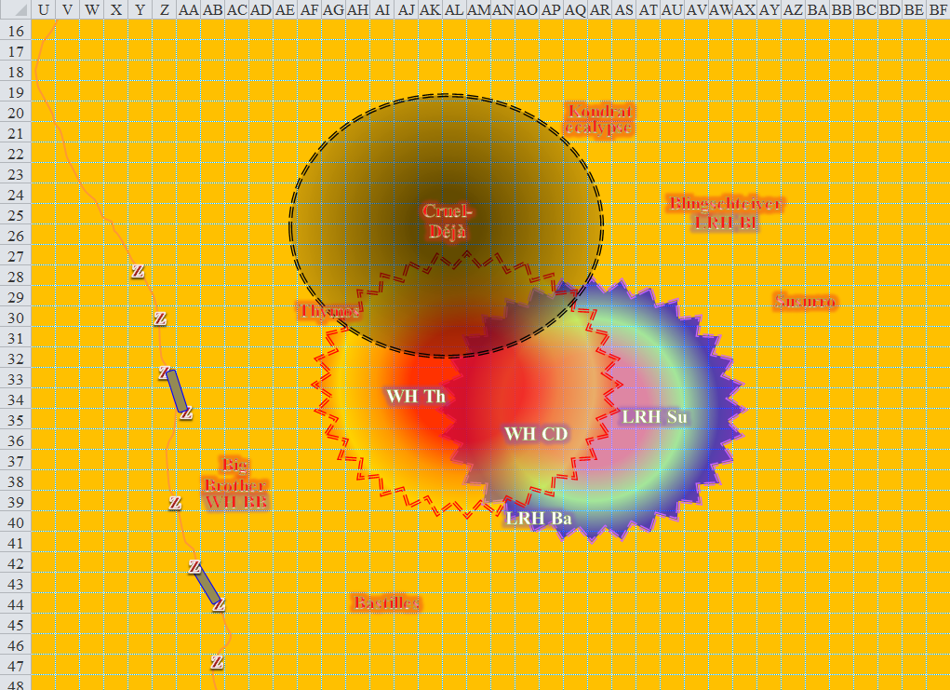

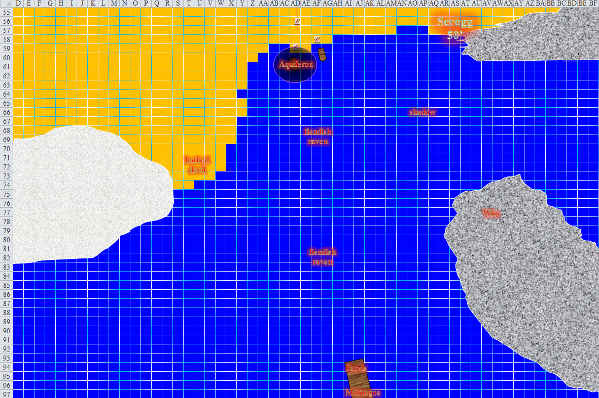

Round 141

|  |  |  |  |  |  |
| --- | --- | --- | --- | --- | --- |
| **Character** | **Group** | **Initiative** | **Roll** | **Modified Roll** | **Move** |
| Jason | 1 | 9 | 15 | 24 | 40’ |
| Kali | 1 | 8 | 8 | 16 | 40’ |
| Bastilles Croixième | 2 | 3 | 12 | 15 | 30’ |
| Milfuegos Mopworken | 2 | 2 | 11 | 13 | 20’ |
| Big Brother Bothammers | 2 | 1 | 12 | 13 | 30’ |
| Frayed | 1 | 2 | 10 | 12 | 30’+10’ |
| Cruel-Déjà Huhlgarix | 2 | 2 | 8 | 10 | 20’ |
| Jarvis Rutherfyord III | 2 | 0 | 10 | 10 | 20’ |
| Susurro Windswept | 2 | 4 | 5 | 9 | 30’ |
| Darkfather Aquíferoz | 2 | 1 | 6 | 7 | 20’ |
| Caleb | 1 | 3 | 2 | 5 | 30’+10’ |
| Blingschteiver | 2 | 2 | 3 | 5 | 20’ |
| Faith | 1 | 1 | 4 | 5 | 20’ |
| Larlum the Redhanded | 2 | 1 | 3 | 4 | 30’ |
| Scrogg the Pleasurepain | 2 | 0 | 4 | 4 | 30’ |
| Who the Bone Whisperer | 2 | 1 | 2 | 3 | 20’ |
| Magpie | 1 | 1 | 1 | 2 | 20’ |
| Thymos the Redhanded | 2 | 1 | 1 | 2 | 30’ |
| Kondrat of Netheril | 2 | 0 | 1 | 1 | 30’ |

The ravens stayed their course, as did the shadow and the barbed devil.

The locust swarms not only stayed their course; they got ahold of Jason, Caleb, and Magpie, and tried to eat them.

*Dmg to Jason: 5 + Distraction [67/72].*

*Dmg to Caleb: 7 + Distraction [74/81].*

*Dmg to Magpie: 5 + Distraction [85/90].*

|  |  |  |  |  |  |  |
| --- | --- | --- | --- | --- | --- | --- |
| **Save vs.**  Distraction | **Rank** | **Ability & Mod.** | **Misc. Mods.** | **Total** | **Roll** | **Check** |
| **Caleb, Fortitude** | **6** | **Con (+2)** | 2 | 10 | 13 | 23 |
| **Jason, Fortitude** | **4** | **Con (+0)** | 3 | 7 | 8 | 15 |
| **Magpie, Fortitude** | **3** | **Con (+3)** | 2 | 8 | 3 | 11 |

*Success, success, fail. Magpie was Distracted [Nauseated].*

With *mass resist energy* cast on him and the others, Jason moved lower and off to the right make sure he was clear of the others by 60’. He still, however, did not fire an arrow towards the enemy.

Superintendent Milfuegos—a middle-aged gnome archivist / diabolist who’d lived prosperously and honorably among the resurrected gnomes in Dothion before turning against them—still wore some of his Gondar gear, mostly just as trophies, and waited until the incoming fools got within medium spellcasting range before unleashing some of his worst preparations of the day their way. The diabolist cast *summon monster IV [expired on Round 152]*, conjuring a fiendish giant wasp that flew towards the cluster of heroes.

A giant wasp followed the trajectory of the ravens to the north, nearly catching up to the closest one.

Bastilles—a gnomish scout famous in his home town for pulling the wool over others’ eyes—and Big Brother—a dwarven fighter, smithy, and siege engineer—both drank potions of *cure moderate wounds*, and put 40’ between themselves and anyone else.

*Bastilles and Big Brother gained 10 + 4 = 14 and 8 + 2 = 12 hps, respectively.*

Cruel-Déjà—a boastful human black dragon shaman in the incessant and ambitious pursuit of draconic power—and Kondrat—an elven shade favored soul of Velsharoon—drank potions of *cure light wounds*, and moved outward to better meet their incoming foes.

*Cruel-Déjà and Kondrat gained 3 + 4 = 7 and 7 + 4 = 11 hps, respectively.*

Jarvis—a human aristocrat as well versed in the use of scrolls and other magic items as he was in the art of negotiation—read a Divination scroll that no hero could discern right now. *[detect thoughts]*

Susurro—an elven ninja who loved having zombies do his chores—didn’t do anything too flashy, and was now effectively hiding from the heroes.

Aquíferoz—an elven inquisitor of Velsharoon and former battleguard of Tempus—aimed the *boreal wind* at Jason, who was at the front of the formation.

|  |  |  |  |  |  |  |
| --- | --- | --- | --- | --- | --- | --- |
| **Save vs.**  *boreal wind* | **Rank** | **Ability & Mod.** | **Misc. Mods.** | **Total** | **Roll** | **Check** |
| **Jason, Fortitude** | **4** | Con (+0) | 3 | 7 | 16 | 23 |

*Success. Jason staved off the cold damage and remained on course.*

The scout remained on course despite the chilling gust that pushed him back and slowed him down only by a few feet.

Being commanded to do so by the black dragon shaman, Blingschteiver—a sadomasochist gnome warmage with minimal drive for self-preservation—cast *fire shield (chill) [expired on Round 149]* upon himself, wishing he’d cast his last *fireball* spell instead.

Impressed by the warmage’s nifty trick of splitting and sculpting his single *fireball* into multiple, smaller *firemarbles*, Frayed suspected the warmage was using a metamagic rod of Shaping, and called dibs on this coveted item. He might have needed to relieve the rival warmage’s smoldering corpse of that rod once he was done playing with him. By now, however, the cavalry had dispersed, so he simply lobbed his second *electrical fireball* at the other gnomish warmage.

|  |  |  |  |  |
| --- | --- | --- | --- | --- |
| **Character** | **Save vs.**  *Electric fireball* | **Ranks** | **Roll** | **Save** |
| Blingschteiver | Reflex | 4 | 10 | 14 |

*Fail. Dmg: 33 electric.*

Blingsteiver died from a burst heart and a sizzled brain.

“One down,” the former captive of the Velshari impostors accounted, “and about a dozen to go.” Frayed was not one to hold grudges for long, mostly because he usually zapped his offenders shortly after their transgressions. But then, in a shocking twist, Frayed’s *fly* spell, which should have ended a minute earlier, expired. Frayed quickly lost all horizontal momentum and began to float down until his feet touched the ground quite painlessly. He gauged that he was still about 350’ – 400’ away from the zombies making their way to the shore.

Caleb once more followed Frayed’s lead, seeing the warmage kill the other warmage, and tossing a *fireball* of his own at the dragon shaman leader of the cavalry.

|  |  |  |  |  |  |  |
| --- | --- | --- | --- | --- | --- | --- |
| **Skill** | **Rank** | **Ability & Mod.** | **Misc. Mods.** | **Total** | **Roll** | **Check** |
| **Caleb, Concentration** | 14 | **Con (+2)** | 0 | 16 | 16 | 32 |

*Success.*

|  |  |  |  |  |
| --- | --- | --- | --- | --- |
| **Character** | **Save vs.**  *fireball* | **Ranks** | **Roll** | **Save** |
| Cruel-Déjà Huhlgarix | Reflex | 5 | 7 | 12 |

*Fail. Dmg: 29 fire.*

The dragon shaman cursed the warmage-evoker as he changed his draconic aura to Power, moving towards the coast and drinking a potion of *cure serious wounds*.

*Cruel-Déjà gained 20 + 8 = 28 hps, and +3 to melee damage.*

Frayed and Caleb considered that part of their enemies’ tactics involved drinking potions and sapping the heroes of their most powerful and far-reaching spells. Kali and Faith did not think about this as they separated to 20’ between them and kept the others 50’ to their left.

Scrogg—an ogre mage diviner looking forward to retirement—descended to 35’ and flew northwestward with his greatsword in his hand, remembering that he *almost* killed Magpie less than a half-hour ago at the bluffs. At this rate, he’d have the scout in his midst within seconds, and the little witch shortly thereafter. Maybe a jousting charge would be best. Yes!

Who—a gnomish dread necromancer who had managed more than a few cemeteries in ages past—wanted to cast another serving of *insect plague*, and completely envelop these bozos, but instead cast *summon undead V [expired on Round 150]*, bringing forth an allip that floated high overhead towards the heroes with great, chattering delight. Most of the villains were mighty enough to repel the creature’s hypnotically compelling chatter, but it was just proper courtesy to Aquíferoz and the others to send this creature directly to the heroes, avoiding all others by keeping at a reasonable altitude until reaching the human scout or those behind him.

Magpie was nauseated for the moment, and could do nothing but fly. She could have tried to fly at full speed for a few seconds as the combat around her unfolded, but that would have ended her and Caleb’s flight capability, so she struggled to stay close enough to him, seeing Kali and Faith veer off a bit from the straight path towards the shore.

Thymos—a fire genasi ranger with a fond appreciation for art, torture, tactical architecture, and hunting trophies—had woken up on the wrong side of the bed today, and decided that he wanted to blame Jason for it, mostly because the scout was the closest target at this point. Pointing his crossbow of fire at the human, the fire genasi said something like, “Take that!”

|  |  |  |  |  |  |  |  |  |
| --- | --- | --- | --- | --- | --- | --- | --- | --- |
| **Character** | **Attack Type** | **Damage** | **BAB** | **Mod+** | **W+** | **Other+** | **d20** | **Total** |
| Thymos the Redhanded | QR Heavy Crossbow of Fire | 1d10+1d6 Fire, x3 | 7 | 2 | 1 | -4 range – 2 height | 8 | 11 |

*Miss.*

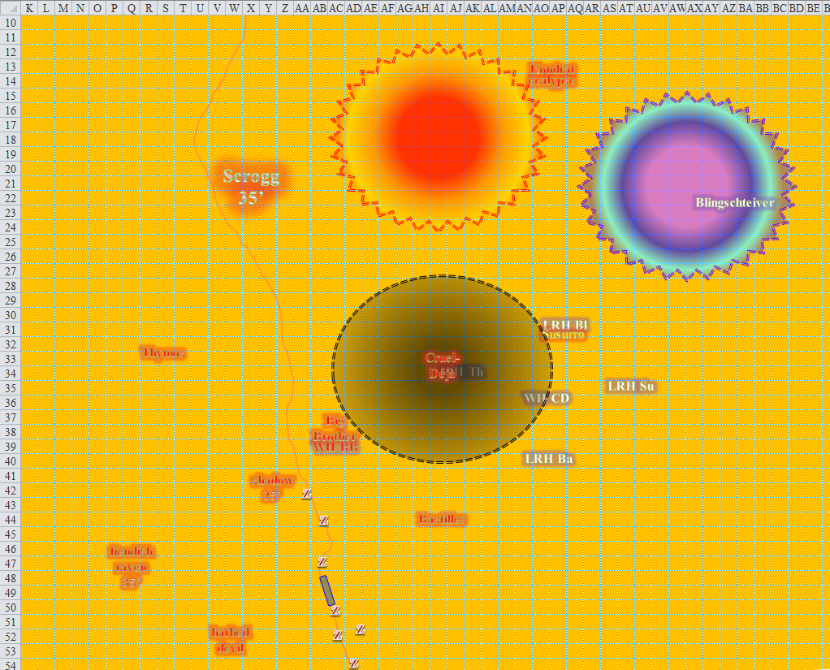

Round 142

The ravens, shadow, and giant wasp continued northwest. The barbed devil headed north some more.

All three locust swarms were still perfectly intact, but were not as fast as Jason, who was achieving his top speed without the need to cast any spells. He was only a few hundred feet away from the nearest enemy on the ground, and the ogre mage was now within one range increment.

Because Caleb had been casting spells, he wasn’t able to outrun the locust swarm that got ahold of him, and the one that had lost its grip on Jason also now meandered towards him.Magpie had just barely outrun the swarm that got her, but she had to stay near Caleb, and that third swarm was now heading for him.

Then, Magpie, Faith, Kali, and Caleb all dropped down from their 15’ to 25’ altitude flight, and touched down with no damage or need to regain their footing. Caleb noted that his flight spell had lasted 12 seconds longer than expected, and nodded to himself as the three swarms converged on him.

*Dmg to Caleb: 6 + 7 + = 13 + Distraction2 [61/81].*

|  |  |  |  |  |  |  |
| --- | --- | --- | --- | --- | --- | --- |
| **Save vs.**  Distraction | **Rank** | **Ability & Mod.** | **Misc. Mods.** | **Total** | **Roll** | **Check** |
| **Caleb, Fortitude** | **6** | **Con (+2)** | 2 | 10 | 5 | 15 |
| **Caleb, Fortitude** | **6** | **Con (+2)** | 2 | 10 | 14 | 24 |

*Success, success. Caleb was not Distracted [Nauseated].*

Bastilles had always enjoyed watching rodents rot, and often hung them in the window of whatever room he was occupying. He fired three quick arrows in the direction of the scout, who was the only hero still flying.

|  |  |  |  |  |  |  |  |  |
| --- | --- | --- | --- | --- | --- | --- | --- | --- |
| **Character** | **Attack Type** | **Damage** | **BAB** | **Mod+** | **W+** | **Other+** | **d20** | **Total** |
| Bastilles Croixième | Composite Longbow +2 | 1d6 | 6 | 3 | 2 | -4 range -2 height | 14 | 16 |
| Bastilles Croixième | 2nd Shot | 1d6 | 1 | 3 | 2 | -4 range -2 height | *19* | 16 |
| Bastilles Croixième | Rapid Shot | 1d6 | 6 | 3 | 2 | -4 range -2 height | 9 | 11 |

*Miss, miss, miss.*

Milfuegos hadn’t always been a mean bastard. He once was beloved by many in Dothion, the more populated layer of Bytopia’s twin realms. Today, though, he was an unforgivable son of devils, and considered his next casting. The Master *had* instructed them to conjure as many monsters as possible and unleash them against the foes in order to weaken them; he likely wanted to seize at least one alive, if possible. Holding his Devil’s Mace in one hand and seeing his barbed devil jogging over to meet Frayed, the man dubbed “Milf” cast *summon monster III [expired on Round 153]* and conjured a fiendish dire bat that made off northward like a bat out of Hell.

The dire bat was not as fast as the wasps, but would outfly a raven on any day, and now joined the flying offensive into the fray. The frontmost fiendish giant wasp swooped down upon Jason, but did not yet reach him. Almost, though.

Big Brother had also started off on a nice guy path, but somewhere along the way, he’d smashed one too many heads, and started getting a persistent hankering for violence. Eventually, some diabolical manipulator inducted the dwarf into a life of profitable sin, and he now found himself in the employ of Larlum. The fighter dismounted, then walked 60’ southeast, taunting the flying scout who was still approaching at an alarming rate. His mount made its way east at a moderate canter.

Susurro was the only soul among the cavalry who had been born into corruption. Like Larlum, he had diabolical heritage, but his was so faint, that it did not manifest in any discernible way. The ninja had grown accustomed to a life alone until learning of this band of zombifying worshippers of Velsharoon. The elf now waited for the right moment to act.

Cruel-Déjà had a young piece of gnome flesh waiting at home, bound and prodded in place. The dragon shaman was not a trophy hunter in the same sense as the ranger, but he *did* enjoy a long walk along the beach followed by the ravaging of a bound slave waiting patiently at the lair. The dragon shaman shifted position on the battlefield, reaching the rocks by the breaking waves.

Jarvis spoke with Milfuegos about the progress on the battlefield so far, and seemed pleased to anyone who saw him up close.

Aquíferoz was Larlum’s right-hand fiend. The elven cleric formerly known as “Queef”, loyal to Larlum’s patronage and true to his faith in Velsharoon, directed the course of the *boreal wind* towards Jason some more.

|  |  |  |  |  |  |  |
| --- | --- | --- | --- | --- | --- | --- |
| **Save vs.**  *boreal wind* | **Rank** | **Ability & Mod.** | **Misc. Mods.** | **Total** | **Roll** | **Check** |
| **Jason, Fortitude** | **4** | Con (+0) | 3 | 7 | 12 | 19 |

*Success. Jason staved off the cold damage and remained on course.*

The interrogator-priest was not pleased with the outcome of this particular spell, and thus thought to change his strategy.

Before dying, Blingschteiver had wished that Cruel-Déjà would lock him up in one of his kennels and treat him like one of his whores, but fate had caused the dragon shaman to not feel any affection for the warmage. Consequently, his pent-up angst manifested itself in destructive ways, and he had hoped to be punished for some mistake or incompetence on his part. Hopefully, he got his wish in the end.

Scrogg enjoyed long walks on the beach with old friends, and candle wax on the nipples when first meeting someone, and continued her flying charge towards Jason, hoping he had some wax on him.

The Bone Whisperer wore the teeth and phalanges of just about every arch-enemy he’d ever slain, and he was now choosing which of the heroes he would spend his time with, taking every molar, incisor, and canine before moving on to the fingers. He now saw his unholy creations flying towards poor Jason, and cast *summon monster IV [expired on Round 153]*, conjuring yet another allip, who followed the first one north-northwestward.

Thymos didn’t really like to talk about his feelings, much less justify his penchant for hurting others and mounting their heads on plaques. Already fed up with these lightweights, he rapid fired his quick-reload crossbow.

|  |  |  |  |  |  |  |  |  |
| --- | --- | --- | --- | --- | --- | --- | --- | --- |
| **Character** | **Attack Type** | **Damage** | **BAB** | **Mod+** | **W+** | **Other+** | **d20** | **Total** |
| Thymos the Redhanded | QR Heavy Crossbow of Fire | 1d10+1d6 Fire, x3 | 7 | 2 | 1 | -4 range – 2 height | 3 | 13 |

*Miss, miss.*

Kondrat enjoyed candle wax as well, but not until she knew her partner well. She now cast *silence* on Frayed.

|  |  |  |  |  |  |  |
| --- | --- | --- | --- | --- | --- | --- |
| **Save vs.**  *silence* | **Rank** | **Ability & Mod.** | **Misc. Mods.** | **Total** | **Roll** | **Check** |
| **Frayed, Will** | **12** | **Wis (+0)** | 3 | 15 | 11 | 26 |

*Success. Silence is ineffective.*

Unscathed by the gradual drop and unaffected by the *silence* spell, Frayed shot an *electrified fireball* at the largest collection of non-zombie enemies he could find. As it happened, however, the enemy had realized that the heroes were also fans of the *fireball* spell, so they were all at least 30’ from one another. The warmage-evoker had wanted to target the dragon shaman, seeing as the poor fellow was not apparently protected from either fire or electricity, but the man had gone south, and was probably just outside his spellcasting range. Pity. He tried the barbed devil instead.

|  |  |  |  |  |
| --- | --- | --- | --- | --- |
| **Character** | **Save vs.**  *Electric fireball* | **Ranks** | **Roll** | **Save** |
| Barbed Devil | Reflex | 14 | 2 | 16 |

*Success. Saves for ½ damage. Dmg: ½ x 33 = 17 electric.*

The barbed devil seemed upset now.

Magpie knew that devils were usually immune to fire damage, but in a genuinely shocking twist, touched down on the ground and used her Goggles of the Golden Sun and a 3rd-level spell slot to cast *fireball* at the swarms that now infested Caleb. Their resistances should protect them.

|  |  |  |  |  |  |  |
| --- | --- | --- | --- | --- | --- | --- |
| **Save vs.**  *fireball* | **Rank** | **Ability & Mod.** | **Misc. Mods.** | **Total** | **Roll** | **Check** |
| **Caleb, Reflex** | **4** | **Dex (+3)** | 2 | 9 | 19 | 28 |
| **Magpie, Reflex** | **5** | **Dex (+1)** | 2 | 8 | 10 | 18 |

*Success, success. Both saved for ½ damage.*

|  |  |  |  |  |
| --- | --- | --- | --- | --- |
| **Character** | **Save vs.** | **Ranks** | **Roll** | **Save** |
| Locust Swarm 1 | Reflex | 6 | 3 | 9 |
| Locust Swarm 2 | Reflex | 6 | 10 | 16 |
| Locust Swarm 3 | Reflex | 6 | 16 | 22 |

*Swarm 3 saved for ½ damage.*

*Dmg to Caleb: ½ x 32 = 16 fire [negated].*

*Dmg to Magpie: ½ x 37 = 19 fire [negated].*

*Dmg to Swarm 1: 36 fire.*

*Dmg to Swarm 2: 27 fire.*

*Dmg to Swarm 3: ½ x 29 = 15 fire.*

One of the three swarms remained whole, though many of its constituent members were hurt or dead. Magpie thought to try that again on another occasion, but perhaps she could finish the swarm off with something less dramatic.

Caleb thanked her as he struggled successfully against the locust swarm, barely able to cast a spell for the moment.He then moved 30’ out of the swarm while getting out a scroll of *magic circle vs. evil*. He cast it upon himself, knowing that no summoned creature could enter the circle, at least not any of the evil ones coming at them.

The giant wasp and other flying conjurings continued heading towards Jason, who seemed to be the most suitable target, given their parameters.

Jason—still flying—looked around for the nearest enemy, which wasn’t too difficult, seeing as he was about to joust with the flying ogre mage in like 2 seconds. At this rate, he doubted he would make it through alive with so many combatants. He passed the cover of the trees on his left side and looked to see where the others were, which was a few hundred feet behind him. With the ogre mage’s sword about to swipe him, the scout did the first part of a 180 and traveled at full speed back toward the group.

*[He could only make a 90o turn with a 5’ penalty (see Table 2-1 in DMG 20), which would allow for the completion of the 180o on the next round. I will assume that the direction of the turn is mostly (85’) upward and slightly (20’) eastward. See map below.]*

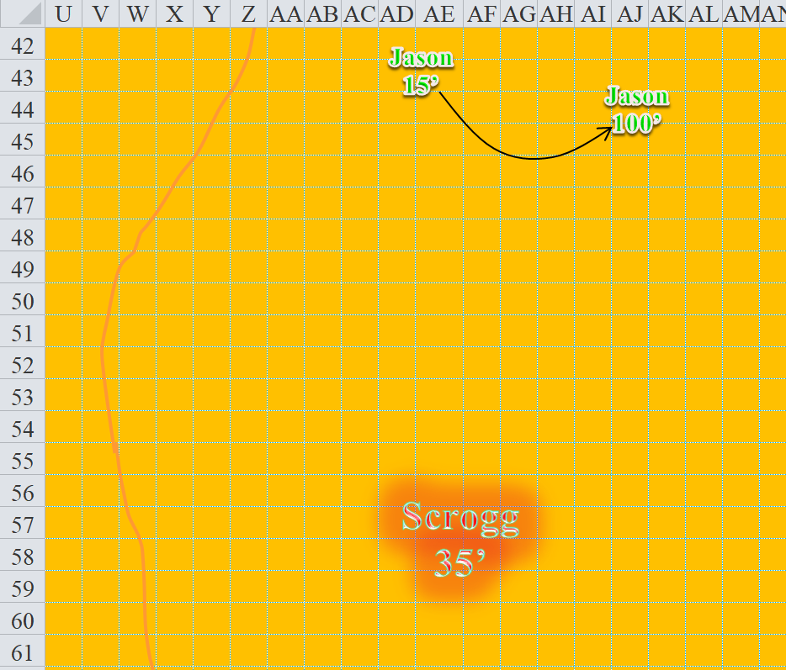

Kali’s and Faith’s fly time had just ended, and now they glided to the ground to be on equal terms with their friends. They were nowhere near anyone they could attack. Kali drank her *barkskin* potion and the two moved forward *[60’]* at a run.

*Kali gained +2 to FFAC and AC (for a total of 32!!).*



Round 143

Rather than worry about the swarm for a moment, Magpie moved into the *magic circle*, then channeled her goggles again to launch a *fireball*, this time at the ogre mage. Why bother with hot wax when you can simply concentrate on the Heat. “Jason, fall back!” She called to the scout.

|  |  |  |  |  |
| --- | --- | --- | --- | --- |
| **Character** | **Save vs.**  *fireball* | **Ranks** | **Roll** | **Save** |
| Scrogg the Pleasurepain | Reflex | 6 | 9 | 15 |

*Fail. Dmg: 32 fire.*

The shemale ogre mage growled with searing pain, not sure about who cast that fiery malady. “Team Laaaaarluuuuum, bitznatchezzzzz!”

Frayed noticed Jason was in a not ideal spot, so also focused his ire on the ogre mage, sending a *lightning ball* his way. Much like Jason’s forward positioning made him a target, Scrogg was facing the same thing.

|  |  |  |  |  |
| --- | --- | --- | --- | --- |
| **Character** | **Save vs.**  *lightning fireball* | **Ranks** | **Roll** | **Save** |
| Scrogg the Pleasurepain | Reflex | 6 | 15 | 21 |

*Success. Saves for ½ damage. Dmg: ½ x 42 = 21 electric.*

“Oh, you fuck!” the ogre mage had to add after the second fireball—an electrified one—seared him further. An allip was just outside of this *fireball*, both horizontally and altitude-wise. “You all didn’t wear enough leather for this discipline session!” the drealocked, gray-cocked, trans-G dominatrix declared, flying at will towards his enemies with a shiteatin’ grin.

The remaining locust swarm did its best to penetrate Caleb’s protective bubble, but failed.

Caleb was out of long range-spells at this point, so couldn’t join in on the Scrogg beatdown. Instead, he tried to work on finishing off the swarm, firing a quintet of *lesser acid orbs* through the mass of insects.

|  |  |  |  |  |
| --- | --- | --- | --- | --- |
| **Ranged Weapon** | **Dmg.** | **Atk** | **Roll** | **Check** |
| Ranged Touch Spell | 1d8 acid | 9 | 2 | 11 |
| Ranged Touch Spell | 1d8 acid | 9 | 11 | 20 |
| Ranged Touch Spell | 1d8 acid | 9 | 10 | 19 |
| Ranged Touch Spell | 1d8 acid | 9 | 20 | 29 |
| Ranged Touch Spell | 1d8 acid | 9 | 17 | 26 |

*Miss, hit, hit, hit, hit. Dmg: 7 + 1 + 3 + 7 = 18 acid.*

The swarm became a fluttering collection of locusts that fled, dropped dead, and eventually disappeared.

Jason completed his 180o turn, returning toward Faith and Kali, but with no time to land, turn around, or draw an arrow.

The barbed devil ran towards Frayed.

With Jason having retreated, the fiendish ravens made a beeline for Frayed as did the fiendish dire bat, shadow and fiendish giant wasp.

The allips continued to head north, not yet deciding on a target.

Bastilles Croixième rapid fired upon Jason.

|  |  |  |  |  |  |  |  |  |
| --- | --- | --- | --- | --- | --- | --- | --- | --- |
| **Character** | **Attack Type** | **Damage** | **BAB** | **Mod+** | **W+** | **Other+** | **d20** | **Total** |
| Bastilles Croixième | Composite Longbow +2 | 1d6 | 6 | 3 | 2 | –4 range –2 height | 13 | 18 |
| Bastilles Croixième | 2nd Shot | 1d6 | 1 | 3 | 2 | –4 range –2 height | *19* | 19 |
| Bastilles Croixième | Rapid Shot | 1d6 | 6 | 3 | 2 | –4 range –2 height | 15 | 20 |

*Miss, miss, miss.*

Milfuegos Mopworken nodded at something that Jarvis said, then cast his most heinous *summon monster* spell at his avail, this being a 6th-order variety *[expired on Round 154]*, and conjured a lesser efreeti.

The lesser efreeti flew towards Frayed, ready to apply its fiery slams onto the naughty gnome. It appeared that the strategy of the day seemed to be not only to have the heroes expend their most destructive spells first, but also perhaps to sacrifice as many conjured creatures in the battle so as to minimize the up-close and personal involvement of the actual villains. Caleb and Magpie could appreciate the strategy, but Faith just judged the villains for it all the more.

Big Brother Bothammers—almost back to full health now—ran northward at full speed, which wasn’t too impressive, given the half-plate he was wearing.

Cruel-Déjà Huhlgarix called all land combatants to battle, then rushed northward as well.

Susurro Windswept took his cue from the dragon shaman, and followed him within his Aura of Power.

Aboard the boat, Jarvis Rutherfyord III cast another Divination of some kind, conversing with Milfuegos all the while.

Seeing that the archer thought they were playing Chicken, Scrogg the Pleasurepain shifted his trajectory upward and charge-attacked Jason in a jousting fashion, slashing as he passed the veering human, then maintained altitude, looking towards Caleb.

|  |  |  |  |  |  |  |  |  |
| --- | --- | --- | --- | --- | --- | --- | --- | --- |
| **Character** | **Attack Type** | **Damage** | **BAB** | **Mod+** | **W+** | **Other+** | **d20** | **Total** |
| Scrogg the Pleasurepain | Greatsword +3 | 3d6+7+3/19–20 | 6 | 6 | 3 | 2 charge | 15 | 32 |

*Hit. Dmg: 10 + 7 + 3 = 20 [47/72].*

Who the Bone Whisperer hefted his scythe in one hand, wondering how the day would end. Activating his owlfeather ring, the dread necromancer flew off the rock where he was perched, then headed north-northwest.

Thymos the Redhanded fired a bolt at Jason.

|  |  |  |  |  |  |  |  |  |
| --- | --- | --- | --- | --- | --- | --- | --- | --- |
| **Character** | **Attack Type** | **Damage** | **BAB** | **Mod+** | **W+** | **Other+** | **d20** | **Total** |
| Thymos the Redhanded | QR Heavy Crossbow of Fire | 1d10+1d6 Fire, x3 | 7 | 2 | 1 | -4 range -2 height | 4 | 8 |

*Miss.*

Spurring her horse towards Jason, Kondrat of Netheril cast *hold person* on the archer.

|  |  |  |  |  |
| --- | --- | --- | --- | --- |
| **Character** | **Save vs.**  *steady mount* | **Ranks** | **Roll** | **Save** |
| Kondrat of Netheril | Ride | 11 | 15 | 26 |

*Steady ride; no Concentration check needed.*

|  |  |  |  |  |  |  |
| --- | --- | --- | --- | --- | --- | --- |
| **Save vs.**  *hold person* | **Rank** | **Ability & Mod.** | **Misc. Mods.** | **Total** | **Roll** | **Check** |
| **Jason, Will** | **4** | Wis (+3) | 1 | 8 | 7 | 15 |

*Fail. Jason was held.*

Jason remained in place, just 20’ over the ground, and maybe another 25’ southeast of where he had intended to land. Many of the non-conjured enemies cheered the shade’s efforts.

Darkfather Aquíferoz gave up on the idea of using the *boreal wind* to thwart the intruders, particularly because it wasn’t working as well as he’d liked, plus now there were too many ravens and other minions in the way. No, he now decided to just step off the dinghy onto dry land, and then he cast *summon undead III [expired on Round 155]*, summoning a ghoul to aid the villains in their plight against their aggressors.

The ghoul smiled a toothy smile and headed north.

*[PC movement not reflected on maps below.]* Faith and Kali both moved directly south 30’. Kali stood firm with a prepared full attack for any one attacking her. “There are too many of them; we cannot win this,” she called back to the others.

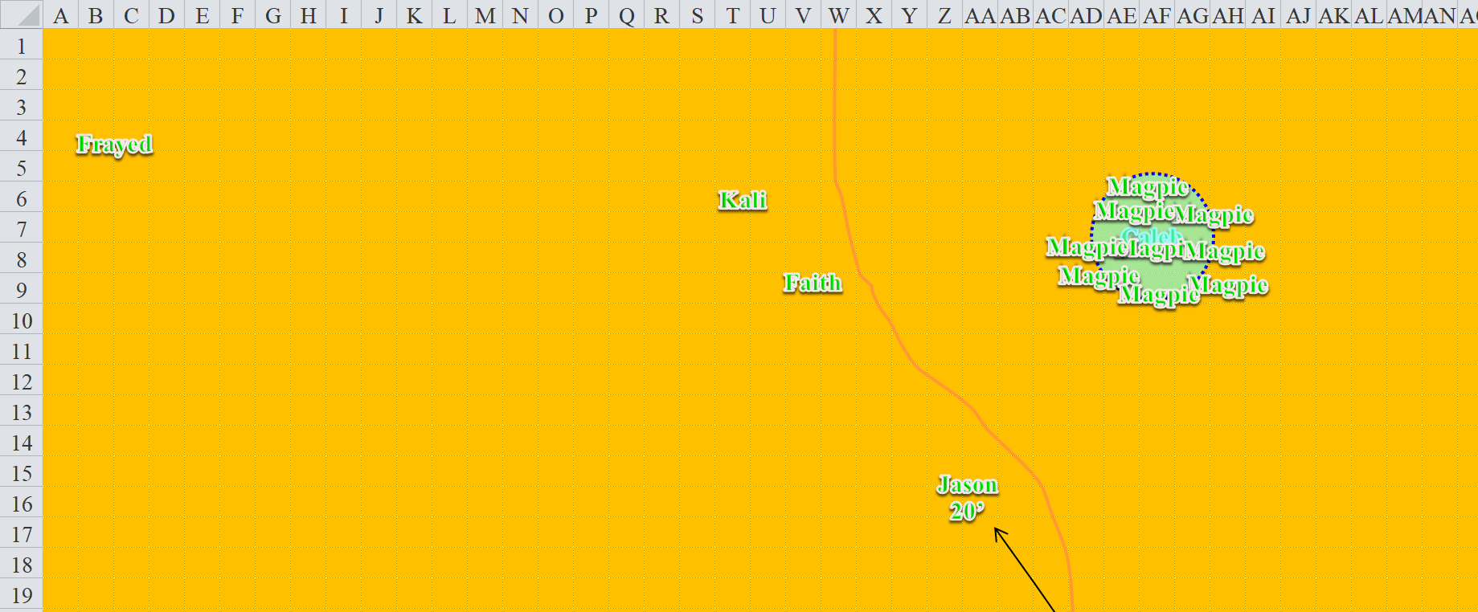

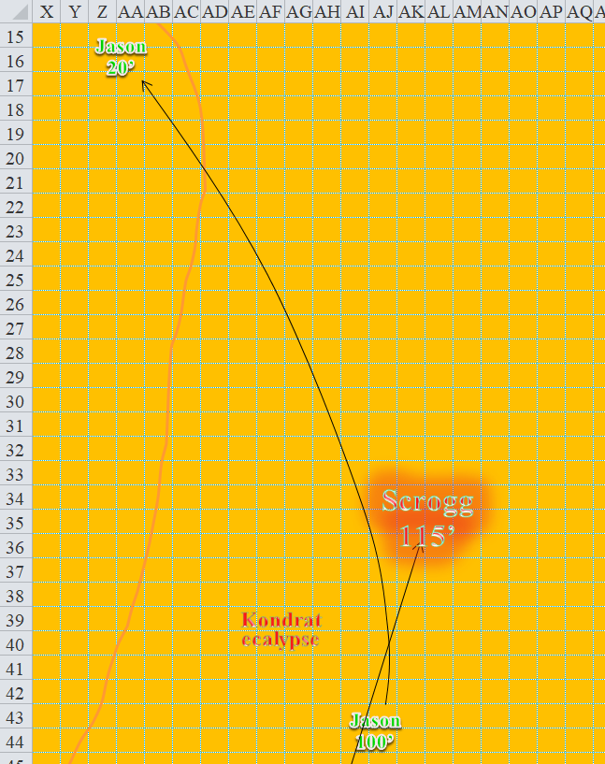

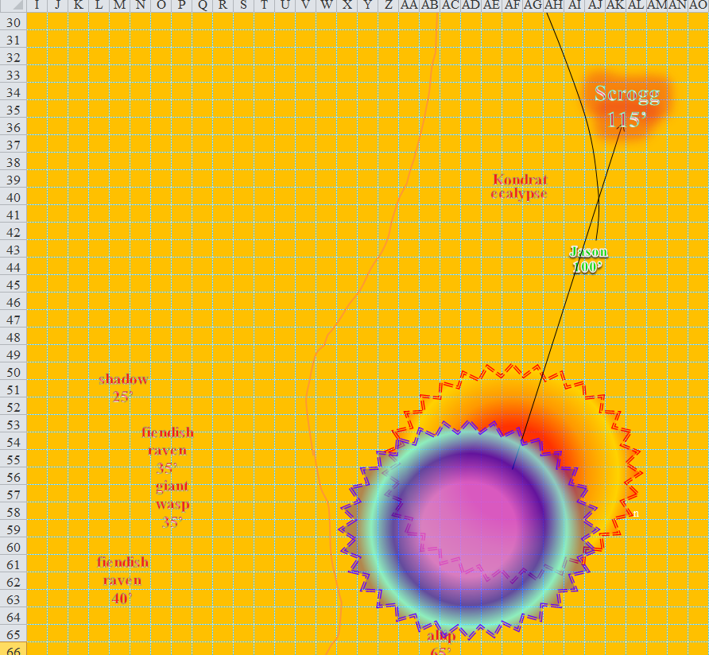

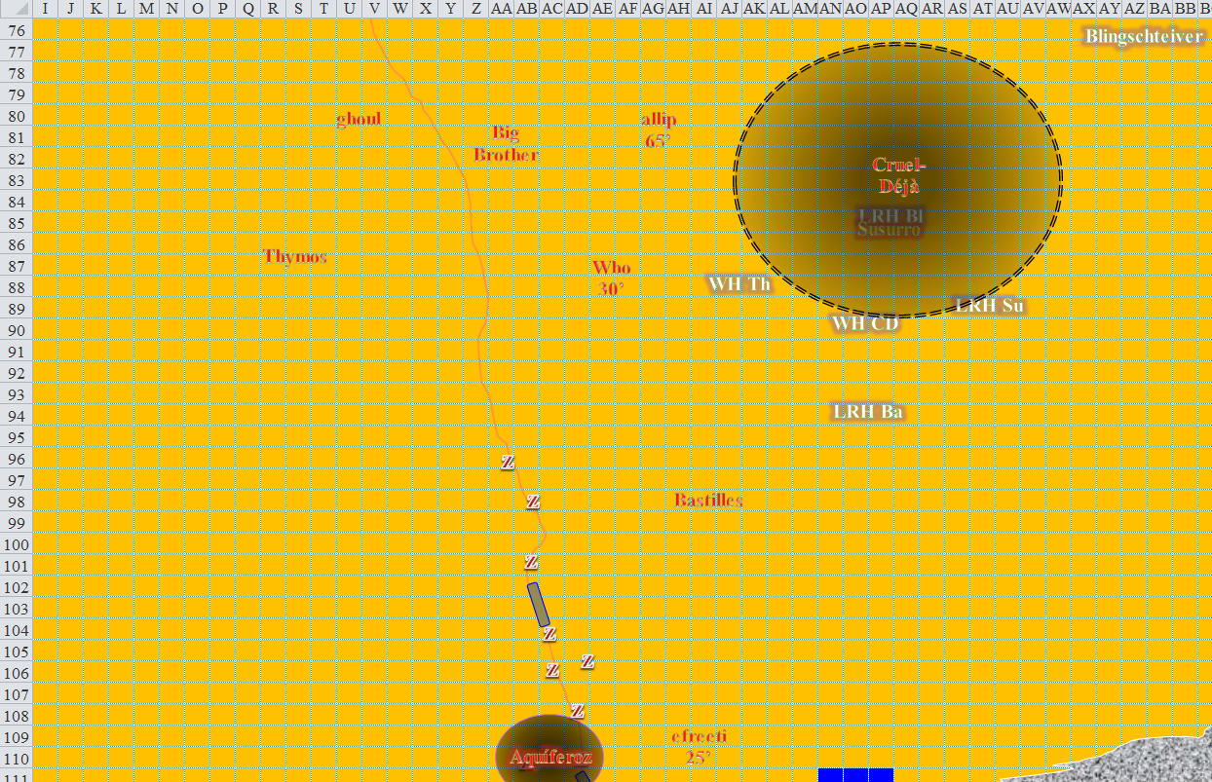

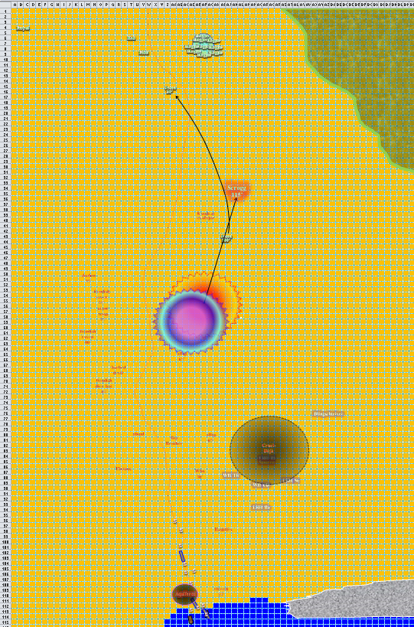

Round 144

Jason could do nothing at the moment.

|  |  |  |  |  |  |  |
| --- | --- | --- | --- | --- | --- | --- |
| **Save vs.**  *hold person* | **Rank** | **Ability & Mod.** | **Misc. Mods.** | **Total** | **Roll** | **Check** |
| **Jason, Will** | **4** | Wis (+3) | 1 | 8 | 3 | 11 |

*Fail.*

Big Brother, Cruel-Déjà, and Susurro ran northward calling out a curse or three each.

The barbed devil kept running, apparently hungry for Kali, whom it eyed. The ghoul ran along a similar trajectory. Descending slightly, the fiendish ravens continued to charge towards Jason, as did the fiendish giant wasp, fiendish dire bat, allips, efreeti and shadow.

The zombies were now almost all gathered by the two dinghies, and were now loading them rather carefully.

Bastilles skirmished at Jason.

|  |  |  |  |  |  |  |  |  |  |
| --- | --- | --- | --- | --- | --- | --- | --- | --- | --- |
| **Character** | **Attack Type** | **Damage** | **BAB** | **Mod+** | **W+** | **Other+** | **d20** | **Total** | **Targeting** |
| Bastilles Croixième | Composite Longbow +2 | 1d6 | 6 | 3 | 2 | -4 range -2 height | 16 | 21 | +3d6 skirmish |

*Hit [vs. FF AC while held]. Dmg: 6 + 2 + 7 skirmish = 15 [32/72].*

Jarvis and Milfuegos oversaw the ship’s exeunt as the zombies aboard manned the sails and steering wheel. The diabolist and aristocrat then began to put distance between the ship and the shore.

Accelerating as he descended upon the cluster of *mirror imaged* Magpies, Scrogg charge-attacked Caleb, who stood within the center of the *magic circle versus evil*.

|  |  |  |  |  |  |  |  |  |
| --- | --- | --- | --- | --- | --- | --- | --- | --- |
| **Character** | **Attack Type** | **Damage** | **BAB** | **Mod+** | **W+** | **Other+** | **d20** | **Total** |
| Scrogg the Pleasurepain | Greatsword +3 | 3d6+7+3/19–20 | 6 | 6 | 3 | +2 charge + 2 height | 10 | 29 |

*Hit. Dmg: 12 + 7 + 3 + 2 = 24 [37/81].*

Who the Bone Whisperer flew northward, calculated the distances between himself and his intended targets, sighed, and continued northward for now.

Thymos moved northward and shot another bolt at Jason.

|  |  |  |  |  |  |  |  |  |
| --- | --- | --- | --- | --- | --- | --- | --- | --- |
| **Character** | **Attack Type** | **Damage** | **BAB** | **Mod+** | **W+** | **Other+** | **d20** | **Total** |
| Thymos the Redhanded | QR Heavy Crossbow of Fire | 1d10+1d6 Fire, x3 | 7 | 2 | 1 | -4 range -2 height | 14 | 18 |

*Miss.*

Kondrat slowed her ecalypse down and cast *silence* on Magpie.

|  |  |  |  |  |  |  |
| --- | --- | --- | --- | --- | --- | --- |
| **Save vs.**  *silence* | **Rank** | **Ability & Mod.** | **Misc. Mods.** | **Total** | **Roll** | **Check** |
| **Magpie, Will** | **7** | **Wis (+2)** | 2 | 11 | 7 | 18 |

*Success. Spell negated.*

The beguiler shook her head, noting that it was the shade favored soul of Velsharoon mounted atop the ecalypse who had emitted the somatic gestures to cast that spell on her, and thought *she* might make a fine example for the others.

Ignoring the fleeting ship, Aquíferoz laughed as he looked like he was running for the first time in months. Then he gave up the attempt and cast *silence* on Frayed.

|  |  |  |  |  |  |  |
| --- | --- | --- | --- | --- | --- | --- |
| **Save vs.**  *silence* | **Rank** | **Ability & Mod.** | **Misc. Mods.** | **Total** | **Roll** | **Check** |
| **Frayed, Will** | **12** | **Wis (+0)** | 3 | 15 | 16 | 31 |

*Success. Spell negated.*

“Ooh!” Frayed could tell. “Try to *silence ME*!” He couldn’t figure out who cast it, but he would surely blast them into oblivion if he found them out. Frayed didn’t want to see Caleb cut down, but felt the ogre mage was probably looking pretty rough at this point, so he used a Warmage spell slot to *magic missile* the ogre mage, hoping to end this fellow’s days.

|  |  |  |  |  |
| --- | --- | --- | --- | --- |
| **Frayed** | **Dmg.** | **Atk** | **Roll** | **Check** |
| Bypass Spell Resistance | Warmage | 8 | 15 | 23 |

*Spell Resistance bypassed. Dmg: 12 + 5 = 17 magic [force].*

And the beast remained alive!

Caleb grimaced, then squinted, and aimed as he targeted the ogre mage with his other *lesser orb of acid* spell, calling to Frayed, “I don’t like our odds!”

Frayed shrugged a bit, “I’m still doing fine!”

Faith and Kali attacked no one, seeing as they had no available melee combatant within their reach. Kali moved to W14.

Magpie was too far to notice that someone had cast the same *silence* spell on Frayed. Realizing that there had been an attempt to *silence her*, Magpie grumbled as the ogre mage came swooping in. “Stupid giants and their stupid swords.” She cast *whelm* at the ogre mage, hoping to help down him.

|  |  |  |  |  |
| --- | --- | --- | --- | --- |
| **Magpie** | **TH+** | **Atk** | **Roll** | **Check** |
| Bypass Spell Resistance | 2 | 14 | 18 | 32 |

*Success. Spell resistance bypassed.*

|  |  |  |  |  |
| --- | --- | --- | --- | --- |
| **Character** | **Save vs.**  *whelm* | **Ranks** | **Roll** | **Save** |
| Scrogg the Pleasurepain | Will | 8 | 2 | 10 |

*Fail. Dmg: 15 nonlethal.*

The ogre mage was nearly dead or knocked out by now, and emitted a noise that could best be written as, “Whoahoa!”

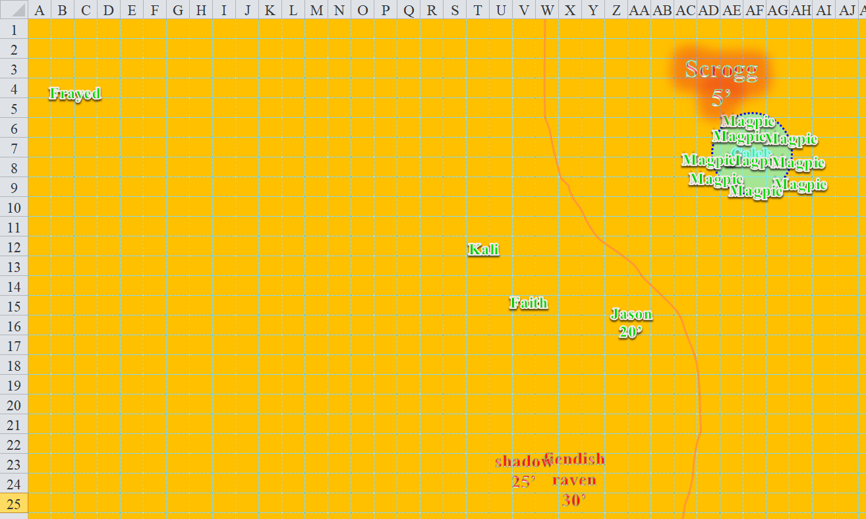

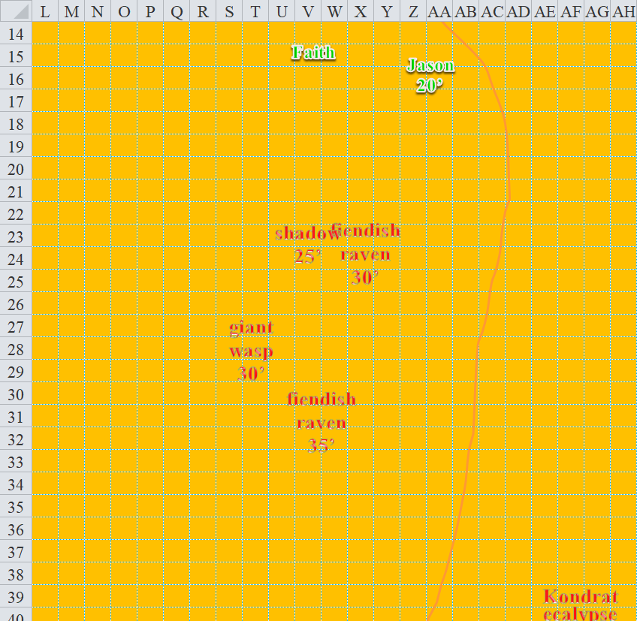

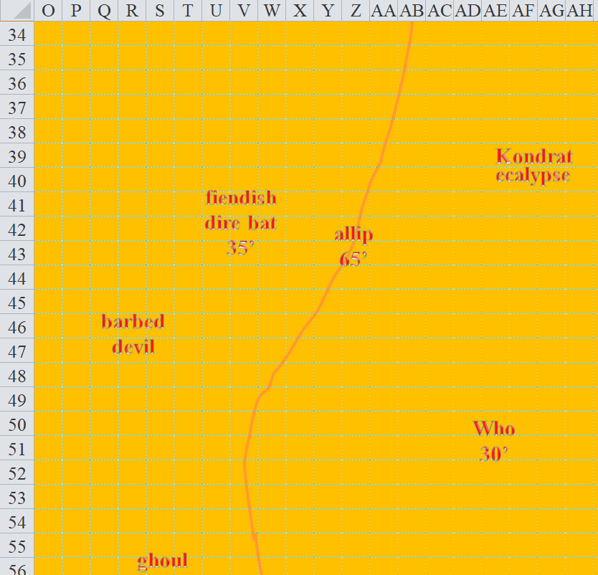



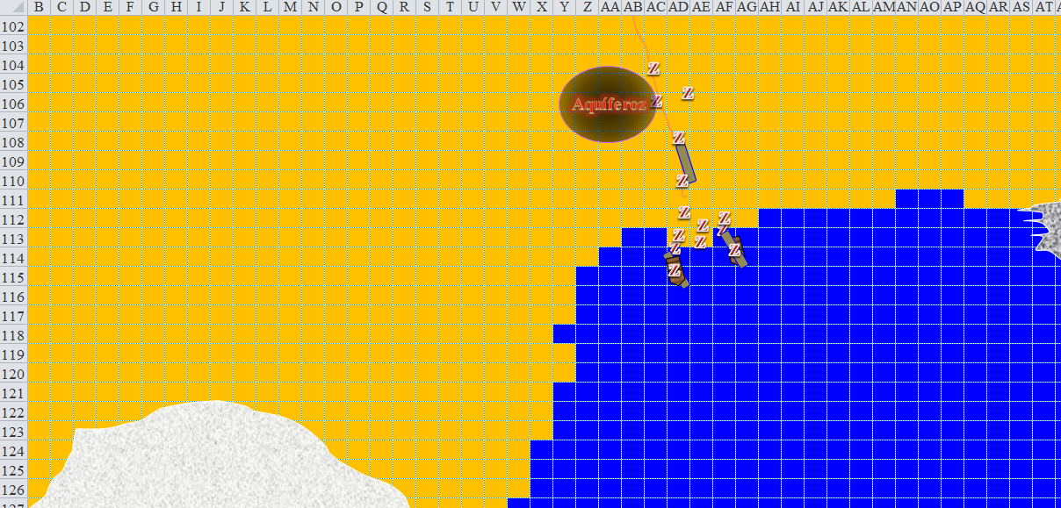

Round 145

Jason struggled against the *hold person* spell, and finally was able to break free from its stiffening compulsion.

|  |  |  |  |  |  |  |
| --- | --- | --- | --- | --- | --- | --- |
| **Save vs.**  *hold person* | **Rank** | **Ability**  **& Mod.** | **Misc.**  **Mods.** | **Total** | **Roll** | **Check** |
| **Jason, Will** | **4** | Wis (+3) | 1 | 8 | 12 | 20 |

*Success.*

The floating archer then northeastward to face his enemy, and backed up 30’ lowering himself in the process to an altitude of 10’. He then fired an arrow at the other mage.

|  |  |  |  |  |  |  |  |  |  |  |
| --- | --- | --- | --- | --- | --- | --- | --- | --- | --- | --- |
| **Ranged Weapon** | **Dmg.** | **D+** | **TH+** | **Critical** | **Rng.** | **Wt.** | **Atk** | **Roll** | **Check** | **Notes** |
| Sacred Composite Longbow, Skirmish | 1d8 | +1 +3d6 +2 | 1 | 19-20/x3 | 200’ |  | +15 | 6 | 21 |  |
| Crystal of Cold Assault, Greater | - | 1d6 | - | - | - |  | - | - | - | -1 to AC 1 round |

*Hit. Dmg: 5 + 1 + 2 + 10 skirmish = 18.*

This was enough to kill the ogre mage, or perhaps render him unconscious, who dropped dead with a thud onto the sandy ground.

Without immediate targets within their reach, Kali and Faith looked as threatening as possible *[actions deferred, see below]*.

Magpie liked the way the *whelm* spell had worked, but the other foes were still too far away for this spell. Instead, she cast a *fireball* spell toward Kondrat.

|  |  |  |  |  |
| --- | --- | --- | --- | --- |
| **Character** | **Save vs.**  *fireball* | **Ranks** | **Roll** | **Save** |
| Kondrat of Netheril | Reflex | 5 | 15 | 20 |
| Ecalypse | Reflex | 10 | 13 | 23 |

*Success, success. Both saved for ½ damage.*

*Dmg to Kondrat: ½ x 30 = 15 fire.*

*Dmg to Ecalypse: ½ x 32 = 16 fire.*

Frayed cheered at the ogre mage’s death, and cast *Electrical fireball* upon Kondrat and the ecalypse.

|  |  |  |  |  |
| --- | --- | --- | --- | --- |
| **Character** | **Save vs.**  *Electric fireball* | **Ranks** | **Roll** | **Save** |
| Kondrat of Netheril | Reflex | 5 | 8 | 13 |
| Ecalypse | Reflex | 10 | 13 | 23 |

*Fail, success. The ecalypse saved for ½ damage.*

*Dmg to Kondrat: 33 electric.*

*Dmg to Ecalypse: ½ x 33 = 16 electric.*

Both the rider and her mount seemed fazed, but remained on course to kill their foes.

Caleb spent his *neutralize poison* spell to cast *cure critical wounds* on himself. The cleric-diviner then scanned the battlefield to see how hurt his friends were.

*Caleb gained 19 + 12 = 31 hps [68/81].*

The shadow charge-attacked Jason as it descended to 15’.

|  |  |  |  |  |  |  |  |  |
| --- | --- | --- | --- | --- | --- | --- | --- | --- |
| **Character** | **Attack Type** | **Damage** | **BAB** | **Mod+** | **W+** | **Other+** | **d20** | **Total** |
| Shadow | Incorporeal Touch | 1d6 Strength | 3 | 0 | 0 | 2 charge | 4 | 9 |

*Miss.*

The fiendish giant wasp descended to 5’ and charge-attacked Faith.

|  |  |  |  |  |  |  |  |  |
| --- | --- | --- | --- | --- | --- | --- | --- | --- |
| **Character** | **Attack Type** | **Damage** | **BAB** | **Mod+** | **W+** | **Other+** | **d20** | **Total** |
| Fiendish Giant Wasp | Sting | 1d6+3+Poison | 3 | 3 | 0 | 2 charge | 11 | 19 |

*Miss.*

The fiendish ravens converged on and charge-attacked Faith.

|  |  |  |  |  |  |  |  |  |
| --- | --- | --- | --- | --- | --- | --- | --- | --- |
| **Character** | **Attack Type** | **Damage** | **BAB** | **Mod+** | **W+** | **Other+** | **d20** | **Total** |
| Raven | Claws | 1d2-5 | 0 | 4 | 0 | 0 | 4 | 8 |
| Raven | Claws | 1d2-5 | 0 | 4 | 0 | 0 | 12 | 16 |

*Miss, miss.*

Kali moved 5’ southeast, and attacked the raven as Faith backed up 5’ and attacked the raven on the opposite side.

|  |  |  |  |  |  |  |  |  |  |  |
| --- | --- | --- | --- | --- | --- | --- | --- | --- | --- | --- |
| **Faith** | **Dmg** | **D+** | **TH+** | **Critical** | **Type** | **Wt.** | **Atk** | **Roll** | **Check** | |
| Adamantine Illuminating  Holy Greatsword +1 | 2d6+2 | +4 + 1  +2d6 good | 1 | 17-20/x2 | Slashing | 8.0 | +16 | 14 | 30 | |
| **Kali** | | **Dmg** | **D+** | **TH+** | **Critical** | **Type** | **Wt.** | **Atk** | **Roll** | **Check** | |
| Scimitar +2 | | 1d6 | 2 | 2 | 18-20, x2 | Slashing | 4.0 | +16 | 14 | 30 | |
| Crystal of Electrical Assault, Greater | | - | **1d6** | - | - | - | 0.0 |  |  |  | |

*Faith: Hit. Dmg: 11 + 2 + 4 + 1 + 8 good = 26.*

*Kali: Hit. Dmg: 2 + 2 + 3 electric = 7.*

Both ravens exploded in two innocuous blasts of fiendish feathers, which disappeared before they hit the ground. The templar paladin and saber dancer now faced the fiendish giant wasp.

The fiendish dire bat made a beeline for Frayed.

Cruel-Déjà Huhlgarix, Susurro Windswept, Big Brother Bothammers, Thymos the Redhanded, and Bastilles Croixième continued northward, all running at full speed now. The allips also continued heading north, as did barbed devil, the efreeti, and the ghoul.

Who the Bone Whisperer flew above them, capable of casting medium-range spells on all foes but Frayed. His spell of choice for the moment was *dispel magic*, and he chose Caleb as its subject.

|  |  |  |  |  |
| --- | --- | --- | --- | --- |
| **Character** | **Check (DC 11 + 12 = 23)** | **Ranks** | **Roll** | **Save** |
| Who the Bone Whisperer | Dispel *resist energy* | 10 | 3 | 13 |
| Who the Bone Whisperer | Dispel *true seeing* | 10 | 11 | 21 |
| Who the Bone Whisperer | Dispel *greater mage armor* | 10 | 2 | 12 |

*Fail3. Spell was wasted.*

Kondrat of Netheril rode her ecalypse northward and also cast *dispel magic* on Caleb.

|  |  |  |  |  |
| --- | --- | --- | --- | --- |
| **Character** | **Check (DC 11 + 12 = 23)** | **Ranks** | **Roll** | **Save** |
| Kondrat | Dispel *resist energy* | 7 | 13 | 20 |
| Kondrat | Dispel *true seeing* | 7 | 1 | 8 |
| Kondrat | Dispel *greater mage armor* | 7 | 13 | 20 |

*Fail3. Spell was wasted.*

Both the dread necromancer and the favored soul of Velsharoon had failed to dispel even a single one of Caleb’s castings.

Darkfather Aquíferoz witnessed the failures of so many of his pupils and underlings, and ran as best as he could, wondering how small a cult they would be by the end of the day.

Milfuegos Mopworken and Jarvis Rutherfyord III laughed aloud and probably drank potions or something as the ship continued heading southeast.

