Round 146

|  |  |  |  |  |  |
| --- | --- | --- | --- | --- | --- |
| **Character** | **Group** | **Initiative** | **Roll** | **Modified Roll** | **Move** |
| Kali | 1 | 8 | 19 | 27 | 40’ |
| Barbed Devil | 2 | 6 | 18 | 24 | 30’ |
| Allip | 2 | 6 | 18 | 24 | 30’ |
| Jason | 1 | 9 | 14 | 23 | 40’ |
| Bastilles Croixième | 2 | 3 | 19 | 22 | 30’ |
| Shadow | 2 | 2 | 19 | 21 | 40’ |
| Caleb | 1 | 3 | 17 | 20 | 30’+10’ |
| Big Brother Bothammers | 2 | 1 | 19 | 20 | 20’ |
| Efreeti | 2 | 7 | 12 | 19 | 20’/40’ |
| Faith | 1 | 1 | 18 | 19 | 20’ |
| Susurro Windswept | 2 | 4 | 13 | 17 | 30’ |
| Frayed | 1 | 2 | 15 | 17 | 30’+10’ |
| Kondrat of Netheril | 2 | 0 | 17 | 17 | 20’ |
| Jarvis Rutherfyord III | 2 | 0 | 16 | 16 | 20’ |
| Who the Bone Whisperer | 2 | 1 | 12 | 13 | 20’ |
| Ghoul | 2 | 2 | 10 | 12 | 30’ |
| Cruel-Déjà Huhlgarix | 2 | 2 | 6 | 8 | 20’ |
| Fiendish Dire Bat | 2 | 6 | 1 | 7 | 20’/40’ |
| Raven | 2 | 2 | 5 | 7 | 10’/40’ |
| Thymos the Redhanded | 2 | 1 | 6 | 7 | 30’ |
| Magpie | 1 | 1 | 4 | 5 | 20’ |
| Fiendish Giant Wasp | 2 | 1 | 4 | 5 | 20’/60’ |
| Milfuegos Mopworken | 2 | 2 | 2 | 4 | 20’ |
| Darkfather Aquíferoz | 2 | 1 | 2 | 3 | 20’ |

Kali full-attacked the fiendish giant wasp in front of her.

|  |  |  |  |  |  |  |  |  |  |
| --- | --- | --- | --- | --- | --- | --- | --- | --- | --- |
| **Melee Weapon** | **Dmg** | **D+** | **TH+** | **Critical** | **Type** | **Wt.** | **Atk** | **Roll** | **Check** |
| Scimitar +2 | 1d6 | 2 | 2 | 18-20, x2 | Slashing | 4.0 | +16 | 17 | 33 |
| 2nd Attack | 1d6 | 2 | 2 | 18-20, x2 | Slashing | - | +11 | 15 | 26 |
| 3rd Attack | 1d6 | 2 | 2 | 18-20, x2 | Slashing | - | +6 | 19 | 25 |
| Crystal of Electrical Assault, Greater | - | **1d6** | - | - | - | 0.0 |  |  |  |

*Hit, hit, threat. 1d20 = 10 + 6 = 16, critical hit. Dmg: (3 + 2 + 1 electric) + (6 + 2 + 6 electric) + [2 x (5 + 2 + 6 electric)] = 5 + 8 + 14 + 19 electric = 46.*

The fiendish giant wasp also became a poofy puff of legs and wing slices, and then nothing at all.

Laughing maniacally like an insane person, which Frayed more or less was right now, he called to the bat, “By the gods, I wish I’d prepared *vortex of teeth* today. What a glorious opportunity it would have been!” He then drew a dagger from his belt and twirled it through his fingers as he began his incantation. However, his limited initiative prevented him from finishing the casting, as he now fell victim to a true devil.

The barbed devil had mostly been making his way over by conventional means to better study the situation from afar. With enough of this intel, the lawful evil Outsider Quick-*teleported* right behind Frayed, and flank-attacked him.

|  |  |  |  |  |  |  |  |  |  |  |
| --- | --- | --- | --- | --- | --- | --- | --- | --- | --- | --- |
| **Character** | | **Attack Type** | | | **Damage** | | **BAB** | **Mod+** | **d20** | **Total** |
| Barbed Devil | | Claw 1 | | | 2d8+6+Fear | | 12 | 6 + 2 flank | 10 | 30 |
| Barbed Devil | | Grapple | | | Grapple | | 12 | 10 | 3 | 25 |
| **Frayed** | **Dmg** | **D+** | **Atk** | **Roll** | | **Check** |
| Grapple | 1d3 | -1 | 4 | 2 | | 6 |

*Hit. 9 + 6 = 15 + Successful Grapple + [15 + 9 Impale] = 39 + Fear [23/62].*

|  |  |  |  |  |  |  |
| --- | --- | --- | --- | --- | --- | --- |
| **Save vs.**  Fear | **Rank** | **Ability & Mod.** | **Misc. Mods.** | **Total** | **Roll** | **Check** |
| **Frayed, Will** | **12** | **Wis (+0)** | 3 | 15 | 9 | 24 |

*Success. Fear was negated.*

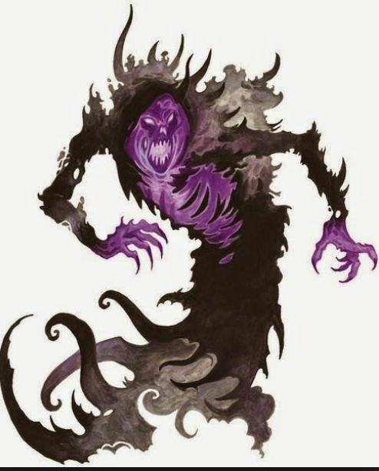

One allip sped towards Jason, while the other one charge-attacked Faith. Both allips were now within babbling proximity to all of the heroes except for Frayed.

|  |  |  |  |  |  |  |  |
| --- | --- | --- | --- | --- | --- | --- | --- |
| **Save vs.**  Babble | **Rank** | **Ability & Mod.** | **Misc. Mods.** | **Total** | **Roll** | **Check** | **Notes** |
| **Caleb, Will** | **11** | **Wis (+4)** | 2 | 17 | 17 | 34 |  |
| **Faith, Will** | **5** | **Wis (+3)** | 5 + 2 *prot. fr. evil* | 15 | 19 | 34 | True Believer bonus +2 |
| **Jason, Will** | **4** | **Wis (+3)** | 1 | 8 | 9 | 17 |  |
| **Kali, Will** | **7** | **Wis (+0)** | 1 | 8 | 18 | 26 | +2 vs. Enchantments, +3 vs. Mind-Affecting |
| **Magpie, Will** | **7** | **Wis (+2)** | 2 | 11 | 20 | 31 |  |

*All saved vs. 1st allip’s Babble.*

|  |  |  |  |  |  |  |  |
| --- | --- | --- | --- | --- | --- | --- | --- |
| **Save vs.**  Babble | **Rank** | **Ability & Mod.** | **Misc. Mods.** | **Total** | **Roll** | **Check** | **Notes** |
| **Caleb, Will** | **11** | **Wis (+4)** | 2 | 17 | 13 | 30 |  |
| **Faith, Will** | **5** | **Wis (+3)** | 5 + 2 *prot.*  *fr. Evil* | 15 | 8 | 23 |  |
| **Kali, Will** | **7** | **Wis (+0)** | 1 | 8 | 11 | 19 | +2 vs. Enchantments  +3 vs. Mind-Affecting |
| **Jason, Will** | **4** | **Wis (+3)** | 1 | 8 | 14 | 22 |  |
| **Magpie, Will** | **7** | **Wis (+2)** | 2 | 11 | 19 | 30 |  |

*All saved vs. 2nd allip’s Babble.*

|  |  |  |  |  |  |  |  |  |
| --- | --- | --- | --- | --- | --- | --- | --- | --- |
| **Character** | **Attack Type** | **Damage** | **BAB** | **Mod+** | **W+** | **Other+** | **d20** | **Total** |
| Allip | Incorporeal Touch | 1d4 Wisdom | 2 | 1 | 0 | 2 charge | **20** | 25 |
| Allip | Incorporeal Touch | 1d4 Wisdom | 2 | 1 | 0 | 2 charge | **15** | 20 |

*Threat (vs Jason), hit (vs Faith). 1d20 = 19 + 3 = 22, critical hit.*

*Dmg to Jason: 2 x 2 = 4 Wisdom.*

|  |  |
| --- | --- |
| **Wisdom:** | 12 |

*Dmg to Faith: 5 Wisdom.*

|  |  |
| --- | --- |
| **Wisdom:** | 11 |

The now-less-wise-than-usual Jason hovered back 5’ and rapid fired on the shadow, not very familiar with the babbling allips.

|  |  |  |  |  |  |  |  |  |  |  |
| --- | --- | --- | --- | --- | --- | --- | --- | --- | --- | --- |
| **Ranged Weapon** | **Dmg.** | **D+** | **TH+** | **Critical** | **Rng.** | **Wt.** | **Atk** | **Roll** | **Check** | **Notes** |
| Sacred Composite Longbow, Strength +1 | 1d8 | +1 | 1 | 19-20/x3 | 200’ | 3.0 | +15 | 8 | 23 | +1 within 30’ |
| 2nd Shot | 1d8 | +1 | 1 |  |  |  | +10 | 10 | 20 | +1 within 30’ |
| 3rd Shot, Rapid Firing | 1d8 | +1 | 1 |  |  |  | +5 | *1* | 6 | +1 within 30’ |
| Crystal of Cold Assault, Greater | - | 1d6 | - | - | - |  | - | - | - | -1 to AC 1 round |

*Hit, hit, miss. Dmg: (1 + 1 + 4 cold) + (2 + 1 + 3 cold) = 5 + 7 cold = 12.*

The shadow was damaged and upset, but not quite dead yet.

With every foe within 2 range increments of his bow’s capacity, Bastilles moved 30’ northward and shot a single arrow at Kali, wondering just how poke-worthy she was.

|  |  |  |  |  |  |  |  |  |  |
| --- | --- | --- | --- | --- | --- | --- | --- | --- | --- |
| **Character** | **Attack Type** | **Damage** | **BAB** | **Mod+** | **W+** | **Other+** | **d20** | **Total** | **Targeting** |
| Bastilles Croixième | Composite Longbow +2 | 1d6 | 6 | 3 | 2 | -2 range | 8 | 17 | +3d6 skirmish |

*Miss.*

The wee-man’s arrow bounced off of the shoulder of the woman’s armor, getting her attention momentarily.

The shadow full-attacked Jason.

|  |  |  |  |  |  |  |  |  |
| --- | --- | --- | --- | --- | --- | --- | --- | --- |
| **Character** | **Attack Type** | **Damage** | **BAB** | **Mod+** | **W+** | **Other+** | **d20** | **Total** |
| Shadow | Incorporeal Touch | 1d6 Strength | 3 | 0 | 0 | 0 | 12 | 15 |

*Hit. Dmg: 2 Strength.*

|  |  |
| --- | --- |
| **Strength:** | 10 |

Caleb used his Wand of *Magic Missile* to zap the shadow attacking Jason. It was profoundly unlikely to kill the summoned critter, but it might, which was good.

*Dmg: 16 + 5 = 21 magic [force].*

And sure enough, it did, and the shadow was no more.

The efreeti sped northward, descending slightly as it sought a wordless audience with Faith. Big Brother also huffed on northward, hoping to go one-on-one with Faith.

Faith had only one foe before her: the allip that had just sapped her of her Wisdom. She swiped three times at the undead babbler.

|  |  |  |  |  |  |  |  |  |  |  |
| --- | --- | --- | --- | --- | --- | --- | --- | --- | --- | --- |
| **Melee Weapon** | **Dmg** | **D+** | **TH+** | **Critical** | **Type** | **Wt.** | **Atk** | **Roll** | **Check** | **Properties** |
| Adamantine Illuminating  Holy Greatsword +1 | 2d6+2 | +4 + 1 | 1 | 17-20/x2 | Slashing | 8.0 | +16 | 6 | 22 | +2d6 to evil |
| 2nd Attack | 2d6+2 | +4 + 1 | 1 | 17-20/x2 | Slashing |  | +11 | 7 | 18 |  |
| 3rd Attack | 2d6+2 | +4 + 1 | 1 | 17-20/x2 | Slashing |  | +6 | 5 | 11 | allip destroyed  by now |

*Hit, hit, miss. Dmg: (8 + 2 + 4 + 1 + 6 good) + (9 + 2 + 4 + 1 + 8 good) = 15 + 16 + 14 good = 45.*

The allip disappeared shortly after the second swipe, while the paladin’s third swing sliced through thin air under the mid-morning sun.

Frayed canceled the *ring of blades* before it was wasted and depleted from his cache of mana, focusing on getting free from the devil.

Kondrat spurred her ecalypse more lightly now, casting *silence* upon Caleb, just to see how it felt.

|  |  |  |  |  |  |  |
| --- | --- | --- | --- | --- | --- | --- |
| **Save vs.**  *silence* | **Rank** | **Ability & Mod.** | **Misc. Mods.** | **Total** | **Roll** | **Check** |
| **Caleb, Will** | **11** | **Wis (+4)** | 2 | 17 | 3 | 20 |

*Success. Silence negated.*

Caleb could tell that he was the target of the ecalypse-mounted elven shade favored soul of Velsharoon named Kondrat of Netheril.

Who the Bone Whisperer flew overhead, slowing down, and cast *Evard’s black tentacles [expired on Round 156]*, centering it on the ground between Jason and Caleb, getting them both, plus Magpie and her eight *mirror images*.

|  |  |  |  |  |
| --- | --- | --- | --- | --- |
| **Grapple** | **D+** | **Atk** | **Roll** | **Check** |
| Caleb | -1 | 5 | 9 | 14 |
| Jason | - | +9 | 3 | 12 |
| Magpie | -2 | 4 | 15 | 19 |

|  |  |  |  |  |  |  |  |  |  |
| --- | --- | --- | --- | --- | --- | --- | --- | --- | --- |
| **Character** | **Attack Type** | **Damage** | **BAB** | **Mod+** | **W+** | **Other+** | **d20** | **Total** | **Targeting** |
| Who | *Evard’s Black Tentacles (Grapple)* | 1d6+4 | 7 | 4 | 4 | 0 | 8 | 23 | Caleb |
| Who | *Evard’s Black Tentacles (Grapple)* | 1d6+4 | 7 | 4 | 4 | 0 | 9 | 24 | Jason |
| Who | *Evard’s Black Tentacles (Grapple)* | 1d6+4 | 7 | 4 | 4 | 0 | 14 | 29 | Magpie |

*Success, success, success. Caleb, Jason, and Magpie were restrained within the tentacles.*

*Dmg to Caleb: 1 + 4 = 5 [63/81].*

*Dmg to Jason: 1 + 4 = 5 [27/72].*

*Dmg to Magpie: 3 + 4 = 7 [78/90].*

The ghoul got into a sweet position to cut down—or be cut down by—Kali.

Susurro followed Cruel-Déjà, who was getting tired of running by now.

The fiendish dire bat finished its descent, slowing down with its parachute-cupped wings only a little, so as to make this a charge-attack upon Frayed, who was already impaled *[flat footed]* by the devil’s barbs.

|  |  |  |  |  |  |  |  |  |
| --- | --- | --- | --- | --- | --- | --- | --- | --- |
| **Character** | **Attack Type** | **Damage** | **BAB** | **Mod+** | **W+** | **Other+** | **d20** | **Total** |
| Fiendish Dire Bat | Bite | 1d8+4 | 3 | 2 | 0 | 0 | 12 | 17 |

*Miss.*

Thymos ran north, resolving to make wherever he next stopped his permanent sniper position.

Magpie was currently unable to use her gloves to cast *hypnotic pattern* on the area around Kondrat and her mount. It might have fundamentally changed the nature of the battle, but alas, the gnomish beguiler now had to contend with the magical, *black tentacles* around her.

Jarvis and Milfuegos took off, leaving the rest of the fools ashore to deal with the enemies.

Aquíferoz saw things going their way, perhaps. Their warmage was a stuck pig at the moment, two of their spellcasters were enveloped in some *Evardian* magic, and the archer didn’t look good at all. So their ravens and other menial summonings had been vanquished... that was, after all, the point of their creation. He had had his doubts about the cavalry’s chances with these intruders when he’d reluctantly dispatched them all to the bluffs earlier, but now that they were all assembled and mostly organized, they were a formidable force to be reckoned with. “Haaaaiiiiiil Larlum!”

“Hail!” a few others across the battlefield responded as Aquíferoz made his way north another 80’, and huffed all the way along the sand, plotting what he would do with these imbeciles when he got close enough to do so.

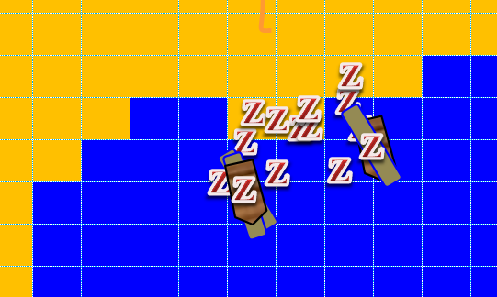

Most of the zombies were in the water now, about ankle- to knee-deep, depending on the wave’s incursion or recession. They were loading a few crates onto the dinghies, and at each dinghy there now sat a gnome-sized zombie, taking the oars and waiting until the treasure was secure to begin rowing.

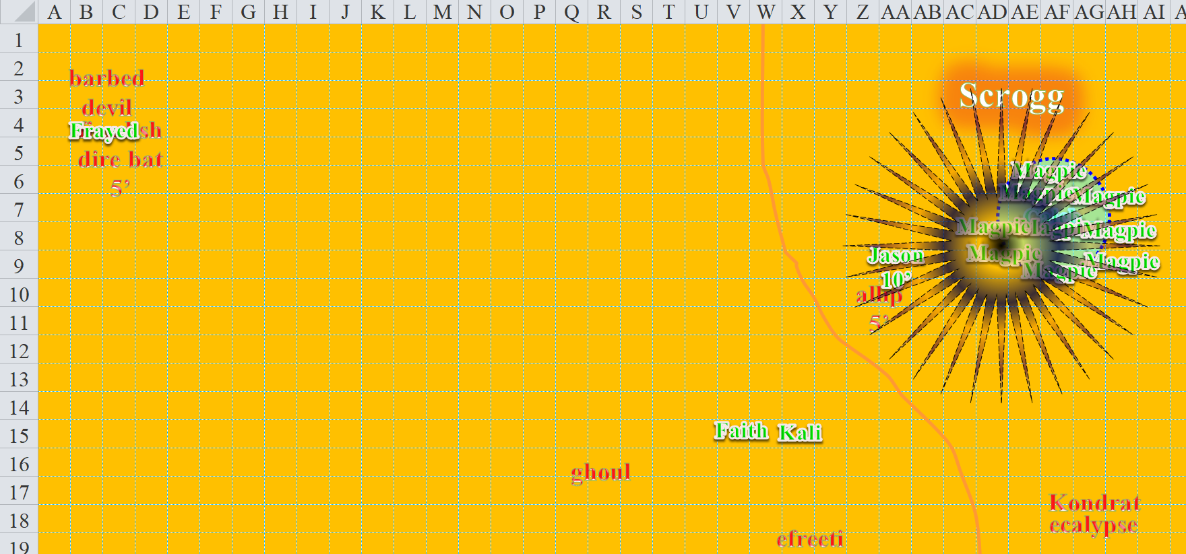

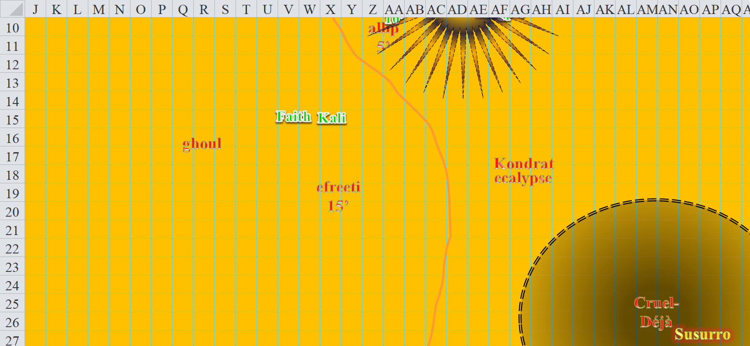



Round 147

The two gnome zombies began rowing the oars of each dinghy towards the ship, which was itself headed southward and away from the shore.

The *black tentacles* did their best to envelop the archer, the beguiler, and the cleric-diviner.

|  |  |  |  |  |  |  |  |  |  |  |  |
| --- | --- | --- | --- | --- | --- | --- | --- | --- | --- | --- | --- |
| **Character** | **Attack Type** | | | **Damage** | **BAB** | **Mod+** | **W+** | **Other+** | **d20** | **Total** | **Targeting** |
| Kondrat of Netheril | *Evard’s Black Tentacles (Grapple)* | | | 1d6+4 | 7 | 4 | 4 | 0 | 14 | 29 | Caleb |
| Kondrat of Netheril | *Evard’s Black Tentacles (Grapple)* | | | 1d6+4 | 7 | 4 | 4 | 0 | 5 | 20 | Jason |
| Kondrat of Netheril | *Evard’s Black Tentacles (Grapple)* | | | 1d6+4 | 7 | 4 | 4 | 0 | 17 | 32 | Magpie |
| **Melee Weapon** | **TH+** | **Atk** | **Roll** | **Check** |
| Caleb | -1 | 5 | 14 | 19 |
| Jason | - | +9 | 12 | 21 |
| Magpie | -2 | 4 | 9 | 13 |

*See below.*

Jason broke free from the *tentacles*, and moved in order to not get snagged by them again *[this is Jason’s move action; his standard or second move action comes below]*.

The remaining allip attacked Jason (AoO from his previous move to X7).

|  |  |  |  |  |  |  |  |  |
| --- | --- | --- | --- | --- | --- | --- | --- | --- |
| **Character** | **Attack Type** | **Damage** | **BAB** | **Mod+** | **W+** | **Other+** | **d20** | **Total** |
| Allip | Incorporeal Touch | 1d4 Wisdom | 2 | 1 | 0 | 0 | 7 | 10 |

*Miss.*

With the *black tentacles* no longer grappling him, Jason skirmished the allip.

|  |  |  |  |  |  |  |  |  |  |  |
| --- | --- | --- | --- | --- | --- | --- | --- | --- | --- | --- |
| **Ranged Weapon** | **Dmg.** | **D+** | **TH+** | **Critical** | **Rng.** | **Wt.** | **Atk** | **Roll** | **Check** | **Notes** |
| Sacred Composite Longbow, Skirmish | 1d8 | +1+3d6+2 | 1 | 19-20/x3 | 200’ |  | +15 | 10 | 25 | +1 within 30’ |
| Crystal of Cold Assault, Greater | - | 1d6 | - | - | - |  | - | - | - | -1 to AC 1 round |

*Hit. Dmg: 4 + 1 + 9 + 2 + 1 = 17 + (-1) to AC on next round.*

The allip remained undead and babbling.

Faith took Kali’s place while Kali moved north.

Bastilles took a 30’ northward path, then skirmished an arrow towards Jason.

|  |  |  |  |  |  |  |  |  |  |
| --- | --- | --- | --- | --- | --- | --- | --- | --- | --- |
| **Character** | **Attack Type** | **Damage** | **BAB** | **Mod+** | **W+** | **Other+** | **d20** | **Total** | **Targeting** |
| Bastilles Croixième | Composite Longbow +2 | 1d6 | 6 | 3 | 2 | -2 range | 2 | 11 | +3d6 skirmish |

*Miss.*

Caleb, as a Swift Action, activated the *freedom of movement [expired on Round 158]* that came from his *heart of water*, causing the tentacles to slip off him without further effect. For the next minute or so, the tentacles would be providing him with an excellent defense against those foolish enough to try to run up on him. He could return the favor with one of his prepared spells, but Magpie was having no luck against the tentacles. Normally, she’d be able to extract herself, but he wasn’t confident that she could with how depleted her spells were, so he walked up to the grappled beguiler, laid a hand upon her, then cast *dimension door*, teleporting a blistering few feet to the back edge of the *black tentacles*, setting Magpie gently outside of the area of effect.

ddd

Big Brother ran north, slowing down at the end, ready to pummel Faith into the next campaign.

The efreeti charge-attacked Faith.

|  |  |  |  |  |  |  |  |  |
| --- | --- | --- | --- | --- | --- | --- | --- | --- |
| **Character** | **Attack Type** | **Damage** | **BAB** | **Mod+** | **W+** | **Other+** | **d20** | **Total** |
| Efreeti | Slam 1 | 1d8+6+2 charge+1d6 Fire | 7 | 3 | 0 | +2 charge | 12 | 22 |

*Miss.*

After attacking in vain, the efreeti passed Faith, turning its back to her and facing Kali.

Faith ignored the efreeti for now, confident that Kali could contend with it for the moment. The paladin produced her holy symbol of Sune, and turned undead.

|  |  |
| --- | --- |
| *Turning Undead* | |
| **Max HD Turned** | 9 |
| **1d20 Roll** | 16 |
| **Turn Check** | 21 |
| **2d6 Roll** | 9 |
| **Turn Damage** | 21 |
| **Turns Used/Daily** | 1/6 |

*Most powerful undead affected: 6 + 3 = 9 HD.*

*Total number of HDs affected: 21.*

*Destroy undead with <7 HD.*

Both the allip threatening Jason and the ghoul exploded into conjuring powder, then disappeared.

Frayed was not a fan of being grappled, so he activated his *heart of water*, which caused him to slip out of the devil’s grasp. He took a 5’ step away from the devil, who wasn’t wielding a polearm given the grapple, then cast *dimension door* to teleport into the *Evard’s black tentacles*.

Kondrat rode her ecalypse northwest towards Kali, then cast *bane [expired on Round 217]* on Faith *[immune]*, Frayed, Jason, and Kali.

|  |  |  |  |  |  |  |  |
| --- | --- | --- | --- | --- | --- | --- | --- |
| **Save vs.**  *bane* | **Rank** | **Ability & Mod.** | **Misc. Mods.** | **Total** | **Roll** | **Check** | **Notes** |
| **Frayed, Will** | 12 | Wis (+0) | 3 + 4 Aura of Resolve | 19 | 1 | 20 |  |
| **Jason, Will** | 4 | Wis (+1) | 1 + 4 Aura of Resolve | 10 | 17 | 27 |  |
| **Kali, Will** | 7 | Wis (+0) | 1 + 4 Aura of Resolve | 12 | 4 | 16 | +2 vs. Enchantments  +3 vs. Mind-Affecting |

*Success, success, success.*

Who the Bone Whisperer cast *phantasmal killer* upon Kali, deeming her to be an assassin, and therefore worthy of such a death.

Kali immediately reacted to the apparition of her dead father vomiting his own entrails from his eyes and mouth by raising her sword.

|  |  |  |  |  |  |  |  |
| --- | --- | --- | --- | --- | --- | --- | --- |
| **Save vs.**  *phantasmal killer* | **Rank** | **Ability & Mod.** | **Misc. Mods.** | **Total** | **Roll** | **Check** | **Properties** |
| **Kali, Will** | **7** | **Wis (+0)** | 1 | 8 | 8 | 16 | +2 vs. Enchantments  +3 vs. Mind-Affecting |

*Success. Spell was ineffective.*

Kali shook her head, blinked, and the apparition disappeared from her mind’s eye.

Cruel-Déjà was exhausted, and simply walked northward with Susurro in tow, both of them catching their breath.

The fiendish dire bat flew towards Jason or Kali; it wasn’t clear.

Thymos knelt and shot a bolt at Faith, then drank a potion of *cure moderate wounds* as his weapon reloaded itself.

|  |  |  |  |  |  |  |  |  |
| --- | --- | --- | --- | --- | --- | --- | --- | --- |
| **Character** | **Attack Type** | **Damage** | **BAB** | **Mod+** | **W+** | **Other+** | **d20** | **Total** |
| Thymos the Redhanded | QR Heavy Crossbow of Fire | 1d10+1d6 Fire, x3 | 7 | 2 | 1 | 0 | 19 | 29 |

*Hit. Dmg: 7 + 4 fire [negated] = 11. Partial damage negated [115/125].*

*Thymos gained 13 +5 = 18 hps.*

Free and clear of the *tentacles* now, Magpie thanked Caleb and cast *freedom of movement* upon herself to prevent further tentacle shenanigans, then moved back into the tentacles, appreciating Caleb’s strategy of using the tentacles defensively.

Jarvis and Milfuegos escaped aboard the ship.

Aquíferoz ran north as much as he could, but had to slow down.

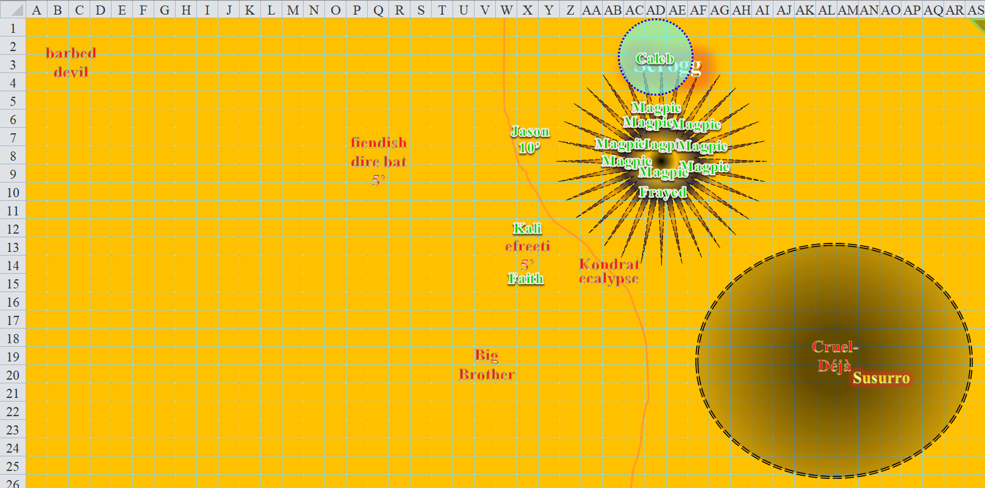

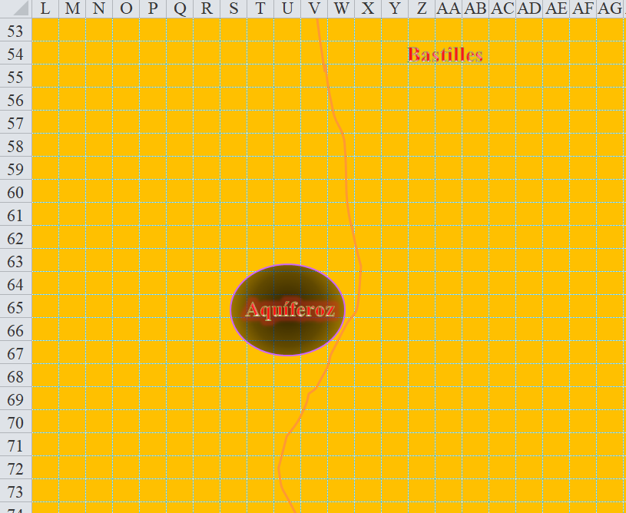 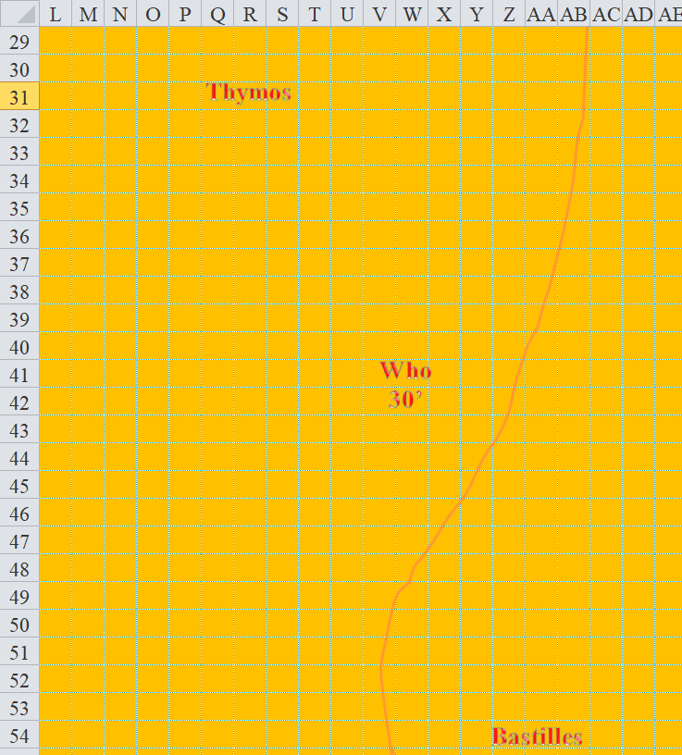

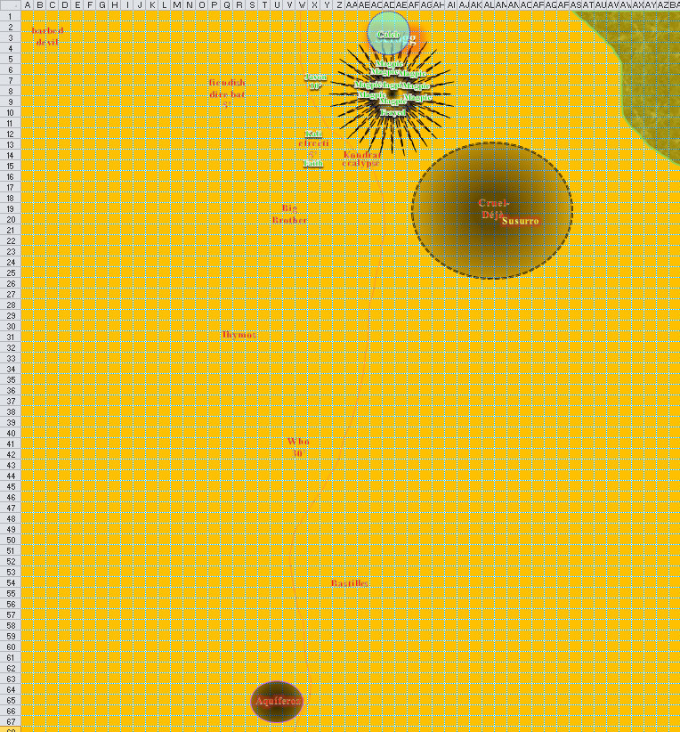

Round 148

Kali full-attacked the efreeti.

|  |  |  |  |  |  |  |  |  |  |
| --- | --- | --- | --- | --- | --- | --- | --- | --- | --- |
| **Melee Weapon** | **Dmg** | **D+** | **TH+** | **Critical** | **Type** | **Wt.** | **Atk** | **Roll** | **Check** |
| Scimitar +2 | 1d6 | 2 | 2 | 18-20, x2 | Slashing | 4.0 | +16 | 12 | 28 |
| 2nd Attack | 1d6 | 2 | 2 | 18-20, x2 | Slashing | - | +11 | 8 | 19 |
| 3rd Attack | 1d6 | 2 | 2 | 18-20, x2 | Slashing | - | +6 | 14 | 20 |
| Crystal of Electrical Assault, Greater | - | **1d6** | - | - | - | 0.0 |  |  |  |

*Hit, hit, hit. Dmg: (5 + 2 + 1 electric) + (4 + 2 + 5 electric) (6 + 2 + 6 electric) = 21 + 12 electric = 33.*

The summoned efreeti remained a threat, steaming and fuming with anger.

The barbed devil *teleported* again, this time not far from Kali, then prepared an attack strategy.

Jason drank a *cure moderate wounds* potion, then fired upon Kondrat.

*Jason gained 10 + 4 = 14 hps [41/72].*

|  |  |  |  |  |  |  |  |  |  |  |
| --- | --- | --- | --- | --- | --- | --- | --- | --- | --- | --- |
| **Ranged Weapon** | **Dmg.** | **D+** | **TH+** | **Critical** | **Rng.** | **Wt.** | **Atk** | **Roll** | **Check** | **Notes** |
| Sacred Composite Longbow, Strength +1 | 1d8 | +1 | 1 | 19-20/x3 | 200’ | 3.0 | +15 | 11 | 26 |  |
| Crystal of Cold Assault, Greater | - | 1d6 | - | - | - |  | - | - | - | -1 to AC 1 round |

*Hit. Dmg: 4 + 1 + 4 cold = 9 + (-1) penalty to AC.*

Bastilles moved 30’ northward, and now that he was within 1 range increment, he skirmished again, this time upon Faith.

|  |  |  |  |  |  |  |  |  |  |
| --- | --- | --- | --- | --- | --- | --- | --- | --- | --- |
| **Character** | **Attack Type** | **Damage** | **BAB** | **Mod+** | **W+** | **Other+** | **d20** | **Total** | **Targeting** |
| Bastilles Croixième | Composite Longbow +2 | 1d6 | 6 | 3 | 2 | 0 | 5 | 16 | +3d6 skirmish |

*Miss.*

Caleb walked up to Frayed but did not reach him in time to burn his *recitation* spell to channel a *cure critical wounds* into the warmage.

Big Brother huffed a charge-attack against Faith.

|  |  |  |  |  |  |  |  |  |
| --- | --- | --- | --- | --- | --- | --- | --- | --- |
| **Character** | **Attack Type** | **Damage** | **BAB** | **Mod+** | **W+** | **Other+** | **d20** | **Total** |
| Big Brother Bothammers | Dwarven Ugrosh +2 | 1d8+2/1d6+2 | 8 | 5 | 2 | +2 charge | 9 | 25 |

*Miss.*

The evil dwarf ran up against the paladin’s *protection from evil* spell, which deflected the ugrosh’s blow.

The efreeti full-attacked Kali.

|  |  |  |  |  |  |  |  |  |
| --- | --- | --- | --- | --- | --- | --- | --- | --- |
| **Character** | **Attack Type** | **Damage** | **BAB** | **Mod+** | **W+** | **Other+** | **d20** | **Total** |
| Efreeti | Slam 1 | 1d8+6+1d6 Fire | 7 | 3 | 0 | 0 | 16 | 26 |
| Efreeti | Slam 2 | 1d8+6+1d6 Fire | 7 | 3 | 0 | 0 | 3 | 13 |

*Miss, miss.*

Kali scornfully laughed at the efreeti’s meager attempts to bypass her armor and agility.

Faith used her armor’s *fly* ability to fly to Jason, and prepared to use a burst of Sacred Healing on the next round.

[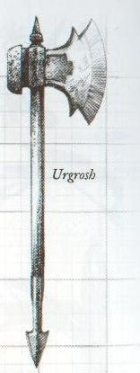](http://www.google.com/url?sa=i&rct=j&q=&esrc=s&source=images&cd=&cad=rja&uact=8&ved=2ahUKEwi08Jnh36faAhXRzlMKHQl5BmkQjRx6BAgAEAU&url=http://forgottenrealms.wikia.com/wiki/Urgrosh&psig=AOvVaw1RTaYY67qjnRYb-kQbMFXG&ust=1523176223416415)

Big Brother and the efreeti got attacks of opportunity against Faith as she passed them.

|  |  |  |  |  |  |  |  |  |
| --- | --- | --- | --- | --- | --- | --- | --- | --- |
| **Character** | **Attack Type** | **Damage** | **BAB** | **Mod+** | **W+** | **Other+** | **d20** | **Total** |
| Big Brother Bothammers | Dwarven Urgrosh +2 | 1d8+5+2/1d6+2/x3 | 8 | 5 | 2 | 0 | *19* | 34 |
| Efreeti | Slam 1 | 1d8+6+1d6 Fire | 7 | 3 | 0 | 0 | 13 | 23 |

*Hit, miss. Dmg: 5 + 5 + 2 = 12. Partial damage negated [105/125].*

Frayed backed up 20’ and cast an *Evard’s black tentacles [expired on Round 160]* centered between Cruel-Déjà and Susurro.

|  |  |  |  |  |  |
| --- | --- | --- | --- | --- | --- |
| **Grapple** | **BAB** | **Mod+** | | **d20** | **Total** |
| Cruel-Déjà Huhlgarix | 6 | 3 | | 5 | 14 |
| Barbed Devil | 12 | 10 | | 5 | 27 |
| Susurro Windswept | 5 | 2 | | 1 | 8 |
| **Character** | **Attack Type** | | **BAB** | | **Mod+** | **d20** | **Total** | **Targeting** |
| Frayed | *Evard’s Black Tentacles* | | 11 | | 4 | 18 | 33 | Cruel-Déjà |
| Frayed | *Evard’s Black Tentacles* | | 11 | | 4 | 4 | 19 | Barbed Devil |
| Frayed | *Evard’s Black Tentacles* | | 11 | | 4 | 1 | 16 | Susurro |

*Grapple vs. Cruel-Déjá and Susurro were successful.*

*Dmg to Cruel-Déjá: 3 + 4 = 7. [Partial damage negated]*

*Dmg to Susurro: 1 + 4 = 5.*

Susurro and Cruel-Déjà had only made it half way to where they’d wanted to be when the *tentacles* sprung around them and grappled them. Now they just struggled.

Kondrat cancelled her own *black tentacles* spell, then cast *darkbolt* upon Frayed.

|  |  |  |  |  |  |  |  |  |
| --- | --- | --- | --- | --- | --- | --- | --- | --- |
| **Character** | **Attack Type** | **Damage** | **BAB** | **Mod+** | **W+** | **Other+** | **d20** | **Total** |
| Kondrat of Netheril | Ranged Touch Attack | varies | 7 | 0 | 0 | 0 | 18 | 25 |

*Hit. Dmg: 5 cold + 5 magic [nonspecific] = 10 [13/62].*

Without much more in mind to do but kill every single hero in sight, Who the Bone Whisperer cast *phantasmal killer* once again, this time targeting Faith, then flew north a bit further.

Faith saw the most vile thing she’d ever imagined, as she flew towards Jason.

|  |  |  |  |  |  |  |
| --- | --- | --- | --- | --- | --- | --- |
| **Save vs.**  *phantasmal killer* | **Rank** | **Ability**  **& Mod.** | **Misc.**  **Mods.** | **Total** | **Roll** | **Check** |
| **Faith, Will** | 5 | Wis (+0) | 5 + 2 *protection from evil* | 12 | 1 | 13 |

*Fail. The phantasmal killer touched Faith.*

|  |  |  |  |  |  |  |
| --- | --- | --- | --- | --- | --- | --- |
| **Save vs.**  *phantasmal killer* | **Rank** | **Ability**  **& Mod.** | **Misc.**  **Mods.** | **Total** | **Roll** | **Check** |
| **Faith, Fortitude** | 8 | Con (+1) | 5 + 2 *protection from evil* | 16 | 14 | 30 |

*Success. Faith did not die. Dmg: 11 unholy [94/125].*

Faith was able to disavow the existence of the apparition, and went on with her life of strife.

The fiendish dire bat charge-attacked Kali.

|  |  |  |  |  |  |  |  |  |
| --- | --- | --- | --- | --- | --- | --- | --- | --- |
| **Character** | **Attack Type** | **Damage** | **BAB** | **Mod+** | **W+** | **Other+** | **d20** | **Total** |
| Fiendish Dire Bat | Bite | 1d8+4 | 3 | 2 | 0 | +2 charge | 14 | 21 |

*Miss.*

Kali laughed at that too.

Thymos fired upon Kali, then drank a potion of *cure moderate wounds*.

|  |  |  |  |  |  |  |  |  |
| --- | --- | --- | --- | --- | --- | --- | --- | --- |
| **Character** | **Attack Type** | **Damage** | **BAB** | **Mod+** | **W+** | **Other+** | **d20** | **Total** |
| Thymos the Redhanded | QR Heavy Crossbow of Fire | 1d10+1d6 Fire, x3 | 7 | 2 | 1 | -2 range | 8 | 18 |

*Miss.*

*Thymos gained 3 +5 = 8 hps.*

Now that enemies had drawn close, Magpie cast *mass whelm* on all enemies within 55’ of her.

|  |  |  |  |  |
| --- | --- | --- | --- | --- |
| **Character** | **Save vs.**  *whelm, mass* | **Ranks** | **Roll** | **Save** |
| Cruel-Déjà Huhlgarix | Will | 7 | 13 | 20 |
| Kondrat of Netheril | Will | 8 | 17 | 25 |
| Big Brother Bothammers | Will | 2 | 1 | 3 |
| Susurro Windswept | Will | 3 | 8 | 11 |

*Fail, success, fail, fail. Cruel-Déjà and Kondrat negated effects.*

*Dmg to Cruel-Déjà: 29 nonlethal.*

*Dmg to Big Brother: 36 nonlethal.*

*Dmg to Susurro: 35 nonlethal.*

The ninja was almost done for, but knew what eternal fate would befall him if he were to desert his comrades, so he stayed.

Jarvis and Milfuegos escaped aboard the ship.

Aquíferoz ran north another 120’, then stopped, satisfied with his position. His *negative energy aura* then expired, and he was sad about this.

The two dinghies now set off into the ocean, each one rowed by a zombie.

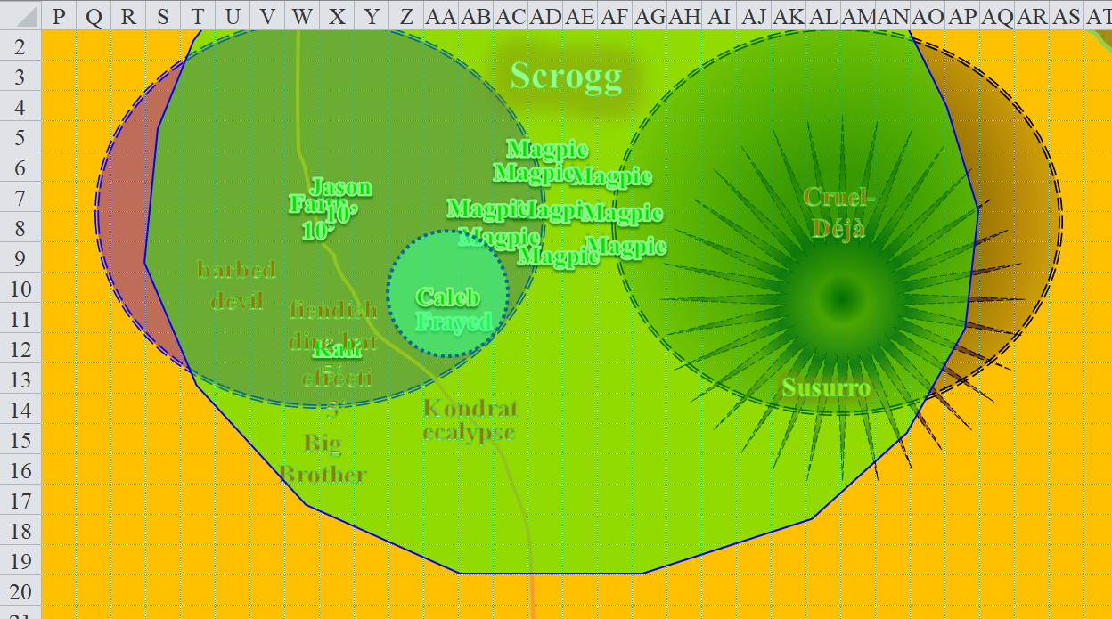

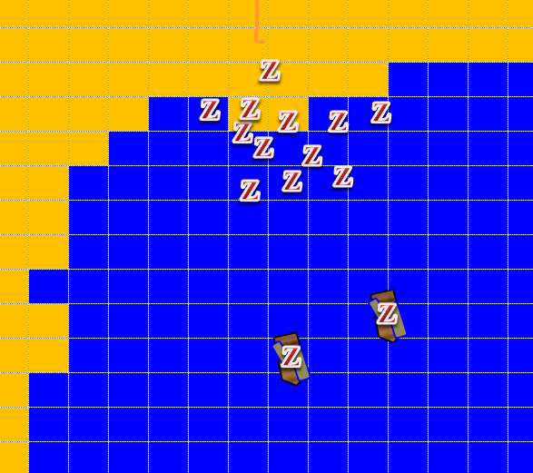

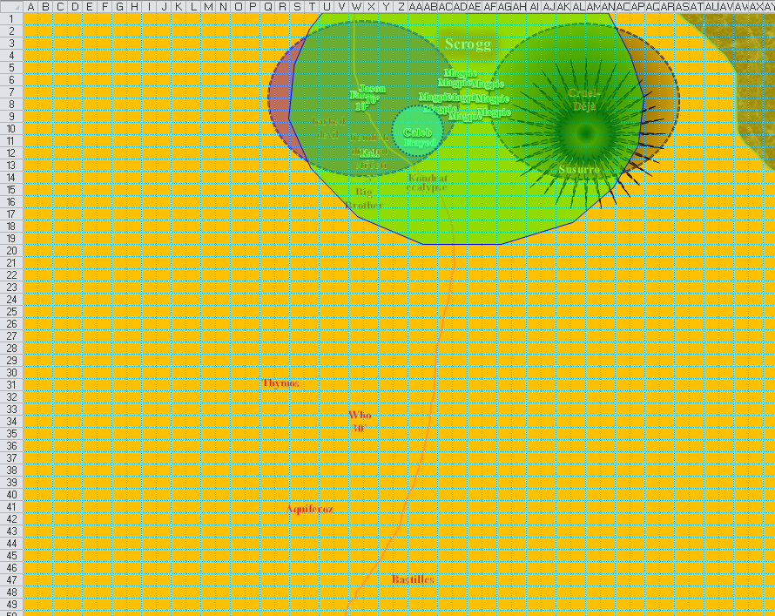

Round 149

Kali full-attacked the efreeti, then stepped 5’ to the northeast.

|  |  |  |  |  |  |  |  |  |  |
| --- | --- | --- | --- | --- | --- | --- | --- | --- | --- |
| **Melee Weapon** | **Dmg** | **D+** | **TH+** | **Critical** | **Type** | **Wt.** | **Atk** | **Roll** | **Check** |
| Scimitar +2 | 1d6 | 2 | 2 | 18-20, x2 | Slashing | 4.0 | +16 | 9 | 25 |
| 2nd Attack | 1d6 | 2 | 2 | 18-20, x2 | Slashing | - | +11 | 5 | 16 |
| 3rd Attack | 1d6 | 2 | 2 | 18-20, x2 | Slashing | - | +6 | 10 | 16 |
| Crystal of Electrical Assault, Greater | - | **1d6** | - | - | - | 0.0 |  |  |  |

*Hit, miss, miss. Dmg: 2 + 2 + 5 electric = 9.*

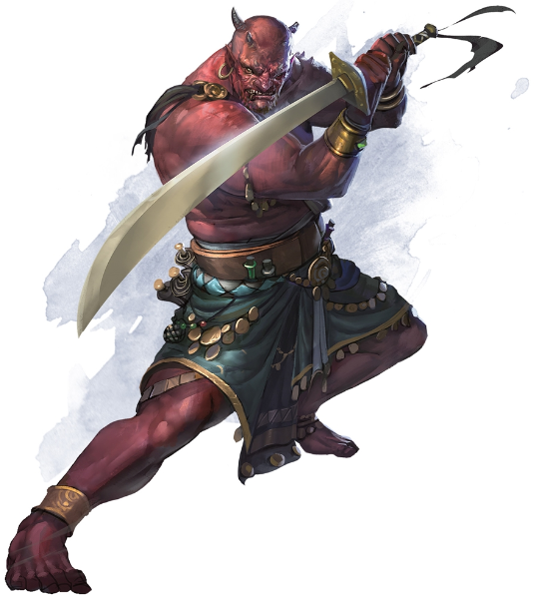

The efreeti gave the swordswoman a dirty look, then disappeared.

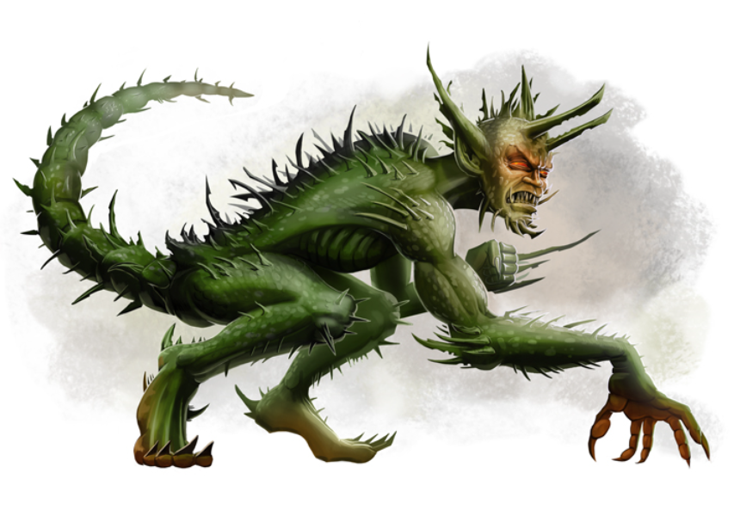

The barbed devil moved to AA9, and cast *order’s wrath*.

|  |  |  |  |  |  |  |
| --- | --- | --- | --- | --- | --- | --- |
| **Save vs.**  *order’s wrath* | **Rank** | **Ability & Mod.** | **Misc. Mods.** | **Total** | **Roll** | **Check** |
| **Jason, Will** | **4** | Wis (+1) | 1 | 6 | 7 | 13 |
| **Kali, Will** | **7** | Wis (+0) | 1 | 8 | 13 | 21 |
| **Magpie, Will** | **7** | Wis (+2) | 2 | 11 | 16 | 27 |

*Fail, success, success. Kali and Magpie save for ½ damage.*

*Dmg to Jason [Chaotic Neutral]: 25 lawful + daze [28/72].*

*Dmg to Kali [Neutral Good]: ½ x ½ x 28 = 7 lawful [98/105].*

*Dmg to Magpie [Neutral]: ½ x ½ x 20 = 5 lawful [73/90].*

|  |  |  |  |  |
| --- | --- | --- | --- | --- |
| **Character** | **Save vs.**  *order’s wrath* | **Ranks** | **Roll** | **Save** |
| Fiendish Dire Bat  *[neutral evil]* | Will | 6 | 6 | 12 |

*Fail. Dmg: ½ x 21 = 10 lawful.*

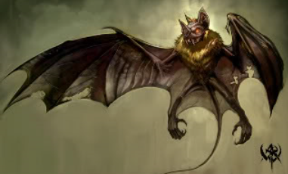

Jason was dazed for the moment, and could do nothing other than float near Faith.

Now well within his normal range increment, Bastilles Croixième skirmished a single shot in the way of Frayed, who was no longer shrouded by the *black tentacles*.

|  |  |  |  |  |  |  |  |  |
| --- | --- | --- | --- | --- | --- | --- | --- | --- |
| **Character** | **Attack Type** | **Damage** | **BAB** | **Mod+** | **W+** | **Other+** | **d20** | **Total** |
| Bastilles Croixième | Composite Longbow +2 | 1d6 | 6 | 3 | 2 | 0 | 13 | 24 |

*Hit. Dmg: 4 + 2 + 11 skirmish = 17 [-4/62].*

Having reached Frayed, Caleb burned his *recitation* spell to channel a *cure critical wounds* into the warmage.

*Frayed gained 19 + 12 = 31 hps [27/62].*

Big Brother Bothammers charge-power-attacked Kali.

|  |  |  |  |  |  |  |  |  |
| --- | --- | --- | --- | --- | --- | --- | --- | --- |
| **Character** | **Attack Type** | **Damage** | **BAB** | **Mod+** | **W+** | **Other+** | **d20** | **Total** |
| Big Brother Bothammers | Dwarven Urgrosh +2 | 1d8+2+5 power/x3 | 8 | 5 | 2 | -5 power | 3 | 13 |

*Miss.*

Faith *[full-round action]* activated her Sacred Healing near Jason, bestowing fast healing (3) upon herself, Jason, Kali, and the fiendish dire bat.

*Caleb, Faith, Frayed, Jason, Kali, and the fiendish dire bat gained 12 hps each over the course of the next 4 rounds.*

*Caleb [75/81].*

*Faith [106/125].*

*Frayed [39/62].*

*Jason [40/72].*

*Kali [105/105].*

Susurro ghost stepped to a beautiful location, then threw a star at Caleb.

|  |  |  |  |  |  |  |  |  |
| --- | --- | --- | --- | --- | --- | --- | --- | --- |
| **Character** | **Attack Type** | **Damage** | **BAB** | **Mod+** | **W+** | **Other+** | **d20** | **Total** |
| Susurro Windswept | MW Shiruken | 1d2+2+2d6 sneak | 5 | 2 | 1 | -2 range | **20** | 26 |

*Threat. 1d20 = 16 + 8 = 22, critical hit. Dmg: 2 x (2 + 2 + 9) = 26 [49/81].*

Kondrat took delight in seeing Jason dazed, Caleb wounded with a shiruken stuck in him, and a few of the other heroes in comparable peril. She decided to go with a *silence* spell again, targeting Caleb one more time.

|  |  |  |  |  |  |  |
| --- | --- | --- | --- | --- | --- | --- |
| **Save vs.**  *silence* | **Rank** | **Ability & Mod.** | **Misc. Mods.** | **Total** | **Roll** | **Check** |
| **Caleb, Will** | **11** | **Wis (+4)** | 2 | 17 | 4 | 21 |

*Success. Silence negated.*

The elven shade was furious now, having exhausted her cache of her highest-level spell slots. The favored soul of Velsharoon shook her head and vowed to kill Caleb.

Healed by Caleb and Faith now, Frayed backed up another 30’, passing through the barbed devil’s threat zone, and *fireballed* Kondrat and her mount.

|  |  |  |  |  |  |  |  |  |
| --- | --- | --- | --- | --- | --- | --- | --- | --- |
| **Character** | **Attack Type** | **Damage** | **BAB** | **Mod+** | **W+** | **Other+** | **d20** | **Total** |
| Barbed Devil | Claw 1 (AoO) | 2d8+6+Fear | 12 | 6 | 0 | 0 | **20** | 38 |

*Threat. 1d20 = 13 + 19 = 31, critical hit. Dmg: 2 x (6 + 6) = 24 + Fear [15/62].*

|  |  |  |  |  |  |  |
| --- | --- | --- | --- | --- | --- | --- |
| **Save vs.**  Fear | **Rank** | **Ability & Mod.** | **Misc. Mods.** | **Total** | **Roll** | **Check** |
| **Frayed, Will** | **12** | **Wis (+0)** | 3 | 15 | 18 | 33 |

*Success. Fear was negated.*

|  |  |  |  |  |
| --- | --- | --- | --- | --- |
| **Character** | **Save vs.**  *fireball* | **Ranks** | **Roll** | **Save** |
| Kondrat of Netheril | Reflex | 5 | 1 | 6 |
| Ecalypse | Reflex | 10 | 2 | 12 |

*Fail, fail.*

*Dmg to Kondrat: 32 fire.*

*Dmg to Ecalypse: 36 fire.*

Both the ecalypse and its rider continued to breathe, and were now both quite upset.

Milfuegos’ *bear’s heart* spell expired, returning Jarvis and everyone aboard the ship to their normal strength. Jarvis cast the same spell from a scroll *[expired on Round 160]*, which Milfuegos had scribed just weeks earlier, and they were back to good pickins.

Who the Bone Whisperer flew north-northeast and downward to an altitude of 10’, then prepared to cast nasty things on Kali.

Cruel-Déjà was now held in place by the *black tentacles*.

|  |  |  |  |  |  |  |  |  |
| --- | --- | --- | --- | --- | --- | --- | --- | --- |
| **Character** | **Attack Type** | **Damage** | **BAB** | **Mod+** | **W+** | **Other+** | **d20** | **Total** |
| Cruel-Déjà Huhlgarix | Grapple | Grapple | 6 | 3 | 0 | 0 | 12 | 21 |
| Frayed | Evard’s Black Tentacles | Grapple | 11 | 4 | 0 | 0 | 15 | 30 |

*Grapple remained in place. Dmg: 3 + 4 = 7 [partial damage negated].*

The fiendish dire bat full-attacked Kali.

|  |  |  |  |  |  |  |  |  |
| --- | --- | --- | --- | --- | --- | --- | --- | --- |
| **Character** | **Attack Type** | **Damage** | **BAB** | **Mod+** | **W+** | **Other+** | **d20** | **Total** |
| Fiendish Dire Bat | Bite | 1d8+4 | 3 | 2 | 0 | 0 | *19* | 24 |

*Miss.*

Thymos fired and quick-reloaded his heavy crossbow, aiming for Jason.

|  |  |  |  |  |  |  |  |  |
| --- | --- | --- | --- | --- | --- | --- | --- | --- |
| **Character** | **Attack Type** | **Damage** | **BAB** | **Mod+** | **W+** | **Other+** | **d20** | **Total** |
| Thymos the Redhanded | QR Heavy Crossbow of Fire | 1d10+1d6 Fire, x3 | 7 | 2 | 1 | 0 | 5 | 15 |

*Miss.*

Magpie cast another *mass whelm*, targeting all enemies within 55’ of her.

|  |  |  |  |  |
| --- | --- | --- | --- | --- |
| **Character** | **Save vs.**  *whelm, mass* | **Ranks** | **Roll** | **Save** |
| Cruel-Déjà Huhlgarix | Will | 7 | 12 | 19 |
| Kondrat of Netheril | Will | 8 | 1 | 9 |
| Big Brother Bothammers | Will | 2 | 12 | 14 |
| Susurro Windswept | Will | 3 | 14 | 17 |
| Who the Bone Whisperer | Will | 4 | 8 | 12 |
| Fiendish Dire Bat | Will | 6 | 8 | 14 |

*Fail, fail, fail, fail, fail, fail. Cruel-Déjà negated effects.*

*Dmg to Cruel-Déjà: 34 nonlethal.*

*Dmg to Kondrat: 30 nonlethal.*

*Dmg to Big Brother: 28 nonlethal.*

*Dmg to Susurro: 33 nonlethal.*

*Dmg to Who: 31 nonlethal.*

*Dmg to fiendish dire bat: 33 nonlethal.*

Kondrat, her ecalypse, and Susurro either died or were knocked unconscious by Magpie’s spell.

Darkfather Aquíferoz walked north another 30’ and cast *thousand needles [expired on Round 259]* upon Faith, who seemed most in need of a humiliating ass-kicking.

|  |  |  |  |  |  |  |
| --- | --- | --- | --- | --- | --- | --- |
| **Save vs.**  *thousand needles* | **Rank** | **Ability & Mod.** | **Misc. Mods.** | **Total** | **Roll** | **Check** |
| **Fortitude** | 8 | Con (+1) | 5 | 14 | 4 | 18 |

*Fail. Dmg: 8 + (-4) to attacks, saves, and checks. Partial damage negated [100/125].*

Faith began to scream in pain.

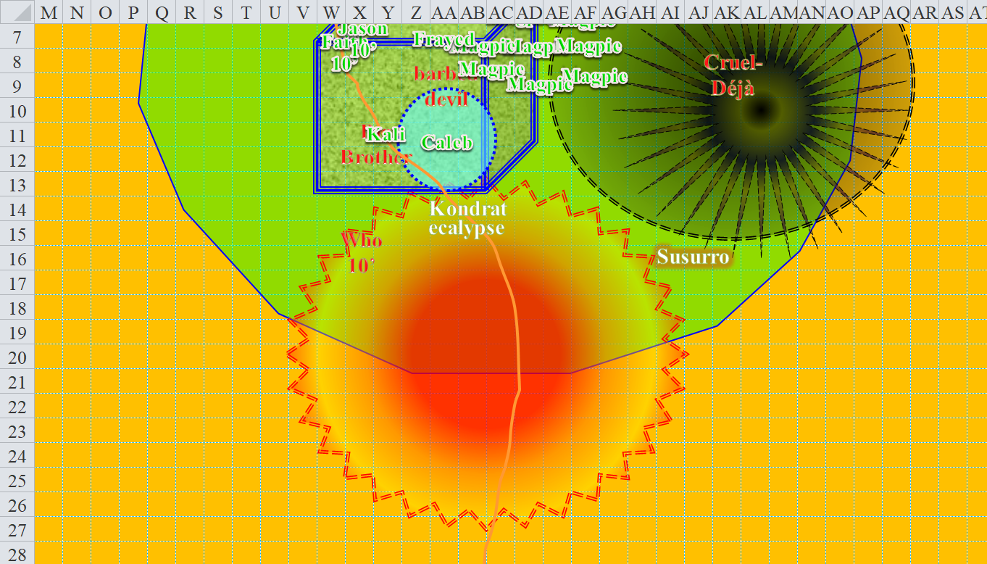

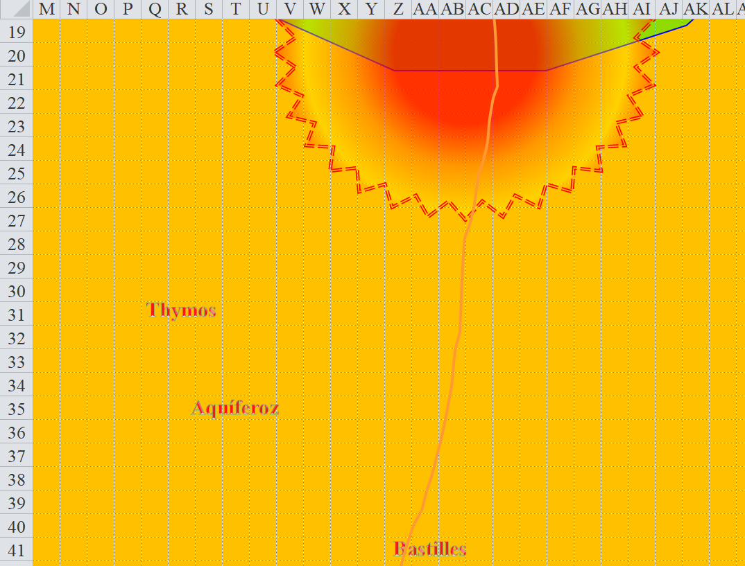

Round 150

No longer able to run, the Darkfather and leader of this bunch in Larlum’s absence walked north 60’.

Jason came out of his stupor, saw Kondrat die, and rapid-fired at Big Brother instead.

|  |  |  |  |  |  |  |  |  |  |  |
| --- | --- | --- | --- | --- | --- | --- | --- | --- | --- | --- |
| **Ranged Weapon** | **Dmg.** | **D+** | **TH+** | **Critical** | **Rng.** | **Wt.** | **Atk** | **Roll** | **Check** | **Notes** |
| Sacred Composite Longbow, Strength +1 | 1d8 | +1 | 1 | 19-20/x3 | 200’ | 3.0 | +15 | 2 | 17 |  |
| 2nd Shot | 1d8 | +1 | 1 |  |  |  | +10 | 16 | 26 |  |
| 3rd Shot, Rapid Firing | 1d8 | +1 | 1 |  |  |  | +5 | 19 | 24 |  |
| Crystal of Cold Assault, Greater | - | 1d6 | - | - | - |  | - | - | - | -1 to AC 1 round |

*Miss, hit, hit. Dmg: (8 + 1 + 6 cold) + (1 + 1 + 4 cold) = 11 + 10 cold = 21.*

Jason could tell that the dwarven fighter was nearly knocked out from Magpie’s and Jason’s attacks.

Kali tried to finish off Big Brother, then moved back a bit, turning to face the barbed devil, who was looking increasingly outnumbered and worried.

|  |  |  |  |  |  |  |  |  |  |
| --- | --- | --- | --- | --- | --- | --- | --- | --- | --- |
| **Melee Weapon** | **Dmg** | **D+** | **TH+** | **Critical** | **Type** | **Wt.** | **Atk** | **Roll** | **Check** |
| Scimitar +2 | 1d6 | 2 | 2 | 18-20, x2 | Slashing | 4.0 | +16 | 8 | 24 |
| 2nd Attack | 1d6 | 2 | 2 | 18-20, x2 | Slashing | - | +11 | 18 | 29 |
| 3rd Attack | 1d6 | 2 | 2 | 18-20, x2 | Slashing | - | +6 | **20** | 26 |
| Crystal of Electrical Assault, Greater | - | **1d6** | - | - | - | 0.0 |  |  |  |

*Hit, threat, threat. 1d20 = 2 (13), 14 (20), not critical hits. Dmg: (5 + 2 + 3 electric) + (1 + 2 + 2 electric) + (2 + 2 + 4 electric) = 7 + 3 + 4 + 9 electric = 23.*

Big Brother fell on the battlefield.

Faith full-attacked the barbed devil.

|  |  |  |  |  |  |  |  |  |  |  |
| --- | --- | --- | --- | --- | --- | --- | --- | --- | --- | --- |
| **Melee Weapon** | **Dmg** | **D+** | **TH+** | **Critical** | **Type** | **Wt.** | **Atk** | **Roll** | **Check** | **Properties** |
| Adamantine Illuminating  Holy Greatsword +1 | 2d6+2 | +4 + 1 | 1 | 17-20/x2 | Slashing | 8.0 | +11 | 19 | 30 | +2d6 to evil |
| 2nd Attack | 2d6+2 | +4 + 1 | 1 | 17-20/x2 | Slashing |  | +6 | 16 | 22 |  |
| 3rd Attack | 2d6+2 | +4 + 1 | 1 | 17-20/x2 | Slashing |  | +1 | 3 | 4 |  |

*Threat, miss, miss. 1d20 = 16 + 11 = 25, not a critical hit. Dmg: 8 + 2 + 4 + 1 + 5 good = 20.*

Caleb backed straight away 30’.

|  |  |  |  |  |  |  |  |  |
| --- | --- | --- | --- | --- | --- | --- | --- | --- |
| **Attack of Opportunity** | **Attack Type** | **Damage** | **BAB** | **Mod+** | **W+** | **Other+** | **d20** | **Total** |
| Barbed Devil | Claw 1 | 2d8+6+Fear | 12 | 6 | 0 | 0 | *1* | 19 |

*Miss.*

The human diviner-cleric had wanted to cast *Evard’s black tentacles [expired on Round 161]* upon Kondrat and her ecalypse, but these two were now good and toasty, so instead, he tried casting that spell on Thymos and his leader, Aquíferoz.

|  |  |  |  |  |  |  |  |
| --- | --- | --- | --- | --- | --- | --- | --- |
| **Character** | **Attack Type** | **BAB** | **Mod+** | **W+** | **Other+** | **d20** | **Total** |
| Darkfather Aquíferoz | Grapple | 3 | 2 | 0 | 0 | 5 | 10 |
| Thymos the Redhanded | Grapple | 2 | 2 | 2 | 0 | 15 | 21 |
| Caleb | Evard’s Black Tentacles | 11 | 0 | 0 | 0 | 17 | 28 |
| Caleb | Evard’s Black Tentacles | 11 | 0 | 0 | 0 | 14 | 25 |

*Both grapples remained in place. Dmg to each villain: 5 + 4 = 9.*

The diviner-cleric was pleased with the results so far.

Cruel-Déjà fought with the *black tentacles*.

|  |  |  |  |  |  |  |  |  |
| --- | --- | --- | --- | --- | --- | --- | --- | --- |
| **Character** | **Attack Type** | **Damage** | **BAB** | **Mod+** | **W+** | **Other+** | **d20** | **Total** |
| Cruel-Déjà Huhlgarix | Grapple | Grapple | 6 | 3 | 0 | 0 | **20** | 29 |
| Frayed | Evard’s Black Tentacles | Grapple | 11 | 4 | 0 | 0 | **7** | 22 |

*Grapple was broken.*

The black dragon shaman positioned himself in a place that would have been choice to start cutting down *mirror images* of Magpie on the next round.

Bastilles skirmished another arrow, also targeting Caleb.

|  |  |  |  |  |  |  |  |  |  |
| --- | --- | --- | --- | --- | --- | --- | --- | --- | --- |
| **Character** | **Attack Type** | **Damage** | **BAB** | **Mod+** | **W+** | **Other+** | **d20** | **Total** | **Targeting** |
| Bastilles Croixième | Composite Longbow +2 | 1d6 | 6 | 3 | 2 | 0 | 6 | 17 | +3d6 skirmish |

*Miss.*

Milfuegos and Jarvis were off to see better days with half of Larlum’s treasure.

Out of higher-level spells, Who cast *ray of exhaustion [expired on Round 250]* upon Kali.

|  |  |  |  |  |  |  |  |  |
| --- | --- | --- | --- | --- | --- | --- | --- | --- |
| **Character** | **Attack Type** | **Damage** | **BAB** | **Mod+** | **W+** | **Other+** | **d20** | **Total** |
| Who the Bone Whisperer | Ranged Touch Attack | varies | 2 | 1 | 0 | 0 | 13 | 16 |

*Hit.*

|  |  |  |  |  |  |  |
| --- | --- | --- | --- | --- | --- | --- |
| **Save vs.**  *ray of exhaustion* | **Rank** | **Ability & Mod.** | **Misc. Mods.** | **Total** | **Roll** | **Check** |
| **Kali, Will** | **7** | **Wis (+0)** | 1 | 8 | 15 | 23 |

*Success. Kali lost 2 to Strength and Dexterity for the spell’s duration, and cannot charge.*

Kali became fatigued, glad to not have become exhausted.

The dread necromancer’s *flight* ability then faded, and he *feather fell* to the ground.

The barbed devil spat upon the mortals. He was bound by a covenant to slay these fools or die trying, and could not simply *teleport* to safety without breaching his contract. Therefore, the spiky fiend full-attacked Kali.

|  |  |  |  |  |  |  |  |  |
| --- | --- | --- | --- | --- | --- | --- | --- | --- |
| **Character** | **Attack Type** | **Damage** | **BAB** | **Mod+** | **W+** | **Other+** | **d20** | **Total** |
| Barbed Devil | Claw 1 | 2d8+6+Fear | 12 | 6 | 0 | 0 | *19* | 37 |
| Barbed Devil | Claw 2 | 2d8+6+Fear | 12 | 6 | 0 | 0 | 2 | 20 |

*Hit, miss. Dmg: 14 + 6 = 20 + Fear [90/105 after Faith’s healing finishes].*

|  |  |  |  |  |  |  |  |
| --- | --- | --- | --- | --- | --- | --- | --- |
| **Save vs.**  *Fear* | **Rank** | **Ability & Mod.** | **Misc. Mods.** | **Total** | **Roll** | **Check** | **Properties** |
| **Kali, Will** | **7** | **Wis (+0)** | 1 | 8 | 9 | 17 | +3 vs. Mind-Affecting |

*Success. Fear was negated.*

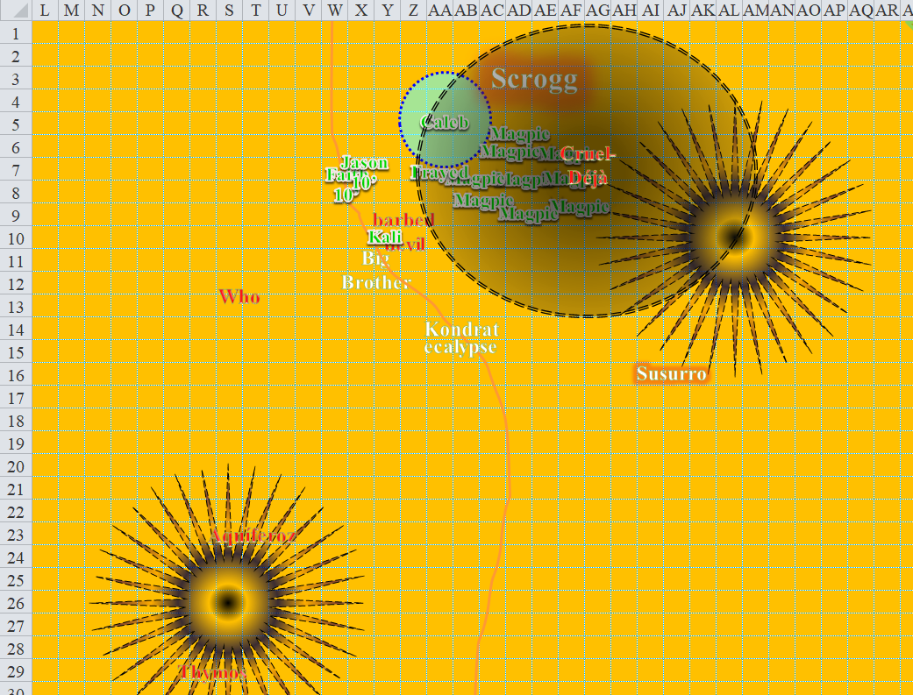

Round 151

Dead bodies started accumulating on the battlefield.

Kali and the barbed devil were both so heavily armored that they sliced and swiped at one another in a near-stalemate for the moment.

Kali attacked the devil.

|  |  |  |  |  |  |  |  |  |  |
| --- | --- | --- | --- | --- | --- | --- | --- | --- | --- |
| **Melee Weapon** | **Dmg** | **D+** | **TH+** | **Critical** | **Type** | **Wt.** | **Atk** | **Roll** | **Check** |
| Scimitar +2 | 1d6 | 2 | 2 | 18-20, x2 | Slashing | 4.0 | +15 | **20** | 35 |
| 2nd Attack | 1d6 | 2 | 2 | 18-20, x2 | Slashing | - | +10 | 14 | 24 |
| 3rd Attack | 1d6 | 2 | 2 | 18-20, x2 | Slashing | - | +5 | 14 | 19 |
| Crystal of Electrical Assault, Greater | - | **1d6** | - | - | - | 0.0 |  |  |  |

*Threat, miss, miss. 1d20 = 17 + 15 = 32, critical hit. Dmg: 2 x (6 + 2 + 3 electric) = 16 + 6 electric = 22.*

*Barbed Defense damage to Kali: 7 + 6 = 13 [77/105].*

Jason rapid-fired on Who.

|  |  |  |  |  |  |  |  |  |  |  |
| --- | --- | --- | --- | --- | --- | --- | --- | --- | --- | --- |
| **Ranged Weapon** | **Dmg.** | **D+** | **TH+** | **Critical** | **Rng.** | **Wt.** | **Atk** | **Roll** | **Check** | **Notes** |
| Sacred Composite Longbow, Strength +1 | 1d8 | +1 | 1 | 19-20/x3 | 200’ | 3.0 | +15 | 15 | 30 |  |
| 2nd Shot | 1d8 | +1 | 1 |  |  |  | +10 | *1* | 11 |  |
| 3rd Shot, Rapid Firing | 1d8 | +1 | 1 |  |  |  | +5 | 7 | 12 |  |
| Crystal of Cold Assault, Greater | - | 1d6 | - | - | - |  | - | - | - | -1 to AC 1 round |

*Hit, miss, miss. Dmg: 5 + 1 + 5 cold = 11.*

Faith continued to use the *fly* spell she’d activated earlier in order to move 5’ from Who, then swung her sword.

|  |  |  |  |  |  |  |  |  |  |  |
| --- | --- | --- | --- | --- | --- | --- | --- | --- | --- | --- |
| **Melee Weapon** | **Dmg** | **D+** | **TH+** | **Critical** | **Type** | **Wt.** | **Atk** | **Roll** | **Check** | **Properties** |
| Adamantine Illuminating  Holy Greatsword +1 | 2d6+2 | +4 + 1 | 1 | 17-20/x2 | Slashing | 8.0 | +11 | 9 | 20 | +2d6 to evil |

*Hit. Dmg: 8 + 2 + 4 + 1 + 7 good = 22.*

*Fire in the Blood damage to Faith: 5 fire [damage negated].*

Faith noted that the dread necromancer’s blood was like magma, and it sprayed her wantonly as she slashed at him with her holy sword.

“I kill you!” Cruel-Déjà full-attacked Magpie.

|  |  |  |  |  |  |  |  |  |
| --- | --- | --- | --- | --- | --- | --- | --- | --- |
| **Character** | **Attack Type** | **Damage** | **BAB** | **Mod+** | **W+** | **Other+** | **d20** | **Total** |
| Cruel-Déjà Huhlgarix | Longsword +3 | 1d8+3 | 6 | 3 | 3 | 0 | *1* | 13 |
| Cruel-Déjà Huhlgarix | Longsword +3 | 1d8+3 | 1 | 3 | 3 | 0 | *8* | 15 |

*Miss, miss.*

Bastilles skirmished another arrow, aiming at Caleb.

|  |  |  |  |  |  |  |  |  |  |
| --- | --- | --- | --- | --- | --- | --- | --- | --- | --- |
| **Character** | **Attack Type** | **Damage** | **BAB** | **Mod+** | **W+** | **Other+** | **d20** | **Total** | **Targeting** |
| Bastilles Croixième | Composite Longbow +2 | 1d6 | 6 | 3 | 2 | 0 | 7 | 18 | +3d6 skirmish |

*Miss.*

Milfuegos and Jarvis sailed away singing, *All the Fools Sailed Away*.

Who cast *ray of exhaustion* again, this time targeting Faith, who had just cut him open, releasing a torrent of fiery blood.

|  |  |  |  |  |  |  |  |  |
| --- | --- | --- | --- | --- | --- | --- | --- | --- |
| **Character** | **Attack Type** | **Damage** | **BAB** | **Mod+** | **W+** | **Other+** | **d20** | **Total** |
| Who the Bone Whisperer | Ranged Touch Attack | varies | 2 | 1 | 0 | 0 | 8 | 11 |

*Miss.*

Bleeding profusely, the dread necromancer then betrayed dread on his face as he anticipated retribution from their foes.

The barbed devil full-attacked Kali.

|  |  |  |  |  |  |  |  |  |
| --- | --- | --- | --- | --- | --- | --- | --- | --- |
| **Character** | **Attack Type** | **Damage** | **BAB** | **Mod+** | **W+** | **Other+** | **d20** | **Total** |
| Barbed Devil | Claw 1 | 2d8+6+Fear | 12 | 6 | 0 | 0 | 6 | 24 |
| Barbed Devil | Claw 2 | 2d8+6+Fear | 12 | 6 | 0 | 0 | 8 | 26 |

*Miss, miss.*

Aquíferoz and Thymos struggled to get free.

|  |  |  |  |  |  |  |  |  |
| --- | --- | --- | --- | --- | --- | --- | --- | --- |
| **Character** | **Attack Type** | **Damage** | **BAB** | **Mod+** | **W+** | **Other+** | **d20** | **Total** |
| Darkfather Aquíferoz | Grapple | Grapple | 3 | 2 | 0 | 0 | 19 | 24 |
| Thymos the Redhanded | Grapple | Grapple | 2 | 2 | 0 | 0 | 10 | 14 |
| Caleb | Evard’s Black Tentacles | Grapple | 11 | 0 | 0 | 0 | 9 | 20 |
| Caleb | Evard’s Black Tentacles | Grapple | 11 | 0 | 0 | 0 | 15 | 26 |

*Thymos’ grapple remained in place. Darkfather got free.*

*Dmg to Thymos: 3 + 4 = 7.*

Free of the *tentacles*, the Darkfather cast one of his worst maladies upon Kali: *necrotic skull bomb*.

|  |  |  |  |  |  |  |
| --- | --- | --- | --- | --- | --- | --- |
| **Save vs.**  *necrotic skull bomb* | **Rank** | **Ability & Mod.** | **Misc. Mods.** | **Total** | **Roll** | **Check** |
| **Kali, Fortitude** | **7** | **Con (+1)** | 1 | 9 | 2 | 11 |

*Fail. Kali gained 2 negative levels.*

Caleb used his wand to *magic missile* Bastilles.

*Dmg: 18 + 5 = 23 magic.*

Frayed used a Warmage spell slot to *magic missile* Bastilles.

*Dmg: 11 + 5 + 4 [I think] = 16 or 20 magic.*

Magpie moved 20’ away from Cruel-Déjà toward the Darkfather, then cast *mass whelm* on all enemies she could reach, conscious or not.

|  |  |  |  |  |  |  |  |  |
| --- | --- | --- | --- | --- | --- | --- | --- | --- |
| **Attack of Opportunity** | **Attack Type** | **Damage** | **BAB** | **Mod+** | **W+** | **Other+** | **d20** | **Total** |
| Cruel-Déjà Huhlgarix | Longsword +3 | 1d8+3 | 6 | 3 | 3 | 2 flank | **20** | 34 |

*Threat. 1d20 = 18 + 14 = 32, critical hit. Dmg: 2 x (7 + 3) = 20 [65/90].*

|  |  |  |  |  |
| --- | --- | --- | --- | --- |
| **Character** | **Save vs.** | **Ranks** | **Roll** | **Save** |
| Cruel-Déjà Huhlgarix | Fortitude | 9 | 5 | 14 |
| Darkfather Aquíferoz | Fortitude | 6 | 9 | 15 |
| Who the Bone Whisperer | Fortitude | 1 | 19 | 20 |
| Barbed Devil | Fortitude | 14 | 3 | 17 |

*Fail, fail, success, fail. Who negated effects.*

*Dmg to Cruel-Déjà: 30 nonlethal.*

*Dmg to Aquíferoz: 25 nonlethal.*

*Dmg to the barbed devil: 35 nonlethal.*

The black dragon shaman was laughing as he spat out blood and teeth, trying to show that he was hard.

The Darkfather was wounded, but not quite subdued by the *mass whelm*, and the barbed devil, well... he could take a little more of a beating today.

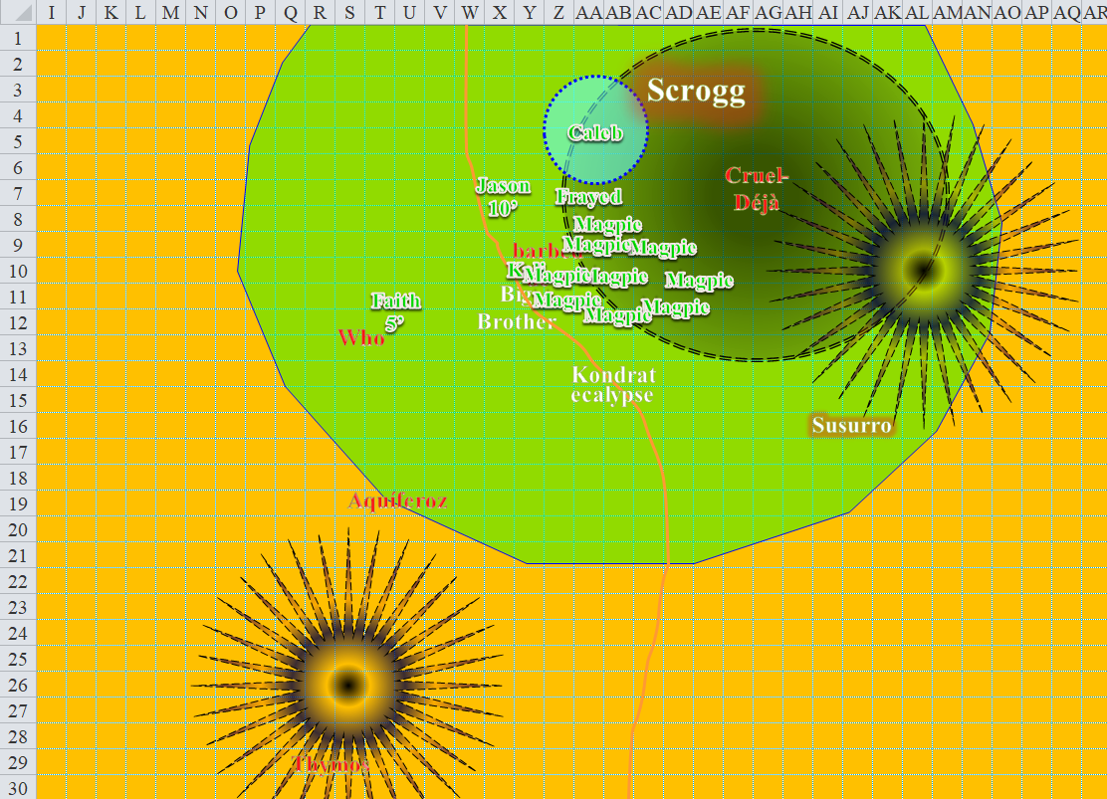

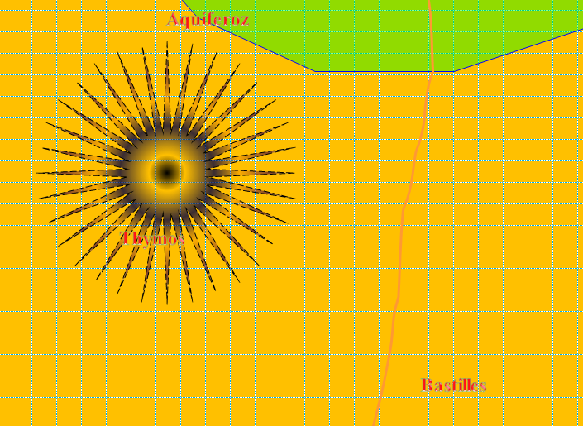

Round 152

Bastilles skirmished an arrow in the direction of his counterpart: Jason.

|  |  |  |  |  |  |  |  |  |  |
| --- | --- | --- | --- | --- | --- | --- | --- | --- | --- |
| **Character** | **Attack Type** | **Damage** | **BAB** | **Mod+** | **W+** | **Other+** | **d20** | **Total** | **Targeting** |
| Bastilles Croixième | Composite Longbow +2 | 1d6 | 6 | 3 | 2 | 0 | 3 | 14 | +3d6 skirmish |

*Miss.*

Frayed used another warmage spell slot to *magic missile* Bastilles.

*Dmg: 15 + 5 + 4 [I think] = 20 or 24 magic.*

Bastilles dropped to his knees, not looking so good.

Caleb had wanted to use his wand to *magic missile* Bastilles once again, but it looked like the archer was down for the count, so the wand was aimed at the devil.

*Dmg: 13 + 5 = 18 magic.*

With her 4th-, 5th-, and 6th-level spell slots used up now, she strategized with her more conventional trickery.

Who the Bone Whisperer cast *vampiric touch*, then touched Faith.

|  |  |  |  |  |  |  |  |  |
| --- | --- | --- | --- | --- | --- | --- | --- | --- |
| **Character** | **Attack Type** | **Damage** | **BAB** | **Mod+** | **W+** | **Other+** | **d20** | **Total** |
| Who the Bone Whisperer | Ranged Touch Attack | varies | 2 | 1 | 0 | 0 | 17 | 20 |

*Hit. Dmg to Faith conveyed as hit points to Who: 28 vampiric [evil] [72/125].*

Jason rapid fired upon Who.

|  |  |  |  |  |  |  |  |  |  |  |
| --- | --- | --- | --- | --- | --- | --- | --- | --- | --- | --- |
| **Ranged Weapon** | **Dmg.** | **D+** | **TH+** | **Critical** | **Rng.** | **Wt.** | **Atk** | **Roll** | **Check** | **Notes** |
| Sacred Composite Longbow, Strength +1 | 1d8 | +1 | 1 | 19-20/x3 | 200’ | 3.0 | +15 | 13 | 28 |  |
| 2nd Shot | 1d8 | +1 | 1 |  |  |  | +10 | 15 | 25 |  |
| 3rd Shot, Rapid Firing | 1d8 | +1 | 1 |  |  |  | +5 | 15 | 20 |  |
| Crystal of Cold Assault, Greater | - | 1d6 | - | - | - |  | - | - | - | -1 to AC 1 round |

*Hit, hit, hit. Dmg: (7 + 1 + 3 cold) + (3 + 1 + 5 cold) + (7 + 1 + 3 cold) = 20 + 11 cold = 31.*

Faith full-attacked Who.

|  |  |  |  |  |  |  |  |  |  |  |
| --- | --- | --- | --- | --- | --- | --- | --- | --- | --- | --- |
| **Melee Weapon** | **Dmg** | **D+** | **TH+** | **Critical** | **Type** | **Wt.** | **Atk** | **Roll** | **Check** | **Properties** |
| Adamantine Illuminating  Holy Greatsword +1 | 2d6+2 | +4 + 1  + 2 charge | 1 + 2  charge | 17-20/x2 | Slashing | 8.0 | +13 | 9 | 22 | +2d6 to evil |
| 2nd Attack | 2d6+2 | +4 + 1 | 1 | 17-20/x2 | Slashing |  | +6 | 11 | 17 |  |
| 3rd Attack | 2d6+2 | +4 + 1 | 1 | 17-20/x2 | Slashing |  | +1 | 9 | 10 |  |

*Hit, miss, miss. Dmg: 11 + 2 + 4 + 1 + 2 + 8 good = 28.*

*Fire in the Blood damage to Faith: 9 fire [partial damage negated] [68/125].*

Who died, and left behind a coven of undead with no truly responsible warden to care for them. Larlum would discard them for sure! Alas...

With Who dead, Kali gave the barbed devil a chance to swipe at her as she charged towards Aquíferoz, who was the apparent substitute leader in Larlum’s absence.

|  |  |  |  |  |  |  |  |  |
| --- | --- | --- | --- | --- | --- | --- | --- | --- |
| **Attack of Opportunity** | **Attack Type** | **Damage** | **BAB** | **Mod+** | **W+** | **Other+** | **d20** | **Total** |
| Barbed Devil | Claw 1 | 2d8+6+Fear | 12 | 6 | 0 | 0 | 4 | 22 |

*Miss.*

|  |  |  |  |  |  |  |  |  |  |
| --- | --- | --- | --- | --- | --- | --- | --- | --- | --- |
| **Melee Weapon** | **Dmg** | **D+** | **TH+** | **Critical** | **Type** | **Wt.** | **Atk** | **Roll** | **Check** |
| Scimitar +2 | 1d6 | 2 + 2 charge | 2 + 2 charge | 18-20, x2 | Slashing | 4.0 | +15 | 6 | 21 |
| Crystal of Electrical Assault, Greater | - | **1d6** | - | - | - | 0.0 |  |  |  |

*Hit. Dmg: 4 + 2 + 2 + 4 electric = 12.*

The barbed devil full-attacked Magpie, or one of her effigies.

|  |  |  |  |  |  |  |  |  |
| --- | --- | --- | --- | --- | --- | --- | --- | --- |
| **Character** | **Attack Type** | **Damage** | **BAB** | **Mod+** | **W+** | **Other+** | **d20** | **Total** |
| Barbed Devil | Claw 1 | 2d8+6+Fear | 12 | 6 | 0 | 0 | *1* | 21 |
| Barbed Devil | Claw 2 | 2d8+6+Fear | 12 | 6 | 0 | 0 | 11 | 29 |

*Miss, hit. One mirror image disappeared.*

Cruel-Déjà charge-attacked two images of Magpie.

|  |  |  |  |  |  |  |  |  |
| --- | --- | --- | --- | --- | --- | --- | --- | --- |
| **Character** | **Attack Type** | **Damage** | **BAB** | **Mod+** | **W+** | **Other+** | **d20** | **Total** |
| Cruel-Déjà Huhlgarix | Longsword +3 | 1d8+3 | 6 | 3 | 3 | 2 charge | 7 | 21 |

*Miss.*

Thymos struggled against the *black tentacles*.

|  |  |  |  |  |  |  |
| --- | --- | --- | --- | --- | --- | --- |
| **Character** | **Attack Type** | **Damage** | **BAB** | **Mod+** | **d20** | **Total** |
| Thymos the Redhanded | Grapple | Grapple | 2 | 2 | 4 | 8 |
| Caleb | Evard’s Black Tentacles | Grapple | 11 | 0 | 2 | 13 |

*Grapple remained in place. Dmg: 2 + 4 = 6.*

The cleric-inquisitor of Velsharoon dubbed Darkfather Aquíferoz was pleased to see Faith in so much pain. He moved 30’ north-northeast and began to cast *mass frostburn*, hoping to catch all six heroes within 30’ of one another.

However, upon seeing this, Magpie cast an immediate spell by the name of *hesitate [expired on Round 164]*.

|  |  |  |  |  |
| --- | --- | --- | --- | --- |
| **Character** | **Save vs.**  *hesitate* | **Ranks** | **Roll** | **Save** |
| Darkfather Aquíferoz | Will | 8 | 4 | 12 |

*Fail.*

Magpie forced the spellcaster to recall his spell before it was expended, and Frayed felt somewhat of a second wind as a result, though he would never know why.

The beguiler took a mental note of her remaining and spent daily powers.

|  |  |  |  |  |  |  |  |  |
| --- | --- | --- | --- | --- | --- | --- | --- | --- |
|  | **Beguiler Spells by Level** | | | | | | | |
|  | **0th** | **1st** | **2nd** | **3rd** | **4th** | **5th** | **6th** | **7th** |
| **Beguiler Spells** | 6 | 6 | 6 | 6 | 6 | 5 | 3 | 0 |
| **Charisma Bonus** | 0 | 1 | 1 | 1 | 1 | 0 | 0 | 0 |
| **Total Daily Spells** | **6** | **7** | **7** | **7** | **7** | **5** | **3** | **0** |
| **DC** | 15 | 16 | 17 | 18 | 19 | 20 | 21 | - |
| **Cast?** | 0 | 2 | 2 | 5 | 7 | 5 | 3 | - |

The Darkfather seemed to second-guess himself, and thought about retreating from the mighty Magpie.

Milfuegos and Jarvis got the zombies to slow the ship by loosening the sails a bit while the two dinghies caught up to the larger vessel.

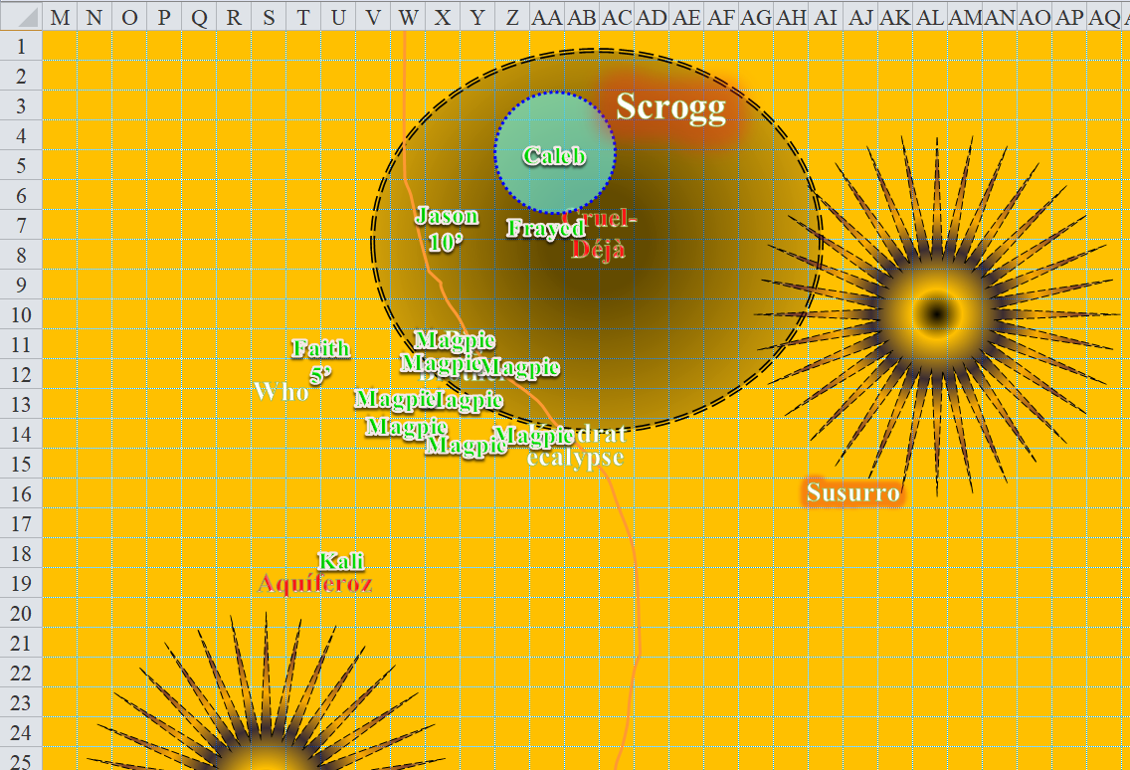

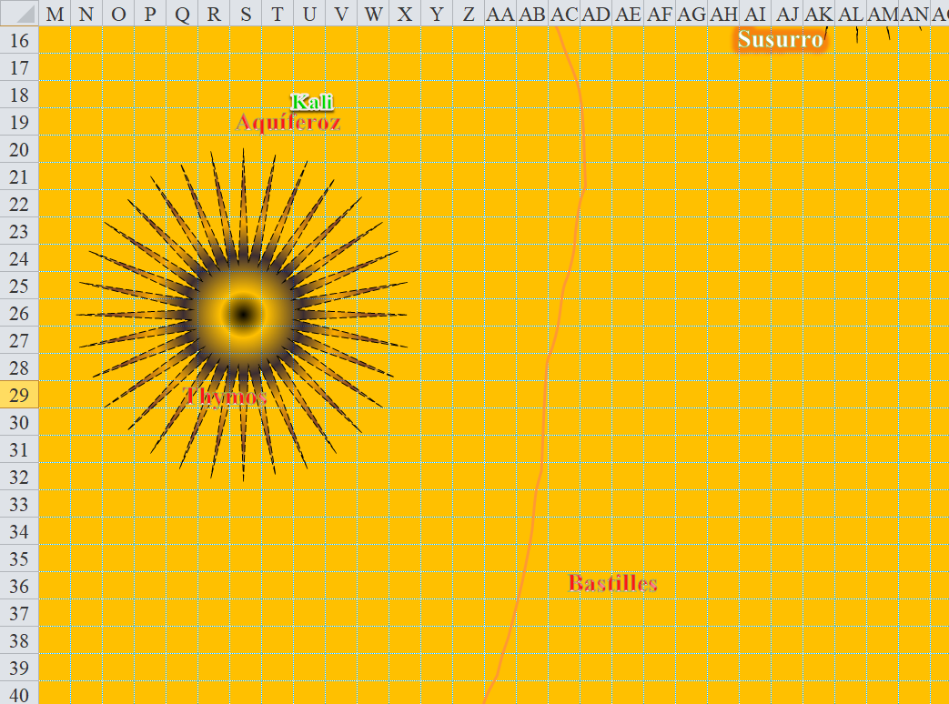

Round 153

On the west-northwestern horizon, there flew a griffon, atop which was either Larlum the Redhanded or a convincing double to anyone who could see him close enough. The griffon and rider were flying at an altitude of 100’ above sea level (only about 30’ above trees that were about 900’ from the heroes. The rider was screaming obscenities, and—fortunately for the heroes—not actually headed for them, but rather for the ship that had already set sail.

This was interesting. Could Larlum be facing a mutiny *and* an attack from these six heroes at the same time? Could the mutineers have planned this ever since they knew that the heroes were underway? Honor among thieves, indeed.

Caleb once again looked upon his friends to determine their medical states.

|  |  |  |  |  |  |  |  |  |  |  |  |  |  |
| --- | --- | --- | --- | --- | --- | --- | --- | --- | --- | --- | --- | --- | --- |
| **Character** | **Melee** | **Ranged** | **Fire** | **Cold** | **Evil** | **Good** | **Chaos** | **Law** | **Magic** | **Total Damage** | **Healing** | **HPs** | **Current**  **HPs** |
| **Caleb** | 49 | 26 | R30 |  |  |  | *Imm* |  |  | 75 | 43 | 81 | 49 |
| **Jason** | 45 |  | R30 |  |  |  | *Imm* | 25 |  | 70 | 38 | 72 | 40 |
| **Kali** | 34 |  | R30 |  |  | *Imm* |  | 7 |  | 41 | 12 | 88 | 59 |
| **Faith** | 16 | 5 | 9 |  | 39 | *Imm* | *Imm* |  |  | 69 | 12 | 125 | 68 |
| **Magpie** | 32 |  | R30 |  |  |  |  | 5 |  | 37 | 12 | 90 | 65 |
| **Frayed** | 63 | 17 | R30 | 5 |  | *Imm* |  |  | 5 | 90 | 43 | 62 | 15 |

Darkfather Aquíferoz started to back away from the heroes.

|  |  |  |  |  |  |  |  |  |  |
| --- | --- | --- | --- | --- | --- | --- | --- | --- | --- |
| **Attack of Opportunity** | **Dmg** | **D+** | **TH+** | **Critical** | **Type** | **Wt.** | **Atk** | **Roll** | **Check** |
| Kali, Scimitar +2 | 1d6 | 2 | 2 | 18-20, x2 | Slashing | 4.0 | +13 | 12 | 25 |
| Crystal of Electrical Assault, Greater | - | 1d6 | - | - | - | 0.0 |  |  |  |

*Hit. Dmg: 3 + 2 + 5 electric = 10.*

The barbed devil—who had made a pact with Superintendent Milfuegos—saw that the fight wasn’t going his way, and Milfuegos seemed to him to be escaping, which breached one of the clauses in the covenant. The Infernal fiend laughed and *teleported* away, leaving Cruel-Déjà with 2 hit points and a fistful of coppers to show for his sacrifice.

Cruel-Déjà was not the type of man who would live on his knees and serve the will of his offenders. Wide eyed, he screamed bloody murder as he hacked away at Frayed.

|  |  |  |  |  |  |  |  |  |
| --- | --- | --- | --- | --- | --- | --- | --- | --- |
| **Character** | **Attack Type** | **Damage** | **BAB** | **Mod+** | **W+** | **Other+** | **d20** | **Total** |
| Cruel-Déjà Huhlgarix | Longsword +3 | 1d8+3 | 6 | 3 | 3 | 0 | 9 | 21 |
| Cruel-Déjà Huhlgarix | 2nd Attack | 1d8+3 | 1 | 3 | 3 | 0 | 18 | 25 |

*Miss, hit. Dmg: 7 + 3 = 10 [5/62].*

The Darkfather turned back to see Kali and Magpie, and cringed at the thought of having to deal with them.

Thymos tried really hard to get out of the *black tentacles*.

|  |  |  |  |  |  |  |  |  |
| --- | --- | --- | --- | --- | --- | --- | --- | --- |
| **Character** | **Attack Type** | **Damage** | **BAB** | **Mod+** | **W+** | **Other+** | **d20** | **Total** |
| Thymos the Redhanded | Grapple | Grapple | 2 | 2 | 0 | 0 | 9 | 13 |
| Caleb | Evard’s Black Tentacles | 1d6+4 | 11 | 0 | 0 | 0 | 7 | 18 |

*Grapple remained in place. Dmg: 1 + 4 = 5.*

The fire genasi ranger still had a good fight left in him, and would do his best to slay the heroes when he got out of the flame-resitant and otherwise indestructible *tentacles*... and he was still optimistic that he would.

Caleb could heal Frayed, but he sensed that Cruel-Deja didn’t have much left in the tank, so would pre-emptively deal with whatever future damage the dragon shaman might deal by zapping the man with his *magic missile* wand.

*Dmg: 11 + 5 = 16 magic [force].*

The dragon shaman fell flat on his face, dead.

“I had it,” Frayed yelled at Caleb as the diviner stole his kill. Grumbling, he activated his belt of healing, spending a single charge.

*Frayed gained 9 hps [14/62].*

Magpie was running on fumes. She’d done her best to keep everyone alive, but she hadn’t expected quite this much resistance. She decided to try to play off how exhausted her magical abilities are by dismissively waving a hand at the Darkfather, “Someone finish off that worm. He’s not worth my time.” Still, she walked toward him, ready to cast *hesitate* again if he made his save and made to nuke the party.

Faith drank a potion of *cure moderate wounds*, and flew to Aquíferoz.

*Faith gained 9 + 4 = 13 hps [81/125].*

Jason drank a potion of *cure moderate wounds* and shot at Aquíferoz.

*Jason gained 5 + 4 = 9 hps [49/72].*

*1d100 = 88, entropic shield bypassed.*

|  |  |  |  |  |  |  |  |  |  |  |
| --- | --- | --- | --- | --- | --- | --- | --- | --- | --- | --- |
| **Ranged Weapon** | **Dmg.** | **D+** | **TH+** | **Critical** | **Rng.** | **Wt.** | **Atk** | **Roll** | **Check** | **Notes** |
| Sacred Composite Longbow, Strength +1 | 1d8 | +1 | 1 | 19-20/x3 | 200’ | 3.0 | +15 | *1* | 16 |  |
| Crystal of Cold Assault, Greater | - | 1d6 | - | - | - |  | - | - | - | -1 to AC 1 round |

*Miss.*

