Round 154

Caleb magic missiled the Darkfather.
Dmg: 12 + 5 = 17 magic [force].

Magpie kept a hesitate on deck to try to head off attacks on the group.

Exhausting his highest-level warmage spell slots, Frayed fired off an orb of electricity at the Darkfather, if he was still alive.
Ranged Weapon | Atk | Roll | Check
Ranged Touch Spells | 9 | 10 | 19
Hit. Dmg: 43 electric.
Character | Save vs.  orb of electricity  [wearing breastplate] | Ranks | Roll | Save
Darkfather Aquíferoz | Fortitude | 6 | 11 | 17
Success. Darkfather was not entangled.

The Darkfather was about to say something, then crackled, broke into a dozen large pieces of carbon and bone, and crumbled.

Frayed blew on his hands and swept them clean, very glad to have chosen the path of Evocation.

Larlum continued to direct his griffon towards the ship, which had slowed down for the two dinghies that were now making their way against the current of the incoming tide and towards the ship.

Thymos started to worry for his own life.
Character | Attack Type | Damage | BAB | Mod+ | W+ | Other+ | d20 | Total
Thymos the Redhanded | Grapple | Grapple | 2 | 2 | 0 | 0 | 13 | 17
Caleb | Evard’s Black Tentacles | 1d6+4 | 11 | 0 | 0 | 0 | 3 | 14
Grapple was broken.

“Aha!” the fire genasi finally got out of the tentacles, then saw that he was the only one on his side still standing, and shat himself.

Magpie forewent the hesitate spell.

Jason fired upon Thymos, who was no longer writhing against the pull of the black tentacles.
Ranged Weapon | Dmg. | D+ | TH+ | Critical | Rng. | Wt. | Atk | Roll | Check | Notes
Sacred Composite Longbow, Strength +1 | 1d8 | +1 | 1 | 19-20/x3 | 200’ | 3.0 | +15 | 9 | 24
2nd Shot | 1d8 | +1 | 1 |  |  |  | +10 | 9 | 19
3rd Shot, Rapid Firing | 1d8 | +1 | 1 |  |  |  | +5 | 9 | 14
Crystal of Cold Assault, Greater | - | 1d6 | - | - | - |  | - | - | - | -1 to AC 1 round
Hit, hit, miss. Dmg: (2 + 1 + 6 cold) + (2 + 1 + 4 cold) = 6 + 10 cold [vulnerable, so 20] = 26.

Kali and Faith charged at Thymos. Kali curved her sprint around the black tentacles spell, knowing she was too far to manifest a proper charge-attack all at once.

Faith, on the other hand, did have a chance to slice at the fire genasi ranger.
Melee Weapon | Dmg | D+ | TH+ | Critical | Type | Wt. | Atk | Roll | Check | Properties
Adamantine Illuminating  Holy Greatsword +1 | 2d6+2 | +4 + 1  + 2 charge | 1 + 2 charge | 17-20/x2 | Slashing | 8.0 | +13 | 14 | 27 | +2d6 to evil
Hit. Dmg: 8 + 2 + 4 + 1 + 2 + 8 good = 25.

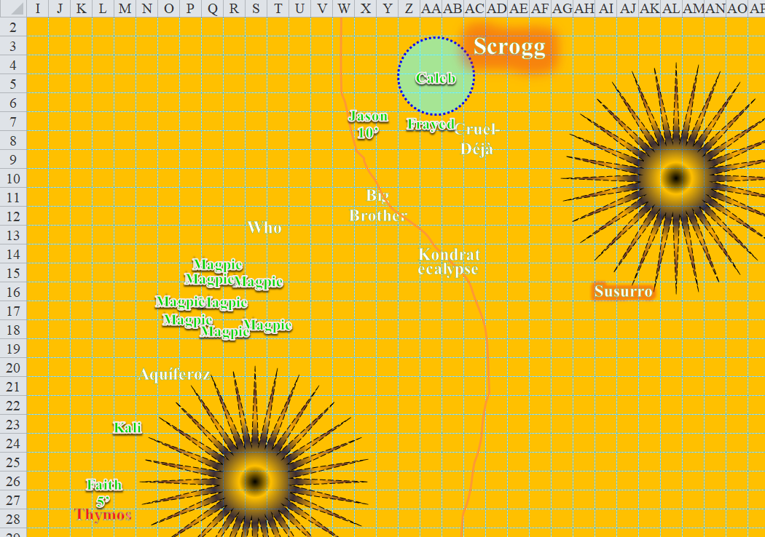

Round 155

Kali finished her charge-attack.
Melee Weapon | Dmg | D+ | TH+ | Critical | Type | Wt. | Atk | Roll | Check
Scimitar +2 | 1d6 | 2+ 2 charge | 2+ 2 charge | 18-20, x2 | Slashing | 4.0 | +15 | 6 | 21
Crystal of Electrical Assault, Greater | - | 1d6 | - | - | - | 0.0
Hit. Dmg: 5 + 2 + 2 + 6 electric = 15.

Thymos died, leaving the only foes in the air and sea, not counting the zombies on the shore.

Having been knocked out by Magpie’s whelm spell, Scrogg the Pleasurepain now regenerated his flesh and bone, and regained consciousness. The ogre mage diviner shook his head as he pushed himself up, dusted himself off, and looked around, staggered.

Jason rapid-fired at the ogre mage.
Ranged Weapon | Dmg. | D+ | TH+ | Critical | Rng. | Wt. | Atk | Roll | Check | Notes
Sacred Composite Longbow, Strength +1 | 1d8 | +1 | 1 | 19-20/x3 | 200’ | 3.0 | +15 | 2 | 17
2nd Shot | 1d8 | +1 | 1 |  |  |  | +10 | 13 | 23
3rd Shot, Rapid Firing | 1d8 | +1 | 1 |  |  |  | +5 | 17 | 22
Crystal of Cold Assault, Greater | - | 1d6 | - | - | - |  | - | - | - | -1 to AC 1 round
Hit, hit, hit. Dmg: (6 + 1 + 1 cold) + (1 + 1 + 5 cold) + (4 + 1 + 4 cold) = 14 + 10 cold = 24.

Scrogg was blinded by one arrow, his heart pierced by another, and his belly button became the home of the third arrow. The she-man almost died, but somehow managed to remain a threat.

Both Kali and Faith would put an end to that. Faith flew to charge-attack the ogre mage using her still active fly spell from her armor, and Kali turned back from her attack, and positioned herself so they could both engage in a flying charge-attack on the next round.

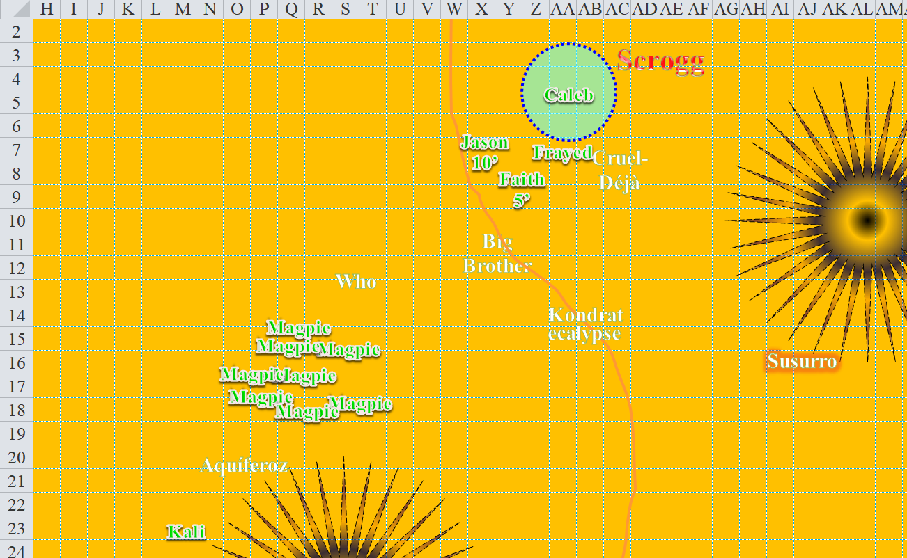

In the distance, Larlum got closer to the ship.

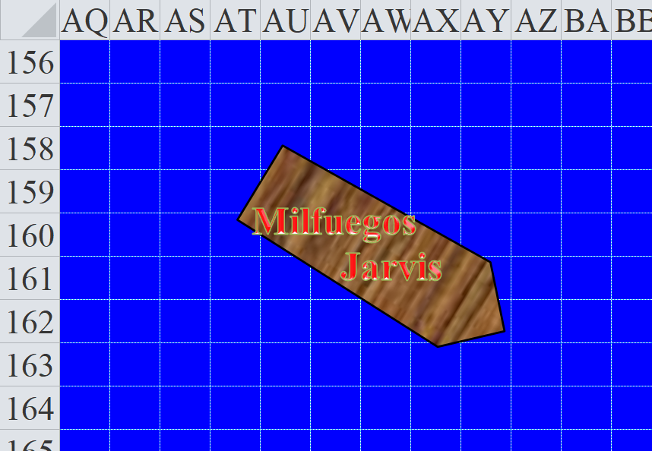

Jarvis cast fireball from a scroll.
Save vs.  fireball | Rank | Ability & Mod. |  | Misc. Mods. | Total | Roll | Check
Larlum, Reflex | 6 | Dex (+1) |  | 4 | 11 | 17 | 28
Character | Save vs.  fireball | Ranks | Roll |  | Save
Griffon | Reflex | 7 | 16 |  | 23
Success, success. Both save for ½ damage.
Dmg to Larlum: ½ x 20 = 10.
Dmg to griffon: ½ x 19 = 9.

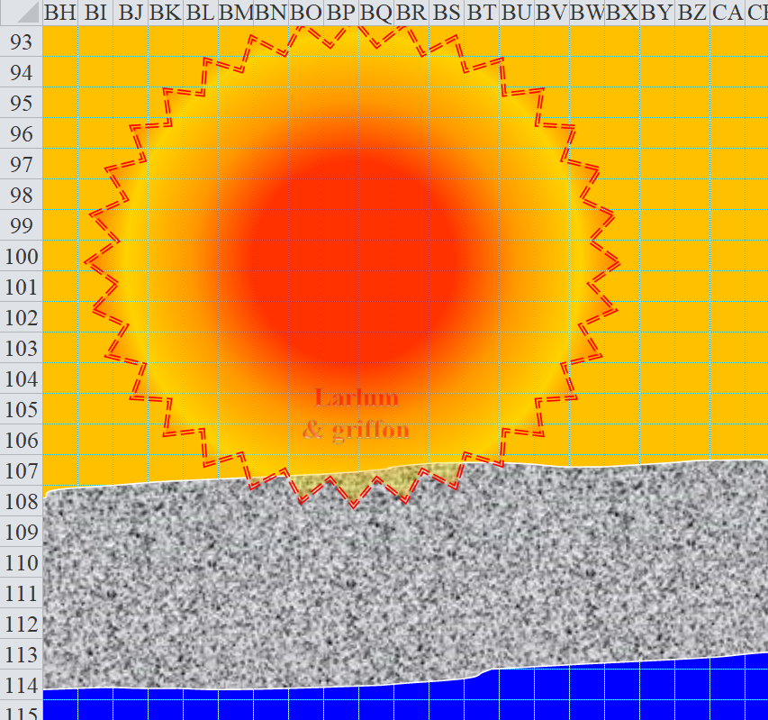

Larlum cursed the ship aboard which Jarvis stood, then urged his mount closer, and cast control water, causing a whirpool to engulf the ship, which slid down into some underwater abyss as Larlum cackled and his mount veered toward the flat spot atop the island-rock where Who had previously stood.

Jarvis and Milfuegos apparently went down with the ship.

Caleb saw his swordswomen friends going to finish off the ogre mage, and stayed his spell hand for the moment. So did Frayed.

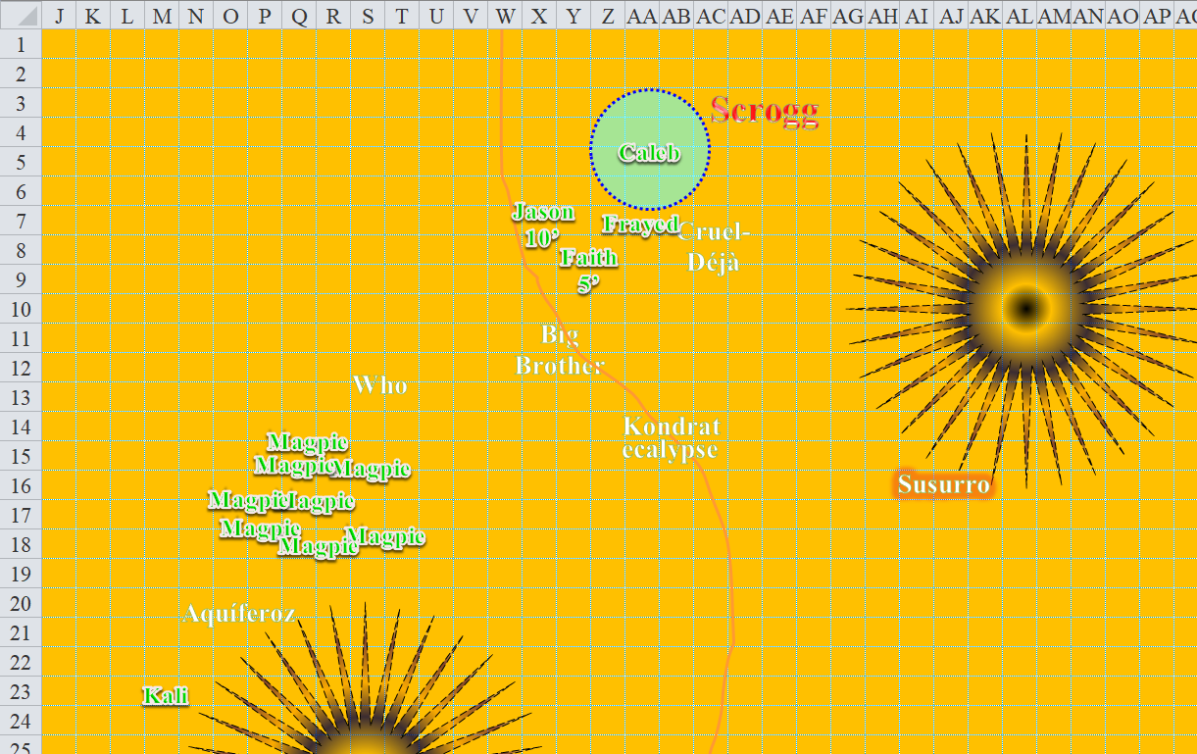

Round 156

Frayed and Caleb heard the snapping of some branches to the northeast, and turned to see a humanoid zombie emerging from the forest. As if bemoaning its own fate, it called out to them with a groan, and began its uneventful and gradual approach.

It was no wonder that Larlum had completely ignored his foes on land when his mutineers were at sea, now that they saw the land infantry that the tiefling had dispatched from his bone grotto. Jason had the keenest eye, and could spot a half-dozen, but heard more zombies in the thicker woods deeper in the forest.

Faith finished her charge-attack.
Melee Weapon | Dmg | D+ | TH+ | Critical | Type | Wt. | Atk | Roll | Check | Properties
Adamantine Illuminating  Holy Greatsword +1 | 2d6+2 | +4 + 1 + 2 charge | 1 + 2 charge | 17-20/x2 | Slashing | 8.0 | +11 | 20 | 31 | +2d6 to evil
Theat. 1d20 = 3 + 11 = 14, not a critical hit. Dmg: 9 + 2 + 4 + 1 + 2 + 8 good = 26.

And now Scrogg was truly dead, though Frayed suspected otherwise.

Frayed walked up to the ogre mage, preparing to coup de grace him on the following round with a lesser orb of fire.

Kali stopped her charge, and turned her face and gaze toward the zombies in the foliage.

Magpie said to the group, “Many of our enemies are just unconscious. As much as butcher’s work disheartens me, I think they’ve earned their deaths. Faith, Jason, Kali, if you wouldn’t mind executing them, I think that’d be the best for everyone.”

Larlum appeared to have the mutineers where he needed them for the moment: inside a squarish depression in the water so deep that even the tallest mast of the ship was beneath the sea’s normal surface. The cleric of Velsharoon flew towards the island-rock as he turned to look upon the remnants of the battlefield, which had seen plenty of his forces killed, but nary a foe slain... and an attempted mutiny by two senior lackeys. He should have cast Divination spells on them instead of on the predictable heroes, and now those spells were spent. He would make do as best as he could with the intel he’d gained on these trespassers.

“Looks like the necromancer is circling back around to engage, rather than fleeing,” Caleb commented drolly as he walked up to Frayed and burned a clerical dispel magic to cast a cure serious wounds on the gnome.
Frayed gained 12 + 12 = 24 hps [38/62].

Magpie cursed, “Dammit, and zombies from the wood. Caleb, toss me that coin. I only need one hand to cast. Frayed, do you have enough in the tank to fight?”

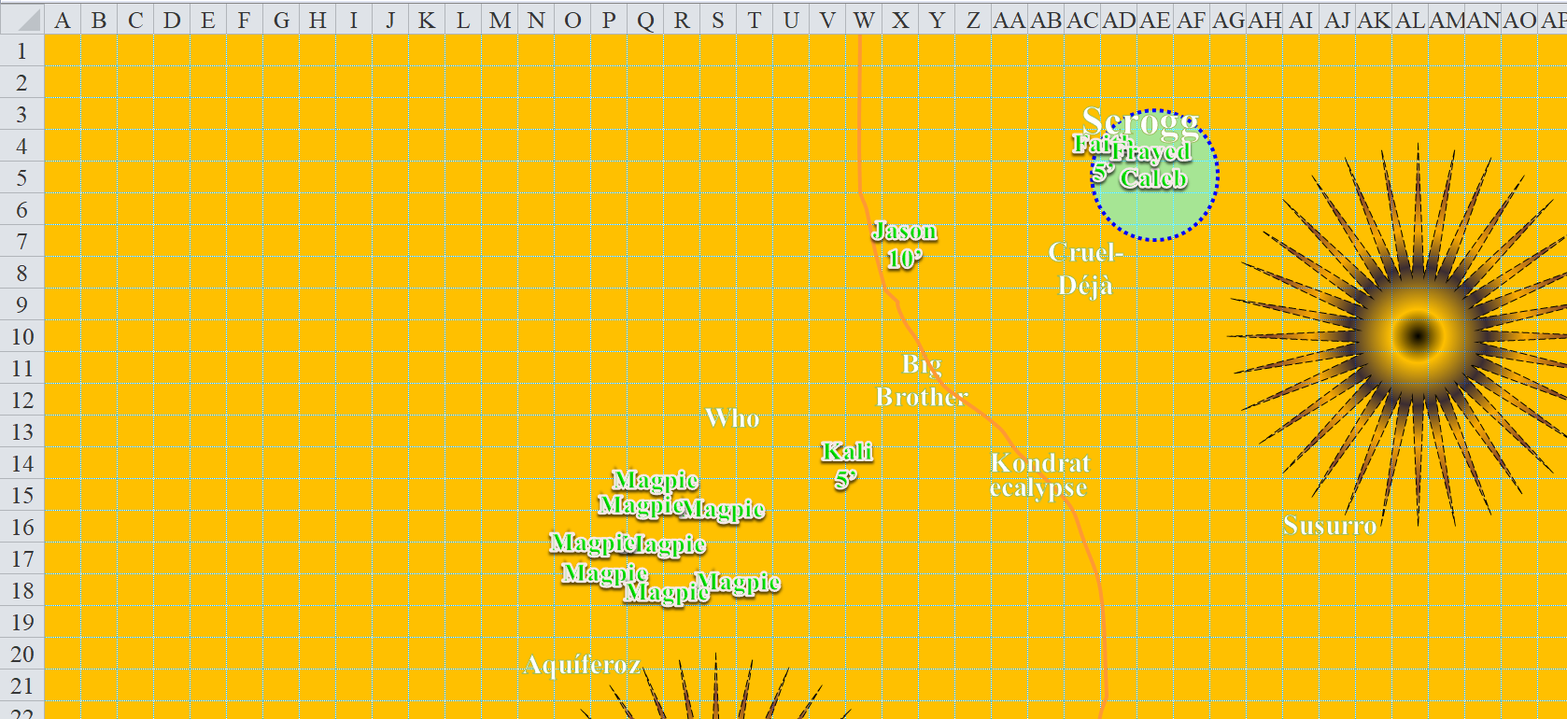

Round 157

It was apparent now that the zombies rowing the dinghies were following typically simplistic orders, and continued to row towards the ship, despite the fact that they were headed for a quadratic waterfall.

Frayed laughed and shot a lesser orb of fire at the fallen ogre mage, just to be certain.
Automatic hit. See below.

The multi-classed gnome then sighed, “You folks keep me alive, I’ll kill the necromancer. That’s a promise. Jason, can you shoot the flying cat bird out of the air?”

The ogre mage’s torso was now seared in half, and the whisper gnome humphed with indignation at the monstrous spellcaster’s gruesome figure, now lifeless. He nodded, then turned to the zombies approaching. “Same methodology?” the warmage-evoker said to the cleric-diviner.

Caleb took out his coin, and tossed it at Magpie, but kept his eye on Larlum, who guided his griffon ever closer to the rock where Who had perched before taking flight.
Toss | Mod. | Roll | Check
Coin (ranged touch) | 9 – 8 range | 14 | 15
Catch | Rank | Ability  & Mod. | Misc.  Mods. | Total | Roll | Check
Magpie, Reflex | 5 | Dex (+1) | 2 | 8 | 7 | 15
Success.

Magpie now held the brilliant coin in one hand. [The 60’-radius circle around her represents bright illumination, but there’s dim light for another 60’ out from Magpie. Only the bright light will affect the zombies.]

The woods were now undead with zombies snapping branches and thrashing through the foliage as they made their way southwest toward the heroes. Larlum’s griffon landed atop the island-rock, and the cleric of Velsharoon stayed mounted, watching the next chapter of the battle unfold. The tiefling studied the party, now combining observation with divination.

There were now eight human- and gnome-sized zombies in sight, all headed for the group of heroes inside Caleb’s magic circle against evil. One was actually headed straight for one of the black tentacle areas, so the heroes wished it good luck with that.

Then, everyone but Faith and Frayed heard the snapping of what must have been an entire trunk, and other sounds betraying a distinctively large creature approaching from the same direction as these zombies. Perhaps a larger zombie?

Caleb moved southwest again, then cast elation [expired on Round 169], giving his allies a warm fuzzy feeling of victory comes over them. “Back away from the woodline. We don’t want them to be able to reach us easily.”
All PCs gained a +2 Morale Strength and Dexterity, and a 5’ increase to speed.

Frayed moved stayed Caleb’s magic circle, replying, “Alright. I’ll retreat from the giant, whatever is coming out of the woods.” He used an Evoker magic missile on the closest zombie.

Magpie kept an eye on Larlum, gauging the distance between herself and the archenemy. Smiling at the fact that he was just over 600’ away from her, and her long-range spells could reach as far as 880’. It was a beautiful day, and she celebrated it by casting silence on Larlum the Redhanded.
Save vs.  silence | Rank | Ability & Mod. | Misc. Mods. | Total | Roll | Check
Larlum, Will | 8 | Wis (+7) | 5 | 20 | 20 | 40
Success.

Larlum smirked at the band of do-gooders, wondering which of them tried to silence him. He then thought to team up with his hound, which probably was a lost cause by now, and benefit from not having to face these allied douchebags all at once.

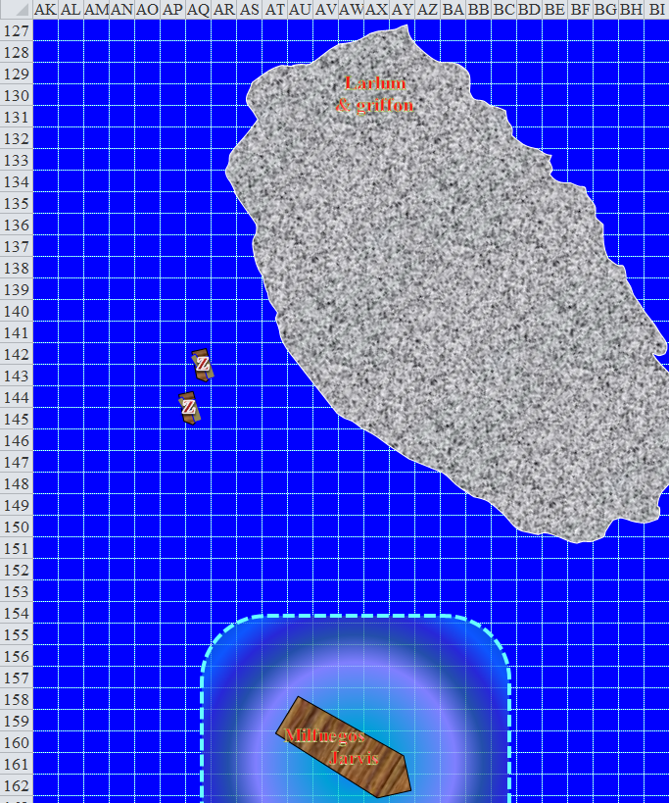

Kali moved fast, stopping at each foe and administering a death blow while the others watched the zombie. She reached Thymos, then came back towards where Magpie’s whelm spells had been centered, since the villains outside this area had received only lethal blows.

Faith moved to stand 15’ east of Magpie, presumably to shield her against the zombies. The paladin had to be careful to stay outside the reach of the nearby black tentacles spell that Caleb or Frayed was maintaining for the next few seconds.

Jason moved to Magpie’s side and readied an arrow for any that needed extra help dying, like the Huge creature they heard in the woods.

Those who were looking into the forest to see what kind of giant creature would emerge were taken aback by the Huge undead that barged through the trees as if they were saplings, ramming through them, and leaving bony shards and calcite rubble along the way.

“It’s a charnel hound!” Caleb identified the towering construct as it descended the foothill and got out of his view behind the black tentacles. Before it disappeared from his line of sight, the all-around-spellcaster noted that the charnel hound was only about half-way completed, and moved about half as fast as the cleric-mage would have expected, based on his studies. Larlum and his necromancer lackeys hadn’t had time to finish this project, and the tiefling had unleashed the beast in a mad, impetuous struggle to rid this plane of these pesky heroes. It came at them, smashing two large trees as it selected its target.

Kali—who could see it perfectly—could also tell that the undead dog was far from complete, and found several apparent weak spots in the structure comprised of the skeletons and flesh of dozens of gnomes and other humanoids.

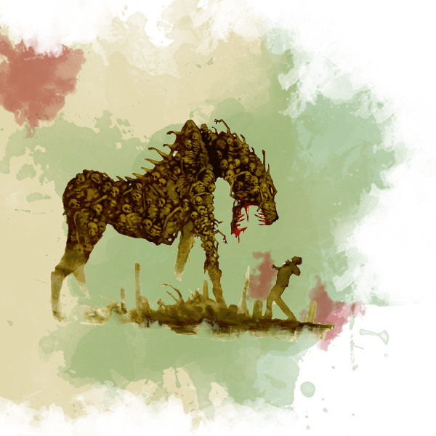

Jason had readied an arrow, but neither he nor Magpie nor Caleb nor Faith had a clear line of sight to it, seeing as the black tentacles were in their way. Frayed barely got a good view on the thing. The archer had been trained in blindsense and blind-fighting, however, and skirmished a single arrow aloft as he said to himself, “I do not aim with my eyes.”
Ranged Weapon | Dmg. | D+ | TH+ | Critical | Rng. | Wt. | Atk | Roll | Check | Notes
Sacred Composite Longbow, Skirmish | 1d8 | +1 +3d6 +2 | 1 | 19-20/x3 | 200’ |  | +16 | 6 | 22
Crystal of Cold Assault, Greater | - | 1d6 | - | - | - |  | - | - | - | -1 to AC 1 round
Hit. Dmg: 8 + 1 + 12 + 2 + 3 cold [negated] = 23.

“Oooh! That looked like it hurted,” Kali spoke like a cheerleader, and not a fleshslicer.

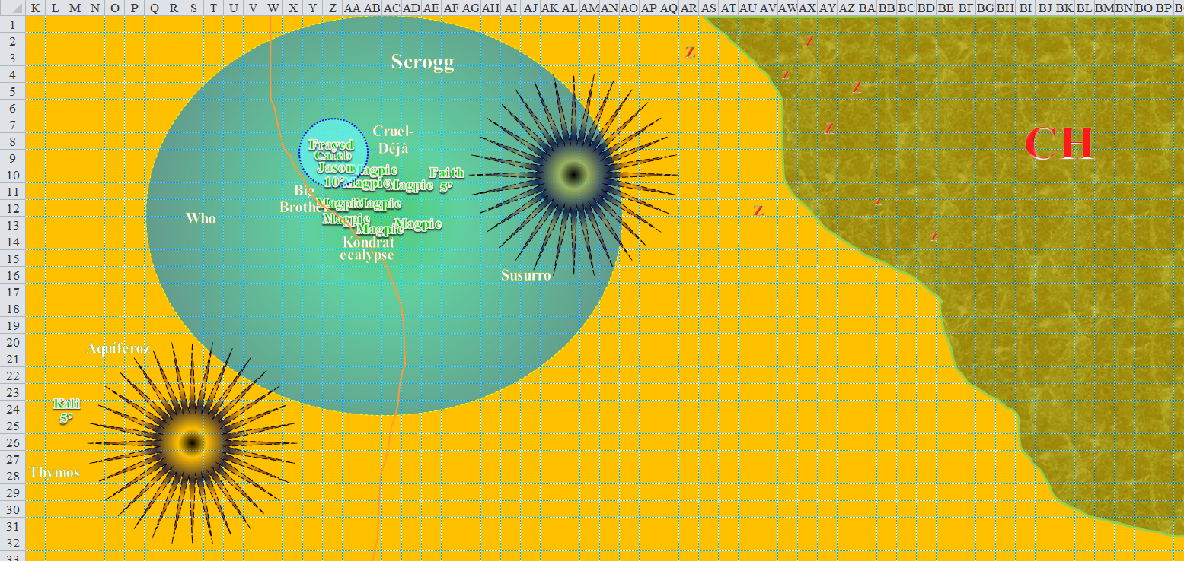

Round 158

Caleb’s freedom of movement ability—based off of his heart of water spell—expired, as did the rest of the spell’s effects.

Frayed cast force missiles on the charnel hound, using his bracers to make it an entangling blast to slow it down.
Inerrant hit. Dmg: ½ x (7 + 6 + 11) = 12 magic [force] + entanglement [expired on Round 159].
Charnel hound sustained -2 to attacks, -4 to Dex, and now moved at 10’ per round, unable to run/charge.

Magpie activated her wand of lesser vigor on herself.
Magpie gained 1 hp/round over the next 15 rounds [66/90 on this round; 80/90 on Round 173 barring further damage/healing].

One of the dinghies fell down into the squarish depression in the ocean, while the other one didn’t quite reach the cataract caused by Larlum’s control water spell.

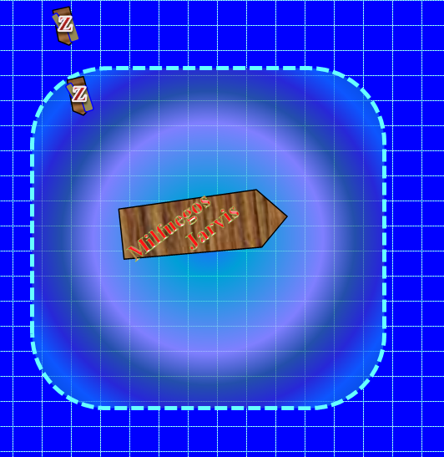

Spurring his griffon into the air once again, Larlum the Redhanded tried to decide which of them he was going to leave alive so the tale of this great day would be told across the ages. So his lackeys were almost all dead, and two had betrayed him. Lackeys could be replaced, better yet, produced, and there were several other islands to choose from in this archipelago. As he got closer, he visually inspected the equipment, fighting styles, and spellcasting of his foes, perhaps with the intention of recruiting or bezombifying one or more of them. The paladin, of course, would have to go, but he had had his eye on the beguiler since the woman possessed Fuchsia just yesterday. A beguiler would be a nice addition to his next syndicate!

As he descended and made his way north-northwestward, he rebuked the pack of zombies that were left in a stupor on the shore after loading treasure and equipment onto the two dinghies.
Rebuking Undead
 |  | Max HD Rebuked | 11
 |  | 1d20 Roll | 16
 |  | Rebuke Check | 33
 |  | 2d6 Roll | 9
 |  | Rebuke Dmg. | 31
 |  | Rebukes/Day | 14
 |  | Rebukes Used | 1

All of the zombies created by Who the Bone Whisperer now turned to face northward, and made their way towards the heroes. Larlum’s griffon stayed its course and altitude.

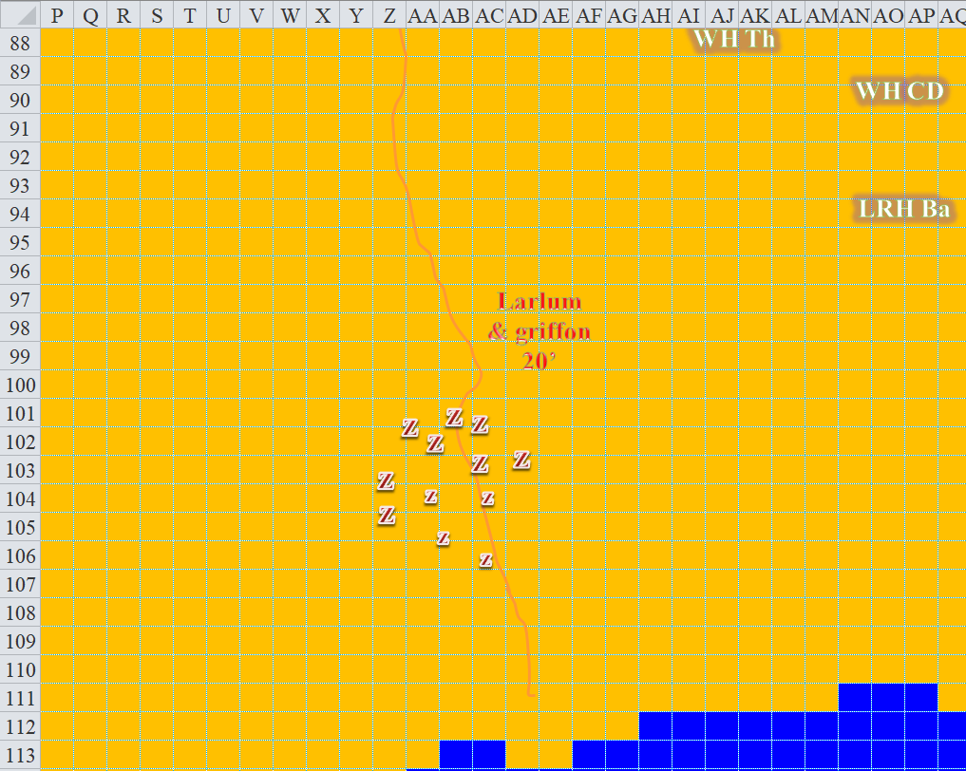

To the north, one zombie got caught in a black tentacle.
Character | Attack Type | Damage | BAB | Mod+ | W+ | Other+ | d20 | Total
Zombie | Grapple | Grapple | 1 | 0 | 0 | 0 | 6 | 7
Caleb | Evard’s Black Tentacles | 1d6+4 | 11 | 0 | 0 | 0 | 11 | 22
Grapple successful. Dmg: 1 + 4 = 5.

The rest of the zombies in its midst ignored their ensnared counterpart, and kept on walking westward.

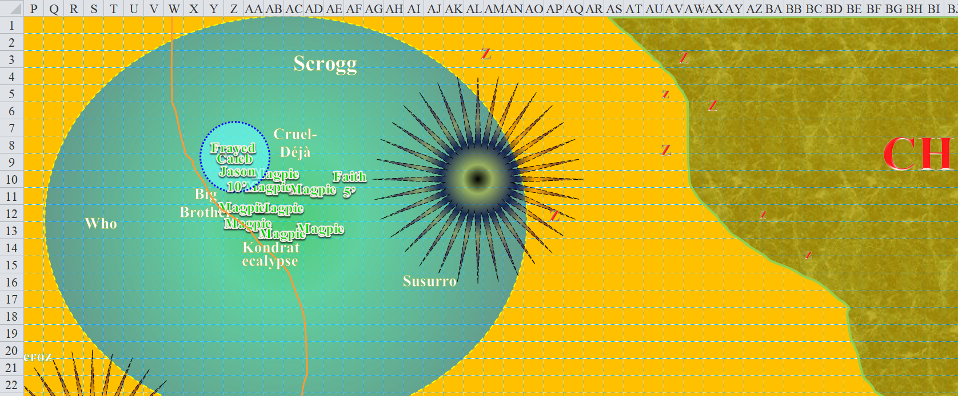

Caleb burned his prepared lesser restoration spell to cast cure moderate wounds on Frayed. “The beast looks... unfinished, but at full strength is very dangerous... and Larlum is coming to play.”
Frayed gained 12 + 12 = 24 hps [62/62].

“Pretty much what Fuchsia said yesterday,” Magpie nodded.

Faith moved north to intercept the frontmost zombie.

Kali headed to a position south of the tentacles as fast as she could.

Jason flew north and fired upon the hound.
Ranged Weapon | Dmg. | D+ | TH+ | Critical | Rng. | Wt. | Atk | Roll | Check | Notes
Sacred Composite Longbow, Skirmish | 1d8 | +1 +3d6 +2 | 1 | 19-20/x3 | 200’ |  | +16 | 17 | 33
Crystal of Cold Assault, Greater | - | 1d6 | - | - | - |  | - | - | - | -1 to AC 1 round
Hit. Dmg: 6 + 1 + 7 + 2 + 5 cold [negated] = 16 + (-1) penalty to AC.

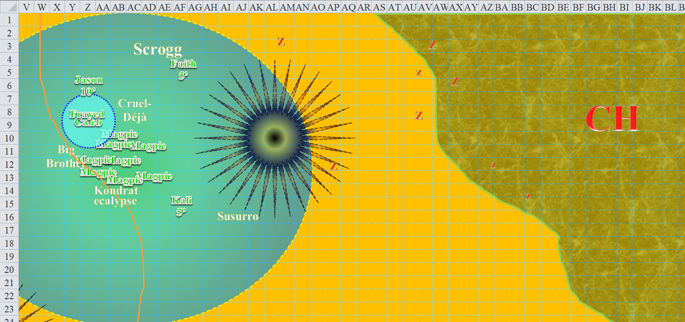

Round 159

The hound was a more immediate threat, so Caleb fired a magic missile from his wand at it.
Dmg: 13 + 5 = 18 magic [force].

Magpie stowed her wand and considered her ever shrinking options, then smiled. “Okay, Mr. ‘I’m a cleric so my brain is resistant to your puny magics’. Try this.” This time Magpie cast silence on the griffon. It might take the enemy caster a moment to realize what she’d done, which was precious time, in her mind.
Character | Save vs.  silence | Ranks | Roll | Save
Fiendish Griffon | Will | 5 | 10 | 15
Fail.

Larlum could immediately tell that the wind in his hair was no longer whistling and blowing as he flew. Bastards!

Frayed... well, Frayed had lots of options, what with all of the blastiness he tooled around with. “That thing resistant to anything, Caleb?”

The cleric shrugged, “Not sure. I don’t think so, but I wouldn’t try negative energy.”

“Well, let’s keep it simple.” The gnome warmage launched a wizard prepared magic missile at the beast. Soon, it’d probably get close enough for an orb of force, and then... whew. Good times.
Dmg: 11 + 5 + 4 [right?] = 20 magic [force].

Despite the barrage of missiles, the charnel hound remained on at least three of its four flimsy legs. It would have taken another few weeks to finish this particular project, and Larlum must have known after casting clairvoyance and other Divinations upon the heroes that his best bet was to expend the hound while he still could.

The griffon descended, meaning to land about 220’ south of Jason.

The zombies and charnel hound made their way over to the heroes. The charnel hound was still entangled, but the entangling webs were beginning to snap, tear, and wither.

Upon a hefty squeeze by a tentacle, the zombie inside the black tentacles burst into chunks that spewed about 15’ out in all directions.

The griffon landed and Larlum dismounted.
Skill | Rank | Ability & Mod. | Misc. Mods. | Total | Roll | Check | Properties
Larlum, Ride | 5 | Dex (+1) | 0 | 6 | 17 | 23 | CROSS-CLASS SKILL
Success. Dismount is a free action.

The cleric of Velsharoon landed on both feet with two flails in his hands, and strode a few feet northward, resolving to finish these fools himself. But as soon as he got outside of the silence sphere cast upon the griffon, he could hear once again, and smiled, casting hold person upon Jason.
Save vs.  hold person | Rank | Ability & Mod. | Misc. Mods. | Total | Roll | Check
Jason, Will | 4 | Wis (+1) | 1 | 6 | 17 | 23
Success. Spell was ineffective.

Larlum had to wipe that smug smile off of his tiefling face.

Ignoring the zombies around her, Kali bent the course of her stride southeastward a bit to avoid the black tentacles, and then back northeastward towards the hound in the forest. One gnome zombie in particular would soon swipe at her if she didn’t do so first.

Jason rapid-shot at the hound.
Ranged Weapon | Dmg. | D+ | TH+ | Critical | Rng. | Wt. | Atk | Roll | Check | Notes
Sacred Composite Longbow, Strength +1 | 1d8 | +1 | 1 | 19-20/x3 | 200’ | 3.0 | +16 | 10 | 26
2nd Shot | 1d8 | +1 | 1 |  |  |  | +11 | 15 | 26
3rd Shot, Rapid Firing | 1d8 | +1 | 1 |  |  |  | +6 | 5 | 11
Crystal of Cold Assault, Greater | - | 1d6 | - | - | - |  | - | - | - | -1 to AC 1 round
Hit, hit, miss. Dmg: (3 + 1 + 5 cold [negated]) + (7 + 1 + 1 cold [negated]) = 12.

Chunks of zombies, skeletons, ghouls, and other undead started to break off of the charnel hound, as the damage from the heroes’ barrage started to stack and mount. “Oh, the beauty of it!” thought Kali as she stopped her advance, realizing that by the time she got to the hound it would be destroyed.

Faith also abstained from pursuing a melee with the charnel hound, and merely shook her head before turning her attention to the zombie that was rushing her as best as it could.
Melee Weapon | Dmg | D+ | TH+ | Critical | Type | Wt. | Atk | Roll | Check | Properties
Adamantine Illuminating  Holy Greatsword +1 | 2d6+2 | +6 + 1 | 1 | 17-20/x2 | Slashing | 8.0 | +12 | 5 | 17 | +2d6 to evil
2nd Attack | 2d6+2 | +6 + 1 | 1 | 17-20/x2 | Slashing |  | +7 | 5 | 12
3rd Attack | 2d6+2 | +6 + 1 | 1 | 17-20/x2 | Slashing |  | +2 | 19 | 21
Hit, hit, hit. Minimum damage destroyed the zombie.

This created or raised zombie fell to the ground, hacked and slashed by the fierce paladin of freedom, then was burned by Caleb’s coin, now in Magpie’s otherwise free hand.

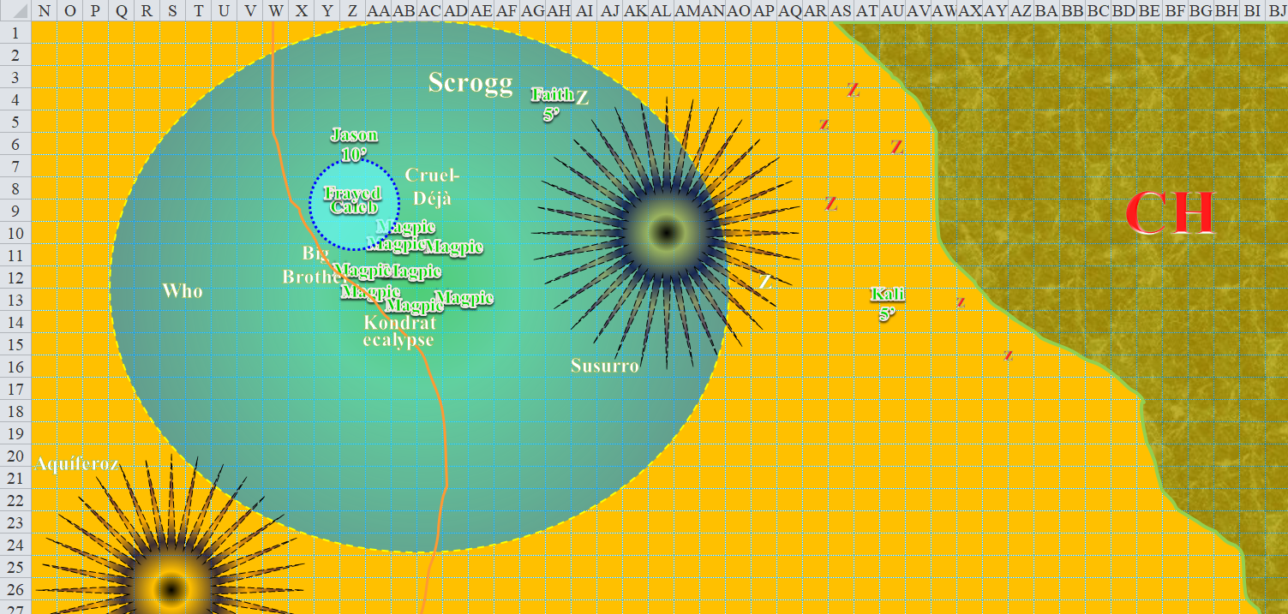

Round 160

The charnel hound was no longer slowed by the ensnaring goo that Frayed had bestowed upon it. It growled menacingly and moved ever westward. The zombies coming out of the forest did pretty much the same, and three new ones emerged from the bushes and trees. One swiped at Kali.
Character | Attack Type | Damage | BAB | Mod+ | W+ | Other+ | d20 | Total
Zombie | Slam | 1d6/x3 | 1 | 0 | 0 | 0 | 5 | 6
Miss.

Kali returned the favor, then spun around to swing at the zombie to her southeast.
Melee Weapon | Dmg | D+ | TH+ | Critical | Type | Wt. | Atk | Roll | Check
Scimitar +2 | 1d6 | 2 | 2 | 18-20, x2 | Slashing | 4.0 | +14 | 15 | 29
2nd Attack | 1d6 | 2 | 2 | 18-20, x2 | Slashing | - | +9 | 8 | 17
3rd Attack | 1d6 | 2 | 2 | 18-20, x2 | Slashing | - | +4 | 17 | 21
Crystal of Electrical Assault, Greater | - | 1d6 | - | - | - | 0.0
Hit, hit, hit.
Dmg to first zombie: 5 + 2 + 5 electric = 12.
Dmg to second zombie: (1 + 2 + 1 electric) + (4 + 2 + 5 electric) = 9 + 6 electric = 15.

Both gnome zombies perished at the hands of the dancer.

One zombie got caught in the black tentacles, and writhed to escape in vain.

The zombies to the far south continued treading northward, though it would be some time before they arrived at the scene of the battle.

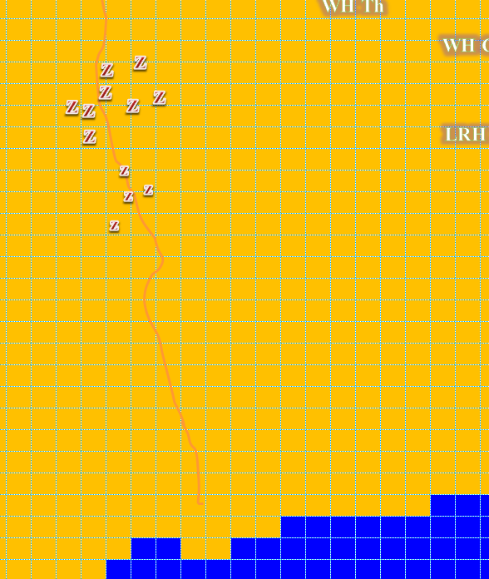

Jason thought he’d finish the charnel hound so they could settle their business with the tiefling coming at them.
Ranged Weapon | Dmg. | D+ | TH+ | Critical | Rng. | Wt. | Atk | Roll | Check | Notes
Sacred Composite Longbow, Strength +1 | 1d8 | +1 | 1 | 19-20/x3 | 200’ | 3.0 | +16 | 17 | 33
2nd Shot | 1d8 | +1 | 1 |  |  |  | +11 | 1 | 12
3rd Shot, Rapid Firing | 1d8 | +1 | 1 |  |  |  | +6 | 9 | 15
Crystal of Cold Assault, Greater | - | 1d6 | - | - | - |  | - | - | - | -1 to AC 1 round
Hit, miss, miss. Dmg: 8 + 1 + 4 cold [negated] = 9.

The charnel hound took a few steps forward, then its front legs buckled under its weight, and it fell, spilling scores of undead body parts—inanimate, thankfully—upon the downward slope that led to the sandier coastline.

With the hound destroyed, the heroes now turned their attention to Larlum, hardly worried about the dozen zombies in their midst.

Larlum pushed ever northward, while his griffon took flight and headed south again. The rogue-cleric then cast dispel magic upon Magpie.
Ranged Weapon | TH+ | Versus | Rng. | Atk | Roll | Check
Dispel Magic | 10 | mirror image | 100’ + 10’/lvl | 10 | 10 | 20
Success.

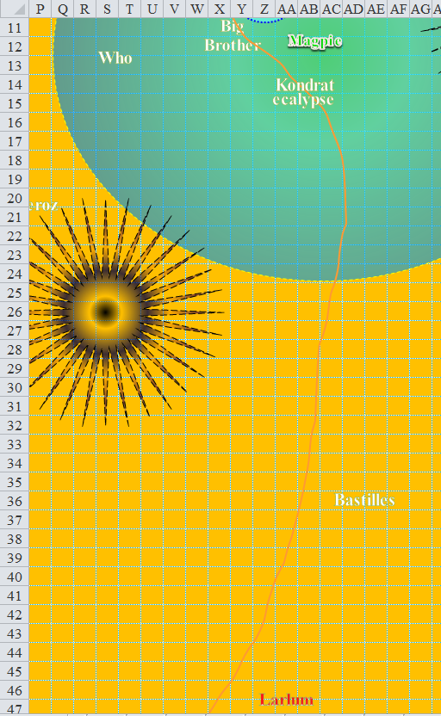

Magpie’s mirror images were now disappearing one by one. With no other buffs currently in place, the gnome frowned at Larlum.

Jason flew southeast [not north], getting Larlum within his shortest range increment, then fired at the arch-villain.
Ranged Weapon | Dmg. | D+ | TH+ | Critical | Rng. | Wt. | Atk | Roll | Check | Notes
Sacred Composite Longbow, Skirmish | 1d8 | +1 +3d6 +2 | 1 | 19-20/x3 | 200’ | - | +16 | 16 | 32
Crystal of Cold Assault, Greater | - | 1d6 | - | - | - | - | - | - | - | -1 to AC 1 round
Hit. Dmg: 6 + 1 + 14 + 2 + 6 cold = 29. Partial damage negated.

Faith flew southeast, and Kali flew west.

Magpie’s last mirror image disappeared. Knowing that the powerful cleric was largely highly resistant to a lot of her effects, she cast haste [expired on Round 172] on the party. “Go get ‘em, folks.” The powerful cleric was probably far less resistant to Faith.
All PCs gained +1 to attack, +1 to Reflex save, and 1 extra attack or 30’ more movement per round.

Frayed hopped from foot to foot, so excited that Larlum had joined the party. “Oi, remember me, you piece of filth!?” The warmage didn’t want his revenge to go too quickly, but at the same time, Larlum was not someone to underestimate. He’d already used his wizard prepared Fire (Lightning) ball spell, but somehow managed to spontaneously sacrifice a 3rd level spell slot [greater mage armor] in order to cast it.
centered near Larlum, now that the griffon had flown southward, and was not worth going after at the moment.
Save vs.  Fireball (Electric) | Rank | Ability & Mod. | Misc. Mods. | Total | Roll | Check
Larlum, Reflex | 6 | Dex (+1) | 5 | 12 | 15 | 27
Save. Dmg: ½ x 38 = 19 electric. Partial damage negated.

Caleb cast Evard’s black tentacles [expired on Round 172] on Larlum.
Melee Weapon | Atk | Roll | Check
Grapple | 9 | 15 | 24
Character | Attack Type |  | Damage | BAB | d20 | Total
Caleb | Evard’s Black Tentacles |  | 1d6+4 | 11 | 10 | 21
Grapple failed.

“Oi, yourslfghrph!” the cleric’s reply to Frayed was interrupted and entangled by Caleb’s black tentacles. The fiendish cleric, however, emerged with a triumphant look in his eyes. “I shall not yield to you!”

The black tentacles that Frayed had cast now expired, and disappeared.

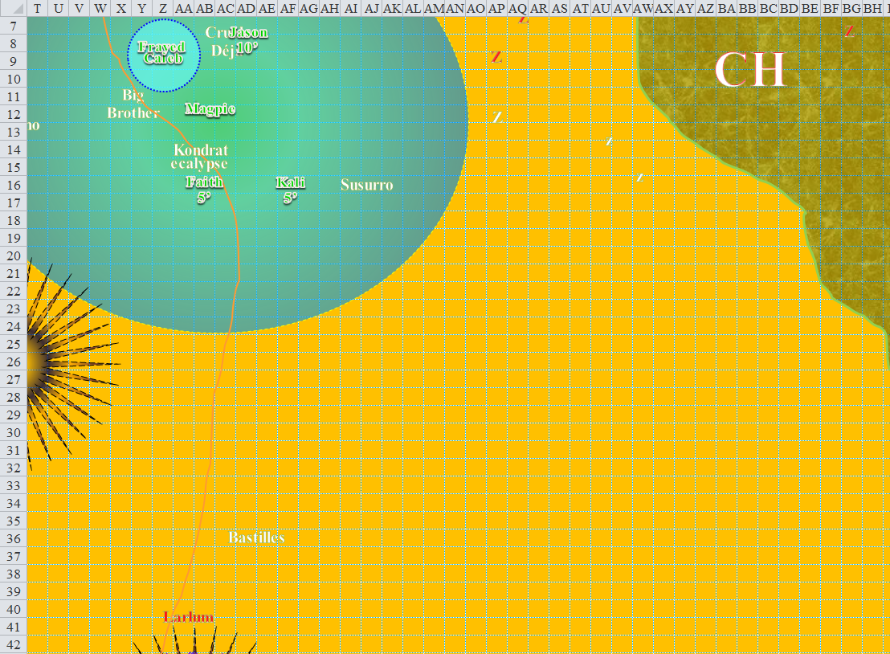

Round 161

Character | Group | Initiative | Roll | Modified Roll | Move
Caleb | 1 | 3 | 17 | 20 | 30’+10’
Kali | 1 | 8 | 11 | 19 | 40’
Magpie | 1 | 1 | 17 | 18 | 20’
Milfuegos Mopworken | 3 | 2 | 14 | 16 | 20’
Larlum the Redhanded | 2 | 1 | 15 | 16 | 30’
Jason | 1 | 9 | 4 | 13 | 40’
Frayed | 1 | 2 | 8 | 10 | 30’+10’
Faith | 1 | 1 | 6 | 7 | 20’
Jarvis Rutherfyord III | 3 | 0 | 3 | 3 | 20’

Magpie’s mirror images started to reappear. “Well!” she remarked. “That’s new and unexpected.”

The zombies to the east headed west, and the zombies to the south headed north. Three of them headed straight into the black tentacles as the one that was already inside was destroyed.

Caleb called back to Larlum, “I don’t expect you to yield. I expect you to die.” He leveled his wand and cast magic missile at the fiend.”
Dmg: 12 + 5 = 17 magic.

Larlum took his lumps, then activated a Healing Belt, and felt much better.
Larlum gained 20 hps.

Another few mirror images reappeared, and within a few seconds, seven of Magpie’s eight identical figments had returned. The beguiler-visionary looked back at Caleb and nodded, “Not a bad line. Let’s make it happen. Sic ‘em folks!” Having just cast haste on the party, she now cast a targeted dispel magic on the enemy at hand.
Ranged Weapon | Dmg. | Atk | Roll | Check | Spell
Dispel Magic | dispel | 12 | 17 | 29 | fire in the blood
Dispel Magic | dispel | 12 | 1 | 13 | bull’s strength
Dispel Magic | dispel | 12 | 9 | 21 | cat’s grace
Dispel Magic | dispel | 12 | 4 | 16 | bear’s endurance
Dispel Magic | dispel | 12 | 18 | 30 | owl’s wisdom
Dispel Magic | dispel | 12 | 19 | 31 | eagle’s splendor
Dispel Magic | dispel | 12 | 1 | 13 | divine power
Dispel Magic | dispel | 12 | 18 | 30 | armor of darkness
Dispel Magic | dispel | 12 | 12 | 24 | water walk
Dispel Magic | dispel | 12 | 5 | 17 | lore of the gods
Dispel Magic | dispel | 12 | 2 | 14 | shield of faith
Dispel Magic | dispel | 12 | 3 | 15 | nightshield
Dispel Magic | dispel | 12 | 15 | 27 | detect good
Dispel Magic | dispel | 12 | 4 | 16 | resistance
Success. Fire in the blood dispelled.
Fail. Bull’s strength not dispelled.
Fail. Cat’s grace not dispelled.
Fail. Bear’s endurance not dispelled.
Success. Owl’s wisdom dispelled.
Success. Eagle’s splendor dispelled.
Fail. Divine power not dispelled.
Success. Armor of darkness dispelled.
Success. Water walk dispelled.
Fail. Lore of the gods not dispelled.
Fail. Shield of faith not dispelled.
Fail. Nightshield not dispelled.
Success. Detect good dispelled.
Fail. Resistance not dispelled.

Magpie then took an account of her remaining spells.
 | Beguiler Spells by Level
 | 0th | 1st | 2nd | 3rd | 4th | 5th | 6th | 7th
Beguiler Spells | 6 | 6 | 6 | 6 | 6 | 5 | 3 | 0
Charisma Bonus | 0 | 1 | 1 | 1 | 1 | 0 | 0 | 0
Total Daily Spells | 6 | 7 | 7 | 7 | 7 | 5 | 3 | 0
DC | 15 | 16 | 17 | 18 | 19 | 20 | 21 | -
Cast? | 0 | 2 | 2 | 7 | 7 | 5 | 3 | -

Jason rapid fired upon Larlum with his longbow.
Ranged Weapon | Dmg. | D+ | TH+ | Critical | Rng. | Wt. | Atk | Roll | Check | Notes
Sacred Composite Longbow, Strength +1 | 1d8 | +1 | 1 | 19-20/x3 | 200’ | 3.0 | +17 | 14 | 31
2nd Shot | 1d8 | +1 | 1 |  |  | - | +12 | 7 | 19
3rd Shot, Rapid Firing | 1d8 | +1 | 1 |  |  | - | +7 | 18 | 25
4th Shot, haste | 1d8 | +1 | 1 |  |  | - | +17 | 20 | 37
Crystal of Cold Assault, Greater | - | 1d6 | - | - | - | - | - | - | - | -1 to AC 1 round
Hit, miss, miss, threat. 1d20 = 8 + 17 = 25, not a critical hit. Dmg: (3 + 1 + 6 cold) + (6 + 1 + 2 cold) = 11 + 8 cold = 19. Partial damage negated.

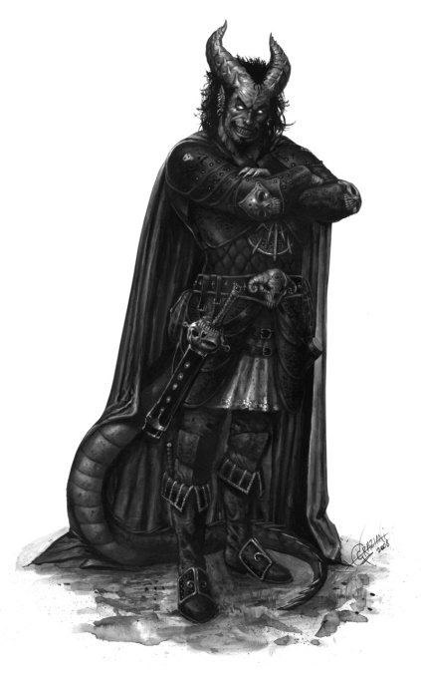

Larlum cast divine power [expired on Round 172] upon himself, then laughed, and taunted his guests on what he deemed his island. He held his position just north of the black tentacles into which he hoped to lure a bulky armored, bull rushing, charging paladin and her dainty sidekick.
Larlum gained +5 to attacks, +6 to Strength, and 11 hps.

Frayed, in an attempt to make it more difficult for Larlum to cast a spell, cast an Empowered Melf’s acid arrow at the cleric, using a warmage slot. If it hit, that ongoing damage would hopefully force some concentration checks.
Ranged Weapon | Atk | Roll | Check
Ranged Touch Spell | 11 | 4 | 15
Hit. Dmg: 1½ x (3 + 3 + 6 + 2) = 14 acid over the course of the next 4 rounds.

Faith moved forward, with Kali following close behind. [DM assumption] The two hastened warriors could have gotten within 5’ of Larlum’s reach, but they would have been vulnerable to his attacks prior to their charge, so instead the paladin slowed her step just a bit in order to get the full benefit of a charge-attack without the risk of a bonk on the head from one of the tiefling’s flails.

Milfuegos and Jarvis ?

The black tentacles that Caleb had cast now expired, and disappeared.

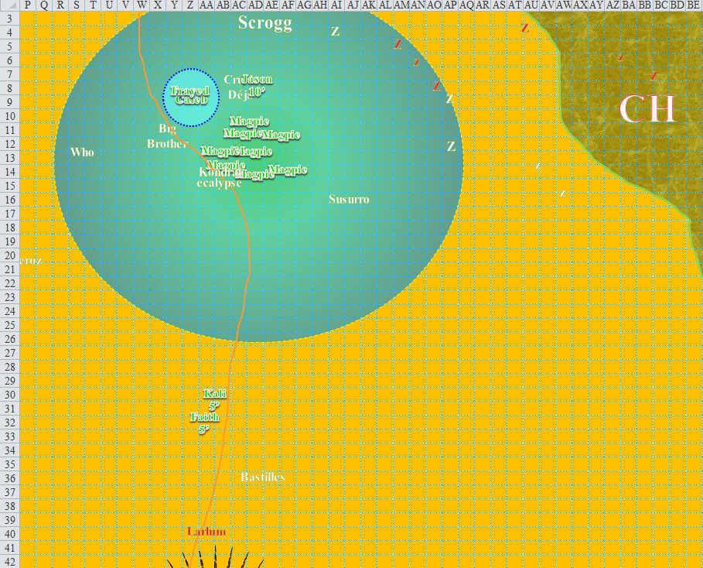

Round 162

The zombies to the east were a lost cause at this point, bursting before the Celestial brilliance of the coin in Magpie’s hand. The zombies to the south wouldn’t be there for a while yet.

Floating in place, Jason continued to rapid-fire.
Ranged Weapon | Dmg. | D+ | TH+ | Critical | Rng. | Wt. | Atk | Roll | Check | Notes
Sacred Composite Longbow, Strength +1 | 1d8 | +1 | 1 | 19-20/x3 | 200’ | 3.0 | +17 | 14 | 31
2nd Shot | 1d8 | +1 | 1 |  |  | - | +12 | 9 | 21
3rd Shot, Rapid Firing | 1d8 | +1 | 1 |  |  | - | +7 | 18 | 25
4th Shot, haste | 1d8 | +1 | 1 |  |  | - | +17 | 17 | 34
Crystal of Cold Assault, Greater | - | 1d6 | - | - | - | - | - | - | - | -1 to AC 1 round
Hit, miss, miss, hit. Dmg: (5 + 1 + 4 cold) + (3 + 1 + 4 cold) = 10 + 8 cold = 18. Partial damage negated.

Faith and Kali canceled their flying charge-attack in order to avoid running into the black tentacles, but attack the tiefling archenemy anyway. [DM assumption that you’d rather avoid a Reflex save than gain a +2 to hit and damage. If this is wrong, let me know and I’ll roll the Reflex save for either or both PCs, then add the +2 to hit and damage.]
Melee Weapon | Dmg | D+ | TH+ | Critical | Type | Wt. | Atk | Roll | Check | Properties
Faith, Adamantine Illuminating  Holy Greatsword +1 | 2d6+2 | +6 + 1 | 1 | 17-20/x2 | Slashing | 8.0 | +13 | 13 | 26 | +2d6 to evil
2nd Attack, haste | 2d6+2 | +6 + 1 | 1 | 17-20/x2 | Slashing |  | +13 | 9 | 22
Kali, Scimitar +2 | 1d6 | 2 | 2 | 18-20, x2 | Slashing | 4.0 | +15 | 14 | 29
2nd Attack, haste | 1d6 | 2 | 2 | 18-20, x2 | Slashing | - | +15 | 6 | 21
Crystal of Electrical Assault, Greater | - | 1d6 | - | - | - | 0.0
Miss, miss, hit, miss. Dmg: 2 + 2 + 2 electric = 6. Partial damage negated.

Larlum grunted from the lingering acid damage and now from Kali’s blade. He retaliated by full-attacking Kali.
Melee Weapon | Dmg | D+ | TH+ | Critical | Type | Wt. | Atk | Roll | Check
Unholy Heavy Flail | 1d10 | +6 2d6 evil | 1 | 19-20, x2 | Bludgeon | 10.0 | 22 | 2 | 24
Throwing Returning Heavy Flail | 1d10 | +6 +1 | 1 | 19-20, x2 | Bludgeon | 10.0 | 20 | 14 | 34
Miss, hit. Dmg: 10 + 6 + 1 = 17 [42/88].

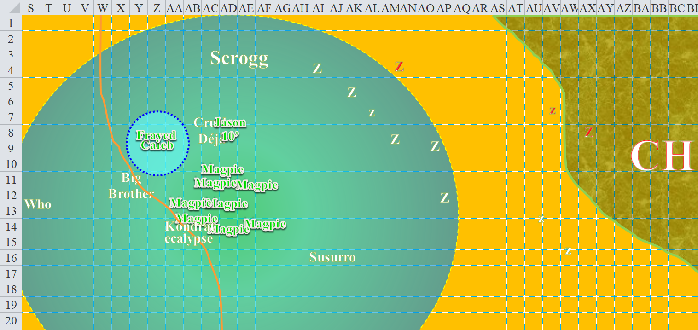

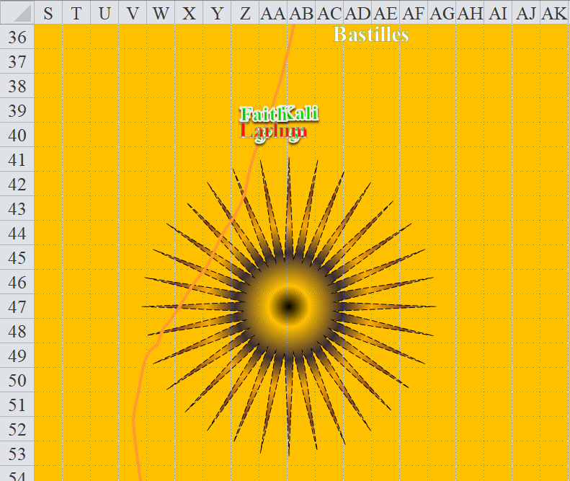

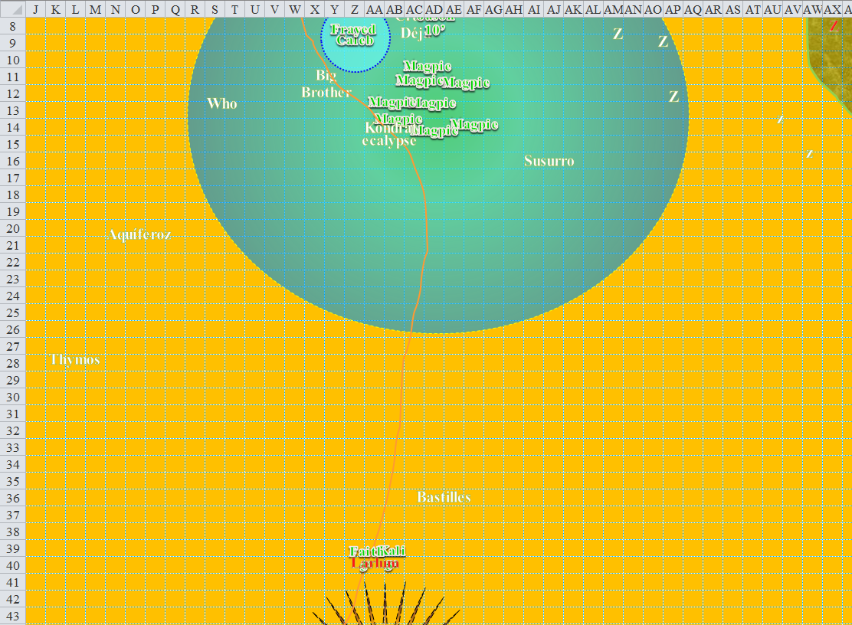

Round 163

Jason rapid-fired again.
Ranged Weapon | Dmg. | D+ | TH+ | Critical | Rng. | Wt. | Atk | Roll | Check | Notes
Sacred Composite Longbow, Strength +1 | 1d8 | +1 | 1 | 19-20/x3 | 200’ | 3.0 | +17 | 16 | 33
2nd Shot | 1d8 | +1 | 1 |  |  | - | +12 | 6 | 18
3rd Shot, Rapid Firing | 1d8 | +1 | 1 |  |  | - | +7 | 15 | 22
4th Shot, haste | 1d8 | +1 | 1 |  |  | - | +17 | 14 | 31
Crystal of Cold Assault, Greater | - | 1d6 | - | - | - | - | - | - | - | -1 to AC 1 round
Hit, miss, miss, hit. Dmg: (8 + 1 + 2 cold) + (3 + 1 + 3 cold) = 13 + 5 cold = 18 + (-1) to AC 1 round. Partial damage negated.

Faith cast Smite on Larlum and attacked as she moved 5’ to Larlum’s left side.
Melee Weapon | Dmg | D+ | TH+ | Critical | Type | Wt. | Atk | Roll | Check | Properties
Adamantine Illuminating  Holy Greatsword +1 | 2d6+2 | +6 + 1 | 1 + 3 | 17-20/x2 | Slashing | 8.0 | +16 | 11 | 27 | +2d6 to evil
2nd Attack | 2d6+2 | +6 + 1 | 1 + 3 | 17-20/x2 | Slashing |  | +11 | 15 | 26
3rd Attack | 2d6+2 | +6 + 1 | 1 + 3 | 17-20/x2 | Slashing |  | +6 | 17 | 23
4th Attack, haste | 2d6+2 | +6 + 1 | 1 + 3 | 17-20/x2 | Slashing |  | +16 | 15 | 31
Miss, miss, miss, hit. Dmg: 7 + 2 + 6 + 1 + 12 + 5 good = 33.

Larlum turned to face Faith now that she’d repositioned herself, and swung both flails with fury.
Melee Weapon | Dmg | D+ | TH+ | Critical | Type | Wt. | Atk | Roll | Check
Unholy Heavy Flail | 1d10 | +6 +2d6 evil | 1 | 19-20, x2 | Bludgeon | 10.0 | 22 | 15 | 37
Throwing Returning Heavy Flail | 1d10 | 1 | 1 | 19-20, x2 | Bludgeon | 10.0 | 20 | 7 | 27
Hit, hit. Dmg: (2 + 6 + 11 evil) + (1 + 6 + 5 evil) = 15 + 16 evil = 31 [50/125].

Kali began swirling around in a circle, her blades slashing at Larlum as she moved 5’ to Larlum’s right side, allowing her to flank the tiefling that had just turned leftwards toward the paladin.
Melee Weapon | Dmg | D+ | TH+ | Critical | Type | Wt. | Atk | Roll | Check
Scimitar +2 | 1d6 | 2 | 2 + 2 flank | 18-20, x2 | Slashing | 4.0 | +15 | 20 | 35
2nd Attack | 1d6 | 2 | 2 | 18-20, x2 | Slashing | - | +10 | 16 | 26
3rd Attack | 1d6 | 2 | 2 | 18-20, x2 | Slashing | - | +5 | 14 | 19
4th Attack, haste | 1d6 | 2 | 2 | 18-20, x2 | Slashing | - | +15 | 20 | 35
Crystal of Electrical Assault, Greater | - | 1d6 | - | - | - | 0.0
Threat, miss, miss, threat. 1d20 = 17, 2, one critical hit. Dmg: [2 x (5 + 2 + 3 electric)] + (4 + 2 + 1 electric) = 20 + 4 electric = 24. Partial damage negated.

Magpie, Caleb, and Frayed saw the two women cut the tiefling down, with Kali’s last swipe being the coup de grace that sent his head rolling and the rest of his body kneeling for a second before collapsing and drenching the sand in blood.

Thus ended the life and misdeeds of one of the vilest villains this archipelago had ever hosted.

