Chapter 14: Astral Assassins

Almost a year later...

Jason had just finished off a handful of githyanki fighters and a githyanki wizard—a gi-wiz—on the deck of one of their Astral ships. They had followed the vessel across half the Astral Plane by now, and in that time, staved off several perils. Having suffered only minimal damage during the brief assault on the ship, the heroes now realized that this ship was actually bait, for they now saw a handful of gith vessels headed their way through the Astral clouds and haze. Most were going at about the same speed as the wayward vessel they’d just taken, but one smaller bullet ship happened to strafe elusively through the thickest of the clouds in front of them, and now meant to ram them.

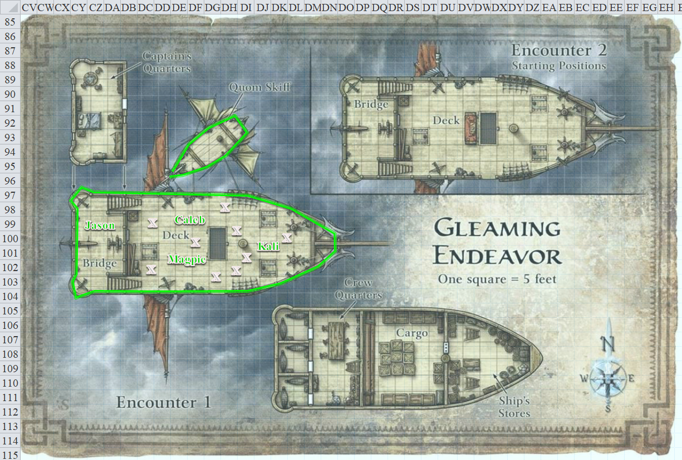

By the time they saw the thing coming, it was too late; a collision was inevitable. They saw the seemingly unmanned craft and braced for impact, suspecting that the crash would not completely destroy the ship, but would surely cause quite a quake on board.

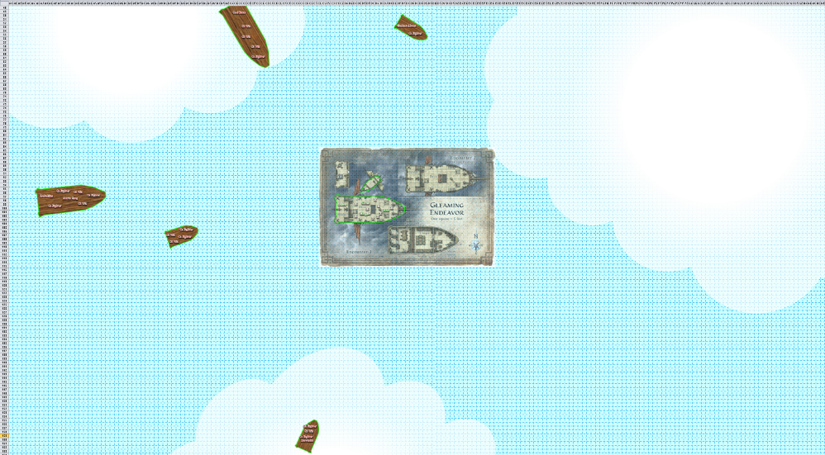

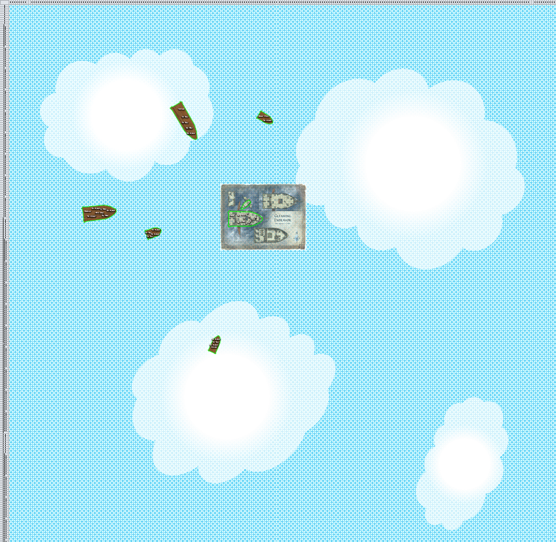

And as much as the gith leaders felt proud that they had cunningly lured these four fools to their doom, Magpie had been clever enough to anticipate such trickery, and not only kept the suspicions to herself for fear that one of their psionic masters might pry the information from her less wily accomplices’ minds, but also had taken precautionary measures in anticipation of the gith renegade they’d been tracking for months on end: Cad Bane.

He was likely to be aboard one of these incoming ships, or perhaps some other unseen vessel further away, but the beguiler rested assured that he was behind this ambush attempt.

Round 1

Kali stood to the rail, drinking a potion of shield of faith [expired on Round 11]. She hovered above it so that the impending crash would not throw her about.
Kali gained +2 to AC.

Jason zoomed up just above the sails [DM assumes it’s not the starboard sail, which is the one that’s NOT about to be crashed into] and watched for targets.

Caleb had cast mass fly [expired on Round 120] and greater mage armor [expired on Round 7790] a minute or so ago.

Magpie had cast greater mirror image [expired on Round 120] and freedom of movement [expired on Round 1290] on herself. She now shouted out to Caleb over the wind, “How did you not see this coming, Mr. Diviner-Man?”

Caleb frowned and shouted as wind ruffled his hair, “Now is not the time, Magpie!” He cast mass resist fire [expired on Round 1301] on the party as fireball was the long-range evocation of choice for discriminating villains.

On her initiative, Magpie, who was nothing if not a team player, cast haste [expired on Round 14] on the team.

The bullet ship t-boned the larger vessel.
Save vs.  Collision | Rank | Ability & Mod. | Misc. Mods. | Total | Roll | Check | Notes
Caleb, Reflex | 4 | Dex (+3) | 2 | 9 | 12 | 21 | +1 haste
Jason, Reflex | 8 | Dex (+5) | 3 | 16 | 8 | 24 | +1 haste
Kali, Reflex | 7 | Dex (+4) | 3 | 14 | 19 | 33 | +1 haste
Magpie, Reflex | 6 | Dex (+1) | 5 | 12 | 5 | 17 | +1 haste
Success⁴. No damage taken.

The heroes flew back and forth evasively, staving off damage from incoming debris resulting from the crash.

Upon a singular command blared out via speakers aboard every incoming ship, eight gi wizzes cast magic missile upon one of the four heroes.
Dmg to Caleb: (2 + 1) + (4 + 1) = 8 magic [force] [74/87].
Dmg to Jason: (3 + 1) + (3 + 1) = 8 magic [force] [65/78].
Dmg to Kali: (3 + 1) + (2 + 1) = 7 magic [force] [102/114].
Dmg to Magpie: (4 + 1) + (1+ 1) = 7 magic [force] [86/98].

Githyanki archers followed up with a volley of arrows.
Character | Attack Type | Damage | BAB | Mod+ | W+ | Other+ | d20 | Total | Targeting
Githyanki Fighter 1 | MW Composite Longbow, Str +1 | 1d8+1 / x3 | 1 | 1 | 1 | -4 range | 12 | 11 | Caleb
Githyanki Fighter 2 | MW Composite Longbow, Str +1 | 1d8+1 / x3 | 1 | 1 | 1 | -4 range | 16 | 15 | Caleb
Githyanki Fighter 3 | MW Composite Longbow, Str +1 | 1d8+1 / x3 | 1 | 1 | 1 | -4 range | 6 | 5 | Jason
Githyanki Fighter 4 | MW Composite Longbow, Str +1 | 1d8+1 / x3 | 1 | 1 | 1 | -4 range | 8 | 7 | Jason
Githyanki Fighter 5 | MW Composite Longbow, Str +1 | 1d8+1 / x3 | 1 | 1 | 1 | -6 range | 12 | 9 | Jason
Githyanki Fighter 6 | MW Composite Longbow, Str +1 | 1d8+1 / x3 | 1 | 1 | 1 | -6 range | 4 | 1 | Kali
Githyanki Fighter 7 | MW Composite Longbow, Str +1 | 1d8+1 / x3 | 1 | 1 | 1 | -6 range | 14 | 11 | Kali
Githyanki Fighter 8 | MW Composite Longbow, Str +1 | 1d8+1 / x3 | 1 | 1 | 1 | -8 range | 2 | -3 | Magpie
Githyanki Fighter 9 | MW Composite Longbow, Str +1 | 1d8+1 / x3 | 1 | 1 | 1 | -8 range | 15 | 10 | Magpie
Miss⁹.

Davtokk had only one ranged weapon at his disposal, so he chucked it at Jason, whose position over the sail made him the most suitable target.
Character | Attack Type | Damage | BAB | Mod+ | W+ | Other+ | d20 | Total
Davtokk | Returning Javelin +3 | 1d6 + 3 | 8 | 3 | 3 | -6 range | 20 | 28
Threat. 1d20 = 5 + 8 = 13; not a critical hit. Dmg: 3 + 3 = 6. Partial damage negated [62/78].

Jason felt the javelin pierce him; then the weapon dislodged itself from the archer’s chain shirt, and returned to the man aboard the vessel to Jason’s southwest.

Shahan Alama shot at Caleb with his laser crossbow.
Character | Attack Type | Damage | BAB | Mod+ | W+ | Other+ | d20 | Total
Shahan Alama | Laser Heavy Crossbow +2 | 1d10 fire + 2 fire | 9 | 2 | 4 | -6 range | 13 | 22
Hit. Dmg: 2 + 2 fire. Fire damage negated. [72/87]

Robobino usually copied Shahan Alama, as he did now.
Character | Attack Type | Damage | BAB | Mod+ | W+ | Other+ | d20 | Total
Robobino | Handgun of Electrocution | 1d3 + 1d20 electric | 13 | 4 | 2 | -10 range | 12 | 21
Hit. Dmg: 1 + 16 electric = 17 [55/87].

Aurra Sing sniped away at Caleb.
Character | Attack Type | Damage | BAB | Mod+ | W+ | Other+ | d20 | Total | Notes
Aurra Sing | QL Heavy Crossbow +4 of Fury | 1d10+4+2d6 fire | 7 | 4 | 4 | -6 range | 4 | 13 | Sudden Strike +3d6; Skirmish +2d6
Miss.

Cad Bane frowned at Aurra from a position of relative concealment, and targeted the planks of wood under Magpie’s many forms, who were occupying the middle of the deck.
Character | Attack Type | Damage | BAB | Mod+ | W+ | Other+ | d20 | Total | Notes
Cad Bane | Handgun +1 of Fireballs | 1d10 + 1 + 3d6 fire DC 18 | 11 | 2 | 4 | 1 | 3 | 21 | Sneak Attack +5d6
Hit. Dmg to hull: 6 + 1 = 7 fire.
Save vs.  fireball | Rank | Ability & Mod. | Misc. Mods. | Total | Roll | Check | Notes
Caleb, Reflex | 4 | Dex (+3) | 2 | 9 | 17 | 26 | +1 haste
Jason, Reflex | 8 | Dex (+5) | 3 | 16 | 18 | 34 | +1 haste
Kali, Reflex | 7 | Dex (+4) | 3 | 14 | 15 | 29 | +1 haste
Magpie, Reflex | 6 | Dex (+1) | 5 | 12 | 3 | 15 | +1 haste
Success, success, success, fail.
Dmg to Caleb: ½ x 16 = 8 fire. Damage negated.
Dmg to Jason: 0.
Dmg to Kali: ½ x 12 = 6 fire. Damage negated.
Dmg to Magpie: 9 fire. Damage negated.

Davtokk caught the javelin that returned to his hand. The weapon had realigned itself so the business end was once more pointing at Jason.

For the moment, Jason and Kali remained stationary relative to the damaged ship led eastward by momentum while Caleb and the nine Magpies remained aboard. The bodies of the giths they’d slain aboard this ship now floated in the Astral Plane, lifeless and without any trajectory beyond momentum.

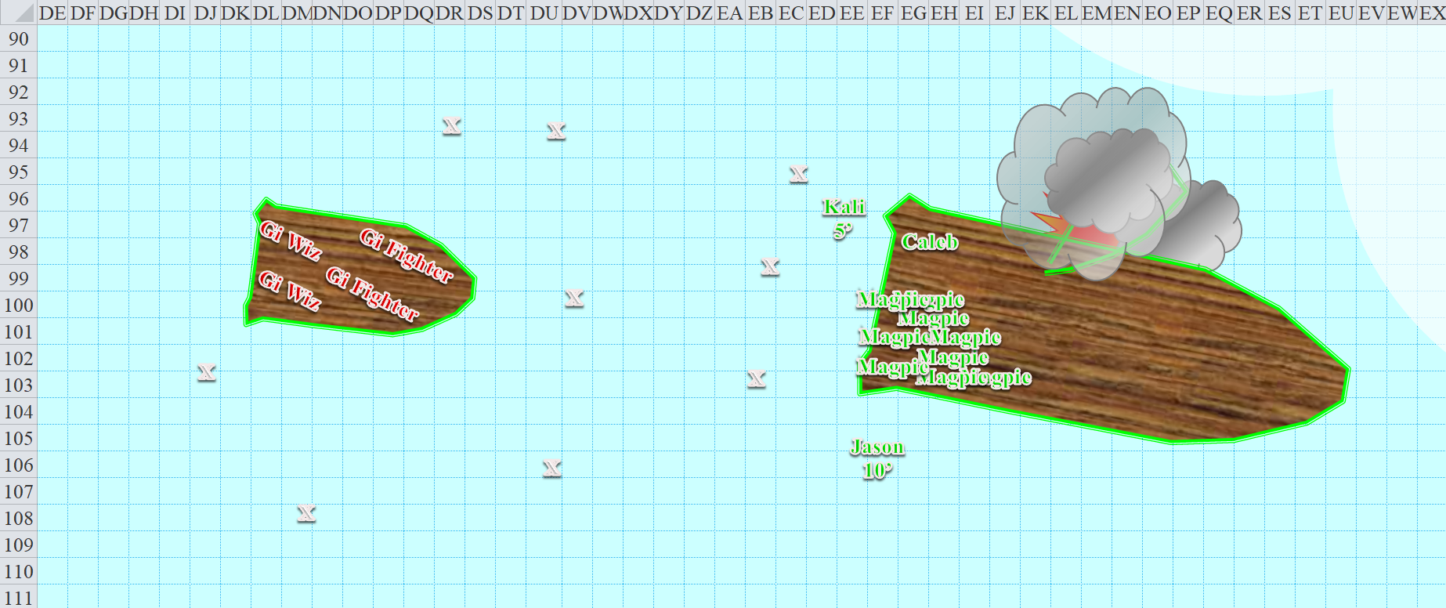
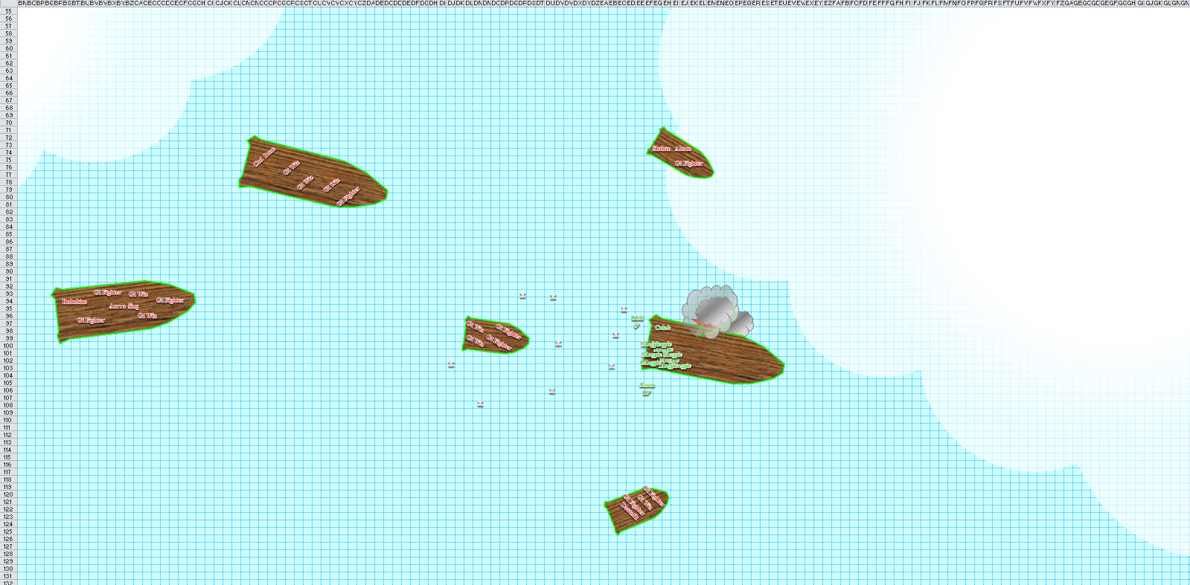

Round 2

Shahan Alama hid behind a stalwart but foolhardy fighter, and fired off a shot at Magpie.
Character | Attack Type | Damage | BAB | Mod+ | W+ | Other+ | d20 | Total
Shahan Alama | Laser Heavy Crossbow +2 | 1d10 fire + 2 fire | 9 | 2 | 4 | -4 range | 18 | 29
Hit. One mirror image went away.

Davtokk threw his javelin again at the scout.
Character | Attack Type | Damage | BAB | Mod+ | W+ | Other+ | d20 | Total
Davtokk | Returning Javelin +3 | 1d6 + 3 | 8 | 3 | 3 | -4 range | 13 | 23
Miss.

The weapon returned to its thrower once it missed its mark.

Robobino socked it to Caleb with his handgun.
Character | Attack Type | Damage | BAB | Mod+ | W+ | Other+ | d20 | Total
Robobino | Handgun of Electrocution | 1d3 + 1d20 electric | 13 | 4 | 2 | -6 range | 17 | 30
Hit. 2 + 12 electric = 14 [41/87].

Jason made notice that Davtokk had thrown the spear. Set to dodge the genasi’s attacks, the human then moved 30’ to the west (skrimish active) and fired upon the ooze genasi ranger.
Ranged Weapon | Dmg. | D+ | TH+ | Critical | Rng. | Wt. | Atk | Roll | Check | Notes
Sacred Composite Longbow, Skirmish | 1d8 | +1 +3d6 +2 | 2 | 19-20/x3 | 200’ | - | +17 | 19 | 36
Crystal of Cold Assault, Greater | - | 1d6 | - | - | - | - | - | - | - | -1 to AC 1 round
2nd Shot, haste | 1d8 | +1 | 2 |  |  | - | +17 | 14 | 31
Crystal of Cold Assault, Greater | - | 1d6 | - | - | - | - | - | - | - | -1 to AC 1 round
Hit, hit. Dmg: (1 + 1 + 7 + 2 + 5 cold) + (7 + 1 + 2 cold) = 16 + 8 + 7 cold = 31.

Cad Bane saw the archer taking down the javelin thrower, and responded with a deadly snipe attack. Being a trained foe hunter with a penchant for human blood, he winked being his sights and squeezed the trigger.
Character | Attack Type | Damage | BAB | Mod+ | W+ | Other+ | d20 | Total | Targeting
Cad Bane | Handgun +1 of Fireballs | 1d10 + 1 + 3d6 fire DC 18 | 11 | 2 | 4 | 1 – 2 range | 12 | 28 | Sneak Attack +5d6
Hit. Dmg: 10 + 1 + 6 fire = 17. Reflex save not needed. All fire damage negated. Partial ranged damage negated [54/78].

The single shot struck true as the githyanki’s pistol auto-reloaded, but the squirrely scout instinctively flew downward and southwestward to avoid the worst of the explosion, emerging unscathed by the fire and barely wounded by the ballistic pellet lodged in his left bicep.

The githyanki fighters fired arrows at their enemies.
Character | Attack Type | Damage | BAB | Mod+ | W+ | Other+ | d20 | Total | Targeting
Githyanki Fighter 1 | MW Composite Longbow, Str +1 | 1d8+1 / x3 | 1 | 1 | 1 | 0 | 17 | 20 | Caleb
Githyanki Fighter 2 | MW Composite Longbow, Str +1 | 1d8+1 / x3 | 1 | 1 | 1 | 0 | 3 | 6 | Caleb
Githyanki Fighter 3 | MW Composite Longbow, Str +1 | 1d8+1 / x3 | 1 | 1 | 1 | 0 | 4 | 7 | Jason
Githyanki Fighter 4 | MW Composite Longbow, Str +1 | 1d8+1 / x3 | 1 | 1 | 1 | 0 | 15 | 18 | Jason
Githyanki Fighter 5 | MW Composite Longbow, Str +1 | 1d8+1 / x3 | 1 | 1 | 1 | 0 | 2 | 5 | Jason
Githyanki Fighter 6 | MW Composite Longbow, Str +1 | 1d8+1 / x3 | 1 | 1 | 1 | 0 | 18 | 21 | Kali
Githyanki Fighter 7 | MW Composite Longbow, Str +1 | 1d8+1 / x3 | 1 | 1 | 1 | 0 | 8 | 11 | Kali
Githyanki Fighter 8 | MW Composite Longbow, Str +1 | 1d8+1 / x3 | 1 | 1 | 1 | 0 | 20 | 23 | Magpie
Githyanki Fighter 9 | MW Composite Longbow, Str +1 | 1d8+1 / x3 | 1 | 1 | 1 | 0 | 7 | 10 | Magpie
Hit, miss, miss, miss, miss, miss, miss, threat, miss. 1d20 = 3 + 3 = 6, not a critical hit.
Dmg to Caleb: 6 + 1 = 7 [34/87].
Dmg to Magpie: 4 + 1 = 5 [81/98].

The gi wizzes did their best with their remaining magic missiles.
Dmg to Caleb: (4 + 1) + (2 + 1) = 8 magic [force] [26/87].
Dmg to Jason: (1 + 1) + (3 + 1) = 6 magic [force] [48/78].
Dmg to Kali: (2 + 1) + (4 + 1) = 8 magic [force] [94/114].
Dmg to Magpie: (1 + 1) + (3 + 1) = 6 magic [force] [75/98].

Kali called to the others in her group, “Some fireballs on their deck would be nice,” as she moved toward the enemy.

Caleb and Magpie had other ideas for what to do with their spells this rounds, but given as both of their companions wanted fireballs, the pair of casters looked at each other, shrugged, then each dropped a fireball onto the nearby deck of waiting gith, Magpie using her goggles, Caleb using a prepared spell. Both then took cover behind the ship’s railing, trying to make it a bit more challenging for ranged combatants to take pot shots at them.

Magpie’s spell was slightly faster than Caleb’s, targeting the Astral skimmer to the south.
Character | Save vs.  fireball | Ranks | Roll | Save
Davtokk | Reflex | 9 | 12 | 21
Gi Fighter | Reflex | 1 | 1 | 2
Gi Fighter | Reflex | 1 | 10 | 11
Gi Wiz | Reflex | 2 | 20 | 22
Success, fail, fail, success. Davtokk and gi wiz save for ½ damage.
Dmg to Davtokk: ½ x 37 = 18 fire.
Dmg to each fighter: 35 fire.
Dmg to gi wiz 1: ½ x 33 = 16 fire.

Caleb’s spell then blew up the skimmer to what he would have called his immediate west.
Character | Save vs.  fireball | Ranks | Roll | Save
Gi Fighter | Reflex | 1 | 11 | 12
Gi Fighter | Reflex | 1 | 11 | 12
Gi Wiz | Reflex | 2 | 1 | 3
Gi Wiz | Reflex | 2 | 17 | 19
Fail, fail, fail, fail.
Dmg to each fighter: 46 fire.
Dmg to gi wiz 2: 34 fire.
Dmg to gi wiz 3: 29 fire.

Gith fighters 1 through 4 died, as did gi wizzes 1 through 3.

The western ship that Caleb hit with the fireball now exploded. Dead bodies started flying in all directions. One fighter’s corpse flew by Kali.

Aurra Sing urged the male steering the ship to get closer to the heroes’ vessel, then shot at Caleb.
Character | Attack Type | Damage | BAB | Mod+ | W+ | Other+ | d20 | Total | Targeting
Aurra Sing | QL Heavy  Crossbow +4 of Fury | 1d10+4+2d6 fire | 7 | 4 | 4 | -6 range | 9 | 18 | Sudden Strike +3d6  Skirmish +2d6
Miss.

An errant bolt whizzed past Caleb’s head.

Davtokk caught his javelin, and snarled at the sensation of his scorching skin.

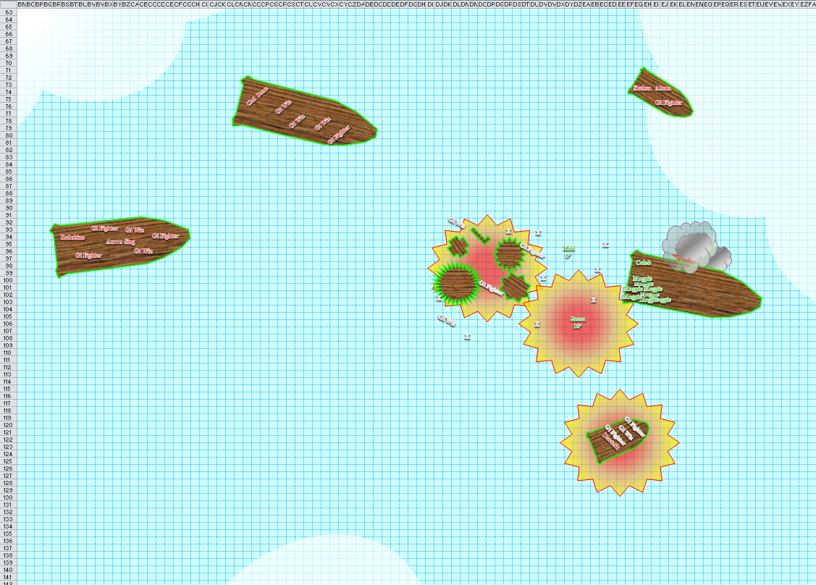

Round 3

Shahan Alama commanded one fighter to leap off their vessel, which was 25’ higher than the one the heroes had taken. The fighter did as told while Shahan took a potshot at one of Magpie’s doubles.
Character | Attack Type | Damage | BAB | Mod+ | W+ | Other+ | d20 | Total
Shahan Alama | Laser Heavy Crossbow +2 | 1d10 fire + 2 fire | 9 | 2 | 4 | 0 | 3 | 18
Hit. Another image disappeared.
Character | Attack Type | Damage | BAB | Mod+ | W+ | Other+ | d20 | Total
Githyanki Fighter | MW Greatsword | 2d6 + 1 / 19-20 | 1 | 1 | 1 | 2 WF + 2 charge  + 2 from above | 4 | 13
Miss.

Davtokk wasn’t liking the turn of events, in particular, the fireball spells. He silenced Magpie with a magical device.
Save vs.  silence | Rank | Ability & Mod. | Misc. Mods. | Total | Roll | Check
Magpie, Will | 8 | Wis (+2) | 5 | 15 | 3 | 18
Fail. Magpie was silenced.

Robobino said the word “electrocutation” while referring to his weapon and zapping Caleb, whom he really wanted to kill.
Character | Attack Type | Damage | BAB | Mod+ | W+ | Other+ | d20 | Total
Robobino | Handgun of Electrocution | 1d3 + 1d20 electric | 13 | 4 | 2 | -4 range | 3 | 18
Miss.

The gi wizzes now cast true strike, and immediately threw magical darts at the heroes.
Character | Attack Type | Damage | BAB | Mod+ | W+ | Other+ | d20 | Total | Targeting
GiWiz 1 | Returning Electric Darts +3 | 1d4 + 3 + 1d6 electric | 1 | 2 | 3 | 20 | 11 | 37 | Caleb
GiWiz 2 | Returning Electric Darts +3 | 1d4 + 3 + 1d6 electric | 1 | 2 | 3 | 20 | 16 | 42 | Caleb
GiWiz 3 | Returning Electric Darts +3 | 1d4 + 3 + 1d6 electric | 1 | 2 | 3 | 20 | 7 | 33 | Jason
GiWiz 4 | Returning Electric Darts +3 | 1d4 + 3 + 1d6 electric | 1 | 2 | 3 | 20 | 1 | 27 | Jason
GiWiz 5 | Returning Electric Darts +3 | 1d4 + 3 + 1d6 electric | 1 | 2 | 3 | 20 | 5 | 31 | Kali
GiWiz 6 | Returning Electric Darts +3 | 1d4 + 3 + 1d6 electric | 1 | 2 | 3 | 20 | 6 | 32 | Kali
GiWiz 7 | Returning Electric Darts +3 | 1d4 + 3 + 1d6 electric | 1 | 2 | 3 | 20 | 4 | 30 | Magpie
GiWiz 8 | Returning Electric Darts +3 | 1d4 + 3 + 1d6 electric | 1 | 2 | 3 | 20 | 17 | 43 | Magpie
Hit, hit, hit, miss, hit, hit, hit, hit.
Dmg to Caleb: (3 + 3 + 1 electric) + (4 + 3 + 3 electric) = 13 + 4 electric = 17 [9/87].
Dmg to Jason: (2 + 3 + 2 electric) = 7. Partial damage negated [44/78].
Dmg to Kali: (1 + 3 + 2 electric) + (3 + 3 + 3 electric) = 10 + 5 electric = 15. Partial damage negated [82/114].
Dmg to Magpie: (2 + 3 + 6 electric) + (1 + 3 + 4 electric) = 8 + 10 electric = 18 [57/98].

Cad Bane ordered everyone to, “Finish off the cleriiiiiic!” Though he didn’t have a clear shot to Caleb himself, he did have a nice line of sight to Magpie and her many forms, and trusted his able squadron to succeed in their endeavor. To be sure that he hit, he again aimed for the deck of the ship instead of one of her multiple illusions.
Character | Attack Type | Damage | BAB | Mod+ | W+ | Other+ | d20 | Total | Targeting
Cad Bane | Handgun +1 of Fireballs | 1d10 + 1 + 3d6 fire DC 18 | 11 | 2 | 4 | 1 | 10 | 28 | Sneak Attack +5d6
Hit. Dmg to ship: 6 + 1 + 11 fire = 18. Reflex save not needed for Caleb and Magpie. All fire damage negated. Partial ranged damage negated.
Character | Save vs.  fireball | Ranks | Roll | Save
Gi Fighter | Reflex | 1 | 11 | 12
Fail. Dmg: 9 fire.

Gith fighter 5 died.

Shahan Alama witnessed the explosion from above, just barely outside its range.

Aurra Sing shot at Kali, to whom she had the most convenient line of sight.
Character | Attack Type | Damage | BAB | Mod+ | W+ | Other+ | d20 | Total | Targeting
Aurra Sing | QL Heavy Crossbow  +4 of Fury | 1d10+4+2d6 fire | 7 | 4 | 4 | -2 range | 11 | 24 | Sudden Strike +3d6  Skirmish +2d6
Hit. Dmg: 8 + 4 + 5 fire = 17. Partial ranged and all fire damage negated [73/114].

The remaining githyanki fighters leapt or flew towards the heroes, and tried to smother Kali and Jason.
Character | Attack Type | Damage | BAB | Mod+ | W+ | Other+ | d20 | Total | Targeting
Githyanki Fighter 6 | MW Greatsword | 2d6 + 1 / 19-20 | 1 | 1 | 1 | 2 | 1 | 6 | Weapon Focus
Githyanki Fighter 7 | MW Greatsword | 2d6 + 1 / 19-20 | 1 | 1 | 1 | 2 | 8 | 13 | Weapon Focus
Githyanki Fighter 8 | MW Greatsword | 2d6 + 1 / 19-20 | 1 | 1 | 1 | 2 | 4 | 9 | Weapon Focus
Githyanki Fighter 9 | MW Greatsword | 2d6 + 1 / 19-20 | 1 | 1 | 1 | 2 | 5 | 10 | Weapon Focus
Miss, miss, miss, miss.

Jason skirmished another shot upon Davtokk, and followed it up with a second, hastened shot.
Ranged Weapon | Dmg. | D+ | TH+ | Critical | Rng. | Wt. | Atk | Roll | Check | Notes
2nd Shot, haste | 1d8 | +1 | 2 |  |  | - | +17 | 16 | 33
Sacred Composite Longbow, Skirmish | 1d8 | +1 +3d6 +2 | 2 | 19-20/x3 | 200’ | - | +17 | 19 | 36
Crystal of Cold Assault, Greater | - | 1d6 | - | - | - | - | - | - | - | -1 to AC 1 round
Bracers of Archery, Greater | - | 0 | 1 (above) | - | - | 1.0 | - | - | -
Hit, threat. 1d20 = 9 + 17 = 26, critical hit. Dmg: (2 + 1 + 2) + [3 x (5 + 1 + 13 + 2)] = 18 + 63 = 81.

The first arrow didn’t do much, but the second one entered Davtokk’s heart and pummeled him, sending his dead body flying in a south-southeastward direction.

Kali said to herself the old catchphrase, “I am become death: destroyer of worlds.…” Seeing the target reach the environment, Kali began to spin in a dervish dance, her blades darted in and out at different targets as she became a blurr.
Melee Weapon | Dmg | D+ | TH+ | Critical | Type | Wt. | Atk | Roll | Check
Keen Scimitar +2 | 1d6 | 2 | 2 | 15-20, x2 | Slashing | 4.0 | +18 | 20 | 38
2nd Attack | 1d6 | 2 | 2 | 15-20, x2 | Slashing | - | +13 | 7 | 20
3rd Attack | 1d6 | 2 | 2 | 15-20, x2 | Slashing | - | +8 | 19 | 27
4th Attack, haste | 1d6 | 2 | 2 | 15-20, x2 | Slashing | - | +18 | 17 | 35
Cleave | 1d6 | 2 | 2 | 15-20, x2 | Slashing | - | +18 | 10 | 28
Crystal of Electrical Assault, Greater | - | 1d6 | - | - | - | 0.0
Threat, hit, hit, hit, hit. 1d20 = 1, not a critical hit.
Dmg to Fighter 6: 1 + 2 + 4 electric = 7.
Dmg to Fighter 7: 3 + 2 + 1 electric = 6.
Dmg to Fighter 8: 6 + 2 + 5 electric = 13.
Dmg to Fighter 9: 4 + 2 + 6 electric = 13.
Dmg to Fighter 7: 1 + 2 + 1 electric = 4.

Kali came to a standstill, and the four gith fighters around her dropped dead in the subjective-gravity environment.

Caleb, displeased with being a pincushion, cast greater invisibility, then flew around to the underside of the airship, and landing on the underside of the hull, so the airship continued to push him along as he tried to deal with the fact all his insides were leaking into the outside. Idly, he wondered how all those githyanki were about to cast true strike and attack in the same round. That’s a lot of Quickened true strikes.

[DM note: I erroneously made true strike a Swift Action casting. I will have to explain it via a new racial ability, or maybe some type of amulet or other device.]

The silenced Magpie was annoyed, but still very capable of wrecking someone’s day. Being a beguiler, she was trained to cast normal spells without verbal components, and knew spells that didn’t require them at all, like rainbow pattern, an illusion spell large enough to cover about ½ of an entire boat. She cast it [expired 14 rounds after Concentration ended] on the front of the boat with Aurra Sing, to catch her and the two wizards with her, then with a free action, moved the pattern toward the back of the boat to catch Robobino.
Character | Save vs.  rainbow pattern | Ranks | Roll | Save
Gi Wiz | Will | 3 | 11 | 14
Gi Wiz | Will | 3 | 2 | 5
Aurra Sing | Will | 6 | 15 | 21
Robobino | Will | 10 | 17 | 27
Fail, fail, success, success. Aurra and Robobino were unaffected by the spell.

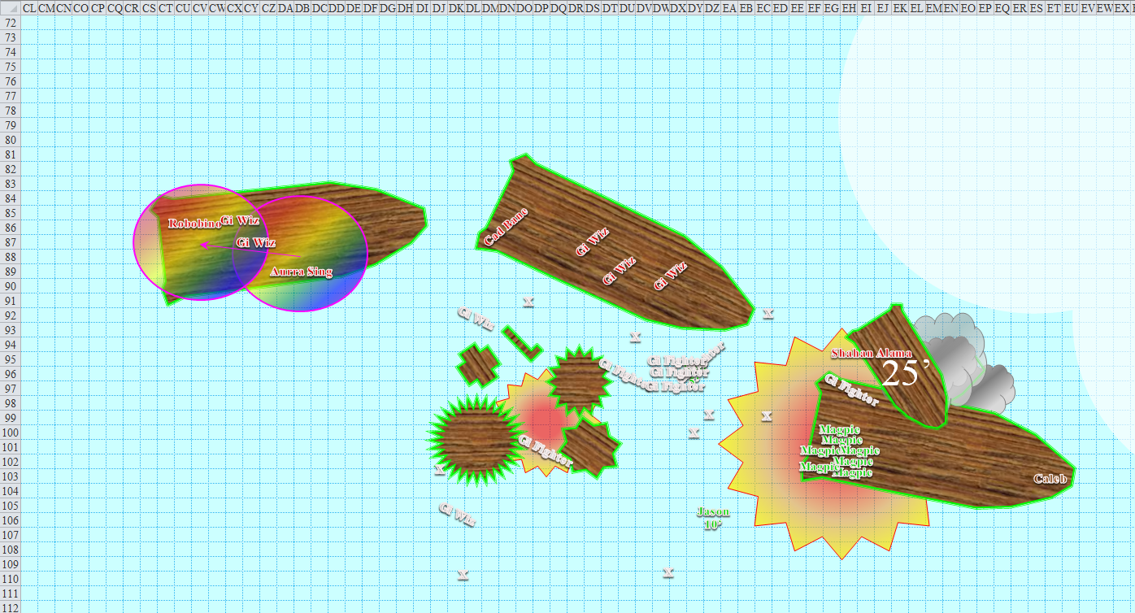

Round 4

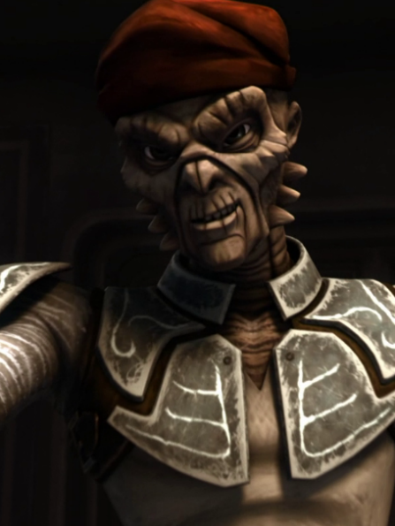

Shahan Alama leapt down along the subjective gravity environment of the Astral Plane, landed safely onto the deck of the boarded ship and failed to see Caleb, so he fired upon Magpie’s many illusory forms instead.
Character | Attack Type | Damage | BAB | Mod+ | W+ | Other+ | d20 | Total
Shahan Alama | Laser Heavy Crossbow +2 | 1d10 fire + 2 fire | 9 | 2 | 4 | 0 | 18 | 33
Hit. One more image disappeared.

As his heavy crossbow recharged for the next shot, the assassin turned on his EM sensors and began scanning for the invisible cleric-diviner.

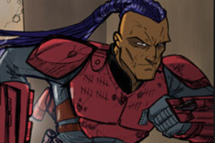

Davtokk continued to drift lifelessly south-southeastward, just as the other lackeys, now dead, drifted along their own respective trajectories.

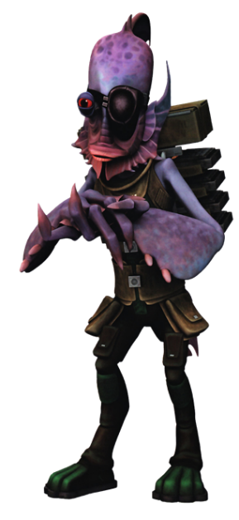

Robobino—the craftiest kuo-toa in the Astral Plane—remained with Aurra Sing aboard the drifting ship while the two wizards leapt off of the deck to remain within Magpie’s rainbow pattern. The swashbuckler-roboticist shot at Kali now.
Character | Attack Type | Damage | BAB | Mod+ | W+ | Other+ | d20 | Total
Robobino | Handgun of Electrocution | 1d3 + 1d20 electric | 13 | 4 | 2 | 0 | 6 | 25
Hit. Dmg: 3 + 4 electric = 7. Partial damage negated [69/114].

Caleb expended his greater magic weapon to cast cure critical wounds on himself, using all three charges from his Ring of Mystic Healing.
Caleb healed 18 + 13 + 20 = 51 hps [50/87].

The two githyanki wizzes to the west that had not yet died were so mesmerized with Magpie’s illusion that they did nothing but float within it. The other three were still in pursuit of the heroes, and now all cast ray of frost upon Magpie’s mirror images.
Character | Attack Type | Damage | BAB | Mod+ | W+ | Other+ | d20 | Total
GiWiz | Ranged Touch Attack | Ray of Frost, 1d3 cold | 1 | 2 | 3 | 0 | 10 | 16
GiWiz | Ranged Touch Attack | Ray of Frost, 1d3 cold | 1 | 2 | 3 | 0 | 17 | 23
GiWiz | Ranged Touch Attack | Ray of Frost, 1d3 cold | 1 | 2 | 3 | 0 | 9 | 15
Hit, hit, hit. Three images disappeared.

Jason drank a potion of moderate cure wounds.
Jason gained 9 + 4 = 13 hps [57/78].

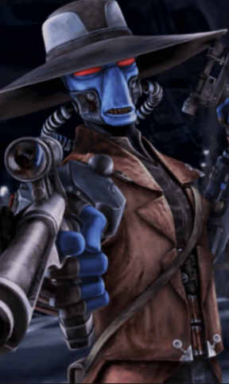

Cad Bane used telekinesis to hurl an L-shaped piece of ship debris at Jason.
Save vs.  incoming object | Rank | Ability & Mod. | Misc. Mods. | Total | Roll | Check | Notes
Reflex | 8 | Dex (+5) | 3 | 16 | 8 | 24 | +1 haste
Success. Saves for 0 damage.

Magpie stopped concentrating on her first rainbow pattern [expired on Round 18], and cast a second rainbow pattern [expired 14 rounds after Concentration ended] on the other boat, using the same tactic of starting at the front and sweeping back to catch everyone.
Character | Save vs.  rainbow pattern | Ranks | Roll | Save
Gi Wiz | Will | 3 | 12 | 15
Gi Wiz | Will | 3 | 2 | 5
Gi Wiz | Will | 3 | 10 | 13
Cad Bane | Will | 5 | 20 | 25
Fail, fail, fail, success. Cad Bane was unaffected by the spell.

The three wizards were now also in a stupor, and would likely remain there for the next minute or so.

The githyanki fighters were all dead by now. One of them lifted a hand slightly, then finished dying.



Aurra Sing crouched behind the ledge and shot at Jason as he dodged the L-shaped piece of debris.
Character | Attack Type | Damage | BAB | Mod+ | W+ | Other+ | d20 | Total | Targeting
Aurra Sing | QL Heavy Crossbow +4 of Fury | 1d10+4+2d6 fire | 7 | 4 | 4 | 0 | 8 | 23 | Sudden Strike +3d6; Skirmish +2d6, +1 AC
Miss.

Kali activated her ring of invisibility [expired on Round 34] and moved at full speed to get to the point where she could attack Sing. She reached the deck of the ship, and had time for a single swipe at the woman.
Melee Weapon | Dmg | D+ | TH+ | Critical | Type | Wt. | Atk | Roll | Check
Keen Scimitar +2 | 1d6 | 2 | 2 | 15-20, x2 | Slashing | 4.0 | +18 | 14 | 32
Crystal of Electrical Assault, Greater | - | 1d6 | - | - | - | 0.0
Hit. Dmg: 3 + 1 electric = 4.

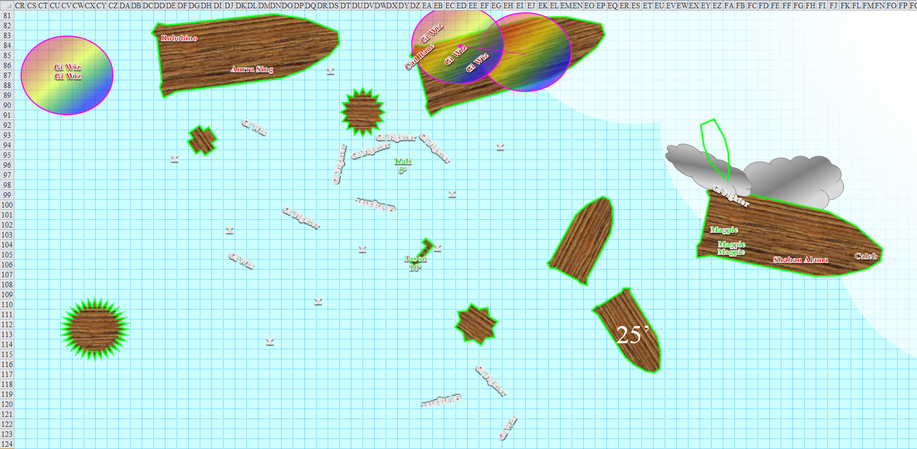

Round 5

Shahan Alama now saw the invisible Caleb, and shot him in the chest.
Character | Attack Type | Damage | BAB | Mod+ | W+ | Other+ | d20 | Total
Shahan Alama | Laser Heavy Crossbow +2 | 1d10 fire + 2 fire | 9 | 2 | 4 | +2 favored enemy | 12 | 29
Hit. Dmg: 7 + 2 + 2 = 11 fire. Damage negated.

Caleb involuntarily smirked.

“Oh, you cheeky bastard!” the killer of humans said as he shouldered his crossbow.

Robobino could no longer see Caleb and Kali, so he, too, switched on his EM sensors, and fired upon Jason in the meantime.
Character | Attack Type | Damage | BAB | Mod+ | W+ | Other+ | d20 | Total
Robobino | Handgun of Electrocution | 1d3 + 1d20 electric | 13 | 4 | 2 | 0 | 19 | 38
Threat. 1d20 = 16 + 19 = 35, critical hit. Dmg: 3 x (3 + 7) = 30 electric [27/78].

Kali attacked Sing using her Dance of Death, which was inapplicable when only a single enemy was in melee with her.
Melee Weapon | Dmg | D+ | TH+ | Critical | Type | Wt. | Atk | Roll | Check
Keen Scimitar +2 | 1d6 | 2 | 2 | 15-20, x2 | Slashing | 4.0 | +18 | 14 | 32
2nd Attack | 1d6 | 2 | 2 | 15-20, x2 | Slashing | - | +13 | 19 | 32
3rd Attack | 1d6 | 2 | 2 | 15-20, x2 | Slashing | - | +8 | 4 | 12
4th Attack, haste | 1d6 | 2 | 2 | 15-20, x2 | Slashing | - | +18 | 9 | 27
Crystal of Electrical Assault, Greater | - | 1d6 | - | - | - | 0.0
Hit, threat, miss, hit. 1d20 = 20, critical hit. Dmg: (3 + 2 + 4 electric) + [2 x (5 + 2 + 5 electric)] + (6 + 2 + 3 electric) = 5 + 14 + 8 + 17 electric = 44.

Then the ship that Aurra Sing was on crashed into the three floating wizards, and killed them instantly.

The githyanki wizzes that weren’t dead yet might as well have been, mesmerized by the rainbow pattern’s hypnotic glow.

Jason took aim upon Cad and let lose a barrage of arrows.
Ranged Weapon | Dmg. | D+ | TH+ | Critical | Rng. | Wt. | Atk | Roll | Check | Notes
Sacred Composite Longbow of Force, Strength +1 | 1d8 | +1 | 2 | 19-20/x3 | 200’ | 3.0 | +17 | 4 | 21 | +1 within 30’
2nd Shot | 1d8 | +1 | 2 |  |  | - | +12 | 8 | 20 | +1d6 vs. undead
3rd Shot, Rapid Firing | 1d8 | +1 | 2 |  |  | - | +7 | 20 | 27 | +2d6 vs. evil Outsiders
4th Shot, haste | 1d8 | +1 | 2 |  |  | - | +17 | 17 | 34 | +1 within 30’
Crystal of Cold Assault, Greater | - | 1d6 | - | - | - | - | - | - | - | -1 to AC 1 round
Miss, miss, threat, hit. 1d20 = 5 + 17 = 22, not a critical hit. Dmg: (3 + 1 + 4 cold) + (1 + 1 + 5 cold) = 6 + 9 cold = 15. Cold damage negated.

Cad Bane removed the two arrows that had struck true, and rapid fired upon Jason.
Character | Attack Type | Damage | BAB | Mod+ | W+ | Other+ | d20 | Total
Cad Bane | Handgun +1 of Fireballs | 1d10 + 1 + 3d6 fire DC 18 | 11 | 2 | 4 | 1 | 7 | 25
Cad Bane | Handgun, 2nd Attack | 1d10 + 1 + 3d6 fire DC 18 | 6 | 2 | 4 | 1 | 7 | 20
Cad Bane | Handgun, 3rd Attack | 1d10 + 1 + 3d6 fire DC 18 | 1 | 2 | 4 | 1 | 15 | 23
Miss, miss, miss.

The bullets ricocheted off of his armor, not impaling him, though each of them burst into fireballs.
Save vs.  fireball | Rank | Ability & Mod. | Misc. Mods. | Total | Roll | Check | Notes
Jason, Reflex | 8 | Dex (+5) | 3 | 16 | 7 | 23 | +1 haste
Jason, Reflex | 8 | Dex (+5) | 3 | 16 | 2 | 18 | +1 haste
Jason, Reflex | 8 | Dex (+5) | 3 | 16 | 10 | 26 | +1 haste
Success, success, success. Saves for 0 + 0 + 0 = 0 damage.

Tapping her circlet of haste [Free Action], Aurra Sing now produced her light saber +5 [Move Action], ghost-stepped right behind Kali [Swift Action], and tried to cut the whirling wench in half [Standard Action].
Character | Attack Type | Damage | BAB | Mod+ | W+ | Other+ | d20 | Total | Targeting
Aurra Sing | Light Saber +5 | 1d10 + 5 + 3 + 1d6 fire/18-20 | 7 | 3 | 5 | 2 | 19 | 27 | Sudden Strike +3d6;  Skirmish +2d6, +1 AC
Threat. 1d20 = 18, critical hit. Dmg: 2 x (6 + 5 + 3 + 6 fire + 11 + 10) = 12 + 10 + 6 + 12 fire + 22 + 20 = 82. Partial damage negated [2/114].

Feeling a bit better about life, what with having put most of his insides back where they belonged, Caleb hefted his mighty rod of many wands and peeked back over the bow of the ship. Not knowing what plans Magpie might have had, he decided to glitterdust [expired on Round 18] the crossbow-wielding Shahan Alama.
Character | Save vs.  glitterdust | Ranks | Roll | Save
Shahan Alama | Will | 4 | 2 | 6
Fail.

Magpie had been planning to cast dominate person on Shahan Alama, but with the assassin now blinded by the glitterdust, she instead cast a Silent hold person [expired on Round 19, or when saved against] on Aurra Sing.
Character | Save vs.  hold person | Ranks | Roll | Save
Aurra Sing | Will | 6 | 10 | 16
Fail.

The light saber wielder stopped dead in her tracks, floating within Kali’s reach now.

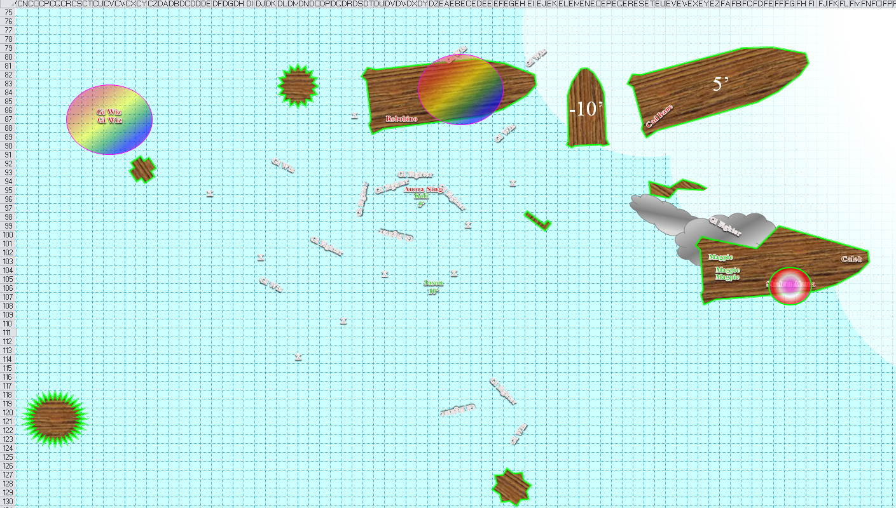

Round 6

Character | Group | Initiative | d20 | Modified Roll | Move
Shahan Alama | 2 | 2 | 20 | 22 | 30’
Davtokk | 2 | 3 | 18 | 21 | 30’
Robobino | 2 | 4 | 16 | 20 | 20’/50’
Kali | 1 | 8 | 11 | 19 | 40’
Caleb | 1 | 3 | 15 | 18 | 30’
Githyanki Wizzes | 2 | 1 | 17 | 18 | 30’
Jason | 1 | 9 | 7 | 16 | 40’
Cad Bane | 2 | 2 | 14 | 16 | 40’
Magpie | 1 | 1 | 11 | 12 | 20’
Githyanki Fighters | 2 | 1 | 11 | 12 | 20’
Aurra Sing | 2 | 5 | 4 | 9 | 40’

Shahan Alama flew upward 60’, but not before dropping a bomb onto the deck of the ship. “Say goodnight, priest!” he said to Caleb as the bomb exploded.
Save vs.  Explosion | Rank | Ability & Mod. | Misc. Mods. | Total | Roll | Check | Notes
Caleb, Reflex | 4 | Dex (+3) | 2 | 9 | 1 | 10 | +1 haste
Fail. Dmg: 13 + 22 fire = 35. Fire damage negated [47/87].

Magpie cast hesitate on Robobino [immediate action] before he could attack Kali.
Character | Save vs.  hesitate | Ranks | Roll | Save
Robobino | Will | 10 | 16 | 26
Success.

The attempt was justified, but ultimately failed.

Robobino tried his best to kill Kali, knowing that if he didn’t, she would surely put an end to his beloved Aurra’s life.
Character | Attack Type | Damage | BAB | Mod+ | W+ | Other+ | d20 | Total
Robobino | Handgun of Electrocution | 1d3 + 1d20 electric | 13 | 4 | 2 | 0 | 8 | 27
Hit. Dmg: 1 + 12 = 13. Partial damage negated [-8/114].

Kali began to die, moving slowly in the direction that the bullet had pushed her as it bore through her chest.

Seeing that Kali was perilously close to falling, Caleb, as an immediate action, cast close wounds on the dancer, hopefully fending off death for another day.
1st effect: Kali healed 3 + 5 hps = 8 [0/114].
2nd effect: Kali healed 13 hps (negating the death-dealing blow) [13/114].

The githyanki wizzes just stayed within the rainbow pattern, musing the beauty of the colors.

Cad Bane nodded in approval at Robobino, and fired upon Jason.
Character | Attack Type | Damage | BAB | Mod+ | W+ | Other+ | d20 | Total | Targeting
Cad Bane | Handgun +1 of Fireballs | 1d10 + 1 + 3d6 fire DC 18 | 11 | 2 | 4 | 1 | 11 | 29 | Sneak Attack +5d6
Hit. Dmg: 7 + 1 + 15 fire = 23. Fire damage negated [19/78].

Character | Save vs.  hold person | Ranks | Roll | Save
Aurra Sing | Will | 6 | 11 | 17
Aurra Sing floated near Kali, quite alive, but unable to escape the clutch of the hold person spell.

Caleb cast glitterdust upon the shooter, Robobino, then flew towards Kali (who was nowhere near a ship at this point) so he could administer better healing.
Character | Save vs.  glitterdust | Ranks | Roll | Save
Robobino | Will | 10 | 1 | 11
Utter failure.

Blinded by the light, revved up like a deuce, another runner in the night, the kuo-toa spacefarer soiled himself [Free Action] and fled into the darker pockets of the immediate area [Move Action executed on the next round].

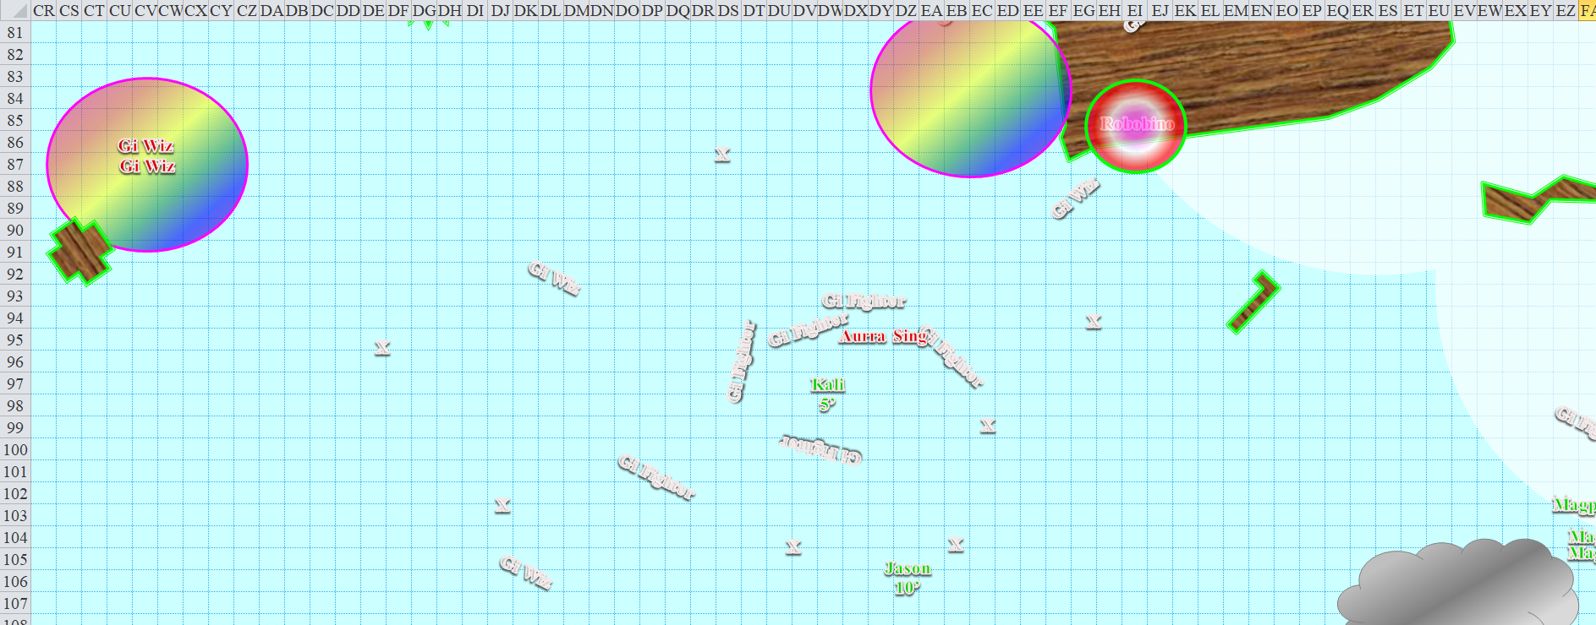

Jason again fired upon Shahan Alama.
Ranged Weapon | Dmg. | D+ | TH+ | Critical | Rng. | Wt. | Atk | Roll | Check | Notes
Sacred Composite Longbow of Force, Strength +1 | 1d8 | +1 | 2 – 2 range | 19-20/x3 | 200’ | 3.0 | +15 | 12 | 27
2nd Shot | 1d8 | +1 | 2 – 2 range |  |  | - | +10 | 6 | 16
3rd Shot, Rapid Firing | 1d8 | +1 | 2 – 2 range |  |  | - | +5 | 18 | 23
4th Shot, haste | 1d8 | +1 | 2 – 2 range |  |  | - | +15 | 8 | 23
Crystal of Cold Assault, Greater | - | 1d6 | - | - | - | - | - | - | - | -1 to AC 1 round
Hit, miss, hit, hit. Dmg: (3 + 1 + 3 cold) + (8 + 1 + 5 cold) + (6 + 1 + 2 cold) = 4 + 9 + 7 + 10 cold = 30.

The man’s feet froze off, each with an arrow in it, but the rest of him flew away.

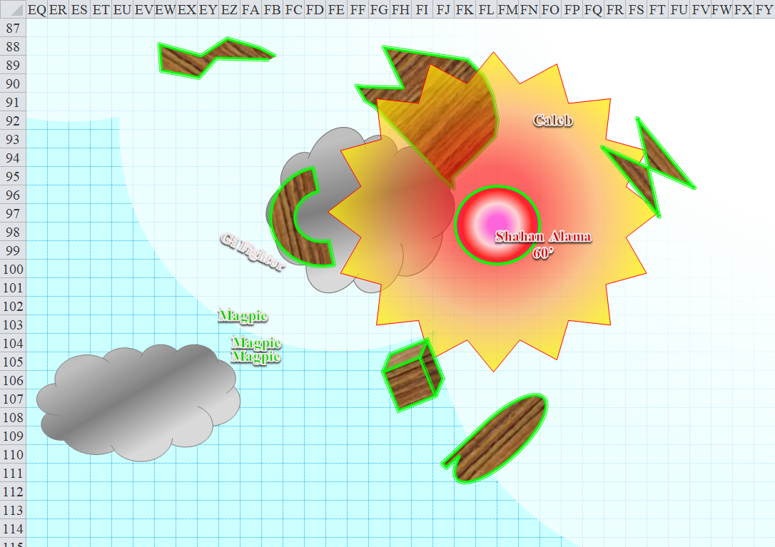

Magpie, tired of not being able to utilize her magic to its full capability, silently cast dispel magic upon herself, explicitly targeting the silence on her.
Spell | Atk | Roll | Check
Dispel Magic | 13 | 11 | 24
Success.

The gnome heard her own sigh once more.

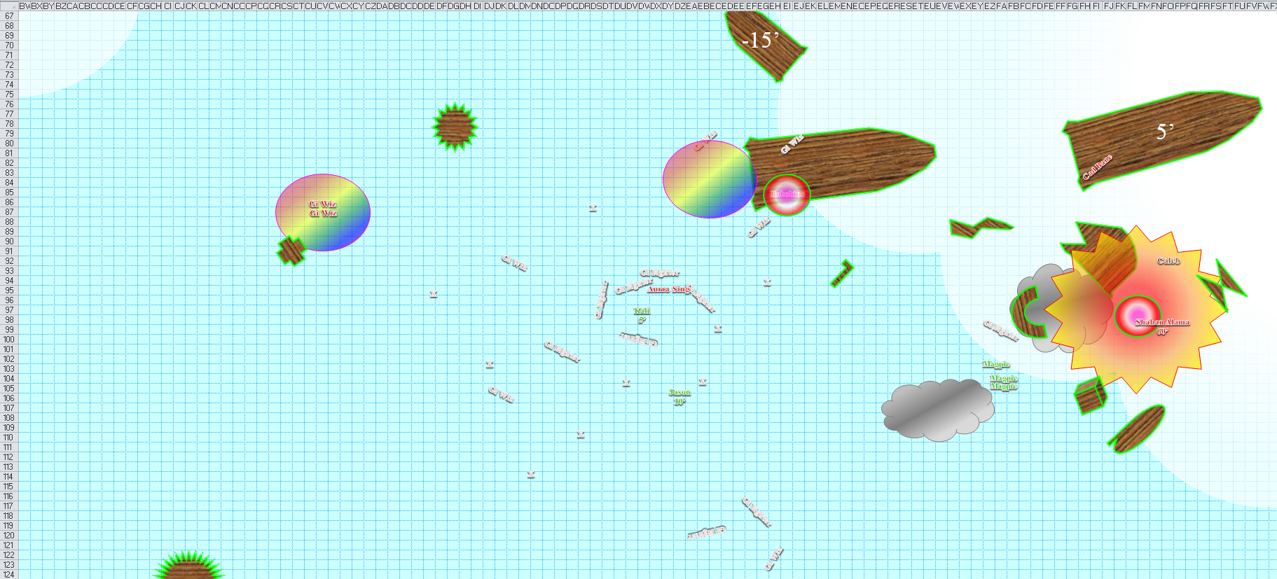

Round 7

Character | Group | Initiative | d20 | Modified Roll | Move
Shahan Alama | 2 | 2 | 20 | 22 | 30’
Davtokk | 2 | 3 | 18 | 21 | 30’
Robobino | 2 | 4 | 16 | 20 | 20’/50’
Kali | 1 | 8 | 11 | 19 | 40’
Caleb | 1 | 3 | 15 | 18 | 30’
Githyanki Wizzes | 2 | 1 | 17 | 18 | 30’
Jason | 1 | 9 | 7 | 16 | 40’
Cad Bane | 2 | 2 | 14 | 16 | 40’
Magpie | 1 | 1 | 11 | 12 | 20’
Githyanki Fighters | 2 | 1 | 11 | 12 | 20’
Aurra Sing | 2 | 5 | 4 | 9 | 40’

Shahan Alama—apparently a cowardly deserter—fled upward some more.

Blind as a Bathymicrops regis, Robobino also hurled himself across the Astral Plane, away from the people who were about to filet him and possibly roast him over an open flame.

The githyanki wizzes remained absorbed in their own respective self-deceptions.

Character | Save vs.  hold person | Ranks | Roll | Save
Aurra Sing | Will | 6 | 18 | 24
Aurra Sing escaped from her bonds, and smirked at Kali, aiming to finish the job once and for all.
Character | Attack Type | Damage | BAB | Mod+ | W+ | Other+ | d20 | Total
Aurra Sing | Light Saber +5 | 1d10 + 5 + 3 + 1d6 fire/18-20 | 7 | 3 | 5 | 2 | 9 | 26
Miss.

Tentative maps
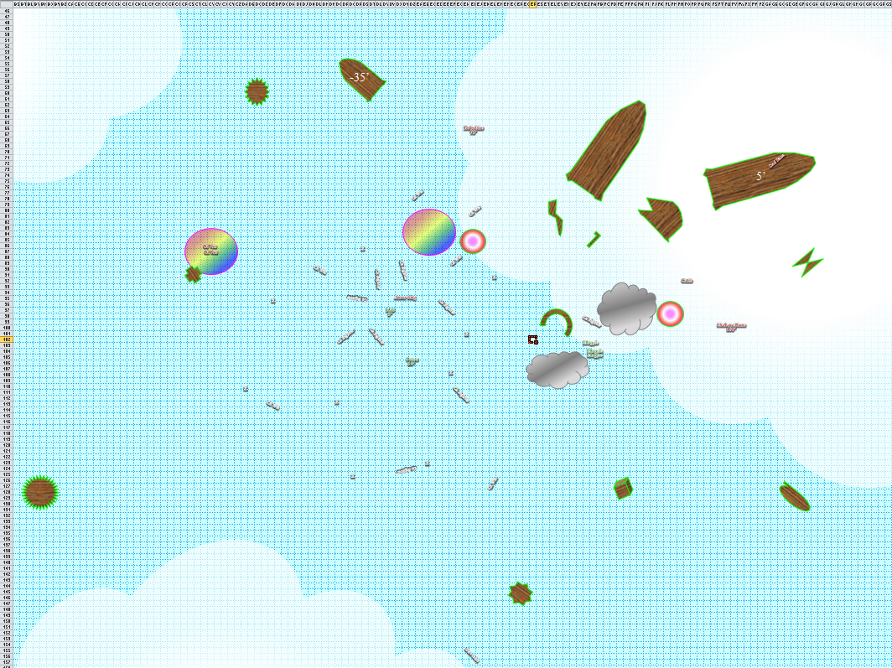
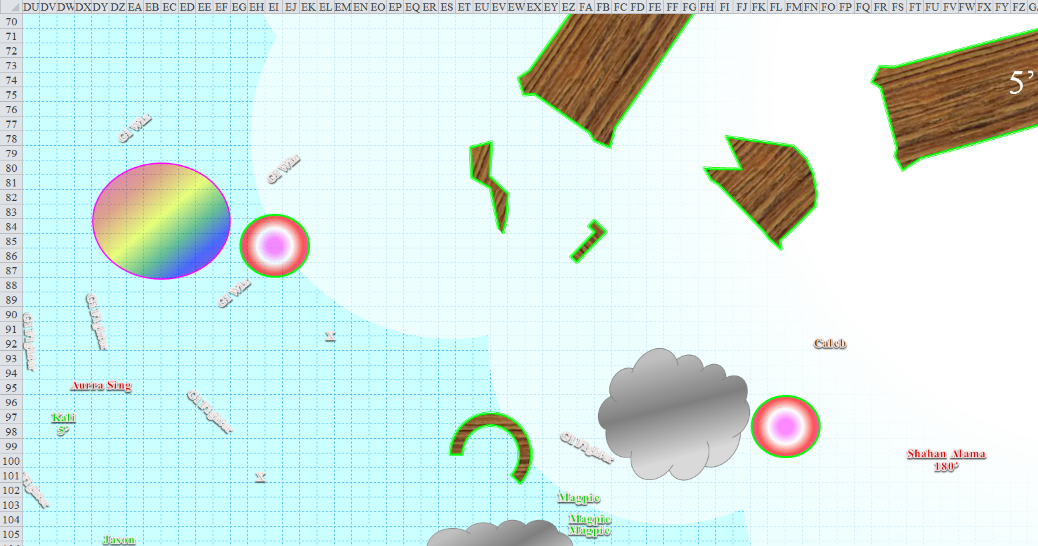

Jason fired upon Shahan again, already being 250’ west and 180’ below him for a total distance of 310’.
Ranged Weapon | Dmg. | D+ | TH+ | Critical | Rng. | Wt. | Atk | Roll | Check | Notes
Sacred Composite Longbow of Force, Strength +1 | 1d8 | +1 | 2 – 2 range | 19-20/x3 | 200’ | 3.0 | +15 | 13 | 28
2nd Shot | 1d8 | +1 | 2 – 2 range | 19-20/x3 | 200’ | - | +10 | 10 | 20
3rd Shot, Rapid Firing | 1d8 | +1 | 2 – 2 range | 19-20/x3 | 200’ | - | +5 | 11 | 16
4th Shot, haste | 1d8 | +1 | 2 – 2 range | 19-20/x3 | 200’ | - | +15 | 1 | 16
Crystal of Cold Assault, Greater | - | 1d6 | - | - | - | - | - | - | - | -1 to AC 1 round
Hit, miss, miss, miss. Dmg: 4 + 1 + 5 cold = 10.

Kali drank her potion of cure moderate wounds, having no lesser version of the potion. She then hastily dropped the vial, and produced her dart, aiming for the no-longer-held woman.
Kali gained 5 + 4 = 9 hps [22/114].

Magpie, able to cast spells with verbal components (without the Silent Spell feat) once again, popped her neck and looked up at Shahan with a grin, then cast a Targeted Greater Dispel Magic upon him to try to strip him of all his magical enchantments, including say, fly.
Ranged Weapon | Dmg. | D+ | TH+ | Critical | Rng. | Wt. | Atk | Roll | Check
Greater Dispel Magic | dispel | - | 0 | - | - | - | 13 | 14 | 27
Greater Dispel Magic | dispel | - | 0 | - | - | - | 13 | 19 | 32
Greater Dispel Magic | dispel | - | 0 | - | - | - | 13 | 13 | 26
Result unknown for the moment.

Caleb saw the end of the battle as foes fled the scene. He aimed his Rod of Many Wands at Aurra Sing and unleashed a flurry of fifteen(!) magic missiles at the woman, suspecting killing her might be a more efficient way of keeping Kali alive than healing spells. He also continued to fly closer to Kali, although tried to stay out of Lightsaber range.
Dmg to Aurra: 35 + 15 = 50 magic [force].

It was evident now that Sing was on her last legs. She maintained a fierce look, but was pierced and sliced in too many places.

Cad Bane shook his head with pity, and teleported away with a whimsical look.

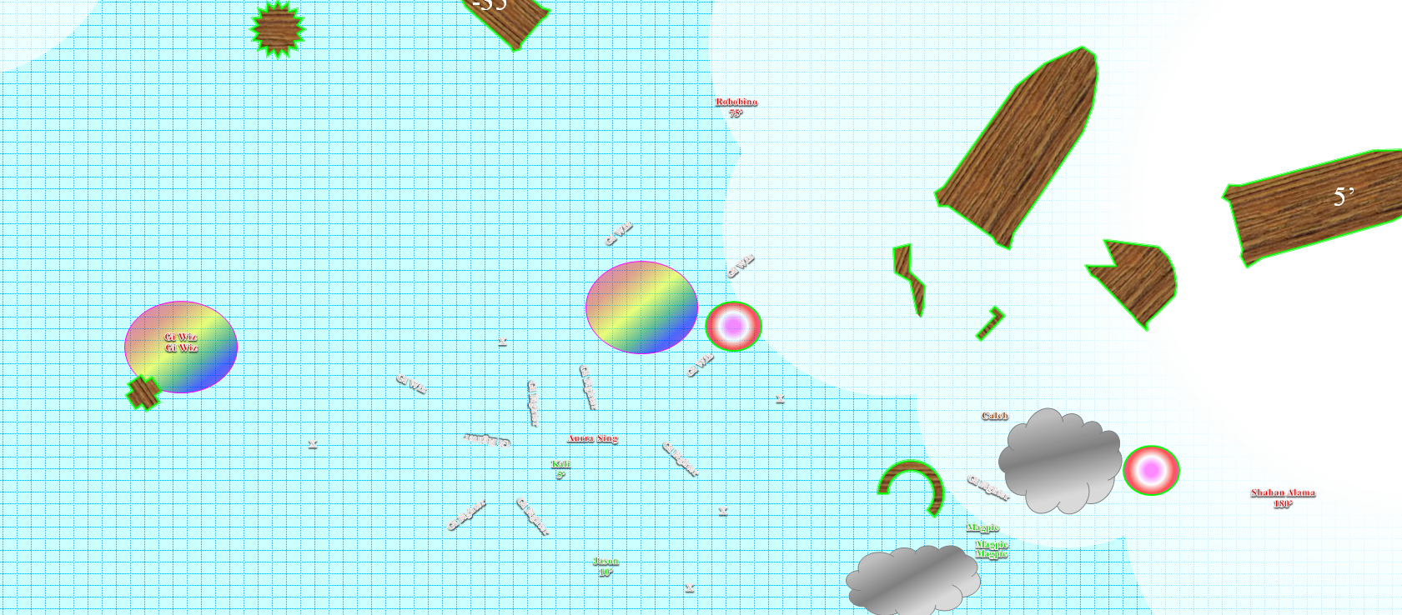

Round 8

Aura Sing slashed at Kali.
Character | Attack Type | Damage | BAB | Mod+ | W+ | Other+ | d20 | Total | Targeting
Aurra Sing | Light Saber +5 | 1d10 + 5 + 3 + 1d6 fire/18-20 | 7 | 3 | 5 | 2 | 6 | 23 | +1 AC
Miss.

Jason fired upon Sing.
Ranged Weapon | Dmg. | D+ | TH+ | Critical | Rng. | Wt. | Atk | Roll | Check | Notes
Sacred Composite Longbow of Force, Strength +1 | 1d8 | +1 | 2 | 19-20/x3 | 200’ | 3.0 | +17 | 20 | 37
2nd Shot | 1d8 | +1 | 2 | 19-20/x3 | 200’ | - | +12 | 14 | 26
3rd Shot, Rapid Firing | 1d8 | +1 | 2 | 19-20/x3 | 200’ | - | +7 | 20 | 27
4th Shot, haste | 1d8 | +1 | 2 | 19-20/x3 | 200’ | - | +17 | 16 | 33
Crystal of Cold Assault, Greater | - | 1d6 | - | - | - | - | - | - | - | -1 to AC 1 round
Threat, miss, threat, hit. 1d20 = 18, 14. First threat is a critical hit.
Dmg: [3 x (4 + 1 + 5 cold)] + (2 + 1 + 2 cold) + (7 + 1 + 3 cold) = 15 + 3 + 8 + 20 cold = 41. Partial cold damage negated.

And that was enough to kill the sith lady, leaving the gith captain on his own, though the captain was nowhere to be seen.

Caleb unleashed another flurry of magic missiles at... oh... no one was in range except the two defenseless gi wizzes. Shrugging, he smiled and just watched the fifteen missiles go.
Minimum damage killed both wizards.

Magpie had no enemies within magic missile range, and so she turned to the others for the moment.

Round 9

The heroes looked around, and saw only the two cowards flying away, while Cad Bane was nowhere in sight; all others were dead.

Caleb guessed that Robobino and Shahan Alana were 250’ and 300’ feet away from him, respectively, but more importantly, he took an inventory of the ships that had not yet been destroyed. Caleb knew that a make whole spell would restore any of these larger hulls still intact to full use, but it made the most sense to commandeer Bane’s flagship; of those salvageable, the one in the best shape was the one on which Cad Bane had been. Not only did it look the coolest, it also looked to be the most structurally sound. It was no bigger than the other large vessels, but Magpie guessed it was faster. If left to continue along its trajectory, it might eventually collide with one of the errant vessels. If they were going to try to salvage one, the time to do so would be now.

The cleric-mage said a few words suggesting they do so.

Jason scooted around, checking each body for any valuables, resolving to board each ship to do the same.

Round 10

Kali replied, “The sooner we do so, the faster we can catch up to those two,” she pointed upward. “We should take one of these more ship worthy vessels. Maybe two the next best behind us for resale,” said Kali in agreement with Caleb.

Rounds 11 – 14

“Alright. Let’s take the fancy ship,” Magpie said with a shrug as she and Caleb flew over to the flagship.

“Magpie, for now, just make sure we don’t hit anything. I’ll find our heading soon,” Caleb told the gnome, then asked Jason and Kali, “Will you two sweep the ship just to make sure we don’t have any stowaways or surprises? Before you do, come close so I can get us all in a mass lesser vigor.” Caleb used his Rod of Extend Spell to double the Lesser Vigor’s duration once everyone was close enough.

The first thing Jason filched was Aurra Sing’s light saber. Pocketing that, he now snatched the Gorget of Flight, which was loosely affixed to her armor’s Latex Breastplate +4, and allowed her additional propulsion here in the Astral Plane.

Three of five arch-enemies had escaped, but Davtokk was still floating a few hundred feet away from Jason, and could be caught up with soon enough. The other three items of note that he took were: a Force Net, a Quick-Reload Heavy Crossbow +4 of Fury, and a Harpoon Musket +3, all of which Caleb could identify on sight.

Kali and Jason followed the others to the selected ship and gathered around Caleb before clearing the ship.

Jason dropped the loot on the deck of the commandeered ship. “I will be right back, I could not carry everything.” He then flew off to acquire Sing’s armor.

NOTE: Aurra’s armor has not been removed.

Rounds 15 – 16

By now, however, it was evident that they were going to face challenges commandeering this ship. Kali kind of got what the astrogation console did, but deciphering its nomenclature and specific controls would require far more than her gut instinct.

Caleb’s understanding of the astronautical gadgets was far less intuitive than the dervish fighter’s, and relied on deductive elimination of the myriad possibilities that presented themselves with such technology. “I think I can come to an understanding of how to chart a trajectory across the Astral Plane,” he said as he fidgeted with one of the display panels at the astrogation station.

Magpie trusted in Kali’s and Caleb’s best judgment, but given that the cleric-mage was so meticulous, his methods helped to curb and check his own and Kali’s more ambitious attempts, and all in all he anticipated being here quite a while before they came to a solid understanding of how to run any of these vessels.

~*~

Three weeks later…

Jason had spent as much time as needed flying back and forth from body to floating body in this shining void pierced by constellations and realms too numerous and distinct to aggregate into a single word. They had looted just about anything and everything that Jason found salvageable—including spare ship parts—and it had all been appropriated by the band and/or stowed in an orderly fashion below deck.

“Alright, I think we’ve finally got this,” Caleb finally announced, having felt zero hunger and weariness during the last three weeks, given that they were in the Astral Plane. Spell preparation appeared to take the same amount of time, but the lack of need for sleep gave them all the more time to study the technology before them.

Kali concurred with Caleb. “I am certain that we can get this ship moving now. Plug in the coordinates into the astrogation matrix, and I’ll rev up the propulsors.”

By now, the rest of the githyanki ships had long drifted into their own corners of the plane, and only what Jason had brought back was anywhere within reach. They stared out in all directions, which were mutually discernible only by virtue of the color patterns formed by stars and other heavenly bodies.

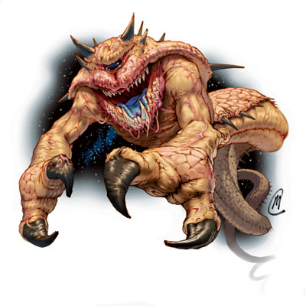

And just as the coordinates were relayed to Kali’s stations and the engines calibrated for Astral locomotion, they saw what appeared in the aft direction to be an Astral dreadnaught the size of a small moon coming their way.

“I hope this thing flies faster than that,” said Kali pointing to the oncoming object, or monster.

“Does this ship have any weapons? If not, I am headed to the aft,” said Jason.

“They didn’t use any ship weapons on us, and I didn’t stumble upon any, so I’m going to assume not.” Caleb replied, sounding somewhat calm despite the moon sized monster to the aft. Kali said, “These are stealth ships. The assassins we bested relied on their own personal arsenals—including planetkillers—to deal with other vessels.

Caleb nodded in agreement, and directed the gnome among them, “Magpie, ahead at full steam.”

“You think, Caleb? I was thinking I’d take us for a leisurely stroll,” Magpie sounded less calm.

“Worse comes to worst and it catches us, everyone form up on me and I’ll get us out of here,” Caleb replied. The travel priest could teleport like a champ.

But within a few seconds, the propulsors had engaged, the inertial dampeners were online, and the vessel made a beeline through the Astral Plane at about half the speed of light, leaving in the Astral dust a dreadnaught voluminous enough to have a gravitational pull.

~ The End ~

OOC: This concludes the interactive portion of this campaign, though you’re both welcome to write an ending for each of your PCs. You can bump them up another level (no need to send me the changes, but assume that Kali and Caleb took some ranks in Profession: Sailor), and either keep your 2 PCs together or separate them into two solo endings. You can even keep all 4 PCs together if both of you want to collaborate on a short narrative. I appreciate you guys having played this campaign through. They’ve been good times.

