Chapter 2: At the Gates of the Wererat Kingdom

T

hey hop aboard, Gordo a bit more trepid than the veterans of this band, and as Dextir sits at the main console, the floating heptagon and hexagons begin to orbit in the circle clockwise.

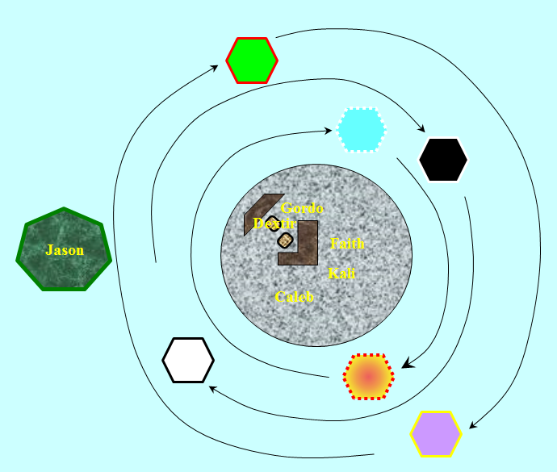

With Jason setting himself up in the heptagonal platform, Dextir casts *Leomund’s tiny hut* and centers it on the center of the central disc.

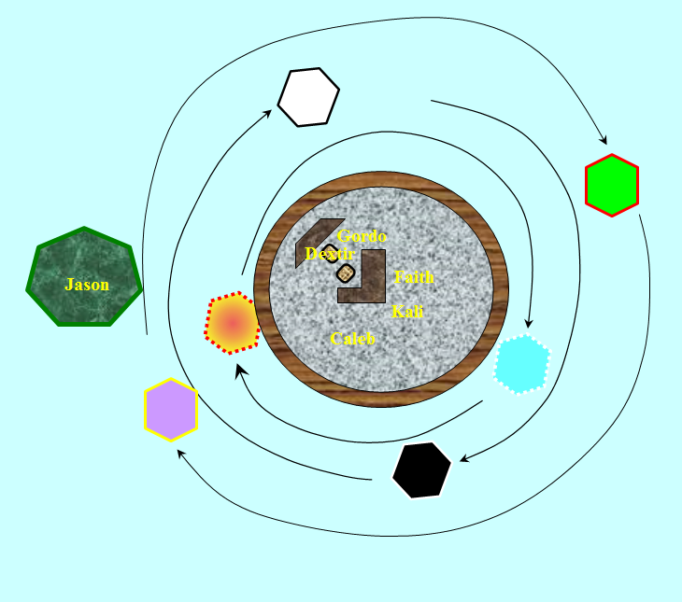

The 20’ radius sphere envelops the entire disc, leaving a 2’ gap all around it. Above them is a skylight nearly the size of the disc itself, giving them all an almost panoramic view of the skies above the River Oceanus.



“Any trash you want to throw out, throw it over the edge and it’ll collect in the basement of the sphere,” Dextir explains to Gordo. “Eventually, the shelter will wear out and we’ll need another casting. We’ll need to stock up on scrolls unless some of you can cast the *tiny hut* spell yourselves.”

The halfling watches attentively as the gatecrasher pulls up a map of their location.

Kali is unsure of this contraption and does not trust it. She takes a seat as close to the center as possible.

“Alright, compatriots,” Dextir says as he directs the platforms upward and away from the flow of the transplanar waters. “Mission objectives complete. Where to now?”

“Bytopia,” Jason reminds the gnome that this is their next stop. “You said it was just over yonder,” the archer points.

“Right, Bytopia.”

Caleb starts trying to heal Faith by casting first level cleric spells one at a time on her until she is cured of the cursed wound. He sacrifices 2 2nd-level spells, another 2 1st-level spells, and 3 orisons.

|  |  |  |  |  |  |
| --- | --- | --- | --- | --- | --- |
| **Caleb: Skill** | **Rank** | **Ability & Mod.** | **Total** | **Roll** | **Check** |
| **CL, Heal [Moderate]** | 11 | **Wis (+4)** | 15 | 3 | 18 |
| **CL, Heal [Moderate]** | 11 | **Wis (+4)** | 15 | 17 | 32 |

*Fail, success. Faith heals 10 + 11 = 21 hps [106/106].*

“That should do it,” Caleb announces.

Faith then realizes that she has not only been blessed by Caleb’s healing, but also by Torm’s good graces.

*Faith levels up and is cured of her Con damage and any other lingering ailments [115/115].*

~*~

They course through the Astral plane above the River Oceanus for what seems like 6 minutes, then approach an ever-spanning realm of stalagmites and stalactites as large and conical as mountains.

“This is it, isn’t it?” Jason smiles, having heard so much about the idyllic retirement plane.

The Twin Paradises of Bytopia did have a finite scope, and beyond those borders lay Elysium on one extreme and Celestia on the other, but these were too far for the mortal eye to see.

“We’re about to penetrate the coterminous boundary between the Astral and Bytopia proper. Brace yourselves,” Dextir informed everyone.

Faith asks, “What can we expect in Bytopia?”

Dextir gives the paladin and others a brief overview of a world that has no sky, save a thin horizon between two earthy layers—one rich in life and abundant in game, the other bleak and barren. “It’s one of the best afterlife planes, if you ask me, but I’m a gnome, so I might be partial.”

Jason adds, “It’s a gnomish realm.”

Caleb mentions, “I don’t have *Leomund’s tiny hut* in my spellbook, but if I can get a copy in it, I can make scrolls.”

“That would be helpful,” Dextir says. “It’s not impossible to travel through the Astral without it; but it does get windy... and some planes we just can’t tread through without some more serious protection, which I haven’t been able to afford.”

Caleb seems very interested in how the craft works, “Can anyone pilot this craft?” He asks as he watches Dextir work the ship.

“I suppose anyone can learn,” Dextir purses his lips. “But it’s hard to master the nuances.”

They pierce the planar veil that separates the Astral Plane from the atmosphere of Bytopia, and begins to descend upon the lusher, more florid landscape below them.

All seems well, until a demon materializes right in front of them, catching Dextir by surprise, “Dextir, you old fox!” the horned demon three times the size of Jason growls.

Dextir tries to veer out of the way, but the demon is too alacritous, and the vessel’s skylight is crushed by the demon’s incoming body, sending shards of glass in all directions.

Jason loses his footing and falls onto the platform that itself falls towards a flat patch of land below.

The central disk begins to spin like a coin in the air, most of the *tiny hut* remnants now concussed or destroyed. The demon scrambles with its limbs and wings to catch Dextir, grappling him with a single claw, then smiling, then teleporting out of sight as the vessel crashes upon the salty, silty soil below, knocking everyone unconscious.

~*~

Faith comes to first. She is groggy and half-dead, having taken significant subdual damage from the impact and successive aftershocks as the vessel completely broke apart into thousands of inservile pieces. They have landed near the side of a road, on an abandoned farmland that looks like it’s been uncultivated for decades.



The modal plant life consists of a green-leafed, squat, circular arrangement capped by a wide-open mouth with decayed-looking teeth and a protruding stalk that waves in the breeze.

She rouses Caleb and Jason next, finding Kali on top of Gordo, both underneath the rubble that was once the console that guided the vessel.



Faith uses all her turn undead (6) to heal everyone 72.

Caleb *detects magic* to see if anything magical can be found among wreckage.

Only their equipment seems salvageable; the components of the vessel are trashed.

With everyone other than Faith herself fully healed, they dust themselves off, inventory their gear, and smell the attractive scent of baked goods carried on the southeasterly wind.

Jason remembers Frayed, and his handy telescope, and wishes he had such a tool as he misses his friend.

Kali moans in pain as she holds her broken arm close to her body. She rolls off the halfling with some great effort and pain. She tries to stand but is unable to and cusses heavily.

Jason sits dazed blood dripping from his head a deep gash in his side. He seems to wobble a bit from side to side.

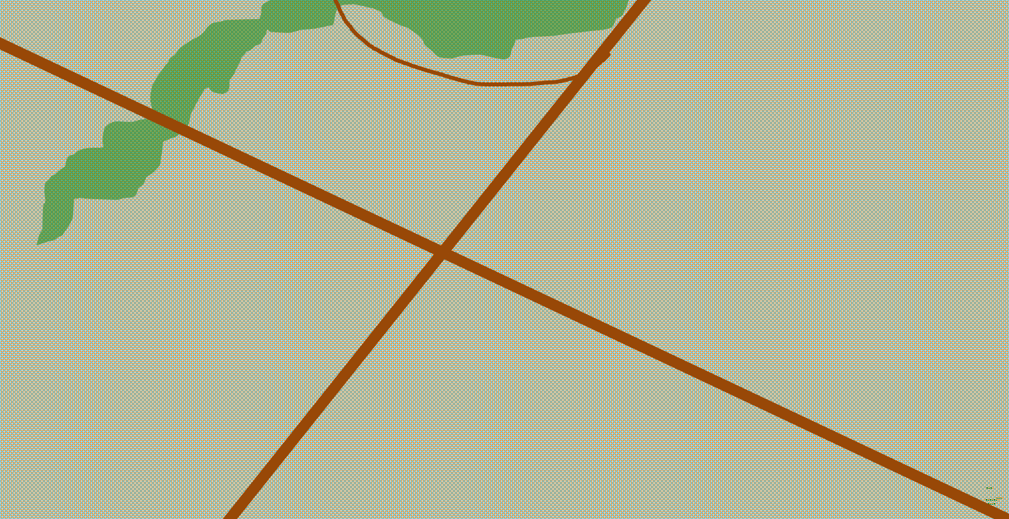

The fallow land at their feet is cross-cut by an intersection of roads. If they were to take this path, they’ll end up going straight into a forest, it seems.

The topography here is not entirely flat, such that some of the hilliness to the north obfuscates their line of sight to the northeastern-bound path. Then, in the mist, it becomes evident that there is a stone keep just past the thin forest to their northwest.

To their south, east and southeast are vast expanses of salt-encrusted plain, no longer suitable for farming.

Dusted off now, the heroes break a sweat at the thought of the long, hilly road, then look back at the keep built into the right-angled concavity in a cliffside that feeds a stream.

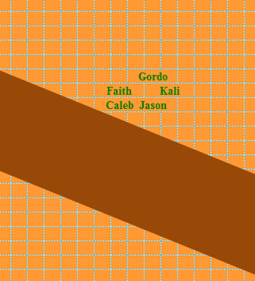

“Well, that was quite a tumble,” the halfling says, fishing out a healing potion from his Bag of Holding and drinking it down.

“I hope Dextir got away from that demon,” Jason sighs, looking to the sky for dropping gnomes, but seeing only the mountainous sky of Bytopia’s barren wasteland plane, Shurrock. “We are on Dothion,” the archer tells part of the little that he knows of this plane. “This is where well-meaning gnomes’ souls go,” he sighs again. “If Dextir perishes at the hands of the demon, let us hope that he chose a path in life that will steer his spirit back to this realm.”

“Those smell like the gammy-cakes my momma used to bake in Waterdeep,” Gordo sighs.

Faith says, “Well, let us go to the castle and see who is there. Does anyone among us speak Gnomish? I do not.”

With a slight limp, Kali gets to her feet. “We should try anyway. Maybe the gnomes will know more than one language. Currently it is our best bet for shelter.”

“Although that castle doesn’t look very gnomish in its design,” Caleb suggests, adding, “Language should not be a problem; I can cast a tongues spell.”

Jason waits for the others to make the decision.

“Yes, let’s try the gnomes!” the halfling says gleefully, clapping his hands in spite of himself.

As the group sets out Caleb casts *extended greater mage armor* and longstrider on himself.

~*~

They walk for a few thousand passes, and reach the crossroads, which Gordo insists isn’t trapped.



They look in all directions, including upward, as they continue northwestward towards the thicket of trees that looked like a forest from farther away.

As the group approaches the woods overgrowing the road, Faith asks Jason to keep an eye out for ambushes.



The party enters the forest, the boughs of which grow over the roadside, then make their way through and reach the open area once again. Going a little further, they reach a rudimentary Y-intersection at the end of the wide, straight road.

This is where things begin to become clear... and strange.

There are farms to the north, completely abandoned, though recently, given the well-tilled fields.

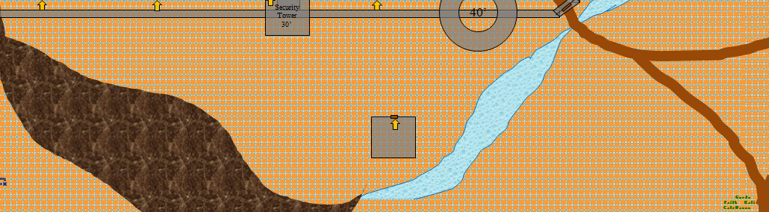

Both the southern and eastern walls are crowned by cylindrical towers 40’ tall, though no ballista, or other siege weaponry is mounted atop either, as far as they can tell. Each of the circular towers has at least 10 archers each, though Jason suspects that some may be hidden behind crenellations and others may be crouching.

There are two square, stand-alone towers: one to the south of the keep, and one to its east, and each has a few archers and spearmen atop it.

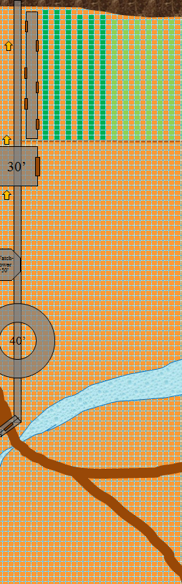

The singular drawbridge is built along a narrow defile through which runs a stream. Faith and Gordo count the visible archers and spearmen atop the outer walls, anticipating a tense diplomatic engagement.

“These people are scared,” notes Gordo.

The heroes reach the juncture of the Y-intersection, and are commanded by a non-gnomish voice in Common, “Approach slowly, and with weapons sheathed!”

The voice—coming from within the castle wall—is not entirely humanoid, and is surely amplified by a magical device, given how clearly it’s heard at this distance. “Identify yourselves! What is your purpose here?” the mousy, sniveling, and perhaps masculine voice calls out.

Not wishing to make any enemies and seeing what looks to be a great number of archers pointing in his direction, Jason attaches his bow to his back. He normally carries it in his hand so that he is ready at a moment’s notice.

Kali stops with the others, leaving her hands such that they are not touching her weapons. She surveys the situation and estimates the optimal range of the archers on the wall, knowing that after that range the miss change is much greater.

Faith calls out to the wall in a clear strong voice. “I am known as Faith. My companions and I were attacked by a demon on our travels and ended up being cast here. We are looking for our missing gnomish companion by the name of Dextir and to get our bearings. We mean you no ill will.” Faith displays her hands showing no weapon in them.

There is some murmuring among the men until an order of silence is roared—or rather, squealed—across the inside of the castle wall.

Gordo draws his short sword, Frost Lick, and stretches himself up to his full 3’1” height. When Faith does her “no weapons” gesture, Gordo quickly puts it away and tries to look less menacing.

Caleb laughs loudly, thoroughly entertained by Gordo the mighty. The paladin then tries to tell if those guarding the keep are gnomes. By their height, she would guess yes, but it is too far to tell by facial features, and their ears are covered either by helmets or feathered caps, depending on their military function. But a rather strange voice for a gnome, if that’s what that is.

After a few moments of tense silence between strangers, the drawbridge opens, and a trio of gnome-sized figures emerge, riding wardogs with spiked collars.

As they come closer, all archers draw an arrow each and all spearmen descend the wall and towers, emerging in a single file that stopped only twenty men out, and then stood still upon command. The three wardogs continued their walking pace towards the outlanders, the leader opening its mouth and letting its tongue taste the strangers who stand upwind and haven’t bathed since before going to the Gauntlet to destroy it.

The gnome atop the dog in the lead, carrying a banner and a few scrolls, stopps his mount, and with a straight face, says, “We greet you on behalf of Lord Raphael Chesmann, The Earl of Gorgon Zoloft.”

“Is that where we are?” wonders Jason.

“You are in the Earldom of Gorgon Zoloft, yes, whose sovereign ruler asks that you state your alignments before being considered for admittance to His Highness’ presence,” the man informs them. “We are a community of evil-smiters; all others we tolerate and embrace.”

Seeing no harm in it, each of the heroes states the moral causes that their lives seek to champion. This is a party that heralds the furthering of chaos first and good second. Faith, who is undoubtedly lawful, had once even considered becoming a paladin of freedom, seeing virtues in that line of thinking as well, so long as it was mixed by good, but ultimately turned to the traditional paladin’s path.

“Very well,” the lead man says. “I am Badgermaster Duncan the No-Longer-Blind. On behalf of Lord Raphael, Earl of Gorgon Zoloft, I hereby welcome you to our quaint village. If you’ll follow us, we shall escort you to the inner court, and delight in tales of your travels over a meal.”

The spearmen march back inside, making way for the dogs and the outlanders to make their way along the collapsed drawbridge.

Once inside, the drawbridge quickly closes, and the murmurs of the mostly male infantry and canine cavalry looks upon the humanoids. They are glad that Gordo, at least, is shorter than most of them, and Caleb can’t help but notice that all of them have a very distinctive look, as if they’re either all inbred, or perhaps one another’s distant cousins, but these aren’t just a random sample of gnomes from across the planes, brought to this afterlife by their dispositions. They’re a clan or something.

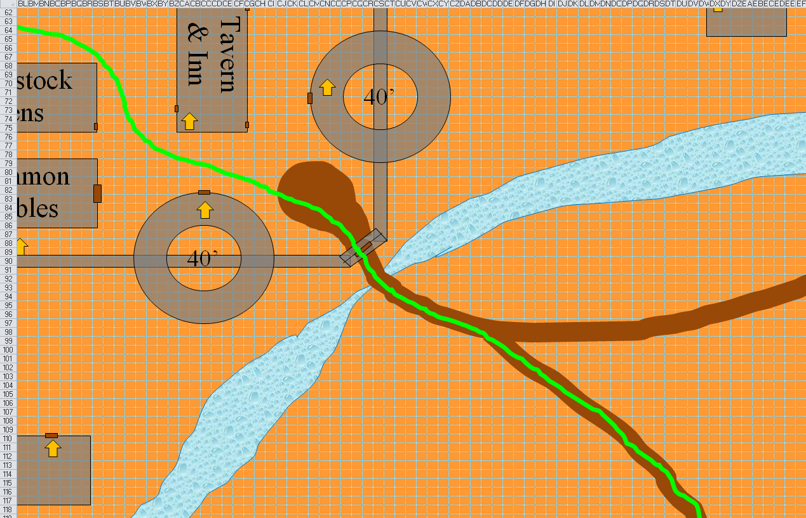

They are led throughout the majority of the extremely well-built fortification. First they pass a row of stables and a chicken coop on their left, then see the entrance to a tavern on their right. Between the coops and a brewery is a path that leads to yet another gatehouse that grants them access to the inner region of the... or not quite inner, since now they are facing yet another gate.

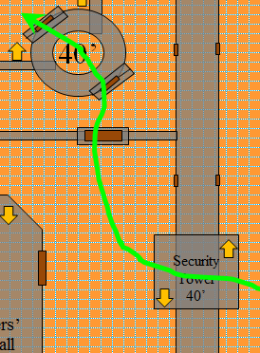

That gate is opened, and upon passing it, as they have come to expect, are more security checkpoints, until at last, the extraplanar heroes are upon the actual keep within this artichoke of a fortress.

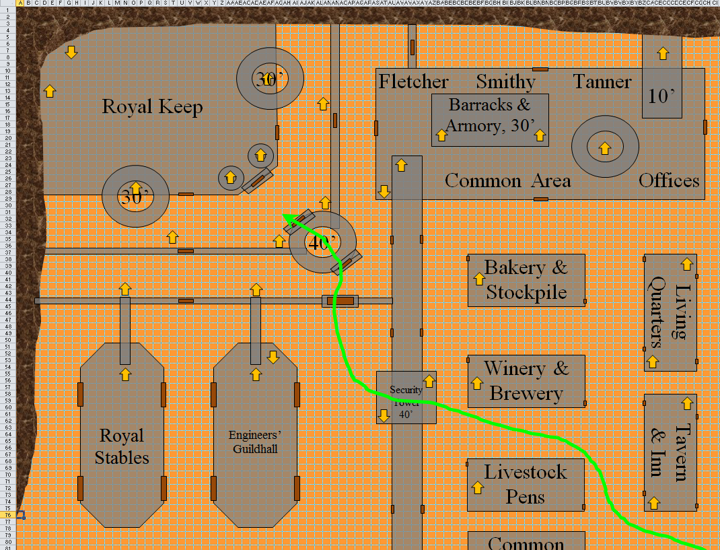

Double doors open, and the three dogs and their riders return whence they came, leaving the heroes with two halberd-bearing elite guards, also with the same facial features as most of these folks: bucked teeth, thin moustaches, patchy beards, elongated nostrils, and pointier ears than most gnomes’ ears. Even the few women visible seem to have little moustaches growing out of the sides of their upper lips.

From within the palace emerge two women—presumably—dressed so completely that only their eyes peek out from burqas and qimars. They speak in unison, saying with shrilly voices, “His Highness, the Earl of Gorgon Zoloft, the Mighty and Benevolent Lord Raphael Chesmann, welcomes you and bids you enter his sacred sanctum.

They are led inside the keep, modest in its decorations but indicative of a former glory, and note the figure sitting at the throne, doted on by a few women, some of whom exit the chamber upon the wave of the king’s hand. The two women clad from head to toe bow and step back against the wall of the court.

“I am told,” the king’s squeaky voice betrays his nature. Caleb suspects it; so does Gordo. “That none of you have chosen to follow the path of evil, so you will forgive the men who greeted you for taking the precautions we deem so needed here.”

The king leans forward into the light, his face ever clearly portraying the features of his countrymen, but so much more pronouncedly. This is a wererat. They are in an earldom of wererats!

Faith and Gordo bow toward the King to show respect. The paladin speaks first: “Your majesty, if I may be so bold as to question, what goes on in this land that you need to take such precautions against evil and what causes the fields to be vacant and untended?”

“Your boldness lies in questioning me before introducing yourself,” the male gnome wererat sovereign scratches his chin and points out, then ponders the paladin’s question. “Alas, evil wears the mask of neutrality in this vast realm,” the monarch spealks as two pieces of metal clank momentarily. They all turn to see one of the king’s 8th cousins—a halberd-wielding male clad in plate—shifting in his armor with a look of respect and fear in his eyes. They will later learn that this man was recently in a battle against yuan-ti adversaries, and nearly didn’t make it.

Gordo notices that the gnomes seem to be relieved by his tiny stature, so he thinks it might be best if he speaks on behalf of the group.

“Your Highness, the Earl of Gorgon Zoloft, the Mighty and Benevolent Lord Raphael Chesmann,” Gordo begins, and then introduces all of the party members, leaving himself for last. “We are indeed allies in the ongoing battle against Evil. Perhaps this small band of adventurers can help to serve your cause, your highness.”

A few minutes of introductions and interchanges elaborating on just how the party might be of service yielded the following information:

There is a burgeoning city-state to the southwest that only one generation ago was a village of gnomes, and is now a monarchy, somewhat like this one. This polity is called the Kingdom of the Snake, and is ruled by a yuan-ti planar expat—much like the heroes—specifically from the warm forests of Arborea, where the present heroes have never been.

By taking the up-and-downhill path towards the southwest, they would take that hilly, winding well-trod trail for about 10 miles, they would find themselves at the perimeter of their current eastern border.

This outcast prince, the self-styled general simply referred to as the Snake, does not have a particularly massive army (see the Boar and the Wolf), though he has cunning, well-trained taskforces of reptilian minions, and often recruits newly resurrected souls who are too naïve to know any better.

The Snake’s main fortification is not only 10 miles away, it is also about 500’ downhill (though you’ll go uphill about a third of the way) from the Earldom of Gorgon Zoloft. The climate is a lot warmer, and the vegetation is lusher. Predators and prey will be bountiful along the path. There are four outposts that the Lord Raphael Chesmann and his court are aware of: two lie between here and the main fortress, but neither lies on the direct path/trail. No signs on this trail point to which offshoot trail leads to what.

The outposts are wood-composed forts with a few palisades and a handful of towers with archers or crossbow operators. The keep itself is a complex of several undulating walls built for maximum defense. Most wererats that go there don’t return to tell the tale. Those that are fortunate enough to do so speak of voracious hunters who butcher and eat those they vanquish.

There are two other kingdoms, known here as the Kingdom of the Boar and the Kingdom of the Wolf. These foes are more formidable than the Snake, but they have left the Earldom of Gorgon Zoloft alone for now, since they are at war with one another, and with the Snake. Their realms lie beyond the Snake’s domain.

The majority of the wererats live in underground burrows. Most of the buildings here have been converted to have functional—not residential—purposes, and each one has access to an underground area. These are not secret entrances; they are integral to their lifestyle, as trivial for them as a threshold between a kitchen and a dining room.

The party won’t know this for another few minutes, but these guys like to eat cheese. Every item in the feast/meal offered is a cheese dish that can be eaten with one’s hands, either one- or two-handed.

Speaking of which, with pleasantries over, and the narrative of each side fully detailed to everyone’s satisfaction, a table is brought into the court, complete with chairs for every guest, as well as the Earl and a few of his confidants.

Within minutes, they’ve been seated and served the zeroeth course—appetizers—including pao de queijo, tequeños, a bit of fondue, and a potato-based puree with a squeezing of mustard cheese on top.

*[PC questions about the Snake, Boar, Wolf, etc.]*

By the time the main course is served—Karnathian onion soup with grated Charmesan cheese—the Earl has drunk two full glasses of cranberry wine, as have most of the wererats, and both the Earl and his viziers now boast about the amount of treasure they once held in their coffers.

It is a melancholy story, given that now they are devoid of any such luxuries. They eat well, but only due to making use of the little arable land at the juncture of these two cliffs with a measure of efficiency; that, and the underground chambers used to produce most of the cheese once it has been extracted from the cows in the pastures along both cliff bases.

Faith asks, “Do the gnomes willingly accept the snake as their Prince or does he rule merely by force over them?”

“I regret that law supersedes goodwill in the Serpent Kingdom,” explains the Earl, munching on a piece of cheese bread. “Theirs is a system incorporating a caste of living things in which reptiles constitute the apex of all life on all planes. Anyone else—gnomes, beholders, the demigods of the illithid pantheon, cockroaches, you name it—is considered food, fodder, test subject, slave, pest, or foe.”

The paladin admits, “I have known paladins who eat of the flesh of innocent beasts, and otherwise adhere to a strict code of ethics. What is virtue when one does not hear the cries of his or her nourishment?” Faith asks rhetorically as she detects for evil among the wererats, finding none. These are a mostly lawful good and lawful neutral folk, and the Earl and the other wererats seated at the table also possess an air of righteousness about them, even if devoid of might relative to the serpents being referenced.

Caleb says, “It might be worth resting for a night before we set out so we are fully prepared. This is so amazing, seeing all these kingdoms and how they are set up. How is it that a kingdom of wererats ended up on this place?” The cleric-mage is quick to pick up on the fact that kingdom and earldom mean the same thing to these guys, whereas the two words point to vastly different amounts of power in the other kingdoms here, which are true kingdoms, with viceroys, earls, counts, and dukes beneath them, if these accounts are true.

“We are young souls,” explains the monarch. “Most of us are nary a decade here since our resurrections or rebirths. We lead short lives here relative to what I imagine we lived in our last incarnations. After we depart from here, I suppose, as the legends go, we are either promoted to archons or perhaps diverted to a plane more hospitable to our dispositions.”

Another course of cheesy dips and other goodies is served.

The host continues as he grabs a hold of a broccoli branch and dips it in his personal vat of warm brie, “This was once a purely gnomish fortress, built by—I presume—one of my ancestors. What I can tell you for sure is that we have been part gnome and part rat for as long as our known history spans. Our best historians can only go back a century, and prior to that we do not remember who we are as a community. We presume to be here because in our previous lives we honored the Great Garl Glittergold, or another non-evil deity, with high deeds, but even here, the gods are vague in their communions with our clerics. Our warrens, built by our forefathers and maintained by all thereafter, allow us to reside in the warm ground underneath this fortress town.”

“How many of you are there, if you don’t mind me asking?” pleads the inquisitive archer.

“We are almost a thousand, counting the farming families that live outside the walls. We are all rejecters of Urdlen the Bloodthirsty, and prefer to coexist with our cattle and other livestock, who sustain us with our blessed dairy,” the rodentesque nobleman waves his hands as if to point out all of the food before them.

The conversation eventually returns to treasure, but now specifically turns to the treasure reputed to be held in the keeps of each of the other lords. “The Kingdom of the Snake is said to exhibit relics which were once the possessions of heroes from ages past. This should serve as a warning to anyone considering setting foot in the realm of these reptilians. They are an avaricious people, bordering on outright evil, but avoiding it officially by abstaining from communing with evil deities, amassing and casting evil spells, and the like. However, their natures are evil at the core—we have divined this, as well as come to know it via experience. Because the Snake is at war with the Boar and the Wolf, he cannot afford to concentrate his attention on us, but this will someday change, and when it does, I fear for the future of our people.”

“What about the other lords?” asks Kali. “Are they treasure hoarders as well?”

“In short, yes,” admits the benevolent ruler, sighing. “But we know very little about those faraway kingdoms, let alone their relic inventory.”

“Why not join with the others and defeat them?” asks Kali.

The feast continues through the afternoon and well into the night, devolving into less conversation, and more eating, drinking, copious fornicating, and sleeping.

~*~

They have slept and prepared spells.

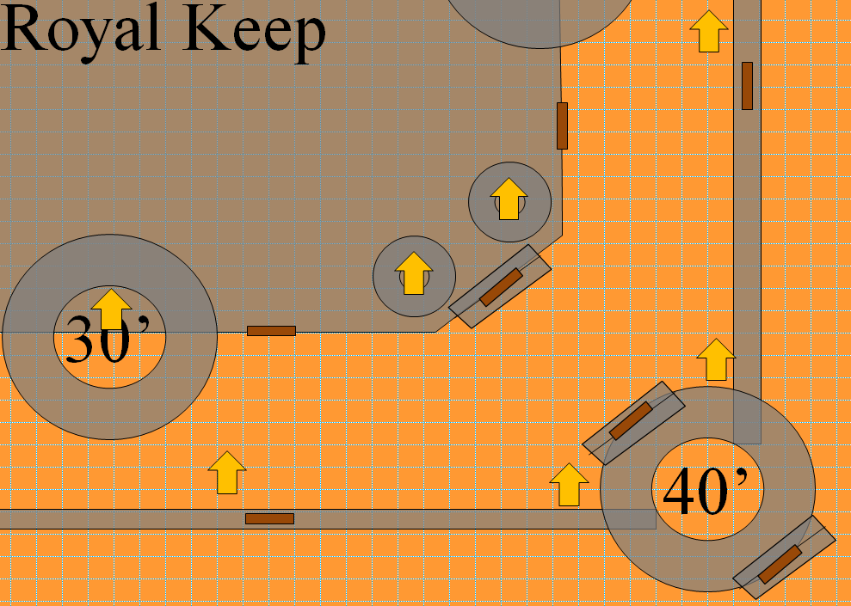

They stand in the full light of day now as the king’s men gather and approach the heroes. Eventually, the Earl himself greets them and commends them on their resolution to try to put an end to the Snake’s tyranny on this plane.

Faith gets a serious look on her face. “Alright, if we are going to do this, I need what information you can give me.”

She details each question, pausing while the wererats answer. She noted the major points: The Earldom has quite a few divine spellcasters of levels ranging from 1 to 5, but the citizens don’t usually live long enough and/or have the intelligence and patience to study arcane magic.

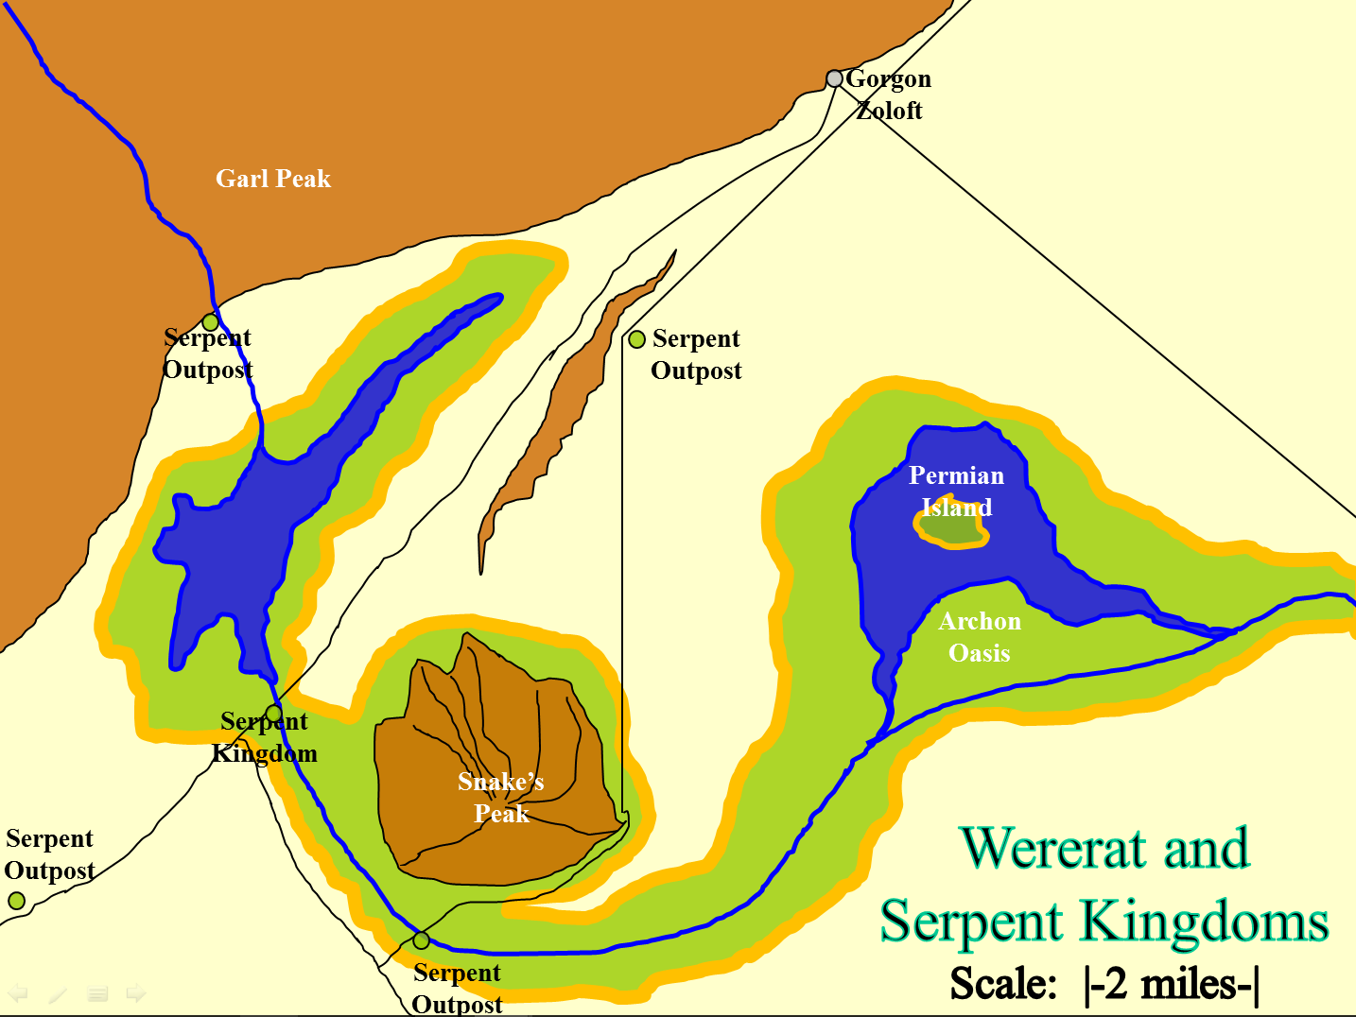

The wererat petitioners of this part of Bytopia provide the heroes with a map showing the layout of the various settlements, outposts, and other landmarks.

The yuan-ti prince is reputed to be a sorcerer. He rose through the ranks of the tumultuous royal-military hierarchy already established by previous lords taking the mantle and moniker of the Snake.

The fighting style of the troops varies by the nature of each strike-force. The party can expect little overture in their methods; rather, they can expect to face situations wherein the Snake’s forces use camouflage, subterfuge, intrigue, decoys, and other sophisticated counterintelligence measures to maximize their odds of overcoming their adversaries. By contrast, the Boar and Wolf kingdoms have historically been more straightforward in their tactical approaches.

Caleb looks thoughtful and then lights up. “Snake, wolf, boar.... Are all of them werecreatures?”

“The yuan-ti are not lycanthropes, though they cavort with wereserpents and a menagerie of other serpentine beasts,” one of the advisors points out. “The Boar and Wolf are—as you suspected—are lycanthropic abominations of what they might have been, bordering on evil by their very nature. The Boar is known for his gluttony, avarice, and envy, while the Wolf’s name is synonymous with wrath, bloodlust, and tyranny.”

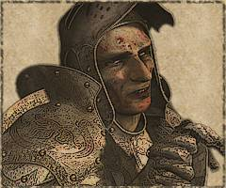

“I bid you heroes well,” the wererat monarch motions for the rather fear-stricken warrior they’d met before to come forth, or perhaps it was a different warrior altogether; their faces all looked the same. “You would honor our dear Trufaux here by allowing him to be your guide, though I doubt a stalwart group such as yourselves would need someone to keep you on the path.”

Gordo turns to the others, and says quietly, “It couldn’t hurt to have a guide. Plus another swordslinger to help us if and when we get into a melee....”