Chapter 4: Ghefi’s Grove

T

he light-emitting clouds that separate the two layers of Bytopia are now glowing pink-salmon-peach-orange, and will soon convulse into dimming violet and twilight indigo. They’ve put the better part of an hour’s walk behind them since the yuan-ti incident, and now find themselves in a subtropical woodland with a greater deal of floral diversity than the chaparral and steppes behind them. Palms, succulents, ferns, and a few giant, carnivorous plants provide shade for the plethora of ground cover and other species of plants and fungi that carpet the entire area.

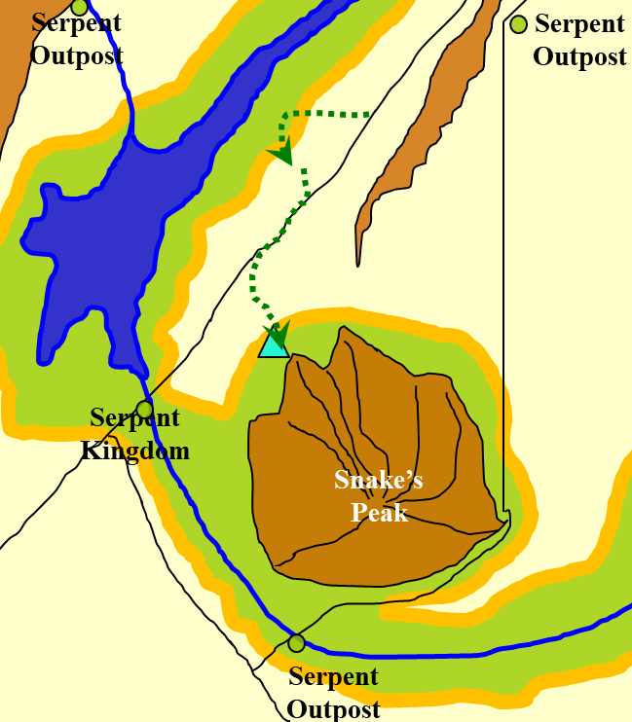

There is no trail at this point. They’ve been headed towards the massive mountain that juts above anything else nearby, and now hear movement up ahead. Each of them stops as a few birds and bugs make their presence known with their respective sounds. Faith halts her mount, and the heroes try to pinpoint the source of the sound. A single figure—clad in a cloak, a mithral shirt, and fairly modest accessories—approaches.

Under the cover of the palms and other subtropical trees, the dimming clouds barely illuminate the visage of the hooded woman as she approaches. The approaching woman spots the fully plated paladin who just can’t keep silent in her metal suit. The stranger stops, then removes the hood of her cloak. Before them stands a human woman with auburn hair and fair skin. At a distance of 70’, she studies the party just as they study her.

Caleb recalls his *magic missile* spell.

Faith says to the woman, “Greetings! I am Faith, and these are my companions: Kali, Caleb, and Jason. What brings you to these parts?”

Rea stands 5’ 11” with deep, rich auburn hair that looks like it’d be around shoulder length if it wasn’t tightly braided into a single braid that runs down her back. She looks over the group of individuals in front of her. “At least they don’t ‘look’ like bandits,” she thinks to herself. She gives the burned out, little amulet a light toss then snatches it again as it falls and hopes for the best as she walks toward the strangers using her spear like a walking stick. With a friendly smile and a half wave she calls out as she gets nearer, “Howdy! I’m Rea Sho, and I hope y’all can help me out a bit. It seems this worthless piece of tin had the power to bring me here and then it just burned out so I’m more than a bit lost. Do y’all know the way to the nearest city?”

“She seems disoriented,” Jason can tell by the voice and speech pattern.

“Aye,” Kali nods slightly, keeping her eyes on the human woman as she studies her mannerisms.

Caleb seems excited by this news. He begins to describe what plane we are on and the location of the wererat and snake cities and he will detect for magic and portals.

Rea listens closely to Caleb. “Well, I certainly ain’t at home no more: that’s for sure. And I gotta say, I don’t think I’d be real comfortable in either the rat or snake cities. How about I travel with all y’all, at least until I can get to some place more um... cosmopolitan? I can take care of myself so y’all don’t have to worry about protecting me none and who knows, I might be able to help out.”

The party agrees, though some might be casting spells under their breath as she comes closer, just in case.

“Tell me,” the temporarily blinded Jason asks, able to tell from Caleb’s voice that this one is a looker. “What do you do for a living?”

Rea knows of an ideal site to pitch their tents, and when she learns that they are almost ready to do just that, she suggests that they trek another few thousand feet towards the foothill.

Minutes later, they arrive at the site, and it is ideal, indeed. Two separate mounds at the base of the mountain will allow two lookouts to have a height advantage of 20’ *and* naturally crenellated outcroppings to shield them, should they be assailed from below. In the event of an assault from above, the two mounds similarly serve as protection from falling boulders, missiles, and the like.

Jason wishes he could help scout the area, but everyone insists that he sit on a convenient rock while the others secure the place.

Rea says she just passed through here, and wonders why no one has ever built a bonfire here or anything like that.

A snake crawls near Jason.

Wishing he still had his axes, he hears the slithering animal, and draws his silver-a-dozen dagger, and slashes at the sneaky reptile.

|  |  |  |  |  |  |  |  |  |  |
| --- | --- | --- | --- | --- | --- | --- | --- | --- | --- |
| **Melee Weapon** | **Dmg.** | **D+** | **TH+** | **Critical** | **Type** | **Wt.** | **Atk** | **Roll** | **Check** |
| Dagger | 1d4 | +1 | 0 | 19-20/x2 | Prcg/Slsh | 1.0 | +9 | 11 | 20 |

*Hit. Dmg: 3 + 1 = 4.*

The snake dies, its head rolling down to the ground while the rest of it writhes atop the rock, bleeding near Jason’s arse.

Kali smirks at the sight, but says nothing.

Rea just smiles and winks, “Well, I’ve got such a naturally charming personality that people tend to believe whatever I say no matter outrageous. But what can I do? Let me show you.” At that she seems to push out her hand, palm forward toward a small tree. A tight shockwave seems to shoot out of her palm and as it hits the tree there’s a mighty bang as several branches are broken off.

“Now, some would call me a warlock, but don’t be thinking I’m some demon worshiping sicko. My patron is from the stars, not some pitchfork carrying fiend. All in all while I can fight my way out of a situation I’d rather talk my way out of it.”

Jason hears the boom and the splitting of wood, and can only guess that it is most likely some sonic attack she has produced.

He stands nonchalantly, smiling his playboy smile, the last light of the daylight clouds flashing off his teeth. Well my darling, I think you would be a great addition to our little band.” If he had been of lesser experience he might have been facing off to her left as he addressed her, giving away his currently blind state. His years of scouting had honed his ears so that he can usually pick the direction a sound comes from. Course, this is not one of those times. The boom disoriented the scout so that we he turns back to where he thinks the woman is standing, he is actually almost back to her. The young woman stood with an odd look on her face as one of Jason’s companions turn him in the right direction with snickers following, mostly from Kali.

At the touch, he realizes his mistake but keeps his poker face as he says, “We were just about to make camp for the night. Tomorrow, I believe, we will visit with the serpents.”

They all agree that this is a tactically sound site for their encampment, and within minutes, they have removed their armor and begun to set up tents and bedrolls.

~*~

“Should we light a fire?” Caleb wonders a short while later as they take seats on patches of dry grass and leaves inside the perimeter of tents that they’ve set up.

“Our rations don’t need cooking; it’s not that cold; and the light and smell might attract yuan-ti or others patrolling the area,” Faith warns.

Before anyone goes to sleep, they try to schedule a sleeping schedule. They’ll need 8 hours of sleep if they are to avoid fatigue and refresh their daily powers, and in 7 hours it’ll be daylight again, so with five of them in the current party, the five humans sit in a circle, resting their tired legs as they talk.

Faith, Caleb, Kali, Jason, and Rea decide that they will stay here for a total of 10 hours, giving everyone 8 hours of rest with 2 hours of night watch, starting pretty much now.

“Who’ll start?”

Caleb says, “If we wish, I can summon an extradimensional space for us to rest securely in.”

Taking another look at the openness of the terrain Rea nods in agreement, “That sounds like a great idea. Not likely to get rained on in an extradimensional pocket. And since the best I’ve got is a bedroll and a blanket, I’d say do it. Probably less likely to be spotted too.”

~*~

Jason is determined to do something other than sit on a rock. As the others eat their daily rations and set up their bedrolls, the archer tries to tune his sense of hearing to the settling sounds of the impending night.

~*~

Caleb’s spell preparation is interrupted by his preparation for a two-hour watch as Jason stretched and breathed in the still cooling night air. He has managed during this time to prepare a few of his divine spells, including *restoration*, which he promptly casts on Jason.

During the 18 seconds that it takes for the priest-diviner to channel his deity’s favors, Jason takes in his last few moments without sight. As he blinks, he feels the trickling of the dim starlight of campfires and magically lit domiciles above them.

“Whooooa!” he sighs and smiles, thanking Caleb.

The spellcaster nods and bids him a good sleep.

~*~

Rea has taken the third watch. With Caleb sitting close by finishing his spell preparation, Rea walks along the periphery of the makeshift encampment, and notes a few possible convenient spots from which to fire her blasts.

She leans up against a few trees, the hooting of an owl giving her some sense of the passing of time as her newfound friends sleep or pray nearby. The moistening of dead, dry leaves at her feet smells of a mineral-rich soil as dew precipitates upon everything. At one point, it is so quiet around her that she could even hear the river gorge just over 2 miles to the southwest.

The placid state of the lush valley sooths Rea’s heart, and she begins to smile...

... until she comes face-to-face—practically nose-to-nose—with a naga.

She doesn’t recognize it, but within seconds, it has soothed Rea’s heart as much as an hour of standing in this serene forest. “I am Ghefi,” the female proclaims in what appears to sound as two identical voices.

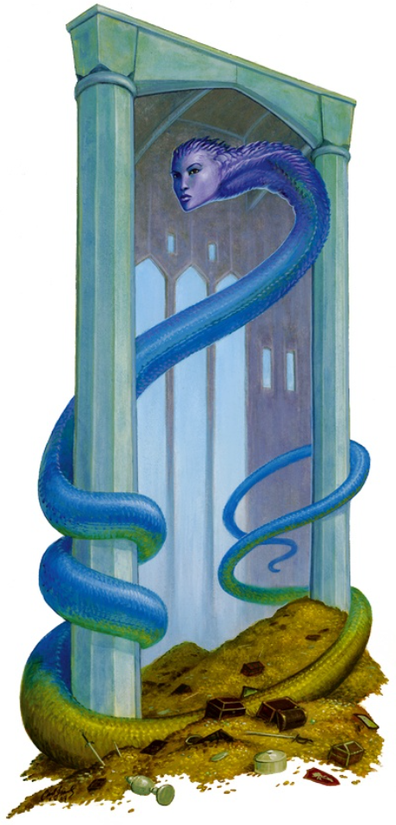

Rea invokes her Beguiling Influence and flashes a charming smile, “Hello, Ghefi. What brings you to our little campsite? I can assure you we mean no harm.” Preparing for any disagreeable actions by their strange guest, Rea casually holds her spear in such a way as to make poking her nearest party member with the butt end easy to wake him up if necessary.

“I have been watching you. You are not like the others who escaped the Serpent King,” says Ghefi.

“Escaped?”

“You do not yet remember,” the naga winds and curls around herself as if she were a person sitting. “You were to be sacrificed to Sseth, the vile deity of the Serpent King. A band of gnomish aasimar called the Redemption liberated you and a dozen others. I have found the bodies of seven of you already, and those whom I could find alive thought me to be in league with the yuan-ti and other evildoers who prey upon this land.”

Rea begins to recollect vague images, having thought them to be remnants of dreams until now. The naga continues, “Yours was a noble purpose, warlock. You were on your way to Alfheim—one of Ysgard’s realms—to fulfill a pilgrimage, and were sequestered for this much darker purpose. I know not *this* band of heroes with whom you now consort, though none emanate evil auras.”

Looking a bit nonplussed, Rea cocks her head a little to the side, “Sacrificed? Me? Alright, I’ve got to admit that I am a bit confused as to where I am, why I’m here and exactly how I got here. I’d a thought I would have remembered being set aside as a sacrifice. If what you say is true I must have been more than a little rattled by that rescue. Maybe I should wake our knight in shining armor and have her join in this little chat. She’d be able to reassure the rest at to your good intentions.”

With that she gently nudges the paladin and quietly says, “We’ve got a visitor and I think she’s not evil or we’d probably be mixing it up right now. However, I thought you might want to ‘have a taste’ as it were so everyone else won’t go crazy when they wake up.”

Faith awakens, eyeing the creature. “Are you sent by the Serpent King?” Her hand rests on the hilt of her sword but she does not draw it.

“Nay, paladin. I am not in league with the Tyrant Monarch, as he is also called, though never to his face. I have seen the gradual degradation of this realm at the hands of his evildoers, and long for a day when they are no more,” the well-meaning naga responds.

A few others begin to wake up to the sound of this strange, new voice talking to the others. “What brings you here?” someone else asks.

“I have lived in this forest all my life, and can recount when its vastness spanned from horizon to horizon. I am safe from the Serpent Kingdom so long as I remain here in these elusive woods, and have never ventured to the now desiccated desert that surrounds this forest. The mere sight of it is an indignation,” Ghefi opines aloud.

Brant, who has been sleeping but is now groggily blinking himself awake, snorts the air, making the usual ululation that sounds like human lips rasping.

They all talk for some time, and the party learns that this naga—whose dispositions lean towards chaos and good—is a reluctant guardian of this part of the forest. She learned of her role as groundskeeper from a vision she received (though she did not describe the vision), and has tried a few times to escape the grove, only to find herself lost, and eventually back in her ascribed domain.

Caleb has heard of such things, and it is likely that she is the resurrected soul of a well-meaning gnome (or other) who made poor life choices, and was possessed by some vice along the way. It is the will of several deities—Azuth and Oghma included—that caring for the beings in an environment such as this is a fitting fate for such souls, the duration of service being a condition of the karmic forces generated in their last lives that facilitated their transition to this state. Faith is also vaguely aware of this.

“Do you have any advice for us if we should confront the Serpent King’s forces?” a hero(ine) asks.

“Beware their trickery,” Ghefi answers after thinking for a few seconds. “They are likely to use a mixture of all-out aggression with some subterfuge, illusion, and feints. Oh, and never parlay.”

“Oh?”

“It’s one of their most common tactics: get adversaries to briefly lower their guard, and then execute premeditated contingencies,” the naga responds.

Brant snorts again, this time taking one hoof a few inches off the ground and arching his neck back and forth. Faith—unarmored—looks around suspiciously.

“There is a predatory animal nearby,” the naga reports.

Faith sighs and goes towards her bedroll to get her sword. “It’s not my shift yet, but we might all be on the clock in a moment.”

The naga assures them that they won’t have to worry. She smiles, her eyes wide, “I see her now. It’s a black bear, one of the younger adults. She’s about 1000’ away.”

Kali has lain listening the naga. She has fought a few of the beast in her time and is not all that convinced of what she says, but decides if Faith is alright with him, then all is fine. The announcement of the black bear makes the woman sit up and put her boots on, making ready should something happen.

Some of the heroes do hear the sound of a creature that size moving around at about that distance. The sound of movement stops altogether, then they hear the bear groan—not with pain or alarm, but with a mixture of disappointment and resolve. The movement then continues, even louder at first, and as the bear goes back the way she came, the noise eventually dissipates beyond audibility.

And with this, the naga excuses herself to go tend to other matters of balance in the grove. “You seem like a benevolent bunch, and I will send prayers to the deities that you might bring the Serpent Kingdom to bay, or at least rectify its leadership’s code of conduct.”

Once the animal turns away Kali, resumes her current state before she was interrupted.

Jason continues to sleep as all the activity dies down. Must have been some residual of the healing on his eyes for normally he would have awoken at the sound when the naga first arrived.

~*~

Faith’s watch is uneventful, save for the occasional groan of the disgruntled black bear, who has been forbidden from entering this part of the grove for the remainder of the night.

~*~

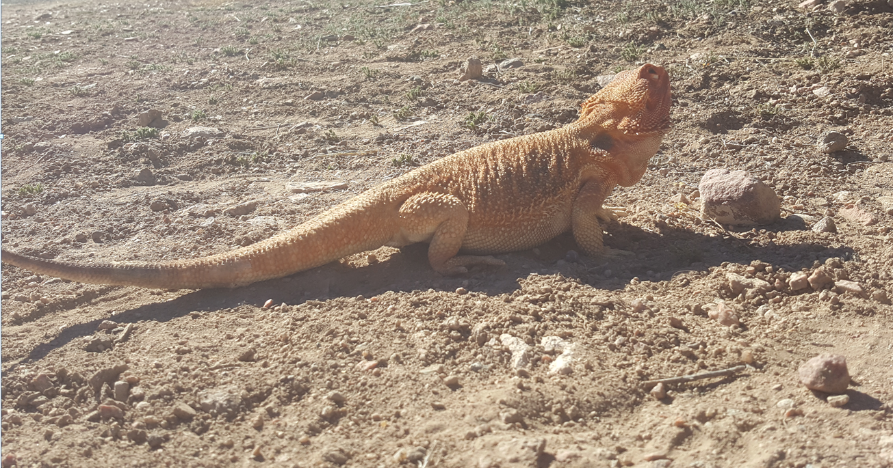

Kali takes the last watch, and is equally unimpressed by the challenges brought before her, which amount to a Tiny lizard making its way along the forest floor.

Most of her shift takes place during full daylight, and with the others well rested by now and stretching themselves awake, it is a gradual transition from her shift to a state in which everyone is awake and alert.

Their meals, evacuations, washings by the nearby stream, and subsequent armor-donning rituals are also as uneventful, and the forest almost lulls them to placidity.

Armored, equipped, sated, and invigorated, the party stands in circumstance and sighs with resolve, ready to face another day.

“Let’s see that map,” one hero says to the next.

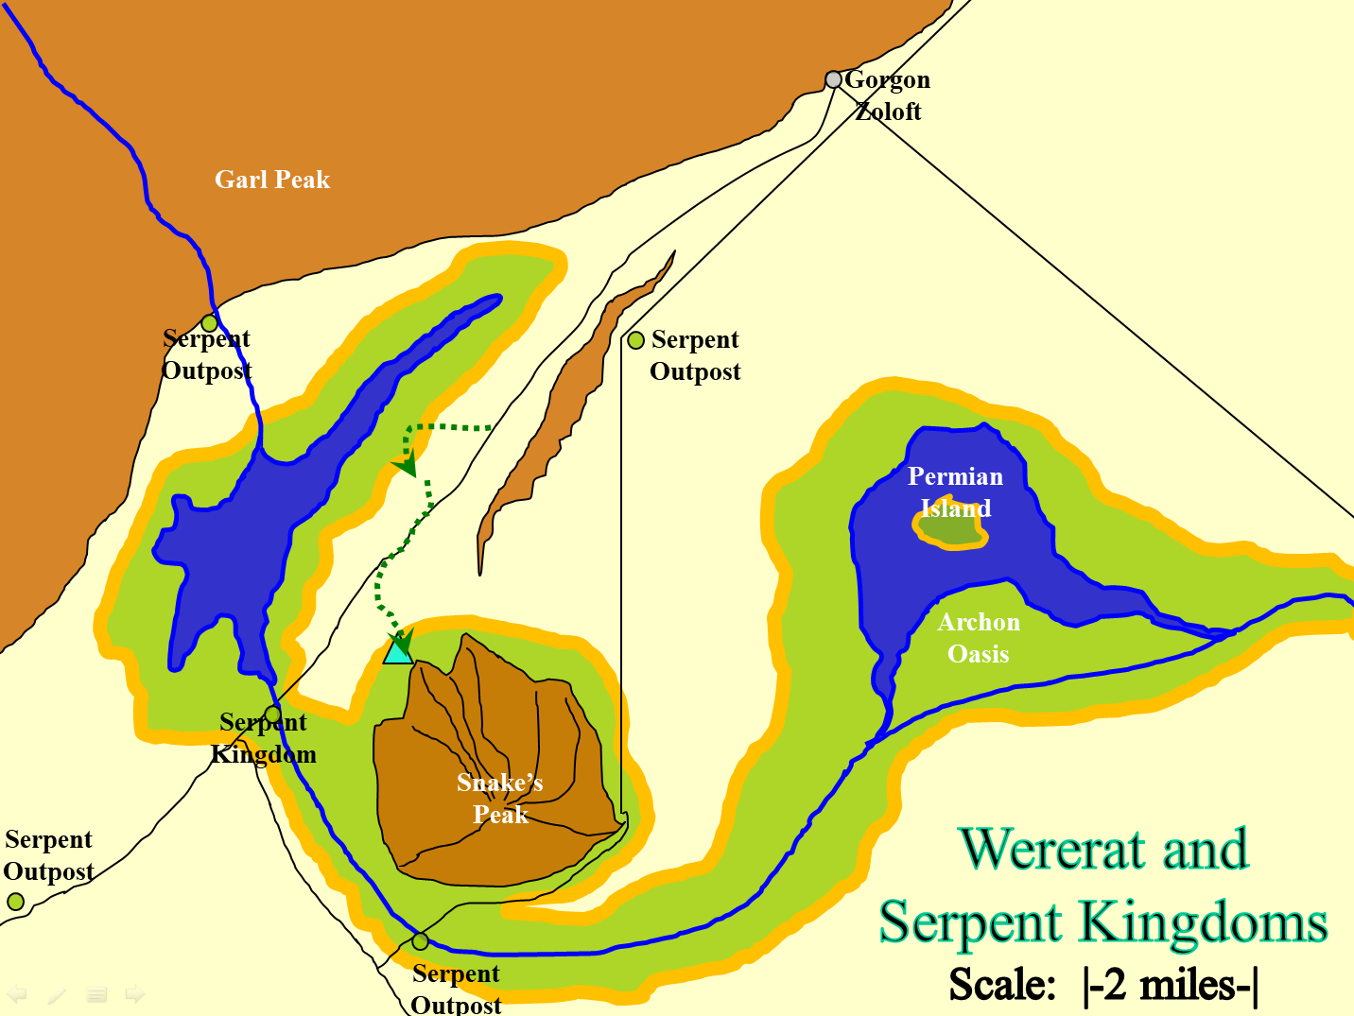

“Didn’t we have another map?” Faith asked.

Jason produces it, and refreshes the body of collective knowledge with it.

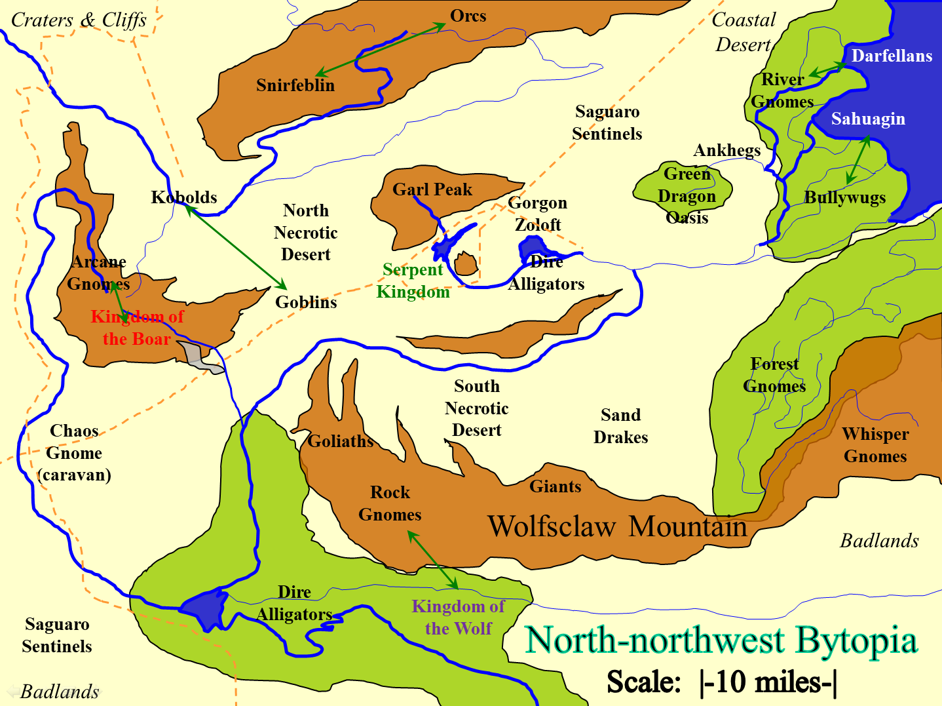

Kali said, “Let us continue to advance on the city and see if more come out to challenge us.”

Faith responds, “It might be dangerous: That small expedition from them was a difficult fight and two of us died. I do not believe that we have the strength to face the whole city.”

“We have no allegiance to the wererats,” a chaotic neutral person says, looking at the map. “We can scale Garl Peak, and see what’s on the other side, or we could circumvent it, strolling along the foothills here, and staying far from the Serpent Kingdom’s settlements.”

“I am not anxious to leave them to their fate, also the wereserpents are under the thumb of this yuan-ti. Perhaps we can try finding and talking to some of the wereserpents,” Faith ponders.

“I say we follow the peak and leave them serpents alone,” says Jason

~*~

They have been traveling southeast for a short time, and the incline of the mountain is now such that they must climb—not simply hike—upwards. Behind them, the slope averages a tough but manageable 20 degrees, whereas before them, the incline now approximates something closer to 45 at best, and 75 at some points.

The vegetation here consists of pines and other conifers, as well as temperate ferns. The droppings of several reptiles have been spotted, but none are large enough to cause much alarm.

Faith, fully armored, is not much of a climber, and proposes a new plan of action. “We’ve not spotted a single wereserpent, yuan-ti, or other agent of the Serpent Kingdom. Perhaps it is time to head back towards the flatland.

Then the ground begins to rumble, and before they can draw their weapons, an ankheg emerges from the ground.

Jason takes up his sacred bow and fires as the creature.

|  |  |  |  |  |  |  |  |  |  |  |
| --- | --- | --- | --- | --- | --- | --- | --- | --- | --- | --- |
| **Ranged Weapon** | **Dmg.** | **D+** | **TH+** | **Critical** | **Rng.** | **Wt.** | **Atk** | **Roll** | **Check** | **Notes** |
| Sacred Composite Longbow, Strength +1 | 1d8 | +1 | 1 | x3 | 200’ | 3.0 | +13 | 12 | 25 | +1 within 30’ |
| 2nd Shot | 1d8 | +1 | 1 |  |  |  | +8 | 18 | 26 | +1 within 30’ |
| 3rd Shot, Rapid Firing | 1d8 | +1 | 1 |  |  |  | +13 | *1* | 14 | +1 within 30’ |
| Crystal of Cold Assault, Greater | - | 1d6 |  |  |  |  |  |  |  | -1 to AC 1 round |

*Hit, hit, miss. Dmg: (3 + 1 + 2 cold + 1) + (8 + 1 + 4 cold + 1) = 7 + 14 = 21 + (-1) to AC.*

Moving forward, Kali attacks the creature with her swords.

|  |  |  |  |  |  |  |  |  |  |
| --- | --- | --- | --- | --- | --- | --- | --- | --- | --- |
| **Melee Weapon** | **Dmg** | **D+** | **TH+** | **Critical** | **Type** | **Wt.** | **Atk** | **Roll** | **Check** |
| Scimitar +2 | 1d6 | 2 | 2 | 18-20, x2 | Slashing | 4.0 | +14 | 9 | 23 |
| 2nd Attack | 1d6 | 2 | 2 | 18-20, x2 | Slashing | - | +9 | 16 | 25 |
| Crystal of Electrical Assault, Greater | - | **1d6** | - | - | - | 0.0 |  |  |  |

*Hit, hit. Dmg: (2 + 2 + 1 electric) + (6 + 2 + 4 electric) = 12 + 5 electric = 17.*

The archer pierces the creature’s cephalothorax, then the dancing swordswoman finishes it off with a *dors-à-dors filet* swipe.

The giant insect lies in segments on the floor, writhing as it seeps fluid onto the leafy floor.

It is then that the party—now comprised of Caleb, Faith, Jason, Kali, and Rea—spot a gnomish woman in the distance. She’s probably 200’ away, and has just come over a ridge that leads downward and southwestward.

“Hello!” Jason called out, waving his hand to get the gnome’s attention.

Kali wipes the goo from her blades as she eyes the newcomer.

Kali returns her swords. She moves forward to meet the new person. “Are you friend or foe? Speak now or Jason here will pepper you with arrows.” She stands with hands on hips as she waits for a reply.

The female gnome, still at a reasonable distance returns the wave. She wears practical traveling garb, although her chest is peculiarly round, likely from a breastplate under her vest. A crossbow is slung across her back and a small silvery shield hangs at her side. As is not uncommon for certain adventuring gnomes, a pair of goggles are perched on her forehead, their purpose uncertain.

She points to each of the greeting party in turn, while speaking too softly to be heard, at least at first. Her soft voice seems to be carried upon the wind up toward them via the magic of *message*.

“Too early to tell if we’re to be friends, I think. Thankfully, I’m not an ankheg, because that ship has sailed, yes? I’m Magpie, a Seeker. I wish your band of heavily armed and potentially murderous mercenaries no ill, if that is in any way reassuring.”

“I wouldn’t say murderous,” replies Kali, “More like lucky fools. Mind you, we do get in a couple of hits, which have managed to save us. Why, earlier today *this* hot head.” She gives Jason a shove, “Got himself blinded and couldn’t even help us out.”

Jason gives Kali a hurt look. “Never mind her, little missy. We are friendly. Only *she* bites.” Jason walked up to the gnome and patted her on the back. “Come join us. I think we were just about to build a fire and make our plans as to where to go.”