Chapter 5: Origin Stories

T
he party has traveled the entire day, encountering only a few menial threats—a viper, an adder, a cobra, a sidewinder—and although they’d gotten lost and circled about for part of the afternoon, they’ve cleared quite a bit of ground.

Jason has scouted the immediate area—a summit that stands barely above the treetops that grow in the valley around it—and everyone with a tent has pitched theirs.

The heroes sit, orbiting around a well-contained fire, telling tales of their origins.

The band of heroes—some mutually familiar, others a reputational blank slate in the eyes of others—comes to a collective understanding of who each member is. The diviner-cleric, the paladin-templar, the scout, the fighter-dancer, the beguiler, and the warlock listen to everyone’s story as the fire crackles and the vege-rations and rabbit limbs are passed from hero to hero.

Magpie munches on a big pile of trail mix she pulled from the battered pouch at her side, the same pouch that she just recently pulled the entire campfire they are sitting around from. It’s a handy pouch. “Mr. Jason, you sound like the scoutiest scout who ever did scout. I bet you’re the bestest scout.”

Jason smiles really big. “I like to think so, sugar,” the man sits right beside Magpie with the other newcomer on the opposite side. Kali and Faith sit across the fire from them. “How about you?”

“Me?” she crunches on a cashew, “My story isn’t that fancy. I mean, basically, I never decided what I wanted to be when I grew up. My folks wanted me to become a wizard, but I couldn’t get the hang of being all blasty boomy, so I sort of skipped out on my apprenticeship and ran off to the big city. There I realized that you need money to live in a city, so I fell in with a thieves’ guild.”

“So now I will have to watch my belongings as well as your asses,” Kali says as she eats some trail rations.

“Don’t worry, scary murder lady. These days I only steal from people who are needlessly rude.” Magpie continues to flash her toothy smile as she shares her trail mix.

Some of them shift in their stony seats.

The gnome scratches the back of her neck, “That was pretty fun. There’s a certain honor in a good burglary. Sneaking into some noble’s house, stealing things they won’t need and using them to buy things you do need. It actually helps out a lot of people because the thief then spends their ill-gotten gains, which helps small merchants and farmers. I mean, helps them more than just some stupid candlestick on a mantle.” She shrugs, “But, the guild as a whole didn’t really see things the way I did. They’d steal from anyone, even people who were struggling. They’d hurt people and make a mess of things. I wanted a way out, but they were pretty serious people, so running away would just cause them to track me down, and who wants that?”

“One day I was burgling this mage’s tower, all alone. The rest of the guild was scared of magic, you see. I could find and disarm the traps, magic and otherwise, because I’m really good at that stuff.” She beams a toothy smile, “Anyway, I found this portal in there. I didn’t know where it went, but there was all this cool exploration gear next to the portal. Who am I to argue with a divine sign like that? I grabbed the gear, jumped through the portal, and have been exploring ever since. For the most part, I don’t try to cause any fuss, but I’ve developed this really bad dislike of slavers, so I’ll go out of my way to ruin their day when I have an opportunity.”

She offers up some of her trail mix, “Anybody want some? It’s really good. It has these little dried berries in it.”

Jason laughs as he takes a bit of the trail mix.

Faith has been fairly reticent today, as has Caleb, but both speak words of gratitude when offered the berries, eating a handful with comfort.

“If i must,” Kali said. “I will go next.”

“It is only by chance that I am here. If it were not for that gate crashing gnome I would be back in my home land. You see I was the daughter of a gypsy prince. Mind you thou we were not in direct line to lead the people and that would only come about if my uncle died. I was not one of those typical gypsy daughters who would stay around the hearth and do women’s work. I need more adventure and did as the men did. I trained hard in between my parents trying to keep me as they thought I belonged and my uncle who pushed me to be better.”

“I trained ‘til I could best any man that challenged me and soon became a leader among my people. I led hunting parties, scouting parties, and raiding parties. As it would happen, I was leading a raiding party on a goblin community when I was rudely shoved into a different dimension.”

~*~

The origin stories eventually lead to tales of dragons and necromancers, which later lead to vivid dreams of dragons and necromancers. By dawn, the midnight crew seems to have disappeared, never having returned from a perimeter check. Faith and Caleb have left no tracks that Jason can find, and the scout scratches his head as to how they could have disappeared without alerting them. By morning, though a bit preoccupied with the well-being of the paladin and the cleric-diviner, everyone present is well rested, satisfactorily fed, suited up, and ready to continue their trek uphill.

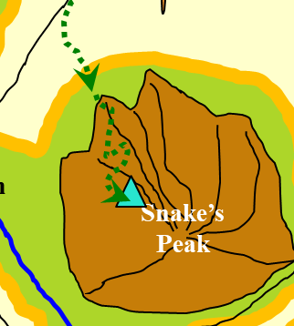

They take their time on the steeper inclines, then stop altogether about an hour after they started the hike. The trail is at an end, and from here on out, a climb will be the only way up, other than flight or teleportation.

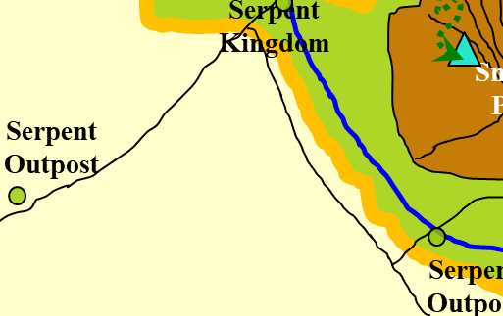

The party looks westward, southwestward, and southward, beholding the wondrous landscape before them. Directly westward, they can see the core of the Serpent Kingdom, its modestly sized keep jutting only slightly above the undulating tendrils of houses and fortifications that radiate from the keep and surrounding infrastructure.

To the southwest is a vast desert, and perhaps there is another, smaller settlement out in the distant haze. To the south, the river widens and feeds a forest of conifers and other tall, looming trees.

Then, riding atop ankhegs, there appear over the ridge to the south—which cannot be reached by foot from the PCs’ positions—three barbaric goliaths bearing almost identical insignia in the form of three feathers dangling from their axes and hammers. The violet, orange, and green plumage is doubly evident in the much larger goliath who rides a bullette and wears wooden armor.

Jason, Kali, Magpie, and Rea stand at the precipice of their path, overlooking a 100’ cliff beyond which they now behold their potential hosts or rivals.

<< Hooold! >> the leader at the rear speaks in Terran, and all of the ankhegs stop. His bullette continues a few more steps to catch up with his posse, and then also halts before the horizontal ground on their path ends. The leader then turns to the heroes and in Common, asks, “What purpose do you serve here?”

“Purpose,” Kali speaks, “That remains to be seen. We were attacked be a demon and crash-landed in this land. The demon took our guide, another two of us just up and left. We have been attacked by the Serpent Kingdom’s men for no apparent reason. I have no idea what purpose or trick the gods play on us.”

Jason follows with, “We could use some friends about now. But I should say, we mean no harm.”

The leader of the band of goliaths tilts his head from the left to the right as he takes a measure of the heroes. He then nods, replying, “You seem like good people.” He then inhales, studying each of the heroes individually, then squints and maybe grimaces as he gauges Rea’s measure as a person. “Yet, our code strictly forbids that I offer you my unquestioning friendship. You have our leave to remain here today, but another scouting group will be by tomorrow with news of you, and their orders will leave less room for interpretation.”

Kali wonders if it was something she said.

Jason wonders if it was what Kali said, looking at her, then pursing his lips.

But it is most likely not what was said, but perhaps what remains unsaid that was still somehow divined by the goliath barbarian. The tattooed and pierced leader frowns upon Rea, and urges his bullette mount to turn around. The ankheg mounts also turn and follow close behind, one even scaling the angled cliffside with its rider confidently straddled atop it.

One ankheg leaves a dropping as it disappears from view around the craggy bend.

The party—Jason, Kali, Magpie, and Rea—decides it’s time for a brief rest while everyone drinks a bit of water and perhaps relieves themselves of fluids. They eventually make their way back down the linear trail until they get to a T-intersection that leads southeastward towards a slightly more vegetated part of the slope.

As they make their way along this trail, they eventually hear the hooves of Brant, Faith’s mount. Seeing her atop it in a clearing amidst an outcropping of rocks where trees could not grow. She and Caleb—who is on foot as usual—are making their way up the same trail that the others are descending.

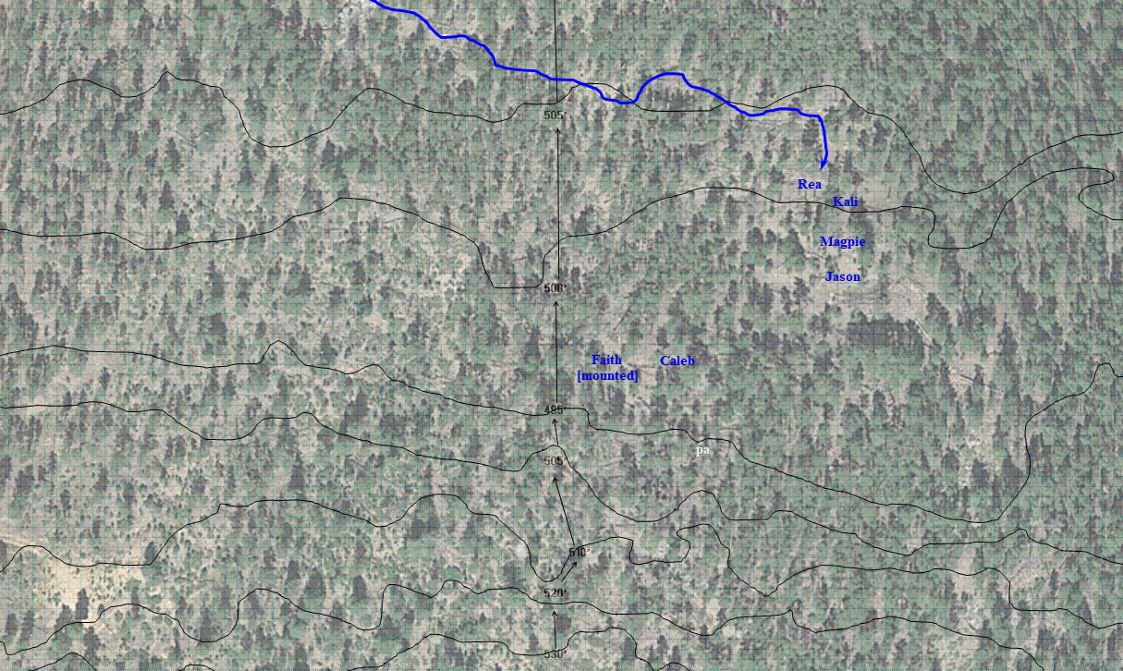

“What happened to you?” Magpie asks in a friendly way.

As the horse and human continue to make their way up, Caleb answers, “We eloped.”

The group is taken aback. “You and Faith? Faith?” Kali is truly surprised—and convinced—by the diviner’s bluff. “I thought she’d made a vow of celibacy.”

Caleb answers as he fidgets through his pouch of spell components, “Yes, well, you see, that’s where...”

“Enough talk!” the mounted paladin says as she rides upward and drew her greatsword.

Round 0

Rea invokes her signature warlock ability.
Ranged Weapon | Atk | Roll | Check
Ranged Touch Attack | 7 | 13 | 20
Hit. Dmg: 14 magic [83/97].

From behind her, Kali feels the zap of the warlock’s eldritch blast tag her [flat-footed] in the back.

“Oh, alright,” Caleb’s element of surprise is compromised by his supposed bride as she holds her blade high and targets Jason.

Trying to exclude Rea in his blast, Caleb casts fireball on Magpie, who is just between Jason and Kali.
Save vs.  fireball | Rank | Ability & Mod. | Misc. Mods. | Total | Roll | Check
Jason, Reflex | 7 | Dex (+5) | 1 | 13 | 10 | 23
Kali, Reflex | 6 | Dex (+3) | 1 | 10 | 20 | 30
Magpie, Reflex | 5 | Dex (+1) | 0 | 6 | 16 | 22
Success, success, success. Kali and Magpie save for ½ damage; Jason saves for no damage.
Dmg to Kali: ½ x 28 = 14 fire [69/97].
Dmg to Magpie: ½ x 41 = 20 fire [55/75].

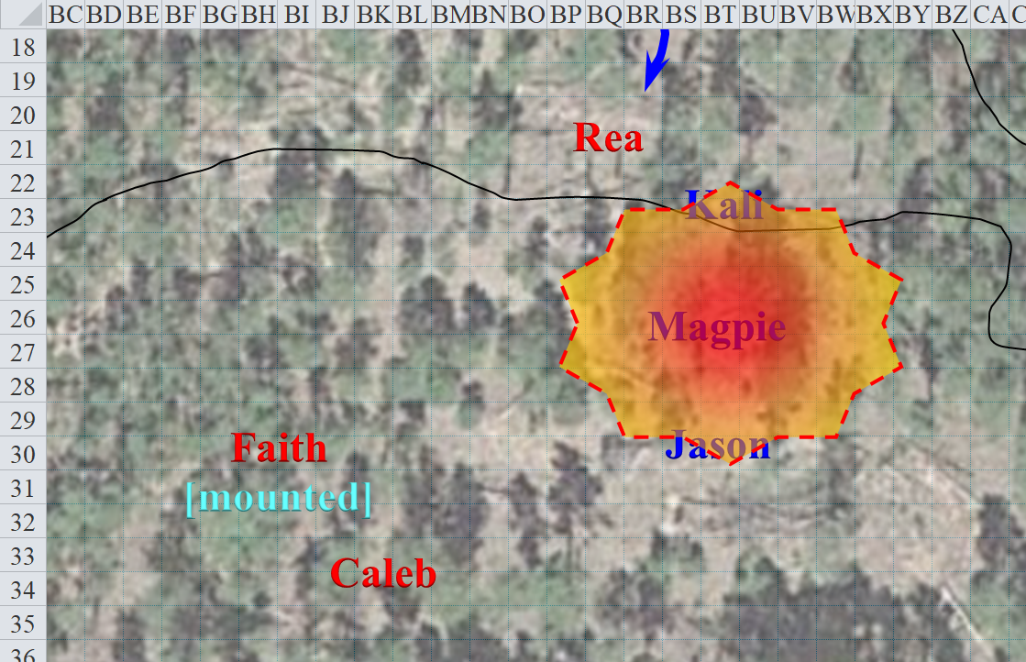

Round 1

Kali draws her weapon, and moves into position to attack Caleb on the next round.

Jason backpedals 30’ and fires an arrow at the backstabbing Rea.
Ranged Weapon | Dmg. | D+ | TH+ | Critical | Rng. | Wt. | Atk | Roll | Check | Notes
Sacred Composite Longbow, Strength +1, Skirmish | 1d8 | 3d6+1 | 1 | x3 | 200’ | 3.0 | +13 | 6 | 19 | +1 within 30’
Crystal of Cold Assault, Greater | - | 1d6 |  |  |  |  |  |  |  | -1 to AC 1 round
Hit. Dmg: 4 + 1 + 1 + 16 + 1 cold = 23 + (-1) to AC.

Faith sees Jason retreating. In a jousting maneuver, the paladin-templar mounted-charge-power-attacks Magpie as Brant gallops past her.
Melee Weapon | Dmg | D+ | TH+ | Critical | Type | Wt. | Atk | Roll | Check
Adamantine Illuminated Holy Greatsword +1 | 2d6+2+2 | +10+1+6 | 1 + 2 + 2 – 3 | 17-20/x2 | Slashing | 16.0 | +19 | 7 | 26
Hit. Dmg: 10 + 2 + 10 + 1 + 6 + 2 = 31 [24/75].

The mount does his best to remain stable along the rough terrain, but falters momentarily as Faith urges him downward and southward along the ridge of the mountain.
Skill | Rank | Ability & Mod. | Misc. Mods. | Total | Roll | Check | Notes
Faith: Ride | 2 | Dex (+1) | 0 | 3 | 4 | 7 | +2 to stay on saddle (Military Saddle)
Fail.

Protected from evil and aided by a recently cast bull’s strength spell, Faith falls off of her saddle.
Save vs.  falling | Rank | Ability & Mod. | Misc. Mods. | Total | Roll | Check
Faith: Reflex | 2 | Dex (+1) | 5 | 8 | 9 | 17
Success. Avoids taking falling damage.

Unable to tumble back onto her feet, the paladin is flat-footed and on both knees as she begins to get up.

Brant stops and turns around, waiting for Faith’s command to approach or retreat.

Rea once again targets Kali with her eldritch blast.
Ranged Weapon | Atk | Roll | Check
Ranged Touch Attack | 7 | 18 | 25
Hit. Dmg: 20 magic [49/97].

<< Byar-nari schlurp tari-nokh, Qyleb! >> the warlock woman then urges in Abyssal, which Magpie barely understands [though she has to commit on her remaining language choices].

Between castings, Caleb has a moment to speak in Common to Jason, Magpie, and Kali, simply blurting, “Suck me off!” The cleric-diviner then casts lesser orb of acid upon Jason.
Ranged Weapon | Atk | Roll | Check
Ranged Touch Spells | 8 | 4 | 12
Miss.

Magpie meeps, and defensively casts improved invisibility, then moves 20’ towards Caleb, regardless of the spell’s success.

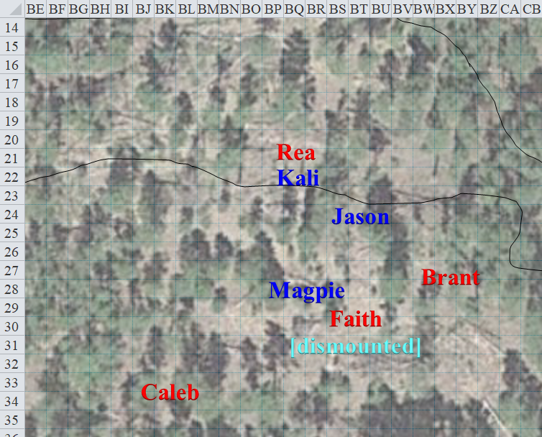

Round 2

Jason rapid fires upon Rea again before Kali reaches her with her whirling blade.
Ranged Weapon | Dmg. | D+ | TH+ | Critical | Rng. | Wt. | Atk | Roll | Check | Notes
Sacred Composite Longbow, Strength +1 | 1d8 | +1 | 1 | x3 | 200’ | 3.0 | +13 | 9 | 22 | +1 within 30’
2nd Shot | 1d8 | +1 | 1 |  |  |  | +8 | 9 | 17 | +1 within 30’
3rd Shot, Rapid Firing | 1d8 | +1 | 1 |  |  |  | +13 | 9 | 22 | +1 within 30’
Crystal of Cold Assault, Greater | - | 1d6 |  |  |  |  |  |  |  | -1 to AC 1 round
Hit, hit, hit. Dmg: (5 + 1 + 1 + 4 cold) + (4 + 1 + 1 + 5 cold) + (4 + 1 + 1 + 3 cold) = 19 +12 cold = 31 + (-1) AC.
Melee Weapon | Dmg | D+ | TH+ | Critical | Type | Wt. | Atk | Roll | Check
Scimitar +2 | 1d6 | 2 | 2 | 18-20, x2 | Slashing | 4.0 | +14 | 17 | 31
2nd Attack | 1d6 | 2 | 2 | 18-20, x2 | Slashing | - | +9 | 14 | 23
Crystal of Electrical Assault, Greater | - | 1d6 | - | - | - | 0.0
Hit, hit. Dmg: (3 + 2 + 6 electric) + (3 + 2 + 3 electric) = 10 + 9 electric = 19.

Rea dies miserably, leaving the spellcaster and paladin to deal with.

Faith remains on foot, and commands her mount to head downhill.

The mount does as commanded, and the paladin power-attacks Magpie, casting rhino’s rush as she charges.
Melee Weapon | Dmg | D+ | TH+ | Critical | Type | Wt. | Atk | Roll | Check
Adamantine Illuminated Holy Greatsword +1 | 2d6+2 | +6 + 1 | 1 – 5 | 17-20/x2 | Slashing | 16.0 | +11 | 1 | 12
Miss.

Caleb shouts a sneer as the paladin misses the gnome and momentarily lodges her blade in the sloped ground. Then, he moves about 30’ eastward and casts haste on himself, Faith, and Brant.

Caleb, Faith, and Brant are now hastened.

Now invisible, Magpie casts feeblemind on Caleb.
Save vs.  feeblemind | Rank | Ability & Mod. | Misc. Mods. | Total | Roll | Check
Caleb, Will | 10 | Wis (+4) | 2 – 4 (wizard) | 16 | 4 | 16
Fail. Caleb’s Int and Cha are reduced to 1.

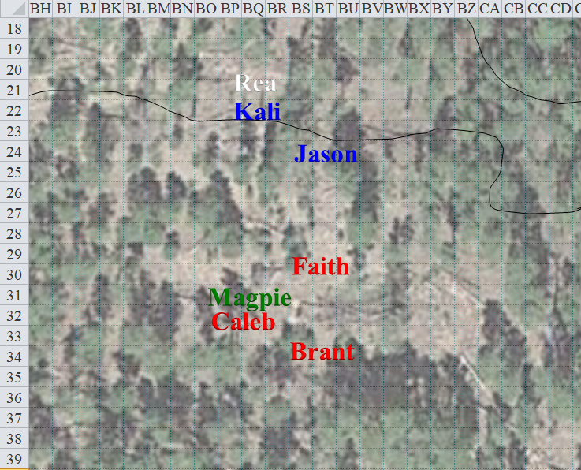

Round 3

Magpie then casts break enchantment on Faith.
Character | Check [Spell] | Ranks | Mods | Roll | Save
Magpie | Break Enchantment | 10 | 1 | 17 | 27
Success.

Caleb [hastened] looks around like a simian child, confused perhaps. Then, he sighs and turns around, looking downhill at the vast, sprawling landscape before them.

Faith [hastened, no longer enchanted] looks around—immediately identifies her friends as such—and puts down her sword and asks, “What on this plane just happened?”

Still invisible, Magpie calls out, “You and your two friends just tried to murder us, you giant, horse riding galoot! Since the break enchantment spell worked, you were probably under some form of outside control. I might have broken your wizard. He can be fixed, but he’s still under control, so he might try to bite you or something if you get close.”

Caleb swipes at a fly with his tongue.

Magpie continues, “We could maybe try to study him to get a better idea of what happened, but I’m not doing it until he’s tied up. Too much of my red stuff that’s supposed to be inside is outside after someone whacked me with their giant, stupid sword!”

Faith looks at her bloodied blade, then back at the gnome beguiler, sheepish and blushing.

Jason and Kali lower their weapons.

“Magpie, I am glad you joined us. It seems you have some powerful spells.” Jason gives the girl one of his charming smiles.

“So you have no idea what happened or who you met,” Kali asks Faith.

Faith squints and frowns, trying to recollect what happened. “Wait,” she pauses, then looks upon the body of the dead warlock. “It was her.” The paladin abstains from calling Rea names, biting her tongue.

Caleb burps, giggling as Magpie produces 50’ of hempen rope from her haversack and they start to tie up the diviner-cleric.

“By the gods! I do remember now,” the paladin says. “She lured us last night into some ambush, though it was not your typical ambush. Outside of earshot from the camp, she presented us to some dark force... incorporeal... lurid... and too powerful for us to resist. Caleb’s mental faculties were quickly usurped, whereas I withstood several psionic attacks until I, too, succumbed and found myself trapped in a dark, silent place... until... now.”

The paladin held back a tear and proclaimed, “I have acted dishonorably, and must pray for forgiveness.” And with this, she mounted atop Brant, and made her way down the hill about 100’ to a flat, level place and whispered offerings of regret to the deities.

~*~

A half-hour has passed, and while the paladin prayed, the others ate. Now, having had their fill of food and drink, and satiated other bodily requisites, the heroes are fit for the rest of the day’s trek.

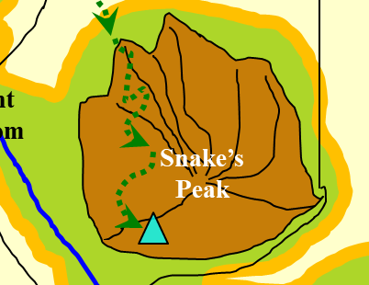

“So, where to?” asks the inquisitive gnome.

Faith looks down at her companion, then back up at the panorama from the west to the south. “To the west is the Serpent Kingdom, and to the south is the Wolf’s domain.”

Jason adds, “We could go southwest and hope to skirt along their hinterland.”

Pursing his lips, Caleb questions the validity of that argument, “I doubt that apparent hinterland actually is a hinterland... probably more like a heavily patrolled border that we cannot see within the trees.”

Kali agrees, “From what the wererats told us about these snake and werewolf people, they’re likely to keep vigilance over this lush territory.”

“The yuan-ti were far out in the juniper to warrant your suspicions,” Faith posits. “With me along, we’ll make quite a bit of noise as we make our way along.”

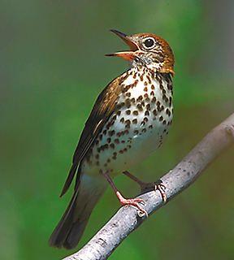

They then hear a melody, a song unknown to them, being chirped by a sole thrush, and delight in its careful progression. They talk for a few more minutes about where to head from here. “Maybe we should just make camp here,” one of them even suggests.

“I forget who is who and who is on whose side,” Jason scratches his head. “Maybe the werewolves would consider us allies.”

“Whoever said this was a great place to retrieve kissed their mark,” Kali remarks.

Faith recounts, “As far as we know, there are no sides, no treaties among these kingdoms, and no armistice among their monarchs.”

Caleb disagrees, “Wait, didn’t the Earl of Gorgon Zoloft tell us that the Wolf and Pig/Boar Kingdoms had struck an alliance in light of the Serpent Kingdom’s encroachment?”

“They didn’t use the word alliance,” Jason remembers. “It was more like the Serpent Kingdom was simultaneously at war with both the Wolf and the Pig.”

Pulling out her Wand of Lesser Vigor, Magpie begins the arduous task of trying to repair her wounds, tapping the tip just below the wound while trying to simultaneously convince the wand that she is a nature-loving druid. “It occurs to me that I have no idea what you adventurers are trying to do. Me, I’m just exploring, but I’d imagine you have some manner of goal in mind to justify these near-death experiences.”
Magpie: Skill | Rank | Ability & Mod. | Misc. Mods. | Total | Roll | Check
Use Magic Device | 12 | Cha (+0) | 0 | 12 | 10 | 22
Use Magic Device | 12 | Cha (+0) | 0 | 12 | 16 | 28
Use Magic Device | 12 | Cha (+0) | 0 | 12 | 13 | 25
Use Magic Device | 12 | Cha (+0) | 0 | 12 | 11 | 23
Success⁴. Magpie heals 11 + 11 + 11 + 11 = 44 hps [73/75].

The gnome then offers to heal the others, but Faith has already tended to that with her own renewable powers.

With birds chirping in the branches and copses of the conifers around them, and fuzzy-tailed rodents scurrying along their well-known turfs, the party’s scout tries to address Magpie’s statement. “So a while back, I was a prisoner with some other folks: an elven cleric and a whisper gnome evoker-warmage-ultimate magus. Faith was there too, and a few others that came and went. We were prisoners in a gladiatorial gauntlet for the amusement of beholders, mind flayers, and other powerful beings, but eventually, we—and others—began to get so powerful that the entire pocket plane was overrun by rioting monsters and people like us. Faith led a campaign to liberate those who’d been left behind when the pocket plane burst into the Astral in several places, and eventually, the whole thing collapsed into itself—we think—and we ended up plane shifting with this gatecrasher named Dextir. We’ve been here in Bytopia for about a day and a half, and we’re really just hoping to find a way to continue traveling the planes.”

“Where do you want to go?” Magpie asks.

After thinking about it, Jason says, “It’s easier to tell you where I don’t want to go: anything with elemental fire, or acid, or any other toxic conditions, any place in or near the Lower Planes, and I’d prefer to avoid the Plane of Shadows, if possible.”

“So you’re just surfing the multiverse... for fun?” Magpie considers this for the first time. “I love it!”

Faith corrects the interpretation, “We definitely have a purpose. So far, it has revolved around the liberation of the innocent, but any noble cause is a worthy expenditure of our efforts.”

Magpie diplomatically opts not to point out that doing good deeds while aimlessly wandering is only really a purpose to a paladin. A big, mean paladin who’d chopped her with a sword. Nope, not letting that go anytime soon. “Liberation of the innocent seems pretty decent as an action plan. ‘Noble cause’ seems just a tad... ummm, vague, but I like that you’re leaving things open for interpretation.” Stowing her wand, she taps her lips and looks about. “Let’s see... I’ve been wandering Bytopia for a little while now, avoiding trouble until I ran into your lot. Probably your best bet for getting back to Sigil is...”

“I suggest,” says Faith, “That we go make our case to the wolf kingdom and get them allied to the boars.”

“I see, we offer then our help,” Jason replies. “Sounds good, but you might have to do the talking. Kali flubbed up are last friendly encounter.

Kali hugs and puts her hands on her shapely hips. “How can you blame me? You did no better.”

“Come on! I was under a hex. I could not help it.” The armor-plated woman looks dejected. “I am sorry. I owe you one.”

“Magpie, you ready too? I want to be away from here before that next patrol arrives,” Jason says.

“Sure, I’m ready. Most of the red stuff is back where it belongs.” Magpie said without any side-eye in Faith’s direction at all. She cocked a thumb back at Caleb, “He should probably ride on the horse with you, big ol’ paladin lady. Otherwise, we’ll need to lead him on a rope and he’ll probably try to wander in weird directions or trip or whatnot. The werewolves might have a talented healer that can fix him.” She shrugged, “If nothing else, maybe we can find a family who’ll take him in and give him a good home: some place with a farm and lots of butterflies for him to chase.”

Faith laughs for the first time today, but says that, no, Caleb is her friend, and they were even negotiating the terms of a romantic endeavor, so she’d miss him. “I’m confident that we can find someone who can liberate him from the spell’s clutches.”

They’ve walked maybe 200’ as they make their way downward a bit, having agreed that they’re not going to climb this mountain for no good reason, though they’re still not sure as to where to head. Then, Magpie hears it better than anyone else, though Jason’s astute ear picks up on it as well: the thrush’s song—the same tune from before—is now being chirped once again overhead. The gnome beguiler looks up first, and then the human scout, followed by Faith and Kali. Caleb sits down on the ground and sneezes, a single bead of snot dripping down into a thin line of clear goo.

The beige thrush perches atop a piñon branch as other birds fly back and forth across the sky between this plane and its less habitable counterpart above them.

“Is it me, or do get the feeling that the thrush is following us?” Jason asks. “If the bird could only speak Common.”

“Silly dunderhead! Birds can’t talk, and it is surely not following us,” replies Kali. “Now, let’s be on our way to make friends with the wolvies.”

The thrush flies down a bit as he lands on the next tree over, now perched perhaps only 20’ above them but also about 30’ to their west. The bird is definitely studying the band of heroes, but if it were a spy for one of these kingdoms, it would surely have fled by now.

The bird then tilts its neck, chirps a few more times, and descends onto the uneven path, not 15’ before them, transmutating into a man.

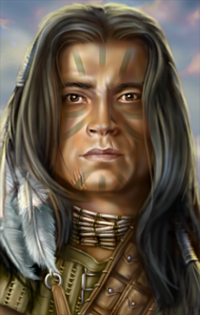

“Ahoy!” he says as his wings become hands and he takes on the size and shape of a druid, barbarian, or ranger; it is not clear at first. With his right hand up, he completes the wave, and in a brand of Common less known to the other heroes, he conveys his peaceful sentiments, introducing himself. “If you are friends, I am Wind in His Hair. I bring you tidings from the trees along your path, who speak well of your deeds.”

“Uh, hello,” a hero says as the others look at one another, wondering if this is some sort of ambush.

Kali stands practically staring at the man. His browned skin makes her warm inside. She imagines herself running her fingers through his hair. Jason looks over, noticing the silly look on her face and promptly steps on her foot when the druid looks away.

“Ouch! What did you...” Kali begins as Jason shushes her.

“I have watched you for some time, as have others in my flock,” the painted-faced half-elf druid says as his ears poke out from his hair, which now rustles as he shakes a few straggling down feathers off from his mane and body.

“So there are more druids around?” Jason asks. “It’s is always nice to be in one’s company, especial out in the woods.”

“No, none I know,” shrugs Wind in His Hair. “Though there are so many birds to share stories with... and other animals and plants...”

Though not supernaturally alluring or beguiling, Kali instantly finds him attractive. Faith, not so much; not enough metal covering him; actually, almost none at all. He recounts a tale similar to Magpie’s, though his affinity to the flora and fauna of this region is comparable to that of Ghefi, the spirit naga that protects the grove to the northwest where the party recently slept.

“No,” he answers Jason’s question. “I am not a keeper of this mountain, or any other grove or forest. I am a druid-errant.”

“So you arrived here by way of...” Faith asks with a truncated statement.

“Others call it spiritual transmigration,” the druid uses a sophisticated term that he learned from the werewolves. “I died and found myself resurrected here.”

Faith knows that resurrection is a metaphor and not a technical term in this case, and remains silent as the druid continues.

“Word came to my flock of your slaying of the yuan-ti, and the two losses your party took that day,” the well-informed master of many forms admits what he knows. “I grew curious of you, and was confused I saw you turn on one another and even slay your warlock.”

They are about to explain to the druid, but he continues, “Until I remained behind, hidden under the canopy of a thick, leafy manzanita bush that rested underneath one of these piñons, and saw the warlock rise as if possessed by undeath, or worse. Casting detect magic, I soon wished I had not.” And the druid describes a horrific sight before him: some dark evil he could not identify whirled around the woman as her severed body parts flew back onto the main corpse and her neck aligned itself with her spine once again.

“It was an evil that was beyond my mere detection... it caused a sensation,” the druid is able to articulate this no further. “A nightmare to behold, and yet I was unable to turn away,” he tries.

The party becomes concerned. Faith, who can usually withstand and shrug off compelling and possessing forces, is particularly worried that she’s already fallen prey to this force, if it is in fact the same entity that caused her to lose herself in a psychological cage. “So there’s a possibility that Rea—or whatever the warlock has become—is behind us, maybe tracking us or simply walking along this linear trail?” she asks.

Wind in His Hair affirms this suspicion, “I spotted her this morning. She is perhaps over that ridge by now.” He points with an extended palm towards a bend in the mountain trail that sits nearly a mile to the northwest.

“So we are being stalked by a zombie?” Jason nonchalantly draws his bow and asks.

Caleb flatulates.

“We’ll be wishing she was a zombie if this nightmare to behold gets into any of our heads again,” Kali worries as well. “Should we get a leash for Caleb?”

“What if we just veer off the trail and wait along some high vantage point?” the scout proposes.

Faith doesn’t think we can fool an entity that powerful by simply veering off the trail. “But I have to admit that we don’t know enough to assume much of anything. If we find a vantage point—like you said—that would also offer us tactical leverage in the event that some evil entity does catch up with us, and if we’re fairly sure that we are being followed, then it makes sense to look for such a place.”

Magpie watches the exchange, and while she has an eccentric demeanor, behind her easy smile and silly phrasing, there is a calculating mind, at time coldly calculating. Perhaps it is good that Caleb is still broken with the entity pursuing them. He’s already been possessed once and while Faith was frankly terrifying one on one, Caleb is a force multiplier and much more dangerous versus a group. As such, she doesn’t ask if the druid can fix him. If Mr. Birdy doesn’t offer, she isn’t going to prompt.

“So... let’s look at this from a worst case scenario. The evil thingy is chasing us. It probably doesn’t need to rest like we do, so it will catch us. I’m just not fast and we’ll need to stop to eat, sleep, answer the call of nature.” She tossed a grin at the druid, “No offense.”

“Now, while my instinct is to just run, because I can do that, it’d be rude to leave you folks alone. If we’re going to face it, we need to put ourselves in an advantageous situation where paladin McStabby can well, get all holy stabby. It’s almost like she’s empowered to smite evil entities or something.” She pointed at Jason with one hand and the druid with her other, “You two are probably our best bet at finding a good place to make a stand.”

“Also, I’ve ticked off a lot of people over the years, but I can’t think of anyone I’d ticked off bad enough to hunt me across planes. If you folks have, that’s good information to help figure out what we’re dealing with.” The gnome goes over the list of nemeses she’s had over the years.

Kali posits, “It might not be that we’re being hunted for revenge, but because we’re a walking store of magic items.”

Some nod as Magpie rubs the back of her neck and admits, “And to be clear, I’m not great versus undead. Most of my magical abilities are enchantment and illusion based and I just don’t have the knack or physical aptitude for fighting. I’ve got some countermeasures for dealing with undead, but a lot of my talents just aren’t effective against them, so don’t expect miracles on this side.”

Jason speaks after Magpie, “You know these woods, Wind in His Hair? Where is a good, defensible place nearby?”

“Defensible?” He tries to understand the context of the word, then points southward, then southeastward, and says, “To get to the werewolves and wereboars, go you must through the Serpent Kingdom’s lands. They are a self-contradictory people who delight in chemical excesses, yet ban sexual promiscuity. They are not to be understood. And the werewolves are just the opposite, copulating with everything in their path but avoiding poisons and spirits of any kind. The wereboars at least have their hedonistic priorities consistent. Food, drink, and flesh upon flesh, are all part and parcel in the Kingdom of the Pig.”

The druid’s ears fidget, and he turns behind him, thinking he’s heard someone a way off, though he sees nothing.

“As for defensible, the places you seek are already taken by the yuan-ti and wereserpents. They’ve left few nooks unexploited. You would not last long in such a place undetected...” the druidic human-elf then puts his hand on his chin and continues, “... but away, let us go and I will take you to the nearest of these spots.

He explains roughly where the location is, just on the other side of a hill that separates this mountain from the expansive basin beyond. With the map out, Jason calculates this to be about half a mile away.

Magpie is less trusting of Wind in His Hair than the others, and thus hangs back about 40’ from the rest of the group on the pretense of being a gnome.

But in fact it is an uneventful trek, which consists of the initial descent, onto flatter ground, then a gradual ascent along the hill, and a final scaling of the ridge beyond which a much more lush forest floor prevails.

They climb down linearly.
Skill | Rank | Ability & Mod. | Misc. Mods. | Total | Roll | Check
Caleb: Climb | 0 | Str (-1) | 0 | -1 | 19 | 18
Faith: Climb | 0 | Str (+3) | -5 | -2 | 9 | 7
Jason: Climb | 0 | Str (+1) | -2 | -1 | 14 | 13
Kali: Climb | 4 | Str (+1) | 0 | 5 | 4 | 9
Magpie: Climb | 0 | Str (-2) | 0 | -2 | 13 | 11
Wind…:Climb | 0 | Str (+0) | -3 | -3 | 20 | 17
See below.

Caleb doessurprisingly well, though he looks rather lizard-like as he hugged the wall, making his way downward. He insisted—somatically and emphatically—by pushing his way past, thinking the challenge to be loads of fun, and now that he’s down, he cheers himself like a toddler, smiling until Faith loses her footing above him and nearly falls on top of him.

The paladin comes crashing down, bruising her shoulder a bit, but not incurring any real damage. The normally graceful Kali also falls right around the time that Jason has reached the bottom, and though Magpie takes her sweet time doing so, she also arrives on horizontal ground, but not without a few close calls and minor slips and catches.

“You guys alright?” she asks as Wind in His Hair confidently jumps once he’s half-way down, landing on his feet.

Rubbing their sore spots, Kali and Faith both nod, though they still grimace a bit.

“How far now?” Jason asks the druid.

“Just up ahead. Patience,” and they continue towards this nearby defensible ground.

Skill | Rank | Ability & Mod. | Misc. Mods. | Total | Roll | Check
Wind in His Hair: Move Silently | 0 | Dex (+3) | -3 | 0 | 2 | 2

A few minutes later, Wind in His Hair stops shortly after stepping on a branch that cracks; he signals for the others to stop also. The human scout—just 10’ behind the druid—stops, as does the full-plate-wearing paladin and the others behind her.

“Jason, my friend who is the greatest scout who ever did scout. This seems tailor made to your talents. Would you be a dear and try to figure out what we might be walking into? I can make you hard to see, or even give you the ability to skitter right up trees.” Magpie made little climbing motions with her adorable tiny gnome hands. “Of course, you need to eat a spider for that, but it’s not a toxic spider... I don’t think. I’m not a spider expert,” she frowns.

“Yes, let’s make me invisible, and I will scout ahead,” says Jason, enthusiastic about the prospect.

With the scout’s agreement, Magpie happily drops an invisibility spell on him, followed by spider climb [both expire in 100 minutes].

Wind in His Hair calmly produces his Darkwood shield, but since he needs his other hand free to cast spells, he does not yet draw his scimitar.

Kali pulls out her swords and turns to watch their rear.

Faith readies her swords in case they are attacked from the front.

Now invisible, Jason thanks the gnome and bids the others to stay their ground, or at least approach very slowly—like 10’ per round slowly.

The stealthy scout turns back to see the druid casting barkskin [expires in 90 minutes] upon himself. Jason—now maybe 200’ from the area in question, judging by the sounds of movement up ahead—blinks his invisible eyelids a few times and smirks, trying out the spider climb spell on a thick log that can sustain his weight for at least the first 20’ before beginning to buckle and creak.
Skill | Rank | Ability & Mod. | Misc. Mods. | Total | Roll | Check
Jason: Move Silently | 12 | Dex (+5) | 0 | 17 | 15 | 32
Result unknown.

The invisible human is pleased with the near silence with which he can scale this trunk, avoiding the branches as much as possible. He climbs back down, then jumps down the rest of the way when he gets about 5’ off the ground. Looking around, he notes that the wind has shifted eastward now, and proceeds a bit further.

Back where the others await, Wind in His Hair casts bear’s endurance [expires in 9 minutes] on Kali, and then says, “You are not as stalwart as the paladin—no offense—but you are likely to be face-to-face with a foe if there is one.”

Kali accepts the enchantment, smiling at the man before blushing.
Kali gains +4 to Con.

All the while, Jason continues creeping southward.
Skill | Rank | Ability & Mod. | Misc. Mods. | Total | Roll | Check
Jason: Move Silently | 12 | Dex (+5) | 0 | 17 | 19 | 36
Jason: Move Silently | 12 | Dex (+5) | 0 | 17 | 15 | 32
Jason: Move Silently | 12 | Dex (+5) | 0 | 17 | 7 | 24
Jason: Move Silently | 12 | Dex (+5) | 0 | 17 | 8 | 25
See below.

He gets 160’ from the sound of at least two human-sized creatures, then 120’, then 80’, then 40’ away from a truly well defensible outcropping of sedimentary rock. Two tower-like convexities jut upward from an already elevated mesa roughly circular and probably 30’ in diameter at its widest.

He stands there for a moment, motionless, then sees a single head pop up from the tower to Jason’s left. It is a wereserpent, already wounded and seemingly emaciated. Jason remains still, hoping the others aren’t following.

A moment later, after the wereserpent lowers its head behind the natural crenellation, Jason sees that a second wereserpent—this one not wounded from the neck up but still harrowed—takes a peek from the outcropping to the right.

The scout thinks like a tactician for a moment. Though this is no castle, and all that is required to breach this plateau is a good climb, which is now effortless for him, there is still the question of the foes: how many are there, for example? Is this a ruse? His mind races with possibilities before he decides to return to the group.

Jason checks his time, not wanting the spells to run out quite yet. He looks around for a tree or rock wall that will give him a view behind the rock defenses.
Skill | Rank | Ability & Mod. | Misc. Mods. | Total | Roll | Check
Jason: Move Silently | 12 | Dex (+5) | 0 | 17 | 14 | 31
Jason: Move Silently | 12 | Dex (+5) | 0 | 17 | 15 | 32
See below.

Climbing up, Jason observes what he can see on the other side, which consists of a roughly circular platform, like a giant pancake resting on a mound 15’ higher than the rest of the forest floor.

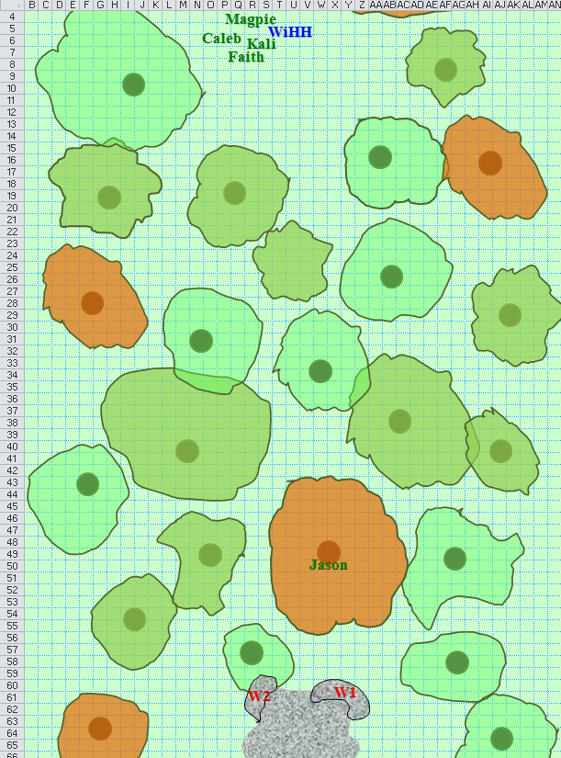

He takes a circumspect survey of his surroundings as far as he can see, then climbs back down silently and returns to report his findings to his fellow heroes. “And that’s all I saw,” he concludes, having described the situation as well as possible.

Wind in His Hair casts call lightning.

“I suggest we all move up as close as possible and I will attack while invisible this should distract them and you can rush in to my rescue. I only saw the two, so be quick just in-case there are more,” Jason says, resolving to attack the guy that is most wounded after breaching the lair.

Magpie clears her throat and holds up a finger, “Just as a quick counterpoint, if one of them is already injured, perhaps we could parley and get valuable information about the area? I mean, they have a defensive position, but they clearly ran afoul of something unpleasant. We could find out what that is, offer assistance, and have both a defensive position, and a bunch of snake dudes fighting on our sides when the zombie possessed warlock appears. Maybe you folks have been with the snake dudes, and if so, fair play. I just like to avoid unnecessary bloodshed when I can.”

Wind in His Hair remains in half-elven form, his shield in one hand. With no other augmentative spells to cast upon himself or anyone else, the druid draws his scimitar of frost, and asks, “How far back does he want us?”

Faith—who knows the archer best—answers, “He usually asks for 40’; give him that unless he motions for us to... oh! Right: he’s invisible.”

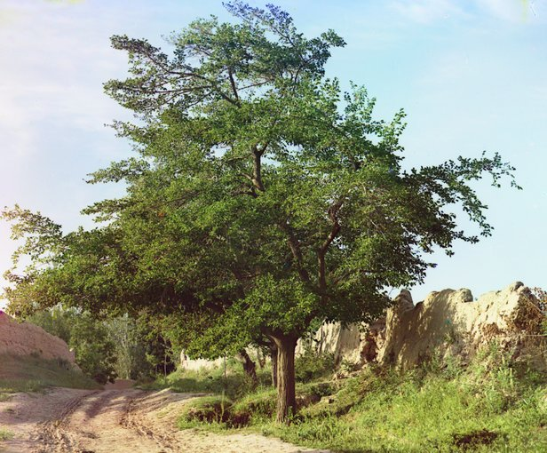

Jason whispers back, “Just don’t go as far as that tree with the mulberries just ready to be picked.”

They spot the tree that Jason previously climbed, and go to coalesce to the tree just before it as Jason sneaks into position.

Skill | Rank | Ability & Mod. | Misc. Mods. | Total | Roll | Check
Move Silently | 12 | Dex (+5) | 0 | 17 | 5 | 22
Move Silently | 12 | Dex (+5) | 0 | 17 | 11 | 28
Move Silently | 12 | Dex (+5) | 0 | 17 | 13 | 30
Move Silently | 12 | Dex (+5) | 0 | 17 | 18 | 35
See below.

It is not difficult to tread lightly upon the leafy forest floor. The real issue is the shrubbery, which impedes direct passage, and forces Jason to take a route that triggers a trap, or rather an alarm that rings only once—sounding like a yuan-ti gong—alerting the wereserpents just as he steps onto the structure that has probably housed them for a few days, by the looks of the animal bones on the ground, and their gear strewn about.

A third wereserpent lies on the ground face up, not unconscious, but delirious, looking at Jason as if the prone fellow is counting his last breaths. The reptilian male—reclining in a mostly mammalian form—is jaundiced, and bleeds from the eyes, nose, and ears.

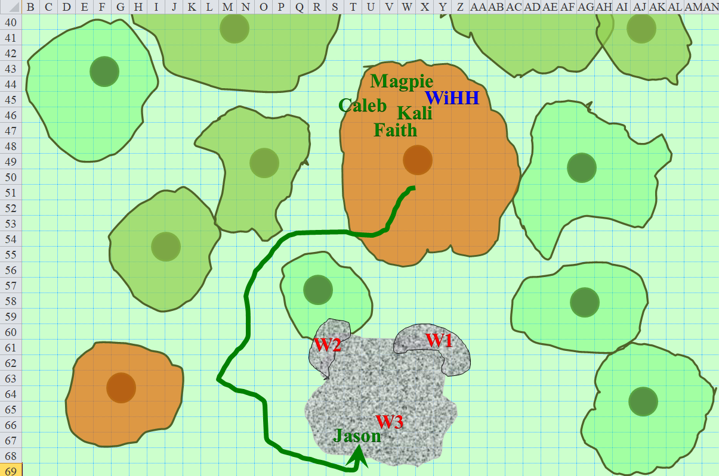

Caleb hangs out by this tree, noting the sap that seeps from the trunk.

Well, no one disagreed with Magpie’s ‘Let’s try diplomacy before murder’ option, so she decides to set it into motion. She knows roughly where the serpent lair is. So, drawing upon her arcane training, she casts a major image, positioning it up in the air over where she believes the serpents can see it. The image is of her, in all her gnomish adventurer glory, waving down in the general direction of the lair as she stands on a branch.

In Gnomish, because there are native gnomes on this plane, she calls down, << Hello, there! Do you need any help? >> Then she repeats the question in Common, and the rest of the languages she knows. If nothing else, if the serpents are hostile, this should get their attention. Should they fire missiles at it, the illusion will attempt to convincingly dodge/take wounds to keep their attention while murder happens.

The two wereserpents, armed with heavy crossbows, turn to see the gnome’s apparition, then put down their weapons with looks of defeat upon their faces.

When the enemies drop their weapons, the still invisible Jason tells them to move over to their hurt comrade. He then calls to the others, “They have surrendered. He will take their weapons. As the other come.”

Kali is the first over the wall and sees the sad disarray of the captives. “What happened here?”

Wind in His hair assumes the guise of a thrush once again, and flies over the natural fortification, perching on the branch of a young aspen.

Faith is next to arrive, simply surveying the situation, but refraining from making her usual paladin-like declamations. She takes a measure of this trio. The one on the ground couldn’t hurt a fly, and is most likely not feigning his condition. The other two wereserpents don’t appear to be capable enough of taking on even one of the heroes, let alone all of them. She sheaths her greatsword and radiates a commanding presence.

Hearing Jason’s call, both Magpie and the illusionary Magpie grin broadly and state, “Diplomacy for the win! Woo hoo!” Then they jump and do a little jig. Realizing her illusion is mimicking her victory dance, she stops and affects a bit more dignity. The illusion sits on its branch, dangling her little legs, feet swaying back and forth. Meanwhile, the caster laboriously starts making her way through the forest in the wake of her speedier, long legged companions, eventually reaching the slope and scaling it with patience.

By the time the gnome is up and among the others, weapons have been lowered, and the tension has gone down to mere wariness. The two moderately healthy wereserpents—Jagmar and Becvar—explain that they have been banished by the Serpent Kingdom, and are now being hunted by sportsmen who would face no charges for murder under the Kingdom’s law, seeing as these three have been branded nonpersons by the state.

Caleb eventually makes it over the mound-like wall, and silently joins the others as the story of how these three young men came to be here. The party is taken aback by the tale, and no one suspects these knaves of deceit, not even Faith, who is a tough one to convince. They have no food, and only about 5 bolts each with which to defend themselves and/or hunt.

“We have been here two tendays and a few nights, and we have chosen this as our final resting place, if fate would have it so,” says Jagmar, the least wounded of the three.

The moribund wereserpent, on the other hand, simply groans and entertains Caleb with contorted facial expressions.

“His name was Fland’r,” says Becvar.

“His name is Fland’r,” Jagmar patiently corrects his brother-in-arms.

Becvar looks down and nods.

Wind in His Hair continues to watch inconspicuously from atop a nearby aspen branch. He thinks to wait until he’s been introduced before turning back into a half-elf.

“Pfft. Mean nasty hunter guys hunting peoples. Bah.” Magpie spat off to the side, which delighted Caleb who decided to do so as well, giggling all the while.

Jason’s voice speaks again, then stops with a curse. “Magpie, please dismiss the spell.”

“Oh, right,” Magpie says as she wiggles her nose.

Moments later, Jason appears. “Anyone have traps we can set up? Also Wind in His Hair, can you scout for us to see if either of the two enemy are headed his way?”

The bird atop the aspen branch leapt off and flew away, chirping.

Reaching into the leather pouch by her side, Magpie brings forth food for the three lizard dudes, happy to share with her malnourished, new friends. “Here you go. Eat up. Do it slow, though. You’ll make yourself sick if you eat too fast after being hungry for a while. I do need to wonder though, why were you banished? I mean, seems like a pretty big dealio for them to drive you out of the entire kingdom. I mean, what’d they catch you doing? Playing with kittens instead of eating them?”

“I don’t know this Dealio,” Jagmar chews and speaks simultaneously. “But we are ingolars.”

“What’s that?” asks Faith, truly not knowing.

“Losers. We failed all attempts to attain manhood during the Golar Rite,” Becvar explains, clearly the brainer but less charismatic of the two. “A string of sparring duels that were once to the death, reducing the young male population by one-half, which increased each bachelor’s take of women. But the Serpent Lord decreed that a fate worse than death should befall the losers.”

“To be cast out?” Jason begins to understand.

“To be cast out, and then to be hunted like the prey that we were once meant to hunt,” Jagmar frames it in his own way, having been groomed by his father for something other than this.

“There is no such thing as ‘meant’,” argues Becvar. “Your fate was sealed by your own hand, not by your father’s expectations.”

Jagmar—obviously irritated—hisses and protrudes his forked tongue as they two stare one another down.

Faith can sense that they are mostly just cranky from being hungry and haggard.

“Depends really on how one defines ‘meant’.” Magpie interjected helpfully. “One could mean meant in a cosmic sense, where one has a certain destiny. Me, I think that’s a bunch of bullhockey. I don’t believe in some cosmic chess match between the gods with us all as pawns, nor do I believe there’s some script that we’re all just playing parts in. That’s just a way to avoid personal responsibility.” She shrugged a bit, but then held up a finger, “However, one could mean ‘meant’ to describe the expectations that society places upon us, be it our parents, our people, our faith. We’re meant to act and perform a certain way, even if we don’t conform to those expectations. So, you’re both right.”

“Not that it matters. You lizard guys are pretty fucked. You need to get out of the area before your people find and kill you. Hmmm... Okay, you aren’t legally lizard people anymore. What if you were property, or at least pretend to be property? Could the hunters just up and off you if you were taken as slaves? To be perfectly clear, I don’t practice or support slavery, but I do like trickery. If we could fool the hunters into thinking we’d taken you as slaves, maybe they wouldn’t get all murdery?” Magpie beamed a happy smile, looking for validation.

“We are neither lizards nor lizardfolk,” the staunch Jagnar protests. “We are wereserpents.”

Within a few more minutes of conversation, it is clear that the three have no intention to ever return to the Serpent Kingdom’s settlements. The third one may not even make it through the night.

After Wind in His Hair flies off, Jason snaps his fingers, “Shoot! I should have asked the druid if he had any heal spells for these guys. Anyone have a healing potion?”

Faith steps over and offers a pray to channel healing for the group. Not only are her friends all healthy now, but the wereserpents all have 12 hps each after all is said and done.

The two crossbow-wielding youths thank the paladin as the third man lies prone no more. Sitting up, he looks up to Faith with gratitude, and pledges, “By all that is powerful over the planes, I shall strive to serve you as a token of my gratitude for my life!”

Faith is taken aback by the pledge, and says, “You are under no obligation to me or to anyone else so long as my sword is near. I do not practice the life of a liberator loosely that I might become like the very tyrants I seek to depose.”

“Well said,” Jason admits.

“Sssssss,” Caleb says and grins.

“What’s wrong with him?” asks Jagnar.

“Feeblemind spell,” Magpie shrugs as she traces a semicircle with her foot on the ground. She could probably call off the magical effect if she tried hard enough, but she won’t just yet.

The two crossbow-bearing youths look at each other. Neither has ever seen such a spell being cast, though it is a common enough staple of arcane compellers that they’ve at least heard of it. They take in the sight of the mouth-breather who is reputed to be an apt diviner-cleric. They then take another look at Faith, who has removed her helmet, and let her golden locks down.

Her intense blue eyes seem to see more than what was before her. Armored in full plate, the paladin bears an animated Darkwood shield that floats near her right arm, emblazoned with the red silhouette of a long-haired woman facing out.

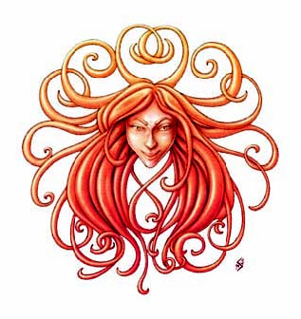

Though she wears a silver holy symbol around her neck with a similar, redhaired crest upon it, the symbol is usually hidden underneath her breastplate. The greatsword once again sheathed on her back is almost as long as she is tall, yet she carries the weight of her armor and gear with ease and poise. By the looks of it, Faith does not hide the fact that she is a Templar of Sune.

The third wereserpent, Fland’r, gets up now and dusts himself off. Though still badly damaged, the wereserpent then bows before Lady Faith Victoria Greystone, Pious Templar of Sune. She merely puts her hands on his shoulders and gives him an additional 15 hps. “I’ll tell you what, Fland’r,” she says as he now looks up and they look one another eye-to-eye. “When we get out of the Serpent Kingdom’s reach, you can buy us all a meal and we’ll call it even. A debt impending is an unnecessary burden.”

Peeking around the wereserpent, Magpie whispers loudly, “Faith! Psst, hey Faith! I don’t think they have any money.” Ever the practical one, the gnome was dubious about the serpent’s ability to front for dinner.

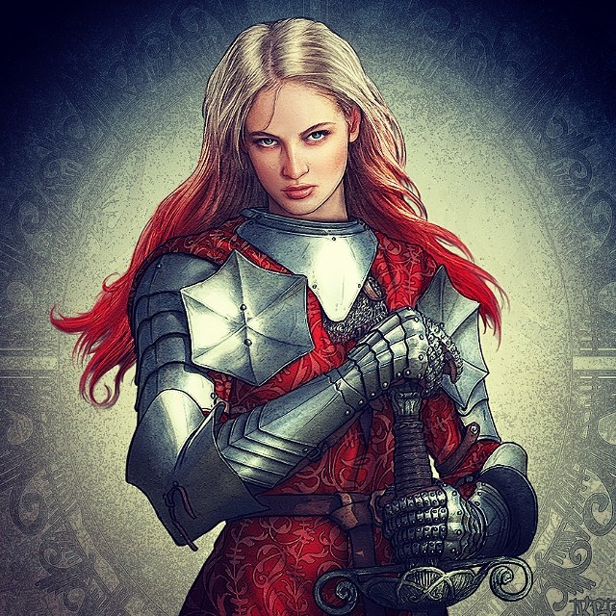

“Oh!” Faith’s eyes shift. “I... meant that as a figure of speech,” she bluffs and convinces everyone but Magpie, who knows that the paladin just had a blond moment.

“Alrighty, snakey guys, who are absolutely going to buy us dinner later, you know this land better than we do, probably. We’re sort of looking to get toward the wolfie folks, largely because I don’t think anyone’s heard or put forth a better option. What do you figure is the best way to get there in terms of safety and speed? If the wolfie area is a no-go for you, where would you want to go?” Magpie clambered up onto a tree branch and started swinging her little legs.

“Let me see that map, scout,” Jagnar asks without using a question mark.

Jason looks at his teammates, then at the wereserpent, fishing for the map in his bag.

“Oh, oh!” She bounced a little on her perch, “It just occurred to me. If you guys bite someone, do they turn into were-snakeys too?”

“Only if you’re mortal,” Becvar answers.

The gnome smiles bigly, “That would be super weird. I mean, all shifters are weird, but going from something with hair to something with scales seems especially fascinating.”

“We do it daily, so it’s not that weird,” Fland’r shrugs, now feeling much better.

“Here,” Jason produces the map, then unfurls it, and shows it to the wereserpents, who point to various areas and tell the heroes what manner of creatures are common there.

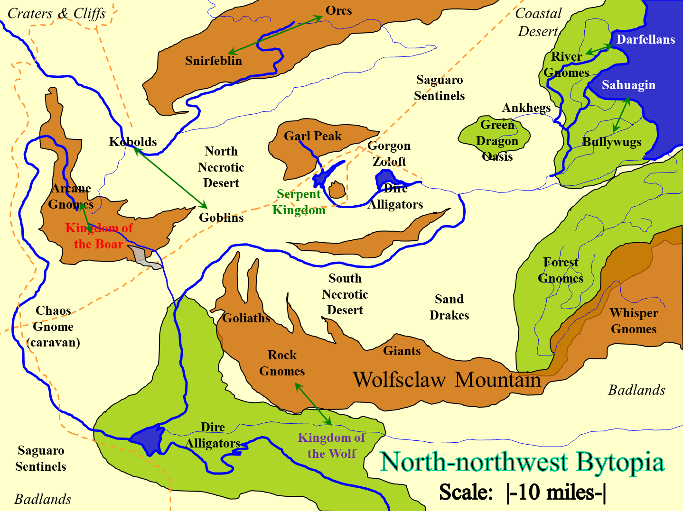

“Is the Serpent Kingdom in war against the green dragon? I am supposing that is what is in the Green Dragon Oasis, and would they be friendly to others?” Jason asked, thinking he might need to ask the druid also.

“The green dragons keep to their desert; the Serpent Kingdom does not venture beyond... here,” Jagnar traces a finger along the empty patch of desert between Gorgon Zoloft and the Green Dragon Oasis.

Faith follows with, “It looks to me that we need to sleep south below the Serpent Kingdom then meet the river just west beyond the mountain and follow it to the wolves. Best to stay away from the goliaths until we can get more information about their friendliness.”

“We should have gone to the gnomes first and then we would not have this serpent problem,” says Kali.

Jason looks for Wind in His Hair, but the thrush is busy scouting up above past the trees that Jason can see.

“Just stay away from the snirfeblin,” Becvar warns. “They’re subterranean, and you’ll run into them below every single mountain on this map.”

“Goliaths are typically pretty chill dudes. Don’t start nothing and there won’t be nothing sorts. But, if they are under stress, they can be pretty tetchy. Probably not a terrible idea of giving them wide berth. Plus, it super hurts my neck talking to them. I mean, it hurts talking to you guys, but goliaths? Pfft.” She waves a hand, indicating just how terrible it would be. Heck, she rubs her own neck in sympathetic pain. Life is hard for the short. Magpie continues, “And avoiding underground sorts is just sound life advice. All that weird magic energy and a high mushroom diet leaves them all sort of wooga-wooga, if you know what I mean.” She crossed her eyes, tongue sticking out the side, to better demonstrate the meaning of wooga-wooga.

“Now, all we need to do is shake the zombie warlock demon that chasing us, avoid getting murdered by were serpents, and cross huge swaths of hostile terrain to get to a place that might not actually be any better. Awesome. I’m on board.”

They talk a bit more, and it is evident to the paladin that although the Serpent Kingdom caters to a dictatorial rule of law, these outcasts’ outlook on life tends to reflect the virtues of chaos, and teeters somewhere between neutrality and good. Faith—the one most sensitive to these things—notes this silently, though some of the others pick up on the nuances as well.

“Alrighty, let’s cut southeast to try to skirt around the outpost. We’ll be passing uncomfortably close, but no way around that. Hopefully our awesome scout can help us avoid patrols. Once we cross the river, we can swoop back toward the southwest, skirt that little mountain range. Then depending on how we feel, we can either cut due south and meet up with the rock gnomes, or follow the river eastward to the coast, fighting big ol’ gators, to get to the werewolves. Me, my vote is rock gnomes. They’re neighbors to the wolves, and I bet they have a way across the range, maybe a pass, that could cut a ton of time off our trip.” Magpie beamed at her fine navigational choices. “Of course, first step is the little dog leg to get the heck out of wereserpent territory before we have to get bloody.”

“Then to the rock gnomes it is,” says Jason. “We had better get going. I would like to reach them by nightfall if possible.”

Everyone looks at the scout with a frown, who couldn’t possibly think they could clear 25 or more miles in one day’s walk.

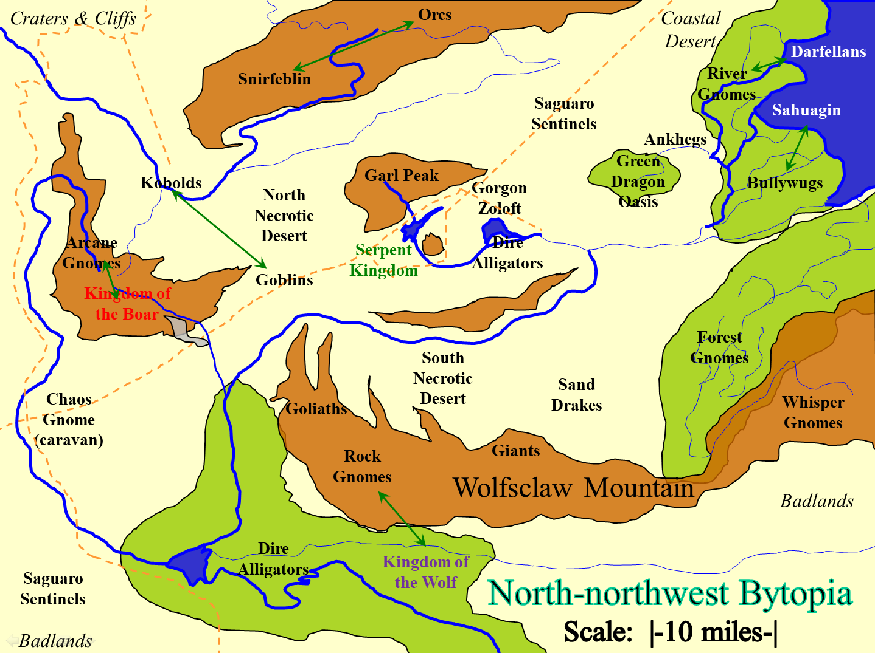

At that moment, Wind in His Hair returns to the group, and becomes once again a half-elf. The others have already warned the wereserpents of their druid friend, and so it does not come as a surprise to the three youths that such a bird should become this man now before them.

He reports that the body of the warlock was disposed of, most likely by a band of aasimar paladins traveling along the mountain from which they just came. “They were heading directly east, most likely across the sands and to the Archon Oasis where such beings are trained and dispatched throughout the planes to avenge and prevent injustices.”

The band notes the information. As the party prepares to venture towards the realms populated mostly by rock gnomes, they study the map once again. The nearest river to them is an eastbound conduit, while they are destined mostly southward and slightly westward, particularly if they are going to circumvent the thin but tall strip of cliffs and plateaus separating them from these gnomish realms. Beyond that is another part of the same river complex, this one flowing westward, and beyond that, the Kingdom of the Wolf

“We bid you farewell then,” Jagnar speaks for the three youths.

The party reciprocates the honorable goodbye, and within a few minutes, the heroes have begun their gnomeward trek and are out of earshot of the wereserpents who chose to make a stand at their makeshift stronghold.

They meander along a path that deviates from their overall south-southwestward trajectory.

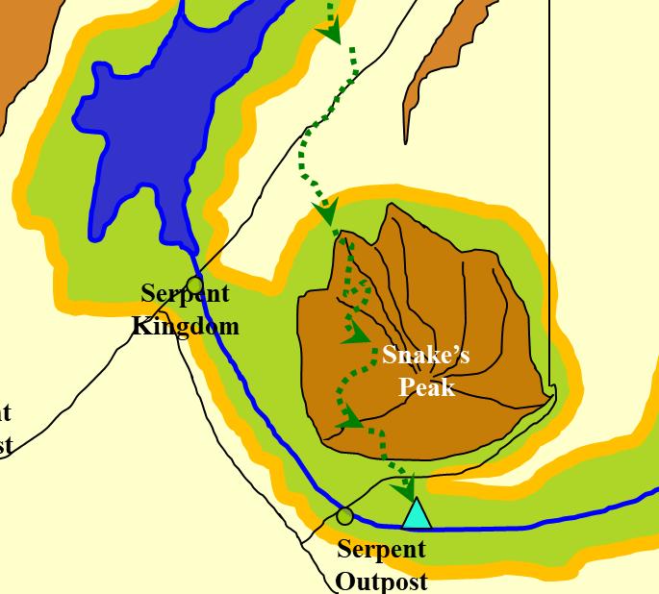

Headed slightly eastward and mostly southward, they eventually reach the eastbound river they’d anticipated. The sounds of the babbling waters as they make their way to lower altitudes lull them to calmness, but Wind in His Hair and Jason can both smell and otherwise sense the presence of predators all around the now lush forest.

“Let’s get there in one day, he says. It’ll be fun, he says. Does anyone thing about the girl with 14 inch legs. Nooo.... Does anyone think about the lady who stabbed me in all her armor? Nooo. Speaking of which, I got nearly cut in half. I know what’ll be a great way to recover, a double paced hike through underbrush for however far two thumbs in on the stupid map.” Magpie mumbles to herself as she trudges along, clearly loving this excursion through nature. Unless something jumps out at her, her intention is to just follow the plan and get to the river as soon as possible. They need to see what they are dealing with before they figures out how to cross it. She can probably just walk along the bottom based on the sounds she is hearing, but maybe there are crazy river monsters? “Hey, Mr. Windy Hair, are there typically horrible river monsters in these parts. Like, I dunno, river trolls or river giants or river dragons or... well, any monster with a river prefix?”

The half-elf looks at the gnome, not knowing whether to be insulted or flattered. He simply nods, then shakes his head, then raises his eyebrows briefly. Eventually, he says, “Yes.”

Skill | Rank | Ability & Mod. | Misc. Mods. | Total | Roll | Check
Jason, Climb | 4 | Str (+1) | 0 | 5 | 3 | 8
Caleb, Climb | 0 | Str (-1) | 0 | -1 | 17 | 16
Faith, Climb | 0 | Str (+3) | -5 | -2 | 14 | 12
Kali, Climb | 0 | Str (+1) | -2 | -1 | 15 | 14
Magpie, Climb | 0 | Str (-2) | 0 | -2 | 9 | 7
WiHH, Climb | 0 | Str (+0) | -3 | -3 | 11 | 8
Partial success for Jason, Magpie, and Wind in His Hair; success for Caleb, Faith, and Wind in His Hair.
Skill | Rank | Ability & Mod. | Misc. Mods. | Total | Roll | Check
Jason, Climb | 4 | Str (+1) | 0 | 5 | 10 | 15
Magpie, Climb | 0 | Str (-2) | 0 | -2 | 20 | 18
WiHH, Climb | 0 | Str (+0) | -3 | -3 | 17 | 14
Success, success, success.

Magpie, being so short, is not able to see the river just past the fallen log up ahead, but as soon as they all climb over it, she beholds the 80’ wide waterway conducing untold gallons of life-bearing liquid past them towards the northeastern coast.

Now atop the log, Jason gets a panoramic view of the area, and sure enough, spots a dire bear about 400’ northeast of them—downwind—already making its way towards the pungent heroes. This, however, is no run-of-the-mill, garden variety dire bear, but a Huge variant species that has been known to take down tyrannosaurs. The massive, multi-ton frame of scaled, spiked, and furred flesh with a nearly 20’ long spine makes its way through the smaller foliage and along the larger trees, now sacrificing grace for speed as it spots its next meal.

“Can you manage to assuage that bear’s hunting instinct?” Jason asks Wind in His Hair.

The druid shakes his head and exhales regretfully through his nostrils. “Nay, brother scout. This fellow will keep coming at us until we kill him... but we must honor our musky cousin by eating his heart afterwards,” declares the half-elf as the sun begins to set over a horizon not visible to them through the treetops.

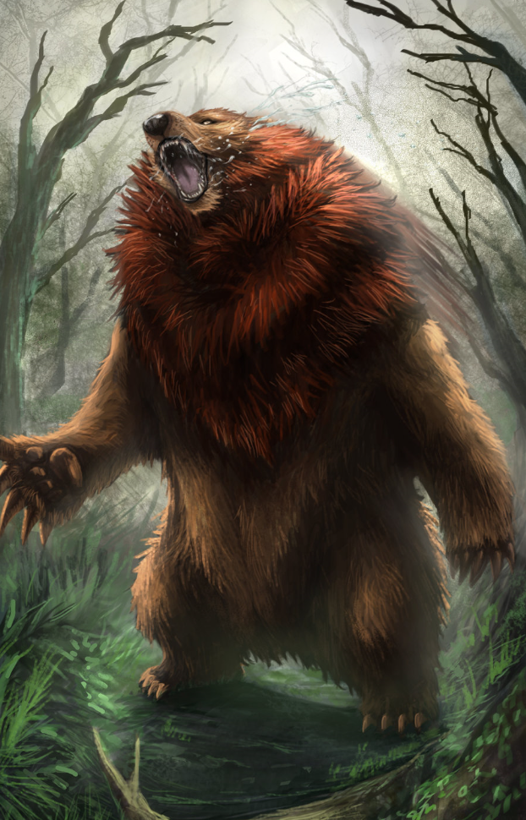

With its head riding 10’ off the ground, the ferocious jaws of the beast open as its lips curl back and the bear snarls with wrathful intentions.

Faith suspects, and says, “If your arrows and spells can bring this beast down before it closes in, I may not have to even swing my blade.” Still, the paladin of freedom draws her greatsword and prepares to cast rhino’s rush.

Round 1

Wind in His Hair casts call lightning.

The bear is now 420’ away.

“By Garl’s Glittering Golden Balls!” Magpie exclaimed as she saw the giant bear, instinctively moving back. It was a complete coincidence that left the tasty, tasty Caleb, who had far more meat on his bones than a stringy gnome, closer to the giant bear.

Of course, Caleb, while not intelligence or particularly charming, promptly demonstrated his unreduced Wisdom by running along the river away from the beastie.

At this sort of range, Magpie didn’t have that many options up her sleeves, but she had one in particular that might be effective. The bear was probably hungry, not deliberately angry at them. So if he had something else to eat...

Instinctively being subtle in her spellcasting, Magpie draws upon her recent experiences. Using major illusion, she creates 14 10’ squares (40’ wide x 30’ deep, then 20’ wide x 10’ deep, all centered in front of the bear) between the bear and the party, filled with weresnakey dudes, with bows and spears, pelting the bear with their pitiful weapons. Assuming the beast decides to deal with his reptilian attackers, who smell like the wereserpents from a couple hours back, she’ll maintain the illusion, having the wereserpents die horrible, bloody deaths when attacked, while ‘reinforcements’ joined from the surrounding forest. The goal isn’t to kill the beast, but delay it while the ranged characters work their magic. She counts on the beast being... well, stupid. She doesn’t have a lot of faith in animal intelligence... or anyone’s intelligence, to be fair. With lightning coming down out of the sky and an occasional arrow biting deep, how will the beast even know who is hurting it?

Having shouldered his bow in order to climb the fallen log, Jason, now draws it along with a single arrow.

“Everyone keep to the higher ground it will give us better reach,” says Kali as she draws her _____ and moves 20’ in front of the rest.

Wind in His Hair draws his scimitar and Darkwood shield, moving 20’ behind the others, wondering if he shouldn’t begin the encounter in animal form.

Round 2

The bear is now 300’ away, and spots several of the wereserpent illusions. Smelling the reptilian stink on the mammals’ clothes, the bear continues to charge towards the apparitions, which are 100’ northeast of Magpie—and consequently about 200’ southwest of the dire bear.

Jason takes his time as he lines up his shot, then releases the barrage of arrows.
Ranged Weapon | Dmg. | D+ | TH+ | Critical | Rng. | Wt. | Atk | Roll | Check
Sacred Composite Longbow, Strength +1 | 1d8 | +1 | 1 – 2 range | x3 | 200’ | 3.0 | +13 | 15 | 26
2nd Shot | 1d8 | +1 | 1 – 2 range |  |  |  | +8 | 5 | 11
3rd Shot, Rapid Firing | 1d8 | +1 | 1 – 2 range |  |  |  | +13 | 7 | 18
Crystal of Cold Assault, Greater | - | 1d6
Hit, miss, hit. Dmg: (6 + 1 + 2 cold) + (3 + 1 + 3 cold) = 11 + 5 cold = 16 + (-1) to AC.

Faith calculates the optimal distance to cast and her traded spell and attack.

Magpie continues to concentrate on the illusion.

Wind in His Hair moves westward along the log, then casts summon nature’s ally IV [expires on Round 12], conjuring a dire ape 50’ northwest of the group, just 250’ from the dire bear. The ape roars, beats its chest, then moves 60’ northwestward.

Round 3

The bear is now 180’ away from Kali, and about 80’ away from the nearest illusory wereserpent. It rears its head and recoils its lips to bare its fangs, roaring mightily, shaking the forest alive.

[DM assumption] Faith joins Kali at the fore of the formation and casts bull’s strength [expires in 5 minutes] upon herself.

Jason rapid-fires again.
Ranged Weapon | Dmg. | D+ | TH+ | Critical | Rng. | Wt. | Atk | Roll | Check | Notes
Sacred Composite Longbow, Strength +1 | 1d8 | +1 | 1 | x3 | 200’ | 3.0 | +13 | 16 | 29
2nd Shot | 1d8 | +1 | 1 |  |  |  | +8 | 16 | 24
3rd Shot, Rapid Firing | 1d8 | +1 | 1 |  |  |  | +13 | 4 | 17
Crystal of Cold Assault, Greater | - | 1d6 |  |  |  |  |  |  |  | -1 to AC 1 round
Hit, hit, hit (barely). Dmg: (2 + 1 + 4 cold) + (6 + 1 + 2 cold) + (4 + 1 + 3 cold) = 3 + 7 + 5 + 9 cold = 24 + (-1) to AC.

With five arrows in him already, the giant bear continues along its intended trajectory: the yummy wereserpents.

Magpie continues to concentrate on the illusion.

The dire ape almost closes in on the dire bear.

Wind in His Hair moves a bit further westward along the log, then casts summon nature’s ally III [expires on Round 13], conjuring a thoqqua that immediately materialized 50’ northwest of the heroes and makes its way 120’ northwestward where the fight is.

Kali watches as conjured animals and arrows took down the bear, albeit slowly. She also drinks a potion of barkskin as she prepares herself for the attack.

Round 4

Caleb begins to smile, even to laugh, then sighs and sits down on the log. To his immediate south is the river’s gorge, and to his northwest are a dire bear and some conjured and illusory fellows. It is a good day.

Jason keeps flicking arrows at the maddened bear.
Ranged Weapon | Dmg. | D+ | TH+ | Critical | Rng. | Wt. | Atk | Roll | Check | Notes
Sacred Composite Longbow, Strength +1 | 1d8 | +1 | 1 | x3 | 200’ | 3.0 | +13 | 5 | 18
2nd Shot | 1d8 | +1 | 1 |  |  |  | +8 | 11 | 19
3rd Shot, Rapid Firing | 1d8 | +1 | 1 |  |  |  | +13 | 4 | 17
Crystal of Cold Assault, Greater | - | 1d6 |  |  |  |  |  |  |  | -1 to AC 1 round
Hit, hit, hit. Dmg: (1 + 1 + 5 cold) + (7 + 1 + 3 cold) + (2 + 1 + 5 cold) = 2 + 8 + 3 + 13 cold = 26 + (-1) to AC.

The beast appears barely scathed by the quill-like arrows. Reaches an illusory wereserpent, the dire bear snaps at it.
Character | Attack Type | Damage | BAB | Mod+ | W+ | Other+ | d20 | Total
dire bear | Claw 1 | 2d4+10 | 9 | 10 | 0 | 0 | 16 | 35
Hit.
Character | Save vs.  major image | Ranks | Mods | Roll | Save
Dire Bear | Will | 9 | 0 | 16 | 25
Success.

The dire bear shakes his head and realizes it’s biting into thin air. It then peers around itself, wondering if all of these wereserpents are illusions.
Character | Save vs.  major image | Ranks | Mods | Roll | Save
Dire Bear | Will | 9 | 0 | 11 | 20
Success (barely).

The dire bear then turns to the archer atop the log and growls even more fiercely—defiantly—then sets off once again with carnage on its mind. The bear then spots the ape, and rethinks its immediate move.

Magpie continues to maintain her illusion, while carefully backing away 10’, making sure the melee folks have ample opportunity to shield her fragile body with their brawny muscle-meats.

The dire ape—running at full speed—crash-smack-smash-charge-attacks the dire bear.
Character | Attack Type | Damage | BAB | Mod+ | W+ | Other+ | d20 | Total
dire ape | Claw 1 | 1d6+6 | 3 | 5 | 0 | 2 charge | 7 | 17
Hit. Dmg: 5 + 6 = 11.

The thoqqua approaches the bear, but does not yet reach it.

Wind in His Hair continues moving westward, and casts summon nature’s ally II [expires on Round 14], conjuring a dire bat that flies northwest to join the fray.

Kali jumps down to run northwest as fast as she can, almost reaching the fight.
Skill | Rank | Ability & Mod. | Misc. Mods. | Total | Roll | Check
Kali, Jump | 4 | Str (+2) | 0 | 6 | 7 | 13
Success.

Faith does the same.
Skill | Rank | Ability & Mod. | Misc. Mods. | Total | Roll | Check
Faith, Jump | 0 | Str (+5) | -5 | 0 | 2 | 2
Fail. Dmg: 2.

Faith falls to the ground, and is now prone.

Round 5

The dire bear engages the dire ape in melee [full attack].
Character | Attack Type | Damage | BAB | Mod+ | W+ | Other+ | d20 | Total
dire bear | Claw 1 | 2d4+10 | 9 | 10 | 0 | 0 | 4 | 23
dire bear | Claw 2 | 2d4+10 | 9 | 10 | 0 | 0 | 11 | 30
dire bear | Bite | 2d8+5 | 9 | 4 | 0 | 0 | 15 | 28
Hit, hit, hit. Dmg: (7 + 10) + (5 + 10) + (16 + 5) = 17 + 15 + 21 = 53.

The dire ape dies and dematerializes.

The thoqqua reaches the dire bear and charge-flank-attacks it.
Character | Attack Type | Damage | BAB | Mod+ | W+ | Other+ | d20 | Total
thoqqua | Slam | 1d6+3+2d6 fire | 2 | 2 | 0 | 0 | 18 | 22
Hit. Dmg: 4 + 3 + 9 fire = 16.

The dire bat nearly reaches the dire bear.

Wind in His Hair takes a few more steps westward, and casts summon nature’s ally I [expires on Round 15], conjuring a dire rat that scurries northwest across the forest floor.

Jason fires more arrows.
Ranged Weapon | Dmg. | D+ | TH+ | Critical | Rng. | Wt. | Atk | Roll | Check | Notes
Sacred Composite Longbow, Strength +1 | 1d8 | +1 | 1 | x3 | 200’ | 3.0 | +13 | 8 | 21
2nd Shot | 1d8 | +1 | 1 |  |  |  | +8 | 9 | 17
3rd Shot, Rapid Firing | 1d8 | +1 | 1 |  |  |  | +13 | 10 | 23
Crystal of Cold Assault, Greater | - | 1d6 |  |  |  |  |  |  |  | -1 to AC 1 round
Hit, hit, hit. Dmg: (4 + 1 + 1 cold) + (2 + 1 + 5 cold) + (8 + 1 + 4 cold) = 5 + 3 + 9 + 10 cold = 27 + (-1) to AC.

Kali closes in on and charge-attacks the dire bear, finding a spot where the conjured animals aren’t in the way.
Melee Weapon | Dmg | D+ | TH+ | Critical | Type | Wt. | Atk | Roll | Check
Scimitar +2 | 1d6 | 2 | 2 + 2 charge | 18-20, x2 | Slashing | 4.0 | +15 | 9 | 26
Crystal of Electrical Assault, Greater | - | 1d6 | - | - | - | 0.0
Hit. Dmg: 5 + 2 + 2 + 4 electric = 13.

Faith gets back up onto her feet.

Magpie, seeing the jig might be up with her illusion, nevertheless tries to maintain the illusion a bit longer so that perhaps the big dumb bear might opt to explore his subjective truth a bit longer before running along to eat her friends.

Round 6

With the dire ape gone now, the dire bear full-attacks the thoqqua.
Character | Attack Type | Damage | BAB | Mod+ | W+ | Other+ | d20 | Total
dire bear | Claw 1 | 2d4+10 | 9 | 10 | 0 | 0 | 13 | 32
dire bear | Claw 2 | 2d4+10 | 9 | 10 | 0 | 0 | 19 | 38
dire bear | Bite | 2d8+5 | 9 | 4 | 0 | 0 | 1 | 14
Hit, hit, miss. Dmg: (4 + 10) + (7 + 10) + (2 + 5) = 14 + 17+ 7 = 38.

The thoqqua dies and disappears.

The dire bat reaches the dire bear and charge-flank-attacks it.
Character | Attack Type | Damage | BAB | Mod+ | W+ | Other+ | d20 | Total
dire bat | bite | 1d8+4 | 3 | 2 | 0 | 0 | 19 | 24
Hit. Dmg: 1 + 4 = 5.

The dire rat does not yet reach the dire bear.

Wind in His Hair gauges the bear to be well within the range of his call lightning spell, and thus he flings one of his 10 bolts at the dire bear.
Character | Save vs.  call lightning | Ranks | Mods | Roll | Save
Dire Bear | Reflex | 9 | 0 | 15 | 24
Success. Saves for ½ damage. Dmg: ½ x 12 = 6 electric.

Jason fires more arrows.
Ranged Weapon | Dmg. | D+ | TH+ | Critical | Rng. | Wt. | Atk | Roll | Check | Notes
Sacred Composite Longbow, Strength +1 | 1d8 | +1 | 1 | x3 | 200’ | 3.0 | +13 | 17 | 30
2nd Shot | 1d8 | +1 | 1 |  |  |  | +8 | 2 | 10
3rd Shot, Rapid Firing | 1d8 | +1 | 1 |  |  |  | +13 | 11 | 24
Crystal of Cold Assault, Greater | - | 1d6 |  |  |  |  |  |  |  | -1 to AC 1 round
Hit, miss, hit. Dmg: (1 + 1 + 4 cold) + (3 + 1 + 2 cold) = 2 + 4 + 6 cold = 12 + (-1) to AC.

The dire bear growls in pain, wounded quite a bit and limping on his left, hind leg.

Faith runs northwest, but in her armor, she’s too slow to even come close.

Once it’s clear the bear has realized the wereserpents are illusions, Magpie casts glitterdust on the bear. It’s been enough that she should be able to bathe it in glitter without hitting her friends. Her goal is to turn the beast into a big, blind, biting disco ball, even if that takes multiple castings.

Kali full-attacks the dire bear.
Melee Weapon | Dmg | D+ | TH+ | Critical | Type | Wt. | Atk | Roll | Check
Scimitar +2 | 1d6 | 2 | 2 | 18-20, x2 | Slashing | 4.0 | +15 | 9 | 24
2nd Attack | 1d6 | 2 | 2 | 18-20, x2 | Slashing | - | +10 | 4 | 14
Crystal of Electrical Assault, Greater | - | 1d6 | - | - | - | 0.0
Hit, miss. Dmg: 3 + 2 + 6 electric = 11.

The glitterdust covers the dire bear, who is now fighting for his life.

Round 7

The dire bear full-attacks the dire bat.
Character | Attack Type | Damage | BAB | Mod+ | W+ | Other+ | d20 | Total
dire bear | Claw 1 | 2d4+10 | 9 | 10 | 0 | 0 | 11 | 30
dire bear | Claw 2 | 2d4+10 | 9 | 10 | 0 | 0 | 4 | 23
dire bear | Bite | 2d8+5 | 9 | 4 | 0 | 0 | 2 | 15
Hit, hit, miss. Dmg: (4 + 10) + (6 + 10) = 14 + 16 = 30.

The dire bat dies and disappears.

The dire rat reaches the dire bear, and charge-flank-attacks it.
Character | Attack Type | Damage | BAB | Mod+ | W+ | Other+ | d20 | Total
dire rat | bite | 1d4+disease | 0 | 4 | 0 | 2 charge | 3 | 9
Miss.

Wind in His Hair throws a second call lightning bolt upon the dire bear.
Character | Save vs.  call lightning | Ranks | Mods | Roll | Save
Dire Bear | Reflex | 9 | 0 | 18 | 27
Success. Saves for ½ damage. Dmg: ½ x 13 = 6 electric.

Kali full-attacks the dire bear again.
Melee Weapon | Dmg | D+ | TH+ | Critical | Type | Wt. | Atk | Roll | Check
Scimitar +2 | 1d6 | 2 | 2 | 18-20, x2 | Slashing | 4.0 | +15 | 14 | 29
2nd Attack | 1d6 | 2 | 2 | 18-20, x2 | Slashing | - | +10 | 14 | 24
Crystal of Electrical Assault, Greater | - | 1d6 | - | - | - | 0.0
Hit, hit. Dmg: (4 + 2 + 4 electric) + (4 + 2 + 5 electric) = 12 + 9 electric = 21.

Faith almost reaches the melee.

Jason shoots another 3 arrows.
Ranged Weapon | Dmg. | D+ | TH+ | Critical | Rng. | Wt. | Atk | Roll | Check | Notes
Sacred Composite Longbow, Strength +1 | 1d8 | +1 | 1 | x3 | 200’ | 3.0 | +13 | 9 | 22
2nd Shot | 1d8 | +1 | 1 |  |  |  | +8 | 2 | 10
3rd Shot, Rapid Firing | 1d8 | +1 | 1 |  |  |  | +13 | 17 | 30
Crystal of Cold Assault, Greater | - | 1d6 |  |  |  |  |  |  |  | -1 to AC 1 round
Hit, miss, hit. Dmg: (8 + 1 + 4 cold) + (5 + 1 + 6 cold) = 15 + 10 cold = 25.

Round 8

Caleb sighs, and watches the fight with limited interest.

Faith casts rhino’s rush and flank-charge-attacks the dire bear.
Melee Weapon | Dmg | D+ | TH+ | Critical | Type | Wt. | Atk | Roll | Check
Adamantine Illuminated Holy Greatsword +1 | 2d6+2 | +10 + 1 | 1 + 2 charge + 2 flank | 17-20/x2 | Slashing | 16.0 | +22 | 5 | 25
2nd Attack | 2d6+2 | +10 + 1 | 1 + 2 flank | 17-20/x2 | Slashing |  | +15 | 6 | 21
3rd Attack | 2d6+2 | +10 + 1 | 1 + 2 flank | 17-20/x2 | Slashing |  | +10 | 8 | 18
Hit (double damage), hit, hit. Dmg: [2 x (10 + 10 + 1 + 2)] + (6 + 10 + 1) + + (12 + 10 + 1)= 46 + 17 + 23 = 83.

The dire bear—nearly dead from Faiths furious slash—turns around and full-attacks the paladin.
Character | Attack Type | Damage | BAB | Mod+ | W+ | Other+ | d20 | Total
dire bear | Claw 1 | 2d4+10 | 9 | 10 | 0 | 0 | 7 | 26
dire bear | Claw 2 | 2d4+10 | 9 | 10 | 0 | 0 | 6 | 25
dire bear | Bite | 2d8+5 | 9 | 4 | 0 | 0 | 18 | 31
Hit, hit, hit. (2 + 10) + (6 + 10) + (15 + 5) = 12 + 16 + 20 = 48 [68/115]. Partial damage negated.

The dire rat full-flank-attacks the gigantic dire bear.
Character | Attack Type | Damage | BAB | Mod+ | W+ | Other+ | d20 | Total
dire rat | bite | 1d4+disease | 0 | 4 | 0 | 0 | 4 | 8
Miss.

Wind in His Hair throws a third call lightning bolt upon the dire bear.
Character | Save vs.  call lightning | Ranks | Mods | Roll | Save
Dire Bear | Reflex | 9 | 0 | 14 | 23
Success. Saves for ½ damage. Dmg: ½ x 18 = 9 fire.

Seeing that this will probably be the coup de grace, Kali full-attacks the dire bear again.
Melee Weapon | Dmg | D+ | TH+ | Critical | Type | Wt. | Atk | Roll | Check
Scimitar +2 | 1d6 | 2 | 2 | 18-20, x2 | Slashing | 4.0 | +15 | 12 | 27
2nd Attack | 1d6 | 2 | 2 | 18-20, x2 | Slashing | - | +10 | 11 | 21
Crystal of Electrical Assault, Greater | - | 1d6 | - | - | - | 0.0
Hit, hit. Dmg: (3 + 2 + 4 electric) + (4 + 2 + 5 electric) = 5 + 6 + 9 electric = 20.

The dire bear dies.

Wind in His Hair walks along the log, then climbs down one of the larger branches.
Skill | Rank | Ability & Mod. | Misc. Mods. | Total | Roll | Check | Notes
Wind in His Hair, Climb | 0 | Str (+0) | -3 | -3 | 1 | -2 | -2 shield penalty
Catastrophic failure.

The overly confident druid falls off and breaks his left clavicle.
Wind in His Hair takes 8 points of falling damage.

“By the spirits!” he exclaims, then casts cure light wounds on himself, noting the spells he has left to cast before the day is through.
Wind in His Hair heals 6 + 10 = 16 hps.

Prepared Spells
Spell | Level | DC | Cast?
Create Water | 0 | 13 | ◻
Cure Minor Wounds | 0 | 13 | ◻
Detect Magic | 0 | 13 | ☑
Guidance | 0 | 13 | ◻
Light | 0 | 13 | ◻
Mending | 0 | 13 | ◻
Cure Light Wounds | 1 | 14 | ☑
Entangle | 1 | 14 | ◻
Obscuring Mist | 1 | 14 | ◻
Produce Flame | 1 | 14 | ◻
Summon Nature’s Ally I | 1 | 14 | ☑
Barkskin | 2 | 15 | ☑
Bear’s Endurance | 2 | 15 | ☑
Heat Metal | 2 | 15 | ◻
Restoration, Lesser | 2 | 15 | ◻
Summon Nature’s Ally II | 2 | 15 | ☑
Call Lightning | 3 | 16 | ☑
Sleet Storm | 3 | 16 | ◻
Remove Disease | 3 | 16 | ◻
Summon Nature’s Ally III | 3 | 16 | ☑
Dispel Magic | 4 | 17 | ◻
Summon Ally IV | 4 | 17 | ☑
Cure Critical Wounds | 5 | 18 | ◻

The druid then calls out to the paladin, “With my ring of mystic healing, I can probably heal your wounds completely... unless you have your own means.”

FAITH

The druid suggests eating the heart of the dire bear. Though a challenge to cut open its torso—a challenge that Faith is up to—he proclaims that it has spiritual properties, and will invigorate them in the days to come.

The 80’ wide river to the south spans slightly curvilinearly, in both directions. Due to the slight curvature, the riverbank vegetation to the west impedes sight beyond 150’, while to the east, they can see about 250’ or more. The water courses eastward, and appears to be drinkable, based on the clarity and rapidity of motion.

Making their way onto the south side of the fallen log, the party now assesses its situation.

“We have a few more minutes before those last lights up there,” Jason points up towards the luminous clouds begin to lose their charges and fall dark for another 6 hours while they build up neon, or xenon, or whatever that is that eventually sparks and lights up for 6 hours straight.”

Wind in His Hair nods, concluding, “The river is both a friend and an attractor of foes. We should enjoy its gifts and be wary of more bears or other cousins.”

“Anyone object to setting up camp here tonight?” Faith asked, somewhat indifferent about it at the moment.

To her credit, Magpie didn’t laugh when the druid fell. I mean, while that’s really funny, especially with the way he cursed, it looked like it really hurt. Besides, a scary lady was making all sorts of oogy woogy eyes at him. Laughing might irritate both windy hair and scary lady. Still, pretty funny, though.

When it is clear that he isn’t hurt, Magpie calls out to the group, “Just to be clear, I’m happy to take a bite of the heart, but I’m not cutting it out. My dagger is itsy bitsy. With the way it was roaring, I’ve got to think any sensible predator is keeping its distance for a bit.”

Faith has cut into the thorax of the dire bear, and Wind in His Hair has removed the organ.

Kali has lit a fire and Jason has prepared some cooking wares, and is now stoking the fire.

Caleb watches the fire, entranced.

Magpie watches Caleb, dismissing about eight temptations of mischief that she dare not attempt on the dumbfounded diviner.

Wind in His Hair cuts the heart into somewhat equal sixths.

Jason places the pan over the fire, and the druid sprinkles what appear to be seasonings as he says something in Druidic.

The paladin of freedom has no problem with eating the heart of the downed bear. It was a formidable enemy, and if what Wind in His Hair says is true, its invigorating properties will be welcome.

They cook the meat in the pan, and though the flesh barely fits in the pan when raw, it contracts quite a bit as it fries and sizzles, the seasonings sparking like glitterdust as the pries of the forest prays to the spirits all around them.

Faith recognizes parts of the speech as the verbal components of a consecrate spell, though the prayer is directed towards the food, and not the area around them. Then she thinks she hears something akin to a purify food and water spell, but again, the druidic variants of these spells are very distinct from those the pious templar casts.

The druid skewers each chunk of heart flesh and hands everyone the munchable muscle.

Caleb is the last to grab one of the meat-on-stick treats, but devours it faster than the others.

They all eat.

They enjoy the gamy, salty taste that reminds some of home and others of adventuring far from home.

Caleb gains the effects of a fox’s cunning spell (+4 to Intelligence) for the next 24 hours (i.e., 2 day/night cycles on Bytopia).

Faith gains the effects of an eagle’s splendor spell (+4 to Charisma) for the next 24 hours.

Jason gains the effects of a cat’s grace spell (+4 to Dexterity) for the next 24 hours.

Kali gains the effects of a bull’s strength spell (+4 to Strength) for the next 24 hours.

Magpie gains the effects of a bear’s endurance spell (+4 to Constitution) for the next 24 hours.

Wind in His Hair gains the effects of an owl’s wisdom spell (+4 to Wisdom) for the next 24 hours.

Jason produces the party’s map again, and proposes, “After everyone has slept, we should try crossing the river at a narrower point. We have to head west to get to the gnomes’ domain, so we may as well start westward along the northern bank. Maybe we’ll get lucky and find a fallen tree that can serve as a bridge.”

Jason volunteers for first watch beating out Kali who gives him a sour look. She then takes the second followed by Faith.

“Ooo, Ooo! I can be useful. This is a terrible place to camp, but there aren’t really better options, so I have an idea.” Magpie shrugged off her backpack, opened it up and reached inside, her arm going deep and she rummaged around, all manner of banging and clanging coming from inside the pack. “Oooo, where are you?” She then crawled into the pack, up to her waist, her legs dangling in the air, and she foraged. “Ahh haa!” echoed from the depths of the magical bag as she worked her way back out and held triumphantly in the air... a bedroll?

“This nifty thing can let me get in a full night of beauty rest in just an hour. I could take a cat nap, while you guys all watch over me to make sure I don’t get eaten, then, when I wake up, I can yawn real big, then keep watch while all you get your 8 hours. We can get out of here three whole hours sooner. And I promise not to use my ink and quill to give you all amazing facial hair.” She crossed her heart.

“Good idea,” the druid answered. “Then we’d have a third of the day left before sunset.”

“Oh, oh! I could also make us all look like something else. It’d last for 12 hours. We could all look like were-crocodiles, lounging by the river. I mean, who’d want to mess were-crocodiles? It’s just an idea. I’m not sold on it. But I could do it. I have amazing magical powers when it comes to making one thing look like another thing. Not so much with the whole calling lightning from the sky or whatnot, but trickery and deception. It’s sort of my thing.”

“Well that sounds pretty good,” says Jason. “We will watch over you and then you can keep watch. The illusion will be great also.”

“I agree with Jason” says Faith.

~*~

And as prepared as they are for whatever beasts present themselves, the night is fairly uneventful. Magpie feels a chill for a moment, thinking it linked to something necromantic, but nothing necromantic presents itself either. This is, in part, due to Wind in His Hair’s skill in isolating them from the carcass of the dire bear—which is sure to have invited scavengers—and having selected an otherwise ideal spot.

It isn’t quite as defensible as the wereserpent mound where they hung out the day and night before. It is chillier near the river, but by the time the clouds have sparked alight again and shone for a good two hours or more, the heroes were once again suited up and ready for another day’s trek.

Refreshed from a full 8 hours of sleep, the heroes feel more than just awake: they are all invigorated. Magpie feels healthier and hardier than usual; Kali finds her gear and sword to be lighter; Jason feels nimbler of hand and foot; Caleb is smarter; Wind in His Hair is wiser, and Faith is far more stunning, and carries a more commanding presence.

Caleb’s Int is temporarily 1 + 2 [headband of intellect]+ 4 [fox’s cunning] = 7, which means he can now carry on a conversation, but is a bit of a blockhead and definitely cannot cast spells.

Jason and Magpie look over the map as Wind in His Hair says a prayer for the ground on which they slept.

“It is a blessing to have a druid in our party,” the paladin pronounces the druid as she gestures to Wind in His Hair.

The black-haired half-elf nods to the sunlight-haired human once he finishes the prayer, which has no apparent effect on anything, “Praises and honors also go to you, heroine and healer.”

Caleb turns to Magpie, and whispers, “Hi, pretty lady!”

The gnome immediately turns to the diviner-cleric with two alert eyebrows. She reads no flirtation in his tone; he appears to be coming out of his stupor, albeit gradually.

Wind in His Hair turns to the idiot-savant, or whatever this poor fool has become, and wonders if this is the effect of the dire bear’s heart or if, in fact, the feeblemind spell is playing itself out. He knows little of this type of magic, and thus, watches on as the others also react.

Kali stands near the half-elf as he talks to Faith. “It is good to have you along. Some of us can’t tell which end is up.” Her eyes glanced toward Jason. “You must tell me more about yourself as we walk today.”

“It is good… to see you,” Caleb begins by poorly imitating Kali, then creates his own sentence. “Thank you all for not leaving me behind. I remember everything... most of it... or maybe that was a dream... the warlock... the dark woman...”

To a stranger, these would be mutterings at best, but Faith has been under the same enchantment, and the others have witnessed the effects it had on their two friends. The pious templar of freedom faces the diviner-cleric, and promises, “It is my primary mission right now to get you back to normal. Trufaux, the wererat that came with us, is dead. We have no intention of fulfilling the ill-conceived quest of the Earl of Gorgon Zoloft... not at this point, anyway.”

Caleb says, “Yes, I remember everything, like I said... or most of it.”

“If we happen to manifest peace between the wererats and wereserpents, all the better,” Jason adds. “But I’m with Faith on this one: we were sent on a fool’s errand with nary a chance of success and if I had to guess, the capacity of the Earl of the Rats or whatever to concoct a tactical plot seemed questionable to me.”

Magpie and Wind in His Hair look at one another, unfamiliar with the Earldom of Gorgon Zoloft and its rat hierarchy.

“Where did we come from?” Caleb asks. “I mean, who are we?”

“We were captives in a gladiatorial maze called the Gauntlet,” Jason recounts, having the best recollection of this time. “Our memories were wiped every so often, and we were grouped with other powerful beings, sometimes to fight alongside them; sometimes to kill or be killed by them.”

Faith remembers, but likes the scout’s summary of the events, so she lets him finish. The scout concludes with their escape from the Gauntlet, and their subsequent campaign to liberate as many other gladiators as possible from the collapsing pocket plane that contained the Gauntlet. “Led by Faith herself,” he points to the paladin with an open palm facing upward.

“If all are ready to head out,” Wind in His Hair faces westward. “We can head upstream a bit. The river’s surface carries with it the occasional piece of driftwood.” He holds a small sample that he just took from the riverbank. “This is from a fallen tree that has been soaking in running water for months,” he reports. “And there are at least three types of bark here,” he adds. “So eventually, we will get to a suitable point to cross at least part of the stream atop a log-bridge.”

“Or maybe an actual, wereserpent-made bridge,” Jason somewhat comically adds, but seriously hopes.

~*~

The 80’ wide river winds southward as they continue westward. They do pass a few fell trees, but these were only about 30’ tall when they were still rooted, and now that the riverbank has given way to the strong current that flows in this narrower but deeper waterway, the fallen logs now lie lifeless and leafless, posing little advantage to anyone trying to cross the river.

They never lose sight of the waterway, though at one point they have to scale a large hill in order to continue, and are eventually rejoined with the river when it winds back northward around the wide hill.

The clouds continue to shine brilliantly above them, and as the vegetation becomes less coniferous and more deciduous, the heroes stop for a snack and a rest of the leg muscles.

The river is now only about 30’ wide, and has forked into two tributaries that will eventually converge further downstream. They finally spot a tree up ahead that looks to be a perfect bridge, which alerts everyone’s suspicions that someone might be guarding it.

After careful scouting on the part of the scout and druid, the party concludes that this was indeed a highly guarded crossing for a brief time. There are remnants of both gnomish and yuan-ti presence, including broken arrows, a dagger hilt, and a sack of trash containing some gnomish mementos. Among them is an originally well painted but now faded portrait of a gnomish man, woman, and girl dressed in garments that most of the heroes associate with the antiquity of a time before their birth.

The log itself—massive, though not as much as the one they’d stood upon yesterday when firing at the dire bear—was at least 40’ from the root to what remained of the copse. One by one, they traversed it. Wind in His Hair became a thrush and took flight.

Skill | Rank | Ability & Mod. | Misc. Mods. | Total | Roll | Check
Jason, Balance | 7 | Dex (+7) | 2 | 16 | 11 | 27
Magpie, Balance | 0 | Dex (+1) | 0 | 1 | 12 | 13
Caleb, Balance | 0 | Dex (+3) | 0 | 3 | 7 | 10
Faith, Balance | 0 | Dex (+1) | -5 | -4 | 20 | 16
Kali, Balance | 7 | Dex (+4) | -2 | 9 | 2 | 11
Success, success, success (barely), success, success.

At one point, Caleb—who takes to crawling atop the log rather than ambulating on his feet only—nearly slipps, causing those crossing before and after him to cringe.

Now south of the river, they are in a position to head directly south for a while, seeing as a trail—long abandoned—is still somewhat outlined by a lack of large vegetation.

The majority of the party clusters behind Jason. Wind in His Hair alternates between perching on Jason’s shoulder and chirping to him in a perfectly understandable Common, reporting what he sees.

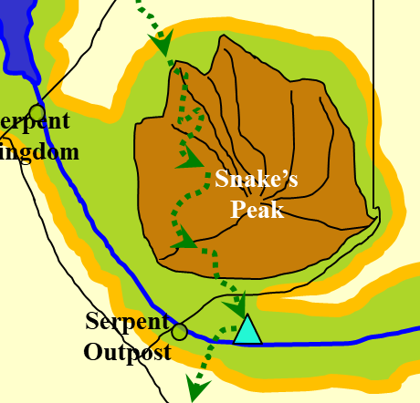

“To the south,” chirps the thrush. “There lies a vast swamp. A single hovel rests atop a mound, and a fire is stoking just outside the hovel. It is not a druid that lives there, for the elements of his campsite are not in balance with nature, but I saw no sign of evildoing.”

The others huddle around Jason, who calls them over with a hand gesture. The druid repeats himself once the others are in earshot.

Cautiously, just like when they spotted the log-bridge, they scout the area ahead of them. With a few more hours of cloudlight, they have plenty of time to approach this hovel and see just who resides in these swampy woods.

But as they come over the last hill, they see to their immediate south not just the clearly defined edge of the swamp. Their boots are still dry, but heading south any further will get them drenched up to their waists at least. Then, from among the mangroves that cluster along the shallow bottom of the swamp, they party spots something moving.

It is a pale-skinned humanoid, robed and hooded, who walks knee-deep in the swamp, carrying a staff in one hand and wearing a lit candle atop his shoulder in broad cloudlight. The heroes recognize a fellow doer of good, and as Faith casts detect magic, she is capable of seeing only divination and abjuration auras surrounding the obvious spellcaster.

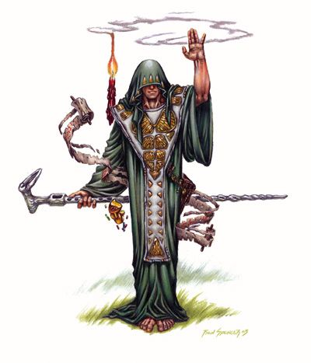

Then, smiling, he removes his hood and smiles even bigger, “Jason!?”

It has been some time, but after blinking a few times, Jason recognizes the fellow laureate of the Gauntlet. “San-ji!?” The archer steps about as far southward as he can without compromising his balance and falling into the nearest puddle that leads deeper into the muck. “Is it really you?”

The ascetic cleric-monk and the scout exchange another round of greetings, and as the muddy man emerges from the swamp, his clothes and legs immediately dry and become perfectly clean. Introductions follow, and by the time all is said and done, the party learns that San-ji has been aware of their coming for a few weeks, and had prepared a spell with Caleb in mind.

“I did not know your name,” the man with few belongings admits. “But Oghma’s guiding hand brought us to this juncture. Have you heard the teachings of Oghma?” he then asked the others, particularly the paladin.

“I am an avid admirer or Sune, though blind worship is antithetical to my order,” states Faith. In the last few days, the paladin has been talking to Kali about Sune, whose portfolio is quite compatible with the dancer’s lifestyle. She has almost convinced Kali to convert. “But yes, Oghma is admittedly a source of much wisdom, even some of which is attributed to other deities—Sune included—who have added to the original dogma.”

“Well said,” San-ji says before turning back to Caleb. “So, son,” the priest smiles calmly at the fellow cleric. “Are you ready to return to your full potential?”

“O-yea!” blurts out the feebleminded spellcaster.

“Through this conduit of faith in Oghma and Sune,” the ascetic cleric pronounced both deities’ names with full affirmation and articulation. “We hereby beseech the force of all that is righteous and mighty to eradicate all manner of harm and debility from this imperfect being.”

Magpie frowns and smiles at the same time, never having understood the nature of divine spellcasting and the highly dramatic rhetoric that complements it. “Why can’t they just say, ‘Alacazam,’ or ‘Wickity-wackity’ like a regular finger-wiggler?” she thinks to herself.

But before she can finish her thoughts on the matter, her attention is diverted to Caleb, who exclaims, “Hot doggity dawg! Whoooweee!”

“Caleb?” now Faith frowns and smiles simultaneously, trying to gauge whether the spell worked.

“Mmm! I feel good!” exclaims the happy human, doing a dance he’d never been seen doing before. “And I’m dying to prepare some spells.”

They all cheer San-ji for helping Caleb to regain his faculties, and decide to have dinner right then and there. Rations are running low, but they manage to divvy up enough for everyone excluding their ascetic, who lives exclusively off the land.

He tells them that the swamp can be circumvented along its western edge better than its vaster eastern hinterland, which gives way to bogs and mires, both of which host some of the deadliest natural inhabitants on this plane, including the flying catoblepas.

He has made peace with the fact that this swamp is his final resting place, and does not join the heroes when asked to come with. San-ji bids the heroes well as they wave goodbye, and tender their final thanks to the woodland ascetic.

An hour later, they have circumvented much of the swamp—which has become an evaporating, salt flat—going according to the path that San-ji pointed out, and eventually, the path begins to wind more and more westwardly.

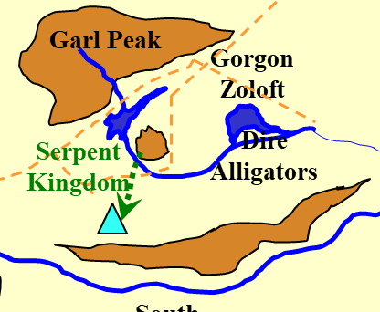

With the mountain range to their immediate south, they decide to circumvent it, but not right now. The bright white of the clouds above them now begins to dim, and soon night will be upon them again. They are not tired, as they have only been trekking for 4 hours, plus the short visit with San-ji, and could probably continue along the flat, lifeless plain that surrounds the mountain range south of them.

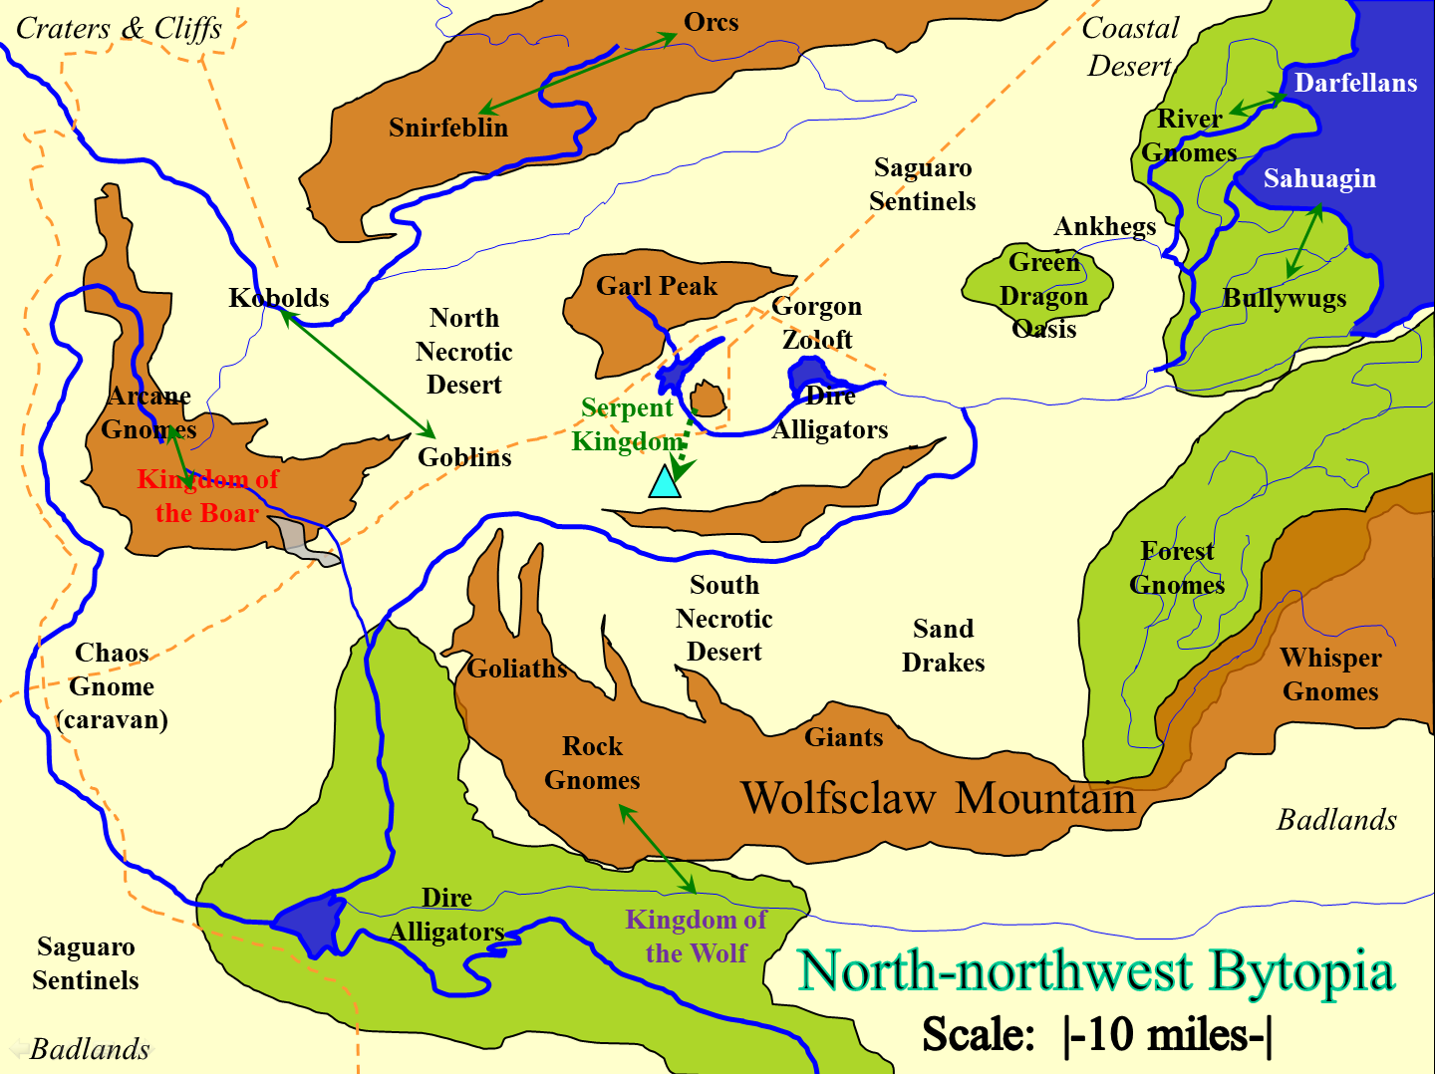

Magpie arches a brow as the imbecile speaks to her. She peers at him for a long moment, then says, “Huh. Good job getting your speech back. That bear heart must have had some sort of restorative properties. If we run across any more bears, we should get you some more heart.” She nodded her head authoritatively.

“I think the bear’s heart helps, but it was that fellow’s heal spell that really gave me the clarity I needed,” says Caleb.

“Sorry about breaking your brain and all.” See? She can apologize, even if she knows she was fully justified.

“Anyone have a torch?” someone in the back of the formation asks.

Magpie looks around and up at all the tall people, “Do some of you not have torches? I mean...” She unstraps a torch from her pack, and pulls a leather cowl off its top. Flame immediately flares up, without need for tinder, flint, or steel. “I got an enchanted one a long time ago. Oh, and I can also...” She holds up one of her black gloves that are covered in tiny bright specks, like the night sky. The glove begins glowing with a bright, silvery radiance, filling their immediate area with light. “I take light really seriously. Hard to spot a trap or pick a lock without the ability to see well.”

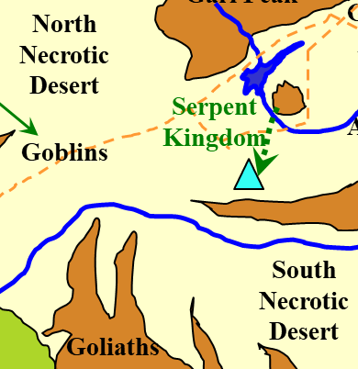

With a torch lit, they walk west for about an hour under a quickly darkening, and then pitch-dark, sky. The occasional light from a mountaintop cabin on the Shurrock side of Bytopia reminds them of where they are. Here on Dothion, the more populated layer of this dual plane, there are usually more lights than on Shurrock, though this salt flat is an exception. Far to the southeast, the lights of a small settlement glow bright, engulfed by an otherwise dark, stony sky.

Walking at a pace of 2 to 3 miles per hour, the party continues to make its way westward and then southwestward until they reach the foothills of the mountain range in their way. They have run out of water, and rations are low. If they push on a bit further, they can probably make it to the river south of them. On the map, it looks to be another hour away at most.

“Should we hustle?” Jason uses a technical scouting term, not quite parched, given that the night is cool, and they all know it’s only getting cooler.

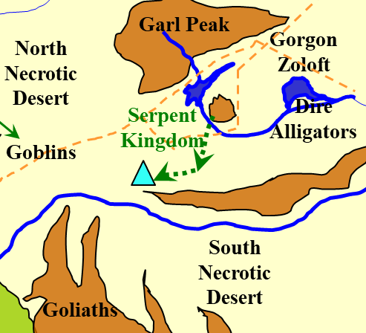

The druid agrees with the scout that this is a no-brainer. The rest concur that it is a sound calculation, and although they will be parched by the time they reach said river, it’ll be well worth the sacrifice to have water to drink both before and after setting up camp again.

They hustle.

They hustle, and hustle.

They hustle for another half-hour or more, and at one point, Magpie calls for a momentary rest, which Caleb is happy to oblige.

Huffing at the rear of the formation with her armor weighing her down a bit. Reaching the others, she inhales deeply and sighs, “Soohh, everyone still on board with trying to reach the river?”

She makes a few of the others laugh as they all put their palms to their laps, hunching and huffing.

Jason pulls out his map again as they all regain their breaths.

“So apparently, we are entering the South Necrotic Desert,” reports Magpie as she looks at the map.

“We really should be reaching the river soon,” Jason is sure of this.

“Yes,” Wind in His Hair replies or affirms.

Silence ensues for a few seconds as Magpie and Jason review the map some more.

“Smell the water?” the druid asks the scout, who tries his best and eventually does catch the slightest waft of petrichor, the ill-known term for the well-known scent of earth doused by recent rains... or the smell of a riverbank in this still salty, silty, gritty grain that can never be called soil.

Jason inhales more deeply, and they smile, nodding.

“We’re not far,” Jason reports, taking point once Magpie and the others give him the go-ahead to return to marching formation and resume their hustle. “It’s going to be more of a sprint and a jaunt than the long trek we just took across the nothing behind us.”

Not 10 minutes later, they can hear the very gentle flow of water, and upon reaching the stream—and it is a stream—they quickly fill their bellies and waterskins with the sweet, water that Wind in His Hair has declared potable.

They do not immediately set camp, but at least set down the bulk of their gear and take in their surroundings.

The vegetation here grows only along the banks of the stream, and also throughout much of the stream itself. There are cattails, rushes, and reeds, but also pepper trees, small elms, white birches, and aspens.

“Faith,” Jason looks along both lengths of the river, eastward and westward. “Do you remember that time—just before we liberated all those people from the Gauntlet—when we took that folding ship along a very similar river, surrounded by a very similar desert?”

“Yes, Borak’s domain, until we helped the raptoran and formian peoples to overthrow the Tyrant Queen, and,” the paladin of freedom laughs as if she were dancing over the dragon’s grave. “Hee, heee! Her own minions slew her when she teleported back into her lair.”

“Seriously?” Magpie asks, wondering how that went down.

“We nearly slew the dragon,” Faith explains. “It was us, and a bronze dragon and his dragon shaman daughter, and hundreds of raptoran and formian braves.”

“Borak mobilized an army of her own, mostly Draconic types: kobolds, dracotaurs, bluespawns, half-dragons, al-Iboraks, and some siege monsters and siege engines to boot,” Jason recalls. “I spent the aftermath looting some fine arrows from the plateau that became our battlefield.”

Faith returns to the point, “Right, but the point is that it was really poetic justice. We hadn’t planned it this way; we had no idea that she would be teleporting as a last resort, let alone to her certain doom.”

“It was a good day,” Jason adds as the paladin inhales.

Faith nods, “It was. So we render Borak—as they say—knocking at death’s door, and you’re right, it’s always safe to assume that a blue dragon I going to have something up her sleeve as a killswitch. So she looks at us all defiant and mocking, and says something—I can’t remember the exact stupidity—and then teleports out of sight.”

“And the minions?” Kali is now curious too.

Caleb and Wind in His Hair come closer.

“Right, so the next day, or maybe two days later—didn’t the raptorans throw us a day-long party?—so we take these mechanical wingpacks, escorted by a dozen or so winged formians to the lair of this self-proclaimed Tyrant Queen.”

“And then?”

The paladin explains further: “And then we get there, expecting all kinds of traps and safeguards, but instead, we get inside her desert lair and find the corpse of the dragon down below in the water chamber. It’s clear that she was slain by all manner of methods: acid, cold, fire, necromancy, slashing, piercing. Some of it was our doing, but there were some instances, such as the two halberds implanted into her eyes, that were the work of her traitorous, treacherous minions.”

The scout adds: “They’d killed her, looted the really good treasure, left behind silver and copper coins and some mediocre stuff, and taken off. We caught up to them, killed almost all of them, and by then we were sure that they were members of the Eldreth Veluuthra, a faction of elven supremacists that were allied with certain dragons.... Good times.”

“See? That story there is why you don’t build a power base of evil folks. I was in this thief’s guild back on the Prime Material Plane, and shortly after I joined, there was a shakeup like that. Admittedly, the guild master was a bit of a bastard in the personality sense, I’m sure his parents were lovely people.” Magpie shrugs, not really sure, but presses on anyway. “Anyhoo, they had a big meeting of the underbosses, where he intended to kill one of the underbosses who was getting a bit big in his britches. What he didn’t know is that underboss had already won the allegiance of 5 of the 6 other underbosses. Everyone except the one who was being groomed to take over the guild.”

“Long story short, the only soup poisoned that night was the underboss and his protégé. Paralytic poison. Nasty. They crucified them both in the main meeting hall. Took ‘em like 4 days to die. Can’t slip your bounds with your wrists are nailed to oak.” That last bit is delivered very matter of fact, as if it were a useful nugget of knowledge to be filed away from a later date.

They all fall silent as they hear movement to the west. Coming up over a hill that shapes the curvature of the stream is a lone dire jackal. Seeing and smelling the party, it whines and turns around, knowing it will not find anything but death here.

“Anyway, I’m not tired really and I’ve been up the longest. That heart really gives a body some pep. Let’s press on. I’d like to find a bed at the end of this trek. Preferably feather, but I’ll settle for not dirt.” See? She doesn’t ask for much.

They press on, but about 5 miles south of the river, they finally concur that there’s no better place than this slightly elevated mound—more of a nipple on the otherwise flat land. “If we are to defend ourselves,” Faith took in the landscape, dotted with sagebrush and complementary desert vegetation. “Then we’ll do better to play king-of-the-hill.”

“Couldn’t agree more,” the marksman archer sharpens his arrow tips.

Setting up camp, the party adopts the same tactic as the night before, wherein Magpie sleeps for an hour, then lets everyone else sleep while she stays awake, and other than the occasional lizard or rodent.

~*~

By the time everyone is rested, Wind in His Hair comes back from a scouting trip, having befriended the lone dire jackal that was stalking them last night, and now riding him. “She said she’d play nice,” the half-elf druid assures everyone. They note that, like the bear they slew, this dire jackal is about twice the size as the ones that Jason and his previous posse cut down back in the desert that bordered Borak’s lair.

Magpie, says nothing, studying the reactions of the others.

Caleb asks, “Does she have a name?”

It’s not clear whether the druid has considered this yet or not, but after a few seconds of looking down and petting her mane, the mounted druid proclaims, “Ravages Savagely.”

Conveniently, Faith considers that if she were to summon Brant and place Magpie behind her, it’s conceivable that Caleb, Kali, and Jason could ride on this animal at a slow enough pace, and the druid—in the form of a thrush—could perch on the shoulders of any of his mates when not scouting above. Over open country, this would make travel both slightly faster and far less tiring.

“Sounds fine to me,” says Jason to Faith. “I don’t mind riding.”

“Let’s make a decision so we can get on our way,” Kali says impatiently.

“See, I was thinking she looked more like a Lady Floofums. This is why you’re a druid and I’m an irreverent gnome who finds animals with mouths larger than my torso terrifying.” She doesn’t sound very scared, but to be fair, Magpie is good enough with the art of the bluff to appear whatever dang way she wants to.

Caleb shrugs, “Ravages Savagely does suit, you must admit. She is a magnificent beast, sir druid. I doubt there’s anything to worry about so long as you don’t annoy the druid, Magpie.”

Magpie gives Caleb a curious look, then replies, “Well, I can see all that fancy diviner training is paying off.”

“Touché!” Caleb allows with a nod, feeling somewhat changed by the whole experience of: (1) being possessed by a great and evil force, (2) being feebleminded by Magpie, (3) having the enchantment broken by Magpie, and (4) having the feeblemind broken by San-ji on their serendipitous way to the gnome settlement. He has gone from neutral to evil, from smart to feebleminded, from evil back to neutral, and eventually back to his old, learned self, even better, actually, after eating that bear’s heart as heartily as he did.

The druid lulls and whispers to Ravages Savagely, soothing her instincts before setting off. The paladin summons Brant, taking Magpie atop the horse’s smaller, rear saddle, while the others climb onto the dire jackal one by one. Once assured that the animal companion will let these other people ride her, Wind in His Hair assumes the role of a thrush once more and perches atop the jackal’s head, chirping further comforting monologue into the reptilian mammal’s left ear.

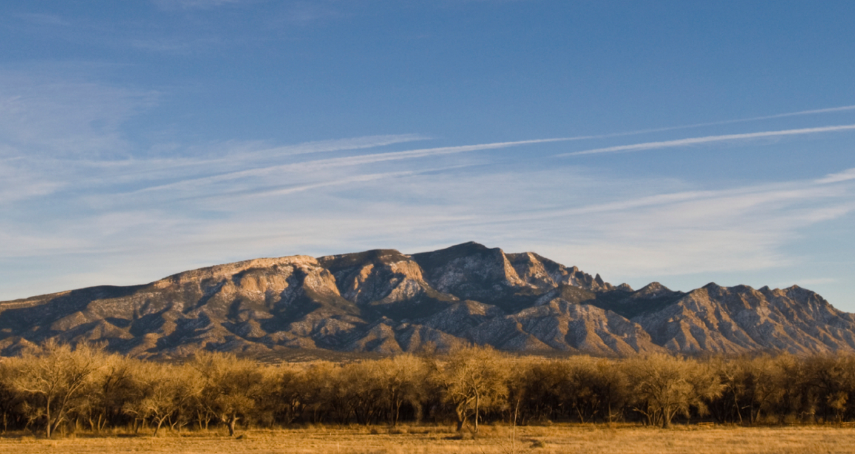

“On towards the mountains then!” Caleb proclaims.

