Chapter 7: Gond’s Sacred Franchise

J
ust at that moment, they spotted a solitary figure coming down from the summit settlement. Obviously headed for them, the unarmed gnome with the funny explorer’s hat was dressed as a layperson, but there was something in his demeanor as he approached that suggested a person of exceptional wisdom and charisma.

Spinning around, Magpie saw the approaching bearded svirfneblin and did a double take, “And where in the world did this guy come from? I think you’re in the wrong hood. Cool hat, though.”

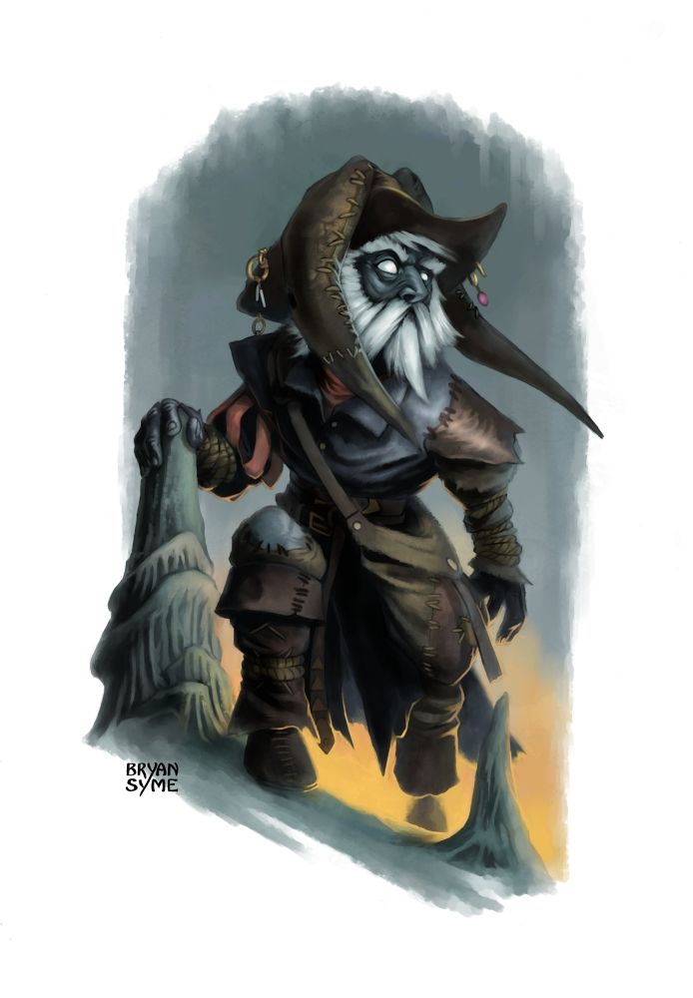

The dark skinned rock gnome explained the urgency of the matter as Magpie realized that he wasn’t actually svirfneblin (at least not full-blooded), but rather looked like he could have been Magpie’s long-lost relative—her father maybe—sporting the same skin tone and strikingly similar facial features.

“My name is Tunaster Dranik,” the only local gnome with a name so far introduced himself before getting to his point. “I wander religiously, as many Gondar clergy do, seeking sources of new and innovative magic. I‘ve been in tombs, dangerous ruins... I’ve even skirted the lair of a foul lich that now lies truly dead by the hand of another... but none of these hold a candle to the sight I saw a tenday past in the temple of Gond, here in the village,” the gnome caught his breath.

“Do tell,” some of the heroes said as they leaned forward, intrigued.

“As an itinerant clergyperson, I am in regular contact with local chapters of Gond’s faithful. That is to say, I know a Gondar when I see one, irrespective of local nuances and adaptations. I was last here in the Deepwinter, when all this is a snowy slope, some of it fit for sledding. I met with at least half of the Temple’s senior clergy and custodians, and gave a lecture to what I was told was the entire enrolled congregation, which was over 200 gnomes and a few other souls.”

Faith shifted in her seat, as did Kali, to get a better measure of this man. He was, in fact, clad in the costumery and iconography of a Gondar priest, and nothing he said or did led the heroes to think this was a ruse.

“But I returned yesterday, and not only has the Superintendent been replaced by a rather reclusive new woman named Milfuegos of whom I’ve never heard tell, but those whom I do remember as having been there before seem altogether... changed.”

“What is it that you ask of us?” Faith asked.

“Yes, you’re telling us all of this for what reason?” Kali asked.

“Aye: Whatever it is that they’re doing, it is not a Gondar practice. I am not a powerful man, not compared to what I heard yesterday about you all,” he admitted.

Wind in His Hair’s dire jackal came back from hunting a snack, and startled the gnome. “Oh, I hadn’t heard about him,” he also admitted.

“She means you no harm, Tunaster,” the druid assured him, petting the giant jackal as the beast comes to her brother.

“Right, as I was saying, I’m not the caliber of gnome that could domesticate a giant dire jackal, for example, and I am asking... pleading for the help of those whom I think are up to this task.”

“But what task, specifically?” Magpie asked quizzically.

“Let me backtrack... yesterday when I entered the temple, looking for familiar faces ,and as I said, I saw a menagerie of new faces and those who were familiar of visage were rather unfamiliar of personality. I made it to the outer courtyard, but was rebuffed from entering the inner areas, which I’d visited before. I was initially told to wait for this Milfuegos, but after an hour’s wait, a man appeared, someone named Zvim, and asked me to accompany him back to the middle courtyard. He wore the garbs of a Mystran cleric, as do I, but something about him wasn’t right. I can’t explain it to you, but something made me… run.”

“This Zvim made you run?” Caleb tried to understand.

“Yes, well, the whole situation: There were guards dressed in black. What Gondar Templar does that? Oh, and so they chased me! Why? I still don’t know, but I escaped with only a crossbow bolt to the shoulder, which I promptly healed once I was out of harm’s way. What in the Nine Hells is going on there?” Tunaster asked rhetorically.

“So you’d like us to find out what this is all about?” Caleb tried to summarize.

“Yes, I need to find out, and let other chapters know what’s happening here, but like I said, my powers are limited compared to what was said of you yesterday at the central mead fountain,” Tunaster pointed behind him with his thumb, indicating the mountaintop. “You folks are far more able than my humble self to see that this is done properly.”

“What about the authorities?” Kali thought to ask.

“I’ve already spoken to the winged one and other administrators. They assure me that the Elders are looking into the matter, and will get back to me in no definite amount of time,” he sighed, holding back a tear of despair. I sense that their reluctance to look deeper into the matter has something to do with the power and influence of Gond’s Temple in the settlement, but I repeat: these are not Gondars, though they masquerade as such.”

Magpie hadn’t earned any wealth, and had replaced her mundane miscellaneous sundries that she’d consumed on her travels. Her irritation with Faith forgotten, the somewhat flighty Magpie clapped, “It’s not every day that I’m asked to break into a temple. I like it. Gond’s not typically concerned with intentions, just results. He welcomes all makers, be it a gentle soul crafting toys for children to a brutal psychopath with dreams of horrifying war machines. It’s not unbelievable to conceive of a given temple populated by terrible people and their terrible creations. That could explain the Elders not being terribly concerned.”

Pacing around, she tapped her lips while humming and thinking aloud, “We’ll need holy symbols. A lot of temples have mystical defenses that won’t trigger on those wearing a holy symbol. Especially somewhere like a Gondar temple where there isn’t a unified ethical viewpoint. And, we need to know everything you know about the temple’s layout. A map would be great.”

“Why... yes, of course!” the gnome was enthusiastic to provide as detailed a model of the “frontstage” section of the temple. “As an itinerant priest, I don’t recall ever having gone into the lower levels of this particular temple, but almost all Gondar temples have at least one such level, where blueprints and other Gondar contributions are stored and curated.”

Casting an augmented amanuensis spell, the gnome was able to produce a fairly accurate map of the Temple of Gond’s main level, which he handed to Magpie when it was done.

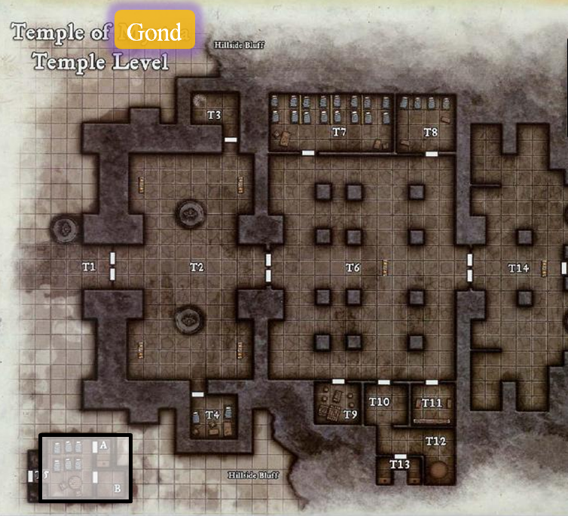

Caleb had scribed some scrolls, and was fumbling through them. “Lesser restoration, see invisibility, magic circle vs evil…” He had two of each kind handy now, and had scribed them at their minimum possible potency. Now, trying to memorize his repertoire, he noted that he’d used up three of his other scrolls recently, and thus remembered to forget them from the list.

Wands, Scrolls and Potions | Qty. | Level | CLev | Notes |  |  | Value
Wand of Magic Missile | 1 | 1 | 9 | 45/50 charges; 5d4+5 |  |  | 6750
Scroll of Comprehend Languages | 1 | 1 | 1 |  |  |  | 25
Scroll of Shield | 0 | 1 | 1 |  |  |  | 0
Scroll of Mage Armor | 0 | 1 | 1 |  |  |  | 0
Scroll of Bless | 0 | 1 | 1 |  |  |  | 0
Scroll of Endure Elements | 1 | 1 | 1 |  |  |  | 25
Scroll of Resurgence | 1 | 1 | 1 |  |  |  | 25
Scroll of See Invisibility | 2 | 2 | 3 |  |  |  | 300
Scroll of Lesser Restoration | 2 | 2 | 3 |  |  |  | 300
Scroll of Magic Circle vs Evil | 2 | 3 | 5 |  |  |  | 750

[Good news: I don’t deduct XP costs that are derived from the “base price ÷ 25” formula when scribing or brewing. ]

Wind in His Hair has been speaking the Druidic language into the dire jackal’s ear, and now smiled and murmured a few assuring phrases, urging the hesitant beast to retreat down the mountain to a modest cavity in the rock face where they’d stored some food. << I shall be back at the end of this venture, >> he reassured the animal, then turning to a thrush—his favorite bird—and perching upon Magpie’s shoulder, chirping twice.

Faith, Jason, and Kali didn’t have much to say against the idea, so everyone said, “alright,” and the party went off towards the temple as Tunaster descended the hill, seeking his own mountainside vantage point to occupy for the moment.

As they trudged up the hill, Caleb mused, “Why do I feel like someone will soon try to kill me?”

“Because you’re like, a dweeb and live in constant fear of the popular kids being mean to you?” Magpie replied blithely.

“Ha, ha. Clever,” the mystic theurge replied dryly.

“Thanks, I know.” Magpie’s teeth were bright white against her dark skin as she beamed a huge smile at Caleb.

Caleb shook his head then pressed on. “So, speaking of someone trying to kill me... Magpie, you can cast mage armor, yes? It’s part of the beguiler training.”

Stopping, Magpie turned to Caleb. “Hold up. Tell me you didn’t.”

“Didn’t what?” Caleb asked.

“Didn’t forget to memorize one of the most essential defensive spells in a wizard’s arsenal. With all the spells you can cast, you missed that one?” The gnome seemed baffled.

“Well... yes. I neglected to memorize it because we were in a safe place and I don’t want to ask people to wait a day for me to change my spells.”

“No scrolls either, I’m guessing. Fine, fine.” Magpie cast mage armor on Caleb, then patted his hip.
Caleb gained +4 to AC and FF AC.

“There you go. In the future, perhaps, diviner, you might need that spell.”

Caleb rolled his eyes, an invisible, blue (to those who could see invisibility) veneer of protection now shrouding the cleric-diviner’s frame, “Thank you, Magpie. I’ll take that under advisement.”

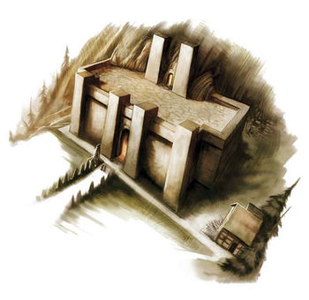

It was early Highsun when they reached the stone causeway between the two fields of ambergris flowers, and made their way towards the temple, spotting at first two figures just outside the doors, then a few others to the north of that entrance. The cabin to the south had its windows drawn open, but its door shut, and to those of keener sight, it was evident that there were a few figures moving inside the Temple of Gond as well.

Everyone looked gnomish from a distance.

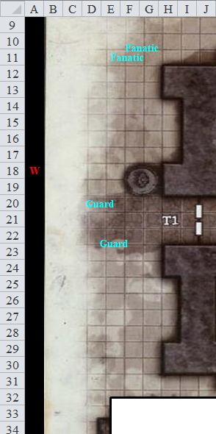

“Tunaster said to be wary of trickery of every sort,” Faith reminded everyone as they approached, and were noticed by the two gnome guards standing in front of the entrance. Though they wore the garbs of a Gondar worshipper, they were also obviously armored underneath, both sporting studded leather in a pacifist community.

They were about 100’ from the entrance, with weapons sheathed and shouldered, and only a mage armor spell cast on Caleb.

“Hello,” called Kali to the guards, moving to the front of the group. “It is a beautiful day isn’t it. How is the day going?”

“Ahoy, friends! You are no doubt the outlanders of whom I’ve heard so many tales,” the shorter gnome greeted them. “Your presence has been the talk of the town, or at least of this neighborhood. I am Genex, a Protector of this Temple of Gond.”

They had earned a quick reputation, seeing as these pacific gnomes longed for tales of strife and struggle, and the party was quick to regale them with stories of glory. They recounted accounts of heroes such as Jadin, Frayed, Persephone, Ti’ki, Eriven, Dmitri, Aegis, Ragnaroek, Taj, Sydney, and so many others who had fought alongside Jason and Faith in what seemed like another lifetime.

Caleb studied the legitimate-looking statue of Gond next to the front doors.

“Won’t you come in and share in a prayer?” asked the frontman at the temple doors. “We’re preparing for the Highsun Call to Duty,” he added.

“Yes that would good. We will join you,” said Faith.

As they walked toward the temple, Magpie turned to face the group, speaking in a low enough tone that it shouldn’t carry to the temple guards, “Fair warning. Prayers to Gond are super boring. Ugg! I mean, at least when we have rituals to Garl Glittergold, there’s like shiny stuff to distract you. Gondar hymnals read like the instruction parts of recipe books.” She stuck her finger down her throat and made a gagging noise, then added, “You’ll probably dig it, Faith.”

“It won’t kill you, so just endure for now,” Jason said with an amused look before Faith could respond.

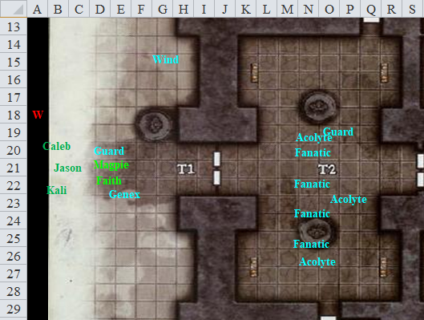

Faith looked about as they entered the temple to see just how they decorated. From her cursory knowledge of this god’s dogma and associated dress codes and décor, the feng shui of the place was singularly centric, counter to the paradigms closest to this deity of intellect and creativity. The architecture was sound—Gondar in every aspect—but nearly every bit of the removable and movable décor was something foreign to Gond, and in some cases even to the greater Gnomish Pantheon.

The statue of a larger-than-life gnome contained one speck of gold amidst the pure bronze cast: the man wore a monocle bearing a wide, convex lens on which the symbol of Gond was brazenly gilded. The brown statue was complemented by the statue of a stout riding dog—this one to scale—standing rampant on its hind legs, which perplexed everyone.

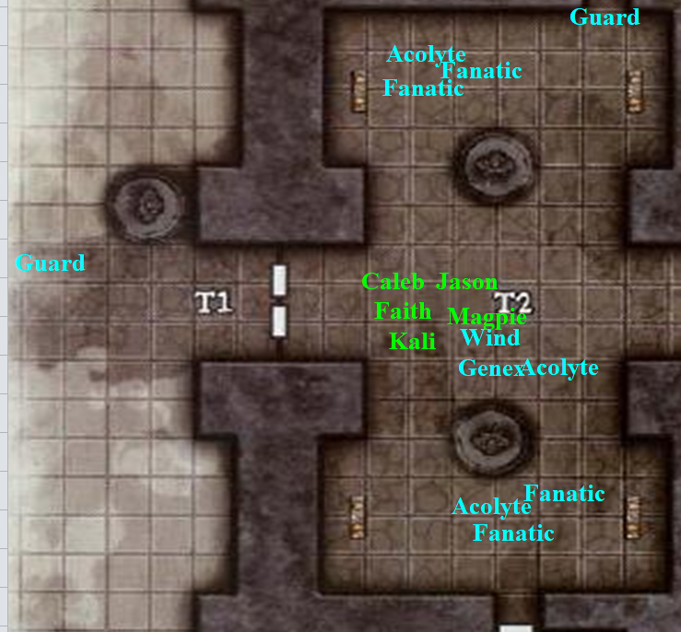

“Won’t you come say hello to Filip?” Genex spoke more softly now, as did the others inside, and though the topic of no conversation could be discerned, it was clear by the tone and the expressions on faces that very solemn religious sentiments were being exchanged.

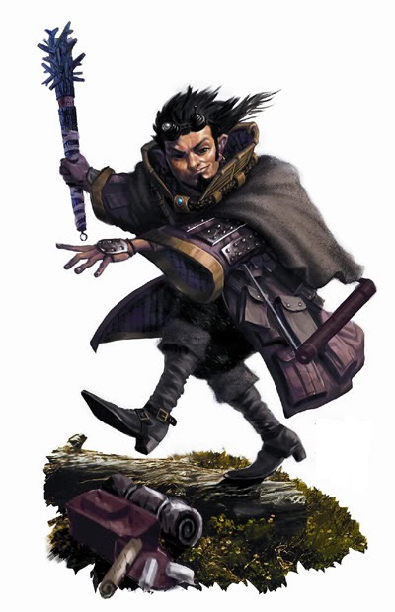

The gnome guard introduced the heroes to Filip, a robed gnome with a great smile, and big, buggy eyes.

“A very good afternoon to you,” the man bowed his head as Genex introduced the heroes, referencing some of the stories they’d heard. “Oh, my! That’s wonderful! And Gond has brought you to our doors. This is surely not random; it is part of His Grand Design,” the holy man ended the sentence a bit more loudly so as to be heard by all in this outer courtyard.

“And for His Sacred Franchise,” most of the strangers in the room repeated in unison.

“And a good afternoon to you as well,” said Faith. “People are always pointed to where the need to be no matter what god they worship. Except maybe for rogues; they seem to have a randomness about them.”

Wind in His Hair kept quiet; as a half-elf, and more so as a druid, the shapeshifter felt ill-at-ease when dealing with gnomes. There were so many layers to what they said! For example:

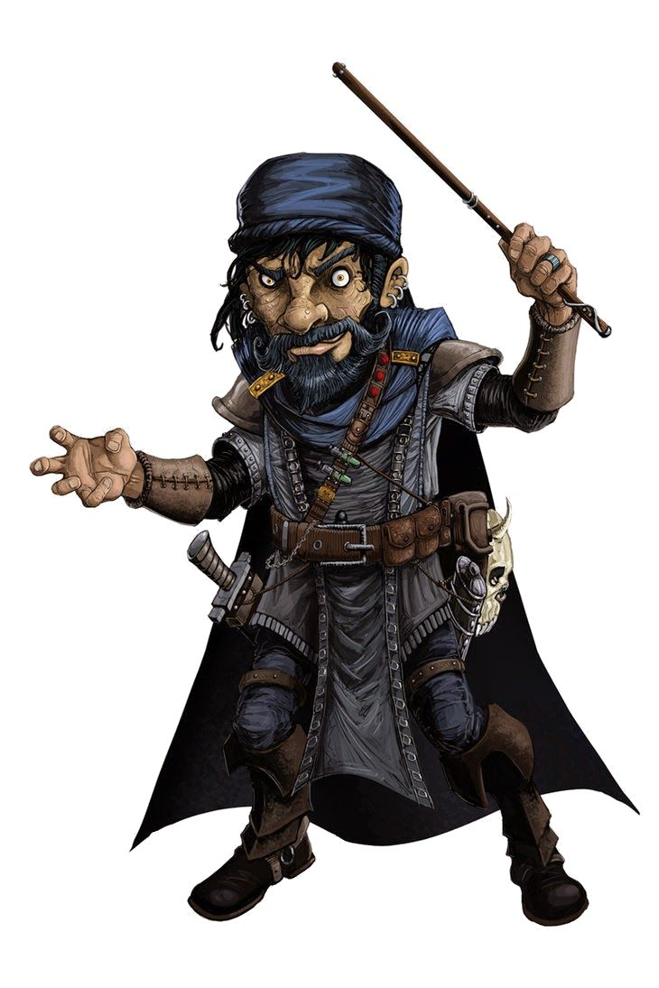

“So, travelers, whence came you?” asked Filip. “Our remote community of well-meaning emeriti is far from most planar crossroads, yet the Astral dust still clings to some of your armor,” jested the young orator, speaking more in metaphors and innuendos than in the vernacular of a Gondar, chiseled with exactitude.

Wind in His Hair held back a smirk and bit his lip, letting the others speak for a moment, not so much aware of the violations of Gondar folkways, but still intuitively cognizant that there was an air of deceit as thick as smoke here in the House of Gond, if such it was.

Magpie narrowed her eyes at Filip, tilting her head first one way, then the other. “Huh. That’s weird. You’re not like any Gondar priest I’ve ever met before. Now, to be fair, I’m not especially pious. In fact, it could be argued by certain big, armor plated, humorless jerks that I contribute to the moral decay of decent cultures.” No, she didn’t look at a certain big, armor plated, humorless paladin while she said that. “I’m absolutely a bullshit artist, and you, sir, feel like a kindred soul. And I don’t say that as an insult. Frankly, Gondar priests are boring, and you are interesting. It’s kind of sexy.”
Skill | Rank | Ability & Mod. | Misc. Mods. | Total | Roll | Check
Magpie, Diplomacy | 11 | Cha (+0) | 4 | 15 | 15 | 30

Blinking, Magpie looked around at her companions, “Oh, crap. I said all that out loud, didn’t I?” She shrugged, then took a step closer to Filip with a bit of a smile, “Eh, who cares? The tall ones spend all their time making moon eyes at each other anyway. Would you possibly be interested in private lessons in religion?” She wriggled her eyebrows, all subtle-like.

“Well, milady,” the bug-eyed male said to Magpie. “normally, I’d take offense to such a sleight, but then, I’m no stranger to sarcasm and exaggeration.” The witty and wily Filip smirked, eyeing Magpie as a predator studies its prey before the lunge.

Caleb had a disturbed expression. “Ugg. I think I might be ill.”

Filip stroked the back of his neck and then proposed, “Say, friends, your reputation precedes you here, and thus I am at liberty to forego with formalities and clearances. You’ve made an impression on me,” he looked at Magpie, then cursorily at everyone else, “and it would only be proper and fitting to invite you to our first post-meridian meal.”

Magpie was fully aware of the gnomish-halfling-goblin custom of eating 11 small meals a day, and knew this upcoming one to be the 5th one.

Wind in His Hair was slightly hungry, and could go either way, leaving the decision to group consensus. The neutral and easygoing druid wanted to become something too small to be seen, like a moth. Alas, he could only become something as small as a thrush, and thus he remained in half-elf form for the moment.

As the party discussed whether or not to partake in fifthmeal, the druid looked up to the sky, then around at all the details of the room and its décor. They had already noted that this outer courtyard was open to the sky, and it was quite remarkable how clean the floor was. The floor was tiled with obsidian slabs, in which stone tiles were set, emulating the holy symbol of Gond. Small altars of devotion to Gond sat in each corner of the temple courtyard, some with an assortment of trinkets and offerings, and others with a single chalice or other ceremonial item. None of the items were mechanical, which was seriously irregular, though Wind in His Hair did not notice. Magpie, however, did.

“I’m not sure that’s wise. My companions have atrocious table manners,” Caleb began diplomatically in an attempt to avoid a potential poisoning.
Skill | Rank | Ability & Mod. | Misc. Mods. | Total | Roll | Check
Caleb, Bluff | 0 | Cha (-1) | 0 | -1 | 20 | 19
See below.

Still, the bluff was apparently accepted as true. To the north, two newbies began kneeling before one of the statues, as their patron acolyte stood by and observed to ensure accuracy.

“Frankly, we expect that,” Magpie replied, looking up at Caleb. “No offence, but you’re all like big, lumbering beasts. If you started chewing cud, it wouldn’t shock me.”

“Remind me again why I’m travelling with you,” Caleb inquired with an arched eyebrow.

“Because I’m so damn charming,” she shot back with a toothy smile before looking back to Filip. “I can’t speak for the others, but I’d love to share a... meal with you.” She grinned and looked him up and down.

“Right... charming.” Caleb sighed with an eye roll.

Filip, quite taken aback by the beguiler, collected his fantasies, rearranged his facial expressions, and blinked, smiling, “Friends, won’t you please come with me then?”

Filip knocked three, then two more times, and the doors opened inward. Joined by a few other fanatics and acolytes, the party entered the temple proper, getting their first look at the inside of the roofed structure.

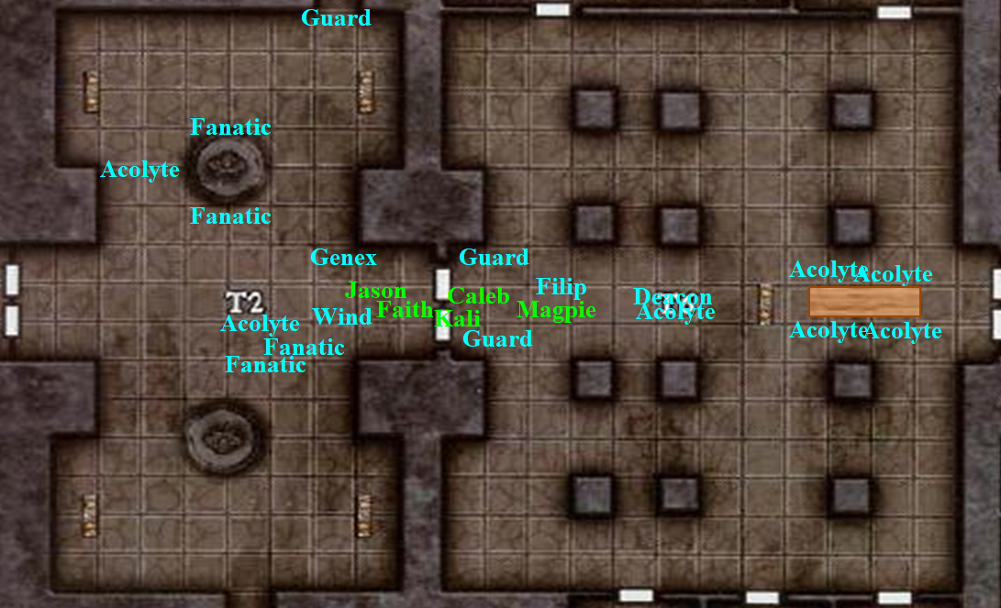

This large room was closed off from the sky, but tiny points of light glittered on the otherwise oil-black ceiling. The floor was tiled with obsidian slabs, and three rows of square pillars marched across the chamber from north to south. Torches were ensconced on the east and west surfaces of each column. A plain stone altar stood alone near the chamber’s center, looking older than all of the heroes combined.

“Ah, Deacon Zvim!” Filip said as Genex followed the heroes only as far as the doors, then bowed to everyone and returned to his post outside the temple as the two other guards closed the doors to the inner courtyard.

As the party entered, they noted an extremely lavishly dressed male who answered to the name of Zvim, “Filip, thank you for joining us. And with whom do we have the pleasure of fivemealing today?” This must have been the Zvim that Tunaster warned them about.

After Filip introduced the six heroes, the acolyte in the back came forth and introduced the two gnomes dressed in workers’ clothes. “And these are Barop and Phlegmscheimer.”

“Phlegm for short,” the simple arugula farmer smiled.

“Yum!” Magpie commented, smelling and looking at the food on the long table, where four robed gnomes already sat, discussing something with a certain passion.

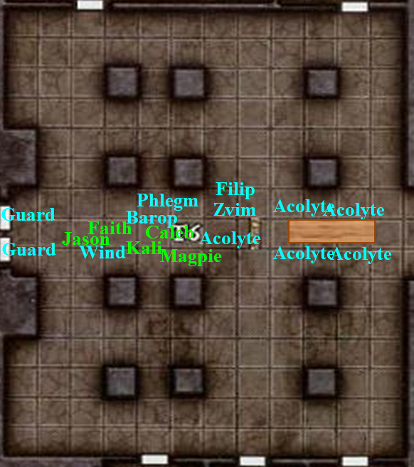

Zvim rolled up his sleeves, buttoning them to his shoulders as some clerics did, then proposed, “Well, friends of Gond, come and share a fifthmeal with us that we might all partake in one another’s company... and in this, let there be an exchange of goodwill.”

They went to the table and met the four gnomes already seated, though within minutes they’d forgotten these students’ names. The conversation began first with a quasi-prayer, then moved into less rehearsed rhetoric about why food was so wonderful.

Faith, among the tallest in the room, could see small scabs on the back of Zvim’s balding head, some freshly picked, others ripe for the unwrapping. “Please sit,” the deacon said.

Jason still smirked at Maggie’s comments. “Yes, yes Magpie. Go have a romp in the hay. We can wait for you.” He continued his words directed at Flip. “We recently crash-landed and have lost our way and have no real agenda but seeing what is here.”

“Perhaps” said Kali, “You could give us directions to what is beyond here.”

They produced the map they had been given by the wererats, and Zvim leaned over it, finding where they were.

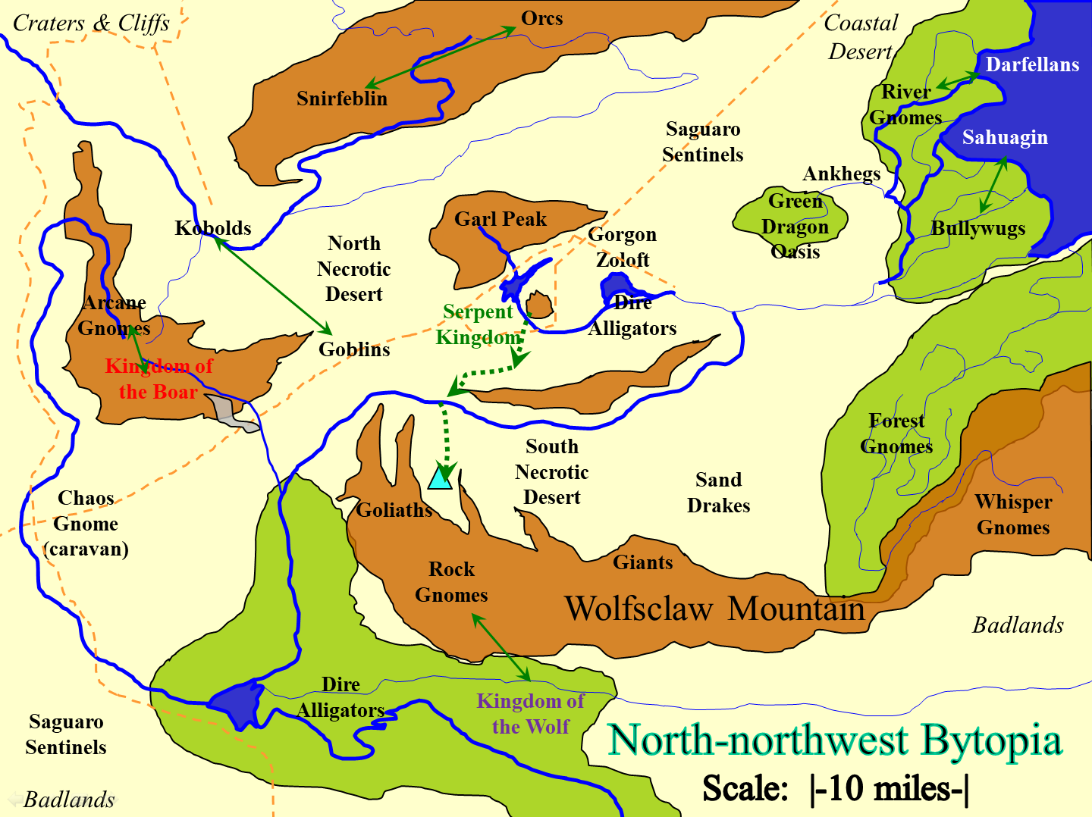

“Right, so we’re here where it says ‘Rock Gnomes’,” he accurately stated. “And so you came from the north, along this arrow that someone drew?”

“Yes,” the group’s scout said as everyone sat down.

A few fanatics and acolytes brought in some food in different trays: turnips, beets, yuccas, yams, carrots, parsnips, garlic cloves, onions, and all manner of other roots.

Magpie was fascinated; the others, not so much. Then the humans noticed some baguettes in a basket, relieved.

After a moment of watching the others, Jason filled his plate and enjoyed the fair.

Kali, on the other hand, would have nothing, saying she was observing a fast.

“Well, it looks like you have the region fairly well mapped out. To the south of this map is a barren wasteland that ends in a precipice the bottom of which is so far down that none here has ever reached it and returned. To the east are more gnome-rich realms where the souls of ages past have gone to rest and live in peace as a reward for their altruism in another life,” Zvim took a few fat roots from a basket as he handed the map back to Jason. “To the west you have the craggy lands, which eventually yield to peaks so high that one can walk from Dothion to Shurrock along stone conduits that cross the gravity barrier up above.”

“You just have to be careful that you’re not doing so when a luminescent cloud is passing by,” warned one of the acolytes. “They’re quite toxic, and can also electrocute you.”

“Noted,” Kali noted.

“Yes,” Zvim nodded. “Must be careful of those. Oh, and I suppose you already know what’s north of here: wereserpents and wererats. Beyond that, I don’t know.”

The Gondar hosts ate, looking at the others to ensure that every guest was comfortable.

Magpie didn’t react to Jason’s rather crude jest, nor was she plotting to grievously embarrass him at a later date when an opportunity presented itself. That would be unethical, and the beguiler was nothing if not ethical: honest.

Wind in His Hair knew this to be so by now, and found it quite uncharacteristic of a beguiler, and of a gnome. What a wonderful world this was, filled with such diversity!

“Ooo! Tubers!” Magpie clapped at the delightful spread, glanced around to make sure there wasn’t some ritualistic nonsense that would delay the meal, then tucked in. “Mmm.... oh, gods! So good. Faith, you need to try these beets. They aren’t better than sex, but you’ve got to take what little pleasures you can get in life. Now, in my experience, elves are better with greens, dwarves have mushrooms nailed down, but nobody makes tubers like gnomes. In all fairness, humans are probably best at cooking animals, but I’m not a meat eater.”

“Yes, it is true that no other race has mastered the artistry behind tuber cuisine,” Zvim pronounced the consonants as well as possible while he chewed minute bits of food. He ate quickly, but in small bites, and appeared to be getting over a cold, given a single cold sore and a slight redness under his nostrils, though he was not currently sniffling.

By contrast, Filip ate in large bites, noisily, and quite heartily.

“Tell me, Magpie,” Zvim thought to ask. “You wear the garments of a practiced spellcaster. What is your particular field of study?”

“Oh, me?” Magpie asked, surprised as she looked down at her breastplate, giving it a bit of a knock with her knuckles. “You’ve got a good eye, Filip,” she complimented the bog-eyed weirdo with atrocious table manners, perhaps with a touch of flirty inflection. “Nothing too interesting, I’m afraid. Like many gnomish spellcasters, I’ve flirted with illusions.” She made a ‘woo-woo’ noise while trilling her fingers through the air. “The only truly skilled arcanist we have in the group is Caleb here.”

“Ah, Caleb,” Zvim sighed as he and Filip turned their attention to him.

Caleb, being a master of intrigue, though he was helping the gnome by saying, “Now, Magpie, one could hardly call you a dabbler. Why, I could argue that you are mo... Ooof!” He rubbed his ribs where the female gnome had just elbowed him. “What in the...”

“When I pay you a compliment, just take it.” Magpie explained, before looking back to Filip, “Don’t mind him. He’s humble. He does both Arcane and Divine magicks, which to my mind are two great tastes that taste great together... like this garlic and yucca!”

Wind in His Hair didn’t get half the references being made, usual or half-elves who lived on the fringes of others’ communities, and thus enjoyed the richness of the fibrous yucca. “Mmmm!”

“And so Caleb,” Zvim played with the hair that grew from his left ear. “Would you say you’re more a mage or a priest?”

“I would say the two disciplines are not as dissimilar as one might imagine.” Caleb began, talking with his hands as he explained, “You see. I approach my studies as explorations. I want to understand the fundamental nature of reality and to be genuine in that pursuit, I need to keep an extremely broad point of view. I believe that underneath the differences between arcane and divine magics, there is a unifying thread. Perhaps mortal minds were not ever meant to genuinely grasp that truth, but I’m trying.”

“And who is your patron deity, might I inquire?” Filip took interest in the spellcaster’s beliefs.

“I follow an old deity who was all but forgotten but is beginning to build more prominence, Shaundakul the Wanderer. His teachings are a large part of why I am exploring the planes, to see sunrises I’d never experience back at my home.” Caleb rubbed the back of his neck, a bit uncomfortable at the flowery language.

Wind in His Hair knew of Shaundakul, and smiled silently at Caleb who had been quite reticent about his faith until now.

“That’s a god I might be able to get behind,” Magpie commented. “Deified wanderlust.”

“But you really have to be for the wandering life,” Wind in His Hair knew this too well, having met over a dozen of his worshippers over the years.

“Essentially. There’s more to it, of course, but if you’d like to discuss it sometime, you know where to find me, Magpie,” Caleb looked down at her with an arched eyebrow.

“Nahh! You’d make it boring,” the gnome replied cheekily and bumped his side with her shoulder.

“I’ll try to find hand puppets,” Caleb replied with a sigh.

~*~

When the meal was over, and the last of the trays were removed by a few animated objects and minor automatons—finally, a legitimate indicator that Gond’s ingenuity was at work here—Zvim cleared his throat, wiped his lips clean, and looked around the table, saying to the repeat visitors, “My brethren, we must now all prepare for the Ceremony of the Bestowing of Gond’s Sacred Franchise.”

The senior man explained further that these four had been chosen from a pool of seventeen applicants based on their faith, talents, and circumstances, and were now about to undergo the transition from mere believer to formal Acolyte of the Temple of Gond.

“An honor it must be,” the druid complimented the four fanatics, finishing the last few sips of mead.

Barop and Phlegm got up first, not quite convinced with the whole Sacred Franchise thing. They were not among the four chosen, but they’d been invited—along with the heroes—to lunch anyway. The two left in quite a hurry, apparently finding something offensive in the present company.

Those who remained exchanged pleasantries, and the guests were then invited to attend a seminar on the topic of Gond’s Sacred Franchise tonight at midnight (3 hours after the last dimming of the light clouds). “The Franchise is a privilege for those who are fit to endure the associated challenges,” Deacon Zvim showed most of his teeth with a big, wonderful smile.

“Challenges?” Faith asked, always up for one, but skeptical of the Deacon’s motives.

“Tests of faith,” the priests assured Faith, who never failed to earn her namesake.

Magpie looked over at Filip with a grin, asking, “You going? Is this something one might take a date to?”

The toothy grin returned, and the male said, “While it is not an event of a leisurely nature to which one might take a lover,” he used the liberal term, “it is a place where minds and hearts surrender to a love of sorts.”

“A love of knowledge,” interjected Zvim. “We are each bestowed with unique problem-solving abilities... we call these ingenuities, and Gond’s Sacred Franchise is the only sure way of harnessing one’s full potential.”

“For every problem, there’s a solution,” three acolytes now present all said simultaneously, clearing the table of a few empty dishes, their small, gnomish hands wrinkled as if they’d soaked them in water for an hour, though they were completely dry and quite well groomed.

Kali and Jason thanked the gnomes for the food but bowed out of the ceremony. Faith made compliments on several of the dishes and even asked for one of the recipes, intending to get the scouto to prepare it at a later time. She then to dismissed herself from the coming ceremony.

Caleb and Wind in His Hair didn’t know whether to go along with Magpie or just go to their respective abodes for the rest of the day. The druid looked to the theurge, raising his eyebrows. On one hand, Magpie would surely need some backup if she got herself in a predicament; on the other hand, this place smelled of foul play, and he didn’t want any of them to end up in an iron maiden, or worse.

“I’m not much for sacred anything really, but Gond’s a cool god and I’m a night owl anyway. Apparently, teaching the locals how to play cards properly is a symbol of my moral failings, so maybe doing some god stuff will be good for my soul. I’ll be back tonight.” Quickly, she rose up on her tiptoes, leaned over, and gave Filip a peck on the cheek, before turning on a heel and heading on out of the temple.

Faith’s eyes darted downward and to the left towards Magpie, then upward as the paladin of freedom turned away to offer a silent prayer for patience. Jason noticed and smiled, but said nothing.

‘Ugg, his cheek was greasy,’ the beguiler thought to herself, fighting the urge to wipe her lips. Appearances were important when you were working a con, long or short.

Caleb followed after the beguiler, “Are you sure that’s wise, Magpie?”

“Absolutely! You said it yourself. We’re supposed to travel and experience things. This will be an experience.” She beamed a smile up at him.

With a sigh and a nod, Caleb agreed, “Well... I suppose you’re right. It couldn’t hurt to attend the sem...”

“Don’t you cock block me, you gangly jerk!” Magpie interrupted, turning to Caleb and poking him in the belly with an accusing finger. “If you want to get all Gondar, you talk to the other dorky kids.”

Caleb held up both hands, “Whoa, sorry. I wasn’t trying to block anything.”

“Good. You do your thing, I’ll do mine.” The gnome grinned again and scampered off.

Caleb stood around awkwardly for a moment, then... then began to wonder. He’d not known Magpie long, but this was out of character for her. There was an entire village of friendly gnomes here, the vast majority of whom were more attractive than Filip, at least to his eye. Plus, the gnome seemed to have a chip on her shoulder when it came to religion. She was working an angle, and while he wasn’t sure what it was, what stood out was, ‘Talk to the other dorky kids.’ After biting his lip for a moment, he turned and looked for Faith, who wasn’t that hard to spot in a village of gnomes. “Faith, would you be interested in helping me with something? Two of the lunch diners left in a hurry. Barop and Phlegm, I believe. I’d like to talk to them because I feel they might have insights, but you’re better at talking to people than I.”

~*~

Night came. The archer, liberator, and sword-dancer had stayed near the town center’s square, enjoying the taste of a new gnomish ale called Elysium’s Calling. The three humans did not understand Magpie’s need to meddle with these temple officials, or charlatans or whatever they were.

Magpie had agreed to meet Filip outside the temple, and there he was, wearing more pink than before. He was upwind, and already she could tell he was wearing musk of basilisk, which was falsely and jokingly reputed to “make a girl stop dead in her tracks”.

~*~

Kali waited until things were in full swing with the ceremony. She found Jason content cleaning his weapons and grabbed him by the ear. “Come. We need to go and look around while everyone is busy. Maybe we will find something.”

Jason made a squeal at the painful ear tug but grabbed his weapons and followed.

Within a few minutes they had approached the last bend before reaching the mountainside Temple of Gond.

“Any potions to drink, or last requests or anything?” Jason asked comically. “But seriously, what’s the plan?”

[Please give me whatever specifics are important here and I’ll improvise the rest.]

~*~

Well inside the Temple, the festivities were in full swing. There was a certain Gondar flavor, Magpie admitted to herself, what with all the clockwork gamelans and animated harpsichords. Aside from the musical instruments—which the beguiler assumed had been part of the Temple before it came under new management—there was very little of Gondar origin going on here. No scientificism, no empirical evidence, everything ambiguous mystified further with every “revelation” presented, and an overall utopian argument for resettling to an afterlife where this idle existence was no more.

“Every soul has a purpose... let this season of the afterlife be spent in action... embrace your potential... go forth and construct... do not forsake your function in the multiverse...” these and others were the more commonly repeated memes, jingles, and shticks that these charlatans threw at her and a few others.

And who were these others? There was a man named Bemvindon, a true Gondar in style and ritual, though very poorly versed in the actual scriptures of the faith, and thus gullible as a child when it came to dogma and the propaganda that was even now being spewed amidst the not quite deafening cacophony of the gamelans, gongs, and other animated musical instruments.

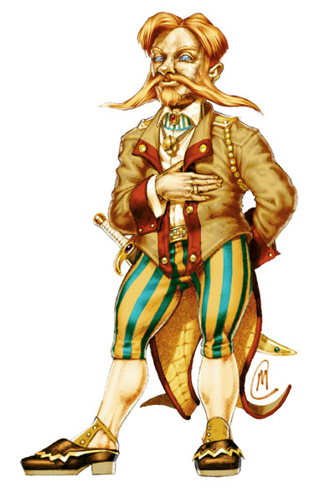

Then there was a young couple—Jaya and Gweniffer—who had just proclaimed their love for one another before Gond, and were about to take the journey to the Land of Purpose, whereupon their lives would be transformed forevermore.

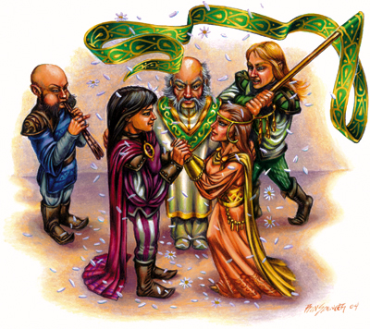

There were a few other participants like Magpie whose names she had not quite caught, but she would try to do so by the end of the night. The Master of Ceremonies for this evening was Deacon Zvim, and although Filip had been there for most of the event so far, an acolyte had summoned him to report to someone, and the man had excused himself and exited via the eastern doors.

After almost 20 ticks [minutes], the wide-eyed gnome returned, smiling. “Ah, this is my favorite part!” he pointed at the rhythmic chiming and clanking of the bronze and brass against one another.

“The nighttime is the right time!” Zvim announced.

The established members of the clergy in the room repeated, as did Gwennifer and a few other guests.

“Woo hoo!”

“Hear that?”

It was starting to get heady in the temple, and though the mood was jolly and altogether gnomey, Magpie just wasn’t feeling it, though she definitely feinted otherwise, shaking those hips and breasts like the lovers next to her.

~*~

Kali murmured as they turned the last bend before reaching the causeway to the temple, “We should be as quiet as possible as we look for evidence of any wrongdoing or what has happened here. Stay away from the main party area. If anyone spots us, act if we were having a good time at the party.”

“So even though we declined earlier,” Wind in His Hair replied, “You’re suggesting we now go inside?”

Kali nodded.

They were now a few hundred feet from the temple’s front doors, and spotted a sole guard out front. It was dark, but it was likely that this was a guard they hadn’t seen during the day. The double doors were open, and light and music both came from the inside of the structure.

Wind in His Hair, Faith, Kali, and Jason approached casually.

~*~

Accompanied by the eclectic and eccentric sounds of everything ranging from a gong to a mechanical cuckoo, the chants and hymns pronounced by the clergy and fanatics began to present a pattern to Magpie, though she couldn’t initially place it.

Magpie wasn’t terribly religious. Well, that was not quite accurate. Magpie wasn’t religious at all. While she believed in the gods, in her mind, the ‘gods’ were just incredibly powerful extraplanar creatures who basked in the adoration of smallminded fools in much the same way as a tribe of kobolds would worship a dragon. It was an unpopular belief to be certain, and one she kept close to her breast.

So, she didn’t pay much attention to religion. She didn’t practice, didn’t seek it out, didn’t give much mind to it in general. However, even with that in mind, Magpie knew there was something wrong with all this. There were Gondar trappings, but this wasn’t a celebration of the Wondermaker, clockwork band aside.

Taking a break from dancing, Magpie leaned against a wall, wiping a bit of sweat from her forehead as she took a full round action and a 4th-level spell slot to cast a Silent, Still, detect thoughts. Using her divination spell, she’d circle the room, trying to pick up surface thoughts that might give her a clue of what’s going on behind the scenes.

During the first few moments, she simply became aware of the confirming fact that there were just under a dozen people present within 60’ of her. Given that the doors were open, this detection extended slightly into the outer courtyard.

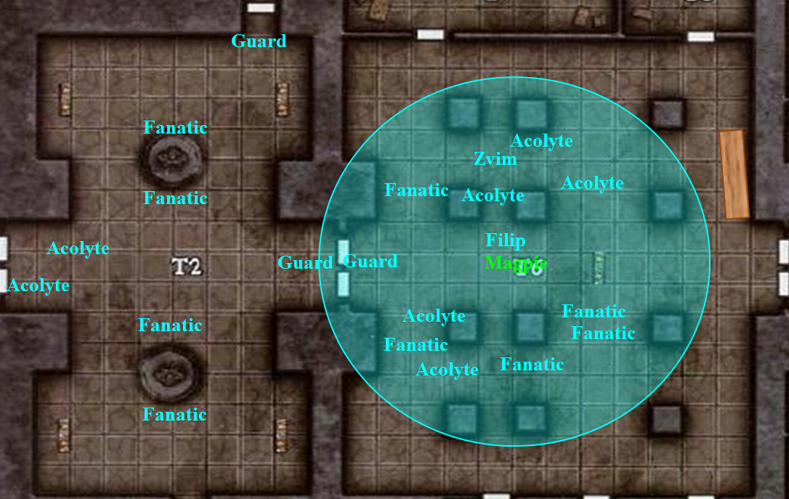

Intelligence of those within effect radius: Fanatics 9, 10, 10, 11, 11; Acolytes 10, 11, 12, 12, 13; Filip 11; Zvim 13.

It was obvious that the guests were now starting to really get into the whole atmosphere, even if she wasn’t, and it seemed that the cacophony around her was causing her to lose concentration.

Magpie, Skill | Rank | Ability & Mod. | Misc. Mods. | Total | Roll | Check
Concentration | 13 | Con (+3) | 0 | 16 | 19 | 35
Success.

Nevertheless, the gnome among gnomes managed to maintain her cool, and began to ascertain the intellectual span of each mind present. She then tried to read the thoughts of the guests, then those of the clergy.

Character | Save vs.  detect thoughts | Ranks | Roll | Save
Fanatic 1 | Will | -1 | 4 | 3
Fanatic 2 | Will | -1 | 9 | 8
Fanatic 3 | Will | -1 | 3 | 2
Fanatic 4 | Will | -1 | 18 | 17
Fanatic 5 | Will | -1 | 7 | 6
Fanatic 6 | Will | -1 | 14 | 13
Acolyte 1 | Will | -1 | 20 | 19
Acolyte 2 | Will | -1 | 19 | 18
Acolyte 3 | Will | -1 | 3 | 2
Acolyte 4 | Will | -1 | 8 | 7
Acolyte 5 | Will | -1 | 12 | 11
Acolyte 6 | Will | -1 | 1 | 0
Filip | Will | -1 | 14 | 13
Deacon Zvim | Will | 5 | 9 | 14
Only Acolyte 1 resists detection.

Other than one bald gnome who rubbed her bald head as if she’d just been struck by a rolling pin, the thoughts of everyone else were easily scried upon. The fanatics were clearly drinking the Kool-Aid, as they said on magicless worlds, but the acolytes had conflicted views on just about everything theological. Her mind then discerned the wills and motives of the clergy, seeing nothing but vileness and greed in their wishes, though the wishes themselves were unclear. Without much effort, she concluded that most if not all of the clergy were objectively evil, as in aligned with demons, devils, or other greater powers. Images of undeath entered her mind as she focused on Filip and Zvim, and it was evident that they were appreciating the flesh of the guests much as a carpenter appreciated the grain of a tree’s bark before it became an instrument of comfort or function for the living.

By the gods! She then saw clearer images of innocent, robe-vested fanatics being pushed into vats and cauldrons of negative energy, only to emerge as ghouls and zombies. She saw dozens of living-dead corpses lining up before a throne-seated overlord too far to recognize, though his horned crown-helmet was distinctive enough if she were to ever glance upon it in the future.

She disconnected and composed her facial expression as Filip approached. She smiled and said, “I missed you,” bumping him with her hip. “Your business went okay? No Gondar emergencies that required your deft touch?”

“Just some decision rules that needed to be implemented into the antikythera machine and the arcane abacus,” the man answered in a purposefully riddling language.

Then it hit her, and it couldn’t have come at a worse time: the realization that this particular movement in the melody—the clanking brass, the cuckooing, and the hooting and hollering in particular—contained fragmented portions of not a few, but several, spells from the Enchantment school. The fragmentedness of each verbal component was further obfuscated by the similarly snuck-in somatic components within the movements of the dance.

The clergy and some of the fanatics were effectively casting spells on the neophytes, who now appeared to be blissfully and wantonly joining in the festivities, even the few that had been on the fringe of hesitation earlier.

The beguiler processed all of this as her facial features reacted to the mention of the two mysterious machines that apparently dwelled deeper inside the temple.

“Sounds... mechanical?” Magpie offered with a shrug.

Magpie knew that the ceremony was either nearly over, or certainly well past introductions and formalities. Everyone inside was either in on this scam or about to be swooped down upon by the scammers. And this was no mere scam; from her visions—and she had little reason to doubt their authenticity—these resurrected souls who had earned their keep in an eternity free from tyranny and oppression were now being diverted to some alternate fate, ultimately becoming the embalmed fodder of necromancers and diabolists.

“Come on, it’s getting hot in here. I need air and I want to talk to you without having to yell over the music.” She took ahold of his sleeve and gave a little tug as she headed west toward the doors and out to the courtyard. She wouldn’t drag him bodily if he resisted, but simply intended to encourage his pursuit.

Unsure of how to interpret the woman’s behavior, the man hesitated, but did not resist her tug and urge.

She intended to get out one way or the other. The beguiler was confident, but not foolish enough to test her force of will against a well laid trap, and didn’t have the sort of adjuration magicks needed to steel herself against the magic. If she could get Filip outside, she could portray herself as someone interested in what was really going on and see about getting deeper into the conspiracy.

The paladin and her crew had preferred to go around without being seen, but already knowing that the temple was built into the face of the steep mountain wall, Faith regretted this impossibility, and thus she resolved to address the guard. “Hello! I am sorry we are late and hoped to slip in without being seen. Can you help us?”

“Hmmm...” the gnomish guard replied. “Our entire guest list for tonight was filled. Are you sure it was for tonight that you told us you would attend?”

Being a paladin of freedom now, Faith had no problem with stone-cold, straight-faced bluffing her way in, or trying to. However, at that moment, Magpie and Filip made their way past a few talkative zealots, and finally reached the outer doors. Then she spotted Faith and company.

A dozen plausible assumptions crossed her mind, most of them involving some development or clue that had urgently led her sortie here, but they looked neither urgently pressed or newly enlightened. She intuited from their nonchalance that she should say what came out of her mouth almost naturally.

“Oh, they’re with me. I forgot to mention it, Branew,” Magpie had remembered the guard’s name.
Skill | Rank | Ability & Mod. | Misc. Mods. | Total | Roll | Check
Magpie, Bluff | 10 | Cha (+0) | 0 | 10 | 20 | 30
Opposed Sense Motive check hidden.

The gnome guard blinked once, then, skipping less than a beat, waved his open hand in a semicircle towards the double doors, and bowed, “Welcome to the Ceremony of Gond’s Sacred Franchise. May you all prosper from the Wondermaker’s infinite ingenuity.”

Now that the others were here, Magpie’s initial plan of posing as a potential conspirator was out the window. The others were terrible liars, plus there was a paladin. No, the others had a pretty specific sort of skill set and subterfuge wasn’t it.

And to top it off, it appeared that Caleb had not come, so they were down one spellcaster.

All in all, this was probably a better resolution. With the others, they could perhaps put a stop to what was happening, whereas she could just get details.

A handful of fanatics that were gathered outside began chanting a soothing melody over the tempo of the gamelans and other clunky, resounding instruments inside. Magpie took the opportunity to draw everyone back into the temple... on account of the chanting.

“Filip, you remember my friends.” Magpie tried to guide the group inside the temple and toward a less populated nook. The beguiler was quite beguiling, and her force of personality and feigned enthusiasm in the grip of Filip’s hand assured that he would follow.

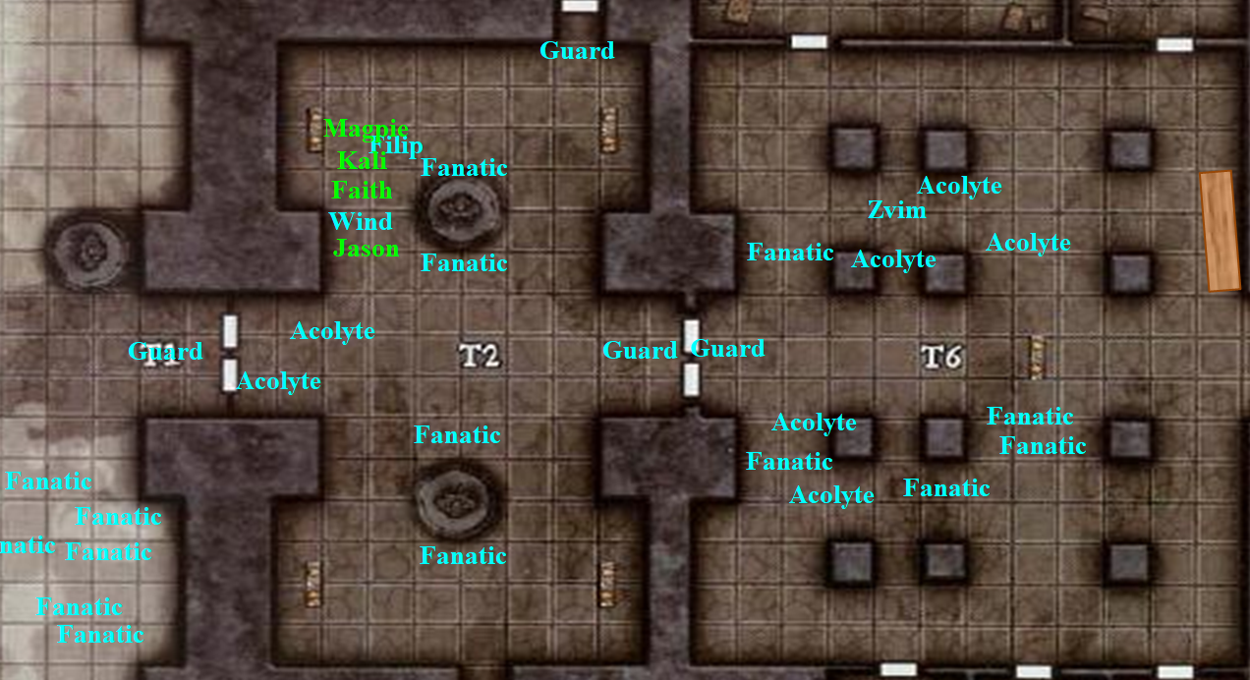

Filip smiled and acted with ample accord and finesse, but he found it peculiar that his lady friend had wanted to urgently to exit the temple until she saw her friends, and then apparently wished to reenter it with the selfsame zeal. Still, he kept cool in the face of the irregularity. At this point, there was no separating him from the woman.

She’d wanted to tell the others that Filip was just about to power up a machine and an abacus that the clergy kept deeper in the temple, and inform them of the enchantment spells woven upon all the guests, probably to make them compliant for when they took them downstairs to turn them into undead abominations.

[DM assumption to follow; please correct if you actually want her to say all of this in front of Filip, giving him time to trigger an alarm with a gesture.] But she could not do so and preserve the element of surprise, so she cast a message spell instead, targeting Kali and informing her of what she knew.

Filip was off guard and busy explaining some bullshit about Gond’s Sacred Franchise when Kali casually gave Jason, Wind in His Hair, and Faith the visual signal.

She added, “Be a dear, and if Filip tries anything other than telling us what the hell is going on here, kill him.” Magpie smiled sweetly at Filip, then flipped the switch on the conversation, her eyebrows no longer raised in a perpetually innocent expression, “So... guy in a horned helmet, sacrifices, perversion and sacrilege. All seems like some weird stuff is going on. You strike me as a pragmatic gnome. Tell me what’s going on here, be detailed, and we’ll let you scurry off while we try to put a stop to it. Maybe we’ll get killed and you can pick right back up where we left off. Probably, we’ll win and you’ll be able to run away escaping the fallout of your cult’s destruction. So, get to talkin’.”

Magpie wasn’t being fully honest. If it were just her, she’d let Filip scamper off. He was a small fish. Wicked, sure, but lots of people were. The real issue was what was going on here. However, there was no way she believed the tall folk would let him go.

Kali, smiled sinisterly as she fingered the hilt of her weapon.

“I will keep watch,” Faith said, not wanting to be part of outright killing someone that would not talk.

Wind in His Hair shifted in his stance, no longer flat-footed, and looked the battlement up above them to count three guards with hand crossbows, and one of them peering very suspiciously at the bewildered look on Filip’s face.

Before Filip could even react, the guard asked, “Acolyte Filip, is all well?”

“Do tell the fine gentleman that everything’s alright, Filip.” Magpie sidled up to the gnome, kissing his cheek as she whispered, “Otherwise, you’re first.”
Magpie, Skill | Rank | Ability & Mod. | Misc. Mods. | Total | Roll
Intimidate | 0 | Cha (+0) | 0 | 0 | 9
See below.

“Heretics!” shouted Filip, brandishing a dagger, but being too slow to attack with it before Jason and Kali reacted.

Round 1

Character | Group | Initiative | Roll | Modified Roll | Move
Jason | 1 | 9 | 20 | 29 | 40’
Kali | 1 | 8 | 11 | 19 | 40’
Guards | 2 | 1 | 17 | 18 | 30’
Zvim/Filip | 2 | 4 | 13 | 17 | 30’
Faith | 1 | 1 | 14 | 15 | 20’
Acolytes | 2 | 0 | 7 | 7 | 30’
Wind in His Hair | 1 | 3 | 3 | 6 | 30’
Fanatics | 2 | 0 | 5 | 5 | 30’
Magpie | 1 | 1 | 2 | 3 | 20’

The guards wasted no time releasing their already loaded and cocked crossbow bolts in the direction of the party. Along with the volley of inward arrows, insults such as “Infidels!”, “Assassins!”, and “Bedamned!” were also hurled at them by guards and acolytes alike. The guard on the ground to their northeast shot first, followed by the one who took up a position directly over their heads before firing at Wind in His Hair.
Character | Attack Type | Damage | BAB | Mod+ | W+ | Other+ | d20 | Total | Targeting
Guard 1 | Hand Crossbow | 1d4 + poison | 2 | 1 | 0 | 0 | 5 | 8 | Magpie
Guard 2 | Hand Crossbow | 1d4 + poison | 2 | 1 | 0 | +2 height | 20 | 25 | Wind in His Hair
Guard 3 | Hand Crossbow | 1d4 + poison | 2 | 1 | 0 | +2 height | 19 | 24 | Jason
Guard 5 | Hand Crossbow | 1d4 + poison | 2 | 1 | 0 | +2 height | 5 | 10 | Jason
Guard 6 | Hand Crossbow | 1d4 + poison | 2 | 1 | 0 | +2 height | 2 | 7 | Jason
Miss, threat (1d20 = 11 + 5 = 16, not a critical hit), miss, miss, miss.
Dmg to Wind in His Hair: 3 + poison.
Save vs.  Poison | Rank | Ability & Mod. | Misc. Mods. | Total | Roll | Check
Wind in His Hair, Fortitude | 9 | Con (+0) | 0 | 9 | 14 | 23
Success. No Dex damage suffered.

Every guard who shot a bolt holstered his or her hand crossbow and prepared to draw a blade.

Three more guards entered the room and got a line of sight on the fingered outsiders, but only two had time to fire and holster their hand crossbows.
Character | Attack Type | Damage | BAB | Mod+ | W+ | Other+ | d20 | Total | Targeting
Guard 4 | Hand Crossbow | 1d4 | 2 | 1 | 0 | 0 | 7 | 10 | Jason
Guard 7 | Hand Crossbow | 1d4 | 2 | 1 | 0 | 0 | 12 | 15 | Wind in His Hair
Miss, miss.

A horn resounded in the next room deeper in the temple—where Magpie had had danced only moments ago—most likely alarming everyone within.

Deacon Zvim spoke in what Magpie thought might have been Abyssal or Infernal. She was disappointed that the party’s linguist—Caleb—had not come with. Magpie then instantly identified one of her own beguiler spells being cast by Zvim, who was now looking at the party with disappointment. Zvim cast mass whelm upon the heroes, adding after the verbal component, “You are hereby banished from this house of worship, and you will suck at everything you do from this moment on,” he exaggerated.
Save vs.  mass whelm | Rank | Ability & Mod. | Misc. Mods. | Total | Roll | Check | Notes
Faith, Will | 5 | Wis (+3) | 7 | 15 | 13 | 28 | True Believer bonus +2 when invoked
Jason, Will | 3 | Wis (+2) | 1 | 6 | 2 | 8
Kali, Will | 6 | Wis (+0) | 1 | 7 | 13 | 20 | +2 vs. Enchantments, +3 vs. Mind-Affecting
Magpie, Will | 7 | Wis (+2) | 2 | 11 | 18 | 29
WiHH, Will | 6 | Wis (+3) | 0 | 9 | 18 | 27 | +2 vs. Enchantments
Success, fail, success, success, success.
Dmg to Jason: 27 nonlethal [39/66].

“By Gond’s Sacred Franchise!” some repeated amidst the combat.

Filip jabbed at dagger at Magpie, saying, “I knew a harlot like you couldn’t be trusted. Now you will be an example to the faithful!” And as he did so, he cast blade of blood and delivered a bit more damage upon impact.
Character | Attack Type | Damage | BAB | Mod+ | W+ | Other+ | d20 | Total
Acolyte Filip | Dagger | 1d4 + poison |  | 0 | 0 | 0 | 7 | 7
Miss.

And though he missed and his spell was wasted, Magpie noted the shiny, glossy coating of poison on the adept-duskblade’s dagger.

Following protocol, the lesser acolytes with a line of sight cast scorching ray on the nearest, most easily targeted opponent: Jason.
Character | Attack Type | Damage | BAB | Mod+ | W+ | Other+ | d20 | Total
Acolyte 1 | Ranged Touch Attack | special | 1 | 2 | 0 | 0 | 14 | 17
Acolyte 2 | Ranged Touch Attack | special | 1 | 2 | 0 | 0 | 9 | 12
Acolyte 3 | Ranged Touch Attack | special | 1 | 2 | 0 | 0 | 20 | 23
Miss, miss, threat (1d20 = 14 + 3 = 17, not a critical hit).
Dmg to Jason: 15 fire [24/66].

Wind in His Hair cast barkskin on himself, and stood with his back against the wall, preparing to cast yet another spell.
Wind in His Hair gained +3 to FF AC and AC.

As for the initiates, Magpie regarded them all as fanatics for sure, but she couldn’t be sure if there was any legitimate belief behind what they were doing at the moment, which seemed ambiguous. For the moment, those with simple, white robes posed ambiguous threats at most, seeing as how most of them just seemed motivated to run to a corner and cower. Some, however, joined the guards and clergy in the name calling from behind bronze and brass statues.

Well heck. Magpie had thought Filip to be more pragmatic and less fanatical. She read him wrong. Valuing her own skin more than everything else, Magpie cast greater invisibility and made her way to P14.

Faith drew her greatsword and charged towards Guard 7.

Jason drew his bow and shot an arrow upward towards Guard 2, who used the crenellated battlement to his advantage.
Ranged Weapon | Dmg. | D+ | TH+ | Critical | Rng. | Wt. | Atk | Roll | Check | Notes
Sacred Composite Longbow, Strength +1 | 1d8 | +1 | 1 | x3 | 200’ | 3.0 | +15 | 11 | 21 | -2 height; -4 cover  +1 within 30’
Crystal of Cold Assault, Greater | - | 1d6 |  |  |  |  |  |  |  | -1 to AC 1 round
Hit. Dmg: 7 + 1 + 6 cold = 14. Partial damage negated.

The gravely wounded gnomish guard pulled back and hid behind the crenellation, taking one arrow to the shoulder and another one that entered under his chin and bolted his jaw shut.

Kali drew her longsword and zigzagged her way past her friends and towards Guard 4.

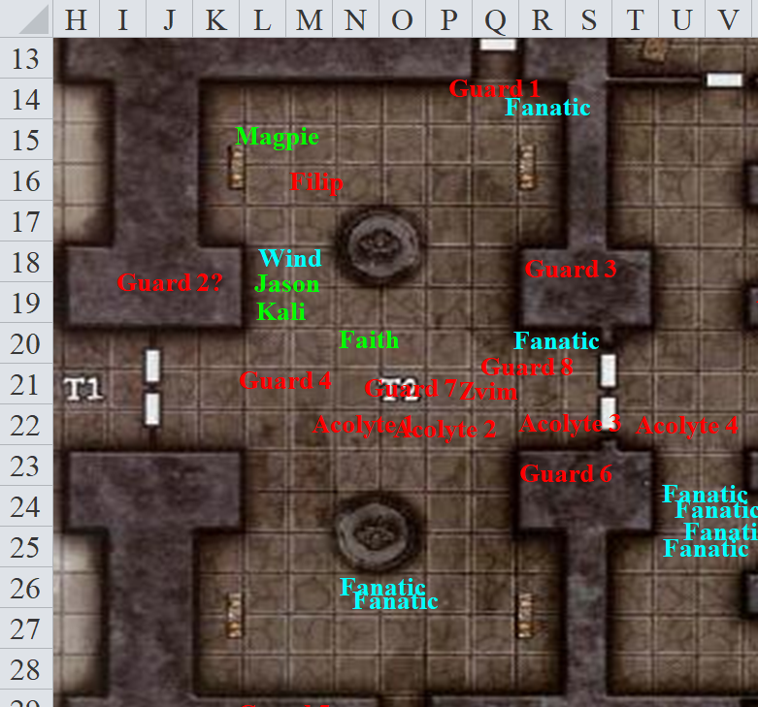

Round 2

Unable to see Guard 2 somewhere up in the battlement, Jason shot three arrows at Guard 1, who now brandished a sword.
Ranged Weapon | Dmg. | D+ | TH+ | Critical | Rng. | Wt. | Atk | Roll | Check | Notes
Sacred Composite Longbow, Strength +1 | 1d8 | +1 | 1 | x3 | 200’ | 3.0 | +15 | 7 | 17 | +1 within 30’
2nd Shot | 1d8 | +1 | 1 |  |  |  | +10 | 14 | 19 | +1 within 30’
3rd Shot, Rapid Firing | 1d8 | +1 | 1 |  |  |  | +15 | 11 | 21 | +1 within 30’
Crystal of Cold Assault, Greater | - | 1d6 |  |  |  |  |  |  |  | -1 to AC 1 round
Miss, hit, hit. Dmg: (1 + 1 + 4 cold) + (6 + 1 + 5 cold) = 9 + 9 cold = 18. Partial damage negated.

Kali full-attacked Guard 4.
Melee Weapon | Dmg | D+ | TH+ | Critical | Type | Wt. | Atk | Roll | Check
Scimitar +2 | 1d6 | 2 | 2 | 18-20, x2 | Slashing | 4.0 | +17 | 13 | 30
2nd Attack | 1d6 | 2 | 2 | 18-20, x2 | Slashing | - | +12 | 8 | 20
Crystal of Electrical Assault, Greater | - | 1d6 | - | - | - | 0.0
Hit, hit. Dmg: (4 + 2 + 5 electric) + (6 + 2 + 1 electric) = 14 + 6 electric = 20.

Guard 4 died before Kali’s blade.

Guard 1 charge-attacked Wind in His Hair.
Character | Attack Type | Damage | BAB | Mod+ | W+ | Other+ | d20 | Total
Guard | Scimitar | 1d6 + poison | 2 | 1 | 0 | 2 charge | 13 | 16
Miss.

Guard 2 remained out of the heroes’ view for the moment.

Guard 3 drank a potion, and drew his sword.

Guard 5 activated a lever that triggered the lowering of a ramp atop which he stood. Before it reached the floor, he jumped off and landed near the two fanatics crouching behind a statue.

Guard 6 made way for this platform, drawing her scimitar.

Guard 7 clashed with Faith, meeting her charge with his own short sword like the fool that he was.
Character | Attack Type | Damage | BAB | Mod+ | W+ | Other+ | d20 | Total
Guard | Scimitar | 1d6 + poison | 2 | 1 | 0 | 0 | 7 | 10
Miss.

Faith parried and full-attacked Guard 7.
Melee Weapon | Dmg | D+ | TH+ | Critical | Type | Wt. | Atk | Roll | Check | Properties
Adamantine Illuminated Holy Greatsword +1 | 2d6+2 | +6 + 1 | 1 + 2 charge | 17-20/x2 | Slashing | 8.0 | +16 | 9 | 25 | +2d6 to evil; ignores 20 hardness
Hit. Dmg: 3 + 6 + 1 + 2 + 7 good = 19.

Guard 7 looked at Faith incredulously, then gurgled a bit of blood, then fell to the floor bleeding to death.

Guard 8 charge-attacked Faith.
Character | Attack Type | Damage | BAB | Mod+ | W+ | Other+ | d20 | Total
Guard | Scimitar | 1d6 + poison | 2 | 1 | 0 | 2 charge | 12 | 17
Miss.

Zvim, seeing full well what these trespassers were resolving to do here, cast hold person on the party’s archer, knowing she would not be likely to affect the paladin.
Save vs.  hold person | Rank | Ability & Mod. | Misc. Mods. | Total | Roll | Check
Jason, Will | 3 | Wis (+2) | 1 | 6 | 4 | 10
Fail.

Jason was held for the moment. Zvim then took the opportunity to study the others as the battle matured.

Filip cast burning hands upon Wind in His Hair.
Save vs.  burning hands | Rank | Ability & Mod. | Misc. Mods. | Total | Roll | Check
Wind in His Hair, Reflex | 6 | Dex (+3) | 0 | 9 | 16 | 25
Success. Dmg: ½ x 13 = 6 fire.

Four junior acolytes rushed Faith and Kali, and three of them got into position and cast burning hands after Filip’s example.
Save vs.  burning hands | Rank | Ability & Mod. | Misc. Mods. | Total | Roll | Check
Kali, Reflex | 6 | Dex (+4) | 1 | 11 | 6 | 17
Faith, Reflex | 2 | Dex (+1) | 7 | 10 | 15 | 25
Faith, Reflex | 2 | Dex (+1) | 7 | 10 | 20 | 30
Success, success, success.
Dmg to Kali: ½ x 12 = 6 fire [91/97].
Dmg to Faith: ½ x (9 + 10) = 9 fire [106/115].

Wind in His Hair cast call lightning [expired on Round 112], and waited for the electrical bolts to manifest in his hands.

Some fanatics escaped; others continued to crouch and hide while hissing insults at the party.

Invisible, Magpie took the opportunity to walk away from Filip after he neatly scorched her barkskinned friend. Zvim was a problem, more so than anyone else in her mind, so she’d teach the weird, little, bald guy a lesson in beguiling. Cloaked in invisibility, she cast feeblemind on the gnome, with a little extra punch because he couldn’t see the spell coming.
Character | Save vs.  feeblemind | Ranks | Roll | Save
Deacon Zvim | Will | +9  – 4 spellcaster target | 18 | 24
Success.

Not only did Zvim shrug off the effects of the spell, but he instantly squinted at Magpie, placing a monocle onto his eye [Swift] and peering at her for a moment.
Character | Check | Ranks | Roll | Save
Deacon Zvim | Spellcraft | 15 | 8 | 23

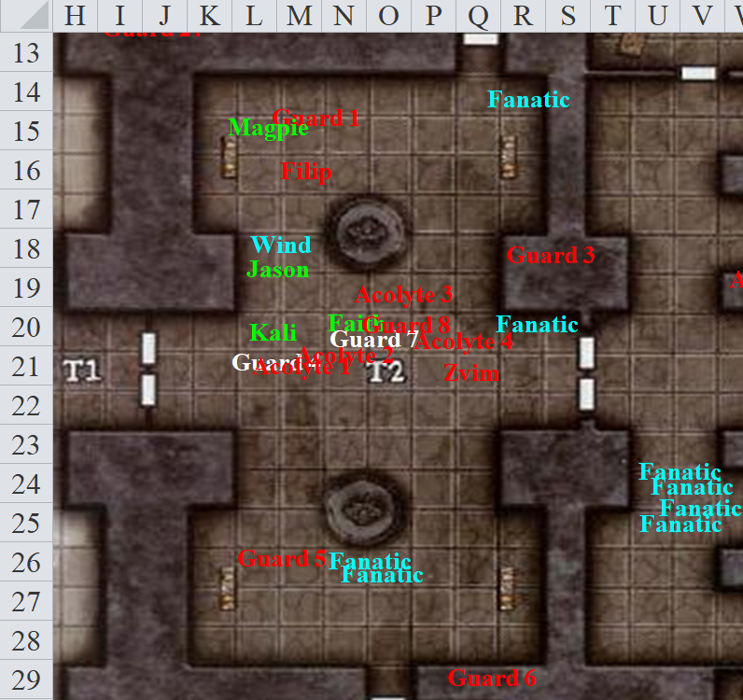

Round 3

Jason saves vs. hold.
Save vs.  hold person | Rank | Ability & Mod. | Misc. Mods. | Total | Roll | Check
Jason, Will | 3 | Wis (+2) | 1 | 6 | 20 | 26
Success.

Jason struggled to break out of whatever held him.

This time, he was able to break free from the charlatan’s spell, and turned to attack Guard 1.
Ranged Weapon | Dmg. | D+ | TH+ | Critical | Rng. | Wt. | Atk | Roll | Check | Notes
Sacred Composite Longbow, Strength +1 | 1d8 | +1 | 1 | x3 | 200’ | 3.0 | +15 | 6 | 21 | +1 within 30’
2nd Shot | 1d8 | +1 | 1 |  |  |  | +10 | 11 | 21 | +1 within 30’
3rd Shot, Rapid Firing | 1d8 | +1 | 1 |  |  |  | +15 | 9 | 24 | +1 within 30’
Crystal of Cold Assault, Greater | - | 1d6 |  |  |  |  |  |  |  | -1 to AC 1 round
Hit, hit, hit. Dmg: (5 + 1 + 1 + 4 cold) + (8 + 1 + 1 + 5 cold) + (1 + 1 + 1 + 3 cold) = 20 + 12 cold = 32 + (-1) to AC. Partial damage negated.

And though the guards’ special armor protected them from all manner of piercing and bludgeoning attacks, Jason’s expert marksmanship targeted the male’s less protected areas, slaying the guard.

Meanwhile, Kali whirlwind attacked Acolytes 1 and 2.
Melee Weapon | Dmg | D+ | TH+ | Critical | Type | Wt. | Atk | Roll | Check
Scimitar +2 | 1d6 | 2 | 2 | 18-20, x2 | Slashing | 4.0 | +17 | 19 | 36
Whirlwind Attack | 1d6 | 2 | 2 | 18-20, x2 | Slashing | - | +17 | 12 | 29
Crystal of Electrical Assault, Greater | - | 1d6 | - | - | - | 0.0
Threat (1d20 = 14 + 17 = 31, critical hit), hit.
Dmg to Acolyte 1: 2 x (6 + 2 + 4 electric) = 16 + 8 electric = 24.
Dmg to Acolyte 2: 1 + 2 + 1 electric = 4.

Acolyte 1 bit the dust, cut up and electrified.

Guard 2 was nowhere to be seen.

The guards continued to attack. Guard 3 threw a flask of acid upon Wind in His Hair.
Character | Attack Type | Damage | BAB | Mod+ | W+ | Other+ | d20 | Total
Guard | Acid Flask | 1d8 acid | 2 | 1 | 0 | 0 | 15 | 18
Hit. Dmg: 8 acid + 1 acid every round for the next 3 rounds.
Dmg to Jason: 1 acid [23/66].

The gnomish guard then moved out of sight.

Guard 5 charge-attacked Kali.
Character | Attack Type | Damage | BAB | Mod+ | W+ | Other+ | d20 | Total
Guard 5 | Scimitar | 1d6 + poison | 2 | 1 | 0 | 2 charge | 10 | 15
Miss.

Guard 6 followed Guard 5 to the lower level via the pulley system to the south.

Guard 8 full-attacked Faith.
Character | Attack Type | Damage | BAB | Mod+ | W+ | Other+ | d20 | Total
Guard 8 | Scimitar | 1d6 + poison | 2 | 1 | 0 | 0 | 12 | 15
Miss.

Magpie could tell that Zvim either had a see invisibility spell going, or maybe an arcane sight, or some similar divining ability. Seeing that the battle wasn’t going very well, he cast greater invisibility upon himself.

Filip withdrew from the conflict and tried fleeing southeastward.

Wind in His Hair fired a lightning bolt at Filip.
Character | Save vs.  call lightning | Ranks | Roll | Save
Senior Acolyte Filip | Will | 6 | 2 | 8
Fail. Dmg: 12 electric.

Though the electricity that coursed through Filip didn’t kill him, it did cause him to curse in the name of his deity. “By Velshar-” he nearly finished pronouncing the name of the Lord of the Forsaken Crypt as he continued his wayward escape.

Magpie’s invisible eyebrows took to the sky. Disciples of Velsharoon posing as Gondar priests? She couldn’t wait to tell Caleb.

The acolytes continued to cast spells or attack.

Acolyte 2 cast burning hands once again upon Kali, while Acolytes 3 and 4 did the same to Faith.
Save vs.  burning hands | Rank | Ability & Mod. | Misc. Mods. | Total | Roll | Check
Kali, Reflex | 6 | Dex (+4) | 1 | 11 | 5 | 16
Faith, Reflex | 2 | Dex (+1) | 7 | 10 | 12 | 22
Faith, Reflex | 2 | Dex (+1) | 7 | 10 | 11 | 21
Success, success, success.
Dmg to Kali: ½ x 7 = 3 fire [88/97].
Dmg to Faith: ½ x (12 + 11) = 11 fire [95/115].

Acolytes 5, 6, and 7 cast cause fear on Faith, Kali, and Jason, but the spellcasters were so weak that they could hardly affect the arch-heroes, particularly Faith. They then drew their slings.

With her first swing, Faith attacked Guard 8.
Melee Weapon | Dmg | D+ | TH+ | Critical | Type | Wt. | Atk | Roll | Check | Properties
Adamantine Illuminated Holy Greatsword +1 | 2d6+2 | +6 + 1 | 1 | 17-20/x2 | Slashing | 8.0 | +16 | 3 | 19 | +2d6 to evil; ignores 20 hardness
Hit. Dmg: 8 + 2 + 6 + 1 + 6 good = 23.

Guard 8 died.

With her second and third swings, the paladin of freedom targeted Acolytes 3 and 4 successively.
Melee Weapon | Dmg | D+ | TH+ | Critical | Type | Wt. | Atk | Roll | Check | Properties
Adamantine Illuminated Holy Greatsword +1, 2nd Attack | 2d6+2 | +6 + 1 | 1 | 17-20/x2 | Slashing |  | +11 | 10 | 21 | +2d6 to evil; ignores 20 hardness
3rd Attack | 2d6+2 | +6 + 1 | 1 | 17-20/x2 | Slashing |  | +6 | 13 | 19 | +2d6 to evil; ignores 20 hardness
Hit, hit.
Dmg to Acolyte 3: (9 + 2 + 6 + 1 + 6 good) = 18 + 6 good = 24.
Dmg to Acolyte 4: (6 + 2 + 6 + 1 + 11 good) = 15 + 11 good = 26.

Both acolytes died.

The rest of the fanatics continued to flee and demoralize heroes.

Invisible, Magpie, being somewhat kinder and gentler than her more moral companions, wanted to try to minimize the deaths of the rank and file gnomes, who could just be deceived. She cast mass whelm, targeting as many folks as she could, including Filip.
Character | Save vs.  mass whelm | Ranks | Roll | Save
Acolyte 2 | Will | -1 | 11 | 10
Guard 5 | Will | 1 | 3 | 4
Senior Acolyte Filip | Will | 6 | 12 | 18
Fanatic | Will | -1 | 10 | 9
Fail, fail, fail.
Dmg to Acolyte 2: 43 nonlethal.
Dmg Guard 5: 35 nonlethal.
Dmg to Filip: 30 nonlethal.

All three fellows passed out immediately.

“I am beguiler; hear me whisper,” Magpie gloated, then moved 10’ further down the wall before preparing to cast see invisibility in order to track down that darn Zvim, whom she also wanted to kill.

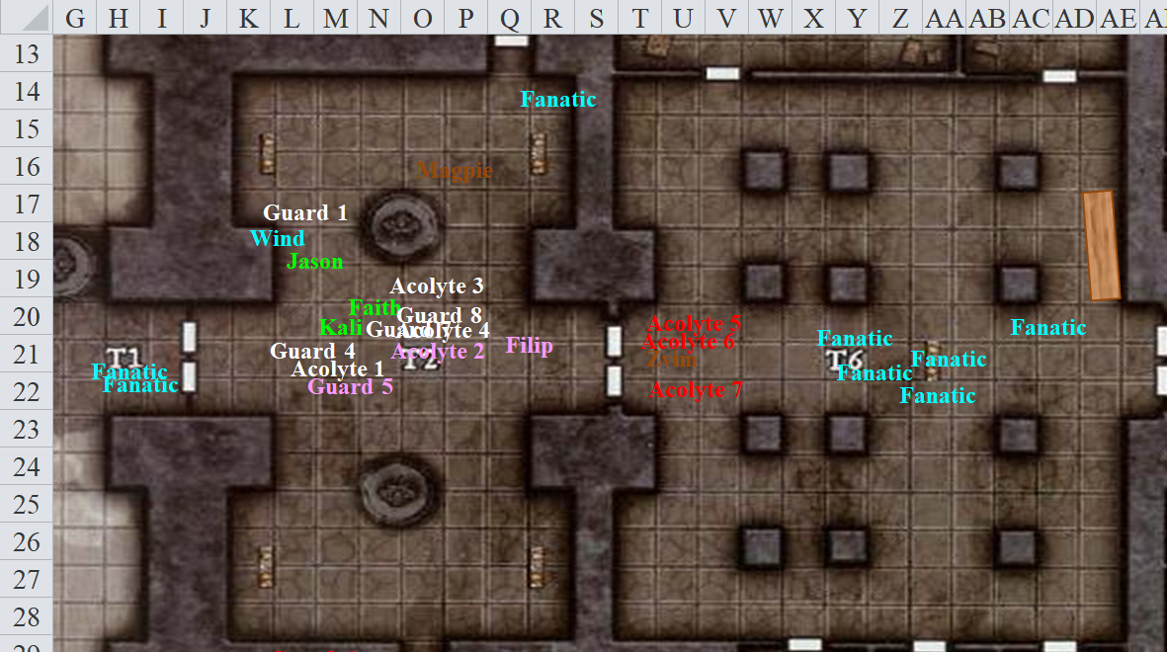

Round 4

Guard 6 stepped off the platform and charge-attacked Kali, jumping over the knocked-out Guard 5 and lunging at the dancer with a scimitar pointed straight at her... a peculiar way to use the slashing weapon.

Zvim escaped eastward and cast major image before reaching the end of the room.

Filip lay face down, as did an acolyte and guard amidst the dead. The sound of a massive gong resounded either in the adjacent room or the one beyond, and Kali could see that the double-doors to the far east had just been opened by a single guard who motioned for fanatics and clergy alike to retreat into this apparent panic room.

The fanatics that were still in the temple escaped eastward along with the acolytes.

Wind in His Hair targeted Guard 6 with his call lightning spell.
Character | Save vs.  call lightning | Ranks | Roll | Save
Guard | Reflex | 1 | 8 | 9
Fail. Dmg: 10 electric.

From around the corner, an ambiguously clad gnome stocked with a plethora of potions and magic items began to cast a spell that none of the heroes could identify based on the verbal and somatic components.

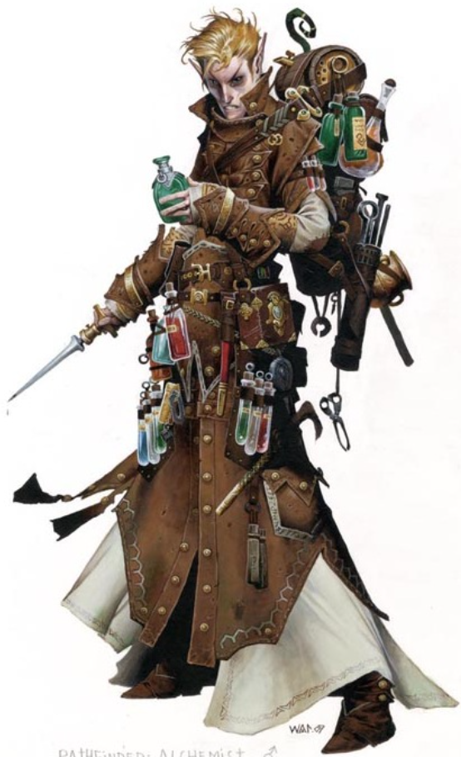

“Try not to kill indiscriminately!” The invisible Magpie called out to her companions. “Many of these worshippers may have simply been beguiled. Zvim is like me!”
It was most likely an abjuration, as no spell effect seemingly followed the casting, though the fellow smirked with satisfaction. Then, a peculiar shift in the angle of the man made the heroes squint. Though the fellow was an illusion cast by quite an able beguiler, none of the five heroes were fooled by the moving, speaking mirage. The druid announced this, in case some of them had not recognized the fake.

With the phantasmal-seeming gnomish fellow who looked very much like a Gondar Techsmith still standing, Magpie wished to test the druid’s theory, hitting him with a targeted dispel, then calling out, “Gond’s temple has been consumed by darkness. Please help us restore it to a place of wonders.”
Ranged Weapon | TH+ | Atk | Roll | Check | Notes
Dispel Magic | 0 | 11 | 14 | 25 | include SEEKER level?
Success.

This was most definitely an illusion, as the image now dissipated, and as Kali reached the spellcaster to attack him, the illusion disappeared altogether.

Then, through the easternmost door that any of them could see, the sole guard ushered in some fanatics before a brass and tin giant emerged through it. Beyond this door, the room was unlit, and though she had a direct line of sight, Kali could see nothing within it.

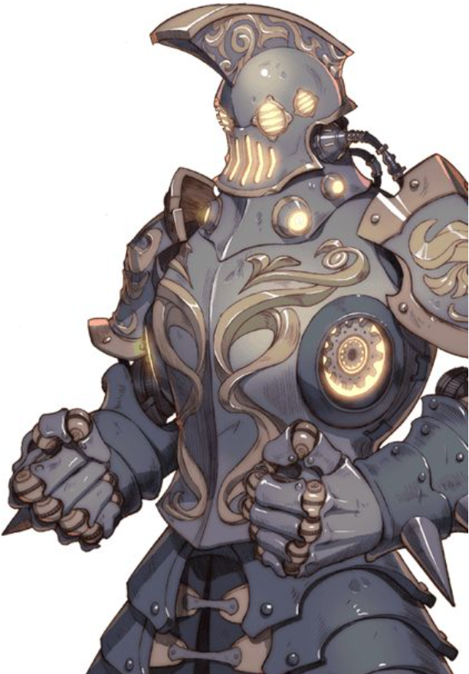

Faith also barely had a line of sight to the golem that was easily twice her height. She recognized it as a gondsman, a specific type of golem with a metallic exterior and a wooden interior that could only be crafted by an expert artificer called a techsmith.

The construct pointed both hands westward upon spotting Kali, and shot two brass missiles at the swordswoman before taking a few more steps forward.
Character | Attack Type | Damage | BAB | Mod+ | W+ | Other+ | d20 | Total
Gondsman | Brass Missiles | 1d4+1 | 3 | 1 | 0 | 0 | 8 | 12
Gondsman | Brass Missiles | 1d4+1 | -2 | 1 | 0 | 0 | 16 | 15
Miss, hit. Dmg: 3 + 1 = 4 [84/97].

Guards 2 and 3 emerged through the door to the northeast and began to charge towards Wind in His Hair and Jason.

Kali reacted to the attacking guard 6, whether he lived or died.
Melee Weapon | Dmg | D+ | TH+ | Critical | Type | Wt. | Atk | Roll | Check
Scimitar +2 | 1d6 | 2 | 2 | 18-20, x2 | Slashing | 4.0 | +17 | 19 | 36
2nd Attack | 1d6 | 2 | 2 | 18-20, x2 | Slashing | - | +12 | 14 | 26
Crystal of Electrical Assault, Greater | - | 1d6 | - | - | - | 0.0
Threat (1d20 = 5 + 17 = 22, critical hit), hit. Dmg: [2 x (4 + 2 + 6 electric)] + (6 + 2 + 1 electric) = 20 + 13 electric = 33.

Jason attacked Guard 3 with his bow, calling out, “Surrender or die!”
Ranged Weapon | Dmg. | D+ | TH+ | Critical | Rng. | Wt. | Atk | Roll | Check | Notes
Sacred Composite Longbow, Strength +1 | 1d8 | +1 | 1 | x3 | 200’ | 3.0 | +15 | 11 | 26 | +1 within 30’
2nd Shot | 1d8 | +1 | 1 |  |  |  | +10 | 10 | 20 | +1 within 30’
3rd Shot, Rapid Firing | 1d8 | +1 | 1 |  |  |  | +15 | 7 | 22 | +1 within 30’
Crystal of Cold Assault, Greater | - | 1d6 |  |  |  |  |  |  |  | -1 to AC 1 round
Hit, hit, hit. Dmg: (8 + 1 + 6 cold) + (4 + 1 + 3 cold) + (7 + 1 + 1 cold) = 9 + 5 + 8 + 10 cold = 32 + (-1) to AC.

Guard 3 died.

Faith, hearing Magpie, agreed and turned her blade now so that the flat hit her opponents, only using its edge to wound if necessary to disable the combatants.

Faith cast rhino’s rush and charge-attacked the construct.
Melee Weapon | Dmg | D+ | TH+ | Critical | Type | Wt. | Atk | Roll | Check | Properties
Adamantine Illuminated Holy Greatsword +1 | 2d6+2 | +6 + 1 | 1 + 2 charge | 17-20/x2 | Slashing | 8.0 | +16 | 6 | 24 | +2d6 to evil
Hit. Dmg: 2 x (9 + 2 + 6 + 1 + 2) = 40. Partial damage negated.

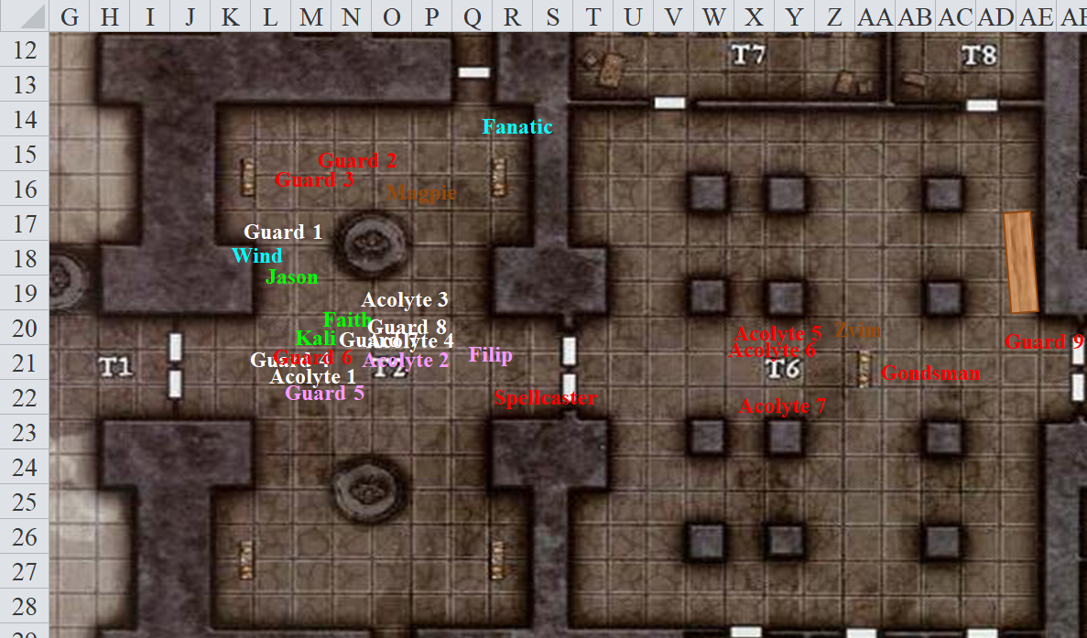

Round 5

Character | Group | Initiative | Roll | Modified Roll | Move
Kali | 1 | 8 | 16 | 24 | 40’
Gondsman | 2 | 1 | 19 | 20 | 30’
Magpie | 1 | 1 | 18 | 19 | 20’
Faith | 1 | 1 | 16 | 17 | 20’
Jason | 1 | 9 | 6 | 15 | 40’
Guards | 2 | 1 | 14 | 15 | 30’
Wind in His Hair | 1 | 3 | 8 | 11 | 30’/var
Deacon Zvim | 2 | 4 | 6 | 10 | 30’
Acolytes | 2 | 0 | 7 | 7 | 30’
Fanatics | 2 | 0 | 5 | 5 | 30’

The gondsman moved another 30’ westward and fired two more brass missiles, then retracted the twin mechanism on its wrists before taking a defensive stance against Faith.
Character | Attack Type | Damage | BAB | Mod+ | W+ | Other+ | d20 | Total
Gondsman | Brass Missiles | 1d4+1 | 3 | 1 | 0 | 0 | 1 | 5
Gondsman | Brass Missiles | 1d4+1 | 3 | 1 | 0 | 0 | 3 | 7
Miss, miss.

[Attack of Opportunity] Faith swung once.
Melee Weapon | Dmg | D+ | TH+ | Critical | Type | Wt. | Atk | Roll | Check | Properties
Adamantine Illuminated Holy Greatsword +1 | 2d6+2 | +6 + 1 | 1 | 17-20/x2 | Slashing | 8.0 | +16 | 14 | 30 | +2d6 to evil
Hit. Dmg: 7 + 2 + 6 + 1 = 16.

The gondsman’s left arm fell off.

Magpie cast see invisibility and [move action].

Kali moved to aid Faith against the construct.
Melee Weapon | Dmg | D+ | TH+ | Critical | Type | Wt. | Atk | Roll | Check
Scimitar +2 | 1d6 | 2 | 2 | 18-20, x2 | Slashing | 4.0 | +17 | 13 | 30
Crystal of Electrical Assault, Greater | - | 1d6 | - | - | - | 0.0
Hit. Dmg: 1 + 2 + 3 electric = 6. All slashing damage negated.

Jason moved 10’ to get a better shot, then tried shooting a single, well-placed arrow at the gondsman to see what would happen, doing his best to avoid hitting his friends.
Ranged Weapon | Dmg. | D+ | TH+ | Critical | Rng. | Wt. | Atk | Roll | Check | Notes
Sacred Composite Longbow, Skirmish | 1d8 | +1 +3d6 | 1 | x3 | 200’ |  | +17 | 9 | 26 | +1 within 30’
Crystal of Cold Assault, Greater | - | 1d6 |  |  |  |  |  |  |  | -1 to AC 1 round
Hit. Dmg: 1 + 1 + 11 skirmish + 4 cold = 17. Piercing damage partly negated.

Seeing that the gondsman was nearly finished, Faith full-flank-attacked the machine.
Melee Weapon | Dmg | D+ | TH+ | Critical | Type | Wt. | Atk | Roll | Check | Properties
Adamantine Illuminated Holy Greatsword +1 | 2d6+2 | +6 + 1 | 1 | 17-20/x2 | Slashing | 8.0 | +16 | 13 | 29 | +2d6 to evil
2nd Attack | 2d6+2 | +6 + 1 | 1 | 17-20/x2 | Slashing |  | +11 | 13 | 24
Hit, hit. Dmg: (10 + 2 + 6 + 1) + (4 + 2 + 6 + 1) = 19 + 13 = 32.

The gondsman fell to the floor, inanimate now.

Guard 2 charge-attacked Wind in His Hair.
Character | Attack Type | Damage | BAB | Mod+ | W+ | Other+ | d20 | Total
Guard 2 | Scimitar | 1d6 + poison | 2 | 1 | 0 | 0 | 15 | 18
Miss.

Guard 6 tried really hard to menace Kali.
Character | Attack Type | Damage | BAB | Mod+ | W+ | Other+ | d20 | Total
Guard 6 | Scimitar | 1d6 + poison | 2 | 1 | 0 | 0 | 20 | 23
Threat. 1d20 = 3 + 3 = 6, not a critical hit. Dmg: 5 + poison [79/97].
Save vs.  Poison | Rank | Ability & Mod. | Misc. Mods. | Total | Roll | Check
Fortitude | 6 | Con (+1) | 1 | 8 | 20 | 28
Success. No ability damage incurred.

Wind in His Hair delivered a call lightning bolt in Guard 2’s direction.
Character | Save vs.  call lightning | Ranks | Roll | Save
Guard 2 | Reflex | 1 | 20 | 21
Success. Saves for ½ damage. Dmg: ½ x 12 = 6 electric.

Deacon Zvim withdrew while he could.

The acolytes escaped eastward, waiting momentarily for Deacon Zvim, and then hurriedly disappearing into the darkness beyond the double doors.

The pious and fervent neophyte that had been crouching in the northeast corner of the outer courtyard now said, “Fragment this!” and bolted out through the door through which Guards 2 and 3 had just entered. These were the same guards that were up above them in the battlement, so it only stood to reason that at least one potential destination for this fanatic was the battlement. Magpie kept an invisible eye above.

The other fanatics were nowhere in sight.

With every fanatic and clergyperson safely inside now, Guard 9 also stepped back through the threshold and closed the double-doors.

LOST ROUND 5 MAP AFTER REPLACING WITH ROUND 6 POSITIONS, SORRY

Round 6

With a brief line of effect to Zvim, and true to her convictions, which were just as strong as Faith’s, simply different, the female beguiler positioned herself on the other side of the statue and cast another mass whelm, targeting all enemies within 50’ of her, including already unconscious targets. This was a temple. There was likely easy access to magical healing. Piling on nonlethal would help keep people down without making them dead.
Character | Save vs.  mass whelm | Ranks | Roll | Save
Acolyte 2 | Will | -1 | 15 | 14
Guard 2 | Will | 1 | 6 | 7
Fanatic | Will | -1 | 13 | 12
Senior Acolyte Filip | Will | 6 | 12 | 18
All saves fail. Dmg to each enemy: 30 nonlethal.

Magpie then went over her tally of already expended slots today.
Beguiler Spells
Daily Slots | SF | Level | DC | Cast?
6 | 2 | 0 | 17 | 1
7 | 2 | 1 | 18 | 0
7 | 2 | 2 | 19 | 2
7 | 2 | 3 | 20 | 1
7 | 2 | 4 | 21 | 3
4 | 2 | 5 | 22 | 1

Jason called to Magpie, “Do you have a spell that can reveal the leader to us?”

Having recently cast see invisibility, Magpie continued to try to pursue Zvim as she called back to Jason, “I do. It’s easy if I can see him, but he’s retreating further into the temple and I don’t have a clear line to him. He could do the same back to me, just so you know.”

Wind in His Hair moved south to get a better view of the incoming construct that had just bombarded Kali and saw that the golem-like foe had been reduced to a pile of junk by the paladin and the others. Having used 3 of his call lightning bolts, he counted 7 left in his hand.

With the double doors closed now, Deacon Zvim, led his surviving acolytes and newbies to safety.

Kali _____.

Faith _____.

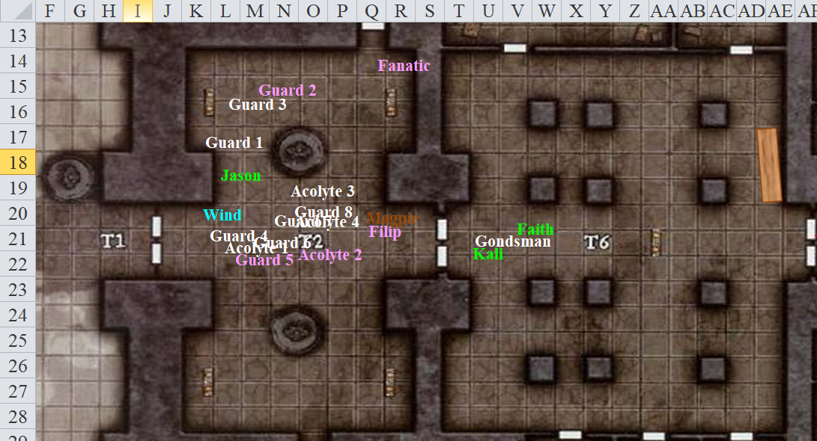

Round 7

Having hoped to cast glitterdust on the fleeing villain before he could make his getaway, Magpie was glad to have at least rendered a handful of his minions unconscious so that they might be interrogated later.

Wind in His Hair cast cure critical wounds on Jason.
Jason healed 18 + 11 = 29 hps [52/66].

Ever the tactician, Faith gauged the level of damage that her friends had sustained.
Character | TAC | FFAC | AC | Melee | Ranged | Fire | Acid | Nonlethal | Total Damage | Healing | HPs | Current HPs
Jason | 15 | 20 | 25 |  |  | 15 | 1 | 27 | 43 | 29 | 66 | 52
Kali | 13 | 24 | 27 | 5 | 4 | 9 |  |  | 18 |  | 97 | 79
Faith | 11 | 24 | 25 |  |  | 20 |  |  | 20 |  | 115 | 95
Magpie | 12 | 20 | 21 |  |  |  |  |  | 0 |  | 83 | 83
Wind in His Hair | 13 | 21 | 24 |  | 3 | 6 | 11 |  | 20 |  | 66 | 46

The paladin of freedom then looked around the rooms, and tried to take a measure of the lethal and nonlethal damage they’d dealt the fallen gnomes.
Character | TAC | FFAC | AC | Melee | Ranged | Cold | Electric | Good | Nonlethal | Total Damage | Healing | HPs | Current HPs
Fanatic | 11 | 10 | 11 |  |  |  |  |  | 30 | 30 |  | 7 | -23
Acolyte 1 | 10 | 10 | 10 | 16 |  |  | 8 |  |  | 24 |  | 11 | -13
Acolyte 2 | 10 | 10 | 10 | 3 |  |  | 1 |  | 73 | 77 |  | 12 | -65
Acolyte 3 | 10 | 10 | 10 | 18 |  |  |  | 6 |  | 24 |  | 13 | -11
Acolyte 4 | 10 | 10 | 10 | 15 |  |  |  | 11 |  | 26 |  | 14 | -12
Guard 1 | 12 | 16 | 18 |  | 7 | 21 |  |  |  | 28 |  | 19 | -9
Guard 2 | 12 | 16 | 18 |  | 3 | 6 | 6 |  | 30 | 45 | 8 | 19 | -18
Guard 3 | 12 | 16 | 18 |  | 12 | 10 |  |  |  | 22 |  | 19 | -3
Guard 4 | 12 | 16 | 18 | 14 |  |  | 6 |  |  | 20 |  | 19 | -1
Guard 5 | 12 | 16 | 18 |  |  |  |  |  | 35 | 35 |  | 19 | -16
Guard 6 | 12 | 16 | 18 | 20 |  |  | 23 |  |  | 43 |  | 19 | -24
Guard 7 | 12 | 16 | 18 | 12 |  |  |  | 7 |  | 19 |  | 19 | 0
Guard 8 | 12 | 16 | 18 | 17 |  |  |  | 6 |  | 23 |  | 19 | -4
Gondsman | 11 | 23 | 24 | 68 | 8 | 4 | 15 |  |  | 95 |  | 76 | -19
Senior Acolyte Filip | 12 | 13 | 15 |  |  |  | 12 |  | 60 | 72 |  | 28 | -44

Jason and Kali took a look in all directions to make sure no one was coming to attack them.

Rounds 8 – 13

“There may be three or four that can be healed to a conscious state. Maybe we can get some information from them,” Kali suggested as she began searching the ones that were obviously beyond healing. Wind in His Hair helped.

Jason moved to the easternmost door to see if it could be opened, but it did not budge.

The druid and fighter arranged the guards’ and acolytes’ bodies according to their class and condition, and Kali noted the uniformity of their piercing- and bludgeoning-proof armor. It was the work of Gondar smiths for sure, but these gnomes weren’t perfectly fitted for any of the suits they wore; they’d been confiscated—most likely from the rightful guards of this temple—and donned by these impostors.

At first glance, before Kali even bent down to search anyone, the fanatic looked to be wearing nothing but his initiate’s robes, and appeared to have nothing on him. The four junior acolytes carried only mundane quarterstaffs.

Each of the eight guards guard was armed with a poisoned scimitar and a hand crossbow (each had 9 bolts left, none poisoned) and except for Guard 2, who had just drunk his after Jason had shot him in the eye, each of them had a potion of cure light wounds [CL 5].

And lastly, Filip was armed with a poisoned dagger. His vestments were the most elaborate out of those who’d been whelmed or killed, and Kali suspected that she would be most likely to find something on this particular fellow.

Rounds 14 – 25

Reaching into the hefty pouch on her side, Magpie pulled out so much rope: like two fifty-foot coils of rough hemp rope. “Let’s securely bind the survivors. I know Filip is wicked, but I don’t know about the others. While at the party, I started reading people’s minds. Filip and Zvim were openly thinking about turning worshippers into undead monstrosities. There was also a dark figure on a throne wearing a horned... You know, there’s an easier way to explain this.” She cast minor image, showing the party exactly what she’d seen peeking into minds this evening, so they understood why she was intent on dealing with this.

Before them, Magpie projected the reproduced images of innocent, robe-vested fanatics being pushed into vats and cauldrons of negative energy, only to emerge as ghouls and zombies. Dozens of living-dead corpses lined up before a throne-seated overlord too far to recognize, though his horned crown-helmet was distinctive enough if they were to ever glance upon it in the future.

[IC reactions]

With the bodies laid out and bound, they were now ready to search each one. The acolytes and fanatic were sure to have nothing else on them, as their garments had no pockets.

“Should we bother to take off their armor?” asked Wind in His Hair, wondering if they could be stashing gems in their gonad protectors.

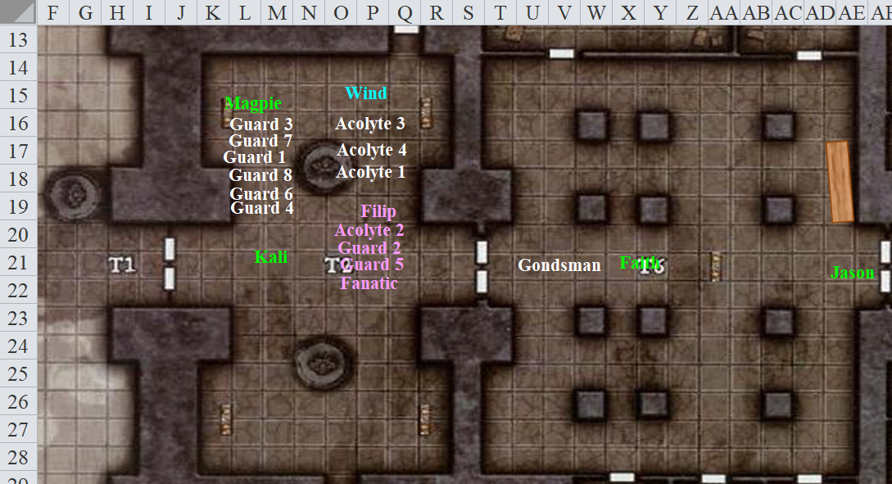

Caleb, having heard the alarms, made his way to the temple, correctly suspecting that Magpie had somehow caused a row. He had lingered nearby, and had now cleared the last bend. He jogged at a hustled pace, slowing down as he got to within 100’ of the main gates. At this distance, he could see and recognize Kali standing just inside the doorway, though she could not see him in the dark outside as he approached. Then the cleric-wizard spotted a robed woman in the cabin just south of the main temple.

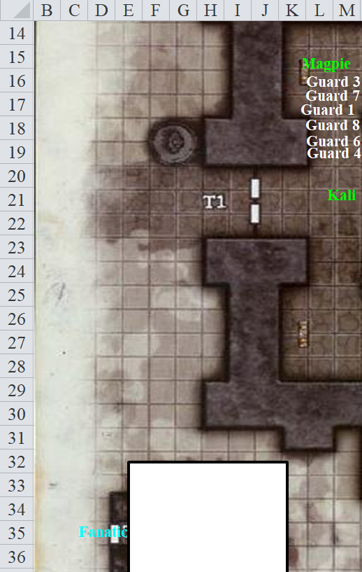

Rounds 26 – 30

Caleb waved to the robed woman, calling over to her, “Don’t worry. I’ll see what’s going on! Stay safe and if you need help, just yell.” Then he continued to head toward the temple, jogging lightly. Sure, he could run, but running was, like, really tiring and he didn’t know exactly what he was heading toward.

“I’d argue that our actions will look unseemly enough to the gnome community without us stripping the dead. Even if we’re working toward a greater good, we’ve attacked a Gondar temple. Leave the dead some dignity.” Magpie, the professional thief, suggested as she left the bodies and made her way eastward. Admittedly, she wasn’t a thief who was motivated by wealth, but still.

Faith shifted in her stance and blinked as she faced Magpie, visibly impressed by the display of sensitivity, wondering for an instant if the beguiler had been the victim of possession after all.

Magpie began to examine the eastern door for some catch or trick that would open it. “Gondar priests are clever. There will be secrets and mechanical widgets, as well as traps. If we can’t open this door, there will likely be a secret passage somewhere.”

Sure enough, there was an ornate lock, and if she had to guess, an arcane lock within the mundane mechanism.

Caleb arrived at the front gates, taking a last look southward and noting a male gnome’s head poking out of the cabin door before disappearing back in, along with the robed woman. So there were at least two fanatics in there.

Those to the far east—Jason and Faith best of all—could hear nothing as they listened for any movement past the double doors that impeded passage beyond. Tunaster’s map, which Magpie produced and handed to Caleb, showed nothing beyond those doors, suggesting that even Tunaster had never been in the inner cloisters of this temple, a privilege not usually reserved for a mid-level priest from another chapter.

The group coalesced inside as they discussed the issues of these doors and of the fanatics that would, no doubt, come soon from the cabin and futilely attack the heroes in supposed defense for the temple.

Jason and Kali used one of the healing potions that were found on the bodies.
Jason healed 8 + 5 = 13 hps [65/66].
Kali healed 2 + 5 = 7 hps [86/97].

Not yet up to her full health, Kali imbibed a second vial as Wind in His Hair saw a gash on Jason’s neck and gently tapped it with a cure minor wounds spell.
Kali healed 7 + 5 = 12 hps [97/97].
Jason healed 1 hp [66/66].

The half-elf druid then mentioned—for tactical purposes—the spells he had and hadn’t cast.

Prepared Spells
Spell | Level | DC | Cast?
Create Water | 0 | 13 | ◻
Cure Minor Wounds | 0 | 13 | ☑
Detect Magic | 0 | 13 | ◻
Know Direction | 0 | 13 | ◻
Light | 0 | 13 | ◻
Mending | 0 | 13 | ◻
Cure Light Wounds | 1 | 14 | ◻
Entangle | 1 | 14 | ◻
Calm Animals | 1 | 14 | ◻
Charm Animal | 1 | 14 | ◻
Summon Nature’s Ally I | 1 | 14 | ◻
Barkskin | 2 | 15 | ☑
Bear’s Endurance | 2 | 15 | ☑
Heat Metal | 2 | 15 | ◻
Restoration, Lesser | 2 | 15 | ◻
Summon Nature’s Ally II | 2 | 15 | ◻
Call Lightning | 3 | 16 | ☑
Sleet Storm | 3 | 16 | ◻
Remove Disease | 3 | 16 | ◻
Summon Nature’s Ally III | 3 | 16 | ◻
Dispel Magic | 4 | 17 | ◻
Summon Ally IV | 4 | 17 | ◻
Cure Critical Wounds | 5 | 18 | ☑

Wind in His Hair then suggested checking all of the smaller side doors, looking to Faith and Magpie as the current tactical experts.

Rounds 31 – 33

Jason went to bar the western doors, looking for the right object with which to do it.

“Alrighty,” Magpie, who’d been visible for a while now, clapped her hands together and rubbed them together vigorously. “I might be able to get through this door. Can’t promise, but it’s magically locked, which I should be able to bypass. Why don’t we close and bar the temple doors to keep others from joining the party and instead of getting lost in the maze of side doors, try to go through the front door. The faster we can get into the inner sanctum, the sooner we can stop whatever madness the dark cultists are up to. I know there are undead beyond, so if Faith can be a vanguard and Caleb can be ready to do whatever he does versus undead, that’d be great.”

Placing a hand over her breastplate, Magpie assured the group, “That’s just my opinion. You’re the team. If anyone has a better idea, I’m game.” Without opposition to that plan of action, Magpie resolved to cast greater mirror image on herself, then cast knock on the door to get it open, giving the others a chance to prepare first.

Caleb cleared his throat and offered, “I’ll defer to the rest of you, although I will say if the principals retreated this way instead of through the side entrances, this is a high-risk, yet high-reward strategy. I don’t know enough about Gondar temples to know of any particular quirks we could exploit for a more subtle approach.” With that, he’d wanted to cast greater mage armor on himself, but hadn’t prepared that spell, so he went with heart of earth instead.

He then went over his daily spell list.
Prepared Cleric Spells |  |  |  |  |  | Memorized Diviner Spells
Spell | Level | Divin | DC | Cast? |  | Spell | Level | Divin | DC | Cast?
Cure Minor Wounds | 0 | 0 | 19 | ◻ |  | Amanuensis | 0 | 0 | 19 | ◻
Detect Magic | 0 | 1 | 20 | ◻ |  | Detect Magic | 0 | 1 | 19 | ◻
Detect Magic | 0 | 1 | 20 | ◻ |  | Mage Hand | 0 | 0 | 19 | ◻
Guidance | 0 | 1 | 20 | ◻ |  | Message | 0 | 0 | 19 | ◻
Light | 0 | 0 | 19 | ◻ |  | Prestidigitation | 0 | 0 | 19 | ◻
Purify Food and Drink | 0 | 0 | 19 | ◻ |  | Benign Transposition | 1 | 0 | 20 | ◻
Read Magic | 0 | 0 | 19 | ◻ |  | Comprehend Languages | 1 | 1 | 20 | ◻
Read Magic | 0 | 0 | 19 | ◻ |  | Magic Missile | 1 | 0 | 20 | ◻
Bless | 1 | 0 | 20 | ◻ |  | Orb of Acid, Lesser | 1 | 0 | 20 | ◻
Endure Elements | 1 | 0 | 20 | ◻ |  | Orb of Acid, Lesser | 1 | 0 | 20 | ◻
Longstrider | 1 | 1 | 21 | ◻ |  | Orb of Acid, Lesser | 1 | 0 | 20 | ◻
Resurgence | 1 | 0 | 20 | ◻ |  | Shield | 1 | 0 | 20 | ◻
Shield of Faith | 1 | 0 | 20 | ◻ |  | Allied Footsteps | 2 | 0 | 21 | ◻
Vigor, Lesser | 1 | 0 | 20 | ◻ |  | Glitterdust | 2 | 0 | 21 | ◻
Analyze Portal | 2 | 1 | 22 | ◻ |  | Glitterdust | 2 | 0 | 21 | ◻
Close Wounds | 2 | 0 | 21 | ◻ |  | Rope Trick | 2 | 0 | 21 | ◻
Elation | 2 | 0 | 21 | ◻ |  | See Invisibility | 2 | 1 | 21 | ◻
Silence | 2 | 0 | 21 | ◻ |  | Fireball | 3 | 0 | 22 | ◻
Lesser Restoration | 2 | 0 | 21 | ◻ |  | Heart of Water | 3 | 0 | 22 | ◻
Dispel Magic | 3 | 0 | 22 | ◻ |  | Haste | 3 | 0 | 22 | ◻
Dispel Magic | 3 | 0 | 22 | ◻ |  | Tongues | 3 | 1 | 22 | ◻
 | 3 | 0 | 22 | ◻ |  | Detect Scrying | 4 | 1 | 23 | ◻
Fly | 3 | 0 | 22 | ◻ |  | Evard’s Black Tentacles | 4 | 0 | 23 | ◻
Mass Resist Energy | 3 | 0 | 22 | ◻ |  | Heart of Earth | 4 | 0 | 23 | ☑
Dimension Door | 4 | 0 | 23 | ◻
Neutralize Poison | 4 | 0 | 23 | ◻
 | 4 | 0 | 23 | ◻
Recitation | 4 | 0 | 23 | ◻

Deferring to the wishes of the majority of his traveling companions, Wind in His Hair offered to help Jason to look for an appropriate item to bar the doors, and added, “I also have a heat metal spell, which can soften the bolt that seals the doors to the east and make it really easy for the doors to be busted open.”

Rounds 34 – 37

Wind in His Hair went back to the laid out corpses and unconscious folks, then pocketed the rest of the cure light wounds vials, of which five remained. He drank one, then assessed his state.
Wind in His Hair healed 4 + 5 = 9 hps.

He wasn’t quite up to full health, so he drank a second one.
Wind in His Hair healed 7 + 5 = 12 hps.

“Ah, better,” he sighed, giving a third vial to Faith, who still looked like she needed it.
Faith healed 6 + 5 = 11 hps [106/115].

“Here,” the druid insisted. “You could use another one.”

She thanked him and handed him back the empty vials, which he was keeping for later use.
Faith healed 8 + 5 = 13 hps [115/115].

The paladin then breathed in deep, cracking her healing ribcage, and tilted her neck to the left a bit until her spine was once again aligned properly from head to pelvis.
Character | TAC | FFAC | AC | Melee | Ranged | Fire | Acid | Nonlethal | Total Damage | Healing | HPs | Current HPs
Caleb | 13 | 16 | 19 |  |  |  |  |  | 0 |  | 75 | 75
Jason | 15 | 20 | 25 |  |  | 15 | 1 | 27 | 43 | 43 | 66 | 66
Kali | 13 | 24 | 27 | 5 | 4 | 9 |  |  | 18 | 18 | 97 | 97
Faith | 11 | 24 | 25 |  |  | 20 |  |  | 20 | 20 | 115 | 115
Magpie | 12 | 20 | 21 |  |  |  |  |  | 0 |  | 83 | 83
Wind in His Hair | 13 | 21 | 24 |  | 3 | 6 | 11 |  | 20 | 20 | 88 | 88

They had taken some damage, but were once again—thanks to the aid of magic—in perfect shape.

Jason had closed the outer doors, and used a longsword previously in the possession of Guard 6 to bar the doors from the inside.

“Ready then?” said the still invisible Magpie along with her 3 + 3 + 1 + 1 = 8 figments. “Right then.”

The then cast the knock spell with a fairly simple verbal gesture, and the doors made a clanking sound, as expected.

The lock was undone. A gnomish voice came from the other side, and Magpie recognized it as the verbal component of a Conjuration.

Then the doors creaked open a few inches.

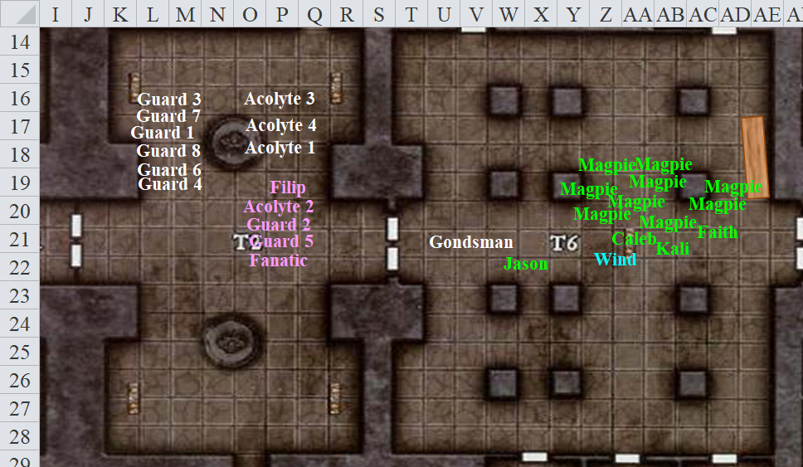

Round 38

Jason readied an arrow, aiming at the growing opening in the door. He thought to himself, any magic user would be the first to feel his sting.

Faith readied her sword as she stood to the right of the opening.

Kali had both swords as she patiently waited on the left.

Then, the doors swung open outward, and a pair of gnome zombies—one a naked male and the other a robed female—emerged through the door and rushed Faith and Kali, though they were too slow to attack them.

Faith and a few others could see a handful of additional gnome zombies coming out of the room, and three guards that now shot green-glowing bolts towards Kali.
Character | Attack Type | Damage | BAB | Mod+ | W+ | Other+ | d20 | Total
Guard 9 | QR Hand Crossbow | 1d4 + poison | 2 | 1 | 0 | 0 | 3 | 6
Guard 10 | QR Hand Crossbow | 1d4 + poison | 2 | 1 | 0 | 0 | 18 | 21
Guard 11 | QR Hand Crossbow | 1d4 + poison | 2 | 1 | 0 | 0 | 14 | 17
Miss, miss, miss.

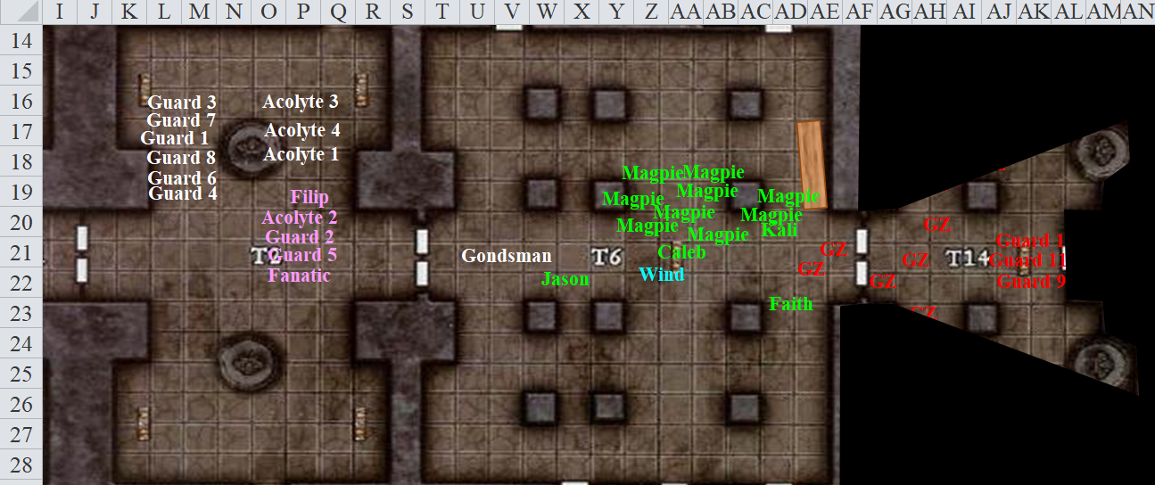

[The real Magpie is in AA20.]

Round 39

Character | Group | Initiative | Roll | Modified Roll | Move
Jason | 1 | 9 | 20 | 29 | 40’
Kali | 1 | 8 | 15 | 23 | 40’
Faith | 1 | 1 | 19 | 20 | 20’
Gnome Zombies | 2 | 0 | 17 | 17 | 30’
Caleb | 1 | 3 | 11 | 14 | 30’
Wind in His Hair | 1 | 3 | 9 | 12 | 30’/var
Guards | 2 | 1 | 7 | 8 | 30’
Magpie | 1 | 1 | 6 | 7 | 20’

Jason, seeing the guards, immediately let loose on the centermost.
Ranged Weapon | Dmg. | D+ | TH+ | Critical | Rng. | Wt. | Atk | Roll | Check | Notes
Sacred Composite Longbow, Strength +1 | 1d8 | +1 | 1 | x3 | 200’ | 3.0 | +13 | 16 | 29
2nd Shot | 1d8 | +1 | 1 |  |  |  | +8 | 15 | 23
3rd Shot, Rapid Firing | 1d8 | +1 | 1 |  |  |  | +13 | 6 | 19
Crystal of Cold Assault, Greater | - | 1d6 |  |  |  |  |  |  |  | -1 to AC 1 round
Hit, hit, hit. Dmg: (5 + 1 + 1 cold) + (6 + 1 + 4 cold) + (1 + 1 + 3 cold) = 15 + 5 cold = 20.

Guard 11 was nearly dead, but not quite there yet.

Kali took a 5’ step and full-attacked the zombie heading in her direction.
Melee Weapon | Dmg | D+ | TH+ | Critical | Type | Wt. | Atk | Roll | Check
Scimitar +2 | 1d6 | 2 | 2 | 18-20, x2 | Slashing | 4.0 | +15 | 1 | 16
2nd Attack | 1d6 | 2 | 2 | 18-20, x2 | Slashing | - | +10 | 15 | 25
Crystal of Electrical Assault, Greater | - | 1d6 | - | - | - | 0.0
Hit, hit.

Kali’s blade went straight through the gnomish zombie with no effect. “It’s an illusion!” she gasped.

Faith pulled out her holy symbol and attempted to turn the zombies, but it appeared that nothing happened. This was highly unusual for such petty undead. She, too, then realized that these were not real zombies, though it appeared that the guards behind them were real enough.

The illusory gnome zombies attacked Faith and Kali, their slams and claw attacks going right through them as the heroes ignored the figments now. Other zombies came into view from both the north and south.

Caleb didn’t see anything that was all that exciting just yet and was terrible at turning undead, so he hung back and readied an action to counterspell, should a magical hazard appear.

Wind in His Hair used a call lightning bolt on Guard 9.
Character | Save vs.  call lightning | Ranks | Roll | Save
Guard | Reflex | 1 | 9 | 10
Fail. Dmg: 14 electric.

Guard 9 was almost dead.

The guards were benefitting from the quick-reload gems affixed to their hand-crossbows. Guard 10 closed the single door behind them, and all three fired at the Magpies.
Character | Attack Type | Damage | BAB | Mod+ | W+ | Other+ | d20 | Total
Guard | QR Hand Crossbow | 1d4 + poison | 2 | 1 | 0 | 0 | 18 | 21
Guard | QR Hand Crossbow | 1d4 + poison | 2 | 1 | 0 | 0 | 17 | 20
Guard | QR Hand Crossbow | 1d4 + poison | 2 | 1 | 0 | 0 | 12 | 15
Hit, hit, hit. 3 figments disappeared.

The flock of Magpies headed into the room, ducking around zombies, trusting her invisibility and mirror images to keep her safe.

As she entered the dark room, the beguiler’s eyes adjusted, and Magpie recognized that the three guards were warded by nightshield spells, the signature auras of which glowed every so faintly in violet and orange. The expert spellcaster knew this meant that Caleb’s magic missiles would be useless against them, and thought to warn her fellow spellcaster, but then figured she’d just take these guys out of commission. She took all three guards within the conic burst of a whelming blast.
Character | Save vs.  whelming blast | Ranks | Roll | Save
Guard | Will | 1 | 9 | 10
Guard | Will | 1 | 6 | 7
Guard | Will | 1 | 15 | 16
Fail, fail, fail.
Dmg to each guard: 19 nonlethal.

One of Magpie’s figments manifested once again.

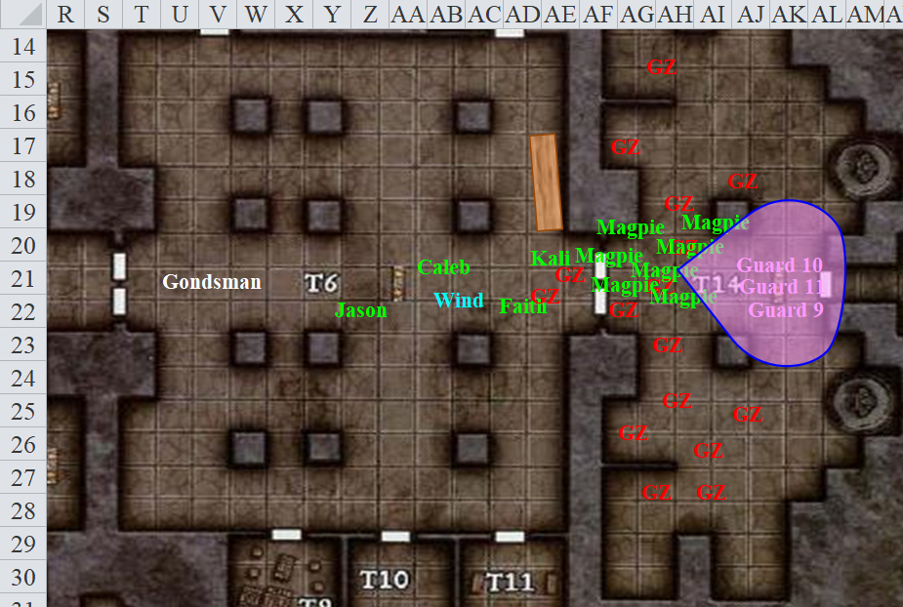

Round 40

Jason, seeing his first target almost dead, fired upon the second one, who had just fallen to the ground on account of Magpie’s whelming blast.
Ranged Weapon | Dmg. | D+ | TH+ | Critical | Rng. | Wt. | Atk | Roll | Check | Notes
Sacred Composite Longbow, Strength +1 | 1d8 | +1 | 1 | x3 | 200’ | 3.0 | +13 | 12 | 25
2nd Shot | 1d8 | +1 | 1 |  |  |  | +8 | 10 | 18
3rd Shot, Rapid Firing | 1d8 | +1 | 1 |  |  |  | +13 | 15 | 28
Crystal of Cold Assault, Greater | - | 1d6 |  |  |  |  |  |  |  | -1 to AC 1 round
Hit, hit, hit. Minimum damage killed Guard 11.

The gnome zombies were swarming all around Faith and Kali, which mostly just dazzled them a bit. The dancer slashed at the unconscious guard on the right for good measure.
Melee Weapon | Dmg | D+ | TH+ | Critical | Type | Wt. | Atk | Roll | Check
Scimitar +2 | 1d6 | 2 | 2 | 18-20, x2 | Slashing | 4.0 | +15 | 4 | 19
Crystal of Electrical Assault, Greater | - | 1d6 | - | - | - | 0.0
Hit, miss. Dmg: 3 + 2 + 1 electric = 6.

Guard 10 bled.

Faith also charged forward through the illusory zombies to finish off the unconscious guard on the left, whom Wind in His Hair had just electrocuted and Magpie had just whelmed.
Melee Weapon | Dmg | D+ | TH+ | Critical | Type | Wt. | Atk | Roll | Check | Properties
Adamantine Illuminated Holy Greatsword +1 | 2d6+2 | +6 + 1 | 1 + 2 charge | 17-20/x2 | Slashing | 8.0 | +16 | 13 | 29 | +2d6 to evil; ignores 20 hardness
Hit. Dmg: 10 + 2 + 6 + 1 + 2 charge + 8 vs. evil = 29.

Guard 9’s head rolled a few inches away from the rest of his body.

Two zombies swiped at Caleb and Wind in His Hair, doing nothing but muddling their view for a moment.

Wind in His Hair saw that the guards were being cut down without effort, and the zombies weren’t even real, so he stayed his hand for the moment.

The guards were passed out or dead by now, and lay on the ground in front of the single door.

Then, one of the zombies—apparently not an illusionist’s figment but a necromancer’s conjuring—slashed at the unsuspecting paladin of freedom.
Character | Attack Type | Damage | BAB | Mod+ | W+ | Other+ | d20 | Total
Gnome Zombie | Slam | 1d4-1 | 1 | 0 | 0 | 0 | 9 | 10
Miss.

The zombie’s fist clanked against the paladin’s ironclad buttock.

“My word!” Faith proclaimed. “Some of these are real!”

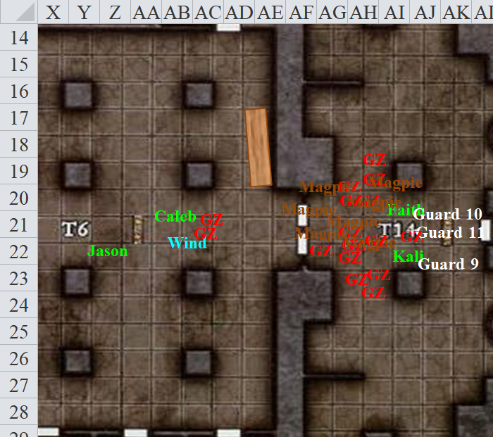

Round 41

Four actual gnome zombies attacked the heroes as the rest of them swiped away at the air.
Character | Attack Type | Damage | BAB | Mod+ | W+ | Other+ | d20 | Total
Gnome Zombie | Slam | 1d4-1 | 1 | 0 | 0 | 0 | 16 | 17
Gnome Zombie | Slam | 1d4-1 | 1 | 0 | 0 | 0 | 6 | 7
Gnome Zombie | Slam | 1d4-1 | 1 | 0 | 0 | 0 | 14 | 15
Gnome Zombie | Slam | 1d4-1 | 1 | 0 | 0 | 0 | 19 | 20
Miss, miss, miss, miss.

It became clear exactly which quartet of zombies was real, not just by the smell and look of the desiccated flesh, but by their far more realistic groans. The illusory ones had a complement of blue varicose veins across their faces and arms that, while dramatic and scary, made them look less realistic, and on top of that, they occasionally mumbled, “Brains…” which seemed rather uncouth to Magpie and company.

Wind in His Hair zapped one of the zombies with a call lightning bolt.
Character | Save vs.  call lightning | Ranks | Roll | Save
Gnome Zombie | Reflex | 0 | 3 | 3
Fail. Dmg: 11 electric.

Magpie gained a replacement image and called to the others, “The zombies, real and not, are distractions intended to slow us down. They can’t get through the gate without distraction, so let’s press on. We can clean them up after we-”

Before Magpie could finish, Faith cut the undead down anyway, taking a single swipe at the ones that Wind in His Hair didn’t zap.
Melee Weapon | Dmg | D+ | TH+ | Critical | Type | Wt. | Atk | Roll | Check | Properties
Adamantine Illuminated Holy Greatsword +1 | 2d6+2 | +6 + 1 | 1 | 17-20/x2 | Slashing | 8.0 | +16 | 4 | 20 | +2d6 to evil
2nd Attack | 2d6+2 | +6 + 1 | 1 | 17-20/x2 | Slashing |  | +11 | 19 | 30
3rd Attack | 2d6+2 | +6 + 1 | 1 | 17-20/x2 | Slashing |  | +6 | 15 | 21
Hit, threat (1d20 = 13 + 11 = 24, critical hit), hit.
Dmg to zombie 2: 7 + 2 + 6 + 1 + 6 good = 22.
Dmg to zombie 3: 5 + 2 + 6 + 1 + 5 good = 19.
Dmg to zombie 4: 6 + 2 + 6 + 1 + 8 good = 23.

And all three went down.

Before Jason could expend another arrow Kali swung at the one that Wind in His Hair had nearly killed.
Melee Weapon | Dmg | D+ | TH+ | Critical | Type | Wt. | Atk | Roll | Check
Scimitar +2 | 1d6 | 2 | 2 | 18-20, x2 | Slashing | 4.0 | +15 | 9 | 24
2nd Attack | 1d6 | 2 | 2 | 18-20, x2 | Slashing | - | +10 | 6 | 16
Crystal of Electrical Assault, Greater | - | 1d6 | - | - | - | 0.0
Hit, hit. Dmg: (3 + 2 + 4 electric) + (2 + 2 + 6 electric) = 9 + 10 electric = 19.

“… deal with the real threats,” Magpie finished her thought, now moot.

The now obviously fake zombies continued to swipe at the air while the party looked eastward.

Rounds 42 – 43

With every immediate threat dealt with, the party convened in the eastern room, contemplating the three guards, the fell zombies, the still groaning illusory zombies, and the single door before them.

“Another knock spell perhaps?” Magpie asked, recognizing this tactic of putting lackeys in front of them as a delay measure rather than an actual attempt to kill them. “If I had to guess, we’ll meet the rest of the guards beyond, and they’ll loyally detain us further until their masters have fled.”

The druid was not so sure about Magpie’s suspicions, but had no counter-expectation to provide. “We should have brought a locksmith on this endeavor.”

Jason and Kali were eager to continue, but Faith took in the moment a bit before pressing the issue.

The paladin of freedom—having only moments ago killed an unconscious guard—squinted and suspected, “Is it possible that we are under a mind-affecting spell?”

Magpie was nearly sure that the answer was no, and said as much.

Jason commented in a low voice. “They were shooting at us and it can’t be helped if the man fall continued as you where swing. It can be tough to stop your motion.”

“Besides,” replied Kali, “Whatever is controlling these people is at fault, not you.”

“Some of our spells are almost half-way through their duration,” the druid also reminded those who had cast spells with a duration of 1 minute per level.

Round 44

Taking her own advice, Magpie continued heading farther into the temple, keeping an eye out for traps.

After bouncing off the door when the knob didn’t turn, Magpie cast knock and tried the door again.

Round 45

Then it turned, and Magpie opened the single door.

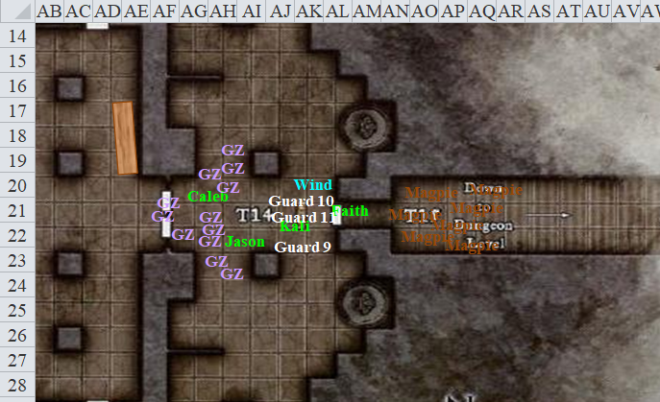

She and her eight invisible mirror images walked stealthily down the stairs, then spotted an acolyte peeking her head and shoulder around the southern corner up ahead.

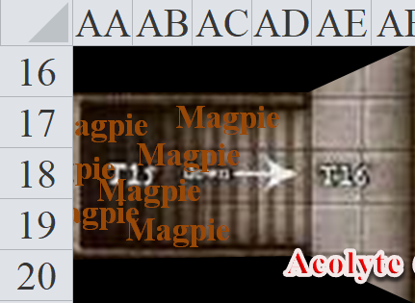

The gnomish priestess definitely didn’t see Magpie, who was nearly upon her, though she did spot Faith ’s silhouette in the doorway, and thus retreated southward.
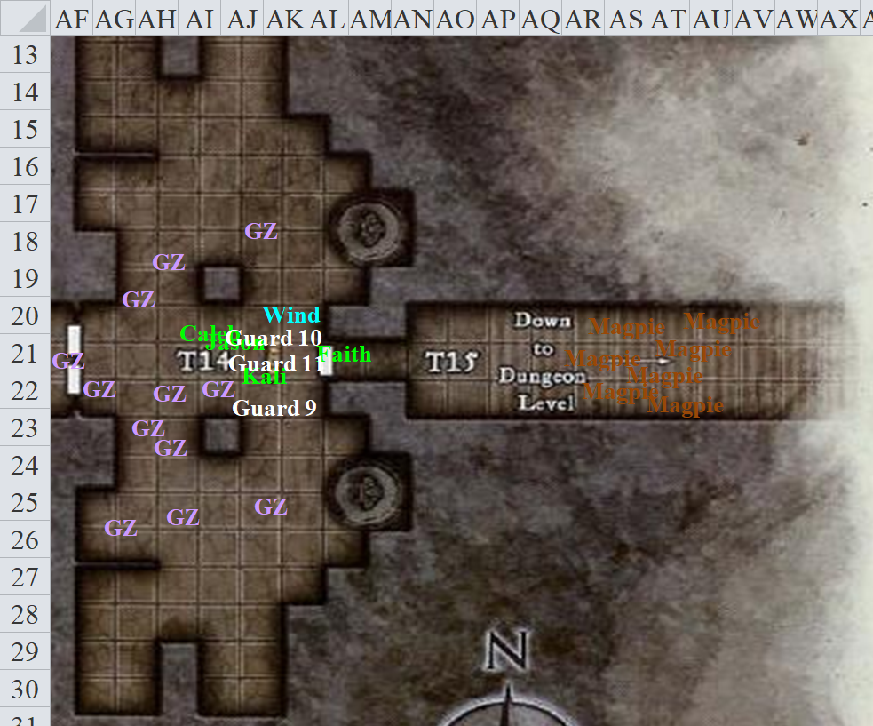

With five uses of his call lightning spell spent, and another five remaining in his left hand, the druid followed Faith in through the door.

Faith took lead of the main group, letting Magpie do her thing.

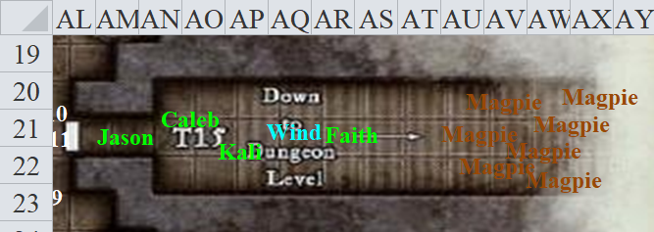

The two warriors followed Faith into the hall, with Jason taking up the rear.

