Chapter 8: Velsharoon’s Ravenous Fraud

R
ound 46

Acolytes 6 and 7, out of useful spells, readied their slings, and prayed to Gond.

Having already cast bear’s endurance [expire on Rounds 91 and 92] on the dragon shaman and monk, as well as resistance [expire on Rounds 54 and 55] on herself and Little Brother Shafron, Siu-ling cast Extended haste [Spell Secret, expires on Round 61] upon her fellow defenders of the temple.

Shafron readied his chi, and drank a potion of bull’s strength.
Shafron gained 4 to Strength.

Surama had already cast mage armor upon herself, and now augmented that ward with a shield spell.

Xhenghis switched his Aura from Senses to Toughness [DR all/2], and positioned himself at the bottom of the northern staircase so as to spray the enemy with his breath weapon.

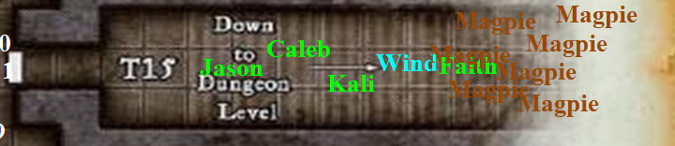

Magpie waited until Faith caught up, keeping out of the paladin’s path for the moment and making one of her telltale clicking sounds to let Faith and the others know where she was. Then, Magpie—but not her mates—could hear the faint sounds of spellcasting and praying. Amidst the clanking of Faith’s armor, the invisible beguiler hesitated.

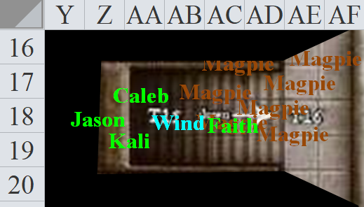

Round 47

[H] Shafron moved into the northernmost position in their formation, then deferred the rest of his actions.

[H] Xhenghis drank a potion of barkskin, then took a few steps towards the bottom of the norther staircase, and deferred the rest of his actions.
Xhenghis gained +2 to AC.

[H] Siu-ling [seeing invisibility, detecting magic] cast stinking cloud upon a spot atop the stairs, then listened and deferred the rest of her actions.

And as the heroes gathered at the end of the long, central, downward staircase, they were unfortunately caught off-guard. Catching Faith, Magpie, and Wind in His Hair in the reach of the cloud, the cloud asphyxiated and nauseated the three heroes.
Save vs.  stinking cloud | Rank | Ability & Mod. | Misc. Mods. | Total | Roll | Check
Faith, Fortitude | 8 | Con (+1) | 5 | 14 | 18 | 32
Magpie, Fortitude | 3 | Con (+3) | 2 | 8 | 19 | 27
Wind in His Hair, Fortitude | 9 | Con (+2) | 0 | 11 | 2 | 13
Success, success, fail.
Wind in His Hair was nauseated.

Wind in His Hair began to vomit, doubling over and holding on to the steps.

[H] Surama cast fireball upon the staircase, engulfing Wind in His Hair, Magpie, Faith, and Caleb in flames, then deferred the rest of her actions.
Save vs.  fireball | Rank | Ability & Mod. | Misc. Mods. | Total | Roll | Check
Caleb, Reflex | 3 | Dex (+3) | 2 | 8 | 3 | 11
Faith, Reflex | 2 | Dex (+1) | 5 | 8 | 4 | 12
Magpie, Reflex | 5 | Dex (+1) | 2 | 8 | 4 | 12
Wind in His Hair, Reflex | 6 | Dex (+3) | 0 | 9 | 4 | 13
Fail, fail, fail, success. Wind in His Hair saves for ½ damage.
Dmg to Caleb: 21 fire [76/97].
Dmg to Faith: 14 fire [101/115].
Dmg to Magpie: 13 fire [70/83].
Dmg to Wind in His Hair: ½ x 18 = 9 fire.

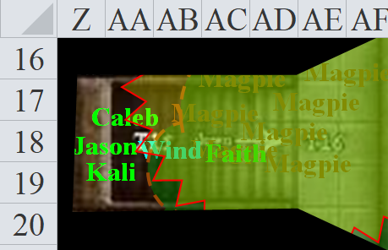

As they were engulfed in the magical flames of the fireball spell, Magpie’s mirror images disappeared.

Wind in His Hair crawled down the staircase a bit, trying to fight off the nausea.

“Ugh! Stinking cloud! Nasty! Ick!” Caleb could hardly contain his disgust as he dropped a dispel magic on the cloud; he was certainly not going to try to walk through it.
Ranged Weapon | Dmg. | CL | Roll | Check
Dispel Magic | Cleric | 10 | 7 | 17
Success.

Almost instantly, the stinking cloud dissipated, with only a sliver of it left along its southern edge, a sliver that could be avoided with some skill. Seeing the sliver to the south, and being closer to the north side of the staircase, Magpie pressed northward, trying to get in the midst of the enemies to avoid area-effect attacks, then happened upon a wizardy-looking gnome and a dragon-shaman-looking gnome. The wizard was her mark, but both appeared to be hastened, and both got the drop on her.

[H] Surama declared, “Now!” and then moved back. This most likely meant that she could see invisibility and/or detect magic.

[H] Shafron had a flask of alchemist’s fire, and now ran south and into view, then threw the flask upon the staircase, continuing south behind the wall once more.

[H] Without much need to aim, Xhenghis emitted a cone of acid that coated most of the staircase. Though the breath weapon fell a few inches short of truly harming her, the acid spray was still enough to cause Magpie to flinch before casting her spell.
Skill | Rank | Ability & Mod. | Misc. Mods. | Total | Roll | Check
Magpie, Concentration | 13 | Con (+3) | 0 | 16 | 6 | 22
Success.

Acolyte 7 slung a stone at the steps, unable to see Magpie.
Miss.

Quite pissed off now, Magpie fireballed the wizard gnome lady and those around her.
Character | Save vs.  fireball | Ranks | Roll | Save
Acolyte 7 | Reflex | 1 | 12 | 13
Little Brother Shafron | Reflex | 7 | 19 | 26
Surama Baatorfrom | Reflex | 2 | 19 | 21
Xhenghis Sarai | Reflex | 1 | 14 | 15
Fail, success, success, fail. Shafron (monk) and Surama (enchantress) save for ½ damage.
Dmg to Acolyte 7: 32 fire.
Dmg to Shafron: ½ x 33 = 16 fire.
Dmg to Surama: ½ x 32 = 16 fire.
Dmg to Xhenghis: 43 fire.



Acolyte 7 died and burned up.

Surama passed out from the severity of her burns.

Caleb moved forward now that the stinking cloud had been mostly dealt with.

Unaware that Caleb had just dispelled the cloud, or perhaps just out of prudence, Kali pulled a cloth out of her pack and tied it tightly around her mouth and noise. Taking a breath and holding it, she ran through the cloud to stand just outside the cloud’s influence to the north.

Jason, seeing Kali’s actions, and not trusting that the stinking cloud had truly been dispelled, pulled out his own cloth and followed suit.

[DM assumption] Faith came down the southern path, spotting Siu-ling, and took a few more steps in order to more properly charge attack her from above on the next round.

Acolyte 6 slung a stone at Faith.
Character | Attack Type | Damage | BAB | Mod+ | W+ | Other+ | d20 | Total
Acolyte 6 | Sling | 1d3 | 1 | 2 | 0 | -2 range | 14 | 17
Miss.

[DM assumption] Caleb followed Faith until he got a line of sight to Siu-ling.

[H] Siu-ling [seeing invisibility, detecting magic] saw her friends to the north getting singed.

Magpie and the others had noticed that the gnomes in this temple had all introduced themselves with names—both personal and familial—which was contrary to the way of life of the gnomes in this settlement. Magpie had suspected that this had something to do with the fact that these were not true Gondars, but what came next was far more of an overture than any of them would have expected.

Though Magpie could not see her from the northern staircase, she could hear the declamation of a wu jen as Siu-ling began to say in Gnomish, << Behold! Her their names were Surama Baatorfrom, Svendar Nuggetminer, and Xhenghis Sarai. They died as they lived, with name and purpose. And I am Siu-ling Karamazov, who will deliver you to- >> she didn’t have time to finish declaring herself.

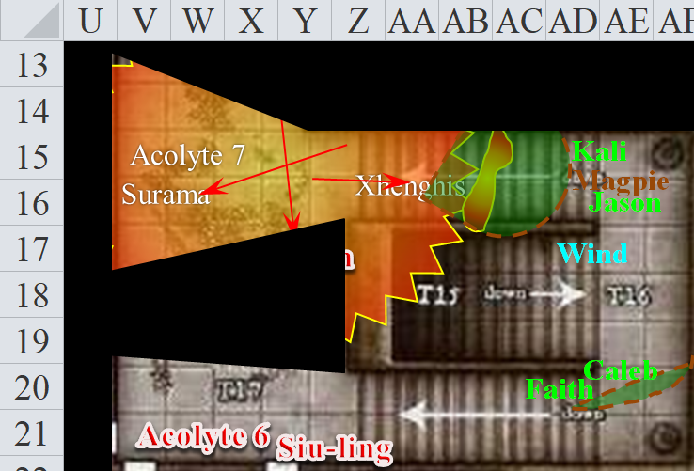

Round 48

Character | Group | Initiative | Roll | Modified Roll | Move
Little Brother Shafron | 2 | 5 | 20 | 25 | 20’
Jason | 1 | 9 | 14 | 23 | 40’
Kali | 1 | 8 | 15 | 23 | 40’
Surama Baatorfrom | 2 | 1 | 17 | 18 | 20’
Acolytes | 2 | 0 | 10 | 10 | 20’
Caleb | 1 | 3 | 6 | 9 | 30’
Faith | 1 | 1 | 8 | 9 | 20’
Siu-ling Karamazov | 2 | 1 | 7 | 8 | 20’
Xhenghis Sarai | 2 | 4 | 3 | 7 | 20’
Wind in His Hair | 1 | 3 | 4 | 7 | 30’/var
Magpie | 1 | 1 | 2 | 3 | 20’

Little Brother Shafron deferred most of his movement, staying behind the corner as he saw Siu-ling’s face. He then saw the paladin charging for her, and resolved to flank-attack her.

Jason, seeing the pool of still-burning alchemist’s fire blocking their path, thought to either jump over it and continue down the stairs or head south where Caleb and Faith had gone.

Kali thought the same.

Seeing the party nicely gathered, and tired of fiery destruction, Caleb cast mass resist energy (fire) [expired in 110 minutes] on everyone.
All PCs and Wind in His Hair gained Resistance (Fire) 10, though they had all been burned by then (see below).

Character | Fire
Caleb | 21
Jason | 15
Kali | 9
Faith | 34
Magpie | 13
Wind in His Hair | 15

Faith jumped over the last seven steps of the staircase, bringing her greatsword down on Siu-ling.
Skill | Rank | Ability & Mod. | Misc. Mods. | Total | Roll | Check
Faith, Jump | 0 | Str (+3) | -5 | -2 | 17 | 15
See below.
Melee Weapon | Dmg | D+ | TH+ | Critical | Type | Wt. | Atk | Roll | Check | Properties
Adamantine Illuminated Holy Greatsword +1 | 2d6+2 | +6 + 1 | 1 + 2 charge + 2 jump | 17-20/x2 | Slashing | 8.0 | +20 | 1 | 21 | +2d6 to evil
Miss.

Little Brother Shafron charge-flank-attacked Faith.
Character | Attack Type | Damage | BAB | Mod+ | W+ | Other+ | d20 | Total
Little Brother Shafron | Unholy Sai, 1st | 1d6+2+2d6 evil | 4 | 2 | 1 | 0 | 19 | 26
Hit. Dmg: 1 + 2 + 9 evil = 12 [90/115]. Partial damage negated.

[H] Siu-ling Karamazov cast prickling torment upon Faith.
Save vs.  prickling torment | Rank | Ability & Mod. | Misc. Mods. | Total | Roll | Check
Fortitude | 8 | Con (+1) | 5 | 14 | 16 | 30
Success. Spell effect was negated.

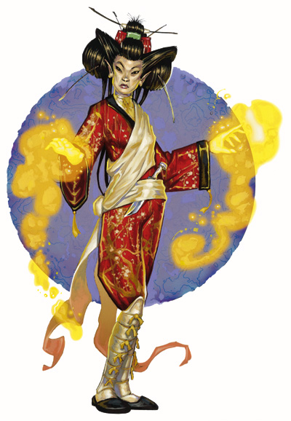

Wind in His Hair reached the corner of the staircase, and saw three of his friends hesitating before acting.



[H] Acolyte 6 slung two more stones at Faith.
Character | Attack Type | Damage | BAB | Mod+ | W+ | Other+ | d20 | Total
Acolyte 6 | Sling | 1d3 | 1 | 2 | 0 | 0 | 3 | 6
Acolyte 6 | Sling, haste | 1d3 | 1 | 2 | 0 | 0 | 7 | 10
Miss, miss.

Jason and Kali both ignored the flames as they made their way down the stairs, then turned southward and made ready to attack as the sword-dancer fumbled in her step.
Skill | Rank | Ability & Mod. | Misc. Mods. | Total | Roll | Check
Kali, Tumble | 8 | Dex (+4) | -2 | 10 | 19 | 29
Kali, Balance | 7 | Dex (+4) | -2 | 9 | 7 | 16
Success, partial success.

Kali exaggerated the forward momentum that would have otherwise caused her to fall flat on her face. Instead, she landed on her shoulder plate, rolled onto the back of her left ribcage, and landed on both feet, having tilted her momentum southward with the weight of her hips and swords. She thus positioned herself conveniently in front of her archer teammate.

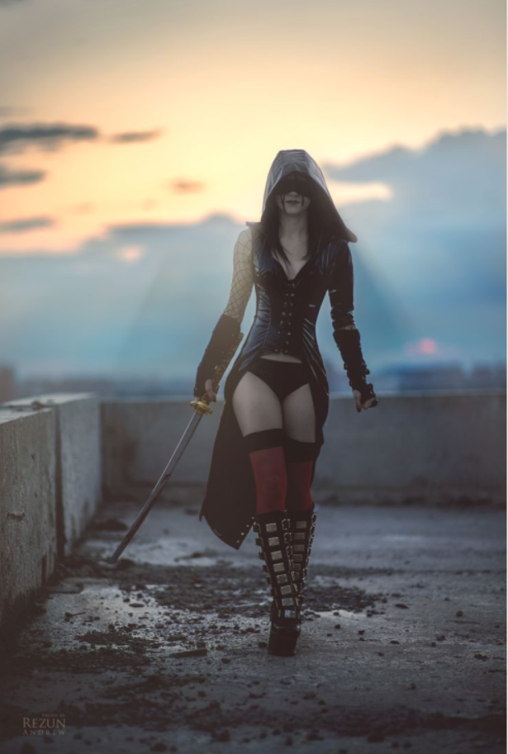

Magpie made her way down the stairs, spotted Siu-ling, and cast magic missile upon the fiery wu jen by channeling a bit of her magic through her gloves at the woman. Siu-ling was not warded with nightshield, as had been some of the resistance here tonight, or this might have gone down quite differently.
[Assuming CL 9th or above; can’t tell] Dmg: 12 + 5 = 17 magic.

Not worried about the monk behind her, Faith prepared her next swing, the one that would surely end the life of this wicked and now moribund fire witch, and gave the wicked witch a final warning.

Both the beguiler and Caleb felt the poor gnome monk had made some very bad life choices in rolling up on the Divine Engine of Destruction known as Faith, so they weren’t interested on wasting spell slots on “Little Brother” Shafron.

Wind in His Hair crawled towards the southern staircase, still nauseous, and reached Caleb.

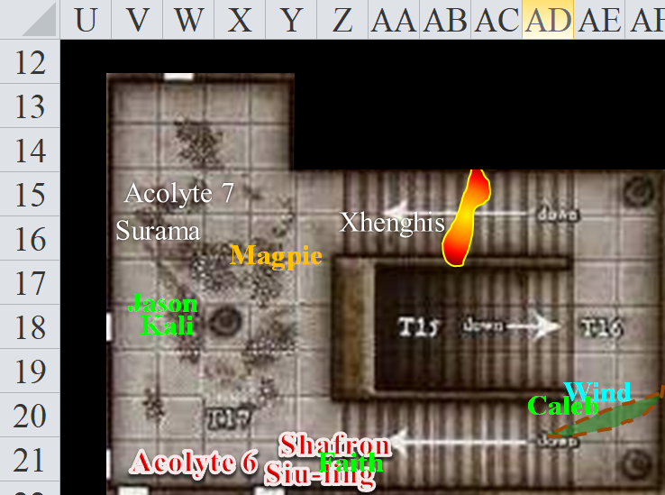

Round 49

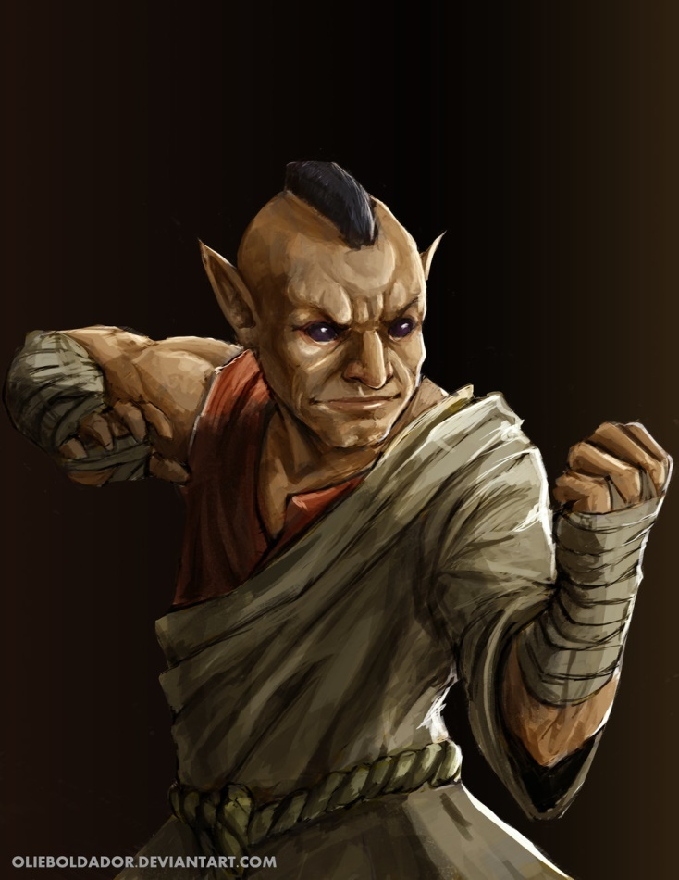

[H] Little Brother Shafron full-haste-attacked Faith.
Character | Attack Type | Damage | BAB | Mod+ | W+ | Other+ | d20 | Total
Little Brother Shafron | Unholy Sai, 1st | 1d6+2+2d6 evil | 4 | 2 | 1 | 0 | 13 | 20
Little Brother Shafron | Unholy Sai, 2nd | 1d6+2+2d6 evil | 4 | 2 | 1 | 0 | 12 | 19
Little Brother Shafron | Unholy Sai, haste | 1d6+2+2d6 evil | 4 | 2 | 1 | 0 | 19 | 26
Miss, miss, hit. Dmg: 4 + 2 + 11 evil = 17 [74/115]. Partial damage negated.

[H] It was evident that Acolyte 6 was scared witless, but with full resolve, she put on a mean-ass face, cast a spell that Kali and Jason could not recognize, and charged towards Kali with little regards for her life.
Character | Attack Type | Damage | BAB | Mod+ | W+ | Other+ | d20 | Total
Acolyte 6 | Touch Attack | ghoul touch | 1 | 0 | 0 | 0 | 18 | 19
Hit.
Save vs.  ghost touch | Rank | Ability & Mod. | Misc. Mods. | Total | Roll | Check
Kali, Fortitude | 6 | Con (+1) | 1 | 8 | 18 | 26
Success. Spell was ineffective.

The mean face turned to a despair that was almost instantly replaced with a solemn preparation for death. Hastened, the robed woman then tried to kick Kali.
Character | Attack Type | Damage | BAB | Mod+ | W+ | Other+ | d20 | Total
Acolyte | Kick | 1d3 | 1 | 0 | 0 | 0 | 11 | 12
Miss.

Caleb gave room to Wind in His Hair as he took a few steps forward calculatedly, trying to maintain a bit of distance from all enemies and fired off a lesser orb of acid at Siu-ling.
Ranged Weapon | Atk | Roll | Check
Ranged Touch Spell | 8 | 13 | 21
Hit. Dmg: 22 acid.

Siu-ling was plastered to the wall under an exploded orb of acid that had become quite a nasty coating of green goo. The woman died instantly.

Faith’s lightning reflexes turned the sight of the dead spellcaster into a reflex that caused her to pivot on one heel with the momentum of her greatsword, and instead of hacking at the already deceased Siu-ling, she cleaved Little Brother Shafron’s body, stepping 5’ further into the room.
Melee Weapon | Dmg | D+ | TH+ | Critical | Type | Wt. | Atk | Roll | Check | Properties
Adamantine Illuminated Holy Greatsword +1 | 2d6+2 | +6 + 1 | 1 | 17-20/x2 | Slashing | 8.0 | +16 | 19 | 35 | +2d6 to evil
2nd Attack | 2d6+2 | +6 + 1 | 1 | 17-20/x2 | Slashing |  | +11 | 18 | 29
3rd Attack | 2d6+2 | +6 + 1 | 1 | 17-20/x2 | Slashing |  | +6 | 18 | 24
Threat, threat, threat. 1d20 = 7, 8, 16 (modified = 23, 19, 22). All hits are critical.
DM laughed and rolled damage, though he didn’t have to.
Dmg: ([2 x (7 + 2 + 6 + 1 + 7 good)] + ([2 x (8 + 2 + 6 + 1 + 3 good)] + ([2 x (6 + 2 + 6 + 1 + 5 good)] = 2 x (16 + 17 + 15 + 15 good) = 32 + 34 + 30 + 30 good = 126. Partial slashing damage negated.

Never had a gnome been cut down so fiercely than the fileting that Faith just inflicted on the fellow who barely had an instant to flinch before becoming a severed lump of various cuts of meat and organs on the floor.

Wind in His Hair, still nauseated, caught up to Caleb again, now getting up, hocking a loogie on the steps, clearing his throat, and wiping his sweaty brow on an absorbent sleeve and nodding to Caleb with assurance of his imminent recuperation. He then went ahead and vomited once he looked down to see what Faith had just made of the formerly ambitious monk.

“That was once a monk,” Magpie murmured to herself with disbelief as the sole living acolyte in the room soiled her robes and the floor beneath her feet.

In the midst of the fight that was now wrapping up, the party had failed to notice the grit and rocks strewn all about the floor down in this candlelit room.

Faith felt a sudden flash of comforting warmth pass over her, and though she had no idea if the two things were connected, at the same time, the rubble and grit began to move as if it were comprised of elemental stone. Only feet from where Kali, Jason, and the acolyte were standing was the base of a column that once supported the ceiling above them, but had apparently been picked and hammered down to this pile of now coalescing rubble. Infinitesimally small grains of sandy minerals as well as the larger chunks on the ground swept innocuously past everyone’s feet and ankles, beginning to gather at the base of the column that was now rising at the rate of about a foot per second towards the 10’ high ceiling.

The alchemist’s fire on the stone steps began to slowly wane.

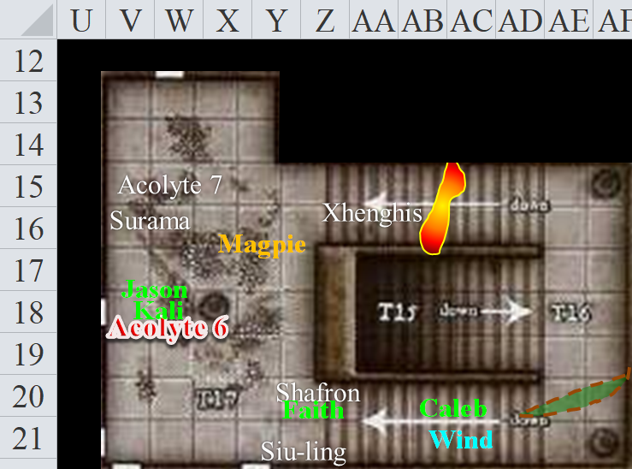

Round 50

Kali swung her swords at the acolyte and at the last minute flipped the flat side of the blade over so it made contact with her target in an attempt to knock the girl unconscious.
Melee Weapon | Dmg | D+ | TH+ | Critical | Type | Wt. | Atk | Roll | Check
Scimitar +2 | 1d6 | 2 | 2 | 18-20, x2 | Slashing | 4.0 | +15 | 5 | 20
Crystal of Electrical Assault, Greater | - | 1d6 | - | - | - | 0.0
Scimitar +1 | 1d6 | 1 | 1 | 18-20, x2 | Slashing | 4.0 | +9 | 4 | 15
Crystal of Cold Assault, Greater | - | 1d6 | - | - | - | 0.0
Hit, hit. Dmg: (1 + 2 + 5 electric) + (4 + 2 + 4 cold) = 9 nonlethal + 5 electric + 4 cold = 18.

It was not evident whether the fighter had slain or simply knocked the acolyte out, but the woman fell to the floor with an icy lump on the left side of her head, and a seared one on the right.

Jason, seeing the girl unconscious, moved 15’ straight east upon noticing the movement rock and sand. “Ooh, sorry!” he said as a matter of reflex when his hips stumbled upon the invisible beguiler.

Magpie’s fatigue wore off. The beguiler was not going to waste a spell on an acolyte, but was concerned about the swirling bits of rubble. She tried to figure out what was up with all that through her knowledge of magic and planar phenomena while moving into the northeastern corner, away from the effect. “Faith, can you detect evil through these doors? Assuming you don’t need to murder rocks shortly? Oh, and someone stick a sword into a fallen mage. Just to make sure she doesn’t get up again. Too many healers in this place.” She pointed at Surama. Magpie wasn’t typically murderous, but she didn’t give people a second chance to kill her.

The paladin of freedom ignored the beguiler for now, focusing her attention on the stone woman who bore a resemblance to her.

Wind in His Hair held fast to his remaining call lightning charges, and shifted his position to the southwestern corner of the room, covering two doors.

Caleb was also curious about the column and tried to identify it. “Anyone badly wounded? I’m a bit out of sorts from the cloud.”

Both casters needed to see what was about to happen before they knew how to react to it.

The alchemist’s fire on the steps was almost out by now.

The column was about half-way restored now.

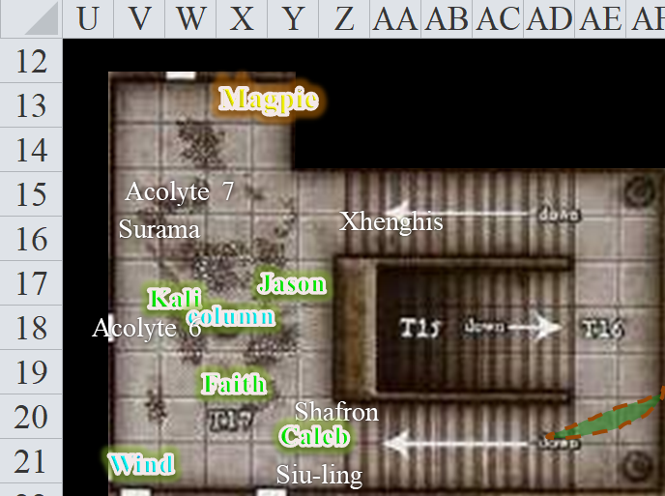

Round 51

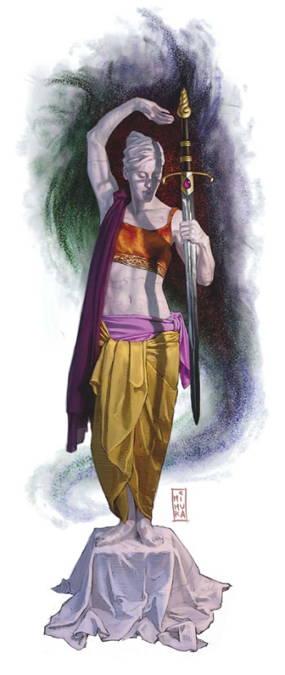

The column had by now not only been restored to its full height, but had also taken on the form of a granite woman with features similar to those of Faith. Holding a sword similar to Faith’s in one hand, the stone woman positioned her other hand to symbolically hold up the ceiling that appeared to be at no risk of caving in, blinked open her eyes, revealing a pair of mechanical eyes, and in what could best be described as a reverse echo, pronounced in Gnomish, << You are the Savior of Sune. >>

Round 52

“She said, ‘You are the Savior of Sune.’” Magpie helpfully translated. “I don’t know what that means, why it’s relevant, or what’s up with the statue lady, but it’s not attacking us, so I feel good about that.” The beguiler slid over to the nearby northern door, looking for a keyhole or a gap, or something to peek through without actually opening it. She’d listen as well, naturally.

“I am indeed a savior of those needy, and swing my sword in the name of Sune, though I do not go by that title,” the paladin admitted the truth despite her recent knack for bluffing.

Round 53

Squinting at the keyhole in front of her eyes now, Magpie absentmindedly but helpfully continued to translate between the human and the statue. << She is indeed a savior… >> and so on. Even with her low-light vision, the gnome could not see what lay inside the pitch-black room beyond the keyhole.

Caleb pulled out a handkerchief and cleaned off his face while murmuring, “Fascinating. This could be a distraction, but it feels meaningful somehow. Perhaps the blade is for Faith?”

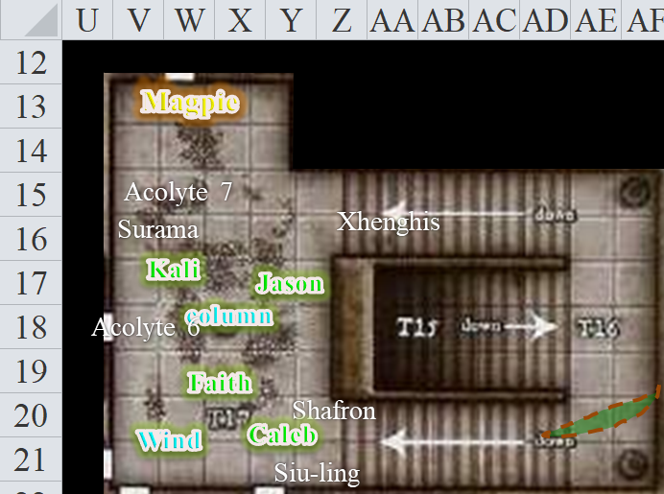

Round 54

The statue blinked its mechanical eyes and took a moment to take in the paladin’s body language and character, it seemed. << You are not yet called that, >> the statue’s voice reverse-echoed across the hallway and stairs. << But you will be known across the planes as the Savior of Sune. >>

Magpie translated as she took in the dimensions of the room, the masonry, the use of candlelight instead of torchlight or gnomish firelight, and other details. Five doors in total allowed egress into the area, in addition to the stairs. A flickering, starry light clung to the statue of the stone woman in the center of the chamber. In the dark, northwestern corner of the room, just feet away from Magpie, was a brass-bound collection of burned scriptures. The pages were almost completely burned away from the open book, but the metal cover was still intact.

Faith looked at Kali, then to the others, then back to the statue.

Magpie knelt down to study the ruined book, feeling a pang of regret at this desecration of knowledge. Even if it was just Gondar navel gazing, it still had value and meaning to someone. She sighed, picked the cover up, looked it over, shook out some of the char, and put it in her magic bag.

Although Faith didn’t proclaim her wounds, Caleb noted them and walked over to cast a Cure Light Wounds on her, channeling an ‘Endure Elements’ into pure healing goodness.

Round 55

The column spoke, << Your next steps lie beyond these doors, heroes. You have restored the caryatid guardian to her rightful place. Accept the blessings of Gond as you pass. >> And with this, they all gained a +1 to their saves vs. Fear-based effects for the time being.

Round 56

Magpie translated, and realized what this statue was, though she wasn’t too familiar with them: a caryatid column. Gondars considered them among the most revered of constructs. These caryatid guardians were to golems what gnomes were to baboons, and Magpie was quite reverent of the statue now, though she herself was not a faithful Gondar. She had never seen one before, and did not expect it to be so lifelike.

Caleb, did not realize what Magpie had, but his understanding of what Gondars referred to as blessing did add some context to the moment. Though Gond was a decidedly neutral god, the conditions in this temple were within the definitional parameters of distress according to this faith, and the caryatid guardian had identified the heroes as heroes upon their vanquishing of the forces of evil.

The Gondar walls had eyes, or so it seemed at the moment.

Round 57

The statue put its weight on one leg more than the other, and pressed firmly against the ceiling with one hand while planting its sword on the base of the stone column like a staff. The caryatid guardian then stiffened and shut its eyes.

“That was weird,” commented Jason.

“I’ve seen stranger things,” Wind in His Hair added.

Magpie and Wind in His Hair then heard something to the west. A bang perhaps, or a thud, and then silence.

“Some of our spells will expire soon,” Wind in His Hair had forgotten that he’d just said that a minute ago, so he said it again.

Magpie didn’t mention that most honorifics of the sort Faith had just received in prophecy were done posthumously. Admittedly, that thought might not bother Faith, but Magpie was quietly pleased the construct didn’t decide to wax poetic on her fate. She examined one of the doors to the west for traps and checked to see if it was locked.

It was, and thus she cast another knock spell, snapping open the mechanism.

“We should not tarry. Let’s finish this.” Caleb cast a lesser vigor spell on Faith.
Faith gained 15 hps over the course of the next 90 seconds (15 rounds) [89/115 by the end of Round 72].

“I thank you,” the paladin said to the diviner-cleric as she began to heal quickly.

Kali bent down and checked the acolyte she had beaten down to see if she was alive. She was no expert but she did not find a pulse, so she shrugged her shoulders and then stood ready to enter the next area.

Round 58

Caleb remained calm, ready to start laying out buffs if combat ensued.

Magpie got everyone’s nods before pushing the dead acolyte’s body aside and opening the door. The room beyond was completely dark, but the faint scent of decaying flesh was picked up on by the druid and the scout as everyone peered in.

Other than the two mundane-seeming columns a few feet in front of them, the party would not be able to see inside without some kind of light source, and the three candles in the room they now occupied were nearly burnt out. It would be possible to fish one out of the candleholder, but the amount of light it produced would not be adequate.

Wind in His Hair lit his everburning torch, and held it out to Faith and the others, “Who wants to lead the way?”

Seeing the room, Faith used the power of her sword, causing it to glow brightly. She turned down the everburning torch since she would need both hands to weld her sword.

Jason offered to take it, keeping his bow in the other hand.

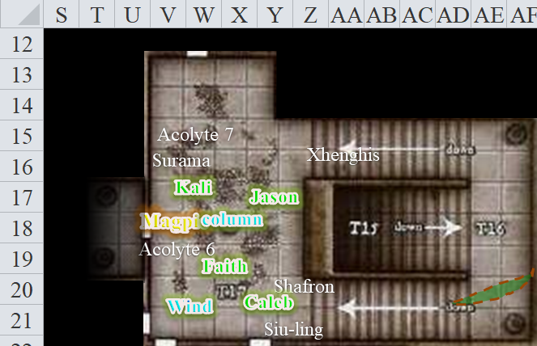

Faith stood to the left of the door while Jason and Kali stood about 15’ back.

Round 59

With a mental command, Magpie’s gloves began glowing with a silvery radiance, casting light out to 20’ and dim light for an additional 20’. She didn’t, however, advance into the room. Undead were her bane as a beguiler.

Faith, on the other hand, figuratively ate undead for breakfast.

Caleb tapped Faith’s armor, imbuing it with light as well, suspecting Faith would be drawn like a magnet to undead, serving as a holy beacon for the more ranged people.

Faith entered. Seeing nothing in the empty room, Faith moved into the middle of the chamber.

Jason and Kali followed 10’ back to either side of the paladin.

Round 60

The room was empty, though as they approached the next door to their west, it was evident that the stench of decay was coming from the weak draft under the doorway. Six inanimate columns held up this section of the temple, or perhaps were just here for show.

The invisible gnome said, “I’m almost out of 2nd-order spells. I hope there aren’t too many more locked doors.”

She then excused herself as she passed by Faith and tried the door. With an invisible look of disappointment, she reported, “Tsk! Locked.”

“I don’t know why you don’t just let me try to bash in the doors,” Faith reiterated her offer to help Magpie conserve these spells.

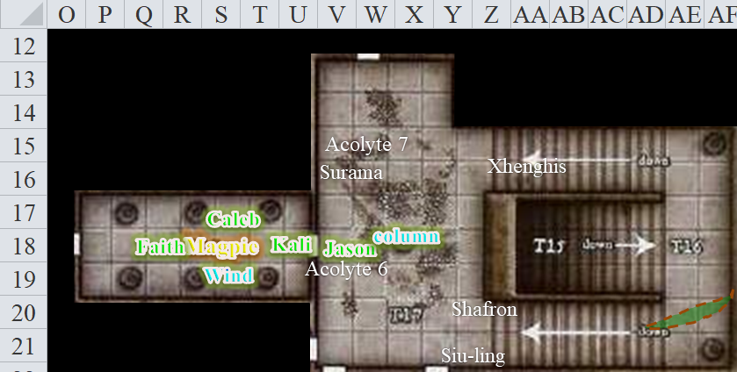

Round 61

“Suit yourself,” Magpie said and snapped her fingers to let the paladin know that she’d gotten out of the way.

The paladin tried kicking the part of the door adjacent to the knob.
1d20 = 11 + 3 = 14, fail.

The wood budged and splintered a bit, but did not break.

Amidst the sound of the paladin’s armor as the heroine took a few steps back, no one heard the sounds of movement in the adjacent room.

Round 62

Faith did her best to break the door with a kick just below where she had just made a dent.
1d20 = 9 + 3 = 12, fail.

Wind in His Hair was embarrassed for Faith, and stuck his head back out through the eastern door to make sure they weren’t being stalked from behind.

And then, without warning, a fireball spell augmented with an electrical charge smashed open the door and caught Faith and Magpie in its field.
Save  Fireball [Electric] | Rank | Ability & Mod. | Misc. Mods. | Total | Roll | Check
Faith, Reflex | 2 | Dex (+1) | 5 | 8 | 10 | 18
Magpie, Reflex | 5 | Dex (+1) | 2 | 8 | 18 | 26
Fail, success.
Dmg to Faith: 14 electric [75/115 after fast healing ends].
Dmg to Magpie: ½ x 17 = 8 electric [58/83].

The electrical dazzle and consequent smoke cleared, and they now beheld the perplexing sight of a Gondar gauntlet guardian approaching with the intent to attack. Repeating the word, << Trespasser! >> in Gnomish, it seemed intent on charge-attacking Faith.

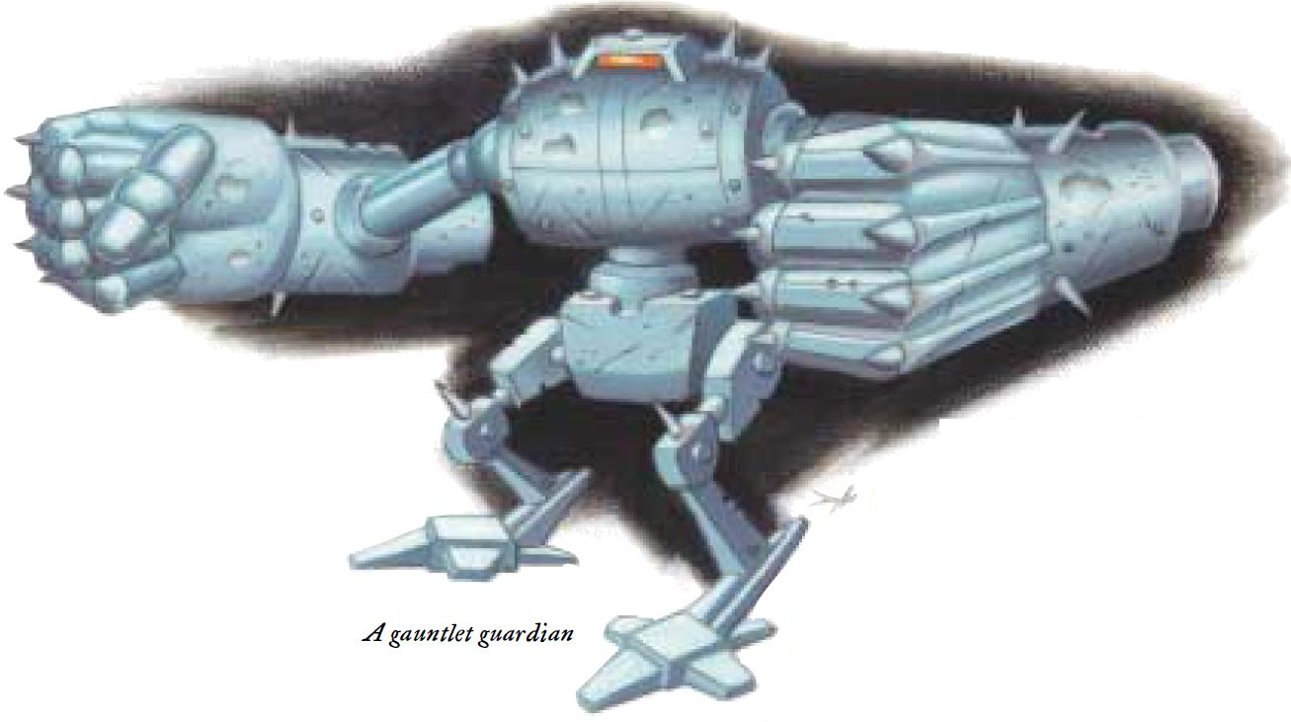

The gnome-sized contraption gained speed as it charged forward, and Faith, who had a clear line of sight to the machine, noted that it was already quite damaged.

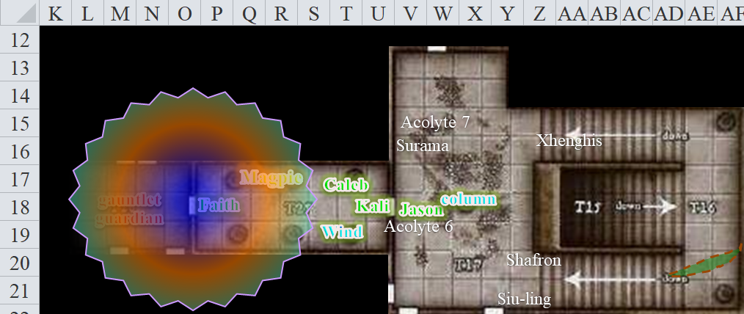

Round 63

Character | Group | Initiative | Roll | Modified Roll | Move
Kali | 1 | 8 | 17 | 25 | 40’
Faith | 1 | 1 | 20 | 21 | 20’
Jason | 1 | 9 | 11 | 20 | 40’
Caleb | 1 | 3 | 15 | 18 | 30’
Wind in His Hair | 1 | 3 | 9 | 12 | 30’/var
Magpie | 1 | 1 | 8 | 9 | 20’
Gauntlet Guardian | 2 | 0 | 9 | 9 | 20’

With a direct line of sight to the guardian, Faith called out, “We are here to restore the temple. Look on me and see my resemblance to the first guardian...” as she prepared to defend herself.

The automaton appeared unresponsive to interaction, and furthermore, in its damaged state, was likely to have only partial cognitive capabilities. As it got through the threshold and Magpie could see it, she was fairly certain that it was “out of order”, for lack of a better term.

With a direct line of sight to the guardian, Jason and Kali held their respective attacks to see if the guardian would adhere to Faith. However, seeing that the paladin’s words were useless, Kali moved past Faith by 5’ so that she was on the monster’s left as she attacked.

Jason rapid fired his bow.
Ranged Weapon | Dmg. | D+ | TH+ | Critical | Rng. | Wt. | Atk | Roll | Check | Notes
Sacred Composite Longbow, Strength +1 | 1d8 | +1 | 1 | x3 | 200’ | 3.0 | +13 | 14 | 27 | +1 within 30’
2nd Shot | 1d8 | +1 | 1 |  |  |  | +8 | 14 | 22 | +1 within 30’
3rd Shot, Rapid Firing | 1d8 | +1 | 1 |  |  |  | +13 | 16 | 29 | +1 within 30’
Crystal of Cold Assault, Greater | - | 1d6 |  |  |  |  |  |  |  | -1 to AC 1 round
Hit, hit, hit. Dmg: (2 + 1 + 5 cold) + (3 + 1 + 1 cold) = 7 + 6 cold = 13 + (-1) to AC. Partial damage negated.

Faith full-power-attacked the humanoid-shaped contraption.
Melee Weapon | Dmg | D+ | TH+ | Critical | Type | Wt. | Atk | Roll | Check
Adamantine Illuminating Holy Greatsword +1 | 2d6+2 | +6 + 1 | 1 – 3 | 17-20/x2 | Slashing | 8.0 | +13 | 11 | 24
2nd Attack | 2d6+2 | +6 + 1 | 1 – 3 | 17-20/x2 | Slashing |  | +8 | 16 | 24
3rd Attack | 2d6+2 | +6 + 1 | 1 – 3 | 17-20/x2 | Slashing |  | +3 | 14 | 17
Hit, hit, hit. Dmg: (6 + 2 + 6 + 1 + 6) + (11 + 2 + 6 + 1 + 6) + (8 + 2 + 6 + 1 + 6) = 21 + 26 + 23 = 72.

The gauntlet guardian was rendered to pieces, much like some of the golems that the party had encountered about a tenday ago when they escaped from the Planar Gauntlet. The familiarity of the automaton—its similarity to those they’d destroyed in that golem-populated dungeon complex—struck Faith as odd. Perhaps the artificer who had designed that portion of the pocket plane was somehow connected to this farce.

Wind in His Hair stayed his lightning hand.

Round 64

Most of the party stood facing the destroyed creation, and as Faith poked her greatsword into the next room, she said, “Um, I’ll defer to Caleb and Magpie to discern what lies beyond.”

The two arcane casters turned to one another, then stepped towards the doorway, peering in. In the dim light of the paladin’s illuminating greatsword, the beguiler and diviner saw what appeared to be a transplanar portal.



Everyone present had seen such portals before, and all but Wind in His Hair had actually traveled through them, but it would take the arcanists a moment to figure out where it might lead.

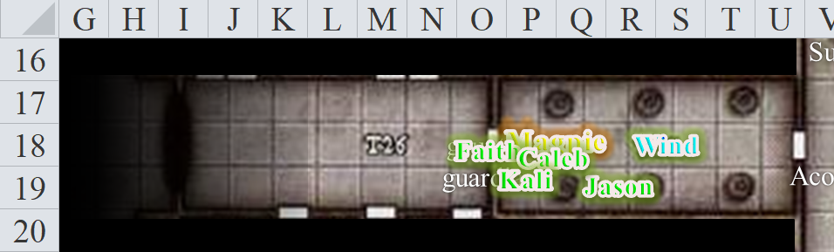

The phosphorous smoke from the electrified fireball dissipated, as did the scent of their singed hair, and now the stench of death, feces, urine, and other offal nearly caused the druid to vomit again, though he had already emptied his body of his lunch. There were no traces of zombies or the like in here, but as Faith’s armor clanked with every step into the room, the moans and groans of gnomes were now clearly coming from one of the southern doors.

Round 65

“Listen, I like to party, but there’s no way I’m crawling through a swirling translucent portal that looks like a storm giant’s sphincter.”

“It does, doesn’t it?” the druid tilted his head as he studied it.

Kali scrunched her noise at the smell, then said, “We need to check out these rooms, especially the one where the moans are coming from.”

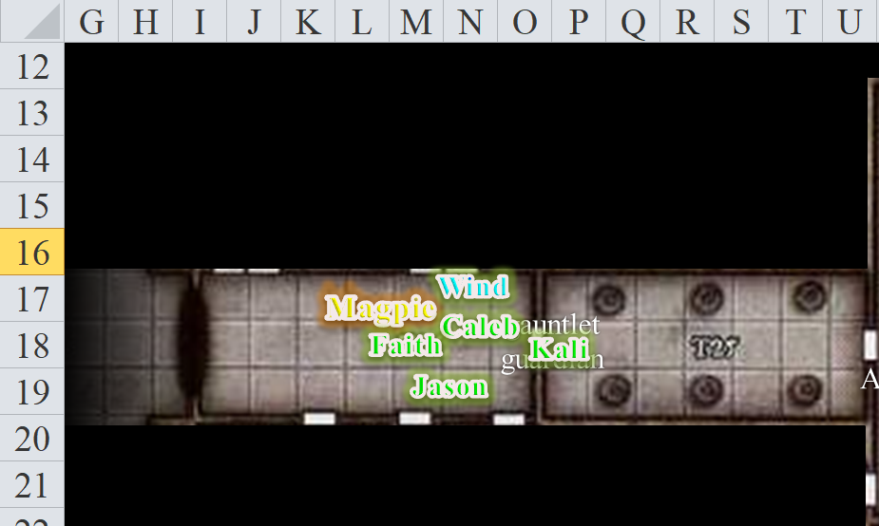

Round 66

After a beat, she added, “Don’t ask why I can make that analogy.”

“I won’t.” Caleb replied with a frown, then added a quick, “Eww!” Presenting his holy symbol, Caleb walked up, murmuring a prayer as he called upon his faith to cast analyze portal.

The cleric-diviner first squinted, then frowned, then smirked, shaking his head, but saying nothing until he was certain.

Round 67

“They knew the gig was up so they fled. Everything else was just to delay us,” Magpie felt grumbly and kicked at a bit of busted golem.

“Well what now?” Jason asked. “We still have to find Dextir. He might be in the same place this portal leads.”

As Jason spoke, Caleb—who had been trying to ignore the comingled scent of everything awful in this world—almost immediately saw through the illusion, though it took the others a bit more squinting to do so once he called it.

Round 68

“Not a real portal?” Wind in His Hair confirmed.

“It’s a fabrication,” Magpie confirmed Caleb’s identification of the undulating portal that did, in fact, seem rather sphincterish. Approaching it head on, her keen eyes could see only a few feet beyond the illusion, and simply saw a continuation of this hallway comprised of the same fashion of tiles and bricks.

Caleb was glad to have cast the analyze portal spell, as it confirmed that this was in fact no real portal, but the concoction of an arsehole like Zvim, or more likely someone more powerful.

The others moved towards the edges of the alleged illusion, and sure enough, at this angle, the figment was almost transparent.

“It’s well cast,” the beguiler again confirmed Caleb’s suspicions. Whoever did this was more powerful than Zvim at least appeared to be. “... but totally safe to step through.”

Round 69

“So far,” Caleb pointed out, “they’ve used little Necromancy, and a great deal of Illusion, to try to slow us down.”

They had counted only four zombies—most likely a single casting of a summon undead spell—while the other 10 or more were illusions. Now there was this portal, and the fact that most of the acolytes appeared to have been duped by these impostors suggested a further combination of Enchantment and Illusory magic. There were likely to be several specialists of various levels working together as they made their getaway. There was also an Evocation of moderate magnitude: the electrified fireball trap that had likely been triggered by Faith’s bashing of the door.

Faith, able to see through the thing enough, poked her greatsword into the empty room to confirm that it was no trap, and once satisfied by the spellcasters’ assurance, walked through.

Some of the others followed through the illusory anus.

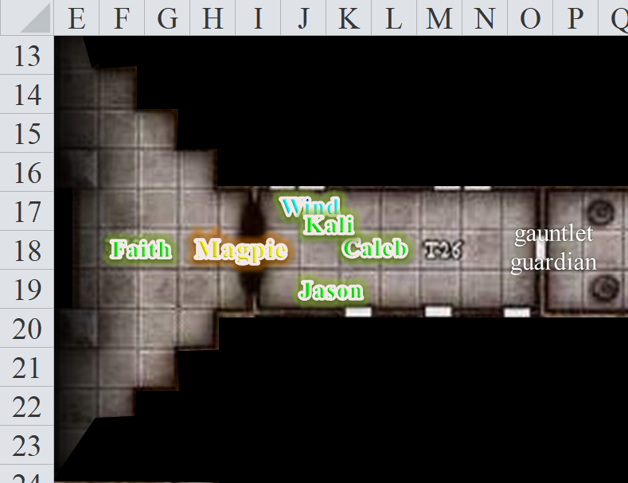

Round 70

The smell of corpses was so strong here that the stench produced an effect similar to the stinking cloud that had just been cast on them by the late fire wu jen, Siu-ling Karamazov.
Save vs.  Mundane stench | Rank | Ability & Mod. | Misc. Mods. | Total | Roll | Check
Caleb, Fortitude | 5 | Con (+2) | 2 | 9 | 9 | 18
Faith, Fortitude | 8 | Con (+1) | 5 | 14 | 18 | 32
Jason, Fortitude | 3 | Con (+0) | 3 | 6 | 8 | 14
Kali, Fortitude | 6 | Con (+1) | 1 | 8 | 8 | 16
Magpie, Fortitude | 3 | Con (+3) | 2 | 8 | 4 | 12
Wind in His Hair, Fortitude | 9 | Con (+2) | 0 | 11 | 16 | 27
All saves succeed.

And though they were able to hold back the need to vomit, they squinted in the now lit room as Faith’s greatsword shed illumination upon emptiness. There were no undead here, certainly no corporeal ones.

Before Faith, there was a wall that appeared to look like a partition, and although the sound of moving bodies was not heard, the sound of carrion-eaters moving in and out of decomposing bodies was clearly discerned by Magpie best of all.

“Around the corner,” she whispered, “on the other side of that partition.”

Back in the hallway to the east, Jason heard again the faint sound of groaning to the south; he moved to the door [K19:K20] and resolved to open it when the others were ready.

Round 71

But there was an equally pressing need for the paladin to secure the area they’d just entered, which smelled like death and sounded like the feast of a lifetime for carrion beetles and centipedes.

The two black pillars that framed the partition had Gondar inscriptions, many of which had been scratched, rubbed, chiseled, and otherwise erased. Faith made her way around the southern pillar, holding her greatsword like a bat, prepared to swing at whatever undead thing accosted her. As her blade lit the otherwise murky area behind the partition, her eyes beheld a heaped pile of gnomish skeletons partly covering an obsidian altar near the far west wall of the chamber. “What on this plane!?” the paladin said as she lowered her blade, detecting no magical auras. A knee-high ebony table rested against the western wall, covered in mostly burnt candles and the wax that dripped from them. Spider webs, skulls, and ribs also littered the wooden table, but not as wantonly as they covered the altar.

Faith also noticed a door behind her to the south.

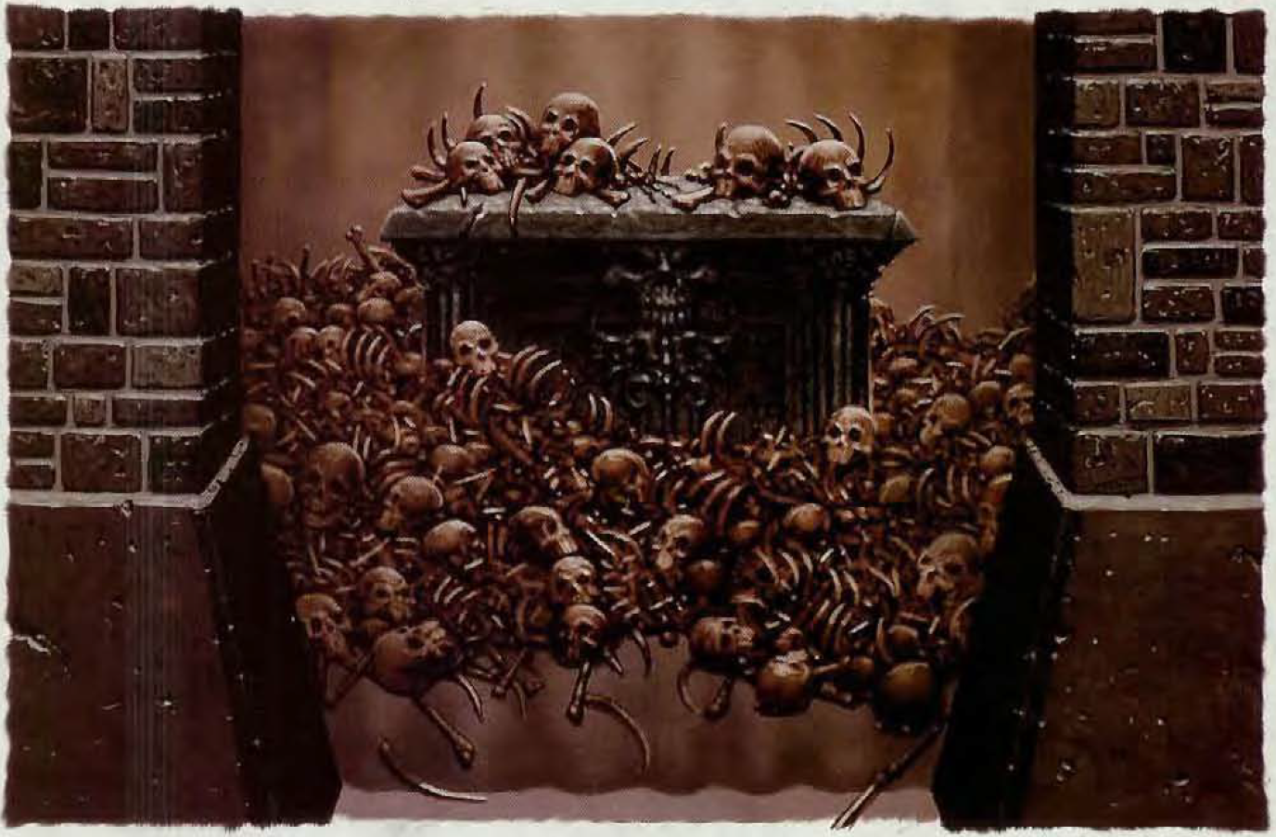

Round 72

Kali had by now circled around the north pillar, and now had a line of sight to the altar and bones. However, she saw what was hidden from Faith’s vantage point: on the floor, resting against the obsidian altar and a few other decomposed bodies lay the fresh corpse of what could only have been a Gondar priest, given the remnants of his clothing, and the silver, bronze, and gold tattoo on his hairless head. The dead gnome’s mouth hung open, and a centipede made its way in and back out of the gaping hole. The fighter estimated that this man had been killed today, yesterday perhaps, while the other remains were mostly bones now cleaned by the fat, little arthropods that seemed innocuous enough.

Kali counted their blessings that no ghouls or ghosts or ghasts were lurking about, but had to hold her nose with her free hand as the other held her favored scimitar.

“Heeelp!” Jason now clearly heard the word in Common, though pronounced by the parched mouth of a raspy throated gnome in the room to the scout’s immediate south.

Upon hearing the call for help, Jason moved into the illusory, giant, blue anus his fellows had entered and shouted, “Come quick! I think we have some survivors.”

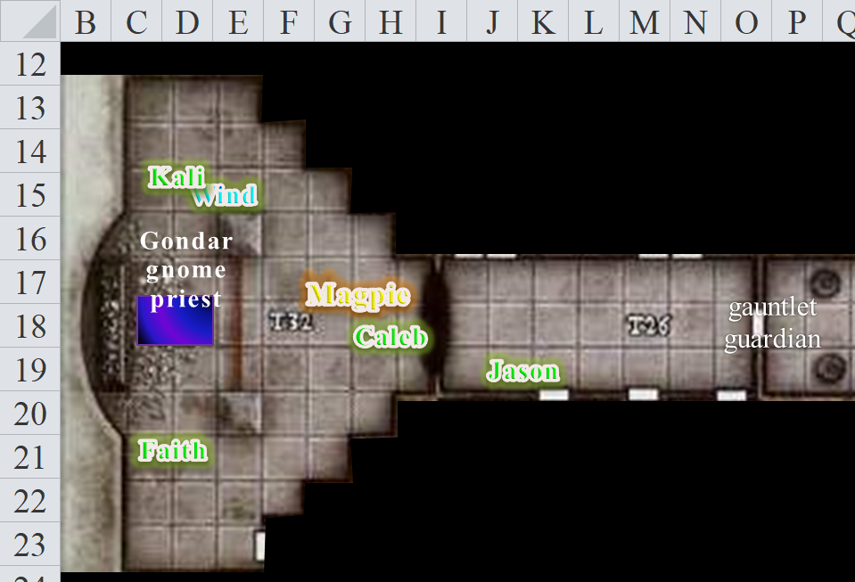

Round 73

Kali and the others gladly rushed back out of the altar room through blue anus and towards Jason as he checked the door.

“Locked,” the scout regretted.

A waft of stench filled everyone’s noses again.
Save vs.  Mundane stench | Rank | Ability  & Mod. | Misc.  Mods. | Total | Roll | Check
Caleb, Fortitude | 5 | Con (+2) | 2 | 9 | 5 | 14
Faith, Fortitude | 8 | Con (+1) | 5 | 14 | 13 | 27
Jason, Fortitude | 3 | Con (+0) | 3 | 6 | 19 | 25
Kali, Fortitude | 6 | Con (+1) | 1 | 8 | 13 | 21
Magpie, Fortitude | 3 | Con (+3) | 2 | 8 | 20 | 28
Wind in His Hair, Fortitude | 9 | Con (+2) | 0 | 11 | 14 | 25
All saves succeed.

Everyone kept their digestive calm for the moment as the waft of air continued to emanate from the altar room outward towards the temple’s entrance, first eastward, then upward, then westward.

Round 74

“Even out here it’s bad enough,” Wind in His Hair could barely speak as he hugged a wall, staying clear of the main draft.

Magpie knew that casting another knock spell would deprive her of the use of another spell cache from which other cool magic could be cast, and figured that if this was rigged with a fireball spell, it wouldn’t make any difference how it was opened. They would trigger such a trap by any means that the door was opened.

“Heeelp!” the voice within repeated, sounding as if it were a mortal gasp, a captive’s dying word perhaps.

With the blessing of the group, Faith tried bashing this less-sturdy-looking door.
1d20 = 13 + 3 = 16, success.

Round 75

The door buckled, then gave way as Faith’s metal boot pushed with follow-through.

The room was dark until the paladin poked her sword within, and therein were no less than three starved gnomes—still alive enough to raise their heads from the beds to which they were chained, and only one of them strong enough to raise an open palm and beg, “Pleeeease heeelp uss!”

The paladin would have detected evil, magic, and other manner of trickery if there were any in this room. Instead, all was as it seemed: three moribund men all bearing the tattoos of Gondar clergymen across their heads, arms and chests. The two weaker ones had had their feet amputated, and in their stead were bloodied rags held in place by old bootlaces or something the like.

The stronger one was missing a few fingers from his left hand, but his feet were intact.

Faith reported the lack of evil and magic in the room.

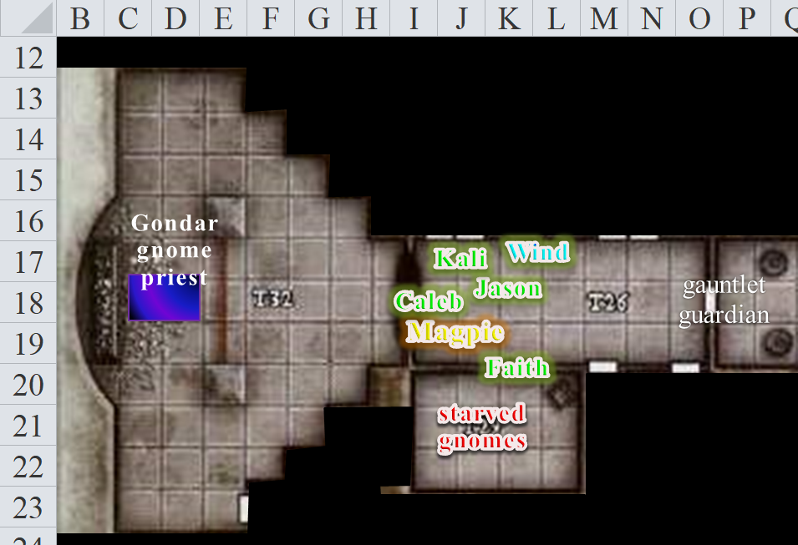

Round 76

“Give them water. I will pray and give them a bit of healing,” said Faith. She then knelt in the midst of the priest as she prayed for healing.

Jason moved quickly to offer water to the men.

Aside from the three men and the Spartan cots on to which they were tethered by chain, a variety of well-used torture equipment was installed along the walls of this stone chamber: racks, iron maidens, stocks, and other machines of pain decorated the room, and it now became evident by the smell and the pool of blood still trickling out of the iron maiden that it had a freshly killed person inside of it. In the dark, southeastern corner lay a pile of cast-off clothing, torn and soiled.

“I’ll check each door until I find one unlocked but will not open it until you’re ready, Faith,” Kali said before backing out of the room and checking the door next to the one they just opened.

Round 77

Kali tried the door immediately to the east, and found it unlocked. Turning the handle back to its default position, she left the door closed and moved on to the next door.

As Jason gave the men water and Wind in His Hair decided on whom to cast cure light wounds—the last of his cure spells for today—Jason was taken aback as he began to recognize an old friend in the haggard, unkempt, wizened, emaciated face of the gnome whose fingers had apparently been chewed off.

Wind in His Hair cast cure light wounds on the most severely wounded of the two footless men.
Anselm gained 7 + 11 = 18 hps.

The druid announced that he was out of cure spells for the day.

“Frayed?” Jason murmured.

Faith turned to look upon the morbidly starved man. It was also evident that the poor fellow had lost most of his sight by now, for although he could sense differences in light and shadow before him, and discern movement from that, he was completely unable to recognize Faith and Jason, with whom he’d traveled through half the Planar Gauntlet years ago, or so it seemed.

“Who calls me by that name?” the pale, bearded gnome asked, his being the raspy voice that had called for help, while the other two were barely able to breathe, let alone speak.

Round 78

Kali tried the next door, and found it unlocked as well. This was consistent with what she’s suspected: the impostors left in a hurry, and only locked doors that led to key areas and/or kept prisoners inside. These side doors were probably just dead ends or places full of things not worth keeping secret. This was, however, still just her speculation.

“Frayed?” Faith also had to ask before being certain. “Frayed, it’s your comrades, Jason and Faith.”

“Jason and Faith?” the prisoner was dumbfounded, gasping from the twin shock of salvation and that it was being carried out by his two comrades. “But there are others with you? Ti’ki?”

Magpie offered her wand of lesser vigor to the druid, then remembered he couldn’t see her and pressed the wand into his hand. “Here. You’ll make better use of this wand of lesser vigor than I would. Use whatever you need. Don’t worry about conserving charges. I can get a new one sometime. The Command Word is ‘Respite’.”

“Oh, sure,” the druid agreed.

This was exactly the sort of nonsense Magpie despised. These gnomes, captured, tortured, mutilated, and for what? She wished she could pretend to be shocked, but this was far too common. What did shock her was how this community allowed this corruption to fester in their midst. It had only been a tenday since the arrival of these fiends—according to Tunaster and confirmed by Frayed—but they had harvested a plethora of souls in the process; given the number of rotting skulls to the west, the estimate was now a few dozen.

Then, Magpie began working on picking the locks on the chains.

Round 79

Kali tried the double-doors along the northeastern portion of this hallway, then those along the northwestern portion, and found both pairs to also be unlocked, then returned to the room with the three captives in order to report all of this to the others.

Jason shook his head, “‘Fraid not. We lost track of him back in the Gauntlet. I don’t know how well you can see, but the invisible gnome here is Magpie, then there’s Wind in His Hair, this is Caleb, and oh, here’s Kali now.

Round 80

Standing in the doorways, the dancer bowed her head to the prisoners, offering a brisk Turmish greeting, then stated, “All the other doors are unlocked.”

“By Gond!” Frayed proclaimed. “By the will of the Manufacturer himself, you have come. We feared that we would rot here in this forsaken shell of what was once our dear temple.”

Rounds 81 and 82

“So you’re a priest of Gond now?” Jason had to ask. “I always pegged you for an arcanist.”

Magpie became instantly intrigued in the conversation as the prisoners were given water to drink by three of the heroes.

After gulping a sizeable portion, the former warmage-evoker admitted, “Oh, well, not exactly. I retired here in town, and as you probably can guess, I discarded my name, my reputation, and any presumption of my identity.”

“If it’s alright with your boot, I can try to open the doors magically from a distance,” Magpie offered to Faith. “That way if there are any fireballs or glyphs, we might be able to avoid them.”

Faith’s face said yes as she nodded.

Rounds 83 – 84

“He’s being modest,” Anselm pointed to his cellmate, whispering with a still hoarse throat, though the cure light wounds spell did him well.

Frayed conceded, “I became a true Bytopian in the local sense. I cast off all pretense of who I was, and when this new priestess came to town, I admit I was caught up in the revel of her bewitching words.”

Rounds 85 – 86

“You don’t say,” Wind in His Hair was also intrigued by Faith’s and Jason’s spellcaster buddy.

“So the tattoos are not actually indicative of a Gondar clerical rank yet,” he pointed out the singular line, which denoted the acolyte level, while the priests and priestesses bore double- and triple-parallel-lined patterns of various metallic colors.

Round 87

“So you’re fixing to become one?” Kali asked.

“I suppose I was,” Frayed answered, “... but this whole experience has made me question my recent life choices a bit.” Jason and Faith knew the man equally well, but it was Faith’s intuition that told her that the man had spent quite some time here in contemplation, particularly while under the duress of torture, and that contemplation was now culminating in the urge to set sail and resume some maritime course across the River Oceanus as in yonder days a younger man named Frayed once did.

But not in this state. The other two lacked feet, which was problematic in and of itself, as they could not ambulate out of here on their own. Faith could probably have carried them up and out to the temple gates, which were presumably still barred shut, but that would further slow them down. It would be the most dignified thing to do with them, however.

Caleb knew they couldn’t afford to get the wounded gnomes out of here, not yet. “We need to put an end to this, but we need these poor souls to be safe. Why don’t I cast a rope trick? Kali or Jason, you can climb up and Faith can pass the gnomes to you. The three of you,” he addressed the gnomes, “Will be able to rest in relative safety and comfort while we clear out the rest of the temple.”

Wind in His Hair and others thought this was a good idea.

“I’ve got some good gnomish food I can put up there with you; bedrolls as well. It’s not a sunny glade with a cool breeze, but it’ll be comfortable and have less death stank,” Magpie offered helpfully.

Though Frayed seemed to have hesitation at first, the three gnomes were glad to accept Caleb’s and Magpie’s complementary offers.

Round 88

Faith spoke up, “We have to find the people responsible for this. Frayed, what can you tell us about this Priestess, and Zvim, and anyone else who has probably already escaped?”

Rounds 89 – 90

Jason and Kali left the others to tend to the captives as Magpie undid each of the locks on the chains. The archer and swordswoman checked out each room, starting with the one to their immediate east.

The gnome was quite instrumental in explaining as much of the hierarchy as he knew to be true. “Do not be deceived by how Zvim was addressed frontstage,” he warned them. “Though he is somewhat powerful, he is just the figurehead. It is the Priestess, and worst of all, the Superintendent, that you should worry about.”

He proceeded to give the heroes as much information as he knew about the arch-adversaries in this hierarchy.

Character | ECL | Details
Superintendent Milfuegos | 11 or 12 | Archivist-Diabolist
Priestess Safiyya | 9 or 10 | Cleric of Velsharoon
Deacon Zvim | 6 or 7 | Beguiler
Little Brother Shafron | 5 or 6 | Monk
Siu-ling Karamazov | 5 or 6 | Shugenja (fire)
Surama Baatorfrom | 4 or 5 | Enchantress
Xhenghis Sarai | 4 or 5 | Dragon Shaman (green)

Round 91

“We already encountered the lackeys you mentioned,” Faith said. “They were not formidable at all.”

The door opened with little ado, maybe a creak or two, and they peered into a storage closet. Boxes, crates, barrels and shelves lined with plates, crockery, and instruments of torture lined and filled this chamber. The smell here was mildew-rich, but not necrotic or fecal like the areas west of here. “Storage closet!” Jason called out.

Round 92

Frayed then warned them about Safiyya’s and Milfuegos’ quarterstaffs, which they both used to channel touch attacks.
Character | Attack Type
Priestess Safiyya | Shocking Quarterstaff
Superintendent Milfuegos | Quarterstaff +2

Kali opened the next door to the east. Inside the somewhat clean-smelling room, three mattresses lined the eastern wall, a small wooden chest visible atop each bed. The room had few personal belongings hanging on the wall, including beaded jewelry depicting Velsharoon’s colors: black, violet, and gray.

Round 93

From the hallway, Jason said to the others, “We should call the locals to come and help move them.”

“As a thrush, I could do this far more quickly than any of us,” Wind in His Hair said, “but I’ll need help unbarring that front entrance.”

The archer and swordswoman then made their way north, opening the double doors and seeing a room that must have previously been kept in immaculate condition, but had recently fallen to the filth so prevalent in this place.

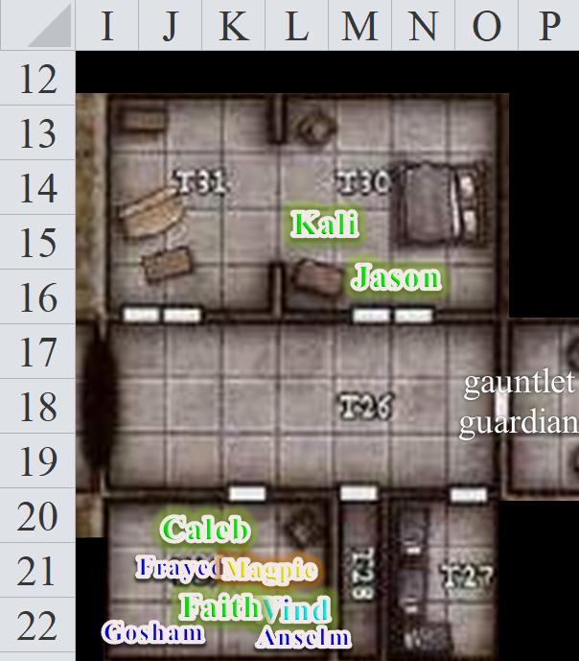

Round 94

A bed large enough for a giant rested against the east wall. Other pieces of furniture were placed about the room, some of them familiar to Jason, given that they used to be Frayed’s. A huge and thickly stuffed chair sat by an elegant table, a nightstand was near the plush bed, and a chest of drawers rested against one wall. One of the chests had clearly been ransacked in a hurry, as most of its drawers were open and empty. The other chest looked like it had been pivoted a few degrees, and its lock was dented but not destroyed.

Though the walls and other fixtures here were of Gondar design—interlaced with gold, brass, and silver lines in mostly parallel patterns—the furniture and personal items were easily identified by Jason and Kali as Velshari in nature, or at least leaning towards necromancy.

They were likely to be in the recently redecorated master bedroom of the Priestess, or the Superintendent, or perhaps both. It did seem like

To the south, Anselm and Gosham—the other near-dead gnomes with no feet—drank water until they could manage to speak a few syllables of gratitude.

“Faith,” Frayed said to his longtime friend, “I can see in your eyes that you mean to pursue the Priestess and Superintendent. Take me with you,” he then pleaded.

The paladin did not protest, but simply stated, “You’re not yet fit for adventuring. We must get you to a proper healer. And to boot, you’re not armored, armed, equipped, or even properly dressed.”

Round 95

Jason could not overhear the conversation between the paladin and the warmage-evoker. He was taking in the sights, searching for traps as best as he could, and trying to discern anything he could from the mundane and magical artifacts all around him. Some were clearly lower-level wands of summon monster—he’d seen them so many times before!—but other stuff included items that were inscrutable gnomish handiwork; perhaps the prisoners or Magpie would know what they were. Nevertheless, the area was kept comfortable, with all bedding being clean and fluffy, and Kali imagined that such comforts—commingled with the sweet scent of decaying flesh—would suit a pack of necromancers just fine.

The group’s consensus on Frayed joining them on their pursuit of the arch-villains was [YES/NO].

Round 96

Satisfied that the immediate area was not trapped, Jason and Kali stepped further into the double room, studying the study, which comprised the western 3/7^{ths} of the room. A divan sat by a low, candlelit and paper-strewn table against the west wall. The north wall held a wide, tall bookcase filled with curios, sculptures, and some tomes and scrolls.

The desk appeared to have been used regularly. A hefty pile of square-cut pieces of blank parchment was set to one side. Nearby was a quill and several jars of red and black ink. On the desk lay three letters, two that looked complete and one definitely incomplete. They were in Gnomish, so both humans were at a loss at the moment.

The sculptures atop two of the shelves of the bookcase depicted Velsharoon; a horned, bearded tiefling with elven ears and two heavy flails in his hands; the infamous lich deathbringer known as the Bone Overlord; and a blackguard assassin that Kali suspected was the right-hand servant of the Bone Overlord.

Though neither of the two heroes recognized the tiefling, the rest of the gang depicted was definitely not something integral to the Gondar faith. Kali suspected that any of these items could be cursed, and said, “Let Faith have a look here before we touch anything.”

To the south, the gnome warmage-evoker, standing up now, said, “I could be wrong, but I think I know which way they went, though I have no idea where they’re ultimately headed.”

Rounds 97 – 98

“Oh?” Caleb tilted his head towards the starved warmage-evoker.

“There is a route to the south of here. It is an underground spring that used to run from here to the mineshafts near the base of this mountain, and then out through the southern slope.”

Rounds 99 – 102

The gnome drank a bit more water from Faith’s flask as the suspense in everyone’s imagination built, then continued, “When this was a proper Gondar temple, the miners would pay a tithe for the blessings of venturing down the cavern aboard a dinghy, mining their gems and whatnot, and emerging along the southern mouth of the spring. The dinghies—and there were several—were returned by arcane means to the source here in this temple. Now the passage leads to a one-way transplanar portal that I believe goes to some layer of the Abyss or the Hells, somewhere grim for sure.”

Rounds 103 – 105

The druid wasn’t able to work Magpie’s wand, but then remembered that he’d found a wand of cure light wounds recently, and began to heal the footless gnomes until their feet had grown back and their wounds and bruises had scarred or disappeared altogether.
Anselm gained 6 + 2 = 8 hps.
Anselm gained 1 + 2 = 3 hps.
Anselm gained 2 + 2 = 4 hps.

Everyone in the room with the freed prisoners was quiet for the moment, taking in the reality of what they’d just heard.

Frayed added, “If you recall, I had a folding ship,” he said to Faith, who remembered the convertible device. “It can go from a small figurine to a four-person boat and then to a 24-person ship. The problem is that the stream is only big enough for the boat, not the ship, and the boat only carries four.”

Round 106

The druid continued his healing.
Anselm gained 3 + 2 = 5 hps.

Anselm sighed, smiled, and thanked the druid, putting both feet down on the floor and standing tall—for a gnome—once again.

“Your turn,” Wind in His Hair turned to Gosham.

“Wind in His Hair can shapechange into a thrush, which brings our tally to Jason, Kali, Magpie, Caleb, and you and me,” Faith did the arithmetic aloud.

Round 107

The druid continued his healing.
Gosham gained 1 + 2 = 3 hps.

“There might be a dinghy left behind,” Frayed hoped.

Round 108

The druid continued his healing.
Gosham gained 6 + 2 = 8 hps.

When Jason returned Faith filled in the two with the information she had gleaned. “If Frayed can come, he would be a great help. I do feel we should follow those vile creatures.”

“Magpie needs to go through one of the rooms we found. It has several gnomish items and papers that might give clues,” said Kali.

Rounds 109 – 111

The druid continued his healing.
Gosham gained 8 + 2 = 10 hps.

“If they’ve fled through a one-way portal, chasing them through it would be idiotic. At least, immediately giving chase. We’re weakened from our work here, and we’d be heading into a place which is far more hostile and dangerous. I think we should finish clearing the temple, alert the community to what’s happened here and tend to the wounded.” Magpie wasn’t shy about her opinions. “And to be clear, I’m not heading through a portal today. I don’t care if the rest of you decide to plunge into hell to mete out righteous justice. I’ll wish you the best of luck, share my wand, but I’m no good to anyone dead.”

Rounds 112 – 113

Wind in His Hair’s call lightning spell expired, and the remaining bolts of lightning in his hand disappeared.

“And no, I don’t think we take the warmage with us. No offense. I’m sure you’ll be nine kinds of awesome after a good sleep, but right now, you’re basically the walking dead.” And she didn’t trust him. An old friend mysteriously turns up after extensive torture and deprivation, and his first thought is to join the good fight, sans spells, gear, or sanitation. Pft. Too much enchantment magic in here for Magpie to believe that.

Frayed sighed, but he knew she was right: even with his magic items, he would be a liability. Still, he wanted to at least go to the room that Kali had just mentioned and see if some of his gear was still intact.

Rounds 114 – 115

Caleb frowned at the halfling’s tone, but sighed, “If they’ve retreated through a portal, I can’t analyze it today to see where it leads. We could be moving into an area hostile to our lives in more ways than simply aggressive fauna. I, unfortunately, find myself agreeing with Magpie. It’d be foolhardy to chase these villains across planar borders today.”

Round 116

Faith replied, “It is not a portal, but a secret passage that leads out of this mountain.”

Round 117

“The gnome did say that in the past tense,” Caleb pointed out. “Didn’t you?”

Round 118

Frayed nodded, “Yes, I think I said ‘used to’ or something like that,” the weary gnome had already forgotten.

Rounds 119 – 120

Caleb continued with his line of thinking, “If a portal has been erected around the tunnel, and we cannot get around it, and if the tunnel is linear, then we can assume that the passage out of the mountain is inaccessible.”

Round 121

Frayed posed, “No self-respecting gnome would carve a unilinear passage!”

Anselm and Gosham also protested in Gnomish. << Never! We spit on the gnome that would. >>

Round 122

With that settled, the druid half-elf said some inscrutable word, turned into a thrush, and skedaddled out and towards the upper-level entrance.

“Are there ways of traversing this tunnel complex without using a dinghy?” asked Faith.

Round 123 – 125

“With enough spider climb spells,” Frayed imagined. “We could at least climb out through the wettest chambers and see if there is an upward passage, which is likely to be a dry tunnel, maybe even a vertical mining shaft. I haven’t lived here long enough to know the ins and outs of the mountain,” he regretted. “Just in case, everyone here know how to swim?”

Round 126

Only Jason and Faith had any experience doing anything other than treading water in a still lake.

Frayed hoped, “If the Velshari cult left my stuff behind—specifically my folding boat—we can at least get you all across. Maybe my spell components are also around.” He knew that if there was no dinghy waiting for them to the south, he might not be able to join the heroes, not without swimming or polymorphing into a mouse, an ability that the warmage-evoker did not have, even with his spell components on him.

Round 127

Reaching the westernmost chamber in the upper level of the temple, which was open to the air, Wind in His Hair noted that the front door had already been unbarred and opened. He then flew straight up and towards the settlement’s center square.

Back in the lower level, Anselm, Gosham, Frayed, and Jason had ventured north into the master bedchamber, and though Frayed could not find his quarterstaff, his scroll case was intact, resting on the Priestess’ desk near her parchments, and he now opened it, sitting at the divan. Jason exited the room and stood in the hallway in case of any straggler menaces.

Most of Frayed’s scrolls—his really good ones—had been confiscated and probably used up by now, though a few were still there, including heart of air, fire, and water, see invisibility, glitterdust, and daylight.

Round 128

Magpie had also come in here now, and began to rummage, finding a few more of Frayed’s things, including a metamagic silencing rod, a healing belt, and a ring of wizardry. Aside from the few possessions that Frayed could recuperate, Magpie also found a few rings inside the desk drawer. They were clearly necromantic—one with the insignia of the Velshari priesthood—and she felt the need to formally identify them before even touching them.

She warned, “Some things here might be cursed, and may have been planted purposefully like a mousetrap.”

Round 129

Caleb was standing in the doorway now, and nodded silently, looking around the room without stepping in. “It would be expected of necromancers to do so,” he nonchalantly said.

