Chapter 8b

Rounds 130 – 131

Magpie sat down to read the correspondence on the desk as Anselm and Gosham rummaged through the chest and nightstand, finding some of their more mundane gear, as well as the gear of others that were probably dead by now. They set these atop the bed for now, browsing for suitable clothing from a modest rack that comprised part of an armoire.

Just outside the room, Faith, Jason, and Kali talked about how they would go about searching the rest of the temple. “This level first, or should we start at the top and work our way back down?” the archer asked his two lady friends.

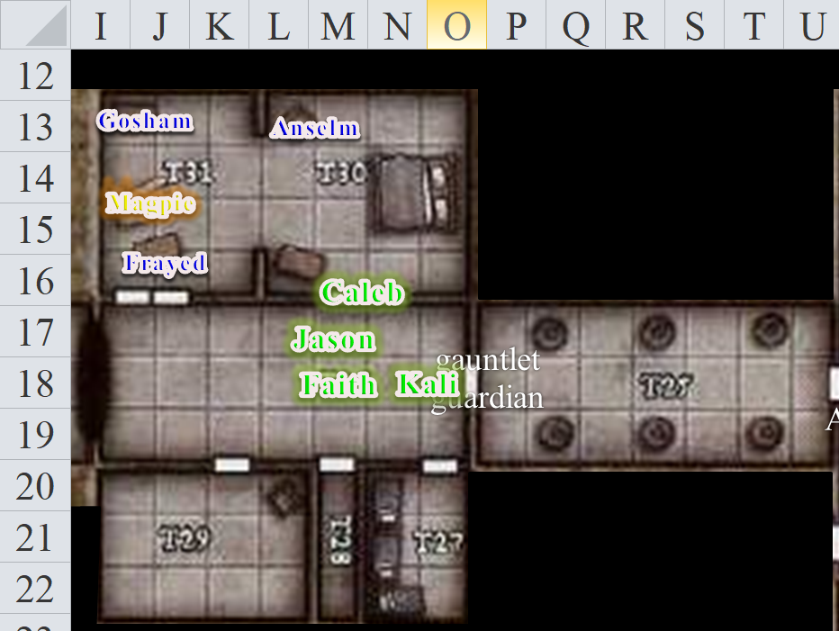

Rounds 132 – 136

Anselm and Gosham put on some robes and began to tie the sashes upon them.

Finding something worth sharing with the others, Magpie began to translate for the others, “‘Lord Larlum: We’ve had some trouble out here... some suspicion. An itinerant cleric of Gond named Tunaster Dranik came to the temple to investigate the mission, but escaped us before we could persuade him to come into the back room. We can only hope that Carthagena is able to neutralize him before he can rouse the suspicion of the nameless sheep in our midst. I am grateful to you for dispatching Carthagena to our cause; she has been most instrumental thus far, and I trust that by the time this letter reaches you, her labor will have been fully realized. The mission is in need of resupplying, and I humbly ask’.”

Rounds 137 – 138

She stopped abruptly, and the other gnomes in the room looked at her. She rubbed her finger over the ink a bit, then looked up and said, “That’s how the letter ends. No period. The ink smells fresh, but it’s dry and won’t smudge, so I’m going to assume this was being written minutes ago while we were upstairs kicking ass.”

Round 139

“Lord Larlum?” Gosham asked.

“That’s not a Gnomish name,” Anselm protested.

Rounds 140 – 144

Two other parchments had letters that were complete and signed. One was addressed to the Council—the body of elders that governed the settlement on this mountaintop—and the other was addressed to someone named Bastilles Croixième.

The letter to the Council was a mundane requisition for an extension of the Gondar Temple’s license, and included a few pertinent bits of data, such as license numbers, dates of expiration and renewal, and the nominal fees due.

The letter to Bastilles Croixième contained a set of directions to the woodland cabin of a sorceress named Drakespawn Fuchsia. “‘She is expecting you,’” Magpie translated the Gnomish into Common aloud again. “‘in two days’ time, and will be ready to join you and aid you as needed. She has pledged her allegiance to Lord Larlum, not to you, so you may not treat her as your property. Harm that comes to her shall come to you as well when you deliver her. She will have sealed instructions from me, which you are to open in front of her. Exercise prudence, and deliver only excellence. Superintendent Milfuegos Mopworken’.”

Round 145

Magpie put down the letters. Having compromised with the others on letting the former captives try to recover their equipment, she now saw that they were dressed and even acceptably equipped. “I’m glad you’re all feeling better. I regret that we could not save more,” sighed the beguiler.

Round 146

The three gnomes—having just found a plethora of material spell components in the back of a desk drawer—were grateful for their lives, freedom, and the recuperation of their health and some of their gear, and expressed this in Gnomish to Magpie.

“Now, if you’ll follow Caleb, he’ll rope trick you all to safety until you’ve had time to rest,” Magpie assured them, “or possibly sooner if reinforcements from the town arrive.”

The diviner-cleric smiled and prepared a bit of powdered corn extract and a bit of parchment from his spell component pouch.

Rounds 147 – 149

The gnomes took the entire shoebox of material spell components, resolving to distribute them according to need and equity once inside the extradimensional space. They proceeded to wherever Caleb wanted them, and the cleric-diviner worked his magic. Anselm, then Frayed, and finally Gosham, all climbed up the knotted rope, and disappeared into the invisible hole, pulling the rope up when the task was done.

Caleb wiped his hands clean of powdered corn extract and with satisfaction, suggested that they next search through the rest of the temple for other captives, “... or anything else of interest.”

Round 150

Seeing Magpie already about to start browsing through the books in this room, the paladin, archer, and dancer said they would do their best to clear the 2nd level of any remaining threats, reconnoiter the level as much as possible, and come get Magpie in a bit before doing the same in the other level.

Caleb and Magpie were on the same page that clearing the temple and rescuing any people who were in danger was a far greater priority than running down the villains. Caleb wanted to bring down the villains more than Magpie, and if the party decided to jump into a portal after them, he’d go, whereas Magpie wouldn’t. But seeing as no one was in a big hurry to begin chase, Caleb was eager to join in on the level clearing gambit for now, seeing as Magpie looked like she needed the solace in which to research the doings and dealings of the Velshari cult.

Round 151

They headed east as they discussed contingencies.

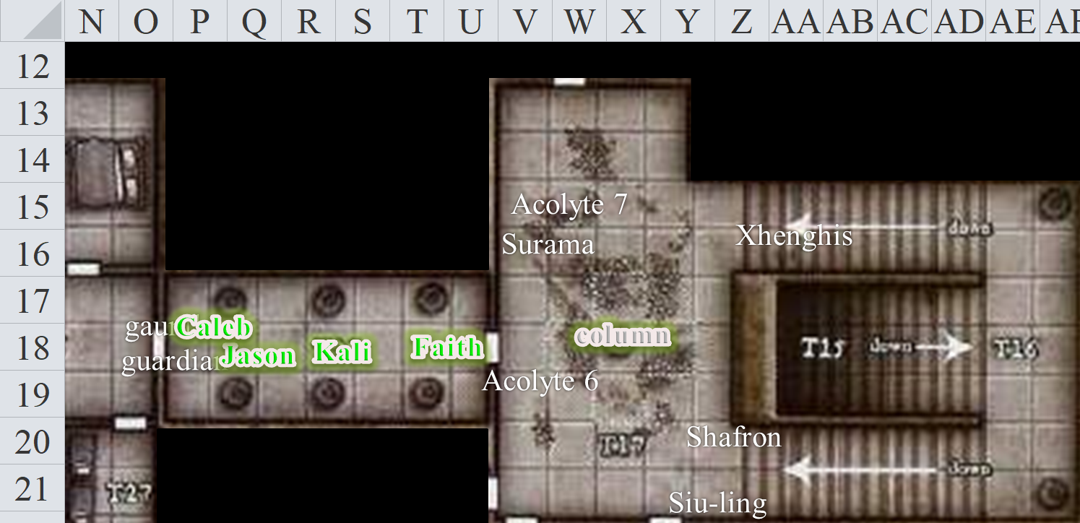

Round 152

Faith decided to check one of the southwestern doors [V21 west door]. Jason and Kali followed the paladin as she made her way along a narrow passage, first westward, then southward. Not only was the next door unlocked; it was wide open. Faith stood safely a few feet before the threshold, peering into a sewer that actually smelled less awful than the area with the corpses to their northwest.

Round 153

Nevertheless, it was a sewer. A drizzle of smelly sludge dripped and slid from a hole in the ceiling to fall 15’ onto a stone dais. Surrounding the crusted dais was a murky subterranean pool, apparently flowing from an entrance beneath the surface in the pool’s northeast corner, around the platform, and out through a similar underwater passage in its southwestern corner.

Dim torchlight flickered here, as if the single torch were almost out. The paladin did not have a line of sight to it, but could tell that the torch was at the northeastern corner of the room. What she could not yet tell is that the room was octagonal in shape.

“I hate to say it, but someone’s got to step in,” said Jason.

Kali followed with, “I don’t think this door was open when we came through the area.”

“We haven’t come through this area,” Caleb pointed out.

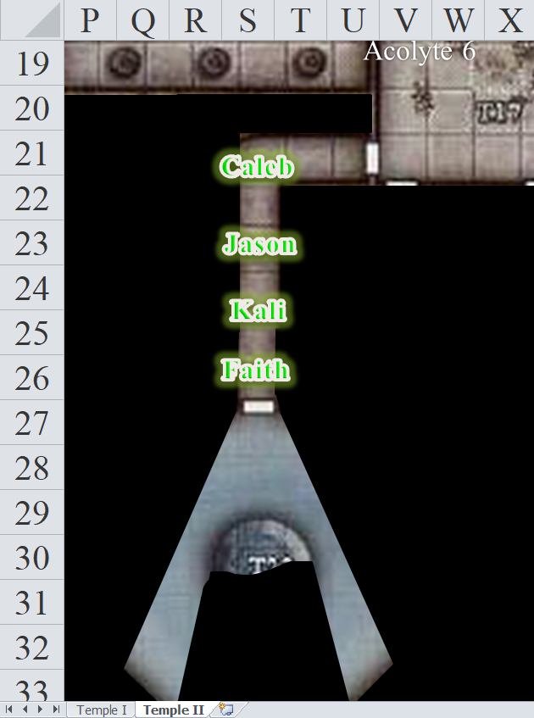

Faith nodded then took a step into the room looking first right, then left. As her boots were now a foot deep in water and nast, she took careful steps as she moved to her right—counterclockwise into the room—in an effort to see. She stayed close to the edge, seeing that the floor was tilted downward further in, a bit like a funnel, which probably helped with drainage and cleaning.

Round 154

By now, Faith had seen nearly the entire room. She supposed some sneaky bugger could be crouching in the filth behind the central dais, which was only raised 2’ above the water, but it was unlikely. So yes, this was, indeed, where the contents of everyone’s bowels were delivered and conveyed to some far-off waterway. The smell was in no way nice, but it was tolerable compared to what they’d had to endure just northwest of here. In addition to shit and piss, there were also solid chunks of food, such as celery, and other vegetables, which had been tossed in from one of the four chutes overhead. The kitchen and privies must have been right above the paladin’s head.

The basin around the dais drained along a southwestern passage, a dark channel that descended into a cascade such that no air passed through—only water. The current towards it might cause a leaf other floating object to move southwestward about 1’ per second once it was caught in its pull. Faith noticed that water did not trickle into the basin from any singular source, but rather dripped down the domed ceiling of the enclosure, making its way down the sides like miniscule, vertical streams that kept the water level stable.

Faith felt the urgent desire to return to the dry floor just a few steps away, and was dually convinced that this was the wrong room for them, when an infant otyugh covered in scales emerged from the southwestern passage and lashed out at Faith in vain.



Kali had encountered otyughs before, though never amphibious ones, so she knew quite a bit about the nature of these detritus eaters. She warned Faith about their nasty grabs, which tended to throw a warrior off her footing. This specimen was most likely feeding on gnomish waste as well as carcasses of faithful shmucks and everyday garbage from the kitchen.

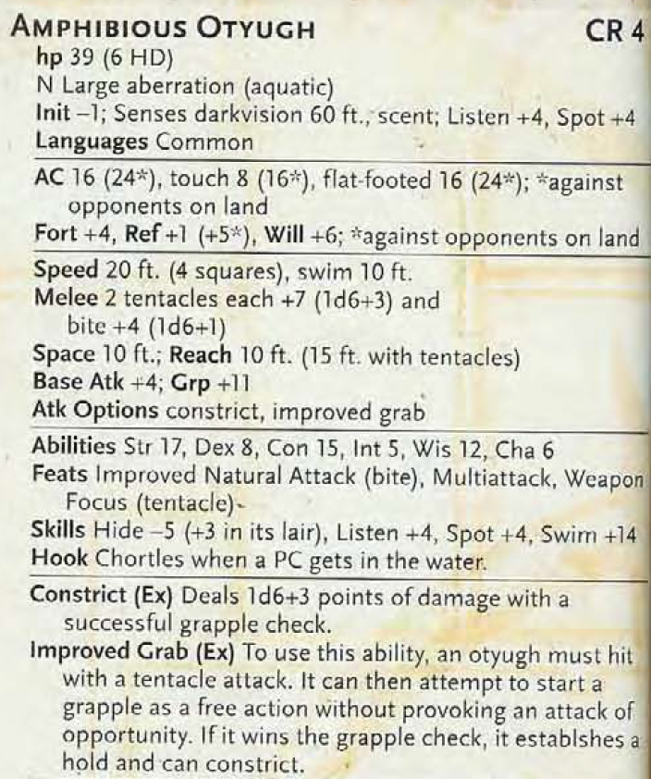

Faith had heard of this type of monster, but had never encountered one. Still, her combat expertise gave her the impression that this monster posed no challenge or threat to her. It might have even been unsporting to slay the poor thing that was defending the only patch of roaming waters where it could eat such sweet offal and all things awful. It was only the size of a fat dwarf, but its teeth were menacing enough, as were its barbed tentacles. It could have lunged at her, but the recently hatched sewer dweller remained just out of range, visibly fearful.

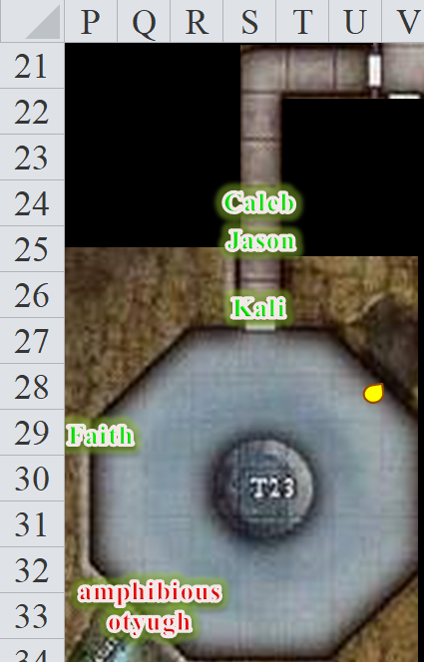

Round 155

Faith called to the others as she retreated to the door. “The beast is only defending its territory. Let’s move on to the next door.”

Round 156

The others took a few paces back and waited long enough to make sure Faith was alright, then moved to the next door.

Caleb stood a bit further north and called out to Magpie, “Is all well?”

“All’s well so far,” the busied gnome replied.

With a faint, itching sensation in both of her feet, ankles and calves, Faith opened the unlocked door.

Round 157

Faith and Jason peered inside as Kali stood to the side to back them up. Two curtailed alcoves concealed what must have been the source of this room’s faintly fecal stink. They could hear water flowing underneath, and as Faith pushed open both stall doors, they could hear it even more clearly. So the privies were not above the sewer; they were adjacent to it; or perhaps there were some above as well... for the congregation. Inside each stall was a foot-wide hole in the floor that dropped into a tributary of the sewage channel into which Faith had just soaked her feet.

Round 158

They tried the next door, which led to three rooms with wide-open doors.

Four comfortable-looking leather chairs were deployed about the perimeter of an antechamber. A circular oak table sat at the center of the room. A deck of cards with a clearly necromantic motif was strewn about, and a few cards had fallen on the floor.

A few scraps of food—still fresh—rested on a napkin atop the southeastern chair, and as Faith walked through the antechamber and into the eastern room, Kali thought she might eat some of the muffin on the napkin.

Round 159

Faith entered a room with a plethora of martial weapons, some of which she’d never seen. They were clearly gnomish in craftsmanship, but looked heavily inspired by traditionally orcish designs.

And yet the quarters looked as if they belonged to quite a civilized person; perhaps he or she was merely a collector, seeing as how these weapons were all displayed so elegantly on the walls and had no wear on their business ends.

A thin layer of dust—probably two days old in a place like this—covered the desk, and a much more evident layer of dust covered the top of the wardrobe, in which hung the robes of a gnome-sized woman. A few other artifacts—jewelry, a black dildo with Velshari engravings, and other personal effects—led the paladin to believe that this was the Priestess’ chambers, while the senior woman—the Superintendent—must have slept where Magpie was now.

By now, Jason had ventured to the south, entering yet another bedroom that looked like it had just been cleaned. There was even a wastebasket right in front of the doorway and a broom lying flat on the floor in the threshold. By the looks of it, some zombified custodian had just finished here, and was about to start cleaning the rest of these rooms when Magpie and company decided to shut down the operation and everyone bolted. That was a supported hypothesis, but not the only possible scenario. Some necromancers preferred to live in filth. He inhaled deeply the relatively clean air in these rooms.

This southern bedchamber, in addition to boasting a perfectly made bed, immaculate bureau, and used but orderly desk, contained eight gnomish heads mounted on the walls like trophies. Glass eyes stared down at Jason from their yellowed flesh, and the acrid odor of preservative hung in the air. A long table stood against the south wall, next to a large, upright wooden cabinet.

Jason took his eyes away from the mounted heads long enough to see a jet-black suit of splint mail that he could only associate with an assassin, or perhaps a blackguard, but he was no expert. Along the western wall was a map of this mountain settlement, with several black pins stuck into seemingly random positions in the settlement.

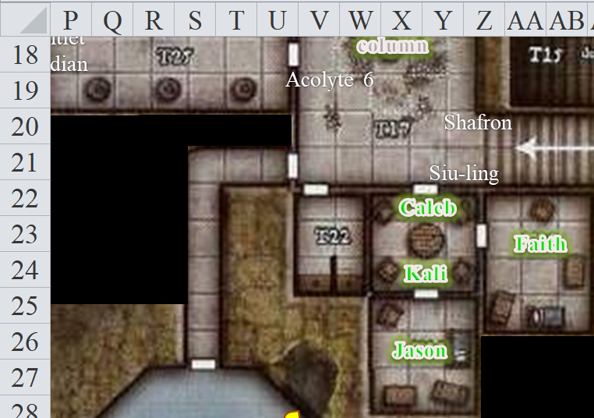

Round 160

Kali followed in, getting a load of the heads, plate mail, and map, then calling the others in here as Jason’s eyes did their best to locate any traps before his less astute friends could step on a landmine.

Round 161

They began to regroup in the antechamber, then moved back into the hallway. Faith continued towards the northern door.

Round 162

This was another unlocked door into another dead-end room. Faith shouted to the beguiler three rooms away, “Magpie, you’re going to want to check this room out as well!”

In case Magpie didn’t hear her, Caleb stood in the westbound doorway and relayed the words.

Round 163

“What is it?” Magpie asked.

Faith was already composing an answer, “I’ll estimate at least one-hundred books in here, some fancy, some old and worn.”

The diviner-cleric again repeated the words.

Round 164

“Almost done here,” Magpie called out.

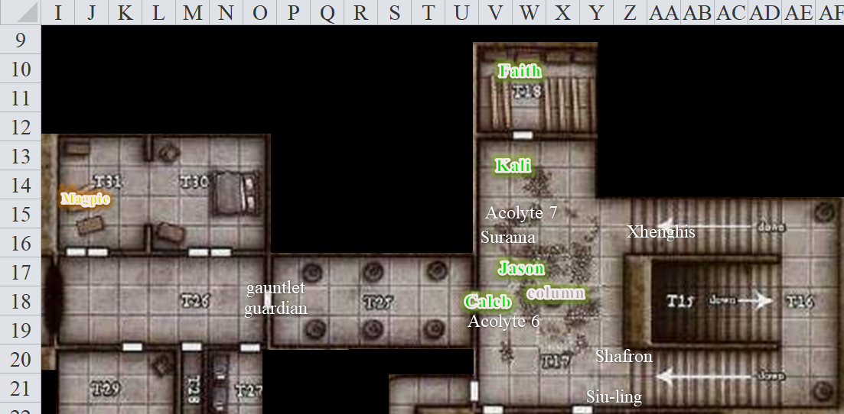

Round 165

The shelves throughout this room were partly lined with tomes and scrolls, and it appeared by the standardized binding that some of these were encyclopedic collections of a sort. Each collection had anywhere from 6 to 30 volumes, and all was written in Gnomish or some other script that Faith could not read.

More remarkably, there was also a heap of books—all of these bound in the metallic colors of Gondar insignia—and it was evident by some of the empty shelves in the room that someone had seen fit to censor the library’s contents somewhat.

“Well, if we had brought Frayed with us, we would know if it is regular temple books or something else without having to go through these,” said Kali.

Round 166

“Go get him if you want,” Faith proposed. “He’s just down the hall in the extradimensional space.”

All in all, it appeared that this was the level where the elite priesthood of Velsharoon took up residence, as well as some of their favored lackeys and underlings. Now as for this Carthagena, and Lord Larlum... Kali wondered who these arch-villains were.

Magpie picked up four books, and walked over to the others.

Round 167

Magpie said to Caleb as she approached via the hallway, “You’re going to want to hear this.”

Rounds 168 – 172

Caleb made way for, then followed, Magpie northward where Faith, Jason, and Kali coalesced. They were all in the room with the caryatid column again, and Magpie peeked into the library behind Faith as she spoke. “Four tomes: Whisperings (the core Velshari scriptures, The Dark Ghoul Mishna (Velshari commentary on Velshari scriptures), Why the Faithless Lie—and Will Eventually Die (Velshari commentary on cherry-picked scriptural passages from other faiths), and a nameless collection of essays by an author named Who the Bone Whisperer. The first essay wantonly references Why the Faithless Lie, going into some detail as to what to do with ‘the faithless’ once they die. It’s a necromancer’s cookbook, with references to some of the most infamous canon recipes in their faith, such as mohrgs and dracoliches.”

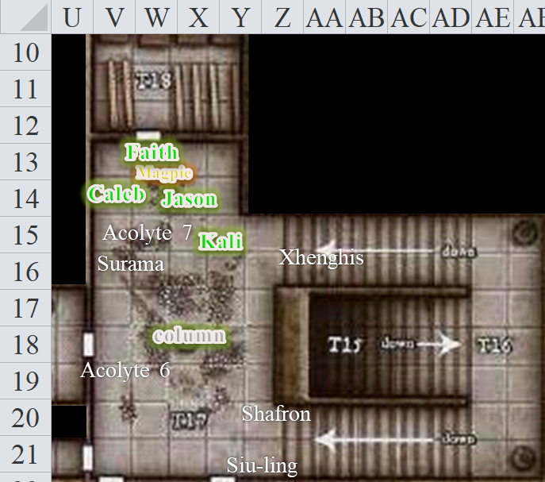

Round 173

“So is this good?” Jason asked.

Rounds 174 – 176

“Well,” Magpie could not resist the urge to go into the library now. “It’s what it is: confirmation that the Gondars were hijacked by the Velshari a tenday ago, and they’ve been running a fly-by-night operation that was apparently trying to get as many of these gullible souls as they could.”

“The question is where,” Faith set Magpie up for her next point.

Rounds 177 – 181

At that point, Magpie put the four books down on an empty shelf in the library as everyone followed her in. She then produced a rolled up parchment that she’d found in the desk, along with the four books. “So there’s a rudimentary map, more like illustrated directions that apparently lead to the necromancers’ destination. I’m not sure what it is, but it’s labeled ‘Larlum’, so I’m going to hazard a guess and wager that Larlum is taking in these gnomes—alive or undead—and putting them to whatever macabre purpose he wishes.”

Round 182

“Wind in His Hair should have arrived at the town square by now,” Caleb estimated.

Round 183

Jason proposed, “Should we search the rest of the rooms upstairs? Or maybe search the bodies of these lackeys?” he pointed to Siu-ling, Surama, Xhenghis, and the other corpses of fallen Velshari whose names they could no longer remember.

Round 184

Magpie shrugged, “That’s two thirds of the muscle. I’m not fronting an expedition, so if you’d rather search corpses than prevent the creation of more, who am I to argue? Passive aggressively disagree, sure, but argue, nah. Caleb, can you?”

“I can,” the mystic theurge replied, casting one of his three prepared detect magic [expired on Round 294] spells and walking through the area, pointing out anything with a mystic aura.

Round 185

Kali said, “Let’s search these, then head upstairs.”

Faith moved just down the stairs to wait for the group. She did not think the dead should be disturbed except for their burial.

Round 186

“I say we gather the stuff, toss it in a bag, and identify it when we have a chance to rest and take a breath,” Magpie could compromise, see?

“Sounds fine,” Kali said as she knelt down at the first body to collect any magic items, coins, and other valuable items.

Round 187 – 189

“The bodies will keep,” Magpie replied. “Although I do want to see what tasty gnome-sized magic items they might be carrying, you know, for curiosity’s sake. And yes, I know stuff resizes. Really, they should find a way to mass-produce that resizing enchantment. You know how hard it is for me to find a tunic that fits well? Harumph.”

As Magpie saw to searching Siu-ling, Kali found a wand of cure moderate wounds (CL 6), a dagger +1, and a sling on Surama.

Round 190 – 192

“Your fashion woes notwithstanding,” Caleb interjected, “I think you’re correct. We should try to secure the rest of the temple before the other gnomes show up to avoid potential casualties. Also, there may be more evidence to find that could be lost if others trample through.”

Magpie took her time with the wu-jen’s body.

Round 193

“I don’t wish to return down here and as I previously stated we should do the search now. It’s not like it will take long,” said Kali as she searched the dead monk, Little Brother Shafron, finding nothing but his two unholy sai and is unholy symbol of Velsharoon.

Keeping watch, Jason agreed with Kali.

By now, Magpie had recovered a ring of protection +1, a flaming quarterstaff, a sling, three potions, and a scroll from Siu-ling.

Rounds 194 – 195

Kali and Magpie then turned to Xhenghis, finding only the falchion of frost, his leather +1 suit, and an unholy symbol of Velsharoon.

Round 196

Having discussed the books, the correspondence, and the bit of treasure found on the four dead gnomes, Magpie and company assessed the deceased lackeys to have been selected for their loyalty. Among them all, they could remember which spells the enemies seemed to have cast, and could also make some guesses—based on material spell components and other clues—as to what spells they also had not yet cast.

Name/Alias | Race | Class | Sex | Feats/Daily Spells | Spells Selected | Spells Known | Weapons | Armor
Little Brother Shafron | Gnome | Monk | M | Flurry of Blows, Unarmed Strike, Slam Attack |  |  | Unholy Sai (2) | none
Siu-ling Karamazov [detecting magic; seeing invisibility] | Gnome | Wu jen (fire) | F | Element Focus, Sense Elements; 4/4/3/2 | Detect Magic, Inflict Minor Wounds, Resistance²; Endure Elements, Mage Armor, Magic Missile, Shield; Bear’s Endurance², See Invisibility; Prickling Torment, Stinking Cloud  [Spell Secret: Extended Haste] | Daze, Detect Magic, Disrupt Undead^{S}, Inflict Minor Wounds, Resistance; Cause Fear^{S}, Endure Elements, Feather Fall, Mage Armor, Magic Missile, Shield, Smoke Ladder; Bear’s Endurance, Haste [Extended], Hold Person, Pyrotechnics, See Invisibility, Warp Wood; Fireball, Prickling Torment, Steam Breath, Stinking Cloud | Flaming Quarterstaff, Darts | Ring of Protection +1
Surama Baatorfrom [detecting magic] | Gnome | Enchantress | F | 4/4/3/2 | Detect Magic, Read Magic, Message^{1/2}; Grease, Mage Armor, Power Word Fatigue, Shield; Sap Strength, Seeking Ray; Fireball, Hold Person | All cantrips; Grease, Nightshield, Kelgore’s Fire Bolt, Magic Missile, Mage Armor, Negative Energy Ray, Power Word Fatigue, Rouse, Shield; Daze Monster, Fog Cloud, Sap Strength, Seeking Ray, Shatter, Web; Evil Eye, Fireball, Hold Person | Dagger +1, Sling | mage armor, shield
Xhenghis Sarai | Gnome | Dragon Shaman (green) | M | Cone of Acid, Move Silently |  | Auras (+2): Power, Presence, Senses, Toughness, Vigor | Falchion of Frost (18 - 20), Breath Weapon (cone of acid) | Leather +1, barkskin

“What a fun fight that was!” Jason muttered, remembering the scuffle fondly.

Having just moved to the bottom of the staircase to wait for the group, Faith now returned just outside the open door to the north, which she’d most recently opened.

Round 197

Jason stood in the room, watching the search.

When they were done, they left the bodies facing up. Faith proclaimed, “On to the upper level then?”

Round 198

Magpie tossed the Wand of cure moderate wounds to Caleb, and anything not sharp and pointy that no one else grabs can get crammed in her Haversack, and that included the evil tomes of plot advancement. Other people could fuss with the pointy stuff. Once that was sorted, she’d salute Faith, “Lead on, oh massive, metal clad wall of righteous purpose.”

~*~

Rounds 200 – 201

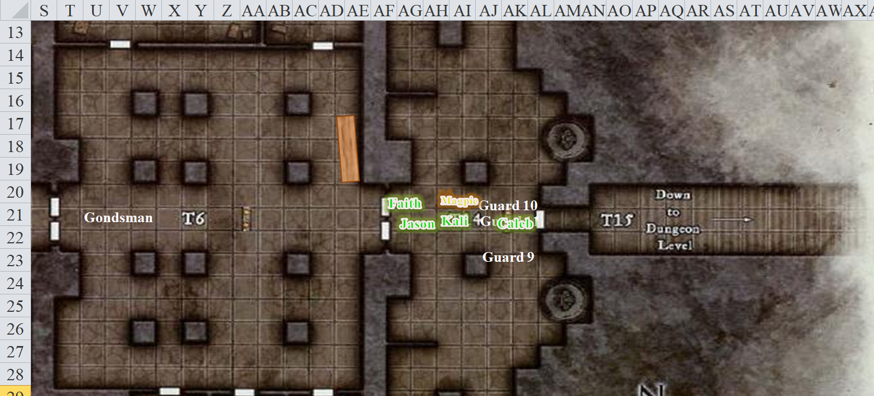

The heroes made their way back up the stairs, and heard only their own footsteps echoing throughout the temple carved directly into the mountain’s façade.

Rounds 202 – 203

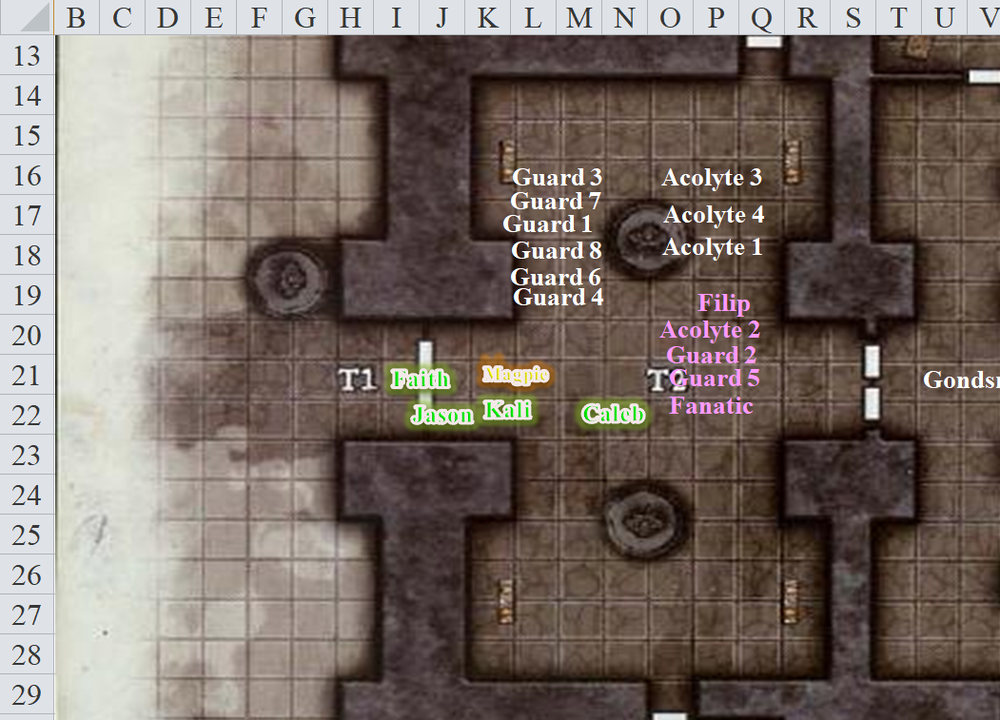

Passing the still unconscious and bound impostors, along with those actually dead, the heroes walked out through the already ajar door. “Someone had to have opened this from the inside, and Wind in His Hair wouldn’t have needed to,” Kali was pretty sure.

The night had brought a fog with it, and as the fog swept over the mountainside, the heroes listened for sounds of movement to their west, but heard none.

“Let us check this door to your south,” said Faith and began moving in that direction.

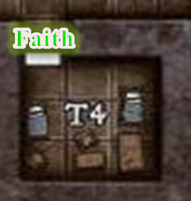

The door was ajar, though no one had noticed it as such before, suggesting that someone had come out of there in the time that it took the heroes to do all they did. The bedchamber inside contained two cots, a desk, a chest beneath the desk, a few chairs, a closet, a foul-smelling chamber pot, and a bookcase on which a few lonely tomes with bottles filled with various colored fluids.

Round 204

“Should we check the rest of the rooms on this level?” asked Jason.

Rounds 205 – 206

Faith replied to Jason, “Yes on to the next door.”

Kali stood guard just inside the main door with her weapon drawn as Faith and Jason checked the next room eastward.

Faith opened the first door, while Jason opened the next one over. In the room that Faith just stepped into, she saw boxes, crates, barrels and shelves lined with plates and crockery. Some supplies were clearly from the town—identified by party members who’d actually eaten some of the picked eggs in jars while staying in the settlement—while others were of a necromantic and/or foreign nature, either stored in glass vessels or in wooden crates with macabre labels written in Infernal.

On the east and west walls of the room that Jason had just stepped into were iron pegs on which were hung dozens of identical ceremonial black robes. The room apparently served as a hallway that led to yet another area that smelled distinctly of urine and feces. Though it was too dark within for him to see without Faith’s illumination, he could guess with some certainty that they were near the sewer they had just recently visited on the lower level.

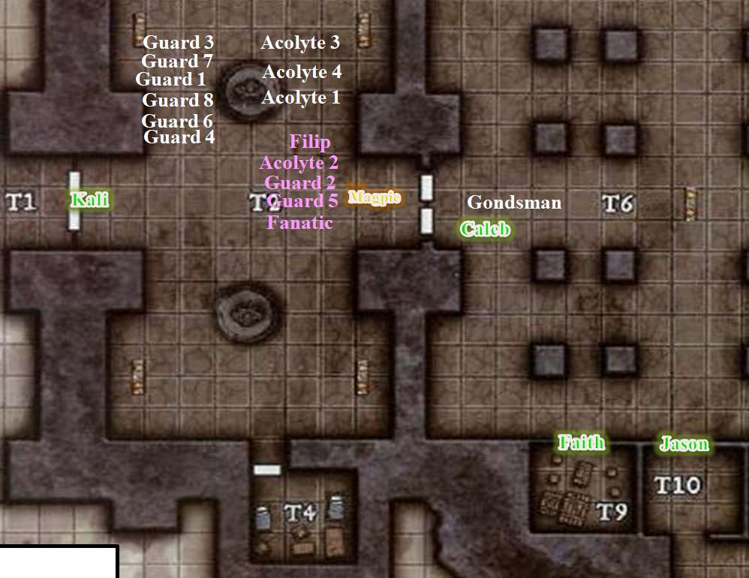

Round 207 – 210

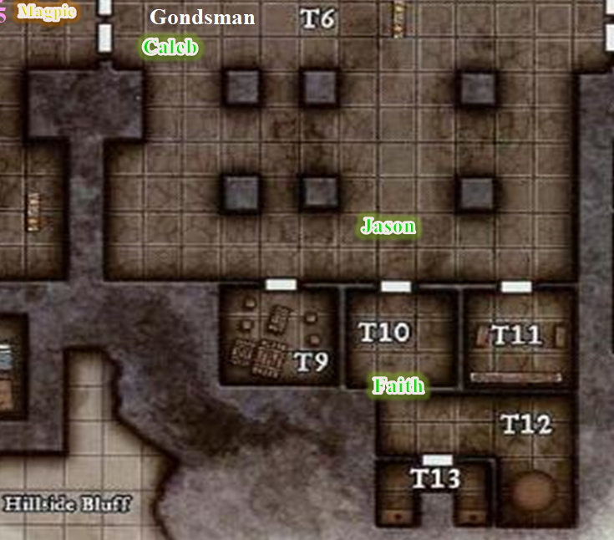

The party searched through the rest of the area. First, Faith peeked into the privies and held her breath for a moment until confirming that this was what it smelled like, then exhaled and announced, “Clear,” making her way eastward with the archer behind her. Then, she found the next door locked.

“Magpie, you feel like dealing with this lock?”

Round 211 – 213

[IF so] Magpie came over to the paladin, agreed, then cast knock again, looking forward to a full night’s rest before doing much of anything else.

[IF not] Faith shrugged and bashed down the door with three tries.

She looked into the quiet room, a somber chamber containing two oblong, freestanding closets, almost coffin-like in dimension, on the east and west walls, facing one another. On the back wall sat a polished, wooden cabinet. Behind the cabinet’s wood framed glass doors, gold vessels glittered. It was evident to Faith that the symbolism here was kept entirely Gondar, with no trace of necromancy at all. This had served as a sacristy for the Gondars, and probably would again, thanks to the heroes, but for the Velshari, it had served as a dressing room before the show began. A semantic difference, some might have argued, forgetting the motives of Gond and Velsharoon alike.

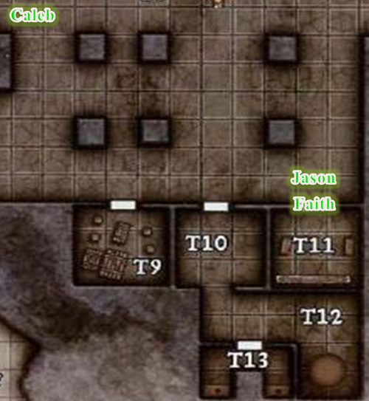

Round 214

Faith opened the unlocked door to her north. Inside, four well-made cots lined the western wall, a small wooden chest beneath each. Some dice were carefully arranged atop a chest pulled out from under one of the beds.

