Chapter 8c

Round 215

Having left all of these doors opened, she braced for a whole lotta nothin’ and opened the last one. Each of this room’s four cell-like alcoves contained a small cot, a neatly folded back robe and stack of blankets, and a wooden chest. On one bed was also a basket with some half-eaten bread, cheese, and meat. The smell of clean linens and half-eaten food was so much more inviting than the southern rooms, which were so foul.

This was quite surely the room afforded to the fools that signed up for whatever fate the necromancers had in store for them. Civilian clothing—all gnomish sizes—covered every bed, each outfit consisting of the usual bottoms, tops, sashes, belts, and other accessories that the aspirants had been asked to leave behind as the partook in their last feast in the temple before going on their journey to receive Gond’s Sacred Franchise.

Rounds 216 – 219

Wind in His Hair returned, and transformed himself into a half-elf once more. Huffing a bit, but not with a look of distress, he caught his breath and announced, “The townsfolk have been informed. Pheeeew! Huff! There is great alarm, and the Council has dispatched a security detail, but a mob is following not far behind. I assured them their security would not have much to face once they got here, but I fear that they might turn on the townsfolk if the mob gets too aggressive. The relatives of the deceased are clamoring for the heads of those responsible.”

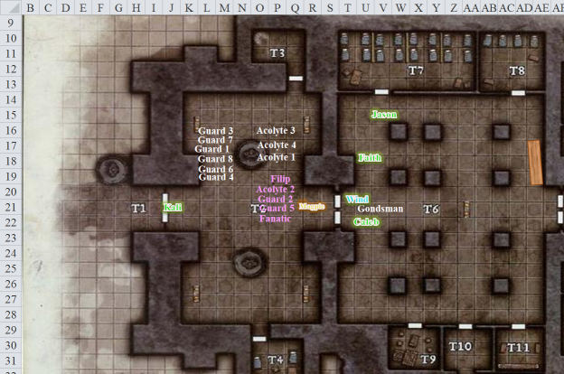

*[End of round-by-round tempo]*

Once done with the search and all have meet back up in the main room Kali said. “We should leave this place and see what is in the nearby building before the crowd gets her.”

“Good idea,” chimed in Faith as she, then Jason, moved out of the building, followed by Kali.

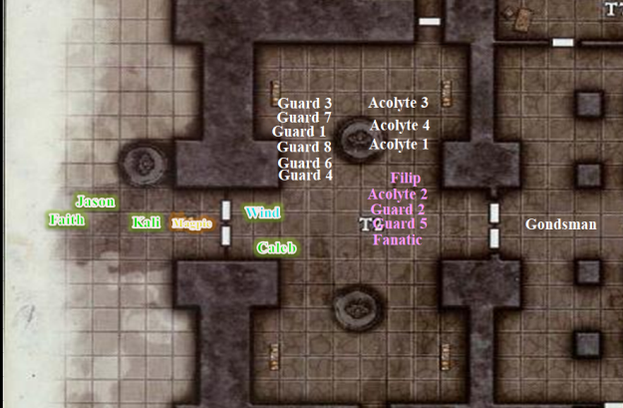

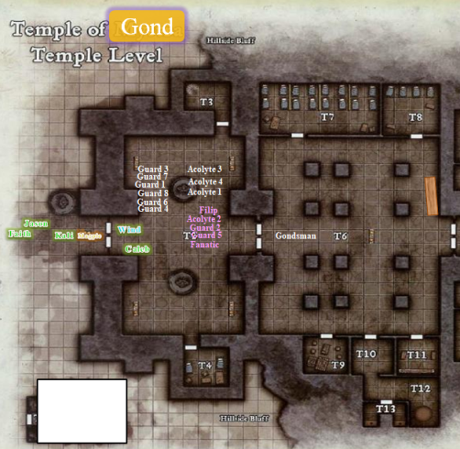

With the shack to their south and the townsfolk already approaching in a procession led by the winged gnome who’d welcomed them to the settlement only a week ago, the party convened in front of the temple, presenting themselves with an air of accomplishment and righteousness as the paladin prepared to speak for the group. With five bound prisoners and over a dozen dead traitors to the Temple of Gond, they prepared to present the townsfolk with the evidence of the malfeasance that prevailed here for a mere tenday and yet claimed the lives of dozens of unwary citizens.

The faces of the gnomes approaching were not betraying anger, outrage, or hostility towards the heroes, but gratitude, though there was certainly alarm in their movement as they hastened towards the temple.

Magpie greeted the arriving gnomes, explaining the situation in Gnomish as best she could, showing them the books she’d found below. “I cannot say the hearts of the unconscious and bound prisoners are wicked. Not for certain. They had a beguiler in their ranks that could have fuddled their minds. There was an arcane machine that wove powerful enchantments through the air via sound, not unlike some sort of Infernal siren. I’m relatively certain that gnome,” she indicated Filip with the toe of her boot, “is a villain. The others could have simply been ensorcelled.”

Caleb was profoundly unsettled by how rapidly this temple was cast into darkness. The idea that faith could be so easily perverted made him nauseous. He needed a bastion of faith, a paragon of ironclad virtue, so he walked over to Faith. “I will aid you clear the remaining building.”

Staying around 10 to 15’ behind Kali, Caleb aided the dancer-assassin and scout in clearing the building.

The nameless gnomes—particularly the Elders of the town—had expressed how grateful they were to the party, but also remarked that two members of the Council of Elders were unaccounted for, and asked the party if they saw the two gnomes. By the description, one of them was likely the fanatic that was still alive but unconscious amidst the other gnomes; the other’s description didn’t ring any bells. The fact that two Elders had fallen prey to this scheme raised concerns for all.

Specialists of all kinds—retired, mostly—entered the temple, having to see things for themselves. It was not disbelief in the heroes’ anecdote, but rather reluctance to believe that pious gnome souls would sell other gnome’s souls down some transplanar river. The bodies began to be carried out by some of the younger lads and lasses, and the Elders shook their heads at the circumstances as the paladin of freedom proposed a few courses of action.

After words were exchanged, the party was asked—begged by one white-haired man—to pursue the renegades behind this nefarious plot, and lay them by their heels if necessary, or bring them back alive for prosecution. Since the epiphany that led her alignment to shift from law to chaos, Faith was not big on bringing in prisoners for judgment, but she was less fond of letting nefarious soul snatchers wander around cajoling people out of the eternal bliss they’d earned in previous lives.

“I don’t have a problem pursuing them,” Magpie began, knowing full well Faith would be all judgey about it. “I’m about tapped magically, and without magic, I’m not much use in a fight.” She shrugged, “With that in mind, I want to sleep. I need a few hours to get my spells back, especially since the big bad who ran didn’t spend the sort of magical resources we did. That said, a few hours gives them more time to put distance between us, or prepare for our coming.”

“I’ve expended some power, but I have deeper reserves than the beguiler.” Caleb looked down to Magpie, “No offense intended.”

The gnome shrugged, “Hey, it’s true. I’m better at what I do, but you do more things.”

“I would be stronger if we rested, but I could continue on tonight. It’s a much riskier strategy, but one that could be of value.” Caleb was a fairly levelheaded fellow.

Once interaction was done with the townsfolk, Kali moved forward the closest out building to begin checking for any holdouts.

Faith replied, “We will most certainly go after this foe and bring them to justice, but first our spellcasters need rest. I do not see any issue with waiting until morning. Maybe our prey will think we are done with the chase.”

~\*~

The night was half-way over, and with the adrenaline pumping through everyone’s blood, there was much ado as guards were posted at every door of the temple, and even the adjacent building had been rendered secure. Contrary to suspicions, the straggling fanatics who had left the temple did not stay in the small building to the southwest very long, if they ever ventured in there. It was a storeroom with a small desk that looked like it had once served a grander purpose; nothing more.

Wind in His Hair had tracked a few of the fanatics paces downhill, stating, “Three fled that way, and one fled that way.” He whistled loudly for his dire jackal mount to return to him, and offered to apprehend them, if possible. “They cannot be far.” Taking two gnome scouts with him atop the Huge mount’s back, the druid led the animal down the slope of the jutting mountain.

Minutes later, the rest of the heroes were back at the settlement enjoying the finest refreshments that could be offered in such a place as this. The nameless gnomes were ever grateful for the heroic gesture of cleansing the temple of evil, and wished to regale the outlanders with something suitable.

*[For each PC, choose 1 to 5 items whose combined value does not exceed 5,000 GPs.]*

*[DM assumption]* Having been presented with the magical items, the party pledged to continue in the pursuit of the vile charlatans who took the lives and souls of so many loved ones in this afterlife settlement.

*[Any Q&A or other interaction with the Council of Elders should go here.]*

“Friends,” Wind in His Hair then announced, having left his jackal mount outside. Followed by the two gnome scouts, the druid brought in three fanatics who had been found making way for the vast plains to the far south. The mood went from mildly nervous about the missing and dead victims to pointedly vicious and accusatory.

Several folks within the crowd were relatives, friends, and/or lovers of those deceased and missing, and they immediately had to be held back by guards as the three fanatics, still dressed in white robes whose hems were now dirtied and speckled with bits of the brush through which they ran.

As the mob was assuaged and dissuaded from taking reprisals against the three males who simply awaited punishment with their eyes cast downward, the winged gnome and other Elders approached and faced the accused. This had become a makeshift interrogation and trial, and as was customary here, would prove to be more useful than the more lawfully-oriented courtroom trials, which had to be scheduled, arranged, etc., etc.

All in all, it was learned that these faithful men were among those initially duped. They described part of the “method of stages”, as they referred to it, which involved limiting the neophyte to a select group of other neophytes and one or two “sponsors” with whom they bonded. After a few days of sharing in dancing, games, lectures, trials of faith, sacrifices of selfhood, and increasingly painstaking rituals, they had begun to forget themselves. In fact, by the time trials of faith came to pass, they had mostly forgotten the dancing and games stage. Their identities and perceptions were becoming timeless, and the heady sensation of living in the moment—losing all they had once been—was simultaneously numbing and titillating.

In the end—and this cohort of five men, two of whom had already died, had only been victims of this plot for six days before Magpie and her friends arrived—and by then they’d been given names, duties, and the promise of Gond’s Sacred Franchise, a vaguely described bestowment of honor that granted visionary power that allegedly could not be put into words. To Faith, the words reeked of a swindler’s tongue, but this they knew already.

Before the repenting, recanting gnomes were sent to the settlement’s merciful rehabilitation facility, diviners cast a multitude of spells on them, nodding shortly between spells. Although the three men were not aware of the true identity of the charlatans that had nearly usurped their very souls, one of the apprehended men—who had by now renounced the name given to him by the Velshari cult—concluded that by the time they were colluding with the cult, their entire mindset was bent on the survival of their cell, and the larger congregation of which they thought they would soon be members. Nothing else seemed important. “The ultimate test of faith, we were led to believe, was to abandon the dogma of one’s faith, and fight for that. It actually made sense at the time.”

The other two nodded, one of them crying now as—after decades of being so inane—he finally realized what a low Wisdom score he had.

*[Any Q&A or other interaction with the three prisoners should either go here, or if you need to insert it between two paragraphs above, just let me know where it should go.]*

The three were led away, and Wind in His Hair took a seat, as did the two scouts, and began to partake in the eating of the cornucopia before them.

Wind in His Hair looked upon his traveling companions, and said, “My traveling companions, I have pondered on this decision since we discovered Frayed and the other two gnomes and realized that the path ahead led out of this plane. I regret that my path lies here, on Bytopia, and for the moment, on this mountain. As we chased down the three escaped fanatics, I was witness to a great deal of natural imbalance along the hillside, and it is evident that evil has escaped, and roams free here. My jackal companion—Ravages Savagely—has sensed it too, and while we remain here to hunt down whatever creature is loose on this mountainside, it will do us both well to know that you are also hunting evil down.”

*[Any interaction with Wind in His Hair should go here.]*

Magpie looked teary-eyed, but said it was part of an illusion she was working on.

The druid added, “Friends, I have very much enjoyed your company, and hope that we meet again. If you return to this place after vanquishing the villains beyond the portal, I will leave word of my destination with these gnomes... once I am finished with my business here. It has been a brief but grand experience wandering and fighting alongside you all.”

Faith stood and turned to Wind in his hair, “It has been an honor to fight by your side. I weigh you safe travels and may your god always look watch you steps.” The woman raised her glass in a toast. Kali and J add-on followed suite. “May your days be long spoon this earth and mutt your strength hold out.” Others answered, “Hear! Hear!” as the glasses clinked together and all drank from their glasses.

Kali said we will miss you.

~\*~

When food, drink and merriment had begun to wind down to a close, the silver-haired, winged gnome approached the paladin and asked, “Won’t you pardon me? I must try to get some sleep before the light of the clouds returns. I leave you with my entrusted assistants, and urge you all to get some rest as well.”

Faith—100% confident in the virtue of the winged woman—agreed, and began to set into motion the formalities necessary to also excuse herself, disarm, remove her armor and clothing, bathe, pray, prepare her spells, and meditate horizontally.

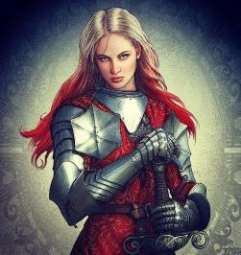

The others eventually also left the reception held in their honor, Kali and Wind in His Hair being the last two to thank the townsfolk and accept a few more cheers. They’d all been offered lodging at just about everyone’s house, but most took to the same quarters that they’d been occupying all week.

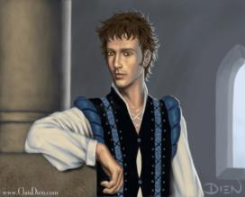

Jason drank his fill of wine and those around could see the affects. He finally was escorted out by two females to their home for a night of pleasure.

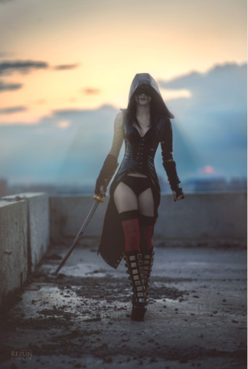

Kali—armed to the teeth—escorted Wind in His Hair back to the hearth he’d made for himself and Ravages Savagely. Her place was just a few thousand paces further up the trail: a small adobe cottage nestled on a rock outcropping overlooking a panorama that spanned for fifty miles on a clear day. The cliffs and peaks of Shurrock above them comprised a sky so unusual to Kali’s eyes, yet so natural to Wind in His Hair’s.

“Kali,” the druid said after a few seconds of silence as they walked.

“Yes?”

“I’m wondering how you would feel about copulating... with me... tonight.”

Kali had watched as Jason left. She wondered why she felt a twang of jealousy. She could not stand the man; anyway, he was below her station as a Turmish princess. She turned at the druid’s interruption of her thoughts, and was then appeared shocked at the bold request. “Oh, you are direct.” Kali had noticed the druid’s nice, appealing features on many occasions. She had even had a dream about the two of them in bed. The woman made a startled face, as she felt her cheeks warm; hopefully, he would think it was the wine.

She smiled as she stood up, “I would love to. It can be my parting gift to you.” She followed him towards the hearth for a wild night of raw unbridled passion.

~\*~

Magpie refused the gifts twice before relenting, basically out of courtesy, and also because she didn’t really feel as though she’d earned a reward. Still, the magical tome and orb the gnomes gifted her with were remarkable in their own right, and she appreciated them.

Knowing they’d be facing undead, Caleb was gifted with a wand of Lesser Restoration 4500 gp, a potion of *lesser restoration*, and 4 potions of *cure light wounds*. He was somewhat envious of Magpie’s cooler items, while recognizing the utility of what he was given.

Caleb watched over the interrogation of the cultists, fascinated and a little horrified by the prospect of what the gnomes had gone through, what they’d done, and how fast it had transpired.

Magpie, by contrast, wanted nothing to do with that. She knew full well the power she wielded and what she could do if she put her mind to it. Beguilers made much better villains than heroes. This entire situation made her feel... dirty. She felt ashamed for the gifts at her disposal, seeing how they’d been misused. That wasn’t a weakness she intended to display to anyone, but it weighed heavily on her heart. To the point where later in the evening, when one of her poker students offered to do a little horizontal tangoing with her, she just patted him on the cheek. “Not after the day I’ve had.”

Her party began to pierce her discontent when the druid announced he’d be staying behind, but she played it off, purposefully making it seem as though she was upset about Breezy Hair leaving rather than her own feeling of disgust. She gave him a little punch in the thigh, “Look after your slavering hell beast, Breezy. I’ll miss that walking mountain of fur and teeth more than I should, given how many bites it’d need to eat me. And, I’ll miss you too. Your hair inspires personal grooming goals.”

As the group started to break apart for the evening, Magpie went back to her quarters, closed everything up, sat down in a corner and wept for what she’d seen this evening.

~\*~

Faith entered the stark quarters that she had been given by the gnomes upon arriving to the settlement several days ago. She undid the latches on her belt and scabbard, then set her holy greatsword down on her cot before removing the heavy flail from its back-mounted clamp. Stooping to look at her battle-scarred face in the gnome-sized vanity mirror, the paladin of freedom sighed and noted today’s wages of virtue marked upon her cheeks and nose, both bruised and lacerated. One last healing spell cured these as well, and—looking at herself once again—she sighed altogether differently now with a bit of self-indulgent vanity.

Her inhibitions caught her admiring her own facial features, forcing her to clear her throat and begin undoing the laces, straps, and clasps on her Full Plate of the Dove, a gallant and resplendent suit of armor that had protected her since her time with Saryn, the brass dragon, and his daughter, Persephone. She went to the bath that she had been told was a standard thing in every room, and drew some hot water from a magical furnace.

~\*~

Caleb was getting ready for sleep, wondering if he should engage in any pre-sleep activities. Sadly though, for him and Magpie, a good night’s rest was crucial to being prepared for the following day’s villain hunting. As he lay back on his bed hand resting on his chest, he stared at the ceiling and wondered about Faith, and how she was doing. She’d changed so much in the time they’d known each other. They both had. A less awkward man might go ask, check in on his friend. Instead, the Mystic Theurge turned and pulled the covers up over his shoulder and tried to get in his 8 hours of rest.

~\*~

Jason had closed the latch on the inside of his door and turned to the gnome women before him. They were two, and though together they weighed less than half of what one of his usual lovers packed on, the scout was willing to honor this evening with the lovely lasses before venturing headlong into some unknown dimension.

The women were no courtesans, but they had led lives to pious in their former incarnations to eschew such carnal pleasures on the basis of the hereafter. This *was* the hereafter, and here was this man twice as tall as them, but without the grotesque features of the goliaths that made their home on the neighboring peak of this mountain range. They led the human to his single human-sized bed, and assured him that the mattress was ample enough for the three of them.

Confident, and having bathed before the half-hour ordeal with the Velshari cult earlier, the man took nature by its reins.

~\*~

Outside, under a gray cloud of moonlight-like illumination, the druid and dancer were facing one another, reminding one another was sex was. Ravages Savagely curled up like a crescent moon not 20’ away, facing away from them and down the hillside as if guarding the two lovers.

Kali and Wind in His Hair held one another by their skulls running their fingers through one another’s manes as their tongues entwined, then tasted one another’s sweaty skin.

~\*~

Faith had lay the suit of armor, now removed, directly onto the floor, and now wore only the underclothing that protected her skin from the abrasive wear of the armor. Her tunic—embroidered with a butterfly pattern—sported a handful of bloodstains, which she would cleanse with a purifying prayer later. Reaching behind her back and undoing the lace that held the tunic in place, she released it, hunched her shoulders to let the garment fall down her wrists and onto her hands, then felt her chest support release and her breasts bounce free for a moment.

Her leggings had little giraffes and daffodils all over them, and the virgin warrior next undid the lace under her navel to release these, letting gravity draw them down to her ankles before stepping out of them.

~\*~

Magpie wept for the fallen. She wasn’t one whose heart would bleed for any gnome, or any being, but these good people really didn’t deserve being robbed of eternal bliss. Some had been zombified; some outwardly killed in some grim ritual; and as for those still missing, she hoped their fate hadn’t been worse than those they’d killed and zombified. As for Frayed and the few that the heroes could save, she was glad. She’d been told that the three gnomes had by now been relocated to a nearby safehouse, and were being fed and clothed.

~\*~

Jason had never tasted a gnomish vulva, and in fact could not recall having ever even kissed a gnome before this evening. Sure, he’d shared drink with Frayed and some other gnomes with whom he’d spent time adventuring, but as for liaisons, nothing like this. And nothing in his inventory of experiences compared to this. One of the nameless girls was sitting on the man’s face, as if riding away from some invisible, imaginary foe. The other woman straddled his cock, at first with some hesitation, but in time with the same fervor as a human-sized woman. Oh, he was sold! The scout started rethinking his entire sexual preference complex as his tongue darted in and out of the woman twice his age and half his girth.

He mumbled something, causing the girl getting tongue-prodded to raise her waist a bit and ask, “What?”

“I said, ‘Once you go gnome, you’ll never go home.’”

Some women would have taken that the wrong way, but not these girls. They just kept on grinding on the scout’s face and groin as the night drew on.

~\*~

Faith stepped into the tub filled with steaming water, her legs immersed half-way up to her knees. She sat in the tub as the water level rose, warming her nude body as she descended further still, her arms and breasts now under the surface. Her golden locks fell into the water once she released the clasp that had held them in a bun all night. This was her reward for her heroism, not so much the trinkets she’d been offered. The sound of a wind chime in the breeze outside, coupled with the essential oil she now dripped into the bathwater, began to soothe the swordswoman-priestess further.

She might have even heard howling wolves nearby.

~\*~

It might have been howling, but from a closer vantage point, it sounded like Wind in His Hair having his way with Kali in the night. They had engaged in all manner of interlocking positions, and were now in the monkey-style posture, revering one another with no regard to anything lawful. “Woohoo!” was about the only intelligible syllable that either of them emitted for minutes on end.

~\*~

Faith prayed, getting her spell repertoire ready for tomorrow’s trial by sword and wit. Once done, with her giraffe-and-daffodil printed leggings, and her butterfly-embroidered tunic magically cleaned and ready to put on, the cleansed body of the paladin was anointed with an oil she’d been given by some of the gnomish women.

Donning the sophomoric but cute garments once again, she got into her cot and began to count fluffy sheep.

~\*~

Jason had by now forced about 10 orgasms on the one woman with his tongue and the women were now embracing on the bed, their legs wrapped around one another, and their business ends exposed. Jason took turns with the two women, sideways-straddling them as he alternated from one sweet woman to the next. By now he had them calling him, Big Daddy, which excited him even more.

~\*~

Kali breathed hard as her naked body laid on its side with her breast pressed against the druid who laid on his back. One of her legs laided across his crotch and she could still fill his hardness and his slick sticky seed that was smeared across her leg and many other places on her body. She wiped at once such spot at the corner of her mouth before placing her hand on the man’s belly. “I wish we had done this sooner.” She shied. She was not able to keep count of her orgasms she had. “If I had no other comment I would stay her with you.” She kissed his chest.

~\*~

Jason lay with one woman on each side. He could feel their small breast pressed against him. “Mmmm, wait for me and I will take both of you as my wives once this ordeal is over. I would make the commitment now but I would hate for both to travel with me.” The girls giggled with nods of approval. He kissed both on the cheek and soon they both were fast asleep. Jason followed shortly behind as the nightly activity had exhausted him.

~\*~

It had been an unusually warm night here on the mountaintop, and as the clouds above them began to glow with a sunlight hue, the heroes awoke in their respective dens.

Faith was first to do so, claiming some religious duty, but really just being used to taking longer to prepare than the rest of her mates, given the armor and all. She performed a ritual much like that which she had afforded herself last night, knowing that this would be one of those fateful days that would propel her and the others into another dimension. Perhaps the Council of Elders had divined more about the nature of the portal by now. Perhaps they would know that they were not headed into probable doom.

She washed her face, not so much repeating a prayer, but rather inventing one fit for the moment, as a good paladin of freedom often did. She had shed her lawful customs, but was still a creature of habit in some sense, particularly in the ritualistic movements with which she washed herself, gestures that had become second nature to her over the years and across the planes.

She looked up into the modest vanity mirror, then did her hair back up, clasping it in a rough but manageable bun for the moment before turning to the suit of armor. She would wear her locks down today, but needed them up while she donned the Full Plate of the Dove. Checking to make sure the daily use of her flight capability was active, she began the process of becoming a knight in shining armor, or something the like.

~\*~

Kali’s left eye opened, scanning the sky to her left and the ground to her right. She was covered in her lover’s bear fur blanket, and her head still rested on a pillow of fluff that he’d fashioned for her last night between throes of sensuality and sexuality. She raised her half-nude form, and the fuzzy blanket slid down a bit, revealing the assassin’s perfect curvatures.

The campfire had dwindled to embers, and those embers were now mostly ashen as the cool southwestward breeze caressed them, urging them to burn out faster. She got up, finding herself alone, under the chirping of birds, all of which could have been him, though none were.

Ravages Savagely, the dire jackal who had stood guard—or rather, slept with a watchful set of senses—all night, was absent, though the patch of dirt and grass over which he’d lain was still rustled and matted. The druid—as was his custom—had left no traces or tracks of his own passage, and had flown by night as so many men she knew had done to her and others.

A good urination on the embers ended their smoldering, and with that, she turned to her armor and gear. It took her a few minutes to realize that Wind in His Hair had left her with an amulet around her neck. She started to put on her Celestial Chainmail when her hand inadvertently touched the locket that hung from the leather strap. Looking down at it, she noted that it was most likely magic, but could not identify its properties. The beguiler or diviner would probably know what it was for. She clasped at her amulet of natural armor to make sure that it was there as well, and was glad to also be wearing it. Though she was not the powerhouse frontline comba-tank that Faith was, her more elusive and stylistic swordsmanship still required some measure of protection from foes, and the amulet, rings, and armor made quite a difference in the thick of battle.

She scanned the panorama before her: an upward hillside to her north, and a downgrade to her south, beyond which lay a vast plain that they might never get the chance to traverse if they all ended up back in some planar gauntlet after entering the portal. Like Faith, she wondered just how much they would be told about this portal once they got back to the temple this morning.

Once done with the donning of her chainmail, she packed what items she did not don from the barely disturbed ground that had served as their lovemaking altar last night. She pulled her cloak’s hood up over her head, taking in the scenery with a renewed appreciation for the sights, sounds, and scents around her. With one last look at the place, and one last gander at the birds above her, she smiled with a welcome soreness between her legs, and the memory of a much needed exercise of her midsection, then departed, making way for the village center.

Perhaps they’d see one another again.

~\*~

The night hadn’t gone well for Magpie, but she’d gotten her eight. Eight hours of fitful sleep, complete with nightmares. She’d felt the magic trying to worm into her head. They wouldn’t have sacrificed her. They’d have warped her. Turned her away from her path and bound her to their nihilistic madness. She’d have used her skills and training to ensnare others, either as slave or sacrifices to feel a horror that would never be satiated.

And she’d have been good at it.

The light of morning awoke her, soaked in sweat and tangled in her sheets. She muttered and cursed as she fell out of bed while trying to worm her way free, the cold stone floor helping to violently awaken her. With a sigh, she rose and scratched her bottom before walking over to a basin of clean water and washing her face then hair and body. The stale stank of sweat gone, she dressed, girding herself to face the cause of her nightmares. To try to put a stop to this madness before it could do more harm, ruin more lives, or tempt others into unbearable darkness.

~\*~

Caleb yawned widely as he awoke. What a lovely morning: a stark contrast to the night before! Today, the community would begin healing from the wound wrought by the cultists. It was inspiring in a way. Despite the assault, life went on. It must. He prayed and studied his books, preparing for the day ahead, then dressed and went to fetch some food. With a bag full of honeycakes, he made his way to the boat, munching as he walked along and offering the bag to each of his companions in turn.

~\*~

They reconvened at the locale where they’d been toasted to the night before. The winged gnome was there, along with dozens of others, and after initial greetings, pleasantries, expression of gratitude, and refreshments, the party was led to the temple as the winged gnome briefed the party.

By the time they got to the last bend and saw the temple and the town guards already posted there, they’d been told of the most important findings. The diviners from town had studied the portal, and could tell that it was a one-way conduit that bypassed the Astral Plane and took objects and travelers directly into another plane with *some* properties similar to Bytopia. The singular direction of the portal prevented them from using it to discern what plane it was, but given the cavernous continuity that they could barely see beyond it, it could have been a number of other Outer Planes, or it might have been the Elemental Plane of Earth or perhaps even a one of the Material Planes.

The Material Planes were the origin of most of the souls now residing in the Outer Planes. These were the soulspawn realms, in which matter became life, each unit of which would eventually be channeled towards some plane whose gravitational forces were calibrated to attract such souls. Those burdened with sentience and a semblance of free will tended to align their polarities with the Outer Planes, while the souls of beings guided by inane instinct and brute imperatives gravitated towards the Inner, or Elemental, Planes, though there were many exceptions to these tendencies, particularly in realms such as the Beastlands.

The Council of Elders had orchestrated the confiscation from the lower levels of several documents that clearly identified a hierarchical structure dedicated to using the souls of the townsfolk to fuel some dark enterprise. It was unclear what the final purpose of their endeavors was, but the organization’s writings portrayed them as deeply invested in Velshari prophecies that urged a manifest destiny in which necromancers ruled over all the worlds and realms. It was unclear how their methods were achieving this destiny, but it was certainly plausible.

After all accounting was done, the census tallied 54 gnome souls in total missing or confirmed dead. Magpie shook her head and closed her eyes, vowing to avenge them in some way.

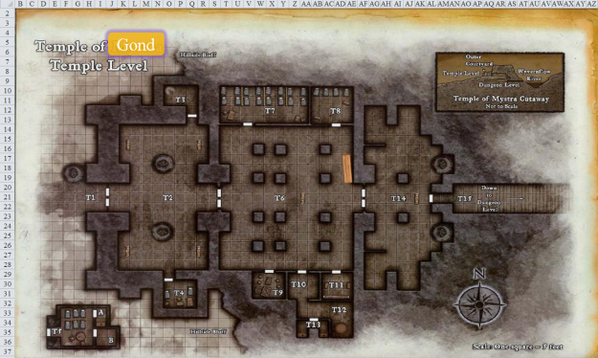

“We’ve prepared a boat—had it magically crafted by the gentleman here,” the winged gnome pointed to a male near her as they continued to make way for the temple doors. “It is now positioned in the aqueduct below, and will carry the five of you, plus Frayed, who has convinced the Council that he is both fit for duty *and* the best qualified resident of the town to pursue these ruffians alongside you... if you’ll have his company, that is.”

Faith nodded her head and smiled when she heard that Frayed would be joining them. It would be like old times.

Jason, too, was glad.

Kali kept looking around hoping Wind would see her off. She made a note to ask Magpie what this new amulet was after they were on the way. The master of many forms—usually a thrush—did not present himself, and deep down, the dancer knew this. The winds that caressed the earth beneath his feet were not his namesake; that which ran through his hair was the wind that he spirited as he rode atop his jackal steed. She would think of him whenever she encountered zephyrs and other free-roaming souls upon her path.

By the time they were inside and passing through the main chambers towards the staircase, they had counted 14 officials inside, either posted at thresholds or examining evidence. The heroes made their way downward, noting that the rooms below had been scrubbed clean. There was one gnome with a pointy hat now casting a spell to restore the caryatid column to its former, resplendent glory. She smiled at the heroes and bowed her head in reverence and thanks for their deeds here.

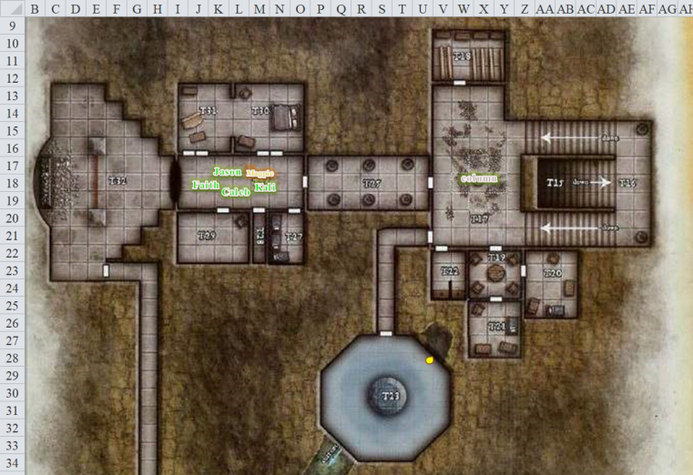

They were famous in this town, and yet they had to leave it, knowing they might never return. It was a bittersweet moment, passing the walls that only yesterday had been blood-drenched, but were now clean once again. Entering the room where the dozens of bodies and bones had been piled, they were now in a room altogether different, though its dimensions were the same. What had been drab, dark pillars and walls now glowed with golden limelight, illuminating the room which would once again be used for Gondar purposes.

Each brass, silver, and bronze vein in the walls now participated in the grand purpose of Gond’s design, acting as neural nodes in a network of knowledge and ingenuity. Gond be praised! Had it not been for their courage last night, this might still be a den of death-dealers.

Half a dozen gnomes entered the room through a passage that the party had not yet taken. They carried atop a makeshift gurney the remains of the amphibious otyugh that Faith had spared the night before. The animal had gotten agitated, and could not be restrained, so it had to be put down.

Pity.

The gnomes greeted the heroes, then continued hefting the creature’s body out of the temple.

The party then headed into that same passage from which the half-dozen gnomes had come, and then made their way southward along a rather long tunnel. Reaching the docks they’d heard about, they met up with Frayed and some others who were now preparing the boat that could carry six Medium folks with light loads. They were four humans and a pair of gnomes, and their equipment was just about right for the hull to float downstream without sinking. There were only two oars, so rowing would be one person’s job while the others would just sit.

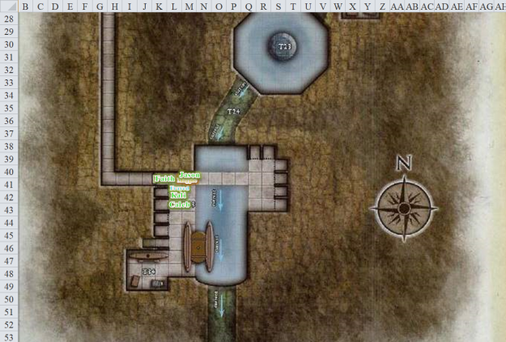

The winged woman spoke, “The portal is about 200 yards up ahead, and can be accessed by taking the central channel at the fork. The leftward channel is wider, and will pull you in if you don’t row into the central channel; other than that, it’ll be smooth sailing until you get into the portal, and thereafter, we can only assume that it is safe enough for our enemies to traverse.”

“Ahoy, landlubbers!” Frayed called from the boat, dressed in a long captain’s coat (alright, a normal sized captain’s coat that looked long on his gnomish body) and an impressive hat with a feather. “I understand you scurvy dogs wish to board me vessel and chase after some scoundrels and scalawags. Well, I be Cap’n Frayed and it’d be me honor to escort yee down river so that I might inflict some righteous arcane vengeance on those who thought it’d be a hoot to torture me but didn’t have the chance to finish me off when they had the chance.”

“Captain?” Magpie asked curiously, looking around at the others.

“Aye, lass. Cap’n.” He pointed at his hat, “Not only do I own the boat, but I have a hat. Hence, Captain.”

“You... are you going to affect a nautical accent the entire time, Captain?” Caleb inquired.

“Nay, lad. No worries. ‘Tis a side effect of me vessel. Once I join yee on the land once more, me fine vernacular will fade back to normal.” Either that, or Frayed just got a kick out of Talk like a Pirate Day, which happened every ten days here on the mountaintop.

They took one look at Frayed’s folding boat, and Magpie couldn’t help but frown, “Unless you’ve got some Persistent *reduce person* spells up your sleeve, we’re not all going to fit here.”

“Oh,” the normally astute warmage-evoker-master specialist-ultimate magus put his hand to his lips and chin. “You’re right. I don’t know why I forgot to account for size. I’ve been here so long…”

The townsfolk’s best artificers had by now brought the masterwork vessel that was the culmination of several *heat metal, stone shape, warp wood,* and other essential forging spells. Though it was not imbued with any magical properties, its design was exquisite, and its wooden bow was reinforced with an iron and quartzite infusion that would resist most slow-speed head-on collisions.

One of the gnomes in attendance leaned over to Magpie and murmured, “That’s not his boat. It’s also not magical.”

Magpie nodded and whispered back, “I know. He’s a terrible liar. But he’d had a rough time of late, so I’m humoring him.”

The gnome nodded, “Oooohhh... Right.”

“Why don’t we take this one?” Faith suggested diplomatically, letting Frayed save face as he jumped back onto the dock and used a command word to bring the boat into his hand once it had shrunk to a 4-lb. scarab figurine.

Those present—mostly from the Council of Elders—bid the heroes well. The winged gnome left them with, “And if you should ever return to Bytopia, know that legends will be told of your deeds, and our children will revere you. May Gond bestow upon you the selfsame blessing of life that you have extended to us all, heroes.”

Once aboard, Faith sat her armored form near the center of the rowboat and volunteered to row.

“You’re probably the most suited,” Magpie agreed.

Kali undid the knot that tethered the dinghy to the dock, and with heartfelt salutes and votes of confidence from the townsfolk, the heroes departed for lands unknown.

“We should make up a name for this adventuring group,” Jason said after years of nocking arrows with some of these folks.

The boat meandered down the winding passage another 60’, and soon was both out of sight and earshot of any of the gnomes they’d left behind. The pitch dark around them was snuffed by Faith’s illuminated sword, which was on her lap, plus Frayed held a lit torch as a backup.

Faith rowed, not so much to propel them downstream, but rather to steer the vessel away from the shallower edges of the stream as it wound and tapered downward slightly.

Kali showed Magpie the amulet she had been given and asked if she could tell what it did.

They followed the winged woman’s advice, which Caleb had memorized to the letter: “The portal is about 200 yards up ahead, and can be accessed by taking the central channel at the fork. The leftward channel is wider, and will pull you in if you don’t row into the central channel; other than that, it’ll be smooth sailing until you get into the portal, and thereafter, we can only assume that it is safe enough for our enemies to traverse.”

They saw the three channels, and Faith saw little challenge in oaring against the leftward drag.

Gradually, the stream grew deep and wide enough for Faith to relax a bit, though she was already doing pretty well *[taking 10 under no duress]*.

Magpie cast *mage armor* on Caleb.

Frayed and Caleb cast their various *heart of...* spells on themselves.

*Frayed, heart of air: +10 to Jump checks, +10’ to fly speed, feather fall ready [immediate] action. Lasts 11 hours or until feather fall is triggered.*

*Frayed and Caleb, heart of water: Swim speed is equal to land speed, +8 to Swim checks, water breathing, +5 to Escape Artist checks, freedom of movement ready [immediate] action. Lasts 11 hours or until freedom of movement is triggered.*

*Frayed and Caleb, heart of earth: +8 vs. bull rush, overrun, and trip attacks; +22 temporary hps, stoneskin ready [immediate] action. Lasts 11 hours or until stoneskin is triggered.*

They took the proper channel, seeing the river narrow again, though it remained deep enough for them to not be able to see the bottom, even with a torchlight.

Did they spot otyughs, though? Oh, yes! Dozens of them, but all about the size of a halfling torso, and therefore not yet ready to pose a challenge, even to a halfling. They clung on the walls of the tunnel like miniature balls of filth with limbs that picked off water lice and other smaller life and kept the cavern vermin from proliferating.

And then there was the portal. Still a few hundred feet away, its faint glow was evident. It was stretched out across the entire tunnel as if deliberately placed and shaped, and a few of them held their breath as they approached, some of them even drawing their weapons in case an astral dreadnaught should be on the other side.

Caleb cast *fly*, then made his way quickly towards the portal as Faith slowed down the descent of the rowboat along the channel. Getting within 60’ of the transplanar membrane, Caleb attempted to cast *analyze portal*.

By the time the others got within earshot, the flying spellcaster got back into the boat and announced, “It is as the gnomes said. There is no command word necessary to activate it; it is ever-active. It is one-way, as we had anticipated, and the area beyond is almost identical to this tunnel.” Caleb’s general assessment revealed nothing unexpected. Based on what they knew already, none of the new information was surprising.

“Let’s just go,” the most eager among them said.

The slip into the new plane was actually quite free of any fanfare. The river continued, though the draw was slightly stronger, as if the center of gravity had shifted about 8 degrees. Faith rowed some more as spellcasters thought to cast other wards, buffs, and abjurations.

“You still alright to row?” Caleb confirmed.

She nodded, her sword still on her lap as she rowed and rowed with one oar at a time, keeping the stone, wood, and metal bow pointed towards the middle of the stream.

“Life is but a dream,” canted Jason after about a minute of being past the portal.

“Could we still be on Bytopia?” asked Faith. “Maybe it was just a teleportation portal, not a transplanar one,” she stated the limits of what she knew about these things.

Caleb answered, “There are divinations that can tell us more about where we are.”

“There’s a dock,” Magpie pointed out the structure. “Is this where we’re supposed to disembark?”

No one knew.

The area looked like a suitable place to set off on this river, but no other boats were moored on the dock. No entrances/exits were visible from their vantage point.

“Well, let us stop and take a gander, at least it will give Faith a break,” suggested Jason.

Caleb answered, “There are divinations that can tell us more about where we are: *detect evil, detect magic,* and such.”

Magpie accepted the amulet from Kali and messed with it for a bit, looking for any sort of evidence as to what the item might be, like an inscribed command word or some such. “Just off the top of my head, looks a bit like an amulet of natural armor, but that’s pure speculation. Hey, Caleb. Get to *detecting*, multicaster.”

Frayed agreed with Jason, “Aye, let’s make dock, me hearties. See what there is to be seen. The fiends we’re chasing were in a hurry, so there’s bound to be clues to be had.”

Caleb took a look at the amulet, admitting, “Well, I don’t know how to cast *identify* spells.”

“What?” Frayed was astonished.

“And you call yourself a diviner?” Frayed asked, also unfamiliar with the *identify* spell.

“Now just wait a tick!” Caleb frowned as he squinted at the object.

The diviner then giggled to himself, and said, “Ah, Wind in His Hair....” He then turned back to Kali, handing her the amulet, saying, “This really is him leaving you—and us—with a part of himself. It has a single use of basic Wild Shape, with no type frills or size variants.”

“Wow!” Magpie remarked at the cleric’s specificity.

Kali grabbed the amulet away from Caleb and gave Magpie a mean look at her statement.

Magpie gestured to the dock, “Why don’t we go ahead and moor at the dock and have a look around?”

Frayed nodded, “Aye, sounds like a right fine plan. Wouldn’t do any good to continue sailing off into the underground sunset if our enemies disembarked here.”

Caleb looked over at Jason, “Could you perhaps look around the dock and see if it’s been used recently? And, of course, we should be wary. If our foes did come here, they do have a habit of leaving traps for us.”

“This dock has definitely been in use,” Frayed proclaimed before Jason could even get off the boat. “Look,” he then pointed out some oars situated behind a boulder, though no boat was found.

They moored, and tethered the boat with the masterwork rope. No anchor had been afforded to them on this handiwork craft, but none was needed on this, mission, as this did not appear to be a quest in which they had to stop at various waypoints along the river.

Jason hopped out of the boat and followed by Kali and began to look for traces of anyone passing this way.

Kali just stood watch while Faith stretched and rested. “Where’s a druid when you need him, right?” Kali sighed as Faith tried to do Wind in His Hair’s job.

The immediate area was little more than a chamber with two paths leading out on one side, and the dock and river on the other. “One path is as good as any,” said Jason, unaware of the subtle difference in light.

Kali corrected him. “No, there is an exit along this path... or some kind of light source.

~\*~

It was an uneventful trek down the short, slightly winding path that led upward and into a splendorous scenery under an orange sunrise. It seemed like late autumn or early winter here, and was considerably chillier than inside the cavern. In the lead, Faith turned to the others before venturing out into the slightly downhill panorama of evergreens and deciduous vegetation, the latter mostly leafless.



“The first snow has fallen, and partly melted,” Kali noted. “It may be possible to track the villains in the remaining snow and mud... if Wind in His Hair were here.”

“Hey, come on, what am I? Chopped pancreas?” the scout protested.