Southwestwardly they continued, and pressed on through one last incline, followed by a gradual, downward slope that delivered them slowly into what must have once been a bustling town.

Reaching the summit and taking in the panorama that awaited their arrival, they noted the coast to the south, and the volcano beyond it.

Once the interrogation was completed Kali said. “These captives are only dead weight to us; shall we end this pathetic life?”

“Faith, it is better if you and Jason scout ahead,” said Kali. Once the two moved out of earshot the women will gage the ones to be killed then cut their throats.

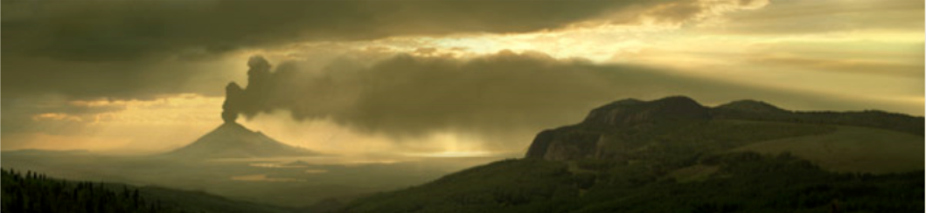

As they descended along the southern edge of this continent or island, the pines gave way to more deciduous trees, and the snowfall decreased with the altitude. Jason decreed, “We’ll have to switch to mud-tracking methods in a bit.” He said this mostly to himself. The snow would be less likely to create mud on a downward slope like this, but so far the tracks had been in perfect tandem with the map’s directions, so it stood to reason that the villains would remain consistent with their premeditated route, or at least its destination. A sign read, “Narwhal Port,” pointing them further southwest.

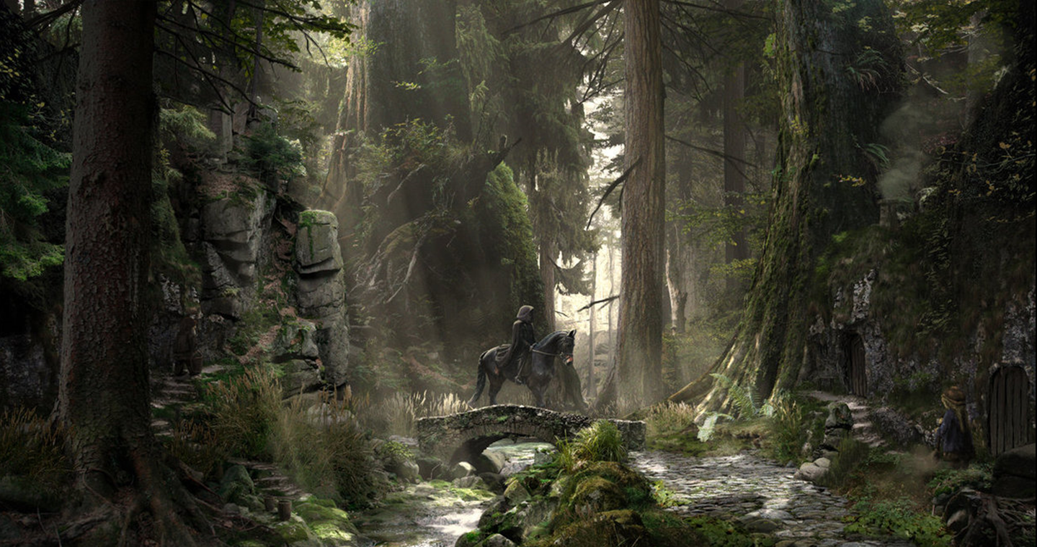

As they came down the mountain—not quite at the center of the town—they noted that the trail was now a cobblestoned road wide enough for a horse-drawn wagon, and upon reaching the warmer valley floor, a stone bridge with evidence of constant use was happened upon. Near the stream, the undead forearm and hand of a human crawled along the floor, unaware of their trespass. *[Actions? Evade? Step on? Put in haversack?]*

Jason imagined the necromancers having ridden back and forth through this town after having ravaged all the people that would surely be here. It was around noon, and they could see the main buildings as the road led further into the center of the settlement. The cobblestoned path was at one point blocked off by a monumental heap of wood and rubble, but there was a dirt path that still granted them access to the town.

The birds around them comforted Kali, particularly the thrushes, though when she saw a white raven at a distant height, she took it as an ill omen and reported it to the others. Jason had also just seen it, but he knew it was out of his bow’s maximum range, and wasn’t sure if it was the servant of their evil adversary.

Evidence of murder began to show itself as pools of dried blood now complemented pools of molten snow. “No bodies, and no recent, body-shaped imprints,” Jason commented, “so we’re looking at walking dead risen soon after death.” He went ahead a bit to scout, staying within eyesight of the others as they neared the sally port that wound around a few more bends.

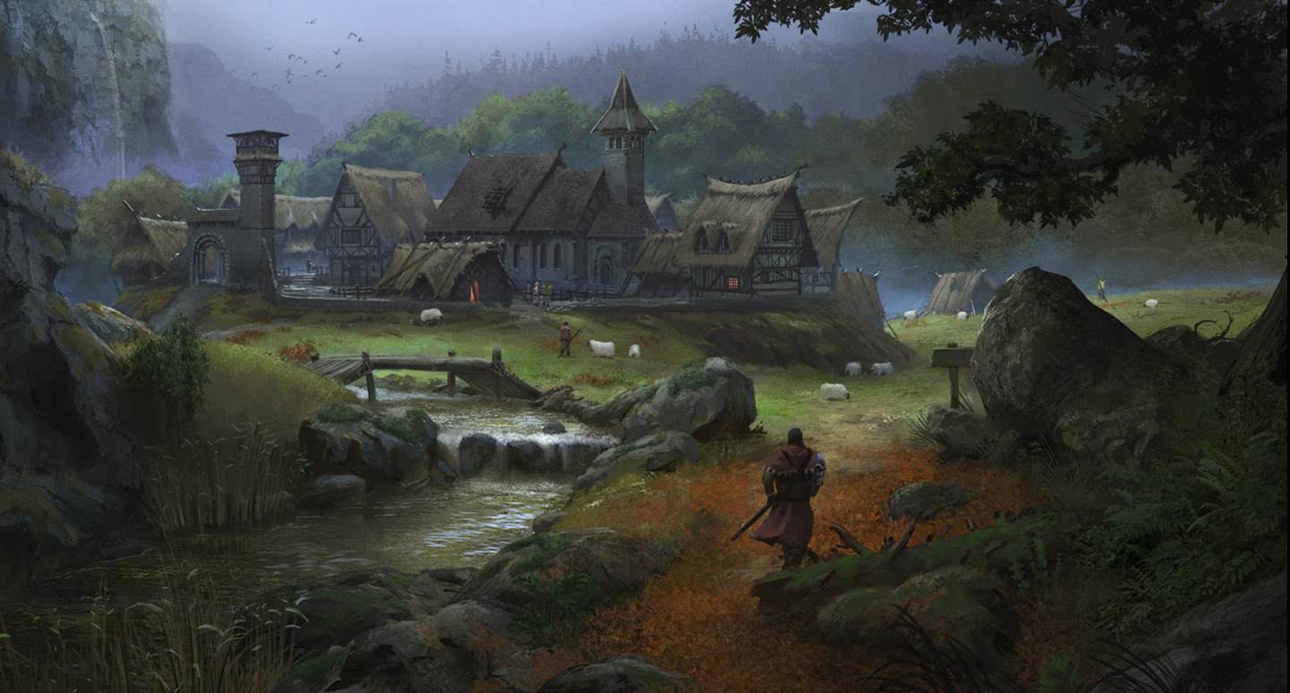

Recent grazing by sheep and goats was evident by the state of the closely shorn grass and the droppings among the patches of late autumn leaves at the heroes’ feet. Jason gave the go-ahead with a wave once he saw that there were no lights, fires, people, or other livestock nearby; only wild birds and squirrels and such. The buildings were not in disarray, but had been in disuse for tendays or months by now, as most of the autumnal preparations had not been made. Mature apples hung on weighed down branches or rotted on the ground along with the poop and leaves. It would seem that Larlum had depleted this town of its denizens a few tendays ago, and since then moved on to multiplanar caches of souls, including Bytopia’s more populated layer, Dothion.

They were nearly at sea level now, and only the downward flow of the stream alerted them to the slightly downward grade as they crossed it. They carefully made their way along, noting that the stench of death—though not strong—was present.

[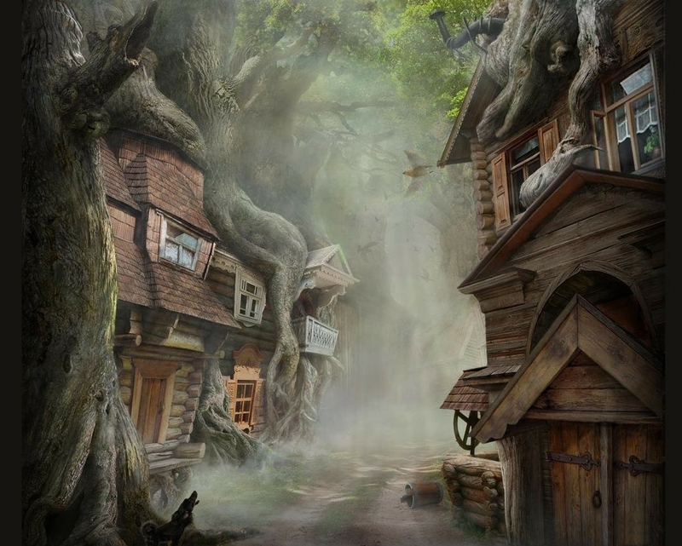](http://www.google.com/url?sa=i&rct=j&q=&esrc=s&source=images&cd=&cad=rja&uact=8&ved=0ahUKEwjm_8_usdrVAhVILmMKHeeWB8oQjRwIBw&url=http://www.firsthdwallpapers.com/fantasy-village-wallpapers.html&psig=AFQjCNGwykSlSNWm6FFj1JjL470lH8DXBw&ust=1502925995958289)

And then in the foggy distance, they spotted a humanoid that looked and moved exactly like an incoming gnome zombie.

Being the first to see the zombie, Jason quick-drew his bow, nocking three arrows in the direction of the woman’s rotting corpse.

|  |  |  |  |  |  |  |  |  |  |  |
| --- | --- | --- | --- | --- | --- | --- | --- | --- | --- | --- |
| **Ranged Weapon** | **Dmg.** | **D+** | **TH+** | **Critical** | **Rng.** | **Wt.** | **Atk** | **Roll** | **Check** | **Notes** |
| Sacred Composite Longbow, Strength +1 | 1d8 | +1 | 1 | 19-20/x3 | 200’ | 3.0 | +14 | 14 | 28 |  |
| 2nd Shot | 1d8 | +1 | 1 |  |  |  | +9 | 2 | 11 |  |
| 3rd Shot, Rapid Firing | 1d8 | +1 | 1 |  |  |  | +4 | 13 | 17 |  |
| Crystal of Cold Assault, Greater | - | 1d6 | - | - | - |  | - | - | - | -1 to AC 1 round |

*Hit, miss, hit. Dmg: (7 + 1 + 4 cold) + (1 + 1 + 4 cold) = 10 + 8 cold = 18. Partial damage negated.*

The zombie perished, but did not disappear as conjured zombies did. This zombie was created from a living person—a gnome, probably from the settlement in Bytopia. Frayed might recognize her if he came closer.

The sounds of shuffling in the far-off distance alerted them to another such creature perhaps; hopefully nothing worse.

“What was the population of this town when Larlum arrived?” Magpie asked Fuchsia, bracing for a worst-case scenario.

“A wee-bit over five-hundred,” the beguiled sorceress recalled.

Adding a few hundred locals—probably humans—to a few dozen gnomes that the party knew for sure were goners, she estimated that they would not have the resources to face these undead all at once.

“Here’s an interesting question,” she posed to the others, particularly the spellcasters, whose daily abilities were more limited than were Kali’s for example. “How many zombies could this outfit handle in one day?”

“Are we counting her?” Caleb pointed to the captured sorceress, wondering if she’d be a reliable co-combatant.

“Let’s do the math without her, and hope her aid makes it all the easier,” the beguiler calculated odds of spell failure, Faith’s hardiness, and other relevant factors, and said, “If we time Faith’s and Caleb’s turning of undead when we are surrounded, we gain advantages over fleeing foes, and reduce the rate at which their attacks can overwhelm us.”

Faith protested, “As much as turning them is a temporary solution, a good cleave should prove to be a far more reliable—and inexhaustible—method of dealing with them permanently. Flesh or shadowstuff, they *will* be cut down.”

Kali had less bravado when she said, “We should be able to deal with no more than ten at any given time. I would advise spellcasters to target them with low-level spells if at all. Jason’s arrows will have to be replenished, and we can’t count on scavenging unbroken ones if they swarm us in the middle of the night.”

Another zombie—this time a human one—presented itself, coming from the same direction as the previous. Jason sighed, “Speaking of which,” and shot again.

|  |  |  |  |  |  |  |  |  |  |  |
| --- | --- | --- | --- | --- | --- | --- | --- | --- | --- | --- |
| **Ranged Weapon** | **Dmg.** | **D+** | **TH+** | **Critical** | **Rng.** | **Wt.** | **Atk** | **Roll** | **Check** | **Notes** |
| Sacred Composite Longbow, Strength +1 | 1d8 | +1 | 1 | 19-20/x3 | 200’ | 3.0 | +14 | *1* | 15 |  |
| 2nd Shot | 1d8 | +1 | 1 |  |  |  | +9 | *1* | 10 |  |
| 3rd Shot, Rapid Firing | 1d8 | +1 | 1 |  |  |  | +4 | 18 | 22 |  |
| Crystal of Cold Assault, Greater | - | 1d6 | - | - | - |  | - | - | - | -1 to AC 1 round |

*Miss, miss, hit. Dmg: DM fudges for maximum damage. Partial damage negated.*

The zombie stood there for a moment, then fell upon her knees, and writhed in place as the others continued to discuss the circumstances. Eventually, the archer took pity upon the prone, elbow-crawling corpse, and delivered a final, crushing blow to the matted-haired skull of the zombie.

Frayed proposed, “We should either press on and face Larlum and his company now before they have any more opportunity to fortify... or stay here, fort up somewhere tactically sound, deal with zombies as they come or maybe even go on a cleansing spree, prepare a nicer assortment of spells for tomorrow, and show up at this guy’s house ‘round dawn.”

“It is true that there is no middle-of-the-road option here,” admitted Caleb. “It’s one or the other.”

The idea of confronting Larlum right now, with some of their most potent spell slots spent, seemed foolhardy. From what they’d heard, even his inner circle of associates was comprised of formidable enough folks to make the heroes think twice about just blundering into some inner chamber unannounced and tactically winging it.

But the idea that an untold number of zombies—even Fuchsia had no clue as to how many had been dispatched to the town from Larlum’s keep—were patrolling these abandoned houses and shops gave them cause to do some reconnaissance before deciding on a course of action.

Using Fuchsia’s indications towards various parts of the map, Magpie updated the crude illustration on the parchment, particularly after the sorceress told her, “That bridge has been burned down. There are always undead posted there, on both sides of the collapsed structure.”

Having seen part of the coastline, Magpie also drew the rift in the island that tapered along a narrow bay at the end of which was nestled this modest township of loggers and fishers, all allegedly zombies or other fodder by now.

“So we should take the southern path,” Magpie confirmed, wondering if her sorceress captive was telling the truth.

“Unless all of you can fly or somehow get across *and* bypass or deal with the skeletons and zombies that patrol both sides of the bridge, south is a surer path. “Oh, and there’s a lake there, with three main tributaries that feed it along here, here, and here.”

The beguiler also did her best to add topographic lines on the map, based on the contour of the peaks to their northwest and southeast. “Anything else?” she asked, but Fuchsia could think of nothing of note, other than: “Cemetery’s on the southwest end of town, but it’s too small to be on the map. That’s Who’s sandbox.”

“Whose?” asked Frayed, confused.

“Yeah, Who’s. Who, the Bone Whisperer. He literally fucks zombies, and I’m pretty sure he still keeps a toolshed stocked nearby.”

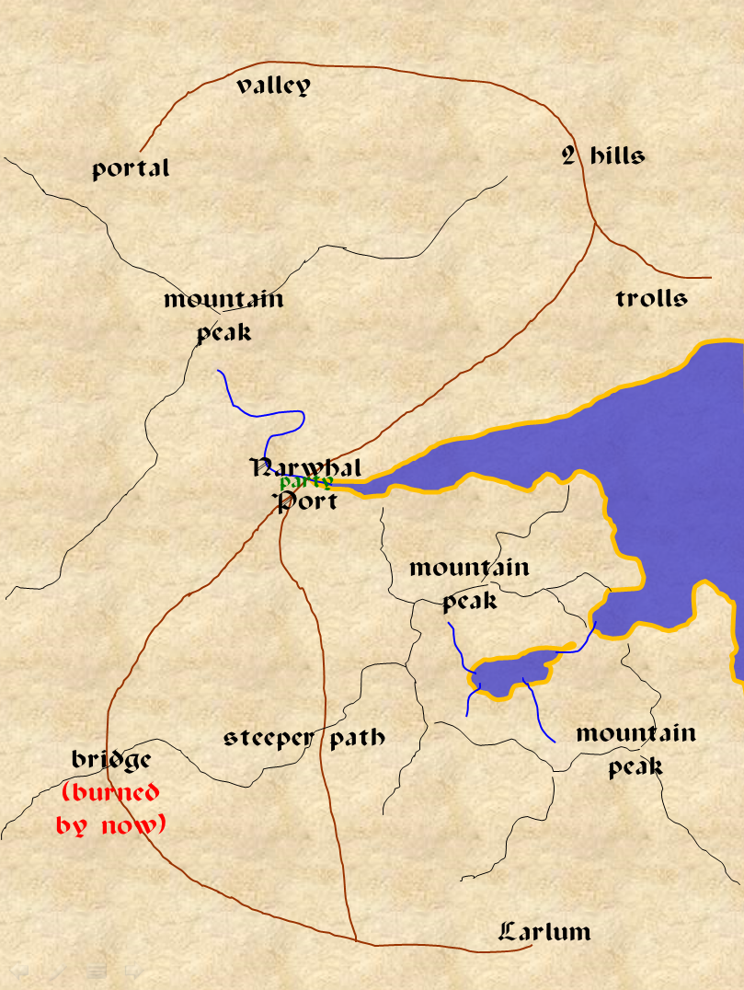

“What a joyful bunch this is,” the paladin of freedom shook her head, then continued “going to be to cull!”

It was quiet, as if all that Larlum had meant to send was a mere pair of zombie women.

“Should we just go through the town and try to be proactive about dealing with any remaining undead?” asked Caleb, not quite a leader.

Kali wished Wind in His Hair were here, and touched the amulet hanging at her neck as the sounds around them alerted them only to the presence of local and migrating birds.

“Make note of any weapon-smiths or merchant buildings. We can pick up more arrows if need be... maybe something flammable to help out the effort,” said Jason.

Fuchsia saved them the trouble. “The smithies are all that way, but Larlum put us gnomes to the task of stripping every building of just about anything that wasn’t bolted down, and that was tendays ago. The Redhanded knows how thorough we can be.”

Jason and the other non-gnomes imagined what Frayed and Magpie alone could accomplish, even if only given a month’s time. The walls would have been stripped bare by now.

“Killing mindless undead is trivial,” Caleb stated as if he was mentioning how cold it was. Magpie and Frayed both looked at him with curious expressions on their gnomish faces. Magpie, in particular, was weak to undead. “I already gave Jason the weapon we need to kill mindless undead. He has a coin with *celestial brilliance* cast upon it. Any undead within 60’ will take damage each round as the divine light burns them away. It requires no effort or additional resources on our part.”

“Ahh, I see.” Frayed nodded thoughtfully, “We merely have to kite the mindless undead. They pursue us, steadily being destroyed. Laborious but effective.”

“I’m not especially quick and that won’t work versus intelligent or swift undead,” Magpie chimed in.

“Certainly, but it will work wonders against a horde of humanoid zombies and skeletons. More potent undead will face our actual resources, including the strength of Faith’s sword,” Caleb explained.

“So what do we do? Stay here? Look around the town? Head to the docks? Head towards the cemetery where the road continues?” asked Frayed.

“Since the bridge is out we need transportation across the water so I guess it is the docks to find a boat. We can kill these as we spot them,” said Jason. “Also be on the lookout for arrows; we need to collect as many as possible.”

The sorceress offered, “That bridge doesn’t cross a river, but a chasm. The other path I pointed out is a surer route,” she appeared convinced.

“Ah, yes, I think the dock confused me as to what the bridge was crossing,” said Jason nodding to the sorceress.

The sound of a zombie groaning downwind of them gave Jason cause to point an arrow in that direction, but the zombie was probably too disoriented to reliably follow their scent around the alleys and buildings.

“It’ll be here soon,” Frayed warned the archer, who would eventually run out of arrows.

“Shall we implement the *brilliant* coin trick then?” Faith suggested.

“I think we have an obligation to lay the undead to rest,” Caleb replied. “The *brilliant radiance* will do most of the work for us, and will keep the undead from causing issues for other visitors to the island. We could clear the cemetery and the delay might encourage our enemies to send more of his resources out after us. If we can stretch them thin, it’ll make for an easier assault on their base.”

Magpie didn’t like the idea, but didn’t have a better one.

Frayed shrugged, “All I know is I’ve a powerful desire to murder the fools who tortured me. Let’s do something other than freeze our nuts off in the snow. No offense intended to the nutless.”

With Kali’s *endure elements* having been dispelled long ago by a now-dead villain, the fighter shivered and struggled to keep her pert body warm. “I second Frayed’s suggestion. The looters couldn’t have taken the fireplaces, and we can find some firewood nearby.”

At the behest of his teammates, Caleb produced the coin upon which he had earlier cast *celestial brilliance*. “Wowsers!” Frayed hadn’t seen the coin before, but even in broad daylight, the illumination made quite a difference.

“Everybody ready?” Jason held his bow out, hoping he wouldn’t have to waste another arrow while in this fishing and logging village.

Within a minute, two gnome zombies and a human zombie had presented themselves before the party, these also coming from the direction of the graveyard. Before they could reach the heroes, all three had been decimated. “That one is about, what? 20’ away?” Kali pointed to the last zombie as it fell onto its knees, gasped, and keeled over, inanimate.

“If more powerful undead are to present themselves,” Faith spun a cautionary statement, “surely they will reach us before the *brilliance* destroys them. I will try to assess whether or not to turn groups of undead. It may be easier to cleave them, depending on how they cluster.”

“If spellcasting undead are to be encountered beyond,” Caleb added to the warning, “they are unlikely to get close enough to be harmed by the *brilliance*.”

“At this point, we could just walk slowly along this path and deal with any zombies as they come,” Magpie thought. “We could even go into the graveyard like this... maybe. Maybe not,” she changed her mind, thinking of liches and other arch-undead.

“Let us move to the center of town first. We must also find some place to hold up tonight and get warm,” said Jason.

Kali agreed wholeheartedly as she tried to keep warm.

“If nothing else, there should be at least one structure with sturdy stone walls that could be a defensible place to rest,” Frayed agreed with Faith and Jason. “Besides, I appreciate direct approaches. Let’s just go, deal with the undead and take it from there.”

“Direct approaches do seem to be your speed,” Magpie observed in a tone that was hard to read. Perhaps a touch of defensive snarkiness for how out of sorts she felt? “You’re with us, Fuschia. You will follow any order that any of my companions give you as if it was coming from me. Now, be a dear and lead the way to the village via the route you deem the safest. Also, tell me what spells you have remaining.”