Jason led the group, following written signs as well as tracks, to the town center. Along the way, seven zombies had mindlessly charged various heroes in the band. Now, as they reached the flat, tree-cleared part of town and saw the cluster of homes and businesses where most of the townsfolk lived and thrived, they saw nothing but zombies approaching. Most were gnomish or human, but the occasional elf or other humanoid presented itself, zombified beyond hope. Many of these were either snow covered on their shoulders and torsos, while others even had ice that now dripped in the midday sun, dampening the few garments that remained on each undead.

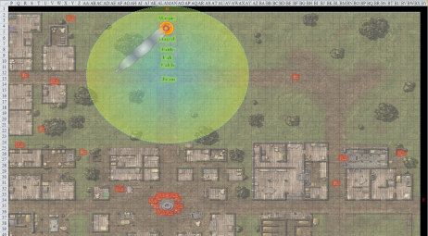

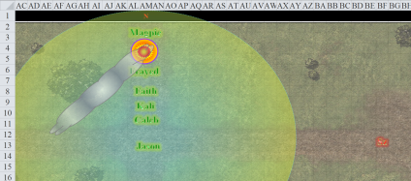

Unable to hasten their step enough to reach the heroes in time before the *celestial brilliance* spell destroyed their negative energy essence, any mindless undead whose senses were alerted to the presence of the living heroes almost instantly turned from their foraging for worms and bugs in the ground, got up from their crouching position, and abandoned their pursuit of meager invertebrates for something with a more sizeable brain: humanoids!

“Remember, the *celestial brilliance* will scour away any mindless undead with time. We can give ground, which will put us out of reach of any mundane zombie. We simply need to be mindful of quick or special undead. Save your strength.” Caleb counseled the group as undead began to take notice.

“That said, if I see something that isn’t just a shamble, I’m blowing it to hell.” Frayed answered the priest.

“Well, technically, their spirits have already moved onto whatever afterli...” Caleb was cut off abruptly.

“Just a saying. It’s just a saying, Caleb.” Magpie shook her head and rubbed her face.

“Oh, right. Yes. Well. Hmm.” Caleb cleared his throat, “I trust we can all decide when something needs to be blown to hell and when to just let it burn.”

All three of the casters kept an eye out for exceptional threats, but didn’t intend to do anything other than give ground versus a zombie horde. There were, however, no immediate hordes, though nearly a dozen zombies who had been eating something in the center square did approach.

Faith held her blade high in anticipation of any of them being resilient enough to the holy damage of the coin’s Celestial emanation, but so far, no zombie that stalwart presented itself.

“We need to group in a circle with each person watching their sectors,” said Jason.

Kali moved with the fire as it was placed next to Jason at the epicenter of the *brilliance*. She did her best to stay warm as she watched her sector for the next 18 seconds as more zombies come in.

Because Magpie was in the back of the formation, this also placed her at the periphery of the *brilliance*, which made it less damaging for zombies to get at her. One zombie was coming at her from the west, and had only been inside the light for a few seconds before it was rearing its limbs in anticipation of striking her, so she moved away southeastward with the *floating disk* between her and the zombie.

The zombie did its best to reach her, but then finally keeled over.

Frayed was towing the *disk* at the moment, and remarked, << Olé! >> in Gnomish.

It was evident that this method *was* working, though one Medium zombie—a bit more robust than the rest—did get through the *brilliance* and almost reached Jason, though not before the paladin of freedom hacked at it.

|  |  |  |  |  |  |  |  |  |  |  |
| --- | --- | --- | --- | --- | --- | --- | --- | --- | --- | --- |
| **Melee Weapon** | **Dmg** | **D+** | **TH+** | **Critical** | **Type** | **Wt.** | **Atk** | **Roll** | **Check** | **Properties** |
| Adamantine Illuminating Holy Greatsword +1 | 2d6+2 | +4 + 1 | 1 + 2 charge | 17-20/x2 | Slashing | 8.0 | +18 | 10 | 28 | +2d6 to evil |

*Hit. Dmg: 8 + 2 + 4 + 1 + 2 + 6 good = 23.*

The zombie fell to the floor, its head rolling off and away.

“Here comes a cluster!” Jason pointed, a bit more alarmed, though by logic a cluster was no less susceptible to the *celestial brilliance* than a single incoming zombie. Still, it increased the probability that one or more would be as stalwart as the one that Faith just had to cut down.

“Conserve your arrows, archer,” Faith referred to Jason by his specialty.

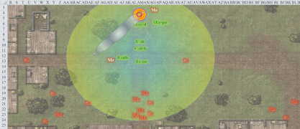

Round 1

Magpie wasn’t all that concerned about the undead. She whistled at Caleb and Frayed as she walked up to the fire, “Here’s my plan. If the undead start getting close to us, because we aren’t all fightery, I’ll just cast an Invisibility Sphere.

“Excuse me?” asked Kali—a fighter-dervish—raised her eyebrow at the gnome. “Between Faith and myself, we’re pretty stalwart, if that’s what you meant by fightery.”

Magpie cleared her throat as she tentatively agreed with that, and continued, “As long as you stay within 10’ of me, we’ll be *invisible*. Just keep in contact with the *floating disk* and you’ll be within 10 of me.”

“Faith, Kali, and Jason can deal with most undead that the Brilliance doesn’t burn away. We’ll support you with spells,” Caleb offered.

“If anything pops up that seems genuinely dangerous, I’m blowing it to hell. And I can do that because I’ve been there. I have directions,” Frayed added. “Jason, you’ve got the light, you’re leading this show.” The casters gave way, huddling around the *floating disk* and timing their movements so they shared initiative.

Faith came close to having to hack another zombie to pieces, but the thing died right before it got into melee range.

The heroes did nothing else for the moment.

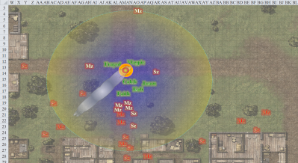

Round 2

The zombies came closer, and only one got close enough to warrant Faith’s attention. She practiced her swordsmanship on the already forsaken shell.

|  |  |  |  |  |  |  |  |  |  |  |
| --- | --- | --- | --- | --- | --- | --- | --- | --- | --- | --- |
| **Melee Weapon** | **Dmg** | **D+** | **TH+** | **Critical** | **Type** | **Wt.** | **Atk** | **Roll** | **Check** | **Properties** |
| Adamantine Illuminating Holy Greatsword +1 | 2d6+2 | +4 + 1 | 1 | 17-20/x2 | Slashing | 8.0 | +16 | 4 | 20 | +2d6 to evil |
| 2nd Attack | 2d6+2 | +4 + 1 | 1 | 17-20/x2 | Slashing |  | +11 | 16 | 27 |  |
| 3rd Attack | 2d6+2 | +4 + 1 | 1 | 17-20/x2 | Slashing |  | +6 | 15 | 21 |  |

*Hit, hit, hit. Minimum damage destroys the corpse.*

The rest of the nearby corpses either advanced onward to their deaths like moths to a flame or died on the spot.

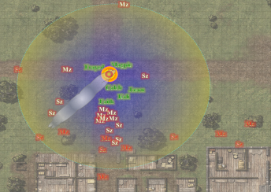

Round 3

And onward they came, and most collapsed before the place could even have been called a battlefield.

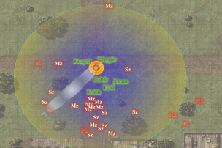

Round 4

“Alright, folks,” Kali sighed, “It’s wrap-up time.”

And within a few seconds the zombie threat was over. If there were stragglers inside some of the buildings, so be it; they would be destroyed as well in time. Otherwise, the town center was relatively quiet under the midday sun. The temperature had gotten considerably more tolerable now that they were almost at sea level.

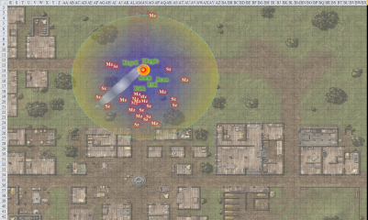

The last zombie gurgled its last, and they looked around. “Where to?” Jason wondered.

Caleb, ever the voice of reason, said, “Jason, find us the most defensible structure. Stone walls if possible. We need to get out of this cold for Kali’s sake. We can rest, get warm, adjust our spell selection. Am I right in assuming our hostage is dominated for a long time yet?”

“My *domination* lasts more than a tenday,” Magpie replied with a shrug.

“That’s why I find Enchantments unsettling. I kill someone, it’s done. You create slaves.” Frayed was not a master of diplomacy.

Before Magpie could get mouthy, Caleb interjected, “So she’s not a threat right now and we can use her to help keep watch.”

Jason stepped over some zombified bodies before he scouted ahead, hearing only birds in the gentle breeze. He stayed within Caleb’s hemisphere of *brilliance* as the others tried to bunch up behind Faith. Frayed tugged at the *floating disc*, which kept Kali warm so long as she stayed near it, and everyone kept an eye peeled for more zombies.

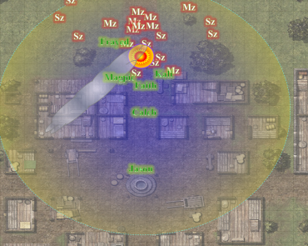

The scout reached the fountain in the center square, which was filled with rotting blood and brains that kept the zombies in an adequately vigorous state. Then Jason got a good look at the stone structure to his west-southwest. He turned back to the others, nodded, pointed, and scouted just ahead of the *brilliance*.

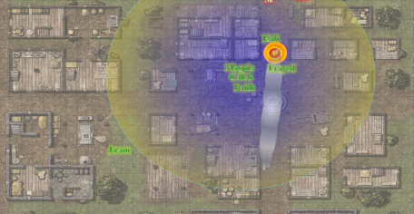

It was evident that a wooden wall had once stood along the northeastern quadrant of the structure, which still had a hearth, a chopping block, a cabinet with no drawers, shelves, or doors, and an underground oven, which in the scout’s imagination could double as a sarcophagus for at least two vampires or liches. It would be an awkward place to put it—right under the sun and all—but still, he kept a distance.

Going westward through an open threshold, he entered what had once been the sleeping and bathing quarters of this comparatively lavish place, such as it must have been while occupied by the living. A tub and a few tables remained, thought they were broken beyond appreciation or use.

The southwest room had a table with three legs, some wicker baskets, and some empty burlap sacks that had once stored wheat. Now, only empty chaffs and a few stray seeds littered the floor. The others caught up to Jason as he came back out before checking the last room. As they convened and secured the rest of the area, the high-powered superheroes took in the idea that they’d traveled an incalculable distance across the Planes, and were now in the Material Plane; presumably the same Material Plane from which they had all come before their resurrection in the Outer Planes. And now they were in Narwhal Port, on an island that comprised an archipelago called the Whalebones, off the coast of a continent called Faerûn.

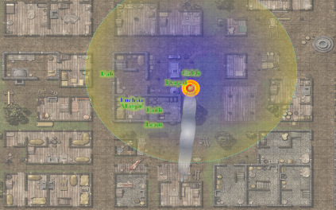

Frayed had remained outside with the fuming fire, as had Caleb and his shiny coin, in case any other zombies came up. None did.

“This is about as defensible as it’s going to get,” Faith had to surrender to the idea that since almost every door in this city had been removed—probably to be used for firewood, wood golems, or worse—fortification was going to require effort.

A straggling zombie came around a corner from Kali’s southeast, and she quickly cut the bugger down.

“Rest here a bit?” Magpie thought.

Frayed wanted nothing more than to press on through to Larlum’s lair.

“If nothing else, we should clear the graveyard. I know the weather isn’t comfortable for Kali, but it’s warmer down here and we still have the fire. We could also probably roust up some warm clothes down here. I can’t imagine the cultist would have lugged every scrap of clothes. They’re heavy. A bit of *prestidigitation*, a *mending* or two, and we should be good to go.” Frayed hadn’t nearly blown enough of his magical power for the day.

Caleb frowned a bit and looked over to Kali, “Feel up to clearing the graveyard at least?”

“Let’s look for some clothes first and then the graveyard,” said Kali.

“Sounds good to me, just should be back here before dark. I want us to be fresh for the big battle,” the scout said.

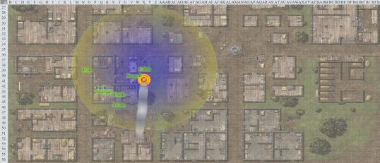

“If we’re going to go with a *mending* spell,” one spellcaster said to another, “why not take the clothes off of some of the zombies we already killed?”

Jason thought for a moment. “Let’s try the house to our north, then maybe the one east of that. If this gets us those clothes we can move directly to the graveyard.”

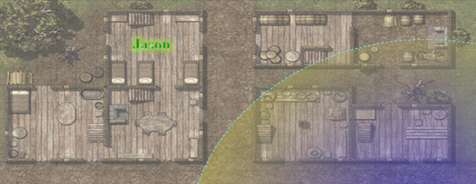

They did this, and scouring both houses, found only a top suitable for Kali.

They regrouped, and entered yet another house, and another, killing the torso of an elven zombie, then continuing to one of the southwestern-most houses in the town center, and finally finding a few more articles of clothes, dirty, but manageable.

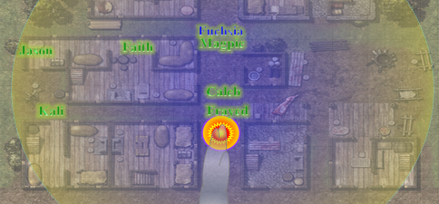

Magpie wasn’t wearing any of the found clothes. First, they were gross. Second, she was a practical adventurer and her items shielded her nicely from the cold weather. The beguiler was a planar explorer and already dressed the part. She would, however, help to mend the clothes using her sewing needle and thread. She also carried extra clothes in her kit, and would offer extra clean clothes to Frayed, so long as the gnome didn’t mind wearing ladies clothes.

Frayed looked pretty rad in Magpie’s Courtier Outfit, which was a dress with a wide, floor length hoop skirt and *so many* petticoats. “Gotta admit... this is pretty warm.” He was wearing his own robes on top of the dress, burned around the waist, which didn’t look rad at all, but it helped keep his arms and shoulders warm, as Magpie’s dress was shoulderless. Frayed looked over the dirty clothing and admitted, “I... uhh, I don’t actually have any mendy type spells. I’m more of a killy spellcaster.”

“I don’t have mending either. My magic doesn’t really do ‘real’ stuff. Hence the needle!” Magpie held her needle triumphantly in the air.

Caleb sighed, “Three of us and none of us *mend*?” Magpie cleared her throat and pointed to the needle again. “Fair enough. I’ll clean everything, Magpie can patch. Frayed can inspire us all with his grace and wit.” Caleb cast *prestidigitation* and began cleaning the clothes, 1 pound at a time.

Frayed grumbled, “Wit this,” and made an obscene gesture at Caleb.

The priest basically just found himself some gloves and a human sized heavier cloak, with a furred hood.

The casters were very content to follow Jason’s tactical lead. Magpie, in particular, didn’t even want to be here, so going slow seemed workable.

Frayed commented, “Keep your eye out for incorporeals. They can move fine in the snow and while the coin will still work on them, *magic missiles* or the like can speed the process along faster than Faith and Kali’s blades.”

“I’ve seen Faith work. I think she’d out missile your missiles,” Caleb replied with a grin.

“Pah. Nothing against Faith, but no-one out-missiles my missiles,” the warmage asserted confidently.

“Yes, yes, we’re all impressed by the size of your missile. Gods above, shut up,” Magpie grumbled.

The sole elf missed the company of her half-elven one-time lover, Wind in His Hair, but still enjoyed adventuring with this band of gnomes and humans. Now that she was better dressed for the occasion, the hair follicles dotting her arms, legs and torso began to relax once again.

With everyone adequately dressed for the weather now, they looked at one another. They were a combination of prepared and stylish, and they now continued southwest, heading past an abandoned house with part of the northern wall gouged out, traces of ochre jelly residue all around the edge of the human-sized perforation.

By the time they got to the last of the three gutted houses along the gradual incline, they spotted what alarmed them at first. It was a troll skeleton. However, this was no threat, as it was evident that the lower bones were mostly broken, shattered into bits, and only the skull, shoulders, left arm, and torso were intact. The sunken eye-sockets stared lifelessly and deathlessly at the heroes as Jason walked by ahead of the others, cautious as ever. Faith confirmed that this was no trap or trick, and soon after passing the downed troll skeleton, they happened upon the graveyard. The trail had turned from southwest to directly south now, and Jason slowed down so as to be encompassed by the *brilliance* of the coin in Caleb’s hand.

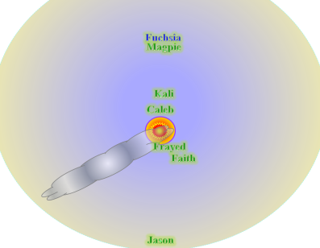

“Might as well wear that around your neck and free up your hand,” one of Caleb’s traveling companions commented on the coin.

Narwhal Port was a small town of loggers and fishers, and the number of headstones in the graveyard couldn’t have been more than 100. There was also a single mausoleum in the center of the roughly 200’ x 200’ area, the perimeter of which was an old, eroded stone wall that was about as high as Jason’s shoulders. They were about 300’ north of the north entrance, and could see nothing wicked lurking therein.

“Paladin! We need a paladin!” Jason called for the specialist. “You want to try and detect wickedness?”

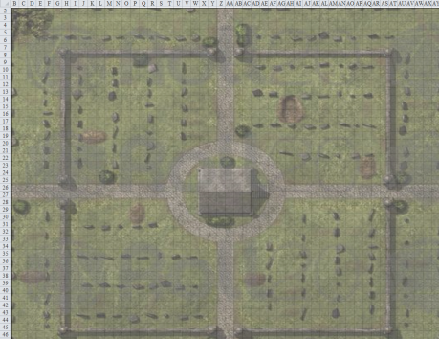

They saw a sole zombie approaching from behind the north entrance.

It was a gnome, a child, of no more than 15 years at the time of death, which, by the severity of the decay, was two months or so ago. Limping its way towards the heroes from the graveyard proper, it hissed with a voice that further identified the child’s gender while it lived. The bottom of her dress was almost completely gone, though both shoulders straps remained intact. Her lifeless body stepped into the *Celestial brilliance* and ceased to be puppeteered by negative energy forevermore, dropping almost instantly upon exposure to the long reach of Caleb’s shiny coin.

All was quiet in the graveyard, except for the usual birds to which they’d grown accustomed since exiting the caverns this morning. Bytopia now seemed like a distant memory to them. Wererats, wereserpents, yuan-ti, and the impostors of the Temple of Gond, who killed off most of the real Gondar clergy, and were now holed up just up the road.

“The way the topography’s laid out,” Jason pointed out. “The only way to continue along the path is through the graveyard.”

“Seems like a tactically sound way to construct the path,” Caleb facetiously replied.

“Well, it’s more because of the natural defile, not so much the way they built anything,” Jason pointed to the downward 30’ cliff to their northeast and the upward 40’ cliff to their northwest. The cemetery appeared to have been walled hundreds of years ago, and its unusual location had most likely been chosen with otherworldly considerations.

Faith moved forward with Jason and cast *detect evil* to see what might be hidden before them. She knew that she would have to get within 60’ of an evil entity before she could discern its presence, and moved with caution at 20’ per round with Jason and the others close behind. Weapons were drawn, and spell triggers were on the tips of tongues as everyone walked quietly southward.

Faith was now 60’ from the north entrance, and spotted nothing. Some branches moved to accommodate the breeze that flowed through them, and then were still as a flock of birds perched on the nearest tree to the northeast of the graveyard proper, chirping cheerfully.

The liberator took a few more steps forward in her bulky armor, still seeing nothing of noteworthy value, not even a zombie.

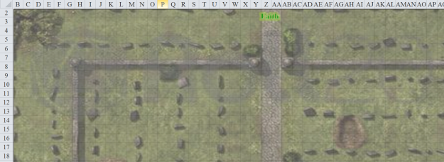

There were enough footsteps and other traces of recent undead treading about, and the land had surely been scoured of all flesh, but nothing that warranted the swinging of a blade. She let the others catch up a bit as she continued to scan for signs of life and undeath, not to mention evil itself.

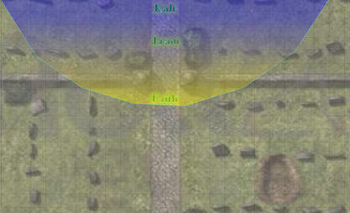

“Much ado about nothing then?” Jason murmured as the smoke from their fire flew right up into the tree where the flock of birdies was, and the birdies took flight, chirping with protest as they found another tree in which to roost and gossip.

Faith shrugged, then heard another murmur to the south, turning her attention to a male figure that came around from behind the mausoleum. He had apparently been talking to himself, but now asked, “And who might *you* be?” Looking like he’d just been found out while in some mischievous act, the human of at least six decades wiped his hands on the legs of his pants. Had... he... been... pleasuring himself behind the mausoleum? Or was he perhaps stealing gems and jewels from the dead?

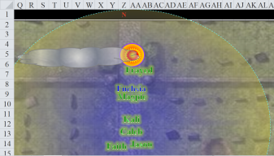

Faith took up a defensive position, as Caleb brought forth his *celestial brilliance* and Frayed tugged at the *floating disk* with the fire dimly lit atop it. The paladin didn’t trust this new fellow one bit, though she could not discern why. Getting within 60’ of him might reveal a thing or two.

“Oh, I think you should stay away from that there area,” the man pointed to the ground just in front of Faith, adding, “It’s about to cave in. Mine traps were set there, but no one ever... hey, you with that shiny coin in broad daylight, what’s that all about?”

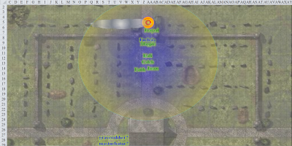

“Not to seem hostile or rude, but this island has been taken over by a death cult, all the civilians seem to have been killed and turned into undead, and we find you under suspicious circumstances in a graveyard. Odds are damn good that you could be aligned with the villains responsible for all this mess, so why don’t you tell us who *you* are?” Magpie chimed up in response.

Caleb, a bit more subtle, asked Faith quietly, “Is he wicked?”

The paladin was still too far away for her *detect evil* ability to discern this.

Frayed, seeing we were talking to this stranger, stopped casting one of his many ‘murder the hell out of a cemetery masturbator’ spells and whistled innocently, rocking back and forth on the balls of his feet.

Seeing no opportunity to fool the living, the disguised stranger then began to decay before their very eyes as the undead creature that he really was activated its *Enlarged* *deeper darkness* ability, centering the effect between the mausoleum and Faith.

A sound of sirens chanting and harping soft melodies tickled the heroes’ ears. Faith, who was immune to such manner of trickery, identified the undead sirens as crypt chanters, and discerned heuristically that at least two such creatures had emerged from the mausoleum now that a magical darkness had enveloped them.