Round 1

|  |  |  |  |  |  |
| --- | --- | --- | --- | --- | --- |
| **Character** | **Group** | **Initiative** | **Roll** | **Modified Roll** | **Move** |
| Jason | 1 | 9 | 16 | 25 | 40’ |
| Crypt Chanters | 2 | 8 | 16 | 24 | 30’/30’ |
| Kali | 1 | 8 | 11 | 19 | 40’ |
| Faith | 1 | 1 | 17 | 18 | 20’ |
| Frayed | 1 | 2 | 15 | 17 | 30’+10’ |
| Magpie | 1 | 1 | 15 | 16 | 20’ |
| Caleb | 1 | 3 | 8 | 11 | 30’+10’ |
| Grave Haunt | 2 | 7 | 3 | 10 | 30’/30’ |

Jason called out, “Fall back!” as he moved 30’ northward and fired his bow at the last spot where he saw the undead monster that manifested *deeper darkness* all around their sphere of *celestial brilliance*.

|  |  |  |  |  |  |  |  |  |  |  |
| --- | --- | --- | --- | --- | --- | --- | --- | --- | --- | --- |
| **Ranged Weapon** | **Dmg.** | **D+** | **TH+** | **Critical** | **Rng.** | **Wt.** | **Atk** | **Roll** | **Check** | **Notes** |
| Sacred Composite Longbow, Skirmish | 1d8 | +1 +3d6 +2 | 1 | 19-20/x3 | 200’ |  | +16 | 12 | 28 | Blind-fight |
| Crystal of Cold Assault, Greater | - | 1d6 | - | - | - |  | - | - | - | -1 to AC 1 round |

*Hit. 1d100 = 97, incorporeality not bypassed.*

Kali moved to Jason’s right side, taking a place 15’ to his right.

Faith would have had to move 40’ back in order to position herself 15’ to Jason’s left. She went half that distance, then cast *righteous fury [Strength bonus expires on Round 61; temporary hps expire in 1 hour]*. She could tell the crypt chanters were trying to lure the heroes into captivity.

*Faith gained +4 to Strength, and 30 temporary hps.*

“Gods damnit! I hate being right all the time,” Magpie sighed and rubbed her face, aware that standing within 10’ of Faith would give her and her friends added defense against compulsion effects, which she now sensed they were facing.

“I hate I just didn’t blow that guy up immediately,” Frayed commented. “I should just trust my murderous instincts.” Noting nothing else going on, Frayed used one of his warmage slots to cast a *continual flame*, countering the *deeper darkness*. However, not having the innate ability to *detect magic*, Frayed could only guess at the location of the *deeper darkness’* center, and so rather than dispelling the *darkness* entirely, he was only able to erect a sphere of torchlight within the *darkness*.

The spell’s effect overlapped partly with Caleb’s *celestial brilliance*, though this would change as soon as Caleb moved.

Staying put for now, Caleb cast *haste [expired on Round 13]* on every one of his traveling companions (except Fuchsia).

*PCs gained +1 to BAB, Reflex save, and AC, + extra attack or move.*

The crypt chanters made their way around Caleb’s resplendent sphere of goodly light, all the while chanting. However, in order to get close enough to Caleb to affect him, they had to enter the light, where they were powerless. The other heroes, who were not in the center of the sphere, however, were a different matter. They, perhaps, could be swayed. For the moment, Jason was the only one caught in the sphere of one of the undead sirens.

|  |  |  |  |  |  |  |
| --- | --- | --- | --- | --- | --- | --- |
| **Save vs.**  Draining Melody | **Rank** | **Ability & Mod.** | **Misc. Mods.** | **Total** | **Roll** | **Check** |
| **Jason, Will** | **4** | Wis (+3) | 1 | 8 | 13 | 21 |

*Success. Effect negated on this round.*

The grave haunt moved somewhere where no hero could see. *[Counter below indicates last known position.]*

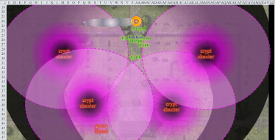

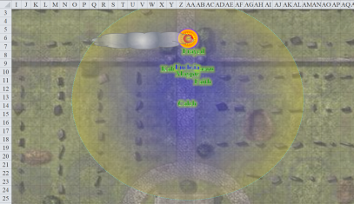

Round 2

The crypt chanters repositioned themselves so as to be within reach of some poor fool, but these were no fools, and their repositioning did little to lure any of them into the cool, enticing darkness.

Frayed *[hastened]* grumbled, “I hate it when I think a thing will work one way and it works a different way and now I look like an idiot who wastes spells.”

Magpie *[hastened]* shrugged, “Eh, it’s not that big a deal. It’s only shadowy illumination. We can still target the singers; the trick is, I bet that singing is dangerous: enchanty or something.”

“Agreed,” Caleb *[hastened]* replied. “Singing undead is never good. Magpie, can you...”

“Yep, cluster up people, it’s about to get quiet. Jason, kill these damn things.” Magpie cast *silence* on her own shirt, centering a 20’ radius of silence on herself.

Caleb and Frayed weren’t happy about it, but stayed within 20’ of Magpie to avoid the chanting.

Magpie, as a beguiler, was trained to cast spells in silence, so on following rounds would begin *magic missiling* the crypt chanters until they ran away or died, or until she was out of her 5 daily *magic missile* casts.

Given its reach, the sphere of *silence* now also encompassed all of the heroes except for Faith. It occurred to Frayed that a single *fireball* spell—if centered on Magpie—would burn them all. Hopefully, the enemy forces did not have an evoker at their disposal. So far it seemed like it was just a handful of crypt chanters and some sort of haunt leading them.

Jason *[hastened]* again told the others to fall back so that they would not be surrounded. He watched for a target and fired upon it as he moved 30’ back down the path.

Kali *[hastened]* followed suit and moved back a few more feet to stay in the center of the *brilliance*, though they were already more than adequately huddled.

Faith *[hastened]* moved back and cast *protection from evil* on herself.

*Faith gained +2 to AC and saves vs. evil attackers.*

Fuchsia *[under Magpie’s command]* followed Magpie for now.

The singing of the undead chanters was now

The grave haunt was royally pissed that these do-gooders were foiling his trap. His disembodied curses could be heard all around them, though most could discern the *ventriloquism* for what it was. The language was Infernal, which might have been understood by Caleb, if he hadn’t been inside the *silence* sphere.

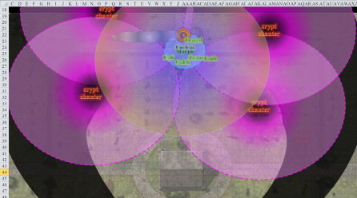

Round 3

The crypt chanters and the grave haunt continued to dance and meander around the heroes. The crypt chanters could barely and intermittently be seen behind the veneer of *deeper darkness* as they avoided both Caleb’s *celestial brilliance* and Frayed’s *continual flame* auras. And yet for all their efforts, the chanters and haunt could do nothing to harm them.

Faith was the only one who could hear the delicious melody, but it did nothing to sway her, and she was in no mood for a serenade on her way to slay Larlum and his company of villains.

Well inside the sphere of *silence*, Jason *[hastened]* seeing the others did not listen to his direction even with hand motions, Jason huffed in disappointment. In truth, they had fallen back to Caleb’s position. Jason readied his bow to fire at the next beast that stepped into the light.

Faith *[hastened]* and Kali *[hastened]* kept their eyes open.

Magpie *[hastened]* silently cast *Rary’s telepathic bond [because Magpie has already exhausted her 5th- and 6th-level spell slots, I’ll allow the casting of this spell, which takes up a 6th-level slot if cast silently, but it will expire in ½ the time (1 hour), and have a maximum range of 1 mile between any two communicating characters]* on the team so they could communicate, then thought at the group, “Alrighty, we have them right where we want them. Everyone get ready and we all move together as one unit. Jason, pick an enemy and move toward them, bringing them into the light, and hit them with an arrow. Faith, murder the undead hell out of whoever Jason highlights. Kali, use your best judgment. We rinse and repeat until we get them all or they run away. As long as we have the light and the silence, they’ve got nothing.”

*All PCs were telepathically linked.*

Faith thought, “They’re incorporeal, so many of Jason’s hits—true as they may be—are likely to fly right through these apparitions.”

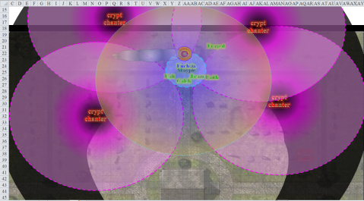

Round 4

Faith *[hastened]*, Jason *[hastened]*, and Kali *[hastened]* kept vigilant.

Caleb *[hastened]* and Frayed *[hastened]* could step out of the silence to get blasty. Caleb wouldn’t. He’d instead conserve his energies to support later. Because of his Darkvision, the whisper gnome was able to discern the general location of one of the crypt chanters, and since Faith and Jason didn’t seem to be attracting any attention, Frayed stepped out of the *silence* and fired off an *orb of force* at an enemy floating about. Then he heard the song.

|  |  |  |  |  |  |  |
| --- | --- | --- | --- | --- | --- | --- |
| **Save vs.**  Draining Melody | **Rank** | **Ability & Mod.** | **Misc. Mods.** | **Total** | **Roll** | **Check** |
| **Frayed, Will** | **12** | **Wis (+0)** | 3 | 15 | 13 | 28 |

*Success. Effect negated on this round.*

The gnome pointed, aimed, prestidigitated, and shot off an *orb of force*, depleting his 4th-level warmage spell slots for the day.

|  |  |  |  |
| --- | --- | --- | --- |
| **Ranged Weapon** | **Atk** | **Roll** | **Check** |
| Ranged Touch Spells | 8 | 2 | 10 |

*Miss.*

Magpie squinted at the spot where her whisper gnome colleague had just shot an *orb of force*. “Aim a bit farther to the left,” Frayed aided Magpie at the last minute, and she nodded as she did so.

The crypt chanters and grave haunt continued to circle the heroes like sharks around prey in a stalemate that might have lasted as many days as the *deeper darkness* and *celestial brilliance* did. The *continual flame*, the undead could bear, but it was that holier-than-thee coin that they would have to convince Caleb to put away, and for now they couldn’t.

Round 5

Faith turned, knowing that they were at a standoff and they needed to get out of the cemetery. She charged back the way they group had come, heading for the crypt chanter to their rear. Faith yelled, “Follow Me!” as she passed magpie and the others.

Kali also turned and followed but stopped just inside the saving sphere that protected them from the song, right next to Jason, who was already at that spot. They waited for the others to move so they could continue to help Faith.

Then the darkness around them ceased to be inky and opaque, and almost instantly became a more mundane sort of shadowy illumination. And the singing became slightly more cacophonic, though Magpie and a few others still couldn’t hear. With the four incorporeal crypt chanters fairly clearly in everyone’s sight, but the grave haunt still unseen, the heroes attacked the most evident target with great resolve.

Jason *[hastened]* fired at the figure he’d already been spying.

|  |  |  |  |  |  |  |  |  |  |  |
| --- | --- | --- | --- | --- | --- | --- | --- | --- | --- | --- |
| **Ranged Weapon** | **Dmg.** | **D+** | **TH+** | **Critical** | **Rng.** | **Wt.** | **Atk** | **Roll** | **Check** | **Notes** |
| Sacred Composite Longbow, Strength +1 | 1d8 | +1 | 1 | 19-20/x3 | 200’ | 3.0 | +16 | 4 | 20 |  |
| 2nd Shot | 1d8 | +1 | 1 |  |  |  | +11 | 13 | 24 |  |
| 3rd Shot, Rapid Firing | 1d8 | +1 | 1 |  |  |  | +6 | **20** | 26 |  |
| 4th Shot, *haste* | 1d8 | +1 | 1 |  |  |  | +16 | *1* | 17 |  |
| Crystal of Cold Assault, Greater | - | 1d6 | - | - | - |  | - | - | - | -1 to AC 1 round |

*Hit, hit, threat, miss. 1d20 = 19 + 6 = 25, critical hit.*

*Hits to bypass incorporeality: 1d100 = 36, 91, 44; hit, miss, hit (critical).*

*Dmg: (3 + 1 + 2 cold) + [3 x (7 + 1 + 1 cold)] = 4 + 24 + 5 cold = 33.*

Magpie *[hastened]* cast a Silent *magic missile* on the same one. *[2 move actions left]*

*Dmg: 15 + 5 = 20 magic [force].*

Faith *[hastened]* saw that she no longer had an adversary before her, so she turned to the next one, just north of her position, and charge-attacked it.

|  |  |  |  |  |  |  |  |  |  |  |
| --- | --- | --- | --- | --- | --- | --- | --- | --- | --- | --- |
| **Melee Weapon** | **Dmg** | **D+** | **TH+** | **Critical** | **Type** | **Wt.** | **Atk** | **Roll** | **Check** | **Properties** |
| Adamantine Illuminating  Holy Greatsword +1 | 2d6+2 | +10 + 1  + 2 charge | 1 + 2  charge | 17-20/x2 | Slashing | 8.0 | +22 | 19 | 41 | +2d6 to evil |
| 2nd Attack, *haste* | 2d6+2 | +10 + 1 | 1 | 17-20/x2 | Slashing |  | +20 | 12 | 32 | +2d6 to evil |

*Threat, hit. 1d20 = 13 + 20 = 33, critical hit.*

*Hits to bypass incorporeality: 1d100 = 21, 65; hit (critical), miss.*

*Dmg: [2 x (6 + 2 + 10 + 1 + 2 + 10 good)] = 42 + 10 good = 52.*

Frayed *[hastened]* was impressed, and what’s more, he was no longer inside a crypt chanter’s sphere of influence. He had been about to zap that exact specter when Faith cut the undead thing down with her holy sword. The warmage-evoker turned around to face the northwestern crypt chanter, and shook his head, casting something less bold than *orb of force* this time. *[specify spell]*

Inside the spheres of *silence* and *celestial brilliance*, Kali *[hastened]* and Caleb *[hastened]* weighed their options.

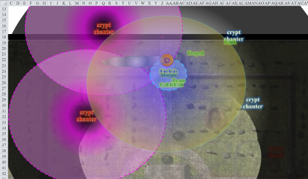

Round 6

Faith cast *bull rush* as she charged at the next closest enemy *[used up her extra move action, so no 2nd (hastened) attack]*.

|  |  |  |  |  |  |  |  |  |  |  |
| --- | --- | --- | --- | --- | --- | --- | --- | --- | --- | --- |
| **Melee Weapon** | **Dmg** | **D+** | **TH+** | **Critical** | **Type** | **Wt.** | **Atk** | **Roll** | **Check** | **Properties** |
| Adamantine Illuminating  Holy Greatsword +1 | 2d6+2 | +10 + 1 + 2 | 1 + 2  charge | 17-20/x2 | Slashing | 8.0 | +20 | 2 | 22 | +2d6 to evil |

*Hit.*

*Hit to bypass incorporeality: 1d100 = 44; hit.*

*Dmg: 2 x [6 + 2 + 10 + 1 + 2 + 4 good] = 42 + 8 good = 50.*

Jason, seeing Faith’s intended target, let loose arrows at the last remaining chanter.

|  |  |  |  |  |  |  |  |  |  |  |
| --- | --- | --- | --- | --- | --- | --- | --- | --- | --- | --- |
| **Ranged Weapon** | **Dmg.** | **D+** | **TH+** | **Critical** | **Rng.** | **Wt.** | **Atk** | **Roll** | **Check** | **Notes** |
| Sacred Composite Longbow, Strength +1 | 1d8 | +1 | 1 | 19-20/x3 | 200’ | 3.0 | +16 | 4 | 20 |  |
| 2nd Shot | 1d8 | +1 | 1 |  |  |  | +11 | 15 | 26 |  |
| 3rd Shot, Rapid Firing | 1d8 | +1 | 1 |  |  |  | +6 | 8 | 14 |  |
| 4th Shot, *haste* | 1d8 | +1 | 1 |  |  |  | +16 | 2 | 18 |  |
| Crystal of Cold Assault, Greater | - | 1d6 | - | - | - |  | - | - | - | -1 to AC 1 round |

*Hit, hit, miss, miss.*

*Hits to bypass incorporeality: 1d100 = 90, 52; miss, miss.*

Jason shook his head at the crypt chanter, hoping to get those arrows back when this was all over.

Kali finally decided to act, and end this ordeal, moving to attack Jason’s target. She was not sure what had transpired that caused the area to lighten, but she silently thanked the gods. Leaving the safety of the *silence* bubble, she now heard the chanting of the last undead chanter.

|  |  |  |  |  |  |  |  |
| --- | --- | --- | --- | --- | --- | --- | --- |
| **Save vs.**  Draining Melody | **Rank** | **Ability & Mod.** | **Misc. Mods.** | **Total** | **Roll** | **Check** | **Properties** |
| **Kali, Will** | **7** | **Wis (+0)** | 1 | 8 | 18 | 26 | +2 vs. Enchantments, +3 vs. Mind-Affecting |

*Success. Effect negated on this round.*

She knew she could not charge fast enough to reach the chanter *and* attack it before the others could do something, so the saber-dancer positioned herself in such a way as to better charge-attack the creature while giving the archer and spellcasters a line of attack.

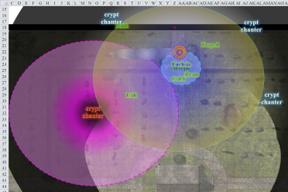

Round 7

Most of them, however, were wiping their sleeves after having downed three crypt chanters in a row, and so Kali *[hastened]* did her best to hop, skip, jump, and twirl like a bladed helix, harrowing the undead specter like the worst of fevers.

|  |  |  |  |  |  |  |  |  |  |
| --- | --- | --- | --- | --- | --- | --- | --- | --- | --- |
| **Melee Weapon** | **Dmg** | **D+** | **TH+** | **Critical** | **Type** | **Wt.** | **Atk** | **Roll** | **Check** |
| Scimitar +2 | 1d6 | 2 + 2  charge | 2 + 2  charge | 18-20, x2 | Slashing | 4.0 | +19 | 18 | 37 |
| Crystal of Electrical Assault, Greater | - | **1d6** | - | - | - | 0.0 |  |  |  |
| Scimitar +1 | 1d6 | **1** | 1 | 18-20, x2 | Slashing | 4.0 | +16 | 6 | 22 |
| Crystal of Cold Assault, Greater | - | **1d6** | - | - | - | 0.0 |  |  |  |
| 4th Attack, haste | 1d6 | **2** | 2 | 18-20, x2 | Slashing | - | +17 | 6 | 23 |
| Crystal of Electrical Assault, Greater | - | **1d6** | - | - | - | 0.0 |  |  |  |

*Hit, hit, hit.*

*Hits to bypass incorporeality: 1d100 = 06, 23, 42; hit, hit, hit.*

*Dmg: (6 + 2 + 2 + 4 electric) + (1 + 1 + 3 electric) + (3 + 2 + 3 electric) = 17 + 10 electric = 19.*

It—she, whatever—gasped, and retreated into the *darkness* that persisted. The singing stopped, and it was likely that the incorporeal creature had fully withdrawn itself and interred its form in or near a grave.

Then the grave haunt emerged from the ground beneath Frayed’s feet, and attempted to push him northeastward and out of the *celestial brilliance*.

*Dmg to grave haunt: 5 good.*

|  |  |  |  |  |  |  |  |  |
| --- | --- | --- | --- | --- | --- | --- | --- | --- |
| **Character** | **Attack Type** | **Damage** | **BAB** | **Mod+** | **W+** | **Other+** | **d20** | **Total** |
| Grave Haunt | Incorporeal Touch | 3d6+push | 6 | 4 | 0 | 0 | 17 | 27 |

*Hit. Dmg: 10 + push.*

|  |  |  |  |  |  |  |
| --- | --- | --- | --- | --- | --- | --- |
| **Save vs.**  Push | **Rank** | **Ability & Mod.** | **Misc. Mods.** | **Total** | **Roll** | **Check** |
| **Frayed, Will** | **12** | **Wis (+0)** | 3 | 15 | 6 | 21 |

*Success. Push effect negated.*

Before Frayed could cast a spell, Jason *[hastened]* had already dispatched four arrows in the grave haunt’s direction.

|  |  |  |  |  |  |  |  |  |  |  |
| --- | --- | --- | --- | --- | --- | --- | --- | --- | --- | --- |
| **Ranged Weapon** | **Dmg.** | **D+** | **TH+** | **Critical** | **Rng.** | **Wt.** | **Atk** | **Roll** | **Check** | **Notes** |
| Sacred Composite Longbow, Strength +1 | 1d8 | +1 | 1 | 19-20/x3 | 200’ | 3.0 | +16 | 7 | 23 |  |
| 2nd Shot | 1d8 | +1 | 1 |  |  |  | +11 | 17 | 28 |  |
| 3rd Shot, Rapid Firing | 1d8 | +1 | 1 |  |  |  | +6 | 13 | 19 |  |
| 4th Shot, *haste* | 1d8 | +1 | 1 |  |  |  | +16 | 10 | 26 |  |
| Crystal of Cold Assault, Greater | - | 1d6 | - | - | - |  | - | - | - | -1 to AC 1 round |

*Hit, hit, hit, hit.*

*Hit to bypass incorporeality: 1d100 = 97, 90, 18, 24; miss, miss, hit, hit.*

*Dmg: (4 + 1 + 3 cold) + (7 + 1 + 4 cold) = 13 + 7 cold = 20.*

This, however, was not enough to bring down the protector of this graveyard defile through which the heroes *had* to pass if they were going to reach Chez Larlum.

Kali *[hastened]*—having no one to attack—turned back to the group to see the haunt. She made a beeline for the fellow intending to end Frayed.

Faith *[hastened]*—being too far away to charge-attack the grave haunt at the moment—also returned toward the group, positioning herself in a prime location to bull rush or charge the grave haunt.

Magpie’s shirt was still *silenced*, and she didn’t really feel like wasting another spell slot on a Silent spell, so she turned to Frayed and Caleb, who were able to step outside her sphere while remaining within the *celestial brilliance* of Caleb’s coin.

|  |  |  |  |  |  |  |
| --- | --- | --- | --- | --- | --- | --- |
| **Skill** | **Rank** | **Ability & Mod.** | **Misc. Mods.** | **Total** | **Roll** | **Check** |
| **Frayed, Concentration** | 11 | **Con (+2)** | 0 | 13 | 17 | 30 |

Frayed *[hastened]* defensively cast a *magic missile* at the grave haunt.

*Dmg: 11 + 5 = 16 magic [force].*

Caleb *[hastened]* moved back out of Magpie’s area of *silence*, away from the haunt. He cast *magic missiles* at it, using his wand.

*Dmg: 14 + 5 = 19 magic [force].*

Not wanting to spend any more spell resources unless she was directly attacked, Magpie *[hastened]* just kept watch for now.

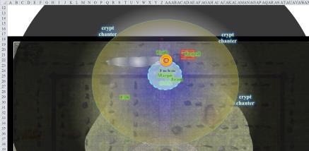

Round 8

Stunned by the barrage of *magic missiles*, the grave haunt cringed with every blow.

Frayed *[hastened]* defensively cast another *magic missile* at the grave haunt.

*Dmg: 15 + 5 = 20 magic [force].*

Caleb *[hastened]* thought he might finish the job with this blast.

*Dmg: 11 + 5 = 16 magic [force].*

The grave haunt writhed and squealed, screeched and hissed as it fizzled out of existence with the last volley of *missiles*.

Magpie grumbled to herself as she realizes a tactical error. She should have cast *silence* on something more portable. Then she could have just stuck it into her haversack, shunting it into another dimension, keeping it handy in case it’d be useful again. But she wasn’t taking off her shirt, so went ahead and dispelled the *silence*.

The battle was over, it seemed, though one crypt chanter had gotten away. Caleb also announced, “It is most likely that the haunt has not been permanently vanquished. Haunts are a persistent and pernicious variety of undead that cannot simply be deracinated by slaying them mundanely as we just did.”

“I’d say that was far from mundane,” Frayed protested.

“I don’t mean without the use of magic in this case, but rather that a haunt can only be completely expunged from a realm by righting whatever wrong bound its spirit to its tether, which in this case, is probably the mausoleum,” Caleb explained. “Perhaps Larlum’s forces are behind the evil that spawned the haunt; by slaying Larlum and his minions, we might avenge whatever terrible deeds keep the haunt roving over this graveyard.

“Hopefully you’ll spare *me*,” Fuchsia said.

“Well,” Faith said as the *deeper darkness* persisted, “We can either stay here and have lunch, or we can finish this once and for all.” The paladin of freedom turned southward, facing the path that lay ahead. “If the sorceress is right, what’s your name again, dear?”

“Drakespawn Fuchsia,” the sorceress answered.

“Yes, well, Fuchsia, your word has been gold since the moment we became friends,” the paladin of freedom diplomatically described the moment of her enchantment, “so you’re saying that over there,” Faith pointed into the blackness to the south, “is a little hilly climb and then we’re pretty much there?”

The sorceress squinted, “I didn’t say we’re pretty much there. It will be a bit further after the climb, but if there are no sentries posted to that hilltop, you can bet we’ll see some resistance well before entering Larlum’s bone grotto.”

“I’ll repeat that we would be far better prepared to contend with them tomorrow after we’ve had a chance to rest,” Magpie reminded her mates. “Based on what Fuchsia has told us of the remaining forces Larlum has at his avail, the odds don’t look good for us with half of our daily wares depleted.”

Frayed was more ambitious than the rest, and had to disagree, “I am not only here on my behalf. I gave up a well-earned, gravy-filled retirement in a promised land more beautiful than I care to miss right now. We made an oath to avenge the deaths of the majority of the zombies that we just destroyed with Caleb’s coin. Let their deaths not be in vain.”

Caleb shared a median perspective, “I think both of you make a good point, but too much bravado will get us killed before the night is upon us. At the same time, if Fuchsia’s ninja friend reports that we survive, they will either come and bring the party to us, or more likely, escape the island now that they’ve depleted it of living inhabitants.”

Fuchsia agreed, “The Master has been reticent with most of us about long-term plans, but my lover, Blingschteiver, overheard him discussing the commandeering of a salvaged ship.”

“At the docks?” Caleb wondered if they should turn back to the town and the docks.

“I know not,” the gnome sorceress shrugged.

“Alright, we’ve mostly cleared the graveyard. Can we go rest now before we get into another fight? This place sucks.”

Magpie didn’t reply to Fuchsia’s grumbles about being spared. The gnome was a true believer, wicked through and through. She was partially responsible for all this senseless death, destruction, and perversion of the natural order. The beguiler didn’t like being judge, jury, and executioner, but Fuchsia’s prospects for retirement didn’t look great.

They didn’t know where they were going to set up camp, but they could tell that another night of snow was likely to present itself. There were already less hours of light ahead of them than behind them, and an approaching storm cloud was clearly depositing a coat of snow over the horizon. It was nowhere near the island, but would be by day’s end if the breeze continued as it did.

Leaving the cemetery behind, the party continued along a fairly uneventful, southwardly path, spotting the bones of some cows and bulls that had been scattered about in what had previously been a rock-based bonfire. About 10 rocks were still laid out in a circular formation, walling in the black, charred ground that the breeze had long ago cleared of ashes. The bones had been added later, as none of them were charred.

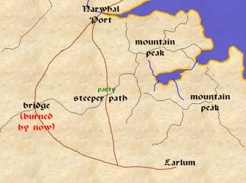

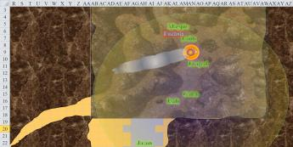

The small cliffs were the next landmark up ahead, and as the heroes got closer, Fuchsia pointed out: “Behind that pine is the best route to ascend.”

To some of the less trustworthy in the band, that was code for, “Be on the lookout for my friends’ ambush.”

The cliffs immediately around them were about 40’ high, but the ones to the south were only 20’ to 25’ on average, and the plateaus above would have been choice vantage points for a good ambush. A few blades were drawn as the cliffs got closer, just out of prudence. The path here turned sharply westward, and the captive said this led to the bridge eventually. Jason imagined what taking the other path would have been like: the one with the bridge.

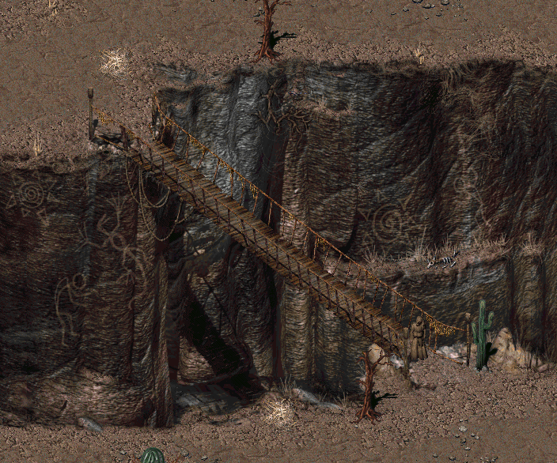

Based on the captured sorceress’ description, the bridge could probably have been fixed with a *make whole* spell, and they could have avoided this whole climbing thing.

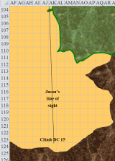

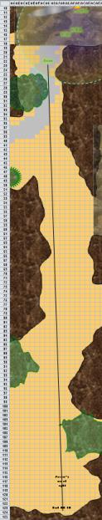

“I don’t like this place. We are to open to attack and should have made camp back down the road. I don’t want to be caught on the side of a hill sleeping, fighting, or in a snow storm,” Jason replied as he wondered why they had not gone back to the town as had been planned before the graveyard. Had it been to gain a tactical advantage over a spot where they were likely to be ambushed or just plain curiosity?

In any case, they descended back to the dockyard town of Narwhal Port. They arrived at the graveyard, noting that the *deeper darkness* spell was still covering most of the area that they had intended to consecrate.

They knew full well that one crypt chanter had escaped their vindictive wrath, and was still underground somewhere, or perhaps in the mausoleum at the center of the graveyard. Of course, swords and a bow were drawn, and spellcasters fidgeted in their spell component pouches to make sure they had the proper doses of their various wares, but neither a threatening screech nor a soothing song were heard. Magpie’s *silence* spell had long been dispelled around her shirt, and the heroes huddled near Faith, whose strong but compact aura provided them defenses against Compulsions and Enchantments such as those they’d wrestled with earlier.

The paladin herself was immune to such trickery, and could not remember a time when she’d last been cajoled in this manner. The archer led the way, only steps ahead of Faith and the others. They knew that if they stayed here longer than a few days, the grave haunt would respawn here, and the heroes would have failed the miserable fool whose soul was stuck here in an endless loop of territorial madness. Some in the band didn’t so much label this a failure as a mere pity that did not take precedence over the matter of dozens—hundreds!—of souls who’d died untimely and gruesome deaths at the hands of Larlum the Redhanded and his minions.

Kati spoke up, “Should we look in this crypt while we are here? It might give us some clue as to how put the haunt to rest.”

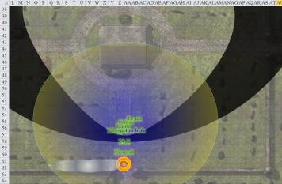

Magpie didn’t chime in on this one, deferring to the cleric.

“Couldn’t hurt,” Caleb replied. “Odds are the crypt has been robbed by these villains, much like the town was looted. There could be an heirloom the haunt wants returned. Perhaps there’s evidence there.”

“We sort of need a rogue,” Faith turned to Magpie. “Do you have any kind of skills for seeing if there are any traps around the mausoleum? My ability to *detect evil* does not penetrate stone, so I can’t see what lies within.”

“I’m not a trap expert, but I’m not terrible either. I’ll take a looksee.” Magpie searched the area for traps, taking a minute or so to go around the mausoleum, and come back to the door.

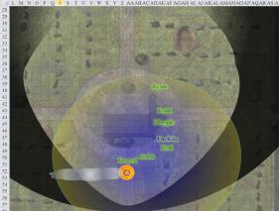

She and Caleb just wanted to look around and see if anything stood out as particularly desecrated or evil. Frayed wasn’t above taking valuables; not like the dead needed them. However, with Faith around, he kept that to himself.

“I would not think the haunt traded the place. If it is sealed, then the tomb was probably not raided by our antagonist.” She looked at the creature under Magpie’s control for any thoughts she might have.

They were all cautious, and as the beguiler walked forth to study the situation, Caleb’s coin illuminated all around them south of the mausoleum, while Frayed’s torch-equivalent spell lit the structure’s northern face.

Magpie declared the area free of traps; then the paladin tried the door.

“We’ll have to force this open,” Faith thought aloud, “unless Magpie wants to cast another *knock* spell.”

Kali was glad to be on the Material Plane, through which all mortal life eventually existed, but did not remember the life she led before she met up with Caleb, Jason, and Faith and helped them destroy the Gauntlet. With the newly refurbished garment, she was able to stave off the cold that would otherwise have kept her more on the edge than they should have been.

Faith attempted to open the door using force if necessary. It took only two tries—and the first one was more of a diagnostic try—to force the metal back and give Faith just enough leverage and clearance to pull hard and force the vault open.

The smell of death—of course—emanated from the now open crypt. Magpie could already see inside, and noted what she’d expected. Taking a few steps inward, she noted four upright sarcophagi with masks of wavy-haired women, one standing at each corner of the crypt. In the center was an urn large enough to contain 20 or more gallons of liquid, or ashes.

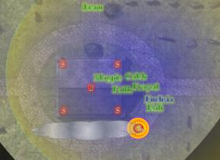

No traps were evident. Nothing stirred, and no singing emanated from within the crypt; and though magical and evil auras were evident in the urn’s handiwork, nothing was immediately threatening them.

“The urn is part of the grave haunt’s curse,” warned the cleric/diviner. “Do not touch it, or we might incur the curse ourselves.”

“Noted,” Magpie said, seeing no gems or anything else to steal.

Jason took watch, focusing back up the road they came from as did Kali in the direction of the town.

Frayed thought to look in the sarcophagi. “Maybe these coffins conceal some treasure that the deceased might have wanted to take with them into the afterlife... some believe in these things.”

Nothing of interest was in the aboveground crypt to the naked eye, though Faith suspected that they would find something worth talking about inside at least one sarcophagus.

“Four sarcophagi, four chanters. Interesting.” Magpie kept her hands in her pockets as she wandered about, “The styling doesn’t match the surrounding aesthetic. Think they were brought here and left by our enemies?”

“Seems likely. Where’d they get the chanters, though?” Frayed asked.

“I’d assume they made them, just like they made the grave haunt.” Caleb walked around the urn, studying it and trying to think of a way to dispel or break the curse. “If the sarcophagi were brought in, I see no harm in looting them, although there is a crypt chanter still alive. Faith, is it in one of the sarcophagi?”

Jason spotted a stray zombie coming at them, and brought it to its knees with a single arrow, then finished its prone body off with a second one.

Kali called from outside. “What’s taking so long? Let’s get back to town.”

Faith concentrated on the sarcophagi as she tried to discern what was in each. “We’ll have to open these bronze caskets before I can determine if they carry anything evil within them.”

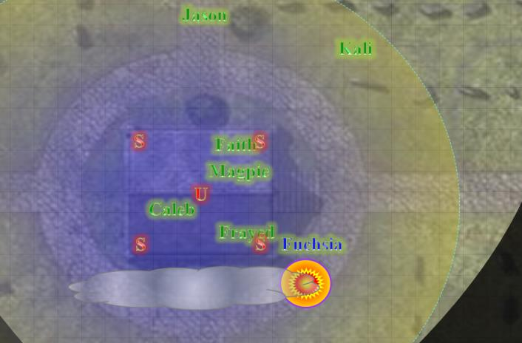

Frayed entered and inspected the southeasternmost sarcophagus. “By force or magic, they *will* open,” he stretched and said.

Fuchsia remained outside, not far from the fire, as the mausoleum seemed to almost lure the heroes inside.

Caleb said, “Based on what we’ve witnessed here, I’ll say with some certainty that if the curse was put upon these five souls by Larlum or someone in his orbit, we stand a good chance at liberating the crypt chanters and grave haunt by slaying Larlum and *all* of his lot.”

Fuchsia frowned behind him, and he turned to see her face, still talking to his mates, “You do as you wish with her, but if I had my way, I would at least retain her until *after* Larlum has been dealt with, and if we return to find any of these undead still bound to their curse, perhaps offering up the sorceress to the accursed haunt and chanters might be a karmically sound course of action.”

“What about looting the urn and caskets?” Frayed went back to the important things.

“Like I said earlier, don’t even think of touching the urn,” Caleb warned again. “There will certainly be corpses inside each of the oblong sarcophagi; whether or not they have valuables, I can only guess.”

“I would not bother them. It might compound the problem,” said Faith.

Magpie clapped her hands together and rubbed them together vigorously, “Alright. Doesn’t look like we can do much of anything here. Back to town, find a defensible place to hole up, eat some food, get some rest, and tomorrow we go to war.” Exiting the mausoleum and walking up to her new thrall, she looked into the woman’s eyes, “Fuchsia, after we make camp, you will create, to the best of your ability, a map of Larlum’s headquarters. You’ll tell us of all traps and hazards you know of, and likely defenders we’ll face.”

“Yes, I think I *shall*. I *love* making maps!” the sorceress exclaimed.