*Chapter 50*

As the magic carpet approached their house on Shipshape Way, they noted the fact that it was intact, exactly as they’d left it during daylight hours, though they had seen it destroyed just over an hour ago. It would take something far more powerful than a *make whole* spell to magically fix such a structure, and as they spotted Kedrik and Thaqualm—the illithid paladin familiar to and trusted by most of the heroes present—at the northeastern corner of the house talking to an armored guard, they deduced that the archivist and other associates had pooled their resources to make this happen.

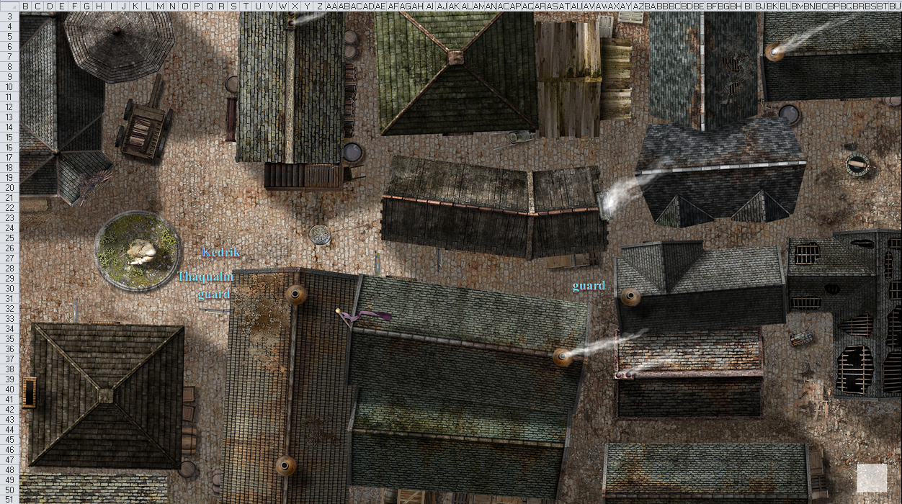

The carpet was still 100’ up, and Fingers spotted a few more guards along the northwestern and southern perimeters of the property before they descended near Kedrik, announcing themselves.

The gnome archivist and illithid paladin greeted the heroes, and expressed gratitude to their favorite deities for the Gambit’s homecoming. And who was this masked woman they’d brought with them? Kedrik greeted her and then Rook made the introductions, “Samara, may I present two of our friends, Kedrik and Thalqulam. Since our home was destroyed a hour ago, I deduce that these folk had something to do with its restoration.”

“Hello!” said Maiko. “I am Maiko and this is Samara. I am glad to meet you and find that Rook has someone to keep in inline.” The dancer returns a smug smile.

“Hello, Milady,” the tall, redheaded half-elf said with a smile. “Rook is my liege lord, so I am bound to follow his commands.” Her green eyes twinkled with amusement. She looked at Samara. “Hello, I am Elaith.”

Samara tagged along silently, only bowing her head in acknowledgement of Rook’s friends, since he had not introduced her to them. She would not want to inadvertently cause trouble for him, and did not know how any of them wished her to be seen. At the first opportunity, whilst there was some rather public planning of private matters between those she assumed were handfasted, she moved closer towards Maiko.

Maiko had been the one to show her the most sympathy in the group, and was the one whose actions had seemed most guided by morality rather than expediency, except for Mellion and Valania, whom she had killed. But there was no time to be sorrowful, because now, out of danger and remembering what had happened, she was gravely concerned. Touching Maiko lightly on the arm to gain her attention, she asked in a low voice, trying not to be overheard, “Maiko? Do you remember what Mellion was carrying for me? I must get it back. It is of the utmost importance.” She did not specifically want to mention the rod that sapped Macaria’s power and bestowed it on mere mortals, not in front of these Overclan types.

Rook stepped over to embrace a tall, redheaded woman. After a moment, she disengaged from him and approached Samara and Maiko. “Excuse me, we haven’t been introduced. My name is Elaith Aefir. Rook is my liege lord, and my lover.”

“Let us not forget those we lost today,” said Maiko.

They took a few moments to inform one another of things that could be said outside, then Kedrik nodded, as an additional guard came out of the front door, the gnome turned to that unarmored but officially dressed woman. She looked to the Gambit and smiled with admiration, then held the door open for the senior agents to enter the house while the City Guards waited outside.

Once inside, Kedrik vouched for the authenticity and integrity of the woman present, and introduced her simply as Agent D9 for the moment.

Agent D9 smiled and said something about being a fan of the Gambit, then reported to Kedrik primarily, looking occasionally at Fingers and the others, “The structure has been fully restored, but I fear that Agent Fingers might have to reset his traps. What you’ll find in their place did not regenerate properly.”

And indeed, Fingers would find that in place of one trap he’d set, there was a mousetrap hanging from a fishing line, and one of his most elaborate traps—set along the northeastern corner of the house—was now a paper plate with clothespins held together. The spellcasters had spread the spells out too thin, it seemed, and things with complex mechanical parts had not been properly replicated. Additional castings might remedy the anomalies, but Fingers would probably have preferred to reset all of his handiwork himself.

Fingers made a mental shopping list of odds and ends he’d need to replace all the traps he’d so meticulously installed in their base, but he’d first check Maiko and Sarge’s nest for traps as such as he’d promised.

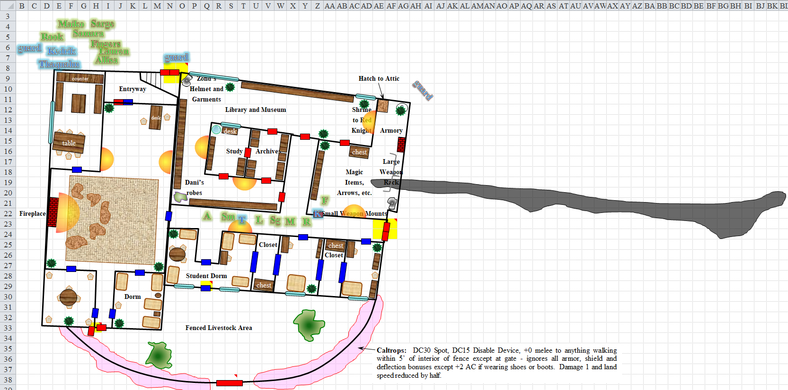

There were few places more secure in this house than Kedrik’s study, and the majority of Rook’s followers—they’d just been told—were waiting for them there. They entered Kedrik’s study, then accessed the overhead staircase that came down gently as each took her and his turn up to the attic and into the gnome’s study. Even though Kedrik had recently moved in with Viola—cleric of Lliira and friend of the Gambit’s—he still kept a secondary abode here. As they made their way up to the attic, Kedrik asked, “And Mellion?”

Mostly with somatic gestures, the Gambit expressed that he was most likely dead, and if not, he would surely prepare a spell by morning that would get him and Valania free.

“I’ll get someone on that in a bit,” Kedrik said, resolving to cast *message* as soon as he got upstairs where his stash was.

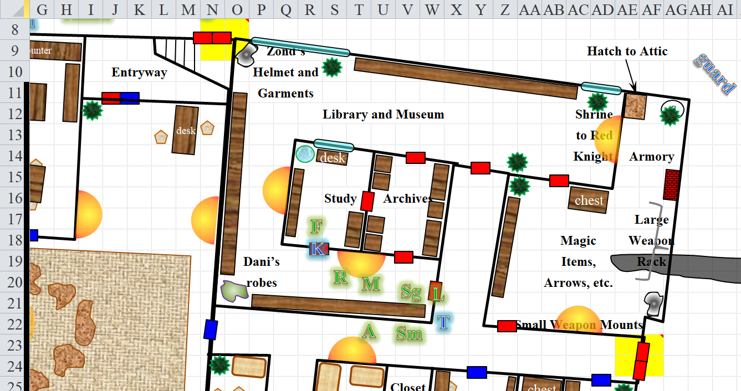

Walking along the corridor towards the only south-facing door, Rook was first to enter the dimly lit room, and greeted each of his acolytes present with the heartfelt hugs of longtime veterans, though some of these knaves were merely aspirants to the title of “cleric of Red Knight”, and little more. Two candles had been burnt to about an inch in height in the middle of the table, and two other candles were ensconced along the east and west walls of the room whose only way in or out was through the door facing north. Rook took a mental tally of who among his flock was here.

|  |  |  |  |  |  |  |
| --- | --- | --- | --- | --- | --- | --- |
| ***Name*** | **Race** | **Class** | **ECL** | **Sex** | **Age** | **Alignment** |
| Elaith Aefir | half-elf | duskblade | 8 | F | 30 | LN |
| Thywine An | human | cleric of Red Knight | 3 | M | 25 | NG |
| Cyka Holsan | human | cleric of Red Knight | 2 | M | 22 | LG |
| Semolina Tinyfoot | halfling | cleric of Red Knight | 1 | F | 23 | LN |
| Samark Elffred | human | druid | 1 | M | 19 | NG |
| Marsyl Muelord | human | cleric of Red Knight | 1 | F | 18 | N |
| Thoret | human | cleric of Red Knight | 1 | M | 19 | LG |
| Osu Reginso | human | cleric of Red Knight | 1 | M | 19 | NG |
| Cassandra Took-Took | halfling | druid | 1 | F | 21 | LN |
| Kaeal Brasfled | human | cleric of Red Knight | 1 | M | 18 | LG |
| Gloryra Inasalor | half-elf | cleric of Red Knight | 1 | F | 22 | LN |
| Ridwulf Carpa | human | cleric of Red Knight | 1 | M | 18 | NG |

They were all unscathed, and suited up for nocturnal combat, if the need should arise. The others—he was summarily told by Elaith—were either shopping for potions and munitions at Fritz’s, or at the Silver Schilling, which was where Allisa had stayed on her first night in the City of Splendors.

Rook nodded, and then he gathered the tall redhead into his arms. “I was so worried about you,” he said, looking up with her two-inch height advantage.

“And I, for you, my love.” Elaith kissed him soundly. “Is there anything else that has to be done before we can go home?”

“I don’t know,” Rook replied with a shrug. “I will ask Lady Lauren.”

“Ask me what?” Lauren smiled as she walked up hand-in-hand with Allisa.

“She wants to ravage me, and we are working on the schedule. Ow!” Rook grunted as Elaith slapped him lightly on the head.

“Just use your old room,” Kedrik pointed down at the room below his feet, where a succubus had seduced him months ago. Then he thought about it twice and was glad that the drow-human spoke.

Lauren grinned. “I’m planning to schedule a ravishing of my own,” she said, glancing at Allisa. “I don’t know how soon that will happen, but probably later tonight.”

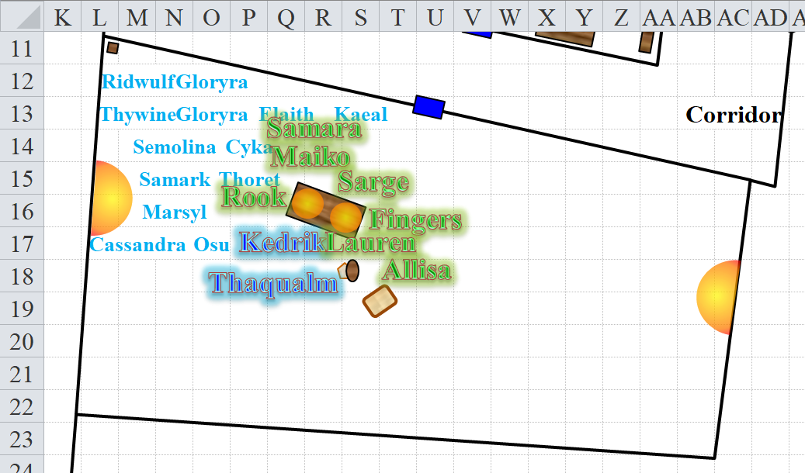

As they all convened, the senior members of the Gambit gathered around the table and the rest coalesced peripherally around their esteemed colleagues. Fingers produced the map they’d been using and updating while on their venture, and placed it on the western part of the table.

Kedrik unfurled a scroll he’d kept at the center of the table in a dish amongst others, knowing he’d need to cast a few of these during and after this meeting, and cast *message*, informing another agent who, in turn, would dispatch a team with the appropriate skill set to help Mellion and Valania. “Where did you say they were caved in?” the gnome asked.

Fingers pointed at the spot on the map near the northernmost edge of level IV, and Kedrik mentally relayed the message to another man who had a similar map in front of him, though 2 years outdated.

Kedrik asked all of Rook’s followers to go into one of the adjacent rooms (to the north) and wait there, which they promptly did once Rook nodded.

Thaqualm stood quietly, being an innate mind reader, but abstaining from probing Samara’s mind until given the direct order to do so.

“And now, friends,” the gnome began, “I must ask about this mysterious woman that you’ve all brought into our midst.”

Fingers shifted uneasily as its wont was to avoid drawing attention to itself, but as all present seemed familiar with its nature, decided to reply, “We encountered her as we made our way towards Supreme Defiance’s lair. Time being of the essence, there was not an opportunity to inquire as to her history or reason for being there, but the trail of Defiance’s slaughtered minions she had left behind made it clear she was no friend to that abomination. We joined forces to hasten its downfall and she was quite helpful in that endeavor. Whether that was the sole reason for her coming to Waterdeep, I cannot say, as we are only now out of the catacombs where casual conversation had been an invitation for enemies to attack while our attention was diverted.”

“Well, then, milady,” Kedrik patiently rubbed the white hairs on his chin, “Tell us about yourself.”

Samara wondered what kind of a military organization the Gambit belonged to, given that apparently fraternization with subordinates was not raising anyone’s eyebrows. Was there no discipline in the ranks? Or was the city corrupt, and Rook too powerful to be brooked? Not reassured as to the level of trust she could have in the white-bearded gnome, she only told him what everyone but him knew anyway. “I not you lady, I am faithful of Macaria, Samara nas Jaddah nas Nuraila var Yahg. This is about the self: I probably killed your subordinate Mellion and Valania. I owe the life-debt to Fingers. I fight by him until life is saved, or 10 years.”

Lauren shook her head. “Samara, you did not kill Mellion and Valania. First, we do not know that they are actually dead, and second, the cave-in was not intentional.”

Samara might later have the opportunity to hear of how Rook had been seduced by a succubus in the last year, and though he was a pious cleric of Red Knight, he *did* indulge his carnal-most desires with some of his co-eds, both before and after his episode with the succubus.

“Now then,” Kedrik continued after Samara had clarified her role in all of this, “there have been some developments in the hours since we last saw each other. Another operative team was dispatched in conjunction with our unit this evening. They were able to find Grim Gerome—though not the rest of the Rumors—and a summary of his surface thoughts was brought to my attention shortly before you arrived.”

Thaqualm produced a scroll, which she unfurled and handed to the archivist.

Kedrik summarized the report: “I’ll spare you the details, but I regret that it is not Whisper that we should have been worried about, but Gerome.”

“Oh?” Rook asked for more.

“Being the only one of the Rumors to not register as evil, it seems that the halfling shade archivist has been plotting to destroy the City of Splendors, or at the very least cause the death of every one of its citizens.”

“My word!” Maiko exclaimed, not being a citizen herself, but an established resident.

“Yes, we have documented several of his original poems, which he kept reciting to himself, in which he seeks to destroy us all. In one verse, he wants us all culled and thrown into a stew.”

“That’s a big stew,” Sarge had to point out.

“He’s also plotted mass beheadings, mass crucifixions, and other highly inefficient but expressive ways of getting rid of us all.”

Lauren inquired, “Do we have any inkling as to his motives? What would trigger such animosity towards an entire city-state?”

“We’re looking into that; it wasn’t part of his surface thoughts during the Divination,” Kedrik answered, looking to the mind flayer.

Thaqualm nodded, expanding on this topic, as she had been the lead investigator on this, “We have reason to believe that Grim Gerome resided here during the Time of Troubles, but under a different moniker. Few records from that time survived, given the destruction that was wrought upon the Castle Ward during the late 1350s, where the archives were kept, so we are trying to find corroborating evidence that would remove any doubt as to his previous identity. We believe him to be the same person as the halfling known as Belee Inzunđat.”

No one in the room had ever heard of that name, nor should they have. This halfling had lived a relatively quiet life in Waterdeep just a few decades ago, but had disappeared from the public record after 1362. They were now being told so by Kedrik, who also mentioned that it was likely that Gerome was successfully hiding these inclinations from his allies, even from his own sister, Myrtle Eyes.

The party stood around the table, nodding as they took in the information. A few maps, charts, lists, and notes were now being made available to everyone as Kedrik continued. “And this is not all. Did you by any chance run into any documentation intended for or written by someone by the name of ‘Best’?”

*REFERENCING CHAPTER 47…*

Maiko—who spoke Draconic—recalled while in the midst of the Rumors that one of the whitespawn hordelings had cried out in its innate language, “Mothhhherrrr!!! Besssssstttt!!! Mothhherrrr!” over and over before finally collapsing and dying.

“Not documentation,” the bard announced, adding what she’d understood coming from the monster’s mouth.

Kedrik and Thaqualm nodded to one another, then looked at Samara, who had been under the scrutiny of everyone else present while she provided everyone with a narrative befitting the motives for her presence in the Dungeon of the Crypt this evening. “No doubt you’ve been told of Destiny’s Gambit, if not before tonight, at least by the Gambit’s members themselves.”

Samara nodded behind her mask.

“Rest assured, and I can vouch for everyone present, that we are a formidable force, even if confronted individually,” Kedrik warned her. “Betray our trust, and you will learn this firsthand.” Then he made eye contact with everyone, scanning the room from right to left, and finally turning back to the masked woman. “With the unanimous approval of every member of Destiny’s Gambit, I am prepared to deputize you as an honorary member, with provisos for later induction as a member of the organization.”

Kedrik refrained from mentioning any other allegiances common to the Gambit’s members, and instead said, “We are all highly trained heroes in the service of a greater good,” he began.

“Multiple greater goods,” Rook argued.

“At least one greater good, if not more,” the archivist tried to fuse his and the cleric’s views on this. “While we have no reason to doubt the authenticity of your identity, I am obliged to ask you to remove your mask. We have many foes, and we need to verify that you are not one of them.”

Samara realized that in the presence of a mind flayer paladin, she could hide little at this point. She was now in the midst of an investigative team of wily sleuths, and knew that she could not dwell in anonymity forever if she was to operate among them.

While there were multitudes of tests that could ascertain if she were one of Kedrik’s foes without the need for her to unmask herself, Samara grudgingly realized she would have to trust him at some point, at least a little. Besides, it would be an awkward 10 years fighting with Fingers if she never once removed her mask. And it was not as if she were forbidden to reveal herself, only that it was preferable to let the Voices do the talking. “I am not the enemy of you,” she said, reaching into the folds of her headcloth to release the buckles of the mask. “But if this one here—” she indicated the mind flayer with her free hand, “—or anyone, tries to rape the mind, I will kill them.”

With this matter-of-fact information dispensed, she took off the mask. Her face could pass for human, especially if she had used her considerable talent to prepare it beforehand, with her headcloth still draped tightly around her face. She suspected Kedrik meant to make sure of who she was, rather than who she was not, however, and began to unwind the headcloth as well. “I am not the one supposed to be this role. I am not good at the diplomacy and talking. I am supposed to be alone, to do the will of Macaria; I am the Hand of the Viongozi, not the Voice. Hopefully, one of them visited this city before me.”

“That is some peculiar vocabulistics,” Sarge whispered to Maiko with his hand to her ear.

The bard thought to sing a song at the moment, or maybe even do some interpretive dance, but remained at the ready.

As the last of the cloth came free in her hand, she shook out her snakes, standing before them with gilded skin and metallic golden scales. She really did hope one of the Voices had been here first, since otherwise the Chosen were only famous for killing everyone who entered their land, even accidentally. Before the Schism, the Law of Macaria dictated it should be so; only recently had Macaria changed her isolationist doctrine and guided her faithful in contacting the outside world. The Voices were meant to smooth the way, changing public—or at least official—opinion so that the Chosen would not be regarded as purely evil monsters, but she did not know if one had been to Waterdeep. Or if one had, but had been killed. It was a dangerous occupation, being a Voice.

“Gods!” Lauren forced herself to not move back by main force of will.

Rook remained silent, though his business hand remained close to the mercy of his Hizagkuur blade, should it be needed.

Allisa averted her eyes as the snakes unfurled. She knew the stories of what a medusa gave could do.

Maiko marveled at the golden skin and snakes. Her eyes glistened with desire. As Sarge stepped in front of her she tried to step around so she could see this creature.

Fingers’ reaction was one more of curiosity than alarm. Being relatively isolated in its clan before wandering, it was unfamiliar with the reputed danger her form possessed. It studied her a bit more carefully, wondering whether its shape-shifting ability was up to the challenge of attaining such a complex form.

Sarge, on the other hand, recognized the apparent form instantly due to his long military training. Stepping in front of Maiko protectively, he managed to suppress the instinctive urge to blast the form with the most powerful attack he had remaining to him. After all, the Gambit was now working with a friendly mind flayer... was a benign medusa that much less a possibility? Nevertheless, he made a mental note to avoid meeting her gaze until she’d proven herself further than just a few hours’ acquaintance.

Verily, this week had reinforced the lesson to not judge books by their cover: Whisper—though evil and erratic—had proven his worth as an ally; the only neutral lackey at his heel—on the other hand—was a depraved, genocidal maniac who apparently had some regret in his will to relieve the good City of Splendors of its citizenry; an illithid could become a five-star paladin; and now, before them, stood a medusa who could transcend her notoriously wicked predispositions, if such they were.

Thaqualm had taken a vow that prevented her from using her psionic abilities to probe the mind of someone not in direct martial conflict with her, so she turned to her immediate superior.

Kedrik pursed his lips as he rubbed his bearded chin. He wanted to react in a manner appropriate to his formal title, but in the end, he just decided to shrug, and cast *detect evil*. As he prepared the scroll, unrolling it, he verified, “I hope you don’t mind me casting *detect evil*,” the polite archivist said, not really giving her much of a choice.

The spell was cast, and Kedrik immediately let his guard down upon realizing that there was no taint of evil in this room. Six seconds later, he looked straight at Samara, seeing nothing alarming, then turned to Thaqualm and the others, and nodded, “Alright then, I hereby invoke the holy power of Oghma, the municipal authority of the City Watch, and the affiliate will of Destiny’s Gambit, and hereby induct you into this blessed order. May your deeds honor the Gambit.”

“Welcome,” Lauren said with a nod.

“Yes, welcome,” Rook said as he relaxed his vigil somewhat.

“Hear, hear!” Sarge proudly cheered for the new inductee.

The mind flayer and gnome had saved the best for last, quite literally. “And now we move to the last item: Best,” Kedrik looked to Thaqualm with some hesitation, but having just deputized Samara, he continued. “I will share what we know. Bestlaranathion is a capricious white dragon who has wreaked havoc across the Spine of the World, and has subsequently become more powerful. Though as cunning as a red dragon, she is as savage as any wild animal.”

Maiko had studied white dragons in her time, and knew them to be the dumbest of all true dragons. She asked, “How did she become as cunning as a red dragon? That’s unheard of,” she had to point out.

Thaqualm nodded, “We believe she has an item that grants her the intelligence of one normally beyond her species.”

Kedrik added, “She now speaks minimal Common, often polymorphs into humanoid forms, and has come to think of herself as something of a diplomat with neighboring polities and tribes. Unfortunately, her efforts at diplomacy are usually limited to stark threats, and even when she is able to browbeat an unfortunate creature into some kind of agreement, Best seldom contains her baser instincts for very long and she usually winds up attacking her reluctant allies.”

“What’s this got to do with us?” Lauren asked, and most wondered.

Maiko suspected what Kedrik said next. “I’m afraid it’s Best who is behind Supreme Defiance’s return to Waterdeep. She sent him to weaken the city from within, and has done similar things all the way along the Sword Coast, including in Luskan and Neverwinter.”

“Our fair sister cities to the north,” sighed Sarge.

“I have a feeling there’s more,” Allisa cringed.

“Not much more, but I think you’re all beginning to anticipate a trip northward to this dragon’s lair,” Kedrik replied.

Sarge puffed up his chest with a big inhalation, and said, “Bring the fight to her, is it?”

Kedrik nodded, and said, “We expect an additional briefing report shortly before Dawn, after which we’ll equip appropriately, and set out on the magic carpet in Lauren’s bag.”

“We?” Fingers asked, raising an eyebrow.

“I’m coming with. This is a senior staff mission,” Kedrik explained. “Core crew only: Allisa, Fingers, Lauren, and myself, and Samara, if your moral proclivities are bent on destroying whatever evil enabled Supreme Defiance, we’ll be glad to have you aboard.

“What about us?” Maiko asked, motioning to Sarge.

“You, Sarge, Rook, and his lot are needed here to see to another matter,” Kedrik advised the junior staff members.

Rook looked surprised, but also intrigued. As much as he wanted to go with his liege, this was an opportunity to work with his followers.

Once the students were gone, Thaqualm shifted in her stance as Kedrik cleared his throat, “I urge you all to get some rest. A half-dozen guards will be posted to keep watch until Dawn. We have folks guarding Mellion’s residence as well. Let’s reconvene downstairs in the kitchen over breakfast at sunrise. I should have more information by then. If you have any equipment requisitions, I can try to have them overnighted.”

~*~

Late Evening

Fingers accompanied Maiko and Sarge back to their hideaway to check the area for any nasty surprises, minions of the late unlamented taint elemental might’ve left. Once given the all-clear, it took its leave and the pair entered their home, eager to wash off the stink of the catacombs.

While starting out as mere cleanup, their shared bath soon turned into a sudsy romp which ended as Maiko fled the tub in mock terror from Sarge’s erect shaft which was aglow from his casting Light playfully on it. With no houseguests to worry about, the nude bard ran thru the manse chased by the equally naked warmage, their way lit by the decidedly unusual torch.

Winding up in their bedroom, Sarge tackled his lover and they fell together onto the bed. Her shrieks of mock fear soon changed into deep moans as the duo made love intensely, the release of tension from the day’s battles leading to releases of another sort entirely. Passers-by were intrigued by the light pulsing on and off from the bedroom window, but none could have dreamed just how that particular torch was being repeatedly displayed and hidden as the night passed by.

~*~

Night’s Heart, 20 Deepwinter 1376

When the day was done, Lauren went to her room to undress. She stripped off her armor and her sweaty clothing. “I am glad to be back home,” she said to Allisa.

“And me,” the half-elf replied as she, too, undressed and set her clothing aside to be cleaned later. “I want a bath before bed.”

“You and me both.” Lauren led the way to the bathing room, and soon had the tub filled with warm water. “You first,” she said to her wife with a smile. After the bath, which involved (mostly) cleaning the day’s grime off, the pair went back to their bedroom and went to bed.

Sometime during the night, Allisa was awakened by the sound of quiet weeping. She rolled over to face Lauren, who was curled up like a child. “My love?”

“I’m okay.”

“I don’t think that’s entirely true.” She reached out to caress Lauren’s arm.

“I’m tired of the fighting and the dying.” Her voice was ragged with emotion. “I want to be just us.”

Allisa sighed, her heart going out to her wife. “Maybe we can talk to Kedrik after we find this dragon.”

Lauren looked at her. “You want to go out again?”

“I think we have to help our friends, at least this time.”

Lauren scooted closer and embraced Allisa. “Just so you know. If I am resurrected again, the only reason I will come back is to be with you.”

“Thank you. I love you.” She held Lauren until they both drifted off to sleep.

~*~

Samara had spent the night kipping in one of the student dorm beds, lacking her own assigned place in the Gambit’s large house. She rose with the dawn, performed her morning ablutions in the form of a refreshing sand scrub which buffed her scales to a high sheen, and then left the room with her head uncovered.

Searching for food that wasn’t her own military trail rations, she found the kitchen and ventured to try the weird meat-free food Sarge and Maiko had prepared. She was standing by the open window of the kitchen, her snakes snapping flies that came through out of the air, when Kedrik came in. Immediately, she came to attention, but did not salute him, and said, “Sir. Is there any of the news about Mellion and Valania?”

~*~

Dawn

Mellion’s home was uncharacteristically noisy, as members of the City Watch shifted about uncomfortably. They didn’t really feel comfortable in a wizard’s home, not even one who was ‘benevolent’. They’d had to get two different wizards before someone could dispel the wards on the front door and pronounce the place safe to wait in. And wait for what? Some elf to come home? Still, as assignments went it wasn’t the worst, even if it were a little boring. One guard sat at the top of the stairs, reading a rather salacious book about the exploits of a half elven bard. The others were in the bottom two rooms, playing dice and chatting.

Then, abruptly, they weren’t alone.

A pair of bedraggled elves appeared in the center of the dice game. They were clad in their adventuring gear, which was covered in dust and blood. Mellion, the taller of the two, was holding the top half of a broken staff, and while he had no visible wounds, blood had dried in his hair and down the side of his face. Valania’s trousers were torn at the thigh, and there was a lot of dried blood down that leg. Frankly, they didn’t look... great, but both roused from a hunched position, looking around the assembled watchmen.

“I must admit, this is twice unwanted guests have entered my home without leave. It’s getting bothersome,” Mellion commented dryly.

“Oh hush,” Valania chided him as she looked at the men, “Are we under arrest, or were you just keeping an eye on things?”

“We was ordered to keep watch until you came home or until we was relieved, ma’am.” The Watchman swallowed and nodded to Mellion, “Sir.”

“You’re relieved. Report to whomever sent you.” Mellion waved a hand, not in the mood to suffer guests, much less guests with appalling grammar. “And warn them that having people break into a wizard’s abode, even if there is no mischief intended, is hazardous to mind, body, and soul.”

“He’s something of an asshole isn’t he?” one of the men murmured to another as they were leaving.

“He’s also an elf, moron. At least wait until you’re outside before you insult him.”

“Fair point.”

Mellion paid the Watch no more mind. Yes, he’d been short with them, but it had been a difficult evening and he was still somewhat enervated. Not to mention, they were in his house. It’d take weeks to air out the meat and cheese smell of their bodies. Ugh.

“When do you want to talk to Kedrik and the Gambit?” Valania asked.

Mellion rubbed his face, “After a bath, at the earliest. But go ahead and send him the message we discussed, if you would. I’ll prepare the bath.”

“Of course.” Valania kissed Mellion’s cheek then sat down on a nearby bench and began to pray with her holy symbol. The message Kedrik would receive after 10 minutes, assuming he hadn’t popped off to another plane of existence was: “Mellion and Valania survived and teleported out this morning. Mellion wishes to change his role in the Gambit to a more advisory position. Warm regards.”

The ‘warm regards’ was a pleasant touch added by Valania. Mellion wouldn’t have wasted the words on such flippery.

~*~

Late Dawn

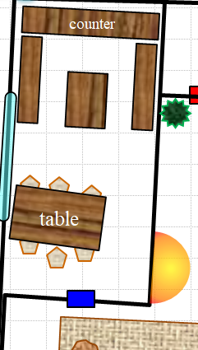

Allisa, Fingers, Lauren, and Samara were in the kitchen enjoying the fruit-and-rice breakfast that Sarge and Maiko had just prepared. The junior staff had been summoned to the City Watch, and would soon board a wagon that had been hailed to wait for them on the corner of Shipshape Way and Grohl Alley.

Allisa kissed Lauren as she sat down to enjoy the fruit that was prepared. She winked at Maiko as the black haired dancer moved gracefully around the kitchen. She smiled at Samara.

Kedrik walked in, ready for breakfast. He had just put his weapons and gear down by the front door, where a guard had greeted him, and as he entered the kitchen, the smell of breakfast woke him up completely.

Lauren was grooming Rook to take care of things while in her absence with some last-minute instructions, and she looked around as Kedrik came in. “Good morning. Have some breakfast.”

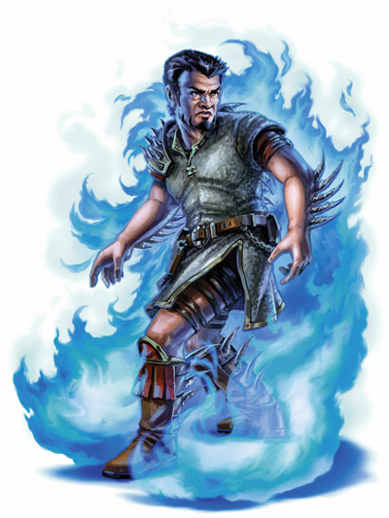

“Don’t mind if I do,” Kedrik replied. He’d braided his goatee since their briefing last night, as well as the locks on the sides and back of his head, leaving the top in a single ponytail angled back about 60 degrees like Maiko had taught him. The whisper gnome from Damara went with a sliced pear for now as he took his place upon the miniature stool that elevated his chest to a proper level so he could eat.

In the time that he’d taken a sabbatical from adventuring with the others in the Gambit, he’d grown quite a bit wiser as to magic, dungeons, dragons, aberrations, giants, and so many other things…. He had brought some materials with him, and laid these out on his portion of the table, putting the plate with the pear half atop the corner of a map.

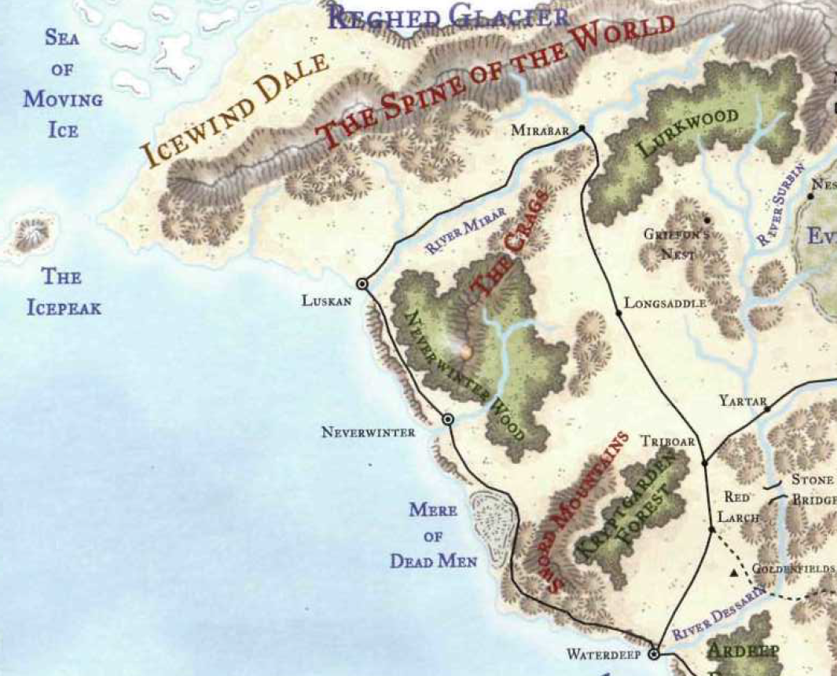

“So we need to decide on a path, at least an immediate one out of Waterdeep. Do we want to skirt the coastline, follow an established trade route, see the Crags from up above…?” his voice trailed off as he considered his own preferences for the moment, but then dismissed then, as they were not tactically an improvement upon any other route.

“The Crags!” said the druid as she turned her head toward Kedrik. This morning her crimson hair had been all arranged and piled in a bun on top of her head. “I have never been there or much anyplace else. I like that idea.”

“Where do we expect the dragon to be?” asked Sarge.

“Our last report does not confirm a sighting, but there are implications that Best is in this mountain range,” he pointed to the mounds just west of Mirabar. “These hills and mountains overlook the much more daunting Spine of the World, a treacherous and inhospitable behemoth of a mountain that separates our green world from an eternally frozen land.”

“So our plan is to find the dragon and slay it?” Maiko asked. “Seems straightforward enough.”

“It will likely involve some investigative work,” Kedrik regretted. “Best has been on the offensive for several tendays, and in that time, she and her forces have razed several villages and towns in the countryside. The city of Luskan was weakened from within by villains on the level of Supreme Defiance—I’ll share the roster of culprits with you later—and has now fallen to the dragon’s sway, but word has it that Best has since returned north with caches of looted treasure from that coastal city, and is storing her booty in an ice castle that she liberated from a lesser villain.”

“Sounds like a charmer,” Rook piped up before asking, “How long do you think this mission will take? This might be what Best wants: for us to leave the City of Splendors undefended, and slay us all on her home court while the agents of evil proliferate here.”

Kedrik nodded, “I shared in your concern until moments ago when I received my last briefing by *message* spell. The lair of Supreme Defiance was cleared out by another crew around the time that we all woke up. There were a few undead that you’d apparently missed, but other than that, it was just a confiscation-recovery-divination type of job. We got plenty of scrolls with Necromancy written all over them, but more importantly, we uncovered some correspondence between Supreme Defiance and Best. It’s not so much incriminating evidence—we have enough of that already—but it pinpoints some of the locations that Best has visited lately, and we’re basically looking at a trajectory going up to these mountains here,” he pointed at the same mounds as before. “Oh, and as for the city being unguarded, we’ve still got the Supermuscled and the Revengers in town, so Waterdeep *will* prevail,” he winked.

“Now, by the time we get there,” Lauren turned back to the topic of their destination, and patted the haversack that contained one of the carpets they were going to take there, “it’s possible that the dragon would already have migrated to some other settlement and wreaked havoc there.”

Kedrik smiled at the challenge before them. “Yes, this is a moving target, and while we have the location of the ice castle, which is nestled along the southern face of the Spine of the World, I’d hate to commit us to going there only to find it to be a decoy or a trap.”

“So Best…” Sarge smirked at Kedrik. “What else do we know about her?”

“We should ask Maiko, who knows dragons better than the rest of us,” Kedrik replied. “What I can tell you is that a white dragon with such a keen intelligence is likely to bring the worst of dragonkind to the conflict: cruel delight in seeing life suffer combined with the ability to delay gratification so as to achieve a greater goal. She has agents in Neverwinter attempting another Luskan, just as she planted Supreme Defiance and Grim Gerome here. Her hope is to wait until the right moment, then swoop down upon Neverwinter. Fortunately, Neverwinter’s forces are at this very moment flushing out the culprits from their safehouses and hidey holes.”

“So just to confirm,” Allisa interjected, “Whisper is not part of this?”

“So far as we can tell,” Kedrik added detail to what he’d said last night, “Whisper and the Rumors were working directly under Supreme Defiance—just as they’d alleged—until a few tendays ago when they had a falling out. Pretty much everything Whisper said checks out, but with the discovery of Grim Gerome being an operative of Best embedded within Whisper’s cell, it casts a much brighter light on the role these shades played in the dragon’s plot.”

“Why us?” asked Fingers.

“Frankly, we’re spread too thin,” Kedrik could only say so much at the moment. “Operation: Waterdepths has taxed the Watch and Guard of most of its spellcasters, and our skillset and level of expertise are ideally suited to the task.”

“I remember when we were just dungeon delvers exterminating kobolds and myconids in the Catacombs of Yintros,” Allisa reminisced.

“Yes, well, let’s think of Best as a really big, white kobold, and wherever we confront her, let’s pretend it’s a dungeon,” Kedrik’s gnomish humor was less than appreciated by the others. “We’ll also be joined by two other agents: Flint and Tali. Flint is a consummate factotum, an occupational chameleon, and jack of all trades. Tali, his companion, is a Shooting Star ranger and a Deepwood sniper. They should be by any moment now with a second carpet for us. We should share our spell preparation before taking off.”

“I think we should fly directly to our destination,” Lauren said.

“A charlatan and a ranger as our replacements. I’m not certain if I should take offense at that or not.” Mellion came walking into the room with Valania a step behind him.

Allisa stood at Mellion’s and Valania’s voice and moved to intercept them hugging Valania and welcoming the wizard back giving him the elfish hand signal for greetings. She then returned to her sit.

Maiko smiled at the two as she offered them some of the food and drink. Her short skirt bounced slightly with every step. She moved to Samara’s side, smiling. “How come your gaze did not turn us to stone?” she asked in a whispered voice that anyone next to her could hear. The bard’s eyes took in the every aspect of the lady as she waited for a reply.

“Why I would do that? Not enemies,” Samara answered. It took her a moment longer to realize that Maiko might be laboring under some popular misconceptions of the Chosen--there was a reason she was not a Voice. People were hard. Especially in a 5th language. She added, “Oh, yes! That idea where Chosen so ugly can turn to stone by looking at! No, that is not true, only the human story. Only me is ugly. I made this way by blessing of Macaria, so that will be easier for interact with outsiders. It is my great honor to be changed like this. Do not worry. Rest of chosen very beautiful.. Will not turn to stone. Well, not anymore.”

“Mellion, my dear, if you didn’t take offense to the watchman calling you an asshole, I think you can live with the Gambit’s personnel decisions.” Valania answered. Neither of them looked the worse for wear, although both were wearing more civilian attire.

“So glad you’re both well,” Kedrik said in a hushed tone as he handed Valania and Mellion the plate of sliced pears to go with the strudel morsels Maiko had just given them.

Mellion was in a set of fine wizard robes with a blue and silver color scheme, and Valania clad in the vestments of Mystra, which honestly weren’t that different from the wizard’s robes in design and style. She poked Mellion with her finger.

“I know, I know.” The male elf groused at the poke before turning back to the assembled breakfast attendees. “As Kedrik has no doubt already informed you, I have decided to retire from adventuring. Frankly, when I weigh the good I can do as an instructor over the course of centuries versus the good I can do as an adventurer with a likely much briefer life expectancy, I cannot continue to justify the risk. I am simply more of an academic than a...” he waved a hand, searching for a word, “Hero, for the lack of a better word. I apologize if this seems like cowardice. I will remain available as a consultant, and should I see a clear and present danger, I will act in the defense of innocents. I simply cannot continue to go looking for danger to insert myself into.”

“And, lest anyone feel otherwise, this decision was not prompted by any actions other than my own and those enemies who’ve tried to kill me since I joined to help with my deranged former student.”

“Sylar...” one of them uttered the name and shook his head.

“M-m-m...” another cringed at the calculated evil behind that sorcerer.

Mellion continued, “I had only joined your band with reluctance because I felt I still had a debt to pay for his actions. Now, I believe that debt is settled.” His luminescent eyes scanned across the room, “You are all a strange breed. I do not understand why you live the way you do, but I know the world is better for your heroism. You are among the finest people I have ever had the pleasure of knowing, and I do wish you all the best in your future endeavors, and you will be mourned when you are inevitably killed.” He grunted as Valania elbowed him. Wincing, he rubbed his ribs and amended, “Mourned when you reach the end of your regrettably short life spans.” He flinched away from her narrowing of eyes.

“What Mellion is trying to say, is we value you all and are sorry if our leaving causes you any difficulty.” Valania said with a smile.

“I think he has the right of it, all the same,” Lauren said as she stood. “I am glad to see that you two made it out of there.” She hugged Valania briefly, and nodded to Mellion.

*OOC: Here are Kedrik’s prepared prayers (archivist spells) for the day:*

|  |  |  |  |  |
| --- | --- | --- | --- | --- |
| **Prayer** | **Level** | **Electric** | **DC** | **Cast?** |
| Amanuensis | 0 | 0 | 17 | ❑ |
| Detect Magic | 0 | 0 | 17 | ❑ |
| Guidance | 0 | 0 | 17 | ❑ |
| Read Magic | 0 | 0 | 17 | ❑ |
| Bless | 1 | 0 | 18 | ❑ |
| Cure Light Wounds | 1 | 0 | 18 | ❑ |
| Detect Chaos | 1 | 0 | 18 | ❑ |
| Detect Evil | 1 | 0 | 18 | ❑ |
| Detect Law | 1 | 0 | 18 | ❑ |
| Nightshield | 1 | 0 | 18 | ❑ |
| Sanctuary | 1 | 0 | 18 | ❑ |
| Shield of Faith | 1 | 0 | 18 | ❑ |
| Cure Moderate Wounds | 2 | 0 | 19 | ❑ |
| Hold Person | 2 | 0 | 19 | ❑ |
| Hold Person | 2 | 0 | 19 | ❑ |
| Identify | 2 | 0 | 19 | ❑ |
| Restoration, Lesser | 2 | 0 | 19 | ❑ |
| Restoration, Lesser | 2 | 0 | 19 | ❑ |
| Silence | 2 | 0 | 19 | ❑ |
| Call Lightning | 3 | 1 | 21 | ❑ |
| Dispel Magic | 3 | 0 | 20 | ❑ |
| Dispel Magic | 3 | 0 | 20 | ❑ |
| Dispel Magic | 3 | 0 | 20 | ❑ |
| Dispel Magic | 3 | 0 | 20 | ❑ |
| Footsteps of the Divine | 3 | 0 | 20 | ❑ |
| Heart’s Ease | 3 | 0 | 20 | ❑ |
| Break Enchantment | 4 | 0 | 21 | ❑ |
| Break Enchantment | 4 | 0 | 21 | ❑ |
| Death Ward | 4 | 0 | 21 | ❑ |
| Diamond Spray | 4 | 0 | 21 | ❑ |
| Divination | 4 | 0 | 21 | ❑ |
| Freedom of Movement | 4 | 0 | 21 | ❑ |
| Bear’s Heart | 5 | 0 | 22 | ❑ |
| Chaav’s Laugh | 5 | 0 | 22 | ❑ |
| Chaav’s Laugh | 5 | 0 | 22 | ❑ |
| Dispel Evil | 5 | 0 | 22 | ❑ |
| Flame Strike | 5 | 0 | 22 | ❑ |
| Chasing Perfection | 6 | 0 | 23 | ❑ |
| Dispel Magic, Greater | 6 | 0 | 23 | ❑ |
| Planar Ally | 6 | 0 | 23 | ❑ |
| Touch of Adamantine | 6 | 0 | 23 | ❑ |
| Dictum | 7 | 0 | 24 | ❑ |
| Holy Word | 7 | 0 | 24 | ❑ |
| Scry Location | 7 | 0 | 24 | ❑ |

*Since this trip will take a few days, please feel free to suggest changes to his prepared spells for “tomorrow” or thereafter.*

*In case it’s useful to know this, here are some other attributes pertaining to Kedrik:*

|  |  |  |
| --- | --- | --- |
| *Feats* |  | *Languages* |
| 1st: Academic Priest |  | Common, Gnomish, |
| 3rd: Archivist of Nature |  | Elven, Dwarven, Draconic |
| 6th: Draconic Archivist |  | Speak with Burrowing Animals 1/day |
| 9th: Trivial Knowledge |  |  |
| 12th: Weapon Focus: Ranged Spell |  | *Racial Abilities* |
|  |  | Low-light Vision |
| *Archivist Features* |  | Darkvision 60’ |
| Dark Knowledge 7/day |  | +1 vs. kobolds & goblinoids |
| Dark Knowledge (puissance) |  | +4 dodge vs. Giant type |
| Dark Knowledge (tactics) |  |  |
| Dark Knowledge (foe) |  | *Weapon Proficiencies* |
| 2nd: Lore Mastery: Arcana |  | Simple Weapons |
| Decipher Script |  | Light and Medium Armor |
| 7th: Lore Mastery: Nobility & Royalty |  |  |
| 13th: Lore Mastery: Dungeoneering |  |  |
| Scribe Scroll |  |  |
| Still Mind |  |  |
| 10th [Bonus Feat]: Consecrate Spell |  |  |
| 11th: Dark Knowlede: Dread Secret |  |  |

*He’ll be leaving his hound at home. Allisa will not be able to bring Ben along.*

Samara had spent Mellion’s entire monologue suppressing unseemly tears of relief. After Lauren spoke, Samara said awkwardly, her voice a little choked, “Yes. This I agree. Um. Glad to see out.” At this point, she remembered she did not have her mask on, and the snakes which had until then been writhing slowly around her head snapped down to lie head-down along her shoulders and back, looking rather remarkably like scaled dreadlocks. She added even more awkwardly, “Oh. Uh. Yes. Also, I not human, am Chosen. Very sorry almost killed you.”

Kedrik looked at Mellion, tilting his head towards Samara and raising his eyebrows as if to repeat, “Chosen.”

“I will admit I was a bit taken aback that a medusa, or medusa variant was having breakfast with everyone else, but as no one was stone and I didn’t petrify, I simply accepted it as just one more charming bit of oddness one sees in Waterdeep.” Mellion favored Samara with a bit of a smile, then his face became more stern, “As far as almost killing us... don’t be daft. Your spell couldn’t have caused that cave in. It simply doesn’t work that way. Even one of Valania’s Greater Stone Shapes wouldn’t have caused that sort of damage. My personal suspicion is that the cave in was caused by some sort of entity, perhaps a greater earth elemental whose rest was disturbed by the nonsense happening within his purview. Or perhaps something even stranger. I doubt it was a trap, as Fingers would have found it.”

“It would be nice if you could glean us some wizards or sorcerers that would join Gambit as you teach at the school,” Allisa said.

“I will, of course, keep an eye out for Arcanists with a reckless disposition and explosive talents. Probably sorcerers.” He rubbed his chin thoughtfully.

“Mellion...” Valania warned ominously.

“What? Sorcerers are useful for blowing things up. Perhaps not much else, but for violence, they tend to excel.” Mellion might have been trying to hide a bit of a smile. Valania just rolled her eyes.

“Hey, that’s MY job!” Sarge growled in mock anger, a grin indicating the jest.

A thought popped into the druid’s head. “Hey, we are going to need winter clothing for this are we not?”

Fingers smiled as it subconsciously fingered the Enduring Amulet at its throat. “Well, some of you anyway,” it thought to itself.

“Yes, I believe we will,” Lauren said.

~*~

“Why are *you* flying the carpet?” the female archer asked as she knelt, wind fluttering her cloak as the magical rug zipped through the sky.

“Because I’m the one who understands magic,” the handsome, well dressed human proclaimed broadly as he stood at the front of the carpet, his shoulder length dirty blonde flowing. He had set a box on the front edge of the carpet, so he could pose with one foot up on the box, standing as one would on the bow of a ship, hand shielding his eyes from the morning sun.

“Magic, yes, directions no. You cannot navigate to save your life,” Tali observed archly.

“Nonsense. The sun rises in the east and sets in the west.” He answered with perhaps a tad of smugness.

“And which way is north?”

“Simple. Moss grows on the north side of a tree.”

“Not always true, but let’s assume you are correct. Point north.”

Flint had a 50% chance to be correct, and confidently pointed north.

“Nope. Try again,” Tali lied.

Flint answered, “I haven’t tried yet, I was merely signaling to other flyers that we were turning south. Do pay attention Tali.”

“Flint, while I adore watching you make a fool of yourself, you flew past our destination 2 minutes ago. It’s back there.” She pointed.

“Ahh... yes. Well, you may have a point.” He banked the carpet about and began flying down toward the house. “Although if you’re wrong about the house, I’ll tease you mercilessly.”

“When have I ever been wrong about where to find a target?” she asked, and Flint didn’t have an answer for her. Perhaps he was busy flying.

~*~

Valania also approached, “Also, Mellion and I could have left, Samara. You didn’t send us into that collapse. We went ourselves because it was simply where we needed to be. Don’t carry guilt for something that might have happened. Neither of us blamed you, and believe me, as we spent 8 hours nearly crushed in a small pocket wondering if we had enough air to prepare new spells, we had ample time to think on why we were in that situation.”

Having very grudgingly accepted her guilt in the matter yesterday, fighting hard to combat the natural instinct to shift blame elsewhere, Samara was rendered speechless by the generosity of Mellion’s absolution. She had thought at the time that there was no possible way that drilling a hole through a component that was not load-bearing could have caused such a collapse; it was only with the utmost self-will that she had convinced herself she had been responsible, given the evidence available. Spell, then collapse. It had been her fault, though it flew in the face of everything she had learned during communal house-raisings in her birth village. But here was this learned man, one of the ones most affected by the cave-in, telling her it had not been her fault (nor that of her debt-holder, in fact). Presumably, Mellion would know, as his book-learning of the principles of these things was likely to vastly out-strip her own—and as Valania mentioned, they had had 8 hours to think about it. Samara let the guilt fall from her shoulders, and the relief was so great, she could say nothing at all.

Mellion focused his glowing eyes on Samara, “Before I leave you all to your preparations, there is a matter I need to address.” He drew forth a certain magic item from within his robes that was designed to siphon power from a goddess. “I haven’t had enough time to study this to be certain how to destroy it safely. I suspect I can disintegrate it, but I’m not completely certain. I would like to hold this and study it in detail in order to understand it’s enchantments and how to unweave them safely. However, this is your responsibility. If you are uncomfortable with my study of it, I will not demand such a thing.” He offered the rod to the ‘Chosen’.

Samara had not been sure how to bring up the matter of the rod, and was relieved that Mellion brought it up himself, though she might have wished he hadn’t done so right in front of his government superior. She met his glowing gaze firmly. “I will trust you to hold this, with two conditions. If you lose it, you swear to join me hunting it down, unless you lost it by death. And also, if has corrupting influence not foreseen, and you become corrupted by this, you understand that all of the Chosen, all twenty-six clans and the Overclan, will come for you. It is not personal, it is just careful when dealing with the things like this.”

Arching an eyebrow in what could have been amusement, Mellion shrugged a bit and inclined his head, “Let’s hope that I am not corrupted then. I agree to your terms. We’ll reconvene when you return from your journey, unless you die. In which case I will either destroy the device myself, or turn it over to your church, depending on the circumstance.” He secreted the rod away. “And with my business addressed, I will leave you all to yours. May your fortunes be favorable.” After a bow to the assembled group, Mellion and Valania took their leave.

Samara raised her fist to her heart in farewell to Mellion and Valania. It was so refreshing to deal with people who did not shy away from discussing practicalities like death. She would miss them.

Shortly after Mellion and Valania left, a new pair of conspicuously competent adventurers walked into the room. The taller of the two, a human male with shoulder length blonde hair wearing Cleric vestments of ivory and gold, although without an openly displayed holy symbol, spied Kedrik and smiled broadly, “Hey, hey, hey... Kedrik! Nice to see you again. It’s been what...” He looked back toward his partner.

The female with him was about half a head shorter, with a black pixie cut, grey leather armor, a quiver on her back, and a large recurve bow. She sighed and answered, “Six months, Flint. We’ve been away from Waterdeep for six months.”

“Ahh, right, yes. Six months. Thank you, Tali.” He returned his gaze to Kedrik, “Anyway, it’s been a while. You look great! Have you been working out?” He looked around the room to everyone else. “Well. Upon reflection, you all look great. Hello, I’m Flint.” He gave a little wave, then gestured back to the archer, “She’s Tali. Don’t mind the scowl. She very rarely bites.”

“Oh, for god’s sake.” The exasperated archer cut in. “Kedrik, please tell me what the job is and why you called us in before I put an arrow in him.”

Lauren laughed softly and gripped Allisa’s hand a bit more tightly. “I would advise both immediate action and brevity, Kedrik.”

Kedrik giggled, his diaphragm causing his belly to heave under the Hammerblock Mithral Chain Shirt +2 that he had donned in the last hour. He sat back down and began to get Flint and Tali up to speed on what they knew so far. By the time everyone in the room was equally knowledgeable in the case, some were nodding at things they’d missed the first time Kedrik had debriefed them. “So I’m going to say we leave at the tolling of the next bell unless some of you need more time prepping. Since no one had any requisitions, we don’t need to wait for the commissary wagon, and I’m only a few minutes away from being ready.”

Rook, Maiko, and Sarge stood up as the cleric of Red Knight said, “Well, we’ll be off to our respective duties then.”

Fingers clapped Sarge on the shoulder in farewell, adding, “Can’t say I don’t wish you were coming along. A *fireball* or two would certainly help in softening up a dragon, I imagine.”

Lauren stepped over to Rook and spoke in a low voice. “If I should not return, know that I valued your service and your friendship.” She held out her hand and grasped his wrist in a warrior’s farewell.

“May the Red Knight and The Protector watch over you, my Lady, and over Lady Allisa,” Rook said as he returned her handshake. Stepping back, he bowed formally to her.

“Go now, my friend, and greet Elaith for me.”

Rook turned and walked out of the room to find Elaith.

The group of seven was now gathered around the table, some fully armored, others mostly ready. Allisa, Fingers, Flint, Kedrik, Lauren, Samara, and Tali. They were choosing their trajectory, with Lauren insisting that the most direct route was the ideal one.

“If we climb high enough, would we not be hard to see from the ground?” Lauren asked.

“True enough and I agree,” Fingers commented, then continued “but with respect to taking the direct path, that presupposes we can maintain a straight line consistently. I admit that sort of thing isn’t my forte. Unless one of you feels up to the task, perhaps we should take a slightly more easterly route where we can view the road and use it to keep from veering off course... at least until we get close enough to see the mountains in the distance.”

“That is reasonable to me,” Lauren said, looking at Allisa. “What do you think, love?”

Maiko hugged her friends and wished them a safe journey. She came to Samara and hugged her as well saying “I hope we can catch some time together when you return. I hope to find out more about your kind. “She then shook the hand of the new couple before leaving with Sarge.

As they walked away from the house, Maiko said to her companion, “You don’t reckon that light trick will have some long term affect and cause the appendage to fall off,” she chuckled.

Giving her pert behind a playful pinch, Sarge grinned and replied, “I shouldn’t think so, but just in case maybe I’ll use Prestidigitation next time. While I’ve never used it in that manner, my old cantrips instructor did mention one of the things it could do is create glowing balls...”

Allisa took a bit of time with Ben before sending him off to the forest.