*Chapter 52*

Round 1

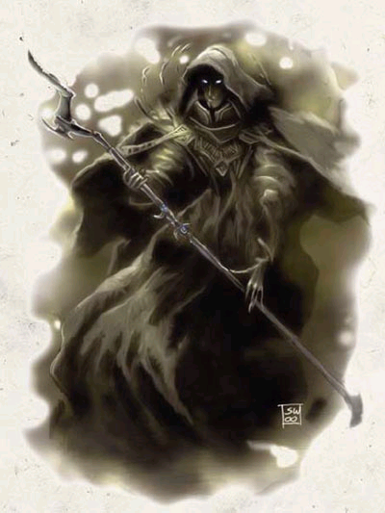

The battle sorcerer—played by Woody Harrelson—read from a scroll, “Ban tibånu, zi shanti v’shatrefit!” and manifested a *shield [expired on Round 71]* before him.

*The battle sorcerer gained +4 to all AC.*

[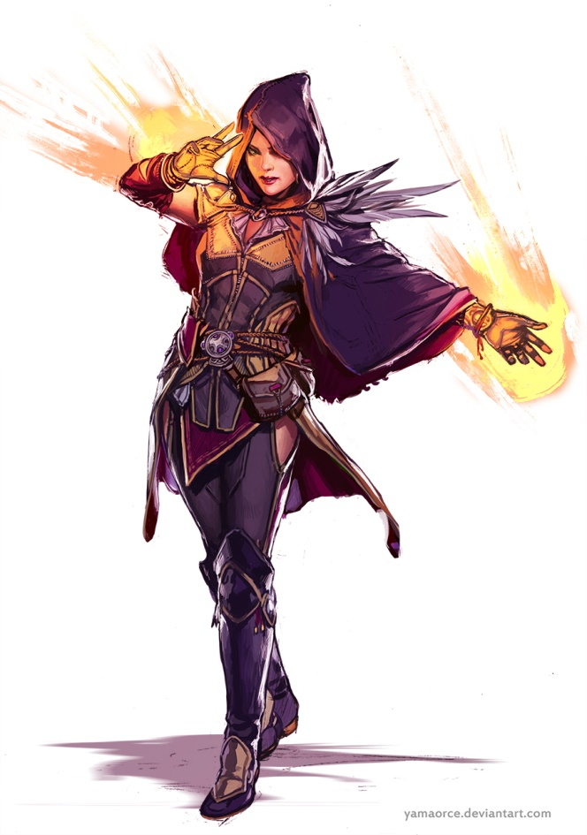](https://www.google.com/url?sa=i&rct=j&q=&esrc=s&source=images&cd=&cad=rja&uact=8&ved=2ahUKEwiBv5vky5jeAhVkzoMKHXyzDTUQjRx6BAgBEAU&url=https://www.5esrd.com/classes/sorcerer/&psig=AOvVaw2UnfKmJpvbkxrpNxGxE7bV&ust=1540247638131324)

“Why are we here again?” the sorceress—played by Brie Larson—asked before casting *mage armor [expired on Round 7201]*.

*The sorceress gained +4 to FF AC and AC.*

[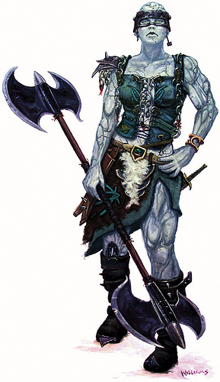](http://www.google.com/url?sa=i&rct=j&q=&esrc=s&source=images&cd=&cad=rja&uact=8&ved=2ahUKEwjwnc7byZjeAhVrwYMKHScADGkQjRx6BAgBEAU&url=http://www.flickriver.com/photos/49260334@N08/tags/goliath/&psig=AOvVaw2sUa0629_6R4eauf6lLHur&ust=1540247081022638)

Barely dressed in silks and sashes, the knight—played by Lucy Lawless—drank a potion of *barkskin [expired on Round 1001]*, then answered, “The sign said to come here and start buffing up.”

*The knight gained +3 to FFAC and AC.*

[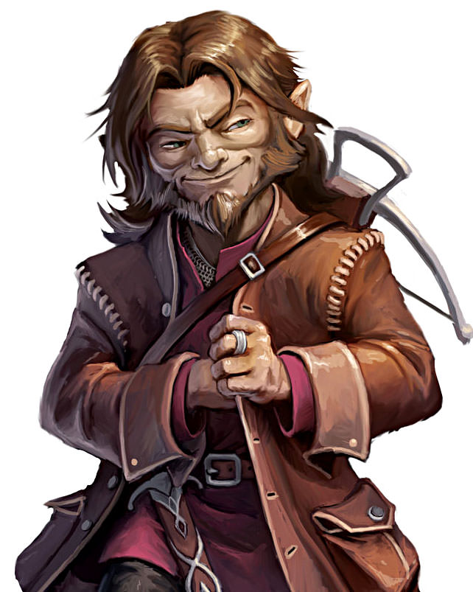](https://www.google.com/url?sa=i&rct=j&q=&esrc=s&source=images&cd=&cad=rja&uact=8&ved=2ahUKEwiq65ORzJjeAhUo5oMKHUAEASwQjRx6BAgBEAU&url=https://www.myth-weavers.com/showthread.php?t%3D427625&psig=AOvVaw2dAob4C-JfTDsJTHsf4O8g&ust=1540247744535833)

The archivist drank a potion of *fox’s cunning [expired on Round 101]*, then added to the knight’s tale, “The *Vilemother* told us to come. She said there will be a test, and then rewards and retributions.”

*The archivist gained +4 to Intelligence.*

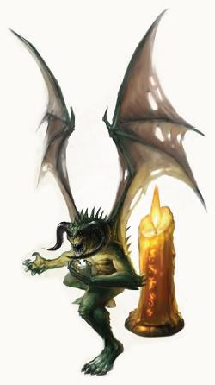

Perching atop the battle sorcerer’s shoulder and warded by his master’s *shield* spell, Typhoid—played by Damon Wayans—held the so-called “Shadow Maniple”, and now began to shake it, causing it contents to rattle with shadowy energy.

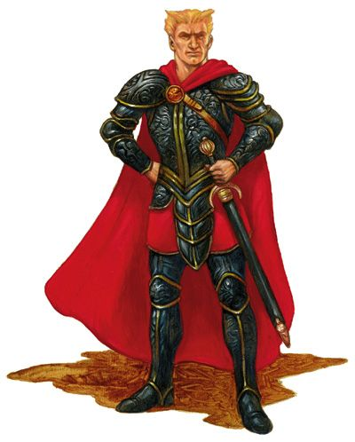

Then there was the new guy, a human sandwich—er, swashbuckler—they’d picked up along the way since they’d left Waterdeep the night before, just after the death of Supreme Defiance. Yurm the Sprinter—played by Sean Penn—drank a potion of *eagle’s splendor [expired on Round 101]*.

*Yurm gained +4 to Charisma.*

They were on the border of a salt flat and a vast desert of igneous rock and silty sand. The starlight above them was all that lit the land under the sky, and the shades were glad to have happened upon this place in the cover of night. Neither bats nor nightingales nor mosquitoes roamed this sterile, unforgiving ashtray of a crater whose ridges were too far away to see beyond the choppy, lunar topography.

Round 2

“Stop that, Typhoid! Put that away,” the human shade battle sorcerer scolded his familiar, waiting for the quasit’s compliance, then casting *enhance familiar [expired on Round 7802]* upon the quasit. “*That’s* a good demon.”

*The quasit gained +2 to all saves, attacks, melee damage, and AC (dodge).*

“Oh...” the halfling shade sorceress replied to her brother’s explanation, then cast *cat’s grace [expired on Round 122]* upon the battle sorcerer and his familiar. “So what is this test? A riddle, perhaps?”

*The battle sorcerer and quasit gained +4 to Dexterity.*

The goliath shade knight drank a potion of *cat’s grace [expired on Round 102]*, then said, “I imagine from the instructions to bone up on buffs that it is to be a test of mettle.”

*The knight gained +4 to Dexterity.*

The halfling shade archivist nodded, and diligently drank a potion of *owl’s wisdom [expired on Round 102]*.

*The archivist gained +4 to Wisdom.*

The quasit rummaged through his master’s inventory inside the mage’s robe, finding nothing else worth filching and admiring... or destroying.

Yurm the Sprinter drank a potion of *cat’s grace [expired on Round 102].*

*Yurm gained +4 to Dexterity.*

The wind kicked up just a bit, and the quasit smelled someone nearby.

Round 3

The battle sorcerer cast *mage armor [expired on round 7803]*, then told the quasit to come out of his garments and perch on his free arm.

*The battle sorcerer and his familiar gained +4 to FF AC and AC.*

The knight drank a potion of *bear’s endurance [expired on Round 103]*.

*The knight gained +4 to Constitution.*

The sorceress cast *fly [expired on Round 123]* upon herself, then levitated a few inches off the ground so she was no longer the shortest in the band.

The archivist cast *detect magic [expired on Round 123]*, then looked around.

The quasit obeyed his master’s commands... for now.

Yurm the Sprinter drew his cutlass, and waited for the right moment to do what he’d been hired to do.

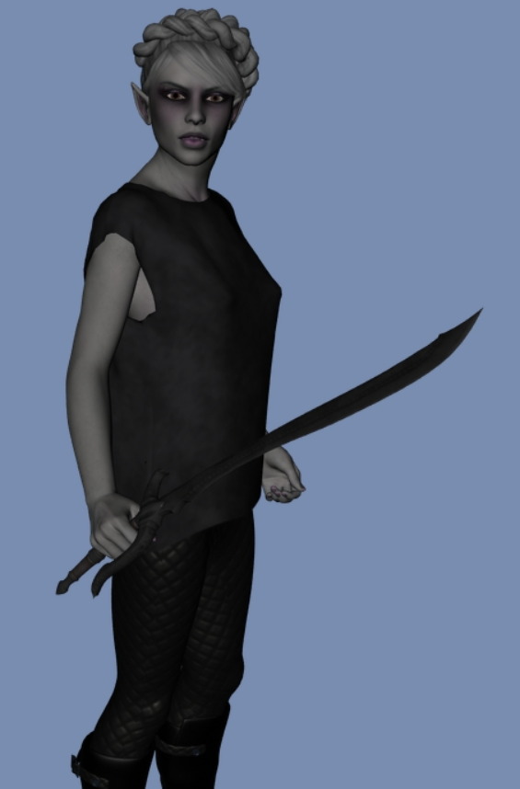

Lauren—played by Alicia Vikander—stretched, reaching over for her lover, but finding only a salty, dirt-encrusted plain in her stead. She instantly rose to her feet, fully dressed and armored, but armed only with *[select only 2 weapons (and appropriate ammo, if applicable)]*. “Allisa?” she murmured, still half asleep but trying to focus her drowsy drow eyes in the starlight.

Round 4

The battle sorcerer cast *bull’s strength [expired on Round 134]* upon himself and his familiar, then told his familiar to fuck off and make his way to the west. The shade then said, “Oh, will you look at that…”

*The battle sorcerer and quasit gained +4 to Strength.*

The knight drank a potion of *bull’s strength [expired on Round 104]*, then turned around to see what Whisper was looking at, and smiled, “The bloody Gambit!”

*The knight gained +4 to Strength.*

“Are you serious?” the sorceress asked rhetorically cast *cat’s grace [expired on Round 124]* upon herself.

*The sorceress gained +4 to Dexterity.*

“*Fuckin’* Dhavies!” the archivist exclaimed and shook his head as he cast *shield of faith [expired on Round 124]* upon himself.

*The archivist gained +3 to all AC.*

The quasit exhaled with bloodthirst, took off and started winging his way westward, hoping to eat a humanoid throat, if possible. He and his master had agreed on a roundabout pincer-claw attack, wherein the quasit would fly in from the north, and Whisper from the east. They had scrimmaged the attack several times, and even the new guy knew what to do in this situation.

Yurm the Sprinter tilted his neck and started doing stretching exercises in anticipation of being *hastened*, as they’d discussed.

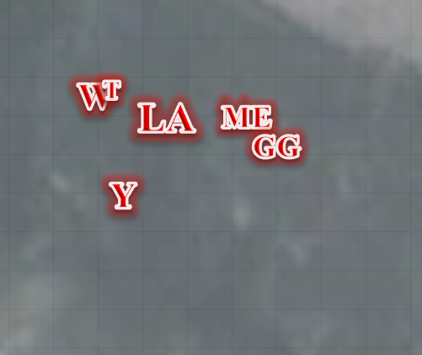

Lauren turned around to see all of her friends—best of all, Allisa—also dressed as they were yesterday on the first day of the carpet journey, and also vested and armored. *[Each PC is armed only with 2 of their weapons; please select them now.]*

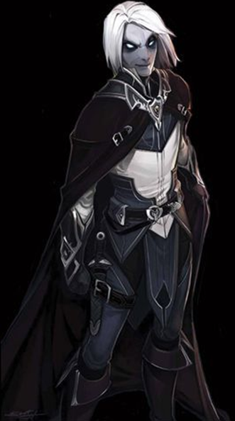

Though some of their weapons were not with them, they noted that all of their scrolls, potions, and other gear were intact, and readily available in their respective haversacks and other containers. “Did you hear that?” Fingers—in its natural form—whispered to the others, having heard the casting of spells by humanoid voices.

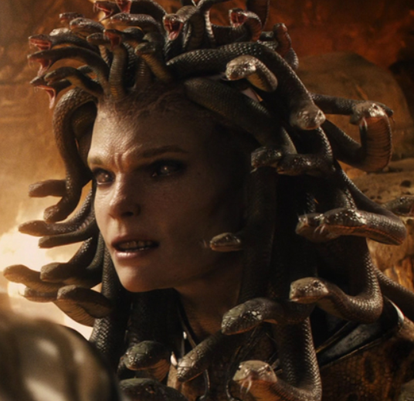

Samara—played by Natalia Vodianova—studied the situation for a moment before reacting.

Fingers—played by Errol Flynn for the moment if Errol Flynn had a humanoid form with no distinct facial features—looked around, but saw nothing for the moment; it attributed this to the uneven topography that could hide even a human standing up behind some of the taller outcroppings of sandstone and other mineral deposits.

As Fingers raised its hand to its eyes peering into the dark, it was startled to realize it had reverted to its natural changeling form. “By the Faceless One!” Fingers thought, “Piloting that carpet all day must’ve tired me mentally more than I thought to lose control of my shape like that.” The trapmaster’s features began to shift as it retook its usual nondescript human form. At the same time, it noted that the only weapons that seemed to be present were its trusty short sword and sling. A quick check verified that the collection of wands—in particular the invisibility wand—were still there.

“Where’s Kedrik?” one of the Gambit asked.

“Let’s hope he’s sound asleep in his little cot,” said someone else.

*It’s a lot darker than it looks on the map below; this is what those with Low-Light Vision and Darkvision can see nearby.*

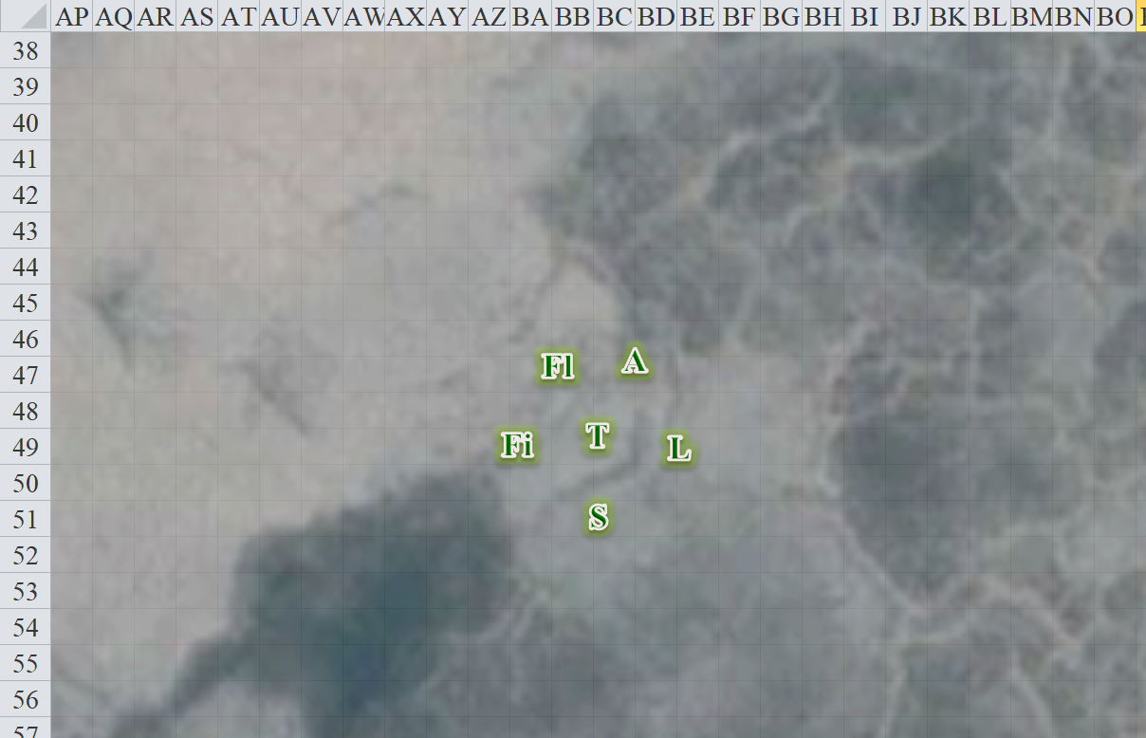

Round 5

Myrtle Eyes cast *haste [expired on Round 17]* on herself and the others, catching the quasit just before the quasit left the spell’s effect range.

*The Rumors gained +1 to BAB, Touch AC, AC, and Reflex saves.*

Then the rogue spotted to the northeast a bat-winged humanoid shape as big as a halfling, and pointed it out silently to the others. It already had a visual on them, and thus ducked behind the uneven canyon floor whose natural trenches and undulations were ideal for a creature its size.

They all recognized it: a quasit, and the same spiky quasit that cavorted with Whisper, they all clearly remembered from their stint with the Rumors just last night. And where this quasit tread, one could assume his master was not far.

Yurm the Sprinter *[hastened]* began to sprint southwest towards the targets.

Whisper *[hastened]* Swiftly manifested his Shadow Stride ability, and subsequently emitted an aura of magical darkness *[100% light reduction]* that only the keenest in the Gambit could see through. *[I’m not actually sure if any PC can actually see in magical darkness. If you can, let me know and I’ll send you a private email.]*



Allisa—played by Drew Barrymore—heard movement to the east and northeast. Coming out from behind a convenient tower of stone behind which the Rumors were coalescing, the swashbuckler was instantly spotted by the non-humans in the Gambit, all of whom were looking in the direction of the voices they’d heard.

Lady Asunder *[hastened]* smirked as she activated her Ring of Arming, calling forth one of her equipment kits, armoring her immediately and equipping her with a nice, hefty greataxe as she tilted her neck back and forth until it cracked twice, then trotted behind the much faster Yurm.

Grim Gerome *[hastened]* was also quite capable of manifesting his own aura of zero light, and he and his sister had learned from Lady Asunder and Whisper the art of doing this in conjunction with a Quickened Shadow Stride. The halfling teleported under the starlight, then protected his own hemisphere of darkness to the north and northeast of the heroes.

Though it was still dark all around her, Tali could now see magical auras coming from the northeast. Because the shades’ darkness was not the result of a *darkness* spell, but rather the selective reduction of all light to 100%, it was still quite dark for her to see within, but she knew something was rustling in both black hemispheres. *[If true seeing actually allows her to see in an area in which light has been reduced to 0%, please let me know and we’ll change this paragraph. If I’m not mistaken, though, true seeing doesn’t bestow Darkvision, so she’s still a human in starlight.]*

Tali, who had her bow and longsword, drew said longbow and looked around the area, “Flint, what the fuck did you do?” Suspecting this might be an illusion, she activated the *true seeing* function of her Scout’s Headband.

Flint shrugged, “Wasn’t me,” Flint didn’t carry any weapons as a matter course, but did have a dagger on his hip. He went ahead and cast a *greater mage armor [expired on Round 8405]* onto himself, just for the sake of argument.

*Flint gained +6 to FF AC and AC.*

The duskblade noted that she had her falchion and her kukri, along with her armor and shield. She walked over to Allisa’s side. “Is this a dream?” Just in case, she cast *barkskin [expired on Round 1205]* on herself to prepare for combat.

*Lauren gained +4 to FF AC and AC.*

“It has to be, I had no clothes on while we were in bed, then poof we are here,” Allisa said as she cast *barkskin [expired on Round 1005]*.

*Allisa gained +4 to FF AC and AC.*

The druid then added, “I have a light spell anyone thinks we should need it.”

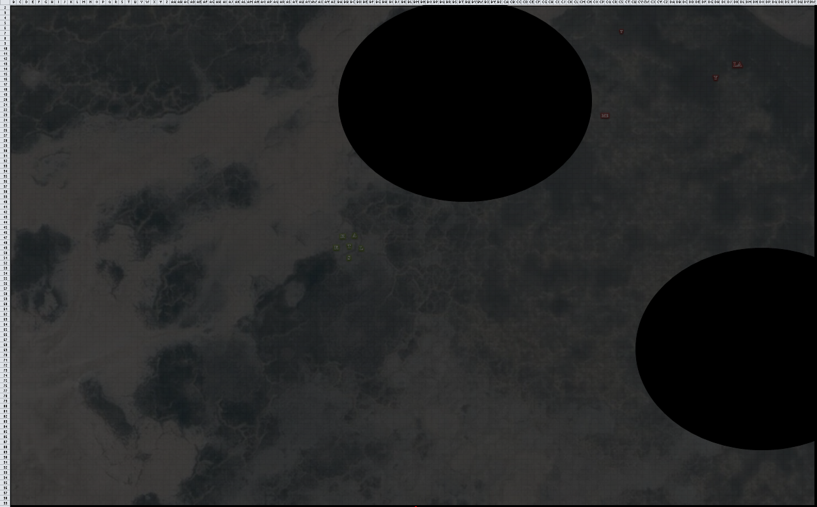

Round 6

|  |  |  |  |  |  |
| --- | --- | --- | --- | --- | --- |
| **Character** | **Group** | **Initiative** | **Roll** | **Modified Roll** | **Move** |
| Whisper | 2 | 4 | 18 | 22 | 50’ |
| Lady Asunder | 2 | 1 | 17 | 18 | 50’ |
| Typhoid | 2 | 7 | 10 | 17 | 20’/50’ fly |
| Lauren | 1 | 4 | 13 | 17 | 30’ |
| Allisa | 1 | 3 | 13 | 16 | 30’ |
| Tali | 1 | 8 | 4 | 12 | 40’ |
| Yurm the Sprinter | 2 | 4 | 8 | 12 | 30’ |
| Myrtle Eyes | 2 | 3 | 9 | 12 | 40’ |
| Flint | 1 | 3 | 7 | 10 | 30’ |
| Grim Gerome | 2 | 1 | 6 | 7 | 40’ |
| Fingers | 1 | 4 | 2 | 6 | 30’ |
| Samara | 1 | 0 | 3 | 3 | 30’ |

Whisper *[hastened]* smiled, seeing that all of his enemies were nicely clustered, and cast *ice storm* on the spot where Tali was standing.

*Dmg to Allisa: 8 bludgeoning + 4 cold = 12 [60/72].*

*Dmg to Fingers: 5 bludgeoning + 9 cold = 14 [52/66].*

*Dmg to Flint: 7 bludgeoning + 5 cold = 12 [60/72].*

*Dmg to Lauren: 13 bludgeoning + 5 cold = 18 [96/114].*

*Dmg to Samara: 11 bludgeoning + 7 cold = 18 [69/87].*

*Dmg to Tali: 14 bludgeoning + 10 cold = 24 [70/94].*

Lady Asunder *[hastened]* charged southwestward, disappearing into Grim Gerome’s lightless sphere.

Typhoid *[hastened]* flew within the sphere of darkness, studying the situation as he approached.

Lauren lifted her hand to her face and sniffed. “This isn’t real,” she said to the group, then _____.

The druid the cast *bear’s endurance [expired on Round 106]* on herself.

*Allisa gained +4 to Constitution.*

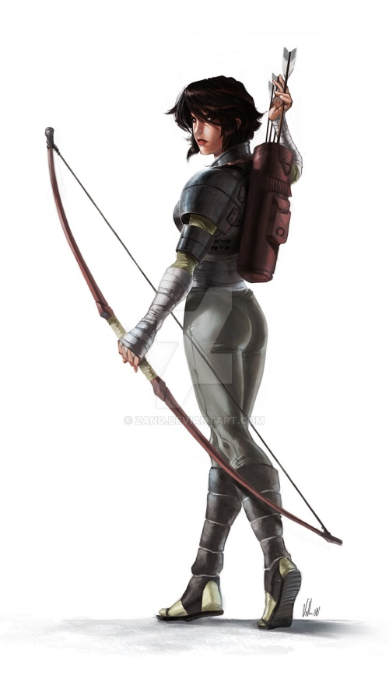

“Scatter,” Tali—played by Ellen Paige—suggested as she backed 40’ straight back away from the approaching darkness, quietly whispering a quick prayer to Mystra as she cast *hunter’s mercy*.

*Tali gained an automatic threat with her bow on the next round.*

With his cutlass in his left hand, Yurm the Sprinter *[hastened]* charged headlong towards battle, aided by a pair of magical boots *and* a *haste* spell.

Myrtle Eyes *[hastened]* cast *chain missile* on Fingers.

*Dmg to Fingers: 19 + 7 = 26 electric [26/66].*

*Dmg to Allisa: 5 + 2 = 7 electric [53/72].*

*Dmg to Flint: 7 + 2 = 9 electric [51/72].*

*Dmg to Lauren: 6 + 2 = 8 electric [88/114].*

*Dmg to Samara: 4 + 1 = 5 electric [64/87].*

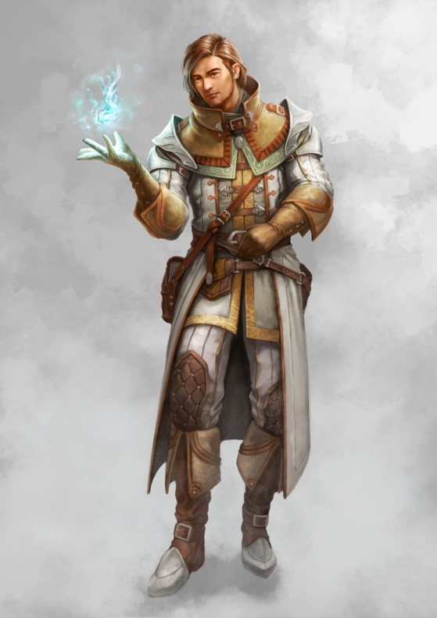

Flint—played by Aaron Eckhart—as a Swift Action, used Minor Shapeshift to rearrange his internal organs, giving him +5’ to his walk speed. He moved in the same direction as Tali, and cast *mass aid [expired on Round 146]* on the party.

*The Gambit gained +1 morale to attack rolls and 1d8+14 temporary hit points.*

*Allisa gained 5 + 14 = 19 temporary hps [72/72].*

*Fingers gained 1 + 14 =15 temporary hps [41/66].*

*Flint gained 3 + 14 = 17 temporary hps [68/72].*

*Lauren gained 8 + 14 = 22 temporary hps [110/114].*

*Samara gained 4 + 14 = 18 temporary hps [82/87].*

*Tali gained 2 + 14 = 16 temporary hps [86/94].*

Grim Gerome *[hastened]* ventured closer southwest, bringing most of his company with him, and said, “You botchy bitches die tonight!” Encompassing all of the heroes except Tali within his hemisphere of darkness, the halfling hater grinned with anticipation.

Lauren—whose Darkvision was perfect [120’]—counted three villains coming at them. Kedrik and Samara could only see half as far as the drow-human in the dark, while Allisa and Flint could not see at all now.

Fingers’ bemusement at this strange situation caused the trapsmith to be slow off the mark. With a muffled curse to get its head in the game, it tried to activate its wand to compensate for losing the chance to catch one of the enemy unaware.

Fingers *[invisible, expired on Round 12]* now crouched as he noted that his arms and hands were transparent, and quickly fading into full *invisibility*.

Tali—who could see just about everything—noted that Fingers was still visible to her.

Samara cast *shield of faith [expired on Round 66]* upon herself.

*Samara gained +3 to all ACs.*

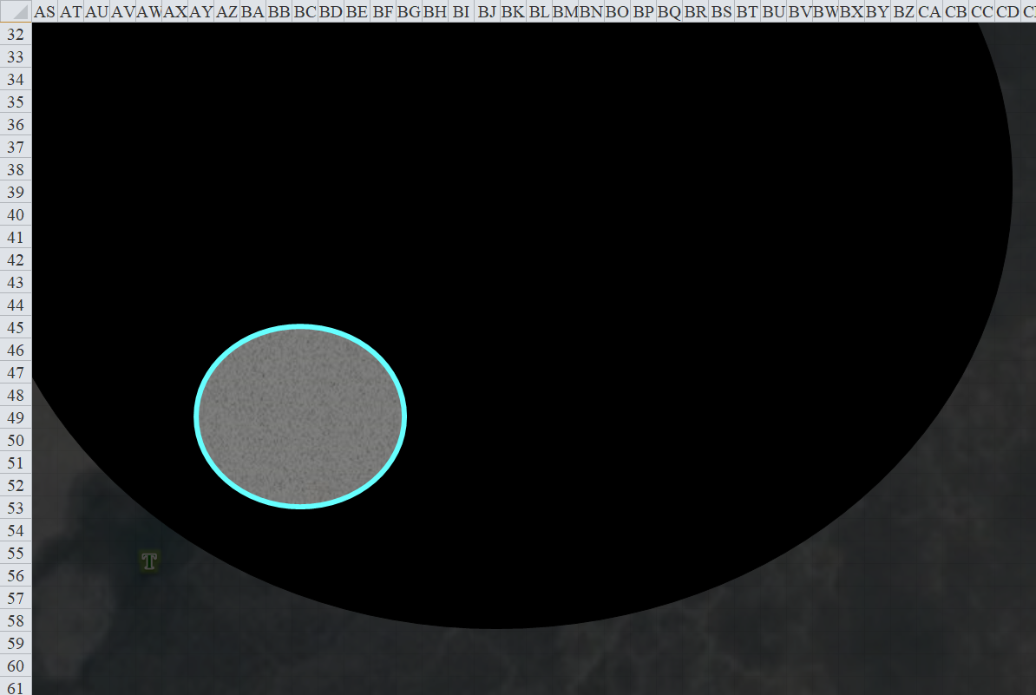

Round 7

Whisper *[hastened]* cast *vitriolic sphere* upon Tali, then walked 80’ westward.

|  |  |  |  |  |  |  |  |
| --- | --- | --- | --- | --- | --- | --- | --- |
| **Save vs.**  *vitriolic sphere* | **Rank** | **Ability & Mod.** | **Misc. Mods.** | **Total** | **Roll** | **Check** | **Notes** |
| **Tali, Reflex** | **8** | **Dex (+6)** | 3 | 17 | 15 | 32 | +1 *haste* |

*Success. Dmg: ½ x 25 = 12 + no additional damage on subsequent rounds [74/94].*

Lady Asunder *[hastened]* shouted a taunt to the flat-footed Allisa, challenging her to a duel to the death, then Quick-Shadow Strode just northwest of Allisa, and in complete darkness full-attacked the druid.

|  |  |  |  |  |  |  |  |  |  |
| --- | --- | --- | --- | --- | --- | --- | --- | --- | --- |
| **Character** | **Attack Type** | **Damage** | **BAB** | **Mod+** | **W+** | **Other+** | **Roll** | **Total** | **Special** |
| Lady Asunder | Domineering Greataxe | 1d12+7**+1**/x3 | 13 | 7 | 1 | 1 | 2 | 24 | *+2 vs. Allisa* |
| Lady Asunder | 2nd Attack | 1d12+7**+1**/x3 | 8 | 7 | 1 | 1 | 3 | 20 | *+2 vs. Allisa* |
| Lady Asunder | 3rd Attack | 1d12+7**+1**/x3 | 3 | 7 | 1 | 1 | 9 | 21 | *+2 vs. Allisa* |
| Lady Asunder | Greataxe, *haste* | 1d12+7**+1**/x3 | 13 | 7 | 1 | 1 | 7 | 29 | *+2 vs. Allisa* |

*Hit, miss, hit, hit. Dmg: (7 + 7 + 1 + 2) + (11 + 7 + 1 + 2) + (2 + 7 + 1 + 2) = 17 + 21 + 12= 50 [22/72].*

Typhoid *[hastened]* flew downward and towards Flint, but did not quite reach him.

*[JR and Wayne, to avoid redundancies and inconsistencies, please read what happens below before posting your actions.]*

Lauren did nothing for the moment.

Blinded and badly wounded, Allisa _____.

Tali took a 5’ step to the southwest, then noted Myrtle Eyes flying at her, and pumped a full, Rapid Shot of arrows into her.

|  |  |  |  |  |  |  |  |  |  |
| --- | --- | --- | --- | --- | --- | --- | --- | --- | --- |
| **Ranged Weapon** | **Dmg.** | **D+** | **TH+** | **Critical** | **Rng.** | **Wt.** | **Atk** | **Roll** | **Check** |
| Dragonbone Composite Longbow +1 Force +2 Strength | 1d8 | +1+2+2+2+3 | 6 | 19-20,x4 | 165’+20’+20’ | 3.0 | +26 | 13 | 39 |
| DB Longbow +1, 2nd Shot | 1d8 | +1+2+2+2+3 | 6 | 19-20,x4 | 165’+20’+20’ | - | +21 | 7 | 28 |
| DB Longbow +1, Rapid Shot | 1d8 | +1+2+2+2+3 | 6 | 19-20,x4 | 165’+20’+20’ | - | +16 | 18 | 34 |

*Automatic threat, hit, hit. 1d20 = 2 + 26 = 28, critical hit.*

*Dmg: [4 x (7 + 1 + 2 + 2 + 2 + 3)] + (7 + 1 + 2 + 2 + 2 + 3) + (4 + 1 + 2 + 2 + 2 + 3) = 68 + 14 + 10 = 92.*

With an indiscernible thud and wretch, Myrtle Eyes died and fell to the floor, which pissed off her brother, who already had a hard-on for the Gambit. She landed face down a few seconds later, and the arrows punctured her deeper still.

“I’ll dance upon your *graaaaaves*!” the halfling archivist’s voice boomed over the barren salt flat battlefield.

With amazing alacrity and built-up momentum, Yurm the Sprinter *[hastened]* began to slow so as to have an optimal opportunity to strike at Lauren at the ideal moment.

Flint moved beside Tali and cast *greater invisibility [expired on Round 21]* upon her.

*Tali became invisible.*

Grim Gerome *[hastened]* looked towards his sister’s body, examining her only with his eyes before Swiftly manifesting his Shadow Stride ability, teleporting to the spot most central to the cluster of enemies, and subsequently blasting everyone with a *blasphemy* spell.

*All PCs become Dazed [expires in 1 full round], and can take no actions other than standing defensively so as to not become flat-footed. However, those without Darkvision are effectively flat-footed already.*

Fingers *[invisible, Dazed]* staggered around in place and tried to act *invisible*.

Samara *[Dazed]* also staggered, hoping to not be attacked at the moment.

*Though the map shows character positions, not all PCs can see where others are, though you can hear normally. Please keep this in mind when posting.*

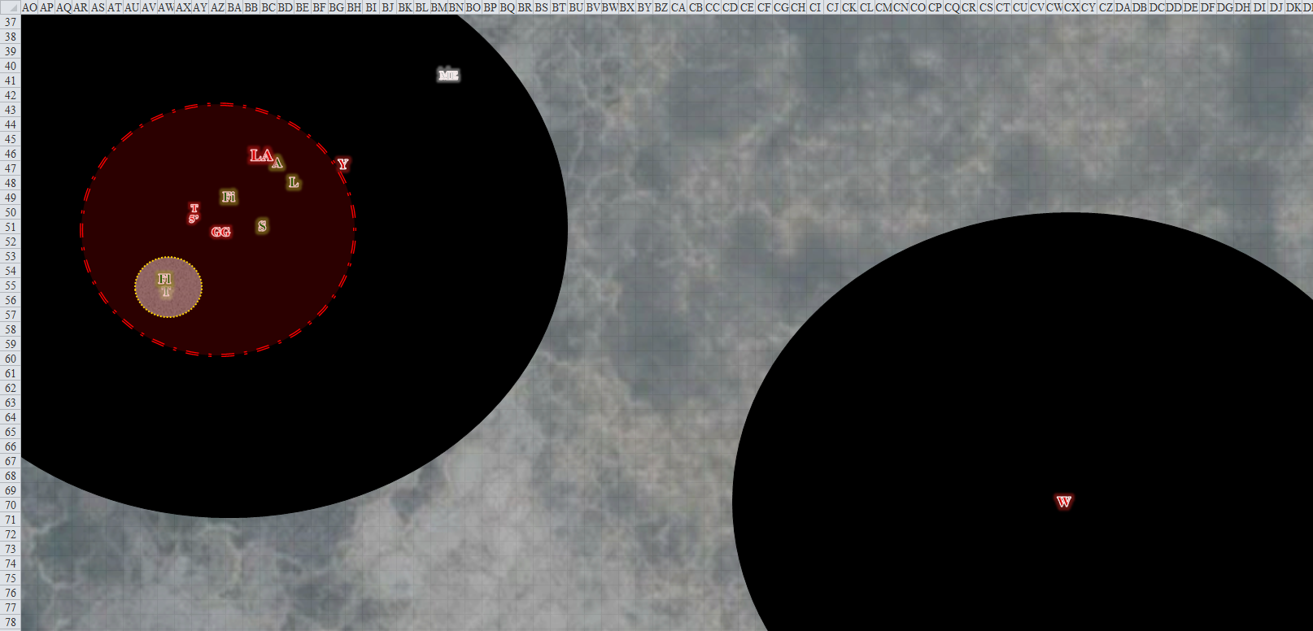

Round 8

Whisper the Geistfather *[hastened]* cast *fly [expired on Round 128]*, then flew towards the heroes at an altitude of 10’. “You fools should know better than to follow us here. Now you must die!”

Lady Asunder the Slaughterer’s Daughter *[hastened]* full-attacked Allisa.

|  |  |  |  |  |  |  |  |  |  |
| --- | --- | --- | --- | --- | --- | --- | --- | --- | --- |
| **Character** | **Attack Type** | **Damage** | **BAB** | **Mod+** | **W+** | **Other+** | **Roll** | **Total** | **Special** |
| Lady Asunder | Domineering Greataxe | 1d12+7**+1**/x3 | 13 | 7 | 1 | 1 | 4 | 26 | *+2 vs. Allisa* |
| Lady Asunder | 2nd Attack | 1d12+7**+1**/x3 | 8 | 7 | 1 | 1 | 2 | 19 | *+2 vs. Allisa* |
| Lady Asunder | 3rd Attack | 1d12+7**+1**/x3 | 3 | 7 | 1 | 1 | 15 | 27 | *+2 vs. Allisa* |
| Lady Asunder | Greataxe, *haste* | 1d12+7**+1**/x3 | 13 | 7 | 1 | 1 | 12 | 34 | *+2 vs. Allisa* |

*Hit, miss, hit, hit. Dmg: (3 + 7 + 1 + 2) + (1 + 7 + 1 + 2) + (12 + 7 + 1 + 2) = 13 + 11 + 22= 46 [-24/72].*

~*~

Allisa awoke.

~*~

Typhoid the Nastiest *[hastened]* reached Flint, and clawed at him, transmitting his poison before flying upwards about 10’ and arcing towards Samara another 20’.

|  |  |  |  |  |  |  |  |  |
| --- | --- | --- | --- | --- | --- | --- | --- | --- |
| **Character** | **Attack Type** | **Damage** | **BAB** | **Mod+** | **W+** | **Other+** | **Roll** | **Total** |
| Typhoid | Claw 1 | 1d8+1+6+poison | 7 | 6 | 1 | 0 | 15 | 29 |

*Hit. Dmg: 1 + 1 + 6 = 8 + poison [60/72].*

|  |  |  |  |  |  |  |  |
| --- | --- | --- | --- | --- | --- | --- | --- |
| **Save** | **Rank** | **Ability & Mod.** | **Misc. Mods.** | **Total** | **Roll** | **Check** | **Notes** |
| **Flint, Fortitude** | **6** | **Con (+1)** | 1 | 8 | 4 | 12 | +4 Divine bonus (if applicable) |

*If the bonus applies (let me know if this focus is active today), this is a success, and Flint sustains no initial poison damage.*

Lauren *[Dazed]* held the mercy of her falchion too firmly, fending off Yurm as best as she could, and then noticed that her lover had been killed.

~*~

Allisa lifted herself onto her right elbow, seeing Lauren sleeping with her back to her. She placed a hand on the slumbering woman’s shoulder.

~*~

Tali *[invisible, Dazed]* said something silly to Flint about having déjà vu. He told her it was probably vertigo. Then they both noticed that Allisa was dead.

Yurm the Sprinter *[hastened]* charge-attacked Lauren in a most acrobatic way, leaping on his last step so as to add the force of gravity to his thrust.

|  |  |  |  |  |
| --- | --- | --- | --- | --- |
| **Character** | **Check** | **Ranks** | **Roll** | **Save** |
| Yurm the Sprinter | Jump | 14 | 17 | 31 |

*Success.*

|  |  |  |  |  |  |  |  |  |
| --- | --- | --- | --- | --- | --- | --- | --- | --- |
| **Character** | **Attack Type** | **Damage** | **BAB** | **Mod+** | **W+** | **Other+** | **Roll** | **Total** |
| Yurm the Sprinter | Keen Cutlass +2 | 1d6+2/15-20 | 14 | 3 | 2 | 0 | *19* | 38 |
| Yurm the Sprinter | Cutlass, *haste* | 1d6+2/15-20 | 14 | 3 | 2 | 0 | 6 | 25 |

*Threat (1d20 = 12 + 14 = 26, critical hit, miss. See below.*

Unhappy with his second jab, Yurm turned it into more of a slicing sweep.

|  |  |  |  |  |  |  |  |  |
| --- | --- | --- | --- | --- | --- | --- | --- | --- |
| **Character** | **Attack Type** | **Damage** | **BAB** | **Mod+** | **W+** | **Other+** | **Roll** | **Total** |
| Yurm the Sprinter [LUCKY] | Cutlass, *haste* | 1d6+2/15-20 | 14 | 3 | 2 | 0 | 14 | 33 |

*Hit. Dmg: [2 x (2 + 2)] + (5 + 2) = 8 + 7 = 15 [95/114].*

Flint *[Dazed]* thought about what he would do when the sensation of powerlessness left his body, now that it was starting to subside.

Gerome the Grim *[hastened]* was still upset, and now whispered something that ended with “stinking, fish-eating Dhavies!”, then cast *flame strike* on Tali and Flint.

|  |  |  |  |  |  |  |
| --- | --- | --- | --- | --- | --- | --- |
| **Save vs.**  *Flame strike* | **Rank** | **Ability & Mod.** | **Misc. Mods.** | **Total** | **Roll** | **Check** |
| **Tali, Reflex** | **8** | **Dex (+6)** | 3 | 17 | 13 | 30 |
| **Flint, Reflex** | **5** | **Dex (+3)** | 1 | 9 | 8 | 17 |

*Success, fail.*

*Dmg to Tali: ½ x 39 = 19 [55/94].*

*Dmg to Flint: 36 [24/72].*

Fingers *[invisible]* came out of his dazed state, and activated its headband to gain Darkvision, then took note of the enemy positions and saw Lady Asunder standing over Allisa’s still body. Fingers drew its trusty blade in preparation to do nasty things to her and prevent the hulking goliath from double-teaming Lauren. And, oh, what a sweet spot it was!

Samara also began to fade into inexistence.

Near Lauren, Allisa’s corpse began to shapeshift into a small tree.

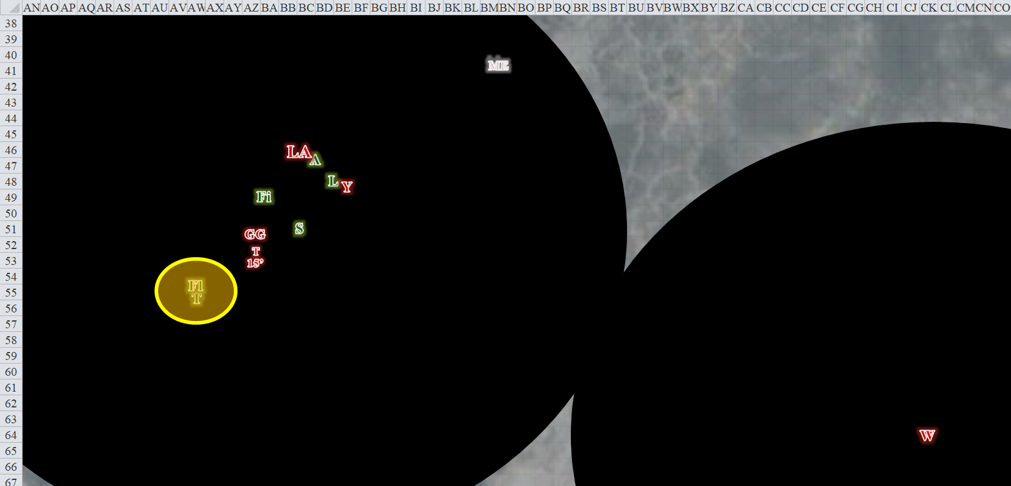

Round 9

Whisper *[hastened]* flew 80’ closer to his enemies, then cast *acid fog [expired on Round 21]*, centering it just southwest of Tali, so as to not harm his coworkers.

*Dmg to Flint: 5 acid [19/72].*

*Dmg to Tali: 9 acid [46/94].*

*Flint’s and Tali’s speeds were reduced to 5’, their vision was limited to 5’ (bypassed by true seeing), and both encumbered a penalty of -2 to melee attack and damage rolls while inside the fog cloud.*

Lady Asunder *[hastened]* spouted some bravado *[challenge]* at Lauren, then took a 5’ step and full-attacked the drow.

|  |  |  |  |  |  |  |  |  |  |
| --- | --- | --- | --- | --- | --- | --- | --- | --- | --- |
| **Character** | **Attack Type** | **Damage** | **BAB** | **Mod+** | **W+** | **Other+** | **Roll** | **Total** | **Special** |
| Lady Asunder | Domineering Greataxe | 1d12+7**+1**/x3 | 13 | 7 | 1 | 1 | 15 | 37 | *+2 vs. Lauren* |
| Lady Asunder | 2nd Attack | 1d12+7**+1**/x3 | 8 | 7 | 1 | 1 | 7 | 24 | *+2 vs. Lauren* |
| Lady Asunder | 3rd Attack | 1d12+7**+1**/x3 | 3 | 7 | 1 | 1 | 4 | 16 | *+2 vs. Lauren* |
| Lady Asunder | Greataxe, *haste* | 1d12+7**+1**/x3 | 13 | 7 | 1 | 1 | 15 | 37 | *+2 vs. Lauren* |

*Hit, hit, miss, hit. Dmg: (7 + 7 + 1 + 2) + (1 + 7 + 1 + 2) + (3 + 7 + 1 + 2) = 17 + 11 + 13 = 41 [54/114].*

Fingers took an Attack of Opportunity against Lady Asunder.

|  |  |  |  |  |  |  |  |  |  |  |
| --- | --- | --- | --- | --- | --- | --- | --- | --- | --- | --- |
| **Melee Weapon** | **Dmg** | **D+** | **TH+** | **Critical** | **Type** | **Wt.** | **Atk** | **Roll** | **Check** | **Notes** |
| Keen Deadly Precision Short Sword | 1d6 | 1 | 1 | 17-20, x2 | Piercing | 2.0 | +14 | 16 | 30 | +5d6 Sneak Attack |
| Crystal of Acid Assault, Lesser | - | 1d6 | - | - | - | - | - | - | - |  |

*Hit. Dmg: 6 + 1 + 20 + 3 acid = 30.*

Lady Asunder cried out from the jab to her thigh, and turned to face whatever enemy had stabbed her with such audacity.

Outside the *fog cloud*, Typhoid *[hastened]* pounced on Samara and clawed at her, hoping to poison her too.

|  |  |  |  |  |  |  |  |  |
| --- | --- | --- | --- | --- | --- | --- | --- | --- |
| **Character** | **Attack Type** | **Damage** | **BAB** | **Mod+** | **W+** | **Other+** | **Roll** | **Total** |
| Typhoid | Claw 1 | 1d8+1+6+poison | 7 | 6 | 1 | 0 | 2 | 16 |

*Miss.*

Dream or not, Lauren wasn’t about to go down without a fight. She attacked the creature who had first attacked her, slashing at the swashbuckler with her falchion before turning her gaze toward Lady Asunder, who now flanked her left side.

|  |  |  |  |  |  |  |  |  |  |
| --- | --- | --- | --- | --- | --- | --- | --- | --- | --- |
| **Melee Weapon** | **Dmg** | **D+** | **TH+** | **Critical** | **Type** | **Wt.** | **Atk** | **Roll** | **Check** |
| Falchion +3 | 2d4 | +5 +3 | 3 | 18-20/x2 | Slashing | 8.0 | +21 | 14 | 35 |
| Falchion +3, 2nd Attack | 2d4 | +5 +3 | 3 | 18-20/x2 | Slashing |  | +16 | 7 | 23 |
| Falchion +3, 3rd Attack | 2d4 | +5 +3 | 3 | 18-20/x2 | Slashing |  | +11 | **18** | 29 |
| Falchion +3, *haste* | 2d4 | +5 +3 | 3 | 18-20/x2 | Slashing |  | +21 | 10 | 31 |

*Hit, miss, threat, hit. 1d20 = 18, critical hit. Dmg: (3 + 5 + 3) + [2 x (2 + 5 + 3)] + (8 + 5 + 3) = 11 + 20 + 16 = 47.*

~*~

Lauren didn’t budge, and her skin felt a bit chilly. Allisa pushed herself up to a sitting position, then leaned to look upon her lover, but the drow had a face with human features—rounded ears, a masculine, hooked nose, and hair the same color as Zond’s. The drow opened her human eyes, and stared at Allisa as if through the lens of death itself, and for a moment, it was as if all the dead were watching her.

Every pore and follicle on Allisa’s body stood on end. Her nipples hardened to the point of hurting her, and then she was in a dark place, and the aquiline, masculine face that had replaced Lauren’s was the only thing she could see, and even that faded into darkness, its eyes blinking before Allisa gasped and awoke.

~*~

Yurm *[hastened]*—a bit more than butt-hurt—full-attacked Lauren.

|  |  |  |  |  |  |  |  |  |
| --- | --- | --- | --- | --- | --- | --- | --- | --- |
| **Character** | **Attack Type** | **Damage** | **BAB** | **Mod+** | **W+** | **Other+** | **Roll** | **Total** |
| Yurm the Sprinter | Keen Cutlass +2 | 1d6+2/15-20 | 14 | 3 | 2 | 0 | 5 | 24 |
| Yurm the Sprinter | 2nd Attack | 1d6+2/15-20 | 9 | 3 | 2 | 0 | 15 | 29 |
| Yurm the Sprinter | 3rd Attack | 1d6+2/15-20 | 4 | 3 | 2 | 0 | *19* | 28 |
| Yurm the Sprinter | Cutlass, *haste* | 1d6+2/15-20 | 14 | 3 | 2 | 0 | 3 | 22 |

*Miss, hit, threat, miss. 1d20 = 13 + 9 = 22, not a critical hit. Dmg: (1 + 2) + (3 + 2) = 8 [46/114].*

Grim Gerome *[hastened]* cast *blade barrier [expired on Round 129]*, then turned momentarily towards Lady Asunder to make sure that she and the new guy were alright before turning back to Tali, who’d killed his sister not a minute ago.

|  |  |  |  |  |  |  |
| --- | --- | --- | --- | --- | --- | --- |
| **Save vs.**  *blade barrier* | **Rank** | **Ability & Mod.** | **Misc. Mods.** | **Total** | **Roll** | **Check** |
| **Flint, Reflex** | **5** | **Dex (+3)** | 1 | 9 | 18 | 27 |
| **Tali, Reflex** | **8** | **Dex (+6)** | 3 | 17 | 9 | 26 |

*Success, success. Both save for ½ damage.*

*Dmg to Flint: ½ x 28 = 14 [5/72].*

*Dmg to Tali: ½ x 46 = 23 [23/94].*

Fingers full-attacked Lady Asunder.

|  |  |  |  |  |  |  |  |  |  |  |
| --- | --- | --- | --- | --- | --- | --- | --- | --- | --- | --- |
| **Melee Weapon** | **Dmg** | **D+** | **TH+** | **Critical** | **Type** | **Wt.** | **Atk** | **Roll** | **Check** | **Notes** |
| Keen Deadly Precision Short Sword | 1d6 | 1 | 1 | 17-20, x2 | Piercing | 2.0 | +14 | 13 | 27 | +5d6 Sneak Attack |
| Short Sword, 2nd Attack | 1d6 | 1 | 1 | 17-20, x2 | Piercing | - | +9 | 17 | 26 | Weapon Finesse |
| Crystal of Acid Assault, Lesser | - | 1d6 | - | - | - | - | - | - | - |  |

*Hit, threat. 1d20 = 15 + 9 = 24, not a critical hit (her FF AC is 26). Dmg: (2 + 1 + 22 + 4 acid) + (5 + 1 + 11 + 6 acid) = 42 + 10 acid = 52.*

Samara was gone now, leaving Fingers, Flint, Lauren, and Tali to contended with Whisper and his bunch.

*[DM assumption]* Tali and Flint did their best to get out of the *acid fog* and *blade barrier*, moving only 5’ in the dense fog and amidst the whirling blades.

“I said scatter, dumbass.” Tali quietly said to Flint as she took a 5’ step directly back from him, then took a full, rapid shot attack at the jerk who hit her with a Blasphemy.

|  |  |  |  |  |  |  |  |  |  |  |
| --- | --- | --- | --- | --- | --- | --- | --- | --- | --- | --- |
| **Ranged Weapon** | **Dmg.** | **D+** | **TH+** | **Critical** | **Rng.** | **Wt.** | **Atk** | **Roll** | **Check** | **Notes** |
| Dragonbone Composite Longbow +1 Force +2 Strength | 1d8 | +1+2+2+2+3 | 6 | 19-20,x4 | 165’+20’+20’ | 3.0 | +25 | 13 | 38 | +1 within 30’ |
| DB Longbow +1, 2nd Shot | 1d8 | +1+2+2+2+3 | 6 | 19-20,x4 | 165’+20’+20’ | - | +20 | 18 | 38 | +1 within 30’ |
| DB Longbow +1, Rapid Shot | 1d8 | +1+2+2+2+3 | 6 | 19-20,x4 | 165’+20’+20’ | - | +15 | 15 | 30 | +1 within 30’ |

*Hit, hit, hit. Dmg: (7 + 1 + 2 + 2 + 2 + 3) + (8 + 1 + 2 + 2 + 2 + 3) + (4 + 1 + 2 + 2 + 2 + 3) = 17 + 18 + 14 = 49.*

“I’m bad at following orders or suggestions,” Flint replied as he used his Shapeshifting feat to gain 12 temporary hit points *[17/72]*, walked 5’ south in the dense *acid fog*, and cast *shield [expired on Round 149]*.

*Flint gained +4 to all ACs.*

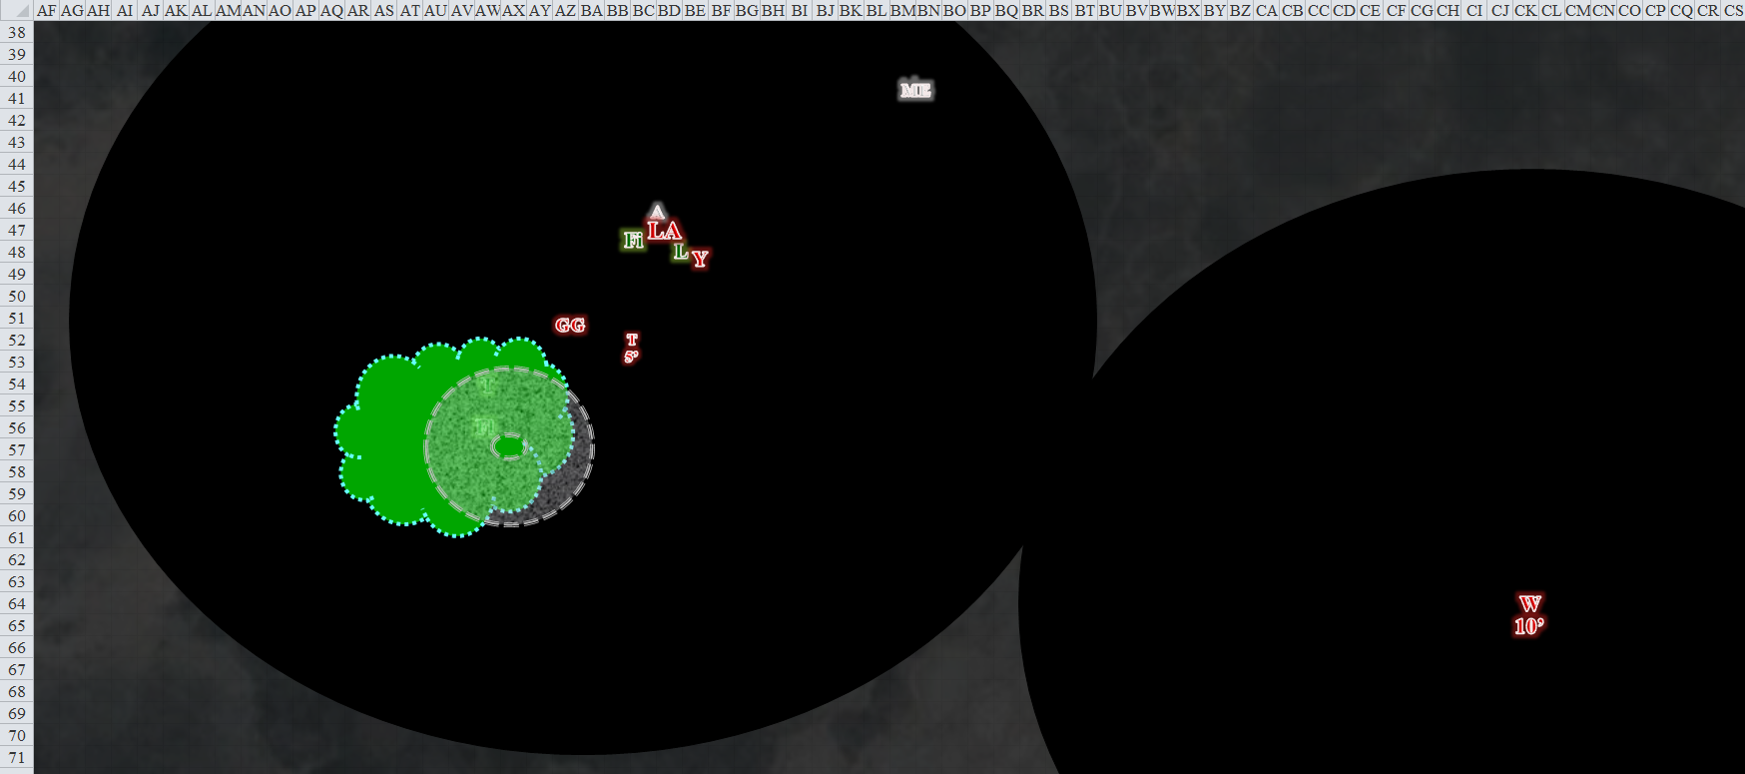

Kedrik was busy playing with his dice and some silver and copper pieces when he suddenly realized he was outdoors, and in the dark.

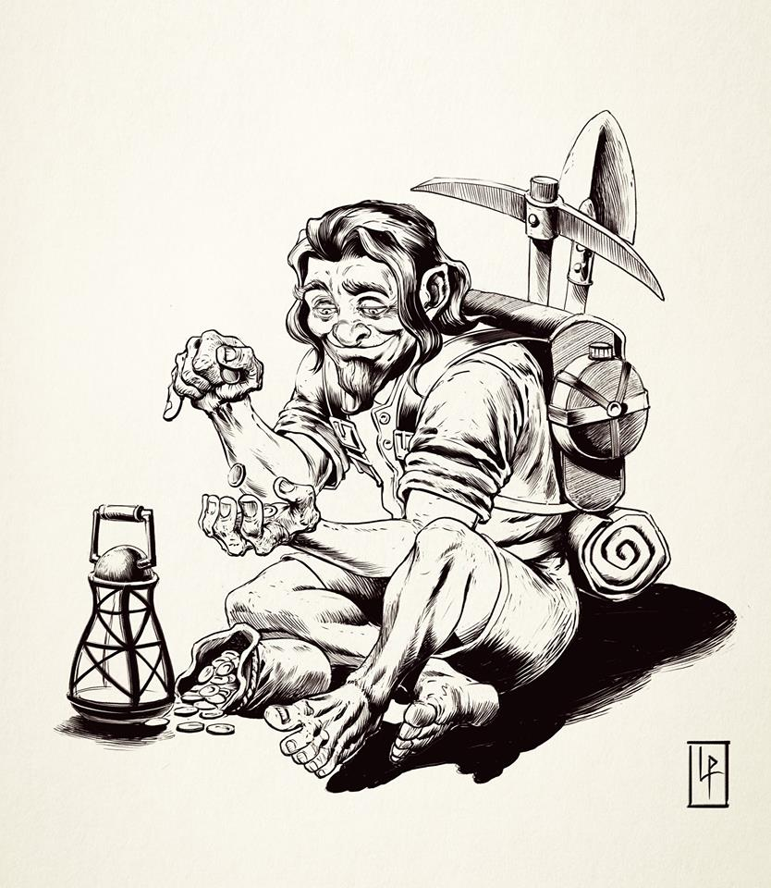

The light in his lantern flickered as the breeze kicked up, and suddenly the sounds of battle were evident behind him. The whisper gnome turned around to see two black hemispheres into which he would not be able to see until he was within 60’ of them. He could hear Lauren’s and others’ familiar voices as well as the gnomish trill in Grim Gerome’s voice. He got up and cast *call lightning* before making his way over, his Blackthorn Shillelagh +2 and Seeking Light Crossbow +2 both on his backpack.

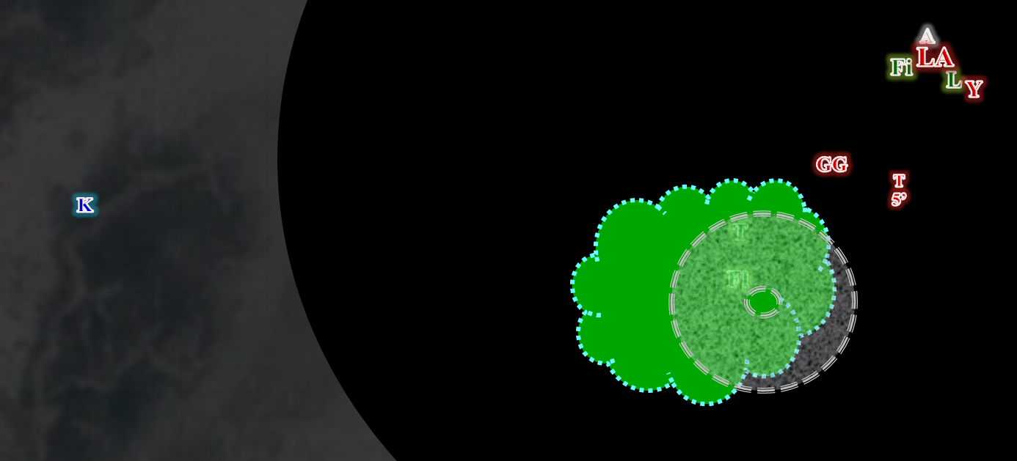

Round 10

Then, the tree that Allisa had become took on an anthropomorphic form, and began to blink back to life. Lauren saw this with one eye as she fended off the goliath shade knight and the human swashbuckler simultaneously.

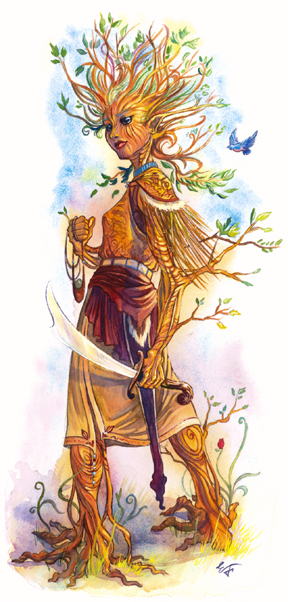

Whisper *[hastened]* stopped sucking the light out of the area around him, and flew another 90’ westward and thought to spice things up a bit, casting an Empowered *magic missile* upon Lauren.

*Dmg: 1½ x (13 + 5) = 27 magic [19/114].*

Lady Asunder *[hastened]* full-attacked Lauren.

|  |  |  |  |  |  |  |  |  |  |  |  |
| --- | --- | --- | --- | --- | --- | --- | --- | --- | --- | --- | --- |
| **Character** | **Attack Type** | **Damage** | **Crit** | **BAB** | **Mod+** | **W+** | **Other+** | **Roll** | **Total** | **Threat** | **Special** |
| Lady Asunder | Domineering Greataxe | 1d12+7**+1**/x3 | 20 | 13 | 7 | 1 | 1 | 8 | 30 | ☒ | *+2 vs. Lauren* |
| Lady Asunder | 2nd Attack | 1d12+7**+1**/x3 | 20 | 8 | 7 | 1 | 1 | 1 | 18 | ☒ | *+2 vs. Lauren* |
| Lady Asunder | 3rd Attack | 1d12+7**+1**/x3 | 20 | 3 | 7 | 1 | 1 | 4 | 16 | ☒ | *+2 vs. Lauren* |
| Lady Asunder | Greataxe, *haste* | 1d12+7**+1**/x3 | 20 | 13 | 7 | 1 | 1 | 8 | 30 | ☒ | *+2 vs. Lauren* |

*Hit, miss, miss, hit. Dmg: (11 + 7 + 1 + 2) + (4 + 7 + 1 + 2) = 21 + 14 = 35 [-16/114].*

Lauren died, and before she could even fall to the ground, began to flake away into the breeze, along with all of her equipment.

Typhoid *[hastened]* flew over to Whisper.

Tali and Flint suffered damage from both the *blades* and the *fog*.

*Dmg to Flint: 7 acid + 38 slashing = 45.*

*Dmg to Tali: 5 acid + 45 slashing = 50.*

Flint and Tali couldn’t take the *blades* anymore, and both died, vaporizing and melding into the blades and acid.

[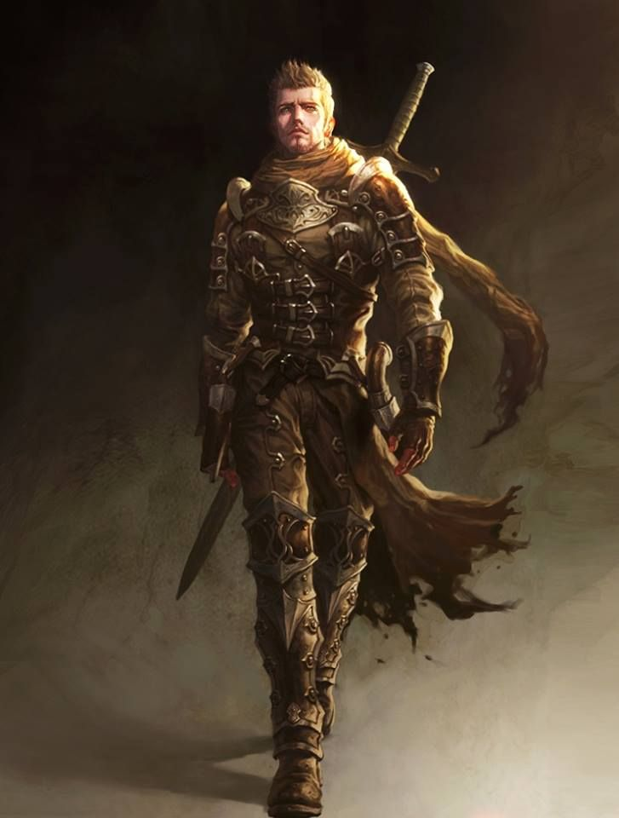](https://www.google.com/url?sa=i&rct=j&q=&esrc=s&source=images&cd=&cad=rja&uact=8&ved=2ahUKEwiU_KSgwabeAhWL8oMKHZhlBbYQjRx6BAgBEAU&url=https://www.pinterest.com/pin/327566572871503880/&psig=AOvVaw2QJD2kUNTAmSNoomrCSGZU&ust=1540725841242176)

Yurm the Sprinter *[hastened]* turned to the woody Allisa, and leapt over to Lady Asunder’s side to try to kill the tree-druid, then took a 5’ back from her.

|  |  |  |  |  |  |  |  |  |  |  |
| --- | --- | --- | --- | --- | --- | --- | --- | --- | --- | --- |
| **Character** | **Attack Type** | **Damage** | **Crit** | **BAB** | **Mod+** | **W+** | **Other+** | **Roll** | **Total** | **Threat** |
| Yurm the Sprinter | Keen Cutlass +2 | 1d6+2 | 15 | 14 | 3 | 2 | 0 | 12 | 31 | ☒ |
| Yurm the Sprinter | Cutlass, *haste* | 1d6+2 | 15 | 14 | 3 | 2 | 0 | 14 | 33 | ☒ |

*Hit, hit. Dmg: (6 + 2) + (3 + 2) = 8 + 5 = 13 [59/72].*

Barely able to see 15’ in front of her, a wood-fleshed Allisa, holding her scimitar in her most able hand, now stood defiantly and murmured something about being Groot, then spoke the words that evoked *baleful polymorph* in an attempt to turn Lady Asunder into a small garden snail.

|  |  |  |  |  |
| --- | --- | --- | --- | --- |
| **Character** | **Save vs.**  *baleful polymorph* | **Ranks** | **Roll** | **Save** |
| Lady Asunder | Fortitude | 8 | 1 | 9 |

*Fail.*

Lady Asunder became a small garden snail, now crawling along the surface of her own suit of plate armor.

Grim Gerome *[hastened]*, riddled with Tali’s arrows, was running out of good spells for the evening. Satisfied with having just avenged his sister and killed her assailant, he gave Whisper a glance. Seeing that the human shade battle sorcerer was flying over with his quasit, and the fight was nearly over, he cast *see invisibility [expired on Round 1210]* and said, “Let’s deal with their sneakthief!” The hastened halfling shade then pointed out the rogue who had just slashed at Lady Asunder.

Meanwhile, Kedrik came closer, reaching the edge of Gerome’s hemisphere of darkness. He then cast *hold person* upon Grim Gerome.

|  |  |  |  |  |
| --- | --- | --- | --- | --- |
| **Character** | **Save vs.**  *hold person* | **Ranks** | **Roll** | **Save** |
| Grim Gerome | Will | 9 | 20 | 29 |

*Success.*

Grim Gerome smirked at Kedrik and shook his head.

Fingers noted that at least one of the foes could now see it, and Lady Asunder was now a snail. The changeling shifted position to keep her and most of the rest of the pack guessing where it might be. With the bizarre transmogrification of some of the other downed Gambit, Fingers hoped that this would be nothing more than perhaps some hallucination-inducing mushrooms that had been part of the evening’s stew, but in any case there seemed nothing for it but to try and inflict as much damage as possible until either the *invisibility* or its luck ran out.

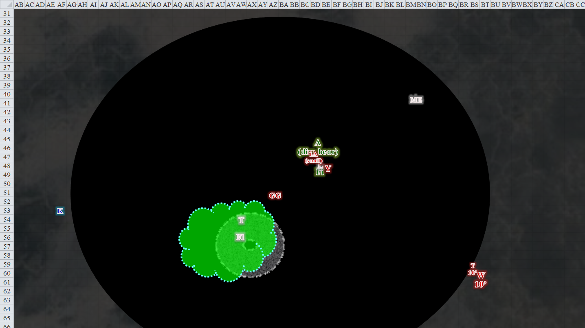

Round 11

Whisper and Typhoid made their way over.

Lady Asunder tried to escape, but her snail foot was not getting her very far. It would take her another minute or so to reach the ground from where she was on her breastplate.

The druid transformed into a dire bear, and attacked Yurm with her claws, grappling the man. In her rush to do so, she stepped on Lady Asunder and her armor, leaving no trace of the snail.

|  |  |  |  |  |  |  |
| --- | --- | --- | --- | --- | --- | --- |
| **Character** | **Attack Type** | **Crit** | **BAB** | **Mod+** | **Roll** | **Total** |
| Allisa (dire wooden bear) | Touch Attack | 20 | 9 | 10 | 10 | 29 |
| Allisa (dire wooden bear) | Grapple | 20 | 9 | 14 | 9 | 32 |
| Yurm the Sprinter | Grapple | 20 | 14 | 0 | 10 | 24 |

*Grapple is successful.*

Yurm the Sprinter tried to get out of the dire wooden bear’s grapple, but could not.

Fingers moved on to the Yurm the Sprinter, who didn’t seem able to see the *invisible* trapsmith, and who was being grappled by his druid-turned-bear friend.

|  |  |  |  |  |  |  |  |  |  |  |
| --- | --- | --- | --- | --- | --- | --- | --- | --- | --- | --- |
| **Melee Weapon** | **Dmg** | **D+** | **TH+** | **Critical** | **Type** | **Wt.** | **Atk** | **Roll** | **Check** | **Notes** |
| Keen Deadly Precision Short Sword | 1d6 | 1 | 1 | 17-20, x2 | Piercing | 2.0 | +14 | 16 | 30 | +5d6 Sneak Attack |
| Short Sword, 2nd Attack | 1d6 | 1 | 1 | 17-20, x2 | Piercing | - | +9 | 3 | 12 | Weapon Finesse |
| Crystal of Acid Assault, Lesser | - | 1d6 | - | - | - | - | - | - | - |  |

*Hit, miss. Dmg: 3 + 4 + 13 + 4 acid = 24.*

Grim Gerome cast *silence* on Kedrik.

|  |  |  |  |  |  |  |  |
| --- | --- | --- | --- | --- | --- | --- | --- |
| **Save vs.**  *silence* | **Rank** | **Ability & Mod.** | **Misc. Mods.** | **Total** | **Roll** | **Check** | **Notes** |
| **Kedrik, Will** | **8** | **Wis (+2)** | 3 | 13 | 18 | 31 | +2 vs. Enchantment & Illusions |

*Success.*

Kedrik smiled as he came a little closer, and spat aloud before casting *hold person* once again on Grim Gerome again.

|  |  |  |  |  |
| --- | --- | --- | --- | --- |
| **Character** | **Save vs.**  *hold person* | **Ranks** | **Roll** | **Save** |
| Grim Gerome | Will | 9 | 5 | 14 |

*Fail.*

Grim Gerome remained in place, a look of frustration fixed onto his mug.

Whisper and Typhoid reached the epicenter of the battle, and the shade smiled as he flew towards Allisa, and charge attacked the dire bear with his flail, aiming for the top of the bear’s head.

|  |  |  |  |  |  |  |  |  |  |  |
| --- | --- | --- | --- | --- | --- | --- | --- | --- | --- | --- |
| **Melee Weapon** | **Dmg** | **+ Mod** | **TH+** | **Critical** | **Type** | **Wt.** | **Atk** | **Roll** | **Check** | **Properties** |
| Unholy Heavy Flail +3 | 1d10 | + 2d6 evil + 3 +5 | 2 | 19-20, x2 | Bludgeon | 10.0 | +18 | 5 | 23 | +2 damage in darkness |
| Flail, *haste* | 1d10 | + 2d6 evil + 3 +5 | 2 | 19-20, x2 | Bludgeon |  | +18 | 12 | 30 | +2 damage in darkness |

*Hit, hit. Dmg: (1 + 6 evil + 3 + 5) + (8 + 4 evil + 3 + 5) = 9 + 16 + 10 evil = 35 [24/72].*

Typhoid tried to poison the bear.

|  |  |  |  |  |  |  |  |  |  |  |
| --- | --- | --- | --- | --- | --- | --- | --- | --- | --- | --- |
| **Character** | **Attack Type** | **Damage** | **Crit** | **BAB** | **Mod+** | **W+** | **Other+** | **Roll** | **Total** | **Threat** |
| Typhoid | Claw 1 | 1d8+1+6+poison | 20 | 7 | 6 | 1 | 0 | 8 | 22 | ☒ |

*Hit. Dmg: 5 + 1 + 6 = 12 + poison [12/72].*

|  |  |  |  |  |  |  |
| --- | --- | --- | --- | --- | --- | --- |
| **Save vs.**  **Poison** | **Rank** | **Ability & Mod.** | **Misc. Mods.** | **Total** | **Roll** | **Check** |
| **Allisa, Fortitude** | **10** | **Con (+2)** | 0 | 12 | 6 | 18 |

*Success. No initial poison damage.*

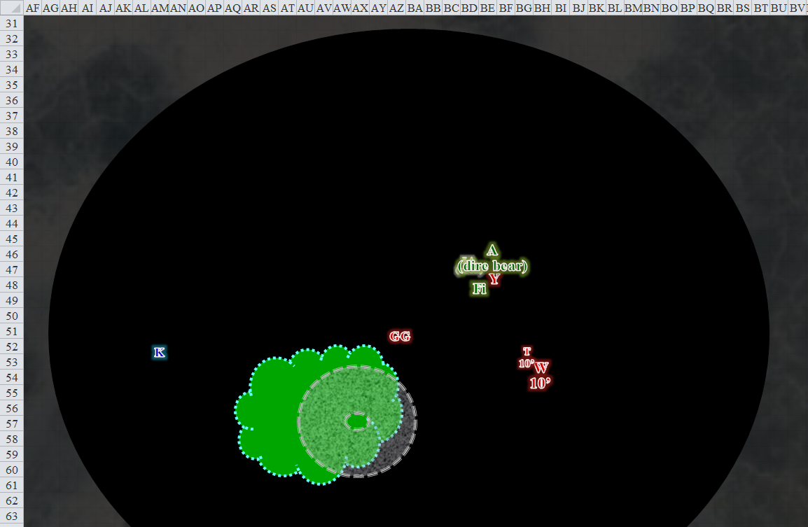

Round 12

The bear cast *heat metal [expired on Round 19]* on Yurm, then *[I presume]* let go of the human.

Then, without any prior warning or further resolution, the Rumors disappeared from view, and the bodies of the living rose up from the lunar landscape of these salt flats and looked down upon a dwindling panorama, barren at first, then green and lush all around them as the horizon revealed more and more of the land that now began to seem spherical, not overall flat.

*See PowerPoint slideshow*