*Chapter 53*

Morning, 21 Deepwinter, 1376

Allisa sighed as if having recently dreamt, though she remembered nothing. She was alone in the bed, but heard quite the commotion downstairs, including her lover’s laughter, which must have woken her up just now.

Kedrik was telling a series of related jokes at the single, rectangular table, and as the druid came down after a brief washing of her face and mouth, the gnome turned to the last of the Gambit to rise and bade her a pleasant start to their day.

Lauren approached with a bowl of cut pears, and Rhianna and Shamesh both appeared from the kitchen.

Allisa smiled at the innkeepers’ daughter greeting her and ruffling her hair as she walked by. She hoped to have a daughter of her own someday.

The druid then greeted the others as she took the offered fruit and then kissed her mate. Her attire consisted of a thread bare shirt which hung down to mid-thigh. It was one of the only things she had left that was Zond’s. Her bare feet made soft pitter-patter sounds as she walked.

“More fruits for the heroes then?” asked Rhianna.

A few yesses were enough to summon the next bowl, which came filled with cut kiwis and dragonfruits.

The innkeepers’ daughter, Rhian-Sabeen, was already seated atop a chair too big for her, and shyly studied the intrepid adventurers from head to toe.

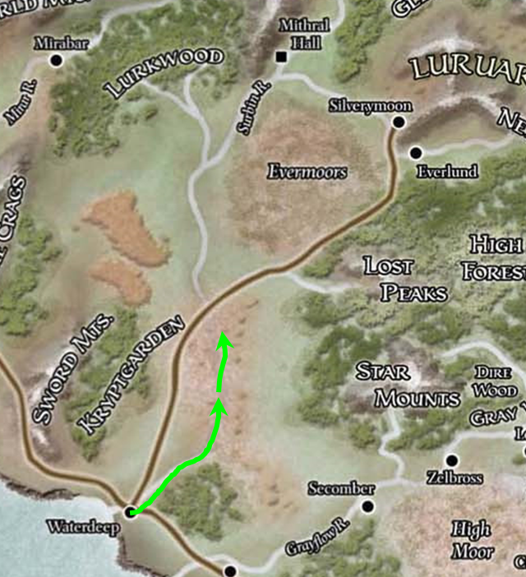

They talked for a few minutes about their day’s itinerary, and the whisper gnome passed the map around to everyone so they could have a good look before committing to any route. They had traced their trajectory thus far with green arrows, and now contemplated their best use of daylight, which was already upon them.

“So we can be in Triboar in an hour, pick up some supplies for the day if we need to, and reach Longsaddle by nightfall,” Fingers estimated, Kedrik nodding beside him.

Lauren asked, “So just to confirm, we’re taking the same route we’d agreed on yesterday?”

“Pretty much,” Allisa remembered the conversation and the lines proposed across the map. “Following the road all the way to the end of the line.”

Samara seemed pensive, but was glad to be along with the others, seeing what it was like to live as one of them.

Once the conversation wound down, and the second fruit bowl was emptied into the heroes’ bellies, the Gambit gathered their belongings, paid and tipped the innkeepers, and expressed their genuine appreciation for the kind and simple hospitality. One by one, they shuffled outside, and Lauren and Fingers began to produce the carpet from the drow’s haversack.

“There,” Lauren grunted as the carpet unfurled and floated a foot above the packed earth that comprised this part of the road.

“Hop on,” Fingers said once he’d sat at the helm and stabilized the craft. “I vote we get some snow gear when we get to Triboar.” While its Enduring Amulet would protect Fingers from any extremes of cold the Gambit was likely to encounter, almost certainly at least some of the others currently had no such recourse without resorting to spells that might be better utilized elsewhere.

They all situated themselves—Tali at the rear with her bow drawn—and took off, reaching an altitude of 40’ to 50’ depending on the height of the trees. Soon, the roadside inn was out of sight, and the snow-capped treetops in the distant horizon were upon them.

Then, one by one, in the silence of the brisk and windy voyage across the sky and with the warm light of the rising sun on their right cheeks (and Tali’s left cheek as she faced south), they began to recollect fragments of a dream... of some conflict.

Of some... scuffle they had with the Rumors.

Oh, dear gods!

This had happened to the Gambit before: shortly after the murder of Ct. Bergère in 1374. The villains that had slain the Count—the only culprits who ever escaped the Gambit’s justice—had somehow colluded with a greater power and infiltrated the dreams of the members of the Gambit at the time.

Allisa had just told part of the dream to Lauren, who then pieced together other fragments, and by the time their suspicions were voiced, Fingers had stopped the carpet and lowered it down to just a few feet above the roadside.

They all remembered now, no individual completely, but among them, just about every detail had been retained.

“Even their blasted quasit was there,” Kedrik murmured, being particularly intolerant of inherently chaotic evil beings. The archivist reached for, grabbed, opened, and consulted one of the many notebooks he kept in a section of his haversack.

“And who was that dashing swashbuckler?” Allisa asked. “I think I killed him... or he killed me.”

Lauren raised an eyebrow at the druid. “Lady Asunder killed us both, I think. What a combatant! We’ll need to prepare if we are to face them in real life again.”

Flint and Tali remembered the searing pain of being doused in acid while also being sliced by blades, and shuddered at the recollection.

Fingers quailed inwardly as the memories of the quasi-battle returned. Should that dream scenario had been real, it seemed likely the outcome would have been lethal once one of the enemy was able to pierce its shield of *invisibility*. The changeling made a mental note to concentrate on any such enemies for whom it seemed reasonable to suspect might have such an ability before they had a chance to use it.

Kedrik put the open notebook down for a moment. “The Vilemother,” he then said, cross-referencing this moniker in Grim Gerome’s greatest hits. “She is largely a mystery; we have no documentation of her physical existence at any point in recorded history, and yet she is mentioned in several texts written in our own city, and elsewhere along the Sword Coast.

Lauren and Fingers, who were also savvy in the way of local history, both expressed a similar hypothesis. The drow said, “There are cases of changed names, adopted names, and honorary titles that are handed down from individual to individual, and the personal names are usually lost to posterity.”

“Yes, it could be several individuals with the same ability to influence others via their dreams,” Fingers said.

Flint—ever out of the box—proposed, “We should prepare to engage such an oneiromancer—I believe that’s what such a being is called—on her own turf, and on our terms. I leave the fine details of that to you, Kedrik, but I’d be honored to be your assistant in that research.”

The archivist and the factotum had a plethora of common interests, and had engaged in quite a bit of conversation the day before on a variety of topics. Kedrik responded, “I don’t have much literature on this topic right now, but Longsaddle has an adequate library. Let’s plan to spend as much time as we can there tonight if we get there early enough; otherwise, maybe in the morning.”

Fingers pondered thoughtfully, “What concerns me is how this creature was able to target us with such a power. Was she able to do so regardless of where we might be or was there some minion of hers who has been dogging or steps somehow and reporting back our location? Neither is a particularly pleasant possibility, but the latter would be much moreso as it would leave us open to more mundane methods of attack in the night as well.”

Samara looked like she wanted to say something for once, but it was really just the beginning of a yawn. With her yawn came a stretch, and every snake protruding from her head also straightened its spine and opened its mouth at an obtuse angle before returning to their coiled state as the woman cracked her knuckles a bit.

As the recounting of the dream went on, Lauren took Allisa’s hand in hers. The druid could feel her trembling slightly, and Lauren spoke in short sentences, volunteering little about her part in the dream.

After that conversation was done, the duskblade still sat close to Allisa, though she said little while the others conversed.

~*~

Late Morning

They had flown for more than an hour under an expansive snow cloud, and most of the gang now shivered as the weather let up a bit. Still overcast, the day proved to be no more hospitable than yesterday.

Having just passed a few ranches off the main road, the party was now arriving at Triboar. They were quite a few hundred feet up now, trying to get a good sense of the town before venturing in. With Highsun approaching, it was as bustling a village as it ever could be, and Samara counted about a dozen souls making their way to and fro, and a lone farmer tending to his field.

[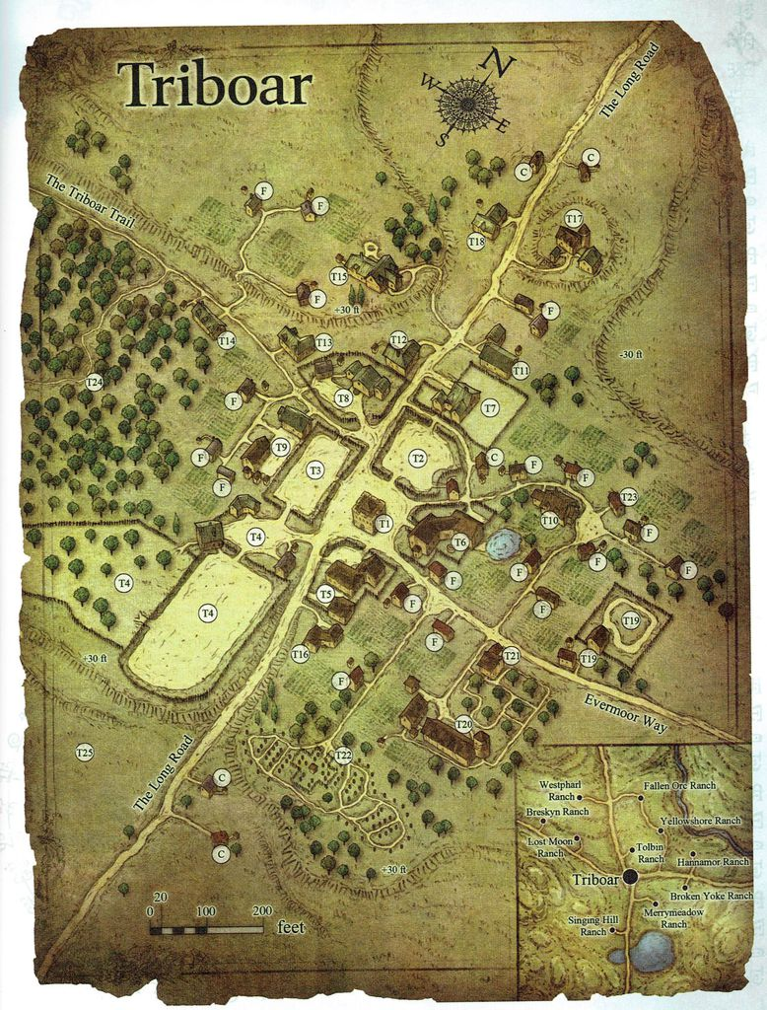](https://boardgamegeek.com/image/3304264)

“How quaint!” one of them said, anticipating more of that downhome warmth they’d received the night before.

It had recently snowed, and though the road was merely damp, most of the ground and treetops were coated in a thin, white layer of snowflakes. Most of the structures were clearly residences, though one or two appeared to be shops. “Where should we drop down?” Fingers asked the group, noting a stone tower in the center of the town.

Lauren pointed to a spot a quarter-mile east of town on the road. “How about there?”

Fingers paused briefly in case anyone objected to the voiced suggestion of once again landing outside of the town and, assuming not, sent the carpet floating downward with a mental command.

Upon arriving, the party would find, as expected, that the shops here had very limited wares. Though food, lodging, and livestock were sold at roughly the same prices as back home, all else was noticeably more rare and valuable. Every experienced adventurer would anticipate finding few to no useful magic items, but then, they weren’t here for a shopping spree, and had had ample opportunity back in Waterdeep to score whatever last-minute specialty items they thought were necessary.

For now, the party set down just under a quarter-mile—something like 7/32nds of a mile—and rolled up their flying contraption, looking around them. A single house could be seen to their west, but they knew that dozens more lay beyond. It was a farmhouse built in the style of the local humans, who were reputed to be as hospitable as the folks who’d lodged them up last night.

“Should we see about lunch?” Kedrik asked, realizing towards the end of his question that he’d spoken over something Samara had just said. “Sorry, what?” he then asked her to repeat.

“Oh... is nothing,” she and her snakes closed their eyes in unison as she shook her head twice and added, “Just prayers.”

Allisa stepped off the carpet and moved a few feet away then others and did several warm up stretches. She was a bit chilly from the wind and lack of activity. “I wonder how the other half of our team is doing back home?”

Fingers paused briefly from its task of rolling up the carpet for storage and mused, “Hopefully Sarge has managed not to blow up anything.”

“Well, I—for one—won’t waste any time in getting to this village,” Kedrik announced, his hunger getting the best of him. With a stride comparable to that of an elf, the whisper gnome headed west, making way for the 20’ tall cliffs that separated the central farmsteads from the larger, more peripheral field where they’d just landed.

Though the field they were presently on was left fallow this year, they could tell by the scent that the terrain ahead was used to grow hops and sage, among less aromatic crops.

Allisa gave Lauren a quick kiss before changing into the largest eagle breed. She flew high into the sky and used her bird’s sight to scan the area around the party. The druid had begun feeling more at home in animal form.

As the party walked, the druid flew above them at an altitude of about 50’. They were about 1000’ east of the center of town. As Fingers caught up to Kedrik, Lauren spoke with Tali and Samara with Flint. The only topic of conversation at the moment was that 30’ cliff they were about to scale.

“No, we don’t have to climb it,” Flint pointed out a hand-carved stairway that led up the steep façade of the east-facing slope.

Kedrik noted that the lone farmer standing outside his house was casting a divine spell that kept his hops from freezing during Deepwinter and the other cold months that followed.

This was not an unusual practice in independent townships such as these, which were usually led by a parishioner of some deity of resilience or fertility.

The resident of the town was a druid, not a cleric, and Allisa’s eagle eye registered enough visual cues as she watched the spellcaster to know this with certainty, though, of course, that didn’t preclude the man from having some experience as a cleric as well; Flint and Kedrik might be better judges of that.

“Greetings, strangers,” the hamlet-dwelling druid nodded to the adventurers as they passed by. He’d no doubt seen them land, and if he had the means, had most likely cast other spells unrelated to his hops by now, perhaps *know alignment* or *detect evil*. That’s what Kedrik would have done.

Some among the party of travelers noted the sign on the side of his house, identifying him as an apothecary.

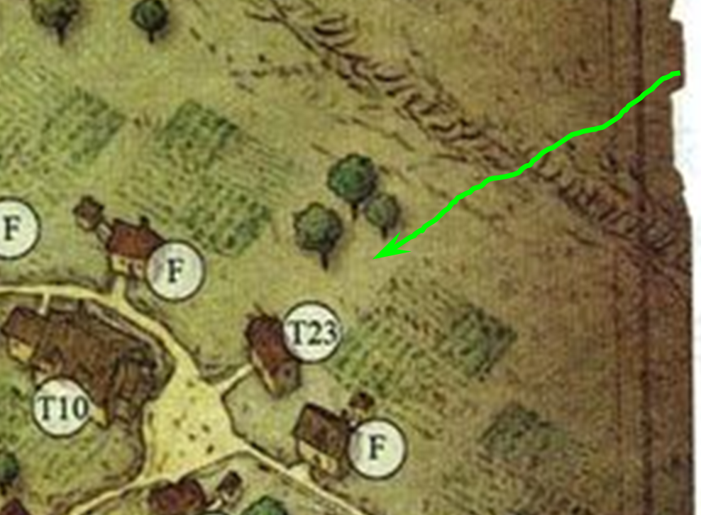

The druid neither invited them onto his plot nor shooed them away, but merely took them to be heading for exactly where they were heading: the miniscule town center that still lay a few hundred feet westward. “Welcome to Triboar,” he smiled with a placid calmness about him.

Allisa remained aloft as the resident looked up and smiled at her as well, squinting under the noonday sun.

Lauren nodded respectfully, but she didn’t speak to the druid. She kept an eye on Allisa, marveling at her wife’s ability to change into creatures at will. The thought occurred to her that she could use a spell to change herself into the same sort of animal, and accompany Allisa.

Fingers said nothing but returned the fellow’s greeting with a nod and noncommittal smile, then casually scanned the surrounding area in case the man was trying to draw their attention away from ambushers—unlikely, but old habits were hard to break.

They eventually made it to the walkway they’d all seen while descending, and then took said walkway towards the singular tower at the crossroads of all the trails, roads, and walkways here.

A half-dozen kids ran past them as the party approached the tower, around which was a market square with three vendors visible, and probably a fourth stationed beyond the far side of the tower.

Everyone they’d seen so far was human—adults and kids alike—and rather provincial looking. Two apparent brothers who couldn’t have been twins bore similarly inbred-looking jawlines and frontal bones. The children giggled at the two young adult boys as they headed south to play in some field or puddle.

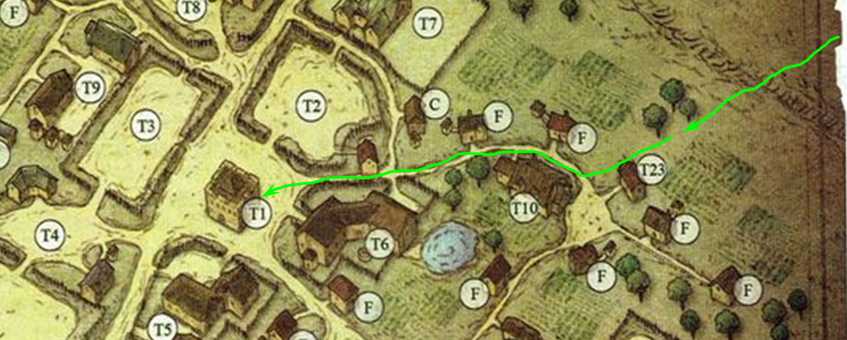

Allisa continued to scan the town, which must have had 20 to 25 adults walking to and fro at any given time, making their way from structure to structure in the brisk midday sun.

As Fingers has no need of cold-weather gear because of his amulet, it resolved to grab a light lunch while schmoozing with the locals about news—especially from the north—as well as any notable travelers who passed thru recently—again, especially those headed northward. Timewise, Fingers will leave that up to others in need of gearing up for the trip ahead.

Lauren looked at Allisa. “I think we should find a place to eat.”

~*~

Lauren and Allisa stared longingly into one another’s eyes, their charismatic mugs being part of the object of one another’s affection. Drinks were on their way, and some of the others were hanging around outside the Talking Troll, a tavern named after an actual troll who was slain nearby before the founding of this hamlet. It was a quaint story, no doubt embellished, that had already been told to them twice while on their search for this tavern.

Kedrik walked in, sitting and ordering, “Just a spot of water for the moment, please.”

The human barmaid looked the gnome up and down and smiled, tilting her head, “Comin’ up.”

Kedrik announced, “Some of the others have gone to the Foehammer’s Forge. Apparently, it’s what keeps this town on the map.”

“Oh?” the duskblade was intrigued, leaning forward and putting her elbows on the table as she took an interest.

“Yes,” Kedrik pushed his chair closer to the table and explained, “the smithy’s a retired adventurer from Cormyr.”

Allisa then fondly remembered Zond, a Cormyrean noble.

Lauren intuited this, and nodded to Kedrik, “World famous for their ironworks. We should visit as well before we go.”

By the time the water had come Kedrik’s way, some of the lunchtime crowd had come and gathered at their usual tables; all but the two whose usual table had been claimed by the three Waterdhavians. The two merely paused, looked at one another, and took another table in a dark, inconvenient corner, and nodded at the barkeep.

Allisa smiled deviously as her unbooted foot touched Lauren’s leg just above her boot then slowly inched up the woman’s thigh. Her toes barely touched that cherished spot at the junction of both thighs, so she settled for just resting her foot on the chair.

Her eyes focused after a moment after her love’s question. “That would be fine. I also need to get a fur coat; mine is not the only best for this weather.” The druid slipped her hand across the table to rest on Lauren’s.

Lauren smiled as Allisa played the now-familiar game. She captured her lover’s hand in her own and listened as she spoke. Before she could answer, the server arrived with their meals. “Ah, we eat first, and then see to the clothing.”

~*~

“Yes, I do have something like that, and in any case, I can alter items to suit your frame for maximum comfort... so comfortable you could sleep in it and not wake up fatigued,” boasted Vernon, the Cormyrean ironsmith whose renown spanned every small town along the northern Sword Coast.

Cormyr. Lauren had never before considered traveling that far from her home, especially with all of the responsibilities the Gambit had taken upon themselves. She took a drink of her ale, and carefully set the mug on the table. She closed her eyes for a moment, savoring Allisa’s presence next to her, even to the playful way the druid would set her foot on top of Lauren’s boot. The duskblade knew well that death stalked everyone until they finally succumbed, but she had seen all too much of it, and not just for herself. The death that had most damaged her determination to fight on was Swansong’s, a young woman much like Allisa had once been. The thought of losing Allisa while she herself lived on was becoming harder to bear as the days went by. She took a breath and rejoined the conversation.

“Allisa, would you like to see the ironworks?”

~*~

The druid, the duskblade, and the archivist had paid for their ales and water, and were now making their way along one of the few dirt roads in this little village.

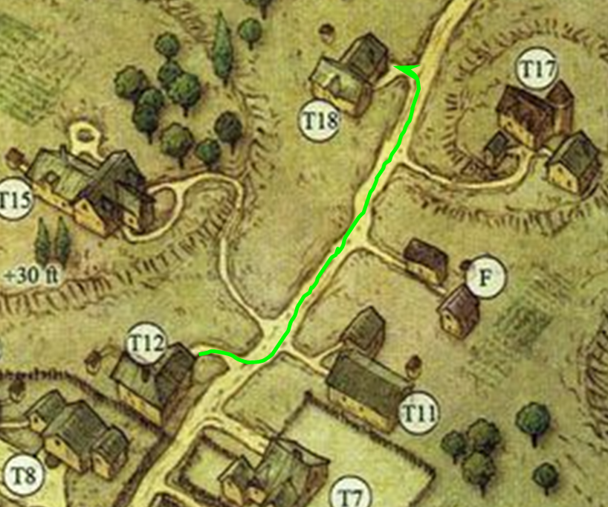

Ahead of them and on the left was the well renowned Foehammer’s Forge, and beyond it, the lonely road to Longsaddle. They turned in and found their mates all outfitted for winter.

Fingers was the exception. Showing off his amulet to the others, he grinned as he dressed for weather reminiscent of Athkatla in mid-Flamerule.

“To be honest, when I bought this bauble, it was just for an extra layer of protection in case I wasn’t quick enough to dodge out of the way of a fireball or the like. However, it’s turning out to paying for itself by avoiding wrapping myself up in those bulky furs. I did get a pair of these tho, in case we encounter deep snow.” The changeling indicated a set of snowshoes lashed to its backpack, ready in case they’d be needed.

Samara and her head snakes eyed the ring with curiosity, then the medusa turned to Vernon to ask, “Where I could find one of these rings?”

Vernon smiled and giggled, “We-el, he he he, you could turn back south and head back to Waterdee-ee-ee-paha hahaha!”

The others laughed too, not just at the fact that it was true, but at how the fact that they were out in a desolate and wilderness-surrounded hamlet hadn’t really sunk in fully. It was one thing to be aware of where one was; it was another to be aware of where one wasn’t.

The selection of weapons and armor here varied somewhat from the style they’d all grown accustomed to on the coast. There were all manner of feral weapons that looked like they were made with intentions of psychological warfare. Sabretooth cat skulls were affixed to axe handles, and above the main counter was mounted a befabled sugliin: not a replica, but the real deal!

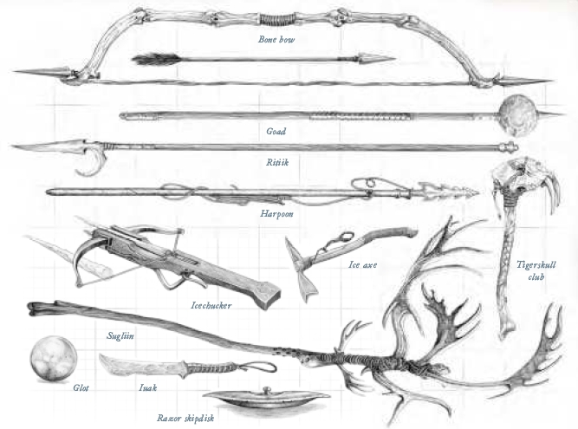

“Well, look at *you*!” Kedrik paraded Tali and Samara as the two women sported their conflict-free owlbear fur coats.

Samara had been conferring with Kedrik, and after talking, they’d both ended up being outfitted identically. The gnome got a cold weather outfit and fur layers over that to match the medusa, and then they each got a fanciful pair of snowshoes to match their furs, snakes, and hair. “What a nice ensemble!” the medusa complimented the garments that Vernon easily adapted to their existing suits of armor.

Lauren took Allisa’s hand and looked to Vernon. “Do you have something similar for us?”

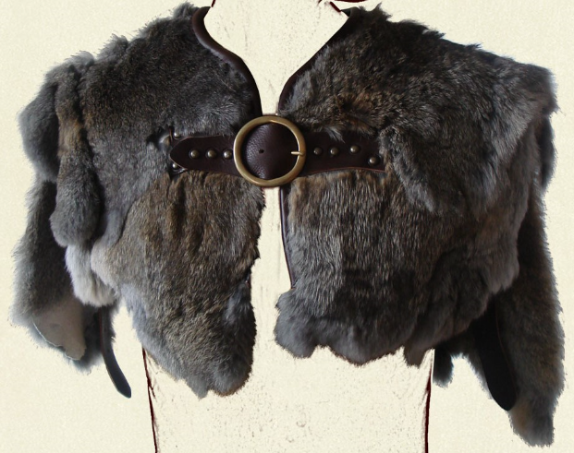

“By all means,” Vernon instructed his son, Lil’ Vern, to help the half-drow with her measurements and color preferences.

The gnome then took a look at the armorer’s weapons, seeing nothing that struck his fancy. Asking about alchemical items and other goods, he was directed to the Lion’s Share, where he led the Gambit on their last run before heading off to Longsaddle.

Allisa looked through the winter waste hopping to find something in a coyote or wolf fur, preferable in white and gray. She held up this and that to herself to serve what it might look like on her and if Lauren approved. She was lucky to come across a pair of women’s leggings made from rabbit fur. This she had to have to surprise her wife with when they got to an inn.

~*~

At the Lion’s Share, Kedrik was quick to acquire 12 flasks of Armor Insulation—that was 1 flask for everyone for 2 days, which should be enough. With their new outfits, they should be able to stave off all but the worst of the elements, and for the worst, there were the flasks. The gnome asked for everyone’s patience while Leon—the owner—showed him how to apply one of the 2-pound doses to his own armor. “Better to test it now, and if it’s better than expected, maybe pick up more in Longsaddle,” he said to the others as they all bought their respective things.

~*~

The Gambit was now well fed, equipped, and ready to undertake the more arduous journey into the northlands as they got ever farther from Waterdeep’s mild winters and came to embrace the fact that all around them would soon be encased in ice or snow.

Samara, Lauren, and Kedrik were marveling at the design in the stitching of their clothing, and the way that their wilderness tailors had managed to be so thorough and quick. “They said if we come back and give them a day, they can outfit all of our armor with a Restful Crystal,” Lauren mentioned.

“Well, not all of us would need one of those, but,” Kedrik reminded everyone, “it’s good to know that we can maybe spend a night or two here on our way back, and upgrade our armor so we can be that much more ready for an ambush out in the field.”

The druid browsed the scrolls and potions and finally came to a decision. She should take; 1 *barkskin* scroll, 1 *bull’s strength* scroll, 1 *shield of faith* potion, and 1 *cat’s grace* scroll, for about 820 gold *[remember the markup]*.

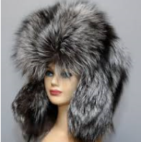

Samara calmed her serpents down before putting the puffy, gray, bugbear fur ushanka on her head. “Ready,” she simply said.

They unfurled the carpet; Fingers hopped aboard and steadied it before the others stepped onto its flat surface, which had the consistency of a soft bed. A few children waved goodbye, and Destiny’s Gambit continued on their mission, on a trajectory that at this moment took them north-northeast but would ultimately wind northwest if they stayed true to the road.

~*~

Their flight was far less than eventful, though a bard would have found much beauty in the scenery to write about. The three blizzards they braved through, the snow-capped treetops that overwhelmed the eye as they made headway north at an average of about 200’ every six seconds. Every half-hour or so, they stopped to rid their clothing and the carpet of the layer of snow and icicles that had accumulated, but all in all—particularly for Fingers and Kedrik, who were completely insulated from the elements—it was a fun time to be had. The worst of the cold, however, was yet to come, and as they descended upon the few lights already stoked in the township of Longsaddle, they squinted at the last sliver of sunlight in the western horizon as the sun peeked between the blanket of clouds above them and the craggy peaks of the Starmetal Hills.

The road had turned sharply westward near where the Ne’erwin’er River ran through the town. Kedrik was the first to notice the positioning of the larger lights, which were focused outside the city fortifications.

“Right on time,” Samara had been anticipating the arrival to their day’s destination. It hadn’t been a particularly harrowing day, but she and some of the others could certainly have used a respite from the incessant cold. Even bundled up, there were certain parts of their bodies—their knuckles and faces, mostly—that just needed to be in front of a crackling fire for a few hours.

Lauren huddled close to Allisa for physical warmth and emotional support. “I want hot food, and to sit in front of a fire, preferably at the same time.”

“Sounds good to me, among others things. Do you think they will have a room with its own fireplace,” the druid said.

“They may,” Lauren allowed. She leaned her face close to Allisa’s. “I would ask why, but I know how your mind works.” She giggled, and then sobered as a thought came to her. “What would you think if I were to transform into an animal like you can do? Maybe we could be a pair of wolves for a little while.”

“That would be an interesting adventure not sure what we would do. Maybe find a Couple of males to double date with.” She whispered. “Sex in animal form is something to experience.”

“Yes, it would.” Laruen smiled at her spouse and, wrapping an arm around her, hugged her as best she could through their thick clothing.

Fingers suppressed a smile as it overheard the byplay of the pair. It was nice to know that at least some of the other members of the Gambit realized that true physical intimacy was only possible when one is not locked with their partner into just a single form.

Then a horn sounded within the city. Kedrik looked over at Fingers, who now squinted its eyes and tilted its head as the carpet descended at about 1’ per second. The changeling and the gnome then looked upon one another and frowned as the changeling intuitively slowed down the craft.

Archers and grenadiers had assembled along the eastern wall, which was a semicircle of gray stone separating the peasants’ dwellings from the abodes of the well-guarded gentry and the nobility. A magically loud warning was issued, “Approach no more by air. Land your craft and show your hands! This is your only warning!”

Everyone on the carpet was silent now, and Fingers estimated the number of arrows pointed at them to be in the hundreds by now. To assemble this many soldiers so quickly meant that either had spotted the Gambit long before their arrival—possibly via a bird familiar or an *arcane eye*—or they were already prepared for an attack from some other enemy approaching from this direction, if not all directions.

Lauren surmised that a town this size could barely muster this many archers without outside reinforcements. Many of these must have been knaves; still, she trusted Fingers’ judgment as the craft descended vertically, landing about 1000’ from the easternmost gate, which hadn’t been on the map that Kedrik had looked at while in Triboar. This gate and the wooden palisades all along the outer edge of the town confines were all brand new, and as they took a measure of what lay before them, they could tell by the color of the wood under the setting sun that this town had been very busy lately tending to its defenses.

They rolled up their carpet and patted the snow and frost off of their pelts and gear.

The red and black flags ensconced along both sides of the gate meant trouble. They were on high alert, and the group knew that as many archers as there were visible, there were probably others mobilizing to defend themselves against any threat.

The party walked westward along the winding road. Beyond the 12’ gate were rooftops barely taller than the gate and palisades, and further still was an obelisk—perhaps 50’ high—that had to have been crafted by multiple *stone shape* spells. Not a ship or boat was visible along the river as they looked both northwest and southwest.

They were now about 600’ from the gate, and saw a half-dozen wagons pulled to the sides of the road near the gate. The warriors in the group could tell that these had been arranged with tactical intentions, and it was safe to assume that each of the six wagons, carts, and other wheeled infrastructure had someone hiding behind it, waiting to strike at them if they should present any threat.

“What is your business here?” the same cacophonous voice called at them from above.

It was clear that the hospitality they’d come to expect in Triboar and elsewhere along their journey was not to be had here. Whatever the reason for this town’s unusually defensive state, their answer would likely determine the outcome of the night’s events.

“Let us go elsewhere,” Lauren said quietly. “I have no wish to be detained by these people.”

“It seems unlikely we could reach anywhere else tonight and, in any case, we’d be traveling by night to get there,” replied Fingers. Raising its voice to all out to the defenders, “We are merely travelers seeking shelter at an inn for the night and some re-provisioning in the morning. Is there a threat we should be aware of?”

Alissa whispered so those around her could hear “Wish Maiko were here she could talk us into the city with ease.” The druid then called out, “We are from Waterdeep and have traveled far this day in the cold and damp. We wish for a warm meal and soft bed to sleep in. We come as friends.”

Samara started to notice the heights and stances of some of the archers. This town—Kedrik had mentioned—was a predominantly human settlement, the remembered. But as she took a measure of the archers, she noted that many of them had to be women—something of a rarity in rural human settlements—and some were notably pregnant, unless they were smuggling cannonballs, which had not yet been invented. In addition, there couldn’t be that many archers of elven descent hailing from such a town, so if they 4’ to 5’ tall archers were elves, they were from elsewhere, and if not, they were adolescent humans. These were not militarily trained troops; they were knaves with bows and half-filled quivers that would barely be able to upset the Gambit with their feeble barrage that even with their height advantage, probably could only reach a little further than the town gates.

Kedrik also noted and reckoned most of what Samara had caught, but his thoughts were on the handful of ballistae that *did* seem to be manned by competent grenadiers. Regardless of how many debutantes were among the archers, a few *were* holding their bows and nocking their arrows in the proper position. An engagement with townsfolk was never a welcome scenario for the lawful good gnome, and this particular one was definitely one he wished to avoid.

“I say, good sirs and mesdames,” Kedrik said after clearing his throat, “My associates and I are of honorable dispositions. Our collective appellation is the Destiny’s Gambit... perhaps you’ve heard of our exploits in Waterdeep.”

After a few seconds of silence, the voice above, which Kedrik now identified as a modified *ghost sound* spell, replied, “Mhm, yes, some of us have heard tell of your bravery against the sea creatures that the Umberlites unleashed upon the coastal cities.”

“We only dealt with those in Waterdeep...” Kedrik humbly stated. “But yes, that was an eventful night.”

Silence prevailed again, and the twin, wooden gates opened. A paladin type came out dressed only in armor, with not a single fur accessory on her. Sword sheathed and shield shouldered, she was followed by four heralds armed with pikes and dressed as warmly as the Gambit, an lastly, out came a bald, fur-robed gnome. The six representatives of the town met the Gambit at 300’ from the gates, and the gnome diviner did his thing. Discerning the alignment of the foreigners, and possibly other things about them, he nodded to the paladin, who removed her helm, revealing a stunning specimen of the human line.

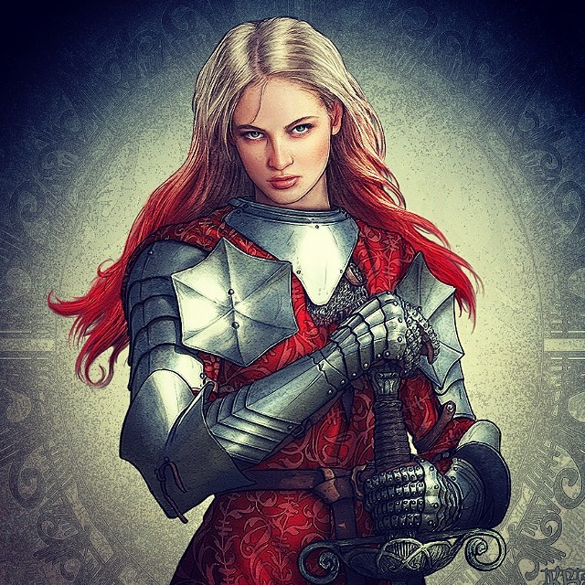

“Greetings!” the woman said, locks of blonde and crimson hair flowing down her shoulders. “On behalf of the township of Longsaddle, I welcome you.” The paladin bore the crest of Selûne, and Kedrik also recognized several other accoutrements and mismatches indicative of a paladin of freedom. While these chaotic freedom fighters were a less palatable variety to Kedrik than the more common, standard paladins, he looked forward to getting to know the woman, and was instantly charmed by her unadulterated and pure personage.

They continued their approach towards the newly crafted gates of the town of Longsaddle, and noted the siege engineers leaving their posts as commanded by their helmeted superiors. Most of the archers remained aloft, but no longer pointed their weapons and arrows at those approaching. It was more of a lingering curiosity that kept them up on their ledges for the moment.

Lauren took Allisa’s hand and stepped forward. “I am Lauren, wife of Allisa.” She turned to indicate her wife with her free hand and a slight smile.

“Kedrik, at your service,” the gnome bowed his head, then returned eye contact with the human’s breasts.

The druid smiled as she was introduced and responded with, “It is an honor to meet you.” As she removed her hood letting several stray ruby hairs blow with the wind.

She squeezed Lauren’s hand sensing a bit of jealousy. She could see why her mate might feel that why as her own thoughts drifted toward running her fingers through that hair. She blushed. “I look forward to chatting with you if time permits.”

After the Gambit introduced themselves, she proclaimed, “I am Faith Graystone, Constable of this township and a servant of Selûne. I bid you all well.”

The pikemen all introduced themselves too, but the strangers to the town could only remember one of them: Seylar. The name was far too reminiscent of the anomalous sorcerer the Gambit had had to vanquish just months ago. The man seemed completely oblivious to the fact that his name had roused such surprise in the newcomers, as news of Sylar never really got out—thank goodness—and the name meant nothing to anyone outside the Waterdeep Chapter of the Gray Hands.

“I am known as Phynias Feyson to those outside of my clan,” Fingers said with a nod of greeting, surmising that its usual appellation of ‘Fingers’ might raise questions it would just as soon not be asked. “Tell me, do you greet all travelers this way or has there been recent trouble in the area we might need to be alerted to?”

The name sounded familiar to Faith, and then she recalled a cartographer she once knew, whose contributions to the so-called Dragon Gazeteer were tantamount to some of the most accurate along the Sword Coast. Kedrik knew this too, and smiled.

“Your namesake is an inspiration to those who would tame these lands, and render them holy and free,” the paladin of freedom proclaimed as they got to about 100’ of the gates.

Allisa mumbled something about striking a balance, but Lauren’s grip on her lover’s hand led to the two half-elves rubbing the sides of their foreheads like lovebirds perched atop their favorite branch, overlooking the sunset.

As the four pikemen trotted in formation toward the gates and joined another six halberd-toting guys and gals, the eyes of dozens at first, then hundreds, of townsfolk gazed upon the heroes. Their clothing revealed peasantry and gentry intermingled—something out of place to Waterdhavian eyes—and they were making a much bigger fuss of the Gambit’s arrival than had been expected.

And then came the bad news.

Faith began to explain that the town had been besieged by marauding bands of trolls from the north.

“Trolls?” asked Samara, not quite having heard right.

“Yes,” Faith said. “We suffered heavy casualties on the first night, when we weren’t prepared at all. Last night we counted at least a dozen fleeing after taking six of ours. I can only imagine they’re eating our people. Tonight will be the fourth night, and we have no reason to believe this dirty dozen won’t return.”

“What kind of trolls?”

“Ice trolls *[Unapproachable East]* call the shots, but they keep mountain trolls *[MM III]* as pets and rammers,” the paladin proclaimed. “We know of two mountain trolls still alive out there.”

“How many have you slain?”

“We recovered 26 of their corpses still lying dead in the morning; only four of them were mountain trolls. Most of their casualties came last night; their tactics seemed desperate yesterday, and we exploited that. Each of their vanquished was subsequently decapitated, the body incinerated, and the heads desiccated for alchemical compo-.”

The diviner gnome then looked up at Samara, then interrupted the conversation, and said, “This one’s a medusa!”

Halberds, pikes, swords and bows all went up, and most were directed at Samara.

Faith drew her Adamantine Illuminating Holy Greatsword +1, and gave the medusa a chance to speak.

“Is true!” Samara said without hesitation, letting two snakes poke their curious heads out from underneath the sashes and furs that insulated them from the biting cold. She did her best to be diplomatic with Faith, and explained her circumstances a bit more succinctly than when she’d had to do the same for the Gambit.

“Samara here is of good character. We had concerns when we learned what she was. But before that time she was worthy. I personally vouch for her,” added the druid.

By the time the explanation was given and the diviner had cast some of his better spells, they were well inside the town gates, which now shut, and the heroes were welcomed to the only standing pub east of the river: the Missing Minotaur. There was no drink to be had, but there was food, and if the heroes were willing to help the town to fight the trolls, they were now promised permanent lodging here anytime they chose. There were a few young men who looked like they’d kill for the opportunity to let these heroines couch surf in their abodes.

“It may not be much to the likes of Waterdhavians,” Faith Graystone shrugged, “but we sure could use your help... perhaps with your skills, we might vanquish this ilk once and for all.”

Lauren’s hand trembled in Allisa’s—the duskblade hadn’t let go of the druid since they approached the town. “I will be glad to help,” she said in an even tone. Only Allisa noted the discordant note of tension in that statement.

Allisa looked to her mate concerned before speaking. “Yes,” said Allisa agreeing with the duskblade. “I am sure the rest agree. These trolls must be stopped. Let us discus this more over a warm meal.”

Fingers’ normal inclination was not to get involved with other people’s problems and was less than thrilled about the prospect but did its best to hide the fact. Upon brief reflection however, it concluded dealing with the icy foes might possibly have a connection with their own quest—after all, who knows what cold-dwelling minions the dragon might have recruited. It vocalized the possibility aloud, taking care not to give away details of their own mission—who knew what unfriendly ears might be among the crowd?

~*~

They had eaten the bread and mutton that had been offered, and Kedrik and some of the others could tell that there was not much more to go around. Despite having fewer mouths to feed after their losses, they were low on foodstuffs. The clerics in town, of course, cast *create food and water* as much as they could, but this was still just a supplement at best.

“I will not leave Allisa’s side,” Lauren said quietly. “Other than that, I will do as you say.”

“My clan has had run-ins with regular trolls, so I’m aware of their ability to shrug off most damage if given the chance, but I’m unfamiliar with these cold types. Do they have a similar defense? My acid crystal will help counteract such, but it might take a while to ensure one goes down and stays down. Some alchemist fire would certainly come in handy, especially if the icy variety is particularly susceptible to fire.”

Faith proceeded to instruct the rogue and his associates in what she knew of ice and mountain trolls. *[The PCs know all of the info in Unapproachable East and MM III regarding both types of trolls.]* “We ran out of alchemist’s fire last night, but we’ve some decent munitions, and with your aid, we should be able to bring down the incursion.”

Fingers gave Kedrik a glance. “I don’t suppose you happen to have any of that sort of thing in your bag of tricks?”

“Alas, nay,” the gnome replied. “That would’ve been a good call. I do, however, have several fiery scrolls; you’ll see.

Turning back to Faith, it continued. “I tend to be most effective at taking down enemies in melee or, at most, in extremely close range. Based on the trolls’ tactics thus far, would they be more likely to try breaching the gates or just climb the walls to attack the ramparts?”

“They will try to destroy the palisade where they can, and exploit that breach once they do. However, you will see some climbers,” Faith posited based on the last few nights’ experience.

“Well then, I should be able to hit them where it hurts while they’re unable to adequately defend themselves but, if not, perhaps I might be better used to infiltrate their lines and try taking down their leaders.” While waiting for her reply, Fingers mused to itself that it was a pity Sarge was back in the city, no doubt dallying with his outlander dancer... his talent for impressively dealing out wholesale destruction would certainly have come in handy right now.

Faith agreed, but warned, “Watch out for the mountain trolls. One smash from their fist can kill a horse.”

As they talked, the paladin got a better idea of everyone’s specializations. There were two archers among them, including the medusa, but also a seasoned frontline combatant, a druid, an archivist, a factotum, and the changeling who specialized in stealth-oriented operations.

It was evident that the town’s economy was fragile enough in the wintertime, but with repeated attacks such as these, they stood no chance against the fierce, regenerating monsters. Longsaddle was on the brink of becoming the staging ground for a massacre if the Gambit didn’t step in, so of course they all agreed, though Fingers was not as enthused as the rest.