Chapter 55

Three hours had passed. The forest was slowly beginning to thin out as taiga gave way to a tundra so expansive that the languages of the feral peoples to the north had no words for trees. Until now, however, the mostly unmarked and recently untrodden path was a barely discernable, more or less straight area empty of trees through it. They were now flying below the treeline—only about 35’ up, within short-range spell reach for any caster worth their salt—and Kedrik sketched outlines of the mountains in the distance, noting other landmarks in the otherwise monotonously white panorama.

Round -4

“Bosssss!” one of the drider’s lackeys warned her of an imminent snack coming from the south at a conveniently low speed. The lookout hadn’t exactly given her much advance notice, but it would have to do.

The boss grinned as she cast mage armor [expired on Round 3596] upon herself, as did the two hybrid-formed araneae [expired on Round 3596] at her side.
Mistress Weaver, and the two araneae gained +4 to FF AC and AC.

They took up positions, as did a pair of phase spiders, who now shifted into the Ethereal Plane.

Round -3

The drider drew her Large Repeating Light Crossbow of Poison +1cast detect magic [expired on Round 67], then did her best to make out the four marks atop the carpet.

The two araneae each cast silent image [duration contingent on Concentration], one producing the image of a woman of no discernible humanoid race sitting atop a barely visible giant spider, and the other arachnid spellcaster projecting a much more believable ettercap with no ominous background to give away the illusion. The arachnid spellcasters then hid.
Character | Check | Ranks | Roll | Save
Aranea | Hide | 2 | 15 | 17
Sets Spot DC.

Round -2

The boss lady summoned a Small fiendish monstrous spider [expired on Round 5], augmenting it with invisibility and _________.
Sfms gained invisibility and +4 to Strength and Constitution.

The invisible spider climbed up a tree trunk, ready to jump atop a prone mammal.

The araneae concentrated on their respective silent images.

Round -1

Mistress Weaver summoned a Medium fiendish monstrous scorpion [expired on Round 6], also invisible and _______.
Mfms gained invisibility and +4 to Strength and Constitution.

The araneae concentrated on their respective silent images in anticipation of eating a hearty meal tonight.

The phase spiders positioned themselves under two different trees, their limbs digging 4” to 5” into the snow before tapping down on the hard earth. Looking up, they prepared to pounce on the agreed upon place where the heroes were likely to fall.

Round 0

Mistress Weaver cast wall of force [expired on Round 7], targeting the area most likely to be crossed by the Gambit if they remained on their current course for the next 6 seconds.

And then the Gambit hit an invisible barrier head-on, and the carpet went from going 20’ per second to 0, throwing the heroes off of the craft, then floating down to the ground as the Gambit got its bearings.
Falling dmg to Allisa, Fingers, and Kedrik: 1.
Character | Falling  Damage | HPs | Current  HPs
Allisa | 1 | 72 | 71
Fingers | 1 | 66 | 65
Kedrik | 1 | 72 | 71

Lauren activated her ring of feather falling, landing near Allisa.

Round 1

Allisa cast barkskin [expired on Round 1001] upon herself.
Allisa gained +4 to FF AC and AC.

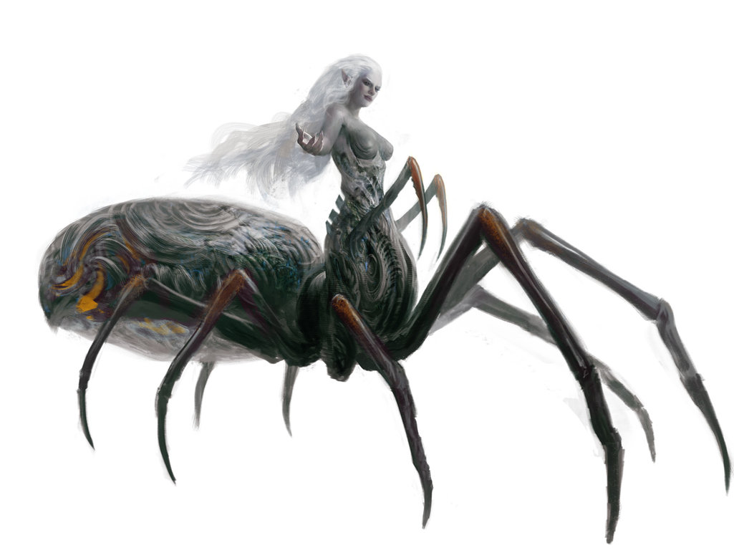

Mistress Weaver did not like to enter into open combat unless needed, preferring to supplement her troops with summoned monsters, which she had just conjured, and defend herself with her coveted crossbow. As she made her way to the fallen carpet, she thought to summon a few more as her prey did their best to survive this. With the ability to cast Augmented and Invisible Summonings, she had rendered a monstrous spider and scorpion both invisible, and tougher than normal, sending them out into the field to harness the resources she’d just swatted. She now added a Huge fiendish monstrous centipede [expired on Round 8] to the mix, hoping to not have to sacrifice one of her unsummoned lackeys.
Hfmc gained invisibility and +4 to Strength and Constitution.

Caught completely off-guard after hours of monotony and silence, the four heroes struggled to get their sense of what had happened, as well as of where north was. They’d landed in a few inches of snow, along what was a more obvious road during the warmer months. The trees had occluded the drider and her minions as she had cast wall of force upon the area just in front of the carpet and just about swatted the mammals right out of the sky.

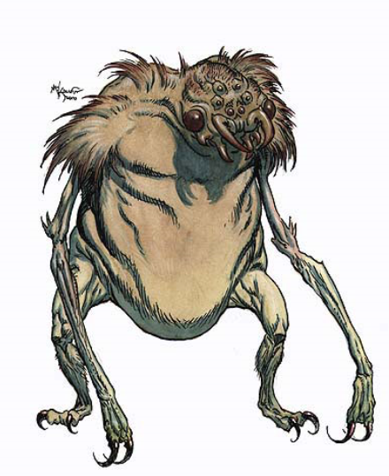

An ettercap jumped out of the snow and approached Kedrik menacingly.

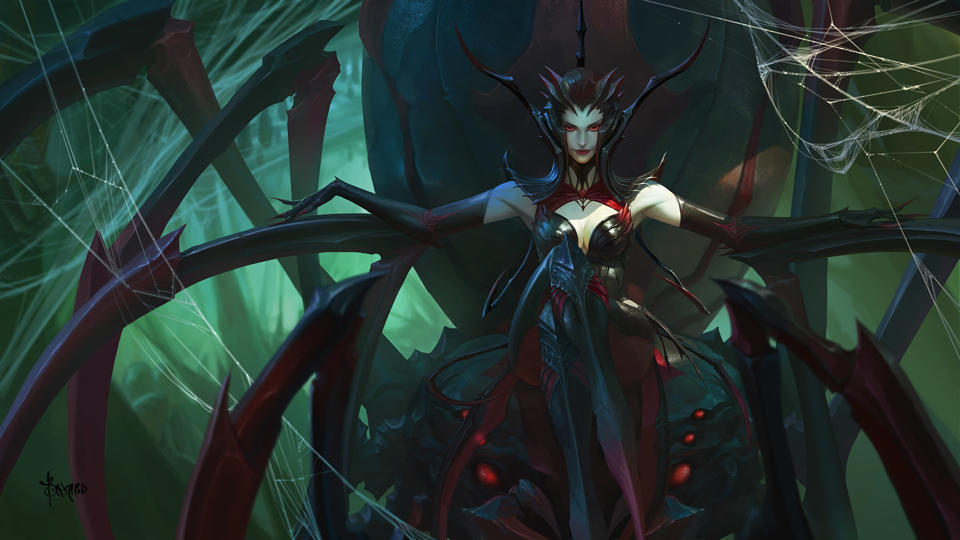

A woman of no discernible humanoid race sat watching, locking eyes with Kedrik.
Save vs.  silent image | Rank | Ability & Mod. | Misc. Mods. | Total | Roll | Check | Notes
Kedrik, Will | 8 | Wis (+2) | 3 | 13 | 10 | 23 | +2 vs. Enchantment & Illusions
Success.

“Bah!” the gnome said as he dusted himself off and picked himself up as quickly as he could. “The pretty lady’s a fake!”

A few cultural nuances of aesthetics were lost in translation from Kedrik’s lips to Lauren’s ear, and the drowling misinterpreted this to mean that the drider was an illusion.

Two araneas in hybrid form cast web [both expired on Round 301] upon the heroes.

A pair of magical webs were cast upon the heroes almost simultaneously.
Save vs.  web 1 | Rank | Ability & Mod. | Misc. Mods. | Total | Roll | Check
Allisa, Reflex | 6 | Dex (+3) | 0 | 9 | 12 | 21
Fingers, Reflex | 9 | Dex (+4) | 1 | 14 | 17 | 31
Kedrik, Reflex | 4 | Dex (+2) | 3 | 9 | 16 | 25
Lauren, Reflex | 4 | Dex (+0) | 1 | 5 | 9 | 14
Success, success, success, fail.
Save vs.  web 2 | Rank | Ability & Mod. | Misc. Mods. | Total | Roll | Check
Allisa, Reflex | 6 | Dex (+3) | 0 | 9 | 2 | 11
Fingers, Reflex | 9 | Dex (+4) | 1 | 14 | 15 | 29
Kedrik, Reflex | 4 | Dex (+2) | 3 | 9 | 3 | 12
Lauren, Reflex | 4 | Dex (+0) | 1 | 5 | 9 | 14
Fail, success, fail, fail.

DC 13 Escape Artist to slip out OR DC 17 Strength to break out.

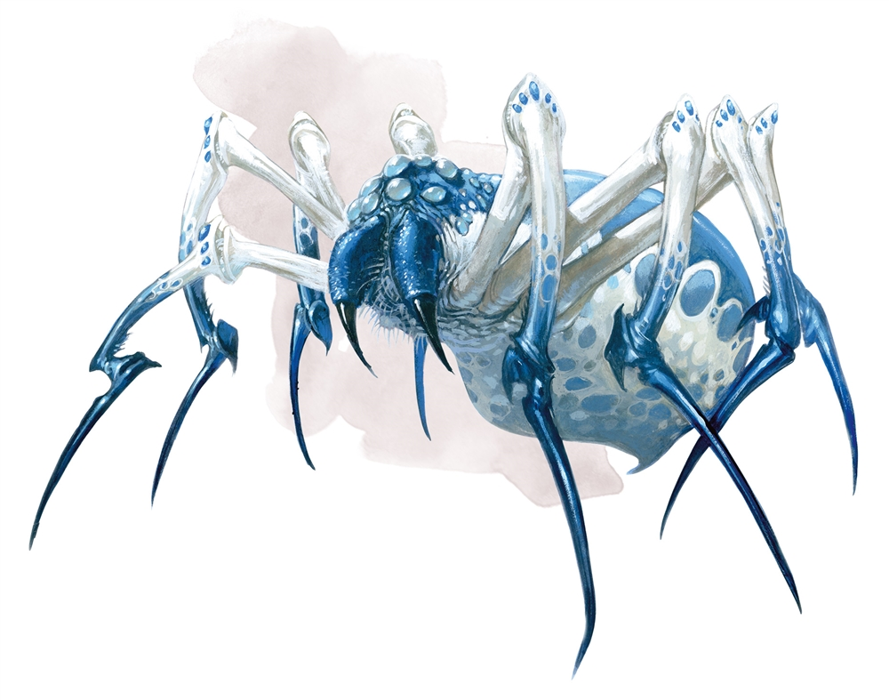

Two phase spiders shifted into the Material Plane behind Lauren, bit at her, and shifted back into the Ethereal Plane.
Character | Attack Type | Damage | Crit | BAB | Mod+ | W+ | Other+ | Roll | Total | Threat
Phase Spider 1 | Bite | 1d6+4 | 20 | 5 | 0 | 0 | 0 | 9 | 14 | ☒
Phase Spider 2 | Bite | 1d6+4 | 20 | 5 | 0 | 0 | 0 | 11 | 16 | ☒
Miss, miss.

The fiendish monstrous spider and scorpion attacked Allisa, who could not see them.
Character | Attack Type | Damage | Crit | BAB | Mod+ | W+ | Other+ | Roll | Total | Threat
S Fiendish Monstrous Spider | Bite, poison: Fort DC 10 | 1d4+ 1d3 Str | 20 | 0 | 6 | 0 | 0 | 9 | 15 | ☒
M Fiendish Monstrous Scorpion | Sting, Fort DC 14 | 1d4+ 1d6 Dex | 20 | 1 | 3 | 0 | 0 | 7 | 11 | ☒
Hit, miss. Dmg: 1 [70/72].
Save vs.  Poison | Rank | Ability & Mod. | Misc. Mods. | Total | Roll | Check
Allisa, Fortitude | 10 | Con (+2) | 0 | 12 | 5 | 17
Success. No primary ability damage.

The invisible fiendish monstrous centipede reared up and flank-attacked Lauren.
Character | Attack Type | Damage | Crit | BAB | Mod+ | W+ | Other+ | Roll | Total | Threat
H Fiendish Monstrous Centipede | Bite, poison: Fort DC 14 | 2d6+4+ 1d6 Dex | 20 | 4 | 3 | 0 | +2 flank | 9 | 18 | ☒
Miss.

Fingers could weasel his way through the webs for the moment, while Lauren was caught by both ankles, and could not wrest herself free. The other two were held down by one ankle and one wrist, also stationary.

Having feather fallen near Allisa, Lauren attempted to extract the druid from the webs.
Character | Check | Ranks | Roll | Save
Lauren | Strength | 5 | 8 | 13
Fail.

Fingers, having noticed the presence of invisible enemies from the traces they left in the snow, and the presence of the two phase spiders that shifted from the Ethereal to the Material and back, yelled out an alert to the others. “Careful: we have some invisible enemies about. Watch the snow for their prints to at least know where they are!” It then activated the trusty headband it wore to see them clearly [expired on Round 601] and readied its wand to likewise go invisible as it wormed its way free of the webbed area.

With this advice, the heroes were able to make out the locations of their invisible foes, if not who or what they were.

Unable to cast spells with somatic components, Kedrik struggled to slip free.
Skill | Rank | Ability & Mod. | Misc. Mods. | Total | Roll | Check
Kedrik, Escape Artist | 0 | Dex (+2) | 0 | 2 | 13 | 15
Kedrik, Escape Artist | 0 | Dex (+2) | 0 | 2 | 11 | 13
Fail, fail.

A Small fiendish monstrous spider made an attack of opportunity upon Fingers, who was never one to get caught flat-footed.
Character | Attack Type | Damage | Crit | BAB | Mod+ | W+ | Other+ | Roll | Total | Threat
S Fiendish Monstrous Spider | Bite, poison: Fort DC 10 | 1d4+ 1d3 Str | 20 | 0 | 6 | 0 | 0 | 5 | 11 | ☒
Miss.

This map reflects how disoriented the PCs are on Round 1.
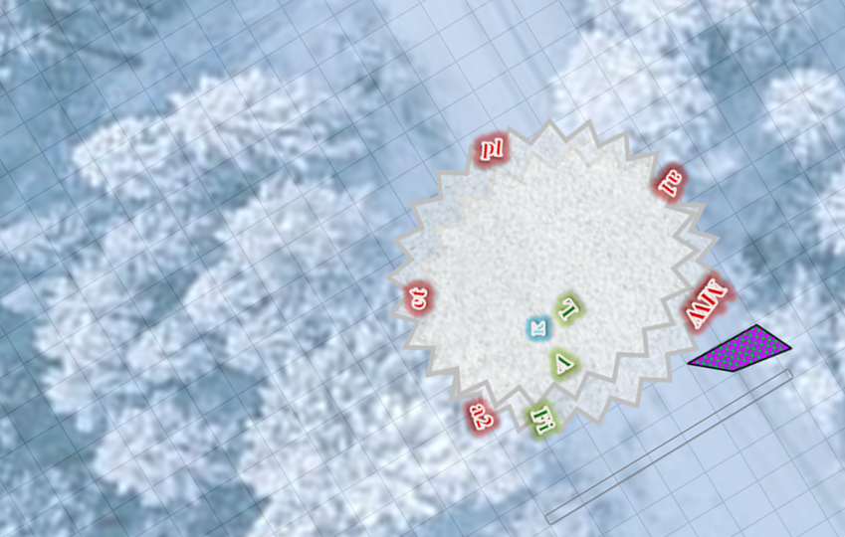
In reality, the rectangular wall of force is north of the party.

Round 2

Character | Group | Initiative | Roll | Modified  Roll | Move
Allisa | 1 | 3 | 19 | 22 | 30’
Kedrik | 1 | 2 | 18 | 20 | 30’
Fingers | 1 | 4 | 14 | 18 | 30’
Phase Spiders | 2 | 6 | 9 | 15 | 50/30’
Aranea | 2 | 6 | 9 | 15 | 50/25’
Mistress Weaver | 2 | 6 | 4 | 10 | 30/15’
Lauren | 1 | 4 | 3 | 7 | 30’

The heroes began to regain their bearings, though they were still stuck in magical webs.

Allisa wrested her wrists and ankles free from both webs.
Character | Check vs. 2 webs | Ranks | Roll | Save
Allisa | Strength | 0 | 9 | 9
Allisa | Strength | 0 | 6 | 6
Fail, fail.

Allisa remained in place, frustrated at being unable to cast spells with somatic components now that she was restrained.

Only able to cast spells with verbal components at the moment, the web-bound Kedrik cast Chaav’s laugh [expired on Round 132].
Kedrik gained +2 to attacks and saves vs. Fear, plus 7 + 13 = 20 hps.
Character | Save vs. | Ranks | Roll | Save
Mistress Weaver | Will | 8 | 9 | 17
monstrous spider | Will | 0 | 18 | 18
monstrous scorpion | Will | 0 | 20 | 20
monstrous centipede | Will | 2 | 1 | 3
Fail, fail, fail, fail.
Mistress Weaver and the fiendish arthropods that she summoned suffered -2 to attacks and saves vs. Fear.

The gnome then proclaimed, “Turn away now and save your lives, vermin! We will not give you this opportunity again.”

The drider hissed a laugh that almost drowned out the sound of the Chaav’s laugh spell, saying something in Undercommon, which only Lauren understood to mean, << That’s Vermin Lady to you, Surfacer! >>

The duskblade was familiar with the terms Vermin Lord and Vermin Lady, which in this context was a window to the power that this drider wielded.

Having seen the phase spiders briefly appear after closing in with a shield of Ethereal invisibility, Fingers decided to do them one better by activating its wand while worming its way clear of the webbing.
Skill | Rank | Ability & Mod. | Misc. Mods. | Total | Roll | Check
Fingers, Use Magic Device | 15 | Cha (+1) | 0 | 16 | 9 | 25
Success.

Now invisible, Fingers tried to weasel and worm its way out of the webs, thinning its wrists in the process.

The phase spiders laced into Lauren again.
Character | Attack Type | Damage | Crit | BAB | Mod+ | W+ | Other+ | Roll | Total | Threat
Phase Spider | Bite | 1d6+4 | 20 | 5 | 0 | 0 | 0 | 2 | 7 | ☒
Phase Spider | Bite | 1d6+4 | 20 | 5 | 0 | 0 | 0 | 18 | 23 | ☒
Miss, miss.

They began to realize that trying to attack Lauren was futile, and turned their attention to Kedrik as they phased back into the Ethereal Plane.

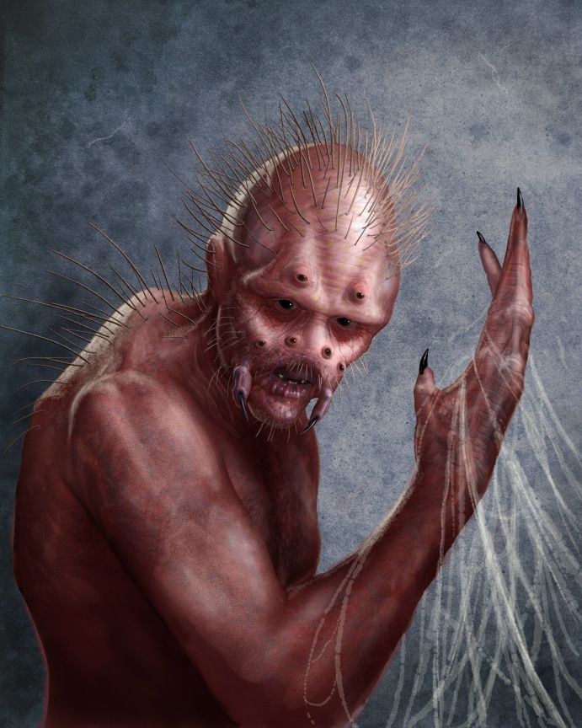

Instead of casting web as they’d done before, the araneae now spit upon Allisa their mundane webs from what looked like their giant cock holes, but were in fact completely different glands.
Character | Attack Type | Damage | Crit | BAB | Mod+ | W+ | Other+ | Roll | Total | Threat
Aranea 1 | Web | entanglement | 20 | 3 | 2 | 0 | 0 | 2 | 7 | ☒
Aranea 2 | Web | entanglement | 20 | 3 | 2 | 0 | 0 | 6 | 11 | ☒
Miss, miss.

Mistress Weaver cast ray of enfeeblement [expired on Round 62] on Lauren, looking at the half-drow with contempt.
Character | Attack Type | Damage | Crit | BAB | Mod+ | W+ | Other+ | Roll | Total | Threat
Mistress Weaver | Ranged Touch Attack | varies | 20 | 11 | 1 | 0 | -2 | 19 | 29 | ☒
Hit. Dmg: 2 + 3 = 5 Strength.

<< You will make a nice addition to my collection, >> the drider told the drowling in Undercommon.

The ettercap made its way carefully along the magical webs towards Kedrik, who thought his goose might be cooked.

The fiendish spider snapped at Allisa’s huge leg.
Character | Attack Type | Damage | Crit | BAB | Mod+ | W+ | Other+ | Roll | Total | Threat
S Fiendish Monstrous Spider | Bite, poison: Fort DC 10 | 1d4+ 1d3 Str | 20 | 0 | 6 | 0 | -2 | 19 | 23 | ☒
Hit. Dmg: 3 + Poison [67/72].
Save vs.  Poison | Rank | Ability & Mod. | Misc. Mods. | Total | Roll | Check
Allisa, Fortitude | 10 | Con (+2) | 0 | 12 | 18 | 30
Success. No primary Strength damage.

The fiendish scorpion and fiendish centipede also full-attacked Allisa’s gigantesque body.
Character | Attack Type | Damage | Crit | BAB | Mod+ | W+ | Other+ | Roll | Total | Threat
M Fiendish Monstrous Scorpion | Claw 1 | 1d4+1 | 20 | 1 | 3 | 0 | -2 | 4 | 6 | ☒
M Fiendish Monstrous Scorpion | Claw 2 | 1d4+1 | 20 | 1 | 3 | 0 | -2 | 15 | 17 | ☒
M Fiendish Monstrous Scorpion | Sting, Fort DC 14 | 1d4+ 1d6 Dex | 20 | 1 | 3 | 0 | -2 | 4 | 6 | ☒
H Fiendish Monstrous Centipede | Bite, poison: Fort DC 14 | 2d6+4+ 1d6 Dex | 20 | 4 | 3 | 0 | -2 | 16 | 21 | ☒
Miss, miss, miss, hit. Dmg: 8 + 4 = 12 + Poison [55/72].
Allisa’s Venom Immunity negates any possible ability damage.

Allisa got free of the webs, and moved out of the affected area via the shortest route. In getting herself free, however, and by passing by them, the druid provoked attacks of opportunity from the spider and scorpion.
Character | Attack Type | Damage | Crit | BAB | Mod+ | W+ | Other+ | Roll | Total | Threat
S Fiendish Monstrous Spider | Bite, poison: Fort DC 10 | 1d4+ 1d3 Str | 20 | 0 | 6 | 0 | -2 | 2 | 6 | ☒
M Fiendish Monstrous Scorpion | Claw 1 | 1d4+1 | 20 | 1 | 3 | 0 | -2 | 2 | 4 | ☒
Miss, miss.

With Allisa quite free from the webs, Lauren attempted to free herself.
Character | Check | Ranks | Roll | Save
Lauren | Strength | 3 | 7 | 11
Lauren | Strength | 3 | 14 | 17
Fail, success.

The duskblade ripped her left hand free of the web, leaving her right hand and falchion still bound.

Looking down at the snow was very telling of the invisible foes’ locations, particularly the Huge centipede.

The NPC positions on this map represent guesses as to where invisible foes (phase spiders & monstrous vermin) are.
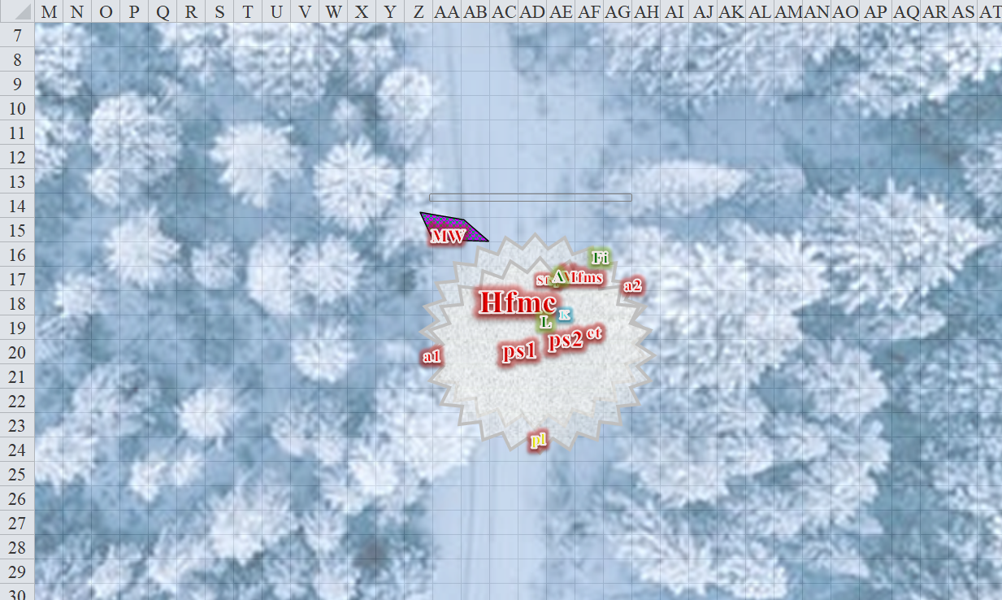

Round 3

Kedrik tried once again to slither out of the webs.
Skill | Rank | Ability & Mod. | Misc. Mods. | Total | Roll | Check
Kedrik, Escape Artist | 0 | Dex (+2) | 0 | 2 | 8 | 10
Kedrik, Escape Artist | 0 | Dex (+2) | 0 | 2 | 19 | 21
Fail, fail.

“This is never going to work!” Kedrik said aloud, then cautioned his friends. “I’m afraid I’m of no use here. Can’t get free, and I can’t cast most of my spells. You’re going to have to end this quickly, and with me playing the role of the damage-taking barbarian!”

His teammates heard the alarm in his voice. Lauren was weakened, while Allisa was comparably strengthened in her current form. Fingers was invisible at the moment, and its ability to see all of the foes before it allowed it a moment of tactical selection of foes. The rogue considered its options.

The ettercap reached the immobile whisper gnome, and the latter screamed for his life as the jaws of the spidery monster opened wide as if to eat his face off. An instant later, he realized the ettercap was a really well cast illusion, putting the “pretty lady” figment to shame in terms of its apparent wholeness and color complexity.

The snow at his feet was too shallow to hamper movement with the snowshoes that Fingers had bought a couple of days back. The trapsmith moved 5” to flank with Alissa against the scorpion, and slashed twice.
Melee Weapon | Dmg | D+ | TH+ | Critical | Type | Wt. | Atk | Roll | Check | Notes
Keen Deadly Precision Short Sword | 1d6 | 1 | 1 + 2 flank | 17-20, x2 | Piercing | 2.0 | +15 | 13 | 28 | +5d6 Sneak Attack
Short Sword, 2nd Attack | 1d6 | 1 | 1 + 2 flank | 17-20, x2 | Piercing | - | +10 | 13 | 23 | Weapon Finesse
Crystal of Acid Assault, Lesser | - | 1d6 | - | - | - | - | - | - | -
Hit, hit. Dmg: (2 + 1 + 23 + 4 acid) + (5 + 1 + 21 + 1 acid) = 53 + 5 acid = 58.

The scorpion ceased to be.

The phase spiders tried to kill Lauren with their sneaky attacks.
Character | Attack Type | Damage | Crit | BAB | Mod+ | W+ | Other+ | Roll | Total | Threat
Phase Spider | Bite | 1d6+4 | 20 | 5 | 0 | 0 | 0 | 19 | 24 | ☒
Phase Spider | Bite | 1d6+4 | 20 | 5 | 0 | 0 | 0 | 13 | 18 | ☒
Miss, miss.

The phase spiders were connecting with their intended target—Lauren—but her armor and wiles prevented them from puncturing her body for the moment.

Having missed Allisa, the araneae lobbed their second webbed attacks at Lauren.
Character | Attack Type | Damage | Crit | BAB | Mod+ | W+ | Other+ | Roll | Total | Threat
Aranea 1 | Web | entanglement | 20 | 3 | 2 | 0 | 0 | 16 | 21 | ☒
Aranea 2 | Web | entanglement | 20 | 3 | 2 | 0 | 0 | 6 | 11 | ☒
Hit, miss. Lauren was entangled against a DC 13 Escape Artist check or a DC 17 Strength check.

Aranea 1 then joined its drider mistress while its counterpart remained in place.

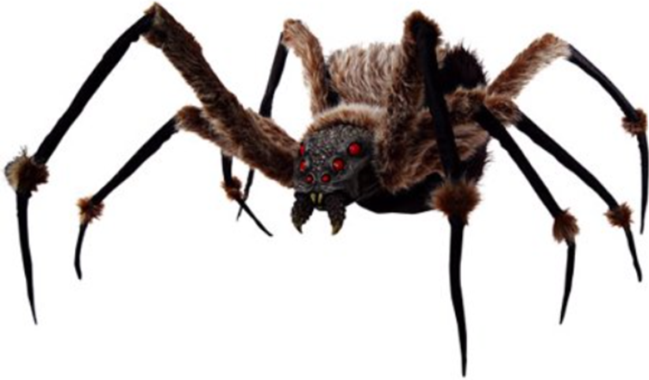
Fingers could clearly see the monstrous, dog-sized spider jumping onto Allisa’s shin.
Character | Attack Type | Damage | Crit | BAB | Mod+ | W+ | Other+ | Roll | Total | Threat
S Fiendish Monstrous Spider | Bite, poison: Fort DC 10 | 1d4+ 1d3 Str | 20 | 0 | 6 | 0 | -2 | 16 | 20 | ☒
Miss.

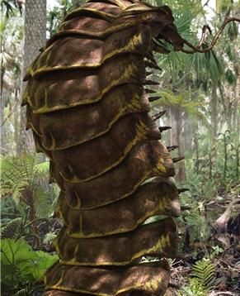

The changeling then saw the centipede rearing and attacking the immobile but well armored duskblade.
Character | Attack Type | Damage | Crit | BAB | Mod+ | W+ | Other+ | Roll | Total | Threat
H Fiendish Monstrous Centipede | Bite, poison: Fort DC 14 | 2d6+4+ 1d6 Dex | 20 | 4 | 3 | 0 | -2 | 10 | 15 | ☒
Miss.

Noting that her conjured pests were doing little to no harm to her intended meals, Mistress Weaver abstained from casting further conjurings for the moment, and instead released a lightning bolt upon Allisa, who marveled at how well these subspecies of spider-like beings had adapted to cold climates.
Save vs.  lightning bolt | Rank | Ability & Mod. | Misc. Mods. | Total | Roll | Check
Allisa, Reflex | 6 | Dex (+3) | 0 | 9 | 7 | 16
Success. Allisa saved for ½ damage. Dmg: ½ x 25 = 12 electric [43/72].
Items melted: Gray Hand Token, Ring of Mystic Healing, Watch Lamp.
If metal from magic items can’t be melted, then the RoMH isn’t melted.
Items burned: Scroll of Light, Scroll of Barkskin, Scroll of Bull’s Strength, Scroll of Cat’s Grace.

Lauren Quick-cast bull’s strength [expired on Round 123], wishing she could also cast dimension door [a 4th-level spell] to break free from the webs.
Lauren gained +4 to Strength.

The half-drow ignored the drider’s taunts, and focused on protecting Allisa, and did her best to use her partially restored Strength to pull herself out of the webbing.
Character | Check | Ranks | Roll | Save
Lauren | Strength | 5 | 15 | 20
Lauren | Strength | 5 | 18 | 23
Success, success.

Now free from the damnable webs, Lauren surveyed the battlefield before her, then charged toward Allisa with the intention of slashing at the webs holding her in place.

Allisa, still stuck in the magical webs, did nothing for the moment.

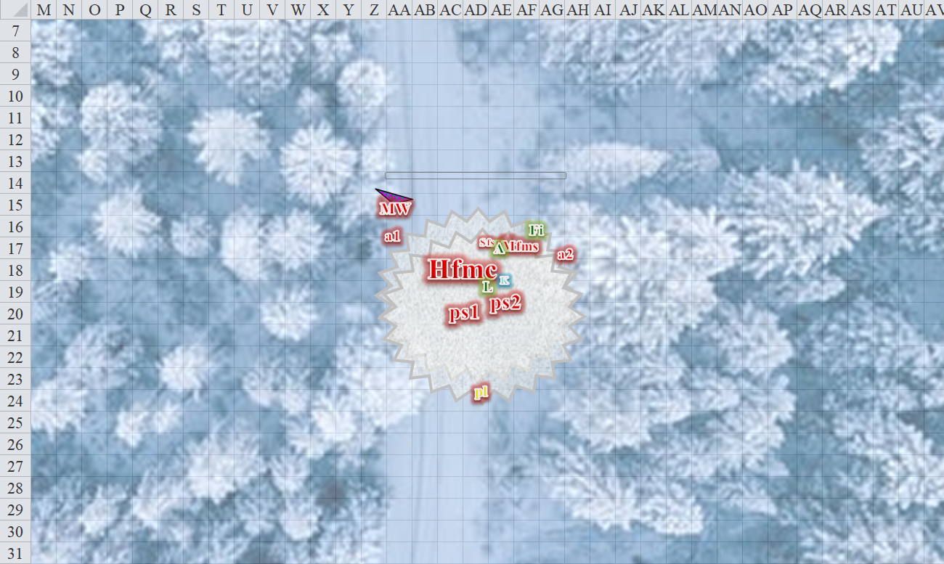

Round 4

Still unable to move his limbs, Kedrik instead tried to use his Dark Knowledge (Foe) to help his friends.
Skill | Rank | Ability & Mod. | Misc. Mods. | Total | Roll | Check | Notes
Kedrik, Knowledge: Arcana | 12 | Int (+7) | 2 | 21 | 2 | 23 | Trivial Knowledge, best of 2 rolls
Kedrik, Knowledge: Arcana | 12 | Int (+7) | 2 | 21 | 11 | 32 | Trivial Knowledge, best of 2 rolls
PCs now inflict +2d6 damage vs. Mistress Weaver.

The gnome then did his best to pull away from the webs, this time using his Strength rather than his flexibility and elasticity.
Character | Check | Ranks | Roll | Save
Kedrik | Strength | 0 | 15 | 15
Kedrik | Strength | 0 | 10 | 10
Fail, fail.

Allisa deferred her actions, seeing that Lauren had headed over.

Having seen Lauren move to assist Alissa and alarmed that the apparent leader of the enemies was beginning to unleash more dangerous spells at Fingers’ allies, it moved to give her something else to think about. Then—from under the figurative cloak of invisibility—it missed the drider who knew that the rogue was somewhere about, but not exactly where.
Melee Weapon | Dmg | D+ | TH+ | Critical | Type | Wt. | Atk | Roll | Check | Notes
Keen Deadly Precision Short Sword | 1d6 | 1 | 1 | 17-20, x2 | Piercing | 2.0 | +13 | 8 | 21 | +5d6 Sneak Attack
Crystal of Acid Assault, Lesser | - | 1d6 | - | - | - | - | - | - | -
Miss.

The phase spiders turned their attention to the immobile but partially ironclad whisper gnome.
Character | Attack Type | Damage | Crit | BAB | Mod+ | W+ | Other+ | Roll | Total | Threat
Phase Spider | Bite | 1d6+4 | 20 | 5 | 0 | 0 | 0 | 12 | 17 | ☒
Phase Spider | Bite | 1d6+4 | 20 | 5 | 0 | 0 | 0 | 6 | 11 | ☒
Miss, miss.

The aranea 1 had some notion of where Fingers was stepping when he attempted to stab at the drider, and pounced on the area above those footprints in the snow.
Character | Attack Type | Damage | Crit | BAB | Mod+ | W+ | Other+ | Roll | Total | Threat
Aranea | Bite, poison: Fort DC 13 | 1d6 + 1d6/2d6 Str | 20 | 3 | 2 | 0 | 0 | 5 | 10 | ☒
Miss.

Aranea 2 shot a mundane web at Lauren.
Character | Attack Type | Damage | Crit | BAB | Mod+ | W+ | Other+ | Roll | Total | Threat
Aranea | Web | entanglement | 20 | 3 | 2 | 0 | 0 | 6 | 11 | ☒
Miss.

The fiendish centipede attacked Lauren while the spider attacked Allisa.
Character | Attack Type | Damage | Crit | BAB | Mod+ | W+ | Other+ | Roll | Total | Threat
S Fiendish Monstrous Spider | Bite, poison: Fort DC 10 | 1d4+ 1d3 Str | 20 | 0 | 6 | 0 | -2 | 10 | 14 | ☒
H Fiendish Monstrous Centipede | Bite, poison: Fort DC 14 | 2d6+4+ 1d6 Dex | 20 | 4 | 3 | 0 | -2 | 18 | 23 | ☒
Miss, miss, miss, miss, miss.

Lauren moved 5’ across the path of the invisible centipede as it attacked, careful to avoid its imprints in the snow. The duskblade then slashed at the strands of web binding Allisa.
Melee Weapon | Dmg | D+ | TH+ | Critical | Type | Wt. | Atk | Roll | Check
Falchion +3 | 2d4 | +3 +3 | 3 | 18-20/x2 | Slashing | 8.0 | +18 | 19 | 37
Falchion +3, 2nd Attack | 2d4 | +3 +3 | 3 | 18-20/x2 | Slashing |  | +13 | 6 | 19
Falchion +3, 3rd Attack | 2d4 | +3 +3 | 3 | 18-20/x2 | Slashing |  | +8 | 8 | 16
Threat, hit, hit. Minimum damage breaks webs.

Mistress Weaver cast invisibility [expired on Round 64] upon herself, then took a few steps back and finishing up rolling up the magic carpet.

Alisa cast call lighting and observed the ground for movement of her enemy around Lauren. Then she caught sight of the drider’s still transparent form before the invisibility kicked in. The druid’s thinking was that Mistress Weaver might have wanted to play who zapped it best?, so the druid hit the drider with a lightning bolt of her own. Right before Mistress Weaver’s form went completely invisible, she zapped the location with a bolt of lightning.
Ranged Weapon | Dmg. | D+ | TH+ | Critical | Rng. | Wt. | Atk | Roll | Check
Ranged Touch Attack | - | - | 0 | - | - | - | +12 | 19 | 31
Hit. Dmg: 13 electric.

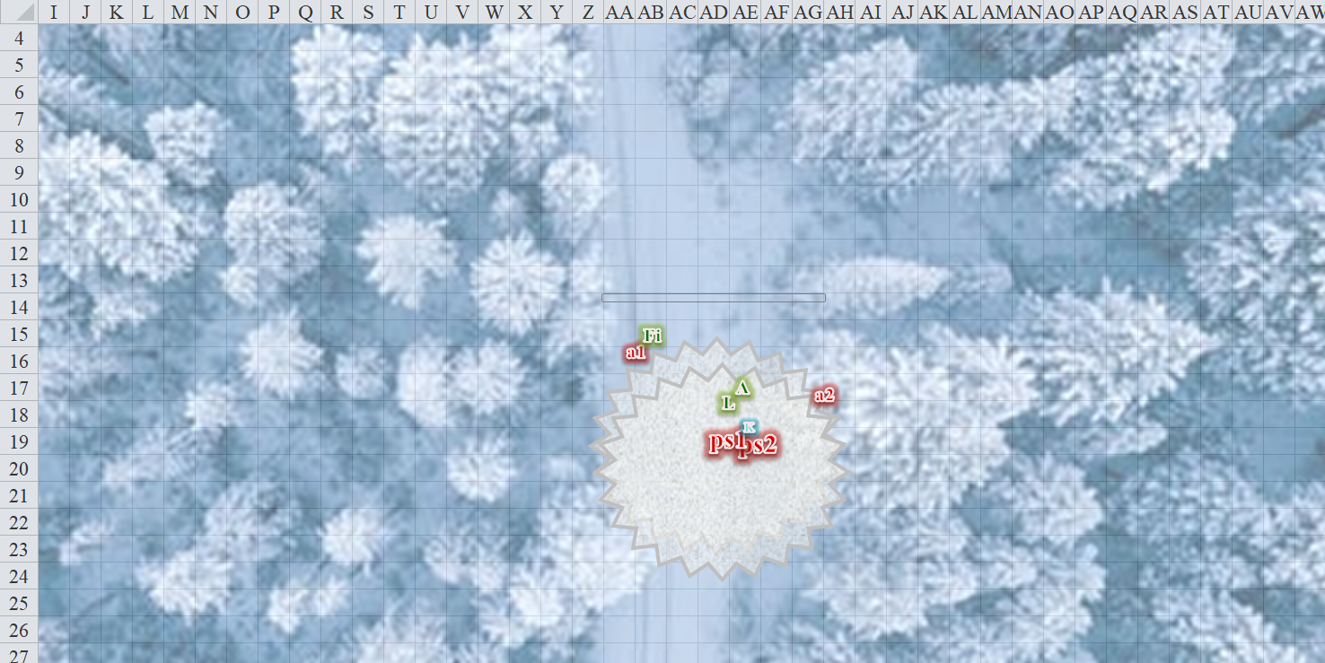

Round 5

Seeing the target just fine, Fingers grinned to itself and hopped about 5’ west to sneak-attack Mistress Weaver with its sword. The would-be carpet thief was about to get a rude awakening if she thought her invisibility would provide protection from attack.
Melee Weapon | Dmg | D+ | TH+ | Critical | Type | Wt. | Atk | Roll | Check | Notes
Keen Deadly Precision Short Sword | 1d6 | 1 | 1 | 17-20, x2 | Piercing | 2.0 | +13 | 11 | 24 | +5d6 Sneak Attack
Short Sword, 2nd Attack | 1d6 | 1 | 1 | 17-20, x2 | Piercing | - | +8 | 18 | 26 | Weapon Finesse
Crystal of Acid Assault, Lesser | - | 1d6 | - | - | - | - | - | - | -
Miss, hit. Dmg: 5 + 1 + 18 SA + 5 DK + 4 acid = 33.

Fingers had overestimated its own prowess against the flat-footed drider, and only struck her once. As soon as it struck her, she could tell by its footsteps where Fingers was, and she guessed that her invisibility wasn’t doing her any good. The drider was not confident that she could make the magic carpet work—magic devices were not her thing—so she cast dimension door—her ticket out of this botched attempt at catching the next week’s meal—and got her hide to somewhere else.

Fingers did not know enough about spellcrafting to discern which spell the drider had cast, and thus deduced that there was a possibility that Mistress Weaver had used an even more powerful form of invisibility, so the trapsmith stood on guard. Or perhaps a teleport spell had been her way out, at which point there was no telling where on this plane the drider had gone. It remained on guard until Kedrik—who had heard the casting of the spell—announced, “That was a dimension door spell; she can be no farther than 1000’ from us.”

The whisper gnome still could do little beyond help his friends with words of wisdom. Seeing that the drider had gone invisible, he thought to draw further upon his Dark Knowledge (Foe), and share what he knew of the phase spiders’ weak spots.
Skill | Rank | Ability & Mod. | Misc. Mods. | Total | Roll | Check | Notes
Kedrik, Knowledge: Arcana | 12 | Int (+7) | 2 | 21 | 12 | 33 | Trivial Knowledge, best of 2 rolls
Knowledge: Arcana | 12 | Int (+7) | 2 | 21 | 1 | 22 | Trivial Knowledge, best of 2 rolls
PCs now inflict +2d6 damage vs. phase spiders.

The phase spiders tried to impale Kedrik in their jaws while his friends fended off the other spider-like creatures.
Character | Attack Type | Damage | Crit | BAB | Mod+ | W+ | Other+ | Roll | Total | Threat
Phase Spider | Bite | 1d6+4 | 20 | 5 | 0 | 0 | 0 | 2 | 7 | ☒
Phase Spider | Bite | 1d6+4 | 20 | 5 | 0 | 0 | 0 | 13 | 18 | ☒
Miss, miss.

The phase spiders—after more than one botched attempt—gave up on the web-bound gnome, and foolishly turned to Lauren to see if they might have better luck there. They became Ethereal, and could be seen no more.

The aranea charge-attacked Allisa. However, Fingers had taken the opportunity to slash at the aranea that had leapt right past it to get to the druid.
Melee Weapon | Dmg | D+ | TH+ | Critical | Type | Wt. | Atk | Roll | Check | Notes
Keen Deadly Precision Short Sword | 1d6 | 1 | 1 | 17-20, x2 | Piercing | 2.0 | +13 | 11 | 24 | +5d6 Sneak Attack
Crystal of Acid Assault, Lesser | - | 1d6 | - | - | - | - | - | - | -
Hit. Dmg: 2 + 1 + 20 SA + 7 DK = 30.

The poor thing died and began to change back into its natural form. Meanwhile, the other aranea bit at the half-elf.
Character | Attack Type | Damage | Crit | BAB | Mod+ | W+ | Other+ | Roll | Total | Threat
Aranea | Bite, poison: Fort DC 13 | 1d6 + 1d6/2d6 Str | 20 | 3 | 2 | 0 | 2 charge | 17 | 24 | ☒
Hit, miss. Dmg: 2 + poison (negated) [41/72].

The fiendish vermin both attacked Allisa now.
Character | Attack Type | Damage | Crit | BAB | Mod+ | W+ | Other+ | Roll | Total | Threat
S Fiendish Monstrous Spider | Bite, poison: Fort DC 10 | 1d4+ 1d3 Str | 20 | 0 | 6 | 0 | -2 | 6 | 10 | ☒
H Fiendish Monstrous Centipede | Bite, poison: Fort DC 14 | 2d6+4+ 1d6 Dex | 20 | 4 | 3 | 0 | -2 | 14 | 19 | ☒
Miss, miss, miss.

The fiendish spider then disappeared.

Mistress Weaver probably ran in the direction opposite of where the fight was or maybe tried to use the magic carpet to fly away. Who knew?

Lauren made sure that Allisa was free of the webs, and then—not seeing the phase spiders stalking her from behind within the Ethereal Plane—swung heartily at the centipede.
Melee Weapon | Dmg | D+ | TH+ | Critical | Type | Wt. | Atk | Roll | Check
Falchion +3 | 2d4 | +3 +3 | 3 | 18-20/x2 | Slashing | 8.0 | +18 | 4 | 22
Falchion +3, 2nd Attack | 2d4 | +3 +3 | 3 | 18-20/x2 | Slashing |  | +13 | 11 | 24
Falchion +3, 3rd Attack | 2d4 | +3 +3 | 3 | 18-20/x2 | Slashing |  | +8 | 15 | 23
Truedeath Crystal, Lesser | 1d6 | vs. | undead
Hit, hit, hit. Dmg: (2 + 3 + 3 + 5 DK) + (7 + 3 + 3 + 6 DK) + (8 + 3 + 3 + 7 DK) = 13 + 19 + 21 = 53.

The centipede disappeared.

Allisa had cast barkskin just seconds after being thrown off of the carpet. She wanted to back away from the fight, but was surrounded on all sides until the spider dematerialized. However, not able to see the invisible foes, she did her best to step in an area where she didn’t hear the sound of a critter attacking her.
Skill | Rank | Ability & Mod. | Misc. Mods. | Total | Roll | Check
Allisa, Listen | 2 | Wis (+3) | 1 | 6 | 11 | 17
See below.

She moved 5’ northeast, then dropped a lightning bolt upon the aranea that had just bitten her.
Ranged Weapon | Dmg. | D+ | TH+ | Critical | Rng. | Wt. | Atk | Roll | Check
Ranged Touch Attack | - | - | 0 | - | - | - | +12 | 6 | 18
Hit. Dmg: 10 electric.

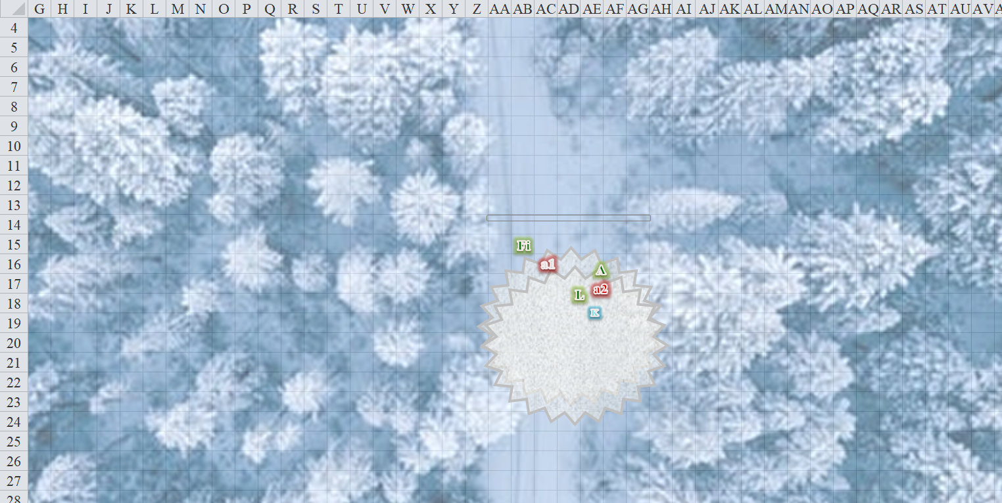

Round 6

Allisa threw another lightning bolt at the remaining aranea, whom she had just zapped.
Ranged Weapon | Dmg. | D+ | TH+ | Critical | Rng. | Wt. | Atk | Roll | Check
Ranged Touch Attack | - | - | 0 | - | - | - | +12 | 2 | 14
Hit. Dmg: 9 electric.

Nearly dead now, the remaining aranea withdrew from the conflict, sprinting northeastwardly.

Lauren listened for the Ethereal phase spiders, waiting for them to move into the Material Plane.
Skill | Rank | Ability & Mod. | Misc. Mods. | Total | Roll | Check
Lauren, Listen | 2 | Wis (+0) | 1 | 3 | 1 | 4
See below.

She couldn’t hear them at all, so she waited until they both attacked her.
Character | Attack Type | Damage | Crit | BAB | Mod+ | W+ | Other+ | Roll | Total | Threat
Phase Spider | Bite | 1d6+4 | 20 | 5 | 0 | 0 | 0 | 9 | 14 | ☒
Phase Spider | Bite | 1d6+4 | 20 | 5 | 0 | 0 | 0 | 18 | 23 | ☒
Miss, miss.

Lauren swung at one spider, then the other, then the first again.
Melee Weapon | Dmg | D+ | TH+ | Critical | Type | Wt. | Atk | Roll | Check
Falchion +3 | 2d4 | +3 +3 | 3 | 18-20/x2 | Slashing | 8.0 | +18 | 14 | 32
Falchion +3, 2nd Attack | 2d4 | +3 +3 | 3 | 18-20/x2 | Slashing |  | +13 | 20 | 33
Falchion +3, 3rd Attack | 2d4 | +3 +3 | 3 | 18-20/x2 | Slashing |  | +8 | 4 | 12
Truedeath Crystal, Lesser | 1d6 | vs. | undead
Hit, threat, miss. 1d20 = 8 + 13 = 21, critical hit.
Dmg to spider 1: (5 + 3 + 3 + 6 DK) + (8 + 3 + 3 + 2 DK) = 17 + 16 = 33.
Dmg to spider 2: 2 x (6 + 3 + 3 + 4 DK) = 32.

Both phase spiders, quite badly wounded now, fled via the puffy tufts of the Ethereal Plane.

Seeing that the drider had managed to make a clean getaway, the shapeshifting rogue threw its sword at the aranea that now tried to scurry northeastwardly.
Ranged Weapon | Dmg. | D+ | TH+ | Critical | Rng. | Wt. | Atk | Roll | Check
Thrown Weapon | - | 0 | 4 – 4 range | - | - | - | +12 | 20 | 32
Threat. 1d20 = 6 + 16 = 18, critical hit. Dmg: 2 x (5 + 1 + 25 SA + 7 DK) = 76.

As the blade impaled its back, the aranea fell to the floor face-down, and began shapeshifting back into a human-sized spider.

Seeing that most of the foes were slain or retreating, Fingers would have alerted the others to the whereabouts of any threats still remaining, but the only ones left were in the Ethereal Plane, and scurrying into crannies of that plane less coterminous and coexistent with the Material.

Alerted by Kedrik that their leader was still likely somewhere in the vicinity, Fingers began scanning the area in case wherever she’d blitted to was within line of sight, but with all the pines and snow around them, it was a futile attempt. While its attack had clearly wounded the arachnoid enough to force her to flee, there was no guarantee she might not return long enough to hurl more destructive spells at the group. Besides, Fingers was not inclined to let an enemy get away if it was at all possible to put an end to them... a dead enemy today was one less thing to worry about tomorrow. And on top of everything else, the drider had stolen their carpet.

Lauren looked around for lingering threats, but none seemed to linger.

“Um...” Kedrik started to feel like chopped kidneys. “Can someone get me out of these webs?”

Then, all of them but Allisa heard a branch snapping to the west-southwest. Lauren could gauge that it was at least 500’ out.

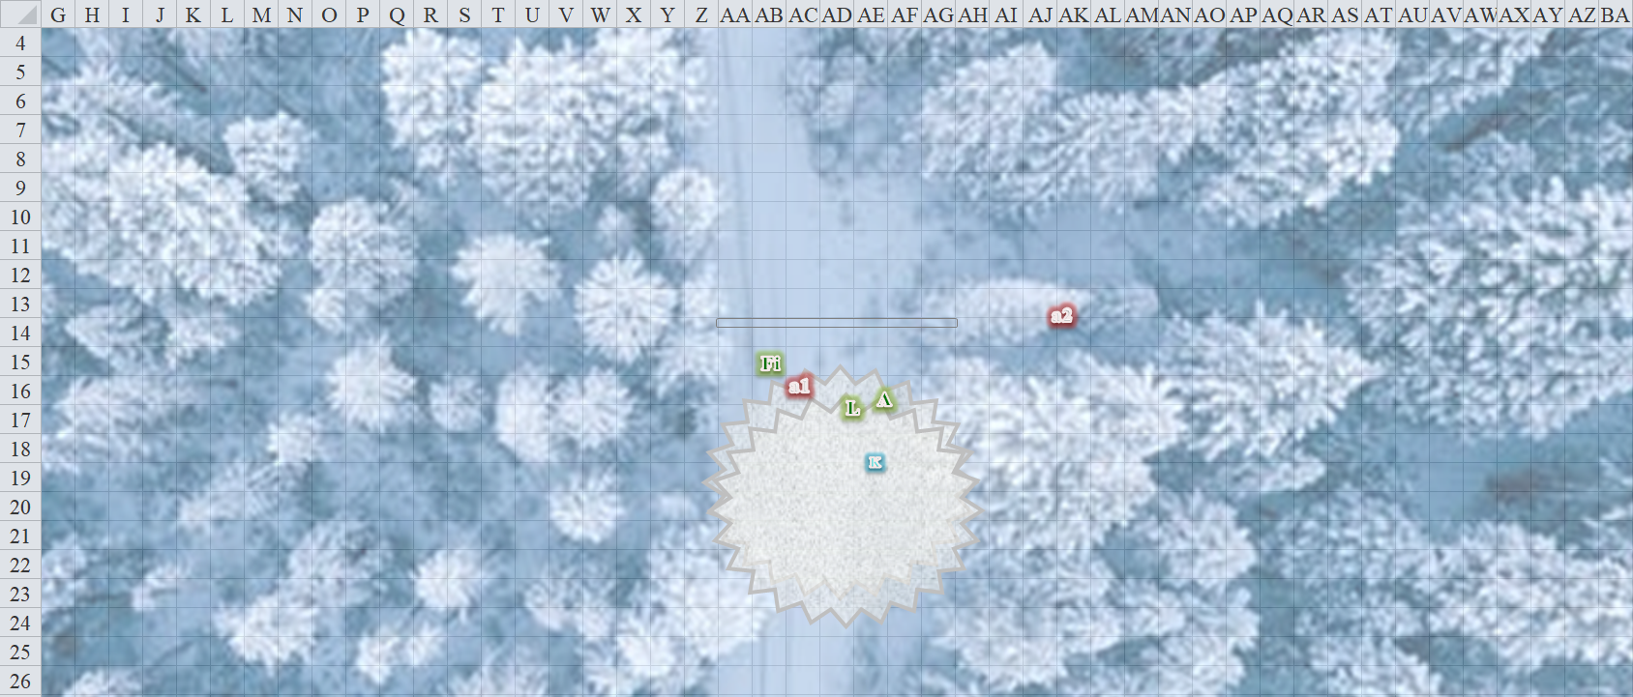

Round 7

Lauren went to free Kedrik from the webs. “There is something coming toward us.” She pointed with her falchion, though Fingers had heard it, and needed no help in discerning the direction.

“I’ll take a look while you all get free of those webs,” Fingers called, not too loudly. Still invisible for the moment, the changeling made its way in the direction of the noise. Perhaps it was the light-fingered drider... if so, Fingers was hoping to intercept her before she figured out the commands to make the carpet fly.

Allisa tossed her Gray Hand token and watch lamp to the ground, and asked Kedrik, “Can you do something about these?” The druid then activated her Ring of Mystic Healing, and healed herself a bit.
Allisa gained 13 hps [54/72].

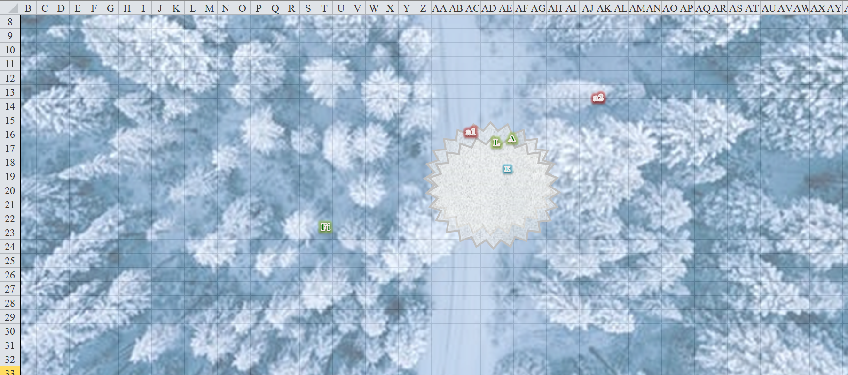

Round 8

The wall of force above them ceased to exist.

Lauren swung three times at the webs holding Kedrik down, breaking him free.

Kedrik replied, “I can prepare two mending spells tomorrow morning, but right now, just stow them in a haversack and keep them from getting wet. Aarrgh!” Kedrik then said as he was able to move once again. “Ohhh, that’s better.”

Fingers followed its sense of hearing and intuition another 60 west, with a very slight southwestward inclination. The drider was moving north, and while it wasn’t blundering about snapping a branch every 6 seconds, its movement was discernible in the four to seven inches of snow.

The changeling and drider were both invisible, but Fingers years of experience had given him an uncanny knowhow of these things: aside from gauging the distance between the drider and itself to be about 500’, it suspected that the drider was moving at 5’ to 6½’ per second [30’ to 40’ per round], and calculated that if it was going to catch up to the drider, it would have to forego any notion of moving silently. This would involve a chase in which Fingers might try to eliminate about 100’ of longitudinal distance as the drider gained about 35’ of latitudinal distance.

Once it reached the drider’s tracks, Fingers would be able to hound its way to its target. Amongst the clusters of trees that at some points were impassable, the rogue saw three clear paths ahead of it: a purely westward path, a north-northwestward path, and a northwestward path.

While the path the fleeing drider was taking was unmistakable, Fingers feared the multi-legged foe might be faster and its only chance to intercept the arachnoid might be to outguess her. Figuring her wounds would make her want to move away from pursuit as directly as possible, Fingers took the westward path and forwent any attempt to suppress noise of its passage. Speed was far more important than stealth at this point.

“Should we follow now that we are all ready? He might need some help? I can’t see him, but I can turn into a wolf and follow him by scent and footsteps,” proposed Allisa as she made her way to the drow to hug the woman in thanks for her help. She also wanted to encourage her lover, hopping it would help her peace of mind. She whispered sweet nothings into her ear along with some hints at where she wanted to put her tongue.

Lauren started off to follow Fingers and the drider, and she glanced toward Allisa to see if she was following.

Allisa kissed Lauren once more before her body changed and molded into a beautiful white furred she wolf. She nuzzled the duskblades hand then went to the last place she had seen Fingers and began sniffing at his tracks she then began following the tracks only stopping to make sure her lover was with her.

Lauren ran behind Allisa, moving as quickly as she could through the woods.

Kedrik overheard the druid and duskblade, and busted wood for a sec, then said, “I fear that my most potent spells against an evil being will hurt you all as well.” He sighed, “These spells are lawful and good at their cores, and none of you are either, so you’d suffer as much as the drider. If you all are going to blunder around in the woods looking for an invisible changeling trapsmith in pursuit of a bleeding drider, I’ll sit this one out. My coin is on Fingers. Ten gold says he comes back with her head and the carpet within 10 minutes.”

“Beheading her is not his style,” Allisa knew the changeling well enough to say.

“But the carpet,” Lauren looked westward.

Meanwhile, the rogue was catching up to the drider. It wasn’t clear to it whether the drider was aware that it was being pursued, but the sounds of its friends behind it talking helped to mask its pursuit. Having traversed about 550’ already, the rogue happened upon the drider’s copious, arthropodic imprints in the snow, along with some purple blood.

A bird up above—a solitary raven—cawed, then leapt off of its perch and flapped its ebon wings a few times before disappearing behind snowcapped pines.

The rogue could smell its target, and as its blood quickened, it felt itself a hunter, the predator. It was unclear as to how much time passed before it spotted the drider, but as it did, it crouched behind a young pine, and evaluated its options. The drider was limping northward, carrying the rolled up carpet, and probably still about 100’ north of Fingers. One lucky strike—or possibly two mediocre ones—should finish off the dishonored drow experiment.

And then a wintry wolf—followed by Lauren—blundered into what might otherwise have been a spectacular ambush upon the already moribund drider. Neither Allisa nor her half-drow lover could see the drider, but they were following its tracks, and Allisa had even found—by scent—an empty vial thrown under a shrub that Fingers had missed.

The drider threw aside another empty vial whose contents she had just drained into her mouth. Mistress Weaver seethed with agony as she turned to face the wolf, who neither spotted nor heard Fingers crouching invisibly in case the drider had cast a see invisibility spell.

Round 58

Mistress weaver cast web on the incoming wolf.
Save vs.  Web | Rank | Ability & Mod. | Misc. Mods. | Total | Roll | Check
Allisa, Reflex | 6 | Dex (+3) | 0 | 9 | 15 | 24
Success.
Character | Check | Ranks | Roll | Save
Mistress Weaver | Concentration | 6 | 13 | 19
Success. Detect good spell remained active.

The druid-turned-wolf dodged the magical wad of arachnid goo, which almost crossed Lauren’s path. The two women were in plain sight of the drider, between 100’ and 130’ away from one another, as was Fingers, though it was shielded by the soft cover of vegetation, and magically invisible.

Seeing the drider’s attention was on its two allies, Fingers took the opportunity to activate its cloak to ensure against popping visible again before getting close to the cornered enemy. It then began moving towards the arachnoid, sword at the ready to put an end to her.

The wolf spoke to Lauren, giving an approximation of the enemy’s location as best she could tell from her sense of smell and the fact of where the webbing had come from. The wolf then moved 30’ to the right at an angle towards its prey so that both the women would not be caught by on spell. Noticing the tracks on the ground, Allisa noted the spot most likely to hold the enemy.

Then the drider became visible once again, and the melee that would ensue would be a quick one.

Lauren spotted her target, and used her Dimension Stride Boots’ 5 charges to jump 60’ past the webs and closer to the drider, running as much as she could, as well.

Round 59

The drider was now about 60’ of Fingers, who charge-attacked her with its sword.
Ranged Weapon | Dmg. | D+ | TH+ | Critical | Rng. | Wt. | Atk | Roll | Check | Notes
Thrown Weapon | 1d6 | 1 | 1 + 4 | - | - | - | +17 | 5 | 22 | +5d6 Sneak Attack
Crystal of Acid Assault, Lesser | - | 1d6 | - | - | - | - | - | - | -
Miss.

The sword flew long, and landed about 20’ north of Mistress Weaver as the rogue became visible once again.

Allisa threw a lightning bolt at the drider as she moved forward another 30’.
[I’m not sure if she can do this while Wild Shaped, but let’s let it happen for now.]
Ranged Weapon | Dmg. | D+ | TH+ | Critical | Rng. | Wt. | Atk | Roll | Check
Ranged Touch Attack | 3d6 electric | - | 0 | - | - | - | +12 | 19 | 31
Hit. Dmg: 12 electric.

Lauren cast inflict serious wounds to channel through her sword, and continued running toward the drider.

Mistress Weaver conjured another centipede, then fled northward.

The centipede materialized in the path of the wolf, reared up, and received the wolf with open jaws.
Character | Attack Type | Damage | Crit | BAB | Mod+ | W+ | Other+ | Roll | Total | Threat
H Fiendish  Monstrous Centipede | Bite, poison: Fort DC 14 | 2d6+4+ 1d6 Dex | 20 | 4 | 3 | 0 | -2 | 1 | 6 | ☒
Miss.

Round 60

Mistress Weaver continued running, but Lauren had just caught up to her. The speed of both drow-descended women cancelled out any charge momentum that Lauren had accrued, but the half-drow swung with great might.
Melee Weapon | Dmg | D+ | TH+ | Critical | Type | Wt. | Atk | Roll | Check
Falchion +3 | 2d4 | +3 +3 | 3 | 18-20/x2 | Slashing | 8.0 | +18 | 19 | 37
Truedeath Crystal, Lesser | 1d6 | vs. | undead
Threat. 1d20 = 20, critical hit. Dmg: 3 x (4 + 3 + 3 + [19 + 12 ISW]) = 3 x 41 = 123.

The duskblade cleaved the drider’s head clean off in a single motion, and the spider woman’s body collapsed, lifeless.

Fingers went over to his thrown sword.

Round 61

Fingers picked up his sword, and returned to the drider’s body, where the wolf and duskblade came together to see the latter’s handiwork.

The centipede followed after the wolf, and nearly reached her.

Lauren whirled and raced to help Allisa by attacking the centipede.
Melee Weapon | Dmg | D+ | TH+ | Critical | Type | Wt. | Atk | Roll | Check
Falchion +3 | 2d4 | +5 +3 | 3 + 2 flank | 18-20/x2 | Slashing | 8.0 | +22 | 8 | 30
Falchion +3, 2nd Attack | 2d4 | +5 +3 | 3 + 2 flank | 18-20/x2 | Slashing |  | +17 | 15 | 32
Falchion +3, 3rd Attack | 2d4 | +5 +3 | 3 + 2 flank | 18-20/x2 | Slashing |  | +12 | 1 | 13
Truedeath Crystal, Lesser | 1d6 | vs. | undead
Hit, hit, miss. Dmg: (6 + 5 + 3) + (5 + 5 + 3) = 14 + 13 = 25.

Round 62

The centipede turned around and snapped back at Lauren.
Character | Attack Type | Damage | Crit | BAB | Mod+ | W+ | Other+ | Roll | Total | Threat
H Fiendish  Monstrous Centipede | Bite, poison: Fort DC 14 | 2d6+4+ 1d6 Dex | 20 | 4 | 3 | 0 | -2 | 8 | 13 | ☒
Miss.

Lauren kept after the centipede until it was dead,
Melee Weapon | Dmg | D+ | TH+ | Critical | Type | Wt. | Atk | Roll | Check
Falchion +3 | 2d4 | +5 +3 | 3 | 18-20/x2 | Slashing | 8.0 | +20 | 4 | 24
Falchion +3, 2nd Attack | 2d4 | +5 +3 | 3 | 18-20/x2 | Slashing |  | +15 | 6 | 21
Falchion +3, 3rd Attack | 2d4 | +5 +3 | 3 | 18-20/x2 | Slashing |  | +10 | 12 | 22
Truedeath Crystal, Lesser | 1d6 | vs. | undead
Hit, hit, hit. Dmg: (4 + 5 + 3) + (3 + 5 + 3) + (3 + 5 + 3) = 12 + 11 + 11 = 34.

The centipede puffed into a wisp of pink glitterdust that itself faded into nothing before it could hit the ground. At the same moment, the ray of enfeeblement spell that Mistress Weaver had cast on Lauren expired.

The wolf snapped at the wisps of summoning dust, as the drow went to fetch their magic carpet from the clutches of the drider’s corpse.

Allisa now in human form made sure to search the headless drider, before returning to the spot where the battle begin.

~*~

Several minutes later…

“The phase spiders came back. I had to put them down with lightning bolts,” Kedrik pointed with an open palm at the two dead arachnids, then asked, “So... how did it go? I see that Fingers didn’t bring back the head of the drider. We should’ve taken bets.”

“I cheated,” Lauren said. “I can’t use my boots’ power for the rest of the day, though.”

“The important thing is we’ve got the carpet back, and we can now be on our way,” one of them concluded.

Lauren finished cleaning her sword and put it away. “I suggest that we get away from this place, and fly high enough to outrange any spells that might be cast against us. We have travel rations we can eat along the way.”

“The important thing is we’ve got the carpet back, and we can now be on our way,” one of them concluded.

