Chapter 56

They had left Longsaddle a few hours ago, and had been back on the carpet for two hours now, headed north-northwestwardly above the road that skirted the southernmost reaches of the Lurkwood. Most of them were eating trail mix as Lauren and Allisa talked about the druid’s melted lamp and badge, Fingers guided the craft, and Kedrik studied the northwestern part of the map.

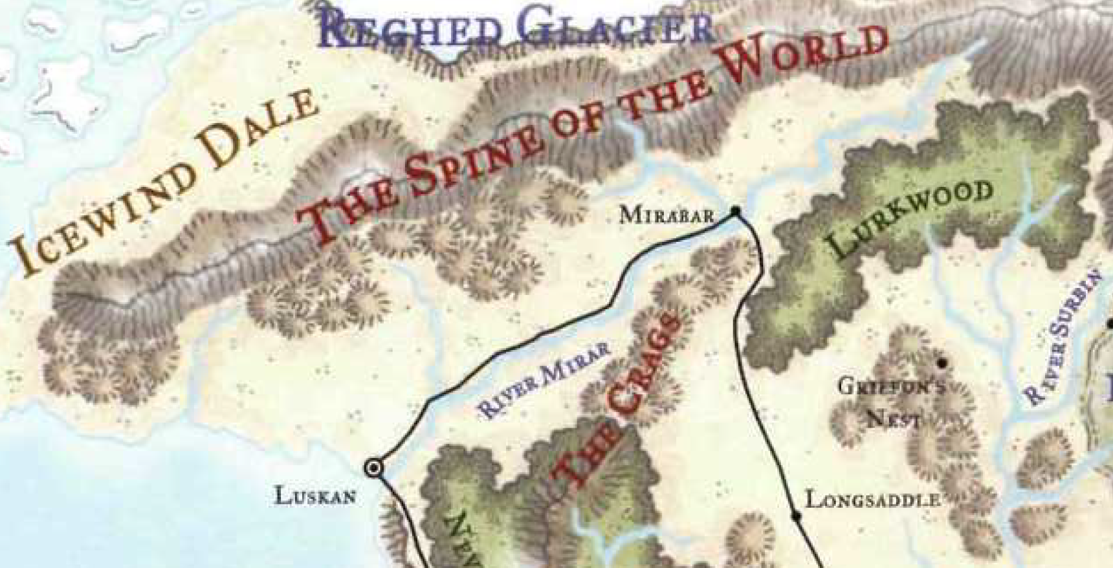

In the summertime, this area was lush and green, and birds sang myriad songs among the trees. In the winter, it seemed like only the sparkle of the snow under the hazy sky twinkled a tune in the silence around them. The carpet pressed on northward as the smaller pines that they’d been traversing became great beings thousands of years old with thousands of years left to live. Their trunks were at least 7’ wide, and they spanned the sky like plinths to the point that the carpet was no longer flying above the treetops, but rather in tandem to them, just west of the crack in the earth that separated the highlands of the Lurkwood from the narrow valley couched by the Crags to the west.

Allisa cuddled with her space as they flew to keep warm. She berated herself for not preparing a spell to keep herself warm. Every now and then she peeked out from her hood to see what their surroundings were. At the moment, she marveled at the huge, old trees for minutes before covering her face and leaning back into Lauren’s arms to rest her head on the woman’s shoulder. The druid had not seen this much snow in all her young life, nor could she remember ever being anywhere that was this cold.

Fingers was doing fine, but after hours in this tundra, everyone else’s eyes were starting to hurt from the cold. The two women had stopped talking, and had slipped their hats completely over their eyes so they could be fully insulated. They held one another as the craft averaged 150’ per round.

Kedrik put away the map, hoping they wouldn’t meet any other trolls or arachnids on the way. The archivist began to fear that he might be leading his trusted friends into a scape so bleak that they would be ill prepared to contend with Best.

The rest of the hours of the journey were thankfully uneventful, and despite the cold, Kedrik felt like wiping a bead of sweat off of his fully fur-covered head.

Mirabar was in the horizon. They had made good time, and thus there was ample light in the sky, though it was cast by a sinking sun at an angle of about 20 degrees. Sunset proper was still almost an hour away.

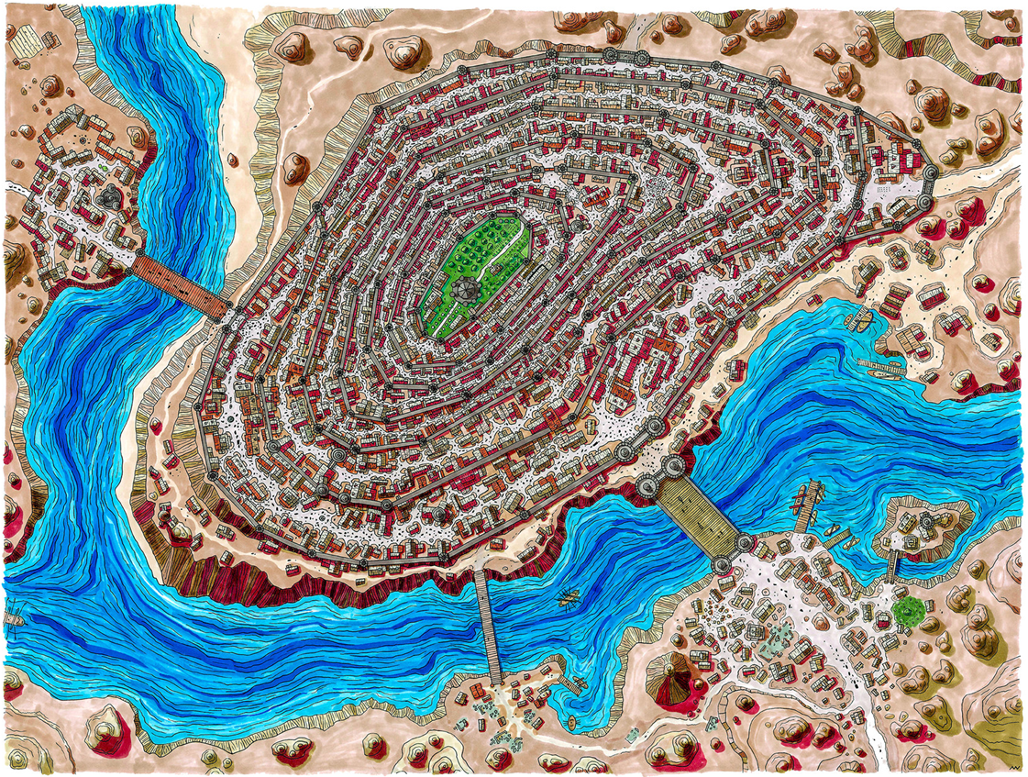

Mirabar, however, was not what they had expected. Reputed to be a small city of just over 10,000 inhabitants, Mirabar was the northern mining hub of the Sword Coast. The city’s shield dwarves had lived underground, overseeing their workshops. The humans and gnomes above cooperated with the dwarves to handle the mining, move the ore to market, and defend the city against magical threats. The nominal ruler of Mirabar was a hereditary marchion, but the true power—Kedrik had learned before leaving Waterdeep—was an assembly called the Council of Sparkling Stones, a dwarf-gnome-human coalition.

What they saw before them instead was the ruins of Mirabar, most of it razed to the ground. They were a third of a mile away, and about 200’ up in the air when Allisa and Lauren lifted up the flaps that shielded their eyes and squinted in the snowy light at the pillaged mining and trading city.

“Gods, what a mess,” Lauren sighed. “I don’t think we need to tarry here. We may have to find a place to camp, since any nearby towns would probably have suffered the same fate.”

“We might as well take a closer look,” countered Fingers. “There are bound to be some nominally habitable buildings left standing, plus we may find some survivors who can tell us what happened. While a reasonable assumption would be an attack by the dragon or its minions, couldn’t hurt to make sure. Plus, might give us a better idea of just what we’d be up against.”

Lauren shook her head with a sigh “For now, we need a place to rest. Then, we can look about in the morning.”

The conductor of the carpet lowered the craft to nearly ground level, then slowed down as they got to the city walls. A dozen armed fighters turned their attention to the hovercraft, and the scantily dressed Fingers then slowed to a stop as the three fur-donning heroes got off the carpet.

Allisa and Lauren removed their facial coverings as a few of the fighters lowered their blades and morningstars. Kedrik did the same, and announced, “We mean you no harm. We are Destiny’s Gambit, from Waterdeep. What has happened here?”

“White dragons,” a human with a mustache and helmet said the words that Kedrik most expected to hear. “They’ve ravaged the northlands, and have wreaked havoc on every settlement from here to the confines Icewind Dale. What brings you to Mirabar, heroes?”

“White dragons,” Lauren replied. “We are attempting to destroy them.”

Fingers suppressed a sigh at the blurting out of their mission and added. “We’d appreciate it if this didn’t become widely known, however. Best may well have eyes and ears within the city and we’d just as soon not announce ourselves.” It made a mental note to have a frank discussion with the other members of the Gambit about the value of information and how it’s better to collect it rather than freely spread it around.

There were a few buildings damaged by fire, but the city appeared to have been razed by cold-based means, as well as general structural damage. White dragons despised fire, and the charred buildings looked like places that had first been smashed, then caught on fire as planks of wood were exposed to indoor hearths, ovens, and fagots. Kedrik’s assessment of the area was bleak; these people would not be rising to their former glory for at least a decade, were it not for the help of magic.

“It is a travesty, what has happened to these people. Hopefully most made it into the dwarf underground,” said the druid.

“But where else will we find shelter? At least in those ruins we might find a roof and four walls. Or maybe a sentry that can take us to the dwarf community.

Lauren nodded in agreement. “That’s a good idea.”

“Are the underground portions of the city still intact?” Lauren asked.

“Yes, mostly,” Serendip was fatigued and battle weary. “The hordelings made short work of some of our defenders, but the stonework held fairly well.”

Some of the men and women in armor reported to the human with the mustache, and he nodded, answering in a discernible but overly localized form of Common. The Gambit found it charming, and a bit funny, but held their smiles in the face of the moment’s gravity. Now that the helmeted warrior knew that the Gambit was here for Best, he said, “My name is Serendip. I was a Commander until two nights ago, when the bulk of our defense forces were wiped out by Best and her ilk. They swept down from the east as Midnight drew to Night’s Heart, and by the time the sun rose, they had left our half-eaten corpses upon our rooftops.”

Some of the women and men in Serendip’s orbit had heard of the Gambit, and were now bustling with murmurs as they smiled and nodded with deference at the four carpet riders.

“You say you were a Commander,” the inquisitive gnome couldn’t help but ask, “Does this mean you were stripped of your rank?” Kedrik tilted his head.

“Nay, friend,” Serendip sighed. “All of my superior officers have been killed. After wiping out most of our standing army, Best obliterated the bunker below the barracks where the High Command convened and executed their plans, and within minutes, I found myself promoted de facto to the rank of Major General. I don the title reluctantly, and until we can say that we live in a proper city again, I’ll simply ask to be referred to by my moniker.”

“So, heroes, what do you intend to do when you encounter Best? She has amassed a powerful enough army to level this fair city. I mean you no offense—and your reputation commands an admiration far greater than I’ve ever earned—but you are only four, and they are a hundred, at least!”

“As you say, obviously we intend no frontal assault. Our task at the moment is primarily to scout out her lair and evaluate its defenses. Until we have a better idea of that, any plan of action would be foolish.” Fingers replied, in part because to its mind that was the reasonable way to proceed but also, even if the Gambit had firm plans at this point, it would be folly to disseminate details.

“Where are they now?” asked Allisa.

“The dragons flew westward on the morn of the 21st, and we’ve not heard word of their misdeeds since,” Serendip reported.

Lauren looked at him. “They went west? Or east?”

Serendip replied, “Came from the east, attacked the city for a good, long while, then continued westward.”

Lauren remembered that to be the day they woke up in that middle-of-nowhere tavern/inn where they stayed their first night away from the city. It had been such a peaceful and romantic night for her, while thousands here in Mirabar were slaughtered.

~*~

While little of the above-ground infrastructure had remained, there lay at 40’ below the surface a layer of excavated passages that themselves led further downward into a network of interconnected chambers, chasms, mineshafts, passages, and exits, all of which comprised the local conduits of the Underdark. Caravan routes from here led to Mithral Hall, and beyond, and all by underground trails. Mirabar would not have become what it was without such a means to expedite their ore across the land.

The heroes had crossed the road that marked the eastern extent of the Sword Coast North, and though they could not describe most of it beyond myriad pines poking out from an expansive patch of white. Now, they were being shown the first layer of this subterranean realm beneath Mirabar—really, still part of Mirabar.

Serendip was kind enough to show each of the heroes to the best source of dwarven spirits that money could buy, and said, “Please try to make yourselves as much as home as you can. I must tend to the safety of my people; your assistance would be most appreciated, if you have any stone shape or make whole spells available, or just want to help nailing some planks back where they belong.”

Fingers commented, “I’m afraid such magics are not my strong suit, although some of my companions might be able to lend such aid once they’ve had time to prepare in the morning. However, I do have some knowledge regarding buildings, and I’d be happy to offer advice as to which structures may be worth saving. By the way, how extensively have the paths to the Underdark locally been charted? If they are reasonably well known, might there be any that would take us to the mountains with exits back to the surface we could use to approach closer safe from airborne eyes?”

Serendip nodded, “They’re all part of the network that comprises the Underdark. If that is a path you wish you take, ask for Gwee. She’s down here on most days, and I know she survived. She can provide you with a map, and take you part of the way, if she’s not already doing so with someone else.”

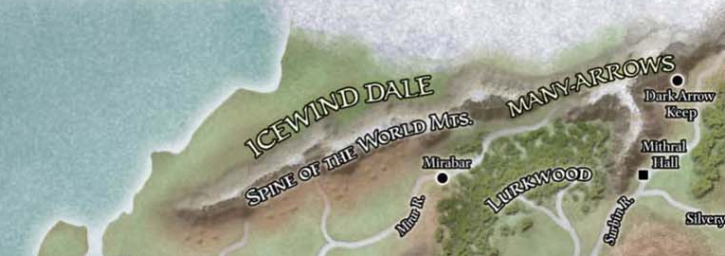

Kedrik thanked the human, then looked up to see a more detailed map of these northern lands. The inquisitive gnome copied some of the names and features onto his own map for future reference. There was also a map of Icewind Dale, the lands beyond the Spine of the World.

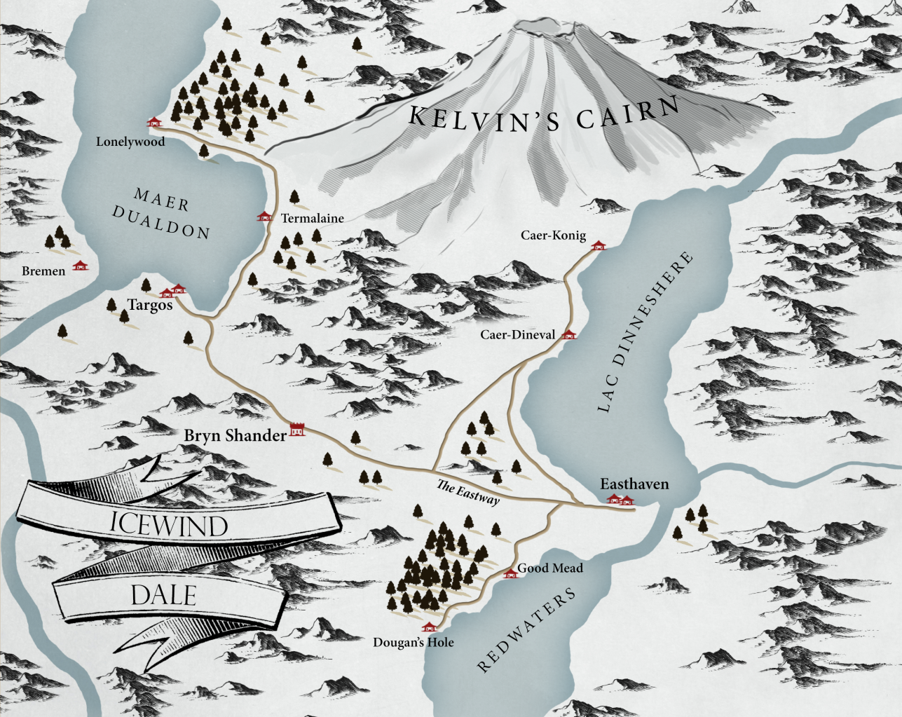

“What’ll it be then, eh?” a smirking dwarf who thought himself dashing came up and asked about their orders. He had a name tag on, written in Dwarven Old Script, which Fingers and Kedrik could both read.

“Thromm, son of Fror, is it?” Kedrik squinted at the name, pronouncing it with Common inflections.

“Aye, cousin, and yer moniker?”

“I am Kedrik, a Waterdhavian archivist, and these are my esteemed associates: Allisa, Fingers, and Lauren,” quoth the gnome. “We were told by Serendip to ask for Gwee.”

“She owe you money?”

“Uh...” Kedrik pursed his lips before giving a good answer, “we hope to owe her some money for her services.”

“Let me see if I can find her,” Thromm said, but not before Kedrik threw a few coins his way. “So... drinks?”

“We could use some rest,” Lauren put in. “I have some questions for Gwee, if she will meet with us.”

“A wine if you have one, otherwise some light mead. Fruit would be nice also.” Allisa smiled at the dwarf, her knee rubbed up against Lauren’s leg as it bobbed up and down.

“This be a dwarven house of spirits, not a human or elven winery. I’ll bring you what wine drinkers like,” Thromm winked at the druid, forcing half a smile upon his downtrodden face. “I’ll see about Gwee.”

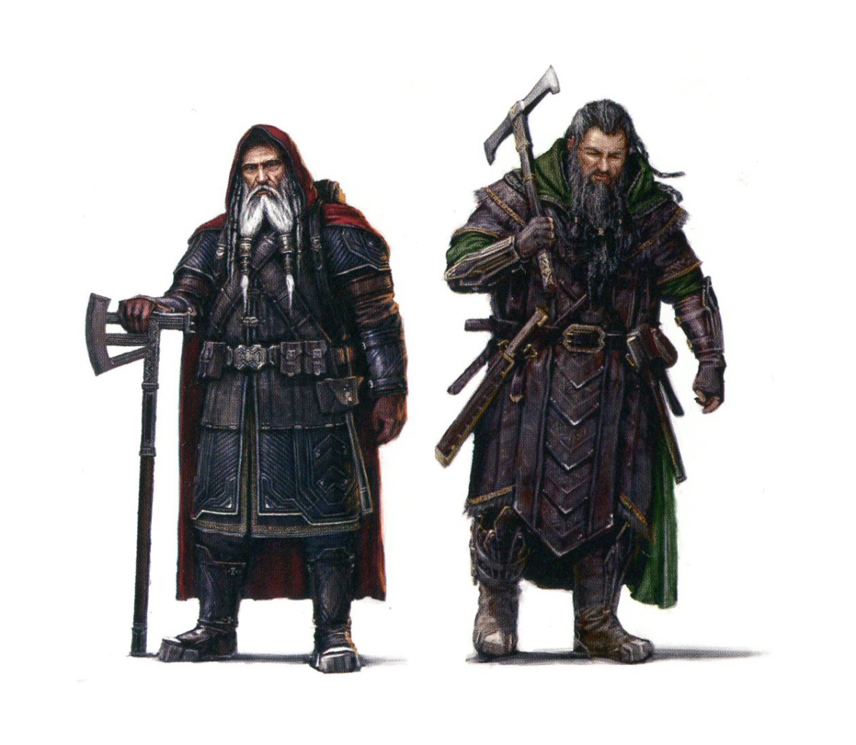

While the humans above focused on rebuilding as they mourned those who could not be resurrected, dwarves were known for being less quick at getting over having their cities razed by dragons, and it showed. The denizens of these underground halls might’ve been cordial and hospitable on a normal day, but one could tell that the dire triage and bitter disappointment of their recent defeat and personal loss was wearing them down more than their human counterparts.

In good time, the drinks were served, a few coins were tossed, and even Gwee showed up, looked the gnome and his friends up and down, and said, “I’m Gwee. What do you want?”

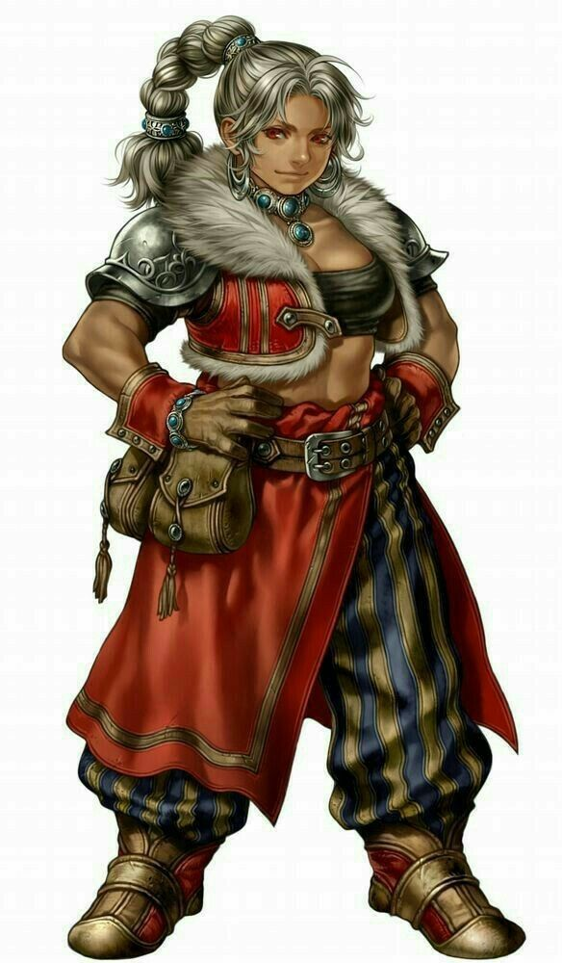

The druid was feeling warm from the drink brought to her. Her cheeks had reddened a bit and she was having a nice buzz. Her feverish blush made it evident that the daughter of a sun elf and a human thought Gwee looked a bit hot, even as her hand on Lauren’s leg slipped onto the woman’s inner thigh, the side of her hand pressing against her crotch. She smiled at the lady as she looked the group over, her eyes inadvertently cast downward whenever the dwarf tried to make eye contact with her.

Lauren looked the dwarf over—all 4’ of her—and shifted in her seat before answering. Allisa’s reaction to Gwee was plain, and Lauren suppressed a spurt of raw desire from the combination of her wife’s teasing and the sight of the cute dwarf. “Uh, we need to travel through the Underdark,” she began. “Despite my appearance, I am not familiar with it.”

Gwee had, by now, read everyone’s faces, gleaning a story about all of them. In Kedrik, she could see what she would have called a cloistered cleric, though he was no proper cleric. Booky, not at all prepared for where he was about to venture, and, well... really booky.

She was partly wrong about the wily wielder of Dark Knowledge and dungeoneering secrets galore, though in taking a measure of Allisa, she was spot on: the druid had hardly been able to keep her eyes off the dwarven woman’s arms, breasts, and face, and the surface drow next to her—it was obvious—wasn’t having it. So... they had a shapeshifter among them....

With Fingers, she didn’t even try. She could tell the poker faced adventurer was good at something other than shielding his emotions, but she thought she found something familiar in his definitively human features.

In the seconds that it took her to intuit what she could about this band, the half-drow had clarified their need for a guide through the Underdark.

She asked to know more, so she could consider the route and other tactically important options as she calculated a price. Her face betrayed the fact that their needs were vague, but upon the mention of the Spine of the World, her eyes opened wide, and she put her hand on Lauren’s wrist, “Let me stop ye right there, dav’risha, >> she used the Drow term for comrade, then continued in Common, “The Spine of the World is pretty much off limits. I can guide you south, east, even west—a little bit—but north... no. The entire southern face of the Spine from Raven Rock to the eastern edge of the Lurkwood has been overrun by the same horde of white dragons that cut us down.”

The Gambit leaned forward in their postures, conveying interest.

“Just how extensive is this horde’s havoc?” asked Kedrik.

The dwarf spoke some more, tilting her head, and not being the best expert on dragons. “Well, normally, white dragons are dumb as the Neanderthals they eat, sedentary as a treant, and confrontational enough ‘mongst one another so they keep their own numbers down. There’s a Duergar saying what held true until recently: << the person who gets killed by a white dragon is a person who chose to get killed by a white dragon. >>” She giggled.

She was the only one at the table who understood that strain of the Dwarven tongue, so she translated it for the newcomers, though the rhyme was lost. She then produced a more detailed map of the Spine of the World than the one on the wall, and pointed to some of the landmarks she’d just referenced. “From here a here... is all destroyed: the mines, the villages and hamlets along the way... all dragon fodder.”

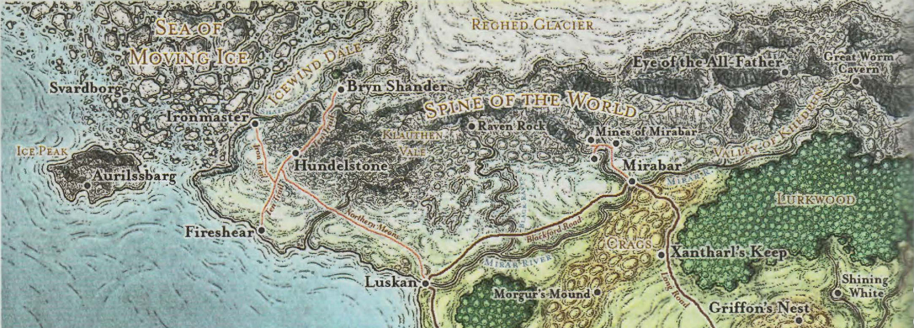

“No survivors?”

“Oh, sure, stragglers come in every day, but now they find us in the same lot. Some of our own folk left yesterday and today, headed south along the caravan route to Longsaddle.”

The heroes proceeded to tell Gwee what had befallen Longsaddle.

“Ice trolls, ye say!?” the dwarf asked. “We get those buggers ‘round here sometimes too. Hm… least their town is still standing.” The dwarf held back a tear as she saw a few armored men come down the stone staircase and approach their table.

One of Serendip’s men—a young human of about 20 years—approached the Gambit with an update from the Major General. They’d seen him before from afar when they’d first arrived, but now beheld his image, which reminded them all a bit of a younger, stubblier, less self-confident version of Zond. Oh, how Allisa had missed Zond, but Lauren’s touch had comforted most of the druid’s sorrow away. And now there was this ruggedly handsome specimen of a dwarf before her, and the Mistress of Many Forms just couldn’t contain the moisture building up around her cervix.

The young human spoke, “Heroes, the Major General sends a message. He would like to take Fingers up on his offer to offer advice as to the masonry and woodwork. If you might all lend a hand, we would be most grateful.”

Fingers nodded, “Naturally, giving a citywide inspection could easily take weeks and we must be on our way fairly soon. However, if you could supply me with a good hooded lantern and a few stout backs to help move debris—dwarves also knowledgeable concerning construction if possible—I can try and identify at least a few buildings that might be saved and a few more that are beyond help you might raze for rebuilding materials. Once we return after our business elsewhere is completed, some additional assistance might be possible.” While the trapsmith could endow itself with darkvision for a few hours, being able to view areas in full color instead of the greyscale of that eldritch sight might be important here and there. Also, if no dwarven help was available, not having assistants stumbling about in the dark would be preferable.

“Oh, the Major General meant at morrow, sire. He’s reserved some cots for you downstairs; that young lady will show you all the way when you’re ready,” he pointed to one of the tavern keeper’s daughters, who bowed her head to the couple at a nearby table as she served them their drinks. “By your leave, heroes,” the young man then bowed his head—they were all very polite about bowing here—and he and his two lieutenants headed back upstairs.

Kedrik felt it important to not delude the dwarf about their motives. He saw in her a strong heart, hardened by hurt, but not turned to stone as so many hearts had after such a horrendous defeat at the hand of Best’s forces. “In truth, Gwee, we are here seeking out Best—the leader of-”

“Yes, I know who she is,” the dwarf meant instead to say, “continue without the introduction.”

Fingers looked at the lawful good gnome and rolled its eyes, wondering why Kedrik even hung out with the rest of the Gambit, who favored neutrality above the archivist’s pursuits of transparency and goodie-good altruism.

Within a minute, Kedrik had not only fully divulged the coarse points of their mission, but had managed to get Gwee on board with going north. She had her own vengeful reasons for seeing to the demise of Best’s forces, but Kedrik was also appealing to her sense of heroism and goodie-good altruism, and it was filling the guide with resolve.

After stating her price—a whopping 190 ₲ per day—“I’ll need to get some rest too. Meet me back here in the morn... after Fingers is done with whatever needs doin’ up there. It’ll be a three-day march to the foothills o’ the Spine. I’ll need a deposit o’ 380 coin—that’s the first two days’ fee—before we head out, which I’ll leave with me mum, and the rest I’ll trust ye fer. If we get to the mountains, and you still need me to guide you somewhere else, we can talk; I won’t be in any hurry to get back here.”

They all agreed to Gwee’s terms.

“Put ‘er there, then,” the dwarf said to the gnome and they sealed it with an Underdark clap-clasp, the signature handshake of armistice among dwarves and gnomes in northwestern Faerûn.

Gwee then bid the others a good sleep, and went off home to rest up for the trip.

Kedrik then cracked his knuckles, and said, “Allisa, I’ll fix your things in the morning once I’ve prepared some mending prayers. I’ll also prepare some make whole and stone shape spells so we can get the higher-priority buildings touched up before we leave.” He shared his intended spell list with the others, in case it affected the others’ plans, and then excused himself to go to the cot that they’d prepared for him further downstairs than they already were.

Prayer | Level | Electric | DC | Cast?
Detect Magic | 0 | 0 | 17 | ❑
Mending | 0 | 0 | 17 | ☑
Mending | 0 | 0 | 17 | ☑
Read Magic | 0 | 0 | 17 | ❑
Bless | 1 | 0 | 18 | ❑
Cure Light Wounds | 1 | 0 | 18 | ❑
Detect Chaos | 1 | 0 | 18 | ❑
Detect Evil | 1 | 0 | 18 | ❑
Detect Law | 1 | 0 | 18 | ❑
Nightshield | 1 | 0 | 18 | ❑
Sanctuary | 1 | 0 | 18 | ❑
Shield of Faith | 1 | 0 | 18 | ❑
Cure Moderate Wounds | 2 | 0 | 19 | ❑
Hold Person | 2 | 0 | 19 | ❑
Hold Person | 2 | 0 | 19 | ❑
Identify | 2 | 0 | 19 | ❑
Make Whole | 2 | 0 | 19 | ☑
Make Whole | 2 | 0 | 19 | ☑
Make Whole | 2 | 0 | 19 | ☑
Call Lightning | 3 | 1 | 21 | ❑
Stone Shape | 3 | 0 | 20 | ☑
Stone Shape | 3 | 0 | 20 | ☑
Stone Shape | 3 | 0 | 20 | ☑
Stone Shape | 3 | 0 | 20 | ☑
Stone Shape | 3 | 0 | 20 | ☑
Stone Shape | 3 | 0 | 20 | ☑
Break Enchantment | 4 | 0 | 21 | ❑
Break Enchantment | 4 | 0 | 21 | ❑
Death Ward | 4 | 0 | 21 | ❑
Diamond Spray | 4 | 0 | 21 | ❑
Divination | 4 | 0 | 21 | ❑
Freedom of Movement | 4 | 0 | 21 | ❑
Bear’s Heart | 5 | 0 | 22 | ❑
Chaav’s Laugh | 5 | 0 | 22 | ❑
Chaav’s Laugh | 5 | 0 | 22 | ❑
Dispel Evil | 5 | 0 | 22 | ❑
Flame Strike | 5 | 0 | 22 | ❑
Bolt of Glory | 6 | 0 | 23 | ❑
Dispel Magic, Greater | 6 | 0 | 23 | ❑
Mantle of the Icy Soul | 6 | 0 | 23 | ❑
Stone Body | 6 | 0 | 23 | ❑
Holy Transformation | 7 | 0 | 24 | ❑
Radiant Assault | 7 | 0 | 24 | ❑
Restoration, Mass | 7 | 0 | 24 | ❑

Lauren and Allisa were the first to be led to their chamber to rest for the evening. They had a single room with two sets of bunk beds, and since they had passed some of the other quarters with doors ajar and open, they now evaluated their own room to be about the best there was in this makeshift hostel.

Lauren arranged the bedding to make a pallet on the floor that would sleep her and Allisa together. She stripped out of her gear and clothing, and carefully set her sheathed sword somewhere close at hand. Using a bit of water from the basin, a cloth, and scented soap, the drow cleaned herself and then rinsed the cloth. “Come here, lover,” she told Allisa. “Let me wash you.”

Allisa agreed.

Lauren helped her undress, and she repeated the cleaning process.

Allisa helped her mate with the bedding thinking they were the only ones to be in the room. When Lauren offered to wash her, she readily accepted. The druid hung her furs on the hanger and placed her weapons next to her side of the bed. She the joined Lauren for the intimate bath.

Shortly thereafter, the barmaid led Kedrik and Fingers in, and curtsied her thanks as Kedrik tipped her a few gold coins.

As Allisa dried, the two males in their party entered the room. She smiled at them, giving a wink at the barmaid’s, expression…. She tossed the towel at the gnome, then turned and picked up her things, placing her armor next to her, and her valuables under the pillow. The rest of her pack was deposited in the box.

“So, is this mission still viable? I mean, we lost three of our numbers. Even with them, I do not believe we could fight a whole army.” Allisa was not worried as she stood before the others, as they had seen her nakedness before. She then sat on the bed crossed legged as the others spoke.

Lauren shook her head. “All we are doing is gathering information. Sooner or later, these dragons will arrive in Waterdeep.” She sighed. “I’m tired of the fighting. I just want to live a normal life with you. To do that, I have to help stop Best.”

Fingers nodded agreement. “Yes, taking on such a force directly without solid information would be utmost folly, even if our numbers weren’t depleted. Even if we were lucky enough to encounter Best by herself, I would hesitate to try taking her down at this point. It seems highly unlikely we could do so before she’d alerted her minions and brought the whole horde down on us. For my own part, my ability to inflict significant damage is dependent on catching the target at a disadvantage, something supposedly most difficult to do with a dragon. If the tales are accurate, even invisibility might not be enough to stymie the senses of such a creature.”

Lauren looked to the changeling with a sad expression. “Who would we even approach to help us fight an army of dragons? Waterdeep?”

“Seems ironic,” the rogue said.

The duskblade continued, “I don’t think they could withstand a full attack any more than Mirabar could. The elves of Silverymoon might manage it.” She sighed and sat on the pallet she’d made and folded her legs under her. “All I want is to live my life in peace, but that is impossible unless these dragons are stopped. We can either help, or we can flee somewhere far away.” The drow looked up at Allisa. “What should we do?”

“Well, heroes, it’s not as lavish as our own comfortable trappings,” Kedrik shrugged, “but it’ll cure us of fatigue, and sure beats having to sleep out in the snow near the drider’s place of ambush.”

They all laughed at how badly the drider’s plans had been foiled, and eventually their chatter became peppered with biddings of goodnight, followed by the faint snoring of Kedrik thereafter.

Fingers examined the room carefully for signs of mischief... the trapsmith had once thought about ways rooms could be built to make it easy for nighttime burgling—solely as a mental exercise, naturally (well, probably). Satisfied that the builder hadn’t shared its own larcenous tendencies, the changeling nevertheless fashioned a simple alarm out of clanking odds and ends to hang before the door so that no one could enter quietly. As Fingers’ grandsire used to say, “It isn’t paranoia if someone’s actually out to get you.”

“Well, it is technically still paranoia; it’s just not pathological... it’s founded on a high likelihood of an aversive event befalling you,” Kedrik had to spoil the saying by overanalyzing it.

After the lamps were out, Allisa cuddled with Lauren. The others could hear the redheads’ muffled giggles every now and then. After finding their shared pleasure, the drow curled up with Allisa in her arms and went to sleep.

~*~

The night came and went uneventfully, or so they perceived. In truth, another town had been ransacked by dragon hordes, and later that day, the tireless dragon forces would likely subdue yet another people further west.

Fingers had stored most of its possessions in the chest and hat tree, but the shortsword had leaned all night against the wall by the head of the bed, and it had kept its small valuables like wands under the pillow for easy access.

Being the first to rise, he saw Allisa sleeping on the bottom of the bunk atop which Lauren also slept. The half-drow had taken the smaller, upper cot out of a preference for a view through the window with a better downward angle. Allisa could just as easily have turned into a kitten and slept in the human-drow’s arms, but she had almost gotten crushed by Lauren rolling over once, and kicked a few times when she’d slept at her feet, so that option was no longer a favorable one.

Fingers then stepped over to the window, waking Kedrik, who opened one eye and nodded groggily to the changeling—still in human form so as not to advertise its nature any more than necessary—before resolving to get himself up and dress his gnomish hide.

The changeling’s movements awakened Lauren, and she found Allisa in her arms. She leaned in to kiss her softly. “Good morning, lover.”

~*~

An hour later, they were dressed, washed up a bit, fed, and headed on their way to see Serendip.

“General,” Lauren was first to greet him once they spotted him just outside the barracks.

His demeanor was still as warm as it could be, but it was clear—and he soon confirmed—that grave news had just reached the city. “Blackford has fallen,” Kedrik and Fingers lowered their heads, having some admiration for that provincial town next to the ruins of a civilization so old, its proper name had been lost to posterity.

It was no bigger than Triboar, the first settlement with a name that the Gambit had passed through on their way here, but just up a crooked trail were the remains of a theocratic state that had devoted this site to building monuments. Surely the dragons had destroyed all of that, and the dear people of Blackford who acted as the wardens and archaeologists of the region.

After a short discussion of Blackford, and other news of the attacks upon the northlands, Serendip asked, “And now, I offer again my gratitude, and hope that you’ll help us with some of these buildings.

Kedrik had already cast both of his mending spells, and now all of Allisa’s melted gear was restored. He now consulted with Fingers and Lauren on how best to apply the three make whole and six stone shape spells.

Skill | Rank | Ability & Mod. | Misc. Mods. | Total | Roll | Check | Notes
Kedrik, Knowledge: Archit./Engin. | 13 | Int (+7) | 0 | 20 | 14 | 34 | Trivial Knowledge, best of 2 rolls
Kedrik, Knowledge: Dungeoneering | 15 | Int (+7) | 2 | 24 | 5 | 29 | Trivial Knowledge, best of 2 rolls
Kedrik, Knowledge: Archit./Engin. | 13 | Int (+7) | 0 | 20 | 10 | 30 | Trivial Knowledge, best of 2 rolls
Kedrik, Knowledge: Dungeoneering | 15 | Int (+7) | 2 | 24 | 14 | 38 | Trivial Knowledge, best of 2 rolls
Fingers, Knowledge: Archit. & Engin. | 5 | Int (+2) | 0 | 7 | 13 | 20
Lauren, Knowledge: Dungeoneering | 6 | Int (+3) | 0 | 9 | 9 | 18
See below.

Lauren and Fingers weren’t too sure about their own assessments, but they trusted Kedrik to be correct in what he was saying as he pointed to the structures around them. In little time, the four heroes had cleared an area of debris with raw muscle and some minor prestidigitation, and the gnome then cast his spells, restoring the better part of a building devoted to overseeing public projects.

The heroes were regaled with huzzahs and other customary cheers, and Serendip returned to the surface. He expressed again his gratitude, and—as Faith had—extended his hospitality indefinitely, should they ever choose to return. “I just passed Gwee on my way up. She says she’ll be waiting for you at the tavern. On behalf of Mirabar, I bid you all a safe journey across the Underdark.”

~*~

There she was, looking far more prepared than she had the night before. Equipped with picks an axe, crampons, and a plethora of other goodies, the experienced spelunker nodded and greeted them in a few different languages, then said, “Took the liberty of ord’rin’ a round o’ yam patties and hot beer to start the blood flowin’.”

The dwarf could tell that this type of breakfast was foreign to the quartet from temperate lands, and urged, “It’ll keep you warm inside during the first part of the trip.”

They sat and discussed their intentions and tactics, and Gwee mostly listened, scribbling lists and notations on a parchment. She then drew a map, then scratched it out and started again.

Kedrik’s eyebrows expressed some concern over whether or not Gwee knew what she was doing, but looking at what she was writing down—the names of prominent nodes and crossroads along the Underdark—his concern receded.

A few dwarves and humans passed the Gambit and expressed their thanks without wanting to linger and interrupt further.

“You’ve done us a great service!”

“Keep on doin’ what yer doin’!”

“Dragon slayers!”

Kedrik asked to borrow Gwee’s map of this section of the Underdark, and laid it atop his own.

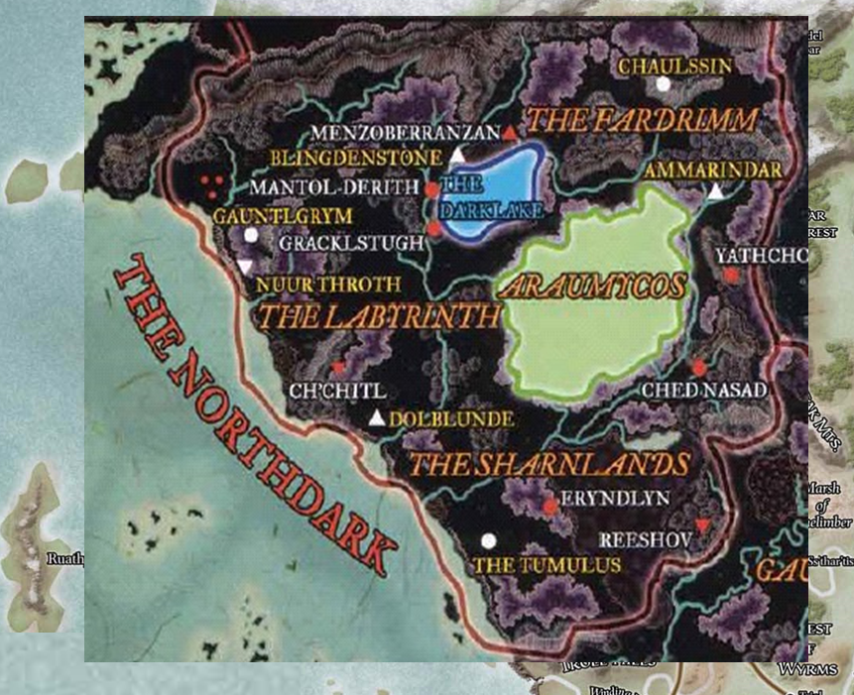

Menzoberranzan—which was squarely situated under the Lurkwood—was the greatest of drow citadels and realms, and Kedrik was glad they didn’t have to go that way.

After Gwee inquired about what the Gambit wanted her to lead them to, Fingers considered a bit and then replied, “Our primary need is getting to the mountains unseen by any of Best’s minions without encountering any Underdark dwellers who might seek to kill us. However, if there is a community of any sort in that area of the Underdark not likely to be hostile to strangers on sight, that would be the ideal. Locals would probably be able to help us zero in on the location of Best’s base or at least have knowledge of their comings and goings that give us an idea of where to look.”

Lauren nodded in profound agreement.

“I reckon we can make that happen, brother-in-arms,” the dwarf tried to imply “yes” and “thank you for saving us last night” in the same sentence. Then she sighed as she looked around at the familiar dwellings, and winked at an ex-boyfriend who passed by on his way up to the privies. “Well,” she then got herself up. “Let’s go by way of the smithy in case you all want to replenish your quivers and what not. They got a new shipment of wares in just this morning.”

Lauren picked up four 50’ ropes, four grapnels, 50 pitons, and four hammers for climbing. She stored these items in her haversack. Fingers looked over the mundane equipment but did not find anything useful other than some odds and ends to replenish its trapmaking kit and material for creating simpler improvised ones.

