*Chapter 57*

36 hours later…

“Take that!” the evoker zapped Kedrik onto the ground with a bolt of lightning far more potent than the stuff that he could muster.

Allisa was next. She and Fingers had both been immobilized by some unseen force, and the rogue couldn’t even activate his *invisibility* or *darkvision* abilities.

The bolt of lightning struck the druid and sizzled her insides as Lauren charge-attacked the drider whose face resembled Gwee’s and whose snakes atop her head resembled Samara’s own.

The duskblade swung, and chopped off one of the drider’s legs before the drider grabbed the half-drow by the neck and crushed it with a single grip.

The drider then turned to Kedrik, who was the only one left with the ability to run away. She stared him down, froze him with her gaze as she approached, then opened her mouth wide and chomped off his little head right before it turned to stone.

~*~

Evening, 24 Deepwinter

Kedrik had had a restless sleep, as he wasn’t accustomed to the 14-hour routine of Underdark travel. Without the sun to guide their circadian rhythms, they were traveling for 8 hours and resting for 6, preparing spells during their somewhat leisurely meandering through caverns.

The gnome could still remember a disconcerting dream in which a drider with Gwee’s face devoured him. The details were slipping away as they gathered their trinkets and gear, and continued. Far above them, the night sky was occluded by a sheet of clouds destined to become the snow that was already falling. Down here, it was actually quite a cozy temperature, and the four heroes from Waterdeep had stowed their snow clothes into Lauren’s haversack.

Gwee was quite the able guide, and more than once had opted to take a slightly longer route in the interest of circumventing trouble with a variety of denizens of this layer of the Material Plane. They had opted to camp and sleep before arriving at the duergar settlement that lay not far ahead so they could be fully invigorated by the time they arrived. It was a small hamlet, and Gwee knew that duergar could be trusted as much as any other race that drafted laws enabling slavery, but she’d been here before, and had even gained some renown in the hamlet as a worthy arm-wrestler.

She had warned the Gambit of duergar customs, training them to establish eye contact after physical contact was made, and other things. However, as they approached their destination, the smell of smoke, and the sounds of weeping alerted them. They hastened their step, careful to not fall for some *ghost sound*, trap. With Fingers and Gwee at the helm of the formation, the torch-bearing party advanced northeast until they rounded a bend and beheld the looted, ransacked, pillaged and razed settlement of Zybrifoghjitzettrim.

Like Triboar and many other places in the region, this collection of a few dozen family-sized hovels had been overrun with hordelings. A single hordeling was no match for an adult dwarf, but in numbers, they were an unleashed force that devoured and destroyed without care. Zybrifoghjitzettrim had been home to a hundred duergar, and at least half as many goblin slaves, but now, they could see a handful of adult dwarves, and two children. The ample bubble in the earth’s crust was only a thousand feet across from edge to edge, and had served as a hospitable node for these duergar to occupy for dozens of generations, but like Triboar, efforts would have to be made to restore this hamlet to its prior state.

One of the women spotted Gwee, and the two women who had hugged one another before now nodded solemnly as they embraced once again. The members of Destiny’s Gambit kept their eyes down until properly introduced, then clasped hands to forearms with each of the members of one of the only surviving families, and locked eyes, saying, “Prost!”

~*~

They were not allowed inside the houses, for reasons to do with dishonor from having outsiders see the state to which they had been reduced. White dragon remains littered the floor, as did duergar and goblin corpses. Despite their numbers, the hordelings had been vanquished, with only a few escaping to other parts of the Underdark (where they would surely be eaten), or back up to the surface via a fairly direct staircase.

A makeshift barbecue was set up, where dragon and goblin meat were promptly cooked, and the heroes were offered some legs and torso parts. As they sat and ate their rations, and some of the meat, they heard stories from the few men and women who’d survived the onslaught.

Kedrik looked at one of the males—a fellow named Zharmiir—as he revealed, “Best has ravaged the Spine of the world in a U-shaped trajectory, starting with Klauthen Vale, working her way to the Mines of Mirabar, the Great Worm Cavern, and then southeast to the northern Lurkwood, where suddenly they turned sharply westward again and came upon our once great city. I had just returned from a trip to Raven Rock, where one of the first attacks, and have heard tales of village after village falling to the mob of drakes from the icy wastelands of the north.”

“We need to send word of what is happening back to Waterdeep by some means. They need to start preparing,” Allisa said.

“I agree,” Lauren said. “We also must determine why Best is conducting these attacks. But, is there anyone who can carry a message to Waterdeep and the other nearby towns. Several messengers would be better, I think.” She sat back to hear the responses to her questions, and then her mind wandered. The latest nightmare had reduced her to a quivering wreck, and she had awakened to find herself clinging to Allisa while weeping like a child. Lauren pushed the thought away, and smiled slightly at her wife. It hurt her heart to consider that neither of them might survive this quest, and that a peaceful life was so much wishful fantasy. But, there was work to be done, and she steeled her resolve to attend to it.

The druid had been disturbed by the night’s dream. In her mind it was a fabrication because if one truly dreamed of their own death then all the wives tells said you would die then and there. This must be a magically induced dream; she tried to explain that to her love as she clung to her. Though they had just woken up maybe a half hour ago, the druid still felt weary as she gently caressed Lauren’s hair and said a small prayer.

“I would imagine that the towns and cities in the vicinity are well aware of the threat after so many being razed. However, it is a good idea to see if Serenity can find a reputable traveler heading south to carry a message with what little we know so far to Waterdeep. Perhaps there is some magical way to send a message as well, although I have no knowledge of such myself.”

“If I were a proper cleric,” the whisper gnome blushed, “I’d be able to prepare a *sending* spell by morning, but as an archivist, I’d have to do some study on this relatively difficult prayer to recite. But a message *should* be sent.”

“I will look through my notes to see if I have some spell that can send a message that would be feasible. If so i well learn it and then we can send one in the morning,” said Allisa.

They ate as they talked for a few more minutes, and soon, there came a woman with a flame totem painted onto her forehead. Her name was Yathrib, and Yathrib was a cleric of Deep Duerra, not the vilest of duergar deities, but certainly the most cunning.

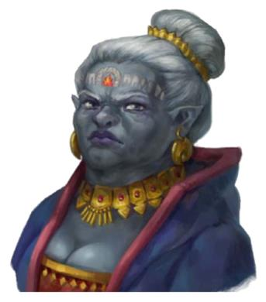

“Gwee...” the woman nodded to the shield dwarf who’d brought the surfacers. Within a minute, hands and forearms had been clasped, eye contact had been established with the duergar, and the party came to know her as one of the former administrators of law in the cluster of nodes that constituted a dwarven city. This was merely a peripheral settlement of recluses and half-hermits who had formed small communities far from the larger, miles-wide centers of activity on par with Mirabar, from where they’d just come.

At first, she was skeptical of the surface folk, but after some platonic wooing on the part of Fingers and Kedrik, Yathrib came to trust the Gambit enough to share her knowledge of Best as best as she’d gained it. She spoke, preferring to direct herself towards her fellow dwarves, and said in Common, “Best has suffered a great defeat in her attempts to invade Luskan. Through a network of clerics and others using *sending* spells, the Illuskans came to know of our defeat, and of the other villages and towns along the dragons’ path, and were well prepared for their attack. Word has it that Best was planning on pressing a southward campaign until reaching Athkatla, but she was spotted by scouts early yesterday retreating northeast, probably to Raven Rock, where some of the Uthgardt barbarians have pledged their allegiance to the white dragon. This horde of zealous barbarians has also joined forces with a band of frost giants, though I know not what sustains those volatile alliances. They mean to defend Best with their lives, and have allegedly been promised senior positions in the Abyss upon their expiration on this plane.”

Best’s style was so reminiscent of Supreme Defiance: emulating a deity before the presence of a horde of barbarians who shouldn’t have been expected to know better. Kedrik was aware that taint elementals had very little personality of their own, and the ones the Gambit had faced were surely embodiments of their masters or victims.

“I still don’t understand why Best is doing all of this,” Lauren said as she shook her head. “I think that’s what we need to determine, and we will probably have to go to Raven Rock to find out.”

Allisa nodded in agreement, while her mind thought over how to be a bit warmer.

Fingers commented in a rare display of philosophical musings, “Who can say what motivates such a beast? A desire for wealth or power, a delight in death or destruction, urgings of yet another more powerful entity as part of a master plan, revenge of some slight real or imagined or possibly even mere boredom—I’ve heard dragons do live for hundreds of years and perhaps Best ran out of things to keep occupied.”

Kedrik opened his mouth to speak, but nobody saw, and his good friend spoke instead.

“Whatever her motivations, they must be known for us to finally defeat her,” Lauren replied. “If we know her goal, then we can better divine her plans and intentions. Otherwise, the initiative is on her side. And, that is how you lose a fight. Or a battle. Or a war.”

“Right,” the gnome then said, having simulated so many fights, battles, and wars with action miniatures. “Knowing is half the battle. Couldn’t agree more.”

Knowing that the other half of the battle involved violence, Lauren kept her eyes peeled in this part of the Underdark. Even if these duergar had been humbled and reduced to a few extended family members huddling to eke out an existence in what remained of this place, the half-drow knew better than to trust them out of hand.

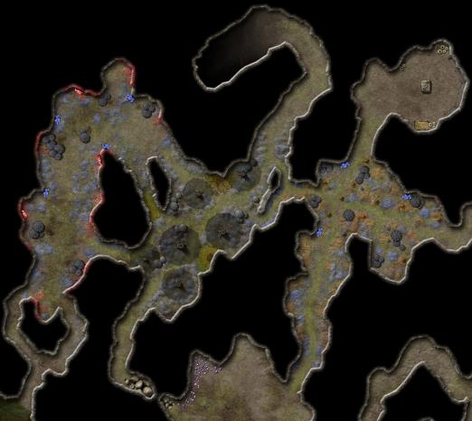

Once everyone had eaten their fill of fell drake, Gwee excused herself, and took her leave to attend to the biologicals, as did a few others. Lauren and Allisa shared an intimate silence as the Gambit turned to the decision of where to go next. They knew Raven Rock was their most likely destination, but would they continue to traverse the Underdark, ascend as quickly as possible and reprise their carpet-borne trek? It was a tradeoff between greater speed and the convenience of being warm.

Fingers considered the possibilities before voicing its two coppers, “Whether to stay in the Underdark to conserve warmth or travel quicker aboveground, I leave that to you as it’s not an issue for me. However, we might consider another possible destination other than Raven Rock. Going there might mean a direct confrontation with Best and her defenders, which we are ill-equipped to handle. If we knew for certain some of the forces that just stymied her were also headed there to finish the job, that’d be another matter. Could we determine whether that is the case via one of the *sending* spells Yathrib mentioned? If not, I would suggest as an alternative we stick with the original plan to try and locate Best’s lair.”

“It was good of Yathrib to relate the contents of one of the last messages that she received through the *sending* spell of another cleric,” Kedrik nodded. “I will do my best to learn such a spell, but I’ll need some time. Maybe next time we rest I can start. Let’s go on the assumption that Fingers is talking about.”

With the gnome’s open hand pointing towards it, Fingers continued, “Knowing that neither she nor many of her defenders are present could be an opportunity to raid it and weaken or even completely eliminate the forces still there. It’s possible there could even be an immature brood of her children. Slain wymlings today means not facing more dragons tomorrow.”

“I think we should fly as far as possible, and then go into the Underdark, if needed,” Lauren said after a moment’s thought. “If we attack Best’s lair, then she will know that someone is hunting her. That would surely cause her to change her plans. So, I suggest that we not do that unless it clearly will be advantageous.”

“I’m ambivalent as to where we go,” Kedrik clarified what he’d previously stated. “Sounds like we have 2 votes to get to the surface as quickly as possible so Allisa can find a bird and we can all get back on the carpet—with you, of course, if you wish,” the gnome turned to Gwee, then continued, “As to whether we head for Raven Rock or elsewhere, we should probably discuss that on our way up, since there’s no real disagreement that our time down here is not of any direct advantage.”

“Long as I get me coin, I’ll lead you up, but afterwards, I’ll prefer to turn around and head back home,” Gwee admitted.

The Gambit was glad to have had her along. They had spent a barely noticeable amount of coin on the guide, and had, in the process, probably circumvented all manner of life-threatening hazards and encounters.

They began to make their way up.

It took two hours to reach a point where a stream trickled in from outside, and they could smell the familiar scents of photosynthesizing plants. “Soon,” Gwee warned them, having already told them that the most hazardous parts of the Underdark were often thresholds to the surface, which one entity or another controlled for their own purposes. She had not been to this exit in quite some time, and did not know how to prepare for possible ambushes. They could have expected a choker as much as a mind flayer, or nothing at all, for all they knew, but it was best to be prepared.

Gwee gathered the heroes at a huddle. “We’re about a minute’s march from the point where we’d begin to see light, but I don’t think the sun’ll be up yet, so no light to guide us. Kedrik and I can see in the dark; Fingers, what about you?”

Tapping the headband at its brow, Fingers answered, “Not normally, but this lets me do so up to three hours daily and I haven’t used any of its power yet today.”

“I assume ye half-elves can see in low light, yes?” Gwee asked as one of them held a torch without which they’d be blind down here.

“I can see just fine in the dark,” Lauren answered with a tight-lipped smile.

“If there are foes beyond, torchlight and smoke will give us away for sure,” Gwee said. “Fingers, maybe ye should go on ahead, and I’ll follow a bit behind, with the rest of ye following at a distance you think is safe.”

“I will follow him,” Lauren answered.

A few canteens were slung up and into the mouths of the heroes. They’d been climbing staircases, treading up rough inclines, and scaling nearly flat surfaces for quite some time by now, and without Lauren’s recent purchases of pitons and other climbing equipment, they would all have had a hell of a time doing so.

“How long is the passage from the point you mentioned where sunlight sometimes begins to trickle in?” Fingers asked.

“Once you get to where I said? Then it be a good one-minute walk at the pace that we’ve been keepin’, so a two-minute walk if you’re creepin’ up on our possible hosts,” the shield dwarf answered. “If you’ve any long- and medium-term spells to cast, particularly if they’re loud, I’d do it now.”

“Other than a few wands, I can’t do much of that sort of thing and even the few I can use are fairly short duration. One thing I can do is create a mist that lasts for a bit. If I espy a significant threat, I’ll create one so that when you encounter the edge of it, you’ll know to make preparations. In the meantime, I’ll be trying to get past them to hit them from behind once you all move up to engage. If I spot a minor threat I can bypass that you should be able to deal with easily, I’ll build a small mound of stones to warn you to keep an eye out while I continue on. Anything really nasty, I’ll back off.”

“A mound of stones...” Kedrik rubbed his goatee. “I like that idea.”

Lauren cast *barkskin [expired in 2 hours]* on herself. *Lauren gained +4 to FFAC and AC.*

Fingers activated all of the charges of its headband to give it an hour of Darkvision and 10 minutes of *See Invisibility*. He resolved to advance as quietly as possible, keeping alert for threats, traps or alarms. Spotting old, tripped traps, and the residual evidence of alarms, wards, and sigils, the rogue could tell this had once been a hotspot for ambushes and the like.

Allisa decided to switch to something more appropriate and in a moment changed into a snow tiger, the love of all bears and cats causing her to have spent many hours in Waterdeep during down time studying books and drawings of such.

In a moment she caught up to Lauren without her knowing. Alisa made sure the woman was not surprised by alerting by her with a word they had both chosen.

Lauren ran her hand though the tiger’s hair, and then she drew her falchion and readied herself for combat.

Fingers went ahead, with Gwee about 100’ behind it, and the others about 40’ behind the dwarf. The trapsmith had expected to at least see some kobold sentry posted at the mouth of the cave, but all it saw was a clutch of carrion crawlers—pretty well fed—huddling for a breeding romp. One of them turned to look in the direction of the hidden rogue, seeing nothing, but smelling the changeling. However, given that they were far more interested in copulation than alimentation, the crawlers paid little mind to Fingers. He estimated with some confidence that they could pretty much circumvent this clutch of invertebrate scavengers by about 25’ if they kept to the eastern edge of the passage, which was farther from the giant grubs than the western edge. Doing so would most likely stave off any kind of conflict with the nesting handful of crawlers.

Building the agreed-upon warning mound of stones, Fingers continued on giving the crawlers a wide berth *[taking 10 on Move Silently]*. Like most things, they probably valued sex more than food but no sense tempting them. If they seemed uninterested in a single potential food source, it seemed unlikely they would stop frolicking for more than one. Even so, the others shouldn’t have much trouble dealing with them should the crawlers decide to get frisky in another way.

Shivering from the incoming cold of the taiga outside, Lauren saw the cairn, and led the way around it away from the carrion crawlers. Gwee *[taking 10 on Move Silently]* was experienced enough to walk so as to not startle them; the two half-elves and the gnome, not so much.

|  |  |  |  |  |  |  |
| --- | --- | --- | --- | --- | --- | --- |
| **Skill** | **Rank** | **Ability & Mod.** | **Misc. Mods.** | **Total** | **Roll** | **Check** |
| **Allisa, Move Silently** | 0 | **Dex (+3)** | -3 | 0 | 16 | 16 |
| **Lauren, Move Silently** | 0 | **Dex (+0)** | -2 | -2 | 11 | 9 |
| **Kedrik, Move Silently** | 0 | **Dex (+2)** | 0 | 2 | 6 | 8 |

*See below.*

One of the carrion crawlers reared its eating end towards Kedrik and Lauren, then Allisa did something druidic, and the carrion crawlers went back to being carrion devourers.

~*~

The auroras above them were a welcome sight on a moonless and mostly cloudless night. They were in a classic taiga forest, not too wooded, and one in which the only vegetation—all conifers—lived under an almost constant coat of snow. Allisa was disappointed that not a single bird was in the sky or perched on a branch in such an inhospitably cold place. She’d have a better chance of finding a penguin than a flying bird here.

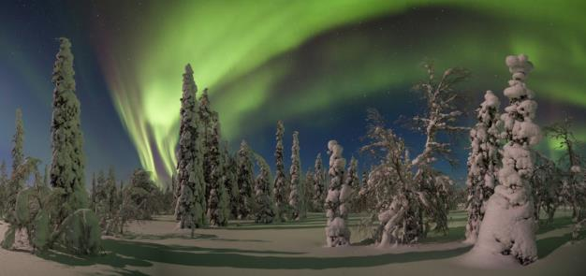

They were a bit weary by now, and while not really ready to sleep, they needed to at least rest and eat. If they returned to the cave that led back to the Underdark, they’d be considerably warmer, but the carrion crawlers would eventually return to their hungry states, sniff the heroes’ hides, and be drawn to them. The beasts would have meant no harm; they would just have wanted to kill the entire party and eat them.

Gwee sighed upon seeing the auroras. “Sight fer sore eyes...” she lamented not being able to set up a remote cabin in a place like this. As much as she liked traveling, she had a lifelong need to return to Mirabar—her natal home—and be with her kinsfolk. “Raven Rock is west of here, the Mirabar mines, southeast along that ridge,” she pointed to the downhill path that led back to where they’d come from.

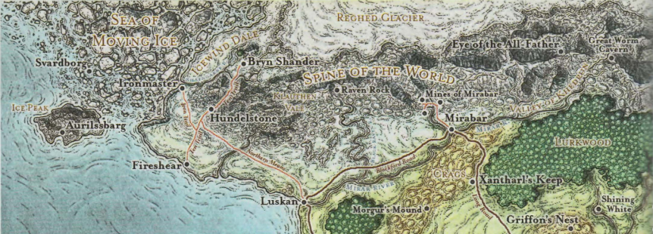

Kedrik produced his newest map, where he jotted down their current location relative to the sites the dwarf had just mentioned.

“What will you do now?” asked Kedrik.

“Oh, I’m headin’ straight back but along a more direct route,” she answered.

“Why didn’t you take us through there instead if it was more direct,” the gnome wondered aloud.

The dwarf shifted her eyes towards Lauren, and shook her head, “It’s a road that needs stealth. We’d be hunted by things we couldn’t fend off if they caught sight of us. I took you along the scenic but safe route; I hope that was appreciated.”

“Oh, it was. We’re a fairly battle worn band by now, and I—for one—look forward to seeing the end of this campaign against Best,” Kedrik admitted.

Having heard that last part, Lauren approached and asked, “What is our plan now?” She didn’t so much mean that a plan should be dictated to her, but that this was the time to discuss their next steps.

“I’m goin’ back to yonder place where I was borned and raised,” Gwee said before anything else. “This is pretty and all, but I’m startin’ to get nostalgic, so it’s time for me to be headin’ back,” she recapped for the druid, rogue, and duskblade.

They bid the dwarf goodbye, paid her a handsome tip above the agreed upon gold, and appreciated her buttocks as she entered the cavern once again and disappeared within.

Starting to feel the bite of the frost, the adventurers also went inside the cave and stayed near the mouth, where the warm air from below bellowed out and kept them from freezing.

“So...” Kedrik rubbed his hands together, then blew warm air into them, “what now?”

“First, we need to find shelter until morning,” Lauren said as she turned from watching Gwee vanish into the tunnel. “Then, I think we should go to Raven Rock.”

The tiger sniffed smelling for dangers as it. She huffed at the stench of the carrions but continued on with her companion watching and smelling for other dangers.

The cat said, “If we only had one of those magic hut spells I have heard about, we would be in good condition.”

“Arcane spell,” Kedrik shrugged his shoulders. “No can do.”

The cat continued, “To stay here is certain to bring a fight with the worms.” The voice came out with a purring sound and some elongation of the words, a cat’s mouth not being made for human words. The now tiger continued to rub up against Lauren in a very affectionate way. “We still need to find some type of winter bird. I doubt any other animal could get into the city.”

“How long can you hold that shape?” Lauren asked. “You’re perfectly fine in this weather, and you’d keep the rest of us warm if we find shelter from the wind.”

“I can sustain any shape for about 13 hours to my reckoning,” said the cat.

“Good news is that there’s a settlement on the way,” Kedrik announced poring over the map. “Bad news is after that, there’s supposed to be a helluvalot of ice.”

“What do you want to bet the settlement has been destroyed?” Fingers asked, a little gallows’ humor sounding good right about now.

And at that moment, though they were inside the cave, Allisa heard the faint but distinctive hooting of a northern hawk-owl. An image of the somewhat familiar bird came to her mind, and she hoped the animal would stick around long enough for her to emerge from the cavern and seek its aid.

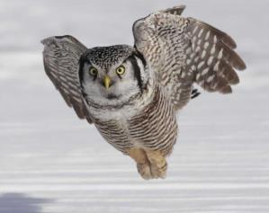

“Ah, I hear a northern hawk-owl. He may be able to deliver our message,” said Allisa as she made headway back up to the surface, Kedrik and the others followed slowly so as to give her time to interact with the animal on peaceful terms. The gnome said, “I’m calculating that we can be there in slightly less than an hour if we head out now... or soon.”

Fingers had no issue with this. “My biologicals are taken care of, but by the time we get there, we’re going to be close to needing a proper rest. I don’t think busting in on a glacial settlement, at Midnight is the best way to go about it.”

“You’re right,” sighed the gnome. “Let me restate: regardless of when we leave, it’ll take us an hour tops to get to this place.”

“It got a name?” Lauren asked most of a question.

Kedrik made one of his faces, “It’s like that roadside inn from a few days ago: someone calls it one thing; someone else calls it another; the locals call it home.”

Fingers was accustomed to that type of thinking, but it wasn’t Lauren’s favorite. She preferred when things were designated, from targets to towns.

As the druid began padding out of the cave she transformed into herself and began calling to the animal in the language of the wood. Once the owl accepted she would cast the spell giving the message as Kedrik had wording then sending the bird to Maiko.

When the druid returned to the mouth of the cave, she returned as the cat.

“Find us a place away from this cave, but out of the wind,” Lauren said. “We can stay next to each other for warmth while we rest.”

“I should be able to fashion a lean-to that will block the worst of the wind,” commented Fingers.

“What message did you give to the noble hawk-owl?” Kedrik asked.

Allisa said, “_____.”

Kedrik told Fingers, who would continue to conduct the carpet, “Like I said: if we head to Raven Rock, we hit an igloo settlement. There should be little to do there but rest, so maybe it *would* be better to head out now under the cover of night, and secure lodging once we get there.”

“Really?” one of the women asked as the other asked, “Seriously?”

“Well, it’s just a suggestion. We’ve only been awake for like 4 hours,” Kedrik clarified. “My spell prep is good to go, so I don’t need to stay here, and if I recall your spell repertoires are also replenished for the moment.”

“We can continue on,” Lauren said after a moment’s thought.

“Fine by me,” agreed Fingers, “But do we head straight for the Rock or check out that town first? I would suggest the latter, Unless it had been completely destroyed, we likely can gain some information there.”

~*~

Fingers hadn’t thought much of it, but the other three heroes had had enough of the cold for the rest of their lifetimes by now. Even with the furs, their faces still got cold anytime they had to peek out to see where they were, which was over taiga. Allisa had tried to remain in tiger form, but her fur wasn’t enough to withstand the 100+ mph wind that they were facing at the speeds that they were traversing. She’d reverted to humanoid form, and wrapped herself up in the thicker layers of clothing that she’d afforded herself during the trip, and how she snuck a downward look.

The land of the ice and snow: they were flying over a region that had been flattened by an iceberg sheet for millions of years before receding as the Age of Dragons came to be. Fingers beheld the white below reflecting starlight, and had by now begun to take a certain comfort in the still monotony of it all. It was hard to misbehave in such cold, hard to frolic, to dance, to celebrate life, and yet if one surveyed it from this height of 200’, the pale panorama was a serene dance, a frolicking celebration of life itself frozen in crystalline form.

In due time, right around when Kedrik had told Fingers to expect it, the lights of the settlement began to come into Fingers’ field of vision. A single hill atop the relatively flat plane hosted perhaps twenty structures, only 10 of which had lights and could be counted by the trapsmith-turned-pilot.

“We’re here,” the changeling—still in human form—announced, rousing the attention of the others, who huddled against the gusts resulting from the natural winds and the speed of the carpet.

“Set us down outside the village,” Lauren said.

Fingers did not protest and set them down outside the village. A single watchman or watchwoman sounded an alarm by blowing into a conch, and soon others emerged from their igloos, harpoons and javelins held in the hands of most. The settlement had no fortifications or palisades, though two short towers had been built atop the largest pair of igloos, and they could now spot atop the closer tower a well camouflaged figure pointing a crossbow at them.

One thing was clear to Fingers under the moonlight: this settlement had not been razed by Best’s forces. It was intact in every way; even the ice around the settlement was unscathed. Torches were placed at even intervals between igloos, far enough to not melt anything around them. Kedrik smelled and heard, then saw the movement of oxen and yaks in the ice stables behind a row of igloos, and could tell by the infrastructure that even with only these 15 igloos that he could count, the locals appeared to be extremely capable of living comfortably here.

One shouted at the top of his lungs with a deep, masculine voice, “Who are you that come in the night uninvited and unannounced?”

“We are travelers, seeking a warm place to sleep,” Lauren replied in a loud voice. She was careful to keep her hands away from her weapons, and she stepped forward as she spoke.

|  |  |  |  |  |  |  |
| --- | --- | --- | --- | --- | --- | --- |
| **Skill** | **Rank** | **Ability & Mod.** | **Misc. Mods.** | **Total** | **Roll** | **Check** |
| **Lauren, Diplomacy** | 0 | **Cha (+1)** | 2 | 3 | 14 | 17 |

*See below.*

There was some huddling above the violet-white ice at the edge of the water-based architecture that distinguished their settlement from the rest of this expansive wasteland. “And what brings the lot of you out here? Why sleep here of all places?”

“Hello,” Allisa said moving up beside Lauren. “I am Allisa. We have traveled far to reach this spot and still have a bit to go. We have been offering help to those that have lost much in the raids. We see you are most fortunate that no harm has come to you and yours.”

|  |  |  |  |  |  |  |
| --- | --- | --- | --- | --- | --- | --- |
| **Skill** | **Rank** | **Ability & Mod.** | **Misc. Mods.** | **Total** | **Roll** | **Check** |
| **Allisa, Diplomacy** | 1 | **Cha (+2)** | 2 | 5 | 9 | 14 |

*See below.*

The huddle turned its six or seven heads towards one another, and the locals conferred on the druid’s framing of their fate. Not sensing their motives too well, she smiled as she continued, “Seeing that it was late and we have flown longer than anticipated *[a lie; it was stated above that they arrived “right around when Kedrik had told Fingers to expect it”]*, we saw your fires and hoped we might find rest was and a warm meal. We can pay for these services whether it be coin or work.” The druid stopped there to her their reply.

|  |  |  |  |  |  |  |
| --- | --- | --- | --- | --- | --- | --- |
| **Skill** | **Rank** | **Ability & Mod.** | **Misc. Mods.** | **Total** | **Roll** | **Check** |
| **Allisa, Bluff** | 0 | **Cha (+2)** | 0 | 2 | 7 | 9 |

*See below.*

Something wasn’t right about the pack of strangers that came flying on a carpet in the middle of the night talking about needing some rest. Some of the locals’ spears now went from being pointed upward to being pointed at the Gambit, and the one with the raspiest voice said, “Piss off! Either go back to where you came from or keep going where you’re headed. You’ll get *no* quarter from us.”

“That went well,” Lauren observed dryly, speaking so only her compatriots could hear. “I think we should keep moving.”

“So be it,” said the druid, with no malice as she continued. “Be warned that an army of foul creatures and possibly orcs and trolls, has been destroying towns all around. Take precautions to warn your people in time. My you be blessed and protected by Corellon Larethian.”

Kedrik agreed that there was little need to argue with folks about whether or not they were worthy of their hospitality, and nodded to Fingers, who was about to unroll the carpet once again. But just then, the wind kicked up and caused an incoming white dragon to flap its wings twice in order to adjust its course. Lauren and some of the locals looked up to see the black silhouette of the Huge white dragon at a height of about 300’ but quickly swooping down upon the igloo dwellers.

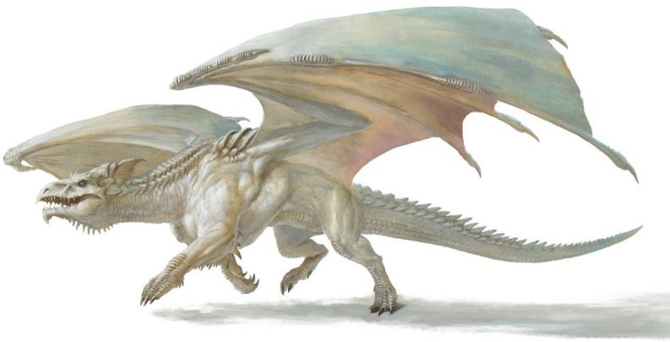

The duskblade then alerted the others to the imminent threat.

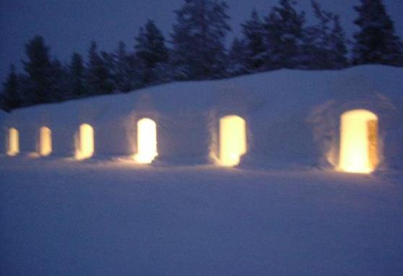

Round 1

|  |  |  |  |  |  |
| --- | --- | --- | --- | --- | --- |
| **Character** | **Group** | **Initiative** | **Roll** | **Modified Roll** | **Move** |
| Lauren | 1 | 4 | 20 | 24 | 30’ |
| Allisa | 1 | 3 | 16 | 19 | 30’ |
| Kedrik | 1 | 2 | 15 | 17 | 30’ |
| Igloo Folks | 1 | 1 | 12 | 13 | 30’ |
| Fingers | 1 | 4 | 5 | 9 | 30’ |
| Yeridajniosjuth | 2 | 0 | 9 | 9 | 60’/ 200’fly |

“Spread out!” Lauren commanded. She murmured three words and made a brief gesture (quick cast *protection from energy (cold) [expired on Round 1201]*), drew her falchion, and started to run perpendicular to and away from the dragon’s flight path. *Lauren gained 120 points of Cold Resistance.*

Allisa sprinted back the way they had flown in making sure she was separating herself from others.

“Fortunately, I’m a draconic archivist,” Kedrik proclaimed as he shared with his three friends certain tips *[Dark Knowledge (puissance)]* for how to best deal with the incoming monster.

|  |  |  |  |  |  |  |  |
| --- | --- | --- | --- | --- | --- | --- | --- |
| **Skill** | **Rank** | **Ability & Mod.** | **Misc. Mods.** | **Total** | **Roll** | **Check** | **Notes** |
| **Kedrik, Knowledge: Arcana** | 12 | **Int (+7)** | 2 | 21 | 15 | 36 | Trivial Knowledge, best of 2 rolls |
| **Kedrik, Knowledge: Arcana** | 12 | **Int (+7)** | 2 | 21 | 4 | 25 | Trivial Knowledge, best of 2 rolls |

*PCs gained +3 to all saves vs. white dragon attacks, spells, etc.*

The igloo folks scattered, and prepared to defend themselves. “They’ve brought a drake with themmmm!”

One of them started casting a spell; Kedrik could tell by the spellcasting that it was an adept that was reciting the incantation even before the *wall of fire [contingent upon concentration]* effect manifested directly above them. The archivist *was* surprised to see that the spellcaster could manage such a high-bar spell.

As much as the changeling hated revealing all the tricks up its sleeve, Fingers decided it was time to pull this one out—it would’ve been nice to keep under wraps in case it was needed for a quick getaway but there was no good way to help against an airborne threat like this while stuck on the ground. Moving in the opposite direction from Lauren to reduce clumping up targets, Fingers drew its trusty *greater invisibility* wand *[expired on Round 7]* while concentrating on a long-disused form. Its humanlike features sharpened into more elflike ones and body frame grew more slender while feathery wings sprouted from its shoulders.

|  |  |  |  |  |  |  |
| --- | --- | --- | --- | --- | --- | --- |
| **Skill** | **Rank** | **Ability & Mod.** | **Misc. Mods.** | **Total** | **Roll** | **Check** |
| **Finers, Use Magic Device** | 15 | **Cha (+1)** | 0 | 16 | 12 | 28 |

*Success. Fingers gained invisibility.*

Then he tapped himself with his wand and became *invisible*.

Yerida descended and cast *shield [expired on Round 3001]* upon herself.

*Yerida gained +4 to all ACs.*

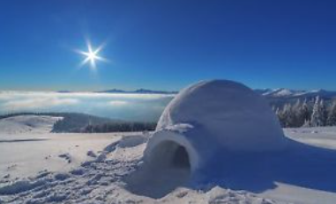

Seeing the *wall of fire* spell in her way, the she dragon veered towards Fingers, Kedrik, and Lauren. She was now 200’ north of Lauren and about 220’ up in the air for a diagonal distance of about 300’ from Lauren, and now turning towards the half-drow falchion wielder.

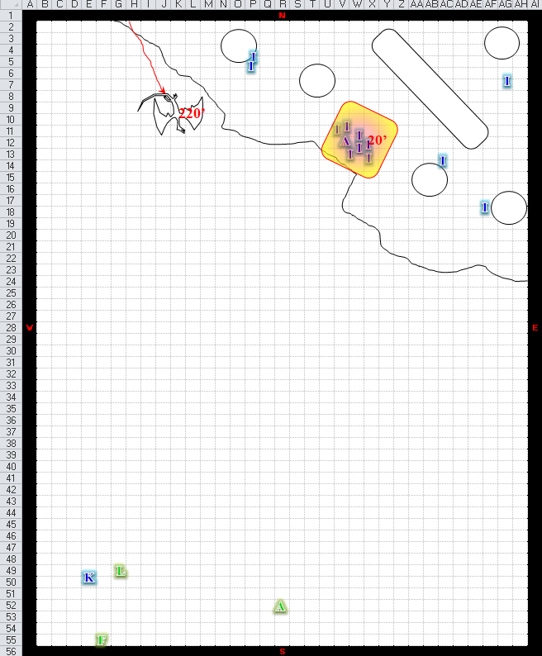

Round 2

Lauren sprinted northwest a few steps while she cast *dragonskin (white) [expired on Round 1202]* on herself. She guessed that the creature would blast her with its breath, and she prepared as best she could to meet the attack. *Lauren gained +5 to FFAC and AC, plus cold resistance 20.*

60’ away from her nearest ally, Allisa cast *endure elements [expires in 24 hours]* on herself. *Allisa gained protection from non-magical and non-martial cold/heat.*

Kedrik thought he’d try to safeguard the party from the dragon’s frightful presence, icy breath weapon, spells, and other nastiness. He dipped into his Dark Knowledge (foe) pool, and drew forth a tidbit of information that would give them an edge at bringing down such a beast.

|  |  |  |  |  |  |  |  |
| --- | --- | --- | --- | --- | --- | --- | --- |
| **Skill** | **Rank** | **Ability & Mod.** | **Misc. Mods.** | **Total** | **Roll** | **Check** | **Notes** |
| **Kedrik, Knowledge: Arcana** | 12 | **Int (+7)** | 2 | 21 | 5 | 26 | Trivial Knowledge, best of 2 rolls |
| **Kedrik, Knowledge: Arcana** | 12 | **Int (+7)** | 2 | 21 | 14 | 35 | Trivial Knowledge, best of 2 rolls |

*PCs gained +3d6 to damage against white dragons.*

The whisper gnome then drew his Blackthorn Shillelagh +2 and prepared to test his mettle against the nearly fully grown dragon.

“Her armpits are good soft spots to aim for when she flaps upward,” he announced.

The adept igloo guy concentrated on the *wall of fire* spell while those who were not underneath the one-way sheet of searing heat ran towards their leader’s shielding manifestation.

Fingers, now in the form of an avariel (a rare species of winged elves), warned the others as it took flight, “Try to aim to the left as I’ll be trying to stay to the right of it.” With a quick prayer to the Faceless One, the changeling attempted to activate the wand to become unseen, then drew its sling while gaining altitude.

Yeridajniosjuth got within 210’ of Lauren and her friends.

|  |  |  |  |  |  |  |  |
| --- | --- | --- | --- | --- | --- | --- | --- |
| **Save vs.** Frightful Presence | **Rank** | **Ability & Mod.** | **Misc. Mods.** | **Total** | **Roll** | **Check** | **Notes** |
| **Allisa, Will** | **8** | **Wis (+3)** | 3 | 14 | 10 | 24 |  |
| **Fingers, Will** | **3** | **Wis (+1)** | 1 + 3 | 8 | 16 | 24 | +2 Lucky |
| **Kedrik, Will** | **8** | **Wis (+2)** | 3 + 3 | 16 | 16 | 32 |  |
| **Lauren, Will** | **8** | **Wis (+0)** | 1 + 3 | 12 | 4 | 16 |  |

*Success, success, success, fail. Lauren suffered -2 on attack rolls, saves, skill checks, and ability checks [expired on Round 13].*

The dragon then selected a target—Lauren Fifthdaughter—and prepared to eat her.

Most of the Gambit fared fairly well against the dragon’s frightful presence; the duskblade felt a chill run down her spine, then did her best to steady her nerves before the incoming drake that had made eye contact with the half-drow under the black, starry sky. It was then that Kedrik noticed that this dragon’s ribs were protruding from its hide, and it looked not quite emaciated, but certainly starved.

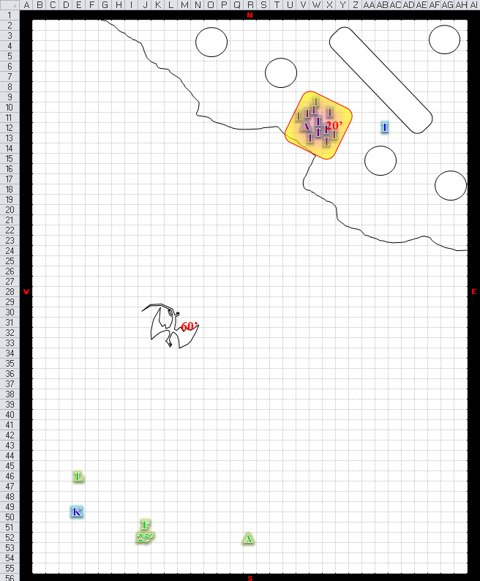Round 3

Lauren stopped and cast *fire shield [expired on Round 16]* on herself, and awaited the dragon’s attack. She’d done what she set out to do: draw the creature’s attention away from her wife and her companions. *Lauren gained 1d6+13 fire to any melee attacker, plus resistance to cold damage.*

Allisa cast *barkskin [expired on Round 1303]* on herself. *Allisa gained +4 to FFAC and AC.*

Kedrik was feeling lucky about his Dark Knowledge (tactics), so he concentrated and remembered some obscure fact about white dragons’ flight patterns, which made them alternately more and less vulnerable.

|  |  |  |  |  |  |  |  |
| --- | --- | --- | --- | --- | --- | --- | --- |
| **Skill** | **Rank** | **Ability & Mod.** | **Misc. Mods.** | **Total** | **Roll** | **Check** | **Notes** |
| **Kedrik, Knowledge: Arcana** | 12 | **Int (+7)** | 2 | 21 | 3 | 24 | Trivial Knowledge, best of 2 rolls |
| **Kedrik, Knowledge: Arcana** | 12 | **Int (+7)** | 2 | 21 | 6 | 27 | Trivial Knowledge, best of 2 rolls |

*PCs gained +2 to attacks against white dragons.*

The leader of the igloo folks cast *web* upon the dragon.

|  |  |  |  |  |
| --- | --- | --- | --- | --- |
| **Character** | **Save vs.** *web* | **Ranks** | **Roll** | **Save** |
| Yeridajniosjuth | Reflex | 12 | 13 | 25 |

*Success.*

The dragon evaded the net of webbing that manifested in front of her, then veered back towards Lauren.

Taking Kedrik’s advice to heart, the changeling attempted to hurl a missile where it would do the most good—at least from the Gambit’s point of view. Now hidden from the dragon’s view, Fingers flew forward placing itself in the dragon’s probable path while drifting slightly to the right in order to reduce the possibility of friendly fire. As the dragon proceeded forward as well, the changeling fired a stone at it once the distance between them was close enough for precise aiming.

|  |  |  |  |  |  |  |  |  |  |  |
| --- | --- | --- | --- | --- | --- | --- | --- | --- | --- | --- |
| **Ranged Weapon** | **Dmg.** | **D+** | **TH+** | **Critical** | **Rng.** | **Wt.** | **Atk** | **Roll** | **Check** | **Notes** |
| Deadly Precision Sling | 1d4+1 | 1 | 1 + 2 DK | x2 | 50’ | 0.0 | +15 | 2 | 17 | +5d6 Sneak |

*Miss.*

Yeridajniosjuth spotted the pebble coming out of nowhere, and sneered at the *invisible* foe that hurled it, but still went for Lauren’s tasty hide, spraying her and Kedrik with a cone of ice.

|  |  |  |  |  |  |  |
| --- | --- | --- | --- | --- | --- | --- |
| **Save vs.** Breath Weapon | **Rank** | **Ability & Mod.** | **Misc. Mods.** | **Total** | **Roll** | **Check** |
| **Kedrik, Reflex** | **4** | **Dex (+2)** | 3 | 9 | 8 | 17 |
| **Lauren, Reflex** | **4** | **Dex (+0)** | 1 | 5 | 2 | 7 |

*Fail, fail. Dmg to Kedrik: 24 cold. Dmg to Lauren: 15 cold (negated).*

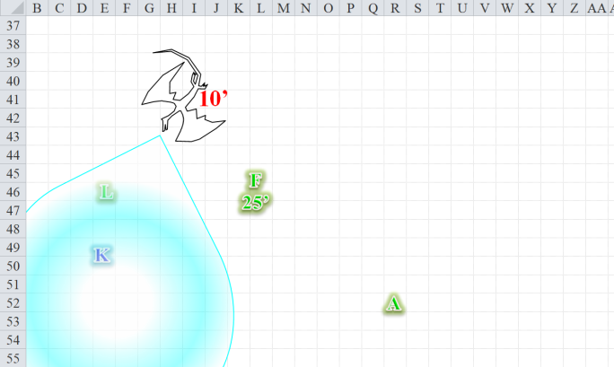

The dragon then proceeded towards Kedrik, who looked more damaged than the resilient drow with the wicked falchion. The dragon flew just over the half-drow’s reach.

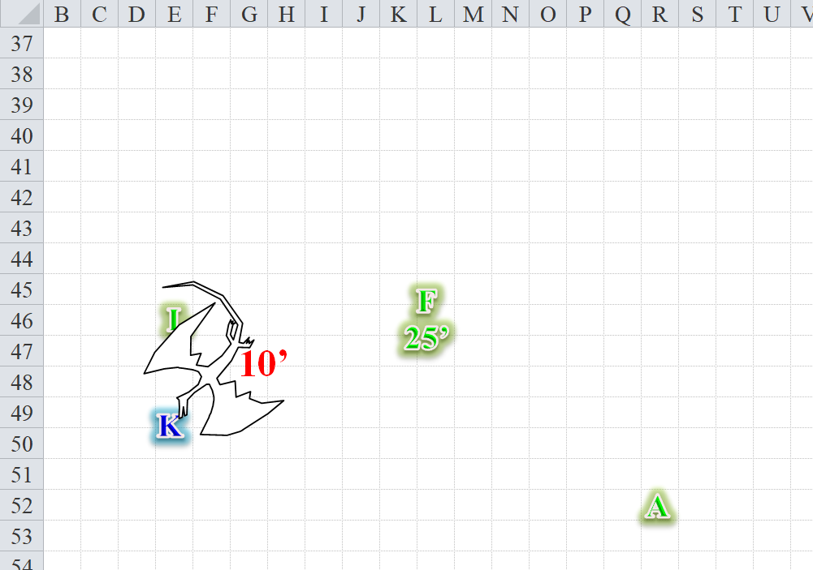

Round 4

Lauren quick-cast *haste [expired on Round 17]* on herself, extending the ability to Kedrik, and then ran southward to attack the dragon by flanking it as it turned to attack Kedrik. *Lauren and Kedrik gained +1 to Reflex saves, BAB, and Touch AC/AC.*

|  |  |  |  |  |  |  |  |  |  |
| --- | --- | --- | --- | --- | --- | --- | --- | --- | --- |
| **Melee Weapon** | **Dmg** | **D+** | **TH+** | **Critical** | **Type** | **Wt.** | **Atk** | **Roll** | **Check** |
| Falchion +3 | 2d4 | +3 +3 | 3 + 2 charge + 2 DK | 18-20/x2 | Slashing | 8.0 | +22 | 9 | 31 |
| Falchion +3, *haste* | 2d4 | +3 +3 | 3 + 2 DK | 18-20/x2 | Slashing |  | +20 | 16 | 36 |

*Hit, hit. Dmg: (7 + 3 + 3 + 2 charge + 13 DK) + (3 + 3 + 3 + 11 DK) = 28 + 20 = 48.*

The druid cast *call lighting [10 bolts, expired on Round 7804]* sending the first bolt at the underarm as suggested by her teammate. The girl glanced around for the nearest tree or rock to hide behind on the completely flat and desolate ice sheet and stepped 5’ southward behind a halfling-sized snowman that had seen better days.

|  |  |  |  |
| --- | --- | --- | --- |
| **Ranged Weapon** | **Atk** | **Roll** | **Check** |
| Ranged Touch Attack | +12 + 2 DK | 17 | 31 |

*Hit. Dmg: 10 electric.*

Kedrik had done what he could to help the others against the dragon. Now it was his turn to deal some damage. He’d wanted to cast *radiant assault*, but that prospect was botched as soon as Lauren charged at the dragon and entered the area that he would have filled with dazzling lights. No, the appropriate spell for the moment was his only preparation of *flame strike*. He cast away.

|  |  |  |  |  |
| --- | --- | --- | --- | --- |
| **Character** | **Save vs.**  *flame strike* | **Ranks** | **Roll** | **Save** |
| Yeridajniosjuth | Reflex | 12 | 5 | 17 |

*Fail. Dmg: [26 fire x 1½ (vulnerable)] + 26 good = 39 fire + 26 good = 65.*

And he was pleased with the results of his casting.

The folks by the igloos huddled under a *wall of fire* as the battle continued to the south. Even their adept was unable to do much against the Huge dragon.

Fingers muttered a curse as the sling caught a wingtip and the shot went far wide. Curving to the left, the airborne changeling came around for another try. It closed to within 30’, and slung at the drake again.

|  |  |  |  |  |  |  |  |  |  |  |
| --- | --- | --- | --- | --- | --- | --- | --- | --- | --- | --- |
| **Ranged Weapon** | **Dmg.** | **D+** | **TH+** | **Critical** | **Rng.** | **Wt.** | **Atk** | **Roll** | **Check** | **Notes** |
| Deadly Precision Sling | 1d4+1 | 1 | 1 + 2 DK | x2 | 50’ | 0.0 | +15 | 12 | 27 | +5d6 Sneak |

*Miss.*

Fingers ascertained that though the dragon was not aware of the changeling’s position, the *shield* spell that the she-dragon had cast was able to deflect the bullet.

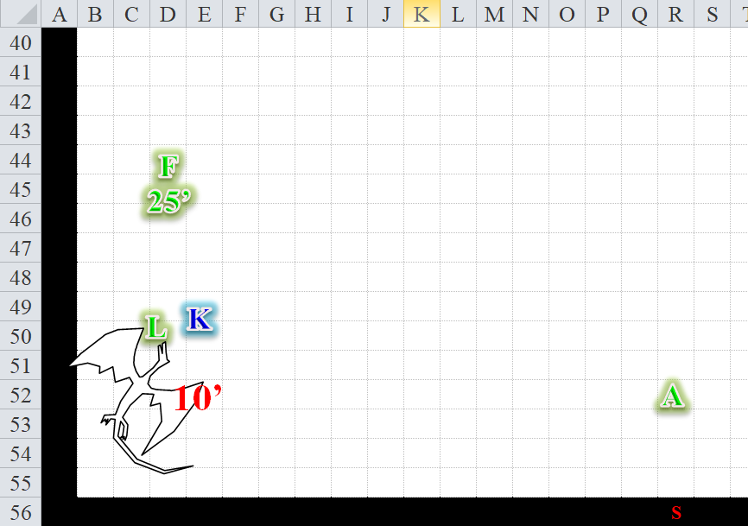

Round 5

Lauren took on the dragon.

|  |  |  |  |  |  |  |  |  |  |
| --- | --- | --- | --- | --- | --- | --- | --- | --- | --- |
| **Melee Weapon** | **Dmg** | **D+** | **TH+** | **Critical** | **Type** | **Wt.** | **Atk** | **Roll** | **Check** |
| Falchion +3 | 2d4 | +3 +3 | 3 | 18-20/x2 | Slashing | 8.0 | +18 | 12 | 30 |
| Falchion +3, 2nd Attack | 2d4 | +3 +3 | 3 | 18-20/x2 | Slashing |  | +13 | 11 | 24 |
| Falchion +3, 3rd Attack | 2d4 | +3 +3 | 3 | 18-20/x2 | Slashing |  | +8 | 3 | 11 |
| Falchion +3, *haste* | 2d4 | +3 +3 | 3 | 18-20/x2 | Slashing |  | +18 | 15 | 33 |

*Hit, miss, miss, hit. Dmg: (6 + 3 + 3 + 10 DK) + (5 + 3 + 3 + 6 DK) = 23 + 16 DK = 39.*

“Woohoo!” one of the igloo dudes shouted, cheerleading the half-drow’s butchering slices.

Allisa delivered another *lightning bolt* towards the dragon and stepped towards cover.

|  |  |  |  |  |  |  |  |  |  |  |
| --- | --- | --- | --- | --- | --- | --- | --- | --- | --- | --- |
| **Ranged Weapon** | **Dmg.** | **D+** | **TH+** | **Critical** | **Rng.** | **Wt.** | **Atk** | **Roll** | **Check** | **Notes** |
| Ranged Touch Attack | - | - | 0 | - | - | - | +12 | 16 | 28 | 8 bolts left |

*Hit. Dmg: 11 electric.*

“Ooooh! That hurted!” another one of the ice barbarians huddling under the *wall of fire* proclaimed as the druid zapped the dragon.

Kedrik

|  |  |  |  |  |
| --- | --- | --- | --- | --- |
| **Character** | **Save vs.** *diamond spray* | **Ranks** | **Roll** | **Save** |
| Yeridajniosjuth | Reflex | 12 | 15 | 27 |

*Success. Saved for ½ damage. Dmg: 34 x ½ = 17 good + dazzle [expired on Round 11].*

The igloo folks did nothing for the moment, other than comment on how badass these four strangers were.

Fingers flew towards the dragon [move action] landed, though not in a flanking position as it would have liked, while putting away its sling and drawing its sword [move action], hoping to make a single attack with it gaining acid damage once it completed the flying charge.

Yeridajniosjuth full-attacked Lauren.

|  |  |  |  |  |  |  |  |  |  |  |
| --- | --- | --- | --- | --- | --- | --- | --- | --- | --- | --- |
| **Character** | **Attack Type** | **Damage** | **Crit** | **BAB** | **Mod+** | **W+** | **Other+** | **Roll** | **Total** | **Threat** |
| Yeridajniosjuth | Bite 1 | 2d8+8 | 20 | 21 | 6 | 0 | 0 | 10 | 37 | ☒ |
| Yeridajniosjuth | Bite 2 | 2d8+8 | 20 | 21 | 6 | 0 | 0 | 10 | 37 | ☒ |
| Yeridajniosjuth | Claw 1 | 2d6+4 | 20 | 21 | 6 | 0 | 0 | 2 | 29 | ☒ |
| Yeridajniosjuth | Claw 2 | 2d6+4 | 20 | 21 | 6 | 0 | 0 | 10 | 37 | ☒ |
| Yeridajniosjuth | Tail | 2d6+12 | 20 | 21 | 6 | 0 | 0 | 1 | 28 | ☒ |

*Hit, hit, hit, hit, miss. Dmg: (10 + 8) + (7 + 8) + (6 + 4) + (7 + 4) = 18 + 15 + 10 + 11 = 54 [60/114].*

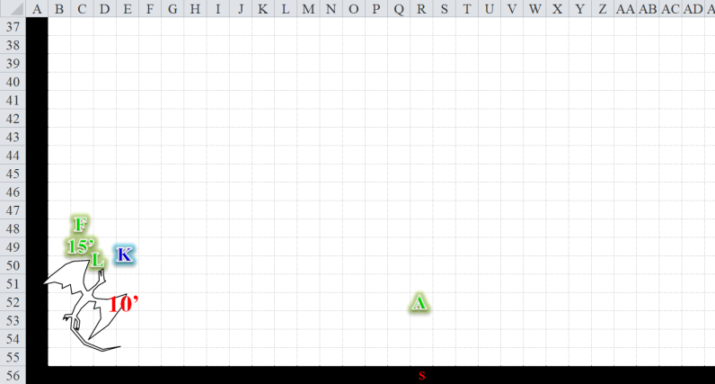

Round 6

Allisa was getting the feeling that the dragon had some immunity against lightning. She moved 10’ toward the beast. Seeing as *flame strike* had given the dragon a good bit of pain, the druid sent her own at the dragon. Allisa was beginning to be worried for her lover after that last attack. The woman was not looking so hot.

|  |  |  |  |  |
| --- | --- | --- | --- | --- |
| **Character** | **Save vs.**  *flame strike* | **Ranks** | **Roll** | **Save** |
| Yeridajniosjuth | Reflex | 12 | 4 | 16 |

*Fail. Dmg: [20 fire x 1½ (vulnerable)] + 21 good = 30 fire + 21 good = 51.*

Kedrik was about to cast another offensive spell when he saw that the druid’s *flame strike* was enough to put the dragon to sleep.

Fingers was now able to concentrate solely on bringing down the dragon, but right as he was about to take a couple of swipes at it, the beast had collapsed. She wasn’t dead, but her body had collapsed onto the icy floor, and her pupils now narrowed into slits.

The igloo folks were all cheers, and would most likely beg to have the Gambit stay a while.

Lauren stood before the beast, her falchion held forward in case it was feigning, and prepared to behead it out of mercy.

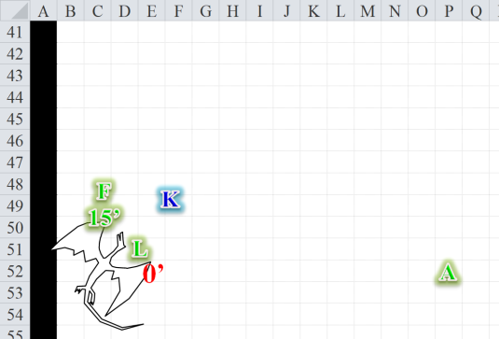

<< I’m sorry, >> Lauren told the dragon in Undercommon as she stepped up and brought her falchion down on its neck at the narrowest point. She took no pleasure in finishing the creature, but there were the others to think about.

Fingers considered for a moment stopping Lauren from finishing off the dragon before trying to question it, but chances are it would just lie anyway, and at this point, it wasn’t conscious enough to even speak.

Allisa breathed a shy of relief as she walked over to her companions. Before she could speak her thoughts about questioning the dragon Lauren cleaved its neck. She had also hoped she had made the kill so she could have the title of Dragonslayer.

The reptile’s head rolled away from the rest of the body as its eyelids shut half-way. The task was done.

“Hoooollllyyy shite, mate!” the adept approached, followed by the younger folks, who were mostly male.

“Who in the bloody fucks are *you*?” another asked.

A cacophony of *holies* and *shites* and *fucks* and *arse* references ensued as the lot of the townsfolk, not a small child among them, finished making their way over. This harsh climate had to be tough on mortality rates, and the few that survived were likely to have spirits toughened by the ice and snow that prevailed here for most of the months of the calendar year.

“Fuckin’ hell! The adept added, having patted the shoulder of the gnome who’d just about had it with the dragon’s icy breath attack.

Kedrik nodded, casting *cure moderate wounds* upon himself. “That was actually not as hard as I imagined it would be.”

*Kedrik gained 3 + 10 = 13 hps.*

“*Ye* fuckers are *hard*!” one said.

“Hard as a *motherfucker*, and comin’ *with* it!” another qualified the previous statement.

Not quite tiptop, the gnome cast *cure light wounds* upon himself.

*Kedrik gained 7 + 10 = 17 hps.*

“Ah, that’s better,” the archivist was now tiptop.

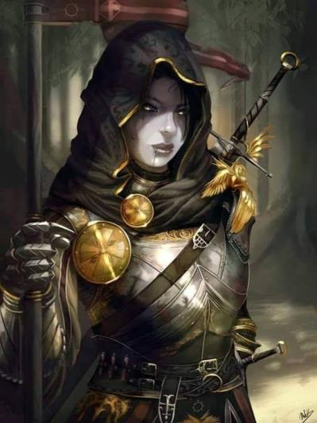

Lauren wiped the gore from her blade with a scrap of cloth she’d saved for the purpose, and sheathed the blade. She turned to Allisa, noting the disappointment in her countenance. “I’m sorry, my love, but the dragon could have killed someone if it awakened.” The duskblade was battered and bruised by her encounter with the creature, and she felt tired, sore, and in need of rest. Standing close to Allisa, she turned to the nearest villagers and spoke loudly enough to be heard. “As we said, we are just travelers who need a place to rest for a few hours.”

“I know. I really wanted to be the one to slay it.” Allisa then turned and said to all her compaigns. “Anyone still hurt? I have some healing.” She scrambled in her pack. “Ah, and this wand.”

“Well, you bet your sweet ass we got a place for you, shero!” one of the women said, meaning heroine.

The druid looked and Lauren and said without lowering her voice. “And it is very sweet.”

Removing their face flaps, it was evident that they were part human, but there was something not quite orcish or ogrish about their mugs. Kedrik frowned, and tried to place the lineage, not wanting to ask them a racist question.

They introduced themselves, and by the end, the Gambit could only remember that the elder male was named Thag, and the woman that had said “shero” instead of “heroine” was named Ayla. Ayla now instructed the youngest among her kin to run into one of the igloos for some purpose, and the adolescents complied diligently.

Meanwhile, some of the younger adults finished cheering on the Gambit and went to cut up the dragon’s flesh while it was still warm. They would probably be at it for the short remainder of the night until the carcass froze completely solid and remained there until Mirtul or Kythorn when the days would be longer than the nights and the top layer of ice and snow would recede.

“Come,” said Thag. “Let’s get inside and away from this breeze,” he understated the gust that chilled the eyes of one foolish enough to stare into it.

~*~

They’d been led to just about the girliest thing that Lauren had ever seen: well inside one of the igloos, the drow-human realized as she and the Gambit were led downstairs that this place was actually quite ample under the ice. But what was so girly about it?

“How cozy!” remarked Allisa, admiring the room.

The younger residents had raced past them in order to clean up a very homey suite, which belonged to the adolescents’ dear grandmother before her passing. The youngsters finished removing votives and devotional objects on bronze trays, then left the elders to speak to the Gambit, probably waiting in the room around the corner and listening.

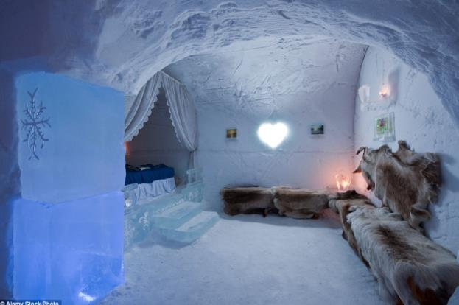

Fingers was always the best at taking in its surroundings. The decorations were few, but spoke volumes. There was a remarkable contrast between roughly hewn ice and packed snow on one extreme and the delicately carved steps, etchings, and crystalline ice sconces throughout the chamber to which they’d been led. A wide bed rested in the corner of the underground igloo, where the temperatures were merely a few degrees below freezing—nothing to sneeze at for these four by now—and a few fur-covered cots ideal for a gnome and a changeling lined the walls, or were those simply for humans to sit on.

“We’d like you to stay in Mother Hrethgra’s old room, which we reserve only for the most revered fuckin’ guests,” one of the ice people said. Without their hoods over their heads, it was evident to Kedrik now, and possibly other Gambit members, that these humans’ ancestors interbred with some of the Neanderthals that were known to inhabit this part of Faerûn and northward. Even the most eloquent among them—Thag—had already presented himself as a bit of a superstitious quack who’d probably killed as many as he’d saved with his medicine and magic.

The Gambit accepted, not having imagined such accommodations in such a desolate place. “Let me show you the potty, eh?” The adept had arranged a Permanent *create water* spell affixed to a faucet and spout that allowed for continuous, lukewarm water to flow at the will of anyone able to turn the handle. Decorations reflecting Thag’s mother’s taste were all around, and a chute aimed straight downward was intended for waste.

They would shiver, but they would have shivered more pooping outside.

Lauren stepped into the icy room and looked around in awe. “This beats sleeping in a cave.” She pointed to the bed. “Allisa and I have dibs on the bed.”

The two half-Neanderthal elders—Thag and Ayla—brother and sister—now stood before the Gambit, still trying to explain their prowess. The woman asked, “So, heroes and sheroes, what brings you to this desolate corner of the world?”

Fingers, having resumed its regular human form while the locals were approaching, replied, “In a way, beasts such as the one lying dead outside. Tales of dragonish activity had reached Waterdeep and we were sent to confirm such—which I’d say we’ve now done—and try to determine whether they might be a threat to the city. Have attacks like these been frequent of late?” The changeling was still reluctant about placing all of the Gambit’s cards on the table and hoped their hosts would not suspect there was more to the story.

It appeared that they didn’t.

Lauren stepped further into the room, content to leave the others to speak with the elders. Moving carefully against the pain of her bruises, she removed her gear and her furs, and then stripped off her armor and gambeson.

The four heroes had told the parts of their story that they thought pertinent and prudent to divulge, and the two elders (and some of their kin from around the corner) had listened avidly. All four members of Destiny’s Gambit could hear them shuffling and leaning, but said nothing out of politeness.

“Well, I’ll say two things:” Ayla prefaced. “For firsters, I’m truly fuckin’ impressed. Can’t remember the last time that anyone came through here and lay waste a dragon that size. Then again, I ain’t ever *seen* a dragon that size before.”

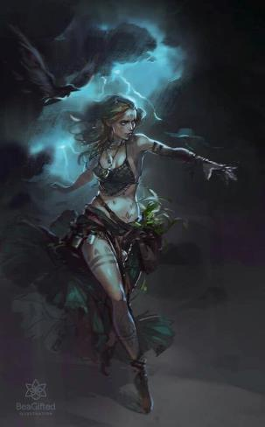

“Thank you,” Allisa kindly blushed, “And what was the other thing?” the druid asked.

“Hm? Oh, right! And secondly,” she cleared her throat, hoping to not offend the sensitivities of the intellectual gnome who had so patiently told their tale. “Eh, Best isn’t on her way to Raven Rock. She’s already reached it, and tried to take the town in a weakened state and with almost no minions left.”

“Oh?” Kedrik’s eyes widened.

“So she’s not on her way to Waterdeep,” Allisa—who had forgotten that Best had been coming back this way—asked.

Thag and Ayla looked queerly at the druid, “No, they done come back this way,” Ayla said, “and are now headed to the Glacier King’s castle.”

“Who’s the Glacier King?” Lauren really didn’t know.

“He was a frost giant slain by Best last year,” Ayla explained. “… along with most of his loyal warriors and wives. Best’s clerics and other sycophants occupy the ice castle now, and word has it that she has left Raven Rock for the castle, seeking to convalesce and regroup before mounting a second campaign.”

“It was voted one of the five best Permafrost Destinations of the world,” Thag boasted, having been there a few times.

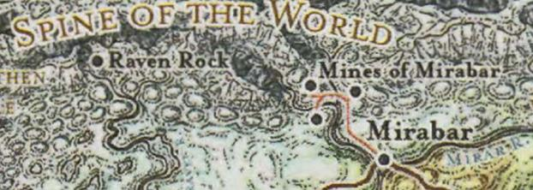

Kedrik had his map out by now, and asked with little expectation, “Could you tell us where that castle is?”

Ayla pointed. “See? We are just south of the southernmost mine,” the half-Neanderthal woman said, able to read writing and understand simple cartography. “From here, you go to west and north until you reach the Glacier King’s statue, and it’s just a short jaunt further to the castle.”

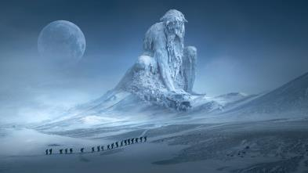

“How far is it from the mine to the statue?” Lauren asked.

Ayla answered, “It’s a good uphill sprint... take you a goddamn hour or more, and that’s if you’re spry.”

Fingers commented thoughtfully, “Well, as long as we’re this far north, I suppose we should at least take a look to give those back in the city what they might be up against.” The trapsmith planned to have a more detailed discussion on what the Gambit should do once they were away from onlookers. If Best was indeed injured and her minions depleted, this might be an opportunity for even the few of the Gambit present to end her threat.

“I do not think tonight is good. We should renew our spells, for my better spells are spent,” said Allisa.

Lauren nodded fractionally in response.

Fingers smiled in reply, “Oh, I was not suggesting we head out immediately. Piloting that carpet starts to give me a headache after a while, so spending the night is certainly a good idea... not to mention travelling at night tends NOT to be.”

“Well, and with that slick-ass carpet you came riding on,” Thag surmised, “I’ll bet you get there in ten yaks’ pissings.”

“That’s about 12 parsecs,” Ayla whispered, confusing space with time.

Kedrik had a pretty good idea based on their previous walking speed estimate, that on the carpet they could reach the place in about 15 minutes.

“Well, then,” Thag and Ayla looked upon the heroes and smiled, “we’ll leave you all to your rest. Just warning you that you might hear stirring around out here in the middle of the night. We’ll do our best to keep the kids from coming in,” Thag said, and it was then that they realized that there was no door to this chamber; only a jagged passageway.

After their hosts had left, Fingers mused, “They mentioned most of the King’s minions were slain. I wonder if all the others were taken prisoner or whether some escaped. While ice giants aren’t my first choice as possible allies, revenge upon a common enemy does often make for good alliances—Whisper showed us that.”

“Hmmmmm,” Kedrik said a few times before humming himself to sleep, playing with his chin braids.

“It is very late. I doubt I will be up and about ‘til lunch. If not, my spells will suffer. Better to be rested before a big fight.” Allisa announced. She entered the room a stripped down, her *warmth* spell still making her feel cozy as she slipped into bed.

Lauren stripped to her skin and crawled into bed. “Come, my love,” she called to Allisa. The duskblade was exhausted from her fight, but she was strangely calm about the experience, given her reaction to earlier fights.

Allisa pressed close to her mate, her hand rubbing at the other’s breast as she whispered, “You are too calm for just coming from battle.” The druid pressed her knee gently into the other’s soft, womanly parts, with intentions of comfort, not sex. She kissed her lightly on the lips. “I know you, and are concerned.” She breathed in the scent of Lauren’s hair as she nuzzled her neck.

~*~

Fingers awoke about an hour into slumber. A slight figure dressed in furs tiptoed past the rogue and made it to the bed quietly, lifting the sheets ever so slightly before Fingers cleared its throat, and the adolescent turned with a guilty look, scrambling out of the room as quietly as possible. Fingers smirked. It’d actually contemplated setting a few noisemakers, but was so sure that a youngster would come in and set them off that it opted to rely on its sense of hearing and the ability to figuratively sleep with one eye open.

He heard whispering down the halls, and held back a giggle as the young half-Neanderthals scolded their sibling for his slight transgression.

~*~

Morning came—though it was still pitch dark—and the smell of dragon flesh cooking nearby alerted the whisper gnome’s salivary glands that it was time to rise from his slumber in this underground chamber. He saw the two women locked in a menagerie of limbs, hair and blankets, and tiptoed past them and past the changeling, who groggily opened one eye to see Kedrik make his way towards his shoes and day clothes. He tried to be silent, taking the buckled garments out to the adjacent passage before putting them on so as to not make too much noise for his friends.

He found his way outside, and saw the younger men and women gathered around the fire, tending to three rotisseries of dragon meat that Kedrik now found quite appetizing.

“A fair Morning to you,” Ayla greeted Kedrik from the other side of the igloo compound as she approached. The sun wasn’t up yet, though it would have been over Waterdeep by now. It was way past Dawn along this longitude of Faerûn, and well into Morning, but those conventions meant very little this far north, particularly in Deepwinter. The sun would shine for a whopping four hours today, and as they prepared for that momentous time, the half-Neanderthals rejoiced that the heroes had happened upon them just as the white dragon had descended upon the village for a free meal.

“You are a cleric of Oghma, are you not,” one of the younger Thag-looking males asked, chewing on the flesh of the dragon that was now half-butchered to be eaten for the next tenday at least, and half-frozen in the ice to be thawed out in the summer months for yet another tenday of feasting.

“Not truly a cleric, more of a devotee,” the modest archivist asserted.

“We know of Oghma here, and of many other deities,” yet another youngster said. “We praise the ice gods the most, but some seek to gain the favor of sun gods.”

Kedrik didn’t really want to get into a discussion on such a touchy subject with his hosts, so he just smiled and said, “Ah, that’s good.”

The other three heroes remained sleeping, and Kedrik enjoyed the only sounds he could hear on this otherwise still and quiet night: the cant of the girl nearby ululating and twirling around to keep warm as her brothers slapped their bone necklaces in a percussive accompaniment and grunted every so often in praise of the power that delivered this dragon’s flesh into their hands. The singing now included the names of the four heroes, and the others began to embellish the lyrics with specific recounts of the Gambit’s efforts to bring down the dragon. *Lightning*, which rhymed with some really cool words in their particular pronunciation of Common, was used as the modal end to their stanzas.

“And they finiiiiiished the beast with a holy *flaaaaame strike*!” Thag added at the appropriate moment.

~*~

They were now all rested, awake, and up on their feet. Breakfast—dragon stew—was being served to those who had slept in, and in the meantime, Kedrik discussed some important points with Thag.

“So your people are not accepted by the Neanderthals, but the Homo sapiens folk don’t treat you well either,” the gnome shook his head. “This is something Allisa and Lauren know of quite well. They’re both half-human too.” He looked over at the two women who munched on the she drake’s flesh in the stew.

“Yeah, well, the humans that pass through here are nice enough, but get a number of them in one place, and they get haughty and lynchy,” protested the old guy. “Anywhooey, my point is: there’s Neanderthals in that direction, and we’ve heard word that they’ve tried to raid the ice castle a time or two in the frost’s giant’s wake.”

“Yes, the elves where I grew up mostly looked down on me, and treated me with disrespect, whereas my human experience only came about as I have lived in Waterdeep. Most in the city are too busy to care either way. A few go out of their way to show their dislike. But it is a city of many races and joinings. As for a settlement that has very little contact with other races, I fear there is more that, should I say, dislike.” Allisa said. She picked at the meal, wishing for more fruit and vegetables then meat. She figured her diet had put several extra pounds on her.

“So,” Fingers approached the two men. “What’s our plan?”

Lauren, who had been carrying on a private conversation with Allisa over the irony of eating their late opponent, looked over at Fingers. “We need to know what we are facing to formulate a plan.”

“Should we perhaps try and track down some of those Neanderthals?” Fingers asked. “If they had indeed tried attacking the castle, they might be able to give us an idea of its defences.”

“Either way is fine with me,” Lauren replied, shrugging. “Or, we can go look for ourselves. When do we leave?” she then asked with a smile.

“The earlier the better. There’s little enough daylight midwinter this far north as it is without wasting some of it.” Fingers inquired of their hosts where the Neanderthalers that might’ve tried raiding the castle could be located.

“They’re nomadic, but they tend to stick to the caves at the foothills of the Spine of the World,” Thag pointed northward, where the flat land began to undulate with the hills that escalated towards the mountain range. “You might be able to track’em, if there’s fresh snowfall.”

Lauren took the last two spoonfuls of her stew, set the bowl aside, and rose. “Let’s gather our gear, then.”

Fingers took the opportunity to pick their hosts’ minds a bit more regarding the Neanderthals, in particular any specific individuals they might ask for (or try to avoid) and tribal customs both to make peaceful contact and prevent inadvertent breaking of taboos.

He was told some peculiarities about their folkways—eye contact, permission to cross invisible boundaries, and the like—and Fingers felt himself a bit more ready to deal with these nomadic humanoids who were altogether new to him.

*Fingers can now use his Knowledge: Local skill on anything Neanderthal related as if Fingers were a local.*

When everyone was ready, Lauren led off on foot. “I think we shouldn’t risk flying unless the snow is too deep.”

“We can fly just a few feet up if need be,” suggested Fingers. “It just might give me a headache steering that close to the ground.”

Allisa hoisted her pack onto her back, then cast her *endure* spell. “Ready,” she said.