*Chapter 58*

Almost an hour later, they’d dredged through some knee-deep snow above several feet of ice layers, and happened upon a bend. Fingers and Kedrik led the way, their powers of observation—though very different—were complimentary at a time like this. The beheld the ice-blue castle as the first light of late dawn began to render violet the southeastern horizon.

“There it is,” Fingers pointed out, crouching against the snowy topography of these foothills of the Spine of the World. It was about a half-mile away, and did not appear guarded at all from the outside. Perhaps it really had been abandoned, or maybe there was just a skeleton crew inside.

“Oh, I just love it,” Lauren said to Allisa. “Let’s buy it, darling.”

The duskblade sighed and looked at Fingers. “Do we try to get closer, or just sit here and observe for a while?”

“It has a nice look about it, but this place is to cold me,” Allisa replied.

“I’d like a place like my father spoke of,” Lauren replied. “People walked around wearing nothing on warm sand next to a warm, calm sea. Maybe we can do that one day.”

“I’d say observe for at least an hour or so,” replied the changeling. “If we’ve seen no signs of movement by then, we can think about getting closer.”

“Let’s find a place out of the wind to sit,” Lauren said as she looked around.

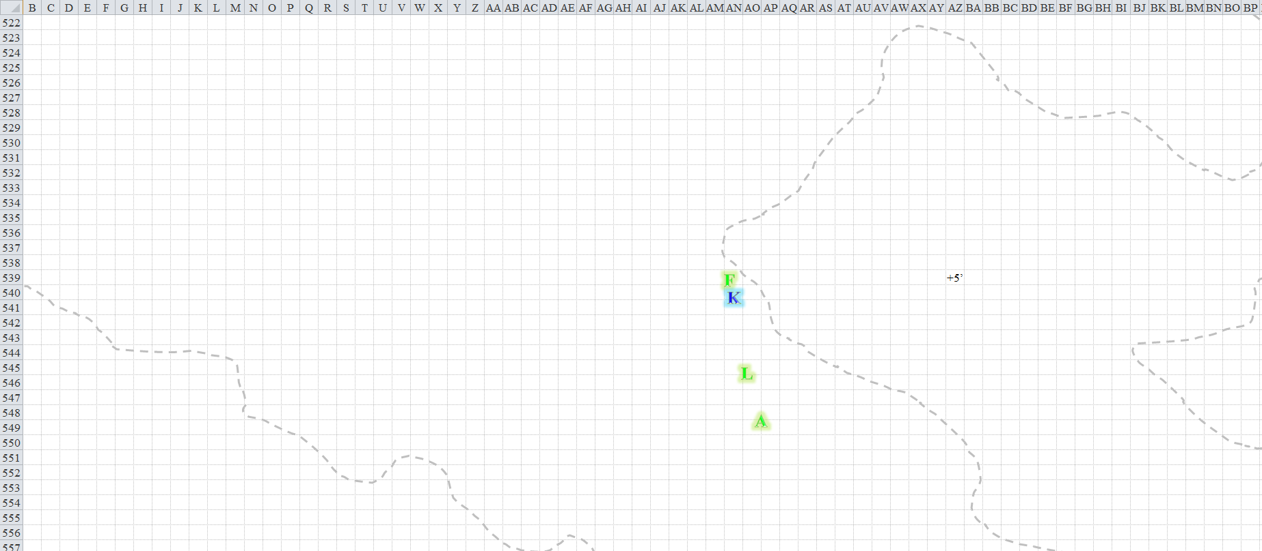

Fingers estimated that they were about 2500’ south of the castle, and this was the last mound of ice and snow that would occlude them from sight of anyone atop those towers. The wall looked like it was 25’ high, and there were a handful of towers that jutted up another 5’ to 15’. The roof was an elaborate, octagon-dominant dome whose southwestern façade reflected the violet hue to the heroes’ left.





Moving at about 15’ per round in a linear formation, Fingers, Kedrik, Lauren, Allisa made their way north. Fingers’ snow shoes gave it faster movement, but it walked at a moderate pace so as to not leave its mates behind. Thinking that a set of *pass without trace* spells from Allisa would’ve come in handy, Fingers scanned the panorama before it as the others got another 15’ further north. Holding his wand of *obscuring mist*, the rogue looked for signs of movement from the castle.

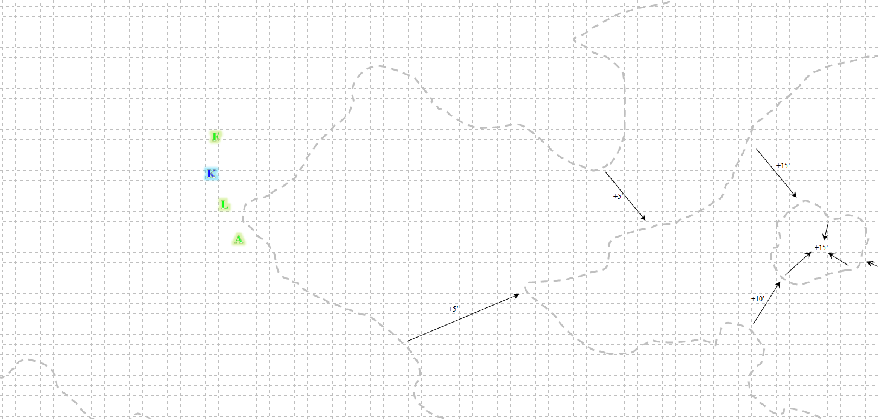

“We might circle around behind these snow hummocks until we get the sun in the eyes of any watchers and get up on top of that cliff, then work our way back west until we can have a bird’s-eye view of the castle with little chance of being spotted, especially if we tucked ourselves up against that higher part of the cliff about there.”

“Are you suggesting we do this on the carpet?” Kedrik confirmed.

“Even if something below happened to look up, I think the chance of them spotting us peeping over the edge would be remote.”

Lauren nodded, “That sounds good.”

Allisa nodded in agreement and followed along with the others, staying close to Lauren.

They moved northward another 45’ or so and Allisa spotted a few puffs of snow carried by the breeze along the smooth surface. Kedrik munched on a strip of dragon meat that he’d brought with him, and looked back to Lauren and Allisa from time to time.

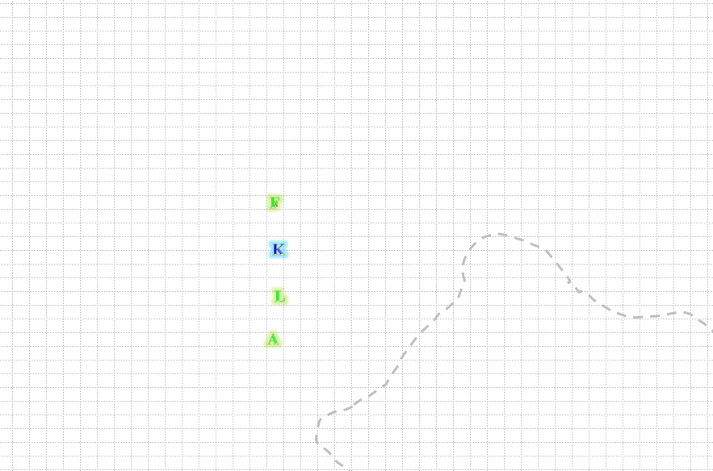

Looking at the wide, featureless expanse of snow between them and the castle, Fingers nodded as if answering a question the changeling had asked itself. “Yes, no sense heading out in broad daylight across that open area - we may as well set off pyrotechnics saying ‘Here we are’. Get out the carpet and we’ll circle back behind these drifts to the east and we’ll make our approach with the sun at our backs hugging the cliff and try to get somewhere above the castle. If we can find an outcropping we can set down on and peer over the edge, that’d be ideal.”

Lauren extracted the carpet from her haversack and unrolled it on the snow.

Kedrik asked, “After you then?” as he waved a hand to Fingers, the pilot.

They boarded and Fingers began to activate the carpet, backtracking slightly to circle behind the raised hillocks. Flying just a few feet above the ground to keep behind cover as much as possible, Lauren and Kedrik spotted an incoming eddy of slow and wind. However, as it got closer to them, the westbound mass began to take on a defined shape. It was about 50’ away, and closing in at about the same speed that they’d been traveling on foot.

“What in the Planes is that?” asked the duskblade.

“A snowflake ooze!” Kedrik identified it, hoping to draw upon his Dark Knowledge to help the team ward off any attempts by the ooze to harm them. However, his Dark Knowledge didn’t pertain to oozes as it did with elementals, fey, aberrations, and other types of creatures. “These things have no weak spots, and can’t be flanked,” he stated as the carpet gained elevation.

“Outrun it, even take to the sky,” said Alissa as she thought of a spell that might help.

“How fast is it? Should I try going around it or over it? I don’t want to go any higher than needed,” Fingers asked.

Kedrik answered that it was moving as fast as they’d been walking in the sand, maybe a bit faster.

Fingers took to the sky, as Allisa had suggested, and the altitude made it so that the snowflake ooze could not reach them.

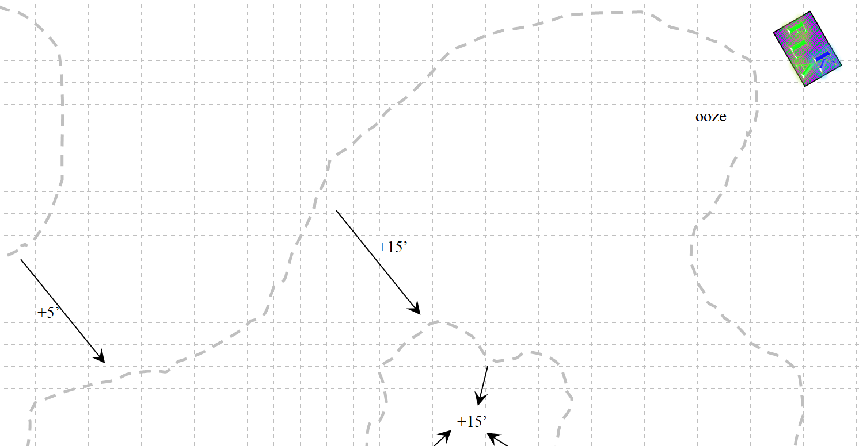

As they made their way to *[I really need to know desired coordinates/direction, and any change in altitude]*, the senior members of Destiny’s Gambit began to spot multiple snowflake oozes all over the ground. Some wriggled and writhed in anticipation of a meal as they swayed in the snow, following the magic carpet along a mostly northward *[confirm]* path. Other oozes seemed to coalesce into larger entities, which also then began to pursue the quartet of heroes.

“Get us out of here,” Lauren said to Fingers. “The castle’s inhabitants no doubt know we are here, and we have no reason to fight.”

“If they don’t, they’ll know soon enough with all this commotion,” Kedrik said as he held on to the carpet’s corrugated fabric.

Fingers nodded and with a mental command the carpet gained another 50’ of altitude as they sped eastward. “Perhaps once out of direct view we can circle back around and come back from the north in a couple of hours over the cliffs the castle is set against. By then, any watchers may have sunk back into complacency.”

They sped away eastwardly for a few minutes, and were eventually above another flat area where no trees or shrubs grew. It was almost as barren as Nogard, except it did have a topography around the half-mile diameter flat area.

They landed, seeing and hearing no foes, but knowing that this may also have been a breeding ground for snowflake oozes. “Don’t dismount just yet,” the changeling warned.

*[The party is about 3½ miles east of the castle. Now’s the time to say you don’t really want to land, so I can change the paragraph above; otherwise, let me know what you want to do for the next 18 seconds [3 rounds].]*

Lauren waited quietly to see if anything moved.

Fingers set the carpet to hover about 10’ above the ground and gave a sigh of relief at the lessened pounding of its head from the mental effort of actively flying the carpet. “We’re at a relatively safe distance from the castle, at least from watchers there, but we still stick out like a bullseye in the middle of this field. Give me a short break and then we can shift over to where we have some cover.”

“How many of those things were there?” Said Allisa not really expecting an answer. “Looked like a breeding ground to me. I wonder if we would have better luck from a different direction.” She looked at the others. “You know, if we just had a way to make all of us invisible we could fly right up to the wall and land.”

After resting briefly until its pounding head had reduced to a dull throb, Fingers once again impelled the carpet to resume flight, now head more northward towards the heights. “Once we get up above the elevation of the castle, we can start working our way back towards it until we hopefully find a vantage point to keep watch for a while.”

Lauren looked closely at Fingers. “Are you not well?”

“Nothing more than a headache. The mental effort of holding this carpet on course for days is catching up to me, that’s all.”

“Can you show me how to control it?” Lauren asked.

“Certainly. Basic control is easy enough using the carpet’s command word. It’s the finer control thru mental commands that’s trickier.”

“So, what do I say?”

“First, say ‘Mufongo’, followed by what you want it to do - ‘Climb’, ‘Dive’, ‘Hover’, ‘Faster’, ‘Slower’, ‘Right’, ‘Left’, ‘Straight’. That’s about the extent of regular commands. Getting it to obey more complex commands is the trick. It also has a tendency to drift to the left on occasion if you aren’t paying attention.”

“Uh... alright. Mufongo!” the drow said.

|  |  |  |  |  |  |  |  |
| --- | --- | --- | --- | --- | --- | --- | --- |
| **Lauren, Skill** | **Rank** | **Ability & Mod.** | **Misc. Mods.** | **Total** | **Roll** | **Check** | **Properties** |
| **Use Magic Device** | 0 | **Cha (+1)** | 0 | 1 | 18 | 19 | Can’t use untrained |

The carpet began to fold into itself like a sea urchin disturbed.

“Help!” Lauren yelped.

“Oh no! Help!” urged Allisa as the carpet began to wrap around them. “MUFONGO! Stop” The druid had latched on to Lauren. In other situations this would have been hilariously, and probable would be when it was retold.

“No, no... it’s Mufongo with an ‘oo’, not ‘uh’,” corrected Fingers, suppressing a snicker.

The drow couldn’t quite pronounce that vowel the same as the articulate changeling “Just take control of the gods-be-damned thing before it kills us!”

With a properly-intoned command, the wayward carpet ceased its bucking and hovered obediently, albeit at a distinct right-tilted angle. A few more commands and it straightened out properly, parallel to the ground.

“Maybe now isn’t the right time for carpet lessons. We can try again some other time.”

“I will think about it,” Lauren gulped as she eased her white-knuckled grip on Allisa’s hand. She’d reached out instinctively to her wife as the carpet began to fall.

Fingers took the proverbial reins of the carpet, and began to approach the castle from the east, but heading in a northwesterly direction so they would end up just north of the castle.

Gaining altitude as they approached the mountain the castle had been snuggled against, Fingers said, “Keep an eye out for a ridge or something we can follow towards the castle. I’d like to hug the edge to minimize anyone keeping watch from spotting us as we get near.”

~*~

A minute had passed and with the sun behind them, the heroes could now see the mound of ice jutting up from the otherwise relatively flat sheet of ice. Fingers was searching the mound’s contours now that they were a mere ¾ of a mile away, hoping to find a ridge with enough of a pronounced edge that it blocked them from view down below.

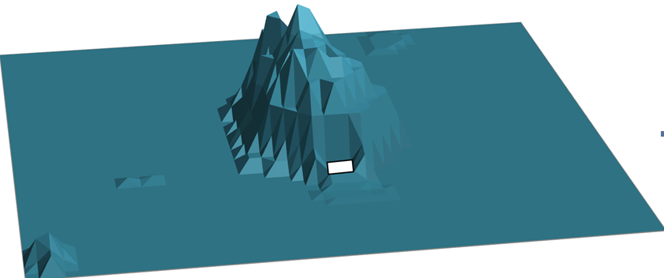

There happened to be a peak—which they would have to hazard balancing on if they got off the carpet—several hundred feet above and to the north of the castle. It was made of sheer ice, and they would later note that it had not a flake of snow on it. The changeling aimed the craft towards the topmost peak, resolving to turn southward from there and descend upon the castle from there.

“We’ll follow it as far as it goes—preferably all the way to that steep cliff just above the castle,” it said to its comrades, bearing the guise of a human (or is it dwarven?) male.

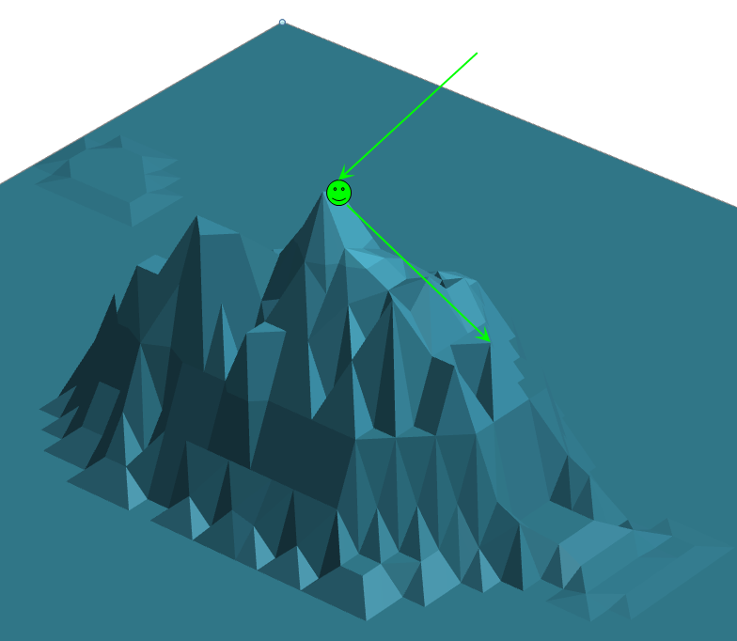

They reached the peak of the mountain, and Fingers slowed down and veered leftward, facing south now as they skirted the lesser peaks that precipitated downward toward the spot the changeling had just mentioned. Kedrik cast *freedom of movement [expired in 130 minutes]*, following that up with *detect evil [expired in 130 minutes]* and *nightshield [expired in 13 minutes]*.

*Kedrik gained +3 to all saves, and immunity to magic missiles.*

The archivist then said, “I’ve prepared a spell called *bear’s heart*. In the event of an emergency, so long as you’re 20’ from me, I can cast it and give us all stronger and tougher. However, it will only last a minute or so, after which we’ll all be weakened. If you object, say so now, and I’ll be sure to exclude you from the burst.”

“I think i shall abstain from the spell,” said Allisa.

They were approaching the spot that precipitated almost 90 degrees down, and the view of the flat land around them, with just a few jutting nipples of ice here and there, was breathtaking. Lauren reveled in the moment as the sun to her left warmed the outer layers of the heroes’ furs.

Fingers, wearing short sleeves and a scarf around its head to keep its beautiful, flowing locks from getting tangled in the harsh wind, squinted as it began to spot the snowflake oozes shifting about the floor just south of the castle. “Any last-minute strategies or contingencies we want to cover?” it asked.

Kedrik had none, but said, “As usual, I’ll do my best to provide some Dark Knowledge about our enemies. I’ll keep in mind that Allisa doesn’t want the *bear’s heart* blessing; the rest of you stay close if things get dear.”

“You mean dire?” asked Lauren.

“Both, actually,” the bookish gnome admitted as he also cast *detect chaos* for good—and lawful—measure.

“I think I will abstain from the spell. I will need all the strength I have if it comes to a fight.”

Fingers had been mulling over the possibility of the spell’s enhancement but decided more information was needed for its decision. “Just now long will the weakness last once the spell expires? While a minute may be long enough to deal with a small group of enemies, if we are then severely weakened for a protracted period, the short boost may not be worth it.”

Kedrik explained that the damage—while nonlethal—was permanent, and would have to be healed like any subdual trauma. In the end, he was left looking at Lauren to see if she wanted to partake in this, but they were all treating him like he was trying to get them hooked on a drug.

“Ah, well it’s only bruising and the like that will recover with time, that’s probably acceptable. When you said it would leave us weakened afterwards, I thought perhaps we would be left fatigued or otherwise less able to defend ourselves should the battle continue.”

Fingers slowed down the craft until they were hovering at a standstill at the edge of the sheer, icy cliff, overlooking the castle.

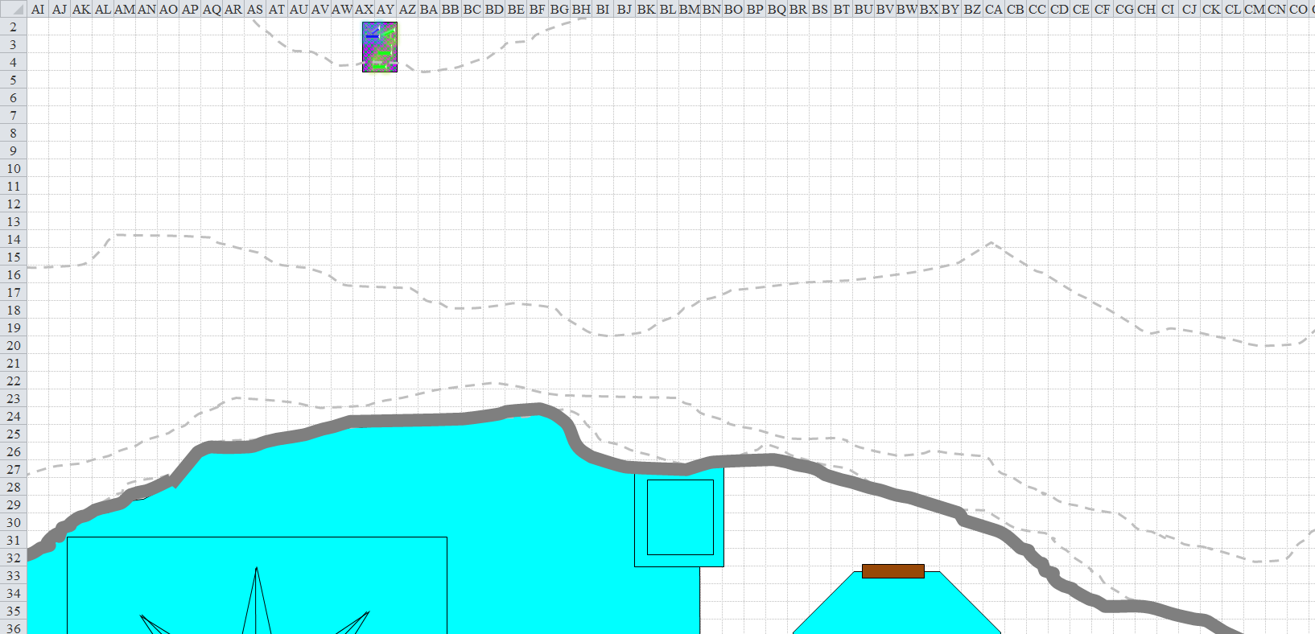

All four heroes could now see the casually meandering snowflake oozes grazing on the ice sheets just south of the castle wall. The warden of this keep had been wise to place them there. Then, they spotted a colorful cape and possibly a suit of armor beneath it, resting, and if anyone was wearing these items, they were likely dead, for the only movement the heroes saw was the flapping of the cape in the slight breeze.

“Looks like someone already tried and failed to breach the castle walls,” Kedrik murmured, pointing at the body hundreds of feet away.

“Looks like they were running south—away from the castle—when they were struck down,” surmised the half-drow.

The changeling chauffeur proposed, “Perhaps they were one of those who tried assaulting the castle we were told about.”

Kedrik rubbed his chin, then smiled, “Wouldn’t it be a great prank on Best if we cleared out any rabble left in her keep, and just waited for her to come in while we were enjoying a nice supper at the dinner table?”

“You’re assuming she *has* a dinner table,” Lauren tilted her head at the comely gnome. “I’ve heard white dragons eat like rabid dogs. I even-” she stopped as she spotted some movement down below.

It looked as though a snowflake ooze was shifting towards the castle, and as it passed across the cape and vestments, it lingered and spiraled like a galaxy aswirl. They all saw this now, and Kedrik was the one to identify it first as it began to fill the armor and clothing, rising with the cape strapped around the neck of a set of shoulder plates joined by a gorget. “It’s... a ghaunadan!” He’d encountered these sentient oozes in the past, but only in musty, dreary, and warm dungeons far to the south. Never in his life did he anticipate that his travels would have him cross paths with a snowflake ghaunadan.

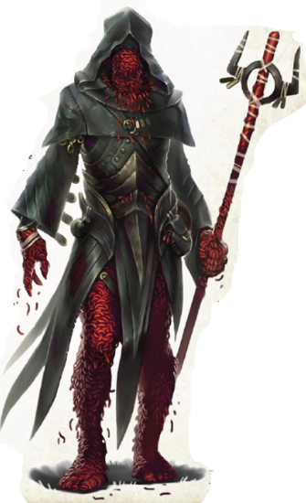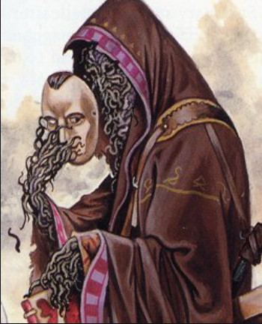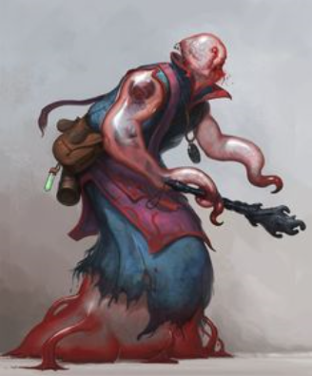

If memory served, the first one he’d encountered was a bloodfire ghaunadan, while the latter two were from gray ooze and ochre jelly stock. They were all as cunning as a humanoid, but still benefitted from their amorphous qualities, and this one was now fully formed, holding a horn-shaped object in one hand, and facing upward and northward with its pale, blank, featureless face. The snowflake oozes to the south were coalescing and undulating once again, forming ever-larger mounds of snow across the icy plane surrounding the southern border of the cyan domicile. The ghaunadan placed the horn to where its mouth would have been, and blew a resonating baritone across the valley that must have been heard for miles around.

Round 1

Kedrik cast *shield of faith [expired on Round 131]* upon himself, figuring he’d need it after that scuffle with the drider that left him vulnerable in her webs.

*Kedrik gained +3 to AC.*

Unable to draw upon his Dark Knowledge against oozes, he then said, “I’m ready to cast *radiant assault* on the ghaunadan, but I’m curious to see if it actually means to attack us.”

“Does anyone have the feeling we have been spotted,” asked Allisa. “There is an army of those things. What does it take to kill just one?” The woman looked a bit worried with thoughts that maybe they should let someone else worry about this.

Fingers grimaced at the possibility of fighting such creatures. “I don’t imagine those things have a vulnerable spot I can aim for?” he asked Kedrik. Pulling out his trapkit, it continued “However, being made of snow, are they especially hurt by fire? If so, I can make a few Great Scorchers.”

“Yes, as you might expect, they don’t do well with heat,” Kedrik answered.

“Let’s get out of here,” Lauren suggested. “He’s alerted the whole valley, and this whole mountain is probably a stronghold. There could be fifty dragons here.”

And just at that moment, as if Lauren had conjured it, an ice drake—visibly wounded, Fingers noticed—crashed through the castle roof, and began to fly upwards towards the heroes atop the carpet. Then, for added dramatic effect, a second ice drake, also a little tattered and battered looking, emerged from the star-shaped cupola atop the castle. It was then that Allisa noted that the breaches in the icy walls of the castle were magically restoring themselves seconds after the drakes had crashed through them.

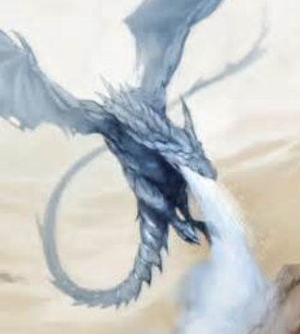

Both of the starving drakes were between 100’ and 120’ below the heroes, and flapping furiously in order to chomp them. Someone, or something, had unleashed the beasts, and they meant business.

On the ground the hundred or so smaller oozes had coalesced into about a dozen or so larger ones, and the 15’ tall mounds of snow and icy grit now hovered around their anthropomorphic leader-at-arms who now drew a gnarled mace, and quaffed a frozen potion, bottle, cork, and all. The ghaunadan ooze then yelled, “Ye who come for our mistress will feed her pets!”

Lauren cast *barkskin [expired on Round 1202]* on herself.

*Lauren gained +4 to FF AC and AC.*

Allisa had cast *endure elements*—a spell with a 24-hour duration—only about 10 hours ago, so she was good to go as far as that was concerned. She’d even prepared spells since then, so she could cast it again if it were dispelled somehow. The drakes were probably too far for her to cast *flame strike*, so she prepared to cast the spell as soon as she was sure that at least one was in range.

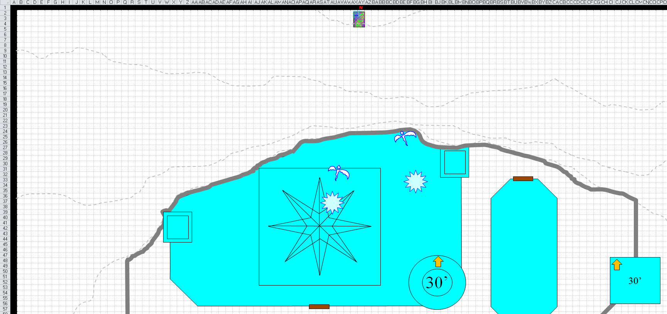

Round 2

The ice drakes continued to ascend, bearing their fangs in anticipation of a frenzied feeding. They didn’t actually reach the carpet yet, but would within seconds.

Now that the beast was within her spellcasting range, Allisa cast *flame strike* on the first dragon coming.

|  |  |  |  |  |
| --- | --- | --- | --- | --- |
| **Monster** | **Save vs.** | **Ranks** | **Roll** | **Save** |
| Ice Drake | Reflex | 8 | 17 | 25 |

*Success. Saves for ½ damage.*

*Dmg: 19 x 1½ (vulnerable) fire + 18 divine = 27 fire + 18 divine = 46.*

This nearly killed the drake, melting its front claws and face a bit.

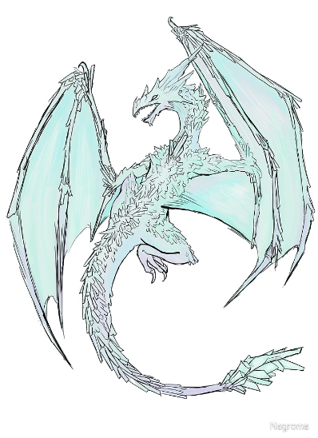

“Here, Lauren. Let me give you Oghma’s deepest blessings,” Kedrik touched the blade of the woman’s falchion, casting *chasing perfection [expired on Round 132]* on her.

*Lauren gained +4 to Strength, Dexterity, Constitution, Intelligence, Wisdom, and Charisma.*

He then told Fingers and Allisa, “I’ve two more castings of this, if either of you wants one.”

As their commander shouted orders that the heroes couldn’t hear well enough to understand, the oozes below mobilized and spaced one another apart so that at least 25’ of flat ice was between them.

Lauren cast *protection from energy (cold) [expired on Round 1202]* on herself.

*Lauren gained immunity to the next 120 points of cold damage.*

Fingers concluded, “No way we can outfly those two. Gonna have to fight them!” In preparation for catching them unaware of its attacks, the changeling drew its wand and attempted to go *invisible [expired on Round 8]*.

|  |  |  |  |  |  |  |
| --- | --- | --- | --- | --- | --- | --- |
| **Fingers, Skill** | **Rank** | **Ability & Mod.** | **Misc. Mods.** | **Total** | **Roll** | **Check** |
| **Use Magic Device** | 15 | **Cha (+1)** | 0 | 16 | 17 | 33 |

*Success.*

With one hand on the carpet, and another reinserting its wand into its invisible vest pocket, Fingers braced for impact with the first beast, who was only 20’ below them and about 25’ south-southeast of them.

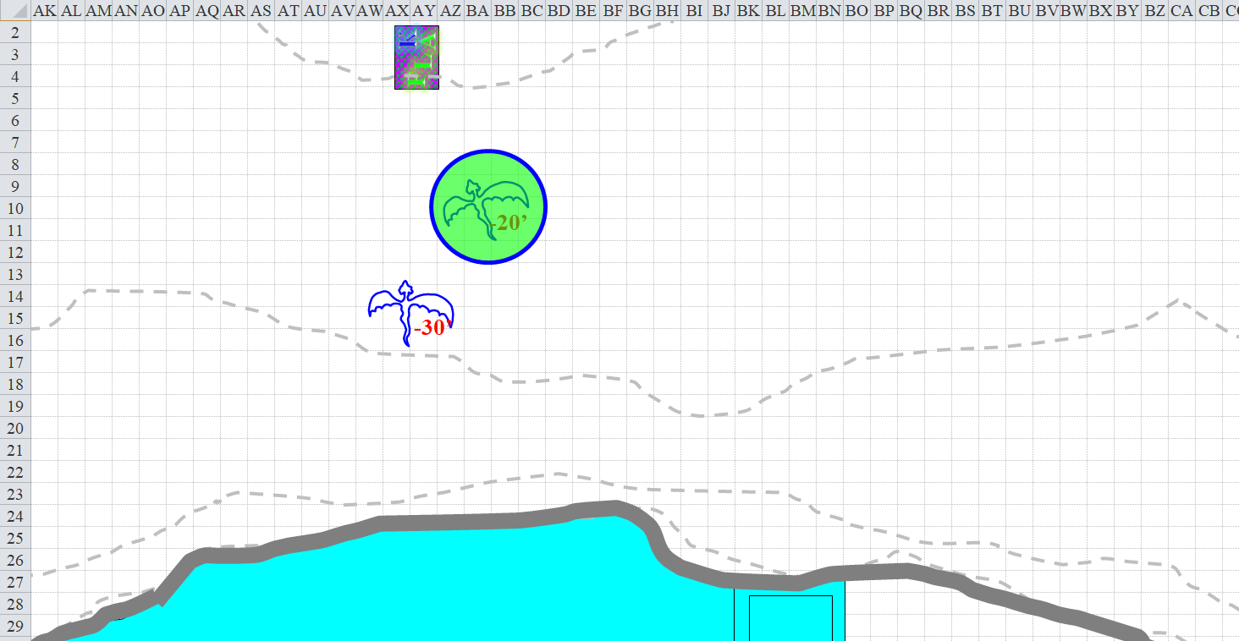

Round 3

|  |  |  |  |  |  |
| --- | --- | --- | --- | --- | --- |
| **Character** | **Group** | **Initiative** | **Roll** | **Modified Roll** | **Move** |
| Lauren | 1 | 4 | 17 | 21 | 30’ |
| Fingers | 1 | 4 | 14 | 18 | 30’ |
| Allisa | 1 | 3 | 15 | 18 | 30’ |
| Ghaunadan Snowflake Ooze | 2 | 7 | 7 | 14 | 30’ |
| Kedrik | 1 | 2 | 9 | 11 | 30’ |
| Ice Drakes | 2 | 2 | 8 | 10 | 30’/110’ fly |
| ? | 2 | 1 | 6 | 7 | 30’ |
| Snowflake Oozes | 2 | -5 | 7 | 2 | 15’/5’ climb |

Lauren growled something vile in Undercommon and drew her falchion. She cast *fire shield [expired on Round 15]* on herself.

*Lauren resists ½ of all cold damage, and deals 1d6+12 fire to any successful melee attacker.*

She then took a mental note of the spell slots she’d spent, and those she had left.

|  |  |  |  |  |  |  |
| --- | --- | --- | --- | --- | --- | --- |
|  | **Daily Duskblade Spells** | | | | | |
|  | **0th** | **1st** | **2nd** | **3rd** | **4th** | **5th** |
| **Duskblade Spells** | 6 | 9 | 8 | 6 | 2 | 0 |
| **Intelligence Bonus** | 0 | 1 | 1 | 1 | 0 | 0 |
| **Total Daily Spells** | **6** | **10** | **9** | **7** | **2** | **0** |
| **DC** | 15 | 16 | 17 | 18 | 19 | 20 |
| **Cast?** | **0** | **0** | **1** | **1** | **1** | **-** |

Now shielded from the dragons’ sight—hopefully, as the changeling had heard some individuals had arcane powers in addition to their already-significant might—Fingers prepared to swing at the scaly creature.

Lacking a *summon nature’s ally IV* spell, Allisa summoned the biggest fire elemental she could with a *summon nature’s ally III [expired on Round 13]* spell, and ordered it to attack the nearest dragon. She then took a mental note of the spells she had left.

|  |  |  |  |
| --- | --- | --- | --- |
| **Spell** | **Level** | **DC** | **Cast?** |
| Create Water | 0 | 13 | ❑ |
| Cure Minor Wounds | 0 | 13 | ❑ |
| Detect Magic | 0 | 13 | ❑ |
| Guidance | 0 | 13 | ❑ |
| Light | 0 | 13 | ❑ |
| Mending | 0 | 13 | ❑ |
| Cure Light Wounds | 1 | 14 | ❑ |
| Entangle | 1 | 14 | ❑ |
| Endure Elements | 1 | 14 | ☑ |
| Produce Flame | 1 | 14 | ❑ |
| Snowsight | 1 | 14 | ❑ |
| Barkskin | 2 | 15 | ❑ |
| Bear’s Endurance | 2 | 15 | ❑ |
| Restoration, Lesser | 2 | 15 | ❑ |
| Animal Messenger | 2 | 15 | ❑ |
| Zone of Glacial Cold | 2 | 15 | ❑ |
| Call Lightning | 3 | 16 | ❑ |
| Greater Magic Fang | 3 | 16 | ❑ |
| Summon Nature’s Ally III | 3 | 16 | ☑ |
| Winter’s Embrace | 3 | 16 | ❑ |
| Conjure Ice Beast IV | 4 | 17 | ❑ |
| Flame Strike | 4 | 17 | ☑ |
| Freeze Armor | 4 | 17 | ❑ |
| Baleful Polymorph | 5 | 18 | ❑ |
| Cure Light Wounds, Mass | 5 | 18 | ❑ |

Two Small fire elementals appeared above the frontmost drake, and attacked.

|  |  |  |  |  |  |  |  |  |  |  |  |
| --- | --- | --- | --- | --- | --- | --- | --- | --- | --- | --- | --- |
| **Character** | **Attack Type** | **Damage** | **Ranged?** | **BAB** | **Str Mod+** | **Dex Mod+** | **W+** | **Other+** | **Total Score** | **Roll** | **Total** |
| Small, Fire Elemental 1 | Slam | 1d4+1d4 fire | ❑ | 1 | 2 | 1 | 0 | 0 | 3 | 5 | 8 |
| Small, Fire Elemental 2 | Slam | 1d4+1d4 fire | ❑ | 1 | 2 | 1 | 0 | 0 | 3 | 12 | 15 |

*Miss, miss.*

The ghaunadan snowflake ooze shouted something with a bellowing, masculine voice, but none of the heroes could understand it at the amidst the ice drake.

Kedrik saw the incoming beasts, and knew they’d be knocked off and fall to their deaths if allowed to fulfill their trajectories. “Shield your eyes, just in case,” he warned before holding his holy symbol in one hand and reciting the words that released a *radiant assault* spell upon the drakes. Having waited until they were both within a sphere with a 40’ diameter, he snapped his fingers and blew the living crap out of at least one of them.

|  |  |  |  |  |
| --- | --- | --- | --- | --- |
| **Monster** | **Save vs.**  *radiant assault* | **Ranks** | **Roll** | **Save** |
| Ice Drake | Will | 9 | 17 | 26 |
| Ice Drake | Will | 9 | 14 | 23 |

*Success, fail. Drake 1 saved for ½ damage.*

*Dmg to ice drake 1: ½ x 52 = 26 magic.*

*Dmg to ice drake 2: 46 magic.*

Ice drake 2 fell back down towards the icy cliff’s face before it could do them any harm. Ice drake 1, on the other hand, died right after it had flapped its wings rather profusely, and the momentum of its upward flight made it reach the height of the carpet, though it did not ram the carpet as the creature had intended to do in life.

Before gravity reclaimed the drake, Fingers took the opportunity to shank it twice—once in each eye—and then watched it fall. With amusement, the snowflake oozes also watched the dead ice drakes crashed against the icy slope then rolled as it continued to fall towards the ice castle.

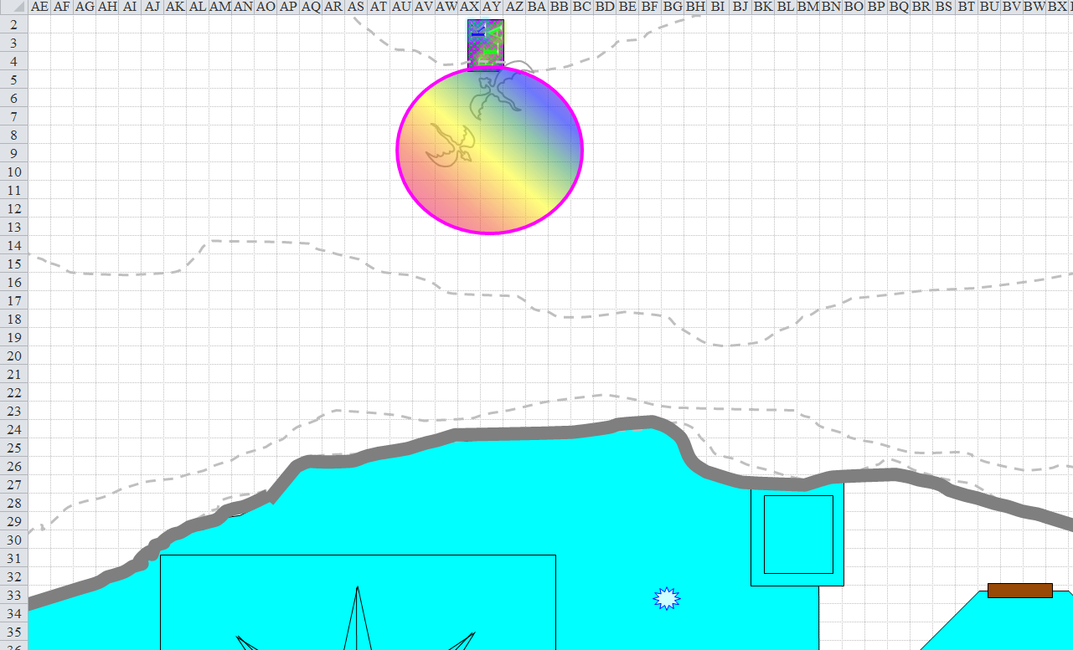

Round 4

The Small fire elementals waited for further instructions from Allisa.

The drakes continued to fall down the cliff, and would soon crash through the castle, making two new breaches in the ceiling as the first two were nearly fixed.

“Fingers, get us out of here, please,” Lauren said as she looked around for any other enemies who might be a threat. “Good work with the drakes, both of you.”

The first drake hit the ice castle, and punched right through it with its massive corpse.

Kedrik cast *chasing perfection [expired on Round 134]* on himself, “Like I said: *chasing perfection*; one casting still available,”

*Kedrik gained +4 to Strength, Dexterity, Constitution, Intelligence, Wisdom, and Charisma.*

Rounds 5 and 6

The second drake also pierced a hole through the castle roof as it was delivered back to the powers that dispatched it.

Fingers suggested, “One alternative would be for you to withdraw as long as one of you can control the carpet. In the meantime, I can take advantage of those breaches in the castle and my invisibility to take a little look around. As you say, we’re on a scouting expedition and this seems a golden opportunity to scout.”

“Oo and uh! Alright, we got this. Go and be safe we will be back at the village” said Allisa. She waited until Fingers flew off the cliff. “Should we stay near in case he needs help?” She looked at the other two and then back down the path they had come to see if those other creatures where trying to get to them.

Round 7

“Anyone else? *Chasing perfection*?” Kedrik looked at Allisa, then probably at Fingers or a spot near the changeling.

Lauren shook her head. “Absolutely not. The gods only know what you’d encounter in there. We have no way to rescue you when you run into trouble.”

Round 8

Fingers shrugged invisibly. “Do you others feel the same way? It’s not as though I need your permission but I’d prefer leaving knowing that someone is willing to control the carpet.”

Round 9

Kedrik looked at Lauren, then at the place where Fingers was standing and talking, and forced the words, “I mean... we... came all this way, right? I’m guessing... if there were any other drakes they would have been unleashed upon us by now,” the gnome noted that the drakes were already wounded by the time they pierced through the thin layer of ice, and they looked rather emaciated as well.

And all the while, the ghaunadan ooze-master cursed and taunted them.

Round 10

Reasonably confident that Allisa would not fly the carpet into the side of the mountain, Fingers stepped off the carpet while shifting into its flight-capable form. As the roof of the castle neared, the changeling headed towards the large of the holes and tried to estimate how long it would take for whatever arcane power was at work for the hole to be completely sealed. Concluding this to be about 20 seconds, it also scanned the rooftop for trapdoors or other methods of egress should an alternate method of retreat be needed... despite volunteering for this recon mission, it had no intention of doing anything other than a quick look around and then run like hell.

The druid looked at Lauren. “Then you wish to stay perched up here as long as the other creatures do not attack?”

|  |  |  |  |  |  |  |
| --- | --- | --- | --- | --- | --- | --- |
| **Allisa, Skill** | **Rank** | **Ability & Mod.** | **Misc. Mods.** | **Total** | **Roll** | **Check** |
| **Use Magic Device** | 0 | **Cha (+2)** | 0 | 2 | 4 | 6 |

*Untrained. See below.*

Lauren shook her head. “I don’t know. Do what you think is best, my love?”

Round 11

Allisa tried turning the carpet without moving forward, and did so. Then she turned it the other way. Lauren stayed with Allisa and watched for any potential threats as Kedrik estimated their elevation to still be about 200’ above the grounds around the castle, where the oozes coagulated.

Round 231

During the 22 minutes of downtime, the individual oozes had begun to detach from their budding mounds, and the ghaunadan had tired of taunting them, sinking back into the ice at its feet as its attire fell once again, lifeless. It was on the 22nd minute that the ghaunadan leader stood up from its pancake-like structure, donning the clothing and armor that had again dropped to the floor, and seemingly kneeling

“We need to leave. Fingers will find a way to escape,” said Allisa. The druid then spoke the command word, raising the carpet off the ledge, moving slowly at first. She made a left turn going around the mountain at the current height without needing to since they were already on the southern side and needed to head back south.

Fingers peeked in the holes in the roof before they closed completely to garner as much of an idea of the layout as possible, including any apparent ways up to the roof and down to lower levels—the changeling was especially interested in whatever method the dragons took to leave the castle to attack the group... if it did not seem particularly guarded, it might serve as a way out for a bit more recon. Mindful that its shield of invisibility was limited, Fingers planned to trigger its Vanisher cloak at any sign of something else in the vicinity—its power would give over an additional precious minute of dependable relative safety without resorting to a fickle wand.

Other than the front gates—on the south façade of the castle—there were no obvious other ways in or out, though crashing through the roof or walls seemed like a viable option.

Fingers first gave an experimental pounding of another section of the roof to get an idea of how thick it was in the pre-holed state, then examined the iced-over hole to judge the speed and to what degree it was thickening—punching thru from above is one thing, but if it iced back over again, doing so from below while flying (unless the ceiling was fairly low) was another... the tallest form Fingers could adopt was maybe 8’ tops, giving it a jump-and-punch reach of around 12 – 13’, unless there happened to be a handy polearm laying around somewhere.

It tried it. It punched through. The ice began regenerating at a rate of a few inches per second.

Widening the hole, Fingers readied to go *invisible* should something hear the noise and come investigate. If the sound of crunching ice didn’t attract anything, it seemed reasonable that either nothing was within earshot or there was and it was preparing an ambush. The changeling planned to jump down 30’ for a look around in either case, but burn a charge from the wand before doing so to prepare an ambush of its own.

Having seen enough for the moment and reasonably certain breaking thru the ice roof was doable, the changeling scout delayed just long enough to make sure the siege weapon on the roof was completely in non-working order.

Returning to the carpet, it relayed its findings, “The castle layout seems simple enough... looks like a single floor except possibly for that domed area and the roof isn’t too hard to break thru. Nobody other than the oozes outside seemed to care about the dead dragons, so can’t be many other defenders there. Shall we all go take a look inside?”

Lauren looked at Allisa. “What do you want to do?”

Round 248

At Fingers’ behest, the heroes all descended, and followed the rogue down into the empty castle.

Allisa stopped the carpet momentarily cast *barkskin [expired on Round 1548]* just before entering.

*Allisa gained +4 to FFAC and AC.*

Kedrik cast *call lightning [expired on Round 378]* as the carpet descended. The gnome then used one of the bolts to zap a hole large enough for the carpet to enter. Outside, the snowflake oozes seemed to get angry.

Allisa took the reins over the carpet again and they entered the chamber through the hole that was already starting to close.

Round 249

Then they spotted the whitespawn hordelings.

There must have been thirty or so, most of them stacked a few feet high up against the western wall of the single chamber, and all dead. The chamber was empty otherwise, blue from the translucent walls and ceiling filtering the arctic sunlight that shone from the eastern wall.

The only other notable feature in the otherwise empty chamber was a hole—roughly 7’ x 7’—just under the center of the cupola above them. The front doors were closed, but the sound of the snowflake oozes outside alerted them to the imminent threat outside.

“What do you think happened here?” Allisa asked.

Kedrik rubbed his goatee, and spotted a few signs of struggle near the front door. “Looks like a conflict took place here, but those bodies were piled up very carefully... not in a rush.”

“Only reason I can think of for stacking the bodies up like that is trying to hide something,” suggested Fingers. “Some of you keep an eye on that hole—whatever killed all these things might well have come up thru that.” The invisible changeling walked west-southwest towards the piles of dead dragon spawnlings.

“I do hope they stay dead,” Lauren said heavily. “So, are we going into this place?”

Staying on the carpet until they landed near Fingers, Lauren drew her falchion and watched for any sign of enemies.

Still on the carpet, the druid suggested they fly over to Fingers in case he needed support. She then moved the carpet along the back wall staying away from the hole in the floor.

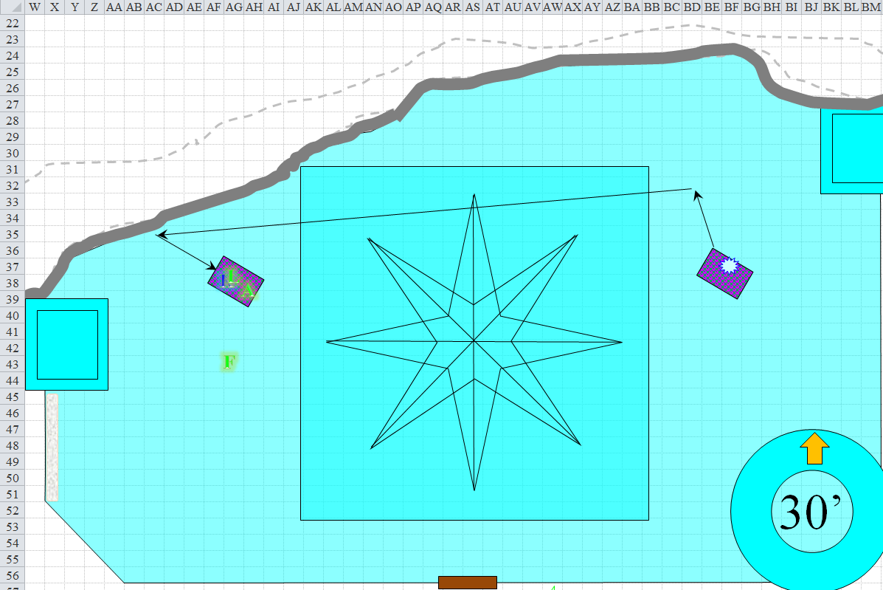

Round 250

Fingers reached and prodded a few of the bodies to make certain they were dead before starting to shove them away from the pile.

All of them looked dead, and nothing moved.

The avariel-shaped shapechanger then noted the footsteps leading from the hole under the cupola to the pile of bodies. There were at least 2 sizes of footprints—both within humanoid range—and it looked like they’d made several trips. It now spotted other, more haphazardly placed footsteps just about everywhere else, now that he was closer to the ground, which told of a scuffle at the southern end of this huge chamber.

Then the door opened, and oozes came in. They’d finally escaped the *entangling* effects of Allisa’s spell, and were now squeezing through. The spectacle looked like white toothpaste coming out of a giant tube, though the heroes wouldn’t have thought so, using magical means to brush their teeth, not toothpaste.

“See if we can burn them,” Lauren called out. “Otherwise, we need to stay away from them.” She began to cast *channeled pyroburst*.

Kedrik hurled a lightning bolt at the supercluster of snowflake oozes, which answered to “Swoosh”.

|  |  |  |  |  |  |  |  |  |  |  |
| --- | --- | --- | --- | --- | --- | --- | --- | --- | --- | --- |
| **Ranged Weapon** | **Dmg.** | **D+** | **TH+** | **Critical** | **Rng.** | **Wt.** | **Atk** | **Roll** | **Check** | **Notes** |
| *Call lightning* Spell | 7d6 | x1½ | 1 | - | - | - | +12 | 11 | 23 | 8 bolts remaining |

*Hit. Dmg: 20 x 1½ = 30 electric.*

Seeing Lauren preparing to fry the invaders, Fingers figured that would be far more effective in dealing with the oozes than the changeling’s weaponry would be... even though the bracers it wore would make an ooze susceptible to precision damage, they would only function three times before their daily charges were exhausted. Fingers sighed as he created a Great Scorcher, hoping to create another if the pyroblast seemed to be dealing with the ooze vanguard or fly over and drop the one just made on top of the largest clump.

|  |  |  |  |  |
| --- | --- | --- | --- | --- |
| **Character** | **Save vs.**  Great Scorcher | **Ranks** | **Roll** | **Save** |
| Snowflake Ooze | Reflex | -3 | 17 | 14 |

*Fail. Dmg: 2 x 19 = 38 fire.*

That seemed to work quite nicely.

Allisa said to those on the carpet, “Get off now unless you can attack from range.” The druid then waited for those who wanted to get off to do so, but everyone had already acted on this round, and Kedrik had no intention of getting off the carpet.

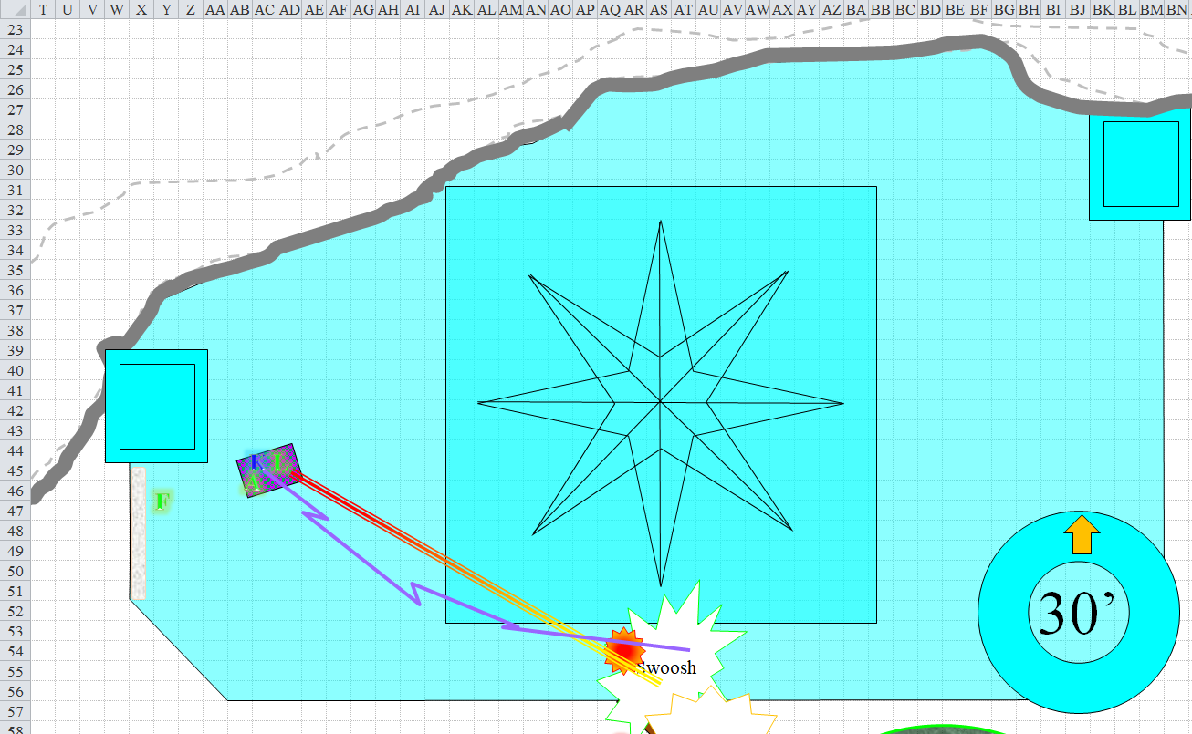

Round 251

Outside, the ghaunadan snowflake ooze ordered its minions to continue to enter the ice castle and lay waste to its intruders.

Lauren finished casting her *channeled pyroburst* spell, and released it at the frontmost clump.

|  |  |  |  |  |
| --- | --- | --- | --- | --- |
| **Character** | **Save vs.** | **Ranks** | **Roll** | **Save** |
| Snowflake Ooze | Reflex | -3 | 14 | 11 |

*Fail. Dmg to Swoosh: 51 fire.*

Lauren stepped off the carpet.

The duskblade then realized she’d cast 3—not 2—4th-level spells, which was more than her daily limit! This would most likely impair her ability to cast lower-level spells today.

|  |  |  |  |  |  |  |
| --- | --- | --- | --- | --- | --- | --- |
|  | **Daily Duskblade Spells** | | | | | |
|  | **0th** | **1st** | **2nd** | **3rd** | **4th** | **5th** |
| **Duskblade Spells** | 6 | 9 | 8 | 6 | 2 | 0 |
| **Intelligence Bonus** | 0 | 1 | 1 | 1 | 0 | 0 |
| **Total Daily Spells** | **6** | **10** | **9** | **7** | **2** | **0** |
| **DC** | 15 | 16 | 17 | 18 | 19 | 20 |
| **Cast?** | **0** | **0** | **1** | **1** | **3** | **-** |

A great deal of the snow evaporated, leaving a gaping cavity in the middle of the ooze through which the duskblade could now see.

Kedrik repeated his tactic, and probably would do so until all of his lightning bolts were spent.

|  |  |  |  |  |  |  |  |
| --- | --- | --- | --- | --- | --- | --- | --- |
| **Ranged Weapon** | **Dmg.** | **D+** | **TH+** | **Atk** | **Roll** | **Check** | **Notes** |
| *Call lightning* Spell | 7d6 | x1½ | 1 | +12 | 14 | 26 | 7 bolts remaining |

*Hit. Dmg: 30 x 1½ = 45 electric.*

The giant ooze named Swoosh was suddenly split into two smaller oozes.

And though Lauren’s pryoburst was dealing sufficiently with the oozes, Fingers noted that there were more outside, and so he made his second Great Scorcher and threw it at the same blob of snow that was already fully inside.

|  |  |  |  |  |
| --- | --- | --- | --- | --- |
| **Character** | **Save vs.**  Great Scorcher | **Ranks** | **Roll** | **Save** |
| Snowflake Ooze | Reflex | -3 | 10 | 7 |

*Fail. Dmg to Swoosh: 1½ x 17 = 23 fire.*

Allisa took the carpet up 30’ [move action], then cast *call lighting* [standard action].

The oozes got closer.

Fingers crafted yet another Great Scorcher, hoping the oozes would run out before its kit materials did—having to scrounge parts would slow things down and increase the possibility of a dud.

*1d100 = 81, success.*

|  |  |  |  |  |
| --- | --- | --- | --- | --- |
| **Character** | **Save vs.**  Great Scorcher | **Ranks** | **Roll** | **Save** |
| Snowflake Ooze | Reflex | -3 | 15 | 12 |

*Fail. Dmg: 2 x 15 = 30 fire.*

The Large ooze that was about to clash with Lauren got a nice blast in its midsection.

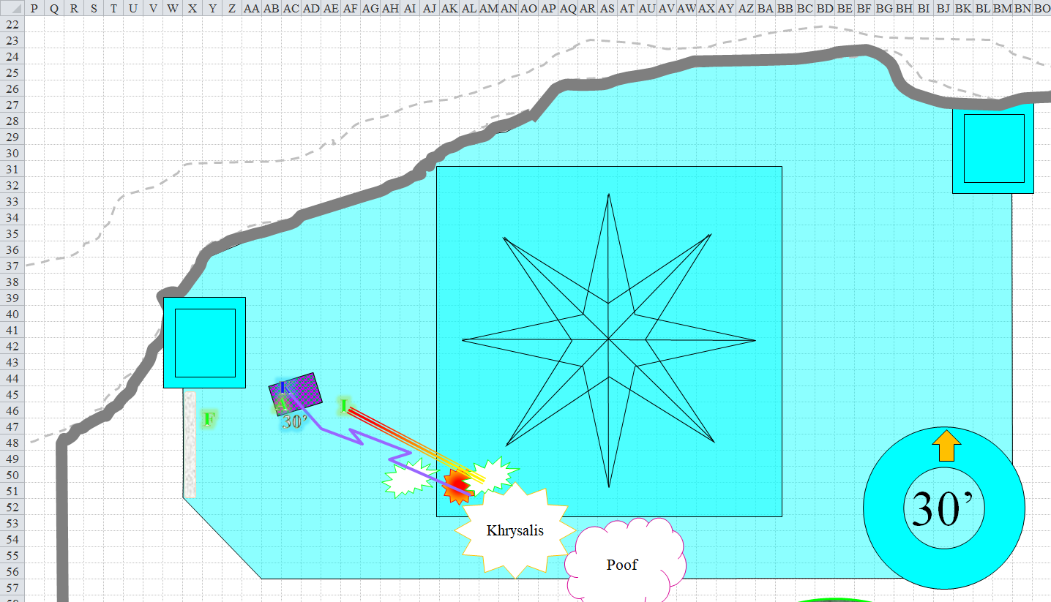

Round 252

Allisa sent her first bolt towards what was left of Swoosh.

|  |  |  |  |  |  |
| --- | --- | --- | --- | --- | --- |
| **Ranged Weapon** | **Dmg.** | **Atk** | **Roll** | **Check** | **Notes** |
| Ranged Touch Attack | 3d6 | +12 | **20** | 32 | 9 bolts left |

*Threat. 1d20 = 3 + 12 = 15, critical hit. 2 x 11 = 22 electric.*

Kedrik did the same with his super-charged bolts.

|  |  |  |  |  |  |  |  |
| --- | --- | --- | --- | --- | --- | --- | --- |
| **Ranged Weapon** | **Dmg.** | **D+** | **TH+** | **Atk** | **Roll** | **Check** | **Notes** |
| *Call lightning* Spell | 7d6 | x1½ | 1 | +12 | 9 | 21 | 6 bolts remaining |

*Hit. Dmg: 1½ x 25 = 37 electric.*

Having already cast *protection from energy (cold) [on Round 2]* on herself, Lauren drew her falchion, and readied an attack.

*[DM assumption]* Fingers fashioned and tossed another Great Scorcher.

*1d100 = 39, success.*

|  |  |  |  |  |
| --- | --- | --- | --- | --- |
| **Character** | **Save vs.**  Great Scorcher | **Ranks** | **Roll** | **Save** |
| Snowflake Ooze | Reflex | -3 | 12 | 9 |

*Fail. Dmg: 2 x 17 = 34 fire.*

The frontmost ooze was almost destroyed now, but pushed through and attacked Lauren.

|  |  |  |  |  |  |  |  |  |  |
| --- | --- | --- | --- | --- | --- | --- | --- | --- | --- |
| **Character** | **Attack**  **Type** | **Damage** | **BAB** | **Str**  **Mod+** | **W+** | **Other+** | **Total**  **Score** | **Roll** | **Total** |
| Snowflake Ooze, Large | Slam | 1d12+11+2d8 cold | 5 | 7 | 0 | 0 | 12 | 3 | 15 |

*Miss.*

Lauren swung once.

*1d100 (against “airy”) = 54, bypassed.*

|  |  |  |  |  |  |  |  |  |  |
| --- | --- | --- | --- | --- | --- | --- | --- | --- | --- |
| **Melee Weapon** | **Dmg** | **D+** | **TH+** | **Critical** | **Type** | **Wt.** | **Atk** | **Roll** | **Check** |
| Falchion +3 | 2d4 | +5 +3 | 3 | 18-20/x2 | Slashing | 8.0 | +20 | 13 | 33 |

*Hit. Dmg: 5 + 5 + 3 =13.*

The Large snowflake ooze split into two Medium oozes, and one of the two moved to flank Lauren. The rest of the oozes were almost upon the duskblade, who evaluated the situation, and figured she could take them all by herself.

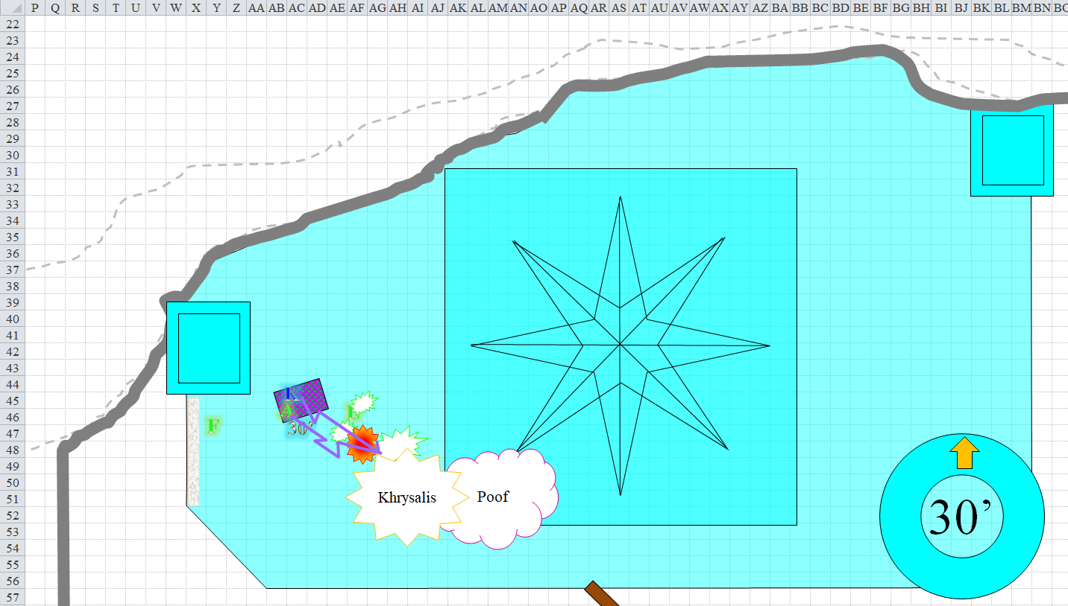

Round 253

The oozes swarmed all over Lauren, trying to pin her down.

|  |  |  |  |  |  |  |  |  |  |
| --- | --- | --- | --- | --- | --- | --- | --- | --- | --- |
| **Character** | **Attack Type** | **Damage** | **BAB** | **Str Mod+** | **W+** | **Other+** | **Total Score** | **Roll** | **Total** |
| Snowflake Ooze, M1 | Slam | 1d8+7+2d4 cold | 4 | 5 | 0 | 0 | 9 | 19 | 28 |
| Snowflake Ooze, M2 | Improved Grab | MM III 161 | 4 | 5 | 0 | 0 | 9 | 18 | 27 |
| Snowflake Ooze, M2 | Grapple/Constrict | MM III 161 | 4 | 5 | 0 | 0 | 9 | 8 | 17 |
| Snowflake Ooze, H1 | Improved Grab | MM III 161 | 5 | 7 | 0 | 0 | 12 | 6 | 18 |
| Snowflake Ooze, H1 | Grapple/Constrict | MM III 161 | 5 | 7 | 0 | 0 | 12 | 16 | 28 |
| Snowflake Ooze, H2 | Improved Grab | MM III 161 | 5 | 7 | 0 | 0 | 12 | 8 | 20 |
| Snowflake Ooze, H2 | Grapple/Constrict | MM III 161 | 5 | 7 | 0 | 0 | 12 | 13 | 25 |

*Miss, miss, moot, miss, moot, miss, moot.*

And though they managed to get ahold of her armor, she was far too well protected for them to do much to subdue the duskblade.

*[DM assumption]* Lauren full-attacked the Medium snowflake ooze in front of her.

*1d100 (against “airy”) = 24, 63, 61, bypassed3.*

|  |  |  |  |  |  |  |  |  |  |
| --- | --- | --- | --- | --- | --- | --- | --- | --- | --- |
| **Melee Weapon** | **Dmg** | **D+** | **TH+** | **Critical** | **Type** | **Wt.** | **Atk** | **Roll** | **Check** |
| Falchion +3 | 2d4 | +5 +3 | 3 | 18-20/x2 | Slashing | 8.0 | +20 | 13 | 33 |
| Falchion +3, 2nd Attack | 2d4 | +5 +3 | 3 | 18-20/x2 | Slashing |  | +15 | **20** | 35 |
| Falchion +3, 3rd Attack | 2d4 | +5 +3 | 3 | 18-20/x2 | Slashing |  | +10 | 4 | 14 |

*Hit, threat, hit. 1d20 = 16 = 15 = 31, critical hit. Dmg: (5 + 5 + 3) + (2 + 5 + 3) + (6 + 5 + 3) = 13 + 10 + 14 = 37.*

The ghaunadan snowflake ooze—hidden within one of the Huge oozes—swiped at Lauren with its longsword

|  |  |  |  |  |  |  |  |  |  |
| --- | --- | --- | --- | --- | --- | --- | --- | --- | --- |
| **Character** | **Attack Type** | **Damage** | **BAB** | **Str Mod+** | **W+** | **Other+** | **Total Score** | **Roll** | **Total** |
| Ghaunadan Snowflake Ooze | Longsword +1 | 1d8+1+1 | 7 | 1 | 0 | 0 | 8 | 2 | 10 |

*Miss.*

From 30’ above, Kedrik hurled another lightning bolt at the coalescence of snowflake oozes, trying to miss Lauren.

|  |  |  |  |  |  |  |  |
| --- | --- | --- | --- | --- | --- | --- | --- |
| **Ranged Weapon** | **Dmg.** | **D+** | **TH+** | **Atk** | **Roll** | **Check** | **Notes** |
| *Call lightning* Spell | 7d6 | x1½ | 1 | +12 | 4 | 16 | 5 bolts remaining |

*Hit. Dmg to Khrisalis: 1½ x 21 = 31 electric.*

*[DM assumption]* Allisa did the same.

|  |  |  |  |  |  |
| --- | --- | --- | --- | --- | --- |
| **Ranged Weapon** | **Dmg.** | **Atk** | **Roll** | **Check** | **Notes** |
| Ranged Touch Attack | 3d6 | +12 | 9 | 21 | 8 bolts left |

*Hit. Dmg to Khrisalis: 13 electric.*

*[DM assumption]* Fingers threw another Great Scorcher at the mass of snow, aiming high and long so as to miss the duskblade. This would likely be its last opportunity to do so without burning his friend as well.

|  |  |  |  |  |
| --- | --- | --- | --- | --- |
| **Character** | **Save vs.**  Great Scorcher | **Ranks** | **Roll** | **Save** |
| Snowflake Ooze | Reflex | -3 | 20 | 17 |

*Fail. Dmg to Poof: 2 x 20 = 40 fire.*

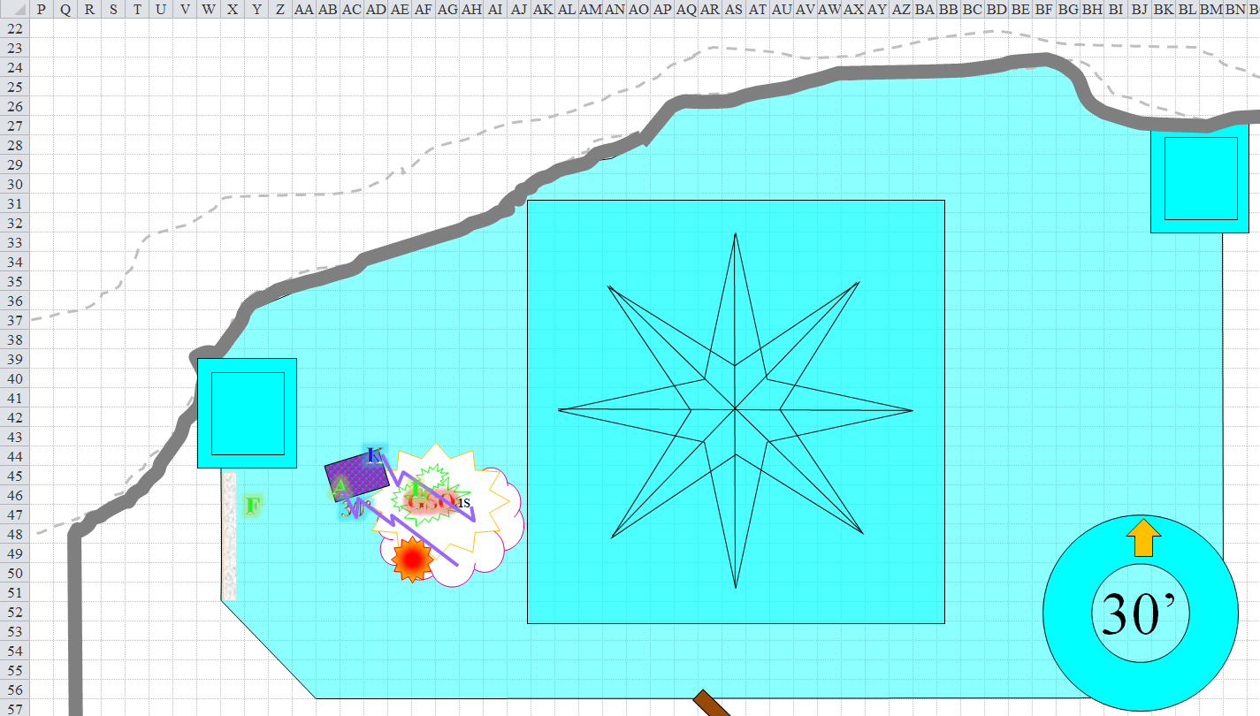

Round 254

The oozes tried to pin down Lauren once again.

|  |  |  |  |  |  |  |  |  |  |
| --- | --- | --- | --- | --- | --- | --- | --- | --- | --- |
| **Character** | **Attack Type** | **Damage** | **BAB** | **Str Mod+** | **W+** | **Other+** | **Total Score** | **Roll** | **Total** |
| Snowflake Ooze, M1 | Improved Grab | MM III 161 | 4 | 5 | 0 | 0 | 9 | 12 | 21 |
| Snowflake Ooze, M1 | Grapple/Constrict | MM III 161 | 4 | 5 | 0 | 0 | 9 | 9 | 18 |
| Snowflake Ooze, M2 | Improved Grab | MM III 161 | 4 | 5 | 0 | 0 | 9 | 16 | 25 |
| Snowflake Ooze, M2 | Grapple/Constrict | MM III 161 | 4 | 5 | 0 | 0 | 9 | 10 | 19 |
| Snowflake Ooze, H1 | Improved Grab | MM III 161 | 5 | 7 | 0 | 0 | 12 | 15 | 27 |
| Snowflake Ooze, H1 | Grapple/Constrict | MM III 161 | 5 | 7 | 0 | 0 | 12 | 13 | 25 |
| Snowflake Ooze, H2 | Improved Grab | MM III 161 | 5 | 7 | 0 | 0 | 12 | 19 | 31 |
| Snowflake Ooze, H2 | Grapple/Constrict | MM III 161 | 5 | 7 | 0 | 0 | 12 | 7 | 19 |

*Miss, moot, miss, moot, miss, moot, miss, moot.*

The ghaunadan ooze tried to cut the drow down.

|  |  |  |  |  |  |  |  |  |  |
| --- | --- | --- | --- | --- | --- | --- | --- | --- | --- |
| **Character** | **Attack Type** | **Damage** | **BAB** | **Str Mod+** | **W+** | **Other+** | **Total Score** | **Roll** | **Total** |
| Ghaunadan Snowflake Ooze | Longsword +1 | 1d8+1+1 | 7 | 1 | 0 | 0 | 8 | 2 | 10 |

*Miss.*

Lauren quick-cast *haste [expired on Round 266]* on herself, and full attacked the closest oozes.

*1d100 = 23, 36, 91, 22. Bypassed “airy”.*

|  |  |  |  |  |  |  |  |  |  |
| --- | --- | --- | --- | --- | --- | --- | --- | --- | --- |
| **Melee Weapon** | **Dmg** | **D+** | **TH+** | **Critical** | **Type** | **Wt.** | **Atk** | **Roll** | **Check** |
| Falchion +3 | 2d4 | +5 +3 | 3 | 18-20/x2 | Slashing | 8.0 | +22 | 12 | 34 |
| Falchion +3, 2nd Attack | 2d4 | +5 +3 | 3 | 18-20/x2 | Slashing |  | +17 | 7 | 24 |
| Falchion +3, 3rd Attack | 2d4 | +5 +3 | 3 | 18-20/x2 | Slashing |  | +12 | **20** | 32 |
| Falchion +3, *haste* | 2d4 | +5 +3 | 3 | 18-20/x2 | Slashing |  | +22 | **19** | 41 |

*Hit, hit, threat, threat. 1d20 = 19, 16, both are critical hits.*

*Dmg to Khrisalis: (4 + 5 + 3) + (3 + 5 + 3) + [2 x (5 + 5 + 3)] + [2 x (2 + 5 + 3)] = 12 + 11 + 26 + 20 = 69.*

This was a formidable series of blows, but it did not quite vanquish the second Huge blob of snow.

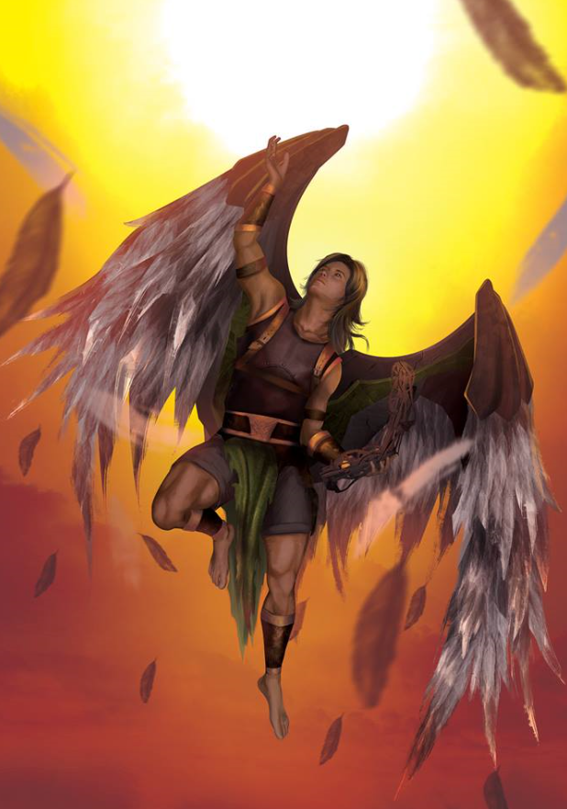

The oozes now too engaged with Lauren to risk further Scorchers, Fingers rejected the other more precise types of traps as likely to be ineffective against the gooey foes. Instead, the trapsmith drew its wand and attempted to activate it. Perhaps at least their sword-wielding leader had enough of an internal structure vulnerable to a well-aimed thrust. At worst, the Deathstrike Bracers it wore would allow a few telling blows to land and draw some attention away from Lauren.

|  |  |  |  |  |  |  |
| --- | --- | --- | --- | --- | --- | --- |
| **Fingers, Skill** | **Rank** | **Ability & Mod.** | **Misc. Mods.** | **Total** | **Roll** | **Check** |
| **Use Magic Device** | 15 | **Cha (+1)** | 0 | 16 | 8 | 24 |

*Success.*

The changeling vanished once again *[expired on Round 260]*.

Kedrik zapped Poof.

|  |  |  |  |  |  |  |  |  |  |  |
| --- | --- | --- | --- | --- | --- | --- | --- | --- | --- | --- |
| **Ranged Weapon** | **Dmg.** | **D+** | **TH+** | **Critical** | **Rng.** | **Wt.** | **Atk** | **Roll** | **Check** | **Notes** |
| *Call lightning* Spell | 7d6 | x1½ | 1 | - | - | - | +12 | 6 | 18 | 4 bolts remaining |

*Hit. Dmg: 1½ x 26 = 39 electric.*

Allisa did the same.

|  |  |  |  |  |  |  |  |  |  |  |
| --- | --- | --- | --- | --- | --- | --- | --- | --- | --- | --- |
| **Ranged Weapon** | **Dmg.** | **D+** | **TH+** | **Critical** | **Rng.** | **Wt.** | **Atk** | **Roll** | **Check** | **Notes** |
| Ranged Touch Attack | - | - | 0 | - | - | - | +12 | **20** | 32 | 7 bolts left |

*Threat. 1d20 = 7 + 12 = 19, critical hit. Dmg: 2 x 13 = 26 electric.*

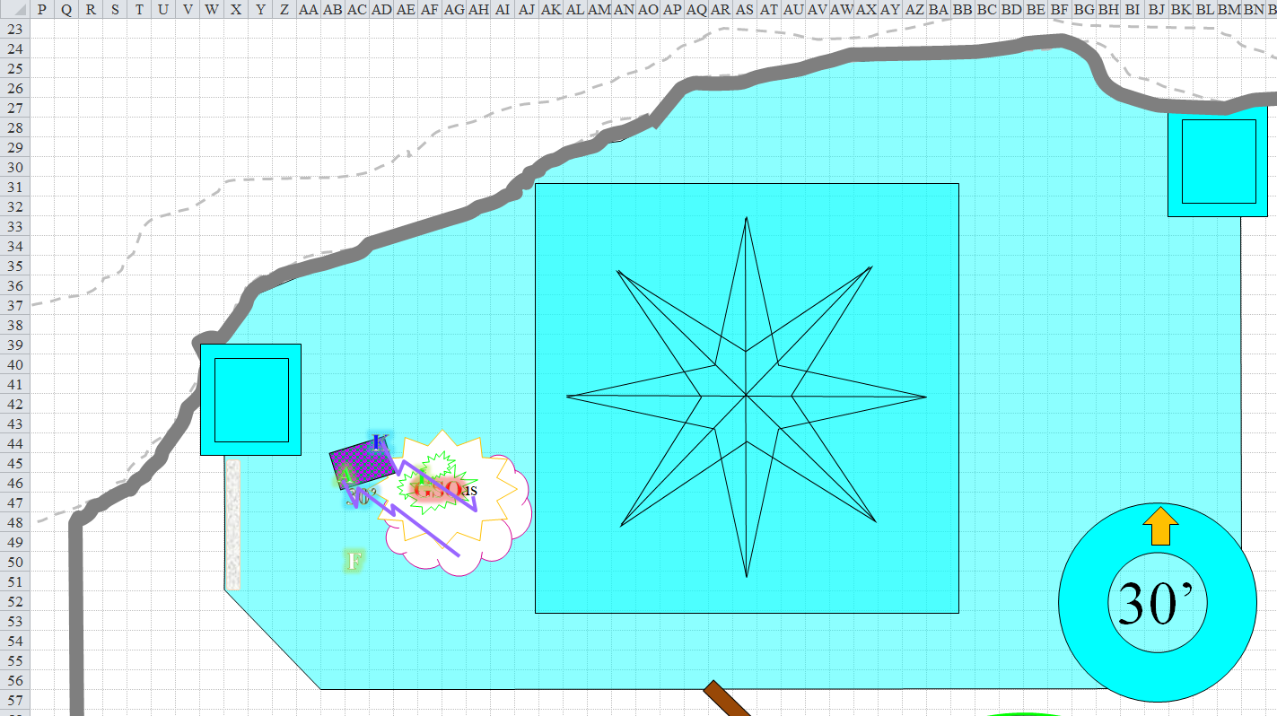

Round 255

Lauren swung profusely again.

*1d100 = 17, 02, 14, 19. LOL, sorry, JR.*

And though her slashes might have destroyed a villain such as Sylar, Whisper, or even Supreme Defiance, these airy oozes were became momentarily lighter in composition than that which her blade could slice, it seemed.

The oozes did their best to work a number on Lauren, but they were outmatched by the duskblade’s defenses.

|  |  |  |  |  |  |  |  |  |  |  |  |
| --- | --- | --- | --- | --- | --- | --- | --- | --- | --- | --- | --- |
| **Character** | **Attack Type** | **Damage** | **BAB** | **Str Mod+** | **W+** | **Other+** | **Total Score** | **Roll** | **Total** | **Crit** | **Threat** |
| Snowflake Ooze, M1 | Slam | 1d8+7+2d4 cold | 4 | 5 | 0 | 0 | 9 | 20 | 29 | 20 | ☑ |
| Snowflake Ooze, M2 | Slam | 1d8+7+2d4 cold | 4 | 5 | 0 | 0 | 9 | 9 | 18 | 20 | ☒ |
| Snowflake Ooze, Khrisalis | Slam | 1d12+11+2d8 cold | 5 | 7 | 0 | 0 | 12 | 6 | 18 | 20 | ☒ |
| Snowflake Ooze, Poof | Slam | 1d12+11+2d8 cold | 5 | 7 | 0 | 0 | 12 | 9 | 21 | 20 | ☒ |

*Threat, miss, miss, miss. 1d20 = 18 + 9 = 27, not a critical hit. Dmg: 3 + 7 + 4 cold = 14 [cold damage negated] [104/114].*

Seeing this relatively fruitless effort, the ghaunadan ooze began to flee as the ooze known as Khrisalis was dwindled down to about half of its original size, but somehow gained an attack of opportunity in the process.

|  |  |  |  |  |  |  |  |  |  |  |  |
| --- | --- | --- | --- | --- | --- | --- | --- | --- | --- | --- | --- |
| **Character** | **Attack Type** | **Damage** | **BAB** | **Str Mod+** | **W+** | **Other+** | **Total Score** | **Roll** | **Total** | **Crit** | **Threat** |
| Snowflake Ooze, L | Slam | 1d12+11+2d8 cold | 5 | 7 | 0 | 0 | 12 | 18 | 30 | 20 | ☒ |

*Miss.*

The archivist suggested to the druid that he hit the largest ooze while she try for the second largest, given their different levels of mastery with lightning spells. Kedrik and Allisa both zapped the shiznit out of Poof and Khrisalis, respectively.

|  |  |  |  |  |  |  |  |
| --- | --- | --- | --- | --- | --- | --- | --- |
| **Ranged Weapon** | **Dmg.** | **D+** | **TH+** | **Atk** | **Roll** | **Check** | **Notes** |
| *Kedrik, Call lightning* Spell | 7d6 | x1½ | 1 | +12 | 16 | 28 | 3 bolts remaining |
| *Allisa, Call lightning* Spell | 3d6 | - | 0 | +12 | 8 | 20 | 6 bolts left |

*Hit, hit.*

*Dmg to Poof: 1½ x 29 = 43 electric.*

*Dmg to Khrisalis: 14 electric.*

Poof was split into two Medium versions of itself, as was Khrisalis, though the latter pair looked weakened by the electrical barrage.

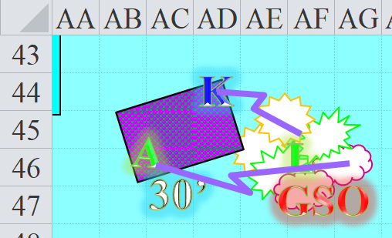

The unseen changeling circled the mass of oozes attempting to overpower Lauren with little success. As long as she seemed to be holder her own, Fingers concentrated on trying to cut off their apparent leader’s retreat. If it could be brought down, the oozes might well disperse on their own.

*OOC: Try to catch up with the ooze containing the leader and start chopping into it.*

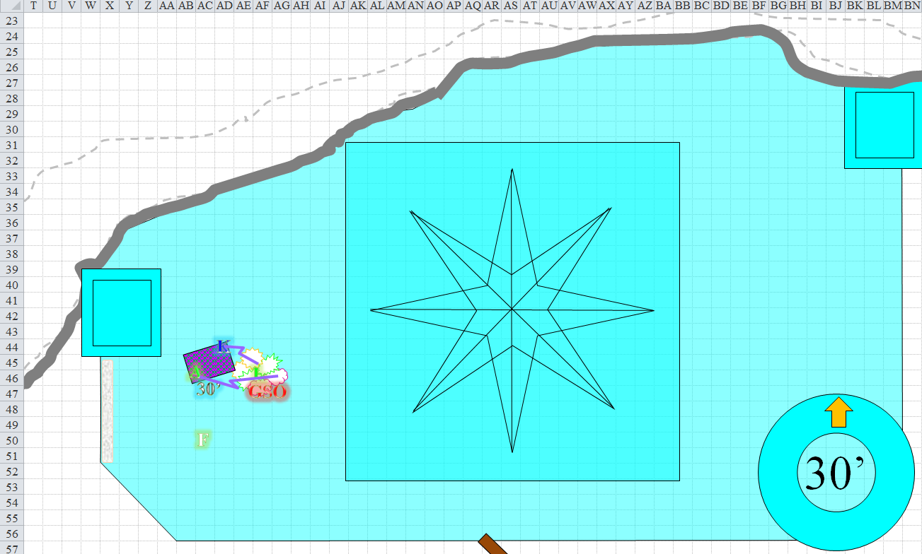

Round 256

Lauren kept up her barrage against the oozes, refusing to give ground, swinging once at each in order to cut the innocuous oozes down gradually. A more formidable group of enemies would have been dealt with one at a time so as to reduce the number of enemies per round later on, but this... this was a walk atop a glacial park.

*1d100 = 55, 60, 35, 22. Airiness bypassed.*

|  |  |  |  |  |  |  |  |  |  |
| --- | --- | --- | --- | --- | --- | --- | --- | --- | --- |
| **Melee Weapon** | **Dmg** | **D+** | **TH+** | **Critical** | **Type** | **Wt.** | **Atk** | **Roll** | **Check** |
| Falchion +3 | 2d4 | +5 +3 | 3 | 18-20/x2 | Slashing | 8.0 | +22 | **20** | 42 |
| Falchion +3, 2nd Attack | 2d4 | +5 +3 | 3 | 18-20/x2 | Slashing |  | +17 | 4 | 21 |
| Falchion +3, 3rd Attack | 2d4 | +5 +3 | 3 | 18-20/x2 | Slashing |  | +12 | 13 | 25 |
| Falchion +3, *haste* | 2d4 | +5 +3 | 3 | 18-20/x2 | Slashing |  | +22 | 13 | 35 |

*Threat, hit, hit, hit. 1d20 = 1, not a critical hit.*

*Dmg to M Ooze 1: (6 + 5 + 3) = 14.*

*Dmg to M Ooze 2: (5 + 5 + 3) = 13.*

*Dmg to M Ooze 3: (5 + 5 + 3) = 13.*

*Dmg to M Ooze 4: (3 + 5 + 3) = 11.*

Kedrik saw one of the four Medium oozes struggling for life, and pointed it out to Allisa. “You get that one, and finish it off.” The gnome then targeted one that was flanking Lauren, and trying to get inside her helmet.

|  |  |  |  |  |  |  |  |
| --- | --- | --- | --- | --- | --- | --- | --- |
| **Ranged Weapon** | **Dmg.** | **D+** | **TH+** | **Atk** | **Roll** | **Check** | **Notes** |
| *Kedrik, Call lightning* Spell | 7d6 | x1½ | 1 | +12 | 5 | 17 | 2 bolts remaining |
| *Allisa, Call lightning* Spell | 3d6 | - | 0 | +12 | 2 | 14 | 5 bolts left |

*Hit, hit.*

*Dmg to M Ooze 4: 1½ x 27 = 40 electric.*

*Dmg to M Ooze 1: 10 electric.*

Neither bolt was successful in fully slaying either blob, though both blobs were rendered Small by the last bolt. They started to follow the ghaunadan ooze out of the ice castle, turning tail.

Lauren took one last swipe at the rearmost fleer.

|  |  |  |  |  |  |  |  |  |  |
| --- | --- | --- | --- | --- | --- | --- | --- | --- | --- |
| **Melee Weapon** | **Dmg** | **D+** | **TH+** | **Critical** | **Type** | **Wt.** | **Atk** | **Roll** | **Check** |
| Falchion +3 | 2d4 | +5 +3 | 3 | 18-20/x2 | Slashing | 8.0 | +22 | 11 | 33 |

*Hit. Dmg: 3 + 5 + 3 = 11.*

She nearly killed the thing outright, and it screeched as it fled her blade.

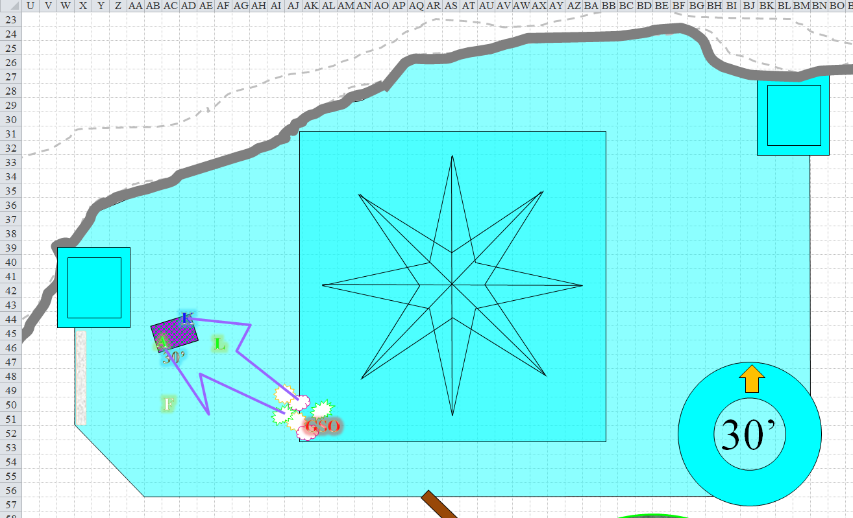

Round 257

The oozes picked up the pace and fled the scene. As soon as the ghaunadan snowflake ooze was outside, its robes and gear fell to the floor, and the wind comingled with the individual oozes that remained, all withered by lightning and blade to lesser shadows of their formerly grand selves.

The carpet remained 30’ aloft, with Kedrik and Allisa atop it, while Lauren stood on the ground, ready to give chase alongside the winged elf whom she knew as Fingers.

Outside, Allisa’s *entangle* spell persisted, and the oozes avoided gliding directly towards it.

Allisa relaxed, and lowered the carpet to a foot above the ground. She then flew to the opening, waiting for the snowflake creature to get out of her sight.

Kedrik stepped off and peered outside, seeing the fleeing oozes making way southward.

Assured that, even if the oozes decided to return, Lauren was positioned to give warning, Fingers took advantage of its current unseen state and flew over to the hole in the floor to see if any immediate threat might lurk there.

Lauren strode to the doorway and looked outside for any additional threats. “If we are done, let us be out of here. I would like to rest before we talk with this dragon.”

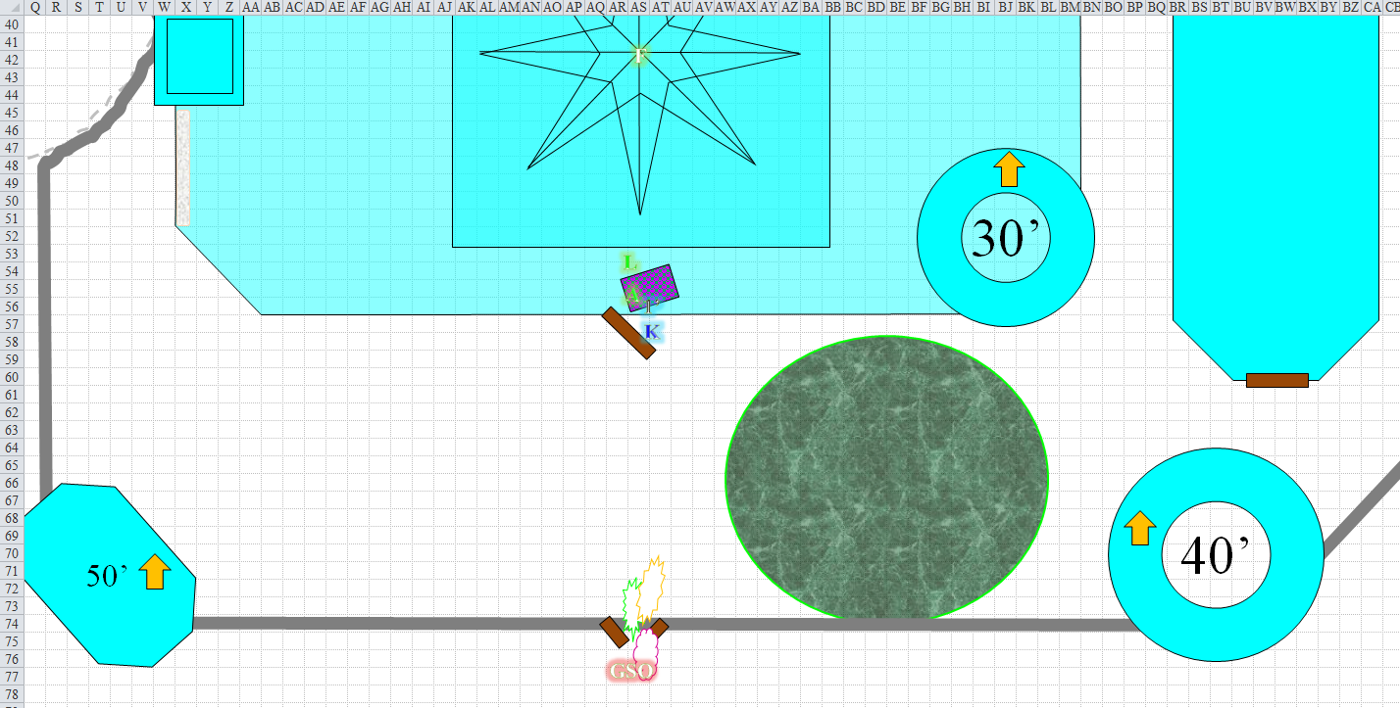

Round 258

Allisa hopped off the carpet, examining the dropped robe and gear. “*Looks* magical,” she shrugged. “I thought that would have been a worse fight than that,” said the druid to no one in particular as she returned to her friends.

Round 259

Pulling out her healing wand, she thanked Kedrik for his expert target directions. She then got off the carpet and approached the drow. “My hero. Are you hurt?” She leaned over and kissed her on the cheek. “Your attacks where flawless and your defense superb.” She smiled, her eyes sparkling with admiration.

Lauren smiled and kissed her wife soundly on the lips. “I think you did more damage to them than I, but thank you. I’m not hurt.”

Fingers peered down the diagonal hole with crude stair and footholds carved into it, and though he could see nothing within, though he could definitely hear at least one creature rustling about down there.

Rounds 260 – 261

“I vote leave before anything else happens,” said Allisa.

Lauren put up her falchion. “Me, too.” She stepped over to Allisa. “We can store this gear in my pack, if you want to keep it.”

Fingers became visible again as it peered downward, flapping its elven wings. “I disagree,” responded the hovering rogue. “There is something down below—perhaps the dragon, perhaps not. In either case, leaving now would merely give the oozes time to recuperate and possibly additional defenders to arrive. At the very least, I would think we should ascertain whether our primary target is here.”

Rounds 262 – 263

“If we find her, she will likely find us, as well,” Lauren pointed out. “I no longer have the ability to cast my best spells today, so I will be that much less effective in a fight.” The duskblade looked to Allisa for her input.

Rounds 264 – 266

Fingers heard the shuffling below becoming briefly more agitated, then stopping altogether. It voiced its point, “But wasn’t our information that the main reason she supposedly came her was because she was injured? Which would you rather face? An injured dragon with incomplete resources or face a healthy one with all your spells?” persisted Fingers.

Rounds 267 – 268

“If we have nothing to fight with then she will win even if she is wounded” said the druid. “As it is my remaining spells are on the low end. Dragons are notorious for being able to overcome must spells.”

Rounds 269 – 271

“If that is the case, then it really doesn’t matter how many spells you have remaining, does it? However, I certainly don’t want to talk you into a confrontation now if your hearts aren’t up to it. I do intend to take a look just to determine if she is here or not, however. The rest of you can begin your retreat and I’ll catch up,” said Fingers, drawing its invisibility wand, obviously intent on performing its stated action.

Rounds 272 – 275

Lauren glared at the changeling. “My heart wasn’t in this from the time we left Waterdeep! I’m *tired* of fighting, Fingers. All I want to do is quietly live out my life with my spouse. If I never have to lift a weapon again, or cast another spell, I would be greatly pleased. I am here because I *have* to be here, because there is no one else willing or able to be here right now. I’m here because some asshole dragon just can’t others live peaceably, and so I have to come out here and kill anything that’s too stupid, or too self-absorbed, to just leave other people alone! So, if I am going to fight, I want to win. If you go down there, I will follow you. You have earned that respect. Don’t abuse it.” The duskblade drew her falchion.

Rounds 276 – 278

Fingers used its wand of *invisibility [expired on Round 282]* made its way down, and entered a room that was about as horizontally spacious as the chamber above, but was only about 20’ high, not really fit for an adult dragon, but certainly for the court of frost giants who had been ousted by the dragon and her minions.

Huddled into a neat heap were the corpses of a half-dozen whitespawn berserkers, along with about twice as many hunters and hordelings whose bodies had been appropriated for nutrition by a dracovore of some sort. Some had been butchered and reduced to bones by now, and a hunch gave Fingers cause to suspect that there was someone hiding behind the heap of berserkers. That particular pile would have served Fingers as a nice hidey place, and, straining to hear, it *could* actually make out the anxious breathing of a frightened humanoid.

Making sure that no one else was sneaking up on it, the winged elf made its way as quietly as possible towards where something was apparently hiding.

Round 279

A robed, shivering half-dragon was huddling, staring out in the general direction of the invisible elf whose movements echoed in the chamber. The cleric of Best—for that is what its charms and vestments suggested—was crouching behind whitespawn bodies on which it had fed, in addition to the mostly eaten plates of food that it surely conjured with a spell for itself.

It appeared male, but Fingers couldn’t tell; what it *could* tell was that this cleric was resigned to die today, and though its quarterstaff rested nearby, the priest or priestess was not going to put up a fight and delay the inevitable.

Fingers was doubtful the minion of Best would give any useful information, but the attempt was worth trying in any case. However, it would be prudent to prevent it making a final stand and with that decision drew its seldom-used sap and closed with the quivering cleric to try rendering them unconscious and thus no immediate threat.

Round 280

Fingers attempted to bash the half-lizard with a pair of well-aimed strikes to its temple. It was a nice hit that made the male half-dragon figuratively say goodnight.

Lauren heard the pop of the sap atop the half-dragon’s head, thinking Fingers might have gotten himself hurt. Allisa and Kedrik—still atop the carpet—heard nothing.

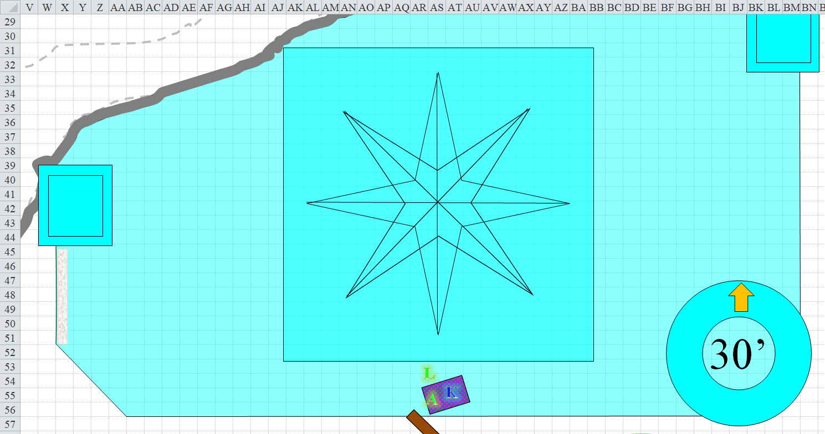

Round 281

Lauren moved quickly toward the sound. “I think Fingers found something,” she told Allisa. “Come on.”

Fingers was now in a position to search or loot the body of the unconscious cleric.

Round 282

“Got a prisoner here,” Fingers called up while divesting the unconscious cleric of weapons, holy symbol and anything else of interest. The changeling looked about the chamber for anything else of use, including something to bind their prize.

Lauren reached the hole and jumped down to the next level, following the changeling’s voice.

Allisa moved the carpet to the edge of the hole and looked over. Kedrik jumped down after Lauren.

Fingers became visible again, and Lauren spotted him holding the half-dragon by the neck of his garments. It removed a tiny mace too small for a Medium humanoid to use. In Kedrik’s hands, it would have been a useful mace, but in the half-dragon’s it would have been something akin to an ornamental scepter with perhaps the sap-like ability to render someone unconscious. Maybe it was time for Fingers to upgrade his sap to a scepter of dragonly might, or whatever this was.

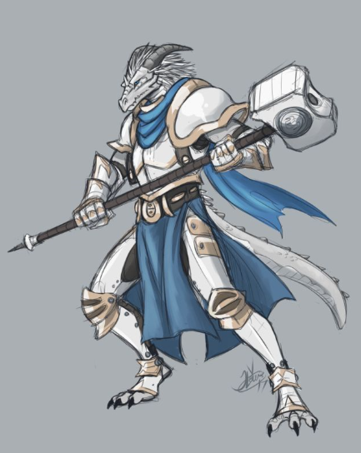

Rounds 283 – 284

Still atop the carpet, Allisa could hear the conversation, but could not see anything or anyone past the nearly vertical chute with the steps and handholds.

Lauren looked around the place they were in, her eyes adjusted to the low light levels. It was the same length and width as the room above, but its ceiling was only 20’ high, and the dim light from above shone through, making the room rather dark for a human, though the changeling, half-drow, half-elf, and whisper gnome were perfectly able to see one another and the half-dragon cleric in the blue-hued room.

Before stripping the half-dragon of the few bits of plate armor that he had under his robes, it decided to grab the quarterstaff that had been resting nearby, noticing that it was quite the magic device. Studying it for a moment, the changeling nodded as the others approached. It pushed a latch along the heft of the staff, and one of the staff’s extremities became a hammerhead. “Hmmmm...” the changeling smirked. It wasn’t the type of weapon that Fingers would invest time into studying, but at least one of Rook’s followers would drool over something like this.

The cleric was otherwise equipped with a spell component pouch—nearly empty—and a few magical rings and other jewelry that needed identifying. The breastplate and other articles of armor were also magical, from the looks of them, and near the edges of each piece were subtle, ornamental engravings in the shape of elongated white dragons.

With no visible paths or doors to any other room, the party could deduce that this was likely the last survivor of a previously numerous band of whitespawns who had fared less than well against a local adversary—could it be the Neanderthals that they’d heard about?—or perhaps ice giants?—and had now been reduced to one cannibalistic priest and a year’s supply of frozen meat. He’d apparently lost all of his muscle except for 2 ice drakes and a pack of snowflake oozes, one of which was a half-sentient ghaunadan that *still* lurked outside, probably planning the next suicidal assault on the heroes as they emerged.

Round 285

“If Best was here at some point, she’s clearly moved on,” observed Fingers. “However, we’ve at least managed to whittle down some of her minions. About all left to do here is give the place a good once-over in the off chance there is anything else of interest, question this lizard to see it it is inclined to be chatty and maybe finish off those oozes if they haven’t hightailed out of the area. However, if we can’t find anything to give a clue where Best may’ve gone, what then? Go back to our original plan of trying to locate her home base?”

“Yes, I think we should keep looking,” Lauren replied. She walked back to the shaft to check on Allisa.

Allisa kept watch as she listened to those below. “You need me to bring the carpet down for a pickup?”

“Yes, please,” Lauren replied.

The druid moved the carpet over the hole and slowly lowered it to about a foot from the ground.

Lauren stepped aboard. “Let’s wait here until they’ve finished questioning our guest.”

~*~

Round 352

Minutes passed. A croaky groan alerted the whisper gnome and his companions as Allisa looked out of the front doors to make sure those snowflake oozes had stayed away.

The cleric of Best awakened.

Oh, what a headache!

The cleric tried getting up, but was bound by now. The familiar smell of hordeling blood was now comingled with the new scents of mammalians. He opened his eyes to confirm that four humanoids had him disabled in every important way.

Kedrik turned to the others, who were now approaching. The archivist stood over the gagged and nearly nude cleric of his white dragon goddess.

Of the two ice drakes that had fallen through the ceiling but not through the thicker floor of the castle’s main chamber, the larger of the two now served as a giant pillow against which the cleric leaned.

“This your *pet*?” Kedrik pointed to the head of the dead drake whose open maw seemed to yawn at the horned man, whose toothy snout was stuffed with rags so he could not emit a single verbal component.

Unable to answer, the cleric looked up at the archivist with a mixture of contempt and resignation.

Since the others hadn’t protested, Kedrik removed the overstuffed gag from the reptilian cleric’s maw, then dispensed with the rhetorical questions and got to business, “What’s *your* story, priest?”

|  |  |  |  |  |  |  |
| --- | --- | --- | --- | --- | --- | --- |
| **Skill** | **Rank** | **Ability & Mod.** | **Misc. Mods.** | **Total** | **Roll** | **Check** |
| **Kedrik, Intimidate** | 0 | **Cha (+2)** | 0 | 2 | 5 | 7 |

*Fail.*

<< My story ends with you, and you needn’t concern yourselves with the previous chapters, >> the cleric snarled defiantly in Draconic, which Allisa, Fingers, and Lauren could not understand.

Kedrik looked at his friends, and translated roughly.

“So he understands Common?” Allisa confirmed.

“Enough to have answered my question in Draconic,” the archivist nodded.

Lauren and Fingers were only marginally more capable than Kedrik with threats and verbal abuse; they considered saying something.

After letting Kedrik play bad guardsman while Fingers sifted thru the materials in the chamber for anything that might be useful intel, it decided ‘twas time for good guardsman. “Look,” it addressed the trussed cleric, “if we’d wanted you dead, we wouldn’t be having this conversation. Answer our questions and you have a fair chance of still breathing after we leave here. Stay stiff-lipped or lie to us and I don’t like your chances at all of seeing tomorrow. First question: When and where did you last see Best?”

|  |  |  |  |  |  |  |
| --- | --- | --- | --- | --- | --- | --- |
| **Fingers, Skill** | **Rank** | **Ability & Mod.** | **Misc. Mods.** | **Total** | **Roll** | **Check** |
| **Diplomacy** | 0 | **Cha (+1)** | 2 | 3 | 15 | 18 |

*See below.*

Allisa kept lookout at the door again as she listened to the interrogation. She had mentioned earlier that she was nervous and thought they should leave with all haste. Lauren sat on the carpet with Allisa, still unwilling to leave her wife unguarded. She knew the druid could take care of herself, so it was for her own comfort.

After having thought to answer in Draconic, << Once I tell you, there’ll be nothing stopping you from wanting to kill me, >> the cleric instead said in Common, “The Queen left four days ago, when she went to punish Raven’s Rock for their defiance. She entrusted me with holding down the fort, but you and the savages have put an end to any hopes of that.”

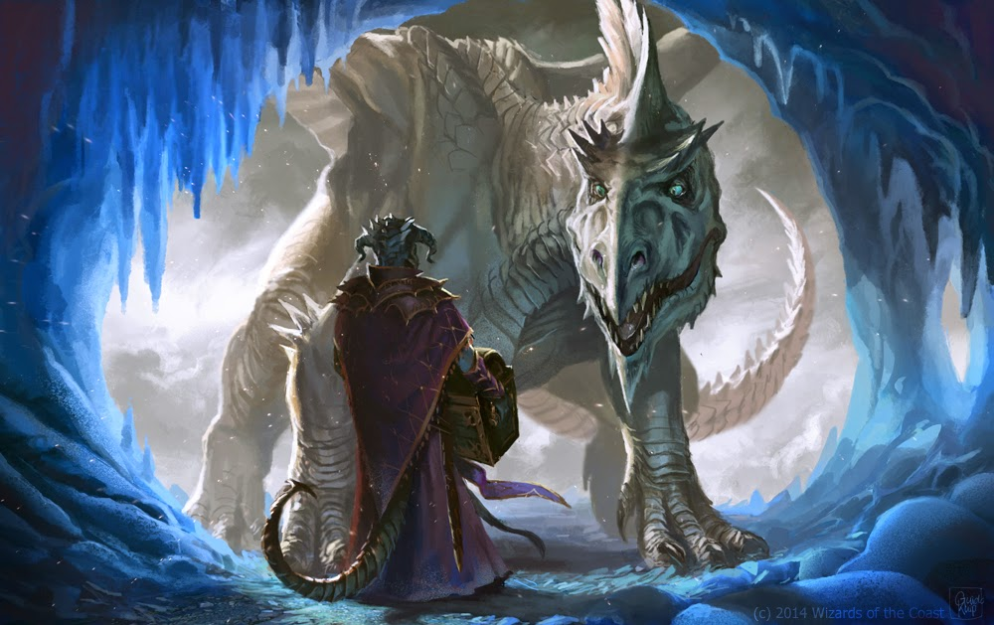

“And where is she now?” asked the rogue, softening his tone.

“She cast a *sending* spell saying that she’d pressed on south to Triboar and west all the way to Luskan, but a subsequent *sending* message said our forces had not fared well in their offense, and she was on her way back... we haven’t heard back for 2 days, and now it’s just me.”

So far, the cleric’s spiel checked out. They’d witnessed firsthand what Best’s forces had done in Triboar, and could only imagine what Raven Rock—a much less defensible settlement—must have looked like.

“We need to get out of here,” Lauren said firmly. “Leave him and let us go.”

“Agreed,” replied Fingers. “We’ve at least verified our other sources of info are accurate. The assault force will have to wait another day to take Best on but she can’t hide forever.” The changeling delivered the last part with its back to the bound cleric while giving the others a wink. Maybe the lizard would swallow the lie, maybe not but couldn’t hurt. If the tale did manage to make its way back to Best’s ears, maybe she’d at least reconsider ravaging another town for a bit. Flying up out of the hole, it made ready to depart with the others.

It was unclear whether or not the cleric believed Fingers.

Lauren shook her head, and turned to Allisa. “Take us out of here, my love.”

With that Allisa did as her spouse asked after everyone was aboard.

“Stay alert,” Lauren warned. “For all we know, Best and her surviving army are right outside.” She pushed aside her fears and mentally prepared herself for battle.

And so the heroes who had trekked north for the better part of a tenday in order to bring this menace of a dragon to rights now turned back and flew out of the castle and up high into the sky as they headed south.

“Let’s go back to where we started this morning,” Lauren suggested. “Now that we know a little more about the castle, we can make plans.”

Leaving the cleric to recover and the snowflake oozes to regroup and reproduce, the senior folks from Destiny’s Gambit made headway across the sky towards the igloo settlement, and maintained their 100’ altitude, wary of ice driders casting *wall of force* spells or the like.

Allisa looked over the cape, longsword, helmet, and breastplate that she’d confiscated from the ghaunadan snowflake ooze, then placed the items into Lauren’s haversack before Fingers went into full acceleration mode.