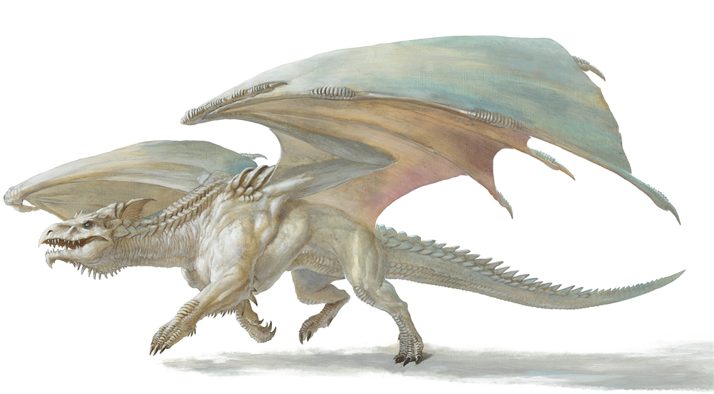*Chapter 59*

They soon made it back to the dozen igloos and the frozen white dragon that had attempted to kill them all just last night. They were a bit tired, having slept less than 8 hours in the cold but otherwise comfortable bedchamber underground.

As they descended, they were spotted by one of the half-Neanderthal youths, and by the time they landed, almost every resident had made his and her way outside to greet the heroes.

And though the heroes *had* scuffled, it had hardly been a match for their respective talents, and they hadn’t actually faced their ultimate mark: Best. Expecting the white dragon to return to her ice castle any day now—even today—the heroes now began to answer questions from the anxious neighbors of the tyrannical, self-proclaimed goddess as to how they’d fared and what had become of Best.

Lauren allowed Kedrik and Fingers to do the talking as much as possible. Once the villagers had been appeased, she turned to her compatriots. “I think we should look for allies who would be able to help us with Best and her minions. We still don’t know how large her army is, though.”

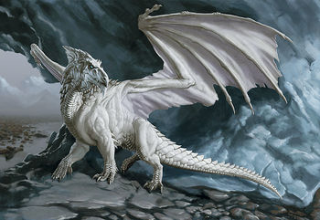

At the implication of the Gambit needing allies, the elders looked at one another, and one of the grandmothers said, “We’d gladly lend a hand if we thought it helped, but we’re hardly capable when it comes to such a mighty creature.”

Her lover asked the Gambit, “What did you encounter while there? Any clues as to when she will return? Perhaps she has been vanquished elsewhere.”

“Her current whereabouts are unknown,” replied Fingers, “but we were able to eliminate a pair of her dragon cohorts and a number of oozelike creatures, altho some of them were able to flee with their leader. We also were able to question the sole other living inhabitant who was unaware of just what she might be planning next. She carried out other attacks on communities but how she and her army fared is as yet unknown.”

The half-Neanderthals couldn’t understand some of the rogue’s words, and looked at one another, frowning and shrugging. Then, one of the elder men said, “No matter. We’ll feed you the stew we’ve been brewing all morning, and tomorrow you’ll be that much fitter.”

One of the women asked, “Is it possible that Best *was* vanquished while trying to destroy the countryside?”

“She is—word has it—” the village’s crier announced, “the most cunning white dragon that this land has ever hosted.”

He went on to describe Best—as they already knew her to be—as an intelligence-enhanced white dragon, something of an oxymoron to any draconomist. They already knew that she had purported to be a goddess, and had bestowed upon Supreme Defiance—via the artifact that they’d confiscated from the Dungeon of the Crypt—favors not unlike those derived from clerical spells. The artifact remained to be identified properly, but the Gambit was likely to undo Best before the dragon could cause more harm through the device.

“So what will you do now?” one of the adolescents asked the Gambit.

Kedrik looked at his three friends, and spoke for them when they didn’t answer, “Why... we’re going to vanquish Best, of course!”

Thag and Ayla, the most talkative of the half-Neanderthals, were speaking in their own familial dialect—rich with phonemic repetition and onomatopoeia—and the family seemed to come to the consensus that they must do something—even if indirectly—to help the Gambit to vanquish Best.

“Come. We have tidied your bedchamber, heroes. Dragon stew is being stirred. Soon, we will eat,” Yerida, the godmother of al who lived here, invited their guests to rest a while before satiating their bellies once more on the meat of the white dragon they’d killed last night.

~*~

Lauren had waited until they had been left alone in the doorless ice chamber where they’d stayed last night. “Are you seriously advocating that the four of us take on Best alone? She has, or at least had, enough combat power to destroy a city!”

Kedrik pursed his lips, “True: on a good day, she could level us... pulverize us maybe, but as the adept said the other day, word has it that she is badly weakened, and her army is all but destroyed.”

“Still a dragon is a very hardy beast. I do not know about just us attacking and if any of her army is left we will be in big trouble?” asked Allisa.

“I agree just taking her on in a frontal assault—let alone with any other surviving minions—would be suicide. I see our mission as what we’ve been doing thus far... tracking down reports of her possible location and when the opportunity presents itself to ambush minions off by themselves, do so. If we can determine a lair where she might hole up for a significant time, we can get word back to Waterdeep for reinforcements to put an end to her threat,” suggested Fingers.

Kedrik looked down. This was a Gray Hands operation, which precluded it from being official Waterdhavian business. The City had its own internal issues that it was dealing with—thankfully, no doppelgangers this year—and its scope of influence this far north was only symbolic. The gnome then spoke, “I can prepare an *omen of peril*, or better yet, an *augury* spell by Morning, and we can get a better idea of what a scuffle with Best would end like. More importantly, since we’ve been to her lair, and had that brief interchange with that damn-fool cleric, which makes it easy for me to cast a *scrying* spell on him, or maybe on that ghaunadan ooze, since Allisa confiscated his possessions!”

The heroes sat on the bed or cots contemplating how they could gain an edge on Best and her ilk. “Could you cast *scrying* on Best?”

“I fear her willpower would be greater than my prayer’s power,” sighed Kedrik, shaking his head. “Her cleric was a dull-clod, though,” he smirked with more confidence.

“Anything you can do to find out where Best is, and how many might be with her, would help,” Lauren replied.

~*~

The food had come. The Gambit had been led to the dining chamber, which was south about 100’ of the bedchamber, via an icy corridor that turned twice and forked thrice before they’d arrived and seated themselves atop pillows around a cloth on the floor, atop which were a healthy assortment of dragon meat dishes, along with a cornucopia of *created* food, cast by the adept among the family of half-Neanderthals.

Yerida entered with yet another dish, and placed it near the edge of the cloth once Thag and some of the younger lads made room by shifting a few bowls over. “We live a difficult life out here in this vast, barren land, but the deities bestow blessings upon us,” the godmother seemed to emit a prayer, though it was just poetry she’d received from her mother and her mother’s mother. “Today, your presence is a blessing, and an honor to these children. Their future is in your hands.”

They began to eat.

Lauren, never a big eater, picked at her food, selecting mostly vegetables and mushrooms. “This is good,” she said.

Allisa tried the soup, but stayed away from most of the meat dishes. She chose vegetables to add to her meal.

All in all, the most delightfully prepared dish, in Kedrik’s mind, was the wing membrane wraps, stuffed with tendered abdominal muscle fajitas, and some of the veggies that had come with the priestess’ *create food and water* spell’s effect. The gnome also gobbled heartily the shmuor-filzé, or white dragon cake, which consisted mostly of the core of white dragon scales, and tasted much like artichoke hearts mixed with water chestnuts. Though he’d given up drinking alcohol, he *did* sample four different teas, and partook of a half-dozen conversations in a place where almost everyone was at least twice as tall as him; only the youngest kids, and Allisa and Lauren, were not.

Lauren once again brought up the idea of finding allies to rally against Best. There were always the surviving frost giants who had forged the ice castle where Best resided, but their whereabouts and ultimate fates were unknown. Then there were the fiercer, more brutish Neanderthals, but the daintier half-Neanderthals were not held in high esteem by their full-blood counterparts, so the Gambit would be on its own to deal with them if they encountered them. They were nomadic, and commonly roamed the hillier, cave-rich tundra that began to the north of the ice castle. There were also snowflake oozes, which could be turned against Best, though these were not to be regarded as a formidable, table-turning ally, particularly after the Gambit had reduced them to about a quarter of their number.

“There are other *allies*, as you call them,” Thag posed, “in the area, but you would need a *charm monster* spell. Ice drakes like the ones you said you slew would be a good mount ally for a fight against a white dragon of Best’s caliber. These are abundant along the fjords east of the ice castle.”

“We still have the question of exactly who we are fighting,” Lauren pointed out.

Fingers had spotted these when they’d flown 3 miles east from the castle shortly after arriving there. They were still another few miles east, but they constituted a beautiful scenery.

~*~

Allisa undressed for bed and crawled under the covers waiting for Lauren so she could cuddle and be warm. When the half-drow joined the half-elf, Allisa moved over to spoon with her love. Letting the cold of the drow sink in to her skin as her warmth took of Lauren’s chill. Allisa enjoyed the touch of flesh to flesh, even the chill of the others body. She kissed the back of the others woman’s neck and whispered her praises of her spouse for the day’s work. She knew her love was tired of fighting and need the encouragement. Her left hand gently moved down Lauren’s side as far as she could reach before moving to cup the woman’s ass-cheek. Several moments later her hand moved to cup her mound as she finally began to doze off.

Lauren sighed and relaxed in her wife’s embrace. “I love you more than my own life, Allisa,” she said as she drifted off to sleep.

Kedrik and Fingers sat on the cot overlooking the two women snuggling, and contemplated their next steps. “Here’s what I intend to pray for tonight...” the gnome whispered to the changeling his intended spell list for the next day.

|  |  |  |  |  |
| --- | --- | --- | --- | --- |
| *Daily Prayers* | | | | |
| **Prayer** | **Level** | **Electric** | **DC** | **Cast?** |
| Amanuensis | 0 | 0 | 17 | ❑ |
| Cure Minor Wounds | 0 | 0 | 17 | ❑ |
| Detect Magic | 0 | 0 | 17 | ❑ |
| Read Magic | 0 | 0 | 17 | ❑ |
| Bless | 1 | 0 | 18 | ❑ |
| Cure Light Wounds | 1 | 0 | 18 | ❑ |
| Detect Chaos | 1 | 0 | 18 | ❑ |
| Detect Evil | 1 | 0 | 18 | ❑ |
| Nightshield | 1 | 0 | 18 | ❑ |
| Omen of Peril | 1 | 0 | 18 | ❑ |
| Sanctuary | 1 | 0 | 18 | ❑ |
| Shield of Faith | 1 | 0 | 18 | ❑ |
| Cure Moderate Wounds | 2 | 0 | 19 | ❑ |
| Hold Person | 2 | 0 | 19 | ❑ |
| Hold Person | 2 | 0 | 19 | ❑ |
| Identify | 2 | 0 | 19 | ❑ |
| Augury | 2 | 0 | 19 | ❑ |
| Restoration, Lesser | 2 | 0 | 19 | ❑ |
| Silence | 2 | 0 | 19 | ❑ |
| Call Lightning | 3 | 1 | 21 | ❑ |
| Dispel Magic | 3 | 0 | 20 | ❑ |
| Dispel Magic | 3 | 0 | 20 | ❑ |
| Dispel Magic | 3 | 0 | 20 | ❑ |
| Dispel Magic | 3 | 0 | 20 | ❑ |
| Footsteps of the Divine | 3 | 0 | 20 | ❑ |
| Heart’s Ease | 3 | 0 | 20 | ❑ |
| Break Enchantment | 4 | 0 | 21 | ❑ |
| Break Enchantment | 4 | 0 | 21 | ❑ |
| Divination | 4 | 0 | 21 | ❑ |
| Diamond Spray | 4 | 0 | 21 | ❑ |
| Divination | 4 | 0 | 21 | ❑ |
| Freedom of Movement | 4 | 0 | 21 | ❑ |
| Bear’s Heart | 5 | 0 | 22 | ❑ |
| Scrying | 5 | 0 | 22 | ❑ |
| Chaav’s Laugh | 5 | 0 | 22 | ❑ |
| Dispel Evil | 5 | 0 | 22 | ❑ |
| Flame Strike | 5 | 0 | 22 | ❑ |
| Chasing Perfection | 6 | 0 | 23 | ❑ |
| Chasing Perfection | 6 | 0 | 23 | ❑ |
| Chasing Perfection | 6 | 0 | 23 | ❑ |
| Dispel Magic, Greater | 6 | 0 | 23 | ❑ |
| Holy Transformation | 7 | 0 | 24 | ❑ |
| Radiant Assault | 7 | 0 | 24 | ❑ |
| Restoration, Mass | 7 | 0 | 24 | ❑ |

“I’ll try to get as much info with the *omen of peril*, *divination*, and *scrying* spells, which should give us an edge against the dragon’s forces,” proclaimed the archivist. “From the moment that we get any crucial intel, we should be ready to move at a moment’s notice.”

~*~

Morning came, and Kedrik was preparing his body for the day’s events before casting his various Divination spells.

The druid had risen about the time as Kedrik to meditate on her spells. She now sat nude cross-legged on her side of the bed with head bow for the time it took to restore her daily blessings. Once done, she leaned over and gave playful kisses to Lauren until she awoke. The mistress of many forms then dutifully helped her spouse dress before putting on her own armor and warm coat. She then made sure Lauren’s and her gear was packed and ready to go.

Now fully equipped and ready for the world, Kedrik began to cast *divination*.

*1d100 = 47, see below.*

Lauren awakened, and pulled Allisa down on top of her. “I love you,” she said huskily. The drow cleverly rolled the half-elf onto her back and stretched out atop her. “I wish we had time to finish this,” she said with a smile and a kiss. She sat up, and then stood to dress, allowing Allisa to help her. “I hope we do at least as well today. Maybe we can find Best and her lackeys before they find us this time.” She smiled again, with more life in her eyes than yesterday.

~*~

Allisa, Lauren, and Fingers had all had some dragon mush for breakfast, and were all now getting dressed, armored, and armed. The half-Neanderthals had also gotten dressed as best as they knew how to, and were all carousing in the large dining chamber as the children fed the scraps of the morning meal to their sled doggies.

Kedrik came out of the underground igloo complex with an appetite, and petted one of the malamutes, missing his own hound back home, Barge. He hadn’t brought his pooch on an adventure, fearing that the same fate should befall Barge that befell Rusty, his previous hound, who had died 2 years ago in the Catacombs of Yintros.

His friends knew Kedrik would have news for them. He sat down at the table, eating alongside only the most gluttonous, who had gone back for a second serving of dragon mush, and drank an ounce of mead before relating what the *divination* spell had revealed. “The spell’s soliloquy was: ‘You squander time if you tarry here; Best is diminished, but she is near. Drain her blood before she lays, or witness firsthand the end of days.’”

“Oh,” the duskblade remarked, finishing up the laces that bound Allisa’s leather armor tightly around her. “No pressure then.”

“So it’s on?” Fingers wondered. “We go; we encounter; we conquer?”

“I’ll have to cast *augury* once we get back to her castle, and see what kind of outcome this timeline is likely to yield,” Kedrik anxiously announced. “And I have an *omen of peril*, as I mentioned yesterday, as well. I’ve been researching some Dark Knowledge on white dragons, and I expect to be able to identify several weaknesses in Best once I see her.”

The sun was about to rise over the arctic landscape, a panorama of ice and hopelessness in which this band of Neanderthal-humans had eked out an existence, continuing age-old traditions pertinent to both of their ancestries.

“Before she lays...” pondered Fingers. “Might that mean she is about to lay a clutch of eggs? While that’d be of no immediate threat, it’s certainly a potential danger to the future that would be far easier to eliminate now.”

“True, but sometimes divination forces don’t take into account time in our finite sense,” posited Kedrik, pursing his lips, and playing with a lock of his hair, which was ready for braiding. Then, out of nowhere, he said, “In any case, it would be nice to add another warlock to our party; I miss Willow. It so sad that she had to die twice: once as a halfling, and once as a succubus... what a fate!”

The gnome was recapping the rogue-warlock’s complex transformation from a mere hin to something demonic that served the will of Supreme Defiance, and received dark gifts for her loyalty. In 1374, they’d vanquished Chief Defiant, who had somehow risen and returned to Waterdeep just recently in the more cunning and anthropomorphic form of Supreme Defiance. In the time between her disappearance into the clutches of necromancers in league with taint elementals and the Gambit’s encounter with her demonic, winged reincarnation, much had happened in the intertwined histories of Waterdeep and Destiny’s Gambit.

“I wonder how the others are doing back in Waterdeep,” sighed Allisa, longing for the warmth of a temperate noontide.

~*~

Highsun, 26 Deepwinter

And so it came to pass that the Gambit’s finest heroes gathered their wits and steeled their nerves, hopping back onto their flying carpet and bidding the half-Neanderthals well before setting off northward again towards Best’s icy keep.

Lauren took a breath, and reached for Allisa’s hand as they flew along. She felt better today, due in no small part to their success yesterday. The specter of her own mortality was still there in her mind, but the drow was better able to take hold of the things that mattered more to her.

“We’ll be there momentarily,” Fingers eventually announced as its light garments kept it from freezing amidst the gusts of wind. The other three heroes—clad in heavy furs—huddled near the center of the carpet, staying as warm as possible.

“There it is,” the changeling pointed northward shortly thereafter. Under the clear sky lit by the seemingly sinking noonday sun behind their backs, the gleaming ice castle and its erect spire glimmered as the heroes approached.

Kedrik knelt from his formerly supine position, cast *detect evil*, and squinted to get a better idea of where evil lurked. The oozes were neutral, so he wouldn’t be able to detect those, but the half-dragon cleric from yesterday would surely still be there.

“Do you want to try going in thru the front door this time or bash out way thru the roof again?” asked Fingers.

“In for a copper,” Lauren said. “Front door.”

“The front is good with me,” said Allisa.

Kedrik agreed, and the changeling guided the carpet down to the door.

As they landed—the carpet floating 1’ above the icy floor just feet from the double doors that would lead them into the singular, grand, ground-level chamber—Allisa caught sight of a snowflake ooze kicking up and staring at them while refraining from approaching. They had seemingly learned their lesson, and as the duskblade also spotted it—and the ghaunadan leader—they realized that the oozes were not going to give them much trouble today.

“They’re about 100’ away, and don’t seem like they’re going to repeat yesterday’s mistake,” Lauren murmured to the others as they stepped off the carpet.

Fingers and Lauren furled up the magic carpet, and stuffed it into her haversack before doing anything else.

The duskblade was careful to not antagonize the creatures; if they were willing to leave her alone, then that was good enough for her.

They had left the door ajar yesterday, but now it was closed, and as the latch turned, and the half-cleric opened the door slightly, he revealed himself to be empty handed. The white-scaled humanoid uncoiled his tail as everyone’s body language communicated the desire to antagonize no one.

“I welcome you in peace if you come in kind,” the cleric said.

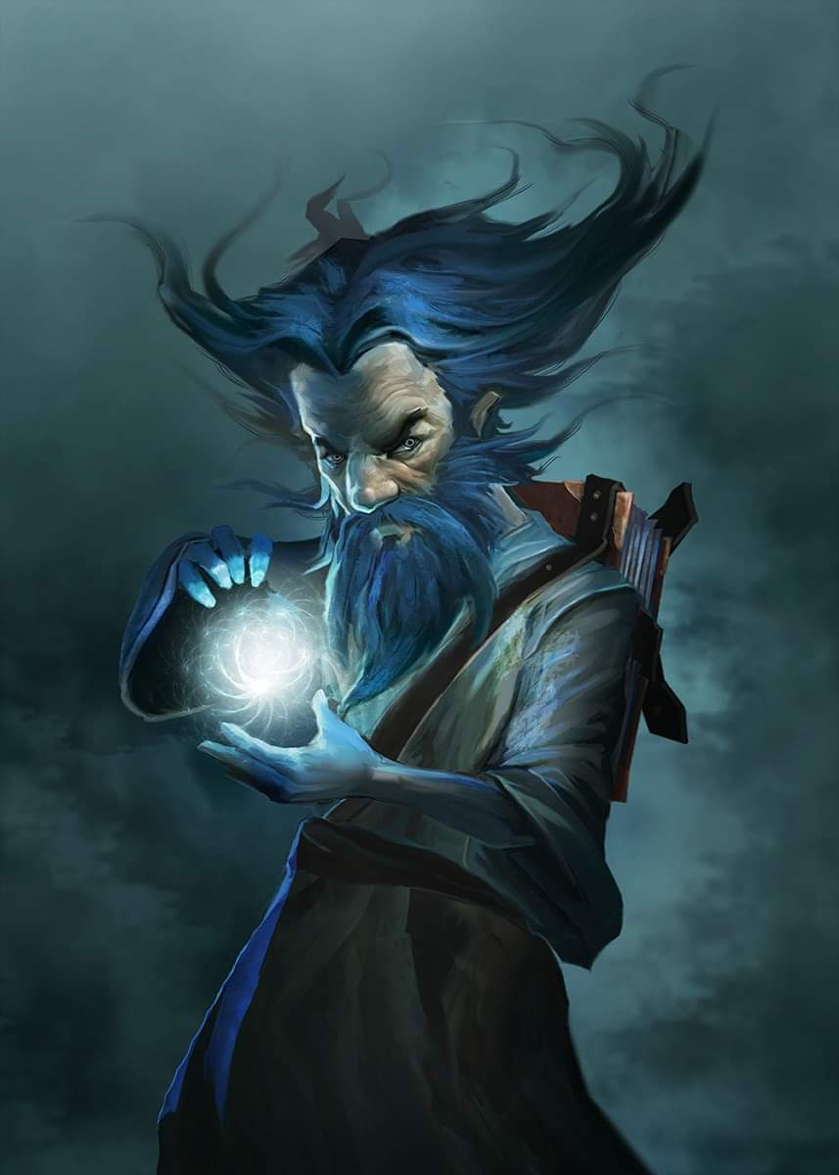

Kedrik—who had come prepared for war—registered the evil cleric’s aura before him. He stayed his casting hand for the moment and lifted his gaze towards the half-dragon, whose stature was twice Kedrik’s. “Glad to see you looking better today,” he said with a stern look.

The archivist was by no means a diplomat, but it seemed that the cleric did not need to be persuaded to be nice. “Please, do come in. I have a proposal that I’d like to discuss with you... no tricks... perform your divinations if you deem it necessary. I’ve a hordeling roasting inside,” he said, and the smell from within confirmed it.

The heroes had eaten their fill of true white dragon meat lately, but they could not say that they’d ever had hordeling helpings. Still, an evil thrall of an evil dragon claiming god-like powers to bestow favors upon clerics could hardly render a credible statement in the eyes of the archivist and his friends, and “no tricks” might have been a red flag for potential tricks.

Being the resident expert on the subject of trickery, Fingers had already scanned the entire exterior for any traps, but had found nothing magical or mundane that looked like a trap or any other intrigue.

The oozes had by now all come to undulate into mounds a few feet high, and were keeping their distance. The ghaunadan ooze stood among the amorphous, intermittently globular forms of ice and snow in this enchanted site. The white lizard held the door open, and seeing hesitation on the part of the heroes, pushed it open even more, and went further inside as if to imply that it was safe to do so. “Lunch will be served in a few minutes. I wasn’t anticipating guests, but you came at a good time, it seems.”

Lauren glanced at Allisa, wordlessly asking for her input in the way only spouses could.

As Allisa looked around she caught the look her spouse gave her. “I have had my fill of meat this day week. But we will listen to your proposition. I had rather not shed blood if there is some other solution.” The druid’s hair had been braided all together in such a way that it hung over and down her right shoulder, thanks to Zond’s sister and the cantrip she had learned from the girl.

After Alissa demurred in partaking in haunch of hordeling, Fingers accepted the offered meal. Hopefully the lizardish cleric was sincerely grateful in previously being spared, and even if not, any nefarious poisoning or the like would have been spur-of-the-moment since it was unlikely the creature knew the group was returning today. Taking an appraising bite, the trapsmith tried to draw on the limited alchemical knowledge it had gathered in order to compile some of its more potent traps to try a detect any questionable substance in the food. Nothing raised any red flags, and when the cleric noticed the changeling nosing the food before eating it, the cleric took a bite out of the same hunk of flesh from which he’d just stripped the portions for the others.

The changeling also made a mental note that if the group actually managed to track down Best’s lair and appropriate some of the dragon’s treasure, it would use some of the proceeds to expand the collection of wands in its possession... a wand of Detect Poison would have been handy about now.

“A wand of *detect poison*?” Kedrik overheard the trapsmith talking to himself. “I have a single scroll.” The gnome then handed the changeling the scroll in question.

Fingers took the scroll, and inspected it before reading its contents.

|  |  |  |  |  |
| --- | --- | --- | --- | --- |
| **Scroll** | **Qty.** | **Level** | **CLev** | **Value** |
| Scroll of Detect Poison | 1 | 0 | 1 | 12 |

It nodded. “Standard... basic.” The group’s locksmith then saw the half-dragon smirking and motioning for Fingers to go ahead with the Divination.

|  |  |  |  |  |  |  |
| --- | --- | --- | --- | --- | --- | --- |
| **Skill** | **Rank** | **Ability & Mod.** | **Misc. Mods.** | **Total** | **Roll** | **Check** |
| **Fingers, Use Magic Device** | 15 | **Cha (+1)** | 0 | 16 | 18 | 34 |

*Success.*

No poison was evident to Fingers, even as its eyes grew ever more fixated on the magical hue that poison would have emanated. “We’re good.”

“So… priest,” Kedrik rubbed his beard and posed, “what is your proposition?”

“I’ve been casting *create food and water* twice a day,” the gluttonous reptile admitted. “One casting for a four-course meal, and the second casting for desserts.” He pointed to a panoply of sucrose-, fructose-, lactose-, and glucose-based goodies.

And as senior members of the Gambit sat and broke bread with the half-drake, the latter explained to the former the nature of his proposal. By the time they were done with the main course, and the ice drake stew and the desserts started to become relevant, they could gather that the desperate cleric saw very little other option than to band with the Gambit against Best.

Jarl of Bestlaranathion—as the cleric was called—had cast *scrying* on his intelligent mistress, and knew that she would be arriving within hours. Her factions had been decimated in Mirabar, and even what was left of her most loyal thralls had been run out of Raven Rock hours ago. She’d started with over a hundred followers—among them, two dozen young dragons—when she’d set out, and the few handfuls that were met with anticipating resistance in Raven Rock were further reduced to two: a paladin of slaughter named G-Code, and a sorcerer named Sylar II.

“I’m sorry... who? What was that name again?” Kedrik asked, putting down the hordeling’s fleshy ulna and swallowing with renewed interest.

“Sylar? Sylar the II? He’s Best’s great-great grandson... a newcomer to her circle... claims to have lived in the south and learned of his lineage, which Best confirmed,” the cleric explained, having only spoken with the sorcerer a few times.

The folks from the Gambit looked at one another. Then they remembered that Sylar had cast *simulacrum*, and created a lesser replica of himself. This was in Eleasis of last year, so it was conceivable that the *simulacrum* could have actually survived and made his way northward.

“*Fucking bastard*!” Lauren snarled in Undercommon.

The cleric continued to explain that Best was hurt, despite her paladin casting healing spells on her; having lost her best diviner in her attempted razing of Mirabar, Jarl was now her new best diviner, and he had already made the decision to turn on her. He wanted to stay here and live with the oozes as the sovereign of this icy home, and this was all he asked for.

“And if we refuse?” Lauren had wanted to ask for a while.

“Then I take my leave now, and take my chances among the Neanderthals,” he shrugged, probably meaning to return to the castle in time.

“Do you have an idea how soon the three of them will arrive?” asked Fingers. If it might be some time, perhaps they would have a chance to gather some assistance from the Neanderthalers or ice giants. In any case, this might be a golden opportunity to end her threat once and for all... and if they could put an end to Sylar’s pseudo-offspring, all the better. It was just a shame that Sarge and Maiko were elsewhere—they probably owed him payback more any anyone else in the Gambit for the loss of their fosterling/bedmate.

Jarl had said “within hours” earlier, but now the cleric clarified, “Based on where I saw them flying, and my knowledge of the lands between here and Raven Rock, I’ll wager that she’ll arrive before sundown.”

The day was only 4 hours long here, and 2 hours of it had already been expended. That was a narrow enough window of time to plan for. “And the likelihood that you’re wrong?”

“They *might* get here shortly after Sunset... maybe Dusk,” the cleric asserted. “And that’s *if* they stop for a lunch break.”

“Ah... and an estimate of how injured Best is?” the changeling continued.

The cleric had described the typical spells that the paladin prepared daily, and divulged as many other details as he could about the dragon and her two surviving servants.

Fingers was disappointed with their host’s clarification of just how few hours it would be before Best’s group returned. Any chance of possibly recruiting help was probably nonexistent. On the plus side, if the trio did in fact arrive that evening, Best would have no opportunity to receive further healing from her paladin. “So, we have a couple of hours more or less to prepare a warm reception for Best... in my case, literally. I plan to exhaust my trapmaking kit to create as many Great Scorchers as I can once we see her coming in the distance... that ensures the least chance any of them will be duds... and once that’s done and there’s time, use whatever odds and ends I can find to make a Glitterbomb or two.” Turning to the cleric, it asked, “The odds are good that the Sylar copy can make himself *invisible*. Do you know if Best casts spells and, if so, whether that’s one of them?”

The cleric answered with a level of detail emblematic of a lifelong servant of Best.

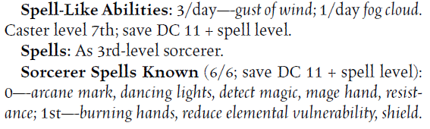

The changeling also thought back to its examination of the siege weapon on the roof. Might it be made functional and moved down inside the castle in the slim time remaining? It would certainly make for a nice surprise for the dragon if so.

Lauren followed the conversation, but her thoughts were focused on her chance to destroy yet another part of Sylar. He was dangerous; not as dangerous as Best, though, and that would be a problem. She forced herself to consider the whole problem. “One of us has to kill Sylar, and quickly. I can take one hit from Best, but I will need your help to kill her. None of you can take even a single attack from her. But, we can’t allow Sylar time to cast spells, either. A disintegrate spell would be fatal to all of us.”

“This would have been a good thing to have known *before* preparing my spells for today,” Kedrik shrugged aloud, “but at least we know Sylar’s nature and motives.”

The cleric said nothing but listened intently, for he did not trust Sylar II in the least.

Kedrik continued, directing himself towards Jarl, “The first Sylar was a peculiarity among anomalies. He was a sorcerer of sorts, but he also was an incantator... a metamagic specialist.”

“Ah,” nodded Jarl.

“But what made him unique in the annals of sorcery and incantation was that he could usurp other sorcerers’ powers… after killing them,” Kedrik let the cleric in on the most intriguing aspect of that case.

“You *don’t* say,” the half-dragon shook his head once. “There were no other sorcerers in Best’s lot; the few that had been around all died of mysterious causes shortly after Sylar’s arriv—oh!”

“Yes, well, I think we can deduce that we’re dealing with a very similar fellow to the one we laid out. Regardless of whether he’s a standard sorcerer, as you stated, or also an incantator,” Kedrik concluded the topic. “If his disposition is anything like his predecessor’s, he’s not to be underestimated.”

“Agreed,” added Fingers. “And it’s the five of us, not four. I believe our host has realized his goddess is nothing of the sort and intends to aid us in taking her down. What do you think of this possible plan of attack?” The devious trapsmith outlined its ideas looking for suggestions from the others:

“The odds are very much against us. The last time we attacked Sylar, it took our entire number, and here we are four in number. We should leave this place.” Allisa looked to be uncharacteristically worried.

“I don’t think we can, my love,” Lauren replied. “Best is seriously weakened, and that won’t be true tomorrow.”

Fingers got right to work as Kedrik and the others worked out the details with Jarl. The rogue scattered the existing debris about the chamber to disguise the traps that he would soon set.

Kedrik reminded his friends, “Because all of us but Fingers are spellcasters, we’ll be depleted of our powers within a few minutes of battle. Fingers, too, will run out of trapmaking materials. Best, on the other hand, will be able to breathe her icy froth upon us every 6 to 24 seconds until we’re blocks of ice, and her paladin of slaughter—even spent of spells—will be a formidable ally until put down.”

Lauren listened carefully, and then she nodded. “Remember, I won’t last long against Best, so do your utmost to damage her.”

“Remember,” Kedrik shared part of his spell list again with the other, noting, “so three castings of *chasing perfection*; and you,” he faced Lauren, “are the first candidate for this buff.”

“Explain,” Lauren asked.

Fingers did his best to create hiding places, placing most of the Great Scorchers along the most likely path the enemy would take moving into the room, which he hadn’t figured out yet.

“It’s what I slapped on you yesterday right before you took out the ice drakes,” he reminded her. “It’s a *bull’s strength, cat’s grace, bear’s endurance, fox’s cunning, owl’s wisdom,* and *eagle’s splendor* all rolled up into one spell.

“Oh, right,” the duskblade nodded. “That will certainly help.”

“Using my Improved Invisibility wand, I’ll lurk beside the door and shadow the trio as they enter, keeping closest to Sylar,” Fingers told the others. “You can conceal yourselves behind larger piles of debris, spread out to avoid having multiple people caught in case Best manages to get a breath attack off.”

Jarl proposed, “Perhaps we can bring some more hordelings up from the basement and use them as cover.” There were only about a dozen left up here, and about five times as many below, from what the heroes remembered.

“Good idea,” Kedrik replied, but Fingers hadn’t made up its mind yet.

“I suggest you try to hit Best with your most effective ranged attacks or spells, and maybe take her down in one fell swoop. Meantime, I’ll focus on Sylar to try and take him out.”

“Can we get the snowflake ooze to help us?” asked Allisa.

“They are Best’s pets, and quite loyal to her. We *will* have to contend with them,” Jarl cautioned. “… what’s left of them.”

“Short work,” Kedrik chuckled, looking out through the crack in the ajar door and seeing them frolicking about across the ice.

Allisa told the group, “I will cast *resist mass energy* on our group just before they arrive and I have *flame blade* and *bear’s endurance*. I think those will be good for you, Lauren.”

“We might not know they’re arriving before they arrive,” the whisper gnome cautioned the half-elf.

“I will keep *barkskin* for myself.”

~*~

An hour had passed, and Fingers had arranged everything quite nicely, making it look like a much bigger battle took place here than the ones that actually befell the keep.

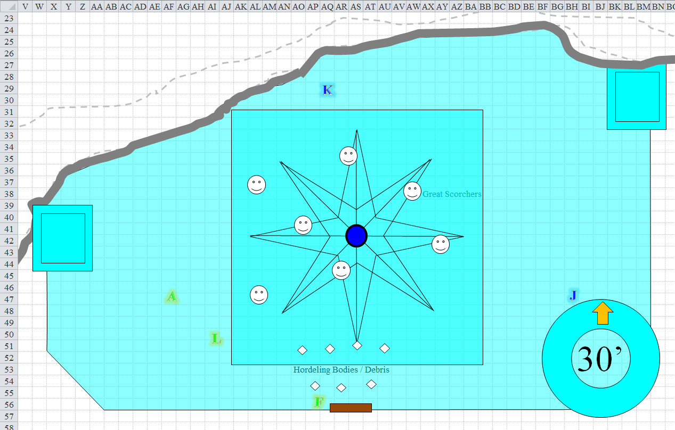

The rogue stood by and shut the large, single door, pointing out the innocuous-looking piles of debris where the Great Scorchers had been stashed. The larger piles of debris, consisting mostly of hordeling corpses and their stone-age gear, were positioned near the door as Fingers anticipated a humanoid’s entrance from the part of the dragon; perhaps this would be so, since dragons often liked to polymorph themselves into humanoid forms.

Lauren and Allisa walked about the room, trying to choose the positions most suited to their talents, while Kedrik stood in plain sight but about as far back as he could get without feeling the claustrophobia of having the icy wall behind him.

Based on Jarl’s assessment of where Best was when he’d scried on her, they expected the dragon to arrive within the next hour or two, but really at any moment. “Alright, folks,” Kedrik sighed. “This is a dressed rehearsal, but soon it’ll be showtime! Any contingencies we want to coordinate?”

Round 1

When they were huddled, Allisa cast *mass resist energy (Cold) [expired on Round 1001]* against cold on the group.

*All friendlies gained Resistance 20 to Cold. [Jarl was already immune.]*

Lauren cast *barkskin [expired on Round 1301]* on herself.

*Lauren gained +4 to FFAC & AC.*

Round 2

Allisa cast *barkskin [expired on Round 1002]* on herself, then offered Lauren a *flame blade* blessing.

*Allisa gained +3 to FFAC & AC.*

The drow asked, “Isn’t that a spell that only you can use?”

Round 3

“Ummm... oh, right,” the druid proposed something inconsistent with what was divinely available to her.

Lauren stayed back near Kedrik and away from Allisa, so as to not draw Best toward the druid, who was closer to the front of what they anticipated would be the dragon’s entry point.

~*~

Round 331

They all took turns going to the bathroom outside. The snowflake oozes were out in the yard like docile dogs wishing no part of any evacuating hero, or of Jarl, for that matter.

~*~

Round 342

“Alright, everybody good?”

“Good to go,” someone cleared their throat and said as they shut the door once more and settled back into their starting positions.

~*~

Round 566

|  |  |  |  |  |
| --- | --- | --- | --- | --- |
| **Character** | **Check** | **Ranks** | **Roll** | **Save** |
| Bestlaranathion | Spot | 22 | 1 | 23 |

*See below.*

The dragon squinted as the ice castle became ever closer. She pointed her wings downward as her paladin and sorcerer riders braced for impact with the thin, icy wall before them. They looked forward to a hearty meal served up by that cunt of a cleric, whom they would later subject to prodding and scrutiny.

Best and her riders began to tell that at least one battle had taken place here in the last tenday since they’d embarked on their ravenous crusade to cleanse the land of weakness and gluttony, and claim land for the sake of the dragon’s might. She was a self-styled demigoddess, after all.

Round 567

|  |  |  |  |  |
| --- | --- | --- | --- | --- |
| **Character** | **Check** | **Ranks** | **Roll** | **Save** |
| Bestlaranathion | Spot | 22 | 15 | 37 |

*See below.*

Then Best started to notice a few more details, though her trajectory had already destined her for a collision with the castle. In and of themselves, they were not signs that enemies were here, but the piles of snow where others had recently peed and pooped, then covered their offings, alerted the dragon to a peculiarity, particularly as she descended and took in the sight of the diminished number of oozes undulating below her. She said, “Boys, watch yourselves. This place was raided. Sylar, fly!”

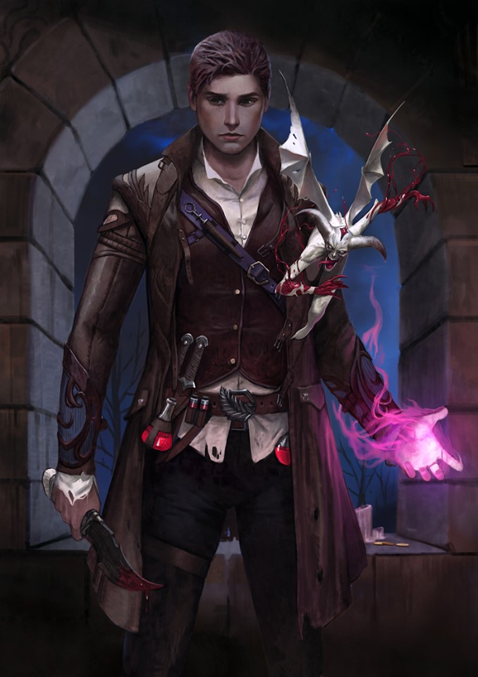

Sylar II—who was a bit prettier than the already handsome Sylar I—cast *fly [expired on Round 667]*, then levitated off of the white dragon’s rear saddle.

The paladin named G-Code cast *bull’s strength [expired on Round 617]* upon himself, knowing that even if there was no threat, he’d probably have to lug bodies around or tend to some other menial grunt work after this failed campaign against everyone. What a shit gig in practice, even if it seemed sound in principle to the paladin of slaughter!

The heroes had waited nearly an hour since they’d cast their first buffs and wards, and the sun was now approaching the end of its seemingly small arc across the southern sky. Then, Kedrik heard it, followed by Lauren and Fingers, the latter of whom could see through the translucent wall only feet from his eyes. Spellcasting? A dragon’s wings flapping? Could be both. The avariel-shaped changeling made a hand gesture to indicate that the moment was at hand as the shadow of the Huge dragon was cast upon the castle wall now that the dragon approached with the setting sun behind her.

Round 568

Allisa heard it too now. She readied her *flame strike* spell.

Kedrik cast *chasing perfection [expired on Round 698]* upon Lauren’s already awesome form, and said, “Unleash your divine wrath upon the wretched beast!”

*Lauren gained +4 to Strength, Dexterity, Constitution, Intelligence, Wisdom, and Charisma.*

Jarl cast *owl’s wisdom [expired on Round 657]* upon himself, and asked for guidance from his goddess... whom he was about to help slay.

*Jarl gained +4 to Wisdom.*

Best crashed through the southern wall, unannounced, only an instant sooner than when the wall began to refresh itself, capturing and amplifying the condensation in the air to form the crystal clusters that constituted the castle. “What the fuuuck!” she instantly proclaimed, somewhat ready for some mischief, but not for treason. At an altitude of about 20’, she cast *shield [expired on Round 598]* as she took in the information from above.

*Best gained +4 to AC.*

Augmented in just about every way now, the duskblade known as Lauren Fifthdaughter quick-cast *haste [expired on Round 582]* on herself when Best appeared, then she drew her falchion and charged Best while avoiding Fingers’ traps.

*Lauren gained +1 bonus to BAB, Touch AC, AC, and Reflex save, plus extra movement or action.*

Her charge got her about half-way there, which was actually fine since the dragon hadn’t actually landed, and the two females couldn’t reach each other.

Seeing the handful of enemies scattered throughout the singular room, the paladin of slaughter smiled and cast *divine favor [expired on Round 578]* upon himself, and remained mounted.

*G-Code gained +1 to BAB and weapon damage.*

Wide eyed, Allisa cast *flame strike* as soon as the dragon crashed through.

|  |  |  |  |
| --- | --- | --- | --- |
| **Ranged Weapon** | **CL** | **Roll** | **Check** |
| Bypass Spell Resistance | 13 | 12 | 25 |

*Success.*

|  |  |  |  |  |
| --- | --- | --- | --- | --- |
| **Character** | **Save vs.**  *flame strike* | **Ranks** | **Roll** | **Save** |
| Bestlaranathion | Reflex | 12 | 3 | 15 |
| G-Code | Reflex | 9 | 9 | 18 |

*Fail, success.*

*Dmg to Best: 20 divine + (2 [vulnerable] x 20 fire) = 60.*

*Dmg to G-Code: ½ x 45 = 11 divine + 11 fire = 22.*

Casting *true strike*, Sylar II flew just outside the breach in the wall, saw the *flame strike* spell’s area of effect, and studied the situation through the shrinking aperture that was still about 12’ in diameter at its narrowest.

Fingers tried to trigger its *greater invisibility [expired on Round 574]* wand while moving towards the hole, seeking Sylar who had not yet revealed himself. Both the original Sylar and his simulacrum had a track record of elusiveness, and the Gambit could nigh afford to let the slippery weasel escape them again.

|  |  |  |  |  |  |  |
| --- | --- | --- | --- | --- | --- | --- |
| **Fingers, Skill** | **Rank** | **Ability**  **& Mod.** | **Misc.**  **Mods.** | **Total** | **Roll** | **Check** |
| **Use Magic Device** | 15 | **Cha (+1)** | 0 | 16 | 7 | 23 |

*Success.*

The *invisible* form of an avariel that was actually a changeling looked up as it put away its wand and resolved to draw its sword.

|  |  |  |  |  |  |  |
| --- | --- | --- | --- | --- | --- | --- |
| **Skill** | **Rank** | **Ability & Mod.** | **Misc. Mods.** | **Total** | **Roll** | **Check** |
| **Fingers, Spot** | 12 | **Wis (+1)** | 2 | 15 | 2 | 17 |

*See below.*

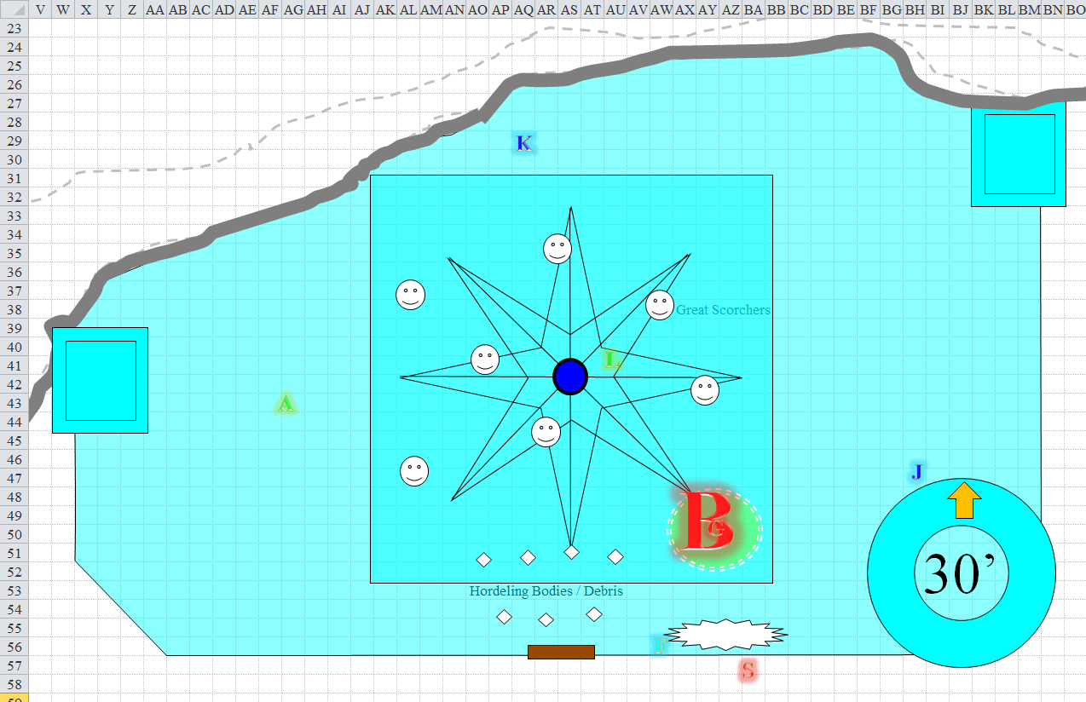

Round 569

|  |  |  |  |  |  |
| --- | --- | --- | --- | --- | --- |
| **Character** | **Group** | **Initiative** | **Roll** | **Modified Roll** | **Move** |
| Allisa | 1 | 3 | 19 | 22 | 30’ |
| Kedrik | 1 | 2 | 18 | 20 | 30’ |
| G-Code | 2 | 2 | 17 | 19 | 30’ |
| Sylar II | 2 | 3 | 15 | 18 | 30’ |
| Lauren | 1 | 4 | 13 | 17 | 30’ |
| Bestlaranathion | 2 | 0 | 9 | 9 | 60’/200’f |
| Fingers | 1 | 4 | 3 | 7 | 30’ |
| Jarl of Bestlaranathion | 1 | 1 | 3 | 4 | 40’ |

“You *dare* breach my keep!?” the dragon rhetorically questioned the intruders, then noticed Jarl about to cast a spell, and seemingly in league with the strangers.

Allisa cast *baleful polymorph* upon the dragon with the new form being a fish.

|  |  |  |  |
| --- | --- | --- | --- |
| **Ranged Weapon** | **Atk** | **Roll** | **Check** |
| Bypass Spell Resistance | 13 | 2 | 15 |

*Spell fails to affect Best.*

“I... *refuse!*” the she-dragon seemed to belch as she shrugged off the effects of the *baleful polymorph* spell.

Kedrik cast *chasing perfection [expired on Round 699]* upon himself.

*Kedrik gained +4 to Strength, Dexterity, Constitution, Intelligence, Wisdom, and Charisma.*

The gnome then moved east and north a bit, trying to get a better sense of the dragon so they could all get an edge over her.

G-Code hopped off of the dragon now that he saw Lauren charging towards them.

|  |  |  |  |  |
| --- | --- | --- | --- | --- |
| **Character** | **Check** | **Ranks** | **Roll** | **Save** |
| G-Code | Jump | 10 | 17 | 27 |

*Success.*

The paladin landed on his feet, and assumed a fighting stance in preparation of the duskblade’s swinging charge.

Sylar II—who had cast *see invisibility* minutes before their arrival, deferred his actions, but readied a nasty spell for anyone that would threaten him specifically.

Unable to reach Best, Lauren charge-attacked G-Code.

|  |  |  |  |  |  |  |  |  |  |
| --- | --- | --- | --- | --- | --- | --- | --- | --- | --- |
| **Melee Weapon** | **Dmg** | **D+** | **TH+** | **Critical** | **Type** | **Wt.** | **Atk** | **Roll** | **Check** |
| Falchion +3 | 2d4 | +5 +3 | 3 + 2 charge | 18-20/x2 | Slashing | 8.0 | +24 | 12 | 36 |

*Hit. Dmg: 6 + 5 + 3 + 2 charge = 16. Partial damage negated.*

“You’re first, drow!” Bestlaranathion hovered and spewed her icy, shaped, line of breath upon Lauren as she charged the dragon.

|  |  |  |  |  |  |  |  |
| --- | --- | --- | --- | --- | --- | --- | --- |
| **Save vs.**  Breath Weapon | **Rank** | **Ability**  **& Mod.** | **Misc.**  **Mods.** | **Total** | **Roll** | **Check** | **Properties** |
| **Lauren, Reflex** | 4 | **Dex (+2)** | 1 | 7 | 9 | 16 | +2 vs. Enchantments; +1 *haste* |

*Fail. Dmg: 26 cold. Partial damage negated [108/114].*

Fingers drew its Keen Deadly Precision Short Sword, then flew up 20’ towards the shrinking hole in the wall where he could not see Sylar, but caught the shadow of a humanoid along the wall, in an attempt to carve the sorcerer a new one. Reaching the hole, he came face-to-face with Sylar II, but could not turn 90 degrees *and* charge-attack the evil man, who was less than 10’ from the gap in the wall.

Sylar, who had been waiting for the opportune moment, saw the *invisible* changeling and cast *hold person* on Fingers even while he’d been flying upwards and coming into the sorcerer’s field of vision. This effectively wasted the *true strike* spell that he’d just cast.

|  |  |  |  |  |  |  |  |
| --- | --- | --- | --- | --- | --- | --- | --- |
| **Save vs.**  *hold person* | **Rank** | **Ability**  **& Mod.** | **Misc.**  **Mods.** | **Total** | **Roll** | **Check** | **Notes** |
| **Fingers, Will** | **3** | **Wis (+1)** | 1 | 5 | 15 | 20 | +2 if Lucky  +3 vs. mind-affecting spells (from crystal) |

*Success.*

The changeling felt the *hold person* spell coursing through it, as it had dozens of times in as many years, but pushed its way through it, and turned southward now, stabbing at the human simulacrum.

|  |  |  |  |  |  |  |  |  |  |
| --- | --- | --- | --- | --- | --- | --- | --- | --- | --- |
| **Melee Weapon** | **Dmg** | **D+** | **TH+** | **Critical** | **Type** | **Wt.** | **Atk** | **Roll** | **Check** |
| Keen Deadly Precision Short Sword | 1d6 | 1 | 1 | 17-20, x2 | Piercing | 2.0 | +14 | 17 | 31 |
| Crystal of Acid Assault, Lesser | - | 1d6 | - | - | - | - | - | - | - |

*Threat. 1d20 = 3 + 14 = 17, not a critical hit. Dmg: 2 + 1 + 3 acid = 6.*

Jarl positioned himself near his so-called goddess and cast *dragon blight*.

|  |  |  |  |  |  |
| --- | --- | --- | --- | --- | --- |
| **Character** | **Attack Type** | **Damage** | **CL** | **Roll** | **Total** |
| Jarl of Best | Bypass SR | varies | 9 | 7 | 16 |

*Spell fails to affect Best.*

“Traitor!” Best almost smiled at Jarl. “I will save you for last,” she promised, resolving to dismember her last remaining cleric.

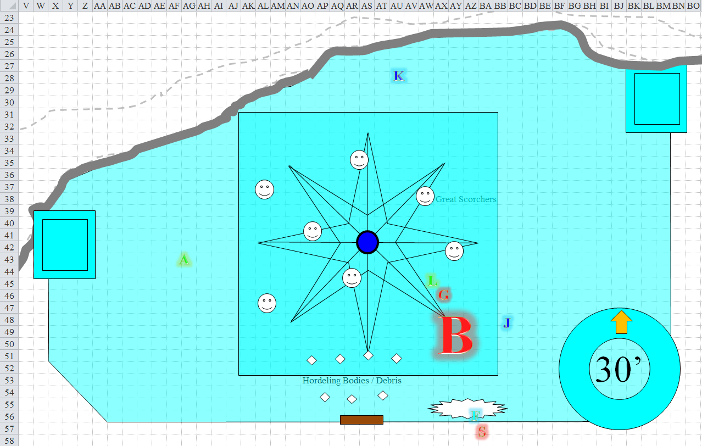

Round 570

Allisa assessed the situation, and moved back 30’, avoiding any traps. She then cast *earthbind* on the dragon.

|  |  |  |  |
| --- | --- | --- | --- |
| **Ranged Weapon** | **Atk** | **Roll** | **Check** |
| Bypass Spell Resistance | +13 | **20** | 33 |

*Success.*

|  |  |  |  |  |
| --- | --- | --- | --- | --- |
| **Character** | **Save vs.**  *earthbind* | **Ranks** | **Roll** | **Save** |
| Bestlaranathion | Fortitude | 17 | 9 | 26 |

*Success. Spell effects negated.*

Kedrik—a trained Draconic Archivist—tapped into his Dark Knowledge (*dread secret*) on white dragons, and noted a few peculiar features of Best’s movements. She was pregnant.

|  |  |  |  |  |  |  |  |
| --- | --- | --- | --- | --- | --- | --- | --- |
| **Skill** | **Rank** | **Ability**  **& Mod.** | **Misc.**  **Mods.** | **Total** | **Roll** | **Check** | **Notes** |
| **Knowledge: Arcana** | 12 | **Int (+9)** | 2 | 23 | 17 | 40 | Trivial Knowledge, best of 2 rolls |
| **Knowledge: Arcana** | 12 | **Int (+9)** | 2 | 23 | 13 | 36 | Trivial Knowledge, best of 2 rolls |

*See below.*

“When are the eggs due? You are... with young, aren’t you?” Kedrik shouted a *dread secret* unto the dragon’s ears.

Best was stunned. She fell from the height of 20’ where she’d been hovering and choosing her targets, and nearly smashed Lauren and G-Code to a blue pulp.

G-Code full-, power-, and smite-attacked Lauren.

|  |  |  |  |  |  |  |  |  |  |
| --- | --- | --- | --- | --- | --- | --- | --- | --- | --- |
| **Character** | **Attack Type** | **Damage** | **BAB** | **Str Mod+** | **W+** | **Other+** | **Total Score** | **Roll** | **Total** |
| G-Code | Cold Warhammer | 1d8+1 D. Favor +1d6 Cold  +2 Power +0 smite | 12 | 7 | 1 | -2 Power | 18 | 10 | 28 |
| G-Code | Warhammer, 2nd | 1d8+1 D. Favor +1d6 Cold  +2 Power +0 smite | 7 | 7 | 1 | -2 Power | 13 | 1 | 14 |

*Hit, miss. Dmg: 6 + 1 + 2 + 2 cold = 11. Cold damage negated [99/114].*

Sylar’s *simulacrum* cast *burning blood* upon Fingers.

|  |  |  |  |  |  |  |
| --- | --- | --- | --- | --- | --- | --- |
| **Save vs.**  *burning blood* | **Rank** | **Ability & Mod.** | **Misc. Mods.** | **Total** | **Roll** | **Check** |
| **Fingers, Fortitude** | **6** | **Con (+1)** | 0 | 7 | 12 | 19 |

*Fail. Dmg: 1 acid + 4 fire = 5 [61/66].*

Lauren full-attacked the paladin of slaughter.

|  |  |  |  |  |  |  |  |  |  |
| --- | --- | --- | --- | --- | --- | --- | --- | --- | --- |
| **Melee Weapon** | **Dmg** | **D+** | **TH+** | **Critical** | **Type** | **Wt.** | **Atk** | **Roll** | **Check** |
| Falchion +3 | 2d4 | +5 +3 | 3 | 18-20/x2 | Slashing | 8.0 | +22 | 14 | 36 |
| Falchion +3, 2nd Attack | 2d4 | +5 +3 | 3 | 18-20/x2 | Slashing |  | +17 | 12 | 29 |
| Falchion +3, 3rd Attack | 2d4 | +5 +3 | 3 | 18-20/x2 | Slashing |  | +12 | *1* | 13 |
| Falchion +3, *haste* | 2d4 | +5 +3 | 3 | 18-20/x2 | Slashing |  | +22 | *4* | 26 |

*Hit, hit, miss, hit. Dmg: (5 + 5 + 3) + (8 + 5 + 3) + (4 + 5 + 3) = 13 + 16 + 12 = 41. Partial damage negated.*

Bestlaranathion reeled and even sweated as she struggled to regain her wits.

Fingers reeled from the pain and cursed inwardly as it was obvious the copy of Sylar was able to pierce its cloak of invisibility, negating its ability to inflict massive damage. The winged changeling strove to stay within melee range of the flying spellcaster, threatening him as much as possible.

The ghaunadan snowflake ooze opened the door, and saw what was going on, then slurred something, and entered the room, headed for Allisa and followed by at least four regular oozes.

Jarl of Bestlaranathion cast *dispel magic* on G-Code, noting that he’d just buffed himself. He then said, “You are a charlatan, Best, and I now know that you are no goddess! We will *finish* you, even if it means that I must lose all of my powers!”

|  |  |  |  |  |  |  |  |
| --- | --- | --- | --- | --- | --- | --- | --- |
| **Character** | **Attack Type** | **Damage** | **CL** | **Wis.**  **Mod** | **Total**  **Score** | **Roll** | **Total** |
| Jarl of Best | Dispel Magic | varies | 9 | 5 | 10 (max.) | 4 | 18 |

*Success. Bull’s strength is dispelled.*

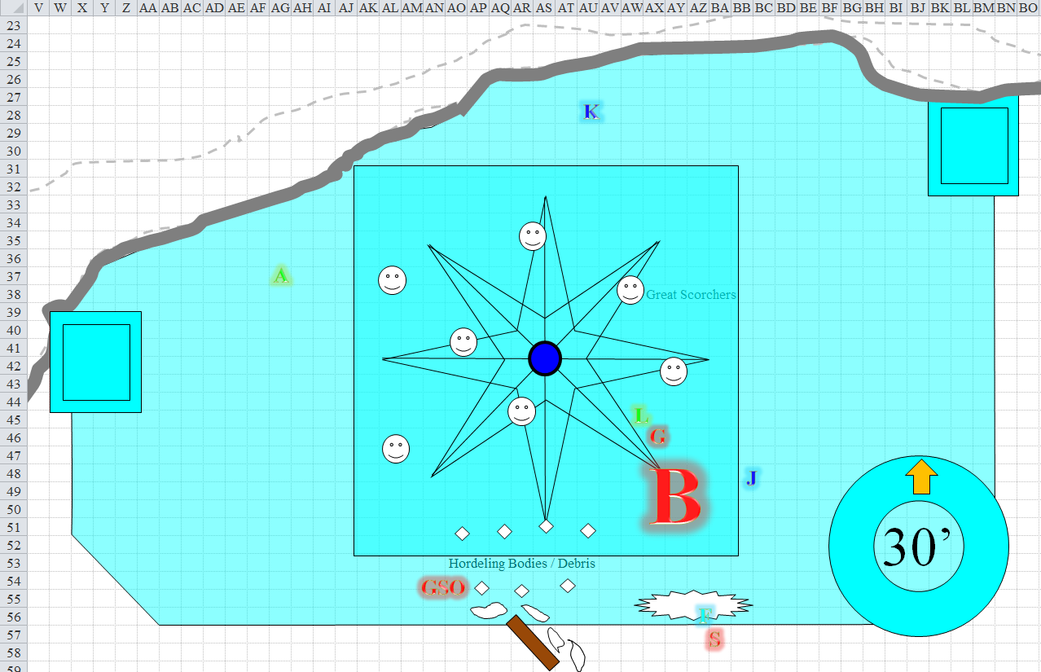

Round 571

Seeing the snowflake gang, the druid summoned a *medium fire elemental* with her 4th-tier summons and directed it at the snowflakes. She then moved 30’ toward Kedrik.

The ghaunadan snowflake ooze led the other snowflake oozes into the house and clashed with the fire elemental that now charged towards them.

The elemental triggered the Great Scorcher in its path, causing a fulminous explosion that engulfed fire in fire. The explosion reached the ghaunadan ooze, but not its amorphous followers.

*Dmg to ghaunadan snowflake ooze: 2 x 23 = 56 fire.*

The ghaunadan ooze was instantly turned to steam, and the fire elemental swung at bits of vapor and floating moisture. The other three oozes mindlessly confronted the fire elemental once the Great Scorcher’s explosion had subsided.

|  |  |  |  |  |  |  |  |  |  |
| --- | --- | --- | --- | --- | --- | --- | --- | --- | --- |
| **Character** | **Attack Type** | **Damage** | **BAB** | **Str Mod+** | **Total Score** | **Roll** | **Total** | **Crit** | **Threat** |
| Snowflake Ooze, M | Slam | 1d8+7+2d4 cold | 4 | 5 | 9 | 20 | 29 | 20 | ☑ |
| Snowflake Ooze, M | Slam | 1d8+7+2d4 cold | 4 | 5 | 9 | 17 | 26 | 20 | ☒ |
| Snowflake Ooze, M | Slam | 1d8+7+2d4 cold | 4 | 5 | 9 | 15 | 24 | 20 | ☒ |
| Snowflake Ooze, M | Slam | 1d8+7+2d4 cold | 4 | 5 | 9 | 4 | 13 | 20 | ☒ |

*Threat, hit, hit, miss. 1d20 = 20, critical hit. Dmg: [2 x (5 + 7 + {2 x 6 cold})] + (7 + 7 + {2 x 5 cold}) + (4 + 7 + {2 x 8 cold}) = 24 + 14 + 11 + 50 cold = 49 + 50 cold = 99.*

The fire elemental was snuffed, but not without searing each of the four oozes a bit.

*Dmg to each ooze: 2 x 8 = 16 fire.*

Unable to do much more to Best with his Dark Knowledge today, and too far from enemies to cast *Chaav’s laugh* or even *diamond spray*, Kedrik moved south a bit in order to have these options on the next round, then cast *flame strike* upon Best, following Allisa’s example.

|  |  |  |  |
| --- | --- | --- | --- |
| **Ranged Weapon** | **Atk** | **Roll** | **Check** |
| Bypass Spell Resistance | +13 | 4 | 17 |

*Fail. Spell has no effect.*

Unable to smite the chaotic neutral duskblade, the chaotic evil G-Code full-attacked Lauren.

|  |  |  |  |  |  |  |  |  |  |  |  |
| --- | --- | --- | --- | --- | --- | --- | --- | --- | --- | --- | --- |
| **Character** | **Attack Type** | **Damage** | **BAB** | **Str Mod+** | **W+** | **Other+** | **Total Score** | **Roll** | **Total** | **Crit** | **Threat** |
| G-Code | Cold Warhammer | 1d8+1 D. Favor +1d6 Cold | 12 | 5 | 1 | 0 | 18 | 15 | 33 | 20 | ☒ |
| G-Code | Warhammer, 2nd | 1d8+1 D. Favor +1d6 Cold | 7 | 5 | 1 | 0 | 13 | 20 | 33 | 20 | ☑ |

*Hit, threat. 1d20 = 19 + 13 = 32, critical hit.*

*Dmg: (8 + 1 + 6 cold) + (3 x [6 + 1 + 5 cold]) = 30 + 21 cold. Partial cold damage negated [68/114].*

Sylar II cast *true strike* once more, then flew into and through Fingers’ position, entering the room without slowing down. After pushing his way past the rogue who would barely fly properly, the *simulacrum* then spotted Jarl and shook his head at the traitor.

Lauren full-attacked G-Code.

|  |  |  |  |  |  |  |  |  |  |
| --- | --- | --- | --- | --- | --- | --- | --- | --- | --- |
| **Melee Weapon** | **Dmg** | **D+** | **TH+** | **Critical** | **Type** | **Wt.** | **Atk** | **Roll** | **Check** |
| Falchion +3 | 2d4 | +5 +3 | 3 | 18-20/x2 | Slashing | 8.0 | +22 | 4 | 26 |
| Falchion +3, 2nd Attack | 2d4 | +5 +3 | 3 | 18-20/x2 | Slashing |  | +17 | 7 | 24 |
| Falchion +3, 3rd Attack | 2d4 | +5 +3 | 3 | 18-20/x2 | Slashing |  | +12 | 16 | 28 |
| Falchion +3, *haste* | 2d4 | +5 +3 | 3 | 18-20/x2 | Slashing |  | +22 | 11 | 33 |

*Hit, hit, hit, hit. Dmg: (4 + 5 + 3) + (8 + 5 + 3) + (4 + 5 + 3) + (5 + 5 + 3) = 12 + 16 + 12 + 13= 53. Partial damage negated.*

The anti-paladin was close to defeat, and he knew it, but this fool was ready to go down for the sake of slaughter itself.

Bestlaranathion snapped out of her momentary lapse of reason, and—seeing that Lauren was about to slay her favorite boy-toy, she tail-slapped Jarl, moved about 10’, and reserved the rest of her attacks for Lauren.

|  |  |  |  |  |  |  |  |  |  |  |  |  |
| --- | --- | --- | --- | --- | --- | --- | --- | --- | --- | --- | --- | --- |
| **Character** | **Attack Type** | **Damage** | **BAB** | **Str Mod+** | **W+** | **Other+** | **Total Score** | **Roll** | **Total** | **Crit** | **Threat** | **Notes** |
| Bestlaranathion | Bite | 2d8+8 | 21 | 10 | 0 | 0 | 31 | 5 | 36 | 20 | ☒ | Lauren |
| Bestlaranathion | Claw 1 | 2d6+4 | 21 | 5 | 0 | 0 | 26 | 20 | 46 | 20 | ☑ | Lauren |
| Bestlaranathion | Claw 2 | 2d6+4 | 21 | 5 | 0 | 0 | 26 | 1 | 27 | 20 | ☒ | Lauren |
| Bestlaranathion | Wing 1 | 1d8+4 | 21 | 5 | 0 | 0 | 26 | 18 | 44 | 20 | ☒ | Lauren |
| Bestlaranathion | Wing 2 | 1d8+4 | 21 | 5 | 0 | 0 | 26 | 19 | 45 | 20 | ☒ | Lauren |
| Bestlaranathion | Tail | 2d6+12 | 21 | 5 | 0 | 0 | 26 | 8 | 34 | 20 | ☒ | Jarl |

*Hit, threat, miss, hit, hit, hit. 1d20 = 11 + 26 = 37, critical hit.*

*Dmg to Jarl: 10 + 12 = 22.*

*Dmg to Lauren: (15 + 8) + [2 x (7 + 4)] + (7 + 4) + (8 + 4) = 23 + 22 + 11 + 12 = 68 [0/114].*

Lauren collapsed onto the floor as G-Code pulled out a potion.

Fingers reeled with pain as his blood burned.

|  |  |  |  |  |  |  |
| --- | --- | --- | --- | --- | --- | --- |
| **Save vs.**  *burning blood* | **Rank** | **Ability & Mod.** | **Misc. Mods.** | **Total** | **Roll** | **Check** |
| **Fingers, Fortitude** | **6** | **Con (+1)** | 0 | 7 | 3 | 10 |

*Fail. Dmg: 3 acid + 6 fire = 9 [53/66].*

*For the duration of this spell, Fingers can only take a single move action on any round in which he fails the save above.*

The changeling tried to chop at Sylar with its sword, hoping give a little acid burning back, but could not move its arms very well while the blood in his body intermingled with acid and magma. It considered breaking off to attack a different foe that would be vulnerable to its sneak attack, but that would leave Sylar free to inflict gods knew what on its allies.

Jarl of Bestlaranathion shouted to Sylar II, “Fuck you *and* your great-great grandmother!” He then cast *hold person* on the sorcerer.

|  |  |  |  |  |  |  |
| --- | --- | --- | --- | --- | --- | --- |
| **Save vs.**  *hold person* | **Rank** | **Ability & Mod.** | **Misc. Mods.** | **Total** | **Roll** | **Check** |
| **Sylar II, Will** | 10 | **Wis (+2)** | 2 | 14 | 11 | 25 |

*Success. Spell has no effect.*

“No, fuck *you*, you *fuck*!” the sorcerer retorted. Neither was a great conversationalist, but both were equally powerful, and this conflict would determine which of the two would live.

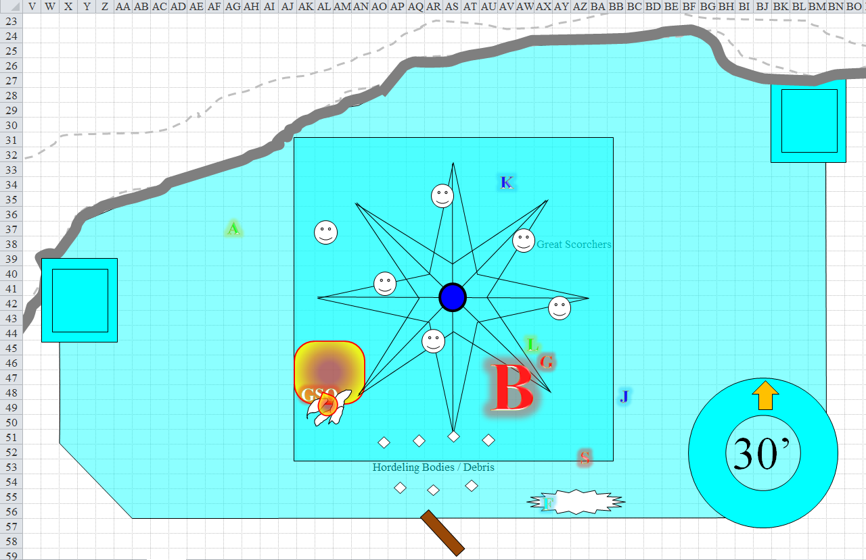

Round 572

Allisa spotted Lauren being slain, and moved another 30’ towards Kedrik, then cast *call lighting*.

G-Code drank a potion of *cure serious wounds*, then took a look at Kedrik and thought to cut *him* down.

*G-Code healed 19 + 8 = 27 hps.*

Keeping away from the Great Scorcher to his left, Kedrik saw Lauren fall, and knew she’d be a goner without his help. He rushed to her aid, seeing that the paladin of slaughter was headed for him, then cast *sanctuary [expired on Round 585]* upon himself before the paladin could reach him. As the paladin got within swinging distance, he saw the *sanctuary’s* cylindrical force and tried to find a gap in it.

|  |  |  |  |  |
| --- | --- | --- | --- | --- |
| **Character** | **Save vs.**  *sanctuary* | **Ranks** | **Roll** | **Save** |
| G-Code | Will | 6 | 13 | 19 |

*Fail. G-Code couldn’t attack Kedrik, even if he had an attack left on this round.*

Sylar II turned back and cast a Maximized (L4) *lesser orb of sound* towards Fingers.

|  |  |  |  |  |  |  |  |  |  |
| --- | --- | --- | --- | --- | --- | --- | --- | --- | --- |
| **Ranged Weapon** | **Dmg** | **+ Mod** | **TH+** | **Critical** | **Rng.** | **Wt.** | **Atk** | **Roll** | **Check** |
| Ranged Touch Attack | 5 x 6 = 30 | (Maximized) | 2 + 20 | n.a. | varies | 0.0 | +32 | 9 | 41 |

*Hit. Dmg: 30 sonic [23/66].*

Lauren bled out as the battle continued. *[-1/114]*

Bestlaranathion chose her next target: Kedrik.

|  |  |  |  |  |
| --- | --- | --- | --- | --- |
| **Character** | **Save vs.**  *sanctuary* | **Ranks** | **Roll** | **Save** |
| Bestlaranathion | Will | 13 | 5 | 18 |

*Fail. Best couldn’t attack Kedrik.*

Jarl of Bestlaranathion cast *hold person* upon Sylar again, saying, “No, bitch, I fuck *youuuuu*!”

|  |  |  |  |  |  |  |
| --- | --- | --- | --- | --- | --- | --- |
| **Save vs.**  *hold person* | **Rank** | **Ability & Mod.** | **Misc. Mods.** | **Total** | **Roll** | **Check** |
| **Sylar II, Will** | 10 | **Wis (+2)** | 2 | 14 | 4 | 18 |

*Success. Spell has no effect.*

“You *suck*!” Sylar smirked as if this were just a big game, then added, “If Best hadn’t chosen you for herself, I’d cut your skull in half!”

The snowflake oozes tripped another Great Scorcher, and two were caught in its blast.

*Dmg to ooze 1: 2 x 16 = 32 fire.*

*Dmg to ooze 2: 2 x 17 = 34 fire.*

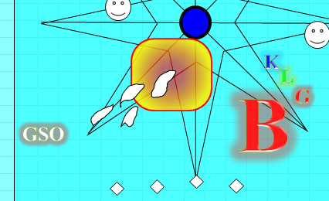

Nevertheless, they persisted; the lead ooze reached Kedrik and tried to attack.

|  |  |  |  |  |
| --- | --- | --- | --- | --- |
| **Character** | **Save vs.**  *sanctuary* | **Ranks** | **Roll** | **Save** |
| Snowflake Ooze | Will | -3 | 10 | 7 |

*Fail. Ooze 1 couldn’t attack Kedrik.*

Fingers hoped the lizard could keep Sylar busy long enough for the changeling to make a major impact elsewhere and moved up next to the dragon.

|  |  |  |  |  |  |  |
| --- | --- | --- | --- | --- | --- | --- |
| **Save vs.**  *burning blood* | **Rank** | **Ability & Mod.** | **Misc. Mods.** | **Total** | **Roll** | **Check** |
| **Fingers, Fortitude** | **6** | **Con (+1)** | 0 | 7 | 1 | 8 |

*Fail. Dmg: 4 acid + 4 fire = 8 [15/66].*

Now, if it could just keep from being distracted by that damnable spell....

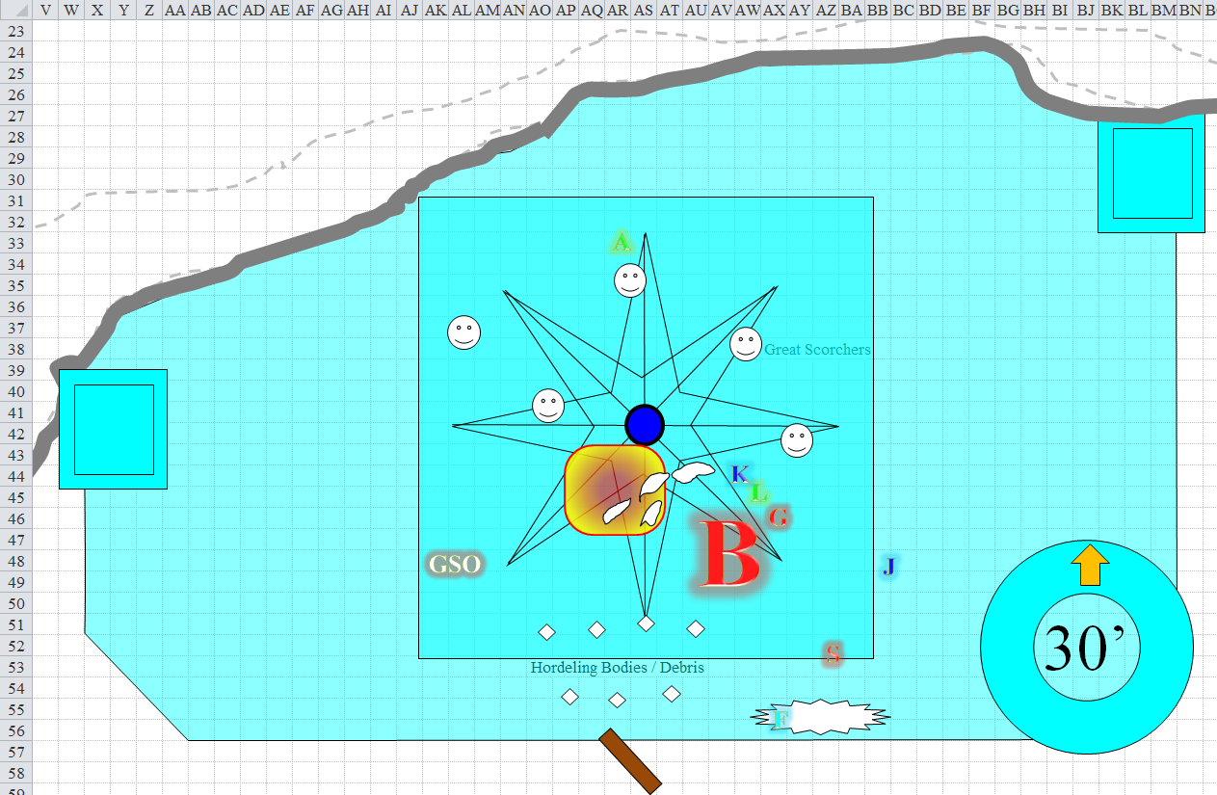

Round 573

Allisa moved another 30’ towards the spot where Kedrik had been standing, then threw a *lightning bolt* at the dragon.

|  |  |  |  |  |
| --- | --- | --- | --- | --- |
| **Ranged Weapon** | **Atk** | **Roll** | **Check** | **Notes** |
| Ranged Touch Attack | +12 | 12 | 24 | 9 bolts left |

*Hit. Dmg: 7 electric.*

The hateful paladin G-Code saw the gnome’s *sanctuary* spell, and wanted to just destroy such goody-good trickery, so he stepped around Lauren’s body to the healer.

|  |  |  |  |  |
| --- | --- | --- | --- | --- |
| **Character** | **Save vs.**  *sanctuary* | **Ranks** | **Roll** | **Save** |
| G-Code | Will | 6 | 10 | 16 |

*Fail.*

Failing to hit the gnome, the anti-paladin managed only to nick the red and violet cylinder around the whisper gnome.

Unable to do much to Kedrik at the moment, and seeing Lauren dead, Bestlaranathion now fired a line-shaped breath weapon unto Allisa.

|  |  |  |  |  |  |  |
| --- | --- | --- | --- | --- | --- | --- |
| **Save vs.**  Breath Weapon | **Rank** | **Ability & Mod.** | **Misc. Mods.** | **Total** | **Roll** | **Check** |
| **Allisa, Reflex** | **6** | **Dex (+3)** | 0 | 9 | 9 | 18 |

*Fail. Dmg: 28 cold. Partial damage negated [64/72].*

Kedrik smiled as the anti-paladin failed, then healed Lauren with his wand of *cure moderate wounds*.

*Lauren gained 9 + 4 = 13 hps [12/114].*

Lauren got up, and swung faced G-Code, who had now focused his attention on the half-dragon cleric.

Jarl backed away cast *conjure ice beast V*, manifesting an icy rhinoceros that charged the anti-paladin as it breathed frosty mist from its nostrils.

|  |  |  |  |  |  |  |  |  |  |
| --- | --- | --- | --- | --- | --- | --- | --- | --- | --- |
| **Character** | **Attack Type** | **Damage** | **BAB** | **Str Mod+** | **W+** | **Other+** | **Total Score** | **Roll** | **Total** |
| Ice Rhinoceros | Gore | 2d6+12 | 6 | 7 | 0 | 0 | 13 | 11 | 24 |

*Hit. Dmg: 5 + 12 + 5 cold aura + 3 cold touch = 25. Partial damage negated.*

The paladin appeared awestruck, but held his ground against the herbivore’s horn. However, this had distracted him from Lauren’s assault, which came swiftly and mercilessly.

|  |  |  |  |  |  |  |  |  |  |
| --- | --- | --- | --- | --- | --- | --- | --- | --- | --- |
| **Melee Weapon** | **Dmg** | **D+** | **TH+** | **Critical** | **Type** | **Wt.** | **Atk** | **Roll** | **Check** |
| Falchion +3 | 2d4 | +5 +3 | 3 | 18-20/x2 | Slashing | 8.0 | +22 | 10 | 32 |
| Falchion +3, *haste* | 2d4 | +5 +3 | 3 | 18-20/x2 | Slashing |  | +22 | 5 | 27 |

*Hit, hit. Dmg: (6 + 5 + 3) + (4 + 5 + 3) = 14 + 12 = 26. Partial damage negated.*

The paladin of slaughter either died or was about to. He fell to the floor, unconscious.

The snowflake oozes pounced upon Kedrik.

|  |  |  |  |  |
| --- | --- | --- | --- | --- |
| **Character** | **Save vs.**  *sanctuary* | **Ranks** | **Roll** | **Save** |
| Snowflake Ooze 1 | Will | -3 | 3 | 0 |
| Snowflake Ooze 2 | Will | -3 | 20 | 17 |
| Snowflake Ooze 3 | Will | -3 | 12 | 9 |
| Snowflake Ooze 4 | Will | -3 | 9 | 6 |

*Fail, fail, fail, fail.*

The gnome was momentarily surrounded by a singular shape of snowflake ooze, with a cylinder-shaped area between himself and the oozes. The four oozes then began to give up the struggle, and set their eyes on Lauren and the ice rhino.

Best saw that Lauren and the rhino had collectively taken out her boy-toy tank, and reeled with fury.

Fingers did his best to withstand the pain and still fly about.

|  |  |  |  |  |  |  |
| --- | --- | --- | --- | --- | --- | --- |
| **Save vs.**  *burning blood* | **Rank** | **Ability & Mod.** | **Misc. Mods.** | **Total** | **Roll** | **Check** |
| **Fingers, Fortitude** | **6** | **Con (+1)** | 0 | 7 | 19 | 26 |

*Success. Spell’s effects are suspended for this round.*

Fingers successfully withstood the burning pain for the moment, then pounced upon and slashed at the dragon’ back, hoping to inflict significant damage and distract her from its allies.

|  |  |  |  |  |  |  |  |  |  |  |
| --- | --- | --- | --- | --- | --- | --- | --- | --- | --- | --- |
| **Melee Weapon** | **Dmg** | **D+** | **TH+** | **Critical** | **Type** | **Wt.** | **Atk** | **Roll** | **Check** | **Notes** |
| Keen Deadly Precision Short Sword | 1d6 | 1 | 1 | 17-20, x2 | Piercing | 2.0 | +14 | 3 | 17 | +5d6 Sneak Attack |
| Crystal of Acid Assault, Lesser | - | 1d6 | - | - | - | - | - | - | - |  |

*Miss.*

The dragon’s hide was tougher than that of the white dragon they’d slain 2 nights ago at the igloo settlement. Still, this *could* be done.

Sylar II turned around to face Fingers again, then said, “Avariel, it is now *your* turn to go.” He cast another Empowered (L3) *lesser orb of sound* towards the changeling in avariel’s form.

|  |  |  |  |  |  |  |  |  |  |
| --- | --- | --- | --- | --- | --- | --- | --- | --- | --- |
| **Ranged Weapon** | **Dmg** | **+ Mod** | **TH+** | **Critical** | **Rng.** | **Wt.** | **Atk** | **Roll** | **Check** |
| Ranged Touch Attack | 5d6 x 1½ = 30 | (Empowered) | 2 | n.a. | varies | 0.0 | +12 | 18 | 30 |

*Hit. Dmg: 1½ x 14 = 21 sonic [-6/66].*

Fingers fell to the floor.

*Dmg: 1 [-7/66].*

No one saw Fingers go down, as it was still *invisible*.

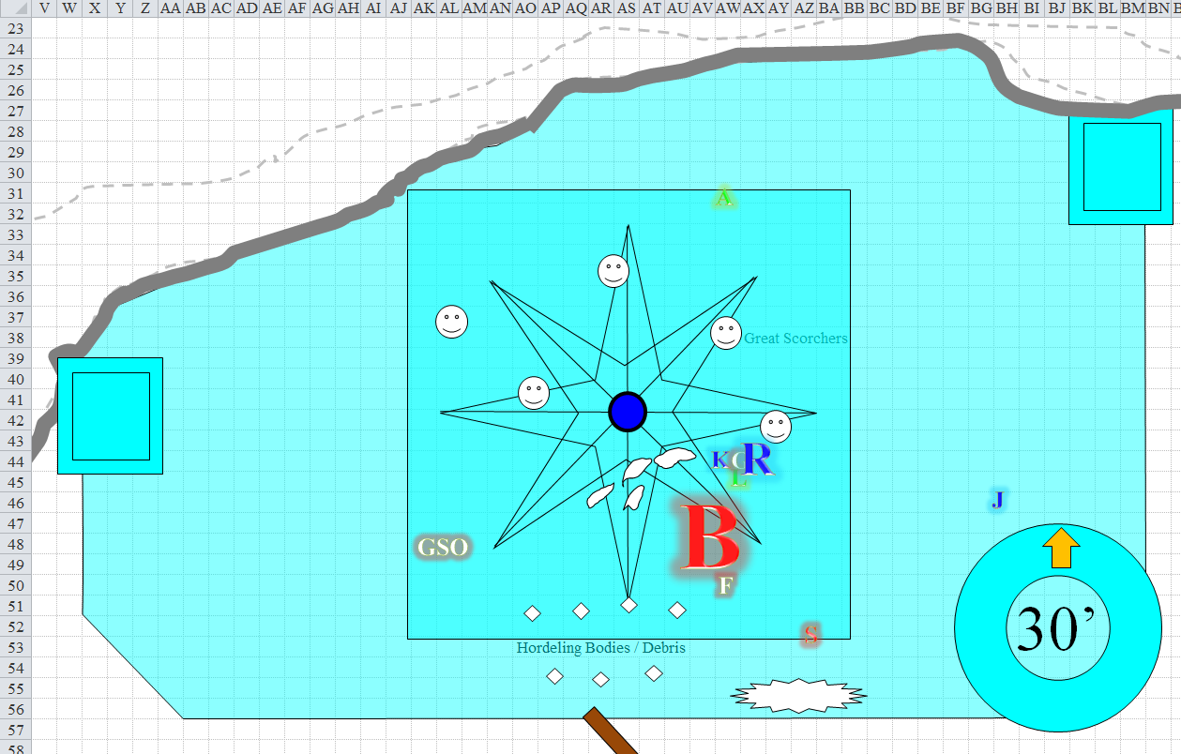

Round 574

Fingers became visible once more. Jarl saw the avariel on the ground, rushed to the rogue’s aid, and cast *cure serious wounds* upon Fingers.

*Fingers gained 15 + 9 = 14 hps [8/66].*

With 9 electrical bolts left to throw at the enemies, Allisa cast *flame strike* on the dragon, then readied one of the bolts in her hand, and chose her next target.

|  |  |  |  |
| --- | --- | --- | --- |
| **Ranged Weapon** | **Atk** | **Roll** | **Check** |
| Bypass Spell Resistance | +13 | 16 | 29 |

*Success.*

|  |  |  |  |  |
| --- | --- | --- | --- | --- |
| **Character** | **Save vs.**  *flame strike* | **Ranks** | **Roll** | **Save** |
| Bestlaranathion | Reflex | 16 | 13 | 29 |

*Success. Saves for ½ damage.*

*Dmg: ½ x [15 divine + (2 {vulnerable} x 14 fire)] = 7 + 14 fire = 21.*

“Oh, you botchy cow!” Best cursed at Allisa.

The ice rhino turned towards the dragon and attacked once the instantaneous flash of the *flame strike* spell was no more.

|  |  |  |  |  |  |  |  |  |  |
| --- | --- | --- | --- | --- | --- | --- | --- | --- | --- |
| **Character** | **Attack Type** | **Damage** | **BAB** | **Str Mod+** | **W+** | **Other+** | **Total Score** | **Roll** | **Total** |
| Ice Rhinoceros | Gore | 2d6+12 | 6 | 7 | 0 | 0 | 13 | 15 | 28 |

*Miss.*

Remembering that he’d actually prepared a *cure moderate wounds* spell, Kedrik tapped Lauren on the shoulder with his finger.

*Lauren gained 9 + 13 = 22 hps [34/114].*

Sylar II saw the cleric rushing to save Fingers, and cast a Maximized (L4) *lesser orb of sound* towards Jarl.

|  |  |  |  |  |  |  |  |  |  |
| --- | --- | --- | --- | --- | --- | --- | --- | --- | --- |
| **Ranged Weapon** | **Dmg** | **+ Mod** | **TH+** | **Critical** | **Rng.** | **Wt.** | **Atk** | **Roll** | **Check** |
| Ranged Touch Attack | 5 x 6 = 30 | (Maximized) | 2 | n.a. | varies | 0.0 | +12 | 11 | 23 |

*Hit. Dmg: 30 sonic [11/63].*

Lauren snarled as she saw Sylar strike down Fingers. “Enough!” The duskblade quick-cast *vampiric touch*, swift-cast *fly*, lifted up and over the dragon, and closed the nonlinear distance between herself and Sylar.

Best got an attack of opportunity as the duskblade skirted the dragon’s threat zone.

|  |  |  |  |  |  |  |  |  |  |
| --- | --- | --- | --- | --- | --- | --- | --- | --- | --- |
| **Character** | **Attack Type** | **Damage** | **BAB** | **Str Mod+** | **W+** | **Other+** | **Total Score** | **Roll** | **Total** |
| Bestlaranathion | Claw 1 | 2d6+4 | 21 | 5 | 0 | 0 | 26 | 15 | 41 |

*Hit. Dmg: 5 + 4 = 9 [25/114].*

Lauren reached Sylar II and hit him as many times as she could. “Join your master, bitch!”

|  |  |  |  |  |  |  |  |  |  |
| --- | --- | --- | --- | --- | --- | --- | --- | --- | --- |
| **Melee Weapon** | **Dmg** | **D+** | **TH+** | **Critical** | **Type** | **Wt.** | **Atk** | **Roll** | **Check** |
| Falchion +3 | 2d4 | +5 +3 | 3 | 18-20/x2 | Slashing | 8.0 | +22 | 7 | 29 |
| Falchion +3, *haste* | 2d4 | +5 +3 | 3 | 18-20/x2 | Slashing |  | +22 | 3 | 25 |

*Hit, hit. Dmg: (3 + 5 + 3) + (2 + 5 + 3) = 11 + 10 + 28 vampiric = 49 [53/114].*

And that seemed to be what did the trick. Not only did the simulacrum’s corpse fall to the ground like a muted sandbag.

Fingers got up, and tossed one of the Great Scorchers it had held onto at the dragon. Maybe its sword can’t pierce that scaley hide but it’d be tough to miss that huge backside.

|  |  |  |  |  |
| --- | --- | --- | --- | --- |
| **Character** | **Save vs.**  Great Scorcher | **Ranks** | **Roll** | **Save** |
| Bestlaranathion | Reflex | 12 | 7 | 19 |

*Success. Saves for ½ damage.*

*Dmg: ½ x (2 [vulnerable] x 25) = 25 fire.*

Bestlaranathion took one look at the rhino with pity, then proceeded to turn it to a rhinoslushieTM.

|  |  |  |  |  |  |  |  |  |  |
| --- | --- | --- | --- | --- | --- | --- | --- | --- | --- |
| **Character** | **Attack Type** | **Damage** | **BAB** | **Str Mod+** | **W+** | **Other+** | **Total Score** | **Roll** | **Total** |
| Bestlaranathion | Bite | 2d8+8 | 21 | 10 | 0 | 0 | 31 | 17 | 48 |
| Bestlaranathion | Claw 1 | 2d6+4 | 21 | 5 | 0 | 0 | 26 | 11 | 37 |
| Bestlaranathion | Claw 2 | 2d6+4 | 21 | 5 | 0 | 0 | 26 | 17 | 43 |
| Bestlaranathion | Wing 1 | 1d8+4 | 21 | 5 | 0 | 0 | 26 | 13 | 39 |
| Bestlaranathion | Wing 2 | 1d8+4 | 21 | 5 | 0 | 0 | 26 | 18 | 44 |
| Bestlaranathion | Tail | 2d6+12 | 21 | 5 | 0 | 0 | 26 | 11 | 37 |

*Hit, hit, hit, hit, hit, hit.*

*Dmg: (6 + 8) + (7 + 4) + (5 + 4) + (6 + 4) + (7 + 4) + (9 + 12) = 14 + 11 + 9 + 10 + 11 + 21 = 76.*

Surprisingly, the icy animal was still kicking, and its horn now threatened the dragon a bit.

Best then said, “Flee, my great-great-grandson; I will...” then she saw that the sorcerer had been more than just killed, but had had the life sucked out of him by the vampiric drow.

The snowflake oozes ganged up on the rhino.

|  |  |  |  |  |  |  |  |
| --- | --- | --- | --- | --- | --- | --- | --- |
| **Character** | **Attack Type** | **Damage** | **BAB** | **Str Mod+** | **Total Score** | **Roll** | **Total** |
| Snowflake Ooze, M | Slam | 1d8+7+2d4 cold | 4 | 5 | 9 | 14 | 23 |
| Snowflake Ooze, M | Slam | 1d8+7+2d4 cold | 4 | 5 | 9 | 13 | 22 |
| Snowflake Ooze, M | Slam | 1d8+7+2d4 cold | 4 | 5 | 9 | 14 | 23 |
| Snowflake Ooze, M | Slam | 1d8+7+2d4 cold | 4 | 5 | 9 | 7 | 16 |

*Hit, hit, hit, miss. Dmg: (1 + 7 + 5 cold) + (4 + 7 + 3 cold) + (2 + 7 + 7 cold) = 8 + 11 + 9 + 15 cold = 28 + 15 cold = 43. Cold damage negated.*

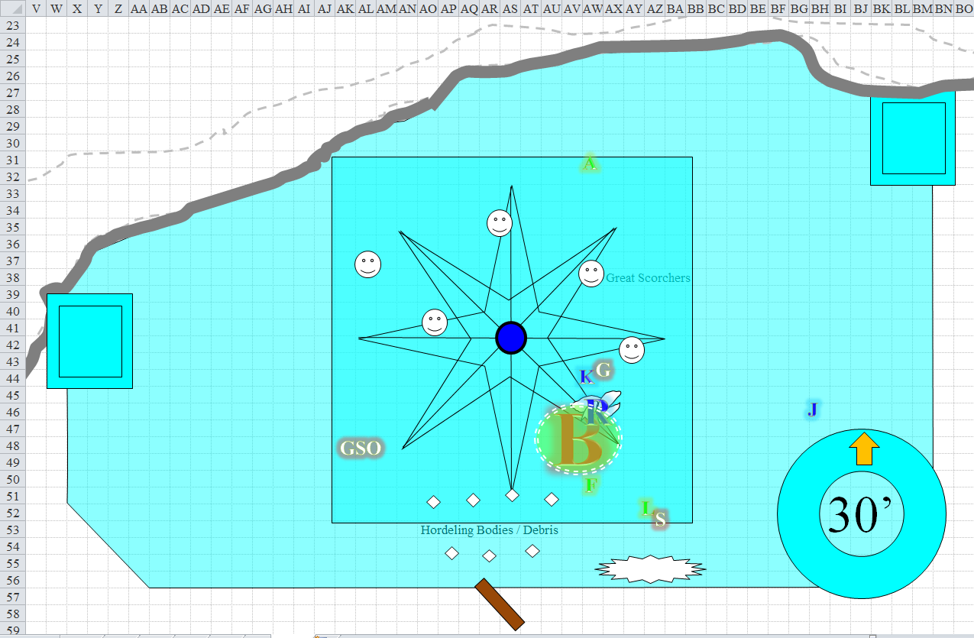

Round 575

Best began to flap her wings again. The rhino attacked the dragon some more before she took flight.

|  |  |  |  |  |  |  |  |  |  |
| --- | --- | --- | --- | --- | --- | --- | --- | --- | --- |
| **Character** | **Attack Type** | **Damage** | **BAB** | **Str Mod+** | **W+** | **Other+** | **Total Score** | **Roll** | **Total** |
| Ice Rhinoceros | Gore | 2d6+12 | 6 | 7 | 0 | 0 | 13 | 10 | 23 |

*Miss.*

The snowflake oozes attacked the rhino.

|  |  |  |  |  |  |  |  |  |
| --- | --- | --- | --- | --- | --- | --- | --- | --- |
| **Character** | **Attack Type** | **Damage** | **BAB** | **Str Mod+** | **Dex Mod+** | **Total Score** | **Roll** | **Total** |
| Snowflake Ooze, M | Slam | 1d8+7+2d4 cold | 4 | 5 | -5 | 9 | 2 | 11 |
| Snowflake Ooze, M | Slam | 1d8+7+2d4 cold | 4 | 5 | -5 | 9 | 9 | 18 |
| Snowflake Ooze, M | Slam | 1d8+7+2d4 cold | 4 | 5 | -5 | 9 | 17 | 26 |
| Snowflake Ooze, M | Slam | 1d8+7+2d4 cold | 4 | 5 | -5 | 9 | 4 | 13 |

*Miss, miss, hit, miss. Dmg: 2 + 7 + 6 cold = 15. Cold damage negated.*

Lauren saw the work she’d done on Sylar, then turned around to face their sole enemy. She Swift-cast *wraithstrike*, and from about 20’ away, she charge-attacked the dragon who was about to jump up and fly again.

|  |  |  |  |  |  |  |  |  |  |
| --- | --- | --- | --- | --- | --- | --- | --- | --- | --- |
| **Melee Weapon** | **Dmg** | **D+** | **TH+** | **Critical** | **Type** | **Wt.** | **Atk** | **Roll** | **Check** |
| Falchion +3 | 2d4 | +5 +3 | 3 + 2 charge | 18-20/x2 | Slashing | 8.0 | +24 | **18** | 42 |
| Falchion +3, *haste* | 2d4 | +5 +3 | 3 | 18-20/x2 | Slashing |  | +22 | 5 | 27 |

*Threat, hit. 1d20 = 17 + 24 = 41, critical hit. Dmg: [2 x (4 + 5 + 3 + 2 charge] + (6 + 5 + 3) = 28 + 14 = 42.*

Fingers threw its last Scorcher at the dragon, simultaneously with Lauren’s attack. Hopefully, it would be enough to drop the enemy.

|  |  |  |  |  |
| --- | --- | --- | --- | --- |
| **Character** | **Save vs.**  Great Scorcher | **Ranks** | **Roll** | **Save** |
| Bestlaranathion | Reflex | 12 | 18 | 30 |
| Ice Rhinoceros | Reflex | 6 | 17 | 23 |

*Success, success. Both save for ½ damage.*

*Dmg to Best: ½ x (2 [vulnerable] x 21) = 21 fire.*

*Dmg to rhino: ½ x (2 [vulnerable] x 18) = 18 fire.*

|  |  |  |  |  |  |  |  |
| --- | --- | --- | --- | --- | --- | --- | --- |
| **Save vs.**  *Great Scorcher* | **Rank** | **Ability**  **& Mod.** | **Misc.**  **Mods.** | **Total** | **Roll** | **Check** | **Properties** |
| **Lauren, Reflex** | 4 | **Dex (+2)** | 1 | 7 | 16 | 23 | +1 *haste* |

*Success. Saves for ½ damage.*

*Dmg: 20 fire. Partial damage negated [43/114].*

“You killed Sylar!! Sons and daughters of ill-gotten *whores*!” Bestlaranathion slashed once at the rhino that threatened her, then rose up in rage and terror, fearing for her life now.

|  |  |  |  |  |  |  |  |  |  |
| --- | --- | --- | --- | --- | --- | --- | --- | --- | --- |
| **Character** | **Attack Type** | **Damage** | **BAB** | **Str Mod+** | **W+** | **Other+** | **Total Score** | **Roll** | **Total** |
| Bestlaranathion | Claw 1 | 2d6+4 | 21 | 5 | 0 | 0 | 26 | 10 | 36 |

*Hit. Dmg: 4 + 4 = 8.*

On its last legs, the icy rhino got an attack of opportunity.

|  |  |  |  |  |  |  |  |  |  |
| --- | --- | --- | --- | --- | --- | --- | --- | --- | --- |
| **Character** | **Attack Type** | **Damage** | **BAB** | **Str Mod+** | **W+** | **Other+** | **Total Score** | **Roll** | **Total** |
| Ice Rhinoceros | Gore | 2d6+12 | 6 | 7 | 0 | 0 | 13 | 19 | 32 |

*Hit. Dmg: 10 + 12 = 22.*

Kedrik had benefitted greatly from his *sanctuary* spell, but now that there was only one enemy in sight, it was time for the gloves to come off. *Radiant assault* would likely be the spell he cast last on Best, if she was getting away. It had a long range, and packed enough punch to most likely take her out of commission at this stage of the game. *Diamond spray* had a much shorter range, and it seemed to him to be the ideal selection of favors to pray for right about now, so he did. “Diamond lies, and lying eyes!” he cursed the evil dragon, spraying her with diamond-like shards.

|  |  |  |  |  |
| --- | --- | --- | --- | --- |
| **Character** | **Save vs.**  *diamond spray* | **Ranks** | **Roll** | **Save** |
| Bestlaranathion | Reflex | 12 | 20 | 32 |

*Success. Saves for ½ damage.*

*Dmg: ½ x 39 = 19 + dazzle [expires on Round 580].*

Though Best could still see, her sight was partially obfuscated by the diamonds for a moment

Unable to do much more at the moment, Jarl cast *doom* upon Best.

|  |  |  |  |  |  |  |
| --- | --- | --- | --- | --- | --- | --- |
| **Character** | **Attack Type** | **Damage** | **BAB** | **Total Score** | **Roll** | **Total** |
| Jarl of Best | Bypass SR | varies | 9 | 9 | 15 | 24 |

*Success.*

|  |  |  |  |  |
| --- | --- | --- | --- | --- |
| **Character** | **Save vs.**  *doom* | **Ranks** | **Roll** | **Save** |
| Bestlaranathion | Will | 13 | 19 | 32 |

*Success. Spell has no effect.*

Best then lifted herself upward and flew a total of about 55’, crashing through the roof.

Allisa threw another bolt and moved 30’ toward the dragon.

|  |  |  |  |  |
| --- | --- | --- | --- | --- |
| **Ranged Weapon** | **Atk** | **Roll** | **Check** | **Notes** |
| Ranged Touch Attack | +12 | 2 | 14 | 8 bolts left |

*Hit. Dmg: 12 electric.*

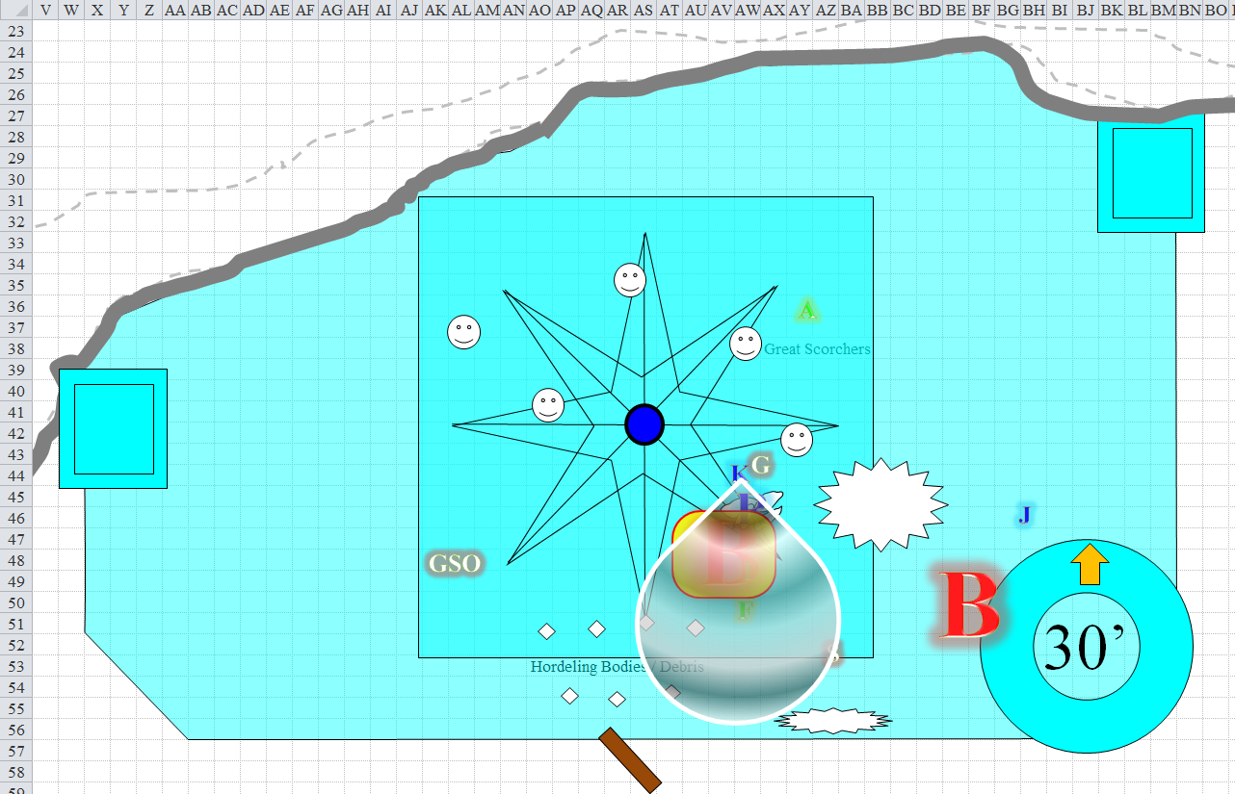

Round 576

Kedrik said, “Oh, it’s on now!” And with this, he ran outside in order to finish the fleeing dragon with his *radiant assault* spell.

Jarl saw Kedrik, smiled with a toothy, scaly snout, and followed the gnome for shits and gigs.

The rhino and the snowflake oozes fought it out.

|  |  |  |  |  |  |  |  |  |  |
| --- | --- | --- | --- | --- | --- | --- | --- | --- | --- |
| **Character** | **Attack Type** | **Damage** | **BAB** | **Str Mod+** | **W+** | **Other+** | **Total Score** | **Roll** | **Total** |
| Ice Rhinoceros | Gore | 2d6+12 | 6 | 7 | 0 | 0 | 13 | 5 | 18 |
| Snowflake Ooze, M2 | Slam | 1d8+7+2d4 cold | 4 | 5 | 0 | 0 | 9 | 8 | 17 |
| Snowflake Ooze, M3 | Slam | 1d8+7+2d4 cold | 4 | 5 | 0 | 0 | 9 | 19 | 28 |
| Snowflake Ooze, M4 | Slam | 1d8+7+2d4 cold | 4 | 5 | 0 | 0 | 9 | 11 | 20 |

*Hit, miss, hit, miss.*

*Dmg to Ooze 1: 10 + 12 = 22.*

*Dmg to ice rhino: 6 + 7 = 13.*

Ooze 1 and the rhino were both destroyed.

Bestlaranathion flew away, and shat a big dookie onto the icy ground from an altitude of about 80’ now.

Lauren cast *swift fly* and lifted off through the hole in the roof to chase Best. As she did, she began to cast *channeled pyroburst*. She was careful to not get between Best and the other spellcasters, lest she get hit by one of their spells.

|  |  |  |  |  |  |
| --- | --- | --- | --- | --- | --- |
| **Ranged Weapon** | **TH+** | **Critical** | **Atk** | **Roll** | **Check** |
| Bypass Spell Resistance | 2 | Spell Penetration | +15 | 12 | 27 |

*Success.*

|  |  |  |  |  |
| --- | --- | --- | --- | --- |
| **Character** | **Save vs.**  *channeled pyroburst* | **Ranks** | **Roll** | **Save** |
| Bestlaranathion | Reflex | 12 | 9 | 21 |

*Success. Saves for ½ damage.*

*Dmg: 2 [vulnerable] x (½ x 30) = 30 fire.*

Allisa moved 30’ but had no line of sight to the dragon now, so she attacked the remaining snowflake oozes with her lighting bolts.

|  |  |  |  |  |
| --- | --- | --- | --- | --- |
| **Ranged Weapon** | **Atk** | **Roll** | **Check** | **Notes** |
| Ranged Touch Attack | +12 | 3 | 15 | 7 bolts left |

*Hit. Dmg: 9 electric.*

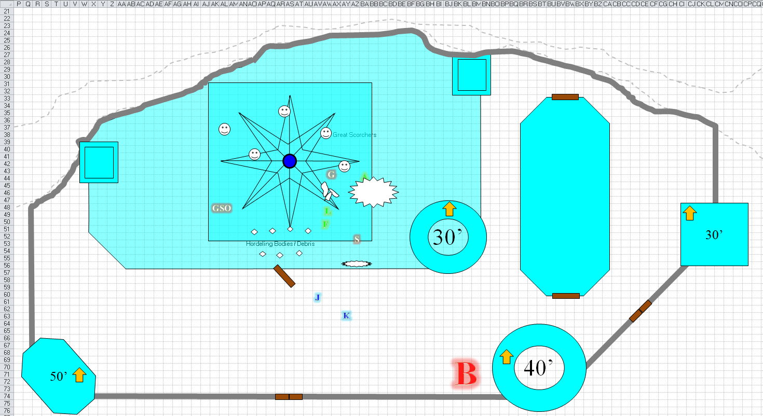

Kedrik was about to unleash his deadliest spell when he saw that Lauren chased the dragon and *pyrobursted* her ass.

The dragon fell to the floor, and cracked the fathoms-thick ice sheet below her.

Seeing the dragon fall, Lauren cast *swift fly* again, and hovered next to the creature’s neck. She struck at the dragon’s spine just behind her head, intending to sever it to ensure that Best was well and truly dead.

Not yet seeing that the dragon was dead, Allisa shouted out in victory as she zapped a snowflake. “Let’s clean this rabble out. Then burn Sylar’s body.”

|  |  |  |  |  |
| --- | --- | --- | --- | --- |
| **Ranged Weapon** | **Atk** | **Roll** | **Check** | **Notes** |
| Ranged Touch Attack | +12 | 19 | 31 | 6 bolts left |

*Hit. Dmg: 13 electric.*

The second of what had been four oozes died, leaving only 2 left. Allisa cutely named them “Eenie” and “Meenie” as she decided which of the oozes to slay next.

Outside, Jarl and Kedrik rejoiced, and nodded with satisfaction. “A job well done,” the gnome commended the half-dragon.

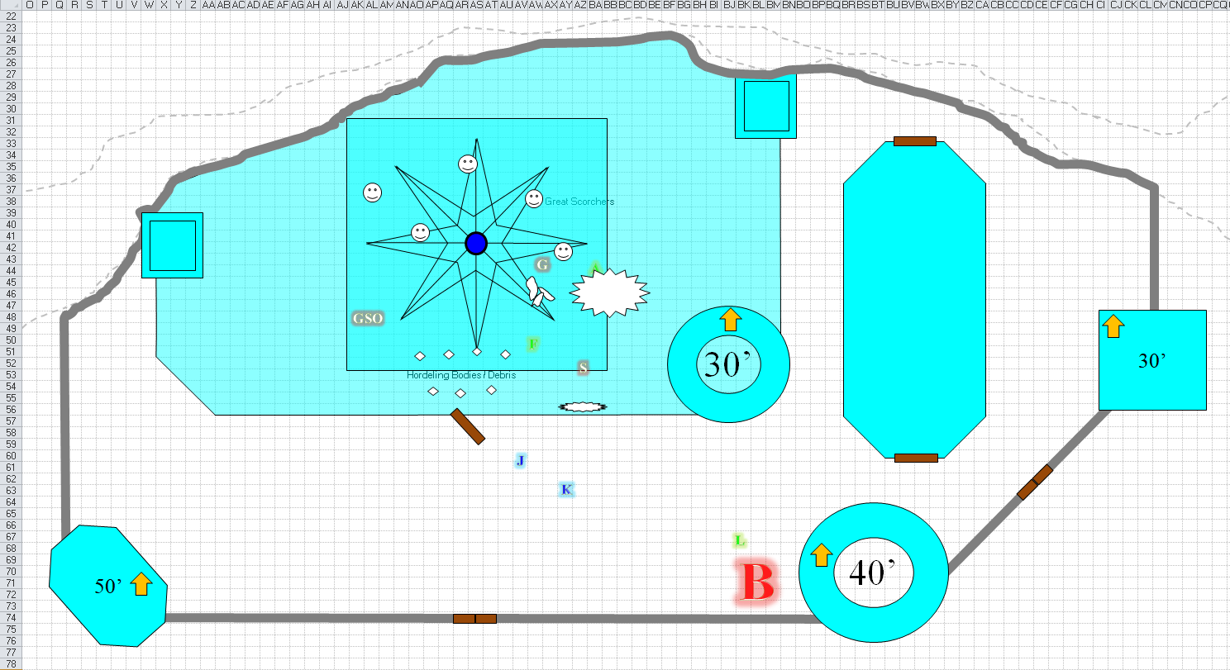

Jarl returned the compliment, but then heard the commotion inside still going on between Allisa and the oozes. He ran inside and shouted, “Stop it!”

At first, Allisa couldn’t tell if the cleric was talking to her, but it soon became evident after he repeated himself and approached that he was talking to the oozes. “Best is vanquished. Go out and see for yourselves if you want. *I* am your lord and master now, and I command you to cease at once!”

Kedrik overheard this from outside the castle, and smirked at the opportunistic cleric’s ambitions. Of *course* he would now proclaim himself the sovereign lord of this magical keep... until someone mightier came along and decided that they liked the climate.

The snowflake oozes backed down, and eventually moped towards the door in a melancholy way, going outside to see Best’s body.

Fingers had flown up thru the hole Best had made, intending to give chase just in time to see Lauren fell the beast. Gliding back down to join her, the changeling gave it a few acid-tinged swipes of its own. Thinking back on Kedrik’s revelation about her condition, it asked, “Do you think we need to do anything about her eggs? There might be a market for them and in any case I don’t think we want to risk leaving them if there’s a chance they’d still hatch and eat their way out.”

“I think we should destroy them,” Lauren answered. “They’re much too dangerous to let live.” She looked around. “I wonder where her mate is.”

Allisa approached Sylar’s desiccated body and kicked it between the legs. She then searched his body, removing all his clothes. Jarl was by now exiting the castle again, and joining the others outside.

Once they were all outside, Lauren hugged Allisa tightly.

“I’m sorry, lover. I should have been smarter about how I fought. I was terrified for you, and not thinking about the fight.”

“I was worried when you went down.” Allisa said as she hugged and kissed her lover.

Lauren hugged the slim girl to her chest. “I promise I will do better.”

“Yes you should have. You need to focus on the job at hand and by doing so you will keep me safe.” She frowned at sweetness before pulling her in for another hug.

~*~

Allisa had all gather ‘round as she used her *mass* *cure light wound* blessing.

*All present gained 5 + 13 = 18 hps.*

*Allisa: [72/72].*

*Fingers: [26/66].*

*Lauren: [61/114].*

The mistress of many forms then attended Lauren using her *cure moderate wounds* spell.

*Lauren gained 7 + 13 = 20 hps [81/114].*

“So,” Kedrik held back another smirk as he asked Jarl, “what do you intend to do now that you are sovereign lord and master of this keep?”

“I—” Jarl didn’t know quite what to say at first. “There is a... bittersweetness in Best’s death.” He then prayed for his *sanctuary* spell, and noted that it actually worked. “As you can see, I am still receiving favors from *some* deity, though I know not which. I must now enlist the help of others to help me discover what theistic force has actually been powering my spells.”

Kedrik thought to mention the item that they’d found on Supreme Defiance less than a tenday ago, but didn’t.

“Jarl, I would suggest that you make friends with the locals. Show them kindness and maybe in time they will return the favor,” said Allisa. The druid then proposed, “We should keep the dragon scales for sale along with some of its blood, heart and eyes. I am sure they can be sold for a good price if only as spell components.”

“Good idea,” Lauren replied. After making sure the dragon and her eggs were dead, Lauren looked at Jarl. “Where is Best’s lair?”

“There is a cave between here and Raven Rock that was her only lair for a thousand years, before she had gained her unusual intellect and goddesshood,” he told them. “It is still where she keeps her hoard, though she has spent much of it on the mercenaries that she entrusted to follow her to their doom across the land as they besieged settlement after settlement.”

Kedrik produced his map, and the cleric pointed it out. The gnome made a marking on the map, and nodded with gratitude. “Is it guarded?”

“I have not visited in years, but Best spoke of a few younger dragons that now occupied the lair,” he said.

“How long would it take for us to travel there,” Lauren asked as she looked over the gnome’s shoulder at the map.

Kedrik replied, “A few hours. It’ll be night here, but it would still be what we temperate folks call Afternoon.”

“Let’s rest here until morning, then,” Lauren suggested. “While we’re here, can we send a message to Waterdeep regarding Best’s demise?” She looked at Fingers and Allisa. “Did either of you find anything interesting on Sylar or that boy?”

“I haven’t had the chance to take a look at that fighter’s body yet,” Fingers replied. “Making sure Best was well and truly dead kind of took priority. I’ll check out his gear now. Even if not magical, that armor will probably fetch a tidy sum.”

The druid said, “I have spent all my relevant spells. It would be wise if we rested. I do not have my *sending* spell learned, but as for the last time I sent one, we have still not heard an answer,” said Allisa.

Lauren nodded. “I agree that we should rest until morning. Maybe we can send off another *message* then, as well.”

“I fear not, we would have to find an animal to deliver it. Anyway, it would take away from what I have to use for tomorrow’s battle,” said Allisa.

“I hope there isn’t a battle tomorrow,” Lauren said. She took a breath, remembering that she’d fallen in today’s battle, too. The darkness had tugged at her, but she was revived before it could take hold. “Come, let us find a place to rest.” The duskblade turned to Jarl. “May we stay here for the night? I take it the creatures outside won’t disturb us if we leave them alone.”

“They’ve lost their foreman,” Jarl referred to the ghaunadan ooze, “and their mistress,” he meant Best, “within the span of 20 seconds. They’ll need some time to get acclimated to the new pecking order, but they’ll stay outside while it’s nice out,” he pointed to the freezing conditions under a setting sun just hours after high noon.

Fingers agreed completely, “If we are going to take on more dragons, I certainly need some rest and recuperation. Even if I’m to merely scope out the lair stealthily, I’d feel better not being quite this killable in case the excrement hits the blade barrier. I’m noways adverse to getting a major payday out of this trip tho.” The changeling ran over its mental list of ‘nice to have’ items and added a wand of regular *invisibility*... maybe even an Eternal one if one such could be located. At nearly five thousand gold, it’d be pricey but being able to remain invisible for more than a few moments would certainly come in handy for future recon tasks.

“Then I’ll turn in right after a bite to eat so I’m fresh for third watch. Not much use my making any potent traps even if I could scrounge up the materials, since they would lose their power after an hour. However, I can at least put an alarm tripwire on the door attached to some noisemakers in case something tries sneaking in during the night,” suggested Fingers. “I didn’t find any other way into this place other than bashing thru the walls or ceiling, and that’s hardly conducive to making a stealthy entrance.”

“We will need to keep watch tonight,” Lauren said as she walked back into the main room. “We can do nothing to hide Best’s remains, and even a cursory look will tell what happened here, should one of her allies come here.”

“Then I volunteer for the first watch,” said the druid.

“I will take the next watch, so you can eat,” replied the duskblade.

Jarl thought about it as the half-drow and half-elf spoke, and shook his head, “She really *has* no allies left here. She scattered them about from raid to raid, and with every *sending* I’d receive, the list of casualties—mighty and meek—and the closest thing to an ally that she left behind are her progeny in her old lair.”

Lauren shook her head with a sigh. “No, we can’t leave more dragons with a grudge behind. That would make this battle a useless endeavor.”

Kedrik insisted, “We should at least send a message to the folks back at the igloo settlement that we have triumphed. They’ll be worried for us, and for themselves if they think we perished at the hands of Best. Fingers, if you teach me to use the carpet, I can go by myself and come back in a jif.”

“I think we can wait until morning,” Lauren said. “Better that we travel together.”

“I meant the Neanderthals. Treat them well or we will return.”

Allisa picked an inside wall to be safe from someone crashing in on her and Lauren. She then went through all the equipment of the dead enemies before and during her watch.