*Chapter 60*

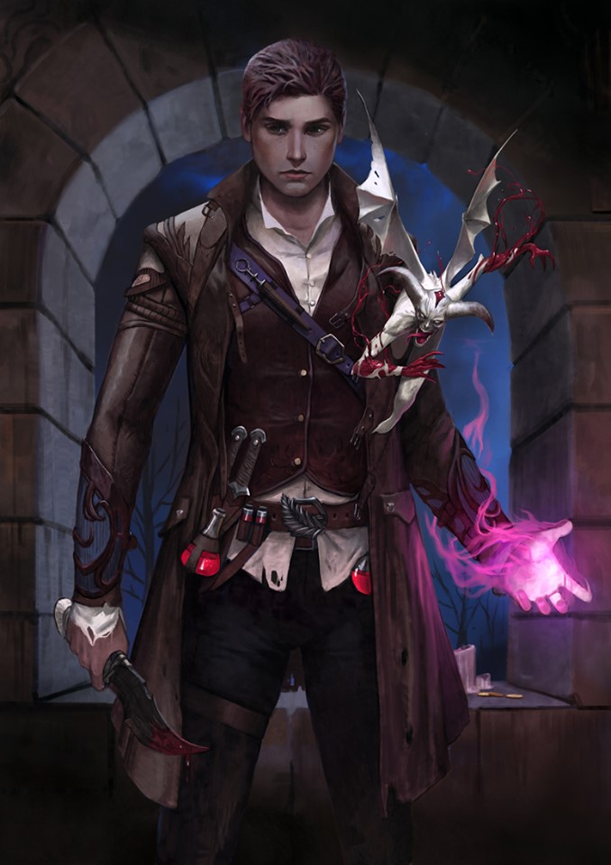Sylar’s *simulacrum* had lived here for about the last 4 months, having taken the better part of Eleasis and Elaint 1376 to (1) discover that the Sylar who created him was a great-great-grandson of a white dragon, (2) learn that said dragon was still alive, named Best, and was the most intelligent white dragon in all of Faerûn, and (3) reach this ice castle. Once here, his scent alone assured her that he was truly of her flesh, though the charismatic sorcerer had known better than to try to hide the fact that he was actually her great-great-grandson’s *simulacrum*, and not truly the seventh son of the seventh son of Best’s granddaughter.



The skull-carving sorcerer’s *simulacrum* had a slightly different sense of style as his predecessor, though his attention to functionality was nearly identical. As Sylar I, Sylar II wore gloves of dexterity and a cloak of charisma, the latter of which had a hidden compartment with two ioun stones, which would—in conjunction with the cloak—enhance the wearer’s ability to cast sorcerer spells *and* win friends and influence people.



The weakling sorcerer had wielded an unholy dagger, which was still encrusted in the carbonized hand inside the left glove of dexterity, and had in a masterwork kukri its scabbard, both of which Allisa liberated from his possession after removing the cloak and gloves. The left-handed sinister sorcerer was truly done for, and the druid felt a sense of internal liberation as she relieved the dead man of his effects.

Inside one of the gloves was a ring of protection, and inside his mundane vest were a wand of *summon monster i* and a scroll of *greater mage armor*.

“He has a few rations on him, and some other things. The soap is really gross, and has pubic hairs on it, and the candle looks like it’s been shoved up someone’s ass, but other than that, it’s worth taking with us,” reported Allisa.

[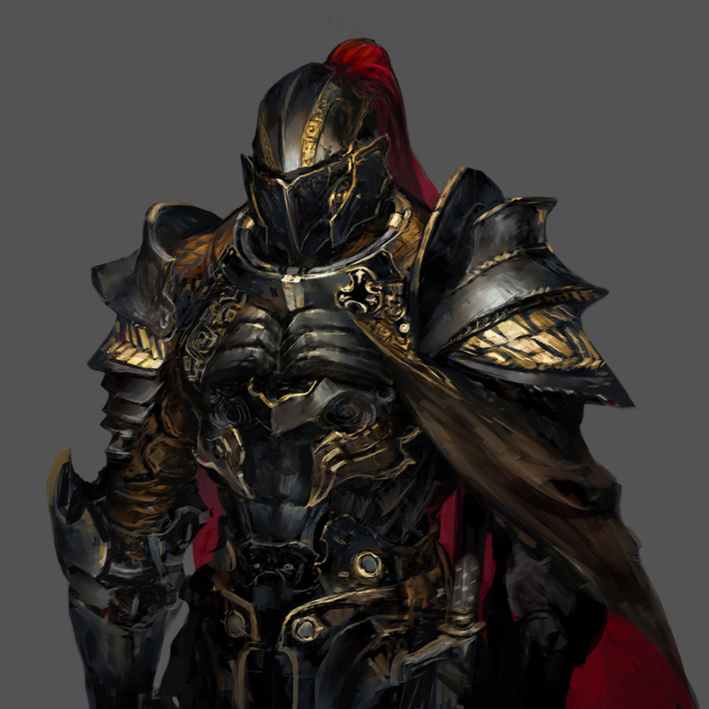](https://www.google.com/url?sa=i&rct=j&q=&esrc=s&source=images&cd=&ved=2ahUKEwjft6_MrtziAhUQOq0KHUELANgQjRx6BAgBEAU&url=https://warosu.org/tg/thread/33106726&psig=AOvVaw3FUWIn54pVwc2FepBrjahY&ust=1560168460840213)

G-Code wore a daunting suit of full plate, the properties of which Allisa could not discern, but his cold warhammer and longbow +1 were beautifully crafted. The paladin of slaughter was apparently too good to carry a sack or anything else with him.

On Best was only a harness with a mounting compartment on her back that allowed her to carry up to two Medium riders or 4 Small riders on her back with no impairment to her flight or movement.

Lauren singlehandedly had carried the paladin’s suit of armor, now that Allisa had carefully removed it, over to where the dead dragoness and her silverbrow sorcerer great-great-grandson, and now pulled open her haversack once more, and asked Kedrik, “Can you discern anything about the full plate?”

The gnome marveled over its craftsmanship, then rubbed his chin, “Now that we’ve decided that we’re staying here, this gives me a reason to cast my only prepared *identify* spell.”

It would take him just over an hour to do so since he wanted to do it in the comfort of the corner along the northern wall that he’d selected as his little area.

~*~

Morning, 27 Deepwinter

The sun was about to rise before doing its daily semicircle across the southern sky and setting four hours later. Kedrik had identified G-Code’s full plate suit of improved stamina yesterday, and now Lauren was deciding whether to keep her mithral chain shirt or change it out for the plate.

Once that decision had been made an implemented, they would be ready to set out towards the igloo settlement to set the half-Neanderthals’ worries to rest, and then it was off to the late dragon’s original lair en route to Raven Rock.

Lauren stripped off her own armor and gambeson, leaving her clad in a thin linen shift above the waist. She put on the plate breastplate, and tried several exercises with her sword, and cast Know Direction as a test. “No, I like the lighter armor,” she said to Allisa. “It’s easier to work with, even with the gambeson under it. Besides, I don’t want to lumber along like Rook does.” She placed the armor parts in her haversack, and then set about helping Allisa with their bed and dinner.

And so they took off, heading south towards the igloo settlement, which they reached within the hour at a leisurely pace and a mean altitude of about 250’. They hardly stopped, and said only enough to circle about some of the elders with joy on their face, and bid the half-Neanderthals well.

“The gratitude is ours!” was the last reply the Gambit heard before they made off west-northwest, headed towards Raven Rock, but with no intention of going that far.

~*~

They would have had a mean encounter with a pack of yetis if they’d been on foot or flying at reach height. As it was, it took them a few hours to follow Jarl’s directions by the few landmarks in this barren wasteland, of ice and snow. Before arriving, it became evident that this had very recently been the scene of a violent conflict. There were dozens of hordelings, and handfuls of humanoids, demidragons, and others strewn about, all seemingly dead, and all lying in pools of blood of the color appropriate to their species.

The blood had been frozen over, and as the carpet descended to less than 50’, they kept their eyes peeled for any kind of ambush, though there was nowhere to hide down below. The 25’ wide aperture of the cavern below was evidently the bottleneck of a conflict between the masses of draconic and mammalian forces, though it wasn’t evident that this divide was unanimous among the participants who now lay dead.

They landed at the mouth of the cave, seeing nothing moving.

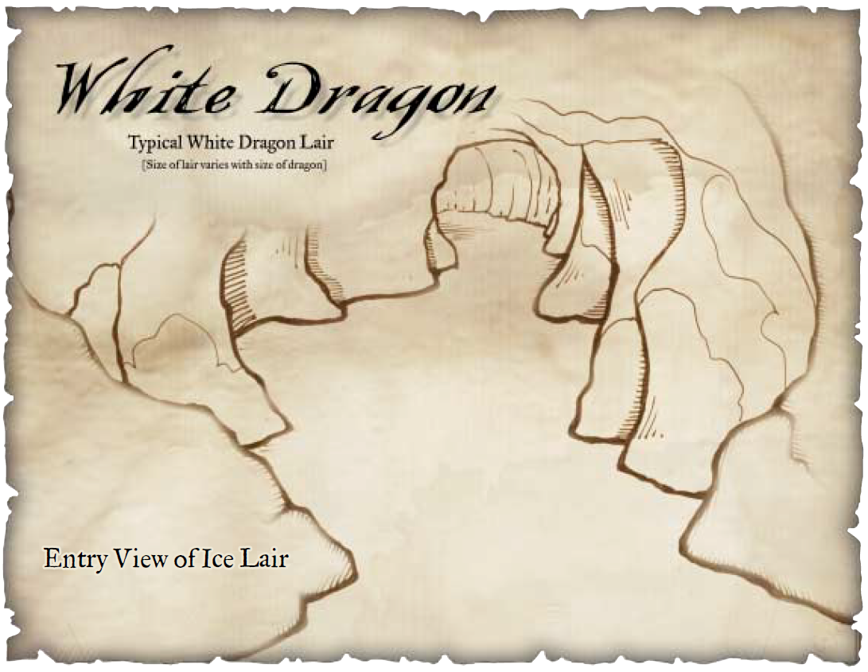

A living whitespawn hordeling was near; this, Fingers could tell by scent itself. The draft that emanated from within was only a few degrees cooler than the well-below-freezing temperature outside. Fingers—dressed scantily—peered into the cavern, which grew darker as it wound left, right, and left again before the angle obfuscated further vision.

Round 1

Lauren used her arcane ability to *detect magic [expired on Round 131 at the latest]*, and waited for the result.

“The amount of slaughter is encouraging in a sense,” observed Fingers. “It seems unlikely any from Best’s side that managed to survive did so unscathed.”

“I will join you in that hope,” Lauren said as she studied the battleground.

Kedrik dusted off his gloves, then cast *chasing perfection [expired on Round 131]* upon himself.

*Kedrik gained +4 to Strength, Dexterity, Constitution, Intelligence, Wisdom, and Charisma.*

He then turned to Lauren, and offered to cast the same spell on her, “Shall we extreme-theme the occasion, champion?”

Lauren nodded. “Yes, please.”

“Right, give me a moment,”

Round 2

Kedrik cast *freedom of movement [expired on Round 1302]* upon himself. “In case of snow driders,” he explained, half-jokingly, remembering having been ensnared by the drider’s web only days ago.

Lauren then stood up and drew her falchion, stepping off of the carpet.

The tunnel led slightly more than 60’ inward before it turned too much for them to see altogether. Lauren—who had just cast *detect magic*—could now see into the tunnel, the first 60’ of which began to emit magical auras.

Aside from the bodies in and near the tunnel, spearheads and hefts lay broken on the cavern floor, and several vials once filled with potions had also been discarded here. Despite the pools of blood, it was possible for them to walk inward along a trail of bloodless ice.

Amidst the humanoids and hordelings that littered the battlefield, there were two whitespawn berserkers and four whitespawn hunters. The Gambit had faced off against such creatures less than a tenday ago, but these seemed far less healthy than those they’d vanquished back in Waterdeep. These were markedly emaciated, and couldn’t have put up much of a fight. The humanoids that they could easily identify included two human barbarian types; a wood elf clad in leather and furs, but also donning a golden tiara; a scantily purple-clad halfling with a pointy hat and most likely the same type of amulet that Fingers had on; and a half-dozen Neanderthals, each far bigger in stature than the half-Neanderthals with whom the Gambit was now familiar. None of the humanoids seemed starved.

Kedrik hopped off of the carpet as well.

The more that Fingers and Lauren—forensic experts by now—studied the scene, the more that it *did* look like a clear division of allegiances along racial classes: reptiles were defending this place from mammalian invaders, and had desperately lunged at superior combatants with little regard for their individual lives.

Kedrik had not prepared the Divination spells that he’d cast yesterday, or he’d be casting these right now in an attempt to find out as much as possible about what was inside this cavern... or perhaps cavern complex. “Seems no matter where we go, we end up in a dungeon,” chuckled the archivist.

“I suppose we should be prepared,” Lauren said as she accepted whatever buffs the others wished to bestow. Just to be sure, she cast her own enhancing spells, one after the other, starting with *barkskin [expired on Round 1302]*.

*Lauren gained +5 to FF AC and AC.*

Round 3

“I see no signs of the dragons that were mentioned. Are these white dragons also or should I cast a different resistance type?” The druid asked as she prepared to cast mass resistance.

Kedrik said, “These are all whitespawns... not pureblood white dragons, but progeny of Best—or some other white—nonetheless.”

Allisa nodded, and cast *mass resist energy [expired on Round 1303]* against Cold damage.

*The PCs gained Resistance 20 vs. Cold.*

Lauren looked at those outside now, and her ability to *detect magic* yielded several magic auras, including the tiara. Each of the humanoids had magic items on them, suggesting that there were no survivors to loot these bodies, or at least no sentient survivors who would have the intelligence and motive to loot them. She cast *keen edge [expired on Round 1303]* on her scimitar, causing it to shimmer momentarily as the blade was magically sharpened.

*Lauren’s scimitar now has a critical threat range of 15 – 20.*

Kedrik thought about this as Lauren stated that magic items were still on the bodies. He looked at the others, and said, “It appears that Best’s intellect did not replicate itself in her progeny.” He then cast *call lightning [expired on Round 133]*, and warned the others, “The floor is icier, and less snowy than what we had to deal with at the castle.”

The rogue now heard the faintest tap coming from inside the cavern. It was a single tap, but alerted the changeling to the presence of something stirring inside. Fingers had scrounged improvised materials for Scorchers, despite the significant possibility of duds, but in the end, had found that the materials that it had filched from a dozen or so hordelings back at the ice castle were plenty good to use as trap fodder, and reached its free hand into a pocket full of trappy things, plus his *invisbility* wand.

Round 4

Kedrik cast *nightshield [expired on Round 134]*.

*Kedrik gained +3 to saving throws, and immunity to magic missiles.*

Allisa cast *barkskin [expired on Round 1304]* on herself.

*Allisa gained +3 to FF AC and AC.*

Having been bestowed with Kedrik’s *chasing perfection* spell, Lauren waited until she actually encountered something to cast *haste*. That done, she drew her falchion as her snow boots slid slightly atop the slick ground.

Fingers removed its hand from its vest, and with the *invisibility* wand now in its off-hand and sword at the ready, Fingers waited for the others to indicate that they were all ready before cautiously leading the way keeping an eye out for traps or alarms. A half-dozen freshly made Great Scorchers sat in its pockets ready for use.

Allisa’s eyes found Lauren’s as unspoken words expressed by knowing looks passed between the two. The message being I love you always; be safe. The druid would be the last to enter the cave, placing herself at the rear of the forming line as they contemplated entering.

Lauren smiled and nodded once, and then turned her attention to the business at hand.

Rounds 5 and 6

“You hear that?” Kedrik then said to Fingers, who looked like (1) it’d heard the three taps, and (2) it was about to tap itself with its wand and go *invisible*.

Fingers nodded.

Kedrik was glad to have buffed up as much as he had up to now, in case an ambush was imminent. There wasn’t enough topography for anyone to have been hiding in the vicinity as they landed, so any “surprises” would surely come from within the cavern, which sloped downward as it wound mostly leftward at the beginning.

With the southern-tipping sun warming their right cheeks, the four heroes stood facing the eastward aperture of the tunnel that led into Best’s hoard, or perhaps to another looted vault. What they needed at a moment like this was a good ranger or tracker who could tell based on the evidence before them what exactly had transpired, and who—if anyone—had survived? Humanoids who fled with loot? Draconic types who still dwelled within? Humanoid squatters? Perhaps Neanderthals! Oooh! Or a beholder!

Lauren looked more closely at the slain combatants to see what their injuries were, noting that most were consistent with bites and/or with the weapon held by the corpse next to them. This told her more about what they faced in the cavern, which was probably more bites. “I sense magic within the cavern, Fingers. Be careful.”

Kedrik asked, “Ready?”

Lauren nodded, and said, “Oh, yes, go ahead.”

The gnome tapped the duskblade on the chain-shirted shoulder, and spoke the magic words, bestowing upon her the same blessing as that which he had bestowed upon himself: *chasing perfection [expired on Round 135]*.

*Lauren gained +4 to Strength, Dexterity, Constitution, Intelligence, Wisdom, and Charisma.*

Allisa prayed softly imploring her god for help and the ability to *cast lighting [expired on Round 135]*. All the dead made her nervous as she crossed the ice floor with the others. She hoped that the dragons were already dead or almost that way.

Fingers nodded and replied, “I’ll take the lead and go *invisible*. I’ll try to stay to the left in case you start flinging spells around.” Expending all its headband charges to both see the unseen and not require lighting, the changeling headed into the cave. Gaining Darkvision *[expired on Round 605]*, and the *see invisibility* ability *[expired on Round 106]*,

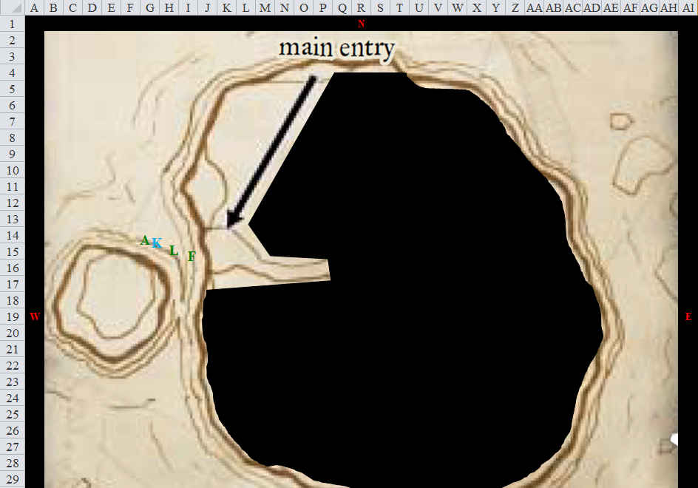

Round 7

Fingers activated its cloak to gain normal *invisibility [expired on Round 10]*.

Lauren stayed to the right of the tunnel and followed Fingers inside. She reserved her *haste* spell until an enemy showed itself, and planned to move at a steady pace that would allow the invisible changeling to stay ahead of her.

There were more bodies in the chamber beyond the cave entrance.

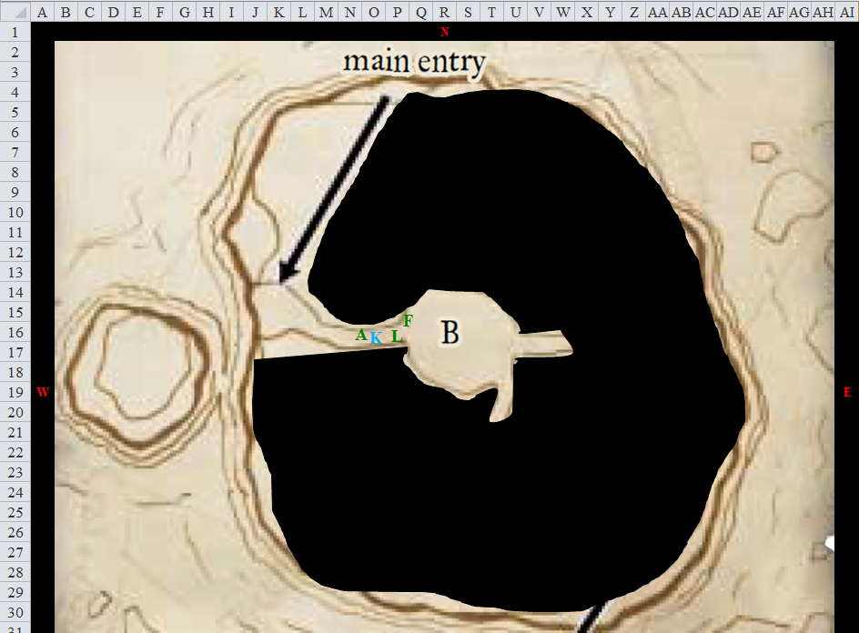

The heroes looked around the room, seeing the handful of humanoids who’d been frozen by icy dragon breath.

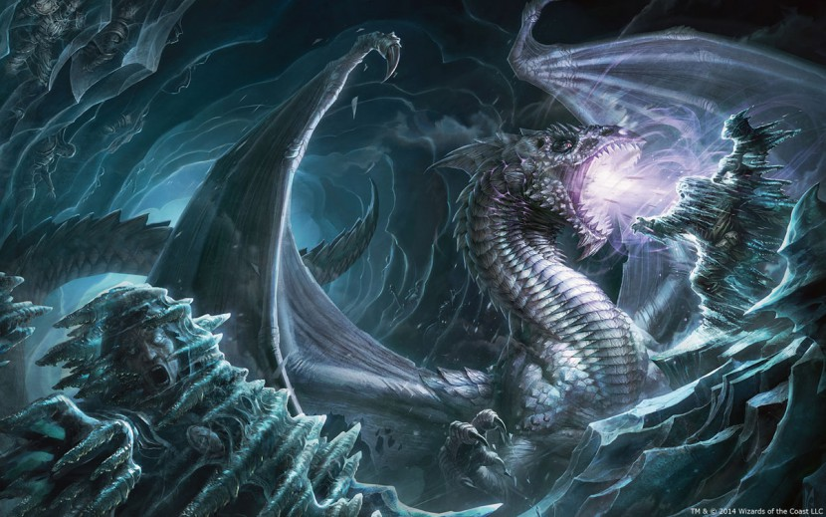

There were enough tracks so that Fingers and Lauren could re-piece the scene of the battle that took place here. There were at least two dragons involved, and these were Large and Huge, it seemed. Allisa identified a fellow druid amidst the frozen humanoids left here like warning sculptures.

Fingers eyed the ground leading into the two other exits from the chamber. While no trained tracker, the changeling figured creatures of such size would likely leave traces that even the inexperienced eye could spot. Once it decided on a path, it would whisper to the others the direction taken.



One path led upward, while the southernmost path led downward; this much Fingers could tell in its *invisible* state as they entered and walked by the frozen bodies left behind. Though both paths looked like they’d both been heavily trod upon, the 3 o’clock path had significantly fresher shavings of ice from the feet of Large creatures with imprinted hordeling-sized tracks on top of them to suggest the unlikely scenario that the smaller creatures may have outlived their larger counterparts.

What’s more, Fingers and Kedrik now heard movement, more of a rasping than a tapping, coming from the path that led upward.

Round 8

“Heading upward; sounds like something’s up there,” Fingers quietly informed Lauren. The changeling continued across the chamber while attempting to activate its wand.

|  |  |  |  |  |  |  |
| --- | --- | --- | --- | --- | --- | --- |
| **Skill** | **Rank** | **Ability & Mod.** | **Misc. Mods.** | **Total** | **Roll** | **Check** |
| **Fingers, Use Magic Device** | 15 | **Cha (+1)** | 0 | 16 | 12 | 28 |

*Success. Greater invisibility [expired on Round 14] manifested.*

|  |  |  |  |  |
| --- | --- | --- | --- | --- |
| **Character** | **Check** | **Ranks** | **Roll** | **Save** |
| NPC1 | Listen | 18 | 6 | 24 |
| NPC2 | Listen | 8 | 16 | 24 |
| NPC3 | Listen | 15 | 19 | 34 |

*Hee hee.*

Lauren lifted her sword tip upward in acknowledgement, and kept moving. As the drow passed the opening to the south, she looked that direction to see what was there. There was not much to see, other than a downward path of trod upon ice. The sound of water dripping was ever so faintly evident to the half-drow’s and half-elf’s ears as they walked by.

Kedrik saw the winged changeling disappear, and could now smell the flesh, wax, and dung of dragons. “*Bear’s heart*?” he whispered

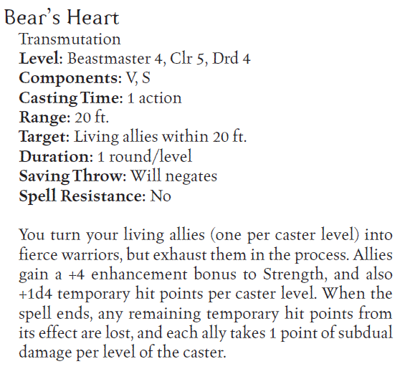

Kedrik often offered to cast this spell before a battle, and it had hitherto been eschewed by the others.

As usual, the women shook their heads and Kedrik kind of knew that Fingers did the same, so he did something equally impetuous, and cast *summon monster I* from a scroll, conjuring a Celestial giant fire beetle up ahead where Fingers couldn’t have run to just yet.

“Really?” Allisa whispered just loud enough for Lauren to hear. “I’ve got to get me a wand or something so I can see in the dark,” she said in a voice louder than a whisper. The druid felt around in her pack, looking for a glowstick, but pulling out and everburning torch and flipping the mechanism on to give her a bit of light. She tucked it through her belt then made sure to stay just far enough behind do she could follow the others and not bother their sight. Allisa was now holding her torch in her left hand and her scimitar in her right hand, and knew that she would not be able to cast spells with somatic components until she freed one hand. The light shone brightly in her face as the druid’s pupils contracted, and although Fingers was *invisible*, its winged shadow now gave away its position just ahead and to the left of Lauren.

*The map is now 5’ x 5’.*

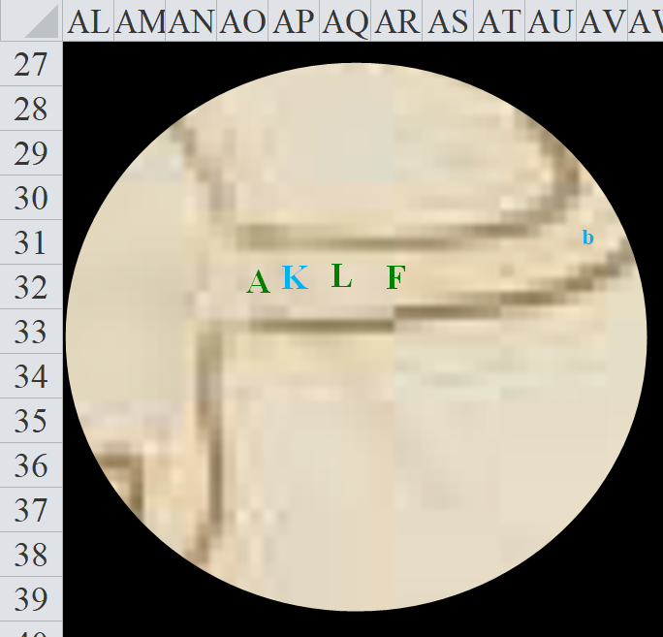

Round 9

The fire beetle made its way north. Then the sound of it being stabbed and poofing out of existence followed. A moment later, the sound of a potion vial being thrown to the icy floor and shattering was heard by all four heroes, and finally a higher-pitched growling than Best’s guttural roar they’d heard yesterday. There were dragons beyond the northward bend.

Movement behind them caused a slight flapping noise; all of the heroes failed to hear it. The indirect sunlight coming in through the tunnel cast the distorted shadow of a dragon closing in on them from behind: Nidhogrym. Allisa’s torch lit up the area, flooding the dim daylight that barely trickled in, obfuscating the shadow of the dragon gliding behind her.

The horse-sized dragon had been hunting much higher up than the carpet had been flying when the heroes got here not a minute ago, and had barely spotted them from within the clouds where it had been gliding. Now it landed, skidded a few feet towards Allisa, and gave her and the other two visible folks a nice spray of its icy dragon breath.

|  |  |  |  |  |  |  |
| --- | --- | --- | --- | --- | --- | --- |
| **Save vs.**  Breath Weapon | **Rank** | **Ability**  **& Mod.** | **Misc.**  **Mods.** | **Total** | **Roll** | **Check** |
| **Allisa, Reflex** | **6** | **Dex (+3)** | 0 | 9 | 12 | 21 |
| **Kedrik, Reflex** | **4** | **Dex (+4)** | 9 | 17 | 14 | 31 |
| **Lauren, Reflex** | **4** | **Dex (+2)** | 1 | 7 | 5 | 12 |

*Success, success, fail. Allisa and Kedrik saved for ½ damage.*

*Dmg to Allisa: ½ x 11 = 5 cold. Damage negated.*

*Dmg to Kedrik: ½ x 19 = 9 cold. Damage negated.*

*Dmg to Lauren: 15 cold. Damage negated.*

<< It’s Grym! >> a draconic voice cheered in its own language—understood only by Kedrik—from within the chamber towards which the heroes had been walking. Now, with a renewed sense of hope, the remaining dragon-types charged down from that chamber like a pack of rabid lizards. << Kiiiilllll! >>

And though no single wyrmling reached Lauren, at least three of them were now visible, and charging her.

Lauren Quick-cast *haste [expired on Round 22]*.

*Allisa, Fingers, Kedrik, and Lauren gained +1 to BAB, AC, Reflex saves, plus extra attack/movement.*

The drow then whirled around toward the larger dragon, whom she perceived as the greater threat. She muttered a few words, and quickly inscribed a symbol in the air with her sword tip, casting *swift fly [expired on Round 10]*, and channeling *vampiric touch*. Then, she flew toward the dragon, and slashed at it with her falchion.

|  |  |  |  |  |  |  |  |  |  |
| --- | --- | --- | --- | --- | --- | --- | --- | --- | --- |
| **Melee Weapon** | **Dmg** | **D+** | **TH+** | **Critical** | **Type** | **Wt.** | **Atk** | **Roll** | **Check** |
| Falchion +3 | 2d4 | +5 +3 | 3 | 18-20/x2 | Slashing | 8.0 | +22 | 12 | 34 |
| Falchion +3, *haste* | 2d4 | +5 +3 | 3 | 18-20/x2 | Slashing |  | +22 | *1* | 23 |

*Hit, miss. Dmg: 3 + 5 + 3 + 20 vampiric = 31.*

Fingers slashed at the unsuspecting lizardlike foe as it passed.

|  |  |  |  |  |  |  |  |  |  |  |
| --- | --- | --- | --- | --- | --- | --- | --- | --- | --- | --- |
| **Melee Weapon** | **Dmg** | **D+** | **TH+** | **Critical** | **Type** | **Wt.** | **Atk** | **Roll** | **Check** | **Notes** |
| Keen Deadly Precision Short Sword | 1d6 | 1 | 1 | 17-20, x2 | Piercing | 2.0 | +15 | 17 | 32 | +5d6 Sneak Attack |
| Crystal of Acid Assault, Lesser | - | 1d6 | - | - | - | - | - | - | - |  |

*Threat. 1d20 = 12 + 15 = 27, critical hit. Dmg: 2 x (6 + 1 + 2 acid + 17 sneak) = 48 + 4 acid = 52.*

Fingers killed the wyrmling.

Allisa began to receive a vision from her deity: Corellon Larethian. It would be days until she would come to a rudimentary understanding, followed by months of further rumination and finally a druidic epiphany. For now, the image consisted of just about the handsomest fey she’d ever seen. And though his features were chiseled and jagged, rugged and defined, the druid could not quite clearly make out his exact guise. He had long, flowing locks of dark, young hair with not a single sliver of silver on his resting mane, and he looked upon Allisa with the peculiar smile of a collector about to add a bug to his inventory.

And then the vision went away, and the sounds of the lush, biodiverse, subtropical forest faded into the echoing clanks of metal and flesh.

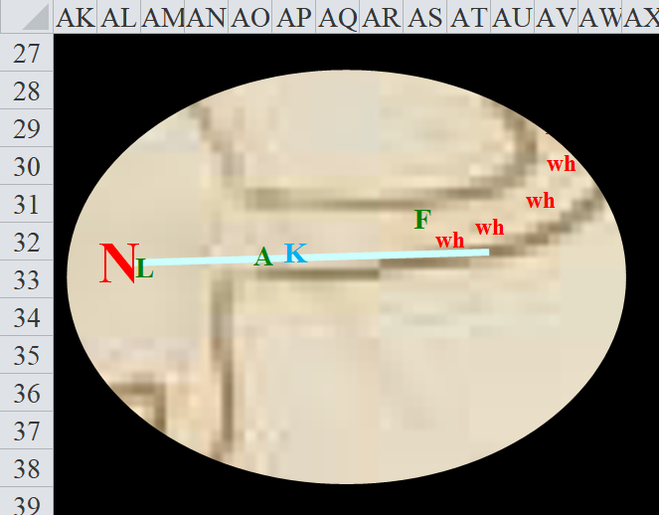

Round 10

|  |  |  |  |  |  |
| --- | --- | --- | --- | --- | --- |
| **Character** | **Group** | **Initiative** | **Roll** | **Modified**  **Roll** | **Move** |
| Whitespawn Hunter | 2 | 5 | 17 | 22 | 20’ |
| Kedrik | 1 | 2 | 17 | 19 | 30’ |
| Fingers | 1 | 4 | 12 | 16 | 30’ |
| Whitespawn Berserker (defer) | 2 | 6 | 3 | 9 | 30’ |
| Allisa | 1 | 3 | 5 | 8 | 30’ |
| Nidhogrym | 2 | 0 | 8 | 8 | 60’/200’f |
| Lauren | 1 | 4 | 1 | 5 | 30’ |
| Whitespawn Hordelings | 2 | 0 | 3 | 3 | 40’/20’f |
| Haaldisath | 2 | 0 | 1 | 1 | 60’/200’f |

Two whitespawn hunters made their way towards Kedrik. Because other hordelings were ahead of them, Fingers took the opportunity to attack the lesser creature before it had seen the larger.

*See below.*

Kedrik cast *flame strike* upon Grym.

|  |  |  |  |  |
| --- | --- | --- | --- | --- |
| **Character** | **Save vs.**  *flame strike* | **Ranks** | **Roll** | **Save** |
| Nidhogrym | Reflex | 9 | 16 | 25 |

*Success. Saved for ½ damage. Dmg: ½ x [(2 x 24 fire) + (25 divine)] = ½ x (48 fire+ 25 divine) = 24 fire + 12 divine = 36.*

The whisper gnome then spent a few seconds fending off the wyrmlings.

Fingers got a good few licks in on the nasty looking whitespawn hunter that got in his way.

|  |  |  |  |  |  |  |  |  |  |  |
| --- | --- | --- | --- | --- | --- | --- | --- | --- | --- | --- |
| **Melee Weapon** | **Dmg** | **D+** | **TH+** | **Critical** | **Type** | **Wt.** | **Atk** | **Roll** | **Check** | **Notes** |
| Keen Deadly Precision Short Sword | 1d6 | 1 | 1 | 17-20, x2 | Piercing | 2.0 | +15 | 9 | 24 | +5d6 Sneak Attack |
| Short Sword, 2nd Attack | 1d6 | 1 | 1 | 17-20, x2 | Piercing | - | +10 | 10 | 20 | Weapon Finesse |
| Short Sword, *haste* | 1d6 | 1 | 1 | 17-20, x2 | Piercing | - | +15 | 17 | 32 | Weapon Finesse |
| Crystal of Acid Assault, Lesser | - | 1d6 | - | - | - | - | - | - | - |  |

*Hit, hit, threat. 1d20 = 20, critical hit. Dmg: (2 + 1 + 1 acid + 21 sneak) + (4 + 1 + 6 acid + 23 sneak) + [2 x (1 + 1 + 5 acid + 13 sneak)] = 24 + 28 + 30 + 17 acid = 82 + 17 acid = 99.*

The hunter died on the spot.

Allisa turned at the noise of a creature landing behind her just in time to dodge to the side as she dropped the light source, saving her from the full blunt of the attack. She had realized the light had been a bad thing as she ignited it, but without it she could not see. With her hand freed, Allisa called forth *flame strike* upon the beast.

|  |  |  |  |  |
| --- | --- | --- | --- | --- |
| **Character** | **Save vs.**  *flame strike* | **Ranks** | **Roll** | **Save** |
| Nidhogrym | Reflex | 9 | 10 | 19 |

*Success. Saves for ½ damage. Dmg: 2 x ½ x 54 fire = 54 fire.*

Nidhogrym full-attacked Lauren, saying something in Draconic.

|  |  |  |  |  |  |  |  |  |  |  |  |  |  |
| --- | --- | --- | --- | --- | --- | --- | --- | --- | --- | --- | --- | --- | --- |
| **Character** | **Attack Type** | **Damage** | **Ranged?** | **BAB** | **Str Mod+** | **Dex Mod+** | **W+** | **Other+** | **Total Score** | **Roll** | **Total** | **Crit** | **Threat** |
| Nidhogrym | Bite | 2d6+4 | ❑ | 15 | 3 | 0 | 0 | 0 | 18 | 12 | 30 | 20 | ☒ |
| Nidhogrym | Claw 1 | 1d8+2 | ❑ | 15 | 3 | 0 | 0 | 0 | 18 | 9 | 27 | 20 | ☒ |
| Nidhogrym | Claw 2 | 1d8+2 | ❑ | 15 | 3 | 0 | 0 | 0 | 18 | 10 | 28 | 20 | ☒ |
| Nidhogrym | Wing 1 | 1d6+2 | ❑ | 10 | 3 | 0 | 0 | 0 | 13 | 13 | 26 | 20 | ☒ |
| Nidhogrym | Wing 2 | 1d6+2 | ❑ | 10 | 3 | 0 | 0 | 0 | 13 | 12 | 25 | 20 | ☒ |
| Nidhogrym | Tail | 1d8+6 | ❑ | 15 | 3 | 0 | 0 | 0 | 18 | 20 | 38 | 20 | ☑ |

*Hit, miss, miss, miss, miss, threat. 1d20 = 14 + 18 = 32, critical hit.*

*Dmg: (5 + 4) + [2 x (7 + 6)] = 9 + 26 = 35 [115/124(150)].*

More insulted than wounded, Lauren channeled *vampiric touch* again, and swung four times at the dragon.

|  |  |  |  |  |  |  |  |  |  |
| --- | --- | --- | --- | --- | --- | --- | --- | --- | --- |
| **Melee Weapon** | **Dmg** | **D+** | **TH+** | **Critical** | **Type** | **Wt.** | **Atk** | **Roll** | **Check** |
| Falchion +3 | 2d4 | +5 +3 | 3 | 18-20/x2 | Slashing | 8.0 | +22 | 8 | 30 |
| Falchion +3, 2nd Attack | 2d4 | +5 +3 | 3 | 18-20/x2 | Slashing |  | +17 | 7 | 24 |
| Falchion +3, 3rd Attack | 2d4 | +5 +3 | 3 | 18-20/x2 | Slashing |  | +12 | 12 | 24 |
| Falchion +3, *haste* | 2d4 | +5 +3 | 3 | 18-20/x2 | Slashing |  | +22 | 9 | 31 |

*Hit, hit, hit, hit. Dmg: (6 + 5 + 3) + (5 + 5 + 3) + (6 + 5 + 3) + (6 + 5 + 3) = 14 + 13 + 14 +14 = 55.*

The horse-sized dragon died.

There were five whitespawn hordelings now in sight. As they made way for Kedrik, Fingers swiped at the frontmost one that was hopping over the one that Fingers had just slain.

|  |  |  |  |  |  |  |  |  |  |  |
| --- | --- | --- | --- | --- | --- | --- | --- | --- | --- | --- |
| **Melee Weapon** | **Dmg** | **D+** | **TH+** | **Critical** | **Type** | **Wt.** | **Atk** | **Roll** | **Check** | **Notes** |
| Keen Deadly Precision Short Sword | 1d6 | 1 | 1 | 17-20, x2 | Piercing | 2.0 | +15 | 14 | 29 | +5d6 Sneak Attack |
| Crystal of Acid Assault, Lesser | - | 1d6 | - | - | - | - | - | - | - |  |

*Hit. Dmg: 3 + 1 + 5 acid + 18 sneak = 22 + 5 acid = 27.*

The second hordeling died.

The other four continued towards Kedrik, and two were able to reach him and charge-attack him.

|  |  |  |  |  |  |  |  |  |
| --- | --- | --- | --- | --- | --- | --- | --- | --- |
| **Character** | **Attack Type** | **Damage** | **BAB** | **Str Mod+** | **W+** | **Total Score** | **Roll** | **Total** |
| Whitespawn Hordeling | MW Kukri | 1d4/18-20 | 0 | 1 | 1 + 2 charge | 4 | 16 | 20 |
| Whitespawn Hordeling | Bite | 1d4 | 2 | 1 | 2 charge | 5 | 17 | 22 |

*Miss, miss.*

A whitespawn berserker stumbled onto Fingers.

|  |  |  |  |  |  |  |
| --- | --- | --- | --- | --- | --- | --- |
| **Save vs.**  *Falling* | **Rank** | **Ability & Mod.** | **Misc. Mods.** | **Total** | **Roll** | **Check** |
| **Fingers, Reflex** | **10** | **Dex (+4)** | 1 | 15 | 6 | 21 |

*Success.*

|  |  |  |  |  |
| --- | --- | --- | --- | --- |
| **Character** | **Save vs.**  Falling | **Ranks** | **Roll** | **Save** |
| Whitespawn Berserker | Reflex | 8 | 15 | 23 |

*Success.*

The invisible rogue and the confused berserker remained on their feet. The berserker began to swing.

|  |  |  |  |  |  |  |  |  |  |  |
| --- | --- | --- | --- | --- | --- | --- | --- | --- | --- | --- |
| **Character** | **Attack Type** | **Damage** | **BAB** | **Str Mod+** | **W+** | **Total Score** | **Roll** | **Total** | **Crit** | **Threat** |
| Whitespawn Berserker | MW Spiked Chain | 2d4+10 | 8 | 8 | -4 blind  to target | 16 | 2 | 18 | 20 | ☒ |

*Miss.*

Haaldisath, a smaller dragon than Grym, was the last to emerge from the lofty chamber, but was not close enough to a visible target, and had too many wyrmlings in her way that would block out her dragon breath, so she sought to reposition herself.

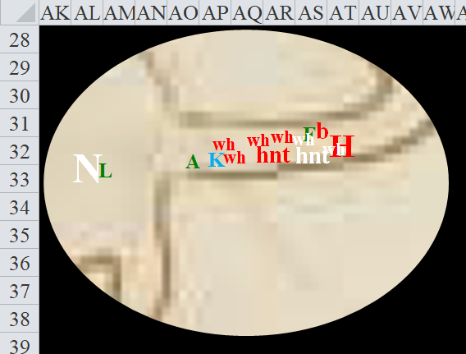

Round 11

The remaining whitespawn hunter charge-attacked Kedrik.

|  |  |  |  |  |  |  |  |  |  |
| --- | --- | --- | --- | --- | --- | --- | --- | --- | --- |
| **Character** | **Attack Type** | **Damage** | **BAB** | **Str Mod+** | **W+** | **Other+** | **Total Score** | **Roll** | **Total** |
| Whitespawn Hunter 1 | MW Ranseur | 2d4+3 | 6 | 2 | 1 | 0 | 9 | 7 | 16 |
| Whitespawn Hunter 1 | MW Ranseur | 2d4+3 | 1 | 2 | 1 | 0 | 4 | 15 | 19 |

*Miss, miss.*

Seeing that the battle was nearly over within seconds, Kedrik shook his head and cast *sanctuary [expired on Round 24]*.

Fingers full-attacked the berserker that threatened the winged changeling.

|  |  |  |  |  |  |  |  |  |  |  |
| --- | --- | --- | --- | --- | --- | --- | --- | --- | --- | --- |
| **Melee Weapon** | **Dmg** | **D+** | **TH+** | **Critical** | **Type** | **Wt.** | **Atk** | **Roll** | **Check** | **Notes** |
| Keen Deadly Precision Short Sword | 1d6 | 1 | 1 | 17-20, x2 | Piercing | 2.0 | +15 | 3 | 18 | +5d6 Sneak Attack |
| Short Sword, 2nd Attack | 1d6 | 1 | 1 | 17-20, x2 | Piercing | - | +10 | 12 | 22 | Weapon Finesse |
| Short Sword, *haste* | 1d6 | 1 | 1 | 17-20, x2 | Piercing | - | +15 | **19** | 34 | Weapon Finesse |
| Crystal of Acid Assault, Lesser | - | 1d6 | - | - | - | - | - | - | - |  |

*Hit, hit, threat. 1d20 = 4 + 15 = 19, critical hit.*

*Dmg: (5 + 1 + 6 acid + 11 sneak) + (5 + 1 + 1 acid + 15 sneak) + [2 x (3 + 1 + 5 acid + 13 sneak)] = 72 + 17 acid = 89.*

The whitespawn berserker was nearly decimated in a single round. The winged rogue managed to lob off the berserker’s left arm, and even part of his right shoulder, but the reptile remained a standing threat. The barely living foe swung again at the invisible changeling.

|  |  |  |  |  |  |  |  |  |  |
| --- | --- | --- | --- | --- | --- | --- | --- | --- | --- |
| **Character** | **Attack Type** | **Damage** | **BAB** | **Str Mod+** | **W+** | **Other+** | **Total Score** | **Roll** | **Total** |
| Whitespawn Berserker | MW Spiked Chain | 2d4+10 | 8 | 8 | 0 | -4 blind | 12 | 17 | 29 |
| Whitespawn Berserker | MW Spiked Chain, 2nd | 2d4+10 | 3 | 8 | 0 | to target | 7 | 3 | 10 |

*Hit, miss. Dmg: 6 + 10 = 16 [56/72].*

The whitespawn hordelings saw the *sanctuary* spell around Kedrik, but couldn’t identify it, so they kept on attacking the gnome.

|  |  |  |  |  |
| --- | --- | --- | --- | --- |
| **Character** | **Save vs.**  *sanctuary* | **Ranks** | **Roll** | **Save** |
| Whitespawn Hordeling | Will | 2 | 19 | 21 |
| Whitespawn Hordeling | Will | 2 | 10 | 12 |
| Whitespawn Hordeling | Will | 2 | 7 | 9 |

*Success, fail, fail.*

|  |  |  |  |  |  |  |  |  |  |
| --- | --- | --- | --- | --- | --- | --- | --- | --- | --- |
| **Character** | **Attack Type** | **Damage** | **BAB** | **Str Mod+** | **W+** | **Other+** | **Total Score** | **Roll** | **Total** |
| Whitespawn Hordeling | MW Kukri | 1d4/18-20 | 0 | 1 | 1 | 0 | 2 | 12 | 14 |

*Miss.*

One of the hordelings went for Allisa.

|  |  |  |  |  |  |  |  |  |  |  |  |  |
| --- | --- | --- | --- | --- | --- | --- | --- | --- | --- | --- | --- | --- |
| **Character** | **Attack Type** | **Damage** | **Ranged?** | **BAB** | **Dex Mod+** | **W+** | **Other+** | **Total Score** | **Roll** | **Total** | **Crit** | **Threat** |
| Whitespawn Hordeling | Dart +1 | 1d3+1 | ☑ | 2 | 0 | 1 | 0 | 3 | 20 | 23 | 20 | ☑ |

*Threat. 1d20 = 15 + 3 = 18, not a critical hit. Dmg: 1 + 1 = 2 [76/78].*

Realizing that Kedrik would not be an easy mark, the other hordelings also turned their eyes on Allisa.

Haaldisath flew over the lesser dragonlings in the tunnel, and pounced upon Kedrik, but not before the *invisible* avariel-shaped fellow swiped at the dragon’s underbelly from below.

|  |  |  |  |  |  |  |  |  |  |  |
| --- | --- | --- | --- | --- | --- | --- | --- | --- | --- | --- |
| **Melee Weapon** | **Dmg** | **D+** | **TH+** | **Critical** | **Type** | **Wt.** | **Atk** | **Roll** | **Check** | **Notes** |
| Keen Deadly Precision Short Sword | 1d6 | 1 | 1 | 17-20, x2 | Piercing | 2.0 | +15 | 2 | 17 | +5d6 Sneak Attack |
| Crystal of Acid Assault, Lesser | - | 1d6 | - | - | - | - | - | - | - |  |

*Miss (vs. FF AC).*

The young dragon’s hide was too thick for its half-hearted slice. It was better to focus on the nearly finished berserker for now.

*[DM assumption]* Allisa apologized to one of the hordelings in her midst, and zapped it with a bolt of *lightning*.

|  |  |  |  |  |  |
| --- | --- | --- | --- | --- | --- |
| **Ranged Weapon** | **Dmg.** | **Atk** | **Roll** | **Check** | **Notes** |
| Ranged Touch Attack | 3d6 | +13 | 7 | 20 | 9 bolts left |

*Hit. Dmg: electric.*

Seeing the dragon foe before her truly dead, and Allisa being harassed by rabid runts that would probably end up on a kabob now that the drow had acquired a taste for their meat, Lauren cast *swift fly* again, channeled *shocking grasp*, and attacked the nearest wyrmling. She had to work through the wyrmlings to reach the other dragon, and she grimly set out on that task.

|  |  |  |  |  |  |  |  |  |  |
| --- | --- | --- | --- | --- | --- | --- | --- | --- | --- |
| **Melee Weapon** | **Dmg** | **D+** | **TH+** | **Critical** | **Type** | **Wt.** | **Atk** | **Roll** | **Check** |
| Falchion +3 | 2d4 | +5 +3 | 3 + 2 charge | 18-20/x2 | Slashing | 8.0 | +24 | 13 | 37 |
| Falchion +3, *haste* | 2d4 | +5 +3 | 3 | 18-20/x2 | Slashing |  | +22 | 11 | 33 |

*Hit, hit. Dmg: (6 + 5 + 3 + 2 charge + 20 electric) + (5 + 5 + 3) = 16 + 13 + 20 electric = 49.*

The wyrmling died by the first slash; the second was Lauren’s gratuitous decapitation, aimed at intimidating the survivors.

|  |  |  |  |  |  |  |
| --- | --- | --- | --- | --- | --- | --- |
| **Skill** | **Rank** | **Ability & Mod.** | **Misc. Mods.** | **Total** | **Roll** | **Check** |
| **Lauren, Intimidate** | 0 | **Cha (+3)** | 0 | 3 | 16 | 19 |

*All enemies became Shaken, suffering a –2 penalty on attack rolls, saving throws, skill checks, and ability checks..*

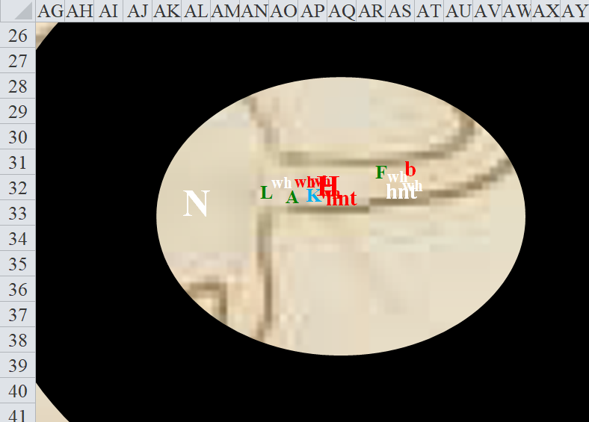

Round 12

The whitespawn hunter charge-attacked Kedrik.

|  |  |  |  |  |
| --- | --- | --- | --- | --- |
| **Character** | **Save vs.**  *sanctuary* | **Ranks** | **Roll** | **Save** |
| Whitespawn Hunter | Will | 6 – 2 | 17 | 21 |

*Success.*

|  |  |  |  |  |  |  |  |  |  |
| --- | --- | --- | --- | --- | --- | --- | --- | --- | --- |
| **Character** | **Attack Type** | **Damage** | **BAB** | **Str Mod+** | **W+** | **Other+** | **Total Score** | **Roll** | **Total** |
| Whitespawn Hunter 1 | MW Ranseur | 2d4+3 | 6 – 2 | 2 | 1 | 0 | 7 | 12 | 19 |

*Miss.*

Kedrik looked up at the hunter that threatened him outside of the cylinder that kept him safe. Once he attacked, the cylinder would disappear, so he cast *holy transformation [expired on Round 25]*—a personal buff—and prepared to do battle with the hunter. During the span of three seconds, the whisper gnome took on the guise and qualities of a hound archon, one of the most revered Celestial creature, in the gnome’s estimation.

*Kedrik gained Medium size (plus a consequent -1 to AC), +4 to Strength and Constitution, Darkvision (60’, redundant), +4 on all saves, and DR 5/evil. All evil foes take -2 penalty to saves vs. Kedrik’s actions.*

<< You sure you’re up to this? >> the archon-resembling archivist asked the Shaken hunter and white dragon in Draconic.

Fingers took two swings at the grievously wounded berserker then moved towards the cluster of foes around Kedrik figuring, even if it happened to miss, the invisible lurker would be positioned to give it another chop if the one-armed lizard was foolish enough to try charging into the fray.

|  |  |  |  |  |  |  |  |  |  |  |
| --- | --- | --- | --- | --- | --- | --- | --- | --- | --- | --- |
| **Melee Weapon** | **Dmg** | **D+** | **TH+** | **Critical** | **Type** | **Wt.** | **Atk** | **Roll** | **Check** | **Notes** |
| Keen Deadly Precision Short Sword | 1d6 | 1 | 1 | 17-20, x2 | Piercing | 2.0 | +15 | 9 | 24 | +5d6 Sneak Attack |
| Short Sword, *haste* | 1d6 | 1 | 1 | 17-20, x2 | Piercing | - | +15 | 15 | 30 | Weapon Finesse |
| Crystal of Acid Assault, Lesser | - | 1d6 | - | - | - | - | - | - | - |  |

*Hit, hit. Dmg: (4 + 1 + 2 acid + 18 sneak) + (5 + 1 + 5 acid + 20 sneak) = 23 + 26 + 7 acid = 59 + 7 acid = 66.*

Fingers practically liquefied the berserker, whose body parts were now all over the ground.

The rogue then moved to within 5’ of the nearest wyrmling, standing a bit to the side so as to AOO the berserker if it was still up and tried charging Kedrik. This also put him 5’ from and behind Haaldisath, the smaller of the two dragons to be vanquished before this piece of real estate would be on the finders’ market once again.

Seeing the dragon foe before her truly dead, and Allisa being harassed by rabid runts that would probably end up on a kabob now that the drow had acquired a taste for their meat, Lauren cast *swift fly* again, channeled *shocking grasp*, and attacked the nearest wyrmling. She had to work through the wyrmlings to reach the other dragon, and she grimly set out on that task. She swung once at the frontmost one, then set out to slay the next, even if she hadn’t killed the first one yet. Given how weak they were, this would likely yield the highest kill-per-round ratio, and *hastened*, she would likely reach the dragon within 6 seconds.

|  |  |  |  |  |  |  |  |  |  |
| --- | --- | --- | --- | --- | --- | --- | --- | --- | --- |
| **Melee Weapon** | **Dmg** | **D+** | **TH+** | **Critical** | **Type** | **Wt.** | **Atk** | **Roll** | **Check** |
| Falchion +3 | 2d4 | +5 +3 | 3 | 18-20/x2 | Slashing | 8.0 | +22 | 15 | 37 |
| Falchion +3, 2nd Attack | 2d4 | +5 +3 | 3 | 18-20/x2 | Slashing |  | +17 | 14 | 31 |
| Falchion +3, 3rd Attack | 2d4 | +5 +3 | 3 | 18-20/x2 | Slashing |  | +12 | 14 | 26 |
| Falchion +3, *haste* | 2d4 | +5 +3 | 3 | 18-20/x2 | Slashing |  | +22 | 16 | 38 |
| Truedeath Crystal, Lesser | 1d6 | vs. | undead |  |  |  |  |  |  |

*Hit, hit, hit, hit.*

*Dmg to wyrmling 4: 7 + 5 + 3 + 18 electric = 33.*

*Dmg to wyrmling 5: 4 + 5 + 3 + 21 electric = 33.*

*Dmg to wyrmling 5: 6 + 5 + 3 + 11 electric = 25.*

*Dmg to Haaldisath: 5 + 5 + 3 + 16 electric = 29.*

The whitespawn hordelings all died, and the half-drow stepped over each fresh corpse as she made her way towards Haaldisath.

Haaldisath did her best to full-attack Kedrik, who was now the spitting image of a hound archon.

|  |  |  |  |  |
| --- | --- | --- | --- | --- |
| **Character** | **Save vs.**  *sanctuary* | **Ranks** | **Roll** | **Save** |
| Haaldisath | Will | 8 – 2 | 5 | 11 |

*Fail.*

The senior dragon’s failure further demoralized the hunter, who was the only remaining adversary left besides her.

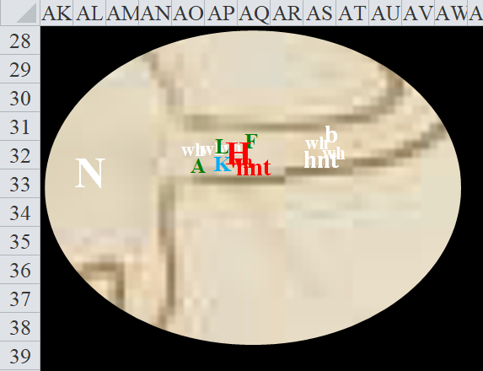

Round 13

The dragon and whitespawn hunter full-attacked Kedrik, seeing him as the softest target.

|  |  |  |  |  |  |  |  |  |  |
| --- | --- | --- | --- | --- | --- | --- | --- | --- | --- |
| **Character** | **Attack Type** | **Damage** | **BAB** | **Str Mod+** | **W+** | **Other+** | **Total Score** | **Roll** | **Total** |
| Haaldisath | Bite | 1d8+3 | 12 | 3 | 0 | -2 Shaken | 13 | 11 | 24 |
| Haaldisath | Claw 1 | 1d6+1 | 12 | 3 | 0 | -2 Shaken | 13 | 3 | 16 |
| Haaldisath | Claw 2 | 1d6+1 | 12 | 3 | 0 | -2 Shaken | 13 | 6 | 19 |
| Haaldisath | Wing 1 | 1d6+4 | 7 | 3 | 0 | -2 Shaken | 8 | 1 | 9 |
| Haaldisath | Wing 2 | 1d6+4 | 7 | 3 | 0 | -2 Shaken | 8 | 17 | 26 |
| Whitespawn Berserker | MW Spiked Chain | 2d4+10 | 8 | 8 | 0 | -2 Shaken | 14 | 9 | 23 |
| Whitespawn Berserker | MW Spiked Chain, 2nd | 2d4+10 | 3 | 8 | 0 | -2 Shaken | 9 | 4 | 13 |

*Miss, miss, miss, miss, hit, miss, miss. Dmg: 5 + 4 = 9.*

Lauren landed to fight on her feet, and channeled *shocking grasp* as she tried to finish off Haaldisath.

|  |  |  |  |  |  |  |  |  |  |
| --- | --- | --- | --- | --- | --- | --- | --- | --- | --- |
| **Melee Weapon** | **Dmg** | **D+** | **TH+** | **Critical** | **Type** | **Wt.** | **Atk** | **Roll** | **Check** |
| Falchion +3 | 2d4 | +5 +3 | 3 | 18-20/x2 | Slashing | 8.0 | +22 | 10 | 32 |
| Falchion +3, 2nd Attack | 2d4 | +5 +3 | 3 | 18-20/x2 | Slashing |  | +17 | 13 | 30 |
| Falchion +3, 3rd Attack | 2d4 | +5 +3 | 3 | 18-20/x2 | Slashing |  | +12 | 6 | 18 |
| Falchion +3, *haste* | 2d4 | +5 +3 | 3 | 18-20/x2 | Slashing |  | +22 | 6 | 28 |

*Hit, hit, miss, hit. Dmg: (2 + 5 + 3 + 18 electric) + (4 + 5 + 3) + (6 + 5 + 3) = 10 + 12 + 14 + 18 electric = 54.*

Haaldisath died.

Kedrik—in hound form—shook his head at the hunter, and dispelled his own *sanctuary* spell by casting *diamond spray* upon the sole reptile in the room.

|  |  |  |  |  |
| --- | --- | --- | --- | --- |
| **Character** | **Save vs.**  *diamond spray* | **Ranks** | **Roll** | **Save** |
| Whitespawn Hunter | Reflex | 6 | 20 | 26 |

*Success. Saved for ½ damage.*

*Dmg: 45 + dazzle.*

*Dmg to non-evil characters within the cone: 0.*

And with this, the evil dragon and the hunter died.

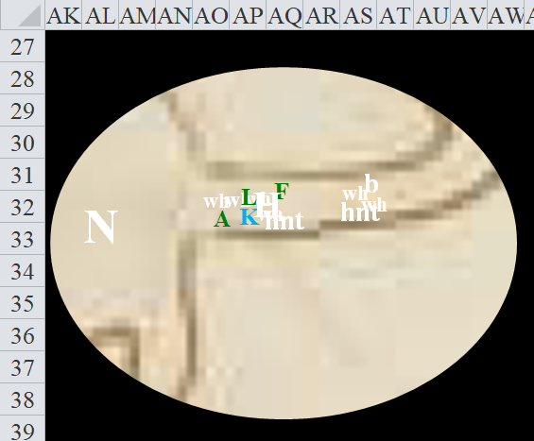

“Keep moving,” Lauren said just loudly enough for her companions to hear. “There may be others up there.” The duskblade pointed eastward with her falchion, which dripped with the blood of her enemies.

“Well, a shame all our battles can’t go as well as this one,” commented Fingers. “I’m going to take a quick look up that passageway while my spells are active to see if anything else is lurking. Back in a bit.” The *invisible* changeling sped up the slope with its *haste*-enhanced speed.

Round 14

Lauren stepped over to Allisa. “Hold onto my shoulder, my love, and I will guide you.”

The druid scooped up the light source and flipped it off stuffing it into her pouch. She placed her hand on Lauren’s should and followed as she thought of the vision she had just seen.

Kedrik had been saving his only *endure elements* scroll for a truly cold day, and inside this chamber, it was actually colder than out in the sun, so he decided to cast it *[expired in 24 hours]*. The gnome then undid some of the clasps on his furs, feeling much more at home.

Fingers became visible once again.

~*~

Rounds 22 – 24

The Gambit’s senior members had done a thorough job of clearing out the den of dragons. With care, they ascended into the chamber where the dragons and other spawns had been huddling, and found only a few mundane blankets, some dragon toys, and food, but no treasure of any sort.

Their *haste* boost now ended.

Then they decided to go downward along the eastern and quickly winding southward and downward tunnel. However, they only got about 15’ along this decline before the surface of a body of chilly water greeted them.

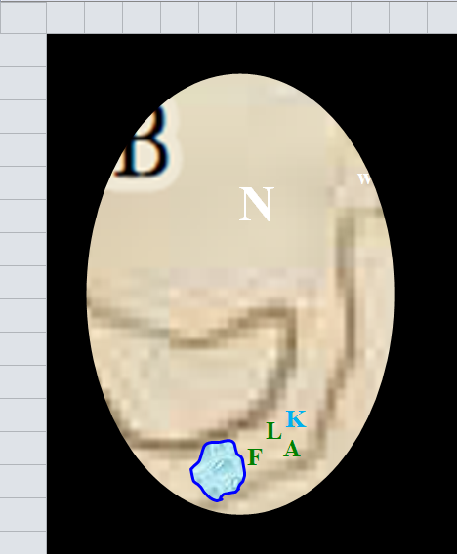

Round 25

Fingers then spotted a gold coin on the ground.

Lauren tried to see the extent of the water from where she was standing. “There is water here,” she told Allisa. “I am looking to see if there is anything beyond.”

Rounds 26 – 27

“Well, then a dragon might be able to survive that cold water, but I doubt we can without special water breathing spells and resistance to cold. I might be able to transform into a seal but, that would make me dragon food,” said Allisa. “Any other ideas?”

“Yes, but I don’t want to take off my armor right now,” Lauren deadpanned. “Let’s wait while Fingers explores.”

Round 28

“No sense you getting wet and taking a chill,” suggested Fingers. “I’ll take a look around to see if this might’ve been Best’s hidden cache.” As the changeling spoke, its wings shrank back into its body while its skin took on a bluish tinge and webbing grew between its fingers. Kicking off its boots to reveal equally webbed toes the now sea elf-shaped trapmaster emptied pockets of items water would not be a friend to and shrugged off its backpack.

Rounds 29 – 30

“Allisa, you can use a small light. We can’t go any further without going in the water.”

“I just cast *endure elements*,” Kedrik reminded them. “I could also go in with Fingers if need be, or with Allisa if she wants to become a manatee or something.”

Round 31

“I do not have *endure elements* learned. And you said a what-a-tee? I have not studied that animal before,” said Allisa.

The encyclopedic gnome sighed, “How about a polar bear? Like the one we saw on our way here from Triboar.”

Round 32

“Ah a polar bear! I did take note of him, plus I have studied them, bears being one of my favorite animals. Oh, the last animal I was studying was a koala bear. They are so cute.”

Round 33

Allisa looked to Lauren. “Will you be fine up here by yourself?”

Fingers waited for a response, willing to go in the water, alone or otherwise.

The druid hesitated. Having only ever shapechanged into brown and black bears, she hadn’t studied the polar bear they’d passed beyond a cursory glance, and didn’t want to chance an accidental shapeshifting into a jellyfish instead. That *had* happened to more than one druid.

Fingers shrugged and smiled, then entered the water, looking back with a calm, scaly face. “Be back in a bit.”

Allisa eventually eschewed her hesitation and changed into a polar bear, diving in after Fingers.

~*~

Round 63

“They’ve been gone quite a while,” Kedrik murmured, referring to the changeling with a masculine pronoun. The gnome was not a very good liar, so he’d told Fingers that he didn’t want to get accustomed to calling it “it” so that it didn’t slip out in conversation when Fingers was undercover and they were in the company of strangers.

Lauren had already started pacing in and out of the narrow tunnel. She was now in the circular chamber where they’d fought the dragons just minutes ago, and saw an ice thoqqua entering the chamber from the west and coming for her. It was hardly a threat, and reminded her of a really fast slug as it slithered towards her.

She skewered it with the tip of her falchion, holding it down, and used her right foot to crush its head before coming back into the tunnel and joining the others at the surface of the water.

“There they are!” the whisper gnome whispered with relief.

Round 64

The blue elf emerged from the icy waters still smiling, and the polar bear emerged seconds thereafter.

In the changeling’s left hand were some coins and gems, and in its right hand was a white scepter that looked nearly identical in shape to the black scepter they’d found in Supreme Defiance’s lair. “There’s probably more treasure than Kedrik’s and Lauren’s haversacks can carry.”

“I have a haversack too,” Allisa reminded Fingers.

“Oh, right. Well, there’s probably still more than three haversacks can carry.”

Round 65

“We may have to dump some of the stuff out of our sacks then,” Kedrik said. “What kind of treasure?”

Round 66

“The dragon hoard kind, mostly shiny things, all metal or stone,” Fingers summarized. “Some weapons and armor—some with the bones of warriors still inside them—but mostly ornate preciosities.”

Round 67

“And no monsters?” Kedrik had to confirm.

Rounds 68 – 69

“Yes, there were two ice thoqquas, but they weren’t a big threat. Looks like the dragons were keeping them as pets and throwing them scraps every so often. There’re probably about 20 skeletons down there, none intact, and I didn’t see any hints of necromancy or any other indication that the bones would turn to combatants.”

Round 70

Lauren mentioned the one that now lay dead just outside this shaft.

Fingers nodded as it rummaged thru its gear, sorting out the mundane stuff to make room for goodies. The bedroll, blanket and most of the trail rations were an easy decision—roughing it for a few nights would be well worth making room for more treasure and its amulet would keep the cold at bay anyhow. Thieves’ tools? Kind of bulky and the lockpicking ring takes up the slack. Trapmaking kit? The changeling lingered over that one a bit longer but finally set it aside with a sigh... the freed-up space would allow more than enough gold to replace it and, worst case scenario, if the need arose there would be a good chance of scrounging enough materials to reliably make most of the types known.

“Let me have one of those haversacks and I’ll go fill up a load. If one of you who can pick out magical stuff wants to come along, that’ll save time. Otherwise, I’ll haul back the stuff that looks especially well made for checking out,” the changeling said, while adding ‘Wand of *detect magic*’ to the ever-growing mental shopping list of things it’d be nice to have when needed.

Lauren removed her magical haversack, emptied it, and handed it to Fingers. “It holds a hundred and twenty pounds, which is about six thousand gold coins, if my counting is correct.”

“Well, it might be best to choose and pick and leave the rest. We can come back for more after we prepare better.” I would hate to leave my stuff here,” said the druid. “Don’t forget all the equipment on those how died. We might want to collect it first and dump what we cannot carry in the water.”

“Alright, let’s play *I’ll Show You Mine*,” Kedrik was right to propose, opening up his haversack and neatly pouring out its contents—mostly books, notepads, and other bound ledgers—onto the icy ground in the main chamber where they’d also dragged the dragons and their ilk against the wall.

Kedrik and Lauren had just finished a brief discussion regarding a hordeling barbecue, which would have to be done outside unless they wanted to melt the ice above them and possibly get caved in and squashed.

|  |  |  |
| --- | --- | --- |
| *Kedrik’s Handy Haversack* |  |  |
| **Item** | **Qty.** | **Wt.** |
| Atlases | * | 8.0 |
| Books on Dark Knowledge | * | 16.0 |
| Books on Superstition | * | 22.0 |
| City Watch Documents | * | 6.0 |
| Dictionaries, Polyglot | * | 10.0 |
| Personal Documents | * | 1.0 |
| Records of Previous Cases | * | 2.0 |
| Spare Clothing | * | 12.0 |

Fingers—still in aquatic elven form—was the only one without a haversack, and so it simply watched as its friends unloaded their backup gear.

|  |  |  |
| --- | --- | --- |
| *Allisa’s Handy Haversack* | | |
| **Item** | **Qty.** | **Wt.** |
| Candles | 2 | 0.0 |
| Everlasting Rations | 1 | 2.0 |
| Everfull Mug | 1 | 0.0 |
| Flint & Steel | 1 | 0.0 |
| Hemp Rope | 1 | 5.0 |
| Holly and Mistletoe | 1 | 0.0 |
| Sacks | 2 | 1.0 |
| Soap | 1 | 0.0 |
| Earplugs, pair | 1 | 0.0 |
| Everburning Torch | 1 | 1.0 |
| Waterskin | 1 | 4.0 |
| Whistle, Silver | 1 | 0.0 |
| Whetstone | 1 | 0.0 |
| Smoke Pellet | 2 | 0.0 |
| *Lauren’s Handy Haversack* | | |  |  |
| **Item** | | | **Qty.** | **Wt.** |
| Personal Grooming Kit | | | 1 | 1.0 |
| Ropes, 50’ | | | 4 | 40.0 |
| Hammers | | | 4 | 8.0 |
| Grapnels | | | 4 | 16.0 |
| Pitons | | | 50 | 25.0 |
| Casual Outfit | | | 1 | 5.0 |
| Hastened Carpet of Flying, 10’ x 10’ | | | 1 | 10.0 |
| Bedroll | | | 5 | 5.0 |
| Flint and Steel | | | 1 | 0.0 |
| Shortbows | | | 17 | 34.0 |
| Arrows | | | 119 | 17.9 |
| Full Plate of Improved Stamina | | | 1 | 50.0 |
| Scrolls | | | 16 | 0.0 |
| Potions | | | 9 | 4.5 |
| Trail Rations | | | 10 | 10.0 |
| Waterskin | | | 1 | 4.0 |

~*~

Two hours later...

The sun had set, and the group had retrieved just about everything from the pool below, fought off about sixteen ice thoqquas, organized their loot—as well as the rest of the contents of their haversacks—into piles, and were now in a position to decide what to keep.

“If we’re going to leave anything behind that we brought with us,” Kedrik looked up at the others, “My vote is for the 17 shortbows there. Let’s eat up all but a few days’ worth of dry rations, and butcher us some of these calves. Take only boneless meat with us to eat on the first day.”

Aside from their own goods, which were now ready to be reinserted into the sacks if selected, they now studied the contents of the hoard:

* jade bust of a rather outlandish looking humanoid
* life size crystal statue of a pseudodragon
* set of ivory and obsidian chess pieces (no board)
* candelabra encrusted with gems
* phylactery with Draconic writing
* horn engraved with musical intentions with 7 holes, gilded mouthpiece
* bronze urn
* nearly complete set of silverware
* beech wood quarterstaff
* 2 wands
* 48 rings
* 14 amulets
* gold clasp
* longsword
* bastard sword
* greatsword
* short sword
* scimitar
* rapier
* falchion
* light mace
* heavy mace
* light flail
* heavy flail
* 33 kukris
* sickle
* scythe
* 11 daggers
* gnome hooked hammer
* warhammer
* full plate suit
* 2 half plate suits
* chainmail
* chain shirt
* breastplate
* splint mail
* banded mail
* 3 light steel shields
* 3 heavy steel shields
* tower shield
* 6 bucklers
* pair of silver bracers
* 1,675 gems collectively worth between 50,000 and 150,000 GPs
* 32,956 gold coins, most of them minted by a kingdom unknown to the PCs; the rest minted by local kingdoms

“It’ll take me weeks to *identify* these once we get back home,” Kedrik said to the others, but I think this may be just about the biggest find we’ve ever had.”

“That’s not a high bar to clear,” Fingers giggled, never having gotten involved in the Gambit for the money. Indeed, their enterprises had been mostly pro-bono, and most of their assets had been rather shrewdly acquired. Maybe this would be the nest egg that got all of their ambitions and aspirations underway. “Perhaps once we’ve picked off the prime treasure for ourselves, we can leave all the mundane stuff and leftover gold here just under the surface of the water. We can leave word with that village where it can be found. After Best’s depredations, I imagine a lot of the towns her forces hit could use funds for their rebuilding efforts,” commented Fingers. Never one to be especially greedy to begin with—its pickpocketing career had mainly been to cover living expenses and bribes for information—the size of the haul was one to make it feel generous.

“That’s fine with me,” Lauren replied.

Lauren sorted through her gear, rearranging it to carry as much loot as possible. She rolled a nightshirt into her bedroll, and used some strands of rope to tie it in a bundle that would ride atop her haversack. She slung the waterskin around her neck and shoulder, and put her flint and steel in her belt pouch. That left the following items in her haversack:

Personal Grooming Kit

Scrolls

Potions

Trail Rations

Looking at the items she’d removed, she thought about what to do next, taking into consideration the hoard, using her innate abilities to detect and read magic to sort out the magical items.

|  |  |  |  |  |  |  |
| --- | --- | --- | --- | --- | --- | --- |
| *Equipment Dropped by Lauren* | | | | |  |  |
| **Item** | **Qty.** | **Wt.** | **Effects/** | **Notes** |  | **Value** |
| Shortbows | 17 | 34.0 |  |  |  | 510 |
| Arrows | 119 | 17.9 |  |  |  | 179 |
| Full Plate of Improved Stamina | 1 | 50.0 |  |  |  | 5500 |
| Hastened Carpet of Flying, 10’ x 10’ | 1 | 10.0 | 60’ fly (perfect); Reflex DC 14 to avoid FF while standing |  |  | 60000 |
| Ropes, 50’ | 4 | 40.0 |  |  |  | 4 |
| Hammers | 4 | 8.0 |  |  |  | 0 |
| Grapnels | 4 | 16.0 |  |  |  | 4 |
| Pitons | 50 | 25.0 |  |  |  | - |

Lauren was interested in the following items, in order:

1. 1,675 gems collectively worth between 50,000 and 150,000 GPs

2. phylactery with Draconic writing

3. horn engraved with musical intentions with 7 holes, gilded mouthpiece

4. wands, rings, amulets, bracers (if magical)

5. weapons (if magical)

6. armor (if magical, and if they can carry it)

7. gold coins to reach max weight in the haversacks, if there’s room.

Allisa put all her stuff back in her bag. Most of what she would have dropped amounted to nothing.

The druid chose the crystal pseudodragon, and gold clasp, but Lauren had already but the 48 rings 14 amulets, and the scimitar. However, now that the drow was trying to stuff the suits of armor into the sack, it became apparent that she wouldn’t even come close to doing so.

Kedrik had already done the math, and reported something to the effect of:

|  |  |  |
| --- | --- | --- |
| ***Lauren’s Haversack*** |  |  |
| **Item** | **Qty.** | **Wt.** |
| Personal Grooming Kit | 1 | 1.0 |
| Scrolls | 16 | 0.0 |
| Potions | 9 | 4.5 |
| Trail Rations | 10 | 10.0 |
| Gems | 1675 | 8.4 |
| Phylactery with Draconic Writing | 1 | 2.0 |
| Engraved Musical Horn | 1 | 3.0 |
| Beech Wood Quarterstaff | 1 | 4.0 |
| Wands | 2 | 2.0 |
| Rings | 48 | 0.0 |
| Amulets | 14 | 0.0 |
| Gold Clasp | 1 | 0.0 |
| Longsword | 1 | 4.0 |
| Bastard Sword | 1 | 6.0 |
| Greatsword | 1 | 8.0 |
| Short Sword | 1 | 2.0 |
| Scimitar | 1 | 4.0 |
| Rapier | 1 | 2.0 |
| Falchion | 1 | 8.0 |
| Light Mace | 1 | 4.0 |
| Heavy Mace | 1 | 8.0 |
| Light Flail | 1 | 5.0 |
| Heavy Flail | 1 | 10.0 |
| Kukris | 33 | 66.0 |
| Sickle | 1 | 2.0 |
| Scythe | 1 | 10.0 |
| Daggers | 11 | 11.0 |
| Gnome Hooked Hammer | 1 | 6.0 |
| Warhammer | 1 | 5.0 |
| Full Plate Suit | 1 | 50.0 |
| Half Plate Suits | 2 | 100.0 |
| Chainmail | 1 | 40.0 |
| Chain Shirt | 1 | 25.0 |
| Breastplate | 1 | 30.0 |
| Splint Mail | 1 | 45.0 |
| Banded Mail | 1 | 35.0 |
| Light Steel Shields | 3 | 18.0 |
| Heavy Steel Shields | 3 | 45.0 |
| Tower Shield | 1 | 45.0 |
| Bucklers | 6 | 30.0 |
| Pair of Silver Bracers | 1 | 1.0 |
| **% Full:** | 264% | 659.9 |

“Alright, so who wants to take along the suits of armor?” the duskblade asked.

Allisa used her two sacks to organize the small stuff before placing them into her haversack. “We should make out good when we determine what we are selling,” she said.

Allisa offered to carry anything that was left that needed to go. She really wanted to see if the corpse had anything magical they might want instead. “We still need to collect the items outside and dump most of it in the lake for safe keeping. There might be something we wish to keep.”

It took them a few more minutes to pack up what they could, and they stowed the rest of the coins and loot just inside the cave where it was out of sight from others who might pass by this area. Leaving the bodies strewn across the makeshift battlefield, Destiny’s Gambit concluded their business here, unfurled their carpet, and made way for Waterdeep.