*Chapter 61.L: Lauren vs. Faith, Part II*

Round 1

|  |  |  |  |  |  |
| --- | --- | --- | --- | --- | --- |
| **Character** | **Group** | **Initiative** | **Roll** | **Modified Roll** | **Move** |
| Faith | 2 | 0 | 19 | 19 | 20’ |
| Lauren | 1 | 4 | 7 | 11 | 30’ |

Lauren heard a human woman’s voice casting a spell.

|  |  |  |  |  |  |  |
| --- | --- | --- | --- | --- | --- | --- |
| **Skill** | **Rank** | **Ability & Mod.** | **Misc. Mods.** | **Total** | **Roll** | **Check** |
| **Lauren, Spellcraft** | 13 | **Int (+3)** | 0 | 16 | 10 | 26 |

*See below.*

Having just cast *righteous fury [expired on Round 71]*, Faith walked away from the eastern edge of the arena.

*Faith gained 35 hps and +4 to Strength.*

“Come out, heathen, that one of us might prevail,” called out the proud defender of a non-drow faith.

The duskblade could not see the paladin of freedom, but by the sound of it, she was coming from the eastern portion of the arena.

Lauren began by casting *barkskin [expired on Round 1401]* while she walked toward the other side of the arena.

*Lauren gained +5 to FFAC and AC.*

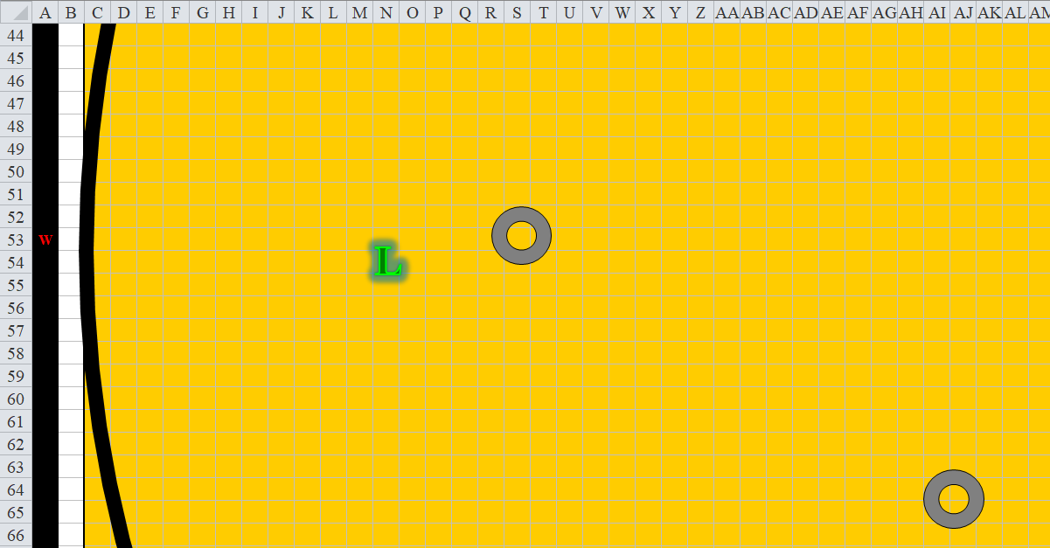



Round 2

Lauren heard the approaching paladin’s footsteps, and made out the sounds of the same spell she’d just cast: *bull’s strength [expired on Round 72]*, though the paladin intoned it slightly differently than the duskblade had.

*Faith gained +4 to Strength.*

The paladin of freedom then continued westward, and made eye contact with the drow.

Lauren cast *bull’s strength [expired on Round 142]*. She saved one of her Quick-cast slots for her *haste* spell in the event that the paladin rushed her.

*Lauren gained +4 to Strength.*

The duskblade then moved another 30’ east-southeast.



Round 3



Faith cast *bear’s endurance [expired on Round 73]*, then moved another 20’ towards the drow, whom she eyed with the intention to exterminate. “Tyrant of the Underdark, here you breathe your last.”

*Faith gained +4 to Constitution.*

There were plenty of pillars behind which either of them could hide, but both of these women were straightforward combatants, the paladin more than the duskblade. Neither of them darted away to hide, at least for the moment.

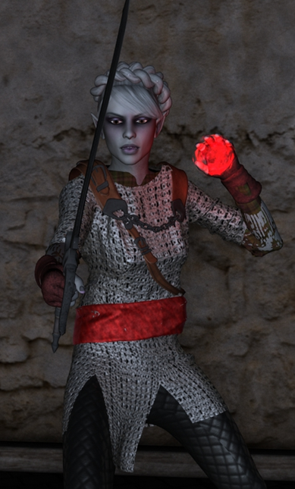

Lauren cast *keen edge [expired on Round 1403]* then moved another 30’ eastward.

*Lauren’s falchion’s threat range increased to 15 – 20.*



Round 4



In her Full Plate of the Dove—which Lauren kind of identified—and with her armor’s latent wings inactive, Faith walked another 20’ west and cast *resistance [expired on Round 14]* upon herself.

*Faith gained +1 to all saves.*

Planning to activate her *blacklight* ability on her own shield, and then use *vampiric touch*-channeled attacks for the first few rounds of combat, Lauren walked another 60’ toward Faith.



Round 5

As the two women continued their approaches, a virtual crowd of beholders and mind flayers all around them reeled with the anticipation of the clash between the two heroines whose wills had been pitted against one another.

Faith cast *divine favor [expired on Round 15]*, canceling another 20’ of distance between them.

*Faith gained +2 to weapon attack and damage.*

Lauren kept walking toward Faith.



Round 6

The pious templar decided to not drink her only potion of *enlarge person*. Instead, she quaffed her only vial of *owl’s wisdom [expired on Round 76]* before she walked another 20’ towards Lauren.

*Faith gained +4 to Wisdom.*

Lauren kept walking toward Faith.



Round 7

“Heard you had some new trick up your sleeve, Underdarker,” Faith said and squinted as she activated her Full Plate of the Dove’s wings. The paladin of freedom then jumped up and flapped in an arced trajectory towards Lauren.

The drow—anticipating some type of imminent smite attack from the human tank flying towards her—Quick-cast *haste [expired on Round 21]*, and activated her *blacklight [expired on Round 22]* ability (on her own shield), cast *swift fly* to flank her, charge-attacking Faith (still 65’ away) with *vampiric touch* channeled through her falchion.

*Lauren gained +1 to BAB, Touch AC, AC, and Reflex saves, plus extra attack or movement.*

Lauren flew towards the paladin, enveloping the human in her Underdark veil.

|  |  |  |  |  |  |  |  |  |  |
| --- | --- | --- | --- | --- | --- | --- | --- | --- | --- |
| **Melee Weapon** | **Dmg** | **D+** | **TH+** | **Critical** | **Type** | **Wt.** | **Atk** | **Roll** | **Check** |
| Falchion +3 | 2d4 | +5 +3 | 3 + 2 charge | 18-20/x2 | Slashing | 8.0 | +22 | **18** | 40 |
| Lesser Crystal of Arcane Steel | - | +1 | - | - | - |  | - |  | - |

*Threat. 1d20 = 3 + 23 = 26, critical hit. Dmg: 2 x (6 + 5 + 3) + 2 charge + 26 vampiric = 28 + 2 + 26 = 56. Partial damage negated.*

*Lauren gained 26 temporary hit points [159/133].*



Round 8

Faith—a capable blind-fighter—slashed at the duskblade thrice with her greatsword, smiting her on the first attack.

*1d100 = 72, bypass Concealment.*

|  |  |  |  |  |  |  |  |  |  |
| --- | --- | --- | --- | --- | --- | --- | --- | --- | --- |
| **Melee Weapon** | **Dmg** | **D+** | **TH+** | **Critical** | **Type** | **Wt.** | **Atk** | **Roll** | **Check** |
| Adamantine Illuminating Holy Greatsword +1 | 2d6+2 | +14 + 1 | 3 | 17-20/x2 | Slashing | 8.0 | +27 | 6 | 33 |
| 2nd Attack | 2d6+2 | +14 + 1 | 3 | 17-20/x2 | Slashing |  | +22 | 12 | 34 |
| 3rd Attack | 2d6+2 | +14 + 1 | 3 | 17-20/x2 | Slashing |  | +17 | 17 | 34 |

*Hit, hit, threat. 1d20 = 1, not a critical hit. Dmg: (7 + 2 + 14 + 1 + 0 smite) + (9 + 2 + 14 + 1) + (5 + 2 + 14 + 1) = 24 + 26 + 22 = 72 [87/133].*

Lauren attacked again, using *swift fly* to flank Faith, and continuing with the *vampiric touch* full-attacks.

|  |  |  |  |  |  |  |  |  |  |
| --- | --- | --- | --- | --- | --- | --- | --- | --- | --- |
| **Melee Weapon** | **Dmg** | **D+** | **TH+** | **Critical** | **Type** | **Wt.** | **Atk** | **Roll** | **Check** |
| Falchion +3 | 2d4 | +5 +3 | 3 | 18-20/x2 | Slashing | 8.0 | +23 | **19** | 42 |
| Falchion +3, 2nd Attack | 2d4 | +5 +3 | 3 | 18-20/x2 | Slashing |  | +18 | **20** | 38 |
| Falchion +3, 3rd Attack | 2d4 | +5 +3 | 3 | 18-20/x2 | Slashing |  | +13 | 2 | 15 |
| Falchion +3, *haste* | 2d4 | +5 +3 | 3 | 18-20/x2 | Slashing |  | +23 | 4 | 27 |
| Lesser Crystal of Arcane Steel | - | - | +1 | - | - |  | - |  | - |

*Threat, threat, miss, hit. 1d20 = 11, 10, both are critical hits.*

*Dmg: 2 x [(3 + 5 + 3) + (5 + 5 + 3)] + (6 + 5 + 3) + 22 vampiric = 22 + 26 + 14 + 22 vampiric = 84.*

*Lauren gained 22 temporary hit points [109/133].*



Round 9

Faith continued to full-attack the duskblade, applying a +3 Power Attack on the first swing.

*1d100 = 93, bypass Concealment.*

|  |  |  |  |  |  |  |  |  |  |
| --- | --- | --- | --- | --- | --- | --- | --- | --- | --- |
| **Melee Weapon** | **Dmg** | **D+** | **TH+** | **Critical** | **Type** | **Wt.** | **Atk** | **Roll** | **Check** |
| Adamantine Illuminating Holy Greatsword +1 | 2d6+2 | +14 + 1 + 3 | 3 – 3 | 17-20/x2 | Slashing | 8.0 | +24 | 13 | 37 |
| 2nd Attack | 2d6+2 | +14 + 1 | 3 | 17-20/x2 | Slashing |  | +22 | 13 | 35 |
| 3rd Attack | 2d6+2 | +14 + 1 | 3 | 17-20/x2 | Slashing |  | +17 | 17 | 34 |

*Hit, hit, threat. 1d20 = 8 + 27 = 35, critical hit. Dmg: (3 + 2 + 14 + 1 + 3) + (8 + 2 + 14 + 1) + [2 x (4 + 2 + 14 + 1)] = 23 + 25 + 42 = 90 [19/133].*

Lauren kept up her full attacks with *vampiric touch* and used *swift fly* to stay in melee range of Faith.

|  |  |  |  |  |  |  |  |  |  |
| --- | --- | --- | --- | --- | --- | --- | --- | --- | --- |
| **Melee Weapon** | **Dmg** | **D+** | **TH+** | **Critical** | **Type** | **Wt.** | **Atk** | **Roll** | **Check** |
| Falchion +3 | 2d4 | +5 +3 | 3 | 18-20/x2 | Slashing | 8.0 | +23 | 8 | 31 |
| Falchion +3, 2nd Attack | 2d4 | +5 +3 | 3 | 18-20/x2 | Slashing |  | +18 | **20** | 38 |
| Falchion +3, 3rd Attack | 2d4 | +5 +3 | 3 | 18-20/x2 | Slashing |  | +13 | 12 | 25 |
| Falchion +3, *haste* | 2d4 | +5 +3 | 3 | 18-20/x2 | Slashing |  | +23 | 6 | 29 |
| Lesser Crystal of Arcane Steel | - | - | +1 | - | - |  | - |  | - |

*Hit, threat, hit, hit. 1d20 = 4 + 18 + 1 = 23, not a critical hit. Dmg: (3 + 5 + 3 + 27 vampiric) + (7 + 5 + 3) + (4 + 5 + 3) + (5 + 5 + 3) = 11 + 15 + 12 + 13 + 27 vampiric = 51 + 27 vampiric = 78.*

*Lauren gained 27 temporary hit points [46/133].*

Faith went down.

Round 10

The drow looked down at Faith, whose body and gear began to fade and disappear.

*OOC: Well done. The vampiric touch is a nice—no pun intended—touch.*