Chapter 61.LRE

Lauren, Rook, and Elaith had gone on a retreat along the Dessaryn Riviera, and had just spent three relaxing days soaking in the hot springs that fed into the Dessaryn, not far from the spot where only a few years ago, they’d faced off a green dragon along with a band of jovial druids, most of whom died that day.

It was nice to be back in the area, particularly after a band of half-elf refugees had tamed this portion of the riverside and opened up a nice spa here. They would spend another few days here, and then head back to Waterdeep where Rook would reprise his role as instructor, and Lauren and Elaith would oversee their own respective plots and operations.

They had spent a wonderful time together—particularly in the afternoons—and this afternoon had been no exception. After some conversation about parrying strategies, they’d gone on a walk, encountered a herd of unicorns, and befriended them. Unicorns bore the most delicious scent of freshly baked sugar biscuits, and Elaith in particular was quite taken by one of the more handsome among them.

By the time they got back to the modest inn where they were staying—the Wacky Weasel—their legs were tired but their spirits were still eager for conversation. The barkeep—a Mr. Savlo Szerlek—indulged them all in the gossip of the day, and after a pint of something that smelled like mead and tasted like malt, they finally excused themselves, settled into their beds, and drifted off to the Realm of Dreams.

~*~

Lauren, Rook, and Elaith found themselves fully armed and armored, and standing a few feet apart from one another on a rocky mountaintop. Suddenly they smelled rotting flesh and heard the movement of at least one plate-armored figure to the north. Then Lauren spotted someone to the southwest, and Rook spotted someone to the northwest. They were surrounded.

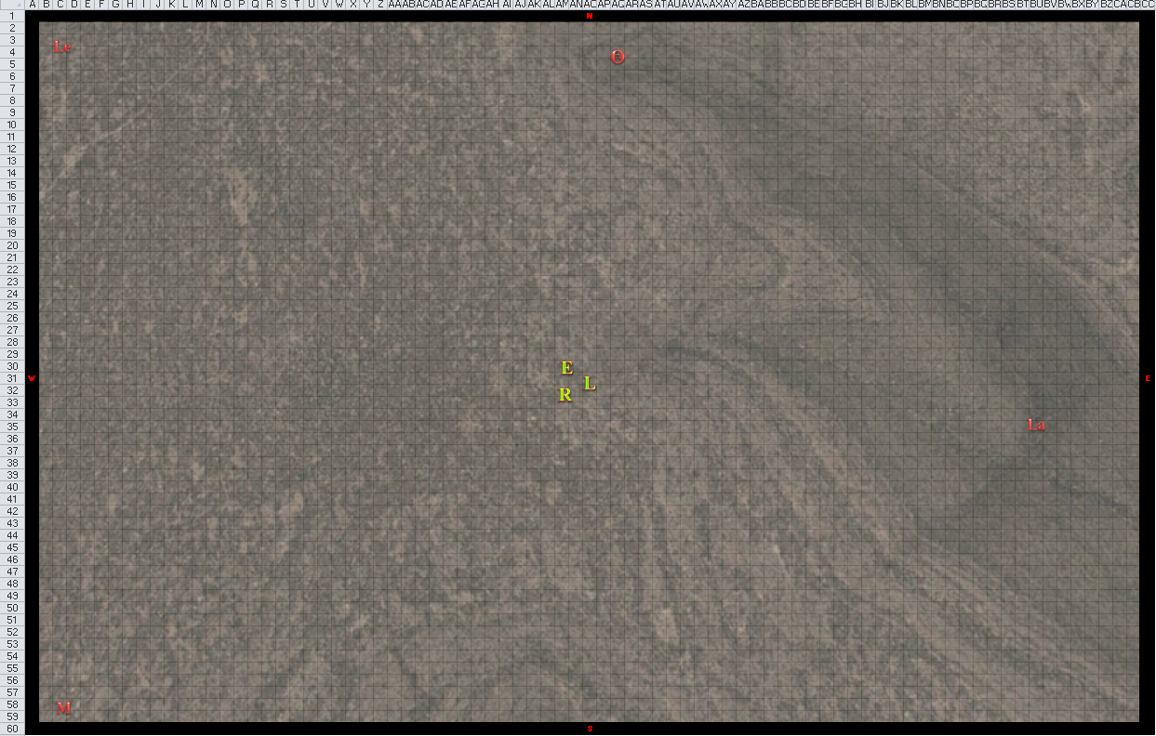

Round 1

Character | Group | Initiative | Roll | Modified Roll | Move
Leighlund | 2 | 6 | 20 | 26 | 30’
Elaith | 1 | 4 | 11 | 15 | 30’
Lauren | 1 | 5 | 6 | 11 | 30’
Larlum | 2 | 3 | 4 | 7 | 30’
Otis | 2 | 1 | 6 | 7 | 20’
Melonpatch | 2 | 1 | 5 | 6 | 30’
Rook | 1 | -1 | 1 | 0 | 20’

Lauren recognized the maddened face of the elf that she, Allisa, and Rook had known years before as the elf named Brandilor, who fought alongside them briefly, but was turned into a ghoul by necromancers and sicced on the party in undead form. They’d ended his existence with tears in their eyes as they could only have guessed back then at the fate of the impetuous Willow, who was also taken by the necromancers during that plight.

Leighlund laughed like a madman as he cast ice storm—his nastiest spell—upon the three shmucks they’d ambushed.
Dmg to Elaith: 11 + 8 cold = 19 [86/105].
Dmg to Lauren: 10 + 12 cold = 22 [111/133].
Dmg to Rook: 15 + 6 cold = 21 [50/71].

Elaith, Lauren, and Rook shivered and cringed as great magical hailstones pounded down. Elaith and Lauren both cast barkskin [expired on Round 1101 and 1401, respectively], while Rook decided if he could attempt to dispel the ice storm.
Elaith and Lauren gained +4 and +5, respectively, to FF AC and AC.
Character | TAC | FFAC | AC
Elaith | 10 | 19 | 19
Lauren | 11 | 32 | 33

The two figures to the north and northeast were each on a different hilltop, and could easily retreat from battle if they chose to, though neither did. Instead, the plate-suited tank to the north began to charge towards the heroes, while the cleric to the east began to cast a spell, which none of them could identify, mostly due to not hearing him very well.

Larlum walked towards the trio, and cast hold person [expired on Round 12] upon Elaith.
Save vs.  hold person | Rank | Ability & Mod. | Misc. Mods. | Total | Roll | Check | Properties
Larlum, Will | 7 | Wis (+0) | 1 | 8 | 15 | 23 | +2 vs. Enchantments; +2 vs. all spells
Success. Spell failed.

As Elaith shrugged off the cleric’s hold person spell, Otis charged southward, preparing to test his mettle with the three strangers.

Azimuth walked a few feet downhill, crouched, and cast summon undead III [expired on Round 8].

A ghoul with an icy glow jumped up and over the hilltop behind Otis, and ran to catch up and surpass the armored warrior.

Melonpatch moved 30’ towards Rook and company, then cast rainbow pattern.
Save vs.  rainbow pattern | Rank | Ability & Mod. | Misc. Mods. | Total | Roll | Check | Properties
Elaith, Will | 7 | Wis (+0) | 1 | 8 | 15 | 23 | +2 vs. Enchantments; +2 vs. all spells
Lauren, Will | 9 | Wis (+3) | 1 | 13 | 8 | 21 | +2 vs. Enchantments; +2 vs. all spells
Rook, Will | 12 | Wis (+3) | 1 | 16 | 18 | 34
Success, success, success. Spell failed on all 3 PCs.

“Frags!” the whisper gnome yelled, ending his concentration once he realized that none of the heroes were bedazzled by his pizazz.

Rook couldn’t cast dispel magic quickly enough to deal with the ice storm, so he cast flame strike on Leighlund. However, the spell could only reach 210’, and Leighlund was about 10’ farther than that from Rook, so the spell barely caught the chaotic evil wizard in its radius.
Save vs.  flame strike | Rank | Ability & Mod. | Misc. Mods. | Total | Roll | Check
Leighlund, Reflex | 5 | Dex (+2) | 0 | 7 | 20 | 27
Success. Saved for ½ damage.
Dmg: ½ x (20 fire + 20 divine) = 10 fire + 10 divine = 20.

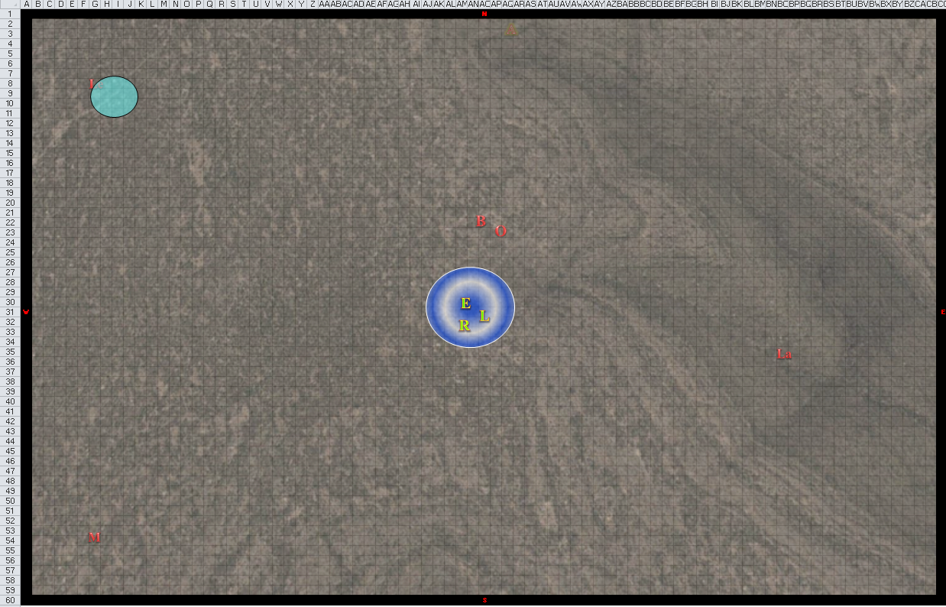

Round 2

From the corner of her consciousness, Allisa awoke, though her disembodied presence was really more like the effects of a prying eyes with a really good clairaudience audio that moved with the prying eyes. She could hear Maiko playing something on her lute, but could neither see the bard not discern the location of the melody. Next to her was Fingers in the form of a woman.

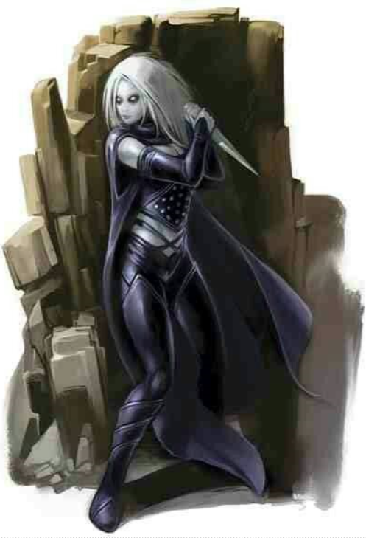

The changeling woman then disappeared, but it could still see and hear, just as Allisa could.

Leighlund walked 30’ southeast, wiped off the ashes from his shoulders, and vengefully cast disintegrate upon Rook.
Ranged Weapon | Dmg. | Atk | Roll | Check
Ranged Touch Attack | disintegrate | +7 | 11 | 18
Hit.
Save vs.  disintegrate | Rank | Ability & Mod. | Misc. Mods. | Total | Roll | Check
Rook, Fortitude | 5 | Con (+0) | 1 | 6 | 10 | 16
Fail. Dmg: 80. Rook was instantly disintegrated.

Elaith witnessed her mentor’s demise, and clamped down on her emotions. She glanced at Lauren, who nodded. Both duskblades cast haste [expired on Round 16] and swift fly [expired on Round 3], and then flew off after Leighlund at full speed.
Elaith and Lauren gained +1 to BAB, Touch AC, AC, and Reflex saves, plus additional 30’ of movement or extra attack.

[For future reference, haste is an area of effect spell, so only one of them needed to cast it when they’re this close to one another.]

Larlum walked westward and chuckled as he anticipated the death of his frenemy, Leighlund. The cleric of Velsharoon then cast armor of darkness [expired on Round 1102] upon himself.
Larlum gained + 5 deflection bonus to Touch AC, Darkvision 60’, and +2 to saving throws versus holy, good, or light spells or effects.

Otis charge-attacked Lauren, the blue glow from within his helmet now evident.
Character | Attack Type | Damage | Crit | BAB | Mod+ | W+ | Other+ | Roll | Total | Threat
Otis | Greatsword +1 | 1d10+1+7 | 20 | 8 | 7 | 1 | 2 charge | 12 | 28 | ☒
Miss.

The undead warrior slashed with no hesitation, but missed the woman as she leapt into flight alongside Elaith.

Brandilor charge-attacked Elaith.

Azimuth cast summon undead II [expired on Round 9], unleashing his favorite quadrupedal creation: Freyja.

Freyja—a formidable skeletal wolf—charged into the battlefield, following the flying women.

Melonpatch walked 30’ northeast and cast confusion [expired on Round 9] upon the heroes.
Save vs.  Confusion | Rank | Ability & Mod. | Misc. Mods. | Total | Roll | Check | Properties
Elaith, Will | 7 | Wis (+0) | 1 | 8 | 17 | 25 | +2 vs. Enchantments; +2 vs. all spells
Lauren, Will | 9 | Wis (+3) | 1 | 13 | 11 | 24 | +2 vs. Enchantments; +2 vs. all spells
Success, success. Spell fails on both subjects.

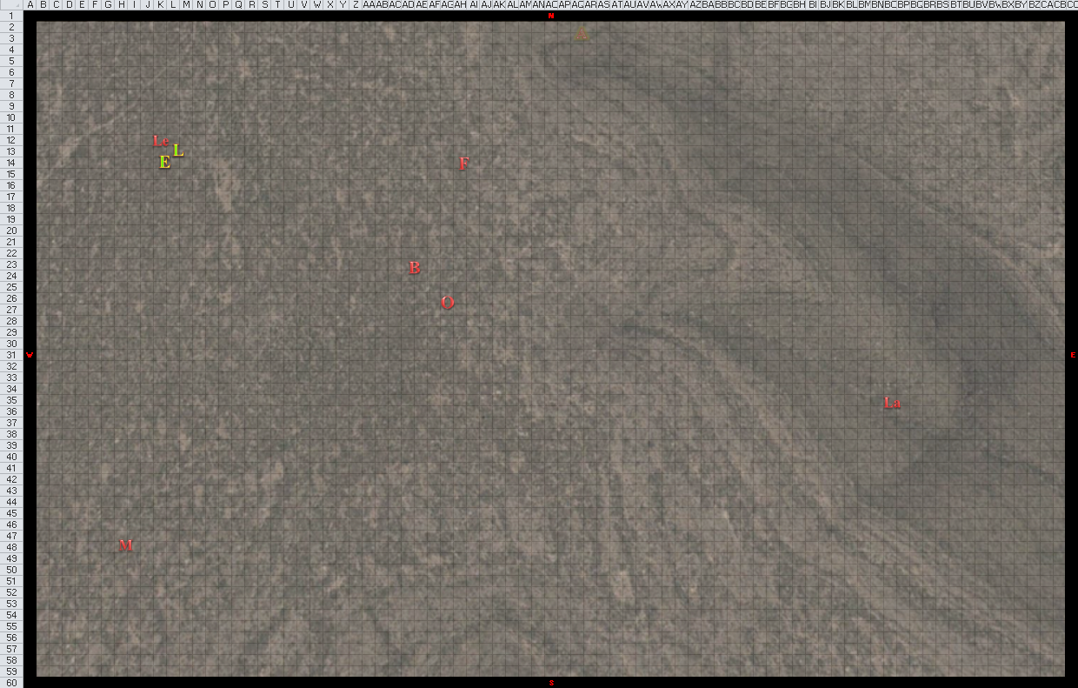

Round 3



Seeing the two duskblades rushing at him at an altitude of about 10’, Leighlund cast dimension door upon himself, and teleported to an unknown location.

Elaith and Lauren had both planned to channel vampiric touch upon Leighlund. With that fool gone and nowhere in sight for the moment, the two duskblades turned around to see a full-plate-wearing skeletal knight, a familiar-looking elven ghoul, and a canine skeleton rushing towards them, so they refocused their efforts on the other spellcaster, Melonpatch. They were looking to full-charge-attack (and couldn’t fly that far and attack—even hastened—on this round), so they flew far enough to put themselves just over 5’ north and above the whisper gnome beguiler named Melonpatch Jingy.

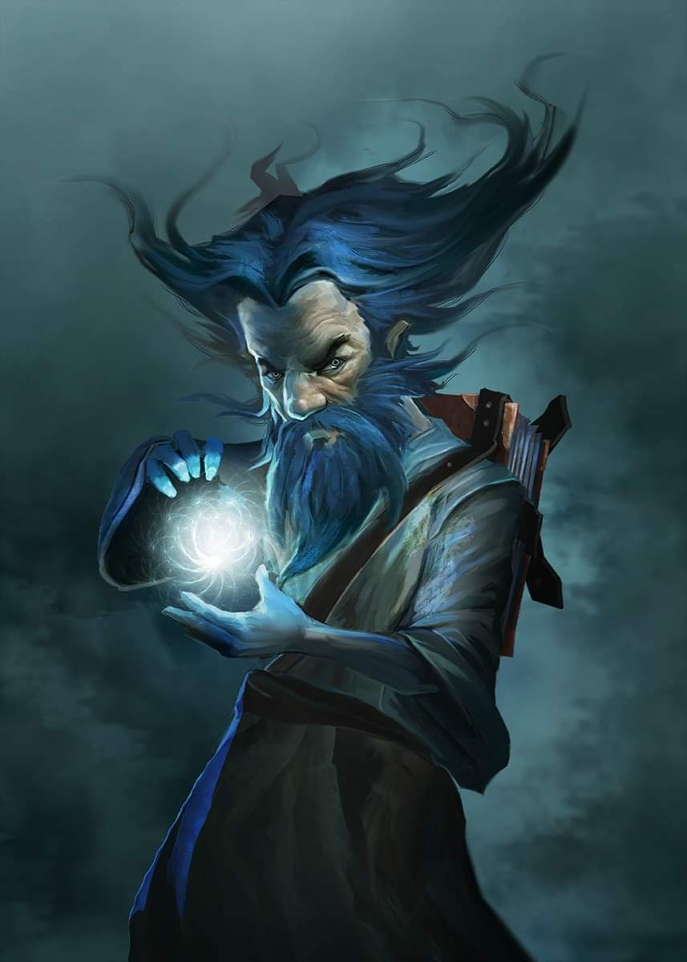

Larlum cast fire in the blood [expired on Round 113] upon himself, walking another 40’ west.
Larlum gained “fire in the blood” damage bonus (see Heroes of Horror 129).

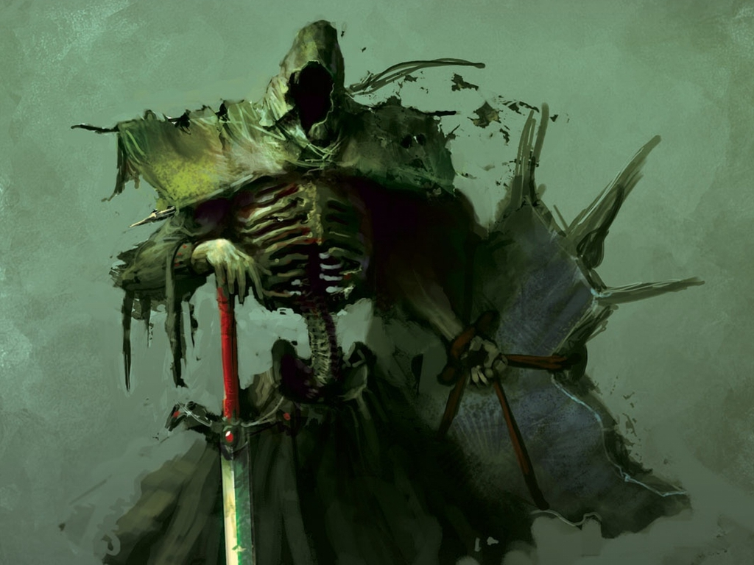

Otis rushed towards the flying women with its greatsword in both hands.

Azimuth cast summon undead II [expired on Round 10], conjuring forth a owlbear seleton.

A Large skeleton—unarmored and unclad—appeared on the battlefield, and charged towards Lauren and Elaith.

Melonpatch cast phantom battle [expired on Round 12] upon the twain bladeswingers.
Save vs.  phantom battle | Rank | Ability  & Mod. | Misc.  Mods. | Total | Roll | Check | Properties
Elaith, Will | 7 | Wis (+0) | 1 | 8 | 12 | 20 | +2 vs. Enchantments; +2 vs. all spells
Lauren, Will | 9 | Wis (+3) | 1 | 13 | 14 | 27 | +2 vs. Enchantments; +2 vs. all spells
Success, success. Spell failed on both subjects.

“Aw, phðk!” the whisper gnome exclaimed.

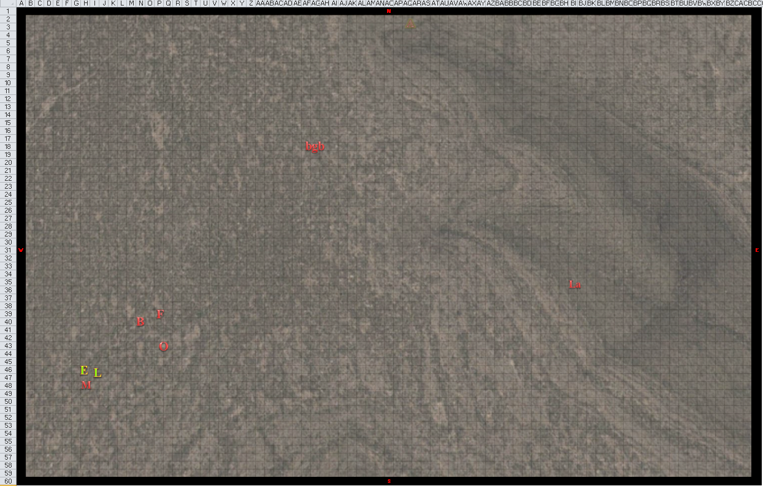

Round 4

Leighlund cast fireball upon the airborne duskblades, careful to keep that gnome twit out of the blast.
Save vs.  Fireball | Rank | Ability & Mod. | Misc. Mods. | Total | Roll | Check | Properties
Elaith, Reflex | 3 | Dex (+0) | 1 | 4 | 11 | 15 | +1 haste
Lauren, Reflex | 4 | Dex (+1) | 1 | 6 | 20 | 26 | +1 haste
Fail, success. Lauren saved for ½ damage.
Dmg to Elaith: 38 fire [48/105].
Dmg to Lauren: ½ x 44 = 22 fire [99/133]. Partial damage negated.

Fingers and Allisa remained motionless and disembodied, able only to see the imminent carnage that the duskblades would dispatch upon Melonpatch.

Seared by Leighlund’s spell, Elaith and Lauren resolved their full-charge-attack upon the beguiler.
Elaith, Melee Weapon | Dmg | D+ | TH+ | Critical | Wt. | Atk | Roll | Check
Greatsword +2 | 2d6 | +4 +2  + 2 charge  + 1 crystal  + vampiric | 2 + 2  charge | 19-20/x2 | 8.0 | +20 | 7 | 27
Greatsword +2, 2nd Attack | 2d6 | +4 +2 | 2 | 19-20/x2 |  | +13 | 19 | 32
Greatsword +2, 3rd Attack | 2d6 | +4 +2 | 2 | 19-20/x2 |  | +8 | 19 | 27
Greatsword +2, haste | 2d6 | +4 +2 | 2 | 19-20/x2 |  | +18 | 8 | 26
Crystal of Arcane Steel, Least | +1 to  touch  spells | +1 | 0
Hit, hit, hit, hit. Dmg: (5 + 4 + 2 + 2 + 1 + 18 vampiric) + (8 + 4 + 2 + 2 + 1) + (9 + 4 + 2 + 2 + 1) + (5 + 4 + 2 + 2 + 1) = 14 + 17 + 18 + 14 = 63 + 18 vampiric = 81.

Melonpatch died, but Lauren took the liberty of swinging at his corpse as it fell, foregoing the vampiric touch spell on the already dead wee-man.
Lauren, Melee Weapon | Dmg | D+ | TH+ | Critical | Wt. | Atk | Roll | Check
Falchion +3 | 2d4 | +5 +3  + 2 charge  + 1 crystal  + vampiric | 3 + 2 charge  + 1 crystal | 18-20/x2 | 8.0 | +26 | 3 | 29
Falchion +3, 2nd Attack | 2d4 | +5 +3 | 3 | 18-20/x2 |  | +18 | 16 | 34
Falchion +3, 3rd Attack | 2d4 | +5 +3 | 3 | 18-20/x2 |  | +13 | 15 | 28
Falchion +3, haste | 2d4 | +5 +3 | 3 | 18-20/x2 |  | +23 | 18 | 41
Lesser Crystal of Arcane Steel | +1 to  touch  spells | +1 | +0 | - |  | - |  | -
Hit, hit, hit, hit.

With each slice, the body was cut into yet another chunk.

Larlum shook his head at the carnage to his west-southwest, and walked another 30’ westward, casting cloud of the achaierai [expired on Round 1104].
Larlum emanated aura causing 2d6 points of damage + confusion.

Otis, Brandilor, and Freyja rushed and leapt to attack Elaith and Lauren.
Character | Check | Ranks | Roll | Save
Brandilor | Jump | 13 | 12 | 25
Otis | Jump | 13 | 8 | 21
Freyja | Jump | 13 | 9 | 22
See below.

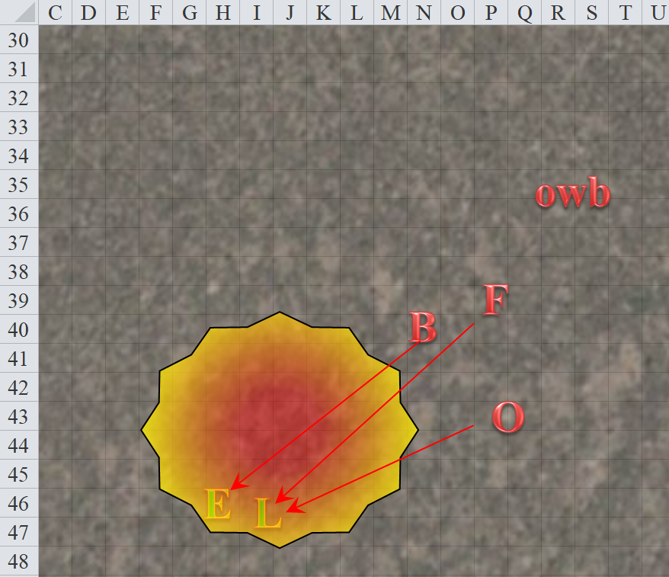

All three undead were able to jump at least 5’ up as they leapt forward and charge-attacked the ladies floating over Melonpatch’s butchery.
Character | Attack Type | Damage | Crit | BAB | Mod+ | W+ | Other+ | Roll | Total | Threat | Target
Otis | Greatsword +1 | 1d10+1+7 | 20 | 8 | 7 | 1 | 0 | 10 | 26 | ☒ | Lauren
Brandilor | Claw 1 | 1d4+1+1d6 cold+paralysis | 20 | 4 | 3 | 0 | 0 | 14 | 21 | ☒ | Elaith
Freyja | Bite | 1d4+1 + 1d6 cold | 20 | 2 | 4 | 0 | 0 | 19 | 25 | ☒ | Lauren
Miss, hit, miss.
Dmg to Elaith: 1 + 1 + 1 cold = 3 + paralysis [45/105].
Save vs.  Paralysis | Rank | Ability & Mod. | Misc. Mods. | Total | Roll | Check
Elaith, Fortitude | 7 | Con (+2) | 1 | 10 | 8 | 18
Success. Paralysis negated.

The owlbear skeleton did not yet reach Elaith and Lauren.

Azimuth cast summon undead II [expired on Round 11], conjuring a second owlbear skeleton.

Another nude owlbear skeleton appeared on the battlefield and rushed southwestward.

