Round 5

Leighlund could not cast *fireball* again without harming his colleague’s undead minions, so he sighed, and cast *mage armor [expired on Round 6605]* upon himself, figuring he was going to have to go in and cast short-range spells before the night was through.

*Leighlund gained +4 to AC.*

Elaith and Lauren each channeled their *vampiric touch* spells and full attacked Otis. However, because Otis was not a living creature, the *vampiric touch* spells were wasted.

|  |  |  |  |  |  |  |  |  |  |
| --- | --- | --- | --- | --- | --- | --- | --- | --- | --- |
| **Lauren, Melee Weapon** | **Dmg** | **D+** | **TH+** | **Critical** | **Type** | **Wt.** | **Atk** | **Roll** | **Check** |
| Falchion +3 | 2d4 | +5 +3 | 3 | 18-20/x2 | Slashing | 8.0 | +23 | **19** | 42 |
| Falchion +3, 2nd Attack | 2d4 | +5 +3 | 3 | 18-20/x2 | Slashing |  | +18 | 5 | 23 |
| Falchion +3, 3rd Attack | 2d4 | +5 +3 | 3 | 18-20/x2 | Slashing |  | +13 | 8 | 21 |
| Falchion +3, *haste* | 2d4 | +5 +3 | 3 | 18-20/x2 | Slashing |  | +23 | *1* | 24 |
| Lesser Crystal of Arcane Steel | +1 to touch spells | 1 | +1 | - | - |  | - |  | - |

*Threat, miss, miss, miss. 1d20 = 9 + 23 = 32, not a critical hit. Dmg: 7 + 5 + 3 = 15. Partial damage negated.*

|  |  |  |  |  |  |  |  |  |  |
| --- | --- | --- | --- | --- | --- | --- | --- | --- | --- |
| **Elaith, Melee Weapon** | **Dmg** | **D+** | **TH+** | **Critical** | **Type** | **Wt.** | **Atk** | **Roll** | **Check** |
| Greatsword +2 | 2d6 | +4 +2 | 2 | 19-20/x2 | Slashing | 8.0 | +18 | **19** | 37 |
| Greatsword +2, 2nd Attack | 2d6 | +4 +2 | 2 | 19-20/x2 | Slashing |  | +13 | **20** | 33 |
| Greatsword +2, 3rd Attack | 2d6 | +4 +2 | 2 | 19-20/x2 | Slashing |  | +8 | 7 | 15 |
| Greatsword +2, haste | 2d6 | +4 +2 | 2 | 19-20/x2 | Slashing |  | +18 | 17 | 35 |
| Crystal of Arcane Steel, Least | +1 to touch spells | 1 | 0 |  |  |  |  |  |  |

*Threat, threat, miss, hit. 1d20 = 15 + 18 = 33; 9 + 13 = 22, no critical hits.*

*Dmg: (6 + 4 + 2) + (10 + 4 + 2) + (5 + 4 + 2) = 12 + 14 + 11 = 37. Partial damage negated.*

Larlum walked another 30 short paces westward, and cast *nightshield [expired on Round 115]* upon himself.

*Larlum gained +2 to all Saves, and immunity to magic missiles.*

Otis, Freyja, and Brandilor full-attacked Elaith as she swung at Otis.

|  |  |  |  |  |  |  |  |  |  |  |
| --- | --- | --- | --- | --- | --- | --- | --- | --- | --- | --- |
| **Character** | **Attack Type** | **Damage** | **Crit** | **BAB** | **Mod+** | **W+** | **Other+** | **Roll** | **Total** | **Threat** |
| Otis | Greatsword +1 | 1d10+1+7 | 20 | 8 | 7 | 1 | 0 | 11 | 27 | ☒ |
| Otis | Greatsword, 2nd Attack | 1d10+1+7 | 20 | 3 | 7 | 1 | 0 | 16 | 27 | ☒ |
| Brandilor | Flurry | 1d8+3+1d6 cold+paralysis | 20 | 4 | 7 | 0 | 0 | 18 | 29 | ☒ |
| Freyja | Bite | 1d4+1 + 1d6 cold | 20 | 2 | 4 | 0 | 0 | 13 | 19 | ☒ |

*Hit, hit, hit, hit. Dmg: (4 + 1 + 7) + (1 + 1 + 7) + (2 + 3 + 3 cold) + (4 + 1 + 1 cold) = 12 + 9 + 6 + 5 + 4 cold = 36 + paralysis [9/105].*

The frontmost owlbear was rearing to charge-attack Elaith, but when Elaith went to full-attack Otis, the skeletal owlbear lost momentum as it diverted its course, then flank-attacked Lauren.

|  |  |  |  |  |  |  |  |  |  |  |
| --- | --- | --- | --- | --- | --- | --- | --- | --- | --- | --- |
| **Character** | **Attack Type** | **Damage** | **Crit** | **BAB** | **Mod+** | **W+** | **Other+** | **Roll** | **Total** | **Threat** |
| owlbear skeleton | Claw 1 | 1d6+5 + 1d6 cold | 20 | 1 | 5 | 0 | 2 flank | 15 | 23 | ☒ |

*Miss.*

The second owlbear skeleton did not yet reach the frontlines.

Azimuth cast *bear’s endurance [expired on Round 74]* upon himself.

*Azimuth gained +4 to Constitution and +30 to HPs*.

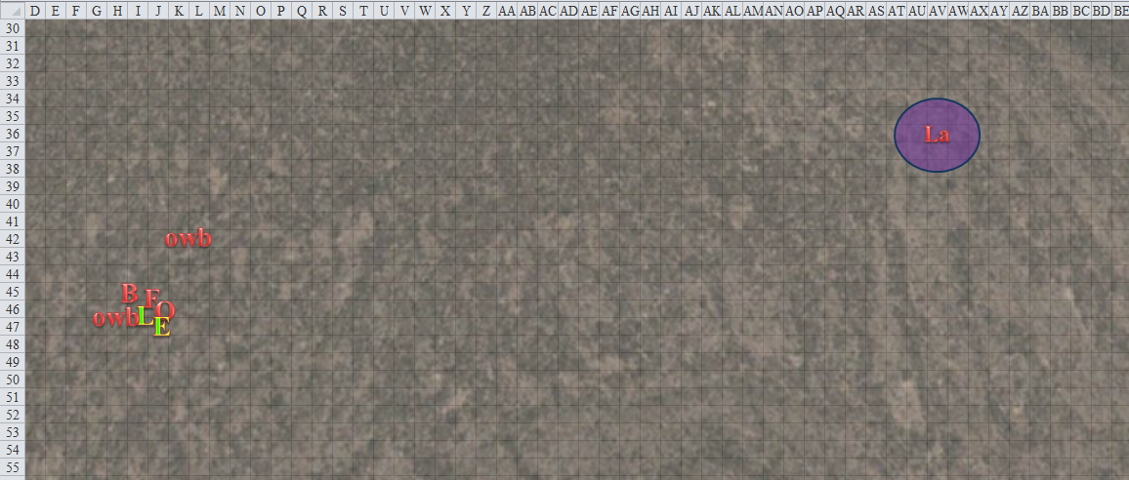

Round 6

Seeing that the undead were about to finish off Elaith, Leighlund cast *melf’s acid arrow [damage repeated until Round 8]* upon Lauren.

|  |  |  |  |  |  |
| --- | --- | --- | --- | --- | --- |
| **Ranged Weapon** | **Dmg.** | **D+** | **Atk** | **Roll** | **Check** |
| Ranged Touch Attack | 2d4 acid | repeats | +7 | 4 | 11 |

*Miss.*

“Drat!” the human rogue / wizard cursed.

The duskblades both channeled *shocking grasp* and full-attacked Otis again.

|  |  |  |  |  |  |  |  |  |  |  |
| --- | --- | --- | --- | --- | --- | --- | --- | --- | --- | --- |
| **Melee Weapon** | **Dmg** | **D+** | **TH+** | **Critical** | **Type** | **Wt.** | **Atk** | **Roll** | **Check** | **Properties** |
| Greatsword +2 | 2d6 | +4 +2 | 2 | 19-20/x2 | Slashing | 8.0 | +18 | **18** | 36 | *shocking grasp* |
| Greatsword +2, 2nd Attack | 2d6 | +4 +2 | 2 | 19-20/x2 | Slashing |  | +13 | 7 | 20 |  |
| Greatsword +2, 3rd Attack | 2d6 | +4 +2 | 2 | 19-20/x2 | Slashing |  | +8 | 11 | 19 |  |
| Greatsword +2, haste | 2d6 | +4 +2 | 2 | 19-20/x2 | Slashing |  | +18 | *1* | 19 |  |
| Crystal of Arcane Steel, Least | +1 to touch spells | 1 | 0 |  |  |  |  |  |  |  |

*Threat, miss, miss, miss. 1d20 = 20, critical hit. Dmg: 2 x (4 + 4 + 2) = 20 + 21 shocking grasp = 41.*

|  |  |  |  |  |  |  |  |  |  |  |
| --- | --- | --- | --- | --- | --- | --- | --- | --- | --- | --- |
| **Melee Weapon** | **Dmg** | **D+** | **TH+** | **Critical** | **Type** | **Wt.** | **Atk** | **Roll** | **Check** | **Properties** |
| Falchion +3 | 2d4 | +5 +3  +3 metal armor | 3 | 18-20/x2 | Slashing | 8.0 | +26 | 15 | 41 | *shocking grasp* |
| Falchion +3, 2nd Attack | 2d4 | +5 +3 | 3 | 18-20/x2 | Slashing |  | +18 | **19** | 37 |  |
| Falchion +3, 3rd Attack | 2d4 | +5 +3 | 3 | 18-20/x2 | Slashing |  | +13 | 9 | 22 |  |
| Falchion +3, *haste* | 2d4 | +5 +3 | 3 | 18-20/x2 | Slashing |  | +23 | **20** | 43 |  |
| Lesser Crystal of Arcane Steel | +1 to touch spells | 1 | +1 | - | - |  | - |  | - |  |

*Hit, threat, miss, threat. 1d20 = 17 + 18 = 35; 13 + 23 = 36, 2 critical hits!*

*Dmg: [2 x (6 + 5 + 3)] + [2 x (8 + 5 + 3)] = 2 x (14 + 16) = 60 + (15 + 17 shocking grasp) = 92.*

“Holy fuck!” exclaimed the ghostwise halfling with levels in rogue, necromancer, cloistered cleric of Velsharoon, and true necromancer. His skeletal minion was no more, and his dog was about to get it next. That was his ride out of here.

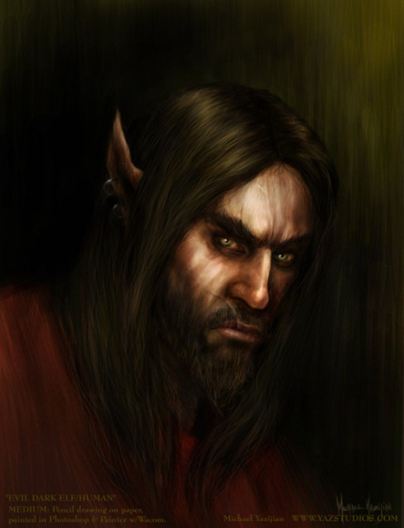

Lauren heard Larlum casting *shield of faith [expired on Round 116]* upon himself. The tiefling then walked another 30’ west and a few feet south. “Bring the bitches to me now!” the half-elf-half-devil beckoned.

*Larlum gained +3 to AC.*

Otis, Brandilor, Freyja, and the two owlbear skeletons clashed with the duskblades, targeting Lauren, who had made herself intentionally a better target to protect Elaith.

|  |  |  |  |  |  |  |  |  |  |
| --- | --- | --- | --- | --- | --- | --- | --- | --- | --- |
| **Character** | **Attack Type** | **Damage** | **Crit** | **BAB** | **Mod+** | **W+** | **Roll** | **Total** | **Threat** |
| Otis | Greatsword +1 | 1d10+1+7 | 20 | 8 | 7 | 1 | 10 | 26 | ☒ |
| Otis | Greatsword, 2nd Attack | 1d10+1+7 | 20 | 3 | 7 | 1 | 8 | 19 | ☒ |
| Brandilor | Bite | 1d6+3+1d6 cold+gf+paral. | 20 | 4 | 3 | 0 | 15 | 22 | ☒ |
| Brandilor | Claw 1 | 1d4+1+1d6 cold+paralysis | 20 | 4 | 3 | 0 | 10 | 17 | ☒ |
| Brandilor | Claw 2 | 1d4+1+1d6 cold+paralysis | 20 | 4 | 3 | 0 | 18 | 25 | ☒ |
| Freyja | Bite | 1d4+1 + 1d6 cold | 20 | 2 | 4 | 0 | 18 | 24 | ☒ |
| owlbear skeleton 1 | Claw 1 | 1d6+5 + 1d6 cold | 20 | 1 | 5 | 0 | 18 | 24 | ☒ |
| owlbear skeleton 1 | Claw 2 | 1d6+5 + 1d6 cold | 20 | 1 | 5 | 0 | 20 | 26 | ☑ |
| owlbear skeleton 1 | Bite | 1d8+2 + 1d6 cold | 20 | 1 | 0 | 0 | 13 | 14 | ☒ |
| owlbear skeleton 2 | Claw 1 | 1d6+5 + 1d6 cold | 20 | 1 | 5 | 0 | 15 | 21 | ☒ |
| owlbear skeleton 2 | Claw 2 | 1d6+5 + 1d6 cold | 20 | 1 | 5 | 0 | 16 | 22 | ☒ |
| owlbear skeleton 2 | Bite | 1d8+2 + 1d6 cold | 20 | 1 | 0 | 0 | 10 | 11 | ☒ |

*Miss, miss, miss, miss, miss, miss, miss, threat, miss, miss, miss, miss. 1d20 = 6 + 6 = 12, not a critical hit.*

*Dmg: 3 + 5 + 4 cold = 12 [87/133].*

Azimuth cast his last preparation of *summon undead II [expired on Round 12]*, and silently called his loyal canine skeletal construct back to him as he continued to study the battlefield, now with more concern than amusement.

Another owlbear skeleton showed up just over the hill to the northeast. Perhaps this would be called the Night of the Owlbear Skeletons. The third owlbear followed the others towards Otis and the melee with the two duskblades.

Freyja, on the other hand, fled northward.

The ghoul and owlbear skeletons went for Elaith.

|  |  |  |  |  |  |  |  |  |  |
| --- | --- | --- | --- | --- | --- | --- | --- | --- | --- |
| **Character** | **Attack Type** | **Damage** | **Crit** | **BAB** | **Mod+** | **W+** | **Other+** | **Roll** | **Total** |
| Brandilor | Bite | 1d6+3+1d6 cold+gf+paral. | 20 | 4 | 3 | 0 | 0 | 11 | 18 |
| Brandilor | Claw 1 | 1d4+1+1d6 cold+paralysis | 20 | 4 | 3 | 0 | 0 | 9 | 16 |
| Brandilor | Claw 2 | 1d4+1+1d6 cold+paralysis | 20 | 4 | 3 | 0 | 0 | 12 | 19 |
| owlbear skeleton | Claw 1 | 1d6+5 + 1d6 cold | 20 | 1 | 5 | 0 | 0 | 15 | 21 |
| owlbear skeleton | Claw 2 | 1d6+5 + 1d6 cold | 20 | 1 | 5 | 0 | 0 | 3 | 9 |
| owlbear skeleton | Bite | 1d8+2 + 1d6 cold | 20 | 1 | 0 | 0 | 0 | 17 | 18 |

*Miss, miss, miss, miss, miss, hit, miss, miss. Dmg: 3 + 5 + 1 cold = 9 [0/105].*

Elaith dropped to one knee, unable to ward off the last two incoming attacks that didn’t pierce through her armor.

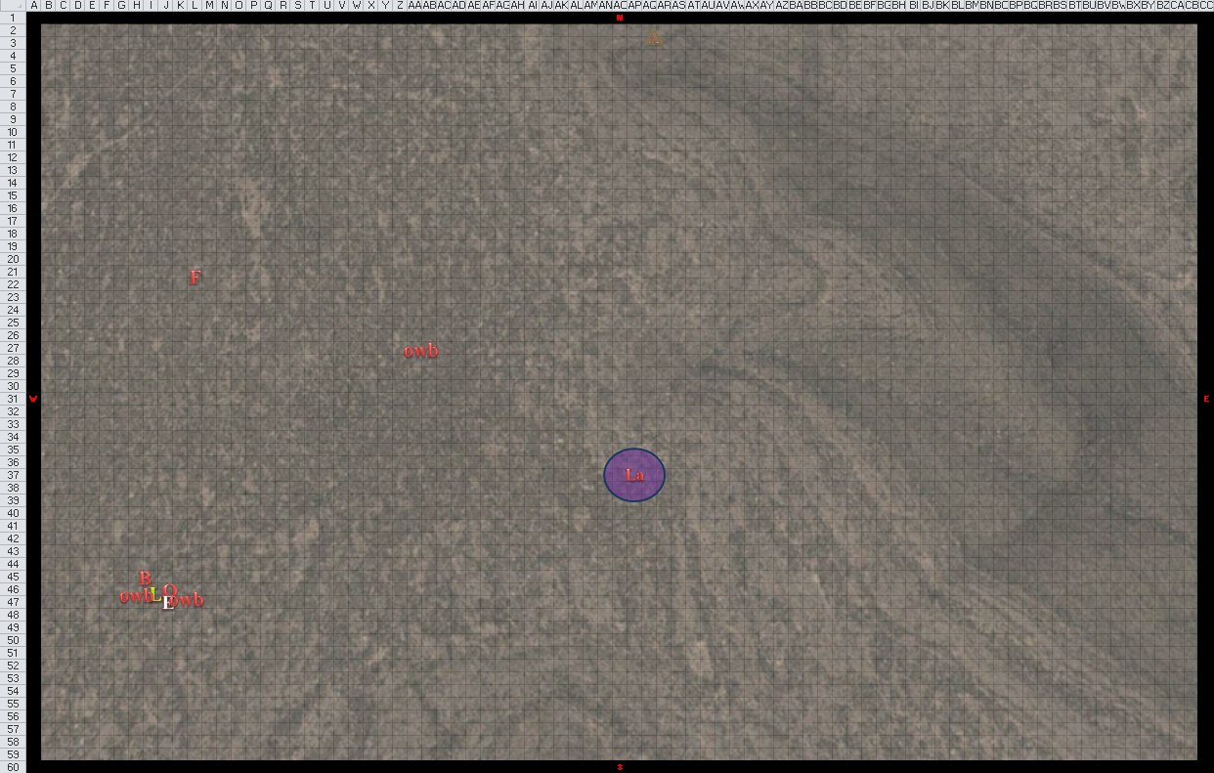

Round 7

Leighlund cast *shield [expired on Round 117]* upon himself.

*Leighlund gained +4 to AC.*

The wizard then crept westward a bit, and was spotted by Lauren. The lower half of his body was hidden behind a short hill, though he was standing.

Elaith *[-1/105]* passed out and began to die.

The third conjured owlbear skeleton reached Lauren, but did not have an opportunity to attack at the moment, which placed it in a precarious situation.

As this third owlbear reached her, Lauren stood her ground over Elaith, channeled her *shocking grasp*, and full-attacked the bony owlbears successively.

|  |  |  |  |  |  |  |  |  |  |
| --- | --- | --- | --- | --- | --- | --- | --- | --- | --- |
| **Melee Weapon** | **Dmg** | **D+** | **TH+** | **Critical** | **Type** | **Wt.** | **Atk** | **Roll** | **Check** |
| Falchion +3 | 2d4+ shocking grasp | +5 +3 | 3 | 18-20/x2 | Slashing | 8.0 | +23 | 5 | 28 |
| Falchion +3, 2nd Attack | 2d4 | +5 +3 | 3 | 18-20/x2 | Slashing |  | +18 | 7 | 25 |
| Falchion +3, 3rd Attack | 2d4 | +5 +3 | 3 | 18-20/x2 | Slashing |  | +13 | **19** | 32 |
| Falchion +3, *haste* | 2d4 | +5 +3 | 3 | 18-20/x2 | Slashing |  | +23 | 6 | 29 |
| Lesser Crystal of Arcane Steel | +1 to touch spells | 1 | +1 | - | - |  | - |  | - |

*Hit, hit, threat, hit. 1d20 = 17 + 13 = 30, critical hit.*

*Dmg to owlbear 1: 2 + 5 + 3 = 10 + 16 electric = 26.*

*Dmg to owlbear 2: 5 + 5 + 3 = 13.*

*Dmg to owlbear 3: 2 x (3 + 5 + 3) = 22.*

*Dmg to owlbear 1: 4 + 5 + 3 = 12.*

With her last of four swipes, the Fifthdaughter finished off the one that had threatened her the longest, chopping it in half, and gauging the other two to be but a swipe away from destruction.

Larlum moved about 30 westward, and cast *owl’s wisdom [expired on Round 117]*, then smirked as he studied the duskblade still standing.

*Larlum gained +4 to Wisdom.*

Freyja continued fleeing northward.

Brandilor and the remaining owlbear skeletons did their best to damage the lady standing before them.

|  |  |  |  |  |  |  |  |  |  |
| --- | --- | --- | --- | --- | --- | --- | --- | --- | --- |
| **Character** | **Attack Type** | **Damage** | **Crit** | **BAB** | **Mod+** | **W+** | **Other+** | **Roll** | **Total** |
| Brandilor | Bite | 1d6+3+1d6 cold+gf+paral. | 20 | 4 | 3 | 0 | 0 | 14 | 21 |
| Brandilor | Claw 1 | 1d4+1+1d6 cold+paralysis | 20 | 4 | 3 | 0 | 0 | 19 | 26 |
| Brandilor | Claw 2 | 1d4+1+1d6 cold+paralysis | 20 | 4 | 3 | 0 | 0 | 2 | 9 |
| owlbear skeleton 1 | Claw 1 | 1d6+5 + 1d6 cold | 20 | 1 | 5 | 0 | 0 | 3 | 9 |
| owlbear skeleton 1 | Claw 2 | 1d6+5 + 1d6 cold | 20 | 1 | 5 | 0 | 0 | 15 | 21 |
| owlbear skeleton 1 | Bite | 1d8+2 + 1d6 cold | 20 | 1 | 0 | 0 | 0 | 10 | 11 |
| owlbear skeleton 2 | Claw 1 | 1d6+5 + 1d6 cold | 20 | 1 | 5 | 0 | 0 | 1 | 7 |
| owlbear skeleton 2 | Claw 2 | 1d6+5 + 1d6 cold | 20 | 1 | 5 | 0 | 0 | 8 | 14 |
| owlbear skeleton 2 | Bite | 1d8+2 + 1d6 cold | 20 | 1 | 0 | 0 | 0 | 18 | 19 |

*All misses.*

Azimuth cast *mage armor [expired on Round 4207]* upon himself, and watched the battle unfold with less amusement than before.

*Azimuth gained +4 to FF AC and AC.*

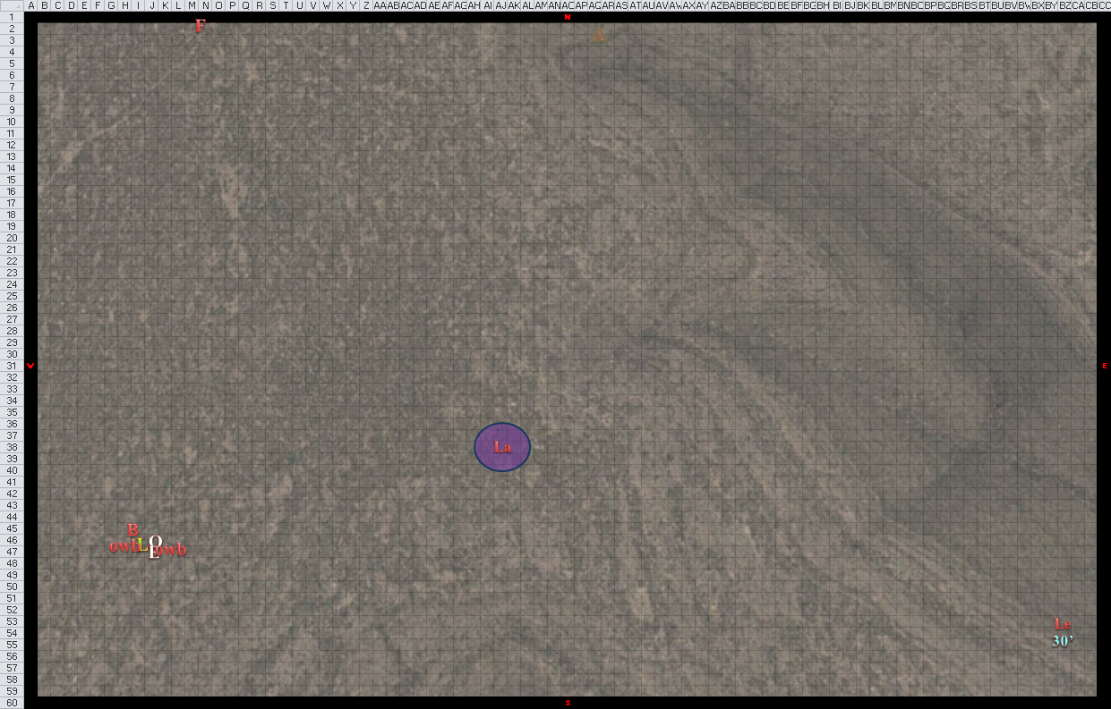

Round 8

Freyja disappeared from sight behind the northern dune.

The other undead minions tried in vain to stop Lauren from living.

|  |  |  |  |  |  |  |  |  |
| --- | --- | --- | --- | --- | --- | --- | --- | --- |
| **Character** | **Attack Type** | **Damage** | **BAB** | **Mod+** | **W+** | **Other+** | **Roll** | **Total** |
| Brandilor | Bite | 1d6+3+1d6 cold+gf+paral. | 4 | 3 | 0 | 0 | 2 | 9 |
| Brandilor | Claw 1 | 1d4+1+1d6 cold+paralysis | 4 | 3 | 0 | 0 | 8 | 15 |
| Brandilor | Claw 2 | 1d4+1+1d6 cold+paralysis | 4 | 3 | 0 | 0 | 12 | 19 |
| owlbear skeleton 1 | Claw 1 | 1d6+5 + 1d6 cold | 1 | 5 | 0 | 0 | 3 | 9 |
| owlbear skeleton 1 | Claw 2 | 1d6+5 + 1d6 cold | 1 | 5 | 0 | 0 | 2 | 8 |
| owlbear skeleton 1 | Bite | 1d8+2 + 1d6 cold | 1 | 0 | 0 | 0 | 9 | 10 |
| owlbear skeleton 2 | Claw 1 | 1d6+5 + 1d6 cold | 1 | 5 | 0 | 0 | 12 | 18 |
| owlbear skeleton 2 | Claw 2 | 1d6+5 + 1d6 cold | 1 | 5 | 0 | 0 | 18 | 24 |
| owlbear skeleton 2 | Bite | 1d8+2 + 1d6 cold | 1 | 0 | 0 | 0 | 6 | 7 |

*All misses.*

Leighlund said something like, “Aw, shucks!” then cast *fly*, and gained 30’ of altitude.

*Leighlund gained flight 60’.*

Lauren activated her Dimension Stride boots to move 60’ south of her position, and then quick cast *regroup* to bring Elaith to her.

Larlum saw the teleportation, grimaced as he cast *flame strike*, then moved 30’ to the south.

|  |  |  |  |  |  |  |  |
| --- | --- | --- | --- | --- | --- | --- | --- |
| **Save vs.**  *flame strike* | **Rank** | **Ability & Mod.** | **Misc. Mods.** | **Total** | **Roll** | **Check** | **Properties** |
| **Lauren, Reflex** | 4 | **Dex (+1)** | 1 | 6 | 10 | 16 | +1 *haste* |

*Fail. Dmg: 19 divine + 20 fire = 39. Partial damage negated [58/133].*

Elaith died.

Azimuth knew that to cast Medium-range spells, he’d have to eliminate some of the distance between the zombie-stock duskblade. He sighed, knowing that by casting one of his last summons, he’d probably give away his position in this desolate, undulating desert. He cast *summon monster I [expired on Round ]*, conjuring a dwarven skeleton that made its way across the battlefield towards Lauren.

A dwarven skeleton appeared upon the battlefield, and began making its way south towards Lauren. The nude skeleton rushed towards Lauren.

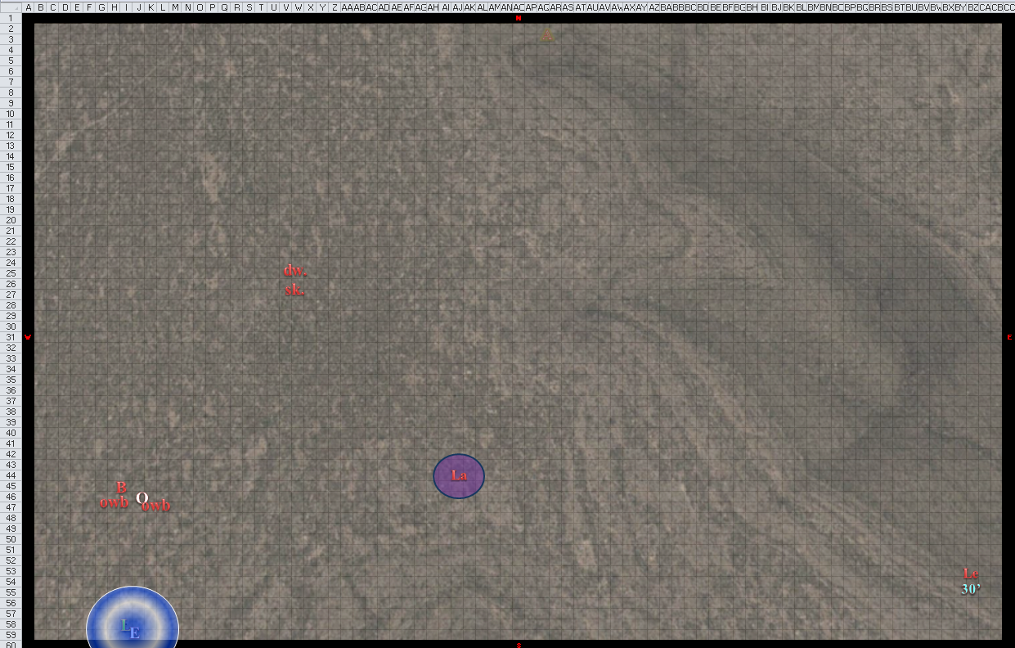

Round 9

The skeletal owlbears and ghoul charged into battle, timing their sprint so as to charge-attack her on the next round. Even the dwarf had almost caught up to the epicenter of the bone-slashing fest that she’d just initiated.

Leighlund cursed, “These *goddamnable* skeletal minions are cramping my style!” Vowing to top off the half-drow bitch with his second *fireball* on the very next round, the injured wizard drank a potion of *cure moderate wounds [CL 5]*.

*Leighlund gained 9 + 5 = 14 hps.*

The wizard then flew northwestward a bit.

Lauren cast Swift *fly* and went after Larlum, reaching the inside of his *cloud of the achaierai*.

*Dmg: 6 evil + Confusion (save) [52/133].*

|  |  |  |  |  |  |  |
| --- | --- | --- | --- | --- | --- | --- |
| **Save vs.**  *cloud of the achaierai* | **Rank** | **Ability & Mod.** | **Misc. Mods.** | **Total** | **Roll** | **Check** |
| **Lauren, Fortitude** | 9 | **Con (+2)** | 1 | 12 | 12 | 24 |

*Success. Confusion staved off.*

“I *knew* you’d return eventually,” Larlum said as he cast *divine power [expired on Round 20]*, then faced his sparring partner and prepared to smash her to bits.

*Larlum gained a BAB of 15, +11 hps, and +6 to Strength.*

Lauren didn’t know what to make of the statement, but kept her guard up.

Azimuth cast his last summoning spell—*summon monster I [expired on Round 16]*—and felt quite naked with no more summoning reserves. Freyja reached him, and kept quiet near her summonner.

A half-orc skeleton appeared on the battlefield, and took a direst southeasterly route towards the duskblade and Larlum.

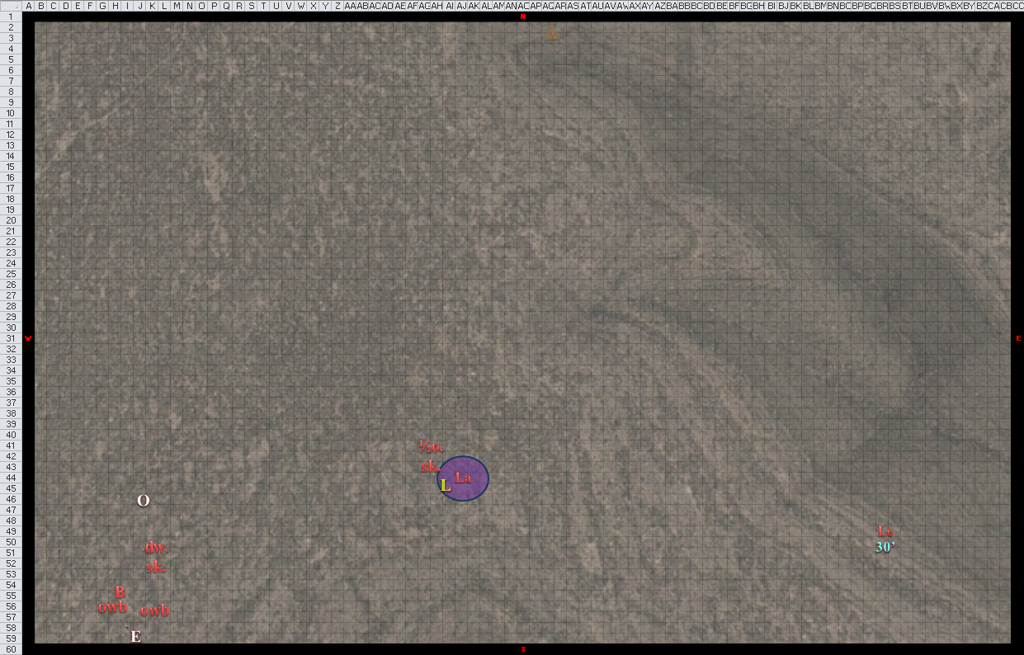

Round 10

Leighlund cast *greater invisibility [expired on Round 120]*, and who knew what he did after that?

Lauren channeled *shocking grasp* and full attacked Larlum.

|  |  |  |  |  |  |  |  |  |  |  |
| --- | --- | --- | --- | --- | --- | --- | --- | --- | --- | --- |
| **Melee Weapon** | **Dmg** | **D+** | **TH+** | **Critical** | **Type** | **Wt.** | **Atk** | **Roll** | **Check** | **Properties** |
| Falchion +3 | 2d4+  *shocking grasp* | +5 +3 | 3 | 18-20/x2 | Slashing | 8.0 | +23 | 12 | 35 |  |
| Falchion +3, 2nd Attack | 2d4 | +5 +3 | 3 | 18-20/x2 | Slashing |  | +18 | 15 | 33 |  |
| Falchion +3, 3rd Attack | 2d4 | +5 +3 | 3 | 18-20/x2 | Slashing |  | +13 | 2 | 15 |  |
| Falchion +3, *haste* | 2d4 | +5 +3 | 3 | 18-20/x2 | Slashing |  | +23 | 5 | 28 |  |
| Lesser Crystal of Arcane Steel | +1 to touch spells | 1 | +1 | - | - |  | - |  | - |  |

*Hit, hit, miss, hit.*

*Dmg: (4 + 5 + 3 + 23 electric) + (7 + 5 + 3) + (5 + 5 + 3) = 12 + 15 + 13 + 23 electric = 63.*

Larlum’s *fire in the blood* spell splashed retribution in the form of flaming blood upon the duskblade.

*Dmg: 3 + 10 + 12 = 25 fire. Partial damage negated [37/133].*

Larlum drew his unholy heavy flail and attacked Lauren.

|  |  |  |  |  |  |  |  |  |  |
| --- | --- | --- | --- | --- | --- | --- | --- | --- | --- |
| **Melee Weapon** | **Dmg** | **D+** | **TH+** | **Critical** | **Type** | **Wt.** | **Atk** | **Roll** | **Check** |
| Unholy Heavy Flail | 1d10 | +6 +2d6 evil | 1 | 19-20, x2 | Bludgeon | 10.0 | 22 | 18 | 40 |

*Hit. Dmg: 2 + 6 + 7 evil = 15 [22/133].*

To the far north, Azimuth mounted Freyja, and was spotted by Lauren out of the corner of her eye despite the menagerie of bones around her.

“Finish her!” shouted Leighlund, now invisible and gloating.

One of the two remaining owlbears disappeared, its effects expired. All of the remaining skeletons converged upon Lauren and Larlum, but did not have time to attack, save for the newly conjured half-orc skeleton.

|  |  |  |  |  |  |  |  |  |  |  |
| --- | --- | --- | --- | --- | --- | --- | --- | --- | --- | --- |
| **Character** | **Attack Type** | **Damage** | **Crit** | **BAB** | **Mod+** | **W+** | **Other+** | **Roll** | **Total** | **Threat** |
| humanoid skeleton | Claw 1 | 1d6+1 + 1d6 cold | 20 | 1 | 1 | 0 | 0 | 2 | 4 | ☒ |
| humanoid skeleton | Claw 2 | 1d6+1 + 1d6 cold | 20 | 1 | 1 | 0 | 0 | 16 | 18 | ☒ |
| humanoid skeleton | Bite | 1d4+1 + 1d6 cold | 20 | 1 | 0 | 0 | 0 | 12 | 13 | ☒ |

*Miss, miss, miss.*

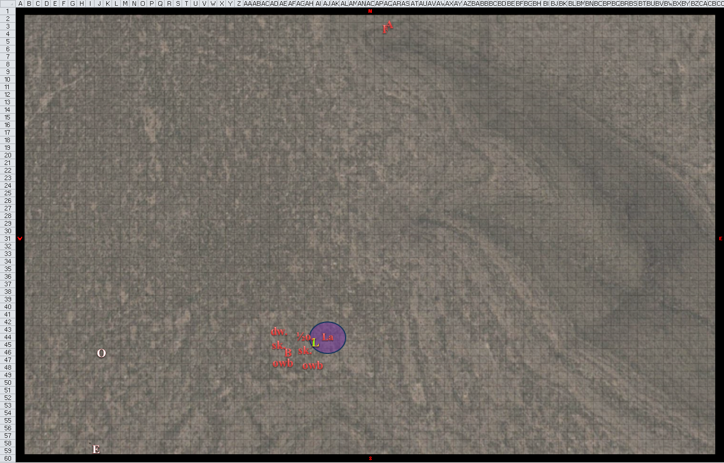

Round 11

Leighlund didn’t have a good spell to use on Lauren that (1) didn’t also harm Larlum, or (2) didn’t require Leighlund to get closer than his cowardice demanded, so instead he cast *dispel magic* on the duskblade, hoping to strip her of at least some of her wards.

|  |  |  |  |
| --- | --- | --- | --- |
| **Spell** | **Atk** | **Roll** | **Check** |
| Dispel Magic | 12 | 19 | 31 |

Lauren lost her haste spell’s effects five rounds early, but no matter. She quick cast *dimension door*, taking herself as far south as she could. When she arrived, she used all of the charges in her healing belt to recover some of her damages.

*Lauren gained 21 hps [43/133].*

The enemy was no longer in sight. She had managed to slay Melonpatch, but the other three arch-villains were still out there somewhere.

Then all went white, and the dream was replaced with the sounds of chirping birds on the morning of 22 Mirtul, 1377.