*Chapter 61*

The Gambit

It was early Mirtul and winter’s grip was not yet loosened on Waterdeep. Several months had passed since Destiny’s Gambit’s expeditionary force returned from their successful eradication of Syracuse and her band of Red Knight pretenders. Much of the city’s rewards from that had been sunk into the luxurious furnishings of Maiko’s brothel and since no subsequent work from the city had been offered, Sarge was looking to make some coin by whatever means chose to present itself. Holding court at his favorite bar, Sarge contemplated his dwindling assets and spun some tall tales – a few of them actually true – he had garnered a few free drinks from listeners when there was a tap on his shoulder. Looking up, he beheld a stranger.

“Are you Marcus Grayson?” asked the fellow.

“That be me, but call me Sarge. What can I do yer for?” Sarge asked.

“The name’s Arog. I understand you’re a talented arcanist and the parties I represent have a proposition if you’re interested.”

“All depends, but costs nothin’ to listen. What’s yer pitch?”

“The city’s sewers tends to attract monsters, thieves and such over time and so the merchant guild periodically raises funds to send a group in to flush ‘em out. This time around, our group got the contract. It pays just 10 gp a day each but we also get a bounty on every monster head or criminal we turn in. You interested? We could use some magic support just in case we run into something nasty.”

Sarge considered a moment but then shook his head. “Afraid not. If we did a trip and came up empty except for a few coins, my woman would raise a fit trooping in stinking of the sewers and I’d probably have to toss out my clothes.”

Arog chuckled, “Hah, that’s already planned for. One of the things the merchants supply is a wand of *prestidigitation* to clean ourselves up with after each trip. Tell you what, we’ll let you keep it with whatever charges are left as a bonus if you stick out the contract.”

Sarge reconsidered and asked, “How long’s the contract run and how often you plan to make a run?”

“End of Flamerule… by then the spring rains will have tended to flush things out by themselves. ‘Till then, we’d probably make a run every 2nd or 3rd day.”

Sarge did some mental figuring – 9 or 10 tendays would make for 30 – 40 runs… a few hundred gold at least even without bounties and a partially-charged wand to boot. “OK, you’ve got a deal!”

Arog beamed and clapped Sarge on the back. “Great! We’re planning our first run in a couple of days. I understand you can be reached thru the base of that Gambit outfit, right?”

“Yep, they can usually get a message to me from there.” Sarge confirmed. “I’d best be off to check me gear then so’s I’m ready when the word comes down.”

~*~

Several tendays had passed, and it was now mid-Kythorn. The profits from the frequent forays into the sewer system were by no means huge, but were reasonably steady. Sarge’s associates in the endeavor were Arog, a fighter, Ruth, a rogue and Marak, a ranger. The majority of bounties were from fairly minor threats such as giant rats and a few of their dire cousins, but the lair of a small band of robbers was discovered on one jaunt and among the goodies recovered was a largish ruby. Sarge had been supplying illumination for the band via *light* spells, which had a distressing tendency to expire at just the wrong time, so he suggested taking the ruby to a jeweler to grind into powder, supplying the material needed for him to fashion *continual flame* items for each of them. After some consideration, the others agreed and each now sported an item whose light was not prone to expiring. Sarge created his as a glowing cloth which he now wore tied about his upper right arm.

Returning home from the latest delve, Sarge gave a nod to the doorman guarding the entrance to Maiko’s domicile-slash-brothel and headed straight towards the sumptuous bath Maiko had renovated. While the wand-wielding rogue did a competent enough job in removing the muck and odor from the slogging thru the sewer, Sarge didn’t feel completely clean until he’d had a good soak in the bath. Then, feeling refreshed, he slipped on a fresh pair of trousers and joined Maiko in their shared room.

~*~

Maiko sat clad in a sheer blue nightgown at her dressing table and brushed her hair as she looked into the mirror. She smiled as the door behind her opened to let in her man. “How did you do today?” she asked.

“Looked to be coming up empty until we ran into a nest of small-time crooks. The bounty was a nice little windfall.” Sarge stripped off his trousers and slipped between the silken sheets of their bed.

She laid her brush down and stood turning away from the table, leaning against it in a sexy flirtatious way. “My girls are doing well. I think that new elf will work out fine although I’m not sure if she’s ready for multiple clients at once yet. Maybe if you have time later this week you and I can test her abilities.” She smiled mischievously..

“Just what I wanted, m’love,” he smiled. “I happened to get you something too.” With a crook of his finger, he beckoned her to join him.

Returning his smile, she shrugged the straps of her nightgown off her shoulders and it fell to the floor as she moved to the bed. Maiko’s naked form slipped gracefully under the covers with Sarge in the dark room. She rolled over, throwing one leg over his so that her womanly parts pressed against his leg as he lay on his back. One hand played with his chest hair as she kissed his cheek and lay her head on his shoulder.

Revealing the silver necklace he had bought with some of the day’s proceeds, Sarge clasped it around her throat, letting it dangle between her breasts.

“Oh sweetie, it’s beautiful,” she exclaimed after pulling the chain out far enough to examine the exquisite workmanship. “I love it!”

Sarge leaned forward and kissed her deeply, which she returned in kind but her thoughts drifted to a different matter that had been nagging at her. Finally deciding it was time to broach the subject outright, she asked with feigned casualness, “My darling sweet,” briefly pausing, unsure sure exactly how to ask, “What do you think about children?” She lay there a bit tense as he did not answer right away.

Sarge was taken aback at the question but answered after a moment’s reflection. “Oh, they’re fine for most stay-at-home types. When I was in the service, I felt they weren’t for me…hard to be a good father when you’re off campaigning most of the time. Probably why my woman Dear Johned me.”

Maiko decided not to press the matter any further at this time and began distracting him in the manner she knew best. The seed of the idea had been planted and there was plenty of time to let it germinate.

~*~

Only a few days remained before the beginning of Flamerule. There were fewer and fewer bounties claimed as the supply of nesting monsters appeared mostly exhausted, so their merchant sponsors decided this would be the last trip of the season. Several hours into their final trudge had been completely empty of anything of note. The crew was exploring smaller side passages that had been previously too choked with debris to pass, but were now cleared out by the frequent springtime downpours flooding thru the system.

“Hells, not so much as a normal-sized rat to be seen down here,” commented Arog. As if to prove him wrong, suddenly the sound of dozens of squeaks and the scrabbling of hundreds of tiny feet erupted around the group and Ruth screamed as she was engulfed by hundreds of rats. As her other two companions did their best to batter the rodent horde away from the hapless rogue, Sarge stepped to one side of the expanse of rats and intoned a quick spell, incinerating a large portion of the swarm with a *burning hands* invocation, being careful to keep the sheet of flame away from the pile of rats covering Ruth.

“My petsssss, my petsssss,” a sibilant voice hissed from the shadows. Looking up, Sarge was shocked to see a large snakelike creature with a human head peering up over a mound of debris. As he met its gaze, he recognized the abomination as a spirit naga!

Too late to avert his gaze, the power of its eyes burned into his consciousness, attempting to ensnare his mind into thinking it was a friend. Barely shaking off its gaze, the warmage managed to suppress the urge to engulf it with a *fireball*… the ancient tunnel they were in would likely collapse on all of them from the blast. Instead, he drew forth an icy globe from nothingness and hurled it at the serpentish creature. The *orb of cold* impacted it squarely in its head, the frost seeping deeply into the cold-blooded monster’s body and rendering it temporarily blinded.

Taking advantage of its momentary vulnerability, a trio of *scorching rays* sufficed to finish off the horrendous foe. With their mistress slain, the remaining summoned rats swiftly began to leave the area, urged on by the stench of their roasted kin. While the shuddering rogue was helped to her feet, Sarge drew his sickle as he stepped up to the naga’s body and lopped off its head with a single swipe of the enchanted blade. “I reckon this might bring us a tidy bounty.”

Taking in the numerous bites covering her arms and legs, he commented, “I don’t suppose you negotiated complementary healing services as part of the contract, did you? I’d get those bites looked at for possible disease if’n I were you. I can even suggest a member of my company who might be willing to do so for a reasonable price.” With the others in agreement they’d more than earned their pay on the final trip, the four started back out of the noisome depth beneath the city towards their final payday.

~*~

Maiko knelt on the bed, behind Sarge as he sat on the side. Her beautiful toned skin shone with the oils she had applied to her nude body. Working Sarge’s bare shoulders with her hands, her fingers trailed down his back in a sensual experienced way as she rubbed the tension from his back. Occasionally she would lean forward kissing his neck gently. She breathed in his scent letting out a shy of desire. “I love you and I enjoy the time we spend together.” She was careful not imply any comment knowing the man’s past and his feelings, though she felt he had become a little softer on that issue. It was fine and good. No commitment was necessary. It had been two, maybe three months that she had slept with another man. She didn’t care for them anymore, the women were fine, but as for men she had eyes for only one.

“Ah, darlin’, I dunno what I did to deserve you. Whatever do you see in a worn-out codger like me?”

She continued to work his back and then his temples feeling his muscles relax. She changed positions, wrapping her legs around his waist and her arms around his chest leaning onto his back, her breasts pressing against him. She sighed, “You were gone all day, did everything turn out right?”

“Things got a bit hairy there for a while… I thought our last run was going to be quiet but it sure didn’t turn out that way.” He related the combat to Maiko, glossing over how it could’ve turned out much worse if he had succumbed to the naga’s sorcerous gaze. “I hope Ruth is alright. I think you’d like her… she’s a lot like you – feisty, with a dancer’s body.”

Her right hand moved through his chest hairs as she listened. She then left the room return with a cup of wine as she did nightly for him. She then took off his boots and pants as she did. This was part of her culture to wait on the husband/companion. Only Sarge knew this side of Maiko. Her next action was not a part of her customs but what she wanted this night. She gently took his manhood in her hands and stroked it until it stood tall, then sat in his lap letting him slide within her. She looked into his eyes as one hand caressed his face before kissing him. Every now and again she would flex her inner thigh muscles. She pulled back from the kiss reading his eyes. “So, have you thought about what I ask? About children?” she said in a soft voice. She looked into his eyes with that look that always catches his breath.

The prospect had been nibbling away in his thoughts since she had brought up the subject some tendays ago. “I’m guessing this isn’t just your way of making conversation. Is this something you have been missing in your life?” She paused briefly, her heart racing…she desired to bear his children but feared what his answer might be, then nodded. Sarge continued, “I always figured my chance at fatherhood had passed me by. But I can’t think of anyone else who I’d like to try being a parent with.”

Maiko hugged him fiercely, half-afraid that she might’ve driven him away, but now all was well. Kissing him deeply all the while, she rode him fiercely urging on his need to release. Her hands ran thru his hair as she drove him into herself again and again, seeking his seed. Their moans of pleasure as both climaxed joined those from those of a woman client in another room down the hall.

~*~

As the group made their way towards the surface, deeper below an abomination stirred, sensing the breach of control over one of its dominated vassals. “Something has happened to my naga minion,” the fishlike horror thought, whipping its tentacles about in aggravation. “Most inconvenient. Inquiries must be made so that the culprit can be made to pay, either with its life or by taking my minion’s place.” In truth, the latter fate would eventually lead to the former.

~*~

The Assassination

Dusk, 22 Tarsakh – Red Knight Temple – Waterdeep

Blue energy crackled along the greatsword’s polished blade, and the wielder grunted as the weapon struck home with a thud. The pell’s tough material withstood the onslaught, and the swordswoman followed through on her strike, returning to a high guard stance.

“Very good,” Lauren said with a nod. “It took me a long while to figure out how to do that. It works.”

Elaith lowered her sword and straightened with a grimace. “It does, My Lady. The other spells you taught me will compliment my sword’s attack, as well.”

“You don’t have to mirror my skills or spells,” Lauren cautioned. “You can try different things to see what works for you.”

“I will probably do that at some point,” Elaith acknowledged. “For now, though, I’m content to learn while you bleed.” She grinned at her mentor.

Lauren smiled. “I would protest if it weren’t true.”

The tall redhead plucked at her sweat-stained tunic. “I’d best get inside and bathe before Rook returns home. I promised I’d make lasagna.”

“You promised to serve lasagna,” Lauren chuckled as she gathered her gear. “I think that’s not quite the same thing.”

Elaith laughed. “That’s true. They’d toss me right out if I tried to help prepare a meal. I’m supposed to be this great warrior, instead of just one of the girls.”

“I have no sympathy to spare,” Lauren sighed. “Everyone who knows of our exploits, which are relatively few, thank the gods, treats me like a noble.” She shuddered. “I just want to be a Watchman again.”

“I’m sure you do,” Elaith said with a gentle sigh. “Allisa, Rook, and the rest of us will help you with that heavy mantle, My Lady.” She hugged Lauren briefly, and then stepped back. “By your leave.” At Lauren’s nod, she turned and walked toward the training salle’s east door.

Lauren finished dressing, and stepped out onto the street. She could have taken a carriage, but she needed at bath, and the walk helped settle her thoughts. The drow was halfway home when she noticed a slim figure approaching her from across the street. They wore a long, hooded cloak, which was too much for the mild evening. The duskblade stopped and faced the figure, her right hand ready to draw her falchion.

As the figure approached, Lauren could see that it was a young girl – and that she was at least part drow. “May I help you?” she called out just loud enough for her voice to carry.

“Are you Lauren Fifthdaughter?” the girl asked as she stopped two paces from Lauren. She wore no weapons that Lauren could see. “We need your help.”

“I am,” Lauren replied.

“It’s my sister. She’s been murdered.” The girl looked down and sniffed as a tear ran down her cheek. “We tried to pay their ransom, but then they just killed her.”

“That’s for the Watch to investigate.”

“They said they couldn’t find anything. I don’t think they liked us much because we’re drow.”

“I will come after the evening meal,” Lauren said.

The girl told her the address and departed.

~*~

Two hours later, Lauren knocked at the door of an unremarkable townhouse on one of the city’s better streets. A woman nearly her own height, and skin of a slightly darker shade than hers, answered the door. “Come in, Lauren.” She stepped back and smiled to usher Lauren inside.

“I’m sorry, but do I know you?” Lauren tried to keep the edge out of her voice. She did the woman’s bidding and stepped into the house’s front room.

“You don’t remember me, but I know you,” she replied. “I’m Llolfaen T’in, your mother’s sister. I helped your mother deliver you.”

Lauren’s mouth dropped open as she faced her aunt. “My family disowned me.”

“My father disowned you,” she corrected. “I didn’t speak to him for years, at least until my own children were born. He is a proud and stubborn old man, but he relented, a little, when I brought my children to him two years ago.”

Lauren took a breath as a flurry of emotions passed through her. “Why call me?”

“As I’m sure Sasra, my younger daughter, told you, we aren’t treated well here. The Watch could find nothing after a whole day of investigation. My Molune is dead, and no one cares.”

Lauren sighed. Her own exploits had mostly overcome the stigma, but not entirely. “I understand. Tell me what happened.”

Llolfaen sat Lauren down while Sasra served bitterroot tea. The story was simple enough; Molune, barely fourteen summers old, had been taken from the street after school four days ago. The next day, a beggar had delivered a ransom note, directing the family to deliver a thousand gold coins to a certain merchant stall by the end of the following day. At midday, before the ransom was due, a Watchman came by to inform the family that the girl’s body had been found in a nearby alley.

The investigation, according to the Watch, was completed yesterday. The verdict was a robbery gone wrong. The girl had struggled, and her attacker had slit her throat. She had not been molested, so rape was ruled out as a motive.

“I’ll do what I can,” Lauren promised. “I have some friends who can help.” With that, she bid her aunt and cousin goodbye, and returned home to Shipshape Way.

~*~

Allisa busied herself with making the evening meal. The roast pheasant had browned to perfection, the spicy potato wedges were arranged in a circular design on the platter, and the field peas salted just enough to delight the palate. She expected several of the Gambit members to show up, maybe not all right on the dot, as she understood what their jobs required. As she sat the mugs on the table, the door opened. Looking up she smiled brightly as she briskly walked over to hug and kiss her Lauren. The two had been married for just over a year.

“Hello, my love.” Lauren returned the affection, noticing the younger woman wearing what amounted to cut off, half-thigh trousers and no top. She smiled, wondering if the girl’s clothing style would rub off on any of the locals.

“Come, I have a meal ready. How was your training?” the druid asked.

“It went well. Elaith was pleased with the technique of casting a spell, and then immediately attacking with the sword.” Lauren pulled off her tunic and hung it on a peg, leaving her in her linen undershirt. “How was your day?”

“I have been doing some house cleaning mostly. I checked with the herbalist and he is good with what I brought him last. Oh,” her face brightened. “Will you be able to come to the forest with me this weekend? We can do some fishing or something and it is always better when you come.”

As the two of them ate dinner, Allisa spoke of the special place she had found just east of the city. The two had been there many times. The crimson haired woman took another bit of pheasant. “I have grown tired of the city.” Her facial expression saddened. “There is not enough fresh air, and too many people.”

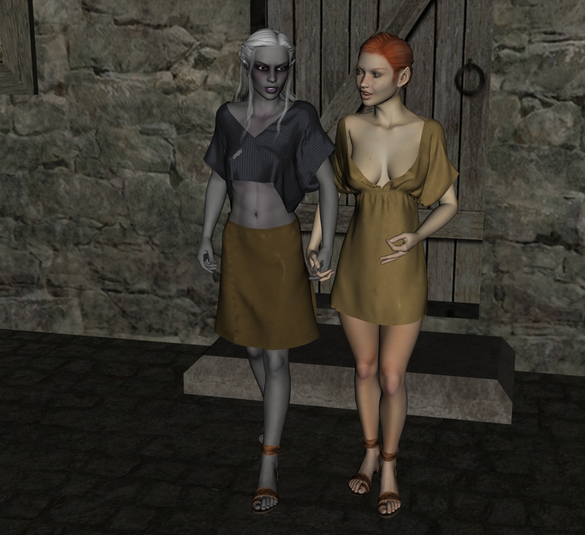

Allisa listened intently as Lauren spoke of her aunt’s situation. “You must help, indeed. People are just so prejudiced, and your kin seem to get the worst of it.” She passed the freshly baked bread. “Let me know how I can help.”

“First, I have to determine what really happened,” Lauren said as she sat back at the table with a mug of ale in hand. “Maybe we can have a spellcaster help with the investigation.”

~*~

The next morning, Lauren rose early and began her investigation. With a spellcaster’s help, she was able to determine that the girl had indeed been deliberately killed – and that any other information was magically shielded from Divination spells. The duskblade searched the area where the body was, but found nothing.

Lauren had better luck with one of Molune’s classmates. She’d noticed the young man, a gnomish lad, standing near the scene, and she went to speak with him. He’d been infatuated with the girl, and so he’d decided to speak with her after school. When he stepped onto the street, he saw two men take her away. He couldn’t describe them, other than that they were drow. He followed them, and he gave Lauren the address of the house they’d entered.

Not wishing to waste time, Lauren went directly to the house, stopping to survey the street before she approached. The midmorning traffic was light, as many of the citizens were at work. The duskblade stepped into the alleyway, as to approach the house from the rear. She took the precaution of drawing her blade and shouldering her shield as she stepped into the gloom.

It was well she had, for, in the next moment, stygian darkness descended around her, and she heard running footsteps on the cobblestones. She invoked her own *blacklight* ability, which rendered her opponents blind, just as Lauren was blind. The next moments were a rush of blows struck in darkness, the clang of steel on steel, and the sounds of spells being cast. Lauren scored several hard hits, and took two serious blows in return, one slamming her shield into her jaw, and the other catching her in the ribs on her right side.

She activated a spell and flew up to the house roof, distancing herself from her attackers. From that vantage point, she saw three drow run down the alley and disappear around the corner. When she was sure they were gone, she flew down to the alley and looked around. A glint of metal caught her eye, and she picked up a brooch with a symbol that she instantly recognized.

Lauren went back home to find Allisa, and called out to her when she entered the house.

Allisa entered the Gambit facility and heard Lauren calling her from the back room. She wondered why her spouse was home so early. The druid had been out studying with a fellow colleague who was instructing her in the delicate matter of how to change into several animals she had not seen in person. The instructor would loan her books and do demonstrations of the various beasts and several humanoids.

Allisa called to her lover, “I am here. Just come in the door.” She continued down the hall and met the drow exiting the room. “What do you need, my sweetness?”

“I will need your help, I think. This is more than just a murder.”

“Yes, definitely; I will help you.” Allisa looked at her mischievously. “Someone’s got to keep your sweet ass out of trouble.” The half-elf giggled before hugging the woman.

“We’re in it, that’s for sure,” Lauren replied gravely. She pulled out a silver brooch with symbols that Allisa couldn’t read engraved on it. “This is a group called ‘Death Hand’. They’re a cabal of assassins and other upstanding citizens, and they are apparently attacking my family members here in Waterdeep. That’s a guess on my part, but that’s how they normally operate. If a family gets cast out, the ruling families will sometimes send the Death Hand to kill them. It’s one of their more endearing traits.”

“We can’t win, not really, but we still need to take out the group here in Waterdeep. Then, we will need to help my family escape the city.”

That night the druid fished out her armor from its storage trunk and looked it over in case it needed repairs. Coming across a slightly newer piece of material, her hand brushed the area in remembrance. The enemy blade had breached her defenses and sliced into her just under her left breast. She remembered the pain as her free hand had gone to the wound holding it, the warm blood seeping through her fingers. If the blade had been just higher and a bit deeper, she probably would not have made it. Someone entered the Gambit residence, laughing; her mind returned to her work as she picked up her blade and oiled the weapons.

~*~

It took several days for Lauren to track the Death Hand group. One member got sloppy and the drow picked up the trail as Allisa went airborne to make sure the suspect was not lost. They were led to an unremarkable townhouse in the harbor district. She and Allisa quietly entered the house one night, and, after a pitched battle, killed five of their enemies outright, captured one, and rescued another half-drow who was about to be murdered.

The captured assassin was compelled to talk by Llolfaen, using a spell Lauren wasn’t familiar with. That information led them to a hamlet a few miles outside Waterdeep, which hid an entrance into the Underdeep. There, Lauren and Allisa killed four more assassins, while at least three more were able to escape deep into the caverns. Lauren was unable to pursue them, as she and Allisa had nearly been killed in the fighting.

A week later, Llolfaen sent an invitation to Lauren and Allisa to visit her home. There, the couple found a group of older drow, along with Lauren’s aunt and cousin. The elders said that they would take Llolfaen and her family somewhere safe, away from Waterdeep. Then, two of the older Drow asked Lauren for her falchion. They took the weapon, and cast some spells on it. When they returned it to the duskblade, the blade, now black, bore a complex pattern made of tiny red crystals, shot through with a constantly shifting pattern of blue sparks. After a short discussion about its properties, Lauren named the blade Arkenlyl, meaning Mageblade in the Common tongue.

~*~

Into the Wilderness

A message was delivered to the Gambit compound on the 2nd of Kythorn, addressed to Allisa.

“Thank the gods you are still alive. I have been searching for you for the past year and only recently came upon a peddler that spoke of a fiery haired druid goddess; seems you and your friends saved his family. The description so matched you. My child, I miss you. First, I have bad news: your stepfather was killed in a raid a year and a half ago. I know you too had little love for each other but I thought you should know. Other news, I have left the big woods and moved to the Westwoods. I have remarried to someone I want you to meet and desperately wishes to see you. We live with a small group of outcast elves at the location I have provided below. My Darling, I love you. Come soon and bring help we are having some problems with an orc tribe in the surrounding mountains.

Love, your Mom, Biyra Maltholas.”

Tendays ago, Lauren had discovered several long-lost relatives; now it was Allisa’s turn to reconnect with her kin and her past.

Allisa was excited at the prospect of seeing her mother, but was unsure if she should go. How would Lauren react? She slipped off to her room, kneeling on the floor with her elbow on the bed she prayed to Corellon. From the start, she had always made time to seek her deity to find what his will was or what she should be doing. The sign she had been give several years back had led her to stay in Waterdeep. After ten minutes of prayer the woman felt enlightened. She felt at least Corellon did not mind if she visited her mom.

That afternoon, Allisa prepared Lauren her favorite meal. She set up a smaller table in their room and lit the room with several different candles arranged just so. Then, she lit an incense burner to tantalize the senses. She asked one of Rook’s followers to direct Lauren to their room as if he was a maître d’. The moments passed and the woman became anxious, being that her spouse was late. Finally, she heard the drow in the hall and was relieved.

“Hello, my love!” Allisa smiled. “I have been waiting for you.” She took Lauren’s hand and kissed her before leading her to the table.

“Aaye, Lirimaer”, Lauren said in the Elven tongue. Her eyes roved down Allisa’s lush figure wrapped in a short and clingy forest green dress that bespoke of Maiko’s expert touch. The elf’s hair and eyes practically glowed in the candlelight, and Lauren smiled in appreciation. She followed her wife to the table, and demurely allowed Allisa to seat her.

The woman removed the cloth from the plates to reveal servings of a perfectly done roasted beef. She poured wine into both glasses, and then she set the bottle down on a dresser behind Lauren. Allisa paused to place her hands on her lover’s shoulders, massaging just a bit before running her fingers though the other’s hair. She then took her seat. The two ate with a bit of chitchat and flirtations.

Afterwards, the druid blurted out excitedly, “I got a letter from my mother. She wants us to visit.” She handed the letter over, looking to Lauren expectantly.

“Of course, my love,” Lauren said with a genuine smile. She had recently been reminded of the value of one’s family, and she was sincerely happy to accompany her wife.

The redhead moved to Lauren, hugging and kissing her. “Thank you. You will like my mom.” Taking Lauren’s hands, she led her to the bed where the two undressed and commenced, touching and rubbing each other into a feverish lust. For the next few hours, they continued their lovemaking with moans of pleasure and contentment.

~*~

The next day Allisa met with several close friends and stopped by the adventurers’ guild. She pleaded her case, asking for help. After some consideration, four people joined her: Shannon, a half-elf druid, Floyd, a human druid, Tharebar a half-orc warrior, and Zinlen, an elven ranger. The party supplied themselves and those needing horses acquired them. The group of six made their plans to leave in two days. The Westwoods were about fifty miles from Waterdeep on the road to Triboar. Then from Amphail, they would trek straight for Kheldell across country, stopping short on the south side of the forest just below the “E” on their map. That would add another sixty or so miles.

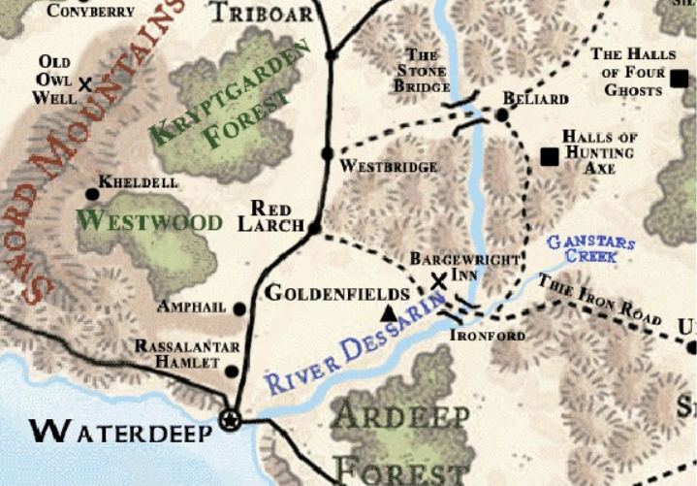

The trip was uneventful, except when Ben met them halfway to their turn off. A few of the members were ready to fight off the beast until Allisa stopped them. The animal had caught Allisa’s scent and was not about to let her leave without him. Along the way, the ranger was able to provide deer meat once they arrived at the forest. The trip took about four days and a half.

As the small troop road into the unnamed town, an older elf with silver hair rushed out to meet them. Allisa recognized her immediately and stepped off her horse before the animal could stop and ran to her. “Oh, Mother, I have missed you so.” She hugged the woman before gesturing for Lauren to come over.

Already dismounted, the drow walked up and greeted the woman. “Mother, this is Lauren. She is my mate.” Allisa slipped her arm around Lauren’s waist as she smiled.

“Well! This is a surprise,” said Biyra “I am honored to meet you, Lauren.” She smiled and stepped forward to hug the drow. Stepping back, she said “Allisa darling, I have someone I want you to meet. Someone you should have been introduced to years ago.” A man had come halfway across the yard without the half-elf noticing. She looked up and her mouth opened in recognition of the man she had played tricks on in the forest back home. His hair still had a bit of reddish tint to it, but was mostly gray now. Her hand went to her mouth. The man cleared the distance, stopping behind Biyra with one hand on each shoulder. He looked strong for his age, still handsome and clear eyed.

“This is Jamison, my husband and your birth father,” Allisa’s mother said.

A raven cawed overhead.

The druid looked to her mother then to her father. The man stepped around his wife. Tears filled her eyes as she rushed into his embrace. Moments passed as the half-elf held onto her father. He just rubbed her hair as he held her and talked softly. “You are such a beautiful young lady; I couldn’t image anything less from your mother. I love you, honey.”

The drow had never grown accustomed to the surfacers’ term of endearment, “Honey”, and held back a smirk upon hearing it.

Allisa stepped back and looked into his face. “All those years I pranked you, and you were my Father.” She said in awe. “I wish I had known.”

“Aye, I was not sure either when you came sneaking around. That’s right; I caught glimpses of you, thinking you were hiding.” He kissed her on the forehead.

Introductions where made all around and that night the group had a small celebration.

Then next morning, the group met with the town officials. “Our problem consists of a goblin horde that makes its home in the mountains to the south. They have not been a problem before. We seldom see them at all. Before this time a couple would come to town and trade for supplies they could not get themselves. Luckily our merchant of the general store can communicate with them. It seems in the last three or four months they have become aggressive. They have killed some of our sheep and taken some chickens”. The group listened intently to the problem. Thoughts had begun to turn to, ‘Why are we here.’

The mayor continued. “A group of our men were out hunting and almost walked into the midst of an encampment of the little fellers. They numbered them to about 100. What was odd though was that there was a big tent on the back side of the camp and the men could hear a guttural language they did not understand. Before they could find out any more information, an alarm was called out and the lot grabbed weapons and charged the men. The three managed to escape with minor wounds except McFarlly, who took an arrow. He is recovering quite nicely.”

Lauren spoke. “Goblins do not act like that on their own. Either someone is controlling them or something is threating their homes.” She stood releasing her spouse’s hand. “Give us the location where this camp is and we will see what we can find and hopefully put an end to the threat.” The group of would-be heroes nodded.

The group headed south on foot. Once out of the Westwood proper, the trees spread out with open areas spaced between patches of trees. The wild grasses stood knee high and offered good hiding places for small game. The mountain range to their front was breathtaking. Snow had accumulated on the highest peaks. As the day passed the ranger had found several different goblin trails moving in different directions. A defensible area on a small hill with a few trees and bushes that would hide the party when they were seated was found. They took a cold meal. not wanting any unwelcome company. Lauren took first watch, with the elf volunteering afterwards. He said, “I will be up anyway so the rest of you sleep.”

Four hours passed, and as the drow was waking Zinlen from **his/her** sleep, they heard noise from the southwest. The two crouched behind the bushes, watching and listening, until a group of about fifteen goblins moved into view. They more or less walked together, no organization. “Me hate big bosses,” said one. “Why do we listen?” Another answered, “Cause they have females. Best you not get heard.” The first replied. “Me no care.” The goblins passed out of hearing to the south.

In the morning the conversation was told to everyone. “I think we should try not to hurt the goblins,” said Allisa, “but find out who these bosses are and deal with them.” The others agreed as the troop ate another cold meal and started on their way.

Today they moved into the hill country. Patches of trees and rocks and boulders were interspersed across the rolling land. By lunch they had neared the valley where the encampment was. Allisa went forward with Lauren and the ranger to look over the ridge. Beyond laid a forest that the ridge had hidden from view. The group noted the natural contours of the surrounding hills and the elongated clearing that still contained the goblin camp, except now there where at least 150 creatures milling around or on sentry duty.

Returning to the others, Lauren spoke. “The camp is over the hill. We need to circle around this valley so that we can come from the other side.”

Allisa said, “I feel strongly that the goblins are only obeying whoever is in that tent. Please use non-lethal force as much as possible.”

The ranger returned hurriedly. “Guys, I saw three trolls come out of the tent, give orders and then two returned and the other went into the trees. About twenty-five goblins jumped up and walked out of camp, heading down the valley to the west.”

“Now we know who we are dealing with. We move east. Shannon, you follow on the ridge between us and the camp while I and Zinlen scout our forward path,” said Lauren.

The group moved cautiously as they circled east far enough not to be seen before crossing the valley through the forest and over the next ridge. By nightfall, they were within striking position. The security was lax on the back side of the encampment, with the command tent sitting up against the woods.

As the group moved in, the warrior knocked out one guard and quickly tied him up. Tharebar put the other guard to bed. Lauren sliced through the tent, creating an opening, and stepped in followed by the ranger, and then Allisa. The ranger slit a sleeping troll’s throat, but that is when their luck ran out. A troll stepped in from the outside and was shocked to see the group.

But, it had sense enough to sound the alarm. Lauren’s first strike was deflected off his armor. The ranger turned in time to block the attack of a third troll, its strength bearing him down on one knee. The two druids moved to the front of the tent, summoned two wolves and one medium sized earth elemental as the warrior battered the goblins with the side of his sword. Allisa was confronted with a fourth troll, and the duskblade called forth her flame strike. The creature yelled out from the fire damage, but advanced upon her, causing her to stand her ground, deflecting his blows with her scimitar.

Lauren cast her magic imbuing her sword with magic might as she attacked her opponent. The blade hit home, finding the week spot between the armor’s seams. It went down and did not move. The ranger scored a minor cut upon his assailant. The troll only laughed as the wound began closing. The beast struck out, wounding the ranger and knocking him unconscious. The earth element slammed the ground causing dozens of goblins to tumble over. Tharebar kicked one goblin which propelled him into a second and third knocking them to the ground. Flyod cast entanglement blocking access to their right flank and stopping a dozen or so goblins in their tracks. The second druid, Shannon, cast Gust of Wind just in time to knock a flight of arrows down.

Lauren was torn between helping Allisa and the ranger, but made the correct decision, taking on the free troll. The beast charged the drow with a head-butt, taking the two out of the tent before depositing Lauren on the ground. She quickly cast her *darkness* spell, making it impossible for the goblins around her or the troll to see her as she shook off the attack and stood.

Ben burst into the tent and barreled into the remaining troll, staggering him. His return strike missed both the half-elf and the bear. Allisa morphed into a dire bear and swiped the creature with her massive claws. He roared in pain but continued to stand.

Floyd called out in Goblin, “we are not here to kill you but to kill your troll masters.” Some of the goblins paused, understanding the druid, but not sure what they should do. The warrior swept with his shield, knocking more goblins off their feet, but sustaining a wound by a small goblin with a dagger. The other druid touched the man’s shoulder, sending healing energy down his body to mend the flesh of his thigh. The elemental stopped into the middle of the camp, goblins climbing up its back and onto its shoulders as it pounded one poor goblin to pulp.

Allisa full-attacked the troll, scoring several hits. The troll stumbled and fell, swinging its arms as it toppled. The tent collapsed and Ben barely made it out the door, roaring his rage at the goblins in front of him; spit and phlegm slapping into the face of the one right in front of him. The creature’s legs wobbled as piss ran down his legs. He turned and fled, causing other to do likewise.

Lauren was now pissed, seeing the tent collapse on her lover. She charged the troll, leaving the earth as she cast *swift fly*. The goblins nearby saw the drow streak out of the black darkness, sword extended, one knee bent, and her other leg outstretched behind her. The troll swatted at her and missed. The duskblade’s sword speared into the creature’s heart and the two toppled over with the impact, just as the earth elemental crashed to the ground, killing several goblins under its bulk.

The goblins stood speechless with mouths open; one tripped and fell into the fire and immediately shot up, yelling and running across the camp with flames on his clothing. No one moved. Then all at once, everyone was in action. The goblins gathered and talked amongst themselves. Lauren slowly crawled off the dead troll and moved quickly to the tent as the tarp moved and a muffled shout was heard. One of the druids turned to help. Shortly, Allisa was freed, holding one of her arms to her side. Even the ranger survived with a bump on his head and a broken leg; it seemed that someone stepped on it during the fight. Allisa’s cheeks turned red.

After a treaty was made between the goblins and the group, the three druids healed themselves and all those who were seriously wounded. The thankful goblins gave out what little presents they could; these being mostly the property of the late trolls.

~*~

The party returned to the village to a hero’s welcome that lasted two days with feasts, drinking, bonfires and more drinking. The members told their story with embellishments of the adventure. During the remainder of their stay, Allisa had time to explore in the Westwoods. She liked the place but could find no trace of a caretaker. On their last day the half-elf kind walked around moping until Lauren pulled her aside.

“What is wrong, my love?”

Allisa replied, “I am tired of the city. I don’t feel like I need to be there anymore. I want to be here in the wild, but I don’t want to do something you are not okay with.” She looked into Lauren’s eyes.

“I will go where you go,” Lauren replied gently. “As I’ve said, I want to live out my life with you. If you want to live here, well, I really can’t think of a better place for us.” She smiled and took her wife’s hand. “Besides, I’m a farm girl, remember? Give me some land to till, and I will be just fine.”

~*~

The Brothel

Since returning to Waterdeep, Maiko’s thoughts turned more towards her business. Currently, she had two girls living with her and Sarge at their home. They had already started doing a small bit of unofficial work for the brothel business. One was a beginner and in need of training. This young girl, Shelly, was seventeen. She had been living on the streets trying to survive when Maiko took her in. She was from up north with jet black hair and a nice figure. The other woman was a friend of Maiko who also worked the dance hall but was not good enough to get any top billings. Azàr was a 25-year-old with blond hair, blue eyes, nice melons, and a well-shaped figure. The woman knew her tricks and was able to pull a wealthier class.

Maiko took time every couple of days to train Shelly. Sometimes the bard would have Sarge assist. This helped her teach special positions for male customers not to mention three-some. Maiko liked working with Sarge she knew she could trust him and the shared experience was always nice.

While cleaning up the house one day, she found a dead bird in her home. She looked at the thing which stank and wondered where it had come from. She promptly swept it into the trash and continued her chore.

For this endeavor to get off the ground, Maiko needed money. It occurred to her that she could buy ladders and split them apart to make 10’ poles. The poles would sell for 2 silvers while the ladders sold for 4 coppers. She could easily take the ladders apart to make the poles and be rolling in coins before anyone knew it.

The next day she had ten ladders sent over and began removing the rungs. About half way through Sarge came home and asked what she was up to. The old man laughed and said it will never work. She gave him a hurt look as he entered the house. The next morning news came that the others where back and had brought with them a substantial amount of treasure and within the next was given a tidy sum. All thoughts of the ladder capper where quickly forgot except for the poles that lay in the back yard until Sarge tripped over them.

~*~

Maiko’s plan was that each girl was given room and board. There room was their work area. The price for the service would cover a payment for girl and for the establishment, while the house took 10% of tips. Maiko had taken time to visit some of Waterdeep’s most popular brothels and while taking advantage of their offers she figured out how she would run her business.

There would be several types of services:

1. Client visits to the brothel

Courtesan companionship 8gp / split to house 4gp

Other 5sp / split to house 3sp

Maiko Females upper class only 20gp

2.Client requesting home visit (special guests) or escort

25gp / Split to house 15gp

3. Parties (upper class)

three to four girls 120gp / split to girls 15gp each

Maiko didn’t plan to partake in the activities of her business, where bodily fluids where pasted between male and female. This was because she had a secret desire that she longed for, however a lap dance for clothed special guest where acceptable. She did, when she chose, perform for upper class female guests.

As of lately, when Sarge took Maiko out, which was only between jobs, she began pointing out children. “Oh, is that boy cute! I like how his haircut highlights his facial features…. Look, that little girl is going to be a boy magnet…. Oh, what a cute baby!” She would say along with other things. Her intentions were to get his mind aligned with her wants. She didn’t want to ask him straight out, not now anyway.

Maiko continued to work several nights a week at the club. She liked her job and she made contacts for her own soon-to-be business.

~*~

The house was not quite right for what Maiko had in mind. With the recommendations from Sarge and Kedrik, she marked the plans and started looking for contractors. She also wanted to make the business to honor Lliira and consulted her priest friend. According to what funding she could find she would add pictures and statues along with color skims’ to honor the god.

They found a contractor via one of Kedrik’s contacts: another gnome who specialized in *stone shape* and other transmutations relatd to architecture, and he quoted her a price much fairer than the local stonemasons and carpenters with whom she’d spoken.

~*~

Before she could start her business, there was the little problem of a license that ran 1,000 gold a year. She was pretty sure she could charm someone into discounting the price of the license so she spoke with Kedrik asking who would be the best city official to approach that she could charm and bribe with free visits. The deal she offered was one free visit a month with any girl he liked. This would be good for as long as she was given the cheaper rate.

She didn’t know if it was the invite to a free bonk a month, the wink of the madame’s eye, of the curvature of her... smile that won the magistrate official over, but she ended up wangling a discount that lowered the thousand gold to 891.

~*~

The work began on the bedrooms on the first floor. Her first customers would have only the services of the girls. Once this was complete a dining room would be setup to serve meads and a limited food items. Maiko could not help herself and had to be in the middle of the construction to oversee the work. She purchased items of Lliira’s design; paintings, a statue or two, a bust. Then there was the downstairs bath, designed for pleasure and passion. The master bath was not too shabby either.

~*~

Finally, the business was opened. She called it, Maiko’s Folly. A third woman had been hired. Selena was a redhead with a fiery spirit and knew the trade well and became the courtesan of the establishment. She brought several clients with her. The other two women had already been seeing clients. Maiko also hired one bartender, a half-orc by the name of Luther, who also filled the bouncer position when Sarge wasn’t around. Sarge had found a job work for the City and was not as available as the bard liked. Fortunately, Luther could cook several simple dishes which added a bit more to the venue. Maiko could not afford a regular cook as of yet.

Maiko, didn’t put up with anyone hurting her girls as one unlucky man found out when he began beating one of the girls for pleasure as he straddled her, humping her and slapping her face and breasts. The dancer ran up the stairs with Luther following behind. She had purchased a magic rod just for this one that would hurt badly but not kill. Opening the door, she stepped into the room and hit him with the rod, releasing one charge of excruciating pain. The man yelled and fell onto the floor. Luther scooped him up with no care about clothes and threw him out the door, warning him not to return. A few weeks later, Maiko found out that some people were made mad by the shocking pain and attempted to fight. Either Sarge or Luther would put them in their place.

As Flamerule approached, Maiko was working to hire a fourth girl. Alavara was a sun elf. Her bronze colored body would cause any man to melt. She had golden eyes and her hair was golden blond. Her skills were up to Shelly’s, who had improved drastically from her streets days.

~*~

The Investigation

25 Uktar, 1376 DR

It had been almost a year since the Gambit’s confrontation with Best, and by now the case had been laid to rest. Supreme Defiance had been declared dead, the cities of Mirabar and Luskan had allied to vanquish the remainder of Best’s known progeny throughout the Spine of the World, and Whisper and his ilk had not been heard from again, as far as Kedrik’s intel could tell.

The archivist had since then worked on a half-dozen cases, some of which had taken months to solve, and a two of which were still pending. These two cases consisted of what was being referred to now as the Dragon Heist and the other was part of a larger set of interrelated cases involving the Dungeon of the Mad Mage. The gnome had just recently wrapped up a case involving some nefarious illithids who had infiltrated their way into Baldur’s Gate to the south, and had taken part in thwarting their efforts to do the same in the City of Splendors.

He’d also taken a vacation—serving as an usher for some of Rook’s followers—in Daggerford, now that the Gambit had carte blanche to stay there indefinitely. It had been a good year—1376—and the lawful good whisper gnome now sighed as he looked back on all that had transpired. Furthermore, Destiny’s Gambit was now flushed with wealth from their own dragon heist in the north, and steady revenues from Maiko’s business kept the organization well equipped.

Kedrik—having made a vow of modesty (though not of poverty)—had invested most of the coin they’d made, and had included the others in the investment, so they all had made out like bandits. Indeed, now the equity of each full member of the Gambit—Allisa, Fingers, Kedrik, Lauren, Maiko, Rook, and Sarge—amounted to 150,000 ₲. The organization—now worth 1,050,000 ₲—was enjoying the limelight of their fame and fortune in the fair city of Waterdeep. It had taken them a year or so to combine Kedrik’s knowledge of the general market with Maiko’s customer service skills, and in the recent weeks, they’d all remarked at how well each of them had done for themselves.

Their newfound affluence had given each of the Gambit’s seven members quite a bit of time to pursue goals nobler than coin, and in this transition, even Fingers had become somewhat of a philanthropist. Kedrik, on the other hand, had delved straight into the further deepening of his Dark Knowledge, and to achieve this, he had somewhat cloistered himself for the better part of the year, and aside from looking in on his investments and his friends, he mostly just stayed in the southern attic of their refurbished house on Shipshape Way.

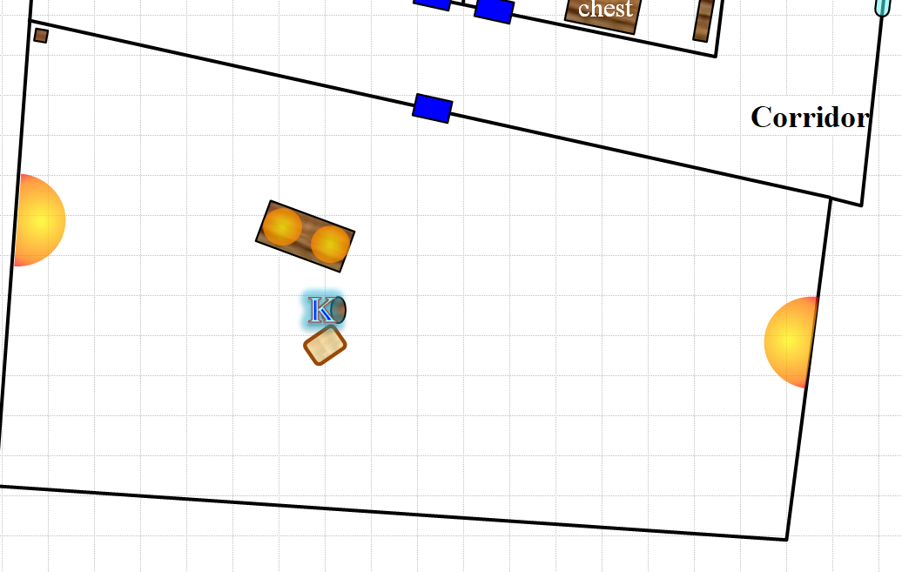

The archivist kept the door to his single, ample room above the main level locked, and warded with a sigil. He’d gone to great lengths to ensure that he would be undisturbed, and had even consulted Fingers’ skills so as to add a few alarms and safeguards to the walls and door. The recovered alcoholic—who hadn’t had a drunken fit since the night that Ct. Bergère was murdered 2 years ago—now obsessed over the two nearly identical items before him, as he had for more days than he could remember. These had been in the custody of the Gray Hands since the Gambit had turned both over as evidence, but as of just over a month ago, the artifacts had been entrusted to Kedrik’s curating and investigative skills.

~*~

“How long has Kedrik been cooped up there?” asked Rook, no longer residing at Shipshape way, and just visiting with Elaith.

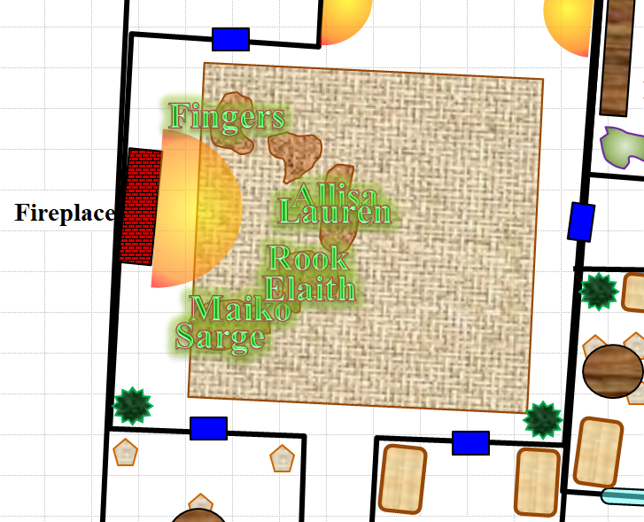

Lauren and Allisa sat on a beanbag next to the cleric and junior duskblade as they all beheld the flames in the fireplace. The druid responded, “He comes down with trash every morning, and grabs about half the fruits in that bowl,” she pointed towards the kitchen. “Sometimes he makes a second pilgrimage downstairs if he didn’t prepare a *create food and water* spell, but it’s been a fortnight since we’ve had more than a passing greeting between us.”

“He’s an archivist,” Lauren stated the obvious. “We’ve all known him to be this way for years. In 74, it was his drinking; this is a much better waste of his time.”

Fingers chuckled.

Maiko proposed, “Why don’t we go up and see if...”

“No, gods, no!” Allisa didn’t let the bard even finish the thought. “Don’t *ever* go near his door.”

Lauren reiterated the warning, “Fingers here helped him rig up some discouragement to anyone who would even dare disturb his quiet time.”

Fingers took on the guise of Lars Ulrich, bugged his eyes out all macabre-like, and grinned mischieviously.

They laughed.

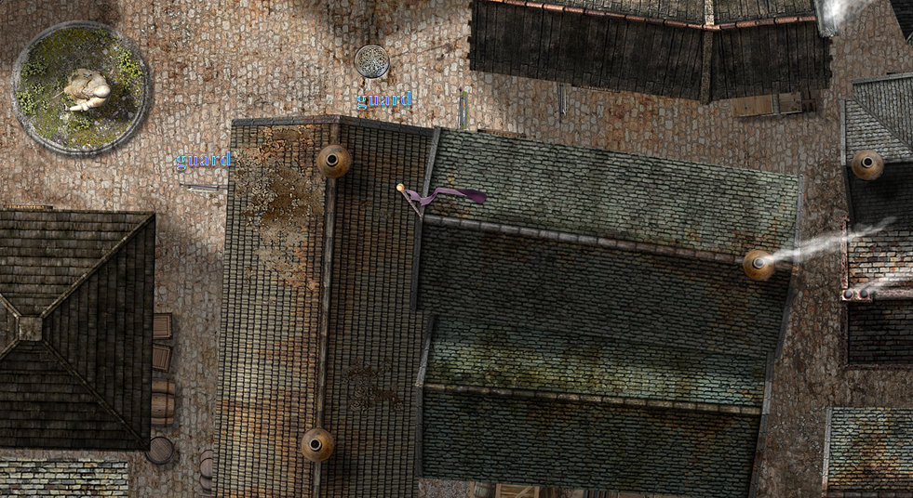

Outside, four guards patrolled the perimeter of the superheroes’ house.

~*~

Had it been a puzzle? A test from Oghma? A trick? How many eons had these two seemingly complementary figurines been in existence? For how many centuries had they been apart until Destiny’s Gambit recovered one from Supreme Defiance and the other from Best’s spawns? Why wouldn’t they fit together like Kedrik now so wholeheartedly wished them to?

He’d eaten today... perhaps. Or maybe it was yesterday. He’d succumbed to sleep a few nights ago, but for the most part, he had spent every moment possible attempting to quantify the patterns along the surfaces of the figurines, and further permute his quantifications in as many ways as he could. Each permutation wove a different fractal of perfect, asymmetric beauty. Some involved the circumference of each object around the torsos and heads, which produced undulating patterns on his graphing ball when he divided those values by the depth of the carved patterns along the surface.

He had named the figurines.

One was named Trkh’shyaxgu, and the other Bolglårghuk, names which came to him spontaneously and which meant nothing to him. His mind then turned its attention to one particularity that he hadn’t yet considered. It was based on the similarity between the 46th etching (for he had numbered them all) on the white figurine—Trkh’shyaxgu—and the 173rd etching on the black figurine—Bolglårghuk. He gasped, wondering why he hadn’t realized this 11 days ago when he’d measured the dimensions of each etching.

Nervously, anxiously, like a child opening a present, Kedrik picked up the white figurine in his left hand, the black one in his right hand, and angled the two so that the 46th and 173rd etchings on each, respectively, were aligned, then pressed one to the other.

They stuck.

Then the two anthropomorphic shapes began to melt into an ooze-like form that coalesced into a swirl of black and white, then suddenly burst. The explosion caused a ridiculously alarming cacophony as it ripped a hole through space-time, swallowing Kedrik along with the furniture and candles within a few feet of the gnome.

A moment later, all was quiet in the room, until the footsteps of the Gambit grew closer and closer.

Fingers undid his own ministrations along the doorway, and Rook kicked in the doorway, triggering the sigil’s alarm. The cleric then *dispelled* the effect as the others entered and all were bewildered by the hole in the floor of the attic, the half of the desk that remained, and the absence of their friend, Kedrik Osvaldur.