Chapter 63

Highsun, 27 Mirtul, 1377

Allisa had spent a good time flying in the form of several birds, shifting from one species to another as food sources changed from nuts and berries to pollen to mosquitoes, and then more pollen again. Her flight was mostly uneventful on the first day, but on the second, in the form of a migrating tern with a stamina that would impel it to cross an entire continent in mere days, she was stalked by a griffon who’d mistaken her for mundane prey.



It had taken some strategic flying, as well as the ability to transform into a roc—a mighty bird twice the size of the famished griffon—to repel the griffon, but in the heat of the battle, the griffon had bitten down quite deeply into her right wing, and she’d had to rest a bit after healing herself. The distress that the subpoena had caused her had taken a toll on the druid, and she had come to feel the lump in her throat and the drip in her sinuses that foretold of a rather nasty cold that by the next day was in full flare.

She had—of course—prepared remove disease and cast it on herself before taking flight on the 27th of Mirtul, and she arrived later that day in the City of Splendors. Her health was again optimal, and she headed first to Shipshape Way.

There, she was enthusiastically greeted by Lauren – a greeting which took some of the afternoon and a good part of the evening to properly convey. The next morning, Lauren arose early to prepare a breakfast for her wife, and sat down to hear about her journey and the mundane details of the goings-on at their new home in the Westwood.

~*~

Highsun, 28 Mirtul, 1377

The magistrates had just cleared some elderly woman and former olympic champion of an unintentional act of homicide involving a spooked horse and a loose tug stop on the splinter bar of the woman’s wagon. The victim had been raised just moments later by paramages who had arrived on the scene shortly after the City Watch.

The head magistrate read aloud the decree following from the jury’s finding, “The city-state of Waterdeep hereby finds you, Fedora Lungefast-Bevine, to have acted with no conscious malfeasance in the events that resulted in the reversible death of Rowen Schleissen. Having furnished the court with proof of your reimbursement to the city-state for the casting of the raise dead spell upon Citizen Schleissen, along with the affidavit of assurance regarding your wagon and horses, the court hereby absolves you of all charges pending on this case.”

“Thank you, your honor,” the elderly human’s voice cracked a bit. “I just can’t say enough how sorry I am that you had to suffer even for a moment,” she then said to Rowen.

Rowen bowed his head, and smiled, repeating what he’d already said a few times, “It’s over now. All is well, and I’ve the rest of my life ahead of me to look forward to.”

The case file floated from one bureaucrat to another as each specialist signed off on their respective portions of the paperwork, and the third magistrate called for Maiko’s case by number.

Sarge sat near the front with all manner of angst and frustration, but held his tongue. Selena was also there, but in the form of an old lady wearing a burgundy and mustard kaftan and a half-veil shielding the lower side of a face with more than enough wrinkles to invite no one to look further.

Sabrina stood first, and Maiko not a second thereafter. Legal jargon was exchanged among the prosecution, defense, and judges, and after about 20 seconds, the person who would have—under different circumstances—done her professional utmost to land Maiko in a prison for the rest of her natural life now turned to the brothel owner/operator, and explained with earnest politeness, “Evidence discovered since the day of your and Ms. Zendar’s arrest places you well outside the realm of culpability, and your testimony is consistent with what we have vetted from the raw evidence.”

Cordelia Zendar—whom Maiko knew as Shelly Bedwarmer—sat alongside other defendants whose cases were still open and would soon be heard, but given her relevance in Maiko’s case, Shelly was asked to stand.

“Maiko,” one of the magistrates now spoke, “The woman you alleged to know as Shelly Bedwarmer has been identified by her next of kin and by the city-state of Waterdeep as Cordelia Zendar, and has further determined that her memories had been altered by magic outside of your spellcasting portfolio and prior to your acquaintance of Ms. Zendar.”

Another magistrate continued, “Consequently, all formal charges against you related to this case are hereby dropped and annulled from the record beyond this hearing.”

A few thanks were exchanged between lawyers and judges, and the prosecutor turned to Maiko again, “On behalf of the City Watch and the city-state of Waterdeep, I extend my solemn apologies for your arrest and detainment.”

Maiko stood “Thank you, sir. I am sure you will have my badge and Allisa’s restored.”

A half-elven magistrate spoke: “The bailiffs are retrieving these for you now.”

The indignant bard continued, “Also, I wish to mention the heavy handiness of the courts emissaries. They were very unprofessional. I being obviously pregnant” she patted her belly, “Would not dare do anything to jeopardize the child. Then there is the matter of my small dog who was also roughly handled for running up the stairs. My lawyer has prepared the paperwork against the officers in question. I have always worked with the Watch. All they had to do is come to me and discuss this. I would have gladly gone down town to answer questions.”

Bureaucrats and sociolegal specialists drew their heads together in pairs or trios like perching lovebirds and murmured like ruminating yaks, some donning funnier hats than others, and one with some serious piercings.

With the magistrates directed at Sabrina—Maiko’s lawyer—things were said in a particular strain of jargon-rich Common that Maiko, Sarge, and most of their friends didn’t understand beyond the prepositions. Sabrina nodded, then turned to Maiko, “Of course, the court will facilitate our requests... let’s talk later about the specifics, but we’ll do what we can to see that there is restitution of some sort for these transgressions.”

Allisa stood at her seat behind Maiko, and was prepared to leave since the case had been won. The old lady on the back bench remained seated as she listened, smelling Fingers nearby. He was probably the dwarven woman who had come alone, or perhaps either the drow or the halfling who had sat silently all through the first five brief cases, including Maiko’s.

The conversation among jargonists wrapped up about a minute later, and Maiko was half-disappointed that no gavel was used to strike a counter or anything like that. The no-fanfare event fizzled out uneventfully, and soon, Maiko was surrounded by her friends, and felt a strong camaraderie that had been absent for months. “I missed you guys,” she smiled.

Sabrina smiled back and took Maiko aside to share information that was for her ears only; if she chose to share it, that was Maiko’s prerogative. “The Zendars send their apologies for their daughter’s involvement in your aggravating experience. They’re eager to compensate you somehow, but they don’t want to communicate that money can lessen your suffering. More importantly, their investigative team has found that Cordelia had been under the influence of a lasting enchantment that had left her not only amnesiac, but with fabricated memories of the brief street whoredom that preceded her tenure at your shop. The Zendars ask that you meet them—I can provide you with their address—for dinner tomorrow evening. They’re hoping that a conversation among you all can help them to piece together what led her to your doorstep, and I think they also want closure with this ordeal, and to know that there’s no bad blood between your Houses, so to speak.”

~*~

Meanwhile...

Kir had spent most of her time doing the occasional odd job, acquiring some coin and listening to the what’s what and who’s who of the city. It had changed in many ways yet had stayed the same in others since she had been gone. It wasn’t ‘til the night before that she had overheard a couple of tavern goers talking about someone she knew. Dulkhende. He was a mutual friend of hers and Xaryn.

Kir had waited ‘til the morning to go talk to Xaryn. She got up, cleaned up and made her way to where her friend was staying. It didn’t take long. She found her way upstairs and knocked on his door and announced herself. “Xaryn, it’s me: your favorite goddess halfling. I’ve come to smother you in kisses and take advantage of you.”

~*~

Maiko hugged a couple of her friends, then called out. “To the Copper! My treat.”

Allisa pulled out of her hug with Maiko her hand sliding from around the woman’s waist. “I will take you up on that.”

Lauren stood at Allisa’s other side. “Is this a private party, or are the spouses invited, too?”

The old woman shuffled out, heading around the companions and in the opposite direction of the group. Once in a safe district, she entered a building and changed privately back into her perfected body. Selena slipped on her normal attire and then exited the opposite side of the building where her cart and buggy waited. The courtesan made for the Copper to join the others.

“Silly, all of my friends and loved ones right here are invited. I would never leave you out,” said Maiko as she smiled.

Allisa returned to Laruen’s side slipping her arm around her and whispering, “Are you jealous, cause that turns me on.” the half-elf then kissed her.

“Hmm,” Lauren mock-growled as she kissed her wife. “Maiko is family; there’s no way I could ever be jealous of her. Besides, she’s devoted to that old reprobate Sarge.”

“True, but you can still be jealous. It will have its benefits,” said the druid as the two walked out of the building hand in hand.

Lauren giggled like a schoolgirl, heedless of who might see or hear. “I am insanely jealous, then.” She clasped Allisa’s hand and walked with her down the street.

Behind them, Elaith leaned close to Rook as they walked arm in arm. “Will we ever be in love like that?”

“I don’t know,” Rook deadpanned. He grunted as the redhead poked him in the ribs with her free hand. “Okay, yes, then. I am desperately in love with your short-tempered self!”

The three acolytes bearing their gear sighed as one, and Elaith heard them. “Learn well, my friends. You have to train them, or they will be hardly useful.” Rook simply shook his head as laughter followed in his wake.

~*~

The Underdark, Erendlyn, Two Weeks Prior to Xaryn’s Exilement

The young drow sat at his desk atop the stalagmite mansion he called his study. He stared the scrolls in front of him up and down blankly once more with an exasperated huff. His plan was falling into place but not at no cost. Xaryn Yril’Lysane hadn’t slept in 4 days and the runes on his spellscrolls were beginning to blur together.

He stood from the ornate obsidian desk in front of him and trapsed across the small room to the bar located opposite him, his heeled leather boots clacking audibly on the worked stone floor. He poured himself another glass of bloodwine and stood for a moment, pondering his next move as he sipped his drink.

Frieda and Cairne had already begun their preparations. He thought to himself absently, ‘I’ve come too far to turn back now.’ He continued, letting his mind run free for the time being, ‘Within a fortnight, my father will fall, and I will take his place.’ “Glorious.” He exclaimed aloud this time, having convinced himself of his superiority to all of the other mages that resided in Erendlyn. Xaryn turned around now, glancing back at the spread of dusty tomes and wrinkled parchments that cluttered his normally pristine desk, “Tomorrow.” He decided with a nod as he turned towards the door to the study, he approached the stone threshold and placed an ebon hand palm down against the door, the room was bathed momentarily in a purple glow as the wards on the door recognized their owner, and the door slid into the floor, revealing the winding staircase behind it.

Xaryn stepped out into the hallway as the door to the study shut behind him, the wards falling back into place with an audible chime. The lithe, young man made his way down the spiral staircase to the, admittedly, much larger room that was his living space and bedroom. As a drow, Xaryn had little use for a bed, though he liked the formality and the homey look that the large piece of furniture gave his humble abode. It was obvious, however, that the bed had seen little use in the time that it had been in his possession, only being employed rarely for those nights where the young mage found time to indulge in the pleasures of the flesh. Tonight, Xaryn had decided on his way down the stairs, it would be used for its intended purpose. Xaryn easily slid out of his robes and boots, and in only his undergarments found himself crawling into the pillowy clutch of his bed. Not long after, he was asleep.

~*~

The Underdark, Erendlyn, One Week Prior to Xaryn’s Exilement

Things were coming along well, Xaryn believed, smiling to himself slyly as he walked the winding streets of Erendlyn, on his way to a meeting of the high mages to be held at House Yril’s private library. Cairne would be there, and Xaryn planned to make contact with him following the meeting, if time allowed. He was supposed to have spoken to Dulkhende three nights prior to the meeting, and Xaryn desperately hoped that the two had come to a fortuitous agreement. The sly rogue Dulkhende was known to be helpful when he wished to be, and Xaryn could only hope that he would cave to his good nature and the promise of power and riches.

The time for thought on that subject found itself cut short as Xaryn rounded the corner and found himself faced with the gigantic stone structure that was his house’s great library. The spider-silk fence ribbed with gleaming mithril spikes that surrounded the structure stood over the street intimidatingly for some, but for Xaryn this was home. He had spent countless hours here in his adolescence, transcribing scrolls for his powerful and lazy father, and by doing so had come to love the library.

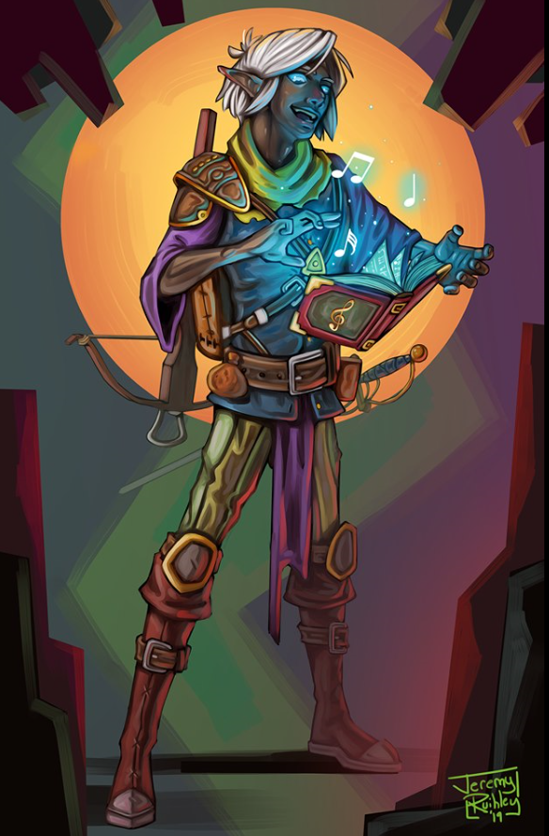

The smell of old books in the air, the peace and quiet required of those inside, the endless echoes that could be heard after even the smallest of noises. It all reminded Xaryn of simpler times. The guards at the gate recognized the pale haired mage immediately and bowed in reverence as he made his way through the towering gate and down the pathway that led to the doors. The gigantic double doors of dark wood were bolted to the stone of the doorway with hinges of black iron that extended at least a quarter of the way across each door. This in and of itself would have been difficult to open if barred from the other side, but the many wards placed on the threshold made it impossible. Wards that Xaryn himself with the aid of his father had put up, thusly, he passed through without impedance. Xaryn made his way quickly through the now empty library. All of the regular residents had been asked to leave for the special occasion. Eventually he came to the main antechamber, in the center of which a large circular table sat, and around it stood the eight grand wizards of the city, his father at the side directly opposite the door.

“Ah, Son. Nice of you to finally grace us with your presence.” Xaryn’s father, Zirafel, chided him with a smile. “Of course, Father,” Xaryn replied “Far be it for me to have more important things to attend to than one of your meetings.” He finished with a chuckle.

Xaryn gave a cordial nod to each of the other mages in attendance before he took his seat opposite Cairne, “What of Dulkhende?” Xaryn asked, his voice naught but a whisper.

“Later,” responded Cairne.

Xaryn nodded in agreement and looked back to Zirafel, who seemed more than ready to begin.

“First things first,” Zirafel began. “The Wards on the main gate must be refreshed within a fortnight, they fell two days ago for reasons undecipherable to anyone that I’ve asked. My guess was faulty casting when they were first erected. Regardless, those wards are priority number one, we wouldn’t want the Duergar to become too reckless.”

Xaryn’s attention quickly waned as his father prattled on about issues that all in attendance were already well aware of, the Duergar, the encroaching beasts from outside the city, the delusional prophecies that he had extracted from his illithid assistant. All more of the same, and without a doubt all of the others were just as bored as Xaryn.

Though as the young mage’s mind wandered so too did the time pass, and eventually the meeting came to a close, and the business that Xaryn really came for could finally begin. He followed next to Cairne as the two walked out of the great hall and back onto the streets of Erendlyn where they could speak more freely, however they elected to wait until they had made it to Cairne’s study before they discussed the real topic that gnawed on both of their minds.

The two made their way into a small outcropping on the city’s outskirts and Cairne activated a door not dissimilar to the one that led to Xaryn’s own study. The stone that made up the cave wall slid aside silently to reveal a cluttered room with shelves lining the walls full of all kinds of magical paraphernalia. Across from the door sat a desk with a large backed chair on one side that was Cairne’s and another, less elegant, for visitors. Xaryn followed Cairne in and took a seat in it.

“Now that the situation allows for discussion,” Xaryn began as Cairne took his seat across from him, “What of Dulkhende?”

“Troubling news, I must admit, my friend,” Cairne began, taking his seat in the padded chair across from Xaryn, “Dulkhende is nowhere to be found, and scrying proves of no help either. I’ve not received correspondence from our favorite swashbuckler in at least a tenday.”

“Troubling indeed,” Xaryn responded with a furrowed brow, “One for theatrics as he might be, Dulkhende is not one to go against his own word. If he told you he would meet he should have shown. Perhaps something is afoot?”

“Perhaps indeed,” Cairne said with a nod, “I fear that more people may know of our plan than we think. Perhaps they feared if Dulkhende was to get involved that the odds would be tipped too far in our favor.”

“You suggest that they’ve had him killed? Whoever it may be?” Xaryn asked.

“Perhaps killed, perhaps kidnapped, extradited from the city or even the Underdark. There are a multitude of things that could have happened to our roguish friend if what I believe is the case,” Cairne responded.

“Hm,” Xaryn mused, “What of Frieda then? Is her end of the preparations complete? You know that we plan to move on my father within the week.”

“Indeed. I’ve spoken to the Priestess. She assures me that Lolth will be in our favor when we finally play our cards, and that the other Priestesses will not intervene,” Cairne replied.

“Good. Then all will be well. I truly believe that you and I together can take on my father and his gaggle of apprentices with relative ease. I was only worried by the chance of the Priestesses becoming involved. I cannot afford to take Lolth’s favor from my house.” Xaryn said matter-of-factly.

“This discussion has reached its conclusion then?” Cairne questioned.

“I believe it has, my friend,” Xaryn affirmed.

~*~

The Underdark, Erendlyn, The Day of Xaryn’s Exilement.

Xaryn paced the living room of the stalagmite mansion he called home nervously. Today was the day. Everything had been set perfectly in place. It was a day of worship for the priestesses and a day of study for the mages, meaning that the two would, for the most part, be kept seperate. This fact, Xaryn relied on for his plan to come to fruition.

He had contacted Cairne the night before to affirm that all of the warding on his father’s tower had been discreetly dispelled, and had been assured by Frieda that the Priestesses will be occupied. The young drow fully believed that he was unstoppable that very moment.

His robes were immaculate just for the occasion. Not a wrinkle could be found on the elaborate spider-silk garments, and his heeled leather boots were polished to perfection. A dagger with a gleaming red gem inset in the pommel hung from a thong on his belt, tucked behind his piwafwi and into his belt just above his tailbone for added security and discreteness, and a collection of several wands of different makes and effects were tucked into his belt above his right hip. He had memorized his spells, including an emergency evacuate in case things went unfavorably, and he was prepared. He only awaited the signal from Cairne.

Just as Xaryn was beginning to worry that something was afoot, that signal came, a flash of arcane purple glowing from the visible windows of Cairne’s tower across the vast city told Xaryn that now was the time to strike, and so, the young mage strode confidently out of his front door and set off towards his father’s tower.

“And so it begins…” he muttered to himself quietly as he left. And so it had.

~*~

Kir stood outside Xaryn’s door. She was wondering what was taking him so long. She gave another knock. “Wakey, wakey, hands off....” She paused, shook her head, then leaned closer to the door. “Xaryn, darlin’, did you stay up too late last night? Should I be jealous? You know what I get like when I’m jealous.”

Xaryn rolled over in his bed, cracking his Amber eyes to squint towards the noise coming from behind the door. He quickly glanced behind himself at the strangely open curtains. Housekeeping perhaps? He shook his head as he deftly hopped out of bed to aggressively slide the shades closed.

“Coming! ... Coming.” He called as he slid the tunic he wore the night prior over his toned upper body, blanketing his ebon skin in a thin crème cloth.

He slipped into his boots with a clumsy thud as he walked across the room towards the door, lacing them as he reached to open it.

Kir heard Xaryn, getting up and coming to the door.

“Kir!” He said with a somewhat feigned excitement brought on by his grogginess “how can I help you this... Morning?”

She gave him a wicked smile at his feigned excitement at seeing her. The grin was quickly replaced by a mischievous one when she looked him up and down. Her eyes then darted to the room behind him, to see if he was with someone. “Well, it is about time there, darlin’. I have been waiting out here for over an hour now.” She slipped past him to come in. She looked around the room to make sure no one else was there.

She walked over to the chair and sat down. “You almost had me jealous, you know. Would have had to take care....” She left the sentence unfinished. She looked to Xaryn, then asked her question, “You remember Dulkhende? I think he is in some kind trouble. I overheard two guys last night. They said that he has not been seen for a week.” She paused for a moment took a breath then continued. “I know what you are going to say. He is probably gone on some adventure or something. I don’t think so. He didn’t take any of his gear. Something is wrong. He is in trouble and we need to find him.” Kir gave Xaryn that “I’m going whether you are or not” look. Then with an innocent grin, “It will be like old times. You know, adventuring, me saving your butt. You do have a cute butt, you know. I don’t mind saving it.” She gives him a grin and a wink. “So what do you say, Master Xaryn, Mage of....... what are you the mage of again? I keep forgetting.” The mocking playful innocence could be heard in her voice and could be seen on her face as she started to laugh.

“Mage of... absolutely nothing now, if we’re to be frank.” Xaryn said with a weak chuckle.

“And yes, I do remember Dulkhende. That sorry swashbuckler is half the reason I am now permanently exiled from my home instead of reigning over it like a god.” Xaryn thought for a moment, “Though I suppose I can’t be too upset at him if he has found himself in some dire pickle with which he requires assistance.”

The young mage thought for a moment more, tying his messy hair behind his head to keep it out of the way for the time being. “Come to think of it, it did seem odd for Dulkhende not to show up to an arranged meeting however... and Cairne did say that perhaps some foul play was afoot. What other details have you for me, Kir?” he asked.

~*~

Afternoon, 28 Mirtul, 1377

The Copper Coronet...

“I really think we should have gone to the Singing Sword,” Maiko proclaimed. “This place is dead today.” It was true: there was not much going on, and less customers than usual were paying patronage to the Copper, but the sun still hung high overhead, and it would be a few hours yet before the shuffle and bustle would begin.

Sarge raised a glass as Rook finished pouring the human wine into each hero’s vessel, and the warmage parted his lips to toast, “To a day of triumph for my child’s mother, and for the Gambit!”

Rook cast neutralize poison upon Maiko’s drink, rendering the alcohol into water, and added a sparkly blessing from Red Knight.

Maiko gave Rook the evil eye fully knowing his intent. “Can’t I have a bit of fun. At least one glass to true wine. Not like I am going to drink the whole bottle. Anyway. They say a little wine is good for the heart.”

Allisa laughed. “I knowing a bit about healing do not think one glass will hurt the baby. I mean, the kid has to turn out better then Maiko,” all laughed at the jest.

Selena entered the establishment. “I have found your crew at last.” The astonishing beautiful woman moved to the table first kissing Sarge on the cheek then Maiko. She took the only open seat between Lauren and rook and purposely gave Rook a tempting, desirous look as her fingers ran across his shoulders. She did it mainly to see the look on Elaith’s face.

The sleeveless gown the courtesan wore accentuated the blue makings upon her upper arm and face only adding to her beauty and mysticism. The design was fluid, flowing down her body clinging here and there to revel her figure at different axes. The material itself, seemed transparent, but one could not get a true glimpse of her skin beneath. Her eyes sparkled as she smiled and nodded to each. Her red tress outmatched Allisa’s hair in its color, and was pulled back behind her ears falling to mid back, held in place by a braided strand on either side of her head.

“I will have Ondal’s wine,” she said to the approaching barmaid. Shortly she was served the golden liquid. This wine not being the true Ondal’s because few proprietor wanted to release uncontrollable destructive magic on their premises much less in Waterdeep, was an expensive knock off with the taste and flavor.

“So I take it we won the case,” Selena said as she elegantly sipped from her glass.

Allisa called for another glass of Clarry, a blend of sweetened table wines. “Why would you think otherwise?”

Selena smiled.

“I will give you the details latter,” said Maiko. Her hand rubbing her belly, with Sarge’s on top.

Looking over at Rook, the druid asked. “When are you two tying the knot?”

~*~

Business picked up.

The cheerful times at the Copper Coronet were always to be expected, and seldom was a patron denied the pleasures of an enjoyable moment of drink, games, dancing, or just plain people watching. There was always carousing, and if one really wanted trouble, there was the alley out back where nearly every illicit substance and activity could be petitioned for. Lauren seemed to be enjoying herself more than usual today, seeing as this was the first fun time they’d had since Allisa had returned to the City, and the duskblade sensed that the druid was once again longing for the solace of her woodsy home. Parting always affected the half-drow for tendays after the fact, and Lauren was probably drowning the foreshadowing of having to embrace her lover and say goodbye for another stint, or be faced with doing the same with her friends here in the City. She wasn’t particularly tied to the City otherwise, as she had been in years past. Yes, she was still a deputized agent of the City Watch, and an initiated member of the Gray Hands, but lately the City seemed like it didn’t need the Gambit’s help.

This time would be different, Lauren resolved. She needed Allisa’s company for many reasons, not the least of which was how her nightmares faded when her wife was present. More simply, though, Allisa was her spouse, and spouses were supposed to live together.

Allisa’s departure from Waterdeep had been a sure sign that she, too, had had enough of the metropolitan bustle, and no longer felt the need to represent the City’s virtues and tenets in the face of opposition. She’d put in her time, paid dues of service she never owed, and her friend had been disrespected by the City Watch, who would surely concoct some heartfelt apology on behalf of the high command, who probably was unaware of the situation at the time. The druid, in short, had lost her taste for the urban hero business.

Fingers was wrapping up a final conversation, and had already said it was going to turn in early. “I’ll light a fire for you guys so it’s toasty when you get home after dark,” it assured Rook and the others on one of the last cool days of spring.

Sarge raised a glass of highly concentrated alcohol called vixen’s bile, and downed it with a face-melting chagrin as the changeling—in the form of an average human male—tipped its hat at his warmage comrade and exited through the door uneventfully.

The cheers and singing continued, and Rook finished playing a game of Chess with Elaith by about the time that Sarge was being called “that guy”. He was red-faced drunk and happy about his fetus being healthy and what not. It was difficult to understand his anecdote completely, but in short, yes, he was a proud father, and “I hereby decree: if the child is a feminine child, she will not court until menopause.”

There were about five guys who were slightly more intoxicated than Sarge, and these all picked him up now and held him over their heads in praise of his manliness. That lasted for about 6 seconds until they dropped him, and the room fell silent except for the warmage’s voice saying, “Owww!”

Laughter ensued on this drunken afternoon, and the heroes were glad to let out some steam after such an insulting ordeal with the legal system. Then, out of nowhere, it seemed to a drunken Lauren, Sarge, Rook, Allisa, Selena, and Elaith (and to a sober and pregnant Maiko), a woman with a short sword entered the establishment, followed by two spellcasters, and started jabbing and zapping people without so much as an introduction or a declaration of motive.

The barkeep protested, “What in the blazes…” and he was zapped by an Empowered ray of frost that probably killed him.

Then the woman did speak, but only one word, and with the guttural voice of what Rook identified as a baatezu. “Dieeeeee!”

A fireball blasted near the far corner of the room, catching about 15 patrons, and killing all but Sarge and another drunken fellow.
Damage to Sarge 25 fire.

Round 1

Since their armor was lightweight, Lauren and Elaith had put it on as soon as they left the courthouse. This alone had been a spectacle, all out in the middle of the street with their bosoms and curves being encased in metal.

Rook eschewed his heavy plate armor, but he did as his companions did, and wore his bracers and other magical items.

Rook cast energy immunity (fire) on himself and as many of his friends as he could influence with the spell.
All of Rook’s allies except for Sarge gained resistance to fire.

Elaith quick-cast haste, drew her greatsword, and channeled vamipric touch through her weapon as she charged the nearest magic user.
Melee Weapon | Dmg | D+ | TH+ | Critical | Type | Wt. | Atk | Roll | Check | Properties
Shattermantle Greatsword +2 | 2d6 | +4 +2 | 2 | 19-20/x2 | Slashing | 8.0 | +18 | 18 | 36
Greatsword +2, haste | 2d6 | +4 +2 | 2 | 19-20/x2 | Slashing |  | +18 | 9 | 27
Greater Crystal of Arcane Steel | +1 to touch spells | 1 | +1 | - | - |  | - |  | - | +1 to spell DC
Threat, hit.

One of the spellcasters died on the spot.

Lauren drew her falchion, quick-cast haste, activated her Dimension Stride boots to place herself on the intruders’ flank, and attacked the nearest magic user with her falchion, using the weapon’s stored vampiric touch spell.
Melee Weapon | Dmg | D+ | TH+ | Critical | Type | Wt. | Atk | Roll | Check | Properties
Shattermantle Bloodstone Falchion +3 | 2d4 | +5 +3 | 3 | 18-20/x2 | Slashing | 8.0 | +23 | 6 | 29
SB Falchion +3, 2nd Attack | 2d4 | +5 +3 | 3 | 18-20/x2 | Slashing |  | +18 | 5 | 23
SB Falchion +3, 3rd Attack | 2d4 | +5 +3 | 3 | 18-20/x2 | Slashing |  | +13 | 7 | 20
SB Falchion +3, haste | 2d4 | +5 +3 | 3 | 18-20/x2 | Slashing |  | +23 | 4 | 27
Greater Crystal of Arcane Steel | +1 to touch spells | 1 | +1 | - | - |  | - |  | - | +1 to spell DC
Hit, hit, hit, hit.

The second caster was split into filets that flew in a handful of directions as his legs trembled and fell to the floor.

The remaining woman turned around and prepared to stab at Lauren.

Sarge cast orb of cold upon the swordswoman before she could do any harm.
Ranged Weapon | D+ | TH+ | Atk | Roll | Check | Notes
Ranged Touch Attack | +3 | 1 | 9 | 15 | 24 | Weapon Focus Included
Hit.

The woman’s left half turned into an icy block, and she died while giving Lauren the meanest of looks.

“Well, that didn’t take long!” sighed Maiko, wondering why such mid-level hooligans would come in like this and start wreaking havoc.

“Get to the back door,” Lauren barked to Elaith. The half-elf nodded and made her way to the tavern’s rear door. Meanwhile, Lauren looked outside via the front window, seeing only people fleeing and shouting in panic, and a few fools coming over to see what was going on.

A few cheers from drunken survivors returned, but the death of over a dozen patrons just now kind of killed it moments thereafter. A few folks—including Rook—had already made their way to where Sarge was sizzling around handfuls of corpses. Raise dead spells would be needed for most of them, but Rook was able to bring back a few with simple cure spells.

Allisa transformed into a gorilla, an animal form she had been practicing and was proud that she got the coloring right. She then flipped the table over to act as a shield.

Maiko and Selena ducked behind the table as the courtesan produced a dagger from her skirt, taking a protective stance to defend Maiko.

“Stay there,” Lauren warned as Allisa transformed. “There could be more, and they could easily appear in our midst.”

There were apparently no other hostilities. “What was that?” asked Sarge, glad that it had been his hide to be seared and not his pregnant wife’s.

Rook voiced the thing about the woman’s voice sounding like a baatezu, to which Sarge replied somewhat absentmindedly, “Heh, yeah, or an aboleth.” He’d recently had dealings with the loyal but reluctant minions of an aboleth, and may have even had a memory of directly dealing with one wiped from his mind.

Lauren opened the door and looked around carefully to see if there were any threats. Back in the kitchen, Elaith peeked out the back door, using her hasted movement to quickly open and close the door.

The attack had ended, and Maiko now climbed out from behind the table, followed by Selena. “I wonder what that was all about,” said Maiko.

Sarge grumbled to himself as he came to the center of the now resolved conflict, and studied the three villains, hoping to make sense of this.

Selena said, “Maybe a disgruntled worker.” The two knelt. Selena searched though the garments and Maiko examined any clues the other found.

The warmage thought not. These were not the types to work in a place such as this. They were adventurers by the look of them, not Waterdhavians, guessing by the fashion, which seemed more from the areas southeast of Waterdeep.

Allisa became herself and went to the aid of their injured, casting spells as needed.

By this time, the barkeep had gone out the back and could be heard calling the apothecary whose abode and locale was just a few buildings down. “… need of healing. Pretty serious stu…” was about all they could make out.

Upon crouching down to search the bodies, Sarge almost immediately spotted the telltale tattoo on the female’s left wrist that he’d seen while on his side gigs. These poor fools were mixed up in that Umberlean fiasco involving an aboleth, and if Sarge had to guess based on his recent experiences, they’d been led down to the aboleth’s lair—which Sarge was still hoping to discover—and had been possessed by the aquatic, psionic Outsider.

“Check the dismembered arm over there,” Sarge pointed to the left arm of one of the male spellcasters.

Rook and Lauren both checked, and showed the same tattoo—freshly applied—to Sarge as Sarge showed the woman’s wrist to them. Allisa checked the other spellcaster’s left wrist, and found the tattoo as well.

Sarge stood up, nodding to himself. Maiko could tell his mind was racing with suspicions, speculations, hypotheses, and a few irrational fears. “Maiko, love, you should get home. I have to go and meet my associates. I don’t think this was random.”

“In the meantime, keep this on you at all times,” he continued, taking a small stone engraved with arcane symbols from his pocket and handing it to her. “I planned to give this to you as a celebration present but now seems the appropriate time. I hold its mate and it will allow both of us to send a message to the other once a day. I’ve been kicking myself for being asleep all the time you were needing me when the city’s stormtroopers came to our home and I’d been looking for a way to keep that from ever happening again.”

Maiko took the stone and pressed it to her bosom. “Thank you. Be safe, my love, and return soon.”

She knew a little of his exploits, but had only heard of the aboleth and its criminal organization in a vague way. Sarge was careful to never mention names, being in a world where divination magic and other means might drive that information out of her. However, the Gambit had codes and traditions of transparency within it, and so the warmage began to divulge the tale of his exploits a few months prior [see Sarge’s story in Chapter 61], the climax of which was the discovery of the aboleth’s existence—though its name remained unknonwn—and its involvement in Waterdeep’s underground economy. “This is the aboleth’s brand. This is its cattle,” Sarge put a finishing touch as he pointed with an open hand at the corpses before them.

“Is this a job for the Gambit then?” Lauren was sure it was.

Sarge sighed, “Alas, no,” as he surprised the duskblade and their fellow teammates. “The contacts I’ve made while happening upon this criminal ring are far more discrete than Fingers even, and my bringing in outsiders to the network would not be interpreted... well, it’s not a good idea. We didn’t plan to come here. If these fools were sent to find me, they were well informed by a spy or source of divination that gave them my position in real time, or close to it.”

Destiny’s Gambit converged as Selena paid the barkeep and they all slowly shuffled outside under the dipping sun.

“They were knaves,” Lauren said, not so much with a haughty tone, but feeling bad for the fools that were probably just starting out their careers as badasses.

Sarge had thought of about 800 more things since he’d last spoken, and concluded, “I’ll probably be gone for a few days sorting this out. I need to ask you to post some guards around the brothel,” he turned to Rook, who was in charge of the guards who patrolled the Shipshape Way house.

“I can dispatch three guards when we get home,” Rook assured him. There were already three guards at Shipshape, and he thought to send them over to Maiko’s, and then maybe walk over to the reserves’ houses to ensure that both Shipshape and Maiko’s Folly would be guarded around the clock. Shame he hadn’t prepared a sending spell. But then he thought of a better short-term alternative, “Or, so you don’t have to go home and be unguarded for even a short amount of time,” Rook turned to Maiko and Selena, “Why don’t we all just stay at Shipshape tonight?”

“Rook, go ahead and help secure Maiko’s house,” Lauren instructed. “Allisa and I will be along shortly.”

“Yes, My Lady,” Rook replied quietly. He’d watched with concern as his liege lady battled within herself. The presence of such a fearsome creature boded ill for everyone, and his heart went out to Lauren as she faced that fact. Elaith took his arm, and he turned to accompany her to Maiko’s house.

Lauren took Allisa’s hand as they walked. After a moment, she spoke. “We can’t just walk away, can we? I want to go to our house and leave the things here... here.”

Maiko and Sarge were already hugging by now, her tummy and his seemingly entwined. Then the warmage warned, “Look for these brands on folks that seem a bit off, especially guards. But not having been tattooed doesn’t mean you haven’t been possessed by the aboleth.”

“Right,” Allisa had already deduced.

“This may be nothing; a random attempt by the aboleth to test the waters with a few sacrificial lambs and cause some mayhem in the city while other things of greater magnitude are probably in motion... who knows? I’ll be in touch when I’ve sorted it all out.” Sarge exited the scene, disappearing into the late afternoon crowd that had gathered around the establishment as body parts were taken out and the undertaker was summoned.

Lauren, Elaith, Rook, Selena, Allisa, and were left to walk off their drunkenness as Maiko worried soberly about Sarge.

“I should really get back to the business. I have been away too long,” said Maiko.

“That will not do, it will take several hours for Rook to get everything checked and ready.” Selena said with a stern look upon her face. “Aa-Aa, do not give me lip, you must think of the child. If they found Sarge so quickly they must know about you.”

Maiko closed her mouth as she had been about to protest. “Come Maiko, here is my buggy. Selena waited for the mother to be to climb in before entering herself. “I will follow you guys since there is only room for two.”

“Then Shipshape Way it is,” said the druid. She squeezed Lauren’s hand as they began to walk alongside Rook.

~*~

Sunset, 28 Mirtul, 1377

The last few rays of light from an age-old sun would be cast down for a short while longer before that orange orb would set behind the sea that separated Faerûn from Maztica and other faraway lands.

Fingers was the first to get home, having drunk the least and left before the others. It was a bit tired, and longed for its pillows and the tinny melody of its music box to lull it to sleep. However, that desire subsided an instant after it entered the main room, noting the handful of things out of place as it felt a dull pain in its forehead. The next few seconds or minutes became very elastic and relative to its bewilderment as Fingers made its way along the hallway, noting that the tapestries that usually hung on the wall were now on the ground. Doors that were normally kept closed were open, and as Fingers entered every room adjacent to the downstairs hallway, it saw every chamber carefully ransacked for valuables. Nothing was broken—probably out of fear of alerting the guards outside—and everything mundane had been left behind, mostly on the ground; only the few things that Fingers recalled in its friends’ bedchambers being of any material value were nowhere to be seen.

The guards had just greeted Fingers like nothing was wrong, but today the guards had been ubiquitously outside, so they hadn’t seen the ransacking inside. Fingers was furious, not just at the fact that he was now standing inside Kedrik’s cloistered office where the changeling had stashed its newly acquired valuables and beheld nothing but an empty crate where its stuff had been placed, but more at the indignation that an expert trapsmith’s security measures had been breached and circumvented with such finesse.

Turning different colors, and incapable of stopping its twin, jet-black pupils from shaping themselves like feline marquises, then like five-side stars, before returning to circular forms, the changeling paced as it studied the scene of the crime, trying to reconstruct the events. Its traps, sigils, wards, and other implementations had either been left intact, purposely triggered from afar, or disabled by at least one specialist whose expertise and style Fingers had never before encountered. The signature miniature bolts that Fingers liked to use to fashion his traps were left on the ground arranged in somewhat geometric positions, all facing up. Fingers grimaced not only at the situation, but at the now localized pain on both sides of its forehead, a pain it had only ever felt when transforming into a horned person. He touched his hand to his forehead, and confirmed that two horns were, in fact, protruding involuntarily, a phenomenon that had only rarely afflicted Fingers. The shock and distress explained the uncontrollable shapeshifting, and it needed to calm down before it could be an effective investigator in what was still likely a warm trail.

The trapsmith’s body sweated, and undulations of color and structure permeated throughout, causing the changeling to look like a swirling, pulsing, ghaunadan ooze for a moment. A very dim light began to emanate from its hands. Somebody was fucking with Fingers directly. This wasn’t some random treasure heist on the now ritziest corner of the Dock Ward; no, this was someone who shared some of Fingers’ affinities for intrigue and subterfuge, and knew what they were getting into, and how to properly deal with the situation. But this was no one it knew... or at least no one it’d worked with for years and years, as this level of skill could not have been mastered quickly, and none of his peers from back in the day worked at this level of sly.

Shaking its head, which now grew and retracted its hair simultaneously at different parts, the rogue went upstairs and found the same scenario, though less valuables had been stored here, where Kedrik had once slept and now Rook’s students held a clubhouse of sorts here. No one had been home on this fine day, and the guards were local knuckleheads that were just doing as told and guarding the perimeter of the house.

As the sunset cast the last few rays of golden light into part of the chamber, Fingers looked down at its hands, which it’d initially thought were just lighter colored than the rest of its body during this time of acute distress, but no, they were actually lighting up a corner of the otherwise window-lit room. And then, it realized that the crackles of energy that were beginning to grow to discernible size were quickly multiplying. With only an intuitive anticipation of what was about to happen, Fingers pointed its hands down as they both fizzled with energy, and then shot said energy downward into the ground and through the wooden beams that separated the upper story from the ground floor.

~*~

Late 1373...

“Who’s there?”

“It’s me: Willow!”

“Oh, heya! What brings you around?” asked Fingers, opening the door in the guise of a male half-elf.

“Just thought I’d stop by after an eldritch workout,” Willow cracked her knuckles.

“Yeah, you warlocks can go all day with those zaps... puts a sorcerer to shame,” Fingers smiled after saying.

“Puts just about any conventional spellcaster to shame,” Willow replied. “Are you going to let me in or are we going to stay in the doorway and talk about eldritch blasts?”

~*~

Pacing back towards the stairs, Fingers willed its system back to calmness, but not without a few initial failed attempts, and figured someone could cast make whole on the beams later. Making its way downstairs, still distraught but making an effort to stay calm, the rogue began to deconstruct the crime from the entry point inward, which it hadn’t yet identified.

Distracted by its sizzling fingertips—which didn’t feel warm at all, but rather tingly—the changeling started to feel the telltale symptoms that Willow had described to it when they were both a few years younger, and Destiny’s Gambit wasn’t even a phrase. The initial stress of having been bested by a rival rogue had brought on the eldritch symptoms that he’d both seen and heard of, and he now thought back to the moment when Fingers and Willow had made love, and she’d probably inadvertently infected the changeling with the condition.

This brought a secondary stress whose synergy with the initial stress tipped the willful rogue beyond a critical limit, and the newborn warlock spewed a rather concentrated blast of energy downward again, barely able to anticipate it, let alone control it for the time being. Then—cringing at the damage that had caused—it realized as it walked along the darkened corridor away from the windows that it could see almost perfectly in the shadows now, and could perceive slight heat differentials in the air around it.

The sexless changeling shook its head as the image of Willow in succubus form entered its mind. It had been over a year since they’d confronted the warlock-turned-demoness, but Fingers would never forget the horrific death that they had to mercifully bestow upon her.

Wearing a beard now, and a rather different set of features than usual, Fingers inhaled deeply and did its best to return to its full composure, realizing that it would have to save up a pretty penny if it was ever going to be as well-equipped as it had come to be. A surge of testosterone had overcome the changeling, and while he was able to minimize the horns’ protrusion to a mere few millimeters, Fingers now felt a definitively masculine member growing within his male form, and tried as he might, he was for the moment unable to assume any semblance of femininity.

So there he was: his stuff burglarized, his gender neutrality rendered male by his ire, and related to this, and his temporary inability to stabilize or otherwise control his semblance. His friends would soon come home, and the knowledge that their belongings had also been liberated by some thief would be shared amongst the bulk of the Gambit’s members. Hopefully, he’d be able to control his form a little better by then.

~*~

Late Sunset, 28 Mirtul, 1377

The sky ranged from violet to black now, and Evening was around the corner. The guards had been alerted by Fingers as to the break-in, and immediately reported this to Lauren and company, who had been giggling almost all the way to the house as the alcohol was partly filtered through their kidneys. By the time they came in, they saw Fingers sorting through some of his personal belongings, and making a list of what was missing.

After speaking with the guard before entering the home, Allisa told him to go and get a divination specialist quickly. She could only guess at what the two humans would be able to muster after closing time. “No,” Allisa was first to say as she and Lauren took in their surroundings.

Fingers nodded his head first, then shook it, as if to say, “Yes, this is horrible. It’s my fault.”

Fingers was duly embarrassed, given that he’d rigged the house a while back with the intention of keeping out just about anyone. But whoever had done this wasn’t just anyone, and it had become evident by now. “We need divination spells quickly before the trail runs cold. I’ve scoured the house, and it looks like the entry point was through the roof above Kedrik’s former quarters.”

“The attic?”

“My sigils and traps were mostly concentrated along the walls and floor,” Fingers blushed for the first time ever in front of his friends.

“What’s with the look?” asked Lauren, noting that Fingers had gray hair now, as well as a gray beard and a pair of tiny protrusions that foreshadowed horns.

“Stress,” shrugged. “I think we’re going to have to reach out to some of my shadier contacts on this one, unless we can get some serious divination scrolls tonight.”

~*~

Minutes had passed. Lauren had prowled through the house, taking note of what was stolen among her and her friends’ possessions. Reaching her room, she’d noted the ransacked chest of drawers and swore vehemently. “They took my mother’s brooch! It was all I had from her. Bastards.” She now gathered what information she could, and then went back to Allisa and Fingers. “What did you find?”

Allisa had kind of done the same, but by the time she realized that her Scimitar of Frost (along with its affixed crystal) and Darkwood Shield were gone, little else mattered when it came to her resolve; the druid was committed to regaining these items and the honor that came with having commissioned their creation.

~*~

Kir nodded as Xaryn talked. She also checked him out as he started to get ready. At his mention of Dulkhende being part of his reason for being exiled. Kir shook her head in acknowledgement and she smiled at the mention of Cairne. “I didn’t say that he probably doesn’t deserve his current misfortune. That being said, he does know some things that I would prefer were kept secret.” She grinned. “You know that there are several documents, that I may or may not have in my possession… that if leaked may not bode well for some of the elite. Then again, if they knew who I am, and not who they think I am, it may be me for whom things wouldn’t bode well.”

Kir took a deep breath and shook her head. “I am only sure that he was taken about a week ago. That’s what heard last night. As for why, it could be any reason. Though there was rather a big heist that was going to be going down or just had recently. Those that I know have not given me a straight answer on it. If this is the case then he might be involved.”

She stood and moved to look out the small window. As she did she reached out and brushed Xaryn’s hair. “So how is Cairne? It has been a bit since I have talked to her. Is she still interested in the venture that I heard about the other day? I am not all too clear on the details but it would fetch a pretty good haul. What about you? You interested?”

~*~

The duskblade took a little over 10 minutes to finish her survey. “We must be after the robbers before they disappear,” she said to the others as she and Allisa went to their room and began searching for anything that might be missing. This was an easy search since most things had been in the druid’s haversack.

Allisa first noticed her scimitar was missing as she had left it in its scabbard hanging around the bedpost. She said a harsh word in druidic. She quickly went through the contents of the haversack and found everything there. She could not figure way they hadn’t conveniently grabbed her pack. Maybe they had their hands full. As she turned to leave the room she noticed her shield was gone. Not really a big loss as she rarely used it.

Fingers had recently bought a timepiece from a gnome friend that he’d met through Kedrik. He now produced it and said as he poked his head into the ladies’ room, “I’ve been using this lately to make my timing more efficient, and I looked at it as soon as I got here and realized what happened. It’s set to mark the passing of an hour for every tolling of the bell at the Gondian Temple. It was shortly after the 18th bell—18:16 to be exact—when I got home, and it’s now 19:09. Shops are closed, so going out for scrolls will be a tall order right about now.”

“Not sure that’s true,” Lauren protested. “The higher-level scrolls—which is what we’re likely to need at a moment like this—can usually only be found after hours, in some retired mage’s basement.” This was partly true, though Fingers did have a valid case.

Allisa added, “Fritz and Nevra. They’ve never turned us down.” Fritz and Nevra had originally contracted Allisa and her original teammates in an effort to liberate treasure from the kobolds and myconids who had overrun the Catacombs of Yintros about 3 years ago. More recently, they’d outfitted the Gambit and the Rumors with some last-minute magical ammunition, scrolls, and other goods. “It’s still relatively early; they might still be at the shop.”

Not everyone thought that was a worthwhile endeavor, though. “What kind of divination do you have in mind?” asked the duskblade.

Fingers answered, “Anything that can tell us what my contacts can, and even better, what they cannot.”

Lauren and Allisa knew this was so. Fingers’ network was one teeming with opportunists, and Fingers had learned from experience what the mark of ineptitude carried with it.

There was silence for a moment, and then Fingers continued, “I don’t want to inquire about this while still being so ill informed. My reputation is on the line, and in the circles in which I’m about to mingle, street credit is a life-or-death determinant.” Fingers—having been relieved of his Keen Deadly Precision Short Sword (along with its affixed crystal), Eager Dagger, Deadly Precision Sling (along with its affixed crystal), Mithralmist Shirt of Agility, Assorted Jewelry, Disguise Kit, Merchant’s Scale, and a mere cache of 500 GPs—tried to make sense of the burglary, which included the rogue’s most prized and valuable items, plus some mundane things that were probably taken on the fly out of a desire to use them later... or perhaps they knew that Fingers held sentimental value for his scale and disguise kit.

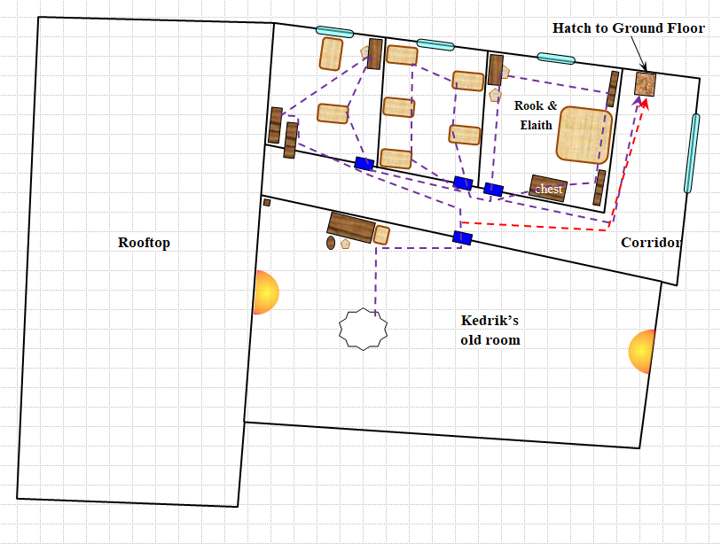

The rogue thought to take the two women through the house to explain the scene of the crime as he’d reconstructed it, but opted instead to describe what he’d seen and inferred. “At the entry point, which has by now been restored with mending or make whole—I’m going to guess—I spotted human-sized footprints. However, from Kedrik’s door, it looks like the human-sized fellow went through the pupils’ rooms upstairs, while a halfling-sized chap headed straight for the hatch and downstairs, where the majority of the looting was done. The pattern of the halfling’s footsteps—if it is a halfling—suggest that he knew exactly where he was headed even before having a line of sight to the hatch. There was no deceleration in those steps until reaching the hatch, and downstairs, there was a very deliberate itinerary taken to reach the most valuable goods: Zond’s helmet, a statue of Red Knight, the bulk of our scroll library, the better halberds and other defensive weapons we give to the guards (other than the ones they had at the time), and Allisa’s and my finest signature items.”

“I’ll say! They took my scimitar. That cost me a pretty penny, and I would really like to have it back,” Allisa said as she met with the others, moving from their bedroom towards the kitchen.

“And my mother’s brooch!” Lauren’s eyes twinkled with flames as she vowed silently to punish the thieves who had gotten the best of them, and gotten away with the best of their stuff. She then asked, “Did anyone find something that might tell us who the thieves were?”

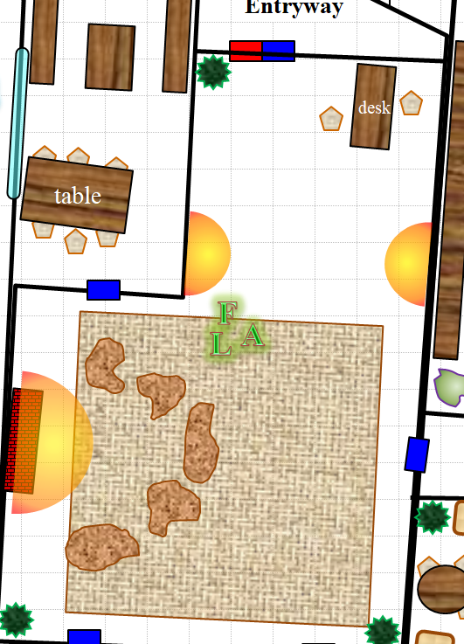

The three stood in a triangle in their partially ransacked living room just outside the kitchen.

“So what do?” asked Lauren. “Do we need to bother trying to get a diviner in here, or getting some scrolls for Fingers to cast?”

“That’s what I told the guard outside as soon as he told us,” Allisa reminded Lauren, who had been too overwhelmed by the news to hear what had been said subsequently.

Lauren tilted her head, imagining what or who that guard would bring back, “The knave out there? The cute one?”

Allisa nodded and shrugged as Fingers pondered their next steps.

~*~

“Hm.” Xaryn said ponderously. “That is a predicament.” He followed Kir’s gaze out the window, trying to figure if she was searching for something specific or just cloud watching.

“As for Cairne. He is, very, unfortunately, I might add, currently chained in the House Yril’Lysane dungeons, soon to be executed.” He said frankly. “Conspiracy to overthrow a house is an offense punishable by death, after all.”

Xaryn turned away from the window, blinking for a moment as the pain of the morning light left his eyes, and took a step towards his sword belt hanging on the coatrack near the bed. “As for the job, I don’t think he’ll be interested.” He said with a chuckle, “I, however, may be depending on my... fiscal situation in the coming few days. I’m less in things for the money nowadays anyways.” He said, pausing for a moment before he spoke again, this time in drow, “I’m more in the revenge business.”

“Oh, in the reve-” Kir was cut off by an unexpected and seemingly agitated knock at Xaryn’s back door, which led to an enclosed courtyard that he believed to have locked.

Both of them drew their weapons in this world of peril.

“Who is it?” Xaryn asked as they both took up positions to either side of the back door, ready to defend themselves or escape through the front door if they had to.

“Xaryn! It’s Cairne!”

Kat looked to Xaryn and shrugged her shoulders. “Sounds like him.” As she kept her weapon drawn, she grinned at Xaryn. “Still can’t take any chances.”

~*~

19:23

Back at Shipshape Way, the superheroes were waiting for the two guards to return with whatever dispatcher they might have conjured.

Fingers mentally went over its list of B&E duos it had had contact with or at least heard about operating in Waterdeep—one large and one small—with one of them possibly being an arcane caster or even trickster due to the apparent ease they had in overcoming the protections on the Gambit base. Unfortunately, not a single soul—let alone a pair that collaborated—came to mind; its knowledge in the area wasn’t as up-to-date as it could be what with being out of the city for prolonged periods so it was quite possible newcomers may well have escaped notice. The changeling made a mental note that perhaps it should do some digging in that respect when the opportunity allowed.

With no idea of what to do, or where to look, Allisa sighed, “It is taking too long for the diviner. We need to do something.”

“We can start by talking to our neighbors,” Lauren suggested, thinking of all the people who lived adjacent to their house.

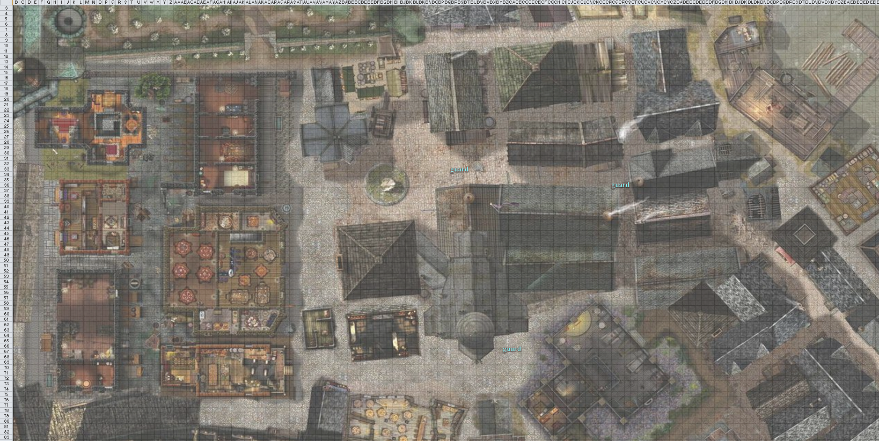

Putting action to words, Lauren opened the main door and stepped into the street. She’d been in the city, and in the neighborhood, long enough to know who would speak with her. Her eyes fell on a battered handcart with an orange canopy sitting on the sidewalk a block from the house. The drow smiled to herself and strode up the street. As she approached, she noted that the tall, redheaded human was busy haggling with a pair of women. That was good, she didn’t have time to chase after him this day. He cheated his customers shamelessly, but if anyone knew who was here that didn’t belong, it was this street merchant. “Still selling overpriced clothing, I see,” she said as she stepped up behind him.

~*~

Cairne finished guzzling down what was left of a bottle of mead as he did his best to regain some semblance of composure. He’d barely explained that he’d escaped the House Yril’Lysane dungeons and was beginning to regain his breath when the sound of a crow cawing outside startled him. He nervously tried to get as much food into his mouth while getting as many words out of it as he could. Though Kir and Xaryn didn’t understand it all, the main gist of his spiel hinged on the fact that he’d apparently divulged a significant amount of sensitive information about some of his Surfacer associates, and given that the information was useless to her, the Yril’Lysane Matron had decreed that for his traitorous actions, he should be delivered unto these former accomplices, along with the message that he’d just betrayed them.

Kir sat and sipped at the wine she had ordered as she listened to Cairne as he tried to explain what had happened to land him where he had been. She would glance at Xaryn to gauge his reaction to all this. Kir stayed silent as Cairne continued on.

Xaryn was taken aback by the return of his longtime friend, and sat nearly silent as the frenzied drow explained his most dire situation. He would later fill Kir in on how he’d betrayed the House Yril’Lysane, but for the moment, they were able to gather that Cairne was being actively pursued, not by local law enforcement, nor by drow enforcers and bounty hunters, but by a force more sinister and powerful than anything Cairne had ever encountered. He insisted on not saying too much for fear that this would imperil Xaryn and Kir against the magic or torture that others would inflict on them. Then he asked Xaryn—his longtime friend—to promise to deliver to Cairne’s mother a sealed envelope, which he now handed to the mage.

The crow outside cawed again, the last few beads of sweat around Cairne’s indigo face now dripping down his cheeks and neck. “I have to go,” he then said. “I fear I’ve already placed you in danger.”

Cairne got up and headed to the back door, peering through the crack in the curtains, and seeing no one about.

Kir watched as Cairne left through the back door. She finished off the glass of wine she had had and shook her head.

Xaryn bolted and locked the door behind him, turning to Kir with an exasperated huff. “What just happened?” he asked, walking away from the door to take a seat at the small table that was one of the few furnishings his room held.

Looking to Xaryn, Kir raised an eyebrow, “Soooo..... What do you think? Me, I can almost guarantee that they will be coming for us.”

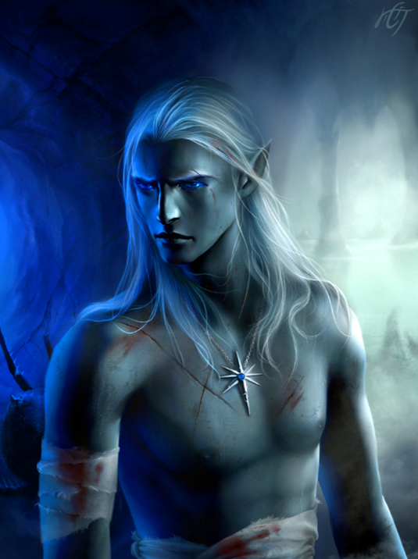

He replied, “I can’t say I’m not shocked, but I also have a sneaking suspicion that we’re both going to die.”

The cawing of the solitary corvid outside seemed to almost second this ominous premonition.

Kir was still trying to wrap her head around it all. None of it made any complete sense. She reached out and took a small piece of bread and started to eat. “Suspicion is not the word for it, my friend. If we do not get out in front of this, somehow, we will be sleeping with the fishes.” She grabbed another piece of bread and started on that. “Whoever it is behind it all wants something. We need to find out what so we can either get it to them or run the opposite direction so that they know that we are not interested in it at all.” She looked to Xaryn. There was concern on her face, which was usually for her. “I love adventure, having fun, maybe running a scam or two, possibly collecting a few things here and there, when Leira blesses me. But dying is not on my lists of things to do.”

Xaryn looked out through the gap between the curtains of the window that overlooked part of his yard, and caught Cairne hopping over the fence with ease and disappearing from sight behind the fence and into a twilight backdrop.

~*~

The man in charge paced back and forth as a tortured man knelt, his hands bound behind his bleeding back. The captive was nailed down to a wooden plank by his ankles and knees. Thin augers also stuck out of his spine where he’d been impaled by a broad-shouldered, chainmail-wearing woman affectionately referred to as the Acupuncturist by her colleagues, and la Matadora in her homeland of Amn, from where she was now exiled.

“So,” the man in charge began as he paced with his hands clasped behind his back, choosing his next words carefully. He wore a black velveteen robe with a lavender trim, and kept in the shadows of the barely moonbeam-lit room. Turning to face the kneeling drow, the gnome in charge said, “They tell me you are now refusing food and water. I don’t blame you, my good man, for you likely realize that there is no escape from here.” He took a few more steps towards the drow, and murmured as his associates shifted in the darkness nearby as hushed slurs about the drow were exchanged.

“I’m afraid that as much as I’ve broken you of your will to live, we must now graduate to the stage wherein I break your will to die. In this, your entire will shall be mine, and you may as well be a skeletal minion. You will wish for nothing as passionately as you now wish for death.”

The taller of the two women in the background giggled at the forecast of the demise of the drow’s mental and spiritual state. She’d witnessed this tactic twice before. The shorter woman—more interested in getting paid and moving on—shifted her eyes upward and to the left, saying nothing to her business associate.

“Or perhaps we can do this quick-like. I give you my word that if you relinquish the talisman, I will do you quickly without any of that other nonsense about ‘your will to die’,” the gnome mocked himself, rolling his eyes at the end as if to portray an inconsistency consistent only with madness.

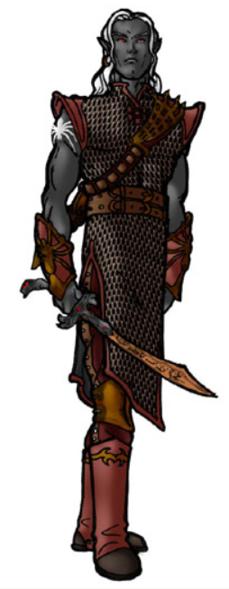

With trails of dried and fresh tears trickling down from his bloodied eyes, Dulkhende looked up, broken in all ways, desperate, and suffering from weeks-long panic, and chittered his teeth before looking back down and willing an extradimensional space to open part of its surface to this plane, and out dropped a seemingly innocuous talisman and necklace sized for a human’s neck.

Casting a prestidigitation, the gnome telekinetically lifted the object and placed it into a bag of holding that hung from his sash.

“I thank you,” smirked the gnome, leaning forward and unto the drow’s defeated face. “This object is—frankly—too robust for the likes of you. It’s better in my care…. But seriously, on the note of breaking your will and all, do you think my word to a betrayer like you means anything?”

Dulkhende cried, his empty lacrimal glands suffering to produce any fluid at all.

“I will make you die a thousand times inside for what you did to thwart my machinations, drow! For the delays you’ve caused me, I will play with your soul until even that becomes tiresome, and then maybe sell you off to the necromancer.”

Dulkhende wept to himself as he looked down with the anticipation of being tortured some more.

“Just kidding! Fuck him up!” the gnome then told the two women who promptly and gladly skewered Dulkhende’s torso diagonally with ceremonial bullfighting sabers, propping up his dying body onto the wooden board where he’d been impaled for the last few days. The sabers would now become hanging hardware. “Mount his body onto the niche in the prison cell,” the gnome then commanded, and the three women in the room complied, picking up the plank—which would now be a sort of a stand for this dead body—as the man atop it convulsed to death. “We’ll make an example of this cuntive swine for anyone who dares trespass into this realm without my consent!”

The two women who’d slain Dulkhende had left the sabers—which had been given to them by the Amnish Acupuncturist—inside the torso of the man whose neck and head now hung limp as his torso bled out.

“Take it away,” the gnome then commanded in a hushed voice, as if he’d been disgusted by what had just happened. “Leave me. I will call upon you after I’ve slept.”

“My liege,” the women all murmured one at a time as they left with the dying or dead man on the plank.

~*~

Maiko left in Selena’s buggy. The two moved down the street in a normal manner as to not draw unwanted attention upon themselves. Shortly they pulled through the gate into the backyard of the Folly. “I will be back after I have stabled the horse,” said the courtesan. She waited till her friend had entered the building then took the rig to the stable just around the block.

In no time at all Selena was back at the Folly. She entered to find Maiko chatting to several of the regulars in the common room. “Come, Selena. Rook left word that a third guard would be here within the hour.”

Selena nodded. She had noticed the man in the corner who looked to be one of the persons she had seen Rook with sometime in the past.

Maiko continued, “The other is finishing her upstairs inspection. Come sit with us.”

“I have a client arriving soon, I must make ready.” The woman smiled and gave a slight bow to those seated at the table before exiting.

~*~

Xaryn nodded along as Kir spoke.

“You’re likely correct, my pint sized companion,” he said, as he assured that the door Cairne had burst through was locked once more. “However, this sounds to me like an adventure, and if there’s one thing I’ve learned about adventures is that if you don’t die you earn many, many favors. Favors are good,” he finished.

“Perhaps this is somehow connected to the Dulkhende caper?” he asked.

Kir looked to Xaryn and gave him a devilish grin. “Favors, yes favors are a very good thing, along with a few knickknacks as well.” She stood, walked over to the window to check out what she might see out of the ordinary. “This could be connected with Dulkhende. I that is the case, then what the he’ll did he get himself into?” she turned to Xaryn. “So, shall we go have some fun?”

Xaryn spun theatrically on his heel and began walking once more towards the coatrack by the main door to his room, upon which hung his elaborate spider silk robes.

He clapped his ebon hands together, rubbing them together in excitement, “We shall!” he said, taking off his tunic to reveal his toned abdomen for a moment as he reached for and put on the robes.

He flattened out a few slight wrinkles in the robe as he reached for his sword belt, placing the ornate dagger back in its sheath located on the small of his back as he strapped the belt around his waist.

“Let’s go on an adventure.”

Kir watched as Xaryn moved to grab his robes. She gave him the once over as he took off his tunic. As she made her way over towards the door, she ran her hand across his shoulders. “Adventure it is.”

She grabbed her bow that she had set by the door, made sure she had the rest of her gear set, then headed out the door. She looked to Xaryn as they headed back down the stairs. “So where do you want to start?”

“I guess our first option is front door or back door,” the soon-to-be-archmage proposed.

Kir gave Xaryn a nod. As to which she chose wasn’t clear ‘til the two got to the bottom of the stairs. She turns towards the back door hoping that Xaryn follows her lead. Once there, she looked to him and grinned.

She cast disguise self [expired in 80 minutes (@ 20:46)], making herself half a foot taller. Dark red hair, dark almost midnight blue cloak, black leather boots, dark blue pants and blouse, black leather gloves, and her bow magically rendered straight to look like a staff.

Once done, she looked back towards the common room to make sure no one was paying too much attention this way, then back to Xaryn. She deepened her voice slightly. Xaryn would recognize this disguise. It was what she looked like when they first met. “You ready there, handsome?”

~*~

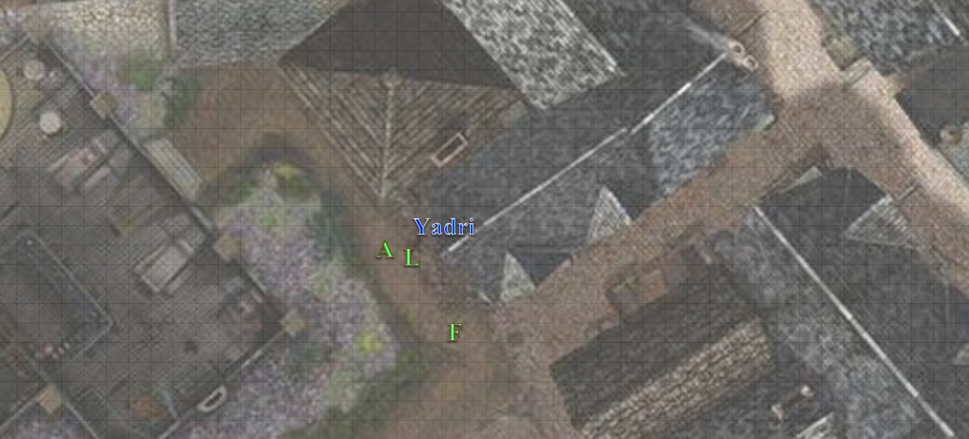

Yadri Lashes had answered her door in the garments that she would wear for the rest of the night, and was taken aback as the very last shades of warm colors faded into lavender and violet in the western horizon. “Oh! Lauren, what is it?”

Fingers had stayed behind a bit, looking down at its watch as it began to regain its full composure and composition, keeping its new horns and beard accents under its skin as it donned the likeness of a male half-orc to help dissuade anyone looking to get fresh with its companions. “19:27,” it sighed into the evening breeze.

Lauren explained the situation, and the woman did exactly as expected: looked in the direction of the Gambit’s house when the robbery was mentioned, and looked up towards their roof when the entry point was referenced. In the end, it only took about 24 seconds for Allisa and Lauren to both be sure that this woman had seen nothing.

Her partner in business and love came to the door—a hefty human named Selfina—and though a bit more defensive in the presence of two gorgeous women who might easily have led Yadri astray in the ways of fidelity, she eventually also made it obvious that the break-in had gone on unbeknownst to the residents of this house, though a direct line of sight did exist between Selfina’s southwest windows and the Gambit’s southern rooftop.

“This happened in broad daylight?” asked Selfina, almost mockingly, not seeing Fingers at the corner of her house. “Don’t you have a locksmith living there?” Fingers overheard her say.

Not wanting to waste more time, Fingers started walking to the next house, and knocked at the door of the next neighbor. “Hylurl,” Fingers noted the half-elf’s name when the resident opened the wooden door. “It’s Fingers.”

“Ah, these are troubled times,” the half-elf said pretty much what Fingers had expected him to say. “First you must answer these questions three: Where did we meet, you and I? What is my maternal aunt’s profession? And, um, who’s the king of ales?”

Rolling its eyes, Fingers answered, “Let’s see... in order: At the Flexible Flagon when it was still owned by K’sandra; seamstress/tailor, one of those two; and Zekkan is your vote for the king of ales; my vote still goes out to Dark Snirf.”

Almost instantly, the pointy eared fellow smirked and asked, “What can I do ye for, big fella?” Then he read in Fingers’ body language that there was something serious afoot. “What’s going on?”

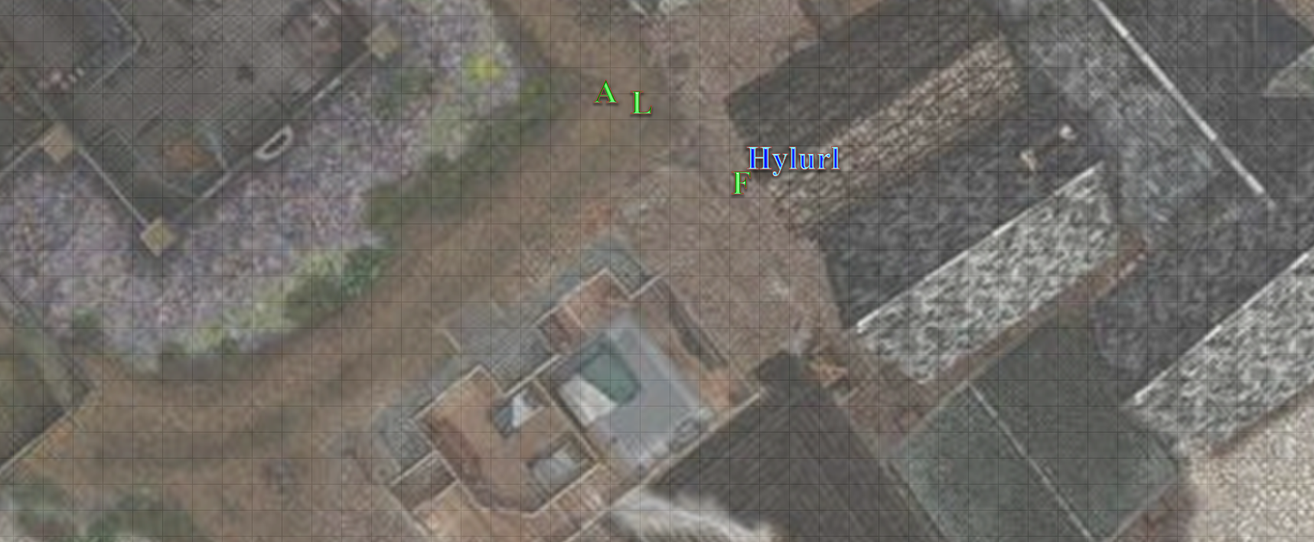

By the time Hylurl had invited Fingers to come in and help him make some tea for the evening, Lauren and Allisa were already making their way over from Selfina’s and Yadri’s place. “Ah, neighbors, unless you’ve come to rob me,” the quite frank half-elf proclaimed, “I welcome your company... but what’s th-” he was cut off as Lauren and Allisa came inside, not so much rudely barging in but forgetting their manners for the moment. The superheroes were all a bit out of breath, and Hylurl waved to his loyal greyhound, who stopped barking, and whined as he obediently went back into the cloistered patio area.

By 19:30, it was also evident to the Gambit that at least from this vantage point—the most likely to have seen something happening along the southern grade of their roof—no one had seen or heard a thing. The guards outside had also neither seen nor heard anything, and any passersby that could have would likely have mentioned it to the guards.

With the immediate neighbors turning out to be bereft of anything useful, Fingers suggested their next course of action. “We might inquire of the city watch posts around the area. While it’s unlikely they may have noticed anything suspicious, we might get lucky.” Being of an occasionally nefarious bent, Fingers naturally had long since made note of the watch post and patrol routes in the immediate area and to a lesser degree farther afield.

Allisa followed Lauren out the door, but turned to the west starting with the building adjacent to their compound.

Fingers had been thinking about the most likely patrol routes that the City Watch would have taken at that time, and while this wasn’t the most heavily patrolled area in the Dock Ward—a fairly unregulated ward—the Watch would already have contacted the Gambit if they were aware of any foul play.

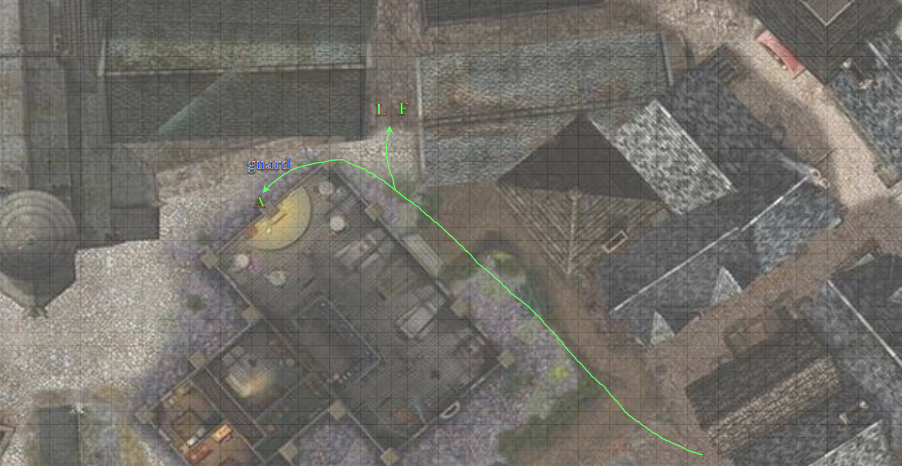

[DM assumption] As Lauren went back home to research some spells and Fingers went to check with the Watch anyway, the druid knocked on a few more doors.

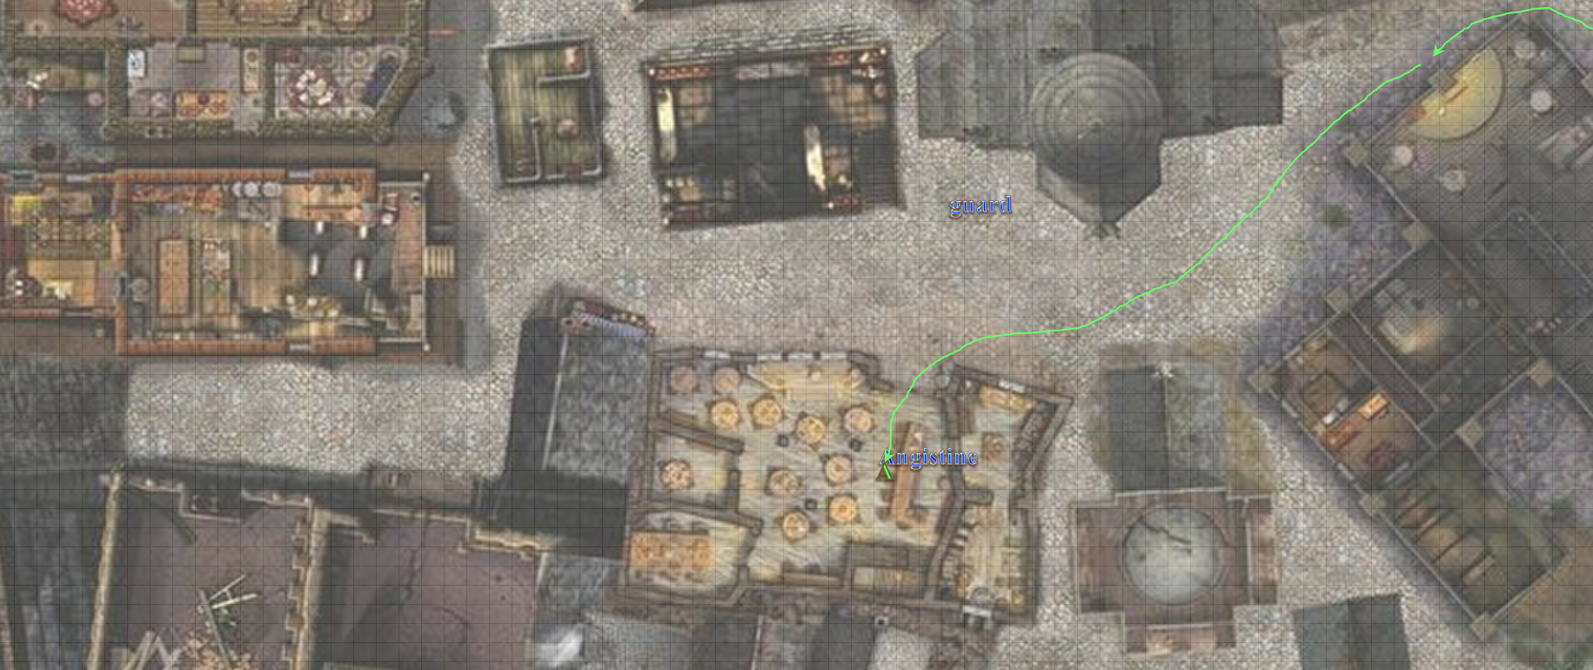

Passing her own house’s guard as she entered the diner and provisions store, Allisa went to the front door and knocked a few times, knowing that this was the house of a night owl who would probably be out for the next 10 hours squandering his inheritance on debauchery. Allisa moved on to the next building to the west, which was an establishment called the Fellow Feline. Entering through the open doorway, she noted the barkeep she’d never seen before, and asked if they had seen anyone working on the roof.

“Oh, Allisa. It’s been a while,” the budding, young human greeted the druid, having grown half an inch vertically and at least as much in bust size since Allisa had last visited the place.

“Angistine?” the druid had not recognized her, but it was the owner’s daughter.

“Yeah, oh, I cut my hair shortly after you left the City,” Angistine explained why she looked so different, but it wasn’t the hair, at least not exclusively.

As the half-elf walked inside, they exchanged the information necessary for Angistine to realize what had happened, and her smile quickly mutated into parted lips coupled with the raised eyebrows that she’d already seen on her other neighbors’ faces. Once Angistine had finished shaking her head at the situation, she nodded, and offered, “I’ll definitely keep an eye out, and I’ll let Mother know when she gets back. The neighborhood is not as safe as it was when Father was alive.”

“Miss!?” a diner called out, raising his glass.

“I’ll leave you to your business, child. My, how you’ve grown up!” she said in an almost proud way that also alluded to the passing of time, and the aging of all things mortal.

~*~

19:41

Fingers entered the local City Watch post, and inquired whether anything suspicious had been noted in the vicinity earlier that day. “There may’ve been some trespassers in our fenced-in area. We found some footprints we didn’t recognize, one human-sized and the other halfling-sized. Any pairs like that you’ve seen today, especially those who you don’t recognize as locals or seemed shady?”

“Nothing’s come through here,” the officer said. “If you’d like to give me your information, I can process a break-in report. Was anything stolen?”

“I’m Phynias Feyson of Destiny’s Gambit and we’d prefer not to make an official report at this time, as it may have ramifications to a current official inquiry,” Fingers replied, wishing it could have displayed its Gray Hand token, “but when appropriate, the relevant documentation will be filed.” The token—he knew—was for internal identification purposes only.

Once again, the wily changeling wasn’t technically lying since that was the name it went by when it first made the acquaintance of Willow and, while it was highly unlikely that the intrusion was related to any current investigation by the city, it could be.

“Ah, yes, Fingers, is it?” the man was familiar with the urban superhero band known as the Gambit. Every copper in the office knew them as well as they knew of Waterdeep’s Faerûn-famous Toxotes, a formidable squash team in their own right.

A few of the Watchmen and Constables came over, smiling with curiosity and admiration for someone as able as Fingers, who always strove to be honest when speaking with those in authority, and to tell the truth—just not necessarily all of the truth. They were staring at the changeling the way dogs reveled at horses, revering them as titans for their massive statures and parading them with parted jowls: the kind of thing that could get a dog kicked by a horse.

If those the trapsmith spoke with happened to draw the wrong conclusions, that wasn’t Fingers’ problem. As to when it might have been appropriate to file an official report, that was naturally a judgement call and, in Fingers’ opinion, that time would likely be ‘never’. “That’s right: they call me Fingers,” it smiled shyly more as a conditioned response than as a betrayal of its emotions.

The bureau Chief was one of the men and women who’d gravitated to the front desk first, and now the whole 8 of them were circled around. There was no one else in the office but Fingers, the Chief—dressed as a paladin of no deity, as was the standard—and the ironclad Constables and Watchpersons, and for a moment, the changeling felt itself a possible victim of a doppelganger ambush, but a changeling could smell a doppelganger from dozens of feet away, and these were just standard-issue humans, half-elves, and a pudgy dwarf.

After a few security questions that the Chief had asked—which revealed the paladin’s knowledge of happenings in his precinct—and Fingers’ answers to each, they both nodded. Fingers was impressed by the Chief’s cognizance of several cases on which the Gambit had worked, and the two had a mutual acquaintance, Thaqualm [Book of Exalted Deeds], the lawful good illithid paladin who fought Whisper and the Rumors back in 1374 atop Castle Waterdeep.

The Chief then asked Fingers to shapeshift, even just a little, to prove its identity with greater certainty, which [DM assumption] Fingers promptly did. The facedancer caused its features to temporarily undulate as they morphed briefly, its skin color aswirl for a moment before its features returned to their former semblance.

The officers all settled in their stances so their armor would not make excess noise, and Chief Stragnarof took Fingers into his confidence, “Given that you are the Fingers that we know and love,” the jovial and down-to-earth paladin smiled as his subordinates giggled at his exaggeration, “and in all seriousness respect, it may interest you to know that while Bulsworth here is correct that our post has received no reports of suspicious activity today—we get mostly disorderly complaints on this beat—there’ve been several instances throughout the Wards of what I heard you say happened at your place.

Fingers paused before responding, trying to look thoughtful when it was actually taking care that its words agreed with the dissembling tale already begun. “Ah, then perhaps not part of a major threat to the city after all, but merely thieves. Still, while not exactly the Gambit’s usual purview, it appears they may have taken an interest in our HQ. If you don’t mind our looking into a normal Watch matter, perhaps you can fill me in on their other suspected activities, as well as any evidence you’ve collected thus far.”

The bureau was able to provide Fingers with a report of every other recorded instance of burglary, and it provided its own summary testimony of its case, and suspected time of entry. The ticking of Fingers’ pocket watch urged the rogue to summarize its pleasantries with the coppers to a few more volleys of gratitude, and then it headed back home, flipping through the reports as it kept one eye on the scenery before it. Three of the burglaries that made it onto the list pertained to petty thefts, and the report clearly showed different patterns and circumstances than those Fingers expected to read. Messy break-ins, successful arrests, poor technique…

The remaining six had been performed—as recorded—about an hour apart, and in a rather clockwise succession across the Wards: first in the Castle Ward, then twice in the Sea Ward—at 12:15 and 13:30—another two in the North Ward, and the last one—the only heist involving a business establishment—in the Trades Ward, which allegedly occurred at 16:05. A logical exit strategy would involve a seaward route, but the clockwork rate at which these burglaries were performed—and all six of these were documented by different precincts, though they revealed the same expert tactics to which Fingers and company had befallen.

~*~

Xaryn chuckled at the return of who he had though Kir to be for many days when the two first met all those years ago.

“As ever,” he said with a tinge of excitement in his voice. The young mage was excited at the prospect of leaving his lodging at the singing sword with a purpose for once, and he planned on taking full advantage of it.

“Shall we be off?”

Just then, they heard the sound multiple adult humanoids wearing metal boots and armor approaching the front door. Kir could not see on account of her wee stature, but the drow could see out of the front window with the translucent curtain that there were more than two armored figures coming to knock on the door.

Round 1

Xaryn’s crimson eyes flicked up at the sound of the pounding metal boots at the doorstep. “Multiple people, armored, walking with a purpose,” he said quietly, looking back to Kir.

He checked the deadbolt and chain on the door once more to assure they were locked before he quietly stepped away from the door back into the room, motioning for Kir to do the same.

Kir gave Xaryn a bigger smile when he recognized the disguise. About to go she heard, at the same time, boots on the ground. Several, in armor as well. She looked to Xaryn to gauge his reaction. He was not feeling it. His words expressed this as well.

“It could be the guard looking for Cairne. Or it could be those who held him looking for him and us.” She pulled three arrows and slid them into place, knowing full well that it was harder to fire three at once and hit the target, but she was hoping that at such close range one of them would go down if it came down to it. Looking up at Xaryn, she grinned with as mischievous grin as she could. “Ready for the fun, darling?”

The footsteps stopped, and they could hear two female voices and a male. The more assertive female said the words, “Figure... entry... execute the order,” in that order, but with indiscernible words interspersed.

A squirrelier female voice seemed to agree, eliciting three affirmations followed by, “... too careful.”

“Over there!” a male then said and Xaryn could only see the man’s arm through the door pointing eastward.

Round 2

“… at once…” the lead woman issued and order, and Xaryn could visibly confirm that the men and women were moving eastward now.

Xaryn shook his head as he held his right hand at the ready, arcane energy crackling between his ebon fingertips. “You and I have very different definitions of fun, Kir,” he said before looking back to the door which was currently under assault by what Xaryn assumed to be city guardsmen of some sort.

Kir looked up at Xaryn, a big mischievous look on her face. “We do? I didn’t know that. (pause) Then again, I do seem to remember that you did get mad at me when I would do that little extra on occasion. I always thought you were just kidding. (pause as she looked to the door) You may not think that possibility of your untimely death is fun, but I do. Lets you know that you are alive. Well, not your death. If you died, I would be very upset. I would then have to bring righteous vengeance down upon the one that killed you. (pause) Now that would be fun.”

Xaryn looked through the locked and bolted door, and was about to call out to the people outside, but now they were almost out of earshot. The drow and the halfling stayed silent for a moment now that the men and women outside weren’t making noise.

Then the doorknob started to wiggle. At least one person had stayed behind, and was trying to get in.

Round 3

Kir had readied her bow when she heard the commotion outside the door. When it died down she lowered her bow and relaxed it, putting two of the three arrows back. She gave a nod to Xaryn when he motioned to be quiet. She was about to say something when the doorknob started to wiggle. Someone had not left with the others. Kir glanced at Xaryn, she didn’t want to hurt anyone, unless it was necessary. So she readied herself to cast confusion on the person.

“May we help you gentlemen?” Xaryn then asked aloud.

~*~

Much later...

Maiko had listened to Sarge as he explained what he was about. She nodded even said she would be glad to get him out of her hair. Telling him he did not have to have sexual pleasures ever two or three hours. She smiled at him, knowing in her heart there was something he did not want to worry her with. The women played her game face not letting him see she had that feeling. He would tell her when the time was right. She trusted him, the father of her child. The man could do no wrong. As much as she wanted to be by his side she knew the child came first. The time was not long in coming, maybe three weeks.

She watched him through the window, walking away from their home, through the light rain shower that fell. Her hand rested upon belly. A tear fall down here cheek as the sky darkened with signs of a heavier rain to come.

The following days were a blur, with the day to day operations of the brothel. Maiko sat at one of the tables showing Selena how she took care of the books. Guests didn’t usually arrive ‘til around Highsun. One of the girls came in for breakfast wearing a thong and topless. Selena promptly popped the woman’s ass as she ventured near, flirting with the woman.

Later, or the next day, Maiko could be heard yelling at some man for trying to use illegal sex toys on his date. The man yelled as Maiko shocked him with a wand. Moments later, he rushed out the front door half-dressed. This was not a regular occurrence where one of the patrons would cause trouble. Most clients were of a higher caliber.

Maiko spent time each day with one of her girls, who would pamper the mistress with massages and favors. Normal Maiko would be doing the pampering, but the girls decided to take care of her during her pregnancy.

Shopping was done every two or three days to make sure the food was fresh. Maiko used this to get out of the house. Selena accompanied her along with one of the guards Rook had sent to watch over her. The trip was done in the mornings, with most items being sent back by carrier.

~*~

20:00

By the time Fingers arrived, it’d taken in most of the reports it’d read along the way. The next few minutes were spent going over the reports, which told of a human and halfling whose figures and likenesses had already been ascertained. And though the Watch had bigger problems to deal with than this pair, every file was stamped with a marker identifying these cases as suspected of being connected and as worthy of being disseminated throughout the various precinct bureaus via message spells. These message spells—the record showed, had not been sent until after a rather influential family’s mansion in the North Ward was hit, and the first four heists were identified as possibly being committed by the same team, which was shortly after 15:15.

All but one of the burglaries were committed in large homes—mansions, by some people’s standards—though Fingers had never thought of their home as a mansion. The Trades Ward heist occurred at a dining establishment called Fuzik’s Thayyan Delicatessen, which operated on the former site of the Drunken Manticore. Two of the heists occurred while occupants were in their houses, though no one saw or heard anything suspicious during the thefts.

“So this is a team of a halfling and a human—both females—and they use subterfuge,” Lauren inhaled before finishing her sentence, “to slip in, grab what they want, and slip away.”

Fingers noted, “Yes, but they things they stole: they knew what they were going for, and they knew where these items were. Everything reported stolen is highly valuable, and in most cases, very magically powerful. The networks in which one can profitably traffic such items is exclusive; you can’t just walk into a high-end fence’s ‘office’ and pawn off these goods for a fair amount. You’re going to need some clout.”

The changeling continued, “Given the timeline and location of the robberies, it gives us a better idea of just when we were hit and how much of a head start the pair have. I doubt there would be much use in going to any of the residences robbed...the Watch likely gathered what information was available there already. Swinging by the business *might* be worthwhile, as it’s the outlier of the bunch, but unless we pass it along the way, it also unlikely to reveal anything new. Since trying to pick up their trail has proven ineffective thus far, perhaps we should try getting ahead of them if we can anticipate which fence they are likely to visit.” Fingers examined the city map, marking the various spots the thieves had visited and their order as well as the positions of the high-end fences it knew of and, more importantly, information sources that could point those not in the know towards them.

“Why don’t we use a discern location scroll to fine one of the items,” Lauren suggested.

“Not sure any of us happen to have that spell immediately available.” Fingers replied. “Fritz might be able to come up with a scroll, but unlikely he could come up with one at a moment’s notice. If it doesn’t take up too far out of the way, I suppose we may as well check while we track down other leads.”

They discussed a few more points before Fingers looked down at its pocket watch, and forecasted, “If we head out to Fritz’s now—and take the carpet (you still have that, right?)...”

Lauren nodded, having kept it in the haversack that she’d given the new kid who’d stood outside the courtroom earlier that day.

“...—we’ll be at Fritz’s by 20:15. His sign’ll say “closed”, but he’ll be there... or Nevra,” Fingers finished.

“You think they’ll have what we need?” Lauren—who didn’t really know the gnome shopkeepers like Allisa and Fingers did—tried to confirm.

“I mean,” Allisa shrugged, “the more potent the spell inscribed in the scroll, the more we’ll have to fork over for it, and the less likely he is to just have it on hand.

Lauren knew this to be one of the most powerful spells wielded by mortal casters, and knew it was a longshot. They could either expend the 12 minutes to find out that Fritz and Nevra could not procure a discern location scroll, though they might have had on hand a less powerful version of that spell. “Should I get the carpet out?” the duskblade got up and stretched.

“If so, we’ll need to gather all the coin we have left, and maybe other items to barter for a scroll as powerful as that,” Allisa pointed out.

By 20:03, Fingers still wasn’t convinced that they needed to expend thousands of gold pieces to regain their goods, so it did the math in its head. It would cost a few thousand gold coins—perhaps more than a few on such short notice—to find out where one of the stolen objects was, and that would not guarantee that the other objects were in proximity to the target object. It confirmed this with Lauren, who knew far more about arcana that the changeling. Relative to the market value of what we’re regaining, it seems like a small investment, if we can find such a scroll.

“I’d settle for a locate object,” sighed Allisa.

“Not enough range,” Lauren shook her head. “Only goes out about 1000’.”

“Is there something that lets us see backward in time if we cast it inside the house?” the druid wondered aloud.

“That still wouldn’t let us know where our goods are,” Fingers posited.

“Then, let’s go get the discern location scroll,” Lauren again said.

“Why not have one of us go for the scroll while the other two follow the clues?” asked the druid. “I can do this if you like?”

Lauren nodded. “Go ahead.” She fished out her Farspeaking Amulet, put it on, and gave Allisa one of the red stones. “Be careful, my love.” The drow kissed her lightly.

Allisa grabbed the furled up carpet, took it outside, and flew over to the Trades Ward where Fritz and Nevra ran a much more lucrative shop than they had back in 1374.

“Did she have enough money on her?” Fingers asked Allisa’s lover.

“Not sure,” the half-drow shrugged. “Hopefully, she will.”

Meanwhile, Fingers mentally ran thru the list of fences who could handle such high-end and those who might point the way to them for those that were in the same direction as Fritz’s shop. “Well, it won’t take us too far off course from our only other area of investigation, so may as well stop by. If he can’t lay his hands on anything helpful immediately, he can at least be searching thru his goods while we inquire elsewhere.”

The half-goblin named Griller Mangun was a sneaky enough broker who could have moved their stolen goods within a day, particularly if he was in any way tied to the heist itself, which meant that he would have known what the targeted items were, and would have found a buyer beforehand. However, the half-goblin had fallen out of favor in his various circles, on account of having double-crossed one too many thieves’ guilds. Word was that his ratio of assassins to clients had risen so much that he was contemplating making a living in another metropolitan area.

Then there was the dwarven bombshell, Jarla Threestrikes, whose reputation for a square deal had recently propelled her to a status that put her on Fingers’ radar. A year ago, she would have been a no-name, but a rising one. Still, Fingers squinted at the prospect of such a green queen of supply and demand taking on such an ambitious hawk. But maybe...

The third mover who came to mind was Phoebe Dreadnought, who, despite the rumors of her being a vampire, was actually a werebat, was the most likely suspect in such a situation, if Fingers’ experience in the City of Splendors was worth his salt. Phoebe—an elf in her 300s—was a far cry from the wide-eyed and perhaps naïve Jarla, whose worldview had yet to be fully jaded by the world she inhabited. On the contrary, Phoebe had long learned to evade harm by flinging it onto others, and Fingers knew of more than a few occasions when she’d either literally or proverbially thrown an accomplice under a wagon in order to escape capture, or worse things.

Still, something in Fingers’ mind told it to shake its head. It wasn’t convinced that something as powerful as its Keen Deadly Precision Short Sword would simply circulate locally, and in the unlikely event that it did, at least some of the things stolen would end up making their way along caravan routes or transplanar conduits.

~*~

20:08

“Allisa?” Fritz was at the door, confirming what he’d just seen with the Permanent arcane eye placed atop the front façade of his shop. They were closed, and only the back light was on, but he was eager to catch up with the druid, who hadn’t come here after hours since the night their house had been bombed by assassins under contract from Supreme Defiance.

“In the flesh, Fritz,” the druid smirked.

“Come in; come in. What can I do for you?” he genuinely wondered.

“Divinations.”

“Oh?”

“We’ve had a burglary.”

“Oh!”

“Allisa? Is that you?”

Allisa curtsied at the gnomish woman in her 90s who still wore the daisy garland of a little girl atop her head.

“Oohhhhhh!” the woman reeled as she got up from her farting chair and came over to hug and kiss the half-elf. “Look at youuuuu. Oh, and I heard about Maiko,” she meant the pregnancy, not the arrest.

They summarized what they needed to catch up on, and then Allisa got back to what was on Fritz’s mind, though he knew better than to interrupt his wife’s flow. “So as I just mentioned to Fritz, we’ve been the victims of a burglary.”

“Oh!” Nevra said it with as much surprise as Fritz.

“Yes, and these are no knaves, so we need to know as much about this as possible. We’ve discussed discern location, which should clearly identify the location of one of our stolen items, but we’ll consider anything that lets us know more about what happened, how it happened, and who these people are.”

“Well,” Fritz thought to shave a little off the price with some gnomish sense. “We pretty much know what happened, but I get that the how is an important piece. So you want a divination that goes back in time and shows you events wherever you cast it? And then something maybe to scry on the folks, depending on where they are, which would require at least one discern location to locate these people, since you have no idea of where they are?” he confirmed.

“That’s pretty much right,” the mistress of many forms said. “Fingers was able to deconstruct the break-in, and the two thieves’ trajectory around the house—particularly the attic, which is dusty and in disuse lately.”

“Two thieves, eh?” Nevra rubbed her beardless chin. “In my experience—and you know it’s been years since I’ve worked directly in that trade—two thieves that work together... and are as capable as you say they are... don’t trust each other enough to leave one another’s sight until their relationship is done. Do you know if they’re a new team, or an established duo?”

“Not really...” Allisa pursed her lips and looked downward, trying to piece together anything he’d discovered so far that would disambiguate that, but nothing came to mind. “Could be either.”

Fritz nodded, and went to the back, where the only lit candle was. Allisa and Nevra made their way over much more slowly as they gossiped about their respective, juicy tidbits.

“Discern location!” Fritz called out as he found two scrolls with the spell inscribed on them.

Allisa was relieved to hear this as they took a few steps closer to the lit office, passing suits of armor, polearms, halberds, ranseurs, bardiches, pikes, guisarmes, Lucerne hammers, longspears, and other reach weapons.

“Scrying! Six of these!” proclaimed the male rock gnome, eager to help his friend of three years.

“That’s wonderful, Fritz,” Allisa was optimistic.

“I have some locate object scrolls, but you’ll have to get pretty close to what you’re looking for before casting it. Not sure that’s going to be of much use... at least not now,” the man said.

“I’m so sorry you all were robbed,” Nevra continued tending to what was important: emotions.

“We’re hopeful that we’ll recover these goods,” Allisa assured Nevra as Fritz continued to sort through his wall of scrolls. “We’re far more capable than we ever have been, and we have the City Watch behind us,” Allisa refrained from speaking ill of the entity that had just arrested Maiko.

“You poor dears.”

Fritz produced a few more scrolls, and said, “Phew! Alright.” He then cracked his knuckles and put on his spectacles.

Allisa, looked at the items then decided to use Lauren’s amulet to see what the others thought. She placed her hand on the amulet to activate it. The device began to glow a soft yellowish light meaning it was ready for use. The druid called Lauren’s name then summed up what Fritz’s had to offer and asked what all did she need to get?

~*~

20:11

Fingers and Lauren had been debating scenarios and hypotheses, and were wondering when Allisa would reach out with the Farspeaking Amulet.

~*~

Earlier...

“Ah, if I could murder with words...” the robed gnome with the buggy eyes closed his eyelids and smiled, resting his head back on his palms as his palms, in turn, rested on a soft pillow.

“Well, technically, you’ve done that plenty of times since I’ve been here,” one of the women around the sole male in the idyllic abode said.

The most glorious songbirds chirped and cooed as they either flew by or perched on nearby branches and boughs as the largest and brightest sun was about to set. The two other suns—more like nearby stars that glowed upon this plane with a lunar intensity—still hung high in the air.

“T’will be a harvest suntide this evening, I’ll wager,” said the gnome to the human and the halfling as the genasi known as the Acupuncturist entered the room with some bitter news. The gnome’s smile faded as he read distress upon his security chief. “What is it?”

“Milord, there’s been another complication.”

“What now?” the gnome’s head came off of his hands, which, in turn, came down to push his body—barely taller than the halfling’s—to an upward-sitting position.

The Acupuncturist sighed before revealing, “The remaining drow snitch has fled the Underdark, and has been identified within the City walls.”

After a few seconds of shaking his head, squinting, and counterplotting, the robed gnome stood up and said, “The Underdark is seeping rats these days.”

“We’ve traced him to the house of another drow—childhood friend, or so our sources say—and have our dragoons on their way as we speak.”

The gnome said to the genasi, “By Cyric’s spleen, bring them both to me. What’s the one’s name? Carney?”

“Cairne... but Sire, we don’t believe the other drow is anything more than a bystander. I would advise that we simply kill that one if we find them together, and bring this Cairne in for questioning, and whatever torture you desire.”

“Have we fixed all of the pillories? And the wall shackles?”

The genasi nodded to both.

“We need to get a rack in there,” he nodded to himself.

“Sire? We have a weapons rack...”

“No, a stretcher. Or maybe we could bring in some horses from the stables and quarter the drow that way.”

“If it pleases you, Sire,” bowed the Acupuncturist.

“Hmm...” the robed gnome squinted with glee. “It does! Bring me that fuck! I want to eat his eyes while he cooperates.”

“I’ll confirm the order, Sire. They’ll be upon the house within ticks. We suspect the drow may have alerted the authorities; I strongly advise that we set up the portals to our high security settings, and remain here while our agents deal with these loose ends.”

“Do it.”

“Yes, Sire.”

And with this, the Acupuncturist bowed and left the room.

“Well,” the robed gnome said, with seconds of silence following the single word. “It looks like the two of you have your work cut out for you. Fence the pieces I gave you,” he motioned to the halfling, “and you and I,” he then motioned and moved towards the halfling’s human partner. “We’ll rig the Citadel to repel any potential intruders, and then you can help me renegotiate a treaty with the fire giants.”



“At your service,” the human—bereft of all weapons and gear, and wearing only a ceremonial dress now—proclaimed.

They all sighed as they looked up at the perfectly picturesque planescape cut down the middle by a tiny tributary of a much larger river in the multiverse. Then, one by one, they entered the portal that led them into a drearier plane.

~*~

Freshly slain corpses, and a few extras that had been dug up from a less guarded section of the City of the Dead, lay inside pinewood coffins in what was once a grand and well adorned altar room. The façades of the walls were decorated in reliefs of mostly Mystran and Selûnian lore, though all of the depictions of good-aligned deities had had their faces and holy symbols chiseled away and marked with smatterings of blood, long dried.

The robed halfling grinned ever so gleefully. In cold blood, he had murdered the bulk of these soon-to-be vessels of negative energy. Oh, the joy that came from infusing these worthless sots with the gift of Velsharoon! Oh, the wonder of the halfling’s dark genius!

They’d called him a scoundrel, an impostor, a madman, a necromancer, a true necromancer—which he took for a compliment—and even a cloistered cleric of his melancholy god. Now they lay horizontally in their oblong housings, so lovely to smell. Azimuth inhaled, calling someone “bitches” as he opened one of the pine coffins to reveal an elven woman in her 300s. Her throat slit from side to side, she continued to bleed inside the coffin that even now dripped onto the porous, stone floor. Azimuth nodded with satisfaction, then thought to look up the word “cloistered”, but heard his minion—Otis—coming closer.

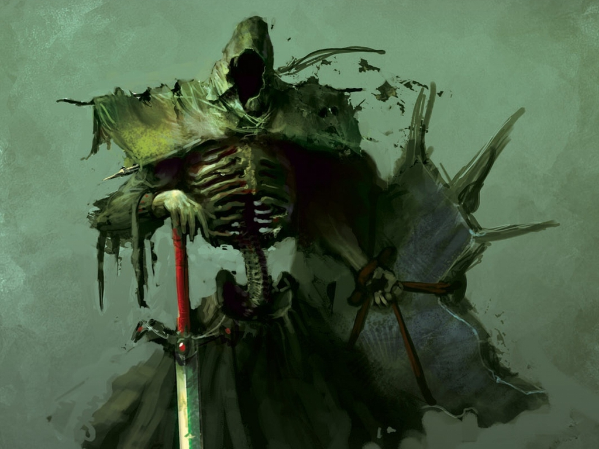

The gigantesque figure—donned in magical plate armor—stomped in and reported in a hissed voice, “Tresssspasssserssss.”

“It is time. Melonpatch, go see to it. Otis, show him the way.”

“Ssssire,” the skeleton bowed and led Melonpatch to the lookout tower at the northwestern corner of the majestic property overlooking the western slope of the Castle Ward. Situated along one of the highest points in this Ward, the chateau had once housed the House of Stormweather, a prominent noble family that had fallen out of favor and lost their material means during the last few generations.

The last squanderers of the Stormweather fortune eventually yielded to a group of land speculators hailing from “the East”, though historical records were no more precise. The development group had purchased the property, keeping it minimally maintained in anticipation of an imminent real estate market surge, and the affluent neighbors all around it had been talking for weeks about who might be the next occupants of this once grandiose estate.

Two tendays ago, a deal had been sealed, and new occupants had begun to arrive by evening with nary a torch or candle, always by horse-drawn wagon, and always with furniture and luggage reminiscent of a century ago. They had entered through the west gate, where Melonpatch’s attention was now needed.

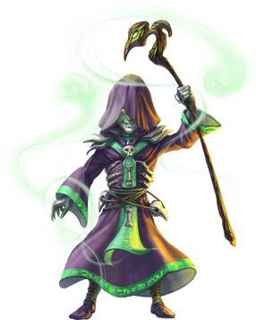

Night had settled, and the last refractions of twilight eventually yielded to a gradually darkening gradient of black as the stars above began to twinkle into visible existence, one by one. Inside, Azimuth began to prepare these mere corpses to be raised as zombies. He’d intended to have more time, and therefore would have rendered ghouls and vampires out of these soon-to-be undead sponges, but alas, this required more of a mass of lower-level minions than a few elite killing machines.

Melonpatch had reached the top of the tower, and saw two figures with pointy ears trying to scale the part of the wall that Melonpatch knew to be the easiest to breach. The beguiler shook his head and inhaled deeply as it prepared a battery of spells to cast.

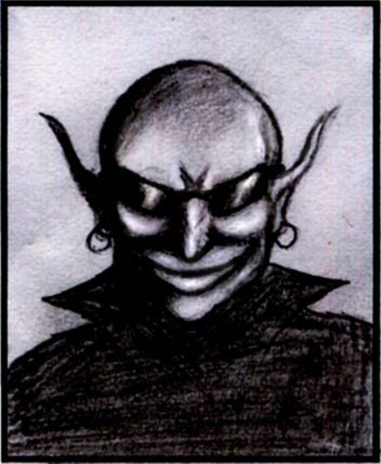

Inside, the robed halfling reeled with delight. Azimuth inhaled as he opened up a few coffins. By the time his preparations were done, Melonpatch and Otis had slain one drow and captured another, leading the enthralled male via a telepathic leash.

Their leader—mass murderer on several planes and mastermind of several mind games—had dispatched these two wee men to see to the demise of any intruders. It seemed that this Dulkhende fellow had leaked some information to his drow associates, and here came House Yril’s expeditionary force to try to regain their stolen goods.

Otis dropped the corpse of the female drow into an empty coffin as Azimuth shrugged with delight, even shivering with goosebumps of excitement. “Well, now, what have we here?” he asked the living drow. “Come to get your Lolth doll, didja? My Velsharoon doll just finished crushing her snatch; whaddaya think of that, eh? Hmmm?”

~*~

The killer was weary, and needed some repose after such a climactic day. The shyster had singlehandedly dispatched his new team of heistresses across a city that was arguably the most lucrative poaching ground on the Material Plane, and now the telekinetic strangler smiled from ear to ear as he bid his two thieves a successful operation. Moving within the shadows, they exited via the southwestern door, leaving the robed gnome alone.

The magical mangler wasted little time in removing the multi-hued gems and other stones from each of the portals around him, including the portal through which they’d just stepped. The blue topaz, the aquamarine, the peridot-green, the crystalline, the one with the resplendent, pink sheen, and then he left the lava rock in the sixth receptacle. Finally, he took the agate, the garnet, and the amber, giggling as he verified that the lava rock was the only stone he’d left. He’d have to place each one back into its portal’s receptacle—to which each gemstone or rock was uniquely fitted—before he could use any of these again, and so would anyone else pursuing him.

When he’d first taken over the place, the killer had made the mistake of locking all of the portals on this side, and had consequently motivated a party of opportunistic but eventually frustrated intruders to simply torch the place, and relieve him of just about anything valuable that he’d left in there. From then on, he led fools into his various chambers, leaving his minions to deal with his would-be assailants. It was a much more convenient arrangement.

He gathered a few days’ provisions—though he was unlikely to need them—and put them into his haversack. Once satisfied with the raiding of his own pantry, he nodded, placed the appropriate gem into the socket under the portal that he wanted to go through, threw his sack and some other gear in, jumped in, reached his hand back around, grabbed the gemstone, retrieved it and his hand back into the other plane, and smiled as the two-way portal shimmered momentarily, letting him know that it was now a one-way portal.

~*~

