*Chapter 64*

Round 4

There was a pause from the person trying to open the lock, followed by a blast that busted the entire hinge off the front door, and sent the door swinging open amidst a puff of explosive smoke.

|  |  |  |  |  |  |  |
| --- | --- | --- | --- | --- | --- | --- |
| **Save vs.**  Collateral Damage | **Rank** | **Ability & Mod.** | **Misc. Mods.** | **Total** | **Roll** | **Check** |
| **Kir, Reflex** | **7** | **Dex (+1)** | 0 | **8** | 6 | 14 |
| **Xaryn, Reflex** | **4** | **Dex (+1)** | 0 | **5** | 13 | 18 |

*Fail, success.*

*Dmg to Kir: 1 [94/95].*

Kir felt something hit her. “What the...” Then it hit her that the person on the other side wanted to hurt them, if not kill them. Without a second thought she cast *knife spray* through the open door.

|  |  |  |  |  |  |  |
| --- | --- | --- | --- | --- | --- | --- |
| **Save vs.**  *knife spray* | **Rank** | **Ability & Mod.** | **Misc. Mods.** | **Total** | **Roll** | **Check** |
| **Leighlund, Reflex** | **5** | **Dex (+2)** | 0 | 7 | 4 | 11 |

*Fail. 3 + 5 = 8.*

As the door was blown in, Xaryn cast *mage armor [expired at 09:11 tomorrow]* on himself. “What in the Nine Hells?!”

*Xaryn gained +4 to FFAC and AC.*

Round 5

Shrouded in both a *mage* armor and a *shield* spell, Hell-Bent Leighlund—contracted to annul the life of any witnesses to their pursuit of Cairne—made his way through the threshold and the smoke from the explosion that he’d caused, spotted his attacker, Kir, then cast *disintegrate* upon her.

|  |  |  |  |  |  |  |
| --- | --- | --- | --- | --- | --- | --- |
| **Save vs.**  *disintegrate* | **Rank** | **Ability & Mod.** | **Misc. Mods.** | **Total** | **Roll** | **Check** |
| **Kir, Fortitude** | **8** | **Con (+1)** | 0 | **9** | 20 | 29 |

*Success. Dmg: 17 [77/95].*

The former student of Norbit Mangonemad, Leighlund smiled as he thought his work was done, then spotted Kir as well.

A fighter—no! A cleric in full plate!—wielding a greataxe and displaying the unholy symbol of Garagos, entered behind Leighlund, and underestimated the resident of the domicile and his sexy cleric friend, and went for the drow.

|  |  |  |  |  |  |  |  |  |  |
| --- | --- | --- | --- | --- | --- | --- | --- | --- | --- |
| **Melee Weapon** | **Dmg** | **D+** | **TH+** | **Critical** | **Type** | **Wt.** | **Atk** | **Roll** | **Check** |
| **Greataxe +1** | 1d12 | +6+1 | 1 | x3 | Slashing | 12.0 | +12 | 13 | 25 |

*Hit. Dmg: 3 + 6 + 1 = 10 [59/69].*

The aspiring archmage backed away from the axe as it sliced him across the chest. It was evident to Xaryn, but not to Kir, that the rival cleric was shrouded in a *shield of faith*, and augmented by a *divine power* spell.

Xaryn clutched his chest as he backed away from the axe-wielding fighter, or cleric, rather. He reached his free hand into his material component pouch as he pointed an ebon finger in the direction of the two assailants, and a crackling lightning bolt streaked from his fingertip towards them.

|  |  |  |  |  |  |  |
| --- | --- | --- | --- | --- | --- | --- |
| **Save vs.**  *lightning bolt* | **Rank** | **Ability & Mod.** | **Misc. Mods.** | **Total** | **Roll** | **Check** |
| **Dimitriov, Reflex** | **2** | **Dex (+2)** | 0 | 4 | 9 | 13 |

*Fail. Dmg: 34 electric.*

Kir saw the greenish light then felt as if she had the worst case of painful tingling throughout her body. Her hand shot up out of instinct and she cast *searing light*, hoping to hit the guy directly in his face; otherwise, hoping the light was bright enough to cause him to see spots.

|  |  |  |  |  |  |  |  |  |  |
| --- | --- | --- | --- | --- | --- | --- | --- | --- | --- |
| **Ranged Weapon** | **Dmg.** | **D+** | **TH+** | **Critical** | **Rng.** | **Wt.** | **Atk** | **Roll** | **Check** |
| Ranged Touch Attack | - | **-** | 0 | - | - | - | +13 | 6 | 19 |

*Hit. Dmg: 17 magic.*

Round 6

Dimitriov had no intention of letting up until Xaryn was dead, and would then turn his attention to Kir, if she still stood.

|  |  |  |  |  |  |  |  |  |  |
| --- | --- | --- | --- | --- | --- | --- | --- | --- | --- |
| **Melee Weapon** | **Dmg** | **D+** | **TH+** | **Critical** | **Type** | **Wt.** | **Atk** | **Roll** | **Check** |
| **Greataxe +1** | 1d12 | +6+1 | 1 | x3 | Slashing | 12.0 | +12 | 8 | 20 |
| **2nd Attack** | 1d12 | +6+1 | 1 | x3 | Slashing | - | +7 | *1* | 8 |

*Miss, miss.*

Leighlund cast *orb of force* on Kir.

|  |  |  |  |  |  |  |  |  |  |
| --- | --- | --- | --- | --- | --- | --- | --- | --- | --- |
| **Ranged Weapon** | **Dmg.** | **D+** | **TH+** | **Critical** | **Rng.** | **Wt.** | **Atk** | **Roll** | **Check** |
| Ranged Touch Attack | - | - | 0 | - | - | - | +7 | 17 | 24 |

*Hit. Dmg: 37 magic [40/95].*

Xaryn ducked and sidestepped the lumbering cleric’s axe, narrowly avoiding further bodily harm and then looked to him for a moment, confused. “You aren’t dead?” He asked as he pointed his finger at his opponent once more. “I suppose I’ll have to remedy that.” Just as with the lightning, as he pointed at his attacker four bright purple streaks of arcane energy shot out of his fingertip.

*Dmg: 12 + 4 = 16 magic.*

And though the rogue-wizard wasn’t dead yet, he certainly was close to it, riddled with the electrical charge and searing with a stank odor coming from his loins.

Kir hesitated.

Round 7

Dimitriov said some garbage about the honor of murder, then slashed twice at the deft drow.

|  |  |  |  |  |  |  |  |  |  |
| --- | --- | --- | --- | --- | --- | --- | --- | --- | --- |
| **Melee Weapon** | **Dmg** | **D+** | **TH+** | **Critical** | **Type** | **Wt.** | **Atk** | **Roll** | **Check** |
| **Greataxe +1** | 1d12 | +6+1 | 1 | x3 | Slashing | 12.0 | +12 | 18 | 30 |
| **2nd Attack** | 1d12 | +6+1 | 1 | x3 | Slashing | - | +7 | 9 | 16 |

*Hit, miss. Dmg: 8 + 6 + 1 = 15.*

Leighlund said, “Fuck this, and fuck you *all*!” then cast *teleport*, and disappeared, leaving Dimitriov to perish at the hands of the drow and halfling.

“Aw, bloody ‘ells!” enounced the cleric of Garagos once he realized the wizard had hung him out to dry.

Kir had not realized how much of an impact that the spell had had on her. After her initial return, she was struck again with another spell. This took her back a couple of feet and she lost her concentration. She got lucky, though, when the wizard teleported away. This snapped her out of it and she focused on the one remaining, casting *spiritual weapon [expired on Round 15]*, and conjuring forth a dagger, which she commanded to attack the cleric of Garagos.

|  |  |  |  |  |  |  |  |  |  |
| --- | --- | --- | --- | --- | --- | --- | --- | --- | --- |
| **Ranged Weapon** | **Dmg.** | **D+** | **TH+** | **Critical** | **Rng.** | **Wt.** | **Atk** | **Roll** | **Check** |
| Spiritual Weapon, Dagger | 1d4 | 2 | 0 | 19-20, x2 | varies | 0.0 | +15 | 17 | 32 |

*Hit. Dmg: 2 + 2 = 4 magic.*

Xaryn took another blow from the viciously sharp battleaxe carried by the yet unnamed war-cleric and winced in pain as it bit into his thigh.

“I concur. Fuck this!” He said, reaching his casting hand to the small of his back to retrieve *[move action]* the bejeweled dagger that was stored there. He grasped the hilt of the blade as he took a few quick steps towards his assailant, closing the distance between them with haste. As he reached stabbing range he whipped out the dagger and stabbed twice at Dimitriov’s stomach.

|  |  |  |  |  |  |  |  |  |  |
| --- | --- | --- | --- | --- | --- | --- | --- | --- | --- |
| **Melee Weapon** | **Dmg** | **D+** | **TH+** | **Critical** | **Type** | **Wt.** | **Atk** | **Roll** | **Check** |
| Dagger +2 | 1d4 | +0 + 2 | 2 | 19-20, x2 | Prcg/Slash | 0.5 | +8 | **19** | 27 |

*Hit. Dmg: 4 + 2 = 6.*

Round 8

“Seriously?” asked the cleric of Garagos rhetorically. “Daggers? You’re both comin’ at me with daggers? Suits me just fine.” Then he full-attacked Xaryn.

|  |  |  |  |  |  |  |  |  |  |
| --- | --- | --- | --- | --- | --- | --- | --- | --- | --- |
| **Melee Weapon** | **Dmg** | **D+** | **TH+** | **Critical** | **Type** | **Wt.** | **Atk** | **Roll** | **Check** |
| **Greataxe +1** | 1d12 | +6+1 | 1 | x3 | Slashing | 12.0 | +12 | 18 | 30 |
| **2nd Attack** | 1d12 | +6+1 | 1 | x3 | Slashing | - | +7 | 9 | 16 |

*Hit, miss. Dmg: 3 + 6 + 1 = 10 [49/69].*

Kir grinned at the fact that the man commented on the fact that they were using daggers. His full out attack on Xaryn gave her the opportunity. She took the necessary steps to get close enough to cast *inflict critical wounds*, then did so with a smile.

|  |  |  |  |  |  |
| --- | --- | --- | --- | --- | --- |
| **Melee Weapon** | **Dmg** | **TH+** | **Atk** | **Roll** | **Check** |
| Touch Attack | 4d8 | 0 | +12 | 5 | 17 |

*Hit.*

|  |  |  |  |  |  |  |  |
| --- | --- | --- | --- | --- | --- | --- | --- |
| **Save vs.**  *inflict critical wounds* | **Rank** | **Ability & Mod.** | **Misc. Mods.** | **Total** | **Roll** | **Check** | **Properties** |
| **Dimitriov, Will** | **5** | **Wis (+4)** | 1 | 10 | 4 | 14 | +1 to energy drain & death effects |

*Fail. Dmg: 22 negative energy [evil].*

Xaryn then full-attacked the fool in black.

|  |  |  |  |  |  |  |  |  |  |
| --- | --- | --- | --- | --- | --- | --- | --- | --- | --- |
| **Melee Weapon** | **Dmg** | **D+** | **TH+** | **Critical** | **Type** | **Wt.** | **Atk** | **Roll** | **Check** |
| Keen Rapier +1 | 1d6 | +1 + 1 | 1 | 15-20, x2 | Slashing | 2.0 | +8 | 11 | 19 |
| Rapier, 2nd Attack | 1d6 | +1 + 1 | 1 | 15-20, x2 | Slashing |  | +3 | **19** | 22 |

*Miss, threat. 1d20 = 3 + 8 = 11, not a critical hit. Dmg: 5 + 1 + 1 = 7.*

Round 9

Badly wounded, and barely able to do so, Dimitriov fled the scene *[full withdrawal; no AoO]*, and took off westward where Xaryn had seen his accomplices heading.

A wicked grin crossed Kir’s face when her spell hit. She wanted to make this man pay for what he had done, not only to her but to her friend. She looked to Xaryn as Dimitriov took off. He could see that she wanted to go after him, wanted to kill him. Of course, he knew her well enough to know that she would follow Dimitriov and kill him if she could. Xaryn also knew that he could stay her hand if he so desired.

Kir cast *cure moderate wounds* on herself, resolving to cast *cure minor wounds* on Xaryn on the next round.

*Kir gained 11 + 8 = 19 hps [59/95].*

Round 10

As Dimitriov fled the scene of the battle, Xaryn locked eyes with the beaten and battered Kir. “Watch this,” he said nonchalantly before he jogged through the splintered doorframe that lead out onto the street.

Stepping out onto the cobblestone streets of Waterdeep once more, Xaryn flicked his head back and forth, looking for the lumbering war-cleric. When Xaryn managed to locate the man, he uttered a few arcane words and faced an open palm towards him as a bead of white hot fire shot out from the extended hand towards Dimitriov. *[Casting fireball.]*

|  |  |  |  |  |  |  |
| --- | --- | --- | --- | --- | --- | --- |
| **Save vs.**  *fireball* | **Rank** | **Ability & Mod.** | **Misc. Mods.** | **Total** | **Roll** | **Check** |
| **Dimitriov, Reflex** | **2** | **Dex (+2)** | 0 | 4 | 8 | 12 |

*Fail. Dmg: 11 fire.*

Dimitriov took one last step, then fell flat on his face and chest as the house next to Xaryn’s caught on fire.

Kir followed Xaryn out and was about to use her bow when Xaryn cast *fireball*. She seen it hit Dimitriov and fall to the ground on his face and chest as the house next door caught fire.

Kir looked to Xaryn. Her face was both concerned and ecstatic with delight. It had been a long time since she had had this much fun. Still, she knew that burning down a building that was not your own was not a good thing, unless you meant to because it had to be done. “Xaryn, you got a spell that can put it out? Or do we need to run?”

It stood to reason that the baddies would reconvene once the bulk of them apprehended Cairne, if that’s who was being pursued. Within seconds, perhaps, the others might return and see the short work that had become of Dimitriov, the neighbor’s house aflame, and Xaryn and Kir standing in front of Xaryn’s house.

~*~

20:12

“Honey, this is what we have to choose from: 2 *discern location,* 6 *scrying,* and some *locate object* scrolls. What do you guys want me to get?”

Lauren smiled as her wife’s voice came through. “I was thinking of getting one *discern location* scroll.”

Despite having no magical ability of its own other than utilizing wands and scrolls, Fingers had a passing familiarity with ways of obtaining information. “At least one *locate object* scroll would let us zero in once we get close. Even better would be a wand of it, if Fritz has any... always handy to be able to draw upon it at need.”

The mistress of many forms conveyed the suggestion to the shopkeeper, who nodded and asked how many.”

“Two *discern location* scrolls is probably overkill, but I wonder whether it might behoove us to get a *detect scrying* scroll if he has one, just in case our prey hears of our inquiries and tries to keep tabs on us.”

Lauren stood close to Fingers, so that its voice carried to Allisa.

Fritz started tallying up the prices, “Let’s see, sooo,” he began muttering to himself, “*discern location*’s a whale; that’ll run you 3,000 ₲ a pop; *locate object* runs 150 ₲ each, if you go the arcane route; each *detect scrying* scroll’ll set you back 700 ₲; and I’m not sure if you want any *scrying* scrolls, but the arcane ones are 700 ₲, and 2,275 ₲ for the *greater* version. Divine versions are more expensive.”

Allisa had 146,963 ₲ in her haversack, and tried to get some consensus on the quantity of each scroll.

Fingers thought a bit and suggested, “If he doesn’t have any wands of *locate object*, then get us several scrolls, although a wand would be more cost-efficient in bulk and take up far less room.”

“Oooh! I *do* have such a wand!” the gnome then said as his bride of 100 years took a look at the scroll wall.

“You really need to organize this better, maybe alphabetize the scrolls,” she nagged.

“I categorize them by *level*, woman!”

“*Level*? What’s he going on about?” Allisa asked.

Nevra didn’t so much as say something, though she opened her mouth and a single, ambiguous vowel came out, coupling her dismissive hand gesture.

The male put a charge gauge against the wand, and reported, “17 castings left on this one.” He calculated, “You can have it for an even 1,500.”

Fingers listened all the while, then said, “Sounds good. So one *detect scrying* is enough for the moment, although I may come back once we’ve sorted this out to get more for myself. We certainly don’t need the more powerful version of *scry* and I’m not even sure getting the normal version is of much use with as little information we have about them. About the only connection we have with them are the items they took, so their chance of withstanding the spell is pretty good.” A final thought came and the rogue added, “Oh, and if none of you others both have *read magic* prepared and can activate those scrolls, ask Fritz for some scrolls of that cantrip so that I can make the attempt. I always have to get a couple of those on the rare occasion I acquire a scroll. That’s another reason why I prefer wands over scrolls—less preparation time. Fritz has been on the lookout for a wand of it, so maybe he finally found one for me.”

Fritz nodded in agreement. “Me too... when I was a younger man, I mean,” he looked to his wife, who looked at him with eyes that said, “don’t even *think* about taking up the adventuring life again.” Her husband concluded with, “*Read magic* scrolls are 12 apiece—I don’t charge in silvers—and a full wand—which I happen to have—will be 375.”

The gnomish vendor started to write out a receipt.

*Detect scrying 700 ea.*

*Discern location scroll 3,000 ea.*

*Locate object wand (x17) 1,500*

*Read magic wand (x50) 375*

“Good,” sighed Fritz as Nevra put the scrolls into a burlap portfolio for the druid. “Anything else we can get you, Allisa? A Staff of the Woodling, a Greenbound Summoning hat perhaps?”

Allisa wasn’t familiar with the staff that would turn her into a woodling once a day, which she could probably do already, and the hat that would augment her summoning spells *and* help her to befriend Greenbound creatures, but now didn’t seem the time to start shopping for nonessentials.

Fritz had been frowning for a good moment now as the druid had carried on her conversation, and shook his head, “Based on what you’ve told me, you might do well with an *augury* spell, or...” he corrected himself, “better yet, a *divination* spell.”

“What *kind* of Divination spell?” Allisa thought he meant the school.

“The specific spell called *divination*,” he caught on and specified. “It’s similar to *augury* but more powerful, and can provide you with a useful piece of advice in reply to a question concerning a specific goal, event, or activity that is to occur within one week. The advice can be as simple as a short phrase, or it might take the form of a cryptic rhyme or omen.

For example, suppose the question is: ‘Where will our stolen goods be sold?’ You probably won’t get an exact address, but some cryptic clue about the place where you have to go. You’ll then want to follow that up with a *find the path* spell, which will provide you the most expedient way to reach your destination.”

Fingers could overhear, and just interjected that the second spell would only be worth a damn if the first spell actually revealed the location rather than just some clue to finding it, and there might be a planar limitation to all of this. “Still, it may be worthwhile to get it.”

Never having interest in finding people or things, Allisa had not studied about any of these types of spells. “Anything else?” she asked Fingers.

Satisfied, she turned to Fritz, “Add one of both to the list. Can I return anyone we decide not to use?”

“Nope!” the gnome said with a customer service smile.

On the counter were 2 *discern location* scrolls, as well as one each of *find the path*, *detect scrying*, *divination*, and *scrying*. Next to them were two wands: one of *locate object*—with 17 castings left—and the other a fully charged wand of *read magic*.

Once everything was paid for and packed up, the druid went straight back to her friends atop her carpet.

Nevra and Fritz stood there looking at one another once the druid had left without a thank you or a goodbye. “Well *fuck* you too, Allisa!” Nevra then said as the two shook their heads, pushed the gold coins on the counter into a haversack, and closed up shop before going to bed.

“See if I ever let *her* in after hours,” Fritz said as he grabbed his lover’s left buttock. “Feel like a scrogg before turning in?”

“Oooh! You really know how to sell it, Big Spender,” the gnomish woman giggled at her husband of a century. “You’ve got me wet *now*!” The sarcasm was the only thing dripping from her.

~*~

A single drop of water hit the tile floor and echoed throughout the room, filled mostly with wooden furniture, cotton towels and robes, and an iron furnace.

“Aaahh! That’s more like it,” the previously constipated gnome said, having taken off his black robes and hung them in the shower room as the furnace heated the water that the killer would use for his shower. He took his time emptying his bowels of the digested ettercap stew, his swollen anus pulsating with the residual stress of the last few days, then pressed down on a lever that activated a suction pump that eliminated his feces from sight, conveying them along a pipe that drained into the nearly infinite waters around him.

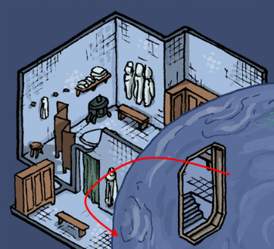

Cracking his knuckles and nodding at his bloodless stool with approval, the rejuvenated and fully healed magus barely bore a smile of satisfaction as he headed for the shower. Turning on the flow with a clockwise motion to a hand-sized knob, the strangler spent a few minutes cleaning his arse and penis, and humming to himself a tune from his childhood. Eventually, he made his way back around to where the scatophagus, or “toilet”, was, and removing the hand towel from around his shoulders and tossing it onto the floor behind him, he descended the four-step staircase and entered the watery sphere where his lover awaited him.

Having penetrated the vertical surface of the water, and able to breathe water via a spell, the mangler beheld the translucent body of his water genasi love slave, who now approached him with deference and prostrated her undulating body before him. Her turquoise flesh—three quarters elemental and one quarter mermaid—felt like the softest butter when he placed his hands upon her shoulders, and as he placed his penis inside his lover’s mouth and pulsated inside, he remembered what all the hardship had been about, and concluded that it had been worth it.

A sextuplet of tetras swam by, then skirted the genasi’s waving mane of fin-like ridges as the slave enjoyed her servitude to her captor. Her fishtail became several tentacles of semisolid flesh, which coiled around his legs as she suckled him just like he enjoyed. She soon drove his desires past his tipping point, his fluid becoming part of her as she thirsted for more, wrapped around his relaxing limbs and moaning as they floated in the seemingly endless expanse of warm ocean all around them.

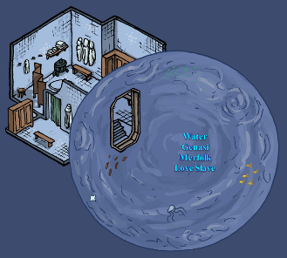

Surrounded by a perfectly spherical *wall of force*, the mangler and his captive seductress waded among shoals of fishes and swimming invertebrates that could pass through the apertures in the *wall of force*, which had been configured to open and close for these harmless species that were germane to this part of the Plane of Water, but not for anything else. The floated idly for almost an hour before the murderer temporarily released his slave from the permanent privilege of servitude and exited the bubble, grabbing a towel hanging from the wall to his left as he dripped onto the porous tiles.

And now, to bed.

~*~

20:19

The druid got home, descending upon her own doorstep after having been spotted and identified by two of the guards. She nodded to the one who opened the door for her, and the other one rolled up her carpet, put it back into Lauren’s haversack and returned it to the duskblade before reprising his post outside.

“Thanks, Malcolm,” the half-drow set the bag atop the long table in the main room, and Allisa opened her own magical bag to reveal the two *discern location* scrolls, and the *find the path*, *detect scrying*, *divination*, and *scrying* scrolls, as well as the *locate object* and *read magic* wands.

Lauren greeted Allisa with a kiss when she returned from the shopping trip. “Should we try to locate one of the stolen items first?”

“Right then,” Fingers looked at the purchases as the three huddled and talked about what to do next.

Fingers greeted Alissa after her spouse had done so. “So, what goodies did Fritz manage to come up with?” The changeling was gratified when told about the wand but less so when Alissa related that Divination was not a spell she was able to invoke.

Reaching up, she removed her periapt of wisdom, a circlet of golden wood that was made specifically at her request instead of its usual metal. She tossed her head to rearrange her hair and passed the item to Fingers. She glanced at Lauren and commented, “It is about time for me to get a haircut?”

Lauren reached out and gently ran her fingers though the half-elf’s silky locks. “I like it long, though.”

“Maybe a medium length cut then.” The woman’s hair currently hung down to her waist and was at most times braided into one long ponytail to either hang over the shoulder or down the back.

“Yes” Lauren agreed. She turned her attention to the issue at hand.

“I don’t suppose Rook is anywhere handy?” it asked, then sighed and murmured, “Faceless One, protect me” as it attempted to activate the wand to decipher the scroll.

|  |  |  |  |  |  |  |
| --- | --- | --- | --- | --- | --- | --- |
| **Fingers, Skill** | **Rank** | **Ability & Mod.** | **Misc. Mods.** | **Total** | **Roll** | **Check** |
| **Use Magic Device: Activate Wand** | 16 | **Cha (+2)** | 0 | 18 | 12 | 30 |
| **Use Magic Device: Emulate Wisdom** | 16 | **Cha (+2)** | 0 | 18 | 8 | 26 |
| **Use Magic Device: Cast Spell** | 16 | **Cha (+2)** | 0 | 18 | 10 | 28 |

*Success, success, success.*

Pleasantly surprised at not being punished by the gods for its temerity, Fingers intoned the question whose answer the Gambit desired. “Where must we go to intercept the thieves who robbed our headquarters this evening?”

Nothing happened.

“Oh, wait,” Fingers then realized that it had to read all of the preceding text, which it then took the next 10 minutes to do.

~*~

20:30

“Where must we go to intercept the thieves who robbed our headquarters this evening?” the rogue then asked again.

*1d100: ??, see below.*

A voice then recited into the changeling’s ear, and it repeated aloud:

“Woe has come to the House of the Gambit.

Theft has alarmed you just as a dog’s bark would.

Stolen are Fingers’ sword, sling, and chain shirt.

As are Allisa’s scimitar and shield of the Darkwood.

Far you must travel, but not on your own feet.

Make way for the manse of the late vampire, Parjit

Whose property overlooks much of the Sea Ward

Though it lies not there, but south of that borough.”

Fingers returned Alissa’s headband to her as it pondered the cryptic results of the spell. The changeling concentrated on anything it might’ve heard regarding this Parjit or its mansion.

Lauren also thought about the riddle. “I mean: the obvious assumption is that we’re looking for high ground in the Castle Ward—which is just south of the Sea Ward—that’s close enough to some low ground in the Sea Ward.

“Who’s Parjit?” asked Allisa.

Fingers thought, “The word manse suggests one of the châteaus along the north side of the Castle Ward. We could check the City Watch records. I’m chummy with Kedrik’s replacement at Headquarters.”

Allisa produced the *find the path* scroll, “Won’t this do?”

“I’m not sure we have enough information to make the spell work,” Lauren—the resident expert in all things arcane—sighed. “Maybe we *should* contact HQ.”

“They’re going to hold us up if we go in there. We need to move fast on this,” Fingers urged.

The women agreed.

“Can we cast the *scry* spell on Parjit’s house?” Allisa asked.

Lauren nodded as she thought about it. “We could, but we don’t have a lot of familiarity with this Parjit; the verse said ‘late’, which even to a vampire applies only when the person’s dead. We shouldn’t waste the spell on someone who might not be there and might not even be among the living *or* the undead.”

“We can cross-reference the name Parjit in the CW records with any land titles in the city—starting with the Castle Ward—and see if we find an address,” Fingers posed. “We *may* be able to do this at the precinct office down the street instead of having to go all the way to HQ in the North Ward and have to fill out paperwork and what not.”

“That sounds good to me. Let’s go,” Lauren said.

~*~

On their way to the CW precinct office atop their carpet, Lauren pursed her lips upon the conclusion that after gathering information with the Constables, it wouldn’t hurt to circle the thin margin between the Castle and Sea Wards from above.

They landed, rolling the carpet up and stuffing it with ease back into Lauren’s haversack.

They entered, led by Fingers in the guise of the same man who had come in earlier.

They were greeted, given almost a round of applause as they entered by the City Watch Chief and his evening staff.

“So-ho!” the Chief excitedly exclaimed, seeing the three heroes of local renown standing before him. “What brings you back? Has justice prevailed yet?” he asked, not so much with sarcasm, but with some hope that the heroes could solve a case such as this in such little time.

“Afraid not, Chief,” Fingers spoke for the group, being the most gifted with his tongue, at least in this context. The cunning linguist continued, “We’ve uncovered some information, which begs for *more* information.”

Fingers quickly explained as much as it needed to for the moment, then requested the addresses in that region, particularly ones that matched the name Parjit.

Within a few minutes, divinations and transmutations had yielded a single scroll that unfurled from the Deputy Chief’s hand to the floor. The DC handed the scroll to the Chief, who speed-scanned it as he made his way back up to the front of the office where the Gambit’s three core members stood in the formation of an isometric triangle.

“Well, well!” the lifelong crime fighter smiled as he got to the P-section of the list, sorted by the names of property owners and prior owners. “There *is* a Parjit in the records, but he’s listed as deceased. His Estate sold the property and liquidated all of his assets to the House Husteem, a known House of vampires—I think you know this…”

Fingers nodded its head, as did Allisa and Lauren.

The Chief continued, “However, the current owner—who just *bought* the property in mid-Alturiak, I might add—is a fella by the name of Cass... Kaz... Jirut,” he motioned to the only gnome on duty tonight, “Can you help me out with this name?”

The uniformed gnome stepped over and read the name of the new owner of Parjit’s former mansion: “Kaszüm. Rhymes with Faerûn and Kaboom,” the wee Constable said. “Kaszüm Sertan, rhymes with curtain and certain.”

“There you have it. Kazoom Certain,” the human Chief grossly mispronounced the landowner’s moniker, then added the address, pointing to it as he handed the scroll to Fingers. “1429 Julthoon Street.”

“It’s that castle on the hilltop overlooking the Cliffride,” added one of the junior officers who’d just been reassigned to this precinct from the Cliffride office. “Nice masonry on the outer wall, which is about all that can be seen from below.” The young Constable got up and pointed to a triangular property the size of a small city block.

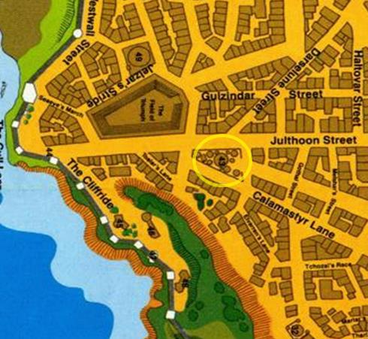

But the Gambit would likely be approaching from above. “Anything else you can think of that might be helpful?” asked Allisa.

The Chief looked over the scroll as Fingers held it up for those huddled to see. “Can’t say that I can glean anything else. You, there, Junior: Any scandals at that location?”

The new transfer—a human boy who wore the name Wilburs on his lapel—smiled, “There’s always trouble in the Castle Ward, but it’s either never reported, or the aristocrat perpetrators arrange for the city’s top barristers to annul and expunge cases faster than we can prepare them. We mostly just police those streets and keep the rabble from adjacent Wards out.”

“That why you came to the Dock Wards?” joked one of his coworkers, another woman named Allisa who looked nothing like the druid in the room. “To be with *these* incorruptible pillars of the community?” she joked, though there was truth in it; this precinct was known for being beyond reproach when it came to their integrity, at least under the current administration.

Pleasantries led to goodbyes, and goodbyes to a cheered exit. “Go get ‘em!” “Let us know if you need anything else.” “Be careful. Vampires are extra thirsty this time of the year!”

20:48

They made their way north-northwestward at an altitude of 100’.

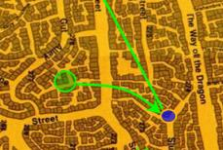

Fingers mentally impelled the carpet to its best speed towards the district where their target lay, maintaining a height of 45’ in order to eliminate any risk of crashing into a treetop or building’s tower but not so high that the riders had a poor chance of making out details on the ground. When Allisa suggested using the scroll, Fingers thought a bit and, ever mindful of not wasting resources, suggested, “Why not hold off on that for a bit? We have a reasonably good idea of where the mansion is already. If it turns out we have problems finding the exact location once we get in the area, we can always invoke it then. If not, then we have it on hand should we need it if the place turns out to point us in the direction of somewhere else.”

~*~

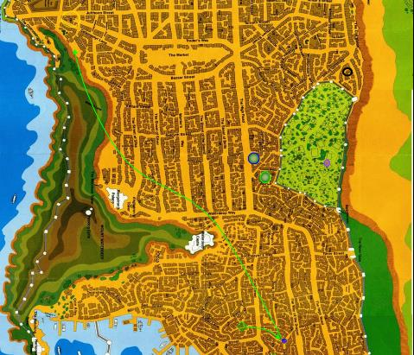

They had rounded Castle Waterdeep, marveling at the smaller mansions and châteaus just downhill of it, and were now nearing their intended destination, though the landmarks of the exact spot that Fingers had studied on the wall map before leaving the CW office were not quite evident yet. And then they were. Allisa and Fingers both spotted the quadrilateral property that was nearly triangular, and constituted its own entire block, separated from all other architecture by nice, ample streets.

However, what alerted them to the general direction of the property in the first place was the very loud and easily identifiable *fireball* that blasted some fleeing fool, and the house next to him or her.

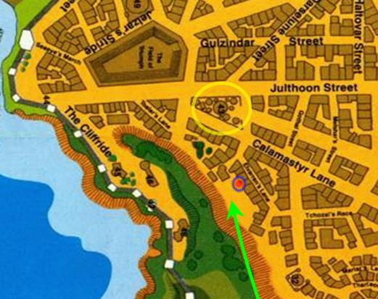

Lauren had been distracted, and had caught sight not of the *fireball* itself, which had now spent itself, but rather of the lingering fire on the side of the house, which was a dozen or so buildings away from the eerie property where they were headed. They then spotted a pair of figures—one human sized and dressed in a mage’s garments, and the other halfling sized and the consummate image of a rogue. The Gambit was actually on the lookout for a pair with those dimensions, and these two had probably just killed the armored figure that lay on the ground face down, smoking and still.

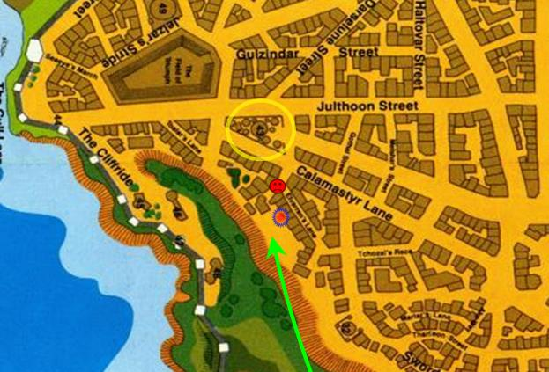

Then Fingers spotted and pointed to almost a dozen figures—also heavily armored—trotting downhill towards the street where the apparent murder had just taken place. Townsfolk were either running away from the blast they’d just heard or towards it, but mostly away, and the Gambit could hear screams and yells, but could not make out the words with the wind coursing through their hair and ears.

20:51

Round 11

“Get us over them,” Lauren said as she cast *barkskin [expired on Round 1511; @ 23:31]* on herself.

*Lauren gained +5 to FFAC and AC.*

Aloft, Fingers observed, “We’ll want at least one of them alive in case they’ve already gotten rid of their loot.” The trapsmith opened its kit and began formulating a Spiderweb trap.

Xaryn had hesitated for a few moments after Dimitriov fell smoking on his face. His calculations on how far he was from the nearest building were... off.

Kir asked if he had a spell for that and he thought for a moment, racking his brain for a spell that could help.

“I’ve got an idea.” He said as he turned to face the house that was considerably more aflame than he would have liked, “If this doesn’t work, we run.” He pointed an open palm at the house as a ray of freezing cold shot from his hand towards the burning wall.

|  |  |  |  |
| --- | --- | --- | --- |
| **Ranged Weapon** | **Atk** | **Roll** | **Check** |
| Ranged Touch Attack | +7 | 17 | 24 |

*See below.*

Fortunately for the drow mage, the flames were infant enough that they’d not yet permeated deep enough into the wood, and with a carefully aimed *ray of frost*, Xaryn was able to get most of the flames out. There were, however, still a few hand-sized patches that were still smoldering and burning.

Kir spotted three figures atop a flying carpet descending from the southern sky. She felt a bit of relief when Xaryn’s *ray of frost* seemed to work. She made a cursory look around to see if there was anyone else around. That’s when she noticed three individuals on a flying carpet heading right towards them.

Kir reached out to take Xaryn by the arm. “Above. We need to move.” She cast *obscuring mist [expired on Round 91]* as she pulled Xaryn back into his house. Manifesting a 40’ wide and 20’ tall hemisphere of darkness centered around her, Kir smiled at her drow friend as they beheld the first few armored soldiers who had earlier knocked at Xaryn’s door now coming around the corner about 5 houses down.

~*~

Round 10

Melonpatch—having returned to the lookout tower after delivering the two drow infiltrators to Kaszüm—had squinted at the flash of the *fireball* spell on this clear, starry, moonless night. He could see neither the armored men nor the human- and halfling-sized pair on the ground, but the wee gnome (for he was short, even for gnomish standards) *did* have a direct line of sight to the flying carpet, and over the city lights, the rectangular platform and the three heroes above it were barely evident at a distance of over 1000’. The gnome may have been slight of stature, and far from mighty with a club or axe; but as for wily and astute, adept and alert: those were among the main bullets on his résumé. For a moment, Melonpatch thought he’d identified the craft as a flying dragon, but within seconds, he would change his speculation, and mumble, “Hmmm... more drow...”

“Otis!” he then called down.

The towering, armored skeleton turned its helmeted head up and to the left so its bony, face faced Melonpatch.

“Tell the Master there may be more of those damnable drow coming.”

Otis returned his head to its normal position, and went to tell *its* master—not Melonpatch’s master—the news of another imminent incursion on the part of House Yril’s more expendable bastard offspring. Its hissing voice could scarcely be understood by anyone other than Azimuth, who grimaced at the mention of the drow.

Round 13

“Lolth be cursed!” said the cloistered cleric of Velsharoon upon hearing the news from the grinning jaws of his skeletal minion. The ghostwise halfling climbed into Otis’ abdominal cavity, squeezing through the open hatch that was like a door for Azimuth. The goliath’s skeleton inside the full plate suit provided its master with a comfortable seat atop the pelvic concavity, while the lumbar and lower thoracic vertebrae provided a nice backrest and headrest. He left the swinging hatch open and commanded Otis to take him outside to talk to Melonpatch.

Round 16

Once outside, he called up to the gnome, “More coming?”

Melonpatch nodded. “Can’t make out who they are, but they’re atop a flying carpet, and it looks like they’re headed here... and someone just cast *fireball* a few blocks that way,” he pointed southeast.

~*~

Round 12

The only armored thug who’d seen the halfling cast and manifest the *obscuring mist* turned around and shouted to his commander, “They’ve cast a darkness spell.”

The owner of the house on fire—a dwarf named Frausineault Rollinstone—came out swearing in his own language, and cursing Xaryn for ruining the new paint job on his masonry. << Qamphthi’ir khulailei, ravalkhaar’zi! >>

Of all the languages that Xaryn could speak and understand, Dwarven was not among them, but he could tell from the tone of his next-door neighbor’s voice that Frausineault would remain upset until Xaryn assured him that he would pay for the façade to be repainted.

The remainder of the armored men and women came trotting around the corner, now seeing the house where they’d been knocking engulfed in a black sphere. The commander, a half-orc who’d earned her ranks by grit alone, snarled, and nodded, “Send in the drow, and who else can see in the dark? You!” he pointed to an elven fighter-sorcerer with plenty good night vision.

The pink and dark blue elves looked at one another, and trotted in their hefty armor towards Xaryn’s home. Another of Xaryn’s neighbors—the widow who lived 4 doors down from him—now opened her door and was startled by the two armored elves making way for the *obscuring mist* spell. The drow turned to the widow and smirked, bidding, “Evening, milady. Have you heard the good news about Lolth?”

The widow put a hand to her mouth and shut the door as the two wicked elves continued eastward.

Merchants and aristocrats continued to either flee or flock from or to the site of the fire that was still on, and burning just outside the *obscuring mist*.

The rest of the soldiers followed the two elves at a slower pace.

At this moment, Allisa propelled herself off the carpet instantly turning into a Sword Coast hawk. She headed toward the crowd, trying to make out who the armored men were without coming into their strike range, which she couldn’t gauge too well, since they were already within the range of a good bow if the enemy should choose to use one. She hoped they would take her for just a bird. She didn’t really want to be on the wrong side of the fight and getting the gist of how they were equipped would help the others.

Fingers complied with Lauren’s request to fly over the pair, as it coincided with the trapsmith’s plan to drop its Spiderweb trap on top of them. As one of the pair began to create a cloud of mist, the changeling decide to drop it anyway. “The trap doesn’t need to see them to snag them. You might keep out of the cloud and just wait for any to emerge,” as it prepared to bomb the duo. Even with the *obscuring mist*, the expert trapsmith and fledgling warlock would likely make his mark.

“Before you do that, let me talk to them. Putting out fires isn’t the main concern of troublemakers.” Lauren waited until the carpet was over the street, and then she stepped off, floating to the ground with the power of her ring. She kept her sword sheathed, and used her shield to steer to a landing point ten feet in front of the pair.

Kir grabbed Xaryn and told him that there might be an attack from above and started for the doorway.

Rounds 13 – 14

It took some time for the carpet to get to where Lauren needed it to be in order to land within the *obscuring mist* and 10’ from its caster.

In the meantime, Allisa had flown a total of 120’, and was close enough to see that out of the 10 armored folks in her field of vision, only two appeared to have ranged weapons—a heavy crossbow and a composite longbow—and nearly every one of them had a longsword on them.

Two of the soldiers were carrying what appeared to be a dead body, or perhaps an unconscious person. Allisa would have to get closer to glean more.

The two elves closed in on the *obscuring mist*, and were now at the far edge of the Rollinstone property, and the dwarf closed his door and went to fetch a pail of water for the fire still burning down his front wall.

Kir made her way northeastward and found her way to Xaryn’s kitchen in the back to look for cover.

Xaryn hesitated.

Allisa flew towards a leafy tree, and perched there, at a distance of about 65’, studying the soldiers. About half of them wore helmets, and the other half were distinguishable as a mixed group of male and female humanoids. The one issuing commands was a half-orc, and the two elves in the lead were the only visibly pointy-eared types.

Then she turned her hawk eyes towards the two carrying the body, and it did indeed look like a bloodied mess had been made of his face. The dead man, another drow dressed in the tattered garments of a prisoner, was beyond healing. The hawk then turned her attention back to the armored trotters. She could now tell—given her years’ experience in combat—that at least some of these soldiers were far from a challenge to someone like her. The way they held the mercies of their swords suggested poor training, and their youthful faces bespoke knaves with less than a dozen frontline episodes under their belts. They were full of bravado, but she wondered what they were about to encumber at the hands of the two mysterious figures inside the *obscuring mist*.

Kir readied her bow and waited to see who came in, though she could not see into the main room, which was engulfed in her *obscuring mist* spell.

Xaryn didn’t quite know what to do.

Those who could *detect magic* could tell that these soldiers were already buffed with some potion, scroll, wand, or otherwise cast spell, and the time of death of the body they were carrying probably came shortly after these blokes and femmes got buffed up. Allisa deduced this while in the shape of a local hawk.

Still inside Xaryn’s house, and also within Kir’s dusky spell, was Kir’s *spiritual dagger*.

Fingers looked at Lauren and nodded as she hopped off, and fell to the ground with the snail’s pace of her ring’s *feather fall* ability. “Coin well spent,” she thought to herself as the two soldiers entered the *obscuring mist* into which she would soon also fall. At an altitude of 25’ now, and about 15’ above the spherical wall of that blackness, she anticipated falling about 10’ south of where the halfling had stood when she’d cast the spell.

The rest of the soldiers weren’t far behind, but the half-orc now spotted Fingers aboard the carpet and commanded his bowman to take the rogue out of commission.

“Sire!” the archer obliged her superior officer.

|  |  |  |  |  |  |  |  |  |  |  |
| --- | --- | --- | --- | --- | --- | --- | --- | --- | --- | --- |
| **Character** | **Attack Type** | **Damage** | **BAB** | **Str Mod+** | **Dex Mod+** | **W+** | **Other+** | **Total Score** | **Roll** | **Total** |
| Mercenary Archer | Composite Longbow +1 | 1d8+1 | 0 | 0 | 4 | 2 | 0 | 6 | 12 | 18 |

*Missed Fingers, hit carpet. Dmg: 1.*

The carpet—punctured—maintained the course and velocity that Fingers wished.

Allisa had seen enough *[correct if necessary]*, and was ready to ascend once more, or perhaps revert to her half-elf form. She *[continued to perch/took flight/reverted to half-elven form/etc.?]*.

From the far southwestern part of the open area with a line of sight to the *obscuring mist,* some hooligan armed with his mother’s sling slung a rock at Fingers just to be a douche.

*1d20 = 3 + 1 = 4, miss.*

Fingers could tell the knave knew nothing of the sling, and less so of the consequences of taking bold action against someone as resourceful as Fingers.

The pink and blue elves in shiny armor found their way to Xaryn, and attacked him blindly.

|  |  |  |  |  |  |  |  |  |  |
| --- | --- | --- | --- | --- | --- | --- | --- | --- | --- |
| **Character** | **Attack Type** | **Damage** | **BAB** | **Str Mod+** | **W+** | **Other+** | **Total Score** | **Roll** | **Total** |
| Mercenary Drow Swordsman | Composite Longbow +1 | 1d8+1 | 4 | 2 | 1 | -4 | 3 | 3 | 6 |
| Mercenary Elven Swordsman | Composite Longbow +1 | 1d8+1 | 4 | 3 | 1 | -4 | 4 | 11 | 15 |

*Miss, miss.*

Lauren sunk softly into the bubble of darkness. As she floated down, Lauren oriented herself to the closest edge of the mist. When she touched down, she immediately walked rapidly to the edge of the mist and looked around from her self-created screen of darkness.

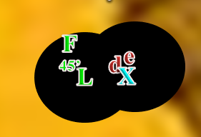

*No one right now is able to see inside Kir’s darkness, and only Lauren can see within her own bubble.*

The dwarven neighbor came out and dumped two bucketfuls of water onto his front wall, cursing everyone around him while protected by a *sanctuary* spell.

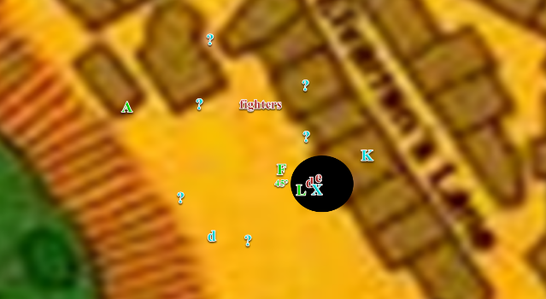

Round 15

Allisa flew to the rooftop behind her where she would have line of sight *[move action 1]* and changed into herself *[move action 2]*.

Fingers muttered, “Enough of this,” after sustaining a few light wounds and ordered the carpet to land outside the mist while drawing and attempting to activate its *improved invisibility* wand. The carpet began to descend and turn northwest.

Kir realized that Xaryn did not follow her back in. “Damn it, Xaryn!” she said to no one. It was also at this time when she realized that her spiritual dagger was still active, so she called it to her, then headed out the back door.

The spiritual dagger followed the rogue through the open door.

Xaryn was trying to call out an apology to his dwarven neighbor for the damages he had done to the man’s house, but he quickly found himself jerked into a cloud of *obscuring mist*. He hesitated for a minute as he tried to comprehend everything going on out on the street and understand why he couldn’t see anything. “Who turned out the lights?”

The two swordsmen heard Xaryn’s rhetorical question and tried their luck against Xaryn once more.

|  |  |  |  |  |  |  |  |  |  |
| --- | --- | --- | --- | --- | --- | --- | --- | --- | --- |
| **Character** | **Attack Type** | **Damage** | **BAB** | **Str Mod+** | **W+** | **Other+** | **Total Score** | **Roll** | **Total** |
| Mercenary Drow Swordsman | Composite Longbow +1 | 1d8+1 | 4 | 2 | 1 | -4 | 3 | 10 | 13 |
| Mercenary Elven Swordsman | Composite Longbow +1 | 1d8+1 | 4 | 3 | 1 | -4 | 4 | 11 | 15 |

*Miss, miss.*

Suddenly, the young mage felt two arrows clip by him and thwack into the wooden siding of the house behind him.

“Could you kindly fuck off!?” he yelled as he thrust a palm forward blindly into the mist and cast burning hands in hopes to hit his assailant before he retreated through the doorway of his house.

*[Full withdrawal.]*

Taking notice of Fingers’ lingering trajectory, and the fact that he’d just dropped a drow of his own into the fray below, the half-orc ringleader of this ragtag band of well clad weekend warriors ordered the rogue’s death in Common, and everyone outside the magical darkness became a ranged combatant all of a sudden.

|  |  |  |  |  |  |  |  |
| --- | --- | --- | --- | --- | --- | --- | --- |
| **Character** | **Attack Type** | **Damage** | **BAB** | **Dex Mod+** | **Total Score** | **Roll** | **Total** |
| Mercenary | Shuriken | 1d3 | 5 | 3 | 8 | 8 | 16 |
| Mercenary | Shuriken | 1d3 | 4 | 2 | 6 | 7 | 13 |
| Mercenary | Shuriken | 1d3 | 4 | 2 | 6 | 5 | 11 |
| Mercenary | Shuriken | 1d3 | 5 | 2 | 7 | 1 | 8 |
| Mercenary | Shuriken | 1d3 | 5 | 3 | 8 | 7 | 15 |
| Mercenary | Shuriken | 1d3 | 3 | 3 | 6 | 12 | 18 |
| Mercenary | Shuriken | 1d3 | 2 | 4 | 6 | 18 | 24 |
| Mercenary | Shuriken | 1d3 | 5 | 2 | 7 | 18 | 25 |

*Miss, miss, miss, miss, miss, miss, hit, hit. Dmg: 1 + 1 = 2 [80/82].*



Kir’s *spiritual weapon* then expired, disappearing into thin air under a post-twilight sky now peppered with stars.

Round 16

Kir remembered that Cairne had jumped the fence instead of using the gate earlier, so she cast *cat’s grace [expired on Round 96]* on herself.

*Kir gained +4 to Dexterity.*

Kir then hopped onto the fence.

|  |  |  |  |  |  |  |
| --- | --- | --- | --- | --- | --- | --- |
| **Skill** | **Rank** | **Ability & Mod.** | **Misc. Mods.** | **Total** | **Roll** | **Check** |
| **Kir, Jump** | 2 | **Str (+0)** | 2 | **4** | 8 | 12 |
| **Kir, Climb** | 2 | **Str (+0)** | 2 | **4** | 20 | 24 |
| **Kir, Tumble** | 0 | **Dex (+3)** | 0 | **3** | 13 | 16 |

*See below.*

The half-orc leader kept his eye on Fingers atop the carpet and spoke into his right bracer.

Allisa cast *flame strike* upon the guy with the bow.

|  |  |  |  |  |
| --- | --- | --- | --- | --- |
| **Character** | **Save vs.**  *flame strike* | **Ranks** | **Roll** | **Save** |
| Mercenary Archer | Reflex | 8 | 13 | 21 |

*Success. Saves for ½ damage.*

*Dmg: ½ x (22 fire + 22 divine) = 11 fire + 11 divine.*

Allisa could tell that—while not quite dead—the archer was in critical condition, though her target remained standing after the *flame strike* pillar disappeared.

The half-orc leader spotted the druid on the rooftop, pointed her out, and said, “Shooters! Get her!”

|  |  |  |  |  |  |  |  |  |  |
| --- | --- | --- | --- | --- | --- | --- | --- | --- | --- |
| **Character** | **Attack Type** | **Damage** | **BAB** | **Dex Mod+** | **W+** | **Other+** | **Total Score** | **Roll** | **Total** |
| Mercenary Archer | Composite Longbow +1 | 1d8+1 | 6 | 4 | 1 | -2 height -2 range | 7 | 14 | 21 |
| Mercenary Crossbowman | Heavy Crossbow +1 | 1d8+1 | 7 | 3 | 1 | -2 height -2 range | 7 | 6 | 13 |

*Hit, miss. Dmg: 7 + 1 = 8 [82/90].*

The rest of the fighters now dispersed and started chasing off the townsfolk.

Inside the house and just out of Kir’s *obscuring mist*, Xaryn saw no trace of Kir, though he noted the back door wide open now.

Smiling grimly, the changeling drew the blowgun the thieves had overlooked and moved within 30’ of the nearest sniper to try sinking the needlike dart where it’d do the most good.

|  |  |  |  |  |  |  |  |  |  |  |
| --- | --- | --- | --- | --- | --- | --- | --- | --- | --- | --- |
| **Ranged Weapon** | **Dmg.** | **D+** | **TH+** | **Critical** | **Rng.** | **Wt.** | **Atk** | **Roll** | **Check** | **Notes** |
| Deadly Precision Blowgun +2 | 1+cripple | 2 | 2 – 6 range+ 2 height | x2 | 10’ | 2.0 | +11 | 16 | 27 | +5d6 Sneak |

*Hit. Dmg: 27 + 2 + 1 = 30.*

The woman who looked like a man and held a heavy crossbow +1 had little time to realize she’d been killed by a flechette that entered through the eye socket an into her brain. Jerking once or twice, she dropped to the floor with little fanfare. With 19 flechettes left on its person, Fingers was satisfied with the blowgun’s initial results, though he wished Sarge were here to end this with a single *fireball*.

Lauren saw the fleeing mercenaries and immediately ran after them, keeping her bubble of *blackness* in effect as she went.

Round 17

Outside, and not in Xaryn’s line of sight, Kir had climbed over the fence and had wanted to make her way around to the front, but the houses and walled properties on this block were all flush with one another, so she had to either run southeast or northwest for at least four houses in either direction. Kir looked both ways, realizing that the houses were all connected. She hoped Xaryn would see the back door open and follow her out. She turned and trotted northwest down to the corner, bow ready as she did.

Kir cast *invisibility [expired on Round 817]* on herself, disappearing into thin air, then headed _____.

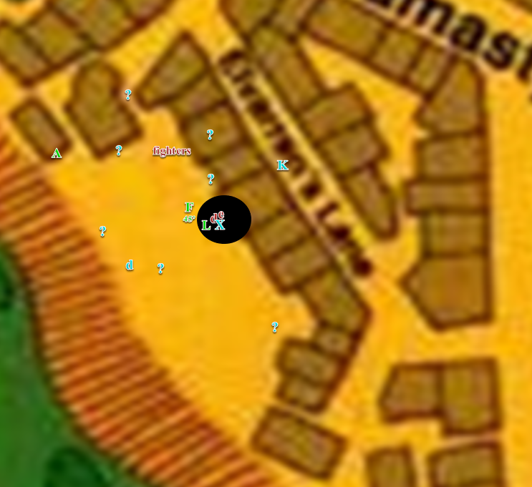

Squatting down to make herself less visible, Allisa cast *barkskin [expired on Round 1517]* on herself.

*Allisa gained +4 to FF AC & AC.*

Fingers lowered the carpet towards the ironclad shuriken throwers, resolving to slash at them with its dagger, confident that despite the relatively minor potential damage, the changeling would be able to hold its own and if a weak spot was discovered, a twist of the knife should down even a hearty foe. In the meantime, Fingers continued peppering enemies with the deadly needles, hoping the 9 remaining needles would be sufficient to deal with most of the enemy. Despite being invisible, there was no need to get up close and personal where a lucky swing might cause another wound any sooner than necessary.

|  |  |  |  |  |  |  |  |  |  |  |
| --- | --- | --- | --- | --- | --- | --- | --- | --- | --- | --- |
| **Ranged Weapon** | **Dmg.** | **D+** | **TH+** | **Critical** | **Rng.** | **Wt.** | **Atk** | **Roll** | **Check** | **Notes** |
| Deadly Precision Blowgun +2 | 1+cripple | 2 | 2 – 4 range+ 2 height | x2 | 10’ | 2.0 | +13 | **20** | 33 | +5d6 Sneak |
| Blowgun, 2nd Attack | 1+cripple | 2 | 2 – 2 range+ 2 height | x2 | 10’ | - | +10 | 18 | 28 | +5d6 Sneak |

*Threat, hit. 1d20 = 18 + 11 = 29, critical hit. Dmg: 2 x (19 + 2 + 1) = 44 to Swordsman 1; 17 + 2 + 1 = 20 to Swordsman 2.*

Another one of the soldiers went down, while the second one hit was blinded in one eye. Oh, then that second one died too.

Fingers was now 15’ above them, and contemplated whether or not to continue its descent and get close up with its dagger or remain aloft and pick off the armed knaves one by one.

The half-orc called for a retreat, and those that could do so were happy to oblige. The elf and drow inside the bubble of *obscuring mist* were among those that heard the call, and immediately withdrew from the impetuous attack against the aspiring archmage.

Exiting the *obscuring mist*, the two swordsmen saw Fingers descending upon their fellow mercs, who were already in full retreat.

The dwarven neighbor finished putting out the fire on his wall, and shut himself inside his house while the conflict resolved itself.

Lauren attempted to close on the nearest mercenary and attack with her falchion. The blade was primed with a *vampiric touch* spell.

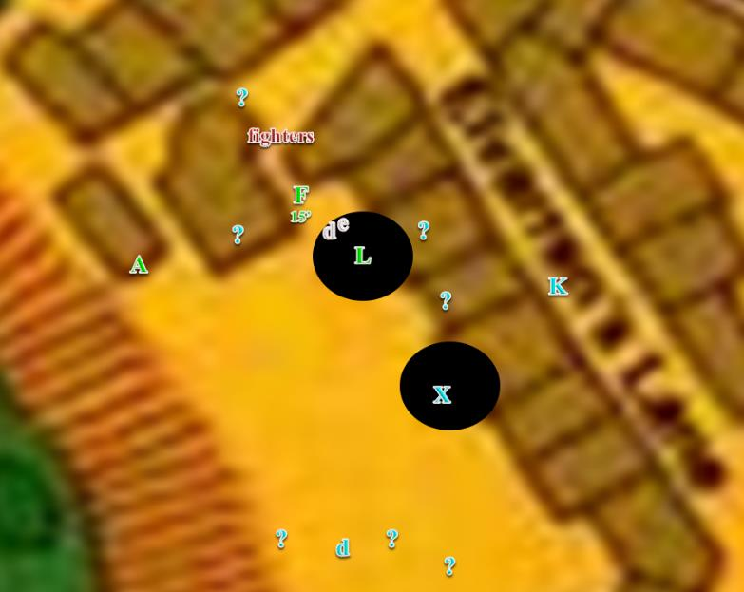

Round 18

Lauren caught up to one armored fool and cut him down.

|  |  |  |  |  |  |  |  |  |  |
| --- | --- | --- | --- | --- | --- | --- | --- | --- | --- |
| **Melee Weapon** | **Dmg** | **D+** | **TH+** | **Critical** | **Type** | **Wt.** | **Atk** | **Roll** | **Check** |
| Shattermantle Bloodstone Falchion +3 | 2d4 | +5 +3 | 3 | 18-20/x2 | Slashing | 8.0 | +23 | 7 | 30 |

*Hit. Dmg: 6 + 5 + 3 = 14.*

The runt of the litter perished.

Allisa used her *call lightning [expired on Round 168]* spell. The first bolt was sent to her earlier target whose back was now turned to her.

|  |  |  |  |  |  |
| --- | --- | --- | --- | --- | --- |
| **Ranged Weapon** | **Dmg.** | **Atk** | **Roll** | **Check** | **Notes** |
| Ranged Touch Attack | 3d6 electric | +14 | *1* | 15 | 9 bolts left |

*Miss.*

The leader of the fleeing mercenaries stopped at the corner, bravely allowing most of his minions to pass before continuing northeastward now, right towards the property where the Gambit had been heading. The drow and elf below had dropped their longbows, and were now running right underneath Fingers, who spat a flechette at each of them as it flew past them and towards the rest of the mercs.

|  |  |  |  |  |  |  |  |  |  |  |
| --- | --- | --- | --- | --- | --- | --- | --- | --- | --- | --- |
| **Ranged Weapon** | **Dmg.** | **D+** | **TH+** | **Critical** | **Rng.** | **Wt.** | **Atk** | **Roll** | **Check** | **Notes** |
| Deadly Precision Blowgun +2 | 1+cripple | 2 | 2 + 2 height | x2 | 10’ | 2.0 | +15 | 6 | 21 | +5d6 Sneak |
| Blowgun, 2nd Attack | 1+cripple | 2 | 2 + 2 height | x2 | 10’ | - | +10 | 7 | 17 | +5d6 Sneak |

*Hit, hit. Dmg: 16 + 2 + 1 = 19 to drow swordsman; 30 + 2 + 1 = 33 to elven swordsman.*

Both of the knave fighters fell flat on their faces, pierced through the jugular by the uncanny rogue’s irreplicable longshots. Fingers now turned to look forward, seeing the last of the mercenaries turning the corner.

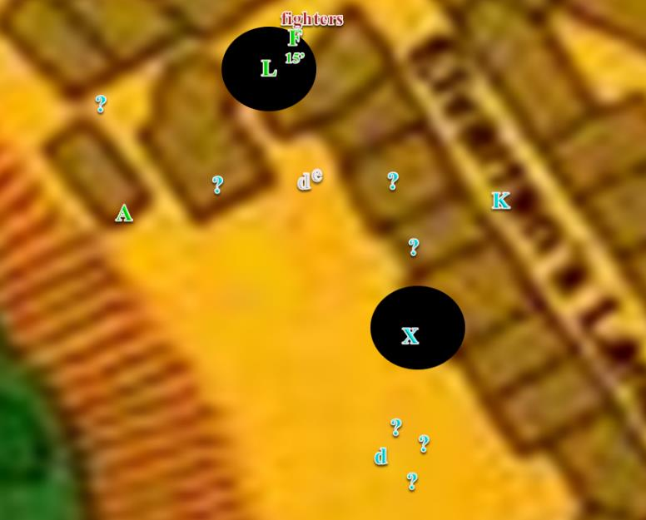

Round 19

The druid had wanted to send her next bolt at the orc leader, but he was now out of Allisa’s line of sight and attack, as were any other unambiguous hostiles. Seeing the orc turn the corner, the druid turned back into the hawk and flew up and in the direction of the fleeing enemy.

With all of the raiders either dead or retreating with its allies in pursuit, Fingers returned its attention to seeking the pair that were the group’s original target. Ordering the carpet to climb once more, the changeling circled the building to try and determine if they had taken refuge back inside or were retreating another direction.

Lauren continued to run northward, and swung her falchion at the next squire that thought himself a warrior.

|  |  |  |  |  |  |  |  |  |  |
| --- | --- | --- | --- | --- | --- | --- | --- | --- | --- |
| **Melee Weapon** | **Dmg** | **D+** | **TH+** | **Critical** | **Type** | **Wt.** | **Atk** | **Roll** | **Check** |
| Shattermantle Bloodstone Falchion +3 | 2d4 | +5 +3 | 3 | 18-20/x2 | Slashing | 8.0 | +23 | 15 | 38 |

*Hit. Dmg: 7 + 5 + 3 = 15.*

That left the half-orc leader, the captain, the archer, and one of the swordsmen.

Round 20

Once in view, the druid called down lightning upon the half-orc.

|  |  |  |  |  |
| --- | --- | --- | --- | --- |
| **Character** | **Save vs.**  *call lightning* | **Ranks** | **Roll** | **Save** |
| Mercenary Leader | Will | 7 | 9 | 16 |

*Success. Saves for ½ damage.*

*Dmg: ½ x 11 = 5 electric.*

Spotting its prey, Fingers dived to about 10’ above (him/her/them as appropriate) and called down. “Halt right there. The Watch wants to have a few words with you.”

|  |  |  |  |  |  |  |
| --- | --- | --- | --- | --- | --- | --- |
| **Skill** | **Rank** | **Ability & Mod.** | **Misc. Mods.** | **Total** | **Roll** | **Check** |
| **Fingers, Bluff** | 15 | **Cha (+2)** | 0 | 17 | 17 | 34 |

*See below.*

The remaining handful of mercenaries stopped dead in their tracks as their leader raised his left fist a bit.

~*~

“Hail Dispater.”

“Hail Dispater.”

The sound of cloven hooves clippity-clopping in pairs rather than quartets intermingled with cobbled humanoid feet and other non-caprine limbs. Complementing the sound of the cloven-hoof bustle on the street, the screams of Petitioners resonated from within residences and businesses here as the chirps and songs of birds were in Elysium, the Beastlands, or certain parts of the Material Plane.

Deep maroon was the color of the normally blood-red sky, a crimson that today seemed like a bloodclot scabbing around the plane. The hint of sulfur satisfied the nostrils of the denizens of Dis as they went about their business along this coastal tourist trap of the city-plane’s edge flush with the River Styx.

At the corner of Impilish Avenue and Shackles Boulevard there stood a vendor of unholy provisions for those entrusted with the duty of self-preservation on this unforgiving plane. The vendor had been calling out to passersby like a toad to its potential mates in a dank swamp, and had ensnared an outlander from the plane of Malbolge, another layer of the Nine Hells.

The vendor sized the fellow devil up, and could not quite place his rank, so he asked, “My cousin and associate, what might I procure for you today? I’ve securities, futures, investments, all manner of Faustian wares.”

They discussed general needs and specific products or services that would satisfy those requisites, and came to an agreement, “Three and a half pounds.”

“I’ll wager you’d charge a local less,” said the tourist as he produced his bag of holding and pulled from it four least lemures, each weighing a pound. Handing them over, he witnessed how the vendor threw three of the masses of eyeball-rich flesh onto a scale to verify their weight, then smiled as the vendor busted out a cleaver, put the fourth lemure—now blinking with panic—on a wooden block, and sliced that new clump of unrepentant protoplasm in two.

Squealing, the lemure halves cauterized as they sought to regain semi-spherical forms, weeping pus and suffering as they knew they would in their last life.

The two devils nonchalantly finished up their deal as the client withdrew one of the halves of the lemure, which he would later merge with another bit into a two-bit lemure.

Transaction concluded, the devils bowed their heads slightly and courteously, keeping a devilishly polite eye contact all the while, and said almost simultaneously once again, “Hail Dispater.”

~*~

20:52: Round 21

It had been 2 minutes since the conflict between Xaryn and Kir on one side, and the mercenaries on the other, had begun. Dimitri was lying dead, face down on Xaryn’s street, while Leighlund had teleported away, but the armored fighters were still mostly kicking. Fingers was now hovering in front of and just above the half-orc leader, and had its pick of targets before it.

Allisa had flown over the last rooftop, and now beheld the handful of targets from which she could also choose. Lauren had just caught up with the remaining handful of fighters and other mercenaries, and the Gambit knew their mercy would be the only thing keeping these fools alive now.

Down the street, Xaryn looked around the portion of his living room that was not *obscured* as he popped out the back of the cloud of obscuring mist. He reached to the small of his back and pulled his dagger into his hand once more as he looked frantically for Kir, who he hadn’t seen since the battle began.

Making her way northwestwardalong the adjacent street now, Kir looked back and noted that Xaryn had not followed her.

“Kir, my friend, where did you get off to?!” Xaryn called from inside his house, hoping for an answer. He stood in the living room waiting for any of the assailants from the street to follow him through the mist.

Round 22

The few warriors left stood before Fingers, who floated atop its carpet. They huddled as the swordsman at the rear faced Lauren, whose falchion threatened to cut them all down. Looking as defiant as they could before the Gambit, the handful of mercenaries prepared to die for the coin their families had been paid.

“Yield, in the name of the law!” Lauren called out from within her englobing darkness. “Lay down your arms, or be destroyed where you stand! You are all under arrest!” She moved forward until her darkness just touched the nearest swordsman.

*Because Lauren is CN, this warrants a Bluff.*

|  |  |  |  |  |  |  |
| --- | --- | --- | --- | --- | --- | --- |
| **Skill** | **Rank** | **Ability & Mod.** | **Misc. Mods.** | **Total** | **Roll** | **Check** |
| **Lauren, Bluff** | 0 | **Cha (+1)** | 0 | 1 | 11 | 12 |

*See below.*

The half-orc grimaced, and proclaimed, “*Earn* your last wages, lads! And be reborn in the Next Worlds!”

And with this, the handful of suicidal mercenaries—some more fanatical than others—rushed back towards Lauren and yelled menacingly at the half-drow who shook her head as she decided which one to cut down first.

Sure to keep his eye on the door should any uninvited guests come through, Xaryn searched around his living room and the adjacent kitchen for Kir momentarily.

Lauren swift-cast *haste [expired on Round 37]* on herself and waded into the mercenaries with Arkenlyl.

*Lauren gained +1 to BAB, Reflex Save, Touch AC, and AC, plus extra action/movement.*

Round 23

Allisa cast another lighting at the half-orc while Lauren channeled *vampiric touch* through her blade, hacking down the mercenaries.

Fingers sighed inwardly at the mercs who apparently had a death wish. It would have been preferable to question them to see if they had any ties to the thefts somehow, but there seemed no reason to waste any more time on them. Wielding the deadly blowgun once more, the invisible sniper targeted the half-orc leader. Perhaps if he could be dropped, the others might see sense.

Round 24

Xaryn had no idea who the saviors on the flying carpet were but they had seemed to be wading into the mercenaries, and that made them friends to him: friends who could probably use his help. He decided that Kir would eventually show herself again and headed back out the door towards the sounds of the fray.

Round 25

He huffed northwestward, seeing one mercenary’s ironclad arm flying west from just around the corner.

Fingers became visible once again.

Round 26

By the time he turned the corner, the *invisible [correct/confirm]* rogue atop the magic carpet was counting body parts as Lauren shook her blade clean of blood.

Xaryn stood and stared at the half-drow and the fellow on the carpet.

Kir then turned the northern corner, and there was the Gambit surrounded on both sides by these two strangers—neither of whom wore metal armor—but both of whom were armed. Neither of the two strangers seemed to bear a particularly threatening posture, but both appeared to Fingers to be capable of defending themselves should the need arise.

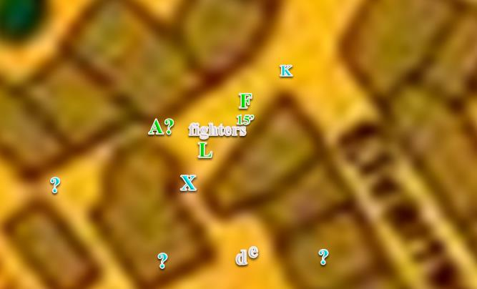

20:53

About 20’ from Lauren, Allisa transformed into her half-elven form as the two new figures showed up. She went straight to the nearest fallen enemy making sure he was dead then searched him for anything thing of use and any identification. This she did for each in turn.

Kir had rounded the corner to find a woman standing between her and Xaryn. She was just putting her blade away. Though she was average in height for a human Kir could tell by the woman’s ashen colored skin, white hair and violet eyes gave away the fact that if she was not drow she was at least half drow. Kir was wearing a black leather armor and a black hooded cloak. She stood about 3’ 5” to 3’ 8”, pale colored skin, thick braided red hair and green eyes.

Allisa sighed. The first mercenary had nothing on him; not a single pouch of personal items. Not a bag of trail mix to chew on before his next kill. His sword lay a few feet from his torso, and his armor had been left intact by Lauren’s skillful blade, which cut cleanly between the breastplate, and the portion that covered his midsection. The stench made her gag as she turned to the next corpse.

“Stay put, you, “Fingers warned the stranger. “We have some questions.”

As the newcomers watched and complied with Fingers’ demand for the moment, the woman with the falchion fished a scrap of cloth from her bag and wiped the weapon’s blackened blade clean, and then she replaced it in the sheath slung across her back. She was of average stature and build for a human woman, but her ash-colored skin, white hair, and violet eyes betrayed her part-drow heritage. She wore a chainmail shirt and leather breeches, with calf-high black boots. Her eyes fell on the drow as he approached. “I am Lauren Maltholas, née Fifthdaughter,” she said formally, “and we,” she indicated her companions with a sweep of her hand, “are Destiny’s Gambit.”

Kir wasn’t yet sure if this woman was friendly or not. Arrow knocked, though she held the bow down, Kir could see Xaryn approach the woman, she turned her attention towards him and then introduced herself. Kir listened carefully: Lauren Maltholas, née Fifthdaugther. She was part of the group called Destiny’s Gambit. Kir relaxed and un-nocked her arrow.

Allisa shook her head, finding nothing on these mercs but weapons, ammo, and armor. She turned to the half-orc, who was probably the best prospect of them all.

As the half-drow woman approached, Xaryn and spoke her name, his posture relaxed slightly. ‘Not enemies, it seems,’ he thought. “I am Xaryn. That is Kir,” he said, motioning to his companion whom he could now see coming around a corner to the north. “And we, do not want any trouble.” He said with a bow.

Kir heard Xaryn respond. She wasn’t happy that he had used her real name, though by the looks of this woman and her companies, they would figure it out eventually. When Xaryn told Lauren that they did not want any trouble. Kir tilted her head slightly when Lauren replied that that was good to know. She put her arrow away and took a few steps forward.

The sound of a knife slashing flesh was heard. Allisa looked up at her name and nodded. The blood dripped from her blade as she turned back to wipe it on the victim and began to search the body.

Allisa found on the half-orc a bag of gold—probably a thousand coins inside it—and a parchment with some instructions, including the name Cairne, and stipulations to obey the directives of “Dimitriof the Merciless”. Allisa then went to a heap of bodies that lay where Lauren had cut them down.

“Laura, Allies, Fingers.” Kir repeated, her voice almost a squeak. “Sorry, it helps me remember names if I repeat them.” Kir walked to stand next to Xaryn. “This was not our trouble, though it seems that someone believes it is.” She looked around to watch for anything out of the ordinary. “It is interesting that you are looking for stolen items. I overheard a little while back that there was going to be a big heist soon. I am not sure who the two were that were taking but they did mention a name I knew from a long time ago. They said something about not believing that she would be involved in it.”

Lauren looked at Kir as she spoke. “Would you be willing to take us to her? We are all in the City Watch, so we have the authority to investigate crimes. Also, my companions were victims of the robbery, as was I,” the half-drow remembered her mother’s keepsake. Kir could see that Lauren’s clothing and gear, while not ornate, were all well made, and likely expensive. Even her steel shield was well cared for, though it showed some scuffing from the recent battle.

Kir didn’t know the whereabouts of anyone involved in the heist, and *[DM assumption]* said as much.

And it was then that Allisa lifted a mercenary’s body to reveal the body of Cairne—which the mercenaries had previously been carrying—underneath the armored corpse. Xaryn’s face instantly betrayed dismay, though not necessarily surprise.

20:54

With no apparent continuation of bloodshed in the immediate situation, Fingers landed the carpet and tucked away the surprisingly effective blowgun. “A Divination led us to a location near here attempting to locate the thieves we are seeking, but it appears this is merely another clue in our quest. Whether the rumors you heard were what is meant to guide us onward, the one who sent these assassins is our real target or both remains to be seen. However, as you two now seem embroiled in the matter, I might suggest you join with us for the time being until we can reach the bottom of the matter.” The changeling was willing to take the duo at face value—to a point—but complete trust of strangers was not in the trapsmith’s nature... it would keep the pair where it could see them for now.

Kir was about to reply to Lauren when she spotted the body of Cairne. “Oh, you poor bastard. You should have left when you had the chance.” At that, she walked over to his body, and leaned down to close his eyes.

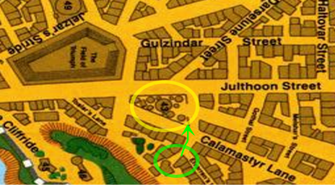

The five formidable folks were now all atop the ample carpet, and Fingers led them upward and northwestward. Within a few seconds, they could see the property towards which they’d initially headed. They were about 100’ above the hill, which was itself about 50’ higher than the streets that ensconced the corner property boasting a fancy château. A few figures made their way to and fro the guard tower, and it was apparent that someone was already atop it, and had probably witnessed the *fireball* and other magical pyrotechnics emitted by the Gambit and other combatants just minutes ago. Fingers would have to descend to get a closer look at who these people were, but it and Lauren were both certain that this was the place in question.

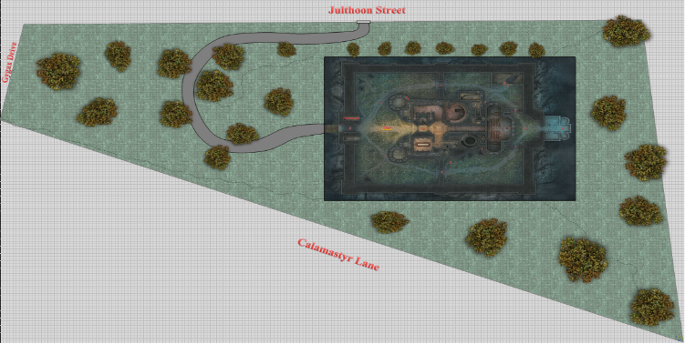

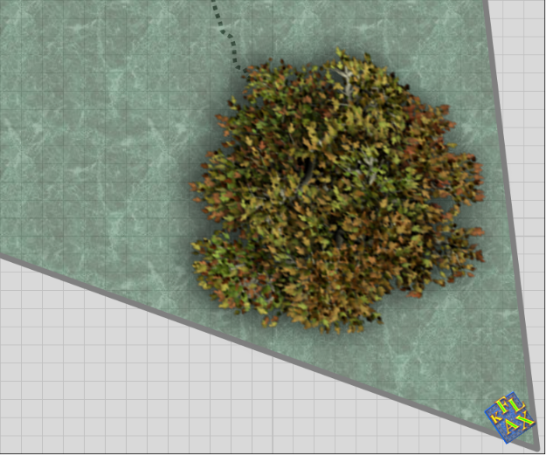

Kir did not offer any more information before they all moved onto the carpet. She had never seen one, let alone ridden on one before. With the wind in her hair, she grinned like a little kid. “Oh, I wish I could get one of these.”

Kir saw the fancy chateaux come into view, along with those that made their way to and from the tower. Without looking at anyone, she asked. “That it?”

“We’re not sure,” Lauren replied. “We’re about to find out.”

Allisa sat behind Kir, “Nice hair color. Is that natural?” The half-elf was about 5’ 2”. Her skin was paler, fairer and smoother than her human ancestry, but her reddish, copper colored hair came from her human father. It was currently at waist length and braided into one long strand. The red hair set off her stunning, green eyes. Her figure was perfect, at least that was Lauren’s description of her busty breasts that peeked out of the front of her leather armor, her well-shaped butt, and nice legs. When she smiled it was like the sun bursting over the morning horizon. She normally wore knee-high boots and leggings of the forest elves. The half-elf had no visible weapons but at her side was an empty sheath for her scimitar.

Kir gave Lauren a quick nod. She pulled her around and made sure that she had room to pull her arrows, just in case. She turned to see who had ask her about her hair. It was the half-elf Allisa. She was a stunner; very beautiful. Kir’s eyes had been drawn to the woman’s breasts then to her hair. She had gorgeous hair.

She gave the woman a big smile. “Not my natural color but close.” She had a feeling about these people, so she cancelled the disguise spell. Her hair became a bit thicker and a darker red, almost crimson color. Her skin went from pale to a light tan and her eyes turned blue. She gave Allisa a mischievous grin.

Alissa grinned back taking in the new look. “It is still beautiful as well as the rest of you.”

<< Down, girl, >> Lauren said in passable Elvish. She grinned at Allisa.

Allisa replied in kind, but in Common, “I only have eyes for you, my darling.”

While the group was chatting about how sexy Kir was, and the carpet flew further northwest, the shrill sound of a halfling-sized male voice rang out from the western watchtower. A few seconds later, a figure materialized at an altitude of about 40’, and began making its way up and southeast—towards the carpet.

Slowing down the craft and maintaining their altitude of 100’ above the street and about 50’ higher than the castle, Fingers announced the figure when it spotted it, and said, “There’s an inordinate amount of glamer magic resonating from the castle.”

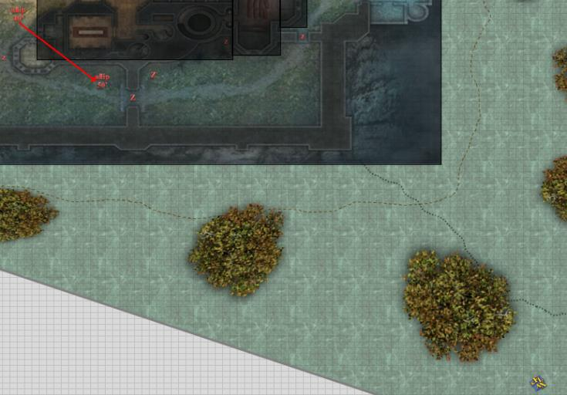

Lauren began to see it too, and soon thereafter, Xaryn could also see through the proverbial smoke and mirrors if he squinted enough and looked down at the correct angles. There were zombies bumping in the night all around the grounds, and what was flying towards them now appeared to be an allip. Allisa remembered the last time she’d encountered one of these in the Catacombs of Yintros back in 1374, and knew that in and of itself the allip would not present a problem, but the fact that it was conjured out of thin air suggested that there was at least one necromancer down below.

Round 1

“Fingers, back away and put us on the ground. I don’t want to fight that thing from here,” Lauren said. She took a moment to swap the crystals in her weapons, placing the Truedeath gem in Arkenlyl.

The changeling guided the tapestry downward and northwestward at a 45-degree angle, and landed right below a tree.

Though they could hear its hideous babbling growing closer, they couldn’t see the allip, but assumed that it was still headed for them, and would emerge through the treetop above at any moment. They could, however, see a human-sized zombie that spotted them, and began its downhill approach towards them.

Its attention triggered by the human-sized zombie, a halfling-sized zombie situated further east also noted the carpet and its passengers, and fired a bolt towards Lauren.

|  |  |  |  |  |  |  |  |  |  |  |  |
| --- | --- | --- | --- | --- | --- | --- | --- | --- | --- | --- | --- |
| **Character** | **Attack Type** | **Damage** | **Ranged?** | **BAB** | **Str Mod+** | **Dex Mod+** | **W+** | **Other+** | **Total Score** | **Roll** | **Total** |
| zombie, S | Light Crossbow | 1d6+1 | þ | 1 | -1 | 1 | 0 | -4 range | 2 | 14 | 12 |

*Miss.*

The bolt fell about 20’ short of its mark, and both zombies now approached.

Lauren stepped off the carpet and moved northward to put herself between her companions and their attackers. Having cast *barkskin [expired @ 23:31]* on herself when they’d confronted the mercs just minutes ago, she planned to quick-cast *haste* when the enemy closed in. The duskblade selected *shocking grasp* to channel through her blade as she attacked.

Kir shook her head slightly at Allisa, “Why thank you.” When Lauren commented Kir let out a chuckle.

When she heard the shrill sound of what sounding like a male halfling voice. This turned Kir’s attention back to what they were doing. Still not feeling up to par, she took one of her potions of *cure moderate wounds*.

*Kir healed 8 + 8 = 16 hps [75/95].*

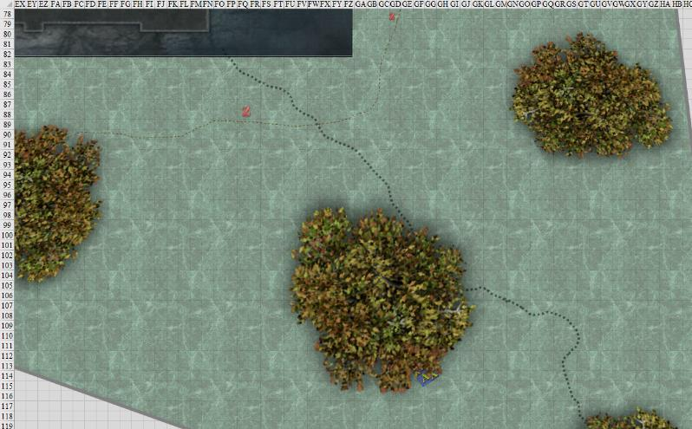

Round 2

|  |  |  |  |  |  |
| --- | --- | --- | --- | --- | --- |
| **Character** | **Group** | **Initiative** | **Roll** | **Modified Roll** | **Move** |
| ? | 2 | 1 | 19 | 20 | 30’ |
| Lauren | 1 | 4 | 14 | 18 | 30’ |
| Xaryn | 1 | 5 | 9 | 14 | 30’ |
| Fingers | 1 | 4 | 10 | 14 | 30’ |
| ? | 2 | 1 | 11 | 12 | 20’ |
| Kir | 1 | 1 | 10 | 11 | 20’ |
| Allisa | 1 | 3 | 6 | 9 | 30’ |
| spare zombies | 2 | -1 | 5 | 4 | 30’ |

With his *mage armor [expired @ 04:48 tomorrow]* already active, Azimuth led Otis closer to the castle’s main entrance. Having heard Melonpatch’s heed, he now cast *protection from good [expired on Round 82]*.

Lauren had wanted to cast *disrupt undead* at the allip, though she could not see it, so she stayed put.

Xaryn hesitated.

The zombified halfling or gnome fell, and started sliding down the hill, dropping its crossbow.

Fingers busted out its blowgun and played blowgun bowling with the zombies.

|  |  |  |  |  |  |  |  |  |  |
| --- | --- | --- | --- | --- | --- | --- | --- | --- | --- |
| **Ranged Weapon** | **Dmg.** | **D+** | **TH+** | **Critical** | **Rng.** | **Wt.** | **Atk** | **Roll** | **Check** |
| Deadly Precision Blowgun +2 | 1+cripple | 2 | 2 – 2 height | x2 | 10’ | 2.0 | +13 | 1 | 14 |

*Miss.*

“Mmmm!” the changeling demoralized itself. “Wasted shot anyway as wouldn’t do enough damage to even slow one down. Damned undead don’t have vital spots usually. If the crooks hadn’t snagged my sling with the crystal on it, be another matter. Not sure whatever that nattering thing is that’s coming but I suspect I may have the same problem with it. Gonna have to do this the hard way.”

Tucking the blowgun into its tunic, the trusty Eager Dagger literally leapt into Fingers’ hand ready to do business. Glancing at Allisa, it concluded, “What do you think, move in to meet them or stay put so we don’t get in the way of the others?”

Melonpatch shook his head, and tried to see what was going on, but now had no line of sight to the grounded carpet and its passengers.

Kir readied her bow, nocked an arrow, and cast *divine favor [expired on Round 12]*. She moved to the right of Lauren and back about 5’. This way Lauren was not in Kir’s line of fire.

*Kir gained +2 to BAB and weapon damage.*

The slope leading towards the castle was about 10 to 20 degrees, depending on the route one took to walk or scale it. The undular ridge *[thick, dotted line]* to their east constituted a sharp ridge—almost like a corner edge of a pyramid—beyond which the predominantly north-south slope became an east-west slope. The top of the slope *[thin, dashed line]* had been leveled centuries ago, and the construction of the courtyard’s rectangular wall had followed shortly thereafter. At the summit, the two zombies faltered in their steps.

|  |  |  |  |  |
| --- | --- | --- | --- | --- |
| **Character** | **Save vs.**  Slipping | **Ranks** | **Roll** | **Save** |
| zombie, M | Reflex | -1 | 18 | 17 |
| zombie, S | Reflex | 0 | 4 | 4 |

*Success, fail.*

The druid had no blade or ranged weapon so she stood back at the carpet next to everyone else waiting in case should could do something.

The allip made its way towards the party and was now 25’ above the hilly ground. Though its cackle wasn’t yet close enough to hypnotize anyone, Fingers surmised that it soon would be.

Allisa replied to Fingers, “Go ahead; I am staying back.”

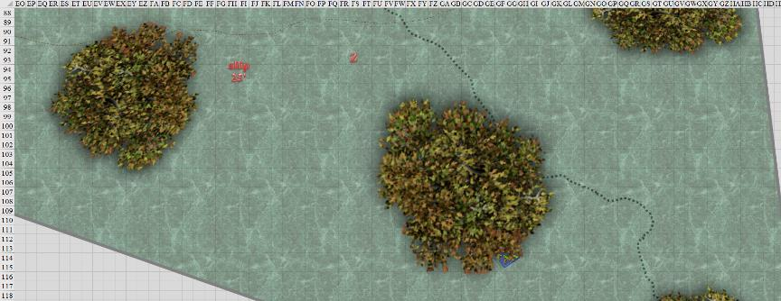

Round 3

“No thanks,” replied Fingers to Allisa. “Unless Lauren or those strangers seem to be having trouble with the zombies, I’ll leave it to them rather than just get in the way. I just wish I could do something about *THAT*.” Fingers then suggested to Lauren that she use her *disrupt undead* spell against the incoming zombies instead.

Lauren said, “Nope. Going to wait for the allip to get in range.”

Xaryn and Kir noted the quirks in the party, and smiled.

Azimuth cast *clairvoyance [expired on Round 603] upon the area just beyond the southern wall, and saw the allip descending upon the party.*

The allip rushed over towards the party, descending into view.

As the changeling pointed towards the airborne monstrosity while speaking the last sentence, the horns that had briefly sprouted on its head back in the Gambit’s HQ again momentarily appeared as an ebon bolt of energy seared from its hand towards the allip. Fingers goggled at its hand but could only comment, “Wha?”

~*~

Many months ago—back in 1374 DR—Willow faced her imminent death at the hands of her captors. Unconsciously, her mind cried out to one who had come to her rescue once before. As the fatal blow fell, she inwardly screamed, “Fingers, help me!” Driven by her terror and impelled by her succubus’ telepathy, a tiny fragment of her consciousness fled her dying body. Eventually, the questing soul fragment touched upon Fingers’ mind and it flowed unfelt into the changeling’s mind, taking refuge there.

Time passed and the trapsmith’s frequent use of *see invisibility* and *darkvision* spells from its headband began to create sympathetic vibrations in the tiny shred of Willow’s spirit. These grew stronger and stronger with each invoking of the spells until the changeling’s former mentor’s soul fragment finally fully integrated with Fingers’ being, making Fingers into a full-fledged warlock!

~*~

The eldritch blast stopped 60’ beyond its origin, about 10’ from its intended mark. Fingers made a mental note of the blast’s range limit.

“Waaaaa! Waaaaa!” the conjured allip flinched, sounding like a humanoid baby weeping with sorrow, invoking the pity of the heroes, which was part of its tactics.

Lauren spotted the allip—barely in range of a short-range spell—as it descended to their level, and cast *disrupt undead* at it.

|  |  |  |  |  |  |  |  |  |  |
| --- | --- | --- | --- | --- | --- | --- | --- | --- | --- |
| **Ranged Weapon** | **Dmg.** | **D+** | **TH+** | **Critical** | **Rng.** | **Wt.** | **Atk** | **Roll** | **Check** |
| Ranged Touch Attack | varies | - | 0 | - | - | - | +17 | 8 | 25 |

*Hit. Dmg: 3 positive energy. Out of range.*

The duskblade—too—wasted a minor effort on a target outside her spell’s range.

Xaryn was paying little attention to the conversation the others were having as the battle began to unfold. He looked around for a moment to take in the scene. A moment passed and a flustered and thoroughly puzzled Xaryn huffed and in exasperation pointed his right index finger at the allip and two magic missiles flew forth, striking the advancing foe.

*Dmg: 11 + 5 = 16 magic.*

The allip faltered, but did not disappear, then wailed at Xaryn with a “why did you dooo thaaaat?” kind of whine.

|  |  |  |  |  |  |  |  |  |  |
| --- | --- | --- | --- | --- | --- | --- | --- | --- | --- |
| **Ranged Weapon** | **Dmg.** | **D+** | **TH+** | **Critical** | **Rng.** | **Wt.** | **Atk** | **Roll** | **Check** |
| Fingers, Eldritch Blast | 1d6 | 0 | 0 | x2 | 60’ | 0.0 | +13 | **20** | 33 |

*Threat. 1d20 = 14 + 13 = 25, critical hit. Out of range.*

Melonpatch stood his ground on the lookout tower, listening to Azimuth’s plan.

When Allisa saw the allip, she cast *earthbind* upon it.

|  |  |  |  |  |
| --- | --- | --- | --- | --- |
| **Character** | **Save vs.** | **Ranks** | **Roll** | **Save** |
| allip | Fortitude | 1 | 7 | 8 |

*Fail.*

The allip began to sink downward with the speed of a feather.

The zombies made their way over to the party so they could say hi one last time. The small one was behind a ridge, and would soon come out from behind it.

Kir hesitated.

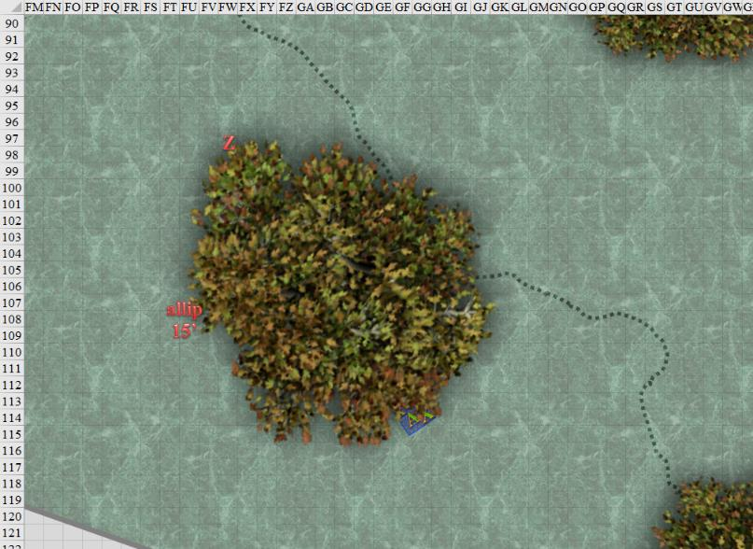

Round 4

Azimuth related what he saw to Melonpatch*.*

The allip continued to fall gently.

Lauren waited until the creature was in range, and then she cast her *disrupt undead* spell again.

|  |  |  |  |  |  |  |  |  |  |
| --- | --- | --- | --- | --- | --- | --- | --- | --- | --- |
| **Ranged Weapon** | **Dmg.** | **D+** | **TH+** | **Critical** | **Rng.** | **Wt.** | **Atk** | **Roll** | **Check** |
| Ranged Touch Attack | varies | - | 0 | - | - | - | +17 | *1* | 18 |

*Miss.*

Fingers paused briefly until its target closed in the few remaining feet and then unleashed another blast. Steeling itself against the mental assault the undead horror was about to inflict, the changeling lamented that its purloined mindcloaking crystal would have been handy right about now.

|  |  |  |  |  |  |  |  |  |  |
| --- | --- | --- | --- | --- | --- | --- | --- | --- | --- |
| **Ranged Weapon** | **Dmg.** | **D+** | **TH+** | **Critical** | **Rng.** | **Wt.** | **Atk** | **Roll** | **Check** |
| Eldritch Blast | 1d6 | 0 | 0 | x2 | 60’ | - | +13 | 11 | 24 |

*Hit. Dmg: 6 magic.*

Melonpatch remained still for the moment as Azimuth described the conflict just south of the keep.

The druid cast *summon nature’ s ally IV [expired on Round 19]*, summoning a Medium fire elemental to attack the allip.

A Medium fire elemental appeared just above the sinking allip, and pounced on it.

|  |  |  |  |  |  |  |  |  |  |  |
| --- | --- | --- | --- | --- | --- | --- | --- | --- | --- | --- |
| **Character** | **Attack Type** | **Damage** | **BAB** | **Str Mod+** | **Dex Mod+** | **W+** | **Other+** | **Total Score** | **Roll** | **Total** |
| fire elemental, M | Slam/Burn | 1d6+1+1d6 fire | 3 | 2 | 3 | 0 | 1 | 6 | 17 | 23 |

*Hit. Dmg: 2 + 1 + 4 fire. Physical damage negated.*

About to die, the allip shrieked, unable to fly outside of the fire elemental’s burning aura.

|  |  |  |  |  |
| --- | --- | --- | --- | --- |
| **Character** | **Save vs.**  Babble | **Ranks** | **Roll** | **Save** |
| fire elemental, M | Fortitude | 3 | 10 | 13 |

*Fail.*

The elemental suddenly left the allip alone and turned its attention back towards Allisa.

Xaryn and Kir watched the heroes deal with the allip as the zombies continued. The small one still didn’t make it over the ridge yet.

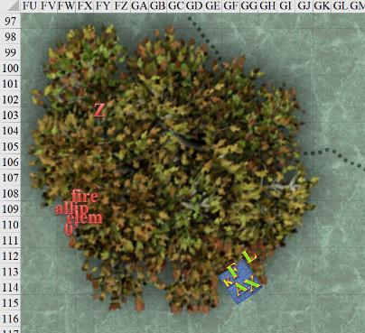

Round 5

Allisa’s fire elemental charged her with chaos in its eyes, but because Kir and Fingers were in its way, it decided to go for Kir instead.

|  |  |  |  |  |  |  |  |  |  |  |
| --- | --- | --- | --- | --- | --- | --- | --- | --- | --- | --- |
| **Character** | **Attack Type** | **Damage** | **BAB** | **Str Mod+** | **Dex Mod+** | **W+** | **Other+** | **Total Score** | **Roll** | **Total** |
| fire elemental, M | Slam/Burn | 1d6+1+1d6 fire | 3 | 2 | 3 | 0 | 1 | 6 | 10 | 16 |

*Hit. Dmg: 4 + 1 + 3 fire = 8 [67/95].*

As the elemental did the allip’s bidding, the allip remained in place, sounding like it was laughing, crying, screaming, and frothing at the mouth.

The Medium zombie tried to run but could not. It would soon reach the carpet.

The Small zombie continued to make its way south and over the ridge, though none of the heroes could see it yet.

From the lookout tower, Melonpatch listened to Azimuth as the ghostwise halfling watched on and continued to describe to the beguiler what he was seeing through his *clairvoyance* spell.

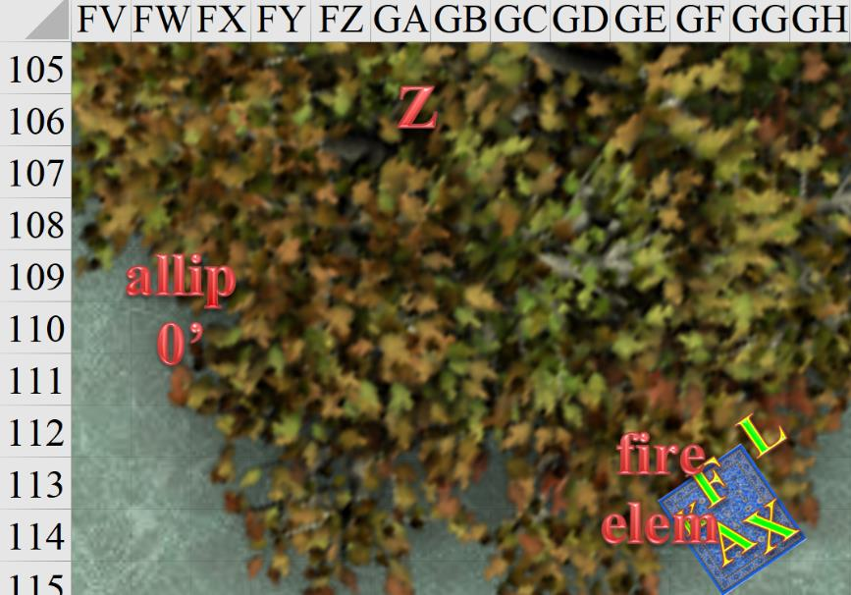

Under the spreading chestnut tree, Fingers moved slightly closer to ensure it was still within range, and fired another blast at the allip, hoping to finish it off.

|  |  |  |  |  |  |  |  |  |  |
| --- | --- | --- | --- | --- | --- | --- | --- | --- | --- |
| **Ranged Weapon** | **Dmg.** | **D+** | **TH+** | **Critical** | **Rng.** | **Wt.** | **Atk** | **Roll** | **Check** |
| Eldritch Blast | 1d6 | 0 | 0 | x2 | 60’ | - | +13 | 14 | 27 |

*Hit. Dmg: 2 magic.*

And with this, the allip was no more, and the fire elemental stood before Allisa, regaining its senses.

Xaryn watched as the allip was dealt with handily by the others. His spell supply for the day was running low and based on how his day was going so far, he knew there would be more battles to come. “So, what are we doing here exactly?” he asked, keeping his deep purple eyes trained on the approaching undead. “We certainly don’t seem welcome.”

Lauren summed up the results of the *divination* spell, and cast *disrupt undead* upon the incoming zombie.

|  |  |  |  |  |  |  |  |  |  |
| --- | --- | --- | --- | --- | --- | --- | --- | --- | --- |
| **Ranged Weapon** | **Dmg.** | **D+** | **TH+** | **Critical** | **Rng.** | **Wt.** | **Atk** | **Roll** | **Check** |
| Ranged Touch Attack | varies | - | 0 | - | - | - | +17 | 14 | 31 |

*Hit. Dmg: 3 positive energy.*

As expected, the zombie was barely fazed by the drain on its undeath. It would take about 5 of those to bring it down, Lauren thought.

Lauren then looked at Fingers. “I think we should fly out of here, and approach from the north side.” She stepped back onto the carpet.

Allisa moved back to the carpet. “We could hover a bit and let my elemental handle these few zombies.”

Allisa redirected the elemental with a thought to attack the oncoming zombie.

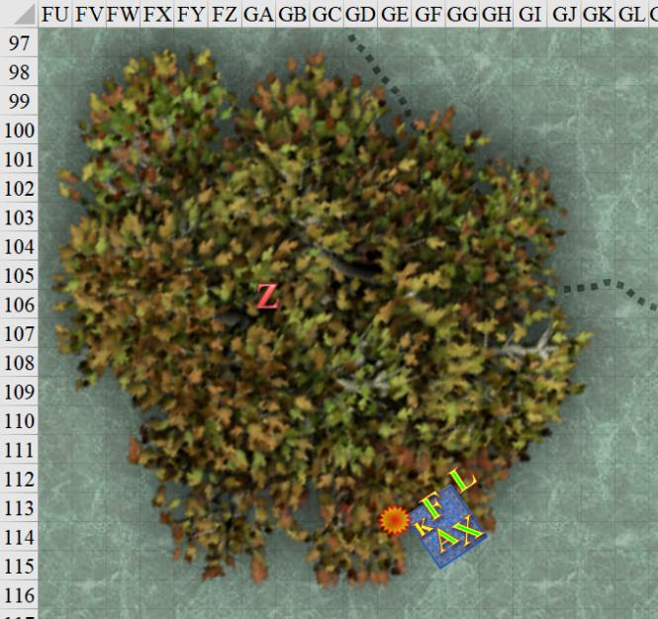

Round 6

Azimuth directed Otis to turn the crank that opened the castle gates.

In the distance—to the northwest—the heroes could hear a squeaky, rusty, iron door swinging open or closed, though there was no dull thud at the end to suggest that it was closed.

~*~

The arena had only two beasts within: one bulky, mighty, and scary, and the other meek, shifty, and unpredictable. The crowd cheered, “Disss-Pater! Disss-Pater! Disss-Pater!” until the referee flapped her wings high above the oval that contained the two devils that would momentarily do a death dance for the delight of greater fiends.

The two devils were contained by a hemispherical wall of force, and separated from one another by a flat, diametric wall spanning the narrower dimension of the oval. Cheers died down to allow the erinyes to announce the name of the devil who would perish and the devil who would slay the other.

And with little other fanfare, the inner wall that dissected the oval down the middle fizzled out and faded like a glitterdust spell had just been cast on it, allowing the larger fiend to charge the diminutive and impish adversary.

~*~

The changeling nodded agreement. “May as well, since it appears whatever is up there knows we’re here. No sense wading thru zombies.” Fingers paused long enough for anyone else wanting to reembark before taking off.

With everyone on the carpet, Fingers led them all back upward, leaving the fire elemental burning the Mirtul grass and dead foliage under the spreading chestnut tree. If they wanted to draw the attention of the neighbors to their operation, the elemental would be very instrumental.

The Medium zombie continued its limping charge on the fire elemental, passing the trunk of the tree and raising its hands to better reach the burning creature. Though the undead didn’t reach the elemental, it would imminently. The heroes could now see the Small zombie, who had almost reached the ridge. It seemed to say, “Awwww,” as they turned northward.

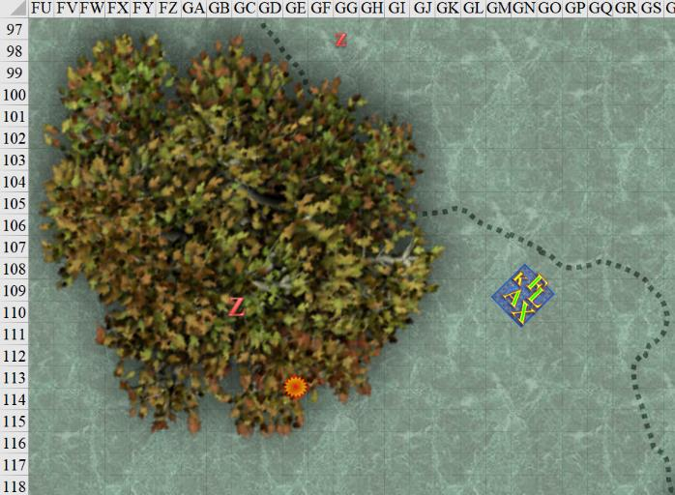

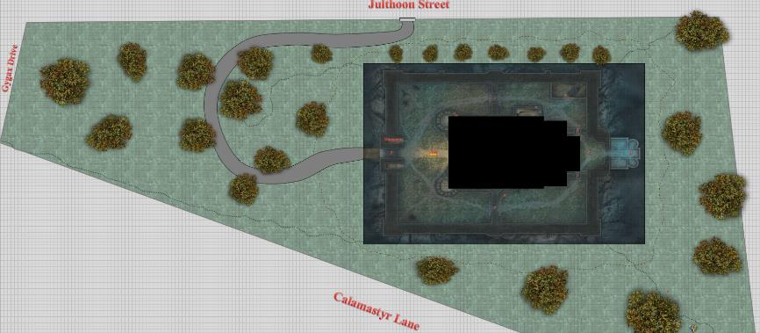

The elemental turned to face the zombie, and attacked it as the heroes got to an elevation of 40’.

|  |  |  |  |  |  |  |  |  |  |  |
| --- | --- | --- | --- | --- | --- | --- | --- | --- | --- | --- |
| **Character** | **Attack Type** | **Damage** | **BAB** | **Str Mod+** | **Dex Mod+** | **W+** | **Other+** | **Total Score** | **Roll** | **Total** |
| fire elemental, M | Slam/Burn | 1d6+1+1d6 fire | 3 | 2 | 3 | 0 | 1 | 6 | 4 | 10 |

*Miss.*

*Proximity damage to fire elemental: 2 x 2 = 4 cold.*

Allisa noted the anomaly, pointed it out to the others, and Lauren’s eyebrows involuntarily lifted with some unconscious trigger. Where had she seen that before? Allisa vaguely remembered it too. Then they looked at one another, both recalling the event in 1374. They’d gone to the Dessaryn Grove where Allisa performed a resurrection on their eidolon ally, but on their way they’d lost more than one friend, including Zond—Allisa’s lover then—and Dani—Lauren’s lover then. “Could it be that *necromancer* that we never put to rights?” one of the women asked the other.

They’d never quite faced off against the necromancer that had sent the zombies whose auras emanated cold because the scoundrel had been quick to withdraw from the scene, but this smelled too much like that night—figuratively and literally—particularly to Lauren, who’d had this fellow thrust into her subconscious recently by an unsettlingly vivid dream.

Lauren faced her wife as her shoulders slumped. “I don’t suppose we can just go home and forget all of this? I am so very tired of dealing with these creatures.”

Kir watched as the group that she and Xaryn ran into. They were good. About to comment, her attention had been shifted to the elemental that turned her direction. She heard Fingers suggest that they leave. Kir moved to the carpet. “Yea let’s get out of here.”

~*~

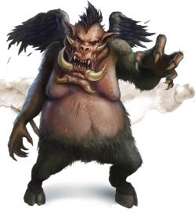

“Dish-phâzer!” the hulking nalfeshnee of middlin’ rank blurted as he reached the impish fellow, who—upon lunging with a bony limb—revealed itself to be a bone devil, and pierced a few more times the behemoth that charged by like a rhinoceros.

“Dispater!” the more eloquent bone devil pronounced with a calcium tongue and an enamel grin. The ivory faced villain—known across the planes as the Bone Overlord—had managed to remain a bone devil longer than any bone devil he’d ever encountered, and part of his success was owed to his extraordinary shapeshifting abilities that were sometimes illusions and other times transmutations. The scientist-turned-adventurer had tired of experimenting with lemure essence for centuries on end, and had in recent years turned his attention to the errant acquisition of exotic skills and artifacts.

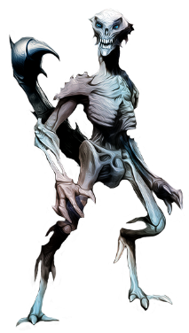

He was now fighting a bit for sport, a bit for the coin he was about to cash in on, and mostly for the attention of Karmen Santiago, who sat reluctantly at one of the balconies reserved only for the most prestigious spectators. Normally occupied by a somewhat stable beholder named Autotheus, the balcony was ample enough for several more, and the newly slain beholder wouldn’t likely be coming back from the dead... not *this* time.

“Disss-Pater! Disss-Pater! Disss-Pater!” the crowd cheered, each spectator a tyrant unto their own right. Some were taking a break from their despotic routines; others had achieved a state of a nearly carefree existence wherein their top minions’ functions were exclusively designed to keep one another in check, and therefore doing the long-term bidding of their dominators by rote default.

These were the thrills of the time. On the sidelines, misguided souls were being mass-raped before the crowd amidst lemures who consumed one another for the shot at being something other than lemures.

The Bone Overlord knew that the nearly slain beast behind it was still breathing, and still plotting to turn the tables, and so with his back turned to it, the handsome bone devil smirked under the spotlight, drew the crowd’s cheers to his glory, and waited for the sound of the lesser devil’s last grunt as it used its final burst of energy to lunge towards the Bone Overlord.

And with this, the Bone Overlord took a split second to sideswipe his stance out of the charging devil’s way, pierce the devil’s cranium from below, through the lower mandible, and remove the piercing stinger before the quadrupedal devil trampled itself onto the arena with a sickening thud and the squirt of ichor from more than one gash.

And *now* the Overlord took a bow, concerned mostly with Karmen, who sat at the balcony seat with a slight smile, conveying just enough for her needs on this grandiose plane. He eyed her out of the corner of his eyebrow-shaded eyes, then returned his gaze unto the crowd before him, and thanked them for their patronage before being shown the way to the coffers.

“In an unexpected turn of events, the long-retired Bone Overlord has returned to the arena tonight,” a spectral reporter announced through an onyx ball, “and has in less than 12 seconds effectively *cleaned* the kitchen, laying out the nalfeshnee formerly known as Gob’ch’k’ee Qo’pho’a, now known as rotting meat on the arena sand. Do you have any words for the fans, Overlord?”

The Overlord walked casually by the reporter on his way into the financier’s office, and blurted, “For the record, I’m *still* retired. I just needed a little something for my next retirement home.” And for the first time in weeks, the devil smiled a toothy smile with true delight. He had his eye on a place, but it wasn’t on the market. For this, the Bone Overlord would have to leverage more than wealth to make this new pursuit his home. It was called the Citadel of the Planes by those who’d collaborated to erect it, and all he needed was to find it, and wrest it from its current denizens, who—he’d recently heard from a now-dead beholder—had gone mad from his dealings with said beholder, an arch-aboleth on the Material Plane, and other powerful creatures from the Far Realm.

~*~

Round 7

Azimuth orchestrated an orderly retreat, ordering Melonpatch to come on down from the tower. He also whistled to all of the zombies within earshot to come back *into* the keep.

As Fingers continued to gain altitude—reaching about 70’—the heroes heard a distinctly purposeful whistle coming from the keep, which disappeared as quickly as it came. Lauren noted that the zombies turned towards the sound, and started to walk westward towards the keep’s iron gates.

Xaryn had a knack for dungeoneering, and by the looks of what he could see at this altitude, this hilly property seemed ideal for building a dungeon underneath it. Lauren knew enough about the vicinity to be aware of the sewers that ran under this property, though her general dungeoneering knowledge would have caused Lauren to agree with Xaryn that short of the existing sewage infrastructure, this *was* an awesome site for an underground dungeon.

Fingers, however, was the resident expert in the way of architecture and engineering, and would have contended that a much more thorough analysis would have to have been done before declaring such a thing. It was also aware of the sewage system that drained past this property—beneath it—and its dear friend—Sarge—had recently acquired detailed maps to the city’s entire drainage complex, as updated and accurate as they could be rendered. First off, this hill was artificial, and was in desynchrony with the rest of the relatively flat topography around it. This place would be a mess, from an excavation perspective. No, the contractors had done what they could with what they had. Fitting a square keep into a rectangular property, they scaled down the proportions of the retro-fantastic design—borrowing from some of the features of Castle Waterdeep and some of the rural keeps in the vicinity of the city. Only the lookout towers had tactical functionality, but the château was more palatial than a refuge against invading armies. Its walls could keep out the urban rabble that wandered here from the nearby Trades Ward, but they had not been erected with military intentions. It was evident to Fingers that the architect who designed this was appealing to someone’s sense of nostalgia for ages past, and for places far more remote than the City of Splendors. They had to be either disillusioned recluses, or cloistered scribes or intellectuals whose removal from public, contemporary life was a daily necessity.

It being mid-spring right now, Allisa did not fail to notice that although there were living trees, shrubs and grasses in the part of the property outside the rectangular keep, almost all of the vegetation inside the courtyard was dead. The few trees that had once grown there were dead as of at least two springs, and the ivies that covered the lower portions of the castle’s walls had not borne leaves in about the same number of blooming seasons. Someone had once loved this place, but it had since been reduced to something of utility and monetary value. Still, the courtyard was orderly as could be, and the zombies that now retreated into the castle were probably its nightly custodians.

The elemental swung at the fleeing zombie, who left itself open to an extra flank attack.

|  |  |  |  |  |  |  |  |  |  |  |
| --- | --- | --- | --- | --- | --- | --- | --- | --- | --- | --- |
| **Character** | **Attack Type** | **Damage** | **BAB** | **Str Mod+** | **Dex Mod+** | **W+** | **Other+** | **Total Score** | **Roll** | **Total** |
| fire elemental, M | Slam/Burn | 1d6+1+1d6 fire | 3 | 2 | 3 | 0 | 1 | 6 | 12 | 18 |
| fire elemental, M | AoO, Slam/Burn | 1d6+1+1d6 fire | 3 | 2 | 3 | 0 | 1 | 6 | 8 | 14 |

*Hit, hit. Dmg: (3 + 1 + 4 fire) + (4 + 1 + 3 fire) = 8 + 7 fire = 15.*

*Proximity damage to fire elemental: 2 x 3 = 6 cold.*

The Medium zombie expired, and fell to the floor, unlike a summoned zombie would have. These were actual folks who’d been zombified by a powerful necromancer. The elemental turned its attention to the Small zombie that had just made it over the crest of the property’s southwestern slope.

The ground at the elemental’s feet caught on fire, and would soon creep across the floor to the chestnut tree, alerting the entire ward to what was happening.

After the demise of the zombie, Alissa dismissed the elemental, giving it thanks for its help. The fire on the ground, however, persisted.

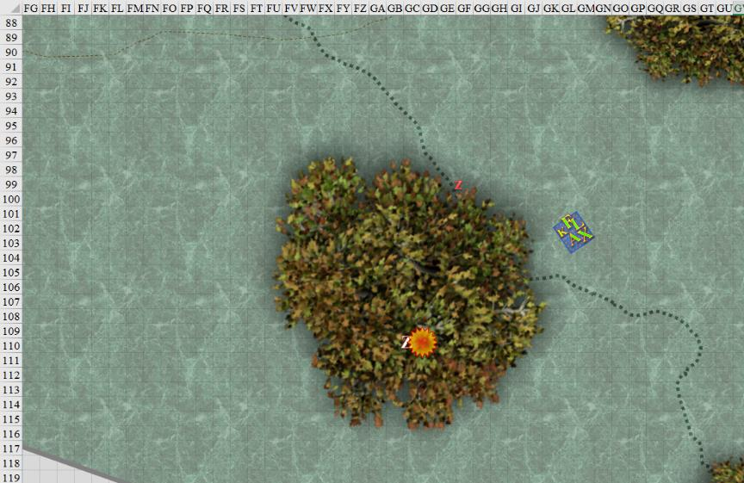

Round 8

Azimuth and Melonpatch ushered the zombies inside, and began to carry out their contingencies, discussing them for the moment.

Fingers, having overheard, commented, “Even if we were willing to forgo any chance of recovering our property—which I, for one, am not—we should ensure that the theft was just random rather than targeting the Gambit specifically. An unknown enemy is far more dangerous than a known one.”

Kir had been listening. She looked at those discussing the options. Lauren wanted to end the search. She must have known something that Kir did not. Fingers was not wanting to stop. She looked to Lauren. “As I said before. I had heard that an old acquaintance was going to be involved in a big job. As to what it was, I am not sure, but it was to happen tonight. I can only assume that it must have been to relieve you and yours of your items. When I knew her, she went by Lenna back then. Of course, that was not her real name; that, I do not know. As to which guild she would be a part of now, I do not know that either. (pause) She a bit shorter than me. Blonde hair brown eyes and she is darker than I.” When she was done, she looked to Xaryn to judge his reaction to it all.

“Well then, how can we get our items back?” asked Allisa to no one in particular.

Round 9

Azimuth cast *bear’s endurance [expired on Round 79]* upon himself.

*Azimuth gained +4 to Constitution, and 30 hps.*

Melonpatch used a leather thong to cast *freedom of movement [expired on Round 909]* upon himself.

*Melonpatch gained freedom of movement bonuses (PHB 233).*

Lauren sighed. “I know, love, we need to get your things back.” The duskblade glanced at the newcomers. “It feels like it’s been a long fight against the people who we believe are here, and it’s not one I relish. I am tired, but this is something that I must do.”

“Alright, then,” Fingers said. “I’ll approach us keeping low so that the trees will give us cover as long as possible.” The changeling began to pilot the carpet towards the building.

Meanwhile, the fire left by the fire elemental began to rage, and would eventually consume the chestnut tree.

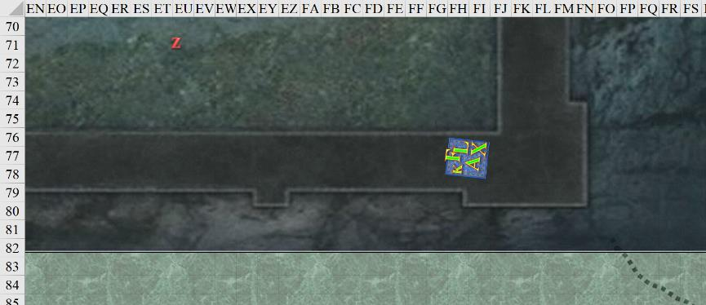

Round 10

Azimuth would save his signature spell—*alter self*—until the right moment. He said, “They are now flying into the inner courtyard, and are headed west towards the entrance.

“They’ll be upon us soon,” Melonpatch gauged as he whispered his thoughts about how best to thwart the intruders.

Xaryn and the rest of them had never left the carpet so they felt no need to move. Though as the banter ramped up during the travel, the drow wizard interjected.

“So, what are we up against?... And who are you all again?”

“We’re the Gambit...” Allisa said with a yawn. The half-elf rubbed the half-drow’s hair as their foreheads touched. She could feel the tension her mate was feeling like a stiff breeze. She knew her mate and could read her plainly.

Lauren leaned her forehead against Allisa’s for a moment, then she faced Xaryn. The half drow, while still young, showed the stress of years of fighting in her violet eyes.

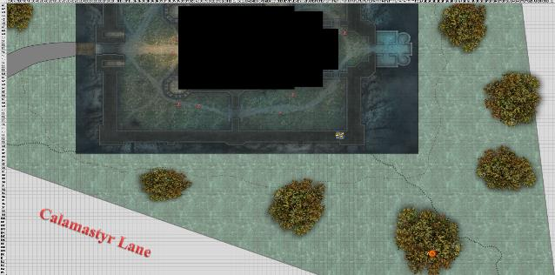

Rounds 11 – 13

Azimuth and Melonpatch continued to whisper as zombies shuffled into the keep and awaited their lord’s next command.

“About three years ago, we became entangled in a battle with some necromancers who styled themselves the Cult without a Name. We lost several people in the ensuing battles, including my and Allisa’s lovers. This cult had kidnapped several children from here in Waterdeep, and we were unable to save any of them. Since then, we have encountered the cult members several times, but we have been unable to either bring them to justice, or to destroy them.”

Round 14 – 15

“Is that them?” Azimuth wondered aloud as Melonpatch squinted and looked towards the open door.

“We can escape now, and leave the dirty work to the zombies,” suggested the gnome to the halfling.

“Do you know what Kaszüm will do when he finds out? He’ll *find* out,” the chaotic evil necromancer warned the lawful evil beguiler: a living contradiction in terms.

“We are Destiny’s Gambit, or a part of it, anyway. We have served on the City Watch, and we are still members, although not actively.” Lauren paused for a moment. “We are also members of a select group within the Watch, where we report directly to the city’s leadership. Some of our own group are attending to other business at the moment.”

Round 16

The defenders of the keep waited as the zombies clustered out of sight of anyone standing at the entrance to the keep. Azimuth dispatched Otis to go up into the cupola, and the bony minion nodded silently, obeying the command.

After Lauren finished speaking, Allisa said, “My most beloved. It is only a scimitar I have lost. It can be replaced. We do not have to do this.” She took the other’s hand, giving her a pleading look. “I should take better care of my things.”

Round 17

Azimuth and Melonpatch hid for the moment. The beguiler wasn’t fond of zombies, but he stood near one, studying its decrepit visage as it faced forward, awaiting contingency triggers.

Seeing the main doors of the keep wide open, Lauren shook her head. “They aren’t going to leave us alone, Allisa.”

“They’re practically inviting us in,” Allisa replied, looking down at the open, wooden, front doors, and iron, inner gate.

Lauren added: “I had a dream about them the other night. They will just keep coming after us, and I will see it stopped.”

They were now floating above the main entrance to the keep, and could see the chestnut tree catching fire to their southeast. Having ignored it until now, Allisa came to the realization of what she’d manifested. In the streets, neighbors began to stop and look at the tree.

One straggling gnome or halfling zombie made its way northwest towards the carpet, though the carpet was still flying at about 40’ above the summit of this hill.

