Chapter 65

Round 18

Azimuth hopped onto Otis’ bent arm, standing on the skeleton’s left bracer plate as he lifted a latch on Otis’ breastplate and opened a door large enough for him to get inside. “Alright, Melonpatch. On the other side, we’ll see one another. May the shadows shroud you.”

“May the shadows shroud you, Azimuth,” Melonpatch smiled. “And don’t be so dramatic. We know their weaknesses, and I—for one—aim to exploit them. This, for me, is a pleasure; the payment’s just the extra treasure” And with this, they took up positions at opposite ends of the keep.

Xaryn eyed the wide-open gates of the keep suspiciously. “For people who don’t want us here they sure seem to be lax on the security.... Suspicious at the least if you ask me.” He looked around and spotted the approaching zombie. “How do we want to proceed?”

Kir listened as Lauren and Allisa explained who they were and what they were up against. Kir understood what it meant about not being left alone from an enemy. She heard the whistle, which drew her attention though didn’t worry too much about it at this time. When Allisa, Lauren, and Fingers were done talking, Kir jumped in. “Just want to thank you all for the help back there. Really appreciate it.” She looked to Xaryn, then to Lauren and with a big smile, continued, “Yep, looks like you need our help.” Then a completely mocking tone which she made it clear it was a joke. “Though it is usually me that does all the heavy lifting between the two of us.” She motions to Xaryn and gives him a mischievous grin.

Round 19

Azimuth got into the skeleton’s midsection, seating himself comfortably atop the inside of the female goliath skeleton’s pelvic bone. He closed the breastplate, which had slits just below the ribcage through which the ghostwise halfling could see, and directed the skeleton’s movement from within the armor.

“This could be a trap,” said Allisa as the chestnut tree blazed on, alerting enough citizens that the City Watch would soon be called to respond.

Lauren nodded in agreement. “Yes, I’m sure it is.” She looked at the building to see if there was a place on the roof to both land and to access the building. “Maybe we can land on the roof.”

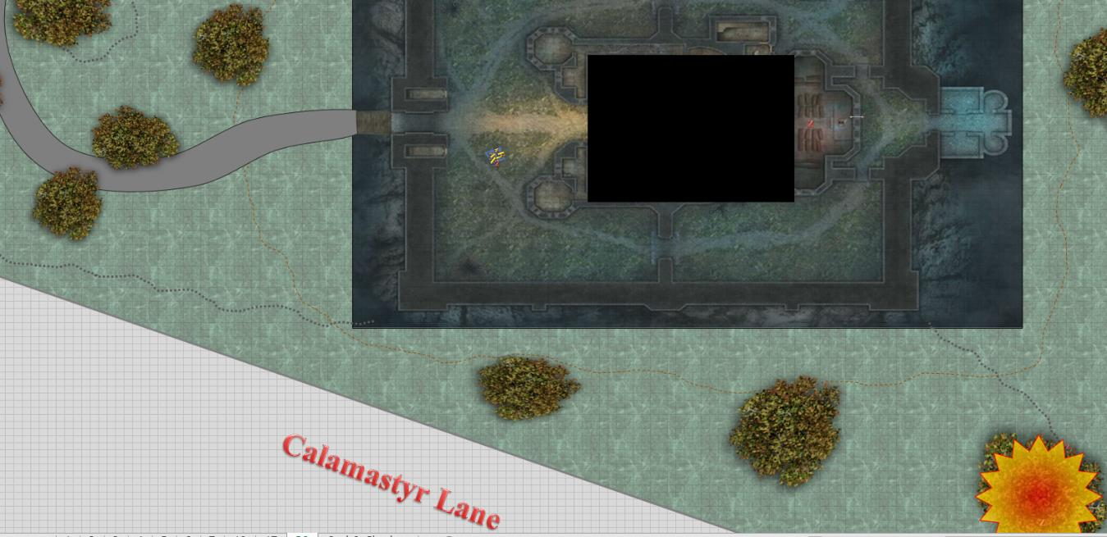

Round 20

Azimuth continued to note where the heroes were, and saw every move they made, though he could not hear them. He sighed at the sight of the burning tree, and thought it would be nice for the City Watch to show up and arrest these intruders.

The tree was fully ablaze now, and embers were beginning to emanate upward and northeastward.

The zombie was now directly underneath them, and hissing as it turned its face upward, one eye sticking out of its skull.

They took a look at the terraced roof, upon which they could easily land, but then Fingers noted a far more distinctive glamer than what he’d seen before. There was an illusion in the form of a tower with a sort of minaret-styled dome that didn’t match the rest of the architecture in style, though the illusory stone was a match for the stone quarried to construct this castle. The illusion was in fact the magical epicenter for an emanating and radially fading illusion that covered the keep’s towers and rooftop, plus a few feet of the area around it.

From the top, it appeared like an uneven, tiled rooftop that only Fingers had found out of place, as it had been a carefully chosen color reminiscent of the same period as the castle’s Ravenloft-styled accents. Now that they were fairly level with it, and all pretty keen of eye, it didn’t take long to see that there was no minaret at that spot, but they also couldn’t see anything of interest in its place.

Lauren studied the illusory tower for a moment. “Circle around to the north and get in closer,” she said to Fingers.

“Alright,” replied Fingers. “I agree that the open gate entrance is almost certainly a trap. I’d like to approach the illusionary tower if no other likely route inside presents itself. I can’t help wondering just what they’re trying to hide.”

Allisa sat on the carpet her hand in Lauren’s as she let the others decide what to do. Occasionally she would look down at the zombie below, but mostly she watched the entrance.

Kir saw the doors were open and automatically felt that they were expected, which was never a good sign. “Trap it is. Setting down on the roof is as good a place as any. I myself feel a little bad, seeing how I didn’t bring a present to the party.”

Once they began to move, she watched for other hazards that might be moving on the ground.

Round 21

Lauren waited as Fingers flew the carpet.

Xaryn chilled out, saving his spells and biding his energy.

Kir reached back and patted her quiver. “Well, would you look at that? I did bring a present for our host.” She took out her scroll of stoneskin, and as soon as they landed, would read it and cast it on herself.

The Small zombie tried to follow the carpet, but once it was out of sight, the undead figure was beckoned to return inside the keep.

The changeling carefully guided the carpet around in a wide circle around the illusion over the castle, as Fingers didn’t trust that the illusion didn’t shroud some trap that they couldn’t yet see.

Round 22

Kir looked around, checking on the zombie below. She had thought of shooting at it but figured it wouldn’t be worth wasting an arrow. She heard Lauren wanted Fingers to circle the tower. He agreed. When Fingers wondered what they were hiding, Kir spoke up. “It is probably some large monster that has been mutated by spells for increasing its strength and defensive capabilities. Or just a fluffy bunny. I’m hoping for the monster. Hate fluffy bunnies.” She continued to keep her eyes open for anything out of the ordinary.

Round 23

Lauren smiled and shook her head. “As long as it’s not a dragon. I don’t like fighting dragons.”

Kir looked to Lauren, a wicked mischievous grin crossed her face. “Dragon. Oh, if it is, I hope it is a blue. They are so pretty in the light,” she said with a slightly manic giggle under the cover of night.

Round 24

Fingers chuckled. “Well, at least not white ones. We’ve seen quite enough of those to last us a lifetime.”

Noting no other entrances into the keep, their voiced choices were either enter through the front door or explore the rooftop’s illusory minaret.

No more zombies bumped in the night, at least not that they could see.

Outside the courtyard and to the southeast, the chestnut tree was dying, engulfed in flames. Dozens of citizens were now gathered around, waiting for the authorities to show up. The frailer branches along the periphery began to break off and catch the ground around the tree on fire. Soon, the entire outer property would be scorching, and the whole neighborhood would be alerted to the happenings here.

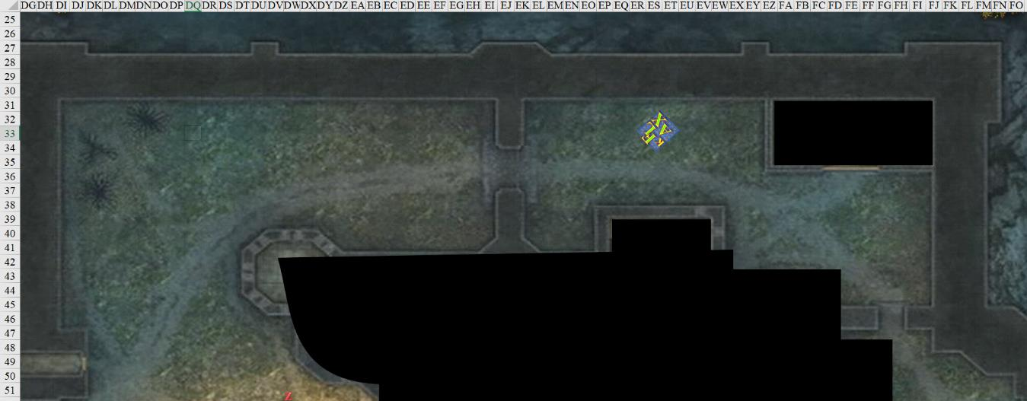

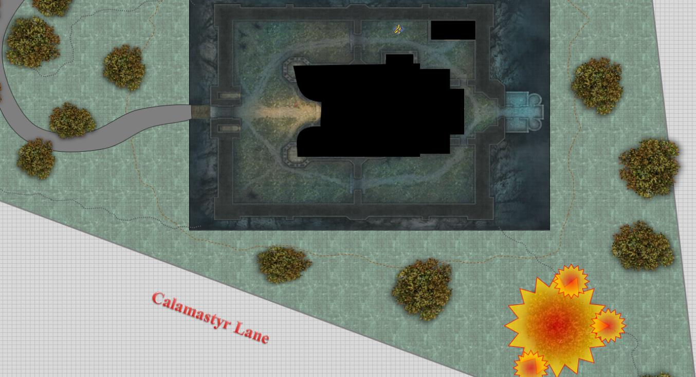

Round 25

Still suspicious of the invitation of the open door, Fingers urged the carpet closer to the illusionary rooftop at a creep, not wanting to crash into whatever the glamer was hiding.

Rounds 26 – 27

There was now such a bustle south and east of the property that it was muffling any sounds that might be made below the heroes by the movement of anything creeping within the shadows. However, enough of the passengers atop the carpet had near-perfect vision at night that their keen eyes would have caught anything larger than a housecat if it were moving... anything not under an invisibility effect, of course.

Fingers continued to guide the craft slowly, and by the time he was 10’ from the minaret—which now flickered into and out of view as they tilted their heads or shifted sideways with respect to its position—the changeling stopped the carpet and lowered it to just inches above the stone roof. Stepping carefully onto the ground with only one foot, Fingers declared the immediate area safe to step on and free of traps, though it kept its eyes open amidst the tricks of light and shadow for anything that might have been a trigger for some snare or other unfortunate security measure on the part of the residents.

Round 28

A few others got off the carpet as Fingers’ senses took in the information around it, and its brain discerned tactile reality from mere illusion. This was an entirely flat area, save for the actual defense towers that were visible from outside the property. The single minaret covered a mundane looking portion of the deck.

The crowd to the southeast was now clamoring for some official auxiliary force to come and save the night.

Lauren turned to Allisa. “Do you want to do something about that fire, while we look around the roof?”

~*~

“... aaaand that wraps up another amayyyyyyyzing round of Fiend-to-Fiend Jousting, Dispater’s favorite show,” the githzerai announcer announced. “I’m the Toooown Crier, and—oh!—there’s the Bone Overlord now. Sire! Bone Overlord! Might you have a moment to tell us of your ambitions now that you’ve defeated Snarlbuick?”

The bone devil turned to the githzerai and his fiend camerawoman, nodding with a pontiff’s pomp. “The nalfeshnee was a mere publicity stunt on the part of my agent, whose head lies severed in my dressing room, along with the contract that justifies his beheading.”

Applause from a menagerie of spectators rose, allowing the bone devil to draw air into his devilish lungs and continue with a tangential thought, “Now that the fight is over, and I’m in the buzz circles once again, I wish for the attention of the pit fiend known as Lil’ Bel.”

A bastard, 3rd-generation offspring of the archdevil Bel, Lil’ Bel was closely following the match from his penthouse suite overlooking the Styx. The heavyweight pit fiend—shaking his head as he did so—patching his audiovisual emitter to the network and began to retort, “You little piece of semisolid mortalshit. I’ve dealt with less bravado from far greater fiends than the likes of the Bonerlord.”

“Bone Overlord!” the self-styled Overlord was caught on scry-video saying.

Standing up in the comfort of his own seaside penthouse, Lil’ Bel pursed his lips, licked the canines that protruded from his lower jaw, and proclaimed, “You wait right there!” the devil commanded, having recently been pledged into his great-grandfather’s diabolical Order. “I hereby CHALLENGE you to a death match!”

By all rights, the holder of the Dis Heavyweight Title—currently Lil’ Bel—had the privilege of invoking a match for his Title at will. Refusal meant forfeiture of any further privilege of ever challenging anyone for the Title, plus a list of discretionary punishments at the discretion of the Heavyweight Champion.

The crowd awed and cheered as the Bone Overlord looked up again to see that Karmen Santiago—a mortal invited by the Bone Overlord himself—was still there, and was quite enjoying the attention that the Overlord was receiving. He’d been trying to court the elusive and reclusive mortal for a few weeks now, and as impure as his motives were, she’d been coyly reinforcing his advances. She knew most of what he wanted from her, but not everything, which was why she’d remained beyond the point that was good for her.

“I will be there in no time!” the pit fiend continued, producing a scroll of teleport that would take him—half clad and unarmed—into the arena that was dozens of miles away across the city-plane of Dis.

The githzerai asked, “So, Bone Overlord, what will you do now?”

“There’s only one thing to do,” the Overlord answered, smirking, as if scripted to do so. “Play out the events that have just been set into motion.”

“Why are you challenging Lil’ Bel?” the githzerai asked. “What will you do with the prize that’s been set aside for such an event?”

The Bone Overlord looked the githzerai up and down, noting the blue markings on his shoulder, which depicted his rank in the Hells. He had likely been given the false promise that his mortal hide was somehow protected by some clause, and had likely been kept ignorant of level 4 or higher legal guidance regulating the status of mortal attachés to public service sectors like the Gladiatorship Guild, which governed this event. “I’m here for treasure. Looking to become an investor and leave the cleansing to others.”

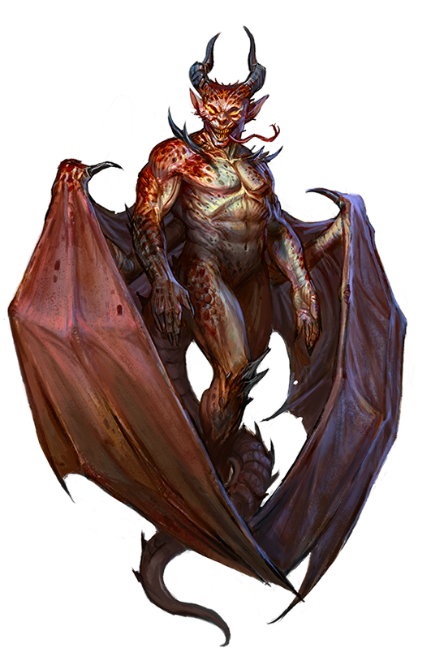

Some cheers and some boos from the crowd followed, and then there was nothing but cheers. The pit fiend had teleported into the main arena, and was now under three spotlights, beating his chest, waiting for the challenged bone devil to present himself. The ruse had worked.

~*~

Round 29

They could now hear the word “fire” being shouted by a handful of residents outside the property.

“Just me on the carpet?” Allisa wondered if they trusted her skills while the changeling secured the area a little better.

At the behest of swift and huffing neighbors relaying the message, a sending spell had been cast by the local CW Precinct Office not long ago, and a handful of evokers and other pyrotechnic specialists were now mounted and flying atop a silver dragon. They would soon be seen by the Gambit in the distance, but as of yet, they’d not.

Rounds 30 – 31

Kir had seen the fire as they had made their way down to the roof top. It had gotten out of hand. It had not crossed her mind to suggest to put it out earlier. Her attention was drawn back to the situation at hand.

When Fingers stepped off the carpet and determined that it was safe. Kir stepped off and read the scroll and cast stoneskin [expired on Round 830; 22:18] on herself. After that she pulled an arrow and knocked it. She continued to scan the area for anything.
Kir gained up to 80 points of DR adamantine/10.

Lauren suggested, “Either that, or you can shapeshift and fly yourself over there.”

“I could go over there but I can only create 30 gallons of water, and I don’t think that would be enough,” said Allisa. “I will go try if you think it is important.”

Lauren shook her head, “No, not if you can’t put it out quickly.”

Fingers noted the peculiarity of his druidic friend having caused the tree to light on fire and being so indifferent about saving its life with no competing urgency to do anything else. She smelled like Allisa, as opposed to a doppelganger or a changeling, but something was off about her at the moment.

Round 32

“It is too late; the city will have to send their fire team up. With that amount of smoke, they should already be on the way,” Allisa said as she followed Lauren.

Allisa had been worried about Lauren’s emotional state, not truly realizing that her beloved nature was taking a hit. Only the suggestion about the fire had her mind returning to the present. “I will have to return and plant a new chestnut trees after this is over.”

“Oh, and looky there! How timely!” one of them pointed towards the southern edge of the North Ward, which bordered the City of the Dead. Under the red clouds that reflected the city lights, the party spotted an approaching dragon about 1000’ east-southeast and about 100’ up, and flying towards them at a hurried pace.

Round 33

Having seen the dragon, but preoccupied with the keep, Lauren had taken a few seconds to study the lack of body parts that she somehow knew Azimuth liked to use in his decorating, then muttered, as if to herself, “This isn’t Azimuth’s place.” She shook her head, then nodded. “He would have revamped it a lot more to suit his needs. He’s working with or for someone.”

Round 34

“How do you know?” asked Fingers, keeping an eye on the incoming dragon.

“I had a dream,” Lauren looked into the changeling’s eyes. “I somehow gleaned the vague memories and even personality of the one called Azimuth, who is—no doubt—the source of the zombies with the cold aura,” she related the information.

Round 35

“Oy! Who the bloody blazes are you?” the neighbors then started to yell and point from outside the property, focusing their attention on what they thought was foul play but could just as easily have been passed off as a random fire. The success would lie in the finesse behind the delivery of such a bluff, and to whom it was furnished.

“Special investigation unit. The arsonist may still be in the vicinity of this building. Keep your distance!” An accomplished prevaricator, Fingers knew the most believable way to lie was to tell just enough of the truth. The Gambit was a special investigation unit, just not one currently on task by the city. Additionally, while the one who started the fire was no longer on this plane, the one responsible for it certainly was in the vicinity... sitting only a couple of feet from the wily-tongued changeling in fact.
Skill | Rank | Ability & Mod. | Misc. Mods. | Total | Roll | Check
Fingers, Bluff | 15 | Cha (+2) | 0 | 17 | 10 | 27

Oh, what tangled webs the changeling wove by stretching truths to their limits! And now they’d have to stick to that story.

About 700’ east-southeast of the keep’s southeastern corner, the silver dragon’s definitive wing shape could now be easily recognized by anyone who’d ever seen a depiction of such a dragon. It continued its approach as they were spotted by the clamoring neighbors now that it was no longer obfuscated by the neighboring rooftops.

And now the attention of the crowd was divided between the incoming dragon for whom they cheered and Destiny’s Gambit, whom they couldn’t recognize.

Lauren backed Fingers up as the trapsmith checked the roof. Kir—in turn—backed up both Lauren and Fingers. She stayed back a few feet, following their path with her bow at the ready.

Fingers continued exploring the roof cautiously, wary of traps and other threats cloaked by the illusions.

Round 36

The dragon—bearing at least three riders—had to have been less than 200’ away from the property line by now, and descended a bit. Fingers guessed them to be flying at a speed of at least 200’ every 6 seconds, which could put them over the party in 10 to 15 more seconds if they had hostile intentions.

“Here they come!” “Here come the Dhavies!” “The Water Dhavies!” “Dhavians!” the crowd could be heard saying this and more.

Round 37

Arriving at the scene of the raging fire, the agents that flew from the east-southeast were none other than the familiar volunteer force that had come to the aid of this Ward more than a few times during the last few years: the Watery Dhavians. This volunteer force once charged coin for such services, but at this point was just doing it for the fame and attention that it brought. Since they were heroes with no enemies, these firefighters enjoyed mostly positive attention, compared to the contention that the City Watch got for its prying methods.

Rounds 38 – 40

It took the dragonriders—with the help of the silver dragon’s icy breath weapon—about 15 seconds to douse the fire, leaving the tree most likely dead. After the first round of spellcasting, one of them cast fly upon himself and came about 200’ closer to the keep’s rooftop. “You the residents? You look like you’re out and about, if you don’t mind me saying so.”

Round 41

Fingers continued massaging partial truths into a shape easily misinterpreted. “No, some residents saw undead wandering the grounds and we are investigating.” Of course, the residents were the Gambit and they were investigating before knowing there were undead present, but technically not lies.

The flying male turned back to see that the fire had been extinguished, and nodded. “Investigating on behalf of whom?”

The silver dragon looped around one last time around the snuffed fire, and headed towards the keep.

Round 42

“I’d rather not announce our authority to the entire neighborhood. If you join us on the roof, I can give you our bona fides.” Fingers hoped that stating they did ‘special investigations’ for the city would suffice but if the nosy fireman required more, there was always the Grey Hand token.

By the time the dragon and its riders were within earshot, they were following the firefighters’ spokesperson towards the Gambit.

Round 43

The shortest member of the Watery Dhavians recognized Allisa and Lauren, “Oh, you’re Destiny’s Gambit!” The dwarven female then rubbed her scruffy chin and asked, “What are you guys doing here, and why’d you leave that fire burning?”

Round 44

“We are investigating a theft, and we believe those responsible are in this building,” Lauren called out. “It’s not safe for you to be here right now.”

Rounds 45 – 46

Kir had been keeping a small distance from Lauren and Fingers watching their back. She watched as Fingers responded to one of the firemen. When the man cast fly and came up to ask more questions, she grinned at how Fingers wrapped the lies in blankets of truth. She watched the fireman closely though. Making sure that he didn’t overstep his bounds.

“As Lauren said, we originally headed here regarding a theft. Then the fire and undead entered the picture and we considered the latter the more urgent situation to be dealt with. Whether the source of the undead or more of them are within this building we were in the process of determining,” replied Fingers while pointing out the bodies of some of the zombies the onlookers hadn’t noticed. “Make sure you keep a lookout, as there may be more wandering out here.”

Rounds 47 – 48

The silver dragon was about to point out that there were no undead anywhere in sight when the autonomously flying elf said, “Well, if you’re the Gambit I’ve heard of,” and he looked at his nodding, dwarven companion, “then we don’t want to get in your way. Our bag is fires; we don’t deal with the toe-to-toe crimefighting that you all do. We’ll be over there schmoozing with the crowd until the Watch gets here, and then we’ll give our statement.”

Round 49

20:59

Fingers looked at its chronometer, and felt that time was a-wasting.

The druid marveled at Fingers’ silver tongue and was glad she had not opened her mouth. Allisa then greeted the group after Lauren’s finished speaking.

Rounds 50 – 52

“Well met, Destiny’s Gambit,” one of them closed the introductions after everyone’s names were said, repeated, and confirmed that everyone’s pronunciation was satisfactory to everyone else.

Round 53

“And there’s the City Watch,” the flying elf said. “It’s Officer Gidal... I’ll go talk to him. You guys schmooze,” he said to his colleagues. They really liked the social attention that heroism brought them, even if it was just fighting fires.

Round 54

The elf flew towards the southeastern corner of the property where most of the well-to-do townsfolk that had gathered (and the rabble had scrambled upon seeing the City Watch). The usual two Constables had come to collect information related to the calls that were made, and had a rapport with a handful of the spectators.

The nosy firefighter having been dealt with, Fingers ignored the dragon and the rest of the firefighters still within their midst and renewed exploring the roof carefully to discover a way into the building as well as whatever the illusion was covering.

“So, Lauren,” the dwarven woman named Tamela began, seeing Fingers reprise his sleuthing. “What do you think you’ll slay tonight?”

Round 55

The flying elf landed outside the property, greeting the Constables in a voice not quite discernible to the folks atop the keep.

Atop the keep, Lauren thought of how to answer as Fingers took his mind off the conversation and allowed the others to speak for the group. “I don’t know,” Lauren replied. “We are still investigating, but those zombies are sure evidence that things here aren’t what they seem. Please tell the townspeople to stay away from this place until we know more.”

The faint smell of undeath alerted Fingers to the presence of the zombies inside as the changeling walked near a chimney too narrow for a comfortable descent in Fingers’ current form.

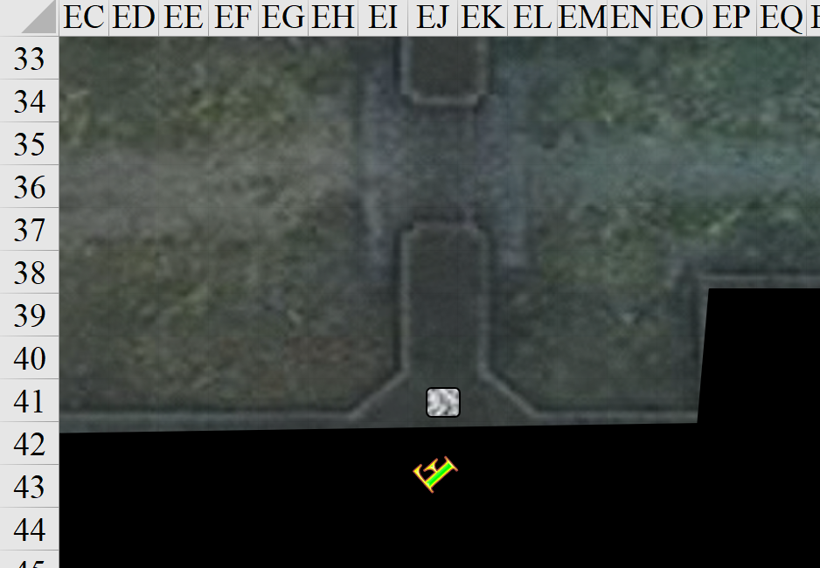

Rounds 56 – 58

“Zombies, eh?” the firefighters asked, confused, seeing none, but smelling them. “Alright, I think that’s our cue,” the gnomish firefighter said. “It was sooo nice to meet you,” they all then said slightly differently, and then the dragon took off again, headed for the Constables on the corner of Calamastyr and Wayward.

“The pleasure was ours,” the courteous Allisa replied as Kir and Xaryn said not a peep.

“Thought they’d never leave,” Fingers finally stopped searching the keep’s flat rooftop, and returned to the now inert carpet.

Round 59

Having seen but not heard all of that social intercourse, Azimuth started to empty his vials of acid onto the steps of the spiral staircase made of stones and encased in a stone cylinder.

Melonpatch farted, causing the zombie next to him to turn towards him momentarily.

“Is there a way in from the roof,” Lauren asked.

“Nope,” Fingers answered a question truthfully for the first time in a few minutes.

With no visible entrances or exits other than the front doors and the chimney, the party pondered on their next steps.

~*~

The acrobat walked along the Infernal cobblestone street with the poise of a lioness and the grace of an egret. Her stalker hovered towards her in the darkness after most of the residents of this seaside periphery of Dis had gone to sleep. A few screams and screeches of petitioners, lemures, and other unfortunate souls broke the silence of the night, and it was only the woman’s steps that could be heard when the screams subsided.

The astute woman turned around at the scent of her recent courter, the Bone Overlord. He was not one for hiding in the shadows... more of a shapeshifter than an invisibility user... and presented himself, continuing to hover a few inches above the cobblestones.

“Bone Overlord,” she pronounced the entire moniker. “I’d expected you to be collecting your prize after that fight.”

The Bone Overlord smirked, wanting to say that he was doing exactly that, but opted for something a few leagues further below the surface. “I have agents who take care of those details.”

“So what will you do now? Sail the Styx Riviera in search of somewhere to settle now that you’ve liquidated your assets?” she reprised a topic they’d discussed on the only semblance of a date that they’d ever shared.

“Yes, well, I haven’t quite settled on a direction, though navigating the Styx had occurred to me,” admitted the Bone Overlord.

She looked lovely under the crimson light of the sky over the Hells, and knew it. Batting her eyelids, she considered toying with the bone devil’s carnal desires for her. His overtures had made it quite obvious that he was smitten beyond the mere lust that devils often felt for mortal flesh, but she wasn’t about to start making little tieflings anytime soon. Still, the human ninja-fighter-scout-marshal-barbarian-cleric of Cyric-thief-acrobat-shadowdancer wondered just how far she could take this.

~*~

Rounds 60 – 62

Lauren shrugged. “The front door it is, then.”

Fingers impelled the carpet towards the yawning portal, not to be confused with the pub called the Yawning Portal. “OK, everyone, be on your guard. In the unlikely event this isn’t a trap, it won’t matter. If it is, then act accordingly.” A sudden thought struck the changeling and it removed its headband. “It’s unlikely I’ll need the True Sight function of this and it seems I no longer need its Darkvision or See Invisibility powers. While I’ll be selling it at some point, one of you may as well wear it for now.” The trapsmith instructed whoever spoke up first with the command words and other details.

“Give it to Allisa,” Lauren said.

Fingers handed it over and went over its charge functions.

Kir had stayed quite while the others had talked to the firefighters. She was never one to talk to authorities, didn’t matter much which part they were from. When Fingers had declared that there was no way in from the roof, Kir made her way back to the carpet. She kept her bow ready just in case. She was about to speak up about Fingers headband when Lauren said to give it to Allisa. Not wanting to rock the boat per say, her being a newcomer, she let it go.

Allisa put it on and listened to the rogue’s brief instructions as the carpet landed between the front door and the front gate. She listened as she placed it on her head, and committed the command words to her memory. “I am ready. Let us do this thing. I wish to return to my forest home as soon as possible,” said Allisa.

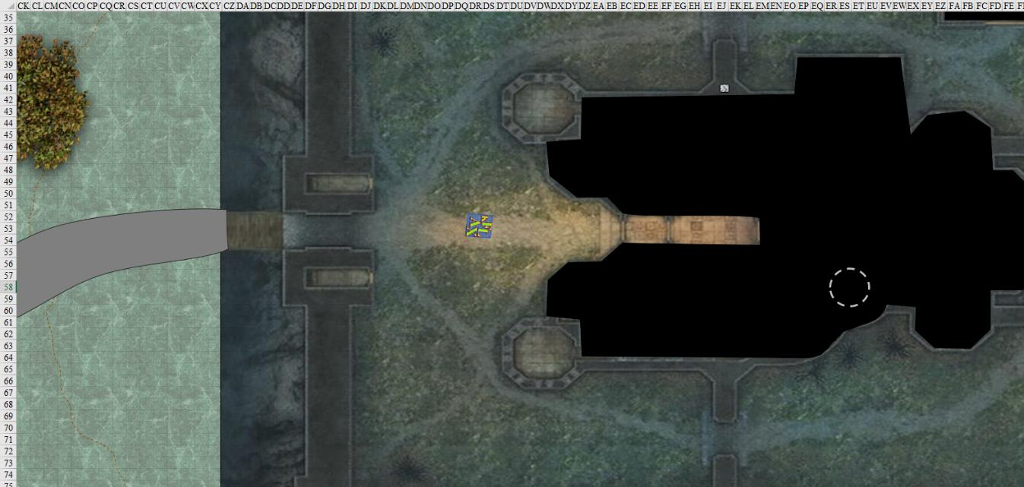

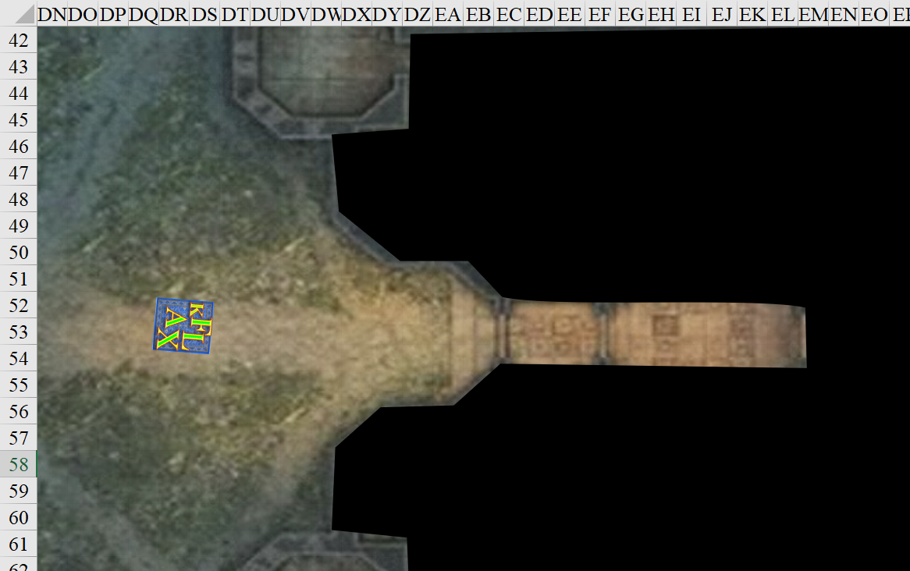

Round 63

Xaryn listened to the conversation as it unfolded. He was not in need of extra Darkvision... In fact, he was in need of quite the opposite now that the oppressive rays of the sun bore down on him every day... at least it was early Evening. He stepped off the carpet as it landed and pulled his ornate dagger from its sheath at the small of his back, and as he approached the door he searched for the tell-tale signs of wards or magical traps that could be lying in wait for the party.

“Shall we go... reacquire you all’s items then?”

When the carpet came to a rest, Kit stepped off and took a couple of steps forward. She was looking for anything out of the ordinary to her: obvious traps and not so obvious ones. While she was looking, she asked the others, “So what do you think we will find in here?”

Leaving the carpet behind rather than placing it in her haversack, Lauren drew her falchion and settled her shield on her left forearm, bolstering her already stalwart defenses.

Next to the half-drow tank, Fingers held its invisibility wand in the left hand, leaving its right free to fire a blast once a target was seen. Walking towards the entrance and catching up with Kir, the trapsmith kept a lookout for any traps still viable, although it seemed likely any such would have been tripped by the zombies.

There didn’t appear to be anything that set off an alarm for either the rogue-cleric nor the rogue-trapsmith. All in all, while Fingers could tell that booby traps had been set here in seasons past, this place did not yield true positives, at least not outside.

Fingers and Kir peered inside the stone tile floor partly covered by a tattered, mostly ochre tapestry. They could all now smell the zombies and hear their raspy breathing. If the residents’ defensive tactic was to hurl zombies at them, it would certainly deter neither the Gambit nor this rogue-cleric they’d just met, who could probably have rebuked them all with a few waves of her holy symbol. The drow wizard didn’t seem to be fazed by the idea of a little zombie slaying either.

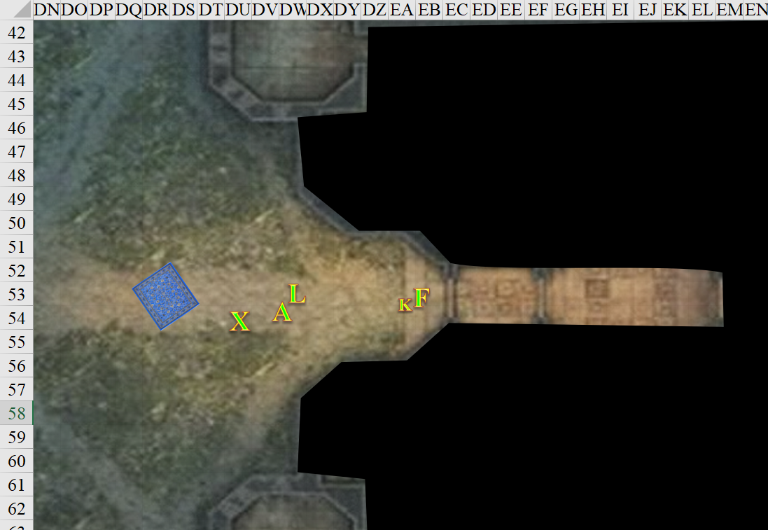

Round 64

Once the changeling had caught up to her, Kir followed Fingers. Seeing nothing that presented itself as a trap, she continued inside. Smelling and hearing the zombies Kir reached up and took out her holy symbol of Leira, resolving to rebuke the undead upon spotting any of them.

The others followed close behind, and now that Fingers and Kir saw a staircase to the north, a closed door to the east, and the continuation of this corridor to the south, the sound of an exhaling zombie somewhere along that staircase clearly alerted the two rogues to the presence of their expected enemy.

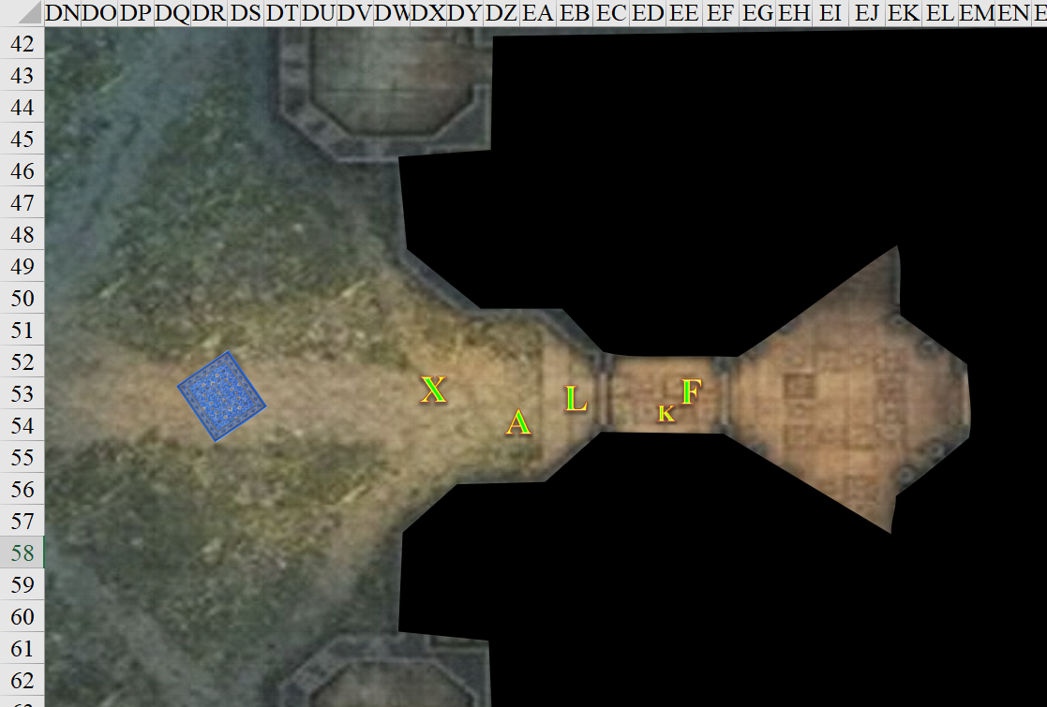

Round 65

Fingers said, “Keep an eye on the approaches to the east and south, those of you able to see farther in the dark, while I check out that door to make sure nothing’s hiding there to hit us from behind.” The changeling approached the door and began checking it for nasty surprises, but before reaching it, it the zombie near the top of the staircase made itself evident, as did a gnome who’d been under the effects of an invisibility spell until casting hold person upon Fingers.
Save vs.  hold person | Rank | Ability  & Mod. | Misc.  Mods. | Total | Roll | Check
Fingers, Will | 6 | Wis (+1) | 1 | 8 | 12 | 20
Success. No effect.

The gnome then chagrined and ran eastward through a stone doorway with no door.

The half-elven zombie descended the staircase and swiped at Fingers.
Character | Attack Type | Damage | BAB | Str Mod+ | W+ | Other+ | Total Score | Roll | Total
zombie, M | Slam | 1d6+1 | 1 | 1 | 0 | 0 | 2 | 4 | 6
Miss.

Kir rebuked the zombie upon seeing it.
Rebuking Undead
 | Max HD Turned | 8
 | 1d20 Roll | 10
 | Turn Check | 20
 | 2d6 Roll | 6
 | Turn Dmg. | 17
 | Turns/Day | 5
 | Turns Used | 1

The zombie crouched on its knees, cowering before Kir’s deity’s power.

Fingers raised an eyebrow at the fact that the chaotic neutral cleric had rebuked—and not turned—the zombie, but said nothing as the gnome escaped eastward. The others witnessed the zombie’s cowering, and took a few steps closer into the hallway with their weapons drawn.

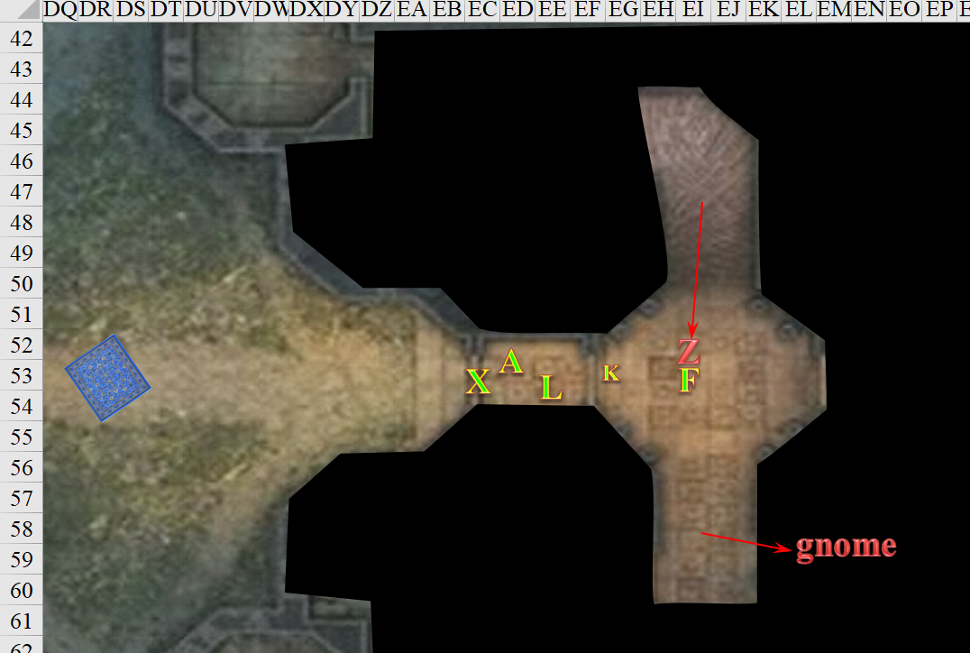

Round 66

The zombie could resist Kir’s holy symbol no more, and was destroyed by its divine wrath, withering to fibers.

Fingers moved south to see that the gnome had just passed a zombie, and was running up a spiral staircase. With nary a second to wste, the trapsmith fired an eldritch blast at the back of the gnome’s head. The human-sized zombie made it a bit difficult.
Ranged Weapon | Dmg. | D+ | TH+ | Critical | Rng. | Wt. | Atk | Roll | Check | Notes
Eldritch Blast | 1d6 | 0 | 0 | x2 | 60’ | - | +13 | 5 | 18 | +5d6 Sneak
Hit zombie. Dmg: 5 magic [sneak negated].

“Goodnight!” the gnome teased the changeling in an outlandish Common as it headed upstairs and out of sight.

The injured zombie came at Fingers.
Character | Attack Type | Damage | BAB | Str Mod+ | W+ | Other+ | Total Score | Roll | Total
zombie, M | Slam | 1d6+1 | 1 | 1 | 0 | 0 | 2 | 3 | 5
Miss.

A second zombie came down the stairs, having just passed the gnome.
Character | Attack Type | Damage | BAB | Str Mod+ | W+ | Other+ | Total Score | Roll | Total
zombie, M | Slam | 1d6+1 | 1 | 1 | 0 | 0 | 2 | 12 | 14
Miss.

Coming out of an alcove in the southeastern corner of the corridor where Fingers now stood, a third human-sized zombie attacked it.
Character | Attack Type | Damage | BAB | Str Mod+ | W+ | Other+ | Total Score | Roll | Total
zombie, M | Slam | 1d6+1 | 1 | 1 | 0 | 0 | 2 | 6 | 8
Miss.

Lauren moved to look southward, her weapon ready, then spotted two zombies taller than her now attacking Fingers. Having deferred to the cleric who had just done such a marvelous job on the first zombie, Lauren wondered if she would waste a whole turning on just two zombies at a time. They were such easy targets!

Kir watched as the zombie she had rebuked could not take it anymore and was destroyed. She turned to see Fingers dealing with more zombies. She readied her bow and was about to shoot when Lauren stepped in to help. Kir shifted her focus onto the one coming down the stairs, but that was the one she’d just destroyed, and she could see no other stairs, so she turned back southward.

Xaryn hesitated.

With a clear line of charge to the northernmost zombie accosting Fingers, Lauren sideswiped Kir by a few steps and socked it to the zombie.
Melee Weapon | Dmg | D+ | TH+ | Critical | Type | Wt. | Atk | Roll | Check
Shattermantle Bloodstone Falchion +3 | 2d4 | +5 +3  + 2 charge | 3 + 2 charge | 18-20/x2 | Slashing | 8.0 | +23 | 11 | 34
Hit. Dmg: 5 + 5 + 3 + 2 = 15.

The already wounded zombie fell to the ground, unable to do anything, then burst with a concussive blast of negative energy.
Dmg to Fingers: 7 negative energy [73/82].
Dmg to Lauren: 9 negative energy [134/143].

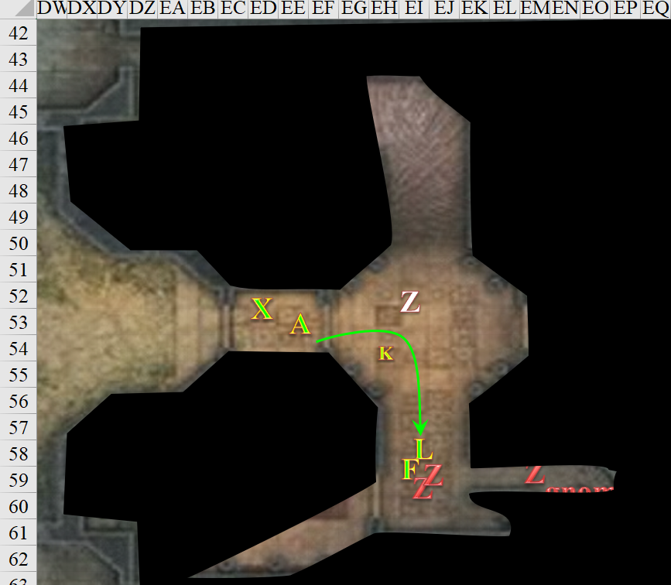

Round 67

A half-orc zombie came charging as much as a zombie could, and swiped a raw paw at Lauren.
Character | Attack Type | Damage | BAB | Str Mod+ | W+ | Other+ | Total Score | Roll | Total
zombie, M | Slam | 1d6+1 | 1 | 1 | 0 | 0 | 2 | 4 | 6
Miss.

Fingers provoked an attack of opportunity from both adjacent zombies as it attempted to activate its invisibility [expired on Round 73] wand.
Character | Attack Type | Damage | BAB | Str Mod+ | W+ | Other+ | Total Score | Roll | Total
Zombie 2, M | Slam | 1d6+1 | 1 | 1 | 0 | 0 | 2 | 17 | 19
Zombie 3, M | Slam | 1d6+1 | 1 | 1 | 0 | 0 | 2 | 7 | 9
Hit, miss.
Skill | Rank | Ability & Mod. | Misc. Mods. | Total | Roll | Check
Fingers, Use Magic Device | 16 | Cha (+2) | 0 | 18 | 16 | 34
Success.

The invisible changeling then slipped to the least gauntly zombie’s west and prepared a sneak attack.

Staying put for the moment, Allisa reached down and pulled at her dagger, the only weapon she had since hers was stolen. She dared not use her remaining spells because surely there was something of greater power ahead, so she could only watch as two more zombies approached the changeling. She thought: why didn’t she learn the bow?

Amidst the miasma of zombies, Lauren sniffed out the musky scent of the gnome she’d encountered in her dreams: Melonpatch. It was a combination of patchouli and his own ball sweat, and the half-drow cringed at having to get closer to the man in order to slay him, wherever he was now hiding. The half-drow swung twice at the half-orc zombie, then once at the human one.
Melee Weapon | Dmg | D+ | TH+ | Critical | Type | Wt. | Atk | Roll | Check
Shattermantle Bloodstone Falchion +3 | 2d4 | +5 +3 | 3 | 18-20/x2 | Slashing | 8.0 | +23 | 3 | 26
SB Falchion +3, 2nd Attack | 2d4 | +5 +3 | 3 | 18-20/x2 | Slashing |  | +18 | 4 | 22
SB Falchion +3, 3rd Attack | 2d4 | +5 +3 | 3 | 18-20/x2 | Slashing |  | +13 | 4 | 17
Hit, hit, hit.
Dmg to Zombie 4: (5 + 5 + 3) + (7 + 5 + 3) = 13 + 15 = 28.
Dmg to Zombie 3: 6 + 5 + 3 = 14.

The formerly human undead remained standing, and the half-orc one blew up, healing the wounded zombie and hurting Fingers and Lauren.
Dmg to Fingers: 5 negative energy [67/82].
Dmg to Lauren: 8 negative energy [126/143].
Zombie 3 healed 8 hps.

Allisa moved forward 25’ and watched the opening to the north.

Kir and Xaryn hesitated.

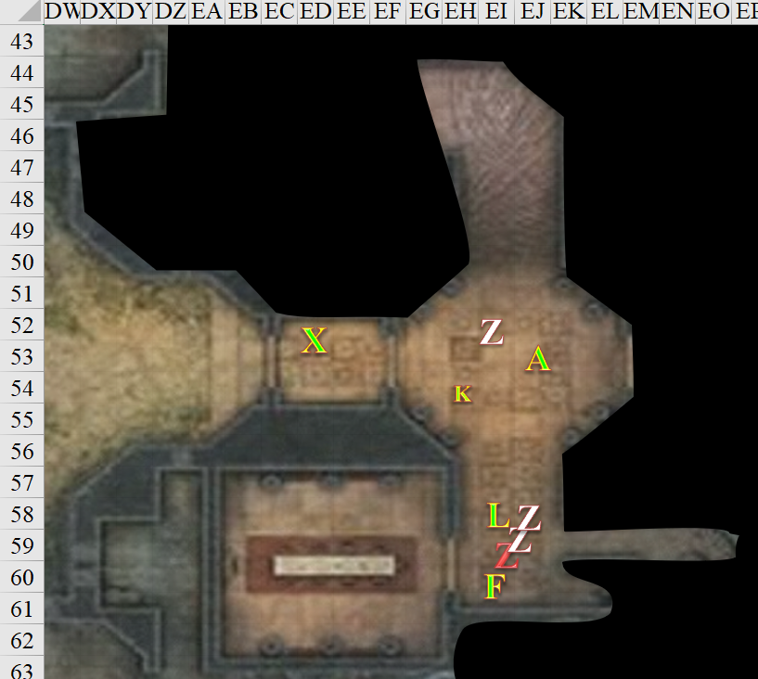

Round 68

Xaryn was aware of the attackers from the stairs just by the sounds, since he had not ventured into the keep much, and had no line of sight to what Lauren was about to do, but it seemed that Kir and Fingers (and Lauren) had them well handled. In lieu of that, Xaryn with his superior Darkvision watched the other corridor. Ready with magic missile if anything was to come out of his corridor, Xaryn waited for the call by the others to move on, but instead heard the opposite.

“Back off, Lauren,” said Fingers. “Best these things be taken down from a distance. I’m going on ahead a bit to see if anything else is coming.” The invisible changeling moved down the corridor towards where it had last seen the gnome, and went about 10’ up a spiral staircase.

“Be careful,” Lauren called out. “Melonpatch is close by. He’s a master beguiler, so watch yourselves.” She continued to attack the zombies in concert with Fingers despite her friend’s heed, striking once at the wounded zombie, and twice at the other one.
Melee Weapon | Dmg | D+ | TH+ | Critical | Type | Wt. | Atk | Roll | Check
Shattermantle Bloodstone Falchion +3 | 2d4 | +5 +3 | 3 | 18-20/x2 | Slashing | 8.0 | +23 | 15 | 38
SB Falchion +3, 2nd Attack | 2d4 | +5 +3 | 3 | 18-20/x2 | Slashing |  | +18 | 2 | 20
SB Falchion +3, 3rd Attack | 2d4 | +5 +3 | 3 | 18-20/x2 | Slashing |  | +13 | 16 | 29
Hit, hit, hit.
Dmg to zombie 3: 3 + 5 + 3 = 11.

“I saw him,” whispered Fingers.

The burst of the destroyed zombie released negative energy that would’ve healed the other zombie, had it been hurt. Instead, it only harmed Lauren as the others stayed back.
Dmg to Lauren: 5 negative energy [121/143].

Dmg to zombie 5: (5 + 5 + 3) + (4 + 5 + 3) = 13 + 12 = 25.

Yet again, Lauren cringed from the negative energy burst put out by these pesky undead.
Dmg to Lauren: 5 negative energy [116/143].

Lauren had swapped her Truedeath crystal into her sword, and now tapped the stone into place the mercy of her falchion.
[This was an oversight on my part. I will double the Truedeath damage on the next two full-attack rounds (against undead) to compensate. Sorry about that.]

Confused about the zombies, Kir kind of held up her holy symbol in an effort to experiment with how quickly she could deplete her daily allotment of spells and rebukings. Fortunately, there were no undead in sight, and she didn’t hold it up high enough to expend a daily favor from her deity.

The zombies decomposed quickly, leaving mostly fibers of undead flesh and the tattered clothing that had distinguished them from one another.

Noticing Kir’s and Xaryn’s wounds, Allisa took out her healing wand and went over to Kir.
Kir healed 7 + 2 = 9 hps [76/95].

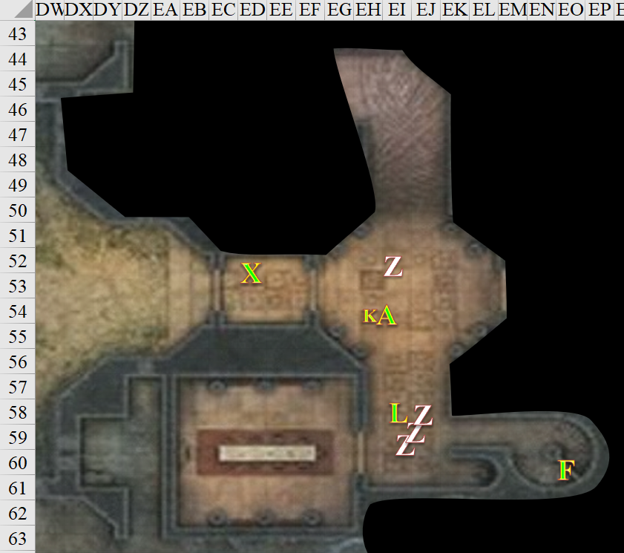

Round 69

Fingers crept up the stairs 10’ trying to make as little noise as possible to see if the enemy was lying in wait just around a bend of the stairway.
Skill | Rank | Ability & Mod. | Misc. Mods. | Total | Roll | Check
Fingers, Move Silently | 10 | Dex (+4) | 0 | 14 | 15 | 29
See below.

The trapsmith knew how to navigate a flight of stairs like few others, and did so by tiptoeing gracefully along both edges of the rock spiral. Reaching the top in about 7 springing strides, the changeling could hear a muffled, unisex voice from the other side of the stone wall to his north, and hurried footsteps—about the weight of a gnome, Fingers would’ve guessed—to the west, and past an office with a single desk atop a tapestry. Peering in out of prudence, it noticed the bookshelves lining the north and south walls, and at a quick glance noted the nice binding on just about all of the books that its eyes quickly scanned.

The next few footsteps sounded like they were more northwest than west, and maybe even moving towards Fingers’ north; it wasn’t sure.

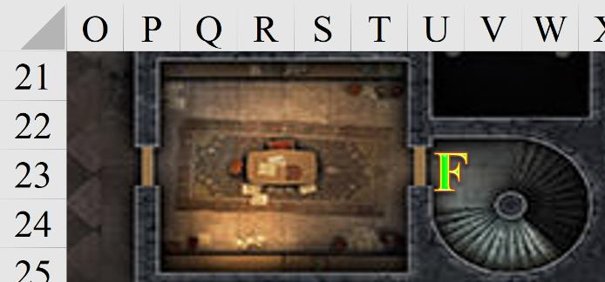

Downstairs, it was a moment of healing.

Lauren used all three charges in her Healing Belt to recover some of her damages. She peered into the empty dining room for a moment, and verified that there were no visible threats, and now felt that could react to an attack from either direction.
Lauren gained 18 hps [134/143].

Allisa kept on doing what she was doing, and called Xaryn over.
Kir healed 4 + 2 = 6 hps [82/95].

Xaryn came over to Allisa.

Kir stayed put and _____.

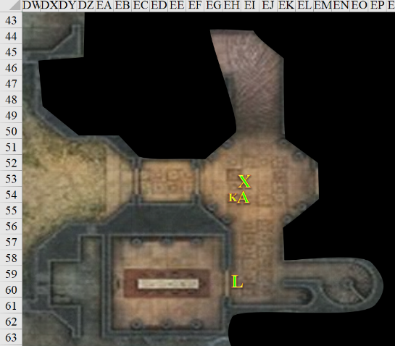

Round 70

Kir and Xaryn stayed put.

Allisa tapped Xaryn on the shoulder with her wand.
Xaryn healed 8 + 2 = 10 hps [59/69].

Upstairs, Fingers stood still, ever mindful of the importance of information and put its ear against the wall to try and make out what whoever or whatever was saying. But because of the mortared stone, the sound was only discernible insofar as Fingers could tell where one sentence ended and another began. Then maybe Fingers made out, “A! ‘Ere ‘e is!” There were aspired Hs in there for sure, but they couldn’t be heard through the wall.

Then the running footsteps stopped, and Fingers could no longer tell where exactly they were once they came to a halt... somewhere not to its south.

Lauren ran up the spiral staircase in an effort to follow behind Fingers. She nearly trampled it as it listened with its ear against the wall. “Well, so much for stealth,” it whispered, sighing.

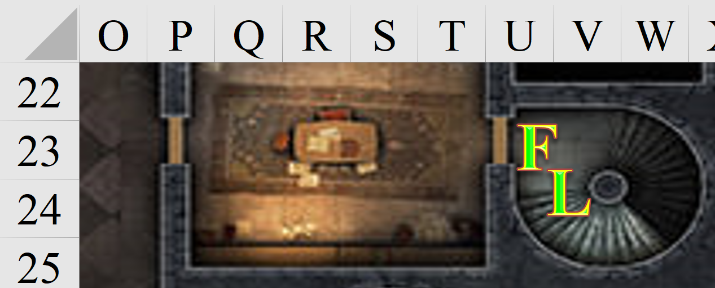

Round 71

Fingers tried to listen, but the sounds of voices had subsided, and how it could only hear the staccato of armored footsteps upon a rock floor.

Lauren stayed beside Fingers.

Downstairs, Allisa kept on doing what she was doing.
Xaryn healed 3 + 2 = 5 hps [64/69].

Kir thanked Allisa for healing her. Realizing that she was almost out of spells she kept her bow ready.

“You’re probably right. I’ve a feeling that sticking together would be best in this place. Threats seem to loom around every corner,” Xaryn said to no one in particular. With that, Xaryn kept watching the darkness around him but slowly made his way to the staircase to follow Allisa up, though she hadn’t gone there yet.

Leaving map as it was.
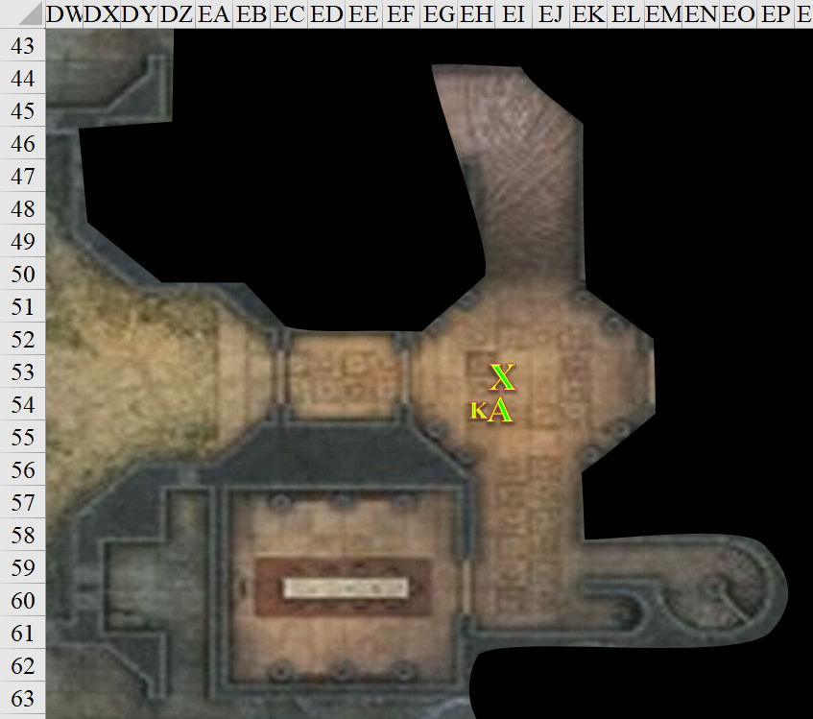

Round 72

“Is that good for now? We should really move up to the landing to be close to the others,” said Allisa.

The druid began to climb the steps as quietly as possible. She stopped just before making herself visible down the hall.

Giving Allisa a nod, Kir followed her up the stairs.

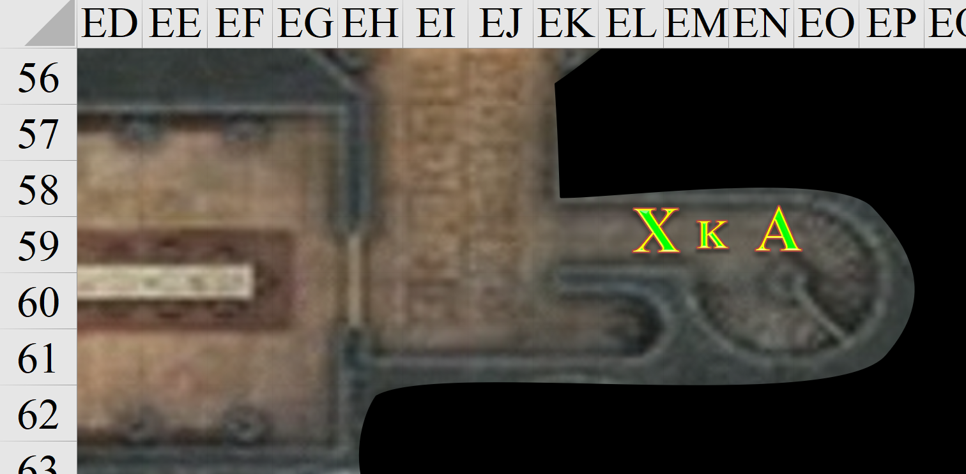

Upstairs, Fingers whispered to Lauren to try and make less noise. The changeling, still invisible, crept up to where it could just peek into the room and strained to listen if someone was coming.

The duskblade grinned at the origin of Fingers’ voice, and shook her head. She really wanted to be quiet, after all. She waited patiently as Fingers presumably scouted the way ahead of her.

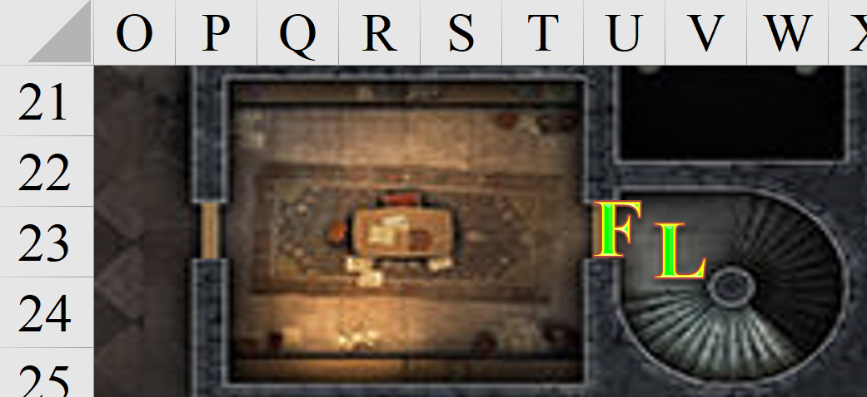

Round 73

Kir and Xaryn followed Allisa up the stairs. Kir had nocked an arrow and readied her as she moved quietly to stand just behind Allisa.

Fingers continued into the room, ready to ambush any enemy with its blast when it came within 30’.

Lauren waited for the changeling to either attack something, or communicate to her in some way, and it was being so quiet that she couldn’t discern its location.

“Hi,” one of the half-human women said to the other as the stragglers caught up.

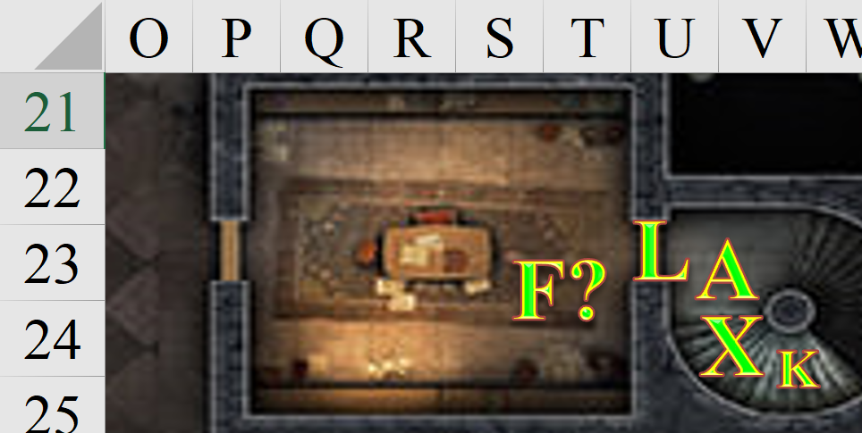

Round 74

Seeing no one in the room, Fingers crossed to the only other obvious exit and checked it for unpleasant surprises. It made sure that the doorless threshold was not trapped, then stepped through, noting to the north the two flights of stairs heading down. There were four open murder holes along the west wall, and another doorway with a burgundy curtain along the eastern wall. They didn’t have many doors here, and the few the Gambit had seen were open. Interesting detail, though the trapsmith.

[DM assumption. Correct as needed.] The others followed close by, making their way around a desk with several parchments that lay atop it. Kir noted the calligraphy was in Gnomish.

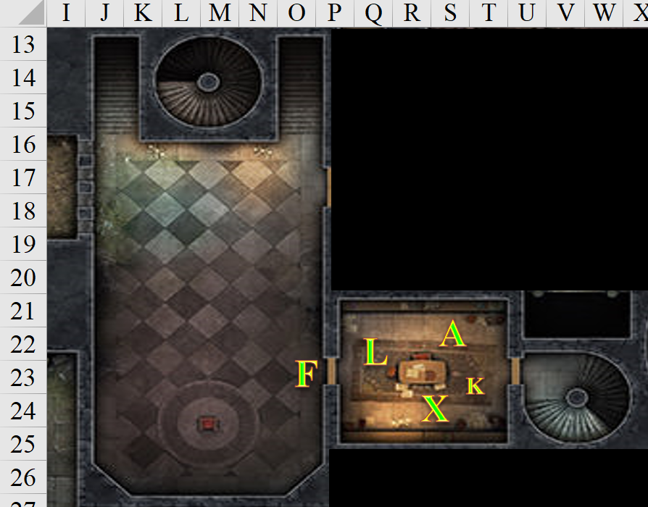

Round 75

Fingers continued moving into the room while studying it. The curtain was not moving, but the southernmost edge was positioned in a way that gravity would fix in a minute or two. This was likely the path that the fleeting gnome had taken, rather than returning down the stairs to where the heroes might still be fending off zombies. Fingers began to suspect that the beguiler wanted to be chased through the labyrinthine château.

Kir followed the others in. Her bow and nocked arrow still in hand, she slowly looked around the room. Her eyes drawn the desk. There were several parchments laying there. She took a closer look and noticed that the calligraphy was in Gnomish. Papers were usually important, so she gathered them quickly and put them in her pouch.

Following the others past the curtain into another, larger room. Kir spotted the strange chest. She immediately noticed the tile was laid different around the chest.

Kir and Fingers both eyed the single chest in the room, whose edge was crimson, painted, and shaped like a luscious pair of lips. The edges were bronze fashioned to look like the limbs of a mimic, bolted with spiked studs reminiscent of grappling thorns. Its craftsmanship was exquisite, as were the tiles—arranged in two concentric circles around the chest—that surrounded the place where it was situated.

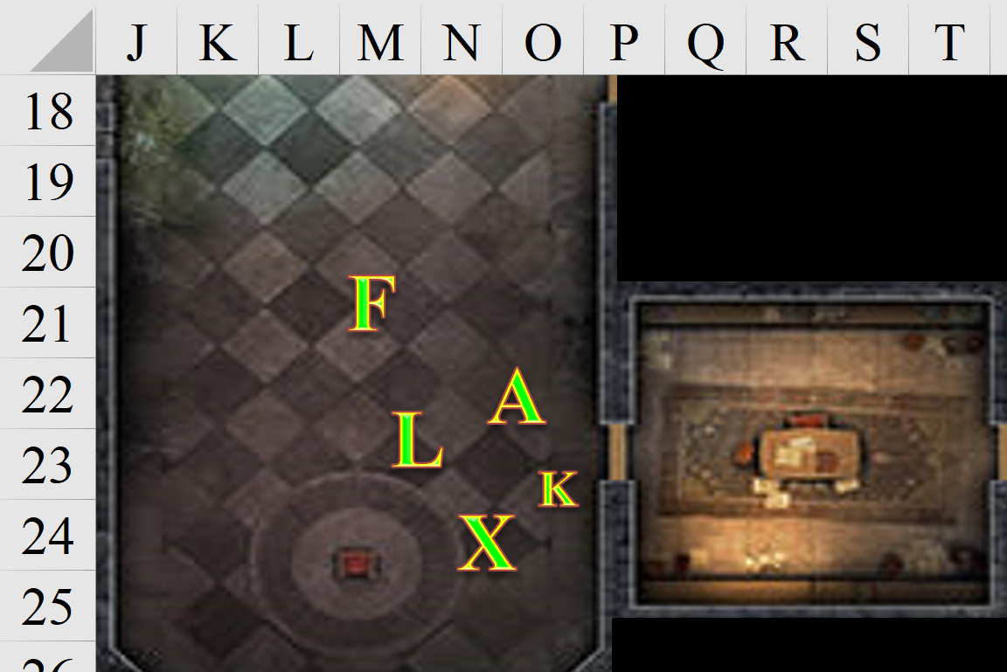

Round 76

Fingers motioned the others to keep clear while the changeling took a closer look at the chest, inspecting it for dangers for the unwary before opening it.

She turned to see Fingers motion for everyone to stay back. Shrugging her shoulders Kir unlocked her arrow, so she could hold her bow and arrow in one hand, and will check the tile. She looked to Fingers and spoke without sound, “Should check the tiles first before going straight for the chest?”

Lauren followed behind Fingers as it checked the rest of the room. “Let’s check those murder holes,” she said in a low voice.

Allisa followed Lauren towards the murder holes, even though Fingers wasn’t going there. At one point when the drow was looking in her direction, the half-elf winked at the other, making a lewd suggestion with her tongue. She hoped to ease the others’ anxiety a bit by the distracting behavior. The crimson redhead continued to hold on to her dagger.

Lauren cracked a smile and winked back, and then she returned her attention to the situation at hand.

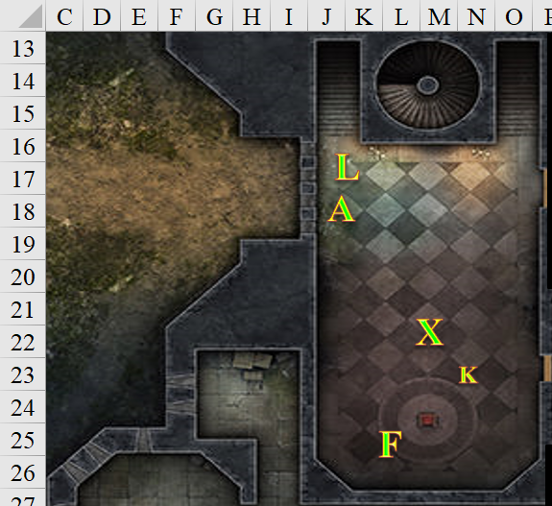

Rounds 77 – 78

Lauren and Allisa could both see the magic carpet in the front courtyard, and no zombies roamed thereabout.

Fingers could tell with near-certainty that this was no mimic, but a chest depicting a mimic. It was a nice design, and was locked and trapped on both hinges that would otherwise open it. A gnome had done this, or someone trying to emulate a gnome’s handiwork.

Kir was slightly less certain, but had no alternative hypothesis, so the two rogues conferred on their next steps.

Xaryn—standing in the middle of the room—began to notice that a slight chill was creeping in from the curtained door to his northeast.

Lauren sighed, “Love, can you go get the carpet before someone steals it, too? I’ll wait here for you.”

Allisa took the bag of holding from Lauren, nodded, and went downstairs to get the carpet.

Kir looked to Fingers. “Gnome work or someone who wants it to look like gnome work.” She pulled out the papers and handed them to Fingers. “These were in the other room. Don’t know if this will help. Gnome wording, I can’t read it. Can you?” Then she remembered that Xaryn spoke and read Gnomish pretty fluently.

Rounds 79 – 81

Fingers shook its head. “Afraid not. If it was Elvish or Dwarven, that’d be another matter. Maybe one of the others can read it.”

Xaryn took the parchments that Kir had just stuffed into her bag and taken back out, then proceeded to look over their contents.

Fingers continued, “In any case, I doubt the contents contain a clue for disabling any traps on the chest... if anything, they would far more likely to make certain one sets a trap off. Why have protections of a chest and leave instructions on how to bypass them out in plain sight just a few feet away?” it asked rhetorically, then turned to the wizard, and asked, “Well?”

Making no effort to walk silently, Allisa arrived at the crossroads in the corridor where they had slain the first zombie inside the keep.

She failed to hear the hissing sounds of Small zombies behind the door to her east.

Round 82 – 83

Xaryn shook his head, “No instructions here. Some of it is coherent: the recalling of a man’s youthful and virile days, a favorite uncle’s bedtime stories, some financial calculations... but the majority of these parchments…”

Allisa bent down to pick up the carpet and roll it up.

Round 84

“Yes? What is it?” asked Kir, now intrigued.

“It’s madness. The parchments at the front—written in fresher, darker ink—bespeak a deranged author’s despair.”

Rounds 85 – 86

Allisa placed the carpet into the bag of holding.

“Like what?” Kir wanted to know all the dirt.

“Like, uh... ‘... just a voice crying out in the wilderness, seemingly calling to itself in the midst of Waterdeep’s bourgeoisie... they know not what lies beneath their beloved city, but a Red Dawn will rise upon them soon, and the City’s greatest treasures will be ours!’”

“Red Dawn?” Fingers asked, yawning. “Never heard of it.”

Round 87

“So we leave the chest alone?” asked Kir. “Can’t you disarm it? I’d try, but I’ve heard you’re one-of-a-kind in this sort of thing.”

Round 88

“That doesn’t sound so crazy or deranged,” protested Lauren.

Allisa entered the keep again as a Small zombie pushed open the door that never really shut quite right, and conveniently so for its reticent residents. In the darkness of the corridor beyond, the half-elf could faintly see and hear at least one other zombie hissing raspily. With barely enough light to see the gnomish zombie coming at her, she prepared for a melee.

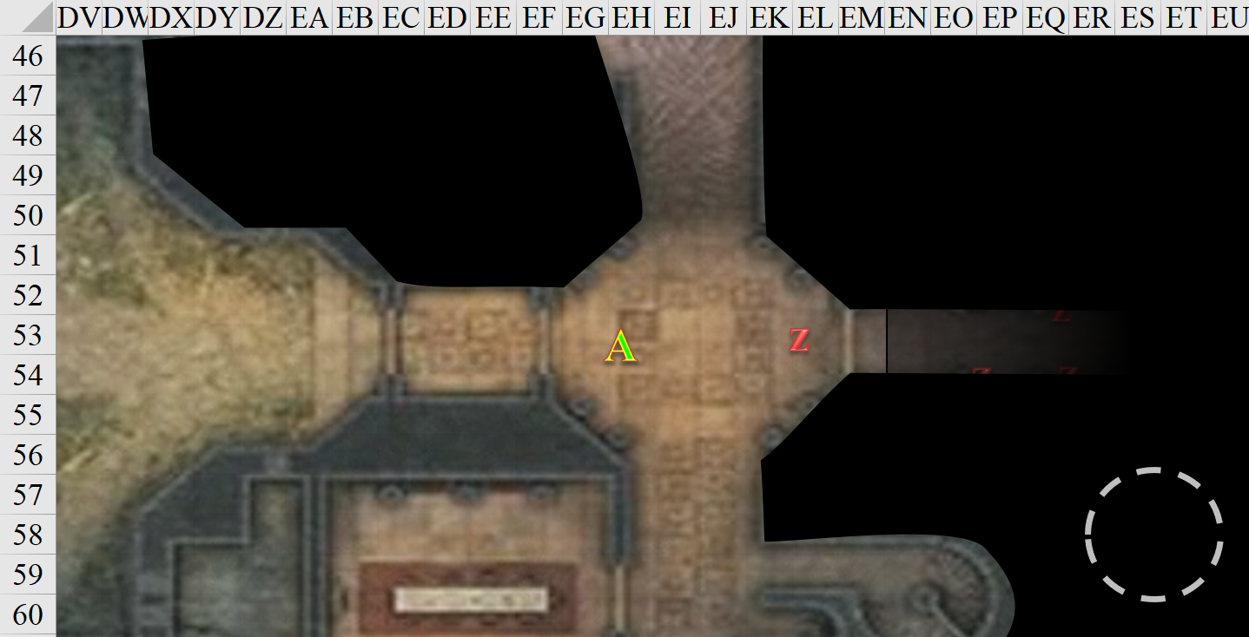

Round 89

“There are also references to the Red Coven, the Red Cabal, and the Kukri Rouge,” added Xaryn, not exactly reacting to Lauren’s comment.

Kir listened as Xaryn went through the papers. “Red Dawn, Red Coven, Red Cable and Kukri Rouge? That’s a lot of red and a rouge named after a knife,” she misunderstood. “Wonder if they had named themselves. That or they are called that because that is the weapon they chose to use.”

Allisa thought better than to attack a zombie with a dagger, and hightailed it to her right and up the stairs.

The zombie could not get a good swipe at Allisa as she retreated.

Belatedly, Lauren realized that Allisa had gone downstairs alone. The duskblade went to the stairs and made her way down to check on her, since they hadn’t explored much of the ground floor, and that damned whisper gnome was still loose.

Round 90

At the spiral staircase, Allisa stopped suddenly when she met her lover and said there was at least one more zombie down there.

Kir remained by the chest, and Xaryn by the doorway through which they’d just passed.

Kir looked around and noticed that Allisa was gone and Lauren was heading back towards the stairs. She figured that Lauren was going to check on Allisa. Turning her attention back to Fingers and the chest, she had to admit that a chest that looked like a mimic was pretty interesting. Whoever had thought of this had a sense of humor. “So what do you think Fingers? See what’s in the chest or come back to it after we check out the rest of this place?”

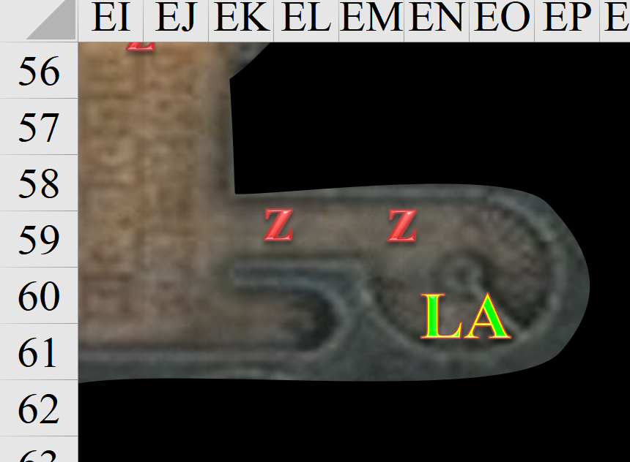

Round 91

“May as well open it while we wait for the others to rejoin us.” The changeling began work to render the traps harmless while trusting in its luck should a misstep occur.
Skill | Rank | Ability & Mod. | Misc. Mods. | Total | Roll | Check
Fingers, Disable Device | 17 | Int (+2) | 2 | 21 | 6 | 27
Success.

Xaryn looked up from the parchments he held in his ebon hands and his eyes flittered between Kir, Fingers, and the chest. “You’re the one with the deft fingers, Kir.” He suggested, “After all, the world already lost one dashing drow sorcerer today!” He said with a grin.

The leftmost trigger was disabled.

At the spiral staircase, Allisa stopped suddenly when she met her lover and said there was at least one more zombie down there.

Lauren stepped past Allisa at this point, to put herself between her wife and the zombies, whose raspy hissing was getting louder.

A gnome zombie made it half-way up the stairs and reached Lauren.

“Move up the stairs,” Lauren told Allisa. “These things will explode.”

Allisa moved to the top of the stairs, and Lauren then slashed at the zombie to stop it.
Melee Weapon | Dmg | D+ | TH+ | Critical | Type | Wt. | Atk | Roll | Check
Shattermantle Bloodstone Falchion +3 | 2d4 | +5 +3 | 3 | 18-20/x2 | Slashing | 8.0 | +24 | 2 | 26
SB Falchion +3, 2nd Attack | 2d4 | +5 +3 | 3 | 18-20/x2 | Slashing |  | +19 | 7 | 26
SB Falchion +3, 3rd Attack | 2d4 | +5 +3 | 3 | 18-20/x2 | Slashing |  | +14 | 9 | 23
Hit, hit, hit. Minimum damage destroyed the zombie.

Dmg to Lauren: 4 negative energy [130/143].

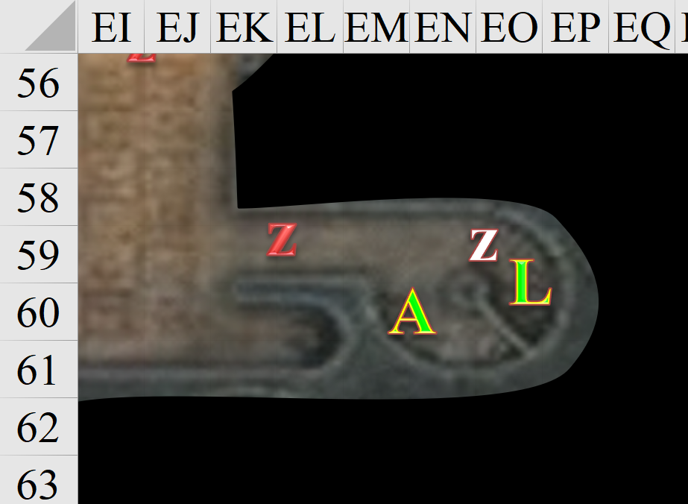

Round 92

The master trapsmith undid the right-panel trigger.
Skill | Rank | Ability & Mod. | Misc. Mods. | Total | Roll | Check
Fingers, Disable Device | 17 | Int (+2) | 2 | 21 | 19 | 40
Success.

The rightmost trigger on the chest was disabled.

A second zombie presented itself—a formerly halfling fellow with one eye—and clawed at Lauren.
Character | Attack Type | Damage | BAB | Str Mod+ | Total Score | Roll | Total
zombie, S | Slam | 1d4 | 1 | -1 | 0 | 3 | 3
Miss.

Lauren fought a rearguard action to give Allisa time to retreat out of range of any death explosions.
Not even going to roll this.
Dmg to Lauren: 9 negative energy [121/143].

Lauren effortlessly decapitated the zombie, and cringed when the blast got her in the face.

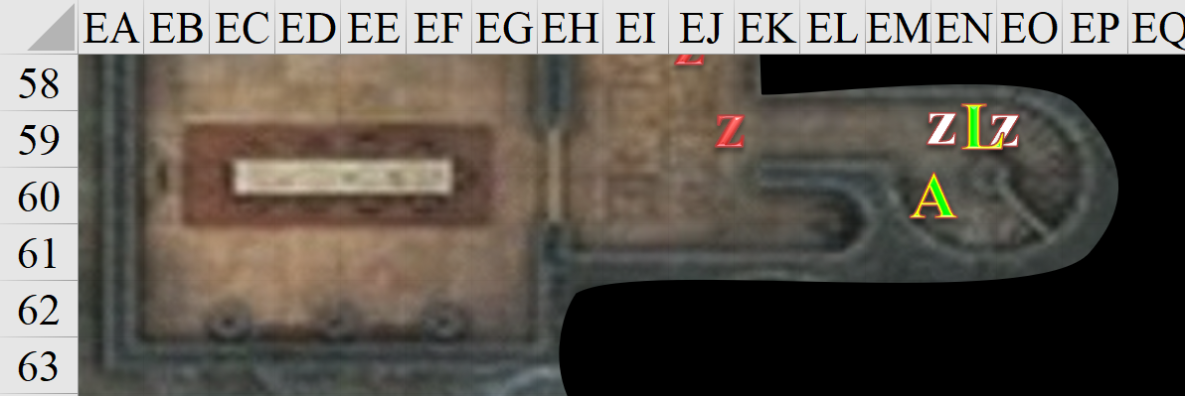

Round 93

Fingers did its best to undo the lock.
Skill | Rank | Ability  & Mod. | Misc.  Mods. | Total | Roll | Check | Notes
Fingers, Open Lock | 16 | Dex (+4) | 7 | 27 | 6 | 33 | Lockpicking Ring
Success.

The lock came unclasped.

Lauren took another few steps westward and met up with a dwarven runt of a zombie.
Minimum damage on 2 hits is good enough.
Dmg to Lauren: 7 negative energy [114/143].

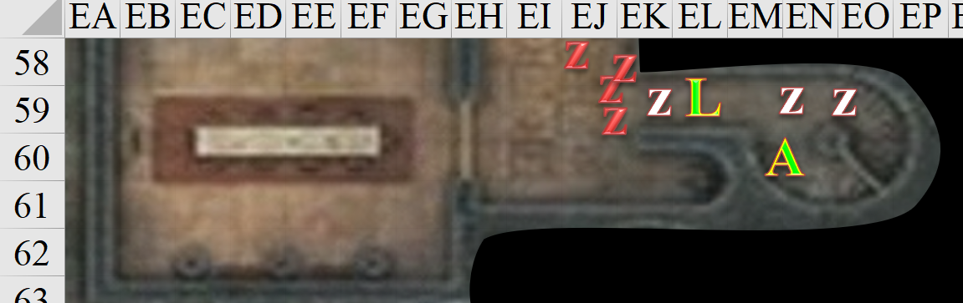

Rounds 94 – 95

“These measures weren’t easy to bypass,” Fingers was not boasting, but warning. “We shouldn’t underestimate whoever warded this chest, particularly if they’re behind the theft of our treasure, which was comparably sophisticated... elegant even. Who wants to open it?” it looked at Kir and Xaryn as the half-drow dealt with the zombies downstairs, and Allisa waited at the top of the staircase.

Lauren barely broke a sweat as she took on the zombies, being sure to keep them away from Allisa. Since a wounded zombie would be healed by one of the Destruction Retribution explosions, Lauren sought to end one’s existence completely before turning to the next one.
Melee Weapon | Dmg | D+ | TH+ | Critical | Type | Wt. | Atk | Roll | Check
Shattermantle Bloodstone Falchion +3 | 2d4 | +5 +3 | 3 | 18-20/x2 | Slashing | 8.0 | +24 | 11 | 35
SB Falchion +3, 2nd Attack | 2d4 | +5 +3 | 3 | 18-20/x2 | Slashing |  | +19 | 10 | 29
SB Falchion +3, 3rd Attack | 2d4 | +5 +3 | 3 | 18-20/x2 | Slashing |  | +14 | 18 | 32
Hit, hit, threat. Minimum damage destroyed zombie. Dmg to Lauren: 5 negative energy [109/143].

The remaining zombies swiped twice each at Lauren.
Character | Attack Type | Damage | BAB | Str Mod+ | Roll | Total | Crit | Threat
zombie, S | Slam | 1d4 | 1 | -1 | 2 | 2 | 19 | ý
zombie, S | Slam | 1d4 | 1 | -1 | 20 | 20 | 19 | þ
zombie, S | Slam | 1d4 | 1 | -1 | 15 | 15 | 19 | ý
zombie, S | Slam | 1d4 | 1 | -1 | 10 | 10 | 19 | ý
Miss, miss, threat, miss. 1d20 = 7 + 0 = 7, not a critical hit. Dmg: 1 [108/143].

Another zombie got into swiping range.
Character | Attack Type | Damage | BAB | Str Mod+ | Roll | Total | Crit | Threat
zombie, S | Slam | 1d4 | 1 | -1 | 1 | 1 | 19 | ý
Miss.

Lauren yawned as she destroyed the next zombie in the queue.
Melee Weapon | Dmg | D+ | TH+ | Critical | Type | Wt. | Atk | Roll | Check
Shattermantle Bloodstone Falchion +3 | 2d4 | +5 +3 | 3 | 18-20/x2 | Slashing | 8.0 | +24 | 15 | 39
SB Falchion +3, 2nd Attack | 2d4 | +5 +3 | 3 | 18-20/x2 | Slashing |  | +19 | 18 | 37
SB Falchion +3, 3rd Attack | 2d4 | +5 +3 | 3 | 18-20/x2 | Slashing |  | +14 | 6 | 20
Hit, threat, hit. Minimum damage destroyed zombies. Dmg to Lauren: 8 negative energy [100/143].

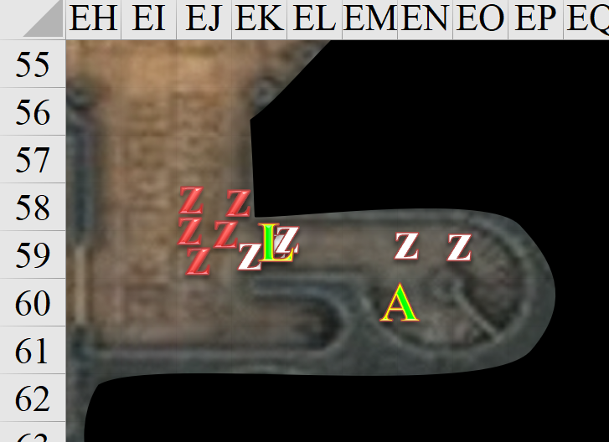

Round 96

Kir watched as Fingers opened the chest. When he spoke about it not being easy to bypass, she could tell that he was not boasting. “I agree that whoever warded the chest should not be taken lightly.” When he asked about opening it Kir stepped forward. “Might as well be me.”

Lauren destroyed another zombie.
Dmg to Lauren: 11 negative energy [89/143].

Allisa made sure to stand just far enough back so the damage from the exploding zombies would not touch her.

Round 97

“Be my guest,” replied Fingers, having no problem with someone else taking a risk now and then. The changeling didn’t back off, however, wanting to keep an eye on the stranger in case they had sticky fingers... after all, that was ITS job!

Lauren kept on slashing.
Dmg to Lauren: 4 negative energy [85/143].

Hearing that more zombies were coming, but having no line of sight to the action now that she was where Lauren had told her to go, the druid summoned a lion, and commanded it to run down the spiral staircase and attack the zombies. This would give the undead another target for a few moments.

The lion complied.

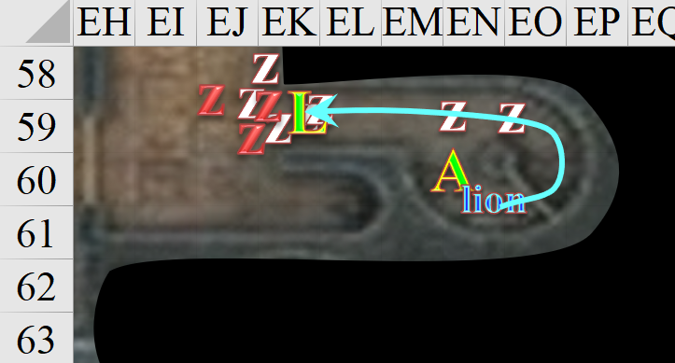

Round 98

The lion charge-attacked the zombie in the middle of the threshold.
Character | Attack Type | Damage | Ranged? | BAB | Str Mod+ | Dex Mod+ | W+ | Other+ | Total Score | Roll | Total | Crit | Threat
Lion | Claw | 1d4+5  +2 charge | q | 3 | 4 | 3 | 0 | 2 charge | 9 | 14 | 23 | 19 | ý
Hit. Dmg: 4 + 5 + 2 charge = 11.

“By the gods!” Lauren exclaimed, not having had a warning about Allisa’s lion charging past her.
Save vs.  Large animal charging  through 5’ corridor | Rank | Ability & Mod. | Misc. Mods. | Total | Roll | Check
Lauren, Reflex | 5 | Dex (+1) | 1 | 7 | 11 | 18
See below.

The distraction caused her to make herself vulnerable—if that was possible—for a split second. One of the uninjured zombies swiped opportunistically.
Character | Attack Type | Damage | Ranged? | BAB | Str Mod+ | Dex Mod+ | W+ | Other+ | Total Score | Roll | Total
zombie, S | Slam | 1d4 | q | 1 | -1 | 1 | 0 | 0 | 0 | 11 | 11
Miss.

The half-drow then pulled herself back a few feet, as the lion took up the space at the bottleneck of the threshold. Though not finished off, the halfling-sized zombie lost an arm, and was surely a goner on the next swipe.

Upstairs, the chest was now opened, and the waft of meimer—an illegal and moderately addictive opiate—filled the nostrils of the two rogues. A small hookah was inside, along with a block of the black tar-like substance, and a few other elements of paraphernalia. While not particularly valuable on the market, the contents of the chest might have had sentimental or addiction-based value to some resident.

Under the stained-glass hookah, Fingers spotted an onyx shard, about the size of a human palm.

Kir smelled the meimer, ignoring the shard. She gave a small exhale out through her nose. She never cared for the smell. She looked at the hookah, the black tar-like substance and the few other things. “Addict. Must not have wanted someone to know.” She took out her dagger so she could move the stuff around without touching it herself.

Xaryn watched as Kir opened the chest that Fingers managed to unlock. She commented on its contents but Xaryn wasn’t as well equated with the criminal underworld as the two rogues in the room, so he kept his commentary to himself. The drow wizard turned around, taking a step back down the staircase to check on the others, and seeing Allisa now at the top of the stair again. “Is all well down there?” he called to Lauren.

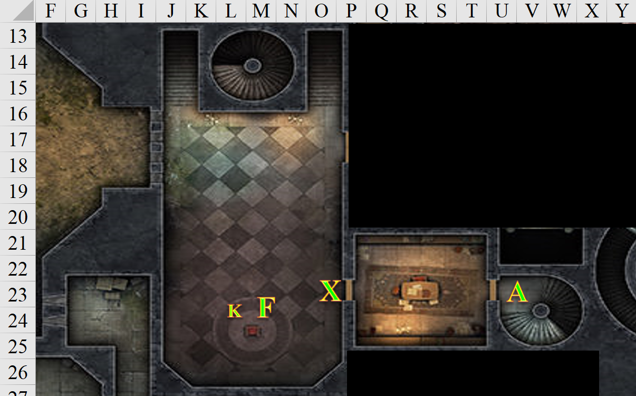

“These zombies are battering me every time I kill them,” Lauren called back. “Thanks for the lion to buffer; a little healing would be nice now.”

Not being close enough to use her wand or cast a touch spell, Allisa went back down the spiral staircase and cast cure moderate wounds upon her lover.
Lauren gained 11 + 15 = 26 hps [111/143].

The zombies attacked the lion.
Character | Attack  Type | Damage | BAB | Str  Mod+ | Total  Score | Roll | Total
zombie, S | Slam | 1d4 | 1 | -1 | 0 | 6 | 6
zombie, S | Slam | 1d4 | 1 | -1 | 0 | 8 | 8
zombie, S | Slam | 1d4 | 1 | -1 | 0 | 14 | 14
Miss, miss, miss.

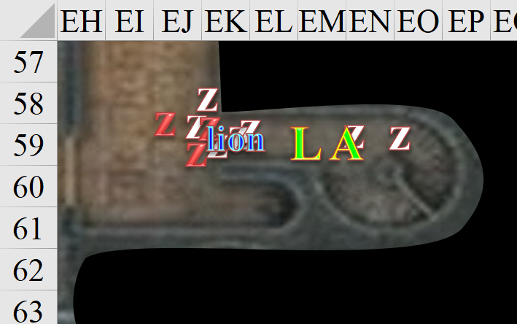

Round 99

Upstairs, Fingers confiscated the gem shard and carefully removed the hookah and drugs to make sure nothing else of interest was in the chest. Seeing nothing else, Fingers placed the shard into its spare sack, and closed the mimic’ mimic.
Item | Qty. | Wt. | Value
Sack 2 | 1 | 0.5 | 0
Waterskin | 1 | 2.0 | 0
Gray Hand Token | 1 | 0.0 | -
Onyx Shard | 1 | 0.02 | ?

Kir turned towards where she heard Lauren. “Healing, that I can do.” She headed east and down the spiral staircase.

The lion attacked the injured zombie.
Character | Attack Type | Damage | BAB | Str Mod+ | W+ | Other+ | Total Score | Roll | Total
lion | Claw | 1d4+5 | 3 | 4 | 0 | 0 | 7 | 5 | 12
Miss.

The zombies swiped at the lion.
Character | Attack Type | Damage | BAB | Str Mod+ | W+ | Other+ | Total Score | Roll | Total
zombie, S | Slam | 1d4 | 1 | -1 | 0 | 0 | 0 | 1 | 1
zombie, S | Slam | 1d4 | 1 | -1 | 0 | 0 | 0 | 16 | 16
zombie, S | Slam | 1d4 | 1 | -1 | 0 | 0 | 0 | 4 | 4
Miss, hit, miss. Dmg: 2.

“Sorry about springing that lion on you. Just figured I would help out and that was the fast way. I hope the beast can hold out long enough to take the rest out,” Allisa said as Lauren tried and failed to find room near the lion to reach and cut down a zombie.

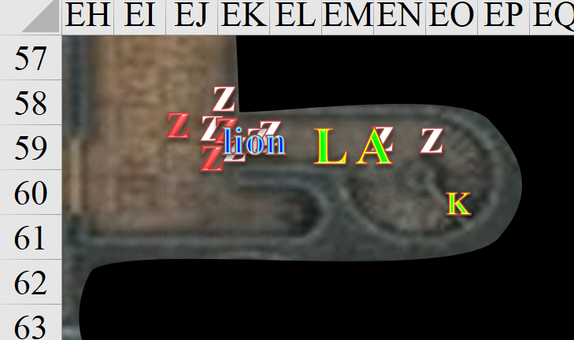

Round 100

“It’s fine,” Lauren said. “I need to see if someone is sending more of them. If so, we need to bottle them up, instead of taking damage every time we kill one.”

Allisa squeezed past Kir and back up the stairs to the landing in case one of the evil things got through.

Kir reached Lauren. “You called for a cleric? I’m running a special for friends, family, and beautiful women.” She used her wand of cure light wounds to heal the duskblade.
Lauren gained 3 + 1 = 4 hps [115/143].

The zombies and lion attacked one another.
Character | Attack Type | Damage | BAB | Str Mod+ | Total Score | Roll | Total | Crit | Threat
lion | Claw | 1d4+5 | 3 | 4 | 7 | 14 | 21 | 19 | ý
zombie, S | Slam | 1d4 | 1 | -1 | 0 | 20 | 20 | 19 | þ
zombie, S | Slam | 1d4 | 1 | -1 | 0 | 2 | 2 | 19 | ý
zombie, S | Slam | 1d4 | 1 | -1 | 0 | 12 | 12 | 19 | ý
Hit. Dmg to S zombie: 3 + 5 = 8.
Threat, miss, miss. 1d20 = 19, critical hit. Dmg to lion: 1.

The zombie exploded with the swipe of the lion’s paw, delivering a mass of negative energy upon the lion.
Dmg to lion: 3 negative energy.

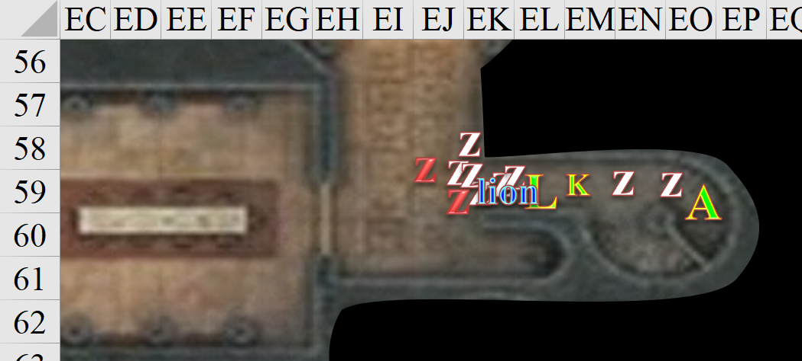

Upstairs, Xaryn remained in place as Fingers approached the curtained doorway and cautiously nudged it aside to check on what lay beyond. It took a few bold steps into the hallway, and peered northward and eastward to get a good look at the two corridors.

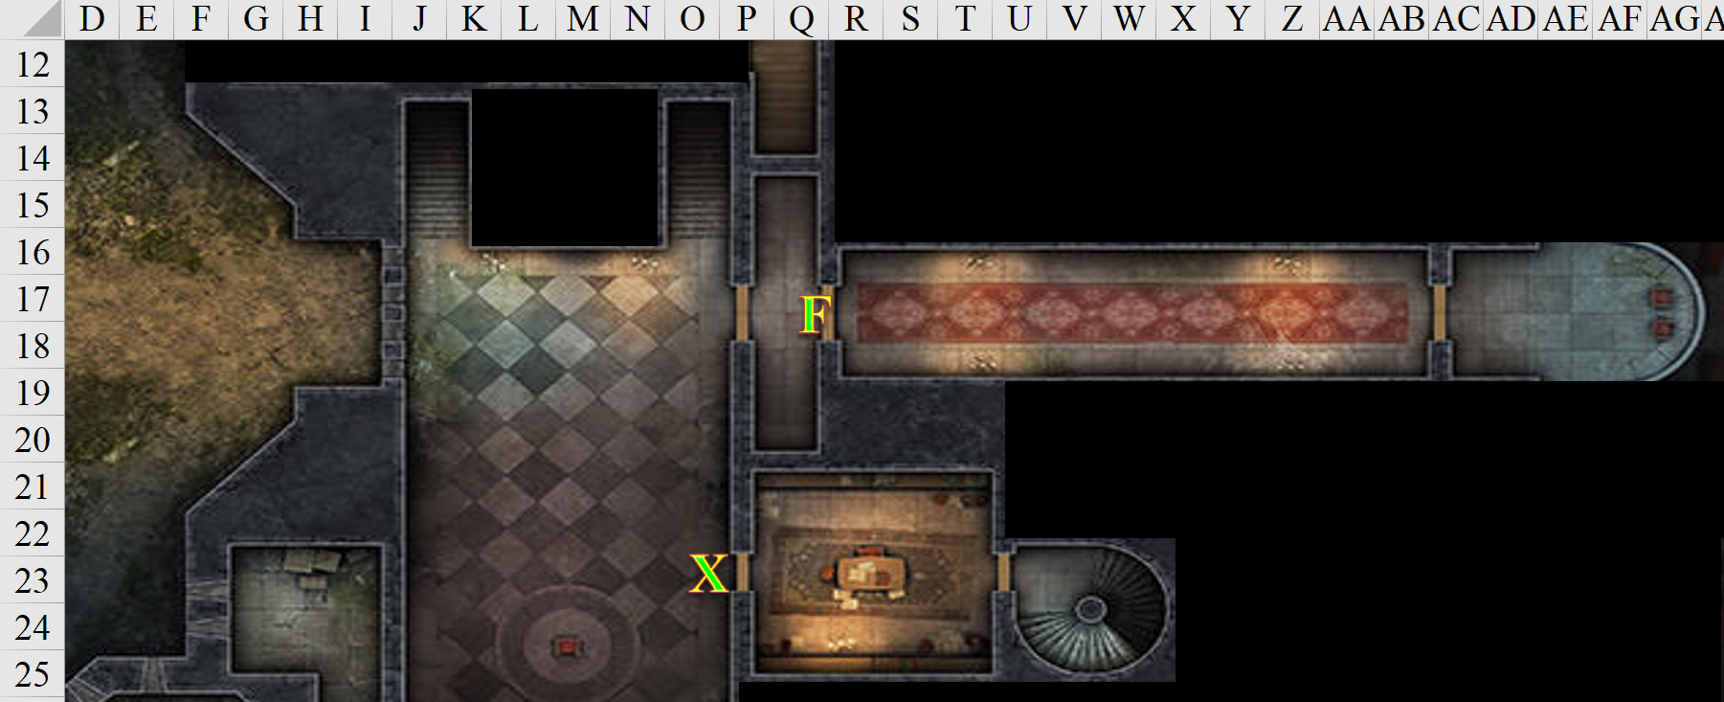

Round 101

Xaryn then peered past Fingers as he, too, brushed aside the curtain hung to separate this room from the corridor beyond, thinking it best to not leave anyone alone in this house of horrors.

“What do you make of it?” He asked when fingers began to step back into the room

“That gnome seemed to have gone that way,” Fingers replied, indicating the side corridor. “I think we should wait here until the others catch up.”

Seeing that there were no new zombies presenting themselves, Lauren laughed, “Maybe I will be able to qualify as all three. Watch yourself with these creatures, they are unpleasant to be around when they die.”

The zombies and lion went at it again.
Character | Attack Type | Damage | BAB | Str Mod+ | W+ | Other+ | Total Score | Roll | Total | Crit | Threat
lion | Claw | 1d4+5 | 3 | 4 | 0 | 0 | 7 | 11 | 18 | 19 | ý
zombie, S | Slam | 1d4 | 1 | -1 | 0 | 0 | 0 | 9 | 9 | 19 | ý
zombie, S | Slam | 1d4 | 1 | -1 | 0 | 0 | 0 | 12 | 12 | 19 | ý
zombie, S | Slam | 1d4 | 1 | -1 | 0 | 0 | 0 | 16 | 16 | 19 | ý
Hit. Dmg to S zombie: 4 + 5 = 9.
Miss, miss, hit. Dmg: 4.

One of the first things Fingers noticed was the way that the long, narrow carpet along the eastward corridor had been trampled out of perfect alignment with the walls, as if children had been treading here, or as if a gnome beguiler had made the hasty escape that Fingers had heard earlier through the stone walls.

The second thing the changeling noticed was that the brisk draft was emanating from the eastern corridor. The smell of undeath also hunt in the air, much like downstairs.

Not wanting to get too far in advance of the others, Fingers began shifting back and forth between the corridor and the stairs to make sure nothing was approaching unannounced.

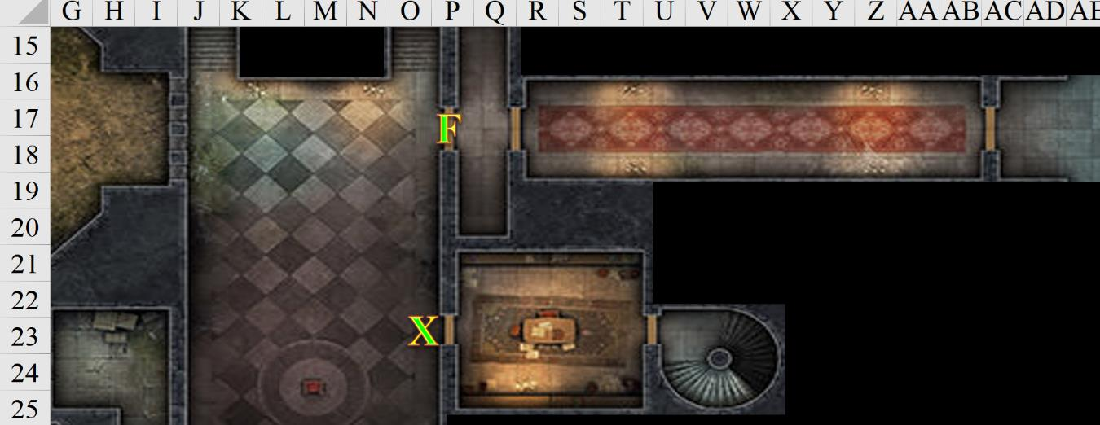

Round 102

The zombies and lion went at it some more.
Character | Attack Type | Damage | BAB | Str Mod+ | W+ | Other+ | Total Score | Roll | Total | Crit | Threat
lion | Claw | 1d4+5 | 3 | 4 | 0 | 0 | 7 | 14 | 21 | 19 | ý
zombie, S | Slam | 1d4 | 1 | -1 | 0 | 0 | 0 | 5 | 5 | 19 | ý
zombie, S | Slam | 1d4 | 1 | -1 | 0 | 0 | 0 | 19 | 19 | 19 | ý
Hit. Dmg to S zombie: 1 + 5 = 6.
Miss, miss, threat. 1d20 = 13, not a critical hit. Dmg to lion: 3.

Destruction Retribution damage to lion: 11 negative energy.

The lion was bleeding and broken, but still swiping away.

Seeing the lion taking up all of the room in the corridor’s mouth, Lauren backed away from the fight, moving up the stairs to rejoin the others.

Kir followed suit with Lauren and started heading back up the stairs. She brought her bow out in order to shoot any zombies that followed them.

Allisa watched as the two women approached the rock-encased spiral staircase, and she ascended to not slow down the retreating heroines. She felt a bit of remorse for the lion, knowing it would die at her whim, but also knew this “animal” was made of shadowstuff, and didn’t actually suffer as a real lion would have.

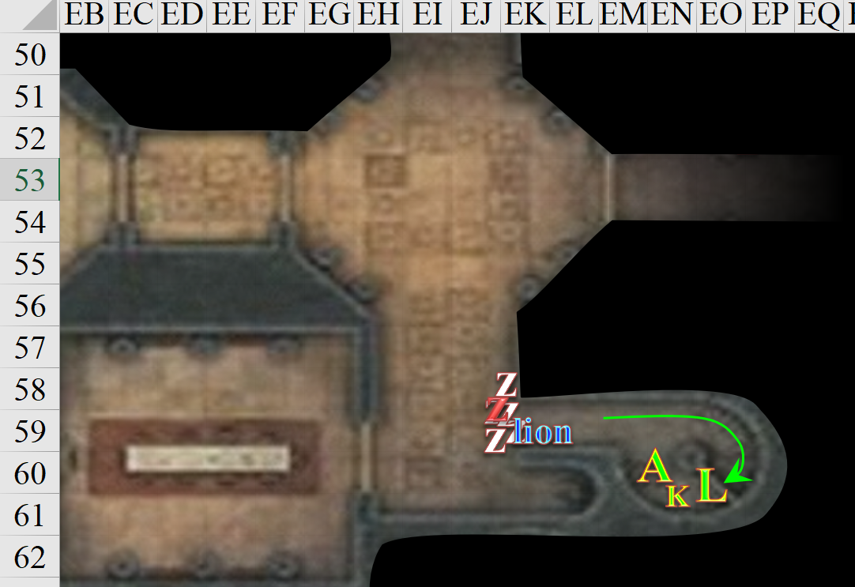

Round 103

Lauren, Kir, and Allisa reached the second floor as the lion swiped at the last zombie.
Character | Attack Type | Damage | BAB | Str Mod+ | Total Score | Roll | Total
lion | Claw | 1d4+5 | 3 | 4 | 7 | 6 | 13
Hit. Dmg: 2 + 5 = 7.

Still swinging, the zombie swung again.
Character | Attack Type | Damage | BAB | Str Mod+ | Total Score | Roll | Total | Crit | Threat
zombie, S | Slam | 1d4 | 1 | -1 | 0 | 19 | 19 | 19 | þ
Threat. 1d20 = 3, not a critical hit. Dmg: 1.

“Good call on the lion,” Lauren commended Allisa. “Made all the difference.” Still in need of healing, the half-drow exhaled as she and the other two women headed back towards the chest that looked like a mimic.

Fingers looked at its chronometer, reading: 21:05. They’d spent about 10 minutes here already—a sixth of a bell’s chime cycle—and Fingers was getting worried that the trail was running as cold as the trail of chilly air that vented into the room from the east.

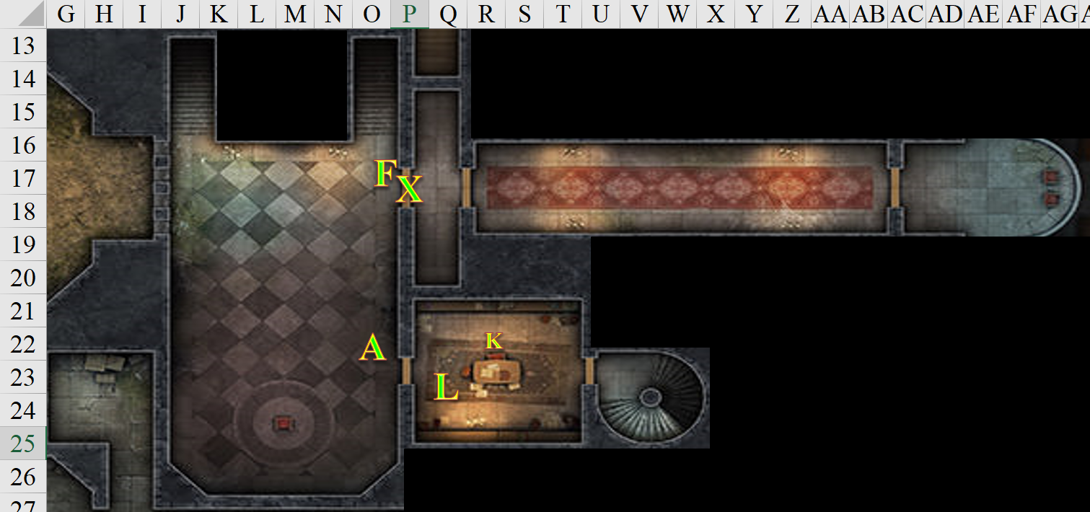

Round 104

The party stood in circumstance.

Though the heroes could no longer see or clearly hear what was going on downstairs, the lion swiped at the remaining gnomish zombie.
Character | Attack Type | Damage | BAB | Str Mod+ | Total Score | Roll | Total | Crit | Threat
lion | Claw | 1d4+5 | 3 | 4 | 7 | 19 | 26 | 19 | þ
Threat. 1d20 = 13, critical hit. Dmg: 2 x (4 + 5) = 18.

The lion swung so hard, the zombie’s head came off, causing the body to burst with negative energy.
Destruction Retribution damage to lion: 6 negative energy.

The lion remained in place, nearly destroyed, waiting for other zombies to present themselves.

Upstairs…

With no visual confirmation that the zombies had all been destroyed, but hearing the lion’s roar stopping, Lauren walked up to Fingers. “The zombies must be down. What next?” If she was wrong, it means that the lion had either been destroyed, or had expired, and at least one zombie was coming up the stairs to get a piece of the Gambit.

Fingers said: “The gnome seems to have gone this way. Might be a trap, but doesn’t matter. If we want to follow the trail, best to do it sooner than later.”

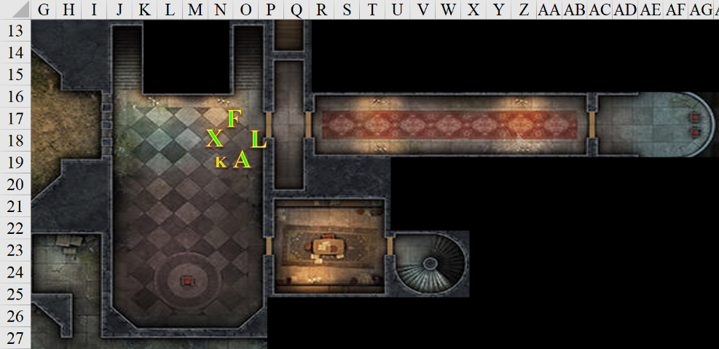

Round 105

“After you,” Lauren said with a grin.

Kir stepped forward. “Two sets of eyes are better than one.” She looked to Fingers to make sure it was alright with her working with it.

“The more the merrier,” Fingers replied as it headed down the hallway. Wand at the ready, the changeling planned to go invisible if and when targets presented themselves.

“I still feel the connection to the lion, though it is very weak. So probable no more zombies for now.” The druid said as she examined Lauren to see if she needed another tap.

Kir’s cat’s grace had expired around the time that they’d come up the stairs, and now she overheard Lauren say that she needed more healing. She put her bow away and took her wand of cure light wounds and used two more charges to heal Lauren. “Hope this helps,” As she used it, she looked to the woman and gave her a bright smile. “Friend.”
Lauren gained 8 + 1 = 9 hps [124/143].

Lauren thanked the halfling, then took her place in the formation as Fingers stopped to look for traps.

Xaryn stepped back and stood near the others as they discussed what their next move was. “Time’s wasting. If our gnomish friend wants to get away, we should make haste before he is able.”

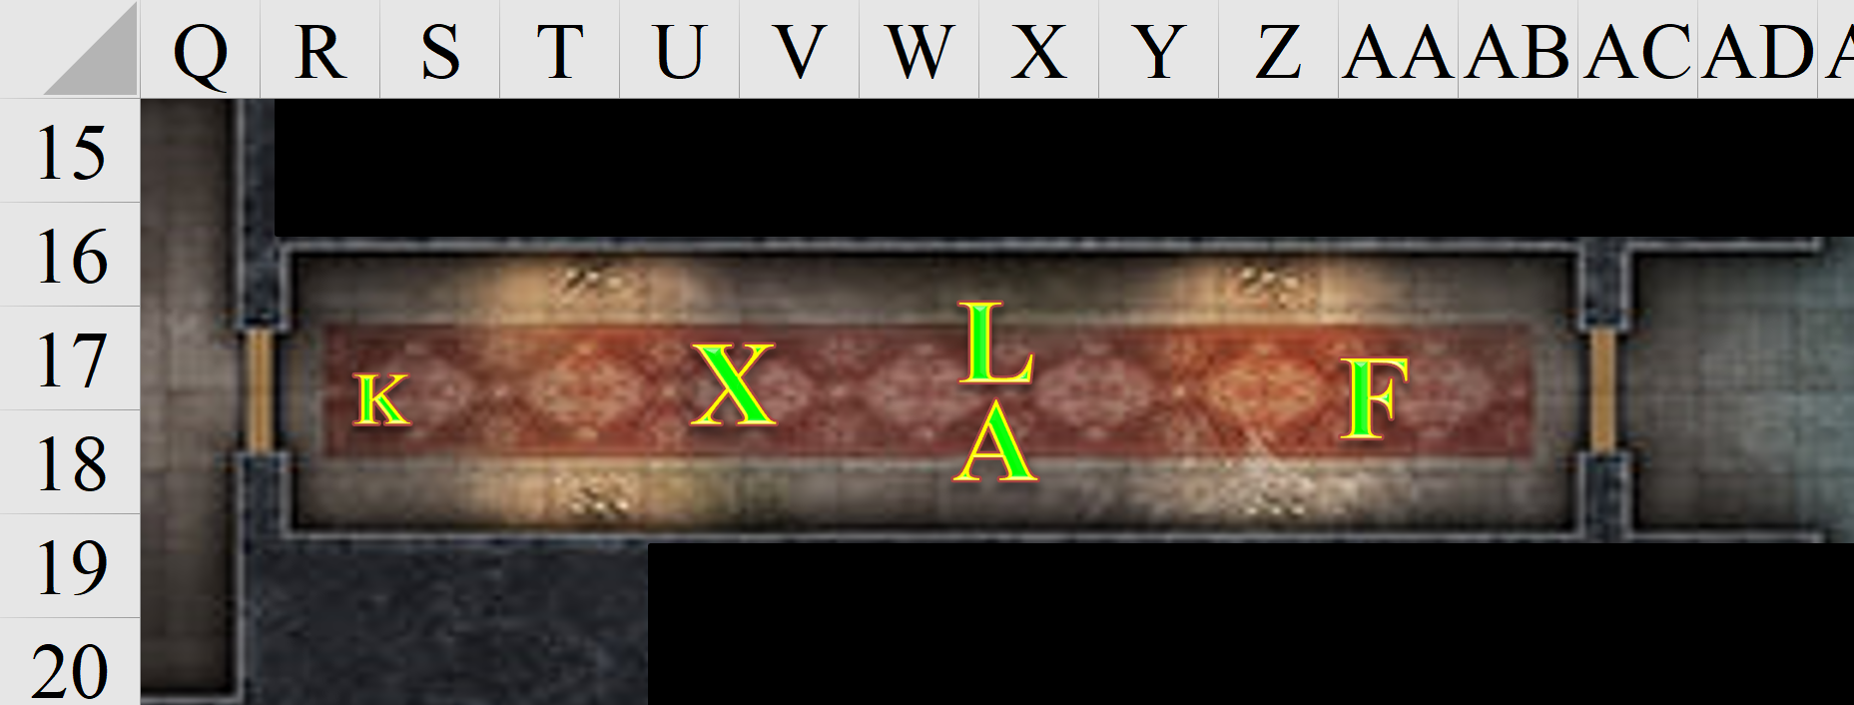

Round 106

Fingers stepped through the threshold uneventfully, noting that one paint coat ago, someone had rigged this with a semi-permanent trigger, but this was long gone.

The changeling came upon a balcony, overlooking a vast room capped by a three-story high vaulted ceiling.

As they made their way eastward, Kir tapped Lauren again with her wand.
Lauren gained 3 + 1 = 4 hps [128/143].

Lauren expressed again her thanks, and made her way to the east-facing balcony as well, and then fell silent, looking at Fingers, who looked back at her before they both looked down again.

Kir eyed the staircase going down and to the west as Xaryn watched the corridor through which they’d just come.

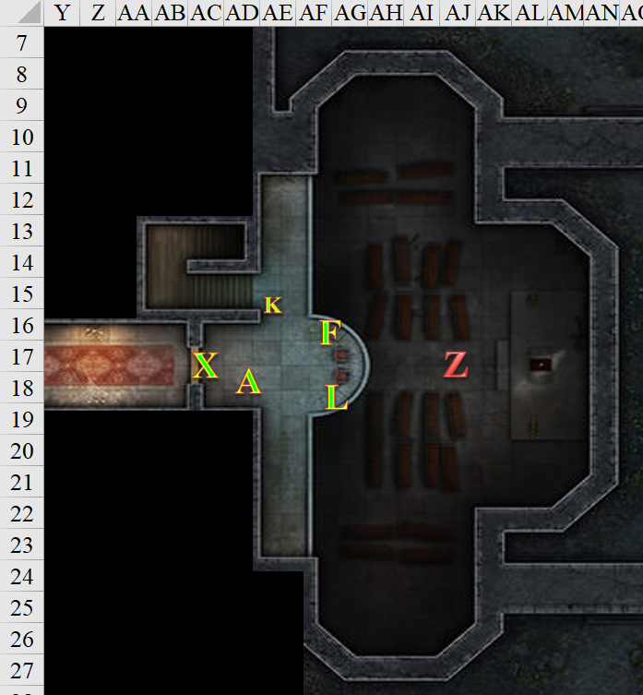

Round 107

Some of the caskets below were open, and no bodies were within. However, there was the single human zombie standing before an altar to what Lauren identified as Cyric, as if worshipping, but rather it was just standing there facing east. It then began to turn around as Allisa and Xaryn made a bit too much noise coming out of the hallway. The undead thing began to hiss.



Lauren was well aware of Rook’s campaign last year against the followers of Cyric masquerading to be the clergy of Red Knight, and few Cyricists could be held above the suspicion of retributive acts against those who brought them to justice. On the other hand, Cyricists were notorious thieves, and not very well organized amongst themselves, so chances are this heist had just been random Cyricists taking what they thought was theirs.

Fingers also noticed a smaller shrine to the side that it thought might have been devoted to the likeness of Velsharoon, but neither it nor the half-drow could say with certainty.

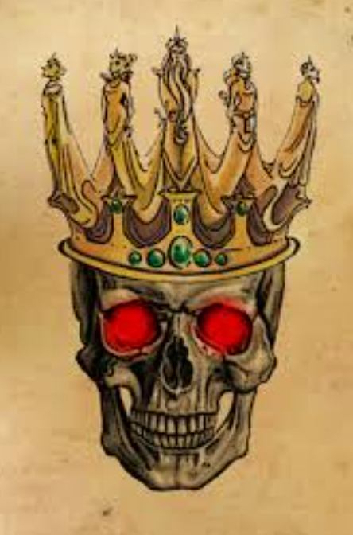

Not much of ranged combatant, Lauren went to the head of the stairs and looked down as she waited for Fingers to move on.

Kir had been watching the stairs that were heading down. She turned slightly when she heard a hissing sound. Seeing Lauren coming to stand by the stairs, Kir moved to look over the edge. Spotting the zombie, she remembered that they had been exploding. Pulling her bow, she will knock an arrow. Aiming down at the zombie she will let loose. However, because the balcony had a 3’ wall, the halfling wasn’t able to get much of a line of attack without lifting the bow over he head and firing it kind of awkwardly.
Ranged Weapon | Dmg. | D+ | TH+ | Critical | Rng. | Wt. | Atk | Roll | Check
Trovacuore (MW Shortbow) | 1d4 | 1 | 1 – 4 no line of sight  – 6 holding bow overhead | x3 | 60’ | 2.0 | +4 | 4 | 8
Miss.

“Worth a shot,” she said.

Fingers noted that others were preparing to deal with the zombie and left them to it. While the stairs seemed the most obvious route the gnome may have taken, it took a moment to give the shrine a once-over to see if perhaps it might be cover for a hidden pathway.

Fingers then noted a secret entrance, or something like it. It walked southward past Allisa, and pushed through a well-made curtain that looked like a stone wall. Sticking its head through the opening, Fingers deduced from the cold emanating downward from the wide-angled spiral staircase that something was afoot ahead. Not only was Fingers standing right about where the illusion of the minaret was one story above them, but this was also the most likely place where the gnome would have run after ruffling up the carpet in the hallway with his dashing strides. The only other way was down where he’d already been, which would be a good idea only if he was planning to escape on foot... or on the Gambit’s carpet, which they’d left out in the courtyard!

Seeing the coffins, Allisa whispered quietly “and me without my vampire disposal kit.”

“Bite your tongue,” Lauren chuckled. “That’s the last thing we need to meet in here.”

Xaryn stayed put.

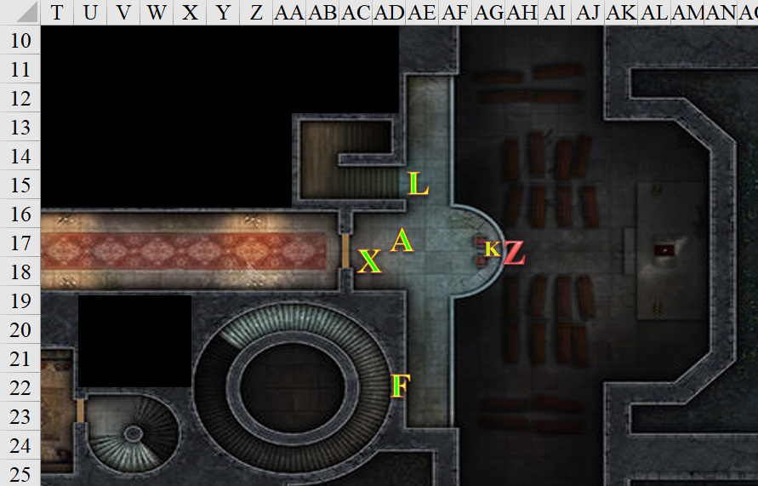

Round 108

The zombie kept moving westward, and was now out of sight.

“We aren’t headed that way anyway,” said Fingers, indicating the hidden stair. “Pretty sure that gnome went this way.” The trapsmith pulled the curtain aside and stepped thru, wary of ambush.

The hissing zombie sounded like it was at the foot of the square staircase. Lauren was standing at the top of said staircase, the half-drow waited for the walking undeath bomb.

“That zombie is coming up the stairs,” Lauren warned the others. “I think we need to move instead of trying to fight it.”

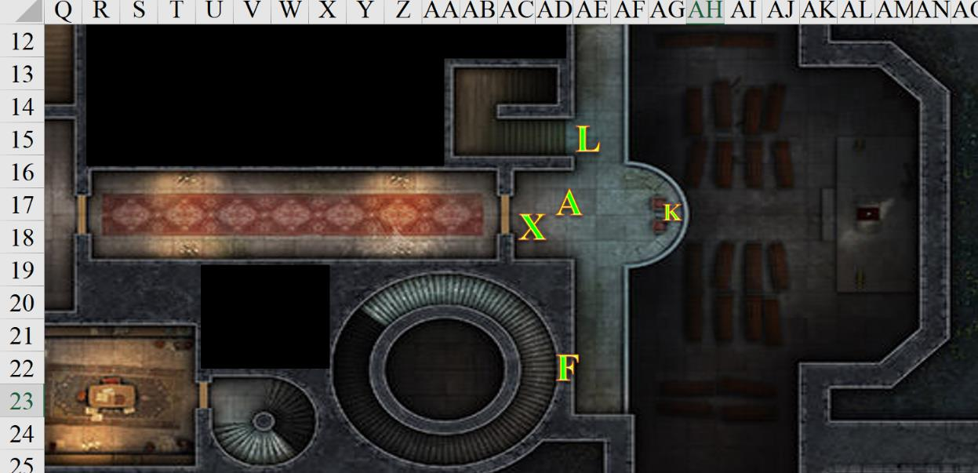

Round 109

Allisa wholeheartedly agreed and moved through the hidden entrance, following the others.

Lauren walked over to Fingers. “Let’s go. Melonpatch is getting away.”

Kir had taken a shot, why not. If she hit it then good. If not, oh well. She heard Fingers say that the gnome probably went up the stairs he had found. Then Lauren said the zombie was at the bottom of the stairs.

Not wanting to deal with an exploding zombie, Kir concurred with the others. Up the stairs she went. As she followed the group she asked, to no one in particular. “I know that you all are looking for what was stolen from you. Still is this something you all do for fun? Fly on a carpet. Check out mansions with open doors. Kill zombies. Stuff like that.”

The nearly growling zombie was half-way up the stairs now, with no line of sight to the heroes yet.

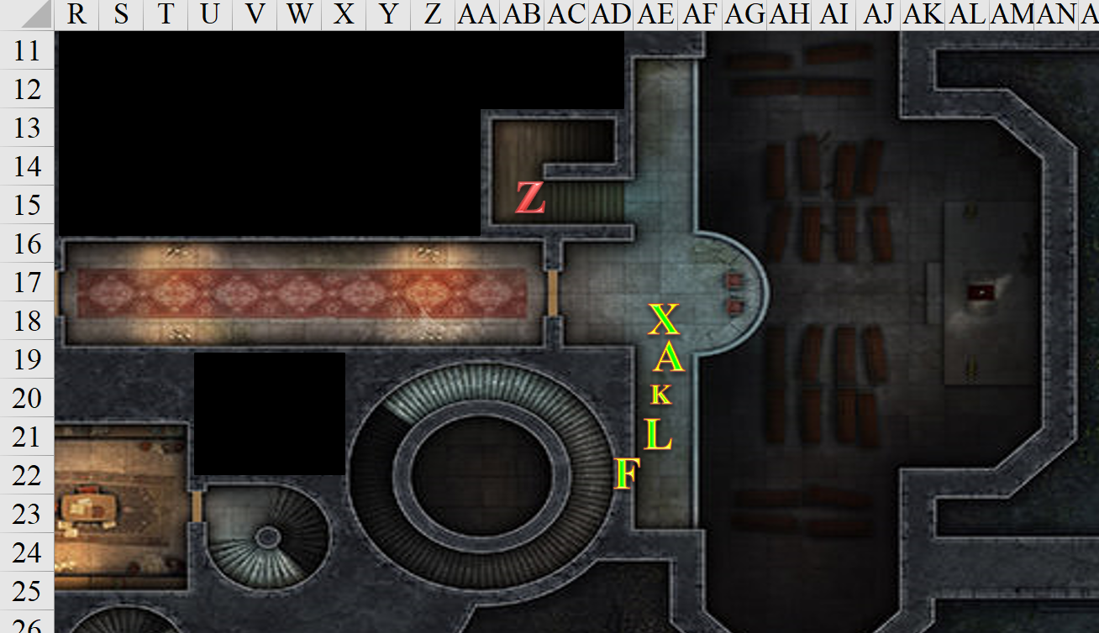

Round 110

With Kir right behind her, Lauren shook her head, and entered the staircase through the camouflaged flap. “I would rather spend my days with my wife at our home in the Westwood. But, here we are chasing necromancers once again.”

Fingers was already inside the spiral staircase, and now that the zombie reached the top of the stairs, only Xaryn and Allisa could see it.

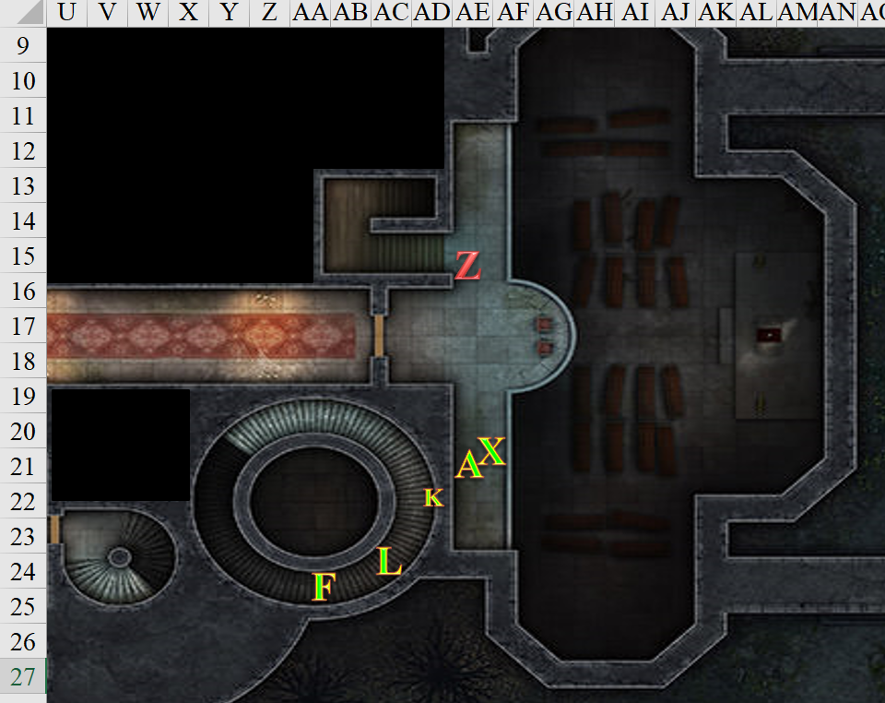

Rounds 111 – 112

Lauren and the others followed Fingers up the stairs.

Fingers added, “As Lauren said, we all have our personal projects we pursue. Occasionally, we perform a task or two for the powers that be—for compensation of course—but this jaunt was more personal... to recover what was stolen if possible and to make sure those who robbed us realize that was a VERY bad idea.”

The zombie caught up to Allisa (Round 11), and attacked her (Round 12).
Character | Attack Type | Damage | BAB | Str Mod+ | Total Score | Roll | Total
zombie, M | Slam | 1d6+1 | 1 | 1 | 2 | 13 | 15
Miss.

Allisa stepped through the opening as fast as the person in front of her could pass out of the way she continued up the stairs with the others.

Keeping his guard against the zombie, Xaryn continued to file into the staircase behind Allisa.

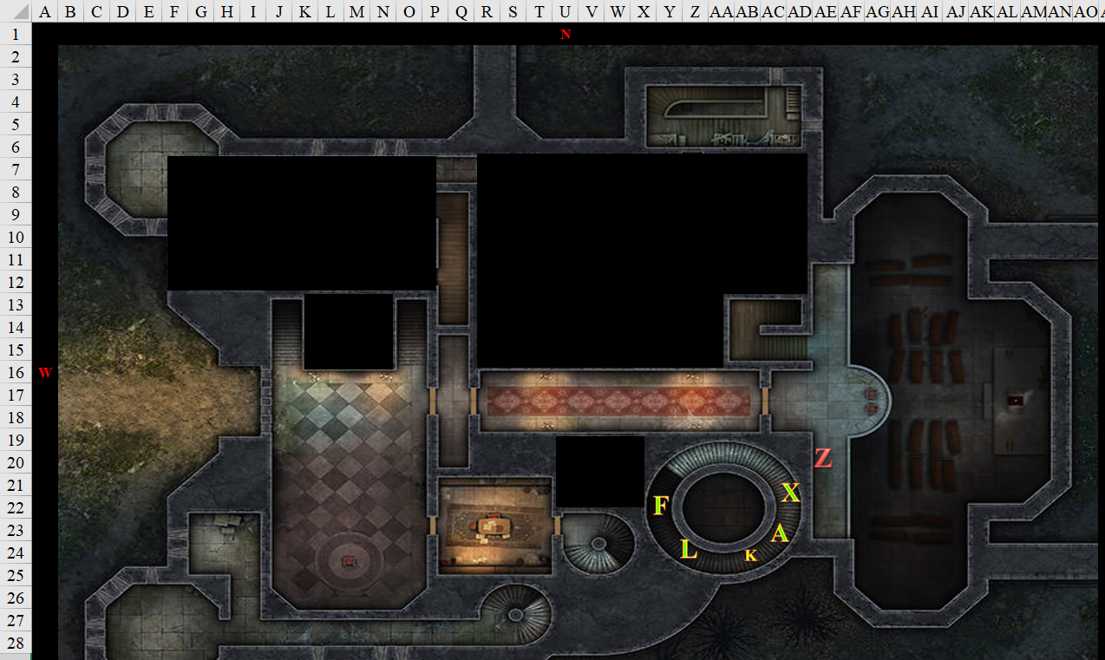

Rounds 113 – 114

The zombie then turned to Xaryn—who was in the back of the line—and attacked him instead.
Character | Attack Type | Damage | BAB | Str Mod+ | Total Score | Roll | Total
zombie, M | Slam | 1d6+1 | 1 | 1 | 2 | 1 | 3
zombie, M | Slam | 1d6+1 | 1 | 1 | 2 | 11 | 13
Miss, miss.

Lauren and the others followed Fingers up the stairs.

Kir listened to both Lauren and Fingers as they gave her an insight on the Gambit group. She replied to both Lauren and Fingers. “Spending time with a loved one is always special. Someday I might get lucky enough. (pause) Compensation is usually a very good thing. Then again, sometimes it depends on what you are getting compensated with.” She gave a noticeable shudder.

Fingers felt the cold increasing with every step upward that it took, and at one point, it felt like a cold blanket had been wrapped around its body. The darkness here was complete, and though some of the heroes had Darkvision

Fingers continued leading the way up the stairs, keeping an eye out for traps in the darkness. In here, there was absolutely no light, and Allisa could only tell by sound how far the zombie was.

“The zombie’s still behind me,” Xaryn reported, fending it off as well as he could while backing away up the spiral staircase.

Able to see in the darkness, Lauren turned around, made her way past, Allisa and Xaryn and prepared to engage it.

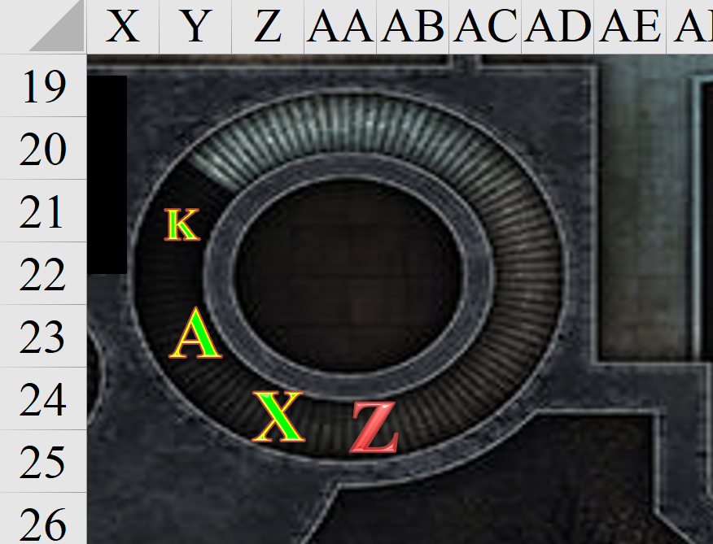

Rounds 115 – 116

Fingers added, “As Lauren said, we all have our personal projects we pursue. Occasionally, we perform a task or two for the powers that before compensation of course, but this jaunt was more personal... to recover what was stolen if possible and to make sure those who robbed us realize that was a VERY bad idea.”

Lauren full-attacked the zombie.
Melee Weapon | Dmg | D+ | TH+ | Critical | Type | Wt. | Atk | Roll | Check
Shattermantle Bloodstone Falchion +3 | 2d4 | +5 +3 | 3 | 18-20/x2 | Slashing | 8.0 | +24 | 16 | 40
SB Falchion +3, 2nd Attack | 2d4 | +5 +3 | 3 | 18-20/x2 | Slashing |  | +19 | 7 | 26
SB Falchion +3, 3rd Attack | 2d4 | +5 +3 | 3 | 18-20/x2 | Slashing |  | +14 | 18 | 32
Hit, hit, threat. 1d20 = 3 + 14 = 17, critical hit. Dmg: (7 + 5 + 3) + (2 + 5 + 3) + [2 x (5 + 5) + 3)] = 15 + 10 + 23 = 48.

The zombie exploded in a black burst.
Dmg to Lauren: 5 negative energy [123/143].

Xaryn, fortunate enough to be just outside the blast radius, kept walking up towards the freezing cold chamber that awaited them above.

