Chapter 67

Dawn, 29 Mirtul, 1377 DR

They awoke, one by one. Fingers was first, and crawled out of the cupboard, noting that the door was still wedged shut from when it had had to re-wedge them after Kir had nearly broken the wedge when she plowed through the door last night. Hopefully she’d not used the shard and gotten lost in the process.

The changeling started to put together some ingredients as quietly as possible, but eventually, the other four superheroic characters in the Shadow Suite were roused, and by the time someone removed the wedge from the doorway and entered, breakfast was on everyone’s mind.

Fingers looked at its chronometer, reading 06:48. They’d gotten an interspersed 8 hours with a very exciting battle in between, and were now ready to cast another day’s barrage of spells.

Fingers took the opportunity to make a quick survey of the area looking for any signs of intrusion before anyone else was up and about.

Spotting some indication of a visitor passing in the night gave the trapsmith pause... while whoever or whatever it was—if it was in fact a true positive—seemed disinclined to attack anyone, Fingers checked over its gear for any signs of tampering and planned to suggest that the others do likewise.

As sounds of the other team members starting to rouse reached its ears, Fingers rummaged thru the kitchen for odds and ends it could fashion traps from.

Allisa woke up as Lauren moved beside her. She stretched before moving to hug and kiss her lover. She would take a quick snack of dried fruit before meeting with the others.

Lauren stirred and awoke as she heard Fingers moving around. She was curled up against Allisa’s back, and she pressed her front against her lover’s slim backside for a moment. Then, she started slightly as a leathery surface brushed her cheek. Moondancer was stirring, too, presumably because she could mentally hear Lauren. The drow gently disengaged from her bedmates and stood up beside the bed. She wore a simple nightshirt, which she stripped off. She used the toilet, washed up with her supplies, and dressed in her usual garb. Moondancer followed the drow, then peeked through the drawn curtain and perched on the ground, smiling at Lauren as Lauren changed her garment.

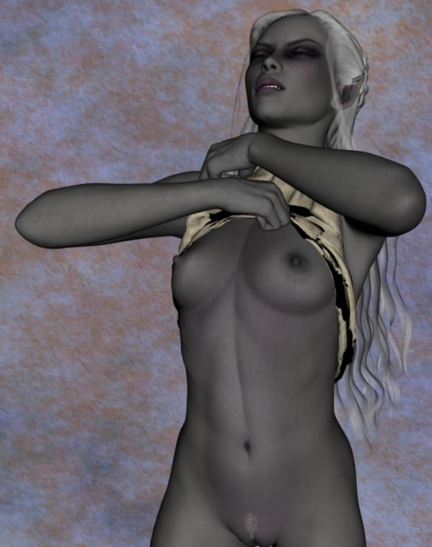

Allisa had watched as her scrumptious wife dressed. She followed her to the other room still clad in her birthday suit, forgetting they had guests. The druid took a moment, speaking to the dragon and giving it a kiss on the head before find what was left of food the little fellow would eat.

Once done, she returned to the others. “We will need to find more food for Moondancer. She needs a bit more protein than us.” Her eyes met each of the other’s, with Lauren making hand gestures in the background. Getting the message, the druid returned to the sleeping room and dressed.

The others blinked at the half-elf’s perky ears and nipples, then made like all was normal. “Hey, Fingers, thanks again for last night. This is what I had been looking at. It looks like it fits in the slot below the Hell Portal.” She showed him the translucent, burgundy shard.

At Kir’s greeting, it commented, “Well, considering we were prepared to go to Hell and back to recover our property, it appears we now have the ability to do so. It’d be nice if we had another possibility however... the prospect doesn’t exactly thrill me.”

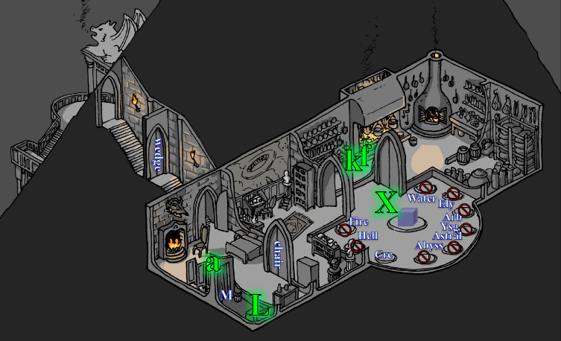

Moondancer then fluttered over to the kitchen, whose doors were now propped open, and sniffed around for something she could eat without having to nag and beg.

While Kir investigated, Lauren went to the kitchen and gathered some food for Moondancer. “I will carry your food here,” she explained to the pseudodragon, showing her one of the side pouches on her haversack. “When you want something, just think of it, reach in here, and you will find it.”

“Gratitude,” the felinoid dragon spoke into her mind and reached in the indicated place, fixating on the woman’s facial features like a chick imprinting on the first glimpse of its mother.

Lauren smiled at her new friend. “Allisa and I welcome your company, Moondancer. You may accompany us for as long as you wish.”

~*~

The five superpowered folks were finishing up their breakfast bits, and were gathered in the portal room.

Lauren settled her haversack into place, and checked that her weapons and gear were in their accustomed places. She looked around the room at the portals. “Do we have any idea where Melonpatch actually went?”

“Not really,” Fingers looked at the floor, and the foot traffic that they had brought in, obfuscating any traces of which were the portals most recently used.

~*~

The five superpowered folks were finishing up their breakfast bits, and were gathered in the portal room.

Lauren settled her haversack into place, and checked that her weapons and gear were in their accustomed places. She looked around the room at the portals. “Do we have any idea where Melonpatch actually went?”

“Unfortunately, no,” replied Fingers. “My tracking ability is nominal at best and these floors don’t hold indications that well. I’m willing to go over the immediate area with a fine-tooth comb before trying anywhere else. If the decision thereafter is to backtrack to look over the rest of this building before trying any more portals, that’s fine with me as I can withstand the cold at least for a while and Alissa should be fine as long as she wears my amulet. The question is, how long can the rest of you deal with the frigid temperature? If we have to come back her every hour for you to warm up, it could take forever. As for Melonpatch, unless he also stopped for a snooze, he may be beyond our catching up.”

“Okay, so let’s search the rest of this place, and then we can try to search this building.”

Fingers took about 5 minutes each to closely search the kitchen and portal room, briefly taking back the Scout’s Headband to improve Spot.

While Fingers conducted its search, Lauren took time to converse with Moondancer. She asked her how she came to arrive in the cage, and if she was familiar with traveling in the Plane of Shadow. She learned that the pseudodragon had never been in the Plane of Shadow before. She was from the River Reaching, where she lived with her mistress, Aridel, and her loyal companions. They were little more than a band of merry woodsfolk who had forged a fortification along the river’s southern bank, and established the worship of several freedom-loving deities.

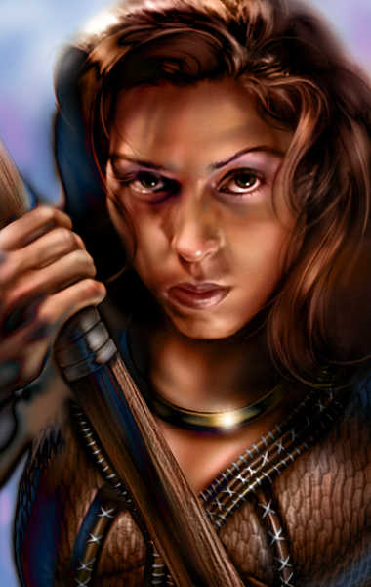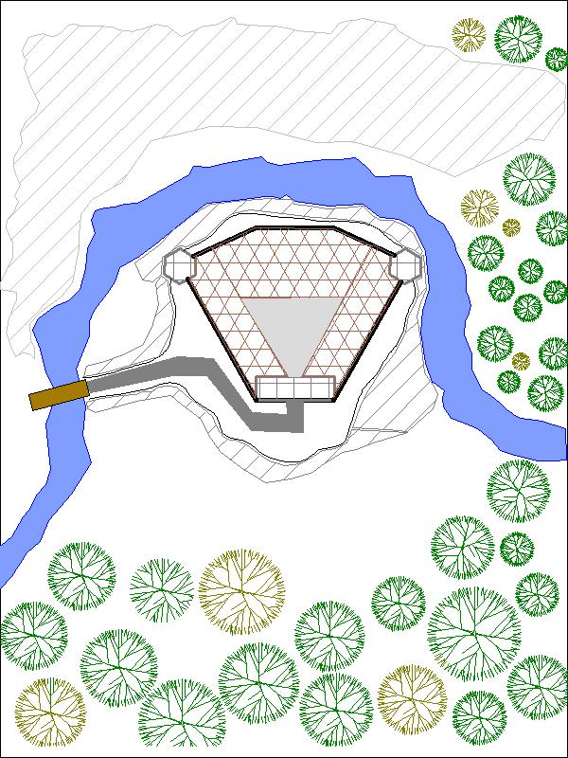

Moondancer also revealed the names of other notable people in the band—chiefly Aridel’s two lovers: Cyrus and Nilyn, plus some TMI about each of them.

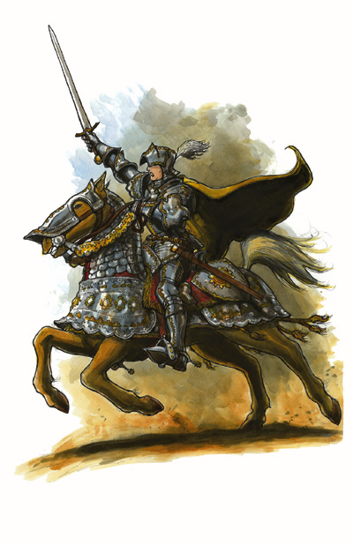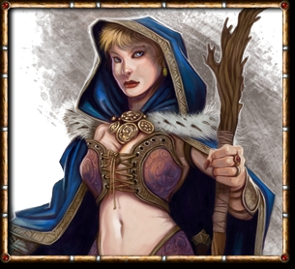

“They seem to be good folk,” Lauren told her. “So, how did you come to be in that cage?”

Moondancer revealed that she was magically rendered unconscious, and when she awoke, she was inside the cage. “The last thing I remember before I was captured was frolicking in the woods—I thought—alone.” She had been blindsided and poached for some sinister purpose. “The owner of this place—a gnome with a beard and some funny goggles—looked in on the beholder and me every day, along with one or two women.”

“Was one about the size of the gnome and another about my size?” Lauren asked, fishing for clues to the burglary.

“Yes, I think a halfling and a human, by the ears and build of each woman... the human always looked a little different every time I saw her.”

“Like Fingers, our shapeshifting friend over there?” asked the half-drow telepathically.

“No, nothing like that, but she dons a mean disguise. I can tell it’s her by scent, but even her mannerisms are well masked,” the pseudodragon’s syntax began to mirror Lauren’s more and more as they melded further. In time, they might have developed a nearly identical way of wording phrases in their head chats.

Kir watched Fingers.

Xaryn sipped on some tea while contemplating the ecstasy of life, and how abruptly it would end in a scuffle with a devil in the midst of one of the Hells. Still, the prospect intrigued him.

~*~

Having spent about 5 minutes each to closely search the kitchen and portal room, with its Scout’s Headband, Fingers had found only four peculiar and notable things that had not been previously spotted. Inside a box that was stowed in the back of the middle cupboard over the potatoes were four jars, each containing elemental essences with appropriately themed bottle stoppers.

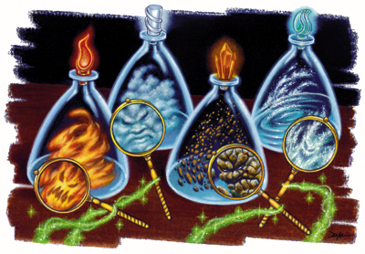

As Fingers took out the bottles, it roused each of the elemental components inside the bottle. From the very thin layer of dust on the cupboard shelf, it was suggestive to the rogue that at least a few weeks had passed since these beings had been put here in storage, enough time for the dust already inside the compartment to settle.

By this time, Kir and Xaryn had struck up a conversation about old times, and Fingers suspected that if the rest of this room and the Carceri chamber were going to get searched, Fingers was going to have to be the one to do it.

Allisa came into the kitchen for some miscellaneous spell components and some tea, spotted the four bottles, looked at them, looked at Fingers, looked back down, and asked, “Where’d you find the mephits?”

“What?”

“The mephits,” the druid pointed with her chin. “Pretty sure that’s what those are.”

Fingers had enquired briefly to Allisa on just what a mephit was and in response to Xaryn’s questions raised one of the bottled elemental creatures and replied, “Maybe to collect things like these? They were stowed back in a kitchen cupboard...maybe whoever lives here uses them for experiments or even food.” The changeling looked down at jarred thing, gagged slightly and finished, “or not.”

“There must be a purpose for these portals logically. The creator wouldn’t just haphazardly throw a portal to the 6th hell in his living quarters for no reason. The key, I believe, is to decipher why each of them are here and why they matter. Ideas anyone?”

“This is the quarters for someone important,” Lauren replied, “and it’s located in one of the major cities in this part of Faerûn. I don’t know whose place this is, but they surely will want it back. The portals certainly lead to places this person visits on a regular basis, implying that they have contacts or alliances in each of these places.”

Xaryn had his fill of reminiscing for the time being and as the conversation with Kir died down he turned his attention back to the room.

“There must be a purpose for these portals logically. The creator wouldn’t just haphazardly throw a portal to the 6th hell in his living quarters for no reason. The key, I believe, is to decipher why each of them are here and why they matter. Ideas anyone?”

“So maybe one of them leads us to someone who knows how to get home? Or another section of his home that could lead to more portals?” he asked, looking to the others who had suggested the regular use of the portals.

“Which keys... or shards... or whatever do we have?” Allisa asked.

“For sure the one that leads to Carceri,” Xaryn answered, “and possibly one that leads into one of the Hells.”

Lauren thought for a moment. “There are two possibilities in play here. Either Melonpatch didn’t think we’d follow him, or he knew we would. I’d bet on the second possibility, myself. So, he is probably expecting us to meander through the open portals, where he can set traps at his leisure. He almost certainly has allies, and they are fighting on their home ground.” The duskblade sighed. “I would rather search for a way back to Waterdeep from here, before we resort to using the portals.”

“Could also be that he suspected that we might follow him, but wasn’t sure either way,” someone pointed out.

Shifting into Neanderthaler form once more, Fingers handed its amulet back to the one who’d borrowed it, and commented, “So between Allisa’s and my alternate forms, and the amulet, that’s three of us not seriously affected by the cold for a reasonable time. What will the rest of you do if we search the rest of this building, let alone venture outside it if that becomes necessary?”

“Is Hell hot?” asked Allisa.

“Only some layers,” Xaryn responded.

~*~

07:15

Having broken fast, the party had now crossed back into Carceri, and the two rogues had scoured the area. They had found a second shard in the pile of assorted skulls on the ground, and Xaryn had detected magical auras around all of the shackles and other instruments of bondage.

“This shard appears to be color-coded to the portal that I’m fairly sure leads somewhere into the Abyss,” speculated Xaryn, who’d been right so far about the portals.

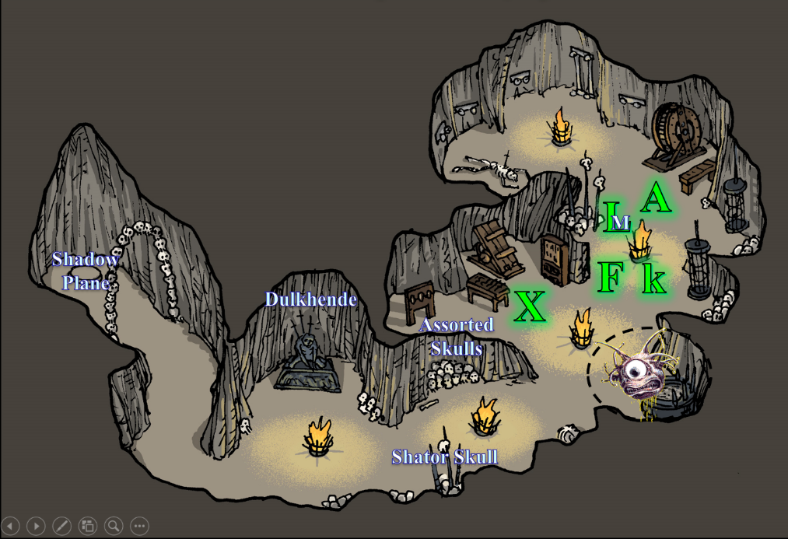

“So, we have another portal option, albeit one that’s as unappealing as the one to Hell,” commented Fingers. The question remains, do we search this building first before trying a portal? If so, how are you others—including our new acquisition,” as it nodded towards the minidrag, “—going to endure the cold?”

“Even if we have to return for a while to warm up, we need to search the Shadow Plane first,” Lauren said. “I’d say to go back, set traps and wedge the door to the portal room, and then conduct our search,” she looked to Allisa first for her opinion.

Kir had talked with Xaryn and then the group got together and discussed their next move. “I am sure I can add a couple of layers to my clothes from what is here. So it might help against the cold. But I agree that we should search what we can. Set traps, wedge the door and see what we find.”

“That’s fine by me,” replied Fingers. “My stronger traps only retain their potency for an hour but I can rig some mundane ones that would help alert us if something forces its way thru the door from a portal while we’re searching the building.” The trapsmith then went back through the portal into the Shadow Suite, and began gathering pots and pans to create a noisemaker trap as well as scavenging materials for a spiderweb trap to slow down any such uninvited guests.

While Fingers set its traps, Lauren also went back through the portal into the Shadow Suite, then went over to check the door through which they entered the bedroom to ensure that they could exit that way. This was the same door that she had wedged shut, and Fingers had locked it on their way in.

Following the others back through the portal, Kir reached through and pulled the stone shard out of the Carceri side’s portal, then pulled out the one on the Shadow Plane side, placing both in her pouch, next to the burgundy one intended for what they were calling the Hell Portal.

They were all back in the Shadow Suite now. While the others prepared, Xaryn spent his time scavenging for some warmer clothes to put on. His robes and his cloak weren’t exactly built to ward off freezing temperatures. In his size, after the others had had their pickings, all he could find was a fuzzy, magenta jacket, which accentuated his broad shoulders and brought out the brightness of his eyes.

“I hear that silk is a good insulator,” Lauren said as she passed by him.

“Not much to choose from,” the wizard shrugged.

Having restocked its inventory of traps and improvised widgets, the changeling was now ready to press on to wherever they were headed next, which was either back downstairs, or presumably either Hell or the Abyss. Their options vied between bleak and melancholy, and all offered plenty of horrific things that could rend their limbs from their torsos and feed them to their pets.

“Perhaps traditionally...” Xaryn began his reply.

“I find spider silk to be quite... breezy” he finished, chucking as he continued searching for warmer garments.

Having nothing to do but stand around, the druid made her way back into the shadow zone to await the others.

Kir made sure she had found some extra clothing that she could make fit her. Along with making sure that she had everything she needed of hers before they left, she made sure that her chronocharm of the grandmaster was on her wrist, that her goggles of night were on her head ready to go, and that her everlasting bag of rations was at her side.

Lauren made her way over to the bedroom again and approached her wife. “Do you have any notions about what Melonpatch is doing? Why would they steal from us, save to draw us into a trap?”

“We’re sure that these are the same baddies as the necromancers who had Ct. Bergère killed back in 74?” asked Allisa.

“Pretty sure. No reason to suspect it’s anyone else impersonating him, but then there’s Azimuth, who’s a much wilier bloke,” Lauren thought as she spoke. “Still, Azimuth must be working for Kaszüm, as the correspondence we found suggests.”

The druid offered, “My best guess is that Azimuth and Melonpatch held a grudge for coming after them, and colluded with Kaszüm, maybe even selling him our names and address.”

~*~

Fingers read 07:27 on its chronometer.

They had eaten, stretched, readied spells, and even invoked a few long-term buffs for the rest of the day, and were now congregating in the portal room for the third time this morning.

“Next steps?” asked Kir, as curious as any of them.

“Let’s explore the rest of this building before we consider the portals,” Lauren suggested again. “Fingers, you can wedge and trap the doors on our way out, so that anything coming through the portals has to contend with it.”

“On it,” replied the trapsmith. Having already examined the wedges used the previous night, they seemed sufficient for another usage. Fashioning a noisemaker from the pots and pans it had gathered for just such a purpose, Fingers fashioned a Spiderweb trap as the group headed out, and placed it near the door. While the latter would only remain potent for an hour, it was better than nothing. While it did this, the others leaned on the balcony railing and stared out at the desolate wilderness that separated this charcoal mound and the house atop it from the walled city of Waterdeep, now miles away. It had seemed much closer last night when they’d entered, but now in the full darkness of day, the dim lights seemed a much more significant distance away. Moondancer stretched her wings and flapped them a few times, leaping off of Lauren and

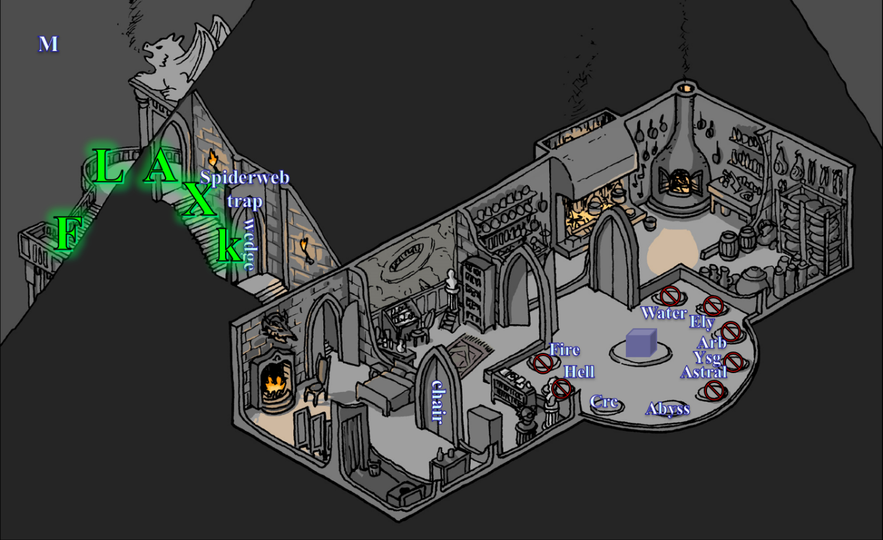

“Done,” Fingers murmured the announcement in the midst of the cold, shadowy wind. It considered scattering a few caltrops, but decided against it... if the group needed to make a hasty retreat back into a portal, it wouldn’t do for one of them to get hobbled by one. Shifting back into Neanderthaler shape, the changeling headed out with the rest to see what other oddities this building held.

Kir had made sure she was ready and made sure her googles were on before she stepped back into the Shadow land with the others. She watched as Fingers changed to a Neanderthaler and Allisa shifted to a snow leopard. She had always been fascinated by those who could change their body. Once everyone was ready, she looked around. “Alright, let’s go.” She looked for anything out of the ordinary and for traps and such, trying to be thorough yet quick, so as to not slow them down.

Allisa stepped out into the cold with the rest of the group she gave Lauren a kiss and handed her the wand of healing she had. She then changed into a snow leopard. In moments, she had white fur with black spots on her head and neck, with larger rosettes the back, flank, and bushy tail. The big cat meowed twitching its ears as rubbed up against the drow.

“Careful there, Pussycat,” Lauren murmured. “We have work to do.” Lauren made sure that she had her Truedeath crystal installed in Arkenlyl, and she followed along behind Fingers. “Be careful through here,” she said quietly. “I’m sure there’s something bad waiting for us.”

The party had descended the staircase, and was now at the foyer that led to the ampler coffin room.

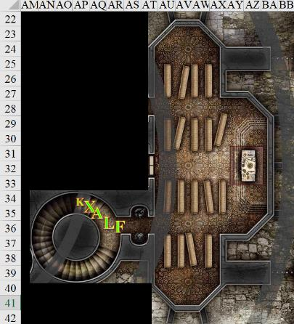

Fingers eyed the coffin-like objects while holding its invisibility wand at the ready, trying to estimate how easily anything inside one could open the lid. “Shall we check all those out to make sure nothing nasty is inside any that might come out and hit us from behind? Also, I suppose it’s possible one might hide the entrance to a secret passage.”

“As much as I hate to say it, yes,” Lauren replied.

Kir looked around and then to the coffins. “I will start with the altar up on the dais.” She headed to the altar and started looking for traps and anything that looked interesting.

“Right then. No sense in putting it off. I’ll see if I can get one open by myself. No reason for all of us be clustered around ready to be jumped if something pops out.” Fingers approached the nearest and examined it more closely.

~*~

Fingers and Kir conferred after having lifted the top of every hinged coffin. They weren’t particularly fancy or sturdy—these pine boxes—but they were functional lo long as they held up. Not a body in them, they all looked like brand-new products awaiting the day when they were needed for their final purpose. The rogues discussed the situation—which they likened to being in a dungeon—from an architectural perspective. “It’s a style altogether unknown in our version of Waterdeep,” Fingers noted, and Kir took note. “Futuristic even.”

Lauren petted Allisa as Xaryn rubbed Moondancer behind the ear holes, causing the dragon to shiver and groan with pleasure. They’d ventured over to the table where the instruments of torture still lay, undisturbed since the last time they’d been in here snooping around, and now discussed the décor and general architectural style from a dungeoneering perspective. “You could seriously set up a carrion crawler breeding pen in here,” noted Lauren.

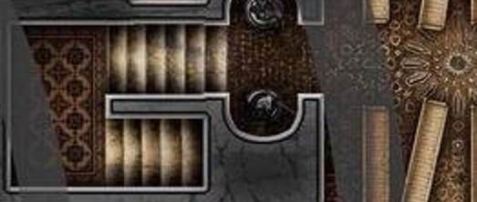

By now, a few of the heroes had ventured into the northernmost westbound passage, and found it to be a staircase leading up. The middle passage, on the other hand, led through a set of open double doors and into a larger room beyond.

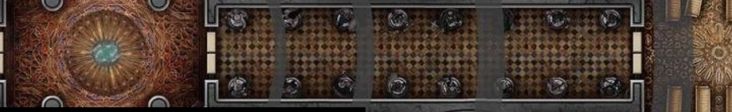

The scent of dust and old wood was present here, but the stench of death that had permeated throughout the house last night was gone. Whatever necromancy existed here until yesterday left with Azimuth.

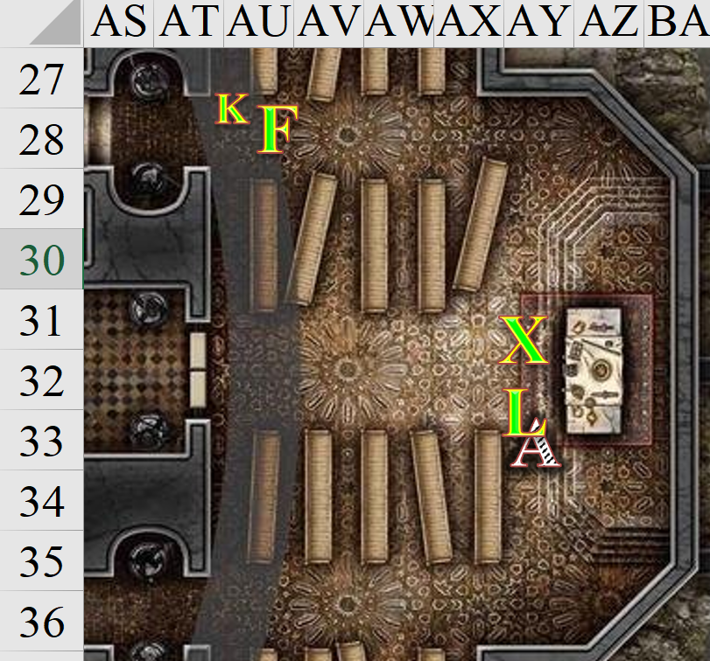

The house was eerily quiet, so much that their ears audibly rang when they weren’t talking or moving. No clocks tick-tocked, no umbral mice stirred, and the breeze outside could not be heard inside the well-insulated stone manse. They began to feel as though the entire plane were setting them up to let their guard down, and would conjure up something out of the shadows once they least expected it.

Fingers and Kir regrouped with the drowlings, leopard, and pseudodragon, sighing and shrugging. “Nothing as exciting as nine transplanar portals here,” reported one of them.

“Good,” Lauren said. “Where to, next?”

Kir had been a bit disappointed when there was nothing in any of the coffin like boxes. She had conferred with Fingers on the structure of the place. Never having seen anything like it before.

Kir stood with the others, the disappointment from not finding anything could be seen on her face. When Fingers suggested to stay on this level and see what else is here, she gave a quick nod. “I agree. There might be some good stuff around here.”

Fingers suggested, “Let’s stay on this level for the moment and see where what large room leads to.”

The cat prowled around each room the group entered, sniffing for the scent of any creature other than themselves. Its whiskers and ears would twitch ever so often as it searched. After making its rounds the beast would come back to nuzzle Lauren. The act being instinct cause of Allisa’s great love for the women. The druid mostly let the cat behavior rule, it being a strong pull upon the desires of the transformed person.

~*~

07:42

They’d explored the entire ground level of the house, and Fingers was now dealing with the fact that the lock on the front door was on the outside, and they were actually locked in. No matter.

Allisa tried to slap Lauren’s butt, but instead clawed at the armor that protected it.

“Hey!” the half-drow scolded the leopard.

The rogue eventually did get the lock open, and noted that the contraption was about as difficult to crack as had been the one warding the Shadow Suite’s front door. “Rather queer: having a door that locks from the outside,” remarked the changeling whose Neanderthal hands hadn’t been very helpful in picking the lock.

Some of the heroes assembled, and braced for whatever might have been outside the apparent enclosure in which they’d been caged. Moondancer hid behind Lauren, clawing at the woman’s armor and peeking over her shoulder. However, no threat presented itself when Fingers opened the doors. It was a typically inhospitable and cold night, just as it had been when they’d exited the Shadow Suite less than an hour ago. Being on ground level, and inside the courtyard, they now had no line of sight to anything outside the keep but the starless sky and a narrow gap in the wall where the drawbridge would have been. Beyond it, it seemed that a narrow stone path continued, with nothing on either side.

No zombies, no signs of carnage... if it weren’t for the walls and keep, they felt like they were in the fictional plane of Nogard, where nothing surrounds you but a flat plane upon which to bemoan and repent your past woes. This was a bit of an exaggeration, however, seeing as how the stone floor outside the keep was not smooth as Nogard was described in local lore.

Still inside, Xaryn had noted that the octagonal room in the center of the keep was somewhat of an epicenter for evil. The desecrate spell had been rendered Permanent here, and was Enlarged beyond what it would have been on the Material Plane. The entire keep—he could now tell—was subject to concentric circles of gradually diminishing evil that bolstered evildoers and attenuated the prowess of heroes.

“What now?” Kir felt frustrated at not having anything to fight.

Allisa hissed at Lauren, and Xaryn announced. “The closer we are to the epicenter of this desecration, the more that this thing will affect us, and Allisa’s mind is more susceptible in animal form. We should either get back upstairs, or out in the courtyard.”

“Upstairs, then,” Lauren replied. She looked at Moondancer to see how the minidrag was holding up under the desecration spell.

The cat responded. “Why not out beyond the walls? Is this plane not a close approximate to our own?” Having completely missed the fact yesterday and today that they were miles away from Waterdeep’s Shadow Plane analog, she paused as what came out was more drawn out and harder to speak with a creature’s mouth. “Could we not travel to the location that would be the Gambit compound? Or to the cemetery where we first encountered the Shadow zone? Maybe we can exit from there.” The cat sniffed the air looking for traces of some living or undead creature.

Xaryn shook his head. “That’s not how transitive planes work. You still need either a portal or a spell.”

Lauren knew of such magic, “We could get such a spell in the Shadow Waterdeep... I guess. But do we want to make the trek? Shouldn’t we search the upper floors first?” Lauren asked her wife.

“I agree. Venturing out into the Shadow Realm at large could cause us to encounter who knows what wandering the plane,” stated Fingers. “And it’s not always easy to retrace one’s steps.”

Xaryn nodded with the knowledge of this being true.

“Let’s move quickly, then. The longer we stay here, the worse the effect,” Lauren said, glancing at Xaryn for his confirmation. “If we don’t find anything, then we can check outside, like Allisa says.”

“It’s a long trek down the hill, and over to the city, not to mention the trek back,” Lauren said. “I suppose the carpet will make things easier, but still.”

“There is that other stairway we have yet to traverse. May as well get that out of the way.” commented Fingers on the stairway [AQ30] next to the spiral one [AO37], as opposed to the others [AG29, AK38] they’d already found throughout the house before Fingers had unlocked the front door.

Fingers led the way. They took the first six steps, reaching a landing covered in a really nice tapestry in the mind of those who could see it. Those without the ability to see in complete darkness could now no longer see, since the shadowlight candles that had illuminated the walls throughout the remainder of the interior could not reach this dark corner. Fingers turned to pace the second groups of six steps, and did so, then paused, waving to those behind him to do the same. The path ahead was just as dark as anything else, and those that couldn’t see now huddled close to those who could, but no tapestries or any other artifice decorated the increasingly irregular passage.

“Xaryn, I’m going to admit that I’m at a loss here,” Fingers smiled in the darkness. “Can you take a look at this and tell me what I’m looking at?”

The full-blooded drow inhaled with resolve, then exhaled as he ascended the last few steps to stand next to Fingers. He looked eastward, most likely, but his sense of direction was a bit off without many reference points.

“That’s not part of the mansion, is it?” Fingers said and asked.

Xaryn smiled too. “It’s the Shadow Plane, so a Material frame of reference doesn’t work here. Dimensions aren’t consistent, as we saw with the fact that Waterdeep went from being about a mile and a half away to being about 10 times farther by this morning. These things oscillate much like shadows on our plane throughout the day; some cyclically, others linearly, and still others quite erratically. If I understood it better, I’d probably have a more elegant explanation of what I’m calling erratically.”

Lauren disagreed on a topic wherein Xaryn was the expert. “Sometimes chaos is not to be understood, or explained. You feel it, claim it, own it, wield it, and you inevitably come to embody it,” she took a more philosophical route than usual, which turned Allisa on. The feline purred as the pseudodragon sniffed the still air.

“You smell that?” Moondancer asked Lauren.

Lauren did, and voiced the question to the others.

“Smoke.”

“Woody smoke, like the Shadow Suite.”

They continued walking along a roughly 10’ wide corridor that turned and wound irregularly until it led them into a furnace room that led up to where the Shadow Suite’s kitchen surely was, at least by the estimation of those who could see, and had a decent sense of architecture and/or dungeoneering.

Other than cords of firewood, stokers, pokers, brushes, brooms, dustpans, flint, and other instruments of ignition and heating, there was nothing of interest in the dead-end, pitch-black chamber composed of unworked stone with a somewhat even floor.

With all its doodads on, Fingers looked for traps, secret doors, and just about anything that would catch its eye, and Kir did the same, now that she could see in the dark.

“If someone can carry it, perhaps we should have enough wood and such to make a couple of small cooking fires. My own haversack is nearly full,” Lauren said.

Noticing Kir ensuring that her own doodads were on properly, Fingers added, “Perhaps some of this stuff is also suitable for torches to help those unable to see in the dark. One of those tapestries should yield plenty of cloth to wrap around the end of a poker. Did anyone happen to liberate some oil from the kitchen?”

Kir had made sure she was ready and made sure her googles were on before she stepped back into the Shadow land with the others. Kir looked to Fingers and shrugged her shoulders. “If you want.”

They stuffed a few cutup logs into their haversacks and felt the need to filch nothing else at the moment. They then left the fireproof chamber, and reached the staircase once again.

Making their way down to the coffin repository once again, they inhaled deeply in the midst of cleaner air.

Fingers, who had been more concerned with picking the lock on the front door than with searching for secret pathways to other parts of this mansion, said, “Xaryn, I appreciate you being here. If we were on the Material Plane, I’d say there’s more to the first floor of this mansion than what we’ve seen, but with these wonky dimensions, I’m not so sure here. We could keep searching the ground floor, go back up to the Shadow Suite, or leave this place altogether and take our chances out in the wilderness.”

Moondancer did not like the sound of that last option, and let Lauren know. “Or we could stay here, and tend to our creature comforts,” Lauren proposed. “Maybe wait this out? Kaszüm would be a fool to not return eventually.”

Xaryn added two comments, “To your point, Fingers, it’s likely that there are pockets of space inside the mansion that we’ve yet to see, but not necessarily where a Materialite would expect them. You have to think in vectors. Being here long enough will help, but you might lose your mind by then, which brings me to another point: we do not want to be stuck here waiting it out. While the Shadow Suite has the measures necessary for a decent insulation from the elements of the plane, this is one of those environments that would stress our souls to no end, eventually fraying away at our personality until we became shadows of our former selves.”

“Not too bleak then,” Kir seemed to apologize for her friend’s pessimistic attitude. “So if we just hole up in the Shadow Suite, we’re good?”

Xaryn rubbed his chin, almost shaking his head as he answered, “It’s... I’m really beginning to be impressed by the methods of those who put this whole place together. It’s an envious design. This chateau down here is fine and all, but the furnace room we just visited, all of it really, is here to either literally or figuratively sustain the Shadow Suite. It’s quite literally built on top of it, with a natural formation jutting forth out of the house, defying Materialite logic. The Material analog—if you recall—was warded from view, and an illusory minaret stood in its place; I wouldn’t be surprised to find that this place is also invisible to those on the outside.”

“Oh, right, the minaret,” Lauren murmured. “This seems like a pretty elaborate enterprise.”

“And we’ve yet to see the places on the other side of most of the portals upstairs,” Xaryn forecast, “so we’ll likely see similar purposefulness in whatever lies beyond them. Those who built this place were not impervious to the elements, or they wouldn’t have gone to such lengths to condition the ambiance in the Shadow Suite to such comfortable levels. Consequently, the well-stocked and comfortable Shadow Suite is effectively both a haven and a prison for mortals susceptible to extreme climates and psychoactive realms… and the desecration node at the center of the mansion makes it even homier to an evil bunch like the folks you’ve been mentioning.”

Lauren sighed and looked around. “I feel like I’m missing something here. Xaryn is right in saying that we can’t stay here long.”

The cat spoke. “That is what I said earlier: We need to leave this place and in our world. There was a portal in and out not like these here but we did cross into and back out of this shadow realm while in the graveyard crypt. And surely something beyond these walls knows a way back.”

Xaryn clarified, “If we’re going to stay long, we should shack up in the Shadow Suite. A few days even in here, and we’ll end up pretty haggard.”

Lauren continued, “So, I propose this: We look for a way home. If we run across anything interesting, then we deal with it, but we need to get out of here, and soon. What do you all think?”

Xaryn spoke again, “Getting out of here and getting home are two different things. We can get out of here by going to Carceri, or the other two planes to which we now have keys. The Material Plane will be a much taller order until we can figure out a proper way back.”

“Unless we missed something of note, it seems we only have three options:

- Travel out into the Shadow plane to try and find the portal Alyssa spoke of... not sure I like the idea of traversing the shadow version of graveyard and that would almost certainly guarantee we never see our stolen property again
- Hole up in the Shadow Suite and hope one or more of the thieves returns thru a portal...perhaps the safest choice in the short run but between lack of supplies and the effect of the desecrate, not one for an extended period or
- Start exploring one of the areas beyond the portals. While the prospect still doesn’t thrill me, seems the best chance to pick up the trail of the thieves and recover our loot.”

“Agreed,” more than one of them said.

“Option 2 isn’t exactly valiant,” said the duskblade, finding her penchant for lounging contrary to her training.

Lauren looked to Allisa for her input.

Kir had listened for the most part as the other talked. She had been a bit down since they had not run into anything to fight. Though the prospect of them possibly being here for a while brightened her mood a little. “There has to be something here we had missed. A spot we missed. Jasmin is probably worried sick.”

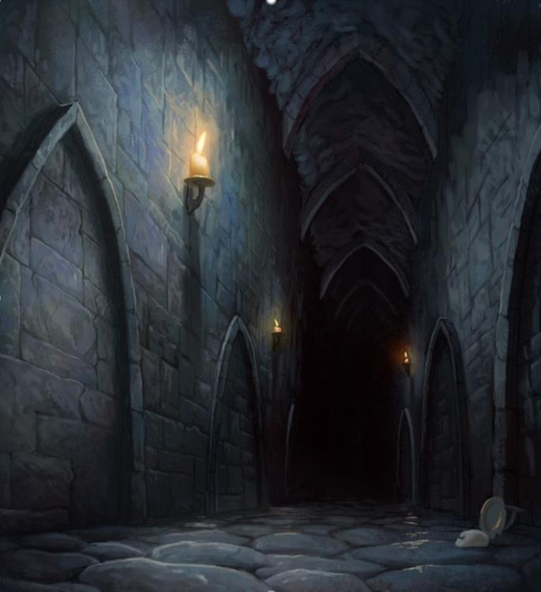

In the stillness of the air, Moondancer asked for a treat. “All this speculation made me hungry.”

“Your food is here,” Lauren reminded her as she patted the right-side compartment in her haversack. “Go easy on it, though.” She turned to her companions. “Why don’t we at least try to find the crypt Allisa mentioned? We will go out and see, and if it’s too far, we come back and try the portals. We can use the carpet and not have to walk.”

~*~

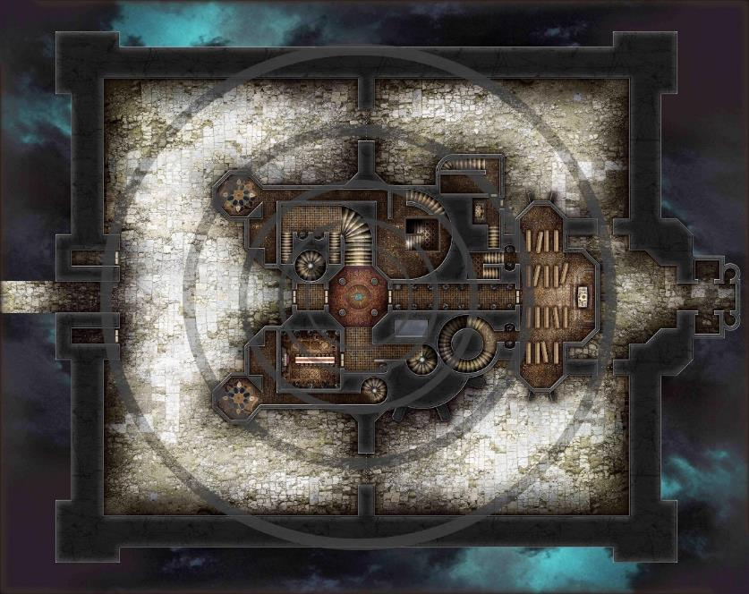

07:51

Outside the mansion, but inside the courtyard, the party now hopped onto the carpet, and Fingers took the reins.

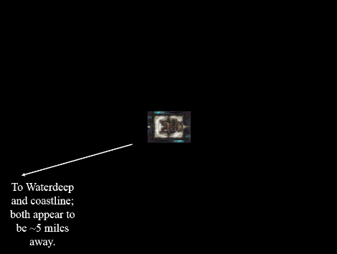

“Let’s take care that we don’t lose sight of the keep,” Lauren warned. “Go slow.”

Fingers followed directions from Lauren as it piloted the carpet. While it had been to the graveyard once before, that was some time ago and not via the air plus everything seemed distorted in the shadow realm. Keeping an eye on the chateau seemed a wise thought to the changeling. It would not do to lose track of what might be their only other possible option.

And sure enough, after about 500’, Lauren’s prophetic words came to pass, and they could no longer see the hilltop from where they’d taken off, let alone the keep atop it.

“Stop,” Lauren said, “and turn around. We can’t afford to get lost out here.”

“My thoughts exactly,” agreed Fingers, as it brought the carpet to a hover. “We can’t even be certain those lights up ahead are of Waterdeep we know.” With a mental command, the carpet did an about-face and started retracing their path.

It was actually not a given that simply turning 180 degrees would get them right back to where they started; no. They had to squint to spot the slope atop which the keep rested, and by the time they got there, they were approaching the keep not from the southwest, where they’d headed, but from the southeast.

It was the weirdest thing, and only Xaryn could really understand the logic at the moment.

They touched down again, noting nothing unusual. The front doors were still open, just as they’d left them. The air was still still.

“Okay, no. We’re not doing that again,” Lauren said firmly. “That leaves exploring the portals, which is probably what the bastards want us to do.”

Fingers sighed, “I agree, unfortunately. So many of our enemies likely wish us to go to Hell and it appears they’ll be getting their wish.”

Lauren chuckled. “I don’t want to look at that beholder, either. Maybe another portal?”

Kir had been watching the keep slowly disappear as they were flying. She had been about to say something when Lauren spoke up. Fingers had brought the carpet to a stop and turned it around. Once they were able to see it, it became clear that they had gotten turned around somehow.

Once they were down and standing outside the still open doors Kir shook her head slightly and giggled a little. “You know, this is something that if I could do, I would have done it. Just to mess with someone.” She adjusted her gear and looked at the others. “Well, no beholder and the idea of going to hell is not hi one our list. Though I think it would be a fun place to check out, we can try one of the others. Just as long as we can get back so Jasmine does worry too much.”

They stepped off the carpet, and Lauren rolled it up, stuffing it back into her haversack. The excursion had only taken a few minutes from unfurl to re-furl of the carpet.

Allisa, the cat, said “If we must go into one of those portals let us choice the least hostile. I want to go home; I cannot miss the birth of our friend’s child. I am hoping to be the godmother. “She rubbed up against Lauren as was natural for one of her current species to do, to a mate.

Still outside the keep, Lauren stroked her mate’s back and head as they talked. “I agree.”

She smiled at Fingers and Kir. “After you, of course.”

As it led the way retracing their steps to the portal chamber, Fingers discussed the possibilities, “The beholder chamber seems a dead end, as neither myself nor Kir found any other way out of there. Much as I’d prefer a more hospitable choice myself, we only have the key to Hell. I’m not sure if a portal can even be used without a key at all, let alone safely, and doing so might strand us on the other side to boot.”

Kir gave a nod when Fingers commented that neither he nor her had found a way out in the Carceri. “The portal to Hell would probably be the warmest one. Heard that the Abyss is all grey. That’s to blah for me. But if that’s the one, then I guess I will have to deal.”

Xaryn chimed in, “The shards are essential to the unlocking of the portal. Mimicking the shard is likely outside my capacities, though given time, I may be able to study some cutting-edge methods, and given the resources, we may be able to collaborate on crafting such a thing, but honestly, I think our time would be better spent on other things. Even having a device that could mimic the shards we don’t have doesn’t guarantee our passage back to the Material Plane.”

As there seemed no objections to Fingers’ suggestion of tackling the Abyss first, the changeling led the group back into the keep, up the stairs, into the Shadow Suite, and to the portal chamber, checking first whether any of the traps both mundane and otherwise had been disturbed. Satisfied that there seemed to have been no visitors during the brief time away, it removed the traps and approached the portal. Turning back to the others, it said, “OK, who has the Abyss key and do you want me to do the honors?”

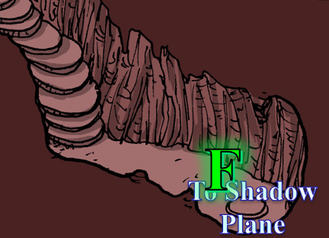

It stepped through, thinking for a moment about a guy it once knew who stepped into a sphere of annihilation thinking it was a portal to another plane. Fortunately for Fingers, Xaryn was correct in that it was a portal, and the slight ringing in Fingers’ ears confirmed that the changeling was, indeed, still existing. The rogue was in a stone chamber, and a roughly hewn staircase led upwards. It looked back into the portal, and nodded to Xaryn and Kir, who followed close behind. Lauren held Moondancer as they confirmed that no one was gasping for air, and Allisa wagged her feline tail, anticipating a scrap with a demon or two.

The smell of brine and the sound of very gently splashing ripples bespoke a body of water—perhaps even a calm ocean—nearby, and as Xaryn entered the cramped chamber, the drow whispered, “Smells like the sea.”

Wary of traps and possible ambushers, Fingers began to climb the rough stairway, wand in one hand and dagger in the other. Not knowing what to expect, the sound of shallow ripples and waves to its right made the rogue turn to see a river flowing from left to right, and probably 500’ wide at this juncture. There was another path on the left that consisted of a quiet, dark corridor.

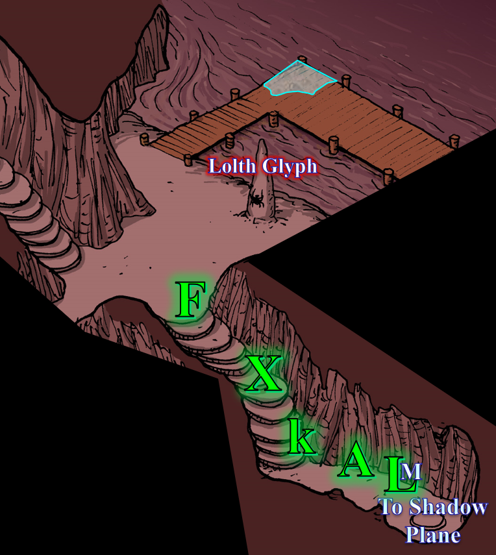

Noting a pier with a bit of water along one corner, the changeling was now leading the others into what appeared to be the end of a 10’ tall tunnel, which opened into a much vaster dome of stalactites no less than 100’ feet above them. At the 12’ wide mouth of the tunnel—where Fingers was now standing—the party followed up the stairs until they could see the X-intersection with a path leading to their left, another to their right, and a third path straight ahead.

The sounds of howling and roaring could be heard in the distance; judging from the cacophony’s quality contrasted against the ambient noise of the babbling river, whatever was making those sounds was probably a mile or more away.

“Not as awful as I thought,” Lauren commented from the back of the line, following along behind Fingers, and keeping an eye on Allisa and Moondancer. The temperature in the Abyss was actually warmer than in the Shadow Plane, and it was actually quite hospitable to those who were not encumbered by heavy robes and winter furs.

Kir had handed the key to Fingers once it was in place and they all stepped through. She then reached through, took the key out, and put it in her pouch. She also looked to see there was a key gem on this side, took that as well, and put it in her pouch.

She followed along behind Xaryn. Watching ahead as Fingers made his way up the roughhewn stairs. Once he stopped and she could see the large cavern and the other passage. She heard the water and perked up. He liked water but she knew enough not to trust it, especially here. “Yea, there should be a boat. As to the howling noise, wish I could place it.” She looked around and saw a 3’ tall stalagmite with something on it. She headed over to check it out.

Allisa sniffed around moving up to Fingers’ side. She heard the noises and tried to place what creatures they might be to inform the others. “If there is a dock then a boat must exist somewhere” she purred. The Cat then went to sniff at each intersection to see what had traveled those paths recently.

Instead of stopping her before it could finish making sure all was kosher, Fingers also approached the spire cautiously, eying the glyph carefully. Magical traps were harder to spot but not impossible for a practiced eye.

It was likely Allisa who tripped the invisible glyph that none could see. Instantly and without so much as a warning, the party was surrounded by a handful of combatants who didn’t appear to have any interest in parlaying. Catching the heroes completely unaware and unexpectant, the villains that had materialized at all four corners of the intersection were now preparing for a deathmatch.

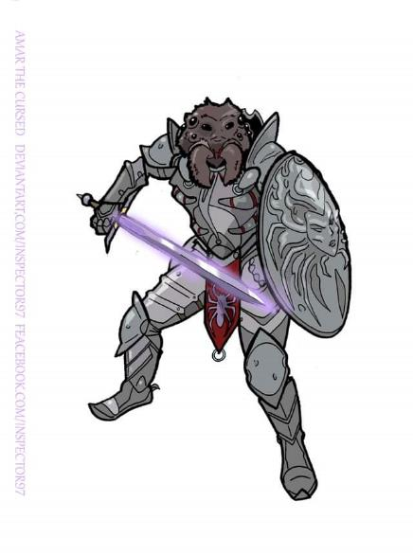

An ettercap paladin of slaughter said in Undercommon, << At last! >> The anti-paladin then looked at Allisa and Fingers, and said in the tongue they could not understand: << Your tripes are my tinsel, and your brains are my dessert! >> Then he cast bull’s strength [expired on Round 131] upon himself.
Ettercap anti-paladin gained +4 to Strength.

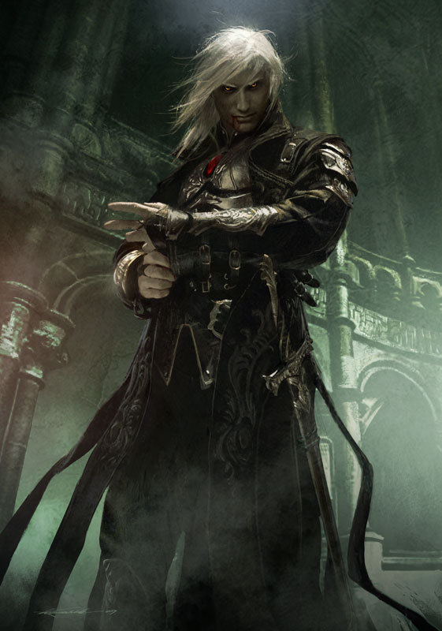

Lauren and Xaryn understood this language, and then heard a male drow to their left casting a barkskin [expired on Round 701] spell after blurting, << Should’ve left well enough alone, Xaryn of Yril’Lysane. Now you’ll join your friend, Dulkhende! >>
This dude gained +4 to AC and FF AC.

Xaryn didn’t recognize this bloke, but they apparently had a mutual acquaintance before Dulkhende’s untimely death.

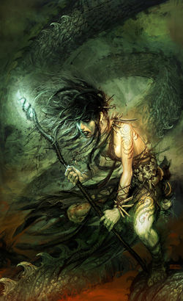

The third passage was now blocked by a water genasi black dragon shaman-marshal who quaffed a potion of bull’s strength [expired on Round 61], while the last hosted an Abyssal drow ghoul springing forth and pouncing on Lauren and Moondancer.
Dragon shaman gained +4 to Strength.
Character | Attack Type | Damage | BAB | Str Mod+ | W+ | Other+ | Total Score | Roll | Total | Targeting
Duncecap | Front Claw 1 | 1d4+7+disease | 8 | 7 | 0 | 0 | 15 | 8 | 23 | Lauren
Duncecap | Front Claw 2 | 1d4+7+disease | 8 | 7 | 0 | 0 | 15 | 6 | 21 | Moondancer
Duncecap | Rear Claw | 2d4+3+disease | 8 | 7 | 0 | 0 | 15 | 13 | 28 | Lauren
Miss, hit, miss. 1d100 = 73, 89, both swings bypass displacement.
Dmg to Moondancer: 3 + 7 = 10 + disease.
Character | Save vs.  Disease | Ranks | Roll | Save
Moondancer | Fortitude | 4 | 8 | 12
Fail. Moondancer contracts demon fever, set to deal 1d6 Con in 24 hours.

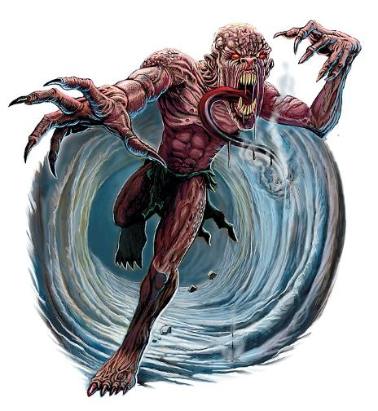

Wounded and now infected, the pseudodragon jumped off of Lauren and flew back towards the portal at an altitude of 10’ to avoid a second swipe from the ghoul. Not having noticed that Kir had taken the shard out of the portal, the dragon crashed against the portal and dishonored its ancestors.

Behind the other male drow, Xaryn could now see another chest that resembled a mimic, this one being a larger, longer version of the one they’d opened back in the Material Plane; the first mimic-looking chest had contained smoking paraphernalia and the first shard they’d found, which had led to Carceri.

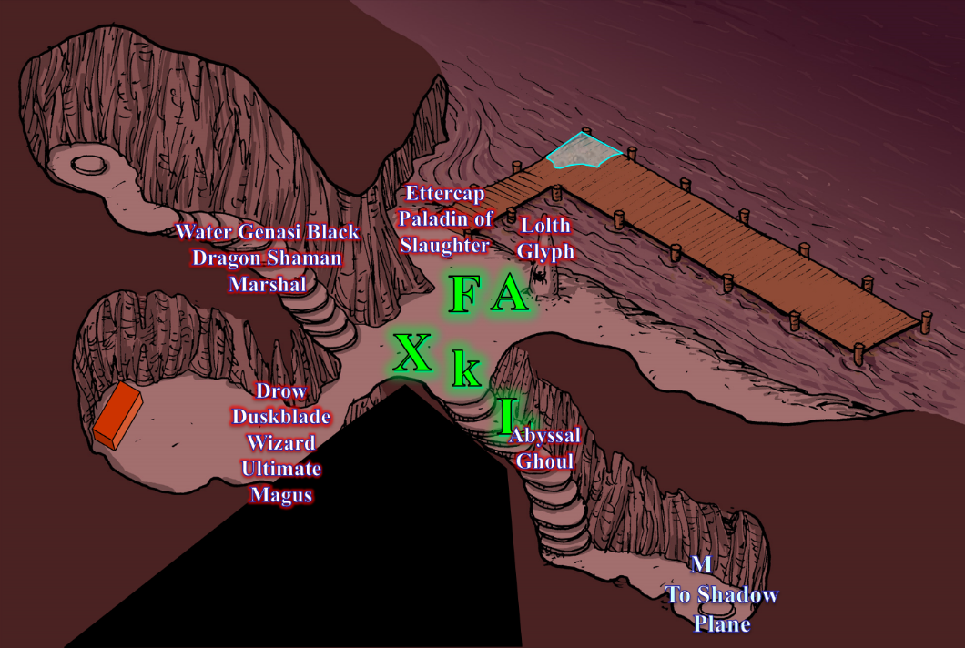

Round 1 [08:02]

Character | Group | Initiative | Roll | Modified Roll | Move
Duncecap | 2 | 7 | 18 | 25 | 40’
Lauren | 1 | 4 | 18 | 22 | 30’
Kir | 1 | 1 | 20 | 21 | 20’
Kafi | 2 | 4 | 16 | 20 | 30’
Xaryn | 1 | 5 | 13 | 18 | 30’
Velvet | 2 | 3 | 10 | 13 | 30’
Allisa | 1 | 3 | 9 | 12 | 30’
Fingers | 1 | 4 | 5 | 9 | 30’
Jinx | 2 | 1 | 1 | 2 | 30’

The Abyssal ghoul attacked Lauren again, trying to pin her down and feed off her soul a little bit.
Character | Attack Type | Damage | BAB | Str Mod+ | W+ | Other+ | Total Score | Roll | Total | Crit | Threat
Duncecap | Touch Attack | Grapple | 8 | 7 | 0 | 0 | 15 | 17 | 32 | 19 | ý
Hit. 1d100 = 05, displacement not bypassed. Grapple unsuccessful.

Lauren swift-cast haste [expired on Round 16], and full-attacked the ghoul with Arkenlyl. She’d thoughtfully installed the Greater Truedeath crystal when they entered the Shadow realm, and her sword had a vampiric touch spell stored. She meant to dispatch the creature quickly, so she could help her companions with the other foes.
Melee Weapon | Dmg | D+ | TH+ | Critical | Type | Wt. | Atk | Roll | Check
Shattermantle Bloodstone Falchion +3 | 2d4 | +3 +3 | 3 | 18-20/x2 | Slashing | 8.0 | +23 | 20 | 43
SB Falchion +3, 2nd Attack | 2d4 | +3 +3 | 3 | 18-20/x2 | Slashing |  | +18 | 19 | 37
SB Falchion +3, 3rd Attack | 2d4 | +3 +3 | 3 | 18-20/x2 | Slashing |  | +13 | 1 | 14
SB Falchion +3, haste | 2d4 | +3 +3 | 3 | 18-20/x2 | Slashing |  | +23 | 1 | 24
Greater Truedeath Crystal | 1d6 | vs. | undead | - | - |  | - |  | -
Threat, threat, miss, miss. 1d20 = (6 + 23 = 29); (3 + 18 = 21): 1 critical hit. Dmg: [2 x (5 + 3 + 3) + 4 pos] + (2 + 3 + 3 + 2 pos) = 26 + 10 = 36.

Moondancer cowered behind the portal.
Character | Check | Ranks | Roll | Save
Moondancer | Hide | 20 | 3 | 23
Outcome unknown.

Kir had been surprised when the enemy appeared. She had expected something at some point, but not so soon. The only good thing was that not all of them attacked right away. Her attention had been drawn to the ettercap paladin. She did not understand what it was saying but she knew enough that it had probably cast a spell upon its self. The cleric-rogue cast dispel magic at the ettercap paladin.
Ranged Weapon | TH+ | Atk | Roll | Check
Dispel Magic | 4 | +12 | 14 | 26
Success. Jinx lost the +4 bonus to Strength.

The ettercap lost its boost, but remained resolute.

Kafi began with a high-level wizard spell: ray of exhaustion [expired on Round 131]. He targeted the closest enemy, his fellow drow.
Save vs.  ray of exhaustion | Rank | Ability & Mod. | Misc. Mods. | Total | Roll | Check
Xaryn, Fortitude | 4 | Con (+2) | 0 | 6 | 5 | 11
Fail. Xaryn became Exhausted: movement halved; –6 penalty to Strength and Dexterity.
Strength | 4 | -3
Dexterity | 6 | -2

Velvet vomited a line of acid upon Xaryn, but the corrosive bile hit Kir, Lauren, Duncehat, and Moondancer a little bit as well.
Ranged Weapon |  | Dmg. | D+ | Rng. | Notes
Breath Weapon (line of acid) |  | 6d6 | +1d6 | 60’ | DC 10 + 2 focus + 5
Save vs.  Breath Weapon | Rank | Ability & Mod. |  | Total | Roll | Check
Xaryn, Reflex | 4 | Dex (-2) |  | 2 | 4 | 6
Lauren, Reflex | 5 | Dex (+2) |  | 1 | 8 | 1 | 9
Kir, Reflex | 7 | Dex (+1) |  | 0 | 8 | 8 | 16
Fail, fail, fail.
Dmg to Xaryn: 15 + 6 = 21 acid [48/69].
Dmg to Lauren: 20 + 5 = 25 acid [118/143].
Dmg to Kir: 21 + 3 = 24 acid [71/95].

Fingers chided itself for being suckered by a standard misdirection ploy and activated the wand to go invisible [expired on Round 7].
Skill | Rank | Ability & Mod. | Misc. Mods. | Total | Roll | Check
Fingers, Use Magic Device | 17 | Cha (+2) | 0 | 19 | 15 | 34
Automatic success.

It then moved as quietly as possible while tucking the wand into its pocket, finishing behind the ettercap in order to ruin the anti-paladin’s whole day.
Skill | Rank | Ability & Mod. | Misc. Mods. | Total | Roll | Check
Fingers, Move Silently | 10 | Dex (+4) | 0 | 14 | 5 | 19
Result unknown due to ambient sounds.

Jinx saw the rogue go invisible, probably heard it stepping on the pier’s wooden boards, cast rhino’s rush, and charge-power[-3/+6]-attacked Allisa’s leopard form.
Melee Weapon | Dmg | D+ | TH+ | Critical | Type | Wt. | Atk | Roll | Check | Properties
Unholy Greatsword +1 | 2d6+2 | +6 + 1  +2 charge  + 6 power | 3 +  2 charge | 17-20/x2 | Slashing | 8.0 | +19 | 2 | 21 | +2d6 to good
Hit. Dmg: 2 (rhino’s rush) x (4 + 2 + 6 + 1 + 2 + 6) = 42 [48/90].

Allisa and Xaryn hesitated.

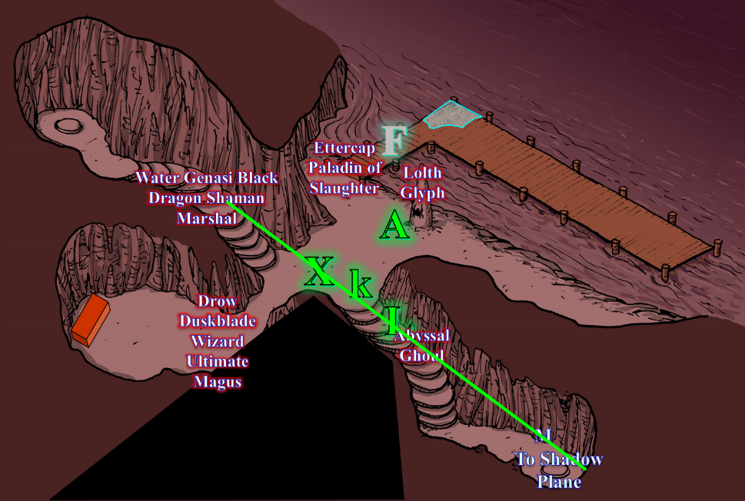

Round 2

Duncecap tried again to pin Lauren down.
1d100 = 53, displacement not bypassed. Attack failed.

Lauren dodged the Abyssal ghoul’s attempt.

Lauren repeated the hack-and-slash maneuvers.
Melee Weapon | Dmg | D+ | TH+ | Critical | Type | Wt. | Atk | Roll | Check
Shattermantle Bloodstone Falchion +3 | 2d4 | +3 +3 | 3 | 18-20/x2 | Slashing | 8.0 | +23 | 7 | 30
SB Falchion +3, 2nd Attack | 2d4 | +3 +3 | 3 | 18-20/x2 | Slashing |  | +18 | 3 | 21
SB Falchion +3, 3rd Attack | 2d4 | +3 +3 | 3 | 18-20/x2 | Slashing |  | +13 | 19 | 32
SB Falchion +3, haste | 2d4 | +3 +3 | 3 | 18-20/x2 | Slashing |  | +23 | 9 | 32
Hit, miss, threat, hit. 1d20 = 9 + 13 = 22, not a critical hit. Dmg: (5 + 3 + 3 + 4 pos) + (3 + 3 + 3 + 1) + (4 + 3 + 3 + 5 pos) = 40.

The ghoul lost an arm, and was now unable to grapple her, but was still fierce and bloodthirsty.

Moondancer spoke to Lauren telepathically, “Git’im! Oooh! You’re good!”

Kir cast summon monster IV, conjuring a yeth hound, and had it attack the water genasi black dragon shaman-marshal.

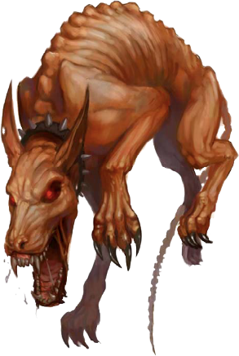

A yeth hound—a native of Hades—materialized in the Abyss just over the genasi dragon shaman’s head, baying instinctively, and pounced down on the enemy below.
Save vs.  Panic | Rank | Ability & Mod. | Misc. Mods. | Total | Roll | Check | Notes
Allisa, Will | 9 | Wis (+3) | 0 | 12 | 12 | 24
Fingers, Will | 6 | Wis (+2) | 1 | 9 | 12 | 21 | +3 vs. mind-affecting spells (from crystal)
Kir, Will | 8 | Wis (+2) | 0 | 10 | 6 | 16 | +2 vs. Fear
Lauren, Will | 10 | Wis (+3) | 1 | 14 | 14 | 28 | +2 vs. Enchantments
Xaryn, Will | 8 | Wis (+2) | 0 | 10 | 10 | 20 | +2 vs. Enchantments
Success⁵.
The heroes were not panicked, and became immune to this yeth hound’s baying.
Character | Attack Type | Damage | BAB | Str Mod+ | Dex Mod+ | W+ | Other+ | Total Score | Roll | Total | Crit | Threat
Yeth Hound | Bite | 1d8+4 | 3 | 3 | 2 | 0 | 0 | 6 | 11 | 17 | 19 | ý
Miss.

The flying hound snapped at the genasi, but pulled back only scraps of the genasi’s black dragonhide cloak. Its hadean baying didn’t faze the heroes all that much, though they weren’t too fond of its resemblance to a humanoid’s desperate screams.

“Fuck you all!” Kafi spat on the ground before taking a few steps forward, and cast negative energy burst, catching everyone in the burst.
Save vs.  negative energy burst | Rank | Ability & Mod. | Misc. Mods. | Total | Roll | Check | Notes
Allisa, Will | 9 | Wis (+3) | 0 | 12 | 2 | 14
Fingers, Will | 6 | Wis (+2) | 1 | 9 | 8 | 17
Kir, Will | 8 | Wis (+2) | 0 | 10 | 12 | 22
Lauren, Will | 10 | Wis (+3) | 1 | 14 | 20 | 34 | +2 vs. all spells
Xaryn, Will | 8 | Wis (+2) | 0 | 10 | 3 | 13
Fail, success, success, success, fail.
Dmg to Allisa: 23 negative energy [25/90].
Dmg to Fingers: ½ x 28 = 14 negative energy [68/82].
Dmg to Kir: ½ x 33 = 16 negative energy [55/95].
Dmg to Lauren: ½ x 21 = 10 negative energy [108/143].
Dmg to Xaryn: 27 negative energy [21/69].
Save vs.  negative energy burst | Rank | Ability & Mod. | Misc. Mods. | Total | Roll | Check | Notes
Jinx, Will | 4 + 2^{PfG} | Wis (+3) | 6 | 15 | 15 | 30 | True Believer bonus +2
Velvet, Will | 7 | Wis (+1) | 0 | 8 | 8 | 16
Success, success, fail.
Dmg to Jinx: ½ x 32 = 16 negative energy.
Dmg to Velvet: 22 negative energy.
Duncecap healed 29 hit points.

The Abyssal ghoul began to grow its missing claw again, albeit slowly.

Velvet full-attacked the yeth hound with her spear.
Melee Weapon | Dmg | D+ | TH+ | Critical | Type | Wt. | Atk | Roll | Check
Returning Shortspear +2 | 1d6 | +5 +2 +2 | 2 | x3 | Piercing | 9.0 | 16 | 10 | 26
Returning Shortspear, 2nd attack | 1d6 | +5 +2 +2 | 2 | x3 | Piercing | - | 11 | 13 | 24
Hit, hit. Dmg: (3 + 5 + 2 + 2) + (5 + 5 + 2 + 2) = 12 + 14 = 26.

This was more than enough for the yeth hound to be destroyed; the conjured beast dematerialized with the second jab.

Fingers backstabbed the anti-paladin twice with its dagger.
Melee Weapon | Dmg | D+ | TH+ | Critical | Type | Wt. | Atk | Roll | Check
Eager Dagger +1 | 1d4+cripple | 1 | 1 + 2 flank | 19-20, x2 | Prcg/Slash | 0.5 | +17 | 16 | 33
Eager Dagger, 2nd Attack | 1d4+cripple | 1 | 1 + 2 flank | 19-20, x2 | Prcg/Slash | - | +12 | 14 | 26
Hit, hit. Dmg: (2 + 1 + 18 sneak) + (4 + 1 + 20 sneak) = 46 + cripple².
Jinx accrued a -4 Strength penalty.

The blindsighted Jinx turned to see no visible enemy, assumed it was the changeling, and turned to full-attack Fingers.
1d100 = 35, 73, 79. Blind Fight reroll: 16. Concealment bypassed on swings 2 and 3.
Melee Weapon | Dmg | D+ | TH+ | Critical | Type | Wt. | Atk | Roll | Check
Unholy Greatsword +1 | 2d6+2 | +6 + 1 | 3 | 17-20/x2 | Slashing | 8.0 | +20 | 20 | -
2nd Attack | 2d6+2 | +6 + 1 | 3 | 17-20/x2 | Slashing |  | +15 | 17 | 32
3rd Attack | 2d6+2 | +6 + 1 | 3 | 17-20/x2 | Slashing |  | +10 | 6 | 16
Miss, hit, miss. Dmg: 7 + 2 + 6 + 1 = 16 [52/82].

The ettercap was able to swing enough times to hit the invisible changeling once.

[I will NPC this character until his player reprises his actions.] Xaryn cast Melf’s acid arrow upon Kafi, who was now upon him.
Ranged Weapon | Dmg. | D+ | Atk | Roll | Check
Ranged Touch Attack | 2d4 acid | Repeat for 3 add’l rounds | +4 | 11 | 15
Hit. Dmg: 7 acid.

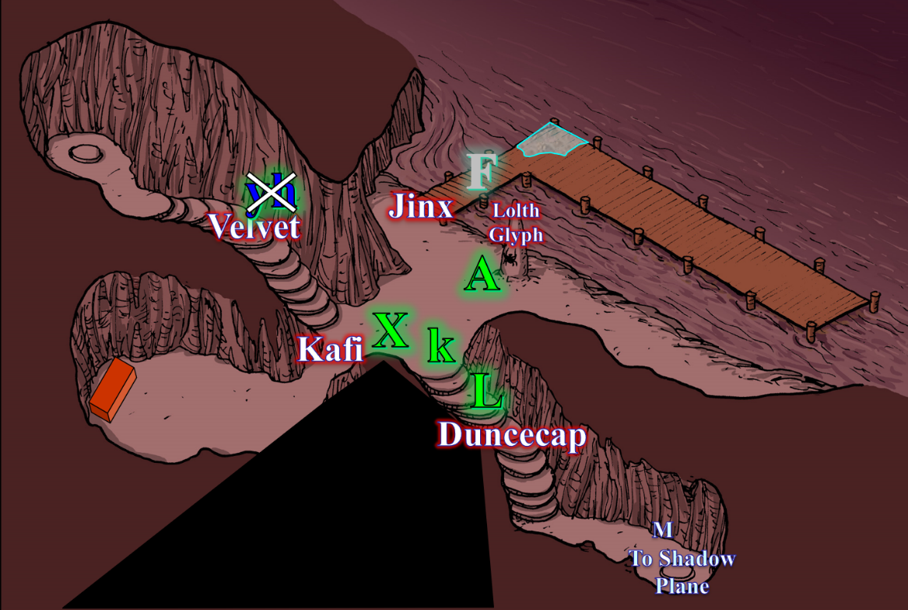

Round 3

Duncecap came to the realization that he probably wasn’t going to be able to pin down the duskblade, so he just swiped at her with its remaining claws as his new baby claw started growing back.
Character | Attack Type | Damage | BAB | Str Mod+ | Total Score | Roll | Total | Notes
Duncecap | Front Claw 1 | 1d4+7+disease | 8 | 7 | 15 | 10 | 25 | DC 17 Fort
Duncecap | Front Claw 2 | 1d4+7+disease | 8 | 7 | 15 | 15 | 30 | Improved Grab
Duncecap | Rear Claw | 2d4+3+disease | 8 | 7 | 15 | 3 | 18 | Sneak Attack +5d6
Miss, miss, miss.

Lauren channeled inflict serious wounds on her next four strikes against Duncecap.
Melee Weapon | Dmg | D+ | TH+ | Critical | Type | Wt. | Atk | Roll | Check
Shattermantle Bloodstone Falchion +3 | 2d4 | +3 +3 | 3 | 18-20/x2 | Slashing | 8.0 | +23 | 14 | 37
SB Falchion +3, 2nd Attack | 2d4 | +3 +3 | 3 | 18-20/x2 | Slashing |  | +18 | 13 | 31
SB Falchion +3, 3rd Attack | 2d4 | +3 +3 | 3 | 18-20/x2 | Slashing |  | +13 | 11 | 24
SB Falchion +3, haste | 2d4 | +3 +3 | 3 | 18-20/x2 | Slashing |  | +23 | 18 | 41
Greater Truedeath Crystal | 1d6 | vs. | undead | - | - |  | - |  | -
Hit, hit, hit, threat. 1d20 = 9 + 23 = 32, critical hit.
Dmg: (5 + 3 + 3 + 3 pos) + (4 + 3 + 3 + 1 pos) + (6 + 3 + 3 + 4 pos) + [2 x (4 + 3 + 3) + 5 pos] = 14 + 11 + 16 + 25 = 66.

The Abyssal ghoul was no more.

Moondancer said, “Whoaaa!”

Kir was pissed now that she had throw-up on her. “DAMN you!” She cast slash tongue at the water genasi black dragon shaman-marshal. It wasn’t much, but if it worked, she would have a little bit harder time casting.
Save vs.  slash tongue | Rank | Ability & Mod. | Misc. Mods. | Total | Roll | Check
Velvet, Fortitude | 7 | Con (+2) | 0 | 9 | 5 | 14
Success. Effect negated.

Kafi suffered from the further corrosive effects of the Melf’s acid arrow spell.
Dmg: 3 acid.

Dripping with the acidic goo, the wizard-duskblade-ultimate magus Quick-cast vampiric touch, and slashed at Xaryn.
Melee Weapon | Dmg | D+ | TH+ | Critical | Type | Wt. | Atk | Roll | Check
Falchion +3 | 2d4 | +3 +3 | 3 | 18-20/x2 | Slashing | 8.0 | +15 | 3 | 18
Miss.

Velvet jumped down the steps and charge-attacked Xaryn.
Skill | Rank | Ability & Mod. | Misc. Mods. | Total | Roll | Check
Velvet, Jump | 0 | Str (+5) | -2 | 3 | 13 | 16
Success.
Melee Weapon | Dmg | D+ | TH+ | Critical | Type | Wt. | Atk | Roll | Check
Returning Shortspear +2 | 1d6 | +5 +2 +2  +2 charge | 2+  2 charge | x3 | Piercing | 9.0 | 18 | 17 | 35
Hit. Dmg: 3 + 5 + 2 + 2 + 2 = 14 [7/69].

Allisa bit at the paladin, going for a grapple if the attack was successful, following by raking the enemy with her claws.
Grapple | D+ | Atk | Roll | Check
Allisa, Touch Attack | +1 | +12 | 4 | 16
Allisa, Grapple | +1 | +12 | 11 | 23
Jinx, Grapple | - | +16 | 9 | 25
Grapple unsuccessful. Jinx broke free.

Unable to do much to Fingers at the moment, Jinx turned around and full-attacked Allisa.
Melee Weapon | Dmg | D+ | TH+ | Critical | Type | Wt. | Atk | Roll | Check
Unholy Greatsword +1 | 2d6+2 | +6 + 1 | 3 | 17-20/x2 | Slashing | 8.0 | +20 | 7 | 27
2nd Attack | 2d6+2 | +6 + 1 | 3 | 17-20/x2 | Slashing |  | +15 | 10 | 25
3rd Attack | 2d6+2 | +6 + 1 | 3 | 17-20/x2 | Slashing |  | +10 | 16 | 26
Hit, hit, hit. Dmg: (9 + 2) + (6 + 2) + (3 + 2) = 11 + 8 + 5 = 24 [1/90].

Barely alive, Allisa’s feline form bled all over the riverbank.

Fingers continued going all stabby-like against the ettercap.
Melee Weapon | Dmg | D+ | TH+ | Critical | Type | Wt. | Atk | Roll | Check
Eager Dagger +1 | 1d4+cripple | 1 | 1 | 19-20, x2 | Prcg/Slash | 0.5 | +15 | 15 | 30
Eager Dagger, 2nd Attack | 1d4+cripple | 1 | 1 | 19-20, x2 | Prcg/Slash | - | +10 | 4 | 14
Hit, miss. Dmg: 1 + 22 sneak = 23 + cripple.
Jinx accrued an additional -2 Strength penalty.

Xaryn got a few steps ahead of the snow leopard and his halfling companion, acquired a line of attack to the rival drow male, and zapped his ass with a lightning bolt.
Save vs.  lightning bolt | Rank | Ability & Mod. | Misc. Mods. | Total | Roll | Check
Kafi, Reflex | 3 | Dex (+0) | 1 | 4 | 4 | 8
Fail. Dmg: 31 electric.

It became evident that the electricity nearly killed Kafi, but the ultimate magus was still kicking and preparing to finish off his foes.

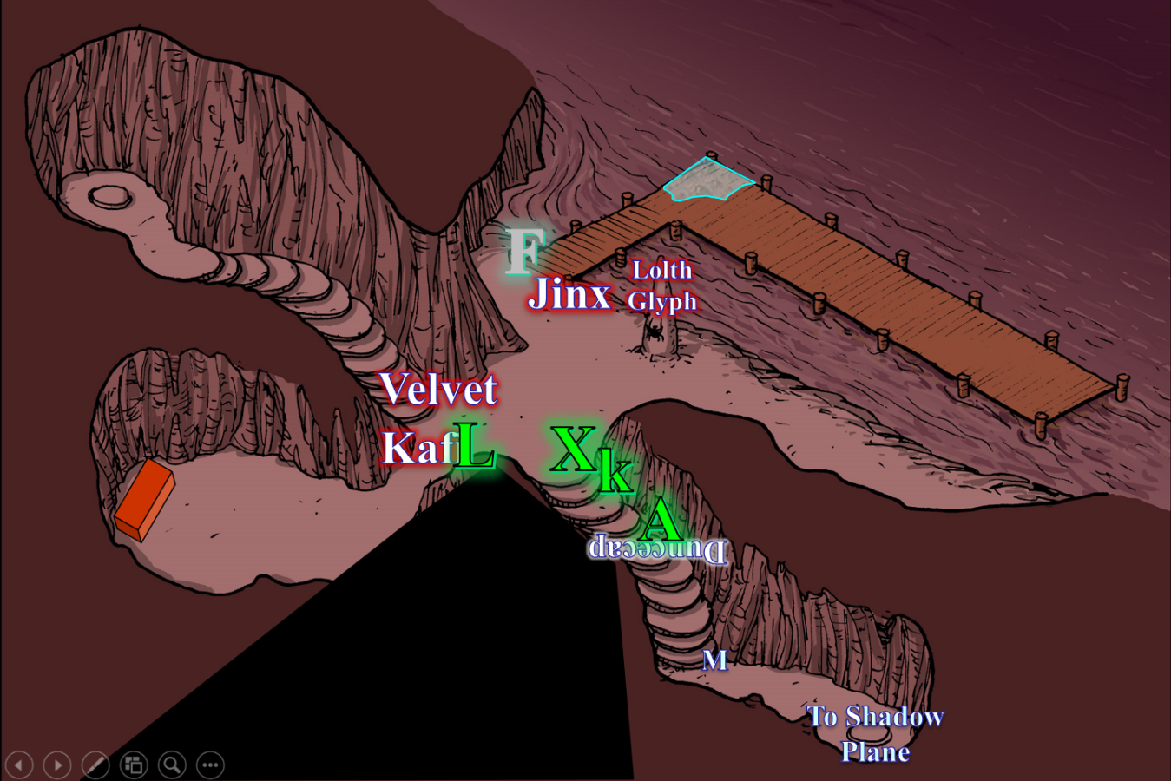

Round 4

Lauren turned to see that Allisa was gravely wounded. The duskblade snarled in rage, and Quick-cast regroup to put everyone else behind her on the stairs.

[DM assumption that all PCs are willing.] Lauren’s friends were immediately teleported to her side, whereupon she then cast swift fly, and charged into battle with Kafi, charge-attacking the enemy duskblade. [Full-attack not possible with 10’ move.]
Melee Weapon | Dmg | D+ | TH+ | Critical | Type | Wt. | Atk | Roll | Check
Shattermantle Bloodstone Falchion +3 | 2d4 | +3 +3  + 2 charge | 3 + 2  charge | 18-20/x2 | Slashing | 8.0 | +25 | 18 | 43
SB Falchion +3, haste | 2d4 | +3 +3 | 3 | 18-20/x2 | Slashing |  | +25 | 10 | 35
Threat, hit. 1d20 = 14 + 23 = 37, critical hit. Dmg: [2 x (6 + 3 + 3)] + (3 + 3 + 3) + 31 vampiric = 24 + 9 = 33.
Lauren [135/143].

Kafi looked like he’d had enough, but Lauren could not tell.

Moondancer sniffed the air as the ghoul withered at Xaryn’s and Allisa’s feet.

Kir watched as the yeth hound was destroyed. Though it had not been here long, it did do it purpose of getting the attention of the genasi. She cast cat’s grace [expired on Round 84] on herself, then took her bow and shot an arrow at the genasi.
Kir gained +4 to Dexterity.

Kafi cast wracking touch upon his counterpart.
Save vs.  wracking touch | Rank | Ability & Mod. | Misc. Mods. | Total | Roll | Check
Lauren, Fortitude | 10 | Con (+2) | 1 | 13 | 13 | 26
Dmg: ½ x (2 + 7) = 4 negative energy [104/143].

Kafi suffered from the corrosive effects of the Melf’s acid arrow spell.
Dmg: 7 acid.

<< Aargh! Blast! >> cursed the ultimate magus in Undercommon as he now resigned himself to death, fell to his knees, and gave up the fight, dropping his sword.

Hardly wounded, and with very little other recourse, Velvet jabbed at Lauren.
Melee Weapon | Dmg | D+ | TH+ | Critical | Type | Wt. | Atk | Roll | Check
Returning Shortspear +2 | 1d6 | +5 +2 +2 | 2 | x3 | Piercing | 9.0 | 16 | 15 | 31
Returning Shortspear, 2nd attack | 1d6 | +5 +2 +2 | 2 | x3 | Piercing | - | 11 | 15 | 26
Miss, miss.

The dragon shaman’s stone spear tip nearly broke against the duskblade’s metal armor.

Fingers felt the pull of Lauren’s spell and resisted it to continue making holes in the ettercap.
Melee Weapon | Dmg | D+ | TH+ | Critical | Type | Wt. | Atk | Roll | Check
Eager Dagger +1 | 1d4+cripple | 1 | 1 | 19-20, x2 | Prcg/Slash | 0.5 | +15 | 4 | 19
Eager Dagger, 2nd Attack | 1d4+cripple | 1 | 1 | 19-20, x2 | Prcg/Slash | - | +10 | 17 | 27
Eager Dagger, haste | 1d4+cripple | 1 | 1 | 19-20, x2 | Prcg/Slash | - | +15 | 11 | 26
Miss, hit, hit. Dmg: (2 + 1 + 14 sneak)+ (1 + 1 + 23 sneak) = 17 + 25 = 42 + cripple².
Jinx accrued an additional -4 Strength penalty.

The ettercap paladin of slaughter faltered, but regained his step. Fingers could tell it was nearly done, and swung again.
1d100 = 21, 11, 59; reroll 13, 12; third attack bypasses concealment.
Melee Weapon | Dmg | D+ | TH+ | Critical | Type | Wt. | Atk | Roll | Check
Unholy Greatsword +1 | 2d6+2 | +6 + 1 | 3 | 17-20/x2 | Slashing | 8.0 | +20 | 7 | 27
2nd Attack | 2d6+2 | +6 + 1 | 3 | 17-20/x2 | Slashing |  | +15 | 3 | 18
3rd Attack | 2d6+2 | +6 + 1 | 3 | 17-20/x2 | Slashing |  | +10 | 20 | 30
Threat. 1d20 = 18 + 10 = 28, critical hit. Dmg: 2 x (9 + 2 + 6 + 1) = 36 [16/82].

Allisa also felt the tug of magic and did not resist as she re-materialized she reverted to herself feeling life flow back into her.
Allisa gained 15 hps [16/90].

Seeing that Lauren was holding the foes back, Xaryn drank one of his potions of cure moderate wounds.
Xaryn gained 8 + 5 = 13 hps [20/69].

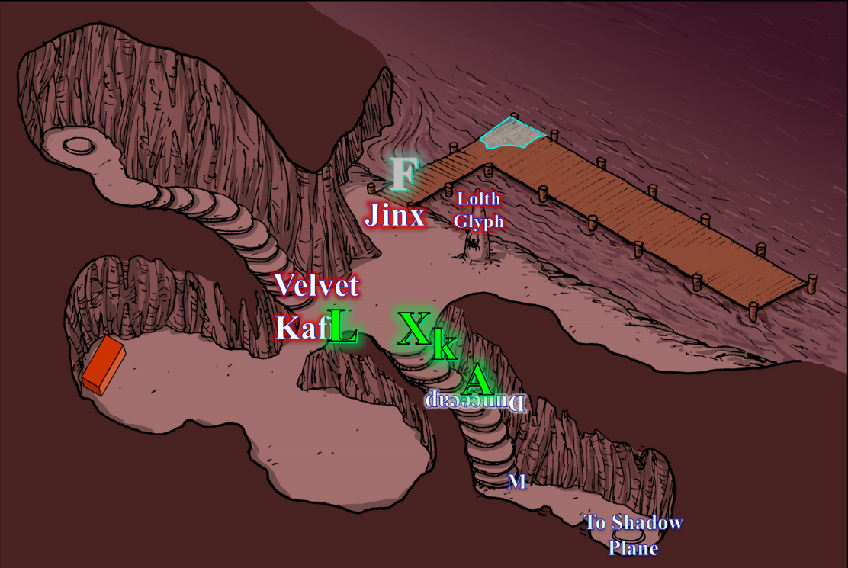

Round 5

Kafi bled out and died.

Jinx began to make his way towards Lauren, stepping meaningfully in his bulky armor.

Fingers was rocked by Jinx’s lucky blow and didn’t think it could survive another. Tiptoeing away onto the dock to open space between them, it then fired a blast hoping to finish the bugger off.
Ranged Weapon | Dmg. | D+ |  | TH+ | Critical | Rng. | Wt. | Atk | Roll | Check | Notes
Eldritch Blast | 1d6 | 0 |  | 0 | x2 | 60’ | - | +14 | 5 | 19 | +5d6 Sneak
Hit. Dmg: 1 + 20 = 21 magic.

The paladin went down face first, his chitinous face now buried in the sand.

As it looked where it was going, Fingers noted that the wet surface of the deck was alive, and probably an elemental, though it appeared to be dying or feigning to die.

[Blending Lauren’s turn with Velvet’s escape.]

<< The Nibbler is no more! A plague upon you all! >> Velvet cursed in Draconic, and ran away, dashing into the shallow shore.
Skill/Save | Rank | Ability & Mod. | Misc. Mods. | Total | Roll | Check
Velvet, Jump | 0 | Str (+5) | -2 | 3 | 10 | 13
See below.

Lauren had anticipated the sole survivor’s fleeing, and had moved back to anticipate the action. She now swung fiercely at the dragon shamaness as she escaped.
Melee Weapon | Dmg | D+ | TH+ | Critical | Type | Wt. | Atk | Roll | Check
Shattermantle Bloodstone Falchion +3 | 2d4 | +3 +3 | 3 | 18-20/x2 | Slashing | 8.0 | +23 | 18 | 41
SB Falchion +3, 2nd Attack | 2d4 | +3 +3 | 3 | 18-20/x2 | Slashing |  | +18 | 12 | 30
SB Falchion +3, 3rd Attack | 2d4 | +3 +3 | 3 | 18-20/x2 | Slashing |  | +13 | 19 | 32
SB Falchion +3, haste | 2d4 | +3 +3 | 3 | 18-20/x2 | Slashing |  | +23 | 20 | 43
Obscene: Threat, hit, threat, threat. 1d20 = 20, 14, 7; all crits.
Dmg: 2 x [(4 + 3 + 3)] + (6 + 3 + 3) + 2 x [(8 + 3 + 3)] + 2 x [(3 + 3 + 3)] = 20 + 12 + 28 + 18 = 78.

The black dragon shaman had intended to disappear into the depths of the river as quickly as her swimming skills could propel her there, but instead Lauren literally cut her arms off, and did a good number on her hamstrings before slicing her thorax and rendering her unable to swim at all.

Moondancer came out from her cowering, snarling as she tried to emulate Velvet’s acidic dragon breath. Alas, nothing happened when the pseudodragon did this. She sighed with the knowledge that she would never be a mighty drake.

[The teleportation was on the previous round, before Kir’s actions took place.] Kir had felt the tug of a spell, and had let it happen, so she was now finding herself behind the duskblade, and looked to see if she had a shot at any of those that were left. She walked about 20’ until she did, then drew her bow.

Seeing for the most part that the battle was over she called out to the others all who are wound gather around me and I will provide healing. Lauren, I need my wand as soon as you can. The druid moved forward to stand in the middle of the crossroads waiting for the others to gather.

Lauren walked 30’ towards the coastline, peering into the Abyssal river. Little did she know that it was a vein of the Styx. Roars and screams echoed throughout the cavern as malignant souls were reaped and wrought by mightier fiends.

Xaryn’s clothes had been slashed and corroded by acid, and it was worth his time to cast mending on them as the others regrouped. Looking tiptop once more, but still quite wounded after quaffing one of his potions, the drow beheld the site of Fingers’ resolve.

Round 6

Unwilling to let one of the foes escape and possibly return with reinforcements, Fingers had already moved to the end of the dock and now fired a blast at the maimed enemy. The invisible rogue said, “Let’s see if I can end this now.”
1d100 = 97, concealment bypassed.
Ranged Weapon | Dmg. | D+ | TH+ | Critical | Rng. | Wt. | Atk | Roll | Check | Notes
Eldritch Blast | 1d6 | 0 | 0 | x2 | 60’ | - | +14 | 7 | 21 | +5d6 Sneak
Hit. Dmg: 2 + 19 = 21 magic.

And it was so that Fingers ended Velvet’s time among the living. Perhaps her soul would stay here in the Abyss.

Allisa asked that the wounded sit for healing, then spotted what she identified as a dying water elemental along the corner of the pier. As they did, she tried communing with the elemental, but had not prepared a commune with nature spell. Her Wild Empathy ability would have to do, but the primal organism couldn’t speak due to its withered state.

Having just slain a water genasi black dragon shaman, Fingers cautioned Allisa regarding the elemental. Allisa disregarded the rogue’s heed, being astute enough in her specialization that she could trust her instincts, then moved close enough that her spontaneous healing would affect it as well.

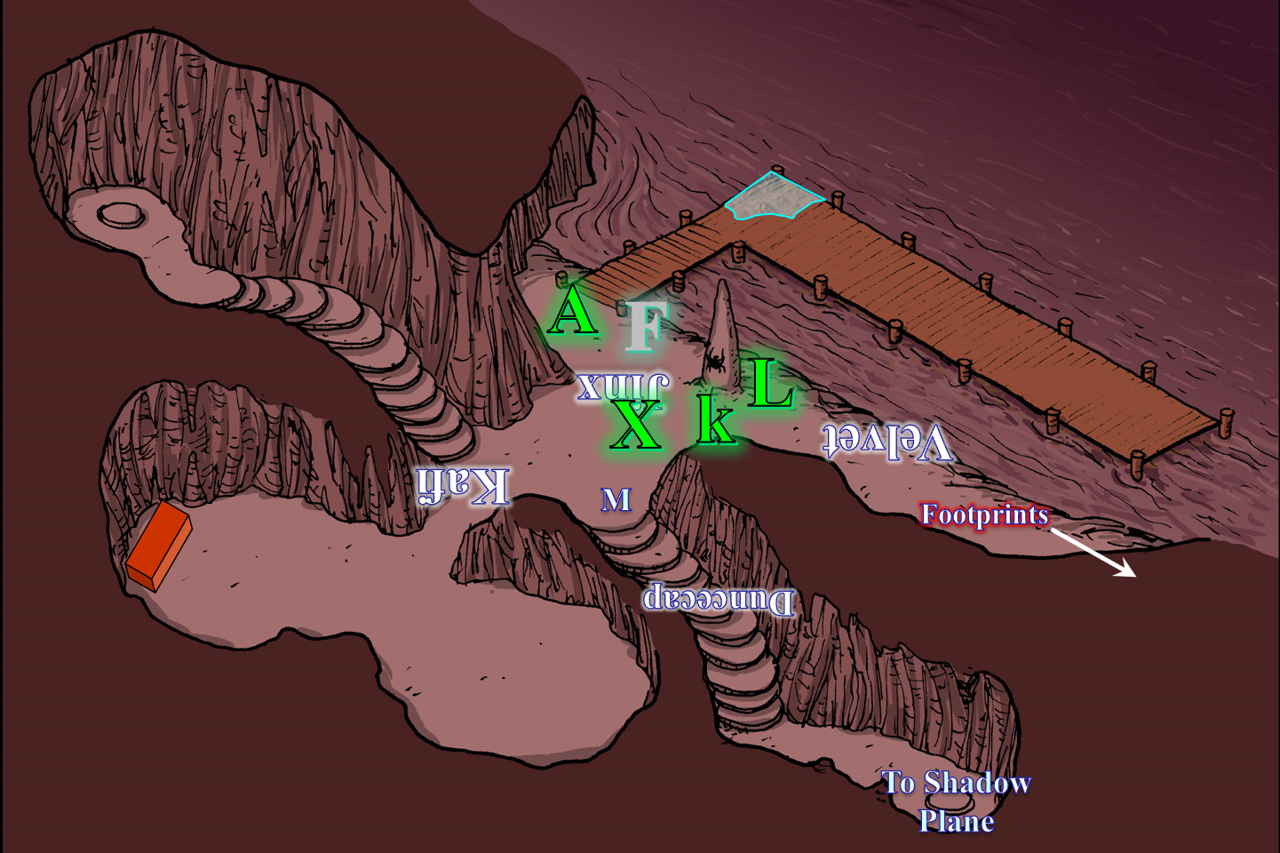

Round 7

Lauren stepped over to Allisa and embraced her in a brief but powerful hug. “Moondancer,” Lauren called to the pseudodragon. “Come to Allisa so she can heal your injuries.”

The pseudodragon did so. The heroes converged near the Lolth pylon on the shore, and the druid burned her baleful polymorph spell to convert it into healing energy. When Allisa cast her spell, Kir concentrated so that the elemental would also be included.
All PCs and the water half-elemental gained 5 hps each, to repeat for 2 more rounds. (See hp tally below.)

Lauren commented, “There are humanoid footprints leading that way... recent ones.”

Fingers was no longer invisible.

Lauren checked the footprints closely to see if she could make any determinations about who or what may have produced them.

Kir released the tension on her bow but kept the arrow knocked. She moved so she was back with the party.

The puddle of water that was a dying half-elemental began to writhe and take form as bones and soft tissues began to undulate and swirl and finally take some form within a growing mass of water drawn from the river. The nude form of a heavily wounded male warrior—hairless and aquamarine colored, tried to get up but could not. Only Xaryn understood its Aquan words, << Gratitude, heroes! >>

Round 8

All PCs gained 5 hps each.

Xaryn translated for the others. The half-elemental was still too wounded to get up, and looked to be trying to solidify parts of its interior.

“Lauren please pass me the wand I asked you to hold earlier today,” Allisa bid her lover as the half-elemental exhaled through a bong-like respiratory system and healed further.

Gasping for air and recuperating, the watery form pushed itself up onto its hands and shins, turned to face Allisa, panting from the near-death experience, and smiled with a sigh, << I would have perished here this day were it not for you. I am in your debt, human, >> the half-elemental mistook Allisa for a human, given that her ears were hidden under her hair, and fleshy folk all looked pretty much the same.

Kir remained cautious of the half-elemental, but heard Lauren say something about footsteps, so she went to check them out. After a few moments she looked to the others. “Well, it looks like we have two things we can do. One, we follow the footsteps and see where they lead. Oorrr two, we look at that chest over there, then follow the footsteps. Me: I’m for option two.” With that, she headed to the mimic-looking chest, and confirmed that it was of the same design as the last chest they’d seen that resembled a mimic. Perhaps this one was a mimic.

Round 9

All PCs gained 5 hps each.

Allisa cast mass cure light wounds upon her allies.
Allisa gained 9 + 15 = 24 hps [55/90].
Fingers gained 5 + 15 = 20 hps [51/82].
Kir gained 7 + 15 = 22 hps [92/95].
Lauren gained 8 + 15 = 23 hps [143/143].
Xaryn gained 5 + 15 = 20 hps [55/69]
Half-elemental gained 3 + 15 = 18 hps.

Character | TAC | FFAC | AC | Spell Resist | Damage Reduction |  | Melee | Acid | Evil/  Neg | Total Damage | Healing | HPs | Current HPs
Allisa | 13 | 19 | 22 | 0 | none | 0 | 66 |  | 23 | 89 | 54 | 90 | 55
Fingers | 14 | 15 | 19 | 0 | none | 0 | 52 |  | 14 | 66 | 35 | 82 | 51
Kir | 12 | 12 | 13 | 0 | adamantine | 10 |  | 24 | 16 | 40 | 37 | 95 | 92
Lauren | 11 | 34 | 35 | 0 | none | 0 |  | 25 | 14 | 39 | 79 | 143 | 143
Xaryn | 9 | 22 | 20 | 0 | none | 0 | 14 | 21 | 27 | 62 | 48 | 69 | 55
Moondancer | 14 | 16 | 18 | 19 | none | 0 | 10 |  |  | 10 | 15 | 20 | 20

In much better shape now, the half-elemental stood up, having drained the river of his weight in water, and had now regenerated into the rejuvenated form of a humanoid monk, completely unarmed and unclad, and now bearing the visage and posture of a capable combatant. << Greetings, heroes, >> Xaryn would momentarily translate to the others. << I am called Brother Mosh. >> Ripples coursed across the male half-elemental’s face has he spoke.

Xaryn related the words in Common.

Lauren kept an eye on the elemental as she examined the prints. She tried to determine how many sets there were, whether they were shod or not, and how tall and heavy the makers were. “Someone, start searching our late foes, please.”

~ End of Rounds ~

