Chapter 68

Lauren began searching the fallen enemies for anything useful.

Allisa cast her cure critical wounds spell as she listened.
Allisa gained 12 + 15 = 27 hps [82/90].

“Greetings to you as well. I am glad you survived. What befell you?” said and asked Allisa, looking to Xaryn to translate, which he did.

Character | TAC | FFAC | AC | Spell Resist | Damage Reduction |  | Melee | Acid | Evil/  Neg | Total Damage | Healing | HPs | Current HPs
Allisa | 13 | 19 | 22 | 0 | none | 0 | 66 |  | 23 | 89 | 81 | 90 | 82
Fingers | 14 | 15 | 19 | 0 | none | 0 | 52 |  | 14 | 66 | 35 | 82 | 51
Kir | 12 | 12 | 13 | 0 | adamantine | 10 |  | 24 | 16 | 40 | 37 | 95 | 92
Lauren | 11 | 34 | 35 | 0 | none | 0 |  | 25 | 14 | 39 | 79 | 143 | 143
Xaryn | 9 | 22 | 20 | 0 | none | 0 | 14 | 21 | 27 | 62 | 48 | 69 | 55
Moondancer | 14 | 16 | 18 | 19 | none | 0 | 10 |  |  | 10 | 15 | 20 | 20

~*~

08:04

Fingers look down at its chronometer once more. A minute or so had passed since the Gambit had slain the last of their assailants and revived Mosh, and by now they’d gotten the basics of his fate. He’d come to find members of his clutch who had gotten lost in a conduit to the River Styx—a tributary of which this river was—and having wandered—really, blundered—into this area past an illusory rock façade where he’d planned to rest, he came upon the dock, made his way onto the shore, and tripped the same glyph only a day ago.

As Mosh wrapped up the gory details of how Jinx the Nibbler had cut him down, and Kafi and Velvet had dwindled his flesh to the watery paste that he had become, the half-elemental monk looked around him and noted that the illusory rock he had breached could not be seen from this side.

They talked about this a bit, and it came to relevance that they’d come through a portal in the Shadow Plane, and that area had also been obfuscated by the selfsame kind of magic that Mosh had just described. The architectural project that was this complex of portals and chambers—it seemed—was far more elaborate than any of them had initially anticipated, but Xaryn was quick to articulate the need for illusion and seclusion if one was to maintain this portal party for any significant amount of time... “particularly if one is linking to planes like the Abyss, and Carceri.”

“And Hell,” Fingers reminded everyone of the other shard and portal to which they now had access.

Lauren’s findings were now displayed near or on every corpse they’d brought down. “Is she one of yours?” the half-drow asked the water half-elemental, pointing to the water genasi.

Xaryn translated and the monk shook his head.

The anti-paladin’s full plate was still on him, but the rest of his stuff was piled atop his body now.
 | Melee Weapon | Dmg |  | D+ | TH+ | Critical | Type | Wt. | Atk | Roll | Check | Properties
 | Unholy Greatsword +1 | 2d6+2 |  | +-4 + 1 | 3 | 17-20/x2 | Slashing | 8.0 | +15 | 9 | 24 | +2d6 to good
 | Ranged Weapon | Dmg. |  | D+ | TH+ | Critical | Rng. | Wt. | Atk | Roll | Check | Properties
 | MW Composite Longbow, Str +3 | 1d8 |  | 3 | 1 | x3 | 110’ | 3.0 | +15 | 12 | 27
 | Javelins, 3 | 1d6[1d8] |  | 3 | 0 | x2 | 30’ | 6.0 | +14 | 6 | 20
 | Armor & Shield | AC Mod. |  | Dex | Check | Arcane | Speed | Wt. | Properties
 | Full Plate +3 | 11 |  | 8 | -5 | 35% | 20’ | 50.0
 | Crystal of Adaptation, Least | - |  | - | - | - | - | 0.0 | Affixed to Full Plate
 |  |  |  |  | Missiles |  | Qty. | Wt. | Atk |  |  | Properties
 |  |  |  |  | Arrows |  | 50 | 2.5 | 0
 |  |  |  |  | Scrolls and Potions |  |  |  | Qty. | Level | CLev | Notes
 |  |  |  |  | Potion of enlarge person |  |  |  | 1 | 2 | 4
 |  |  |  |  | Potion of owl’s wisdom |  |  |  | 0 | 2 | 4
 |  |  |  |  | Wand of cure light wounds |  |  |  | 1 | 1 | 1 | 50 charges
 |  |  |  |  | Potion of cure moderate wounds |  |  |  | 1 | 2 | 4
Equipment Worn
Item |  | Qty. | Wt.
Silver Unholy Symbol |  | 1 | 0.0
Traveler’s Outfit |  | 1 | five
Belt Pouch |  | 1 | 0.5
Pearls of Power, 1st level |  | 4 | 0.0
Healing Belt |  | 1 | 0.5
Amulet of Wisdom +2 |  | 1 | 0.0
Vest of Resistance +2 |  | 1 | 1.0
Cloak of Charisma +2 |  | 1 | 2.0
Gloves of Dexterity +2 |  | 1 | 0.0
Equipment Carried
Item |  | Qty. | Wt.
Whetstone |  | 1 | 0.0
Lesser Metamagic Rod of Extend |  | 1 | 5.0

The duskblade-wizard-ultimate magus had a nice falchion consistent with a duskblade of his limited capabilities. Lauren remembered those days.
Melee Weapon | Dmg | D+ | TH+ | Critical | Type | Wt. | Atk | Roll | Check | Properties
Falchion +3 | 2d4 | +3 +3 | 3 | 18-20/x2 | Slashing | 8.0 | +15 | 14 | 29
Truedeath Crystal, Lesser | 1d6 | vs. | undead
Dagger | 1d4 | +3 | 0 | 19-20, x2 | Prcg/Slash | 0.5 | +12
Kukri +2 | 1d4+2 | +3 +2 | 2 | 18-20, x2 | Slashing | 2.0 | +14
Ranged Weapon | Dmg. | D+ | TH+ | Critical | Rng. | Wt. | Atk | Roll | Check | Properties
Shortbow +1 | 1d6 | 1 | 1 | x3 | 60’ | 2.0 | +10 | 5 | 15
Armor & Shield | AC Mod. | Dex | Check | Arcane | Speed | Wt. | Properties
Mithral Chain Shirt +3 | 7 | 6 | 0 | 10% | 30’ | 12.5 | Treated as light armor
Ring of Protection +2 | 2 | - | - | - | - | 0.0
Light Steel Shield +1 | 3 | - | -1 | 5% | - | 6.0
 |  |  | Missiles |  | Qty. | Wt. | Atk | Properties
 |  |  | Arrows |  | 36 | 5.4 | +0
 |  |  | Scrolls and Potions |  |  |  | Qty. | Level | CLev | Notes
 |  |  | Potion of cure moderate wounds |  |  |  | 2 | 2 | 10

Item | Qty. | Wt.
Backpack | 2 | 2.0
Belt Pouch | 1 | 0.5
Ring of Feather Falling | 1 | 0.0
Dimension Stride Boots | 1 | 1.0
Healing Belt | 1 | 1.0
Explorer’s Outfit | 1 | eight
Amulet of Tears | 1 | 0.0
Cloak of Resistance +1 | 1 | 1.0

Velvet traveled a bit lighter than the other two evildoers, but still had some nice equipment fit to filch.
 | Melee Weapon | Dmg |  |  | D+ |  | TH+ | Critical | Type |  | Wt. | Atk | Roll | Check | Notes
 | Returning Shortspear +2 | 1d6 |  |  | +5 +2 +2 |  | 2 | x3 | Piercing |  | 9.0 | 16 | 5 | 21
 | Eager Dagger | 1d4 |  |  | 0 |  | 1 | 19-20, x2 | Prcg/Slsh |  | 1.0 | 14 | 17 | 31
 | MW Sap | 1d4 |  |  | 0 |  | 1 | x2 | Bludgeon |  | 2.0 | 14 | 16 | 30
 | Ranged Weapon | Dmg. |  |  | D+ |  | TH+ | Critical | Rng. |  | Wt. | Atk | Roll | Check | Notes
 | Light Crossbow +1 | 1d6 |  |  | 0 |  | 1 | 17-20, x2 | 30’ |  | 1.0 | 12 | 5 | 17
 | Returning Shortspear +2 | 1d6 |  |  | +5 +2 +2 |  | 2 | x3 | 10’ |  | 9.0 | 14 | 3 | 17
 | Armor & Shield | AC Mod. |  |  | Dex |  | Check | Arcane | Speed |  | Wt. | Notes
 | Black Dragon Scale Mail +1 | 6 |  |  | 3 |  | -2 | 25% | 20’ |  | 12.5
 | Black Dragonhide Cloak +1 | 1 |  |  | - |  | - | - | - |  | 1.0
 | Ring of Protection +2 | 2 |  |  | - |  | - | - | - |  | 0.0
 |  |  |  |  | Missiles |  |  |  | Qty. |  | Wt. | Atk | Notes
 |  |  |  |  | Bolts |  |  |  | 30 |  | 4.5 | 0
 |  |  |  |  | Undeadbane Bolts |  |  |  | 5 |  | 0.8 | +2 | Bonus to hit and damage specific to target
 |  |  |  |  | Lycanbane Bolts |  |  |  | 1 |  | 0.2 | +2 | Bonus to hit and damage specific to target
 |  |  |  |  | Electric Bolts |  |  |  | 3 |  | 0.5 | 0 | 1d6 electric
 |  |  |  |  | Sonic Bolts |  |  |  | 4 |  | 0.6 | 0 | 1d6 sonic
 |  |  |  |  | Cold Bolts |  |  |  | 4 |  | 0.6 | 0 | 1d6 cold
 |  |  |  |  | Scrolls and Potions |  |  |  |  |  | Qty. | Level | CLev | Notes
 |  |  |  |  | Potion of Water Breathing |  |  |  |  |  | 1 | 3 | 5
 |  |  |  |  | Potion of Bull’s Strength |  |  |  |  |  | 0 | 2 | 3
 |  |  |  |  | Potion of Eagle’s Splendor |  |  |  |  |  | 1 | 2 | 3
Item |  |  | Qty. | Wt. |  | Effects/
Dragon Spirit Cincture |  |  | 1 | 0.0 |  | +1 die to breath weapon damage
Necklace of White Dragon Scales |  |  | 1 | 0.0
Reins of Ascension |  |  | 1 | 1.0
Ring of Entropic Deflection |  |  | 1 | 0.0
Vanguard Treads |  |  | 1 | 2.0

The ghoul didn’t have anything worth looting on it. “Lots of goodies here, but I doubt we can bring it all with us,” Lauren said with her hands at her hips.

“Loot responsibly,” Fingers smiled. “Where do the footprints lead?”

“I didn’t have time to follow them too far, but they just keep going along the edge of the rock into that foliage,” Lauren pointed.

Kir had by now taken her leave from the others in order to get a better sense of the chest that mimicked a mimic. As some of the others approached, the rogue-cleric said what little she knew, “Looks to be of the same design as the one back on the Material Plane, but as you can see, far bigger.”

“Looks menacing,” Xaryn remarked, entering the chamber to let Mosh and the other stragglers in.

“The most notable thing is,” Kir looked at Fingers, who would immediately also notice, “the clasps that keep it closed are toggled open and shut from the inside.”

It was true: the mimic’s pincers were made to look menacing and even icky, drawing attention from the fact that the hinges that maneuvered them were only partly outside the box, and there was no visible latch to open it.

“Can you guys open it?” Xaryn didn’t know Fingers well enough to have confidence in its lockpicking skills just yet.

Fingers didn’t answer the question, but looked at the contraption from as many angles as possible—given that it was up against the wall—and asked Kir a few confirmatory questions of a highly technical nature. The two rogues referred to gauges, vectors, and other terms germane to the art and science of undermining the efforts of stashers and hoarders, and then nodded to one another.

Fingers turned to the others, “I mean, we can assume that whoever locked this thing is inside the box, right?”

“Unless they teleported out,” Xaryn said. “We need to account for all manner of spatial repositioning when it comes to those who run this palace of portals.”

“Are we sure it’s not a mimic?” asked Allisa.

No one had touched it yet.

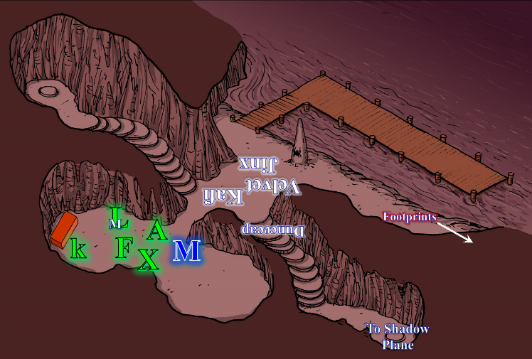

“Trickier to open a lock from the other side as it were,” said Fingers, “but Kir and I might be able to double-team it. Worst come to worst, I can use the knock spell in my ring to open the locks.”

Kir and Fingers talked it through and came to the same conclusion. She gave Xaryn a nod to his suggestion that whoever it was might have teleported out. When Fingers commented that the two of them could possibly double team it, she grinned. “We could try. Though I do agree with Allisa that it could be a mimic, so let’s find out.”

Kir took her bow, backed up a few feet and shot an arrow at it. Figuring that if it is a mimic, getting hit with an arrow, they would know pretty quick.
Ranged Weapon | Dmg. | D+ | TH+ | Critical | Rng. | Wt. | Atk | Roll | Check
Trovacuore (MW Shortbow) | 1d4 | 1 | 1 | x3 | 60’ | 2.0 | +16 | 19 | 35
Hit.

“If it’s a mimic, it’s got a hell of a mind-over-matter thing going for itself,” the witty halfling then praised the inanimate, ornate box.

Fingers chuckled, “As good a way of testing as any, I suppose. Hopefully, the arrow didn’t poke all the way thru the side and possibly break something fragile... unless that ‘something’ is some nasty creature ready to pop out and attack. I imagine being impaled to the side of a chest makes popping out of it a bit difficult.”

“Didn’t sound like it broke through, though it’s lodged into this wood panel quite nicely,” Kir appraised her own marksmanship, having dug the arrowhead along the wood’s grain pattern. No, this was not a mimic.

While the rogues worked on the chest, Lauren, having no need for any of the magic items on the bodies, went back to investigating the footprints. “Allisa, you might want the potions and other items they’re carrying.”

Allisa and Lauren stood looking for a moment at the coastline illuminated by phosphorescent bioforms and reflective minerals. The druid then began to peruse the loot to see what was of greatest use-value to her. As the pink skinned half-elf tended to the equipment of the fallen, her blueberry hued lover took her time following the footprints along the coastline. She made it a good 200’ away from Allisa, and would soon reach an angle in the cliffside that would cut the line of sight she had to the druid.

~*~

Meanwhile, as the two lockpickers were crouching and kneeling down, Fingers first smirked, then gasped a smile, and just emitted, “Awww!”

It wasn’t as if something was cute or endearing, but almost like the changeling had just found out that its taxman had overcharged it. “What is it?” Kir asked with a slight frown of one eyebrow.

“Tssshh,” Fingers said shaking his head, still with a bit of a blushing grin on its face. “This isn’t a chest,” it then informed Kir, Mosh, and Xaryn who were still in the chamber.

Kir stood back up and trained her bow on the thing she again feared was a mimic, asking, “Alright... what is it?”

Exhaling through its nostrils, Fingers brushed away some of the dirt at the base of the apparent chest, revealing that it was built into a stone floor just inches underneath the irregular gravel and natural porous rock all around them. “It’s a door.”

“That’s how it locks from the inside. It isn’t a compartment!” Kir slung her bow and eagerly crouched again, ready to open this hidden doorway in the Abyss.

Xaryn cautioned, “We may want to proceed with caution. I can only imagine what manner of creature would voluntarily cloister itself under this wretched place.”

“I would imagine the area will be damp, given the proximity of the river,” Fingers erred in its assumption.

“Not here. Extradimensional forces and irregular gravity are the norm here. You’d be surprised—some have even gone mad—over some of the things that happen in this plane. You could walk in a perfect circle, and end up in a completely different place.”

“You don’t say,” Fingers was almost ready to pop the hood on this baby. “See this?” it pointed a jimmy zone out to Kir, then inserted one of its awls into the slit, and began to loosen a spring-loaded gear.

Xaryn curbed his previous comment, “Then again, chaos is all about its own unpredictability; it may very well be that this ‘door’ leads down to some waterway or sewage channel.”

Kir took her eyes of the chest for a moment, and looked up at the drow, “You’re just full of cheer, aren’t you, Magister Schrodinger? Is there a possible narrative where we find a trove of caramelized cherry muffins?”

“Like I said, chaos’ll keep you guessing,” Xaryn paraphrased himself. “Let’s see what manner of ill in the box.” he played on the Schrodinger joke.

“We need to find a way back to your world. Would you happen to know of a way or someone that could show us?” the half-elf asked the elemental.

The monk shrugged, not understanding. Xaryn was still in the chamber with the chest, while the druid was by the loot now.

Allisa looked through the lot and determined what they might need to take with them. First the elf pried loose the Crystal of Adaptation, least figuring this would help herself or one of the others. She then opened up her Heyward’s handy haversack to see how much room he had in there, and it wasn’t enough to store the stuff she’d intended to put in there.

All these items could be divided later if they were not used for the good of the party before then. She figured that the others Might want to use some of what was left. She picked up the arrows to hand to Kir as she glanced down the river for her lover.

Moondancer hid inside the chamber where the bodies still lay, and had abstained from following Lauren out to where she perceived things to be unsafe. She now looked over at Allisa with sad eyes and sniffled.

Seeing Moondancer with sad eyes, the druid waved the creature over. “What is wrong, little one?” She smiles and talked with reassurance.
Skill | Rank | Ability & Mod. | Misc. Mods. | Total | Roll | Check
Allisa, Diplomacy | 1 | Cha (+2) | 2 | 5 | 3 | 8
Allisa, Handle Animal | 8 | Cha (+2) | 2 | 12 | 7 | 19
See below.

And though Allisa had a way of appealing to intelligent creatures’ comforts, she was only able to rub a few purrs out of the dragon and calm her down, though the druid didn’t get the same telepathic treatment that Lauren did... at least not now.

Fingers took a break from the chest/door to grab Kafi’s healing belt, ring of protection, and amulet of tears. Jinx’s wisdom amulet would be useful for some of its skills, but the rogue deferred to the cleric and druid. Then, returning to the chest, the rogue resolved to get the job done.

~*~

Lauren’s sense of direction was shot in this underground place, and as she took a few more steps towards the bend, she turned back one more time to make sure that she could still see Allisa, but was alarmed at the fact that not only was her lover nowhere in sight; the entire coastline before her was gone! What was there instead was perhaps a 7’ stretch of the sand where she’d just stepped, and then a nearly vertical rock surface where the rest of the path would have taken her back to the others.

The duskblade froze in her tracks, and looked down at the sand to see if her footprints were still there. They were, but the last one visible was cut in half by the obsidian façade. An illusion, much like the one they’d beheld on the Shadow Plane and on the Material Plane. Every extension of this multiplanar complex—it seemed—was warded from outside view by illusory landscapes. She wondered what hid the part of Hell beyond that portal as she caught sight of a flying dragon about half a mile downstream. It was about ten times farther than she’d walked to get from the dock to here, and had likely not spotted her, but it might smell her—in time—if she stayed upwind of it for long. It might have been prudent to warn the others, particularly since it was a dragon that—at least at this distance—she could not identify.

Lauren turned and retraced her steps the way she came.

~*~

“Ah, there!” Fingers sighed as he and Kir got the clasps off of the chest, allowing its top to open easily at the hinges. Resting the lid against the wall, the rogues peered in, and saw a stone staircase leading downward into a completely dark area. The staircase appeared to bend leftward after about the first fifteen steps.

Turning back to the group, Fingers stated, “So, we have another option as to where we can go from here. Shall I open it up and see where it leads? You can stand ready in case something pops out and tries to eat me, right Lauren... Lauren? Wait, where’s Lauren?” Fingers had heard her say that she was going to follow the footprints, and just remembered this.

~*~

Lauren did not yet know what a pickle she was in. She’d taken a few steps back towards the façade, and walked through it, only to see a quickly distorted shift in her field of vision, which left her with the realization that she had fallen victim to another of her host’s one-way deals, and was now in a 10’ x 10’ room with a 10’-high ceiling. There were no windows, but each wall other than the one behind her had a glowing, wooden door with a number above it.

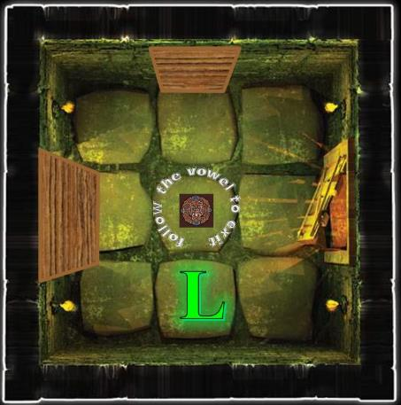

To her left was a tall, 4’-wide door with a 1 hung above it; right in front of her was a medium-height, 3’6”-wide door marked 2; and to her right was an even shorter, 3’-wide door marked 3. Though the dimensions of the room were truly cubic—as far as she could tell—the different size of each door provided the mundane illusion of differential depth from one end of the room to the other. Engraved on the floor of the room was written “follow the vowel to exit” in Underdarker script—in which she was literate—wrapped around nothing less than the seal of Demogorgon.

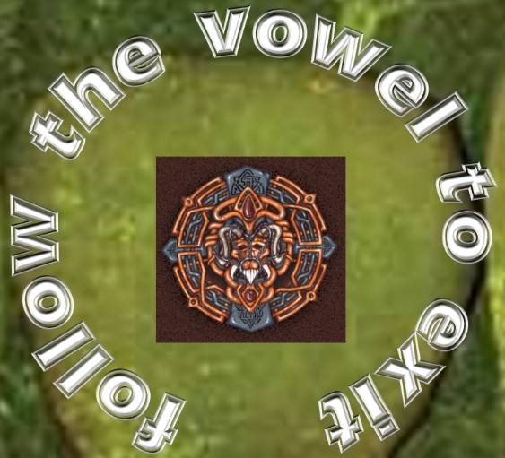

The only other feature of the room was behind her: a portrait of a primordial beast that she knew to be an aboleth, though she’d never seen this particular one striking such a striking pose.



The cozy room was neither hot nor cold, and was of a very plain décor, save for the portrait and apparent communication at Lauren’s feet.

Lauren pulled out her Farspeaking Amulet and put it on. Allisa had one of the charms, as did Fingers. “Allisa, Fingers, can you hear me?”

“Nothing happened.”

“That’s not good,” Lauren said out loud as she thought, “this is supposed to be good anywhere on the same plane.” Beginning with the doors, Lauren closely examined the room without touching anything. She looked for any levers or other controls, details like color, and wear patterns, dust (or lack of it) or other evidence of use. If someone passed through on a regular basis, then maybe they left some sign of how this room worked.

Then she turned her attention to the depth of the engravings’ indentations, and noted indeed that the word “follow” was slightly emboldened. One would think this might have been because it was the first word, and the engraver tired of chiseling, yet the contrast was not gradual across the entire phrase, but rather discreet between the first word and the four that followed.

Blessed by the cognitions that she’d honed for decades now, Lauren pondered a moment as she chewed on the noteworthy feature of the room. Turning her attention to the doors, she noticed that the glowing doors were actually portals with illusory doorknobs and wooden grains. Looking at them from about 1’ away, she could clearly tell that these were of the same handiwork as the portals they’d used before, but there were neither locking mechanisms nor shard receptacles to unlock them.

“Okay, so the vowels in ‘follow’ are ‘o’ and another ‘o’,” Lauren reasoned. She went to the portal marked “2”, and examined the floor in front of it for any sign of wear on the stone floor that didn’t match the floor in front of the other portals. She might have been reaching, but maayybe there was a little more wear along the door right in front of her marked “2”.

Lauren stood up and glanced back at the engraving. “‘O’ and ‘O’,” she said slowly. “So, two, and too, plus it’s the second letter of the word?” she sighed. “Any way I look at it, I have a one-thirds chance of being right.” She sighed, settled her shield in place, drew her sword, and gingerly stepped though the portal marked ‘2’.

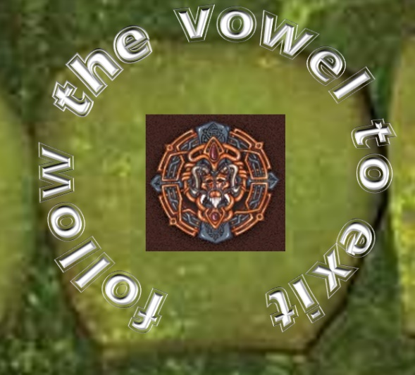

She found herself in a deceptively similar room, nearly identical, except the word “the” was now emboldened instead of “follow”, and behind her was the portrait of a beholder commanding one of its thralls.

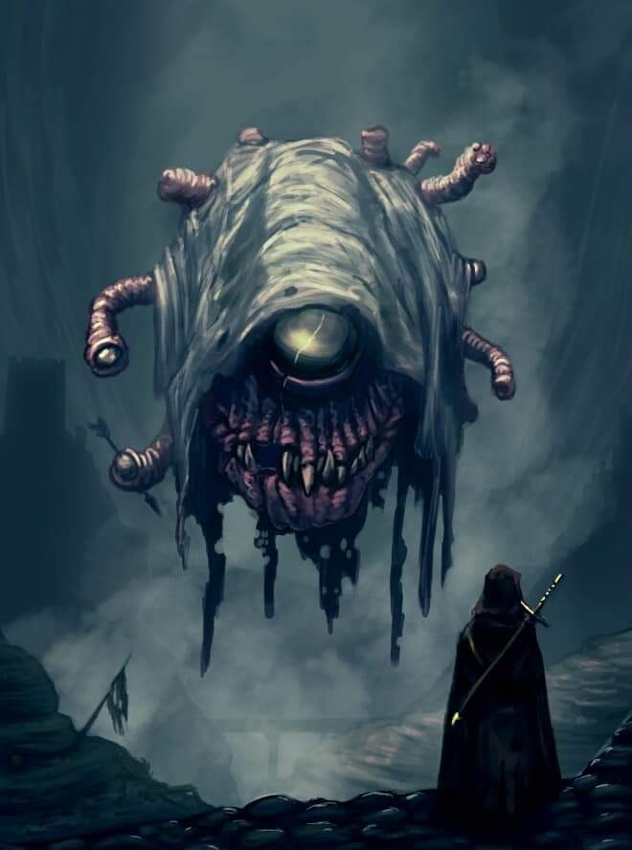

Lauren looked down. “One vowel, so the way must be door One.” She checked again for signs of wear on the floor, comparing all three doorways, but as with the previous room, there really was no significant evidence of anything that she wasn’t already reaching for. The foot traffic method might’ve been useful to Fingers and Kir, but to Lauren, the floor wasn’t much of a clue beyond the engraved writing.

She stepped through the portal to her left with the number 1 atop it.

~*~

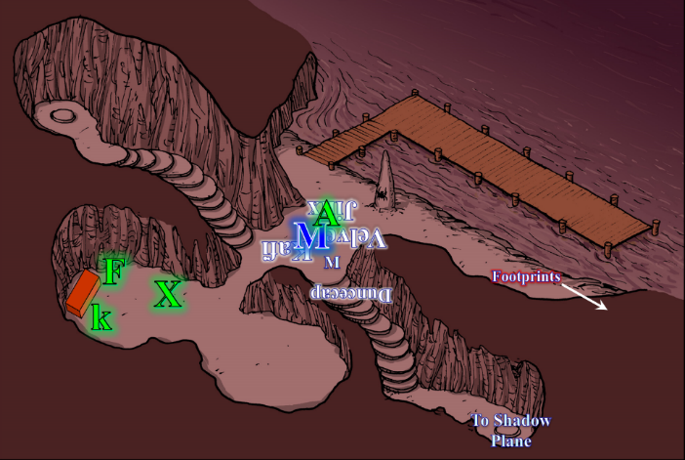

Since they had met, Kir had had a give-and-take relationship with Xaryn, though when she and Fingers finally got the chest/door open her excitement grew: a set of stairs leading down to who knew where.

Fingers turned to the rest of the group to let them know that they had another option. Her attention was brought back to the group when she heard Fingers ask where Lauren was. Kir turned to look for Lauren. Kir head to where the footprints are and look in the direction they are going.

“Lauren, where are you?” she asked as Allisa threw a necklace, some gloves, and a quiver at her and told her that her lover had just gone down the riverbank to investigate some footprints.

With more than one of the party members being concerned that a split party was a compromised one, Allisa took a few steps northeast to confirm that Lauren was still there, but she was no longer there.

Allisa’s mouth dropped open. “She... she was right there at that corner the last time I looked. Lauren!” the druid called. Not hearing a reply, she turned to the others. “I do not see Lauren. We must find her.” The woman’s voice was a bit shaky. “Moondancer can you try and call to her?” She turned to the monk as she pointed. “Is that the direction you came from, do you know what is in that direction?”

Xaryn overhead Allisa still trying to communicate with the monk, and translated her question.

The monk pointed to the northwest—the opposite of where Lauren had gone. << Upstream, >> the monk said, and the drow translated.

Allisa looked from one to the other, hoping for some solution. She thought to herself if she found her wife and they were out of this mess, she would get some kind of device that would allow them both to talk and now where the other was.

~*~

08:12

Round 100

Character | Group | Initiative | Roll | Modified Roll | Move
Chwidencha | 2 | 7 | 3 | 10 | 30’
Lauren | 1 | 4 | 5 | 9 | 30’

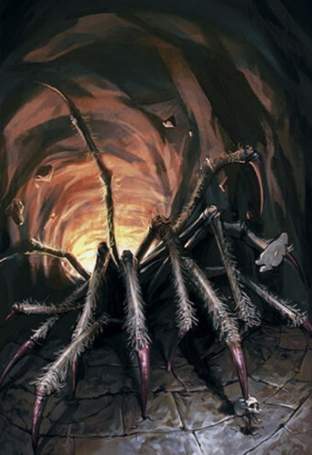

A chwidencha—one of Lolth’s own creations, Lauren knew—spotted her, and instinctively leaped upon her from its web.
Character | Save vs. | Ranks | Roll | Save
Chwidencha | Jump | 0 | 10 | 10
No ill effects. 1d100 = 71, concealment bypassed.
Character | Attack Type | Damage | BAB | Str Mod+ | Total Score | Roll | Total
Chwidencha | Touch Attack | Grapple | 9 | 6 | 15 | 15 | 30
Chwidencha | Grapple | Constrict 3d6+9 | 9 | 10 | 19 | 6 | 25
Lauren | Grapple | - | 0 | - | +20 | 20 | 40
See below.

Lauren broke out of the nearly blind fiendish dodecaspider’s grapple, quick cast haste [expired on Round 115], and full attacked the spider while channeling shocking grasp through her sword.
Lauren gained +1 to AB, TAC, AC, and Reflex saves.
Melee Weapon | Dmg | D+ | TH+ | Critical | Type | Wt. | Atk | Roll | Check
Shattermantle Bloodstone Falchion +3 | 2d4 | +3 +3 | 3 | 18-20/x2 | Slashing | 8.0 | +23 | 15 | 38
SB Falchion +3, 2nd Attack | 2d4 | +3 +3 | 3 | 18-20/x2 | Slashing |  | +18 | 9 | 27
SB Falchion +3, 3rd Attack | 2d4 | +3 +3 | 3 | 18-20/x2 | Slashing |  | +13 | 4 | 17
SB Falchion +3, haste | 2d4 | +3 +3 | 3 | 18-20/x2 | Slashing |  | +23 | 16 | 39
Hit, hit, miss, hit. Dmg: (6 + 3 + 3 + 20 electric) + (5 + 3 + 3) + (6 + 3 + 3) = 12 + 11 + 12 + 20 electric = 55.

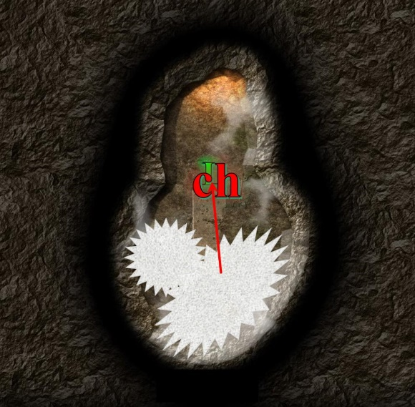

Round 101

Realizing that it could not easily pin down the mighty duskblade, the chwidencha full-raked Lauren.
Character | Attack Type | Damage | BAB | Str Mod+ | W+ | Other+ | Total Score | Roll | Total
Chwidencha | Leg Rake 1 | 1d6+6/19-20 x2 | 9 | 6 | 0 | 0 | 15 | 13 | 28
Chwidencha | Leg Rake 2 | 1d6+6/19-20 x2 | 9 | 6 | 0 | 0 | 15 | 3 | 18
Chwidencha | Leg Rake 3 | 1d6+6/19-20 x2 | 9 | 6 | 0 | 0 | 15 | 8 | 23
Chwidencha | Leg Rake 4 | 1d6+6/19-20 x2 | 9 | 6 | 0 | 0 | 15 | 6 | 21
Miss⁴.

And though some of the rakes did connect, they did not penetrate Lauren’s armor. Unable to penetrate the swordswoman’s defenses, the spider-shaped aberration began to rethink its strategy.

Lauren looked at the creature with a scowl in Undercommon, << If you leave, I won’t pursue you. I have no interest in you, or what you may have. >> She cast barkskin [expired on Round 1601] on herself, and waited to see if the creature would retreat.
Lauren gained +5 to FF AC and AC.

The main cluster of vile appendages now had six legs less than it had started with, and Lauren was prepared to lob off those still intact. The demonic aberration understood this, as well as the Undercommon tongue, and though it could not speak, it took several steps back onto its web, and opened a fold in the blanket of dried, crisscrossed goo, revealing a diagonal, downward chute decorated with the selfsame illusory wood that had been used to coat the doorways in the previous two rooms.

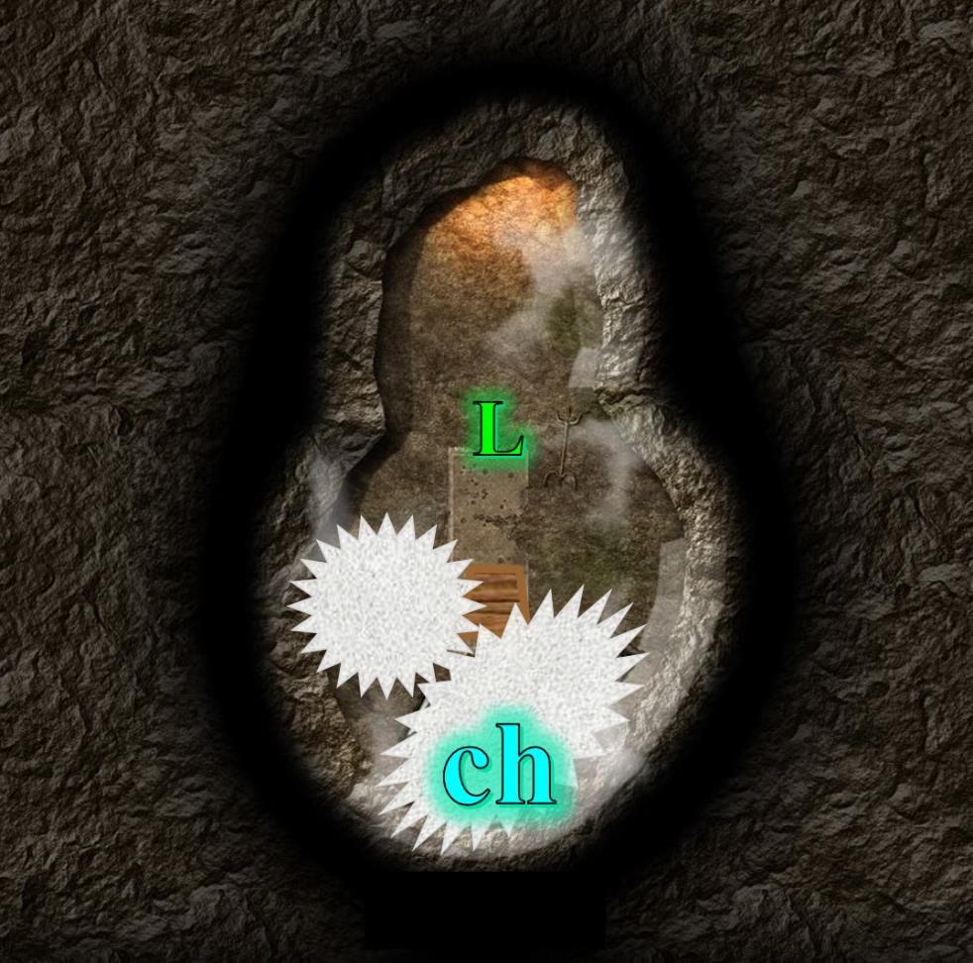

Round 102

<< Thank you. Not all creatures are cruel and merciless. I will pass through and not harm you. >> Lauren stepped down through the portal, her senses on high alert for anything out of place – not that she could tell if things were out of place here. The thought amused her, but she kept her focus on the business at hand.

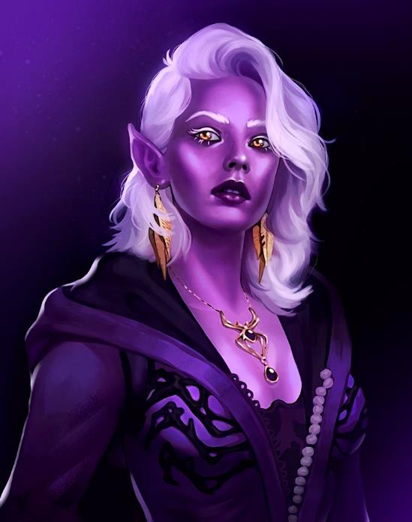

Rounds 103 – 104

Unscathed by the arachnid demon-spider, Lauren found herself at another room with three doors, a portrait, and the same phrase at her feet. This time, however, the third word— “vowel”—was emboldened, and the portrait was of a drow woman whom Lauren did not know, but found attractive. The half-drow once again examined the floor to see if any clues lay there, but it was only the fact that the middle word was chiseled in extra hard.

Reasoning that only the word “one” contained both “o” and “e”, Lauren readied herself and stepped through portal 1.

Round 105

The first thing she noticed was a golden breastplate lying on the ground to what she regarded as the east, and the skeletal remains of a shator strewn over the southern portion of the floor.

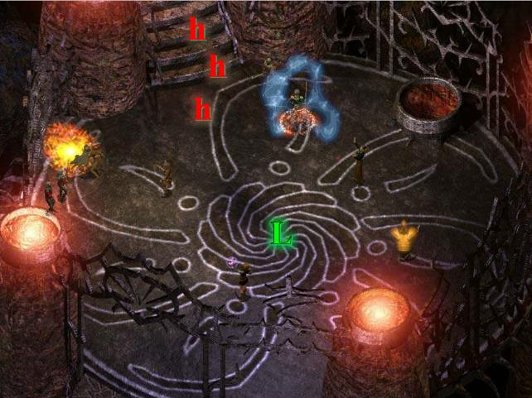

A number of darkly dressed drow knaves dropped in from invisible portals overhead, and one of them said in Undercommon, << It is time! Finish her! >> All of the boys before her drank a potion of invisibility and she now could see none of them.

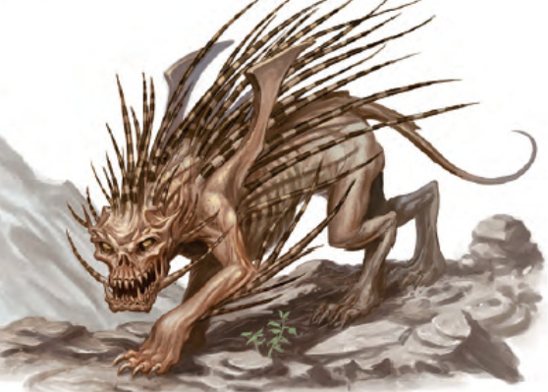

Three howlers rushed down a staircase from the north, aiming to attack Lauren.

The duskblade activated her Dimension Stride boots, aiming for as far up the staircase as she could see behind the howlers.

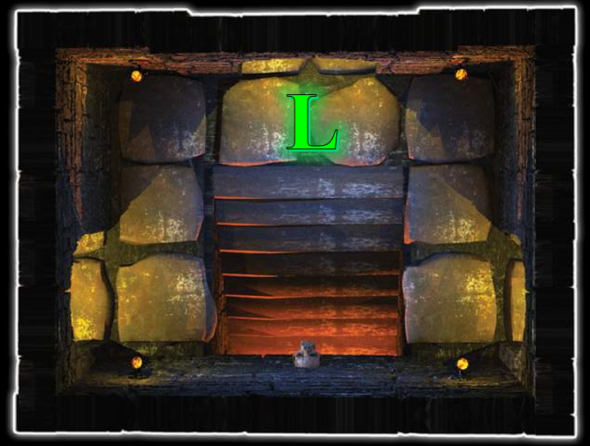

Then, nearly at the top of the stairs, she cast swift expeditious retreat [expired on Round 106], and reached a chamber lit by four continual flame candles and decorated with a single howler skull above the staircase looked inside the three much better lit kennels at the top of the stairs, finding rotting flesh, bones, and crap. The place had not been cleaned out for at least a few days.

Round 106

Character | Group | Initiative | Roll | Modified Roll | Move
Lauren | 1 | 4 | 15 | 19 | 30’
Howler | 2 | 7 | 3 | 10 | 60’
Drow Assassins | 2 | 3 | 3 | 6 | 30’

Lauren activated her blacklight [expired on Round 121] ability and prepared to fight with shocking grasp channeled through her sword.

The alacritous howlers came crashing at her first, not having prepared for the magical darkness in their midst. Their eponymous howling didn’t make Lauren feel any better, though it didn’t manifest any ill effects on Lauren. Able to see in mundane darkness, the howlers listened for the duskblade’s movements
1d100 = 2, 91, 27. Concealment bypassed once.
Character | Attack Type | Damage | Ranged? | BAB | Str Mod+ | Dex Mod+ | W+ | Other+ | Total Score | Roll | Total | Crit | Threat
Howler | Bite | 2d8+5 | q | 6 | 4 | 0 | 0 | 0 | 10 | 14 | 24 | 20 | ý
Miss.

Lauren struck the howler that bit at her.
Melee Weapon | Dmg | D+ | TH+ | Critical | Type | Wt. | Atk | Roll | Check
Shattermantle Bloodstone Falchion +3 | 2d4 | +3 +3 | 3 | 18-20/x2 | Slashing | 8.0 | +23 | 6 | 29
SB Falchion +3, haste | 2d4 | +3 +3 | 3 | 18-20/x2 | Slashing |  | +23 | 12 | 35
Hit, hit. Dmg: (6 + 3 + 3 + 26 electric) + (7 + 3 + 3) = 38 + 13 = 51.

The first howler died and strobed with electricity for another second or two.

The assassins were no longer in her line of sight. Then one came into view at the bottom of the stairs, and shot a crossbow into the sounds of carnage.
1d100 = 24, concealment not bypassed.
1d100 = 29, howler got in the way.

The assassin’s bolt went wayward.
Character | Attack Type | Damage | Ranged? | BAB | Dex Mod+ | W+ | Other+ | Total Score | Roll | Total
Drow Assassin | Light Crossbow +1 | 1d6+1 | þ | 7 | 2 | 0 | 0 | 9 | 7 | 16
Miss.

The drow assassins—Lauren could not quite hear—were murmuring their tactic amongst themselves as some quaffed potions.
Assassin 2 drank a potion of bull’s strength [expired on Round 166], and gained +4 to Strength.
Assassin 3 drank a potion of owl’s wisdom [expired on Round 166], and gained +4 to Wisdom.
Assassin 5 drank a potion of bear’s endurance [expired on Round 166], and gained +4 to Constitution.
Assassin 6 drank a potion of fox’s cunning [expired on Round 166], and gained +4 to Intelligence.

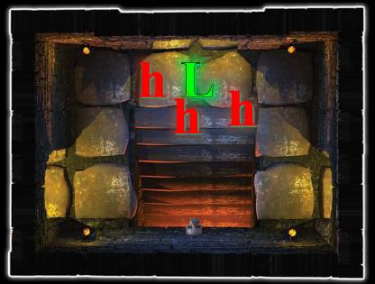

Round 107

Lauren stepped to one side to avoid any direct attack from below, and set about dispatching the howlers, using her cloak and her blacklight as concealment against counterattack. She continued to channel shocking grasp through Arkenlyl.
Melee Weapon | Dmg | D+ | TH+ | Critical | Type | Wt. | Atk | Roll | Check
Shattermantle Bloodstone Falchion +3 | 2d4 | +3 +3 | 3 | 18-20/x2 | Slashing | 8.0 | +23 | 4 | 27
SB Falchion +3, 2nd Attack | 2d4 | +3 +3 | 3 | 18-20/x2 | Slashing |  | +18 | 7 | 25
SB Falchion +3, 3rd Attack | 2d4 | +3 +3 | 3 | 18-20/x2 | Slashing |  | +13 | 12 | 25
SB Falchion +3, haste | 2d4 | +3 +3 | 3 | 18-20/x2 | Slashing |  | +23 | 10 | 33
Hit, hit, hit, hit. Dmg: (4 + 3 + 3 + 21 electric) + (6 + 3 + 3) + (4 + 3 + 3) + (3 + 3 + 3) = 31 + 12 + 10 + 9 = 41 + 21 electric = 62.

And this made the second howler die. The third one didn’t get the message.
Character | Attack Type | Damage | BAB | Str Mod+ | Total Score | Roll | Total | Crit | Threat
Howler | Bite | 2d8+5 | 6 | 4 | 10 | 20 | 30 | 20 | þ
Howler | Quills | 1d6+2 | 6 | -1 | 5 | 7 | 12 | 20 | ý
Howler | Quills | 1d6+2 | 6 | -1 | 5 | 18 | 23 | 20 | ý
Howler | Quills | 1d6+2 | 6 | -1 | 5 | 12 | 17 | 20 | ý
Howler | Quills | 1d6+2 | 6 | -1 | 5 | 5 | 10 | 20 | ý
Threat, miss, miss, miss, miss. 1d20 = 3 + 10 = 13, not a critical hit. Dmg: 3 + 2 = 5 [138/143].

Lauren had moved to where she couldn’t be effectively targeted by the assassins, so she had no line of sight to them at this point.

The drow assassins collaborated on a plan to bring the half-breed wench down. One of the assassins—the resident lockpicker—had a Heightened faerie fire spell-like ability, and was taking a cue from his elder, who pointed to the top of the staircase as Lauren thought to take cover inside one of the kennels. They giggled as they buffed up some more with a potion each of divine favor [expired on Round 117].
The drow assassins gained +1 to AB and weapon damage.

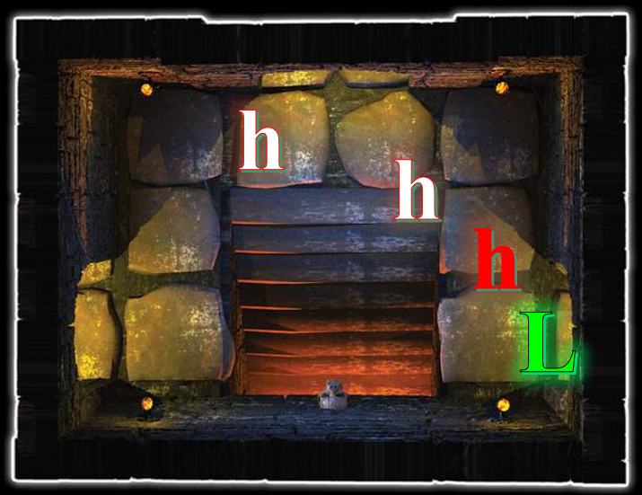

Round 108

Lauren took on the last howler.
Melee Weapon | Dmg | D+ | TH+ | Critical | Type | Wt. | Atk | Roll | Check
Shattermantle Bloodstone Falchion +3 | 2d4 | +3 +3 | 3 | 18-20/x2 | Slashing | 8.0 | +23 | 15 | 38
SB Falchion +3, 2nd Attack | 2d4 | +3 +3 | 3 | 18-20/x2 | Slashing |  | +18 | 16 | 34
SB Falchion +3, 3rd Attack | 2d4 | +3 +3 | 3 | 18-20/x2 | Slashing |  | +13 | 2 | 15
SB Falchion +3, haste | 2d4 | +3 +3 | 3 | 18-20/x2 | Slashing |  | +23 | 5 | 28
Hit, hit, miss, hit. Dmg: (5 + 3 + 3 + 23 electric) + (6 + 3 + 3) + (3 + 3 + 3) = 11 + 12 + 9 + 23 electric = 55.

And with that regretful labor achieved, she took a glance down the stairs to see if any of the drow were visible. None were.

The duskblade took a moment to consider how much longer her blacklight [expired on Round 121] would last, and noting that she had 2 charges left in her boots. Then, she activated her Farspeaking Amulet [expired on Round 208]. “Allisa, Fingers,” she said quietly, “can you hear me?”

The drow wizard assassin cast haste [expired on Round 113] on his mates and himself.
The drow assassins gained +1 to AB, TAC, AC, and Reflex saves, plus extra attack or movement.

The handful of assassins positioned themselves in select spots as one of them prepared to cast faerie fire.

~*~

Elsewhere, Allisa and Fingers heard the half-drow via the amulet’s crystals.

Round 109

“Lauren, where are you? Allisa lost sight of you shortly after you headed down the path. Are you still out in the open plain somewhere?” Fingers replied.

Allisa moved to stand next to Fingers as he spoke waiting for a reply from her lover.

One of the assassins manifested the verbal and somatic phrases and gestures unlocking his faerie fire [expired on Round 178] ability.

“I have no clue where I am,” Lauren said quietly, “other than we are on the same plane of existence. Don’t follow me. There are invisible portals just ev-.” Then she saw faerie fire like she’d never seen before, and it was actually countering her blacklight spell.

Round 110

“We found another way out of the portal chamber. We can explore it and see if it leads to somewhere you recognize.”

“Right now, I’m holed up in a howler kennel with several drow knaves shooting crossbow bolts at me,” Lauren said testily as the blacklight started to become penetrable to the naked eye. The seasoned duskblade could tell this when she peeked around the corner and saw the drow assassins—hastened now—implementing their untested strategy.

<< Now! >> said one of them, and trigger fingers squeezed.
Character | Attack Type | Damage | BAB | Dex Mod+ | W+ | Other+ | Total Score | Roll | Total | Notes
Drow Assassin 1 | Light Crossbow +1 | 1d8+1+Poison | 7 | 3 | 1 | 1 | 12 | 4 | 16 | divine favor +1 dmg.
Drow Assassin 2 | Light Crossbow +1 | 1d8+1+Poison | 6 | 2 | 1 | 1 | 10 | 13 | 23 | divine favor +1 dmg.
Drow Assassin 3 | Light Crossbow +1 | 1d8+1+Poison | 6 | 3 | 1 | 1 | 11 | 14 | 25 | divine favor +1 dmg.
Drow Assassin 4 | Light Crossbow +1 | 1d8+1+Poison | 5 | 3 | 1 | 1 | 9 | 17 | 26 | divine favor +1 dmg.
Drow Assassin 5 | Heavy Crossbow +1 | 1d10+1+Poison | 5 | 1 | 1 | 1 | 10 | 4 | 14 | divine favor +1 dmg.
Drow Assassin 6 | Hand Crossbow +1 | 1d4+1+Poison | 5 | 3 | 1 | 1 | 10 | 8 | 18 | divine favor +1 dmg.
Drow Assassin 1, haste | Light Crossbow +1 | 1d8+1+Poison | 7 | 3 | 1 | 1 | 12 | 17 | 29 | divine favor +1 dmg.
Drow Assassin 3, haste | Light Crossbow +1 | 1d8+1+Poison | 6 | 3 | 1 | 1 | 11 | 20 | 31 | divine favor +1 dmg.
Drow Assassin 4, haste | Light Crossbow +1 | 1d8+1+Poison | 5 | 3 | 1 | 1 | 9 | 17 | 26 | divine favor +1 dmg.
Drow Assassin 5, haste | Heavy Crossbow +1 | 1d10+1+Poison | 5 | 1 | 1 | 1 | 10 | 4 | 14 | divine favor +1 dmg.
Drow Assassin 6, haste | Hand Crossbow +1 | 1d4+1+Poison | 5 | 3 | 1 | 1 | 10 | 1 | 11 | divine favor +1 dmg.
Miss¹¹.

Lauren looked down the stairs to see where the drow were. Even with her cover, they could still see that she was moving, and the stairwell served to show her enemies where she was.

Round 111

“Not much point in our staying put here if they have you treed. We’ll start down the stairway we found,” Fingers said.

The assassins implemented their plan, some shouldering their crossbows and rushing up the stairs in a staggered formation so as to avoid a line-shaped-attack from the unknown intruder. The rest took up positions along the bottom of the staircase, and aimed carefully in order to avoid hitting their comrades.

Round 112

“Yell something obscene at your snipers every so often. Maybe we’ll hear you when we’re getting close.” Fingers glanced at the others. “Who’s staying and who’s going?”

The first drow entered the faerie fire’s area of effect, and attacked her, blurting in Undercommon, << Half-breed heathen! >>
Character | Attack Type | Damage | BAB | Str Mod+ | Dex Mod+ | W+ | Other+ | Total Score | Roll | Total
Drow Assassin 5 | Falchion +1 | 2d4+1+Poison | 5 | 3 | 1 | 1 | 1 | 10 | 2 | 12
Miss.

“Too late for that,” Lauren blurted back to her friends, defending herself. For this knave, her sense of tactics told her to dispense with the shocking grasp, vampiric touch, and any other augmentations. She fancied his falchion, but hers was better.
Melee Weapon | Dmg | D+ | TH+ | Critical | Type | Wt. | Atk | Roll | Check
Shattermantle Bloodstone Falchion +3 | 2d4 | +3 +3 | 3 | 18-20/x2 | Slashing | 8.0 | +23 | 4 | 27
SB Falchion +3, 2nd Attack | 2d4 | +3 +3 | 3 | 18-20/x2 | Slashing |  | +18 | 18 | 36
SB Falchion +3, 3rd Attack | 2d4 | +3 +3 | 3 | 18-20/x2 | Slashing |  | +13 | 6 | 19
SB Falchion +3, haste | 2d4 | +3 +3 | 3 | 18-20/x2 | Slashing |  | +23 | 2 | 25
Hit, threat, hit, hit. 1d20 = 12 + 18 = 30, critical hit. Dmg: (2 + 3 + 3) + [2 x (6 + 3 + 3)] + (7 + 3 + 3) + (5 + 3 + 3) = 8 + 24 + 13 + 11 = 56.

The assassin had buffed up with a bear’s endurance potion, but even this was not enough to withstand Lauren’s four slashes. The 56-year-old boy was dead by the third swipe.

The snipers below took their shot when Lauren’s torso was exposed.
Character | Attack Type | Damage | BAB | Str Mod+ | Dex Mod+ | W+ | Other+ | Total Score | Roll | Total
Drow Assassin 2 | Light Crossbow +1 | 1d8+1+Poison | 6 | 2 | 2 | 1 | 1 | 10 | 3 | 13
Drow Assassin 3 | Light Crossbow +1 | 1d8+1+Poison | 6 | 1 | 3 | 1 | 1 | 11 | 15 | 26
Drow Assassin 6 | Hand Crossbow +1 | 1d4+1+Poison | 5 | 0 | 3 | 1 | 1 | 10 | 17 | 27
Miss, miss, miss.

The snipers knew at this point that they would have to engage the woman in melee if they were to have any chance in taking her down. They were wrong, but they would die trying.

Round 113

“You’re funny,” Lauren growled as other assassins came up the stairs and stepped over the dead howlers to get to her. “Allisa, take care of yourself, my love.”

Two more melee combatants reached her and now did their best to kill her.
Character | Attack Type | Damage | BAB | Str Mod+ | Dex Mod+ | W+ | Other+ | Total Score | Roll | Total | Crit | Threat
Drow Assassin 1 | Kukri +2 | 1d4+2+Poison | 7 | 1 | 3 | 2 | 1 | 11 | 10 | 21 | 20 | ý
Drow Assassin 4 | Short Sword +2 | 1d6+2+Poison | 5 | 2 | 3 | 2 | 1 | 10 | 19 | 29 | 20 | ý
Miss, miss.

The senior combatant studied the two forty-somethings and shook her head as she considered how to best take them out with four swipes total. Lauren moved to the side away from the stairs—which put her in the direct line of fire—and took on the knave with the kukri first, and then the other fellow next.
Melee Weapon | Dmg | D+ | TH+ | Critical | Type | Wt. | Atk | Roll | Check
Shattermantle Bloodstone Falchion +3 | 2d4 | +3 +3 | 3 | 18-20/x2 | Slashing | 8.0 | +23 | 17 | 40
SB Falchion +3, 2nd Attack | 2d4 | +3 +3 | 3 | 18-20/x2 | Slashing |  | +18 | 13 | 31
SB Falchion +3, 3rd Attack | 2d4 | +3 +3 | 3 | 18-20/x2 | Slashing |  | +13 | 8 | 21
SB Falchion +3, haste | 2d4 | +3 +3 | 3 | 18-20/x2 | Slashing |  | +23 | 14 | 37
Hit, hit, hit, hit. Dmg: (8 + 3 + 3) + (4 + 3 + 3) + (5 + 3 + 3) + (7 + 3 + 3) = 14 + 10 + 11 + 13 = 48.

The guy with the kukri was still standing, and Lauren’s sense of combat helped her to gauge this as she swiped, leaving the other one with the short sword intact for now.

The three snipers below fired at Lauren.
Character | Attack Type | Damage | BAB | Str Mod+ | Dex Mod+ | W+ | Other+ | Total Score | Roll | Total | Crit
Drow Assassin 2 | Light Crossbow +1 | 1d8+1+Poison | 6 | 2 | 2 | 1 | 1 – 2 range | 8 | 15 | 23 | 20
Drow Assassin 3 | Light Crossbow +1 | 1d8+1+Poison | 6 | 1 | 3 | 1 | 1 | 11 | 20 | 31 | 20
Drow Assassin 6 | Hand Crossbow +1 | 1d4+1+Poison | 5 | 0 | 3 | 1 | 1 | 10 | 2 | 12 | 20
Miss, threat, miss. 1d20 = 4 + 11 = 15, not a critical hit.
Dmg: 8 + 1 = 9 + poison [medium spider venom, DC 14] [130/143].
Save vs.  Poison | Rank | Ability & Mod. | Misc. Mods. | Total | Roll | Check
Lauren, Fortitude | 10 | Con (+2) | 1 | 13 | 3 | 16
Success. Poison effects negated.

Round 114

With the kukri-wielder barely standing, she swung once at him and three times at the other bloke.
Melee Weapon | Dmg | D+ | TH+ | Critical | Type | Wt. | Atk | Roll | Check
Shattermantle Bloodstone Falchion +3 | 2d4 | +3 +3 | 3 | 18-20/x2 | Slashing | 8.0 | +23 | 12 | 35
SB Falchion +3, 2nd Attack | 2d4 | +3 +3 | 3 | 18-20/x2 | Slashing |  | +18 | 10 | 28
SB Falchion +3, 3rd Attack | 2d4 | +3 +3 | 3 | 18-20/x2 | Slashing |  | +13 | 9 | 22
SB Falchion +3, haste | 2d4 | +3 +3 | 3 | 18-20/x2 | Slashing |  | +23 | 1 | 24
Hit, hit, hit, miss.
Dmg to Assassin Leader: 6 + 3 + 3 = 12.
Dmg to Assassin 4: (5 + 3 + 3) + (4 + 3 + 3) = 11 + 10 = 21.

The leader’s neck started gushing blood, and he fell to the floor, relaxing unto death.

The other guy almost lost his arm to Lauren’s last swipe, but pulled back just before she lobbed his limb off.

Kir looked to Fingers and Allisa. She knew enough to not split the group up. “I usually tend to work alone. Though when I do work with others, I find it best not to split up. We split up it becomes a divide and conquer that our enemy wants.” She paused then looked to Xaryn and back to Fingers and Allisa.

Xaryn shrugged, glad that Lauren was alright. “So down we go?”

Round 115

Dude swung in vain at Lauren.
Character | Attack Type | Damage | BAB | Str Mod+ | Dex Mod+ | W+ | Other+ | Total Score | Roll | Total
Drow Assassin 4 | Short Sword +2 | 1d6+2+Poison | 5 | 2 | 3 | 2 | 1 | 10 | 19 | 29
So close... but miss.

Lauren could see the she had targets beyond this fool with the short sword, and thus cut him down as well.
Melee Weapon | Dmg | D+ | TH+ | Critical | Type | Wt. | Atk | Roll | Check
Shattermantle Bloodstone Falchion +3 | 2d4 | +3 +3 | 3 | 18-20/x2 | Slashing | 8.0 | +23 | 2 | 25
SB Falchion +3, 2nd Attack | 2d4 | +3 +3 | 3 | 18-20/x2 | Slashing |  | +18 | 7 | 25
SB Falchion +3, 3rd Attack | 2d4 | +3 +3 | 3 | 18-20/x2 | Slashing |  | +13 | 3 | 16
SB Falchion +3, haste | 2d4 | +3 +3 | 3 | 18-20/x2 | Slashing |  | +23 | 20 | 43
Hit, hit, miss, threat. 1d20 = 14 + 23 = 35, critical hit.
Dmg: (5+ 3 + 3) + (2+ 3 + 3) + [2 x (3+ 3 + 3)] = 11 + 8 + 18 = 37.

Lauren’s haste expired as the swordsman before her fell down the stairs and Lauren held her shield in front of her, taking two steps forward and shaking her head.

“Then again, that just might be what they want us to think, therefore we should split up. Flank them and crush them from all sides.” She moved back to the chest/stairs. “I wish Clementine was here. She would know what would be the better choice. Oh, Clementine, my Clementine, how I miss you so!” she looked to the others. “Well what are you all waiting for.” She opened the chest again.

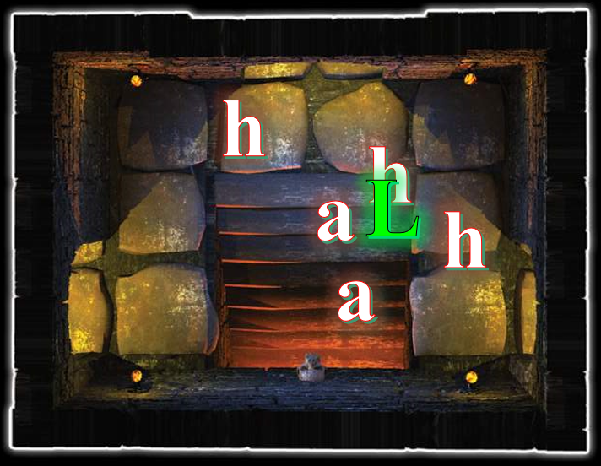

Round 116

“I miss you, my love. Stay safe, and come back to me; you must.” All could hear the worry in her voice. Looking to Kir, “We don’t usually split up. I doubt Lauren thought that they would have set such traps to keep her from returning to me.”

Lauren began winding up her channeled pyroburst spell, planning to take it to two full rounds, and then let ‘er rip.

Round 117

Allisa hefted the spear she had picked up. “I have most items. But if you want any of the ones left please grab it so we can be off.”

Kir gave Allisa a quick nod. She went and pick out an amulet, the White dragon scale necklace, a pair of gloves and the 36 arrows.

“I don’t know that you can follow behind me. The portals may not lead to the same place,” Lauren warned as she peeked down the stairs and studied the three ruffians destined for demise in honor of their soulthirsty goddess. The duskblade’s channeled pyroburst began to build up more fiery energy within her, and was nearly ready to deliver its maximum blast.

The remaining assassins studied Lauren.

Round 118

The remaining assassins studied Lauren.

“That’s why we’re not following your route. I agree that it’s quite likely that doing so might cause us to be even more scattered,” replied Fingers.

Lauren came down the stairs with her channeled pyroburst ready to blast. The bad boys reloaded, gulped saliva, and began to pray to Lolth for their souls. One was mirror imaged; the other was warded by a protection from normal missiles spell; and the third from a protection from good. None of these wards would be likely to make a bit of difference in how they would go down. Lauren targeted the spell halfway between the weakest bad boys, fired it, and then moved to attack the stronger-looking one with her sword.
Character | Save vs.  channeled pyroburst | Ranks | Roll | Save
Drow Assassin 2 | Reflex | 11 | 15 | 26
Drow Assassin 3 | Reflex | 11 | 16 | 27
Drow Assassin 6 | Reflex | 11 | 4 | 15
Success, success, fail. Assassins 2 and 3 save for ½ damage.
Dmg to Assassin 2: ½ x 50 = 25 fire.
Dmg to Assassin 3: ½ x 62 = 31 fire.
Dmg to Assassin 6: 46 fire.

And that left the sixth wheel of the bunch charred and soon to be forgotten by the living, and nearly killed the other two, who knew that death would come soon, and Lolth would eat their souls. Yum!

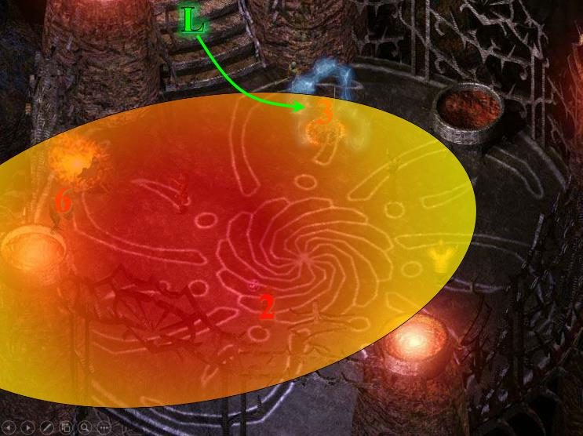

Round 119

Though the duskblade’s movements exposed her to the two remaining lesser combatants, the lesser combatants shot at her.
Character | Attack Type | Damage | BAB | Dex Mod+ | W+ | Other+ | Total Score | Roll | Total
Drow Assassin 2 | Light Crossbow +1 | 1d8+1+Poison | 6 | 2 | 1 | 1 | 10 | 14 | 24
Drow Assassin 3 | Light Crossbow +1 | 1d8+1+Poison | 6 | 3 | 1 | 1 | 11 | 3 | 14
Miss, miss.

“We’re trying the other way out that we discovered. Since it was a less obvious exit, it may be less trapped,” replied Fingers.

“Sounds good,” Lauren said as she finished off the man before her with one swing, then moved over to the last fool as he reloaded.
Melee Weapon | Dmg | D+ | TH+ | Critical | Type | Wt. | Atk | Roll | Check
Shattermantle Bloodstone Falchion +3 | 2d4 | +3 +3 | 3 | 18-20/x2 | Slashing | 8.0 | +23 | 11 | 34
Hit. Dmg: 3 + 3 + 3 = 9.

Kir packed away the dragon scale necklace, put on the amulet, and made sure it was under her shirt next to her unholy symbol of Velsharoon.

Allisa took a moment to attach the Crystal of Adaptation to her armor while Kir picked up items.

Round 120

Kir added the arrows to her quiver and put on the gloves. She checked to make sure her chronocharm of the grandmaster, her boots (acrobat), belt (healing), spell component pouch and her pouch of everlasting rations were good to go.

The remaining assassin’s hands shook as he shot a bolt towards Lauren.
Character | Attack Type | Damage | BAB | Dex Mod+ | W+ | Other+ | Total Score | Roll | Total
Drow Assassin 2 | Light Crossbow +1 | 1d8+1+Poison | 6 | 2 | 1 | 1 | 10 | 5 | 15
Miss.

The bolt was blocked by the woman’s shield, as the woman reached the man and swung to end him.
Melee Weapon | Dmg | D+ | TH+ | Critical | Type | Wt. | Atk | Roll | Check
Shattermantle Bloodstone Falchion +3 | 2d4 | +3 +3 | 3 | 18-20/x2 | Slashing | 8.0 | +23 | 5 | 28
Hit. Dmg: 4 + 3 + 3 = 10.

She was impressed by this one’s constitution. Apparently, it would take another swipe or two to finish him off.

Round 121

Lauren’s blacklight expired, though it had been countered already.

The remaining assassin cowered and dropped his crossbow, pleading in Underdark, << I beg you, Mistress, please spare my life and I shall pledge my service to you forevermore. >> Lauren was fairly certain that the male drow believed his own words, but who could trust such spider worshippers?

Lauren made a mental note to investigate how her Blacklight ability had been countered. In the meantime, she had an unwanted prisoner to contend with. She kicked the crossbow away, and glared at him. <<“You do anything I don’t like, and you’ll see your boss,” she growled. “I don’t like drow, I don’t like boys, I don’t like boys’ equipment, and I certainly don’t like little shits who try to poison me. So, you screw with me, at all, and I’ll turn you into a gelding, and then I will kill you.”>> Lauren pointed with her sword. << Strip. All the way to your smallclothes. Don’t do anything stupid. >>

She watched carefully as he disrobed, alert for anything he might do, or for anyone else who might enter the chamber.

~*~

Moondancer sat quietly by the mimic-looking chest as the others coalesced and planned to descend the staircase.

Kir made sure her Goggles of Night were on her head and her backpack, with the rest of her stuff tied tight and ready to go. Once done, she looked at Allisa, Fingers and Xaryn. “I’m ready.” She smiled. “Oh, Josie, I will be home soon.” She said to no one as she returned to the chamber with the downward staircase.

They’d completely ignored the northwestern passage where yet another portal was waiting.

With a nod to the rest, the changeling followed Kir down the stairway, alert for traps despite its confident tone with Lauren.

Still Exhausted from Kafi’s ray of exhaustion, Xaryn cast mage armor on himself, waited for Fingers and Kir to lead the way down the stairs, and said, “I’m readier than a red cheeked maiden.”

Brother Mosh was also ready to follow along the rear of the formation, and deferred to the rogues to enter first.

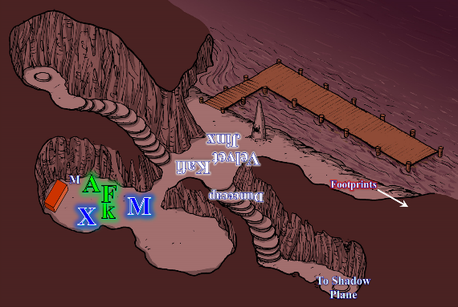

Round 122

Lauren’s new boytoy had put all of his weapons on the ground by now, and was removing his boots as hastily and compliantly as possible.

Lauren stood by, taking in the sense of where she was, and of the boy before her. There was a passage to the southwest—if that’s what it was—and back up the stairs to the north. There were other apparent passages, but by now the half-drow was well aware of their illusory nature.

~*~

They’d stayed clear of the northwestern passage where yet another portal was waiting.

Now that all were somewhat better geared-up, Fingers led the way down the hidden stairway. Rather than allow Lauren to fight her way thru who knew how many threats alone, the changeling intended to meet her halfway if at all possible. Given its mistrusting nature and experienced eye towards devious traps, the trapsmith eschewed the obvious path of the other portal in favor of the easily overlooked one it was now traversing. The fact that whoever had built this otherworldly corner of the plane apparently liked playing games with one-way portals made taking the other route even a more dicey choice.

Kir followed down the stairs behind Fingers. She kept her eyes open for anything out of the ordinary, traps and such. Like Fingers, she had not liked the looks of the other portal. For her, though, the idea of using the stairs was one of deductive thought. The chest was locked from the inside. So that meant that whoever had come through here, more than likely used this way to get to where they were going. “Whoever came up with this was either a genius or a crackpot…” she paused for a moment… “or both.”

Mosh followed next, and behind him were Xaryn and Allisa. Once the druid was inside, she noted the lever that closed and locked the chest from the inside, and contemplated doing so. Moondancer perched atop the shoulders of Allisa, who smelled enough like Lauren to comfort the pseudodragon. “We’ll need a light source,” the half-elf said, having the poorest night vision in the group.

The others could see perfectly as they descended the u-shaped passage along its stone staircase. Taking 20’ steps downward, Fingers noted that the u-shape above them was growing, meaning that the ceiling was getting higher and higher with every step, and the walls to their sides were getting wider, though the staircase was still about 5’ wide.

Round 123

At the 30’ mark from the chest above them, which Allisa had left open, Fingers and the rest of the gang failed to spot a faint aura of abjuration magic. Blundering right into it, they continued until Fingers was 50’ down and Allisa was 30’ down the staircase, with everyone in between standing about 5’ apart.

Moondancer shivered as she clawed Allisa’s armor. The screams they’d heard earlier along the river could still be heard, as if the echoes of souls gone mad dwelled here. The path ahead was a bit confusing to Fingers, who could now see to its sides not walls, but a chasm with no discernible bottom. “Something’s wrong.”

Allisa attempted to calm the little dragon.

They were all disoriented now. If they turned back and up, they could see the opening of the chest leading to the phosphorescent cave and the River Styx beyond it. However, none of them saw the way back in the same direction. Fingers took it to be to its right; while Xaryn to Fingers’ left, and as dim lights ascended from the chasm below, they began to illuminate the area, showing an irreverently hopeless complex of stairs and space between them.

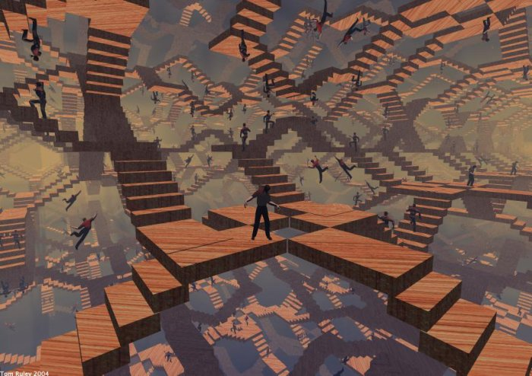

~*~

The young drow was now removing his pants.

Round 124

The young drow was now removing his shirt.

~*~

They appeared to be far from one another now, but their voices suggested otherwise. Yes, this was Limbo, but Xaryn assured them, “This is likely just an illusory effect. The architect of this charade is indeed elaborate, and has taken attention to detail to the extreme,” the drow remarked.

“Can we dispel it?” asked Fingers.

“It’s likely augmented with a permanency spell,” Xaryn guessed, but wasn’t too confident. “This kind of thing, you don’t want to have to keep re-casting.” Xaryn’s mental faculties and illusion-piercing vision aided him in seeing what was and was not before him. “The path goes this way,” he pointed, and Kir could hardly see him so far away, but when he placed his hand on her shoulder, she turned around to see his true image, and sighed.

The half-elf offered a small snake to the dragon, then readied her newfound short spear in case there was trouble, and spoke more encouraging words to Moondancer in a low tone.

Moondancer buried her face in Allisa’s robed bosom.

Round 125

With Xaryn leading the way now, and Fingers right behind him, the group continued another 100’ down or so, reaching solid ground. The floor beneath them was neither naturally formed nor carved nor masoned, but stone shaped by a craftsperson with whose handiwork Xaryn was familiar. “This is Dulkhende’s work,” he mentioned.

Kir turned to look up at him. “So Dulkhende was in league with these people?”

“He probably thought he was serving the interests of his noble house... not this Kaszüm bloke,” the wizard spoke.

~*~

Pretty much down to his knickers and leggings now, the drow boy looked up and asked, “Like this, milady?”

Round 126

Where the staircase ended, and the masonry reminded Xaryn of his friend, another slender corridor continued for another 15’ or so, leading to a door under which a sliver of flickering light pierced through the crack. Kir and Fingers heard movement within.

Speaking into the communication amulet, Fingers whispered, “Lauren, we’re at a door. Say something out loud so we’d know if you’re on the other side.”

Lauren used the opportunity to belittle the male drow further. “Yes. Now, lie down on your front, facing away from me. Do not move until I tell you.” After he complied, she put up her sword and shield, and drew her kukri. Using the blade, Lauren thoroughly searched his clothing and footwear for weapons, and made note of anything else he was carrying.

~*~

Fingers heard only Lauren’s voice emanating from its own head, as did Allisa, but the sound seemed altogether inconsistent with the sounds they were hearing from the other side of the door.

Round 127

Lauren separated anything dangerous from his clothing and personal belongings, and taking the weapons, she stepped back. “Come and get dressed.”

Character | Attack Type | Damage
Drow Assassin 2 | Dagger +1 | 1d4+1+Poison
Drow Assassin 2 | Light Crossbow +1 | 1d8+1+Poison

Aside from the dagger and crossbow at Lauren’s feet, the unarmored male had also been relieved of a handful of personal items of no threat to Lauren, all of which were in his manpurse/fanny pack. She left them in there after rummaging to her satisfaction, and threw the manpurse back at him. The man’s boots were magic for sure, though she couldn’t identify them, and the man had on more than one piece of jewelry, likely with magical properties.

“Might I ask what will become of me, milady?” asked the prisoner of war, an assassin gone soft.

~*~

The sound of metal, wood, and leather percussing about alerted the heroes, and Mosh urged in Aquan, << I say we move in and confront whatever’s in there. >>

Xaryn was much more trepidatious. He figured this was as good a time as any to cast protection from spells [expired on Round 1427] upon himself.
Xaryn gained +8 resistance bonus on saves against spells and spell-like abilities (but not against supernatural and extraordinary abilities).

While Xaryn took the opportunity to cast the spell spell, Fingers approached the door and inspected it for any signs of nasty surprises.

Round 128

Finding nothing worrisome, Fingers gently and silently tried the door to determine if it was locked, and it was indeed.

Xaryn then asked his friends, “Could anyone benefit from a bull’s strength spell? I prepared it with Lauren in mind.”

Round 129

“Then wait to cast it on her when we regroup,” Allisa kept them optimistic.

The door unwilling to open easily, Fingers looked for a way to release the impediment, planning to use its ring to knock it open if need be.

Fingers diagnosed this situation as one in need of its lockpick set, or its knock ring. Keeping the daily use of the spell as a fallback in case the lockpicks weren’t sufficient, Fingers began attempting to manipulate the lock’s tumblers.
Skill | Rank | Ability & Mod. | Misc. Mods. | Total | Roll | Check | Notes
Fingers, Open Lock | 16 | Dex (+4) | 7 | 27 | 17 | 44 | Lucky Fingers, Lockpicking ring
Success.

“Unholy Mephistopheles!” the master locksmith blurted. “Good thing I brought the good lockpick set.” This was one of those extremely elaborate mechanisms—such as the one that locked the Shadow Suite’s front door—that Fingers had to really strain to open.

~*~

Lauren sheathed her kukri and took up her sword and shield once more. “Honestly, I don’t know. I am Lauren Maltholas. What is your name?” She glanced around as he dressed, more carefully noting her surroundings. Having switched from Undercommon to Common, the duskblade was now calling the shots.

Round 130

“I... I am Dresden, of the House Ularn,” he replied in Common to his newfound mistress. “I have the privilege of offering you my virginity whenever you choose to usurp it,” he kept his gaze down as he spoke, knowing what would become of him if he did not display the appropriate levels of male subordination consistent with drow custom. Knowing nothing about the half-drow, he simply assumed that the path of Lolth was hers as well.

~*~

A second locking mechanism had to now be bypassed, and Fingers was on it.
Skill | Rank | Ability & Mod. | Misc. Mods. | Total | Roll | Check | Notes
Fingers, Open Lock | 16 | Dex (+4) | 7 | 27 | 18 | 45 | Lucky Fingers, Lockpicking ring
Success.

“By the gods!” Fingers whispered. It was coming to suspect—based on the way this area had been built—that a panic room was likely to be beyond this door. In any case, the rogue tried the ring-shaped handle now, which lifted and turned clockwise just fine. It looked back to the others and nodded, indicating that they were in a position to enter.

Round 131

Xaryn’s Exhaustion began to fade away as the ray’s malign effects wore off.
Xaryn’s Strength and Dexterity returned to normal.

“Whoo! That malignant wizard’s ray just wore off... I think,” he explained aloud to himself.

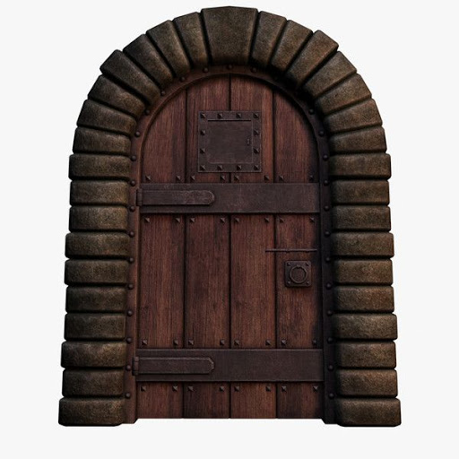

Kir, Mosh, Allisa, and Xaryn now prepared to go into the next room as Fingers steeled its own nerves. Because none of them had been detecting magic, they had not realized that upon descending the staircase, they’d tripped an alarm spell’s glyph, but based on the movements they’d just heard a few moments ago, they were pretty sure that someone or something was stirring in the chamber beyond the sturdy wooden door.

Round 132

“If you start flinging spells around, keep in mind I will be staying to the left of any enemies as much as possible,” Fingers warned quietly. Wand at the ready, the changeling produced its wand and prepared to go unseen. It would open the door when the others indicated their own readiness to face whatever lay beyond.

Towards the back of the formation, Xaryn and Mosh both nodded. With the stair behind them leading back up to the River Styx, Fingers beheld a series of steps going downward, starting about 30’ east—if east it was—of it, and the downward staircase appeared to turn leftward before it was out of the heroes’ lines of sight.

Seeing that the others had indicated their readiness, Fingers cracked open the door and peered inside.

Y-axis purposely concealed

~*~

“I don’t think my wife would appreciate that,” Lauren replied dryly. She decided to take a more authoritative stance with young Dresden. “Now, in exchange for your life, I require that you be truthful and forthright with me. Show me the exits from this room, and tell me where they lead. Point out any traps or other magic wards along the way.”

Round 133

Dresden got up, pushing his feet into his boots until his toes were snugly compacted at the tip, and postured a submissive demeanor as he explained the composition of this self-contained drow dwelling. “We are in the Abyss, roughly at the midpoint of a complex of conduits and hermetical spaces. This passage leads to the next chamber,” he pointed to the southwest, and led the way, explaining what he knew of how to get around this complex.

~*~

[DM assumption] Fingers tapped itself with its wand of greater invisibility [expired on Round 139], leaving 34 charges on the item, and became invisible.

Xaryn and Mosh approached, leaving room for Kir and Allisa in case either or both wanted to place themselves in the middle of the formation.

Kir pulled an arrow and knocked it in her bow. When Fingers said that he would be keeping to the left she grinned. “Understood. Now let’s see what is in here and if killing needs to be done then let’s get it done.”

Round 134

Fingers led the way, covering only 15’ every six seconds, but doing so with assuredness that they were not about to trip a wire or plate or other trap trigger.

Kir stayed to the right side of the corridor so she could fire her arrow past where Fingers had said he’d be.

Mosh waited.

Saving his true seeing and greater heroism spells for a time when he knew he’d need them, Xaryn cast a much longer-lasting spell—stoneskin [expired on Round 1434]—upon the half-elemental monk.
Mosh gained DR 10/adamantine, absorbing up to 130 points of damage.

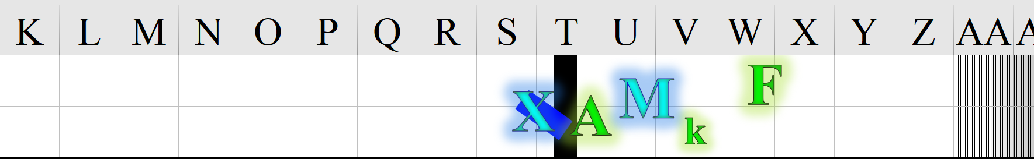

~*~

As the drow boy spoke, Lauren began to get a better picture of the schematic of the extradimensional trap in which she’d been ensnared. The two ventured along a 50’ long causeway, and Dresden indicated the concealed portal at their feet. “We’ve to jump in vertically, and will land as if we’d stepped through horizontally. It may be a bit disorienting at first,” he warned.

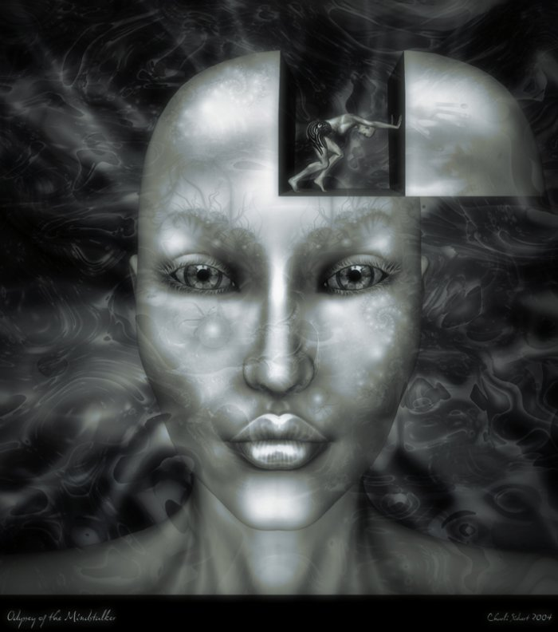

In her head, the cunning swordswoman started to create a mental picture of the path flows that comprised not only this immediate trap, but the greater Citadel of the Planes that this Kaszüm has assumed as his own home.

~*~

As Fingers, Kir, Allisa, Mosh, and Xaryn moved another 15 eastward, the invisible changeling tapped Kir’s shoulder and whispered, “Wait.”

The 10’-high corridor bent leftward as a downward staircase led deeper into this layer of the Abyss, but along the corner of the staircase, a pendulum blade hung motionless from the ceiling. Bits of bone and long-dried flesh too minute for carrion crawlers to care about were strewn about the edges of the staircase, which was chiseled flat, contrasted with the more irregular, U-shaped walls and ceiling.

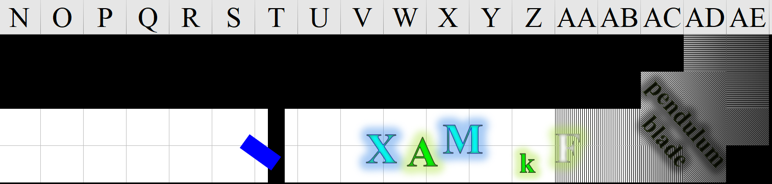

Round 135

Though she could not see Fingers, Kir gave him a nod when he said to wait. She saw the pendulum that hung from the ceiling, bits of bone, dried flesh strewn across the staircase. She also noticed the irregular wall and ceiling. “It’s been sprung,” Kir surmised. She still wasn’t truly sure. Kir shot her arrow at the pendulum just to make sure it had been triggered.
Ranged Weapon | Dmg. | D+ | TH+ | Critical | Rng. | Wt. | Atk | Roll | Check
Trovacuore (MW Shortbow) | 1d4 | 1 | 1 | x3 | 60’ | 2.0 | +16 | 17 | 33
Hit.

The lack of any effect was consistent with the hypothesis that it was currently inert, though Fingers knew of more than one way to trigger its movement from a plate adjacent to its slicing trajectory.

Allisa followed with spear at the ready, occasionally whispering to the dragon to keep her distracted.

Fingers was less trusting that the trap was harmless; nevertheless, the trapsmith examined the walls and floor, trying to spot the triggering mechanism. It was not difficult to do so, as the plate that did so was under a step that was a few degrees off kilter. “Don’t step there,” it pointed with an invisible finger, then disambiguated the step that it didn’t even have to crouch to verify its uneven positioning. “Third step down. That’s likely the plate that either resets it, triggers it, or both.”

“I just want to remind everyone that I’m blind down here,” Allisa repeated herself, wondering if she would trigger the trap.

Mosh and Xaryn let the rogues do what they did best, and were cautious to skip the third slab of stone comprising the surface of the staircase.

Allisa did her best, taking tactile cues from Xaryn, who touched her perhaps a bit too much now, and resting a hand against the wall for stability.
Skill | Rank | Ability & Mod. | Misc. Mods. | Total | Roll | Check
Allisa, Balance | 0 | Dex (+3) | -3 | 0 | 16 | 16
See below.

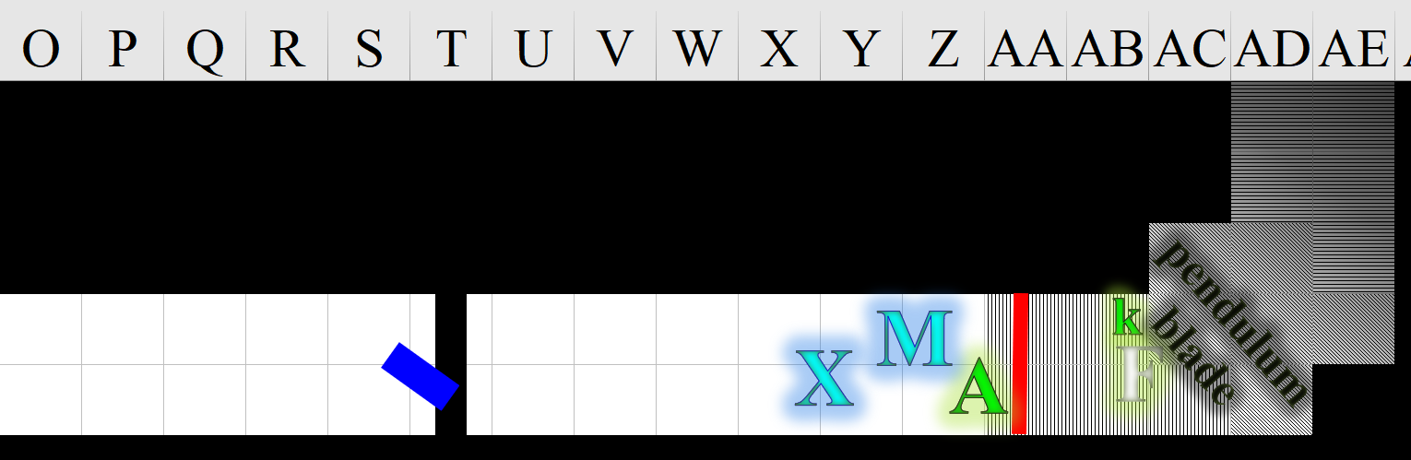

~*~

Dresden waited for Lauren’s permission to enter the concealed portal, unless she wanted to go first.

“Do you know where a dock along the River Styx would be from here? There was a stairway concealed as a chest, and two other portals, both in narrow passageways,” Lauren questioned Dresden.

Round 136

“That’s where this leads... eventually: the Abyss Suite,” Dresden answered.

“And what is the Abyss Suite? Who lives there?”

~*~

Kir was confident enough to take a few more steps down the stairs, quickly continuing to scan over the floor. She was looking for trap elements primarily, but noted a flattened silver bracelet in one corner amongst some bones that had never been cleaned up.

Mosh and Xaryn kept to the back with Allisa as Fingers continued past the blade and down the stairs, reasonably satisfied that the trap was inert. “The blade is right in front of you,” Xaryn warned the druid.

“I’m not going to be of much use in combat if I can’t see anything,” Allisa sort of sang.

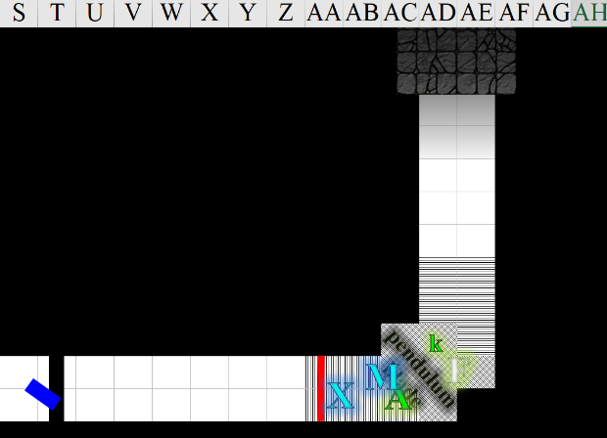

Round 137

Smelling carbonized flesh and wood, like a faraway barbecue, Fingers and Kir saw nothing perilous up ahead, and continued a vigilant and wary descent unto level ground, seeing a sudden widening of the corridor up ahead. With its Darkvision, Fingers could discern traces of debris in the widened chamber up ahead.

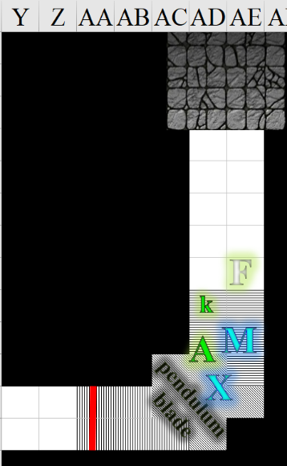

~*~

“Oh, I...” the young man smiled, coming to the realization of how little the stranger knew of where she was. “The Master’s lover—Karmen. The Master keeps two lovers, and the Abyss Suite is the area relegated to the taller of the two women.”

Round 138

Dresden went on to tell Lauren that the Abyss Suite was a later add-on, and would likely soon be scrapped out of security concerns. It’s the easiest to detect from outside. “Shall we proceed to the next room?”

~*~

The path ahead had clearly been the site of a fiery feud, or perhaps this was another trap. “Yes,” Fingers deduced, seeing the remnants of a fireball blast centered in the middle of the square area. “This’ll hurt if we trip it. Avoid the four central tiles,” it warned the others.

Another downbound flight of stairs also lay ahead, beyond the fire chamber.

Allisa put her newfound spear away and proposed taking out her torch. No one protested.

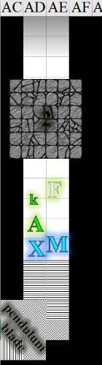

Round 139

Allisa pulled out her torch and lit it once the others were far enough forward. She held it low so she could see where she was stepping.

Moondancer, Mosh, and Xaryn remained towards the back while the two scouts did their best to ascertain the situation ahead.

As its invisibility expired, Fingers kept its wand at the ready but determined not to be fooled into wasting more charges unless a clear threat was in view. Skirting the suspected trap trigger in the center of the room, the changeling continued down the only visible path ahead with Kir behind it.



~*~

“I need more information before we go on,” Lauren said. “I want to know how and why I arrived at the place where we fought.”

Dresden let his new mistress finish her thought as she inhaled.

Round 140

I came from a dock on the River Styx, and then I found myself in a small room with three doors, and a painting with an aboleth on the wall,” Lauren continued, and Dresden listened.

~*~

The party continued north.

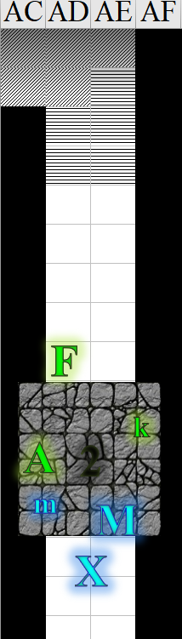

Round 141

The party approached the next downward staircase, and Fingers noted no guillotine, or pendulum blade, or anything placed there with lethal intentions. By the time Kir got a line of sight to the staircase, the others were making their way through the fire trap chamber.
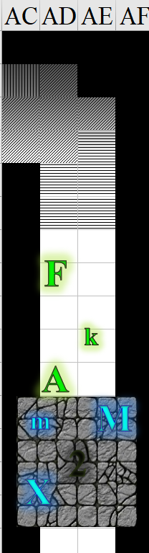

~*~

“I took the second door, and I was in another room with a portrait of a beholder. I took the first door, and there was a spider creature that decided to not fight.”

Round 142

Dresden nodded, following her thoughts through the architecture of the seemingly chaos-ridden corridors and portals.

“I took a passage in the floor, and arrived in yet another room. This one had a portrait of a woman. I took the first door, and I ended up in the room with you all.”

~*~

About as sure as ever of the absence of traps along this corner of the corridor, Fingers continued.

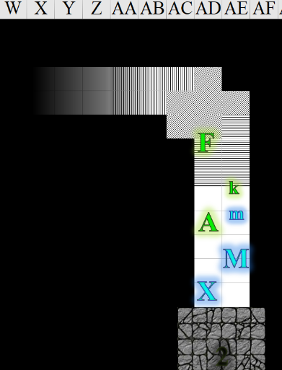

Round 143

Allisa continued to monitor the little dragon speaking softly to reassure her Lauren was alright and that they would be too.

Having passed by it earlier, Kir now sped back over to the south, making her way past the others. “Don’t get lost!” she heard Xaryn urging her as she passed him.

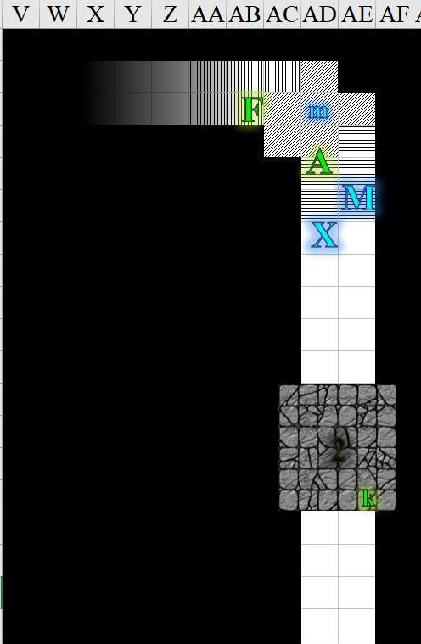

~*~

Dresden explained, “If you fell into our training grounds, you did not go through the door whose number corresponded with the first vowel in the emphasized word.”

“The first vowel?!” Lauren thought that a pretty stupid way to make a riddle, but now that she knew that, she was intrigued to hear more.

Round 144

The drow boy—conditioned from birth for submissiveness towards drow women—began to paint a picture—a schematic flowchart, really—of the logic paths that led to the last room.

~*~

Kir reached the bracelet, and bent down.

Fingers saw a figure standing in the next wide chamber, then realized it was some kind of inanimate object.

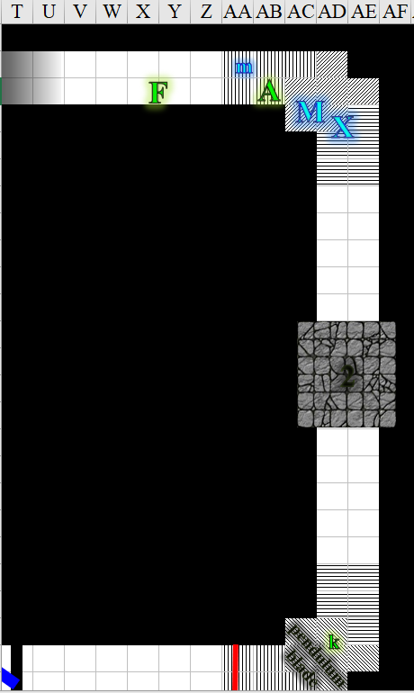

Round 145

Kir picked up flattened silver bracelet, stuffed it in her pouch, and sped back towards the Gambit with the bracelet in hand and without looking back.

Fingers now had the clear image of a scythe hanging much like the straight blade, as a pendulum, but now limp, and in the center of the room.

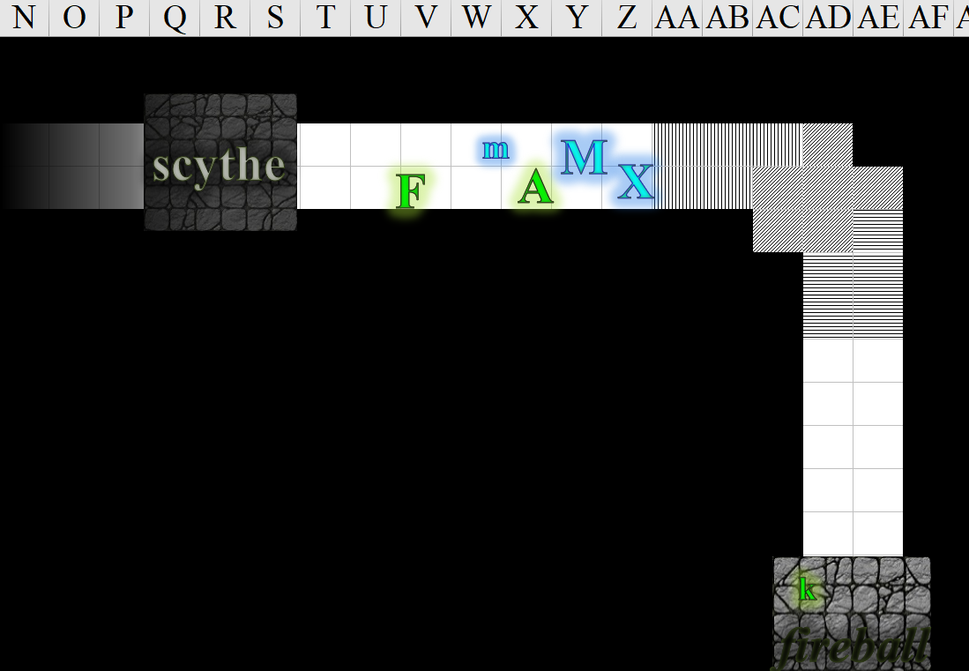

~*~

By the time Dresden was done talking—and he was nothing if not concise—Lauren had a much better picture of the situation at hand, and had devised a sort of mental picture of what she’d done, and what she needed to do next.

The loopy arrow represents an oversight on my part. I should’ve brought Lauren back into Room 2, but instead I took her directly to Room 3. The abyss is a chaotic place, so this advantageous anomaly fits in nicely with the theme.
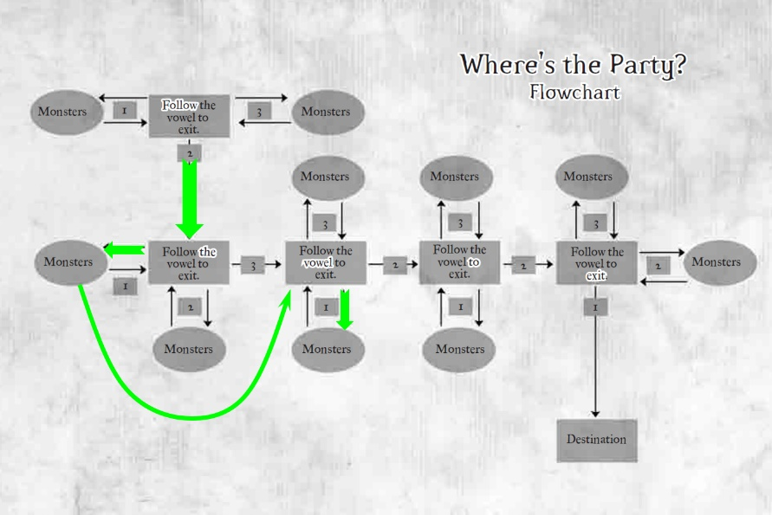

Round 146

“But how did I get into the first room in the first place?” asked Lauren, for kind of the second time.

~*~

The Gambit continued cautiously as Kir caught up and Fingers warned the others. “It’s tripped too, and recently, it looks like from the bits of flesh on the blade,” the changeling said.

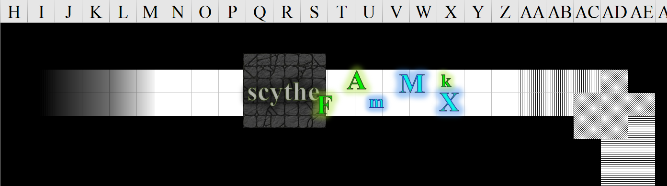

Round 147

The Gambit ventured further west.

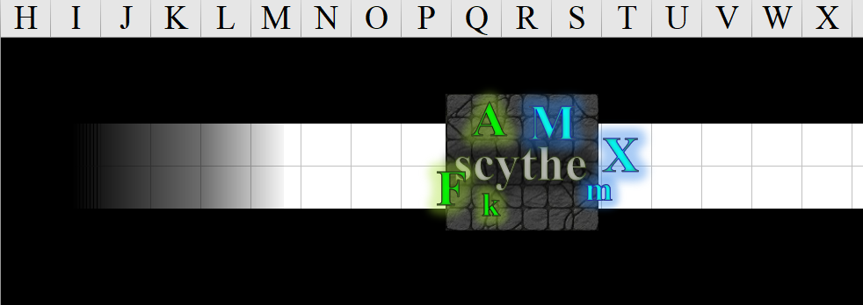

~*~

“There’s a trap—a one-way portal—hidden southeast of the Abyss Suite. I’m assuming you went there,” Dresden explained.

Round 148

Lauren nodded. “What is the destination, and does this path,” she pointed at the portal he wanted to use, “take us there?”

~*~

The druid called forward just loud enough for the person in front of her to hear, “Let me know if I need to put out my torch for any reason?”

The Gambit, led by Fingers, continued down the corridor. The changeling cautiously checked the floor, walls and ceiling as it went. Just because the traps so far all seemed obvious and tripped didn’t mean a far more subtle one was ahead—at least that’s the way the trapsmith would have done it to lull the unwary.

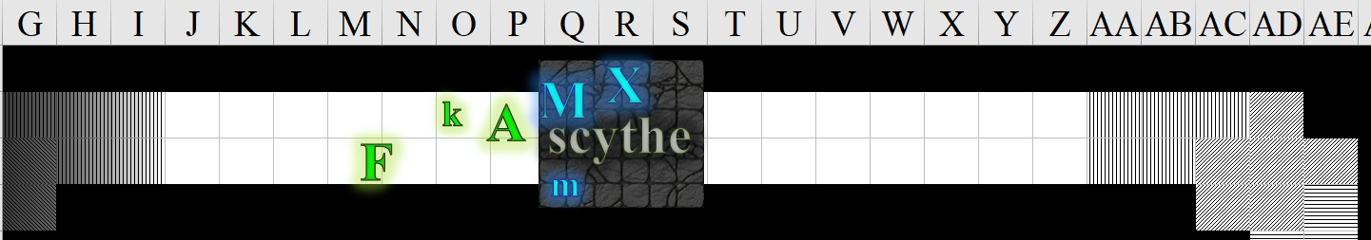

Round 149

The Gambit continued on its careful way.

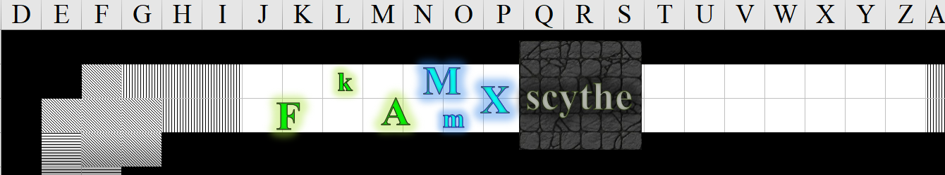

~*~

Dresden described the destination as the shore by the dock where they’d fought Jinx, Kafi, and Velvet just minutes ago, though he did not mention the three villains.

Round 150

Lauren cursed mentally as an idea came to her. She spoke through her still active Farspeaking Amulet. “Allisa, Fingers, can you both hear me?

“Yes,” they both telepathically said.

“I want you to stop where you are, and describe the place.”

“Alright,” the mistress of many forms replied.

The Gambit proceeded down the next flight of stairs, which curved southward.

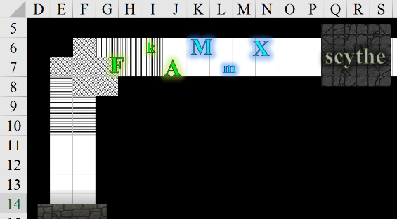

Round 151

Lauren added, “I have a young man in my service who may be able to help us find one another.”

Another chamber with a trap lay ahead, but this was no pendulum blade or fireball barbecue. In the room ahead was a pit. Fingers described it to Lauren.

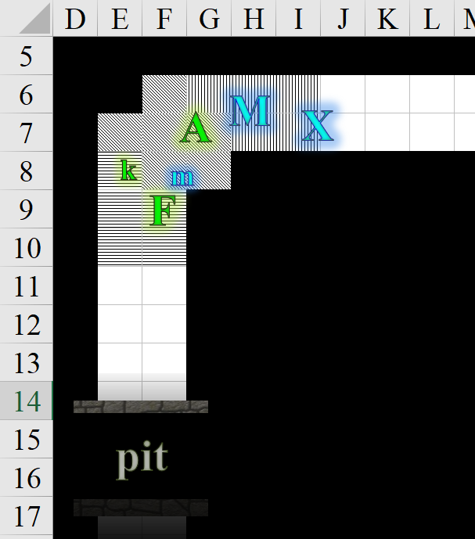

Allisa piped up Lauren’s voice. “I don’t know we have been traveling downward kind of in a spiral direction. But I am not good at directions in tunnels or whatever this maze is.”

Round 152

“I love and we both miss you,” the half-elf said. Then what her lover had said registered, and Allisa added, “Wait, what young man?”

Round 153

Fingers made a gesture to suggest that the details could wait if he was indeed in her service, and projected with its mouth closed, “Allisa is correct: it looks like we’re headed into an inward spiral that by Material Plane logic has to end soon.”

Round 154

“We can tell that traps along the corridor have been triggered, and it looks like whoever triggered them did so not too long ago.”

Round 155

“We saw scraps of meat and bone near some pendulum blades. It’s like a gauntlet.”

“Got it,” Lauren said, following up with, “and the young man is guiding me.”

Round 156

Dresden pointed down and added, in case it was pertinent, “Though the chamber beyond has no threats, two of its portals do lead to some monster pits.”

Lauren conveyed the message as she heard it.

Round 157

“What else does Kaszüm keep locked up in these transplanar chambers?”

Round 158

“Surely, you know chitines,” Dresden assumed by her drow heritage.

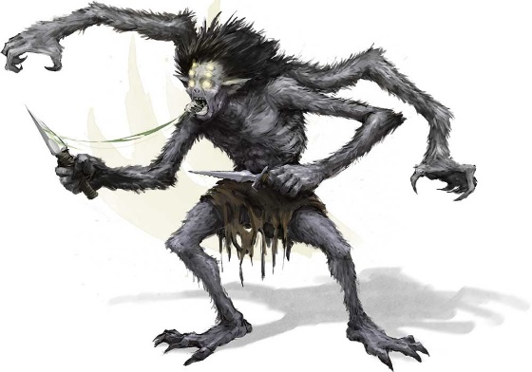

The woman cringed and nodded.

The humbled male continued, “Driders and ettercaps, phase spiders, maybe things I’ve yet to see or hear about.”

Round 159

Lauren conveyed to Dresden the description of her friends’ whereabouts.

Round 160

Lauren finished her description of what her friends had said.

Dresden shrugged, saying, “If they’re in Karmen’s suite, I have no knowledge of what lies in that chamber.”

“Can you take me to that chamber?”

Having seen no alternative paths to the spiraling stairs, Fingers continued the lead, making a mental note to inquire about the availability of a wand of detect secret doors if they ever escaped from this maze of planar travel. The trapsmith couldn’t help wondering whether one such covert path might’ve been missed sometime along the way. However, upon reflection it concluded that finding such a wand with a sufficiently high caster level to be of practical use when doing significant travel might be financially problematic. The rogue recalled hearing once about an item called a runestaff that was powered by ones arcane ability that might be cheaper in the long run, but was nevertheless quite expensive to acquire.

Reaching the pit, Fingers and Kir stopped and waited for the others to catch up and figure out how they would get across in order to continue the plunge into the center of the corkscrew-shaped corridor, if such it was.

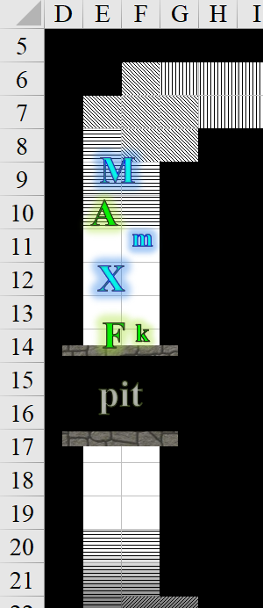

Round 161

“Why… yes, as I said: it’s right down here,” Dresden smiled, then hopped in.



Lauren followed, and landed gracefully in a room with three doors identical to those before. Behind her was now a hyperreal landscape painting depicting what Lauren perceived to be a rather dramatic precipice of the Styx.

~*~

As the remainder of the Gambit caught up, Fingers peered ahead into the darkness with its devil-touched eyes while pulling its silken rope from its backpack, trying to spot anything within 50’ a rope might be looped around. Those that built this place had seen to it that no ropes could be fastened anywhere in sight.

Round 162

To the south, the Gambit saw just another continuation of the corridor beyond the pit, and down below an abyss that went deeper into the Abyss. The wall of that drop was irregular, but smooth enough that even an experienced climber would have had a difficult time along it, and who knew how deep it went?

~*~

As expected, the word “to” was emphasized in the chiseling at her feet, and given that the only vowel in that word was in the 2nd position, Lauren simply waved to door #2, and Dresden nodded, walking through the portal that looked like a wooden door.

The were in another identical room now, with the last word emboldened.

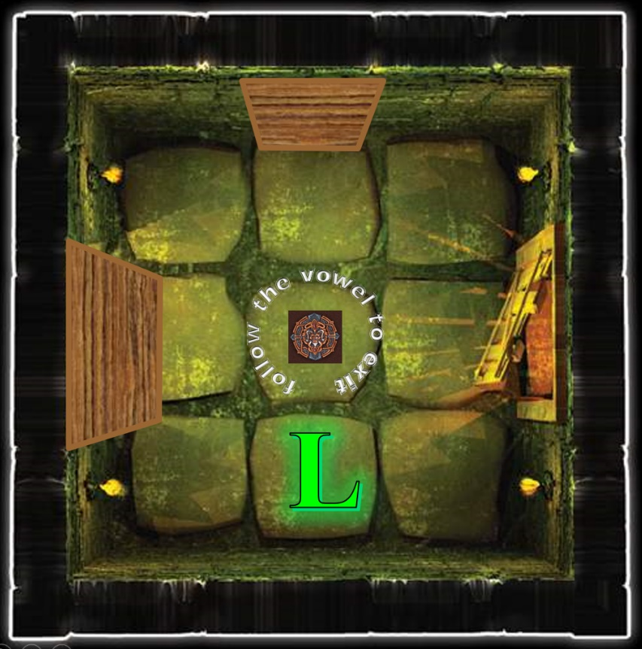

Round 163

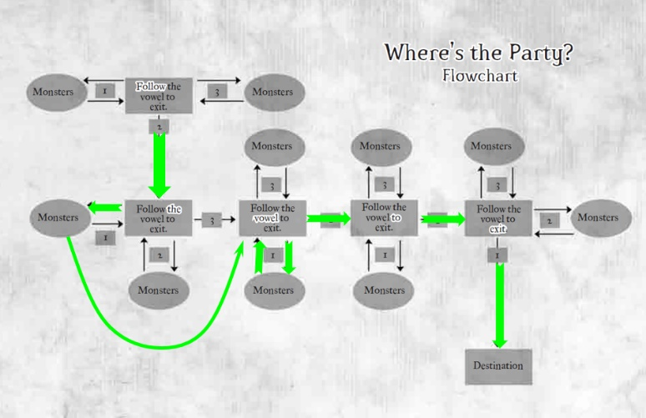

Understanding the pattern now, Lauren chose portal #1 this time and ended up in a room that was only slightly similar to the identical chambers that preceded.

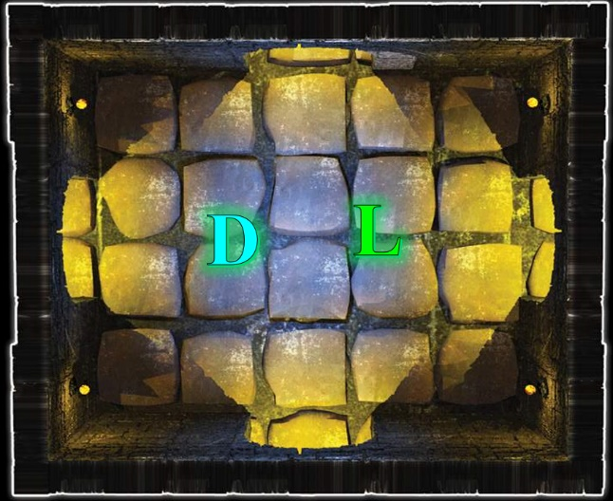

“Now what?’ asked Lauren.

~*~

The trapsmith muttered to itself in frustration, “Well, so much for that idea.” Just to make sure the pit wasn’t a cunning illusion, Fingers tossed a coil of about half the 100’ length of the rope out into the apparently bottomless pit.

The rope fell into the hole.

Round 164

Fingers looked at its timepiece, which read: 08:18. The end of the 100’ of rope hit something solid, and something solid grunted, then growled, rousing from sleep.

Xaryn—the group’s expert dungeoneer alongside Lauren—immediately identified the sound. “That’s an adult otyugh,” he said as the monster’s guttural complaint was followed by a pulling of the rope.

~*~

The boy-servant said, “Doesn’t matter really. This used to be a dressing room inside a bigger room.”

Lauren, intrigued, took one of the four exits and confirmed that they were indeed in a larger room. She also noted four portals on the ground, just like the one they’d jumped through in the drow training grounds, and four spartan cots with a few personal belongings strewn about each corner.

“They all lead to the dock,” Dresden answered the question she was about to ask, and then she realized that this is likely where Jinx and the other three elite guards were when they were dispatched to deal with the Gambit.

Round 165

Lauren could tell with sufficient certainty that one of the cots had been claimed by the ettercap paladin they’d recently killed; another was clearly the resting place of the Abyssal ghoul, who could just as easily have rested on the ground; the third cot had the trinkets and mementos of an outcast drow; and the last one she saw had so much black dragon fuzz and memorabilia that if this wasn’t their little base of operations, she didn’t know what was.

The half-drow then walked over to one of the portals on the floor and asked the drow, “So we just drop in here, and we’re back at the dock?”

“Yes,” Dresden replied.

~*~

Fingers began trying to reel the rope back in, having no desire to get up close and person with the monster. Worst comes to worst, the changeling planned to let the rope drop for the creature to play with—it was merely a mundane rope after all that could be replaced easily enough if the Gambit ever managed to make their way back to Waterdeep.

The animal grappled the rope with one or more of its tentacles, and pulled hard.
Save vs.  Tug | Rank | Ability & Mod. | Misc. Mods. | Total | Roll | Check
Fingers, Reflex | 11 | Dex (+4) | 1 | 16 | 17 | 33
Fingers, Balance | 0 | Dex (+4) | 2 | 6 | 7 | 13
See below.

Round 166

Fingers had to let go of the rope, or he would surely have fallen in, drawn by the superior strength of the formidable omnivore below.

Moondancer—chaotic as fuck when hangry, and often hangry—skedaddled onward and southward, landing on the other side, and sniffing around.

~*~

“I’m going back to the dock,” Lauren announced. She looked at Dresden. “After you.” She followed the young drow through the portal.

Dude dropped down.

Lauren followed through the portal directly opposite the one that Dresden had just taken, and landed at the bottom of the steps from which she’d initially entered the Abyss. Behind her was the portal leading back to the Shadow Plane, but because Kir had taken back the shard, the portal was currently locked.

She hadn’t noticed before, but there were seven concavities carved into the rock to her right, and it looked like each had been used for sacrificial purposes in ages past, though not that recently.

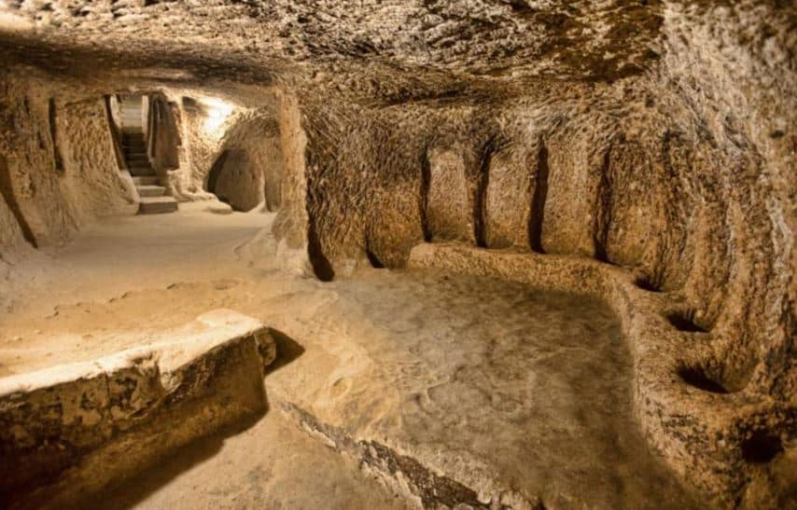

Round 167

Landing surely of foot and taking in their surroundings, Dresden and Lauren made their way down and up the respective staircases onto which they’d been thrust.

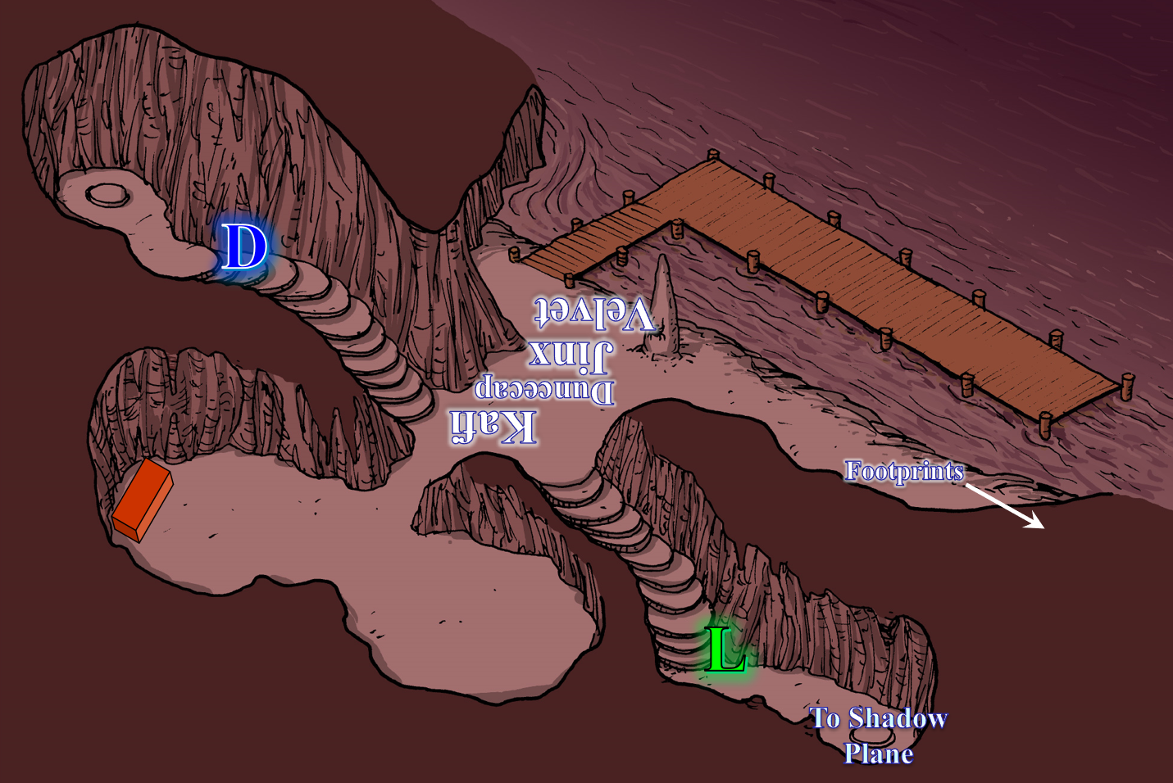

And though Lauren hadn’t yet realized it, any telepathic conversation that had taken place within any of the rooms with the bits about the vowels had not been heard, on account of those rooms being part of Limbo, and not any layer of the Abyss. Fortunately, that communication had only included the last few fragments that she’d meant to relay. Now that she was back on the same plane as the others—presumably—she attempted contact again.

