*Chapter 70*

Fingers stepped through, saw nothing out of place, heard nothing moving, turned back, and nodded to Kir, who also entered the suite.

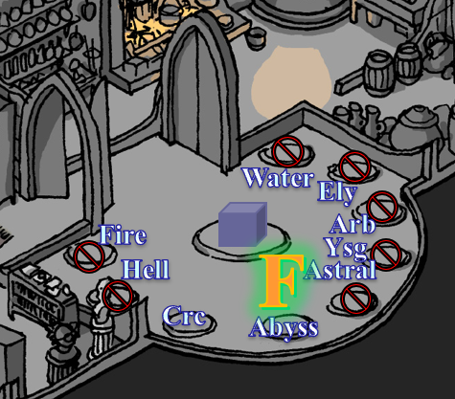

Lauren stepped through the portal into the Shadow Suite, and went into the kitchen to make sure no baddies were here.

Allisa remained in the Abyss Suite for another minute, giving the others time to look around.

Xaryn stepped through as everyone took their respective directions to go scout. Dresden stepped in next looking around as if he’d never been there before. When he had, he’d been hooded.

Fingers was now by the front door, ensuring that it was still locked, and it was.

Xaryn had meanwhile wandered into the study, and went back to looking at the scale model of the multiplanar cosmos.

Lauren and Kir had secured the kitchen, and now the duskblade passed Xaryn on her way to the bedroom.

“Nothing?” Lauren asked Fingers as the changeling came back down the stairs from the front entrance. Moondancer was perched atop the half-drow’s shoulders like a proud dragon.

“I don’t think a soul has been through here since we left,” Fingers confirmed.

Kir had slapped together a sandwich, and now also walked over to the others, who seemed to be congregating by the fireplace.

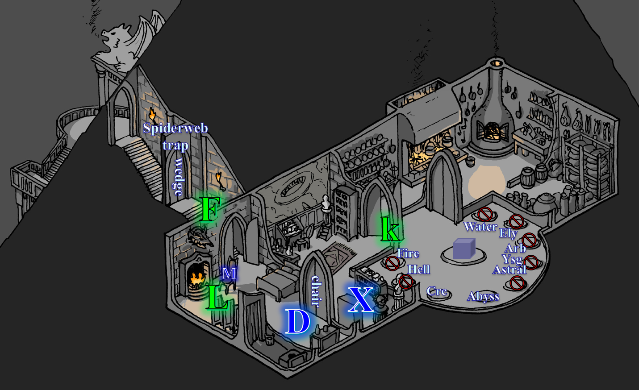

Dresden also was in the bedroom now, admiring all the expensive-looking stuff.

Allisa followed her wife through the portal, and followed the sounds of her friends’ voices into the bedroom.

Fingers looked at its chronometer, which read 08:43. “The morning is young yet,” it sighed. “Those who escaped are likely plotting a second engagement. It would behoove us to stay alert and on the defensive.”

Lauren waited for Allisa to arrive before she spoke. “Fingers, if you can lock that portal so they can’t follow, that will help. I suppose that those we kill probably won’t stay that way, so we need to be careful. I’ve used a lot of magic this morning, so if we keep exploring, I won’t be able to do what I did to Larlum.” She looked at Allisa. “So, should we keep exploring, or wait until our magic is fully restored?”

Fingers listened to Lauren before going over to retrieve the shard that Allisa had left in the portal on the Abyss side, then returned to the conversation, which was now about food.

“We’re all hungry,” Lauren spoke for everyone.

Kir offered, “You give me half a toll’s bell, and I can whip us up something good. Give me the whole hour, and it’ll be even better.”

Dresden sat in the armchair since no one else was doing so.

“So our plan is to sit here for at least an hour?” Xaryn wanted to know. “I could take that time to study all of these documents we found, and try to make sense out of where the rest of your stolen items are, and maybe the keeper of this lair.”

“All my major spells are used. Even with Lauren’s scimitar which I hardly ever us. I am not a match for a what we have been fighting. I had rather stay her and reacquire my spells,” said Allisa. “I cannot believe all that traveling took no time at all.”

“We can examine the items we’ve taken, as well as take the time to search this place more carefully,” Lauren suggested.

~*~

They’d decided on 10:00 as the time to get a-movin’ again, and it was now 5 minutes short of that. They’d taken a bit more than an hour to tend to the group’s needs based on their respective specializations. Xaryn had studied about two thirds of the parchments and other documentation, while Allisa, Fingers, Kir, and Lauren had looked through the less arcane, more gossipy portions of the correspondence.

Kir had delivered on her promise, and now everyone was concluding an even better breakfast than the previous one. They’d also just wrapped up a mutual debriefing, and were now much better informed. They’d confirmed what they’d originally found out from the late Parjit in the records. His Estate—they’d earlier learned from the City Watch Chief *[Chapter 64]*—had sold the property through which the Gambit entered the Shadow Plane, and liquidated all of his assets to the House Husteem, a known House of vampires. From there, it had exchanged hands through three separate shell entities—all tied to the Cult without a Name, based on the implicit references—and eventually the house and grounds found themselves in the hands of Kaszüm, fair and Lawful Evil, as Kaszüm’s attorney had put it shortly before being decapitated and fed to the gnome’s Abyssal pets for daring to insinuate his collusion with Law.

“So he’s a madman,” Kir synopsized.

Xaryn gave a more specific and elegant diagnosis, “Bonkers. Off the boulder, and the boulder’s nowhere near in sight... but I’m not even saying that because of the decapitation of his real estate lawyer. No, the guy’s entire ramblings are basically...” he started to giggle with a physician’s sense of humor, “... if I had to guess, I’d say an aboleth and a beholder are playing tug of war with his mind... there are entire dialogues here between the two eldritch monsters, and the alphabets toggle from Aquan to Abyssal, but the language conveyed in the Abyssal script isn’t Abyssal; it’s something entirely alien to me, and I dare not stare too deep into that abyss, not this close to the actual Abyss.”

Dresden had been taking a nap in the nicest bed he’d ever seen, and was now suited up and ready to go. He looked to Lauren, who waved for him to relax a moment while they figured out what to do next.

Allisa said, “So we have now keys or shards that let us get into Carceri, the Abyss, and—we think—Ysgard?”

“Yes,” Xaryn. “There are gaps in what was revealed in these documents, so we can’t know for certain where these really lead, even when we’re there, though I can guess with enough confidence in most cases once I’ve had a chance to analyze the properties of the plane.”

Moondancer had buried her face in a bag of dried apricots in the kitchen, and now came back into the portal room weighing about 5 pounds more.

“Wow!” Xaryn noticed the dragon’s belly, and raised an eyebrow momentarily before returning to the topic. “But I will say this: I’ve documented several references to these and other planes, including Dis—the 2nd layer of the Nine Hells—the Elemental Planes of Fire and Water, and Arvandor, which is a layer of Arborea.”

“Oooh!” Allisa hoped to spend eternity there, or somewhere like it.

“That’s pretty much what you’d guessed earlier,” Lauren pointed out.

“Yes, but there’s no mention of Elysium anywhere, so I may be wrong about that portal. Also, there’s a mention of a Verdant Prince who occupied an area coveted by Kaszüm, but had apparently been vanquished or banished; the word doesn’t translate unambiguously into Common... ‘cast down,’ the flowery entry reads. Oh, and even before the onset of madness, he was still a textbook sadist. Likes to torture at least one lover, using that as leverage against the others, and they’re all his captives in one way or another, albeit well-kept women.”

Kir elbowed his hip. “I’m not sure I like the way you put that all provincial-like.”

The drow smiled, and sighed, “Anyway, that’s pretty much it; what did *you* learn?”

Allisa and Lauren summarized the many hatreds Kaszüm harbored for his adversaries—who tended to be taller male humanoids and vampires—and the nearly as many euphemisms that he fostered for his misdeeds and ill-intentioned plots. They’d found several hit lists, with most of the names lined out, sometimes with a date or trivial tidbit, such as “nice loot” and “pleaded cuntively”.

“But there really wasn’t anything tactical that helped us to better understand these portals and Kaszüm’s ultimate plan,” Lauren regretted.

“I think it’s just to kill us all and take the stuff he stole from us,” Allisa posited.

“And the rest of what they *didn’t* steal from us,” Fingers added.

“And *our* stuff too!” Kir huffed.

Dresden offered, “It’s likely that the Master—sorry, old habits—Kaszüm is either recruiting more muscle to deal with you now that he’s had time to study your tactics against his champions. I once overheard a conversation as he was looking over our living quarters about him playing a ‘long game’, and I think from what was being said that he meant that his strategy was to wait something out. This was moons ago, so I don’t know if it ever worked out.”

“What is your family name, Dresden?” Xaryn asked, hoping to have time later today to copy a newfound arcane scroll to his spellbook.

“I am a Third Outcast of the House Ularn,” the younger male modestly replied.

“Ah,” Xaryn nodded, then shook his head. “My condolences for your defunct House.”

“None are necessary. Mine were two of the hands that labored in tearing it down,” the male confessed, suspecting that eventually the treason brand on his forearm was plain enough. “I mourn, yes, but not for my own blood, nor will I grieve for my former master.”

“How did he come to be your master?” asked Kir.

“Ahhh,” he reviewed his greatest blunders, and summarized, “A scandal, a love triangle, and my optimistic naivety led me to collude with others against my own, and through a series of bargains, I and a handful of my coconspirators became his howlers’ keepers, and his dark-elven pets in the process.”

Lauren had cut those beasts—and the man’s accomplices—down with hardly an effort, and would eventually send a prayer that their souls might not reach Lolth’s clutches.

Fingers inhaled deeply, seeing the next logical path forward being through this Ysgard portal or the similar one in the Abyss. “So, next steps....”

“We can go,” Lauren said, “but I won’t have my most powerful spells available.”

The Gambit, and these three new folks—four if the pseudodragon counted—looked at one another and then turned to the Ysgard portal.

The chronometer read 09:59. They placed the ivory and amber shard into the receptacle, and the portal unlocked; the sheen that had prevented all passage into the portal now disappeared, and the flat screen seemed like a perfectly still liquid surface beyond which was likely Ysgard. Because Xaryn was less sure that this was Ysgard than he’d been about the previous planar destinations, he insisted on going first. Fingers nodded, and the drow stuck his head through the portal, peeking about first before entering.

He turned back and nodded to Fingers, who then led the rest of the folks through.



The chronometer had just switched to 10:00; never had they been so punctual. Dresden stepped through last, and they found themselves in a 5’ wide, 10’ long staircase that led to a locked door. Like most of the other portals, the opening had been facing a wall, so the adventurers couldn’t tell what was up ahead except for the grain of the jaundice-freckled white granite that comprised the wall.

Fingers was already trying the knob, having studied the area and found it to be devoid of traps, but now it was getting crowded by the others. Even in halfling form, the changeling had to ask, “Can you guys give me some space here?”

|  |  |  |  |  |  |  |  |
| --- | --- | --- | --- | --- | --- | --- | --- |
| **Skill** | **Rank** | **Ability & Mod.** | **Misc. Mods.** | **Total** | **Roll** | **Check** | **Notes** |
| **Fingers, Open Lock** | 16 | **Dex (+4)** | 7 | 27 | 13 | 40 | Lucky Fingers, Lockpicking ring |

*Success.*

Lauren pushed up against Dresden, whose blue skin blushed an indigo-violet for a moment, and she even felt an adequately sized member pulsating against her left quadricep. On her right side was Allisa, squeezed in between Xaryn and Kir.

“I truly believe this to be Ysgard,” proclaimed the archmage now that the others could hear him.

“Here we go,” Fingers had zero trouble with the mundane lock, though it noted the Ysgardian design, with which it was previously unfamiliar. It was not unlike dwarvencrafted mechanisms, but a bit more refined, and less blocky. The runes were nice.

As befitted her status, Lauren archly ignored the touch. Besides, he wasn’t her type. She waited for Fingers to proceed, and then she followed it and Kir.

Allisa grabbed the stone key from the portal and passed to Xaryn for safekeeping. She followed the others out taking her place in line.

The door creaked open at first, then the hinges were silent as the rest of the 90-degree arc was completed. Fingers and Xaryn were at the front, and could see the shifting perspective before them. “By the gods,” the drow exclaimed.

“What is it?” Fingers turned, its eyes a bit dazed by the visual effect before him.

As their eyes got from 2’ to 1’ to mere inches from the threshold, it was as if a magnifier was being placed before their eyes, and as Xaryn took the lead on stepping into the ample dome before them, he explained, “This is *definitely* Ysgard. This is Ysgardian transdimensional space, not to be confused with transplanar.”

“So this isn’t another portal?” Fingers wondered, noting the threshold’s likeness to a definite border between one space and a different type of space, though it couldn’t put its finger on it.

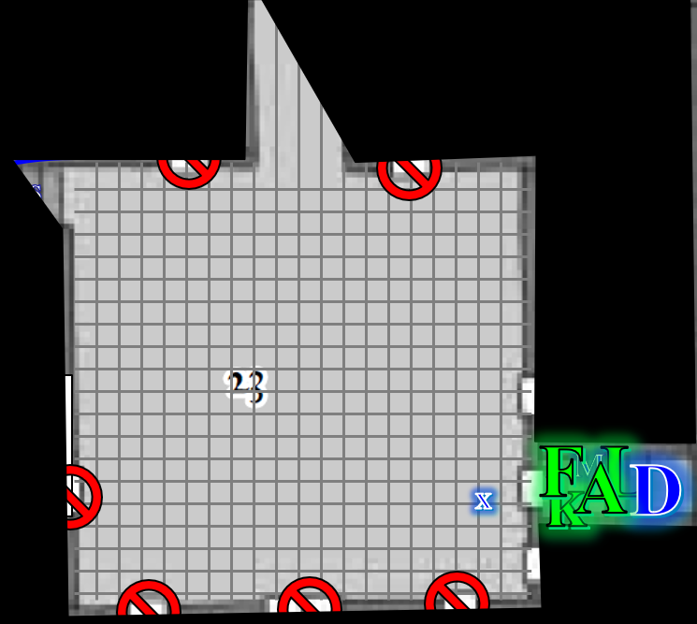

Standing near the southeastern corner of a room whose dimensions the others couldn’t quite discern from inside the staircase, Xaryn shook his head and said, “No, the space in which I’m standing would only be slightly more voluminous—about five times, I’m guessing—than the stairwell, but it’s amplified to allow for a much larger space in which to practice combat, as you can tell by the weapons,” he pointed to the assortment of martial gear displayed on racks along the walls. Some of it was for Large combatants, but as the party stepped through, the majority of them noted just how finely crafted they all were, as well as the helmets, shields, and suits of armor that were also displayed along the walls of what was now evidently a dojang. Several years’ worth of footwork was evident along the floor, which was padded with a single 100’ x 100’ leather mat carved from the hide of an Astral dreadnought.

“See? I calculate about 100’ across,” Xaryn pointed to what might have been north and then west, “both ways, but given the size of the door,” they looked back to see that the 5’ x 10’ door through which they’d just stepped now looked like a 20’ x 40’ door covering nearly all of the 50’ tall walls around them. A total of 7 seemingly huge doors—including the one though which they’d just stepped—were lined at uneven intervals throughout the room.

Above their heads was a clear glass dome that streamed in light at about a 45-degree angle, so it didn’t reach the floor. To the northwest was another corridor leading westward, and to the direct north was a causeway that seemed to lead outside, based on the indirect light that emanated from that direction.

The room was otherwise lit by everburning candles ensconced in pairs onto wall-mounted candelabras. The smell of fresh air—nothing like the Abyss and Carceri—characterized the area outside the previously closed staircase, and to those with finer olfaction—Fingers and Kir in this case—there was also the scent of old paper and ink that came with the freshness in the air. There was a school, or a library, nearby, it seemed to the halfling and the changeling.

“Impressive,” Lauren said as she took a few steps, and then turned to look at the chamber. “Don’t touch anything, just in case. I don’t think the owners would like that.” She looked at Fingers. “Where to?”

Allisa had a disappointed look on her face. She was hoping to find some better gear. She refrained from touching, but thought, “If I were a thief, I probably would not be able to resist.”

Lauren glanced at her and, divining what she was probably thinking, smiled at her. “I’m sure there will be opportunities to find more things.”

Letting Fingers worry about the rest of the doors in the place, and Lauren appraise the weaponry, Xaryn studied just about everything else: the architecture, the indirect light that came in from above and their north, the space itself, and its dimensions. “Astounding,” he began walking north to see what else lay ahead.

Fingers had by now eyeballed all of the locks, and felt that it could probably crack each one with moderate effort at most.

Lauren stayed equidistant to Fingers, Xaryn, Kir, and Allisa as they looked around the room. “Stay alert,” she said to Dresden and Moondancer. “The owners may not like us being here without permission.”

“I don’t know that I care what this Kaszüm thinks of us being here any longer,” Kir stated. “I didn’t to begin with, but at this point, I *want* him to show up.”

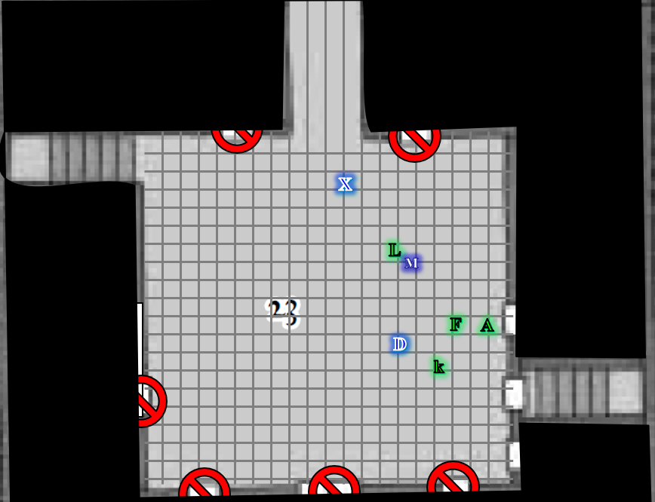

“There’s another staircase going up,” Xaryn announced. “And a portal is at the top, but it’s facing the wall, as usual, so I can’t tell where it goes.” The archmage started to make way for the stairs, but as he approached the threshold into the corridor, a similar spatial distortion took place, this time coupled with a chaos-infused—he could tell—illusion, which multiplied the number of paths before him. “Whoa!”

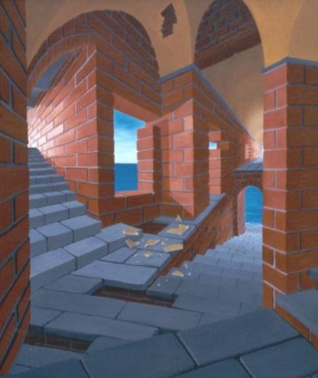

“What is it, Xaryn?” Lauren—who was trying to remain equidistant from everyone—asked.

“The same illusionist that forged that labyrinthine house of mirrors back in the Abyss likely crafted this one too,” Xaryn surmised.

Kir approached cautiously, and took a step back as soon as she saw what her companion had just described. “Phew!”

“Fingers, what do you think?” Lauren called.

Kir approached Xaryn, careful in her step despite the visual distortions, and wondered, “Hey, what would happen if we were to transport this portal back into the Shadow Plane through the other portal that we just walked through?”

Xaryn smiled with an unanticipated image in his mind. “That’s a comic strip waiting to happen. No, it’ wouldn’t work. The polarity of two portals makes it such that neither surface can cross the other. It’s like a *wall of force* effect.”

“Ah,” the halfling sighed.

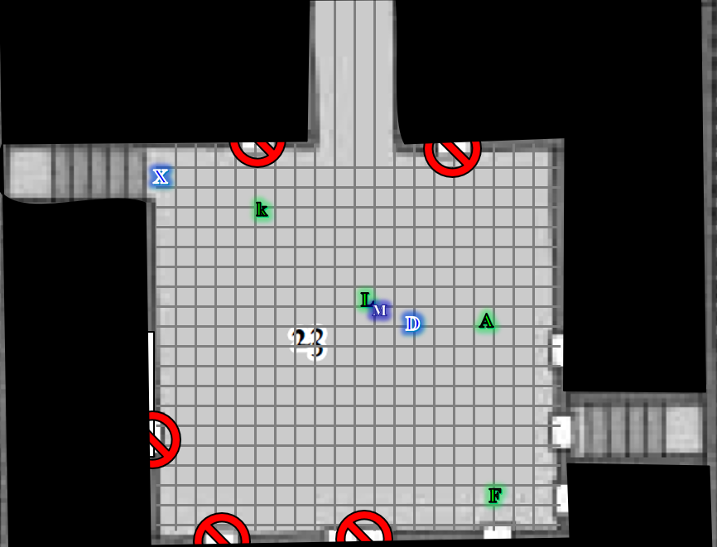

*[DM assumption]* To the south, Fingers had reached the nearest doorknob—which had appeared to be the size of its chest from afar, but was actually the size of its palm by the time it had reached the door. By then, it was well aware that the door was ajar, and through the ¼” crack there wafted the scent of recent carnage... not so much rotting flesh, but freshly spilt blood.

Fingers made a familiar snapping sound that echoed throughout the domed concavity, alerting the others to possible danger. Xaryn and Kir helped one another to return eastward so as to be outside of the illusion-ridden area, and kept their attention divided between Fingers to the south, and the 20’ tall, 20’ wide, 50’ long causeway to the north, which seemed to open up to a pink and orange sky.

Fingers pushed the door open, finding a desk with a pool of liquid blood atop it, covering parchments and books and other stationery. The fancy office was decorated in a martial theme, with a fresco and oil paintings of battle scenes covering the three walls that the rogue could see while standing just outside the room. The severed and mounted heads of a few extraplanar monsters stared down at Fingers from high on the walls, and a case next to an ornate desk displayed various medals and honorable regalia.

An empty chair behind the desk also had smatterings of now dried blood. Only the edges of the desktop puddle, and the smaller smatterings were dry, suggesting to fingers that the blood would have been spilled around 08:00 or 08:30, if it was humanoid blood. The crimson fluid was the most notable feature of the room, which otherwise contained the effects of a martial bureaucrat, perhaps the overseer of this training ground, if such it was. No bloody tracks or footprints gave any clue as to how a bleeding person would have disappeared from this room, other than *teleportation*, which was coming up as a possible explanation for many interrelated mysteries in the last day.

Two bookshelves lined the east and west walls of this suite, and the empty chair faced the door, suggesting that whoever was in the chair was facing whoever entered the room to kill them. It was all in a moment’s speculation, but as the changeling’s eyes took in the rest of the visual cues to forge a coherent forensic narrative, Kir asked, “Is all well?”

Before speaking, Fingers turned to its right, noting that the other doors along the southern wall were not ajar. “There’s blood here; probably a murder, but I don’t see a body,” Fingers reported, not yet having looked behind the desk. The rogue noted that though there were some books on the shelves, the latter were mostly adorned with trophies and gladiatorial memorabilia.

Lauren moved to within 25’ of the office door. “Any idea who, or what, the victim was?”

“Someone who bleeds red, and probably fit in that chair,” Fingers pointed as Lauren shifted her position so she could see through the door that still looked to be 20’ wide and 40’ tall to her.

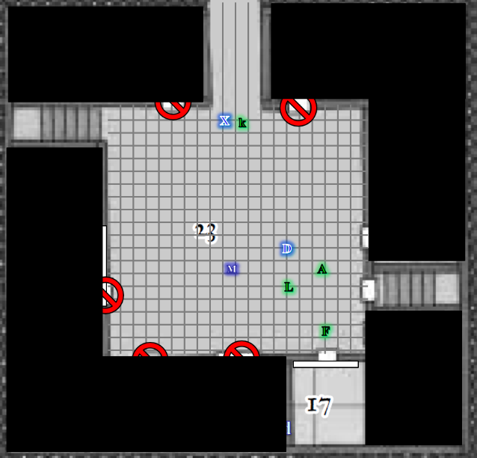

“Whoo, that door looks strange,” Lauren sad as she blinked a couple of times. “That doesn’t narrow the possibilities all that much.”

Allisa whispered as she moved close to Lauren and Fingers. “Let’s not explore who did what. Let’s just get out of here.”

“Okay, but it might be important to know,” Lauren said with a shrug. “Let’s move on.”

“Which way?” Kir asked. “Move on through that other portal, across that causeway, or into these other places?” she pointed to the doors all around them.

Lauren sighed. “I don’t know up from southeast here. Fingers, what’s your best guess?”

Fingers turned to Xaryn, who offered from afar, “We can see the sky from here,” he pointed north and into the causeway. “And even though that portal’s a little difficult to get to on account of the illusions that send you wayward, I’m figuring it out, and with a rope, we can get there without anyone walking around in a circle.”

“Why not try these doors?” the ever-inquisitive halfling shrugged, taking the initiative to open the unlocked door that she’d just tried to turn.

“Ooh!” she exclaimed, seeing the goods stockpiled beyond the doorway.

“Be *careful*!” the changeling alerted the halfling.

“I’m well aware of the looming lure behind an unlocked door amidst locked ones, partner,” Kir asserted her position, still careful to look for a guillotine coming down on her neck as she stuck her head into the room. “These metaspatial effects are funn-kyy!” she said as she entered. “No blood in here,” Kir reported. “But plenty of supplies.”

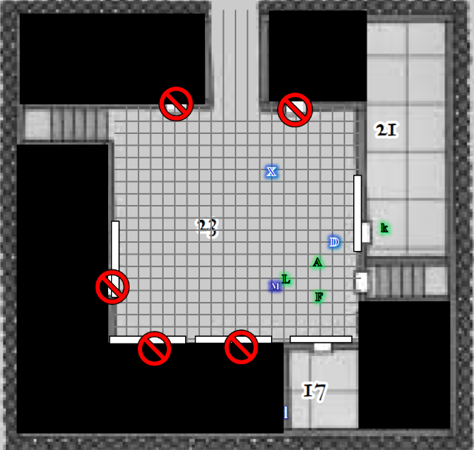

“If you are meaning to open the locked doors that might pose a problem. This place is like an arena and those doors could hold monsters for people to fight,” said the druid. As she waited on the others Allisa pulled out her everfull mug and took several drinks from the container before replacing it.

Lauren entered the room where Kir now was, and started to marvel at all the stuff. Some of the items looked quite rare, and gravitated towards a half-dozen ornate boxes, hoping they weren’t trapped. “Kir,” she got the halfling’s attention, and as the others conferred out in the dojang, Kir took a look at the boxes to make sure they weren’t baby mimics.

“No traps here, as far as I can tell,” the rogue-cleric announced as Xaryn walked in.

“A repository of sorts…” the archmage took a look around as well and noted that Lauren was now opening up what looked like a teak and ebony jewelry box. “What’s this?” he asked, coming over.

“Goodies,” Lauren said, finding a gorgeous ring inside as Xaryn picked up a similar box and found a similar ring inside it.

“Nice!” Xaryn said of the rings, which he identified only as magical, adding, “I shall prepare some *identify* spells tomorrow to see what these can do.”

“They look to be made by the same craftsperson,” Lauren remarked.

“I agree,” Xaryn inspected the one in his hand carefully. “Quite exquisite, really.”

The room was actually L-shaped, and around the corner, Kir found yet more stuff.

Fingers entered at this point, having come to trust Kir in her less-than-meticulous methods of checking for traps. Had there been one, it wasn’t sure if she would’ve actually spotted it. Nevertheless, after a cursory glance at every shelf and aisle in between, the master trapsmith got quite comfortable in its own selective looting. It took all of 36 seconds for it to frown, squint, and make its way past Xaryn towards a familiar leather-bound case with a shoulder strap. “I’ll be *damned*!”

“What is it?” Kir asked, concerned.

“My disguise kit!” Fingers clarified.

“Oh!” Lauren turned to confirm that the rogue was withdrawing the familiar manpurse from a nearby shelf. “Score!”

~*~

Within minutes, the trapsmith had recovered not only its disguise kit, but also a chest full of its gems—most of them— and its merchant’s scale. In addition, it was highly likely that a sack of 500 GP that had been taken from the fireplace stash of their Shipshape Way residence the day prior was one of the dozen or so sacks of gold in another wooden chest in the corner of the L-shaped room.

“All’s well that ends well,” commented Fingers, wanting for none of its goods at this point, save for its armor.

~*~

It was 08:58 by Fingers’ chronometer, and they had by this time all found one or two items that were not only highly valuable, but highly useful to their respective crafts, and considered this to be compensation enough for their time. However, they now also had the opportunity to turn the tables on the thieves and fence the rest of this loot, or distribute it to those who need it most, or perhaps just turn it over to the authorities.

Lauren put the box in her pack. “I doubt the owner will like us for doing this,” she commented. “Let’s finish here and get going.”

“At this point,” Xaryn had come to feel quite free to speak his mind since he’d met the Gambit yesterday, “I don’t much care for this Kaszüm’s opinion of us.”

“I’ll see your discounting scoff of indifference, and raise you an, ‘If he hates us, it gives me a hardon’,” Kir had to add, slipping on some sandals that she would soon identify.

Xaryn noted Fingers looking a bit pale, and asked, “You alright?”

Fingers sighed through its nostrils, its face shifting slightly as it thought about how to answer. Its eyes met Xaryn’s, and it smiled half-heartedly, “I’ll be alright. I was just reminded of someone I lost.”

Having perused the aisles of the miniature warehouse, the party eventually emerged into the dojang once again, and Fingers tried the remaining door along the eastern side of the domed building.

“Oh, wow!” exclaimed the trapsmith as it continued to check for traps, though it seemed by now that this suite was not trap-ridden at all.

Kir followed in, adding, “Hmm, a cartographer’s study,” she told the others who were still outside.

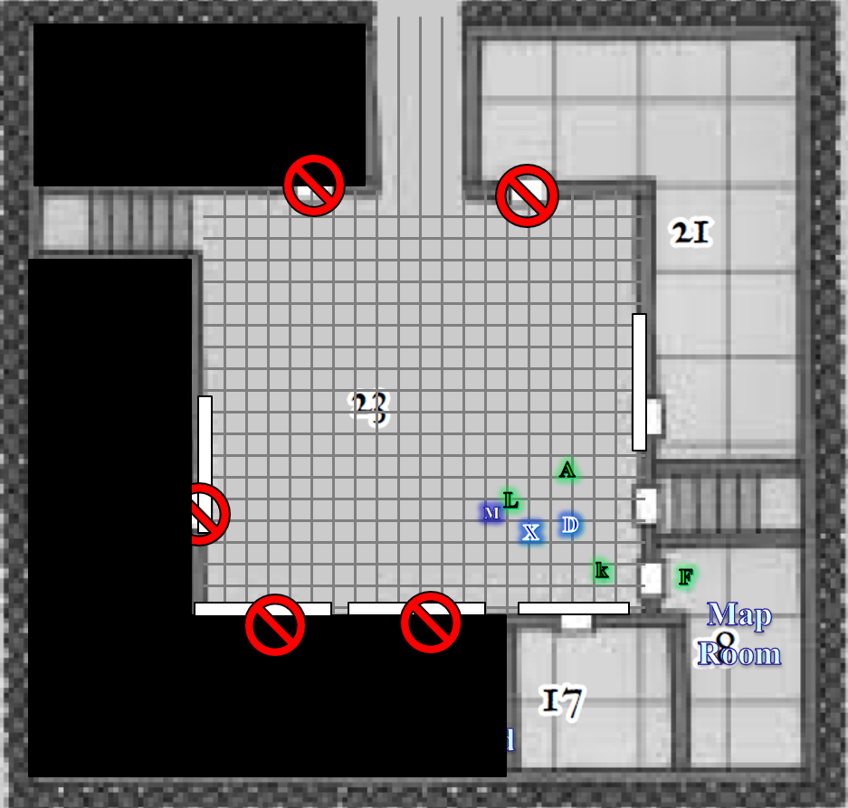

Xaryn and a few others entered, and marveled at the maps of exotic scapes and blueprints representing a variety of structures exhibiting styles altogether incompatible with one another.

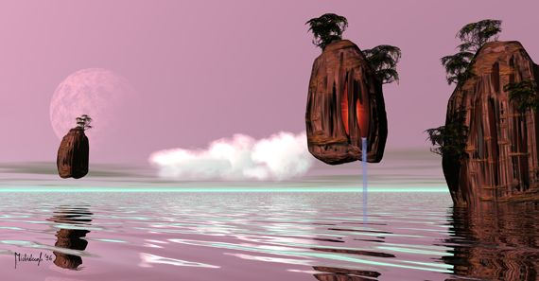

The room—the only one so far with a window—had been designed with the intention of exploiting the natural light that was cast from the east, where a nearby moon or planet orbited and clumps of rock and earth floated over a calm surface of liquid that spanned into the eastern horizon.

Aside from the dozen maps along the walls of this room, there were also tubes—probably filled with rolled up maps—in a cylindrical bin that rested in the southeast corner, and a somewhat cubic box that contained about twenty hanging folders the size of Kir, each also containing at least one map.

Xaryn had glanced at all of the maps on the wall, and had noted that most represented areas completely unknown to him, but as he came closer to the map hung near the center of the south-facing wall, the archmage nodded, and announced, “Here’s where we are.”

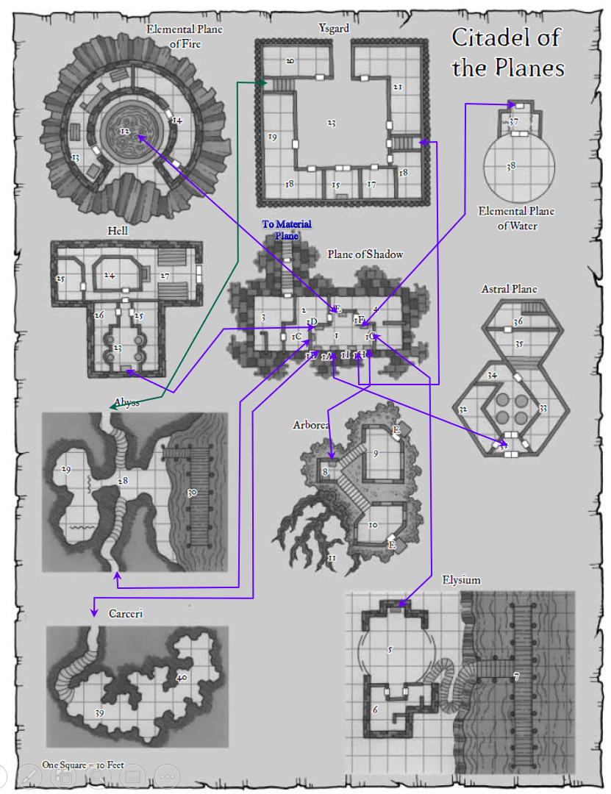

The framed leather rectangle represented the suites they’d occupied, plus a number of other areas equal to the number of remaining portals in the Shadow Suite. There were also periwinkle lines linking each room by each portal, suggesting the general architecture of the conduit complex that comprised this keep.

“This is the schematic for where we are,” Xaryn pointed out.

“So it’s true!” Allisa squinted at one of the two maps in the middle of the collection, noting the term Arborea. “This place leads to the realm to which non-evil elven souls gravitate,” the druid remarked.

Xaryn nodded, pointing, “Yes, it would seem so.”

“Let’s take this map with us,” Lauren suggested. “It appears that the only way back home is the way we came in, though.”

Fingers had been shuffling through the hanging file folders and while it had seen a handful that were nice to look at, it now removed one in particular, and showed it to the others, “This might be of use too.”

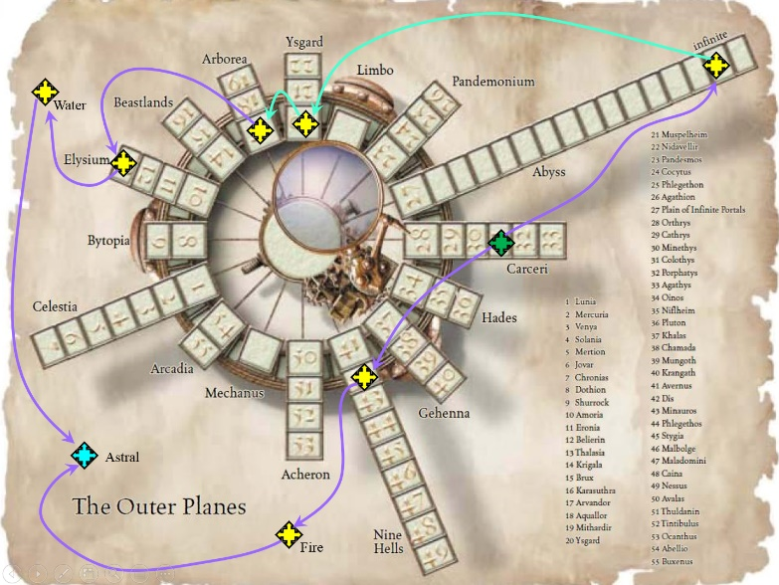

It was a roughly 2’ x 3’ parchment with creases along both axes, suggesting it had at one point been folded twice. All the writing was in Common, including a legend to the right, with planes labeled and their layers numbered. Markers had been affixed atop the paper, and the same periwinkle ink showed the logical paths that the architect of this portal complex had intended.

Xaryn looked it over and confirmed, “Based on where we’ve been so far, the arrows point to the itinerary that this Kaszüm intends for us to take in order to reach him. He’s probably cloistered here,” he pointed to the only marker that had arrows pointing exclusively to it. “This looks like the final destination.”

Lauren looked to Allisa. “What do you think, Melamin?”

“I do not really know. My preference would be to slip out of his trap and return home, in such, disappointing him because we did not play his game,” the druid said. She, too, had been looking over some of the maps while the others chatted. She moved to Lauren’s side, putting her arms around her and leaning her head upon the other’s shoulder.

“I know, and I wish we could do that.” Lauren turned her head and planted a kiss on Allisa’s head. “If we don’t stop him now, we will have to do something even worse the next time, until we do stop him.”

“I suspect he will not disappear from our lives now that he owns the property in the Castle Ward,” Fingers calculated. “And Waterdeep’s not big enough for him *and* us. He knows we’ll try to track him down, so we have to know that he’ll try to kill us on the first chance he gets.”

Xaryn and Kir were outsiders to the burglary, but agreed on the premises, and Dresden and Moondancer just nodded out of deference. The drow said, “Besides, this bugger killed one of my friends...”

“Rest in peace, Dulkhende,” Kir murmured.

“... and in doing so made a mortal enemy of me,” Xaryn sighed. “So if *you’re* going for a final showdown, I will be there alongside you.”

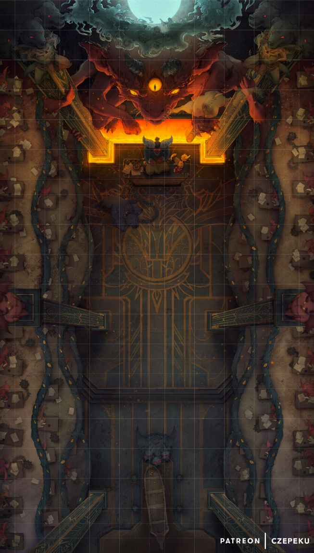

“Cue the trumpets!” Kir exclaimed, looking at one of the framed maps—more of an illustration—with the brass engraving at the bottom reading, “Infernal Taxation Bureau D5291.”

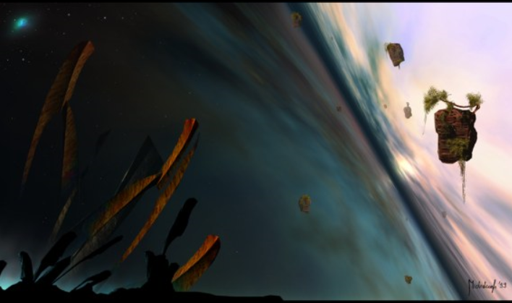

Xaryn then went to the window to better orient himself. He nodded as he surveyed the liquid expanse to their east, and pressing his face to the window, he was able to tell that there was a north-south shoreline that also stretched as far as the eye could see. “If we are to leave this place by some means other than a portal, we will have to swim.”

“Or take the carpet,” Lauren patted her haversack.

“We should go back through the portal,” the cautious druid insisted, not wanting to explore the natural surroundings of the secluded Ysgardian dojang.

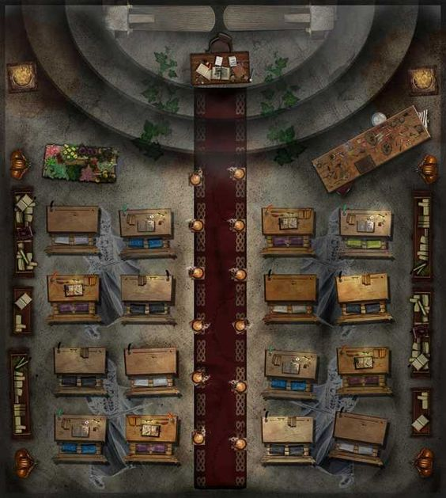

Dresden leafed through the hanging file folders, and produced a nice folio of what appeared to be a classroom. The imagery was nearly perfect, and though paint produced the images it was obvious that magic had something to do with the pixelization of the colors on the sturdy cardboard.

“Let’s take anything useful,” Lauren said, “and then we go to Arborea next.”

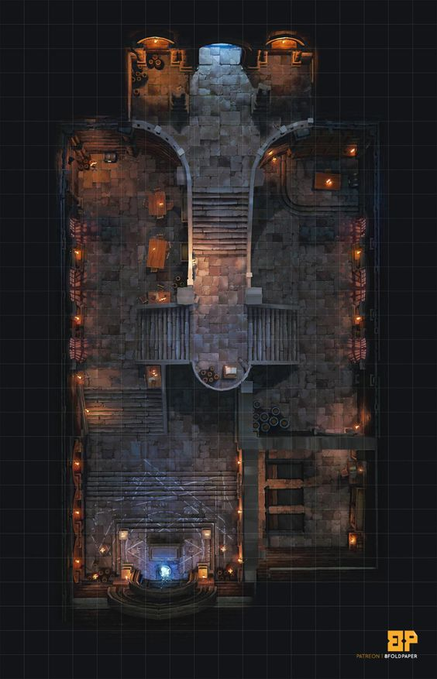

“We don’t have the shard to unlock that portal,” Fingers reminded the half-drow as it examined the folio that had been filed next to the illustration of the classroom that Dresden had just produced. “To that end, we’ve found at least one shard on every plane. Assuming Kaszüm is theming it this way in order to lead us into his web, we can hope that the shard to the next plane in the diagram—Arborea—is nearby.”

Lauren studied the maps again. “Okay, so we’ve only visited three of the nine planes, and we haven’t explored all of this place for shards. According to the citadel map, only this one and Abyss directly connect.” She pointed to the closed doors. “Can we look in there, and then we can go back to the Shadow Plane?”

“Yeah, let’s check the rest of the rooms,” Kir suggested.

Xaryn followed up with, “I’d rather go outside and see what it’s like.” They exited the map room one by one, and Fingers and Kir spent a few moments making sure the rest of the dojang’s doors weren’t trapped.

Once the doors had all been unlocked by the trapsmith and the lesser rogue, Kir stepped into a 10’ x 15’ room with simple wood-paneled room a mirror identical in design to the oval portals. A gold-filigree inscription above the door to the north read “Hall of the High Ground” in Common. Along the wall were glass cases full of different color dirt, likely collected from the different planes that this complex reached.

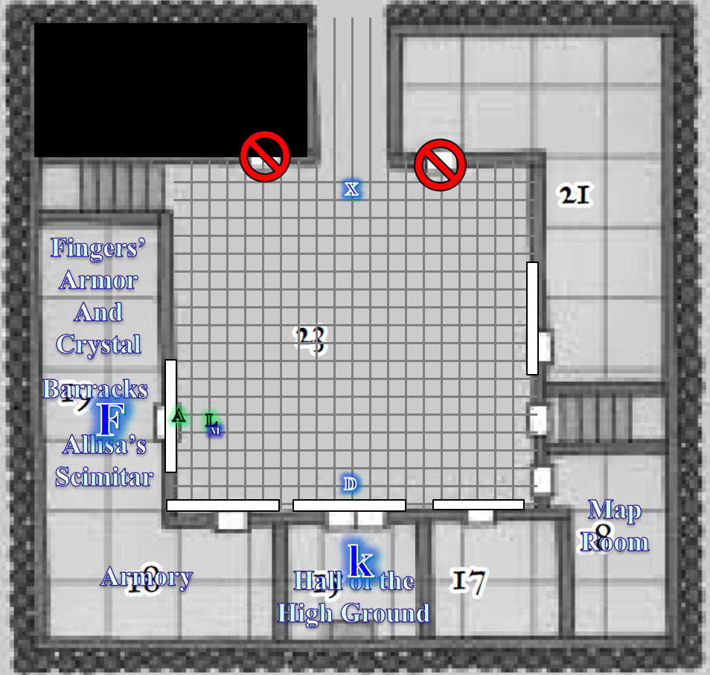

Fingers, meanwhile, had broken into the armory, which was the repository’s equivalent, containing armor, shields, and all manner of weapons.

“Allisa!”

“Yes?” the druid responded to Fingers’ excited call.

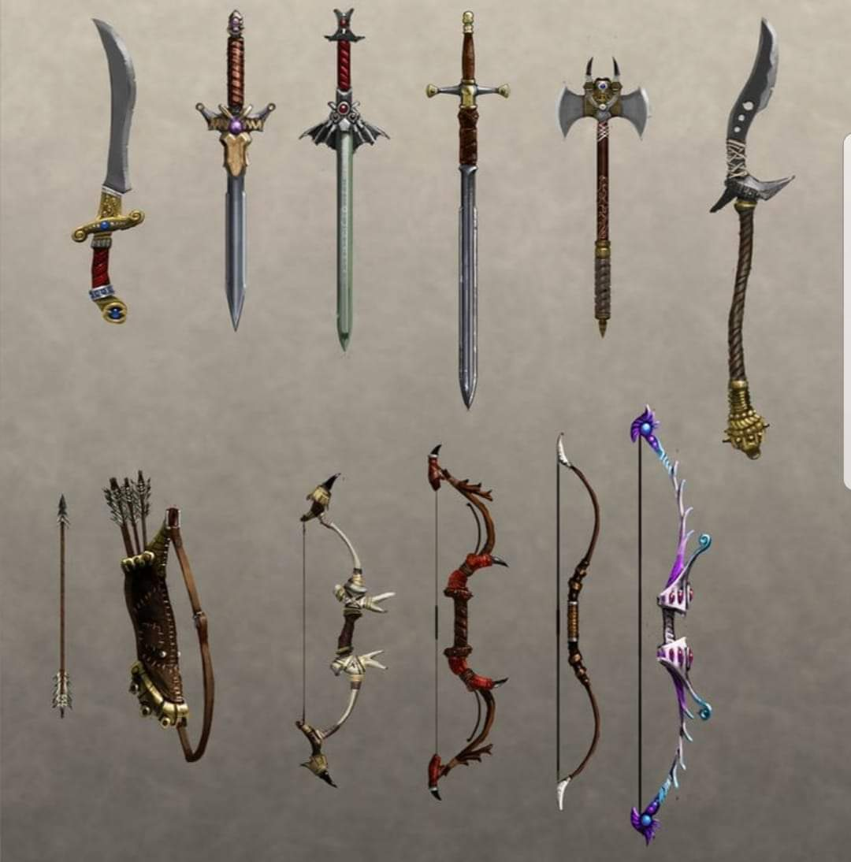

“You’re going to want to see this,” the trapsmith opened the second door of the armory from the inside and the

“Oh, praised be Larethian!” said Allisa as she recognized her shield and weapon. She gave Fingers a hug and began taking the items. Upon examining them she noticed the new crystal. “Oh, these have been enhanced.” she told whoever was near. “I will need it identified before I can use them. Don’t want to be cursed.” She tucked the scimitar into her pack along with the shield noting how full it was.

She then turned to see another mannequin. This one wore what looked to be a beautiful cloth of red, yellow, and orange leaves sewn together. The druid moved to it, taking the material in her. “Oh!” she exclaimed. “This… this is the Armor of Fallen Leaves, sewn together by the very hand of Ehlonna and presented as a gift to Obad-Hai. This is a great relic.” She made a holy symbol in the air, thanking Corellon Larethian. “Blessed by Eholonna and Obad-Hai.”

“That’s great, Melamin,” Lauren said with a smile. “You can certainly use it.”

“Oh!” Fingers remarked, “and here’s *my* armor!” It began to don the familiar Mithralmist Shirt +1 of Agility.

The others found goodies on the shelves, racks, and mannequins as well, and in no time, they were outfitted like kingslayers.

Lauren hefted a falchion that looked a lot like hers, stuffing it into her haversack and thinking, “I wonder if this is all stolen stuff.”

“To fence all this and fetch the optimal price,” Kir appraised the bulk of what was in the two repositories they’d come across, “… would likely take months. Sure, you could liquidate the stuff and make a quick coin, but to get the *most* coin...” she looked around her, just inside this repository, and estimated the standard worth of the visible inventory at over a million gold. “You’d have to *really* know the lay of the planes and the prospective buyers within it.”

“And with a multiplanar keep like this,” Xaryn added, “you might be able to do just that, and turn months into tendays.”

It then occurred to some that Kaszüm’s intentions may not have been to settle in Waterdeep, but to simply use this keep as a warehouse to liquidate what had probably taken him years to amass.

“It’s starting to look to me like our enemy is a lifelong hoarder. Do you think... maybe...” Fingers thought as it formulated the question, “that his recent onset of madness is what’s prompting him now?”

“We’re not really sure that he’s even trying to liquidate these things,” Allisa added.

Xaryn shook his head, “Actually, I think at this point, we can deduce—or at least infer—that he is. The parchments had references that didn’t make sense until now, about the High Ground and what not. I thought by capitalizing the characters, he had been referring to the moral high ground, but seeing those jars of dirt, and the plaque that reads Hall of the High Ground...” he burped a little bit as he got excited in his deductions and pulled out some of the parchments from his man-purse. “Let’s see... alright...” he read the passages, nodding, “So, he—yes—he has a thing about going to a plane; conquering some woman—what else?—oh, right: executing a heist, which apparently he used to do himself, alone; putting some dirt from the highest ground in sight into a jar; and then returning to and reveling in his hoard.”

“There are guiltier pleasures,” Dresden contributed.

“But what points to the madness that Fingers just referenced is the ledgers that are clearly pointing to the sales of these items, and,” Xaryn fumbled through the pages, “These start pretty recently; just a few tendays ago.”

“It’s all a pretty coherent narrative,” Kir summarized. “An aboleth and/or beholder zapped Kaszüm’s brain, and ever since, he’s been running errands for the master or masters of his insanity. The two women he used to steal your stuff may not be crazy, though. Maybe we can leverage them against the madman?” she proposed with an interrogative inflection at the end.

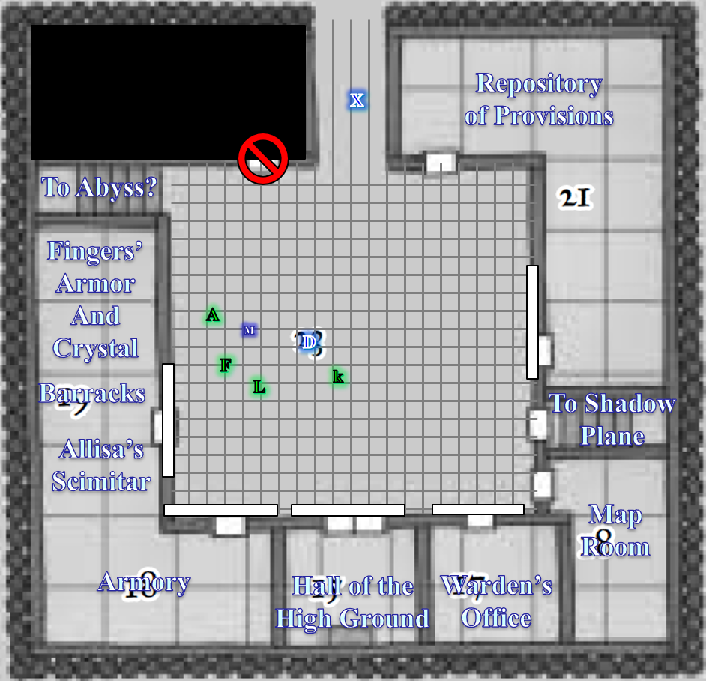

As they stepped back out into the dojang, Moondancer saw that Xaryn was now making his way north along the causeway that led outside. “I’m just going to take a look out here.”

There was one door that had not yet been opened, but this one being in the midst of the illusory area that led to the upward staircase with the portal in it, they had avoided it until now.

Kir had already passed it, and took Fingers by the hand as they both experienced a bit of vertigo, walking straight through a wall that was not truly there.

The others began making their way casually north, discussing their current situation, and clustered at the mouth of the causeway as the two rogues picked the lock on the remaining door and Xaryn meandered further north.

“Oh, jibeneeze! This is marvelous!” exclaimed Xaryn as he reached the end of the stone floor that comprised the causeway, beyond which was a wooden pier that led to a pair of tethered dinghies.

Xaryn confirmed the features that characterized Ysgard—an azure sky peppered with stars and nebulae all around, a unique scent that only a planar expert such as him could discern, and the quality of the water—and inhaled deeply at the solace of this place. Yes, this had to be Ysgard, but they were nowhere near a center of civilization, and so they might as well have been in the Beastlands, though not a beast stirred in the archmage’s field of vision.



Inside, the rogues got the last door open, and pushing it inward, they cautiously entered and beheld yet another repository, this one full of scrolls, potions, wands, staffs, and a handful of wondrous items.

Having upgraded his rapier to a Keen Rapier +3 with a Greater Crystal of Life Drinking, and with a new Ring of Wizardry III to complement the Ring of Wizardry I that he’d been wearing for years, Xaryn squinted as he spotted something queer at the end of the pier. He calmly but cautiously walked along the wooden planks, turning back to see the 50’ tall tower that jutted above the calm sea to their east, marking this otherwise unmarked and unvisited periphery of the grandiose expanse that was Ysgard. He took comfort in the fact that if he were killed here, his body would rise again by the next morning, and suspected that this is why the body of whoever was murdered had been removed to prevent their resurrection.

Lauren got herself a few goodies, including a Cube of Force, which should come quite useful in a jam. She noted that Kir had found a motherlode of scrolls, and though most were 1st-level toilet paper, she managed to find and pocket three scrolls of *teleportation*. The halfling had also found a Python Rod in the repository where Allisa’s scimitar had been, and a wand of *cure serious wounds*.

Lauren went to stand with Xaryn for a moment. “It’s a beautiful place, to be sure.” She turned to see Allisa stripping down to put on her new armor.

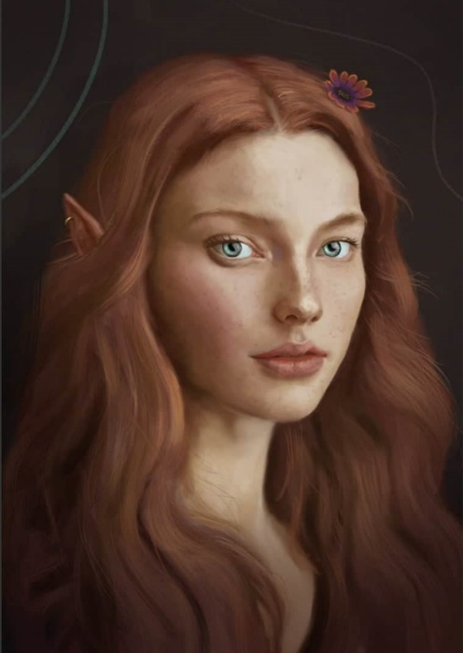

“When she’s dressed,” Lauren continued, “I think we should go back to the suite with the portals. Do we have the shards we need, or do we look for more of them here?”

“I think Xaryn confirmed that we don’t have any other shards,” Kir said, “But we didn’t really search the bloody office or the room with the jars of dirt very well either. I’ll see if I find anything there in a jiff.”

Fingers saw Xaryn making his way along the wooden boardwalk—a pier, really—and wandered over there, seeing no traps that Xaryn would’ve missed tripping.

Dresden and Moondancer stayed just outside the illusory area that made them both woozy and borderline nauseous while the rest of the folks got some scrolls and potions.

~*~

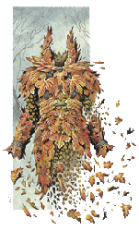

“Oh, are we all going outside?” Allisa came out of the armory treasure room with her new armor on, finding the rest of the crew outside the 50’ causeway appreciating the scenery. The druid walked north, towards them—careful to avoid the northwest corner of the structure, which made her motion sick—and saw that Xaryn was walking south along a wooden pier rather briskly, but not in an alarmed way.

The excited drow reached the others as a breeze kicked up and nearly blew his headdress off. “There’s another portal,” he huffed a bit after pronouncing the six syllables. It leads to an area surrounded by wood and dimly lit.”

“Arborea?” the druid hoped.

“I’m inclined to say yes,” Xaryn tilted his head. “It’s what the map suggests, and the place looks... well... arboreal enough.”

“You didn’t find any other shards then?” Lauren confirmed.

“I just checked,” Kir shook her head. “The bloody office had this—which I thought was nice—and the room full of jars of dirt had little else of interest.” The halfling was holding a gray, rectangular object with a half dozen buttons on it.

“That looks like it controls something,” Xaryn speculated, then turned back to the portal. “If you walk about half-way out along the pier, you’ll begin to see it. It’s just off to the right of the pier.”

“I don’t see it,” complained Kir.

“It’s not like the other portals, which have material edges and require a shard. It’s like the invisible one that we stepped through when we entered the Plane of Shadow last night,” explained Xaryn. “In other words, it’s almost untraceable unless you’re standing there,” he pointed to the pier, then to the shoreline nearest the end of the pier, “or there.”

Allisa could already tell by the virgin quality of the shoreline that no one had trod there for seasons, and said as much.

“Like the rest of the suites adjoined by these portals,” Xaryn generalized, “their designers took great measures to choose remote areas and hide them all with illusory veneers.”

They began to walk along the pier, careful to spread their weight evenly along the planks that would not have supported a mount or pack animal. Re-equipped, invigorated by the very nature of Ysgard’s pure air, and with a new sense of momentum towards Arborea, some of the crew was ready to go. Fingers and Kir, on the other hand, turned around and admired the towering building that had been situated in the most unlikely of places for something so opulently majestic.

“Oh, alright,” Allisa nodded, now seeing the edgeless doorway adjacent to the pier’s endpoint. Wondering what the aquatic life was like here, she was tempted to turn into a fish and find out, but abstained from doing so for the moment.



Trying out her newly acquired everfull mug, Lauren fancied both the handiwork’s depiction of a placid humanoid face as well as the taste of the dwarven ale that she’d imagined as she’d filled it with her voice command. Sharing it with her druid lover, they sighed and took in the calmness of the barely rippling water beneath the pier’s boardwalk.

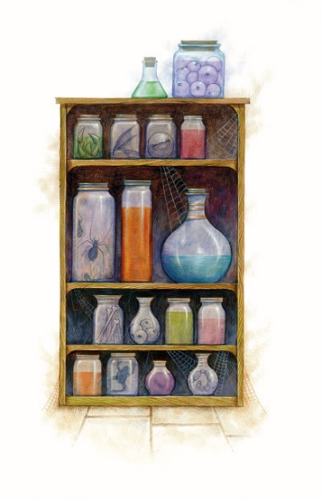

Having stocked upon potions, scrolls, new weapons, and a handful of assorted items, the party contemplated their next move. Would they go back into the repositories, saturate their haversacks with treasure, and return to the Shadow Plane in hopes of retracing their steps to their Material Plane home; or slip into the Arborean plane—if such it was—at the opposite end of this seamless rift between worlds?

“Since Arborea is next on the map, let’s go see it,” Lauren said.

The druid handed the mug back to the drow as she belched. The woman put her hands to her to hide her embarrassment, the drink being much stronger the Allisa was used to.

“So do we have a safe route straight back to home? If so, I would say grab what we can and secure it somewhere at home. Then we can come back and look for this villain. As much as I want to go see Arborea are packs are mostly full.”

“Second: do we have time for a bath in this beautiful water?” she smiled. “At least a dip to refresh.”