*Chapter 71*

Allisa certainly wasn’t complaining, and those that were indifferent shrugged and followed Fingers into the woody confines of a threshold between some stables and a grove. As Fingers and Kir ensured that there were no traps about, they stepped away from the combination of roots and planks that constituted a cluster of stables, and beheld their whereabouts. Around a massive tree with a trunk perhaps 20’ across at its base, there spread an irregular, doughnut-shaped area with relatively little growth. Part of this area was now obfuscated from the sunlight above them, and it was obvious to Allisa that the doughnut represented the shadow of the grandfather tree’s copse over the land around it. About 200’ above their heads was the trio of rooms that the heroes had already seen on the Arborea map, confirming where they were.

Suddenly, Xaryn and the others were startled by movement from within the stables, which they’d initially thought were empty. Within 12 seconds or so—once everyone’s weapons and spells were at the ready—a pair of antlers reared up and the party beheld a completely wooden buck staring at them, blinking a pair of leaves that functioned as eyelids on both sides of its head. They could only see the antlered head and neck, which stood above the height of the stable, and it stared at them for a moment, tugging with its tongue and chewing on a twig that looked like it grew out of its lower lip, as the heroes all turned to Allisa for guidance.

Allisa marveled at the creature as she studied it. She then began using gesture with in a slow non threating way. “Hello, creature, I am Allisa house of Maltholas.” Her companions heard her speak but could only make out a few words here and there as she spoke in Sylvan. “We mean you no harm but are following a vile thief. What is your name?” If given the chance she would explain to her friends what the creature was and his reply.

|  |  |  |  |  |  |  |
| --- | --- | --- | --- | --- | --- | --- |
| **Skill** | **Rank** | **Ability & Mod.** | **Misc. Mods.** | **Total** | **Roll** | **Check** |
| **Diplomacy** | 1 | **Cha (+2)** | 2 | 5 | 6 | 11 |
| **Handle Animal** | 8 | **Cha (+2)** | 2 | 12 | 20 | 32 |
| **Knowledge: Nature** | 12 | **Int (+1)** | 4 | 17 | 10ish | ?? |

*See below.*

The wooden deer sniffed at the air that wafted into and through the porous stable walls, noting the variety of the fragrances that the newcomers had brought with them. Yes, there was the familiar scent of the Ysgardian coast, but these folks were devoid of the sulfurous stenches that accompanied the Master’s lackeys.

The screeching of a hawk somewhere nearby echoed across the sky and the woods below them, and the cool breeze that kicked up on the otherwise warm day caressed their hair before dying down again. A second deer reared its head—this one with no antlers—and blinked as the first deer spoke in its own way, its jaws widening as its trachea vibrated—whether it was a thousand words or a dozen was unclear to the others—and Allisa understood that the deer, as well as the other wooded bucks and does stabled here began to awaken and rise up to look at the heroes, who were now huddled behind Allisa, staring back.

“They are greenbound animals... plants really,” she explained. “Kaszüm’s henchmen captured them and keep them here as mounts. They’re well fed on the soil,” she pointed to the stable’s floor where hay would have been put for herbivorous animals, though there was none here.

Lauren stood and watched her wife work in her element. The scene reminded her of their new home in the Westwood, minus the plant-animals, of course.

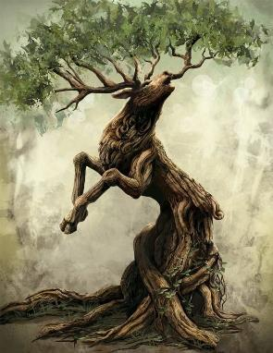

The druid then inquired of the greenbound deer asking where they were from and if they desired to return. She also asked how they were bound here, for she felt for the animals to be owned by such a one as Kaszüm.

The answer was akin to what a normal animal would’ve provided: a scrambled chase, a snare and a trap, and a confusing period of acclimation to a more sedentary life.

“I have asked these beautiful creatures where their home is. I would like to free them from the likes of Kaszüm if at all possible, even if it means taking them to our plane to live in the forest around my home.” Allisa said to her companions as she waited for an answer from the greenbound ones. “How far do we need to go through this plane?” she asked. “They may allow us to ride them.”

“I don’t see any map that tells us that,” Lauren responded. “I would imagine that the next portal isn’t that far away, given what we’ve found so far.” The duskblade pointed toward the rooms. “We can try that place first, though.”

The majority of the group was in agreement.

“Yes, I was forgetting about that.” She turned back to the deer and asked, “Are there some stairs or rope that will get us up to the treehouse?”

Lauren looked up to see if there was a doorway she could access, or a flat place where she could stand.

“Are you also forgetting that we have a flying carpet?” Fingers asked. “Or was the experience of flying through that spiral gauntlet less than an hour ago so traumatic that it’s already been suppressed?”

A greenbound bird of prey flew by overhead, crossing the skyline westwardly before disappearing behind the copse of the 40’-tall tree adjacent to the 200’ tree that loomed over the rest of the forest like a watchful sentry. Its leafy wings were splendidly adorned with bristles that aided it in sensing the wind currents around it, and Allisa marveled at the majestic flying plant.

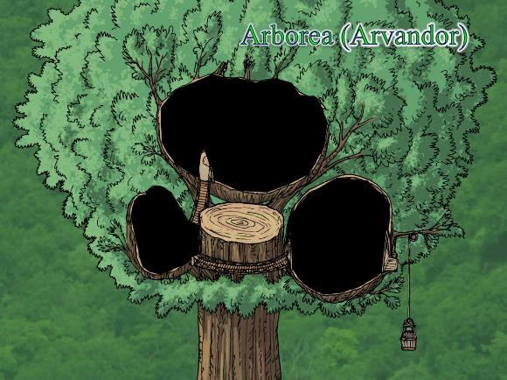

“I didn’t see it when I was looking for something else,” Lauren replied. “Who has it?”

Dresden produced the carpet from the haversack, and unfurled it for Fingers to conduct.

“Let’s go see,” Lauren said as she stepped onto the carpet.

Less than a minute later, the Gambit and their friends were floating above the great tree, and noting that the trunk could easily have reached another 100’ up before tapering to a copse, but was sawed off along a section that served as an outdoor platform. Evident on this surface were the droppings of greenbound creatures, Allisa could tell, and as she referred to the map they’d recently found, she turned it so it was square with what they were looking at, and noted the open doors on what were labeled rooms 9 and 10, while chamber number 8 had two closed doors.

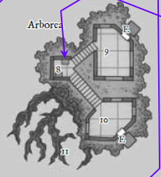

“Let’s check one at a time.” Lauren gestured to the open door marked “9” on their map.

Once Fingers flew around to the other side, Kir volunteered to hop down onto the swinging rattan chair and peek into the open doorway.

She did so, and took a look around, then motioned for the others to come in. This fancy bedroom suite featured intricate, delicate wooden furniture and rough-fiber tapestries on the walls. Designed by a druid-apothecary, this bedroom included a small chapel and a rope elevator that connected the room with both the forest canopy and the ground below.

Allisa wanted to stay here tonight, and Xaryn marveled at the characteristics of the design.

“We may be able to,” Lauren replied. “It depends on what the rest of the day brings. I wonder what is in the other rooms.”

As Fingers secured the immediate chamber, Kir’s legs were taking her where Lauren’s eyes wanted to go. She walked through the manila curtain that led to a rope-and-wooden-plank bridge, and made it to the locked door that led to the next room.

At that moment, she spotted a startled greenbound cat that had likely fled the room before they entered, and was now jumping down from one branch to the next, at about 10’ or 15’ increments. Wanting nothing to do with the halfling, it hopped effortlessly down another 12’.

As Fingers and Xaryn looked about the first chamber thoroughly, Lauren followed the halfling to the wooden-plank-and-rope bridge. By the time she’d caught up to the halfling, the greenbound cat had made it about a third of the way down the tree, and was mostly out of sight.

Joining Kir, she nodded as the jewel thief picked the lock on the door before her, but was not able to do much. “Fingers is really the lockpicker,” she shrugged, waiting for him.

“We haven’t tried the doors over there,” Lauren pointed. “Let’s wait for Fingers and the carpet.”

Once Fingers had deemed the largest suite among the three pods suspended atop a tree that had once been hundreds of feet tall, Xaryn had discovered in a sack stowed in the back of the center drawer of the boxy desk to the right of the doorway leading out to where Kir and Lauren were. The archmage could tell by the size of the crystals that they were all Greater, in terms of the scope of their magic; three of them were intended for weapons, and the other three for armor or shields. He sat on the bed while the others continued to explore the area to see if he could identify any of them.

“Ready for the carpet, I suppose,” Fingers had exhausted its curiosity within the first chamber, but was also perfectly capable of picking the lock that Kir was unable to work. Dresden held on to one end of the rolled-up carpet still within the haversack as the master trapsmith toyed with the lock leading to the central pod in the Arborea Suite.

|  |  |  |  |  |  |  |  |
| --- | --- | --- | --- | --- | --- | --- | --- |
| **Skill** | **Rank** | **Ability & Mod.** | **Misc. Mods.** | **Total** | **Roll** | **Check** | **Notes** |
| **Fingers, Open Lock** | 16 | **Dex (+4)** | 7 | 27 | 4 | 31 | Lucky Fingers, Lockpicking ring |

*Success.*

The former thief took a moment to secure the area, with Kir following in closely thereafter, and by the time Xaryn had identified one of the crystals as bearing the Truedeath property, the room had been deemed clear of traps.

Allisa sat at the wicker bench that served as a rope-pulled lift to and from the ground as Dresden waited along the first rope bridge, and Lauren and Xaryn noted the portal inside the smallest pod of the suite. “Looks like the Shadow Suite,” Xaryn stated the obvious as the two rogues had already opened the next door—locked from the inside and easily unlocked without any special handling—and were now exploring the locked door that led to the last of the pods.

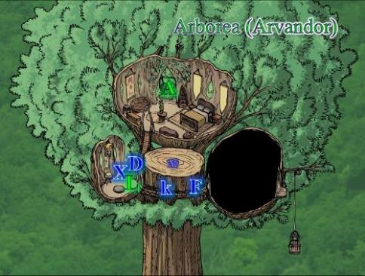

|  |  |  |  |  |  |  |  |
| --- | --- | --- | --- | --- | --- | --- | --- |
| **Skill** | **Rank** | **Ability & Mod.** | **Misc. Mods.** | **Total** | **Roll** | **Check** | **Notes** |
| **Fingers, Open Lock** | 16 | **Dex (+4)** | 7 | 27 | 3 | 30 | Lucky Fingers, Lockpicking ring |

*Success.*

“Phew!” sighed the rogue, adding, “Wasn’t as much of a piece of cake as I thought.” It pulled the sturdy, wooden door open.

What they beheld inside the third room was truly remarkable. The area was given over to botanical treatises on bookshelves, specimen jars atop a workbench, and a hothouse designed to cultivate rare and sensitive species. Much of the room was glassed over to allow the right amount of sunlight in. Much like the wicker bench where Allisa still sat adoring the view, a rope elevator allowed for the lowering of a bucket to the ground.

Lauren and Moonflower peeked in, and the half-drow murmured, “Allisa’s never going to want to leave here.”

It was truly idyllic.

Then Moondancer’s claws gripped so tightly onto Lauren’s shoulder that it would’ve hurt her had she not been wearing armor. “Hey!” the duskblade protested, but the pseudodragon had instinctively hopped off, smelling and seeing something that triggered her direly.

Within seconds, the magical beast had sent a hasty apology to Lauren and landed on the floor along the far side of the room. She grabbed a talisman that hung from a leather strap long enough to be a necklace, and turned back to Lauren, sending the most emphatic whimper, “This was Aridel’s.”

Lauren looked at the talisman. “I wonder what it is,” then squinted and said, “Oh!” as she identified it as a holy symbol of Mielikki and smiled sadly. “Do you want to carry this, Little One? I can fix it so you can wear it around your neck.”

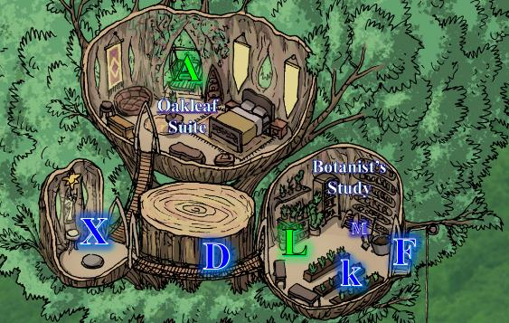

Dresden joined Lauren and the others in the botanist’s study, marveling at the diversity of plant life herein, and the herbs and other ingredients collected. “Jalifrees!” he exclaimed. “Allisa will *love* this, right?”

Having had her fill of the view for the moment Allisa finally got up and went to see the rest of the treehouse. As she entered the last room, she said, “I wish I had seen this place before building mine.” Her voice tapered off as she beheld all the plants. She moved to examine each and discover what they each were.

Lauren looked around in each room as Allisa examined the botanist’s room. “Dresden, help me look to see if there’s anything interesting here. Be really careful about handling things, though.” She looked at the other three. “There is probably a portal shard here somewhere. We may have to search the stables on the ground, too.”

After Lauren decided that she’d found nothing personally useful in the botanist’s study, Allisa asked for and took several minutes to peruse the flora, starting with the living samples, and eventually moving on to the powdered and preserved ingredients in the jars.

In the meantime, Xaryn studied the properties of the portal, and Fingers and Kir looked for the shard that Lauren had prophesized, though none was found. There were plenty of nice things to confiscate, but no apparent way back into the Shadow Plane from here.

“So to get back to the Shadow Plane,” confirmed Lauren, helping to look for a shard, and a bit overwhelmed by all that was going on this morning, “we’d have to backtrack down to the stables, and then back to Ysgard?”

“Yyyesss,” Xaryn could think of another highly implausible alternatives, but decided these prospects would’ve been a waste of time.

“We can search the stables,” Fingers posed, not even having stepped inside, which was expected for most of them, but not for Allisa.

“We could,” Kir thought, but at this point, “I’m not sure I’m that motivated to leave here. As long as there’s some potable water nearby...”

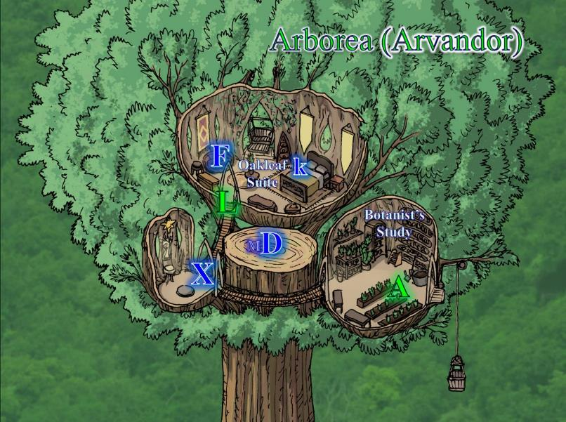

Xaryn and Allisa were still deep in their own respective contemplation over this place while the others talked within earshot.

The rogues were in what was called the Oakleaf Suite, as it was carved ornately but discretely into the bed’s headboard. This was about the coziest, homiest bedroom they’d ever occupied, and although the chronometer read 09:12, the rogues at least were ready for a short nap Kir bounced lightly atop the bed that rested on two layers of wood bound magically and mundanely with great precision. Fingers toyed with a newfound Chaos Diamond, only barely cognizant of its potential powers.

Atop the tree trunk’s truncated terrace, Dresden tended to Moondancer as Moondancer reveled in her person’s holy symbol, smelling the faint traces of the familiar woman, and hoping she was nearby.

Allisa eventually came out with a burlap sack that she’d just appropriated and filled with goodies. Having had breakfast—as well as second breakfast—no one was hungry at the moment, so she announced the yummy finding, “These herbs will make the provisions we got from the Shadow Suite even tastier.”

Dresden stood up as Moondancer flew over to look in the sack and see for herself what the druid was talking about, and as Allisa made her way into the Oakleaf Suite to join the majority of the others, Xaryn put away the parchments he was reviewing and also coalesced in the main pod of the Arborea Suite.

Fingers summarized, “No new shard found, but we have more goodies that our host just had laying around here in the drawers and shelves,” he flipped a flatish gem worth over 100,000 gold pieces whose properties might come in handy for this chaotic bunch.

Xaryn piped up, “Among what we found here was this handful of parchments. I’ve ascertained that four are the more recent ramblings of our now deranged adversary—which gives me confidence—but what appears to be earlier documentation in the first three sheets points to a scheme that... oh, wait...” he realized as he spoke, “No, I shouldn’t have split it into two categories,” he laid out the parchments on the bed near Kir, and continued, “It’s a gradient of madness. In the second one, he seems to have forgotten about part of a nefarious plot he’d made documented in the first parchment with someone named Prince Dendrogh in order to secure this tree and the surrounding area. In the third one, there’s no mention of Dendrogh, but about half of the document at least makes sense, and discusses a vague pact to overpower greenbound creatures and confine them to the tree and its vicinity.”

“And after that?” Allisa asked.

“Just...” he shook his head. “More of the same flavor of crazy that we’ve seen in his other etchings. ‘The beholder ate the aboleth; the aboleth ate the gnome; the gnome eats them all,’ that sort of thing.”

The present company tended to skew towards Chaotic Neutral, so this sort of thing really wasn’t as unpalatable for them as it would have been for—say—a do-gooder quartet comprised of a hound archon paladin, gnome rogue illusionist artificer, human favored soul warlock crusader, and half-elven bard, so they kind of went with it, for the most part.

“We still need to find a way to Elysium, and that, according to the map, is only possible through the Shadow Suite.” Lauren sighed, “Can we open that portal?”

“We have no shard for it,” Xaryn shook his head. “I just want to clarify that the portal there,” he pointed to his immediate south, “probably goes back to the Shadow Plane, and we *do* have a shard for that. We can also return to Ysgard via the unframed portal by the stables.”

“Then what is left here for us to explore? If necessary, I can fly around and get the lay of the land,” Allisa proposed as her arms encircled Lauren, pausing at her breasts before moving just below them.

“We can come back here whenever we wish,” Lauren reminded her wife. “We *do* need to find the shard for the next portal, though.”

The screech of the greenbound hawk circling above made Allisa look out the window, and see the flying plant hundreds of feet up. She sat next to Lauren at the swinging wicker bench that served as the main elevator, looking at Kir as Kir thumbed through the parchments that Xaryn had found. “From all of the converging evidence—the maps and their markings, the color-consistency between shards and portals, and this documentation—we can either explore the surrounding area, or go back to the Shadow Plane, and from that Plane, we are now able to go to Hell—as some of our enemies would wish for us to do—or back to any of the other exotic planes we’ve visited over the last day.”

“That pretty much sums it up,” Xaryn shrugged as he sat on the stool along the southwest of the Oakleaf Suite.

Allisa couldn’t contain a single burst laughter, “Let me see if I can sum this up further: we can either stay here in Arborea, taking our chances with plants that mean us no harm, or go to one of the layers of the Hells? As in Baator? Where Asmodeus lives?”

“I can tell where you’re going with this,” Xaryn read the druid’s mind—so to speak—and smirked, “I wouldn’t jump to conclude that Arborea is devoid of peril. So far, all of the Suites have been warded from the outside world, and it stands to reason that this tree is as well.”

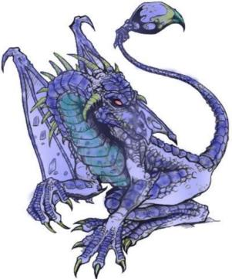

Moondancer asked Lauren, “If Aridel’s here, can we consider at least looking around nearby?”

“Moondancer wants to look for her mistress,” Lauren told the others. “Would it be wise to look for a short time?”

The party had no particular qualms about this. Fingers motioned to Dresden, who now finished taking the carpet back out and unrolled it for the group, setting it atop the tree trunk’s serrated terrace.

“Let’s start off that way,” Lauren pointed northwest. “Moondancer, you can fly, but be very careful. There might be things here that consider you a snack.”

Allisa chose to take on the form of a Large eagle. She fluttered, her wings then leapt into the air, soaring much higher than the carpet was flying, her bird eyes able to a mouse moving on the ground below. The wind refreshed her as she flew, and she scanned the area around the carpet.

~*~

They’d taken their time, and were now seated atop the carpet, flying northwestward, with Moondancer flapping happily in their left wake. Flying at an altitude of about 30’ above a canopy of trees that was itself about 60’ high above the ground, the carpet took the heroes for several minutes into an ever-widening expanse of trees of various deciduous varieties.

With Moondancer trailing close behind, the party considered veering in one direction or the other.

“Let’s turn east,” Lauren called as she pointed to their right and slightly behind them.

Fingers nodded and veered to its right, keeping a safe distance from the copses of trees.

Five more minutes went by, and as the carpet got to about a mile north of their starting point, the foliage started to thin out and become shorter on average, so that groves opened up to the sun from time to time. The smell of baked goods drew their attention towards a particularly large clearing—perhaps 100’ in diameter—which was now about 80’ below them and maybe 400’ to their direct north-northeast.

They were about to discuss their next steps when a single creature burst up and out from the trees below. It had the form of a raptoran archer—complete with a bow and arrow—but like the creatures they’d seen earlier, it was a greenbound creature. It flapped its wings in a hovering position for a moment as it pointed the arrow straight at the incoming carpet while calling out in Sylvan, “Identify yourselves!”

As the passengers thought about what to say first, Fingers slowed the carpet down to a gradual halt, and a half-dozen other greenbound creatures emerged from the grove and surrounding trees in front of the heroes. Allisa could tell by their shapes and movement that three were aarakocra, one was a spirit of the sky, one was an avoral, and one was a noble senmurv, whom she’d never seen in real life before. They were all greenbound, and all able to hover in position fairly well as the mid-morning sun shone in the heroes’ right-hand field of vision.

Fingers focused on holding the carpet in position, while Lauren and Dresden stood still, not wishing to antagonize the creatures further. Moondancer curiously eyed the creatures as she circled them, still looking for any sign of Aridel.

The greenbound raptoran flew a bit closer, studying the carpet’s occupants, then pronounced in Sylvan, << Who be you? >>

The other winged creatures also approached, but stayed at least a javelin’s toss away for the moment, seeming more curious than hostile, though all ranged weapons were at the ready.

<< We are called Destiny’s Gambit, >> Lauren replied in Elven. She didn’t speak their language, but Allisa did, and Lauren had picked up enough to guess at their meaning.

Allisa saw the creatures flying up toward her friends and swooped down from behind the carpet to land beside Lauren. She changed into herself.

From behind the canopy of trees shielding the heroes’ eyes from the grove beneath there emerged a male figure, sitting cross-legged while levitating in midair. The fellow had what Allisa would have termed an unearthly grace, and though his legs wore leggings made of leaves and woven fibers, the rest of him was devoid of clothing. A few simple accessories—a necklace, a crown of antlers, a bracelet, and an anklet—accentuated the otherwise unclad man.

Fingers and Dresden were the first to notice the subtle line across the canopy of trees that delineated a river that carved through the green expanse at its lowest elevation. The slight cleavage in the earth and treetops—Fingers noted—was about 50’ from the clearing. And that’s when Fingers also noticed that about a third of the trees along the edge of that clearing were actually treants, and were now turning to look curiously at the heroes. If one listened during the moments when the breeze was not wooing in their ears, they could hear the murmur of the brook that quenched the thirst of this old growth.

The male stranger clearly had some measure of druidic background, and as he floated a bit closer, his appearance betrayed subtle signs of the greenbound. What had appeared to be a crown of antlers was actually a pair of antlers growing from both sides of his frontal bone.

On the ground, there now came into view a walking hulk of wood, maybe half as tall as the average treant in its midst, and looked on upward as if concerned for the safety of his comrades in the air.

After the few seconds that it took for the Gambit to take in all of this, Lauren continued, << We are here to capture a thief and a murderer. >> She carefully reached up and opened her cloak to show her City Watch badge. << We are officers of the law from the city of Waterdeep. >>

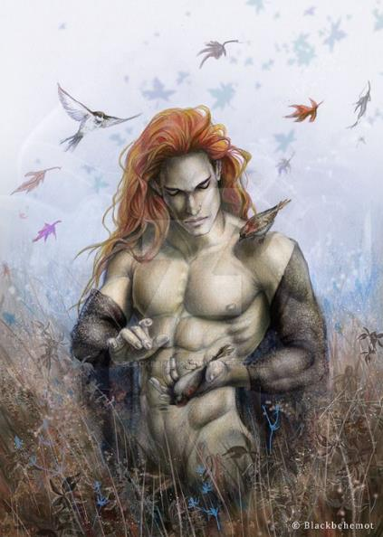

The floating man stopped approaching, tilted his head, and smiled, then held back a chuckle, and wrestled his lips into an inhibited smirk. << Well... >> he exhaled, then inhaled again before speaking back to Lauren and company in fairly fluent Elven, << You’ll find little appreciation *here* for your adherence to the laws of a place so remote. The only laws we observe here are based on reciprocity and mutual respect for one another’s leave. >>

<< We shit in the woods! >> proclaimed an eager greenbound aarakocra before being motioned by its fellow warrior to let the floating druid speak.

Now in half-elf form and able to speak eloquently, Allisa made note of the creatures before her, adding in Sylvan. << Greetings, I am Allisa and these are my friends. We come as friends and were looking for Aridel. We have reason to believe she is in this region and mean no harm to you and yours. >>

The strangers all looked at one another before their leader, and asked, << A half-elven ranger, also from Faerûn? >>

One of them answered in the affirmative.

<< She and her troupe passed through here not a tenday ago, >> the man’s statement was consistent with the amount of time that Moondancer had stated she’d been incarcerated and starved in Carceri. << They were searching for something... wouldn’t say what, though they were looking for Girash the Hermit, who might have some wisdom to impart on whatever they were seeking. >>

The Gambit and their friends were at an immediate loss for follow-up questions.

The stranger once again approached the carpet, and was now hovering at a distance of about 40’ from the party while his greenbound followers flew in with curiosity, lowering their weapons. Two of them even reintroduced their arrows into their quivers.

Allisa could now tell that the walking mass of wood in the middle of the clearing was a verdant reaver, and felt no hostility on the part of the strangers now that they’d identified themselves.

The cross-legged male’s ears were hidden behind his locks of hair, which shifted from red to brown to black as the angle of the sunlight above changed. He offered on behalf of all locals present, << If it is the pursuit of law that guides you, then better that you should continue on your way, strangers; but if you would partake in a celebration of life before reprising your hunt for lawbreakers or what have you on your plate, we extend our hospitality and welcome to those of peaceful intentions towards this land and all that creepeth upon it. >>

Lauren looked to Allisa for her response, silently deferring to her.

Allisa turned to the others and translated what was spoken, got some consensus from her mates, then relayed, << We would be honored to visit and celebration with you. >>

<< Yes, we can stay a while, >> Lauren said in Elvish.

The others were very much into the idea as well, and within minutes, the carpet had landed, all weapons had been sheathed and shouldered, and introductions had been started by the time Fingers’ chronometer read 10:03. The master rogue was accustomed to looking for traps—particularly in an enclosed environment—and its attention to any intentional snares or booby traps in the vicinity yielded nothing shy of nothing. It left the speculations about security to Allisa for the moment, nodding to her with a cautious look before turning to smile at their approaching host who introduced himself as they clasped forearms.

Allisa had acknowledged the look with an even subtler nod before turning frontstage to smile at their kind host, and took a measure of all the fey and plants frolicking about the clearing, but got no notion of an ambush in sheep’s clothing, or anything like that.

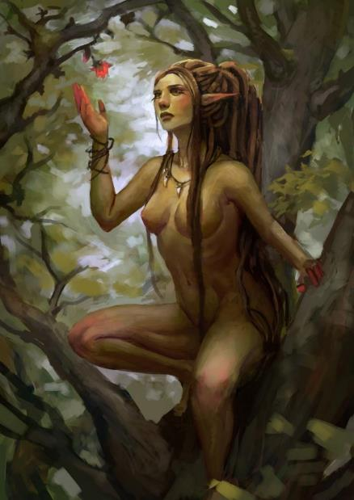

Dresden mostly noticed the titties. No one had ever-perkier titties than dryads, and a few of the satyr chicks had twice or thrice as many, though most were just hoofed and horned hotties. The drow assassin’s toes danced up and down in his boots as he tried to keep his composure within his tightening loincloth.

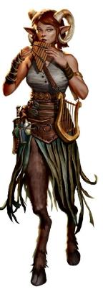

Kir noticed Dresden pitching a tent on account of the menagerie of sexy fey, but said nothing at the moment, instead trying to get a read for the leader, a dryad man whose name she’d just missed.

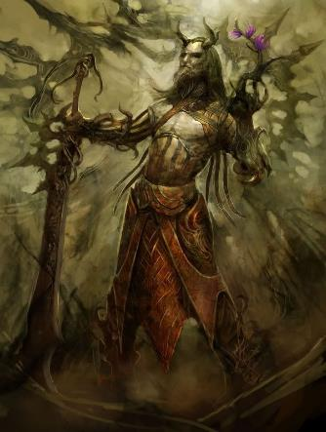

Xaryn also beheld the man who was their host: a figure slightly taller than the archmage, and with shifting features comprised of flesh, bark, and leaves. Now that he’d taken to walking, his face took on the guise of a slightly older and more formidable man than the boyish figure they’d first encountered, and it occurred to Xaryn that this had perhaps been a test of their intentions, making the Gambit and its allies think they’d been dealing with a mere boy. The drow also took notice of the beauty of the women—those less barky, anyway—and contemplated making friends with one of them.

Moondancer stirred near Lauren’s feet, looking up at the half-drow occasionally, and at one point making eye contact with the somewhat wary woman. Lauren stayed her weapon, but was quick-witted and ready to attack anyone at the first sign of treachery, feeling already somewhat claustrophobic after having flown freely over this wondrous land now that they were surrounded by sentient trees. The pseudodragon nosed at some of the smoking meat roasting just 40’ upwind of them, and seemed a bit soothed by the prospect of an early lunch.

The leader of this merry band of nature spirits of the hereafter was named Nephalus, and though only Allisa could pronounce the names of the plants with reliability, there non-plant folk in the company of the treants and greenbound creatures were quite sociable. It was still difficult for everyone to keep everyone’s names straight at first, but these fluencies developed over the course of a conversation.

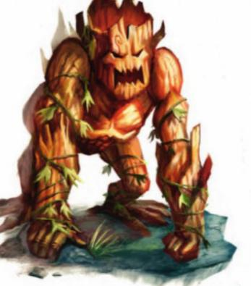

The wariest of the locals by far was a creature that Allisa had identified as a verdant reaver. Comprised almost entirely of bark with a few green twigs and leaves, the lumbering hulk remained poised to strike at a moment’s notice, and Lauren read the body language.

It seemed to the more observant newcomers after the first minute of pleasantries that there were pixies and faeries who came into the grove and left of their own regard without much of a salutation to punctuate their entry or exit; then there were the “regulars”, and these were mostly the aforementioned assortment of satyrs, dryads, and other Medium fey.

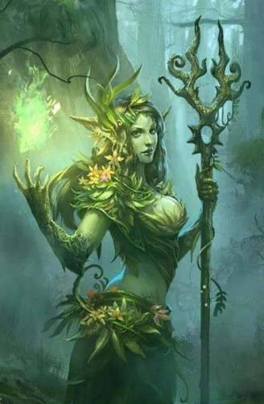

*[If anyone approaches any of the treants…]* The treants in the periphery of the clearing spoke mostly among themselves initially, but began to warm up to the fleshy ones who approached them first. << We the simple sylvan folk, >> explained one of them in broken Elven, as if asked about their customs. << If you will ask us, we would answer, but prefer gossip the birds and pixies. >> Those that spoke Sylvan understood that they were saying something about not being great conversationalists about many topics aside from their knowledge of the local scandals among cognate creatures.

The verdant reaver paced nearby on wooden knuckles, much like a gorilla, subtly scanning the clearing for things it had no reason to worry about at the moment.

<< And how did you get here from the Material Plane? >> asked Nephalus, switching from Sylvan to Elven, which more of the newcomers seemed to understand.

Lauren explained that they were tracking a thief and a murderer, who had constructed a building with portals to many planes, including this one.

Nephalus’ right eyebrow raised somewhat at the mention of the portals, << You don’t say. Intriguing…. >>

Moondancer flitted around, looking for any sign of Aridel, or where she might have gone. She approached a few of the treants along the perimeter of the clearing, and attempted to communicate with them.

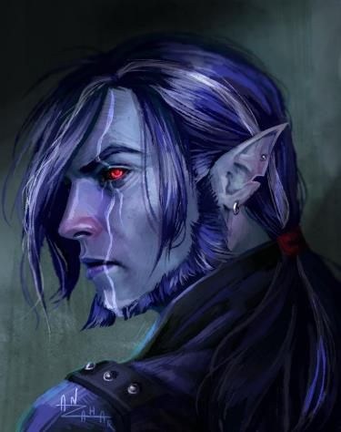

Dresden gave up on trying to conceal his condition, and just enjoyed the scenery. << I have pledged my service to Lady Lauren, because she spared my life, >> he explained in poor Elven to those who asked.

And at that, Nephalus’ eyebrows lowered into a frown, as his lips struggled to formulate the proper words. He shook his head first, looking at some of his fey friends before saying, << Some of us were or knew victims of such evil in our past lives. You believe this group came through here? >>

The various fey creatures around them marveled at the duskblade’s armor and bejeweled accents as panpipes, tambourines, and lyres were taken up once again, and a song ensued.

Fingers said much the same thing as Lauren, adding that the person they sought had also been with a group who killed children from their home city.

Moondancer had struck up a conversation with a treant, doing so telepathically. She’d asked about Aridel, but the treant knew nothing of the person that the pseudodragon named and described.

Dancing followed once the music had achieved a desirable melody at an adequate rhythm.

<< Care to dance? >> a dryad slightly taller than Xaryn asked Xaryn as a satyr approached Kir, and curtsied his hands into hers.

There were couples, trios, entire circles of dancers clasping hands, and even solo moshers and skankers here and there. It was not what they’d expected to be in the midst of when they’d woken up in the shadow plane this morning.

<< And tell me, >> Nephalus asked, contemplating asking Allisa and Lauren to waltz with him amidst the plucked strings and blown pipes. << Once you cut down this renegade group of villains, what do you intend to do? >>

<< I too wish to return home and stay with my spouse, away from the tools of man. Maybe travel a bit. Even return here with your people for a season, >> the druid said. She looked to her love as to would they dance with this fey.

Lauren sighed, and blinked as tears came to her eyes. << I want to grow old with my wife, >> she said as she held Allisa’s hand in her trembling fingers. << We may adopt children, as my parents did for me. >> She looked around them. << I know that we all suffer at times. Perhaps I am not strong enough to be a hero, for I am tired, and I am still young. >>

The longhaired man nodded and smiled at the women’s ambitions, commending them both before raising a wooden cup that had not previously been in his hand, and drinking from it. << These are noble desires: to seek out a place in which to settle and be left alone after a lifetime of strife, >> said the man with antlers and leaves growing from him. The self-styled maestro then picked up a twig from the ground, and—using it like an orchestral baton—motioned for the drummers, cantors, strummers, and pipers to liven up their melody.

Men and women of all ages and sizes—from the gauntest treants to the tiniest, thumbeline faeries—frolicked, danced, and otherwise caroused throughout the clearing and in its vicinity. It took Nephalus a total of six measures before he tired of playing the tempo conductor, and tossed the twig back to the ground as dancers swayed and spun around Allisa and the others.

Lauren held out her hand to Allisa. “Shall we dance, Melamin?” Although she wasn’t as graceful as her elven partner, Lauren could move well, even in her armor. It felt odd to be dancing in full gear, but she dared not remove it in such a strange place.

When offered to dance, Allisa’s eyes sparkled and she took Lauren’s hand and led her out to join into a group doing a circle dance.

Moondancer settled down onto a stout limb and contemplated Aridel’s talisman. It was heartbreaking to be close to finding her, and then to not have any clue about what to do next. She watched as her new friend danced with her other rescuers. If it had not been for them, she’d still be dying of thirst in that cage. The minidrag hung her head and mourned for her mistress as the music poured over her.

Dresden was caught up in the new experience of being around truly happy people, in a place that swarmed with living things. There was a sky overhead, not stone, and he looked up at it past the treetops. From the conversations, he’d caught that many of the people here had suffered in their lives, and so had he. But now, they were happy, and the drow found himself wishing for the same thing. Lady Lauren had spared his life, and she had asked nothing in return – other than to carry a lightweight, magical pack for her.

There was no guile, no deceit, no plotting in this place, or in the people he’d met. For the first time, Dresden was happy, and he danced his heart out as the realization coursed through him.

Everyone was attracted to just about everybody else there, and even the treants were partaking in the fun, mostly caressing fleshy dryads with their leafy limbs.

Kir through her suspicions to the wind. and joined in with the drinking and dancing. She took a liking to one of the dryads women that kept inserting herself beside her and shortly the two disappeared.

Xaryn watched the dancing as he sat at a table and sample bit of this and that.

Allisa watched at first, enjoying the beautiful creatures. She could be at home here. Several times her eye lingered on one dryads or some other fey. She nudged Lauren commenting on their features occasionally turning to kiss her. She took a glass of solstice wine and drank deeply.

Kir had returned to the group dance with this and that fey. She seemed to have a glow about her as she sat down beside Allisa sometime later to eat. The druid commented to Kir as well as Lauren. “If Maiko were here what an orgy she would have. We will have to bring her sometime.” Her thoughts continued on as she ate some of the exotic food. “I wonder if she has had my god child yet. I will feel bad If I miss it. Maybe we can find some present while on this journey.”

Lauren laughed at the statement about the baby. It had been less than 24 hours since they’d all left the courtroom together.

Xaryn had at this time found someone who was willing to talk magic and sat off to the side ignoring the festivities.

All in all, the Gambit and their associates had found acceptance among these woodsy folk, and by the time they’d realized that sunset was drawing near, they’d partaken in almost a hundred dances, songs, games, senseless chases, and other activities.

Their legs were so tired, and the exhilaration and drunkenness on the part of those who partook in drink had at times been so heady that they had to take a cackling tumble in the shallow grass before reprising their rhythmic celebration of life. Moondancer had sulked at first, but in time, she—too—succumbed to the temptations of the moment, and got so many people to pet her, that her scales and ridges were almost sore.

A cool breeze was blowing in over the plane, and night would soon descend upon the endless forest. << Friends, >> sighed Nephalus as soon as he spotted some of the older fey wandering off in every direction and disappearing behind the foliage. << It occurs to me that we may be in a position to help one another out. You say you came to be here via some portals. I would very much like to see this portal, and a few of my brethren are interested in going back to Faerûn. If you truly hail from Waterdeep, some of us can follow you back to your home plane, and make our way to Tethyr where these two were first born , >> he addressed the shapeshifting druid as he motioned to a dryad and a satyr in the middle of a sexual encounter.

The verdant reaver began to settle in a dark portion of the woods still visible from the clearing, and curled up, facing the clearing like a vigilant watchdog.

Lauren nodded. << There may be danger in following us, and we ourselves are having trouble finding the portal from the Plane of Shadow back to our home. But, they may come if they wish. >> She turned to Allisa. << Perhaps we can stay in the treehouse suite we found here for the night. >> She grasped her wife’s hand. << I think the bed is big enough for the two of us. >>

“I can do so. Should we not tell the others? What if the owner returned?” the druid asked. Allisa shrugged and started looking for a more private place, at least out of eyesight.

<< Oh? Treehouse? >> frowned the man, not quite understanding what the treehouse suite was. << Sure! >> he accepted the offer out of hand, with the idea of a treehouse intriguing him. The music began to dwindle one instrument at a time, and gradually song gave way to chatter. << Tonight, you may sleep where you and your lovers please, >> he told the band of newcomers as a pair of dryads took his arms and waited for him to finish. << In the morrow, we’ll guide you to where your friend was last seen. >>

Moondancer’s ears perked up at the reference to Aridel, and she flapped over to Lauren, finding comfort in her scent and treats. As the sunlight dimmed, the least of the fey still flitting to and fro began to glow ever so faintly, and within the hour, their lights would meander across the clearing and into the woods, lighting the way for those whose eyes were suited to diurnal activities.

Having heard and spoken Elven and Sylvan pretty much all day, Allisa’s head was spinning with the delirium of dancing and kissing her spouse. The prospect of staying in such an idyllic place brought her a sense of peace and gladness, and while there was nothing wrong with her abode in the Westwood, she knew that her ultimate dwelling place would either be here or somewhere in the Beastlands, and so she took in all the sights, sounds and smells around her, considering making this her last stand against eternity.

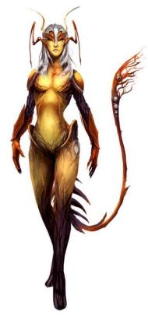

<< Let’s find a place to bed down, >> Lauren said to Allisa. << Moondancer, my wife and I would like a little time to ourselves. Don’t go too far, though. >> Even though Lauren’s armor held an enchanted crystal that would allow her to rest in it, she stripped out of it, laying her weapons, clothing and other possessions down next to their makeshift bed for the night. She drew Allisa down next to her, and lost herself in her lover’s arms. After they were sated, Lauren wrapped Allisa in her arms. << You want to come back here, yes? >>

<< Mm-hmm, >> the dragon communicated telepathically, snuggling up against the half-drow’s abdomen before dozing off again.

Allisa had stripped off her garments as well, and lay down next to Lauren. She continually teased the woman, making sure that she received the most pleasure possible, as their bodies pressed and rubbed against each other. Finally, redhead cuddled in her lover’s arms, knee still pressed tight to the other’s wet sex as she slept. She had answered her sometime in the middle of their passion that she would love to spend some time here.

~*~

Morning, 30 Mirtul, 1377

Sunrise had come after a comfortable night of rest, and most had slept right through it. Xaryn was the first of the outlanders to awaken, and among him were a handful of fey. Some of the early risers had gone off to pee and whatnot, and now that a fire was in the process of being stoked, the drow anticipated breaking fast soon.

Kir had been snoring within the blankets she’d shared with Xaryn before he’d gotten up, and now began to awaken when the first hint of smoke reached and roused her. She opened one eye to confirm that the fire was an intentional and contained one, then rolled over and snoozed for a few more ticks.

Dresden remained passed out—his calves and quads the sorest of all from yesterday’s gallivanting—ensconced in a mass of bodies of various species.

Fingers was also a bit sore from the previous day’s activities, and stirred in the ever-so-comfortable concavity in the earth for a bit longer, cracking its neck and back as it writhed and stretched, still in the guise of a male human. The rogue read 09:17 on its chronometer, and hesitantly stat up, clearing its dry throat and looking for a pitcher of water.

Morning came, bringing the sounds of birds and other creatures moving in the forest. The druid had woken early as she was apt to do but continued to lay beside her mate gentle creasing her hair. Maybe an hour before the rest awoke, Allisa gently detached herself from the sleeping woman. Finding a nearby tree, she climbed up to find a comfy place and sat nude as she went over her spells *[1 hour]*.

Lauren rose and went to find a place to bathe. She didn’t bother with clothing, and she let her body air dry as she walked back to put on her gear. It took little time to get nice and clean, after which she refreshed her mana pool, and cleared her mind of all distractions that might prevent her from focusing on whatever came at them that day. Once everyone was ready, she addressed the group, switching back to Common after a day’s use of speaking Elven and picking up Sylvan, “Shall we look for Aridel and her party before we continue?”

They were huddled in a circular formation: a literal circumstance. Seeing that Nephalus was gathering around him the troupe of his brethren that would come with, they converged on the topic of Aridel. “Moondancer here—as you might imagine—” the duskblade spoke for the reptile, “sees this as the most urgent of things, and it looks like we’re not looking to stall this at all,” she motioned with her chin towards Nephalus, who briefly placed a hand on a younger male fey before dispatching him towards the sound of the river.

“If we find her,” Fingers proposed, “maybe we can all spend the rest of today here, celebrating, and eventually head back to the Shadow Plane.”

“It’s a thought,” Xaryn shrugged. “Did anyone leave anything in the Shadow Plane?”

No one spoke up.

Kir offered, “If there’s a need to go back for something, I can go back, maybe take some muscle with me,” she looked at Xaryn.

Nephalus approached, << Come, my new friends. These folks know the way better than I do. >> He motioned for the quartet of guides—a dryad, a satyr, a greenbound raptoran, and a greenbound aarakocra—to ready their walking sticks so they could be on their way.

<< We have a flying carpet, as well. Would it be acceptable for us to ride it, rather than walk? >> Lauren asked in Elven.

Some of them laughed at the idea, but their leader said, << Oh, um, sure! It might get a little crazy towards the end as the branches get thicker. There’s no beaten path or anything. This here’s the gods’ country. >>

Lauren smiled, << We will walk with you, then. >>

Allisa dressed as she spoke with two fey who had followed her from the tree. One had claimed the tree was hers, embracing it as a lover almost. She caught up with Lauren and gave her a passionate kiss right in the middle of the camp, her hands pressed upon the others armor above her breasts.

The druid changed into a black leopard as they began their trek. She moved beside of her mate for the most part, when not playing with some small faeries.

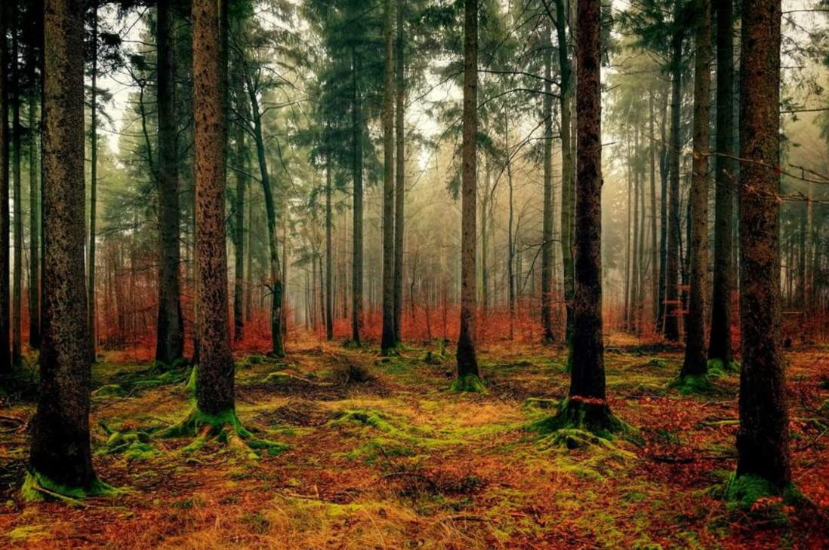

The first five minutes or so, the fey folk led the way towards and across a small stream, which was not the river that had been referenced. It had seemed closer from the air but as the foliage cleared to a grove with minimal undergrowth, they realized that the brook was but a mere tributary, and what Nephalus was describing was at least twice as wide as what they’d just traversed, hopping across a jutting ford that peppered the stream. Having cleared that small tributary, they took a path along a hill, reaching its summit and surveying the panorama of rolling hills before them.



They continued for a while longer, and eventually got to the river in question, which fed both banks along a rather wide margin of flora, most of which bore pink leaves whose refractions painted the water a ruby hue.



<< It’s just past the river, >> Nephalus pointed the way as his adopted family members started to cross the river, which quickly got to about their chests as they entered the midpoint.

Lauren reached into her sack and drew out the carpet. << Fingers, would you do the honors, please? >>

Hopping atop the carpet, the panther spoke commenting on how beautiful the river area was.

Curious faeries and pixies looked on in fascination as the tapestry transported the heroes across the rose-hued waters.

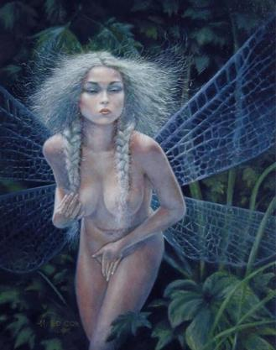

Once they’d used the carpet to get across, they were pretty much there. The guides took a moment to study the trees and other landmarks, twirling in circles once or twice, and then pointed to a tree with a now noticeably humanoid structure. Though the base of its trunk was singular, it was evident as the heroes looked closer that a cleave down the middle of the first 3’ or so from the roots delineated two legs. A woman’s torso was also clearly defined, with two main branches arching diagonally upward and the trunk continuing upward with elongated facial features, reaching a height of about 15’.

By the time Lauren and Allisa began to wonder if this was the Aridel of which Moondancer had spoken telepathically, the pseudodragon was already upon the trunk, scratching gently and sniffing before turning to Nephalus with a startled expression.

After a second, Nephalus replied to the dragon’s question with speech, << It is indeed. She has decided to make this her final dwelling, as have most of the denizens of Arborea. >>

Fingers then noted that of the multitude of trees around them, nearly half of them had distinctly humanoid trunks and branches. It nonchalantly activated the crystal of their Farspeaking Amulet in order to communicate clandestinely with its partners.

|  |  |  |  |  |  |  |  |
| --- | --- | --- | --- | --- | --- | --- | --- |
| **Skill/Save** | **Rank** | **Ability & Mod.** | **Misc. Mods.** | **Total** | **Roll** | **Check** | **Notes** |
| **Fingers, Sleight of Hand 1** | 15 | **Dex (+4)** | 4 | 23 | 8 | 31 | Lucky Fingers |
| **Fingers, Sleight of Hand 2** | 15 | **Dex (+4)** | 4 | 23 | 18 | 41 | Lucky Fingers |

*See below.*

Unfortunately, the rogue didn’t possess the central crystal, so it couldn’t activate the communication stream, so it simply looked at Lauren, who was the most battle-conscious of her friends, guiding her eyes all around her.

Allisa asked, “I did not know she was of such an age to do, or was she sick?” The cat sniffed the air and its ears twitched as it listened for anything out of the ordinary.

“I don’t know,” Lauren replied in Common. She looked up to Aridel’s face, continuing in her modal language. “Hello, Aridel. I’m Lauren Matholas, wife of Allisa Maltholas,” she set her hand on Allisa’s shoulder. “We found Moondancer imprisoned in Carceri, and we brought her here to find you.” She looked at Moondancer. “Do you wish to stay here with her, Little One?”

<< We *shit* in the woods! >> the greenbound aarakocra guide emphasized with the growly croak to which they’d grown accustomed, being a bit limited in his vocabulistics.

Along with some of the lesser fey, Nephalus shook his head and held back most of a giggle, paraphrasing, << What my little brother here means is that Aridel... isssss... >>> he looked up as if for inspiration to find the right word, and returned, << Placid. I’ll wager she can hear you, but... >> he shook his head again, but this time made contact with the Gambit and their friends. << I doubt she’s going to want to come out of such a blissful state on such a peaceful day. >>

Moondancer’s character immediately changed from bewildered to defensive, and her nape and throat became engorged as she lowered her body, bending at the elbows and rattling her tail’s stinger left to right. Exhibiting every sign of a distraught animal or magical beast—as diagnosed by Allisa—the pseudodragon now clearly regarded Nephalus and his company with mistrust and hostility, though she did not lunge out of fear of being killed.

Allisa reverted to half-elf form, speaking in Common, so as to be less readily understood, “Are you saying you did this?”

Lauren glanced around to gauge everyone’s reactions. There was certainly a sense of tension and apprehension in everyone’s body language. She made no move toward her own weapons, but she noted who was where around them. There were six of them: Allisa, Dresden, Fingers, Kir, Lauren, and Xaryn, plus Moondancer, who hadn’t contributed much to the previous struggles; and they were surrounded by as many of Nephalus’ minions, plus him.

It took a moment for the satyr to translate Allisa’s question into Sylvan. The fey prince took this reversion to the tongue of urbanites as a sleight unto this revered place, inhaled indignantly, and responded, << You, druid, should well know the nature of such a place. Aridel’s form can come and go at any time. What I—*we all*—have done is to help her, and so many others transition here. >>

“What’s he saying?” Kir asked in Common, knowing neither Elven nor Sylvan.

<< Transition… >> Allisa interjected.

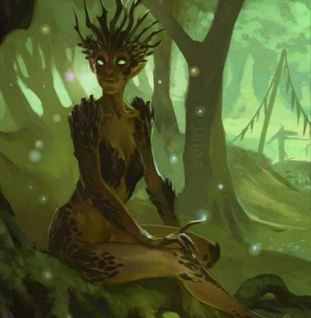

The shirtless male nodded and smirked, as his dryad girlfriend sat at the roots of the tree next to Aridel and caressed the tree absentmindedly. Nephalus clarified as most of the heroes stood ready to draw weapons and cast spells. << It was no mere coincidence that you came to be here, wanderers. Fate brings travelers from near and far to our grove, and it is the wish of most to stay, and among those who do, the great majority grow placid and seek to lay roots here, near the river that will always be here for them. >>

Allisa took a moment to translate for the others. Xaryn asked, “And those who do not choose to stay?”

The satyr translated and Nephalus parted his lips to provide clarification, << There is no single answer to that, and I know not the fate of those who take their leave once they do so... but more importantly, this grove can offer you a gift, which I would be glad to broker: if you give us the shards you spoke of, my brethren and I can come and go as we please, and visit those we left behind on the Material Plane. You are welcome to stay here with Aridel, unless she chooses to come with you as you seek out your arch-nemesis. >>

Allisa protested with clarification that she thought had already been provided, << No, we need the shards to find this villain. >>

Nephalus thought about it a moment, and waved an open hand towards the bulk of his followers, << And what if this team of able warriors aids you in cutting down this renegade thief? Perhaps we can get you back home, and we can take the portals you spoke of out of Waterdeep, stashing them somewhere in the woods. >>

Fingers and most of its friends were on high alert. Kir considered casting a defensive spell before anything else was said or done, and Xaryn had little faith in the promise of further parlaying with the embodiment of whatever power had transformed Aridel into an aspen.

<< Know that we have to still travel to several other planes to accomplish our mission, >> Lauren said. << Are you all willing to do that? >> She looked to Aridel. << Aridel, would you want to come with us, as well? >>

<< I believe I speak for all who have come with me. They do not wish to rest here. Maybe they would return as their natural lives come closer to the end. As for my knowledge of this type of place, I am lacking. You must understand, to us it looks like you have somehow seduced these placid creatures into their current state, >> the druid spoke in Elfish again, remembering her manners. << So, you would take the portals and hide them in my plane, and defend them from evil use? You would also allow us the knowledge of their locations? >>

<< I would do my best to safeguard the portals, >> Nephalus proclaimed, shrugging, << but if a power mightier than myself should wrest them from me, I would have to withdraw from any further pursuit... as I imagine you all would. >>

<< This I would have to discuss with my friends. >>

<< By all means, brothers and sisters, >> he smiled as his dryad girlfriend came into his embrace and planted a full kiss on his lips.

Moondancer crouched behind the tree that Aridel had become, and Fingers could see not only her distress, but also the preparation of some of the other woodland fey for a fight. Stances were defensive, and dominant hands were on the mercies of their swords and the hefts of their javelins.

The Gambit and their friends considered the moment. Allisa’s questions had been answered, but Dresden, Kir and Xaryn could tell that there was at least omission in Nephalus narrative, and at most, deceit. They could get on the carpet and flee now, but it was obvious that Moondancer wasn’t going anywhere without Aridel, and they couldn’t take a tree with them. They could also continue to parlay, or they could resolve this here and now with sword, fang, and spell. Dresden gave his mistress a look of concern, nodding slightly to let her know he was at the ready for an engagement, should one ensue.

Lauren stood tall and looked around, meeting each person’s eyes with a neutral expression. She addressed the group in Eleven. << “We did not mean to cause any trouble, and we have a task to accomplish. So, we are leaving. If that is offensive to you, I am sorry, but we are leaving. >> She gestured to her companions, and moved carefully away from the woodland folk. << Let’s move away, shall we? >>

Still speaking in Elfin, Allisa stepped back on the carpet just 10’ from her. << When we find the way, we can return and help you leave this place if that is what you want. If you must, let the fairy come with us. >> She pointed at one of the little winged creatures that she had been chatting with on journey to the river.

As she watched the group, a fey brought to the forefront of her mind a *fog* spell centering on the area where they stood on the carpet but not to attach it to the carpet or any person upon the cloth.

Nephalus turned to the fairy in question. The butterfly-winged fey fluttered over to him with a look of concern on her face. The druid understood Nephalus comforting her in Sylvan, << Fear not these kind people. Seek out new playgrounds, and frolic, >> he held out a forearm on which she first perched, then sat, calming herself down as she studied the newcomers and their nearly rabid pseudodragon.

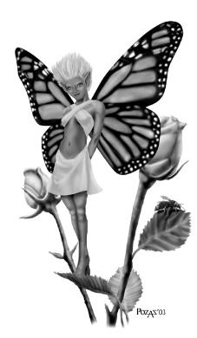

Standing under the copse of the tree that was Aridel, Allisa noted the two leaves that on her shoulder and breast, though she remained intent on studying Nephalus.

<< Alright, if that is what you choose, >> he spoke for her once she nodded to him, not so much with a sense of reluctant obedience but out of sincere faith in the elder fey’s words. << Zhiranne agrees to accompany you, >> he then faced the heroes as his brethren gathered around, now cognizant that their friend was departing.

<< Welcome to our group, Zhiranne, and thank you for allowing her to come. I will look after her. >> Allisa bent down to pick up the two leaves, and slid them into one of her pockets.

Lauren glanced up at Aridel, noting that her leaves were beginning to fall, and her branches were beginning to shake. “You are welcome to come with us, Aridel. If not, at least talk to Moondancer.”

Allisa had a thought and said “hold on” to her companions. She then stepped to the tree, putting both hands and forehead to the bark and tried to commune with the tree, hoping that the being inside was telepathic.

Without much warning, the bark and flesh that touched began to meld and become one, and the rustling of branches and leaves took on a crescendo that seemed to also incite other trees. Leaves quaked all around them now, some raining down gently upon the two factions that now seemed to be poised to defend one another’s interests.

Seeing this, Moondancer hissed and rattled her stinger as the tree shook less subtly now in the calm breeze that caressed the brook and the surrounding grove. Zhiranne, buzzed behind Nephalus, hiding behind his antlers.

It was 10:29 by Fingers’ chronometer, though the rogue wasn’t about to check the time. Instead, Fingers reached for its wand of *greater invisibility*, and shifted in its stance in order to have more potential adversaries in its field of vision than behind it.

Inhaling the scent of adrenaline, Kir steeled her reflexes. Seeing the tree’s roots quiver and struggle to free themselves from the earth beneath, the rogue-cleric inadvertently emoted, “By Leira!”

Allisa seemed to be not in pain, but looked at Nephalus with a knowing glare, and squinted as her comrades saw a glad smirk on the shirtless man’s face.

The tree’s bark stretched and split at certain points of its surface, taking on a slightly more humanoid and more feminine shape, and what’s more, the trunk’s top was shrinking quickly, taking on a rounder form as the pointy top was drawn down and inward. Slowly but with notable effort on the tree’s part, a face began to form, and by the time Moondancer recognized Aridel’s features, the face opened its eyelids, revealing a pair of perfectly half-elven eyes, and the face contorted with a grimace before screaming in a strained, woody Common, “Saaavvvve yourseeelvessss! He’ll torture you here foreverrrrrr!”

The hair follicles on Lauren’s legs stood on end as she heard the terror in the tormented tree’s scream, and the message that the woman inside the bark body had just conveyed.

Nephalus held out his left hand towards Aridel, and seemed to shut her up, forcing her humanoid nature further within the writhing, quaking bark and leaves.

“Oh, Hells, no!” Lauren realized what this dude was doing to her bride.

Panicked, Moondancer protracted her wings and prepared to lunge at Nephalus, who looked to those who spotted it like he was casting a spell with Somatic components only. Then, a *blinding color surge* hit Fingers square in the face.

|  |  |  |  |  |  |  |  |
| --- | --- | --- | --- | --- | --- | --- | --- |
| **Save vs.**  *blinding color surge* | **Rank** | **Ability & Mod.** | **Misc. Mods.** | **Total** | **Roll** | **Check** | **Notes** |
| **Fingers, Will** | **6** | **Wis (+2)** | 1 | 9 | 14 | 23 | +2 if Lucky |

*Success. Blinding effect negated.*

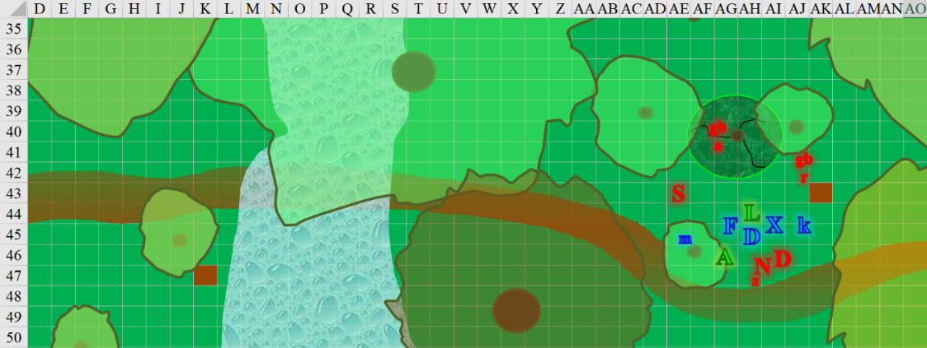

Nephalus then became *invisible*, and sighed, << I had higher hopes for you all. >>

“A lot of good that’s going to do you,” Fingers murmured to itself, referencing its ability to see the *invisible* fey lord.

Round 1

|  |  |  |  |  |  |  |
| --- | --- | --- | --- | --- | --- | --- |
| **Character** | **Group** | **Initiative** | **Roll** | **Modified Roll** | **Move** |  |
| Nephalus | 2 | 12 | 11 | 23 | 30’ |  |
| Fingers | 1 | 4 | 13 | 17 | 30’ |  |
| Moondancer | 1 | 2 | 15 | 17 | 15’/60’f |  |
| GB Raptoran | 2 | 1 | 15 | 16 | 30’ |  |
| Zhiranne | 2 | 2 | 13 | 15 | 15’/50’f |  |
| Xaryn | 1 | 5 | 9 | 14 | 30’ |  |
| Dryad | 2 | 4 | 9 | 13 | 30’ |  |
| Kir | 1 | 1 | 12 | 13 | 20’ |  |
| Verdant Reaver | 2 | 0 | 13 | 13 | 30’ |  |
| Dresden | 1 | 3 | 7 | 10 | 30’ |  |
| Allisa | 1 | 3 | 7 | 10 | 30’ |  |
| Lauren | 1 | 4 | 3 | 7 | 30’ |  |
| Satyr | 2 | 1 | 4 | 5 | 40’ |  |
| GB Aarakocra | 2 | 2 | 2 | 4 | 20’/90’f |  |

Nephalus cast *silent image*, creating a rendition of himself behind the verdant reaver.

Nephalus appeared once again behind the verdant reaver, looking like he was casting an offensive spell, thought its effects and intended victim(s) were not immediately evident.

Fingers tapped itself with its wand of *greater invisibility [expired on Round 7]*, and then drew its recently recuperated Keen Deadly Precision Short Sword, selecting the satyr as its first target.

*Fingers gained invisibility.*

Moondancer sprinted towards Nephalus, flying past the satyr, greenbound aarakocra, and the verdant reaver in order to get to their leader.

|  |  |  |  |  |  |  |  |
| --- | --- | --- | --- | --- | --- | --- | --- |
| **Character** | **Attack Type** | **Damage** | **BAB** | **Str Mod+** | **Total Score** | **Roll** | **Total** |
| Satyr | Head Butt | 1d6 | 5 | 0 | 5 | 10 | 15 |
| GB Aarakocra | Talon 1 | 1d4-1 | 4 | 0 | 4 | 19 | 23 |
| Verdant Reaver | Slam 1 | 1d8+5 | 3 | 4 | 7 | 17 | 24 |

*Miss, hit, hit. Dmg: (3 – 1) + (6 + 5) = 2 + 11 = 13.*

|  |  |  |  |  |  |  |  |
| --- | --- | --- | --- | --- | --- | --- | --- |
| **Character** | **Attack Type** | **Damage** | **BAB** | **Str Mod+** | **Total Score** | **Roll** | **Total** |
| Moondancer | Bite | 1 | 3 | 2 | 5 | 2 | 7 |

*Miss.*

The pseudodragon felt the pain of two swipes, and the second swat really banged her up pretty badly. Still, she continued her beeline, but missed the target.

The greenbound raptoran had already gotten his visual cue from his leader, and now rushed Kir to grapple the cleric of Leira.

|  |  |  |  |  |  |  |  |
| --- | --- | --- | --- | --- | --- | --- | --- |
| **Character** | **Attack Type** | | **BAB** | **Str Mod+** | **Total Score** | **Roll** | **Total** |
| GB Raptoran | Touch Attack | | 5 | 2 | 7 | 16 | 23 |
| GB Raptoran | Grapple | | 5 | 2 | 7 | 6 | 13 |
| **Kir** | **Atk** | **Roll** | **Check** |
| Grapple | +8 | 3 | 11 |

Kir was currently trapped in the wooden raptoran’s grip.

Zhiranne also became *invisible*.

Nephalus then spotted Xaryn reaching for his spell component pouch with a look of intent as they made eye contact. The fey leader cast *[Immediate Action]* the *stay the hand* spell upon the archmage.

|  |  |  |  |  |  |  |  |
| --- | --- | --- | --- | --- | --- | --- | --- |
| **Save vs.**  *stay the hand* | **Rank** | **Ability & Mod.** | **Misc. Mods.** | **Total** | **Roll** | **Check** | **Properties** |
| **Xaryn, Will** | 10 | **Wis (+2)** | 0 | 12 | 15 | 27 | +2 vs. Enchantments |

*Success. Effect negated.*

It then became evident that Nephalus hadn’t teleported, but had rather created a *silent image* of himself, which had tricked Moondancer and the others, and had actually made himself *invisible*. Visible once more, the man’s face began to change slightly as his powers of disguise began to recede with his attention to the martial engagement now ensuing. His antlers became longer, and his teeth sharper.

Xaryn shook his head, and smirked at Nephalus, whose eyebrows betrayed some surprise. The archmage put his hand on Lauren’s shoulder, and bid her well in combat, casting *greater heroism* upon her.

*Lauren gained +4 to attack rolls, saves, and skill checks, plus immunity to fear effects, and 13 temporary hit points [****156****/143].*

The *silent image* of Nephalus laughed in silence as it faded from view, leaving the pseudodragon shaking her head and frothing as she sought out another target.

The dryad cast *nature’s balance [expired on Round 801]* upon Nephalus.

*The dryad gained a -4 penalty to Dex, and Nephalus gained +4 to Dex.*

The dryad then retreated from the epicenter of the battle, backing away northeastwardly.

Kir struggled to escape the raptoran’s grip.

|  |  |  |  |  |  |  |
| --- | --- | --- | --- | --- | --- | --- |
| **Skill** | **Rank** | **Ability & Mod.** | **Misc. Mods.** | **Total** | **Roll** | **Check** |
| **Kir, Escape Artist** | 5 | **Dex (+3)** | 2 | **10** | 4 | 14 |

*Fail.*

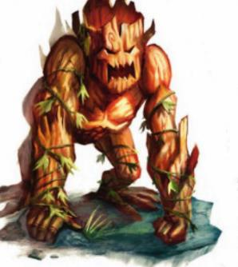

The verdant reaver charge-attacked Lauren, forcing the greenbound aarakocra to take flight and draw a javelin.

|  |  |  |  |  |  |  |  |  |
| --- | --- | --- | --- | --- | --- | --- | --- | --- |
| **Character** | **Attack Type** | **Damage** | **BAB** | **Str Mod+** | **Other+** | **Total Score** | **Roll** | **Total** |
| Verdant Reaver | Slam 1 | 1d8+5 | 3 | 4 | 2 charge | 9 | 5 | 14 |

*Miss.*

Dresden drew his light crossbow—already loaded—and shot at the reaver that had just rushed Lauren.

|  |  |  |  |  |  |  |  |  |  |
| --- | --- | --- | --- | --- | --- | --- | --- | --- | --- |
| **Character** | **Attack Type** | **Damage** | **Ranged?** | **BAB** | **Dex Mod+** | **W+** | **Total Score** | **Roll** | **Total** |
| Dresden | Light Crossbow +1 | 1d8+1+Poison | þ | 6 | 2 | 1 | 9 | 3 | 12 |

*Miss.*

Allisa concentrated on detaching herself from the tree.

|  |  |  |  |  |  |  |
| --- | --- | --- | --- | --- | --- | --- |
| **Skill** | **Rank** | **Ability & Mod.** | **Misc. Mods.** | **Total** | **Roll** | **Check** |
| **Allisa, Concentration** | 6 | **Con (+0)** | 0 | 6 | ?? | ?? |

*See below.*

Barely able to turn her hand back to her half-elf form by expending a use of her Wild Shape ability, the druid detached her hand from the tree, paused as she cast *call of the twilight defender [expired on Round 16]*, and directed it to attack the reaver.

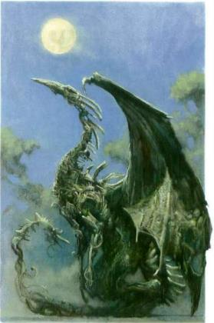

The very ground erupted in a shower of stone and dirt, accompanied by a thunderclap. Standing in the center of the damaged ground was a creature of stone, wood, and plant parts resembling the regal form of a guardian dragon that now attacked the reaver.

|  |  |  |  |  |  |  |  |
| --- | --- | --- | --- | --- | --- | --- | --- |
| **Character** | **Attack Type** | **Damage** | **BAB** | **Str Mod+** | **Total Score** | **Roll** | **Total** |
| Twilight Guardian | Claw 1 | 1d6+7 | 6 | 6 | 12 | 8 | 20 |
| Twilight Guardian | Claw 2 | 1d6+7 | 6 | 6 | 12 | 4 | 16 |
| Twilight Guardian | Tail | 2d6+3+Poison | 6 | 1 | 7 | 7 | 14 |

*Hit, hit, miss. Dmg: (3 + 7) + (1 + 7) = 10 + 8 = 18.*

Buffed by Xaryn’s spell, Lauren now cast *swift expeditious retreat*, activated *arcane strike* with a 1st-level spell’s power, and stepped between Dresden and Xaryn to attack Nephalus with Arkenlyl, which had a single, stored *vampiric touch* spell, and the Greater Arcane Steel crystal in place. Coming at him at an angle, her sword did the rest of the work.

|  |  |  |  |  |  |  |  |  |  |
| --- | --- | --- | --- | --- | --- | --- | --- | --- | --- |
| **Melee Weapon** | **Dmg** | **D+** | **TH+** | **Critical** | **Type** | **Wt.** | **Atk** | **Roll** | **Check** |
| Shattermantle Bloodstone Falchion +3 | 2d4 | +3 +3 | 3 | 18-20/x2 | Slashing | 8.0 | +28 | 5 | 33 |

*Hit. Dmg: 4 + 3 + 3 + 27 vampiric = 37.*

The duskblade didn’t need the healing, but she saw the man cringe from the single slash she’d made. He shook his head.

The satyr saw the threat that the conjured twilight guardian posed to the verdant reaver, and reared up about 5’ to get a head start, then charge-flank-attacked it with his horns.

|  |  |  |  |  |  |  |  |  |
| --- | --- | --- | --- | --- | --- | --- | --- | --- |
| **Character** | **Attack Type** | **Damage** | **BAB** | **Str Mod+** | **Other+** | **Total Score** | **Roll** | **Total** |
| Satyr | Head Butt | 1d6 | 5 | 0 | 2 charge | 7 | 3 | 10 |

*Miss.*

The greenbound raptoran swooped down and grabbed Kir.

|  |  |  |  |  |  |  |  |  |
| --- | --- | --- | --- | --- | --- | --- | --- | --- |
| **Character** | **Attack Type** | **BAB** | **Str Mod+** | **Total Score** | **Roll** | **Total** | **Crit** | **Threat** |
| GB Raptoran | Touch | 4 | 1 | 5 | **20** | 25 | 20 | þ |
| GB Raptoran | Grapple | 4 | 1 | 5 | **10** | 15 | 20 | ý |

*Hit (threat not applicable).*

|  |  |  |  |  |  |  |  |  |  |
| --- | --- | --- | --- | --- | --- | --- | --- | --- | --- |
| **Melee Weapon** | **Dmg** | **D+** | **TH+** | **Critical** | **Type** | **Wt.** | **Atk** | **Roll** | **Check** |
| Grapple | Grapple | - | 0 | - | - | - | +8 | **20** | 28 |

*Kir escaped the grapple.*

|  |  |  |  |  |  |  |
| --- | --- | --- | --- | --- | --- | --- |
| **Save vs.**  Falling on Ass | **Rank** | **Ability & Mod.** | **Misc. Mods.** | **Total** | **Roll** | **Check** |
| **Kir, Reflex** | **8** | **Dex (+3)** | 0 | **11** | 4 | 15 |

*Success.*

The rogue-cleric fell 5’ to the ground, landed on both feet, and looked up at the wooden raptoran with an intrepid stance and stare.

The greenbound aarakocra hurled a javelin at the hulking twilight guardian.

|  |  |  |  |  |  |  |  |  |
| --- | --- | --- | --- | --- | --- | --- | --- | --- |
| **Character** | **Attack Type** | **Damage** | **Ranged?** | **BAB** | **Dex Mod+** | **Total Score** | **Roll** | **Total** |
| GB Raptoran | Javelins | 1d6+1 | þ | 5 | 2 + 2 height  – 4 into melee | 5 | 10 | 15 |

*Miss.*

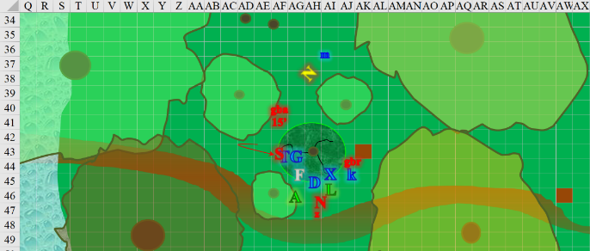

Round 2

Nephalus began to realize just how stalwart Lauren was, and just how otherwise apt and able her comrades were. With a higher regard for safety than victory, the fey lord smirked and cast *baleful polymorph* on the individual he’d pegged to be the most vulnerable to such a curse, or perhaps on the individual whose gifts he most coveted.

|  |  |  |  |  |  |  |
| --- | --- | --- | --- | --- | --- | --- |
| **Save vs.**  *baleful polymorph* | **Rank** | **Ability & Mod.** | **Misc. Mods.** | **Total** | **Roll** | **Check** |
| **Kir, Fortitude** | **9** | **Con (+1)** | 0 | **10** | 3 | 13 |

*Fail.*

Kir took on the form of a box turtle.

The greenbound raptoran picked up the turtle and took flight.

Fingers deduced that with Lauren on Nephalus’ heels, the changeling needed to end the satyr’s life first. Closing in on the horned, hoofed fey, it got into position to pierce his kidney.

|  |  |  |  |  |  |  |  |  |  |  |
| --- | --- | --- | --- | --- | --- | --- | --- | --- | --- | --- |
| **Melee Weapon** | **Dmg** | **D+** | **TH+** | **Critical** | **Type** | **Wt.** | **Atk** | **Roll** | **Check** | **Notes** |
| Keen Deadly Precision Short Sword | 1d6 | 1 | 1 | 17-20, x2 | Piercing | 2.0 | +15 | 3 | 18 | +6d6 Sneak |
| Crystal of Acid Assault, Lesser | - | 1d6 | - | - | - | - | - | - | - |  |

*Hit. Dmg: 2 + 1 + 4 acid + 20 Sneak = 27.*

It was not enough to completely murder the satyr, but it made the point, and the enemy would likely fall with a second jab like that.

Fingers retained its *greater invisibility*.

Moondancer charge-attacked the aarakocra, piercing through the illusion of Nephalus, which then dissipated

|  |  |  |  |  |  |  |  |  |  |  |
| --- | --- | --- | --- | --- | --- | --- | --- | --- | --- | --- |
| **Character** | **Attack Type** | **Damage** | **BAB** | **Dex Mod+** | **Other+** | **Total Score** | **Roll** | **Total** | **Threat** | **Notes** |
| Moondancer | Sting | 1d3-2+poison | 3 | 3 | 2 charge | 5 | ***20*** | 25 | þ | DC 14 Fort |

*Threat. 1d20 = 13 + 5 = 18, critical hit. Dmg: (2 x 1) – 2 + 2 charge = 2 + poison.*

|  |  |  |  |  |
| --- | --- | --- | --- | --- |
| **Character** | **Save vs.**  Poison | **Ranks** | **Roll** | **Save** |
| GB Aarakocra | Fortitude | 0 | 11 | 11 |

*Fail. Asleep for at least 1 minute.*

|  |  |  |  |  |
| --- | --- | --- | --- | --- |
| **Character** | **Save vs.**  Poison | **Ranks** | **Roll** | **Save** |
| GB Aarakocra | Fortitude | 0 | 7 | 7 |

*Fail. Asleep for 2 hours beyond 1st minute.*

The aarakocra fell to the ground, completely knocked out by the pseudodragon’s sting.

The greenbound raptoran saw its greenbound brother attacked, and flew away with Kir in talon, reaching an altitude of 55’.

Zhiranne flew west towards the brook a bit as she began to chant a soft melody in the midst of battle, “Sing me to sleep… I’m tired and I… want to go to bed…”

|  |  |  |  |  |  |  |  |
| --- | --- | --- | --- | --- | --- | --- | --- |
| **Save vs.**  Lullaby | **Rank** | **Ability & Mod.** | **Misc. Mods.** | **Total** | **Roll** | **Check** | **Notes** |
| **Allisa, Will** | **9** | **Wis (+4)** | 0 | 13 | 14 | 27 | +4 vs. Fey |

*Success. Effect negated.*

The fairy fluttered among the branches of the tree that was Aridel. Unable to resist Zhiranne’s song, Aridel’s consciousness began to drift back into the bark, and her struggling to free herself receded for a moment. Allisa, on the other hand, noted the hypnotic chanting, and recognized it for what it was, identifying the creature as a petal. Normally, petals would never collude with the likes of someone as seemingly malicious as Nephalus, which gave Allisa further suspicion of mischief.

Xaryn also spotted the raptoran flying away with the turtle that Nephalus had just made of Kir. He cast *fly*, and pursued the raptoran, reaching an altitude of 40’.

The dryad saw her lover threatened, and cast *deep slumber* upon Lauren.

*Spell ineffective.*

Lauren barely felt a yawn coming on.

Kir wiggled in her shell as the raptoran continued to escape with her in its grip.

The verdant reaver full-attacked Dresden.

|  |  |  |  |  |  |  |  |
| --- | --- | --- | --- | --- | --- | --- | --- |
| **Character** | **Attack Type** | **Damage** | **BAB** | **Str Mod+** | **Total Score** | **Roll** | **Total** |
| Verdant Reaver | Slam 1 | 1d8+5 | 3 | 4 | 7 | 17 | 24 |
| Verdant Reaver | Slam 2 | 1d8+5 | 3 | 4 | 7 | 11 | 18 |

*Hit, hit. Dmg: (2 + 5) + (4 + 5) = 16 + (7 + 7) Verdant Rend = 30.*

Dresden stepped through the verdant growth underfoot, preventing him from charge-attacking, and stabbed at the wooden adversary.

|  |  |  |  |  |  |  |  |  |  |
| --- | --- | --- | --- | --- | --- | --- | --- | --- | --- |
| **Character** | **Attack Type** | **Damage** | **BAB** | **Dex Mod+** | **W+** | **Other+** | **Total Score** | **Roll** | **Total** |
| Dresden | Dagger +1 | 1d4+1+Poison | 6 | 2 | 1 | 1 | 10 | 12 | 22 |

*Hit. Dmg: 2 + 1 + 11 Sneak = 14 + Poison.*

|  |  |  |  |  |
| --- | --- | --- | --- | --- |
| **Character** | **Save vs.**  Poison | **Ranks** | **Roll** | **Save** |
| Verdant Reaver | Fortitude | 11 | 9 | 20 |

*Success. Primary effects negated.*

Allisa detached from Aridel, then quickly stepped back 30’ from the tree and any assailant.

Lauren stayed after Nephalus, channeling *shocking grasp* on her next attack.

|  |  |  |  |  |  |  |  |  |  |
| --- | --- | --- | --- | --- | --- | --- | --- | --- | --- |
| **Melee Weapon** | **Dmg** | **D+** | **TH+** | **Critical** | **Type** | **Wt.** | **Atk** | **Roll** | **Check** |
| Shattermantle Bloodstone Falchion +3 | 2d4 | +3 +3 | 3 | 18-20/x2 | Slashing | 8.0 | +28 | 2 | 30 |
| SB Falchion +3, 2nd Attack | 2d4 | +3 +3 | 3 | 18-20/x2 | Slashing |  | +23 | *1* | 24 |
| SB Falchion +3, 3rd Attack | 2d4 | +3 +3 | 3 | 18-20/x2 | Slashing |  | +18 | 7 | 25 |
| SB Falchion +3, 4th Attack | 2d4 | +3 +3 | 3 | 18-20/x2 | Slashing |  | +13 | 17 | 30 |

*Hit, miss, miss, hit. Dmg: (4 + 3 + 3) + (6 + 3 + 3) = 10 + 12 + 17 electric = 37.*

Lauren then inhaled deeply, which usually gave her a reliable estimate of how much mana she had left.

|  |  |  |  |  |  |  |
| --- | --- | --- | --- | --- | --- | --- |
|  | **Daily Duskblade Spells** | | | | | |
|  | **0th** | **1st** | **2nd** | **3rd** | **4th** | **5th** |
| **Duskblade Spells** | 6 | 10 | 9 | 8 | 6 | 2 |
| **Intelligence Bonus** | 0 | 1 | 1 | 1 | 0 | 0 |
| **Total Daily Spells** | **6** | **22** | **10** | **9** | **6** | **2** |
| **DC** | 13 | 14 | 15 | 16 | 17 | 18 |
| **Cast?** | **0** | **2** | **0** | **1** | **0** | **0** |

The satyr took a sidestep around the conjured plant-dragon in order to finish off Dresden, an enemy of flesh and blood. He didn’t care much about the risk of being attacked by the conjuration, but he also wasn’t aware of Fingers’ position, so he got more than he bargained for.

|  |  |  |  |  |  |  |  |
| --- | --- | --- | --- | --- | --- | --- | --- |
| **Character** | **Attack Type** | **Damage** | **BAB** | **Str Mod+** | **Total Score** | **Roll** | **Total** |
| Twilight Guardian | Tail | 2d6+3+Poison | 6 | 1 | 7 | 14 | 21 |

*Hit. Dmg: 6 + 3 = 9 + Poison.*

|  |  |  |  |  |
| --- | --- | --- | --- | --- |
| **Character** | **Save vs.**  Poison | **Ranks** | **Roll** | **Save** |
| Satyr | Fortitude | 3 | 5 | 8 |

*Fail. Dmg: 2 Con.*

Fingers swung as well.

|  |  |  |  |  |  |  |  |  |  |  |
| --- | --- | --- | --- | --- | --- | --- | --- | --- | --- | --- |
| **Melee Weapon** | **Dmg** | **D+** | **TH+** | **Critical** | **Type** | **Wt.** | **Atk** | **Roll** | **Check** | **Notes** |
| Keen Deadly Precision Short Sword | 1d6 | 1 | 1 | 17-20, x2 | Piercing | 2.0 | +15 | 1 | 16 | +6d6 Sneak |
| Crystal of Acid Assault, Lesser | - | 1d6 | - | - | - | - | - | - | - |  |

*Miss.*

The satyr’s horns made a nice connect with the drow’s torso.

|  |  |  |  |  |  |  |  |  |  |
| --- | --- | --- | --- | --- | --- | --- | --- | --- | --- |
| **Character** | **Attack Type** | **Damage** | **BAB** | **Str Mod+** | **Total Score** | **Roll** | **Total** | **Crit** | **Threat** |
| Satyr | Head Butt | 1d6 | 5 | 2 charge | 7 | ***20*** | 27 | 20 | þ |

*Threat. 1d20 = 19 + 5 = 24, critical hit. Dmg: (2 x 2) + 2 = 6.*

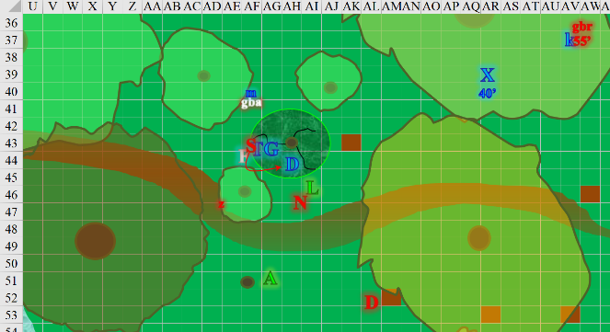

Round 3

Nephalus observed the ensuing events around him.

Fingers figured it could finish off the satyr—its closest target with a direct line of attack—so it sneak-charge-attacked the cloven-hooved drunkard.

|  |  |  |  |  |  |  |  |  |  |  |
| --- | --- | --- | --- | --- | --- | --- | --- | --- | --- | --- |
| **Melee Weapon** | **Dmg** | **D+** | **TH+** | **Critical** | **Type** | **Wt.** | **Atk** | **Roll** | **Check** | **Notes** |
| Keen Deadly Precision Short Sword | 1d6 | 1 | 1 + 2  Charge  +2 Flank | 17-20, x2 | Piercing | 2.0 | +19 | 10 | 29 | +6d6 Sneak |
| Crystal of Acid Assault, Lesser | - | 1d6 | - | - | - | - | - | - | - |  |

*Hit. Dmg: 4 + 1 + 2 Charge + 24 Sneak = 31.*

It was gruesome to see the satyr get pierced, then cleft nearly in half as the rogue hacked through the right side of the fey’s abdomen, spilling his guts all over the leaf-covered grove.

Moondancer was delighted to see that she’d brought down the aarakocra javeling wielder, and now saw the satyr go down too. The fierce dragon runt spotted Zhirenne doing something sinister in Aridel’s copse, lulling the tree back into submissive slumber. Moondancer charge-attacked the petal.

|  |  |  |  |  |  |  |  |  |  |
| --- | --- | --- | --- | --- | --- | --- | --- | --- | --- |
| **Character** | **Attack Type** | **Damage** | **BAB** | **Dex Mod+** | **Other+** | **Total Score** | **Roll** | **Total** | **Notes** |
| Moondancer | Sting | 1d3-2+poison | 3 | 3 | 2 charge | 7 | 17 | 24 | DC 14 Fort |

*Hit. Dmg: 1 – 2 = 1 minimum + Poison. Damage negated.*

|  |  |  |  |  |
| --- | --- | --- | --- | --- |
| **Character** | **Save vs.**  Poison | **Ranks** | **Roll** | **Save** |
| Zhiranne | Fortitude | 2 | 15 | 17 |

*Success. Sleep negated.*

The same tactic proved ineffective against the fey girl.

Zhiranne wasn’t about to take any disrespect from a reptile, so she drew her dagger, and punched at Moondancer with it.

|  |  |  |  |  |  |  |  |  |
| --- | --- | --- | --- | --- | --- | --- | --- | --- |
| **Character** | **Attack Type** | **Damage** | **BAB** | **Dex Mod+** | **W+** | **Total Score** | **Roll** | **Total** |
| Zhiranne | Dagger +1 | 1d2-4 | 0 | 5 | 1 | 6 | 3 | 9 |

*Miss.*

The greenbound raptoran continued to flee with Xaryn trailing close behind, and they both disappeared beyond the treetops.

The dryad smirked at Allisa, and ran southeastwardly.

More confident now, the verdant reaver full-attacked Dresden.

|  |  |  |  |  |  |  |  |
| --- | --- | --- | --- | --- | --- | --- | --- |
| **Character** | **Attack Type** | **Damage** | **BAB** | **Str Mod+** | **Total Score** | **Roll** | **Total** |
| Verdant Reaver | Slam 1 | 1d8+5 | 3 | 4 | 7 | 14 | 21 |
| Verdant Reaver | Slam 2 | 1d8+5 | 3 | 4 | 7 | 12 | 19 |

*Hit, hit. Dmg: (1 + 5) + (6 + 5) = 17 + (4 + 7) Verdant Rend = 28.*

Dresden died where he stood, pretty much torn in half, pending by a few ligaments and other tissues.

Nephalus had seen enough. With the duskblade before him, he was not about to underestimate this woman’s prowess. She seemed skilled enough to take down small armies. << Your dragon may have her mistress, but I shall take two of yours. >> He then cast either *dimension door* or a more powerful version of the spell, leaving Lauren to contend with the magenta swirl that remained for a few seconds afterwards. The drow had fulfilled his hour-old vow to defend his mistress to the death.

Allisa cast *flame strike* on the reaver.

|  |  |  |  |  |
| --- | --- | --- | --- | --- |
| **Character** | **Save vs.**  *flame strike* | **Ranks** | **Roll** | **Save** |
| Verdant Reaver | Reflex | 2 | 14 | 16 |

*Fail. Dmg: (2 Vulnerable x 29 fire) + 29 divine [magic]= 87.*

The druid pulverized the verdant reaver with the call of her deity’s divine fire.

The mighty twilight defender held a defensive against any would-be assailants.

*I still don’t have intended actions for the defender on this round.*

Lauren channeled *shocking grasp*, cast *swift fly*, and went after Zhiranne before she could kill Moondancer.

|  |  |  |  |  |  |  |  |  |  |
| --- | --- | --- | --- | --- | --- | --- | --- | --- | --- |
| **Melee Weapon** | **Dmg** | **D+** | **TH+** | **Critical** | **Type** | **Wt.** | **Atk** | **Roll** | **Check** |
| Shattermantle Bloodstone Falchion +3 | 2d4 | +3 +3  +2 charge | 3  +2 charge | 18-20/x2 | Slashing | 8.0 | +30 | 7 | 37 |

*Hit. Dmg: 8 + 3 + 3 + 2 = 16. Partial damage negated.*

Despite the fey’s supernatural ability to eschew some of the damage, the fairy bit the dust quite literally as she landed uneventfully face down on the leafy dirt.

Aridel’s branches began to somehow retract their remaining leaves, and Allisa and Lauren realized that a good handful of trees were even now becoming humanoid or theromorphic in shape.

The greenbound aarakocra did nothing but dream.

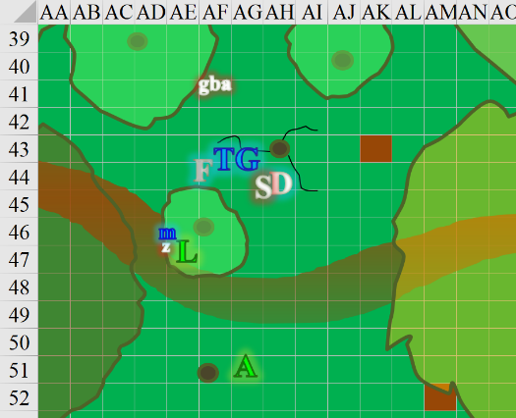

Round 4

The dryad was now out of sight, having sprinted and then skipped off south-southeastwardly.

Aridel was now splitting her trunk into two legs, and stepping out from where she’d been rooted as others now liberated from their tree forms fell to their wooden knees and took on fleshier features as they gasped and heaved, not having used lungs in an innumerable amount of time. Though it had been a sweet, slumberful existence, the handful of helpless people were coming back to sentience and animation.

Fingers and Moondancer looked at Allisa and Lauren as the rogue whistled distinctively to give them a sense of its position. The twilight guardian also looked towards Allisa.

Lauren went to Allisa. “You and I can go after the others while Fingers stays here and guards these folk with the guardian, yes?”

Before the druid could answer, the trees began to transform in front of them, and then they were inundated with people giving them thanks. The guardian would only persist for another minute, so that wasn’t a deciding factor for Allisa. As the druid contemplated the proposition, the quivering of the brook’s trees now came coupled with the shaking and rumbling of the earth beneath their feet. It was a mild earthquake, and didn’t necessitate holding on to anything, but as Lauren bent down to pick up the haversack from Dresden’s cooling corpse, Aridel regained the ability to speak, albeit gasping a bit. Moondancer joined Aridel, and the two bonded as the duskblade looked inside the extradimensional bag and produced the carpet.

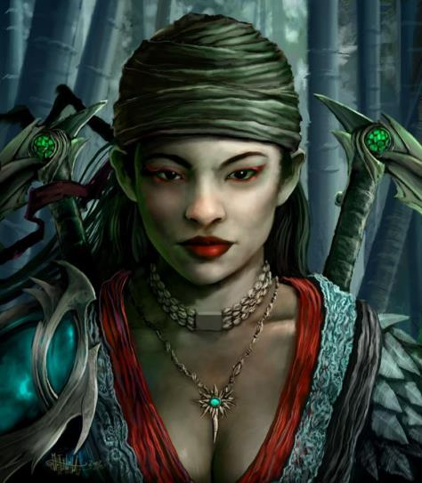

“I... I thank you, strangers,” Aridel said in Common, sighing with a strain to reboot her cardiorespiratory system as a few others began to approach with both caution and gratitude in their body language.

Fingers became visible once again.

Allisa contended that these people could still perceive what was going on around them even as plants, and Aridel’s initial words corroborated this suspicion. “You’ve been a prisoner here?”

“In a manner of speaking,” the woodsy half-elf now looked almost exactly as she had before transforming into a tree.

A male human wearing a helmet, but no other armor came within a few feet of Aridel, and made eye contact with her. They embraced. Moondancer perched on Aridel’s shoulders, and the three relished the scent of each other’s hair for a moment.

“We are in your debt,” the human male said to Allisa, Fingers, and Lauren as he hugged Aridel tight and let Moondancer nuzzle and sniff his ears.

Another five or six people—all now returned to their natural states—stepped closer to the party and bowed with respect and gratitude, while others wandered through the brook and yet others fled in terror. Also speaking in Common, the most amicable folks regaled the women and changeling a nice assortment of thanks, compliments, introductions. The most notable personage was a woman named Drexille. They couldn’t tell just what she was exactly, but it was something unicornish.

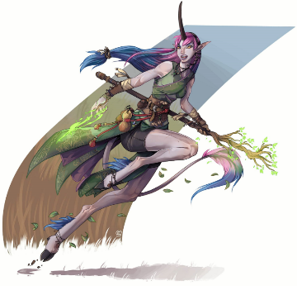

Not two seconds after introducing herself, the fleet of hoof woman sped off to a canter northward across the grove and disappeared as the others introduced themselves. They were a party consisting of a dragonborn pious templar, a dwarven fighter, an elven sorceress, her genasi wolf familiar, a halfling thief-acrobat, and a half-elf bard, and they called themselves the Singularity.