*Chapter 72*

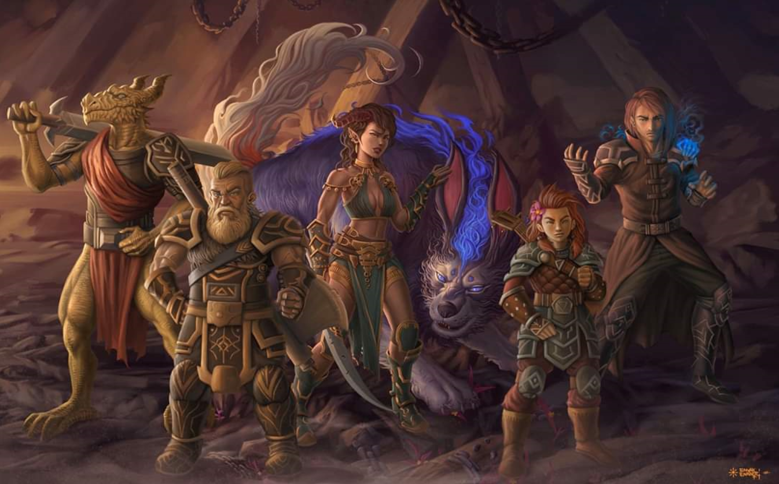

“We call ourselves Destiny’s Gambit,” Lauren said after the introductions were complete. “We are here to destroy a threat to Waterdeep, since we are all part of that city’s defense force. Our opponent has set up a place with portals to many planes, and we have to find him. If I may ask, what brought you here?”

The earth continued to rumble beneath their feet. The dwarf spoke on his team’s behalf for now. “I am Farleigh, son of Groth. Our party was ambushed while adventuring through Arborea in search of an oracle.”

The elven sorceress comforted her lupine companion as she took over the conversation, “My deity—Corellon Larethian—guided us here.” She locked eyes with Allisa, who bore the holy symbol of the same deity, and nodded in solidarity.

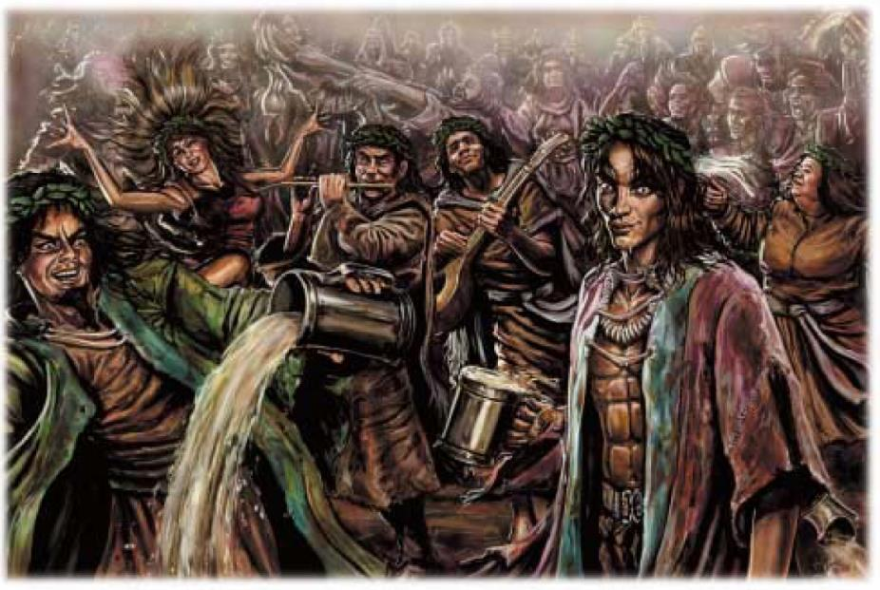

“But alas...” the human bard shrugged. “We found ourselves lured into a wandering bacchanal... I swear: the party never stopped.”

The dragonborn pious templar said some fancy, honorable stuff in Draconic, then added, “I did my best to keep them all straight.”

“Oh, please!” the bard retorted. “You ended up as bad as the rest of us at the end.”

“Well, I meant at the beginning,” the pious templar lifted his snout indignantly.

The halfling rogue said nothing for the moment, preferring silence to the banter now ensuing. The party told the tale of how the bacchanal gradually lost momentum as it made its way deeper into the seemingly endless forest, and eventually dwindled down to just a few lingerers. “At some point, a figurehead emerged,” Farleigh asserted.

“Nephalus,” Lauren’s lips parted to say.

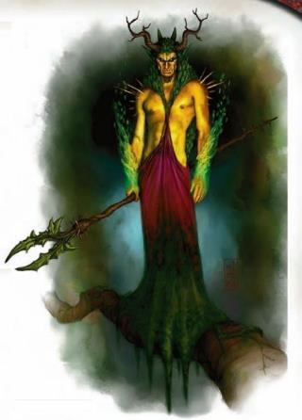

They all nodded. The bard said, “He is a verdant prince, the son of a particularly nefarious dryad, but in this case, neither emitting evil nor attracting it...”

The templar spoke of his specialty, “But rather corrupting others to the epitome of chaos and the border of evil and neutrality.”

“Mischief,” the thief-acrobat finally spoke up, offering her perspective on the matter.

Allisa’s mind resolved with the conclusion that her suspicions were sound. “So he *is* a verdant prince!”

“And a powerful one at that,” the sorceress added. “We now know—at the expense of the life of one of our own—of his extensive training as a beguiler.”

Lauren laid out their carpet once more. “We should leave this place before there is more trouble. There is a treehouse south of here that appears to be safe. Would any of you like to accompany us?”

They agreed, and as the carpet was unfurled, the team was now missing Kir and Xaryn, and young Dresden was deader than a doornail. There was no saving the drow, and the other two would likely find their way back to the tree—one hoped.

Fingers hopped on first, along with Lauren, Allisa, and the sorceress and her familiar. Fingers assured the others, “I’ll be back by myself for the rest of you.

A few salutations ensued as they departed, and within seconds, the carpet was aloft and headed for the tree once again, but not before they could spot the epicenter and cause of the rumbling of the earth beneath them. Behind them, to what appeared to be north on this wooded plane, there lay the inclining figure of the goddess Mielikki. The heroes could not know this, but with the slaying of Zhiranne—a curse had just been lifted over this land, and the massive avatar of the goddess on this plane turned to the heroes as she rose, and smiled upon them as scores of unicorns emerged from her navel and pranced over the land.



“Wow!” Fingers huffed. “What a day!”

Zhiranne—as it turned out—was not truly a petal, but rather the mother of the verdant prince known as Nephalus. Cursed to wear the guise of a petal, and having channeled most of her strength and power into trapping Mielikki’s avatar here, the dryad queen was bested by the concerted efforts of the pseudodragon and the duskblade. An uneventful and undramatic ending for such a vile spirit of nature.

And as for the fate of Nephalus and the rest of his ilk, they would likely find another patch of the forest in which to feast, at least until a vengeful herd of unicorns found them.

~\*~

Within the hour, the carpet had conveyed everyone to the base of the tree that hosted the Oakleaf Suite, and Allisa was now feeding the greenbound deer in the stables as the others chatted about what to do next.

“So we are able to get back to the Shadow Plane—to a house situated just outside of Waterdeep—and if we can cross back into the Material Plane, we’ll be smackdab in the middle of Waterdeep proper,” Lauren summed up.

“And the portal’s up there?” asked the dwarf.

“Yes, and there’s another one right around the corner that goes to Ysgard,” Fingers added.

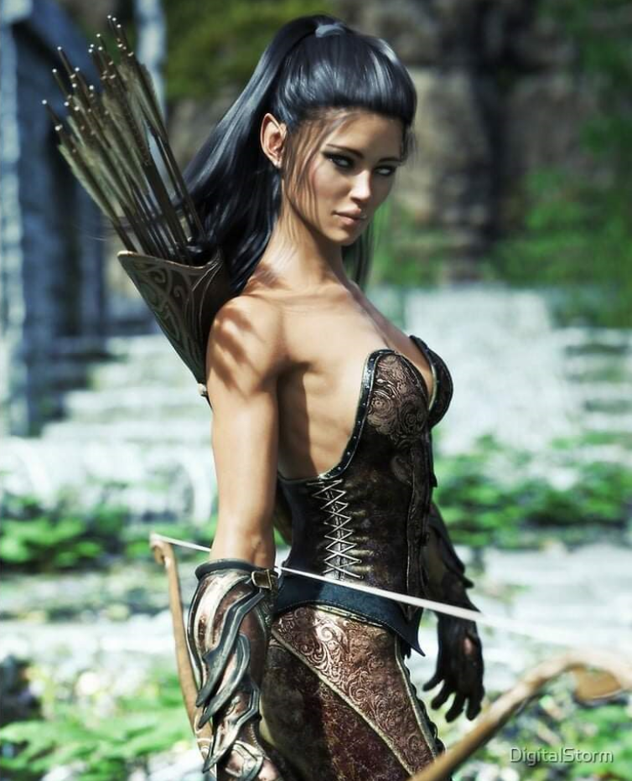

Near a fire that they’d just started, Aridel and Moondancer resolved their longing for one another’s nuzzles, and reveled in the pleasure of togetherness as the half-elf’s male consort removed his helmet and leaned in to manifest a group hug.

Lauren inhaled the crisp, clean, afternoon air, and nodded to herself, confident that their strife against the woodland fey led to a righteous outcome. She had liberated a few dozen souls—many of which were even now wandering the endless forest in joyous wonder—and those that had come with them seemed a fine lot.

Now the question of what to do next formed. These folks seemed pretty eager to get back to the Material Plane, but the Gambit was still motivated to deliver justice to Kaszüm.

“Excuse us while we confer for a few moments,” Lauren said. She turned to Allisa. “I don’t know if Kir and Xaryn will return, or if we can find others to help us. What do you think we should do?”

The druid finished feeding the greenbound cervids and pondered on her lover’s question. They’d only known Kir and Xaryn for about 15 hours, only 7 of which were waking hours, so they didn’t have a good gauge for what the two would do. Go back through the Oakleaf Suite and to the Shadow Plane? Stay where they were? Become the prey of Nephalus and his remaining ilk?

Nevertheless, they faced the option of shepherding these folks back to the Shadow Plane, where they were far more likely to find their way back into the Material Plane. Fingers had overheard the conversation, and contributed, “It would only take a few minutes at most to get these folks back to the Shadow Suite, where they could eat and rest. Some of them have already voiced their desire for a stretch and a nap after being in such stiff positions for so many months. After that, we’d have the option of continuing our search for our newfound acquaintances, or reprising our quest for Kaszüm’s whereabouts.”

As they began to eat the freshly cooked mutton that the pious templar had cast into existence in marinated form, the halfling thief-acrobat and a half-elf bard took turns unloading and reloading the rotisserie with a new helping of summoned body parts for their nutritious consumption.

“What a strange morning it’s already been!” Fingers sighed, sitting down to munch on the mutton it’d just been offered. “We’ve trekked across the Outer Planes as if they were neighboring villages: Carceri, the Abyss, Ysgard, and now Arborea.”

“And that’s not counting the Shadow Plane,” Lauren added the only plane outside the Outer Planes.

“We’re still far from home,” Fingers pointed out, though Allisa was becoming less and less convinced of this notion with every moment spent in this lush and salutary plane.

“I’m not so sure...” the mistress of many forms proclaimed, “that I want to go back at this point... maybe to visit... but look around you. What else is there that we need?” she referred to her lover, and Fingers could tell at that moment that the druid had hit a turning point.

Perhaps it *was* best for the Gambit to retire, and for Fingers to take its merry way and perhaps finish off this Kaszüm on his own. Allisa and Lauren would likely not let it go off on its own, but with every passing minute that Kir and Xaryn didn’t show themselves, it seemed a bleaker a bleaker prospect to wait for these two. They would either fend for themselves in such a relatively hospitable plane, or they were, sadly, already doomed and done for.

As they ate and discussed the various forks in their proverbial road, dilemmas and opportunities were weighed against one another, and the members of the Singularity offered their input as it was welcome.

Lauren thought for a moment. “So let’s take the people who want to go home, and then we can come back here to see about Kir and Xaryn.”

“Are you sure we should not look for Kir? I mean if it where you or me the other would do such,” Allisa looked a bit distressed.

“Yes, we just had a conversation about it,” Fingers could tell that Allisa was becoming altogether engrossed with this plane. “We’ll come back and look for them. We can leave them a note too.”

~\*~

A few minutes later, they’d walked through the seamless portal that led from Arborea to Ysgard, and from Ysgard took the portal back to the Shadow Plane. Once back in the comfortable quarters that they’d left behind, the Gambit showed the Singularity about, and grabbed a sandwich before heading directly back into the Oakleaf suite up aloft via the direct portal to Arborea.

“That was *quick*,” they surprised even themselves.

Now in the even more hospitable Oakleaf Suite, Allisa, Fingers, and Lauren sat and rested, discussing their next steps.

Lauren sat back in her chair. “So, what do we do? We have our items back, and Kaszüm is gods-know-where. Xaryn and Kir know of this place, so I presume that they will return here at some point.”

“On one hand, we are stronger as five than as three,” Fingers pointed out, “and Xaryn’s magical prowess could really come in handy, not to mention Kir’s wiles and divine magic. On the other hand, we may be giving Kaszüm the time he needs to amass an offensive against us.”

“I just want to return home. Ben is probable worried sick,” said Allisa. She had thought of staying here, but come to the conclusion home was better.

Lauren nodded. “Let’s wait here for the night to see if Xaryn and Kir return, then we can try to find our way back home.”

~\*~

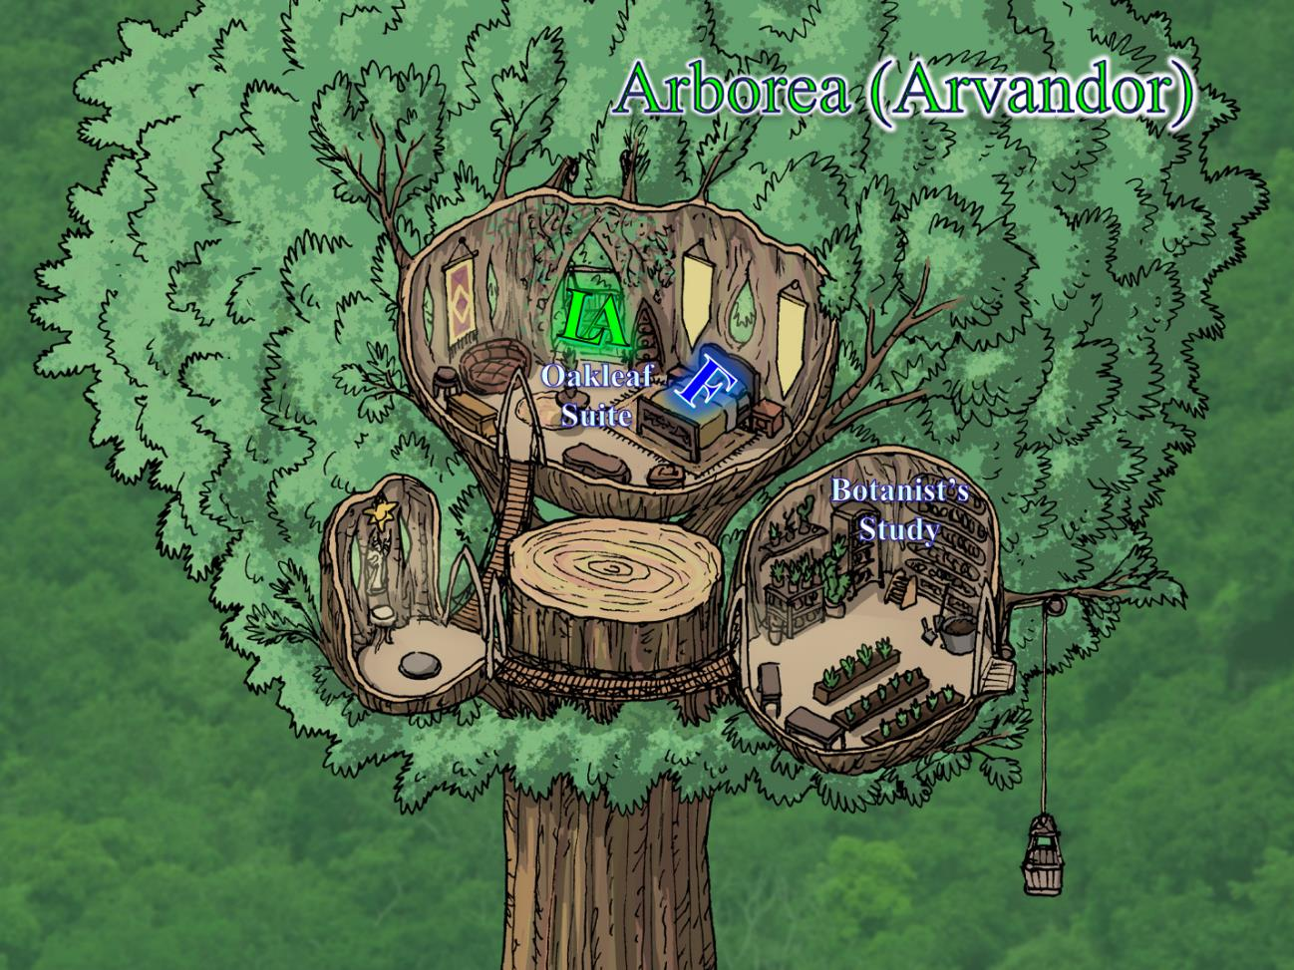

They’d waited the better part of the day, and with the sun now setting in what they’d come to call the west, the two women swung on the bench that hung from a series of very sturdy and fibrous ropes as Fingers rested on the most comfortable bed it’d occupied in months. For a moment, it came to see Allisa’s point about staying here in lieu of ever returning to the City of Splendors.

Kir and Xaryn never showed, and not much else happened. They’d talked about the Singularity, and about Aridel, Cyrus, and Moondancer, who were all probably resting in the Shadow Suite, and had raided the provisions in the Botanist’s Study a few times. Soon, night would sweep over this part of the plane, and greenbound bats—whose guano coated the trees’ branches in this area—would likely feast upon the fruits that grew here for all to enjoy.

Lauren considered going back for Dresden’s remains, but she was hesitant to risk another encounter with the denizens of that part of the forest. “We haven’t seen anything of the others,” she said at length. “Xaryn knows his way back to the Shadow Suite, though.” She sighs. “Perhaps we should return there, as well.”

“Perhaps,” said Allisa. “I wonder if we should be asking the others how they got here. Maybe they know a way back, or at least closer. And for our two new companions, I fear the two are dead.” The druid looked a bit sad for their loss.

“We *did* ask them,” Fingers reminded the druid. “They even mentioned your deity—Corellon Larethian, right?—as the central cause.”

“Then, maybe we should go back to the Shadow Suite before nightfall,” Lauren said as she tried to arrive at a decision. “I must’ve been on some pixie dust too when they told us that.”

“Or,” Lauren said as she put her arm around Allisa, “we can stay here and enjoy the evening in this place.”

With the portal to the Shadow Suite, just a few dozen feet away, they contemplated where they would sleep tonight. The Shadow Suite had been cramped enough with the half-dozen people who’d slept there last night; it would be far more difficult to find a place to sleep as comfortably as the bed and beanbag in their current midst.

“Forgive me; my mind was on our lost friends. Then if my god led them here, she also intended us to be here. Maybe tomorrow we should find the goddess and see if she will give us an audience. She might be able to help,” said Allisa.

“Then maybe we should ask for Corellon’s guidance first,” Lauren said. She took Allisa’s hands, and began to recite a prayer. << Hei-Corellon shar-shelevu lye nomin. >> She continued in a supplication to their god to decide if to meet with Mielikki.

They looked around to find only the treetops waving to them in the breeze. Allisa knew that the deities were fickle in their response to unstructured prayers, and thought to prepare a Divination-type spell for tomorrow’s endeavors.

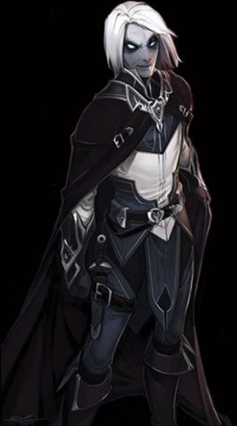

Fingers’ body language betrayed a restless changeling. Its face was contorting as it often did when it was in a state of shapeshifting. Allisa—as a mistress of many forms—knew well her friend’s mannerisms, and suspected the trapsmith to be wondering what their adversaries were up to. “One thing that’s good about the Singularity being in the Shadow Suite,” Fingers looked out the window with its back to the women as they swung on the bench, enjoying the last hour of daylight.

Lauren took out food and drink for their evening meal. “We can rest here for the night, and then return to the Shadow suite in the morning.”

~\*~



Dawn, 1 Kythorn, 1377

Oakleaf Suite

Their sleep that night was so deep and salutary that by morning, they’d nearly forgotten where they were. Fingers rose to a sitting position, taking in its surroundings as it got up to pee down the 200’ precipice. The morning air was crisp and a bit foggy, but the orb of the sun that shone over Arborea was visible in the horizon opposite where it had set. All was calm as the sounds of diurnal birds roused all other creatures—greenbound and otherwise—throughout the endless forest.

Within the hour, Destiny’s Gambit had gone down to eat at the fire they’d started, and Allisa had spoken to the deer, who were starting to grow restless after so many tales of adventure from the druid. They even voiced a desire to roam the woods a bit. << We’ve been here—what?—six weeks now? >> one of them asked the others.

<< M-hm. We could stand to stretch our legs. >>

They’d stretched—at least their arms—and donned their armor by the time the fire was snuffed out, and ventured back to the top of the Oakleaf Tree, surveying the land around them. Though this plane wasn’t actually an entire field of trees with this single monstrosity of an oak jutting above it, but it certainly seemed like it from here. If they continued in one direction or another, they might eventually encounter swamps, estuaries, savannas, rolling prairies, and other environs besides this oak-and-pine medley.

Lauren shouldered her pack. “We should get back to the Shadow Suite.”

“I am sorry, but we can stay now. Maybe we will return. If you feel it is safe explore a bit,” Allisa said and hugged each deer that allowed it. She shouldered her pack. “I am ready.”

The deer said their goodbyes, and the three adventurers discussed which path to take.

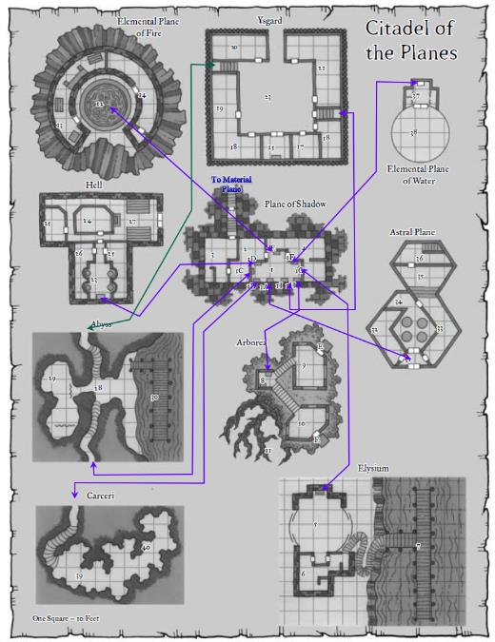

Fingers proposed the path through the Ysgard Suite and Lauren proposed taking the carpet up to the top of the tree and taking the direct portal back to the Shadow Suite.

A minute or two later, they were at the portal to the Shadow Suite, and saw the dwarf sitting cross-legged on the floor reading a book. Spotting the three as they moved into view and placed the correct shard into the portal, he turned his head up and smiled at them, then waved, and then turned to his right and likely announced that the Gambit was here.

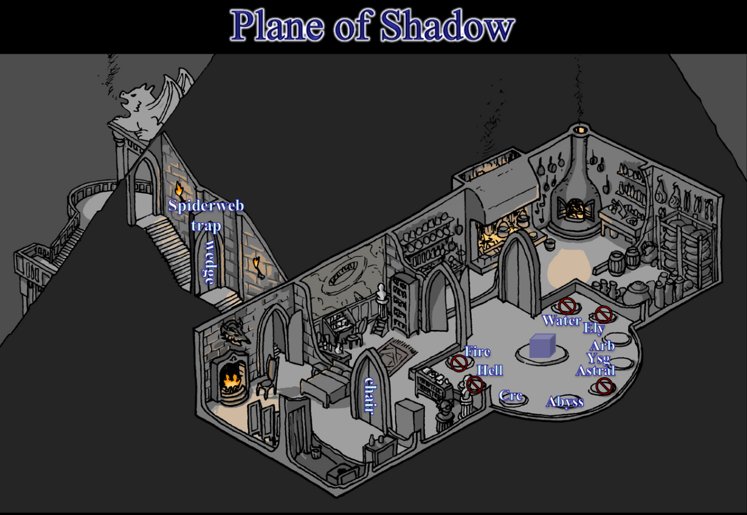

The smell of food coming from the kitchen immediately let them know that the Singularity had at least one culinary expert.

“Good morning, Farleigh,” Allisa remembered the man’s name.

“Well!” the dwarf said, having been posted to guard this room as the others relaxed. “How was *your* night?”

“Uneventful,” one of the Gambit’s constituents said.

“Wish we could say the same,” he sighed as others heard the voices and came into the room from the adjacent parts of the suite.

It took them about a minute to recount the events, but within a few minutes of having been in the Shadow Suite, an invisible stalker that had been hiding in the lavatory attacked the sorceress—Naomi—and though it didn’t take her long to deal with it herself, by the time the others had gotten to the scene, she’d been pretty hacked up.

Naomi emerged from the bedroom, all healed up by now, and nodded at the rude and unexpected encounter.

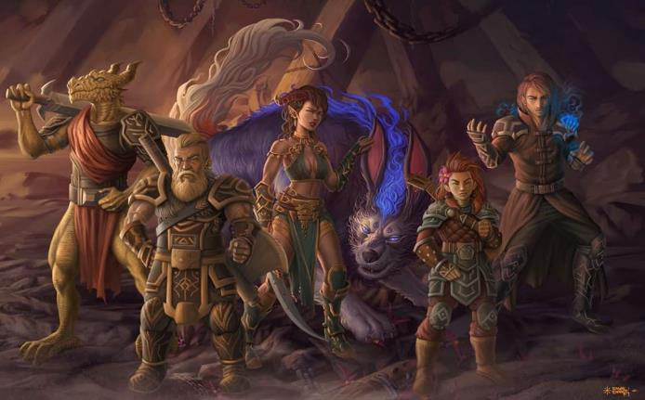

“To top it off,” Phrax—the dragonborn pious templar—said, “at the stroke of midnight, another invisible stalker decides to come out from underneath *this* thing.”

They’d vanquished that one too, but not without a few additional scrapes. The Gambit had forgotten to warn the Singularity about this phenomenon.

“I wasn’t aware that more of the creatures were here,” Lauren said in an apologetic tone. “Perhaps we can cast *detect evil* spells to see if there are more in hiding.”

“We’ve secured the area,” Octane pointed out.

“And Aridel?” asked Lauren. “And Moondancer?”

“They and Cyrus left,” the dragonborn paladin said, looking to Octane, “She found the path back to the Material Plane.”

“Oh?” Fingers was taken aback, having spent hours trying to achieve that result.

Octane led the Gambit to the Shadow Suite’s front entrance, the halfling pointed out the latch that had been hidden behind the torch sconce, one of the few places that Fingers had not searched. The changeling had concentrated on searching both the interior of the Shadow Suite, and the keep that lay beneath it, but not the outdoor spaces between the two, and it was this latch that temporarily rendered the Material-to-Shadow conduit to work in both directions before resetting.

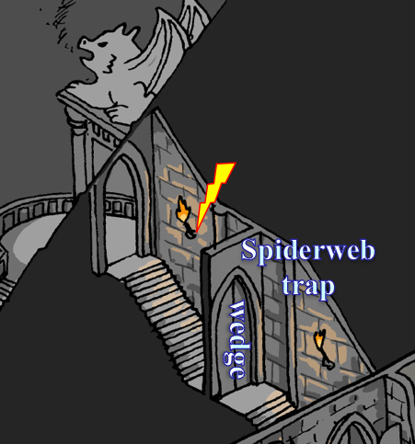

“So we’re able to return to our home?” Lauren just wanted to confirm.

“Yes,” Farleigh verified that he’d already returned twice and secured the mansion, both in the Shadow Plane and its Material Plane analog.

Allisa wasn’t so sure that she wanted to return to that metropolis, but could see the enthusiasm in the eyes of her spouse and their trapsmith companion.

The Singularity added that they were actually thinking of staying here, and setting up a base of operations. Vheren added, “Since you’d already expressed no interest in doing so yourselves. Perhaps we’ll all vanquish this Kaszüm together.”

Lauren glanced at Allisa as she thought. “If we don’t kill him, he will just keep making trouble. He surely has the means,” she waved her hand to indicate the fortress around them, “to do that.”

Fingers proclaimed, “Our friends from the Singularity, if you truly mean to bring this villain to justice, I hereby pledge my blade and keys to your cause.” It was willing to end this, and even give the rest of the Gambit a respite from all of this if they wished it.

The Singularity was a group about as formidable as the Gambit, though the latter had three members now. “Together,” Vheren said, “Perhaps we might give this villain and his associates a run for their coin.”

“My soul is prepared,” the dragonborn huffed.

“Ready when you are,” Octane announced.

“Heard *that* last night,” Farleigh jested, and got a punch in the arm for it.

Lauren stepped over to Allisa. “Shall we see this thing through?”

With a grimace on her face the druid answered, “ I guess so. Anyway, we have to find the exit, so it does not matter if we take care of that along the way.”

Everyone looked at the druid as if she were intoxicated, wondering what caused her to completely miss the point of the current conversation.

“They found the way back home,” Lauren politely summarize. “We could be back at Waterdeep in a few moments, if you want. Otherwise, we will press on.”

Allisa rubbed her forehead and then sat down in the nearest chair. She looked a bit peeked as she exclaimed, “I am sorry, I am just not myself today. Her eyes met Lauren’s before she bowed her head as she massaged her forehead and closed her eyes.

Lauren looked at the others. “We have lost much in this fight, and we are weary of it.” She knelt in front of Allisa and clasped her hands. “Melamin, we don’t have to continue. We can give these folk what information we have, and they can take up the fight from here.” The duskblade sighed. “I think we would be best served to see this through, but I’ll not go without you. We know how to get home, and we know how to find our enemy.”

Allisa leaned her head against her lover. She whispered, barely audibly at the other’s ear. “It is not that, my sweetness. We can continue with the mission.” She kissed the other’s cheek as she finished. “It is that time of the month and is more so painful than most.” She gave a weak smile.

“I know, love,” Lauren said in a low voice. “We share that same cycle, after all.” She hugged her wife and stood. “We are ready. According to the map, the nearest route is through Arborea to Elysium and the Plane of Water to the Astral Plane.”

Fingers sympathized with the involuntary bodily changes—particularly given the horns that grew on its head not 2 full days ago—and nodded quietly, repeating that it was willing to assist the Singularity in defeating Kaszüm sat this one out.

The Singularity was grateful for the extra help, and the halfling also offered, “We could also search the areas that you said you hadn’t scoured very carefully,” she referred to Carceri and Ysgard, based on the Gambit’s recounting of their adventure through the Citadel of the Planes.

“Did you find any other shards?” asked Fingers.

“Nay,” Farleigh simply said.

“Where have we not exhausted our search?” Lauren asked Fingers, who—in concert with Kir—had done its best to find what might have been useful.

“We could stand to scour the Ysgard repositories a bit more,” Fingers had been overwhelmed with the plethora of treasures and riches they’d found therein, but added, “and if nothing there pans out, one place I really didn’t bother to search was the Botanist’s Study in the Oakleaf Suite. Either place—based on Kaszüm’s pattern of placing these breadcrumbs—is likely to have a shard, if we know where to look.”

“Ysgard first, then,” Lauren said.

~\*~

09:17

The Gambit had the shard that fit into the Hell portal, but they’d decided the day before that they wouldn’t be taking that route until they’d exhausted all other options. Consequently, the Singularity and the Gambit had returned to the Ysgard Suite, and had scoured all of the repositories. An hour had passed, and by the gods’ will, Fingers had found an aquamarine-and-emerald-colored shard inside a mundane helmet, and the shard would fit the Elysium portal just fine, Fingers surmised.

“Shall we?”