Chapter 73

09:21

Once inside the Shadow Suite once again, the team stared into what Xaryn had previously termed the Elysium portal, and Fingers placed the shard into the receptacle at the base of the portal’s oblong frame. “Any last-minute sandwiches?” Octane asked before they stepped through.

Round 1

Octane and Fingers waited as others began casting buffs and wards.

Phrax cast protection from evil [expired on Round 151] upon himself.
Phrax gained +3 to AC & other bonuses vs. evil opponents.

As was her custom, Lauren held her falchion and shield in hand, ready to follow the others into Elysium.

Farleigh drank a potion of bear’s endurance [expired on Round 41].
Farleigh gained +4 to Con.

Vheren cast chasing perfection [expired on Round 151] on himself.
Vheren gained +4 to all six primary abilities.

Naomi cast mage armor [expired on Round 9001].
Naomi gained +4 to AC.

Three Growls waited for the rogues to enter.

Round 2

Octane and Fingers entered through the portal.

Phrax and Lauren followed the rogues through the portal, seeing latter already taking in the idyllic surroundings on a stone platform overlooking a riviera. The platform was the least remarkable feature of the only architecture in sight: an outdoor banquet hall fashioned in the likeness of a gazebo adjacent to a small, flat-roofed house done in the style of Zakhara and the lands beyond it on the Material Plane. An open doorway led along an unnecessarily winding path to a dock on a river that looked nothing like what they’d beheld in the Abyss the day before.

Lauren followed the rogues through the portal and looked around at the beautiful place. “Let’s not fight unless we have to,” she cautioned the others as she held Arkenlyl in hand, then sheathed it when no immediate threat appeared.

At their feet were assorted instruments that a bard would have found delightful to play, and Allisa noted that although beautiful, not a single species of plant was familiar to her. Every specimen she beheld—from the young cedar-like conifers to the least blade of grass—the flora here was a more exotic and vibrant analog of its Material Plane counterpart. There were no birds in sight, but the druid could hear their chirping and singing in the distance nonetheless.

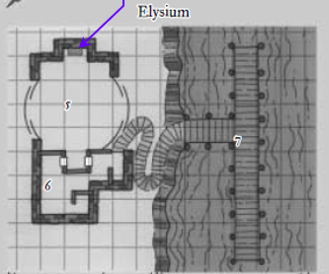

Round 3

Fingers took a look at the map they still had, and confirmed that they were in the Elysium Suite. As the last of them—Vheren—was stepping through the portal, Fingers and a few others heard a single ding coming from inside the house.

They looked at one another, and Naomi whispered, “That’s an alarm spell.”

Gwen activated her Intelligent Brooch of Denial to cast arcane eye [expired on Round 103].

The sound of a single individual murmuring inside was also barely audible, but Allisa’s ear caught it, and so did a few others’. They were not alone, but they couldn’t tell much more. A long table with seventeen chairs—none of them with their back to the river—lay bare, but clean.

Octane then spotted a pool of what looked like blood on the dock, and pointed it out.

The duskblade sheathed her sword and stepped toward the sound. “Hello in the house,” she called in a loud voice.

Three Growls stepped through the portal, and Fingers took back the shard, closing the conduit that led between the Shadow Plane and here.

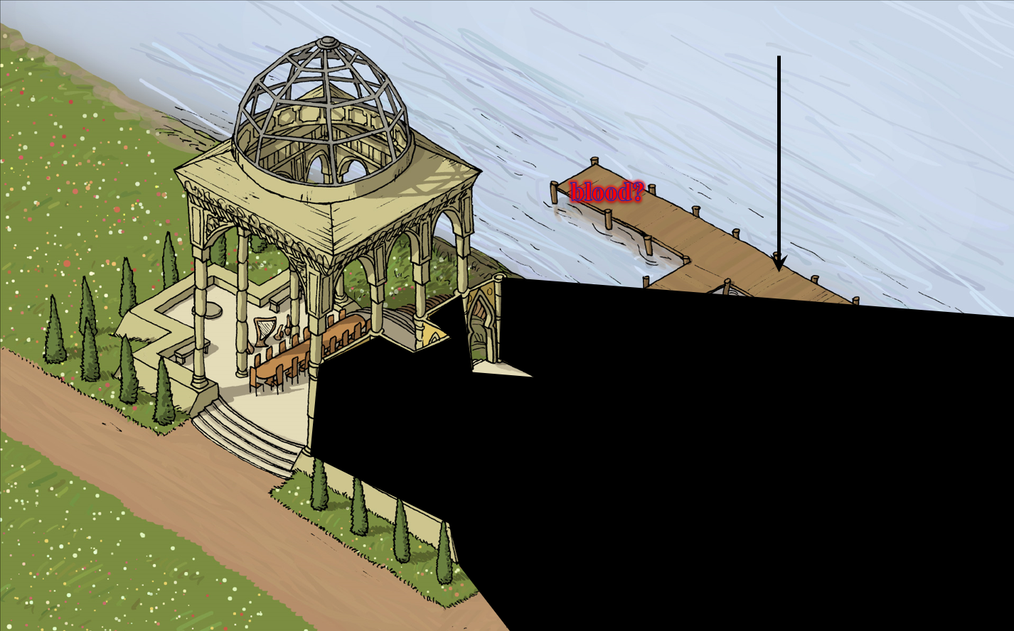

Round 4

“Looks to be a nice place. Maybe they use the alarm to let them know guests have arrived. I do suggest we spread out a bit just in case we do need to fight,” said Allisa. The woman turned half-way to her right to see what might be behind them, which was more of the same Elysian fields, dotted with bushes and trees such that the horizon wasn’t visible. The water flowed from east to west—opposite the direction of the River Styx’s flow at the length of the Abyss Suite.

Lauren remained in a non-threatening posture with her Shattermantle Bloodstone Falchion +3 back in its sheath.

Also sheathed, Allisa’s Scimitar of Frost +1 hung in waiting as the druid and duskblade conferred with the others. She was feeling quite a surge of optimism, and could tell that the air was doing her wonders.
Allisa leveled up to 17th; new stats will become effective after this scenario.

Gwen grabbed her satchel, and rolled under her bed.

The arcane eye exited the structure, and peered at the heroes.

Round 5

Gwen triggered the latch that lowered the escape hatch silently, allowing her to escape. She descended a few feet, then pushed the hatch closed until it clicked ever so slightly.

“Friends, there’s an arcane eye right there,” Fingers—who could see invisibility—reported, then tapped itself with its wand of invisibility [expired on Round 12].
Fingers became invisible.

Octane said, “Good call,” and used her only scroll of stoneskin [expired on Round 9005] on herself.
Octane gained DR all/10 for up to 100 hps.

Lauren stepped up closer to the spot Fingers pointed out. “Forgive us for arriving unannounced, be we are chasing a murderer and a thief. We intend to search this place, and then be on our way.”

Round 6

Gwen heard the half-drow’s chatter, raised an eyebrow at the fool’s words, descended along the wooden staircase that led to the ground, not far from the dock, hopping down effortlessly to skip the creakiest steps, and snuck over to a bush, tapping herself with a wand of invisibility [expired on Round 12].

“Lauren, my love, repeat that in Elfish just in case but be a little less demanding. Say we would like to look around.” The half-elf smiled at the other instead of saying it herself. “Well, it could not hurt.”

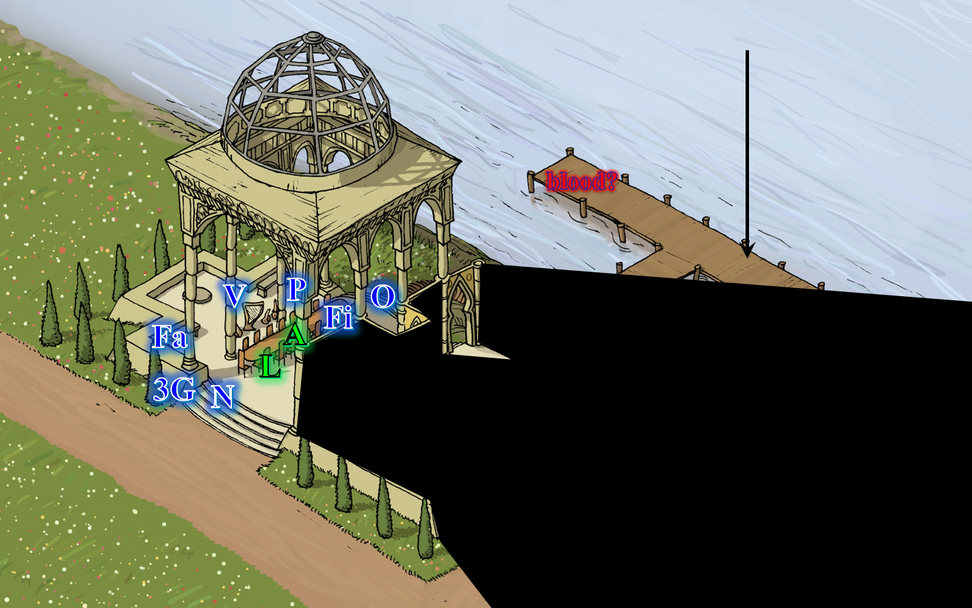

Round 7

Gwen drank a potion of haste [expired on Round 12].
Gwen gained +1 to BAB and AC (both countered by Elysium’s properties), plus an extra 30’ of movement or an extra attack.

The halfling thief-acrobat then climbed a sturdy ladder that she’d rigged herself in the interest of stealth. The con artist was at home.

[This will likely take more than 1 round to repeat, but if it’s prolonged any more, the dialogue below won’t take place.] Lauren repeated her statement, adding, << We would like to look around, >> all in Elvish, while she smiled at her wife with an amused expression.

‘Oh, sure!’ Gwen thought to herself, hoping none of the intruders had cast detect thoughts on her. ‘Come right on in!’

“Aaaah, I don’t like this,” grimaced Farleigh, his sense of danger spiking as birds chirped.

Nearby, Azimuth was roused from his sleep by Lauren’s voice, and opened the hatch of the secret compartment that housed him. From his well-hidden vantage point, the halfling spotted the handful of fools that he’d encountered a few nights ago on the Material Plane, plus some new fodder for the grinder. “Otis, stay here for a moment,” commanded the true necromancer.

Round 8

Azimuth made his way along a row of bushes and rocks that served as a nice ambush approach.

Gwen got to her premeditated rooftop firing position, and acquired a line of attack to the paladin, bard, and fighter, who were still near the portal, and could not see the invisible woman. She produced her Deadly Precision Blowgun +2 and decided to start with the bard, whom she’d met the day before, and had wanted to turn into a corpse just from hearing him talk. With the arcane eye, she could see all of the assailants, and began to concoct a schedule of execution as she wondered when Azimuth would show up to the party.

“Yes, it is getting strange. One would expect someone to have greeted us by now. Maybe we should have our look around,” Allisa said.

Round 9

But no sooner had she said that than all hell seemed to break loose.

‘Bite the dust, poet,’ the sniper mentally said as she squinted and sought to end the bard’s life with three well placed blowgun pellets to the eye sockets.
Ranged Weapon | Dmg. | D+ | TH+ | Critical | Rng. | Wt. | Atk | Roll | Check | Notes
Deadly Precision Blowgun +2 | 1 | 2 | 2 + 2 height  - 6 range | x2 | 10’ | 2.0 | +15 | 7 | 22 | Sneak Attack 4d6,  Sudden Strike 2d6
Blowgun, 2nd Attack | 1 | 2 | 2 + 2 height  - 6 range | x2 | 10’ | - | +10 | 2 | 12 | Sneak Attack 4d6,  Sudden Strike 2d6
Blowgun, haste | 1 | 2 | 2 + 2 height  - 6 range | x2 | 10’ | - | +15 | 12 | 27 | Sneak Attack 4d6,  Sudden Strike 2d6
Hit, miss, hit. Dmg: (1 + 2 + 14 Sneak + 2 Sudden Strike + 9 Deadly Precision) + (1 + 2 + 18 Sneak + 6 Sudden Strike + 7 Deadly Precision) = 28 + 34 = 62.

Vheren’s eyes became two nests for the two microbullets that hit him, and the bard died with zero fanfare or drama.

“By Moradin’s Hammer!” shouted Farleigh as everyone steeled their nerves and looked around for an assailant.

Three Growls growled fiercely, looking for anything that moved.

Azimuth snuck along the row of bushes that he’d preemptively selected as an ambush path, and got within 110’ of the Elysium Suite. As the dwarf swore and the wolf growled, the halfling used the commotion to cast a spell unheard, producing a bit of dirt from a gravesite, invoking the magical knowledge of Kelgore, and releasing a grave mist [expired on Round 18] upon the party of heroes.
All characters within the hemisphere of effect became fatigued;–2 to Strength and Dexterity, and they can neither run nor charge.
Dmg to Allisa: 4 cold [92/96].
Dmg to Lauren: 3 cold [159/162].
Dmg to Fingers: 4 cold.
Dmg to Naomi: 5 cold.
Dmg to Phrax: 1 cold.
Dmg to Farleigh: 5 cold.
Dmg to Three Growls: 3 cold.

Azimuth then silently called Otis to action, who rose, spotted the battle about 130’ away, and began making his way in his metal suit of armor.

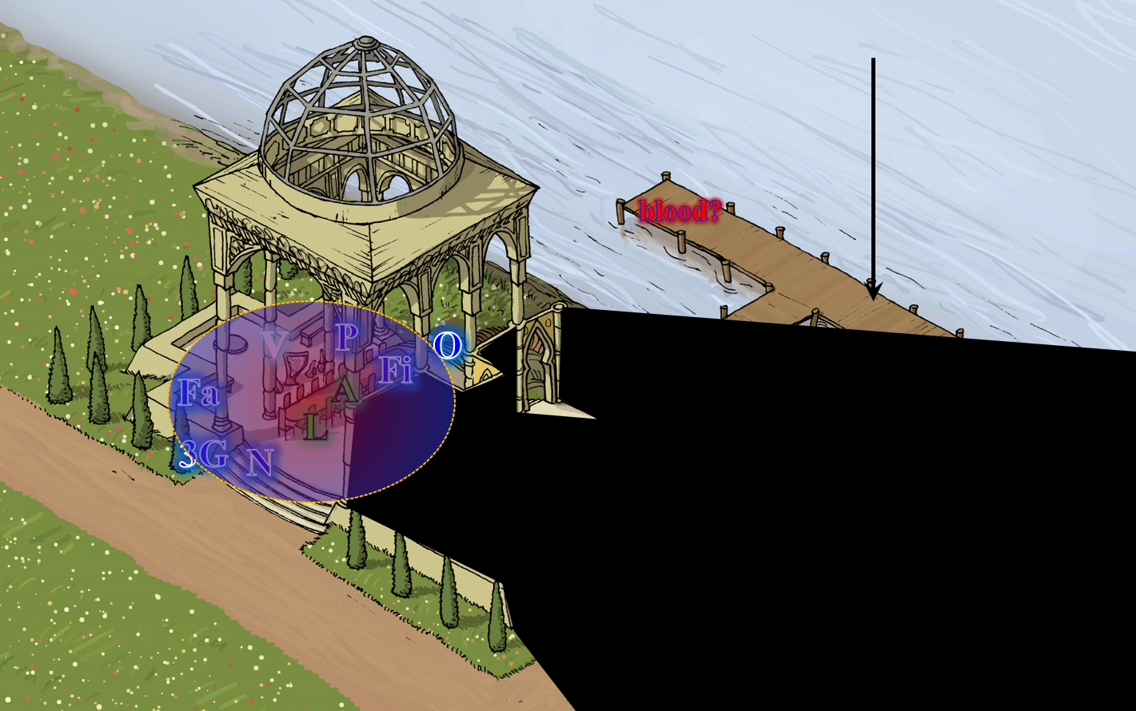

Round 10

Character | Group | Initiative | Roll | Modified Roll | Move
?? | 2 | 5 | 18 | 23 | 30’
Vheren | 1 | 3 | 20 | 23 | 30’
Three Growls | 1 | 4 | 17 | 21 | 50’
?? | 2 | 4 | 15 | 19 | 30’
Lauren | 1 | 4 | 13 | 17 | 30’
Phrax | 1 | 2 | 13 | 15 | 40’
Octane | 1 | 5 | 9 | 14 | 20’
Allisa | 1 | 3 | 4 | 7 | 30’
Fingers | 1 | 4 | 2 | 6 | 30’
Farleigh | 1 | 1 | 4 | 5 | 30’
Naomi | 1 | 2 | 2 | 4 | 30’

Vheren was likely a goner by now, bleeding out of his skull profusely.

Gwen targeted the dwarven fighter, and hastily applied three dart-bullets to the man’s eye sockets as well.
Ranged Weapon | Dmg. | D+ | TH+ | Critical | Rng. | Wt. | Atk | Roll | Check | Notes
Deadly Precision Blowgun +2 | 1 | 2 | 2 + 2 height  - 6 range | x2 | 10’ | 2.0 | +15 | 5 | 20 | Sneak Attack 4d6,  Sudden Strike 2d6
Blowgun, 2nd Attack | 1 | 2 | 2 + 2 height  - 6 range | x2 | 10’ | - | +10 | 12 | 22 | Sneak Attack 4d6,  Sudden Strike 2d6
Blowgun, haste | 1 | 2 | 2 + 2 height  - 6 range | x2 | 10’ | - | +15 | 8 | 23 | Sneak Attack 4d6,  Sudden Strike 2d6
Hit, hit, hit. Dmg: (1 + 2 + 12 Sneak + 4 Sudden Strike + 10 Deadly Precision) + (1 + 2 + 17 Sneak + 7 Sudden Strike + 4 Deadly Precision) + (1 + 2 + 15 Sneak + 8 Sudden Strike + 6 Deadly Precision) = 29 + 31 + 32 = 92.

Farleigh died just a few feet from where the bard had been taken out. He hit the floor with nary a complaint, now wearing three dart-bullets in his eyes.

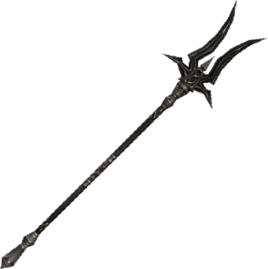

Three Growls spotted an armored figure approaching from the south. Clad in armor from head to toe, the warrior held a ranseur that—judging by the wanton design of the forked, spiked blade—had to be from the Hells or somewhere nasty. The canid genasi took a few steps past the dragonborn pious templar, as his mane began to flow like an aery flame.

Otis von Kaltenbrunner spotted the dragonborn paladin, and hastened his step towards him, raising his unholy ranseur in anticipation of a swift kill.

Azimuth grinned at his minion’s entrance, and cast summon undead IV [expired on Round 19], placing a ghast right behind Otis, and calling it to attack the dragonborn paladin as well.

In broad daylight, with birds still chirping all around them, behind the plated ranseur-wielding warrior, the heroes could now see a ghast making headway towards them with a fiendishly menacing look in its eye.

“Allisa, come on!” Lauren drew her falchion and moved down the steps to look around the building on the side away from the dock.

Three Growls now sprinted southwestwardly towards Otis.

Phrax noted that both the plated warrior and the ghast were coming for him, and held his Adamantine Illuminating Holy Greatsword +1 in a stance indicative of skill and prowess. He cast righteous fury [expired on Round 710], and moved outside the grave mist’s area of effect, preparing for the impending clash. “Three Growls, don’t take him alone!” the dragonborn said in vain.
Phrax gained 35 hps and +4 to Strength.

Octane stayed out of the spell’s area of effect, and cast true seeing [expired on round 160], peeking inside the hallway to see if there was someone sniping at them from within or otherwise pulling the strings.

Still invisible, Fingers hopped down to get a safer vantage point to the mayhem. It would soon need another tap of the wand to remain invisible. From its new position, it still could not see any assailant, but it didn’t know if an assailant could see it.

Naomi started following Lauren out of the grave mist and spotted Otis charging towards Phrax. She squinted and cast magic missile.
Dmg: 7 + 3 = 10 magic.

Allisa got out of the harmful area of effect, and followed her partner along the perimeter of the Zakharesque structure. She also could plainly see that Otis was now 25’ from Phrax, and that Eatsoul—the ghast—was about 25’ behind Otis, charging in the same direction.

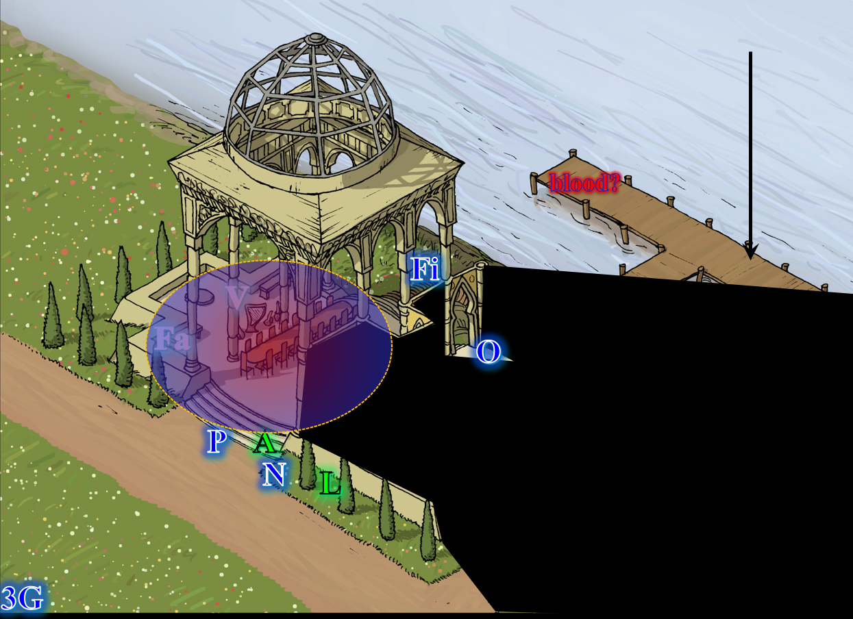

Round 11

Gwen tapped herself once with her wand of greater invisibility [expired on Round 17], and tapped thrice her Scout’s Headband, augmenting her natural vision and arcane eye ability with the true seeing [expired on Round 21] ability. Noting Fingers in invisible form now studying her from the riverbank near the dock, she raised an eyebrow, and thought to herself, “I’ve got one that can see.” She shifted her position to the southern corner of the structure, out of the invisible intruder’s field of vision. She couldn’t identify the changeling, although she’d seen the Gambit a few days earlier, on account of the human form that it was donning now.

Three Growls executed his charge-attack against the armored figure.
Character | Attack Type | Damage | BAB | Str Mod+ | Other+ | Total Score | Roll | Total
Three Growls | Bite | 1d8+2 | 5 | 2 | 2 charge | 9 | 4 | 13
Miss.

The armored figure blocked and wrested the incoming aerial wolf away, sending it skidding on its paws before turning around, growling. Three Growls then turned back again and spotted the ghast coming at him.

Azimuth cast summon undead III [expired on Round 20], conjuring a ghoul at the same location where the ghast had appeared.

With the ranseur trained on his target for optimal penetration, Otis sped up his charge-attack towards Phrax, and did his best to connect.
Character | Attack Type | Damage | BAB | Str Mod+ | W+ | Other+ | Total Score | Roll | Total
Otis | Unholy Ranseur | 2d4/x3+8+2d6 unholy | 8 | 8 | 1 | 2 charge | 19 | 10 | 29
Hit. Dmg: 6 + 8 + 10 unholy = 24.

Eatsoul charge-attacked the wispy wolf.
Character | Attack Type | Damage | BAB | Str Mod+ | Other+ | Total Score | Roll | Total
Eatsoul | Bite | 1d8+3 + Paralysis | 2 | 3 | 2 charge | 7 | 12 | 19
Miss.

Three Growls struggled to resist the ghast’s stench.
Character | Save vs.  Stench | Ranks | Roll | Save
Three Growls | Fortitude | 5 | 19 | 24
Success. No ill effects incurred.

Not far behind Eatsoul, a ghoul appeared behind the ghast, and charge-attacked Three Growls.
Character | Attack Type | Damage | BAB | Str Mod+ | Other+ | Total Score | Roll | Total
Ghoul | Bite | 1d6+1 + Paralysis | 1 | 1 | 2 charge | 4 | 4 | 8
Miss.

The duskblade moved toward the incoming enemies, placing herself in their path as they rushed forward, and channeling shocking grasp through her blade.
Melee Weapon | Dmg | D+ | TH+ | Critical | Type | Wt. | Atk | Roll | Check
Shattermantle Bloodstone Falchion +3 | 2d4 | +2 +3  +5d6 electric | 3 + 2 charge  +3 vs. metal armor | 18-20/x2 | Slashing | 8.0 | +32 | 16 | 48
Greater Truedeath Crystal | 1d6 | vs. | undead | - | - |  | - |  | -
Hit. Dmg: 3 + 2 + 3 + 2 charge + 14 electric + 1 positive energy = 25.

Phrax full-attacked Otis with his smite ability.
Melee Weapon | Dmg | D+ | TH+ | Type | Wt. | Atk | Roll | Check | Properties
Adamantine Illuminating  Holy Greatsword +1 | 2d6+2 | +10 + 1 | 3 | Slashing | 8.0 | +25 | 6 | 31 | +2d6 to evil
2nd Attack | 2d6+2 | +10 + 1 | 3 | Slashing |  | +20 | 13 | 33 | ignores 20 hardness
3rd Attack | 2d6+2 | +10 + 1 | 3 | Slashing |  | +15 | 13 | 28
Miss, miss, miss.

Octane was now inside the house.

Allisa had hoped to cast wall of flame earlier, but had faltered as events had unfolded before her eyes, and now everyone is in melee. She now paused, making symbols in the air as she uttered the magical phrase to call forth lighting, aiming the first bolt at the assailant clad in armor and holding a ranseur.
Ranged Weapon | Dmg. | Atk | Roll | Check | Notes
Ranged Touch Attack | 3d6 electric | +14 | 7 | 21 | 9 bolts left
-4 penalty for firing into melee not applied. Hit. Dmg: 11 electric.

With the constant ability to see invisible folks since a few days ago, Fingers tapped itself with its wand of greater invisibility [expired on Round 17], and spotted a halfling on the rooftop, shouting as much from its unseen position.

Naomi cast magic missile again, not being much of a combat sorceress.
Dmg to Otis: 6 + 9 = 9 magic.

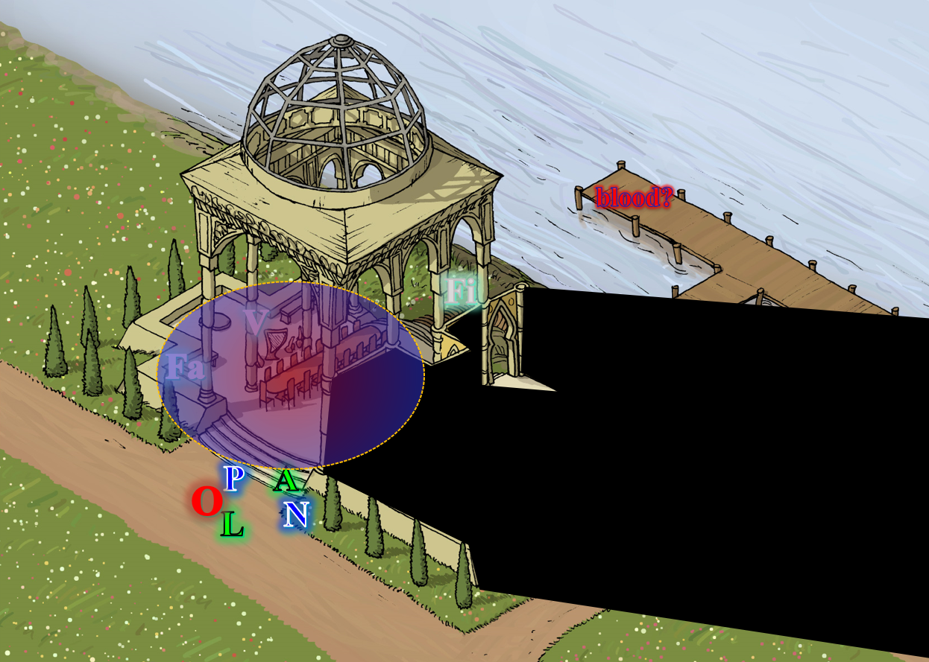

~*~

From his lofty and safeguarded position in the Arcane Study that was the epitome of planar suites, Kaszüm studied the battle, and nodded, seeing that one of his coveted centerpieces had just stepped into the exact location needed for his extraction. Like Gwen, he could see the invisible rogue through his crystal ball, but unlike Gwen, Kaszüm did recognize Fingers, as he had been scrying on the changeling during the moment when the latter had last shapeshifted from a dwarven form to its current human guise. He smiled with glee as he triggered the device that from a plane away activated the transplanar vacuum that rapt Fingers upward into Kaszüm’s keeping.

Round 12

Gwen peered down the southwestern façade of the house, and saw a handful of the intruders. She targeted the weakest-looking one—Naomi—and let her have it with her blowgun.
Ranged Weapon | Dmg. | D+ | TH+ | Critical | Rng. | Atk | Roll | Check | Notes
Deadly Precision Blowgun +2 | 1 | 2 | 2 + 2 height | x2 | 10’ | +21 | 16 | 37 | Sneak Attack 4d6,  Sudden Strike 2d6
Blowgun, 2nd Attack | 1 | 2 | 2 + 2 height | x2 | 10’ | +16 | 11 | 27 | Sneak Attack 4d6,  Sudden Strike 2d6
Blowgun, haste | 1 | 2 | 2 + 2 height | x2 | 10’ | +21 | 8 | 29 | Sneak Attack 4d6,  Sudden Strike 2d6
Hit, hit, hit. Dmg: (1 + 2 + 16 Sneak + 4 Sudden Strike + 2 Deadly Precision) + (1 + 2 + 16 Sneak + 8 Sudden Strike + 6 Deadly Precision) + (1 + 2 + 18 Sneak + 5 Sudden Strike + 9 Deadly Precision) = 25 + 33 + 35 = 93.

Naomi fell to the ground with three flechettes piercing her jugular. No one spotted her right away.

Three Growls full-attacked the ghoul.
Character | Attack Type | Damage | BAB | Str Mod+ | Total Score | Roll | Total
Three Growls | Bite | 1d8+2 | 5 | 2 | 7 | 9 | 16
Miss.

Azimuth cast summon undead II [expired on Round 20], conjuring a dwarven zombie.

A dwarven zombie materialized behind the ghast and ghoul, and came limping over to the fight against the genasi wolf.

Otis slashed at Phrax with no hesitation.
Character | Attack Type | Damage | BAB | Str Mod+ | W+ | Total Score | Roll | Total
Otis | Unholy Ranseur | 2d4/x3+8+2d6 unholy | 8 | 8 | 1 | 17 | 14 | 31
Otis | Unholy Ranseur, 2nd Attack | 2d4/x3+8+2d6 unholy | 3 | 8 | 1 | 12 | 11 | 23
Hit, hit. Dmg: (6 + 8 + 11 unholy) + (5 + 8 + 6 unholy) = 25 + 19 = 44. Partial damage negated.

Eatsoul and the ghoul full-attacked Three Growls.
Character | Attack Type | Damage | BAB | Str Mod+ | Total Score | Roll | Total
Eatsoul | Bite | 1d8+3 + Paralysis | 2 | 3 | 5 | 17 | 22
Eatsoul | Claw 1 | 1d4 + 1 + Paralysis | 2 | 3 | 5 | 3 | 8
Eatsoul | Claw 2 | 1d4 + 1 + Paralysis | 2 | 3 | 5 | 15 | 20
Ghoul | Bite | 1d6+1 + Paralysis | 1 | 1 | 2 | 1 | 3
Ghoul | Claw 1 | 1d3 + Paralysis | 1 | -1 | 0 | 8 | 8
Ghoul | Claw 2 | 1d3 + Paralysis | 1 | -1 | 0 | 14 | 14
Hit, miss, hit, miss, miss, miss. Dmg: (1 + 3) + (3 + 1) = 8 = Paralysis². Damage negated.
Character | Save vs.  Paralysis | Ranks | Roll | Save
Three Growls | Fortitude | 5 | 19 | 24
Three Growls | Fortitude | 5 | 16 | 21
Success².
Character | Save vs.  Stench | Ranks | Roll | Save
Three Growls | Fortitude | 5 | 10 | 15
Success.

Lauren repeated her attack on Otis, again channeling shocking grasp through her blade.
Melee Weapon | Dmg | D+ | TH+ | Critical | Type | Wt. | Atk | Roll | Check
Shattermantle Bloodstone Falchion +3 | 2d4 | +2 +3 | 3 | 18-20/x2 | Slashing | 8.0 | +27 | 16 | 43
SB Falchion +3, 2nd Attack | 2d4 | +2 +3 | 3 | 18-20/x2 | Slashing |  | +22 | 10 | 32
SB Falchion +3, 3rd Attack | 2d4 | +2 +3 | 3 | 18-20/x2 | Slashing |  | +17 | 4 | 21
SB Falchion +3, 4th Attack | 2d4 | +2 +3 | 3 | 18-20/x2 | Slashing |  | +12 | 10 | 22
Greater Truedeath Crystal | 1d6 | vs. | undead | - | - |  | - |  | -
Hit, miss, miss, miss. Dmg: 5 + 2 + 3 + 22 electric + 6 positive energy = 38.

Phrax full-attacked the armored adversary before him.
Melee Weapon | Dmg[Large] | D+ | TH+ | Critical | Type | Wt. | Atk | Roll | Check | Properties
Adamantine Illuminating  Holy Greatsword +1 | 2d6+2 | +10 + 1 | 3 | 17-20/x2 | Slashing | 8.0 | +25 | 13 | 38 | +2d6 to evil
2nd Attack | 2d6+2 | +10 + 1 | 3 | 17-20/x2 | Slashing |  | +20 | 16 | 36 | +2d6 to evil
3rd Attack | 2d6+2 | +10 + 1 | 3 | 17-20/x2 | Slashing |  | +15 | 14 | 29 | +2d6 to evil
Hit, miss, miss. Dmg: 5 + 2 + 10 +1 + 3 holy = 21

The paladin’s greatsword not only connected once in such a way as to pierce the warrior’s armor, but knocked the helmet clean off the warrior, revealing a skull with no flesh. This was an undead adversary, which could likely be Turned!

The skeleton’s armor and bones were tough as anything Lauren had ever tried to bring down with a sword, and she was duly impressed by the hardiness of her adversary. Nevertheless, the team was putting the skeleton out of its misery, slowly but surely.

Octane triggered a trap that activated an augmented form of the hold person [duration unknown] spell.
Save vs.  hold person | Rank | Ability & Mod. | Misc. Mods. | Total | Roll | Check
Octane, Will | 9 | Wis (+3) | 0 | 12 | 5 | 17
Fail.

The druid cast barkskin [expired on Round 9012] on herself.
Allisa gained 4 to AC.

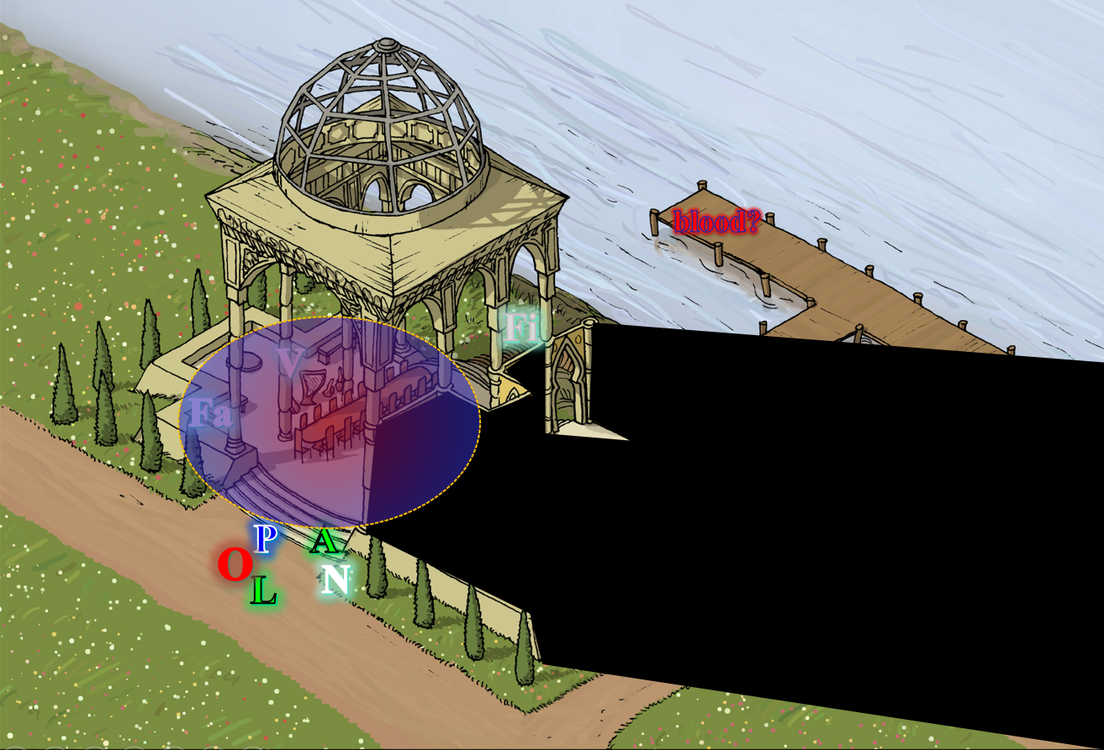

Round 13

Gwen noted her choice between the paladin, duskblade, druid, and the wispy wolf; she chose the first.
Ranged Weapon | Dmg. | D+ | TH+ | Critical | Rng. | Wt. | Atk | Roll | Check | Notes
Deadly Precision Blowgun +2 | 1 | 2 | 2 | x2 | 10’ | 2.0 | +19 | 15 | 34 | Sneak Attack 4d6,  Sudden Strike 2d6
Blowgun, 2nd Attack | 1 | 2 | 2 | x2 | 10’ | - | +14 | 18 | 32 | Sneak Attack 4d6,  Sudden Strike 2d6
Blowgun, haste | 1 | 2 | 2 | x2 | 10’ | - | +19 | 9 | 28 | Sneak Attack 4d6,  Sudden Strike 2d6
Hit, hit, hit. Dmg: (1 + 2 + 18 Sneak + 4 Sudden Strike + 5 Deadly Precision) + (1 + 2 + 13 Sneak + 11 Sudden Strike + 7 Deadly Precision) + (1 + 2 + 17 Sneak + 5 Sudden Strike + 8 Deadly Precision) = 30 + 34 + 33 = 97.

Phrax died on the spot. Lauren heard the three flechettes that killed him being hastily shot from behind and above her, though she couldn’t take her eyes off of Otis, who was likely about to attack her.

Three Growls full attacked the ghoul.
Character | Attack Type | Damage | BAB | Str Mod+ | Total Score | Roll | Total
Three Growls | Bite | 1d8+2 | 5 | 2 | 7 | 17 | 24
Hit. Dmg: 3 + 2 = 5.

Azimuth cast message, and began to communicate with Gwen.

As expected, Otis full-attacked Lauren.
Character | Attack Type | Damage | BAB | Str Mod+ | W+ | Total Score | Roll | Total
Otis | Unholy Ranseur | 2d4/x3+8+2d6 unholy | 8 | 8 | 1 | 17 | 16 | 33
Otis | Ranseur, 2nd Attack | 2d4/x3+8+2d6 unholy | 3 | 8 | 1 | 12 | 4 | 16
Hit, miss. Dmg: 7 + 8 + 6 unholy = 21 [138/162].

Eatsoul, the ghoul, and the zombie full-attacked Three Growls.
Character | Attack Type | Damage | BAB | Str Mod+ | Total Score | Roll | Total | Crit | Threat
Eatsoul | Bite | 1d8+3 + Paralysis | 2 | 3 | 5 | 20 | 25 | 20 | þ
Eatsoul | Claw 1 | 1d4 + 1 + Paralysis | 2 | 3 | 5 | 15 | 20 | 20 | ý
Eatsoul | Claw 2 | 1d4 + 1 + Paralysis | 2 | 3 | 5 | 10 | 15 | 20 | ý
Ghoul | Bite | 1d6+1 + Paralysis | 1 | 1 | 2 | 20 | 22 | 20 | þ
Ghoul | Claw 1 | 1d3 + Paralysis | 1 | -1 | 0 | 2 | 2 | 20 | ý
Ghoul | Claw 2 | 1d3 + Paralysis | 1 | -1 | 0 | 15 | 15 | 20 | ý
Zombie, M | Slam | 1d6+1 | 1 | 1 | 2 | 6 | 8 | 20 | ý
Threat, hit, miss, threat, miss, miss, miss. 1d20 = 17 + 5 = 22; 13 + 2 = 15; one critical hit.
Dmg: [(2 x 2) + 3] + (2 + 1) + (3 + 1) = 7 + 3 + 4 = 14 + Paralysis³. Partial damage negated.
Character | Save vs.  Paralysis | Ranks | Roll | Save
Three Growls | Fortitude | 5 | 17 | 22
Three Growls | Fortitude | 5 | 4 | 9
Three Growls | Fortitude | 5 | 14 | 19
Success, fail, success.

Three growls was Paralyzed [expired on Round 16] and flat-footed for the moment.

Lauren kept after Otis, even as she noted that Naomi was also down. Seeing that the skeleton was nearly also down, Lauren full-attacked the skeleton, not using shocking grasp on this one.
Melee Weapon | Dmg | D+ | TH+ | Critical | Type | Wt. | Atk | Roll | Check
Shattermantle Bloodstone Falchion +3 | 2d4 | +2 +3 | 3 | 18-20/x2 | Slashing | 8.0 | +27 | 10 | 37
SB Falchion +3, 2nd Attack | 2d4 | +2 +3 | 3 | 18-20/x2 | Slashing |  | +22 | 10 | 32
SB Falchion +3, 3rd Attack | 2d4 | +2 +3 | 3 | 18-20/x2 | Slashing |  | +17 | 8 | 25
SB Falchion +3, 4th Attack | 2d4 | +2 +3 | 3 | 18-20/x2 | Slashing |  | +12 | 2 | 14
Greater Truedeath Crystal | 1d6 | vs. | undead | - | - |  | - |  | -
Hit, miss, miss, miss. Dmg: 4 + 2 + 3 + 3 positive energy = 9.

The skeleton inside the suit began to fragment, but was not yet toast.

Octane remained held in place.

Seeing the skull, Allisa cast flame strike upon the helmetless villain.
Character | Save vs. | Ranks | Roll | Save
Otis | Reflex | 1 | 17 | 18
Success. Saves for ½ damage.
Dmg: ½ x 42 = 10 fire + 11 holy = 21.

Otis disintegrated inside his suit as the plate mail dropped to the ground.

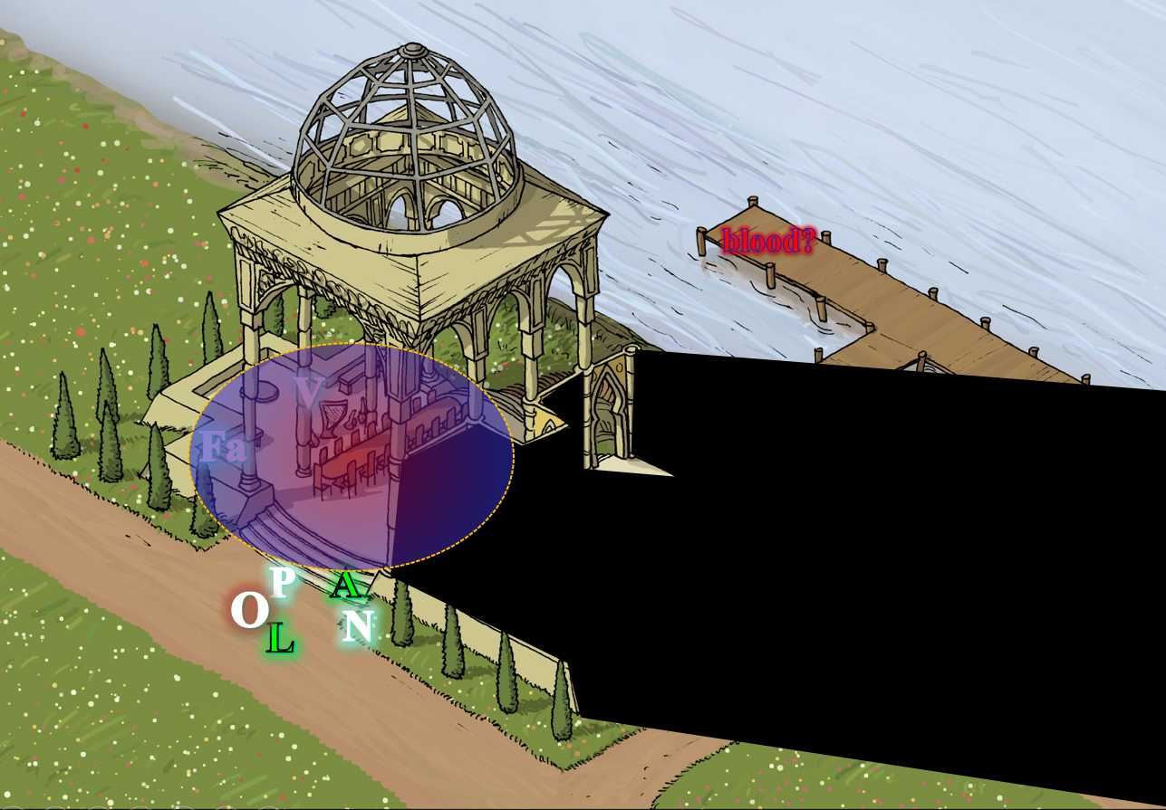

Round 14

Paralyzed, Three Growls could do nothing at the moment, and so the three undead had their way with the wolf’s hide.
Character | Attack Type | Damage | BAB | Str Mod+ | Other+ | Total Score | Roll | Total
Eatsoul | Bite | 1d8+3 + Paralysis | 2 | 3 | 2 flank | 7 | 18 | 25
Eatsoul | Claw 1 | 1d4 + 1 + Paralysis | 2 | 3 | 2 flank | 7 | 12 | 19
Eatsoul | Claw 2 | 1d4 + 1 + Paralysis | 2 | 3 | 2 flank | 7 | 11 | 18
Ghoul | Bite | 1d6+1 + Paralysis | 1 | 1 | 2 flank | 4 | 12 | 16
Ghoul | Claw 1 | 1d3 + Paralysis | 1 | -1 | 2 flank | 2 | 6 | 8
Ghoul | Claw 2 | 1d3 + Paralysis | 1 | -1 | 2 flank | 2 | 12 | 14
Zombie, M | Slam | 1d6+1 | 1 | 1 | 2 flank | 4 | 19 | 23
Hit, hit, hit, hit, miss, miss, hit. Dmg: (5 + 3) + (3 + 1) + (2 + 1) + (4 + 1) + (2 + 1) = 8 + 4 + 3 + 5 + 3 = 11 + Paralysis⁴. Damage negated.
Character | Save vs.  Paralysis | Ranks | Roll | Save
Three Growls | Fortitude | 5 | 16 | 21
Three Growls | Fortitude | 5 | 5 | 10
Three Growls | Fortitude | 5 | 11 | 16
Three Growls | Fortitude | 5 | 14 | 19
Success, fail, success, success. Paralysis persisted into next round.

Lauren stepped up next to Alissa and activated her Cube of Force, erecting a shield that would keep any non-living thing from penetrating, and slow them down just a tad. “We need to find whatever just killed four of us,” she told Allisa. “Where is Fingers?” She looked above them to see if she could spot whatever it was that was throwing the darts, but did not have the ability to see invisible creatures, and she suspected that—like Fingers—this enemy had access to the greater invisibility spell.

As the remaining undead cut down the wispy wolf, Allisa hurled some lightning at the ghoul, whose back was to the druid.
Ranged Weapon | Dmg. | Atk | Roll | Check | Notes
Ranged Touch Attack | 3d6 electric | +14 | 12 | 26 | 8 bolts left
Hit. Dmg: 13 electric.

“I have not seen him,” said the druid.

The ghoul disintegrated—confirming its conjured nature.

Unable to see the wall of force, let alone identify it, Gwen attacked Allisa with her blowgun.
Ranged Weapon | Dmg. | D+ | TH+ | Critical | Rng. | Wt. | Atk | Roll | Check | Notes
Deadly Precision Blowgun +2 | 1 | 2 | 2 | x2 | 10’ | 2.0 | +19 | 17 | 36 | Sneak Attack 4d6,  Sudden Strike 2d6
Blowgun, 2nd Attack | 1 | 2 | 2 | x2 | 10’ | - | +14 | 15 | 29 | Sneak Attack 4d6,  Sudden Strike 2d6
Blowgun, 3rd Attack | 1 | 2 | 2 | x2 | 10’ | - | +9 | 14 | 23 | Sneak Attack 4d6,  Sudden Strike 2d6
Blowgun, haste | 1 | 2 | 2 | x2 | 10’ | - | +19 | 12 | 31 | Sneak Attack 4d6,  Sudden Strike 2d6
Miss, miss, miss, miss.

Three flechettes bound for the back of Allisa’s neck bounced right off the wall of force. The druid and duskblade could still not see their assailant, but they heard the darts striking the invisible barrier, and saw them drop to the floor.

Gwen’s work had been thorough. She’d reduced a full party down to two plus the doggie. The hastened halfling shook her head, and targeted Three Growls.

Azimuth saw that the jig was nearly up so he summoned another zombie, and watched the events unfold.

A second zombie appeared near Three Growls, and started making its way over to join the fight.

Octane struggled to break free, but could not.

Round 15

Gwen shot a single flechette at Three Growls, then picked up her backpack and started making her way northeast towards the staircase.
Ranged Weapon | Dmg. | D+ | TH+ | Critical | Rng. | Wt. | Atk | Roll | Check | Notes
Deadly Precision Blowgun +2 | 1 | 2 | 2 | x2 | 10’ | 2.0 | +19 | 19 | 38 | Sneak Attack 4d6,  Sudden Strike 2d6
Hit. Dmg: 1 + 2 + 12 Sneak + 6 Sudden Strike + 7 Deadly Precision) = 28.

Though she didn’t finish off the animal genasi, her work here was done, and along with Azimuth, she would now return to Kaszüm for her reward. However, the druid and duskblade were now headed towards the portal as well.

Three Growls whined with pain, gave up the fight, and darted off westwardly as fast as he could. The ghast—Eatsoul—wasn’t able to catch up, but did its best, as did the limping zombies.

The druid cast her last flame strike on her Eatsoul.
Character | Save vs.  flame strike | Ranks | Roll | Save
Eatsoul | Reflex | 4 –  2 evil | 11 | 13
Fail. Dmg: 29 fire + 29 holy = 58.

The fire damage alone killed the ghast, and the holy damage pulverized the filthy undead.

Azimuth got Gwen’s message, and began to casually and silently walk towards the women as they turned towards the portal and away from him.
Skill | Rank | Ability & Mod. | Misc. Mods. | Total | Roll | Check
Azimuth, Hide | 6 | Dex (+1) | 4 | 11 | 7 | 18
Azimuth, Move Silently | 2 | Dex (+1) | 2 | 5 | 14 | 19
See below.

Lauren and Allisa looked again for an enemy on the roof, but saw none, and at the moment, they weren’t being fired upon.

With only two zombies left in sight, and both of them headed off towards Three Claws, Lauren leaned close to Allisa so she couldn’t be overheard. “Let’s get back through the portal before that thing kills us all.” She moved in that direction while making sure her wife was following her.

Allisa blew the divine dust off of her hands after casting flame strike when Lauren said, “Let’s go.” She followed on the woman’s heels.

With Allisa in close company, Lauren hightailed it back to the portal, though the wall of force was slowing their movement by about a third of its normal rate.

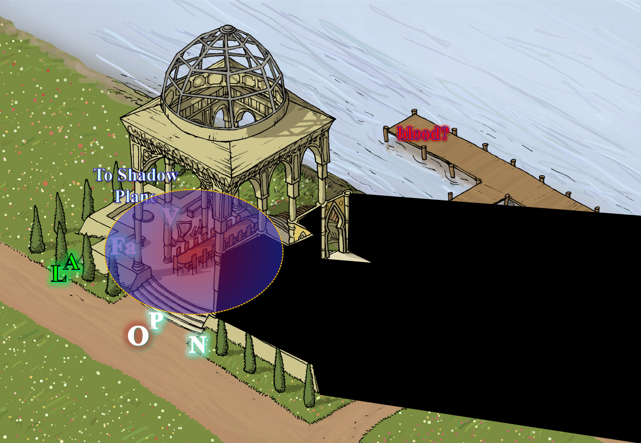

Round 16

Azimuth cast dimension door, placing himself behind the portal to the Shadow Suite.
Skill | Rank | Ability & Mod. | Misc. Mods. | Total | Roll | Check
Azimuth, Hide | 6 | Dex (+1) | 4 | 11 | 7 | 18
Azimuth, Move Silently | 2 | Dex (+1) | 2 | 5 | 14 | 19
See below.

Three Growls outran the zombies who mindlessly chased in vain after the speedy wolf. By the time Allisa and Lauren reached the ledge that led back into the courtyard, they could no longer see the elemental wolf who had darted behind and beyond the bushes in sight.

The two women could’ve taken the more direct route through the grave mist, but that would’ve likely caused more cold damage, and they were already Fatigued. They made their way to the portal, but as Lauren confirmed that Fingers was nowhere in sight, and it held the portal shard in its vest pocket, she felt a sinking feeling of despair. That, plus there was some wily, little shit hiding behind the portal.

Oh, and now he was coming out like they hadn’t seen him, “Yeeah, fuckers!” he blurted, instantly calling to Allisa’s recollection a harrowing event on a night three years prior.

Gwen made her way to the portal for a possible showdown of sorts.

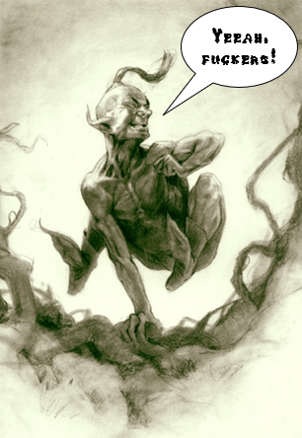

Allisa instantly recognized the barely clad halfling who came out from behind the portal, “You?” She didn’t know his name, but she and the original Destiny’s Gambit—Lauren included—had been accosted by this little turd—and his towering skeletal minion, come to think of it—back in 1374, on their way along the River Dessaryn to the hallowed grove where they’d resurrected their eidolon friend into a half-orc who immediately ran away from the party. Strange days, but what was this little shit doing here? He used to ride with the Cult without a Name, which had corrupted high-ranking officials across Waterdeep in an effort to enslave and zombify children and other defenseless Humanoids... and they’d gotten away with it!

The Gambit had ventured all the way to the Lost Refuge in the middle of nowhere, but in their inexperience, had hesitated to step into the Shadow Plane analog of that fortress, and thus the Cult without a Name had escaped to practice their slavish necromancy elsewhere in the multiverse; and a small multiverse it was if mere chance had brought them together again, here in Elysium, of all places. No, there had to be a connection.

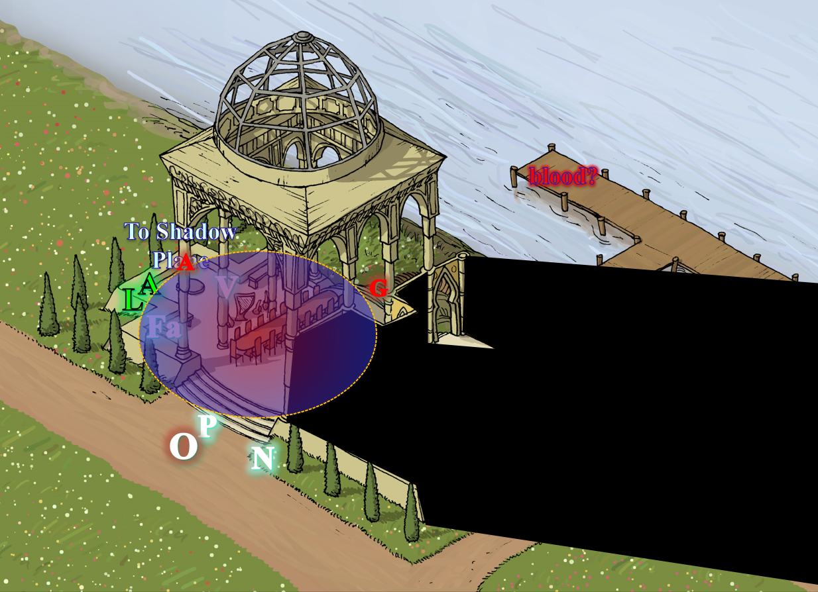

Round 17

Azimuth knew that Gwen was approaching, and readied a spell that required him to point his finger at Lauren. “Don’t,” he simply said, grinning with the glee of a child.

At a distance, the zombies continued their leisurely chase after Three Growls, unable to run or so much as jog.

Gwen’s greater invisibility expired as she came around the northeastern corner of the property, approaching from the riverbank now. The halfling woman studied the two women, holding a wand in one hand, and her blowgun in the other, a few inches from her mouth, ready to strike the moment it appeared from their body language that their wall of force was down. “You will be wise to put down your weapons and hold your hands aloft.”

The halfling woman was now standing partly behind the table and chairs, considering them provisional cover should the two surviving intruders decide that parlaying was for pussies.

By the accounts that Xaryn had read and related to them the day before, this was likely Gwen Triflestrife, Kaszüm’s principal thief-extraordinaire, and from what had just transpired, an expert assassin when armed with a blowgun.

Lauren pressed the Cube of Force into Allisa’s hand, and then went into action, but not before Azimuth tagged her ass with an enervation spell.
Ranged Weapon | Dmg. | Atk | Roll | Check
Ranged Touch Attack | 1d4 negative  levels | +9 | 14 | 23
Hit. Dmg: 2 negative levels.
Lauren suffered –10 hit points [128/162], and –2 on attacks, saving throws, skill/ability checks, and effective level (when relevant), plus both 5th-level spell slots.

With the frustration of her adolescent self, the duskblade swift-cast dimension hop, placing herself to Gwen’s right side, within striking distance.

They were both standing just a foot away from the grave mist, and as Lauren used one of her more powerful spell slots to empower her Arcane Strike ability (+4 TH and 4d4 damage/hit), she channeled a disintegrate spell though her sword as she struck the halfling woman saving the vampiric touch spell stored in Arkenlyl for the second swing.
Melee Weapon | Dmg | D+ | TH+ | Crit | x | Type | Wt. | Atk | Roll | Check
Shattermantle Bloodstone Falchion +3 | 2d4 + disintegrate | +2 +3 | 3 + 4 AS | 18 | 2 | Slashing | 8.0 | +26 | 3 | 29
SB Falchion +3, 2nd Attack | 2d4 + vampiric touch | +2 +3 | 3 + 4 AS | 18 | 2 | Slashing | - | +21 | 10 | 31
SB Falchion +3, 3rd Attack | 2d4 | +2 +3 | 3 + 4 AS | 18 | 2 | Slashing | - | +16 | 18 | 34
SB Falchion +3, 4th Attack | 2d4 | +2 +3 | 3 + 4 AS | 18 | 2 | Slashing | - | +11 | 15 | 26
Hit, hit, hit, miss. Dmg on 1st strike: (5 + 2 + 3 + 4 Arcane Strike + 124 disintegrate) = 138.
Gwen was disintegrated. 2nd and 3rd strike struck thin air.

Gwen ceased to exist, her equipment being unaffected, save for the single swipe that Lauren’s sword had done to the halfling’s mithralmist chain shirt.

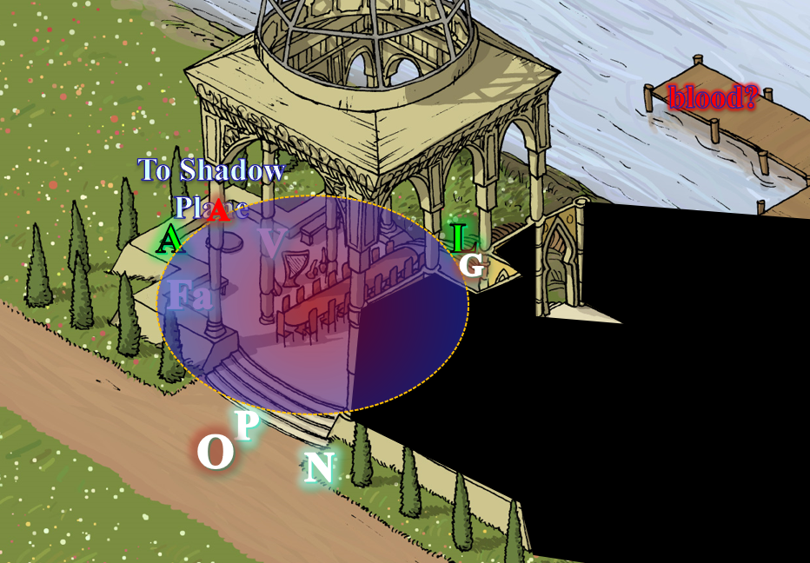

Lauren noticed that the blowgun the assassin had used to kill their new friends was none other than Fingers’ blowgun: the only stolen item they’d not yet recovered from this group of thieves.

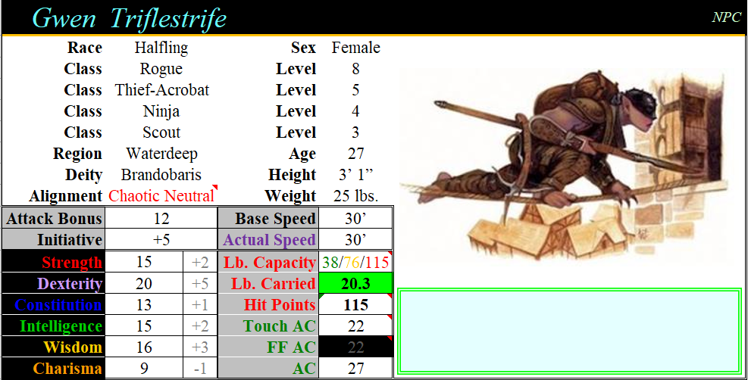

Once Lauren teleported, Allisa moved 15’ straight back from Azimuth keeping the wall of force between them. Since she was moving straight back, and didn’t see where she was going, she missed the exact position of the ledge she had to cross and fell a few feet.
Save vs.  Falling | Rank | Ability & Mod. | Misc. Mods. | Total | Roll | Check
Allisa, Reflex | 7 | Dex (+3) | 0 | 10 | 4 | 14
See below.

It wasn’t too bad a fall, and as she got up, she dropped her wall of fire [expired on Con + 16 rounds], folding it 15’ then back behind itself 15’ as many times as possible.
Dmg: 2 + 16 = 18.

Having only backed up 15’, and having cast a wall of flame larger than 5’, Allisa was also burned a bit.
Dmg: 3 fire [89/96].

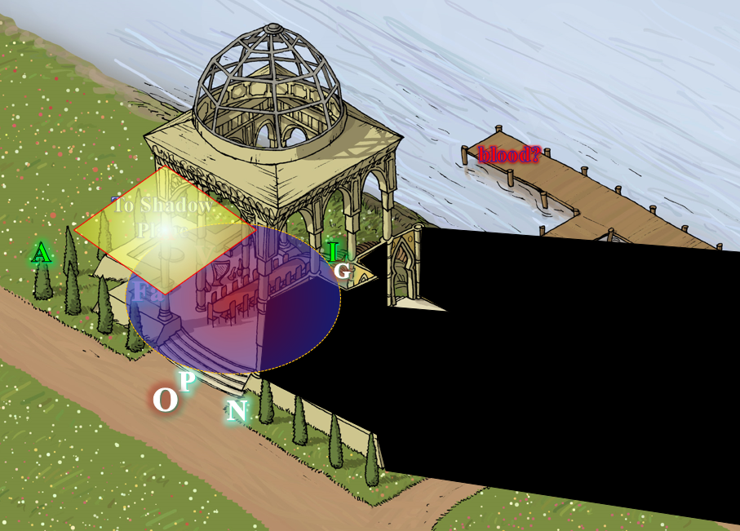

Rounds 18 – 20

Azimuth struggled to cast a spell as the searing pain overcame his senses.
Skill | Rank | Ability & Mod. | Misc. Mods. | Total | Roll | Check
Concentration | 8 | Con (+1) | 0 | 9 | 16 | 25
Success.

A bit charred, Azimuth was at least able to cast dimension door once again, and disappeared from sight.

Allisa immediately threw her lightning bolt at the enemy, backing up another 15’, but could not do so in time.

Three Growls could no longer be seen or heard.

The Elysium Suite was idyllically quiet, save for the chirping birds in the aftermath of all this carnage. And all around them lay the corpses of their friends, except for Fingers and Octane, who had gone missing in the midst of the ensuing chaos.

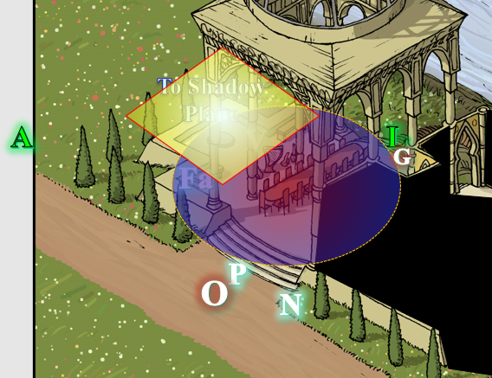

Lauren stayed out of the grave mist spell effect as she circled northward and around all of the spell effects to find Allisa. “My love, are you here?” she called.

Allisa dismissed the fire as she answered her lover’s call. She then cast cure moderate wounds on herself.
Allisa gained 11 + 10 = 21 hps [96/96].

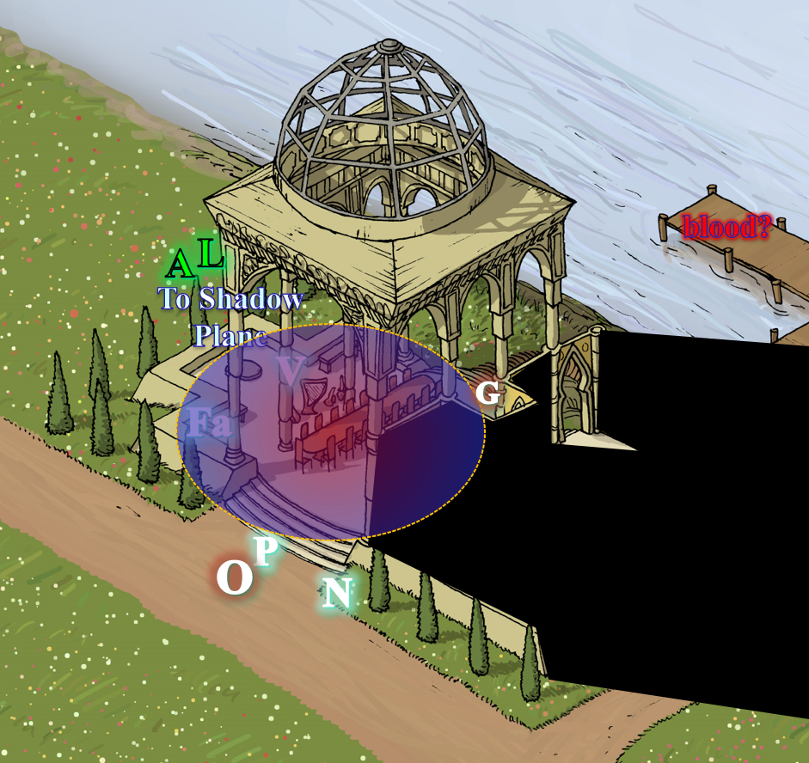

Azimuth hid in a nice patch of bushes about 400’ away from the Elysium Suite, and spied on the two women, ready to sucker punch and confront them if things got rough.

Round 21

Once the two were together, the druid hugged the drow and passed back the cube. She took another moment to check Lauren’s health. “We need to search for the other two. I hope they survived.”

Rounds 22 – 24

The grave mist spell dissipated as the magic that sustained it faded.

“Which two?” asked Lauren, seeing four of their recently made friends dead on the floor all around them. Lauren hugged Allisa tightly; her entire body trembled as she fought to control her emotions. “That could have been you,” she said in a hoarse whisper. “That bitch could have killed you, instead.” She took a ragged breath to keep from breaking down completely. “I can’t do this anymore. I just can’t.” And although they had often talked about retiring from the adventuring and heroics game, Lauren felt it now with an urgency that had heretofore been absent.

“I know. I just wished I had been able to fry that halfling, so we would not have to worry about him.” Allisa kissed the woman as she stroked her hair.

“Where’s Fingers?” Lauren wondered. Without the shard to activate the portal, they were stuck in Elysium, which wasn’t an altogether horrible place to spend time as a castaway, particularly with the river coursing nearby.

Round 25

The latest situation could not have been contrived to be worse for Lauren’s already frazzled mental balance. To see a whole group of people casually murdered in front of her by an assailant she couldn’t even see, much less fight, was horrifying enough. Add to that that she barely got back to Allisa in time to save her, using an artifact that she’d only just acquired, and Lauren was very nearly lost in her PTSD. She could function, and she could fight, and she was dedicated to killing Kaszüm, or whatever his name was, only because she knew the bastard would never just leave them alone. Afterwards, though, she was done with risking their lives. If Allisa was still alive, then Lauren will would go anywhere and do anything to simply live peacefully with her. If Allisa was dead, Lauren would seek her own end.

As the two women spoke, the bodies on the stone tiles continued to bleed out, and the two that could have been saved by one of Allisa’s cure spells died.

Lauren held Allisa for a moment as she fought to retain her composure. “Here, you hold the cube. I can’t both fight and use it effectively.” She stepped back and took a deep breath. “Let’s see if we can find Fingers and anyone else who might be alive. Keep an eye out for Azimuth, too. I doubt we’ve seen the last of him today.”

They made a full perimeter check around the house, but after a few minutes found nothing and no one. Along the northeast corner of the house, they found a wooden staircase leading from the bottom of the house to the ground, and a ladder nearby leading up to the roof. This was likely Gwen’s escape route once the party had sprung the alarm and roused her attention.

With their friends dead, Gwen also dead, Otis’ empty suit of plate on the ground, and Azimuth nowhere in sight, they contemplated their next move.

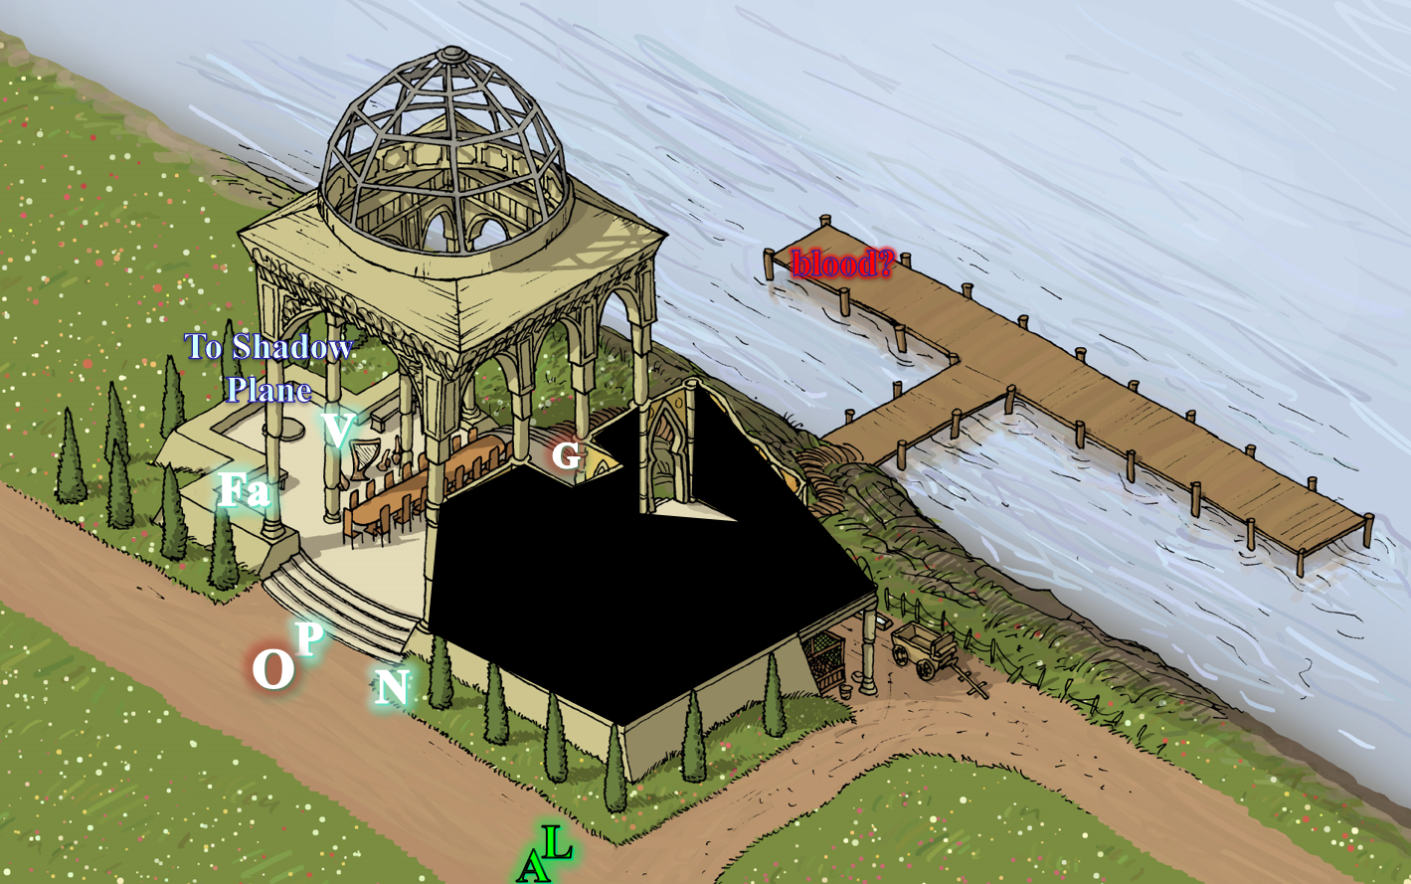

“Let’s check inside the house, but only from the door,” Lauren suggested.

They had not noted it during the conflict, but the house had two open doorways, and as they entered the one they’d just discovered, they found the queerest and most unexpected thing: Octane—who had gone inside the house as the conflict had ensued—was frozen in midair as if held by a hold person spell that somehow also defied gravity. She could neither speak nor fudge in her position, which was of one startled by and reacting quickly to an explosion.

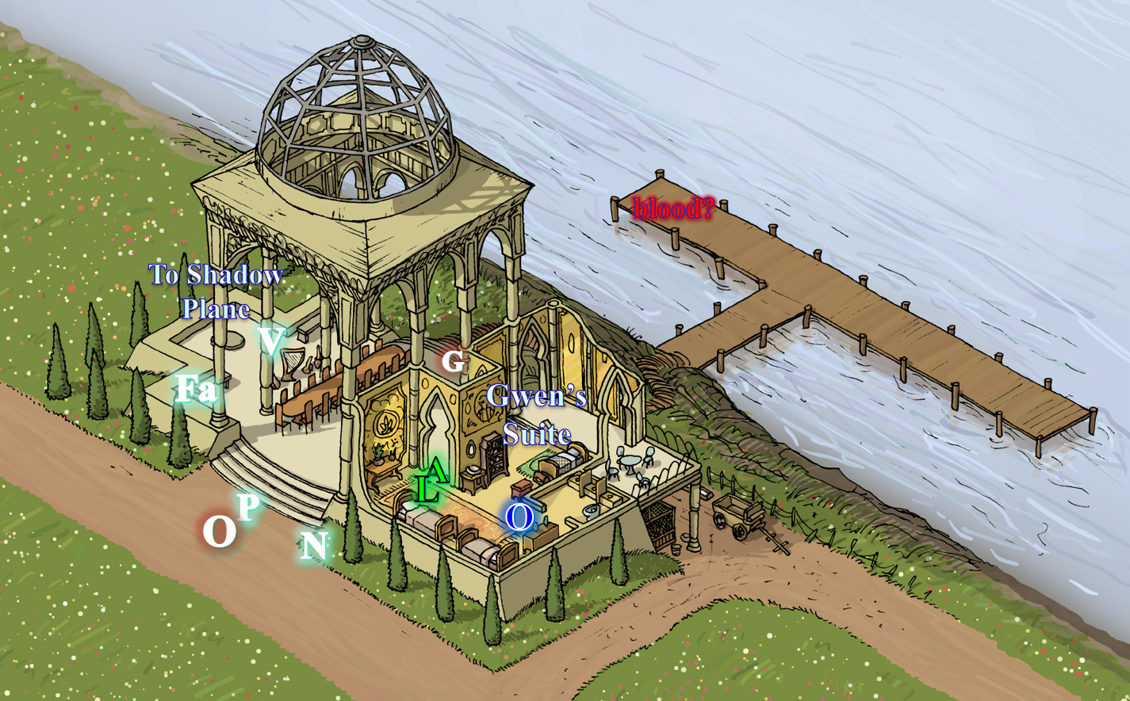

Azimuth had by now noted that the women had either gone inside or were at the banquet table where he couldn’t see them. Casting clairvoyance [expired in 10 minutes] on them, the cloistered cleric with the Knowledge Domain was able to target the threshold under which Allisa now coincidentally stood; the location had a line of sight to part of the courtyard and part of the inside of the suite, and now that he could see both women trying to understand the fate of the third woman held in the bubble, he drank a potion of invisiblity [expired in 6 minutes], and approached the house with caution, wondering if his next Otis would be Lauren’s shorter but more statuesque skeleton.

They had not noted it during the conflict, but the house had two open doorways, and as they entered the one they’d just discovered, they found the queerest and most unexpected thing: Octane—who had gone inside the house as the conflict had ensued—was frozen in midair as if held by a hold person spell that somehow also defied gravity. She could neither speak nor fudge in her position, which was of one startled by and reacting quickly to an explosion.

Lauren cast dispel magic to release Octane. She remained at the doorway. “Watch behind us,” she reminded Allisa.
Ranged Weapon | TH+ | Atk | Roll | Check
Dispel Magic | 0 | +17 | 10 | 27
Success.

Lauren had not quite understood the nature and scope of the spell that she’d just dispelled, and was not aware that she’d only dispelled one effect: the hold person spell; an invisible, hemispherical bubble of silence remained around the rogue as she dropped to the ground with no thud, then making everyone aware of the silence effect.

Octane got up, and quickly ran out of the spell’s effects and towards Allisa. Reaching the doorway—she gasped as if previously suffocated—though she bore no symptoms of having been asphyxiated. “By the gods! I thought you were all dead! I could hear nothing, and see nothing outside the room.”

The druid kept watch outside the door, making sure no one came at them from behind. She answered the woman, “I am glad you are still alive. The others are dead and we are still looking for fingers.”

“Everyone else is dead, and our changeling friend is still missing,” Lauren said as she stepped outside. “Their thief murdered them all before I could kill her.”

“Holy fucksauce!” Octane reacted to Lauren’s statement, confirmed by the sight of her friends dead before her eyes as she exited the house. “Farleigh! Naomi! Oh, gods, Phrax! Vheren! Oh, fuck-oh-fuck!”

After a minute or so of recounting the half-minute battle, the three women stood in circumstance. The halfling got her bearings and sighed, “Alright, so what do we do now? I’ll need to say a prayer for my friends before we get out of here.”

“The prayer won’t be a problem, but getting out of here will,” Lauren began.

Allisa finished the thought, “Fingers is gone, and it had the shards to the portal with it. Our only recourse is to find the next portal. That is if we cannot find Fingers,” said Allisa.

Lauren—whose knowledge of the Planes was now the most cultivated among present company—pointed out, “Of all the planes we’ve visited, only the Ysgard Suite had a portal to anywhere other than back to the Shadow Plane. I doubt we’ll find another portal.”

The duskblade shrugged. “All we can do now is take care of these remains, collect anything useful, and then try to find Fingers.” She stepped over to where Gwen’s equipment lay on the ground, and picked through it. “Watch for Azimuth, too. He could pop back in at any instant.”

Within 30 seconds, Lauren had found a variety of items including a short sword, a dagger, a sap, a blowgun, Mithralmist Shirt +1 of Agility, a pair of Deathstrike Bracers, 3 wands, a potion, a scroll, and some miscellaneous items.

Equipment Worn
Item
Vanisher Cloak
Scout’s Headband
Talisman of the Disk
Intelligent Brooch of Denial
Third Eye Surge
Acrobat Boots
Lockpicking Ring
Equipment in Backpack
Item
Climber’s Kit
Silk Rope
Bag of Endless Caltrops
Thieves’ Tools, Masterwork
Oil Flask
Skull Shard

Among the items, there was an onyx shard much like those they’d found so far, and carved onto one extremity was a skull, while the other tip looked like it would fit nicely into any of the portal receptacles. She wasn’t able to identify all of the items with certainty, but she could tell that this was the most lucrative bunch of loot that she’d ever taken off of a single person, which was not surprising at this point, after what they’d seen in the Ysgard Suite’s repositories.

And despite the fact that Lauren had cut Gwen down in record time, the duskblade also suspected that the thief-acrobat was likely the most powerful being she’d ever fought.

Lauren quickly gathered everything, and, except for the skull shard, stored the haul in her haverpack, and took the skull shard in hand.

Octane couldn’t believe her eyes, and as she said a prayer beside each of the bodies of her fallen comrades, she spent a moment and a tear on her memory of their friendship. The wolf genasi was nowhere in sight, and with the knowledge that Naomi was dead, the magical beast would likely revert to a feral state and live out the rest of his days in these Elysian fields.

Lauren curiously tried the skull shard, placing it into the portal’s receptacle, and seeing the barrier that locked the portal disappear. “We’re back in business.”

“Maybe we can go back to the citadel, and travel to the next plane with this,” Lauren continued. “Let’s try it before Azimuth decides to attack us again.” She stood next to the portal while she awaited their response.

“Should we not search the rest of the building? Fingers could be trapped too. Otherwise, might as well go back,” said Allisa.

“I think that small space is all there is,” Lauren replied. “I will do what you think is best, though.”

Octane had seen enough of the inside of that exotic bungalow, and preferred to not go back inside, “Beware the traps... it’s a thief-acrobat’s studio, after all.”

Lauren arched an interrogatory eyebrow at her wife in one of the more annoying habits she had.

With nary a peep from Allisa or Octane to the contrary, Lauren took the initiative to insert the skull shard into the portal, and urged the other two women back into the Shadow Plane. She had zero interest in waiting for something else nasty to show up, and she needed to recover her levels and spells.

~*~

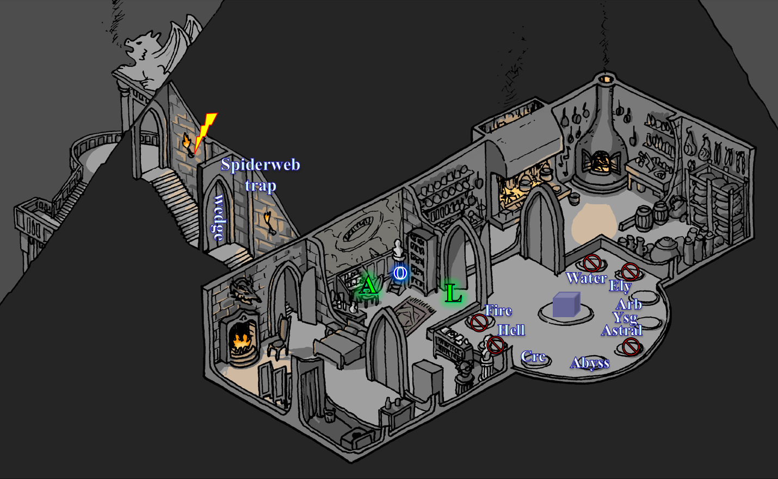

They’d been back in the Shadow Plane for several minutes now. Lauren had immediately removed the skull shard from the other side of the portal, and was now coming back into the study to find Allisa sitting at the chair and Octane sitting on a stepstool, both reading a book they’d each picked up while Lauren had gotten some food. Handing a slider to the druid and ranger-cleric, the duskblade sighed and said, “We’re one step closer to reaching Kaszüm.”

Allisa had hoped they’d find the villain soon enough, and compared a diagram in the book she was perusing to the map of the Citadel of the Planes, though it was more confusing to her than enlightening.

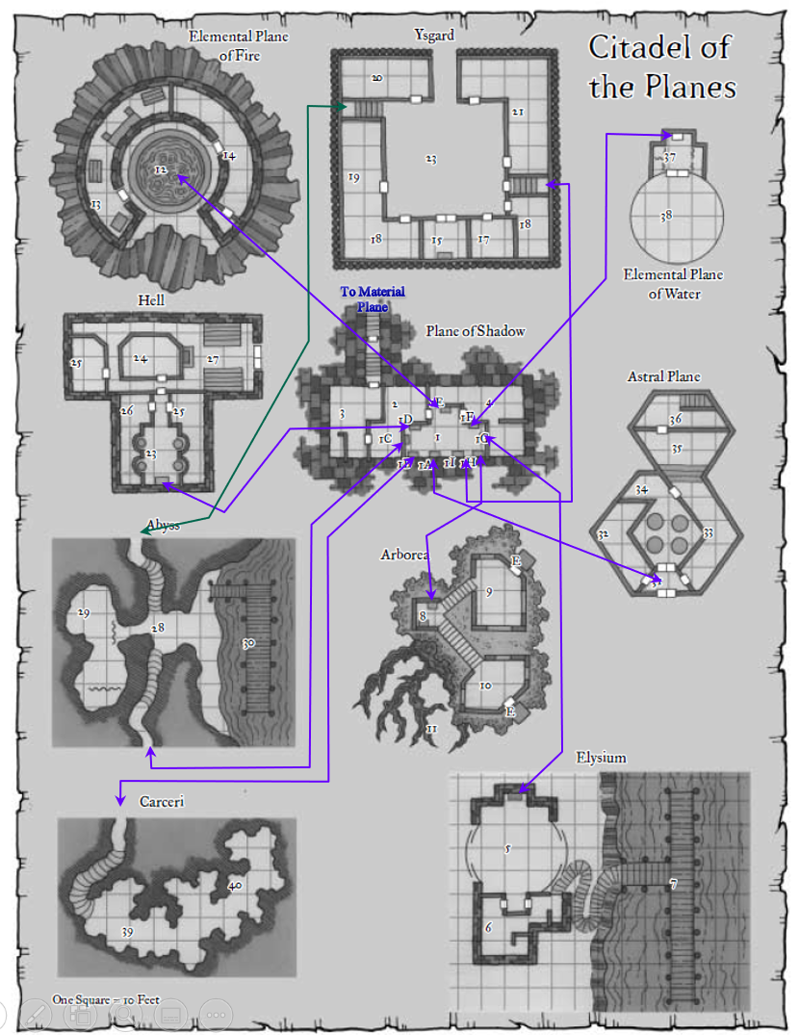

“Let me check something,” Lauren said as she went back into the portal room and checked the portal to Arborea to see if the skull shard could open it, since Fingers had taken all of the portal shards. She didn’t step through, but passed her hand in and out of the threshold, and confirmed that this worked for all of the portals. “I think we can actually access all of the suites now,” she announced. They hadn’t been to the Fire Suite, the Water Suite, the Hell Suite, or the Astral Suite and now considered what to do next.

As they strategized, there came a sound of—not a knock—but a rasp at the door. Their conversation halted, and the duskblade got up as quietly as possible, and made her way up the stairs.
Skill | Rank | Ability  & Mod. | Misc.  Mods. | Total | Roll | Check
Lauren, Move Silently | 0 | Dex (+1) | -2 | -1 | 16 | 15
See below.

Allisa followed close behind Lauren, but the duskblade motioned for her to stay with Octane, as the halfling stayed behind the door at the bottom of the stairs. It was unclear as to whether those outside could hear Lauren making her way up fully armored, but they could definitely hear humanoid voices—both male and female—outside. It was impossible to tell what was being said, but at least two timbers were discernible to the half-drow’s ears as she came within a few feet of the wedged front door.

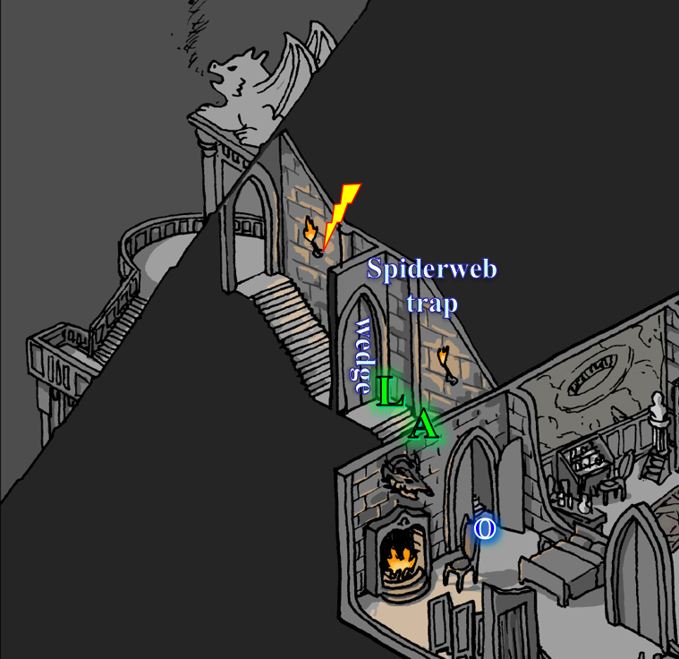

Lauren waited for a moment with her sword drawn, standing far enough behind the door as to not be struck if it was forced open. She had her sword and shield in hand while she listened.
Skill | Rank | Ability & Mod. | Misc. Mods. | Total | Roll | Check
Lauren, Listen | 2 | Wis (+3) | 1 | 6 | 5 – 10 | 11 – 16
See below.

It wasn’t clear who or what was on the other side of the door, but the tone of the ensuing conversation was calm, and devoid of any shouts and hostility.

Lauren removed the wedge, pulled the door to open it slightly, and stepped back, her sword and shield ready.

The chatter outside died down as soon as the door creaked open ever so slowly, and then Lauren locked eyes with a perplexingly familiar visage, “Oh, hi, darlin’!” Elaith greeted Lauren as Rook, Maiko, Sarge, and Selena stood behind her.

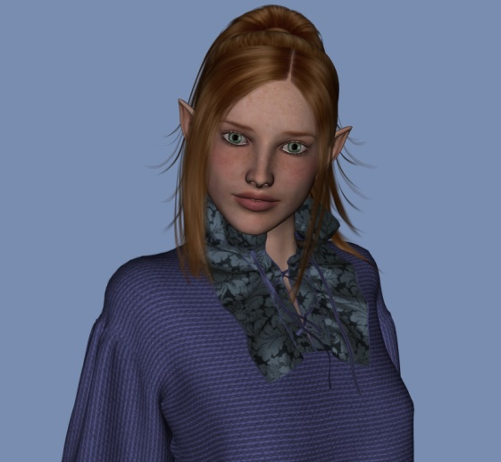

Lauren stood there, first disbelieving her eyes at the sight of their dear friends, and giving Elaith a look like, “You’d better explain yourself.”



Selena—in her natural changeling form—explained, “We used some Divination magic to trace your steps two nights ago. It took some time, but we tracked you to this house... or...” she couldn’t quite explain where they were, since they’d only been on the Plane of Shadow for about 30 seconds before Lauren had opened the door.

Seeing her friends, Allisa put up her scimitar. She smiled big and she greeted Maiko, giving her a hug and rubbing her belly. She then hugged Sarge and Selena.

After all was caught up Allisa took Maiko aside. “You are, so pregnant and about to pop any day. You should not even be here.”

Maiko replied. “I had to come and find out what happened to my friends.”

“You have found out, and you cannot stay. I wish I could talk Lauren out of this, but she is insistent that he will come back for us if we leave well enough alone. Sarge would not approve and I don’t want my godchild killed,” the druid said.

Lauren’s senses were all confirming that these were not impostors. Even the smell of Maiko’s gestating pheromones was evident to Lauren, who bid her friends to enter, “You’ve just crossed into the Shadow Plane,” she explained, taking in the vision of Waterdeep now miles away in the distance as gargoyle-like creatures swooped above them and under a gray moon.

Rook gave Lauren a strong but brief hug, and murmured, “We were worried about you.”

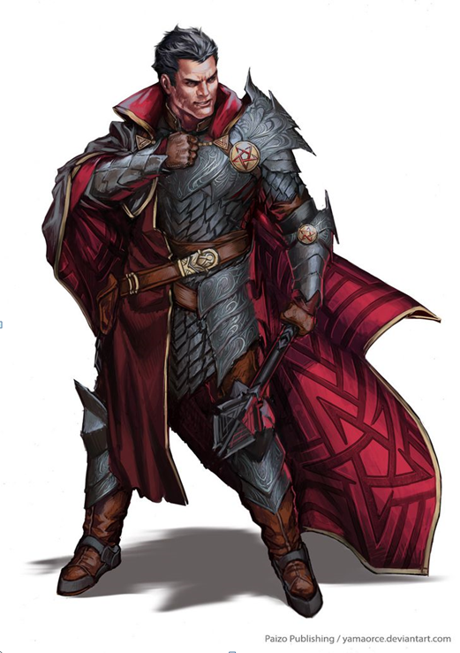

They made their way in and a short debriefing began.

~*~

Having explained to their cohorts what had happened since the day of Maiko’s trial, and the robbery they’d subsequently discovered, Allisa and Lauren concluded with, “And Octane is the only member of her party to survive the attack from Gwen.”

“Good riddance,” Octane said of Gwen, spitting in the corner of the lair that still belonged to Kaszüm.

Lauren sat next to Allisa, holding her hand in what Rook recognized as a measure of support. “My Lady, how are you holding up?” he asked gently.

His liege lady sighed. “Not well. If it had not been for the magical cube I found, Allisa would be dead, too. Had Gwen not gotten overly confident, I would have never been able to find her.”

Elaith smiled grimly. “But you did find her.”

Lauren bared her teeth. “I did.”

Octane was excited to learn that Lauren had found a wand of raise dead, and now suggested going back to Elysium to resurrect her friends, though they would be battle weary to say the least.

Lauren looked at the group after she’d distributed the items she had. “Maiko, you really should stay here, and at least one other person should stay with you. Wedge both bedroom doors and wait for us to return. Who will stay with her?”

Sarge chimed in, “We really shouldn’t be in such a place with my little chromosome in the oven.” He patted Maiko’s tummy, and added, “Anyway, now that I’ve ruled away any suspicions of you being impostors, or you...” he pointed to Octane... “being in the service of Kaszüm, I’ve got a bit of news from the Underground that you should hear.”

There was some clamor and disagreement, but most agreed that this was no place for a woman with child, and so Sarge summed up the story that he’d told Maiko and Rook the night earlier, detailing the aboleth nicknamed Big Red, and the strings the eons-old monster was pulling. The warmage confirmed what they’d learned in the notes they’d found throughout the Citadel—particularly in the Shadow Suite and Ysgard Suite repository—that this aboleth was vying for control over Kaszüm’s mental faculties against a tenacious beholder.

“From what I’ve gathered,” Sarge added some speculation, “I’m willing to bet Kaszüm is about to lose his marbles, or already has.”

Lauren and Allisa concurred, based on their findings. “His notes from weeks ago are quite meticulous, but they devolve into scribblings, rants, and what seems like complete nonsense,” the druid recalled.

Sarge had learned, “Kaszüm had been known across the Faerûnian Shadow Plane as a mastermind thief and fencer of high-quality goods, but his interest in arcane arts drove him into the expansive web of the beholder, and in order to escape the beholder’s thrall, the gnome had to make a pact with Big Red. He probably realizes by now that his time is nigh. I had to confront a handful of others in the same state, and they are a sore sight by the time their madness is done with their undoing.”

Lauren sighed. “So, that means we might come to Big Red’s attention, too. I still think,” she glanced at Allisa, “that we can’t just walk away from Kaszüm, and expect that he will leave us alone. But let us go resurrect the people we just lost, and then we can decide what to do next.” She turned to Sarge. “Can you identify the wands, potions, and the scroll I gave you?” Until they were done, Lauren would keep the other items she’d found, just in case.

Lauren looked at the bunch as they said their goodbyes to Maiko and Sarge. “If you haven’t heard from us in two days, check back here.”

Lauren looked at the bunch as they said their goodbyes to Maiko and Sarge.

~*~

Allisa now looked upon her bride, as well as the others around her: Selena, Rook, Elaith, and Octane. “Well, we have a rounded representation of divine spellcasters, two duskblades, and two rogues,” she sighed.

“Think that’ll do?” asked Octane with an ambiguously sarcastic tone.

“All we’re doing right now is a rescue,” Lauren said. “Elaith, Rook, and I will stand watch, while the rest of you use the wand to get the others up and through the portal back here. Any questions?”

“You’re not going with?” Octane confirmed.

“No, I trust you with the wand.”

“I’m no resurrector, but...” Octane shrugged. “I’ll do what I can.”

~*~

Elysium Suite
Courtyard

Octane stood next to Allisa and Selena, who had just stepped through the portal. She saw the bodies of her fallen comrades, but noted that the wolf genasi was still gone; nowhere to be seen or heard. She stepped up to Vheren, who’d been the first to be killed by Gwen, and tapped the bard with the wand of raise dead.

Nothing happened, other than a charge being expended. She was about to try again, shaking the wand like she’d seen clerics do before, but then saw the beginnings of the effect manifest before her eyes, and recalled that she had to continue to hover the wand over the deceased for a minute or so before the spell’s full power took effect.

Within five minutes, Octane stood next to Vheren, Phrax, Naomi, and Farleigh who—albeit a bit weaker than when they’d woken up that morning—had been briefed on what had happened, and were ready to face off against Kaszüm. They stepped back through the portal, and introductions were made until everyone knew everyone else.

Destiny’s Gambit (PCs)
Allisa, half-elf druid / mistress of many forms 17
Elaith, half-elf duskblade 14
Lauren, half-drow duskblade 17
Rook, human martial rogue / cleric of Red Knight / church inquisitor 15
Selena, changeling rogue / seductress 12

The Singularity (NPCs)
Farleigh, dwarven fighter (-1 HD) 14
Naomi, elven sorceress (-1 HD) 14
Octane, halfling rogue / cleric of Leira 17
Phrax, gold dragonborn paladin / pious templar (-1 HD) 13
Vheren, half-elf bard (-1 HD) 14

That’s 146 ECLs stacked up against Kaszüm and whoever else he has at his disposal.

Before leaving, Sarge had identified the wands, and had written down the names and other properties that he could discern. Octane, in turn, appraised the items, adding a gold-piece value.
Scrolls and Potions | Qty. | Level | CLev | Properties | Value
Wand of Greater Invisibility | 1 | 4 | 6 | 37 charges | 22200
Potion of Haste | 3 | 3 | 5 |  | 1125
Scroll of Greater Invisibility | 1 | 4 | 8 |  | 800
Eternal Wand of Mage Hand | 1 | 0 | 1 | 2x/day; Spellcraft DC 15 | 460
Eternal Wand of Obscuring Mist | 1 | 1 | 1 | 2x/day; Spellcraft DC 15 | 820

Lauren now thought of how best to distribute these, and turned to the group at large. “During the last fight, I was weakened considerably by a spell, and I won’t recover until morning. If we do wait, that gives Kaszüm that much more time to prepare for our arrival.”

“If we don’t wait, we’re that much weaker against whatever we encounter,” Elaith continued her liege’s thought.

“We also know that there is a beholder and an aboleth out there somewhere,” Rook mused. “I don’t know that we could defeat such creatures in any event. It is possible, but it would likely cost most of us our lives.”

Octane sported a chronometer that was only slightly less nifty than Fingers’, and read 09:48 by the time they were all ready to go. The day was young, and although Gwen had put a serious damper on the group’s powers, the fatigued druid and duskblade looked to the others and confirmed that everyone was ready to proceed.

Octane held her Keen Dagger of Wounding in her hand and looked to the rest of her team, the Singularity. Farleigh produced his Holy Heavy Flail +3, and swung it over his right shoulder, ready to rumble. Naomi wasn’t one to use her Keen Rapier +3 in battle all that often, but she had it out for solidarity with her fellow combatants. Vheren drew his Keen Deadly Precision Short Sword, and examined its resplendent blade. Phrax lifted his Adamantine Illuminating Holy Greatsword +1 and said some definitive and resolute things in Draconic.

Selena had her Dagger of Circumcision +2 in her left hand, but sheathed it and drew her Sword of Subtlety instead. Rook took out his Divine Wrath Dwarvencrafted Hizagkuur Longsword +2 and marveled at its craftsmanship as Lauren did the same with her Shattermantle Bloodstone Falchion +3, which was only a few notches mightier than Elaith’s Shattermantle Greatsword +2. Allisa’s Scimitar of Frost +1 was the last weapon to be drawn, and with this, the men and women standing around the throne in the middle of the portal room pointed their blades and flail, and Phrax said a few more words, which Vheren translated with heavy paraphrasing, “Friends, our might has been compensated... but with the help of the Gambit... we have risen anew, and though weary, together... we shall make... what? Toast?” he confirmed that he’d understood the dragonborn.

Phrax nodded, and added definitional context.

“Ah,” the bard shrugged, and continued, “So... we shall make toast of Kaszüm and his ilk.”

Some of the others had never heard of toast as a figure of speech, but there was unanimous alignment on the idea of ending the arch-villain behind their collective woes.

“Alright,” Lauren—ever the strategist—established, “we have gathered our resources, our numbers, and our wits; what we need now is a plan, or at least some preemptive contingencies, since we don’t have a vantage point of what lies ahead... other than these maps.”

And just as they were beginning to lay out such contingencies, and better coordinate their complementary specializations, all went black. None of them could fathom whether the lights had dimmed, their senses had been compromised, or they had been whisked away to a completely dark space, but even those who could see perfectly in darkness were at a loss.

