Chapter 74

A moment later, the sound of waves crashing all around them, and the sensation of firm ground beneath their feet suggested that they were somewhere coastal, which was thereafter confirmed by the scent of brine in the breeze. As their eyes adjusted—or perhaps the darkness subsided just a bit—stars became evident overhead, obfuscated only by a handful of passing, gray clouds.

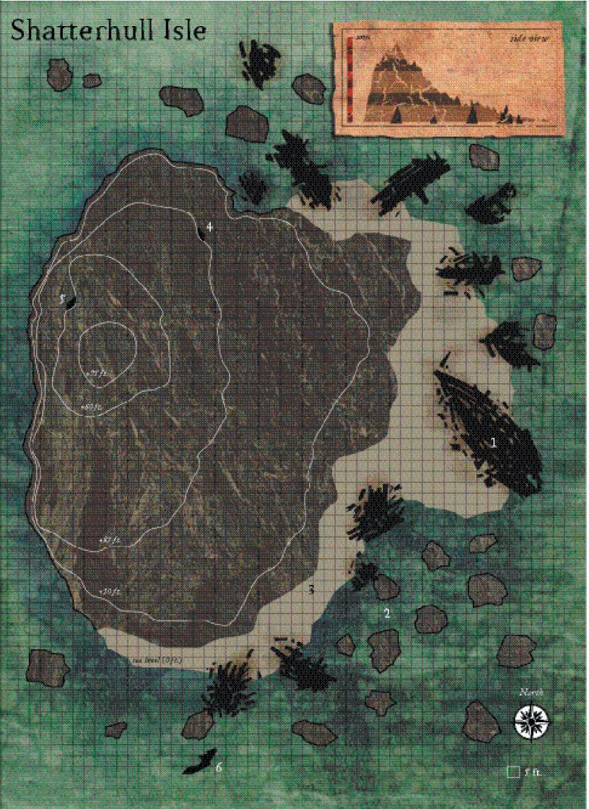

They were on a beach, and to one side was the sole peak on what appeared to be an island, while all along the coast were shipwrecked vessels from ages past.

At the top of the mountain was a human-sized figure who spotted them and ducked behind the peak as soon as the folks from the Singularity pointed it out.

A bat-winged, halfling-sized creature flew overhead, making way for what might have been the northern portion of the island where a robed, human-sized rider atop an armored horse looked towards them. At the horse’s side were a robed, halfling-sized figure, and a greataxe-wielding feminine form with no hair. Allisa and Lauren noted a faint familiarity in the greataxe’s shape, though she couldn’t place it in her memories.

The horned, bat-winged creature reached the rider and perched atop their shoulder, retracting its wings as the rider nodded.

“It’s on,” Farleigh murmured, reaching for a potion.

Round 1

Having conferred with Kaszüm and Azimuth on the best course of action, Karmen—who wore a pair of Cloudwalker Anklets—walked to a point that was above the heroes and at an angle, so as to get a nice few shots in while she was still invisible.

Azimuth waited to see what the fleshies would do.

“Everyone spread out. This is not good. My best spells have already been used and my new spell list is not ready,” said Allisa as she put 15’ distance between the nearest person. She’d wanted to cast stoneskin upon herself, but had not prepared it.

This was Selena’s first real fight and she wished she were back with Maiko, so she stayed near the back at first, but seeing the druid’s position, she then moved to be in front of Allisa, her sword in one hand, and the cube in the other. She had adopted her female halfling form and wore her revealing bikini chainmail.

Lauren—noted that Selena was now too close for comfort, and turned to the group, handing her the magic cube as she took a frontline position. “Selena, take this cube. Your job is to help cover Allisa. Octane, if you would, go with Allisa and Selena, and have them cover you. Rook, you and Elaith stay with me.” The duskblade did as Allisa suggested and moved 30’ away from the druid, placing herself between Allisa and their opponents to limit the effect of any area spells sent their way.

Phrax cast protection from evil [expired on Round 71] upon himself, murmuring something about mutual distancing.
Phrax gained +3 to AC & other bonuses vs. evil opponents.

Farleigh drank a potion of bear’s endurance [expired on Round 41], and moved towards the fore of the front against the stranger, catching up to Phrax.
Farleigh gained +4 to Con.

Vheren cast chasing perfection [expired on Round 151] on himself from a gold-foiled scroll that disintegrated upon its reading, then stood near the southern outfield of their diamond configuration. If he’d moved just a few feet to the left, he’d lose his line of sight to the potential enemy, which would be both defensively advantageous and offensively a crutch.
Vheren gained +4 to all six primary abilities.

Naomi cast mage armor [expired on Round 9001], and positioned herself also along the rear of the northward front.
Naomi gained +4 to AC.

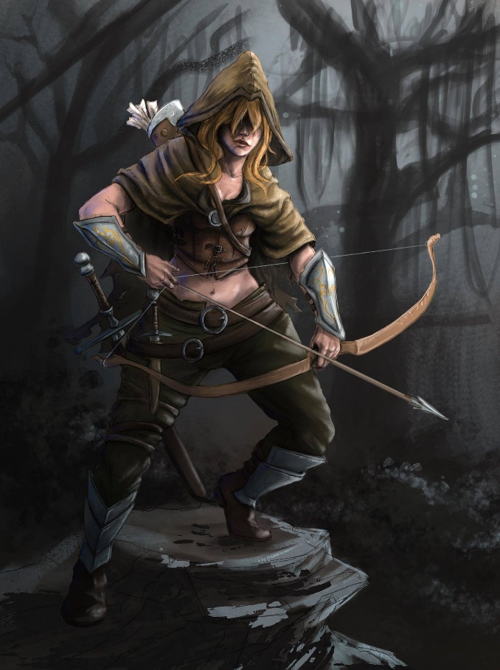

Octane used her last scroll of stoneskin [expired on Round 9001] on herself, then positioned herself behind a crate near the wreckage of a sailing ship.
Octane gained DR 10/adamantine for up to 100 hps.

The stranger on horseback cast mage armor [expired on Round 9601] upon himself as he took note of the Gambit’s and Singularity’s stances, and smiled, though they could not see the robed man’s face from this far away. “Do you not recognize us?”
Stranger gained +4 to AC and FF AC.

The quasit now perching on his back retracted its wings and held on to the man’s back in a way that was indeed familiar to Allisa, Lauren, and Rook, but not to the others.

The towering, bald woman to the horseman’s side drank a potion of bull’s strength [expired on Round 61] as well, tossing it aside as she waited for the others to reply to her leader’s question.
Stranger gained +4 to Str.

The wee man to the horseman’s other side cast what sounded from afar to be a see invisibility [expired on Round 1301] spell.
Stranger gained the ability to see invisibility.

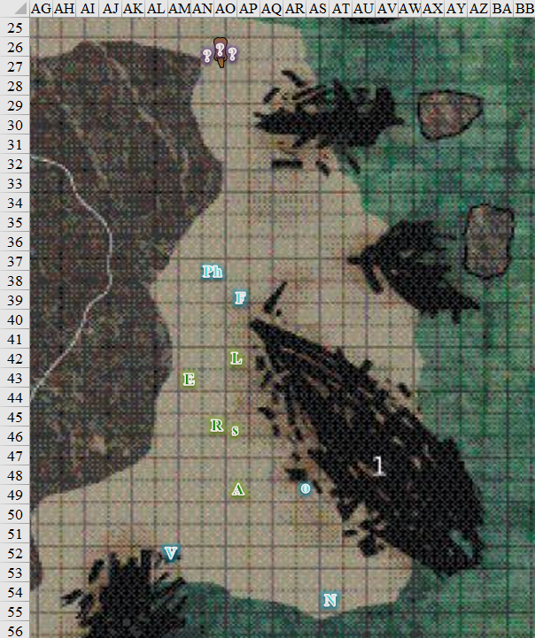

Round 2

Farleigh was ignoring the man, not recognizing any of the strangers from afar, and drank a potion of bull’s strength [expired on Round 72]. He then took up a position closer to the coastline as the shallow waves broke and rippled onto the single, jutting island.
Farleigh gained +4 to Str.

Allisa drank her potion of greater magic fang [expired on Round 3005].
Allisa gained +2 to attack and damage with any of her natural weapons.

Lauren cast dragonskin [expired on Round 1502].
Lauren gained +5 to FF AC and AC.

She then smiled grimly at the stranger’s question. “No, not really. It’s been a long day.”

Being a combat caster, Rook cast mass shield of faith [expired on Round 152] to help his companions, then moved north to support Lauren and Elaith, while shielding the other spellcasters behind him.
PCs and allies (including Phrax and Naomi) gained +4 to AC.

Elaith cast barkskin [expired on Round 1402] on herself as she waited to follow Lauren’s lead.
Elaith gained +4 to AC.

Octane cast divine retribution [1505], warding herself in an anti-acid layer that would spit acid back at her attacker.
Octane gained 10d6 retributive acid damage and 1d4 ability damage against any successful attacker.

Phrax cast bull’s strength [expired on Round 72] upon himself.
Phrax gained +4 to Str.

Naomi cast true seeing [expired on Round 151].
Naomi gained the true seeing ability.

Vheren cast greater invisibility upon himself, then smiled and waved at Naomi.
Vheren became invisible.

The strangers—unsure whether the other side had an interest in parlaying further—buffed up a bit more.

The man on horseback cast bull’s strength [expired on Round 161] upon himself, buffing up his quasit. This was Whisper, and whatever what left of his shade legions, but Lauren was not recalling the true identity of these seedy people with whom they’d colluded to rid Waterdeep of an even greater evil.
Whisper the Geistfather gained +4 to Str.

The bald axewoman—Lady Asunder—saw that things were going sour, and quaffed a potion of bear’s endurance [expired on Round 62], cracking her neck and placing herself in front of her leader’s horse as a reaction to Rook and others positioning themselves strategically.
Lady Asunder gained +4 to Con.

The halfling shade—Grim Gerome—cast see footsteps of the divine [expired on Round 15], and studied the hostile mannerisms of those before them.
Grim Gerome gained the flight ability.

Selena took her borrowed wand of obscuring mist, but wasn’t sure as to where to drop the effect.

Kaszüm cast greater invisibility [expired on Round 25] upon himself.
Kaszüm gained greater invisibility.

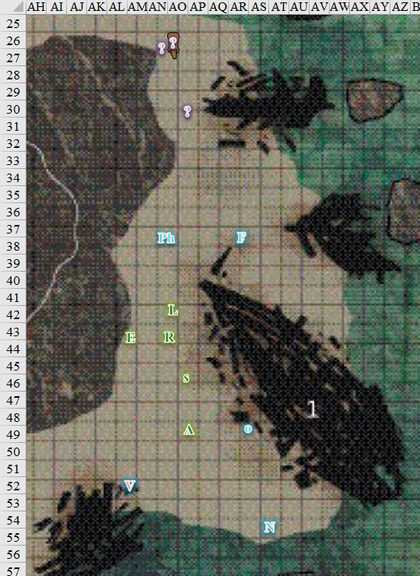

Round 3

Rook looked to their opponents next, and, summoning one of his most powerful spells, cast flame strike, centering it on the group facing them.
Save vs.  flame strike | Rank | Ability & Mod. | Misc. Mods. | Total | Dark Total | Roll | Check | Dark Check
Whisper, Reflex | 4 | Dex (+4) | 2 | 10 | 14 | 18 | 28 | 32
Success. Whisper saved for ½ damage.
Dmg: (½ x 58 fire) + (½ x 58 divine) = 29 fire + 29 divine = 58.
Dmg to horse: automatic death.
Dmg to quasit: automatic death.
Character | Save vs.  flame strike | Ranks | Roll | Save
Grim Gerome | Reflex | 7 | 4 | 11
Fail. Dmg: (½ x 48 fire) + (½ x 48 divine) = 24 fire + 24 divine = 48.

Lauren let Rook’s spell land, and then she quick cast dimension door, aiming for a spot behind and to the right of the horseman as the horse died and the shade battle sorcerer landed swiftly on his feet. When she stepped out of the door, she empowered her strikes, and released the stored vampiric touch spell in Arkenlyl (with the Truedeath crystal still in place) as she attacked the mounted spellcaster.
Melee Weapon | Dmg | D+ | TH+ | Crit | x | Type | Wt. | Atk | Roll | Check
Shattermantle Bloodstone Falchion +3 | 2d4 | +2 +3 + 3d4  Arcane Strike | 3 + 3  Arcane Strike | 18 | 2 | Slashing | 8.0 | +23 | 11 | 34
SB Falchion +3, 2nd Attack | 2d4 | +2 +3 + 3d4  Arcane Strike | 3 + 3  Arcane Strike | 18 | 2 | Slashing | - | +18 | 9 | 27
SB Falchion +3, 3rd Attack | 2d4 | +2 +3 + 3d4  Arcane Strike | 3 + 3  Arcane Strike | 18 | 2 | Slashing | - | +13 | 20 | 33
SB Falchion +3, 4th Attack | 2d4 | +2 +3 + 3d4  Arcane Strike | 3 + 3  Arcane Strike | 18 | 2 | Slashing | - | +8 | 4 | 12
Hit, hit, threat, miss. 1d20 = 4 + 13 = 17, not a critical hit.
Dmg: (6 + 2 + 3 + 9 Arcane Strike + 43 vampiric touch) + (3 + 2 + 3 + 7 Arcane Strike) + (5 + 2 + 3 + 5 Arcane Strike) = 20 + 15 + 15 + 43 vampiric = 93.
Lauren gained 43 vampiric hit points, moot.

The last swipe took Whisper’s head off, leaving Grim Gerome in disbelief over the swiftness of the kill.

Elaith followed her liege lady, quick cast dimension hop, which placed her at her target’s right and a bit uphill. She then cast swift fly, and attacked the small man directly from his right side with her two-handed greatsword. The blade had her Arcane Steel crystal in place, and she channeled shocking grasp through the weapon as she struck.
Melee Weapon | Dmg | D+ | TH+ | Critical | Type | Wt. | Atk | Roll | Check
Shattermantle Greatsword +2 | 2d6 | +4 +2 | 2 + 1 crystal | 19-20/x2 | Slashing | 8.0 | +21 | 18 | 39
Greatsword +2, 2nd Attack | 2d6 | +4 +2 | 2 + 1 crystal | 19-20/x2 | Slashing |  | +16 | 13 | 29
Greatsword +2, 3rd Attack | 2d6 | +4 +2 | 2 + 1 crystal | 19-20/x2 | Slashing |  | +11 | 9 | 20
Greatsword +2, haste | 2d6 | +4 +2 | 2 + 1 crystal | 19-20/x2 | Slashing |  | +21 | 9 | 30
Greater Crystal  of Arcane Steel | +1 to touch spells | 1 | +1 | - | - |  | - |  | -
Threat, hit, hit, hit. Dmg: (4 + 4 + 2 + 1 crystal + 11 shocking grasp) + (6 + 4 + 2 + 1 crystal) + (6 + 4 + 2 + 1 crystal) + (7 + 4 + 2 + 1 crystal) = 11 + 13 + 13 + 14 + 11 electric = 62.

And this took care of Grim Gerome once and for all, which was a good thing, since he was pretty hellbent on reducing the population of Waterdeep to zero.

The group was now facing Lady Asunder, who broke into a raging fit, and charge-attacked Lauren, blurting all manner of obscenities.
Character | Attack Type | Damage | BAB | Str Mod+ | W+ | Total Score | Roll | Total
Lady Asunder | Domineering Morningstar | 1d8+7+1 | 13 | 9 | 1 + 2 charge | 25 | 10 | 35
Hit. Dmg: 7 + 7 + 1 + 2 charge = 17 + Shaken.
Lauren incurred -2 penalty to attacks, saving throws, skill checks, and ability checks.

Seeing that it was time for action, Phrax and Farley ran northward with the intention of charge-attacking.

Octane, Vheren, and Naomi also ran northward, unable to do much to a single attacker embroiled in melee with Lauren.

Karmen had studied the intruders enough, and now let four stones fly down the hill towards Vheren.
Ranged Weapon | Dmg. | D+ | TH+ | Critical | Rng. | Wt. | Atk | Roll | Check | Notes
Deadly Precision Sling | 1d4+1 | 1 | 1 | x2 | 50’ | 0.0 | +18 | 7 | 25 | +4d6 Sudden Strike
Deadly Precision Sling, 2nd Attack | 1d4+1 | 1 | 1 | x2 | 50’ | - | +13 | 8 | 21 | +4d6 Sudden Strike
Deadly Precision Sling, 3rd Attack | 1d4+1 | 1 | 1 | x2 | 50’ | - | +8 | 19 | 27 | +4d6 Sudden Strike
Deadly Precision Sling, haste | 1d4+1 | 1 | 1 | x2 | 50’ | - | +18 | 17 | 35 | +4d6 Sudden Strike
Range and height mods cancel one another out.
Hit, hit, hit, hit. Dmg: (3 + 1 + 1 + 17 Sneak) + (3 + 1 + 1 + 7 Sneak) + (1 + 1 + 1 + 21 Sneak) + (2 + 1 + 1 + 11 Sneak) = 22 + 12 + 24 + 15 = 73.

And much like he’d done earlier this morning, Vheren hit the ground, probably dead.

Allisa called out to the group with her “Advance” and she moved forward 55’, right up against Phrax. Selena moved with Allisa, keeping the current form.

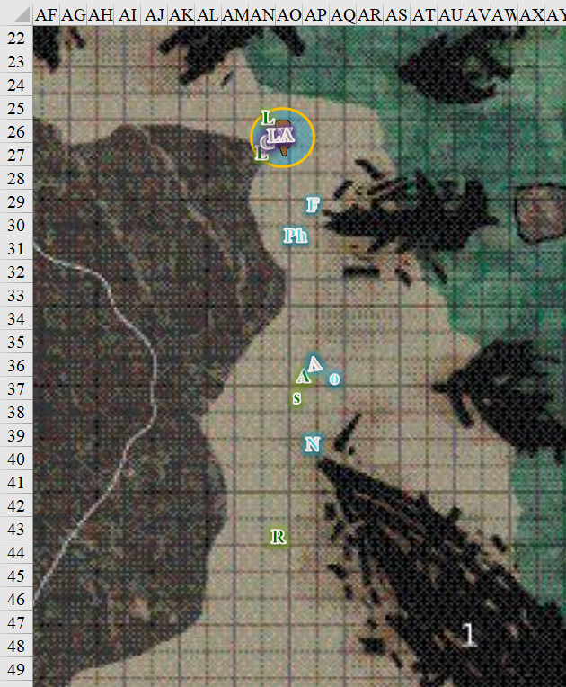

Round 4

Character | Group | Initiative | Roll | Modified Roll | Move
?? | 3 | 8 | 19 | 27 | 50’
Elaith | 1 | 4 | 19 | 23 | 30’
Lauren | 1 | 4 | 18 | 22 | 30’
Vheren | 1 | 3 | 17 | 20 | 30’
Allisa | 1 | 3 | 17 | 20 | 30’
Octane | 2 | 5 | 14 | 19 | 20’
?? | 3 | 3 | 15 | 18 | 30’
Rook | 1 | 0 | 18 | 18 | 20’
?? | 3 | 4 | 9 | 13 | 20’
Selena | 1 | 0 | 7 | 7 | 20’
Lady Asunder | 2 | 2 | 4 | 6 | 30’
Naomi | 2 | 2 | 3 | 5 | 30’
Farleigh | 2 | 1 | 4 | 5 | 30’
Phrax | 2 | 2 | 1 | 3 | 40’

As the Gambit and the Singularity cut down the Rumors, Karmen took a few potshots at Naomi.
Ranged Weapon | Dmg. | D+ | TH+ | Critical | Rng. | Wt. | Atk | Roll | Check | Notes
Deadly Precision Sling | 1d4+1 | 1 | 1 | x2 | 50’ | 0.0 | +18 | 17 | 35 | +4d6 Sudden Strike
Deadly Precision Sling, 2nd Attack | 1d4+1 | 1 | 1 | x2 | 50’ | - | +13 | 14 | 27 | +4d6 Sudden Strike
Deadly Precision Sling, 3rd Attack | 1d4+1 | 1 | 1 | x2 | 50’ | - | +8 | 14 | 22 | +4d6 Sudden Strike
Deadly Precision Sling, haste | 1d4+1 | 1 | 1 | x2 | 50’ | - | +18 | 4 | 22 | +4d6 Sudden Strike
Hit, hit, hit, hit. Dmg: (2 + 1 + 1 + 11 Sneak) + (2 + 1 + 1 + 10 Sneak) + (1 + 1 + 1 + 16 Sneak) + (4 + 1 + 1 + 13 Sneak) = 15 + 14 + 19 + 19 = 67.

Naomi went down as well.

Elaith had not noted Vheren’s fall, but did hear Naomi hitting the ground behind her. She tapped her Scout’s Headband twice, and then attacked Lady Asunder, channeling shocking grasp through her greatsword, and activating her Hellcat Gauntlets as she struck.
Melee Weapon | Dmg | D+ | TH+ | Critical | Type | Wt. | Atk | Roll | Check
Shattermantle Greatsword +2 | 2d6 | +4 +2 | 2 | 19-20/x2 | Slashing | 8.0 | +20 | 12 | 32
Greatsword +2, 2nd Attack | 2d6 | +4 +2 | 2 | 19-20/x2 | Slashing |  | +15 | 12 | 27
Greatsword +2, 3rd Attack | 2d6 | +4 +2 | 2 | 19-20/x2 | Slashing |  | +10 | 2 | 12
Greater Crystal of Arcane Steel | +1 to touch spells | 1 | +1 | - | - |  | - |  | -
Hit, hit, miss, miss. Dmg: (8 + 4 + 2 + 1 crystal + 21 shocking grasp) + (7 + 4 + 2 + 1 crystal) + (10 + 4 + 2 + 1 crystal) + (8 + 4 + 2 + 1 crystal) = 15 + 14 + 17 + 15 + 21 electric = 82.

Lauren again empowered her strikes [3], and channeled inflict serious wounds through Arkenlyl as she struck Lady Asunder.
Melee Weapon | Dmg | D+ | TH+ | Crit | x | Type | Wt. | Atk | Roll | Check
Shattermantle Bloodstone Falchion +3 | 2d4 | +2 +3 +3d4 AS | 3 + 3 AS | 18 | 2 | Slashing | 8.0 | +21 | 16 | 37
SB Falchion +3, 2nd Attack | 2d4 | +2 +3 +3d4 AS | 3 + 3 AS | 18 | 2 | Slashing | - | +16 | 11 | 27
SB Falchion +3, 3rd Attack | 2d4 | +2 +3 +3d4 AS | 3 + 3 AS | 18 | 2 | Slashing | - | +11 | 14 | 25
SB Falchion +3, 4th Attack | 2d4 | +2 +3 +3d4 AS | 3 + 3 AS | 18 | 2 | Slashing | - | +6 | 11 | 17
Hit, hit, miss, miss. Dmg: (6 + 2 + 3 + 7 AS + 18 ISW) + (3 + 2 + 3 + 10 AS) = 18 + 18 + 18 = 54.

Vheren bled out.

Allisa cast sunbeam [expired on Round 18], hurling the first of five beams upon Lady Asunder.
Character | Save vs.  sunbeam | Ranks | Roll | Save
Lady Asunder | Reflex | 8 | 13 | 21
Success. Blindness negates; saves for ½ damage.
Dmg: ½ x 14 = 7 fire (light).

Octane—seeing events unfolding much as they had in Elysium—had the true seeing ability active, and could see a human woman floating about 60’ above them. She pointed her out to Allisa and Selena, who were right next to Octane, and cast dispel magic upon Karmen Santiago.
Ranged Weapon | TH+ | Atk | Roll | Check
Dispel Magic | 4 | +14 | 11 | 25
Dispel Magic | 4 | +14 | 4 | 18
Air walk: Successfully suppressed for 1d4 rounds.
Greater invisibility: Not dispelled.

Karmen swiftly activated the feather fall ability resident in the heart of air spell effect, and made use of her persisting invisibility, now targeting Octane, whose sight could pierce through her arcane veil.

Looking a bit more disheveled than usual, Kaszüm had been observing and buffing all along, and had been communicating with Karmen and Azimuth via a Rary’s telepathic bond. The ultimate magus had bestowed upon himself heart of air, heart of earth, heart of fire, and heart of water, and now cast silence upon Allisa.
Save vs.  ?? | Rank | Ability & Mod. | Misc. Mods. | Total | Roll | Check
Allisa, Will | 10 | Wis (+4) | 0 | 14 | 15 | 29
Success. No effect.

Allisa felt a spell being cast on her, but could not identify it before shrugging off the magic.

“Octane, Selena, and Allisa, watch yourselves!” Rook cast true seeing [expired on Round 154] on himself, and pointed out any enemies he saw in a loud voice. He moved to keep up with Allisa.
Rook gained the true seeing ability.

Looking around, he could now see the woman he’d barely spotted back in the Abyss, now wearing a different outfit, feather falling towards the slope to his west.

A trio of waves crashed more emphatically than the rest before the more peaceful, subdued splash-and-break pattern was reprised.

Azimuth waited for his boss’ signal, then cast summon undead I [expired on Round 17], conjuring a zombie with a form resembling his own.

With his attention still on Karmen, the inquisitor also noted a naked, halfling-sized zombie bumbling down the grade towards them.

Naomi bled out.

Farleigh charge-attacked Lady Asunder, flanking the goliath woman.
Melee Weapon | Dmg | + Mod | TH+ | Critical | Type | Wt. | Atk | Roll | Check
Holy Heavy Flail +3 | 1d10 | + 2d6 good + 3 +5 | 2 + 2 | 19-20, x2 | Bludgeon | 10.0 | +9 | 18 | 27
Hit. Dmg: 2 + 12 Good + 3 + 5 + 2 charge = 12 + 12 Good = 24.

Phrax swift-cast rhino’s rush, then charge-attacked Lady Asunder, also flanking the enemy combatant.
Melee Weapon | Dmg | D+ | TH+ | Critical | Type | Wt. | Atk | Roll | Check | Properties
Adamantine Illuminating  Holy Greatsword +1 | 2d6+2 | +10 + 1 + 2 | 3 + 2 | 17-20/x2 | Slashing | 8.0 | +27 | 9 | 36 | ignores 20 hardness
Hit. Dmg: 2 Rhino’s Rush x (7 + 2 + 10 + 1 + 2 charge) = 2 x 22 = 44.

Lady Asunder fell to her knees.

Selena could not see the invisible woman. She noted the direction Rook was pointing, and laid out a mist bank with her borrowed wand. Enveloping herself and Allisa within the narrow bank, the seductress noted Octane moving out of their way.

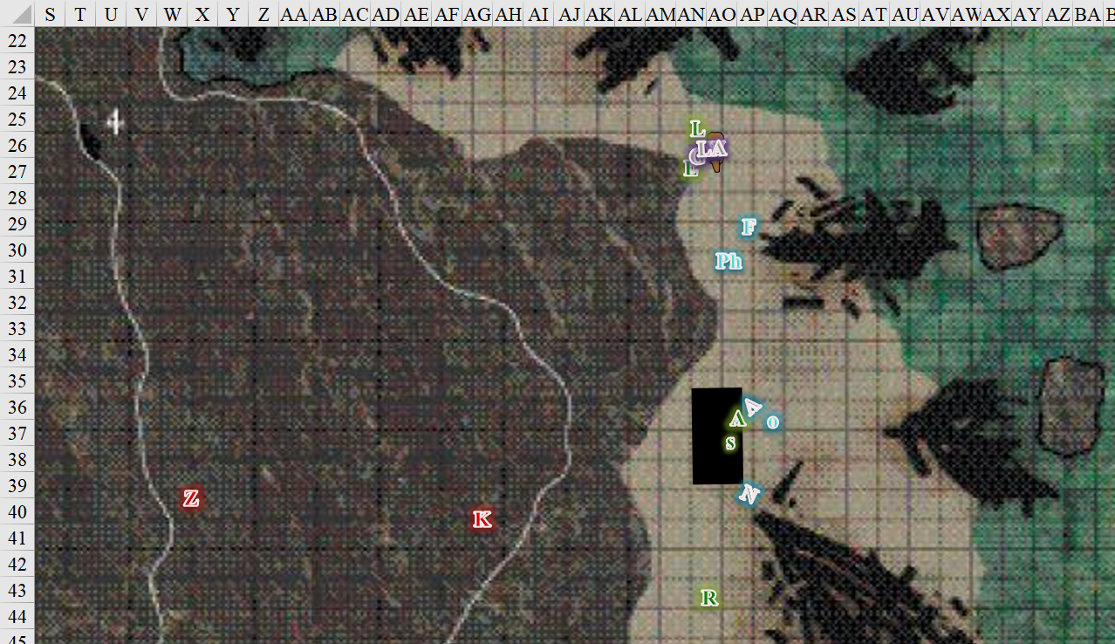

Round 5

Karmen activated a teleportation effect, and blinked out of sight.

The zombie slid and limped downward about 45’.

Allisa cast call of the twilight defender [expired on Round 20], summoning a twilight guardian dragon spell and sent it up the mountain to her left as she moved to her right.

The twilight defender took a 5’ step closer to the halfling-sized zombie, and gave it a good whack.
Character | Attack  Type | Damage | BAB | Str  Mod+ | Total  Score | Roll | Total
Twilight Guardian | Claw 1 | 1d6+7 | 6 | 6 | 12 | 13 | 25
Twilight Guardian | Claw 2 | 1d6+7 | 6 | 6 | 12 | 9 | 21
Twilight Guardian | Tail | 2d6+3+Poison | 6 | 1 | 7 | 8 | 15
Hit. Dmg: (2 + 7) + (6 + 7) + (10 + 3) = 9 + 13 + 13 = 35 + Poison [immune].

The zombie disappeared from sight, destroyed upon contact with the vegetable dragon’s raking claw.

Selena moved up to where the druid had stood, standing atop Vheren’s corpse.

Elaith looked at Lauren. “Let me lead, Milady.” She touched her headband for emphasis, and trotted back toward Allisa and Rook. She kept a sharp lookout for any invisible foes along the way, reaching the seductress’ obscuring mist rectangle.

Lauren walked around the dead horse and quasit, then followed 10’ behind Elaith, her sword ready.

Octane couldn’t see Karmen anymore, and chaotically and haphazardly decided to cast magic circle against law [expired on Round 1505], enveloping Allisa, Elaith, Lauren, and Selena in the sphere. “Just in case,” she shrugged.
Octane, Allisa, Elaith, Lauren, and Selena gained +2 vs. Lawful-aligned characters’ attacks and fear effects.

Kaszüm cast haste [expired on Round 24] from a scroll.
Kaszüm, Azimuth, and Freyja gained +1 to BAB, AC, and Reflex saves, plus 30’ of movement or an extra attack.

Rook walked toward Allisa, and looked around for any other threats, including toward the noise he’d heard from seaward.

Azimuth cast bear’s endurance upon himself.
Azimuth gained +4 Con and +30 hps.

Farleigh and Phrax also joined the others, but the paladin steered clear of the magic circle against law.
Any character inside the circle (which moves with Octane) is protected against law.

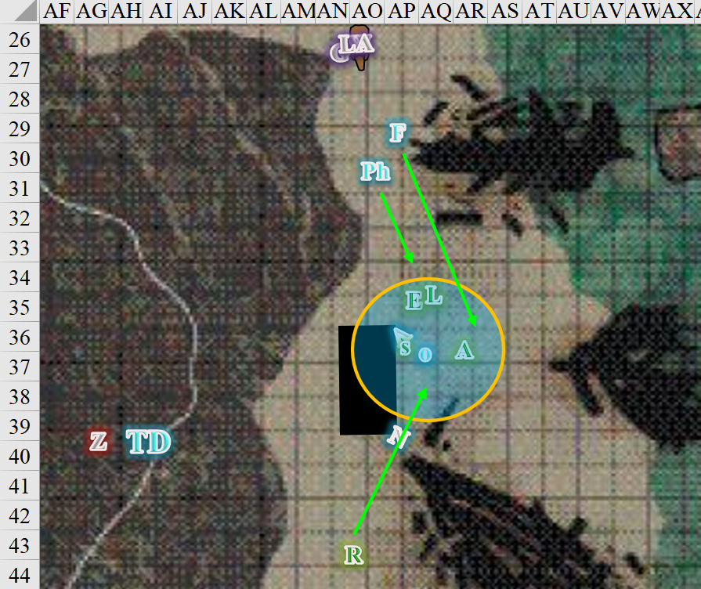

Round 6

Allisa had seen the zombie out of the corner of her eye but know the dragon would take care of it. She was still focused on Lauren as the woman grabbed at her stomach. “Where is that wand of resurrection? Let us revive those that are fallen,” said Allisa. She let the dragon continue to do guard duty.

Farleigh and Phrax kept their eyes peeled.

Octane cast cat’s grace [expired on Round 156] upon herself.
Octane gained +4 to Dex.

Azimuth cast his last summon monster I [expired on Round 19] spell, placing this zombie further south than the first one.

A zombie appeared about 40’ southwest of the twilight guardian, and started stumbling down the hill.

The twilight guardian attacked the zombie.
Character | Attack Type | Damage | BAB | Str Mod+ | Other+ | Total Score | Roll | Total
Twilight Guardian | Claw 1 | 1d6+7 | 6 | 6 | 2 charge | 14 | 16 | 30
Hit. Dmg: 5 + 7 = 12.

The second summoned zombie also dematerialized after a single swipe from the dragon-plant.

Kaszüm cast cruel disappointment upon Lauren.

Lauren suddenly felt an acute stomachache, and a sinking sense of despair and disappointment. She inadvertently placed her hand on her abdomen.

Karmen—still in communication with Azimuth and Kaszüm via Rary’s telepathic link—spotted this visual cue, and attacked Farleigh—the most accessible target—with her sling from the rock atop which she was perched.
Ranged Weapon | Dmg. | D+ | TH+ | Critical | Rng. | Wt. | Atk | Roll | Check | Notes
Deadly Precision Sling | 1d4+1 | 1 | 1 | x2 | 50’ | 0.0 | +18 | 7 | 25 | +4d6 Sudden Strike
Deadly Precision Sling, 2nd Attack | 1d4+1 | 1 | 1 | x2 | 50’ | - | +13 | 17 | 30 | +4d6 Sudden Strike
Deadly Precision Sling, 3rd Attack | 1d4+1 | 1 | 1 | x2 | 50’ | - | +8 | 16 | 24 | +4d6 Sudden Strike
Deadly Precision Sling,  bracers of blinding strike | 1d4+1 | 1 | 1 | x2 | 50’ | - | +18 | 5 | 23 | +4d6 Sudden Strike
Hit, hit, hit, hit. Dmg: (1 + 1 + 1 + 15 Sneak) + (2 + 1 + 1 + 13 Sneak) + (4 + 1 + 1 + 16 Sneak) + (1 + 1 + 1 + 18 Sneak) = 18 + 17 + 22 + 21 = 78.

Farleigh fell to the sandy ground face down.

Perching atop a rock to their east, Karmen’s silhouette was evident as a wave crashed behind her and white surf and foam reflected the moonlight.

Rook summoned a celestial hippogriff [expired on Round 21] and sent it after Karmen.

A celestial hippogriff materialized along the splashing surf, and flew towards Karmen, charge-attacking her.
Character | Attack Type | Damage | BAB | Str Mod+ | Other+ | Total Score | Roll | Total
Hippogriff | Bite | 1d8+2 | 3 | -2 | 2 charge | 3 | 1 | 4
Miss.

Elaith hesitated while Allisa healed her, and then she cast swift fly and attacked Karmen, channeling shocking grasp through her greatsword, and activating her Hellcat Gauntlets as she struck.
Melee Weapon | Dmg | D+ | TH+ | Critical | Type | Wt. | Atk | Roll | Check
Shattermantle  Greatsword +2 | 2d6 | +4 +2  + 2 charge | 2 + 2 charge | 19-20/x2 | Slashing | 8.0 | +20 | 10 | 30
Hit. Dmg: 6 + 4 + 2 + 2 + 14 electric + 6 slashing (Gauntlets) = 20 + 14 electric = 34.

“You will be the next to perish by my hand, bitch!” Karmen spoke directly to Elaith before doing her best to end her life.
Ranged Weapon | Dmg. | D+ | TH+ | Critical | Rng. | Wt. | Atk | Roll | Check
Deadly Precision Sling | 1d4+1 | 1 | 1+1 within 30’ | x2 | 50’ | 0.0 | +19 | 12 | 31
Sling, 2nd Attack | 1d4+1 | 1 | 1+1 within 30’ | x2 | 50’ | - | +14 | 3 | 17
Sling, 3rd Attack | 1d4+1 | 1 | 1+1 within 30’ | x2 | 50’ | - | +9 | 14 | 23
Sling, haste | 1d4+1 | 1 | 1+1 within 30’ | x2 | 50’ | - | +19 | 4 | 23
Miss, miss, miss, miss.

Elaith’s shield of faith protected Elaith from the truest of the shots, while the others bounced off of her armor.

Allisa made her way towards the coast in order to cast cure critical wounds on Lauren. Lauren read this in her lover’s body language, and shouted that Elaith needed the healing first. Allisa could heal neither woman, and so she remained near the foam at the shoreline.
Lauren gained 17 + 17 = 34 hps [152/152]; no effect; Lauren was already at full hps.

Lauren followed suit, casting swift fly and channeled shocking grasp though her falchion as she came in from Karmen’s other side.
Melee Weapon | Dmg | D+ | TH+ | Crit | x | Type | Wt. | Atk | Roll | Check
Shattermantle Bloodstone  Falchion +3 | 2d4 | +2 +3  + 2 charge | 3 + 2 charge | 18 | 2 | Slashing | 8.0 | +18 | 11 | 29
Hit. Dmg: 8 + 2 + 3 + 2 charge + 18 electric = 15 + 18 electric = 33.
Interaction Save vs.  cruel disappointment | Rank | Ability & Mod. | Misc. Mods. | Total | Roll | Check | Properties
Lauren, Will | 10 | Wis (+3) | 3 | 16 | 2 | 16 | +2 vs. all spells  -2 Negative Levels  -2 Shaken
Fail.

It wasn’t a particularly death-dealing blow to Lauren’s arch-enemy, but the duskblade felt extremely confident in her delivery.

Selena moved to stand in front of Allisa and the enemy. She called out to Rook, pointing in the direction of the new threat. Paying no mind to how it worked, she randomly activated the cube.
1d6 = 2, cube manifests forcefield barring nonliving matter; 2 charges expended.

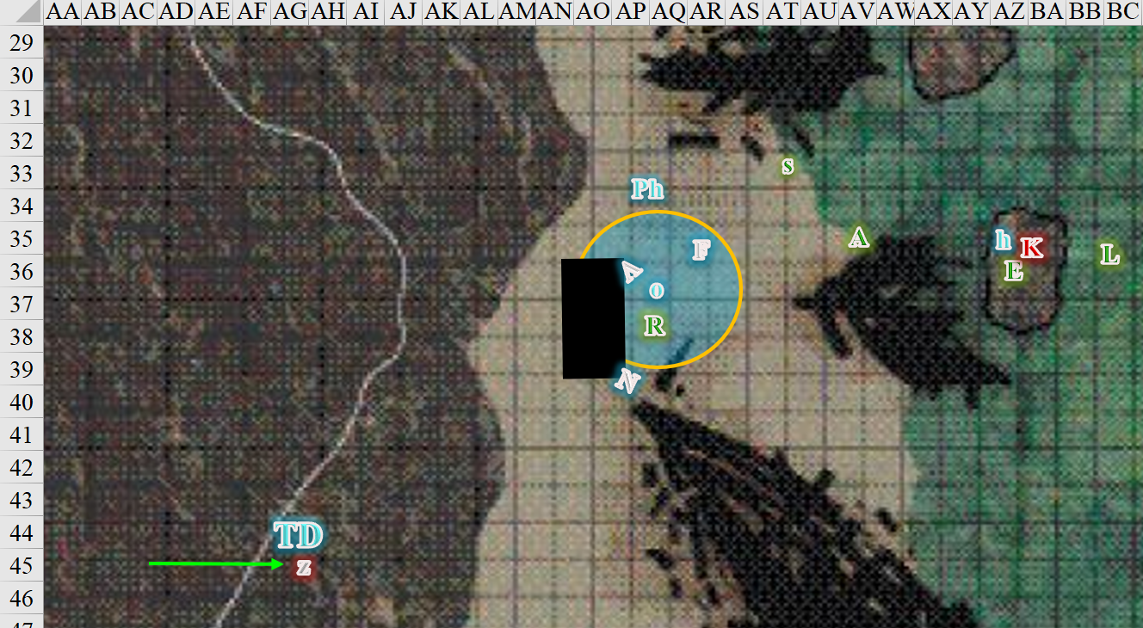

Round 7

As Lauren’s fly spell began to expire, the woman who’d inadvertently overshot her mark now floated slowly downward towards the shallow waves behind the rock so that she could see none of her allies. Lauren then came to a dismal realization: she’d imagined the moment when she’d hit Karmen, and her memory was now beginning to permeate through an illusory figment of events in her mind.
Skill | Rank | Ability  & Mod. | Misc.  Mods. | Total | Roll | Check
Knowledge: Arcana | 5 | Int (+3) | 0 | 8 | 14 – 19 | 23
Spellcraft | 8 | Int (+3) | 0 | 11 | 20 | 31
See below.

Lauren squinted with disgust; she suspected she’d just been the subject of an illusory spell called cruel disappointment, and such it was.

Elaith fell onto the rock, and was careful not to fall as the hippogriff continued to attack Karmen.
Character | Attack Type | Damage | BAB | Str  Mod+ | Dex  Mod+ | Total Score | Roll | Total
Hippogriff | Bite | 1d8+2 | 3 | -2 | 3 | 1 | 15 | 16
Miss.

Octane moved northeast around the obscuring mist so she could see both fronts a bit better, and pointed out a figure moving at the summit of the lone, jutting rock to their east that comprised nearly the whole island. The robed person—who looked to be about Octane’s height—was likely casting a spell.

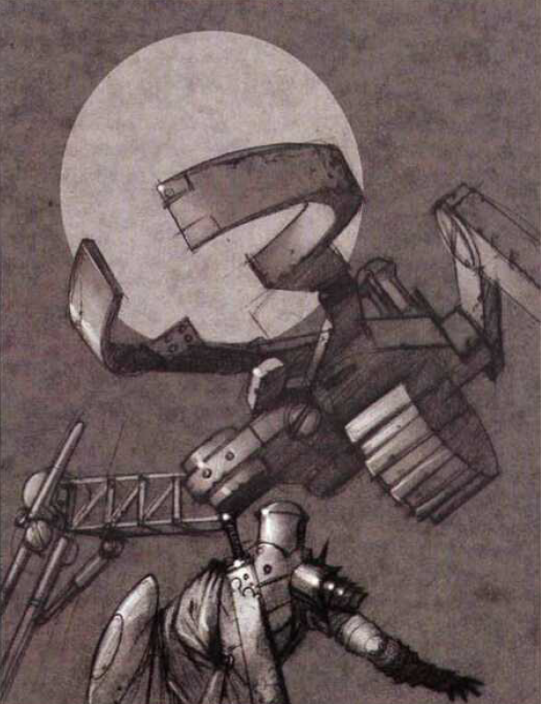

Suddenly, there appeared a 12’-tall contraption behind Phrax, and it immediately full-flank-attacked his ass.
Character | Attack Type | Damage | BAB | Str Mod+ | Other+ | Total Score | Roll | Total
Greater Fantastic Machine | Slam | 1d8+4 | 3 | 3 | 2 flank | 8 | 6 | 14
Miss.

The twilight guardian spotted and made its way over to attack the greater fantastic machine, poised to charge-attack it in a few seconds.

Octane cast spiritual weapon [expired on Round 22], conjuring an obsidian dagger that materialized and flew towards the minute spellcaster atop the minute mountain.
Ranged Weapon | Dmg. | D+ | TH+ | Critical | Rng. | Wt. | Atk | Roll | Check
Spiritual Weapon, Dagger | 1d4 | 3 | 0 | 19-20, x2 | varies | 0.0 | +17 | 2 | 19
Miss.

The dagger—like Lauren—overshot its mark, and had to turn back around for the next swipe. It was momentarily behind the summit, and so none of the heroes could see it against the night sky anymore. “Drat!” Octane cursed.

Phrax turned around and beheld the golem-like contraption. “Fight fire with fire,” the silver dragonborn paladin pursed his reptilian lips and let the wizard’s toy have it, swiping three times at its most vulnerable-seeming parts with his adamantine sword, which was made specifically to deal with adamantine constructs like this one.
Melee Weapon | Dmg | D+ | TH+ | Critical | Type | Atk | Roll | Check | Properties
Adamantine Illuminating  Holy Greatsword +1 | 2d6+2 | +10 + 1 | 3 – 3 Power | 17-20/x2 | Slashing | +22 | 12 | 34 | ignores 20 hardness
Greatsword, 2nd Attack | 2d6+2 | +10 + 1 | 3 – 3 Power | 17-20/x2 | Slashing | +17 | 16 | 33 | ignores 20 hardness
Greatsword, 3rd Attack | 2d6+2 | +10 + 1 | 3 – 3 Power | 17-20/x2 | Slashing | +12 | 14 | 26 | ignores 20 hardness
Hit, hit, hit. Dmg: (11 + 10 + 1 + 6 PA) + (5 + 10 + 1 + 6 PA) + (9 + 10 + 1 + 6 PA) = 28 + 22 + 17 = 67.

“Get’im!” Octane cheered her friend as he very nearly destroyed the fantastic machine.

The hippogriff attacked Karmen.
Character | Attack Type | Damage | BAB | Str Mod+ | Total Score | Roll | Total | Threat
Hippogriff | Claw 1 | 1d4+4 | 3 | 3 | 6 | 20 | 26 | þ
Hippogriff | Claw 2 | 1d4+4 | 3 | 3 | 6 | 19 | 25 | ý
Hippogriff | Bite | 1d8+2 | 3 | -2 | 1 | 8 | 9 | ý
Threat, hit, miss. 1d20 = 4 + 6 = 10, not a critical hit. Dmg: (3 + 4) + (2 + 4) = 7 + 6 = 13.

Acting in concert, Eaith and Lauren both cast swift fly, and channeled shocking grasp through their weapons to full attack Karmen.
Melee Weapon | Dmg | D+ | TH+ | Critical | Type | Wt. | Atk | Roll | Check | Properties
Shattermantle Greatsword +2 | 2d6 | +4 +2 | 2 | 19-20/x2 | Slashing | 8.0 | +20 | 17 | 37 | +1 to spell DC
Greatsword +2, 2nd Attack | 2d6 | +4 +2 | 2 | 19-20/x2 | Slashing | - | +15 | 17 | 32 | +1 to spell DC
Greatsword +2, 3rd Attack | 2d6 | +4 +2 | 2 | 19-20/x2 | Slashing | - | +10 | 16 | 26 | +1 to spell DC
Greater Crystal of Arcane Steel | +1 to touch spells | 1 | +1 | - | - | - | - | - | - | +1 to spell DC
Melee Weapon | Dmg | D+ | TH+ | Crit | x | Type | Wt. | Atk | Roll | Check
Shattermantle Bloodstone Falchion +3 | 2d4 | +2 +3 | 3 | 18 | 2 | Slashing | 8.0 | +18 | 20 | 38
SB Falchion +3, 2nd Attack | 2d4 | +2 +3 | 3 | 18 | 2 | Slashing | - | +13 | 8 | 21
SB Falchion +3, 3rd Attack | 2d4 | +2 +3 | 3 | 18 | 2 | Slashing | - | +8 | 3 | 11
SB Falchion +3, 4th Attack | 2d4 | +2 +3 | 3 | 18 | 2 | Slashing | - | +3 | 18 | 21
Elaith: Hit, hit, hit. Dmg: (3 + 4 + 2 + 17 electric) + (7 + 4 + 2) + (8 + 4 + 2) = 9 + 13 + 14 + 17 electric = 53.
Lauren: Hit, hit, miss, hit. Dmg: (6 + 2 + 3 + 15 electric) + (8 + 2 + 3) + (5 + 2 + 3) = 11 + 13 + 10 + 15 electric = 49.

Karmen died and fell into the surf.

Selena did nothing for the moment.

Rook took the opportunity to cast spiritual guardian, and moved toward Allisa, careful to avoid Octane’s spell against Lawful creatures.

The sound of hoofbeats began in the distance and drew swiftly nearer. As though leaping down from an invisible charger, a translucent knight, clad head to toe in heavy plate, appeared at their side. The holy symbol of Red Knight was emblazoned across her tabard and shield, and she wasted no time in cutting down the construct before her.
Melee Weapon | Dmg | D+ | TH+ | Critical | Type | Wt. | Atk | Roll | Check
Spiritual Guardian | 2d6 | 3 | 2 flank | 19-20, x2 | Slashing | - | +16 | 6 | 22
Hit. Dmg: 5 + 3 = 8.

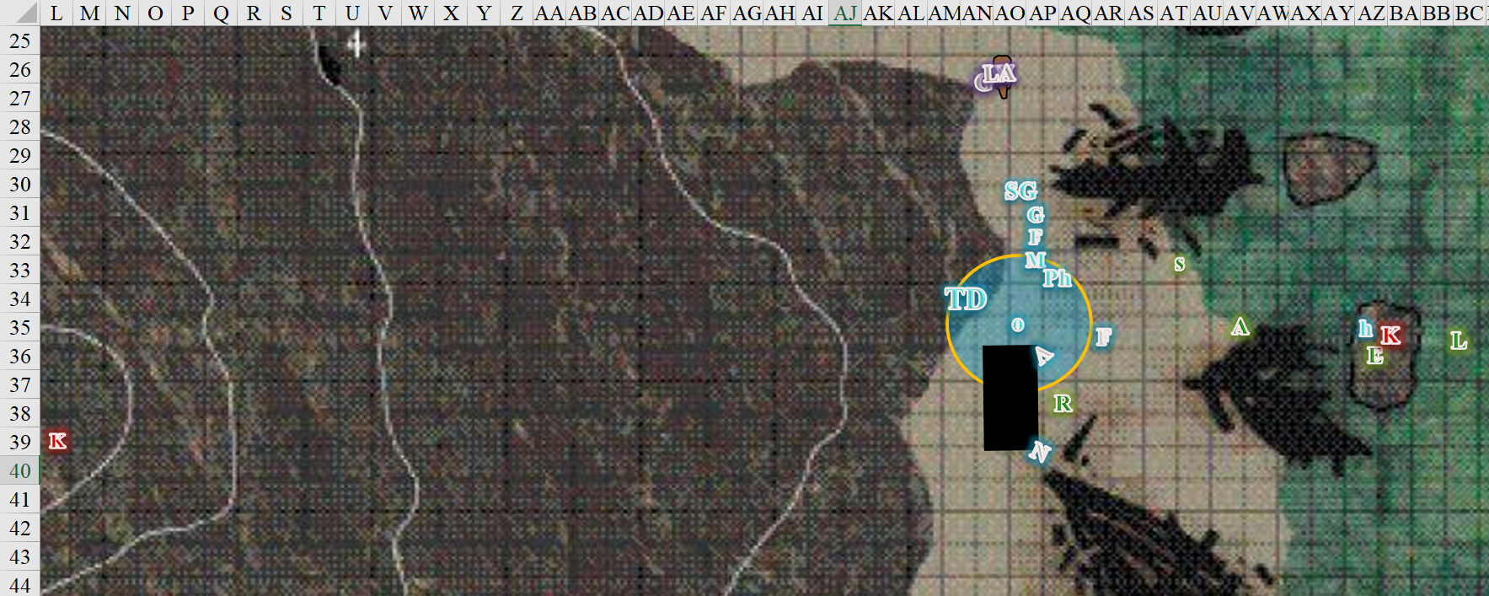

Round 8

Azimuth cast hold person [expired on Round 19] upon Octane.
Save vs.  hold person | Rank | Ability & Mod. | Misc. Mods. | Total | Roll | Check
Octane, Will | 9 | Wis (+3) | 0 | 12 | 19 | 31
Success. Effect negated.

Although Octane had been the subject of a long-term hold person spell in Elysium less than an hour ago, she was able to shrug off a single, standard casting of it by an unseen assailant.

Octane noted her dagger attacking Kaszüm once again.
Ranged Weapon | Dmg. | D+ | TH+ | Critical | Rng. | Wt. | Atk | Roll | Check
Spiritual Weapon, Dagger | 1d4 | 3 | 0 | 19-20, x2 | varies | 0.0 | +17 | 18 | 35
Hit. Dmg: 4 + 3 = 7.

The halfling rogue-cleric could do next to nothing to the strange golem, so she cast divine favor [expired on Round 16] upon herself.
Octane gained +3 to attacks and weapon damage.

Phrax did his best to lay out the construct.
Melee Weapon | Dmg | D+ | TH+ | Critical | Type | Wt. | Atk | Roll | Check | Properties
Adamantine Illuminating  Holy Greatsword +1 | 2d6+2 | +10 + 1 | 3 | 17-20/x2 | Slashing | 8.0 | +25 | 6 | 31 | ignores 20 hardness
2nd Attack | 2d6+2 | +10 + 1 | 3 | 17-20/x2 | Slashing |  | +20 | 17 | 37 | ignores 20 hardness
3rd Attack | 2d6+2 | +10 + 1 | 3 | 17-20/x2 | Slashing |  | +15 | 3 | 18 | ignores 20 hardness
Hit, hit, miss. Dmg: (6 + 10 + 1) + (9 + 10 + 1) = 17 + 20 = 37.

The greater fantastic machine busted into several parts that dematerialized before they even hit the ground.

Kaszüm thought to flee, but instead decided on pitting the heroes against one another. He cast friend to foe on the epicenter of where the beachbound fools were.
All PCs and friendlies on the beach roll Save.
Save vs.  friend to foe | Rank | Ability & Mod. | Misc. Mods. | Total | Roll | Check
Allisa, Will | 10 | Wis (+4) | 0 | 14 | 7 | 21
Octane, Will | 9 | Wis (+3) | 0 | 12 | 2 | 14
Rook, Will | 14 | Wis (+3) | 1 | 18 | 3 | 21
Selena, Will | 7 | Wis (+0) | 0 | 7 | 8 | 15
Phrax, Will | 7 | Wis (+3) | 6 | 16 | 8 | 24
Success, fail, success, fail, success.
Character | Save vs.  friend to foe | Ranks | Roll | Save
Twilight Guardian | Will | 1 | 13 | 14
Spiritual Guardian | Will | 8 | 9 | 17
Fail, fail.

Octane and Selena now looked at those around them with contempt, as did the twilight guardian and spiritual guardian.

“Keen!” Selena activated her Dagger of Circumcision’s special ability and charge-attacked Allisa.
Melee Weapon | Dmg | D+ | TH+ | Critical | Type | Wt. | Atk | Roll | Check | Notes
Dagger of  Circumcision +2 | 1d4+2 | 2 | 2 + 2 charge | 19-20, x2 | Prcg/Slsh | 1.0 | +12 | 2 | 14 | Sneak Attack
Dagger,  2nd Attack | 1d4+2 | 2 | 2 + 2 charge | 19-20, x2 | Prcg/Slsh | - | +7 | 11 | 18 | Sneak Attack
Scabbard of  Keen Edges | - | - | - | 17-20, x2 | Slashing |  | - | - | -
Crystal of  Acid Assault, Greater | +1d6 acid | - | - | - | - | - | - | - | - | +1 to AC for 1 Round
Miss, miss.

Next to the hippogriff, Elaith and Lauren now stood upon the rock that jutted upward from the choppy coast.

Elaith cast swift fly and then fire shield [expired on Round 22] as she moved to physically place herself between Allisa and Selena. She kept her sword ready, but she would only use the flat of it to defend herself and Allisa from the addled Selena, who were already touching.

Lauren’s countenance hardened as she spotted Kaszüm standing atop the ridge to the west. Seeing that Elaith and Rook were moving to help Allisa, she resolved to end this fiasco there and then. Summoning her abilities, she cast swift fly, and then quick-cast dimension door, placing herself off the bastard’s left side. The duskblade used some of her arcane energy and empowered (Level 3) her sword, and channeled vampiric touch though it as she struck her quarry with all the power she could muster.
Melee Weapon | Dmg | D+ | TH+ | Crit | x | Type | Wt. | Atk | Roll | Check
Shattermantle Bloodstone  Falchion +3 | 2d4 | +2 +3 | 3 | 18 | 2 | Slashing | 8.0 | +18 | 4 | 22
SB Falchion +3, 2nd Attack | 2d4 | +2 +3 | 3 | 18 | 2 | Slashing | - | +13 | 14 | 27
SB Falchion +3, 3rd Attack | 2d4 | +2 +3 | 3 | 18 | 2 | Slashing | - | +8 | 19 | 27
SB Falchion +3, 4th Attack | 2d4 | +2 +3 | 3 | 18 | 2 | Slashing | - | +3 | 5 | 8
Miss, hit, hit, miss. Dmg: (3 + 2 + 3 + 26 vampiric) + (5 + 2 + 3) = 8 + 10 + 26 vampiric = 44.
Lauren gained 26 hps [152/152].

“You’ll never get out of here alive!” Kaszüm tried to demoralize Lauren a bit.

Freyja—a skeletal timber wolf—full-flank-attacked Lauren.
1d100 = 58. Concealment bypassed.
Character | Attack Type | Damage | BAB | Str Mod+ | Total Score | Roll | Total
Freyja | Bite | 1d6+1+1d6 cold | 6 | 9 + 2 flank | 17 | 16 | 33
Hit. Dmg: 3 + 1 + 4 cold = 8 [144/152].

Rook cast greater dispel magic against Kaszüm’s friend to foe spell, aiming to release Octane and Selena from it.
Ranged Weapon | TH+ | Atk | Roll | Check
Dispel Magic | 4 | +18 | 16 | 34
Success.

The friend to foe spell effect dissipated, and friends were back to being friends.

The hippogriff rested firmly atop the rock, flexing its wings.

The spiritual guardian was about to try to kill Phrax, but then put down her sword and made a hand gesture of apology to the noble silver dragonborn paladin.

Allisa caught herself before dismissing the dragon and now changed it to a command for the dragon to attack the only enemy on the hill that she could see.

Selena moved to stand in front of Allisa.

The twilight guardian did not yet reach Kaszüm, but was in a position to navigate the last uphill portion in the next few seconds.

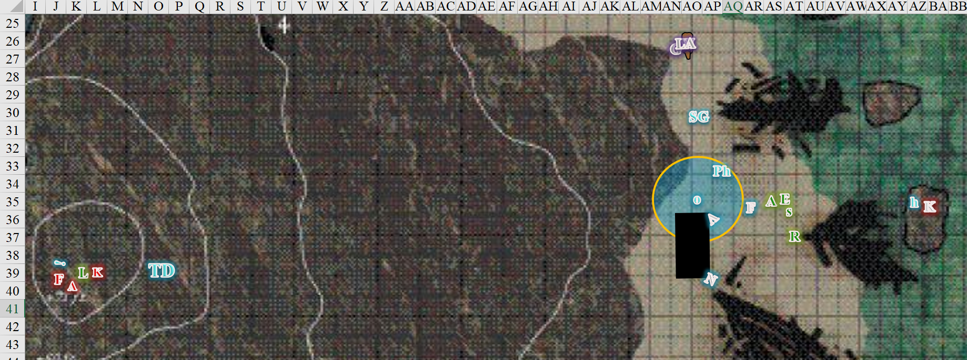

Round 9

“Hmmm, mmhhwaa haaaa! You suck!” Kaszüm said as he teleported somewhere before Octane could cast dimensional anchor on him.

Freyja full-attacked Lauren.
1d100 = 06. Concealment not bypassed.

Azimuth cast ray of exhaustion [expired on Round 119] on Lauren.
1d100 = 31. Concealment not bypassed.

Octane’s spiritual dagger attacked Freyja.
Ranged Weapon | Dmg. | D+ | TH+ | Critical | Rng. | Wt. | Atk | Roll | Check
Spiritual Weapon, Dagger | 1d4 | 3 | 0 | 19-20, x2 | varies | 0.0 | +20 | 16 | 36
Hit. Dmg: .

Phrax, Octane, Rook, Elaith, and the others continued to look for any other enemies along the beach as Lauren faced Freyja and Azimuth atop the jutting peak to the west. She activated her blacklight [expired on Round 23] ability and full-attacked Azimuth, channeling Shocking Grasp and using her Arcane Strike (+3).
Melee Weapon | Dmg | D+ | TH+ | Crit | x | Type | Wt. | Atk | Roll | Check
Shattermantle Bloodstone Falchion +3 | 2d4 | +2 +3 + 3d4  Arcane Strike | 3 + 3  Arcane Strike | 18 | 2 | Slashing | 8.0 | +21 | 2 | 23
SB Falchion +3, 2nd Attack | 2d4 | +2 +3 + 3d4  Arcane Strike | 3 + 3  Arcane Strike | 18 | 2 | Slashing | - | +16 | 4 | 20
SB Falchion +3, 3rd Attack | 2d4 | +2 +3 + 3d4  Arcane Strike | 3 + 3  Arcane Strike | 18 | 2 | Slashing | - | +11 | 12 | 23
SB Falchion +3, 4th Attack | 2d4 | +2 +3 + 3d4  Arcane Strike | 3 + 3  Arcane Strike | 18 | 2 | Slashing | - | +6 | 20 | 26
Greater Truedeath Crystal | 1d6 | vs. | undead | - | - | - | - | - | - | -
Hit, miss, hit, hit. Dmg: (5 + 2 + 3 + 16 electric + 5 AS) + (3 + 2 + 3 + 7 AS) + (4 + 2 + 3 + 8 AS) = 15 + 15 + 17 + 16 electric = 63.

Rook sent the hippogriff to help Lauren, and he looked to see where the other enemy might have taken himself. The hippogriff flew towards the blacklight effect.

Rook’s spiritual guardian returned to his side.

Elaith ran toward Lauren, wanting to save her remaining spells for combat.

The twilight defender reached the melee, but could not see within the blacklight effect.

Phrax started to make his way up the hill.

Allisa and Selena hesitated.

Octane and Phrax each seemed to all into portals that formed instantly at their feet. The rest of the heroes felt a tug at their psyches, but they all resisted the downward pull that had dragged down the rogue-cleric and paladin. Octane’s dagger dematerialized along with her and her anti-law bubble.

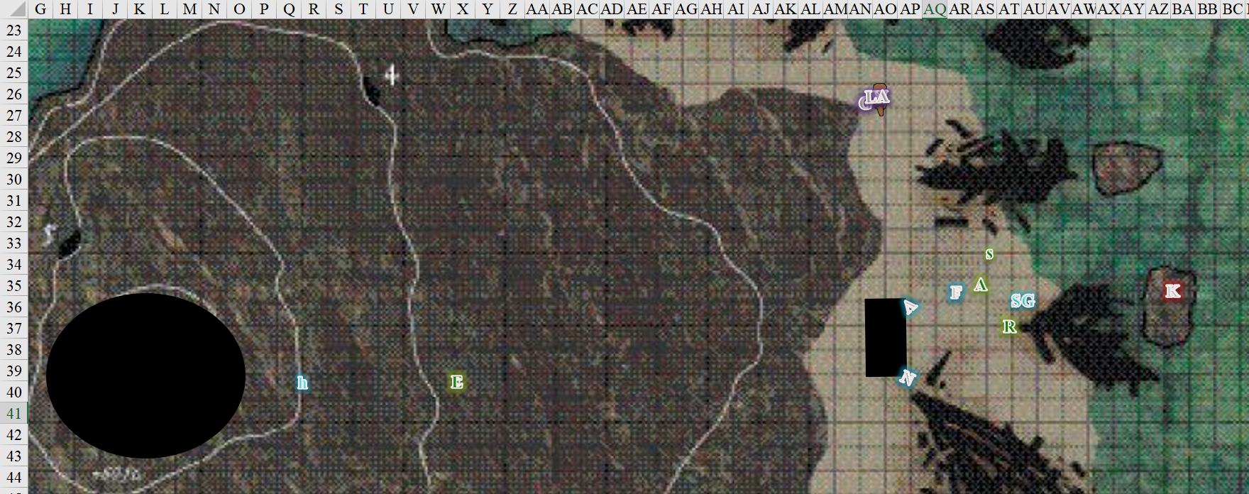

Round 10

Nearly dead, Azimuth cast dimension door, leaving Freyja to fend for herself.

Knowing that she needed to expend no mana to embolden her strikes, Lauren finished off Freyja with minimal effort.
Melee Weapon | Dmg | D+ | TH+ | Crit | x | Type | Wt. | Atk | Roll | Check
Shattermantle Bloodstone Falchion +3 | 2d4 | +2 +3 | 3 | 18 | 2 | Slashing | 8.0 | +18 | 14 | 32
SB Falchion +3, 2nd Attack | 2d4 | +2 +3 | 3 | 18 | 2 | Slashing | - | +13 | 18 | 31
SB Falchion +3, 3rd Attack | 2d4 | +2 +3 | 3 | 18 | 2 | Slashing | - | +8 | 6 | 14
SB Falchion +3, 4th Attack | 2d4 | +2 +3 | 3 | 18 | 2 | Slashing | - | +3 | 15 | 28
Greater Truedeath Crystal | 1d6 | vs. | undead | - | - | - | - | - | - | -
Hit, hit, miss, hit. Dmg: (7 + 2 + 3 + 6 TD) + (5 + 2 + 3 + 1 TD) + (6 + 2 + 3 + 4 TD) = 12 + 10 + 11 + 11 TD = 44.

The skeletal mount crumbled into a pile of now mundane bones.

A disembodied bout of laughter echoed across the island, comingling with the crashing of the waves, and suddenly the remaining heroes were in a completely different place. The scent of brimstone stung Allisa’s and Lauren’s nostrils as their eyes adjusted to the light, and their bodies to the toasty but tolerable temperature. They were standing above what appeared to be a pool of lava, and their feet were firmly planted on what must have been a wall of force. They saw a few wisps of yellow-white vapor drifting toward them from a lateral breach in the igneous rock that otherwise surrounded them. Rook also could see beyond an open door, and noted a display of weapons adoring a wall against which rested a wooden chest.

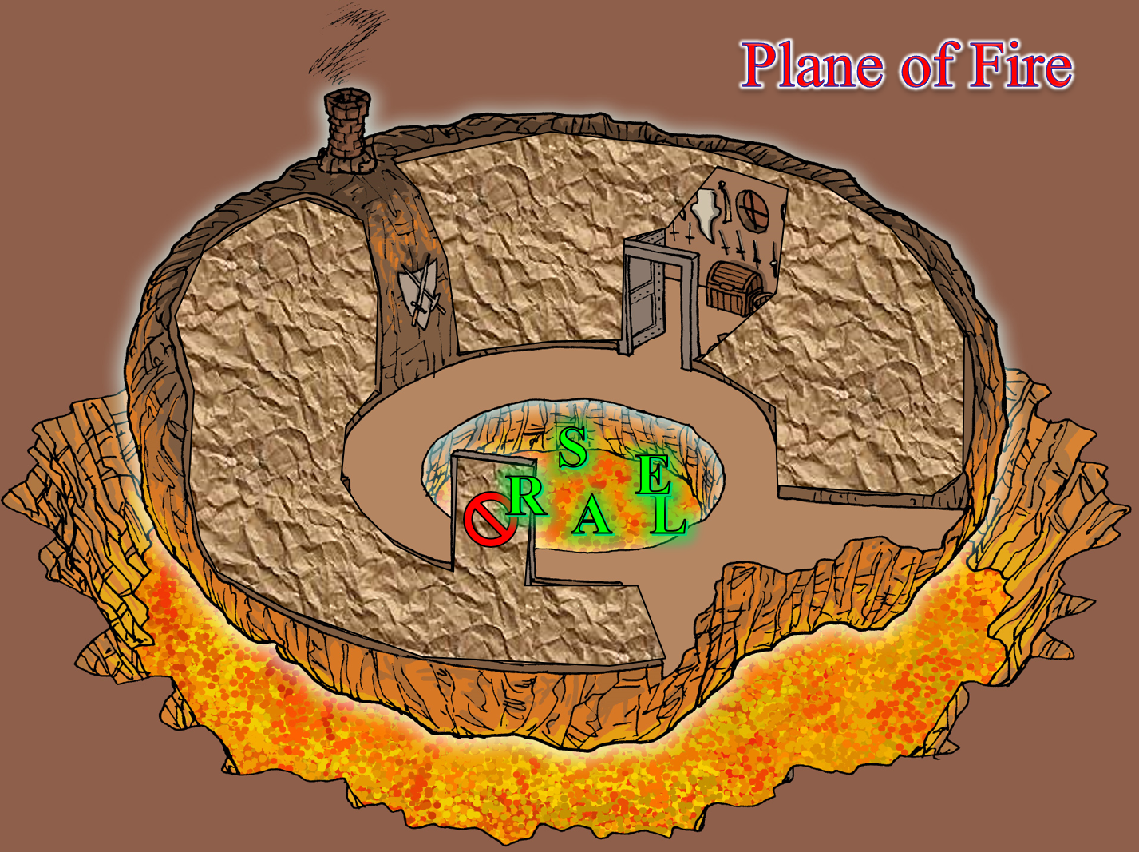

Round 11

Taking in everyone’s condition, Allisa said, “We should secure this room and take care of the wounded and rest, for most of us our spells are depleted.” She then cast cure critical wounds on Lauren, but since she’d already cast cure critical wounds today, her mana manifested her remaining cure moderate wounds spell instead.
Lauren gained 9 + 10 = 19 hps [152/152], which like the last attempt, had no effect, since she was unharmed.

The mistress of many forms then tallied her remaining spells.
Prepared Spells
Spell | Level | DC | Cast?
Create Water | 0 | 14 | q
Cure Minor Wounds | 0 | 14 | q
Detect Magic | 0 | 14 | q
Guidance | 0 | 14 | q
Light | 0 | 14 | q
Mending | 0 | 14 | q
Cure Light Wounds | 1 | 15 | q
Entangle | 1 | 15 | q
Flame Blade | 1 | 15 | q
Produce Flame | 1 | 15 | q
Cure Light Wounds | 1 | 15 | q
Summon Nature’s Ally I | 1 | 15 | q
Barkskin | 2 | 16 | þ
Bear’s Endurance | 2 | 16 | q
Earthbind | 2 | 16 | q
 | 2 | 16 | q
Fog Cloud | 2 | 16 | q
Restoration, Lesser | 2 | 16 | q
Call Lightning | 3 | 17 | þ
Cure Moderate Wounds | 3 | 17 | þ
Cure Moderate Wounds | 3 | 17 | þ
Resist Energy, Mass | 3 | 17 | q
Summon Nature’s Ally III | 3 | 17 | q
Flame Strike | 4 | 18 | þ
Flame Strike | 4 | 18 | þ
Vortex of Teeth | 4 | 18 | q
Summon Nature’ s Ally IV | 4 | 18 | q
Baleful Polymorph | 5 | 19 | q
Wall of Fire | 5 | 19 | q
Cure Critical Wounds | 5 | 19 | þ
Call of the Twilight Defender | 6 | 20 | þ
Cure Light Wounds, Mass | 6 | 20 | q
 | 6 | 20 | q
 | 7 | 21 | q
Sunbeam | 7 | 21 | þ

The druid then realized that those present were completely unharmed.

Character | Melee | Cold | Chaos | Law | Total Damage | Healing | HPs | Current HPs
Allisa |  |  |  |  | 0 |  | 102 | 102
Selena |  |  |  |  | 0 |  | 90 | 90
Lauren | 4 | 4 | Imm |  | 8 | 8 applied | 152 | 152
Rook |  |  |  | Imm | 0 |  | 89 | 89
Elaith |  |  |  | Imm | 0 |  | 133 | 133

Lauren dismissed her blacklight effect and immediately took the carpet out of her pack. “Everyone, climb on,” she said urgently. Rook tugged at Selena’s sleeve, as he complied, while Elaith also reached for Allisa’s garment as she stepped onto the carpet. “Come, my Lady.” The inquisitor and the junior duskblade scanned the room, ensuring that their respective sight-aiding effects were still active.

As they did this, those that happened to look down saw a definitive movement in the magma just feet below their feet. Rook—the most astute of all at the moment—noted that the movement was directed towards the breach before them, and an instant later, a handful of red-hot, serpentine heads emerged from the lava moat to what could have been their southeast. Each head rose, revealing an elongated neck that quickly betrayed the nature of the beast: it was a fire hydra, and perching atop its shoulder plates were an efreeti and two lava mephits who looked like they could give Destiny’s Gambit a run for their money. And that’s when a Huge fire elemental and two fire giants jumped from the lava and onto the platform with their weapons sheathed and shouldered, and indiscernible grimaces on their molten faces.

<< Dhafash! >> said one of the giants as magma dripped from their bodies onto the igneous floor that had been filed smooth, revealing both giants’ feminine forms.

Allisa and Lauren could tell the language was Ignan, but none of the heroes spoke the tongue, or anything like it.

Round 12

Elaith and Lauren both sheathed their swords. The duskblade lifted the carpet with everyone aboard to put them more at the giants’ eye level. “We are hunting two evil halflings,” Lauren tried first in Common speech.

Allisa tried to speak with them using slow speech and hand gestures to show they meant no harm and wanted to be friends.

There was pause as the hydra floated atop the liquid minerals, huffing smoke from its dozen or so nostrils as the fire elemental took on a more upright form and studied the fleshen ones. Standing between the two fire giants, whose orange flesh now dripped with the last few drops of lava that coated the floor at their feet, the elemental produced a giant face over the center of its form, and seemed to blink as it studied the others and took in Lauren’s words in Common, and Allisa’s slower speech in no particular language.

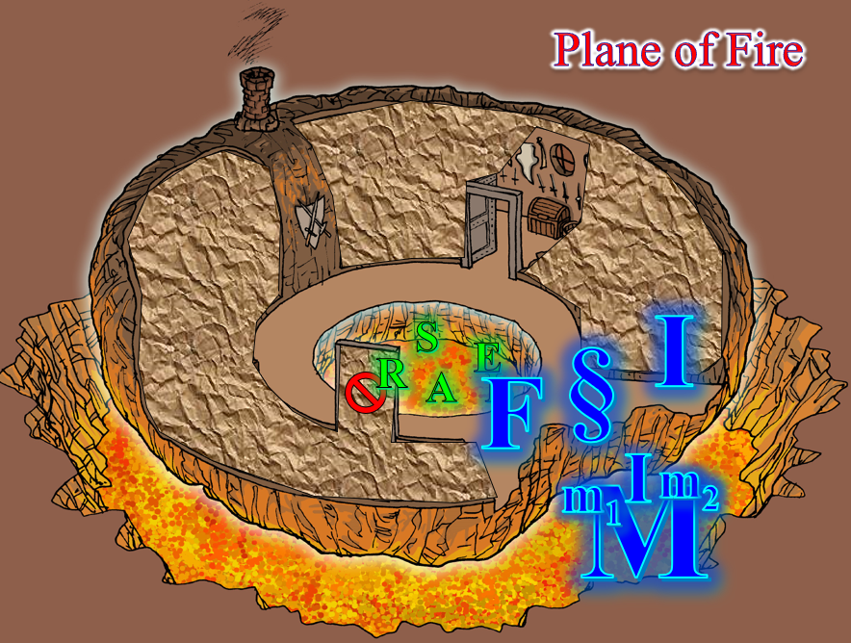

Round 13

With the two fire giants at its side, the elemental nodded a bit, and replied, “You seek Kaszüm.…” Smoke trailed from the face that spoke the words, its features blending back and forth into the mass of fire and molten rock. “What is your business with him?”

The hydra looked like it wanted to fight, and it took the two lava mephits some hydra whispering to keep the guard animal on standby.

Lauren continued. “My companions and I are Watchmen from the City of Waterdeep. We are here to arrest Kaszüm and his associate Azimuth for murder and theft, committed against the people of Waterdeep. We are authorized to kill them if they will not surrender.”

The two giants looked at one another, then at the elemental, who introduced itself in broken Common. All in all, within a painstaking minute of forcing its pronunciation of the words that were not their names, the native Ignan speaker had revealed all of their monikers:

Ignaçe (H fire elemental)
Fosfra and Imola (fire giants)
Furnaçe (efreeti)
Moltar and Magmar (lava mephits)
Moisea (fire hydra)

The Gambit had positioned themselves in a less menacing formation now, and no weapons were currently drawn. Lauren introduced everyone by name. “We are called Destiny’s Gambit,” she finished.

Ignaçe took another minute to briefly explain their predicament. They were trapped in a ball of solid rock interlaced by concentric, spherical walls of force that prevented them from escaping, and the portal in the Fire Suite—what this place was called—was inactive.

“We’re are trapped,” Ignaçe did its best to observe Common grammatical conventions, but had never been on the Material Plane, and had only needed a working knowledge of the language in order to deal with nefarious outlanders like Kaszüm. It said some other things that were a bit incoherent and mostly flow of consciousness, and then, as its flames grew a bit in size and blue resonance, the elemental fiercely almost shouted, “We’re will kill him! Or—better—as the you say: trap him here.”

The two giant women uttered a one-syllable cheer with their fiery voices, and the hydra’s heads hissed in unison like a medusa’s hairdo on a bad-hair day. The now mostly blue flames that constituted the elemental subsided once again into a predominantly red-orange blend, and the leader of this band of captives turned dramatically to Lauren, with whom the conversation had begun. It took a slither forth, examining her with a thousand wispy eyes and an inscrutable expression on its core belly, if such it was. Ignaçe pleaded in the imperative with Destiny’s Gambit, “Taken the we’re to Kaszüm, the Acquirer! The we’re will help end him,” the elemental referred to its band of warriors.

“I believe we can open this portal, but it leads only to the Plane of Shadow. We will need to think on how to safely leave this place.” She noticed the trunk sitting nearby. “Is that trunk yours?”

By now, twelve separate hydra heads were fuming at the nostrils, studying the newcomers to this spherical trap.

“Nay,” the elemental shook parts of its form. “The we’re are not from like to this place, and the cold within,” it pointed to the open door, then to the closed door to its left.

Rook’s combined knowledge of Arcana the Planes was more comprehensive to this instance than the others’. He said to Lauren in a low but audible voice, “I believe these chambers may be temperature-treated.” He pointed to the open door, which—upon closer inspection, and not without squinting—could be seen as emanating mirage-like vapor trails, suggesting a stark difference in the temperatures of the areas on opposite sides of the threshold.

“You cannot enter there?” Lauren asked for confirmation.

“We’re can,” the elemental said in Common. “But the we’re suffer within, and the finding nothing of use to the we’re.”

The efreeti named Furnaçe hopped off of the hydra, commanding it to swim down and go for a short swim as the two lava mephits also hopped off and landed near the fire elemental. As the last of the hydra’s dozen heads was submerged in the lava moat, the mephits melded with the fire elemental, giving the spokesperson for this group a wider berth and a more solid constitution. With a raspier, less hollow voice now, Ignaçe invited the heroes to enter, stating, “You’re will finding weapons and wares for your size, but nothing of lots valuable.”

“We will do our very best to help you out of here,” Lauren said to the group of fire folk. “It will take us a little time to determine how to do that. We are also fatigued from our recent battles, so we may need to rest before we can continue.”

The fire elemental smiled as if making an attempt to empathize with the fleshen ones. It finally landed on, “Refresh,” as the single word of agreement, and instructed its band of fire folk to retreat into the moat for now before sinking into that selfsame pool of molten stones.

“I will attend to the trunk, M’Lady.” Rook stepped carefully from the carpet and made his way to the trunk. Entering the definitely air-conditioned chamber, the priest used his sword tip to slowly lift the lid, but the chest appeared to be locked.

[DM assumption] Selena was nowhere near as skilled as Fingers, Octane, and Kir, but neither of the master locksmiths were here at the moment, so the courtesan would have to do.

Making her way inside at Rook’s request, the mid-level rogue studied the chest before doing her best to undo its lock.
Skill | Rank | Ability & Mod. | Misc. Mods. | Total | Roll | Check
Selena, Open Lock | 5 | Dex (+0) | 0 | 5 | 8 | 13
Fail.

Unable to unlock it on her first attempt, she stated to those near her, “I’ll need a few minutes if I’m going to get this at all.”

Lauren stepped off the carpet onto the solid ground, shooed everyone else off it, and rolled it for storage in her haverpack. She took the portal shard, stepped over to the portal, and waved to Elaith.

“That’s alright, Selena; come help with this door,” she pointed to the door she’d just tried, and added, “Elaith, help me here, just in case.” The two duskblades drew their swords, and Lauren waited for the rogue to work her craft.
Skill | Rank | Ability & Mod. | Misc. Mods. | Total | Roll | Check
Selena, Open Lock | 5 | Dex (+0) | 0 | 5 | 19 | 24
Success.

Selena picked the lock on the door with minimal effort, and entering what appeared to be a smithy. The finest metallurgic tools were displayed here, and looked to be in recent and frequent use. This room was as inhospitably cold as its counterpart across the central area despite the fact that the smithy’s furnace was glowing with embers only a dozen or so feet from Allisa, who now surveyed the room as Lauren used the shard to open the portal, which she hoped would lead to the Shadow Suite.

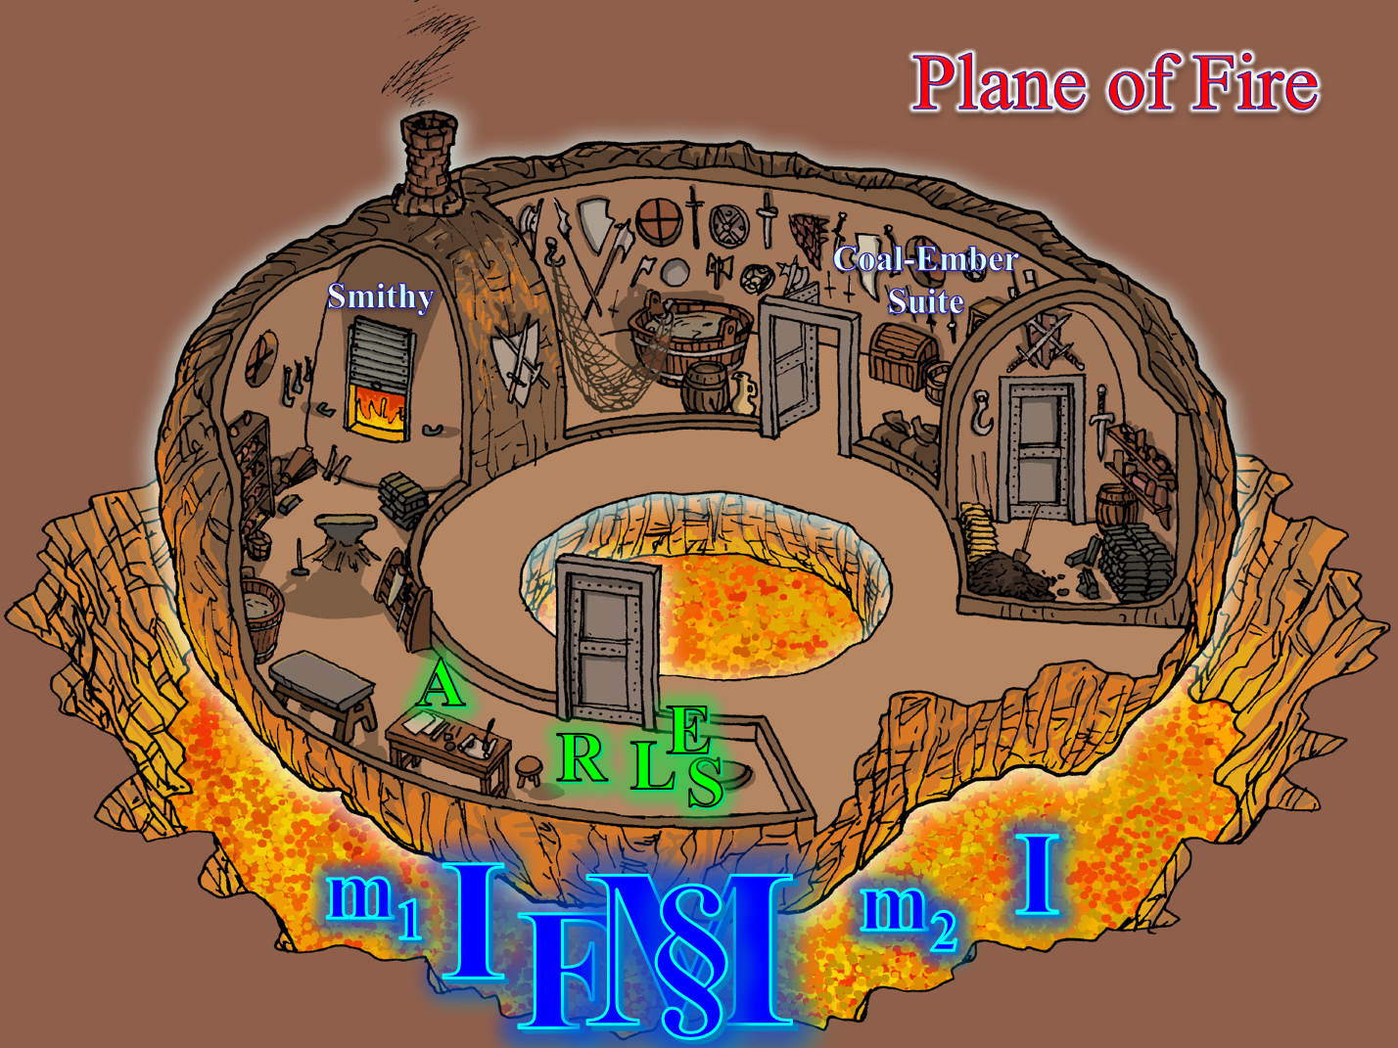

Along with Allisa, Rook noted further details, including what the cleric regarded to be a summoning stone that at first glance had looked like a large sharpening stone. His knowledge of such items told him that a smaller rendition of Ignaçe was likely the elemental that could be conjured with such a device, if one had the skills to do so. Rook had earlier noted the rope hammock in the other section of this suite, and now realized that the pattern of the weaving—which was culturally Gnomish despite the human-adapted size of the hammock—was identical to the pattern embossed along the edge of the flat summoning stone.

The porthole-style windows that lined this suite’s outer walls provided the onlooker with a limited view of the narrow strip of thin air that separated the suite from the layer of igneous rock that constituted the innermost layer of this effective pocket plane. As expected, after a few brief seconds, the portal now activated a two-way conduit between the two worlds, and the more curious among them tested it by putting a hand through it, and retracting it with no ill effects, as usual.

“So far so good,” Lauren confirmed, noting the dramatic shades of gray in the Shadow Suite beyond. No movement was apparent, though they were ever-wary of a possible invisible stalker returning to guard that suite.

But then, just as frustratingly and unexpectedly as they’d been whisked away to Shatterhull Isle and then here, they were now thrust with no forewarning into water that was initially cold, but as their newfound, fiery friends were similarly thrust into this area, their fiery bodies heated the water rather quickly.

Round 48

In the green-blue water, the heroes were all disoriented by several things: there was no apparent center of gravity, no singular source of light, and no semblance of a surface anywhere in sight. Furthermore, the distorting effects that the water had on their vision rendered barely recognizable those beyond 10’ of one another, save for the fact that some were made of molten or fiery elements and others of flesh and blood. And, of course, none of them were able to breathe underwater, and the natives of the Plane of Fire were being quite literally snuffed by the water that boiled around them and warmed the rest of the water near them to what would soon be intolerable temperatures for the Gambit.

They were all about 15’ to 20’ from one another, and once Allisa changed into a dolphin, she and Lauren did her best to swim away from the elementals while holding her breath. She knew that Allisa was the only one among them who could shift into a water-breathing creature, and thus not drown here.

Meanwhile, Lauren, Rook, and Elaith struggled in the water while holding their breath. Lauren and Allisa—and no others—spotted a in immovable rectangular shape amidst the undulating waters. Then, perhaps, Imola might’ve spotted it too, for the stalwart warrior began to swim clumsily towards the shape as the water seared her skin and hair like acid. Ignaçe—made exclusively of fire—was likely snuffed out by now.

Round 49

At this point, Selena could see a school of fishes swimming by, while Rook witnessed a magnificent but deadly jellyfish, and did his best to steer clear of it as he began to suffocate.

Lauren swam toward the shape, and then she stopped, waved her arms at her cohorts, and pointed in that direction. Then, she started swimming as best she could toward it, still holding her breath.
Skill | Rank | Ability  & Mod. | Misc.  Mods. | Total | Roll | Check
Lauren, Swim | 2 | Str (+2) | 0 | 4 | 16 | 20
See below.

It took her a little longer than she thought it would to reach what she now saw to be a doorway, and right about at the point where it was becoming difficult to hold her breath, Allisa effortlessly reached the door.

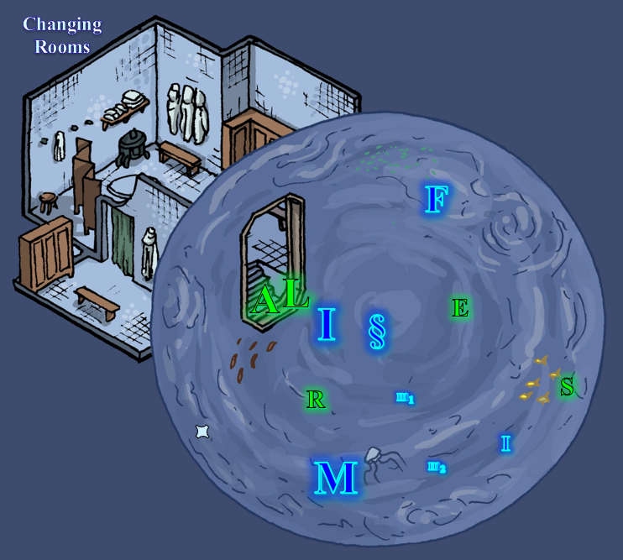

Rounds 50 – 53

However, lacking digits, the dolphin was at a loss to try the knob, which—if it was locked—could really only be picked by Selena.

Fortunately, Lauren finally reached the door, and frantically turned the knob, finding beyond it a tiled spa and changing room. Pushing her face past the barrier that was the surface of the water in which they were engulfed, the duskblade drew in a deep breath and wondered why her druidic lover was squandering her elemental shapeshifting abilities in lieu of the much less useful marine mammal form.

Imola swam unto and past her, escaping the water that had doused her fiery flesh and nearly killed her. The giant woman had barely made it, and was still fuming and steaming from the water that would soon evaporate off of her body. Her voice betrayed the sting of injury, and the fierce resolution of revenge as she said things that Lauren could not understand.

Allisa’s eyes fed the porpoise information about the dimensions of this bubble of force that contained all this water, and them within it, and began to suspect that—as with the Ysgard Suite—the bubble constituted an extradimensional space that warped distances. The door that had seemed to be 5 times her size was really just a slightly larger door than what she was used to by the time they’d reached it.

Rook spotted the now open door, as did a few of the other fiery folk, but by now, Ignaçe was quite dead—a smoky blob in the water—and the hydra was just about to cease to exist as well. The efreeti and mephits would likely not make it, though they also did their best to reach the exit through which Imola had just emerged. The other fire giant—Fosfra—seemed blinded, and swam towards what appeared to be the edge of a sphere that contained all of this water.

Lauren took three deep, quick breaths, filled her lungs to capacity, and went back to help Elaith and Selena. She swam toward them, and waved her arms to draw their attention.

Allisa used her echolocation to find the others and nudged Rook toward the hole, letting him take her fin before plowing back to the hole/door. Selena shapeshifted into a merfolk after distancing herself from the elementals. She did not spot Allisa now taking people with her, and in fact swam to the opposite side of the bubble of force.

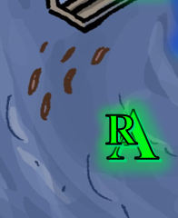

Gasping from the water’s breakdown of her skin, esophagus, eyes, and the inner lining of her trachea and lungs, Imola produced a flask that contained a potion of cure critical wounds, and drank it.
Imola gained 23 + 16 = 39 hps.

The dolphin did her best to usher Rook through the doorway, and out he fell, water dripping from his armor as he—too—gasped for air.

Imola saw the man regain his breath as water trickled onto the tile staircase that led up to the level floor. She looked and felt a little better as she lay on the tiles, and breathed more easily, but would need her remaining jar of healing juice before she was tiptop. Meanwhile, inside the murky waters, her fellow combatants were snuffed out by the water, leaving Imola as the sole Ignan with a chance to face her captor, and she now vowed that she would. She drank the second potion as Lauren swam through the waters once again with Elaith and Allisa sped towards the opposite extreme of the bubble where Selena—now in merfolk form—was confusedly swimming.
Imola gained 17 + 16 = 33 hps.

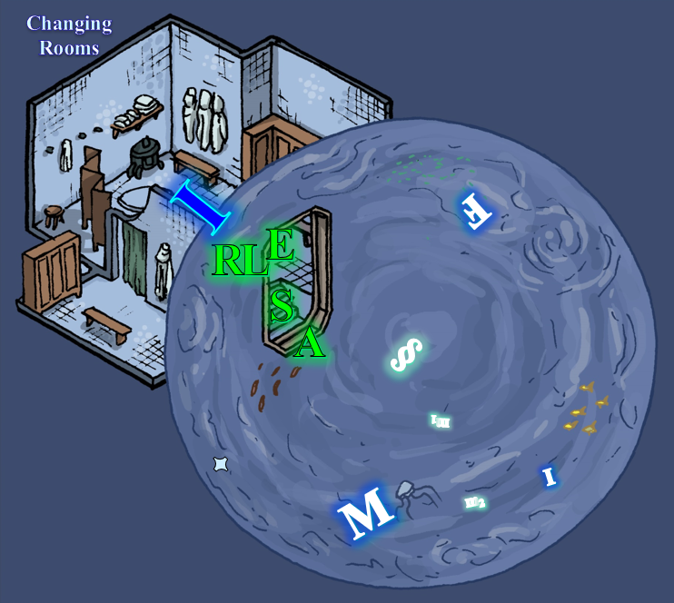

Lauren, Elaith, and Rook turned towards the door, whose choppy surface afforded them no vantage to Allisa’s impending advent through the door with Selena.

Round 54

With most of the fire folk finished off, Kaszüm had singlehandedly wiped out almost half of the force that was coming for him. The Gambit still heaved a bit as they vomited gulps of water and coughed to clear their lungs as much as possible. They’d emptied their bladders in the water out of distress, and were now in a lavatory ideally designed for the evacuation of bodily wastes and the cleansing and grooming of the flesh. An unlit stove rested near the fire giant, and as Imola blurted the curse, << Flargishth! >> the others began to kneel and rise.

Round 55

Lauren clambered to her feet and looked to the others. “Rook, please help our new friend. Elaith, let’s see if there are any other rooms here. We need to move quickly.” Lauren began to search for another door in this suite.

Rook nodded and made his way over to Imola, noting that she could still stand to be healed with a spell of light or moderate magnitude. Rook used his detect thoughts slot to cast cure moderate wounds on Imola.
Imola gained 9 + 10 = 19 hps.

If the fire giant wasn’t fully healed by now, she was almost there, and gave a nod of gratitude as she rose to tower over the cleric, crouching a bit in order to avoid hitting her head on the tiled ceiling. << Zhiar’d’niesch! >> Producing her greatsword from the sheath that hung diagonally across her back, the fierce woman indicated that she was prepared for a confrontation with their host and assailant.

There was no other door per se, but Elaith and Lauren noted the portal right next to the furnace, and were likely to be able to activate it with their newfound skeleton key.

Selena changed back to her human form, which resembled the halfling form she’d donned earlier, but was twice the size. “This is ridiculous. What did you all do to piss this fellow off?”

“As we did not have a choice last time, I advise we rest,” said Allisa once she transformed back into herself and checked over everyone, noting that no one needed healing.

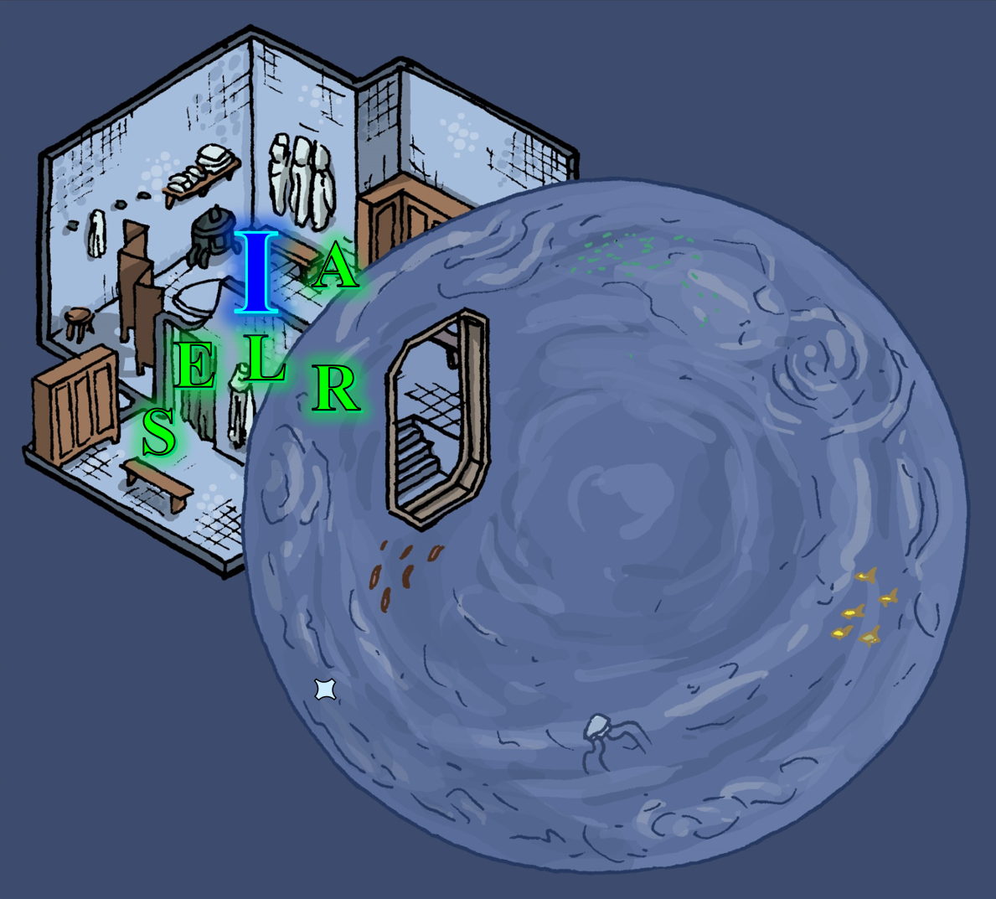

Round 56

And then, as if Allisa had pulled a devil by his tail, they were once again elsewhere, though this time there had been no fade to black effect, and their eyes had instantly realized that they’d been teleported from one part of the Citadel of the Planes to another. And what manner of place was this?

They were in a giant, dodecahedron-shaped dome, and though Rook was standing on a pedestal that matched all of the others across the Citadel, this pedestal was about two or three times bigger than the others, and had no portal. As they all took in their surroundings, they realized that everything in this library—not just the portal pedestal—was at least twice the size that they’d expected for a human-sized person. Could this be Kaszüm’s study? If so, it would have been inconveniently grand for the gnome.

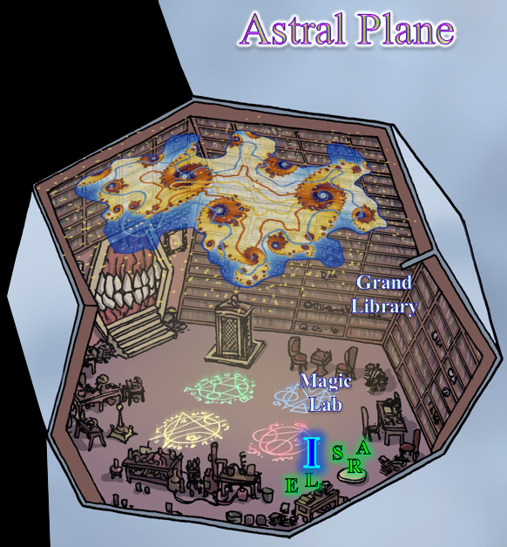

Imola—the fire giant—would have been quite at home in a study of these proportions, though she wouldn’t have likely studied much. However, her red-hot form would have been detrimental to the wood and fabric that comprised almost everything in the room with the sandstone floor, including the dark, vertical panels of oak along the walls. It was unusually quiet, save for their movement, and aside from the toothy mouth that constituted the only visible exit in this place, the décor and ambiance were altogether welcoming.

Large chalkboards along the walls—where there were no bookshelves—were covered with experiment schedules, messages to the figure named Big Red whom Sarge had described to them as an aboleth, drawings of a half-dozen beholders being killed in different ways, and half-completed magical formulae and corresponding diagrams. There must have been thousands of books in this room, taking as many years for a mage or scholar to read.

Another notable feature was the rather detailed configuration of constellations across a navy-blue ceiling, giving the illusion of a starry twilight. And before them were four circles that were likely for summoning or protection of some kind.

