*Chapter 76*

Round 68

The remaining legionnaires kept on swinging, completely impervious and indifferent to their caster’s demise.

|  |  |  |  |  |  |  |  |  |
| --- | --- | --- | --- | --- | --- | --- | --- | --- |
| **Character** | **Attack Type** | **Damage** | **BAB** | **Str**  **Mod+** | **Total**  **Score** | **Roll** | **Total** | **Notes** |
| Sentinel Legionnaire | Longsword | 1d8 | 14 | 0 | 14 | 10 | 24 | Rook |
| Sentinel Legionnaire | Longsword | 1d8 | 14 | 0 | 14 | 10 | 24 | Allisa |
| Sentinel Legionnaire | Longsword | 1d8 | 14 | 0 | 14 | 5 | 19 | Allisa |

*Miss, hit, miss. Dmg: 1 [95/102].*

Imola gave each remaining sentinel a piece of her sword.

|  |  |  |  |  |  |  |  |  |  |
| --- | --- | --- | --- | --- | --- | --- | --- | --- | --- |
| **Character** | **Attack Type** | **Damage** | **BAB** | **Str Mod+** | **Dex Mod+** | **W+** | **Total Score** | **Roll** | **Total** |
| Imola | Greatsword +3 | 3d6+15+3 | 11 | 9 | -1 | 3 | 23 | 16 | 39 |
| Imola | Greatsword, 2nd Attack | 3d6+15+3 | 6 | 9 | -1 | 3 | 18 | 8 | 26 |
| Imola | Greatsword, 3rd Attack | 3d6+15+3 | 1 | 9 | -1 | 3 | 13 | 3 | 16 |

*Hit, hit, miss.*

*Dmg to L9: 8 + 15 + 3 = 26.*

*Dmg to L10: 13 + 15 + 3 = 31.*

*Dmg to L12: 11 + 15 + 3 = 29.*

She dispatched the rest of the semi-illusory legion.

The room was quiet for a moment as they looked around and confirmed that all golems, legionnaires, and anything else hostile was no longer moving. Kaszüm twitched as he died, having failed his rival masters, but likely to their amusement.

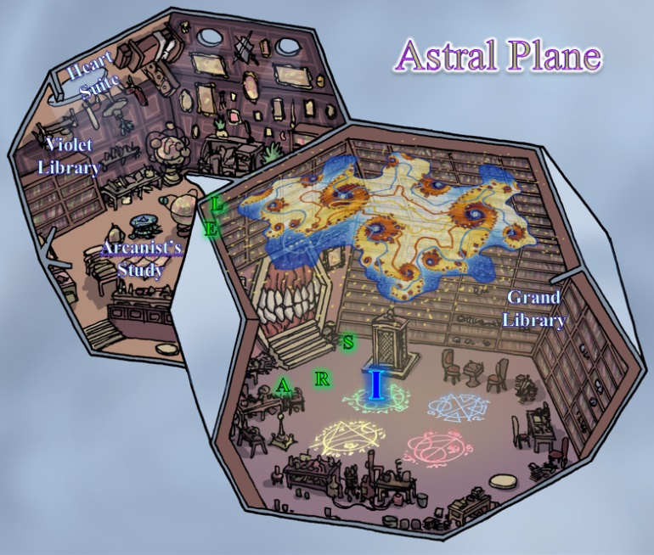

Round 69

Lauren and Elaith landed softly atop a fancy library with a violet ceiling painting of grape vines, in contrast to the three-dimensional, magical relief of a starry twilight sky in the other room. The dodecahedral composition of the adjacent quarters gave the library a sense of vastness, and it was now evident from the furnishings that rested along the walls that this suite benefitted from subjective gravity... or could, under other conditions.

“See if there’s anything valuable, before we get pulled out of here,” Lauren said. She searched Kaszüm’s remains, tossing whatever she found into her haverpack. “Selena, bring me that cube, while I’m thinking of it.”

Selena picked up the cube and brought it to Lauren then begin searching the room where they were.

Elaith began searching the other bodies, also placing what she found in her haversack.

“We need to search the room,” said Allisa to the others. She then returned to her normal form went around to heal those needing such with wand and spell.

Rook moved to help the duskblades with their search and recovery effort. He also looked around to see if there was anything else worthy of note in the odd chamber with floors all around.

They now had a moment to note the large collection of books on arcana, the planes, and religion... those that they could reach, given the objective gravity now set to the side of the dodecahedra that were level with the portal. Desks and study carrels were scattered as if by force, with books strewn across the floor among the humanoids corpses, and ladders on sliding rails allowed easy access to the thousands of books here. Other books covered topics like geography, history, and nobility, and it was likely that a few days here would raise someone’s knowledge of these topics significantly. A few grimoires, rare spell components, and other trappings betrayed the magic laboratory for what it was. This was likely Kaszüm’s central base of operations, and the Water Suite from where they’d just come was likely his sole shitter.

Allisa and Lauren had been in nearly every Suite in the Citadel by now, and from their recollection of the map, it was only the Hell Suite that they’d staved, and all the better, since they had now vanquished Gwen Triflestrife, Karmen Santiago, and Kaszüm “the Acquirer” Sertan, multiplanar criminal masterminds.

Selena looked up at the starry night hologram and noted a 2’ wide breach in the ceiling skylight where miniature eruptions of flame seemed to intermingle with crashing waves of water, tornadoes of air, and massive chunks of earth all in an everchanging chaotic boil. Not only was it visually impressive, but was ensconced by a 6” wide cylinder around it that would have extended to about waist high on Selena if she’d been standing on the ceiling, which appeared possible, given what they were all seeing.

Within minutes, they’d uncovered quite a bit, though without specificity in what they were searching for, their trove wasn’t necessarily the most conclusive. First, they’d tried activating the portal’s pedestal with the skeleton shard, and it did activate the portal to the Shadow plane. Imola looked at it, noting that she’d have to squeeze through, but could definitely do it.

The fire giant had sat herself on the floor after wiping out the last of the legionnaires, careful not to burn any of the wooden furnishings and carpentry nearby. She was neither fatigued nor mortally wounded, but had seen better days, and was grateful to Rook for the healing that had likely saved her life. As was customary in her realm, if one saved another’s life, the savior was obligated to care for the life they salvaged, and now that she’d caught her breath and bearings, and Rook looked less busied than a moment earlier, Imola approached the cleric of Red Knight, and placed herself before him on her right knee, holding her sword face down in front of her like a walking stick, and promising, << Krer phram’thraivve, ba-shri’akh adrúumina! >>

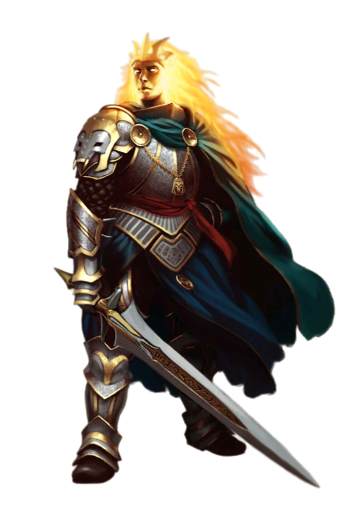

Rook did not understand the words, but was wise enough to know the woman’s ways, and had half-expected this, knowing that the pledge could be resolved and dissolved if and when she ever saved his life. “Thank you for your help, and I am sorry for your friends’ deaths,” the inquisitor said solemnly. “I appreciate your pledge. Would you like to return to the Plane of Fire, or come with us?”

The woman nodded, obviously not getting the gist of the choice she was being given, and sheathed her sword behind her back, standing by. The bodies included arcane and divine spellcasters, plus a handful of zombies that Lauren could now identify as Azimuth’s creations, given their blue hues, caused by his Deadly Chill ability. The wee man still lived, and if she knew anything about such a weasely scoundrel, she expected him to slip away, back into the woodwork of the planes where he could foil others’ lives and futures.

For now, Destiny’s Gambit had triumphed. They’d bested their three principal offenders, and now beheld just about every book they’d ever want to read. Selena had by now found a console that she and Lauren studied together and now came to understand. It had several functions, including setting the gravity in the room to a specific side of each dodecahedron, and an option to leave gravity subjective, which they now did, effortlessly feather falling from one side to another as they explored the dual dome that constituted a library, a laboratory, and a lounge.

They had no idea what lay in the Hell Suite, but they could assume it wasn’t anything more formidable than a twelve-headed fire hydra and its elemental and giant friends, so in time—if they wished—they could likely retain this multiplanar piece of real estate by simply taking the portals found in the Shadow Suite to any other secure location. And with the treasures still in the Ysgard Suite alone, they could likely fund just about any operation they could concoct.

“The people of Waterdeep would greatly benefit from the treasures here,” Lauren observed as she looked over a section of the library that pertained to the martial arts. Her eyes fell on a tome detailing a class of warrior called a “Warblade”. She perused a few pages, and then she slipped the book into her haverpack for later reference. “As much as I’d like to simply return home, there are a few things to settle. One is, we should try to rescue Fingers, and the people we left at the island. Second, Azimuth is still out there somewhere, and, if we don’t find him now, we will have to contend with him later. Third, we do need to consult with Sarge about this aboleth, to see if we will need something from this place to defend against it.”

Lauren looked at Allisa. “Shall we continue, or shall we return home and bring more people to help us with these remaining tasks?”

Imola looked at Rook, who now took Elaith’s hand and turned to Allisa.

Lauren went and knelt next to her, swinging her haverpack down to set it on the floor. She hugged her wife, and pressed her lips into her hair. “Then, let’s go home.”

“I wish this was all behind us, but someone needs to collect and catalog all these items. We should bring others of our organization to do so.” The druid had spoken from her kneeling position where she had stacked a pile of books and other items to take with her. “As for Fingers, we should try some locate or scurry spell that works across the planes, but going after these enemies you spoke of, I wish not.”

They finished putting the newfound books in the haversack that Kedrik had once used to gather up a ton of manuscripts and other evidence for the doppelganger caper back in 1,374. Lauren and Allisa remembered that adventure well, and as the last of this round of treasure troving wound up, the heroes finally began to chuckle at dialogue that had taken a while to become jovial again.

Then they were all startled, and had only time to draw their weapons as they got a sense of what was happening. From the portal that seemed to lead to the Shadow Plane there emerged a shady figure with an active lightning-based spell active.

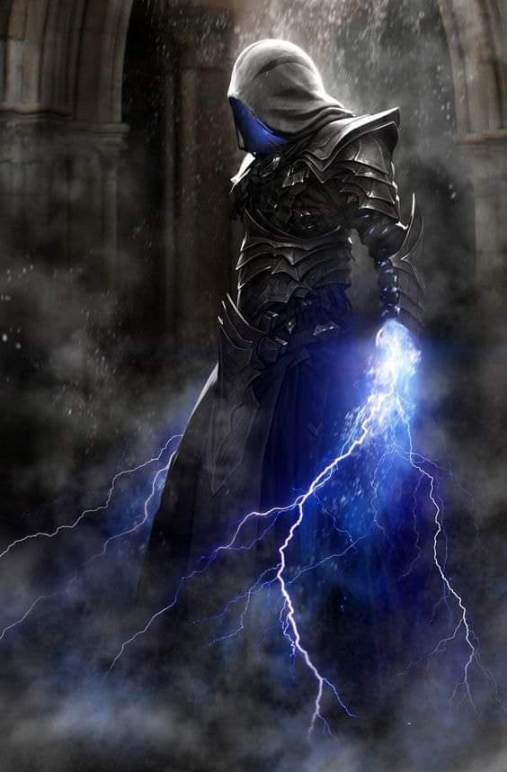

The hooded figure came into the light just as the Gambit were readying spell components, revealing himself.

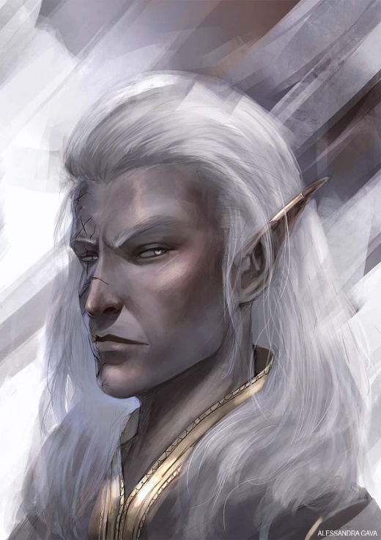

“Xaryn!” Lauren blurted.

Imola thought that might have been a war cry, but studying the duskblade’s body language, and her falchion now lowered, the fire giant also lowered her sword, as did the others.

Selena, Rook, and Elaith also didn’t recognize the drow archmage, but Allisa and Lauren took a few steps forward before Xaryn proclaimed, “Pleasantries later. Help me with *this* fiend!” and with that, he turned around, waited about a second and a half longer than he thought he would have to, witnessed the bone devil stepping and squeezing like a skinless lizard through the portal, beholding the Gambit, and continuing its mad charge towards Xaryn.

It was a little evident to Allisa, and very evident to Rook and Lauren, that the bone devil was already badly damaged, but still constituted a threat to them all.

Xaryn zapped the bone devil with both hands.

Selena backed away by 20’ to stand beside the tall pillar as Allisa cast *vortex of teeth* upon the creature one of if not the last of her offensive spells. She held in her hand the rod if force instead if her sword.

The devil cringed as the piranhas devoured its bones.

Lauren and Elaith leapt into action and charged the bone devil, one from each side. Elaith channeled *vampiric touch* through her blade as she attacked. Lauren channeled *shocking grasp*, and empowered her strikes.

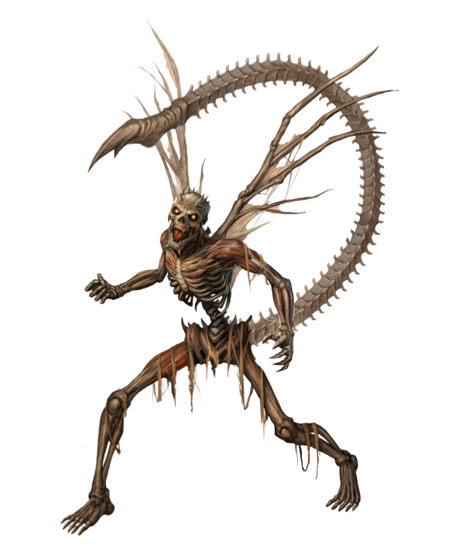

The two duskblades came out of the vortex of teeth a bit nipped at, but they’d put the devil’s bones to rest, and they were once again without enemies.

“That all of’em?” Rook asked.

“Yes,” Xaryn caught his breath, adding, “that was the Bone Overlord we’d read about in Kaszüm’s journal. The devil had been courting Karmen, and didn’t know of Kaszüm’s existence. I inadvertently blundered into the Hell Suite, and once the portal was opened, he and his minions chased me into the Shadow Suite. I was able to neutralize the lesser devils, but not without major damage to the Shadow Suite, but I’m pretty sure there are no more fiends trailing behind.”

“But the conduit from Hell into the Shadow Plane is still open?” Allisa asked.

“Yyyyes, we may want to go secure that,” Xaryn agreed with the implication.

There were introductions made, since Rook, Elaith, and Selena didn’t know the drow archmage, and they all then went to the Shadow Suite to secure all of the portals to the other planes.

“You really *did* make a mess here,” Lauren agreed with his assessment. The damage had been force-based so there was no need to worry about charred or corroded materials, but a *make whole* spell would do the place well.

They talked a bit more as they returned to the Astral Suite, where Xaryn had only been momentarily, though he’d seen enough to want to see more of it. As they discussed what had happened over the course of the last day, the Gambit asked about Kir.

Xaryn nodded his head, and said, “A cautionary tale... I can’t bear to tell it right now; she’s no longer with us.” He then shook his head, and painted the event more gloriously, “She fell honorably, and by her conscious choice.”

They talked for a bit more, and the Gambit learned of Xaryn’s return to the Shadow Suite and subsequent trek into the Hell Suite and surrounding area. “It was Hell, but it was about the most picturesque of the Hells,” he described the coastal suburbs of the city-plane of Dis.



Topics led from one tangent to the next, and with further searching on Selena’s part, they uncovered a secret latch that caused a secret compartment near a workbench to open, and a crystal ball to be revealed. After the proper amount of trap finding and diffusing—the prior resident had been duly cautious—the rogue was able to make the ball available to Xaryn, who had an appetite to use it.

“This thing looks like the highest-end crystal ball I’ve ever seen in my young life,” the drow reported, trying out the contraption.

Within minutes, they were able to ascertain the following:

* Kaszüm had at least one permanent *arcane eye* patrolling in and around every Suite in the Citadel, which were the surveillance cams feeding audio/visual information into the ball.
  + No picture-within-picture. Only one area could be surveyed at any given time.
* Kaszüm (or any competent user of the crystal ball) could theoretically scry on anyone in and near any of the Suites at any given time.
* Fingers appeared to now be floating inside a bubble much like the one that had encased Octane in the Elysium Suite.
  + The surroundings encasing Fingers looked to be the same porous, orange walls of the Abyss Suite, which they hadn’t fully searched.
* They could also switch the crystal ball’s channel to scry on themselves, and Xaryn deduced that this would have been a useful function on the go.
* The rest of the Suites appeared to be unoccupied, as expected.

“Well,” said Allisa “least we can go back and let Fingers out.” She took out her everfull mug and drank, then offered it to the others.

“What do we do about the others we left on that island?” Lauren asked. “And how did we get shifted from place to place so quickly?”

Xaryn got filled in on that detail, and posited, “Perhaps there’s a device that can be used in tandem with the crystal ball.”

“Let’s get Fingers back first,” Lauren said. We will worry about the others later.”

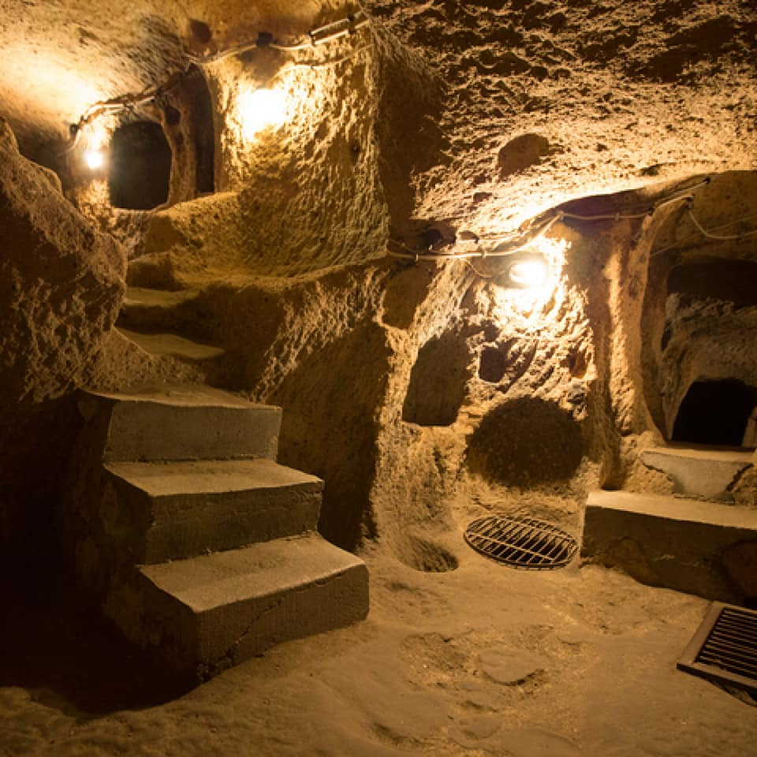

It took them about 10 minutes of spelunking through some winding ways through the Abysmal rock carved out by umber hulks centuries earlier, but in time, they found a stairwell leading downward into a radiant room illuminated by phosphorescent stalactites and stalagmites that constituted the irregular ground. In the middle of the cubic, 20’ chamber, there floated Fingers, as if stored for some future purpose.

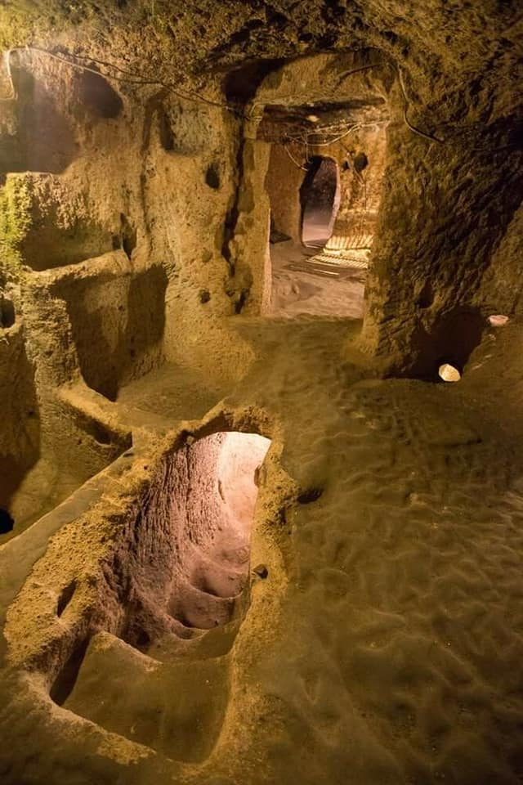

Xaryn’s aptitude was remarkable, but even his mind took almost an hour to figure out how to free their changeling friend.

In the end, they did, though, and after another round of debriefing, it was now known to all that Fingers had—despite its invisibility—been reconnoitered by Kaszüm’s arcane divinations, and apprehended by some teleporting force that instantly trapped it here, able to see and hear everything, but not sleep or move. It was fatigued, and now noting that the Gambit had recovered the rest of its stolen goods, the trapsmith asked, “Can we just go to sleep now?”

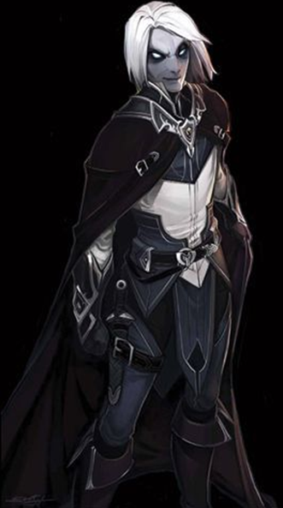

They made it back to the Shadow Suite, which was partly in ruins due to Xaryn’s spellcasting. The drow proclaimed, “I will prepare several *make whole* spells overnight, and by tomorrow this’ll be tiptop again.”

Fingers had half a mind to coopt this piece of real estate by taking the undamaged portals with them to Shipshape Way, or maybe it would sell some of the treasure they’d found, and buy the château on the Material Plane that led here so Destiny’s Gambit could have a second base of operations, and right by Castle Waterdeep, no less.

In less than four years, they’d become quite a formidable band of experts, and their talents had been well cherished by the Hidden Lords and many others throughout the city, meek and mighty. Now that they stood around the room that had been the nexus of their plight for the last three days, a sense of overwhelming accomplishment had ensued, and as the conversation turned to what the rest of their Morning would look like, they were glad to know that Gwen, Karmen, and Kaszüm had been dispatched to wherever their souls belonged. Perhaps they were back in the Abyss, but in their final forms, beyond which they would cease to exist altogether. Perhaps they would meet again on that Lower Plane, and settle the score once more.

~*~

Lauren proposed that the group sell or trade some of the artifacts they’d found for the keep, and have Rook and his followers become its caretakers. She herself wished to retire from the City Watch, but retain her Gray Hand membership in an inactive status. She and Allisa would retire to their home in the Westwood, and possibly spend time in the Citadel’s more scenic locations. Lauren further proposed to use the former owner’s security measures to secure the Citadel against unwanted planar visitors, and also to release (or in the beholder’s case, kill) any entrapped creatures.

Allisa amended Lauren’s suggest. “We need to go back and bring the others we found here to Waterdeep and recruit any of them into our folds. We should then make Shipshape way to be the entry point for new recruits for at least a year, maybe two, while they are trained and evaluated to be trustworthy.” Also, she thought buying the Chateau was a good idea since it would give them full access to the Shadow suite and should becoming the main Base of operation that only the trusted members would know of.

“I am planning on retiring with the love of my life, but I will be available for consulting, maybe even training for some of the new upcoming druids.” She moved to stand aside of Lauren taking the other hand. “We must make decision as to the new officers will be. Maiko and Sarge would be good choices for the leadership. She has good contacts among the more shifter people. Rook also would do well, as would Elaith. We just need to choose their roles or let them decide.”

She looked over a Lauren. “I wish to stay here in Waterdeep ‘til our godchild is born; then we can return home. Anyway, we have a lot of information and secrets that need passed on to the new leadership.”

Allisa would spend her time between working with the new council and taking care of Maiko. The druid after a bit of divining would tell Maiko and Sarge that they were having twins. If they wished she told them one would be a boy and a girl. When the time came, Allisa helped with the delivery. Both children where healthy. Marcus Jr. was born first, followed by his sister, Alissa. The two would grow up to be heroes like their parents.

The appointed day arrived, Lauren and Allisa said their goodbyes to their friends as they stood in the courtyard. Allisa asked, “have you ever ridden a dragon, my love?” She smiled wickedly and after her reply she changed into a gold dragon for the trip home.

When they arrived, they found the house was in disarray, nothing that could not be fixed. Someone or thing had trashed the place. Allisa shied, “Well, I guess there is one more thing we have to take care of. I will talk with the local animals and see if they can tell us anything. We may have to go clean out the forest before we can settle down.” She kissed Lauren. As they cleaned up a familiar growl was heard and moments later Ben came walking out of the woods. Allisa hugged the big animal. “I missed you.” The bear growled again as he rubbed his head against her. He then moved to Lauren doing the same thing. Allisa looked at her spouse. “Now we are all home.”

~*~

Maiko’s business would thrive, and in several years, would own two brothels the second being bigger then the first, with a main room for dinning and shows. She would make many new contacts and train many new recruits in the art of espionage. Their son which looked a lot like Sarge in his younger days would follow in his father’s footsteps. Their daughter was every bit as beautiful as Maiko and then some. She excelled at espionage and the ways of a rogue, and could charm the pants off anyone better.

Lauren helped Allisa to secure ownership and to set Rook and Elaith up to manage the Citadel. She retired from active duty on the City Watch, but retained her status as a Gray Hand, although she only accepted an occasional case. She worked with Elaith to increase her skills until Maiko’s children were born. Then, she went home with her wife.

Rook and Elaith married and had four children. They had their share of adventures stemming from Rook’s offices as an inquisitor, working with Rook’s growing organization to settle matters as they came up. The couple grew to be influential in the city’s affairs, and they both won council seats in their middle years.

Lauren was content to spend her days with Allisa in their forest home. She still practiced her training in sword, shield, and magic, but, as her prowess was well-known, no one challenged her to a fight. She developed an interest in woodworking, where she was careful to only use materials from trees that had died. At last, she was able to lay her ghosts to rest, hang up her sword, and simply live her life.

