**Full Moon Nights: Introduction**

Hlammach, Impiltur (Metropolis 36,386): This walled and compact seaport, populated with merchants, tradesfolk, and sailors boasted docks are with ships across the seasons that passed over this northern, coastal settlement. Hlammach was the site of the kingdom’s mint, and thieves constantly tried to steal the coins and trade bars stored here. Its small wizard school mainly taught magic appropriate to the sea trade and spells to protect and ward valuables.

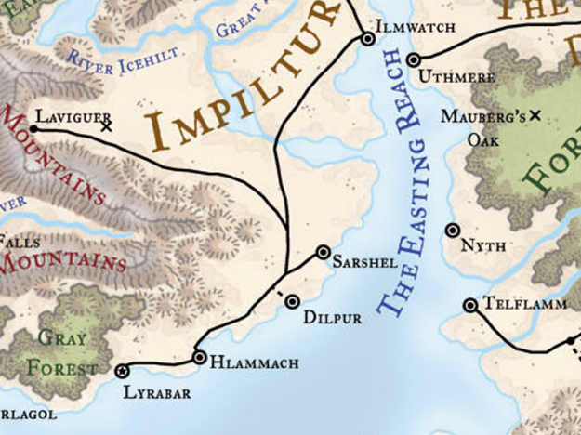

Landorin had found a fairly inexpensive rooming house overlooking the sea, and after playing for a bit on the streets, he’d managed to find work here and there, not steady work but enough to get by. The elf had gotten a few gigs as a backup singer for other performers, but his bread and butter were gigs at several taverns not far from the docks, frequented by sailors. As his sea chanteys were big hits, and having been a sailor himself, he enjoyed exchanging anecdotes with other sailors. He kept the customers happy without starting brawls, so the tavernkeepers let him bring in the customers, keep any tips he got, eat a good meal, and earn a few coins in the process.

Among his friends were both the local constables and the local gangs. As elves were somewhat uncommon in Impiltur, he was fairly recognizable, but the fact that he was a bit chubby for an elf made others more comfortable in his vicinity.

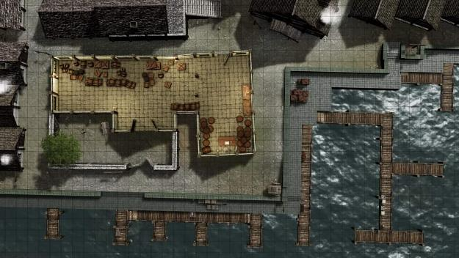

At the moment, Landorin was purchasing a few provisions and enjoying a cross-pollinating conversation on some interesting lore with a fellow musician who was a known associate of the Impilt Shinobi, a gang specializing in conducting illicit trade with foreign merchants coming from the roads that lead to the Unapproachable East. Their counterparts, the Skullduggers, handled the westbound and southbound trade routes mostly through a fleet of unregistered vessels that skirted the ports along the Sea of Fallen Stars.

The shop was devoted to providing everyday goods for locals, but also had a few shelves along the wall with an assortment of pawned and otherwise used wares.

Landorin’s contact, a human named Fler, had just stocked up on some magical components, and had just purchased a curious miniature cannon that someone had allegedly found washed up on the beach. It was apparently useless, but added to the sailor’s mystique.

Landorin admired the strange looking miniature cannon, and remarked with a grin, “Y’know, Fler, if nothin’ else that looks like you could use it like a club, knock a fellow out maybe.”

Landorin had been in the shop picking up a batch of cheap candles and some stationery for writing down some songs he’d been working on, and continued. “That reminds me, I been thinkin’ of pickin’ up a sap, so if I need to I can settle a fellow down without bleedin’ ‘im.”

He followed the lad with the apron, drifting over to the shelves of pawned and used stuff, wondering if he could get a deal on a used sap. “2 gold costs as much as a regular dagger cost… how much for this damaged sap?”

Fler tagged along, going back to an earlier discussion regarding the amusing intricacies of dealing with merchants from the East, and Landorin admitted that the Wavedancer had pretty much had a regular route going to a series of cities around the local shores. “I didn’t get involved with the merchants so much as the merchandise—pickin’ stuff up, carryin’ it a ways and puttin’ it down again. Not real excitin’ but it kept me busy!”

Landorin was offered a used mundane sap for 5 silvers, and a used masterwork sap for 230 gold. “Accepting the offer for the ____ sap, the elf insisted, “You sure you don’t need a proper club?”

“I’ll stick with my cutlass,” Fler patted his blade’s mercy as he paid the boy who’d brought him his things, and bid them both a good day.

As Fler walked away, Landorin added 5 silver coins for the used mundane sap to the coins he’d readied for his other purchases, handed them over and grinned at the fellow. “Man, I wish I had the coin to afford to be buyin’ the good one, but I’m near strapped until my next gig. Drop on by the Broken Rudder two nights hence, I’m singin’ for my supper there!”

Once Fler left the dockside building, Landorin paid for the rest of the equipment he’d just stocked up on, and noted the sounds of someone walking along the boards that held the roof’s thatches in place.

Tucking the sap into the sack with the rest of the goods, he nodded to the fellow and strolled towards the exit, the sack in his left hand. He glanced up to see if he could spot movement to go along with what he’d heard, but his guess was the mover was on the roof, not under it. His low-light vision helped in that regard, but he squinted a little, his murky eyes not doing him any favors.

Not seeing anything in the rafters, he placed his right hand on his rapier hilt as he lengthened his strides towards the exit. He tried to get a line of sight on Fler as he neared the doors—if someone were stalking his fellow musician, he’d intervene if it seemed necessary.

*Fler already left.*

It was then that Landorin and the shopkeeper’s son heard movement and scratching along the western wall. Turning in that direction, a pair of nasty-looking rats the size of kittens came out from behind the barrels, and foamed at the mouth a bit as they turned northward in an effort to not be smashed by the broom that the young human had already grabbed.

~*~

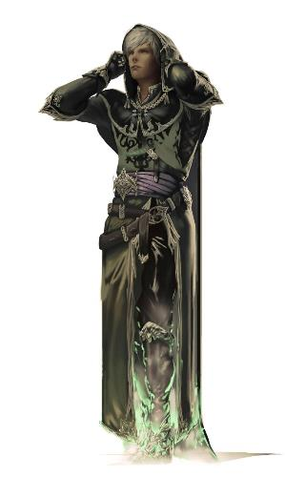

Malicia walked towards a befabled ruin where rumors alleged the presence of her mark.

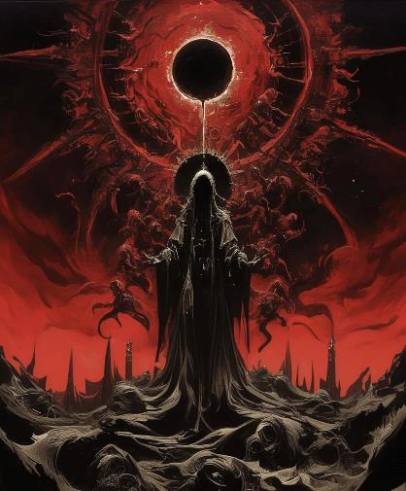

She was fulfilling a pact for her patron—the Undying—and in so doing, she would earn a power heretofore unreachable to her; the anticipation began to cloud her attention, and she reminded herself to remain focused on the objective at hand.

Her contract was a gaunt goblin named Ome’th, and she’d been pursuing a lead given to her by a trusted contact back in Cormyr. Now more than 20 miles from that age-old metropolis, the warlock drew her blade in anticipation of happening upon Ome’th at any moment now, and walked cautiously into a clearing where the ruins of a colossal guardian statue lay. Watchful of the rubble, and half-suspecting that her presence would trigger the statue’s reconstitution, she pressed on, searching the area for clues, as her training had prepared her to do.

~*~

Round 1

Seeing the rats foaming at the mouth, Landorin thought they might be rabid, and swiftly called upon Selûne to protect both himself and the young human, activating his Protection Devotion, while drawing his rapier.

*Landorin and the lad gained +2 sacred bonus to AC [expired on Round 11].*

“Stay back,” he said calmly, stepping towards the rats and thrusting at the nearest one.

|  |  |  |  |  |  |  |  |  |  |
| --- | --- | --- | --- | --- | --- | --- | --- | --- | --- |
| **Melee Weapon** | **Dmg** | **D+** | **TH+** | **Critical** | **Type** | **Wt.** | **Atk** | **Roll** | **Check** |
| Rapier | 1d6 | 0 | 0 | 18-20, x2 | Slashing | 2.0 | +3 | 11 | 14 |

*Hit. Dmg: 4.*

The divine bard skewered the rat that writhed on the end of his rapier as it died.

The squeamish shopkeeper squirmed with disgust as he swiped at another one with a broom.

|  |  |  |  |  |  |  |
| --- | --- | --- | --- | --- | --- | --- |
| **Character** | **Attack Type** | **Damage** | **BAB** | **Total Score** | **Roll** | **Total** |
| Shopkeeper | Broom | 1 | 0 | 0 | 1 | 1 |

*Miss.*

The remaining handful of rats made their way north and west, away from the humanoids.

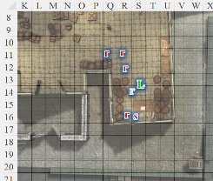

Round 2

While tempted to chase the larger group, Landorin didn’t want to leave the kid facing a rabid rat with just a broom.

“Hey, ye scurvy rat, leave the lad alone!” he shouted, flicking the first rat’s blood from his blade as he moved next to the table and thrust at that rat.

|  |  |  |  |  |  |  |  |  |  |
| --- | --- | --- | --- | --- | --- | --- | --- | --- | --- |
| **Melee Weapon** | **Dmg** | **D+** | **TH+** | **Critical** | **Type** | **Wt.** | **Atk** | **Roll** | **Check** |
| Rapier | 1d6 | +1 | 0 | 18-20, x2 | Piercing | 2.0 | +3 | **20** | 23 |

*Threat. 1d20 = 13 + 3 = 16, critical hit. Dmg: (2 x 2) + 1 = 5.*

The elf cleft the rat’s head clean off. The shopkeeper was emboldened by the divine bard’s prowess, and sought to mimic the heroic action upon the now decapitated animal.

|  |  |  |  |  |  |  |
| --- | --- | --- | --- | --- | --- | --- |
| **Character** | **Attack Type** | **Damage** | **BAB** | **Total Score** | **Roll** | **Total** |
| Shopkeeper | Broom | 1 | 0 | 0 | 4 | 4 |

*See below.*

The boy was able to sweep the rat further against the barrel as the rest of the rats scurried away at full speed.

~*~

Malicia stood in the midst of the ruins and was relieved to not have triggered the resurrection of the colossus that lay amongst downed pillars. Her attention had been so focused on this statue that she was completely overtaken by the stealthy wererat that had crept up behind her.

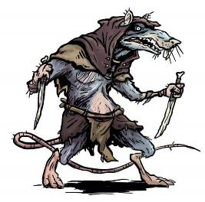

And with a hankie doused in ether of *deep slumber*, the wererat passed the kerchief over the warlock’s nose and mouth, and the warlock easily succumbed to the magical properties of the close-contact chemical.

~*~

Round 3

Disappearing from sight, the rats probably escaped through the front door, which was held ajar when the establishment was open and the weather was fair.

Landorin looked around for any stragglers among the two corpses, and saw and heard nothing other than the lad cheering him on.

“It didn’t bite or scratch you, did it?”

“Nay, I stand unscathed,” the sedentary villager spoke like a stalwart adventurer.

Seeing him unharmed, Landorin said, “Don’t touch it,” and hustled towards the door and looked for the rats, or rather looked to see if anyone else was being attacked by them.

~*~

Malicia was magically roused from her unconscious state, and healed only to restore her body to basic functioning. She was naked, bound by her wrists and ankles, and reclining on a table, surrounded by humanoids hooded and robed, much like she had been before she’d been rendered inert by magics similar to those that now had her fully awake.

And then there stirred another form that she could only barely see if she turned her head and eyes upward. The others removed their hoods, revealing rodentesque features, and their shaman approached the bested warlock with a vial of oil. He poured it down the middle of her torso, pronouncing a few vile words in a toneless voice. His acolytes reached in to anoint her body with it methodically, speaking in a language that the woman could neither understand nor identify.

“We know who you are, and what you seek,” the shaman then switched to Common, directing himself downward at the warlock of the Undying, and adding, “Know that your fate was sealed by your own hand, and by your choosing. As I was delivered into a mightier hand than mine, thus have you been delivered unto me. And now of my litter you will be.”

“… and now of his litter you will be,” chanted the acolytes.

~*~

The vermin were gone; Landorin could neither hear nor see a single rat about. The shopkeeper and his father came outside and inspected the infrastructure that they knew like the back of their hands. They checked a few traps, finding only one with a caught rat, and another that had been tripped with no victim to claim.

“Never used to be like this,” complained the senior man as he and his son went back into the store and bid Landorin well. “See you soon, I hope.”

Landorin cleaned and sheathed his rapier after the shopkeeper and son found no more vermin, and told them to be careful not to get any of the rat saliva on them when they cleaned out the dead vermin, as they appeared to have been rabid, possibly diseased.

He then bid them goodnight, and headed back to his lodgings with his purchases, but with eyes scouring the shadows for more vermin just in case, whether on four legs or two.

As he walked, he started singing a jaunty tale of the adventures of a sea captain blown off course by a miffed sea goddess, channeling some of that adrenaline that had surged through his body with the rat attack into music. After all, it was bad luck to mug a bard, right? And he didn’t mind if his friends on one side of the law or the other heard him coming...