*Chapter 11: Solstice Equinox*

Evening, 6 Tarsakh

The Missing Minotaur

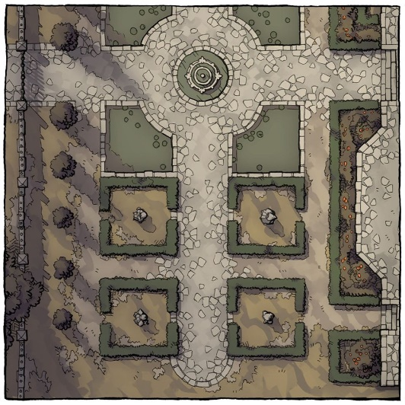

As the heroes made their way back along the street that had initially led them to the Southspur, they noted the heavy guard distribution along the adjacent wall of the Baron’s Keep. By the time they were in the outer courtyard, they could tell that some debris had caused damage to one of the vendors’ carts, but fortunately Saradette’s cart was intact, and when Widget spotted Saradette and came rushing to her with a passion, the gnome could tell that something was not right.

Speaking to the raccoon, the rock gnome came to understand that the fawn had escaped in a panic when a crowd began to flee from the threat of a giant, purple worm with nasty teeth: another wyste.

Saradette sighed. “There’s nothing we can do now, Little One. After I rest, I will see if we can find it. Watch after Gadget and the cart, will you?”

Elsabet sighed. “Well, that future buck will have to make it on his own, I suppose. No way we’re finding him tonight, he should have hidden rather than run. If him comes back, we can take him to the halflings in the morning,” she yawned. “I’m way too tired to care right now. Tell Widget there’s no blame there.”

The innkeepers heard the voices outside as the heroes approached, and came out to make sure all was well. “Ah, good,” sighed the husband, whose mononym was Radnar. “You’re all well, and found some company, I see. Laryssa’s upstairs; come in and have some stew.”

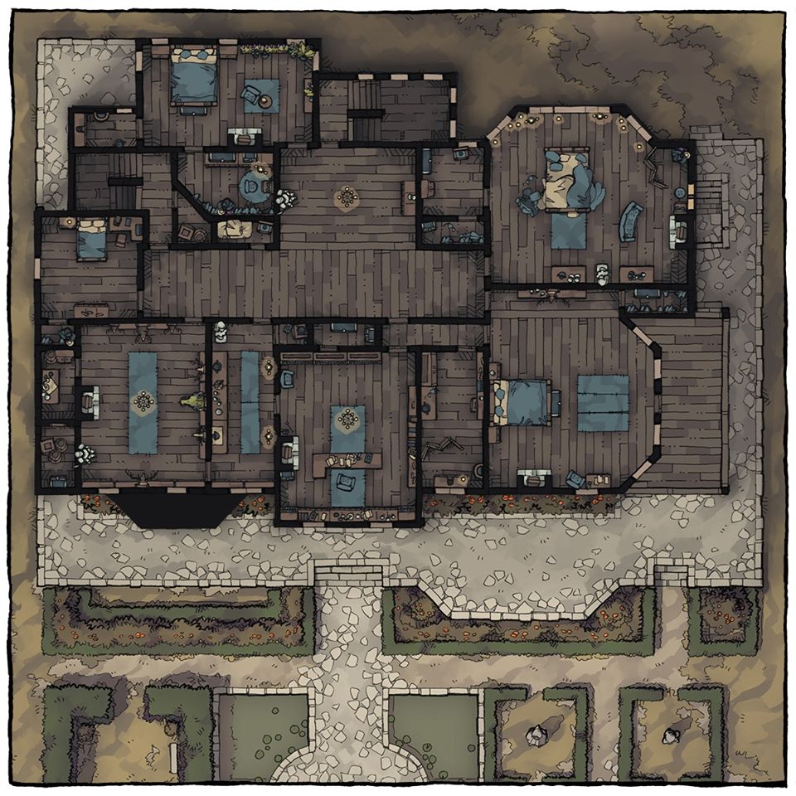

“What’s *your* name?” Mrs. Radnar asked Luran as they made their way towards the front door.

Sensing the motherly interview subtly under her question, Luran responded. “Greetings, mistress. I am Luran Ebonchord, recently acquainted with these good champions you know. A singer and star reader, originally of Darromor. I am traveling, looking for good causes to lend myself and my aid to. Getting my new friends to some well-earned rest being only the current one,” he smiled kindly.

Elsabet was headed straight to bed after the stew, and maybe a mug of tea, which she drank as the stew was served. “‘Eeere you are, love,” Mrs. Radnar almost sang as her husband related the fateful news of the siege upon the Baron’s Keep.

“What?” Saradette couldn’t believe her ears.

“Yyeees,” Mr. Radnar confirmed, “Some hooligans broke into the dungeons, and jailbroke just about everyone awaiting trial.” Radnar didn’t know the details related to the prisoner they’d ushered over from Saradush—Oral—but given what Radnar had just said, the villain was probably out on the loose by now.

“And they got *away*!?” Barkley was beside himself for a moment.

“We’ll know by morning when the crier passes through,” Mrs. Radnar said. “For now, it’s probably best that you all get your rest. Come on. I can see those bags under your eyes. Take your stew upstairs. Your friend’s already up there, likely sleeping.”

The party made their way upstairs, haggardly and worn to the edge of delirium. Luran—who was quite awake, on the other hand—followed close behind to make sure none of them fell going up the stairs. He’d been invited to share a bed with Elsabet, and was glad to have a roof over his head tonight.

They reached the top of the stairs and Saradette took the single key they’d been given earlier that day, inserted it into the hole, turned it and the knob, and pushed open the creaky door. A single candle lit the dim room whose window was open, and as she entered Saradette made the queerest frown upon seeing Laryssa sitting on her bed entertaining a conversation with what after tonight registered as a cream-colored wererat. This *had* to be a figment of her fatigue, a glamer of sorts that ailed even the illusionist.

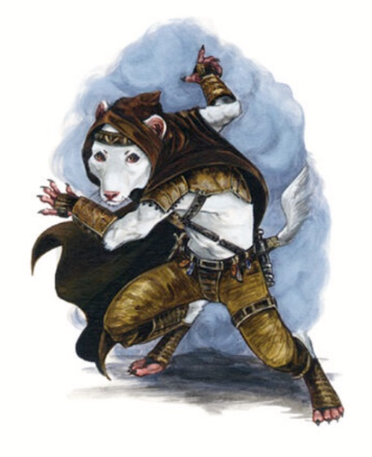

The shifty, rodentesque fellow was startled, and took on a rather defensive stand, or perhaps a cautionary one.

Saradette lifted a hand and waved tiredly. “I do hope you weren’t expecting a fight. I’m too tired to care right now.” With that, she walked over to what she claimed as her bed, and began to drop her gear, armor, and clothing in a pile on the floor. When she was done, she rummaged in her pack for a loose shirt, pulled it on, and practically dropped into bed.

The flighty stranger let down his guard a bit as the party came in looking as haggard as Laryssa was.

Elsabet, seeing what seemed a fever dream, and so tired she was a fit befuddled, looked at Laryssa, and said, “Hey, Laryssa—that’s Luran,” pointing at the bard, “he might be joining us.” Then she looked at the mini ratman - a child, perhaps? “Hey, kid. If Laryssa is cool with you, you’re safe here.”

“Kid?” the cream furred fellow confirmed that he heard right, turning to Laryssa, who looked like she was about to explain the stranger’s presence.

“What’s yer...” <yawn> “...name? I’m Elsabet. Don’t play with my stuff. I’m tired and if I wake up because someone is messing with my stuff I’mlikely to be really grumpy.”

Then she looked at Luran, and said, “that one’s ours,” pointing at a bed against a wall, “I get the inside. Maybe you can stay up and watch over us for a bit, before you turn in.”

Dumping her kit, weapons, and armor at the foot of the bed, Elsabet used the facilities, stripped down to her undergarments and crawled under the covers.

As the others made it clear that rest was the only item on their agenda, Laryssa introduced them all to the musteval sitting at her bed. “This is an envoy from the Shield Maiden herself.”

Elsabet immediately opened her eyes again, and lifted her head from the pillow as a breeze blew open the curtains momentarily, drawing in the moonlight and the image of the Baron’s Keep’s wall.

“It’s a privilege to meet you all. My name’s Solstice. Solstice Equinox,” the creature proclaimed, and the heroes began to tell that the dressed adventurer was not a wererat at all, but some type of sentient weasel or mink.

“I beg your pardon,” Elsabet said, sitting up. “It has been a really, really long day, my vision is blurry, and we just took out most of a murderous pack of wererats. Please forgive my impertinence.” Elsabet took a few deep breaths, and blinked her eyes a few times trying to clear her vision. “Extremely pleased to meet you.” Elsabet continued, “Oh, and before that there was huge worm thing too. Luran knows what it was I think...”

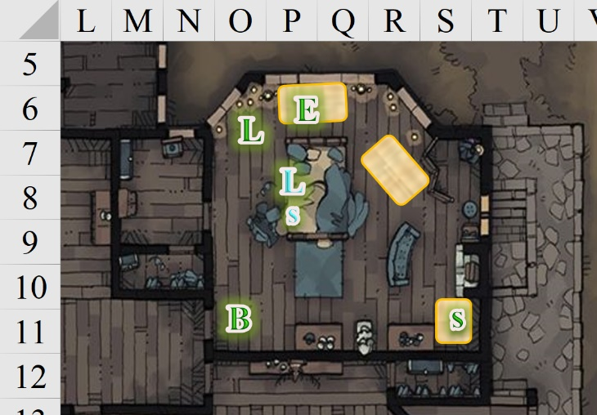

When Barkley saw the little white furry thing by Laryssa’s bed, he sniffed at the air first. He did not pick up the stench of wererat, so he continued into the room and sat down in the corner with his stew. He listened to the others as they spoke and his right eyebrow went up in surprise and curiosity when Laryssa revealed that the white rodent was from the Shield Maiden. He was curious to see just why this envoy was sent.

~*~

Within a few minutes, it was revealed that Priestess Uma Sarasvati and Deacon Tåriq Sarkrin had both had the same vision at sunset, and within the hour, the chaos that the heroes fought back had ensued. The authorities would surely reveal what was deemed appropriate for the public to know tomorrow, but the Priestess and Deacon had both come to understand that Solstice was to be entrusted with the task of assisting three of the heroes from Saradush, while Laryssa was called to a higher purpose elsewhere. It was also repeated that the prisoners in the municipal dungeon had been jailbroken, and this likely meant that Oral was once again at large.

“I cannot share the nature of my mission, other than that it is in the greater interest of the Shield Maiden,” the paladin said calmly before lying down in the center bed.

“Rest, paladin. A most pivotal day lies before you at dawn,” Solstice gently placed a hand on her forehead, and caressed the woman before turning to the others, who were now spread about the room in their own respective beds.

The Celestial creature revealed that he was a musteval, one of the guardinals distantly related to archons such as Barkley. With the guise of a weasel, Solstice told the heroes a bit about himself, and his travels across Zakhara and other lands to their southeast. He was over 300 years old, but only in the last century had he been chosen for his talents of benign subterfuge. He reveled in thwarting the efforts of any agents of evil who thought themselves cunning, and had served Mayaheine’s cause on this plane for a few decades now.

“And what was this revelation about?” asked Saradette.

Elsabet rephrased the question, “Yes, what were the Priestess and Deacon shown? Have you been shown a path?”

The musteval nodded, looking down as if formulating an outline for how to best present the information. He started with, “The Priestess’ vision foretold of the attack on the city, though it did not provide a timeline. Deacon Tåriq was the first to behold the image of us five in an irregular semicircle.”

Luran sat on the bed, removing his boots as he listened.

Solstice elaborated: “He described it to me—before I was dispatched here—as an open hand, with Barkley sticking out like a thumb, Luran (whose name was not known to me until now) and Elsabet comprising the index and middle fingers, respectively, Saradette in the ring finger position, and as you might imagine, me as the pinky.”

“You don’t say,” Barkley was truly intrigued, having dreamt of something similar a few nights ago on the way to Mintar, and completely forgotten about it since.

“Their vision included me?” Luran was even more intrigued than the others.

“Not by name, but I was told to expect another with you this evening,” the musteval reported. “And here you are. Ever-wise is the Shield Maiden.”

Laryssa—the most lawful one among them all—repeated the praise.

Elsabet’s instincts—particularly before someone who looked so much like the wererats they’d just eviscerated—had been on high alert for deceit, but as far as she could tell, the Celestial creature betrayed no hints of treachery.

Barkley could sense zero evil coming from the fellow Outsider, and in fact smelled a calming sweetness emanating from his musky pelt. “So what are we to do now, Solstice?” asked the archon.

The weasel-faced Celestial smiled and said, “Tonight we sleep. Most of you look like zombies. In the morning, the Priestess will come by on her way to the Baron’s Keep for a convening that has already been called throughout the Temple Ward. All municipally bonded clergy are expected to attend, as well as their selected delegates, which in this case, includes us.”

“When will she be by?”

Solstice said, “We should expect her by the ninth bell. The meeting is to take place at the tenth, and we’ll likely want to meet internally before the general assembly is convened. I imagine the Baron’s priority will be to recoup the fugitives awaiting trial and/or sentencing, but we’ll know soon enough.”

Barkley nodded, “Then we should get some rest.” Looking at the musteval, Barkley added, “Are you hungry, friend? I have some stew I’d be happy to share.” Barkley then set down his bowl and went to gather a blanket. “As for sleeping, Luran you can have my bed. I will sleep over here in the corner.” He placed the blanket in the corner before transforming into a giant short-tailed zorse (giant schnauzer) and circled around on the blanket a couple of times, adjusting it before laying down and closing his eyes.

“Many thanks,” the musteval accepted some of the stew, and the meal was finished quickly, after which Solstice took his place in a corner of the bed where Laryssa slept.

Luran laughed heartily and explained, “I know some of my bardic brethren have a reputation for hopping from bed to bed. I can assure you I’m not that kind of bard! Ha! Also, being accustomed to roughing it when I need to, I’ll be comfortable in whatever arrangement is best for all. That said, I’ll take the entire bed with no one to steal the blankets, for the time being. Thanks to you both for your graciousness to a new companion.”

~*~

Morning, 7 Tarsakh

The Missing Minotaur

The heroes had slept—some would have said overslept—soundly and were now making their way downstairs after having washed up. Solstice had left around dawn, and had told the bard—who was stretching himself awake at the time—that he would be back with the Priestess at nine tolls, and to make sure they were ready to attend the meeting with the city clergy and constabulary.

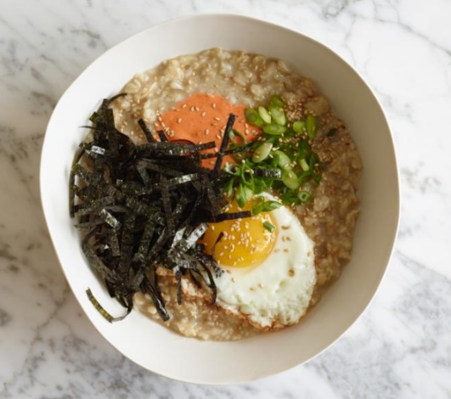

Saradette took a few moments to check on Widget, Gadget, and her cart before sitting down to her breakfast.

With a few beams of cosmic sunlight streaming in from an eastern window an illuminating the meals before them, the heroes ate the hearty oat, rice, and wheat mush that the Radnars had prepared and served with pumpkin seeds, a sunny-side-up egg, and some seaweed from the very shores of Mintar.

Before they were done, the Priestess entered the Minotaur, followed by Solstice, and greeted everyone. She didn’t know the Radnars, but they knew of the Priestess, and commended her on the sanctity of her faith, as well as Solstice on the keenness of his outfit.

The bard actually curtsied and bid Uma, “Blessings and the best to you, priestess. I have heard I am to be included in this goddess blessed group of questors. My basket of divine patrons, indeed, runneth over. The Blessed Song humming under it all guides me, as ever, to the service of highest good. I am ready and willing to aid as I can.”

“You’re taller than you appeared in my vision,” Uma inhaled as if to take an olfactory sample of Luran Ebonchord, cantor extraordinaire. “But I sense that you—along with these three fine folk...”

“Ehem…” the musteval’s voice was like a soothing reed instrument.

“Four fine folk—will do great deeds,” the Priestess corrected herself.

Barkley smiled at his fellow Celestial’s correction of the priestess.

Pleasantries resolved, Uma sat at the heroes’ table as Solstice nodded hello and jumped on Barkley’s lap, giving the fellow Celestial a fist bump.

Barkley returned the greeting to Solstice and nodded and smiled at the Priestess as they all sat at the table.

Elsabet had a question. “Were there any other details in your vision, Priestess?”

The ranked official did not receive such revelations lightly, and was still recovering from the shock of the vision, which had left her with a blind spot in front of her field of vision for hours, and had given the Deacon a migraine from which he was still recovering, though he was diligently manning the shrine as the townsfolk sought to regain some semblance of normalcy after the dozen or so hotspots of mayhem the night before.

They discussed their anticipation of what would ensue in the Baron’s Keep, and Uma—whose reverence for Elsabet’s was on par with the respect she held for Celestials like Barkley and Solstice—stated her law-and-order position, knowing that this bunch skewed more chaotic than the conversation could withstand, so she remained brief, and sighed with a conclusive smile, “... but I must put my trust in the Shield Maiden.”

At breakfast, Elsabet addressed her friends, “In light of last night’s escapades, we should pick up some silver weapons this morning: one for each of us. The way things seem to go, this may just mean we don’t fight were-creatures again for a while, but that would be fine too!”

At that moment, as if called down by Mayaheine herself, Laryssa made her way downstairs, fully armored and ready for her own clandestine mission. Her visage was solemn, but far from somber. She had also had a vision last night, but during a dream, and felt just fine this morning.”

“Lady Laryssa,” Priestess Uma stood up, as did Barkley and the others, one by one. They knew her path would diverge from theirs at this very moment, and if they should meet again, it would be by the will of the deities. “You are ready,” the Priestess stated with no hestitation.

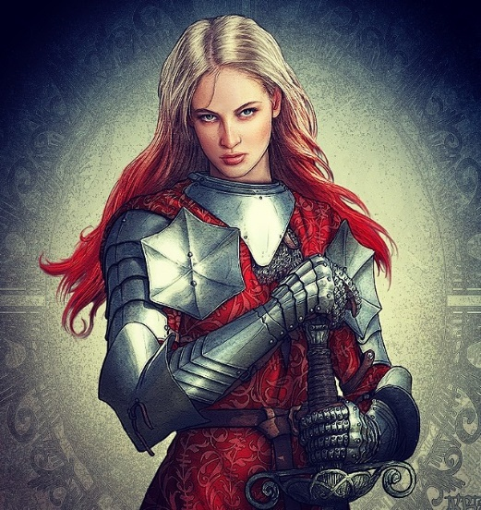

Laryssa inhaled and nodded with thousands of passages running through her head, keeping her steadfast in the face of fear of the unknown as she resolved to take leave of her friends of half a decade and brave the task that lay before her.

When it was time to part, Saradette hugged her friend tightly. “You take care of yourself, since I won’t be able to watch your back.”

Elsabet gave Laryssa a big hug as well, wishing her the best. It had been an honor to travel and fight beside her. As the two exchanged greetings, Elsabet asked Laryssa if she would pass her signal whistle over to Luran, like a ritual passing of the torch, affirming her approval of him joining us even as she herself departed.

“Of course,” she said as she handed the whistle to Elsabet.

|  |  |  |  |  |  |
| --- | --- | --- | --- | --- | --- |
| **Item** | **Qty.** | **Wt.** | **Notes** |  | **Value** |
| Signal Whistles, Engraved | 4 | 0.0 | 4 different tones |  | 32 |

*All 4 whistles are reflected in Elsabet’s equipment, but each PC holds one of them.*

As the others gave their goodbyes, Luran stood politely. He offered his forearm to Laryssa, clasping hers reciprocally while saying, “Exceedingly brief though our meeting was, I am honored to be joining these friends of yours. Best blessings on your own quest.”

The paladin nodded, holding back a tear as she beheld all of her friends one last time.

After the others had said their goodbyes, Barkley stepped up to Laryssa and hugged her as well. “It has been an honor to fight alongside you and call you friend. There will always be a place for you wherever we are.”

Steeling her wits, Laryssa mustered a few parting words of her own, “It is with a bittersweetness in my heart that I leave you. I hope our paths will cross again. May the Shield Maiden be with you.”

“May Mayaheine protect you,” Elsabet bid her sister-at-arms before the paladin walked to the open door of the Missing Minotaur, looked back one more time with an assuring smile, focused on her goddess’ divine guidance, and ventured forth to fulfill her destiny.

~*~

The Baron’s Keep was a short walk away along the scenic route, which meandered through some outer gardens where children played. They were identified at the gates, and along with the Priestess and Solstice, the party entered the keep and was led down to the same barracks where they’d been the morning before upon delivering Oral to the authorities.

There was a table with a banquet of food that looked like it had been cast by a cleric just minutes ago, and would dwindle down to a few grapes and lesser delicacies soon before another one would need to be cast.

There was already a woman—a stranger to the party—speaking atop a makeshift platform that had been used for a variety of purposes over the years. With a compelling voice, she pointed at a map of the city that hung on the wall not far from the cornucopia of goodies as two dozen or more men and women of various clerical and administrative ranks listened to the woman and reacted to one another. Some ate; others had probably broken fast at about the same time as the heroes, and as the heroes entered, some partook of a few culinary delights. Solstice had hidden inside Priestess Uma’s robes, and spied attentively, listening for voices that he knew.

Elsabet had remained fairly quiet most of the morning, asking only a few questions—things were happening, best to pay attention rather than being the center of attention, she thought. But she was well rested, all her items had reset, and for the last hour of “sleep”, she had actually been meditating, communing with the Goddess, regaining her spells, so she was fully ready for the day. The morning repast had been excellent, and she had personally spoken to the Radnars to express her appreciation.

Uma’s admiration made her slightly uncomfortable, but it just made her vow to herself to live up to those high expectations. Elsabet had received such seemingly fanatic attention from others before, particularly ranked clergy who had advanced through pious practice along the simple, ecclesiastical hierarchy of the Mayaheinean faith rather than having been imbued with the favors of the Shield Maiden herself. In some cases, it could be said that she’d ben envied by such theocrats.

She did bring up the subject of the wealth garnered from the wererats with Uma, the plan to ask the two temples to split the value, take 10% of their portions for expenses, and use the rest to help the families of those whose lives had been disrupted by the previous night’s events. Was Uma willing to take on the task of taking those gems and coins back to share between the two temples for that purpose?

Now, she paid close attention to the woman on the platform.

Luran took immediate interest in the speaker and the crowd around her.

Barkley listened intently and looked at the map. He wondered just how widespread the chaos from the previous night had reached. He also wondered if this was a disturbance created just to spring Oral or if it was a much larger escape attempt.

Pointing to various portions of the map that were marked with sad faces to mark epicenters of conflicts around the city, the woman began to explain the series of coordinated attacks that took place within 2 minutes of one another.

Within a few minutes they’d gathered the following details:

|  |  |
| --- | --- |
| **Location** | **Offenders** |
| Baron’s Keep | Unknown |
| Bell Tower | Wererats |
| Chatterstreet | Grimlocks (4) |
| Ford North | Krinth (5 or 6), unidentified spellcaster |
| Southspur | Wererats, dire rats, wystes, possibly an evoker and/or conjurer |
| Temple of Tempus | Unknown |

The majority of the identified offenders had been neutralized during the night, “but it appears that it was the Baron’s Keep where the true motives of the concerted effort were directed. Almost every suspect and convict remains at large.”

“How many have we recouped?” asked a bald-headed, bearded gnome with the markings of a Sacerdot of Gond.

“As of this moment, seven. Twenty-two remain at large, and are likely still within city limits. Security at the docks and gates has been doubled, and we expect to round up the bulk of the stragglers.”

A concerned mage—a dwarven woman—piped up, “Wererats and grimlocks are a worrisome lot as it is, and lycanthropy won’t be an easy thing to extricate from our city once it’s taken root. But what concerns me the most is the krinth. What’s a krinth—let alone a handful of them—doing on this plane?”

Another arcanist added, nodding, “Aye, where there are krinth, their illithid masters are not far behind.”

“As I mentioned earlier,” the conversation’s organizer said as she came forth towards the center of the torchlit room. “We are dealing with separate teams of operatives directed to commit suicide upon capture.”

“Uhh-uhh… that has to be based on the promise of some heinous power in the hereafter,” a wary cleric of Ilmater said with a shaky voice.

“A Faustian pact!” another voice in the crowd concurred before a generalized cackle from the crowd took form.

“Order, please,” the lead woman said, her name being pronounced as Bratislava by one of her assistants before she began to explain, “And as some of you are now aware that our beloved, historic bell tower was burned to the ground about two hours ago.”

Another wave of disorder ensued amongst the clerics, magistrates, and officiaries before Bratislava’s voice shushed the others with information, “We were able to investigate rumors of wererats occupying the structure, and were saddened by the news that old O’Herlihy—the bellringer—was a lycanthrope himself, and had been infecting others with the nefarious affliction.”

“By the *gods*!”

“What folly!”

“We’ve really gone downhill.”

“Bastard!”

“How could this happen under our nose?”

“I *knew* that creep was up to something, stowing all those rounds of exotic cheeses whenever he could!”

Saradette listened quietly, and took note of how the people reacted to the speaker’s proclamations.

Before the meeting was over, they had jotted the locations of all of the attacks on Saradette’s personal map, which Valerie had given her shortly after arriving. None of them had ever run across a grimlock, but being familiar with wererats by now, they thought to mention their involvement in the bell tower incident.

It was at this time that the gnomish officer who had talked with them the night before after they’d vanquished a wyste entered with a message for Bratislava, handing her the furled parchment. As she opened and read it, the gnome officer spotted and identified the party, and said, “Oh, you were among the brave fellows who cut down that giant worm in the Southspur.”

Priestess Uma hadn’t heard that part of the story, and raised an eyebrow as the four heroes seemed to be under a spotlight now.

Barkley looked to the gnome and bowed his head, “We were simply in the right place at the wrong time,” he said with a smile. “It was an honor to assist in vanquishing the beast.”

Luran had been surprised to learn the bell tower had burned, that morning. He made certain to emphasize the efforts that had been made to save the old, wooden structure, and asked what was known about the fire.

Elsabet asked if they could get names and descriptions of the remaining uncaptured prisoners, so that if they spotted them, they could capture them and return them. She also had looked around the crowd to see if their recent companions on the road—Captain Samand and Valerie—were present, but they were not. A parchment was handed to the crusader by a prefect’s assistant, a smiling halfling named Vloshvik. She nodded as she noted the names and descriptions of all the outstanding fugitives, with two names from this morning’s intake manifest crossed out, these being the most recently arrested fellows.

Several guards had been killed, and a few of them in such wanton ways that they could not be resurrected, and a list of names was made available for those who knew the victims. In addition, a Captain of the Guard named Merdick Forren is not accounted for, and was dispatched to the Chatterstreet Quarter at the time of the attacks, which were most severe in that part of the city.

Luran had been surprised to learn the bell tower had burned, that morning. He quickly spoke up, gaining the attention of those gathered. He recollected meeting up with group and their subsequent purge of the rodent menace from the tower, acknowledging the sad truth that one of the shapechanging monstrosities escaped. He made certain to emphasize the efforts that had been made to save the old, wooden structure, and asked what was known about the fire.

~*~

Having shared the tale of the heroes’ stalwart vanquishing of the wererats from the tower, the bard answered a few follow-up questions and the party was commended for their deeds.

“The City of Mintar is grateful for your bravery, heroes,” Bratislava proclaimed as she nodded to Uma, as if bestowing upon her the commendation of the others’ heroism. Cheers followed, and some pats on the back as well.

It was then that a dispatch was delivered by a picket who was ushered in by a pikeman. The winded youth bowed to Bratislava and delivered the update, which she read as quickly as possible, then summarized, “A wererat was caught not a toll ago.”

The crowd murmured singularly before Bratislava spoke again, “Our detectives were able to question her, but she died without a current explanation of the cause. During a brief moment when the interrogators turned down to take notes on what she’d just divulged, her head tilted sharply to the left and her neck snapped instantly.”

“An invisible stalker!” someone speculated.

“Nay! A strong telekineticist could do that!”

<< Fri-etymoth garpechkhõrr! >> some outlander added in Chondathan.

“What did she divulge?” asked a cleric of Fharlanghn.

“The woman—who remained in wererat form until her death—was only partly coherent, but referenced someone or something called The Blessed several times, as well as the Laughing Ghost of West Hill... and that her dreams are her oracle,” Bratislava answered, looking down at the parchment again, smiling nervously. “And a lot of threats of the entire city becoming a rat warren.”

“Madness!”

“Where there are krinth, illithid are sure to lurk!”

<< Krinthraar, preikh illithraar bremphra iq! >> the Chondathan agreed.

|  |  |  |  |  |  |  |
| --- | --- | --- | --- | --- | --- | --- |
| **Luran, Skill** | **Rank** | **Ability & Mod.** | **Misc. Mods.** | **Total** | **Roll** | **Check** |
| **Knowledge: Arcana** | 9 | **Int (+1)** | 6 | 16 | ?? | ?? |
| **Knowledge: History** | 1 | **Int (+1)** | 6 | 8 | ?? | ?? |

*See below.*

The bard squinted in the midst of all the banter, and tried to link the phrases he’d just heard. The obvious connection was West Hill, which was the informal name of the that included the Westgate Quarter and the Baron’s Keep, so pretty much where they’d slept, and where they now were. Laughing Ghost? That rang no bells. And The Blessed? He shrugged to himself, thinking maybe that was something pertinent to the Holy Quarter.

Concern, disbelief, scoffs, and the shaking of heads ensued, and subsided with the assurance from Bratislava that, “Our diviners are even now working to uncover more, and we expect to have an update at the twelfth toll, when the Baron is expected to address this Council.”

When the morning meeting was adjourned, and rank-driven directives were issued, the militarists shuffled out in pairs and trios, and the majority of the clergy did so shortly thereafter, some staying behind to strategize or get information that they’d missed during the meeting.

Priestess Uma had been speaking to Bratislava and a gnomish cleric of Gond, and now bade them both a fortuitous day and rejoined the heroes, sharing what gems she’d gathered from her clerical colleagues. “Come, heroines of the Shield Maiden and heroes of the Maimed God. Aside from wanting to show you the row of shops I mentioned yesterday for the sake of getting you some proper weapons, one of the shops mentioned in the meeting is there, and I know the owner, Shoomma. I’m anxious to see how extensive the damage to her shop was, and if she’s alright.”

~*~

On the way to the Chatterstreet Market, the musteval emerged from Uma’s bag, and perched on her shoulder as she did most of the talking, digesting the tidbits of pertinent information that they had on the case. “The way the attacks were planned—the sites and intensities—suggests that they were trying to lure the authorities away from the Baron’s Keep, which was the last place that was hit.”

And sure enough, by the time they got to the general area where the main shops were, it was evident that this quarter had been hit much harder than the Southspur. It seemed that the culprits had attacked peripheral areas of the city more extensively, worst of all, this quarter. And though repairs and cleanup were fully underway, they passed a pile of stained glass and other debris in the middle of the strip that had been deposited by the handful of vendors whose shops had been caught in the path of one of the bigger wystes.

As they headed into and through the Chatterstreet market, noting the carnage, Elsabet wondered if they could find a vendor of beverages with an intact table somewhere; she was willing to pay extra to get them all drinks and be able to study the descriptions while seated. She didn’t think reading while walking was a good idea; there were too many things to stay aware of along the way. She suggested that idea to her companions, and asked Uma if she might know of such a vendor.

“There is,” she said, now opening the door to the shop where they’d arrived. “We’ll get equipped, and then we’ll go there and maybe pick up something for the Deacon, who’s probably still not well.”

Solstice hopped onto the counter, and greeted Shoomma, “Mama Shoomma!”

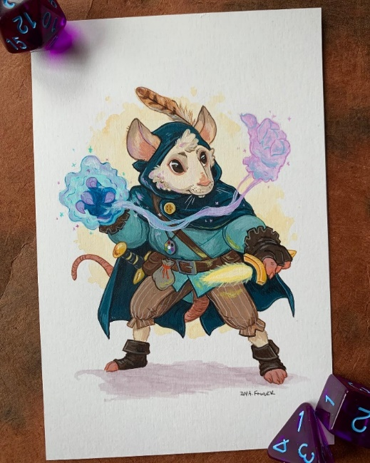

“Well, if it isn’t my favorite Celestial?” Shooma smiled as she recognized Solstice, and Uma. “And who are these strangers that you bring?” she asked as she swept some glass into a dustpan and put down both the dustpan and the broom in order to give the Priestess her full attention.

“Fellow missionaries of Mayaheine,” Uma turned to Saradette and Elsabet, then added, “And pilgrims of Tyr,” letting Barkley and Luran come forth.

“I am Saradette Gangytee,” the gnome said with a smile. “I have some locks and utensils sets to sell, and I am seeking quality wood- and metalworking tools.”

A much younger dwarf—a man with more hair than just about any dwarf Saradette had ever beheld—came out from the back of the shop, having heard the chatter, and approached, taking a measure of the strangers.

When Uma introduced them, Barkley bowed, “It is a pleasure to make your acquaintance.”

Elsabet bowed, “Elsabet of the Dalelands, Favored of Mayaheine, dabbler in exotic arts martial and eldritch, at your service.” She smiled at the woman—anyone on good terms with the little Celestial and her new friend Uma had to be a good person to know.

“I’m Luran, Madame Shoomma. And, yes, indeed, a bard who sings the celestial song of the Tyrian triad.”

“Ooh!” Shoomma replied in the key of F#, Luran noted. “Fancy that yarting!” she complimented the bard, introducing her son, Renton.

“How d’you do?” the soft spoken weaponsmith smiled.

Luran offered his shortbow to the shopkeepers asking, “Would you have a light crossbow in stock? Something that would better suit my arms, which, while well suited to fretwork on the yarting you like, aren’t such great shakes on pulling a bowstring.”

Renton nodded and went back behind a curtain.

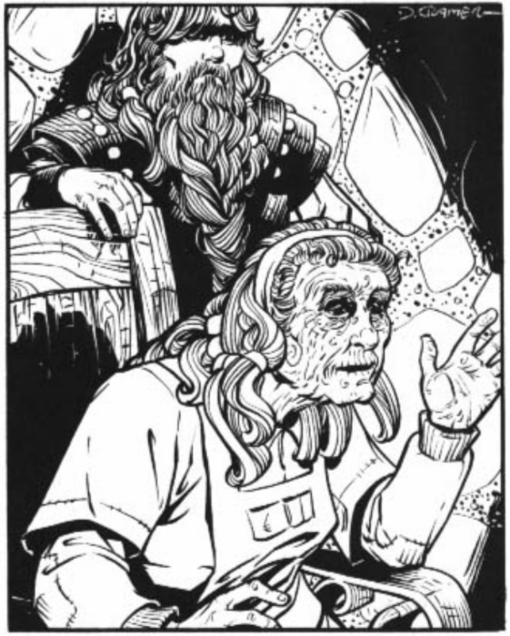

Barkley was by now looking around the store, and picked up a hand axe. He began practicing with it in his left hand (his off hand). After a couple of swings to test its parlance, he pulled out his long sword and began going through maneuvers with both weapons.

Renton brought out the whip-dagger, and Elsabet, Luran and Saradette all marveled at it for a moment.

At this point, as he made a spin, Barkley knocked into a stand holding several well-made dangers. He stopped and looked at Shoomma, “I apologize; I will clean it up and pay for any damage,” he said, a bit embarrassed. Once he had cleaned up the mess, he approached the counter and inquired, “I would like to purchase two hand axes: one of them silvered, if possible. I’d also like to purchase 20 silvered arrows as well. I understand this may take time to complete the order.” He then pulled out one of his daggers, “Would it also be possible to have this dagger silvered?”

Barkley added, “Also, I am seeking an Efficient Quiver, do you know where I might locate one?”

Shoomma wondered why the archon hadn’t asked for that before, and asked her son to go to the back of the shop again, “See if we have an Efficient Quiver left.”

<< Sure, >> Renton replied in Dwarven, disappearing once again behind the curtain.

Luran’s ear pricked up at the archon’s request. Strange, the coincidence, he thought. He had also very recently been hoping to someday earn such an item.

~*~

As the heroes made their purchases, Shoomma asked Saradette, “So, dear, did you say you were looking to unload some things?”

Saradette hadn’t brought her cart with her, so most of her hardware was back at the Missing Minotaur, but she did have a few trinkets that were crowding her pockets. She extracted one of her smallest locks, and a utensil set. “I have the rest back at the inn,” she explained.

“You just want coin for’em, or are you looking for some arrows for your shortbow?” asked Shoomma.

“I would like to trade these for some silver alloy that’s ready to use,” Saradette replied. “I am an artificer, so I have the tools to make my own weapons.”

Elsabet admired the fine workmanship of the array of weaponry in Shoomma’s shop, and asked for a bundle of 20 silvered arrows and a silvered kukri. “And do you sell alchemical products in general, or can you recommend someone who does? I’d like to get a flask of acid and a flask of alchemist’s fire I used up last night.”

“I do,” she reached down and got the flasks in question, adding, “How many are you looking to get?”

“One of each for now,” Elsabet stated.

“Sounds good,” the dwarf added two flasks—one green and one a swirl of orange and yellow—to the lot.

Elsabet complimented the woman on her wares, and admitted to having learned a little of the weaponsmithing craft at her own mother’s leather apron strings. “I still enjoy working at the forge, even as just an assistant,” she said. “Though Mayaheine has called me onto another path, I still carry my tools with me wherever I travel. I’m nowhere as skilled as Saradette in general metalworking and other crafting, but if I am careful not to rush, I can turn out a serviceable martial weapon, not masterwork by any means, but it will do the job.”

When the items were brought out, Barkley looked them over, impressed in the craftsmanship and quality. “Very impressive, the work certainly lives up to the reputation,” Barkley said in an impressed and respectful tone. “I was wondering if you would consider a custom item. I have always wondered about combining a rope of entanglement with a set of bolas. This would make the bolas a more formidable non-lethal weapon should you want to stop and capture an opponent rather than kill them.”

Shoomma produced a blunt arrow—designed to administer bludgeoning damage, and showed it to the archon. “So something like this at the tip of the whip?”

Barkley grinned, “Pretty much, yes.”

“I’d need to fashion the bolas—maybe three of them are enough?—with proper tethers, so it might take me as much as half a tenday for this. Give me 30 gold today and 20 more upon delivery, and I’ll start thinking about how best to do this. I take it with the silver goodies that you’re part of the security team?” Shoomma sort of guessed right.

Barkley nodded, “Yes, that would be fine, and yes, we will be assisting the town guards and temple guards in patrolling the city for those that escaped as well as any sign of the wererats.”

Uma nodded, “The city’s vested clergy has been warned that the lycanthrope threat is still very real, and we are all to secure the area within 200’ of our respective temples. The Deacon has likely already received this message via a courier, and I expect it’ll be a long day of patrolling the streets and alleys that lead to our dear shrine.

“Well, I can tell you this: wererats are a lawful enough bunch, and they do—on occasion—act in organized ways like what we saw last night, but with the grimlocks and spellcasters that the town crier was going on about this morning, not to mention the purple aberrations that were slithering around town destroying everything in their path. We got one of those right there,” she pointed to the corner just southwest of her shop.

As they were figuratively wrapping up their purchases, the dwarf added a final heed, “I remember a wererat attack upon my natal village; ‘twas over a hundred years ago now, and it was put down quickly by our village clergy and as many warriors as our clans could muster, but not before a dozen of our own were afflicted... most could not be saved,” she shook her head. “I can’t overstate the importance of striking down this threat before it proliferates,” she urged Uma. “Tell the Baron’s Council this.”

Barkley listened to Shoomma and nodded, it was indeed a grim story highlighting the situation.

Uma had a look on her face like she’d been asked to convey the sentiments of the people to the Baron’s women and men before, and nodded, “I will do my best to make sure this is understood.”

~*~

With their purchases concluded, the party hefted their goodies on their persons, and shook a few times in their armor to get properly situated, and thanked the dwarven smith and her hairy son.

Uma, Solstice, and the others exited the shop, and wandered over to the juice vendor, sitting at a table to take in the information on each of the escaped convicts and suspects. While doing so, they discussed the situation, and enjoyed the juices and nectars that had sounded the most refreshing on the paper menus.

Excited to see the vendor had a spiced cider on the menu, Luran ordered that. He sat, attentive as he was able, while the group discussed the escapees, the most pressing next steps, and enjoyed their own drinks. He was largely successful at maintaining focus, though the occasional, novel passerby would draw his slightly flighty eye....

Barkley had ordered an orange-juice-flavored drink and lapped it up as he listened to the others. “I suggest we pass on Shoomma’s message as soon as possible, perhaps splitting up into two teams and agreeing to a meeting place and time. Shoomma’s message carries importance and the weight of her reputation, so should be delivered quickly.”

Uma’s eyes turned to Barkley, though her face remained pointed at her drink, which she now raised. In truth Shoomma had been a bit of a troublemaker down at the Baron’s Keep more than a few times, and though she was well meaning, her suspicions were often a false positive. Still, in this case, Uma was in full agreement that this was a serious issue, so she let the observation go, and nodded as she drank a jicama-cranberry infusion with a few slices of bok choi on top as a garnish.

Solstice had ordered a crème-du-lait-and-boysenberry thing that he lapped up from a shot glass as he sat on Uma’s lap and enjoyed the shade. Minstrels and musicians were already walking by and carousing with jugglers, jesters, clowns, and mimes as merchants began to set up shop for the day’s bustle in the aftermath of last night’s punctuated disasters.

Saradette ordered a strawberry and watermelon fruit drink, and listened to the conversation as she ate it with one of her spoons.

Elsabet was in the mood for a nice sweet juicy beverage with nothing too chewy in it, and asked the vendor to recommend one, which she then ordered. Most if the items on the menu were strange to her eyes, but she was willing to try whatever the vendor recommended, even if he was just trying to use it up.

While the others chatted, her attention was primarily on the descriptions—before letting others study any of the pages, she got out her journal, opened it to the second blank page (leaving the first blank page to add explanatory notes to), held the sheaf of papers firmly together in her left hand by pinching the upper left corners, and with her right hand cast her *amanuensis* spell, concentrating as the spell started copying the words from the sheaf of papers into her journal, then inventoried her remaining deity-mojo for today.



With the information duplicated, Elsabet took the facsimile and pocketed it for later review as Priestess Uma rose from her chair, “As you know, I’m due back at the Shrine, and particularly with Tariq ill, I want to ensure that our block is fortified.”

Mintar was built in the old manner, with each temple and shrine representing the epicenter of some spiritual community within the Holy Quarter. The musteval assured her, “I’ll be sure to heal and embolden them if there’s more trouble than we can handle.”

Uma nodded, “Perhaps you’ll join us for prayers tonight. Barkley and Luran, you’re more than welcome to participate.”

*[IC reactions and parting thoughts.]*

~*~

The heroes had finished their drinks, and now considered where to go next. They were about as far southeast in Mintar as they’d wandered so far, and the sun was now approaching its zenith. With the map of the city unfolded and weighed down by a few glasses, Solstice studied the map and finished his drink, pouring the remainder of the shot glass’s contents into his snout before suggesting, “If you’re all tired, we can perhaps walk back to the Minotaur and gather our second wind before continuing our pursuit of these ruffians.”

The party was nearly unanimously opposed to this, and the topic quickly was resolved to the contrary. “We’ve rested enough,” Elsabet said almost inadvertently, having enjoyed her choice of beverage, and hoping to repeat the experience before long.

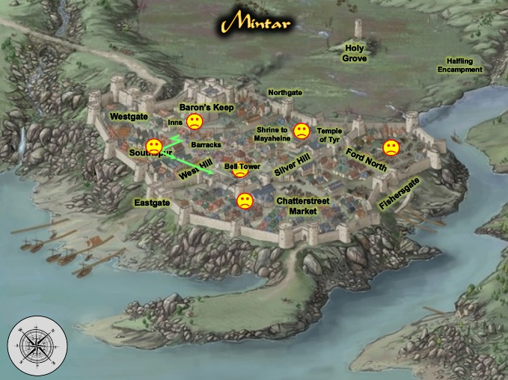

Barkley sat back in his chair, enjoying the last few moments of rest before warming their heels again, and listened as the fellow Celestial proposed, “Then, if we are to go now,” he looked down at the map, sitting on a napkin atop the table. “Where to?” Barkley looked at the map and noted the sad face marker between them and the Eastgate. “What happened at that location?” he asked, pointing to the unhappy face.

“Much of the same that happened throughout the rest of the town,” Elsabet recalled from this morning’s briefing, “but I think Bratislava said there were no wystes unleashed there.”

“Summoned, really,” Luran betrayed a certain penchant for literary exactitude when arrows weren’t flying.

“Right,” Elsabet added, “I believe this is where the grimlocks were seen fleeing towards Eastgate and into the sea,” she referred to the Lake of Steam, which was actually a marine body of water.

“Perhaps we should go past that location on our way to the Eastgate,” Barkley proposed.

The musteval studied the map and pointed out, “That marker actually represents all of this area that was ravaged... from here to Eastgate.”

They began to walk along in that direction, noting that the “ravaging” had only been in punctuated areas where—according to locals who engaged the heroes as they walked by and expressed their sympathies—grimlocks fled in a less-than-concerted effort towards the dockside where the city bordered the golden shores, and less flighty wererats did their best to indiscriminately harm passersby before they disappeared into crowds and alleys.

Some of the grimlocks had been killed, but most—allegedly—had gotten away, and as everyone got to the block indicated on the map as being the epicenter of that destruction, they did note the damage that would take several *make whole* and/or *stone shape* spells to get back up to code. It was only two adjacent buildings whose façades had been partly demolished, and even now, masons, artisans, and spellcasters were arguing about the most efficient way to go about doing this, and still have some juice to undo other damages before the day was out.

Elsabet mused for a moment, then asked, “Where were our companions from the trip here staying? I’ve of a mind to check on them, but I don’t recall what their exact plans were for today.” Then she pulled out her journal, to check whether or not she had remembered to make a note of that... a lot had happened the day before, it almost felt like two days had passed.

“Oh, right: Valerie was staying with her family, and attending her relative’s funeral, and Samand was likely already on his way back to Saradush,” Elsabet said aloud.

Saradette was usually the most astute one in the bunch, and this morning was no exception. The Small rogue kept her face turned slightly down as her bangs obfuscated the direction of her gaze. She studied all of the commoners, merchants, and even a handful of flatulent barbarians upwind of her, but landed mainly on a human and a dwarf, about 50’ away at her 7 o’clock, whom she’d never seen before, but who had been walking in the same direction as the group for two blocks now.

She dissimulated the fact that she was aware of the two mid-age males, but the dwarf’s body language told her that she’d either botched the nonchalance, or that the dwarf was simply shifty and edgy, but when she turned away for a moment to scan the rest of the area again for anything that might look like they were surrounded by enemies, the dwarf and human darted into a tapestry and fabric store. By the time the gnome turned back around, the door of the shop was closing, and a bell attached to it rang a few times.

As they walked to and through the area, Barkley continued to sniff at the air to see if he could pick up the scent of any of the escaped prisoners whose scents he had been provided. They were walking against the breeze, which was advantageous in the way of forecasts of who and what was ahead, but disadvantageous insofar as who was following them was concerned.

“I think I need some fabric,” Saradette said casually. “We just passed a store back there. Elsabet, would you like to come with me?” Her tone and body language were light and casual, but her eyes told another story. The gnome rested her hand on her sword pommel for a moment as she turned back toward the store.

“Sure!” Elsabet replied, “I love checking out new shops. Do you think they have silk?”

Barkley at first didn’t think anything of Saradette’s comment, but when she touched the pommel of her sword, Barkley asked, “Perhaps I can give my opinion on color or cut?” He then rested his hand on the pommel of his sword for a moment.

Saradette smiled up at Barkley. “Perhaps you can, yes.” She pushed the door open and stepped into the shop, blinking as her eyes adjusted to the inside light.

Luran was wildly confused for a second and started to ask, “Fabric? But I thought you worked in metals and such, S?” He looked quizzically at the gnome for a short second before noticing Saradette’s telling expression, and although he hadn’t traveled with this lot for the last half a decade, he could pick up on the latent tension in her voice and the patent concern on her face. To boot, he spotted the multiple hands on weapons, and it sunk into his cute but not quick skull that trouble was amidst. “Oh...” the bard took on a nonchalant demeanor and pretended to check out other stalls and vendors as he prepared to back up his friends in their next actions.

The party casually made its way to the store, now about 30’ away, led by Saradette, with Luran at the rear.

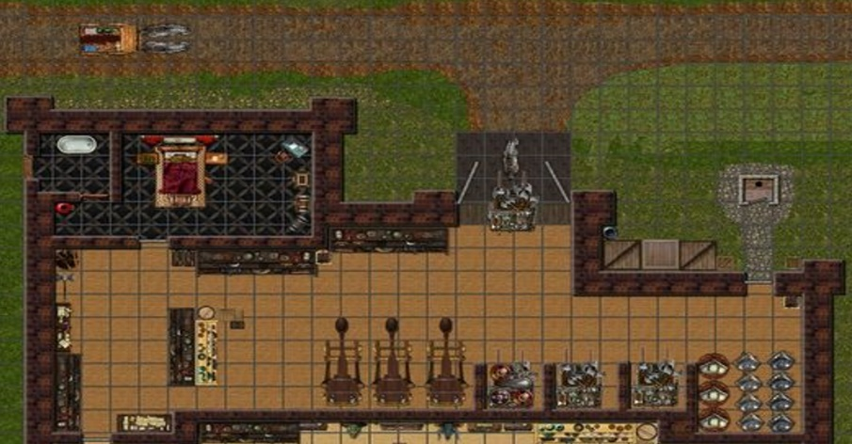

They stepped inside, finding not only tapestries, but three wheeled looms, each priced at almost a thousand gold, and an assortment of weaving gear. To their right as they walked in was a tall half-elf with golden locks. Barkley caught him looking to his right—southward—at the doorway that led to the back of the shop, and the man then smiled and greeted the adventurers. “What c’n I do ye fer?” the half-elvish man spoke with the accent of a human from the Ride, Elsabet could discern.

The heroes had spotted an outhouse just outside the shop, and now a woman could be heard opening and shutting the door to that privy. The human lady made her way inside the shop and simply said, “Good morning,” as she picked up a feather duster that had been laid on a counter at along eastern edge of the shop, then resumed dusting a shelf.

Barkley greeted the half-elf in returning, “Good morning to you as well.” He then continued towards the door at the back of the shop, sniffing the air as he went trying to pick up any scent in the air that did not belong to anyone or anything present in the room.

Saradette smiled up at the man. “Good morning. Did you see a dwarf come in here just now?”

“A dwarf? We’re outta those,” the shopkeeper jested, but Elsabet could tell that he was stalling them.

Saradette glanced around the room, and then her eyes settled on the woman with the duster. The shapely gnome walked over and smiled up at her. “Good morning, my good lady. Did you see a dwarf pass through here just before we came in?”

Solstice murmured something into Barkley’s ear.

Barkley glanced at Solstice on his shoulder and nodded. He then stopped walking towards the door and instead walked up to the counter, a couple of feet from the keeper, and took a strong whiff. “Wererat!”

The opening of a door to Barkley’s south was now audible, coupled with the sunlight that crept into the back room now that the back door was hanging open. The dwarf and human had likely escaped.

The woman reached for a cutlass that had been hidden under a tapestry, and now wielded it menacingly at Saradette.

Saradette backed away and pulled her dagger from its boot sheath, where it had not been peace bonded.

Elsabet gave a loud sigh, and as she released the peace bond on her shiny new silvered kukri, said, “More wererats? I guess a tower full wasn’t enough exercise...”

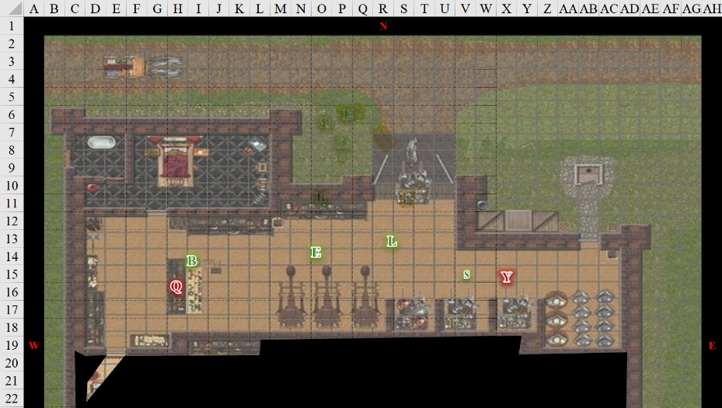

Round 1

|  |  |  |  |  |  |
| --- | --- | --- | --- | --- | --- |
| **Character** | **Group** | **Initiative** | **Roll** | **Modified Roll** | **Move** |
| Elsabet | 1 | 4 | 17 | 21 | 30’ |
| Snorg | 2 | 1 | 20 | 21 | ??’ |
| Luran | 1 | 1 | 19 | 20 | 30’ |
| Yvonda | 2 | 2 | 11 | 13 | 40’ |
| Barkley | 1 | 4 | 8 | 12 | 30’ |
| Quiñones | 2 | 0 | 12 | 12 | 40’ |
| Saradette | 1 | 1 | 5 | 6 | 20’ |
| Solstice | 1 | 4 | 1 | 5 | 20’ |

Elsabet felt the inspiration of the Shield Maiden.

|  |
| --- |
| *Current Maneuvers* |
| Battle Leader’s Charge |
| Crusader’s Strike |
| Shield Block |
| Stone Vise |
| Foehammer |

Looking quickly in both directions, Elsabet had to decide. Barkley had smelled wererat on the man to her right, but it looked like he was behind a counter or table with wares, and the angle wasn’t good for a charge. To her left, the woman had reached for a weapon and was within a step of Saradette. If the shopkeeper was a wererat, the woman likely was too.

“Elsabet, help!” Saradette called.

She couldn’t draw her weapon while charging, so despite getting the maneuver she couldn’t use it—but she could still get into action! Elsabet moved 30’ straight across the room to her left while drawing her now-unbound silvered kukri, arriving just behind Saradette’s left shoulder, and then with a grin and a swift command word activated her Anklet of Translocation for the first time since sunrise, teleporting another 10’ forward, putting her between the gnome and the woman. Still grinning, she slashed at her, with a snarled “Try me, bitch.”

|  |  |  |  |  |  |  |  |  |  |
| --- | --- | --- | --- | --- | --- | --- | --- | --- | --- |
| **Melee Weapon** | **Dmg** | **D+** | **TH+** | **Critical** | **Type** | **Wt.** | **Atk** | **Roll** | **Check** |
| Silver Kukri | 1d4 | 1 | 0 | 18-20, x2 | Slashing | 2.0 | +6 | 15 | 21 |

*Hit. Dmg: 4 + 1 = 5.*

The wound seared the rat-woman, who flinched with pain at the silver-coated blade.

Elsabet felt her third maneuver—Shield Block—granted; if the wererat woman tried to move past her and strike at Saradette, the gnome would be a lot harder to hit than the rat woman might think.

A stranger approached the shop, and opened the door.

Luran removed the bag from over his crossbow bolt quiver as he heard Barkley’s warning and noted his companions making similar actions.

A heavyset half-orc with an unkempt beard entered the establishment through the main door, took in the sights of what was going on, nodded, and engaged Luran in unarmed combat.

|  |  |  |  |  |  |  |  |  |  |
| --- | --- | --- | --- | --- | --- | --- | --- | --- | --- |
| **Character** | **Attack Type** | **Damage** | **BAB** | **Str Mod+** | **W+** | **Other+** | **Total Score** | **Roll** | **Total** |
| Snorg (Hyb.) | Slam | 1d4 | 3 | 2 | 0 | 0 | 5 | 15 | 20 |

*Hit. Dmg: 1 [41/42].*

The woman near Saradette—also taking on rodentesque features— swiped menacingly at Saradette with her cutlass. “The master will feast upon your brains!”

|  |  |  |  |  |  |  |  |  |  |
| --- | --- | --- | --- | --- | --- | --- | --- | --- | --- |
| **Character** | **Attack Type** | **Damage** | **BAB** | **Str Mod+** | **W+** | **Other+** | **Total Score** | **Roll** | **Total** |
| Quiñones (Hyb.) | Dagger | 1d4+1 | 1 | -1 | 0 | 0 | 2 | 18 | 20 |

*Miss due to Shield Block.*

Barkley hastily undid the peace bond on his silvered handaxe as he yelled with pain and prepared to attack the filthy imposter.

“*Take* her, Yvonda!” the shopkeeper grimaced as his incisors lengthened and the rest of his teeth shrunk. His face was nearly instantly covered in fur, and his ears began to look like two gray discs as the male wererat reached for an ornate dagger under the till and stabbed at Barkley.

|  |  |  |  |  |  |  |  |
| --- | --- | --- | --- | --- | --- | --- | --- |
| **Character** | **Attack Type** | **Damage** | **BAB** | **Dex Mod+** | **Total Score** | **Roll** | **Total** |
| Quiñones (Hyb.) | Dagger | 1d4+1 | 1 | 1 | 2 | 8 | 10 |

*Miss.*

Saradette backed away a few feet from the menacing woman and toward Elsabet for protection, as she’d not purchased a silvered weapon, and so she was effectively unarmed.

Solstice drew his blowgun, and darted away behind a copper pot near the counter.

|  |  |  |  |  |  |  |
| --- | --- | --- | --- | --- | --- | --- |
| **Skill** | **Rank** | **Ability & Mod.** | **Misc. Mods.** | **Total** | **Roll** | **Check** |
| **Solstice, Hide** | 5 | **Dex (+3)** | 8 | 16 | 4 | 20 |

*Result unknown.*

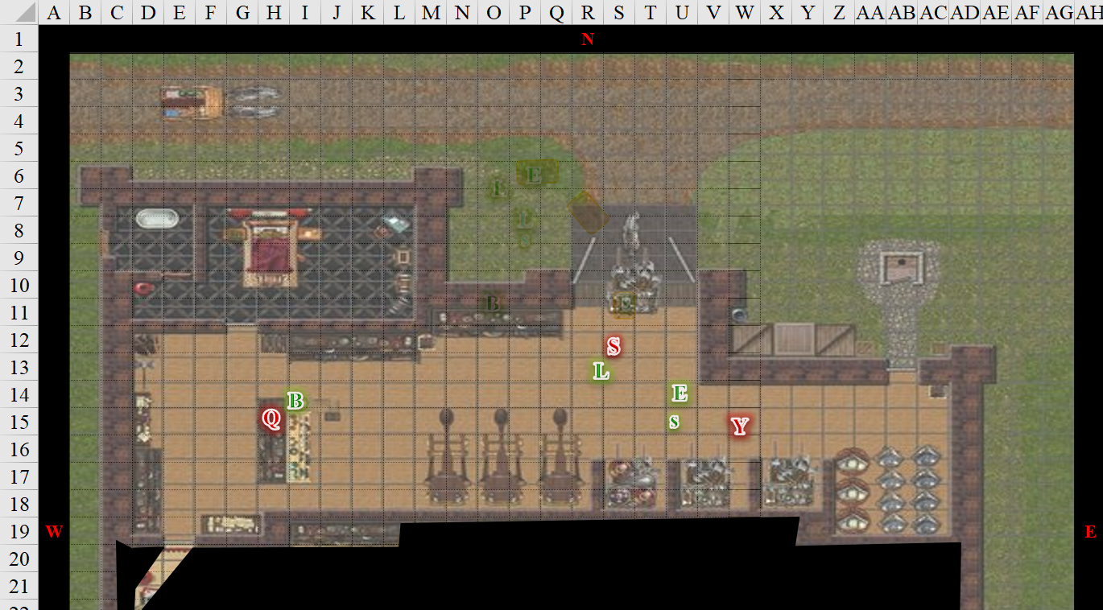

Round 2

Elsabet stepped diagonally forward to place herself right between Saradette and the ratwoman, and slashed again at the nasty creature with her shiny new silvered kukri.

|  |  |  |  |  |  |  |  |  |  |
| --- | --- | --- | --- | --- | --- | --- | --- | --- | --- |
| **Melee Weapon** | **Dmg** | **D+** | **TH+** | **Critical** | **Type** | **Wt.** | **Atk** | **Roll** | **Check** |
| Silver Kukri | 1d4 | 1 | 0 | 18-20, x2 | Slashing | 2.0 | +6 | 1 | 7 |

*Miss.*

She called out, “Get closer Luran!” as she felt her Stone Vise maneuver granted to her. But a glance over her shoulder showed Luran having a problem of his own. Well, hopefully these ratfolk weren’t as tough as the tower ones, and at least here there were no stairs to climb!

Snorg—now fully ratty-looking—jumped atop Luran, biting at his pretty face.

|  |  |  |  |  |  |  |  |
| --- | --- | --- | --- | --- | --- | --- | --- |
| **Character** | **Attack Type** | **Damage** | **BAB** | **Str Mod+** | **Total Score** | **Roll** | **Total** |
| Snorg (Hyb.) | Bite | 1d4+1+Dis | 3 | 2 | 3 | 13 | 16 |

*Miss.*

Luran appealed to his attacker, “Hey, pal! What’s the deal? What’s your problem here?” His words shifted to song as his bardic music lifted the very air around them. Looking to his defense, he hastily grabbed a silver bolt shaft from the quiver and held it aggressively between himself and the newly transformed rat-orc.

*PCs and Solstice gained +2 to attacks, weapon damage rolls, and saves vs. charm and fear effects.*

Yvonda made the crucial mistake of attacking Elsabet.

|  |  |  |  |  |  |  |  |
| --- | --- | --- | --- | --- | --- | --- | --- |
| **Character** | **Attack Type** | **Damage** | **BAB** | **Dex Mod+** | **Total Score** | **Roll** | **Total** |
| Yvonda (Hyb.) | Cutlass (Scimitar) | 1d6+1 | 2 | 3 | 5 | 9 | 14 |

*Miss.*

Barkley growled and lunged at the wererat behind the counter, swinging his silvered hand axe at the filthy beast.

|  |  |  |  |  |  |  |  |  |  |
| --- | --- | --- | --- | --- | --- | --- | --- | --- | --- |
| **Melee Weapon** | **Dmg** | **D+** | **TH+** | **Critical** | **Type** | **Wt.** | **Atk** | **Roll** | **Check** |
| Hand Axe, Silver | 1d6 | 1 | 0 | x3 | Slashing | 3.0 | +6 | ***19*** | 25 |

*Threat. 1d20 = 7 + 6 = 13, not a critical hit. Dmg: 6 + 1 = 7.*

Quiñones dramatically grabbed the handle of Barkley’s axe now that the hound archon had lodged the weapon’s metal wedge into the wererat’s ribs. As the hero retrieved the bloody axe from the wererat’s ribcage, Quiñones dropped to the ground, and stared at Barkley with contempt, unable to say much as one of his lungs filled with his own blood.

With Yvonda busy with Elsabet, Saradette worked her way around behind Snorg and sneak-attacked the orc, kicking him in his arse.

|  |  |  |  |  |  |  |
| --- | --- | --- | --- | --- | --- | --- |
| **Skill** | **Rank** | **Ability**  **& Mod.** | **Misc. Mods.** | **Total** | **Roll** | **Check** |
| **Saradette, Hide** | 5 | **Dex (+3)** | 4 | 12 | 3 | 15 |
| **Saradette, Move Silently** | 5 | **Dex (+3)** | 4 | 12 | 2 | 14 |

*See below.*

|  |  |  |  |  |  |  |  |  |  |
| --- | --- | --- | --- | --- | --- | --- | --- | --- | --- |
| **Melee Weapon** | **Dmg** | **D+** | **TH+** | **Critical** | **Type** | **Wt.** | **Atk** | **Roll** | **Check** |
| Dagger 1 | 1d3 | +0 | 0 | 19-20/x2 | Slsh/Prc | 0.5 | 3 | 18 | 21 |

*Hit. Dmg: 2 (no Sneak bonus). Damage negated.*

Solstice was now behind cover, and loaded a flechette into his blowgun. Ready to fire it at Quiñones, he stood up from his crouching position to find his target already down, and Luran was in the musteval’s line of attack to the half-orc wererat. He would have to move to get into a better position, and suspected that Barkley would also close the distance between himself and the two remaining enemies, so he made his way eastward.

|  |  |  |  |  |  |  |  |  |
| --- | --- | --- | --- | --- | --- | --- | --- | --- |
| **Skill** | **Rank** | **Ability** | **Mod.** | **Ability**  **& Mod.** | **Misc. Mods.** | **Total** | **Roll** | **Check** |
| **Solstice, Hide** | 5 | Dexterity | +3 | **Dex (+3)** | 8 | 16 | 11 | 27 |
| **Solstice, Move Silently** | 2 | Dexterity | +3 | **Dex (+3)** | 8 | 13 | 2 | 15 |

*Some PCs could hear Solstice approaching.*

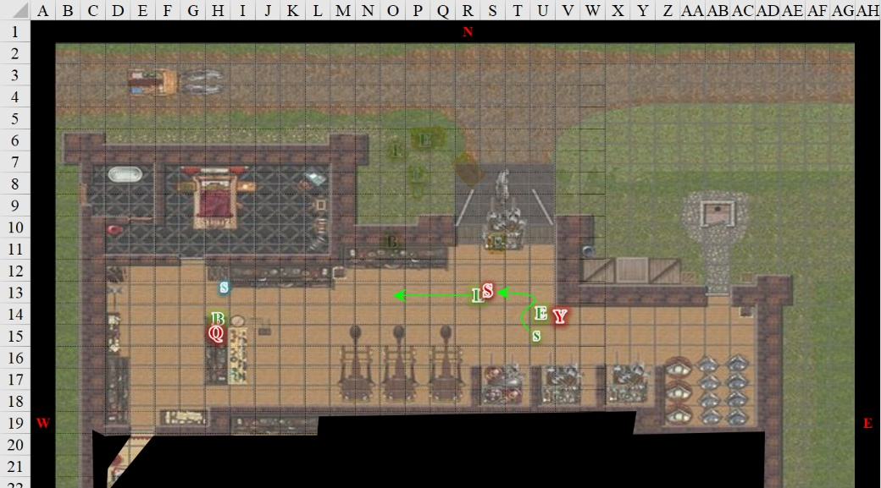

Round 3

Feeling the adrenaline rush of Luran’s inspiration, Elsabet shook her head sadly at the ratwoman, and initiated her Stone Vise strike, feeling the power of the earth flow through her as she slashed down hard with her kukri.

|  |  |  |  |  |  |  |  |  |  |
| --- | --- | --- | --- | --- | --- | --- | --- | --- | --- |
| **Melee Weapon** | **Dmg** | **D+** | **TH+** | **Critical** | **Type** | **Wt.** | **Atk** | **Roll** | **Check** |
| Silver Kukri | 1d4 | 1 | 2 Courage | 18-20, x2 | Slashing | 2.0 | +8 | 14 | 22 |

*Hit. Dmg: 1 + 1 +2 Courage + 5 Stone Vise = 9.*

|  |  |  |  |  |
| --- | --- | --- | --- | --- |
| **Character** | **Save vs.** | **Ranks** | **Roll** | **Save** |
| Wererat | Fortitude | 6 | 7 | 13 |

*Fail. Speed is reduced to 0’ for 1 round.*

Yvonda fell to her knees, barely able to crawl away as she began to shrink and morph into a dire rat, albeit slowly an in the throes of death. Elsabet could tell Yvonda wouldn’t make it, and stepped away from the ratwoman to get next to Saradette and the rat-orc, looking toward him and snarling “you’re next, goblin face.” She felt her Foehammer maneuver granted to her, and laughed, hoping to get the enemy to attack her as the obviously more dangerous opponent.

Snorg attacked Luran again.

|  |  |  |  |  |  |  |  |
| --- | --- | --- | --- | --- | --- | --- | --- |
| **Character** | **Attack Type** | **Damage** | **BAB** | **Str Mod+** | **Total Score** | **Roll** | **Total** |
| Snorg (Hyb.) | Slam | 1d4 | 3 | 2 | 5 | 11 | 16 |

*Miss.*

Taking a defensive stance, and fending off attacks with his crossbow, Luran repeated his questions lyrically, berating their remaining foe.

Yvonda collapsed.

Quiñones bled out on the floor. His eyelids fluttered, then closed.

Having pulled the axe free, Barkley sighed at the bloody pool forming underneath Quiñones. Seeing that his mates were handling the situation, he headed south through the doorless threshold to look for the original people they had come in for. He was now in the back room, which had a few tapestries, but mostly looked like it was storage for the most heterogeneous collection of things that Barkley would’ve expected. The back of the store looked like a pawn shop, and then—by the way things were bundled and arranged—the archon began to suspect that this was all stolen stuff.

Solstice moved 30’ eastward, got near Luran’s heels, and fired a flechette upon the half-orc wererat.

|  |  |  |  |  |  |  |  |  |
| --- | --- | --- | --- | --- | --- | --- | --- | --- |
| **Skill** | **Rank** | **Ability** | **Mod.** | **Ability & Mod.** | **Misc. Mods.** | **Total** | **Roll** | **Check** |
| **Solstice, Hide** | 5 | Dexterity | +3 | **Dex (+3)** | 8 | 16 | 11 | 27 |
| **Solstice, Move Silently** | 2 | Dexterity | +3 | **Dex (+3)** | 8 | 13 | 12 | 25 |

*See below.*

|  |  |  |  |  |  |  |  |  |  |  |
| --- | --- | --- | --- | --- | --- | --- | --- | --- | --- | --- |
| **Ranged Weapon** | **Dmg.** | **D+** | **TH+** | **Critical** | **Rng.** | **Wt.** | **Atk** | **Roll** | **Check** | **Notes** |
| MW Blowgun | 1 | 0 | 1 – 2 Range  + 2 Courage | x2 | 10’ | 0.1 | +10 | 5 | 19 | +3d6 Sneak |

*Hit. Dmg: 1 + 2 Courage + 13 Sneak = 16. Partial damage negated.*

Saradette turned and started to search the bodies, starting with the woman.

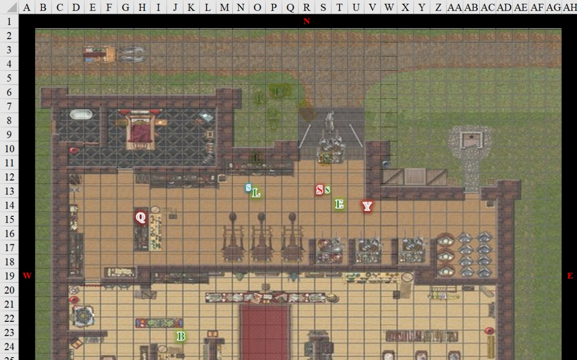

Round 4

Elsabet generated the momentum to swing at the wererat half-orc with her Foehammer maneuver.

|  |  |  |  |  |  |  |  |  |  |
| --- | --- | --- | --- | --- | --- | --- | --- | --- | --- |
| **Melee Weapon** | **Dmg** | **D+** | **TH+** | **Critical** | **Type** | **Wt.** | **Atk** | **Roll** | **Check** |
| Silver Kukri | 1d4 | 1 | 2 Courage | 18-20, x2 | Slashing | 2.0 | +8 | 19 | 27 |

*Threat. 1d20 = 11 + 8 = 19, critical hit.*

*Dmg: (2 x 4) + 1 + 2 Courage + 5 Foehammer = 16.*

The grimacing wererat gruesomely fell to the floor with various organs spilling out as its rodentesque features faded slowly.

“Anyone needs healing, speak up,” Elsabet said, as she started hustling in the direction Barkley had gone.

No one replied.

Barkley had gone in the back room, and the rest of the heroes were now left with these three dying wererats. The female had attempted to turn into a dire rat and flee, but was now reverting to her human form.

Luran’s song continued as a low, rolling cycle, awaiting crescendo. He loaded the bolt he had used to threaten the now deceased wererat in his crossbow and waited to be sure of hostilities ending. He moved over to the door Barkley had gone through.

As he looked around, Barkley sniffed at the air, trying to find where the others they had followed went. He kept his silvered handaxe at the ready and moved cautiously through the room.

As the others dealt with the last opponent Saradette slipped her dagger back in her boot top, so as to not be caught with it unbonded, and put the dead woman’s cutlass aside for later appraisal. Aside from 35 gold, 12 silver, a hunk of Camembert, a copper ring worth less than the metal that someone would have to melt down to use, and a few personal trinkets of no value to anyone else, the woman’s pockets were empty. If her clothing had been the right size, Saradette would have found the outfit rather nice to wear herself, but they were not here to filch the fashion of these felled fellows.

Solstice sighed, “You all are better than I’d been told. But then, Priestess Uma never saw you fight.”

“The silver weapons helped,” Saradette was glad the others had made those purchases just now. Her sense of economics told the artificer to suspect that with the wererat threat on the rise, the price of silver would soon skyrocket throughout the city and its peripheries.

In the room to the south Elsabet beheld Barkley sniffing around. Not a minute before, when they’d entered, Barkley had gotten the olfactory and auditory information to deduce that the dwarf and human who had been tailing them had gone south through the doorless threshold through which Elsabet had stepped through, and scrambled out through the double doors just south of Barkley’s current position.

“They escaped through here,” the archon pointed southward, towards the double doors that had been left ajar, leading to an alley.

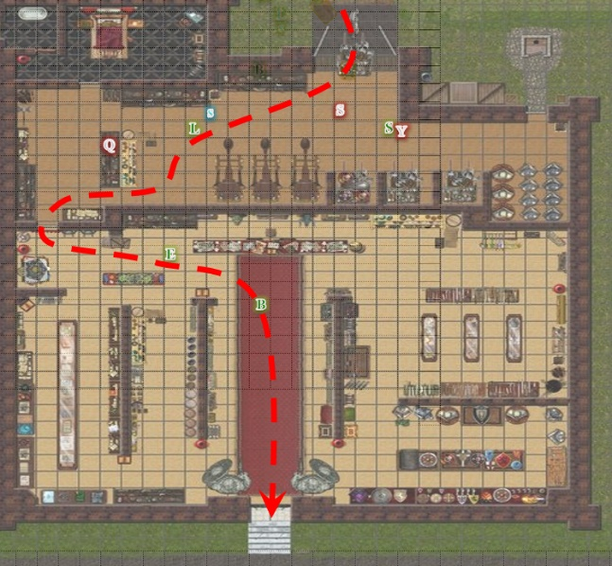

Saradette pocketed the coins, then stepped towards the half-orc, and started searching him as well, feeling her coin purse a bit heavier.

|  |  |  |  |  |  |
| --- | --- | --- | --- | --- | --- |
| *Equipment Carried* | | | |  |  |
| **Item** | **Qty.** | **Wt.** | **Value** |
| Gold Coins | 280 | 2.80 | 280 |
| Silver Coins | 21 | 0.16 | 1.05 |

Solstice followed Barkley’s voice to the back room, and he then saw all the inventory that had little to do with tapestries. He looked over at Elsabet, and raised his weasely eyebrows, tilting his head with an implication of this being no small find. They were a few blocks away from the city walls beyond which spread out the port of Mintar, which could serve as the conveyance point for so many of these goods if someone had the inclination to sort through them, appraise their export value, and see to their shipping. Then again, there was a lot of junk, the musteval could almost immediately tell as he walked down one of the aisles.

The smell in the back of the shop was not quite one of garbage, but carried perhaps a hint of urine, which was likely emanating from the less valuable goods. Tents, bedrolls, and clothing lined the row to his left, while pottery, cutlery, and adornments of every variety characterizing the cultures prevalent in the Lake of Steam area could be found to his right.

As the others came into the back room, Barkley continued to sniff around before turning to ask, “De we want to pursue the two that escaped, or just contact the authorities about this location and secure it until they leave. I believe if we leave then the organization that owns it will try to remove as many items as they can.”

Elsabet nodded to the archon. “I think you’re right. Let’s secure the place and contact the authorities. Maybe poke your nose out for a second, see if you can scent which way they headed.” She kept her kukri in her hand and started looking around to see if there were any rat holes in the back room.

Saradette found the address for this place written down on a parchment in the half-orc’s pocket, as well as a ring that looked to be magic.

Barkley poked his head out through the double doors before closing and locking them. Within a minute, the group had regrouped. On Quiñones, Saradette had found the dagger with which he’d attacked Barkley, a good amount of gawdy jewelry—none of it, silver—and a ring that Luran had just identified as a ring of *undetectable alignment*. The bard couldn’t identify the other ring that Saradette had found.

Solstice had looked over a fair portion of the back-room’s aisles and counters, and had to agree that the articles looked more stolen than pawned. “Investigators will surely confirm that these wererats *were* up to foul play,” he said, placing a few scrolls on the display counter where others had placed findings of their own.

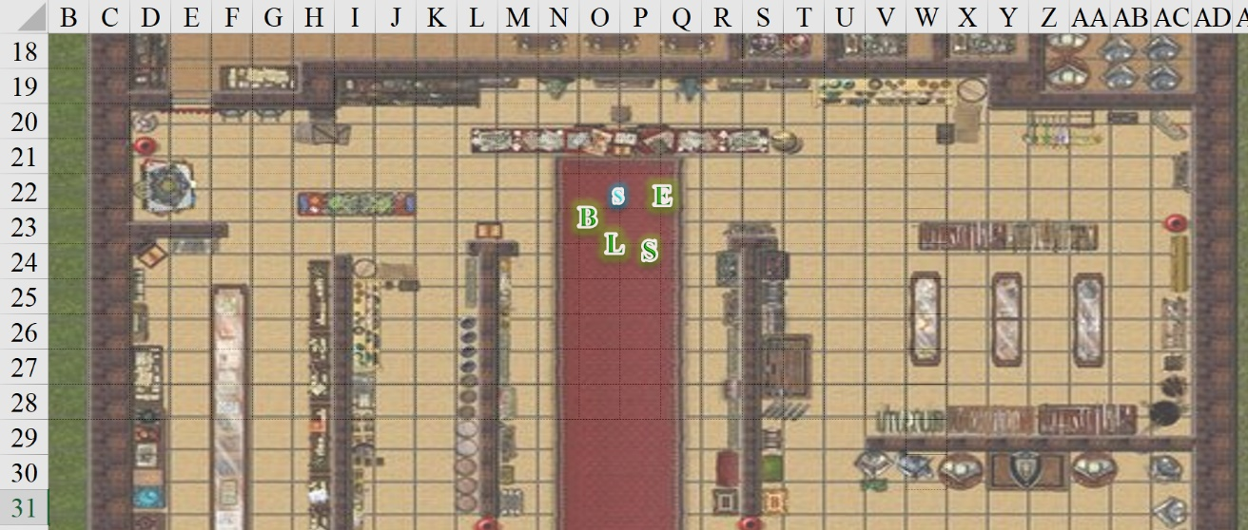

They’d also found 3 divine scrolls, and 4 arcane scrolls, and 5 energy-infused arrows.

Other than some mundane lamp oil, Saradette had taken only items from their slain enemies; not from the shop’s legitimate and illegitimate inventory. However, she now found a single application of an Oil of *greater magic weapon* +2, and considered taking it.

Elsabet had meanwhile found a Replenishing Skin, while Barkley had found a pair of Bracers of Opportunity, and Luran had been handling a hand crossbow with a magical enhancement that he could not recognize. Solstice found—of all things—a buckler tailored for a fellow his size; it bore exquisite craftsmanship, and Luran guessed had magical properties, but also could not readily determine what they were.

Barkley nodded, “Yes, if we can have them secure the building and see about locating any owners of some of these items then we would be free to continue our patrol or pursue the two that ran. Also, if there is no guard nearby, I can alter my form and go looking for one. Mind if I take the electric and/or acid arrow?” he pointed to the ammunition on the counter.

“Hey Luran, you wanna give a shout out for the guard? Or should I? Are we all agreed on calling them in now?”

“I would agree that the priority should be securing this dubious location for the authorities. I’ll take a look for local guards, on the street.” Luran then stepped out to look around, asking passersby if they’d seen a constable, lately.

~*~

Elsabet said, “I am fine with appropriating items we can use; sadly, I suspect that magic items like these gave been taken from slain and probably eaten adventurers. We can inform the authorities that we are doing so, and we should certainly abide by any city laws which apply to this situation, which may require discussions with higher ranking individuals such as were at the briefing. Anything our foes were carrying is clearly forfeit to us by right of combat, while store goods are potentially problematic. Let’s sort things into separate piles based on that, and review all that we’ve found. Does that seem reasonable?”

Elsabet cast *read magic*, and began to decipher the scrolls’ imbued spells. “These two are divine scrolls; this one represents a *devil’s eye* spell,” she put one scroll on her left, and laid out the second one to its right, “and this one a *chain of eyes* spell.

“Divine Divination, eh?” Barkley noted.

“And these two might suit Saradette or Luran. “This one casts *control darkness & shadow*, and this one, *keen edge*.”

“How many castings?” Saradette asked.

“Just one on each parchment,” Elsabet had hoped for more.

Elsabet continued, “Hey, did anyone claim the ring of unknown quality from the half-orc? Saradette, why don’t you take that? If the ring turns out to be something you don’t want to wear, you could give it to someone else to wear, or sell it to fund your research and crafting. Solstice, you’ve got the buckler, why don’t you grab the jewelry from the human guy, you could wear it, donate it to the temple, or convert it to cash to buy other stuff with.”

*IC REPLIES…*

Elsabet spoke up after others had made their wishes known. “I will take and wear the bracers, and take the divine scrolls. Barkley, go ahead and take the skin and all the arrows, and take the hand crossbow to sell, too, unless I missed someone claiming it? Luran, the arcane scrolls make sense, and go ahead and take the ring.”

Solstice said what Elsabet had already considered, “Maybe we can sell it.”

~*~

Luran returned with a tall, thin myrrh-skinned elf with hair to match his skin. The man was dressed as a guard, and his composure was weary, indicative of a night of tireless toil during the city’s duress.

“These are my acquaintances,” Luran introduced the gang, already having explained the situation.

The guard’s voice was hoarse, and his eyes were haggard, but he mustered the diplomacy to say, “I applaud your efforts, and will alert the Precinct dispatch to file a report.”

Elsabet could tell that the elf was either a paladin, or a squire with ambitions to become one, and in time—given his expected longevity—he would likely become a mighty one. Today, he was still fresh out of the Academy, and would likely have to make his share of mistakes in battle and devotion before experience would gild his tired brow. Barkley, too, could read this on the young guard’s face.

They exchanged information about what had transpired, and with Barkley there to keep everyone honest, they all stuck to a balanced version of events.

The guard—who had provided his full name: Xharthur Shessfisfam—nodded, “I appreciate your time, and ask that at least one of you remain here while I report to the Precinct.”

Barkley nodded to the Guard. “I will stay here and secure the location until the team arrives. I can transform into a small canine and hide in case the owners attempt to return, then surprise them.” He did not think that anyone would return, but in the off chance they did, he wanted to catch them off guard.

“Why don’t we all stay?” said Elsabet. “Maybe if someone does show up, we can detain them for the guard, or take them down if they get rowdy. Given the events of last night, I really don’t think splitting up is a good idea.”

Seeing the haggard nature of the elf, Elsabet approached him before he left. “With your permission, I offer you a boon on behalf of my goddess Mayaheine, that should refresh you so that you may resume your duties with renewed vigor. Do you accept?”

His eyebrows and surprised smile betrayed that of a humbled man. “Why... certainly; thank you.”

Elsabet cast *lesser restoration*, and then *cure light wounds*, on the guard to get him bright eyed and raring to go.

*Guard gained 4 + 4= 8 hps.*

“May the Shield Goddess give you renewed energy and watch over you, friend.” Elsabet made the sign of her Goddess and laid her hand gently on the elf’s shoulder as she channeled the divine magic into his body. “Have faith, remain true, and be blessed.”

She then noted her remaining daily mojo.

|  |  |  |  |  |  |  |  |  |  |  |
| --- | --- | --- | --- | --- | --- | --- | --- | --- | --- | --- |
| *Favored Soul Spells per Day* | | | | | | | | | | |
|  | **Spell Level** | | | | | | | | | |
|  | **0th** | **1st** | **2nd** | **3rd** | **4th** | **5th** | **6th** | **7th** | **8th** | **9th** |
| **Favored Soul Spells** | 6 | 6 | 3 | 0 | 0 | 0 | 0 | 0 | 0 | 0 |
| **Charisma Bonus** | 0 | 1 | 1 | 0 | 0 | 0 | 0 | 0 | 0 | 0 |
| **Total Spells** | **6** | **7** | **4** | **0** | **0** | **0** | **0** | **0** | **0** | **0** |
| **DC** | 12 | 13 | 14 | 15 | 16 | 17 | 18 | 19 | 20 | 21 |
| **Cast?** | **1** | **1** | **1** | **-** | **-** | **-** | **-** | **-** | **-** | **-** |

~*~

Customers had, indeed, stopped by during the 20 minutes or so that the heroes had waited for the authorities to return. Barkley and Elsabet had been for years the traveling party’s spokespersons, but having met Luran last night, they were quick to leave the pleasantries to the bard, whose silver tongue spewed verbal ambrosia like Barkley’s and Elsabet’s blades could cut down a ruffian. “There has been a violent incident,” was the half-elf’s modal explanation for why no one could enter, and with Barkley standing proudly at Luran’s side, no one protested.

Barkley attributed that to his chiseled snout and defined jowls. “It’s the jowls that make the man,” his father used to say before engaging in their mandibular exercises with a taut tugging rope and a lot of umph.

They were now finishing up providing their testimonies, and as with the original guard, the uniformed women and men were all notably overworked and altogether lacking sleep. The shop’s doors were cordoned off, and the heroes were again thanked for their high deeds. By the end of the day, their names would again appear in the city’s registry under an altruistic heading, and it would do Priestess Uma good to know that some progress was made against the wererats.

Still, no real information had been learned about those who fled. The dwarf and human were still at large, and given the guards’ workloads in trying to round up all of the defendants and convicts who had fled the dungeon last night, it was likely that the assistance of the party was still needed. Barkley and Solstice had gotten as good a whiff of the two fugitives as they could, and with his sensory information—given that they were in a part of town now suspected of being an epicenter of this malice—they had a better chance than anyone at finding the two fleeting wererats.

They left the shop and were thanked again by the guards, and stood by the corner for a moment, collecting their thoughts. One thing that his bardic knowledge had revealed earlier was still gnawing at the back of his mind: the Laughing Ghost of West Hill. He’d been thinking of other things given the fight to the death in which he’d just been involved, but his curiosity took him back to the reference, which—of those provided by Bratislava and the rest of the Baron’s agents—was the only concrete reference to a location in the city.

The newly equipped lycanthrope hunters discussed their next steps.

Barkley had no specific destination in line, however, investigating the Laughing Ghost of West Hill as well as the West Hill area in general was as good a place to check out next as any. “I think we should check out West Hill unless anyone else has an objection.”

~*~

They had been to two shops, and had found the merchants therein to be rather unreasonable with the price of the crossbow they were trying to hawk. The third shop had been the charm, and without too much fanfare, Luran had been able to fenagle a handsome sum of *[2,400 x (80% + 5 + 4) =*  2,400 x 89%*]* 2,136 GPs.

“That’s about... 427 gold apiece,” Saradette worked it out in her head, not worrying about the silver and copper chips in the remainder. “Even split?”

All agreed.

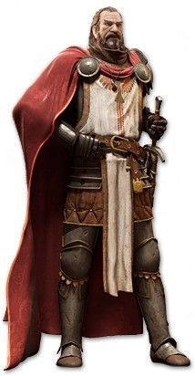

With Highsun approaching, they were now realizing that they would not likely be able to reach the Baron’s Keep in time for the Baron’s scheduled debriefing. Priestess Uma was likely already on her way there to represent Mayaheine’s presence in the city, and Bishop Jericho of Tyr and Warrior-Priest Br. Qaleb would likely be there already.

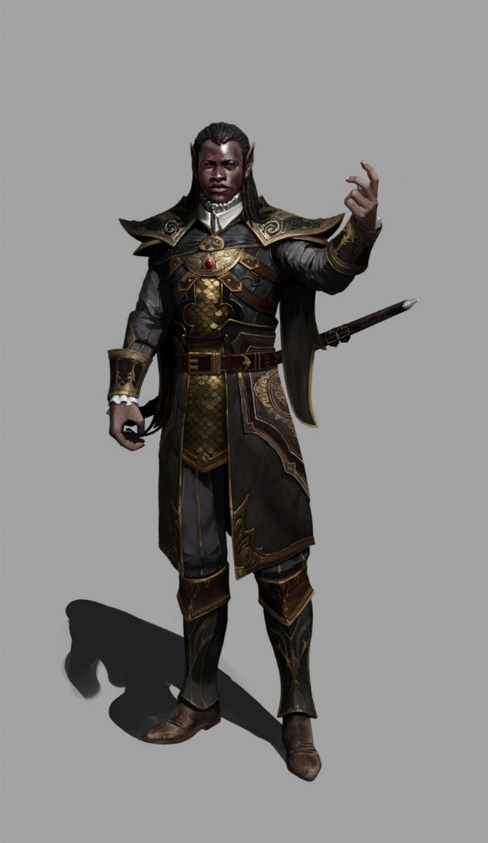

Solstice knew Uma would surely take notes to relay to the group, and as he hopped and climbed back onto Barkley’s shoulder with the archon’s consent, the musteval voiced his motive to continue to pursue the two men whose shiftiness initially drew them into the tapestry shop.

With said shop still within their line of sight about 10 sites away, the five heroes decided on their next steps.

“I think we should go to the keep. Maybe they have some information we can use,” Saradette said.

“Good point—being a little late shouldn’t be a problem,” Elsabet replied. “Let’s hustle!”