*Chapter 12: Tannery Road*

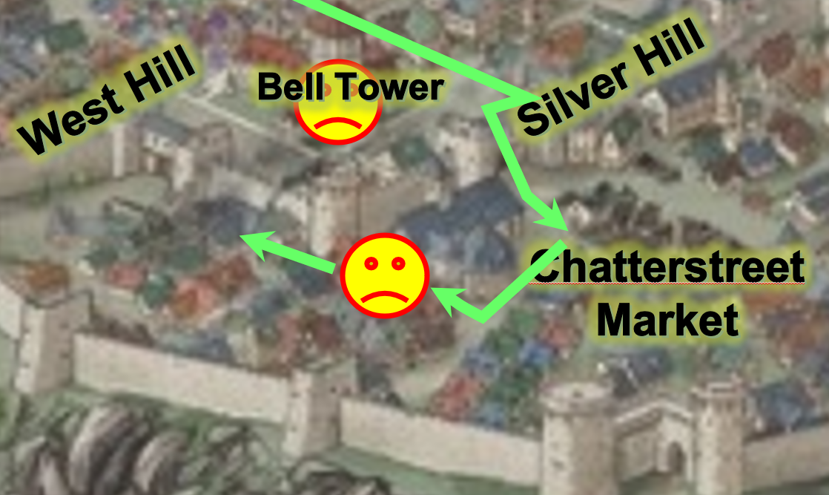

The quintet of heroes made their way northward along Eastgate Way a bit, and then through a stretch of narrow streets that even Luran—who’d been in Mintar a while—didn’t know. It was a slum hidden in a depression in the earth that was about 10’ to 15’ lower than the boroughs around it. The poorly paved and cobbled streets and buildings obviated to Saradette that heavy rains that had ensued in the last few weeks, and likely would return before the end of Tarsakh, had swept through and flooded the area, which had—as far as she could tell—smaller than necessary drainage gutters. They must have been at maybe 30’ above sea level, and the gnomish artificer wondered just how often this obfuscated quarter suffered damages due to flood.

Perhaps it was the city’s roundabout way of communicating to the citizenry the sinking sensation that one got as they entered the dreary section of unpainted and unkempt houses and shifty businesses: a brothel, a bondswoman’s office, an unspecified night school, and a guy pushing a cart toting dozens of dangling wares towards another brothel; but Saradette’s mind quickly shifted from such speculation when the group almost synchronously realized that they were about to be ambushed.

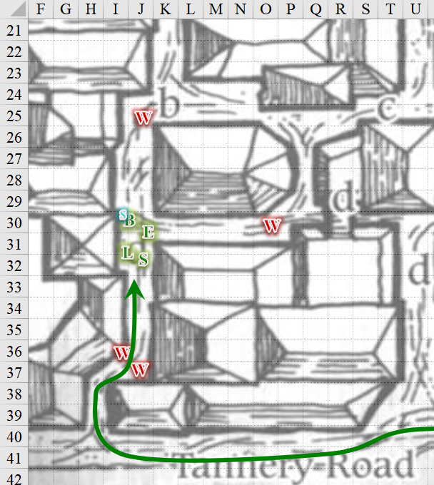

Men and women who had probably just now taken on their lycanthropic guises appeared from the north, east, and south.

Round 1; 11:52

|  |  |  |  |  |  |
| --- | --- | --- | --- | --- | --- |
| **Character** | **Group** | **Initiative** | **Roll** | **Modified Roll** | **Move** |
| Saradette | 1 | 1 | 18 | 19 | 20’ |
| Elsabet | 1 | 4 | 7 | 11 | 30’ |
| Barkley | 1 | 4 | 3 | 7 | 30’ |
| Wererats | 2 | 2 | 3 | 5 | 40’ |
| Solstice | 1 | 1 | 4 | 5 | 30’/10’ |
| Luran | 1 | 1 | 2 | 3 | 30’ |

Saradette *[aid (+1 to attacks and saves against fear effects, plus 6 + 6 = 12 temporary hit points) expired on Round 52]* sighed in disgust when she realized what sort of trap they blundered into. “This way!” she barked. “Don’t let them encircle us!” However, when she remembered that her sword was bonded, Saradette changed her mind and cast *mage armor [expired on Round 601; 12:52]* on herself, and then worked to free her short sword and draw it while she moved ahead toward the wererat.

*Saradette gained +4 to FFAC and AC.*

Elsabet *[aid (+1 to attacks and saves against fear effects, plus 4 + 6 = 10 temporary hit points) expired on Round 51]* sighed, and unbound her kukri... again. “Don’t panic, Saradette—this is a good spot.” With a swift action, she settled into her Leading The Charge stance. She stepped forward a few feet and planted her feet, making it clear she didn’t intend to go running northward. Perhaps if the group stayed together, she could make more efficient use of her capabilities.

She felt her third maneuver being granted, and right after that used an immediate action to activate her Protection Devotion—for the next minute, thanks to Mayaheine’s grace. Perhaps the wererats, even if experienced, would have a bit of a tough time hitting them.

*PCs gain +3 to AC.*

Barkley *[aid (+1 to attacks and saves against fear effects, plus 7 + 6 = 13 temporary hit points) expired on Round 55]* quickly undid the peacebond on his silvered hand axe.

A dwarven-shaped wererat named Ivan went into a raging fit in this sleepy nook of a part of town that was only active at night.

*Ivan gained +4 to Strength & Constitution, and +2 to Will saves, and incurred –2 to AC.*

He targeted Barkley, and charge-attacked with an impetuous, mad, growling squeal.

|  |  |  |  |  |  |  |  |  |
| --- | --- | --- | --- | --- | --- | --- | --- | --- |
| **Character** | **Attack Type** | **Damage** | **BAB** | **Str Mod+** | **W+** | **Total Score** | **Roll** | **Total** |
| Ivan (Rage) | MW Club | 1d6+4 | 2 | 4 | 1 + 2 charge | 9 | 1 | 10 |

*Not a good start.*

The dwarven barbarian wererat was astonished at how much he sucked compared to the stalwart archon and the musteval who now hopped off his shoulder *[action resolved below]*.

A wererat of half-elven height named Jenga already had a heavy crossbow bolt trained on Elsabet, who had just gotten into her line of sight moments ago, and now fired a bolt. Jenga then impressively Quick-Reloaded the crossbow in record time, ready to fire again on the favored soul.

|  |  |  |  |  |  |  |  |  |  |
| --- | --- | --- | --- | --- | --- | --- | --- | --- | --- |
| **Character** | **Attack Type** | **Damage** | **BAB** | **Dex Mod+** | **W+** | **Total Score** | **Roll** | **Total** | **Crit** |
| Jenga | MW Heavy Crossbow | 1d10+1d6 acid | 2 | 3 | 1 | 6 | 4 | 10 | 20 |

*Miss.*

The bolt bounced off of Elsabet’s shield.

The cloaked spellcaster named Rutherfyord cast *negative energy ray* upon Luran.

|  |  |  |  |  |  |  |  |  |
| --- | --- | --- | --- | --- | --- | --- | --- | --- |
| **Character** | **Attack Type** | **Damage** | **Ranged?** | **BAB** | **Dex Mod+** | **Total Score** | **Roll** | **Total** |
| Rutherfyord | Ranged Touch | varies | þ | 0 | 0 | 0 | 11 | 11 |

*Miss.*

The agile bard flinched away from the necromantic beam an instant before it raced past his ear.

A wererat named Parsnips, who was maybe twice the size of Solstice, had four shirukens in his off hand, and one in his business hand. He threw the active star at Luran, the target best positioned to be his throwing board.

|  |  |  |  |  |  |  |  |  |  |
| --- | --- | --- | --- | --- | --- | --- | --- | --- | --- |
| **Character** | **Attack Type** | **Damage** | **Ranged?** | **BAB** | **Dex Mod+** | **Total Score** | **Roll** | **Total** | **Notes** |
| Parsnips | Shiruken | 1 | þ | 3 | 3 – 2 range | 4 | 5 | 9 | Sneak Attack +2d6 |

*Miss.*

Saradette heard and then spotted a fifth wererat on the rooftop, who now started lobbing acid flasks upon the heroes. Dressed in the garb of a ninja, the rat-snouted assailant chose Elsabet—who had her back turned to him—as his target.

|  |  |  |  |  |  |  |  |  |  |  |
| --- | --- | --- | --- | --- | --- | --- | --- | --- | --- | --- |
| **Character** | **Attack Type** | **Damage** | **Ranged?** | **BAB** | **Dex Mod+** | **Other+** | **Total Score** | **Roll** | **Total** | **Notes** |
| Shemzin | Acid Flask | 1d6 acid | þ | 3 | 3 | 2 height | 8 | 3 | 11 | Sudden Strike +1d6 |

*Miss.*

The flask of acid hit the floor near Elsabet, splashing onto her armored boots, but causing her no damage.

Solstice *[aid (+1 to attacks and saves against fear effects, plus 1 + 6 = 7 temporary hit points) expired on Round 54]* produced his blowgun and palmed a few flechettes, darting behind a trash bin under the eaves of the nearest building.

|  |  |  |  |  |  |  |  |  |
| --- | --- | --- | --- | --- | --- | --- | --- | --- |
| **Skill** | **Rank** | **Ability** | **Mod.** | **Ability & Mod.** | **Misc. Mods.** | **Total** | **Roll** | **Check** |
| **Solstice, Hide** | 5 | Dexterity | +3 | **Dex (+3)** | 8 | 16 | 16 | 32 |
| **Solstice, Move Silently** | 2 | Dexterity | +3 | **Dex (+3)** | 8 | 13 | 4 | 17 |

*See below.*

A few neighbors started to peek out through their windows, careful to keep out of sight through the cracked curtains.

Luran *[aid (+1 to attacks and saves against fear effects, plus 3 + 6 = 9 temporary hit points) expired on Round 53]* had cursed lightly to himself as the ambush revealed itself. But as the adrenaline of it all began to pump, he reveled in the excitement of being chosen for such a challenge. His throaty vocals started up, once again, to lift his companions’ spirits and strengthen their arms. As he did, he dove to the side as best he could to avoid further throwing stars from his assailant’s paws.

*PCs gained +2 to saves vs. charm and fear effects, and to attack and weapon damage rolls.*

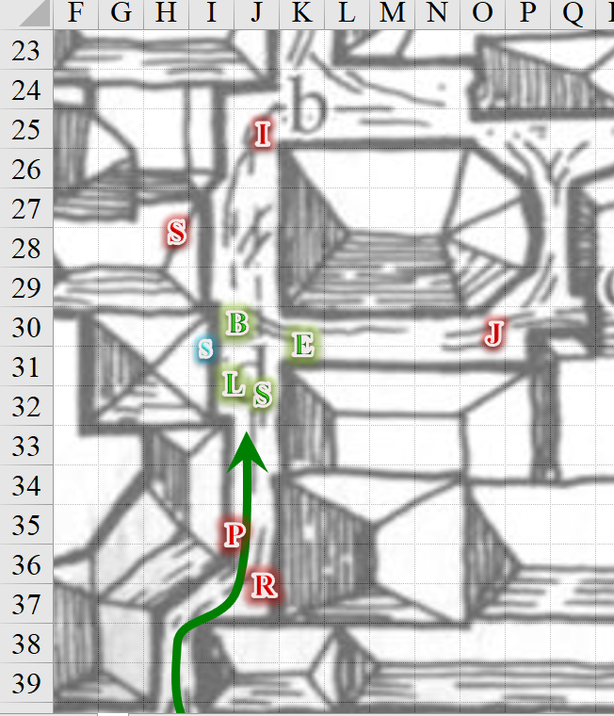

Round 2

As the wererats revealed their respective specializations, Saradette came to recognize two of them, not by their faces—which had by now turned to rodentesque forms—but by their clothing and general body shapes. The short, pudgy rager had to be the dwarf they’d pursued into the tapestry shop, and the taller wererat was wearing the same finger-wiggler garbs as the dwarf’s human counterpart. They’d been tailed, and with more caution this time. The artificer hesitated for a moment to see what Barkley and Elsabet would do.

Seeing that some of the wererats were not engaging in melee, Elsabet grinned. She called upon the power of Mayaheine, cast *bull’s strength [expired on Round 42]*, took a step back next to Barkley and released the spell on him with a touch.

*Barkley gained +4 to Strength.*

Elsabet then grinned at the raging dwarf-rat, drew her silvered kukri, and made sure to catch the wererat’s attention. To her now hulked up friend, she said, “Barkley, show him how it’s done.”

She felt her fourth maneuver being granted. If anyone took a swing at one of her friends within reach, she had a shield block available for a little longer, but the wererats didn’t seem very effective yet. She kept smiling with confidence.

Barkley agreed they shouldn’t get surrounded and wanted to deal with the one in front of them as quickly as possible so they could turn to deal with the others, so he hacked at Ivan with his axe.

|  |  |  |  |  |  |  |  |  |  |
| --- | --- | --- | --- | --- | --- | --- | --- | --- | --- |
| **Melee Weapon** | **Dmg** | **D+** | **TH+** | **Critical** | **Type** | **Wt.** | **Atk** | **Roll** | **Check** |
| Hand Axe, Silver | 1d6 | +3+ 2 Inspiration | 2 + 2 Inspiration | x3 | Slashing | 3.0 | +11 | 11 | 22 |

*Hit. Dmg: 4 + 3 + 2 Inspiration = 9.*

Ivan—who would likely have died had it not been for the adrenaline rush to his lycanthropic pituitary—swung back at Barkley with a wonderful looking club.

|  |  |  |  |  |  |  |  |  |  |
| --- | --- | --- | --- | --- | --- | --- | --- | --- | --- |
| **Character** | **Attack Type** | **Damage** | **BAB** | **Str Mod+** | **Dex Mod+** | **W+** | **Total Score** | **Roll** | **Total** |
| Ivan (Rage) | MW Club | 1d6+4 | 2 | 4 | -2 | 1 | 7 | 14 | 21 |

*Miss.*

Jenga fired upon Elsabet, who had her back to her.

|  |  |  |  |  |  |  |  |  |  |  |
| --- | --- | --- | --- | --- | --- | --- | --- | --- | --- | --- |
| **Character** | **Attack Type** | **Damage** | **Ranged?** | **BAB** | **Dex Mod+** | **W+** | **Total Score** | **Roll** | **Total** | **Notes** |
| Jenga | MW Heavy Crossbow | 1d10+1d6 acid | þ | 2 | 3 | 1 + 2 flank | 8 | 12 | 20 | Acid Bolts |

*Miss.*

The lycanthropic woman then reloaded the heavy crossbow like Elsabet had never seen anyone do before. Such grace! Pity she would likely die in the next few seconds.

Rutherfyord shook his head and cast *magic missile* upon Luran, despising half-breeds.

*Dmg: 5 + 2 = 7 magic [44/42].*

Parsnips went to look for Solstice where the weasely hero had last been seen.

Solstice popped Parsnips with his blowgun from behind the trash bin.

|  |  |  |  |  |  |  |  |  |  |  |
| --- | --- | --- | --- | --- | --- | --- | --- | --- | --- | --- |
| **Ranged Weapon** | **Dmg.** | **D+** | **TH+** | **Critical** | **Rng.** | **Wt.** | **Atk** | **Roll** | **Check** | **Notes** |
| MW Blowgun | 1 | +2 Inspiration | 1 + 2 Inspiration | x2 | 10’ | 0.1 | +13 | 1 | 14 | +3d6 Sneak |
| Blowgun, 2nd Attack | 1 | +2 Inspiration | 1 + 2 Inspiration | x2 | 10’ | - | +8 | 16 | 24 | +3d6 Sneak |

*Miss, hit. Dmg: 1 + 2 Inspiration + 14 Sneak = 17. Partial damage negated.*

Parsnips fell to the ground, and began to slowly morph into halfling form, gasping for air as her punctured jugular spurted blood.

Seeing Parsnips go down, Shemzin lobbed a flask of acid at Elsabet again.

|  |  |  |  |  |  |  |  |  |  |  |  |
| --- | --- | --- | --- | --- | --- | --- | --- | --- | --- | --- | --- |
| **Character** | **Attack Type** | **Damage** | **Ranged?** | **BAB** | **Dex Mod+** | **W+** | **Other+** | **Total Score** | **Roll** | **Total** | **Notes** |
| Shemzin | Acid Flask | 1d6 acid | þ | 3 | 3 | 0 | 2 height | 8 | 12 | 20 | Sudden Strike +1d6 |

*Hits armor. Dmg: 6 acid to armor. Ernie protests.*

Luran yelped in pain from the force projectile that struck him. Gritting his teeth, he wrestled with the peace bonded braid over his quiver, hoping he’d have a chance to reciprocate in some small manner, soon.

Saradette followed Barkley’s lead, and tried to circle around Ivan. However, not being well trained in the art of tumbling, she was clumsy enough to let Ivan get a swipe at her.

|  |  |  |  |  |  |  |  |  |
| --- | --- | --- | --- | --- | --- | --- | --- | --- |
| **Character** | **Attack Type** | **Damage** | **BAB** | **Str Mod+** | **W+** | **Total Score** | **Roll** | **Total** |
| Ivan (Rage) | MW Club | 1d6+4 | 2 | 4 | 1 | 7 | 18 | 25 |

*Hit. Dmg: 3 + 4 = 7 [36/31].*

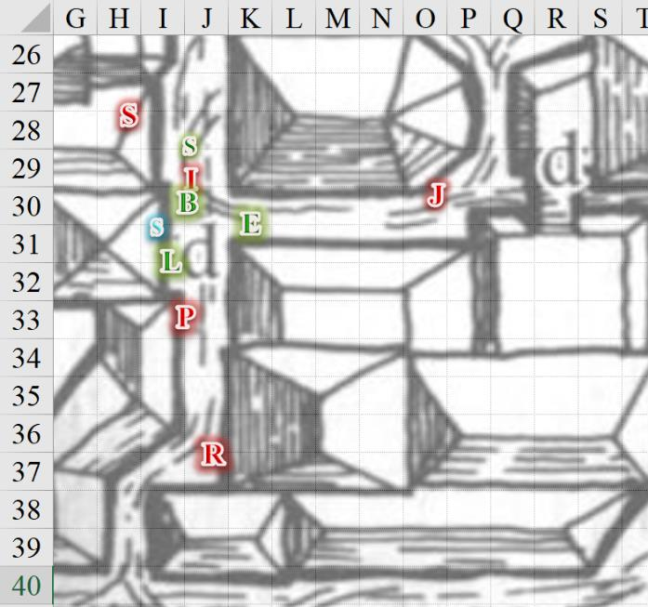

Round 3

Saradette slipped behind Ivan and sneak attacked him with her short sword.

|  |  |  |  |  |  |  |
| --- | --- | --- | --- | --- | --- | --- |
| **Skill** | **Rank** | **Ability & Mod.** | **Misc. Mods.** | **Total** | **Roll** | **Check** |
| **Saradette, Hide** | 5 | **Dex (+3)** | 4 | 12 | 17 | 29 |
| **Saradette, Move Silently** | 5 | **Dex (+3)** | 4 | 12 | 1 | 13 |

*See below.*

Even in optimal conditions, it would have been difficult for the gnome to come at the dwarven wererat silently, but she could at least flank the fool.

|  |  |  |  |  |  |  |  |  |  |
| --- | --- | --- | --- | --- | --- | --- | --- | --- | --- |
| **Melee Weapon** | **Dmg** | **D+** | **TH+** | **Critical** | **Type** | **Wt.** | **Atk** | **Roll** | **Check** |
| Short Sword | 1d4 | +2 Inspiration | 2 + 2 flank + 2 Inspiration | 19-20/x2 | Piercing | 1.0 | 10 | 3 | 13 |

*Miss.*

Saradette missed altogether.

Elsabet grimaced as the acid slipped through the links of her chain shirt and went mostly into her delayed damage pool briefly, though she knew that the aid from Barkley would protect her from any real harm. Seeing Barkley slash his foe, and Solstice take down one of the two wererats in that direction, she looked up at the wererat throwing acid at her. The wererat was leaning over the ridgeline, it seemed. Perhaps...

Smiling, and focusing on her fey presence, Elsabet unleashed her Deep Slumber spell-like ability, targeting the acid thrower. Hopefully, he would either collapse in sleep on the roof, or collapse and slide down the slope of the roof to land in the street, waking up when he slammed into the cobblestones. Indeed, if he had another flask in his hand it might even fall with him or even on him!

|  |  |  |  |  |
| --- | --- | --- | --- | --- |
| **Character** | **Save vs.**  *deep slumber* | **Ranks** | **Roll** | **Save** |
| Wererat | Will | 4 | 3 | 7 |

*Fail.*

The wererat ninja collapsed into a deep sleep, and rolled down and northward, getting stuck between two adjacent rooftops.

Elsabet had hoped for a more cascading outcome, but turned to look at the cowardly but rapidly firing crossbow shooter at the end of the alley. “Well? Really?” She took a step back to quickly check on the wererat casting magic, and that the down wererat was really down, then turned back and paced slowly down the alley partway to the shooter. She was glad she had bought that crystal for her buckler—no wonder the shooter was having trouble! She felt her last maneuver being granted—Battle Leader’s Charge….

Barkley focused on Ivan, swinging his axe and howling at the wererat.

|  |  |  |  |  |  |  |  |  |  |
| --- | --- | --- | --- | --- | --- | --- | --- | --- | --- |
| **Melee Weapon** | **Dmg** | **D+** | **TH+** | **Critical** | **Type** | **Wt.** | **Atk** | **Roll** | **Check** |
| Hand Axe, Silver | 1d6 | 3 + 2 Inspiration | 2 + 2 Inspiration | x3 | Slashing | 3.0 | +13 | 17 | 30 |

*Hit. Dmg: 2 + 3 + 2 Inspiration = 7.*

Ivan—still quite enraged—swung at Barkley.

|  |  |  |  |  |  |  |  |  |
| --- | --- | --- | --- | --- | --- | --- | --- | --- |
| **Character** | **Attack Type** | **Damage** | **BAB** | **Str Mod+** | **W+** | **Total Score** | **Roll** | **Total** |
| Ivan (Rage) | MW Club | 1d6+4 | 2 | 4 | 1 | 7 | 10 | 17 |

*Miss.*

The dwarven lycanthrope’s club kind of ricocheted off of Barkley’s Mithral Chain Shirt.

Jenga—alacritous as she was—pointed her heavy crossbow, released the bolt in Elsabet’s direction, and loaded another bolt like a lifelong arbalist.

|  |  |  |  |  |  |  |  |  |  |  |
| --- | --- | --- | --- | --- | --- | --- | --- | --- | --- | --- |
| **Character** | **Attack Type** | **Damage** | **Ranged?** | **BAB** | **Dex Mod+** | **W+** | **Total Score** | **Roll** | **Total** | **Notes** |
| Jenga | MW Heavy Crossbow | 1d10+1d6 acid | þ | 2 | 3 | 1 | 6 | 6 | 12 | Acid Bolts |

*Miss.*

Rutherfyord couldn’t tell what was happening around the corner, but he was beginning to worry. He had a few bullshit spells left, and tried *ray of frost* on Barkley, before considering hightailing it like a rodent.

|  |  |  |  |  |  |  |  |  |
| --- | --- | --- | --- | --- | --- | --- | --- | --- |
| **Character** | **Attack Type** | **Damage** | **Ranged?** | **BAB** | **Dex Mod+** | **Total Score** | **Roll** | **Total** |
| Rutherfyord | Ranged Touch | varies | þ | 0 | 0 – 4 into melee | -4 | 5 | 1 |

*Miss.*

The ray went high, and missed everyone.

Parsnips bled out.

Shemzin snored like no ninja should.

Able to *detect evil* at will, Solstice noted that these rats were all registering the telltale vile aura that surrounded those with such a bent. The musteval was also able to *detect magic* at will, and noted that the wererats were not particularly heavily warded. He cast *magic missile* upon Rutherfyord.

*Dmg: 4 + 2 = 6 magic.*

Rutherfyord, was knocked back against the corner of the building behind him, and the amateur wizard tried to scramble away, bleeding profusely.

Luran described the situation with articulate poise.

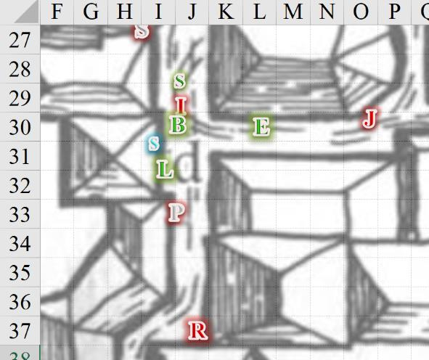

Round 4

Saradette backstabbed Ivan.

|  |  |  |  |  |  |  |  |  |  |  |
| --- | --- | --- | --- | --- | --- | --- | --- | --- | --- | --- |
| **Melee Weapon** | **Dmg** | **D+** | **TH+** | **Critical** | **Type** | **Wt.** | **Atk** | **Roll** | **Check** | **Notes** |
| Short Sword | 1d4 | + 2 Inspiration | 2 + 2 Flank  + 2 Inspiration | 19-20/x2 | Piercing | 1.0 | 10 | 15 | 25 | Sneak Attack 2d6 |

*Hit. Dmg: 3 + 2 Inspiration + 6 = 11. Partial damage negated.*

“Roof-rat asleep!” crowed Elsabet, having seen the wererat on the roof collapse, and then suddenly charged the crossbow wielder, initiating her Battle Leader’s Charge maneuver and taking full advantage of her stance and Luran’s music to slash powerfully down on the annoying wench with her kukri.

As she reached her target, Elsabet realized that at least temporarily both Saradette and Luran would be out of the Protection aura due the interference from the corners of buildings. Luran could easily step into the intersection though, and Saradette was probably fine with her and Barkley flanking their foe.

|  |  |  |  |  |  |  |  |  |  |
| --- | --- | --- | --- | --- | --- | --- | --- | --- | --- |
| **Melee Weapon** | **Dmg** | **D+** | **TH+** | **Critical** | **Type** | **Wt.** | **Atk** | **Roll** | **Check** |
| Silver Kukri | 1d4 | 1 + 2 Inspiration | 2 + 2 Charge  + 2 Inspiration | 18-20, x2 | Slashing | 2.0 | +13 | 5 | 18 |

*Hit. Dmg: 4 + 1 + 2 Inspiration + 2 Charge + 3 Leading the Charge + 10 Battle Leader’s Charge = 22.*

Elsabet overdid it a bit, and found herself with a bloody kukri and hand as the extra dead woman fell back. “Oh, I thought you were a man, baby!” Elsabet then grimaced as the wererat began to slowly lose her rodentesque features.

Her maneuvers faded, and then two were granted as the cycle renewed...

|  |
| --- |
| *Current Maneuvers* |
| Stone Vise |
| Battle Leader’s Charge |
| Shield Block |
| Crusader’s Strike |
| Foehammer |

Barkley did his best to finish off Ivan.

|  |  |  |  |  |  |  |  |  |  |
| --- | --- | --- | --- | --- | --- | --- | --- | --- | --- |
| **Melee Weapon** | **Dmg** | **D+** | **TH+** | **Critical** | **Type** | **Wt.** | **Atk** | **Roll** | **Check** |
| Hand Axe, Silver | 1d6 | 3 + 2 Inspiration | 2 + 2 Inspiration | x3 | Slashing | 3.0 | +13 | 6 | 19 |

*Hit. Dmg: 1 + 3 + 2 Inspiration = 6.*

Ivan pretty much began to die, his beady, black eyes looking into Barkley’s as the man’s pupils shrunk to Humanoid size and his amber-brown irises were made salient once again. He dropped to the ground as the sound of the archon’s axe leaving the man’s rib cage seemed to declare the conflict’s conclusion.

Solstice noted Rutherfyord trying to get away on his hands and knees, unable to move much. The musteval pointed his blowgun at the mage, making his way over carefully.

“And that’s how we do it downtown!” Luran concluded his ode to the group’s aptness, looking up and noting the ninja slumbering deeply.

*End of rounds…*

Elsabet moved to the intersection and saw Solstice and Rutherfyord, noting that all was under control.

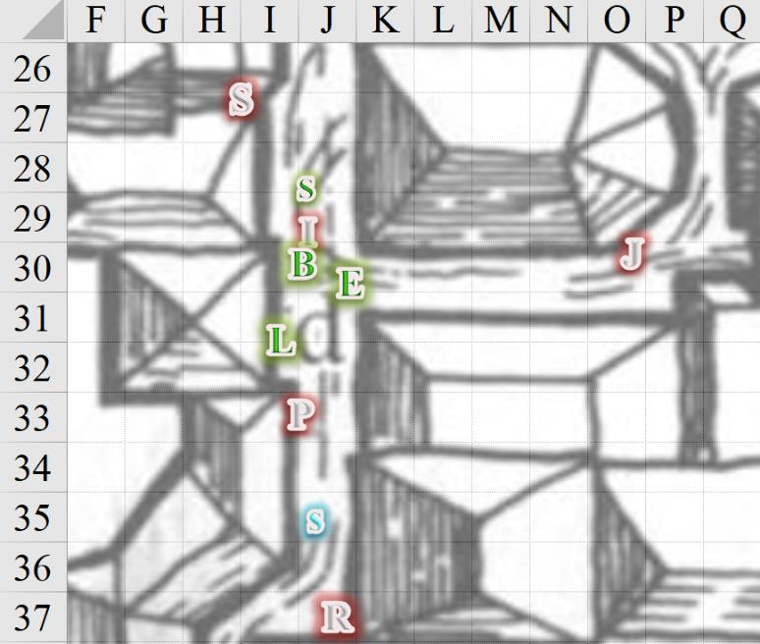

Barkley attempted to reach the slumbering wererat to take into custody for now. Perhaps he could be questioned to find out where some of the other rats are hiding.

|  |  |  |  |  |  |  |
| --- | --- | --- | --- | --- | --- | --- |
| **Skill** | **Rank** | **Ability & Mod.** | **Misc. Mods.** | **Total** | **Roll** | **Check** |
| **Barkley, Climb** | 5 | Str (+4) | 0 | 9 | 10 | 19 |

*See below.*

Elsabet moved up past Ivan’s body to look up to where the ninja ratman snored, looking for an alternate way to climb up, or perhaps use her Anklet to teleport up—or maybe she could boost Barkley up and he could take care of the fellow. She kind of wanted to take him prisoner, but remembered he could just turn into a rat when he wanted. A couple de grace might be in order, whoever did the work.

Elsabet stayed put in order to avoid an anticipated tumble on her buttocks.

Though Barkley had chosen a less direct route, his path had been the more prudent. Elsabet’s took her tumbling down along the straight and narrow corner with brittle ledges. Saradette climbed up to the sleeping wererat via the same path that Barkley had chosen, and then made her way up to it.

|  |  |  |  |  |  |  |
| --- | --- | --- | --- | --- | --- | --- |
| **Skill** | **Rank** | **Ability & Mod.** | **Misc. Mods.** | **Total** | **Roll** | **Check** |
| **Saradette, Climb** | 6 | **Str (+0)** | 0 | 6 | 11 | 17 |

*See below.*

Elsabet, Luran, and Solstice now waited below, watching Rutherfyord and the others bleed out. “It would be good to take that one alive,” the musteval echoed Elsabet’s proposition.

A half-elven woman of about 100 years dressed in the garments of a servant and holding a stack of folded, white sheets came around the corner to the north where they’d first spotted Ivan, saw the dead bodies of the wererats as they were still reverting to humanoid forms, and screamed, running away. She’d likely not spotted the archon and gnome on the rooftop, nor the ninja that still snored there, but her footsteps receded as she ran further.

Luran ran a few steps after the aged clerk, raising his voice in a hopefully calming manner. “No need to run. Everything is in order, now. Baddies dealt with and brought down, ma’am!”

The woman, however, kept on clippity-clopping away along the poorly cobblestoned alley barely wide enough for two horses.

Saradette took any weapons she could find from the ninja rat’s sleeping form. Leaving the outfit on the human wererat, she took the climbing gear, a ninja-to, shurikens (10), and flasks of acid (2).

*Gear added to Saradette’s haversack.*

Luran returned to the group, looking up to see the progress atop the roof. Barkley had assisted in searching the wererat, having applied the manacles that Elsabet had tossed him. The archon now tied a rope around the ninja, and lowered him down to Elsabet and Luran as Solstice ceded to the thricelings that had become his friends.

With care and patience, the task was done, and the ninja’s black-clad body now lay in the street under the shade of the eaves above them. Unhooded, Elsabet took in the guise of the human male’s face, noting his features to be Kara-Turi. This man had traveled a long way across Toril to wind up mixed up in this wererat business.

Another commoner—a male dwarf—came through the alley with a lot on his mind, then stopped, studied the heroes’ body language, saw the fully human-looking man now in his loincloth on the floor, looked back at the heroes, and took a step back to ensure his successful escape. “Oy! What the blazes are ye doin’?”

Barkley looked at the dwarf saying, “We mean no harm, we are charged by the city guard in helping maintain order. These bodies,” he used his hand to indicate the dead, “were all wererats that attacked us. If you do not trust my word, the city guard can confirm our duties.”

|  |  |  |  |  |  |  |
| --- | --- | --- | --- | --- | --- | --- |
| **Skill** | **Rank** | **Ability & Mod.** | **Misc. Mods.** | **Total** | **Roll** | **Check** |
| **Barkley, Diplomacy** | 0 | **Cha (+2)** | 0 | 2 | 15 – 20 | 17 – 22 |

*See below.*

The dwarf raised his eyebrows, then nodded as if looking up into the recesses of his mind’s acceptance of the hero’s claim. “Wererats, eh?” the stranger had obviously heard the news that had swept through the city by now. He came closer, looking down at the felled enemies with the look of a child that was simultaneously enthused and disgusted.

Solstice prepared a spell in case the foolhardy commoner was a wererat himself.

“By Moradin’s Hammer, they look like regular blokes!” the dwarf then stopped, and the musteval stayed his spell hand. The dwarf sniffed up a nostril’s load of snot into his sinuses, and grimaced, shrugging, “Well, good job... heroes. Not sure if that’s what one’s supposed to say, but thanks.”

“We’re glad to help,” Saradette said as she hopped down the last two feet to the street. She looked at her companions. “We should be on our way. It wouldn’t do to be late.”

“Bentley!” a woman’s voice called from the northeast, and the dwarf turned.

For a moment, Barkley thought he’d heard his name, but Bentley dispelled that suspicion.

“Wha?” he answered.

Some unintelligible banter from the woman that sounded more like a ukulele’s arpeggio peppered by “and another thing” every 6 seconds gave the heroes the idea that this was the dwarf’s life partner, and that she might be about to begin menstruating. The dwarf sighed, and gave the heroes a half-hearted wave as he walked back out of sight.

The hound archon had climbed and hopped down as carefully as he could, and now everyone was standing around the bodies of their adversaries.

Elsabet sighed. “It won’t do to just leave these people here unguarded, dead or just resting, until the guards arrive, but someone should try to make it to the briefing on our behalf. Should a couple of us remain here while the rest hurry to the briefing?”

Barkley nodded, “I can remain behind and guard the bodies until they can be collected.”

“I will stay, too,” Saradette said.

“Sounds good,” replied Elsabet. “Luran, you’re with me. Solstice, your choice, stay or go? I’d recommend staying, in case these guys have friends show up, three are better than two and it keeps some healing power handy. We’ll notify the guards as soon as we find one.”

Elsabet made sure Barkley had the manacle keys just in case, nodded to Luran and headed out. She mused to herself, everything her manacles got used, the party split up. This better not become a trend!

~*~

20 minutes later…

While she waited for Elsabet to return, Saradette searched all of the bodies. “I wonder where all of these creatures came from,” she said to Barkley as she worked.

Barkley kept an eye on their prisoner while Saradette conducted her search. “That would be good to know. It would also be good to know when they actually became infected with the lycanthropy. Did they come here as wererats or were they just unfortunate victims.”

Saradette examined the corpses and their clothing more closely, looking for clues that might speak to their professions or to their recent activities, such as minor possessions or stains.

~*~

Elsabet and Luran arrived well into the main portion of the meeting. Introductions had already come and gone, and the subject at hand was unfolding before them as a threat that had so far only been partly contained. The first few minutes yielded for Luran and his newfound Mayaheinite friend that:

* Most of the suspects/convicts on the PCs’ list had been apprehended and restored to custody already.
  + Elsabet struck a line through the names of those listed as bagged, leaving 8 names representing those still at large.
* There were 3 confirmed cases of lycanthropy among the suspects and convicts arrested since the jailbreak last night, but because there was no suspicion of wererat malfeasance until that moment, no information was being given at this time as to whether these lycanthropes had been infected prior to the jailbreak or thereafter.
* Bratislava was not the speaker in this round of debriefing, though she stood in the corner near the door with her hands clasped in front of her in the way of a disciplined warrior-priestess.
  + Instead, a civilian-clad male—balding and with a graying goatee—delivered the well-rehearsed news as he presented a narrative of anticipating having this under control by the closing of the business day.
* Neither Priestess Uma nor Deacon Tariq were present, as far as Elsabet and Luran could tell.

~*~

Barkley, Saradette, and Solstice had searched the bodies and conferred on the findings.

* Ivan was a shield dwarf whose leather armor had a faint embroidery along the back, underneath his wooly nape, that represented Dugmaren Brightmantle, a deity popular with barbarians, but Good-aligned. It was possible that the dwarf might’ve leaned towards Chaotic Neutrality—thought Barkley—but this finding pointed to the idea that lycanthropy had set in recently, or the deity’s emblem might’ve been done away with out of contempt.
* Jenga was a wiry, flat-chested woman—likely from the north of the continent—whom Elsabet had originally mistaken for a boy. Her forearms were extremely muscular relative to the rest of her, and it was evident that the arbalist was a lifelong ranged combatant.
* Rutherfyord, a human male of Calimshite extraction, the most apt of the wererats, and apparently the one with the best taste in clothing and accessories, was clearly a wizard. His spellbook contained cantrips and the lowest-caliber spells, revealing a knave in the craft, though probably one that would’ve shown promise in a few more semesters of study.
* Parsnips seemed the usual ghostwise halfling, with whom Saradette was familiar. The instruments of his roguish trade evidenced his life’s work, which was oriented towards getting into and out of places, and backstabbing.
* Shemzin was also the backstabbing type, and his ninja accoutrements betrayed a human with a penchant for throwing things and running away to throw more things another day.

Saradette stood with her hands on her hips as she considered their fallen adversaries. “Why would these people be involved with the wererats? They appear to have little in common, which suggests that they were turned at some point, instead of joining them voluntarily.”

Barkley nodded, “It is likely they were infected shortly after their arrival. That is a shame as they may have been law-abiding citizens unwilling turned into evil beasts.”

Solstice chimed in a bit. “They might be newcomers to the city, much like you,” he looked at the archon and gnome. “The writing on the ninja’s short sword,” he referred to the ninja-to, “is from Kara-Tur, though I can’t tell which country. The heavy crossbow is Cormanthor, or thereabout.”

Saradette had spent a good amount of time in Cormanthor before meeting Barkley and company, and nodded at the musteval’s assessment. “We’re also from different parts of Toril,” she stated, “but you’re right that this lot looks like they would never have worked as a team without a lycanthropic bond. The spellcaster bears the marks of evil magic, and his piercings and decades-old scarring suggest he was never in league with a Good-aligned deity.”

Barkley would have said the same thing. Rutherfyord seemed like a rotten-to-the-core asshole, while Parsnips seemed like the kind of guy who’d led a jovial and innocuous lifestyle until recently. Jenga may just as well have been a heroine in her day, while Ivan and Shemzin—the latter of whom had been taken to the Baron’s Keep—were probably lifelong slayers in their own right.

~*~

At the meeting, when it came time for a second round of briefing from the field (they’d missed the first round), Elsabet informed the officials as to the wererat ambush she and her friends had just thwarted, noting that one of the wererats had been captured and was manacled, and that some of her friends were keeping the scene intact until the guard could send someone. “Make sure at least one guard has a silvered weapon if possible, these wererats weren’t too tough but without the threat of silver the captured one might turn dire rat and escape.”

She was not the only one who had bagged a wererat, and they now placed the wererat—for whom the *deep slumber* effect had expired on the way over—next to the other three captured ones.

*[DM assumption to avoid the wererat slipping through the manacles once awake.]* Special considerations had been made to bind up the wererats in such a way that transforming into a dire rat would not have allowed them to slip free.

*[I leave it to your imaginations to envision how that works, but any future instance of this will likely lead to the wererat having an opportunity to escape from mundane manacles if it’s awake.]*

Elsabet also mused on the various wererats they had fought. If they’d all been human, she would have thought maybe an extended family of wererats, born to be bad... but with dwarves and halflings and who knows what other races, surely some had been afflicted.

The wererats—who had all proven their nature by trying to shapeshift, all in vain—were now ushered out of the briefing room and into separate holding cells, marched in a multitude of newly clapped shackles and chains. As they left the room, spurred by two guards with prods, they eyed the congregation of heroes and city officials, and Shemzin made eye contact with Elsabet and Luran, squinting with a defiant gaze before being pushed out of the room.

Bratislava was now called forth by the robed male, and she came into the center of the room where the majority of the speaking was done. The senior guard said a few words of condolences for the sake of those present who’d lost friends, comrades, or relatives in the last day over this. She then turned the tone to one of resolve and resilience, trying to rustle a bit more bravado from everyone, but it was clear to Luran that she was demoralized by the whole situation. With her platitudes concluded, she took again a position near the wall with other officials of the Baron’s defense forces, and the balding male spoke some more.

“Defenders of Mintar, based on the numbers, we expect to have the situation under control by the end of the day, but not without everyone’s efforts. Go forth, and strike into the heart of this lycanthropic...” the man interrupted himself as he saw the Baron entering. “Ah, my liege!” he bowed, and ceded the center of the room to the city’s sovereign monarch.

“Citizens,” he said before he’d stopped walking. His was the air of a busy nobleman, but his demeanor when addressing those present was neither condescending nor haughty. His focus—it was clear—was on the task at hand, and not on his own position, or at least this is what Elsabet and Luran gleaned from this first impression.

The Baron was a human male of 40 to 50 years of age, and his amber skin and dark, dreamy eyes suggested a local ancestry. “You and so many others not present are responsible for our quick attention to this uncanny siege from within our walls. A day ago, we were none the wiser to the existence of a lycanthropic threat, and now—in every corner of the city—our Municipal Forces are hunting down these culprits in hopes of finding their leadership, and quashing this scourge once and for all.”

The Baron continued with some details on which he’d just been briefed, many of which overlapped with what Elsabet and Luran had heard just now and earlier this morning, but by the time the Baron was done speaking, it was not clear to Elsabet and Luran that they had any definitive intelligence on the identity and location of said leadership.

~*~

As Solstice, Saradette, and Barkley conferred, a guard approached with a short sword already in hand. “Halt! Lay down your weapons and explain yourselves!”

A second guard came around the corner behind him and raised a bow with a nocked arrow, pointing it at Barkley.

Barkley turned to the first guard with the sword, “We are aiding the city guard on behalf of our churches. We were ambushed by these former wererats. We are no threat to you.” Barkley did not lay his axe on the ground, instead he slipped it back into its holder.

Saradette sheathed her sword and began to replace the peace bond. She let Barkley do the talking as the human male watched the gnome redo the bond, and nodded.

~*~

The human guard had by now been joined by a halfling guard with a twirly mustache and a medal indicating a valorous deed. The two had asked the necessary questions to ascertain that the archon, gnome, and musteval were indeed on the right side of law and intent.

“I am to convey the Baron’s gratitude,” the senior guard—the halfling—said. “to any and all who act in the interests of Mintar’s citizenry during this crisis.” The two men were earnest in this conveyance, but as with the other guards, these two were quite nearly zombies, given the amount of sleep they’d likely missed, and the double or triple shift that they were probably pulling already.

~*~

Elsabet and Luran were about to ask a few follow-up questions when the Baron himself was interrupted by a picket with a dispatch. The Baron read the first few lines—Luran could tell by the number of times his eyes had shifted from right to left and back to the right again as he studied the Thorass alphabet—and then turned back towards his heralds, and excused himself more briskly than when he’d come in. There was a bit of commotion among the clergy and secular ministers, but one by one, conclusive statements were exchanged across dyads and triads, and soon thereafter, folks started exiting either via the public double-doors to the courtyard or the more exclusive VIP door that the Baron and his Cabinet took to get to the upper levels of the keep.

Once the bard felt the awkwardness of standing around the clearing room, he motioned by tilting his head sideways towards the doors, and the two exited the stone-and-wood meeting room, making their way along the courtyard where many of the congregants of the debriefing were still meandering and coalescing around various topics and positions of interest.

As they walked by, there was much to be heard, but Luran’s and Elsabet’s ears were sending little more than speculative slurs and far-fetched accusations directed at churches with dispositions opposed to those of the speakers. Pettiness was ladled upon nearly every comment that Luran heard as they reached the center of the courtyard, continuing towards the front gates that led to the Missing Minotaur.

~*~

The bowyer guard had gone to get other guards and a wagon to take the bodies to the precinct office, and as they hauled away the last one—Jenga—Barkley, Saradette, and Solstice thanked the local guardians of this ward, and exited the maze of alleys with them, passing the Stony Gaze Tavern, half of which was under repair after a *fireball* blast scorched it last night.

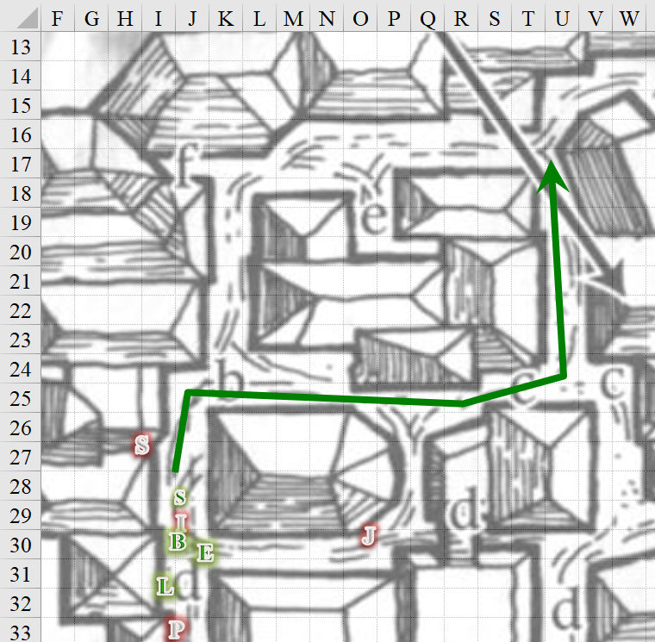

A few humanoids of different races were outside arguing about the process of retrofitting and refurbishing the place, and as the guards and heroes passed, a few good mornings were exchanged.

The arbalist’s body was set inside the wagon with the others, and the guards hopped onto the ledge of the wagon, which served as a makeshift seat, before the wagoner spurred the horses onward and a crowd of children tried to follow the wagon until the guards yelled at the kids to go home.

Barkley, Saradette, and Solstice were now on a main thoroughfare that would convey them northward to the Baron’s Keep with only two or three turns right at the end.

~*~

Luran motioned his head toward the gathered listeners. “I’m gonna schmooze,” he informed Elsabet.

As the debriefing continued, Luran conducted do some measure of intel gathering from the crowd, focused on this sudden, surprise, rat-based infestation that seems to be growing, as they speak.

The bard got a ton of compliments for his bravado once it was clarified that he and his friends had just cut down a handful of the ruffians. In the end, Luran came away with only corroborative information, including the mention by one priest of Ilmater that West Hill was surely infested with things worse than wererats. “The laws of physics and magic are being played with, and the gods—particularly the Crying God—will not be pleased when the culprits break the mold of reality.”

Perhaps the pessimistic priest was posing the poorest perception of the populace’s perilous plight. Nonetheless, the favored soul and bard nodded to one another as they waited for the others to meet them at the front gates.

~*~

Another few ticks later—no longer of the bell tower’s clock that was now destroyed—Solstice and Barkley were spotted approaching, looking as dapper and stalwart as always. Six seconds later, Saradette’s peanut form was also seen coming up the slightly graded cobblestone road towards the Baron’s Keep.

“So?” Barkley looked up at the streaming banners that blew in the breeze overhead, bearing the herald of Mintar’s sovereign Baron. “How’d it go? Anything to note?”

Everyone filled everyone else on what had happened in the last half-hour, and by 10:30—which only those with chronometers knew had come—the party was fully cross-briefed and ready to resume their investigation. They were neither hungry nor tired, and with most of their spells and powers still available to them, they weighed their options as they marked and looked at the map.

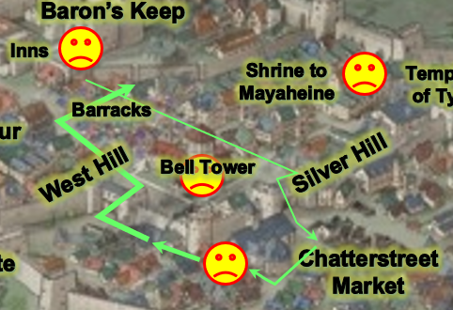

“Now, when you walked along the perimeter of West Hill,” Elsabet asked Barkley, who had taken a less direct route to the keep than she and Luran had. “Did you notice anything irregular? Not necessarily the people, but the way light and sound worked maybe?”

Barkley looked at Solstice, who had noted to their left as they’d skirted the quarter within a quarter, and said, “Saradette couldn’t hear it, but we both noted a high-pitched undulation,” they referenced a vibration higher than the 22,000 hertz that the gnome’s ears could register. Solstice, who could discern its quality a bit better, described it as a “woowoo” sound wooing at even intervals as if whatever was making it had no need to inhale.

“So it probably wasn’t the voice of a monster or something,” Barkley deduced.

Luran interjected, “The priest of the Martyred One seemed to imply the sort of power that slaps reality in the face and upsets gods. Do you think any of the villain types from last night fit that description?” His own mind rifled through what recollections he had of any such beings, but only curiosity remained after he ruminated on this.

Saradette had been intrigued by the news of there being only a handful of baddies left. She asked for the manifest to see whose names had been crossed off by now.

“Well, if Solstice and Barkley heard it, that’s good enough for me,” said Elsabet, whose own ability to pick up stray sounds was definitely inferior. “Let’s try to track the source of that down. While keeping an eye out for these remaining fugitives, and a sharp nose out for more wererats.” She smiled at Barkley as she showed the others the modified list of evildoers one last time and then slipped it back in her haversack.

Saradette sighed as she handed over the revised list. “The first thing I need to do is buy a silvered dagger. I’m sick of not being able to fight these things on even terms.”

“Good idea,” replied Elsabet. “It has to be frustrating to line up a shot at what should be their vulnerable spots but have your blade fail to pierce their skin for more than a scratch if that. Hey, if you want me to, I can pop a *bull’s strength* on you for the next fight!”

Saradette stretched to her full height and grinned up at the human towering over her. “Sure, if you think it will help.”

Solstice smiled as he imagined the prospect of a musclebound Saradette striking fiercely with a silvered dagger.

“Small bull is better than no bull!” Elsabet grinned back at the gnome.

As they strolled away from the Baron’s Keep, they passed a shop that would likely carry the manacles that Elsabet needed to replace her own, and the silver dagger that Saradette was now coveting.

They entered, inquired, and found the manacles, but due to the overwhelming demand for silver, such an instrument was unavailable. “Fresh out of silver goods,” shrugged the halfling vendor as she pointed to the empty shelves where such wares had been displayed. “Only silver I have is in coins, I regret.”

“Where is the nearest smithy,” Saradette asked. “I have the blade and the materials; all I need is a forge and some time to make it.”

“Tis true,” Saradette said with a laugh.

Elsabet replied, “The murderous magic-wielding bastard we just escorted here and handed over to the locals before he was busted out—the primary objective of the prison break in my opinion—might well be such, or at least a devotee of that sort of power anyways.”

She reached back into her haversack and pulled out her journal, flipped back a few pages from her latest entries, and holding it open to a relevant page, handed it over to Luran. “Here, you can read about the crimes he was being brought back to stand trial for, and my observations during the trip here.”

Elsabet mused for a big, trying to remember anything she might have heard about the “Crying God” that had been mentioned earlier. Could that sound the sharp-eared celestial folk heard be somehow related to worship of such an entity? Her knowledge of Ilmater and his martyrdom-bound followers didn’t corroborate such a suspicion.

They headed southward towards West Hill, retracing the path that Barkley, Saradette, and Solstice had taken. They would eventually make a left turn at the Southspur border towards the east, but before they could do so, at that very corner, Saradette noted the presence of one of her conspecifics: another gnome, his body language bespeaking a distressed state as he looked circumspectly, locking eyes with Saradette, squinting, and seemingly recognizing her. This was no random gnome; Saradette now began to realize. It was that Varsili fellow that had commended the team on their work just last night. He was now in plain clothes, and looked both ways before crossing the street and approaching them.

Barkley spotted him, and though he didn’t recognize the Mintari guard, he noted the distressed look on the man’s face. By the time Elsabet spotted him and reached for the peace-bonded mercy of her blade, he was upon them, and directed himself towards Saradette, with whom he was on eye-level.

Their suspicions of any intention of malfeasance on the guard’s part were dispelled as he spoke rapidly and hermetically. “No time to explain everything now! City’s under siege from within.” He was out of breath, but not from running. The pallor in his skin and the dried sweat on his disheveled hair were telltale signs of stress beyond that which the rest of the guards had displayed. He began to walk southward with the group, dissimulating his distressed state as much as possible, but he was no thespian, and passersby gave him frowns as they made their way along the busy, cobblestone street.

With her brows narrowed in concern, Elsabet asked Varsili, “Is there something ailing you that my magic may be able to help with?”

Looking a bit embarrassed, he replied, “We’re all like this... all the guards. I just got off a double-shift, and I’m one of the lucky ones. The younger ones are pulling triple-shifts now. I... no, I don’t think healing will do any help.”

“What do you want us to do?” Saradette asked as she walked with him.

He looked as if he hadn’t even considered such a thing. “I regret saying this, but the city is doomed. You looked like you were heading out of here. There are ships leaving today, and I hear they’re checking everyone for signs of lycanthropy.” The guard was about to desert his post, and from the looks of the southward traffic of wagons packed with housewares and personal effects, he was not the only person with an immediate drive to flee Mintar. It was just past noon, and while yesterday, the sounds of festivities and the smells of sweet, baked goods filled the air, today, there was only the sound of distress and the scent of adrenaline.

Elsabet replied, “No, we’re not leaving. We’re doing what we can to track down and put an end to this wererat menace. Mayaheine and Tyr will not desert this city, nor will their servants, such as ourselves. Have faith, friend, and allow Mayaheine’s grace to renew your spirit.”

|  |  |  |  |  |  |  |
| --- | --- | --- | --- | --- | --- | --- |
| **Skill** | **Rank** | **Ability & Mod.** | **Misc. Mods.** | **Total** | **Roll** | **Check** |
| **Elsabet, Diplomacy** | 8 | **Cha (+2)** | 4 | 14 | 8 – 16 | 22 – 30 |

*See below.*

Luran offered the beleaguered guard further encouragement, as well, his charming earnestness hopefully breaking through the gnome’s lack of faith.

“Perhaps you will accept Aid from a servant of Tyr,” Elsabet continued, with a meaningful glance at Barkley. “The good people of this city deserve our help, and your loyalty, sir—do not give up hope, for our gods are with you,” she allowed her voice to ring out a little louder with that last bit, so that other traffic on the street might take notice that not all those heading in that direction were fleeing the city.

Saradette turned to go back to the inn. “We need to get my cart,” she said.

Elsabet nodded. “What’s the shortest route?”

“It’s just back that way,” Saradette pointed back towards the Baron’s Keep, which was adjacent to the Missing Minotaur.

The favored soul cast *lesser restoration* upon Varsili as Barkley bestowed *aid [expired in 6 minutes]* upon the man. Barkley then took a moment to do the same for Elsabet, Luran, Saradette, Solstice, and lastly, himself as Solstice thanked him and took pity upon Varsili.

The gnome looked like he’d seen ghosts, though it probably wasn’t ghosts. With the *lesser restoration* spell cast, the man’s eyes lost their glaze, his pupils dilated to a constant, mid-aperture gauge, and he began to act less shifty and frayed. “Phew!” he involuntarily exhaled before gathering his wits. “Friends, I thank you for restoring my mind to some semblance of normalcy. I must warn you that if you stay... I...” he seemed to lose his senses for yet another moment before returning to where he was, “I can’t exactly explain what I saw, but I believe the wererats are only the tip of the iceberg. I’ve seen friends of a lifetime turn on each other over fealty to the Baron, whose message today was one of hope, despite the fact that he has a completely new contingent of confidants and viziers, and all are strangers to Mintar. I...” he shook his head.

“What is it?” Solstice could tell the man was dealing with something unfamiliar to him.

Varsili continued to shake his head, adding, “I think, at one point, I even saw the visage of one of the viziers take on a gruesome guise as the torchlight flickered more intensely for a mere instant.”

Just then, a contingent of dog-riding gnomes and halflings comprising part of the city’s Canine Cavalry rode by. With no horseshoes, the dogs were significantly stealthier than a conventional cavalry, and spotting them startled Varsili to the point that he gasped, doing his best to shield his face and give them his back as they rode by, turning to the right and heading westward as if dispatched to some specific location in the Southspur or Westgate.

Looking relieved that he’d not been made by those riders who knew him cursorily, the infantryman held back tears of desperation. “Take heed, good people—and my sense of judgment tells me you are all good people—this city has likely fallen to powers far more sinister than a wererat criminal ring. If you value your lives, consider your current path carefully.” He heard one of the riding dogs around the corner barking, and became alarmed, cutting to the conclusion of what he thought was proper to say to the party. “I can’t thank you enough for your aid. I will pray for you all.” And with this, he ran southward into a crowd of people toting tents and bedrolls among other wares on their way towards the docks.

“Thank you, brother,” Saradette responded quietly, knowing he wouldn’t hear, though her goddess would. “Be careful in your travels.”

Solstice and Saradette could tell that this man had seen enough, and as the musteval shook his head, he positioned himself a little better on Barkley’s shoulder. The party continued towards West Hill, and as they did, Solstice did his best to listen for the undulating, high-pitched sound.

They found it pretty much where they’d heard it before. Overhearing rumors and murmurs of wystes appearing, disappearing, and even a brief mention of one shrinking down from its original gigantesque form to microscopic proportions, though in less eloquent terms, the party began to feel like this part of town—despite the lack of structural damage—had been most affected by last night’s ado.

A dwarven woman tugged at her beard and shifted her gaze with a crazed look about her. Her indigent state and scent of urine—devoid of rat, Barkley and Solstice noted—made her look about as mad as she’d been driven, and her drivel about her “‘usband’s ‘ead rollin’ in a mud” carried the breath of someone who enjoyed seafood far more than hygiene of any kind. “Lick yer pinky for a few coins,” she tried to smile at Barkley as she passed by.

They made it another six blocks—noting the high-pitched whine still there, but its source seemingly unlocatable—and were now reaching the highest point of the hill for which West Hill was named. They could see a good portion of the city behind them as they ascended, and as they did, they noted several gradual changes. The architecture was from the older period, almost all wood from trees that no longer grew here, and stone quarried from sites long ago depleted of suitable rock. In addition, the houses were larger, and nearly all of them were one-story houses. The structures were nearly entirely residential, and as Afternoon progressed, residents entered their homes, likely in pursuit of a midday meal.

By the time they made it to the summit, they had spotted a few puddles of blueish-violet blood that looked exactly like the wyste blood they’d spilt last night. The higher they got, the more frequent the stains on the ground were, though some had made efforts to clean them. They now beheld the wondrous site of the Lake of Steam to their south, the fertile flood plains to their north and west, and some cliffs to the east. More notably, however, they’d been able to echolocate the whine, and could more clearly pinpoint its source to be a bookshop surrounded by what must have been modest mansions in their day, but were now at best small chateaus in decay. On the corner of Foglighter Court and Bridgehaunt Promenade was this reader’s getaway whose door hung open under a sign that read, “The Reality Wrinkle”.

All five heroes now felt a sensation devoid of pain, but not pleasant. It included vertigo and a slight nausea, and their senses were being confused by a brief irregularity in their perception of time and distance. For an instant, the very fabric of space seemed to warp. Distances stretched to seeming infinity and then close to nothing, straight lines warped and weaved, and Solstice held tightly onto Barkley’s armor to not fall off.

In the eye of this sensory—or perhaps real—storm, space opened up, and a pool of thick, blue slime oozed out onto the street. Their vertigo subsided as quickly as it came, and with it the other symptoms of malaise, and as the party thought to undo their peace bonds, they noted the dead or dying miniature wyste in the middle of the puddle. It twitched once, its translucent, purplish-blue skin revealing strands of quickly decomposing organs beneath it, and a ring of hooked tentacle-like limbs surrounding its gaping mouth, then died and deflated.

As Elsabet unbonded her bastard sword, she frowned at the puddle. “Is that ooze alive? Solstice, evil?”

“I don’t think it’s alive, and I don’t see any evil aura coming from it,” the weasel-bodied Celestial replied as he shook his head.

Elsabet took a step to get next to Saradette—if this got ugly, she had a promise to keep.

Saradette wrinkled her nose and took a cautious step closer to... to... well, to whatever that thing was. “What *is* that?”

“It’s wyste blood,” Luran was pretty sure, based on his up-close experience with the beasts yesterday, and others shook their heads on the note of the prognosis. “but why we’re looking at oodles of puddles of it is anybody’s guess,” he said of the headscratcher.

Elsabet, after unbonding her bastard sword, loosened it in its scabbard but left it there for the moment, slowly moving around the goo in the wake of the others, ready to blast it with eldritch energy if it started acting like more than a puddle.

The puddle began to look like the other puddles they’d passed as the surface of the ichor quickly dried in the seaside breeze under a noontide sun.

As the others tried to figure out the goo that was now on the ground, Barkley steadied Solstice making sure his little friend didn’t fall. He then began walking towards the bookstore. Saradette followed close behind Barkley, who moved towards the bookstore and unbound his hand weapons, leaving his bow and arrows alone for now.

During a moment-eternity when distances seemed least, Solstice peered into the windows of the Reality Wrinkle, which displayed handbound books on obscure philosophical treatises dealing with other dimensions and alternate realities, pseudo-theological texts of an alchemical or theosophical bent, and the ravings of lunatics who delved too deeply into bizarre magical secrets. There were also some self-help and travel books mixed in there for pop appeal, which probably kept them in business. The musteval related a brief description of what he saw.

Seeing that the puddle didn’t turn into a blob monster, Elsabet, instead of blasting the puddle with eldritch energy, cast *protection from evil [expired on Round 42]* upon herself. In addition to the normal protective benefits, she was especially interested in in the other effects, of summoned non-good creatures being unable to touch her, and keeping her mind free from outside control, since some weird otherworldly stuff appeared to be going on.

Elsabet then made her way to catch up with the others so as to be in a better position to execute her spellcasting contingency upon Saradette.