*Chapter 13: The Reality Wrinkle*

Round 3.8 or 38



The party reached the bottom of the staircase leading to the open door under the sign that swung gently in the Mintari breeze. Some weren’t sure of how they’d gotten there, or if they’d even meant to, but there and here they now were. Usually, Barkley and Solstice were the best at hearing, but at the moment, it was Elsabet and Luran who could hear a calm murmuring dialogue within, but as Elsabet shifted in her armor, the conversation was halted by a “shh”.

No longer suffering from vertigo and perception variability, the heroes could smell an herbal tea being brewed or enjoyed at the moment, and a voice from within now called out, “Please *do* come in.” The party could now see things in their appropriate perspective, though they noted the irregularity of the accents on the store’s façade, which created perceptions of the same type of spatial distortions that they’d just seen, albeit far subtler. Because they were too low to the ground, Barkley could not yet see inside the elevated structure.

The intersection was not quite desolate; aside from a few pedestrians visible hundreds of feet away in three directions, there was a single carriage now being drawn eastward by two clippity-clopping draft horses, making its way past them along Foglighter Court, the transversal that crossed Bridgehaunt Promenade, which the heroes had taken to get to this summit neighborhood.

The horses were notably spooked by what was likely a similar experience to what the party had just been through, but the herbivores’ eyes, covered by blinders, focused on the path ahead as the half-orc wagoner covered his eyes with a grimace and a curse in Orcish.

Once the vertigo left and his stomach settled, Luran began untwisting the binds around his dagger hilt. “Is that... tea?” he mused aloud as he prepared to back up his companions’ next moves.

*[DM assumption from the last round of posts…]* The party made their way up the stone staircase and onto the wooden beams that constituted the entrance to the shop. Their eyes were peeled for any funny business, but they only peered upon mundane and expected bookstore things: primarily, a table partly covered with books, with two empty chairs pulled out as if they’d been in recent use. Other than the books that Solstice had previously identified from afar, the archon and his friends noted nothing else in the front portion of the room. The threshold just beyond the table led to the back room, where two figures turned to look at the incoming heroes.

Elsabet smelled the hint of tea that Luran had referenced, and thoughts rushed through her head as they approached the entrance. “Oh, no, are these civilized foes? If it is Zakharan tea, I might need to try some. Time to ready my social skills. Maybe. The name of this place is suspicious. Hmmm.”

Only the last thought slipped out. “Hmmm,” she said as her nose tingled.

Barkley, however, was not interested in the tea. Instead, he’d walked with his hand on his silvered axe, ready to use it or pull out his regular axe should it be a non-lycanthropic foe, and now, spotting the two folks nearer to the back of the shop standing across from one another at a counter, he took a measure of the two males.

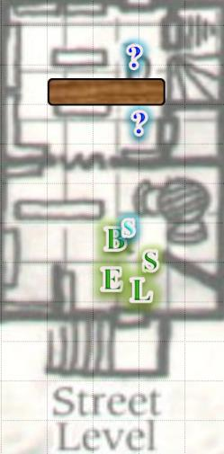

One was clearly human, while the man behind the counter looked to be half-elven, with only barely pointy ears displayed over a short-cropped hairdo. Both men were gray-haired; the human must’ve been in his 50s, while the half-elf was likely twice that age, though he had twice the life expectancy of the customer who was now admiring what he’d likely just purchased. “You let me know when you’re ready for the sequel,” the vendor told the human as Solstice waited for his larger friends to initiate dialogue.

As she looked around, Elsabet wonder if this bookstore had a resident cat or other pet, or perhaps a sneaky mouse or two, that she might talk to. She also took a look at a few of the books on the table, curious as to their titles. Heck, if there were any travel guides, she might purchase one.

As Barkley entered, his hand remained close to his axe as he sniffed the air, picking up no scent of wererats, and keeping a close eye on the two at the counter as he approached. He was not yet close enough to get a meaningful look at the book the human was holding, and asked, “Did either of you just experience some sort of dimensional shift or other odd shift of time and distance?”

They didn’t quite laugh, but responded with an air of resignation. The shopkeeper replied, “It’s been like that since last night. Did you all just get into town today?”

Solstice clarified that they were aware of the disturbances.

“Yes, well, though there were parts of town that were wrecked worse than ours—you can’t even see the bell tower from here anymore—we got a number of odd and inexplicable happenings at this very corner, and from what we’ve heard, throughout the rest of West Hill,” the half-elf said. “Fortunately,” smiled the man, “you’re in one of the epicenters of thought in the city, and though it may not look like much, you outlanders are sure to find something here that suits your literary interests.”

By now Elsabet’s eyes had scanned a few shelves, which contained treatises and other writings on the subjects of metaphysics, epistemology, Astral trigonometry, multilevel marketing, and conspiracy theories. This spurred her curiosity as to what other shelving categories lay beyond.

The human thanked the vendor, and nodded to the others as he took his leave via the front door. Barkley inhaled as the stranger passed, by, half-disappointed that there were no hints of wererat scent on him.

Barkley kept an eye on the bookseller as Saradette inquired about the store.

Luran cranked up his disarming grin and responded to the bookseller, “While I have no doubt a good portion of us would be overjoyed to peruse your wares, we’re on a more immediate mission, today. We’ve been deputized by city officials to look into these events and attacks. It seems your building here is an epicenter of a particularly mind-bending one. I notice your shop is a good floor or two taller than most of the other buildings in the neighborhood. Are all three floors filled with books and media? And is this the first such instance of any weirdness associated with this place? I know some tomes of a supernatural nature have a tendency to attract odd occurrences...”

“Epicenter of many things, yes,” said the vendor, “pretty much what I told the guards earlier. Well, you’re welcome to look around, but I’m afraid I don’t have any new information to add to the report I gave *them*.”

Luran nodded, noting that the vendor had sidestepped some of his questioning. Rather than press the man who did not seem overly giving in this area, the bard looked to his companions, ready to back up their next moves. Luran began lightly humming, warming up his voice in anticipation of having to manifest his Bardic Music the instant he saw any of his companions taking aggressive actions.

Barkley noted a peculiar charm comprised of interlaced rhombi hanging on the wall and woven from gray, green, and pink fibers, while Luran noticed the decaying composition of the half-elf vendor’s teeth, and the others enjoyed the ambiance.

Scrolls and tomes, some bound in materials they did not recognize, filled shelves that lined every wall. The small table they’d passed in the corner near the entrance looked rather inviting to the heroes, who had spent the majority of the last few hours on foot.

Anyone with a penchant for arcane studies could spend months—perhaps years—here, and still find want for more information contained herein. Those of keener ears then heard the creak of someone—likely another patron—walking along the boards above them.

Saradette’s excitement at seeing the books overcame her reticence. “Do you have any books on engineering or metalworking?”

The man smiled and looked up, then nodded, “It’s not a big section, but yes, on the second floor: metalworking, metallurgy, and metaphysics.

Saradette looked around for the stairs. “I’m going upstairs,” she told her compatriots.

“Oh, if you don’t mind waiting, there’s a study session... in... session right now,” the half-elf’s ears twitched as he got up and fetched a keyring from his vest pocket, unlocking the door, and excusing himself for a moment, “Let me go find out how much longer they’re going to be.” The male then disappeared into and up the curving staircase as the door swung towards the frame, but did not completely shut.

Barkley followed Saradette towards the stairs, adding, “We do have much to do; so we will try not to interrupt the session. Besides, my friend here,” Barkley indicated Saradette, “may be able to contribute to their conversation.”

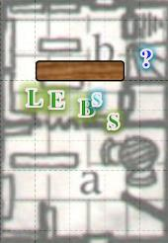

Round 1

Elsabet sensed prevarication there... and quickly gestured for her friends to follow. “Go, B,” she whispered, and stepped next to Saradette, where she cast *bull’s strength [expired on Round 41]* with her last 2nd-level spell. She strongly suspected a cabal of evildoers messing with powerful magic was upstairs, and didn’t want them to have a chance to prepare or escape.

*Saradette gained +4 to Strength.*

Saradette gave the crusader-warlock a nod of gratitude, though she did not know how the boost would be helpful to her.

Barkley followed Saradette towards the stairs, adding, “We do have much to do, so we will try not to interrupt the session. Besides, my friend here,” Barkley indicated Saradette, “may be able to contribute to their conversation.

The gnome then drew her dagger and started up the stairs, watching for traps and wards as she went.

Solstice relied on his ability to *detect evil*, and while he hadn’t detected any dubious emanations from the vendor or customer—now gone—he began to smell the faintest hint of a waft coming in from the crack in the door, and with it a hint of….

Barkley smelled it too; it was ever so faint, but given how recently they’d smelled it, the two snouted heroes were certain. Solstice whispered nonchalantly, “*Were*rats!” The musteval’s sense of magical discerning then focused on the charm that Barkley had spotted earlier, and noted that it had magical properties, but then so did dozens of other objects for display. He hopped down to the ground, and drew his short sword as they all finished moving around the counter and towards the cracked door.

And just when they were about to react to the scent, they heard—not from the cracked doorway, but from beyond a closed door just north of it—a disconcerting sound that they couldn’t be quite placed. It had the tinny treble of a gnomish or halfling voice, but it was ambiguously either moaning, crying, or maybe laughing. Solstice put his ear to the door, but that didn’t seem to help, as the musteval just stayed listening with a frown.

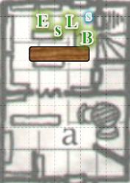

Round 2

Elsabet moved to the door Solstice was listening at, as she whispered loudly enough for the others to hear, “I’ll check this door with Solstice; you guys head upstairs.” She was a bit uncertain about giving orders, but she felt they had to move quickly, and Barkley could lead the way up, like he had in the tower. She tried opening it, first checking to see which way it opened. Unlike the door to her right this one was to be pulled—not pushed—open. However, this door was also locked. Solstice asked if he could hop atop Elsabet’s arm to pick the lock.

*[DM assumption]* With Elsabet’s nod, the musteval took a moment to study the lock before getting to work.

*Taking 10 on Open Lock over the course of the next round.*

Saradette reached out and, with the tip of her dagger, pushed the door open. It hadn’t creaked the first time, and it didn’t do so for Saradette either. A series of stone steps led up and to the left, and as the draft from above pushed the air into the room, Barkley and Solstice got a confirmatory whiff of the wererat, as well as other scents they couldn’t discern.

|  |  |  |  |  |  |  |
| --- | --- | --- | --- | --- | --- | --- |
| **Skill** | **Rank** | **Ability & Mod.** | **Misc. Mods.** | **Total** | **Roll** | **Check** |
| **Saradette, Move Silently** | 5 | **Dex (+3)** | 4 | 12 | 6 – 10 | 18 – 22 |

*Outcome unknown.*

Barkley nodded and headed for the stairs. With the scent of wererat—among other living things—in the air, he drew his silvered axe as he moved.

As the others pulled out their blades, Luran began a low, pianissimo chant that strengthened their sword arms and girded their loins for any conflict that would find the group. Though audible, he worked at keeping the volume as contained to their present room as possible.

*PCs gained +2 to weapon attacks and damage.*

Despite the pianissimo quality of the chat, it was likely that anyone at the top of the staircase would hear it.

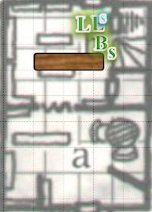

Round 3

Solstice fidgeted with the locking mechanism a bit, and the doorknob clicked into the unlocked position.

|  |  |  |  |  |  |  |  |  |
| --- | --- | --- | --- | --- | --- | --- | --- | --- |
| **Skill** | **Rank** | **Ability** | **Mod.** | **Ability**  **& Mod.** | **Misc.**  **Mods.** | **Total** | **Roll** | **Check** |
| **Solstice, Open Lock** | 9 | Dexterity | +3 | **Dex (+3)** | 2 | 14 | Takes 10 | 24 |

*Success.*

Saradette often thought of Widget at a time like this, and what would become of the familiar if some ill fate befell her. She took a few steps up the leftward-winding staircase, and with Barkley only inches behind her, heard the vendor’s voice softly speaking. She and Barkley could make out bits of what was being said, “… getting a bit… forsake the mo… and rid of them.”

Solstice heard something new and unignorable.

|  |  |  |  |  |  |  |  |  |
| --- | --- | --- | --- | --- | --- | --- | --- | --- |
| **Save vs.**  Gibbering | **Rank** | **Ability** | **Mod.** | **Ability & Mod.** | **Misc. Mods.** | **Total** | **Roll** | **Check** |
| **Solstice, Will** | **7** | Wisdom | +2 | **Wis (+2)** | 0 | 9 | 2 | 11 |

*Fail. Confused until Round 5.*

Without thinking about it too much, Solstice turned the knob on the closed door and cracked it open, causing it to creak a bit, and revealing a dark, downward staircase that did not wind like the one where Saradette now stood. The basement beyond it had a scent of mold and sulfur, and the murmuring they’d just heard within was now a discernible gibbering that captivated their ears and seemed to drown out the encouraging sound of Luran’s chant.

|  |  |  |  |  |  |  |  |
| --- | --- | --- | --- | --- | --- | --- | --- |
| **Save vs.**  Gibbering | **Rank** | **Ability & Mod.** | **Misc. Mods.** | **Total** | **Roll** | **Check** | **Notes** |
| **Barkley, Will** | 4 | Wis (+1) | 0 | 5 | 3 | 8 |  |
| **Elsabet, Will** | 6 | Wis (-1) | 4 | 9 | 8 | 17 | +3 vs. Enchantments |
| **Luran, Will** | 5 | Wis (-1) | 2 | 6 | 12 | 18 |  |
| **Saradette, Will** | 3 | Wis (+0) | 0 | 3 | 3 | 6 |  |

*Fail, success, success, fail. Barkley and Saradette were confused until Round 4 and 5, respectively.*

*Barkley 1d100 = 92. Saradette 1d100 = 78. See below.*

Barkley and Saradette began to attack one another.

|  |  |  |  |  |  |  |  |  |  |
| --- | --- | --- | --- | --- | --- | --- | --- | --- | --- |
| **Melee Weapon** | **Dmg** | **D+** | **TH+** | **Critical** | **Type** | **Wt.** | **Atk** | **Roll** | **Check** |
| Barkley, Hand Axe, Silver | 1d6 | 3 | 2 | x3 | Slashing | 3.0 | +11 | 10 | 21 |
| Saradette, Short Sword | 1d4 | +1 | 2 | 19-20/x2 | Piercing | 1.0 | 7 | 8 | 15 |

*Miss, miss.*

Fortunately, no one had gotten hurt yet, but Elsabet and Luran could tell that their three allies were being affected by the inscrutable, captivating gibberish coming from the door that Solstice had now pushed wide open. The musteval was now descending the stairs, and would not likely survive an encounter with an adult gibbering mouther—with which both the bard and the warlock were familiar—if he was headed down there under its influence.

Elsabet shrugged off the strange sounds, and spoke loudly enough to be heard by Solstice over the noise, “Let me go first,” as she moved past the musteval down the stairs, moving carefully to be sure not to trip while hoping.

In the dim light cast by the now open door, Elsabet had only time to notice the acidic spittle that smacked her right in the face. The gibbering mouther then slithered closer into view.

|  |  |  |  |  |  |  |  |  |  |
| --- | --- | --- | --- | --- | --- | --- | --- | --- | --- |
| **Character** | **Attack Type** | **Damage** | **Ranged?** | **BAB** | **Dex Mod+** | **Other+** | **Total Score** | **Roll** | **Total** |
| Gibbering Mouther | Spittle | 1d4 acid + blind | þ | 3 | 1 | -2 height | 2 | 5 | 7 |

*Miss.*

The human noted the Aberration, and had encountered one before, shortly before meeting up with her core group of friends. It had taken the entire clergy of a small village to bring down the monster, and though she was a far more formidable heroine these days, she wondered if she could take on such a challenge by herself.

Solstice spoke to himself for a moment.

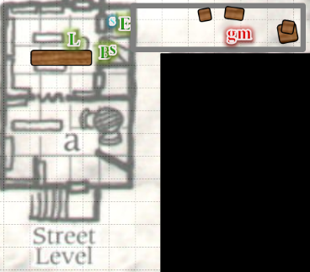

Round 4

Spotting the source of that evil noise as the monster came closer, Elsabet fired off an eldritch blast at it.

*1d100 = 42, no spell failure.*

|  |  |  |  |  |  |  |  |  |  |
| --- | --- | --- | --- | --- | --- | --- | --- | --- | --- |
| **Ranged Weapon** | **Dmg.** | **D+** | **TH+** | **Critical** | **Rng.** | **Wt.** | **Atk** | **Roll** | **Check** |
| Eldritch Blast | **1d6** | 0 | +1 *guidance*  +1 *divine favor*  +2 Courage | x2 | 60’ max. | - | +11 | 8 | 19 |

*Hit. Dmg: 5 magic + 2 Courage = 7.*

The warlock managed to do little more than upset the beast, who spit back with kneejerk alacrity before making its way to the bottom of the staircase.

|  |  |  |  |  |  |  |  |  |  |  |  |
| --- | --- | --- | --- | --- | --- | --- | --- | --- | --- | --- | --- |
| **Character** | **Attack Type** | **Damage** | **Ranged?** | **BAB** | **Dex Mod+** | **Other+** | **Total Score** | **Roll** | **Total** | **Crit** | **Threat** |
| Gibbering Mouther | Spittle | 1d4 acid + blind | þ | 3 | 1 | -2 height | 2 | 20 | 22 | 20 | þ |

*Threat. 1d20 = 12 + 2 = 14, critical hit. Dmg: 2 x 2 = 4 acid + blinding [****48****/42].*

|  |  |  |  |  |  |  |
| --- | --- | --- | --- | --- | --- | --- |
| **Save vs.**  Blinding | **Rank** | **Ability**  **& Mod.** | **Misc.**  **Mods.** | **Total** | **Roll** | **Check** |
| **Elsabet, Fortitude** | **6** | **Con (+1)** | 1 | 8 | 9 | 17 |

*Fail. Elsabet was blinded for ?? rounds.*

Elsabet—still *aided* by Barkley’s blessing—could no longer see, and held on to the wooden railing against the wall as she tried to regain her bearings. Shuddering, she quickly spoke. “Solstice, come back out.” She took a good grip on the door, and got ready to close it the instant Solstice stepped back through and out of the way. She mentally dope-slapped herself, but at first, she’d thought “prisoners” and had the urge to save them. But she knew better once she realized how much trouble she could have been had she faced that aberration with only the musteval for backup.

Saradette did her best to attack what she beheld as a foul creature in front of her, all the while wondering how she came to be there in combat. Barkley—taken for a foul creature at the moment—defended himself against Saradette, who was still controlled by the odd noise.

|  |  |  |  |  |  |  |  |  |  |
| --- | --- | --- | --- | --- | --- | --- | --- | --- | --- |
| **Melee Weapon** | **Dmg** | **D+** | **TH+** | **Critical** | **Type** | **Wt.** | **Atk** | **Roll** | **Check** |
| Short Sword | 1d4 | +1 | 2 | 19-20/x2 | Piercing | 1.0 | 7 | 17 | 24 |

*Miss.*

The archon’s fully defensive maneuvers made all the difference between a miss and a swipe.

Luran recognized the maddening power of the mouther’s jabber. Attempting to do something before Saradette stabbed Barkley in an uncomfortable place, Luran’s song shifted to overcome the creature’s influence.

Almost instantly, those who appeared to have been possessed by a spirit of chaos returned to their normal states. “For wha-? Oh!” Solstice then came back to his senses.

A black-clad, thuggish-looking human kicked at Barkley in order to push him down the two steps that he’d already taken up the stairs.

|  |  |  |  |  |  |  |  |
| --- | --- | --- | --- | --- | --- | --- | --- |
| **Character** | **Attack Type** | **Damage** | **BAB** | **Str Mod+** | **Total Score** | **Roll** | **Total** |
| Ploughtosword | Kick | 1d4+Bull Rush | 6 | 2 | 8 | 3 | 11 |

*Miss.*

The man who looked like he was on the blackguard path grimaced at the archon and spat at the gnome.

|  |  |  |  |  |  |  |  |
| --- | --- | --- | --- | --- | --- | --- | --- |
| **Character** | **Attack Type** | **Damage** | **BAB** | **Dex Mod+** | **Total Score** | **Roll** | **Total** |
| Ploughtosword | Spittle | Insult  (free action) | 6 | 0 | 6 | 12 | 18 |

*Miss.*

*[DM assumption]* Saradette did not take lightly to the stranger’s insult, and now that Luran’s lyrics were countering the gibberling’s ability to cloud her mind, she decided this wannabe blackguard would have her full attention.

A *fog cloud* spell filled the bookstore’s first floor, obfuscating most things.

Solstice used his ability to *detect evil and magic*, tapping Elsabet’s shin and confirming what she could hear, “There’s a scuffle on the staircase.” The musteval then moved closer to Luran, announcing himself to the bard so he was not mistaken for an enemy, and got a line of sight to the blackguard’s squire, though he did not have enough time to act at the moment.

Ploughtosword attacked Barkley.

|  |  |  |  |  |  |  |  |
| --- | --- | --- | --- | --- | --- | --- | --- |
| **Character** | **Attack Type** | **Damage** | **BAB** | **Str Mod+** | **Total Score** | **Roll** | **Total** |
| Ploughtosword | Spiked Knuckles, L | 1d4+2 | 6 | 2 | 8 | 13 | 21 |
| Ploughtosword | Spiked Knuckles, R | 1d4+2 | 1 | 2 | 3 | 16 | 19 |

*Miss, miss.*

And though the punches did connect, the shock of the spiked knuckles was absorbed by Barkley’s chain shirt.

Hubris made her way to the staircase, casting *shield of faith [expired on Round 44]* upon herself.

*Hubris gained +2 to AC.*

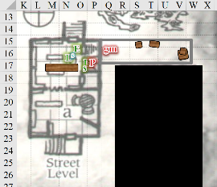

Round 5

The Wererat Lord slew the shopkeeper with little effort and no remorse.

The Blessed cast *magic weapon [expired on Round 46]* upon her scourge.

*The Blessed’s scourge gained +1 magic bonus.*

*Invisible*, Hubris descended the staircase, swiftly triggered her *greater invisibility [expired on Round 12]* ability.

|  |  |  |  |  |
| --- | --- | --- | --- | --- |
| **Character** | **Check** | **Ranks** | **Roll** | **Save** |
| Hubris | Hide | 6 | 13 | 19 |

Saradette could hear a scuffle upstairs, echoing against the staircase wall. She couldn’t make it out, but the sound included voices—probably spellcasting ones—and metal hitting other solid objects. If gnome—astute of hearing—had to guess, it was a copper or bronze pot hitting the ground, but it could’ve been a mace or morningstar hitting someone’s armor as well.

With Saradette no longer attacking him, Barkley focused on the new offender. Unable to move forward, Barkley slammed into the Ploughtosword, trying to force him back and bit at the squire’s neck.

|  |  |  |  |  |  |  |  |  |  |
| --- | --- | --- | --- | --- | --- | --- | --- | --- | --- |
| **Melee Weapon** | **Dmg** | **D+** | **TH+** | **Critical** | **Type** | **Wt.** | **Atk** | **Roll** | **Check** |
| Slam | 1d4 | 2 | 2 | 20 | Bludgeon | - | +10 | 14 | 24 |
| Bite | 1d8 | +4 | 2 | 20 | Piercing | - | +11 | 9 | 20 |

*Hit, hit. Dmg: (4 + 2) + (5 + 4) = 6 + 9 = 15.*

Though he was not able to push the black-clad ranger up the stairs, Barkley *did* put a nice bruise and two big incisions—followed up by some lacerations—to the clavicle region of the stranger’s chest. The gnome also snarled and jabbed at him with her sword, trying to drive the point up into his conveniently-located, and likely poorly armored, crotch.

|  |  |  |  |  |  |  |  |  |  |
| --- | --- | --- | --- | --- | --- | --- | --- | --- | --- |
| **Melee Weapon** | **Dmg** | **D+** | **TH+** | **Critical** | **Type** | **Wt.** | **Atk** | **Roll** | **Check** |
| Short Sword | 1d4 | +1 | 2 | 19-20/x2 | Piercing | 1.0 | 7 | 3 | 10 |

*Miss.*

His crotch ended up being fairly well armored, for a crotch, and she noted the elusive and tricky design, as well as the emblem emblazoned on his belt buckle, which was at her eye level. Though she couldn’t recognize it, it had to be the crest of a noble house or religious faction.

Saradette began to hear one of the voices upstairs—a female humanoid voice—take precedence over all other sounds.

Having just positioned herself to close the door, as soon as she felt Solstice move past her, Elsabet firmly closed the door and leaned against it, muttering “freaking gibberer” to herself, then called out “got the door!”

Elsabet thought about casting *resurgence* upon herself, but realized from her earlier experience that the Blindness was just a brief physical effect from the acid, not something magical. Instead, she cast *guidance* on herself, which she figured to use the next time she had to save against something weird.

*Elsabet gained +1 to a single attack roll, saving throw, or skill check.*

And why did it feel like she was outside on a foggy day, moisture on her skin?!? She blinked her eyes, hoping the acid flushed out quickly.

The gibbering mouther reached and tried to slam the door open, but the door opened towards—not away from—the mouther, and Elsabet’s foot was reinforcing the plank in case the frame and hinges could not.

Luran continued his chant, “… isolate the timber of my voice, my friends, that your ears and minds might be safe from the sway of these fiends…”

Saradette and Barkley could now hear a woman’s voice—likely casting a spell—quite close to them, but could see no one.

Solstice drew his sword and carefully made his way through the fog towards the sound of the scuffle on the staircase, and—unmistakably spotting the blackguard-to-be—fired a *magic missile* at his right shin.

*Dmg: 4 + 2 = 6 magic.*

Though still alive, the human was visibly wounded, and appeared to be heavily favoring his left leg now, as the musteval had intended. It was now time to finish off the unsalvageable soul.

Hubris cast *bewildering visions [expired on Round 9]* upon Saradette.

|  |  |  |  |  |
| --- | --- | --- | --- | --- |
| **Character** | **Check** | **Ranks** | **Roll** | **Save** |
| Hubris | Hide | 6 | 11 | 17 |

Saradette felt herself falling subject to an unfamiliar and unwelcome spell effect.

|  |  |  |  |  |  |  |
| --- | --- | --- | --- | --- | --- | --- |
| **Save vs**  *bewildering visions* | **Rank** | **Ability**  **& Mod.** | **Misc.**  **Mods.** | **Total** | **Roll** | **Check** |
| **Saradette, Will** | **3** | **Wis (+0)** | 0 | 3 | 10 | 13 |

*Fail. Saradette became Sickened. [–2 to attacks, weapon damage, saves, skill checks, and ability checks.]*

|  |  |  |  |  |  |  |
| --- | --- | --- | --- | --- | --- | --- |
| **Save vs.**  Nausea | **Rank** | **Ability**  **& Mod.** | **Misc.**  **Mods.** | **Total** | **Roll** | **Check** |
| **Saradette, Fortitude** | **1** | **Con (+1)** | 0 | 2 | 6 | 8 |

*Fail. Saradette became Nauseated. [Limited to 1 move action per round.]*

The world appeared once again to be tossing and rippling in a nauseating manner in Saradette’s perception. Saradette was sickened and nauseated, and could do little else besides retreat or defend herself.

Ploughtosword punched Barkley a few more times, connecting with the archon’s jaw on the first jab.

|  |  |  |  |  |  |  |  |
| --- | --- | --- | --- | --- | --- | --- | --- |
| **Character** | **Attack Type** | **Damage** | **BAB** | **Str Mod+** | **Total Score** | **Roll** | **Total** |
| Ploughtosword | Spiked Knuckles, L | 1d4+2 | 6 | 2 | 8 | 17 | 25 |
| Ploughtosword | Spiked Knuckles, R | 1d4+2 | 1 | 2 | 3 | 15 | 18 |

*Hit, miss. Dmg: 4 + 2 = 6. Partial damage negated [****48****/36].*

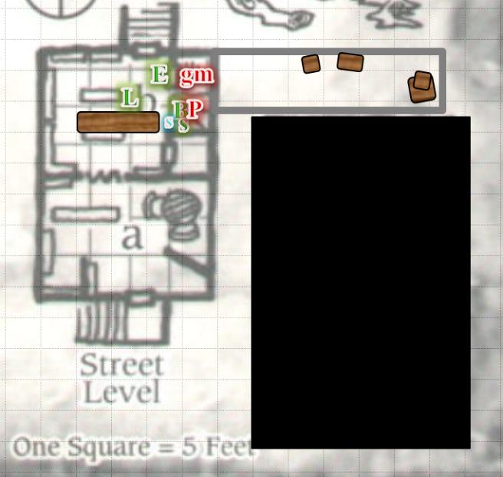

Round 6

|  |  |  |  |  |  |
| --- | --- | --- | --- | --- | --- |
| **Character** | **Group** | **Initiative** | **Roll** | **Modified Roll** | **Move** |
| Elsabet | 1 | 4 | 18 | 22 | 30’ |
| ?? | 2 | 2 | 17 | 19 | 40’ |
| Saradette | 1 | 1 | 17 | 18 | 20’ |
| ?? | 2 | 2 | 12 | 14 | 30’ |
| Solstice | 1 | 1 | 13 | 14 | 30’/10’ |
| Barkley | 1 | 4 | 8 | 12 | 30’ |
| Luran | 1 | 1 | 7 | 8 | 30’ |
| ?? | 2 | 1 | 7 | 8 | 30’ |
| Ploughtosword | 2 | -1 | 5 | 4 | 30’ |

Unable to see yet, Elsabet continued bracing the door, hoping the gibberer would give up and go away, and cast *divine favor [expired on Round 12]* on herself, hoping the acid would clear from her eyes soon. She couldn’t make out quite what was going on from sound alone, but figured once she could see again she’d need all the advantages she could get.

The Wererat Lord smiled as he sat on the windowsill facing the stairwell, and took on the form of a dire rat.

The world appeared once again to be tossing and rippling in a nauseating manner in Saradette’s perception. Saradette was sickened and nauseated, and could do little else besides retreat or defend herself. The gnome leaned heavily against the wall and stumbled down the stairs, trying valiantly to hold down her last meal.

|  |  |  |  |  |  |  |
| --- | --- | --- | --- | --- | --- | --- |
| **Skill** | **Rank** | **Ability**  **& Mod.** | **Misc.**  **Mods.** | **Total** | **Roll** | **Check** |
| **Saradette, Fortitude** | **1** | **Con (+1)** | 0 | 2 | 18 | 20 |

*Success. Nausea averted this round.*

Saradette *[standard or 2nd move action]*.

The Blessed joined Hubris on the staircase, passing the *invisible* woman and slapping at Saradette with her enchanted scourge.

|  |  |  |  |  |  |  |  |  |
| --- | --- | --- | --- | --- | --- | --- | --- | --- |
| **Character** | **Attack Type** | **Damage** | **BAB** | **Str Mod+** | **W+** | **Total Score** | **Roll** | **Total** |
| The Blessed | Scourge +1 | 1d4+1+1 | 2 | 1 | 1 | 4 | 4 | 8 |

*Miss.*

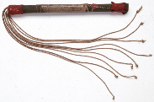

“*Nay*, my lady Blessed,” Ploughtosword protested, “You mustn’t be harmed. *Flee* that I might not carry the burden of mourning your countenance!”

Barkley yelled, “Solstice, the *spellcaster*!” He hoped that the musteval would dart past him and hit the spell caster with a *magic missile* or three to distract her spellcasting.

|  |  |  |  |  |
| --- | --- | --- | --- | --- |
| **Character** | **Check** | **Ranks** | **Roll** | **Save** |
| The Blessed | Spot | 4 | 3 | 7 |

*See below.*

|  |  |  |  |  |  |  |  |  |
| --- | --- | --- | --- | --- | --- | --- | --- | --- |
| **Skill** | **Rank** | **Ability** | **Mod.** | **Ability**  **& Mod.** | **Misc.**  **Mods.** | **Total** | **Roll** | **Check** |
| **Solstice, Sense Motive** | 0 | Wisdom | +2 | **Wis (+2)** | 0 | 2 | 16 | 18 |

*See below.*

Solstice noted from the ranger’s words in Common (in the accent of a local) the importance of what appeared to him to be a cleric holding a nasty, barbed scourge that now glowed with magically chaotic and evil energies, and could tell with some confidence that she hadn’t spotted him yet. In agreement with Barkley, he debated internally whether to just stab the would-be blackguard through his well-protected crotch, and finish him off without much ado, but with Saradette’s retreat, he instead saw an opportunity to snipe at the cleric.

|  |  |  |  |  |  |  |  |  |
| --- | --- | --- | --- | --- | --- | --- | --- | --- |
| **Skill** | **Rank** | **Ability** | **Mod.** | **Ability**  **& Mod.** | **Misc.**  **Mods.** | **Total** | **Roll** | **Check** |
| **Solstice, Hide** | 5 | Dexterity | +3 | **Dex (+3)** | 8 | 16 | 19 | 35 |
| **Solstice, Tumble** | 2 | Dexterity | +3 | **Dex (+3)** | 2 | 7 | 19 | 26 |

*See below.*

He hopped [Tumbled] and landed on the same step as Saradette, stabbing at the cleric’s crotch.

|  |  |  |  |  |  |  |  |  |  |  |
| --- | --- | --- | --- | --- | --- | --- | --- | --- | --- | --- |
| **Melee Weapon** | **Dmg** | **D+** | **TH+** | **Critical** | **Type** | **Wt.** | **Atk** | **Roll** | **Check** | **Notes** |
| Keen Short Sword | 1 | 1 | 3 | 17-20, x2 | Piercing | 0.1 | +13 | 16 | 29 | +3d6 Sneak |

*Hit. Dmg: 1 + 10 = 11.*

It wasn’t quite enough to kill the woman, but she would not likely be reproducing in the future without some serious healing magic. The cleric looked down at the musteval with contempt as Barkley put effort into finishing off the blackguard-to-be so that they could give the cleric their undivided attention.

|  |  |  |  |  |  |  |  |  |  |
| --- | --- | --- | --- | --- | --- | --- | --- | --- | --- |
| **Melee Weapon** | **Dmg** | **D+** | **TH+** | **Critical** | **Type** | **Wt.** | **Atk** | **Roll** | **Check** |
| Slam | 1d4 | 2 | 2 | 20 | Bludgeon | - | +10 | 6 | 16 |
| Bite | 1d8 | 4 | 2 | 20 | Piercing | - | +11 | 3 | 14 |

*Hit, hit. Dmg: (2 + 2) + (8 + 4) = 4 + 12 = 16.*

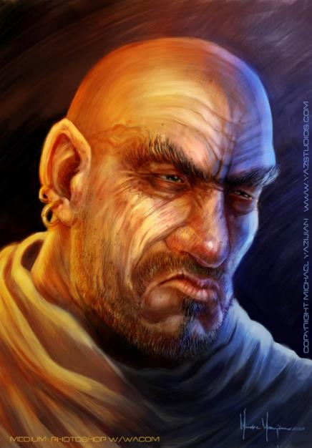

Barkley was surprised his slam and bite had connected so well despite poor execution of both. He dropped the man whose body now lay limp in his arm as the blood of a likely lycanthrope now coursed throughout his mouth and jowls, and growled at the cleric, unaware of an *invisible* attacker to his left.

Luran kept on declaiming the plight of the heroes in the foggy dew.

“…In squadrons passed me by… no fife did hum, no battle drum… did sound its dred tattoo…”

Hubris wasted no time in attacking Barkley.

|  |  |  |  |  |
| --- | --- | --- | --- | --- |
| **Character** | **Check** | **Ranks** | **Roll** | **Save** |
| Hubris | Hide | 6 | 15 | 21 |

Something or someone attacked Barkley.

|  |  |  |  |  |  |  |  |  |
| --- | --- | --- | --- | --- | --- | --- | --- | --- |
| **Character** | **Attack Type** | **Damage** | **BAB** | **Str**  **Mod+** | **W+** | **Total**  **Score** | **Roll** | **Total** |
| Hubris | MW Scourge | 1d4 | 3 | 0 | 1 | 4 | 9 | 13 |

*Miss.*

Ploughtosword bled on the ground.

The gibbering mouther tried in vain to bang the door open, but it was not strong enough. Its racket continued to be drowned by Luran’s eloquent ditty.

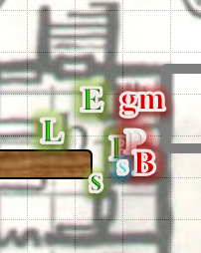

Round 7

Continuing to brace the door, Elsabet thought for a moment, and then drew her magical bastard sword. She figured if any enemy pushed past her buddies through the other doorway, she could get an attack of opportunity against it—and if the gibberer on the other side of the basement door managed to squeeze a pseudopod through a broken door panel she could chop it off!

The Wererat Lord escaped onto the rooftop.

Saradette tried to hold back the nausea.

|  |  |  |  |  |  |  |
| --- | --- | --- | --- | --- | --- | --- |
| **Save vs.**  Nausea | **Rank** | **Ability**  **& Mod.** | **Misc.**  **Mods.** | **Total** | **Roll** | **Check** |
| **Saradette, Fortitude** | **1** | **Con (+1)** | 0 | 2 | 8 | 10 |

*Fail.*

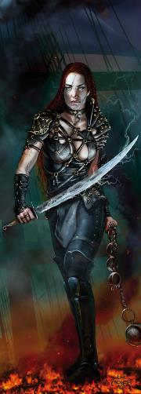

The Blessed full-attacked Barkley.

|  |  |  |  |  |  |  |  |  |
| --- | --- | --- | --- | --- | --- | --- | --- | --- |
| **Character** | **Attack Type** | **Damage** | **BAB** | **Str Mod+** | **W+** | **Total Score** | **Roll** | **Total** |
| The Blessed | Scourge +1 | 1d4+1+1 | 2 | 1 | 1 | 4 | 19 | 23 |

*Hit. Dmg: 2 + 1 + 1 = 4 [****44****/36].*

Solstice had lost the element of surprise, and could do little harm to the cleric, so instead he cast *magic missile* upon the cleric.

*Dmg: 6 + 2 = 8 magic.*

It was not enough to bring down the spellcaster, but certainly put a bigger dent on her than his measly stabs with his poker.

*[DM assumption]* Having finished off the blackguard’s squire, Barkley repeated the slam-and-bite maneuver versus the cleric.

|  |  |  |  |  |  |  |  |  |  |
| --- | --- | --- | --- | --- | --- | --- | --- | --- | --- |
| **Melee Weapon** | **Dmg** | **D+** | **TH+** | **Critical** | **Type** | **Wt.** | **Atk** | **Roll** | **Check** |
| Slam | 1d4 | 2 | 2 | 20 | Bludgeon | - | +10 | 19 | 29 |
| Bite | 1d8 | 4 | 2 | 20 | Piercing | - | +11 | 17 | 28 |

*Hit, hit. Dmg: (3 + 2) + (2 + 4) = 5 + 6 = 11. Partial damage negated.*

Barkley bit down into the cleric’s arm as she tried to block his punch, and tasted the blood, flesh, and hair of a wererat for sure.

Luran saw the cleric trying to beat back Barkley as he clocked her against the wall and gnawed at her forearm. The bard directed his lyrics at the sole enemy in sight, still bolstering his friends’ powers against the mouther but now at the expense of the cleric’s dignity as he insulted her cousins and courters by lumping them into a single Venn circle with his rhythmic rhetoric.

Hubris had had a full morning of killing and beating the shit out of people, and had no more spells left. She full-attacked Barkley with contempt for the Lawful being.

|  |  |  |  |  |
| --- | --- | --- | --- | --- |
| **Character** | **Save vs.** | **Ranks** | **Roll** | **Save** |
| Hubris | Hide | 6 | 20 | 26 |

An *invisible* lash swiped at Barkley’s face.

|  |  |  |  |  |  |  |  |  |  |  |
| --- | --- | --- | --- | --- | --- | --- | --- | --- | --- | --- |
| **Character** | **Attack Type** | **Damage** | **BAB** | **Str Mod+** | **W+** | **Total Score** | **Roll** | **Total** | **Crit** | **Threat** |
| Hubris | MW Scourge | 1d4 | 3 | 0 | 1 | 4 | 20 | 24 | 20 | þ |

*Threat. 1d20 = 2 + 4; not a critical hit. Dmg: 3. Damage negated.*

Saradette stepped away from the fight to regain control of herself, and to watch Luran’s back.

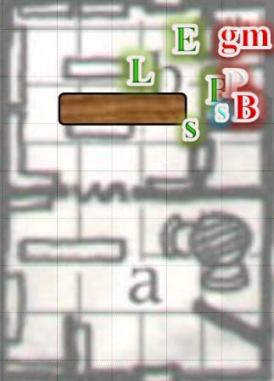

Round 8

The gibbering mouther managed to get one of its flatter appendages through the slit under the door, but didn’t appear to be breaching the effective barricade any.

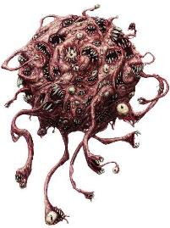

Seeing the gibberer’s thin pseudopod thrusting through the cracks under the door, instead of using a maneuver, Elsabet reacted in revulsion and fired a blast with her left hand straight down at the tentacle-like thing, figuring the energy would shock its system more than losing a bit of flesh to a sword blow, counting on her *guidance* spell, *divine favor*, and Luran’s music to guide her aim.

|  |  |  |  |  |  |  |  |  |  |
| --- | --- | --- | --- | --- | --- | --- | --- | --- | --- |
| **Ranged Weapon** | **Dmg.** | **D+** | **TH+** | **Critical** | **Rng.** | **Wt.** | **Atk** | **Roll** | **Check** |
| Eldritch Blast | **1d6** | 0 | +1 *guidance*  +1 *divine favor*  +2 Courage | x2 | 60’ max. | - | +15 | 7 | 22 |

*Hit. Dmg: 1 + 1 + 2 = 4 magic.*

The gibbering mouther retracted the mouth-eye-appendage and squealed its gibbering, still muffled by the bard’s cant.

Saradette wretched some more.

|  |  |  |  |  |  |  |
| --- | --- | --- | --- | --- | --- | --- |
| **Save vs.**  Nausea | **Rank** | **Ability**  **& Mod.** | **Misc.**  **Mods.** | **Total** | **Roll** | **Check** |
| **Saradette, Fortitude** | **1** | **Con (+1)** | 0 | 2 | 1 | 3 |

*Fail.*

She then went to help Elsabet hold the door closed against the whatever-it-was on the other side, but could not manage to do it very well.

The Blessed noted that Barkley—whom she’d momentarily pushed off of her—was fairly well armored, much better than the weasel at her heels. She struck down at that varmint instead.

|  |  |  |  |  |  |  |  |  |
| --- | --- | --- | --- | --- | --- | --- | --- | --- |
| **Character** | **Attack Type** | **Damage** | **BAB** | **Str Mod+** | **W+** | **Total Score** | **Roll** | **Total** |
| The Blessed | Scourge +1 | 1d4+1+1 | 2 | 1 | 1 | 4 | 15 | 19 |

*Hit. Dmg: 2 + 1 + 1 = 4.*

Solstice groaned at the pain of the bristled end of the scourge that would make a nice heavy flail for him. He took a 5’ hop back down onto the level floor and shot a pair of *magic missiles* at the wench who’d just done him wrong.

*Dmg: 3 + 2 = 5 magic.*

Barkley tried to finish off the woman with the scourge.

|  |  |  |  |  |  |  |  |  |  |
| --- | --- | --- | --- | --- | --- | --- | --- | --- | --- |
| **Melee Weapon** | **Dmg** | **D+** | **TH+** | **Critical** | **Type** | **Wt.** | **Atk** | **Roll** | **Check** |
| Slam | 1d4 | 2 | 2 | 20 | Bludgeon | - | +10 | 12 | 22 |
| Bite | 1d8 | 4 | 2 | 20 | Piercing | - | +11 | 7 | 18 |

*Hit, hit. Dmg: (3 + 2) + (1 + 4) = 5 + 5 = 10. Partial damage negated.*

And though he’d put enough of a hurting on her that she would surely fall within seconds, to Barkley’s dismay, she remained defiant for the moment.

Luran kept on decanting, and stayed out of the way of combat.

Hubris full-attacked Barkley again.

Another invisible swipe came at Barkley again.

|  |  |  |  |  |  |  |  |  |
| --- | --- | --- | --- | --- | --- | --- | --- | --- |
| **Character** | **Attack Type** | **Damage** | **BAB** | **Str**  **Mod+** | **W+** | **Total**  **Score** | **Roll** | **Total** |
| Hubris | MW Scourge | 1d4 | 3 | 0 | 1 | 4 | 4 | 8 |

*Miss.*

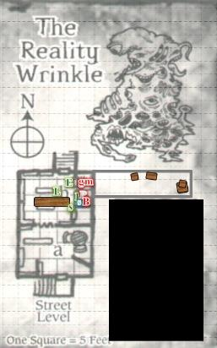

Round 9

Saradette started to feel better.

|  |  |  |  |  |  |  |
| --- | --- | --- | --- | --- | --- | --- |
| **Save vs.**  Nausea | **Rank** | **Ability**  **& Mod.** | **Misc.**  **Mods.** | **Total** | **Roll** | **Check** |
| **Saradette, Fortitude** | **1** | **Con (+1)** | 0 | 2 | 20 | 22 |

*Success.*

The gnome went to help Elsabet hold the door while taking swipes at anything that tried to come past it.

The Blessed attacked Barkley, all in vain.

|  |  |  |  |  |  |  |  |  |
| --- | --- | --- | --- | --- | --- | --- | --- | --- |
| **Character** | **Attack Type** | **Damage** | **BAB** | **Str Mod+** | **W+** | **Total Score** | **Roll** | **Total** |
| The Blessed | Scourge +1 | 1d4+1+1 | 2 | 1 | 1 | 4 | 1 | 5 |

*Miss.*

Solstice squinted, but it looked like Barkley realized that the cleric was a wererat, and now the musteval watched the archon stop his slam and bite attacks, and instead swung his silvered axe at the cleric. As he attacked, he tried to close the gap, forcing her backwards up the stairs.

|  |  |  |  |  |  |  |  |  |  |
| --- | --- | --- | --- | --- | --- | --- | --- | --- | --- |
| **Melee Weapon** | **Dmg** | **D+** | **TH+** | **Critical** | **Type** | **Wt.** | **Atk** | **Roll** | **Check** |
| Hand Axe, Silver | 1d6 | 3 | 2 | x3 | Slashing | 3.0 | +11 | 10 | 21 |

*Hit. Dmg: 4 + 3 = 7.*

The cleric fell, leaving only the *invisible* assailant that had swiped at Barkley a few times by now.

Luran kept on doing his thang.

The *invisible* assailant apparently stopped attacking, and now Barkley and Solstice heard footsteps up above, suspecting that the enemy was fleeing or hiding.

“Hey Saradette, think you could wedge the door shut with a hammer and piton?” Elsabet retrieved her hammer from her haversack and a pit on from her belt pouch, handing them over.

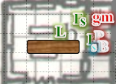

Round 10

Saradette wordlessly took the tools and drove the wedge home in the door jamb where the gibberer couldn’t reach it.

Elsabet trusted the master of mechanical devices to know just where best to pound in the climbing spike. And with a piton strategically placed plus the gnome’s magical muscles, Elsabet figured maybe Saradette could keep the door shut, and that would free her up to go get involved in the other action.

Having finished off two opponents, and having received a glancing blow from an unseen opponent, Barkley headed up the stairs cautiously. He focused his senses to watch for any movement or possible distortions as the invisible opponent moved around. He also swiveled his ears trying to take in any noises while his nose has sniffed at the air trying to pick up the change in odors.

Solstice followed close behind.

Barkley’s nose twitched from the scent of dried cilantro nearby.

This floor of the building contained two tiny bedrooms with simple bedrooms and threadbare blankets spread on the floor, a kitchen with cupboards and counters along the north and west walls, a table with six chairs as a dining area, and a privy. The door to a privy was open, and the smell of the crap of several types of humanoids emanated therefrom, obfuscating further the scent of wererat that might have been on Barkley’s face or elsewhere in the room; it wasn’t clear to him at all.

On the table, from this distance, Barkley could see some parchments, quills, and ink vials, in addition to a few candlesticks with half-burnt candles, still lit though it was the middle of the day. A single window faced west, overlooking the portion of West Hill the heroes had not yet seen, given that they’d come from the north. Another round of stairs followed upward to the third level, and the cupboards contained cookbooks in addition to the mason jars and burlap sacks likely filled with spices and other edibles.

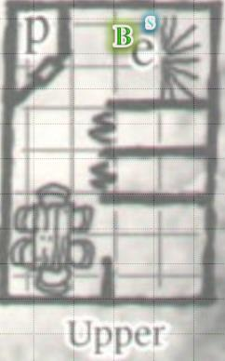

Downstairs, Luran drew down the tempo of his cant, though his tenor voice remained louder than the monster’s supernatural ability.

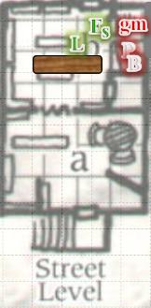

Round 11

As he walked about the floor, Barkley told Solstice, “Stay alert my friend, we have a coward walking about.” He moved to close the door to the privy, hoping to put a stop to the smell emanating from within. Still listening for any noises that might give away the invisible attacker, Barkley then moved to the open window to get some fresh air into his nostrils, and heard and saw some of the wooden tiles on the roof slipping down as if the *invisible* enemy was escaping via the pitched eaves.

*[Barkley has 1 move or standard action left on this round, but see below.]*

Solstice heard it too, and jumped atop the windowsill once Barkley’s perked ears and body language confirmed the musteval’s suspicion.

|  |  |  |  |  |  |  |
| --- | --- | --- | --- | --- | --- | --- |
| **Skill** | **Rank** | **Ability**  **& Mod.** | **Misc.**  **Mods.** | **Total** | **Roll** | **Check** |
| **Solstice, Jump** | 1 | **Str (-2)** | 2 | 1 | 13 | 14 |

*See below.*

Now able to see the *invisible*, horned assailant making her way south along the ledge that skirted the western wall at this level, he had thought to *magic missile* the woman, but instead put his sword down and clandestinely produced his blowgun for a better overall effect as he used the window’s frame as a wall behind which to hide.

|  |  |  |  |  |  |  |
| --- | --- | --- | --- | --- | --- | --- |
| **Skill** | **Rank** | **Ability & Mod.** | **Misc. Mods.** | **Total** | **Roll** | **Check** |
| **Hide** | 5 | **Dex (+3)** | 8 | 16 | 3 | 19 |

Barkley then turned to his left towards something that caught his eye, and spotted a pentagram etched onto the ground with a variety of burnt candles and offerings of jewelry and other inorganic trinkets.

*[Barkley can act here.]*

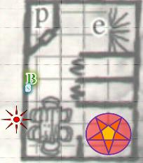

Downstairs, and unaware of what was happening about 10’ above them other than the creaks in the floorboards that Barkley was manifesting, and maybe the sound of the enemy as well, Luran said something like, “And when the fist was through a-poundin’, Bigby’s wrist was sore from groundin’.”

“Keep it going down here, Luran, and lend a hand to Saradette for now?” Elsabet asked, stepping away slowly from the door now that Saradette had wedged the door with the piton, and Luran was close enough to lean in as well, but watching for a moment just to make sure.

Saradette succeeded in reinforcing the door’s closure a bit better. The hinges were now the weakest point in the breach, which was the way it should be. The artificer then stepped away from the door.

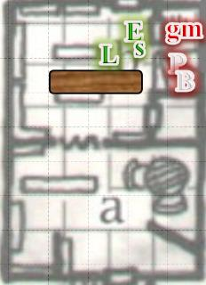

Round 12

Satisfied the door would be held until they could come back to deal with the gibberer, Elsabet turned and hustled up the stairs to the upper story to back up Barkley and Solstice, while holding her arms back and out so her sword tip dragged along the wall on the right and her buckler dragged along the wall to her left, hoping to ensure she didn’t miss any invisible foes scrunched up against one of the walls of the stairwell.

Barkley, seeing the *invisible* attacker attempting to flee by virtue of the wooden tiles that she was dislodging, decided to not worry about the pentagram for now and went after the horned beast. He cautiously *[taking 10]* made his way down the roof and along the eaves, howling as he moved towards the beast. Wanting to keep the beast in sight, he would worry about closing the gap when he got to better footing and a flatter surface.

Solstice fired a pair of flechettes towards the demon lady.

|  |  |  |  |  |  |  |  |  |  |  |
| --- | --- | --- | --- | --- | --- | --- | --- | --- | --- | --- |
| **Ranged Weapon** | **Dmg.** | **D+** | **TH+** | **Critical** | **Rng.** | **Wt.** | **Atk** | **Roll** | **Check** | **Notes** |
| MW Blowgun | 1 | 0 | 1 | x2 | 10’ | 0.1 | +11 | 18 | 29 | +3d6 Sneak |
| Blowgun, 2nd Attack | 1 | 0 | 1 | x2 | 10’ | - | +6 | 3 | 9 | +3d6 Sneak |

*Hit, miss. Dmg: 1 + 12 = 13.*

The *invisible* attacker suddenly became visible upon reaching the corner of the ledge, and turned around with her scourge still in her hand.

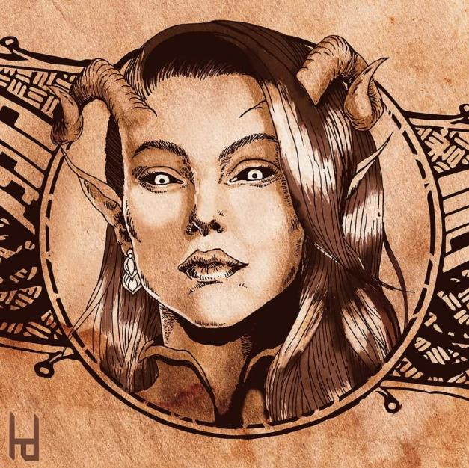

“A tiefling!” thought Barkley, smelling being almost biologically opposed to such fiendish spawns. Given her collusion with such chaotic agents of malfeasance, the archon suspected that he was dealing with a chaotic evil progeny of demons—not devils—and attacked her at the expense of his own balance.

|  |  |  |  |  |  |  |  |  |  |
| --- | --- | --- | --- | --- | --- | --- | --- | --- | --- |
| **Melee Weapon** | **Dmg** | **D+** | **TH+** | **Critical** | **Type** | **Wt.** | **Atk** | **Roll** | **Check** |
| Hand Axe, Silver | 1d6 | 3 | 2 | x3 | Slashing | 3.0 | +11 | 10 | 21 |

*Hit. Dmg: 3 + 3 = 6. Luran’s boost was inaudible at this point.*

|  |  |  |  |  |
| --- | --- | --- | --- | --- |
| **Character** | **Check** | **Ranks** | **Roll** | **Save** |
| Hubris | Balance | 3 | 8 | 11 |

*See below.*

|  |  |  |  |  |  |  |
| --- | --- | --- | --- | --- | --- | --- |
| **Skill** | **Rank** | **Ability**  **& Mod.** | **Misc.**  **Mods.** | **Total** | **Roll** | **Check** |
| **Barkley, Balance** | 0 | Dex (+1) | 0 | 1 | 7 | 8 |

*See below.*

Barkley and Hubris both fell to the ground.

*Dmg to Hubris: 1. Currently prone and flat-footed.*

*Dmg to Barkley: 1. Damage negated. Currently prone and flat-footed.*

The archon—having landed on his back just a few feet from the tiefling—noted that the woman was nearly done for now.

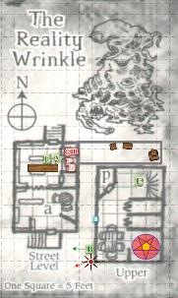

Round 13

Saradette backed away from the spiked door, but she watched it to be sure the creature couldn’t escape. So long as Saradette remained in the room, Luran kept on barding.

Quickly, Barkley got to his feet and glared at the tiefling, growling. “Surrender now and you may be allowed to live, or fight me and you will surely die!” Barkley thought the tiefling might have useful information and, like many chaotic fiends, would value their own skin and would gladly throw others in front of the cart to save themselves.

The tiefling was a solid card player, but as she feigned surrender with a defeated look on her face, the archon spotted one of her arms positioning to reach into her boot if and when he came closer.

Surprised to not see either Barkley or any enemy, Elsabet listened for a moment and looked around. She spotted Solstice and hustled over to the little celestial. “Which way did Barkley go?”

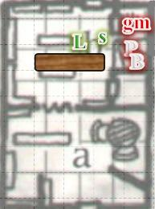

Round 14

“He just... apprehended the fugitive,” cringed the musteval at the sight of Barkley having crashed into the ground.

Barkley smiled and approached slowly, prepared to defend himself from the attack he saw coming. “Don’t even try to pull that knife from your boot or I will end your life.” Barkley hoped that pointing out the tactic he saw coming would make the tiefling think twice before being stupid.

|  |  |  |  |  |  |
| --- | --- | --- | --- | --- | --- |
| **Skill** | | **Ability**  **& Mod.** | **Total** | **Roll** | **Check** |
| **Barkley, Intimidate** | | Cha (+1) | 1 | 12 | 13 |
| **Character** | **Save vs.** | **Ranks** | **Roll** | **Save** | |
| Hubris | Intimidate | 6 | 7 | 13 | |

*Fail.*

“Eat shit, pinkie dick!” the tiefling pulled herself onto a kneeling position, threw a dart at Barkley, and offered an unusual insult and did what she’d intended to anyway.

|  |  |  |  |  |  |  |  |  |  |  |
| --- | --- | --- | --- | --- | --- | --- | --- | --- | --- | --- |
| **Character** | **Attack Type** | **Damage** | **Ranged?** | **BAB** | **Dex Mod+** | **W+** | **Other+** | **Total Score** | **Roll** | **Total** |
| Hubris | MW Darts (5) | 1d4 | þ | 3 | 2 | 1 | -4 prone | 2 | 15 | 17 |

*Overruling the “cannot used a ranged weapon except for a crossbow” rule on account of me thinking that a thrown object is another reasonable exception. -4 penalty still applied, as this item’s thrust depends on movements similar to those in melee.*

*Miss.*

Motioning Solstice out of the way, Elsabet squeezed through the window onto the ledge—if Barkley could do it, so could she! She looked at the scene below, and saw that if she jumped down, she should be able to land in a flanking position on the closer side of Barkley’s opponent.

Swiftly tapping her Brute Gauntlets once to gain a bonus to her jumping ability, she took a quick breath and jumped down!

|  |  |  |  |  |  |  |  |
| --- | --- | --- | --- | --- | --- | --- | --- |
| **Skill** | **Rank** | **Ability**  **& Mod.** | **Misc.**  **Mods.** | **Total** | **Roll** | **Check** | **Notes** |
| **Elsabet, Jump** | 5 | **Str (+2)** | -1 | 6 | 8 | 14 | +2 Brute Gauntlets |

*No damage.*

Luran and Saradette remained downstairs guarding the door. “That’s how we do it in Min-tarrrrr!” Luran was starting to get winded.

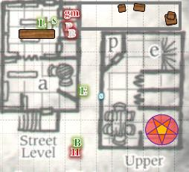

Round 15

Luran had run out of lines appropriate for this scene, so he started over, switching from Common to Elven.

Saradette stayed with Luran while the bard played to help the group.

When the tiefling still threw her dart and missed, Barkley shook his head. “Pathetic.” It was not a creative insult, but an accurate one. He then charged in, his intent to subdue the tiefling and take her as an unwilling prisoner now.

|  |  |  |  |  |  |  |  |  |  |
| --- | --- | --- | --- | --- | --- | --- | --- | --- | --- |
| **Melee Weapon** | **Dmg** | **D+** | **TH+** | **Critical** | **Type** | **Wt.** | **Atk** | **Roll** | **Check** |
| Slam | 1d4 | 1 | 2 | 20 | Bludgeon | - | +8 | 5 | 13 |

*Miss.*

The woman finished getting up and withdrew before Barkley could react.

|  |  |  |  |  |  |  |  |  |  |
| --- | --- | --- | --- | --- | --- | --- | --- | --- | --- |
| **Melee Weapon** | **Dmg** | **D+** | **TH+** | **Critical** | **Type** | **Wt.** | **Atk** | **Roll** | **Check** |
| Slam, AoO | 1d4 | 1 | 2 | 20 | Bludgeon | - | +8 | 17 | 25 |

*Hit. Dmg: 3 + 1 = 4 nonlethal.*

Hubris fell back down and looked like she was down for the count.

Solstice went downstairs to let the others know that the assailant was getting away, reaching the top of the staircase.

Luran’s voice finally wobbled from the strain of such continual, supernatural impact on his surroundings. His countersong ended. He said to Saradette in his normal speaking timbre, “If that door’s gonna hold, we should check on the others, upstairs.”

Round 16

Solstice reached the lower level and announced that there one of the enemies was fleeing westward.

Elsabet said “Good work, B! Let’s get her back inside and rejoin the others.” She looked up at Solstice, but the latter was already downstairs, so she moved to help the archon pick up and bring the tiefling inside. There was still that gibberer to deal with.

Barkley looked at the tiefling as she lay unconscious. He and the warlock began to drag her inside of the building.

“Oy!” a dwarven guard barked at Barkley as he rounded the corner. “Get your hands off...” the dwarf—now visibly followed by at least two guards that also came out from around the corner wielding their pike and halberd in the traditional marching fashion, indicating that the were doing their regular rounds—interrupted himself, trying to figure out if it was racist of him to assume that a hound archon was doing justice by dragging an unconscious tiefling into a shop. The human beat guards stopped as the dwarf inhaled and tilted his head, studying the archon and human beside him. “Please explain what’s happening here.”

Luran and Saradette remained inside with their attention on keeping the gibbering mouther at bay, while Solstice made it to the southern door and noted the three guards. The musteval though to try hiding in plain sight and study the conversation in case things went sour.

|  |  |  |  |  |  |  |
| --- | --- | --- | --- | --- | --- | --- |
| **Skill** | **Rank** | **Ability**  **& Mod.** | **Misc.**  **Mods.** | **Total** | **Roll** | **Check** |
| **Solstice, Diplomacy** | 0 | **Cha (+2)** | 2 | 4 | 7 | 11 |
| **Solstice, Hide** | 5 | **Dex (+3)** | 8 | 16 | 6 | 22 |

*See below.*

And though he was hiding extremely well, he looked quite circumspect to anyone that would’ve spotted him.

Seeing Solstice on the stairs and learning of their companions’ status, Luran waited with Saradette as the mouther behind the door scratched and jabbered in frustration.

Round 17

As Elsabet held the tiefling’s legs, and Barkley her arms, they took a quarter of a second to determine who would speak first and what would be said.

Elsabet smiled at the guard, and turning on her best diplomatic charm, said, “Hi, I’m Elsabet, Favored of Mayaheine. Glad you’re here so we didn’t have to call you!”

The two human guards caught up to their captain and stopped, looking at him for a moment to get a sense of their expectations.

The warlock took a breath. “Rough couple of days! After clearing a wererat nest out of the tower last night, and almost missing the big briefing earlier due to uncovering a wererat fencing operation over thataways,” she gestured tiredly in the direction of the store, “where I gave a bit of divine boost to a young paladin comrade of yours, my celestial friend Barkley here helped us trace more wererats to this bookstore.”

“Aw, y’all’s the ones that cleared the belltower!” the taller, skinnier human nodded, having heard of their plight last night. Then he looked in the tower’s direction, shaking his head at the fact that it no longer stood.

Elsabet had taken another deep breath, and now exhaled the next two sentences, “Why don’t you come inside? They have a very disquieting aberration they keep as a pet in the cellar and there’s some kind of arcane summoning that we disturbed, the pentagram and candles and stuff are in plain sight on the second floor.”

“Oh?” the dwarf’s eyebrows betrayed a truly unanticipated sense of surprise. “That what we’re hearing now?” he asked of Luran’s cant.

Solstice made his presence evident, “No, officer. There’s a gibbering mouther inside. Our resident bard is now countering its chatter. Come any closer, and it may just get the best of your wits.

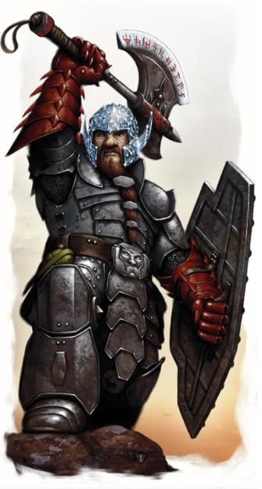

The dwarven captain looked at the guard who hadn’t spoken yet, and ordered him to go get a specialist, “Make sure she brings the barbed snare with the *silence* trigger.”

Round 26

Elsabet continued, “As my esteemed colleague states, our comrade Luran is countering the aberration’s gibbering from affecting us with his bardic music, and we were going to deal with that next...”

She looked around, then continued, “Do you want to take this... woman... into custody? Come check out the evidence, start working on the reports? Or go get a superior, let them handle the paperwork?”

|  |  |  |  |  |  |  |
| --- | --- | --- | --- | --- | --- | --- |
| **Skill** | **Rank** | **Ability**  **& Mod.** | **Misc.**  **Mods.** | **Total** | **Roll** | **Check** |
| **Elsabet, Diplomacy** | 8 | **Cha (+2)** | 4 | 14 | 15 – 20 | 29 – 34 |

*See below.*

By then the human guard who hadn’t sped off to get the monster catcher specialist now approached the tiefling as the dwarf began to ask the stock questions associated with this type of case: names, motives for being here, and their account of events.

Still outside, and now joined by Solstice, Elsabet shook her head. “Didn’t expect this city to be so exciting; only reason we are here is we helped deliver that murderer Oral into custody.”

The guards squinted and frowned, not recognizing the name. It was a big city, after all.

“Got the paperwork to prove it! But let’s get inside so we don’t cause the citizens more distress.” She nodded at the dwarf like he couldn’t help but come along, nodded at Barkley to continue into the building, helping him move the unconscious tiefling.

“Aye,” the captain said, taking in a measure of the bowing musteval, and introduced himself as they went inside.

“Name’s Solstice. I will warn you that we will have to restrain you if the gibberer causes you to become hostile,” he then warned the guards, who stopped.

Captain Hamrinson introduced himself and placed a hand on the human guard next to him. “Another one of them mouthers; we’d best stay outside until the Catcher comes.” The specialist had been busy all night nabbing aberrations, and the guards in the West Hill Precinct had all by now heard or seen of such a monster.

“What will you do to it?”

The dwarf at first seemed to smile, but it was actually a cringe, followed by a shaking of the head. “Not much to be done. They’ve been cullin’em—*and* the wystes that you, no doubt, have heard about by now—along with other weird monstrosities.”

Elsabet replied, “Oh, yeah, we helped take out one of those things last night. That’s where we met Luran, the bard inside—good fellow. We had been working with the paladin of Tyr, Larissa, but she’s been called to another task for her Temple it looks like Luran is joining our squad for the foreseeable future, and we’re lucky to have him!” Elsabet also reported that Barkley or Solstice could point out which miscreants seemed to be wererats according to their scent.

“There’s a cleric inside. She’s *definitely* a wererat. This one, though,” Barkley pointed at Hubris. I think I’m only smelling rat on her clothes and hair.”

“Lycan-lover,” Solstice tilted his head like a confused puppy for a moment.

Round 33

Elsabet then described the proprietor, and pointed out that his current whereabouts were unknown, “but he *had* to be complicit in this... what with a gibberer in the basement.”

Saradette remembered her desire to return to the inn as she took her attention away from the gibberer, walked about 30’ south until she reached the threshold of the shop’s front door. “Captain, you have questions for me?” she asked politely.

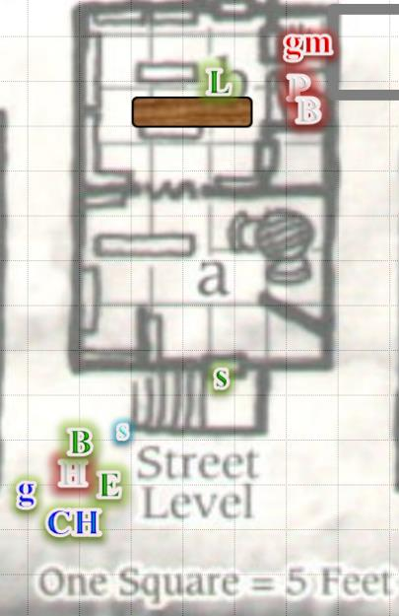

“Good day, citizen,” the Captain politely greeted the gnome, asking, “All well in there now?”

“We have a gib-” the gnome was cut off by Solstice.

“We told them. They’re bringing a guy named the Catcher,” the musteval said.

“Then yes, I suppose all is well,” the illusionist replied. “Our friend is watching the door to make sure it stays closed. I should probably get back to my position in case it doesn’t.”

Round 38

Elsabet was getting a little anxious, waiting for the Catcher to arrive. She had earlier resheathed her bastard sword in order to help move the unconscious woman, and had checked to make sure the woman was stable when she realized the conversation and wait was going to take a while.

She was less worried about the enemies on the stairs, but as Saradette appeared in the doorway, had suggested the gnome check on their status—and keep a sharp ear out in case the proprietor tried sneaking out. And if the downed foes had bled to death, hopefully they wouldn’t suddenly become zombies or something. She shuddered—undead were even worse than aberrations, she thought. She continued answering any questions the Captain posed, as she had nothing to hide.

With the tiefling turned over to the guards, and after Saradette came to the door, Barkley decided he should also go inside and make sure the gibbering beast didn’t come through the door. He had his long sword in hand, ready to use it.

Luran concluded his ode—now in Elven, and nodded to Saradette, who came back to watch the door.

Round 50

The Catcher had arrived, along with three other guards, and an entourage of lasses and lads who said they wanted to become City Guards, but would likely end up street urchins like their older siblings. The Catcher was nothing like what they’d expected; instead of some drab human or dwarf in armor, a blue-skinned water genasi from the Shining South made his way toward the Reality Wrinkle.

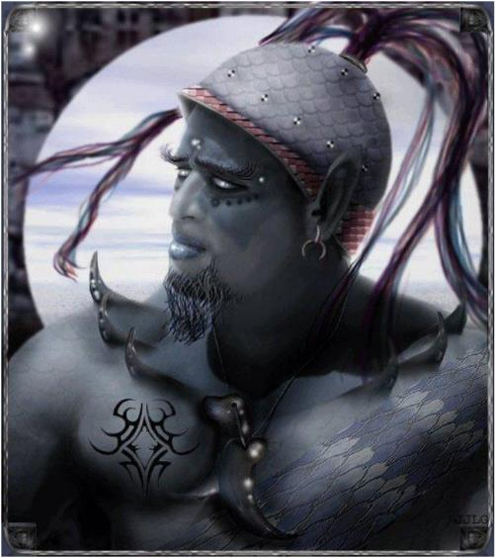

Wearing a sash of shiftweave, the azure male greeted everyone politely and with the calming, reverbing voice of one of his hybrid species. Rather than having brought armaments, the genasi carried on his back a hefty bag that had all manner of magic items and special equipment. “Another gibberer then?” he asked, having been asked to bring the *silencer*.

“Aye,” the Captain responded with no further explanation needed.

“A peaceful afternoon to you, brethren,” the Catcher bid the others as he went into the house with his assistants. “Can you keep the youngsters away while we get this one?” he then asked Elsabet as the tall human guard held the now rousing, cuffed, gagged tiefling’s arms in a secure hold.

The specialists wore earplugs and the *silencer*—a barbed snare with a *silence* spell Permanently cast on it—was now produced as the team stepped onto the four-step staircase and entered the house one by one. Nodding to Luran, and showing the snare to express, “We’re the guys here to deal with the motherfucker in the basement,” the quartet came around the counter, and asked Barkley, Luran, and Saradette to step away.

“Better if you go by the door,” one of the four professionals wielding a crossbow pointed to the southern door.

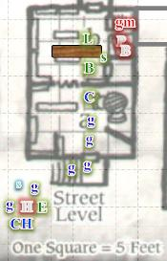

~*~

Round 63

Luran hopped up the stairs to investigate the arcane trappings and summoning setup to determine if he could infer something more from the sigils and patterns. He was first intrigued by the contents of the pantries, which had a variety of items that could be improvised as percussive accents: nuts whose shells were often fashioned into castanets, goats’ hooves that they’d already seen being used as anklet and belt accessories, adding to dancers’ rhythmic sounds during performance. Still, these ingredients didn’t look like they were being stored for musical purposes, but perhaps for alchemical ones.

Barkley, when asked to step back, did so, but stayed where he could see and aid the guards should they need it. He was impressed with their efficient and professional techniques. He then followed them out to the back of the store and watched as they dispatched the beast. Though it did not belong on their plane of existence, he wished there were a more humane way to dispatch the beast as it likely was conjured to this plane against its will.

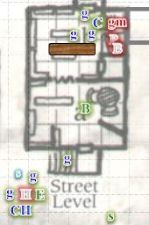

A minute or so later, the gibbering mouther was brought out in a series of snares and looped coils around its relatively amorphous shape. The magical and mundane fixings were keeping the creature from getting loose, and once they’d taken it out around the back, the Catcher pulled a crank on the main snare and squeezed the barbed wires so tightly around the Aberration that it sliced it into a placental mire of mouths, eyes, and viscera on the ground. As the strange flesh decomposed and melted onto the ground, it coagulated into a puddle of green and violet fluid that would eventually dry up and evaporate.

“Best we could do for the wretched beast, really,” Captain Hamrinson consoled some of the younger children that just *had* to go around the corner and watch the gruesome euthanizing of the creature that belonged nowhere near this plane.

Elsabet gladly helped keep the youngsters back out of the way as requested, chatting with them, introducing herself and distracting them with toned down versions of her recent adventures. While doing so, she waited for the all clear to be given, as there might be more work to do inside, unless the Captain indicated he wanted to secure the building himself; she was willing to assist if needed, but also knew Saradette was getting a little worried about her little friend and her wagon back at the inn.

Saradette looked to her companions. “I need to go check on Widget and Gadget, and see if my cart is still there.” She reached out mentally to see if she could sense Widget anywhere around.

The raccoon familiar was still back at the Missing Minotaur, and stopped grooming the pony as she got the sense that Saradette was near. Turning around, she saw no one, but now sensed the presence of her magical source, and scrunched her nose, sending positive vibrations to her gnomish soulmate.

“I’m coming, Little One,” Saradette sent back to her familiar before she bid the others well and said she was going to start walking back toward the inn and her critters. Barkley offered to accompany Saradette to check on her wagon and the other critters left back at the inn, and Elsabet then looked at the house where Luran still inspected the contents of the second floor.

The Catcher and his people nodded to the others, said a few nice things, and went back to the Precinct Office where they would likely be dispatched to deal with another doosie before the day was through.

Then, suddenly, and with nary a cloud in the sky, a single bolt of lightning came from the farthest reaches of the sky down unto the area where the belltower had stood until last night. Elsabet, who was outside with the guards and tiefling, saw it before they all hear the peal of thunder that razzled nearly the entire city.

“By the holy *gods*!” remarked one of the remaining guards as the violet-white bolt receded into the sky once again and the clear day continued to work itself out.

Still seeing a few stars on account of Barkley’s punch to the frontal lobe, Hubris smirked to herself, and Elsabet caught the expression.

Luran had nearly jumped out of his own skin when the thunder had rattled the jars around him, and now that he had scoured cursorily the shelves and contents of the pantries, he turned his attention to the southeast corner, where he now noted the pentagram that had been described earlier. Then he froze dead in his tracks before taking another step.

Round 75

“Heroes,” Captain Hamrinson needed to close the loop on this as per today’s emergency protocols. “I’ve taken your statements, and commend your efforts. We’ll get a forensic team here in a bit, and we don’t need to trouble you here any longer, but seeing as you are staying at the Missing Minotaur, and our directives are to furnish our reports to the Baron’s Central Command along with the witnesses, I’ll ask Withmund and Shracter here to accompany you to the Keep, whereupon your testimonies can be submitted.”

To the carefree gnome, this seemed excessive; to the lawful hound archon, it seemed quite prudent, and in the interest of the greater order.

Luran took only seconds to survey the pentagram, and the body thrown to bleed to death in the northeast corner of the area comprising the pentagonal star.

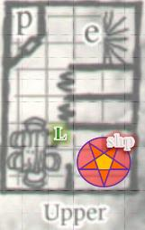

Luran bolted down the stairs after his discovery on the second floor. “The shopkeeper’s been sacrificed to the summoning circle! It looks like it’s connected to Beshaba! I think that could have something to do with the unexpected thunderclap. The mistress of storms is either pissed or coming for dinner!”

Saradette was growing tired of the whole mess. “Look, all I want to do is to go by the inn, get a quick meal, and check on my animals and my cart. We’ve been fighting all morning, and I’m tired and hungry. Whatever questions you have, you can ask me while I eat. Then, I will accompany you back to the Baron’s Keep, or whatever else it is I have to do.”

Elsabet supported this plan.

When the lighting had struck the area where the tower once stood, Barkley had looked at the house wherein Luran had stayed. Once the bard had emerged, Barkley had looked at the others. “Should we investigate the tower and the lighting strike before we head to the Baron’s Keep?”

She looked at the guards. “I will even pay for your meal while you interview me,” she offered.

The gnome had completely missed the half-elf’s announcement of the shopkeeper’s body in the corner, partly inside the pentagram, and now continued on her way to the inn. “Barkley, I’m useless until I get some silvered weapons, and retrieve my gear with my thrower. Unless these people intend to arrest me, I’m going back.”

One of the guards placed himself in front of Saradette and placed the point of his ranseur at the level of her solar plexus, “Stay your ground, citizen.”

Saradette smiled mirthlessly at the guard holding her at swordpoint, but she kept her mouth shut, and waited to see what happened next.

Elsabet told the Captain, “I give you my word as a Favored of Mayaheine that the group will proceed to the Keep...after we have returned to the Missing Minotaur to take care of some business. Withmund and Shracter are certainly welcome to accompany us, and Saradette has graciously offered to buy them lunch. Surely you have no problem with that, Captain?” She looked him straight in the eyes, letting him see both her total honesty and her belief that he really, really didn’t want to push the issue. She called out a bit louder, “Luran, Solstice, come along, we’re heading for the Missing Minotaur.”

*[Saradette and Elsabet have rendered the Captain’s attitude Unfriendly.]*

|  |  |  |  |  |  |  |
| --- | --- | --- | --- | --- | --- | --- |
| **Skill** | **Rank** | **Ability & Mod.** | **Misc. Mods.** | **Total** | **Roll** | **Check** |
| **Elsabet, Diplomacy** | 8 | **Cha (+2)** | 4 | 14 | 6 | 20 |

*Captain reverts to indifferent. See below.*

As were his express orders, the dwarf shook his head as the remaining guards assumed a more imposing stance, “Heroes, I *must* comply with this mandate, or it will be *me* who has to answer to a court martial, so I ask again, please proceed with my men to the Baron’s Keep, and once your statements have been notarized, you will be free to carry out the rest of your day with the Baron’s thanks and blessings. Now, you’ve presented yourselves candidly and lawfully until now, but I really don’t want this day to end up for us badly. I can tell you’re stalwart, but we are a lawful city, and in the midst of what’s been happening, I can’t have you runnin’ off,” a bead of sweat trickled down the mid-aged warrior who’d been resurrected more often than he cared to remember as he anticipated having to go through death yet again.

Elsabet could read in the Captain’s face that the father of twelve didn’t personally have a dog in this fight, but much like Barkley, the enforcer of order would likely be willing to die unquestioningly on this literal and proverbial hill in the defense of the City’s ordinances. It was also evident to her that while he was likely familiar with Mayaheine, his frown at the mention of being her Favored was likely due to theological ignorance on the burly dwarf’s part.

With the news that an additional body had been found, this complicated matters further, and delayed the satiation of Saradette’s hunger. Solstice could tell the artificer was growing impatient with these pesky guards and their procedural goings on, and offered her a sack of trail mix that would’ve lasted him the rest of the day.

Captain Hamrinson kept his blade sheathed as a diplomatic gesture of optimism on his part, but his posture told Elsabet that she would not have much of a head start if and when his optimism waned.

Barkley turned to the dwarf, a bit of an edge to his voice, “We have been nothing but helpful and we will proceed with you to the keep. However, if one of your guards points a weapon at any of us again, I shall consider that a threat and the wielder of said weapon an enemy.” He then turned and glared at the guard holding his ranseur at Saradette.

Elsabet looked deeply into the dwarf’s eyes and noted his resolve. After a tense moment, she nodded slightly, acknowledging his courage in holding to his duty. While she herself felt the rules should be able to be bent, she knew Mayaheine respected the rule of law, and to go against the law here would be to possibly violate her deity’s wishes. “The Goddess would not approve of bloodshed over this, friends,” she spoke so that her voice would carry. “Let us accompany the guards as requested.”

A tense minute had passed since Luran had made the announcement.

“Can you show Shracter the body?” the Captain asked Luran.

At the behest of the Captain, one of the guards returned to the bottom of the stairs where Luran stood, and the two went back up the staircase and entered the house again, instantly finding the back door—which was closed a minute earlier—hanging wide open. Luran and Shracter looked at one another, and the latter asked the former, “Did you open that?”

Luran shook his head, looking to all the corners of the shop in case an assailant was among them.

Shracter poked his head out of the shop once more and alerted the Captain, “Back door’s been opened... possible security breach.”

“Gods proclaimeth!” the Captain emitted an innocuous exclamation of disbelief at the level of chaos he’d had to deal with during the last day or so. He now pointed to Withmund to go around the building, and hurried into the house after Luran and Shracter, exhaling with distress, “I will hold you to your word to aid us or stand by.” It was the best he could say as he now *did* draw his short sword and made his way up the stairs.

Barkley followed the guard as he headed to the back of the building. Perhaps he could pick up a familiar scent.

Saradette rolled her eyes and followed Barkley.

~*~

Sure enough, the party and the guards had ascertained that the cleric Barkley had apparently killed had, in fact, gotten up, and escaped through the back door. A trail of blood led eastward from the shop for about 20’, and then disappeared altogether, suggesting a *cure* spell or even a mundane application of gauze to her wounds. In addition, the shopkeeper’s body was identified, and by the time the forensic team arrived about a quarter of a toll later, the smell was beginning to waft throughout the first two levels of the shop.

Things got awkward again when Saradette stared down the human twice her size, whose eyes turned to the Captain as he made somewhat of a duck face in recognition of having been bested by the feisty artificer’s witty stare. The Captain was satisfied that the forensic team could finish up here, and as the guard that had gone off in hopes of giving chase to the cleric now returned, reporting that the trail had run cold after the blood had ceased to lead him eastward. Even Barkley and Solstice had tried to use their scent to track the woman, but it had come to nothing.

After the heroes had answered some of the forensic team’s very reasonable questions, Captain Hamrinson concluded, “You young heroes have been good sports about all of this, and I feel obliged to say that it’s nothing personal to have kept you here. Please accompany these Withmund and Schracter, who will convey your honorable deeds to the Baron’s women and men. You have my personal gratitude for your service to our Precinct. If we meet again once these paranormal things are dealt with, I will be honored to buy you a pint once I’m off duty.”

Barkley went with the escort to the Keep without argument. He knew they were simply doing their job, though he could not see a reason not to make the detour to check on their items at the inn.

“Understood, Captain,” Luran smoothly responded. “No one is having a good time with this madness, present company particularly included. It is our duty and pleasure to help in these trying times, in whatever manner is required.” He looked toward his companions, feeling hopeful that his stepping in to speak for them (especially after the near confrontation they had deftly avoided) was acceptable to all. “And a pint of Mintar’s finest sounds completely delightful. I look to it!”

~*~

They walked for a little over 10 minutes, and as they neared the Baron’s Keep, they noted the slightly different attire of the Baronial Guards who patrolled the perimeter of the Keep with more seriousness than usual. There seemed to have been less bustle than before along the streets as caravans could be seen trickling along the main throughways that they had taken to get back, and now that they were within view of the Missing Minotaur and approaching the Keep’s main gate, they also noted about half of the shops on this block closed at this early hour. Luran—who had been in the city the longest of the five—pursed his lips a bit at the irregularity of what he was seeing.

They were promptly if somewhat curtly accepted into the courtyard and ushered into the barracks where yet another debriefing was taking place. It didn’t take the heroes long to ascertain that nearly all of the fugitives from last night’s jailbreak were now fully in custody, and looked at one another when they saw that Oral’s was one of the three names on the list of at-large convicts. All of the suspects who were awaiting trial had been apprehended, and diviner inquisitions were now underway to determine any complicity with those still believed to be in the city, but not in custody.

The second person on the list of current fugitives went by three monikers: Stephanus, the Incisor, and the Wererat Lord. The last title had just been ascertained as part of the aforementioned inquisitions, and they had reason to believe that he’d been living on West Hill. Solstice volunteered at that moment that they had just come from West Hill, and—facilitated by Withmund’s and Schracter’s somewhat forced introductions, the musteval provided as much of an oral summary of the testimonial documents that Withmund now provided to the Baron’s representative, Bratislava.

Barkley politely greeted those present, and answered any and all questions truthfully. He felt that the sooner they all answered the questions, the quicker they would be able to get Saradette something to eat before she began gnawing on a priest or aristocrat.

Luran offered what he witnessed during the bookstore encounter as well as the grisly scene he found, afterwards. He mentioned having found a symbol of Beshaba in the pentagram. While he did not repeat his earlier mistake of applying storms to her domain, he realized his error from the response of a cleric who gasped in surprise at the mention, offering her actual moniker, Maid of Misfortune. He kicked himself internally and swore to increase his understanding of other churches, soonish.

The scribe who was taking this down paused at the mention of Beshaba, and made eye contact with Bratislava, who returned the look. “How many is that now, Brendaby?” she asked before the group.

“That makes five distinct references to an affiliation with Beshaba on the part of the suspects, milady,” the scribe shook his head as if anticipating great misfortune to befall them.

“Someone cast a spell on me, and I puked a lot,” Saradette volunteered when asked about the conflict on West Hill. “Other than that, what they said.” Luran looked to catch the gnome’s eye and grinned, friendly. Saradette caught the look and shrugged lightly. “I’m even hungrier, now.”

*[Other information or questions from PCs]*

The conversation was then interrupted by a herald who entered the barracks’ briefing room, and announced, “Miladies and lords, the Colonel’s women and men have apprehended the Wererat Lord.”

There was great commotion as a half dozen investigators and diviners entered, followed by guards who ushered in the shackled man reputed to be the Wererat Lord. With this arrest, a man known as the Mintar Inspector identified himself from among the diviners, and stated, “My fellow Mintaris, after nearly a full day of mayhem across our city, our Taskforce believes it has apprehended the leadership of the group of mages and lycanthropes who aimlessly attempted to destroy our city-state. We must now undertake an additional inquisition into the mind of *this* man,” the diviner pointed to the lycanthropic hegemon, “in order to better ascertain the deeper motives behind their misdeeds. Take him to the brig, and prepare the inquisition room for his participation. Comrades in arms,” he now directed his gaze to the guards and investigators, “the Baron would have our report by the fifth afternoon toll. Since we’ve no belltower to guide our notions of time now, I ask that you provide me with your reports when your shadows are twice as long as you are tall, which—with the sun at 22½ degrees—would be around what the fourth toll would have been, giving me a toll or so to summarize our findings into a report.”

A trio of young lads brought in two rolling trays of food and refreshments. With the Wererat Lord now ushered out of the room via the back door as the other convicts had been earlier, the group now consisted of about a dozen folks, plus our five heroes. There was a sense of relief and rejoice in the room, but the professionalism of the hard-bitten soldiers and weary clerics kept the bravado checked. Soon, the Baron’s men would have their answers, and if they uncovered any pending malfeasance or other fugitives—Oral was still at large, after all—they would be in a better position to address it by the end of the day.

Once the current briefing had been officially adjourned and Saradette had found her way to the hors-d’oeuvres, the heroes were commended by the highest ranked officials in the room, and Bratislava took the five aside. One of the mid-level officiaries brought a sack of gold for them, and she said with evident pride in her voice, “Your actions during your brief stay in our usually fair city have been exemplary of a hero. We are in the position to compensate you for your expenses and troubles thus far, and I am also pleased to be the one to thank you for these high deeds, which now guild your names in the ears of our citizens. Please take these badges, and wear them visibly while in our city. Our Guards will identify you as deputized agents of the Baron, and you may leave your weapons unbonded without rousing their suspicion.”

Elsabet took the badge with a nod, and replied “It’s an honor” as she attached it.

Saradette straightened and put aside her attitude for a moment. “Thank you,” she said with utter sincerity. “I, we, really appreciate this honor.” She pinned the badge on her cloak’s hem. Then, she went to look for the guards and the guard captain who’d brought her to the Keep. “I promised you all a meal,” she reminded them. “If you are able, I am returning to the inn for lunch.

Barkley gladly accepted the badge, putting it on his cloak. He then unbound his arrow quiver and all his weapons. With Saradette speaking up, Barkley simply nodded.

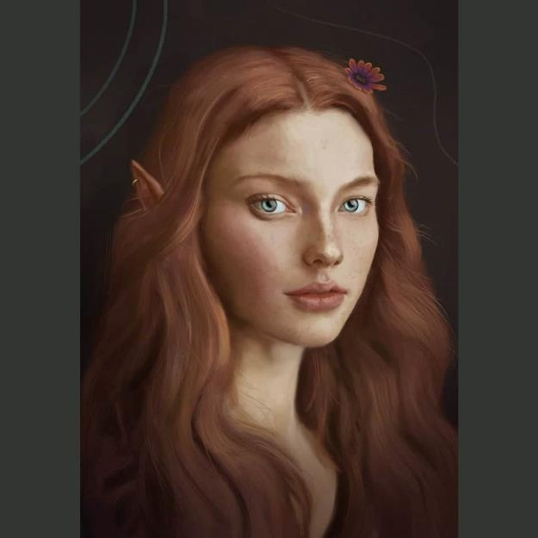

A young woman who could have been Bratislava’s half-elven daughter—though the two were about the same age—entered via the back door. Dressed in the attire of a civilian, but displaying the crest of a cleric of Oghma on her lapel, she gave a friendly smile and greeting before announcing, “My countrywomen and countrymen, as you know, the inquisition of our primary suspect in this case is underway, and as preliminary information from previous inquisitions of his minions reaches the Baron, His Lordship extends his invitation to you all to attend a banquet at the Baronial Keep at Sunset.”

The woman went on to explain that the Baron’s Court had been attacked over the course of the last few hours, but the situation was now under control. A few neutralized culprits—beings from the Plane of Shadow called the krinth—had been raised and interrogated, and they had all pointed to the Wererat Lord as their personal savior. The few who were versed in the culture of the krinth—who had been enslaved for millennia by the illithids—found their voluntary submission to someone outside their kind to be odd. They were usually staunchly isolationist and libertarian in their dealings with others to the point of being characteristically xenophobic.

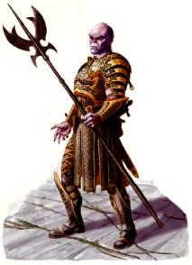

As Barkley chomped on some lamb-based munchies, he studied some of the pictures on the wall of the apprehended krinth, noting their similarity to the distraught stranger they’d encountered on their way into the city when they’d approached with Valerie and Captain Samand. The longhaired freedom lover was likely escaping the Wererat Lord’s orbit, and had hopefully succeeded.

The half-elven woman who had announced the banquet from the threshold of the back door now entered the room and mingled with the others, starting with another party of heroes who had helped to bring down a clique of evokers and illusionists in the Chatterstreet area over the course of the night. Though their prowess was evident in how they carried themselves, they currently looked even more haggard than the archon and his four friends, who had actually slept for 8 hours the night before.

