*Chapter 14: The Banquet and the Dream*

With at least 4 hours before they were expected back at the Baron’s Keep for more food and festivities, the heroes were thanked one last time, and forewarned that the Baron would likely draw the crowd’s attention to all of the day’s heroes by name.

When Saradette made her plans to leave, Barkley spoke up. “I will join you in checking on your other friends.”

Barkley added, “We shall return before the Baron’s feast.”

Once they were able to leave, Saradette went to check on Widget and Gadget. The ungulate and procyonid greeted her at first sight, their tails wagging like dogs’ tails for a moment as the heroes gladly welcomed the sight of the inn.

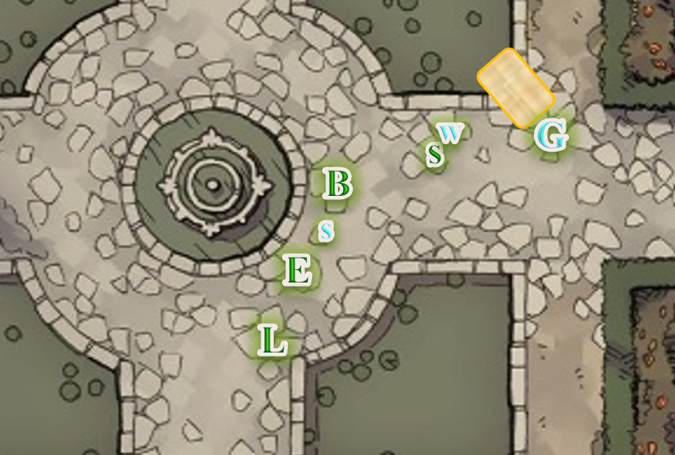

The artificer also inspected her cart, confirming that nothing had been taken while she was gone. Then, it was lunchtime again, or as halflings said, Second Elevensies. As she ate, Saradette thought about what tools and supplies she had, to see if she could fashion a silver weapon, possibly by modifying one she had on hand. She would later forge weld a thin sheet of silver over one of her daggers. That would take her a couple of hours, and while it wouldn’t be polished, it would give her a silvered weapon.

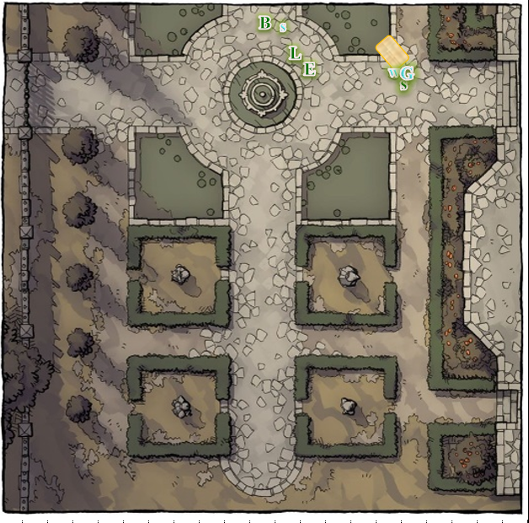

Radnar was fast asleep on the loveseat in the lobby, having taken part in an early-morning scuffle with a wererat. The icepack on his head bespoke of a concussion, and as the Missus came out to the lobby from the office where her son could be seen sweeping, she greeted the heroes, “Blessings to you, heroines and heroes.” She then looked to her husband, explaining briefly what had transpired. “In the end, the Baronial Guards put an end to the wererat, who had been a local bum before the infestation.”

“Was Radnar bitten?” Solstice felt compelled to ask, walking warily towards the loveseat as he produced the appropriate wand for what appeared to be a minor bludgeoning to the left temple.

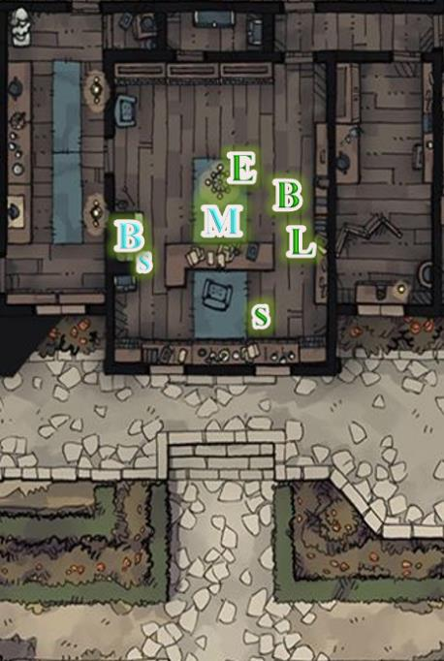

“Nay, fortunately. One of our neighbors was bitten, but the Guards were able to get her to the Abjurer Magistrate in time. “Son, get these folks a proper tray of food,” she motioned to the adolescent with the broom, who nodded and went to the kitchen to fetch a few dishes.

Radnar opened his good eye, recognized the musteval, and nodded as best as he could with a frown on his brow and barely a grunt.

*Radnar gained 11 + 5 = 16 hps.*

Within seconds, the swelling and blueness of the wound subsided, and the proprietor of the Missing Minotaur was once again able to see properly and reason with clarity. He was thankful, but fatigued from last night’s fright and this morning’s fight, and offered the heroes a free stay for the rest of the tenday. “That tap o’ healin’ alone likely cost as much,” he speculated, tilting his neck to both sides to get the kinks out of it.

It was 7 Tarsakh, and Luran noted that he and the others now had at least three nights of free lodging here, plus the goodwill of the proprietor. The bard reviewed his brief but action-packed hours he’d shared with these heroes....

|  |  |  |  |
| --- | --- | --- | --- |
| ***Event*** | º | R | ƒ |
| The party battles wererats and a wyste in Southspur | Sunset | 6 | Tarsakh |
| The party investigates the city’s bell tower, and finds the wererats’ warren, then dispatches most of the villains | Evening | 6 | Tarsakh |
| The party ventures to Chatterstreet Market and Southspur, and engages wererats in a tapestry shop, and near the Stony Gaze tavern | Morning | 7 | Tarsakh |
| The party investigates the West Hill region, ventures into the Reality Wrinkle, and eliminates agents of a cell of chaos-worshippers | Highsun | 7 | Tarsakh |
| The Baron hosts a banquet in honor of all the heroes of the city, including the party  **(HASN’T HAPPENED YET)** | Sunset | 7 | Tarsakh |

1,372 had started out as a rather mundane year for Luran, but it looked like things were picking up, and the most memorable moments were yet to come.

Radnar’s kid returned with a tray bearing three plates consisting of halibut, veggies and figs, and lemon-seared mutton; and his mother brought out some empty plates and the utensils common to the area, which they’d already learned to use.

Luran took the stuffed fish meal that was popular, locally. The vegetables and tubers steamed as his utensil opened its outer layer. Once the consumption was well underway, his expression took on a more serious demeanor as he said, “I can only express thanks to have made such an auspicious acquaintance with you all, in this time of trial. That our venture is evidently not only divinely, but doubly blessed, lifts my spirits as nothing before now has. I pray our arms and our armor never give, as long as songs are sung.”

“See, Junior, if you keep on working on yer lyrics,” the boy’s mother indirectly complemented the bard’s articulate presence, “maybe you’ll befriend a nice bunch of heroes like these and right wrongs from here to the end o’ time.”

The reticent boy nodded politely and went back to the brooming.

“But with that said, what’s next in wrecking wickedness’ day?” His grin returned to its usual prominence, after the solemnity of the prior statement.

Barkley was glad to see the innkeeper family all well and mostly unharmed. At the mention of free room and board, Barkley smiled, “There is no need. The Baron’s Guards have offered to pay our expenses, so you may send them the bill for our stay.”

“No, they meant the coin purse that they gave to Saradette,” Solstice pointed out, feeling like even without counting the coins, it was enough for a lifetime of lodging.

Barkley tilted his head to the side and walked over to Saradette, “May I have the purse for a moment?” he asked.

Saradette gave him the coin purse. “Do you want to hold it for us?”

Barkley opened the purse and pulled out enough money to cover twice the price of the cost for the rooms. “Here, you have earned it through your efforts to defend your family and in your kindness to us.”

“This buys you all goodwill, my friends,” Radnar Radnar—if that was indeed his given moniker—now got up and tested his bearings before making his way around the counter to behold his restored state. “Feels a lot better.”

Barkley nodded, “If there are no objections, I will carry the coin purse.” He will then put it into his Handy Haversack where there was sufficient room.

Saradette picked from the food on the plates, assembling a plate for herself to eat as she worked with her forge. She snagged a mug of smallbeer as she went out, and set her food down on the cart’s seat. “Now, Widget, I brought you two wedges of cheese, and some carrots, but that’s it,” she lectured her familiar. Working between bites of food, the artificer set up her mobile forge and fired it. Then, she set about the task of hammering out a thin sheet of silver, and forge welding it to one of her spare daggers.

Barkley said, “Only some juice for me. We have a feast at the keep to attend later.”

~*~

Barkley followed Saradette out and checked on the other animals with her, nodding to Widget, adding, “Good to see you are still well my little friend.” He also helped Saradette set up her forge, but stepped aside when she started working, not wanting to be in her way.

The pony pretended to be a bucking bronco for a moment, then made a few respiratory noises that confirmed for Saradette that the worst thing they’d had to endure in the last few hours was boredom.

Saradette smiled gratefully when Barkley helped her lift the anvil and base down from her cart. “I’ve been meaning to rig a small crane so I can have a larger anvil,” she said as she clamped the hunk of cast iron to the wooden base.

While Saradette worked at her forge, Barkley pulled out his longsword and his normal hand axe. He then began walking through some exercises with both weapons, going through strikes and offensive maneuvers as well as some defensive ones. They weren’t the most graceful, but it was something he had just started working on.

When the forge and anvil were set, Saradette peeled off her armor and gambeson, and slipped a heavy leather apron on over her head. Barkley noticed she had a random collection of tiny burn marks across her chest and on her arms, where the apron didn’t cover her dusky skin.

~*~

The artificer busied herself with gathering her materials and supplies as the forge heated to operating temperature. She would pump the bellows occasionally, and soon the coals were red hot. Saradette began by hammering out a silver ingot into a thin sheet on the anvil, cold forging it into shape. Then, she placed an unhilted dagger blade tip first into the coal bed. She heated it to a yellow color, and then pulled it out with her tongs. Wrapping the silver sheet around the back of the blade, she hammered it into the basic shape she wanted. Then, the whole assembly went back into the fire. She repeated this process until the blade was clad in dull silver.

Finally, she lifted the blade with her tongs and regarded it critically. “Well, it’s not polished, but it is silver plated.” Saradette finished by carefully heat treating the blade to harden it, and then she attached a pair of wooden grips to the hilt with brass rivets, also heated in the forge. “Is there anything else that needs fixed while the fire is hot?”

While Saradette was a very fine general metalworker, Elsabet suddenly realized that her own expertise in the specific craft of weaponsmithing might prove useful in assisting her in her afternoon project. So as the gnome was firing up her forge and readying her tools to start bonding silver to her small blade, Elsabet put her journal away and approached the artificer. “Perhaps I can be of assistance? I’ve assisted with similar projects before, and at the very least I can help hold things steady while you do the fine work. And I’m not that hungry at the moment anyways.”

“Sure, I’d love your company,” Saradette said with a smile. For a small, portable operation, Saradette had a good selection of tools to produce smaller items. She would pump the bellows occasionally, and soon the coals were red hot. Saradette began by hammering out a silver ingot into a thin sheet on the anvil, cold forging it into shape. Then, she placed an unhilted dagger blade tip first into the coal bed. She heated it to a yellow color, and then pulled it out with her tongs.

As they worked, she talked about welding fluxes, and showed Elsabet some more esoteric varieties besides the fine glassmaker’s sand that most smiths used. “This is a good flux,” Saradette explained as she sprinkled some sand on the hot blade, “but you really have to watch for the impurities. Metallurgy is about the mix of elements, or materials, in the metal, and in the heat treating. That, literally, makes or breaks a blade.”

Wrapping the silver sheet around the back of the blade, she hammered it into the basic shape she wanted. Then, the whole assembly went back into the fire. She repeated this process until the blade was clad in dull silver.

Elsabet paid close attention to the gnome’s explanations, recognizing her expertise in metallurgy, and added her own two bits regarding the importance of weapon balance and tempering, tips that she had picked up during her own apprenticeship. She carefully did exactly what Saradette told her to do, no more and no less, without delay. The alchemical silver acquired earlier seemed to be working as expected, and she was confident the finished product was without flaws.

After about an hour of practicing, with a few small breaks, Barkley checked on Saradette’s progress before getting some water and a pint of ale from the inn. He then returned and sat where he could keep an eye on the courtyard as well as Saradette and her companions and meditated. His ears and nose reaching out, actively listening and sniffing as he closed his eyes and relaxed.

Finally, the gnome lifted the blade with her tongs and regarded it critically. “Well, it’s not polished, but it is silver plated.” Saradette finished by carefully heat treating the blade to harden it, and then she attached a pair of wooden grips to the hilt with brass rivets, also heated in the forge. “Is there anything else that needs fixed while the fire is hot?”

Barkley made his way around the room seeking out the commoners that were there to be recognized for their deeds. He was interested to hear about their experience and their take on the events. After that he mingled with the other warriors to compare notes on how they dealt with certain opponents versus how he and his companions had dealt with them.

Saradette replaced her boot dagger with the silvered one.

*[Feels like a Teamwork Benefit coming on.]*

While Barkley trained and Saradette forged, Luran found an innocuous spot to sit with this yarting, and continued on his ongoing musical project, a symphony dedicated to the Tyrian triad and the benevolent musical creative force underlying all creation. While not overwhelming the atmosphere of the courtyard, his tuneful work lilted over the scene, at one point drawing the attention of the innkeeper’s son as he took a break from his duties.

~*~

They had arrived at the banquet, which was a cozier gathering with less well-to-do aristocrats, and populated more prominently by stalwart fighters and others who had recently risked their necks and wellbeing for the good of the city. Some had even lost their lives, and most of those heroes had been *resurrected* by the Barony’s abjurers and conjurers. The Baron’s Keep bustled with the sounds of a few musicians who had set up a stage near a fountain, and though no one was in the balcony at the time, it was lit with a few torches and prepared for the Baron to deliberate later.

Saradette mingled with the guests, while watching for anyone who seemed out of place. She saw the gnomish guard she’d spoken with before, and she approached him as he stood his post next to the door. “I missed seeing you at Second Elevensies earlier.” She lifted her mug of smallbeer. “They really do make a fine smallbeer.”

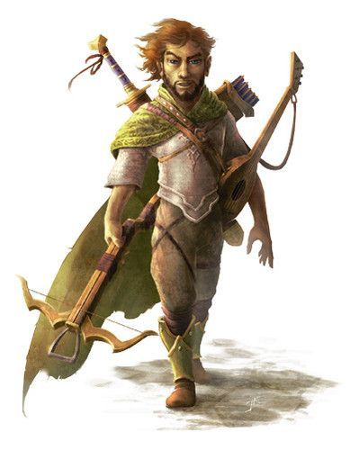

The gnomish guard paid her little mind, being preoccupied with something, likely his own weariness in light of a full day’s shift. However, another, heroic-looking rock gnome with a long-necked strumming instrument approached the green-haired artificer, and introduced himself, “I’m Niles. How do you do?”

His accent was from the Sword Coast, but his command of Common suggested that he’d traveled elsewhere, particularly around here.

“I’m Saradette,” she replied, choosing to forgo the formality of using her full name, as the wanderer just had. “What brings you to the Baron’s Keep this day?”

“Killed some grimlocks who were trying to escape from the guards. Doused the docks with the blood of their leader,” he tried to say it as humbly as he could, but he was taken by the heroism that the moment had demanded, and really was proud of his deeds. Saradette could tell that the fellow skewed goody-good, but was perhaps a bit insecure from being studied by Elsabet as he tried to mack on Saradette.

Elsabet noted the courtship lunge, or overture, or whatever it was, and saw nothing but earnest lust in his eyes, nothing Saradette had likely missed. His accoutrements bore the resemblance of a lifelong traveler, and the buckle of the belt that held his backpack against his shoulders depicted the holy symbol of Fharlanghn, the god of traveling.

Elsabet had suggested on the way to the banquet that Barkley and Solstice ‘keep their noses open’ just in case a wererat assassin tried to infiltrate the gathering, they might or might not catch a whiff of them. She’d changed her own outfit before they left the inn, wearing her red and blue traveler’s outfit as it had just been cleaned, and taken a moment to wash up, so she wouldn’t smell like she’d been in multiple fights that day.

So far, no rats were within whiffing vicinity, though someone had to have been flatulent around the musteval and archon, given the brief hint of sulfur that passed them once. Solstice remained on Barkley’s shoulder, like a familiar, getting a much better vantage of folks’ faces and costumery.

A few people wore masks, but took them off occasionally to wipe sweat from their brows in the tropical city as sunlight yielded to torchlight, revealing their faces. Luran had tried to note a single person who looked circumspect, or who did not reveal their face at all, but found no clandestine acts in his midst.

Elsabet now asked Luran to escort her as she mingled and engaged as many folks as she could in small talk and comparing notes on what had occurred, downplaying her own efforts a little while praising those of other heroes, including her friends. With her left hand resting on the bard’s arm, she carried a glass of punch in her right hand, and sipped from it sparingly—she had a feeling something might happen, it could have just been nerves but she didn’t want to risk getting intoxicated.

She let Luran steer her around the room, including over near the musicians if he wished. She paid special attention to the body language and mannerisms of those she spoke to, looking for any sign that one or more of the guests were not what they seemed, and made sure to try to keep track of her other friends’ locations in the process.

By now, Niles had divulged that—like Saradette and her company—he had arrived at the onset of the Festival, which was nowhere as jovial as it had been in years past, on account of the attacks. “I grew up here... briefly, so I come and visit my cousins for the Festival whenever I’m nearby... I try to stay nearby this time of year. The adventuring’s good here.”

Saradette took a slight liking to the fellow, who was about her age, and evidently trying to emit some bravado about his travels, though he was humble enough to not boast of high deeds unless prompted to do so. He’d lost many an opportunity to reproduce by pumping himself up too much on the first encounter, and had learned that his awesomeness needed to be presented with some reservation, and finesse; Saradette gleaned all of that in a few sentences and gestures, but didn’t think it an irreparable flaw.

*[Saradette’s Sense Motive—aided by Female Intuition +2—gives her a high confidence in her perception and heuristic reaction to Niles.]*

Above all, she suspected the barely attractive fool to be far better company than the more handsome fellow that had urged them to leave the city at all costs earlier that day.

Barkley continued to mingle with those present that either appeared to be non-professional warriors (commoners that rose to the challenge) or any of the female persuasion that are elegantly dressed (nice dress, high heels, that sort of thing) and chat with them. His approach for all of them would simply be to get them to talk about their deeds while downplaying his efforts or involvement.

Elsabet continued to follow Luran’s lead as far as their mingling, eventually to gravitate back towards their friends as it got closer to the time the Baron was to appear.

~*~

An hour later…

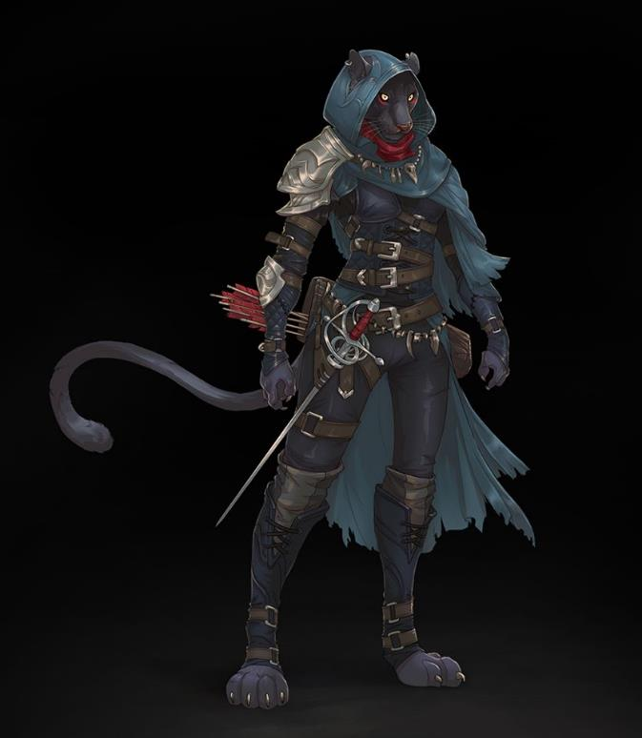

A tabaxi named Three-Fangs-Then-Purr had picked up Barkley by the heels—figuratively—and the two were dancing to a triplet beat with an improvised melody in which Luran partook alongside the most bardy folks in the lot, who had all gravitated to the stage by now.

Solstice sat on a branch high aloft, taking in the serenity of the evening above them while listening to the bustle of the banquet below. He’d learned that by noon tomorrow, the caravans associated with the fair would depart a few days early, and head for the next town. In the wake of the fiasco that had just swept the city and wreaked havoc on every single ward, security checkpoints would check every wagon and pack for a possible lycanthrope, and interrogate folks on a case-by-case basis. He and Barkley had been propositioned by the Chief of Security to assist in this effort tomorrow at the Westgate, and they had accepted.

Barkley had nodded at the time, “It would be my pleasure,” and they’d each been handed a writ that confirmed their acceptance of the task, and the expectation of their presence at Westgate.

“Since the belltower restoration’s on hold, we ask that you arrive in the mid-Morning, and we expect to set up well before noon to get the exodus underway,” stated a Baronial Guard named Wexler. “Appreciate you guys,” he had said to Barkley and Solstice before moving on to other olfactorily dominant folks, including the tabaxi.

Barkley realized at that moment that he wouldn’t even have to be too bold tonight with her to get her digits since they were due to meet by proxy tomorrow

The others on the ground were also aware of the intent to purge transient outsiders associated with what may have brought the wererats here in the first place, but with their knowledge that this was a larger matter than just the Wererat Lord and his ilk, the Barony’s advisors had converged on the idea that the prudent path would be to relieve the city of those who were passing through, and a more thorough investigation could be conducted.

Everyone on the team had danced at least once—sometimes with strangers; other times with one another—and now that things were winding down for some and progressing into louder shenanigans for others, the group rendezvoused and debriefed on their fun. They had not seen much to rouse their suspicions, though they’d not seen much of the Barony... until now.

“Fellow citizens,” the Baron’s voice could barely be heard at first as the cacophony of untuned musical instruments died down. He said some other words that the heroes couldn’t quite capture as they made their way closer, then added, “and I know this to be true. Alas, our city mourns for many whom it could not resurrect, and at morrow, we will return to a more austere and serene state as the fair concludes early. With a few bandits still at large, we are hopeful that within the next day, we will have apprehended them, and our metropolis can be restored to order.”

Cheers ensued, and while the nobleman said a few more platitudes, he also appeared to have been affected by the event, as his voice shook a bit at the end, betraying an emotional fatigue akin to that exhibited by the guards, who were now being relieved of duty one by one and allowed to go back to the barracks to rest.

The party continued with a skeleton crew of officials, who were now mostly directed to keep the bards in line. One even asked them to tune their instruments before the next number.

Barkley enjoyed the dance with the Tabaxi, though he did note it would be a task to get her out of her outfit, a task he’d be willing to attend to after the dance. In the end—on account of the high likelihood of seeing her at the Westgate tomorrow, he played it cool.

~*~

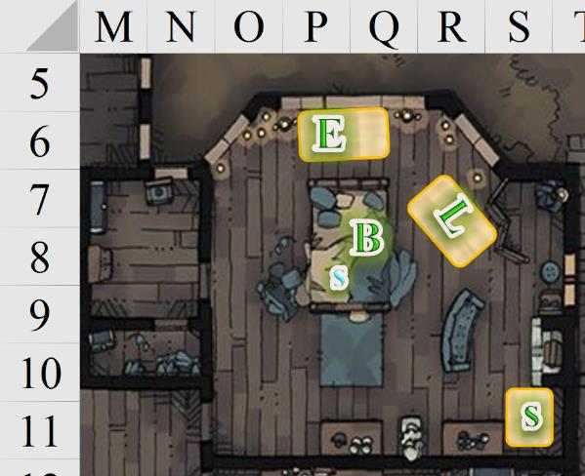

Boots had come off, and the heroes had now aired out their feet in the room with the windows open, letting in the draft from the warm night as they relaxed. They would soon close the windows for security, but it was better to let the scent of ten feet that had walked and danced all day and night as they evaporated and moods grew calmer and reflective of the day’s events.

Saradette went to take care of Widget and Gadget, after which, she would take a bath before retiring to bed, clad in her nightshirt, hoping to catch up on what the others had said.

Elsabet looked out the windows over her bed, idly checking out the nearby trees looking for any birds, squirrels, or other wildlife that might be hanging out there, as well as evaluating any security implications. The urban-adapted wildlife was quick to gravitate to the favored soul of Mayaheine, and as she offered some snacks to the warblers and thrushes that now hovered over or perched on the eaves and windowsill, she evaluated whether, say, rats of the two-legged variety could use any branches to get close to the window—and conversely whether there would be a way to climb out and down from the room.

And though she got a good bit of gossip about Mrs. Radnar and the ironsmith down the street, there was nothing in their debriefing that gave her any new information. A few of the birds had spotted a scuffle nearby, and had noted the wererat in the center of the conflict, but that was it. She bade them all well before finally closing the north-facing window.

“Good work today, friends,” Elsabet then said. “This place definitely has a lot of interesting people living in it, or visiting. That cat person was especially intriguing... don’t you think, Barkley?”

Barkley was sitting on his bed, sharing a snack of meat and cheese with Solstice when Elsabet spoke. He looked over and smiled, “Intriguing, yes. I look forward to working with her at the gate tomorrow and hearing more or her travels.” Barkley left out any other interests he might have as those were not the concern of his friends.

Turning back to her journal, she smiled and continued making notes on the rather packed day of excitement. She tried to make notes on everyone she could remember meeting, and she also asked her companions whether there were specific things she should make note of that they might have noticed.

By the time Saradette had gotten back, Barkley and Solstice were already fast asleep, and Luran and Elsabet were talking at a low voice about their lives prior to yesterday. In her nightgown now, and with her pony and raccoon downstairs and tended to, the gnome closed the only other open window, and got onto the gnome-sized mattress and under the thin, smooth sheet.

Two lit candles had by now grown short, and Luran eventually blew them both out, the light of the moon now casting down at an angle through the east-facing window as it had the night before when they were in the belltower amidst wererats, dire rats, and other rodentesque folks. The night was peaceful, and the sounds of comrades snoring softly was a melody in and of itself.

~*~

Elsabet turned over in bed, woke up, and sat up. The room was filled with a fine gray mist, though it didn’t feel wet or smell like smoke. She heard some sort of strange gibbering, faint and muffled, as though coming through a dense blanket. She looked around intently, and though the room was dark, she could see her immediate surrounding quite clearly defined—though the color had leached out of her clothes, in fact out of everything. She realized she must have finally mastered the invocation she had been practicing, though she couldn’t remember using it before going to sleep. That was weird. She swung her feet out from under the covers, put them firmly on the floor and stood up, and felt dizzy....

The room had disappeared, and she was standing in the woods, fully geared up. That made sense, she never went anywhere without her stuff, but where were her friends? She heard a branch snap behind her, whirled around, and not 10 yards away stood an ugly, smelly, two-headed giant, with a massive club in each hand! But she wasn’t worried—she drew her recently acquired magic wand and pointed it at the massive creature, and mustering her deepest voice, in the tongue of giants, said “stop right there, misters, or I’ll turn youse into a newt!”

Unfortunately, the head on the right snorted, not intimidated in the least, while the head on the left grinned and said, “lunch talks!” As the creature started to step forward, Elsabet mustered her will and focused her energy into blindly activating the wand. Success! She felt the wand stop resisting her desire and suddenly....

~*~

Her breath rasped in her ears as Saradette ran down the alley. It was very dark, and strangely, she couldn’t see her hand in front of her face. Suddenly, a little human girl appeared in front of her. “Lady, are you lost,” the child asked.

“Uh, no. Well, yes. Where does this alley lead?”

The girl smiled, and her front teeth grew downward into rodent’s incisors, and the girl sprouted claws, rat ears and face, and a tail. “It leads to your death!” Four other children appeared behind her, and Saradette stabbed the nearest one. Her knife blade bent like it was made of cloth, and she threw it down in disgust. The wererats charged her, and the gnome turned to flee.

She raced away, bouncing off the walls blindly as she followed the maze of twists and turns in the alleys. She rounded a corner, and there was her forge, lit with a blade in the fire. She grabbed her tools and began to frantically hammer out a silvered blade. Saradette glanced back down the alleyway, but saw no one. Tap, tap, tap. The blade went back into the fire, and sweat poured down her face as she pumped the bellows. The metal heated to the right the right color, and she picked up her hammer again. Tap, tap, tap.

Her vision narrowed until she could only see the blade, and then everything went black.

~*~

Solstice tread upon a swampy area that would have been mere puddles to his companions, though they were nowhere in sight. He often perched on Barkley’s shoulder, and at a time like this, he would have gladly accepted this offer, but as it was, the musteval was

~*~

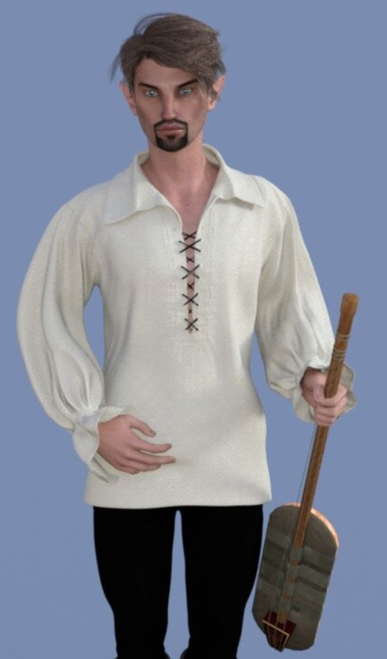

Luran—who looked a bit more like his elven mother in his dream—sat in a well-appointed lounge, working on his magnum opus. Papers, pens, instruments were strewn all around in not quite disarray, though hardly orderly. Thinning wafts of incense smoke hung and drifted in the air. His mind ran ever faster than his pen. It was so basic and fundamental to him the connections between divine benevolence and holy creation, stitched in songs. While his current focus was on Tyr and his subject gods, Torm and Ilmater, Luran could easily imagine shifting his outer focus onto other goodly gods, at some later point. His core tenet of music as divine, benevolent creation remaining, regardless. As such, his musical pen put other powers in, where before were only the three of Tyr’s house. The pages literally sparked with wonder. Cascades of color leapt from the bars and notes of Luran’s previous feverish printing.

He thought, absently, wait, what’s that I hear? And went to investigate the noise from down the hall....

~*~

As Barkley drifted off to sleep, he found himself emerging from a light fog into a forest. As the listened closely, he could hear a faint voice chanting off in the distance. After a moment of concentration, he was able to determine the direction of the chanting and headed out to see what was going on. He then headed off to see exactly what was going on. When he neared the clearing, he climbed up into a tree and balanced on a branch, looking down on a humanoid figure. As he watched, he remembered the something he had read in one of the libraries in Mintar while expanding his knowledge of religions in the area. The figure was an elf druid praying over a newborn fawn, the doe standing peacefully nearby.

A moment later, Barkley spotted several orcs moving towards the druid. The druid showed no sign of seeing or hearing the orcs, her concentration on the blessing she was giving. Barkley could sense that their motives were not good and quickly moved to intercept them. Jumping down from the branches, he landed and drew his weapons quickly. Spinning and using both his sword and axe, he made quick work of the first two orcs. As he turned to fact the remaining orcs, the sky was split by a blast of lightning that struck the orcs and knocked Barkley back, sending everything into bright blur....

~*~

Round 0

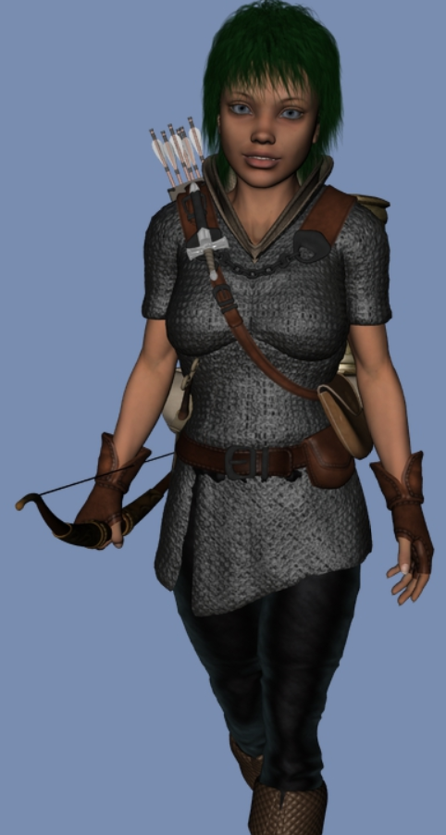

The heroes found themselves armored, but only armed with their primary weapons. Elsabet’s spiked knuckles were absent, as was Solstice’s nicest healing wand. “Aw, what?” the musteval said as the moonlight above them was coupled only with what appeared to be a Shadowlight lamp atop a futuresque, metal post. Each member of the team could see two others, but none could see all the others on account of the fully restored—nay—brand new belltower at their backs.

With elements of the historical past—known best to Luran—and the unforeseen future, the courtyard around the belltower was altogether devoid of citizens or even so much as a dire rat; and what’s more, they could not see past the mist that was synonymous with the streets that ensquared the courtyard.

And then five black-clad nasty-looking characters showed up, one of them darker than the shadows, and barely visible.

A cleric with the proper gear but no unholy symbol borne took in her surroundings, and spotted the heroes, hissing some command to the others.

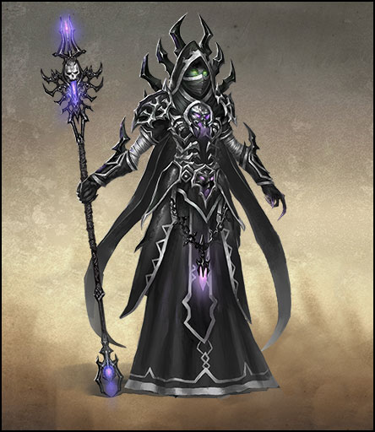

Following her lead, a pair of heavily armored knights turned around, and tilted their necks, cracking them.

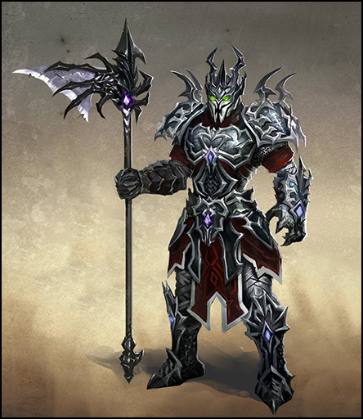

The more masculine of the two bore a dire halberd, while his female counterpart wielded a more limber dire naginata.

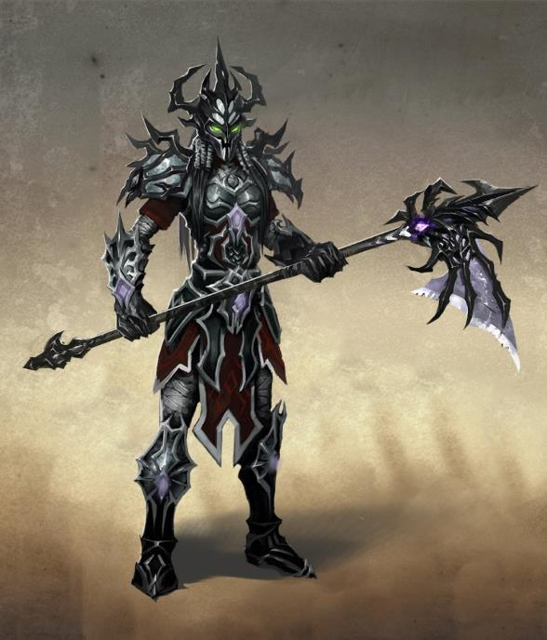

A necromantic type of spellcaster emitting a mist from the hem of his robe got up from a crouching position.

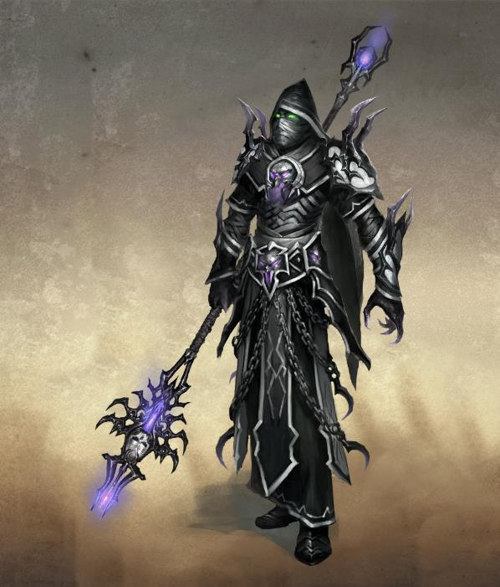

And lastly, there was Rasqueado, an infamous bard-extraordinaire whose renown throughout Mintar was near legendary, despite his short lived career. Having only produced three collections of music in his lifetime, it now seemed to Luran that the musician had been composing as he was decomposing, for he now heard the bard’s voice decanting some never-before-heard material. As the cantor canted, the disembodied strumming and arpeggiating of a guitar accompanied his voice.

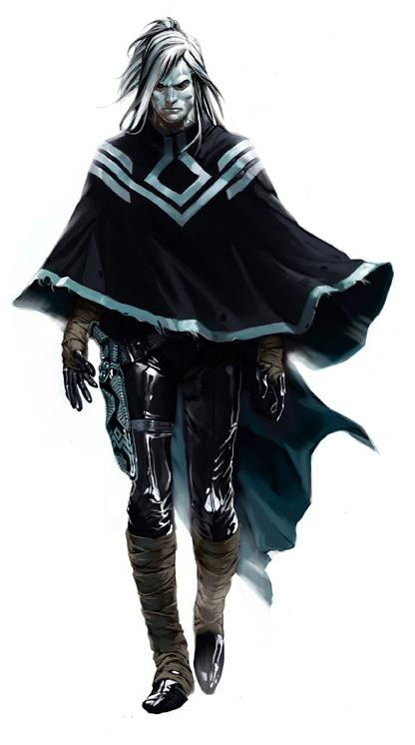

“Everybody wants…

Everybody needs…

Everybody loves…

Everybody bleeds…”

*Elsabet, Barkley, and Luran beheld Rasqueado’s Fascinate aura; Rasqueado targeted Elsabet and Luran.*

|  |  |  |  |  |
| --- | --- | --- | --- | --- |
| **Character** | **Check** | **Ranks** | **Roll** | **Save** |
| Rasqueado | Perform | 9 | 8 | 17 |

*DC = 17.*

|  |  |  |  |  |  |  |  |
| --- | --- | --- | --- | --- | --- | --- | --- |
| **Save vs.**  Fascinate | **Rank** | **Ability & Mod.** | **Misc. Mods.** | **Total** | **Roll** | **Check** | **Notes** |
| **Elsabet, Will** | 7 | Wis (-1) | 4 | 10 | 12 | 22 | +3 vs. Enchantments |
| **Luran, Will** | 7 | Wis (-1) | 2 | 8 | 17 | 25 |  |

*Success2.*

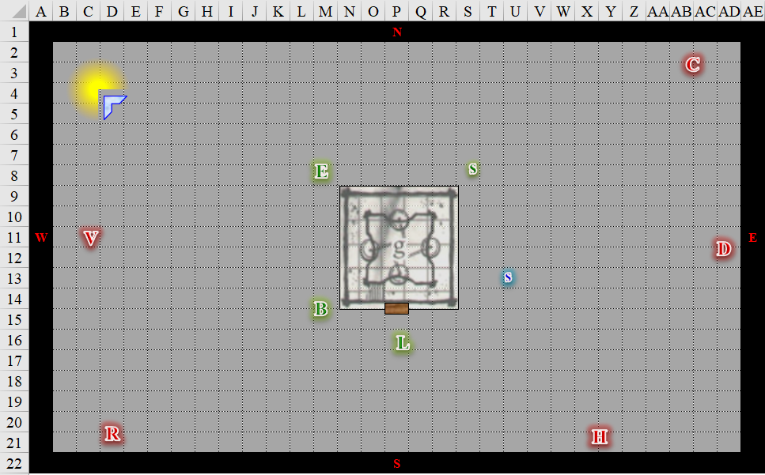

Round 1

|  |  |  |  |  |  |
| --- | --- | --- | --- | --- | --- |
| **Character** | **Group** | **Initiative** | **Roll** | **Modified**  **Roll** | **Move** |
| Saradette | 1 | 3 | 20 | 23 | 20’ |
| Rasqueado | 2 | 3 | 19 | 22 | 40’ |
| Dame Dahlia | 2 | 0 | 20 | 20 | 30’ |
| Barkley | 1 | 2 | 17 | 19 | 40’ |
| Elsabet | 1 | 4 | 14 | 18 | 30’ |
| Corpuscarth | 2 | 1 | 15 | 16 | 30’ |
| Solstice | 1 | 1 | 12 | 13 | 30’/10’ |
| Hacken Slashen | 2 | 1 | 7 | 8 | 30’ |
| Luran | 1 | 1 | 5 | 6 | 30’ |
| Visceratya | 2 | 0 | 2 | 2 | 40’ |

Saradette moved to stand behind Elsabet next to the tower wall (O8) as she cast *mage armor [expired long after dream set to end]* on herself, and drew her short sword.

*Saradette gained +4 to AC.*

Rasqueado moved northeastward 30’, and continued, “Everybody yearns; everybody learns; everybody dies, and everybody burns!”, now fomenting a *mirror image [expired on Round 61]* spell effect with *[3 + 2]* 5 separate figments.

|  |  |  |  |  |
| --- | --- | --- | --- | --- |
| **Character** | **Save vs.**  Aura of Menace (DC 10) | **Ranks** | **Roll** | **Save** |
| Rasqueado | Will | 8 | 8 | 16 |

*Success. Effect negated.*

Dame Dahlia took steps towards Solstice, and cast *deific bastion [expired on Round 7]*, calling upon Velsharoon’s protection.

*Dame Dahlia gained 1 to AC and Resistance 5 to Cold.*

Elsabet raised an eyebrow at the reference to the deity whose name she’d not heard in years.

Barkley growled at the dark shadowy figure (Rasqueado). With his longsword in his right hand, he hefted his favored hand axe with his left hand, and charged towards Rasqueado, intending to disrupt his singing by running him through with his sword.

|  |  |  |  |  |  |  |  |  |  |
| --- | --- | --- | --- | --- | --- | --- | --- | --- | --- |
| **Melee Weapon** | **Dmg** | **D+** | **TH+** | **Critical** | **Type** | **Wt.** | **Atk** | **Roll** | **Check** |
| Hand Axe | 1d6 | 2 | 2 + 2 charge | x3 | Slashing | 3.0 | +11 | ***19*** | 30 |

*Threat. 1d20 = 13 + 11 = 24, critical hit.*

One of the *mirror images* disappeared as Barkley spun to better ascertain which figment was not—in fact—a figment.

“Everyboooodyyyy bleee-eeds!” the bard repeated the last bar to taunt the Celestial warrior.

Seeing Barkley go after the enemy bard, Elsabet decided that threat could wait. Looking one way at the dire naginata wielder, then the other way at the obvious arcanist. So many possibilities, so little time, she mused briefly. But first, with a swift action, she called upon Mayaheine to protect them, activating her Protection Devotion, and took a 5’ step to get next to Saradette, where she would be able to use Shield Block to protect the gnome if needed.

Then, deciding the spellcaster might be the greater threat, she spoke the words of a *silence [expired on Round 41]* spell, targeting the arcanist. With luck the arcanist’s will would fail him and for a few minutes at least he would be unable to speak his own spells.

|  |  |  |  |  |
| --- | --- | --- | --- | --- |
| **Character** | **Save vs.**  *silence* | **Ranks** | **Roll** | **Save** |
| Corpuscarth | Will | 8 | 14 | 22 |

*Success. Effect negated.*

Grinning down at Saradette, Elsabet said “got yer back, girl” as she pulled out her signal whistle and blew the quick “to me!” signal. She wasn’t sure if Luran or Solstice were nearby, but if they were, hopefully they could hear the signal and would gather closer, so they’d be within the protection aura. She could feel the adrenalin rush of impending battle, and while she had no idea how she got here, there were evil enemies and no at-risk civilians. She felt foehammer granted as she looked back and forth alert to whatever came next.

Corpuscarth spat out the taste of the *silence* spell, and cast *ray of exhaustion [expired on Round 61]* upon Elsabet.

|  |  |  |  |  |  |  |  |
| --- | --- | --- | --- | --- | --- | --- | --- |
| **Character** | **Attack Type** | **Damage** | **BAB** | **Dex Mod+** | **Total Score** | **Roll** | **Total** |
| Corpuscarth | Ranged Touch Attack | varies | 3 | 1 | 4 | 5 | 9 |

*Miss.*

Elsabet saw the approaching arcanist pointing at her, and dodged out of the ray’s trajectory.

Solstice could tell that he wasn’t going to be able to hide from the dread necromancer and cleric, so he fired off two magic missiles at the latter.

*Dmg: 4 + 2 = 6 magic.*

Hacken Slashen charge-attacked Luran.

|  |  |  |  |  |  |  |  |  |  |
| --- | --- | --- | --- | --- | --- | --- | --- | --- | --- |
| **Character** | **Attack Type** | **Damage** | **BAB** | **Str Mod+** | **W+** | **Other+** | **Total Score** | **Roll** | **Total** |
| Hacken Slashen | Dire Halberd | 2d6 + 3/ x3 | 6 | 3 | 1 | 2 charge | 12 | 19 | 31 |

*Hit. Dmg: 5 + 3 = 8 [40/48].*

The others weren’t as aware of this as Luran, but Rasqueado had returned from the dead—or perhaps lingered since—as an eidoloncer: a persistent, spellcasting ghost. The kilt-clad half-elf flinched from the fighter’s slash, and parted his lips. “Everybody loves, everybody leaves, everybody’s got the strength to be-lieve!” Luran belted in response to the wicked words of Rasqueado. He sent an internal prayer to Tyr and the music within himself to bolster his companions in this sudden, dreamy battle.

*Party gained +2 (Inspire Courage + inspirational boost) to rolls.*

The bard then attempt to tumble beside Solstice so as to get out of Hacken’s melee range and hook up with a friend on this field.

|  |  |  |  |  |  |  |
| --- | --- | --- | --- | --- | --- | --- |
| **Skill** | **Rank** | **Ability**  **& Mod.** | **Misc. Mods.** | **Total** | **Roll** | **Check** |
| **Luran, Tumble** | 1 | **Dex (+1)** | 0 | 2 | 8 | 10 |

*Fail. Provokes attack of opportunity.*

|  |  |  |  |  |  |  |  |  |  |
| --- | --- | --- | --- | --- | --- | --- | --- | --- | --- |
| **Character** | **Attack Type** | **Damage** | **BAB** | **Str**  **Mod+** | **Dex**  **Mod+** | **W+** | **Total**  **Score** | **Roll** | **Total** |
| Hacken Slashen | Dire Halberd | 2d6 / x3 | 6 | 3 | 1 | 1 | 10 | 4 | 14 |

*Miss.*

Visceratya charge-attacked Elsabet.

|  |  |  |  |  |  |  |  |  |  |
| --- | --- | --- | --- | --- | --- | --- | --- | --- | --- |
| **Character** | **Attack Type** | **Damage** | **BAB** | **Str Mod+** | **W+** | **Other+** | **Total Score** | **Roll** | **Total** |
| Visceratya | Dire Naginata | 2d6 / x3 | 4 | 2 | 1 | 2 charge | 9 | 8 | 17 |

*Miss.*

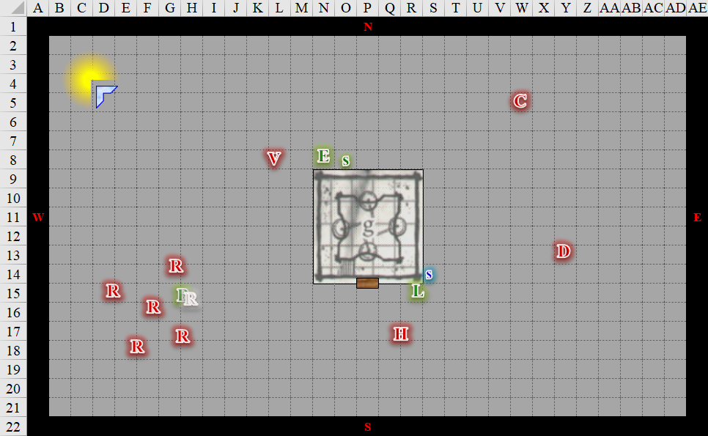

Round 2

Saradette sighed in frustration as she’d missed seeing the necromancer. Not willing to tangle with two enemies if she charged the spellcaster, she instead circled around Elsabet at a run to attack Visceratya.

|  |  |  |  |  |  |  |  |  |  |  |
| --- | --- | --- | --- | --- | --- | --- | --- | --- | --- | --- |
| **Melee Weapon** | **Dmg** | **D+** | **TH+** | **Critical** | **Type** | **Wt.** | **Atk** | **Roll** | **Check** | **Notes** |
| Short Sword | 1d4 | -1 | 2 + 3  Boost | 19-20/x2 | Piercing | 1.0 | 8 | *1* | 9 | Sneak Attack 2d6 |

*Critical miss.*

Tonight was not Saradette’s night; or perhaps this dream was not her dream.

Barkley grumbled, “Typical coward!”

Rasqueado busted out the big guns, and cast *enthrall [expired long after dream set to end]*, emanating a luring orbit of intriguing, irreverent splendor around him.

|  |  |  |  |  |  |  |  |
| --- | --- | --- | --- | --- | --- | --- | --- |
| **Save vs.**  *enthrall* | **Rank** | **Ability**  **& Mod.** | **Misc. Mods.** | **Total** | **Roll** | **Check** | **Notes** |
| **Barkley, Will** | 4 | Wis (+1) | 3 boost + 4  religious bias | 12 | 1 | 13 |  |
| **Elsabet, Will** | 7 | Wis (-1) | 4 + 3 boost + 4  religious bias | 17 | 11 | 28 | +3 vs. Enchantments |
| **Luran, Will** | 7 | Wis (-1) | 2 + 3 boost + 4  religious bias | 15 | 14 | 29 |  |
| **Saradette, Will** | 3 | Wis (+0) | 0 +3 boost + 4  religious bias | 10 | 3 | 13 | +1 vs. Fear |
| **Solstice, Will** | 7 | Wis (+2) | 0 +3 boost + 4  religious bias | 16 | 15 | 31 | +2 vs. Sleep/Charm, +2 if Lucky |

*Fail, success, success, fail, success.*

*Barkley and Saradette became Indifferent to their foes.*

Barkley and Saradette looked around, confused for a moment, and unable to assess what was happening. “Why are we fighting again?” Saradette asked as she turned in her sleep.

Dame Dahlia nodded at the eidoloncer’s success. She cast *sadism [expired on Round 8]* upon herself.

*Dame Dahlia gained +1 to rolls contingent upon dealing 10+ damage during previous round.*

Barkley was about to slash at the images around him with his sword and his axe, hoping that one of his blades would find the flesh of the evil bard, but he really didn’t have anything against these guys and gals. He couldn’t recognize the *sadism* spell that had just been cast with anticipation of trying it out on him, and showed the cleric and bard his happy tongue.

Saradette did the same, but no tongue.

Corpuscarth made his way to the belltower, keeping an eye on the wily-looking musteval, then cast *ray of exhaustion [expired on Round 62]* upon Solstice.

|  |  |  |  |  |  |  |  |
| --- | --- | --- | --- | --- | --- | --- | --- |
| **Character** | **Attack Type** | **Damage** | **BAB** | **Dex Mod+** | **Total Score** | **Roll** | **Total** |
| Corpuscarth | Ranged Touch Attack | varies | 3 | 1 | 4 | 12 | 16 |

*Hit.*

|  |  |  |  |  |  |  |
| --- | --- | --- | --- | --- | --- | --- |
| **Save vs.**  *ray of exhaustion* | **Rank** | **Ability & Mod.** | **Misc. Mods.** | **Total** | **Roll** | **Check** |
| **Solstice, Fortitude** | **6** | **Con (+1)** | 0 | 7 | 12 | 19 |

*Success. Dmg: Fatigue (–2 penalty to Strength and Dexterity + inability to run/charge).*

Only Fatigued, Solstice knew he wouldn’t be able to make much of a dent against the wretched dread necromancer with his blowgun unless he could hide, so instead, he fired a pair of magic missiles at the man.

*Dmg: 3 + 2 = 5 magic.*

Barkley and Saradette started to come to their senses.

Hacken Slashen full-attacked Luran with a slur of contempt in the Infernal tongue.

|  |  |  |  |  |  |  |  |  |  |
| --- | --- | --- | --- | --- | --- | --- | --- | --- | --- |
| **Character** | **Attack Type** | **Damage** | **BAB** | **Str Mod+** | **W+** | **Other+** | **Total Score** | **Roll** | **Total** |
| Hacken Slashen | Dire Halberd | 2d6 + 3/ x3 | 6 | 3 | 1 | 0 | 10 | 13 | 23 |
| Hacken Slashen | Halberd, 2nd Attack | 2d6 + 3/ x3 | 1 | 3 | 0 | 0 | 4 | 7 | 11 |

*Hit, miss. Dmg: 6 + 3 = 9 [31/48].*

Luran’s song of inspiration continued to waft through the air of the dreamscape as he wove a tune of higher magic into his harmonics. Hacken’s weapon vibrated slightly in his hands, resonant with those harmonic interplays. The length of the halberd’s haft was immediately coated in a slick layer of lubricant.

|  |  |  |  |  |
| --- | --- | --- | --- | --- |
| **Character** | **Save vs.**  *grease* | **Ranks** | **Roll** | **Save** |
| Hacken Slashen’s halberd | Reflex | 3 | 5 | 8 |

*Fail.*

With a grimace, Hacken Slashen dropped his halberd, now having nary a dagger with which to fend off this rabble.

Visceratya full-attacked Saradette.

|  |  |  |  |  |  |  |  |  |  |
| --- | --- | --- | --- | --- | --- | --- | --- | --- | --- |
| **Character** | **Attack Type** | **Damage** | **BAB** | **Str Mod+** | **W+** | **Other+** | **Total Score** | **Roll** | **Total** |
| Visceratya | Dire Naginata | 2d6 + 2/ x3 | 4 | 2 | 1 | 0 | 7 | 17 | 24 |

*Miss due to Elsabet’s bonus.*

Elsabet had deferred to Visceratya’s actions to best determine the course of her own. She now snarled at the naginata wielder, “Pick on someone your own size, bitch!” as she circled around her to get into flanking position on the opposite side of the foe from Saradette, ending up further away from the necromancer as well.

|  |  |  |  |  |  |  |  |  |
| --- | --- | --- | --- | --- | --- | --- | --- | --- |
| **Character** | **Attack Type** | **Damage** | **BAB** | **Str Mod+** | **W+** | **Total Score** | **Roll** | **Total** |
| Visceratya | Dire Naginata | 2d6 +2 / x3 | 4 | 2 | 1 | 7 | 3 | 10 |

*Miss.*

Calling upon Mayaheine to guide her blow, she initiated her Foehammer strike, slashing powerfully at her with her bastard sword.

|  |  |  |  |  |  |  |  |  |  |
| --- | --- | --- | --- | --- | --- | --- | --- | --- | --- |
| **Melee Weapon** | **Dmg** | **D+** | **TH+** | **Critical** | **Type** | **Wt.** | **Atk** | **Roll** | **Check** |
| Bastard Sword +1, 1-handed | 1d10+1 | +2 | 4 | 19-20/x2 | Slashing | 6.0 | +11 | 11 | 22 |

*Hit. Dmg: 7 + 1 + 4 Foehammer = 12.*

Suddenly she realized Saradette was no longer actively threatening the woman. Perhaps that strange magic the enemy bard was using had gotten to her. She felt her next maneuver granted as she wondered where the heck Luran and Solstice were.

After some study, the heroes could tell—to some degree—whom they were dealing with, professionally speaking. Elsabet was familiar with the sohei fighting style, and prayers to Velsharoon had been smattered in the spellcasting.

|  |  |  |
| --- | --- | --- |
| **Character** | **CR** | **Details** |
| Dame Dahlia | 6 | Cleric of Velsharoon |
| Visceratya | 6 | Sohei |
| Hacken Slashen | 6 | Fighter |
| Corpuscarth | 6 | Dread Necromancer |
| Rasqueado | 6 | Bard 5 Eidoloncer 1 |
| **Total Levels** | 30 |  |
| **Avg. ECL/CR** | 6.0 |  |
| **Party Members** | 5.0 |  |

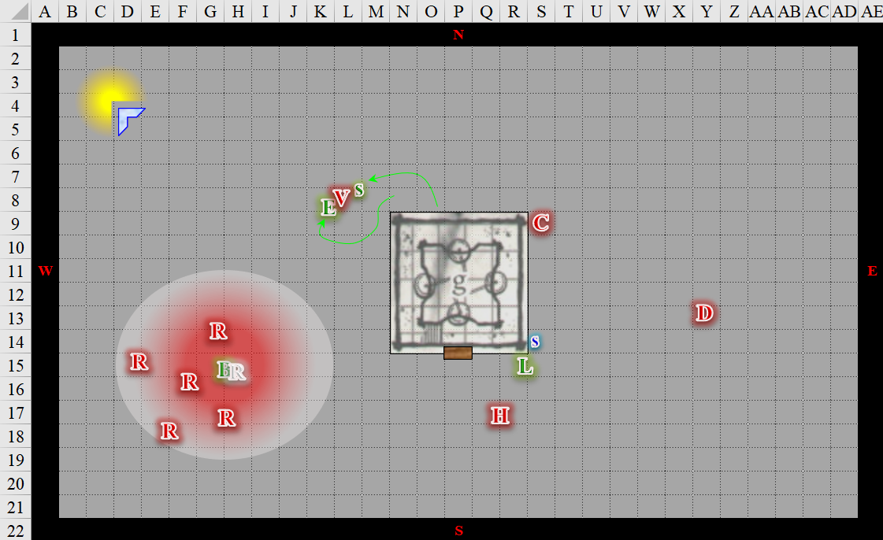

Round 3

Saradette reprised her attacks against Visceratya.

|  |  |  |  |  |  |  |  |  |  |
| --- | --- | --- | --- | --- | --- | --- | --- | --- | --- |
| **Melee Weapon** | **Dmg** | **D+** | **TH+** | **Critical** | **Type** | **Wt.** | **Atk** | **Roll** | **Check** |
| Short Sword | 1d4 | -1 | 2 + 2 flank | 19-20/x2 | Piercing | 1.0 | 7 | 18 | 25 |

*Hit. Dmg: 4 – 1 + 2 + 3 Sneak = 8.*

Rasqueado cast *Tasha’s hideous laughter [expired on Round 9]* upon Barkley.

|  |  |  |  |  |  |  |
| --- | --- | --- | --- | --- | --- | --- |
| **Save vs.**  *Tasha’s hideous laughter* | **Rank** | **Ability & Mod.** | **Misc. Mods.** | **Total** | **Roll** | **Check** |
| **Barkley, Will** | 4 | Wis (+1) | 0 | 5 | 19 | 24 |

*Success. No effect.*

“Illegitimate *spawn*…” the ghost frowned.

Dame Dahlia cast *hamatula barbs [expired on Round 63]* upon herself, and walked towards Solstice and Luran.

*Dame Dahlia gained defensive damage: 1d8 points slashing and piercing to successful melee attackers.*

Barkley looked around, unsure what was going on. He noted the singing and felt an odd sensation. He didn’t know the singers, and was unsure if he liked them or not. As Barkley looked at the singers, it was as if a fog lifted from his mind and he remembered that the singer was a bad guy. Using his Detect Evil ability to see if that would tell him which image was the real singer. Barkley then went charge-attacked another the singer’s true form, slashing with his sword and threatening with his axe.

|  |  |  |  |  |  |  |  |  |  |
| --- | --- | --- | --- | --- | --- | --- | --- | --- | --- |
| **Melee Weapon** | **Dmg** | **D+** | **TH+** | **Critical** | **Type** | **Wt.** | **Atk** | **Roll** | **Check** |
| Longsword | 1d8 | 2 + 2 charge | 2 + 2 charge | 19-20/x2 | Slashing | 4.0 | +9 | 18 | 27 |

*Hit. Dmg: 0 to incorporeal creatures.*

“Illusory *fiend*!” Barkley grumbled at the ghost, who was neither illusory nor fiendish in the strictest senses, but was incorporeal and nefarious, indeed.

Elsabet grinned as Saradette landed a sharp thrust while the sohei was distracted by her own maneuvering, especially after landing her Foehammer. Between the two of them—literally—hopefully, they could make short work of the enemy woman. Feeling the courtyard solidly under her feet, she pulled on the power of the stone dragon discipline and initiated her Stone Vise strike with a powerful overhand blow.

|  |  |  |  |  |  |  |  |  |  |
| --- | --- | --- | --- | --- | --- | --- | --- | --- | --- |
| **Melee Weapon** | **Dmg** | **D+** | **TH+** | **Critical** | **Type** | **Wt.** | **Atk** | **Roll** | **Check** |
| Bastard Sword +1, 1-handed | 1d10+1 | +2 | 4 | 19-20/x2 | Slashing | 6.0 | +11 | 19 | 30 |

*Threat. 1d20 = 12 + 11 = 23, critical hit.*

*Dmg: (2 x 5) + 1 + 2 + 2 Music + 2 Stone Vise = 17.*

|  |  |  |  |  |
| --- | --- | --- | --- | --- |
| **Character** | **Save vs.**  Stone Vise | **Ranks** | **Roll** | **Save** |
| Visceratya | Fortitude | 6 | 4 | 10 |

*fail.*

Elsabet’s crushing blow staggered her opponent, leaving the sohei unable to move. The crushing weight of her swipe forced the dream warrior to waste a precious moment regaining her footing.

As Elsabet recovered from her swing, she felt her last maneuver, Crusader’s Strike, being granted. The crusader was about to finish off the sohei, but then the latter hit the floor, landing on her left side, and dropping the naginata, which now morphed into a one-bladed battleaxe, or perhaps a dire handaxe—it was unclear.

Corpuscarth heard and spotted this out of the corner of his eye, then took a few steps southward and with Luran and Solstice in his sights now, he cast *scare [expired no later than Round 9]* upon the two.

|  |  |  |  |  |  |  |  |
| --- | --- | --- | --- | --- | --- | --- | --- |
| **Save vs.**  *Scare* | **Rank** | **Ability**  **& Mod.** | **Misc.**  **Mods.** | **Total** | **Roll** | **Check** | **Notes** |
| **Luran, Will** | **7** | **Wis (-1)** | 2 + 2  Music | 10 | 1 | 11 |  |
| **Solstice, Will** | **7** | **Wis (+2)** | 2 Music | 11 | 8 | 19 | +2 Lucky |

*Fail, success.*

*Luran encumbered –2 to attacks, saving throws, skill checks, and ability checks.*

Luran became frightened, and fled southward.

Hacken Slashen took the opportunity to slash at the fool as he withdrew.

|  |  |  |  |  |  |  |  |  |  |
| --- | --- | --- | --- | --- | --- | --- | --- | --- | --- |
| **Character** | **Attack Type** | **Damage** | **BAB** | **Str Mod+** | **W+** | **Other+** | **Total Score** | **Roll** | **Total** |
| Hacken Slashen | Dire Halberd | 2d6 + 3 / x3 | 6 | 3 | 1 | 0 | 10 | 12 | 22 |

*Hit. Dmg: 7 + 3 = 10.*

Solstice anticipated being overrun by the three villains closing in on him, so he, too, fled, but in a more collected manner than Luran. Turning the corner *[2 move actions expended]*, the weasely Celestial prepared to strike with a *magic missile* any pursuant that presented themselves.

Hacken Slashen did exactly that, coming around the corner and charge-attacking Solstice.

|  |  |  |  |  |  |  |  |  |  |
| --- | --- | --- | --- | --- | --- | --- | --- | --- | --- |
| **Character** | **Attack Type** | **Damage** | **BAB** | **Str Mod+** | **W+** | **Other+** | **Total Score** | **Roll** | **Total** |
| Hacken Slashen | Dire Halberd | 2d6 +3/ x3 | 6 | 3 | 1 | 2 charge | 12 | 6 | 18 |

*Hit. Dmg: 7 + 3 = 10.*

“AAAAHHHHHHHHH, FUUUUUUUUUUUUUUUUCK THIIIIIIIIIIIIIIISSSS!!!!!!!!” Luran screamed with no intention of going back to that fight.

Visceratya bled out.

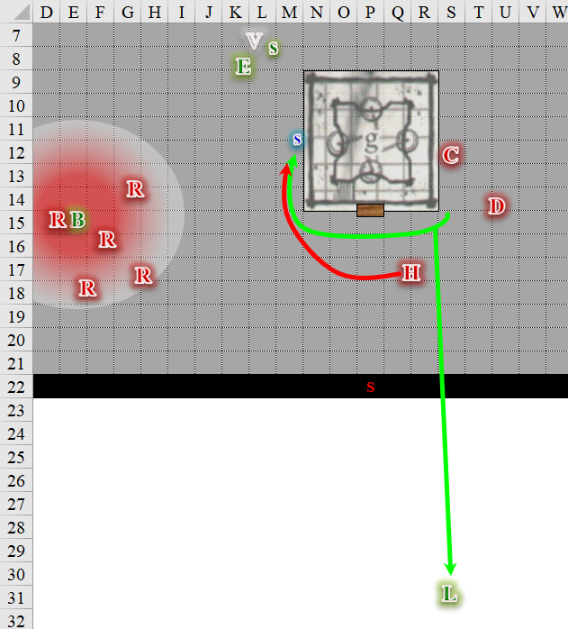

Round 4

Saradette, not wanting to take on a fighter head-on, went to the corner and peeked *[assuming stealth]* around it to see what the other two bad guys were doing.

|  |  |  |  |  |  |  |
| --- | --- | --- | --- | --- | --- | --- |
| **Skill** | **Rank** | **Ability**  **& Mod.** | **Misc.**  **Mods.** | **Total** | **Roll** | **Check** |
| **Saradette, Hide** | 5 | **Dex (+3)** | 4 | 12 | 18 | 30 |
| **Saradette, Move Silently** | 5 | **Dex (+3)** | 4 | 12 | 4 | 16 |

*Result unknown, but see below.*

Rasqueado seemed to be both smiling and frowning, and again cast *Tasha’s hideous laughter [expired on Round 10]* upon Barkley. “You know the story of the featherless cock?”

|  |  |  |  |  |  |  |
| --- | --- | --- | --- | --- | --- | --- |
| **Save vs.**  *Tasha’s hideous laughter* | **Rank** | **Ability**  **& Mod.** | **Misc.**  **Mods.** | **Total** | **Roll** | **Check** |
| **Barkley, Will** | 4 | Wis (+1) | 2 Music | 5 | 9 | 16 |

*Fail.*

Barkley was suddenly afflicted with uncontrollable laughter, collapsing into gales of manic tail-wagging and baying, and ultimately falling prone as his abdominal muscles began contracting uncontrollably.

Dame Dahlia came around the corner and charge-attacked Solstice.

|  |  |  |  |  |  |  |  |  |  |
| --- | --- | --- | --- | --- | --- | --- | --- | --- | --- |
| **Character** | **Attack Type** | **Damage** | **BAB** | **Str Mod+** | **W+** | **Other+** | **Total Score** | **Roll** | **Total** |
| Dame Dahlia | Staff +1 | 1d6+1 | 4 | 0 | 1 | 2 charge | 7 | 11 | 18 |

*Hit. Dmg: 3 + 1 + 2 charge = 6.*

Barkley could do little more than kick at anyone that came his way, and now that the *mirror images* were crowding him from all sides, he could not see what his allies were doing.

With the sohei falling at her feet, Elsabet grinned at Saradette. As the gnome moved to check out the far corner, Elsabet worried for a moment that she’d get in trouble, but looking in the other direction, she saw the halberd fighter swinging at Solstice. This was not to be allowed!

Still in her leading the charge stance, she used a swift action to activate one charge in her brute gauntlets to gain a little more damage *[expired on Round 5]*.

*Elsabet gained +2 to Strength.*

Then she initiated her Battle Leader’s Charge strike and barreled towards the halberdier while yelling out, “Solstice... pop... images... Barkley... heel!!!” as a sort of bizarre battle cry, finishing with a mighty swing of her sword.

|  |  |  |  |  |  |  |  |  |  |
| --- | --- | --- | --- | --- | --- | --- | --- | --- | --- |
| **Melee Weapon** | **Dmg** | **D+** | **TH+** | **Critical** | **Type** | **Wt.** | **Atk** | **Roll** | **Check** |
| Bastard Sword +1, 1-handed | 1d10+1 | +3 | 2 + 2 Brute  +2 Music  +2 Charge | 19-20/x2 | Slashing | 6.0 | +14 | 15 | 29 |

*Hit. Dmg: 3 + 1 + 3 + 2 music + 2 charge + 2 +brute + 4 Stance + 10 BLC = 27.*

As she recovered from her blow, she felt her remaining maneuvers fade and two then being granted. She grinned at the halberdier and raised her eyebrow.... The crusader-warlock-favored of Mayaheine then saw the moment’s maneuvers revealed before her.

|  |
| --- |
| *Current Maneuvers* |
| Stone Vise (Round 5) |
| Foehammer |
| Crusader’s Strike |
| Shield Block |
| Battle Leader’s Charge |

Corpuscarth likely failed to spot and hear Saradette behind him, and clicked the heels of his boots, swiftly *dimension dooring* to where he could see Elsabet hurting Hacken. He then cast *ray of exhaustion [expired on Round 64]* upon the warlock.

|  |  |  |  |  |  |  |  |
| --- | --- | --- | --- | --- | --- | --- | --- |
| **Character** | **Attack Type** | **Damage** | **BAB** | **Dex Mod+** | **Total Score** | **Roll** | **Total** |
| Corpuscarth | Ranged Touch Attack | varies | 3 | 1 – 4 firing  into meele | 0 | 16 | 16 |

*Hit.*

|  |  |  |  |  |  |  |
| --- | --- | --- | --- | --- | --- | --- |
| **Save vs.**  *ray of exhaustion* | **Rank** | **Ability**  **& Mod.** | **Misc.**  **Mods.** | **Total** | **Roll** | **Check** |
| **Elsabet, Fortitude** | **6** | **Con (+1)** | 1 | 8 | 20 | 28 |

*Success. Dmg: Fatigue (–2 penalty to Strength and Dexterity + inability to run/charge).*

Solstice did not understand Elsabet, and cast *magic missile* upon Hacken Slashen instead of the illusions.

*Dmg: 6 + 2 = 8 magic.*

Hacken Slashen was hurt by the bastard sword and missiles, but remained on foot, and now full-attacked Elsabet, whom he perceived to be the greater threat.

|  |  |  |  |  |  |  |  |  |  |
| --- | --- | --- | --- | --- | --- | --- | --- | --- | --- |
| **Character** | **Attack Type** | **Damage** | **BAB** | **Str**  **Mod+** | **Dex**  **Mod+** | **W+** | **Total**  **Score** | **Roll** | **Total** |
| Hacken Slashen | Dire Halberd | 2d6 +3/ x3 | 6 | 3 | 1 | 1 | 10 | 9 | 19 |
| Hacken Slashen | Halberd, 2nd Attack | 2d6 +3/ x3 | 1 | 3 | 1 | 1 | 5 | 9 | 14 |

*Miss, miss.*

The fighter had another trick up his sleeve, and swiftly activated all the charges in his Ring of the Ram, bull rushing Elsabet with an invisible force.

*Dmg: 13 [35/48] + Bull Rush.*

|  |  |  |  |  |
| --- | --- | --- | --- | --- |
| **Character** | **Check** | **Ranks** | **Roll** | **Save** |
| Ring of the Ram | Strength | 7 | 1 | 8 |
| Elsabet | Strength | **1** | 20 | 21 |

*Bull Rush withstood. No effect.*

Luran ran another 100’ or more to the south, then—winded—doubled over, having forgotten what he was running from. He was in a field of spice and lilies where half-elven mythologies lived, swirling between elven and human tales and interpretations of the landscape and its verdant richness, either to be nurtured or exploited.

“Wait, what?” Luran quickly spun and looked in all directions to discern his new surroundings and how he came to be here.

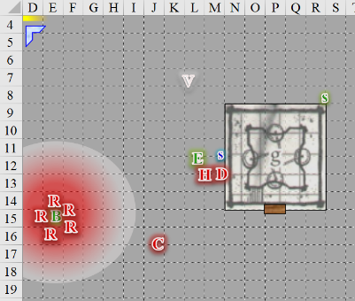

Round 5

~*~

Luran was not in a good place. He could see all manner of things around him under the moonlight, but nothing was recognizable, no shape discernible, no object namable. His skin crawled with goosebumps, and the hair on the nape of his neck stood like quills against the breeze.

~*~

Barkley was rather enjoying the view from below. The eidolomancer was a funny-looking sport.

Saradette ran south along the tower wall, and looked around the southeast corner.

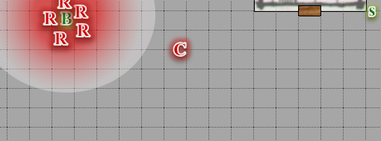

Rasqueado stabbed at Barkley with a downward swipe of his sickle.

|  |  |  |  |  |  |  |  |  |  |  |
| --- | --- | --- | --- | --- | --- | --- | --- | --- | --- | --- |
| **Character** | **Attack Type** | **Damage** | **BAB** | **Str Mod+** | **W+** | **Total Score** | **Roll** | **Total** | **Crit** | **Threat** |
| Rasqueado | Sickle of Speed | 1d6-1 | 4 | -1 | 1 | 4 | 4 | 8 | 20 | ý |
| Rasqueado | Sickle of Speed, Hastened Attack | 1d6-1 | 4 | -1 | 1 | 4 | 20 | 24 | 20 | þ |

*Miss, threat. 1d20 = 17 + 4 = 21, not a critical hit. Dmg: 3 – 1 = 2 [43/45].*

When Rasqueado swung and missed, Barkley let out a loud belly laugh and pounded the ground with the hilt of his sword. “You are so lame........ How did you miss?” he laughed as he rolled over and looked up at Rasqueado and his *mirror images*. Then, as the spellcaster swung again and nicked Barkley, he flinched then laughed again, adding, “Stop tickling me you pile of dragon dung!! HAHAHAHA HAHAHA HAHAHAHA!” It was not his most dignified moment, what with his tail wagging, tongue dangling from his cackling maw, and ears flopping back and forth.

Dame Dahlia—surrounded by the *hamatula barbs* that she’d recently cast upon herself—took it upon herself to aid her bodyguard in putting down the real threat. The cleric of Velsharoon cast *bestow curse* upon Elsabet.

|  |  |  |  |  |
| --- | --- | --- | --- | --- |
| **Character** | **Check** | **Ranks** | **Roll** | **Save** |
| Dame Dahlia | Concentration | 9 | 13 | 22 |

*Success.*

|  |  |  |  |  |  |  |
| --- | --- | --- | --- | --- | --- | --- |
| **Character** | **Attack Type** | **Damage** | **BAB** | **Total Score** | **Roll** | **Total** |
| Dame Dahlia | Touch Attack | varies | 4 | 4 | 17 | 21 |

*Hit.*

|  |  |  |  |  |  |  |
| --- | --- | --- | --- | --- | --- | --- |
| **Save vs.**  *bestow curse* | **Rank** | **Ability**  **& Mod.** | **Misc.**  **Mods.** | **Total** | **Roll** | **Check** |
| **Elsabet, Fortitude** | **6** | **Con (+1)** | 1 | 8 | 14 | 22 |

*Success. No effect.*

Elsabet sighed, knowing all too well the permanency of such ill effects. She then snarled, “Wait your turn, bitch!” at the enemy cleric as she shrugged off whatever the cleric intended to curse her with, and continued to focus on taking down the halberdier. With both stone vise and foehammer available, she pondered briefly. Then, with a swift action she used a second charge on her brute gauntlets for another boost to damage, initiated her foehammer strike, and swung another powerful blow at the fighter.

|  |  |  |  |  |  |  |  |  |  |
| --- | --- | --- | --- | --- | --- | --- | --- | --- | --- |
| **Melee Weapon** | **Dmg** | **D+** | **TH+** | **Critical** | **Type** | **Wt.** | **Atk** | **Roll** | **Check** |
| Bastard Sword +1, 1-handed | 1d10+1 | +1 | 4 | 19-20/x2 | Slashing | 6.0 | +10 | 5 | 15 |

*Miss.*

As she pulled back her bastard sword again to ready it for whoever next deserved her ire, she felt her crusader’s strike being granted. While fatigued, she had yet to take any damage - perhaps that was about to change...

Corpuscarth appeared to be targeting Elsabet or Solstice, but then moved westwardly before casting *crushing despair [expired on Round 65]* upon Barkley and Rasqueado.

*Rasqueado gained +2 to attacks, saves, checks, and weapon damage as if affected by good hope.*

|  |  |  |  |  |  |  |
| --- | --- | --- | --- | --- | --- | --- |
| **Save vs.**  *crushing despair* | **Rank** | **Ability & Mod.** | **Misc. Mods.** | **Total** | **Roll** | **Check** |
| **Barkley, Will** | 4 | Wis (+1) | 2 music | 7 | 4 | 11 |

*Fail. Barkley suffered -2 to attacks, saves, checks, and weapon damage.*

Solstice was putting a moderate but reliable hurting on his assailant, and so he stayed the course, targeting Hacken.

*Dmg: 3 + 2 = 5 magic.*

Hacken Slashen—likely to die from a papercut at this point—full-attacked Elsabet.

|  |  |  |  |  |  |  |  |  |
| --- | --- | --- | --- | --- | --- | --- | --- | --- |
| **Character** | **Attack Type** | **Damage** | **BAB** | **Str**  **Mod+** | **W+** | **Total**  **Score** | **Roll** | **Total** |
| Hacken Slashen | Dire Halberd | 2d6 +3/ x3 | 6 | 3 | 1 | 10 | 9 | 19 |
| Hacken Slashen | Halberd, 2nd Attack | 2d6 +3/ x3 | 1 | 3 | 1 | 5 | 12 | 17 |

*Miss, miss.*

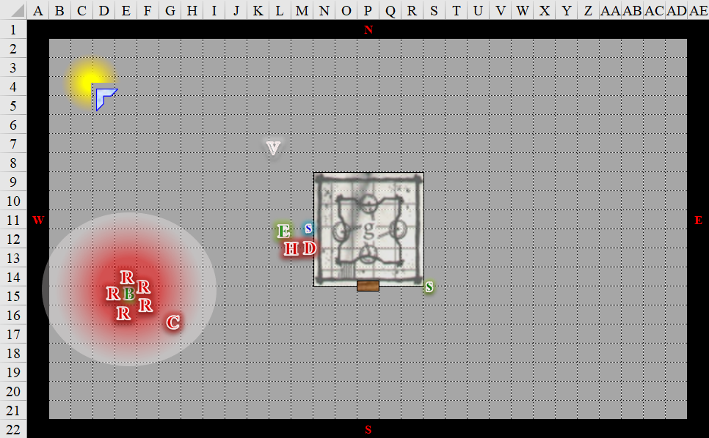

Round 6

Saradette waited until Corpuscarth was absorbed in casting a spell, and then she darted out of cover and ran south to get behind the mage.

|  |  |  |  |  |  |  |
| --- | --- | --- | --- | --- | --- | --- |
| **Skill** | **Rank** | **Ability**  **& Mod.** | **Misc.**  **Mods.** | **Total** | **Roll** | **Check** |
| **Saradette, Hide** | 5 | **Dex (+3)** | 4 | 12 | 19 | 31 |
| **Saradette, Move Silently** | 5 | **Dex (+3)** | 4 | 12 | 6 | 18 |

*A tough act to follow.*

|  |  |  |  |  |
| --- | --- | --- | --- | --- |
| **Character** | **Check** | **Ranks** | **Roll** | **Save** |
| Rasqueado | Listen | 6 | ?? | ?? |
| Rasqueado | Spot | 4 | ?? | ?? |

*See below.*

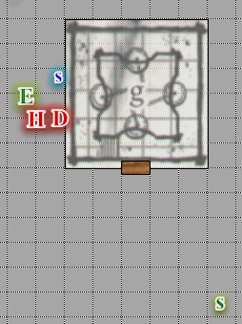

Rasqueado turned towards the east as he heard Saradette, then squinted, impressed by her ability to hide in plain sight but spotting her due to the sound she’d made. He took a moment to consider his actions.

*Deferring for the moment.*

Dame Dahlia full-attacked Elsabet.

|  |  |  |  |  |  |  |  |  |  |
| --- | --- | --- | --- | --- | --- | --- | --- | --- | --- |
| **Character** | **Attack Type** | **Damage** | **BAB** | **Str**  **Mod+** | **W+** | **Other+** | **Total**  **Score** | **Roll** | **Total** |
| Dame Dahlia | Staff +1 | 1d6+1 | 4 | 0 | 1 | 0 | 5 | 8 | 13 |

*Miss.*

Barkley rolled around a bit, canceling out the images around him without even realizing it at first.

As he rolled around laughing, Barkley noticed that there were suddenly fewer of the ugly humanoids around him. Noticing only one left, and that one looking off to the east, he laughed as he called out, “Hey ugly, BWAHAHAHA, I’m down here not over there! HAHAHAHAHAHAHA.”

Seeing that the halberdier was barely standing, Elsabet glanced at Solstice and said, “Finish him!” She also realized her sword was much more unwieldy since she’d become fatigued—no wonder her last swing was ineffectual!

She stepped next to the tower wall to get between the fiendish looking cleric and the musteval, used a swift action to activate the last charge on her brute gauntlets, dropped her bastard sword, drew her morningstar, and initiated her stone vise strike, smashing down hard at the prickly priest and hoping to pin her in place.

|  |  |  |  |  |  |  |  |  |  |
| --- | --- | --- | --- | --- | --- | --- | --- | --- | --- |
| **Melee Weapon** | **Dmg** | **D+** | **TH+** | **Critical** | **Type** | **Wt.** | **Atk** | **Roll** | **Check** |
| Morningstar | 1d8 | +1 | 2 | x2 | Prc & Bldg | 6.0 | +8 | 9 | 17 |

*Hit. Dmg: 8 + 1 + 2 Music +2 Brute +3 Stone Vise = 16.*

|  |  |  |  |  |
| --- | --- | --- | --- | --- |
| **Character** | **Save vs.**  Stone Vise  (DC 13) | **Ranks** | **Roll** | **Save** |
| Dame Dahlia | Fortitude | 6 | 7 | 13 |

*Fail. Dame Dahlia’s movement drops to 0’ for 1 round.*

*Dmg to Elsabet: 1 piercing + 1 slashing = 2 [33/48].*

As she tiredly pulled back her sword, grimacing a bit, she felt her shield block maneuver being granted. She’d use it to protect Solstice if anyone moved to attack him, but she doubted that would be necessary.

Rasqueado smirked, and did the truly unexpected: he disappeared, sinking into the cobblestone ground just feet away from Barkley.

Corpuscarth blinked and studied what was happening before him.

|  |  |  |  |  |
| --- | --- | --- | --- | --- |
| **Character** | **Check** | **Ranks** | **Roll** | **Save** |
| Corpuscarth | Listen | 4 | ?? | ?? |
| Corpuscarth | Spot | 5 | ?? | ?? |

*See below.*

|  |  |  |  |  |
| --- | --- | --- | --- | --- |
| **Character** | **Check** | **Ranks** | **Roll** | **Save** |
| Corpuscarth | Sense Motive | 4 | 4 | 8 |

*See below.*

It was evident to Corpuscarth from the ghost’s body language and subsequent exeunt that something was afoot behind him. He cast *ghoul touch [expired on Round 12]*, imbuing himself with the negative energy necessary to paralyze a single living humanoid, in addition to bestowing a ghastly stench upon the subject.

*Corpuscarth gained ghoul touch ability.*

Solstice noted the cleric’s moribund state, and as the rival teetered in her step, the musteval sought to end her existence with a few more missiles, but instead noted Elsabet’s body language and pointed at the fighter instead.

*Dmg: 4 + 2 = 6 magic.*

The fighter dropped where he stood.

Luran turned around and found himself walking up some stairs now that there was nothing else there, and nowhere else to go but up.

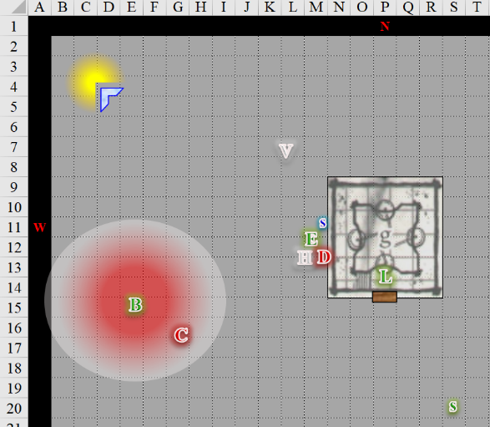

Round 7

Luran reached the top of the stairs, realized that he was just inside the open threshold of the belltower, and happened upon the others.

*Full round of actions available now.*

Saradette reversed course and ran back behind the tower.

Barkley tried to get to his feet, cackling at the stinky-smelling Corpuscarth, “Man, ever hear of taking a bath?”

Dame Dahlia attacked Elsabet.

|  |  |  |  |  |  |  |  |  |
| --- | --- | --- | --- | --- | --- | --- | --- | --- |
| **Character** | **Attack Type** | **Damage** | **BAB** | **Str Mod+** | **W+** | **Total Score** | **Roll** | **Total** |
| Dame Dahlia | Staff +1 | 1d6+1 | 4 | 0 | 1 | 5 | 10 | 15 |

*Miss.*

“Thanks Solstice!” Elsabet appreciated the musteval dropping the melee threat, and smiled at the evil priestess. Time to hopefully put her out of action and possibly give the little guy behind her some healing. She initiated her crusader’s strike and swung her morningstar around from the side, wincing a little at the expected pain of more barbs.

|  |  |  |  |  |  |  |  |  |  |
| --- | --- | --- | --- | --- | --- | --- | --- | --- | --- |
| **Melee Weapon** | **Dmg** | **D+** | **TH+** | **Critical** | **Type** | **Wt.** | **Atk** | **Roll** | **Check** |
| Morningstar | 1d8 | +1 | 2 | x2 | Prc & Bldg | 6.0 | +8 | 19 | 27 |

*Hit. Dmg: 5 + 1 + 2 Music = 8.*

Pulling her morningstar back, she channeled the healing energy from the strike back into Solstice, to make sure the little guy’s wounds would be less dangerous, and smiled as she felt her battle leader’s charge maneuver granted. Almost time to recycle her maneuvers again, but not quite.

*Solstice gained 6 + 4 = 10 hps.*

“‘Preciated,” Solstice sighed as Dame Dahlia fell, some of her barbs breaking off while the rest held her body about a foot from the ground.

Corpuscarth likely went to put his cooties on someone.

|  |  |  |  |  |  |  |  |
| --- | --- | --- | --- | --- | --- | --- | --- |
| **Character** | **Attack Type** | **Damage** | **BAB** | **Dex Mod+** | **Total Score** | **Roll** | **Total** |
| Corpuscarth | Ranged Touch Attack | varies | 3 | 1 | 4 | 1 | 5 |

*Miss.*

As easy a target as Barkley was, prone and giggling, the dread necromancer still failed to connect, and overstepped his mark. Turning around, he vowed to stop the archon from ever wagging his tail again.

Solstice dropped his sword, hopped 5’ westward, busted out his blowgun, and fired upon Corpuscarth.

|  |  |  |  |  |  |  |  |  |  |  |
| --- | --- | --- | --- | --- | --- | --- | --- | --- | --- | --- |
| **Ranged Weapon** | **Dmg.** | **D+** | **TH+** | **Critical** | **Rng.** | **Wt.** | **Atk** | **Roll** | **Check** | **Notes** |
| MW Blowgun | 1 | 0 | 1 | x2 | 10’ | 0.1 | +10 | 12 | 22 | +3d6 Sneak |

*Hit. Dmg: 1 + 15 Sneak = 16.*

The unwary dread necromancer barely heard the single pellet as it whirled towards his temple. By the time it pierced his brain, the vile man had little time to regret his choices in life.

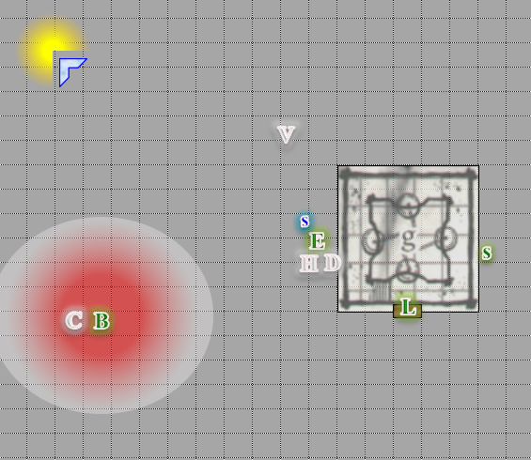

Rounds 8 and thereafter

The belltower was no more. Luran stood among his friends, and the bodies of the fallen disintegrated as the cobblestone ground became ever more irregular, and stones and earth became one.

Barkley got up, no longer giggly.

They stood together, five feet apart perhaps, as the light from the single lamppost grew brighter. For a moment, Elsabet held her blade as if the light were an incoming will-o’wisp, but it was not. A bipedal figure descended from a place beyond—or within—the light, and as its form exited the nexus of photons behind it, its wings became evident. Armored and helmeted, the figure approached with its sword sheathed, and the form of a woman tipped up the visor of her helmet to reveal Laryssa’s face.

She was clad in the Celestial armor and garments emblematic of Mayaheine, and the heroes could tell that they were beholding a reborn version of their paladin friend: a lesser avatar of the Shieldmaiden herself. “Greetings, brethren,” the human’s voice now carried a reverberating echo indicative of a holiness that only Elsabet had recently experienced when communing with her deity.

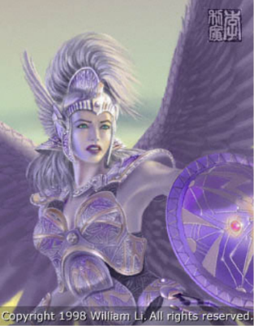

Elsabet looked at her now truly divine friend in awe. Unable to help herself, she smiled and said, “Girl, you look positively radiant! Love the wings!” Then she knelt and bowed her head.

Saradette didn’t feel any urge to bow and scrape, but she did nod respectfully as the transformed shieldmaiden approached. She kept silent as the others conversed.

The armor, weapons, and other items that the dead had left behind before disintegrating included an Amulet of Wordtwisting that lay where Rasqueado had sunk into the ground where grass now grew, a Belt of Healing, a Cloak of Protection, an Animated Shield, and an unidentified, 1’ long boat shaped into the rough likeness of a scarab whose legs consisted of oars, and whose shell irradiated with an indigo-turquoise hue.

As Elsabet spoke, Barkley knelt down and bowed his head for a moment before looking up. “It is good to see you once again. To what reason does the shield maiden grace us with the presence of one of her shieldmaidens?”

And so it came to pass that Laryssa Firehair—Emissary of the Shieldmaiden—revealed to the group not so much a prophecy of what would come, but context for understanding what had transpired. The villains they’d just battled—Mae-lee “Dame Dahlia” Singh-Apur, Clarence “Hacken Slashen” Pointdexter, Corpuscarth Varmintcull III, and their traitorous leader, Rasqueado Ciphrante—had in recent years terrorized the countryside near Mintar, and had been lured into a scheme far more nefarious than anything they’d ever concocted. Serving as mercenaries for a figure known to Laryssa only as the Speaker in Dreams. They had taken part in the siege of the city the night before, but had not been identified, and were not being pursued by authorities. They had slain three of them in the dreamscape, and the paladin confirmed that this reality was indeed in tandem with their own.

Rasqueado—she confirmed—remained undead, as she had just spotted him streaming away across a planar conduit parallel to the one she’d just taken to get here. The elusive bard had likely sunk back into the Shadow Plane, or worse, the Negative Energy Plane, and was recuperating in the wake of his inconveniently fleshy henchmen’s deaths.

Laryssa elaborated: “Rasqueado and his ilk—and there are more in his thrall—are known as the Clutch of Darkness, and while the eidolomancer and his Clutch are only minions in the Speaker of Dreams’ greater schemes, you five have been chosen by Mayaheine for something that will only begin with the vanquishing of these agents of malfeasance.

There was some commotion as half-questions were posed, but not clarified.

Laryssa nodded to express that she acknowledged the need for further clarification. “By Mayaheine’s grace, brethren, while your deeds hitherto have been heroic, you have yet to receive confirmation of your purpose, which I am now in a position to convey upon you. Henceforth, you—Elsabet, Favored Soul of Mayaheine; Bazazath, of Celestia; Solstice Equinox; and Saradette of a Thousand Eyes—as well as you—Luran Ebonchord, Mouthpiece of Heroism—will be known as the *Fist of Light*.”

Saradette and Luran had never been referred to this way, and were quite taken aback at the honorifics.

The paladin of Mayaheine concluded with a sigh, “Return to your rest, and regain what strength you can, heroes, for tomorrow, a greater test of your faith is likely to present itself. Though the horizon is as of yet unrevealed to me, I must warn you that I have seen glimpses of malice surrounding the Baron’s Keep, and I suspect you’ll find the Speaker of Dreams making his or her way into the Court’s inner circle if s/he hasn’t already.

“Thank you for your blessing and your warning, sister of my heart,” Elsabet replied, looking up from where she knelt. “We shall do what we can to counter this threat. Your words will warm us in the cold, and your faithful service to the Goddess will inspire us in dark times.”

Before leaving the dream, Elsabet looked at the goods scattered around. The healing belt, for some reason, seemed to call to her, so she picked it up....

Barkley looked from Elsabet to Laryssa as they spoke. When Laryssa finished, Barkley bowed his head and allowed Elsabet to sum up the group’s sentiment. He then looked up and smiled, adding, “It was good to see you and speak with you once more.” He then followed Elsabet, the cloak catching his eye as he picked it up and studied it.

*[Looks like a Cloak of Protection +X, which he can don now if he wants to.]*

Barkley also took a liking to the boat and the shield, not sure what to make of them at the moment.

Hefting and donning some new goodies after their scuffle with the vanquished villains and the escaped ghost, the Fist of Light—as they were now called—were drawn to the light of the lamppost. “You’ll find you way back through there,” the paladin said, becoming a beacon of light herself before the photons that comprised her form beamed out in all directions, causing a spectacular flash that left nothing but air where she’d just stood.

Solstice was fatigued, and gladly led the way into the light.



Elsabet was also similarly dwindled to an electrolyte-deficient shadow of her usual self, and as they all went into the haloed sphere of light emanating from the lamp to their northwest, they began to see their quarters, and within them, their respective cots. It took them no time at all to drop their sheaths and gear, and stumble back onto them and enter an even deeper sleep than what they’d enjoyed prior to their scuffle with the Clutch of Darkness.