*Chapter 15: The Partition*

8 Tarsakh, 1372

The five heroes awoke just after sunrise as the screams of a humanoid woman alerted them. Though the sun was up, it was heavily overcast this morning, with little definition in the sheet of clouds that made it seem like it was an hour earlier.

Solstice followed the sound to the east-facing window, and seeing below what was happening, he described the situation to the others as they rose, somewhat alarmed. “Guards are arresting a young boy across the street, and a woman—perhaps his mother?—is pleading with them.”

As Barkley got up and moved to the window to see what Solstice was looking at, he began to put on his chainmail shirt. Unfortunately, he was not able to discern much more than Solstice, “We must see what is going on.”

A murder of crows flew overhead, making way for the Baron’s Keep, it seemed.

Saradette started with her nightshirt. She slipped on her pants, then stepped into her boots.

It became evident that the conflict was collected enough that the woman’s desperation was being curbed by the neighbors’ resignation to the arrest. Nobody looked happy, but the only active resistance was coming from the pleading woman as the boy was put into a wagon.

Solstice flicked his tail with a chaotic disdain for the imprisonment of a young boy whose guilt couldn’t have been more malicious than a mischievous pilfering... or perhaps it was another wererat issue. He looked at Barkley and Elsabet, who were by the window, seeing the woman looking as haggard as he felt, and squeaked, “Looks like the Guard’s work is never done.”

It was then that Barkley’s keen eye spotted something that the other two had missed. As Saradette donned her gambeson, which was a short sleeved jacket with four buckles, Barkley saw a new, unfamiliar sash worn by the guards. It was scarlet—or perhaps crimson—but in any case, it was a detail that he’d not caught in any of the military regalia prior to this moment.

The gnome threw her mithral shirt over the gambeson, then buckled her belt, and threw her shiftweave, which usually resembled a cloak, over her shoulders before shouldering her pack and quiver.

Seeing that the ruckus below probably didn’t merit immediate action, and feeling a bit fatigued by the weirdness which had occurred in the night, Elsabet first cast *lesser restoration* on herself, and then on Solstice who looked similarly worn out.

*Elsabet and Solstice lost all Fatigue.*

“Ah, wow! *That* did more for me just now than all those hours of sleep,” Solstice was duly thankful, and now felt his neck so much more flexible.

By about the time that Saradette was done, Elsabet had picked up her gear, belting on her weapons and shrugging into her haversack. The new belt which had returned with her seemed to improve her understanding of the healing arts, but she’d need help to figure out the command word for activating it. Perhaps at the Shrine to Mayaheine....

Elsabet asked Barkley if he was familiar with the sashes, but they were completely alien to him, and none of them had any confidence in hazarding a guess, other than they were somehow related to the city’s recent attack. Perhaps they were flags of distress, announcing martial law throughout the city until order could be restored, as they’d heard happened in Saradush around 1368 when this band of heroes—minus Luran and Solstice, and plus BelDamon—was off far to the north saving some woman named Pollyanna from a pack of gnolls. That was over half a decade ago now, and since then, they’d managed to stave off having to deal with urban centers under such conditions. Even Barkley himself—an incarnate bastion of Celestial order—was beginning to doubt the purpose of law if and when law was so dubiously abusing its authority, if indeed it was.

The wagon’s doors closed, and the lead guard handed a parchment to the woman who was presumably the boy’s mother. It was a tense moment as the commoners struggled to hold their sister or cousin back from spitting and hissing at the guard, and as they led her back to her bakery across from the Minotaur, the wailing was punctuated by a single word that those inside the room could not discern. It was likely an insult, and though it made the guards stop and turn back, they did not arrest her, as Barkley half-suspected they would.

When Elsabet asked if he could detect evil, Barkley replied, “I will see what I can detect.” He then used his spell-like ability and concentrated on the area of the guard and others gathered around, but no one out there triggered his second nose.

~*~

After breaking fast downstairs, Saradette spent a few minutes tending to her pony and racoon while the others went back up and talked a bit, gathering the last of their gear and trying to identify their items. Shoomma—the dwarven shopkeeper to whom Uma had introduced them—would likely be the person who would be able to help them out with this, and so at about the time that Saradette was giving Gadget and Widget their kiss to last them the rest of the morning, the other four folks came out.

Solstice had been toting the scarab-shaped ship—a covetous and preciosity—in plain sight on his back, but Barkley had thought to stow it away in his pack for safety; plus, the musteval was already weighted down enough.

Before going to the Shrine to Mayaheine to pick up some divine scrolls that should be ready by now, and then to the Temple of Tyr so Barkley could donate the shield they’d happened upon in their dreamscape (which they knew to be quite real), they headed to the Chatterstreet Quarter and made it to Shoomma’s shop without so much as spotting a wererat, grimlock, or even so much as a guard. The streets were quiet and sparsely traversed by anyone, and by the time they reached Shoomma’s shop, they saw along the main thoroughfare headed south a single line of caravans even now lined up to exit, though the city gates were likely still closed.

Saradette was not with them. She had gone to the Temple of Gond instead, and had agreed to meet the others at the Temple before they were to report to the Westgate.

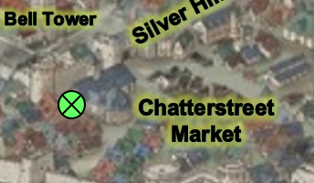

“Shoomma!” Luran called out the woman’s name as he smiled, though it was difficult for any of them to smile wholly, with the dismal clouds above them, and the tense climate amidst Mintar’s wards.

“Heroes! Glad we are to see yer faces again,” she groaned at the end of the sentence as she got up from her chair. Her son’s smithing in the back room was evident, and only stopped long enough for him to cautiously approach the threshold of the door to that room and ensure that his mother was well. He immediately recognized the Fist, and waved a hammer, looking relieved that they were neither guards nor looters.

As the tin-tin-tin of the smithing resumed, the heroes began to produce the items that they needed identified, and after being given a 153-GP quote to do so, the party agreed, paid (from Solstice’s coffer), and got the good news about their goodies. None of them had any evil properties—which Barkley could have probably sniffed out—and the party was all the more prepared for the day now, knowing how to activate the healing and other abilities that they now had at their fingertips.

Solstice confirmed, “So the boat can become a rowboat for four—not counting me—and also a sailing ship?”

“Yes, but you’d need an able crew if you’re to commandeer the ship,” Shoomma warned.

Fitzroy Quentine: Elsabet noted the name of the Prefect’s signature upon the warrant for the boy’s arrest. The name was unfamiliar to the group, but they might need it to inquire about the baker’s son—Errol Baker—at the Baron’s Keep. Errol had been arrested for treason, specifically for aiding the wererats and possibly being one. The accusation was made on the basis that the boy was selling bread on the corner, and a known wererat had been spotted at the bread stand, and had confessed to bringing the boy under his wing.

~*~

A few blocks down from Shoomma’s shop, Saradette had arrived at the Temple of Gond, which was not in the adjacent Silver Hill district like most of the other temples. Instead, it was right here in the Chatterstreet Market, ensconced among some of the more reputable gnomish retailers.

“A salutary day to you, sister,” a gnome cleric of about 100 years smiled and bowed, clad in the garments and accessories of his station. “I am Deremahr the Alacritous. Have you come for guidance today?”

“Not specifically, Brother Deremahr,” Saradette replied with a smile. “I am seeking an audience with Sacerdôt Fritz, if he, or she, is available.” She extended her hand with ten gold coins to the cleric. “And, here is a donation for your ministry.”

The donation was well received, and placed with no clandestine sleight of hand into the tithe-coffer near the entrance of the structure. “Come, and we shall see if the Sacerdôt is available. Do you know him?”

“Not well,” she admitted as she was led to the back of the temple where a few cells with nice views housed various tinkerer-bureaucrats who barely noticed her passing by their cells’ doorless thresholds. The temple was a trove and repository of knowledge and figurative transparency was not only their creed but their practice. *Walls of force* could be erected around the Temple at any time, but otherwise, the monument to the Wonderbringer was a public-facing revelation built into a blend of architecture and theological artistry.

The last cell was the Sacerdôt’s, and though he was busy studying some tome by the indirect sunlight coming in from the barless window, he flipped up the top layer of his spectacles, squinted, and nodded, “Ah, yes. I remember you.”

Brother Deremahr smiled, and said, “I’ll leave you and the Sacerdôt to discuss matters of the spirit, or anything gear-related. Blessings and sparkles.”

“Thank you, Brother,” Saradette said as the cleric departed. She turned to Fritz, and spoke in Gnomish. “I am Saradette Tarapple Febble Tallniss Nensy Gwaella Grangytee of Clan Warblerivet,” she said formally. “I was told by one of the city guards named Varsili that I could come to you if I needed assistance. I cannot think of anything I need at this moment, but I wanted to meet you, anyway.”

~*~

A few minutes passed as Shoomma helped Barkley with his new chain shirt, getting almost his entire investment back in the old shirt, and feeling resplendent under the chinks of elven mithral woven into a houndstooth print... so chic!

“Handsome,” more than one person described Barkley’s proud profile, accentuated by the shinier garment that would serve him well.

“We should get going to rendezvous with Saradette soon,” Solstice reminded the others during an opportune moment.

Barkley scratched his chin in thought. I would think something simple, like an arm band or a patch that could be sown into our cloaks or armor. The fist or gauntlet emitting light would be very appropriate and self-explanatory in my opinion.”

When Shoomma emerged with the new armor, Barkley, without reservation or the slightest modesty, removed his cloak and armor to don the new protection. As he did, he caught the glances of a couple of females, including Elsabette, glancing his way. Though he wasn’t sure if Elsabette was admiring him or the armor, he knew the others were checking him out. So, he made sure to flex and show off his muscular chest and abdominal muscles as he worked his way into the elven chainmail shirt.

Not interested in the bard, in that way, Barkley neglected to notice Luran was equally appreciative of the display. While not a particularly randy or promiscuous one, the bard had a broad spectrum of what he found attractive, male, female, animal heads, and more. And while not precisely his “type” Barkley definitely ticked one or two of the boxes. Enough for the archon’s performance to catch his eye, as well, at the very least.

Once on, he looked at himself in a nearby mirror, very pleased with the fit and the shine of the new, well-crafted armor. Looking at Shoomma, he smiled as she handed him the magical longsword as well. “Thank you, Madam Shoomma. You never disappoint.”

When Shoomma later brought up the stew, Barkley smiled, “I certainly hope that we will be free to return for dinner. I look forward to tasting your stew.”

They said their goodbyes, and Shoomma invited them over to dinner tonight. “If yer not otherwise engaged.”

“We’re not sure if we’re going to be needed at the Westgate until late,” Luran spoke truthfully.

“Well, I can *message* you ‘round Sunset, and you can let us know if and when you’d be droppin’ by,” the nice woman left the invitation open. “I mean: we’re dwarves; it’s stew; it’ll keep. The residential entrance is ‘round back, and up the stairs,” she pointed.

As they walked away from the shop, Elsabet mused, “I wonder if we should get FoL embroidered on our outfits, or a golden fist with symbolic light emanating from it painted on something, or some such visible identifier. Maybe Saradette could make some brooches of silver and gold we could wear.”

Luran was still a bit mindblown by the accolades received during Laryssa’s divinely energized interaction, early. “Mouthpiece of Heroism” was a title that felt amazing but he had only dreamed of the type, prior. Thinking on Elsabet’s suggestion, he happily supported the idea of a broach for the party members to each wear, in honor of the trust Mayaheine had put in the group, as a whole.

~*~

They left Shoomma’s shop, and had only a few blocks to stroll before happening upon the Temple of Gond. Once inside, they described Saradette, and Brother Deremahr led them to the back of the sparsely occupied temple. They saw the busy tinkerers in the public cells that they were now using to research and experiment with their respective mysteries and gadgets. At the last cell, they caught Saradette and the Sacerdôt sharing a moment of deep, philosophical conversation, and as she recognized her friends and gestured towards them to introduce them, the senior gnome’s face turned from a contemplative one to a “glad-to-meet-you” smile reflecting a calmness sustained by wisdom and tolerance.

By now Saradette had gotten a fair measure of the man, who hailed from Essembra, and could vouch for his dogmatic view of Good being the source of Gond’s motives for crafting, construction, and self-edification. All Creation was the everchanging result of the deliberate will of a thousand gods and their equals, and though destruction was endemic to all existence, so was the rearrangement of that which had been destroyed into new collages of being, and Saradette found it inspiring that in her own innovative and creative undertakings, she was embodying the essence of Gond’s message to the multiverse.

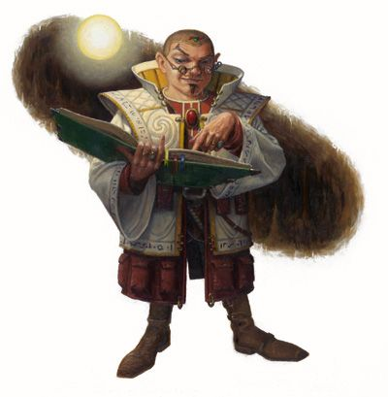

They’d all been properly introduced, and Saradette debriefed her mates on the most pertinent discovery. “Sacerdôt Fritz has shared with me the schematic for one of his old gadgets: a _____.”

Barkley nodded and greeted Fritz, “Any friend of Saradette is a friend of mine. It is a pleasure to meet you.” He had answered Fritz’s questions with a delight for this conversational interchange.

~*~

Brother Deremahr abruptly interrupted, first excusing himself for doing so as he stood in the doorless, arched threshold between the cell and the corridor that led back out to the temple’s main chamber. “There’s been... another disturbance.”

Fritz didn’t really say anything, but his posture became serious again, and he tilted his head until Brother Deremahr clarified, “Possibly another wererat attack, near the Northgate. Criers are in the streets now. The Baron means to address the city within the hour.”

The Fist of Light knew that the Northgate was the city’s unofficial temple quarter, and both the Shrine to Mayaheine and the Temple of Tyr were situated there. If wererats were still at large—or the chaos-loving madmen that the Fist had taken down at the Reality Wrinkle the afternoon prior—the exodus of the caravans might be stalled even longer, and Barkley and Elsabet now looked at one another in anticipation of what security measures they would have to enforce on behalf of the Barony at their posts later on.

Fritz got up slowly, betraying the fact that he was already over the shock of the happenings in the city over the last two days, and a certain resignation to the idea that it wasn’t going away anytime soon. He sighed, forcing half a smirk towards Saradette, though it was evident that, like the Fist, he was bracing for another arduous afternoon. “Brothers and sisters, it has been a pleasure to speak with you today. I can see that you all radiate Good from your hearts, and hope that your post at the Westgate is as uneventful as can be. I regret that we will have to erect the forcefield and safeguard the temple once more.”

As he and the others walked back through the main part of the temple and towards the front door, a gnome-sized golem was being activated by one of the acolytes who now spoke parameters in Gnomish into the golem’s auditory capacitor.

“Saradette tells me you’re headed to see Priestess Uma,” Fritz looked at them all as they reached the front of the temple. “Please wish her well for me.”

“Yes,” Barkley stated, “we must be on our way. We still have a couple of things to do, but those may end up waiting should the city’s need be greater than our own.”

Elsabet had remained relatively quiet, but reassured Fritz that she would pass his best wishes on to Uma personally, very shortly.

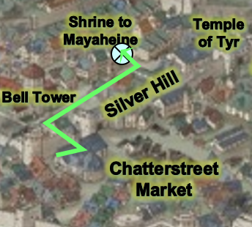

As they approached the Shrine to Mayaheine, with every block they passed, things began to get successively dire. Their stroll through the Silver Hill was uneventful enough, but after passing the belltower—which had been about half-way restored by now—and a few dozen spellcasters, masons, and other civil servants, there seemed to be less people in the street. By the time they got to the Temple Quarter, things were evidently not well. A few humanoids scurried to and fro, mostly entering houses or shops, and shutting doors behind them. The last few blocks were unmistakably grim. A scream alerted them to something happening right around where their destination would have put them, and as they hastened their pace and rounded the last corner, they noted to their west about a half-dozen wounded or dead people on the ground, with about twice as many living people kneeling and crying over them. A cleric bearing the symbol of Mystra was already doing her best to heal those who were not yet dead, and as she spotted the heroes, she identified the holy symbols on their garbs as well and asked, “Might you spare some healing for the wounded?”

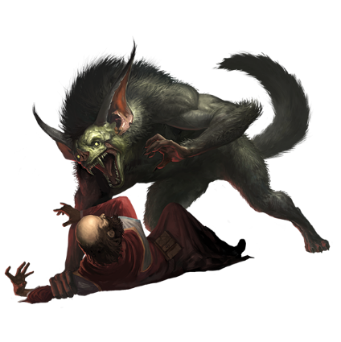

Solstice agreed out of hand, and instantly went to the four survivors of what was now being described as an attack by a fiendishly-clad bugbear fellow and a barghest that materialized out of nowhere and ambushed the vendors and passersby at and near this corner.

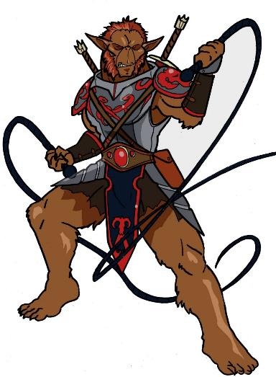

Barkley was taken aback a bit more than the others. A barghest was a Lawful fiend, as were most wererats, and yet their discoveries yesterday at the Reality Wrinkle had yielded a cult bent on sewing Chaos. Barkley’s sense of archon intuition made his head tilt for a moment at the consideration of whether these cultists—perhaps including this bugbear—were using devilish and other Lawful agents as a ruse for their anarchic plots.

“Bugbears are usually chaotic, right?” Barkley asked Elsabet, who sometimes knew things about alignment that he did not.

“Indeed,” she followed his logic, as she was thinking along a similar vein. “Chaos delimiting law...”

“Ironic,” Barkley sighed.

The musteval put his wand back into his vest and reprised the conversation with the cleric of Mystra, whose name was Thyeska. She answered Solstice’s follow-up question with: “Many temples have been ransacked by Baronial Guards. The entire quarter is under siege, and in conjunction with their maniacal bent on securing order, we now face barghests and bugbears!”

She noted that her temple—now occupied by the Guards—was a few blocks to the west, and Saradette remembered having passed it the day before on their way to the Shrine to Mayaheine, but the cleric warned, “I urge you to avoid the Guards. I don’t believe they mean the populace well, even if they state that their securing of our holy sites and residences is a necessity. It may be, but their demeanor isn’t right.”

Barkley shook his head at the mess about them. He asked, as he sniffed at the air, “Which way did the fiends go and how long ago?”

Thyeska bid the heroes well and continued eastward towards another cluster of wounded folks.

When they left the area and headed for the shrine of Mayaheine, Barkley turned to the others. “It seems that Laryssa’s warning is coming true. Once we are done at the shrines, we must determine who is in charge and how they are controlling the others or how they are being controlled.”

Elsabet followed Solstice to where the wounded were, and inspected the wounds, pointing out that any who were bitten should be checked later to determine whether they had been infected. She contributed a couple of *cure light wounds* herself to help heal the worst injuries.

|  |  |  |  |
| --- | --- | --- | --- |
|  | **Spell Level** | | |
|  | **0th** | **1st** | **2nd** |
| **Favored Soul Spells** | 6 | 6 | 3 |
| **Charisma Bonus** | 0 | 1 | 1 |
| **Total Spells** | **6** | **7** | **4** |
| **DC** | 12 | 13 | 14 |
| **Cast?** | **0** | **2** | **2** |

“Agreed. Barkley, perhaps you should take a few moments to fortify us all with your divinely powered aid before we proceed.”

Rounds 1 – 5

Barkley agreed, and cast *aid [expired on Rounds 71 – 75]* on each of his friends, and she continued, “I fear the Guard has indeed been coopted by an evil advisor to the Baron. If we have to fight them, I recommend nonlethal attacks. I may need to try to charm their officer—my fey power lets me attempt that once per day, and it is not obvious spellcasting, so if the officer is distracted, he or she shouldn’t notice the attempt comes from me. I might also be able to cause some of them to fall into a *deep slumber*.”

Rounds 6 – 8

The families of the wounded thanked the heroes, and carried the two bodies of the fallen inside, hoping to find a resurrector before it was too late.

The Fist made their way westward, noting a few blocks further west the Temple of Mystra that the cleric had mentioned, and a pair of black-clad guards at the entrance, about 250’ away.

Round 9

At that corner, they turned northward, making it to within 100’ of the Shrine to Mayaheine, but the Shrine to Mayaheine was....

“What on Faerûn?”

*Walls of stone* had been erected around the tapered, single-chamber structure that couldn’t have been bigger than 500’ square feet at its base. There was no sign of Princess Uma and Deacon Tåriq, and a single, black-clad guard now turned the corner, and began walking southward along the same side of the street along which the party was walking northward.

Passing the Shrine, the male Baronial Guard made eye contact with the group around the moment that Barkley was close enough to know that the man was not radiating an Evil aura.

Solstice’s ability to similarly *detect magic* caused the musteval to murmur into Barkley’s ear so only he could hear, “Magical auras, can’t identify them yet.”

Rounds 10 – 16

The Baronial Guard engaged them in a greeting from 40’ away, his red sash hanging from the right side of his belt as his longsword and scabbard hung from the left. His face was clearly shown under his visorless helm, and his thin facial hair betrayed a human of 20 to 25 years. “Citizens, I bid you well, but you are not peacebonded, and...” he then spotted the badges on the heroes’ lapels, and started again, “Apologies, Deputies; I’d not seen your emblems. You are not obliged to peacebond your weapons, but I am obliged to take down the names of all deputies in active service.”

Solstice said, “He’s got an Abjuration around him; probably a *mage armor* or something typical of an on-duty officer with some rank.”

Barkley watched the approaching guard and turned to the others and whispered a *message* (Spell-like ability) to them. “No Evil detected. Solstice picking up magic auras.” He then turned back to the guard and waved his left hand, “Good day,” he began, then indicated the wall, “Any way for us to pass to get to the temple?”

They were now about 20’ away from one another, and the Guard clarified, “Afraid this temple’s under quarantine until further notice. The Barony’s Security Threat Level has now been elevated to Red.”

Based on similar conventions throughout Faerûn, they had a pretty good idea that this was about as severe a situation as could be conceived from the standpoint of the establishment, and were duly cautious of their demeanor before the Lieutenant, who bore a pinned medal marking 5 years of service in the Baronial Guard, Luran noted. Saradette had no notion of the ranks and honorifics displayed on the soldier’s regalia, which was now—as opposed to two days ago, when they’d first arrived—accentuating a brand-new, coal-black outfit of very outlandish and culturally ambiguous design.

Round 17

Elsabet cocked her head, seemingly thinking of how to respond, while focusing her will on using her *charm monster [expired in 7 days]* spell-like ability on the guardsman, and then smiled at him like an old friend. “Hail, friend! I am Elsabet, favored of Mayaheine. You know, I and my companions here have been busy helping during this crisis. I see you and the other guards have shiny new uniforms, what’s the story there?”

|  |  |  |  |  |
| --- | --- | --- | --- | --- |
| **Spell** | **Level** | **SF** | **DC** | **Cast?** |
| Charm Monster | 4 | 0 | 16 | þ |
| **Character** | **Check** | **Ranks** | **Roll** | **Save** |
| Captain L’auvre | Will | 5 | 10 | 15 |

*Fail.*

“Ah, upgrades,” the man smiled and patted down the black leather covering most of his breastplate. “The Baron’s defenses have been overhauled from the ground up.” Solstice and Saradette were the first to notice the bronze Ring of Protection, which was actually the source of the Abjuration that Solstice was now identifying.

“Solstice Equinox: locksmith, intel, and healing the sick and injured. At your service, Captain…” the musteval allowed the human the opportunity for an introduction once the others had provided him with their names and occupations.

“L’auvre,” Captain L’auvre said. “There have been attacks in the quarter. If you need a place to pray, there are several temples throughout this quarter that might serve your needs. I ask that you be vigilant today as we try to put down the rest of the unrest throughout the city.”

The Temple of Tyr was a few more blocks away to their northeast, and Solstice thought to ask about it.

“To my knowledge,” Captain L’auvre responded, “it is open to the public, though there may be a wait if officials are currently there.”

Barkley tilted his head to the side at the mention of the temple being under quarantine. “For what reason is it under quarantine? Surely the priests and warriors of Mayaheine would be helpful at this time.”

“All places of worship have been decreed to have been targets of infiltration by the city’s assailants. Several clergy have already been identified as culprits or victims in these affairs.”

Solstice asked, “Clergy of which deities?”

“Though you all seem like wonderful folks,” the Captain couldn’t take his eyes off of Elsabet as he said, “I couldn’t tell you even if I knew. The Baron will deliver an announcement by the zenith,” he pointed to the sun now that the belltower was under reconstruction. “You should attend.”

Elsabet asked one last question of the Captain as he turned to leave. “To whom do you report now?” She smiled. “I’ll be sure to commend you on your diligence to them when I see them.”

“I’m technically a Lieutenant Captain; Captain Tothuk is my Senior Officer; he’s likely to be at the Keep during the announcement.” And with this, the man spotted some folks limping a block southward, and excused himself to go help them. “A good day to you, friends!”

Saradette remained quiet and vigilant as they went along.

“Temple of Tyr?” Elsabet asked Barkley and Luran, who were the two in the party that had spiritual business with this deity.

Barkley’s faith had been tested recently, though he hadn’t had cause to mention it to the others, and was still working it out in his head. One thing he’d given up on was the idea of entering paladinhood, and had recently developed a penchant for a more natural approach to the divine path. Consequently, the archon brewer had recalled lore told to him in Saradush about Tempus, and he now wanted to at least keep an eye out for a temple to this lesser deity’s worship.

~*~

The crowd today was the largest they’d seen yet gathered here; Barkley estimated that the whole city had shown up, but Saradette’s calculations put the estimate at a much smaller fraction of Barkley’s call. As the heroes shuffled through the ensuing crowd, the Baron came out punctually as a crier decreed the time of day—which would otherwise have been announced by the belltower—and the citizenry slowly settled and focused their attention upwards at the balcony.

“Good people of Mintar, I address you today with a heavy heart, standing amid the chaos that has befallen our town. Lawlessness and disorder have reigned since this street fair began, and even the efforts of a heroic band of adventurers have not put an end to the madness. While we celebrated these heroes and feasted in their honor, assassins plotted to end their lives.”

The Fist of Light assumed that the Baron was referring to other heroes, since the Baron wasn’t talking about dreamscape assassins.

“The ranks of our fair city have been decimated. The streets are not safe to walk at night. Therefore, I have been forced to call upon a new force of law, one that will restore order to Mintar. Let it be recorded that I, Baron Euphemes II of Ulfren, have decreed this day these new edicts.

“The street fair is hereby over. All booths must be removed from Eastgate Way before sundown tonight. Any booths, carts, or wagons found on Eastgate Way at sundown will be destroyed.

“The gates of the city will hereafter be closed. No one shall enter or leave Mintar until further notice.

“The carrying of weapons in the city is hereby prohibited. Anyone not authorized to carry a weapon seen to be in possession of one will be arrested.

“The Temple of Tyr, whose clergy have seen fit to usher the forces of discord upon our city, is indefinitely closed. Bishop Jericho of Tyr and his accomplice, Sir-Brother Qaleb, are in custody, and will be tried alongside the wererats and their other associates. The junior clergy of the Temple of Tyr will be released as soon as their statements have been taken, and they will be subsequently exiled from our city forevermore.”

This took the heroes aback—most of all, Barkley.

Barkley shook his head in disbelief. How could the worshippers of Tyr have been involved in this mess? He would need to find out for himself if this was true, and even possible. Had the heads of the temple been replaced or infected somehow? Had they been controlled or charmed somehow? So many questions that needed answers.

“In order to maintain this new order in our fair city, I summon to active duty all deputized reserves, and confer upon them the provisional rights and responsibilities of any enlisted Guard.

“Let the forces of lawlessness know that we will brook no disobedience of our law. Defiance will be punished by death, and justice will be executed without delay.”

As Barkley listened, it seemed that the Baron was going to extremes to restore order. This did not feel right to Barkley, especially after the warning from Laryssa. They would need to look into this and find out who was truly behind this.

Elsabet tried to get a good look at anyone near the Baron during this announcement, with an eye to possible *disguise self* purposes later. Jericho and Qaleb likely faced execution... and the heroes needed to identify who among the Baron’s advisors were evil....

Given the height of the balcony, getting close enough to be within detection range—60’—would likely put them at an angle where they could only see the Baron and anyone else standing at the very edge, while the stone masonry would obfuscate a line of sight to the handful of figures now stirring near the threshold of the balcony that led into the Baron’s chambers.

Saradette muttered something vile under her breath, and then looked around to gauge others’ reactions.

Luran struggled to make the Baron’s words make any rational, lawful sense. Taking clergy of Tyr of all gods! And then proclaiming obedience to the law... something’s fishy and he knew it. His intuition had red flagged the Baron, and as he and the others studied the situation atop the balcony, they spotted two figures—both hooded under red and black robes and wielding pretty gnarly staves—leaning towards one another and nodding intermittently as if having a private conversation.

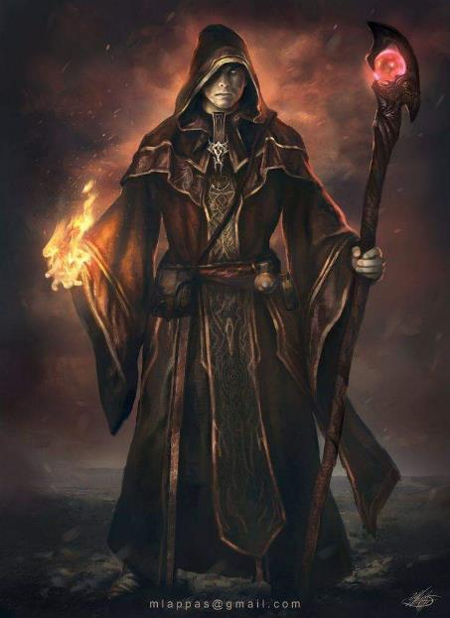

The Baron continued, “The Baronial Authorities shall now open the Four Gates, and all carnies... ehem...” the usually eloquent Baron corrected his vulgar reference, “all itinerant entertainers and merchants are to now proceed towards the gate through which their respective wagons and personnel entered. Attempting to exit through another gate will result in you being turned back, plus a fine of 10 GP per person for delaying the processing.”

There was commotion as the Baron pushed himself back from the balcony and waved to the crowd, “I rest assured that order will return to Mintar, and we can then resume the lifestyle for which our city is known.” He then receded into his chamber once more, joined by all those with him at the threshold.

The slip of the tongue by the Baron caught Barkley’s ear as did the two cloaked figures behind him. That was a slipup that the Baron would not make in his right mind. Barkley also looked closer at the two in the cloaks, trying to identify any emblems or symbols. He was unsure if they were clergy or possibly warlocks of some kind. They certainly had the uniform robes of a clergy of some type

“We need to leave, now,” Saradette said to her companions. “Otherwise, we’re stuck here.”

Barkley turned to Saradette, “Do you mean the Keep or the city? I believe we must look into what has happened here. Laryssa came to us and I believe she meant for us to restore order here.”

Saradette gazed up at the archon for a moment, and then the gnome shook her head slightly. “I suppose I can’t ask you to go against your nature, can I? Fine, we stay. I don’t like it, mind you, but I’ll cooperate.”

Barkley smiled at Saradette as he placed his hand on her shoulder. “I do not like it either, my friend, but I am glad *you* will be here to help.”

Saradette placed her hand over his. “Oh, who am I to turn down a handsome archon, hm?” She smiled up at him in genuine amusement punctuated with a wink.

Barkley smiled back, glad to have Saradette and his other friends close by during this time of chaos as his beliefs in Law and Order seemed to be tested.

“Berkley!” someone mispronounced the archon’s name.

The familiar voice made his made stand on end, and he quickly turned around to hide it, his tail wagging against Saradette as he greeted back, “Three-Fangs-Then-Purr.” He not only got the name right, but pronounced it like he might have pronounced Mayaheine of Celestia.

She giggled at the formality, “Woo! You remembered all that. 3Fang is the handle on my handle,” the would-have-been-a-bard-but-didn’t-have-the-money-for-a-guitar type of heroine half-joked, then showed the handle of her sabre, which did indeed read “3Fang”. She then turned it around, showing that the other side read “Mercy” and added, “And the handle of my blade is Mercy, as you can see on the other side of the mercy.”

Luran was taken aback, wanting to comment on the double-entendres in as flowery a way. He liked this one, though not in the way that Barkley was gunning for her. If one looked closely, one might see crosshairs in the archon’s eyes, and all who stood closely now began to smell the somewhat sweet scent of Barkley’s musk glands perspiring.

“Quite the character with your blade being both balm and bane, miss.” Luran’s expression was welcoming and inclusive, glancing at Barkley as the bard attempted his best “wingman” attitude. He could sense the archon’s interest and excitement and aimed for assistance rather than obstacle with the tabaxi.

“What’s your take on all this mayhem and upheaval?”

Barkley smiled at the Tabaxi as Luran spoke. The double meaning, though, did seem appropriate. Even the merciful still needed to defend themselves after all. He waited for her reply, he was interested in her input on the situation.

Saradette rolled her eyes and shook her head. She clamped her mouth shut, fanned away some of the musk, and watched the mating display.

3Fang was actually quite tickled at the bard’s return of her figurative birdie, and entertained the question, “My, uh, scientistic oversight? Overview?” the woman half-joked to make niceties in the company of strangers, but they could tell she was uneasy, and studying the heroes with the intention of taking them into their confidence. As they made their way towards Westgate, the tabaxi waited for the cluster of familiar folks to be isolated from unfamiliar ones, and provided her diagnosis, “The Baron’s lost his wits. With the wystes and other chaotic assailants besieging the city, I’d have to guess that demonologists are back of all this, but…”

The others looked at her as if to say, “Yes? Continue.”

3Fangs allowed a pair of children to run by them as they chased one another and then went on to say, “Someone was telling me that wererats are characteristically lawful, so that kind of blows my theory out of the water. In any case, where there is madness among the affluent, Evil is likely involved. When madness befalls the downtrodden, it is merely apathy that is to blame.”

Barkley did add one final thought that had been brought up before, “It could be possible that the forces of chaos are using the forces of law in order to gain their advantage and sew confusion.”

“You speak cultured... like a philosopher,” Luran pointed out.

“I am a warrior of Tempus,” the tabaxi proclaimed. “My philosophy and my art are one.”

“Ah,” Barkley was trying to contain himself, liking the gracile woman more and more.

“Ye, gods,” Saradette muttered. She took a breath, and addressed the group at large. “All right, so what do we do now?”

Elsabet was deep in thought as they walked and the others talked. She wasn’t sure what the proper path was to untangle this mess. It was a quandary....

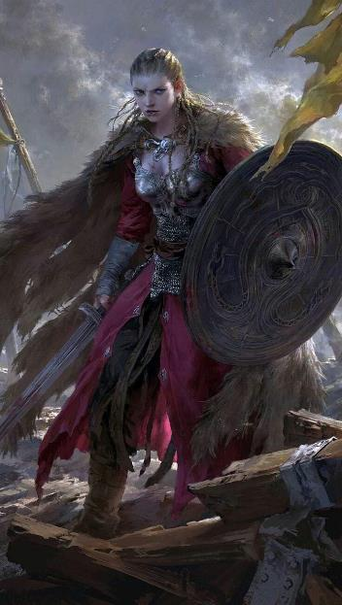

Perhaps the Goddess would provide some inspiration. For the immediate future, she thought carrying out their assigned task might suffice. She pondered whether she might be able to get access to the Baron and his ‘advisors’, perhaps with help from her new friend the Lieutenant Captain....

Solstice noted her composure as they walked, and at one point when she and Barkley were close together, the rogue hopped from the archon’s shoulder to Elsabet’s. “I’m not able to *detect thoughts*, but,” he looked back towards the Baron’s Keep, “the heart of this matter has to lie back there. Either that’s not the Baron, or there’s a malfeasant force corrupting him.

She nodded nonchalantly as the others talked and got to know 3Claw. If some force of Chaos was the true motivating force of all this disorder... perhaps the surviving wererats could be convinced to turn on those who had manipulated them. Could they be convinced to become allies in return for being exiled rather than executed? It was a distasteful thought indeed.

Solstice remained quiet while on Elsabet’s shoulder, hoping she wouldn’t mind him shielding himself from the sun under her golden locks.

Barkley really was still an adolescent, wasn’t he? Mayaheine knew she had passions of her own, but she would not be a slave to them. She rolled her eyes, and bit back the temptation to suggest the archon, tabaxi and gnome get a room and get it out of their system. The somewhat feylike bard was looking handsome and talking pretty though. She inwardly laughed at herself, muttering “down girl” under her breath.

A trio of Baronial Guards ushered two skimpily dressed elves—one a man and the other a woman—bearing spiked iron pillories around their necks. They were both muzzled, suggesting that they were spellcasters, and they were all headed right back to the Baron’s Keep for processing.

As she walked and ruminated, Elsabet wasn’t ignoring the streets around her, staying alert for signs of trouble. She looked to Barkley, who noted the smell of wererat as the garroted captives were led east and the heroes walked west. The archon nodded to the crusader’s unspoken question. The processing had already begun.

Once Elsabet had realized their badges gave them leave to openly bear arms, she had slipped on her spiked knuckles. They looked cool. She missed Laryssa, but was happy the paladin’s spirit was serving the Goddess still.

Too many thoughts ran around in circles in her brain. Focus, girl, she thought.

~*~

They’d arrived, and were being stationed along several parts of the checkpoint. There was already a considerable flow through the gate, and as Baronial Guards and deputized civilians collaborated in the search of three or four wagons at a time, usually another wagon had just been cleared and was exiting at any given time.

A woman in with the decorations of a Colonel-Priestess—the highest rank displayed anywhere in sight at the moment—and likely the holy scriptures of some deity was directing the armored women and men with black and red armor, still off-the-shelf shiny.

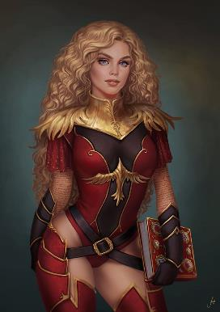

Solstice detected Divination magics emanating from her eyes, which was to be expected for her, and as they came closer, the musteval detected what was likely a *zone of truth* area of effect where three Guards were now questioning a dwarven woman.

Barkley was not detecting any Evil auras around him within the 60’ range of his ability, nor was he smelling anything ratty at the moment. As he and the others checked in with a scribe standing next to a vigilant, pallbearing squire, Barkley and Elsabet were instructed to speak with Colonel-Priestess Petrovski, while Luran was asked to provide more information about his talents. It was determined that his role would be among the frontline Guards, speaking to those who were approaching the gates and making initial assessments as to likelihood of lycanthropes or other evil beings. As he went to do that, Saradette and Solstice were positioned above 20’ up, each along a different machicolation under the crenellations of the two towers that ensconced the Westgate.

Barkley and Elsabet approached Colonel-Priestess Petrovski, likely a cleric-wizard of Azuth, based on the regalia and lack of a martial weapon on her. She has just cast *cure minor wounds* on a young boy whose arm had been lacerated when he fell out of his parents’ wagon. The wagon in question had just been cleared, and the parents bowed and thanked the healer as the boy ran into his father’s arms and they resumed their place in the exodus queue.

Elsabet and Barkley presented the papers they’d just been given, and the woman half-smiled, notably weary as were most of the full-time Guards. “The Barony is grateful for your sacrifice,” she reacted only to what she knew, which was that they’d volunteered for today’s task, and that they were deputized; little did she know what they’d done for the city in the last two days to earn those badges.

“I love it! I looove it! I looooooove it!” a jovial, burlesque courtesan joked with her friends as they stood by and watched some of the younger men of the carnival pass by bearing lickable pecks and biceps. Saradette noted from her lofty hidey hole

Barkley and Elsabet joined the Baronial Guards at the bottleneck of the checkpoint where wagons were diverted to four tracks for inspection. They were instructed to man the second track from the west, and barely noted Saradette and Solstice up in the machicolations above them as they took their positions and began to inspect the wagon there. 3Claw had been dispatched to the easternmost track, and made eye-contact with Barkley—smiling shily—as the wagon between them was cleared and exited the city.

3Fangs allowed a pair of children to run by them as they chased one another and then went on to say, “Someone was telling me that wererats are characteristically lawful, so that kind of blows my theory out of the water. In any case, where there is madness among the affluent, Evil is likely involved. When madness befalls the downtrodden, it is merely apathy that is to blame.”

Saradette glanced toward their inn. “Oh, I forgot something.” The artificer hurried off to collect her flechette gun, the pump, and her ammunition, and then she returned to the group.

~*~

Later...

The sun was bright, and so Saradette had sought shade while she watched the proceedings from the gatehouse’s upper reaches. She’d been working out her latest creation in her mind when her keen ears caught the soft clink of metal on stone. Curious, she rose and went to a part of the inner wall that was somewhat hidden by the gatehouse and the structure of an adjacent buttress that housed an onager atop it. There, a small grapnel hung from the rail, and the taut rope attached wiggled as someone climbed up. The artificer shrank back into the shadows and leveled the flechette gun at the grapnel.

A moment later, a blonde head peeked up over the rail, and then a slight form, clad in gray, followed. As soon as the stranger’s feet hit the floor, Saradette spoke. “Not another move, or I will turn you into a cheese grater.” The figure squeaked and turned, and Saradette saw that it was a young teen girl with greenish skin, but the features of a human. Or, mostly human. Her ivory tusks also gave away her orcish blood. “Don’t kill me,” she whispered urgently. “I have no weapons.”

Saradette stepped out, her weapon still leveled. “What are you doing?”

“What is that?” the girl asked.

“My cheese grater. Answer me.”

“Huh. I need to get out of the city, but the guards won’t let me.”

“And why is that?”

“I, uh, took something.”

“Keep going.”

“Okay, look, none of these people like me. I had an, er, arrangement with one of the guards, and the bastard stiffed me. I took his purse and ran. Now, he and his buddies are looking for me.”

“So, give it back.”

She sighed. “I can’t. I used the money for clothes and supplies so I can leave. Let me get my pack.” At Saradette’s nod, she pulled on the rope and brought up a backpack with a pair of sheathed daggers tied to it. “All I want to do is leave.”

“I want to see everything you’re carrying,” Saradette replied. The girl unloaded the pack, and turned out her bag and belt pouches. When she was done, Saradette saw that it was only mundane items, including a sad pile of copper coins. She pulled out ten gold coins and added them to the pile. “Pack it up, and let’s go.”

“Go?”

“Bring that rope, and be quiet.”

The artificer had noticed a blind spot in the outer wall, and so she led the girl there. “Get down, and I’ll drop your grapnel. We never saw each other. Got it?” The girl nodded, and Saradette waited until she’d clambered down the rope. Then, she unhooked the grapnel and dropped it over the wall. As she watched, the girl crept along the wall to a place where the road ran close. From there, she blended into the throng leaving the city and vanished from Saradette’s sight. Saradette smiled, and went back to her post.

~*~

Barkley had gone through several wagons and had yet to find anything unusual or that had triggered his senses. As he nodded to the guards to let the last wagon through, something caught his eye. The driver of the approaching wagon seemed a bit nervous and on edge. Barkley had seen others that were nervous, but there was something different about this driver.

As Barkley approached the wagon, he turned to the guards he had been working with and whispered a ‘message’ to them. “I have a bad feeling about this wagon. Be ready but remain calm.” The guards all simply nodded and did their best to act as if nothing was out of place.

“Good day to you good sir,” Barkley said as he began to pick up a source of evil emanating from the back of the wagon. “We will need to search your wagon.”

“Vvvvvery well,” the old man at the reigns replied, “I got nothin’ to hide. Me wife and grandson are in tha back along with our belongins.”

Barkley nodded, the aura he was detecting was not coming from the old man, so Barkley cautiously moved to the back of the wagon. When he got there, he noticed an old woman and a young boy. They were both sitting atop a chest in the back of the wagon. The aura became stronger and centered on the old woman sitting with her arm around the boy who was about 5 or 6 years old.

“Good afternoon ma’am, and young sir. I will need you both to step out so we can search the wagon,” Barkley said in an even tone.

As the boy started to move, the woman’s grip on him got a little tighter. “I’m tired son,” the woman said, looking at Barkley, a glint in her eyes that did not fit her old and fragile exterior. “Can’t you just make your check and let us go.”

Barkley looked from the woman to the boy. There was a twinge of fear and pain in the boy’s eye. Barkley slowly climbed into the back of the wagon, “Very well,” he said as he began to pick up the scent of a wererat under the other strong odors coming from the back of the wagon. It had been well covered until he got close enough. With his muscles tensed and his senses on edge, he moved closer. Then, with a quick motion, he grabbed the boy and spun, tossing the boy to a couple surprised guards who caught him awkwardly. As Barkley completed his spin, he pulled his silvered axe. The woman shapeshifted, becoming the wererat that she was.

However, before the wererat spellcaster could cast its first spell, Barkley’s axe came around, cutting right through the vile beast’s throat. As it grabbed its throat, Barkley finished it off with a return stroke that bit deeply into the beast’s chest. As the wererat crumpled to the floor of the wagon, Barkley grabbed it by the back of his cloak and dragged it to the end of the wagon, tossing it out onto the ground. “Take this trash away and burn it,” Barkley told the guards that looked up at him. With a quick check of the wagon, and with help from the old man, Barkley discovered that the chest belonged to the wererat. The chest and its contents were set aside to be gone through later or turned over to the Baronial Guard when they had time to take it away.

*[As a reader, I’m left to wonder about the nature of the man in the front of the wagon who is now helping Barkley. Is he a neutral-aligned conspirator fooling Barkley, a victim who had to keep quiet, or was he completely unaware of the woman being an evil lycanthrope?]*

~*~

Elsabet performed her duties as required, while seemingly still a little distracted by her own thoughts. To keep herself from getting too lost in her own head, she chatted not just with the people leaving town but with the animals as well, doling out occasional treats, making sure none of the draft animals had been abused, asking if they had noticed anything unusual, and so on. After a while the guards got used to her eccentric behavior.

A few of wagons even had pets traveling with the families on the wagons. On one wagon, a large tabby cat sprawled on the driver’s bench beside a grizzled farmer who’d been stuck in the city after unloading his vegetables. Elsabet greeted the feline as though he were a prince, because she and the cat both knew which was the superior being.

“Oh, most noble of cats, he of the sharp claws and keen senses, guardian of this mere mortal man, have you any information to share? Have you seen anything unusual that might help us defeat the scourge of ratmen that have caused havoc these last few days?”

“Well,” the tabby replied, “I am no fan of rats, nor ratmen either.” He licked his paws. “But I don’t see as how it is any concern of mine.”

Elsabet smiled, and reached into her Haversack - yes, she had remembered correctly! She pulled out a bit of catnip from her assortment of treats, and said, “How about a trade—a bit of a treat a bit of your great wisdom?”

The tabby shrugged, and said, “Well, I suppose that will do well enough. That wagon just ahead, that the guards have just cleared? There was a big black dire rat hiding in it. It slipped off the wagon a little while before it reached the guards, and has been ‘sneaking’ over towards that part of the wall.” There was obvious disdain in the tabby’s voice, as he gestured with one paw. “I don’t think it is just a rat, it doesn’t really move quite right... now how about handing that bit of tasty on up here?”

Elsabet handed the catnip up to the cat with a polite nod and said, “Thank you, you have been most helpful.” She then sprinted in the direction the tabby had indicated, and sure enough spotted a black dire rat starting to climb the wall.

As the startled guards stood still in brief shock, as soon as she got within range of the dire rat, she let loose with her deep slumber fey spell-like ability. She managed to avoid getting any other creatures in the effect, and luckily the rat failed to resist, slipped and tumbled back down to the ground.

“Wererat, I believe,” she said, as the guards came up to place the dire rat under restraint. Sure enough, when Barkley focused his detect evil on the creature, it was indeed evil. Later when forced to resume humanoid form it was determined to be one of the wererats the group had fought early on.

~*~

Luran was steadfastly passing the time, doing initial assessment interviews for the exit checkpoint. He was able to offer pithy, if occasionally saccharine words to the more bedraggled and trial weary of the passers. With only occasional exceptions, his first impressions of the travelers all checked out.

About midway through one particular hour of investigator duty, the sometimes little observant bard was able to pinpoint a particular pest to the city. A single traveler had gotten his figurative antennae quivering. Hooded and hunched, they immediately seemed suspicious. As he did with every group and individual who had come through his station and the other initial interviewers, Luran greeted the cloaked humanoid with a smile.

“Hallo, good citizen! If you’d do the kindness of pulling your hood down and answering a question or two of general consequence.”

Halting a pace or two away from the bard, the figure pulled back the hood, seemingly revealing another half-elf of dark haired persuasion. “I worked as day laborer for the big tent at the carnival. They done forced us out.”

The shabbily dressed but strong-backed looking older man’s story was one Luran had heard a handful of times, already. The bard was just about to pass him on when something about his demeanor didn’t vibe the same as the previous conversations. He subtly offered the pre-arranged signal to the next-in-line investigators of someone worthy of closer inspection. Seeing the return signal given, Luran turned back to the line and his next conversation.

A few minutes had passed when the sounds of a scuffle broke out from the next station. The half-elf whom Luran had flagged was revealed to be a disguised, runty krinth rogue who had been a lonely survivor of the prior night’s troubles, hoping to escape the city in cowardice. Flushing with a tiny bit of pride that his attentions had successfully caught a problematic agent, Luran confidently returned to his due diligence.

~*~

All in all, it had been a well-earned medal of commendation for altruism that they each received from Colonel-Priestess Petrovski, who seemed a nice enough person despite the fatigue. She’d mentioned finally being able to get some sleep tonight, and congratulated the heroes on their respective heroism.

They’d been at the Westgate all afternoon, and during those five hours or so, much had changed that the heroes had not seen at the bottlenecked, western periphery of the city. Quarters had been walled off with makeshift materials, and some areas were already being separated by *walls of stone* cast by those who had the means to do so. They noticed this as they made their way back to the Minotaur, and saw that the Southspur was now only accessible by a narrow defile in the palisades of debris that had been placed along the street that separated the Missing Minotaur from the house across the street where the wererat boy had been arrested.

“What on Faerûn?” Solstice rhetorically blurted.

“The Baron’s people have been busy,” Barkley noted.

By the time they got back to the inn, the Radnars were standing outside, witnessing the continued bustle along their familiar street, though all carnival wagons were gone by now. They shook their heads as the Fist of Light approached. Mrs. Radnar looked like she’d been crying. Saradette did not see her wagon, pony, or racoon. Hurrying her step until she was within speaking distance, she was about to ask the obvious question, but Mr. Radnar Radnar III beat her to it, “They’re out back. I had to hide them.”

Barkley was concerned at first, especially after seeing the drastic measures being taken in town. However, he relaxed when Mr. Radnar said the wagon was around back.

~*~

The back courtyard was shielded from the light by wooden beams covered by palm leaves, and the pony and cart were peacefully resting there as the racoon came out, sniffing Saradette and the others. The reunion was a very memorable moment as the gnome reunited with the two animals, rubbing the pony’s head and the racoon’s back at the same time.

“Okay, Widget, I know I left you here. It’s dangerous out there, and we’re not traveling, okay?” She turned to Gadget. “Here’s a carrot, Sweetie. Look, I promise we will leave as soon as we’re done here. Widget, I want you to climb up where you can see what’s going on. If there’s danger, you have to hide Gadget and yourself, okay?” Saradette double checked the locks on her cart, and made sure it was locked to one of the stable’s posts with a chain. The bonds could still be broken, she knew, but at least they would discourage pilferers.

As Saradette tended to the animals, Barkley also took a moment to stroke the pony’s back after he gave the raccoon a piece of jerky.

They spoke for a minute or two about what had happened, and it was apparent that, “the Barony of Mintar was still not rid of its internal menaces, so mercenaries have been hired to help the Baronial Guard keep the peace. The quarters are quite literally being quartered,” Mrs. Radnar said as her somber son came out of the back with some blankets.

“Ah, son, take those up to the heroes’ room, and bring the old ones back down, will ya?” Mr. Radnar bid the boy, who forced a smile and did as he was told.

“A lot of his friends live across the street,” explained his mother. “He’s worried that he’ll be unable to see them.”

Barkley nodded, “Perhaps, if there is time, I can instruct young Mr. Radnar in the use of sword or axe in self-defense. Perhaps even some work with bow and arrow?” Barkley looked at the young lad for his reaction, which was a half-hearted node as he continued up the stairs with the blankets. Things were certainly a mess.

~*~

Elsabet had been deep in thought for a while. She had declined dinner, asking the Radnars only for a pot of boiling water for tea, and a suitable mug to drink it from. She got out a packet of her favorite Zakharan tea blend for Mrs. Radnar to steep in the water. “But first I need to wash the day’s grit from my skin, while the tea is being prepared.”

She went to take a quick bath, changed into a clean outfit, and returned to get the tea, asking Mrs. Radnar for a potholder to rest the pot of tea on. “I’m going to attempt a meditative ritual in our room,” she told the others, “and I would be pleased if any of you, my friends, wish to join me too, if nothing else, observe me trying to be still.” She took the pot upstairs, hoping that her friends would follow.

Once in the room, with the door closed, she smiled at them, and started to explain, while drinking her tea. “It might take a while, and could be rather boring and fruitless, so it would be fine if not everyone wishes to watch, or if some of you watch for a while and then decide to leave. I ask only that you try not to interrupt, and make sure nobody else interrupts. If Luran were to play a soothing melody, that would be most appreciated. Feel free to place yourselves where you will.”

Continuing to drink her tea as she began preparing her improvised ritual, she told her friends what she was going to attempt, first clearing a space on the floor and making sure no flammable rugs were there, then sitting cross-legged on the floor with her haversack beside her, the pot of tea resting on the potholder on her other side.

She pulled a scroll from her belt, checked that it was the correct one. “This is one of the scrolls I obtained from the wererat fence’s shop. It is of a spell called *devil’s eye*. It is a 3rd-level spell, and evil by its very nature. I intend to destroy it with fire and to quench the fire with holy water in a sacrifice to the Goddess.”

She placed it on the floor. Reaching into her Haversack, she pulled out several other items—an iron cooking pot which she placed in front of her, 4 scented masterwork candles which she placed at the four cardinal points around the pot, a handful of tindertwigs, an hourglass, and a flask of holy water.

“I’m going to light the 4 candles, turn the hourglass, meditate upon the situation here in Mintar in the hopes of gaining some insight into what our best course of action might be to free the wrongfully imprisoned from captivity and the rightful ruler from evil influence. When the hourglass is about half run out, signifying the press of time, I am going to light the evil spell scroll on fire, watch it burn, and then quench the remnants with holy water.”

She smiled at her friends again. “If some of you wish to participate, you could sit by one of the candles and ask the good deity of your choice to give its blessing on this effort—I of course will be praying to Mayaheine, she whose favor I bear - and you can light the candle yourself. I will light this candle in front of me, which is the northern candle, representing the colder lands I grew up in.”

She moved the scroll into the pot, which should be sufficient to contain the flames, but if any sparks got loose she figured the rest of the tea could be used to drench them. She took a tindertwig and prepared to light her candle and any others thatcshe needed to. She began by casting Light upon the cooking pot with her other hand, which would last 40 minutes, 10 minutes past when she planned to burn the scroll. Then she turned the hourglass, said “begin” and lit her candle...

After having looked to his own daily hygiene, Luran assisted the ritual with his basic grasp of drum circle type percussion. His light tap and thuds upon a small tabletop to the side rolled under Elsabet’s meditations and quiet reflections. When the rite turned more active, the bard’s voice and its accompanying magic lifted the favored of Mayaheine’s divinely magical attempt to a higher level.

Saradette worked on her latest artifact until late into dinnertime. She then locked up her equipment, gathered her gear, including her flechette launcher, and went to her room. There, she changed into one of her shifts, and went to bathe. Next came dinner, and then she sat down with Elsabet. She lit a candle when instructed, and quietly observed the ceremony.

As they closed the windows of the room, locked the door, and settled into their newly washed sheets, the heroes began to feel the weariness of their bodies after the psychological tolls of the day’s events. They were in perfectly good health, relatively safe, and together, and that’s what mattered most.

Barkley did not think anyone should be alone, so while Saradette worked, he was in the yard not far away. For a while he transformed into a medium size dog and played ‘chase’ and tag with Widget until the two sat down and rested, watching Saradette finish her work.

At dinner, Barkley ate well and drank plenty of water. He thanked the Radnars for the meal before taking the time to wash up when he had time.

When Elsabet began her ritual, Barkley lit a candle as well, attempting to reach Tyr. He was hoping for his deities help both file Elsabet and perhaps some guidance as to what happened at the temple in town.

Just after the half-hour of sand had run through the hourglass, Elsabet reached out, grabbed a tindertwig, and used it to light the Devil’s Eye scroll carefully, watching it burn and making sure no fragments or embers escaped, and as it burned down to the end, she took the flask of holy water, thumbed off the plug, and used it to drench the ashes. It made a bit of a mess in the bottom of the pot, but she’d clean it out before going to sleep. She felt a sense of approval, as well as relief in doing what she thought right. She looked around at her friends, and thanked each of them for joining her and assisting in the impromptu ritual. She especially thanked Luran for providing music appropriate to the circumstances, it had helped her achieve true calm.

~*~

Barkley awoke, already panting, his mouth parched. His limbs shook, and mucus trickled out of his eyes, collecting and drying on the fur of his cheeks. He looked around, and noted no one around him. A foggy dew began to clear as a ground-level cloud passed him, and he could then see perhaps another 100’ around him, noting that beyond that were other clumps of nimbic steam that seemed to be seeping from the ground, which looked like it had been quite grassy until recently, though now all that remained were dry, beige remnants of a formerly verdant pasture.

Elsabet was in the same boat, or rather inside of a destroyed rowboat, complete with broken oars, in the shape of a scarab. She intuitively stepped out of it and onto the dry ground, wondering how long it had been since water flowed through the undulating hills decorated with steaming puffs all around her. She took note of what condition her condition was in, and it seemed infirm. She felt the weight of her armor and weapons—all on her possession—and found it difficult to balance.

Luran’s ears seemed clogged as he found himself standing upright; his vision was rendered myopic as he looked around, standing in a field of dry grass with nothing but his loincloth. In the distance, as a cloud rolled by to his right, he spotted Saradette lying on the ground, seemingly unconscious, but then lifted her head, and propped herself up onto one elbow, making eye contact with the bard from about 70’ away.

Barkley sniffed at the air, though it was unlikely to reveal anything more than he could already see. He hoped that even a faint odor might give him an idea in which way to head.

After a few seconds he decided that he would head into the wind, hoping he would pick up something soon. As he moved off, he made sure to keep glancing to his surroundings. He wanted to make sure nobody snuck up on him from any direction.

Drawing her bastard sword, Elsabet pressed it point down in the ground to brace herself until she could get her balance, settled into her leading the charge stance, and looked around for her friends. Not seeing them, with her off hand she drew her signal whistle and blew it. If her friends were nearby, perhaps they would hear it and reply; if not, perhaps it would summon a foe to battle.

The others instantly heard it, and as the clouds receded somewhat, the heroes could tell that the sun was high above them. As some moved closer to the whistle’s locus, they could see Elsabet standing near a wrecked rowboat. She was ready, even if a bit unsettled. If this was just a vivid dream, she would laugh about it in the morning. But if this was another real jaunt into the dreamlands, she was ready. Somewhat concerned about what might happen next, once she had finished blowing her whistle, she let it fall back to her breast and called upon the power of Mayaheine to cast protection from evil on herself, hoping the Goddess could hear her prayer.

“Oh, not again,” Saradette groaned. She stood up and took stock of how she was dressed, armed, and equipped.

Within a minute—or so it seemed—they had coalesced: Barkley, Elsabet, Luran, and Saradette. Solstice was not around, but as the mist of their dreaminess cleared from their midst, they spotted an armored figure emerging from a ticket of trees as the only clouds in sight were now high above them and to the heroes right as they turned towards the stranger whose height was at least twice that of Elsabet’s.

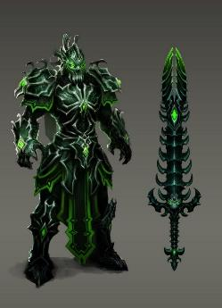

The masculine, heavily armored figure had been hefting a mean-looking sword on his back, and now walked casually towards the heroes, drawing the weapon while twisting his neck in anticipation of combat.

“He does *not* want to parlay,” Barkley was fairly certain, yellow-matter custard dripping from the archon’s eye.

Sniffling, Solstice noted that she had her handy devices—and even her cart—right behind her. They hadn’t been there a moment ago, but it was convenient to have her wares nearby; neither Widget nor Gadget were anywhere in sight.

The figure began to trot over to the Fist of Light, and they could tell by now that this was a member of Rasqueado’s band of ne’er-do-wells, or at least that’s what the distinctive armor and emblematic facemask suggested. The ghost was nowhere in sight, nor was his singing audible, but they suspected he was behind this.

“Steel yourselves,” Luran said, noting his spell component bag at his feet.

As it came closer, the heroes could actually see ghostly, humanoid shapes whirling around it in terror, as if trying to escape the gravitational thrall of the warrior’s massive form. It was truly a ghastly sight, even in broad daylight.

*Automatic success for all PCs, reducing effect to Shaken.*

*PCs suffer –2 to attacks, saving throws, skill checks, and ability checks.*

Barkley had already drawn and nocked back an arrow, and now released the bowstring, propelling the limber bolt towards the approaching figure.

|  |  |  |  |  |  |  |  |  |  |
| --- | --- | --- | --- | --- | --- | --- | --- | --- | --- |
| **Ranged Weapon** | **Dmg** | **D+** | **TH+** | **Critical** | **Rng.** | **Wt.** | **Atk** | **Roll** | **Check** |
| Composite +2 Longbow +1 | 1d8 | 3 | 1 | x3 | 110’ | 3.0 | +8 | 16 | 24 |

*Miss.*

*The scale on this map is 5’ x 5’ only south of row 13. North of that, it’s a lot bigger vertically, given the slope of the hill. Though the map shows the counter for H as being the same size of the Medium PCs, the NPC is actually Huge, and his counter will reflect that on the next round when he reaches the PCs.*

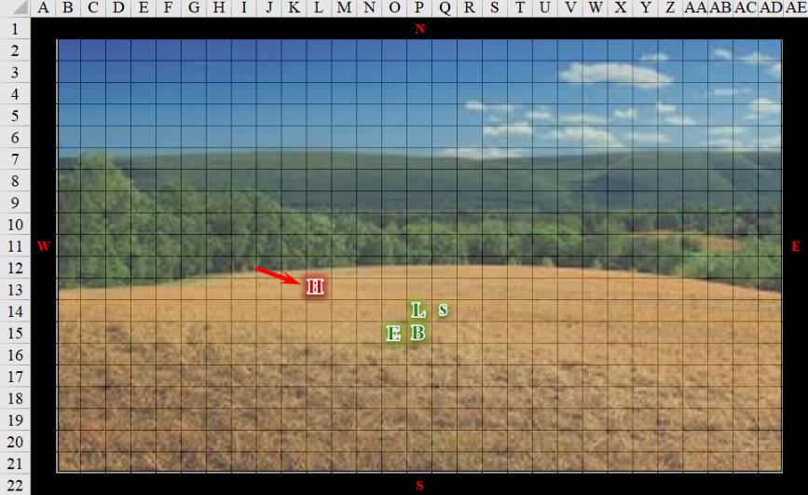

Round 1

|  |  |  |  |  |  |
| --- | --- | --- | --- | --- | --- |
| **Character** | **Group** | **Initiative** | **Roll** | **Modified Roll** | **Move** |
| Saradette | 1 | 3 | 15 | 18 | 20’ |
| Luran | 1 | 1 | 17 | 18 | 30’ |
| Barkley | 1 | 2 | 13 | 15 | 40’ |
| Hroth | 2 | 6 | 7 | 13 | 40’ |
| Elsabet | 1 | 4 | 4 | 8 | 30’ |

Saradette moved to her right, and changed her Shiftweave into the tan and brown ghillie suit in an attempt to hide and escape the giant’s notice as she flanked him.

|  |  |  |  |  |  |  |
| --- | --- | --- | --- | --- | --- | --- |
| **Skill** | **Rank** | **Ability & Mod.** | **Misc. Mods.** | **Total** | **Roll** | **Check** |
| **Saradette, Hide** | 5 | **Dex (+3)** | 4 | 12 | 6 | 18 |
| **Saradette, Move Silently** | 5 | **Dex (+3)** | 4 | 12 | 12 | 24 |

*See below.*

It appeared that the gnome was hiding in plain sight as the death giant focused his full attention on Elsabet.

Luran’s voice fairly crackled with menace as he began a dirge chant. A chant filled with steady rage and conviction to overcome. Though his usual inspirational tone was more positive, this moment brought out a frustration in the bard that wasn’t his norm. As his music attempted to lift his companions out of the dire impact of the charging juggernaut, he thought to himself. “Again, with these dreamscapes forcing our hand, causing us to leap on its strings. If this *is* all the work of that undead crooner, I swear, he *will* answer for it!”

*PCs gained +2 to AB and damage.*

Barkley, with his bow and an arrow ready, let loose with an arrow and quickly nocked and fired a second one at the closing figure.

|  |  |  |  |  |  |  |  |  |  |
| --- | --- | --- | --- | --- | --- | --- | --- | --- | --- |
| **Ranged Weapon** | **Dmg** | **D+** | **TH+** | **Critical** | **Rng.** | **Wt.** | **Atk** | **Roll** | **Check** |
| Composite +2 Longbow +1 | 1d8 | 3 | 1+2 Inspiration | x3 | 110’ | 3.0 | +8 | 3 | 11 |

*Miss.*

Hroth executed a charge-attack against Elsabet.

|  |  |  |  |  |  |  |  |  |
| --- | --- | --- | --- | --- | --- | --- | --- | --- |
| **Character** | **Attack Type** | **Damage** | **BAB** | **Str Mod+** | **W+** | **Total Score** | **Roll** | **Total** |
| Hroth | Greatsword +1 | 3d6+8+1 | 7 | 8 | 1 + 2 | 18 | 12 | 30 |

*Hit. Dmg: 9 + 2 charge + 8 + 1 = 20* *[28/48].*

Elsabet could see through the slits in the helmet, and suspected that she was confronting a death giant. She briefly thought about what she knew of death giants—it wasn’t much, but if this was a fully grown death giant, which it certainly seemed to be, she figured they were all dead. She shrugged. This had to be a dream, or rather nightmare. But that didn’t mean it wasn’t deadly... but perhaps this was an illusion! It had to be, right? As she thought that, she activated her anklet to teleport next to the thing and initiated her Foehammer strike, swinging her blade as hard as she could, trying with all her might to smash through what she hoped had to be some sort of phantasm or something, screaming “Not real!”

|  |  |  |  |  |  |  |  |  |  |
| --- | --- | --- | --- | --- | --- | --- | --- | --- | --- |
| **Melee Weapon** | **Dmg** | **D+** | **TH+** | **Critical** | **Type** | **Wt.** | **Atk** | **Roll** | **Check** |
| Bastard Sword +1, 1-handed | 1d10+1 | +2 | 4 + 2 | 19-20/x2 | Slashing | 6.0 | +13 | 15 | 28 |

*Hit. Dmg: 4 + 1 + 2 + 2 Courage + 7 Foehammer + 1 FC = 18.*

As mighty as death giants were reputed to be, the crusader could tell that she and the others were already wearing it down.

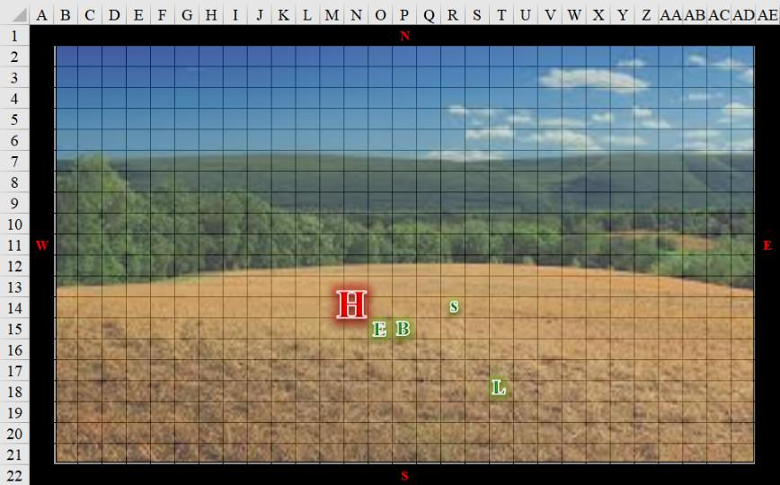

Round 2

The death giant beheld Barkley’s Aura of Menace.

|  |  |  |  |  |
| --- | --- | --- | --- | --- |
| **Character** | **Save vs.**  Aura of Menace | **Ranks** | **Roll** | **Save** |
| Hroth | Will | 11 | 2 | 13 |

*Fail. Hroth suffers -2 to AB, AC, and saves.*

Saradette attempted to move to further flank the giant.

|  |  |  |  |  |  |  |  |  |  |  |
| --- | --- | --- | --- | --- | --- | --- | --- | --- | --- | --- |
| **Melee Weapon** | **Dmg** | **D+** | **TH+** | **Critical** | **Type** | **Wt.** | **Atk** | **Roll** | **Check** | **Notes** |
| Short Sword | 1d4 | -1 | 2 + 2 | 19-20/x2 | Piercing | 1.0 | 5 | 18 | 23 | Sneak Attack 2d6 |

*Hit. Dmg: 3 – 1 + 2 Courage + 9 Sneak = 13.*

Luran continued to inspire the bunch by slandering and defaming their adversary. “He once even lost to a virginal, gnome boy! He’s our virtual homeboy! We kick him to the curb like an old toy.”

After the futility of his shot, which seemed to bounce off the giant’s armor, Barkley quickly put his bow back on is back then drew his longsword +1 and hand axe, preparing to take on the massive being.

|  |  |  |  |  |  |  |  |  |  |
| --- | --- | --- | --- | --- | --- | --- | --- | --- | --- |
| **Melee Weapon** | **Dmg** | **D+** | **TH+** | **Critical** | **Type** | **Wt.** | **Atk** | **Roll** | **Check** |
| Longsword +1 | 1d8 | 2 | 2 + 2 | 19-20/x2 | Slashing | 4.0 | +9 | ***20*** | 29 |

*Threat. 1d20 = 9 + 9 = 18, not a critical hit. Dmg: 6 + 2 + 2 + 1 = 11.*

Hroth backed up and attacked Barkley, who now seemed the greater threat.

|  |  |  |  |  |  |  |  |  |
| --- | --- | --- | --- | --- | --- | --- | --- | --- |
| **Character** | **Attack Type** | **Damage** | **BAB** | **Str Mod+** | **W+** | **Total Score** | **Roll** | **Total** |
| Hroth | Greatsword +1 | 3d6+8+1 | 7 | 8 | 1 | 16 | 16 | 32 |
| Hroth | Greatsword, 2nd Attack | 3d6+8+1 | 2 | 8 | 1 | 11 | 4 | 15 |

*Hit, miss. Dmg: 10 + 8 + 1 = 19 [26/45].*

Though worried about the power of the giant in front of her, Elsabet was greatly heartened to not only successfully strike the giant but to also see both Saradette and Barkley strike hard as well, the gnome taking the giant by surprise and the archon landing a solid hit as well—the gods were surely on their side in this fight!

The giant was huge indeed, but that could be to its disadvantage. Elsabet took note of her companions’ exact positions, took a 5’ step to her left, and then used the second and last charge on her anklet to teleport another 10’, placing her on the opposite side of the giant from both of her friends, giving all three of them flanking! The bonus to hit might well prove crucial, and giving Saradette another chance to sneak attack the giant was always a good idea.

She then summoned the power of the earth beneath her, initiating her stone vise strike with and overhead slash down towards the giant’s knee.

|  |  |  |  |  |  |  |  |  |  |
| --- | --- | --- | --- | --- | --- | --- | --- | --- | --- |
| **Melee Weapon** | **Dmg** | **D+** | **TH+** | **Critical** | **Type** | **Wt.** | **Atk** | **Roll** | **Check** |
| Bastard Sword +1, 1-handed | 1d10+1 | +2 | 4 + 2 flank | 19-20/x2 | Slashing | 6.0 | +13 | **20** | 33 |

*Threat. 1d20 = 15 + 11 = 26, critical hit. Dmg: (2 x 6) + 1 + 2 + 2 Courage + 1 Stone Vise = 18.*

|  |  |  |  |  |
| --- | --- | --- | --- | --- |
| **Character** | **Save vs.**  Stone Vise | **Ranks** | **Roll** | **Save** |
| Hroth | Fortitude | 14 | 18 | 32 |

*Success.*

The warlock-crusader-favored soul could tell that the adversary was nearing the end of its death-dealing existence, but it would take a few more hacks before that end was achieved.

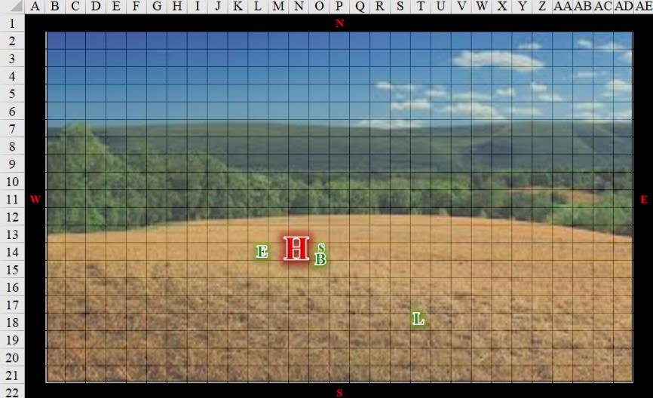

Round 3

Saradette dropped her sword, unlimbered her flechette launcher and fired a shot into the creature’s flank.

|  |  |  |  |  |  |  |  |  |  |
| --- | --- | --- | --- | --- | --- | --- | --- | --- | --- |
| **Ranged Weapon** | **Dmg.** | **D+** | **TH+** | **Critical** | **Rng.** | **Wt.** | **Atk** | **Roll** | **Check** |
| Sabot Launcher | 6d6 | - | 0 | 15o cone | 50’ | 5.0 | 5 | 15 | 20 |

*Miss.*

*[DM assumption]* Luran continued to declare and proclaim things as they were coming to pass, aiding his friends’ tactics and maneuvers.

After taking a blow from their large opponent, and seeming to be a potential target for its next attack, he opted to defend himself and taunt the beast. “Is that all you got! I’ve been bitten by flees harder than that!”

Hroth grimaced and full-attacked Barkley.

|  |  |  |  |  |  |  |  |  |
| --- | --- | --- | --- | --- | --- | --- | --- | --- |
| **Character** | **Attack Type** | **Damage** | **BAB** | **Str**  **Mod+** | **W+** | **Total**  **Score** | **Roll** | **Total** |
| Hroth | Greatsword +1 | 3d6+8+1 | 7 | 8 | 1 | 16 | 1 | 17 |
| Hroth | Greatsword, 2nd Attack | 3d6+8+1 | 2 | 8 | 1 | 11 | 17 | 28 |

*Miss, hit. Dmg: 7 + 8 + 1 = 16 [10/45].*

*Estimates based on Elsabet’s perception:*

|  |  |  |  |  |
| --- | --- | --- | --- | --- |
| **Character** | **Melee** | **Total**  **Damage** | **HPs** | **Current**  **HPs** |
| **BarkleyPD** | 35 | 35 | 45 | 10 |
| **ElsabetPD, PfE** | 20 | 20 | 48 | 28 |
| **SaradettePD** |  | 0 | 48 | 48 |
| **LuranPD** |  | 0 | 36 | 36 |
| **Hroth** | 76 | 76 | 89 | 13 |

Elsabet was pleased with her previous slices to the giant’s femoral artery. Seeing Barkley badly wounded, and sensing the giant was on its last legs as well thanks to her lucky slash, Elsabet used a swift action to activate her brute gauntlets, using all 3 charges to get a +4 to damage. She wound up and, initiating her crusader’s strike, slashed with great power as hard as she could at the giant’s groin/upper thigh area.

|  |  |  |  |  |  |  |  |  |  |
| --- | --- | --- | --- | --- | --- | --- | --- | --- | --- |
| **Melee Weapon** | **Dmg** | **D+** | **TH+** | **Critical** | **Type** | **Wt.** | **Atk** | **Roll** | **Check** |
| Bastard Sword +1, 1-handed | 1d10+1 | +2 | 4 + 4 Gauntlets | 19-20/x2 | Slashing | 6.0 | +15 | 6 | 21 |

*Miss.*

Elsabet grunted with the effort of her swing. Grimacing, she looked over at Barkley and thought to herself, he could die. Gritting her teeth, she attempted to tumble back around the giant to get back next to Barkley, where she could employ the shield block maneuver she was about to be granted to protect him. “Finish him!” she shouted.

|  |  |  |  |  |  |  |
| --- | --- | --- | --- | --- | --- | --- |
| **Skill** | **Rank** | **Ability & Mod.** | **Misc. Mods.** | **Total** | **Roll** | **Check** |
| **Elsabet, Tumble** | 1 | **Dex (+2)** | 1 | 4 | 17 | 21 |

*Success.*

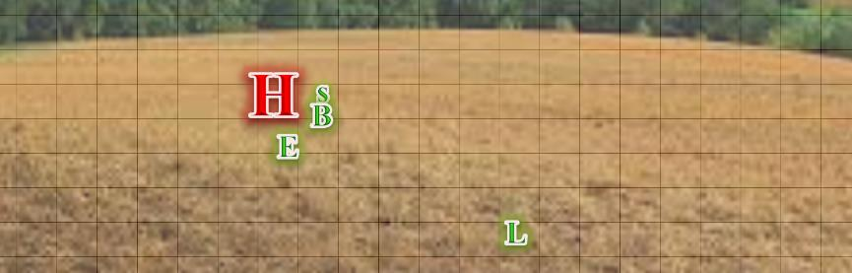

Round 4

Barkley, after taking another solid hit, growled and went into a full offensive attack!

|  |  |  |  |  |  |  |  |  |  |
| --- | --- | --- | --- | --- | --- | --- | --- | --- | --- |
| **Melee Weapon** | **Dmg** | **D+** | **TH+** | **Critical** | **Type** | **Wt.** | **Atk** | **Roll** | **Check** |
| Longsword +1 | 1d8 | 2 + 1 | 2 | 19-20/x2 | Slashing | 4.0 | +7 | ***19*** | 26 |
| Hand Axe | 1d6 | 2 | 2 | x3 | Slashing | 3.0 | +7 | 8 | 15 |

*Threat, miss. 1d20 = 4 + 7 = 11, not a critical hit. Dmg: 4 + 2 + 1 = 7.*

Saradette hissed in frustration as her first shot had no effect. She lined up her second shot and fired upon the giant.

|  |  |  |  |  |  |  |  |  |  |
| --- | --- | --- | --- | --- | --- | --- | --- | --- | --- |
| **Ranged Weapon** | **Dmg.** | **D+** | **TH+** | **Critical** | **Rng.** | **Wt.** | **Atk** | **Roll** | **Check** |
| Sabot Launcher | 1d6 | - | 0 | 15o cone | 50’ | 5.0 | 5 | 15 | 20 |

*Miss.*

Luran cheered the others on as the crucial moment of the lesser death giant’s death approached.

*[DM interpretation of intentions]* Elsabet did her best to finish off the creature while providing defense for Barkley.

|  |  |  |  |  |  |  |  |  |  |
| --- | --- | --- | --- | --- | --- | --- | --- | --- | --- |
| **Melee Weapon** | **Dmg** | **D+** | **TH+** | **Critical** | **Type** | **Wt.** | **Atk** | **Roll** | **Check** |
| Bastard Sword +1, 1-handed | 1d10+1 | +2 | 4 | 19-20/x2 | Slashing | 6.0 | +11 | 17 | 28 |

*Hit. Dmg: 3 + 1 + 2 + 2 Courage = 8.*

Elsabet usually slashed with her bastard sword, but as the heavily wounded giant bent down in pain from the gashes at his hamstrings and thighs, the opportunity presented itself to thrust the weapon directly into the death giant’s exposed neck, and she did so, summarily withdrawing the blade and allowing the towering form to collapse within its armor.

The field was quiet as Luran took a few cautious steps closer and slowed his cant’s tempo a bit, lowering his tone to a sweet lullaby that caressed the breeze as it blew by them with neither fog nor clouds in the midday sky now.

Barkley was only slightly satisfied with is last hit, feeling that it should have, somehow, been enough to take down the giant. However, he was glad that Elsabet was able to finish off the giant.

Taking a couple of steps back, Barkley sheathed his weapons and took a knee. He was about to pray to Tyr, but stopped. He couldn’t feel Tyr’s presence. Not that he had ever felt it in an overwhelming way before, but he had always felt something, but now, there was nothing. Perhaps it was this odd dreamland they were in or perhaps it was what happened at the temple in town. No matter the case, he was disheartened for a moment, but did not let it show to his friends. He did not want them concerned for his spiritual wellbeing, when his physical wellbeing needed more attention.

Elsabet could hardly believe none of them were dead. She stepped back next to Barkley, and laid her hand on his shoulder, casting cure light wounds.”

“Next time,” she said, looking over towards the forested area, “if we get sucked into another dream, don’t forget to aid yourself. That was close!”

The death giant’s armor was made of a mixture of adamantine another alloy that even Saradette could not identify. His sword was a massive thing that would have been unwieldy for any of them, but a ring worn over his metal gauntlets was about the size of a bracelet fit for a gnome wrist.

As Luran ended his song, he trotted over to join his companions, offering his own healing spells to the wounded archon, as well.

The hillside was now dry, and it seemed like hours had passed since they were in the midst of a dewy, hazy version of this place.

“Thanks,” the wounded archon said to the bard as the latter healed the former.

“You’re welcome, and thanks!” Elsabet replied to Barkley.

Though they’d arrived on this hilly place when it seemed to be a late, hazy morning, and they’d fought with the sun at its zenith, they now noted that the orb above was visibly migrating westward.

Saradette filched the ring from the giant’s gauntleted finger, and tried to identify it as she did her best to lift the sword with the intention of taking it with her.

After tending to his companions, Luran noticed the giant’s massive form was still a presence in the dreamscape. The intricate design of the armor the caught his eye.

Between Elsabet’s ability to *detect magic* and the bard’s honed intuition about these things, they were able to deduce that the giant’s armor had a warding signature to Barkley’s and Saradette’s mithral armor, though there was not a stitch of mithral on the giant’s suit of plate.

The ring—which could only have been worn by Saradette as a bracelet—was capable of producing goodberries, which the gnome accidentally triggered while donning it. Sharing the berries with the others, she set about to search the rest of the plated giant’s person.

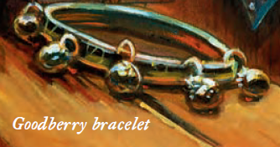

“Are there any buckled sections that can be removed?” asked Elsabet.

“There sure are,” Saradette had already been thinking to dismantle the suit in order to salvage most or all of it, but it would be quite a feat to haul a 15’ tall giant’s suit of plate back through a dream portal into their home plane... or maybe not.

Barkley thanked Elsabet and Lucan for their healing. He then began casting *aid* on everyone, including himself. Since this ‘dream’, or whatever it was, didn’t end with the death of the giant, Barkley figured it would be prudent to do so.

Saradette had half-forgotten about the unidentified ring that she’d found on one of the wererats the day before, and as she took it out to see how it looked next to the bracelet, Luran was immediately able to identify it (though he hadn’t the day before). “That’s a ring of *feather falling*!” he said, unaware that it was the same ring he’s seen while awake.

“Nice!” Saradette said, being the only one with fingers slender enough to warrant the wearing of the ring on any finger.

As others joined Saradette in the attempt to find loot on the body, they managed to find a parchment and the stylized etching of the unholy symbol of Ilsensine, which Barkley identified and Luran confirmed. “The dread deity of illithids,” proclaimed the archon.

“A death giant who worships the central deity of the mind flayers,” Luran looked down at the armored thug, realizing full well that the design of this armor and sword betrayed the selfsame craftsmanship as that which had forged the armor of the cleric, fighter, and dread necromancer in their previous collective dream. “Not sure what to make of that.”

“Rasqueado might be nearby,” Barkley had no cause to suspect this other than the link to this felled foe.

Having unfurled the parchment, Luran now parted his lips to summarize what he was now reading. “Our names are on this parchment, and a brief description of our likeness... this is a contract for our hides... ‘... and bring me back their pelts that I might confirm to our master their demise...’ apparently, this guy was sent specifically for us.”

“Ooh!” Elsabet exclaimed, let me make a copy of that for my journal. She pulled out her journal and used her amanuensis cantrip to do so.

After that, and after eating a goodberry, Elsabet took a moment to assess the health of herself and her friends. “Did anyone else need healing?” Seeing that they were all in good shape, she kept her weapon in her hand and looked about.

They continued to exchange a few more articles of information, and then Elsabet pointed out something in the midst of the treeline to their north. “Look at that...”

~*~

Solstice stirred in his sleep, and awoke with the sensation of limbs wrapped all around him. He struggled to free himself from the grasp as his eyes tried in vain to adjust to absolute darkness, and for a moment, thought he was free. As the undulating waves of despair in the form of Rasqueado’s voice penetrated the musteval’s subconscious, he suddenly found himself able to see that he was inside a torchlit cell with a single, barred window about 15’ above the ground, and a door big enough for a tall human to step through.

He was still pulling away at arms that were no longer grappling him, and he wondered just what in the Planes was going on. The ghostly bard’s voice was now discernible as it canted in Common, “Everybody yearns, everybody learns...”

The musteval drew his short sword, and looked about, then turned around to find his four friends—Barkley, Elsabet, Luran, and Saradette—with sunken, eyeless sockets staring squarely at him before the four zombified versions of his friends charged at him with frenzied unison and famished, toothless maws.

~*~

“Seriously?” Elsabet asked, confirming that the musteval was serious.

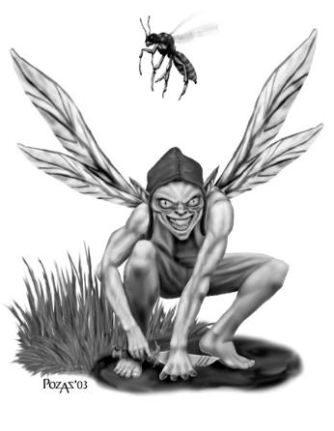

“I swear,” he recounted the first part of his dream, and followed it up with the summary of his short battle with an elusive, winged fey, and his quasi-illusory wasp familiar.

“I take it you defeated them both?” Saradette wanted to cross-reference the fidelity of their dreams to their current states.

“I did, though the wasp may never have existed,” the shrugging rogue admitted his lack of confidence in the interpretation of his dream as they ate amidst the Radnars’ mundane conversation on the other side of the main lobby of the Missing Minotaur.

Outside, the occasional accentuation of some altercation related to the barricade ensued and subsided, interspersed with the sounds of the now familiar seagulls and some bellringing vendor whose cart was stationed along the nearest corner. The temperature was slightly warmer than the morning before, though it was still overcast, and the air smelled of petrichor from a recent shower that had swept the city shortly after sunrise.