*Chapter 16: The Baronial Guard*

They’d stayed here several nights now, and as Barkley read the etched date—9 Tarsakh—on the lobby chalkboard, he noted that they should probably start paying the Radnars if they were going to remain here any longer. They’d been gracious enough, and with the purging of the carnival personnel from the city, and the obvious problem fomenting at the heart of the Barony, the team of five wrapped up the topic of their respective dreams, speculated on why Solstice’s was separate from the others’, and turned their attention to the breakfast that now came their way courtesy of Mrs. Radnar and her son.

Solstice wasn’t paying much mind to the food and the Radnars, being more immersed in the topic of the dreams, and of what to do today—pretty much now—about the Baron and whatever was transpiring within the keep. The illithid symbol that Barkley had just mentioned gave him cause for alarm, given how unexpected something like that was after their scuffle with the fervent agents of chaos, but then, what was an illithid if not a nefarious bender of law and order into sheer madness fit to exist only within chaos? If it were not for...-

The hairs on the back of Solstice’s neck suddenly stood on end, and though he had been quiet, he made his alarm evident to Barkley, whose mane also stood erect at the follicles for a moment as the archon and musteval turned to one another as nonchalantly as they could.

|  |  |  |  |  |  |  |
| --- | --- | --- | --- | --- | --- | --- |
| **Skill** | **Rank** | **Ability**  **& Mod.** | **Misc.**  **Mods.** | **Total** | **Roll** | **Check** |
| **Barkley, Bluff** | 0 | **Cha (+1)** | 0 | 1 | 15 | 16 |
| **Solstice, Bluff** | 1 | **Cha (+2)** | 0 | 3 | 11 | 14 |

*See below.*

They were likely able to fool the Radnars from the fact that they were both suddenly alarmed, and quickly turned their gazes to the food, smiling, and ooing at the yummy meal. The boy and his mother went back to the kitchen with the empty platters they’d just used to serve heroes their breakfast, and keeping a real-friendly-like façade, Solstice smiled, leaned forward and murmured, “Wererat.”

Barkley nodded, and said unrelated things a little louder, “My word, so scrumptious!”

The others were quick-witted enough to dissimulate the moment, and join in the feigning that all was normal. It was not evident to either Barkley or Solstice which of the two Radnars—if not both—bore the scent of rat or wererat on them, but it was something that they’d not caught a whiff of until this very moment.

Barkley looked over at the Radnars. “Young Radnar, would you care to join me for some archery practice after breakfast?” Barkley wanted to see if he could get the boy outside alone to determine if he was the one that they had picked the scent up from. If one of them had been infected, the others would be soon. They needed to put an end to it as soon as possible.

|  |  |  |  |  |  |  |
| --- | --- | --- | --- | --- | --- | --- |
| **Skill** | **Rank** | **Ability & Mod.** | **Misc. Mods.** | **Total** | **Roll** | **Check** |
| **Diplomacy** | 0 | **Cha (+1)** | 0 | 1 | 10ish | 11ish |

*See below.*

“OhnahIpreciatit!” the teenager slurred the phrase as if they were a single word, as was common for the youth of his social station here.

He then retreated into the back where his cot and belongings resided.

Barkley raised an eyebrow in curiosity at the boy’s response. He then began using his ability to Detect Evil and concentrated on the Radnar family, but there was no evil to be discerned.

Luran was able to realize something was odd with his companion’s behavior and it was decidedly focused on the Radnars. His less than focused eye wasn’t able to entirely deduce what was going on, but he sat at attention, waiting to see how things transpired, after the young lad’s departure.

Seeing no evil emanating from the father, mother, and son in the triad, Barkley went over the myriad possibilities. Solstice did as well, also noting that none of the Radnars were emitting evil auras, but that smell of wererat was unmistakable…. Granted, it could have been mundane rat. The kid could have been cleaning out the cellar of rat infestations. Other things were possible.

“What’s going on?” Elsabet whispered, sensing something was up but not sure what.

Barkley used his *message* ability and told Elsabet, “We could smell wererat on one of the Radnars, but I can detect no evil emanating from any of them.”

“Ah,” Elsabet whispered back. “Can your ability penetrate the doors and walls? Maybe try scanning in all directions, see if you can sense and evil nearby? Maybe there’s a fugitive hiding in the back? I will scan for magic as well.”

Elsabet leaned back, half-closed her eyes, and quietly concentrated on finding call the magic auras she could. Knowing her companions had magic, she noted those but focused on determining what she could from any magical aura not associated with her group.

Barkley nodded, and mouthed the words, “I shall walk around and continue my attempts to pick up the scent as well as any traces of evil.” Barkley then pointed at all of his friends so that he could speak to all of them and hear their replies through his *message* ability.

Once the suspicion was clear to Luran, he offered, “Invisible?” by way of reply.

Barkley’s right eyebrow went up slightly. He hadn’t considered that possibility. “That is a good possibility, and a dangerous one too,” he mouthed back to everyone. He then got up and began to head out of the room, following where the young Radnar boy had gone.

“Oh, what do you need dear?” Mrs. Radnar offered once she realized Barkley was nosing for something.

Barkley smiled at Mrs. Radnar, “Nothing specific,” he replied. “Just wanted to stretch my legs and perhaps get in some target practice out back.” He then realized that the boy had not gone out of the house, but to his quarters, which were beyond the short corridor that started behind the lobby desk.

The boy came out again at that moment with a fresh pair of sheets for one of the lower-level rooms, and said something to his mother about the lye in the vat being done before he passed by Barkley, nodding politely and with nary a tingle of evil in his eye, then entered the room directly beneath the heroes, placed the sheets on an armchair, and began to remove the old sheets from the bed therein.

It was him.

It may also have been his mother, but the scent was definitely on the boy’s person.

Barkley mouthed (using his *message* ability) “I still smell it on the boy. It may not be polite, but I suggest we confront him. I detect no evil, but he carries the scent of wererat.”

Barkley couldn’t help himself, and his legs impelled him through the threshold of the room. He again did not note any evil emanating from Radnar Radnar III, and thought to say something when his mother squinted, made an ooo or perhaps a w with her lips as if to ask something, then took a few steps closer until she could see that her son was well.

“I say, Barkley, you’re acting rather peculiar. Are you alright?” she asked as the boy turned around from making the bed, and then looked around him to try to figure out what Barkley was looking at.

Barkley looked at Mrs. Radnar, then to Radnar III. “I hate to be so blunt, but the situation in town calls for it.” Focusing on the boy he asked, “I need to know where you have been and if you have been bitten or scratched by a rat or possibly a wererat. I can smell their distinct scent emanating from you.” He did not move for his weapons, but did stand his ground. He would have preferred not to harm the child, as the family had been good to them. Perhaps a paladin or cleric could cure him if they acted swiftly enough.

“What?” the kid blurted. “I mean... I heard you, but...”

His mother’s gaze took on quite a different demeanor, as they might’ve expected with this news, and she looked back at the others at the table, then at Barkley, then at Radnar. “Son? Is this true?” She kept her gaze on Barkley, and did not give her back to the rest of the heroes for fear. Having heard the conversation, Mr. Radnar came out from the indoor privy, and with as serious a look as they’d ever seen on his mug, held a club in his hand and asked, “What’s all this about then?”

His wife recounted the interchange in about eight words.

Radnar looked at the Fist of Light and said with solemness, his voice trembling, “I know that your might can smite me in one blow, but if your hearts are anywhere but in the right place right now, I swear that I will go down in defense of my family this day!”

Mrs. Radnar’s urge to be near her son now superseded her fear of Barkley’s bite and swing, and she pushed past him in despair, entering the room, and going to her son. “Radnar, is it true? Tell us; we can help you before it’s too late!”

They all read nothing but sincerity in the three Radnars, and the figurative bloodhound that was Barkley was now at a loss as to which—if any—of them were better liars than he was a sleuth.

Solstice got up and walked over to Mr. Radnar with his palms out and kindness in his voice, “Radnar, we mean you no harm, but we’ve been working on this exact case for going on three days now. If he’s been bitten, I can assure you he’s not radiating evil, and can almost certainly be cured with little fanfare. I’ll personally spring for the bill.”

|  |  |  |  |  |  |  |
| --- | --- | --- | --- | --- | --- | --- |
| **Skill** | **Rank** | **Ability & Mod.** | **Misc. Mods.** | **Total** | **Roll** | **Check** |
| **Solstice, Diplomacy** | 0 | **Cha (+2)** | 2 | 4 | 20ish | ?? |

*See below.*

The next few seconds were tense indeed, with all eyeballs shifting to and fro, but in the end, Radnar lowered his club, keeping his grip warily tight on its handle, and took a few more steps closer to the threshold, “Son...”

The kid was completely bewildered by the accusation, and shook his head, “I’m not a fucking wererat, and I wasn’t bitten!” He began to remove his clothing, not really violently, but certainly with some resentment, knowing that these heroes were no one with whom to trifle.

By the time he was done, Barkley and Solstice were also in the room, having been somatically invited by the parents’ hand gestures, and the rogue could now tell that the smell was actually on the pile of clothing at the boy’s feet, and even more so on the sheets in the basket. The boy had been tending to the sheets of several beds this morning, and a wererat had very likely slept on one of the two beds in this room, likely the one that had been made earlier, which would have put a fresh coat of rat scent on anyone pressing these sheets against their chest before dumping them into the basket.

Barkley was taller, but as he bent down to follow his nose’s compass, he, too, came to the same conclusion.

“Who slept here last night?” the musteval asked.

The boy began to put his clothes back on.

“Whyyyy...” Radnar looked at his wife, “No one notable. Two merchants. This was their second night here. They checked out nary an hour ago. You’re saying they’re wererats?” Radnar did put his club down on the bed now, and held his wife and son, who were overcome with relief.

Barkley bowed and apologized, “I am glad my assumption was incorrect and apologize for the anxiety I have caused you. Had he been infected, I promise you we would have done all we could to cure him, or any of you, rather than harm you. I would not want to fight a father protecting his family. Now, though, we must find those merchants. Did they happen to mention where they were headed?”

The two adult Radnars looked at one another, shrugging, then the husband led the heroes to his desk, whereupon he opened his ledger, and noted the names Ghaerleth Axom, and Abzar Jennings. “I can tell you they were two human males, about my age, maybe a few seasons younger, and looked the Luran type,” he motioned to the pale-skinned, brown-haired, gracile bard in the kilt. “Like they’s from the North or West.”

It was then that Luran got a *sending* from Shoomma. “I missed you all last night. Was hoping to get a *sending* from you,” the telepathic note began, continuing with, “Please let me know you’re doing well.”

“We are well. The watch duty was successful. Sorry no dinner, last night. Today, a new mystery has us busy. Promise to check in, soon.”

“Gotcha! Talk to you soon!”

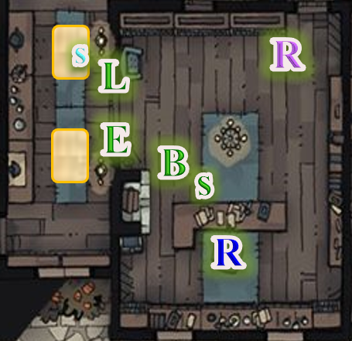

Fully dressed now, young Radnar, went back to making the second bed in the lower-level suite as Solstice returned to the table, grabbed a muffin, ripped off a hunk about the size of a cherry, engulfed it, grabbed a fried yam strip, and brought it back to the group with him, considering that to be the rest of his breakfast.

The others were now standing between the breakfast area and the lobby, and came closer to take a look at the ledger. Elsabet thought to cast *amanuensis* again, but decided on simply using Radnar’s quill to jot down the two names on her ledger of baddies at large.

She tried to study the penmanship of the signatures, but there seemed nothing peculiar or otherwise notable in them.

The Radnars asked, “What’ll you do now?” “What should we do if they come back?”

Barkley looked around and then asked, “I would recommend locking your doors when we leave. If they return, I would not let them in.”

“But the other guests...” Mr. Radnar protested as bugles could be heard blaring just down the street. Luran’s relaxed facial expression became a slight frown at the sound of the brass.

“I think he means we should lock them and stand by to open it for those who knock,” his wife clarified.

The eye slot hadn’t been used in years, and Mr. Radnar now went to the door, inspected it to ensure that it worked, and looked back at the heroes. “It seems we’re *all* barricading ourselves now.”

The mood was somber for a moment, and the heroes realized that they had become embroiled in something growing faster than a spiraling wildfire.

The bugles were a bit closer and louder as they began the same 12-second melody once again, after which a faint humanoid voice could be heard announcing something in a declamatory fashion. None of the words were discernible yet, but Luran shook his head almost involuntarily at the sound. There was nothing supernatural about it, nor was he under some form of magical effect, but as a musician, he was realizing something that would not likely have alarmed the others about the music that had preceded the crier’s words.

Barkley asked Mr. Radnar, “You don’t recall anything they said about any place or person here in town? We will need to find them and any detail you can recall would be helpful.”

“Agh!” the man tried to recall, shifting his gaze up and to his left to access sensory recollection, and frowned as he exhaled, “I-”

“They’re jewelers,” the boy’s voice startled them. “I overheard them talking about gems, using words I didn’t understand, but always about rhyolites and azurites and stuff like that.”

The unified steps of at least a dozen soldiers now reverberated rhythmically with another round of bugling, and this time, Luran moved closer to the front door to get a look at the infantry and pageantry passing by. At the end of the fourth 3-second bar, the crier’s clear voice announced, “Hear ye, hear ye! The Barony has triumphed over the threat! All culprits are now in custody, and the Baron will announce more good tidings at Highsun!”

They could all hear the announcement, but turned back to their discussion, all except for Luran, who waited for the cadence to be played again, just to get a sense of what on Faerûn was happening. Radnar III’s mother had stepped closer, and now asked him, “Did they say anything else?”

“I mean, nothing about where they were going, though they *did* say something about an artificer from the Dalelands,” Radnar III added.

“What?” Saradette blurted. “That’s me. *I’m* from the Dalelands,” she added what her friends already knew.

Luran produced his masterwork yarting, and began to arpeggiate the melody that the bugles had just played. “All well?” Solstice asked him, and he nodded with a diagnostic look on his face.

The rest of those present looked at Saradette for a moment until the boy spoke again, “No, I don’t think so. They kept saying ‘he’ and ‘him’. They were talking about some guy who had promised them more than they’d gotten, or... at this point I’m guessing... I don’t know. I didn’t think much of it. You know—Father—how it is with some guests; you’d rather not know.”

The father nodded and shrugged, offering only part of a refrain, “You try to run a clean business, but...”

Barkley knew full well how that sentence ended, having reluctantly served more than a few ne’er-do-wells in his time as a barkeep. Most of the time—he had to agree—one didn’t want to ask, and was better off for it by the time the bar closed.

Solstice could tell by divine and mundane means that the kid—indeed all three Radnars—were being forthright.

Luran was now playing the ditty in different keys as if studying its progression.

With the bugles now barely audible as the crier and his black-and-red-clad entourage continued heading westward toward Westgate, Mr. Radnar noted this, asked Luran if all was well, got a nod, and shut and bolted the door, stating with a sigh, “A wererat’s going to have little problem busting through *any* of our windows, upstairs or down. And we’re talking about shapeshifters here, right. How would we know it’s you if they imitate your likeness and come back here?”

Mrs. Radnar offered the heroes, “Knock three times and we’ll know it’s you.”

“Three times is a bit common, love,” her husband protested.

Solstice agreed, and proposed, “How about three knocks, a pause, and two more?”

“We’ll open for you then,” Mrs. Radnar said, adding, “As other guests come in—hopefully not lycanthropes—we’ll give them the code for future entry.”

“Easy, Warden,” her husband joked. “One step at a time. If this city has any heart left in it, we’ll root out the remaining wererats soon enough.”

“I’m not sure it’s that simple,” Elsabet—who had been mostly quiet all this time—shook her head, not sharing in Radnar’s sunny optimism on such a dreary morning.

“Luran,” Barkley had to ask, though the others had already checked, “This isn’t like you. What’s going on.”

The bard turned to them all, and with assurance now, he held the instrument down for a moment, only describing what he’d heard before mimicking it. “The general melody of those bugles... I’ve lived here for months, and have heard that cadence dozens of times. It’s changed.”

“Alright...?” Elsabet suspected more was coming.

He nodded to himself, and posited, “There’s a subtle change in the key. Listen: here’s the way it’s traditionally played.” He raised the instrument, and began harping the strings with his fingernails, producing a major scale resting on the root and fifth. “Right? Traditional warcry, battlehorn-type of sound...”

“Sure!” Saradette had heard such a thing across kingdoms; it wasn’t universal, but modal for sure.

“What we all just heard is this,” Luran said as he played nearly the same arrangement in a subtly different key. “That’s a 9th where a 7th would have gone.”

“What?” the Radnars all asked.

“Never mind,” Luran tried to paraphrase. “What I mean is: that use of the 9th to replace the 7th is unheard of in this part of Faerûn. It usually invokes the scales associated with Thayyan musical traditions, and others even further east, but they way it’s woven into the melody—and the fact that it’s being played with bugles—makes it sound authentically Mintari, or at least somewhat Western.” He played it again on the yarting, and the others could now hear the tones associated with musical temperament that—indeed—invoked in their minds only images of the Hordelands and the realms beyond.

“What do you make of it?” Barkley asked as they all converged on this topic, not quite forgetting about the other artificer referenced.

The bard said: “It points to a definite and unprecedented shift in cultural values within the Barony. I don’t know of any history of this in the city.”

“He’s right,” Radnar said, informally schooled in a few things, including local lore.

Luran’s face grew somber. “I wish I could say that’s my real concern, but that’s only the alarm that triggered it. The traditional Mintari criers’ cadence is played in the key of G.” He played it again as he had before, then said, “And again, this...” he played the changed note, “is the 9th in that key, but...” he shifted his hand’s position, what we just heard a minute ago was in the key of A, which contains notes that most bugles can’t usually play, so there’s something about the tuning of those instruments that’s a bit off.”

“And?” Elsabet could tell by now when Luran was and wasn’t done talking.

He nodded, making his way back over to the ledger on the desk, and adding only speculation now, “Some musicians—bards in particular—are very particular about the keys in which their pieces are played, and some have even snubbed others for playing arrangements in alternate keys.”

Solstice nosed the air, mostly with curiosity over where Luran was taking this. Luran looked down at the first of the two names from the guests who were suspected of being wererats. “Ghaerleth Axom. G to A.”

There was silence, and an air of implausibility around that last conjecture.

“And what of Abzar Jennings?” Elsabet posed.

Luran shrugged, “No idea. Maybe just some lackey shmuck, or maybe just a random name to throw off the authorities.”

Solstice sighed, “In any case, we know almost for sure that there are non-Mintari influences holding sway over the Baron, if the Baron even still lives.”

After listening to the exchange, Barkley knew there were at least three things, from his point of view, to look into. “I have three concerns to add to what Luran has given us here. First, the warning from Laryssa about this ‘Speaker of Dreams’ who has seemed to come after us twice. Second is Fitzroy Quentine, I would like to speak with him personally about that warrant he served across the street. Finally, we need to get inside the Baron’s court and find out who those two cloaked figures that were with him on the balcony the other day. I’m sure that somehow, all of them are connected. Possibly even connected to the two guests that we were just discussing.”

“It’s too bad we don’t have someone who can sneak into a place without being seen,” Saradette said with a lurking grin.

“And get through locked doors and such,” Elsabet replied with an answering smile.

Solstice turned to Saradette, and asked, “You mean me or you... or both?”

“Note, with dawn I got my fey stuff back, so I can use deep slumber once, to neutralize guards or something for several minutes, charm monster once to try to get someone to be helpful which would last days, and disguise self to appear to be one of the trusted leaders or inner cabal at some point, which would last just over an hour.”

I am better once the fighting started, Elsabet thought to herself—this intrigue planning wasn’t her forté. Barkley seemed to have some ideas, and Saradette seemed eager to test her skills, while Luran appeared to have found yet more evidence of foreign meddling... Then she thought of something.

“Don’t forget,” she mentioned, “we should also try to free the high priest of Tyr and others. Perhaps they will be less well guarded than the enemy leaders... and it is possible that the Baron is also imprisoned, and they have put one of their own in the Baron’s place as a figurehead - perhaps a doppelganger.”

Barkley nodded, “Then it seems our destination is clear. We head to the Baron’s Keep in an attempt to infiltrate it. Stealth and guile will be needed.” He looked at Saradette, Solstice, and Luran as he said the last sentence.

Just then a knock came at the door; three knocks, in fact.

The conversation came to an abrupt stop as Radnar walked over to the door, asking who was there. By the time his hand was on the eye slot and ready to slide it open, he’d heard the familiar voices of the couple outside. Recognizing them, he whispered, “Other guests, upstairs.” Everyone remained alert in case of wererats of other villainy, and Radnar unlatched the door.

The mood that the strangers brought in was comparatively jovial, and it was clear that they weren’t even aware of any tension in the room. To the two men—a dwarf and an elf named Yemishov and Kevraux, respectively—the Fist of Light looked like they were standing in waiting to check in or out, and as the two introduced themselves, and removed their hats, Radnar explained a little of the situation.

“So as long as the threat of wererats and the barricades stand,” the innkeeper concluded, “we’ll be minding the door from the inside. These good folks have been good enough to keep us updated on things,” he left out the part about them being part of the investigative taskforce, being smart enough to know how compromising that would be if these two guests were in on the nefariousness.

“Ah, well then you must not have been out yet,” Yemishov announced, more concerned than trying to show that the Fist of Light wasn’t up to date, “The Barony is announcing even now that the threat is over.”

Kevraux also pointed out, looking at his man, “And yet the barricades remain.”

The two looked at one another as if they’d been discussing a disagreement over whether things were headed back to normal, and Kevraux then shook his head, and said, “Folks, it’s been a long night; it’s time to retire.”

Barkley—the most sleuthy judge of character of the bunch—could detect neither evil nor magic on them, and their demeanor—like that of the Radnars—was indicative of no hidden malice. They smelled as if they’d been drinking, and had likely been less than pious, but there was no trace of ill will or even mischief in their weary mannerisms.

Luran also tried his best to find fault with the strangers, but found no cause to conclude anything wary. His horse sense for people told him that at least one of the men—Yemishov—was a landed aristocrat by birth. His beard had been braided by specialists, but months ago—it seemed—and some of its weave had begun to fray.

Saradette could tell by their leather clothing—really thin leather armor, really—the two were prepared to face off common thugs and muggers, but neither appeared to be a stalwart ruffian, and they were unarmed, as, by now, all civilians had to be.

The two men took the stairs up, and turned left, towards the side of the inn opposite the room occupied by the protagonists.

Elsabet had mostly listened to this series of conversations, and now, went over her notes, asking the Radnars if there was anything else worthy of noting.

“Not really, Elsabet,” the male admitted after the female had shaken her head while searching in vain through her recollection. “On the off-chance that they *do* return, I’ll keep my club nearby, but if you have any ointments or potions to buff it or me, I’d be grateful for the kick.”

Elsabet mulled over Radnar’s request for a moment. “I mostly have scrolls rather than potions, but might have a few things that would help you if things get hairy.

She pulled out her silvered spiked knuckles. “Wear these and you can punch werecritters effectively, getting through their weird resistance to normal damage. They don’t do a lot of damage, but some werecritters may just run away when they realize you can actually hurt them. They really don’t like silver.”

She started rummaging through her alchemical gear, and pulled out some items.

“I’m assuming you would not want to risk fire, but this flask contains a potent acid that can damage foul things. If you have to use it, throw it to smash on the target—might be good for the missus to have handy to throw. Watch out for it splashing back, and you might have to repair damaged flooring or whatever.”

By now, Solstice had produced his wand of *greater invisibility*, which serendipitously had three charges left. “Do you know how to use a wand?”

“Afraid not,” the Missus said, and the Mister shook his head.

Elsabet continued, “Then there’s this bag, it has tanglefoot goo in it which can cause a critter to get stuck to the floor or at least get slowed down, could give you a chance to get out of harm’s way while the critter tries to get free—it dries up and cracks apart after roughly half a minute.”

“Finally, this is a thunderstone; throw it against a target or a hard object and it makes a very loud sound that, out to about 10’ in all directions, can cause temporary deafness. If someone is a spellcaster it could mess up their ability to get their spells right, and cause some disorientation, etc.”

“I wish I had more to loan you, but even more, I pray to Mayaheine that trouble will pass you by.”

Solstice considered now many other innkeepers, barkeeps, shopkeepers, and residents were currently worrying about the same thing. They couldn’t help everyone, unless—perhaps—they put a stop to the source of this apparent madness.

Saradette had gone to take care of Widget and Gadget, and with that labor achieved, now took a moment to check her improved air pump and tank for the flechette thrower. She had forty flechette bundles left, and she determined that the device’s seals would last that long before she had to replace them. The weapon, pump, and ammunition went into her haversack, and she picked up an extra dagger in anticipation of her foray into the Baron’s Keep. Before she went back inside, she spoke to Widget. “Be careful of anyone who smells like a rat. They are bad people.”

With that, she returned to the inn, where the others were discussing all-out assault strategies countered with more inventive ruses involving masquerading as the Colonel-Priestess they’d worked with yesterday, and some random guard dog.

Saradette set her ale mug down on the table, and pitched an alternative caper. “Let me try to sneak in first.” She pointed at the musteval. “I should be able to do it, especially if he taps me with that wand first.”

“First order of business would be to get close and scout out access possibilities, right? We should find a place close to the keep where the rest of us can wait while you do your things.”

Saradette smiled up at her friend. “This is the part of my job that I have had little opportunity to actually perform,” the gnome reminded her. “It’s the essence of what I am trained to do. Widget will know where I am, and if I’m still alive or not.” Her grin morphed to a smirk. “Besides, if I get into trouble, the rest of you can pull off a heroic rescue.” She pointed toward the keep. “The place is right next door, and I can go in, see if the Baron is still alive, and be out all in a couple of hours.”

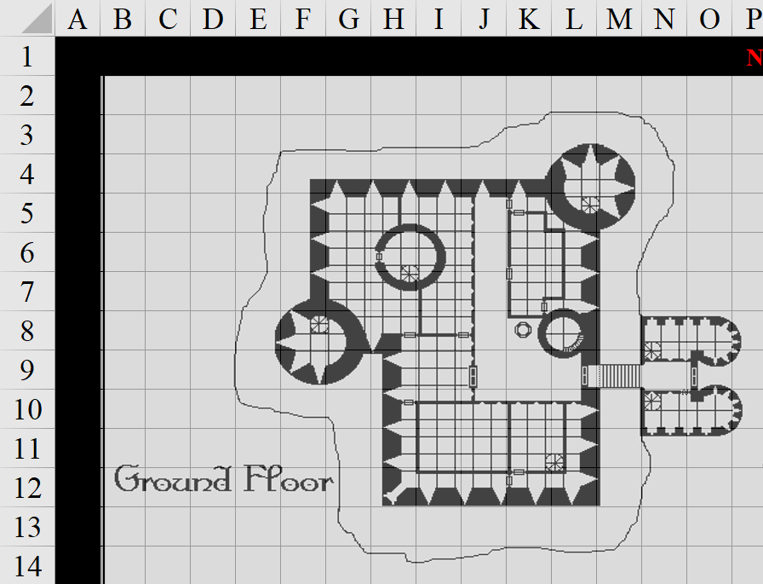

She had spent some time earlier this morning drawing up a schematic of what she knew to exist, and pointed out the known areas. “So the south wall is the balcony facing the courtyard, and the entrance is here along the east. We’ve been here in the central area, and in the barracks via the circular staircase that leads down, but I don’t think any of us have seen the inside of the upper floors, of which I’m guessing there are five.”

“Really?” Barkley asked. “The Keep has five upper floors, a ground floor, *and* a cellar?” He was duly impressed by the masonry and reinforcement that must’ve taken.

“Yeah, it’s misleadingly tall. The original structure was dwarven craftsmanship; consequently, as you’ll recall, the ceilings are low, but high enough for even Barkley,” Saradette pointed to all 6’ 2” of archon to her right.

The belltower would likely be finished today, based on what they’d seen yesterday before reaching the temple quarter, and once done, it would return to being the tallest structure in the city, but for the last three days, Saradette’s destination held that distinction.

“So what’s the plan now?” Solstice was last to get up to speed.

Saradette had ducked out of the main room for a moment to change. She removed all her gear except for her Shiftweave, and placed everything in her haversack. Taking a large sack and some rope, the concealed the haverpack inside, and tied the rope to the closed bag to form a carrying loop. She added her sandals, and changed her Shiftweave to her casual outfit. She tugged the top open a bit more, and then she stepped out.

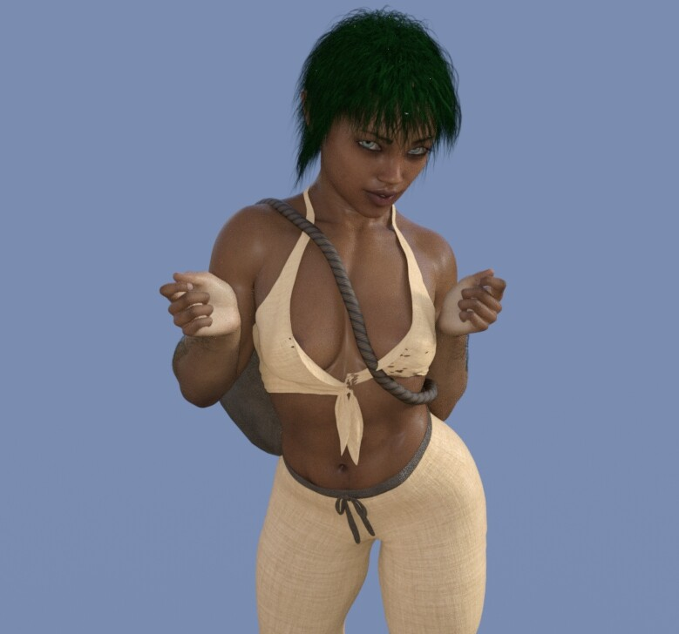

“I plan to walk through the gate as a courtesan, visiting the Baron’s Keep at someone’s call.” She struck a pose. “I don’t think I look too threatening.”

“Not the word I was thinking of, no,” Solstice had bent down to tie the laces of his boots but was really shifting his boner to a less conspicuous direction. “You need a partner for this?”

Luran had been struck by Saradette’s command of the conversation when her chosen specialty became the object. A different type of impression hit him as she revealed the look she would sport for the work. He nodded appreciatively, and gave the gnome an up and down, immediately returning to eye contact after acknowledging the visual appeal of the outfit.

**Saradette caught his look and grinned crookedly. “I’m no blushing maiden, you know. I hope it has the same effect on the guards. I wish I didn’t have to risk losing my pack, but it’s a chance I’ll have to take. Skulking around in my dark clothing will get me in trouble much more quickly.”**

Barkley looked at Saradette, a smile on his face. “No, you do not look threatening in the least. I will use my message ability on you before you go in. If you get much beyond 150’ from me I do not think your messages will reach me. However, as you said, Widget will be able to tell us if there is a problem. We will not be far away. In fact, we, as members of the locate militia should be able to enter the main audience area of the keep and mingle.”

Saradette caught his look and grinned crookedly. “I’m no blushing maiden, you know. I hope it has the same effect on the guards. I wish I didn’t have to risk losing my pack, but it’s a chance I’ll have to take. Skulking around in my dark clothing will get me in trouble much more quickly.”

Saradette’s reflection in Solstice’s wide-open, beady eyes nodded. “I will go in ahead of you, then. I don’t want to be there officially, and then vanish. I will instruct Widget to go inside when I do.”

“Oh! Everybody, Shoomma sent me a sending! She missed us, last night! I apologized to her, told her we’re still embroiled in the city’s mysteries and will check in with her as soon as possible!”

“Oh, right. Shoomma,” Solstice had also forgotten about going to see her for dinner last night.

Returning to the conversation at hand, the heroes finished hearing Saradette’s proposed strategy, added to it, and the rogue then steeled her nerves in anticipation of storming the castle with her good looks.

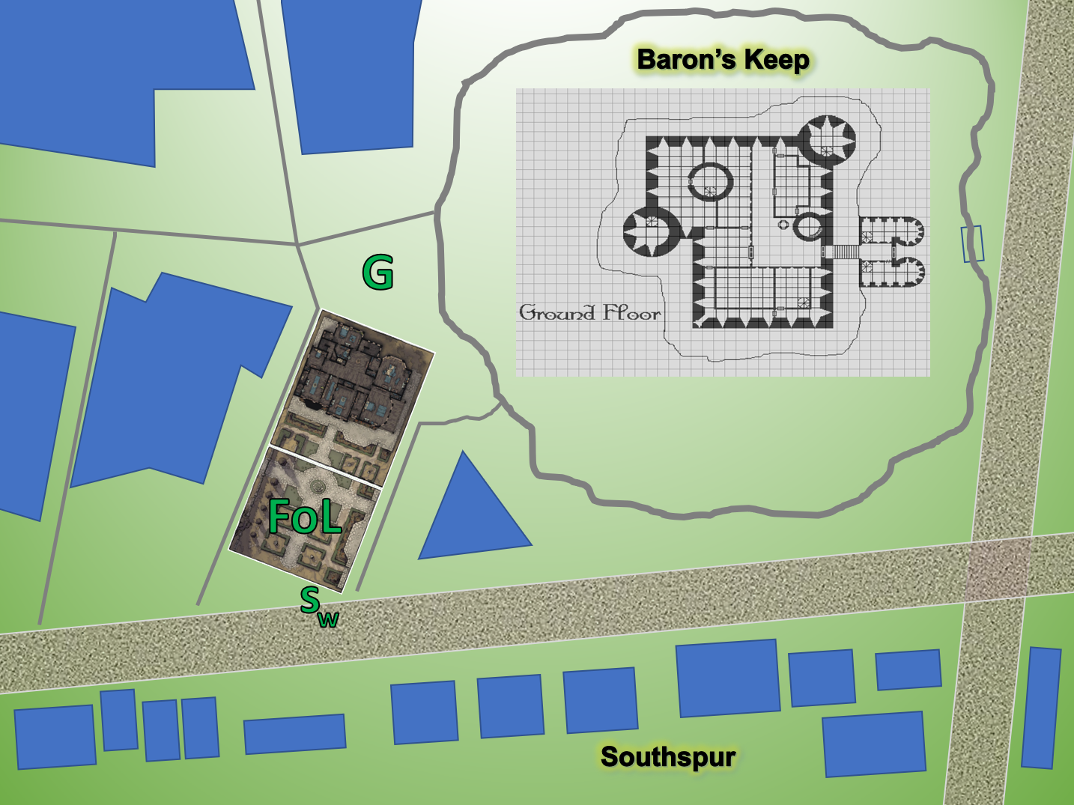

“The G represents Gadget, the S and W are Widget and me, and the rest of you are here in the courtyard to start off,” Saradette wrote some letters on the map, and asked if the rest of the crew was staying behind.

“And remember that all the main streets—including these two—are barricaded right along the middle,” Solstice reminded them.

“Where do you want us?” Elsabet asked Saradette directly. “Oh, and I was just thinking, you should pick up a disguise kit, if you don’t have one—I have been thinking of getting one myself, it contains makeup which would help convey the look you got going there.” She grinned at the gnome, who was definitely built to kill....

Saradette wiggled her shoulders as she grinned up at the human woman. “I don’t think they will be looking at my face. You can stay behind me far enough still hear what’s being said, I think.”

Barkley suggested, looking at Saradette first, “If you wish to go in ahead of us, that makes sense. We should all probably arrive dispersed slightly.” Looking over to Luran, “Perhaps we should visit Shoomma for a short time to give Saradette time to get in. Then you and Elsabet can arrive together. I can arrive with Solstice a few minutes after the two of you. The four of us can meet up in the main hall and be close just in case Saradette needs help.”

~*~

Round 1

The belltower startled everyone at the moment when its newly restored bell started to resound throughout the city after a 3-day hiatus. By the time it struck the tenth and last toll, confirming the time of morning, the heroes were outside in the courtyard.

“Alright, here we go,” Solstice said as Barkley and Luran started to cast *message [expired between Rounds 601 and 702]* on the others.

*Barkley was now telepathically linked to ? and ?.*

*Luran was now telepathically linked to Solstice and ?.*

Saradette had considered the disguise kit, and knew of a shop a few blocks further east where she could likely find one. With shops already open, and pedestrian traffic in its mid-morning bustle, Saradette and Widget meandered around a playground with maypoles and swings where half a dozen kids played. They pointed at the courtesan and her raccoon, being old enough to know what both were, and as Saradette now reached the corner that would turn northward towards the Keep’s entrance, a wagon passed her, led by two draft horses, emanating a scent of camphor and frankincense from within.

“Oh, that isn’t good, Widget. They use that stuff for bodies, to hide the smell of death.” The rogue considered for a moment. “I think I need to disguise myself more.” She went toward the shop to purchase some supplies.

Meanwhile, Barkley and Solstice were following slowly about 120’ behind Saradette, while Luran and Elsabet were still in the courtyard, and would soon be out of telepathic range from Barkley.

Elsabet deferred to Luran, saying, “You are a bit more familiar with the city, and I’m a little fuzzy still from the midnight meandering of my mind, so I’m going to let you decide our positioning and timing today. Lead on, oh master of the verse!”

Barkley was now in the middle of the street, trying to strike up a conversation with one of the Baronial Guards at the barricade’s only visible breach.

“Seriously?” the guard had already had enough of kids bothering him, and now two adults that looked like a weasel and a dog? “Enter the queue if you want through; otherwise, move along.”

Luran looked to Elsabet and shrugged his shoulders. “Well, care to step out for a noontime walk a bit earlier than intended? We can trail at a leisurely distance and keep in range of whatever info Barkley can offer. I’m starting to get the itching intuition that we may want to be in closer contact than first planned.”

“I’m going shopping for a few minutes,” Saradette advised the others as she walked to the aforementioned shop for a disguise.

Barkley and Solstice could still see Luran leading Elsabet towards Saradette’s last known position, but the gnome was now out of sight. They saw little prospect in continuing a conversation with the Guards, and thus left eastward.

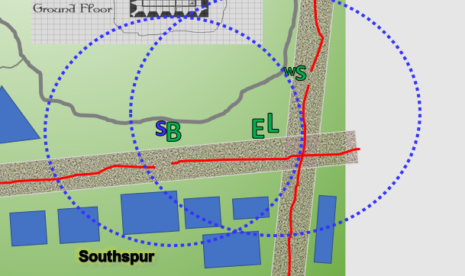

Two minutes later…

With her badge, Saradette had passed rather uneventfully through the well-guarded breach in the barricade, and had noted the same red sashes hanging from the otherwise black uniforms of the infantry that manned the breach. They were all humanoids of common stocks, were armored in studded leather, and otherwise bore no notable features. Some wore helmets, but their faces were all evident, and none were familiar to her.

Meanwhile, the other four heroes were congregating just southwest of the Baron’s Keep’s outer wall, and no longer within the *message* spell’s effect to talk to her.

She had ventured northward towards a shop where she suspected she would get a decent disguise kit, and was currently almost 200’ north of where she would have had reception, were her friends sending a message.

“Wha’g’n’a do ye fer?” the human with the Sembian highlander accent with the tufty mustache and the ink-stained apron came out from the back of his shop of curiosities and met Saradette at the counter.

“I need something to change my hair color, and some makeup for my face,” Saradette told him. “I need to look more the part, you know?”

“Ah, say n’more. Chaaarlet!” he called out to the back of the shop as he opened an armoire with a dozen or so wigs, “bring at one’deym stormin’ tha keep kits.”

Saradette was taken aback, but then again, a disguise shop so close to the Baron’s Keep had to be serving a pretty narrow niche, and though it was clear that this had long been a supply store for the Baronial minstrels and other performers, the nonchalant reference to outward treason gave her cause to sustain her reservation.

A human perhaps a few years younger than her male counterpart came out with a polite nod, wink, and greeting, “Darlin’.”

Having laid out the so-called kit—ideally suited to mask her face—the woman stood back and watched as the male came back to the counter with two shades of colored wigs. “These’d suit’cher eyes’n whatnot, but if’n y’see any others in ma’inventory that you wanna try on, poin’it out,” the human dude was polite enough, and had sensible enough taste to have picked out colors that were indeed complementary to her eye color and complimentary to her overall attractiveness, which she was resolving to exploit today.

After they talked about wig colors, settling on the sunset shade, the woman named Charlet went over some of the techniques recommended with the type of makeup that on which the gnome was about to spend 50 gold.

|  |  |  |  |
| --- | --- | --- | --- |
| **Item** | **Qty.** | **Wt.** | **Value** |
| Disguise Kit (including wig) | 1 | 4.0 | 50 |

*Purchase?*

“Yes, this will do nicely,” Saradette said as she extracted the coins from her haversack-in-a-leather-bag. “I’m in a hurry, so can we just do something simple this time?” She planned to place whatever she didn’t use up into the haversack.

~*~

A pair of Baronial Guards patrolling on foot saw the badges on the heroes at the corner, and aborted their attempt to confront the deputized agents of the Baron for simply standing around bearing weapons after the citywide decree on the weapons ban had been messaged across all the boroughs.

Elsabet and Luran stood under a flock of blackbirds and a mostly cloudy sky, and a bit further down, Barkley and Solstice, nodded at the guards that also passed them up, at least once Barkley and Solstice flashed their badges, flipping over a lapel on their vests. These badges were worth more than their weight in gold, and hopefully would continue to give the Fist of Light the edge they needed to enter the Keep and set the Barony to rights.

~*~

The man had gone to the back for a moment, and when he came out and saw Saradette, he forgot whatever he was going to say.

“There,” Saradette smiled at the two failed bards who now ran the curiosity store. “How’s that?”

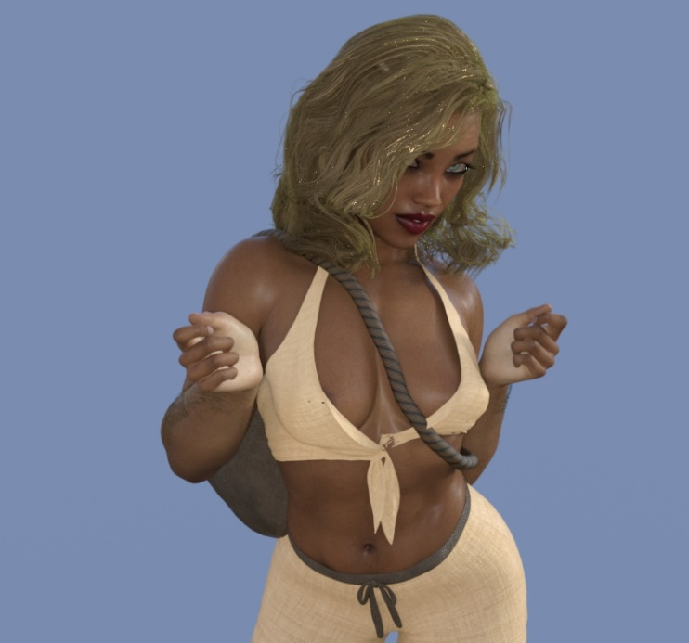

The human woman noticed her man’s eyebrows, and raised her own at him.

“Wha? She look like Jo’lene... s’all,” he shrugged and inhaled deep enough to make up for the three breaths he’d missed. “Hee’s ‘nother wig,” he then said as he opened a box, revealing a white-haired wig currently in a bun that would add age to her guise. “Kit come w’two wigs, an’ mos’ ov’um’s too big fer ye.”

“This will be fine,” Saradette replied with a smile directed at the woman.

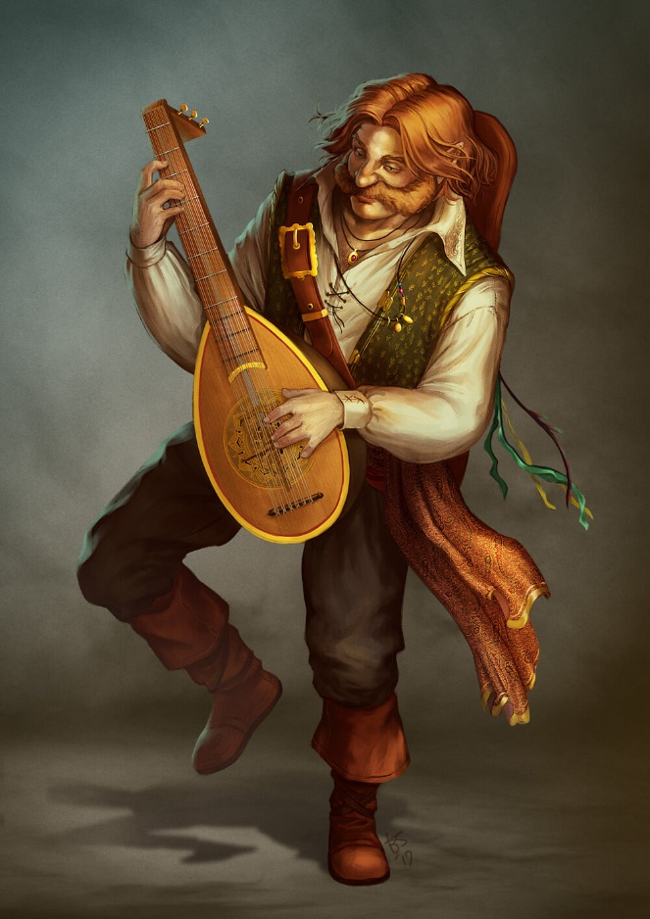

The bardsy salesman wrapped up the goods, and wore a grin betraying impure thoughts. There was some thanking back and forth, and then he even grabbed a lute and started serenading her with a song about a girl with a wig. She had no desire to fuel the flame between the two shopkeepers, so she packed her purchases away and slung the bag over her shoulder. “I need to be about my business. Thank you very much.”

“Yeeep,” Charlet tried to be polite in front of the customer, but was likely about to slap her man as soon as the gnome left. “We’ll be here if’n ye need som’n else.”

With that, Saradette ducked out of the shop, and walked toward the Keep’s gatehouse.

~*~

A wagon had stopped at the corner of Southspur Promenade and Baron’s Road, just upwind of Elsabet and Luran, and by the time the traffic at the now blocked intersection had resumed its flow, allowing the wagon to turn to the right, the wind’s course had shifted, and Elsabet and Luran could smell the camphor and frankincense emanating from the discretely gray and black wagon pulled by two black horses and commandeered by a black-and-red-clad Baronial Lieutenant bearing the same regalia worn by the other Lieutenant whom they’d encountered the day before while trying to get into the Shrine to Mayaheine.

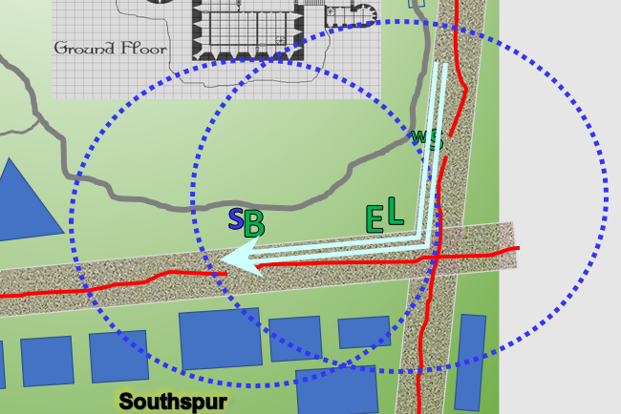

The wagon now resumed its previous speed, and clippity-clopped and rolled westward, coming up on Barkley and Solstice as the breeze foretold of the incense within the wagon via the scent that the others had already caught. The archon and musteval did not recognize the wagoner Lieutenant, but did make note of the helmeted man’s apparent rank from their recollection of yesterday’s encounter.

As Barkley picked up the odor, he used his ability to *detect evil* on the driver of the wagon and the area of the wagon in general. He had a suspicion that the scents were being used to hide something. Hopefully, it was just hiding something else with a bad odor and not more wererats.

Then it occurred to him that camphor was a common ointment used by undertakers, and frankincense was often used by members of this profession to cleanse their workspaces of the scent of ill-gone flesh. Nevertheless, there was no hint of evil or rats carried in the heady aroma, and the musteval and archon conferred on this, noting that this was likely a hearse wagon with bodies headed to the cemetery just outside of Westgate.

Barkley whispered to the others, “We are going to follow this wagon a bit.” He then looks at Solstice, “You think you can have a peak in the back if I can get you over there?”

Solstice proposed, “I’d be willing to spy a bit.”

Barkley nodded and as the musteval hopped down to the ground, the archon tried getting the wagon to halt for a moment, transforming into a dog and running in front of it, then transforming back and yelling halt.

|  |  |  |  |  |
| --- | --- | --- | --- | --- |
| **Character** | **Check** | **Ranks** | **Roll** | **Save** |
| Wagoner | Reflex | 3 | 12 | 15 |

*See below.*

|  |  |  |  |  |  |  |
| --- | --- | --- | --- | --- | --- | --- |
| **Skill** | **Rank** | **Ability & Mod.** | **Misc. Mods.** | **Total** | **Roll** | **Check** |
| **Barkley, Diplomacy** | 0 | **Cha (+1)** | 0 | 1 | 1 | 2 |

*See below.*

“Blast!!” the wagoner had to pull hard on the horses’ reins to get them to stop in time, and the archon was now in a position to spook the horses, should he make any sudden movements.

Though it didn’t work exactly how Barkley had wanted, he stuck his arms out wide hoping to get the horses to stop, though he was ready to leap out of their way. “Hold up there, Lieutenant!! I think one of your wheels is coming loose!”

|  |  |  |  |  |  |  |
| --- | --- | --- | --- | --- | --- | --- |
| **Skill** | **Rank** | **Ability & Mod.** | **Misc. Mods.** | **Total** | **Roll** | **Check** |
| **Barkley, Handle Animal** | 0 | **Cha (+1)** | 0 | 1 | 7 | 8 |

*See below.*

The horses were spooked, reared up rampantly and neighed, bucking the wagon and rousing the attention of just about everyone in sight. Solstice did his best to

|  |  |  |  |  |  |  |
| --- | --- | --- | --- | --- | --- | --- |
| **Skill** | **Rank** | **Ability & Mod.** | **Misc. Mods.** | **Total** | **Roll** | **Check** |
| **Solstice, Hide** | 5 | **Dex (+3)** | 8 | 16 | 5ish | ?? |
| **Solstice, Move Silently** | 2 | **Dex (+3)** | 8 | 13 | 5ish | ?? |

*Result unknown for the moment.*

“Stand down, citizen!” the wagoner said as two guards emerged from the wagon and rushed Barkley with blades drawn. The wagon was just past the Southspur Promenade breach at this point, and—seeing what the armed civilian had just done to the wagon’s horses—guards came rushing from the southeast.

~*~

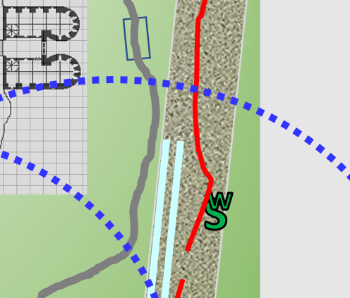

With her racoon in tow, Saradette found herself approaching the breach once again, wondering how she was going to pass through the most sensitive breach in the city’s makeshift barricades disguised as a courtesan when only minutes ago she and her not-very-inconspicuous familiar had so nonchalantly passed through and documented her identity to the Baronial Guards. It would take more than a little subterfuge to con the uniformed men and women she’d just met, even with her badge.

~*~

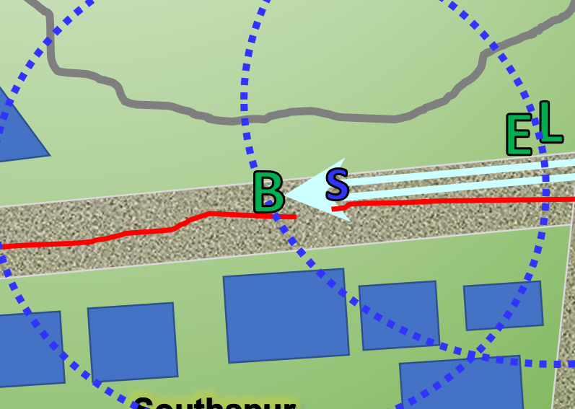

Barkley was seconds away from being taken down by a half-dozen guards whose resolve seemed unwavering. Surrounded by the majority of those posted to the Southspur Promenade breach, the archon was now being commanded at swordpoint to disarm by the same Guard who’d just told him to run along a minute ago.

Solstice was nowhere in sight, which—in Barkley’s estimation—was a plus; otherwise, all of this would’ve been for naught.

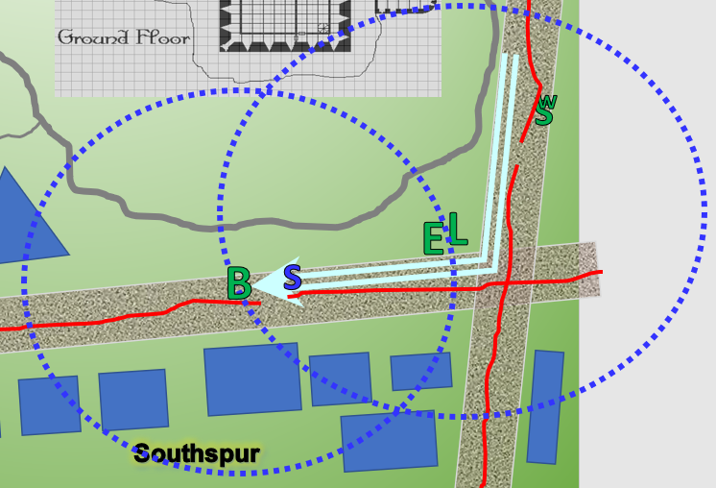

Elsabet whispered through the message link, “Barkley, what should we do?” She was shaking her head, thinking, ‘Lawful, my ass—that puppy is more easily distracted than I am!’ They had a plan, it lasted for like, what, a block? She looked at Luran....

Luran mouthed the words of a message to Saradette, “Barkley has gotten distracted, at the moment, so you are aware if you continue to the gate.”

Luran and Elsabet could see the tense interchange going down by the wagon, which now had five wagons waiting behind it. One of the guards started to direct traffic around the scene along the already narrowed throughway north of the barricade.

As the guards approached, Barkley identified himself, showing his badge. “I am sorry: I did not mean to cause a scene. It looked like one of the wheels was coming loose. I did not want anyone to get hurt.” He kept his hands away from his weapons.

|  |  |  |  |  |  |  |
| --- | --- | --- | --- | --- | --- | --- |
| **Skill** | **Rank** | **Ability & Mod.** | **Misc. Mods.** | **Total** | **Roll** | **Check** |
| **Barkley, Bluff** | 0 | **Cha (+1)** | 0 | 1 | 10ish | ?? |

*See below.*

There was a tinge of dubiousness in Barkley’s voice, and he could tell. It didn’t take more than a moment for a handful of the guards to take a look at the wheel to which the archon had just pointed, and from the looks of it, they weren’t buying the bit.

“Lieutenant, restrain this man,” the Captain of the Guards at the barricade’s checkpoint ordered the woman next to him, and she and two males now moved to cuff Barkley for further interrogation. “The City of Mintar is hereby detaining you, citizen, for your reckless demeanor,” the Captain proclaimed. “State your name.”

|  |  |  |  |  |  |  |
| --- | --- | --- | --- | --- | --- | --- |
| **Skill** | **Rank** | **Ability & Mod.** | **Misc. Mods.** | **Total** | **Roll** | **Check** |
| **Solstice, Move Silently** | 2 | **Dex (+3)** | 8 | 13 | 10ish | ?? |

*Outcome unknown to PCs.*

Barkley looked at the guard, “I have served the Baron and his guards with dignity. I admit my mistake, the wheel must have hit a hole, or my eyes deceived me. There is no need for your restraints, I will come along peacefully and an appointed member of this city’s defense, I request an audience with the Baron.” His tone was one of respect but firm. He stood straight and tall, emphasizing his full height, but he could tell that standard arrest procedures were about to be followed.

“Oh! He’s requestin’ an audience with the Baron!” the Captain ushered a wave of irreverence from the Guards, bolstering their sense of being on the side of right, particularly in the midst of them being so taxed of their energies for the last three days. “We’d *all* like an audience with the Baron, wouldn’t we, lads? Walk ’im to the brig,” the Captain ordered a Lieutenant and two Infantrymen.

Round 28

Within seconds, they were in the midst of a fight.

|  |  |  |  |  |  |  |  |  |  |
| --- | --- | --- | --- | --- | --- | --- | --- | --- | --- |
| **Melee Weapon** | **Dmg** | **D+** | **TH+** | **Critical** | **Type** | **Wt.** | **Atk** | **Roll** | **Check** |
| Slam 1 | 1d4 | 1 | 2 | 20 | Bludgeon | - | +8 | 10 | 18 |
| Slam 2 | 1d4 | 1 | 2 | 20 | Bludgeon | - | +8 | 17 | 25 |

*Hit, hit.*

*Dmg to Guard 1: 3 + 1 = 4.*

*Dmg to Guard 2: 2 + 1 = 3.*

|  |  |  |  |  |  |  |  |  |  |  |  |
| --- | --- | --- | --- | --- | --- | --- | --- | --- | --- | --- | --- |
| **Character** | **Attack Type** | **Damage** | **BAB** | **Str Mod+** | **W+** | **Other+** | **Total Score** | **Roll** | **Total** | **Crit** | **Threat** |
| Baronial Guard | MW Club | 1d6+3 | 3 | 3 | 1 | 0 | 7 | 19 | 26 | 20 | ý |
| Baronial Guard | MW Short Sword | 1d6+3 | 3 | 3 | 1 | 2 flank | 9 | 20 | 29 | 20 | þ |
| Baronial Guard | MW Sap | 1d3+3 nl | 3 | 3 | 1 | 2 flank | 9 | 5 | 14 | 20 | ý |

*Hit, threat, miss. 1d20 = 15 + 9 = 24, not a critical hit. Dmg: (6 + 3) + (2 + 3) = 9 + 5 = 14. Partial damage negated [41/45].*

A hefty half-orc came over to grapple the archon, but not before the archon got one good punch in.

|  |  |  |  |  |  |  |  |  |  |
| --- | --- | --- | --- | --- | --- | --- | --- | --- | --- |
| **Melee Weapon** | **Dmg** | **D+** | **TH+** | **Critical** | **Type** | **Wt.** | **Atk** | **Roll** | **Check** |
| Slam 1 | 1d4 | 1 | 2 | 20 | Bludgeon | - | +8 | 17 | 25 |

*Hit. Dmg: 3 + 1 = 4.*

|  |  |  |  |  |  |  |  |
| --- | --- | --- | --- | --- | --- | --- | --- |
| **Character** | **Attack Type** | **Damage** | **BAB** | **Str Mod+** | **Total Score** | **Roll** | **Total** |
| Baronial Guard | Touch Attach | Grapple | 4 | 5 | 9 | 5 | 14 |

*Hit. Grapple initiated.*

|  |  |  |  |  |  |  |  |
| --- | --- | --- | --- | --- | --- | --- | --- |
| **Character** | **Attack Type** | | **BAB** | **Str Mod+** | **Total Score** | **Roll** | **Total** |
| Baronial Guard | Grapple | | 4 | 5 | 9 | 14 | 23 |
| **Melee Weapon** | **TH+** | **Atk** | **Roll** | **Check** |
| Grapple | 2 | +9 | 14 | 23 |

*Tie on roll and modifier. Reroll:*

|  |  |  |  |  |  |  |  |
| --- | --- | --- | --- | --- | --- | --- | --- |
| **Character** | **Attack Type** | | **BAB** | **Str Mod+** | **Total Score** | **Roll** | **Total** |
| Baronial Guard | Grapple | | 4 | 5 | 9 | 15 | 24 |
| **Melee Weapon** | **TH+** | **Atk** | **Roll** | **Check** |
| Grapple | 2 | +9 | 10 | 19 |

*Barkley was held by the half-orc’s grapple.*

Saradette was coming up on the checkpoint, and once through the breach, would only be maybe 100’ from the Keep’s main gates. She acknowledged the information conveyed to her regarding the situation right around the corner, and used the distraction to slip past the guards at the checkpoint without speaking with them.

Round 29

In his surprise, Luran forgot to whisper and almost shouted (but not quite), “Ilmater’s Busted Ballsack, Saradette! Barkley’s getting arrested!”

Elsabet sighed, and whispered to Barkley “see you inside one way or another,” then turned to Luran and said “Shall we proceed with the plan? B is tough and resourceful, and S is...also resourceful.

Once the half-orc had Barkley in a solid grip, Barkley relaxed and submitted. Though a distraction wasn’t his initial intent, he hoped it worked. Solstice had thus far found no wererats hiding in the wagon, and was trying to quietly pry open the four coffins within to confirm that none of the contained corpses smelled of rodent. Though he had no evidence to support them, Barkley still had his doubts about the driver, but the rest of the guards were at least not emanating evil. Perhaps ending up in the dungeon would be a positive situation and allow Barkley to work a different angle.

~*~

“You again?” the man in charge of the Baron’s Road breach noted that the racoon-friendly gnome was now disguised as a different person. This immediate red flag got her into the yellow circle, which had a currently active *zone of truth* spell cast on it, as it had recently been manifested to deal with the scoundrels now being led away eastward. A diviner was on standby, waiting to emit another casting when needed.

It was beginning to dawn on them that they had inadvertently tested the limitations of their badges’ ability to get them into, through, and out of the situations they’d confronted during the last few minutes. If she wasn’t careful, she might also end up in a cell with or near Barkley.

Two Baronial Guards asked Saradette to stand in the middle of the yellow-chalk outline, and asked her why she was wearing a wig that she hadn’t been wearing before, and what she intended to do in the Baronial Quarter today.

“I bought a wig and some makeup,” Saradette said indignantly. “What, precisely, is wrong with that?” She pointed toward the inn. “And I’m staying right over there.”

~*~

Recognizing Barkley’s submission to the situation, Luran stifled his excitable self and scouted around to see who had heard his outburst. Seeing no one paying him any mind, he turned to Elsabet, wondering if she noticed Barkley’s “good boy face”, as well.

Townsfolk were returning to their hustles, having little time in the midst of rigid restrictions to gossip and dally about, and as Elsabet and Luran scouted eastward—keeping a distance from the archon and the guards—Solstice’s thoughts alerted the bard as to the musteval’s location. “Don’t flinch. It’s just me,” the invisible Celestial said telepathically before climbing atop the half-elf’s shoulder. Elsabet then heard him calling her over, and as she came a foot closer, he said sotto voce, “Four bodies lie dead in coffins inside the wagon. I didn’t want to alert Barkley in case he’s interrogated, but he knows that I was in there.”

By the time they reached the breach in the barricade along Baron’s Road, Saradette was finally being allowed through. She’d been questioned this time as to why she’d been deputized, and mentioned the deeds to which she and her friends had contributed. There was enough truth in her heroism that she was released and now spotted Barkley being ushered into the Baron’s Keep, then made eye contact with Luran and Elsabet, who were just across the street.

Barkley was led inside by the grunts with swords, and thereafter he was both out of sight and *message* range from the others.

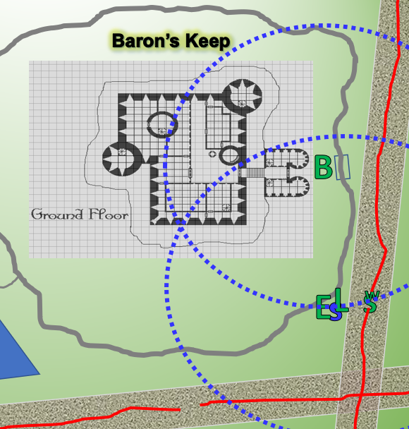

The gnome seemed to be annoyed, but she wiped the look from her face and followed after Barkley toward the keep, first crossing the western half of the barricaded street. Now, she needed to get inside for his sake, and she’d had to identify herself to the paranoid guards at the temporary gate. Things were definitely not going according to the plan. Still, she had to try.

With Luran and Elsabet a few dozen feet behind her, she modified her walk a bit, and worked herself up into the persona of a well-paid courtesan, which stuck out like a sore thumb as she approached the most heavily regulated part of the city. She wasn’t overly flashy – she didn’t need to be to do her job well. This time, there would be no badge-showing. She had to get in without identifying herself. While she approached, she carefully observed every tiny detail she could see about the gate area and who and what might be guarding it.

Saradette stopped to observe the guards’ behavior, not approaching the keep itself. She crouched down to pet Widget while she watched for a moment. “We need to wait,” she said softly to Elsabet, “or at least I do.”

Elsabet, Luran, Saradette, and Widget stood in circumstance near the most heavily fortified and guarded structure in the city wondering how to best execute their plan for entry now that Barkley had beaten everyone else to the short-term goal. Where he was now was left to the imagination, though the heroes were aware that while the barracks was underground, previous prisoners had been taken to brigs on upper floors: the Fist of Light had witnessed this firsthand when Bratislava was briefing everyone.

The group started moving northward, and a Guard looking down from a tower nodded at Saradette as the two made eye contact. Elsabet had a plan that involved casting *lesser restoration* on one of the weary Baronial Guards, though perhaps she might be faced with having to do so for more than one of them, as there were usually three or four posted to the main gates. They had briefly discussed the few related contingencies, and were now a few dozen feet from the main entrance, which they’d crossed several times before the restriction of movement throughout the city had been manifested.

~*~

The situation at the gates was tense at first.

|  |  |  |  |  |  |  |
| --- | --- | --- | --- | --- | --- | --- |
| **Skill** | **Rank** | **Ability & Mod.** | **Misc. Mods.** | **Total** | **Roll** | **Check** |
| **Elsabet, Diplomacy** | 8 | **Cha (+2)** | 4 | 14 | 16 | 30 |
| **Luran, Diplomacy** | 2 | **Cha (+5)** | 4 | 11 | 9 | 20 |
| **Saradette, Diplomacy** | 0 | **Cha (+0)** | 0 | 0 | 5 | 5 |
| **Solstice, Diplomacy** | 0 | **Cha (+2)** | 2 | 4 | 17 | 21 |

*See below.*

Saradette was sporting less than a smile, and Luran knew how to keep a poker face in the midst of Elsabet’s schmoozing. Saradette was pulled aside for questioning, and as she gave the account of the courtesan getup being part of an undercover guise, the woman was patted down by an overly ambitious youngster whose fatigue did not outweigh his curiosity.

The young – and attractive – man’s attention actually lifted the gnome’s spirits. “You know I couldn’t hide a coin without your seeing it,” she said lightly. “Careful with the merchandise, I normally get paid for this,” she said in a low and sultry voice as he searched her top half. She honestly didn’t mind if he looked and touched, as long as he wasn’t cruel about it. Saradette gave him a genuine, if small, smile when he was done. “Thank you for being decent about this.”

A pair of squires were approaching, and now passed the group on their way out, nodding to their fellow guards. One of them noted Saradette, then made eye contact with the young guard talking to her, and the two males exchanged raised eyebrows.

Elsabet managed to single out the weariest of them, and once his Sergeant—a human female about twice Elsabet’s age—agreed to let Elsabet cast *lesser restoration* on him. She did so, and it worked wonders for the young man, who nodded at Elsabet with appreciation.

Saradette finished getting searched, and was petting Widget after the unpleasantries.

The Sergeant of this contingent now smiled at Elsabet and asked if she had any more of that love for the other two guards posted, and made no indication that she included herself in the plea.

“Certainly, Sergeant, I can do it once more for whichever of your team you deem needs it more.” Elsabet willingly cast the spell on the wearier of her two remaining crew while the one with the erection had to settle for Saradette’s pleasantries. “I’d offer it to you too, of course, but I believe scuttlebutts say Sergeants don’t get tired.” She winked at the woman, knowing that the perceived toughness of sergeants was a cornerstone of military and constabulary lore.

|  |  |  |  |  |  |  |  |  |  |  |
| --- | --- | --- | --- | --- | --- | --- | --- | --- | --- | --- |
| *Favored Soul Spells per Day* | | | | | | | | | | |
|  | **Spell Level** | | | | | | | | | |
|  | **0th** | **1st** | **2nd** | **3rd** | **4th** | **5th** | **6th** | **7th** | **8th** | **9th** |
| **Favored Soul Spells** | 6 | 6 | 3 | 0 | 0 | 0 | 0 | 0 | 0 | 0 |
| **Charisma Bonus** | 0 | 1 | 1 | 0 | 0 | 0 | 0 | 0 | 0 | 0 |
| **Total Spells** | **6** | **7** | **4** | **0** | **0** | **0** | **0** | **0** | **0** | **0** |
| **DC** | 12 | 13 | 14 | 15 | 16 | 17 | 18 | 19 | 20 | 21 |
| **Cast?** | **0** | **0** | **2** | **-** | **-** | **-** | **-** | **-** | **-** | **-** |

After assessing the results of her second casting, Elsabet leaned in towards the sergeant, and said in a low voice, “I should probably save the rest for an officer, but I’m thinking it wouldn’t be fair to only refresh two of your three crew. Shall I?”

The Sergeant shook her head, “Nay, that one’s fine; he’s just a bit disheveled by the whore,” the prudish woman betrayed her own contempt for women of the night, but had grown accustomed over the last few days at the occasional courtesan being summoned by one of the Baron’s new men. “Usually, they’re told to come at night,” the Sergeant nodded as the rest of the heroes were processed.

“I thank you, milady,” the first man Elsabet had healed said as they were allowed to enter.

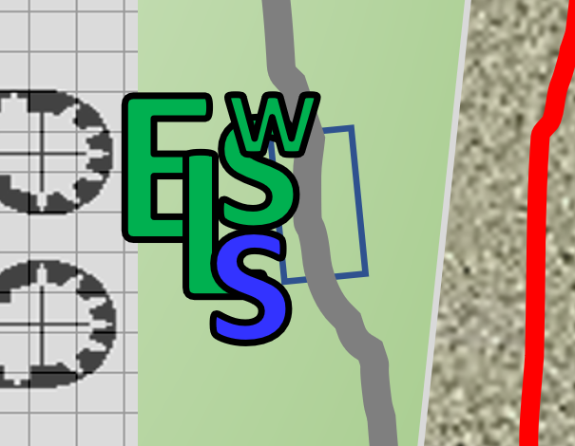

“We’ll escort her up,” Elsabet said. “Where are the new guys located?”

~*~

There was no shortage of new guys in the Keep, and the party had been pointed in the same direction as usual: the barracks.

“Oh, there’s no briefing at...” Bratislava had opened the door to say, then recognized the bunch, and opened the door further, “Ah, it’s *you* good people.”

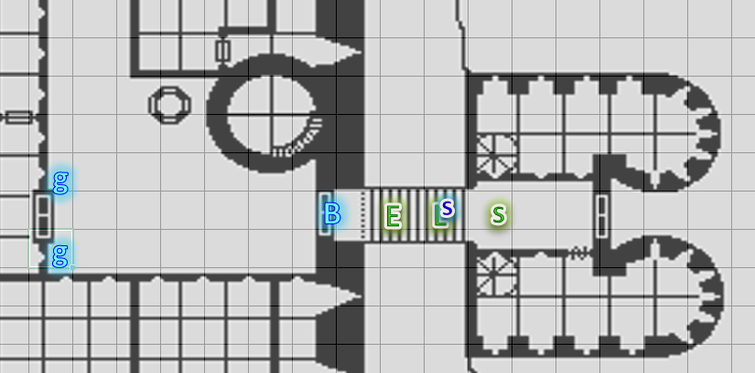

She let them in under the assumption that they had more information to relay has they had done for the last few days, but now there was only Bratislava in the room, plus two guards and a crimson-robed cleric who looked like the Baron a little, if maybe ten years younger.

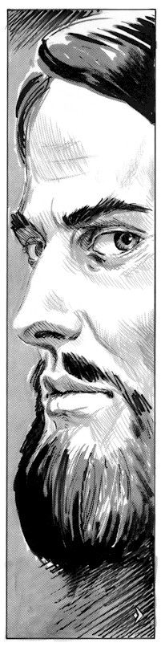

Elsabet made note of the guards’ attire, which was the now usual black-and-red leather armor get-up, and though all the guards here had previously been armed only with blades, these two were outfitted with light crossbows as well.

The male cleric of no obvious deity stared at the newcomers as the turned his attention from the two guards to the front doors. “And who is *this*?” he asked Bratislava, keeping his eyes on Elsabet and the others as they entered the main hall that led directly north into the barracks, and through the westward door to the rest of the keep, presumably.

“Prefect, these are a contingent of deputies who were helpful in dealing with the Chaosbringers,” Bratislava announced the heroes, identifying the villains at the Reality Wrinkle by a previously unheard title. She did not remember the heroes’ names, so they each stated them before the man in charge.

He did not seem pleased, no matter how courteous the deputies were, and scoffed at the intrusion on what must have been a good conversation with the guards. “And what news have you to bring us this day?” the tall, gracile human merely rubbed his beard and skeptically beheld Elsabet, who was closest to him. She could tell his eyes were wandering towards her breasts, but he was more concerned with their unplanned presence than the warlock’s femininity.

What’s more, the Prefect—as he had just been called—was emanating evil, and though Solstice could not say it at the moment, he concluded that he was the only one among his friends who knew this. He spoke, “Prefect, Colonel,” he referred to both of the people whom he deemed to have the most authority. “We beg to report that although we had some good fortune at the Reality Wrinkle, our investigation has run cold, and what’s more, our dear associate—Barkley—has just been arrested over a misunderstanding.”

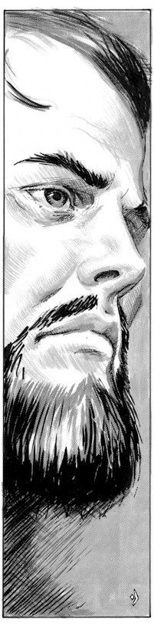

“Oh?” the Prefect’s eyebrows betrayed some interest as he looked down at the musteval, then over at Bratislava. “And who is this associate?”

“His name is Barkley. He’s a hound archon with a bit of a paladin complex. You remember him...” he stated the question directed at Bratislava, who nodded.

He turned towards one of the guards, and nodded, as if the guard understood the man’s will, and the guard did indeed nod, open the door, and disappear behind it, presumably to go get Barkley.

Saradette hung back at the rear of the group, using the tall people to screen herself from the Prefect (and what a title that was). The rogue unobtrusively looked around the room, careful to not move her head too much. Widget walked with her, and Saradette wanted to send her familiar to explore the Keep, but she would bide her time. She didn’t want her little friend to be caught and probably killed here.

*[Any additional dialogue goes here. I don’t think any PC in this scene can detect evil at will. Saradette would have had to cast the spell beforehand in order to do so (or can do so now, making it obvious that she’s doing it).]*

~*~

Barkley had only been inside the cell for a few minutes, and was already sitting on the less-than-clean single cot in the otherwise barren, three-walled room with bars as thick as his wrists intended to keep the strongest of prisoners inside.

On his way the cell he had been blindfolded, but once inside, Barkley took note of his surroundings and the route he was taken. He maintained his detect evil, reactivating it when he felt it had faded.

Barkley’s mane stood on end as footsteps approached from around the corner. He knew the sensation, but waited to confirm it as soon as the human male came into view. Evil as fuck. The black-clad guard with crimson accents smirked at Barkley, and congratulated him. “You’re in luck, dawg. Your friends are here to bail you out,” the man’s vocabulary bore the tinge and taste of an uneducated local who’d dodged a turnip picker’s destiny. He was the kind of man who looked down on his parents and ancestors on the basis of his quick rise to power, if such it was, and though in his face Barkley might have seen a young boy with promise and hope, there was now merely a resignation to his collusion with an unstoppable force, or perhaps Barkley was reading too much into the depressive character of the man before him, who now unlocked the mechanism that enclosed Barkley and instructed him to turn around and place his hands behind his back again.

Barkley turned, adding, “Is that really needed if I am being released? It’s not like I would try to escape my release now would I?” He knew he would see this man again, even if it meant seeking him out to extinguish his evil flame.

“Oh, it’s quite standard. Turn ‘round,” he then put his hands on the still lawful hound archon and applied the shackles, communicating that Barkley was a prisoner until they decided otherwise.

The chains were an added psychological tool, both restraining his hands and echoing throughout the stony corridor as the blindfold went back on. Barkley sniffed as he was led down a spiral staircase that must have wound about 500 degrees before yielding to the ground floor. A door on his left then opened, and he was then led through it, then to the right, then again to the right, then another door opened and to the right he went again, as a set of double doors opened and he could hear his friends’ voices. He had definitely not been taken along this path on his way up to the Baron’s brig.

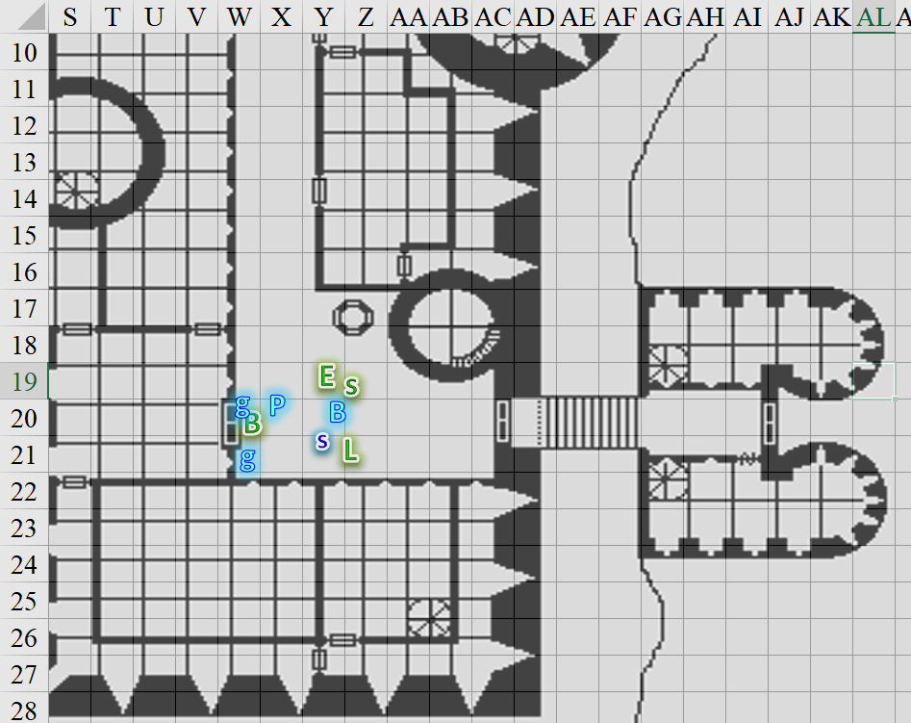

The blindfold came off, and the Prefect—whom Barkley had never seen before—asked the heroes to confirm the identity of the archon.

“Milady, they’re evil!” Elsabet suddenly blurted out to Bratislava, as she took a step forward and to her right, then made a warding gesture, casting protection from evil upon herself.

*Elsabet gained +2 to AC and Saves vs. evil + misc. PfE wards.*

“Elsabet!” Bratislava frowned but the Prefect’s kneejerk reflexes were quicker.

The shifty cleric’s eyes made it seem like he didn’t realize that he was the subject of the statement, but he did. Defiantly, he raised a scoffing gaze at Elsabet and shook his head, ordering the guards, “*She* is the one. Seize her *and* the other accomplices.”

Acting as if they’d had a premeditated motive, the two guards nodded. One of them trained his crossbow on Elsabet while the other tried to open one of the double doors, yelled, “Prawwwww-cesss!” and approached Elsabet with the intent to restrain her.

Barkley got in the man’s way, preventing him from opening the door.

It became evident from the sound of at least two armored figures approaching and a woman’s voice around the corner repeating, “Process on the ground floor!”

Bratislava froze, trying to figure out where deceit lay.

