*Chapter 17: The Prefects’ Faction*

Round 1

|  |  |  |  |  |  |
| --- | --- | --- | --- | --- | --- |
| **Character** | **Group** | **Initiative** | **Roll** | **Modified Roll** | **Move** |
| Saradette | 1 | 3 | 20 | 23 | 20’ |
| Barkley | 1 | 2 | 18 | 20 | 40’ |
| Elsabet | 1 | 4 | 13 | 17 | 30’ |
| Guards | 2 | 2 | 12 | 14 | 30’ |
| Prefect | 2 | 2 | 10 | 12 | 30’ |
| Luran | 1 | 1 | 5 | 6 | 30’ |
| Solstice | 1 | 1 | 2 | 3 | 30’/10’ |

Saradette, while caught completely unarmed and unarmored, and nearly topless, ran north along the hallway to gain some room, passing the guard that thought to swipe at her, though he obeyed the goateed cleric’s orders.

Widget remained in place as footsteps were now audibly approaching on the other side of the double doors.

With his hands shackled behind his back, Barkley bit at the guard by the door.

|  |  |  |  |  |  |  |  |  |  |
| --- | --- | --- | --- | --- | --- | --- | --- | --- | --- |
| **Melee Weapon** | **Dmg** | **D+** | **TH+** | **Critical** | **Type** | **Wt.** | **Atk** | **Roll** | **Check** |
| Bite | 1d8 | 4 | 0 | 20 | Piercing | - | +9 | ***20*** | 29 |

*Threat. 1d20 = 15 + 9 = 24, critical hit. Dmg: (2 x 2) + 4 = 8.*

Elsabet cast her *bull’s strength [expired on Round 41]* spell but rather than putting it on herself, step next to Barkley, the prefect and the crossbow-aiming guard, reaching between the two evil folks to touch Barkley, causing the hound archon’s muscles to bulge, and continued to speak rapidly as she drew her bastard sword.

*Barkley gained +4 to Strength.*

“Now you die!” The crossbowman fired upon Elsabet as she drew her blade.

|  |  |  |  |  |  |  |  |  |  |
| --- | --- | --- | --- | --- | --- | --- | --- | --- | --- |
| **Character** | **Attack Type** | **Damage** | **BAB** | **Str Mod+** | **Dex Mod+** | **W+** | **Total Score** | **Roll** | **Total** |
| Prefect’s Guard | MW Light Crossbow | 1d8 | 3 | 3 | 1 | 1 + 1 PBS | 8 | 3 | 11 |

*Miss.*

Dodging the bolt, the warlock proclaimed, “By Mayaheine, milady, these newcomers are foes—command them to stand down and see whom they obey. They have dominated the Baron! They subvert justice!” The woman then opportunistically swiped at the man as he began to reload.

|  |  |  |  |  |  |  |  |  |  |
| --- | --- | --- | --- | --- | --- | --- | --- | --- | --- |
| **Melee Weapon** | **Dmg** | **D+** | **TH+** | **Critical** | **Type** | **Wt.** | **Atk** | **Roll** | **Check** |
| Bastard Sword +1, 1-handed | 1d10+1 | +2 | 2 – 4 | 19-20/x2 | Slashing | 6.0 | +5 | 16 | 21 |

*Hit. Dmg: 10 + 1 + 2 = 13.*

Bratislava drew her short sword, and cast *magic circle against evil*.

*Most of those present (see map below) gained +2 to AC and Saves vs. evil + misc. PfE wards.*

The Baronial Guards scoffed at the spell, and Bratislava could tell by their faces that both men were wicked.

Their leader—the serpentine Prefect Almódovar—cast *sanctuary [expired on Round 5]* upon himself, but before he could finish the manifesting the abjuration’s verbal and somatic trigger, Elsabet activated her bracers and immediately attacked this fool as well.

|  |  |  |  |  |  |  |  |  |  |
| --- | --- | --- | --- | --- | --- | --- | --- | --- | --- |
| **Melee Weapon** | **Dmg** | **D+** | **TH+** | **Critical** | **Type** | **Wt.** | **Atk** | **Roll** | **Check** |
| Bastard Sword +1, 1-handed | 1d10+1 | +2 | 2 | 19-20/x2 | Slashing | 6.0 | +9 | 8 | 17 |

*Hit. Dmg: 3 + 1 + 2 = 6. Add Foehammer and/or render nonlethal?*

|  |  |  |  |  |
| --- | --- | --- | --- | --- |
| **Character** | **Check** | **Ranks** | **Roll** | **Save** |
| Prefect | Concentration | 7 | 6 | 13 |

*Fail.*

The cleric grimaced at the strike, and flinched, botching the casting, and he then backed away, saying something in Infernal, which only Barkley could understand, << Finish them! >>

Luran nodded and selected a fine limerick sung to the melody of a dirge from the North, his bravado invoking an additional inspirational boost of courage upon his comrades.

*The PCs and Solstice gained +2 to weapon attacks and damage.*

Solstice took the opportunity to jab at the man who’d just been bitten by Barkley.

|  |  |  |  |  |  |  |  |  |  |  |
| --- | --- | --- | --- | --- | --- | --- | --- | --- | --- | --- |
| **Melee Weapon** | **Dmg** | **D+** | **TH+** | **Critical** | **Type** | **Wt.** | **Atk** | **Roll** | **Check** | **Notes** |
| Keen Short Sword | 1 | 1 | 1 + 2 | 17-20, x2 | Piercing | 0.1 | +12 | 11 | 23 | +3d6 Sneak |
| Short Sword, 2nd Attack | 1 | 1 | 1 + 2 | 17-20, x2 | Piercing | - | +7 | 20 | 27 | +3d6 Sneak |

*Hit, threat. 1d20 = 4 + 7 = 11, not a critical hit. Dmg: (1 + 1 + 1 + 2 Courage + 9 Sneak) + (1 + 1 + 1 + 2 Courage + 10 Sneak) = 14 + 15 = 29.*

The cleric flinched again at the double stab of the tiny but carefully placed blade. The man’s femoral artery had been compromised, and it was only a matter of time until he would collapse.

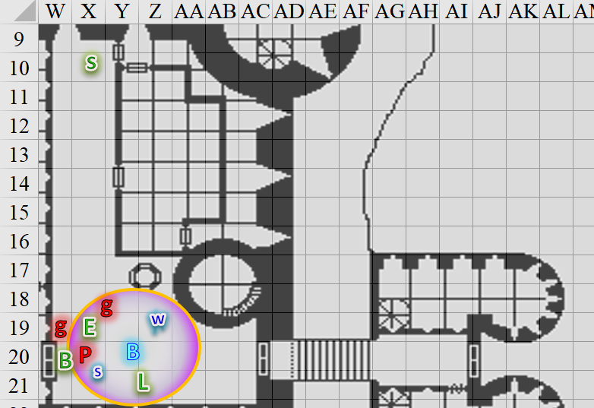

Round 2

Saradette set her bag down and pulled out her flechette launcher, which was fully charged to fire four shots before the tank ran flat.

With the *bull’s strength* spell added Barkley leaned against the door, holding it closed. His intent had initially been to prevent the adjacent schmuck from opening it, but now developed into the struggle to slow down any reinforcements from arriving until the Prefect and the two guards could be dealt with.

|  |  |  |  |  |
| --- | --- | --- | --- | --- |
| **Character** | **Check** | **Ranks** | **Roll** | **Save** |
| Barkley | Strength | 4 | 9 | 13 |

*See below.*

As the captive held the door closed and attempted to break the handcuffs, Barkley was able to stretch a few of the links, but not enough to free himself.

The doors then burst open eastward against Barkley, and two more guards—human females—entered with blade and club drawn. “Process!” one of the lower-level warriors proclaimed as the two attempted to jab Barkley’s abdomen and concuss his head.

|  |  |  |  |  |  |  |  |  |  |
| --- | --- | --- | --- | --- | --- | --- | --- | --- | --- |
| **Character** | **Attack Type** | **Damage** | **BAB** | **Str Mod+** | **Dex Mod+** | **W+** | **Total Score** | **Roll** | **Total** |
| Baronial Guard | MW Club | 1d6+3 | 3 | 3 | 2 | 1 | 7 | 8 | 15 |
| Baronial Guard | MW Short Sword | 1d6+3 | 3 | 3 | 2 | 1 | 7 | 13 | 20 |

*Miss, miss.*

Bratislava appeared to be convinced now of whose side she was on. “Prefect, I’ll expect an explanation for this.”

Elsabet winced at the obvious fiendish inflection to the Prefect’s pronouncement, nodded at Solstice’s well-placed stabs in flanking position, and with a mighty blow, initiated her foehammer strike against the wounded spellcaster, but while taking advantage of the flanking position, turned her blade sideways to deal nonlethal damage in order to take the prefect alive. Elsabet turned to face the guards after the evil priest had fallen, and shouted out, “Submit to the Colonel-Priestess, or else!”

|  |  |  |  |  |  |  |  |  |  |
| --- | --- | --- | --- | --- | --- | --- | --- | --- | --- |
| **Melee Weapon** | **Dmg** | **D+** | **TH+** | **Critical** | **Type** | **Wt.** | **Atk** | **Roll** | **Check** |
| Bastard Sword +1, 1-handed | 1d10+1 | +2 | 4 – 4 + 2 | 19-20/x2 | Slashing | 6.0 | +9 | 16 | 25 |

*Hit. Dmg: 6 + 1 + 2 + 2 Courage + 11 Foehammer = 22 nonlethal [****-14****/22].*

*NOTE: I thought swords couldn’t deal nonlethal damage.*

The man was now on the ground, and unresponsive.

Elsabet looked into the remaining guard’s eyes, and coldly proclaimed, “Your plans will fail, by the Fist of Light!” As she felt her shield block being granted to her, Elsabet looked around and for the first time that day, felt confident they would prevail. She was close enough to Barkley that she could use the shield block to protect him against the next guard who swung at him.

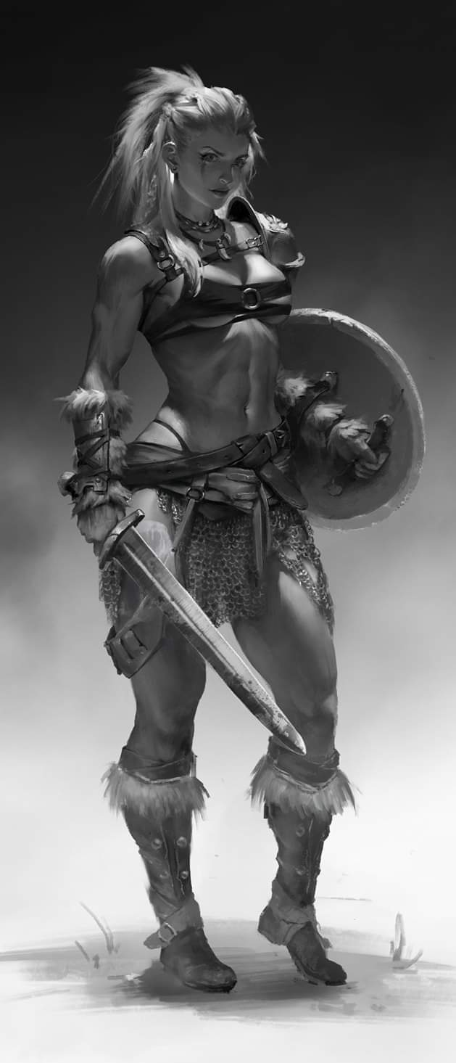

Bratislava could hear more guards—likely to be on the side of these three—and cast a spell that Elsabet and Barkley mistook for *entangle*, while the others could tell it had thorny brambles not consistent with such a menial spell. It was *briar web [expired on Round 42]*, and she centered it on a spot west of the double doors, likely getting the majority of this level, and even manifesting some vines on the upper levels.

*Those that attempt actions (attack, cast a spell with a somatic component, move, and the like) take thorn damage of 1d4 points, plus 1 additional point per caster level, and must make a successful Reflex save or be entangled. A character who tries to cast a spell must also make a Concentration check (DC 15 + spell level + damage taken) or lose the spell.*

*A creature that fails the Reflex save is entangled, can’t move, and suffers a –2 penalty on attack rolls and a –4 penalty to effective Dexterity. An entangled creature can try to break free and move at half normal speed by using a full-round action to make a Strength check or Escape Artist check (DC 20). A nonentangled creature can move through the area at half speed, taking damage as described above. Each round nonentangled creatures remain in the area, the plants attempt to entangle them.*

*The plants provide one-quarter cover for every 5 feet of substance between a creature in the area and an opponent—one-half for 10 feet of briar web, threequarters for 15 feet, and total cover for 20 feet or more.*

The crossbowman north of Elsabet remained still for the moment, unable to do anything without undergoing stinging pain.

“Milady, my group has had various bits of evidence from a variety of sources, including at least one guards stalwart, that members of a chaotic evil cult were using the lawful evil wererats to stir up trouble and cause a crackdown in the city while they wormed their way into the Baron’s confidence and usurped his rule in a coup. I have recorded many of these things in my journal, and while they may not hold up as evidence in a formal court, they paint a compelling picture. You are welcome to examine my journal at any time, I have no secrets to hide, on my honor as a favored soul of the Shield Maiden.

“Speak!” Bratislava’s distraught voice commanded the Prefect’s remaining loyalist.

Luran maintained a defensive stance as he continued to emit bardic music.

Solstice hid within the brambles standing perfectly still, likely unseen by the newcomers to his west.

|  |  |  |  |  |  |  |
| --- | --- | --- | --- | --- | --- | --- |
| **Skill** | **Rank** | **Ability & Mod.** | **Misc. Mods.** | **Total** | **Roll** | **Check** |
| **Solstice, Hide** | 5 | **Dex (+3)** | 8 | 16 | 5ish | ?? |

*Result unknown.*

Widget shrugged as she was apprehended like the others by the tendrils of the spell’s effect.

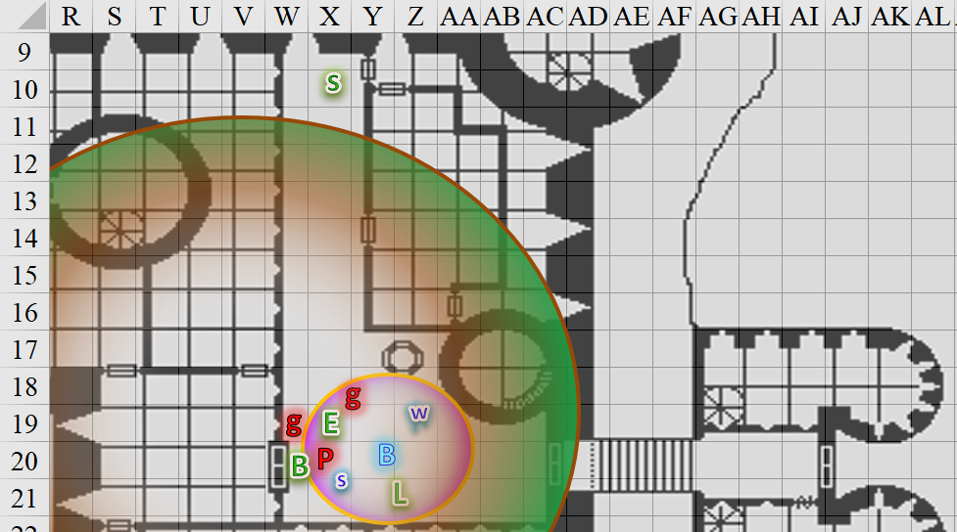

Round 3

The sound of a horn resounding throughout the level above them—or perhaps a staircase nearby—alerted them to the fact that there were likely more reinforcements on the way, but with these briars, they would likely be stuck as well.

Saradette moved forward 5’, inches away from the spell’s grasping vines, and shouldered her launcher.

The two guardswomen—though outwardly hostile in their demeanors—hesitated, not so much because of Elsabet’s and Bratislava’s commanding presences, but mostly due to their own incapacitated state now that the *briar web* was in full effect. The moment—as tense as it was—suddenly lent itself to dialogue once again, and though Saradette was prepared to snipe the remaining hostiles with a few pulls of her trigger, she stayed her launcher as her crusader colleague made efforts to speak quickly.

“We had hoped to be able to find some high ranking officer truly loyal to the Baron and the Barony who had long been in service, so that we could go over this evidence and come up with a sanctioned plan to sort out the loyal guards from the traitorous, rescue the Baron from their evil influence, and release certain falsely accused political prisoners such as various good and honorable priests that have been imprisoned on false pretenses and trumped up charges.”

Bratislava was by now looking at the two women guards, and their male accomplice. At this point, they’d identified five definite culprits, and were relieved that the Colonel-Priestess was receptive to their intentions. “What do you know of this? Katrineth? Kristineth? Tucker?”

Looking more like assassins than like the regular infantry, these elite warrior women appeared to be significantly better equipped than the male grunt that remained standing among them. The three evil guards smirked, and one of the women—dressed in a highly revealing suit of protective silk and tattooed with reptilesque designs across her limbs—simply said, “Everybody dies.”



The other woman—similarly skimpily armored but far more muscular, untattooed, and with a horned helmet and a set of epaulettes that bore raven wings—said, “Everybody burns...”



For the first time, Bratislava betrayed contempt—perhaps indignation—at what she’d just heard. She’d tolerated the Baron’s new entourage of consultants, mercenaries, and ad-hoc advisors who had swept the Court since the wyste and wererat incident. She’d reluctantly looked the other way when courtesans and guards became as one in the midst of these new men, and the few women who now had the Baron’s ear. She’d vomited last night over the conflict that she tried so hard to ignore, but now—as if a dam had burst—her tolerance was no more. “Fiends! Traitors to your own city!”

“All must cower before the Speaker in Dreams,” the male guard—Tucker—said, now grinning.

Elsabet took the opportunity to say more: “I am glad you are with us. They were seeking to incarcerate us all, as evidenced by the wrongful detention of my archon friend, who while sometimes impulsive, does not, nor could he ever, have a single evil bone in his body.”

“Rest easy, heroes. I *do* believe you. You have acted honorably.” Bratislava kept the spell in place, knowing full well that, “there are at least a dozen guards beyond, and as many courtiers with the Baron now, if not more. Others are elsewhere in the city, but with a few castings, I suspect they’d be notified of what is happening and be summoned, so we haven’t much time if what you say is true. Are you saying the Baron himself is behind this?”

Solstice wanted to say no, but it would have given away his position. He was relieved when Elsabet did so instead.

“The presence of the Prefect here surprised me, and he verily reeks... reeked... of evil. I apologize for acting hastily, but I am glad to have this out in the open. We have been aiding the city and the loyal guards these past few days, not for reward but because we strive to do the right thing. The sergeant at the gate knows I just on the way in revitalized the two most fatigued members of his team with the boon of *lesser restoration* so they could continue to serve the city in these trying times.”

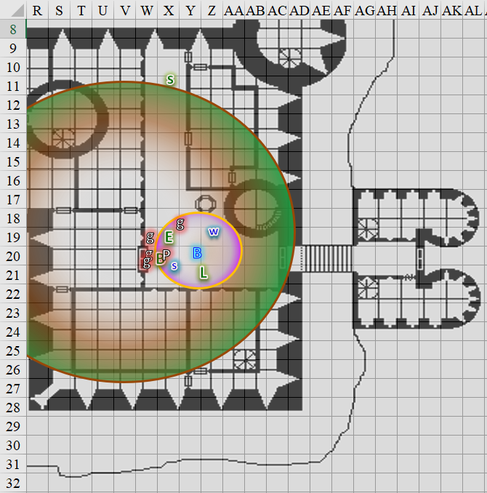

Then the three guards’ eyes suddenly rolled back into their heads, and they collapsed, held partly up by the briars so that they were kneeling as their faces betrayed certain death.

Elsabet continued. “I believe the Baron has either fallen sway to persuasive words, or more likely, is under magical compulsion. I do not believe he would have ordered the changes of the last few days if in his right mind, and I believe we must act to save him from these outland cultists. I have only knocked out this prefect, though I were sorely tempted to slash him dead.”

She took a breath, and further explained. “Our party has been targeted for nightmares these last two nights, where we fought foes in the dreamlands—and awoke with evidence that our victories there were real. They must fear what we can do—and their very attempts to destroy us in our dreams sparked us to action today. After one of those victories, a sending from the Goddess Mayaheine, in the form of our slain paladin comrade, warned us of some of what we faced, and dubbed us the Fist of Light. We seek to be worthy of that honor.”

Bratislava listened as faint sounds of nearby commotion could barely be heard.

“While the enemy may be mustering, we may be able to call upon other heroes to aid us in the fight. Many of the guards have not been corrupted, with no taint of evil upon them. And our archon’s ability to detect that taint is invaluable. I suggest that one place we may find aid is in the dungeons—we heard that the high priest of Tyr was taken, and I strongly suspect he and others were taken precisely because the cultists fear what they can do. I only hope they have not been slain.”

Then, two of the guards who had admitted them into the grounds now entered the hall with weapons drawn and were perplexed by the situation. Bratislava said a few clarifying words, and asked the guards to stand down for the moment. “We’ve been betrayed from within,” she concluded.

Elsabet added, “The sergeant at the gate and his team seemed untouched by evil, perhaps they could be brought inside to hold the main gate secure against cultists still out in the city.”

“Who is behind this?” asked the Sergeant who’d just entered via the front doors as two pikemen joined her and saluted, then took their pikes in both hands and stood by.

“We know not,” Bratislava tried to be as monosyllabic as possible.

Bratislava frowned, “What did Tucker mean by a ‘Speaker in Dreams’?” She directed the question rhetorically as she scanned her memories in vain for such a reference.

“We stand ready to aid you,” the Sergeant pledged, casting *detect evil [expired in 40 minutes]*.

Bratislava considered dispelling the *briar web*, but first said, “Reinforcements have no doubt been mustered. Once this *web* disappears, they’re likely to come rushing in.”

“Understood,” Sgt. Pepper nodded, her comely features diminished only by the weariness brought on by the last few days’ efforts. “Where’s the courtesan? Was she behind this plot?”

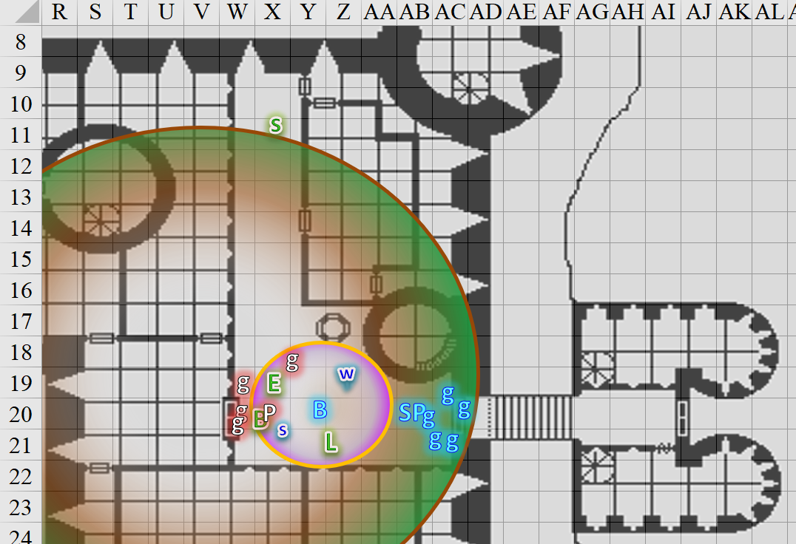

Rounds 11 – 19

The Prefect awoke, groggy from the lump on the side of his head, then passed out again.

As Elsabet and Bratislava talked, Barkley continued to strain against the restraints with the aid of the *bull’s strength* spell.

When the restraints finally gave way, his arms flew out to his sides and he smiled in satisfaction.

When talk turned to the priests of Tyr and also the mention of the courtesan, Barkley laughed.

“The courtesan is our ally,” he said and pointed to Saradette, whom no one near the entry could see. “Also, I must retrieve my equipment to be of better assistance. I am still capable of fighting with my natural weapons, but not as effectively.”

“Allow me to change clothes,” Saradette said, shouting around the corner so Sergeant Pepper could confirm her location. She quietly spoke the proper command word, and her shiftweave morphed into her regular travel clothes. She still had her sandals on, since her boots were in her pack.

Through all this, Luran had continued his song at a low, threshold volume, certain it was only a matter of time before his support would be needed.

By the time Saradette looked like a proper woman from the neck down—still sticking out like a town crier on an empty corner due to the wig and makeup—the luscious spellcaster saw and heard Bratislava dispelling her own *briar web* spell, and all friendlies coalescing in anticipation of an impending putsch.

Elsabet asked Barkley, “Where would your gear have been put? Was he disarmed near where he was taken from?”

“No, they took my stuff before we even got around the corner,” the archon shook his head. “Could be anywhere.”

“I would like to combine two goals: freeing political prisoners who will hopefully be able to help us, and recovering Barkley’s gear in the process if possible. Then we make our way to the Baron. With our *two* Celestial companions able to sort out who is evil, we can operate on the assumption that anyone who registers as evil is a foe, and everyone else is at least a possible ally.”

Solstice agreed, but said nothing.

“But, Bratislava, if you instead prefer to seek the Baron immediately, I will certainly bow to your authority. Please speak up as necessary, you are ranking officer here.”

“Any guards that are new in the last week are suspect, any who have been here a long time are provisionally allies. Also—any guards who do not submit to the colonel-priestess’ authority had better get out of the way and stay out of it, or get taken down. Loyal guards will submit and back us up.”

Bratislava was glad to have this band of heroes here at the right time.

“You still have at least a couple of minutes of strength, Barkley. One of the guards attacking you had a nice-looking short sword—you can have my normal morningstar for your primary hand and use the short sword in your off hand if you want.”

Round 20

Barkley waited until Bratislava released them—and others—from the *briar web*, then reached down and grabbed a masterwork short sword as the hurried footsteps of the guards reprised.

“Guards are coming; ready yourselves,” Bratislava said in a hushed voice as Barkley—still bruised from the lump on the head he took during his arrest—cast *aid [expired on Round 70]* upon the guard beside him.

*Baronial Guard 1 gained +1 to attacks and saves vs. fear, and 1 + 5 = 6 temporary hps [****31****/25].*

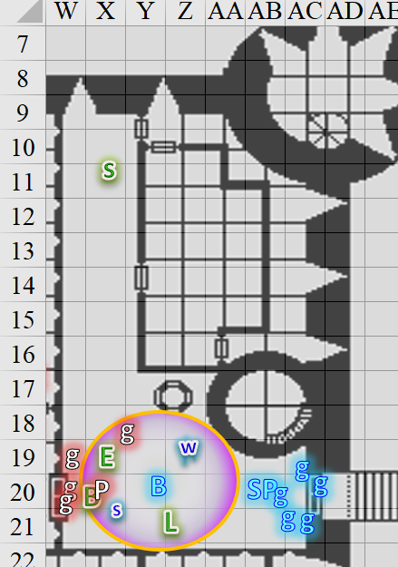

Round 21

|  |  |  |  |  |  |
| --- | --- | --- | --- | --- | --- |
| **Character** | **Group** | **Initiative** | **Roll** | **Modified Roll** | **Move** |
| Saradette | 1 | 3 | 17 | 20 | 20’ |
| Barkley | 1 | 2 | 18 | 20 | 40’ |
| Luran | 1 | 1 | 12 | 13 | 30’ |
| Solstice | 1 | 1 | 12 | 13 | 30’/10’ |
| Elsabet | 1 | 4 | 8 | 12 | 30’ |
| Guards | 2 | 2 | 10 | 12 | 30’ |

Saradette extracted her armor from her haversack in order to strap it on. “Widget and I will go after the prisoners.” Working quickly, she settled her gear in place and hefted her launcher. “Now, if someone can tell me where I need to go.”



The Prefect moaned and groaned on the floor, still unable to rouse himself.

Barkley moved towards and cast *aid [expired on Round 71]* on Elsabet, then took Elsabet’s morningstar, set it back down, and reached into his haversack to get some rope from haversack restrain the hands of the evil priest.

*Baronial Guard 2 gained +1 to attacks and saves vs. fear, and 6 + 5 = 11 temporary hps [****36****/25].*

Luran added emphasis to the bolstering actions of the heroes within the entrance hall to the keep, making even the strangers feel emboldened and resolute.

Solstice moved into the corner, and hid in plain sight.

|  |  |  |  |  |  |  |
| --- | --- | --- | --- | --- | --- | --- |
| **Skill** | **Rank** | **Ability & Mod.** | **Misc. Mods.** | **Total** | **Roll** | **Check** |
| **Hide** | 5 | **Dex (+3)** | 8 | 16 | 15ish | ?? |
| **Move Silently** | 2 | **Dex (+3)** | 8 | 13 | 5ish | ?? |

*Probably good to go.*

As Barkley looked for something to secure the prefect, Elsabet, said “Oh! Here,” and pulled her manacles out of her haversack, and handed them to the archon. “Forgot I replaced these. I should have picked up extras....”

*[Deferred NPC actions for the sake of the conversation.]*

Barkley looked over at Saradette, “Be careful, and take Solstice as well. Don’t forget to whisper to us if you are in trouble. Wait. Where’d he go?” There was a bit of concern in his voice until he spotted Solstice, and he knew that Saradette could handle herself.

The artificer patted her launcher. “I can completely ruin four peoples’ day,” she said with a fierce smile.

The Baronial Guards made their way in, first spotting and identifying the dead people on the ground, then shooting their crossbow bolts point-blank at Barkley and asking no questions.

|  |  |  |  |  |  |  |  |  |  |
| --- | --- | --- | --- | --- | --- | --- | --- | --- | --- |
| **Character** | **Attack Type** | **Damage** | **BAB** | **Str Mod+** | **Dex Mod+** | **W+** | **Total Score** | **Roll** | **Total** |
| Prefect’s Guard | MW Light Crossbow | 1d8 | 3 | 3 | 1 | 1 | 7 | 5 | 12 |
| Prefect’s Guard | MW Light Crossbow | 1d8 | 3 | 3 | 1 | 1 | 7 | 14 | 21 |

*Miss, miss.*

“Bastards! Dieee!” the male that entered first yelled. The guardswoman that followed lodged her crossbow bolt into Barkley’s armor, though it fortunately did not penetrate into his skin, but gave him more of a friendly nudge to the chest.

“Really?” Barkley confirmed their boldness, smirking as a third guard’s torso was now visible, but he did not have a line of attack at the moment. It also sounded like a fourth fool was coming down the hall to meet his or her doom.

Sgt. Pepper commanded, “To arms! For Mintar!” and the guards on the heroes’ side immediately retaliated, positioning themselves so as to better manage the breach. Two of them reached the traitors to the Baronial Crown, and swung a club and jabbed a blade at Barkley’s two assailants.

|  |  |  |  |  |  |  |  |  |  |
| --- | --- | --- | --- | --- | --- | --- | --- | --- | --- |
| **Character** | **Attack Type** | **Damage** | **BAB** | **Str Mod+** | **Dex Mod+** | **W+** | **Total Score** | **Roll** | **Total** |
| Baronial Guard | MW Club | 1d6+3 | 3 | 3 | 2 | 1 | 7 | 6 | 13 |
| Baronial Guard | MW Short Sword | 1d6+3 | 3 | 3 | 2 | 1 | 7 | 18 | 25 |

*Miss, hit. Dmg: 6 + 3 = 9.*

The pikemen held their long weapons in preparation of holding the line if needed.

*NOTE: All living characters are now in their own square.*

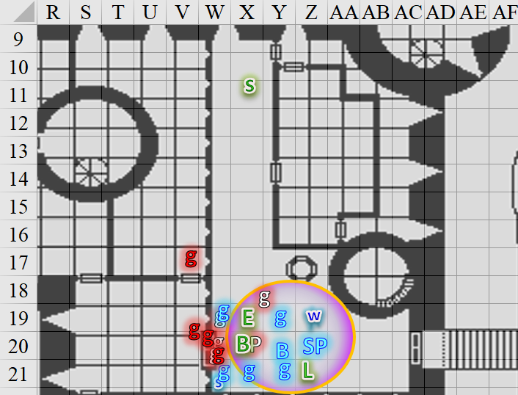

Rounds 22 – 31

Saradette strapped on her armor.

Round 22

Barkley considered his options: defend himself with the sword in his hand, drop the haversack and pick up the morningstar, cast *aid* on someone else, or take out the rope from the haversack and tie up the Prefect, or take Elsabet up on the offer. He turned the Prefect over and slapped the manacles on his wrists... tightly.

Luran continued to aid his allies.

Heartened by the arrival of more loyal guardsmen, and feeling battle leader’s charge and stone vice granted to her, Elsabet grinned at the crazed cultists, uttered a command word and activated her anklet of translocation. With a puff of displaced air, she disappeared from where she stood and reappeared directly behind the 2 cultists crammed in the doorway, flanking them with Barkley on the opposite side.

“Process that, asswipes,” she muttered, as she lifted her sword high. “If any go down, bind and gag them,” she called out to the body of good guards out in the main group. As she glanced to her left, contemplating her next action, she saw one cultist right beside her and another coming through the doorway behind them.

Then, seeing that a friendly guard with a short sword had stabbed one of the guards in the doorway that she now flanked, she initiated her Stone Vise and slashed down hard at the wounded guard.

|  |  |  |  |  |  |  |  |  |  |
| --- | --- | --- | --- | --- | --- | --- | --- | --- | --- |
| **Melee Weapon** | **Dmg** | **D+** | **TH+** | **Critical** | **Type** | **Wt.** | **Atk** | **Roll** | **Check** |
| Bastard Sword +1, 1-handed | 1d10+1 | +2 | 4 | 19-20/x2 | Slashing | 6.0 | +11 | **20** | 31 |

*Threat. 1d20 = 8 + 11 = 19, critical hit. Dmg: (2 x 3) + 1 + 2 + 2 + 5 Stone Vise = 16.*

|  |  |  |  |  |
| --- | --- | --- | --- | --- |
| **Character** | **Save vs.**  *Stone Vise* | **Ranks** | **Roll** | **Save** |
| Prefect’s Guard | Fortitude | 4 | 12 | 16 |

*Success. Mobility penalty ignored.*

She felt Foehammer being granted to her, and though she didn’t finish this one off, she grinned even more ferociously as she called out to the loyal guards and looked around to check out the area.

The enemy guards had looks of pure contempt on their part. Elsabet saw a burly one purposely slicing his cheek with his dagger before throwing it at her.

|  |  |  |  |  |  |  |  |  |
| --- | --- | --- | --- | --- | --- | --- | --- | --- |
| **Character** | **Attack Type** | **Damage** | **BAB** | **Dex Mod+** | **W+** | **Total Score** | **Roll** | **Total** |
| Prefect’s Guard | MW Dagger, Thrown | 1d3+3 nl | 3 | 2 | 1 | 6 | 3 | 9 |

*Miss.*

The dagger flew past her, cartwheeling inches away from her before bouncing as expected against the wall and falling uneventfully to the floor. The other guards attacked.

|  |  |  |  |  |  |  |  |  |  |  |  |
| --- | --- | --- | --- | --- | --- | --- | --- | --- | --- | --- | --- |
| **Character** | **Attack Type** | **Damage** | **BAB** | **Str Mod+** | **W+** | **Total Score** | **Roll** | **Total** | **Crit** | **Threat** | **Notes** |
| Prefect’s Guard | MW Short Sword | 1d6+3 | 3 | 3 | 1 | 7 | 3 | 10 | 20 | ý | Baronial Guard 1 |
| Prefect’s Guard | MW Short Sword | 1d6+3 | 3 | 3 | 1 | 7 | 13 | 20 | 20 | ý | Elsabet |
| Prefect’s Guard | MW Short Sword | 1d6+3 | 3 | 3 | 1 | 7 | 20 | 27 | 20 | þ | Baronial Guard 2 |

*Miss, miss (I think), hit.*

*Dmg to Baronial Guard 2: 3 + 3 = 6. Temporary hps depleted; still at full health.*

Bratislava ordered the men and women loyal to the Baron to execute their offensives. The pikemen stood by as the honorable swordsmen did their best to put down the vile insurgents.

|  |  |  |  |  |  |  |  |  |  |
| --- | --- | --- | --- | --- | --- | --- | --- | --- | --- |
| **Character** | **Attack Type** | **Damage** | **BAB** | **Str Mod+** | **W+** | **Total Score** | **Roll** | **Total** | **Notes** |
| Baronial Guard | MW Club | 1d6+3 | 3 | 3 | 1 + 2 Courage | 9 | 15 | 24 | Prefect’s Guard 3 |
| Baronial Guard | MW Short Sword | 1d6+3 | 3 | 3 | 1 + 2 Courage | 9 | 5 | 14 | Prefect’s Guard 4 |
| Baronial Guard | MW Short Sword | 1d6+3 | 3 | 3 | 1 + 2 Courage | 9 | 14 | 23 | Prefect’s Guard 4 |

*Hit, miss, hit.*

*Dmg to PG3: 4 + 3 + 2 Courage = 9.*

*Dmg to PG4: 6 + 3 + 2 Courage = 11.*

These swipes nearly killed the already wounded frontline of traitors to the Barony, but the two guards continued to defend themselves.

Bratislava then moved a bit and full-attacked the nearest enemy.

|  |  |  |  |  |  |  |  |  |  |
| --- | --- | --- | --- | --- | --- | --- | --- | --- | --- |
| **Character** | **Attack Type** | **Damage** | **BAB** | **Str Mod+** | **W+** | **Other+** | **Total Score** | **Roll** | **Total** |
| Bratislava | MW Short Sword | 1d6+3 | 4 | 2 | 1 | 2 | 9 | 11 | 20 |

*Hit. Dmg to BG3: 1 + 3 + 2 Courage = 6.*

And still, the enemy combatant was not slain *[1 hp left by any PC’s guess]*.

Solstice had been biding his time, and now picked the right moment to *magic missile* the nearest enemy. He could have used his blowgun, but felt that it wasn’t necessary to hit a weak spot and risk a miss, so he sought to end the mortally wounded soldier with the most predictable means that he had available. Both missiles inerrantly hit their target.

*Dmg: 6 + 2 = 8 magic.*

And finally, the guard went down.

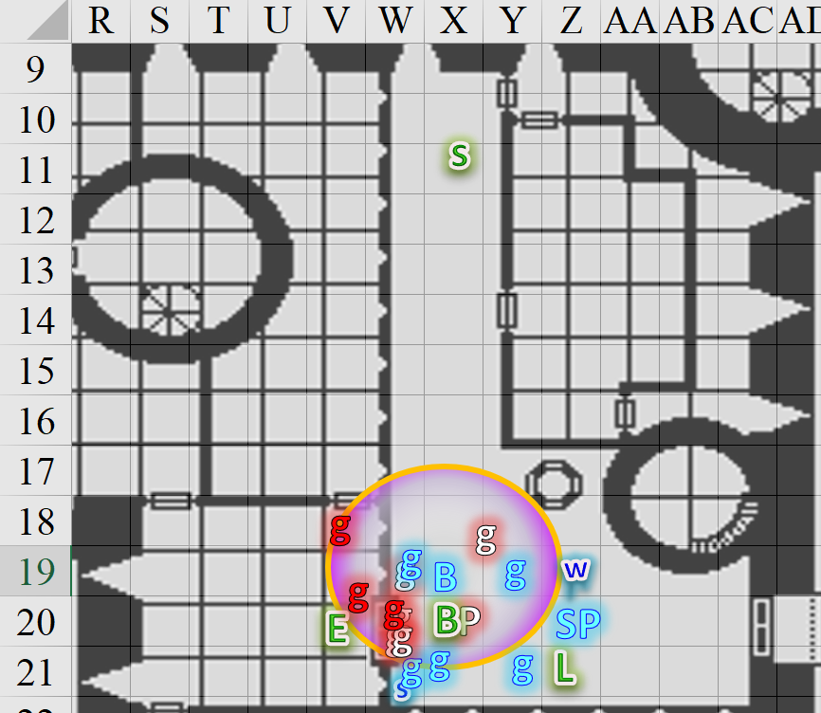

Round 23

Elsabet had half-expected another dozen soldiers to be approaching, but this was it for now. She did, however, hear some commotion to the north, which sounded like a separate melee about two rooms away. Unexpected as that was, it *did* suggest that forces representing both the Baron *and* his enemies were already resolving this conflict, and the Baron’s life might be in immediate danger now.

Saradette continued donning her armor as Widget held her ground.

Barkley picked up the Prefect and walked him over toward the wall, slamming him face first into it. Then put his short sword at the base of his skull, adding, “Tell your followers to surrender or I end your life right now.” Barkley’s concern about arresting and detaining the evil cleric being overridden by the desire to keep any further death or injury.

The Prefect remained unconscious.

Luran kept bolstering his friends’ actions, and in anticipation of either having to defend himself or heal his allies, unsheathed his dagger and reached into his magical shoulder bag, pulling forth his minor curative wand.

Solstice could tell this guard was also nearly dead, so he stayed his blowgun, and popped another *magic missile*.

*Dmg: 3 + 2 = 5 magic.*

Figuring that her allies on the other side of the foe left in the doorway would make short work of him, Elsabet stayed where she was to continue giving some of them flanking, while turning slightly to get started on the next foe. “I hear fighting to my north!” she yelled to keep the others informed. Drawing upon her faith in Mayaheine, and still bolstered by Luran’s impeccable performance, Elsabet muttered a swift command word to activate one charge from her gauntlets, initiated her Foehammer maneuver and slashed hard at the foe to her north.

|  |  |  |  |  |  |  |  |  |  |
| --- | --- | --- | --- | --- | --- | --- | --- | --- | --- |
| **Melee Weapon** | **Dmg** | **D+** | **TH+** | **Critical** | **Type** | **Wt.** | **Atk** | **Roll** | **Check** |
| Bastard Sword +1, 1-handed | 1d10+1 | +2 | 4 | 19-20/x2 | Slashing | 6.0 | +11 | 6 | 17 |

*3 + 1 + 2 + 2 Courage + 8 Foehammer + 2 Gauntlet = 18.*

Standing her ground, eyes going back and forth between the two foes she threatened, she thought to herself, these guys weren’t too bright... but they were pretty tough. As she felt her Crusader’s Strike granted, she kinda hoped this guy would hit, and activate her Furious Counterstrike ability. She smirked at the thought.

Sergeant Pepper had not exactly hesitated, but had taken care to expedite her forces in an orderly fashion so that the pikemen did not block the swordsmen. She was no marshal or legendary leader, but did her best to boost the confidence of her men and women as the battle unfolded in the adjacent room now.

The Baronial Guards prepared to finish off the baddies on this level, but when Bratislava stepped over the woman whom Solstice had just killed and full-attacked the Guard occupied with Elsabet, the other guards were unable to step through the threshold.

|  |  |  |  |  |  |  |  |  |  |
| --- | --- | --- | --- | --- | --- | --- | --- | --- | --- |
| **Character** | **Attack Type** | **Damage** | **BAB** | **Str Mod+** | **W+** | **Other+** | **Total Score** | **Roll** | **Total** |
| Bratislava | MW Club | 1d6+3 | 4 | 2 | 1 | 2 | 9 | 3 | 12 |

*Miss.*

The Prefect’s Guards attacked Elsabet.

|  |  |  |  |  |  |  |  |  |  |
| --- | --- | --- | --- | --- | --- | --- | --- | --- | --- |
| **Character** | **Attack Type** | **Damage** | **BAB** | **Str Mod+** | **W+** | **Other+** | **Total Score** | **Roll** | **Total** |
| Prefect’s Guard | MW Short Sword | 1d6+3 | 3 | 3 | 1 | 0 | 7 | 9 | 16 |
| Prefect’s Guard | MW Short Sword | 1d6+3 | 3 | 3 | 1 | 0 | 7 | 14 | 21 |

*Miss, miss.*

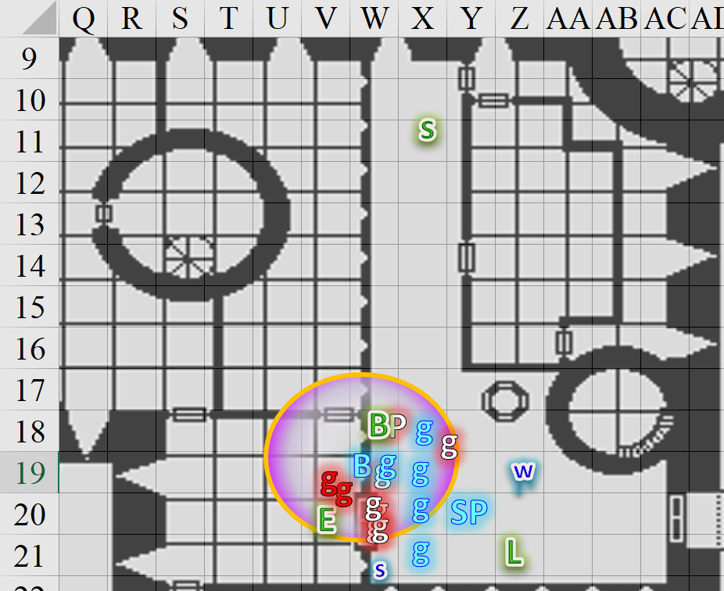

Round 24

Saradette slipped on the first sleeve of her chain shirt.

Barkley looked at the Prefect’s Guards and yelled, “Surrender now or I end his life.” Not sure just how important the prefect was, Barkley stood ready to slide his short sword up into the base of the Prefect’s skull.

***NOTE:*** *The following was resolved before I realized that this guard was killed on the previous round. There’s no longer an enemy with a line of sight to Barkley right now, but I’ll post this anyway to give you a better impression of your PCs’ perceptions of the enemy guards.*

The Guardswoman stared at Barkley for about a second before making up her mind.

|  |  |  |  |  |
| --- | --- | --- | --- | --- |
| **Character** | **Check** | **Ranks** | **Roll** | **Save** |
| Prefect’s Guard | Sense Motive | 3 | 10ish | ? |

*Not usually shown, but it’s obvious from the enemy’s look that she was trying to read Barkley.*

***NOTE:*** *I’m assuming that Barkley is telling the truth.*

The Prefect’s Guardswoman shook her head and smirked, not trusting that Barkley was telling the truth. She consequently thought it more efficient to make sure that the Prefect was not taken prisoner, and retorted, “He has made his bargain,” before drawing and throwing a (probably poisoned) dagger with an emerald-green mercy at the Prefect.

|  |  |  |  |  |  |  |  |  |
| --- | --- | --- | --- | --- | --- | --- | --- | --- |
| **Character** | **Attack Type** | **Damage** | **BAB** | **Dex Mod+** | **W+** | **Total Score** | **Roll** | **Total** |
| Prefect’s Guard | MW Dagger, Thrown | 1d3+3 nl | 3 | 2 – 4 off-hand | 1 | 2 | 2 | 4 |

*Miss.*

*[DM assumption based on there being no bluff involved above.]* Barkley executed his threat with no hesitation.

|  |  |  |  |  |  |  |  |
| --- | --- | --- | --- | --- | --- | --- | --- |
| **Melee Weapon** | **Dmg** | **D+** | **TH+** | **Critical** | **Type** | **Wt.** | **Atk** |
| MW Short Sword | 1d6 | +4 | 3 | 19-20/x2 | Piercing | 2.0 | +12 |

*Automatic hit. Dmg: 6 + 4 + 2 Courage = 12.*

Luran kept vigilant and continued his lyrical spiel.

Solstice stepped into the threshold and fired a dart upon the adjacent enemy.

|  |  |  |  |  |  |  |  |  |  |  |
| --- | --- | --- | --- | --- | --- | --- | --- | --- | --- | --- |
| **Ranged Weapon** | **Dmg.** | **D+** | **TH+** | **Critical** | **Rng.** | **Wt.** | **Atk** | **Roll** | **Check** | **Notes** |
| MW Blowgun | 1 | 0 | 1 | x2 | 10’ | 0.1 | +10 | 5 | 15 | +3d6 Sneak |

*1 + 2 Courage + 11 Sneak = 14.*

The slighter male Guard now died for his cultist allegiance, leaving burly fool who had thrown the dagger at Elsabet to fend for himself.

Elsabet took a step to her left in order to flank the remaining foe with Bratislava, to gain the advantage of splitting the foe’s attention. With no other useful maneuvers for this situation, and with her maneuvers about to be reset, she initiated her Crusader’s Strike and slashed at the crazy cultist.

|  |  |  |  |  |  |  |  |  |  |
| --- | --- | --- | --- | --- | --- | --- | --- | --- | --- |
| **Melee Weapon** | **Dmg** | **D+** | **TH+** | **Critical** | **Type** | **Wt.** | **Atk** | **Roll** | **Check** |
| Bastard Sword +1, 1-handed | 1d10+1 | +2 | 4 | 19-20/x2 | Slashing | 6.0 | +11 | 19 | 30 |

*Threat. 1d20 = 19 + 11 = 30, critical hit. Dmg: 2 + 1 + 2 + 2 + 2 Courage = 9.*

*Due to Barkley’s aid spell, no allies within 10’ need healing.*

She nodded in satisfaction as her blade cut the foe again, and she felt the healing energy infuse her blade—looking past the enemy, she channeled the energy to Bratislava, in case the woman had any injuries. She maintained her position to give the colonel-priestess the flanking advantage, and reached into her haversack with her left hand and pulled out her crowbar, as she felt her remaining maneuvers fade and then two new ones granted.

|  |
| --- |
| *Current Maneuvers* |
| Foehammer |
| Stone Vise |
| Shield Block |
| Crusader’s Strike |
| Battle Leader’s Charge |

Elsabet then pulled out my crowbar with her left hand, so that next round or whenever if they needed to force a door open, she could use it for that.

Bratislava took a 5’ step to free up the threshold for another guards, and jabbed her short sword in the direction of the burliest, meanest, ugliest of the enemy guards so far.

|  |  |  |  |  |  |  |  |  |  |
| --- | --- | --- | --- | --- | --- | --- | --- | --- | --- |
| **Character** | **Attack Type** | **Damage** | **BAB** | **Str Mod+** | **W+** | **Other+** | **Total Score** | **Roll** | **Total** |
| Bratislava | MW Short Sword | 1d6+3 | 4 | 2 | 1 | 2 | 9 | 7 | 16 |

*Miss.*

The Baronial Guards stepped further westward, and one of them stabbed at the musclebound grunt.

|  |  |  |  |  |  |  |  |  |  |
| --- | --- | --- | --- | --- | --- | --- | --- | --- | --- |
| **Character** | **Attack Type** | **Damage** | **BAB** | **Str Mod+** | **W+** | **Other+** | **Total Score** | **Roll** | **Total** |
| Baronial Guard | MW Short Sword | 1d6+3 | 3 | 3 | 1 | 2 | 9 | 14 | 23 |

*Hit. Dmg: 2 + 3 + 2 Courage = 7.*

The meanest of the guards loyal to the late Prefect full-attacked Elsabet.

|  |  |  |  |  |  |  |  |  |  |
| --- | --- | --- | --- | --- | --- | --- | --- | --- | --- |
| **Character** | **Attack Type** | **Damage** | **BAB** | **Str Mod+** | **W+** | **Other+** | **Total Score** | **Roll** | **Total** |
| Prefect’s Guard | MW Short Sword | 1d6+3 | 3 | 3 | 1 | 0 | 7 | 13 | 20 |

*Miss.*

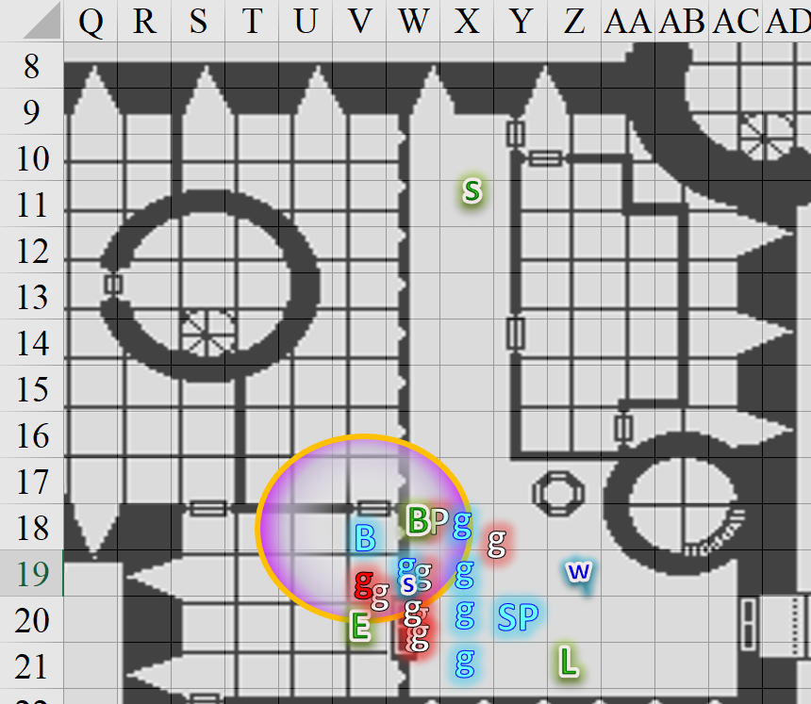

Round 25

Saradette continued donning her armor.

The Prefect’s guards falling quickly, Barkley let go of the prefect and let him fall to the floor. He turned to two of the Baron’s guards fighting alongside them, “Keep an eye on him and gag him if he wakes.”

|  |  |  |  |  |  |  |
| --- | --- | --- | --- | --- | --- | --- |
| **Skill** | **Rank** | **Ability & Mod.** | **Misc. Mods.** | **Total** | **Roll** | **Check** |
| **Barkley, Diplomacy** | 0 | **Cha (+1)** | 0 | 1 | 6 | 7 |

*See below.*

The Guards ignored the deputized archon, and continued to follow their commanding officer’s orders. Barkley then moved to the door in hopes of attacking any enemy guards remaining.

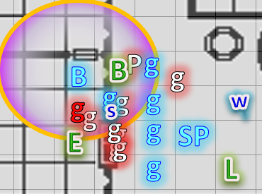

Luran lifted his friends’ spirits with his positive feedback. As his song continued, he shifted his position in the scene to be better connected to all involved.

Solstice held his blowgun for the moment, waiting to get a good shot in if the others didn’t put the massive guard.

With Bratislava having circled the remaining guard and given her flanking, and with her favorite maneuver being one of the two just granted, Elsabet grinned even wider, muttered “idiot,” and initiated her foehammer, swinging her bastard sword hard at the burly guard.

|  |  |  |  |  |  |  |  |  |  |
| --- | --- | --- | --- | --- | --- | --- | --- | --- | --- |
| **Melee Weapon** | **Dmg** | **D+** | **TH+** | **Critical** | **Type** | **Wt.** | **Atk** | **Roll** | **Check** |
| Bastard Sword +1, 1-handed | 1d10+1 | +2 | 4 | 19-20/x2 | Slashing | 6.0 | +11 | 17 | 28 |

*Hit. Dmg: 3 + 1 + 2 + 2 Courage + 2 flank + 4 Foehammer = 14.*

Feeling her shield block being granted, she was ready to use it to defend Bratislava if the guard were to attack the other woman. With contempt in her eyes at the foe, she then stepped up next to the colonel-priestess, assuming other allies would be moving into the area. “Do we need this?” she asked, holding up the crowbar.

The Baronial Guard at the threshold jabbed again at the remaining enemy.

|  |  |  |  |  |  |  |  |  |  |
| --- | --- | --- | --- | --- | --- | --- | --- | --- | --- |
| **Character** | **Attack Type** | **Damage** | **BAB** | **Str Mod+** | **W+** | **Other+** | **Total Score** | **Roll** | **Total** |
| Baronial Guard | MW Short Sword | 1d6+3 | 3 | 3 | 1 | 2 + 2 flank | 11 | 7 | 18 |

*Hit. Dmg: 6 + 3 + 2 Courage = 11.*

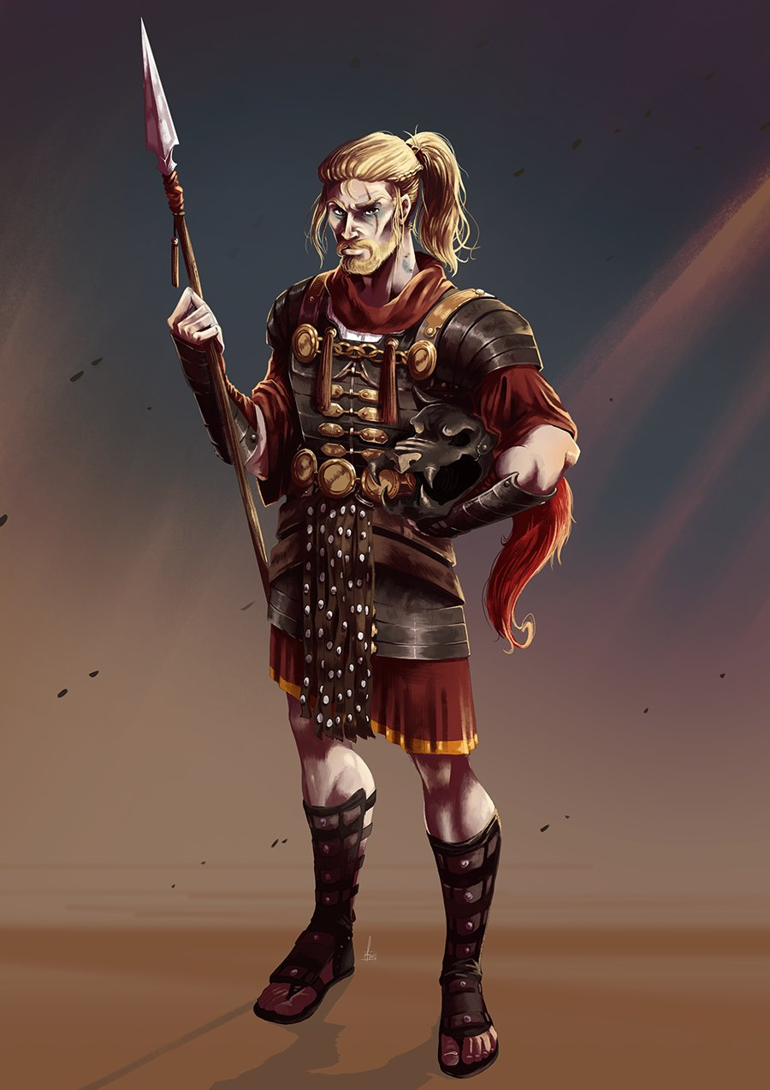

The Guards loyal to the Baron shuffled into the next room as best as they could. The pikemen stood their pikes up along both sides of the double doors, and drew their short swords in anticipation of further close-quarters combat as a gracile, young Guard with blood splattered on his breastplate and face entered through the northern door with an obvious look of bloodlust on his face. Within seconds, however, the depraved look settled on the distress that came from seeing his allies being killed, and the twenty-something turned tail and disappeared behind the wall to the next room, but not before Bratislava could get a jab at the youngster.

|  |  |  |  |  |  |  |  |  |  |
| --- | --- | --- | --- | --- | --- | --- | --- | --- | --- |
| **Character** | **Attack Type** | **Damage** | **BAB** | **Str Mod+** | **W+** | **Other+** | **Total Score** | **Roll** | **Total** |
| Bratislava | MW Short Sword | 1d6+3 | 4 | 2 | 1 | 2 courage + 2 flank | 11 | 4 | 15 |

*Miss.*

“Olé!” Solstice cheered the human guard as he pierced the last of the cultists, withdrawing the blade as the hefty man dropped to the floor. The sounds of battle to the north suggested that the conflict was far from over.

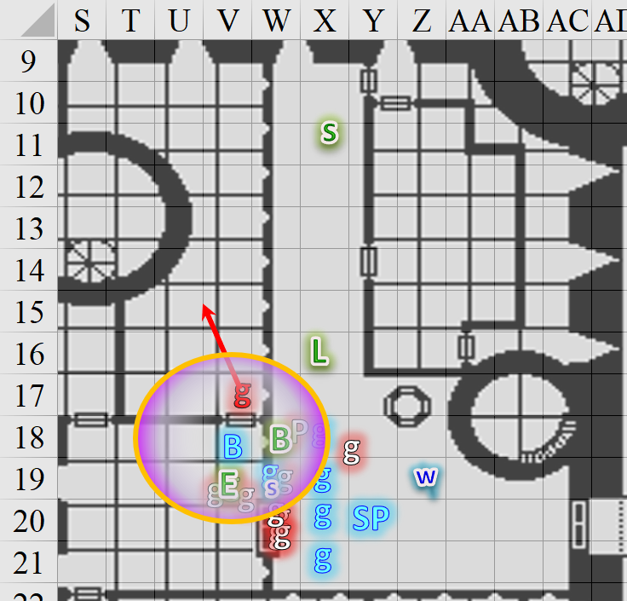

Round 26

Saradette continued to don her chainshirt, slipping on the second sleeve now but still needing another half-minute or so to finish up.

Seeing that none of the guards acknowledged his authority, and the fact that his ‘guards’ tried to kill him, told Barkley he might be a bit more useful. Barkley ripped off some of the Prefect’s cloak and clothing and gagged him before plopping him face down on the floor.

Luran kept on saying motivating things. “Mammaaaa, ouououou! They didn’t wanna die; sometimes they wished they’d never been born at aaaalllll!”

Elsabet realized that the fleeing guard had not fully closed the door in front of Bratislava, chuckled “never mind” and quickly moved through the door herself. Not worried about these lame posers, she continued forward as she scanned the room taking in the scene, and then....

The guards on the floor were knocking at death’s door, and could neither speak or move much.

Luran appears to be moving to help Saradette finish buckling up, while Elsabet and Bratislava are making out in the other room—well, not making out but partnering up it seems. Which way do you go?

Seeing the fleeing guard downed, Elsabet yelled back “need healing and Detect Evil!” as she moved over towards the prone guard in the middle of the group, making the snap judgment that if he fought the fleeing guard, he was a good guy. Unable to reach him with enough time to heal him, she swiftly used one command word to use the second charge in her anklet to teleport next to the fallen guard in the middle, then with a second command word she activated her healing belt for 1 charge, dropped the crowbar, reached down and touched the guard with her left hand to heal him.

Solstice went to Saradette’s side, and did his best to help with the fasteners of her chain shirt.

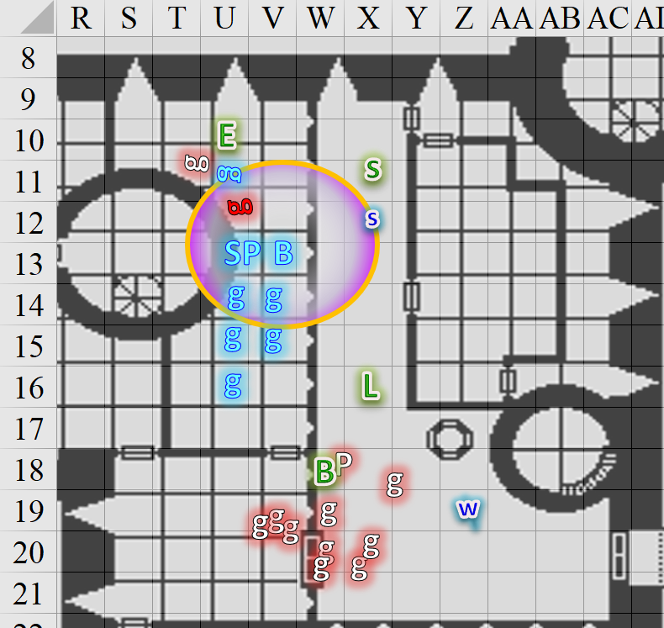

Round 27

Barkley, as he moved to the door, yelled, “Saradette, take solstice and check the lower levels!” Barkley picked up the morningstar before following the others, looking back to make sure that Saradette was alright.

The half-elf hopped over to his gnome companion, reaching a rest point in his ceaseless song, melodically supporting all who could hear him and shared his goals. Diving immediately into the bridge, his body language offered to assist Saradette’s endeavors, personally.

Saradette had pulled the one-piece chain shirt on over her head, and she was endeavoring to pull it down over her bust and settle it into position atop her gambeson. The heavy chain fabric was awkward to handle for her, and it was taking some wiggling and tugging to get it settled. “Help me get this on, please.”

Seeing that Solstice was also offering assistance with Saradette’s armor, Luran then turned southward and headed toward the halls.

Not knowing whether the man was friend or foe, Elsabet cast *cure minor wounds* on the guard, which would at least stabilize him. Perhaps Bratislava could identify the guard as friend or foe, or Barkley could sort out which were evil. Looking at Bratislava, she hoped the colonel-priestess had instructions or guidance.

*Stranger gained 10 hps.*

Round 28

Barkley ran to catch up to Elsabet and Bratislava.

Seeing the healing take hold and the guard begin to stir, Elsabet said quickly, “you’ll live; report,” turning to the next guard to check whether they were alive or dead.

“Arrgh!” the healing man got up and tried to thank her, then inhaled as the healing set in, and divulged, “We’ve been... aghh... infiltrated by lycanthropes.” He got up and pointed with his short sword at the thin knave on the ground. This one is with them, though they’ve enthralled men and women who weren’t transformed, but I saw at least three of them on the third floor.”

Round 29

“By wererats?” asked Sgt. Pepper, having been briefed as much as the others on the last few days’ happenings.

He felt better now. “Wererats... no, milady. Wereserpents! I believe the wererats were a ruse... I heard Prefect Garter-Kinder discussing it with his aide de camp.”

Round 30

“Where’s the Prefect now?” asked Sgt. Pepper.

“Last I saw, he was upstairs.”

Bratislava nodded with acknowledgment as she abstained from casting a *cure lights wound* on him. “Brezhnev, get yourself to the infirmary. It’s unmanned, but there are potions there, and it would be best if you brought a case of the curative ones. Drink two of the smaller vials, and you should be tiptop.”

Round 31

“Yes, milady,” the beardless guard nodded and went towards the double doors, making his way to the infirmary.

Elsabet had seen the infirmary from the barracks’ lower level, and was glad to know that the cleric was saving her spell slots for a martial engagement. Finding the Baron seemed to be gaining in priority, she mused, as she felt her next maneuver granted.

Not willing to waste a spell on the gracile fellow whose face looked smug even as he lay bleeding, Elsabet aided the completely unconscious guard with a curative spell.

*Stranger gained 5 + 4 = 9 hps.*

The man sighed, and looked thankful as he also slowly got to his feet, still limping.

Saradette and Solstice finished with the former’s chain shirt, and discussed their next steps.

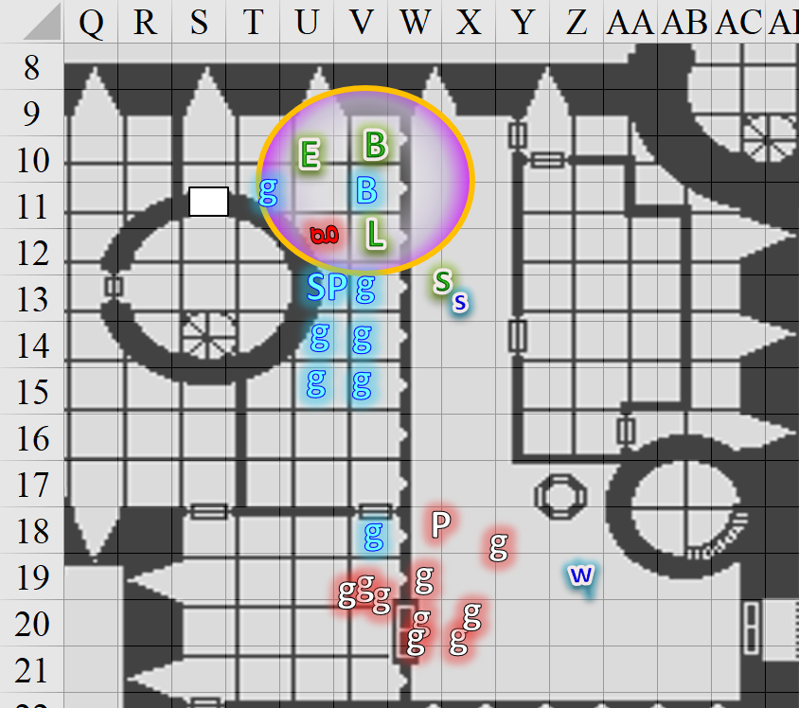

Rounds 32 – 36

Taking note of her remaining mojo, the favored soul then cast *bull’s strength [expired on Round 72]* on herself, and noticed Barkley frowning at the mention of lycanthropes.

*Elsabet gained +4 to Strength.*

|  |  |  |  |  |  |  |  |  |  |  |
| --- | --- | --- | --- | --- | --- | --- | --- | --- | --- | --- |
| *Favored Soul Spells per Day* | | | | | | | | | | |
|  | **Spell Level** | | | | | | | | | |
|  | **0th** | **1st** | **2nd** | **3rd** | **4th** | **5th** | **6th** | **7th** | **8th** | **9th** |
| **Favored Soul Spells** | 6 | 6 | 3 | 0 | 0 | 0 | 0 | 0 | 0 | 0 |
| **Charisma Bonus** | 0 | 1 | 1 | 0 | 0 | 0 | 0 | 0 | 0 | 0 |
| **Total Spells** | **6** | **7** | **4** | **0** | **0** | **0** | **0** | **0** | **0** | **0** |
| **DC** | 12 | 13 | 14 | 15 | 16 | 17 | 18 | 19 | 20 | 21 |
| **Cast?** | **0** | **2** | **4** | **-** | **-** | **-** | **-** | **-** | **-** | **-** |

“Hey, Barkley,” she said, “Want silver? Here!” She drew her silvered kukri from her belt and held it out hilt first, smiling. She had every confidence in her maneuvers helping her get through their defenses using her bastard sword, so she didn’t need it as much as he might.

The kukri would do less damage to most foes than the morningstar or short sword—but hurt lycanthropes more for sure. The archon could decide when to use it in place of either the short sword or morningstar; he could tuck it through his belt without the scabbard, it wasn’t magical so he wouldn’t risk cutting himself due to his own innate damage reduction.

Barkley, finally caught up to the others, listened to them talk as he looked at the bodies to determine if any radiated evil. The talk of were-creatures had him wishing he had his gear, but he would have to make do. As they did talk, Barkley looked around and cast *aid [expired on Rounds 81 – 85]* on five of the seven Baronial Troops present, including the man heading to the infirmary.

*Priestess-Colonel Bratislava, Sgt. Pepper, and three Guards gained +1 to attacks and saves vs. fear, plus 6 + 5 = 11 temporary hps each.*

There was a door to the west that went to the central tower’s spiral staircase, which led to every floor above them. Bratislava said as much.

Saradette picked up her launcher. “Okay, since I was busy, I didn’t hear what they were saying. Do we follow them, or go some other direction?” She remembered Widget. “Widget, come with me, Little One.”

Widget finally moved from where she’d sat motionless in the midst of the battle.

Saradette followed after her companions.

While Barkley provided various folks with aid thanks to his celestial nature, Elsabet took a good look at the second guard she had healed, noting that he was still limping, and said with a smile, “let’s see if we can fix you up a bit more, friend.” She was about to cast cure light wounds on him again, but Bratislava suggested she should hold on to the spell for now and the guard could follow Brezhnev to the infirmary.

Turning to Bratislava, taking advantage of the brief delay she said quickly, “I think the first priority now has to be finding the Baron and taking out any remaining evil prefects. So, we go up? Note, I can do a *deep slumber* effect once—if I can *sleep* a couple of traitors that way, I’ll leave it to you and your people as to what to do with them.”