*Chapter 18: The Baron’s Keep*

Round 37

“So... barracks?” Solstice had seen the one they called Brezhnev making his way to the infirmary through the same door that they had previously taken to go to where the briefings had been held.

Saradette replied, “we’re supposed to go down to the prison area. Is that the way?”

~*~

In the adjacent room, a handful of guards had already made their way upstairs, and the sound of more conflict alerted Barkley, Elsabet, and Luran to what they could expect if they followed.

The last guard to have been healed also started to go to the infirmary to get some potions in him before he bled any more, and cursed the frail, dying traitor on the ground as he walked by him. “Your mother would be so incredibly ashamed if she still lived.”

The three heroes saw the full-time guards shuffling up the stairs to reinforce the two who had already made it to the next level, and decided whether to leave the fool on the ground to die on his own schedule or cut to the punchline and put him out of his misery.

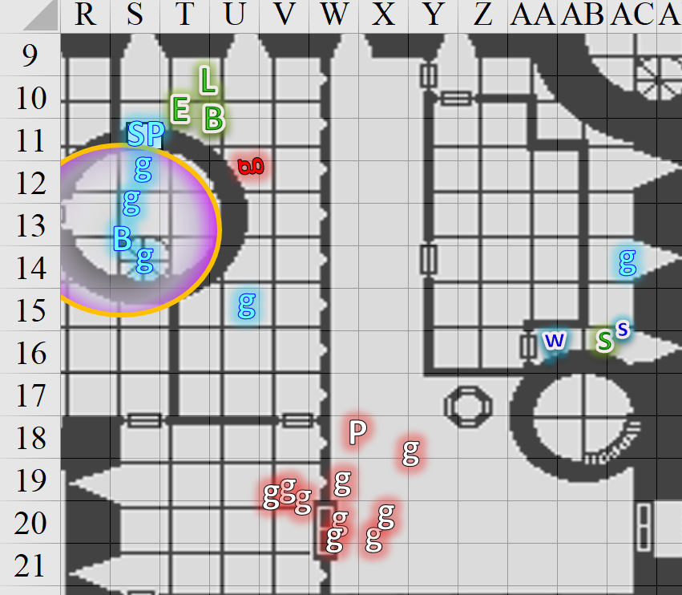

Round 38

“The cell where Barkley was being held are that way, if I understood,” Solstice pointed to the southwest. “The barracks, where the temporary holding cells were are downstairs.”

“Let’s go, then.” Saradette moved toward the stairs leading down. “Widget, be careful, now, and don’t get lost.”

And down they went.

Barkley dropped the short sword and accepted the kukri from Elsabet before following the others into the tower. With the warning of lycanthropes about, he began to constantly sniff at the air. He wanted to provide any warning if he could, should he pick up their foul odor.

Sgt. Pepper commanded the adjacent guard to stay behind and guard this post, then followed Bratislava up the stairs.

Elsabet looked past Barkley to the dying bad guy, then started following the guards. If she were out in the wilds, or fighting for her life in an alley, she wouldn’t think twice about finishing off the cultist, but somehow it didn’t seem right to slit his throat here, now, in the Baron’s Keep. That, and he was fixing to die with his index and middle finger directed at her, the local somatic insult of choice.

Luran stopped his inspiring cant, and followed in as well.

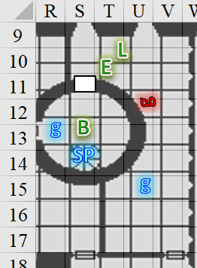

Round 39

Saradette and her two Tiny friends passed by the injured guard, who was already procuring gauze and potions. He nodded with a still concerned smile that he forced before drinking the first of two vials.

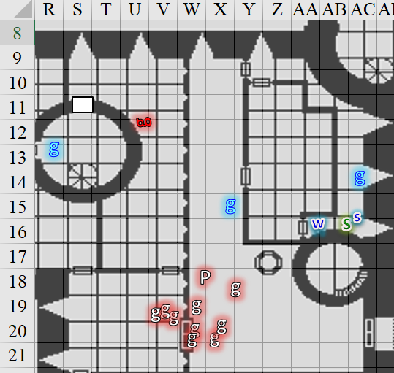

“Be well, hero,” Solstice murmured with reverence for the young man’s bravery as they continued towards the spiral staircase that led down to the place where they’d attended briefings over the course of the last few days.

Barkley had just asked a guard if the cells where he’d been kept were accessible.

“Yes, just that way: west, then south and then east through a door,” the young woman said as she and Barkley reached the next level.

Upon exiting the tower and entering a larger chamber, Barkley beheld a few dead or dying guards on the floor, as well as those he’d followed up here now facing two more evil-radiating guards and nothing less than an evil wereserpent wearing robes nearly identical to those of Prefect Almodóvar, whom Barkley had just slain.

|  |  |  |  |  |
| --- | --- | --- | --- | --- |
| **Character** | **Save vs.**  Aura of Menace | **Ranks** | **Roll** | **Save** |
| Prefect’s Guard 7 | Will | 3 | 2 | 5 |
| Prefect’s Guard 8 | Will | 3 | 7 | 10 |
| Prefect Garter-Kinder | Will | 4 | 11 | 15 |

*Fail, fail, fail. Guards 7 and 8, and Prefect G-K incurred -2 to attacks, AC, and saves.*

Having huffed all the way up, Barkley could tell that one of the guards had already been worn down, and was nearly dead. All three enemies took a look at Barkley, and he was also able to guess that they were threatened by his mighty pectorals and well-defined jawline.

The enemy guards did their best to fend off the reinforcements from the ground floor.

|  |  |  |  |  |  |  |  |  |  |  |
| --- | --- | --- | --- | --- | --- | --- | --- | --- | --- | --- |
| **Character** | **Attack Type** | **Damage** | **BAB** | **Str Mod+** | **Dex Mod+** | **W+** | **Other+** | **Total Score** | **Roll** | **Total** |
| Prefect’s Guard | MW Short Sword | 1d6+3 | 3 | 3 | 2 | 1 | -2 | 5 | 13 | 18 |
| Prefect’s Guard | MW Dagger | 1d3+3 nl | 3 | 3 | 2 | 1 | -2 | 5 | 12 | 17 |

*Hit, miss. Dmg to Baronial Guard 4: 6 + 3 = 9.*

The wereserpent cast *hold person* on Barkley, then took a 5’ step eastward towards the door that the guard had mentioned to Barkley, and opened it.

|  |  |  |  |  |  |  |
| --- | --- | --- | --- | --- | --- | --- |
| **Save vs.**  *hold person* | **Rank** | **Ability & Mod.** | **Misc. Mods.** | **Total** | **Roll** | **Check** |
| **Barkley, Will** | 4 | Wis (+1) | 1 | 6 | 19 | 25 |

*Success. Effect negated.*

Bratislava noted the wereserpent’s garments, and said, “That’s Prefect Garter-Kinder!” She then swiped at the badly injured guard as the other guards loyal to the Baron dealt with the other human cultist.

|  |  |  |  |  |  |  |  |  |  |  |  |
| --- | --- | --- | --- | --- | --- | --- | --- | --- | --- | --- | --- |
| **Character** | **Attack Type** | **Damage** | **BAB** | **Str Mod+** | **W+** | **Other+** | **Total Score** | **Roll** | **Total** | **Crit** | **Threat** |
| Bratislava | MW Short Sword | 1d6+3 | 4 | 2 | 1 | 2 | 9 | 9 | 18 | 20 | ý |
| Baronial Guard | MW Club | 1d6+3 | 3 | 3 | 1 | 2 | 9 | 20 | 29 | 20 | þ |
| Baronial Guard | MW Short Sword | 1d6+3 | 3 | 3 | 1 | 2 | 9 | 6 | 15 | 20 | ý |

*Hit, threat, miss. 1d20 = 6 + 9 = 15, not a critical hit.*

*Dmg to Prefect’s Guard 7: 3 + 3 = 6.*

*Dmg to Prefect’s Guard 8: 5 + 3 = 8.*

One evil guard dropped to the ground; the other remained on foot, and threatened the others with eternal damnation.

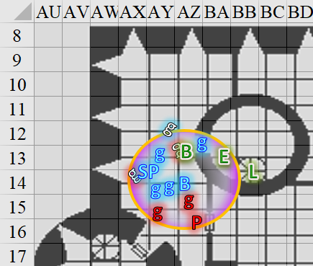

Round 40

|  |  |  |  |  |  |
| --- | --- | --- | --- | --- | --- |
| **Character** | **Group** | **Initiative** | **Roll** | **Modified Roll** | **Move** |
| Elsabet | 1 | 4 | 18 | 22 | 30’ |
| Barkley | 1 | 2 | 18 | 20 | 40’ |
| Solstice | 1 | 1 | 15 | 16 | 30’/10’ |
| Saradette | 1 | 3 | 12 | 15 | 20’ |
| Baronial Faction | 2 | 2 | 12 | 14 | 30’ |
| Prefects’ Faction | 2 | 2 | 7 | 9 | 30’ |
| Luran | 1 | 1 | 4 | 5 | 30’ |

Saradette continued down the stairs.

Widget ranged out ahead of her mistress, sniffing out the air as she went down the stone steps.

Solstice followed Saradette down the stairs and into the barracks. The door to the holding cells was to their immediate northwest, and the area was empty, filled only with five chairs and an easel with a brand-new board and no chalk.

The subterranean room was lit by a single candle that looked like it would last another 20 minutes or so before burning out along with the rest of the wicks that now lay charred in the other five candlesticks ensconced in the walls.

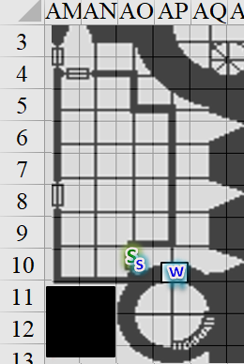

~*~

Having reached the landing, Elsabet took a step to the north to get out of the way, reached into her haversack for the scroll she wanted, and cast *shield other [expired on Round 70]* on Luran, who had reached the top steps right behind her. “40’ tether,” she joked with a grin.

*Luran gained +1 to AC and saves, and negates ½ damage from all wounds and attacks, diverting that ½ damage to Elsabet.*

***(Please remind me about the damage transfer if you don’t see it tallied.)***

Despite the dire circumstances, she was in her element, as she heard the sound of battle and anticipated a new series of maneuvers coming.

Barkley focused on the wereserpent near the door. He knew he couldn’t squeeze past the Prefect’s guards, so he charged forward with the intent of finish off the guards quickly to pursue their leader. The wereserpent got a smack in on Barkley as Barkley got close.

|  |  |  |  |  |  |  |  |  |  |
| --- | --- | --- | --- | --- | --- | --- | --- | --- | --- |
| **Character** | **Attack Type** | **Damage** | **BAB** | **Str Mod+** | **W+** | **Other+** | **Total Score** | **Roll** | **Total** |
| Prefect | Venomous Staff | 1d6+Poison | 4 | 1 | 1 | -2 | 4 | 11 | 15 |

*Miss..*

Barkley then carried out his lunge.

|  |  |  |  |  |  |  |  |  |  |
| --- | --- | --- | --- | --- | --- | --- | --- | --- | --- |
| **Melee Weapon** | **Dmg** | **D+** | **TH+** | **Critical** | **Type** | **Wt.** | **Atk** | **Roll** | **Check** |
| Silver Kukri | 1d4 | 3 | 2 | 18-20, x2 | Slashing | 2.0 | +11 | 9* | 20 |
| Morningstar | 1d8 | +4 | 2 | x2 | Prc & Bldg | 6.0 | +11 | 11 | 22 |

*\* Previous roll retained.*

*Hit, hit.*

*Dmg from kukri: 1 + 3 = 4.*

*Dmg from morningstar: 2 + 4 = 6. Damage negated.*

That did the trick, and now the wereserpent hissed in fear as Sgt. Pepper secured the western tower, standing in the doorway listening for any movement above and below them.

Bratislava came in an swiped at the wereserpent.

|  |  |  |  |  |  |  |  |  |  |  |
| --- | --- | --- | --- | --- | --- | --- | --- | --- | --- | --- |
| **Character** | **Attack Type** | **Damage** | **BAB** | **Str Mod+** | **Dex Mod+** | **W+** | **Other+** | **Total Score** | **Roll** | **Total** |
| Bratislava | MW Short Sword | 1d6+3 | 4 | 2 | 2 | 1 | 2 | 9 | 4 | 13 |

*Miss.*

The Baronial Guards got into a better surrounding formation, and the frontmost combatant stabbed at the wereserpent.

|  |  |  |  |  |  |  |  |  |  |  |
| --- | --- | --- | --- | --- | --- | --- | --- | --- | --- | --- |
| **Character** | **Attack Type** | **Damage** | **BAB** | **Str Mod+** | **Dex Mod+** | **W+** | **Other+** | **Total Score** | **Roll** | **Total** |
| Baronial Guard | MW Short Sword | 1d6+3 | 3 | 3 | 2 | 1 | 2 | 9 | 3 | 12 |

*Miss.*



Prefect Garter-Kinder—a handsome wereserpent, if there could be such a thing—slurred something as he escaped inside the next room, which was darker than their current housing. Illuminated by murder holes, this room smelled a bit like wererat in here. Barkley got the scent as a breeze crept through the ample room, comingled with the smell of blood and other mortal humors. The hint of reptile was far more subtle, and faintly caressed the archon’s nostrils, reminding him of the only green dragon he’d ever faced.

The Prefect had pushed the door closed, but it had not quite shut, and now bounced ajar about 10 degrees.

The Prefects’ Guards lay dead or dying on the ground.

Luran felt the effects of Elsabet’s spell coursing through him as the scroll in the crusader’s hand withered to the ground. He used that as an inspirational hook to start up his rhythmic rhyming. “The scrooooollll on which the prophets wrote is cracking at the seammmmsssss...” As Elsabet’s spell further emboldened the bard a bit with its bolstering effects, his voice once again rose above the scene, bringing his allies a boost of strength and bravery.

*The PCs and Baronial loyalists gained +2 to weapon attacks and damage.*

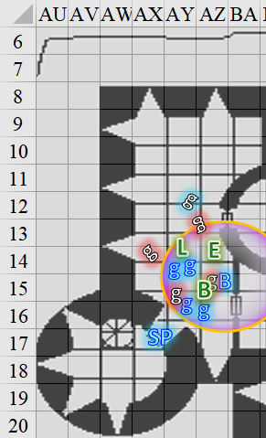

Round 41

With Solstice and Widget nearby, Saradette walked toward the holding cells, her weapon at the ready.

~*~

“Which way?” Elsabet called out, with new maneuvers granted to her.

She hustled in the direction indicated, with the intent of using her stone vise maneuver if she caught up to an enemy. She was careful not to get too far ahead of Luran. She spotted a woman inside the room who had just cast a spell, and as she took on the guise of a wereserpent, she hissed a curse in Infernal, which only Barkley and Bratislava understood. << Your flesh shall serve the Speaker in Dreamssss! >>

Elsabet fired a blast of eldritch energy at the woman.

|  |  |  |  |  |  |  |  |  |  |
| --- | --- | --- | --- | --- | --- | --- | --- | --- | --- |
| **Ranged Weapon** | **Dmg.** | **D+** | **TH+** | **Critical** | **Rng.** | **Wt.** | **Atk** | **Roll** | **Check** |
| Eldritch Blast | **1d6** | 0 | 2 Courage | x2 | 60’ max. | - | +9 | 5 | 14 |

*Hit. Dmg: 2 + 2 Courage = 4.*

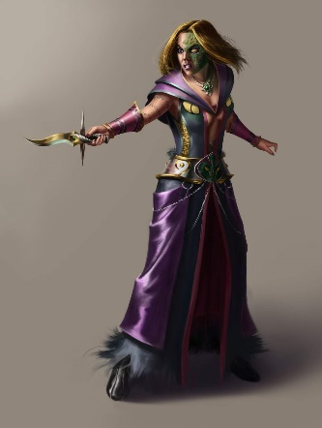

Barkley *[first move action]* followed the wereserpent through the door, weapons ready to pounce, and heard the second wereserpent’s hissing curses in Infernal. He then cast *continual flame [expired at will]*, targeting the middle of the floor inside the room.

|  |  |  |  |  |
| --- | --- | --- | --- | --- |
| **Character** | **Save vs.**  Aura of Menace | **Ranks** | **Roll** | **Save** |
| Zhang-Yasria | Will | 3 | 9 | 12 |

*Fail. Zhang-Yasria incurred -2 to attacks, AC, and saves.*

The wereserpent woman came clearer into view as it became evident that the door to the northeast had just been opened. It creaked, swinging into the room about 90 degrees ever so slowly, and it was likely that the one referred to as Prefect Garter-Kinder had just escaped through that route.

The Baronial Faction stood ready to face whatever was in that room, if anything. Bratislava led them inward along with Barkley and Elsabet. They had shouldered their crossbows, and now followed south at Bratislava’s command. “Seize Zhang-Yasria if you can; slay her if you must. I’ve had my *fill* of these heathens!” she began to speak as if she’d just clocked out.

They were not able to reach the wereserpent woman, who had by now entered the room to her immediate south, and closed the door, locking it behind her.

Barkley *[second move action]* continued through the northeastern door looking for the wereserpent, discontinuing his *continual flame*, and leaving Elsabet and the others in the dark room. He could see another open door to the north, and reached it, turning to the east to note yet another door swinging a bit like it had just been walked through.

A single torch lit this room, and looked like it had another 20 minutes before it would burn out.

Luran followed along behind Elsabet, keeping within the metaphorical binding between them.

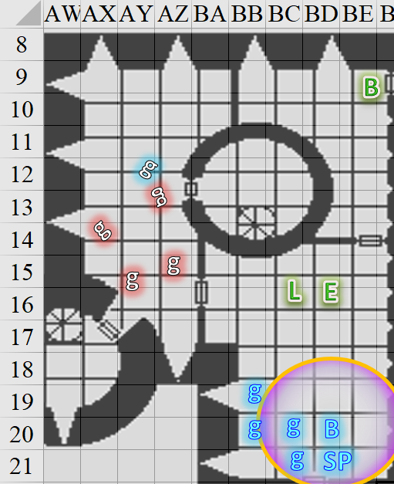

~*~

Downstairs, the unsalvageable knave bled out and died. The guard posted just a few feet away entered the room once again and pitied the wretch for whose character he never much cared.

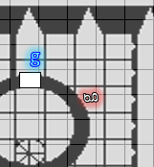

~*~

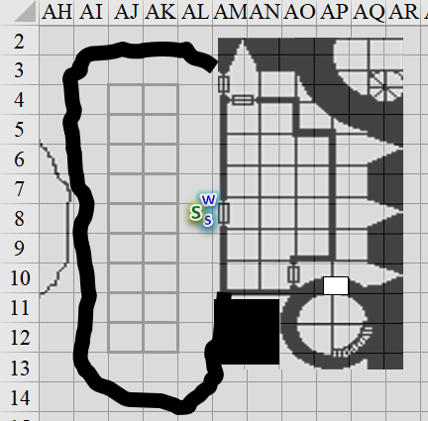

Solstice, Saradette, and Widget had not entered the room with any specific expectations, but they did not anticipate what was now before them. They knew this was a holding area for criminals recently apprehended in this quarter, but they hadn’t realized just how many cells there actually were. Each cell was indeed filled with at least one sot or guttersnipe, though as Saradette cautiously made her way north along the corridor, she noted that none of them looked like particularly thuggish folks. There were roughly as many women as men in the cells (a noteworthy rarity), and all appeared to be sleeping or unconscious. The gnome, musteval, and racoon continued around the corner, noting the same pattern until they spotted something more macabre: one woman lay on the ground as if she’d just been clutching the bars before passing out, and on her neck were two circular bitemarks.

Round 42

Solstice noticed this, then took a few steps back to enter the previous cell, and saw the same mark on the unconscious but breathing prisoner in that cell as well.

Saradette grimaced at the sight. “Widget, can you get between the bars and try to wake one of these people?” Not realizing that Solstice was already inside the cell, she stepped over to the woman with the bite marks, and examined them closely through the bars.

The punctures were much more separated than the incisors of a wererat, and were cleaner slits than the lacerations that the canine teeth of most mammals would have rendered. They were confused at the sight—which was wholly different from all the wererat bites they’d seen in the last few days—and felt chills as they thought they heard a disembodied hiss from no particular direction. They each looked around suspiciously to make sure no one was watching them, and could now hear only each other’s movements in the torchlit cellblock.

~*~

The *briar web* would have expired in the main hall by now had Bratislava not dispelled it.

~*~

Barkley, as he reached the door, glanced back over his shoulder and discovered he was on his own. He was torn between pursuing the wereserpent or going back to help the others. In the end, he decided to continue his pursuit. He could always fall back and retreat if he became outnumbered, but he couldn’t let the Kinder get away.

He ended up in the first fully furnished room that he’d seen. All the other rooms had a few pieces of furniture along the walls, but the spaces were open. This room had two desks and two chairs, and each desk looked like exactly what it was: a medieval bureaucrat’s workstation, complete with quills, ink vials, parchments galore, Baronial seals, wax, candles, tinder stones, and other stationery.

The machicolations and murder holes along the eastern wall brought the morning’s light into the room, and as Barkley spotted the enemies and stopped, the sneaky gnome behind him kicked the door shut and backstabbed the archon.

|  |  |  |  |  |  |  |  |  |  |
| --- | --- | --- | --- | --- | --- | --- | --- | --- | --- |
| **Melee Weapon** | **Dmg** | **D+** | **TH+** | **Critical** | **Type** | **Wt.** | **Atk** | **Roll** | **Check** |
| MW Dagger | 1d3 | 0 | 1 | 19-20/x2 | Slsh/Prc | 0.5 | 5 | 8 | 13 |

*Miss.*

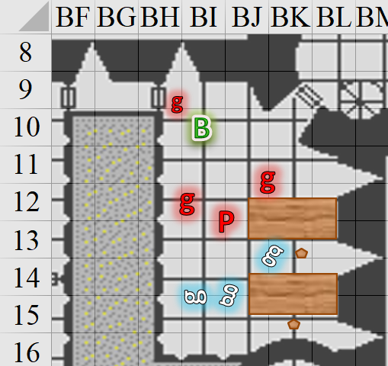

Aside from the backstabbing gnome, Prefect Garter-Kinder was now joined by two bookish boys—visibly bruised by a recent fight—dressed in less martial attire than guards, but donning nothing as fancy as the Prefect’s robes. Upon the Prefect’s hasty entrance, these acolytes had likely cast some kind of spell, and were now sizing the archon up. They had black ink on their fingers, suggesting that they were scribes by day but also likely had an arcane skillset.

Barkley suspected that a *message* spell was likely in effect between the Prefect and one of these guards, and they’d had a few seconds of anticipation to prepare themselves for another fight.

~*~

“Nooo!” the heroes heard a male voice to the south pleading with terror, followed by other voices—male and female, gnome, human, dwarven, and other—screaming indiscernible things.

Bratislava had the keys to just about every door in the keep, and now opened the door, leading the Baronial faction southward unto a second door that locked from this side, and had been left unlocked by the serpentine woman who’d only recently come into the Baron’s inner circle. Sgt. Pepper opened this second door and the two superior officers headed straight into where Barkley had been housed.

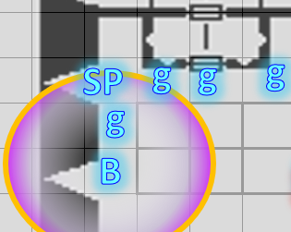

They entered, and secured the northwest portion of the cellblock.

Luran wanted to see if could rejoin the archon, who had ventured through the northward door.

As Luran came towards her, Elsabet made a “hustle up” gesture and pointed in the direction Barkley had taken. “Leap frog” she blurted out, hoping the bard had played the childhood game, “stray dog!” As soon as Luran got past her, she, too, hustled in that direction.

“Good luck! For Mintar!” She shouted over towards the guards, thinking that Bratislava was rightfully pissed off and would take care of that direction.

Making their way into another room, they heard a door slam to the north, headed there, turned eastward, and came up against a locked door [DC 23].

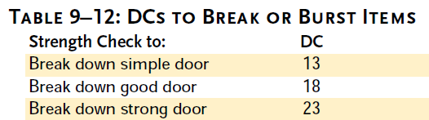

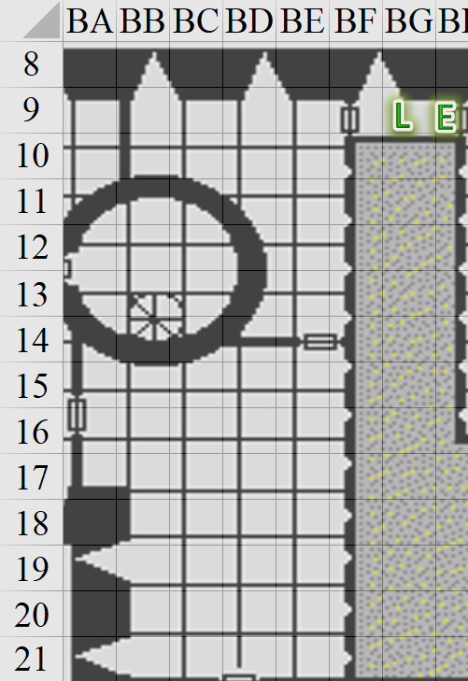

Round 43

|  |  |  |  |  |  |
| --- | --- | --- | --- | --- | --- |
| **Character** | **Group** | **Initiative** | **Roll** | **Modified Roll** | **Move** |
| Barkley | 1 | 2 | 11 | 13 | 40’ |
| Saradette | 1 | 3 | 7 | 10 | 20’ |
| Prefects’ Faction | 2 | 2 | 7 | 9 | 30’ |
| Luran | 1 | 1 | 5 | 6 | 30’ |
| Elsabet | 1 | 4 | 1 | 5 | 30’ |
| Baronial Faction | 2 | 2 | 2 | 4 | 30’ |
| Solstice | 1 | 1 | 1 | 2 | 30’/10’ |

***Comment:*** *This has to be the worst round of initiative rolls ever.*

|  |  |  |  |  |
| --- | --- | --- | --- | --- |
| **Character** | **Save vs.**  Aura of Menace | **Ranks** | **Roll** | **Save** |
| Prefect’s Guard | Will | 3 | 11 | 14 |
| Prefect’s Guard | Will | 3 | 6 | 9 |
| Prefect’s Guard | Will | 3 | 16 | 19 |
| Prefect’s Guard | Will | 3 | 8 | 12 |

*Fail, fail, success, fail. All Medium guards incurred -2 to attacks, AC, and saves.*

Barkley took in his surroundings as he moved to put his back to the wall and swung his morningstar at the gnome that just tried to stab him. There was an almost omnipresent trace scent of wererats that was mostly masking the wereserpents’ odors. As with the previous mundane guards, it did not appear by looks and smells that any of them were lycanthropes.

*You mentioned no AoO, though Barkley just moved out of the gnome’s threatened area. Is it a no because it was only a 5’ step?*

Barkley whispered a *message* to the others, specifying, ‘In a library northeast second floor with 4 enemies.” No urgency or fear in his voice. He also growled and bared his teeth at his opponents.

The three human guards—bureaucrats, really—did their best to attack Barkley with the few spells they had left. It was becoming increasingly evident that although they’d won in a recent scuffle, their enemies had put up a good fight. Barkley estimated his imminent efforts as if he were facing half as many opponents. All before him were evil—of this, his senses assured the Celestial.

One of the bookworms pointed a *ray of frost* at the ducking archon.

|  |  |  |  |  |  |  |  |  |  |
| --- | --- | --- | --- | --- | --- | --- | --- | --- | --- |
| **Character** | **Attack Type** | **Damage** | **BAB** | **Dex Mod+** | **W+** | **Other+** | **Total Score** | **Roll** | **Total** |
| Prefect’s Guard | Ranged Touch Attack | varies | 3 | 0 | 1 | -2 | 2 | 13 | 15 |

*Hit. Dmg: 2 cold [39/45].*

Another knave with rotting teeth spoke the words that released an *acid splash* upon Barkley.

|  |  |  |  |  |  |  |  |  |  |
| --- | --- | --- | --- | --- | --- | --- | --- | --- | --- |
| **Character** | **Attack Type** | **Damage** | **BAB** | **Dex Mod+** | **W+** | **Other+** | **Total Score** | **Roll** | **Total** |
| Prefect’s Guard | Ranged Touch Attack | varies | 3 | 0 | 1 | -2 | 2 | 6 | 8 |

*Miss.*

Barkley hadn’t spotted the ne’er-do-well who had ducked into an alcove upon the wereserpent’s entrance. The rogue fired a pellet at the archon’s jugular.

|  |  |  |  |  |  |  |  |  |  |  |
| --- | --- | --- | --- | --- | --- | --- | --- | --- | --- | --- |
| **Ranged Weapon** | **Dmg.** | **D+** | **TH+** | **Critical** | **Rng.** | **Wt.** | **Atk** | **Roll** | **Check** | **Notes** |
| MW Blowgun | 1d3 | 0 | 1 | x2 | 10’ | 0.1 | +6 | 8 | 14 | +1d6 Sneak |

*Hit. Dmg: 1 + 6 Sneak = 7. Damage negated.*

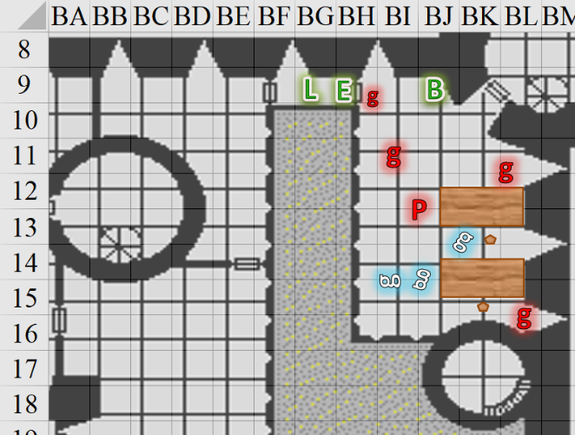

~*~

Saradette placed her hand in front of the girl’s mouth to see if she was still breathing. “Are they dead?”

Solstice tried to rouse the bitten detainee, but the gentle nudges weren’t having an effect. He exited the cell and moved south towards the next one, which had two young girls—both half-elves about 30 years of age. Not yet inside the second cell, he spotted the fang marks on one of them; the other would have to be turned around.

“Don’t think so,” the weasely guy said. “Bitten for sure, and likely in lycanthropic gestation…” he said with little idea of what he was talking about, “… or something.”

~*~

The Baronial Faction encountered the Baron’s new confidante, Zhang-Yasria, who had taken a hostage and was backing away eastward.

Bratislava did her best to use Diplomacy to control the situation.

|  |  |  |  |  |
| --- | --- | --- | --- | --- |
| **Character** | **Check** | **Ranks** | **Roll** | **Save** |
| Baronial Guard | Diplomacy | 8 | 15 | 23 |

*??*



Round 44

Barkley decided to deal with the gnome that tried to backstab him first.

|  |  |  |  |  |  |  |  |  |  |
| --- | --- | --- | --- | --- | --- | --- | --- | --- | --- |
| **Melee Weapon** | **Dmg** | **D+** | **TH+** | **Critical** | **Type** | **Wt.** | **Atk** | **Roll** | **Check** |
| Silver Kukri | 1d4 | +5 | 2 | 18-20, x2 | Slashing | 2.0 | +11 | 12 | 23 |
| Morningstar | 1d8 | +4 | 2 | x2 | Prc & Bldg | 6.0 | +6 | 4 | 10 |

*Hit, miss. Dmg: 4 + 5 + 2 Courage = 11.*

Barkley could tell that while the Saradette-sized fool was not quite dead, but he was dropping in a manner that suggested that he wasn’t getting up without some aid. “Murderer!” he thought he heard one of the other bureaucrats saying, though it could have been a word in another language.

Barkley began to feel strange, though it was likely not a spell effect. As he fought these diehard-lawful cultists, he began to question the fanaticism behind his own adherence to procedural and divine law as a standalone creed. Dozens of times during critical moments in his life, he had seen himself forced to choose between law and justice, and it was during times like these—when he witnessed such loyal-to-the-death mentalities at play—that his faith wavered. His ears fell subconsciously tharn for a moment as his resolve was tested against the wereserpent and his pasty followers, who now looked at the wereserpent for guidance before drawing their daggers and charge-attacking Barkley.

|  |  |  |  |  |  |  |  |  |  |
| --- | --- | --- | --- | --- | --- | --- | --- | --- | --- |
| **Character** | **Attack Type** | **Damage** | **BAB** | **Str Mod+** | **W+** | **Other+** | **Total Score** | **Roll** | **Total** |
| Prefect’s Guard | MW Dagger | 1d3+3 | 3 | 3 | 1 | -2 | 5 | 11 | 16 |
| Prefect’s Guard | MW Dagger | 1d3+3 | 3 | 3 | 1 | -2 | 5 | 19 | 24 |

*Hit, hit. Dmg: (2 + 3) + (1 + 3) = 9. Damage negated.*

Barkley finally spotted the now hooded rogue in the corner who spat another pellet at him before ducking into the narrow spiral staircase behind him or her.

|  |  |  |  |  |  |  |  |  |  |  |
| --- | --- | --- | --- | --- | --- | --- | --- | --- | --- | --- |
| **Ranged Weapon** | **Dmg.** | **D+** | **TH+** | **Critical** | **Rng.** | **Wt.** | **Atk** | **Roll** | **Check** | **Notes** |
| MW Blowgun | 1d3 | 0 | 1 | x2 | 10’ | 0.1 | +6 | 15 | 21 | +1d6 Sneak |

*Hit. Dmg: 2 + 4 Sneak = 6. Damage negated.*

The wereserpent could have cast a spell, but having tried to *hold* Barkley earlier—and failed—the Prefect decided to continue to bolt away, following the blowgun-toting scribe-assassin.

Downstairs, the two wounded guards had by now quaffed the potions necessary to restore their health, and heard the Prefect and his fleeing thrall inside the tower.

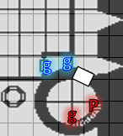

Prefect Kinder-Garter assumed a human form, hearing the two guards now making their way back towards the door from which they’d entered, and eyed the half-elf rogue with contempt for not remaining behind to face off against Barkley and the other heroes.

~*~

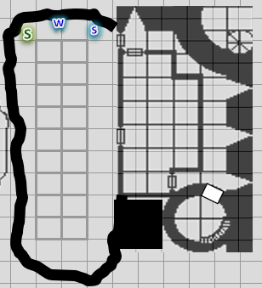

Unable to rouse anyone, Solstice came back to the north part of the cellblock in order to better talk with Saradette.

~*~

Frustrated by this, Elsabet used a swift command work to activate her brute gauntlets to use up a charge, and smashed into the door as hard as she could.

|  |  |  |  |  |  |
| --- | --- | --- | --- | --- | --- |
| **Ability Check** | **Ability & Mod.** | **Misc. Mods.** | **Total** | **Roll** | **Check** |
| **Elsabet, Strength** | **Str (+4)** | 1 + 6 (or thereabout) Brute Gauntlets | 11 | 19 | 31 |

*Success.*

Luran witnessed the goddess-blessed woman in action as the latter slammed into the door with enough momentum to bust the hinges, and slam against the already dying gnomish bugger on the other side.

*Dmg: 4 nonlethal.*

The unconscious ruffian continued to bleed out under the door that would have likely hit Barkley as well, but instead did a good job at keeping the gnome down.

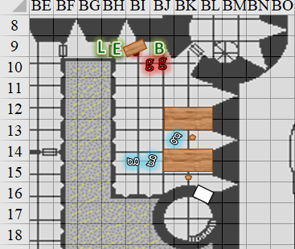

~*~

The Baronial faction did its best to coax Zhang-Yasria into letting go of the man they knew as Bishop Jericho of Tyr, and whom—by now—the Baron’s loyalists surely suspected to have been arrested under false pretense.

It became clear that the wereserpent wasn’t going to back down, and maintained her hold on the cleric as she opened a door behind her, disappeared behind it with her hostage, and closed it, likely locking it.



Round 45

Barkley smiled as the door came crashing down on the dying gnome. He then focused on his two newest foes adding, “The Prefect and another ran through the far door! I’ll handle these two!” Barkley then attacked the enemy on his right so that his allies could continue past without obstruction.

|  |  |  |  |  |  |  |  |  |  |
| --- | --- | --- | --- | --- | --- | --- | --- | --- | --- |
| **Melee Weapon** | **Dmg** | **D+** | **TH+** | **Critical** | **Type** | **Wt.** | **Atk** | **Roll** | **Check** |
| Silver Kukri | 1d4 | 5 | 2 | 18-20, x2 | Slashing | 2.0 | +11 | 9 | 20 |
| Morningstar | 1d8 | +4 | 2 | x2 | Prc & Bldg | 6.0 | +11 | 12 | 23 |

*Hit, hit. Dmg: (4 + 5 + 2 Courage) + (1 + 4 + 2 Courage) = 11 + 7 = 18.*

The guard was likely a goner from the swipe of the kukri, but the morningstar sealed the man’s fate.

The scribe-guard next to him prayed in Infernal for immediate deliverance unto the Hells in the form of a greater devil as he swung again at Barkley.

|  |  |  |  |  |  |  |  |  |  |
| --- | --- | --- | --- | --- | --- | --- | --- | --- | --- |
| **Character** | **Attack Type** | **Damage** | **BAB** | **Str Mod+** | **W+** | **Other+** | **Total Score** | **Roll** | **Total** |
| Prefect’s Guard | MW Dagger | 1d3+3 | 3 | 3 | 1 | -2 | 5 | 4 | 9 |

*Miss.*

Being fairly familiar with the Diabolical Hierarchy, Barkley understood the words perfectly, and thus prepared to dispatch the man’s soul to the Lower Planes, per this apparently preordained will. Barkley knew enough of Faustian pacts to suspect that the fine print would prevent this poor soul from becoming anything more formidable than an imp, which was still better than the standard lemure package.

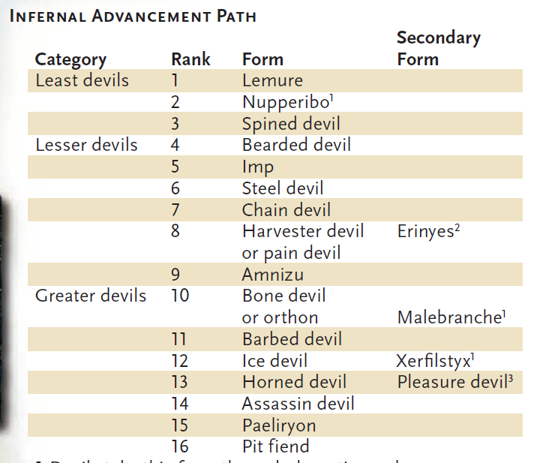

“Hey, B. Miss me?” Elsabet said as she stepped through the door with a grin, careful not to step on a prone gnome. Seeing Barkley take down one foe, with the other attacking her friend, and with no applicable strikes available yet, she simply slashed at the remaining foe facing the archon.

|  |  |  |  |  |  |  |  |  |  |
| --- | --- | --- | --- | --- | --- | --- | --- | --- | --- |
| **Melee Weapon** | **Dmg** | **D+** | **TH+** | **Critical** | **Type** | **Wt.** | **Atk** | **Roll** | **Check** |
| Bastard Sword +1, 1-handed | 1d10+1 | +4 | 4 | 19-20/x2 | Slashing | 6.0 | +13 | 12 | 25 |

*Hit. Dmg: 4 + 1 + 4 + 2 + 2 Courage = 13.*

And with this, the second scribe went down for the count.

“Any bosses?” she asked the archon beside her.

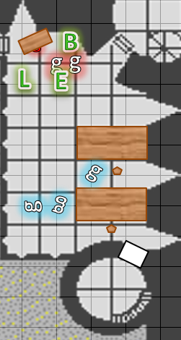

Luran’s volume dropped to a low pulse with peaking syllables.

That door took a hard, hard hitTIN’

Our blades are in all our mitts AND

We’ll trounce all these mewling kitTENS

This hound, bard, and swordmaiDEN

~*~

Saradette sighed and straightened. “Let’s check the rest of this area.” She pointed to the next door. “This way.”

Solstice followed the fellow rogue along the cellblock, and happened upon others whose necks were either visibly bitten or not exposed to the rogues’ lines of sight. “They’ll all wake up evil as the wereserpent that bit them.”

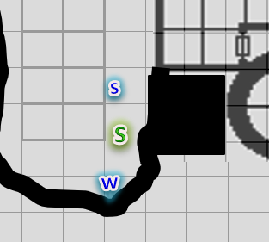

~*~

The Baronial Faction proceeded to pursue Zhang-Yasria, careful not to trigger her any further but letting her know with some bravado that she wouldn’t get away with this.

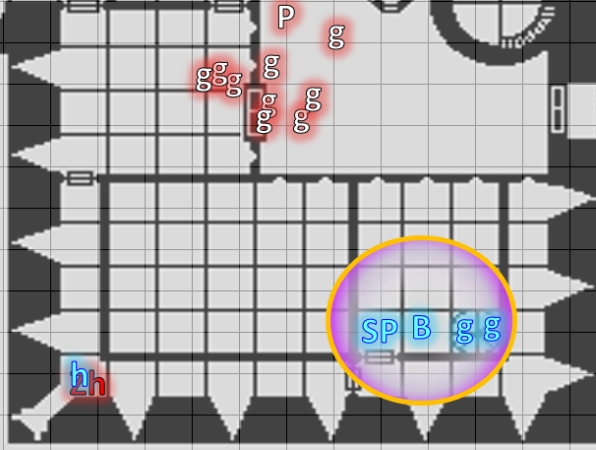

~*~

Prefect Garter-Kinder grabbed his half-elf follower by the neck and did his best to frame her as a cultist. He opened the door and beheld the two guards, whom he immediately recognized. “Ah, Brezhnev,” he said to the frontmost man. “Process this traitor. She nearly killed Praveen and his staff just now.”

“What? No! It was the Prefect!” the rogue lied as well as her superior.

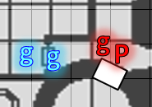

Round 46

With the scribes dead and likely visiting their demon of choice, Barkley sprinted after the wereserpent yelling, “Follow me!”

Luran and Elsabet followed close behind as the hound’s nose confirmed that downstairs was the direction to head. The open door and the sound of the Prefects’ voice also corroborated the sound pursuit, and Barkley caught his breath as he happened upon the Prefect and his hostage, who were both facing at least one guard, whom Barkley could not yet see, but whose voice he’d just heard.

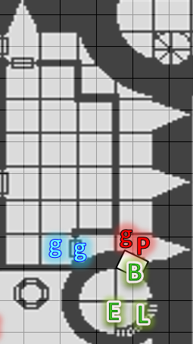

~*~

The Baronial Faction pursued Zhang-Yasria, who released her cleric hostage and bolted towards the front doors of the keep.

“See to the Bishop!” Sgt. Pepper instructed the two pikemen.

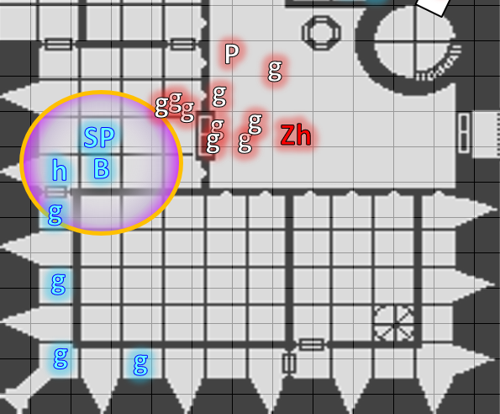

~*~

Saradette, Solstice, and Widget had walked around the entire cellblock, and had found men, women, and children therein, but no one awake or even rousable.

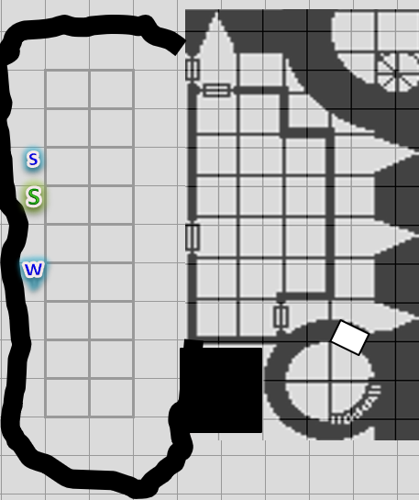

Round 47

Seeing the wereserpent holding someone he believed to be one of his minions, Barkley ignored the potential of a hostage situation, dropped the morningstar, and charged ahead into the Prefect.

|  |  |  |  |  |  |  |
| --- | --- | --- | --- | --- | --- | --- |
| **Melee Weapon** | **Dmg** | **TH+** | | **Atk** | **Roll** | **Check** |
| Touch | Grapple | 2 | | +11 | 13 | 24 |
| Grapple | Grapple | 2 | | +11 | 10 | 21 |
| **Character** | **Attack Type** | | **Damage** | | | **BAB** | **Str Mod+** | **Other+** | **Total Score** | **Roll** | **Total** |
| Prefect | Grapple/Bite *[DM assumption]* | | 1d3+4 + 2 Courage | | | 4 | 1 | -2 | 3 | 14 | 17 |

*Grapple successful. Dmg: 1 + 4 + 2 = 7.*

The Prefect did his best to struggle against Barkley’s grapple, and released the hostage, who made her way westward a few feet, stopped by the two newly healed guards who now had their short swords out and were trying to read everyone’s facial expressions.

Luran sang to Barkley, while Elsabet could do little more than chuckle at this point, seeing the archon grapple the prefect, while looking for an opening. She wanted to take the wereserpent alive, despite these cultists’ insane desire to self-destruct, so she slipped into the alcove, turned her blade sideways, and with a quick mental prayer to Mayaheine that the blow knock the creature unconscious, initiated her foehammer strike which had just been granted and swung her sword like a club against the nearest exposed area of the prefect’s body.

|  |  |  |  |  |  |  |  |  |  |
| --- | --- | --- | --- | --- | --- | --- | --- | --- | --- |
| **Melee Weapon** | **Dmg** | **D+** | **TH+** | **Critical** | **Type** | **Wt.** | **Atk** | **Roll** | **Check** |
| Bastard Sword +1, 1-handed | 1d10+1 | +4 | 4 – 4 nonlethal | 19-20/x2 | Slashing | 6.0 | +9 | 19 | 28 |

*Threat. 1d20 = 6 + 9 = 15, critical hit vs FFAC. Dmg: 4 + 1 + 4 + 6 = 15 nonlethal.*

She called out to the guards, “Hey, guys—these two are both evil.” She felt her last maneuver being granted, crusader’s strike, and figured if the prefect kept struggling, she could use it to heal Barkley.

MAP UPDATE

~*~

Saradette, Solstice, and Widget went back upstairs to find the others.

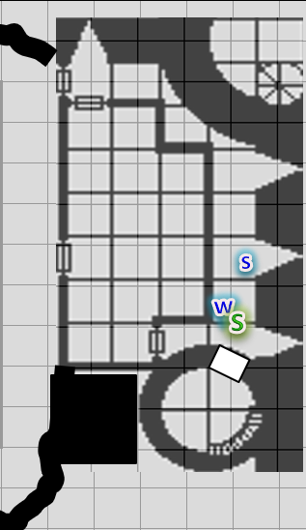

They all then heard a scuffle on the other side of the door, and noted Luran’s lyrical voice amidst it.

~*~

The Baronial Faction split up, with some chasing after Zhang-Yasria, and two guards remaining behind with the Cleric of Tyr.

“Were you bitten, Bishop Jericho?” a dwarven guard asked as he and the other guard stepped over the dead bodies around them and grabbed the pikes they’d left in the main room.

“Nay, but without my holy symbol and blade, I regret I will not be of much use. I know by now just how deep this conspiracy goes. I *had* damning evidence, but they took that from me as well. These poor men and women….”

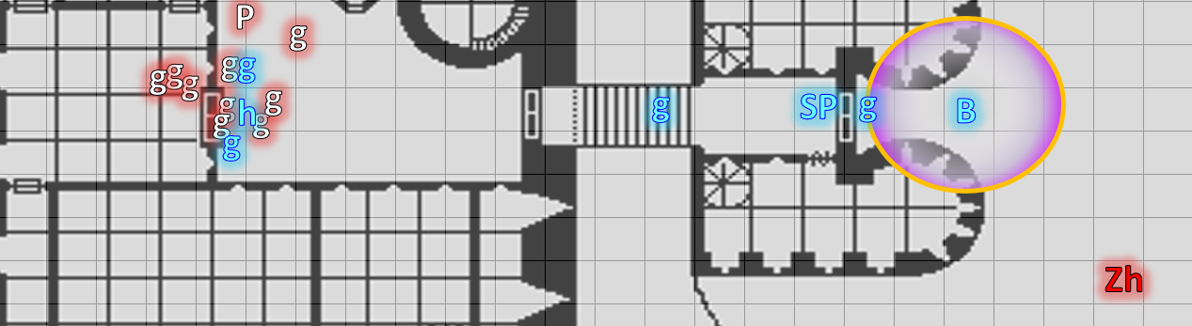

Round 48

“Damning evidence?” the dwarf frowned.

Jericho clarified, “Documents, mostly, but our Chapter’s diviners also uncovered a nefarious network answering to the guidance of one they call the Speaker in Dreams.”

“Let us fetch your belongings, Bishop,” the human pikeman put his pike back down and ushered the cleric to the evidence repository.

As the dwarven guard took up a defensive position in the middle of the entry room, the human guard and cleric made their way into the barracks, then heard the scuffle nearby as soon as they opened the door.

~*~

“Stop, by the authority vested in me by the City of Mintar!” Bratislava cast *hold person [expired on Round 53]* upon Zhang-Yasria.

|  |  |  |  |  |
| --- | --- | --- | --- | --- |
| **Character** | **Save vs.**  *hold person* | **Ranks** | **Roll** | **Save** |
| Prefect | Will | 2 | 8 | 10 |

*Fail.*

Zhang-Yasria froze in her tracks as a pair of guards produced a pair of manacles, and a gag.

“Careful, ladies and men,” Sergeant Pepper cautioned the guards. “The lycanthrope could break free of this spell at any moment.”

“By the gods!” Two guards manning the front gates—who had both been aided by Elsabet minutes ago—came to assist.

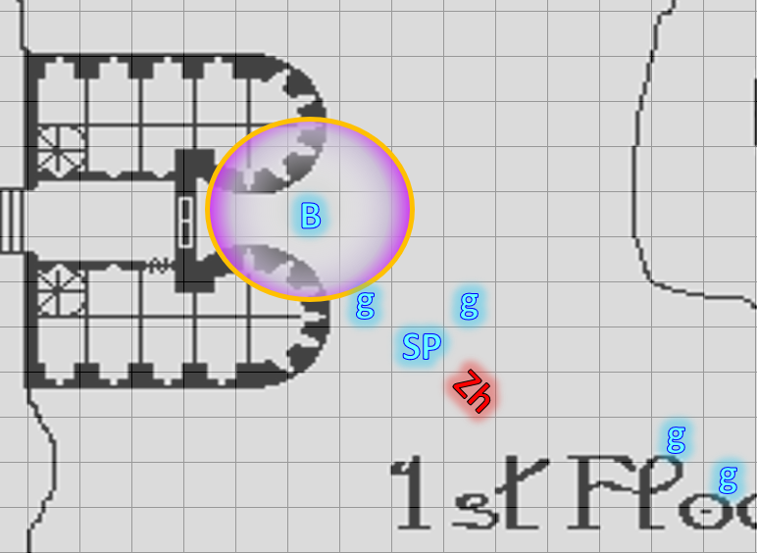

~*~

Barkley continued to grapple with the Prefect until he saw an opportunity to bite him.

|  |  |  |  |  |  |  |  |  |  |
| --- | --- | --- | --- | --- | --- | --- | --- | --- | --- |
| **Melee Weapon** | **Dmg** | **D+** | **TH+** | **Critical** | **Type** | **Wt.** | **Atk** | **Roll** | **Check** |
| Bite | 1d8 | 4 | 2 | 20 | Piercing | - | +11 | 17 | 28 |

*Hit. Dmg: 5 + 4 = 9. Damage negated.*

*I believe this ends the grapple.*

Luran started his uplifting lyrics from the top once more, though he now looked behind him.

Saradette had no idea what was going on, and was following her senses and intuition up the stairs from the cellar. Solstice and Widget were close behind, but not yet in view.

Elsabet activated her crusader’s strike, hoping to direct some healing to Barkley, but could not reach the target.

|  |  |  |  |  |  |  |  |  |  |
| --- | --- | --- | --- | --- | --- | --- | --- | --- | --- |
| **Melee Weapon** | **Dmg** | **D+** | **TH+** | **Critical** | **Type** | **Wt.** | **Atk** | **Roll** | **Check** |
| Bastard Sword +1, 1-handed | 1d10+1 | +4 | 4 | 19-20/x2 | Slashing | 6.0 | +13 | 15 | 28 |

*Hit. Dmg: 6 + 1 + 4 = 11.*

*I assumed this was lethal damage.*

*Barkley healed 5 + 4 = 9 hps [45/45].*

The rogue bolted northward.

The guard in the doorway had already seen Brezhnev and his healed friend coming in, and now said in a low voice, pointing, “Cover the north door!”

The guard who had just entered now positioned himself by the north door with westward access as Brezhnev took up a position in front of the other door.

Completely unarmed and unarmored, Bishop Jericho stayed put. “I’ll do my best with these as a last line of defense,” he said as he balled up his fists and stood in the doorway that led back to the main hall.

The wereserpent got free of Barkley’s grapple as soon as he bit him, and backed away 5’, exercising his right to Free (or Immediate) speech. “Foooolsssss!” he hissed, having no good spells left to cast. “You’ll neverrr get off thessse groundsss with your soulssss intact!” Dropping his single dagger, the Prefect backed away as his legs became a snake’s tail and he shrunk to the size of a viper. His robes fell to the ground uneventfully, as did the magic items and accessories he’d sported.

Elsabet received a new series of inspirational moves, though it appeared that she might not need them.

|  |
| --- |
| *Current Maneuvers* |
| Battle Leader’s Charge |
| Shield Block |
| Stone Vise |
| Crusader’s Strike |
| Foehammer |

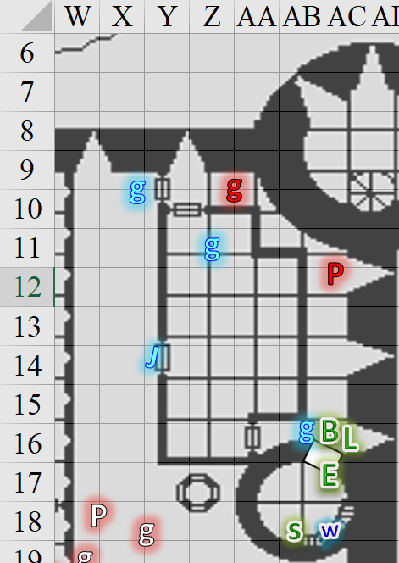

Round 49

The rogue opened the westward door, and the guard at the other side pointed a crossbow at her. “Freeze, Dzamila. You will be given a fair trial; I promise you.”

Brezhnev opened the other door and pointed a second crossbow at her. She immediately put down her blowgun and put up her hands.

The two guards restrained her hands behind her back as Bishop Jericho made his way over to block the doorway in case she tried to bolt.

The 5’ long snake that was the Prefect bolted northward from under the robes and slithered away amidst the feet of the guards.

|  |  |  |  |  |
| --- | --- | --- | --- | --- |
| **Character** | **Save vs.** | **Ranks** | **Roll** | **Save** |
| Prefect | Hide | 8 | 17 | 25 |
| Prefect | Move Silently | 8 | 16 | 24 |
| Baronial Guard | Listen | 5 | 12 | 17 |
| Baronial Guard | Spot | 4 | 18 | 22 |
| Baronial Guard | Listen | 5 | 3 | 8 |
| Baronial Guard | Spot | 4 | 17 | 21 |
| Bishop Jericho | Listen | 6 | 13 | 19 |
| Bishop Jericho | Spot | 6 | 9 | 15 |

*See below.*

The snake was able to slither past the men and woman unnoticed, and continued along the floor of the entry hall until he spotted the dwarven pikeman standing guard and facing east towards the front doors.

The guard near Barkley ran after the wereserpent, running into the arrest to the north, and warning, “The Prefect: he’s just escaped.”

“Bastard!” Brezhnev was at his wits’ end, poking his head back out into the hall, but seeing no snake.

“What the bloody hell?” the dwarven pikeman could be heard in the main room, turning his head to the north, and spotting the tail of the snake now hiding behind a single potted palm tree.

Saradette sighed and turned around to find Widget behind her, and Solstice finally making his way up the stairs. “What happened? There are a lot of people who have been bitten down in the cells. If they don’t get help, they will probably die, or worse.”

Elsabet let the Prefect get caught by the staff, suggesting, “Let’s find the Baron, and get Barkley his gear back!”

Barkley had no argument with that, and agreed with retrieving his gear and finding the Baron. He turned to one of the guards, “Where would a prisoners gear be kept if they were held in the upper levels? Can you take me there?” Then he noticed there were no longer any guards in his midst.

Widget came up the stairs after Saradette as Luran kept on singing. “All here?” one of them asked. “Let’s go,” and with this they followed their ears until they saw the rogue being arrested.

One of the guards from outside was dispatched by Bratislava once she’d heard the dwarven pikeman’s curses. The swordsman entered, and beheld the naked wereserpent.

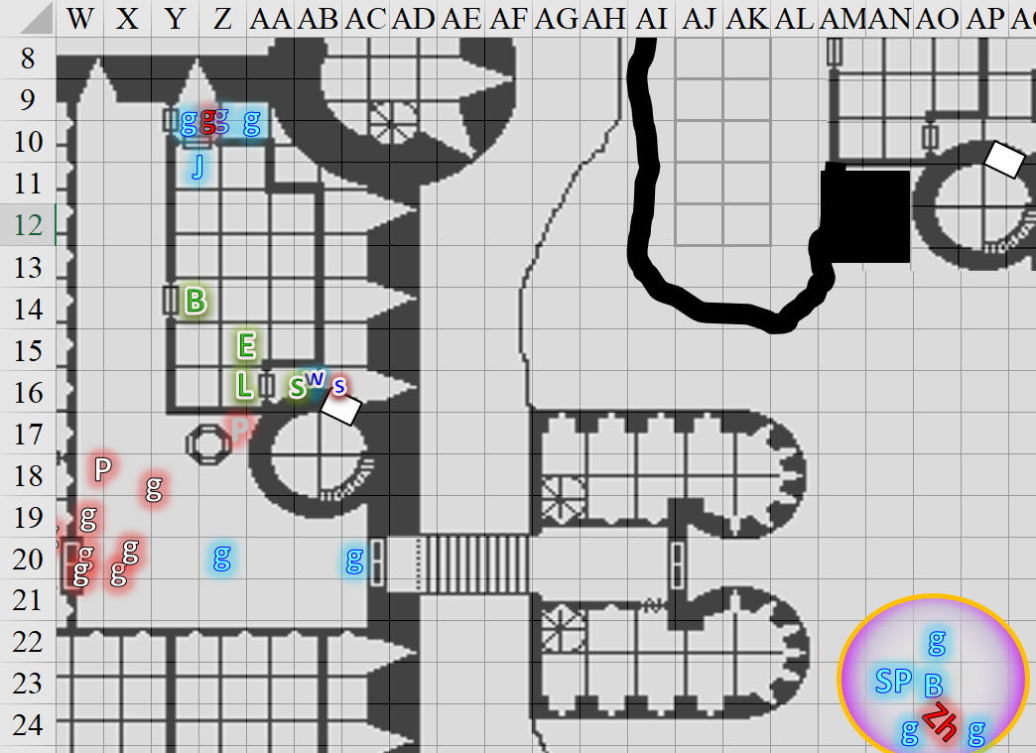

Round 50

As the dwarven guard in the main room approached, the serpent took on the guise of a wereserpent again and backed away from the dwarf towards the front doors. The Prefect hissed, “Your soulsss will be fodder for the Speaker in Dreammsssss!”

The rogue was restrained and led out to the main room by the three guards and Jericho, but as they heard the wereserpent’s voice again, two of these guards rushed to aid the pikeman.

The pikeman attacked the unarmed, unarmored, and unclad wereserpent.

|  |  |  |  |  |  |  |  |  |  |
| --- | --- | --- | --- | --- | --- | --- | --- | --- | --- |
| **Character** | **Attack Type** | **Damage** | **BAB** | **Str Mod+** | **W+** | **Other+** | **Total Score** | **Roll** | **Total** |
| Baronial Guard | MW Pike (Halberd, piercing) | 1d10+4 | 3 | 4 | 1 | 2 | 10 | 7 | 17 |

*Hit. Dmg: 7 + 4 = 11. Partial damage negated.*

The gnome turned to Elsabet. “Which way is Barkley’s gear?” She started off in the direction she’d seen the archon brought into them.

Elsabet got within earshot of the scuffle in the main room and asked, “Could they have caught the wereserpent?”

They all went out to where the commotion was and happened upon the Prefect, who—surrounded and vastly outnumbered—assumed the guise of a slender jungle elf whose features were comely only to the likes of Saradette. His penis hung flaccid, and his scrotum was contracted into a walnut-sized thing that was comely to no one. The evil male put up his hands, likely unable to cast any useful spells at this point. Trusting that these fools would give him a fair trial, he smirked like the cad he’d been in younger days, and began to plot his serpentine escape as the guards approached.

Bratislava took up a position from where she could see both Zhang-Yasria and whatever was going on inside. Through the now open double doors, she witnessed the imminent subdual of Prefect Garter-Kinder.

|  |  |  |  |  |
| --- | --- | --- | --- | --- |
| **Character** | **Save vs.**  *hold person* | **Ranks** | **Roll** | **Save** |
| Zhang-Yasria | Will | 1 | 3 | 4 |

*Fail.*

The woman remained magically *held* for the moment.

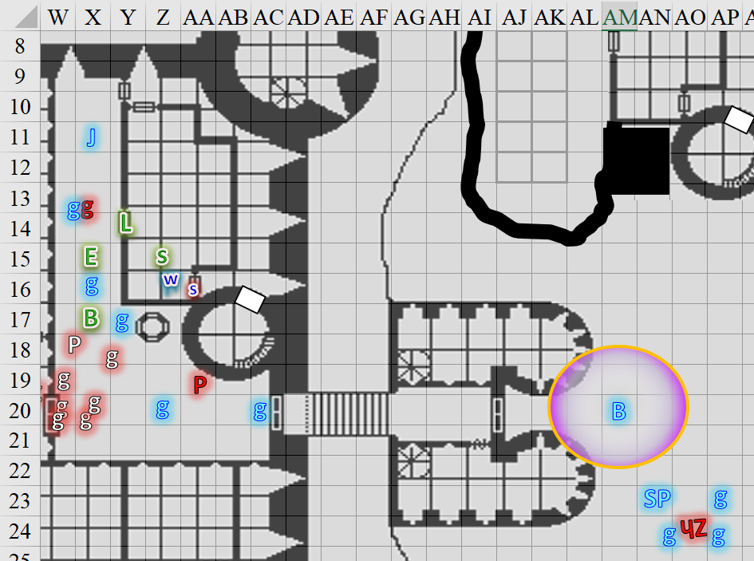

Round 51

Saradette felt a sudden unease from Widget. Empathizing with the emotion, she could not discern what it was about, but confirmed from the racoon’s body language as it climbed onto her shoulders and looked around the room.

|  |  |  |  |  |
| --- | --- | --- | --- | --- |
| **Character** | **Save vs.**  *hold person* | **Ranks** | **Roll** | **Save** |
| Zhang-Yasria | Will | 1 | 17 | 18 |

*Success. Hold Person no longer effective.*

The guards near the Prefect slapped a pair of manacles upon the unclad man, and Bratislava gave a gesture of gratitude from outside as her men and women finished restraining the no longer *held* Zhang-Yasria with lycanthrope-subduing bonds.

Jericho greeted Luran, recognizing the bard. “So good to see two of the faithful among us. I thank you all for your bravery.”

The bard offered the Tyrean priest a vocal flourish in the soundtrack of the scene he continued to maintain through the group's dialogue. As he did so, he additionally bent his head in respect.

Sgt. Pepper led the other guards back inside as the arrested trio was reunited for a few brief seconds. “Keep the suspects apart!” the Sergeant warned. “Is this one secured?”

“Yes, Sergeant,” the dwarven pikeman replied.

“Process them,” Bratislava’s voice entered the keep. “Brezhnev, Take their belongings to the evidence locker. Sauverenth, see that your guards put them in separate cellblocks.”

“Aye, Priestess-Colonel,” the humans both said as they began to search the rogue and sorceress, finding a few personal items of no notable quality, plus a single playing card—the king of clubs—depicting a wereserpent. Those *detecting magic* could tell that it emitted some dweomer, but could not yet discern its nature.

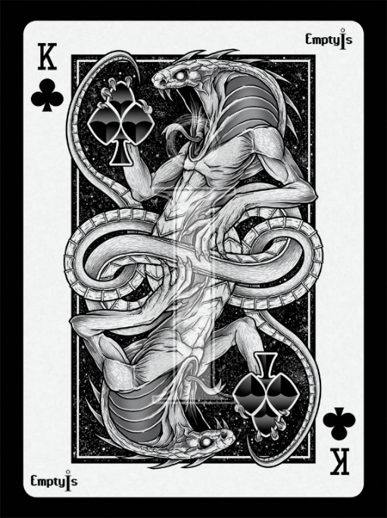

Upon seeing that the playing card had been confiscated, the Prefect’s eyes lost a bit of their twinkle, and he seemed to reluctantly sigh, “All must cower before the Speaker in Dreams.”

The rogue and sorceress also looked deeply distressed, and as their skin seemed to turn gray along with the Prefect’s, they solemnly pronounced in tandem the syllables, “Everybody burns,” before their eyes rolled back into their heads and their souls were wrenched from their bodies, dropping to the floor amongst the other fallen.

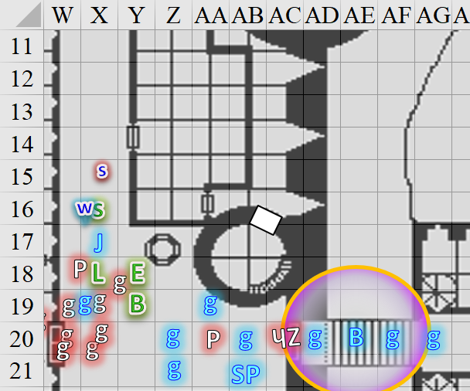

Rounds 52 – 57

“I really don’t get that,” Elsabet muttered as more of the cultists suicided. She continued with the others on the quest to recover gear.

As she encountered guards she had previously met, she greeted them by name. She hoped the Baron was still alive—and not enthralled by this foul cult. She shuddered to think of what Mintar might have become, a breeding ground for evil...

“I really don’t get that,” Elsabet muttered as more of the cultists suicided, though she didn’t really sense that this was their motive; no, it seemed that they were reluctantly resigned to a realization of imminent death, and were perhaps peppering their transmigration to the Lower Planes with nefarious words that would bolster them in the afterlife. In any case, she shook her head and continued with the others on the quest to recover gear.

As she encountered guards she had previously met, she greeted them by name. She hoped the Baron was still alive—and not enthralled by this foul cult. She shuddered to think of what Mintar might have become, a breeding ground for evil....

“Sauverenth,” Sgt. Pepper then changed that order. “Please see to the proper consecration of the bodies, and prepare both Prefects—and that scribe—for *resurrection*. If we can *raise* them, they will divulge all they know, and then they can answer for their crimes at our discretion.”



“Madam,” Sauverenth nodded as weapons were sheathed, and the swordsmen began to arrange the bodies in a row while the pikemen set down their heavy spears and made their way into the barracks to fetch some stretchers.

Bratislava conferred with Sgt. Pepper, nodding, then the rest of the men and women in the employ of the Baron finished inspecting each body for damage and likelihood that they were faking their deaths while Sgt. Pepper noted every body’s ad-hoc diagnosis on a roster. Priestess-Colonel Bratislava then ordered Brezhnev, “Go to the Precinct 2 post and relay what has happened here. Do you know their names?”

Brezhnev looked over the bodies, and nodded while shaking his head, holding back the expression of remorse of these losses and of his trust having been betrayed by some of them, whom he called friends. “Aye, milady, alas.”

The word “good” would have been in order, but Bratislava simply nodded and sighed through her nose. “Be well, and take Liv here with you. Tell Hangries or whoever is on dispatch right now that this is an all-precinct notice, and ask for backup from all adjacent precincts, but leave peripheral forces where they are. This could be yet another ruse.”

“Yes, milady,” a swordswoman named Liv said as the two left to relay the message to the rest of town.

“We’ll need these brave heroes’ help if we are to confront any forces above,” Sgt. Pepper said as Elsabet and others came closer.

Bratislava was in agreement, and turned to Barkley and Bishop Jericho—saying, “Come, let us fetch your belongings, that we might better serve the cause of justice.”

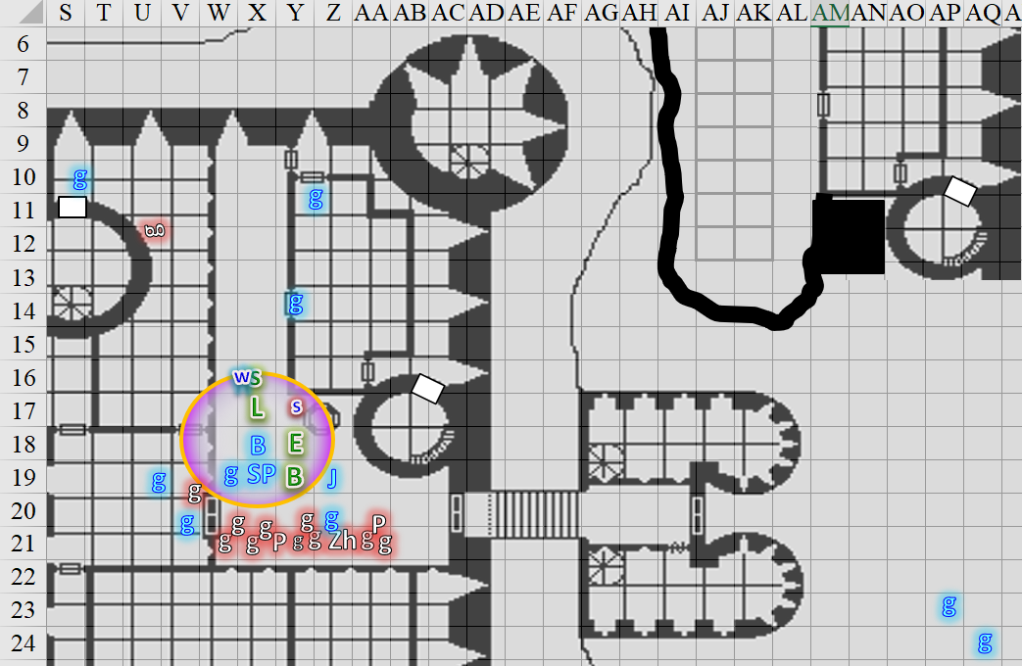

They began to make way back to the barracks.

Barkley was about to follow when he caught a glimpse of Solstice that triggered his senses. “Solstice, do not move. Saradette, have you and Solstice been apart for any period of time?” Barkley was on edge, ready to give chase should Solstice decide to bolt.

“Only for a moment,” Saradette replied as she turned to look at Solstice. Her weapon was still in her hands, but she had it pointed downward at the moment.

The others turned to Solstice, who looked right, but then twitched a bit, and smirked with a piercing look at Barkley, speaking in Infernal. << Prepare yourself, Master. They’re coming, >> said Solstice in a voice altogether unfamiliar, raspy and with the accent of a fluent speaker.

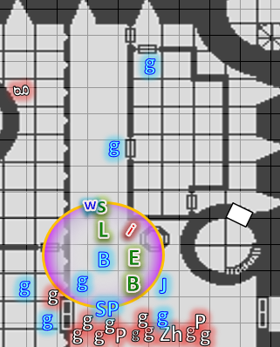

Round 58

“That’s not Solstice!” one of Solstice’s slower friends said.

Barkley’s Aura of Menace triggered a flight reaction in the Infernal impostor.

|  |  |  |  |  |
| --- | --- | --- | --- | --- |
| **Character** | **Save vs.**  Aura of Menace | **Ranks** | **Roll** | **Save** |
| Imp | Will | 4 | 6 | 10 |

*Fail. The imp incurred -2 to attacks, AC, and saves.*

The musteval was now taking on the guise of an imp of about the same size and girth, and the deceptive wee-devil leapt up into the air and took flight, making way southeast along the 15’ high ceiling.

Elsabet was spurred to action.

|  |
| --- |
| *Current Maneuvers* |
| Shield Block |
| Foehammer |
| Crusader’s Strike |
| Stone Vise |
| Battle Leader’s Charge |

“The wee devil!” Elsabet exclaimed, then moved to get a good line of sight and as close as possible, then used her *deep slumber* fey spell-like ability to try to make the creature sleep, placing the center point near it up at the ceiling to try to avoid catching anyone else in the effect. Her calculations were exceedingly precise, and Jericho had to merely stand back to avoid having his head caught in the spell’s effect.

|  |  |  |  |  |
| --- | --- | --- | --- | --- |
| **Character** | **Save vs.**  *deep slumber* | **Ranks** | **Roll** | **Save** |
| Imp | Will | 2 | 17 | 19 |

*Success. Effect negated.*

Before anyone could get in her way, Saradette brought up her flechette launcher, tracked the imp, and fired.

|  |  |  |  |  |  |  |  |  |  |
| --- | --- | --- | --- | --- | --- | --- | --- | --- | --- |
| **Ranged Weapon** | **Dmg.** | **D+** | **TH+** | **Critical** | **Rng.** | **Wt.** | **Atk** | **Roll** | **Check** |
| Sabot Launcher | 1d6 | - | 0 | 15o cone | 50’ | 5.0 | 7 | 19 | 26 |
| Sabot Launcher | 1d6 | - | 0 | 15o cone | 50’ | 5.0 | 7 | 14 | 21 |
| Sabot Launcher | 1d6 | - | 0 | 15o cone | 50’ | 5.0 | 7 | 4 | 11 |
| Sabot Launcher | 1d6 | - | 0 | 15o cone | 50’ | 5.0 | 7 | 1 | 8 |
| Sabot Launcher | 1d6 | - | 0 | 15o cone | 50’ | 5.0 | 7 | 11 | 18 |
| Sabot Launcher | 1d6 | - | 0 | 15o cone | 50’ | 5.0 | 7 | 12 | 19 |

*Hit, hit, miss, miss, hit, hit. Dmg: 6 + 5 + 1 + 6 = 18. Damage negated.*

Widget was scared of the imp who had just been creeping right behind her, and bolted north a bit as the two guards who had gone to get stretchers now returned to back their friends up.

As the imp-poster flew away, Barkley gave chase and, having nothing useful with him, went towards the keep’s southern wall, grabbed the pike resting along that wall, and threw it at the fleeting imp.

|  |  |  |  |  |  |  |  |  |  |
| --- | --- | --- | --- | --- | --- | --- | --- | --- | --- |
| **Ranged Weapon** | **Dmg** | **D+** | **TH+** | **Critical** | **Rng.** | **Wt.** | **Atk** | **Roll** | **Check** |
| Thrown Item | varies | 0 | Inappropriately weighted weapon -2 | - | 10’ | - | +5 | 7 | 12 |

*Miss.*

The pike fell to the floor with a few resonating bangs.

Luran followed Elsabet and sang a bridge, “My faaaaaather waaaaaas a gaaaaaamblin’ maaaaan…”

The Baronial faction had been caught off guard, and stumbled to make sense of the moment before acting *[movement only]*.

Ostor the Imp—as he had always wanted to be called but never really was—became invisible as it flew away.

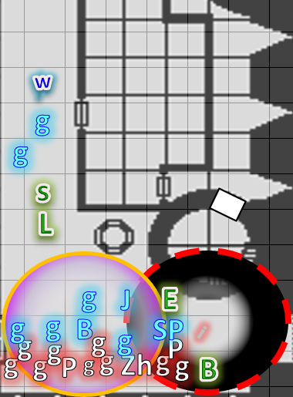

Round 59

|  |  |  |  |  |  |
| --- | --- | --- | --- | --- | --- |
| **Character** | **Group** | **Initiative** | **Roll** | **Modified Roll** | **Move** |
| Saradette | 1 | 3 | 20 | 23 | 20’ |
| Solstice Impostor | 2 | 2 | 20 | 22 | 30’/50’ fly |
| Barkley | 1 | 2 | 11 | 13 | 40’ |
| Baronial Faction | 2 | 2 | 6 | 8 | 30’ |
| Elsabet | 1 | 4 | 3 | 7 | 30’ |
| Luran | 1 | 1 | 5 | 6 | 30’ |

Saradette reloaded six more sabots into her portable cannon and _____.

The imp continued to flee unseen through the causeway that led outward.

“Impostor!” one of the guards called him.

“Close enough,” the imp thought.

Several Baronial Guards chased after the imp as it flew away.

Barkley could hear Bratislava’s expression of disappointed frustration as the invisible devil escaped.

Elsabet moved into position to blast the imp, but by the time she’d done so and had a line of sight to the keep’s entrance, the imp had exited and veered upward.

Luran shook his head.

*[DM assumption]* The archon sighed as they resigned themselves to the fact that the imp had escaped.

Sgt. Pepper was now appointing a pair of swordsmen to patrol the courtyard and surrounding grounds before she and Bratislava returned westward.

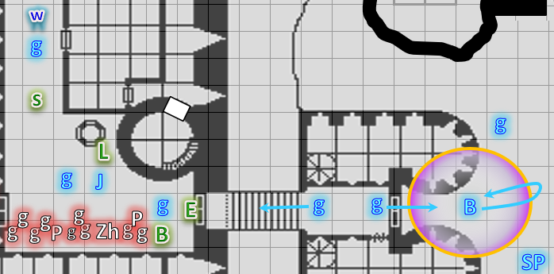

Rounds 60 – 62

Bratislava entered the main hall once again, and had two of the remaining guards help Barkley and Jericho with their gear.

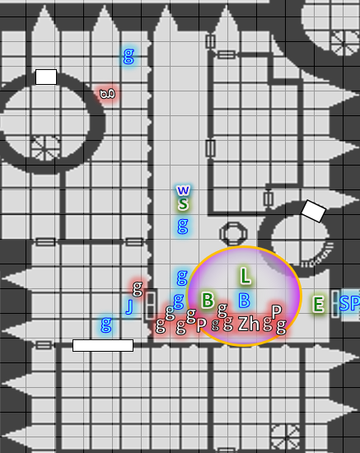

To the north, Barkley could see one of the guards they’d helped, who was still faithfully manning his post, and nodding in gratitude to the archon.

A tapestry was hoisted up, revealing a wide breach in the wall with a sliding metal door that was now unlocked and slid open, revealing a good number of fairly well organized weapons, suits of armor, and shelves of other items. There was likely enough stuff here to outfit a dozen specialists of varying calibers, but it was not so much that Barkley and Jericho couldn’t almost instantly spot their goods. Their armor and weapons were near the sliding door, having been placed there rather recently, and their smaller items were in bags appended to their breastplates.

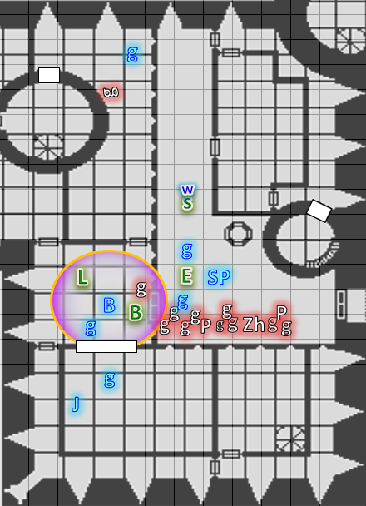

Rounds 63 – 65

Elsabet moved past two guards as Sgt. Pepper instructed the pair to, “Find the musteval. The imp likely replaced him recently, and he can’t be far.”

Saradette added, “He was last seen in the cellar of the barracks.”

“We’ll do our best,” nodded one of the guards as they executed their orders.

As Barkley entered and resolved to take a few minutes alongside Jericho donning his armor, Bratislava took a few steps north to not have to yell, and asked the northernmost guard, “Any action here?”

“Not here, milady, but there was another scuffle above, maybe a minute ago,” the young man reported. “By my guess, it was likely on the third floor.”

Bratislava turned back to the cleric and archon, bidding them to suit up quickly and be ready for what lay ahead.

Jericho nodded and started putting on his chain shirt, leaving his smaller items for last.

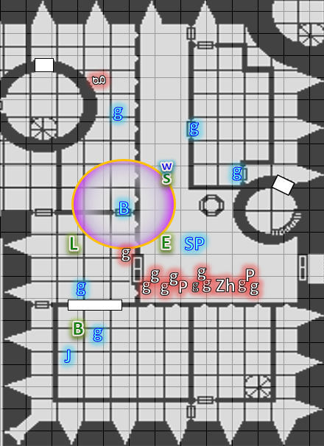

Rounds 66 – 68

Barkley dressed quickly, though he did not feel comfortable around the cleric of Tyr. He hadn’t felt the presence of Tyr for a while and wondered if his thoughts of justice or law were the reason for that. However, he did feel another presence, as if he were being watched by some other being. Perhaps it was Tyr or perhaps he was just imagining it.

Once he was dressed and ready, he headed out to follow Bratislava, the morning start that Elsabet had given him in one hand and his silvered hand axe in the other.

Saradette took a moment to load the empty barrel on her launcher, and used her air pump to top off the tank while she waited for Barkley.

“The new Prefects had the evidence locker moved,” Sgt. Pepper explained to Bratislava, who had been off during the last shift.

“Any take on what they might have been planning?” Bratislava. “What they still may be carrying out?”

“Your guess is as good as mine, though I would request permission to make haste for the Baron’s chambers,” the Sergeant said.

Elsabet had moved into the open doorway where much blood had spilled and where she could see all her friends except for Solstice—hoping the guards would find the little guy okay. “Be careful, Saradette,” she called out to the gnome, who seemed to be going her own way. She reminded herself to see if the woman would be willing to bond silver to her morningstar when they were done with the current trouble.

Seeing Bratislava, she sort of saluted the Colonel-Priestess, and then walked over to where Barkley was kitting up. “I guess you won’t need my crappy morningstar now,” she smiled, picking it up and holding it back on her belt. “Did you want to hold on to the kukri or do you have a silvered weapon of your own? In all this excitement I have quite lost track.”

She admired his muscular form, but thought of him more like a kid brother—it might be years before the kid grew up beyond the teen puppy stage as an archon, but he seemed like he might be picking up some mortal skills and abilities in the meantime. He also seemed a bit troubled.

“Sorry if it is none of my business, B,” she said quietly, for his sharp ears alone, “but you look troubled.” She turned away slightly as he adjusted a particular piece of his armor. “Just have a chat with Bishop Jericho once these cultists are cleared out,” she suggested.

Rounds 69 – 75

Barkley was about half-way done donning his chain shirt, as was Jericho. He would have preferred to use his breastplate, but it was back at the Temple—he hoped—and the one in this room was too small for him, and rightfully belonged to someone else. After Bratislava dispatched Sgt. Pepper and the other guards present to the tower and then up its stairs, she turned to Jericho and Barkley, and said, “I will free the captives in cellblock B, and return once you are ready to join me.”

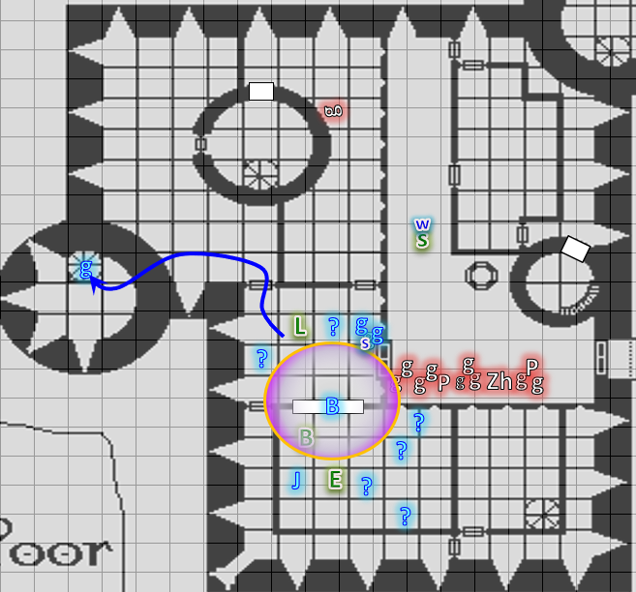

Round 76

Barkley and Jericho were strapping their scabbards on and were about to start putting on their clothing and other gear when Bratislava returned with five others, some of whom entered the evidence locker and greeted the heroes with gratitude as they also suited up.

Solstice returned with the two guards behind him, chugging the last of the *cure wounds* potions that the guards had given him at the potion station after they’d recovered him from the cellar, where he’d been knocked out. Barkley immediately noted the lack of an evil aura around his friend, and grinned at him as the musteval entered and remarked, “So *this* is why they carried out a coup.”

“I doubt it,” Jericho frowned at the assumption. “I worry that what they’re really after is not riches, but the Baron’s power.” He placed a ring upon his finger, fortifying his armor further.

“Bishop Jericho, you’re welcome to join us, unless Bratislava prefers you with her?” Elsabet looked at the Colonel-Priestess, deferring to her authority.

“Bratislava, what do you say?” the cleric asked

As he had been throughout most of the events, the bard continued his vocal magic at a low volume under the conversations and preparations.

Round 77

When Elsabet talked to Barkley, he remained quiet. He showed her his silvered axe after he handed back the kukri and morningstar. He also simply nodded when she mentioned talking to Jericho.

“Barkley, Luran, perhaps you could establish a message link to the Colonel-Priestess and Bishop Jericho, provided they agree of course? As well as reconnecting us, just in case we get split you need to send messages. As long as there are cracks under doors, open keyholes, and suchlike, the whispers could reach a reasonable distance inside the keep.”

Barkley tugged on his chain shirt and his pack as he nodded, “That is a good idea.” Barkley established the Message Connection with them Bratislava and Sgt. Pepper.

Once all of his companions were together again and also fully equipped, Luran lifted his voice a bit higher and increased the tempo of his song. He assumed that the group would finally be off to find and either rescue or deal with the troublesome baron and his new colleagues.

Round 78

The two civilians who were not suiting up and had not had anything large confiscated had by now grabbed their few effects, and thanked Bratislava for saving them before leaving.

Elsabet looked at her friends, and figured if they had any ideas they could speak up, but she didn’t want to sit around idle while yet more folks got their armor on. “Bratislava, with your permission, I think I and my group should hustle upstairs to provide Sgt. Pepper some backup.”

“I bid you strength,” Bratislava nodded to Elsabet. “I shall be up shortly. Trust in Sgt. Pepper’s direction.”

Barkley nodded, “Yes, we must move before our foes are able to fortify any positions they might have within the castle.” He then moved to follow Elsabet.

Saradette followed Elsabet as well. “Come on, Widget,” she called to her familiar, who followed her to the spiral staircase in the tallest of the keep’s towers. With every step, their approach brought with it clearer signs of another conflict above them.

“To arms!” one of them called downward only loud enough to be heard by the person behind them.

Luran followed up, with the others, in search of more rot within the keep to root out, humming a rumbling marching tune to bolster their steps.

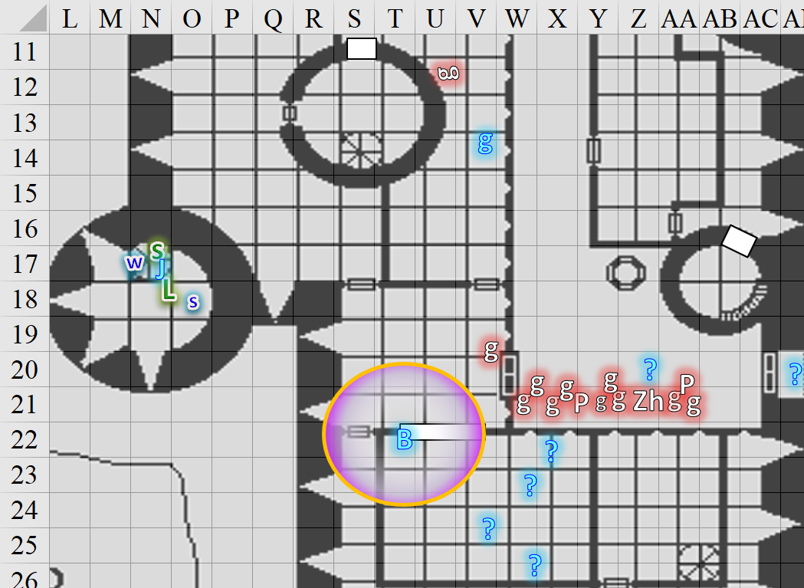



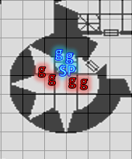

Round 79

Following Elsabet, Barkley put on his Cloak of Resistance as they approached the sounds of battle.

Behind them on the floor below were Saradette and Widget, leading Jericho, Luran, and Solstice up the spiral staircase.



They cleared two flights of stairs, and happened upon Sgt. Pepper and her forces dealing with a handful of human and half-elven cultists. Only Saradette and those behind her had not yet reached this level, but were only seconds away from doing so, and anticipated having to fight in the cramped tower.

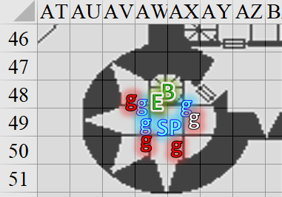

Round 80

|  |  |  |  |  |  |
| --- | --- | --- | --- | --- | --- |
| **Character** | **Group** | **Initiative** | **Roll** | **Modified Roll** | **Move** |
| Elsabet | 1 | 4 | 18 | 22 | 30’ |
| Barkley | 1 | 2 | 20 | 22 | 40’ |
| Solstice | 1 | 1 | 15 | 16 | 30’/10’ |
| Baronial Faction | 2 | 2 | 8 | 10 | 30’ |
| Prefects’ Faction | 3 | 2 | 7 | 9 | 30’ |
| Saradette | 1 | 3 | 4 | 7 | 20’ |
| Luran | 1 | 1 | 4 | 5 | 30’ |

Elsabet squeezed past the friendly guard as she heard footsteps coming down the stairs behind her.

|  |
| --- |
| *Current Maneuvers* |
| Foehammer |
| Battle Leader’s Charge |
| Shield Block |
| Crusader’s Strike |
| Stone Vise |

“For Mintar!” Elsabet called out, as she faced a foe immediately on her right that had been outflanking the nearest Baronial guard, who looked heavily wounded.

|  |  |  |  |  |  |  |  |  |  |
| --- | --- | --- | --- | --- | --- | --- | --- | --- | --- |
| **Melee Weapon** | **Dmg** | **D+** | **TH+** | **Critical** | **Type** | **Wt.** | **Atk** | **Roll** | **Check** |
| Bastard Sword +1, 1-handed | 1d10+1 | +4 | 4 | 19-20/x2 | Slashing | 6.0 | +13 | 8 | 21 |

*Dmg: 4 + 1 + 4 = 9.*

The decrepit guard fell to the ground with no words.

Barkley, seeing that the others seemed to have the tower under control, noticed the door to the side. Barkley decided to head to the door to see what these guards were trying to keep them from getting to.

The door was locked. The hero slammed into it.

|  |  |  |  |  |
| --- | --- | --- | --- | --- |
| **Ability** | **Mod** | **Total** | **Roll** | **Check** |
| **Strength** | 4 | 6 | 16 | 22 |

*Success.*

The door was now open, but no one was visible in the triangular room beyond the threshold

Once again up to full health, Solstice could detect the evil auras emanating from the enemy guards. The lump on his head was gone, but he still recalled the pain of the mighty blow to the back of his head that had rendered him unconscious. The musteval decided this was a good time to use his daily ability to render himself invisible.

The Baronial faction did their best to eliminate the cultist guards without any further dialogue. Sgt. Pepper and her men and women were beyond words at this point.

|  |  |  |  |  |  |  |  |  |  |
| --- | --- | --- | --- | --- | --- | --- | --- | --- | --- |
| **Character** | **Attack Type** | **Damage** | **BAB** | **Str Mod+** | **W+** | **Other+** | **Total Score** | **Roll** | **Total** |
| Sgt. Pepper | MW Short Sword | 1d6+3 | 4 | 3 | 1 | 2 | 10 | 13 | 23 |
| Baronial Guard | MW Club | 1d6+3 | 3 | 3 | 1 | 2 | 9 | 6 | 15 |
| Baronial Guard | MW Short Sword | 1d6+3 | 3 | 3 | 1 | 2 | 9 | 14 | 23 |
| Baronial Guard | MW Short Sword | 1d6+3 | 3 | 3 | 1 | 2 | 9 | 7 | 16 |

*Hit, miss, hit, miss. Dmg: (5 + 3) + (6 + 3) = 8 + 9 = 17.*

The Prefects’ remaining faithful parried and defended the tower to the best of her ability.

|  |  |  |  |  |  |  |  |  |  |
| --- | --- | --- | --- | --- | --- | --- | --- | --- | --- |
| **Character** | **Attack Type** | **Damage** | **BAB** | **Str Mod+** | **W+** | **Other+** | **Total Score** | **Roll** | **Total** |
| Prefect’s Guard | MW Short Sword | 1d6+3 | 3 | 3 | 1 | -2 | 5 | 8 | 13 |

*Miss.*

Saradette looked for an opening through which to shoot the remaining enemy in sight without risking hitting a friendly. The six sabots would likely have harmed Sgt. Pepper, so she stayed her cannon hand for the moment.

An additional cultist guard came down from the level above them, and attacked Elsabet.

|  |  |  |  |  |
| --- | --- | --- | --- | --- |
| **Character** | **Save vs.**  Aura of Menace | **Ranks** | **Roll** | **Save** |
| Prefect’s Guard | Will | 1 | 18 | 19 |

*Fail. Guard incurred -2 to attacks, AC, and saves.*

|  |  |  |  |  |  |  |  |  |  |
| --- | --- | --- | --- | --- | --- | --- | --- | --- | --- |
| **Character** | **Attack Type** | **Damage** | **BAB** | **Str Mod+** | **W+** | **Other+** | **Total Score** | **Roll** | **Total** |
| Prefect’s Guard | MW Dagger | 1d3+3 | 3 | 3 | 1 | -2 + 2 charge | 7 | 9 | 16 |

*Miss.*

As he finished coming up the spiral staircase, Luran’s song went full throttle as he joined the martial fun, whacking at the traitor guard that just came down the stairs from the level above them.

|  |  |  |  |  |  |  |  |  |  |
| --- | --- | --- | --- | --- | --- | --- | --- | --- | --- |
| **Melee Weapon** | **Dmg** | **D+** | **TH+** | **Critical** | **Type** | **Wt.** | **Atk** | **Roll** | **Check** |
| MW Dagger | 1d4 | -1 | 3 | 19-20, x2 | Prcg/Slsh | 1.0 | +8 | **19** | 19 |

*Threat. 1d20 = 19, critical hit. Dmg: (2 x 3) – 1 = 5.*

The guard was injured, but not enough to back down.

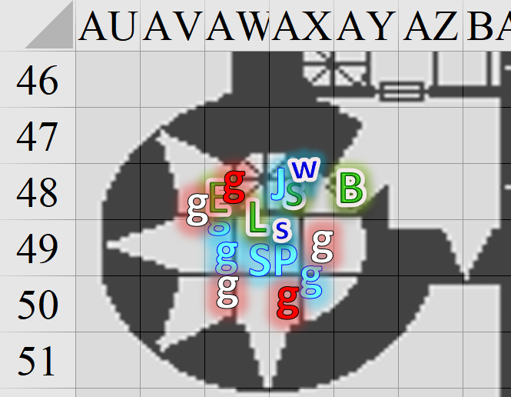

Round 81

A door above them was slammed shut.

With a swift action, Elsabet called upon Mayaheine and activated her protection devotion *[expired on Round 90]*.

*All allies gained +3 AC while within 30’ of Elsabet.*

With righteous anger, she then initiated her foehammer maneuver and slashed down hard at the enemy who had just charged down from the top level and tried to stab her.

|  |  |  |  |  |  |  |  |  |  |
| --- | --- | --- | --- | --- | --- | --- | --- | --- | --- |
| **Melee Weapon** | **Dmg** | **D+** | **TH+** | **Critical** | **Type** | **Wt.** | **Atk** | **Roll** | **Check** |
| Bastard Sword +1, 1-handed | 1d10+1 | +4 | 4 + 2 flank | 19-20/x2 | Slashing | 6.0 | +15 | 18 | 33 |

*Hit. 3 + 1 + 4 + 3 = 11.*

The guard continued to grimace as Elsabet added to the wound that Luran had just opened.

As she felt her shield block maneuver granted, Elsabet grinned at the wounded guard next to her. “Got yer back, friend!”

“Much obliged, heroine,” the friendly guard replied, joining in the fun.

|  |  |  |  |  |  |  |  |  |  |
| --- | --- | --- | --- | --- | --- | --- | --- | --- | --- |
| **Character** | **Attack Type** | **Damage** | **BAB** | **Str Mod+** | **W+** | **Other+** | **Total Score** | **Roll** | **Total** |
| Baronial Guard | MW Short Sword | 1d6+3 | 3 | 3 | 1 | 2 + 2 flank | 11 | 17 | 28 |

*Hit. Dmg: 6 + 3 = 9.*

At last, the guard who had come down from the topmost level fell to the ground.

The Baronial faction surrounded the remaining cultist and did their best to bring her life to an end.

|  |  |  |  |  |  |  |  |  |  |
| --- | --- | --- | --- | --- | --- | --- | --- | --- | --- |
| **Character** | **Attack Type** | **Damage** | **BAB** | **Str Mod+** | **W+** | **Other+** | **Total Score** | **Roll** | **Total** |
| Sgt. Pepper | MW Short Sword | 1d6+3 | 4 | 3 | 1 | 2 | 10 | 13 | 23 |
| Baronial Guard | MW Club | 1d6+3 | 3 | 3 | 1 | 2 | 9 | 12 | 21 |
| Baronial Guard | MW Short Sword | 1d6+3 | 3 | 3 | 1 | 2 | 9 | 2 | 11 |

*Hit, hit, miss. Dmg: (6 + 3) + (2 + 3) = 9 + 5 = 14.*

The Prefects’ henchwoman collapsed, not quite dead, but unable to defend herself as she bled profusely.

Barkley took a quick whiff of the air, trying to pick up any familiar odors, be they friend or foe. Detecting the now familiar scent of wererat and wereserpent, plus a few humanoid aromas of strangers he’d not yet killed, he said a few words relaying the information his nostrils were gleaning.

The sound of a horn bellowed outside, suggesting reinforcements were here, or perhaps the Baron’s forces were trying to alarm the citizens and rouse them to preparation.

Luran pulled a scroll from his haversack, gesturing toward Elsabet’s sword and adding a flourish to his vocalizations, implying arcane enchantment of some form. As well, with Barkley, he indicated his pouch of material components and pantomimed casting something upon the archon. With that image, he reached an accelerating crescendo, suggesting speed.

Jericho steeped over to Barkley to check out the triangular room to the east.

Solstice remained *invisible*, and said nothing as he tiptoed under Jericho and stepped inside the room as well, noting that it was really more of a causeway between the tower and somewhere else. A northward door was closed, and a few vases bigger than him rested along the walls on carven, wooden pedestals in a style indicative of this time and place.

Saradette stepped such that she could see better into the room through those standing in the doorway.

Sgt. Pepper said, “The Baron’s bedchambers are upstairs.”

“What’s over here?” Barkley asked.

Jericho answered, “The Treasurer’s bureau.”

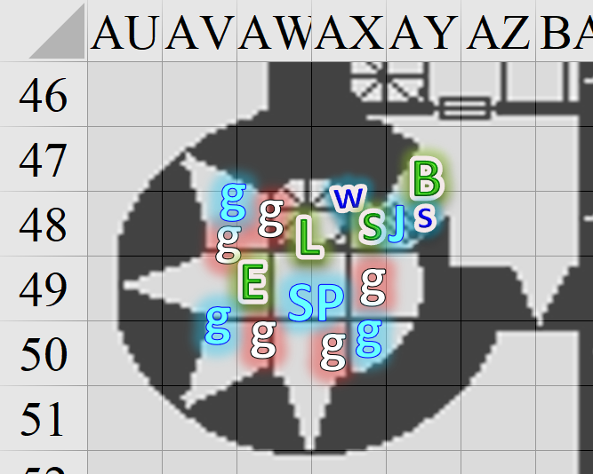

Round 82

“… Which was occupied by Prefect Almodóvar for the last few days,” Sgt. Pepper needed to add before the clarification was through.

“Where’s Prefect Ma’imün? Jericho asked.

“He was sent to Saradush on a diplomatic mission the day the wystes and wererats made their overture,” Sgt. Pepper informed the Prefect’s acquaintance.

Luran cast *keen edge [expired on Round 482]* on Elsabet’s bastard sword from the scroll he’d just produced.

|  |  |  |  |  |  |  |
| --- | --- | --- | --- | --- | --- | --- |
| **Skill** | **Rank** | **Ability & Mod.** | **Misc. Mods.** | **Total** | **Roll** | **Check** |
| **Use Magic Device** | 4 | **Cha (+5)** | 2 | 11 | 13 | 24 |

*Success. Elsabet’s bastard sword gained a threat range of 17 – 20.*

Round 83

“Personnel, was drastically changed since then...” sighed Sgt. Pepper’s aide-de-camp, adding, “Anyone above the rank of Priestess/Priest-Colonel was put on administrative leave, dismissed, reassigned, dispatched, or tried for heresy.”

Jericho was among those in the last category. Though he had no rank, his influence over those who did had gotten him lumped in with several of the guards and heroes who were even now suiting up downstairs in anticipation of joining them.

Solstice and Barkley thought they heard footsteps to the north.

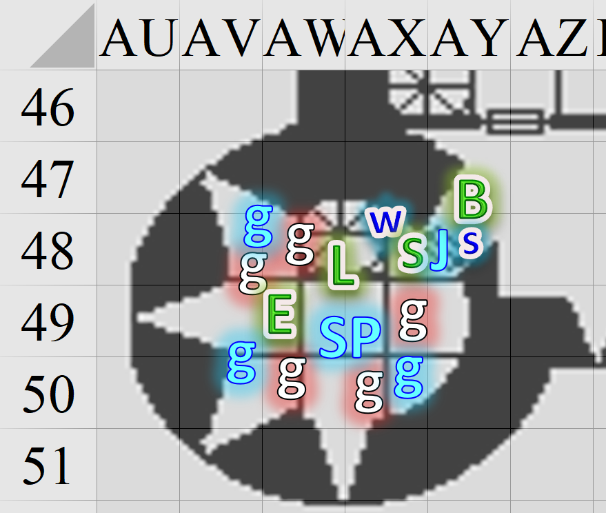

Round 84

“If you’ve iron in your blood, and steel in your sinews,” Sgt. Pepper said in cadence with Luran’s rhythmic melody. “Let us lay the rest of these renegades by the heels.”

Upon her saying this, Elsabet heard the door open to their northeast, and a formidable figure stepped through, ducking under the threshold as he entered.

|  |
| --- |
| *Current Maneuvers* |
| Stone Vise |
| Foehammer |
| Crusader’s Strike |
| Battle Leader’s Charge |
| Shield Block |

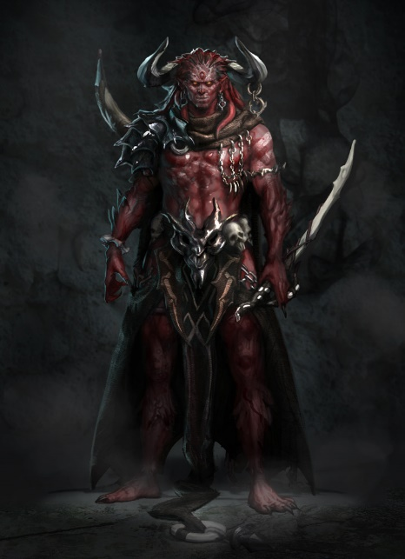

The tiefling man towered about a foot over Barkley’s head, and growled in Infernal, << Lunch! >>

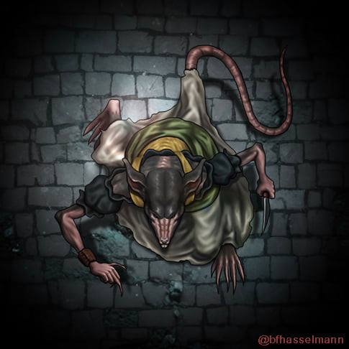

Behind him, there entered a wererat armed with a glowing dagger and a hand crossbow, followed by another tiefling of lesser stature.

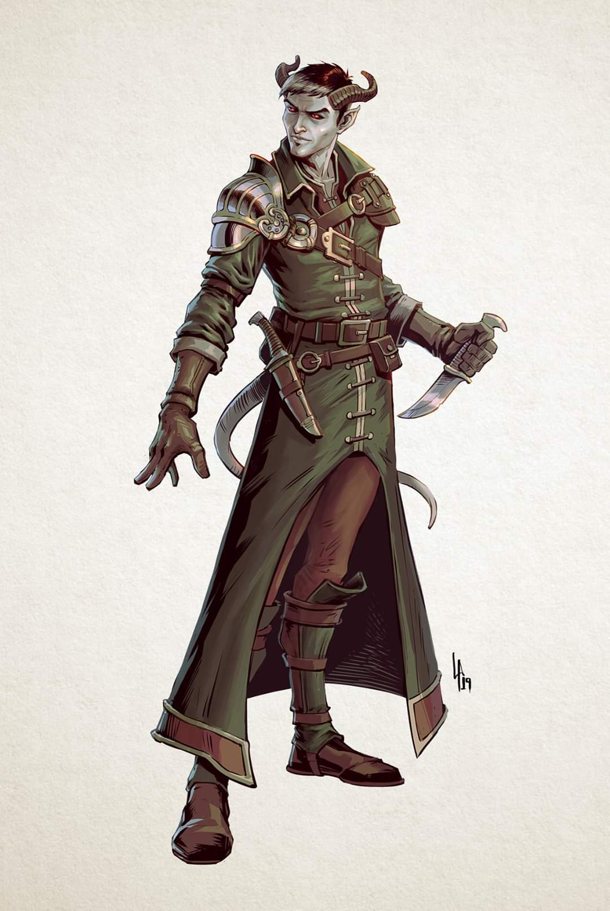

The three looked pretty buffed up, and beheld Barkley.

|  |  |  |  |  |
| --- | --- | --- | --- | --- |
| **Character** | **Save vs.**  Aura of Menace | **Ranks** | **Roll** | **Save** |
| Xenar | Will | 6 | 9 | 15 |
| Wererat Lord | Will | 7 | 20 | 27 |
| Phylac | Will | 6 | 5 | 11 |

*Success, success, fail. Xenar and Phylac incurred -2 to attacks, AC, and saves.*

Barkley identified the wererat by smell as being the same fellow who had escaped them at the Reality Wrinkle as the three fiendish fellows converged on the hound archon.

|  |  |  |  |  |  |  |  |  |  |  |  |
| --- | --- | --- | --- | --- | --- | --- | --- | --- | --- | --- | --- |
| **Character** | **Attack Type** | **Damage** | **BAB** | **Str Mod+** | **Dex Mod+** | **W+** | **Other+** | **Total Score** | **Roll** | **Total** | **Notes** |
| Xenar | Falchion +2 | 2d6+2+3 | 8 | 3 | 0 | 2 | -2 | 11 | 15 | 26 |  |
| Wererat Lord | MW Hand Crossbow | 1d3 | 5 | 1 | 3 | 1 | 0 | 9 | 14 | 23 | Sneak +2d6 |
| Phylac | Dagger +1 | 1d4+1+1 | 3 | 1 | 3 | 1 | -2 | 5 | 2 | 7 | Sneak +2d6 |

*Hit, miss, miss. Dmg: 6 + 2 + 3 = 11 [34/45].*

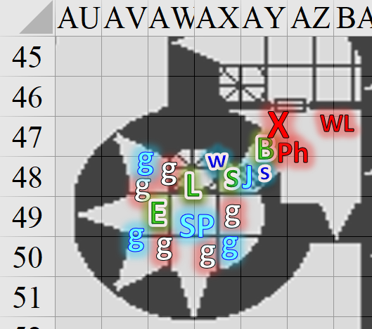

Luran cast *haste [expired on Round 91]* on Barkley, Luran, Elsabet, Saradette, and Solstice, plus Sgt. Pepper and Jericho.

*Agents of BLESS, Sgt. Pepper, and Jericho gained +1 to AC, Reflex Saves, and BAB, plus extra attack or move.*

*(Elsabet has been getting the +1 BAB all along due to divine favor never having been removed.)*

Sgt. Pepper and Jericho thanked the bard for the extra buff.

Barkley smiled at the large tiefling and, in Infernal, replied to his offer of lunch, << No thanks; I’m not hungry. >> Barkley then went after the large tiefling with his magic longsword and his silvered hand axe.

|  |  |  |  |  |  |  |  |  |  |
| --- | --- | --- | --- | --- | --- | --- | --- | --- | --- |
| **Melee Weapon** | **Dmg** | **D+** | **TH+** | **Critical** | **Type** | **Wt.** | **Atk** | **Roll** | **Check** |
| Longsword +1 | 1d8 | 5 | 4 | 19-20/x2 | Slashing | 4.0 | +14 | 5 | 19 |
| Hand Axe, Silver | 1d6 | 3 | 4 | x3 | Slashing | 3.0 | +9 | 15 | 24 |
| Longsword +1 | 1d8 | 5 | 2 | 19-20/x2 | Slashing | 4.0 | +12 | 13 | 25 |

*Hit, hit, hit. Dmg: (1 + 5 + 4 Courage) + (6 + 5 + 4 Courage) + (8 + 5 + 4 Courage)= 10 + 15 + 17 = 42.*

With a swift command word, Elsabet used a second charge on her brute gauntlets to boost her strength checks by two, shouted “breaking through!” so her allies would not impede her, and attempted to bull rush her way into the small chamber, by forcing the smaller, weaker looking tiefling back into the space between the other two.

*1d100 = 94, 68, no erred swings.*

|  |  |  |  |  |  |  |  |  |  |  |
| --- | --- | --- | --- | --- | --- | --- | --- | --- | --- | --- |
| **Character** | **Attack Type** | **Damage** | **BAB** | **Str Mod+** | **W+** | **Other+** | **Total Score** | **Roll** | **Total** | **Notes** |
| Xenar | Falchion +2, 1st Attack | 2d6+2+3 | 8 | 3 | 2 | -2 | 11 | 19 | 30 |  |
| Phylac | Dagger +1 | 1d4+1+1 | 3 | 1 | 1 | -2 | 5 | 12 | 17 | Sneak Attack +2d6 |

*Threat, miss. 1d20 = 13 + 11 = 24, critical hit. Dmg: 2 x (4 + 2 + 3) = 18 [30/48].*

|  |  |  |  |  |
| --- | --- | --- | --- | --- |
| **Character** | **Check** | **Ranks** | **Roll** | **Save** |
| Phylac | Strength | 1 | 12 | 13 |
| Elsabet | Strength | 4 + 2 charge | 3 | 9 |

*Fail.*

Elsabet bounced back out of Phylac’s space and fell prone in the space with Jericho and Solstice.

Elsabet muttered “that went well” as she prepared to deal with the results of her efforts, and she felt her Crusader’s Strike granted to her.

Jericho helped Elsabet up.

“Let them come to us,” the Sergeant said to the frontline archon.

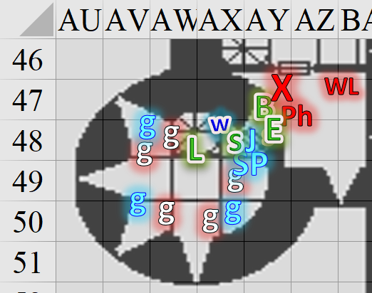

Round 85

|  |  |  |  |  |  |
| --- | --- | --- | --- | --- | --- |
| **Character** | **Group** | **Initiative** | **Roll** | **Modified Roll** | **Move** |
| Elsabet | 1 | 4 | 20 | 24 | 30’ |
| Baronial Faction | 2 | 2 | 18 | 20 | 30’ |
| Wererat Lord | 3 | 7 | 9 | 16 | 30’ |
| Luran | 1 | 1 | 15 | 16 | 30’ |
| Xenar | 3 | 2 | 13 | 15 | 30’ |
| Saradette | 1 | 3 | 8 | 11 | 20’ |
| Barkley | 1 | 2 | 6 | 8 | 40’ |
| Phylac | 3 | 3 | 3 | 6 | 30’ |
| Solstice | 1 | 1 | 4 | 5 | 30’/10’ |

“Ouch!” Nodding a thanks to the Bishop, Elsabet was torn between using a single strike or taking advantage of the haste effect, but decided on the latter. Having two foes within reach of her bastard sword, she decided the big guy with the nasty blade was the more dangerous foe.

With a swift command word, she used the last charge in her gauntlets to gain extra damage and taking advantage of the bard’s very inspiring music, quickly swinging her blade twice at the falchion-wielding tiefling. If they could take that one down fast, they would be much better off.

|  |  |  |  |  |  |  |  |  |  |
| --- | --- | --- | --- | --- | --- | --- | --- | --- | --- |
| **Melee Weapon** | **Dmg** | **D+** | **TH+** | **Critical** | **Type** | **Wt.** | **Atk** | **Roll** | **Check** |
| Bastard Sword +1, 1-handed | 1d10+1 | +4 | 2 + 4 | 19-20/x2 | Slashing | 6.0 | +15 | 10 | 25 |
| Bastard Sword +1, 1-handed, *haste* | 1d10+1 | +4 | 2 + 4 | 19-20/x2 | Slashing | 6.0 | +15 | 12 | 27 |

*Hit Xenar, hit Phylac.*

*Dmg to Xenar: 2 + 1 + 4 + 2 Gauntlets + 4 Courage = 13.*

*Dmg to Phylac: 3 + 1 + 4 + 2 Gauntlets + 4 Courage = 14.*

Xenar fell to the floor with a massive thud, and was likely dead before he hit the ground.

“Go meet your master,” she snarled at the dying foe.

The Baronial faction wasn’t able to enter the room yet.

The Wererat Lord fired upon Elsabet.

|  |  |  |  |  |  |  |  |  |  |  |  |
| --- | --- | --- | --- | --- | --- | --- | --- | --- | --- | --- | --- |
| **Character** | **Attack Type** | **Damage** | **BAB** | **Dex Mod+** | **W+** | **Total Score** | **Roll** | **Total** | **Crit** | **Threat** | **Notes** |
| Wererat Lord | MW Hand Crossbow | 1d3 | 5 | 3 | 1 | 9 | 19 | 28 | 19 | þ | Sneak Attack +2d6 |

*Threat. 1d20 = 9 + 9 = 18, not a critical hit. Dmg: 3 + 6 sneak = 9 [21/48].*

The magical field created by the bard’s voice warbled rapidly as he focused on the towering tiefling’s massive weapon, casting *grease* *[expired on Round 155]* on the rogue’s blade.

The blade—and its handle—instantly became greasy.

Saradette looked for an opening to shoot at one of the enemies. The projectiles were just over a foot wide at thirty feet, so she didn’t need much room to fire at closer ranges. If she had a shot, she took it.

Widget sniffed the air uneventfully.

Barkley, seeing his success, too a 5’ step and went after the slighter tiefling, going after him with his longsword and his silvered hand axe, hoping to turn him so that others could take advantage of flanking maneuvers on him. Barkley also whispered, “Solstice, do you have an opening to finish one of these two.”

|  |  |  |  |  |  |  |  |  |  |
| --- | --- | --- | --- | --- | --- | --- | --- | --- | --- |
| **Melee Weapon** | **Dmg** | **D+** | **TH+** | **Critical** | **Type** | **Wt.** | **Atk** | **Roll** | **Check** |
| Longsword +1 | 1d8 | 5 | 4 | 19-20/x2 | Slashing | 4.0 | +14 | 8 | 22 |
| Hand Axe, Silver, *haste* | 1d6 | 3 | 4 | x3 | Slashing | 3.0 | +14 | 16 | 30 |

*Hit, hit. Dmg: (4 + 5 + 4 Courage) + (3 + 5 + 4 Courage) = 13 + 12 = 25*

Phylac died, his chest hacked wide open and his arm landing on the floor a few feet from the rest of him.

Solstice attacked the Wererat Lord, losing his *invisibility*.

|  |  |  |  |  |  |  |  |  |  |  |
| --- | --- | --- | --- | --- | --- | --- | --- | --- | --- | --- |
| **Ranged Weapon** | **Dmg.** | **D+** | **TH+** | **Critical** | **Rng.** | **Wt.** | **Atk** | **Roll** | **Check** | **Notes** |
| MW Blowgun | 1 | 0 | 1 | x2 | 10’ | 0.1 | +11 | 18 | 29 | +3d6 Sneak |
| Blowgun, 2nd Attack | 1 | 0 | 1 | x2 | 10’ | - | +6 | 13 | 19 | +3d6 Sneak |
| Blowgun, *haste* | 1 | 0 | 1 | x2 | 10’ | - | +11 | 18 | 29 | +3d6 Sneak |

*Hit, hit, hit. Dmg: (1 + 4 Courage + 4 Sneak) + (1 + 4 Courage + 11 Sneak) + (1 + 4 Courage + 12 Sneak) = 42. Partial damage negated.*

The hardy Wererat Lord remained the sole survivor among the enemies, and steeled his nerves before the incoming heroes.

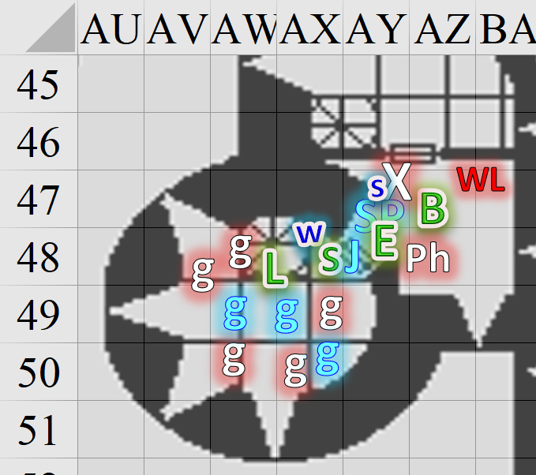

Round 86

Elsabet thought quickly, and decided her wounds were less important to deal with immediately than taking down the wererat—whose shot had after all just activated her furious counterstrike. She moved around Barkley past the body of the smaller tiefling, possibly stepping out of the way of Saradette’s line of fire for a moment, and then got close to the wererat, while snarling “two down, you’re next!”

In order to slash through the creature’s damage reduction, she initiated her foehammer strike and slashed down hard with her bastard sword, hoping the creature would go down hard and fast, without a chance to utter that fanatic death prayer.

|  |  |  |  |  |  |  |  |  |  |
| --- | --- | --- | --- | --- | --- | --- | --- | --- | --- |
| **Melee Weapon** | **Dmg** | **D+** | **TH+** | **Critical** | **Type** | **Wt.** | **Atk** | **Roll** | **Check** |
| Bastard Sword +1, 1-handed | 1d10+1 | +4 | 6 | 19-20/x2 | Slashing | 6.0 | +13 | 8 | 21 |

*Hit. Dmg: 5 + 1 + 4 + 4 Courage + 1 + Counterstrike 4 Foehammer = 19.*

The Wererat Lord was not nearly as stalwart as his title would have suggested, and fell to the floor, staring at Elsabet with contempt as the stranger returned to his human form.

The Baronial faction congratulated the heroes as Solstice hopped onto Phylac’s chest and began to search him. “You look like you’ve some nice toys.” Finding a dagger that could have been a longsword for himself, he continued to search.

With the threats all eliminated, Barkley turned his attention to the door leading out of the room, adding, as he approaches it, “Some should continue up the tower stairs. I will begin searching this floor.”

Sgt. Pepper agreed with the archon, and they went up the stairs and into the Baron’s chambers.

After a wave of his hand that removed the slick residue from Phylac’s fallen weapon, Luran stepped through the doorway, past the friendly guards to stand beside Elsabet and await the companions’ next move. His song continued, unabated, keeping all their spirits that much higher.

Saradette stayed with Barkley on the current floor.

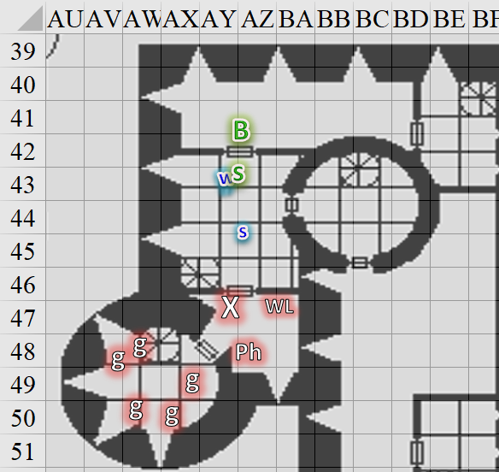

Round 87

Jericho joined the Baronial faction up the spiral staircase as Solstice followed Barkley and Saradette northward.

Having passed an open-doored tower to his right—the same one they’d partly escalated from the ground floor earlier—Barkley now opened the unlocked door to the north, and looked inside before stepping into the nearly empty corridor. As with the other hallways, there were a few vases and small sculptures, none of which romanticized lycanthropy or anything evil.

Saradette stayed a bit behind and to Barkley’s offside, her launcher at the ready.

Feeling rather wounded, Elsabet cast *cure light wounds* on herself and then headed for the stairs with Luran by her side, taking advantage of the *haste*.

*Elsabet gained 7 + 4 = 11 hps [32/48].*

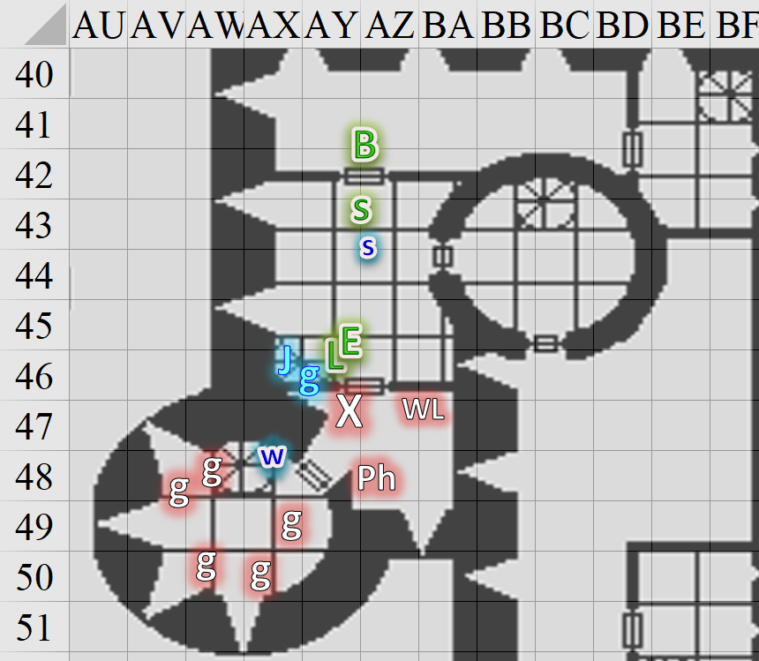

Round 88

Elsabet and Luran followed Jericho and the guards upstairs, and stopped in their tracks once they spotted the dead servant girl in the corner lying in a pool of her own blood, and the Baron himself—unkempt, and dreamy eyed—sitting stark naked on his bed. The breeze from the westward windows diluted the faint smell of blood and urine.

A second body—a fully armored woman—was also evident.

Sgt. Pepper simply uttered two syllables: “Baron?”

The Baron’s crouched posture gave him a simian semblance, and he seemed deep in thought, or some primitive form of meditation. He then parted his lips, gazed upon Sgt. Pepper, and muttered and sighed, “The Speaker in Dreams... ahhhh... commands that we submit. You *must* submit.”

~*~

Barkley, Saradette, and Widget headed towards the door that presumably led to the Treasurer’s bureau, but found it locked.

Saradette examined the lock to see if she could open it. “Maybe this is something I can do,” she muttered as she took out her lockpick tools.

Round 89

Barkley nodded as Saradette walked up to the door and pulled out her lock picks. While she worked on the lock, he took a moment to both listen and sniff the air for any indication that something might be nearby.

Saradette did her best to bypass the lock.

|  |  |  |  |  |  |  |
| --- | --- | --- | --- | --- | --- | --- |
| **Skill** | **Rank** | **Ability**  **& Mod.** | **Misc.**  **Mods.** | **Total** | **Roll** | **Check** |
| **Saradette, Open Lock** | 4 | **Dex (+3)** | 0 | 7 | 14 | 21 |

*Success.*

The latch gave way to the gnome’s deft hands.

Barkley peeked in first, seeing a tapestry on the floor along the southern wall, where it had once hung to conceal a passage into the next room. The tapestry was corrugated haphazardly, as if torn down in a mad scramble to escape... perhaps.

“Ah!” Saradette exclaimed softly. “Got it!”

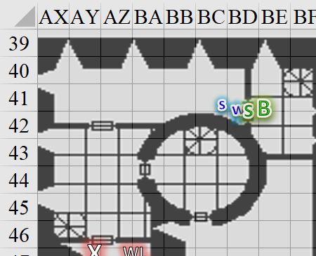

~*~

Elsabet first glanced around to make sure no invisible imps were in the room, and then spoke up. “I will use my *detect magic*,” she stated, and then proceeded to focus on her spell-like ability to detect magic in the chamber—it would take her a few rounds to determine how many magical auras there were in her sight, and where they were, and start to try to identify the schools of magic they belonged to, especially any on the Baron.

With her limited knowledge of spellcraft, the latter might prove futile, but she thought she had to try. In the meantime, she hoped Luran might heal more of the damage she had sustained, so if another foe appeared she would be better prepared to fight it.

Her maneuvers were due to be refreshed, but if none were forthcoming, she thought there would be no immediate danger.

Two of the guards approached the dead bodies, confirming that they were not merely wounded. They shook their heads at Sgt. Pepper, remaining vigilant of the dumbstruck Baron.

Luran’s song ended abruptly, partly from the shock of the scene and partly from the realization he may need his voice for traditional communication, in the next few moments. Seeing Elsabet still ailing from her wounds, he reached back into his magical haversack for the wand of healing he kept there. Also, recognizing the discerning look on his companion’s face as magical sight, he queried, “You see anything? I can take a look, as well,” as he offered her further magical healing.

*Elsabet gained 7 + 8 = 8 hps [40/48]*

